St. Petersburg University

Graduate School of Management

[Master in Information Technologies and Innovation Management]

[**The impact of leadership style on project success and mediation of team-building in Saudi Arabia]**

Master’s Thesis by the 2st year student

Concentration — [Leadership style

Leadership competences

Project Success ]

[Sharif Saif]

Research advisor:

[Professor. Andrey.L. Zamulin]

St. Petersburg

[2017]

ЗАЯВЛЕНИЕ О САМОСТОЯТЕЛЬНОМ ХАРАКТЕРЕ ВЫПУСКНОЙ КВАЛИФИКАЦИОННОЙ РАБОТЫ

Я, ________________________________, студент ___ курса магистратуры направления 080500 - «Менеджмент», заявляю, что в моей магистерской диссертации на тему «………………………………………………………………………………………………………………………………………………………………………………………………………………………………………………………………………………………………………………», представленной в ГАК для публичной защиты, не содержится элементов плагиата. Все прямые заимствования из печатных и электронных источников, а также из защищенных ранее выпускных квалификационных работ, кандидатских и докторских диссертаций имеют соответствующие ссылки. Я ознакомлен с действующим в Высшей школе менеджмента СПбГУ регламентом учебного процесса, согласно которому обнаружение плагиата (прямых заимствований из других источников без соответствующих ссылок) является основанием для выставления за выпускную квалификационную работу оценки «неудовлетворительно».

________________________________________________(Подпись студента)

________________________________________________ (Дата)

STATEMENT ABOUT THE INDEPENDENT CHARACTER OF THE MASTER THESIS

I, **Sharif Abdulmajid Abdullah Saif**, (second) year master student, ______program 080500 «Management», state that my master thesis on the topic «………………………………………………………………………………………………………………………………………………………………………………………………………………………………………………………………………………………………………………», which is presented for the public defence for the Official Defence Committee, does not contain any elements of plagiarism. All direct borrowings from printed and electronic sources, as well as from master theses, PhD and doctorate theses which were defended earlier, have appropriate references. I am familiar with the study process regulations at Graduate School of Management of Saint-Petersburg State University, according to which finding of plagiarism (direct borrowings from other sources without appropriate references) can be the reason for master thesis to be evaluated as «unsatisfactory».

________________________________________________(Student’s signature)

________________________________________________ (Date)

АННОТАЦИЯ

|  |  |
| --- | --- |
| Автор |  |
| Название магистерской диссертации |  |
| Факультет |  |
| Специальность |  |
| Год |  |
| Научный руководитель |  |
| Описание цели, задач и основных результатов |  |
| Ключевые слова |  |

Abstract

|  |  |
| --- | --- |
| Master Student's Name | Sharif Abdulmajid Abdullah Saif |
| Master Thesis Title | The impact of leadership style on project success and mediation of team-building in Saudi Arabia |
| Faculty | Graduate School of management |
| Major Subject | Master in Management |
| Year | 2017 |
| Academic Advisor’s Name | Andrey.L. Zamulin |
| Description of the goal, tasks and main results | The present study examines the nation of the relationship between leadership style and project success and intervention from team-building in construction companies in Saudi Arabia in average 50 constructions project & 50 project managers, data gathering utilized MLQ + PIP + team-building in total 50 items deployed over internet. Moreover, the study used qualitative research method and study the correlation between each leadership style (transformational, transactional, laissez-faire) with project success, then controlling by team-building, results revealed significant correlation concerning all of independent variables, mediation appeared in all scenario but for leadership style & transformational was partial mediation, for transactional & laissez-faire full mediation occurred. However, finding & research discussion provided. |
| Keywords | Leadership style, transformational, transactional, laissez faire, project success, team-building, construction company, Saudi Arabia |

Table of Contents

Chapter one 6

Introduction 6

Leadership history 7

Study objectives 12

Part one 14

Main three character of Leadership 14

Leadership Style 15

Transformational Leadership 15

Transactional Leadership 17

Laissez-Faire 18

Part Two 18

The key elements of project 18

Project success 18

Team-building 20

Project management 22

leadership style in project management 24

Chapter two 27

Research Design 27

Leadership Style and project success 28

Leadership style and team-building 29

Team-building and project success 31

Team-building mediation 32

Methodology 33

Research aims and concentrated domain 33

Data gathering and sampling 34

Questionnaire design & meaning 35

Leadership style (the independent variable) 35

Project success (dependent variable) 36

Team-building (mediator) 37

Chapter three 38

Results 38

Validity and reliability 38

Model results 40

Research discussion 46

Conclusion 48

References 50

Table of Figures 53

# Chapter one

## Introduction

In the beginning, we need to define the meaning of leadership, to pave our research path in order to put a light in this papers. Leadership according to oxford dictionary means “ *the action of leading a group of people or an organization* ” (oxford dictionary n.d.). thus this definition still general and vague, but from that, we can find that leadership concept itself has huge implication in our life on personal context and organizational as well, for instance, this concept could interfere with our behavior within a family relationship and how to guide and reach better outcome from each member. Nonetheless, according to Malcom Gladwell the well-known writer in New Yorker magazine in his Book “ *Outliers* ” that “ People aren’t born geniuses, they get there through effort ” (Gladwell 2008) that could deviate us from the ancient inappropriate notion about the great wasn’t great because of birth but also due to deliberate practice.

Let us cover some public figure during history to clarify how leader could make a radical different into his/her community or subordinates, one of the best leadership example is Gandhi, who was India’s independent movement leader and the founder of form of non-violent civil disobedience as well, he’d been standing against British colony in India. (Mahatma Gandhi Biography 2017) Another example is Warren Buffett, CEO of Berkshire Hathway, who has achieved glory by driving the company to fifth-most-valuable company in the world, he’s changed 300,000 subordinates’ perception toward doing businesses by giving managers wide flexibility freedom and encourage them like shareholders (Warren Buffett 2017).

Bass’s book “ *the Bass handbook of leadership* ” (Bernard M. Bass , Ronald E. Riggio 2008) has provided more than four hundred of an academic article, that would be a backbone of this papers in some branches of the study and the argument itself.

## Leadership history

Leadership theory has been started since 1950 (see figure 2 end of the chapter), through history leadership topic has been undertaken by scholars in extensive scale including leadership behavior, traits and its influences over team members. Prior 21st century, specifically in the late years of 20th century, the majority of the contribution in this field come from Dr. Peter Northouse with Dr. Gary Yuki: leadership theory & Practice (Northouse 2016), leadership in organization (Yunki 2013), from these appreciable work of both authors leadership studies has become absorbable and applicable for building novel research. Before that precisely in the beginning of 20th century, another indirect contribution from management practices domain by Frederick Winslow Taylor (Taylor 1911), who developed the practice of scientific management and later this theory reconstructed the relationship between all of managers and employees. In another word, leaders might breakdown huge task with the aim of simplifying the whole task and train their subordinate to be skillful in subtask to attain best productive results.

Additionally, Great man (Carlyle 1840)and Trait theories (Stogdill 1974). Great man theory refers that great leader are not made but God-gifted, moreover leader could be born with some characteristics and appear when a crisis exists. Beside that trait, theory demonstrates people with certain features from infanthood lead to successful leadership exclusively. R.M. Stogdill (Stogdill 1974) concludes from previous group studies first group consist of 124 studies took place in 1948 another 163 in 1974 ten highest traits & abilities:

1. Drive from responsibility and task completion.
2. Vigor and persistence in pursuit of goals.
3. Venturesomeness and originality in problem-solving.
4. Drive to exercise initiative in social situation.
5. Self-confidence and sense of personal identity.
6. Willingness to accept consequences of decision and action.
7. Readiness to absorb interpersonal stress.
8. Willingness to tolerate frustration and delay.
9. Ability to influence other persons’ behavior.
10. Capacity to structure social interaction system to the purpose at hand.

Furthermore, one of the figures who dedicates his academic path toward leadership style is Kurt Lewin (Kurt Lewin, Ronald Lippitt, Ralph K. White 1939), in this work Kurt and his colleagues illustrate three various leadership type appeared into the organization, below each type with its brief description:

1. **Autocratic leadership**: describes independent leader with dominant behavior over decision-making process without consultation.
2. **Democratic leadership**: show the opposite character than the former one above described, the leaders in this section tend to be social supervisor than a dominant ruler.
3. **Laissez Faire leadership**: this type has lower credibility due to submissive personality precisely at making a decision.

In one hand, German sociologist Max Weber in his book “The Protestant Ethic and Sprit of Capitalism” (Weber 1904) define for the first time Charismatic leadership, it’s a combination of traits & Abilities in a person which increase his/her trustworthiness and perceived a unique leader by his/her followers. In contrary, study (Fiedler 1985) argues that various leadership style is not matter, there is only one best option that could fit the situation, in his theory Fiedler summarize Kurt Lewin three leadership type into one criterion despite his/her position in organization, managers/leader become successful leader according to given task. In the other, the inventor of Likert scale Rensis Likert (Likert 1967), the well-used measurement tool utilizes to measure the degree of acceptance, Likert & Yuki have published two papers regarding leadership style. First, Likert leadership style with tree subtitle.

1. **Exploitative authoritative**: perhaps similar to autocratic leadership prior mentioned that neglect his/her subordinates in terms of taking a decision
2. **Benevolent authoritative**: this style tends to reward program to followers but still has full control over the decision with interfering with outer authority.
3. **Consultative**: has an implication of open-door approach with his/her followers to listen to solutions due to in-site experience followers have but with slight centralize the final decision.
4. **Participative**: which has full concern for subordinates’ opinion, involve them in the crucial decision process.

Second, participative leadership (Yukl 1989) demonstrated alike findings as Likert but using different terms for each respectively Autocratic, Consultation, Joint Decision, and Delegation.

In mid of 20th century, precisely 1975 another study bubbled up and overwhelmed scholars especially from organizational behavioral scientist’s figures called Leader-Member Exchange Theory (Fred Dansereau. George Graen. William J. Haga 1975) (Graen, G., & Cashman, J. 1975) (Graen 1976), that exhibit the kind of relationship gathers leaders with their followers and highlighted that leaders encourage mutual interests with subordinates to generate individual role for each them. Nonetheless, (Yukl 1989) has listed nine finding as results of high exchange rate between them,

1. Less turnover.
2. More positive performance evaluation.
3. Higher frequency of promotions.
4. Great organizational commitment.
5. More desirable work assignment.
6. Better job attitudes.
7. More attention and support from the leader.
8. Greater participation.
9. Faster career progress.

Another study lunched (Paul Hesey. Kenneth H. Blanchard 1969) under the name life cycle theory of leadership, it’s had showed four dimensions for leadership, that subjective to followers’ maturity base of leaders’ relationship behavior degree along with task behavior (see figure 1, end of the chapter).

1. **Telling**: this section shows high directive behavior and low support.
2. **Selling**: located on the upper-right side of the model, that also illustrate leadership behavior in each direction supportively & Directive.
3. **Participation**: this direction subordinates quiet enthusiastic about designated task but unfortunately with the lack of self-esteem.
4. **Delegation**: this part, followers are highly oriented toward performing the task and have fewer interests of leaders’ support.

Besides that (House, A Path Goal Theory of Leader Effectiveness 1971) (Evans 1970) have described subordinates incentives and how to motivate them. The main findings displayed by this work, subordinates could accomplish their task ones they have faith in their capabilities, as well as the efforts provided, will be appreciated by leaders, one more finding that the incentive delivered afterward is satisfied. (House, A Path Goal Theory of Leader Effectiveness 1971) studied the correlation within three parties (style of the leaders, characteristics of the employees, nature of the work) in the theme of the study covered above, leader assign him/herself from four dimensions of situational leadership (Paul Hesey. Kenneth H. Blanchard 1969) and encourage employees when leader consider financial compensation next to delegate simplified goals with trial of removing obstacles that could tackle goal path, plant satisfaction in employees’ perception.

Dr. Robert Greenleaf between 1970-1977 has written a number of scientific papers regarding leadership and various behavior, that published in his book (Greenleaf 2015) carries the servant as leader. The idea investigates the relationship between all of leaders and their subordinate but the radical change from the rest was consider the relationship from their subordinates’ perspective and named it servant leadership. Since that the concept of servant leadership wasn’t clear until beginning of 1990 when another researcher and the former CEO of Spears Center (Spears 2010) took the concept and point out 10 characteristics incorporated under servant leadership (listening, empathy, healing, awareness, persuasion, conceptualization, foresight, stewardship, commitment to the growth of the people, building community).

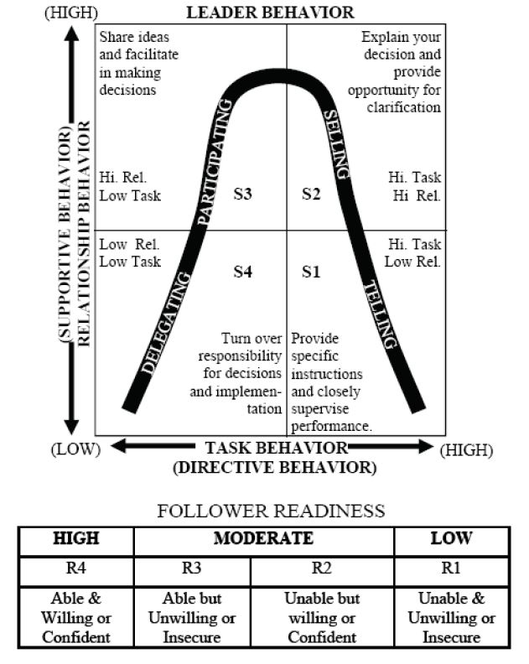

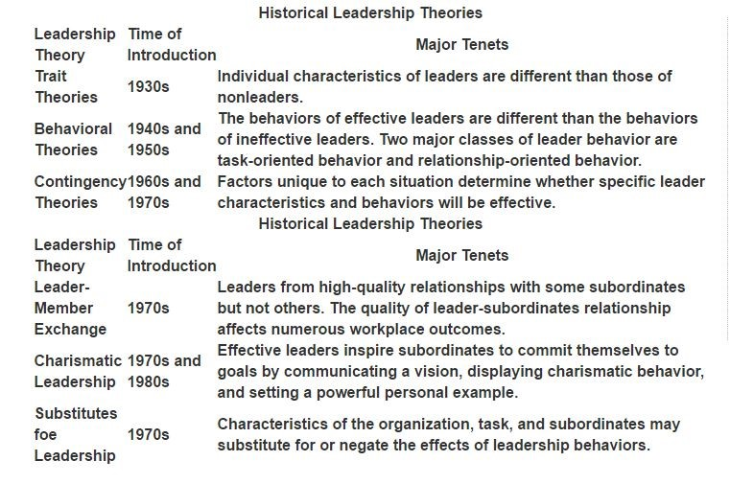Figure 1 Situational leadership model

Figure 2 Historical Leadership Theories

## Study objectives

The main aim of this paper is utilizing of two academic years’ work and efforts into one great image to appreciate all time has been provided from Gsom[1] board members and various given approaches and methods. Furthermore, we would dedicate these efforts to serve the core component in this research (leadership style), beside decomposing leadership characteristic & traits to create a base of this research due to the fact weak base leads to inefficient results. Precisely, we need to recognize the correlation between specific leadership style (transformational leadership) and team building that could have significant impact of project deliverables at construction company context,

Leadership in project-based companies’ idea comes to me due to my experience in this field for one year and during this period I realized some malpractices of fundamental principles from decision makers. I will try in this paper to analyze the working environment and attain new approaches to commute useful applications to achieve the maximum outcome. Project leaders, in particular, has huge burden over his/her shoulders and need to perform in a way that delivers any undertaken project without bearing loses or discredit his/her company. In other words, leaders nowadays could succeed or fail to attain project success. Furthermore, referring to prior reason the research would be certainly valuable for personal use as well as organizational use, we can implement leadership style in a business ground as well as any ground, because leadership style contains vulnerable benefits for each of individual and a collective sense. According to (Srdjan NIKEZIĆ Suzana DOLJANICA Dragan BATAVELJIĆ 2013) definition of leadership, there are three dimensions (transformational, transactional, Laisses-fair). Here a brief explanation of each leadership style, transformational leader who has charisma and able to influence team members to reach maximum goals and encourage them to improve the way of performing assigned task, transactional or managerial leader refers to the process of distributing orders from higher level to subordinate without motivating or pave the path to them to gain extra skill and execute well. Laisses-Faire leaders refer to the role of delegate absolute responsibility to subordinate even making decisions, in other words full independence to finish the work. However, these three dimensions of leadership could be found separately or together, because of this reason we need to analyze our potential project manager to understand which dimension they fit in or in case of multi-dimension appears what combination they have in order to facilitate our main goal of this study that aims to what dimension has significant impact on project success or team-building, otherwise our argument would be weak and could not serve goal of this paper.

In addition, if we decompose any project from a company side, we will find three main aspects that been called stakeholder (sponsor, project manager, project team) and with bureaucratic regime team members are not allowed to report to project sponsors directly and vice versa, in fact project leader in this regime play a role of connecter between project stakeholder in company side, in case of transformational leader, team member would not find difficulty to communicate with their immediate leader if they have questions or idea that might make different during the project in the same time they will be likely receiving feedback or instruction from their leader, on the contrary, transformational leaders would be lower concentrated to his team, and some questions and ideas are going to be depreciated by this type of leader but on the bright side they will be probable to get rewarded regarding their performance and attained goal. Indeed, Laisses-fair leader would perform passivly and disregard his teams’ requests, this kind of leader at big project could be burden for the company as well as team members beside some loses will be taken. However, enormous amount of companies in middle east especially Saudi Arabia have been neglected leadership styles, during last decade most of companies filed bankruptcy due to lack of knowledge regarding leadership style in several instances employers do not recognize fully the position of project leader and his/her responsibilities,

In this paper we would draw the light toward leadership style and his/her impression that could stimulate subordinates’ performance as well as project’s deliverable satisfaction, beside the team-building mediation. Moreover, targeted market (Saudi market) allows us to leverage this opportunity due to the fact that it’s underdevelopment, Saudi government push extra budget to transform current infrastructure to tech-infrastructure, as we know the world has been shifted into technological environment because of the improvement of technology and facilitate current business. Nonetheless, Saudi market considered less challengeable to the fact of same language that I speak and full awareness of the culture beside last five years from late 2009 till early of 2015, this experience unlocks curiosity to discover secrets, conducting business and manage project. Even though, the relationships and trust that I’ve build, it’s time to use them and take advantage in order to generate profitable knowledge for my academic path and my country as well.

In conclusion, the goal of this study could be translated into one statement. providing detailed image about leadership style contribution in project-based companies beside team-building intervention. Therefore, three main variables rise up in mind (leadership style, project, team-building) these will be provided later on with description of every variable role in the conceptual model (see figure 8) in the beginning of chapter 2 specifically research design.

## Part one

### Main three character of Leadership

This part of the work will be assigned around the full range of leadership model according to transformational leadership book (Bernard M. Bass , Ronald E. Riggio 2008) (see figure 2), this model consist of three main (transformational, transactional, laisses-faire) further description is provided below. Author allocated four components for transformational leadership in MLQ (Idealized Influence (II), intellectual stimulation (IS), Individualized Consideration (IC)), beside tow for transformational (Contingent Reward (CR), Management-by-exception (MBE)), as a final point, Laisses-Faire Leadership (LE) or in other word non-leadership.

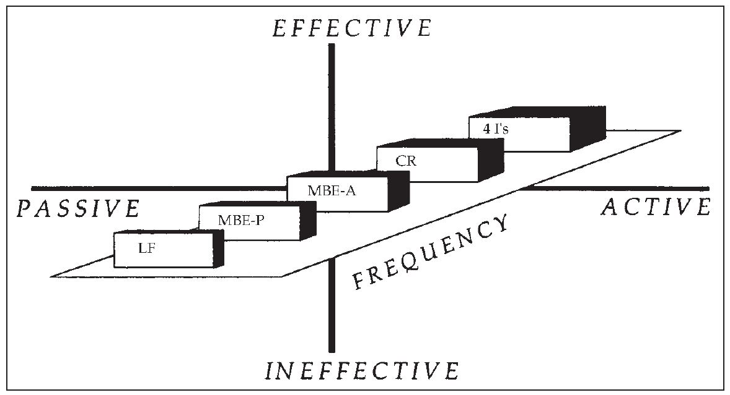

Figure 3 The full range of leadership model

### Leadership Style

### Transformational Leadership

after the prospering era of leadership, the research went through depression again most of the empirical research, in that time researches had a shortage of developments or visions. Until Bass and his colleagues (B. M. Bass, Leadership and performance beyond expectations 1985), (B. M. Bass 1994), (Hater 1988)endorsing visionary and charismatic leadership theories.

(B. M. Bass, Leadership and performance beyond expectations 1985) base on the findings of House (1977), Burns (1978) to debate that previous forms of transformational leadership, his argument was that old study focused only on the social exchange of transactional obligations. Bass feel unsure about the leadership affection whether it has a significant impact on a follower. He denotes this kind of leadership by transformational leadership, whose leaders with this character likely to encourage subordinates to shift their interests to aspiration. The Bass full range leadership model discussed early has a prevalent concern during leadership history, in this model (B. M. Bass 1994)shows four components of transformational leadership, who is effective in Effective-active side, Second leadership is rewarding, who sitting in the highest level of management and his approach is limited in setting a plans and requirements then awards follows upon them achievements.

1. **Idealized Influence (II):**  this criterion involves two features, leader’s behavior and features which followers assign to him, leaders represent a role model for their followers in terms of capabilities, persistence, and determination. three items in MLQ refer to this criterion “*make others feel good to be around their leader”, “Others have complete faith in their leader*”. “*Others are proud to be associated with their leader*”
2. **Inspirational Motivation (IM):** it’s easy to guess from the title that leaders motivate and encourage his workers by synergizing their ability to be involved in decision making process and augmenting team sprit by planting enthusiasm and sit clear goals beside support to achieve them. Idealized influence and Inspirational Motivation are hard to segregate, due to that charismatic leadership theory (House, Theory of Charismatic Leadership 1976) (Bass & Avolio 1993) describe them as combination under charismatic leadership. Three items in MLQ refer to this criterion “leaders *express with a few simple words what we could and should do”, “leaders provide appealing images about what we can do”*. “leaders *help others find meaning in their work”*
3. **Intellectual Stimulation (IS):** Transformational leaders grant absolute freedom to their followers, involving them in discussion of generating new approaches to solve problems and their ideas are appreciated as well. Followers are allowed to pull back old problem and resolve it to provide improvement in new solution. MLQ examines IS by three more questions “*leaders enable others to think about old problems in new ways”, “leaders provide others with new ways of looking at puzzling things”*. “*leaders get others to rethink ideas that they had never questioned before”*.
4. **Individualized Consideration (IC):** transformational leaders treat followers in positive discriminative way based on individual need couching and mentoring are applied by leaders, further, employees could receive various degree of encouragement according to this criterion high prospect outcome of potential development of the followers. MLQ indicators for Individualized Consideration are “*leaders help others develop themselves*”, *“leaders let others know how leaders think they are doing”*. “leaders *give personal attention to others who seem rejected”*.

In addition, In study (D.A. Aga N. Noorderhaven B. Vallejo 2016) has conducted four experiments to test the impact of leadership style in context of governmental organization in Ethiopia within three variable (project supervisor, project success, teambuilding) and argued about existence of effect to the project success from team-building mediation beside team-building plays mediating role in the relationship between transformational leadership and project success. this study targeted non-governmental organization(NGO) in Ethiopia to collect the data via questionnaire survey handed to 300 project managers, for each variant Likert scale to measure. Firstly, Project success as dependent variable and measured by projects constraints tringle (time, cost, quality) beside model of project success (Jeffrey K. Pinto, D. P. Slevin 1988) concerns satisfaction from client’s side. Secondly, transformational leadership as independent variable, used MLQ[2] questioner (Dr. Jens Rowold Jens Rowold 2005) (Bernard M. Bass & Bruce J. Avolio 2004) in purpose to obtain correct character for ever leader. Finally, team-building taken as mediator in this study based on previous works (Salas, E., Rozell, D., Mullen, B., Driskell, J.E 1999) (Klein, Salas, DiazGranados 2009), that show team-building has multi- dimensional build on interventional promoting interpersonal relations, role- clarification, problem-solving and goal-setting. As a result, positive contribution from transformational leadership in project deliverable has approved as well as correlation between team-building and transformational leader.

Another study (Mohamed 2016) has measured the influence of transformational leadership on followers in hospitality context in Egypt within some features (innovation climate, creativity, creative self-efficacy, satisfaction). Their supervisors are chosen to perform the questionnaire with their subordinates in total 500 followers 150 supervisors, the results showed that transformational leadership occupied the majority of the sample as well as encouraging followers’ creativity and satisfaction, an insignificant relationship appeared in creative self-efficacy between transformational leadership and followers.

### Transactional Leadership

This charisma appears when rewarding system for followers is considered, the system is subjective to either efficacy or performance of the followers. Transactional leaders implement carrots & stick approach in form contingent reward (CR) or ineffectively passive management in shape of management-by-exception (MBE-A or MBE-P).

1. **Contingent Reward (CR):** leader in this section has a clear vision. In order to achieve higher performance and outcome they try to encourage employees by rewarding system granted on task objectives. Transactional & transformational leaders shared same concept with reward in slight distinct prize. For instance, if the prize is material one (bonus, promotion, suitable position) the leader represents transaction if the prize is psychological (self-esteem encouragement, development of especial trait, involvement in purposing solutions) in this case he/she represents transformation.
2. **Management-by-exception (MBE):** leaders from this catalog likely to be passive introvert than what they are in previous section despite common traits with transformational leaders. MBE parts into (MBE-A) active, (MBE-P) Passive. Firstly, MBE-A keeps mentoring and tracking followers’ task and ensuring performance without errors or mistakes otherwise taking a corrective action will be in use. MBE-P just the opposite of active one, the taken policy would be waiting inertly for performance’s error or mistake to arise then taking corrective action. The in charge MLQ questions for each active and passive respectively “*The leader directs attention toward failures to meet standard*”, “T*he leader takes no action until complaints are received*”.

### Laissez-Faire

Laissez-Faire Leadership (LF) is considered as non-leader due to the avoidance or evasion. Most of researchers entitled who present this attitude inactive, ineffective leader. Crucial decisions aren’t taken or delayed. Responsibility isn’t preferred. Because of previous statements bass & Riggio (Bernard M. Bass , Ronald E. Riggio 2008) locate it on the quarter of passive-ineffective

## Part Two

### The key elements of project

### Project success

Initially, project success is highly related to project management, the full responsibility of success or failure of the project reflects on choosing of stakeholder (team members, project managers, team supervisors, resource suppliers) on one side, on the other iron triangle of project (see figure 4) considered as a measurement of project success. But before going deeper in our judgement on the project let us define project success. According to Project Management Institute(PMI®) the definition is a difficult task due to individual perception of whether project successful or not (Liu, A.N.N., & Walker, A. 1998) authors have dissolved project success measurement into two part, first outcome has a relation with project success is relying mainly on second part that is related to participant’s satisfaction, assigned different influential factors such as degree of complexity, commitment, goal, expectancy and environmental change to a fundamental in appreciating of project outcome. Extra research (Williams 2015) has studied project success definition by examine the correlation between multiple measurable and psychosocial factors , the finding of this paper reveled the success factors effect upon project performance, another way the study illustrate how could looking backward to map out problem root lead to successful criteria.

Primarily. The degree of success is controversial topic between scholars, iron triangle (Budget, Time and scoop) depicts insufficient measurement for project due to one side judgment that some cases project could reach satisfaction in perception of client despite on time, on budget. Therefore, clients’ opinion need to be incorporated under project success criteria, (Jeffrey K. Pinto, D. P. Slevin 1988) in his study authors argued the concept of project success and backed his disagreement with various scenario when project become on budget on time but considered as failure. On the contrary, project could deliver its objectives late as well as over budget but perceived as successful. Another statement authors drew attention toward is a case when project initially perceived as failure but with time it might approved its efficiency, for that ambiguous perception, study has invented Project Implementation Profile (PIP) which is questionnaire consist of twelve Likert scale questions demonstrate two side of the issue project and client. Correspondingly, (Cooke-Davies 2002) has formulated three comprehensive question to analyze imperative factor that has impact on the project success. According to his publication, the following questions were targeted 70 multi-national organizations (1- What factors lead to project management success? / 2- What factors lead to a successful project? / 3- what factors lead to consistently successful projects?). as a result, 12 factors indicate as crucial to project success. Six of them related to on-time & risk management plan, such as risk management experience, maturity of risk ownership, indexing of maintained risk, updating risk management plan, assignment of project responsibilities and keep project duration lower than 3 years. Two go to on-budget side, such as agree with budget control in certain level of maturity of project scoop, maintain the performance under the actual plane. Additionally, mutual cooperation is reliable factor for ensure project success. Three more factors go for big organization practices, firstly, in organization portfolio, projects’ consistency are recommended to support the entire portfolio and the reputation as well, secondly, estimation of future project success that hard to measure based on project portfolio particularly potential issues could be avoidable if the same issue found in previous projects, therefore performance improvement is going to be high, so project success is achieved. finally, “learning from experience” by merging explicit & implicit knowledge is key factor for performance sustainability. Another new study (Davis 2017) has argued that failure of a project refers to various interpretation of project success factors and criteria by stakeholders, consequently, findings dictate behavioral instrument is the productive tool to support project success perception.

### Team-building

We cannot proceed this work without considering team-building which has partial impact over project success but before stating analyze this impact we need to step back to review previous studies and researches that discovered the same element, two main studies has been developed regarding team-building are (Salas, E., Rozell, D., Mullen, B., Driskell, J.E 1999) (Klein, Salas, DiazGranados 2009). Respectively, first study has examined team-building over performance and attempted to measure the effects of team-building in main four components concerning it (goal setting, problem solving, interpersonal relations, role clarification). They have demonstrated different perspectives (objective, subjective) over operationalization of performance, the findings reveled that an insignificant impact on objective measures from team-building factor to decrease operational performance. In the other side, significant impact took a place in subjective measures and show increase in operational performance, in particularly only role clarification was probable to increase the performance despite the rest components that remain same without impacts, also they showed that team size effects team-building in matter of size.in addition, second study proceed the work from previous article (Salas, E., Rozell, D., Mullen, B., Driskell, J.E 1999) but expand the experiment of bigger data base and vast outcomes, the same four components have been examined within varied application such as cognitive, affective, process, and performance outcomes. As results, teams project that team-building has significant impact in mediocracy at team outcomes. We could generate from prior study a brief description for each component, for more information see the table below.

1. **Goal Setting:** this component responsible for main project objectives and familiarizing team members with them, concern for development of individual and team goals. team member supposed to be involved in goal-setting in order to gain a knowledge and invent a new way to improve achieving those goal.
2. **Problem Solving:** the main aim for this component pull out issues concerning the team with purpose of extracting them and implement solutions beside evaluation of those solution to improve efficiency.
3. **Interpersonal relations:** relation is crucial due to the mature skills each member has in a way to generate co-operative energy such as supportiveness, communication, and shearing of feeling, that leads to mutual trust and confidence between team members,
4. **Role clarification:** make a kind of channel among team members to avoid interfering varied assigned role together between members. As a result, clear understanding of each duties and roles that have been given to members.

|  |  |  |
| --- | --- | --- |
| Component | Salas, Rozell, Mullen and Driskell, 1999 | Salas, Priest, and DeRouin, 2005 |
| Goal Setting | Emphasis: setting objectives and developing of individual and team goals  Team members: become involved in action planning to identify way to achieve goals | Designed to strengthen team member motivation to achieve team goals and objective.  By identifying specific outcome levels, teams can determine what future resources are needed.  Individual characteristics can also be altered by use of this intervention. |
| Interpersonal relations | Emphasis: increasing teamwork skills.  Team members: develop trust in one another and confidence in the team. | Based on the assumption that teams with fewer interpersonal conflicts function more effectively than teams with greater numbers of interpersonal.  Requires the use of facilitator to develop mutual trust and open communication between team members.  As team members achieve higher levels of trust, cooperation, and cohesiveness, team characteristics can be changed as well. |
| Role clarification | Emphasis: increasing communication among team members regarding their respective roles within the team  Team members: improve understanding of their own and others’ respective roles and duties within the team | Defines the team as comprising a set of overlapping roles.  Theses overlapping roles are characterized as the behaviors that are expected of each individual team member.  Can be used to improve team and individual characteristics and work structure by negotiating, defining, and adjusting team member roles. |
| Problem solving | Emphasis: identifying major task-related problems within the team.  Team members: become involved in action planning, implement solutions to identify problem and to evaluate those solutions. | Buller’s (1986) problem-solving component subsumes aspects from all of the components described by beer (1976)  Team members practice setting goals, develop interpersonal relation, clarify team roles, and work to improve organizational characteristics through problem-solving tasks.  Can have the add benefit of enhancing critical-thinking skills |

Figure 4 models/components of team-building (Klein, Salas, DiazGranados 2009).

### Project management

We cannot finish this paper with devote part of the work to the combination of transformational leadership with project management due to the heave load of this study is pouring into this pool. Initially, we need to break the title of this section apart then combine them together to reach better understanding and investigate previous studies that discovered the same concepts. Project management definition according to (PMI 2008) is usage of competencies, managerial skills, concepts and approaches to match project objectives. Project management roles consist of five phases. They are initiating, planning, executing, monitoring, and closing phase (see figure 5). Each of them assigned to identify and cover objectives. as anything else in order to obtain better understanding you need to break it down into small pieces to facilitate the undertake tasks. Furthermore. Initiating phase is the first step in management of a project as you as it’s clear in the name of the phase. also It’s in charge of identifying and enlisting deliverables. In other word, initiating phase draws the overview of the project and addresses a current problem that should be solved in the end of the project lifecycle beside recommended solution, with analyses of capability of doing this solution in form of document. Ones recommended solution is approved by stakeholders. Assigning of manager, team, deliverables of the project. Moving to second phase for planning, in this part project manager role appears due to handing project file from stakeholders to designated project manager. project manager identifies iron triangle (see figure 6) estimation all of scope, project schedule, and budget, during planning process. Nonetheless, risk plan takes place during this phase, manager has to predict potential problems and prioritize them to create problem reference to avoid time-wasting in risk management part. As a result, first part of the cycle has attained, now project is pointed requirement to achieve deliverable as well as schedule, budget, designated team-members, resources. And finally communication plan to map out who reports to who. As we mentioned above third phase is for execution, this phase works simultaneously with monitoring phase, during this phase performance starts and take a form of motion, project manager spends the majority of his time in these two phases because of maintaining and controlling this phase, manager should trace its performance in case of deviation from the plan he needs to ensure every task working according to the plan, if the situation needs extra time out of the actual plan adjustment should be taken and informed to each stakeholders and project sponsors on a regular basis. Ones tasks start to reach ending points without any sudden issue closing phase will be started, during closing phase project managers releases final deliverables and project documentation to the client, beside termination of various contracts that is involved in the project and extract lessons to be used as reference point for future projects (Westland 2006).

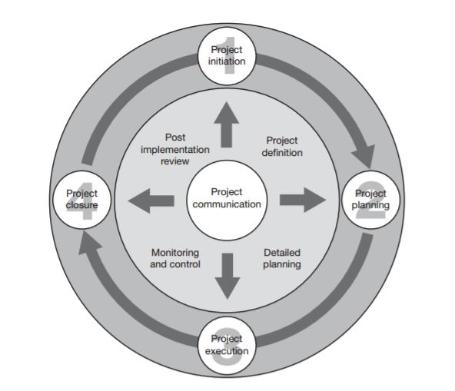

Figure 5 The four phases of the project life cycle

### leadership style in project management

This part will cover project management concept as well as project leadership in construction companies and its contribution to improving project success beside assigning project managers to enhance on project’s deliverable, project management department responsible for archiving customers’ satisfaction and added value to its company as well. Nowadays, next to project’s deliverables in triple constraints (time, cost, quality) for success, there are client side of project success (Jeffrey K. Pinto, D. P. Slevin 1988) figure 1, that to reach project success the department should match both sides. Moreover, incorporate this model besides the orginal one with the purpose of achiving maximum outcomes.

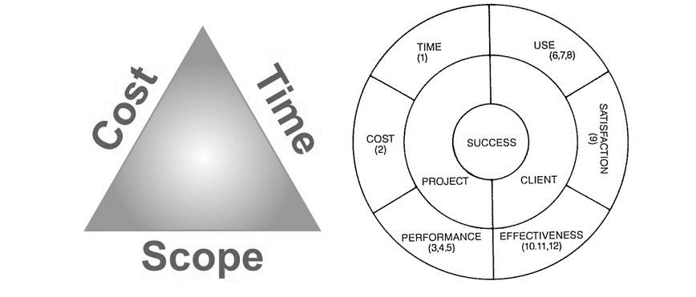

Figure 6 Model of project success

From another side, assigning appropriate project manager leads to desirable outcome (Karin Bredin, Jonas Söderlund. 2013) that add new task upon the department. Project managers has radical impact over project’s live cycle from initiation through closing phase, improving plan, resources, procurement and suppliers.

In contrary, we can’t cover project management without decompose project leadership due to its influential attitude around stakeholders. Project leadership considered a crucial technique every leader need to exhibit in order to push outcome to superior satisfaction, however to accomplish the desirable outcome leaders essentially need to initiate a project map including standards of behaviour and performance for participating team. Moreover, this technique has various tasks to appropriate usage, for instance, problem-solving approach should be contemplated around high performing team members. In Susan Madsen book (Madsen 2015) has described the project leadership matrix (see figure 5). This matrix illustrates four dimensions intersect between vertical (proactive, reactive) and horizontal (task focus, people focus) arrows, for each direction managers concentrate in one aspect, furthermore, managers express the lift side of the matrix are tending to be task-oriented, they perform logically dominancy, so they allocate task according to follower competencies with particular task, this approach called push approach due to the full usage of authority. Unlike who express the right side, their tendency goes to appreciation of the crew. People-focused managers allow crew to get involve into each phase of the project together with decision making, inspiring followers preferable than just dictating commands, author names this approach a pull approach. Nonetheless, in some cases managers could fall into confusion especially when they can’t define what direction he’s performing as task-focus or people-focus. but that scenario is not crucial, managers should better measure the difficulty they face to approach worker that is not related to their project in this method managers can easily define what direction they’re in.

The other side of the matrix discovers short & long term vision. Managers from reactive side tend to pick immediate issue that could appear but unfortunately this issue might tackle and affect the entire project plan. In the upper arrow, managers with a proactive mindset looking for strategic vision of the project and moving gradually toward objectives to accomplished them in a best way, they’re taking into their consideration stakeholders’ satisfaction, in case of unexpected issues, they prioritize them then top priority has to be solved but in a way doesn’t interfere with project’s affair.

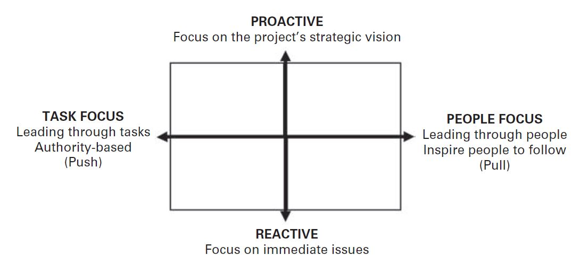

Figure 7 The Project Leadership Matrix

# Chapter two

### Research Design

This chapter will be dedicated to the research framework and hypotheses and shows our argument about the niche in previous study that analyses only transformational leader instead of leadership style entirely (D.A. Aga N. Noorderhaven B. Vallejo 2016) because transformational leadership is not a tangible asset to discriminate from the rest of leadership characteristics, according to (Bernard M. Bass , Ronald E. Riggio 2008) model (transformational, transactional, and Laissez-Faire). Managers usually combine between various components from different characteristics, beside he/she attitude that differ from person to person. Nonetheless, the concept of leadership is application of knowledge, from (MLQ) different statement leader to a subcomponent under the characters, in other word item 1,8,15 reflect the practice degree of idealize influence and so on. On other hand, project success is not related only to single environment, it’s abroad concept, any operation has limited time and money within group of people called project, therefore project could be applied when all the requirements are fulfilled, and team-building differ from context to another, for instance, team-building in non-profitable organization perform differently than profitable one. For that reason, this study will examine the relation between different characteristics of leadership style with project success once, and with mediation of team-building (see figure 8).

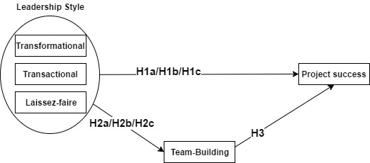

Figure 8 Research model

Correspondingly, Construction companies in Middle East especially Saudi Arabia is targeted segment for this study. In addition, three main variables are leadership style as independent variable, project success as dependent variable, team-building dependent variable as well. The considerable relationship will analyze whether project success will be affected by interfere form team-building or not. in other words, we generate two path of model hypotheses conventional path that shows the direct influence from leadership style on project success in chosen context, novel path that relies on team-building interrelationship between independent variable leadership style and dependent variable project success. Moreover, the study based on two previous studies that analyze separately the impact of leadership style according to (Bernard M. Bass , Ronald E. Riggio 2008) on project success in context of construction industry in South Africa in one paper (Muredeni Liphadzi. Clinton Aigbavboa. Wellington Thwala 2015), in the second paper, study has analyzed transformational leadership’s impact on project success with exploit team-building role despite of transactional and Laissez-Faire characters at non-profitable organization in Ethiopia (D.A. Aga N. Noorderhaven B. Vallejo 2016).

### Leadership Style and project success

The majority of studies that took place in this domain approve significant impact over project deliverables. Also correlation among project deliverable and project success is exist, once deliverable have achieved within iron triangle (cost, budget, and scope) project considered successful despite of degree of successfulness (Jeffrey K. Pinto, D. P. Slevin 1988). Furthermore, leadership style approved significant effect on project success with neglecting of laissez faire leadership due to missing relationship with project success (Muredeni Liphadzi. Clinton Aigbavboa. Wellington Thwala 2015). Recently, transformational leadership specifically has been examined in temporary organizations in form of association with subordinate work engagement (WEG) and project turnover intention(PTI), findings have reveled positive influence by transformational leaders over work engagement and negative relation over project turnover intention (Xiang Dinga, Qian Lib, Haibo Zhanga, Zhaohan Shengb, Zeya Wangc, 2017). Obviously, study has been devoted to reviewing all of project success and project managers’ leadership style. Before this study, literature of project success has been avoided project managers including his/her leadership style and not considered as success factor on project. On the contrary, managerial literature exhibited leadership style as crucial success factor in context of organizations’ management (Rodney Turner, Ralf Muller 2005). However, transformational leadership is crucial to improver project outcomes. Despite the lack of experiment on this style studies examined transformational leadership (Bernard M. Bass , Ronald E. Riggio 2008) effects over project success. Also finding support authors argument and exhibit positive relation to project success in contingent reward element (Aga 2016).for this reason, research question was raised with three sub question.

H1: positive relationship between leadership style and project success.

H1a: transformation leadership has significant effect on project success in construction company.

H1b: transactional leadership has significant effect on project success in construction company.

H1c: laissez-faire has significant effect on project success in construction company.

### Leadership style and team-building

(Klein, Salas, DiazGranados 2009) have reveled four components (read team-building in previous chapter for more information) goal-setting, interpersonal relation, problem solving, and role-clarification, these four components allow managers improving his/her team-building outcomes in order to reach best projects’ deliverables that could lead to project success. Leadership managers could utilize all of the four components combined or enhance one instead of the rest because some team-building approaches need two component or one depend on scarce point in the potential project team. (Donald D. James F 1995) has considered project manager roles as procedure to build cohesive team, and enhance motivations project teams require with the purpose of achieving project deliverables. Furthermore, this article has exhibited authors considerable contributions in pool team-building practices that enlist six key element for project managers to enhance project outcomes, these elements are, [1] valuing team members and rising mutual trust between them which has significant results among members, according to golden role principle that says treat others as you desire to be treated, team members with mutual respect are able to reach solutions for unsolved problems and avoid blaming each other if problem appears that in turn consolidate team cohesiveness. [2] role responsibilities deployment. Mangers in most cases don’t bother themselves take enough time to identify job responsibilities and assign them to appropriate team members that in turn could accelerate role’s familiarization for members. In other words, manager might consider his/her project as unsolved puzzle by putting every member in his/her right place according to his/her competencies project overall image will be completed. [3] communication channel, team members usually suffering from not them voice hasn’t been heard by project managers. Therefore, managers need to think thoughtfully about initiating a participative approach to involve member in decision making, frequently team members exhibit effectively respond to sudden change in project plan when they open toward project lifecycle phases. [4] generate motivation by assessing goal per group or individual, managers who encourage individual needs for instance self-leadership skills improvement have probability to be appreciable by his/her team members, unfortunately companies that non-project oriented seem to be desirable by new entrants due to considerable work spending in individual goal-setting than project-oriented companies. [5] compensation and reward of teamwork efforts, discriminate or appreciate one team member outcome instead of entire team at the rest expense usually escalate hatred between members and demotivate them, that in turn certainly has direct negative impact on project overall image, thus mangers should draw huge attention toward compensation and reward and evaluate outcome as team members’ efforts, nonetheless, appreciating team member efforts and contributions in desired motivation which lead to sincere work from members to attain project deliverable. [6] loyalty for team members by them managers, not only team members who have responsibilities for them managers also managers have responsibilities for them members, managers oblige to be loyal for them members, such one responsibility is enough to increase self-confidence on team members, for instance dedicate time and efforts for team members in order to emphasize team-building procedure. (Chantal M.J.H. Rob F, Beatrice I.J. Heijdena 2015) has indicated leadership behaviour (e.g. task-oriented and person-oriented) impact has negative relationship over team stability. However, positive relationship has been showed over team learning, as result, leaders could utilize task and person orientation to influence team-building procedure.

H2: leadership style has significant effect on team-building

H2a: Transformational leadership has significant effect on team-building.

H2b: Transactional leadership has significant effect on team-building.

H2c: Laissez-faire has significant effect on team-building.

### Team-building and project success

(Baccarini, David 1999) extensive amount of studies has devoted to measuring project success but this domain still elusive due to lack of distinct identification of product success and project management success that have different outcomes, product success is oriented to goal-setting and role-clarification. On the other hand, project management success is minded toward problem-solving as output results and mutual relation with various stakeholders as input. Logical framework method (LFM) (see figure 9) has been used by authors to measure project success for effectively and conclude that LFM is highly recommended for project leader to create articulated project plan to enhance role-clarification component on team-building procedure.

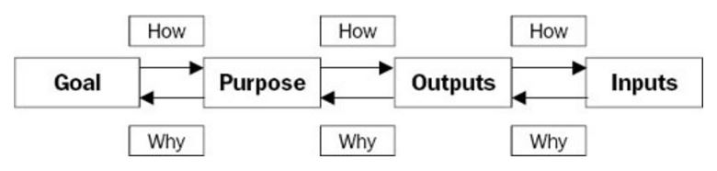

Figure 9 LFM

(Cameron Klein, Deborah DiazGranados, Eduardo Salas, 2009) meta-analysis revelled positive improvement from team-building efforts to attain satisfied improvement of project outcomes, that in turn could depict project managers approach to integrate team-building intervention technique to emphasize project success. Part of leadership style (Bernard M. Bass , Ronald E. Riggio 2008) for example transformational and transactional style consist of four components and two components respectively contribute on project success and team-building, revering to the encouragement of idealized influence, intellectual stimulation, and individual consideration on project success (D.A. Aga N. Noorderhaven B. Vallejo 2016). Problem-solving is considered to be important for project leaders in ambiguous environment that generated by the complexity of the project and number of stakeholder involved in the project. Predefine of solution for problem and giving a spice for members to provide them opinion are empowering project outcomes therefore project success will be achieved (Yuzhu Lia, Ming-Hsien Yangb, , Gary Kleinc, , Houn-Gee Chend, 2010). Leadership of project manager and project team efficiency is utilized by project management as critical factor to obtain stakeholders’ satisfaction (Sequra, Marcos, Romero, Javier 2016). Based on this study, synergetic performance from managers and team members will do noticeable influence on project success that project success factor subjective to stakeholder satisfaction (Jeffrey K. Pinto, D. P. Slevin 1988). According to previous works in this filed, third question is formulated

H3: Team-building intervention influences project success.

### Team-building mediation

In spite of diverse leadership styles but still all of these practices are driven by one purpose that serves project success, according to (Bernard M. Bass , Ronald E. Riggio 2008) that generated six components incorporated into two main characters (transformational & transactional), Idealized Influence that responsible of deploying projects roles according to the member’s competency, Inspirational Motivation implies encourage member individually as well as collectively, Intellectual Stimulation refers to drawing members attentions toward new perception of problem’s solutions beside appreciation of individualism. Individualized consideration forms in specific treatment for each member in order to extract buried talent to light. As you read above all of specific component of transformational leaders pour into one pool team member enhancement. Furthermore, contingent reward works as motivation for members in case project goal is attained if not punishment policy is going to be applied. Management by exception appears in two different situations, actively if safety is required and deviances takes a place, on the contrary, passively behavior spreads out and waits to deviances otherwise no corrective action will be taken. Moreover, second style of leadership serves same purpose that drawing attention toward project success by develop members’ competencies. (Cooke-Davies 2002) has recommended close co-operation from project team and sponsor to obtain potential benefit by support from project managers. (Jeffrey K. Pinto, D. P. Slevin 1988) at early stage of project success internal performance tend to be more important that attained by developing effective team, team with productivity plan could save project from falling to succeeding due to experience of working under budget and time frame. (Zareen. Razzaq. Mujtaba 2015) in various context than project-based organization transformational and transactional leaders perform critical factor in motivate employees, leaders’ competencies subjective to employees’ size and accomplishments. (Mohamed 2016) transformational leaders in hospitality sector exhibit fostering behavior to their immediate employees in ongoing mechanism that concentrate on three aspects including innovation climate, creativity, and self-efficacy, trying to reach potential customer satisfaction, that in turn leads us to same goal we’re planning to reach customer’s satisfaction. In other words, second dimension of project success factor (Jeffrey K. Pinto, D. P. Slevin 1988). (Rodney Turner, Ralf Muller 2005) in literature of project management leadership style has dictated working environment beside project team tends to achieve project success, however leaders implant various characteristics into project team for instance (ethics, mutual respect, and courage) that is going to push the team toward appropriate goal and achievement. (Williams 2015) project requires five influences to be considered successful project, these influences are efficiency (deliverables was attained in best performance), effectiveness (projects’ outcomes match the goal), relevance (project has been performed along with organization undergoing mechanism), impact (project outcomes are highly connected with intended client goals), sustainability(project outcomes’ influence serves long term). Consequentially, team-building mediatory is supported by prior finding and arise the fourth hypotheses question.

H4: leadership style influences project success by mediating from team-building.

H4a: Transformational influences project success by mediating from team-building.

H4b: Transactional influences project success by mediating from team-building.

H4c: Laissez faire influences project success by mediating from team-building.

### Methodology

### Research aims and concentrated domain

Before indulging in project success, a definition of project would be useful basis to measure success of failure degree, (Jeffrey K. Pinto, D. P. Slevin 1988) has quoted project as

“*A project is an organization of people dedicated to a specific purpose or objective. Projects generally involve large, expensive, unique, or high risk undertakings which have to be completed by a certain date, for a certain amount of money, within some expected level of performance. At a minimum, all projects need to have well defined objective and sufficient resources to carry out all the required tasks*”

Moreover, this study devoted to analyze the influence in form of relationship between all of project success factors and leadership style, and questioning if mediation of team-building does affect the nature of prior relationship, the targeting market for this work is Saudi market especially project managers in construction companies, the projects have been covered during last three years of project manager experience, and the intended project manager has to have team in order from us to understand the technique managers are following to improve the nature of the project and efficiency of his/her team. The market is chosen due to facilitations, accessibilities, and most important common language (Arabic). Other markets were offered for instance, Russian, European, and China but unfortunately all of them need extra budget and intensive work because lack of experience and entering mode, each market of them has various peculiarities such as labor law, language, and low concentrating on construction project particularly European market that has precious heritage beside limited spaces in case of developing, on the same fashion, Russian Petersburg market was rejected. On the contrary, Chinese market would be a nightmare for us due to highly language barrier.

### Data gathering and sampling

During midterm vacation after third semester through 2017 new-year holyday, my professor and me decided to proceed our work due to varies working calendar between Russian Federation and Saudi Arabia, Russian labor law gives two rest day (Saturday, Sunday), ten days of vacation starts from 31 Dec until 10 Jen. On the contrary, Saudi labor law gives two days as well but in different order (Friday, Saturday), without new year vacation due to different applications of calendar Hijri vs Gregorian. So we keep our work up and start to communicate with project managers in all of Riyadh, Jeddah, Dammam that have extensive portfolio profile in terms of infrastructure development project. In addition, primary stage for finding participants is internet research by google.com just to create an index including contact information, magnitude, project concentration, project portfolio, intended client (most probably government institutions), years of experience in the market, and number of project managers of the company. Research showed some obstacles for instance company’s portfolio is missing from the website, company size wasn’t clear enough and number of employees as well. Furthermore, secondary stage was encouraged by my thesis advisor, contact information was appreciated, so calls started to obtain extra information, this calls took place between 25 Dec 2016 till 29 Jan 2017 by voice over IP app (VOIP), we started to gather our anticipated question in order to avoid time-wasting then translated them to local language (Arabic), thus questions were [1] who are your intended users? [2] how many project managers and undertaken projects do your company have? [3] how many employees are assigned on one project? [4] could you nominate one project manager to participate in our study?, we tried in our questions formulation to avoid fiscal connotation due to conservation from a company to disclose its book. Sequentially, we attain fifteen companies consist of international and local, they nominated twenty project managers only male due to the nature of the nature of working environment for our study, all of the have at least seven years of experience, have completed projects in same domain, each positioned as project manager (PM) or project manager office (PMO).we start our experiment by interview them to generate better understanding of the nature of the project he has covered, extra question were directed to manager’s attitude toward his subordinate, the average project’s life time, in case of potential relationship between PM and intended client we asked (do this kind of relationship serve you to achieve your goal?). Likewise, online questionnaire of three part was designed effectively, first section consist of twenty one question in Likert scale from 1 to five, assigned to assess the degree of combination of leadership style (Bernard M. Bass & Bruce J. Avolio 2004), second section stated project question and indicate two side of project success factor (company and client) (Jeffrey K. Pinto, D. P. Slevin 1988), project part specifies six question served company requirements, the rest six served client requirements. Third section customized for four elements of team-building factor (Klein, Salas, DiazGranados 2009), also to assess the load of each element. Moreover, questionnaire was sent to PM via email and follow up via call or social media app (LinkedIn, Skype, Viber) just to ensure the questionnaire has arrived to the right PM. The session took place between 25th Mar 2017 till 13th Apr 2017, with updating by ensuring every manager has fulfilled his questionnaire fully, in the end we gathered twenty questionnaires ready to be analyzed

### Questionnaire design & meaning

### Leadership style (the independent variable)

most of the previous studies have measured leadership style individually, recent study (D.A. Aga N. Noorderhaven B. Vallejo 2016) has measured transformational leadership impact on project success by mediating for teambuilding in Ethiopia and adapted MLQ in concentration of transformational leadership, the findings approved efficiency of questionnaire. According to enormous studies in this domain extraction of knowledge described briefly, that studied transformational leadership has incorporate twelve question assigned for four elements of transformational leader ship (idealized influence, inspirational motivation, intellectual stimulation, and individualized consideration) three question each. On the contrary, studies have measured transactional leadership incorporated six question also assigned for two elements (contingent reward, management-by-exception). Multifactor leadership questionnaire (MLQ) (Bass, B. M., & Avolio, B. J. 1990c) becomes viral in measuring three characters of leadership within 67 items including 30 item allocated for transactional due to consideration of Laissez-Faire as subcomponent of transactional, 30 items allocated for transformational. In spite of (Avolio, B. J., Bass, B. M., & Jung, D. I. 1997) MLQ (5X) 36 items remain and four questions were enlisted for each subcomponents of leadership style with isolating of Laissez-Faire from transactional. However, (Bass, B. M., & Avolio, B. J. 1992) MLQ (form 6) comprising of 21 items, three question incorporated for each subcomponent in random order with the intention of avoiding subjective answers, (IF) under transformational leadership designated items on MLQ are (1, 8, & 15), IM designated items are (2, 9, & 16), IS designated items are (3, 10, & 17), IC designated items are (4, 11, & 18). On the transformational side, designated items for CR and MBE are (5, 12, 19, 6, 13, 20) respectively. Laissez-faire has only (7, 14, 21) designated items. The MLQ measures leadership style by 4 points Likert scale from 1 refers not at all to 4 refers frequently if not always, but according to intended project managers’ interview that draw our attention on the various Likert scale in each part of the questioner.

### Project success (dependent variable)

The debate of project success factor wouldn’t end and there is no reliable measurement could satisfy the requirements, because project success factor is multi-dimension, has both side and various perception. the argument goes to biased judgment about whether the project whether considered succeed or failed. Preliminary. Project Critical success factors (CSF) consist of eleven questions but has lack of objective evaluation due to focusing into satisfaction of stakeholders in terms of tangible outcomes without measuring the intangible side that could shift the project from side to side (David Bryde 2007), comprehensive questionnaire need to discover ever potential factor which in turn could affect the overall results. Consequently, multi-dimension questioner comprising of 11 items combine project efficiency, customer’s impression, business success, and future implication (Aaron J. Shenhar, Dov Dvir, Ofer Levy and Alan C. Maltz 2001), the study has demonstrated the early stages of project lifecycle (initiating, planning, executing, monitoring, and closing phase) (see figure 5) but from literature review, the requirement of this paper to measure project success factor after closing phase.

Project implementation profile (PIP) demonstrate two dimension of project success factor, project dimension examines iron triangle by five question discover all of time, cost, and performance of the project. On the client dimension, three components examined, the usage of the project for intended user, the degree of satisfaction in intended user perception, efficiency is examined by measuring of direct benefit and its impact on users’ effectiveness, also by evaluating the performance after project implementation and the positive impact upon intended users. Subsequently, PIP consist of twelve statements each of them has Likert scale from 1 Strongly Disagree to 7 strongly agree but for improve overall questionnaire efficiency, customization of Likert scale to fit the three part of the questionnaire, therefore Likert scale become from 1 Strongly Disagree to 5 Strongly Agree (Jeffrey K. Pinto, D. P. Slevin 1988).

### Team-building (mediator)

During literature review team-building section various structured questionnaires was being evaluated in order to fit this study’s requirements. However, team learning behavior could be part of the team-building processes but because of the number of the items enlisted, that has 28 items and in case of incorporated into team-building questionnaire intended participants’ time is going to be unappreciated (Chantal M.J.H. Rob F, Beatrice I.J. Heijdena 2015) due to that reason team learning behavior was eliminated.

Two appreciated academic work have devoted to team-building (Salas, E., Rozell, D., Mullen, B., Driskell, J.E 1999) (Klein, Salas, DiazGranados 2009) in this studies meta-analysis of team-building interventions has revealed mediating role to improve team outcomes, according to team-building interventions, four subcomponents have revealed (goal setting, interpersonal relations, problem solving, and role clarification) but no survey has published could enlist statement with Likert scale to measure degree of correctness that we discussed in project success and leadership style section. For that reason, adaptation of 17 items dedicated to team building interventions’ subcomponents enlisted in this order respectively four items located to reflect goal-setting depict timing of setting project goals beside simplify them and periodic feedback on performance, the involvement of team members in inventing novel way to achieve those goals. Consequently, five items located to reflect interpersonal-relations and consider encouraging members to exchange knowledge between them, decreasing sensitivity by enhancing frankly discussion, shearing and developing communication are accepted. Five items located to reflect problem solving, including providing idea concerns project problem beside engagement into solution procedure. Nonetheless, extra three items located to reflect role-clarification, depicts disclosure of each member responsibility and normalizes project’s requirements for its team members. In additional, each item measured by five point Likert scale 1 strongly disagree to 5 totally disagree , questionnaire was adapted by (D.A. Aga N. Noorderhaven B. Vallejo 2016) based on (Klein, Salas, DiazGranados 2009).

# Chapter three

### Results

After collecting data from intended participants, fifty questionnaires have been filed, all the participants’ questionnaire have no missing data, so all the data is undertaken to a laboratory for processing and converting into figure that could be helpful in interpretation and result phase, however testify the validity and reliability should be next steps before showing the final results, the purpose of reliability test is going to define Cronbach’s Alpha (α) that can legitimatize participants’ answer and the quality of the incorporated items into the questionnaire. following by liner regression between main variants according to the study model namely(transformational leadership with project success, transactional leadership with project success, laissez faire with project success, transformational leadership with team building, transactional leadership with team building, laissez faire with team building, and team building with project success) to investigate the hypotheses for conventional path, for mediation, liner regression with adding team building as independent variable as well as leadership styles individually Therefore, the description of the laboratorial performance is going to be in same order as actual events.

### Validity and reliability

Most of the publications indicate Cronbach’s Alpha (α) value is appreciated when it more than (.7 or .8), otherwise α is unreliable, but that could be confusing in such cases. According to (Kline 1999) (Field 2013), Cronbach’s Alpha differs from study to study, for measuring cognitive or intellectual test, α should exceed .8 in order to satisfy validity’s requirements, on the contrary, for measuring ability or physical test, α doesn’t need to exceed .8 just .7 is acceptable. Therefore, in order to approve validity and reliability, the questionnaire has to show α more than .7 in every main variable namely leadership style, project success, teambuilding. For preparation of the data, every item that incorporated under one main variable was computed into one variable in the structure leadership style computes items from 1 till 21, project success computes items from 22 till 33, and team-building computes items from 34 till 50. The study utilizes IBM SPSS to conduct statistical tests and approve the hypotheses,

For leadership style factor, initial test was Pearson correlation, starting from computed variable with its items to investigate whether the item is valid or invalid based on degree of confidence (sig < 0,05), Pearson correlation test was performed for each style of leadership namely (transformational, transactional, and laissez-faire). Consequentially, transformation leadership reveal absolute reliability (see figure 10), all items showed less that (0,05) that means, all items are valid and no need for excluding any. Simultaneously, same test performed to investigate transactional and laissez-faire, none of them reveled sig more than (0,05), therefore all constructed items is valid. Subsequently, reliability test has some requirements need to be satisfied discussed early in this section, regarding reliability of leadership style, reliability analysis was performed as well to measure and compere Cronbach’s Alpha value that should be more than .7, reliability analysis has implied .794 which approves validity and reliability of 21 items, 3 items was reflect each of transformational leadership subcomponents (idealized influence, inspirational motivation, intellectual stimulation, individualized consideration), 3 items reflect transactional leadership subcomponents (contingent reward, management by exception), the last 3 items go for non-leadership.

For project success factor, Pearson correlation was performed for project items as well as client items individually, entire items revealed sig below (0,05) therefore project success twelve items are valid (see figure 12) so project success section in the questionnaire have no request to eliminate any of them. On the contrary, reliability test was performed for twelve items combined, Cornbach’s Alpha value reflect high reliability by ,766. Based on this data reliability test can be concluded that items are reliable (project side by 12 items, client side by 12 items).

Fortunately, the study couldn’t be proceeded without testing validity and reliability for last factor, team-building was examined by Pearson correlation as well, the test has been taken two time for investigating the changing in α and whether it would be increased or not by excluding items according to Pearson correlation. For that matter, initial test wasn’t highly correlated between its items, the results showed indicate high correlation between items. In the same time, reliability test was performed as well and disclose high value for α by ,798. Therefore, team building section is highly reliable that can be concluded that 4 goal setting items, 5 interpersonal relations items, 3 role clarification items, and 5 problem solving items (see figure 13).

### Model results

Simultaneously, data analyse segregated the investigated project into two group based on overall project section score, maximum score is 60, so below 30 scores, project considered failure due to insufficient collected score for instance, a project could be succeeded in perception of iron triangle (cost, time, scope) but failed to achieve intended client’s satisfaction, thus this project will be under unsuccessful project in this paper, beside investigating about if laissez faire leadership has visible hand on this failure. (see figure 14) descriptive analysis was performed to exhibit projects’ overall score and determent failure than succeed in statistical table in IBM SPSS environment, on the table, there are 2 from 50 projects didn’t reach 30 score at minimum, that in turn could be interpreted as unbiased evaluation in the perception of intended project managers. The questionnaire deliberately notified participants to think about any project that has been covered during last three years from project manager’s experience, which mean the room of manipulating the score was available in front of them but with this figure but instead intended manager preferred to reflect the nature of chosen project despite weather that project was match its requirements or not. Sequentially, leadership style in processing phase was computed as overall score of leadership style in order to serve first hypothesis that states influence from leadership style on project success ones, and individually namely (transformational total, transactional total, and laissez faire total) to examine the following hypotheses H1a, H1b, H1c, therefore total score for each variables 105, 60, 30, and 15 respectively. Furthermore, team building has been performed as well as the rest, the maximum score a chosen manager could gain in one questionnaire session is 85 despite the subcomponents team-building has because of this procedure could be generated in 16 hypotheses and need extra time to be interpreted.

In addition, after discovering validity & reliability as well as overall score for each construct, next move for preparing the date to examine all stated hypothesis is obviously Pearson correlation coefficient but this time will be performed for the main constructs in order to define whether all the variables correlate with each other or not, in other word, the attention will be toward degree of relationship between them in form of value, the value appeared in actual number from 0,00 to 1+ which mean not correlated to perfect correlated. However, the table (see figure 15) revealed various degree of relationships among constructs, the numbers could be concluded that the Pearson correlation is positive but laissez faire correlated with transformational leadership moderately, with transformational low, beside low correlation with project success and team-building as well. On the contrary, leadership style as well as project success showed high correlation among others.

Mainly, for approving the effect of the hypotheses in the model (see figure 8), every assumption need to be tested under linear regression proposed by (Baron & Kenny 1986) to define R2, sig, and beta value, each output represents different meaning of the test, for instance R2 exhibit influence percentage from independent variable on dependent variable, sig in turn explains if the correlation between variable is exist, beta need to be taken as evidence in case of mediating influence investigation. However, to perform these regressions, each suggested relation between variables, in this study leadership style with project success once and with team-building, therefore team-building with project success to accept the third hypothesis.

For hypothesis 1 that stated positive influence from leadership style as it’s on project success, and leadership characters individually with project success, for determining the effect between variables. In other words, the affecting variable is regarded independents namely (leadership style, transformational, transactional, laissez faire) and the affected variable is regarded dependents variable namely (project success), as far a table will be presented to sited R2, sig, and beta for each assumption (see table 1)

Table 1Linear regression result for hypothesis 1

|  |  |  |  |
| --- | --- | --- | --- |
| Hypothesis | R2 | Sig | Beta |
| H1 | 0,565 | 0,000 | 0,751 |
| H1a | 0,484 | 0,000 | 0,695 |
| H1b | 0,250 | 0,000 | 0,500 |
| H1c | 0,216 | 0,001 | 0,465 |

Form the table above, leadership style influences project success by 56,5% that in return gives obvious evidence to accept hypothesis one. For transformational leadership, the percentage of influence over project success is 48,4% with high correlation, transactional leadership obtained 25% over project success and laissez faire only 21,6% of influence. Despite various percentages but still the acceptance of hypotheses under main hypothesis is highly evident. Once first regression approved positive results, now moving forward to investigate second group of hypotheses under H2 that investigate the kind of relation between leadership style and its subcomponents with team-building

Sequentially, second hypothesis was ready to be investigated the strength of the relationship between leadership style and its subcomponents with team-building in a way to pave the unconventional path or mediation path. However, all the results is sited in the table (see table 2) including R2, sig, and beta, the variable was performed as independent for leadership and dependent for team-building.

Table 2 Linear regression result for hypothesis 2

|  |  |  |  |
| --- | --- | --- | --- |
| Hypothesis | R2 | Sig | Beta |
| H2 | 0,485 | 0,000 | 0,696 |
| H2a | 0,396 | 0,000 | 0,629 |
| H2b | 0,268 | 0,000 | 0,517 |
| H2c | 0,171 | 0,003 | 0,413 |

From the table above, when leadership style was taken with team-building into liner regression, leadership style exposed positive influence team-building by 48,5% with significant correlation according to Anova figures, beside influence by 39,6%, 26,8%, and 17,1% for each of transformational, transactional, laissez faire respectively. Which implies strong evidence to accept these hypotheses. Under this circumstances, part of the whole study’s image started to appear by conventional path that already has been approved the suggestions there are influence in different degree from leadership style and its subcomponents as well as influence from same variables on team-building. Additional, the study is one step far from examination, the existence of effect from team-building on project success, but in this time only two variables are engaged prior mentioned, team-building was taken as independent and project success as dependent under linear regression, regarding stated hypothesis that suspect positive influence from team-building on project success, the test was performed and revealed the table below that in a way could be explained high percentage of influence from independent on dependent variable beside positive relation from independent (team-building). As a result, the initial hypotheses model could be adjusted with the new values (see figure). Accordingly, the way to approve the mediation is already paved as adjusted version below, from the model

Table 3 Linear regression result for hypothesis 3

|  |  |  |  |
| --- | --- | --- | --- |
| Hypothesis | R2 | Sig | Beta |
| H3 | 0,629 | 0,000 | 0,793 |

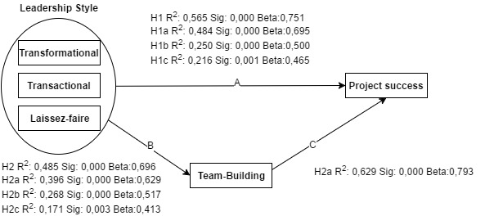

Figure 10 Research model including the results

Two point have to regarded point A and point (B, C) combined called M point for the last phase, in order to approve mediation of team-building on point M, point A should affected by the mediator and generate insignificant correlation in other word sig > 0,05 beside low beta value otherwise the mediator won’t be useful and hypotheses 4 is going to be rejected, for instance, if transformational (predictor 1) no longer significant by controlling from team-building (predictor 2) that can be concluded a full mediation. Nonetheless, in some cases sig could be significant for both mediator and independent variable for that case, in statistical notion called partial mediation that reflect the phenomenon when both predictors have significant relationship after controlling from the mediator, in practical context, if path a leadership style as (predictor 1) in adjusted model remain significant even when there is control form (team-building predictor 2) that interpreted partial mediation. Likewise, all the variables are formulated to incorporate individually under linear regression, initial test is undertaken linear regression in IBM SPSS for project success as dependent variable beside leadership style (predictor 1) controlled by team-building (predictor 2), as a result, (see figure 10) the correlation between predictor 1 and project success remain significant by 0,001<0,05 and β 0,386 even with controlled via predictor 2 that disclosed significant correlation by 0,000<0,05 and β 0,524, in this case, full mediation was rejected and compensated by partial mediation. Deliberately, team-building influences leadership style with project success by 70,6%. Suddenly, another partial mediation jumped up, but in first subhypothesis that investigate transformational leadership specifically. As a reminder, subhypothesis is regarded the correlation between transformational leadership (predictor 1) and project success as dependent variable could be controlled fully by team-building’s influence (full mediation), but technically speaking, team-building influences the correlation between predictor 1 and dependent variable by 69,3% only and that could be concluded as partial mediation due to parallel significant correlation in both paths as first scenario with overall leadership style, however, two subhypotheses remain for investigating transnational’s influence with project success along with laissez faire controlled by team-building. Furthermore, third ssubhypothesis was performed in the same way as preceding hypothesis, in this time, transactional plus team-building was contained in independent variable section in linear regression oppositely with project success in dependent variable, in comparison with previous results, unpredictably positive evidence approved this assumption, transaction this time loosened his significant correlation from 0,000 to 0,238 which is >0,05 confidence than former result even β value suffered 378 less than before, therefore team-building (predictor 2) controls both variables with significant correlation 0,000<0,05 beside 64% degree of influence, to put it more simply, thus H4b was approved the full

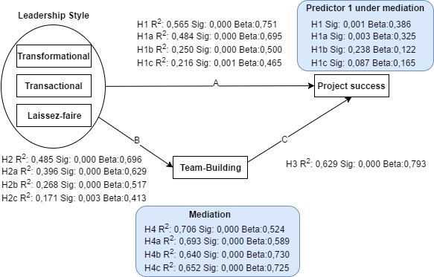

Figure 11 Research model including mediation results

Mediation. On the final stage, team-building was performed as predictor to control the correlation in path a that in previous test showed significant correlation by 21,6% of influence from laissez faire on project success, at present, radical chanced has happened, significant correlation in path a drop down by 300 less in β and instead of sig<0,05 sig spike up to reach insignificant correlation sig: 0,087> 0,05, thus imposed a strong evidence of full mediation, technically speaking, laissez faire (predictor 1) influence the value of project success via 65,2% influential control from team-building.

Just a reminder of this paper, the whole work concentrate on project manager practices that reflect in form of performing a given project under constraints certain budget and money beside scope that transforms into project team, sponsors, and client. However, these three components performed variously in terms of concentration, for instance, high deliberation devoted to project manager could lead to different outcome for both project deliverables and contributed team. On other words, these three components are subjective to operating organizations. Additionally, the paper generated four potential possibility in Saudi market that discover leadership style according to (Bernard M. Bass , Ronald E. Riggio 2008) model as unseparated component with its influence on project success, and investigating whether team-building consist of four subcomponents namely (goal-setting, interpersonal relations, role-clarification, and problem-solving) has somehow invisible hand that could control the main relationship if it does then how much degree of influence team-building controls? was the second move. On practical language, team-building ascend significant correlation 0,00<0,05 β 0,524 R2 0,706 that could be concluded as full mediation but due to remain significant correlation in path a, results retreating of full mediation into partial mediation. On other hand, transformational leadership was undertaken alone into same hypotheses’ model to be performed under same circumstances, and also this time team-building failed to attain full mediation because same effect has occurred from transformational leadership, but this time with different in numerical language, team-building exerted influence estimated by0,00<0,05 β 0,589 R2 0,693 alone with 0,01<0,05 β 0,386 exerted by transformational leadership, that in turn could be established partial mediation than full mediation as its hypothesis stated.in form of proceeding these hypotheses, unpredictably transformational leadership when was undertaken into multi-regression procedure near team-building as two protectors of the project success outcomes, dramatically team-building exerted influence to deflate the correlation between predictor 1 and project success (independent variable) by 64% of effect that leaded transformational leadership to decrease its correlation from 0,000 to 0,238>0,05 and β from 0,500 to 0,122, according to this figure team-building attained full mediation other than its predecessor (H4, H4a) that showed opposite than the expectation. Last but not the least, laissez faire leadership when approved its significant correlation as independent variable alone with project success as dependent variable under linear regression by 0,001 p-value <0,05 and β 0,465 with 21,6% degree of influence, in this time under controlling from team-building into multi-regression, team-building (predictor 2) smashed previous notion and flipped the situation upside down that reduced p-value for predictor 1 as well as β by 0,086 more and 300 less respectively, to put it simply, laissez faire influence project success by controlling from team-building with 64,2% degree of influence.

### Research discussion

The present study regarded two standpoints, firstly, investigate the notion of the relationship between leadership style as well as its dimensions namely (transformational, transactional, laissez faire) with project success in one side, in the other side, explore the impact of team-building intervention on project success outcomes, all the work undertaken Saudi construction companies as targeting segment. However the first part of inquiry took leadership style according to (Bernard M. Bass , Ronald E. Riggio 2008) full range of leadership style (FRL)into four stage of test beside project success as follow: (leadership style & project success , transformational & project success, transactional & project success, laissez faire & project success) in contrast with previous study (D.A. Aga N. Noorderhaven B. Vallejo 2016) (Xiang Dinga, Qian Lib, Haibo Zhanga, Zhaohan Shengb, Zeya Wangc, 2017) that have specified one dimension of leadership for each study. The purpose of this approach was to offer detailed understanding of each dimension with its degree of influence. In addition, the examined hypotheses appeared higher influence become from leadership style which leads to fact that project manager with leadership style can improve project outcome, as novel result, laissez faire perform the lest robust on the studied model as individual dimension against (FRL) that incorporated laissez-faire under transactional leadership beside contingent reward and management by exception. Separately, another four steps in this time performed with intervening from team-building, the results provide various notions than what the present study stated, both of leadership style and transformational leadership maintained the correlation with project success even with mediation from team-building which is against the finding (D.A. Aga N. Noorderhaven B. Vallejo 2016) that showed full mediation of team-building, on other words, transformational leadership differs from context to context, transactional leadership along with finding provided by (Aga 2016) generated full mediation with team-building, practical speaking, transactional improve project success by helping from project team, so project manager who features contingent reward and management by exception performs effectively on developing his team. lastly, as last characteristic of leadership style, laissez-faire exhibit spuriously impacts on project success even with low degree of influence but still this impact could serve organization need especially with few studies has discovered separately this dimension, in the same way, laissez-faire correlates significantly with team-building that lead to productive effort to develop the participated team.

Another considerable finding that couldn’t be neglected is that leadership style with its diminutions in (FRL) (Bernard M. Bass , Ronald E. Riggio 2008) is subjective to different factors, for instant, in the present study the context of leadership style roles in project-based companies has revelled various finding than previous its sister studies (D.A. Aga N. Noorderhaven B. Vallejo 2016) & (Aga 2016) that has dictated significant correlation and full mediation between leadership style and project outcomes which approve in current study the opposite correlation and partial mediation in all of entire leadership style as one variant and transformational leadership specific along with team-building intervention (Goal-setting, Interpersonal-relation, Role-clarification, Problem-solving). Consequentially, study experiment took place two years ago (Muredeni Liphadzi. Clinton Aigbavboa. Wellington Thwala 2015) has conducted experiment to investigate the same variables in present study, suddenly as the results, the research has disclosed missing correlation from Laissez-faire style and project success on construction industry in South-Africa that could be supportive evident to present study’s prior statement that states the correlation between leadership style and project success is subjective to a nation,

Commercial implication could be taken from present study, human resource & project management practitioners could identify project manager’s character according to (FRL) (Bernard M. Bass , Ronald E. Riggio 2008) during hiring procedure, also project management practitioners could utilize varied results to assess project budgets in order to decrease cost and increase profit, for instance, big project requires more resources different from small project, in this scenario, project management department would differentiate project leaders according to his/her competences according to leadership style and prioritize project managers price from higher to low based on undertaking project complexity. Moreover, once leadership style identified among project manager, then project management could strengthen project manager’s shortage and draw attention toward uncharted feature of sophisticated project manager attitude, for instance, conventionally laissez-faire leadership is the most unattractive competence, the project department can point out intended laissez-faire weaknesses and compare them with most appealing characteristic of transformational style, in a situation of transforming laissez-faire to transformation the win-win situation will attained, project manager advance his/her character and elevate his/her market proposition.

On the contrary, the finding indicates significant relationship interferes between project manager and project success that could be translated into commercial perspective when the factors of improving project deliverables has identified, project management practitioners could utilize the need of developing project team and assign further role for project managers to sever project team, that could be taken as new approach to enhance relationship between them and lead to harmonic working environment. However, (Klein, Salas, DiazGranados 2009)(goal-setting, interpersonal-relation, role-clarification, problem-solving) has various impact on project outcomes that could serve project management practises in prepare potential team before performing a project,

### Conclusion

Project-based construction companies in Saudi Arabia along with various type of leadership practices and intervention of team-building has been demonstrated, MFL questionnaire contributed in the decompose leadership style into different traits based on (Bernard M. Bass , Ronald E. Riggio 2008) that dictates four main characters for transformational leadership with twelve items whish facilitate project manager procedure to understand their traits betters, in part of transactional leadership, one items has extracted and considered separately that was given in FRL model provided by (Bernard M. Bass , Ronald E. Riggio 2008) due to recent study has follow same approach that is used in present study (Alaedin Khalil Alsayed, Mohammad Hossein Motaghi, Intan Binti Osman November 2012) the new distribution of leadership style allow the study to improve accuracy results. on the contrary, project success has been considered as multi diminution factor that represented in present study into two sides (project, client side) which is crucial in measuring project success and avoiding misperception of success and faller. Consequentially, team-building is the third variable in present study, four subcomponents has taken into questionnaire team-building section namely (goal-setting, interpersonal relation, role clarification, problem solving) each subcomponent exhibit into bundle of items. In addition, thirteen relations have been investigated between all of leadership style impact over project success factor once and with team-building intervention another. Team-building intervention individually being explored with project success to define if there is significant correlation that could paving the final stage of the experiment which responsible of recognizing the degree of influence from team-building over leadership style to predict the main impact on project success. Under these situations, findings targeted the direct impact from leadership style over project success reveled significant correlation in every situation even though Laissez-faire disclose least degree of influence, on the second bundle of experiment that responsible of measure the mediation of team-building intervention astonishingly disclose partial mediation with the whole leadership style in one side and transformational style with team-building, which differ from the previous study and showed the factor of leadership style is subjective to various factors such as domain environment, nature of relationship between project manager and intended customer, communication style with project team. for the rest of the style, transactional and laissez-faire indicate full mediation with team-building intervention.

# References

1971A Path Goal Theory of Leader Effectiveness*Saga Publications*321-339

Aaron J. Shenhar, Dov Dvir, Ofer Levy and Alan C. Maltz2001Project Success: A Multidimensional Strategic Concept*Long Range Planning*6 699-725

Alice H. Eagly, & Mary C. Johannesen-Schmidt, & Marloes L. van Engen2003Transformational, Transactional, Laissez-Faire Leadership Styles: A Meta-Analysis Comparing Women and Men*Elesevier*569-591

2017An empirical Investigation into different stakeholder groups perception of project successInternational journal of project management 35

2016Assessing the effects of transformational leadership: A study on Egyptian hotel employees*Elesevier*Journal of Hospitality and Tourism Management2749-59

Avolio, B. J., Bass, B. M., & Jung, D. I.1997Replicated confirmatory factor analyses of the mulitfactor leadership questionnaire*Center for leadership studies*

Baccarini, David1999The logical framework method for defining project success*Project Management Journal*Project Management Journal30(4), 25—32

Baron & Kenny1986The moderator-mediator variable distinction in social psychological research: Conceptual, strategic, and statistical considerations*Journal of Personality and Scial Psychology*51, 1173-1182

Bass & Avolio1993Transformational leadership: A response to critiques. In M. M. Chemers & R.San Diego Academic Press49-80

Bass .M B. & Avolio1994Transformational leadership: Improving organizational effectiveness*Thousand Oaks*

Bass, B. M., & Avolio, B. J.1992Manual for the organization questionnaire (ODQ)*Consulting Psychologists Press*

Bass, B. M., & Avolio, B. J.1990cTransformational leadership development: manual for the multifactor leadership questionnaire *Consulting Psychologists Press*

Bernard M. Bass , Ronald E. Riggio2008*the Bass handbook of leadership*Free Press

Bernard M. Bass & Bruce J. Avolio2004Multifactor Leadership Questionnaire. Manual and sampler set*Mind Garden*

Cameron Klein, Deborah DiazGranados, Eduardo Salas,2009Does Team Building Work?*SAGE*SAGA 40181-222181-222

Chantal M.J.H. Rob F, Beatrice I.J. Heijdena2015Does team stability mediate the relationship between leadership and team learning? an empirical study among Dutch project teams*Empirical Research Paper* International journal of project management 332 406-418

2010Character and Servant Leadership: Ten Characteristics of Effective, Caring Leaders*The Journal of Virtues & Leadership*25-30

1985Contingency Theory of Leadership: An application of the meta-analysis *Psychological Bulletin*274-285

D.A. Aga N. Noorderhaven B. Vallejo2016Transformational leadership and project success: The mediating role of team-building*ScienceDirect*810

David Bryde2007Perception of the impact of project sponsorship practices on project success*International Journal of Project Management*800-809

Donald D. James F 1995Team building and project management how are we doing?Project Management Journal

Dr. Jens Rowold Jens Rowold 2005Multifactor Leadership Questionnaire *Mind Garden*

Fred Dansereau. George Graen. William J. Haga1975A vertical dyad approach to leadership within formal organizations*Organizational Behavior & Human Performance*46-78

1998Functional relations among constructs in the same*Journal of Applied Psychology*234–246

Graen, G., & Cashman, J.1975A role making model of leadership in formal organizations: A developmental approach*Organization and administrative sciences.*143-165

1974*Handbook of leadership: A survey of theory and research*Free Press

1999*Handbook of Psychological testing* Routledge

2015Identifying success factors in construction projects*project management journal*Project Management Journal47197-112

1950Interaction process analysis: A method for the study of small groups*Cambridge*

Jeffrey K. Pinto, D. P. Slevin1988Project success: definition and measurment thechniques*Project Management Journal*67-72

john E. Katsos, Timothy L. Fort2016Leadership in the promotion of peace: Interviews with the 2015 Business for Peace honorees*ScienceDirect*

Karin Bredin, Jonas Söderlund.2013Project managers and career models: An exploratory comparative study*Project Management*889–902

Katz, D., Maccoby, N., Gurin, G., & Floor, L. G.1951Productivity, supervision and morale among railroad workers*Institute for Social Research, University of Michigan.*

Klein, Salas, DiazGranados2009Does Team Building Work?*Small group research*SAGE Publications 402181-222

Kurt Lewin, Ronald Lippitt, Ralph K. White1939Patterns of aggressive behavior in experimentally created social climates*Child Welfare Research Station* 271-299

1985Leadership and performance beyond expectations*New York: Free Press*

2013*Leadership in Organazations* albanyPearson

2016*LEADERSHIP THEORIES AND STUDIES*http://www.referenceforbusiness.com/management/Int-Loc/Leadership-Theories-and-Studies.html

2016*Leadership Theory and Practice Seventh Edition*MichiganSAGE

Liu, A.N.N., & Walker, A.1998Evaluation of project outcomesConstruction Management and Economics162

2017*Mahatma Gandhi Biography*http://www.biography.com/people/mahatma-gandhi-9305898#synopsis

1989Managerial Leadership: Rewiew of Theory and Research *Journal of Management*251-289

Muredeni Liphadzi. Clinton Aigbavboa. Wellington Thwala2015Relationship Between Leadership Styles and Project Success in the South Africa Construction Industry*Procedia Engineering*Elsevier123284-290284-290

1840*On Heroes, Hero-Worship, and the Heroic in History*CreateSpace Independent Publishing Platform

2008*Outliers*Newyork

Paul Hesey. Kenneth H. Blanchard1969Life Cycle Theory of Leadership

PMI2008*A Guide to the project Management Body of Knowledge*PMI

2013Reliability analysis675-676SAGE Publications Ltd

Reuben M. Baron and David A. Kenny 1986The Moderator-Mediator Variable Distinction in Social Psychological Research: Conceptual, Strategic, and Statistical Considerations *Journal of Pe~nality and Social Psychology*

1967rhe human organization: Its management and value *McGraw-Hill*

Rodney Turner, Ralf Muller2005The project manager's leadership style as a success factor on projects: A literature review *Project Management Institute* Project management Journal36149-61

1976Role making processes within complex organizations*industrial and organizational psychology*1201-1245

Salas, E., Rozell, D., Mullen, B., Driskell, J.E1999The effect of team building on performance: an integration *Small Group Res*309–329

Sequra, Marcos, Romero, Javier2016Critical success factors in large projects in the aerospace and defense sectors.Journal of Business Research

Srdjan NIKEZIĆ Suzana DOLJANICA Dragan BATAVELJIĆ2013Charismatic and Transformational leadership approaches for effecting change *UNIVERSITY Fascicle of Management and Technological Engineering*

1988Superiors’ evaluations and subordinates’ perceptions of transformational and transactional leadership*Journal of Applied Psychology,*695–702

2002The "real" success factors on projectsInternational ornal of Project Management203

1970The effects of supervisory behavior on the path-goal relationship*Organizational Behavior and Human Performance*227-298

1911*The principles of scientific management*Harper & Row

2006*The project management life cycle*london Kogan Page Limited

1904*The Protestant Ethic and the Spirit of Capitalism*Germany

2015*The servent as Leader*The Greenleaf Center for Servant Leadership

2015*The world is changing and so must you*Kogan Page limited

1976Theory of Charismatic Leadership*Working Paper Series 76-06*

Timothy A, judge, Erin Fluegge Woolf, Charlice Hurst, Beth Livingston2006Charismatic and transformational Leadership*organisationspsychologie*203-214

2016Transactional Leadership and Project Success: The Moderating Role of Goal Clarity*Procedia Computer Science*Procedia Computer Science 100517-525100 517-525

1998Transformational leadership Industrial, military and educational impact*Mahwah, NJ: Lawrence Erlbaum*

1994Transformational leadership: Improving organizational effectiveness*Thousand Oaks*

2017*Warren Buffett*http://www.biography.com/people/warren-buffett-9230729

Xiang Dinga, Qian Lib, Haibo Zhanga, Zhaohan Shengb, Zeya Wangc, 2017Linking transformational leadership and work outcomes in temporary organizations: A social identity approachInternational Journal of Project Management354

Yuzhu Lia, Ming-Hsien Yangb, , Gary Kleinc, , Houn-Gee Chend, 2010The role of team problem solving competency in information system development projectsInternational journal of project management 297 911-922

Zareen. Razzaq. Mujtaba2015Impact of Transactional, Transformational and Laissez-Faire Leadership Styles on Motivation: A Quantitative Study of Banking Employees in Pakistan*Springer Science*Public Orgnization Review8

# Table of Figures

Figure 1 Situational leadership model 11

Figure 2 Historical Leadership Theories 11

Figure 3 The full range of leadership model 14

Figure 4 models/components of team-building (Klein, Salas, DiazGranados 2009). 22

Figure 5 The four phases of the project life cycle 24

Figure 6 Model of project success 25

Figure 7 The Project Leadership Matrix 26

Figure 8 Research model 27

Figure 9 LFM 31

Figure 10 Research model including the results 43

Figure 11 Research model including mediation results 44

Figure 12 Transformational leadership Pearson correlation 54

Figure 13continued Person Correlation 55

Figure 14 Project success Pearson Correlation 56

Figure 15 Team-Building Pearson correlation 57

Figure 16 Project overall scores 58

Figure 17 Constructs correlation 58

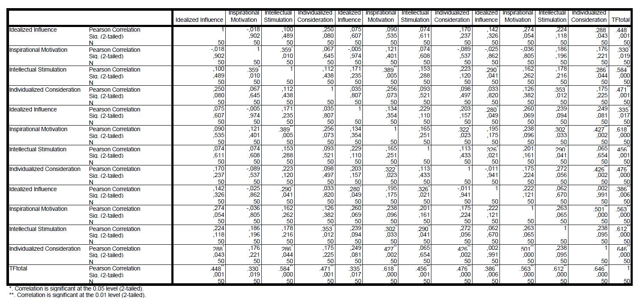

Figure 12 Transformational leadership Pearson correlation

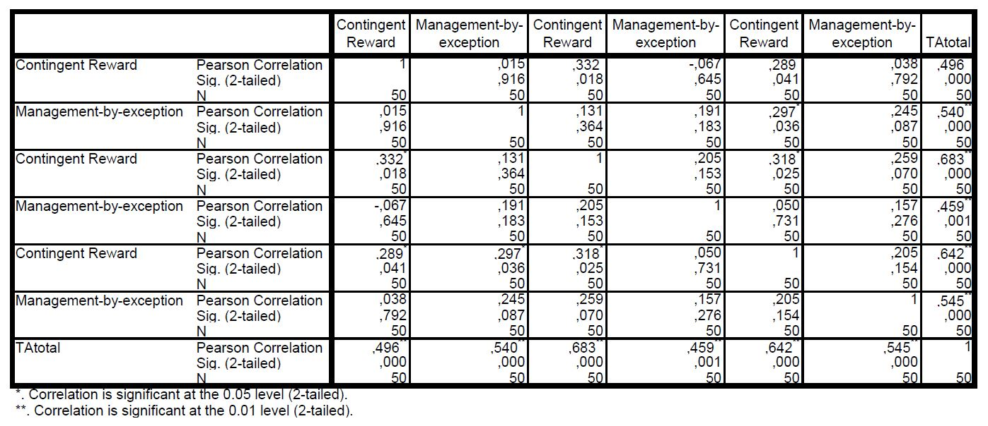

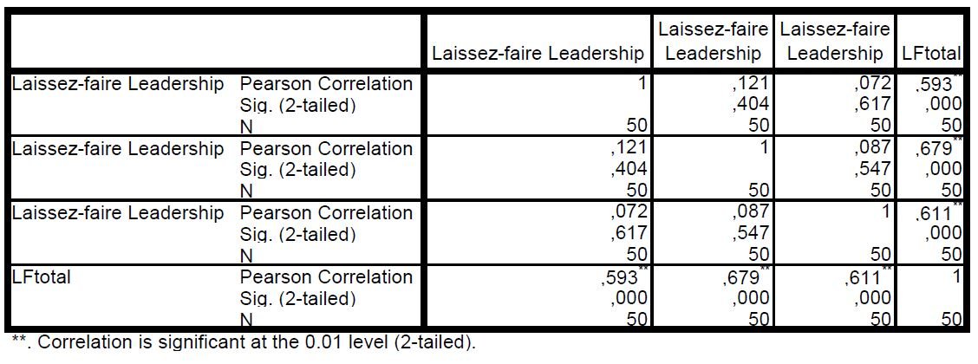

Figure 13continued Person Correlation

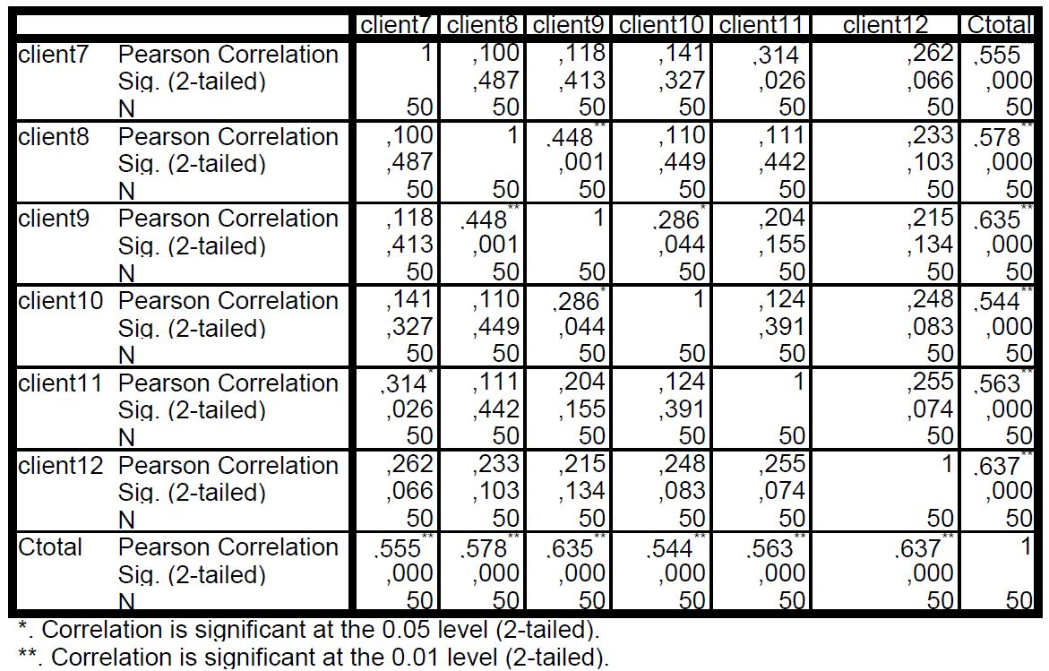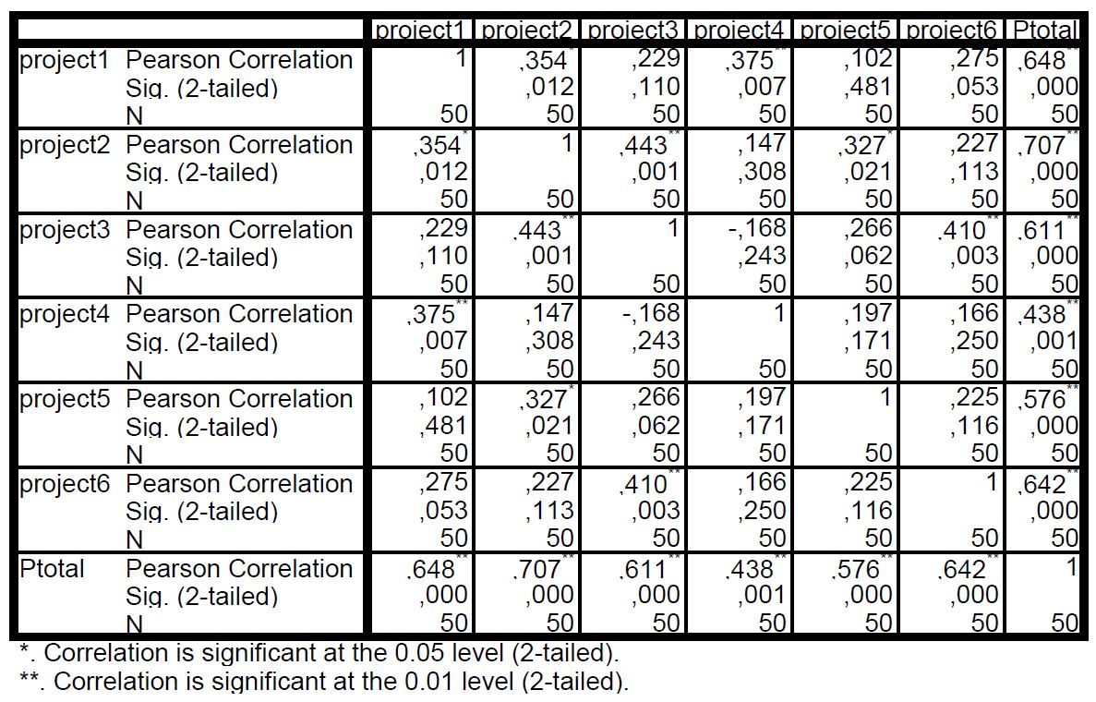

Figure 14 Project success Pearson Correlation

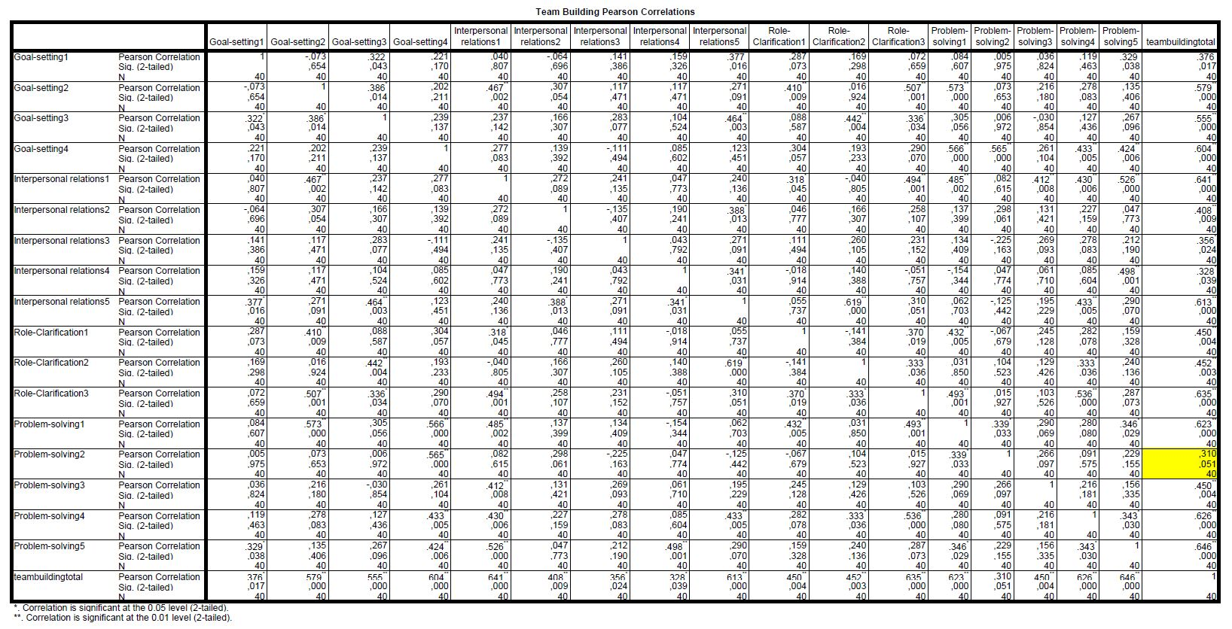

Figure 15 Team-Building Pearson correlation

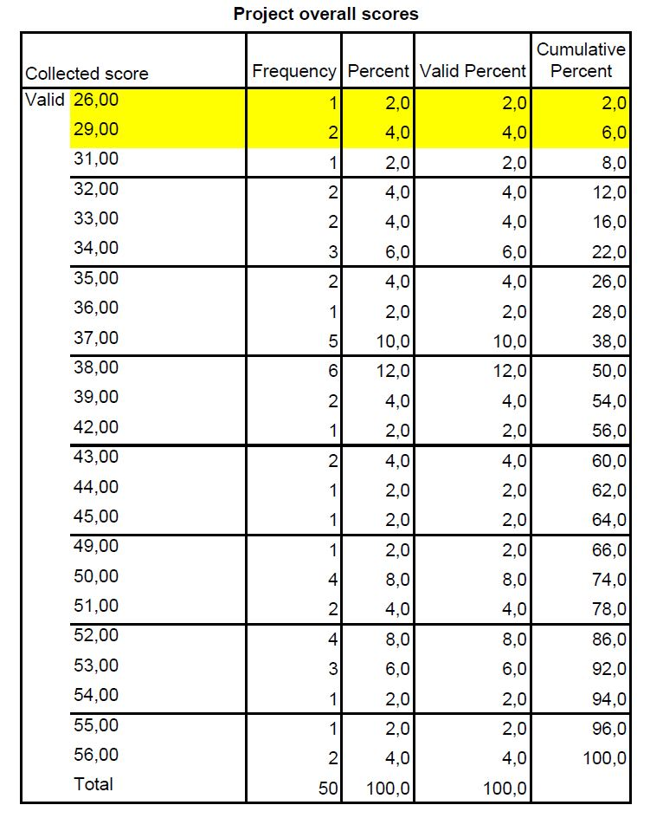

Figure 16 Project overall scores

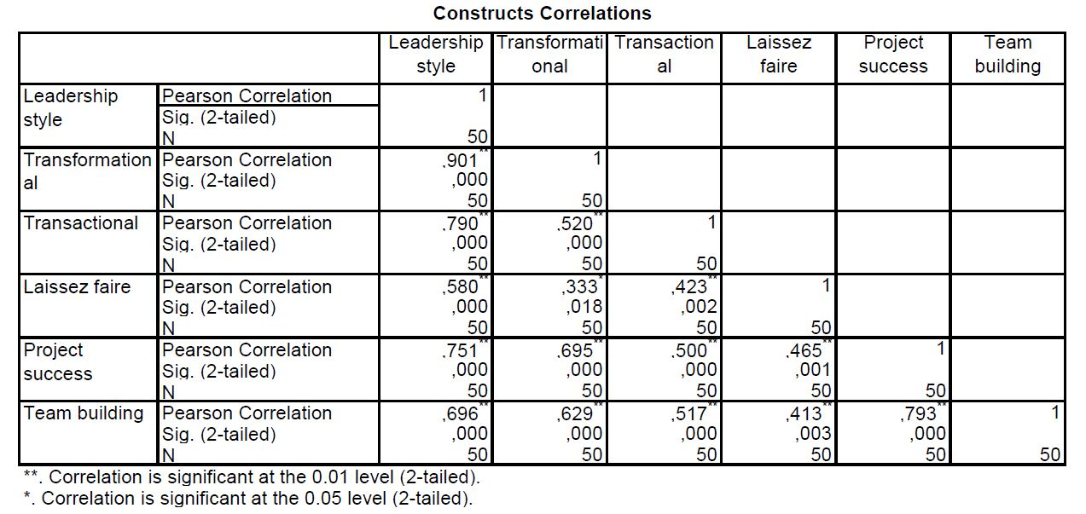

Figure 17 Constructs correlation

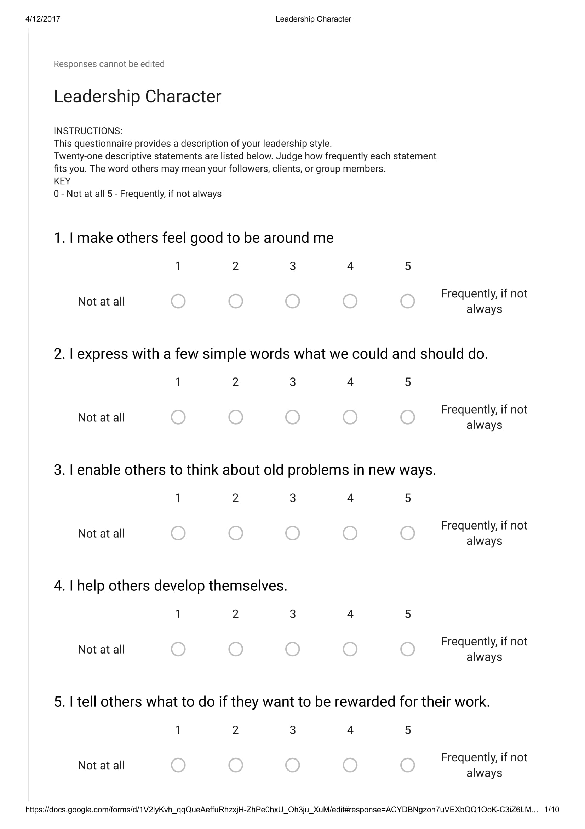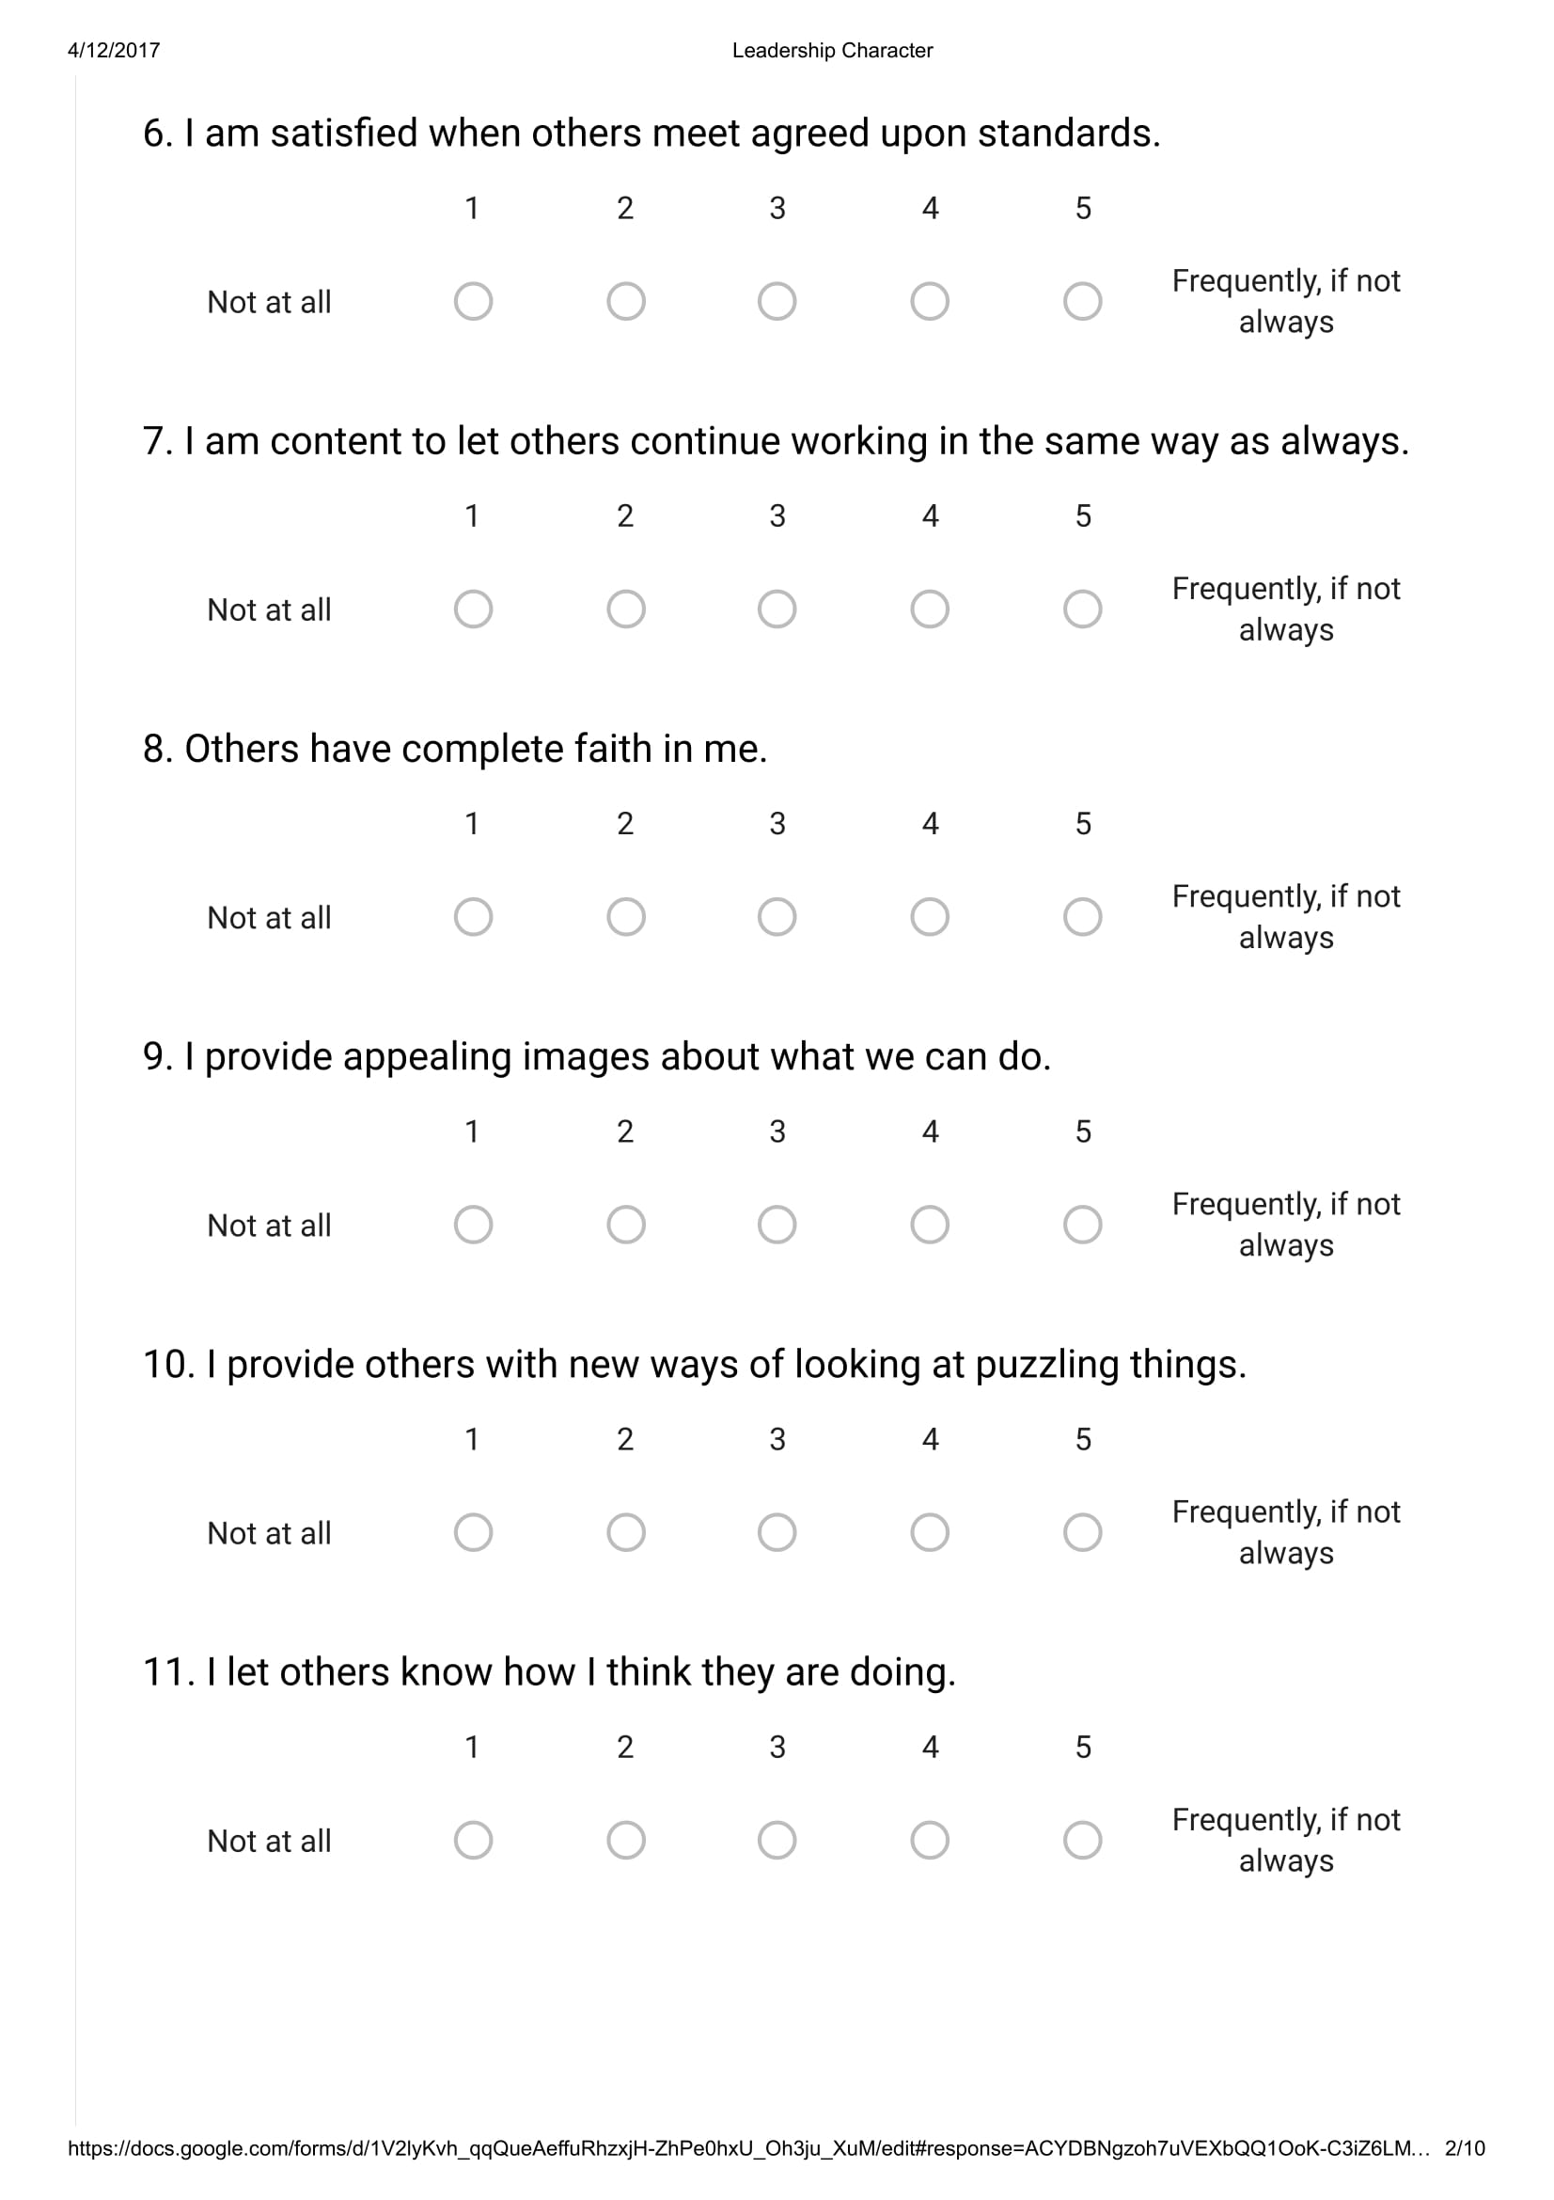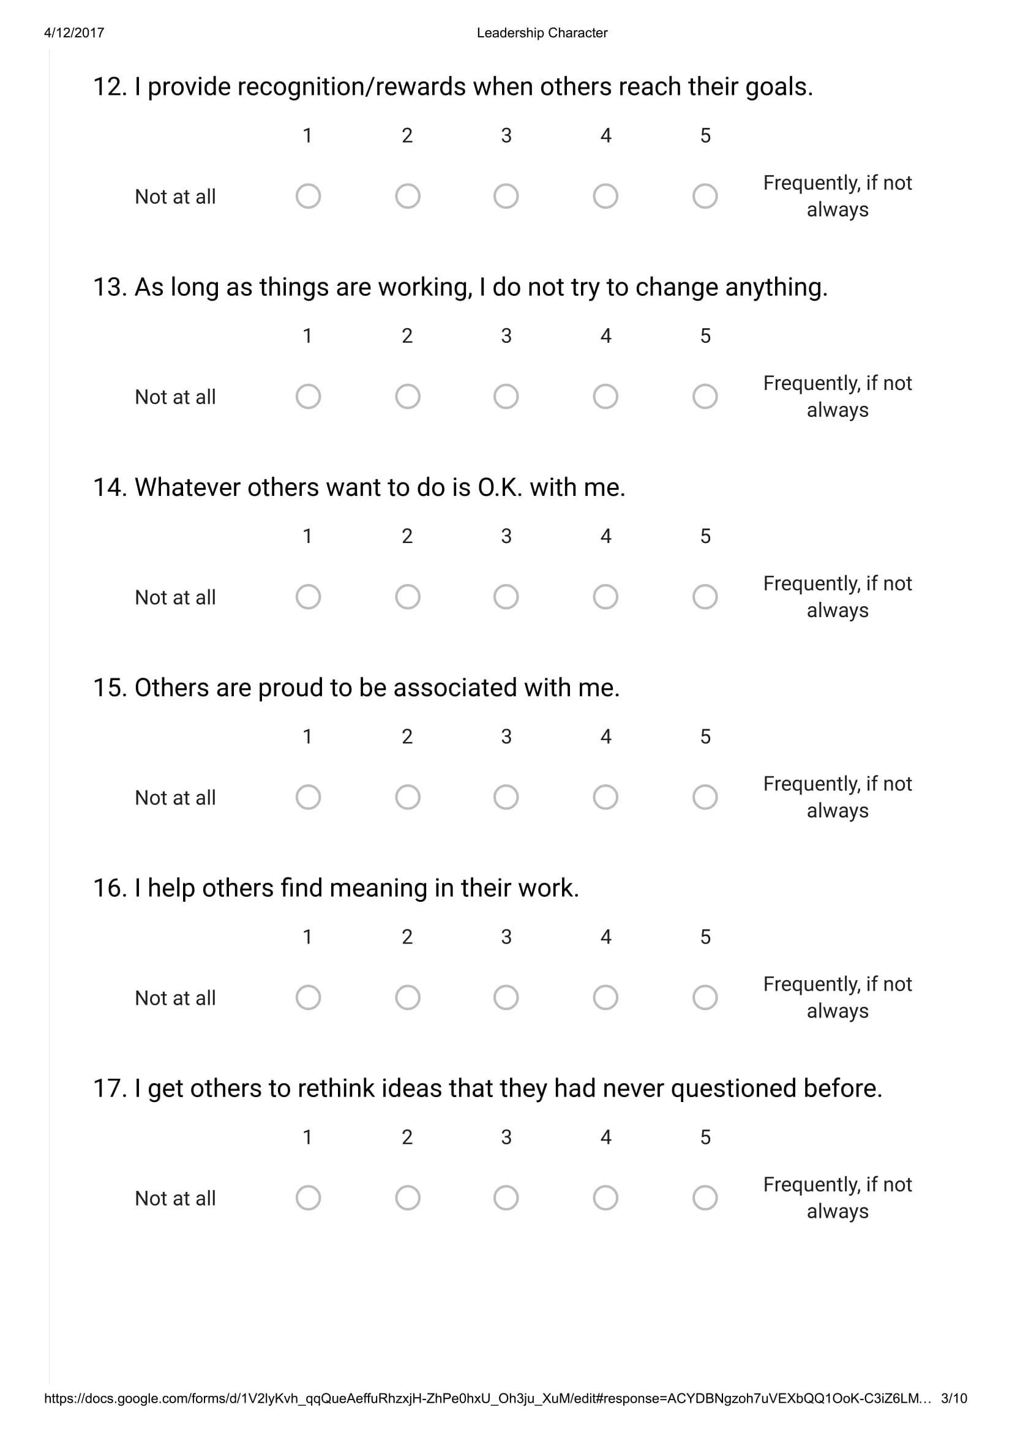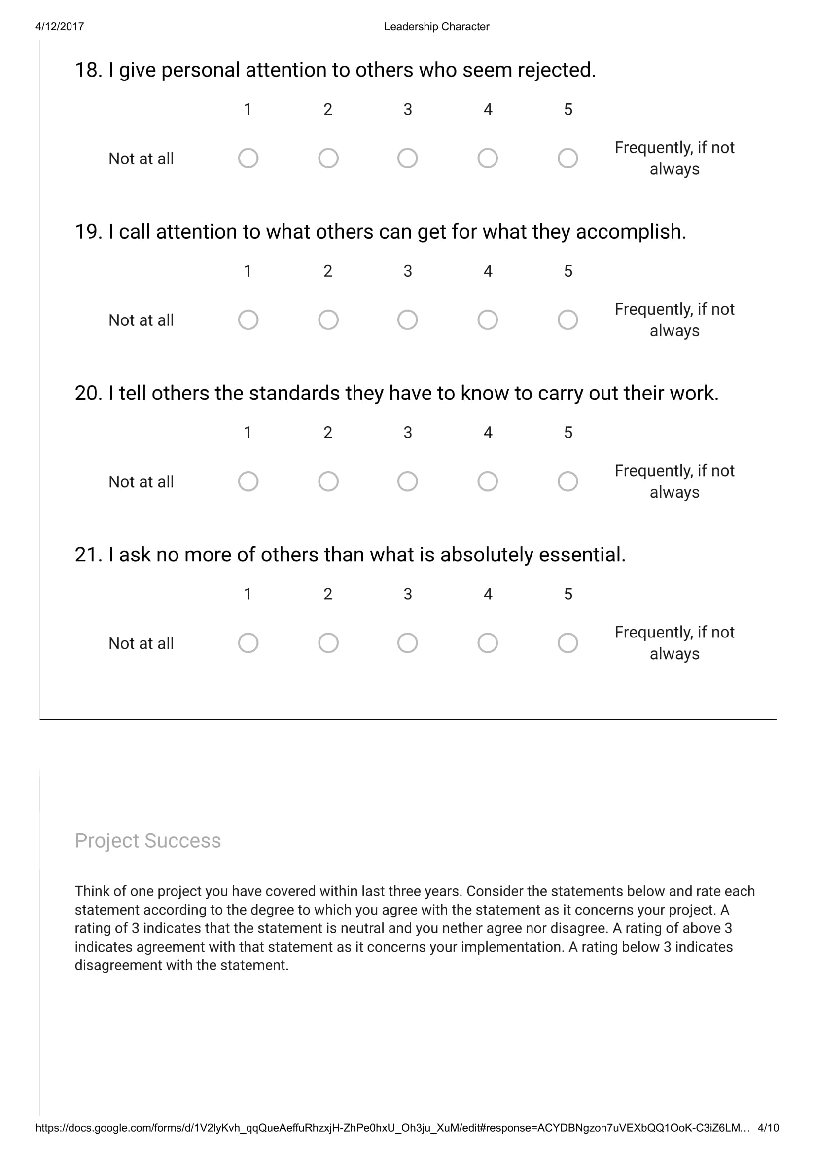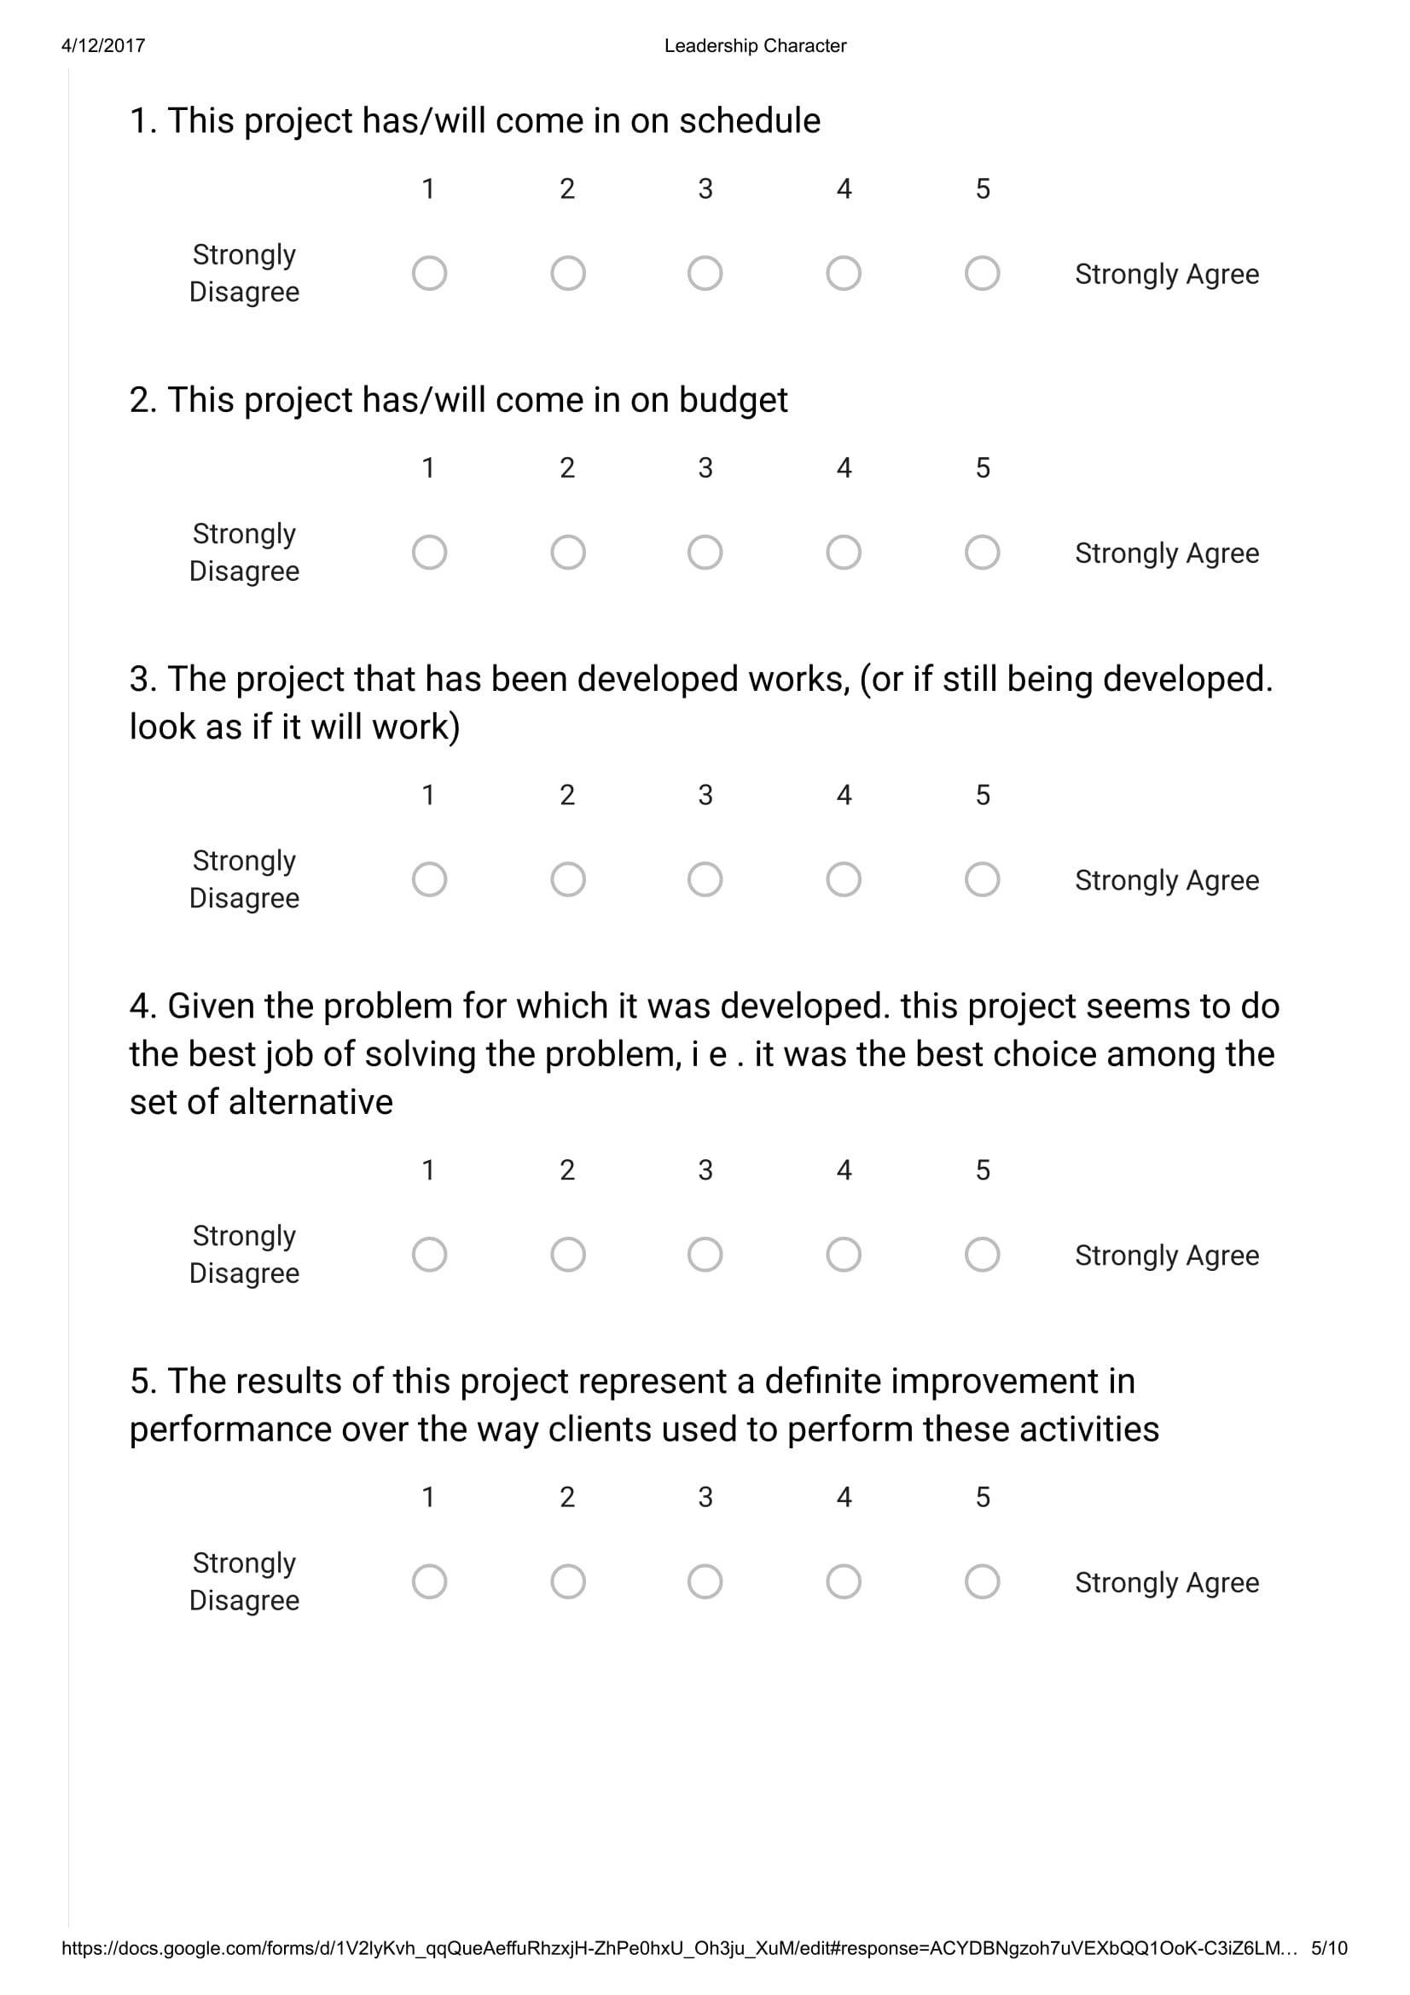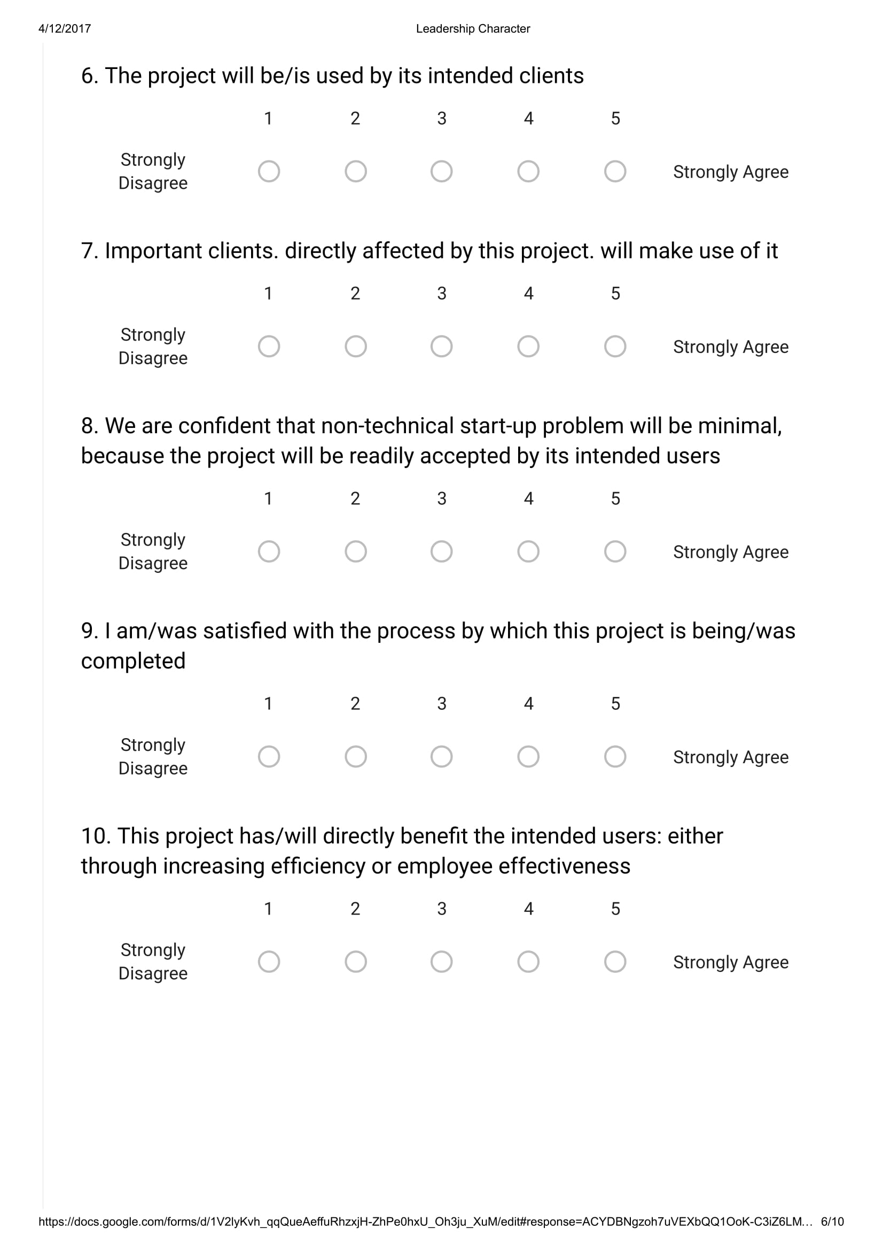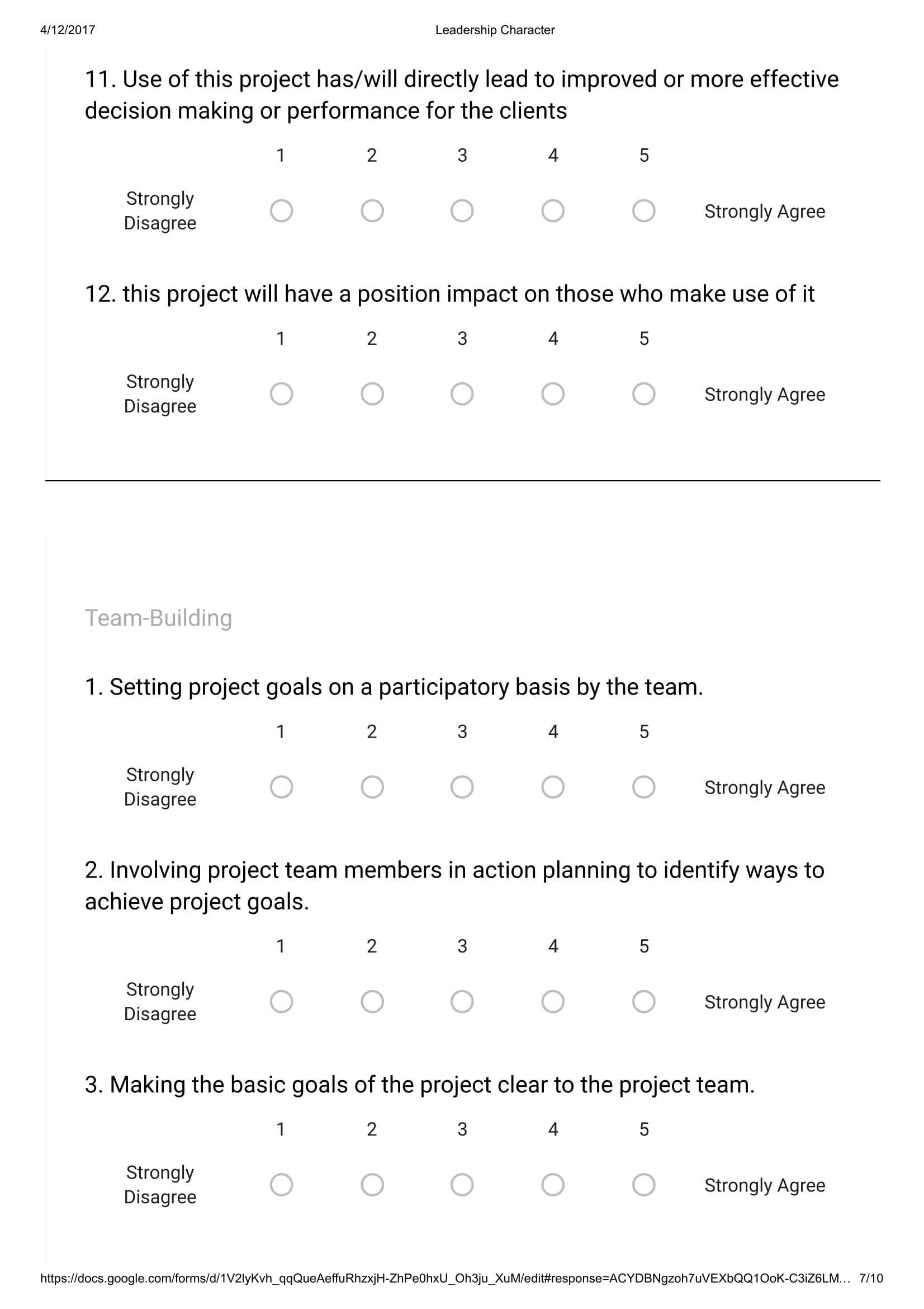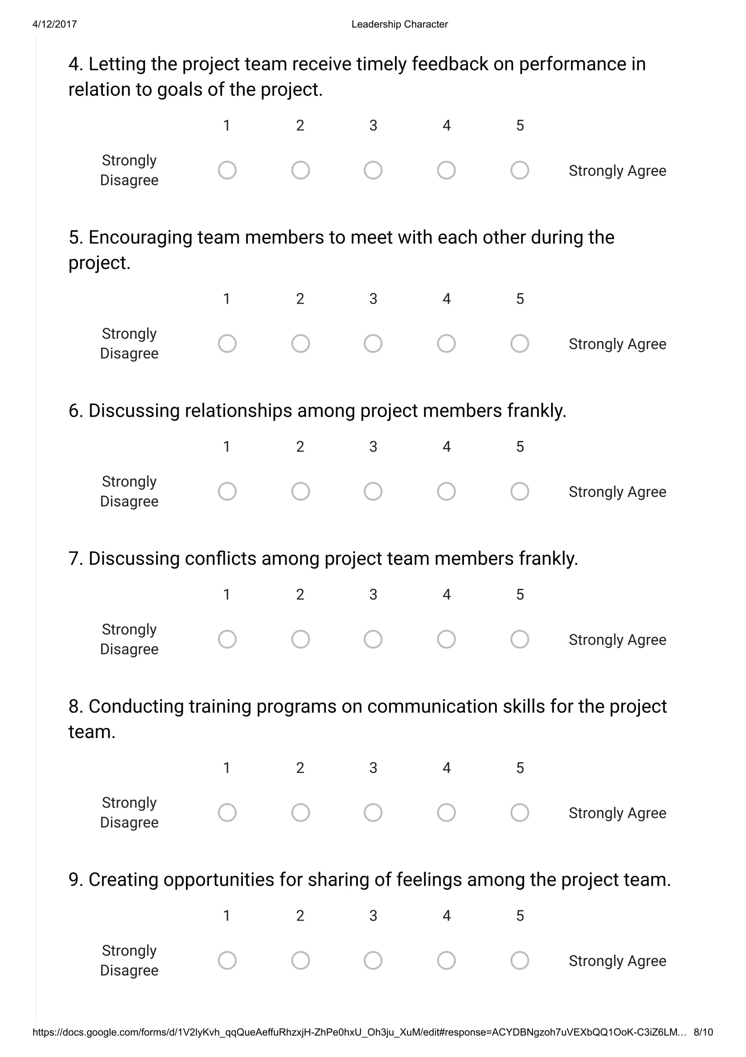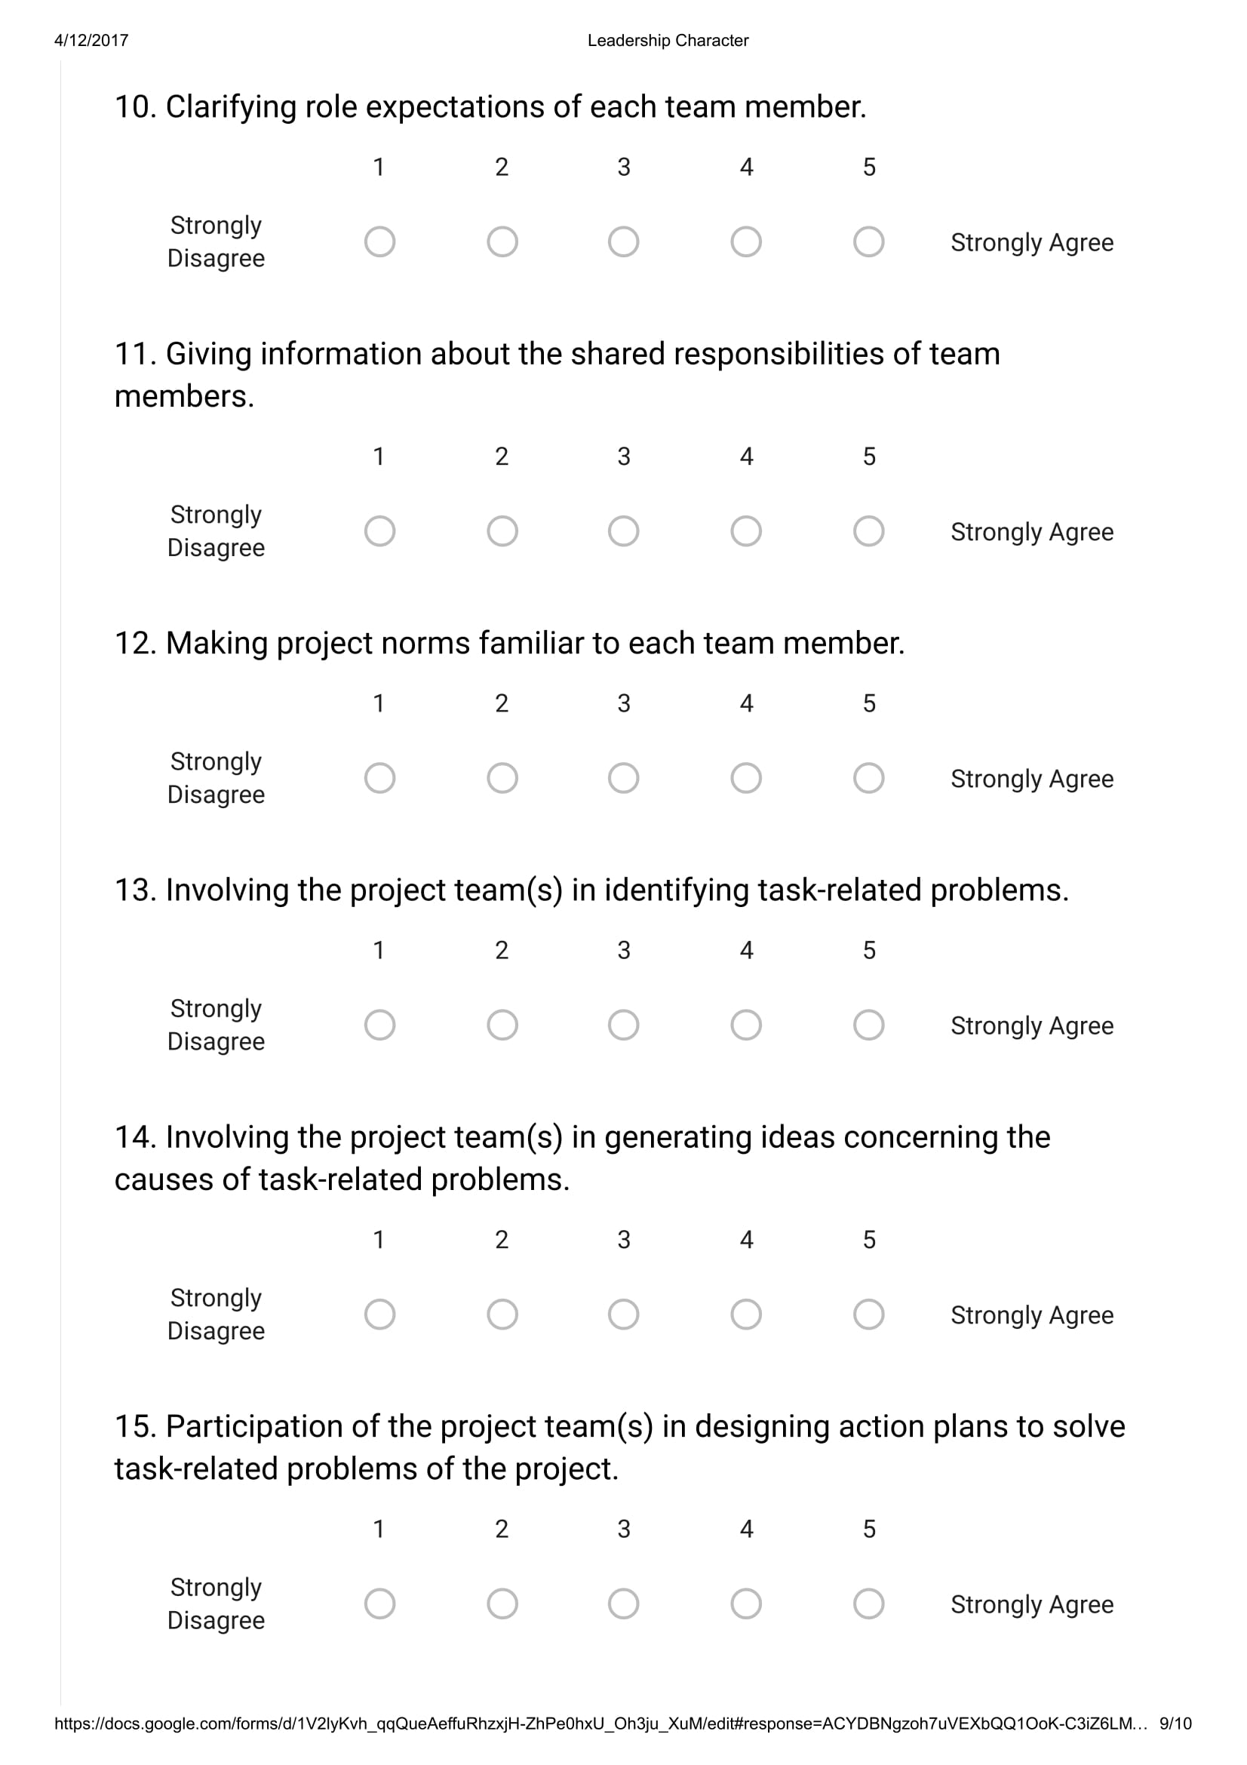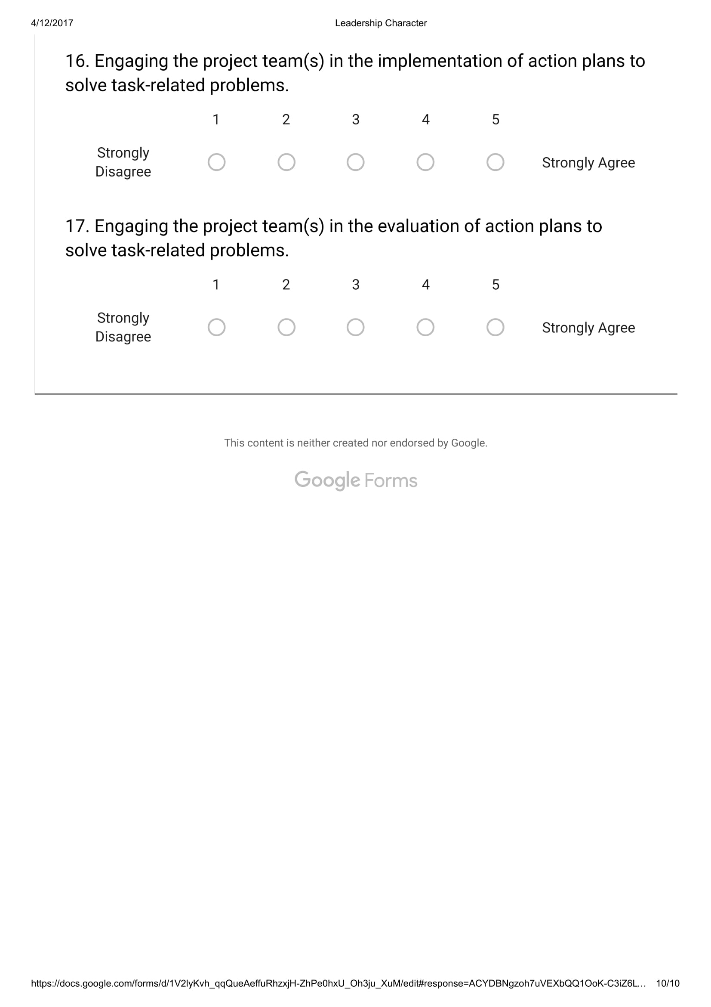

1. Graduate school of management, RU
2. Further explanation will provide in second chapter