**SCIENTIFIC ADVISOR’S REFERENCE**

|  |  |
| --- | --- |
| **Program:** | International Business |
| **Student:** | Rahmonov Salohiddin |
| **Title of thesis:** | Social and economic consequences of Tajikistan entering Customs Union |

|  |
| --- |
| **Justification of the topic choice. Accuracy in defining the aim and objectives of the thesis.** Justification of the topic choice; accuracy in defining the aim and tasks of the thesis; originality of the topic and the extent to which it was covered; alignment of the thesis’ topic, aim and objectives. |
| It is well known that at the present time members of the Customs Union (CU) are the Russian Federation, Kazakhstan, Armenia, Belarus and Kyrgyzstan. The next real candidate for joining the Eurasian Economic Union (EEU) and CU is Tajikistan. Therefore, for that country the question “to be, or not to be” the member of EEU and CU is really relevant. |
| **Structure and logic of the text flow.** Logic of research; full scope of the thesis; alignment of thesis’ structural parts, i.e. theoretical and empirical parts. |
| He started his paper with traditional issues regarding research relevance and research questions. Offering in the first chapter some theoretical background and literature review on history and theory of CU development, the author pays special attention to existing CU (EU, Mercosur, EEU) as well as to advantages and disadvantages of current customs unions. Second chapter of his paper does present methodology of his research. Later, in the third chapter, he does present the results of his analysis and offers some managerial applications. So, we have traditional in a good sense development of events. In general, it seems to me that the structure of the paper and its logic correspond to each other. |
| **Scientific aspect of the thesis.** **Quality of analytical approach and quality of offered solution to the research objectives.** Quality of selecting research tools and methods; data validity adequacy; adequacy of used data for chosen research tools and methods; completeness and relevance of the list of references. Adequacy of objectives coverage; ability to formulate and convey the research problem; ability to offer options for its solution; application of the latest trends in relevant research are for the set objectives. |
| Salohiddin Rahmonov’s paper is independent scientific research. He proved to be able to formulate and convey the research problem. The main value of his master thesis paper is in the following: based on statistical calculations he managed to make an assumption about the possible aftermath of Tajikistan entering CU. Namely, if Tajikistan enters CU probably trade within CU will increase, and FDI inflow will increase. Migration outflow will probably be increased. |
| **Practical/applied nature of research.** Extent to which the theoretical background is related to the international or Russian managerial practice; development of applied recommendations; justification and interpretation of the empirical/applied results. |
| The author managed to develop some practical recommendations. Namely, having in mind that single market is a very competitive environment, inefficient companies will lose their market share and some of them even will have to close down. Joining CU single market will give companies some opportunities to expand their business. Therefore, local companies have to decrease as the costs of production and the price for final consumers. Another thing that some companies should do is specialization. So, local production have to focus mainly on the production of goods or services where it has comparative advantage. |
| **Quality of thesis layout.** Layout fulfils the requirements of the Regulations for master thesis preparation and defence, correct layout of tables, figures, references. |
| Salohiddin Rahmonov’s paper layout fulfils the requirements of the regulations for master thesis preparation and defence. |
| **Originality of the text.** All sources of match identified by the Safe Assign system follow the allowed cases, the paper does not contain any elements of plagiarism. |
| The verification of the Salohiddin Rahmonov’s paper for borrowings in the Blackboard system revealed 9% of matches with external sources. A meaningful analysis of identified coincidences has shown that they are associated with correct citation and some technical points (bibliography, frequently used phrases). |

The Master thesis of Salohiddin Rahmonov meets the requirements for master thesis of Master in International Business program thus the author of the thesis can be awarded the required degree.

02.06.2017

Scientific advisor: Associate Professor

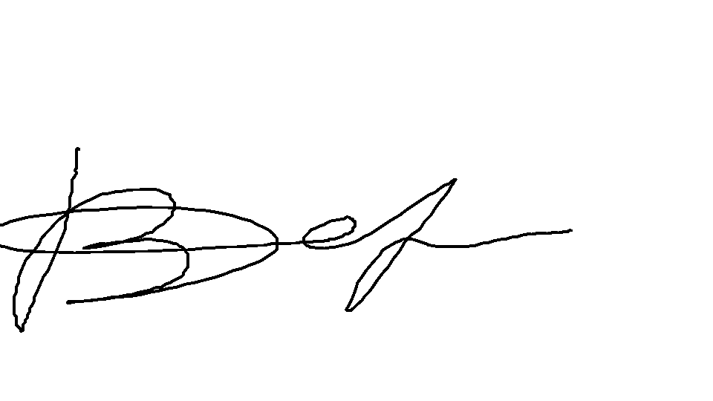

Vassily K. Dermanov