St. Petersburg University

Graduate School of Management

Master in Management

**THE STUDY OF MARKETING KNOWLEDGE MANAGEMENT ROLE**

**IN MARKETING STRATEGY OF TELECOMMUNICATION COMPANIES IN INDONESIA**

Master Thesis by the 2nd year student

Concentration — Management General Track

Zelfa Lola Maretha

Research advisor:

Senior Lecture, Olga N. Alkanova

St Petersburg

2017

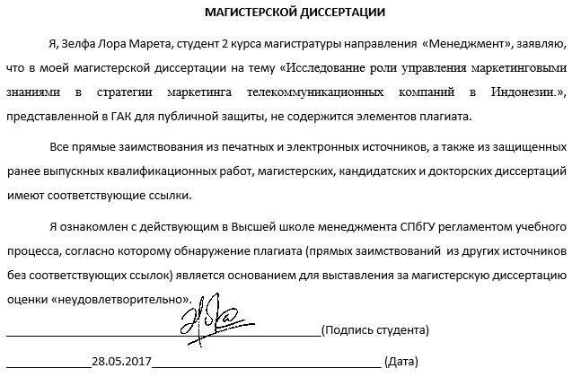

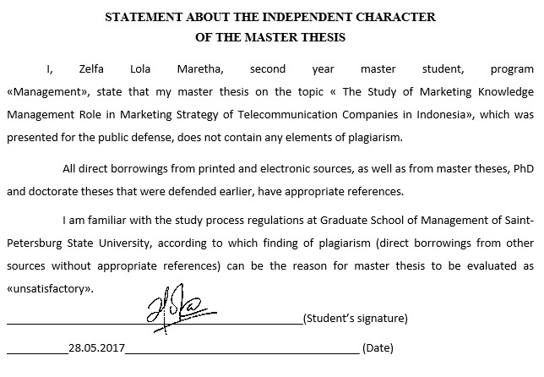

**АННОТАЦИЯ**

|  |  |
| --- | --- |
| ФИО студента | Зелфа Лора Марета |
| Тема магистерской диссертации | Исследование роли управления маркетинговыми знаниями в стратегии маркетинга телекоммуникационных компаний в Индонезии |
| Факультет | Высшая школа менеджмента, Санкт-Петербургский государственный университет |
| Программа | «Менеджмент» |
| Год окончания | 2017 |
| ФИО научного руководителя | кандидат экономических наук,  Алканова Ольга Николаевна |
| Описание целей, задач и основных результатов исследования | Цель исследования-изучить роль управления маркетингового знания на маркетинговые стратегии телекоммуникационных компаний в Индонезии. Исследование также исследует специфики страны Индонезии, которые могут повлиять на результаты. Исследователи использовали методологию исследования в изучении четырех телекоммуникационных провайдеров в Индонезии, соответствующих с управлением маркетингового знания в своей маркетинговой стратегии. Исследователя пришли к выводу, что управление маркетингово знания отражалась в разработке маркетинговой стратегии. Что касается специфики Индонезии, язык, географическая структура, а также культура властных дистанции являлются отражеными факторами в результате. |
| Ключевые слова | Управления знаниями Управление маркетингом знание, маркетинговая стратегия, Телекоммуникационной отрасли, Индонезия |

**ABSTRACT**

|  |  |
| --- | --- |
| Master Student’s Name | Zelfa Lola Maretha |
| Master Thesis Title | The Study of Marketing Knowledge Management Role in Marketing Strategy of Telecommunication Companies in Indonesia |
| Faculty | Graduate School of Management,  Saint-Petersburg State University |
| Program | «Management» |
| Year | 2017 |
| Academic Advisor’s Name | Senior Lecture, Olga N. Alkanova |
| Description of the goal, tasks and main results | The objective of the study is to investigate the role of marketing knowledge management on marketing strategy of telecommunication companies in Indonesia. The study also investigates the country-specific of Indonesia that might affect the findings. With multiple case studies methodology, researcher have researched four telecommunication service providers in Indonesia in regards to marketing knowledge management within their marketing strategy processes. From the study, researcher found that marketing knowledge management is reflected in the formulation of marketing strategy. And in regards to country-specifics of Indonesia, such as language, geographical structure, and power distance culture, they were reflected in the findings as well. |
| Keywords | Knowledge Management, Marketing Knowledge Management, Marketing Strategy, Telecommunication industry, Indonesia |

**Table of Contents**

**Introduction6**

**Chapter 1. Marketing Knowledge Management in Marketing Strategy**8

1.1 Understanding Knowledge Management8

1.2 Understanding Marketing Knowledge Management15

1.3 Understanding Marketing Strategy18

1.4 Summary20

**Chapter 2. Telecommunication Industry in Indonesia**23

2.1 Telecommunication Industry Overview23

2.2 Country Specific - Indonesia26

2.3 Indonesia Telecommunication Industry30

2.4 Methodology and Data Collection33

2.5 Summary36

**Chapter 3. Analysis of Case Companies**38

3.1 PT. Smartfren Telecom38

3.2 PT. XL Axiata43

3.3 PT. Telkomsel47

3.4 PT. Indosat Ooredoo51

3.5 Discussion of Findings55

**Chapter 4. Conclusion**61

4.1 Conclusion61

4.2 Implication of the Study62

4.3 Limitation62

**Bibliography**64

**INTRODUCTION**

Telecommunication industry is one of fast changing industry because of the rapid change and development of technology. Customer is their main player that has important role in their business process. Therefore, it is important to them to attract new customer and retain current customer by creating their loyalty to their brands. Indonesian telecommunication market, unlike the other, has unique characteristics. First, Indonesia is very huge market for telecommunication industry. This phenomenon has created the intense competition within telecommunication industry in Indonesia. Second, there are five players in market that control market share of telecommunication industry in Indonesia. PT. Telkomsel has conquered almost 50% of market share in Indonesia

Third is unique consumer behavior. This phenomenon had been said by Indonesian Telecommunication Association, that mobile service penetration is Indonesia is more than 120%, which means there are many customers that used more than one cellular number, either from the same service or from different operator service. In Indonesia, you can have a lot of number of cellular because Indonesia has loose regulation on number registration, we can even use a fake name and identity to registry.

All of those aspects that are mentioned above, have created the intense competition among players. Because telecommunication companies are relying much on their marketing strategy to retain and attract customer, so their marketing strategy should be differ from competitors. Knowledge management could be one of best answer to this. Knowledge is seen as important resource for companies to create competitive advantage. Therefore, knowledge management is crucial tools for company to managing the existing knowledge efficiently, especially knowledge about market or marketing knowledge management.

In this study, there are three research questions:

1. What is the role of marketing knowledge management in marketing strategy of telecommunication companies in Indonesia?
2. How the role of marketing knowledge management is reflected in marketing strategy formulation of telecommunication companies in Indonesia?
3. Whether influence of country specific in Indonesia is reflected in marketing knowledge management of telecommunication companies?

This study used multiple case studies methodology with four telecommunication services providers in Indonesia by in-depth interview with related department and documentation from companies. This study consists of four chapters. **Chapter 1** explains about the initial conceptual framework of this study with three main concepts, they are knowledge management, marketing knowledge management, and marketing strategy. **Chapter 2** explains about the industry and country specific context. In this study will be telecommunication industry and country specific of Indonesia that might be reflected in the findings. In this chapter, researcher also will explain about the findings of study from the case companies. Then finally **Chapter 4** will be conclusion, theoretical implication and managerial implication, and limitation of the research.

**CHAPTER I**

**MARKETING KNOWLEDGE MANAGEMENT IN MARKETING STRATEGY**

There are three big concepts that are explained in this chapter, they are, knowledge management, marketing knowledge management, and marketing strategy. This chapter explains about the link between all three concepts for generating the initial conceptual framework of the study.

**1.1 Understanding Knowledge Management**

**Knowledge**

Knowledge is one of the company’s intangible assets. With knowledge, company’s capabilities, external condition and the past, ongoing, and upcoming changes can be anticipated. Economic value from knowledge can be obtained from the creating of superior performance through high costumer value, investor profit, and a good career path for employment.

Van Der Spek and Spijkervet (1997) in Liebowits (1999:3) stated *“Knowledge is the whole set of insight, experiences, and procedures that are considered correct and true and that therefore guide the thought, behavior and communication of people”*. Meanwhile based on Turban in Liebuwits (1999:3), *“Knowledge is information that has been organized and analyzed to make it understandable and applicable to problem solving or decision making”*. Meanwhile according to Wang and Noe (2010: 117) stated that *“knowledge is the process of information by individual including ideas, facts, expertise, and judgment relevant for individual, team, and organizational performance”.*

Based on definitions above, at least knowledge has three important things: (1) Knowledge as the collection of information about intuition, experience and procedure; (2) Knowledge is organized and analyzed in order to be understood and applicable; (3) Knowledge is used as procedure for thinking, behaving, communicating, problem solving, and decision making. With the redundant knowledge within the company, therefore it’s so important to understand what and how to manage them.

Knowledge is created from the interaction of knowledge type’s component. According to Pfeffer and Sutton (2000) on Kusumadmo (2013), there are two types of knowledge inside human, namely tacit knowledge and explicit knowledge.

According to Pawit (2012), tacit knowledge is: 1) cannot be divided; 2) more knowable than deliverable; 3) often contained of habit and culture; 4) cannot be codified, but only can be moved or can get from the experience; 5) Draw the know what (fact) and know why (science); 6) involves learning and skills; 7) created in group and organizational relations, core value, assumptions and faith, hard to identify, keep, and calculate.

In Groff and Jones (1999:3), “*Tacit knowledge refers to personal knowledge embedded in individual experience and involving intangible.”* In addition, Malhotra (2005) stated “*Tacit knowledge is know how contains people’s head. The challenge inherent with tacit knowledge is figuring out how to recognize, generate, share and manage it.”* Based on some definitions above, tacit knowledge is a knowledge which is come from experience, faith, assumption, habit and culture or learning process that is explained about know what and know why, which is created in individual or group, hard to identified, keep, and hard to divided. Meanwhile in recent book, Harry Collins (2010), purposed the three types of tacit knowledge categorizations, they are relational tacit knowledge (trade secret, unrecognizable knowledge); somatic tacit knowledge (bike balancing); and collective tacit knowledge (anecdote). Wang, Zheng and Zhu (2013: 93) stated that tacit knowledge is difficult to codify that will contribute to the difficulties to imitate capabilities that creates competitive advantage of a company.

The second type of knowledge is explicit knowledge. According to Groff and Jones (1999:3), *“Explicit knowledge refer to tacit knowledge that has been documented. It has been articulated into formal language and can be much more easily, transferred, among individual.”* Meanwhile, according to Nonaka and Takeuchi (2004:3), *“Explicit knowledge (documented, computer) readily accessible, as well as documented into formal knowledge resources that are often well organized.”* Based on this definitions, explicit knowledge is a knowledge which is come from tacit knowledge that be articulated, documented, codified, organized, in one media, such as the help of IT, in order to can be easy to be accessed and spread to another (Chen & Huang, 2012).

In Nonaka and Takeuchi (2004:61), the differences between tacit knowledge and explicit knowledge are the followings:

**Table 1.1 The Differences between Tacit and Explicit Knowledge**

|  |  |
| --- | --- |
| **Tacit Knowledge** | **Explicit Knowledge** |
| Knowledge experience (body skill) | Knowledge of rationality (mind) |
| Simultaneous knowledge (here and now) | Sequential knowledge (there and then) |
| Analog knowledge (practice) | Digital knowledge (theory) |

Source: Nonaka and Takeuchi (2004:61)

Tacit knowledge is more difficult to identify and codified, while explicit knowledge is easier to identify. Tacit and explicit knowledge should be considered carefully when managing the knowledge. They are both having different effect and implication that requires different actions.

When it comes to knowledge, there are two other concepts that are relating to knowledge, namely data and information. Data, information, and knowledge is not the same and some researchers have tried hard to define them. Dick Stenmark created the table which is consisting of the definition of those 3 concepts from different books on his article. (Stenmark, 2001) Some literature said that the relationship between data, information, and knowledge is a process of transforming; data is the first one then followed by information, and finally become knowledge (Figure 2). For example: there was a match Real Madrid vs Barcelona with scores Madrid 3: Barcelona 2. The written score is data, the information could be that Barcelona is lost, and knowledge is Barcelona could not make it to final.

**Picture 1.1 The Relationship of Data, Information, and Knowledge**

Source: Steenmark (2001)

There is often a misunderstanding between those three concepts in term of knowledge management. Some company argues that they already have a good knowledge management system, whereas in fact they stop in information phase.

**Knowledge Management**

Knowledge management is a way to generate value from organization’s intellectual wealth through creation, storage, spread, and implication of knowledge for reaching the organization’s goals. Definitions of knowledge management from many experts as the following:

Macintosh in Halawi (1996) stated *“Knowledge management involve the identification and analysis of available and require knowledge and the subsequence planning and control of actions to develop knowledge assets so as to fulfil organization objectives”*. Hibbard in Halawi (1997), *“Knowledge management is process of capturing a company’s collective expertise wherever it resides in data base, on paper, or in people’s head and distributing it to wherever it can help produce the biggest payoff”.* Beckman (1997) in Liebowitz (1999) said *“Knowledge management is the formalization of and access to experience, knowledge and expertise that create new capabilities, enable superior performance, encourage innovation and enhance customer value.”* According to Wigg in Liebowits (1999:6), *“Knowledge management is systematic, explicit and deliberate building, renewal and application of knowledge to maximize an enterprise’s knowledge-related effectiveness and return from its knowledge assets.”* Quintas on Tiwana (2000:5) stated *“Knowledge management enables the creation, communication and application of knowledge of all kind to achieve business goal.*” Groff & Jones (2003:2) stated *“knowledge management is taken as tools, techniques and strategies to retain, organize, improve, and share business expertise.”*Another interesting definition about knowledge management is stated by Levinson (2005), *“Knowledge management is the process which generates the value from their intellectual Knowledge-Based Assets. Most often, generally value from such assets involves codifying what employee’s partners and customer know and sharing that information among to devise best practice.”* Meanwhile Zhang, Wang, Cao, Wang, & Zhao (2012) defined knowledge management in simple sentence, *“Knowledge management is defined as the process of acquiring, processing, codifying, storing, distributing and applying knowledge”*

Based on some definitions above, there are four important things in knowledge management:

1. Knowledge management is a system, tool to organize intangible resources for organization’s purpose.
2. Input of knowledge management is an organization’s intangible asset.
3. Process of knowledge management consists of the knowledge creation effort, division or communication and implementation of knowledge.
4. Output of knowledge management is new capabilities, superior performance, innovation and enhancing customer value.

According to Malhotra (2005), the reason of implementation of knowledge management in the company is because of:

1. The increasing of market competition and innovation level;
2. The time saving for searching business experience and acquisition of knowledge;
3. There is a dismissal of employees and the increasing of employee’s mobility in the work environment, causes the lost off company’s knowledge;
4. There is the need for organize the complexities to operational of small business and the source of transnational operation;
5. The change in strategy creates the loss of knowledge, or there are more jobs that need information;
6. There is an organization’s competition based on the knowledge control;
7. The need of learning in the whole life;
8. The ability in the procedure of knowledge as the important opportunity to achieve substantial saving;
9. The need for get the knowledge from the external sources;
10. The used of knowledge in decision making;
11. The development of service and product;
12. To increase employee retention through the determination of the knowledge employee’s value and rewards.

Steps that should be done to implementing the knowledge management strategy are:

1. Considering the organization’s aspect;

Organization’s aspect that needs to be considered is leadership aspect. According to Debowski (2006:14), this is because leadership can affect the value system, operation priority, system and policy and activity of organization which is determined the focus of strategy and process.

1. Manage to building knowledge culture;

The next step is building knowledge culture. Knowledge culture can be built with four models: 1) building the effect of knowledge; 2) building knowledge foundation; 3) applying knowledge; 4) increasing knowledge and improve the execution.

**Picture 1.2 Building a Knowledge Culture**

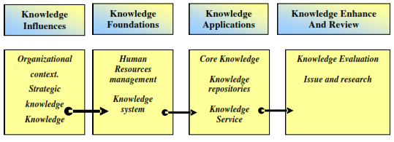

Source: Shelda Debowski (2006:23)

According to the picture above, first step is building the knowledge effect in the organization context, knowledge strategy, organization strategy, leadership, and culture. Second step is building the management foundation through the support of human resources management and knowledge system, which is focused on the role of information technology. Third step is implementation of knowledge by determine the core competency of the organization, knowledge repositories, and knowledge service. Last step is the effort to increase and evaluate the steps that is already done.

1. Identify the 5P keys on the organization.

5P keys on the organization are planning, people, process, product, and performance. First key is planning defined as knowledge needs, determined of the system and process that will apply, determine long-term result. This is a knowledge philosophy. The second key is people, the act that can be done is determine employee’s commitment to knowledge, develop knowledge sharing culture, and determine leadership values. This will generate knowledge culture. The third key is process, in the process of implementation knowledge management; need to formulate strategy, principal, and knowledge management application. The fourth key is product, include the way of organization to get product, manage, distribute, use the core of knowledge for product in short and long term. The fifth key is performance, performance can be measured from efficiency, business, development of core business, the used of organization expert and organization’s core competency. Product and performance are knowledge value that will be delivered by the organization.

Knowledge management strategy as it already explained above has significant role on the organization performance. It is extremely important for company to understand knowledge management as theory and strategy in order to keep survive within its industry. Along with tacit and explicit knowledge, the process of knowledge management can explain by the picture above:

**Picture 1.3 Knowledge Management Process**

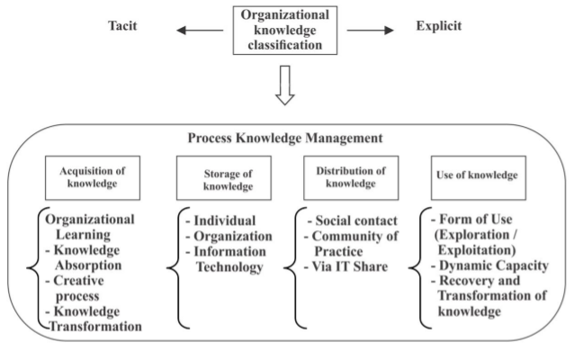

Source: Gonzalez and Martins (2016)

According to Gonzalez and Martins (2016), the first stage is the acquisition of knowledge. On this phase knowledge is created form tacit and explicit knowledge through the organization learning internally and externally with four major issues, they are organizational learning, knowledge absorption, creative process of individual, and knowledge transformation. The next stage is storage of knowledge. The storage in the organization is like the memory in human brain, so this is very crucial things for the organization. Therefore, it is important to create a good internal information system within the corporate organization. The next stage is distributing of knowledge, where the new knowledge is being shared to all stakeholders within organization, that is required a direct contact and the use of Information Technology (IT). And finally the last stage is use of knowledge where on this stage individual should be able to access or use the knowledge that already stored formally or informally. All of those stages are to help company to manage the redundant knowledge within their organization.

**1.2 Understanding Marketing Knowledge Management**

There are a lot of data and information in the market. To capture and manage those redundant data and information, company needs to integrate knowledge management to marketing process. According to Srivastava (2001) market knowledge is consists of the combination of costumer knowledge and competitors knowledge.

1. Customer knowledge

There are basically three categories of customer knowledge source according to Salomann et al (2005), they are:

* Knowledge for customer refers to knowledge that customer can get or gain including knowledge about product, market and supplier (Zanjani 2008).
* Knowledge from customer refers to knowledge that firm get from customer regarding products, market, suppliers, and etc.
* Knowledge about customer refers to data and information generation of customer itself to know the customer better than competitors. This knowledge can be generating from consumer behavior pattern.

There are some studies about how to capturing customer knowledge. Calder (1977) and Kamberelis (2013) acknowledged the use of focus group. Gouling (2004) and Kozinets (2010, 2012) considered ethnography to get more insight. While Hague et la (2013) highlighted all traditional methods, they are interviews, surveys, focus groups, ethnography, questionnaire and etc.

1. Competitor knowledge

According to Siu Loon Hoe (2008) competitor knowledge is the analyzing of competitor’s movement in the market in order to know where our product’s position is. By analyzing the movement in of competitors on the market, company can determine the strategy that is being used.

Srivasta, Shervany and Fahey’s (1999) defined marketing knowledge management in more holistic way, they urged that marketing knowledge management is embedded in three marketing processes: Product Development Management (PDM); Supply Chain Management (SCM); and Customer Relationship Management (CRM). (Arnett & Badrinarayanan, 2005)

Product Development Management (PDV) is a series of activities which is started from market analysis and then finished by production phase, marketing, and product distribution. (Ulrich and Steven 2001:2). Product development is activities that need contribution from all of functional department in a company. According Kotler and Armstrong, product development is developing of product’s concept to the real product. Product development management consists of new product; development of product (marketing analysis, manipulated, and design); product modification (improvement of quality, features, and style); and merchandising. The success of product development is determined by four factors: high quality of the process of new product; the understanding of new product strategy in all business level; resources commitment; and the ability of research and development (R&D). Cooper and Kleinshmidt (2000) also stated that the success of product development can be seen form the quality of product, money and values ratio, and high benefit for end user. While according to Masson, et al (1994), quality of product is determined by knowledge quality and human resources skills. Rozenfeld (2006) provides the flowchart about product development process: pre-development phase, development phase, and post-development phase. (Rozenfeld H., 2014)

**Picture 1.4 Product Development Process**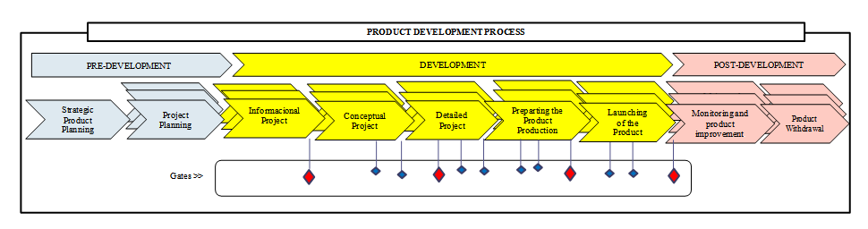

Source: Rozenfeld H (2014)

The second process is supply chain management (SCM), according to Cooper (1997), the concept of supply chain management have appeared in the beginning of 90’s. Supply chain management can be defined as a series of activities of transformation process and distribution of product from raw materials become product and finally reach end consumer. According Ross F.D (2003), the development of SCM concept is based on two facts: in 1960’s factory is accused to decrease production cost and the development of information technology especially internet that can help to cut the cost. Douglas M. Lambert (2014) provided the flowchart of supply chain management process.

**Picture 1.5 Supply Chain Management Process**

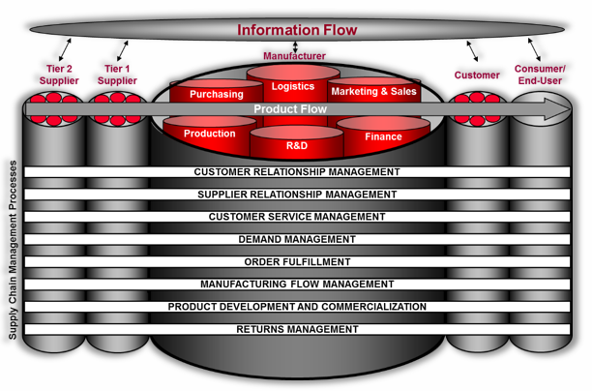

Source: Douglas M (2014:3)

And the last process on marketing process that embedded with knowledge management is customer relationship management (CRM). Buttle (2007:4) stated that customer relationship management (CRM) is the main factor for developing customer-oriented culture. This culture is for keeping customer’s loyalty and creates value-added for consumers. In customer culture-oriented, all of resources will be allocated for supporting the company’s value in customer’s eyes. Lukas (2006) defines customer relationship management as: (1) an activity that involves all of human resources to keep consumer stays loyal; (2) a strategy for managing and maintaining the relationship with customer; (3) an effort to understanding the need of customer. According to Kotler Keller (2009: 148), CRM is a process to manage detail information about customer individually for maximizes customer’s loyalty. As according to Peppers and Rogers, CRM is a strategy that have value-added for customer. Some managers defined CRM as software that can collect the customer’s data and information. CRM is a strategy to add value for customer.

Process of good CRM planning covered some phases, they are technology. people, process, and knowledge & insight. Technology is about what technology should be used to support CRM program. People refer to skill and behavior of human resources in managing CRM. And knowledge and insight refers to the approach that is used by company to add value or benefit to customer’s data and information that already being collected by company.

**Picture 1.6 CRM Process Planning**

Source: Gordon (2002)

Business Model, Strategy, and Structure

Leadership Culture

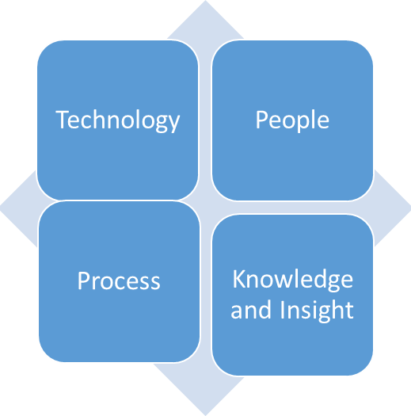

Core Costumer

Leadership Culture

Channel for Stakeholder communication, transaction, and logistic

Leadership Culture

**1.3 Understanding Marketing Strategy**

Marketing is a process social and managerial in which individual or organization is achieving what they need and want through the creation or transfer of the value to others. In the term of narrow business, marketing covers the creation of the relation of content exchange with costumer. Marketing refers as a process in which company creates value for costumer and builds a good relationship with costumers to get the value of costumer. Marketing management is defined as the art and science in choosing market target (Kotler & Armstrong, 2008). Concept of marketing according to Kotler and Armstrong (2008) is shown in the picture below.

**Picture 1.7 Marketing Concept Model**

Source: Kotler and Amstrong, 2008

Another concept of marketing is marketing mix which according to Basu Swastha (2002: 42), marketing mix is the combination of four variables to the core of marketing activity, they are product, price, place, and promotion.

1. Product

According to Kotler (2002: 52), product is all things that can be offered to market for fulfill the needs. Products that are being market covers physically goods, service, peoples, place, organization, and ideas. In planning offer the product, marketer needs to understand five product levels:

1. Main product is the real benefit which is needed or consumed by consumer from each product.
2. Generic product is basic product which can fulfill the basic product function
3. Prospect product is formal product that is offered with any attribute and condition, is prospected and agreed to buy formally.
4. Complementary product is product attribute that is complemented or added by any advantages and services, so that can be give an additional value of satisfaction and can be differed by competitor’s product
5. Price

According to Swastha (2002: 147), price is the quantity which is added to some of products that is needed for get some combination from product and service. Price is some money that should be paid by costumer to get the product. Price is the only one marketing mix which gives profit for company. The main factor in determine the price is company’s marketing goal.

1. Place

According to Kotler (2006: 63), place is the activity of company that makes product. Place is distribution channel, organization structure which is related each other and involve in the process of making the product or service to be ready to used or consumed.

1. Promotion

Product with good quality and good price will be not success in market if costumer doesn’t know about this prospect. Therefore, promotion is the way to introduce the product to costumer

Kotler and Amstrong (2008) also defined marketing strategy as a marketing logic in which company hopes to create costumer’s value and achieve a profitable relationship. According to Benner (1988) in Tjiptono (2008), marketing strategy is state, whether implicit or explicit, about how a brand or product line reaches the goal. Meanwhile according to Davis (2004), formula of marketing strategy is development of long-term plan for the effectiveness of management from opportunity and threat of environment, seen from the advantages and drawbacks of company. The procedure of this strategy can be divided into three phases:

1. Strategy formulation

Strategy formulation including development of vision and mission, identification of opportunity and threat from external, determine strength and weakness of internal, set the long-term purpose, formulate strategy alternative, and choose particular strategy to be implemented.

1. Strategy implementation

Strategy implementation presupposes company for setting their annual goal, making policy, motivating employees, and allocating resources, so that the strategy plan can be implemented.

1. Strategy evaluation

Three basic activities in strategy evaluation is reviewing external and internal factors which become the current strategy, measuring the performance and achievement, and set a correct action. This step is the last step of strategy management.

Harper, Arville and Jean Claude (2000: 204) stated that the success of company is determined by the compatibility of the strategies.

**1.4 Summary**

Knowledge management is process of generating knowledge from data and information to knowledge. There are two types of knowledge that company should take into consideration, they are tacit knowledge and explicit knowledge. Tacit knowledge is somehow hard to codify and identify, while explicit knowledge is easier to codify. The ability to manage those two knowledges will give more value to completive advantage. There are four stages of knowledge management processes, they are acquisition of knowledge or the creation of knowledge, knowledge storage, distribution of knowledge, and last the use of knowledge or the knowledge application. Each stages will help company to manage knowledge efficiently.

Knowledge about market can be identified as the combination of customer knowledge and competitor knowledge. There are two significant definitions of marketing knowledge management: 1) it’s about using knowledge management process stages (acquiring, storage, distribution, and application) in managing the existing market knowledge (customer and competitors); and 2) the phenomenon that embedded in three core marketing activities (product development management (PDM), customer relationship management (SCM), and supply chain management (SCM)). Those two definitions are basically having the same meanings. The second definition is more holistic view than the first definition.

There are some studies about marketing knowledge management. Cader (2007) investigated knowledge-based marketing effects on innovation in engineering and biotechnology industry in United Emirate Arab. Roth et al (2009) created the model for assessing foreign marketing knowledge in subsidiaries of multinational enterprise. Akroush and Al-Mohammad (2010) studied an empirical study of an effect of marketing knowledge management to organizational performance using marketing knowledge management assets and capabilities, and it showed the positive effect in telecommunication organization in Jordanian. Sztangret (2013) studied the structural approach of marketing knowledge management by investigating knowledge communities as one of the implementation of marketing knowledge management in Microsoft.

Researcher tried to connect the link by integrate the whole marketing knowledge management into marketing strategy process. There are three stages of the process of marketing strategy; they are formulation of marketing strategy, implementation of marketing strategy, and evaluation of marketing strategy. From the three stages, marketing knowledge management is happening in the formulation stage. The first step for formulate the marketing strategy is acquisition of customer knowledge and competitors knowledge. Then storage data and information above in archive in order not to lose them and can be re-using again next time. Then data and information above is distributing to all related party by IT share or social interaction. And finally the combination of those knowledge is used to create marketing strategy. And the whole process of marketing knowledge management is reflected the process of Customer Relationship Management (CRM), Product Development Management (PDM), and Supply Chain Management (SCM). However, this study will not investigate deeply about how marketing knowledge management reflected CRM, PDM, and SCM, but will be more focused on investigating the process of marketing knowledge management in the formulation of strategy.

The initial conceptual framework of this study is the following:

**Picture 1.8 Conceptual Frameworks**

Formulation of marketing strategy

Implementation of marketing strategy

Evaluation of marketing strategy

Acquisition of knowledge

Storage

The use of knowledge

Marketing plan creation

CRM, PDM, SCM

Costumer

Competitor

Tool:

Survey, questionnaire, interview, focus group, etc.

Object knowledge:

Knowledge from, for and about customer.

Object knowledge:

Product, advertisement, price, strategy

Big data

Social Interaction

Distribution

Via IT Share

Internal department

Source: Author

**CHAPTER 2**

**TELLECOMUNICATION INDUSTRY IN INDONESIA**

This chapter investigates the industry telecommunication overview globally and then will discuss about the country specific of Indonesia that might be influence the finding of the case companies. Then at the end of this chapter explains about the methodology, data collection, and the selection of case companies.

**2.1 Telecommunication Industry Overview**

The rapid development of mobile phones and internet created the highly-engagement between people and communication channel. Nowadays, people are spending a lot of their time by using communication services for their daily activity. The increasing of people’s engagement with Smartphone and internet can be seen in statistic below (Picture 2.2 & Picture 2.3).

**Picture 2.1 Smartphone User Worldwide**

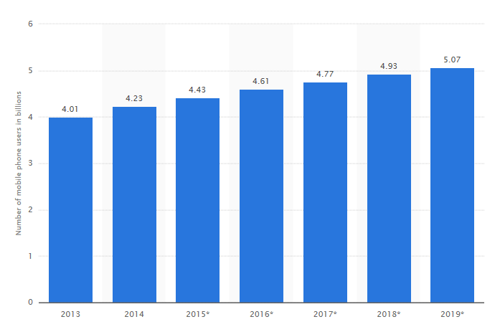

Source: www.statista.com

**Picture 2.2 Internet User Worldwide**

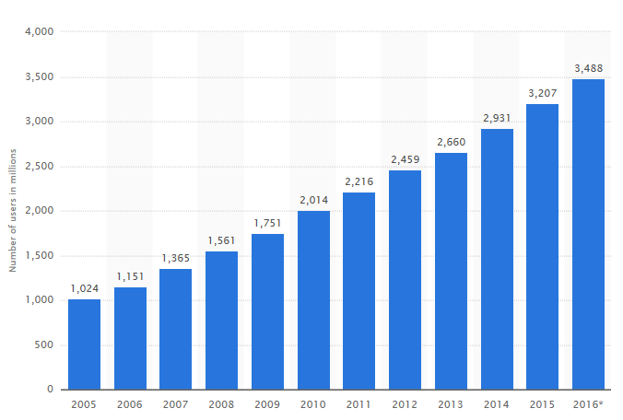

Source: www.statista.com

This engagement surely affects telecommunication industry as well. Telecommunication industry also has a rapid growth and creates more intense competition. To survive in the intense competitive market, company in telecommunication in industry should keep innovating and creates good brand image to customer. Revenue of telecommunication industry worldwide is increasing and expected to reach 1,2 trillion euros by 2019 as it shows in Picture 2.5. Asia/Pacific remains the biggest contribution of this industry and expected to increase by 2019.

**Picture 2.3 Global Telecommunications Services Market Value by region**

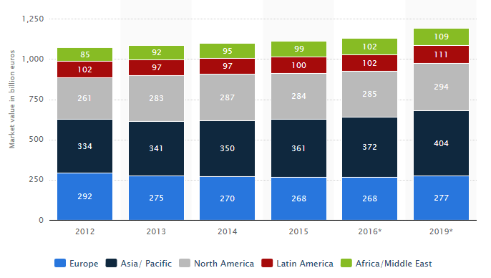

Source: www.statista.com

And also, telecommunication industry is competing to expand the speed of their connection (2G, 3G, LTE or higher). Picture 2.3 shows that the user of the fastest connection is increasing because nowadays people values speed for their communication channel.

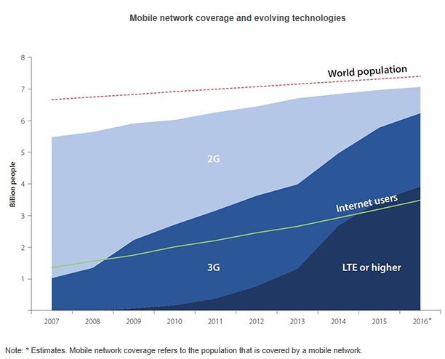**Picture 2.4 Mobile Network Coverage and Evolving Technology 2007-2016**

Source: www.itu.int

Basically, the main products of telecommunication companies are wireless (mobile voice & text, mobile data) and wireline (fixed voice, fixed broadband, IPTV, business solution). They provide those services to individual customer, business customer, and other carriers. In regards on competition from outside industry is cable companies and also social media companies such as Netflix or Skype.

There are three group that working together to provide the connection services infrastructure in telecommunication industry, namely vendor; operator; and sub-contractor. Vendor is company that provides the network’s equipment, operator is the one who have license to sell telecommunication services to people, and subcontractor is for helping vendor and operator. And of course government also plays the role in telecommunication industry.

**Picture 2.5 Telecommunication Industry Infrastructure**

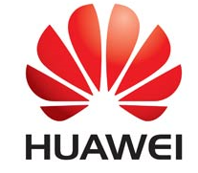

Source: Author

In this research, we will focus only to telecommunication operator services because they are the one who have license to sell the product directly to customers.

**2.2 Country Specific - Indonesia**

Indonesia is an archipelago country that lies in the Southeast Asia. The fourth world’s largest population makes Indonesia become one of the fastest growing economies in Southeast Asia.

**History**

In the early history, Indonesia consisted of many kingdoms. In 2nd century, the first kingdom was Sriwijawa, the most powerful Hindu and Buddhist kingdom in that era. Islamic sultan’s era was in 12th century and Christian kingdom was in 16th century. In 13th century, one of prominent figure under Majapahit Kingdom created Indonesia by unites all of kingdom under the name Nusantara. Europe invasion started in 1512 with the arrival of Portuguese trader, and followed by British and Dutch. Dutch colonialized Indonesia in 17th – 18th century. Then in World War II, Dutch had been pushed by the power of Japanese. In the end of World War II, Indonesia got its independence under their first president, Soekarno.

The first president was established the first communist party. He was really close with communist country, such Soviet Union. But then there was a coup against the communist party by military. After the death of first president, Soeharto took over the power. His dictatorship presidency had leaded a coup in 1998. First direct president election happened in 2004. Today, Indonesia is democracy country.

**Geography**

Indonesia is archipelago country with more than 13000 islands within the border of territory. Indonesia lies in the equator and that makes the climate is stable with two seasons, dry season and wet season. The geology of Indonesia is not stable, lies in pacific ring of fire and numerous an active volcano mountains, have made earthquake is usual natural disaster Indonesia.

**Demography**

Indonesia is number four world’s largest population in the world.

**Table 2.1 Indonesian Demography**

|  |  |
| --- | --- |
| Capital City | Jakarta |
| Total Population | 263,081,100 (January 2017) |
| Land | 1,904,569km2 |
| Languages | Bahasa Indonesia (Official) + >700 regional languages |
| Ethnic groups | 250 ethnic |
| Religion | Islam (87%), Christian (10%), Hindu (1,6%), Buddha (0,72%), Confucianism (0,05%) |

Source: http://www.nationsonline.org/oneworld/indonesia.htm

**Political Stability**

After the end of Soeharto regime, Indonesia is democracy country with multiparty system. This reform had created many problems within the political system. The increasing of corruption problems is one of them. The liberation of speech in Indonesia is the result of the impeachment of Soeharto regime, but freedom of speech could also cause problem in the Indonesian society. Recent incident that happened in Indonesia in regards to political is the election of Jakarta’s governor that created a massive unstable political and social stability.

**Economic Growth**

Indonesia is the largest economy country in Southeast Asia in regards to total population. Despite the slow growth of economic global, Indonesian economic shows the positive growing in 2016.

**Picture 2.6 Indonesia GDP**

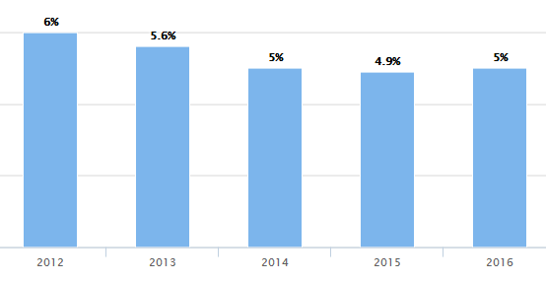

Source: World Bank Stats 2016

**Infrastructure**

Infrastructure is one of the most unsolved problems in Indonesia. As an islands country, it’s hard to create a good infrastructure system in all over the islands. The infrastructure development was centralized in five big islands (Sumatera, Java, Kalimantan, Sulawesi, and Papua). There is bus rapid transit in some big cities in Indonesia. There are 4 unconnected network of railway in Java and Sumatran islands. As maritime country, sea transport is extremely important. There are many link that connect island to island for the sea transport and it supports the shipping business in Indonesia, globally or locally.

**Culture**

In regards to culture, Indonesia has diversified cultures with their own characteristic.

1. Ethnic

Indonesia has around 250 ethnics. Java ethnic is the dominant ethnic in Indonesia with almost 40% from the total population. Most of ethnic cultures in Indonesia are influence by their religion. And because of this Indonesian government is giving a space for local law. For example, in Aceh almost all people is Islam and they have adopted the sharia law instead of Indonesian law. Same condition with Bali where most of the populations are Hindu and all people should stay at home when they celebrate their Saka new year and this is tied with local law.

1. Religion

As is said before that the biggest religion in Indonesia is Islam with 87% of total population. And basically how people behave in Indonesia is influencing by their religion.

1. Language

Indonesian official language is Bahasa Indonesia. However, Indonesia has more than 700 local languages and dialects. Most of the local languages are completely different each other. Bahasa Indonesia itself is used as everyday language only in 5 provinces in Indonesia; they are DKI Jakarta, West Papua, Riau, North Sumatera, and East Kalimantan. Meanwhile the other 28 provinces are using their own local language for communicate each other and only use Bahasa Indonesia in formal occasion, such as in school.

In order to analyze the culture in Indonesia as general, researcher used cultural dimension by Geert Hofstede (2001), they are: power distance, uncertainty avoidance, indulgence, individualism vs collectivism, masculinity vs femininity, and long-term vs short term orientation.

**Picture 2.7 Indonesian Cultural Dimension Score**

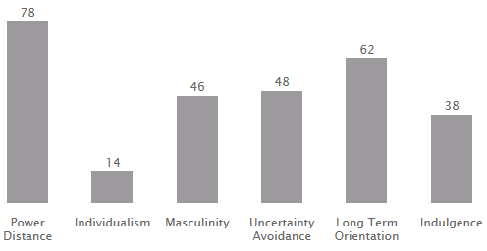

Source: https://www.geert-hofstede.com/indonesia.html

1. Power Distance

Power distance by Hofstede means the distance between people who have more power the other who have less power, to what extend this power will be distribute to people with less power. Power distance in Indonesia is really high with 78, it means there are a strong hierarchy system within the country. Address people according to their status, it could be their age, their knowledge, or their position. In Indonesia, this kind of attitude called respect. You will be called rude if you call your oldest sister of brother by their name. The same situation in the business, there are a high hierarchy system that you should follow.

1. Individualism vs Collectivism

Indonesia has a low rate in individualism, which means like the other Asian countries, Indonesia is collectivism oriented society. This collectivism oriented has been taught since child, the term called “Gotong Royong” means working together. In organization, if there is someone made a mistake, the fault is not on that someone but the mistake is on that organization. This collectivism oriented is supported the high family oriented in Indonesia.

1. Masculinity vs Femininity

According to Hofstede, Indonesia has low score on femininity in comparison to the score of masculinity. But the score of masculinity is not that high in comparison to other Asian countries. It means they are driven by competition, success, and achievement, but at the same time they believe that success is not everything.

1. Uncertainty Avoidance

Uncertainty avoidance means how to deal with the unwanted situation in the future. Indonesia score 48 which means they are more likely to avoid the unwanted situation in the future. Usually in organization, if someone angry, they will not let other people know to avoid the mess in the future. Or the other solution is the will use third party to solve the problem.

1. Long-term orientation vs Short-term orientation

With the score 62, Indonesia is long-term orientation country. They are care about the future much and want to keep something that has benefit in the future. This also shows that they have the capability to adapt in the changes environment.

1. Indulgence

Indonesia has low score on this dimension, which means Indonesia is the restraint society, where people behave according to high control of social norms. If they are doing something that is not according to social norms then they feel that it is wrong.

**2.3 Indonesian Telecommunication Industry**

**History of Telecommunication Industry in Indonesia**

Telecommunication service in Indonesia was started to develop at the Dutch colonialization in 1882. The first telecommunication service firm is Post Telegraph Telephone (PTT). After the independence of Indonesia from colonialization, this firm changed its name to PN Postel (Post and telecommunication Nation Company). Not long after that this company was divided into Post Company and Telecommunication Company. In 1991, the telecommunication company was changed to PT. Telekomunikasi Indonesia (Telkom) according to government regulation No. 25.

The first foreign investment in Indonesia telecommunication sector was an American telecommunication company ITT (International Telephone and Telegraph Corporation). Both companies along with Indonesian government built the first ground segment in Indonesia. This ground segment provides international connection from and to Indonesia. Then to manage this international connection, ITT created PT. Indosat. Therefore, at that time there are two companies that were running in telecommunication sector of Indonesia, PT. Telkom for local connection and PT. Indosat for international connection. These two companies continued monopolize market for 10 years because they were protected by Indonesian government that prohibited any foreign direct investment or private in telecommunication sector. Then in 1999, the telecommunication regulation had changed, Indonesian government allowed private companies join the market. Then the competition within the market was getting intense until now.

**Indonesian Telecommunication Industry Today Overview**

Indonesia market is one of unique market, especially in telecommunication industry. Some unique characteristics of this market are:

1. Huge market

Indonesia is the fourth world’s largest population with total 263,081,100 (per January 2017). This fact makes Indonesia have a huge market size compare to other country.

1. High penetration of smartphone and internet

The launched of 4G/LTE technology in Indonesia has created the massive internet users penetration and smartphone users within the population. The statistic shows that there is an increasing in mobile users in Indonesia since 2011 until 2016, and it will keep increasing. And Indonesia is ranked 3 in term of the growth of internet penetration in the world per 2016. Growth in cellular users entails ever-higher penetration of smartphones. The Erickson mobility Report for Southeast Asia and Oceania in the first quarter of 2016 showed that smartphone penetration reached 38% in Indonesia in 2015 and is expected to grow to 98% by 2021. Indonesia records the highest number of smartphone users in Southeast Asia and Oceania, reaching nearly 100 million in 2015, expected to grow to 250 million users by the end of 2021. Indeed, the number of smartphone users is expected to exceed that of cellular telephone users by 2018.

**Picture 2.8 Smartphone users in Indonesia in Millions** 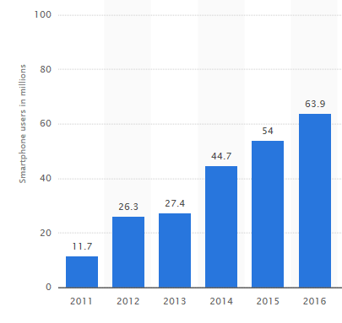

Source: www.statista.com

With the total population 263,081,100 (as per January 2017), Indonesia’s share of internet user of the world is 1,6 %. (Internet Live Stats, 2016). Statistic also shows the increasing of internet penetration in Indonesia.

**Table 2.2 Internet Penetration in Indonesia (2013-2016)**

|  |  |  |  |  |
| --- | --- | --- | --- | --- |
| **Year** | **2013** | **2014** | **2015** | **2016** |
| **Total Population** | 251,268,276 | 254,454,778 | 257,563,815 | 260,581,100 |
| **Internet Users** | 37,539,480 | 43,613,549 | 50,004,175 | 53,236,719 |
| **Internet Penetration** | 14.9 % | 17.1 % | 19.4 % | 20.4 % |

Source: www.InternetLiveStats.com

1. One company is dominating market

Indonesia is indeed very huge market for telecommunication industry. This phenomenon has created the intense competition within telecommunication industry in Indonesia. There are five players in market that control market share of telecommunication industry in Indonesia. They are PT. Telkomsel, PT. Indosat Ooredoo, PT. XL. Axiata, PT. Smartfren Telecom, and PT. Hutschison 3. Among them, PT Telkomsel is the biggest one, as state-owned company, PT. Telkomsel has conquered almost 50% of market share in Indonesia. Followed by PT. Indosat Ooredoo, and then PT. Hutschison 3 and PT. XL Axiata were having tight competition, and the last is PT. Smartfren Telecom. Meanwhile PT Bakrie Telecom is facing many problems so they are not really that active in Indonesian market.

**Picture 2.9 Market Share of Indonesian Telecommunication Industry 2016**

Source: [www.katadata.co.id](http://www.katadata.co.id)

1. Unique consumer behavior

From the data in the picture above, there is an odd fact regarding the number of people. If we count all the number of the customer above, the total of customer will be around 351 million people, meanwhile Indonesia’s total population per January 2017 is around 263,081,100. This phenomenon had been said by Indonesian Telecommunication Association, that mobile service penetration is Indonesia is more than 120%, which means there are many customer that use more than one cellular number, either from the same service or from different operator service. In Indonesia, you can have a lot of number of cellular because Indonesia have loose regulation on number registration, we can even use a fake name and identity to registry.

**2.4 Methodology and Data Collection**

**Multiple Case Studies**

Case study is a technique to solve a problem with depth analysis through observation and research to get the understanding of the cause of the problem. According to Winkel (1991: 660), the purpose of case study is to understand an individual about its development in term of environment engagement. According to Creswell (Creswell, 1998, pp. 37-38) case study is focused on case specification in one problem, individual or cultural group or even life events. Furthermore, Creswell explained about characteristic of case study:

1. Case identification for a case study;
2. A case study is a system that is linked to time and place;
3. Case study is using a lot of source to collect data for picturing one event;
4. Using the case study approach will be time consuming when picturing the context of a case study.

Stake (Stake, 1994, pp. 236-238) also explained about the characteristic of case study approach are the following:

1. Case study is the form of inquiry about a problem that has a particularity;
2. Case study may be quantitative or qualitative, but qualitative is more relevant;
3. Target of case study may be individual or group, or even entity.

According to Yin (Yin, 1994: 21), case study approach is questioning not only “What?”, but also “How?” and “Why?”. “What” is to get descriptive knowledge, “How?” is to get explanative knowledge, while “Why?” is for understand the explorative knowledge. Case study will explore an event from the bottom to the surface. Below is the relevant research question from different research approaches according to Yin (Yin, 1994: 6):

**Table 2.3 Research Questions**

|  |  |  |  |
| --- | --- | --- | --- |
| Research approach | Research question | Control to a research event? | Focused on contemporary event? |
| experimental | How and why | yes | Yes |
| Survey | Who, what, where, how many | no | Yes |
| History | How and why | no | No |
| Case study | How and why | no | yes |

Source: Yin 1994

Furthermore, Yin (Yin, 2008: 29) suggested five important components in designing case study, they are (1) research questions; (2) research proportion, research problem; (3) research analysis unit; (4) relevant logic between data and proposition; and (5) result interpretation.

Like any other qualitative research (phenomenology, ethnography, ethnology, text study, and grounded research), case study is a real-event, holistic, and comprehensive. In order to that, study case also use in-depth interview to understand the insight knowledge of the event. Besides that, there are five technique for collecting data in case study approach, they are documentation, direct observation, participant observation, physical artifact. And they are complementary each other. By using the phenomenology paradigm, case study is focused on a certain object that become a study case which is being research deeply to expose reality in phenomena. In phenomenology paradigm, reality is not what we see in the surface. So study case is to expose the one that we couldn’t see to create knowledge about that.

In this research, researcher is using multiple case studies approach to understand more deeply about marketing knowledge management in Indonesian telecommunication industry. The telecommunication provider in Indonesia that being researched is PT Telkomsel, PT. Indosat Ooredoo, PT. XL Axiata, and PT Smartfren Telecom.

**Table 2.4 Characteristic of Case Companies**

|  |  |  |
| --- | --- | --- |
| **Name of Company** | **No. of employee** | **Main products** |
| PT. Telkomsel | More than 4000 | Telecommunication service |
| PT. Indosat Ooredoo | More than 3000 | Telecommunication service |
| PT. XL. Axiata | More than 2000 | Telecommunication service |
| PT. Smartfren Telecom | More than 2000 | Telecommunication service |

**Data Collection**

The data collection techniques of this research are the following:

1. In-depth interview

The purpose of in-depth interview is to get data from the inside. The questions are the following:

1. Is there a specific process to collect data and information for marketing decisions? Can you describe it? Which departments are involved and how?
2. Can you describe your current marketing strategy? To what extent is it based on information collected?
3. Do you collect data and information about customers? What data specifically do you collect? Do you use any tools for collecting data and information about customer? Do you save them?
4. Do you collect data and information about competitors? What data specifically do you collect? Do you use any tools for collecting data and information about competitors? Do you save them?
5. Do you collect data and information about suppliers and distributors? What data specifically do you collect? Do you use any tools for collecting data and information about supplier and distributors? Do you save them?
6. How do you use the above mentioned data and information in your marketing activities and strategy development?
7. Are there any specific reasons to use the abovementioned tools to collect marketing-specific data? If yes, can you name them? Are there any specific processes in relation to the abovementioned data collection that are unique to your department? Are these processes formalized somehow?
8. How do you organize introduction of new department members into the abovementioned data collection processes?

The detail information about the interview are the following:

**Table 2.5 Interview Detail Information**

|  |  |  |  |  |
| --- | --- | --- | --- | --- |
| **Name of the company** | **Department/ Division** | **Position** | **Interview approach** | **Date** |
| PT. Telkomsel | Marketing / prepaid | Assistant Manager | Email | 10.05.2017 |
| PT. Indosat Ooredoo | Marketing /  product management | Manager | Phone | 13.052017 |
| PT. XL. Axiata | Marketing/  ecommerce | Assistant manager | Email | 11.05.2017 |
| PT. Smartfren Telecom | Marketing/ digital service | Manager | Phone | 12.05.2017 |

1. Observation

Forms of observation that is being used in this research are: (1) descriptive observation, to get general picture of the knowledge management in Indonesian telecommunication industry; (2) focused observation which is more focused on marketing knowledge management in telecommunication industry in Indonesia.

1. Documentation

Documentation technique is being used to get information that could not get by interview and observation. The forms are financial statement of the companies, annual report of the companies, articles or documents that created by the companies, and news about the companies in regards to knowledge management.

**2.5 Summary**

Telecommunication industry is one of the fastest growth industry along with the increasing of technology. As market oriented industry, telecommunication industry are focusing on their marketing strategy. Therefore customer satisfaction is their core purpose in order to survive in the intense competition among the players.

Telecommunication industry is also one of the fastest growing sector in Indonesia. The market itself has some unique characteristic in comparison to other market. First, being number 4 world’s largest population has make the customer base is very huge. Second, there’s a high penetration of smartphone and internet in Indonesia. Third, there is one player who dominates the market with almost acquired 40% of total market share. And last, the unique behavior of consumer who have more than one mobile number.

According to Indonesia country specific, there are two factors that probably is reflected in the findings. First, unique geographical pattern (consist of islands) in Indonesia makes the spreading of development of infrastructure for telecommunication sector is uneven in all regions. This factor could be a challenge for telecommunication companies on how to maintain a good connection for all customer evenly in order to create good brand reputations.

The second factors is cultural aspects. Culture is one of the biggest factors that probably effects knowledge management in Indonesia. They are:

1. Language

Indonesia has 250 ethnics with more than 700 local languages and dialects. Out of 33 provinces, only 5 provinces that actually use Bahasa Indonesia as their everyday conversation, while the other 28 are using their own local languages which are completely different form each other. Knowledge management concept is basically dealing with human, communication is the fundamental parts, and therefore language is one of the important thing. Sometimes people who speaks the same language could be misunderstood.

1. Religion

People in Indonesia is behave according to their religion and they have a highly restraint on religion believes. There are some norms that they should respect in term of religion.

1. Power distance

Indonesia has a high power distance, which means they have a high hierarchy within the society. This aspect will affect the distribution of knowledge where people with more power or authority will get more knowledge than other.

1. Uncertainty avoidance

People in Indonesia tend to avoid the conflict. They choose to keep silent if they are angry or find the third part to solve problem. This tendency will hampered the flow of information if someone choose not to speak what is wrong just because they want to avoid conflict.

The methodology of this study is multiple case studies of four telecommunication service operators in Indonesia. They are PT. Smartfren Telecom, PT. XL. Axiata, PT. Indosat Ooredoo, and PT. Telkomsel. The data was collected by in-depth interviews with the related marketing department in each companies and by collect information of the companies from internet source (annual report, news report, etc).

**CHAPTER 3**

**ANALYSIS OF CASE COMPANIES**

This chapter analyzes marketing knowledge management in marketing strategy of case companies of telecommunication service provider in Indonesia, they are PT. Smartfren Telecom, PT. XL. Axiata, PT. Telkomsel, and PT. Indosat Ooredoo. The conclusion of chapter explains the answer of research questions.

**3.1 PT. Smartfren Telecom**

PT. Smartfren Telecom is the merger of some telecommunication service providers/operators. Formerly known as PT. Mobile-8 Telecom Tbk which was established in 2002 and merged with Komselindo and Metrosel in 2003 and launched their first product called “Fren” at the same year. In 2004 they acquired another telecommunication provider, Telesera. In 2006, they launched 3G technology through CDMA EV-DO and noted their first stock in Indonesian Stock Exchange. Then in 2008, they launched fixed wireless access and entered mobile data service market in 2009. The turning point of the company happened in 2011, where the company acquired PT. Smartel Telecom Tbk and changed their name to PT. Smartfren Telecom Tbk. And in 2015, PT. Smartfren Telecom launched 4G/LTE hybrid. (Annual Report, 2016)

PT. Smartfren Telecom is not the leader in Indonesian telecommunication market. But they are still active and owned around 4% of total market share of Indonesian telecommunication market. Their net Revenue and EBITDA can be seen below: (Annual Report, 2016)

**Picture 3.1 Net Revenue and EBITDA PT. Smartfren Telecom**

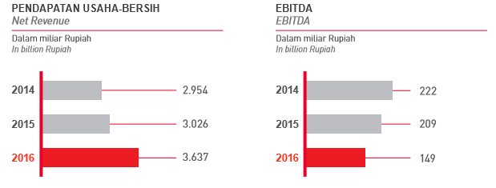

Source: PT. Smartfren Telecom Annual Report 2016

Their business cover:

1. Telecommunication service in all over Indonesia;
2. Providing multimedia products and services;
3. Building, renting, and having telecommunication network without cable with the basic CDMS;
4. Selling telecommunication products or equipment;
5. Offering e-money services;
6. Providing money transfer system.

Shareholders consist of three big companies and public (11.8%). Their group structure is the following:

**Picture 3.2 PT. Smartfren Telecom Group Structure**

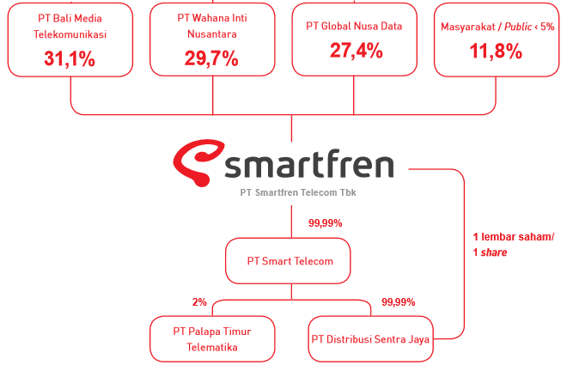

Source: PT. Smartfren Telecom Annual Report 2016

PT. Smartfren Telecom vision is *“Most loved and trusted by customers, employees and stakeholders”*, while their mission is *“Enriching our customers’ lives through innovative products and services enabled by the widest and most reliable 4G LTE network in Indonesia”*. (Annual Report, 2016). From their mission, we can see that customer is their number one priority, and it is also written on their corporate culture.

**Marketing Strategy**

In their corporate annual report 2016, it is clear that their marketing strategy is designed to satisfy their costumer and it is also stressed in the interview that customer’s satisfaction is their number one priority. Their current marketing strategy is to communicate the product through marketing channel, such us banners, websites, social media, TVC ads, SMS broadcast, and etc. And furthermore, sales team will provide detail information about the product to customers. They said that because now customer is moving to digital era, then social media is their most efficient marketing strategy.

Another marketing strategy that they use is “Community Marketing”. Community marketing refers to communities in Indonesia that can increase the awareness of the brand. This community is the one who always active in social media or digital, bloggers. PT. Smartfren Telecom conducts gathering with bloggers every time they want to launch new product. By doing so, they believe that bloggers can increase the level of awareness of one product before the launching event by writing on their blog.

In order to create marketing strategy decision, they have some certain process:

1. Data survey.

They collected related data and information from internet and also from questionnaire. This phase is responsible of marketing intelligence department.

1. Product research.

They are comparing their product with competitor’s product. This phase responsible of internal digital services.

1. Market survey.

They are researching the acceptance of the product or service to the market in order to making decision to go or not to go. This phase is also responsible of marketing intelligence department.

1. Revenue projection.

They are creating the projection of the revenue of certain products and this phase is involving finance department.

**Picture 3.3 Marketing Strategy Decision Making Process**

Source: Author

From the explanation above, we can see that marketing department is fully responsible on this and only involving finance department at the last phase.

**Marketing Knowledge Management in Marketing Strategy Formulation**

The first phase is to acquiring the knowledge by collecting all data and information about customers and competitors. For collecting customer knowledge, they are using FGD (Forum Group Discussion) to collect customer’s basic data (gender and age) and also the feedback to their product and services from their customer. And for collecting competitor knowledge, they are using certain statistic tools or buying some data on the internet, data and information that they are collecting are the competitor’s products, price, and its benefit.

The next phase is storage of the knowledge by saving them in the archive of their department. The next phase is distribution of the knowledge, this data and information is not really accessible for all employee, they need to have permission from the people who have authority. And finally the last phase is use of the knowledge; they use the certain knowledge to make certain marketing strategy. To conclude, marketing knowledge management process that happens in PT. Smartfren Telecom is the following:

**Picture 3.4 Marketing Knowledge Management Process on Marketing Strategy PT Smartfren Telecom**

Formulation of marketing strategy

Implementation of marketing strategy

Evaluation of marketing strategy

Acquisition of knowledge

Storage

The use of knowledge

Marketing Strategy creation

CRM, PDM, SCM

Costumer

Competitor

Tool:

Focus group discussion

Object knowledge:

Product, market, behavior pattern

Object knowledge:

Product, advertisement, price, strategy

Tool:

Statistic tools from internet

Archive (internal department archive)

Limited access

Distribution

Social Interaction

Via IT Share

Source: Author

**3.2 PT. XL Axiata Tbk**

PT. XL Axiata Tbk was established in 6th of October 1989 with the name PT. Grahametropolitan Lestari. In 1996, the company entered Indonesian telecommunication sector with GSM operation license and officially launched their GSM services. This makes they become the first private telecommunication provider firm in Indonesia, but they only operated in Jakarta, Bandung, and Surabaya. Then in 2000, they entered Sumatra and Batam market and expanded to more region in the next year. In 2005, they became subsidiary of TM Group and registered in Indonesian Stock Exchange. In 2006, they launched 3G services to all Indonesian region. In 2008, Axiata acquired XL and then changed their name to PT. XL Axiata tbk. In 2011, they changed their marketing strategy from low-cost to more sophisticated products by increasing the quality of networks. In 2014, they acquired one of telecommunication provider firm in Indonesia, Axis, and since then they are promoting dual brand, XL and Axis. Still in 2014, they launched 4G/LTE network.

In Indonesian telecommunication market, PT. XL Axiata is one of firms that have big market share. They acquired around 13% of total market share in telecommunication sector in Indonesia. But in regards to their financial performance, 2016 is not their best year because their gross revenue decreased from 2015.

**Picture 3.5 Gross Revenue and EBITDA PT. XL Axiata tbk**

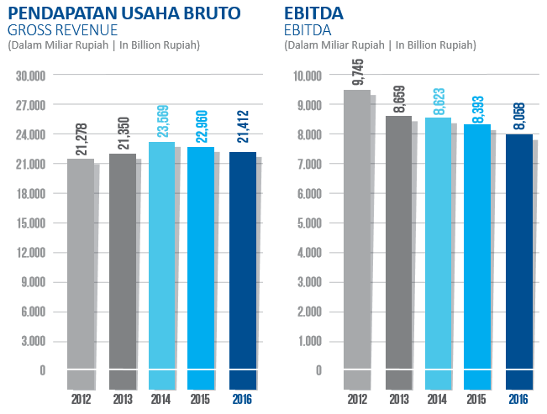Source: PT. XL Axiata Annual Report 2016

Core businesses of PT. XL Axiata are:

1. Provides cellular mobile networks;
2. Provides internet service provider;
3. Provides voice over internet protocol;
4. Provides content provider;
5. Provides money transfer service for non-bank
6. Provides e-money issuance service;
7. Provides internet interconnection service;
8. Provides closed fixed network.

Vision of PT. XL Axiata is *“To be the most preferred data connectivity provider in Indonesia by 2020”.* To achieved this vision, their strategy is 3R (Revamp, Rise, and Reinvent). Revamp is to change model business from customer volume to customer value, Rise refers to their dual-brand strategy to acquired new market potential, and Reinvent refers to innovation of business.

Their shareholder consists of Axiata investment and public. The composition of the share are the following:

**Picture 3.6 Shareholder PT. XL Axiata Tbk**

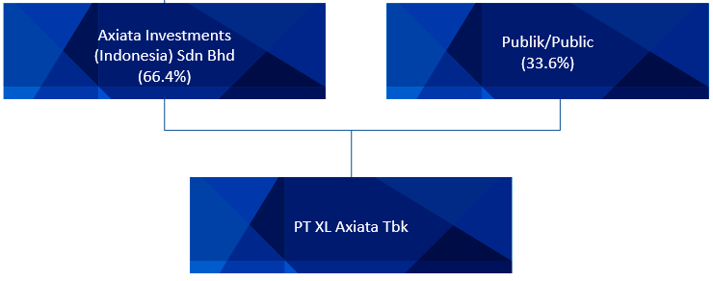

Source: PT. XL Axiata Annual Report 2016

**Marketing Strategy**

Their marketing strategy is focusing on data networks coverage. They keep improving their networks coverage in all over Indonesia. Their strategy are:

1. Creates customer value by giving high speed data network service and also building good customer relationship.
2. Dual-brand strategy. This strategy means they are promoting both XL and Axis to conquered potential market.
3. Innovation.

In order to create marketing strategy decision, they have some certain process:

1. Market insight or call survey. Collect all data and information from customer by Market Insight division and involving customer analytic division.
2. Competitor monitoring. Monitor product, price and promotion about competitor by Marketing department
3. Business case creation. After two phase above, they make business case consists of what product or service that they will create, how much is the price, what is the target customer, and how to promote this product or service.
4. Projection revenue. Furthermore this business case will be review by Business Analytic Department and Yield Management division (under finance department) to analyze whether they use a good pricing strategy on this product or service. If Business Analytics and Yield Management division have agreed on the business case, then Marketing Department will proceed the business case to the market.

**Picture 3.7 Marketing Strategy Decision PT. XL Axiata Tbk**

Source: Author

We can see that marketing department is fully responsible on their marketing strategy with the approval of business analytics department and yield management division.

**Marketing Knowledge Management in Marketing Strategy Formulation**

First phase is acquiring knowledge about customer and competitor. For collecting data from customer, they need data and information about how often and how long customer used or access data (service data or core data), how much customer spend their balance in a month to analyze purchasing power of their customer, and etc. And they are using survey, interviews, and focus group discussion and interview to collect them. For collecting data and information about competitor, they are using internet research and direct observation with competitor’s number. By doing this they will know what product, price, and promotion that competitor’s do now. This phase is fully marketing department responsible.

For saving the knowledge, they are using SQL Teradata. Data and information about customer is accessible for all employee, meanwhile distribution about competitor’s knowledge is only within the marketing department but could be distributed to certain department, such us business analytic and finance department in order to get approval of the business case that marketing department made. In the phase when they are creating the business case, they are actually using their knowledge that they got before from customer and competitors.

**Picture 3.8 Marketing Knowledge Management on Marketing Strategy of PT XL. Axiata**

Formulation of marketing strategy

Implementation of marketing strategy

Evaluation of marketing strategy

Acquisition of knowledge

Storage

The use of knowledge

Business case creation

CRM, PDM, SCM

Costumer

Competitor

Tool:

Focus group, Interviews

Object knowledge:

Product, market, behavior pattern

Object knowledge:

Product, advertisement, price, strategy

Tool:

Internet research, personal observation

Big data (costumer)

Accessible (costumer)

Distribution

Limited (competitor)

Internal department (competitor)

Social Interaction

Via IT Share

Source: Author

**3.3 PT. Telkomsel**

PT. Telkomsel was established in 1995 by the collaboration of PT. Telekomunikasi Indonesia and PT. Indosat, they launched KartuHalo at the same year. In 1997, their network covered 27 province in Indonesia and launched first prepaid service in Asia. In 2006 they launched 3G network in Indonesia. Thanks to the huge population in Indonesia, they got world’s seventh largest telecommunication operator based on customer base in 2011. They even build the first research and development center of cellular in Indonesia at the same year. They were successful in LTE trial at 2013 and became the first operator in Indonesia that launched 4G/LTE in 2014. Until now, PT. Telkomsel is still dominating market share in Indonesia by acquiring almost 50% of the market.

**Picture 3.9 Revenue and EBITDA of PT. Telkomsel**

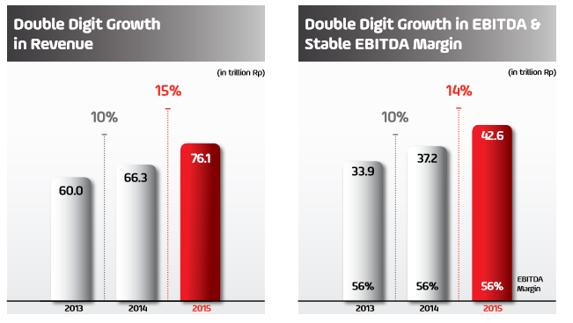

Source: PT. Telkomsel Annual Report 2015

PT Telkomsel is the leading telecommunication operator in Indonesia with the huge market share. Their vision is *“Be a world-class, trusted provider of mobile digital lifestyle services and solutions”***.** Like any other telecommunication firm, they also in the phase of changing their culture to market-oriented because the intense competitor within the market. Their transformation was happening in three core of their business, they are business transformation, organizational transformation, and people transformation. PT, Telkomsel is subsidiary of PT Telkom that is owned by Indonesian government. They network coverage is the widest in Indonesia. The composition of market share are the following:

**Picture 3.10 PT Telkomsel Shareholder**

Source: PT. Telkomsel Annual Report 2015

PT Telkomsel main activities are:

1. Providing telecommunication service to all Indonesian region;
2. Providing telecommunication service for SME and enterprise segment;
3. Providing digital service;
4. Building towers;

**Marketing Strategy**

PT. Telkomsel now is focusing in digitization on their business, organization, and people. Their marketing strategy is focusing on customer’s satisfaction by delivering customer experience to another level. As the leading company of Indonesian telecommunication service provider, PT. Telkomsel is always one step ahead from the other competitors. Their customer is the most loyal costumer from the other competitor. Therefore, customer satisfaction is their main purpose in order to retain the customer’s loyalty.

Their key marketing strategy is customer’s experience:

1. Enrich the smartphone experience;
2. Engage youth experience;
3. Trusted service experience;
4. Priority quality experience.

PT. Telkomsel recognizes that in order to give best experience, the need to understand what data and information on the market and how to manage them efficiently. They have a certain process in order to create marketing strategy, they are:

1. Market Analysis. They are in-depth analyze market situation (customer behavior and competitor’s behavior). This phase is marketing directorate responsible in collaboration with sales directorate.
2. Marketing plan. After analyzing all market situation, then they create a marketing plan / business plan. In this phase they will create product or service with certain segment of market, set the price, and choose its marketing communication channel. This phase is marketing directorate fully responsible.
3. Finance approval. After they created certain service or product for certain segment of market, then they need finance directorate to approve their marketing plan budget. This phase is marketing directorate responsible in collaboration with finance directorate

**Picture 3.11 Marketing Strategy Decision Process PT. Telkomsel**

Source: Author

**Marketing Knowledge Management on Marketing Strategy Formulation**

The first phase is acquiring the knowledge. In this phase they are collecting knowledge about customer and competitors. For collecting customer’s data and information they used focus group discussion, interview, surveys and they introduced “Multi-dimensional Customer Profiling” for analyze the data. Data that they collect is customer profile, behavior pattern, products, supplier, and customer feedback. For collecting data and information about competitor, they don’t use a formal method, they only use internet research and personal observation. This phase will be marketing directorate responsible in collaboration with sales department.

The next phase in storage the knowledge. They are saving all their big data platform. The third phase in distribution of knowledge. Data and information about customer is accessible in their big data platform, but competitor knowledge is saved in their internal department and only distribute to certain department. The last phase is the use of knowledge. They are using the knowledge about market to create a marketing plan.

**Picture 3.12 Marketing Knowledge Management on Marketing Strategy of PT Telkomsel**

Limited (competitor)

Social Interaction

Via IT Share

Accessible (costumer)

Formulation of marketing strategy

Implementation of marketing strategy

Evaluation of marketing strategy

Acquisition of knowledge

Storage

The use of knowledge

Marketing plan creation

CRM, PDM, SCM

Costumer

Competitor

Tool:

Focus group, interviews, survey

Object knowledge:

Product, market, behavior pattern, supplier

Object knowledge:

Product, advertisement, price, strategy

Tool:

Internet research, personal observation

Big data (costumer)

Distribution

Internal department (competitor)

Source: Author

**3.4 PT. Indosat Ooredoo**

Indosat was established in 1967 as the first foreign direct investment in Indonesia which was providing international telecommunication services via international satellite. Few years later, Indonesian government bought Indosat and acquired 100% of share. In 1994, Indosat became public firm and registered in Indonesian Stock Exchange. In 1994-2003, Indosat took over the share of Satelindo and SLI Indonesia and established to PT. Indosat Multimedia Mobile (IM3) as the pioneer of GPRS network and multimedia service in Indonesia. In 2003, Indonsat joined its subsidiaries, Satelindo, IM3, and Bimadraha, to create cellular operator in Indonesia. In 2003 until 2009 Indosat got license for 3G network and introduced 3,5G network in Jakarta and Surabaya. In 2009, Qtel bought 24,19% Indosat’s stock and became the majority of share with 65%. At the same year Indosat got additional license of 3G network from Ministry of Communication and Information of Indonesia. Indosat did organization transformation in 2012, when they had reached 58,5 million customer. in 2014, Inodat got 4G network license in some of the big cities in Indonesia. In 2015, Indosat officially changed its name to Indosat Ooredoo. Under the new name, their customer had reached 68,5 million in 2015.

**Picture 3.13 Revenue PT. Indosat Ooredoo**

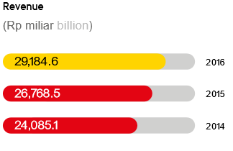

Source: PT. Telkomsel Annual Report 2015

Their activities are:

1. Providing personal telecommunication service;
2. Providing international service;
3. Providing business telecommunication service;
4. Providing digital service.

**Picture 3.14 Indosat Ooredoo Ownership Composition**

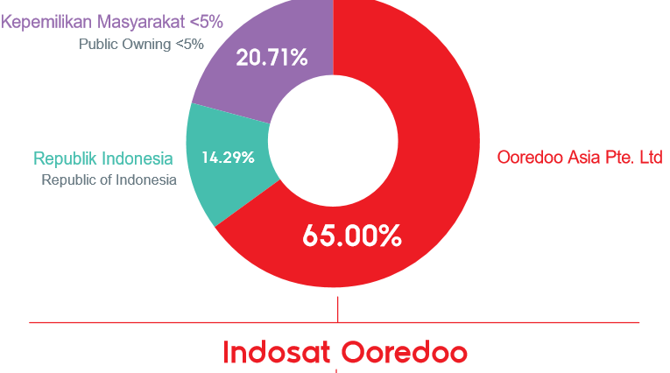

Source: PT. Telkomsel Annual Report 2015

**Marketing Strategy**

Marketing strategy of PT. Indosat Ooredoo is focused on offering simplified, data-heavy offerings in the retail market that aimed to ‘liberate’ subscribers to use the internet, a position in line with our brand image as a ‘liberator, innovator’ and leader in data. They also continued to push direct selling through online as well as offline channels.

In order to create marketing strategy, there are a certain process:

1. Market Insight Analysis. They collected all data and information about market with the collaboration of marketing directorate (product management group and commercial planning group) and sales and distribution directorate (channel management group and retail and device management group)
2. Business case creation. After collect all data and information that they need, marketing directorate will start to create the business plan. This process is involving all groups under marketing directorate. The will create what kind of product or service that they want, pricing strategy, and commercial strategy.
3. Finance control. They need an approval form finance directorate to proceed the business case.

To conclude, the process are the following:

**Picture 3.15 Marketing Strategy Decision Process PT. Indosat Ooredoo**

Source: Author

**Marketing Knowledge Management in Marketing Strategy Formulation**

First phase is acquiring knowledge. In collecting data of market, there are two directorates that involve in this phase, they are marketing directorate and sales and distribution directorate. From this collaboration they collect data about customer and competitors. For acquiring customer knowledge, they are using ICITY (Indosat Community Forum), the first crowdsourcing platform in Indonesian telecommunication industry. From this ICITY forum, they will deeply connected with their customer and make them easy to understand the customer needs. Other than that, they are also using their *Data Center System* for collecting the consumption pattern of customer. For collecting data of competitor, they don’t have formal method, they are using internet research and personal observation.

The second phase is storage the knowledge. Data and information about customer is saved in *Data Center System,* meanwhile for competitor is only saved in internal archive of marketing directorate. The next phase is distribution. As already mentioned before, all employees can access all data and information about customer. Meanwhile data about competitor is only distributed to related directorate, such us sales and distribution directorate or finance directorate to get an approval.

For the last phase, the use of knowledge. Basically this phase is the almost the same like other firms before. When they are creating a business case then they are using the knowledge of all data that they have collected before.

**Picture 3.16 Marketing Knowledge Management in Marketing Strategy PT. Indosat Ooredoo**

Formulation of marketing strategy

Implementation of marketing strategy

Evaluation of marketing strategy

Acquisition of knowledge

Storage

The use of knowledge

Business case creation

CRM, PDM, SCM

Costumer

Competitor

Tool:

Crowdsourcing platform

Object knowledge:

Product, market, behavior pattern, supplier

Object knowledge:

Product, advertisement, price, strategy

Tool:

Internet research, personal observation

Big data (costumer)

Distribution

Internal department (competitor)

Accessible (costumer)

Limited (competitor)

Social Interaction

Via IT Share

Source: Author

**3.5 Discussion of Findings**

From five telecommunication services operators, researcher managed to get interviews from four of them. The discussion of the findings that researcher found are the following:

1. *What is the role of marketing knowledge management in marketing strategy of telecommunication companies in Indonesia?*

*2. How the role of marketing knowledge management is reflected in marketing strategy formulation of telecommunication companies in Indonesia?*

All four companies realizes that customer satisfaction is their number one priority because of the intense competition within the market. PT. XL Axiata, PT. Indosat Ooredoo, PT. Smartfren Telecom are focusing on how to attract new customer while retain the current customer. Meanwhile the leader, PT. Telkomsel, is focusing on retain the customer and innovation in order not to lose their leading position and market share.

From the literature and findings, it is clear that the role of marketing knowledge management in marketing strategy of telecommunication companies in Indonesia is in the formulation of marketing strategy.

1. Acquiring the knowledge.

Market knowledge is the combination of customer knowledge and competitor knowledge. The tools that are being used for customer knowledge acquisition in telecommunication companies Indonesia are: focus group, interviews, surveys, and crowdsourcing. The objects of knowledge that they acquire are:

* Knowledge from customer: products, brand, market, supplier
* Knowledge about customer: behavior pattern

As for competitor knowledge, they are using internet research and personal observation to acquire them. The objects of knowledge that they acquire are product of competitor and its benefit, competitor marketing strategy, competitor advertisement, and competitor product price.

**Table 3.1 Acquisition of Knowledge**

|  |  |  |
| --- | --- | --- |
| **Type of knowledge** | **Tools** | **Object of knowledge** |
| Customer knowledge | Focus group, interviews, survey, Crowdsourcing | * Knowledge from customers (products, brands, market, and supplier) * Knowledge about customers (behavior pattern) |
| Competitor knowledge | Internet research, personal observation | Product, advertisement, price, strategy |

Source: Author

1. Storage the knowledge.

Companies are saving the knowledge that they have collected to their archive, they are in big data platform and in their internal archive of their department.

1. Distribution of the knowledge.

The distribution of knowledge is in two forms: social interaction and via IT share. In social interaction basically it’s happened within the department, when they are preparing marketing plan. Data an information that is on the big data of company (customer knowledge) is accessible for all employee, meanwhile competitor knowledge is only for the use within the marketing department.

1. The use of knowledge.

The combination of customer knowledge and competitor knowledge is used for creating marketing plan. According to customer and competitor knowledge that they have collected, they will know what the needs of markets and their brand position on the market. So that they can create know their goal is and create an efficient marketing strategy.

**Table 3.2 Storage, Distribution and The use**

|  |  |  |  |  |
| --- | --- | --- | --- | --- |
|  | **Storage** | **Distribution** | | **The use of knowledge** |
| Customer knowledge | Big data platform | Via IT Share | Accessible | Marketing plan |
| Competitor knowledge | Internal department archive | limited |
|  |  | Social interaction | |  |

Source: Author

From the explanation above, we can see that most of the companies are using traditional method and some knowledge are accessible while some are not accessible for all employee. If we integrate them to our model of framework then the combination of all marketing knowledge management in this study will be the following:

**Picture 3.17 MKM in Marketing Strategy in Indonesian Telecommunication companies**

Formulation of marketing strategy

Implementation of marketing strategy

Evaluation of marketing strategy

Acquisition of knowledge

Storage

The use of knowledge

Marketing Plan Creation

CRM, PDM, SCM

Costumer

Competitor

Tool:

Focus group, interviews, survey, Crowdsourcing

Object knowledge:

From customer (Product, market, brand, supplier)

About customer (behavior pattern)

Object knowledge:

Product, advertisement, price, strategy

Tool:

Internet research, personal observation

Big data

Distribution

Internal department

Accessible

Limited

Social Interaction

Via IT Share

Source: Author

*3. Whether the influence of country specific in Indonesia is reflected in marketing knowledge management of telecommunication companies?*

From the findings, there some aspects from country-specific of Indonesia that influence the marketing knowledge management of telecommunication companies.

1) Acquisition of knowledge.

There are some country-specific aspect that is reflected in the acquisition of customer knowledge, especially when companies are using focus group discussion or interview with customer from all different regions from Indonesia, they are geographical structure and languages.

1. Geographical structure

It is hard to get insight from customer in all over Indonesia because the unique structure of geography and the uneven development of infrastructure. Some telecommunication companies aren’t that big as the other, so some companies do interviews or focus group discussion in the cities where they have a regional branch and mostly in big cities.

1. Language.

With only 5 out of 33 provinces that actually use Bahasa Indonesia in everyday conversation, of course language is the huge barrier for companies. Some case companies said that they only do market research (for acquiring customer knowledge) basically in big cities of Indonesia. In most of big cities they will use one local language and not so many dialects in comparison in the small cities or villages.

2) Distribution of Knowledge

There are some country-specifics of Indonesia that is reflected in distribution of knowledge, they are language and power distance

1. Language

Language is the most fundamental part in communication. It will affect distribution of knowledge through social interaction. Again Indonesia only have 5 out of 33 province that are actually using Bahasa Indonesia in their daily conversation, of course language sometime could lead to misunderstanding.

1. Power distance

In findings there are some knowledge that is limited, this is the reflection of power distance. As it already mentioned that Indonesia have very high score on power distance which means that people with more power will get more than the less power. That’s why in distribution of knowledge, some knowledge couldn’t be access by employee that don’t have higher position. Some companies even said that if they want to get data and information, they should ask a permit to their boss to get access. Some staff tends to say “*yes*” to their boss rather than *“I think…”*. Therefore, the distribution of knowledge somehow is not efficient because of this high power distance.

**CHAPTER 4**

**CONCLUSION**

This chapter explains conclusion, theoretical implication, managerial implication, and limitations of the study.

**4.1 Conclusion**

In telecommunication companies, marketing strategy is their fundamental part of business. In order to survive in intense competition within the market, they need to create an efficient marketing strategy. And in order to create an efficient marketing strategy, they need to manage knowledge about market, which is called marketing knowledge management. Marketing knowledge management is basically the process to manage knowledge about market that consists of customer knowledge and competitor knowledge to support the marketing strategy formulation.

Telecommunication companies in Indonesia are also effected by the intense competition within the market. Acquisition of knowledge is divided into customer knowledge and competitor knowledge. Customer knowledge acquisition tools of Indonesian telecommunication companies are mostly using surveys, interviews, focus group, and crowdsourcing. The object of customer knowledge that they are acquired is knowledge from customer (product, brand, supplier, and market), and knowledge about customer (behavior pattern). In acquisition of customer, there are some country-specifics of Indonesia that are reflected in the process of acquisition, they are geographical structure and languages. For acquisition of competitor knowledge, they are using internet research and personal observation to know the competitor’s product, price, advertisement, and marketing strategy.

They are saving all knowledge in their big data platform and their internal department archive. For distribution of knowledge, there are two forms of distribution, they are social interaction that are happened when they want to create a marketing plan, and via IT share. Some knowledge via IT share is accessible while some are not. And the distribution by social interaction is also limited to the activity of making marketing plan or strategy. This is reflected the high score of power distance in Indonesia where the more power you have then the more you got.

And the last for the use of knowledge, they are using the combination of customer knowledge and competitor knowledge to create marketing plan.

**4.2 Implication of the Study**

**Theoretical Implication**

The model of marketing knowledge management in marketing strategy that researcher have created can be useful to investigate the marketing knowledge management.

**Managerial Implication**

The managerial implication of this study can be divided into two parts:

1. Managerial implication for telecommunication companies in Indonesia

* To keep all necessary knowledge to big data platform, especially data about market;
* Make sure that everyone can get all knowledge evenly by create sharing culture within the departments;
* Make sure that when acquiring a customer knowledge through interview or focus group discussion, the marketing team should understand how to translate the local language into Bahasa Indonesia correctly, so that there is no misinformation when sharing it to others.
* In regards to geographical structure, telecommunication companies in Indonesia can get a help from external consultancy, but this will be costly.

1. Managerial implication for foreign companies that probably will expand their business in Indonesia, especially in telecommunication sector

* To understand the country specific factor that influence the marketing knowledge management, especially in telecommunication sector, they are: geographical structure, languages, and power distance;
* Please carefully dealing with the power distance in Indonesia;
* Create a marketing team that is consisted of Indonesian people with different culture and languages.

**4.3 Limitation**

There are some limitations of this study, they are:

1. The Indonesian telecommunication companies might be different from another country in regards to country specific;
2. The interview was done within the marketing department only, it could be better if the researcher could get an interview from another related departments, for example sale department.

For the future research, it is strongly suggested to research on the marketing knowledge management area in another country especially telecommunication sector or service sector. Researcher also suggest to do research about how marketing knowledge management on telecommunication sector reflects on supply chain management process. And also researcher suggest to research about the effect of power distance culture in knowledge management implementation, especially in the country that have a high power distance.

**Bibliography:**

Calder, B. (1977). *Focus Groups and the Nature of Qualitative Marketing Research*. Journal of Marketing Research, 14(3), 353.

Chen, Y. Y., & Huang, H.-L. (2012). *Knowledge management fit and its implications for business performance: A profile deviation analysis*. Knowledge-based Systems, 27, 262-270

Collins, H. (2010). *Tacit and Explicit Knowledge.* US: University of Chicago Press.

Davison, R.M., Ou, C.X.J., M.G. (2013) Martinsons, Information technology to support informal knowledge sharing, Inf. Syst. J. 23 (1), pp. 89–109.

Daegeun, H., & Euiho, S., Choonghyo, K. (2011). Developing strategies for overcoming barriers to knowledge sharing based on conversational knowledge management: A case study of a financial company. Expert Systems with Application, 38(1)

Ferrell, Michael, D.,Hartline, and George, Lucas, H. (2004). *Marketing Strategy, 2th edition.* South Western: Thomson Learning.

Ghorbani, Noghabi, and Nikoukar. (2011). *Relationship between organizational structure dimensions and knowledge management (KM)* in educational organization, World Applied Sciences Journal,vol.12,no.11,pp.518-528.

Gonzales, Rodrigo VD, and Martin, Manoel F. (2016). *Knowledge Management Process: A Theoretical – Conceptual Research.* Scientific Electronic Library Online: Sao Paulo.

Goulding, C. (2005). *Grounded theory, ethnography and phenomenology*. European Journal Of Marketing, 39(3/4), 294-308.

Groff, T. R. & Jones, T. P. (2003). *Introduction to knowledge management: KM in business.* Burlington, MA: Butterworth-Heinemann.

Hadjimanolis A., (2000). *An investigation of innovation antecedents in small firms in the context of a small developing country.*. R&D Management 30(3), 235-245.

Jiangping Wan, Ming Zeng, Yahui Zhu. (2013). *Case Study on Tacit Knowledge Management Systems within X Company.* Technology and Investment. 92-100

Kamberelis, G. & Dimitriadis, G. (2013). *Focus groups*. Abingdon, Oxon: Routledge

Kotler, P., & Keller, K. L. (2009). *Marketing Management*, (12 ed.). Upper Seddle River: Prentice-Hall.

Kotler, P., Armstrong, G., Wong, V., & Saunders, J. (2008). *Principles of Marketing*. London: Prentice Hall.

Kotler, P., Armstrong, G., Saunders, J., & Wong, V. (2002). *Principles of Marketing* (3rd European ed.). London: Prentice-Hall.

Kozinets, R. (2010). *Netnography: The Marketer’s Secret Weapon (1st ed.).* Mountain View: NetBase

Kusumadmo, E. (2013). *Strategic Knowledge Management*. Yogyakarta : Cahaya Atma Pustaka.

Liebowitz, J. and T. Beckman (1999). *Knowledge Organizations: What Every Manager Should Know.* Florida: CRC Press, Boca Raton,

[Mamoun N. Akroush](http://www.emeraldinsight.com/author/Akroush%2C+Mamoun+N), [Samer M. Al‐Mohammad](http://www.emeraldinsight.com/author/Al-Mohammad%2C+Samer+M), (2010). *The effect of marketing knowledge management on organizational performance: An empirical investigation of the telecommunications organizations in Jordan.* International Journal of Emerging Markets, Vol. 5 Issue: 1, pp.38-77, doi: 10.1108/17468801011018266

Mclnerney, C., Koenig, M. (2010) Knowledge management process in organizations: theoretical foundations and practice. San Refeal, Calif Publication

Nonoka, I. and Takeuchi, H. (1994). *The Knowledge-Creating Company*. Oxford: Oxford University Press.

Pervaiz K. Ahmed and Charles D. Shepherd. (2010). *Innovation Management; context, strategies, systems & processes.* Prentice Hall.

Ravi, R., Selvi, K. R. (2013). A study on knowledge management in business opportunity to industry

R.K. Srinivasta, T. S. (1999). *Marketing, Business Process and Shareholder Value: an Organizationally Embedded View of Marketing Activities and Discipline of Marketing*. Journal of Marketing, 168-179.

Rozenfeld H., F. F. (2014). *Comparative Analysis of Product Development Process Management Models*. American Journal of Industrial Engineering, 5-9.

Salomann, H., Dous, M., Kolbe, L., and Brenner, W. (2005). *Rejuvenating Customer Management: How to Make Knowledge For, From and About Customers Work.* European Management Journal, 23(4), 392-403.

Senge P (2009). *The necessary revolution: how we got into this mess*. Reflect Soc Learn J.

[Siu Loon Hoe](http://www.emeraldinsight.com/author/Loon+Hoe%2C+Siu), (2008). *Benefiting from customer and competitor knowledge: A market‐based approach to organizational learning.* The Learning Organization, Vol. 15 Issue: 3, pp.240-250, doi: 10.1108/09696470810868864

Sztangret, Izabela. (2013). *Marketing Knowledge Management in Structural Approach. Community of Practice in Microsoft – International Comparison.* From: http://yadda.icm.edu.pl/yadda/element/bwmeta1.element.desklight-ca7dd09e-e1b3-4fcf-ba65-f743d1c8b5ac/c/12_I.Sztangret_Marketing_knowledge_management....pdf

Kayes, D. C (2005). *Internal validity and reliability of Kolb’s learning style inventory version 3.* Journal of Business and Psychology. Forthcoming.

Seufert, Andreas, Georg von Krogh, and Andrea Back (1999), *Towards Knowledge Networking*. Journal of Knowledge Management, 3 (3)

Shaw, M., Subramaniam, C., Tan, G., & Welge, M. (2001). *Knowledge management and data mining for marketing*. Decision Support Systems*,* 127 - 137.

Shelda Debowski., (2007). *Knowledge management.* Wiley India Pvt Ltd.

Stake, R. (1994). *Case Studies: Handbook of Qualitative Research*. Sage, 236-238.

Stenmark, D. (2001). *The Relationship between Information and Knowledge*. In Proceedings of IRIS.

Tadepalli, Raghu and Avila, Ramon A. (1999). *Market Orientation and the Marketing Strategy Process*. Journal of Marketing Theory and Practice. 7 (2), 69-82.

Tiwana, A. (2000). *The Knowledge Management Toolkit: Practical Techniques for Building a Knowledge Management System*. Prentice Hall, Upper Saddle River, NJ

Ulrich, K. T., & Eppinger, S. D. (2000). *Product Design and Development.* Boston: McGraw-Hill Education.

Van den Hooff, B. and Hendrix, L. (2004) *Eagerness and willingness to share: The relevance of different attitudes towards knowledge sharing.* Paper presented at the Vth European Conference on Organizational Knowledge, Learning and Capabilities, Innsbruck, Austria, April.

Wang, S. and Noe, R. A. (2010). *Knowledge sharing: A review and directions for future research*. Human Resource Management Review, 20(2), 115-131.

Yin, R. K. (1994). *Case study research: design and methods.* Michigan: Sage.

Yin, R. K. (2008). *Case Study Research: Design and Methods (Applied Social Research Methods) 4th Edition.* Michigan: Sage.

Yusup, Pawit. M. (2012). *Perspective of Knowledge Management, Information, and Education.* Jakarta: Rajawali Pers

Zhang, L, Wang, H, Cao, Xf, Wang, X, & Zhao, K. (2012). *Knowledge management component in managing human resources for enterprises*. Information Technology & Management, 13(4), 341-349. http://dx.doi.org/10.1007/s10799-012-0127-8

Zanjani, M.S., R. Rouzbehani and H. Dabbagh, 2008. *Proposing a conceptual model of customer knowledge management.* Int. J. Hum. Social Sci., 2: 60-64.

**Internet**

Statista: The Statistic Portal. <https://www.statista.com/>

International Telecommunication Union (ITU). <http://www.itu.int/en/>

One World Nations Online. <http://www.nationsonline.org/oneworld/indonesia.htm>

The World Bank database. <http://data.worldbank.org/country/indonesia?view=chart>

Geert Hofstede cultural dimension: Indonesia. <https://www.geert-hofstede.com/indonesia.html>

Internet Live Stats. <http://www.internetlivestats.com/>

D Kata Data Portal. <http://katadata.co.id/>

**Report:**

PT Telkomsel Annual Report 2015

http://www.telkomsel.com/media/upload/annualreport/AR_TSEL2015.pdf

PT. XL Axiata Annual Report 2016

https://www.xl.co.id/ss/Annual%20Report%20XL%20AXIATA%202016_9MAR17.pdf

PT. Indosat Ooredoo Annual Report 2016

https://assets.indosatooredoo.com/Assets/Upload/PDF/Laporan%20Tahunan/Eng/AR%20Indosat%202016.pdf

PT. Smartfren Telecom Annual Report 2016

http://www.smartfren.com/id/annual-report/