St. Petersburg University

Graduate School of Management

Master in Informational Technology and Innovation Management Program

Method of Using Business Capability Mapping in Small and Medium-sized Enterprises Strategic Planning

Master’s Thesis by the 2nd year student

Concentration ­­­­– Master in Information Technologies and Innovation Management

Aleksandr I. Sidorov

Research advisor:

Candidate of Engineering Sciences, Associate Professor, Dmitriy V. Kudriavtsev

St. Petersburg

2017

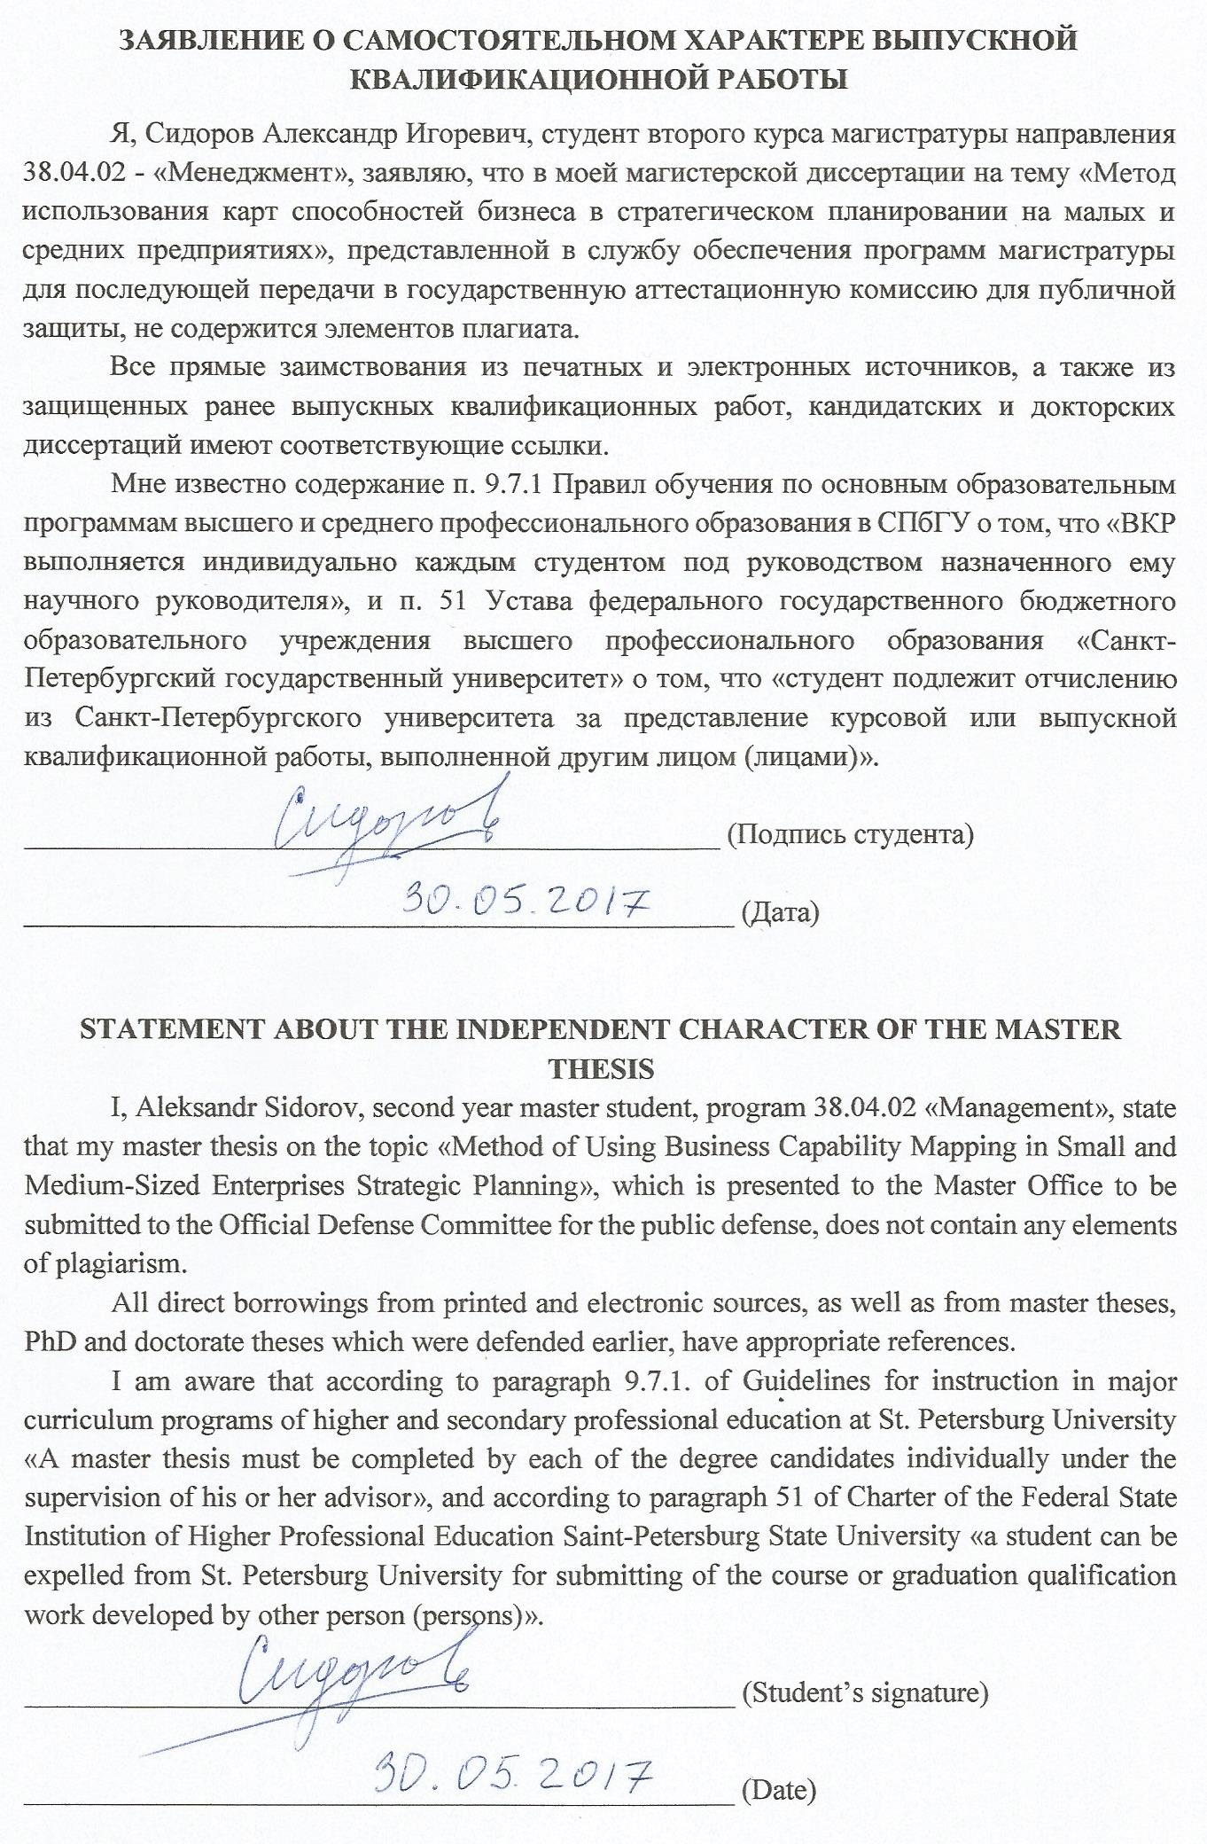

**АННОТАЦИЯ**

|  |  |
| --- | --- |
| Автор | Сидоров Александр Игоревич |
| Название магистерской диссертации | Метод использования карт способностей бизнеса в стратегическом планировании на малых и средних предприятиях |
| Факультет | Высшая школа менеджмента |
| Специальность | Информационные технологии и инновационный менеджмент |
| Год | 2017 |
| Научный руководитель | к.т.н., доцент, Кудрявцев Дмитрий Вячеславович |
| Описание цели, задач и основных результатов | Основная цель данной работы заключается в разработке метода использования карты способностей бизнеса в стратегическом планировании на малых и средних предприятиях, принимая во внимание их специфику. Исследование носит качественный характер и использует кейс-метод. Для достижения указанной цели были поставлены следующие задачи:   * Проанализировать существующие подходы к стратегическому планированию, в том числе со стороны использования способностей организации; * Разработать метод использования карт способностей бизнеса для использования в стратегическом планировании на малых и средних предприятиях, с учетом существующих методик и инструментов; * Провести опытную реализацию предложенного метода на примере конкретной компании.   В рамках исследования был разработан метод использования карты способностей бизнеса в стратегическом планировании, который предусматривает также использование других известных структур и инструментов для полноты анализа, обеспечения согласованности предлагаемых инициатив и выравнивания бизнеса с ИТ-инфраструктурой. Предложенный метод учитывает особенности малых и средних предприятий, в том числе со стороны подходов к планированию, и обладает рядом преимуществ в кратко-, средне- и долгосрочной перспективах. Опытная реализация метода была проведена для компании HIQE Digital. |
| Ключевые слова | Стратегическое планирование, способности бизнеса, малые и средние предприятия |

**ABSTRACT**

|  |  |
| --- | --- |
| Master Student’s Name | Aleksandr I. Sidorov |
| Master Thesis Title | Method of Using Business Capability Mapping in Small and Medium-Sized Enterprises Strategic Planning |
| Faculty | Graduate School of Management |
| Major Subject | Master in Information Technology and Innovation Management |
| Year | 2017 |
| Academic Advisor’s Name | Candidate of Engineering Sciences, Associate Professor, Dmitry V. Kudryavtsev |
| Description of the goal, tasks and main results | The goal of the research depicted in the thesis is to develop a method of using business capability mapping in small and medium-sized enterprises strategic planning, which would consider their specificity. This research is of qualitative nature and uses a case-study method. To achieve this goal, the following tasks were set:   * To list and analyze known frameworks, tools and approaches in the sphere of organizational capabilities and strategic planning; * To elaborate a method for using business capability mapping in a small and medium-sized enterprise strategic planning, taking into account existing tools and frameworks; * To demonstrate the method on a case study company.   As a result, a method of using business capability mapping in strategic planning was designed. By using existing tools and frameworks in visualizing business model, mapping capabilities and applying planning methods, it provides a more complete analysis of the current situation in a company, ensures coherency and consistency in orchestrating organizational development projects, promotes business-to-IT alignment. The suggested method considers features of small and medium-sized enterprises, including planning approaches, and has several advantages in short, medium and long-term perspectives. The method has been adapted by HIQE Digital company. |
| Keywords | Strategic planning, business capabilities, small and medium-sized enterprises |

**Table of contents**

INTRODUCTION 7

CHAPTER 1. THEORETICAL BACKGROUND OF BUSINESS CAPABILITIES 9

1.1 Resource-Based View of the Firm 9

1.2 Resources and Capabilities 12

1.3 Capabilities, Competencies and Processes 16

1.4 Strategic Planning 18

1.5 Capability-Based Planning 26

1.6 Value Proposition and Value Mapping approaches 29

1.7 Capability Mapping Approaches 32

1.8 Benefits of using capability mapping 42

SUMMARY OF CHAPTER 1 42

CHAPTER 2. RESEARCH GAP AND METHODOLOGY 44

2.1 Research Gap 44

2.2 Research Goal and Objectives 44

2.3 Design Science Research Methodology 45

2.4 Choosing the case study company 46

2.4 Data collection methods 46

CHAPTER 3. METHOD DESIGN AND DEVELOPMENT 47

3.1 Frameworks and tools 47

3.2 Requirements for the method 48

3.3 Artifact (method) 50

CHAPTER 4. METHOD DEMONSTRATION 54

4.1 Company and industry description 54

4.2 Identifying strategic goals 56

4.3 Business model 58

4.4 Designing a capability map 60

4.5 Designing a value stream for the stakeholder 64

4.6 Capability and value stream cross-mapping 66

4.7 Applying heat color scheme 68

4.8 Applying capability-based planning approach 71

4.9 Development program suggestions 76

DISCUSSIONS 82

Benefits and limitations of the model 82

Suggestions for further research 83

CONCLUSION 83

REFERENCES 85

Appendix 1 91

Appendix 2 92

Appendix 3 93

Appendix 4 99

Appendix 5 100

Appendix 6 101

Appendix 7 102

# INTRODUCTION

In today’s fast moving business environment, almost each and every company, regardless of its size, experiences increasing problems in designing a strategy. Ever since the first talks about long-term business development, it has been considered that strategy is something that should not be changed, and, ideally, once defined and based on organizational needs, should be implemented in a step-by-step sequence.

Unfortunately, this is not the case of today’s business world. Increasing pace of disruptive innovations, sudden changes in world economic and political environment, trends and tendencies that are hard to predict – all of this influences an organization, forces it to become more agile, to adjust its need, and to constantly redesign the strategy and align its Informational Technology resources to new conditions.

In any way, after the strategy is somehow defined, the next challenge is to implement it and translate it into action, which appears to be a much harder task for managers. A survey of 587 senior executives, conducted by The Economist Intelligence Unit in March 2013, shows that the majority of survey respondents (88%) believe that implementing a strategic plan is important, but 61% of them admitted that their companies were struggling with overcoming the gap between strategy formulation and strategy implementation (The Economist Intelligence Unit, 2013).

Such environment forces not only multinational companies, but also small and medium-sized enterprises (SMEs), which largely represent the economies of developed countries[1], to find a way to translate their strategy into the implementable actions. Moreover, knowing that many SMEs fail to plan on a long-term basis due to inconsistent or incomplete approach to strategy planning (Hathway Management Consulting, 2013), in order to survive they need to adopt a method of strategic planning that would allow organizational transformation to flow in a consistent and coherent way.

In addition, current strategic planning methodologies, even the most widely adopted ones (e.g. strategy map and balanced scorecard), are unbalanced, do not explain how to achieve such alignment and coherence in action plans execution, and are suitable only for large corporations in several industries.

As a response to the turbulent environment, capability-bases theories can be used to complement strategic management. Capabilities are considered to be the most stable starting points for any discussion around strategic planning and help determine the impacts of such plans from an enterprise perspective (Ulrich and Rosen, 2011). Capability analysis, including capability mapping, can help companies define what must be done (or, in other words, translate into actions) in order to successfully execute the strategy.

To address the above-mentioned issue, the method of using business capability mapping in strategic planning has been created to help small and medium-sized enterprises successfully translate their strategic goals into implementable actions and facilitate organizational transformation.

Capability-based approach to strategy is a new and perspective approach in strategic planning that is now being developed and studied in leading European universities. This master thesis contributes such studies and develops it from the point of view of small and medium-sized enterprises, which explains its theoretical significance. From the practical point of view, the method of using business capability mapping in strategic planning, developed in the thesis, may facilitate growth, development and successful organizational transformation of those small and medium-sized enterprises, which decide to apply it.

The thesis consists of 6 parts:

1. Introduction
2. Literature review, where the theoretical background of capabilities and current strategic planning methodologies are critically analyzed;
3. Definition of a research gap, based on the literature review, setting of thesis objective and goals, definition of a study methodology;
4. Method design, where on the basis of explored knowledge and set requirements a new method of using capability mapping in SME strategic management is designed;
5. Demonstration of the method on a chosen case-study company, where the author will apply the developed method on a real-life small enterprise;
6. Discussion and conclusion, where the author will discuss the empirically identified benefits and flaws of the method, suggest topics for further research;

# CHAPTER 1. THEORETICAL BACKGROUND OF BUSINESS CAPABILITIES

## 1.1 Resource-Based View of the Firm

In order to get a clear view of what business capabilities are and how to use them in strategic management, I will start with the discussion on the origins of the term.

Business capabilities are closely connected to firm resources since the theory of the resource-based view of the firm best describes the process of converting resources into capabilities. The hypothesis of the resource-based view is that firms compete on the basis of combination of their resources and capabilities (Peteraf and Bergen, 2003), which are determinants of their competitive advantage and performance.

The first known contributor to this theory was Edith Penrose. Her book “The theory of the growth of the firm” (1959) has become a “classic” of business literature. Many business scholars (e.g. Pitelis, 2002) indeed view it as a germinal work for the resource-based view (RBV onwards). Not only her paper contributed to RBV theory, it also had an immense impact on the field of strategic management, which at that time was at its embryonic stage, as it heralded the work of Chandler (1962), Ansoff (1965), Porter (1980), Wernerfelt (1984) and many others (though neither of them cited her work, the similarity of the wordings leads to such conclusions).

In her book, Dr. Penrose describes resources as “the physical things firm buys, leases or produces for its own use and the people hired on terms that make them effectively part of the firm” (Penrose, 1959). This, so to say, template term is later used and developed by the contributors to RBV theory.

However, the paper was criticized due to its theoretical focus and substance (Pitelis, 2002). Penrose was clearly biased toward internal growth factors and almost did not consider outside influence on the company. Also, Penrose was concerned with growth in established corporations and not with new firms (Garnsey, 1998).

Inspired by the work of Dr. Penrose, scholars further developed her ideas. which ultimately resulted in the appearance of the Resource-Based theory of the firm as we know it today. The main contributors to the RBV are Wernerfelt (1984), Grant (1991), Barney (1991), Prahalad and Hamel (1991), Peteraf (1993).

In his early paper (1984), Wernerfelt adapted the Porter’s five forces analysis (1980) to identify the circumstances under which a resource will generate high returns over long period of time, although he himself stated that this tool was originally intended for product analysis only (Wernerfelt, 1984). He also came up with the idea of resource-product matrix (which looks similar to the growth-share matrix, also known as BCG matrix (Henderson, 1970), which at the time was considered as a powerful tool that helped mathematically indicate the relative importance of resources in products and vice versa (Wernerfelt, 1984). The main contribution of Wernerfelt to the RBV theory was that he suggested to look at firms not as product portfolios, but rather as portfolios of resources, which helped to see different strategic opportunities for diversified firms.

Picture 1 Wernerfelt’s Resource-Product Matrix (1984)

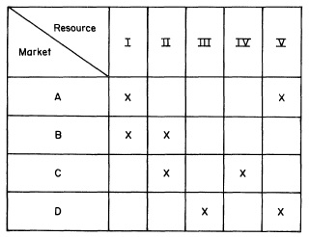

However, as the author mentions himself, the original paper is too abstract and lacks practicality of the ideas (Wernerfelt, 1995). While explaining the resource-product matrix the author assumed too theoretical market conditions, that have little in common with reality. He also did not suggest ways to measure different kinds of resources (e.g. knowledge) and did not offer a structured view of resource types. Wernerfelt suggested that in order to gain competitive advantage a firm must possess heterogeneous and immobile resources, but it appeared to be insufficient condition to sustain this competitive advantage. This issue later found the solution in the evolved concept of RBV (Barney, 1991).

Barney is known for his contribution to the link between resource-based view of the firm and sustainable competitive advantage. In his work “Firm Resources and Sustained Competitive Advantage” (1991) he not only gave the classification of firm resources, but also developed a framework for distinguishing among different types of company performance. The author also distinguishes what makes a competitive advantage sustainable - implementation of a “value creating strategy not simultaneously being implemented by any current or potential competitors and when these other firms are unable to duplicate the benefits of this strategy” (Barney, 1991, p.102).

According to Barney, there are three types of resources a firm can possess: (1) physical capital resources, (2) human capital resources and (3) organizational capital resources (Barney, 1991, p.101). The author develops a VRIN (later, VRIO) framework, according to which a resource, in order be a source of sustained competitive advantage, must be (1) *valuable*, i.e. exploit an opportunity or diminish a threat on the market, (2) *rare*, i.e. unique and none of the competitors can possess it, (3) *in-imitable*, i.e. hard or costly to imitate, and (4) *non-substitutable* (later renamed to “*organized*” in order for a firm to exploit it (Barney & Hesterly, 2011), i.e.aq there is no strategically equivalent resource (Barney, 1991, p.112). Putting these assumptions together and the abovementioned framework, a summary can be put in the following table, where questions define the resource attributes:

Table 1 VRIN framework

|  |  |  |  |  |
| --- | --- | --- | --- | --- |
| Is it Valuable? | Is it Rare? | Is it hard to Imitate? | Is it Non-substitutable? | Result |
| No |  |  |  | Competitive disadvantage |
| Yes | No |  |  | Competitive equality |
| Yes | Yes | No |  | Temporary competitive advantage |
| Yes | Yes | Yes | No | Unused competitive advantage |
| Yes | Yes | Yes | Yes | Sustained competitive advantage |

Nevertheless, there are some flaws in Barney’s model. Until updated in 2002 (Barney, 2002), the framework claimed the non-substitutability of a resource as a separate attribute, however, from the empirical point of view this attribute is quite similar to in-imitability. Also, some authors (Priem and Butler, 2001) believe that this framework is tautological and does not comply with the theory of the firm. Also, Barney’s paper is built on an assumption that resources and capabilities are identical terms, whereas they are not (will be discussed later in this paper), and thus puts little emphasis on this important aspect. Moreover, Barney himself admitted (Barney, 2001) that his theory applies only to static environments, whereas today’s business reality is dynamic and changes rapidly, which makes irrelevant assumptions of sustainability. Finally, the VRIN framework lacks managerial implications and does not explain how managers can actually gain such resources.

A further research of Margaret Peteraf (1993) adopts Barney’s ideas and presents additional four conditions underlying a firm’s ability to generate above-average returns: superior resources (heterogeneity within an industry creates extra rents), ex post limit to competition (prevents the rents from being competed away), imperfect resource mobility (ensures that valuable factors stay within the firm) and ex ante limits to competition (keeps costs from offsetting the rents) (Peteraf, 1993). She also suggests the implications for the RBV theory both in single business and corporate strategy, in contrast to many scholars (Porter, 1991; O’Shaughnessy, 1996; Priem and Butler, 2001) which said that RBV can hardly be used in real-life conditions. Later Peteraf and Barney (2003) made it clear that their frameworks are consistent once some terms are unambiguously defined.

However, at the time, Peteraf’s paper repeated the flaws that were already mentioned in Barney’s work (1991). Although she suggests possible managerial use of the resource-based view of the firm, there were no clear distinguishing between firm’s resources and capabilities.

## 1.2 Resources and Capabilities

Further development of the RBV theory showed that some scholars (Grant, 1991) believed that there is a difference between capabilities (some call them competencies, which is incorrect as this term has another meaning and will be explained later) and firm’s resources. Indeed, firms on the same market may have the access to identical resources (though the amount would be different as we assume that resource distribution is heterogeneous), and at the same time achieve different results. There must be something more than just resources that influence firms’ performance.

One of the key papers that developed the idea of competencies is “The Core Competence of the Corporation” by Prahalad and Hamel (1990). In the article the authors argue that competitiveness of a firm derives from an ability to build the core competences on the basis of corporate-wide technologies and production skills (Prahalad and Hamel, 1990). They define core competencies as “the collective learning in the organization on how to coordinate diverse production skills and integrate multiple streams of technologies” (Prahalad and Hamel, 1990). Physical resources decay over time, whereas core competencies are enhanced and do not wane with use (Prahalad and Hamel, 1990). Authors outlined three tests that must be applied to determine whether something is a core competence:

* “Core competence must provide potential access to a variety of markets”;
* “Core competence must make a significant contribution to the perceived customer benefits of the end product”;
* “Core competence must be difficult for competitors to imitate” (1991).

Since Wernerfelt (1984), the authors moved from the concept of a firm as a “resource portfolio” and changed it to “competence bundle”. Also, the authors were among the first who started to put emphasis on strategic business units of a firm (SBUs). The article had a huge impact on management society and forced firms to rethink what they consider to be the source of their potential and what they could potentially outsource or get rid of.

Picture 2 Prahalad and Hamel’s model of a diversified corporation (1990)

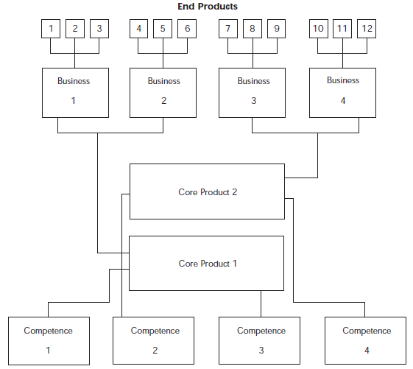

However, authors’ explanation of the term “Core Competencies” is too vague and the paper itself lacks theory and scientific approach. The paper is based on a case study research corporations and is obviously biased towards the success stories of Japanese corporations (whose performance, by the way, decreased at the end of the decade). Case studies are also dependent on a single case exploration making it difficult to generalize conclusion (Tellis, 1997). Moreover, the paper is written in a way that may be appropriate for large companies, whereas small and medium enterprises are ignored.

Another valuable starting point in the separation of capabilities and resources is presented in the work “The Resource-Based Theory of Competitive Advantage: Implications for Strategy Formulation” by Robert Grant. In the paper, the author creates a framework of a five-stage procedure for strategy formulation (Grant, 1991).

Picture 3 A practical framework of a resource-based approach for strategy formulation (Grant, 1991)

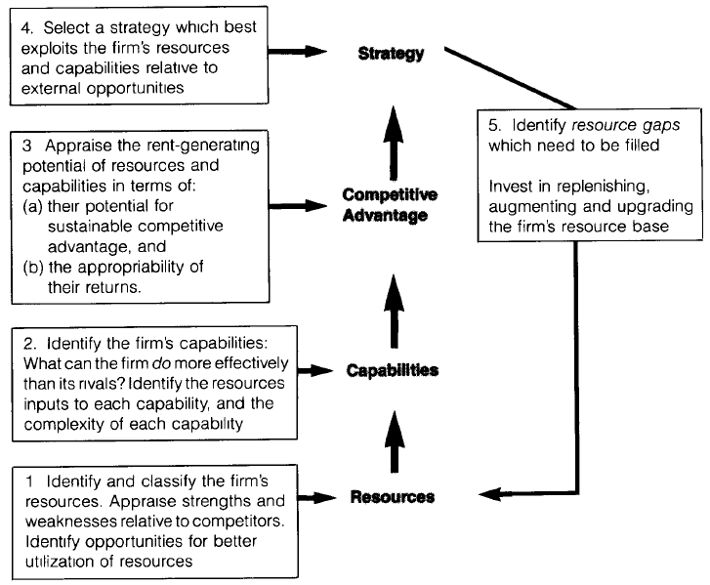

Although the author argues that resources are the fundament of strategic positioning of a firm (whether cost or differentiation advantage on a large or small scale), he also provides a distinction between firm’s resources and capabilities. Grant defines resources as “inputs into the production process… [that] include items of industrial equipment, skills of individual employees, patents, brand names, finance and so on” (Grant, 1991). At the same time, combinations of resources and “the capacity for a team of resources to perform some tasks or activity” is defined as a capability (Grant, 1991). The relationship between those two is that resources are sources of firm’s capabilities, which are, at the same time, sources of competitive advantage that defines future strategy of a company (Grant, 1991). This significant distinction between those two terms has changed the future development of the RBV in terms that resources are no longer the shaping force of strategic decisions, they are instruments that enable certain unique capabilities, when combined and utilized.

Grant (1991) provides a classification of resources, which is much broader than that of Barney’s (1991). He was probably among first scholars which regarded capabilities as more important than resources for the sake of sustaining competitive advantage. Grant also came up with four determinants of the sustainability of competitive advantage, based on attributes of core resources and capabilities (1991). The ability of company’s capabilities & resources to sustain competitive advantage helps design a strategy that makes the best use of these critically important resources and capabilities, or obtain new ones and update a firm’s resource pool in case a resource gap is found (Grant, 1991).

In his later works (e.g. Grant, 1996), the scientist provides a knowledge-based approach to the RBV and argues, that it is not *resources* themselves that generate competitive advantage, but *capabilities* of managers to exploit them, which further proves his initial approach. Grant formulates a gradation of integration capabilities from individual resources to the organizational capabilities in dynamic and unpredictable markets, which extends the idea of RBV (Grant, 1996). Grant’s papers provide a massive research field for further development of the RBV using a neater terminology of resource and capability.

Further distinction between resources and capabilities was done by Amit & Shoemaker (1993). In their work, they focus on linkages between the industry analysis framework (Porter, 1979, 2008), the RBV (Wernerfelt, 1984; Barney, 1991; Grant, 1996) and Behavioral Decision Theory (BDT) (Shoemaker, 1990). The authors define resources as “stocks of available factors that are owned or controlled by the firm”, whereas capabilities are “firm’s capacity to *deploy* resources, using organizational processes, to affect a desired end” (Amit & Shoemaker, 1993). Resources are converted into final product, and capabilities are processes that are developed through combination of resources and based on creating, carrying and transferring information between employees (Amit & Shoemaker, 1993). This leads us to a conclusion that a capability is always firm-specific and depend on a firm’s existence (since they are implanted in the firm, its processes and employees), whereas a resource is an asset that can potentially belong to any firm in an industry regardless of its performance. If we take Intel corporation, for example, and imagine that it disappears, then their registered microprocessor patents (a resource) could still exist, but the skill of making innovative microprocessors (a capability) would be lost (Makadok, 2001).

Authors mention, that resources and capabilities (R&C) should be complementary, but not substitutable, because their combined value to a firm may be higher than the cost of developing each asset separately, thus, if they can substitute each other, their collective value decreases (Amit & Shoemaker, 1993). Authors believe that Core capabilities (strategically important) are more important for the firm as they cannot be purchased, but rather require vision, time and investments to develop (Amit & Shoemaker, 1993). They also emphasize the importance of managerial decisions of developing, exploiting and investing in core R&C for the sake of competitiveness, innovation and positive rents potential. These strategic decisions are always under the pressure of uncertainty, complexity and potential conflicts (see agency theory by Jensen and Meckling, 1976), which makes manager risk averse and slow in making decisions, thus missing opportunities (Amit & Shoemaker, 1993).

Amit & Shoemaker argue that capabilities and processes are synonyms, however, it is not completely true (will be explained further in this paper). Authors also suggest that a complex view on the firm competitiveness must be applied (from the point of view of industry analysis (Porter, 1979, 1980), RBV and BDT), but they do not offer any concrete frameworks and do not provide any examples of case studies of such an approach.

A more modern approach in identifying resources and capabilities has been studied by many scholars (e.g. Eisenhardt and Martin, 2000; Makadok, 2001; Homann et al, 2005, Rosen, 2010 and many others). For example, in a more realistic context of constantly changing environments, Eisenhardt and Martin (2000) further develop a term “dynamic capabilities”, previously explained by Grant (1996) and Amit and Shoemaker (1993), and explain it as “the firm’s processes that use resources [...] to match and even create market change” (Eisenhardt and Martin, 2000). In other words, dynamic capabilities are simple organizational routines by which managers create, use, manipulate and recombine resources in order for the firm to adapt to changing conditions and thus create value (Eisenhardt and Martin, 2000). Examples of dynamic capabilities are: alliance and acquisition routines, knowledge creation and brokering, product development, strategic decision making, patching, exit routines. However, authors themselves argue that dynamic capabilities themselves are not sources of long-term competitive advantage, because according to RBV, although they are valuable and most of the times rare, they are also quite mobile, imitable and substitutable. Eisenhardt and Martin suggest that in dynamic markets, where sustainability is achieved almost nowhere, it is more logical to use dynamic capabilities to develop a sequence of temporary competitive advantages that should match the current situation on the market.

## 1.3 Capabilities, Competencies and Processes

During the literature analysis I mentioned, that many scholars synonymize terms “capabilities”, “competencies” and “processes”. For example, Amit and Shoemaker (1993) as well as Eisenhardt and Martin (2000) stated that *capabilities* are actually information-based processes. Prahalad and Hamel (1990), on the other hand, mostly focus on *competencies* as the collective learning on how to coordinate skills and integrate technologies. All these scientists are considered to be the fathers of competence-based view (CBV) - an extension of the classical RBV theory that focuses on competencies of the firm as a source of competitive advantage. However, interpretations the above-mentioned terms are fairly alike.

Some scholars (e.g. Kangas, 1999) put a strict distinction between capabilities and competencies. Kangas argues that organizational competency is a unique *knowledge* owned by the firm (similar to a definition of Prahalad and Hamel), whereas capabilities refer to a firm’s *skill* to use its competencies (Kangas, 1999). In contrast, Beimborn, Martin and Homann (2005) state that competencies should be regarded as the cross-functional integration and coordination of capabilities, thus reversing the usual hierarchy. Although this approach looks quite odd, it helps the authors develop a special capability-mapping technique that will be revised later in this paper. Another contributor to the competence-based theory of the firm (CBV), Freiling (2004), argues that it is not necessary to differentiate between capabilities and competencies. However, he does state that in contrast to resources, which are the results of successful asset management process (Freiling, 2004), competencies are the abilities to sustain these results of asset refinements in order to achieve organizational goals.

In order not to deepen into the terminology debates, in this paper we will consider the following: since competencies and capabilities are all parts of the RBV, and the starting point of both of them are resources (including those that are used to perform processes), it is reasonable to assume that competencies and capabilities are basically the same things. Further on we will use the definition by Business Architecture Guild, which states that a capability is “*a particular ability or capacity that a business may possess or exchange to achieve a specific purpose or outcome*” (Business Architecture Guild, 2016). In my opinion this is the simplest and, at the same time, full definition of what a capability is.

At the same time, it is essential to agree on the terminology when we talk about processes. Our compatriots Oikhman and Popov (1997) stated that the term “process” (“business process” in our case) is extremely important as managers tend to misunderstand it and confuse it with such concepts as “tasks”, “jobs” or “goals”. The authors defined “business process” as “many internal activities, that start with the one or more inputs and end with the creation of products required by the client” (Oikhman and Popov, 1997). They also mention that the “client” may not necessarily by an outside buyer, but it can also be another process in the external environment.

A firm can have many processes that basically start from resources and end with either another processes or creation of a product. Modern authors, such as Rosing, Scheer and Scheel (2015) created the whole handbook about business processes, where they divide internal business processes into three groups based on management levels:

* Management (strategic) processes govern the operation of a system.
* Operational (tactic) processes create the primary value stream.
* Supporting (operational) processes support the core processes.

Another interesting thing about processes is that by identifying and analyzing the efficiency of the process helps to optimize the business capability’s effectiveness (The Open Group, 2016). Thus, we can say that a combination of business processes also forms a capability, but from a perspective of action, because it is fair to assume that business processes do consume resources in order to be executed, and regularly performed well-established processes actually form an organizational capability.

In this research paper, we will use the abovementioned definitions of capabilities and processes and will assume that *competencies and capabilities are mostly the same things*.

Business Architecture (BA onwards) is the tie that binds business **processes**, organizational **capabilities**, business **strategy** and **information flows**. As mentioned on the website of Business Architecture Working Group, BA is a “formal blueprint of governance structures, business semantics and value streams across the extended enterprise” that “articulates the structure of an enterprise in terms of its capabilities, governance structure, business processes, and business information”. (BAWG, 2012).

BA combines several views on the enterprise, including Business Strategy, Business Capabilities, Business Process and Organizational views, in order to develop an integrated picture of the company (BAWG, 2012). Strategic view considers tactical and strategic goals of an organization, that are mapped to metrics for evaluation of how successfully the organization is achieving its goals. Capabilities view defines the primary business activities and the departments of the company that perform those functions. Process view not only describes the set of management, operational and support processes that expand functional and organizational boundaries, but also depicts which people, resources and controls are involved in the process.

Overall, by combining theoretical and practical approaches of RBV and by applying relevant methods, tools and different views on the organization from the BA point of view, organizations can not only achieve and sustain competitive advantage, but also execute needed processes and adapt to constantly changing external and internal business environment. This approach makes enterprises agile and helps them successfully execute business transformations (Grigoriev and Kudryavtsev, 2011).

## 1.4 Strategic Planning

Resource-Based View management philosophy, including everything that is in it is a wide approach to strategic management. But what about strategic *planning*? Getting to know the company from the inside and developing its capabilities to sustain competitive advantage is definitely useful. But in any way, it all starts from analysis of current situation and creating a plan.

According to the Balanced Scorecard Institute, strategic planning is a management activity of an organization that is used to set priorities, focus resources, strengthen operations, ensuring that all employees and stakeholders are working towards common goals, and setting organizational direction in accordance to changes in environment (Balancedscorecard.org, n.d.). This activity produces fundamental decisions and actions that shape and guide organization with a focus on future.

One of the first approaches to enterprise strategic planning was Hoshin Kanri, successfully used by Toyota in 1960s (Page, n.d.). From the Japanese, “Hoshin” means setting an objective, “Kanri” stands for management, together the meaning is “management of objectives”. It is a strategic planning and implementation method which gives direction to an organization and ensures that the goals of a company are translated into action at every level within a company. Within this aspect, Hoshin is a breakthrough objective that the organization will accomplish over the next twelve to eighteen-month period of time

The initial stage of Hoshin Kanri, as it will be seen later in the text, is quite common for any strategic planning process (Boisvert, 2012). It starts from top management gathering data on current company situation, identifying objectives and vision within a 3-5 years’ period and setting KPIs to these objectives. Usually not more than 5 goals (Hoshins) are advised to be identified. Then, Hoshin-style strategic planning decomposes in four important ways: “the degree of focus, the involvement of all levels of the organization, the use of planning and process improvement tools, and the rigor of the reviews” (Boisvert, 2012).

Focusing means selecting one hoshin for a planning year. After is has been done, it is important to conduct a “catchball”, which is the activity that connects selecting the hoshin and deploying it. In catchball, managers and front line workers develop the tasks and metrics to support the accomplishment of the hoshin by being asked “what are the things that we need to do to accomplish our part of the strategy?”. The output of the activity is developing of an annual plan table. Then the detailed plans transferred to the executives through the higher levels of the plan, which allows for adjustments in the highest-level strategies. This kind of tossing back up of these plans reflects the word "catchball" (Boisvert, 2012). Then planning meetings of executives with employees are being conducted, where planning tools and tables are filled to support consensus decisions (e.g. Hoshin matrix, Picture 4). These plans are often reviewed and updated, metrics are checked for misses or mistakes. It is all done through company meetings. At the end, the company has the reviewed and detailed plan of implementation of every hoshin, and the workers know exactly what they need to do and how they are going to do it to achieve a common goal.

However, as one might already mention, this method of strategic planning is extremely slow and does not consider the time it takes to conduct such procedure and approve the plan at all the levels of company. This can be normal for the Japanese culture, but western companies are afraid to implement such approach on a regular basis, because it is very time-consuming. Also, the Hoshin matrix and many of the numerous tables and reports, that have to be filled and somehow collected documented (which is often not done correctly, thus it is definitely another flaw of the method) appear to be extremely complicated and most of the time require a prerequisite real-time training of those who are responsible for filling these tables. And in the end, if the hoshin is unprecedented, the company may not know how to measure it. Over-attachment to existing measures that have been around a long time but are no longer connected to the direction of the organization can distort how the executive team evaluates the success of the hoshin plan (Boisvert, 2012).

Picture 4 Hoshin planning matrix example

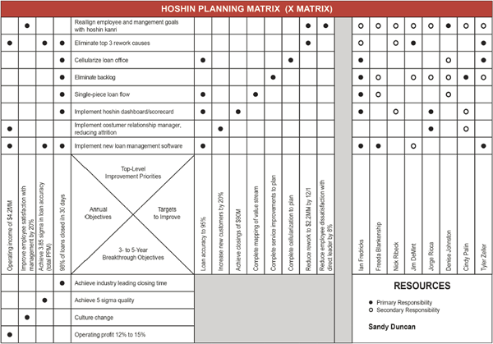

Switching to the western practice of strategic planning, the two most influential scientists that promoted the idea of strategic planning are Robert Kaplan and David Norton. Their article “The Balanced Scorecard – Measures that Drive Performance” (1992) and the ideas expressed in it are still widely used by many companies, including SMEs, all over the world.

The authors of the article stated that current (at that time) measurement systems in organization, that separates financial KPIs and operational, is obsolete and gives “misleading signals for continuous improvement and innovation” (Kaplan and Norton, 1992), thus arguing that in order to be competitive a company must have a balances presentation of financial and operational measures. It could help identify possible weak spots, take actions to improve them and drive future company performance, which basically what strategic planning is about.

To promote such an understanding of the situation in the company the authors came up with a concept of balanced scorecard tool (BSC), which is “a set of measures that gives managers a fast but comprehensive view of the business”. This tool allows to assess the company from four different perspectives:

* Customer
* Internal
* Innovation and learning
* Financial

Picture 5 Balanced Scorecard concept (Kaplan and Norton, 1992)

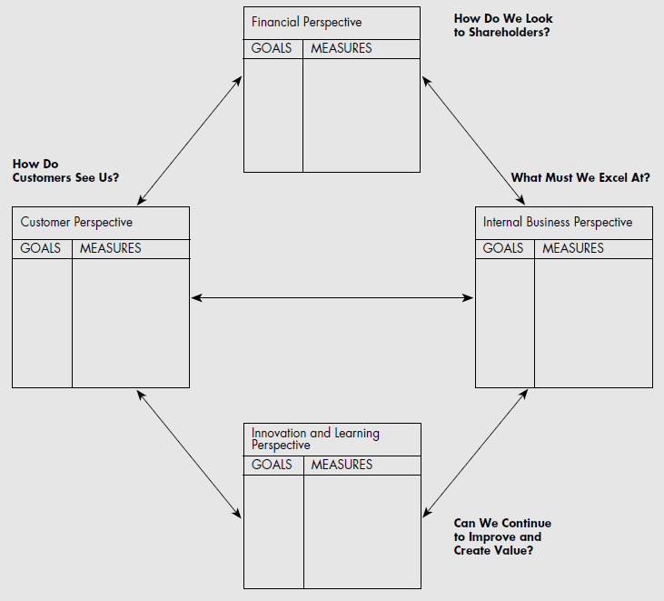

To use the BSC properly, firms need to translate goals in each of the 4 perspectives into measures and factors that really matter. The authors claim that this tool meets several managerial needs:

* Brings together, in a single report, several elements of the company focal points;
* By forcing senior manager to consider all the important measures together, the tool lets them see if the improvement in one area have been achieved at the expense of another (Kaplan and Norton, 1992);

Nevertheless, at first the BSC looked like a useful analytical tool and did not seem to help in generating strategic decisions, until the authors updated the concept in 1996, which now was enabling organizations to translate a company’s vision and strategy into implementation.

Picture 6 Balanced Scorecard provides a framework to translate a strategy into operational terms (Kaplan and Norton, 1996)

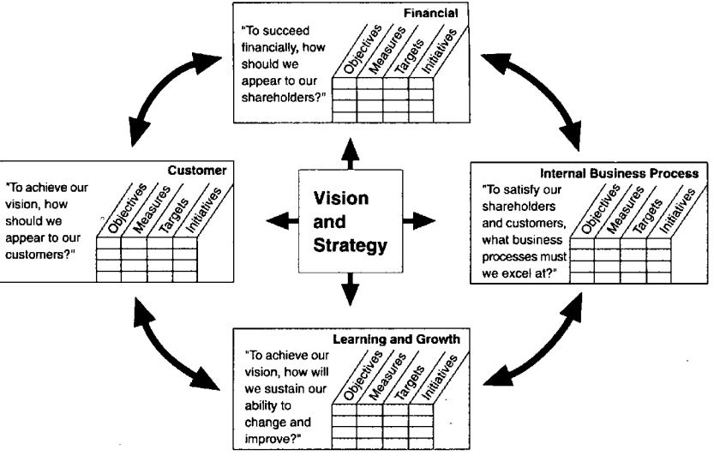

* Vision and Mission help formulate the strategy, which in turn clears up strategic objectives – continuous improvement activities that have to be performed in order to implement strategy and achieve strategic goals (e.g. increase revenue, improve customer experience, improve cost-effectiveness and so on).
* From financial perspective, authors say that, although financial data is no doubt very important, business owners and manager put too much emphasis on finance-related data, which leads to misbalance with regard to other perspectives, and propose including additional data (e.g. risk assessment and cost-benefit data) (Kaplan and Norton, 1996) to maintain a more effective use of resources.
* From customer perspective, it is important to focus on customer satisfaction as it is a leading indicator of future company performance, even though current financial situation may look good.
* From the internal business process view, such metrics allow the managers to know how well the business is functioning and whether products and/or services match customer requirements. The authors also separate different kinds of processes into three groups: strategic management processes, mission-oriented processes and support processes. Each type should be measured and influenced.
* From the learning and growth perspective, it is all about employees. Training and corporate cultural attitude, individual and corporate self-improvement and so on. The authors state that in current rapid technological change environment it is essential for knowledge workers “to be in a continuous learning mode” (Kaplan and Norton, 1996). When companies are unable to sustain training of existing employees and hiring new ones with needed knowledge and skills, the company is showing a decline.

In essence, the BSC approach demands that organizations keep track on these four types of measures and identify corporate objectives within each category, and then align management hierarchy by assigning each manager a scorecard with more specific objectives, thus focusing every manager of a balanced set of performance measures.

The concept of the balances scorecard has been widely adopted and is still used in business and industry, government and nonprofit organizations around the world. However, it has attracted a lot of criticism. For example, it has been criticized for the lack of scope of the balanced scorecard itself as it does not provide instructions on developing strategies (Brignall, 2002)[2] or for the lack of other perspectives that are important in nonprofit organizations (e.g. Kong, 2010)[3]. The biggest criticism was that BSC is just a list of metrics (Jensen, 2001[4]) and, although a more comprehensive performance measurement system is a great idea, executives needed a tool to apply it to solve the main problem – how to implement new strategies.

*Strategy map* (Kaplan and Norton, 2004) is a natural evolution of the BSC, and has become a methodology within a so-called Value-Based Management philosophy (see 1.5 for details about value-based view) as it assumed to describe how the company can create value for its stakeholders. The authors transformed the BSC by using a top-down method that starts with the executive team defining organization’s strategic goals, and then passing those goals downward using the BSC. Kaplan and Norton state that the strategy map is a “visual framework of the cause-and-effect relationships among the components of an organization’s strategy and it is used to integrate the four perspectives of the BSC” (Kaplan and Norton, 2004). By using a strategy map, managers and executives can describe strategy and decompose it into objectives and thus establish and manage measures on the balanced scorecard.

Picture 7 Strategy map template (Kaplan and Norton, 2004)

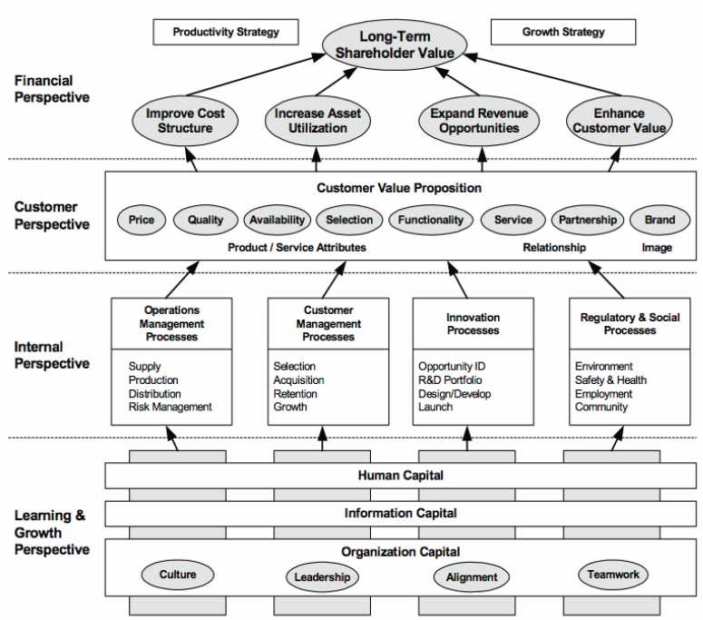

The essence of a strategy map is that desired financial goals are closely related and directly influenced by customers and the value that the company creates for them, which in turn involves outstanding performance of internal organizational processes, enabled by intangible assets. The strategy map illustrates the relationships that link the desired outcomes to performance improvements, which in turn help create and deliver value. The key point here is that the intangible assets, that are invaluable to sustainable value creation, must be *aligned* to the strategy and objectives at the top of the map and *integrated* with each other to achieve synergy. In their book, Kaplan and Norton suggest which activities help in aligning intangible assets to strategic goals, and propose some generic algorithms for customizing the strategy map for an enterprise. In the end of the planning stage, authors propose the use of initiatives, which are the projects with a start and end date, designed to put the organizational strategy into action

However, strategy map is not flawless. Although the authors emphasize that the intangible assets along with initiatives to improve them must be aligned with the strategy, the problem with any of these initiatives is that authors do not explain how to achieve such alignment and coherence, and thus if these initiatives are not carefully thought over, they just get lost in all the other not so important for strategy achievement processes. If the company has too many initiatives ongoing (which is a natural outcome of using strategy map), and these initiatives, although looking sane and doable, are not specified into smaller pieces and reviewed on a regular basis, it becomes hard to actually get things done and follow the strategic course. Moreover, it is not clear how to balance short-term (e.g. cost-reduction) objectives with long-term goals (e.g. innovation and relationship), as the framework does not provide the prioritizing scheme or explanations on balancing[5]. The framework also does not assume that some improvement projects are more important than the others and thus need to be prioritized (which is also a kind of coherency procedure). Going further, it is not clear how these four internal processes fit together to produce value, if the company produces more than one product or services, or has business units producing different product lines. Maybe the authors meant that for each business line there has to be a separate strategy map, but still it is not clear how to align them within the whole organization regardless of its size. And as a finishing note, strategy map carried one more flaw from the BSC – it can hardly be adapted to organizations that are not multinationals, e.g. SMEs, nonprofit or government.

In 2008, Kaplan and Norton presented their so-called Closed-Loop Management system, that describes how strategy, operations and monitoring are linked.

Picture 8 Closed-Loop Management System (Kaplan and Norton, 2008)

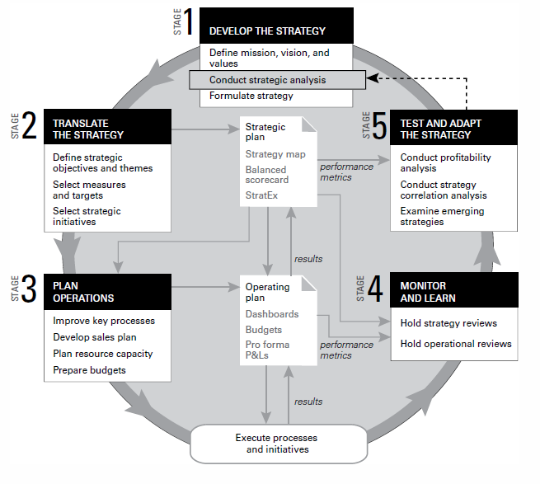

In this closed-loop management system authors decided to implement the idea of strategic themes, which is basically a strategy map for a particular business unit, linked to its goals and objectives within the whole organizational strategy map. This can be a solution for inconsistency and incoordination of overall company initiatives. Also, as one can see, the authors implemented their concept of BSC and strategic map onto this framework, which seems quite logical and agile. But still it carries the flaws of BSC and Strategy Map as they are included in the scheme.

## 1.5 Capability-Based Planning

Capability-based planning is an alternative view on how strategic organizational transformation can be planned from the capability improvement point of view.

Nowadays more organizations are faced with a rapidly-changing environment, which means they have to go through more frequent transformations to stay competitive. Of course, there are multiple frameworks, which are supported by methods, languages and tools, created for designing, planning and implementing organizational change. However, these frameworks are designed primarily for Enterprise Architecture professionals and lack a business-focused view to understand “what” a business does and where investments will bring the most value. This makes it difficult to elaborate the required changes in terms that businessmen recognize. Also, long-term strategic plans, delivered by business leaders, need to be specified and made actionable in a way that everyone understands and can act upon them. In addition, it is not always easy to predict the moment of change, and when the time comes, it is even harder to understand which processes or capabilities need to be transformed. The Capability-Based Planning approach can potentially eliminate this gap and uncertainty.

Capability-based planning (CBP) was originally proposed by the Department of Defense (DoD) in the US, UK Australia and Canada and is used in military agencies. Business experts and enterprise architects adapted this approach for business purposes using organizational capabilities. They stated that organizational capabilities can be used as the business-oriented starting point for any discussion around strategic planning and can help determine the impacts of those plans from an enterprise perspective (Ulrich & Rosen, 2011). Capability-based planning (CBP) also assumes, as it was mentioned in section 1.3, that capabilities are the ways in which enterprises combine resources, information, processes, and their environments to deliver value to stakeholders.

Capability-based planning is a powerful mechanism to ensure that the strategic business plan drives the enterprise from a top-down approach: no matter how the corporation structures itself, the delivery of business capabilities will require coordination and alignment across business verticals (TOGAF 9.1, 2011). Aldea et al. (2016) stated that CBP allows to plan organizational transformations in terms of capability changes over time (e.g. creation, improvement or elimination (outsourcing) of a capability). In other words, *CBP is a technique for planning of improvements and setting investment priorities in capabilities that would contribute to realizing a specific organizational strategy* *and deliver the most value to an organization* (Aldea et al., 2016). CBP accommodates most, if not all, of the corporate business models and is focused on identifying and planning high-level capability improvements. Managing such improvements is challenging, but in the end, it will deliver synergistically derived business value that will lead to increase in profitability and stock value (The Open Group, 2011).

Such improvements are done via executing business or technology improvement projects, and are planned in terms of *capability increments*. A capability increment is “a version of a capability that represents a change in the performance/maturity of the capability” (Aldea et al., 2016). To put it simple, capability increments look like step-by-step changes of a certain capability. The TOGAF standard states that capability increments are brought about by changes to *Capability Dimensions*, that result in performance change. A capability dimension is “an aspect of a capability that has to be analyzed, assessed, and actioned in order for the capability to be realized” (Aldea et al, 2016). There can be any number of capability dimensions, but all of them should be well explained and understood. TOGAF standard assumes 3 main groups of capability dimensions, in each of the group could be any reasonable number of dimensions:

* People Dimension (e.g. Individual training, Collective training, Professional development, etc.)
* Process Dimension (e.g. Concepts, Business processes, Information Management)
* Material Dimension (e.g. Infrastructure, Information Technology, Equipment, etc)

The changes in performance of a capability, as well as target parameters, are assessed, measured and evaluated by applying qualitative or quantitative metrics. Developing a capability will normally involve many projects delivering numerous increments. In addition, stakeholders expect to gain real business value from the capability as soon as possible, so the improvements need to maintain momentum and achieve the associated executive support and corporate funding. Therefore, it is useful to break the capability into capability increments that deliver discrete, visible, and quantifiable outcomes as well as providing the deliverables from numerous inter-dependent projects (TOGAF 9.1, 2011).

An easy way to describe how the capability will evolve over time and map the “*before*” state of a capability, all the increments (“*after*”) and align them on dimensions is by using a Radar chart (see picture 7 for an example). The architect selects the important aspects of capability (dimensions) as lines radiating from the center. Against each line, the architect draws points that represent significant "capability points" (from "lowest", which are nearest the center, to "higher", farthest from the center). By joining up the capability points into a closed loop, the architect can demonstrate in a simple form how each capability increment will extend on the previous increment (TOGAF 9.1, 2011).

Picture 9 Capability Increment “Radar” (TOGAF 9.1, 2011)

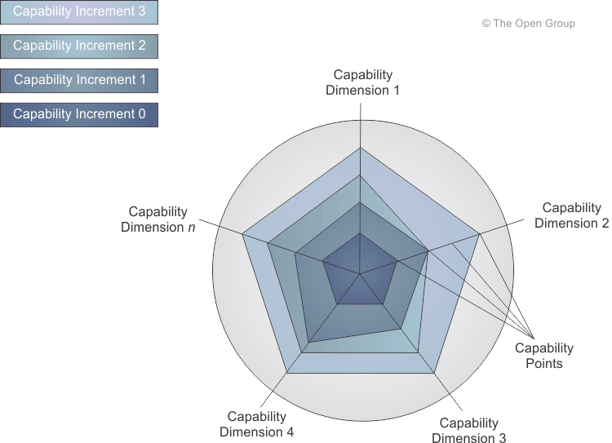

As proposed by Aldea et al. (2016), CBP includes 4 activities, which can be performed in successive cycles:

* Map (identifying, describing, relating and decomposing capabilities of the organization, linking them to their goals)
* Analyze (identifying metrics/KPIs and their scoring, under/ over-performing, missing or duplicative capabilities based on targets and strategy, building heat maps)
* Plan (planning of increments (improvements) over time, allocating resources, composing scenarios and roadmaps, collaboration across organization)
* Improve (identify performance levels and compare to expected levels, review and assess implementation with respect to people, procedural steps and asset usage)

Grant stated that establishing the competitive advantage requires formulating and implementing a strategy, which exploits the specific resources and capabilities of an organization (Grant, 2016). Therefore, specific resources and capabilities are required for implementing a strategy, and CBP could help an organization to identify the required capabilities for executing a specific strategy and meet its strategic priorities (Cheng, 2015). Some concepts of Capability-Based planning will be used later in this paper.

## 1.6 Value Proposition and Value Mapping approaches

While talking about RBV, resources, capabilities, processes and business architecture, it is essential to remember that the global purpose of any firm is to make the customers satisfied and generate revenue for its owners. The purpose of any business is, first, to create value for customers and, second, to create value for the firm itself by extracting some of that customer value in the form of profit (Grant, 2016). In other words, an organization must create *value* for its *stakeholders* by leveraging *business capabilities* and executing organizational routine. The better business capabilities are realized and performed, the more value stakeholders get in the output. Moreover, an organization exists only if it provides enough value for at least one of its stakeholders. How can we define value?

The term “value” was the main focus of Michael Porter’s concept of value chain (Porter, 1985) and numerous scientific literature on that subject over the last 30 years. BIZBOK describes value as the “benefit that is derived by an organization’s stakeholder while interacting with that organization” (Business Architecture Guild, 2016). To put it simple, for a consumer, value is the solution of his problem, satisfaction, embodied in company’s product or service; for an investor, value is the amount of money he receives for investing in the company; for an employee, value is the salary he gets for working at the company, etc. Typically, the biggest problem for a commercial organization is the difference in values between the investors and the customers. When the investors are driving for revenues, this usually causes the customer satisfaction to fall dramatically.

Another key term that is nowadays being used regularly in business environment, is “value proposition”. It is the central notion of a business model, which describes how the business, through its activities, adds value to the consumer or marketplace. It is a statement from the viewpoint of the target customers that informs everyone why" the business' products and services are valuable (Motivationmodel.com, 2017). According to Osterwalder, value proposition describes the benefits customers can expect from a firm’s products and/or services (Osterwalder et al., 2014). Based on their previous work on Business Models (2010), authors developed a “Value Proposition Canvas” in order to visualize what particular groups of customers expect from a product or service, and how can a firm comply with their demands.

Value proposition can only be formulated and *visualized* through value mapping. Value maps are blueprints that articulate how value proposition is achieved (Business Architecture Guild, 2016). All value maps must be based on the following principles:

* stakeholder focused - viewing the organization from a stakeholder’s point of view;
* value-centric - each stage creates value for one or more stakeholders;
* easy to understand and take little explaining - simple depiction of how stakeholders achieve value
* provide a holistic view on how value is achieved and allow building common strategies across divisions or with external partners;
* facilitate a decomposition of views on how value is achieved
* define **how to leverage business capabilities** to achieve stakeholder value.

Most popular value mapping techniques include:

* Value chain (originally developed by Michael Porter in 1985). A famous and the oldest approach that provides a framework for identifying the distinction between value creating and supporting activities. Porter’s value chain analysis was a good fit for organizations that have a well-defined customer and are focused upon a defined discrete product and a family of supporting products. This is the main flaw in this approach - nowadays such situation almost never happens and the economy of developed countries is based mostly on services. Overall, value chain is a well-known approach and we will not discuss it in details.

Picture 10 Porter’s value chain analysis framework (Porter, 1985)

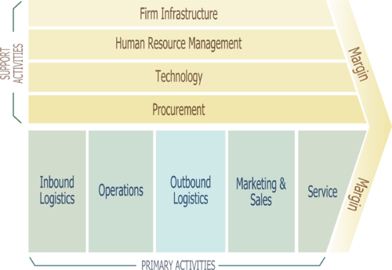

* Value stream is an alternative approach to value that is focused on defining organization-specific sets of core value-creating processes (Rother and Shook, 2003). It is a linear graph that represents how an organization provides value through a sequence of stages. Each stage should contain:
  + name
  + definition,
  + defined enter and exit criteria
  + identification of participating stakeholders.

Any given stage in the value stream could be decomposed into sub-stages. Each sub-stage can be decomposed into capabilities (that we talked about earlier) that enable this stage. This is the essential point of combining resource-based and value-oriented approaches (for details, see 1.7).

It is a stakeholder triggered, end-to-end depiction of how a firm delivers value to that stakeholder (Whittle and Myrick, 2005). This approach is popular in the sphere of manufacturing, but it is also used in logistics, supply chain, service related industries, healthcare, software development, product development, and administrative and office processes. Therefore, I will also use Value Stream as the basic value mapping approach.

Picture 11 Value Stream example (BIZBOK, 2016)

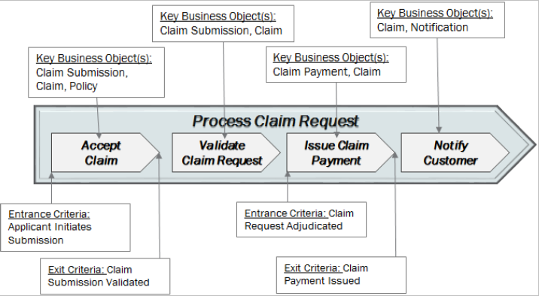

Value mapping techniques allow to conduct changes in business from the perspective of what is offered to the client and what must be kept or changed in the value proposition in order to achieve advantage on the market. In contrast to RBV concept and all the concepts that emerged from it, offering an “*inside-out*” perspective on how the firm operates (e.g. resources - capabilities - core capabilities - competitive advantage), by focusing on value it becomes possible for an organization to view itself from an “*outside-in*” perspective (e.g. how the firm’s external stakeholders see the organization providing value for them), which is a significantly different point of view and requires a serious mind-shift. Until the recent years these two approaches have not been complementary and actually contradicted each other (see details in paragraph 1.7). In this paper, I will further develop a concept that makes it possible to combine these two approaches in strategic business transformation.

### 1.6.1 Value stream heat mapping

Heat mapping is the evaluating the aspect of business architecture, defining the degree of its performance and assigning a rating that represents the performance. Heat mapping technique uses measurements criteria that enable the analysis of the actual performance of the business architecture elements (Roelens and Poels, 2014). These criteria include (BIZBOK, 2016):

* Quality and Correctness;
* Efficiency and Timeliness;
* Consistency and Standardization;
* Availability to stakeholder community;
* Performance against expectations.

Depending on the actual performance, BIZBOK (2016) identifies the typical heat mapping color coding scheme of value stream elements as follows:

* Red - Poor;
* Orange - Problematic, not severe;
* Yellow - Not working to ideal;
* Green - Working well;
* Purple (or other color) - Does not exist, but should;
* No color - not evaluated.

Picture 12 Heat-mapped value Stream example (BIZBOK, 2016)

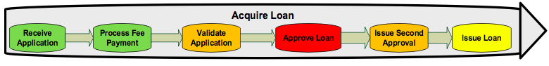

As the color coding is done, the improvement plan can be conducted in order to improve the performance of a certain value stream element or the whole value stream. This is a way reflects the core idea of Capability-Based planning, which was discussed in detail earlier in the paper. As various stages are improved, the colors are changed to reflect the improvements.

Most often cause for a red color of a value stream stage is the poor deployment of capabilities that should be enabling this stage (BIZBOK, 2016), and, therefore, it appears that value stream and capabilities are interconnected, which, in turn, signifies that Resource-based view of the firm, an inside-out perspective, and Value-based view of the firm, an outside-in perspective, can be combined (see 1.7.2 for value stream and capability cross-mapping approach).

## 1.7 Capability Mapping Approaches

By now we have considered two perspectives to designing business strategy: “inside-out”, which is Resource-Based theory in general and Capability-Based Planning specifically, and “outside-in”, which is Value chain theory and Value Stream mapping specifically. We have discussed that both these approaches can be used to strategically develop an organization whether by using the resources to improve processes or capabilities, or by focusing on the stakeholder value creation to leverage business capabilities and accumulate more value. How exactly do we use these approaches and how to understand which capabilities have to be improved?

### 1.7.1 Capability mapping and Heat maps

As capabilities represent the basic building blocks of a business, it is logical that these blocks can be used, improved, rearranged and leveraged in many ways to achieve a certain objective (Business Architecture Guild, 2014). In order to define capabilities a capability map is created, which delivers a business-centric view of a firm at its most basic level, so that we have a complete picture of what a business does. One the map is done, strategies and plans at any business level or within any business unit can be created and executed in symphonic way.

BIZBOK (2016) suggests several principles of business capability, that must be strictly followed in order to perform capability mapping. They include:

1. Capabilities provide business-centric views of an organization;
2. Capabilities are defined in short, concise terms: one should be able to see a business capability and immediately understand what it means;
3. Capabilities are nouns, because they describe *what* a business does, not *how* it is done;
4. Capabilities are stable, they rarely change within an organization;
5. Capabilities are defined once for an enterprise, regardless of how many business units possess that capabilities or how many business processes deploy it;
6. Capabilities decompose into more capabilities until a sufficient level of details is achieved;
7. There is only one capability map for a single business;
8. Capabilities map to other views of the business (e.g. value streams);
9. An automated capability is still a business capability;
10. If you cannot define a capability, it is probably not a capability, but rather a combination of business processes or other capabilities;
11. Capabilities are named and defined by the individuals and business units who have and exercise those capabilities.

Once we understand these principles, a capability map can be made. Homann et al (2005) defined a capability map (CM) as a “nested hierarchy of capabilities and a taxonomic diagram that describes the interplay of capabilities while doing business”. According to BIZBOK (2016) a business capability map presents a logically grouped set of capabilities that are independent of organizational structures, business processes, IT assets and company’s products. This statement is supported by Homann et al, who said that a capability map should not necessarily fit with the organizational chart, as it describes what is being done, not who is responsible for it.

There is no single correct way to perform capability mapping. However, the two most popular frameworks are used in modern practices: *decomposition* and *component business model*.

#### 1.7.1.1 Decomposition

Grand stated, that all the capabilities, that are defined by the company, can be disaggregated into more specialist capabilities, as well as functional capabilities integrate to form wider cross-functional capabilities (Grant, 2016). Thus, not only decomposition of capabilities takes place, but also their aggregation. Grant also argued that companies have a “hierarchy of capabilities where more general, broadly defined capabilities are formed from the integration of more specialized capabilities (Grant, 2016). Thereby it is evident that top-level capabilities are the most difficult to develop and improve, as they require a lot of effort from many different individuals and specialists, so it is easier to “disassemble” broad capability into smaller pieces and focus on those that are most problematic.

As it is might be already understood, all decomposition frameworks imply subdivision of higher-level capabilities (usually called Level 1 capabilities) into more specific groups. The level of decomposition depends on the level of details we need to achieve.

BIZBOK Guide (2016) suggests that all Level 1 capabilities can be assigned to one of three *stratification tiers*:

* Strategic: Direction Setting capabilities. Reflect those capabilities that reflect executive focal points;
* Core: Customer facing capabilities. Ensure viability and thrive in the marketplace
* Supporting capabilities. They ensure business functionality;

Picture 13 Example of stratified, Level 1 capability map (BIZBOK, 2016)

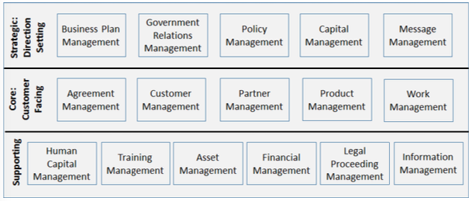

Business architecture guild, based on their rich experience, have created several “reference models” of capability maps for different industries, thus providing companies and business architectures with a useful starting point for developing their own individual models. They also state that Level 1 capabilities, represented in Picture 7, are common across many industries and governments, but the placement of a given capability in a certain tier is often industry or even company dependent: certain capability can be of a strategic tier in one industry, and, at the same time, of a core tier in another (BIZBOK, 2016).

Another similar approach was suggested by Homann et al in their capability-based model of a firm (2005), where they suggested that all Level 1 capabilities are basically the same for and are present in every company. These constant level 1 capabilities include:

* Product development
* Client interaction
* Collaboration management
* Fulfillment
* Plan and manage Enterprise

Regardless of the approach, all 1st level capabilities are then decomposed into a more detailed Level 2 capabilities, which in turn, if needed, are prioritized and those of priority are subdivided into Level 3 capabilities, and this process goes on until a needed level of details is achieved. It is not necessary to decompose all capabilities to the same level of details. Any decomposition beyond Level 2 requires validation of business professionals with expertise.

Picture 14 Example of capability decomposition into Level 3-4-5 (BIZBOK, 2016)

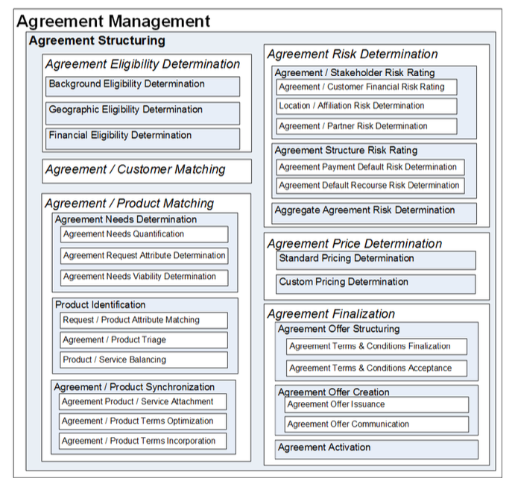

The flaw of both approaches is that they all require careful attention to details and are prone to redundancies and excessiveness. If the starter list of Level 1 capabilities is not refined, redundant and extraneous capabilities are not eliminated and the list is not validated and cross-checked against industry terms and concepts, the whole capability map would be incorrect.

Another interesting point is that Homann et al (2005) suggest that after capabilities have been mapped to a certain degree of granularity, their connections between each other have to be included. Indeed, sometimes it is essential to see how capabilities are interconnected. The problem is that in an organization (especially, a large one) there could be thousands of such connections between capabilities, so it becomes extremely complicated not even to analyze, but to map all of them. I believe the necessity of mapping capability connections depends on a scope and depth of analysis.

Homann also states that capabilities are regularly parts of many business processes and provide specific output, which is an input for any other process (represented by a capability). I do not believe this statement is correct, as we agreed that business processes and business capabilities are totally different things, and, moreover, processes are the smaller parts of an organization than capabilities. Thus, we cannot say that business processes cannot be represented by capabilities. Connections between capabilities can be made in terms of value stream mapping (see 1.7.2 for details), but not from the business process point of view.

Picture 15 Example of 2nd level capability map of a bank (Homann et al, 2005)

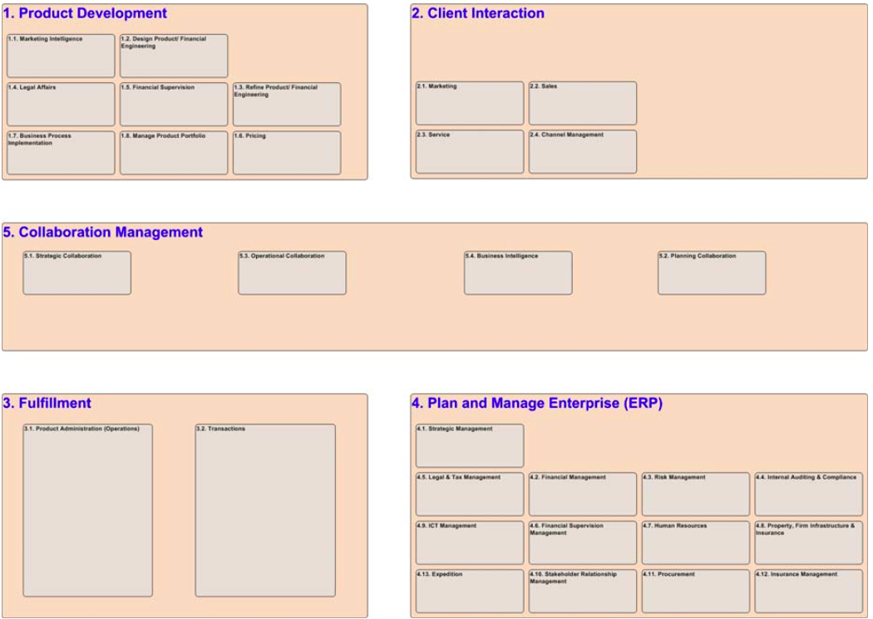

#### 1.7.1.2 Component business model

Component business modeling of a firm is an approach that has been widely discussed and used by IBM Institute for Business Value scientists (e.g. Pohle, Korsten and Ramamurthy, 2005; Coppinger, 2010). It is a slightly different approach to map business capabilities.

The authors of the framework claim that in a modern increasingly networked marketplace, organizations should focus on their specific areas of expertise, provide others with access to their specialized capabilities and become a part of industry “ecosystems” (Pohle, Korsten and Ramamurthy, 2005). At the same time, the more optimized the organization from the inside the better, as a firm can improve processes, share technology between business units and split risks. Thus, in order to pursue internal and external specialization, authors suggest that firms can use the concept of component business model (CBM).

A business component is a modular block that makes up a specialized enterprise (Pohle, Korsten and Ramamurthy, 2005). This definition is quite similar to the one of business capability (which was described in section 1.3). Authors state that every business component represents “highly cohesive” and autonomous activity and consists of four dimensions, shown in Picture 9.

The CBM framework allows to map all the business components, both internal (performed by the firm) and external (outsourced) by competency (capability) and accountability (same as “tier” in Decomposition framework) levels and form a component map of the entire organization (see Picture)

Picture 16 Dimensions of a business component (Pohle, Korsten and Ramamurthy, 2005)

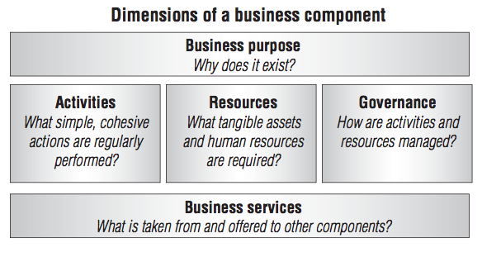

Picture 17 CBM Framework (Pohle, Korsten and Ramamurthy, 2005)

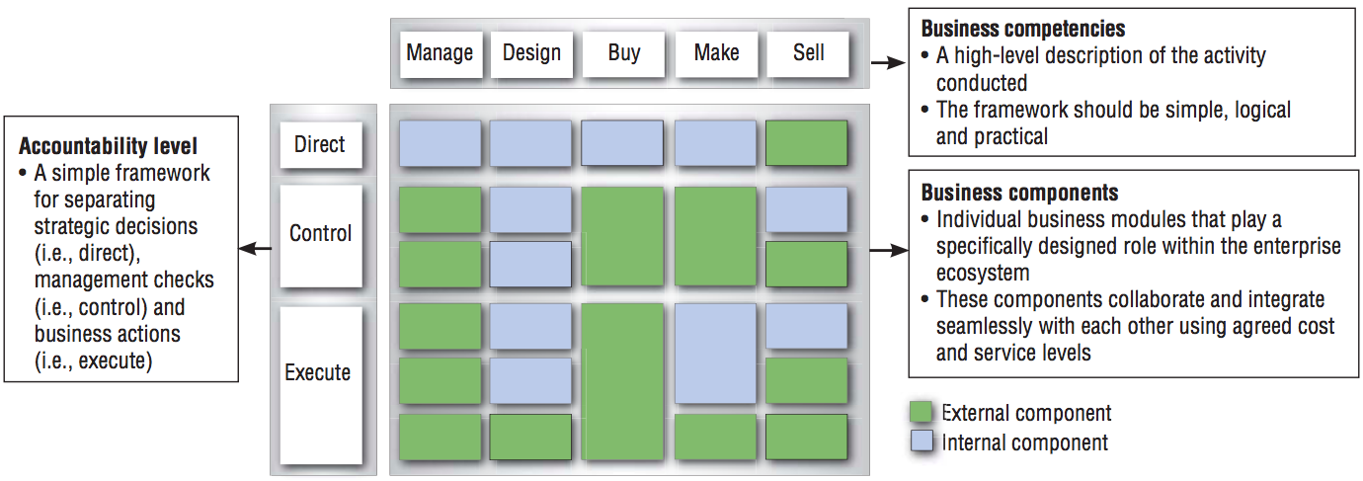

CBM framework allows to identify the gaps and redundancies in current state of business capabilities, provides a basis for developing strategic and operational insights for the business and helps determine which components require immediate attention.

This framework *does not require* to decompose business components into smaller parts, as each of them is supposed to be highly autonomous and thus be well-detailed, assuming a business component attains 5 dimensions.

#### 1.7.1.3 Capability heat mapping

Once the capability map (or a component map) has been created the goal is to identify the “hot” capabilities/components that need to be prioritized and worked with. This can be done using a heat map. I mentioned heat mapping of a value stream earlier in the paper (see 1.6.1 for details), and capability heat mapping uses the same approach and coding scheme. This is an essential step in the planning perspective in both capability mapping approaches - decomposition and CBM - as it serves as input to strategic business planning and helps leverage information for further capability improvement (see 1.4 for additional information) and identify the current versus future state capability development. The color scheme is a useful and simple way to visualize weaknesses in current capabilities or even the lack of capabilities (BIZBOK, 2016).

The criteria for color coding include criticality of the capability state (which includes number of problems and efforts required to fix them), its impact on business (for example, a poor performing Customer Relationship management capability in a customer-oriented company has a significant impact on company operations and profitability), and, of course, the level at which a capability is performing (for example, appropriate functioning of strategic capability is more important than supporting one). BIZBOK (2016) identifies the typical heat mapping color coding scheme of capability map elements is as follows:

* **Red** - Significantly problematic;
* **Orange** - Problematic, not severe;
* **Yellow** - Suboptimal;
* **Green** - Working well;
* **Purple** (or other color) - Does not exist, but should;
* **No color** - not evaluated.

Picture 18 Capability heat map concept (BIZBOK, 2016)

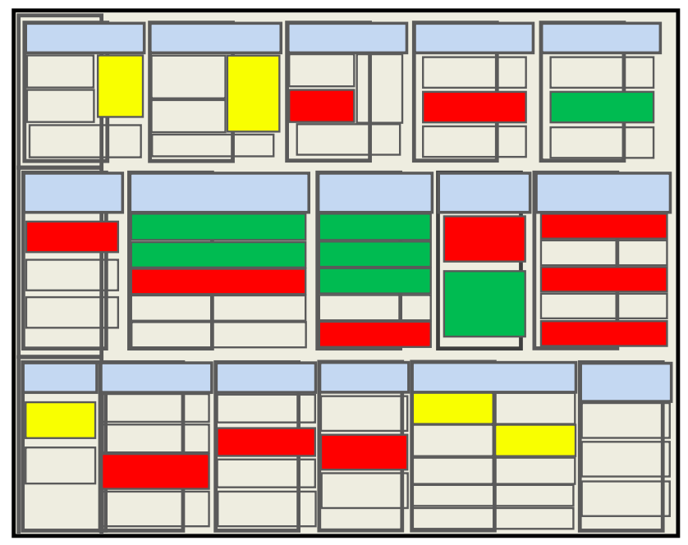

Picture 19 CBM simple heat mapping concept (Pohle, Korsten and Ramamurthy, 2005)

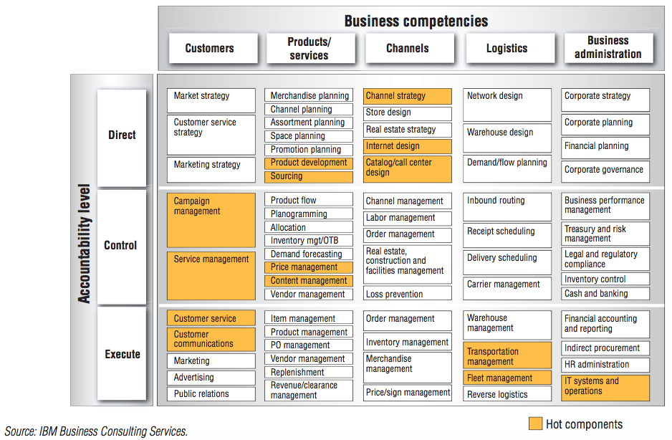

There are some guidelines on how the capability heat mapping must be done:

* Heat mapping attributes are assigned from lowest level capabilities to the upper ones (in contrast to the approach of building a capability map);
* If a single color dominates lower level capabilities (for example, red), then the next level capability should be applied with the same color;
* If there is a mix of colors and no color is dominated, additional attributes to weight a given capability must be used (for example, the overall level of impact of a capability on a business from 5 to 1 where 5 is “negligible impact” and 1 is “significant impact”);
* The process of color coding is continued to the highest level of the map;
* Assignment of a color to a capability must be validated by an expert

Heat mapping can be a stage in the process of Capability-Based planning as it helps identify areas of improvement and create a plan for executing these enhancements.

### 1.7.2 Value stream and capability cross-mapping

As it was discussed previously, value stream is a collection of activities triggered by a certain stakeholder and ending when a certain value (product, service, notification, degree of satisfaction, communication, etc.) is delivered back to that stakeholder. And capability modeling by itself is sometimes not enough for a complete understanding of the part where they transform into stakeholder value.

*Value stream stages*, that move from left to right, *are* *enabled by capabilities* (BIZBOK, 2016). Therefore, capabilities can be mapped to each stage of the value stream, representing direct relationship between value stream stages and enabling them capabilities and capability outcomes. Capabilities contribute to the movement of value creation process (work, in other words) as it transitions across a value stream. This concept allows to combine both outside-in and inside-out perspectives of the firm in order to see the full picture of an enterprise, and, with an addition of capability-based planning approach, to understand areas of improvement and business transformation.

Picture 14 below represents a simple value stream/capability cross-mapping template: each stage within a value stream has a list of enabling capabilities. One high-level capability can enable several value stream stages even across different value streams (see picture 15). It is worth mentioning that that both value stream and capability mapping tools/approaches can be combined into a single blueprint, which will increase the accuracy and value of the end result. Usually, when doing cross-mapping, high-level capabilities, e.g. Level 2 capabilities, are mapped on value stream stages, but it implies that, when decomposing these capabilities (if necessary), all the “children”-capabilities must not only match the “parent” and the value stream stage, but also contribute to enabling that value stream stage.

Picture 20 Value stream/capability cross-mapping template (BIZBOK, 2016)

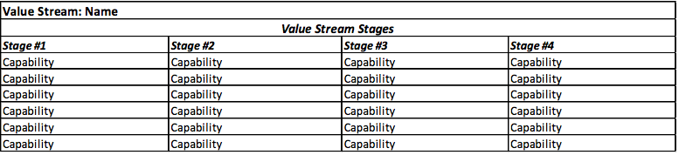

Picture 21 Example of a visualized value stream/capability cross-mapping blueprint (BIZBOK, 2016)

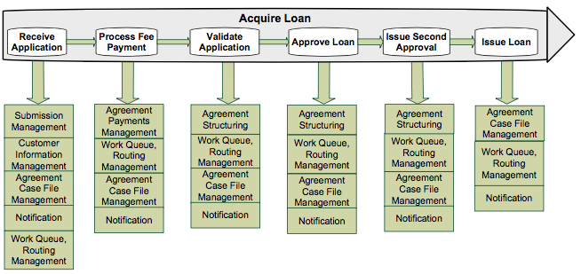

The obvious benefit of such technique is that it allows to rapidly understand how to drive stakeholder value and improve weaknesses in the value stream through capabilities. When the same capability enables several value stream stages, improvement in this capability will benefit all the stages which it enables. When heat mapping approach is also applied to capabilities, weak spots in the value stream become visible, which significantly simplifies identification of investment areas and which capabilities need to be improved. After that, combining it with a capability-based planning, a comprehensive transformation road-map with set KPIs and described desired state can be created and put into action.

This cross-mapping technique and related blueprint plays an important role in business planning and transformation and will be used in model creation in Chapter 3 of this paper.

## 1.8 Benefits of using capability mapping

There are several benefits that ground reasons of using capability mapping in business transformation, and prove that business capabilities are the necessary part in this process (Aston, 2016):

1. Capabilities and capability mapping provide a communication instrument for managers. Using such instrument ensures general understanding of the business and its focal points (especially problematic and strategic ones) not only within one business unit, but of the whole enterprise. Moreover, using capability mapping is a beautiful visualization tool for proving, reporting and presenting strategic initiatives to top-management;
2. Capabilities help focus on investment opportunities. Capability-based planning creates integrated multipurpose investment options and ensures stable long-term planning. Capability mapping and heat mapping guarantees that investments are done exactly where they are needed;
3. Business capabilities serve as a basis for strategic planning and change management. They also help to eliminate redundancies in development projects before it even appears, ensures the correct sequence of interrelated projects and provides business-to-IT alignment;
4. Capability analysis promotes understanding of the whole business, its functions, organization, value generating abilities, etc.

## SUMMARY OF CHAPTER 1

In this chapter, the author started to study the strategic management theory from the point of view of the resource-based view of the firm. It has been discovered that consistent and repeated use of the same resources in the same way creates capabilities - “particular abilities or capacities that a business may possess or exchange to achieve a specific purpose or outcome” (Business Architecture Guild, 2016). Capabilities are considered to be stable in organizations, and thus their effective usage in company strategy can potentially be a source of sustainable competitive advantage in a fast-changing environment.

The author then studied current approaches to strategic planning, including the Japanese Hoshin Kanri and western Balanced Scorecards and Strategy Maps. The result of that study was the discovery that all these methods bear serious flaws that negatively affects their usage, such as: too time-consuming, too complicated, too narrow in terms that it applies not to every industry or company, initiatives are uncontrolled, incoherent, not prioritized or even not executed because there are too many of them.

At the same time, capability-based planning approach, although not being a panacea for strategic planning, covers most of the shortcomings that are present in previously mentioned methods, and by its nature can be quite sufficient to be used in small and medium-sized enterprises.

A capability map, which is an enterprise architecture tool, allows to get a full view of an organization in terms of what it does to operate and bring products and services to the clients, which is the value. As any strategic planning is aimed at delivering value to company’s stakeholders, in order to define which capabilities have to be leveraged in order to achieve stakeholder value, the author also used the value-based approach and value streams as enterprise architecture tool as an addition to capability mapping.

This capability and value stream cross mapping promote understanding of the whole business, its value generating abilities, and serve as a basis for strategic planning and change management.

# CHAPTER 2. RESEARCH GAP AND METHODOLOGY

## 2.1 Research Gap

The problem of designing and implementing a business capability map in strategic planning in SMEs is bilateral. First of all, the existing models and strategic planning approaches are too complicated or cannot be applied in every industry or company, proposed action plans are disordered, not prioritized or even are lost in the general flow of initiatives. The more complicated and “academic” the framework, the more difficult it is for employees and businessmen to use it. And although capabilities provide a fairly simple and stable view of an organization, it is just an analysis tool and single usage of capability mapping without any other supporting tools is definitely not enough to come up with improvement initiatives. Every business, in order to grow, needs to overcome business transformation, and as it is a complex process, involving a careful alignment of IT, processes and people. Not every business has enough available monetary resources to hire an external consultant to create a capability map and develop a transformational roadmap.

Secondly, these frameworks of business capability and value mapping have proved to be applicable in large enterprises and even big cities analysis (Morgan and Sharieh, 2013). And from the first sight any business of any size can potentially apply this framework. However, there is no evidence in the existing literature (and practical experience) of using capability mapping techniques in small and medium enterprises. In order to enable growth, the firm needs to understand its strengths and weaknesses in terms of what it does to achieve strategic goals and sustain competitive advantage. As the environment, where SMEs are developing, is highly volatile and competitive, mapping firm’s capabilities would be a stable basis for further development and would force the firm to understand opportunities and areas of improvement. Nevertheless, no research or practical implementation case on this topic has been conducted yet.

## 2.2 Research Goal and Objectives

The goal of the research depicted in this thesis is to develop a method for applying capability mapping in strategic planning in small and medium-sized enterprises in order for them to be able to plan and execute organizational transformations. As the method will be based on a set of existing models, it is also important to test whether a business capability map, combined with other frameworks, can be applied to use in small and medium-sized enterprises (SMEs). Based on the results, the author will make suggestions on what parts (if any) of the existing frameworks should be changed or simplified in order to be used by SMEs.

In order to achieve this goal, the following objectives must be achieved:

* To list and analyze known frameworks, tools approaches in the sphere of organizational capabilities and strategic planning;
* To elaborate a method for using business capability mapping in any small and medium-sized enterprise strategic planning, taking into account existing tools and frameworks;
* To demonstrate the method on a case study company.

## 2.3 Design Science Research Methodology

In this thesis, qualitative research methods are used. For this thesis, the design science research methodology (DSRM) suggested by Peffers et al. (2007) was adopted. This process proposes six consecutive steps where the output of each is treated as input in the next one and with some iterative activity.

Picture 22 The DSR methodology (Peffers et al. 2007)

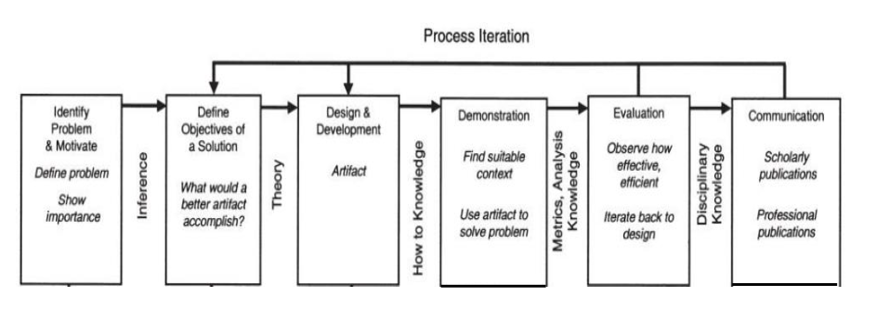

1. Definition of the problem and its importance (described earlier in the chapter).
2. Definition of the objectives for a solution of the problem. Here the objectives are deducted from the problem definition (previous step) and from what is feasible. The literature review chapter is committed to that.
3. Design and development. Here the actual artifact, a method, is created. This step is a key focus of this master thesis. The artifact will be created using the following steps:
   1. Step 1. Search for and study existing tools and frameworks, that can potentially be combined in an artifact;
   2. Step 2. Based on literature review, develop requirements and limitations for method creation. As the artifact involves capability mapping and capability-value cross mapping tools, requirements must include:
      1. General requirements, involving limitations of SMEs strategic planning;
      2. Capability map requirements;
      3. Value map requirements;
   3. Step 3. Using a combination of frameworks, design a step-by-step method for applying business capability map in combination with other frameworks;
   4. Step 4. Describe each step and its role in the algorithm.
4. Demonstration. Here the actual use of the method is tested and demonstrated to solve one or more examples. Here the theoretical background is linked to practical level by applying it in the case company.
5. Comparing the results with requirements and evaluation of the method. This activity involves comparing the objectives of a solution to actual observed results from use of the artifact in the demonstration.
6. Communication. Here the discussion takes place about the problem and its importance, the method and its quality characteristics.

However, proper evaluation is not possible without the implementation of the proposed framework in more companies, thus the last two steps are not considered in the thesis and remain for further study.

As a result, the paper has the following structure:

* Literature review;
* Main findings and model development;
* Demonstration of the model (case study);
* Discussions and conclusion.

## 2.4 Choosing the case study company

In order to demonstrate the viability of the proposed model, the author chose the case study of HIQE Digital, a small-sized communications agency in Saint Petersburg, to which the author has the access to resources (including managerial and knowledge). The company is service-oriented with a strong emphasis on experience in the industry, human and non-tangible resources, which makes it the best candidate for model testing. Detailed information about the company and its market will be provided in chapter 4.

## 2.4 Data collection methods

Theoretical information is collected through literature review and analysis of current approaches to capability mapping, organizational strategic planning and enterprise architecture tools. Information of the case company is collected via the interview of company management, communication of the method and application of frameworks is done via participation in weekly report sessions, strategic planning sessions and interviews with heads of departments.

# CHAPTER 3. METHOD DESIGN AND DEVELOPMENT

The main advantage of capability maps (and capabilities in general) is that they are stable and rarely change, therefore using them in organizational modeling will enable creating a sustained view of an enterprise, which can be used for long-term planning, portfolio management, investment planning, firm transformation, etc. (Trofimtseva, 2015).

As it was mentioned in Chapter 1, in order to see a full picture of business, it might be useful to combine several methods of mapping and planning, discussed above. Based on requirements and existing frameworks, I will deliver an approach that will

1. depict an enterprise both from the inside-out and outside-in perspective;
2. not only answer the question “what” a business does, but also cover “how”;
3. be applicable for strategic planning of organizational transformation.

## 3.1 Frameworks and tools

In order to develop and test the method on the actual enterprise, I will use several frameworks and tools, described in academic papers and journals:

* **Business Model Canvas**, described by Osterwalder and Pigneur (2010). This model will help identify key characteristics of a business, describe stakeholders and their value streams. It is also a starting point for a company analysis that will lead to an understanding of what an enterprise does, what value does it create for its stakeholders and how it creates it. In the method, described in 3.3, this tool will be used *only to provide the researcher* (or an architect, or a businessman) *with more input data* to work on and analyze, and *it does not assume any implementation of strategic vision*. Business model, combined with capability assessment, allows to identify and focus on developing future and redesigning current elements of value proposition, which will evolve in a sustained competitive advantage.
* **Business Architecture Guild tools** for value stream mapping and capability mapping (2017), described above, including heat maps. These are the standard *tools*, used by business architects, which, thus, allow to design a model in a way that would be applicable to the architects’ community and businessmen.
* **Business Engineering Group** methodology of development, created by company’s top consultants (Kudryavtsev and Grigoriev, 2015). This is the basic reference of using capability mapping in real life, based on which the whole artifact will be designed according to the requirements, described in 3.2.
* **Capability increment and capability-based planning** approach, as this model allows to describe and plan the practical usage of the model and create a development plan for an enterprise.

## 3.2 Requirements for the method

As long as this paper is focused on Small and Medium-sized Enterprises, the method of business capability mapping should not only *meet general requirements for building a capability and value maps*, but also fit the specificity of SMEs.

### 3.2.1 General requirements

Specifics of small and medium-sized enterprises impose certain restrictions and assumptions on a method.

Any SME, that is considering business transformation, is most probably entrepreneurship type of venture rather than just a mediocre small business, which cares only about current situation and profit-making (Nieman and Nieuwenhuizen, 2014). That said such enterprises possess specific features:

* Employees and management are mostly occupied with daily routine and do not have enough time for diving into business transformation tasks (Tenhunen et al., 2001);
* Although innovation-oriented, the strategy of an SME is often informal, non-documented and is mostly defined by the owner without proper communication to employees (Chalmeta, 2012; Hudson et al., 2001);
* Usually, an SME has no culture of using KPIs (Chalmeta et al., 2012);
* SMEs are more short-term minded than larger companies are (McAdam, 2000)
* Many SMEs fail to plan on a long-term basis due to inconsistent or incomplete approach to strategy planning (Hathway Management Consulting, 2013);
* SMEs have potential for growth and set strategic objectives in relation to growth targets, market share, market positioning, market segmentation, etc. (Nieman and Nieuwenhuizen, 2014)
* SMEs top-management teams consist mostly of entrepreneurs which:
  + sometimes manage several business functions
  + often do not have appropriate business education (Nieman and Nieuwenhuizen, 2014).

Taking into account all the above-mentioned ideas, in order to be applicable to SMEs, the method should attribute to the following requirements:

* can be visualized in a way that a person without special education can understand it;
* can be easily communicated across the whole organization;
* provide insights for mid- and long-term firm growth opportunities;
* be balanced
  + not too detailed as the precise details are often not needed,
  + not over-generalized to prevent the loss of meaningfulness;
* use simple metrics and KPIs for performance measurement according to objectives (although, SMEs don’t have a culture of using KPIs, it is used in a way to track progress and control the execution of tasks).

### 3.2.2 Capability map requirements

When composing a capability map, it is essential to follow the principles of business capability (see 1.7.1 for details). Moreover, Business Architecture Guild (2016) has developed several validating rules as a guide to delivering a correct capability map, which I will use as requirements for the part of the model that concerns capabilities.

* Each capability within a map should be focused on a business objects that it is dependent on (e.g. agreement, customer, account, policy, asset, message, research, etc.)
* Each capability should describe *what* a business does, *not how* it does it or a process (e.g. topics that require a stakeholder)
* There should be no redundancies and repeated capabilities in a map;
  + if two capabilities seem alike, it is highly possible that one is just a particular case of the other
  + when mapped on a value stream, one capability can be present in several value stream stages, which is not a repetition;
* Even rarely used capabilities must be mapped along with others;

### 3.2.3 Value stream map requirements

Principles of any value map were described in Chapter 1 (§1.5). However, Business Architecture Guild (2016) provided a set of guidelines that can be a useful addition for successful value mapping.

* Any value stream requires a stakeholder or a group of stakeholders with similar value propositions;
* each value stream (if there are many) must be tied to a particular value proposition;
* value streams that are facing an external stakeholder (e.g. customer) are of priority;

## 3.3 Artifact (method)

The method of using business capability mapping as a strategic planning tool in small and medium-sized enterprises, as it was said before, consists of a combination of frameworks and tools, that, when used in a particular order, allow to plan strategic development of an organization.

Overall idea of the method can be described as follows: by following a step-by-step algorithm and based on the company’s existing vision, business model, long-term goals, objectives, sets of *capabilities* and value propositions, the analysis of the current situation in the company will evolve in a set of strategic plans, that are coordinated and concerted with each other and will lead to organizational change, sustaining competitive advantage, and thus company’s evolution and growth.

The method itself includes the following steps:

1. **Input stage**
   1. **Identify strategic goals and direction of company development.** These goals should be associated with key stakeholders, or groups of stakeholders, or a particular business line of an enterprise, and must encourage company growth and evolution. In order to plan organizational change, management must have a clear set of goals it wants to achieve by performing business transformation. Examples of such strategic goals could be “growth by 5% in market share in 2 years”, or “improving customer satisfaction by 25% in 1 year”, etc.
   2. **Draw a business model canvas of the enterprise** (Osterwalder and Pigneur, 2010). This step not only helps to get a helicopter view of an organization, but also serves as a way of obtaining more input data for analysis and planning. It is highly recommended to design two business model canvases: one with the description of current situation (“as is”) and another with inclusion of target elements that would support company growth in a certain direction (“to be”).
2. **Analysis stage**

The next steps are *parallel* in their timeline:

* 1. By using organizational chart, business model or industry specifications, **build a *common* capability map for the whole business** that defines capabilities down to at least level 2 view and ideally level 3 view. There are many industry reference models and instructions on how to build a capability map (BIZBOK, 2017; Trofimtseva, 2015), but the overall algorithm is as follows:
     1. If possible, try to get a capability map reference model of a similar enterprise in the industry;
     2. Develop a Level 1 capability map based on reference models, organizational chart, business model or any other company documents and existing models;
     3. Communicate Level 1 capability map with company management and agree on it;
     4. Based on strategic goals discussed above, decompose Level 1 capabilities into Level 2 and/or Level 3 (using expert help if necessary);
     5. Validate the overall capability map, visualize and publish it.

Keep in mind the capability map requirements, discussed in 3.2, when building a capability map of an enterprise.

* 1. Based on strategic goals and understanding of a chosen stakeholder or group of stakeholders that are influenced by these goals, **build a value stream for that particular stakeholder/group of stakeholders** (see 1.6) for instructions). The value stream must describe key elements of value creation process that can be present or even missing in the current situation. There can be many value streams, depending on the scope of strategic goals. Value streams are the main vehicle for organizing a business’s thinking about how capabilities may be arranged, improved or added to deliver stakeholder value.
  2. **Map business capabilities onto value stream** in order to understand *how* value is created and *what* is used to create it. By performing this step, one can understand which capabilities take part in the process of value creation and, accordingly, contribute to the strategic goal achievement;
  3. **Develop a combined heat map** of value stream and capabilities to identify key areas of improvement, which capabilities must be considered first, which capabilities or value stream elements should be created (or eliminated). This is essential part of the process as it helps understand how to put strategic goals into practical achievement by using step-by-step improvements of selected capabilities thus increasing the value created by an organization. Heat maps of the current situation can be developed in several ways, but the most common are:
     1. Benchmarking with competitors, if the company has access to such information;
     2. Attracting external experts and consultants;
  4. Conducting internal evaluation of each capability by communicating goals and problems. The most effective way of doing so is by using the Delphi method.

1. **Plan stage**
   1. By using capability-based planning method, **develop an execution plan for organizational change** according to selected objectives. This method was described in details in 1.4 and by Papazoglou (2014), but the overall algorithm is as follows:
   2. Develop a target combined heat-map (when applicable)
   3. Identify capability gaps
   4. Plan (evaluate, prioritize and select)
   5. Engineer (define increments, dimensions, timeline)
   6. Deliver action

Below is a visualized view of the method, described above:

Figure 1 Method of using business capability mapping in strategic planning

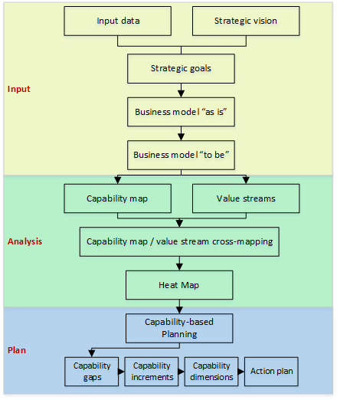

If, at any point in time and at any step of the method, the situation changes, or if mistakes have been made in a certain step, it is implied that the organization can go back and redo whatever is needed to be redone. Application of this method ensures coordination and stability in organizational development projects and helps to avoid common mistakes in strategy-to-action implementation. For example, a strategy can be poorly communicated to organizational levels and transformed into goals and KPIs. Or even if there’s no problem with that, the IT-support of activities is not present. The method, described above, eliminates such gaps in organizational transformation in terms of organizational activities, information systems and even corporate culture, and takes into account features of SMEs to ensure successful plan implementation.

This method’s main use is to articulate strategy implementation within the already developed strategic direction, i.e. mission, vision and goals, as it is a required input information. It also helps in identifying such direction, but is not intended to be used to di it from scratch.

The method suggested can be successfully implemented as an addition to Kaplan and Norton closed-loop management system (pictures 7 and 8) and strategy map in particular. Capabilities and capability maps serve as components of learning and growth perspective, as they explain what the company consists of, what it actually does and structures it in a coherent way. Capability dimensions clearly remind of the internal perspective processes. Value stream and capability/value stream cross-mapping, as it includes stakeholders such as customers, touches upon the customer perspective. The capability-based planning approach helps to improve capabilities and thus enhance customer value proposition (customer perspective) according to the strategic goals and track the progress using KPIs. The results of the capability improvement projects, which will eventually lead to an increase in company performance, are represented in the financial perspective and are partly touched by capability increments

Although this method can be an addition to strategy maps, when we consider small and medium-sized enterprises, with their problems with the usage of complex KPI systems (and that is what strategy map and BSC is about), the simplicity and coherency of the author’s method for them is preferable than the classic use of strategy map. Thus, the method can, in a way, be an alternative to those that are proposed by Kaplan and Norton, when applied in an SME.

# CHAPTER 4. METHOD DEMONSTRATION

This chapter considers the actual use case of the model, described in Chapter 3, how it can enhance and what value it can bring to the SMEs strategic planning and IT alignment. Due to the fact, that the components of the model (including capability map, value stream map, business model canvas, heat mapping, etc.) are universal analysis and communication tools, the whole model can be applied to any type of business, regardless of its business model and value creation method.

Following the global trend of digital transformation of enterprises, many startups nowadays are initially created as digital companies (McKinsey Global Institute, 2016), thus, most of the small and medium-sized enterprises are fully digitized. This thesis paper considers such a small firm, that operates in the industry of digital marketing, as a case study company, on which the capability map will be designed and the overall model will be applied to enhance the process of putting strategic decisions into actions.

## 4.1 Company and industry description

HIQE Digital is a small-sized communications agency, located in Saint Petersburg. The business of HIQE Digital is mainly B2B and consists of 6 business units, each of them provides different kinds of services to their corporate clients.

Table 2 HIQE Digital business units’ description

|  |  |
| --- | --- |
| **Business unit name** | **Services** |
| Advertising and Marketing | Business analytics, Communications strategy, SEO[6], contextual advertising, media advertising, SMM[7], affiliate programs, working with celebrities |
| Concepts and creativity | Creative concepts, guerilla marketing, event concepts, identity, slogans, special projects, creative consulting, PR, viral videos, social advertisement |
| Design and illustrations | Logotypes, branding, polygraphy, web design, illustration, 3D graphics, ad prints, infographics, animation |
| Software development | Web sites, mobile applications, UI/UX[8], usability, application and server software, software testing, CRM[9], CMS[10] |
| Video Production | Video clips, TV advertisement, promo videos, corporate videos, 3D animation, viral videos, sound design, video localization |
| Event organization | HR-events, business events, official events, festivals, social events, event-marketing, MICE[11], sport events, own projects |

As one may have already understood, the company is busy with a wide range types of digital marketing services and solutions. According to the information from the company website, there are numerous well-known companies of different industries, listed as their clients, such as Adidas, Samsung, Coca-Cola, Nestlé, VISA, Schneider Electric, Alfa Bank, Mercedes-Benz, Sony and others.

The company currently hires 20 employees, half of them work remotely (mostly designers and programmers). According to the opinion of the company CEO, their greatest assets are the employees and reputation on the market. The company puts great effort on finding and hiring professional designers, managers and programmers in order to deliver the best quality product or service (internal communication refer to such activities simply as “projects”) to the client, whether it is a huge corporation or an automobile service station on the south of Saint Petersburg. This value proposition allows to set quite high prices on company services, which, however, are more or less equal to the average pricing on the market.

Speaking of the market, all the communications agencies in Russia face constant and rapid changes in industry such as:

* Decelerating growth of demand for digital marketing services, as most companies that are trying to reach out their customers on the Internet, have already done so.
* Increasing competition, as the industry entry barriers and switching costs are low, thus reducing profitability of business;
* Changes in customer requests, as client companies’ expectations increase due to the acceleration of customer interaction, customers' connectivity and the availability of customer data (Dmoch, 2016). Thus, clients expect that digital marketing agencies can perform almost any business functions on outsource basis;
* Although agencies provide creative, media- and marketing-related executions, the weight and complexity of this task shifts to increase;
* Changes in payment models to those that are based upon success, although projects often last for several months and require constant payments;

Considering all the above-mentioned factors, the company management made a decision to develop a strategic plan of organizational transformation in order to better suit the market needs. The company provided the following documents as the input information:

* Company charter
* Organizational structure
* List of structural and functional business units
* Workflow map, designed by employees (appendix 1)
* Projects documentations

## 4.2 Identifying strategic goals

The company management appealed to the author with a request of developing a road map of organizational transformation that would support the company’s strategic vision and goals for the year of 2022 and provide business-to-IT alignment to achieve these objectives.

As it was expected, the company management did not have any strategy and long-term goals written in any form, they were communicated poorly to the employees. Only key employees and top management were aware of the situation, and only the CEO (founder, at the same time) had an idea of where the company should go. Thus, the information about the desired state of the company and strategic goals was obtained through a series of interview with company CEO and the management team.

According to the discussed plans of development, the company wanted to use its assets in a more complete way, realizing its full potential and raising revenues. As it was said before, the company assumes that its most important resources are the talented people (employees), expertize in the field of digital marketing solutions, and reputation. These are non-tangible assets that can be used in a variety of ways, not only in the current project works. Before the author of the thesis was invited to participate in strategic sessions, company management assessed several ways of how the strategy could potentially be implemented, taking into account the market situation in digital marketing industry, existing and potential partnerships and connections, and current situation inside the company (see 4.1 for details). It was decided that at the moment the company obtained enough knowledge and experience in digital marketing and managing small enterprise, and could not only use the experience in managing current projects more effectively, but also “sell” the knowledge to those who wanted to dive into the field of digital marketing and entrepreneurship. Also, the company management mentioned the overall tendency of SMEs and entrepreneurs towards the deterioration in the quality of entrepreneurial preparation, which concerns the awareness of how to start and run a business and avoid problems with the law and partners, and also on what conditions should the B2B relations be built between clients, partners and executors, especially in the sphere of service provision.

Thus, it was decided that the company needed a new business department that would focus on providing B2C educational and B2B consulting services. This way the company could achieve the following benefits:

* Build a community of educated entrepreneurs and digital marketing professionals;
* Gain additional revenues from educational and consulting services and from providing advertisers with a platform for advertising their products and services inside the community;
* Partially reduce costs, associated with maintaining staff, by
  + engage in working process those employees who were in an idle state due to the lack of project work;
  + provide other employees an opportunity for self-development and learning;
* Increase the client base and, by segmenting it, apply additional sales strategies;
* Attract well-known partners and thus increase the level of trust from new clients.

In order to sustain and maintain the development of community, the company set an additional (optional) goal to develop a SaaS[12] platform where users (clients) will have access to educational materials and be able to communicate, share knowledge, participate in teaching, expert and projects activities, participate in assessing and improving the quality of educational process; whereas 3rd party advertisers can reach their target audience and promote their products and services.

Courses graduates will have obtained modern competencies, that include critical and business thinking, data-driven decision making, ability to analyze market and customer data, knowledge of digital marketing tools, skills in developing digital strategy, skills in starting, organizing and running own business, team work, project management, interpersonal communication skills, and many others. In order to achieve such excellence in graduates training, it is essential to obtain educational partners, that already have enough experience, gained solid reputation, are currently active and have sufficient number of experts in different fields, and, ideally, have state accreditation and educational license.

Thereby, the strategic vision of the management team was clear: by developing a new business direction of education and consulting (later named as “HIQE Education”), the company will have achieved leadership positions on several markets in Saint Petersburg, such as digital marketing services and business education services. The potential of growth, as it was though by the CEO, is not limited to only Saint Petersburg market, in future the company will either spread its influence on other cities, or be acquired by a multinational company and become its separate division (this scenario happens quite frequently with small companies that experience exponential growth). According to the vision, several strategic goals were identified with planning period of **5 years**:

1. Increase overall yearly revenues to ₽100 000 000 per year by launching a new business division;
2. Eliminate “idle time”, when employees are not busy with value-generating activities;
3. Integrate IT solutions that would improve customer relations and service, achieve understanding and communication between departments and provide adequate return on investment.

Thus, the company management was able to identify its vision, strategy and long-term goals by using some popular methods (e.g. brainstorming and SWOT analysis), but eventually faced a problem of strategy implementation. The situation when a company knows what it wants to achieve, but has no idea how to do it, is not uncommon, particularly in small and medium-sized enterprises, where strategic thinking is a rather rare case. Knowing strengths and weaknesses, available resources and own goals is not enough to get the strategy working, especially when this knowledge is kept in mind of a strategist and not communicated or discussed with others. One of the main reasons why attempts of taking action fail most of the time is the lack of coordination and consistency in organizational transformation. As setting strategic goals is the first step in the method, to which this thesis is devoted, the next step would be defining current and future states of the company, that would be consensual with these goals and provide an overview of company business, value propositions and stakeholders.

## 4.3 Business model

The first stage of designing organizational transformation plan (and the second in the method described in Chapter 3.3) is the visualization of company’s business model using Business Model Canvas framework (Osterwalder and Pigneur, 2010). This simple model can be the starting point for any decision making in SMEs. Such tool allows making preliminary considerations on which company assets should be modernized or used in a different way, which assets the company needs to obtain in order to achieve a target state and be competitive on perspective markets. Moreover, business model canvas helps identify and compare key and perspective stakeholders of the company and current and future value proposition for them.

Taking into account the input information, the “as is” business model was designed:

Picture 23 Business model canvas of current situation (as is)

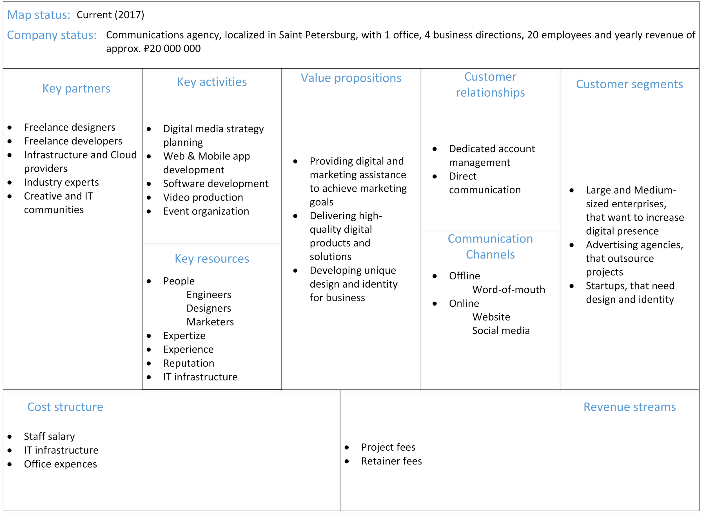

Based on this model and using the information, provided by the company, the following target (5 years ahead) business model was designed, where the changes are marked with red. Further on this model will be used to formulate conditions of future company development.

Picture 24 Business model canvas of future projections (“to be”)

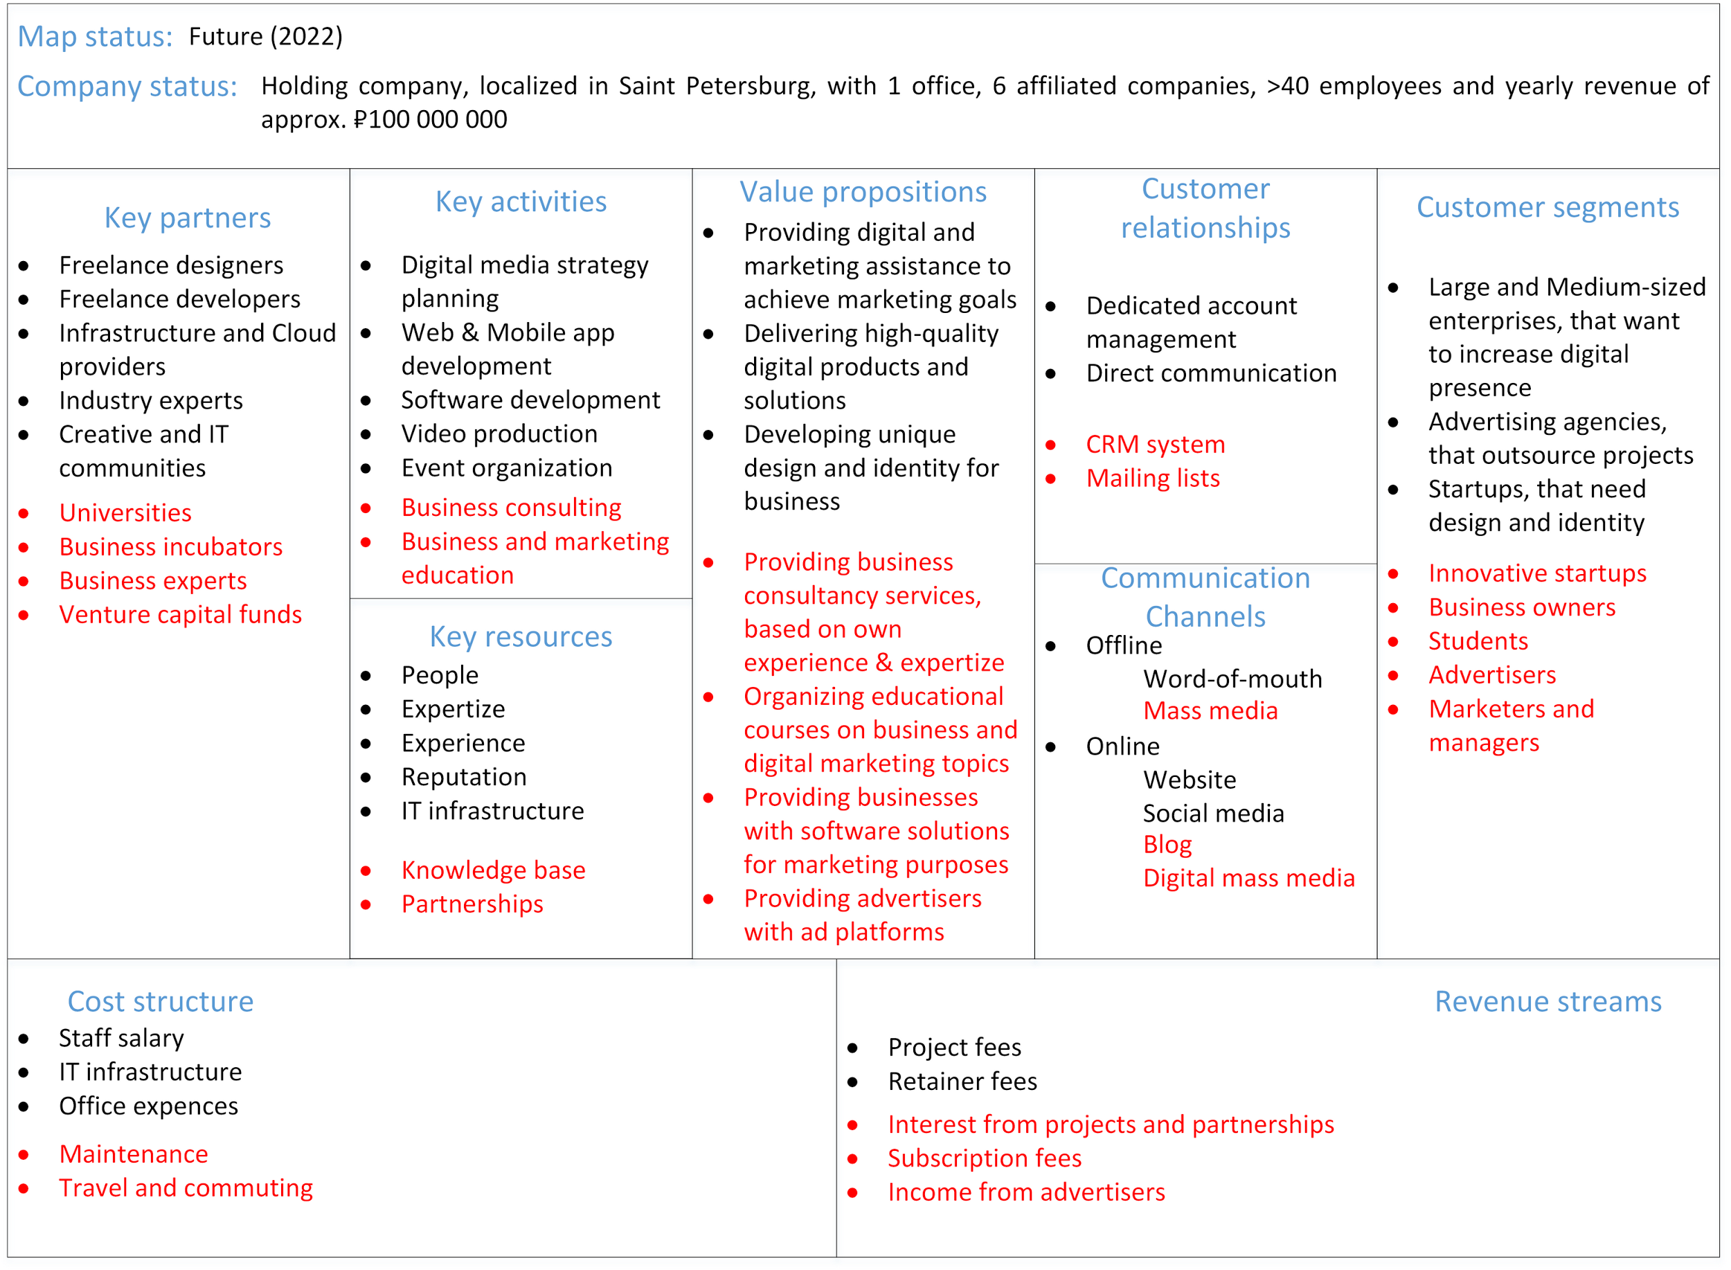

Business model of the projected year 2022 reflects not only the target state of the company, but also the changes that must occur to the organization (marked red). The Canvas is served as another form of secondary input information, that was derived from analysis of primary documents. As it was said before, it is not meant to be used as an action planning tool, and does not assume any implementation activities.

In order to make changes, reflected in Canvas 2022 happen, as a next step it is necessary to understand, what are the current capabilities the firm possesses. Thus, the next step is designing a capability map.

## 4.4 Designing a capability map

The method, described in Chapter 3 (paragraph 3), assumes that building a capability map for an enterprise can be based on internal company data (input information) and external expertize (industry reference models). Activities, that companies perform in the sphere of digital marketing, can be reflected in a kind of standard model, just like any other form of business. While analyzing the information, acquired both from open sources (the Internet) and limited-access information (internal documents and Business Architecture Guide), it became clear that there has been little research done in this sphere and there is no typical capability map yet, that the author can take as a blueprint for company’s individual capability map. However, there are some references that the author found useful. They include:

* BIZBOK® Guide, 2016, Part 8, Section 8.5, Page 572-583: “Insurance Industry Reference Model” – although this is a reference model for insurance services, there are many capabilities that a company in digital marketing shares with such enterprises, especially on the strategic and supporting levels. Also, this reference model provides clear definition to capabilities and the most complete list of capabilities.
* An, J. (2014). “Introducing the Digital Capability Reference Model.” – an online article that describes and lists typical capabilities of any digital business. Although this reference model lacks capability descriptions and some of the capabilities are missing, nonetheless it is a great start-off for building individualized capability map.
* Dejnicki, M. (2016). “Comparing 10 Digital Marketing & Technology Agencies in Toronto” – another online article, where the CEO of a digital marketing agency lists 25 crucial capabilities for an agency.

There were also articles that helped in understanding what a digital business capability map should look like (Dmoch, 2016; Galante et al, 2013)

The next step in building a capability map is to set a map frame, which means identifying horizontal and/or vertical map levels, according to which capabilities will be mapped.

Concerning horizontal levels, the author had 2 options, which included

* Naming levels according to BIZBOK framework:
  + Strategic (Direction Setting)
  + Core (Customer-Facing)
  + Supporting
* Naming levels according to IBM Component business model framework:
  + Direct (Strategic decisions)
  + Control (Management checks)
  + Execute (Business actions)

After personal evaluation of both frameworks, the author decided to use BIZBOK names for vertical axis of the map due to the fact that they are more universal, simple to understand and applicable to SMEs. Moreover, terms suggested by IBM (and their CBM model in general) can hardly be applied in capability mapping, but rather an operational mapping tool, which is not considered in the thesis.

Concerning vertical levels, the author decided not to apply vertical separation of capability map, because, on the one side, it might be useful while elaborating a more detailed operational model of the company, but on the other it severely limits opportunities for top-level capability mapping (Level 1), making it subject to loss of generalized view of the company and visual simplicity.

The next step in the process of designing a capability map is identifying top-level (Level 1) capabilities on each of each vertical axis of the map according to the input information. On the “Direction Setting” axis the following capabilities were identified:

Table 3 Level 1 capabilities

|  |  |  |
| --- | --- | --- |
| **Tier** | **Capability name** | **Capability description** |
| Strategic: Direction setting (1) | Investment management | Ability to control, predict, process, organize, present and analyze the balance of owned financial instruments, including the acquisition and disposal of a variety of financial instruments. |
| Business management | Ability to control, predict, process, organize, present and analyze activities of a business in order to achieve defined objectives. |
| Policy management | Ability to define, interpret, disseminate, enforce and administer legislation, regulation, principles, rules and procedures to guide the company and related stakeholder actions. |
| Market management | Ability to identify, name, analyze, frame, segment and cater to a component of an actual, virtual, or otherwise nominal place where forces of demand and supply operate, and where buyers and sellers interact, directly or through intermediaries, to exchange product and services for monetary or non-monetary value. |
| Core: Customer facing (2) | Account management | Ability to establish, access, organize, analyze, administer, and report on all aspects of a formal business arrangement for providing regular dealing or services between the company and one or more customers or partners. |
| Channel management | Ability to establish, analyze, and coordinate various mechanisms through which products, related services, or communications are delivered and received, and customers and organization interact. |
| Customer management | Ability to control, predict, process, organize, present and analyze all information, documents, preferences, experiences, and history related to an individual or organization that has, plans to have, or has had a formal contract or an account with the company in pursuit of the company’s products or services. |
| Partner management | Ability to control, predict, process, organize, present and analyze all information, documents, preferences, experiences and history related to an individual or organization that has, plans to have, or has had a legally binding agreement with the company, with the intent to exchange monetary and/or non-monetary value. |
| Product management | Ability to research, define, conceptualize, design, develop, bundle, implement, maintain and retire one or a combination of digital products, instruments and services that can be offered to customers, in whole or in part, to satisfy the customer’s overall experience. |
| Supporting (3) | Financial management | Ability to define, track, account for, and report on individual and aggregate movement of monetary and non-monetary value in accordance with generally accepted accounting principles. |
| Human Resource management | Ability to identify, hire, source assess, mentor, compensate, develop, dismiss, and otherwise administer individuals who are or have been incorporated under plan that includes compensation and other benefits on a temporary or permanent basis. |
| Information and IT management | Ability to define, organize, structure, store, coordinate and maintain the systems and data that support the organization’s business processes, and actions and analysis thereof. |
| Work management | Ability to capture, organize, prioritize, route, interpret, disseminate and administer communications, tasks and related decisions. |
| Asset management | Ability to administer, maintain, track, and report on a tangible or intangible item of value that the organization owns, benefits from, or has use of, in generating income. |
| Legal proceeding management | Ability to identify, organize, analyze, respond to, and administer all work related to a litigation filing, including trials, appeals, or related actions in which the company is a named party. |
| Project management | Ability to establish, coordinate, staff, measure and deliver a temporary, time-bounded endeavor as part of creating a specific deliverable or deliverables to achieve objectives and benefits. |

The overall Level 1 capability map has been composed in the following way:

Picture 25 Capability map (Level 1)

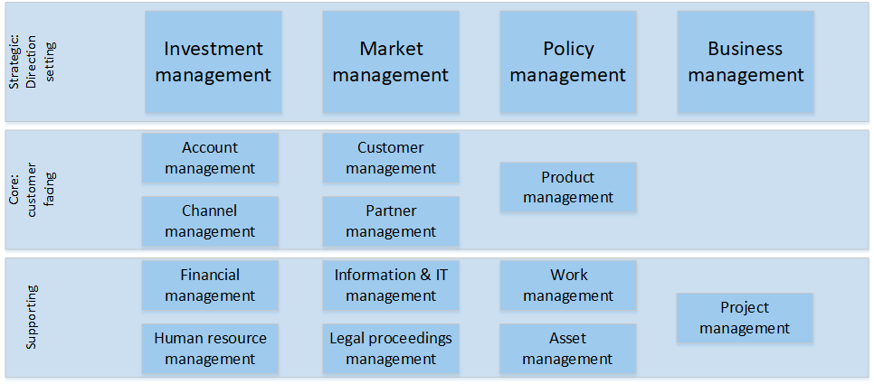

While designing a Level 1 capability map, it was discovered that one essential strategic capability, Message Management (ability to define, craft, frame, disseminate and track a structured conveyance of information, including missives, notifications, alerts and other internally and externally targeted communication about the company’s mission, products, plans, activities and other focal points), is missing in the company and must be developed in future. This will be taken into account by the company and will be reflected in a heat map.

Next step was to decompose Level 1 capabilities into sub-levels. While performing decomposition of top-level capabilities it is essential to think **not** in terms of processes, that enable such capabilities (“how” approach), but provide a detailed lower level capabilities view (“what” approach). Also, due to specificity of the thesis paper and its limitations, the author will not provide descriptions of lower level capabilities, as they just describe in more details Level 1 capabilities, and will not go further than Level 2 capabilities (with rare exceptions to Level 3 decomposition, where applicable).

Level 2 capability map will be published in the Appendix section of the thesis (Appendix 2) along with a list of capabilities in the form of hierarchical list (Appendix 3). The list includes some capabilities that are decomposed to Level 3, because it will be required to use these level 3 capabilities when mapping them onto a value stream.

The form of hierarchical list is not comfortable to analyze and evaluate, and lacks visualization. To present and discuss list of capabilities with the company the Level 2 capability map has been created (Appendix 2).

After the Level 2 capability map was designed (with several capabilities decomposed to level 3) it was decided by the company management that further detailing is not necessary for development of strategic goals implementation plan. In order to proceed with this process, according to the method described in Chapter 3.3, the next step is identifying the stakeholder (or stakeholder group) that is going to be influenced by company’s strategic goals and building a value stream for that stakeholder.

## 4.5 Designing a value stream for the stakeholder

As the strategic vision of the company is to develop a new business department that would provide B2C educational services along with B2B consulting, current stakeholder groups (e.g. clients, clients’ customers, employees, owners, partners, etc.) will not be greatly affected by this ambitious goal. Thus, a new stakeholder group has to be identified.

As it was said, perspective B2C educational service will consider providing individuals or groups of individuals with educational courses on digital marketing, entrepreneurship, e-commerce, digital content production and other disciplines where the company has expertize. A person can sign up for courses based on his/her own decision, or a company can apply for educational partnership and conclude a contract for the provision of educational services for its employees. In any case, a person, regardless of age and social status, that is willing to acquire knowledge in particular field listed above, either for personal or/and professional development, in other words, **student**, is a new stakeholder of the company that will trigger the new value stream for this perspective service.

On the other hand, as this perspective business department will be busy with activities that the company has not been performing before, this educational service can be considered as a new product for the company. Thus, it must be developed and tested, which triggers another important value stream with **product manager** as a triggering stakeholder.

Therefore, there are 2 value streams that can be identified in order to successfully implement strategic decisions: “Launch new product” and “Provide educational service”.

Table 4 "Launch new product" value stream description (triggering stakeholder - product manager)

|  |  |
| --- | --- |
| Assess market need and conceptualize product | Perform market research and competitor analysis as well as undertake customer satisfaction study in order to conceptualize a new potential product |
| Test market product concept | Test a product concept in the market using potential customer feedback, determine appropriate pricing and profitability |
| Prepare product for launch | Create the product and everything required to support it, including new/changed IT functionality to support it |
| Pilot deployment | Release the minimal viable product on small scale to test the demand and make corrections to the product itself, ensure that all supporting elements are in place to enable the sale and distribution of the product across its lifecycle. |
| Full deployment | Launch the product to all applicable delivery channels, ensure that the customers know about the launch and where they can find the product. |
| Post rollout assessment | Assess the performance of the product following launch to ensure that it is performing as expected. |

Picture 26 "Launch new product" value stream

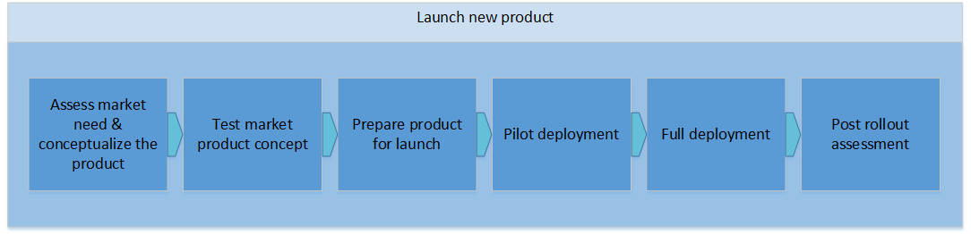

Table 5 "Providing educational service" value stream (triggering stakeholder – student)

|  |  |
| --- | --- |
| Publish and market information about the service | Run digital and offline communication channels to market the service and attract potential clients, provide them with enough information to make decision in company’s favor, motivate them to leave a request with contact data |
| Receive requests for additional information | Perform further communication with clients that left their contacts, explain the value of service to them, answer questions, work with objections |
| Prepare terms of service and its explanation | Prepare digital or paper form of agreement for the provision of educational service, communicate it to customers |
| Conclude an agreement for the provision of educational services | Sign an agreement for educational service provision contracts, receive payment, prepare study materials, explain further steps to client. |
| Provide the service | According to service provision contract, provide the educational service during a period of time, conduct progress evaluations. |
| Hand in confirmation document | After finishing education, hand in the confirmation document (diploma or certificate) to the client. At this moment, the service is rendered |

Picture 27 "Providing educational service" value stream

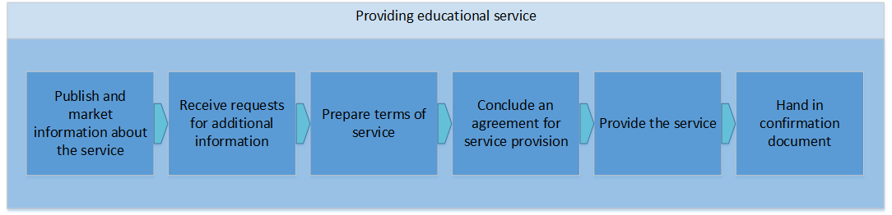

Thus, the author identified value streams and their triggering stakeholders that are required to achieve strategic goals. In order to understand which capabilities enable stages of each value stream, the next step is capability and value stream cross-mapping

## 4.6 Capability and value stream cross-mapping

As it was said in Chapter 1, capabilities enable certain value stream stages. Thus, this step helps to understand which capabilities take part in the process of value creation and, accordingly, contribute to the strategic goal achievement.

In order to perform value stream/capability cross mapping, the author, along with company top management and internal experts (project managers, heads of department) conducted a working session, where the above-mentioned value streams and capability map were presented and approved, and variants for cross mapping technique were discussed. The result is presented in capability/value stream template below, and the visual form (the actual map) can be found in appendix section of the paper (appendix 4 and appendix 5)

Table 6 "Launch new product" capability/value stream cross mapping

|  |  |  |  |  |  |
| --- | --- | --- | --- | --- | --- |
| Value stream name: Launch new product | | | | | |
| Value stream stages | | | | | |
| Assess market need & conceptualize the product | Test market product concept | Prepare product for launch | Pilot deployment | Full deployment | Post rollout assessment |
| Enabling capabilities | | | | | |
| Market analysis | Market targeting | Investment portfolio mgt[13] | Product development | Customer relationship mgt | Customer feedback mgt |
| Market segmentation | Customer preference management | Business plan management | Channel development | Market positioning | Channel performance analytics |
| Customer establishment | Product concept development | Channel definition | Channel performance analytics | Partner relationship management | Analytics management |
| Product/strategy matching | Product concept approval | Channel development | Customer matching | Product information mgt | Financial information mgt |
| Product concept development | Product performance measurement | Customer matching | Product deployment | Work routing management | Project reporting |
| Product similarity analysis | Investment identification | Product development | Work routing management | Work queue management |  |
| Information acquisition |  | Product testing | Information aggregation | Information aggregation |  |
|  |  | Product price determination | Analytics management | Money movement |  |
|  |  | Work queue management |  |  |  |
|  |  | Project management |  |  |  |

Table 7 "Providing educational service" capability/value stream cross mapping

|  |  |  |  |  |  |
| --- | --- | --- | --- | --- | --- |
| Value stream name: Providing educational service | | | | | |
| Value stream stages | | | | | |
| Publish and market information about the service | Receive requests for additional information | Prepare terms of service | Conclude an agreement for service provision | Provide the service | Hand in confirmation document |
| Enabling capabilities | | | | | |
| Market management | Policy definition | Policy interpretation | Legal proceedings mgt | Customer relationship mgt | Customer feedback mgt |
| Policy definition | Channel development | Policy dissemination | Account compliance mgt | HR supply and demand mgt | Account relationship mgt |
| Channel definition | Account matching | Account matching | Account sales management | HR compensation management | Project reporting |
| Channel development | Information distribution | Legal proceedings mgt | Money movement | Technology management | Financial information mgt |
| Account preference management | Analytics management | Partner relationship management |  | Information distribution | Information archive management |
| Product/channel matching |  |  |  | Work routing management | Legal proceedings mgt |
| Technology management |  |  |  | Asset matching |  |
|  |  |  |  | Product deployment |  |

As one can see, some capabilities participate in both value streams, and in one value stream some capabilities participate in different stages. This is not a contradiction, moreover, one capability can indeed be present in several value creating activities and influence them according to its development level. Assessing how well the capabilities are developed in order to plan organizational transformation, application of IT solutions and its alignment with company strategy, and suggesting development program – all this can be done after applying het map color scheme.

## 4.7 Applying heat color scheme

As it was mentioned in Chapter 1, heat mapping can be applied to the capability and value stream maps either separately or using cross mapping. The goal of this step is to leverage information for planning purposes, because a color scheme can be used to easily signify weaknesses in current capabilities or even the lack of a given capability.

In order the capabilities assessment to be objective and reflecting the real situation in the company, the author, along with company management, decided to perform company conference and invited internal experts – project managers and heads of departments – that are directly involved in company operations. The expert session was conducted using Delphi[14] method. By analyzing company goals and comparing existing problems capability assessment session was conducted, where all capabilities and related problems were listed and assessed according to two criteria:

* Number of mentions of the problem by experts
* Criticality of a capability and the level it affects strategic goals achievement.

The result of the strategic session is the application of heat color scheme (described in Chapter 1) to both capability/value stream cross maps and deciding on which capabilities further work should be focused on (see heat map in Appendix 6 and Appendix 7).

After this work is done, by just looking at the heat map one can easily understand which capabilities must be developed or created, and where management should focus their attention, make investments and plan organizational transformation. Development of problematic capabilities that are important in achieving strategic goals allows not only to quickly achieve results, but also to strengthen company competitive advantage. Capability heat mapping provides a basis for determining where problems occur and a basis for defining a solution. However, while applying capabilities to a value stream, **the same capability can perform differently in various value streams** and work well in the particular value stream stage it enables, while needing corrections in another.

According to the heat map, there are many capabilities that were identified as problematic and the company should work in their improvement. However, the following capabilities were identified as the most problematic ones and the most critical ones in strategic goal achievement:

* “Launch new product” value stream
  + **Product performance measurement**, which is denoting the quality and performance of existing products with respect to the development of new products.

Although the company due to its industry specificity does understand what KPIs matter for successful marketing campaign, it has no consistency in understanding the KPIs of the product performance. The team constantly switches to measuring everything that can be measured (even unrelated), and then for a period of time no one tracks any KPIs. Thus, time is lost and information cannot be processed.

* + **Business plan management**, which is the ability to develop, document, communicate and coordinate a business plan.

This is one of the most significant problems in the company, as it has no documented and properly communicated business plan, according to which the work on a new product will be based. There are many concepts, ideas and plans written or designed, but it is all unstructured, stored in different places and sometimes lost. Absence of a detailed business plan, that would include all aspects of a future product, causes chaos in communication and destroys unity in the team.

* + **Customer relationship management**, which is the ability to manage and analyze customer interactions and data throughout the customer lifecycle, and forecast customer trends and behaviors.

The company has experience of managing relationships with B2B partners and clients. However, this experience can hardly be applied to a B2C product and its customers, as there are totally different amounts of data that must be collected, analyzed and used. Also, another CRM IT solution must be used, with which the company has no working practices. Now a simple CRM is represented in just an Excel sheet with information about the clients, which is obviously not enough for further business development.

* “Provide educational service” value stream
  + **Customer relationship management**, described above.

Here is the same issue as in the “Launch new product” value stream. The company is just not used to working with large amounts of data on B2C customers and has not IT solution for that.

* + **HR compensation management**, which is the ability to determine and implement financial and non-monetary packages, including salary and benefits for individuals.

Educational service, as a new product of the company, will be using the existing employees (with rare exceptions of invited experts), their knowledge and expertise in delivering the product to customers. However, current compensation system does not assume that employees are being compensated for participating in several projects AND for being “teachers”. Designers, programmers and marketers are sometimes in conflict with project managers on this basis. That is why people are not willing to take on additional work, as they will not be provided with additional rewards for that.

* + **Work routing management**, which is the ability to make work tasks available to individuals, teams or systems based on triggering events.

The issue here is closely connected with previous “hot” capability. Even now the some of the abovementioned employees experience inadequate work load (and not being rewarded for that), while others are in the idle state and do nothing on the work place (while still being paid a salary). This is a significant problem, especially when it comes to delivering additional service to the market.

* Overall missing capabilities:
  + **Message management**, which is the ability to define, frame, disseminate and track a structured conveyance of information, notifications, alerts and other internally and externally targeted communication about company’s mission, products, plans, activities and other focal points.

It is an essential strategic capability that somehow is missing in the company. As it was said before, opinions and information about strategic plans, development and projects is rarely disclosed to anyone beside top management team and is hardly ever documented in any way. Thus, only the CEO and a few close associates understand the direction of company development, creating a communication gap inside the company.

As these are the capabilities that are marked in red color, there is no need to develop a target combined heat map unless the issues with these capabilities are solved on a satisfactory level.

By applying color coding scheme, the author was able to identify capability gaps and problems in capabilities on which the focus must be placed, improvement plan developed and performance tracked. Of course, not all problems will be solved instantly, this process requires time, people and resources (investment) and sometimes even fighting with fear of change and uncertainty. But by solving issues with the most significantly problematic capabilities (and then focusing on those that are also problematic, but not that severe, which are marked in orange) will boost company performance and will provide opportunity for successful strategy implementation and complete achievement of strategic goals.

## 4.8 Applying capability-based planning approach

Capability-based planning (CBP) deals with the planning, execution and delivery of the target business capabilities. As it was mentioned in Chapter 1, one of the key goals of CBP is to formulate plans in the form of value-adding business improvements, rather than in the form of work packages and deliverables (Aldea et al, 2016). In the previous sections, the author completed the first two (out of four) stages of capability-based planning method, which are **Mapping** and **Assessing** capabilities, by using capability, capability-value stream cross and heat mapping as core elements of the process. By using the diagrams created and information gained in previous parts about the identified *capability gaps and issues*, in the last section the company needs to be provided with a **Plan** about how to obtain or develop those capabilities that are crucial in strategic goals achievement. The fourth stage of capability-based planning approach (**Control**) will not be viewed in this thesis, as it is responsibility of the company to control capability realization, monitoring and evaluation activities.

Previously, the author identified 5 capabilities that are in a critical unsatisfactory state and 1 capability that is essential, but missing in the company. But not all problems have the same value, which is determined by their impact on strategic goals achievement, thus additional assessment of problematic capabilities is required. Also, there are some projects initiated in the company that are aimed on improving problematic capabilities.

It is obvious that a missing strategic capability can evolve into a real problem in strategic goals achievement, which will lead to the organization underperforming. This is why the first priority capability is Message management.

At the same time, at the moment of analysis, the company already had ongoing projects aimed at improving several problematic capabilities. They include:

* For Product performance measurement and related capabilities:
  + Identification of the most important product performance metrics and their decomposition, including profit and turnover metrics;
  + Applying systematic approach to constantly measure metrics, including constant data collection, storing and analyzing (involves another capability);
  + Learning to use statistical method of metrics measurements, including usage of specific software and IT solutions (IBM BlueMix)
  + Learning to get insights of statistics for product improvement;
* For HR compensation management capability:
  + Updating current compensation policy
    - Additional monetary rewards based on work load for employees that are busy in multiple projects;
    - Additional non-monetary rewards for all employees;
  + Composing list of employees that are or will be suitable for revised compensation;

Other problematic capabilities were prioritized for development based on capability gaps and the choice of the CEO. For example, with a missing message management capability (1st priority) there could be severe problems in communication both within and outside the organization, which will make the realization of a strategy impossible. Next, without a proper business plan management (2nd priority), it is quite risky to launch a new product, when nobody has provided proper analysis and plan, and documented it so that others can rely on that information in future. Further on, without a proper customer relationship management (3rd priority) system, there will be no opportunity for organizational growth in future and product improvement. Next, work routing management (4th priority) is present in some state in the company, but in order to handle additional work loads, connected with new product launch, this capability will have to be improved. New product will require specific performance measurements (5th priority) and metrics in order to evaluate product performance and take actions in case something goes wrong. Finally, HR compensation management (6th priority) will help employees be more productive and willing to perform at their best, so they, along with the company, would achieve mutual goals. Overall logic for prioritizing capabilities is in accordance to their impact on strategic goal achievement.

Before coming to planning capability transformation, the author broke down problematic capabilities into increments, that represent evolution of a capability, and dimensions, that represent a specific aspect that needs to be improved (see 1.4 for details about capability increments and dimensions):

Table 8 Capability increments of problematic capabilities

|  |  |
| --- | --- |
| **Message management** | |
| Increment 0 (current state) | Absence of a capability |
| Increment 1 | Developed channels of message management |
| Increment 2 | Developed structures and content of messages |
| Increment 3 | Stabilized message management system |
| **Business plan management** | |
| Increment 0 (current state) | No documented business plan |
| Increment 1 | Documented business plan |
| Increment 2 | Structured and communicated business plan |
| **Customer relationship management** | |
| Increment 0 (current state) | Simple Excel CRM work sheet |
| Increment 1 | Integrated CRM |
| Increment 2 | Tuned CRM |
| Increment 3 | Automated CRM |
| **Work routing management** | |
| Increment 0 (current state) | Unequal load distribution and work routing |
| Increment 1 | Employees are assigned to projects based on expertize and work load |
| Increment 2 | No “idle” employees |
| **Product performance measurement** | |
| Increment 0 (current state) | Indiscriminate product performance measurement |
| Increment 1 | Regulated product performance measurement |
| Increment 2 | Systematic product performance measurement |
| Increment 3 | Considered product performance measurement |
| **HR compensation management** | |
| Increment 0 (current state) | Unified compensation system |
| Increment 1 | Compensation system based on work load |
| Increment 2 | Compensation system that includes non-monetary rewards and additions |

For those capabilities that already have ongoing projects, the author decided not to assess them in terms of capability dimensions, because correct execution of those project will eventually lead to an improvement in capability. Still, when composing an overall capability development program, these projects will also be considered and aligned with others.

Dimensions of problematic capabilities were considered by the author with the help of resource-based view theory and internal company experts. Each problematic capability will be assessed according the following set of dimensions, which describe the fullness of asset use by a capability:

* Process (intention to produce defined outcome)
* Financial (cash needed to support implementation and cash generating opportunity)
* Physical (reliance on certain physical resources)
* Technology (contribution of technology and intangible resources to the capability)
* Organizational (contribution to overall company development, formal reporting, reputation and culture aspects)
* Human (expertise and effort offered by the employees)

In order to assess capability increments in terms of these dimensions, a rating scale from 0 to 5 was implemented to assess performance level of each dimension. It is important to realize that the desired performance level of the capability dimension is not necessary to reach the highest score. The required performance level of a specific capability dimension is good enough to support the capability achieving the desired capability performance level[15] (Cheng, 2015).

Table 9 Capability rating scale

|  |  |
| --- | --- |
| Scale | Description |
| 0 | Capability dimension is not performing at all |
| 1 | Initial dimension performance, requires immediate improvement |
| 2 | Under development dimension, requires execution of development projects |
| 3 | Tolerated dimension performance, enough to support capability on the same level |
| 4 | Good dimension performance, enough to support short-term capability development |
| 5 | Excellent dimension performance, can be considered as a benchmark |

With the help of internal company experts, capability increment radar charts were developed to visualize the process of improvement of problematic capabilities. The author

Picture 28 Message management capability radar chart

Picture 29 Business plan management capability radar chart

Picture 30 Customer relationship management capability radar chart

Picture 31 Work routing management capability radar chart

As one can mention, some capability dimensions on some capabilities are not necessarily to be developed to the highest level, because there is obviously not need in such great improvements and it can potentially not worth the effort.

Now that problematic capabilities are prioritized, performance is assessed and target performance level is set, it is time to identify actions that will enable capability transformation, taking into account the ongoing projects.

## 4.9 Development program suggestions

To realize the strategy, the organization should execute a set of strategic initiatives. Capabilities are almost always required to direct and/or execute such initiatives. Thus, strategy related capabilities, and especially those that are underperforming, are needed to be improved, transformed or even created to enable delivery of a given strategy. Capability development projects should be planned in capability increments in the different capability dimensions.

The final step is to document capability development projects into an affordable Capability development plan (CDP). Each project can be contributing to one or more capability dimension, which is emphasized in *italics*. Having all the required initiatives documented helps the company to achieve capability improvements, which are required to achieve the strategic objectives (Cheng, 2015).

Table 10 Message management capability development plan

|  |  |
| --- | --- |
| Capability | Message management |
| Final increment (capability goal) | Stabilized message management system |
| Development projects | * Defining and agreeing on optimal messaging format and IT software (e.g. corporate messenger) (*Process, Organizational, Technology*) * Acquiring messaging software (*Technology, Financial, Physical*) * Integrating IT software (incl. setting of employees’ accounts) (*Technology, Human, Physical, Financial*) * Employee training on messaging system (*Human, Organizational, Process*) * Developing alerts template and rules (*Organizational, Process*) * Integrating chat bots for quick actions and alerts (*Organizational, Process*) * Integrating messaging system into other company IT (*Technology, Organizational, Physical, Process*) * Setting a schedule for regular company updates (*Organizational*) |
| Estimated resource | Project group with skilled IT integrator, messenger experts, etc. |
| Estimated spend % of total budget for capability development projects | 20% |
| Benefit | All employees can communicate with each other regardless of their status and location; employees are aware of strategic plans |
| KPIs | Time loss decrease dynamic, idle time decrease dynamic |
| Impact of doing nothing | Communication lags, no distribution of information, failure to meet deadlines |

Table 11 Business plan management capability development plan

|  |  |
| --- | --- |
| Capability | Business plan management |
| Final increment (capability goal) | Structured and communicated business plan |
| Development projects | * Defining and agreeing on business plan template and structure (*Process, Human, Organizational*); * Drawing up a business plan for each ongoing and future project, including all the analysis, road maps, calculations, projections, participating people (*Process, Human, Organizational, Financial, Physical*); * Agreeing on business plan content, correcting (*Process, Organizational, Human, Technology*); * Communicating business plan to related employees (*Technology, Organizational, Human*); * Updating business plan once in 3 months and communicating it with all related personnel (*Financial. Human, Process, Organizational*) |
| Estimated resource | Project manager, product manager, CFO |
| Estimated spend % of total budget for capability development projects | 10% |
| Benefit | Business plan serves as a reference in case questions are raised on any aspect or stage of project execution |
| KPIs | Number of projects executed, overall NPV of executed projects, profit |
| Impact of doing nothing | Communication lags, failure to meet deadlines, inconsistency with stated goals, failure to deliver quality product |

Table 12 Customer relationship management capability development plan

|  |  |
| --- | --- |
| Capability | Customer relationship management |
| Final increment (capability goal) | Automated customer relationship management system |
| Development projects | * CRM purpose definition (*Organizational*); * CRM software scouting and assessment (*Human, Technology, Process*); * CRM software acquisition and integration (*Financial, Physical, Technology, Process*); * Employee training on CRM software (*Human, Physical*); * Filling CRM software with data about customers (*Process, Human, Financial, Organizational, Physical*); * Applying machine learning on CRM data to get insights (e.g. RFM-analysis[16]) (*Process, Technology, Organizational*); * Constant support of CRM software (*Financial, Human*); |
| Estimated resource | Project manager, CEO, Account manager, IT engineer, data scientist, |
| Estimated spend % of total budget for capability development projects | 50% |
| Benefit | Retained customers, increased sales, increased revenues, increase in customer loyalty |
| KPIs | Number of customers retained, number of return customers, feedback rate, LTV increase |
| Impact of doing nothing | Possible loss of clients, inability to achieve financial results |

Table 13 Work routing management capability development plan

|  |  |
| --- | --- |
| Capability | Customer relationship management |
| Final increment (capability goal) | No “idle” employees |
| Development projects | * HR software system purpose definition (*Organizational*); * HR software system scouting and assessment (*Human, Technology, Process*); * HR software system acquisition and integration (*Financial, Physical, Technology, Process*); * Employees personal and professional assessment (*Human, Technology, Physical, Financial*); * Assessment of current projects in terms of workload, needed expertize, busy employees (*Human, Technology, Organizational, Process*); * Assigning employees to projects according to workload, expertize and preferences (*Human, Organizational, Process*); * Continuous assessment of employees work and routing effort (*Process, Human, Organizational, Technology, Financial*) |
| Estimated resource | Project manager, CEO, HR manager, IT engineer, data scientist, |
| Estimated spend % of total budget for capability development projects | 20% |
| Benefit | Elimination of idle employees, effective project work, successful execution of business plans |
| KPIs | Employee workload, increase in project pace |
| Impact of doing nothing | Additional spending on idle employees, employee burnout, unequal work distribution |

Of course, these are the problematic capabilities that are of high priority and require immediate action. As one had seed before, on the heat map there were some capabilities, which are also problematic, but are not in severe condition. It is logical that after the improvement projects on the most important capabilities are executed, the company must develop the same strategy for developing other problematic capabilities.

It can be clearly seen that capability improvement and development projects are closely interconnected and coherent with each other, all of them support strategic goal achievement of the company. In order to show more precisely the interconnection of projects and overall coherence of capability development plans, the author uses a concept map, that represents a link between the “way of working”, i.e. model of the overall enterprise development model (“what” knowledge), and “way of modeling”, i.e. meta-model for linking capabilities with strategic goals and measures (“how” knowledge), developed by Business Engineering Group and Kudryavtsev et al. (2014).

Picture 32 Meta-model for linking capabilities with strategic goals and measures (Kudryavtsev et al., 2014)

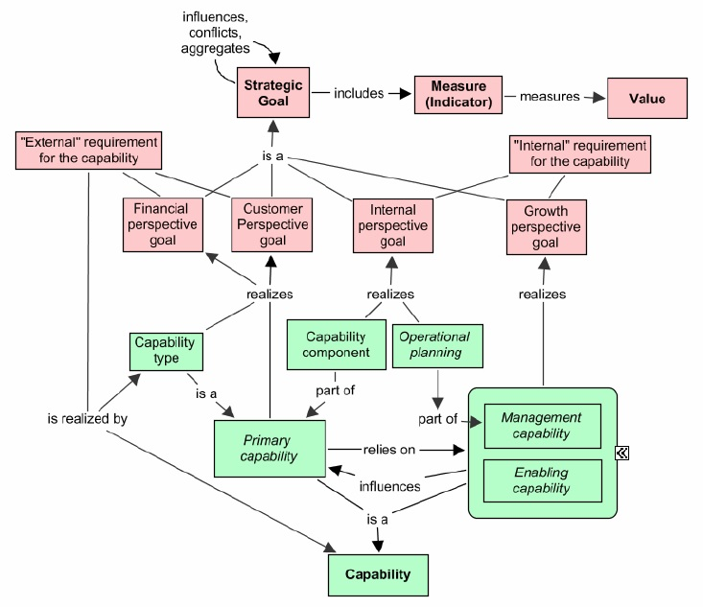

Picture 33 Enterprise development model

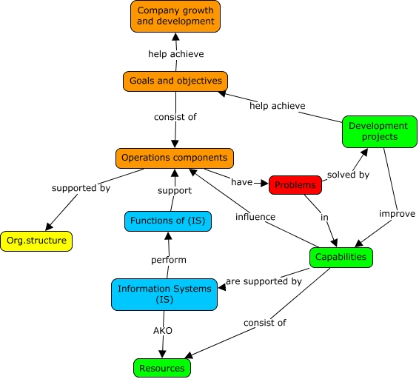

The concept map in Pic.28 illustrates that company growth and development is achieved through identification of problems in capabilities and consistently running development projects on improving those problematic capabilities. Using this method, an organization transforms from the lowest levels of its structure, which will eventually bring up strategic results.

# DISCUSSIONS

## Benefits and limitations of the model

Throughout method implementation, it was evident that small and medium-sized enterprises will not face challenges in using it due to several reasons:

* Detailed, but not over-generalized structure
* the method suggests implementing a limited set of urgent initiatives, which ensures that SMEs will not waste their limited resources
* simple and easy-to-measure KPIs of initiatives
* visualized in a way that can be easily communicated throughout the organization
* provides insights for mid- and long-term improvements;

It is assumed that the step-by-step method, proposed in the thesis, will allow small and medium-sized enterprises management to develop a strong awareness of the internal business environment, and, in combination with external environment knowledge will lead to a realistic set of goals and their achievement plans. All the benefits of using this model by SMEs can be divided into 3 groups:

1. Immediate benefits
   1. Sparking the focus on organizational goals by careful analysis of organizational capabilities, which leads to a carefully elaborated decision-making
2. Near-term benefits
   1. Guiding strategy-making and problem-solving through coordination of action plans and shared purpose;
   2. Improving usage of resources;
   3. Prompting intensified internal communication;
   4. Appreciation of improvement by stakeholders (mainly customers) through delivery of a better value;
3. Long-term benefits
   1. Achieving a sustained competitive advantage through capability development (as they are stable company elements that need time to progress);
   2. Achieving long-term strategic goals thus bringing value to stakeholders;
   3. Entering a new level of company development, thus achieving business growth;
   4. Increasing company value and market power;
   5. Development of agile organizational culture.

However, during model implementation and testing, the author identified some limitations of the model, which include:

1. The model focuses on internal development factors, mainly disregarding the external analysis (except for the first step of business model analysis and industry overview), although this does not limit opportunities for capability benchmarking;
2. Small and medium sized enterprises, especially in Russia, tend to provide little info about their business, or don’t have the information needed. There is also not many (if any) capability reference models on SMEs capabilities in different industries.
3. The method significantly relies on experts’ opinions and assessment, which can lead to non-objective view of the situation. Although there are techniques for increasing assessment objectivity (e.g. Delphi method), human factor can become the main problem of the method.

## Suggestions for further research

There is still not enough scientific literature written on the capability-based planning, which is one of the major parts of the method described in thesis. Also, as the method is new, it requires more testing and applying it to SMEs in different industry sectors. Moreover, further researchers are advised to think about enhancements to the method, for example, on how to decrease reliance on expert opinions, simplify more the execution of step-by-step algorithm, apply more numerical assessment of capabilities.

# CONCLUSION

The goal of this master thesis was to develop a method for applying capability mapping in strategic planning in small and medium-sized enterprise in order for them to be able to plan and execute organizational transformations. As a result of conducting the intensive research on the topics of business capabilities, capability-based planning, value-based and resource-based theories, business architecture tools and small and medium-sized enterprises specificity, the desired outcome, in particular the development of a method of using business capability mapping in strategic planning, has been achieved. The method has been put to use in a small-sized company and proved to be applicable in translating strategy to action in SMEs and facilitating organizational transformation. Thus, the research goals and all the research objectives have been successfully achieved.

The theoretical contribution of the thesis was in further developing the capability-based approach to strategic planning, putting a business architecture tool, such as capability map, into use in a method that ensures coherency and consistency in implementing the strategy, business-to-IT alignment. Moreover, the author put emphasis on small and medium-sized enterprises and focused on their features, which may become a new branch for further studies of capability-based approaches.

The practical significance of the study lies in offering a new practical tool for strategic planning, which facilitates growth of a small or medium-sized firm, creates a new communication platform for enterprise employees and provides comprehensive and coherent company development for those small and medium-sized enterprises, which decide to apply it.

The main limitation of this paper concerns the validation of the model on only one example of a small firm, which may probably be not enough for the full implementation of the method in small enterprises of all industries. Moreover, as the method concerns long-term strategic development of the firm, it is not possible to evaluate the results of proposed transformational activities within the nearest 2-3 years.

Further research may include not only qualitative studies, but also quantitative researches of the viability of the designed method. In addition, researches may try to apply the method in small and medium-sized enterprises of different industries and test whether it is applicable in any SME or should be modified in some way.

# REFERENCES

1. Aldea, A., Iacob, M., Lankhorst, M., Quartel, D. and Wimsatt, B. (2016). Capability-Based Planning: The Link between Strategy and Enterprise Architecture. 1st ed. Berkshire: The Open Group.
2. Alturki, Ahmad and Gable, Guy G. (2014). THEORIZING IN DESIGN SCIENCE RESEARCH: AN ABSTRACTION LAYERS FRAMEWORK. PACIS 2014 Proceedings. Paper 126.
3. An, J. (2014). Introducing the Digital Capability Reference Model. [online] Blog.freerangefuture.com. Available at: http://blog.freerangefuture.com/introducing-the-digital-capability-reference-model [Accessed 7 May 2017].
4. Aston, D. (2016). Efficiency & Cost Reduction via Business Capability Planning. [online] erwin, Inc. Available at: http://erwin.com/blog/efficiency-cost-reduction-via-business-capability-planning/ [Accessed 20 May 2017].
5. Balancedscorecard.org. (n.d.). The Basics of Strategic Planning, Strategic Management and Strategy Execution. [online] Available at: http://www.balancedscorecard.org/BSC-Basics/Strategic-Planning-Basics [Accessed 30 May 2017].
6. Barney, J. B. (2002), Gaining and Sustaining Competitive Advantage (2nd ed., Upper Saddle River, NJ: Prentice Hall).
7. Barney, J.B. (1991) “Firm resources and sustained competitive advantage”. Journal of Management, (17), pp 99-120
8. Beimborn D., Martin S. F., Homann U. (2005). Capability-oriented Modeling of the Firm. In: IPSI 2005 Conference; Amalfi/Italien.
9. Boisvert, L. (2012). Strategic Planning Using Hoshin Kanri. 1st ed. [ebook] GOAL/QPC. Available at:

https://goalqpc.com/cms/docs/whitepapers/GOALQPCHoshinWhitepaper.pdf [Accessed 29 May 2017].

1. Bpmn.org. (2011). BPMN Specification - Business Process Model and Notation. [online] Available at: http://www.bpmn.org/ [Accessed 5 Feb. 2017].
2. Business Architecture Guild, A Guide to the Business Architecture Body of Knowledge®, v 5.1 (BIZBOK® Guide) (2016). Part 3, Section 3.4 & Page 299.
3. Chalmeta R., Palomero R., and Matilla M. (2012). Methodology to develop a performance measurement system in small and medium-sized enterprises. International Journal of Computer Integrated Manufacturing 25(8).
4. Cheng, S. (2015). Translating Strategy into Implementation via Capability-based planning. Master of Science. University of Twente.
5. Coppinger, P. (2010). Component Business Modeling: A new lens for examining warranty administration. IBM Business Consulting Services.
6. Dejnicki, M. (2016). Comparing 10 Digital Marketing & Technology Agencies in Toronto [online] Digitalpurpose.ca. Available at: http://www.digitalpurpose.ca/10-digital-marketing-agencies-toronto/ [Accessed 7 May 2017].
7. Dmoch, T. (2016). Radically digital! Agencies rethink their Business Model. [Blog] Digital Marketing Expert and Car Enthusiast. Available at: https://www.linkedin.com/pulse/digitisation-makes-ad-agencies-rethink-business-models-thomas-dmoch [Accessed 26 Apr. 2017].
8. Eisenhardt, K. and Martin, J. (2000). *Dynamic capabilities: what are they?* Strategic Management Journal, 21(10-11), pp.1105-1121.
9. Freiling, J. (2004). A Competence-based Theory of the Firm. Management Revue, 15(1), pp.27-52.
10. Galante, N., Moret, C. and Said, R. (2013). Building capabilities in digital marketing and sales: Imperatives for consumer companies. [online] McKinsey & Company. Available at: http://www.mckinsey.com/industries/consumer-packaged-goods/our-insights/building-capabilities-in-digital-marketing-and-sales [Accessed 7 May 2017].
11. Garnsey, E. (1998). A Theory of the Early Growth of the Firm. Industrial and Corporate Change, 7(3), pp.523-556.
12. Grant, R. (1991). The Resource-Based Theory of Competitive Advantage: Implications for Strategy Formulation. California Management Review, 33(3), pp.114-135.
13. Grant, R. (1996). Prospering in Dynamically-Competitive Environments: Organizational Capability as Knowledge Integration. Organization Science, 7(4), pp.375-387.
14. Grant, R. (2016). Contemporary strategy analysis. 9th ed. John Wiley & Sons, p.35.
15. Grigoriev, L. and Kudryavtsev, D. (2011). The Ontology-based Business Architecture Engineering Framework. In: H. Fujita and T. Gavrilova, ed., New Trends in Software Methodologies, Tools and Techniques. Amsterdam: IOS Press, pp.233-252.
16. Hathway Management Consulting (2013). Strategic planning: 5 essential considerations for SME owners. North Vancouver.
17. Henderson, B. (1970). The Product Portfolio. Boston Consulting Group Perspectives.
18. Hudson M., Smart A., and Bourne M. (2001). Theory and practice in SME performance measurement systems. International Journal of Operations & Production Management 21 (8).
19. Jensen, M. and Meckling, W. (1976). Theory of the firm: Managerial behavior, agency costs and ownership structure. Journal of Financial Economics, 3(4), pp.305-360.
20. Kangas, K. (1999). Competency & Capabilities Based Competition and the Role of Information Technology: The Case of Trading by a Finland-based Firm to Russia. Journal of Information Technology Case and Application Research, 1(2), pp.4-22.
21. Kaplan, R. and Norton, D. (1992). The Balanced Scorecard: Measures that Drive Performance. Harvard Business Review, 70(1), pp.71-73.
22. Kaplan, R. and Norton, D. (1996). The Balanced Scorecard: Translating Strategy into Action. 1st ed. Boston, MA: Harvard Business School Press.
23. Kaplan, R. and Norton, D. (2004). Strategy Maps: Converting Intangible Assets into Tangible Outcomes. 1st ed. Harvard Business School Press.
24. Kaplan, R. and Norton, D. (2008). Mastering the Management System. Harvard Business Review, 86(1), pp.62-77.
25. Kudryavtsev, D. and Grigoriev, L. (2015). Business Engineering Group - Theory. [online] Bigc.ru. Available at: http://bigc.ru/theory/ [Accessed 14 Apr. 2017].
26. Kudryavtsev, D., Arzumanyan, M. and Grigoriev, L. (2014). Business engineering technologies. 1st ed. Saint Petersburg: Polytechnic University Publishing House.
27. Kudryavtsev, D., Grigoriev, L. and Bobrikov, S. (2014). Strategy-focused and Value-oriented Capabilities: Methodology for Linking Capabilities with Goals and Measures. In: 16th IEEE Conference on Business Informatics. [online] Saint Petersburg. Available at: http://ceur-ws.org/Vol-1182/paper8.pdf [Accessed 1 Apr. 2017].
28. Makadok, R. (2001). Toward a synthesis of the resource-based and dynamic-capability views of rent creation. Strategic Management Journal, 22(5), pp.387-401.
29. Malešević, E. (2015). Specificities of strategic management of small and medium-sized enterprises in countries in transition. In: 2nd IRI Economics Conference. Novi Sad, Serbia: University of Novi Sad, Faculty of Technical Sciences.
30. McAdam R. (2000). Quality models in an SME context: A critical perspective using a grounded approach. International Journal of Quality and Reliability Management 8.
31. McKinsey Global Institute (2016). Digital globalization: The new era of global flows. Digital McKinsey. [online] McKinsey Global Institute. Available at: http://www.mckinsey.com/business-functions/digital-mckinsey/our-insights/digital-globalization-the-new-era-of-global-flows [Accessed 20 Apr. 2017].
32. Morgan, H. and Sharieh, S. (2013). Business Capability Model ‐ A Starting Point for Enterprise Architecture. In: ASUG Annual Conference. Toronto, Ontario, Canada.
33. Motivationmodel.com. (2017). Ontology – Business Model Viewpoint – Enterprise Business Motivation Model. [online] Available at: http://motivationmodel.com/ontology-business-model-viewpoint/ [Accessed 5 Feb. 2017]
34. Nieman, G. and Nieuwenhuizen, C. (2014). Entrepreneurship: A South African perspective. 3rd ed. Pretoria: Van Schaik.
35. Oikhman, E. and Popov, E. (1997). Reinzhiniring biznesa. Moscow: "Finansy i Statistika”.
36. Omgwiki.org. (2017). Start [Business Architecture Working Group]. [online] Available at: http://www.omgwiki.org/bawg/doku.php [Accessed 5 Feb. 2017].
37. Osterwalder, A. and Pigneur, Y. (2010). Business Model Generation. 1st ed. New York, NY: John Wiley & Sons.
38. Osterwalder, A., Pigneur, Y., Bernarda, G., Smith, A. and Papadakos, T. (2014). Value Proposition Design. 1st ed. New York, NY: John Wiley & Sons.
39. Page, B. (n.d.). Hoshin Planning: Making the Strategic Plan Work. [online] Isixsigma.com. Available at: https://www.isixsigma.com/methodology/hoshin-kanri/hoshin-planning-making-strategic-plan-work/ [Accessed 28 May 2017].
40. Papazoglou, A. (2014). Capability-based planning with TOGAF® and ArchiMate®. MSc thesis. University of Twente.
41. Peffers, K., Tuunanen, T., Rothenberger, M. A., & Chatterjee, S. (2007). A design science research methodology for information systems research. Journal of Management Information Systems, 24(3), 45-77.
42. Penrose, E. (1959). The theory of the growth in the firm. 1st ed. New York: Wiley.
43. Peteraf, M. (1993). The cornerstones of competitive advantage: A resource-based view. Strategic Management Journal, 14(3), pp.179-191.
44. Peteraf, M. and Barney, J. (2003). Unraveling the resource-based tangle. Managerial and Decision Economics, 24(4), pp.309-323.
45. Pitelis, C. (2002) The Growth of the Firm: The Legacy of Edith Penrose. Oxford: Oxford University Press.
46. Pohle, G., Korsten, P. and Ramamurthy, S. (2005). Component Business Models: Making Specialization Real. IBM Institute for Business Value.
47. Porter, M. (1980). Competitive strategy. 1st ed. New York: Free Press.
48. Porter, M. (2008). The Five Competitive Forces That Shape Strategy. Harvard Business Review, pp.24-41.
49. Porter, M.E. (1979). How Competitive Forces Shape Strategy. Harvard Business Review
50. Porter, Michael E. (1985). Competitive Advantage: Creating and Sustaining Superior Performance. New York.: Simon and Schuster
51. Prahalad, C. and Hamel, G. (1990). The Core Competence of the Corporation. Harvard Business Review.
52. Priem, R. and Butler, J. (2001). Tautology in the Resource-Based View and the Implications of Externally Determined Resource Value: Further Comments. The Academy of Management Review, 26(1), p.31.
53. Roelens, B. and Poels, G. (2014). The Creation of Business Architecture Heat Maps to Support Strategy-aligned Organizational Decisions. In: 8th European Conference on IS Management and Evaluation (ECIME 2014). Gent, Belgium.
54. Rosing, M., Scheer, A. and Scheel, H. (2015). The Complete Business Process Handbook: Body of knowledge from process modeling to BPM. 1st ed. Waltham, Mass. [u.a.]: Morgan Kaufmann/Elsevier.
55. Rother, M., & Shook, J. (2003). Learning to See: Value-Stream Mapping to Create Value and Eliminate Muda: Version 1.3 June 2003. Lean Enterprise Institute.
56. Tellis, W. (1997). Introduction to Case Study. The Qualitative Report, 3(2), July.
57. Tenhunen J., Rantanen H., and Ukko J. (2001). SME-oriented implementation of a performance management system. Lahti, Finland: Department of Industrial Engineering and Management, Lappeenranta University of Technology.
58. The Economist Intelligence Unit (2013). Why Good Strategies Fail: Lessons for the C-suite. [online] The Economist. Available at: http://www.pmi.org/-/media/pmi/documents/public/pdf/learning/thought-leadership/why-good-strategies-fail-report.pdf [Accessed 29 May 2017].
59. The Open Group (2011). TOGAF Version 9.1 (Togaf). 1st ed. Zaltbommel, The Netherlands: Van Haren Publishing.
60. The Open Group (2016). The Open Group Guide. Business Capabilities. Reading, Berkshire: The Open Group.
61. Trofimtseva, A. (2015). Application of competency map to develop company strategy. MSc. The Bonch-Bruevich Saint-Petersburg State University of Telecommunications.
62. Ulrich, W., & Rosen, M. (2011). The Business Capability Map: The Rosetta Stone of Business/IT Alignment. Enterprise Architecture, 14(2), 1–23
63. Web.archive.org. (2008). Business Process Modeling Forum - FAQ | Business Process Modeling Forum. [online] Available at: https://web.archive.org/web/20081109082206/http://www.bpmodeling.com:80/faq/ [Accessed 5 Feb. 2017].
64. Wernerfelt, B. (1984). “A resource-based view of the firm”. Strategic Management Journal, (5), pp 171-180
65. Wernerfelt, B. (1995). The resource-based view of the firm: Ten years after. Strategic Management Journal, 16(3), pp.171-174.
66. Whittle, R. and Myrick, C. (2005). Enterprise business architecture. 1st ed. Boca Raton, Fla.: Auerbach Publications.

# Appendix 1

Workflow diagram, presented as an input information. Shows the processes within the organization, responsible person and results of process execution. Designed internally in the company

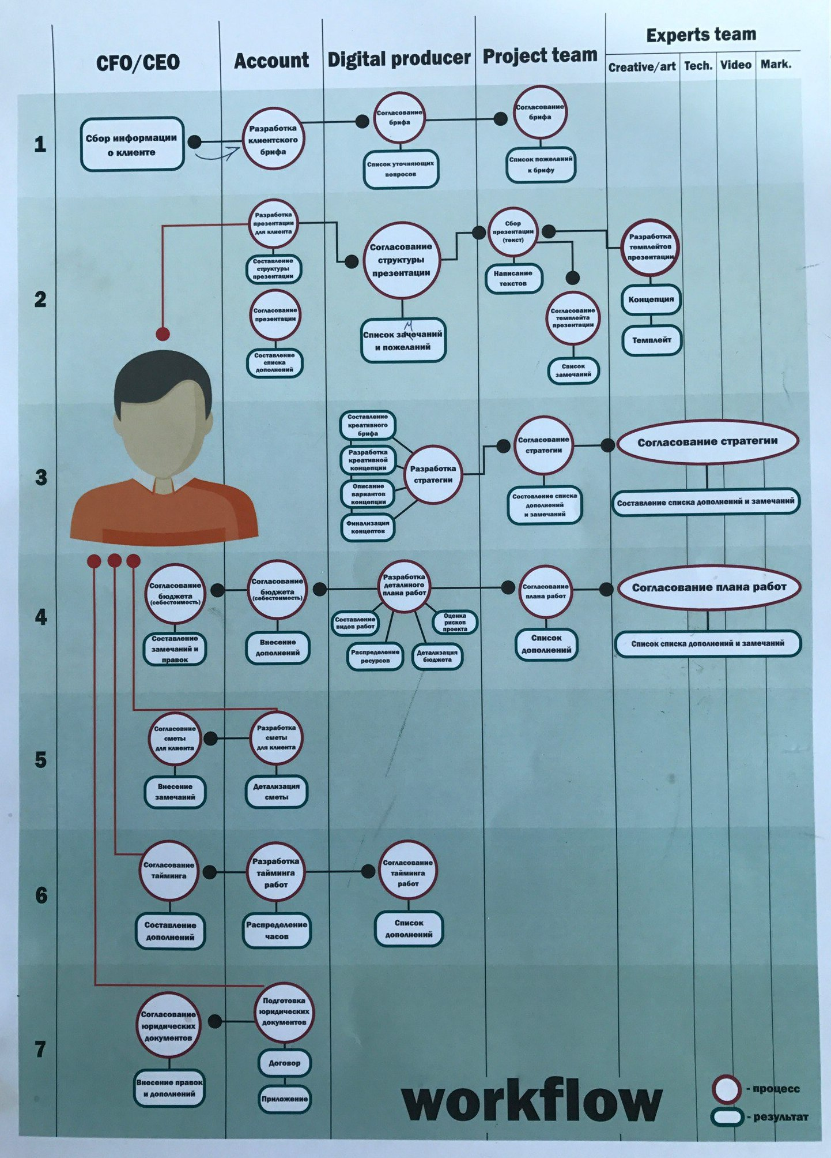

# Appendix 2

Level 2 capability map

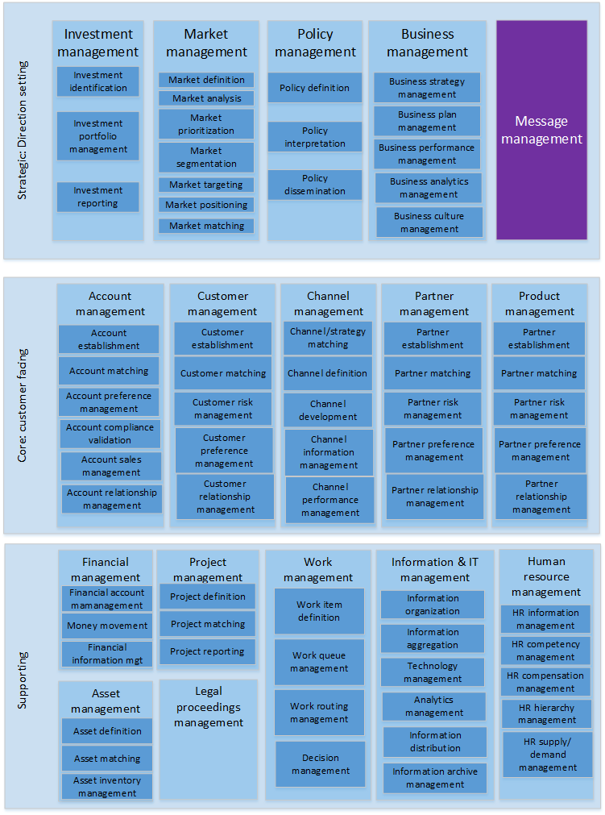

# Appendix 3

Hierarchical view of capability map in HIQE Digital (some capabilities are decomposed to Level 3)

1. Strategic:
   1. Investment management
      1. Investment identification
      2. Investment portfolio management
         1. Investment decision making
         2. Investment/strategy matching
         3. Investment/asset allocation
         4. Investment risk management
      3. Investment reporting
   2. Market management
      1. Market definition
      2. Market analysis
      3. Market prioritization
      4. Market segmentation
      5. Market targeting
      6. Market positioning
      7. Market matching
   3. Policy management
      1. Policy definition
      2. Policy interpretation
      3. Policy dissemination
         1. Policy publishing
         2. Policy distribution
   4. Business management
      1. Business strategy management
      2. Business plan management
         1. Business plan development
         2. Business plan strategy matching
         3. Business plan communication
         4. Business plan coordination
      3. Business performance management
      4. Business analytics management
      5. Business culture management
2. Core
   1. Account management
      1. Account establishment
      2. Account matching
         1. Account needs identification
         2. Account solution matching
      3. Account preference management
      4. Account compliance validation
      5. Account sales management
      6. Account relationship management
         1. Account support
         2. Account analytics
         3. Account retaining
   2. Channel management
      1. Channel/Strategy matching
      2. Channel definition
         1. Digital channels definition
            1. Email channel
            2. Website channel
            3. Social media channel
            4. Mobile channel
            5. Online advertisement channel
            6. Search engines channel
         2. Offline channels definition
      3. Channel development
         1. Digital channel development
         2. Offline channel development
      4. Channel information management
         1. Channel information gathering
         2. Channel information analysis
         3. Channel information storing
      5. Channel performance analytics
         1. Conversion rate analytics
         2. Usability analytics
         3. Interaction tracking
   3. Customer management
      1. Customer establishment
      2. Customer preference management
      3. Customer relationship management
         1. Customer profiling
         2. Customer type management
         3. Customer status management
         4. Customer task management
         5. Customer analytics management
         6. Customer feedback management
         7. Customer communication and notification
      4. Customer matching
         1. Customer needs assessment
         2. Customer/product matching
      5. Customer risk management
   4. Partner management
      1. Partner establishment
      2. Partner preference management
      3. Partner relationship management
         1. Partner profiling
         2. Partner type management
         3. Partner status management
         4. Partner feedback management
      4. Partner matching
      5. Partner risk management
   5. Product management
      1. Product information management
         1. Product information gathering
         2. Product information organization
         3. Product information storing
         4. Product performance measurement
         5. Product performance analysis
      2. Product development
         1. Product concept development
         2. Product similarity analytics
         3. Product concept approval
         4. Product functionality development
         5. Product content development
         6. Product design development
         7. Product testing
         8. Product quality management
         9. Product launch preparation
         10. Product deployment
         11. Product retirement
      3. Product price determination
      4. Product matching
         1. Product/strategy matching
         2. Product/channel matching
         3. Product/customer matching
      5. Product portfolio management
3. Supporting:
   1. Financial management
      1. Financial account management
      2. Money movement
      3. Financial information management
   2. Human resource management
      1. HR information management
         1. HR information organization
         2. HR information tracking
         3. HR information reporting
         4. HR information storing
      2. HR competency management
         1. HR skills acquisition
         2. HR skills assessment
         3. HR skills development
      3. HR compensation management
      4. HR hierarchy management
      5. HR supply and demand management
   3. Information & IT management
      1. Information organization
      2. Information aggregation
      3. Technology management
         1. Technology acquisition
         2. Technology deployment
         3. Technology education
         4. Technology alignment
      4. Analytics management
      5. Information distribution
      6. Information archive management
   4. Legal proceeding management
   5. Work management
      1. Work item definition
      2. Work queue management
         1. Work prioritization
         2. Work structuring
         3. Work filtering
      3. Work routing management
      4. Decision management
         1. Decision reaching
         2. Decision formalizing
         3. Decision documenting
         4. Decision communication
   6. Asset management
      1. Asset definition
      2. Asset matching
      3. Asset inventory management
         1. Asset inventory administration
         2. Asset inventory maintenance
         3. Asset inventory tracking
         4. Asset inventory reporting
   7. Project management
      1. Project definition
         1. Project purpose definition
         2. Project goal definition
         3. Project scope definition
      2. Project matching
         1. Project staff matching
         2. Project time matching
         3. Project asset matching
      3. Project reporting

# Appendix 4

“Launch new product” value stream with cross-mapped capabilities

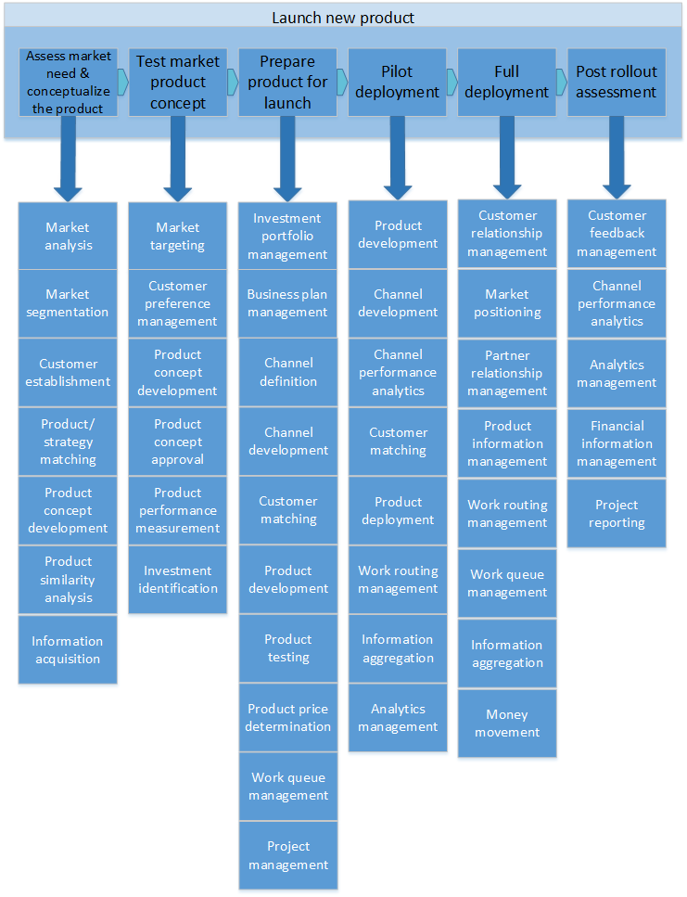

# Appendix 5

“Providing educational service” value stream with cross-mapped capabilities

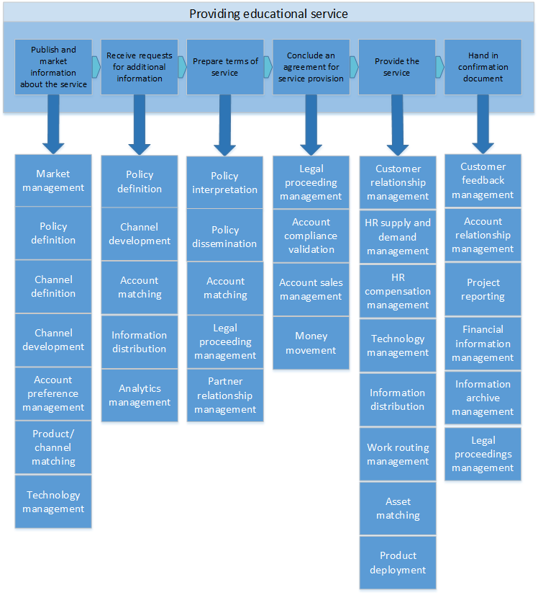

# Appendix 6

“Launch new product” cross-mapping with color coding scheme (heat map) applied

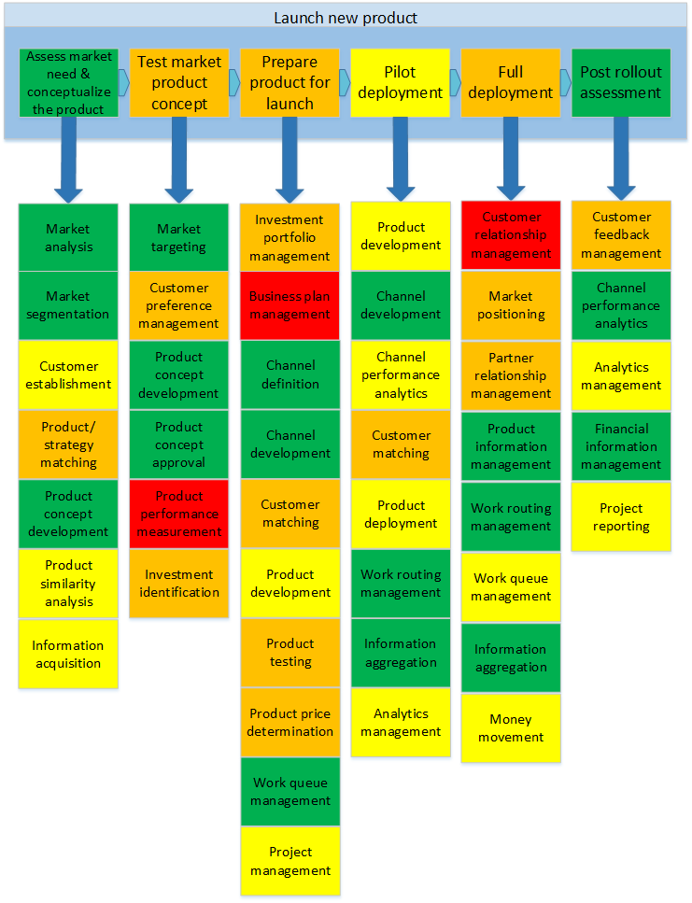

# Appendix 7

“Providing educational service” cross-mapping with color coding scheme (heat map) applied

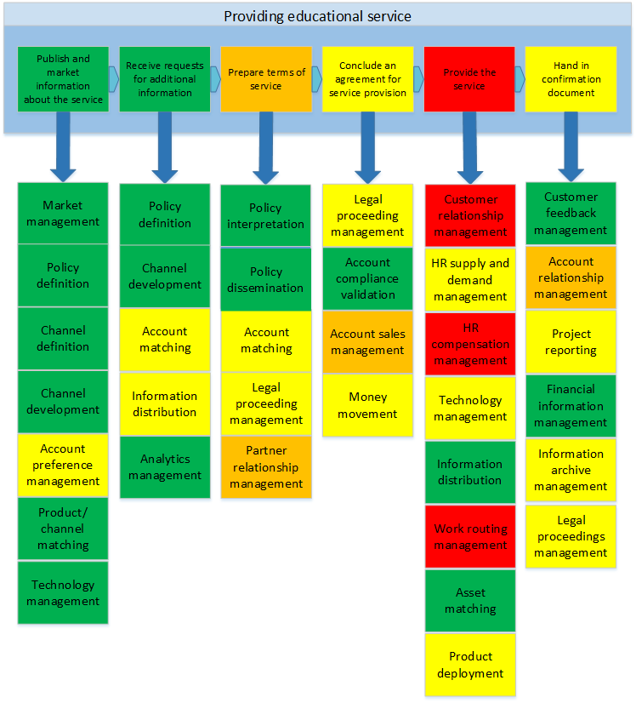

1. According to the United States Small Business Administration (<https://www.sba.gov/>) and Eurostat statistics explained (http://ec.europa.eu/eurostat/statistics-explained/index.php/Main_Page), 98% of the US businesses and 99,8% of European businesses are small and medium-sized enterprises.
2. Brignal, S. (2002). The UnBalanced Scorecard: a Social and Environmental Critique. Proceedings, Third International Conference on Performance Measurement and Management
3. Kong, E. (2010). Analysing BSC and IC's usefulness in non-profit organisations. Journal of Intellectual Capital, 11(3), pp.284-304
4. Jensen, M. C. (2001). Value maximization, stakeholder theory, and the corporate objective function. European Financial Management, 7 (3), pp.297–318.
5. Kaplan and Norton attempted to close this gap be introducing so-called “strategic themes”, which is “a vertical slice within the map, that consists of a distinct set of related strategic objective” (Kaplan and Norton, 2008), but in author’s opinion this just makes the framework more complicated and challenging to understand and implement, especially in SMEs.
6. SEO - Search Engine Optimization
7. SMM - Social Media Marketing
8. UI – user interface, UX – user experience
9. CRM – customer relationship management system
10. CMS – content management system
11. Meetings, incentives, conferences and exhibitions
12. Software-as-a-Service (SaaS) is a cloud-based software delivery model in which software is licensed on a subscription basis and is centrally hosted
13. mgt = management
14. The Delphi method is a structured communication technique based on the results of several rounds of questionnaires sent to a panel of experts.
15. Detailed capability dimension performance assessment framework was described by Shu Cheng in the work “Translating strategy into Implementation via Capability-Based planning” (2015)
16. RFM stands for “Recency, Frequency, Monetary value” customer value analysis