St. Petersburg University
Graduate School of Management

Master in Management Program

INSTITUTIONAL INVESTING IN INTERNATIONAL PRIVATE EQUITY: IMPACT OF PORTFOLIO DIVERSIFICATION STRATEGIES ON RISK AND RETURN

Master’s Thesis by the 2nd year student
Concentration – General Track
Aleksandr Golubev

Research advisor:
Andrei Panibratov,
Dr./PhD, Professor

St. Petersburg
2017

ЗАЯВЛЕНИЕ О САМОСТОЯТЕЛЬНОМ ХАРАКТЕРЕ ВЫПОЛНЕНИЯ
ВЫПУСКНОЙ КВАЛИФИКАЦИОННОЙ РАБОТЫ
Я, Голубев Александр Александрович, студент второго курса магистратуры направления «Менеджмент», заявляю, что в моей магистерской диссертации на тему «Вложения институциональных инвесторов в фонды прямых инвестиций: влияние диверсификационной стратегии на риски и доходность», представленной в службу обеспечения программ магистратуры для последующей передачи в государственную аттестационную комиссию для публичной защиты, не содержится элементов плагиата.
Все прямые заимствования из печатных и электронных источников, а также из защищенных ранее выпускных квалификационных работ, кандидатских и докторских диссертаций имеют соответствующие ссылки.
Мне известно содержание п. 9.7.1 Правил обучения по основным образовательным программам высшего и среднего профессионального образования в СПбГУ о том, что «ВКР выполняется индивидуально каждым студентом под руководством назначенного ему научного руководителя», и п. 51 Устава федерального государственного бюджетного образовательного учреждения высшего образования «Санкт-Петербургский государственный университет» о том, что «студент подлежит отчислению из Санкт-Петербургского университета за представление курсовой или выпускной квалификационной работы, выполненной другим лицом (лицами)».
13.10.2017

STATEMENT ABOUT THE INDEPENDENT CHARACTER OF
THE MASTER THESIS
I, Aleksandr Golubev, second year master student, program «Management», state that my master thesis on the topic «Institutional Investing in International Private Equity: Impact of Portfolio Strategies Diversification on Risk and Return» which is presented to the Master Office to be submitted to the Official Defense Committee for the public defense, does not contain any elements of plagiarism.
All direct borrowings from printed and electronic sources, as well as from master theses, PhD and doctorate theses which were defended earlier, have appropriate references.
I am aware that according to paragraph 9.7.1. of Guidelines for instruction in major curriculum programs of higher and secondary professional education at St. Petersburg University «A master thesis must be completed by each of the degree candidates individually under the supervision of his or her advisor», and according to paragraph 51 of Charter of the Federal State Institution of Higher Education Saint-Petersburg State University «a student can be expelled from St. Petersburg University for submitting of the course or graduation qualification work developed by other person (persons)».

13.10.2017
АННОТАЦИЯ
Автор | Голубев Александр Александрович
Название магистерской диссертации | Вложения институциональных инвесторов в фонды прямых инвестиций: влияние диверсификационной стратегии на риски и доходность
Факультет | Высшая Школа Менеджмента
Направление подготовки | Магистр Менеджмента
Год | 2017
Научный руководитель | Андрей Юрьевич Панибратов, профессор
Описание цели, задач и основных результатов | В данной работе анализируются различные стратегии диверсификации портфеля, для институциональных инвесторов, которые готовы вложить часть своего капитала в фонды прямых инвестиций. Данный фонды активно привлекают внимание различных сегментов инвесторов из-за низкой корреляции с публичными компаниями, а также дают возможность получить большую прибыль, чем государственные институты. Таким образом, инвесторов привлекает возможность получить доходность выше средней, а также диверсифицировать часть риска своего инвестиционного портфеля за счет вложения в фонды прямых инвестиций.  Несмотря на высокий интерес со стороны инвесторов, данные фонды остаются относительно неясным классом активов по сравнению с государственными ценными бумагами: нет единого мнения среди инвесторов или исследователей относительно того, как измерять доходность и риски в фондах, как оценивать эффективность портфеля фондов, или как построить оптимальную инвестиционную инвестиционную стратегию для фондов прямых инвестиций. Таким образом, мы сочли важным рассмотреть один из подсубъектов этой проблематики: диверсификации инвестиционной стратегии в фонды прямых инвестиций.  Поскольку фонды не до конца описаны современной теорией портфеля, основанной на дисперсии, мы построим портфели с использованием случайной выборки с заменой, основанной на доходности различных категорий фондов. Благодаря такому подходу будет продемонстрирована, что некоторая диверсификация в рамках портфеля фондов прямых инвестиций может обеспечить более высокую доходность инвесторам с учетом риска.  Однако также отмечен тот факт, что практическое применение стратегий диверсификации в рамках данных вложений может иногда быть проблематичным; и что многие инвесторы предпочитают гибкие инвестиционные стратегии, что дает альтернативу инвестирования в фонды прямых инвестиций.
Ключевые слова | Фонды прямых инвестиций, венчурный капитал, институциональные инвесторы, инвестиционная стратегия, диверсификация

ABSTRACT
Master Student's Name | Aleksandr Golubev
Master Thesis Title | Institutional Investing in International Private Equity: Impact of Portfolio Strategy Diversification on Risk and Return
Faculty | Graduate School of Management
Main field of study | General Track
Year | 2017
Academic Advisor's Name | Andrei Panibratov, Dr./PhD, Associate Professor
Description of the goal, tasks and main results | In this paper we take the opportunity to analyse portfolio diversification strategies that are open to institutional investors willing to allocate a portion of their capital to Private Equity. Private Equity has been gaining attention of an increasingly large investor pool, as it is believed to have a low correlation with publicly traded securities, as well as to deliver higher returns than the public markets. Thus, investors are attracted by the opportunity Private Equity offers to earn above-average returns and to diversify away some portion of the risk of their investment portfolio.  Despite high interest from investors, private equity remains a relatively obscure asset class as compared to public securities: there is no unanimity among investors or researchers as to how to measure return and risk in Private Equity, how to benchmark the performance of a portfolio of funds, or how to build an optimal Private Equity investment strategy. Thus, we thought it important to consider one of the sub- questions of this problematic: namely the diversification strategies in private equity investing.  Since Private Equity doesn’t fit well in a Modern Portfolio Theory mean variance based model, we construct portfolios of funds using random sampling with replacement based on historical returns of different categories of Private Equity funds (e.g. Buyout & Venture Capital, US & Europe focused BO and VC funds, Small & Mid-sized and Large funds, Early stage and Traditional Venture Capital). Through this approach we demonstrate that some degree of diversification within a Private Equity portfolio can provide higher risk-adjusted returns for investors.  However, we also point out the fact that practical application of diversification strategies within Private Equity may sometimes be problematic; and that many Limited Partners prefer to keep their investment strategies flexible and don’t refrain from investing into Private Equity on opportunistic basis.
Keywords | Private equity, Venture capital, institutional investor, investment strategy, diversification

Table of Contents
List of tables, figures and graphs 9
List of abbreviations 11
INTRODUCTION 13
CHAPTER 1. INDUSTRY AND RESEARCH BACKGROUND 15
1.1. Private Equity – an Asset Class directed at Institutional Investors 15
1.2. Place of Private Equity in an Institutional Investor’s Portfolio 16
1.3 Academic literature review 18
1.3.1 Institutional shareholders 20
1.3.1.1 Pension funds 22
1.3.1.1 Mutual funds 24
1.3.2 Diversification at Fund Level 27
1.3.3. Impact of diversification on risk & return in PE 27
1.4. Defining research gap and research questions 29
Summary of Chapter 1 30
CHAPTER 2. METHODOLOGY 31
2.1. Key research considerations 31
2.1.1. Diversification by vintage year 31
2.1.2. Diversification by industry 32
2.1.3. Diversification by strategy 32
2.1.4. Diversification by Stage 33
2.1.5. Diversification by geographic focus 33
2.2. Data construction, methodology and potential sample biases 34
2.2.1. Data Sample 34
2.2.2. Methodology: Constructing Portfolios 36
2.2.3. Methodology: metrics selection 36
2.2.4. Potential sample biases 38
Summary of Chapter 2 39
CHAPTER 3. EMPIRICAL ANALYSIS AND RESULTS 40
3.1. Diversification by fund strategy: Buyouts and Venture Capital 40
3.2. Diversification by stage 44
3.2.1. Early Stage and Traditional Venture capital funds 45
3.2.2. Small, Mid-Sized and Large Buyout funds 48
3.3. Diversification by geography: US and Europe focused funds. 51
3.4 Overview of diversification strategies of several large LPs 58
3.5 PE investments in Asia 61
Summary of Chapter 3 68
RESEARCH FINDINGS AND DISCUSSIONS 70
LIMITATIONS AND PROSPECTS FOR FUTURE RESEARCH 71
CONCLUSION 73
REFERENCES 75

List of tables, figures and graphs
Tables
Table 1. Key characteristics of the performance sample used in the study
Table 2. Comparing the risk/return profile of Buyout and Venture Capital Funds
Table 3. Comparing the risk/return characteristics of General Venture Capital and Early Stage Funds
Table 4. Comparing the risk/return characteristics of Large and Small & Medium Buyout Funds
Table 5. Comparing the risk/return profile of Buyout and Venture Capital Fund
Table 6. Private Equity programs of 6 large Limited Partners
Table 7. Largest Asia-Focused Private Equity Funds Currently in Market
Figures
Figure 1. Investor Attitudes towards Different Fund Types, as of June 2014
Figure 2. Annual Buyout fundraising by Geographic focus, 2008-2016 YTD
Figure 3. Regions Investors are targeting for venture capital investments, as of June 2014
Figure 4. PERACS Risk Curve of a typical PE portfolio
Figure. 5. Buyout funds Historical TVPI multiples
Figure. 6. Venture capital funds Historical TVPI multiples
Figure, 7. Buyout vs. Venture average historical TVPI
Figure, 8. Buyout vs. Venture average historical IRR
Figure. 9. US VC-BO Portfolio Risk/Return (vintages 1985-2000)
Figure. 10. Av. Returns on portfolios of 6 BO & VC funds
Figure. 11. Av. Returns on portfolios of 10 BO & VC funds
Figure. 12. Av. Returns on portfolios of 30 BO & VC funds
Figure 13. Av. Returns on portfolios of 50 BO & VC funds
Figure 15. PERACS risk curve - portfolios of 5 BO & VC funds
Figure 16. PERACS risk curve – portfolios of 50 BO & VC funds
Figure 17. Early Stage funds Historical TVPI
Figure 18. Venture Capital funds Historical TVPI multiples multiples
Figure 19. Top Quartile Boundary net IRR for Early Stage and traditional VC by vintage
Figure 20. Av. Returns on portfolios of 6 Early Stage & Traditional VC funds
Figure 21. Av. Returns on portfolios of 10 Early Stage & Traditional VC funds
Figure 22. Av. Returns on portfolios of 30 Early Stage & Traditional VC funds
Figure 23. Av. Returns on portfolios of 50 Early Stage & Traditional VC funds
Figure 24. PERACS risk curve - portfolios of 6 Early Stage
Figure 25. PERACS risk curve – portfolios of 50 Early Stage VC funds & VC funds
Figure 26. Large BO funds Historical TVPI multiples
Figure 27. S-Midcap BO funds Historical TVPI multiples
Figure 28. Av. Returns on portfolios of 6 Large & S-Midcap
Figure 29. Av. Returns on portfolios of 10 Large & S- BO funds Midcap BO funds
Figure 30. Av. Returns on portfolios of 30 Large & S-Midcap
Figure 31. Av. Returns on portfolios of 50 Large & S- BO funds Midcap BO funds
Figure 32. PERACS risk curve - portfolios of 6 Large & S- Midcap
Figure 33. PERACS risk curve – portfolios of 50 Large & S- Midcap BO funds Midcap BO funds
Figure 34. US focused VC funds Historical TVPI
Figure 35. EU focused VC funds Historical TVPI multiples
Figure 36. US focused BO funds Historical TVPI
Figure 37. EU focused BO funds Historical TVPI multiples
Figure 38. Av. Returns on portfolios of 6 US & EU BO funds
Figure 39. Av. Returns on portfolios of 10 US & EU BO funds
Figure 40. Av. Returns on portfolios of 30 US & EU BO funds
Figure 41. Av. Returns on portfolios of 50 US & EU BO funds
Figure 42. PERACS risk curve - portfolios of 6 US & EU BO
Figure 43. PERACS risk curve – portfolios of 50 US & EU funds BO funds
Figure 44. Av. Returns on portfolios of 6 US & EU VC funds
Figure 45. Av. Returns on portfolios of 10 US & EU VC funds
Figure 46. Av. Returns on portfolios of 30 US & EU VC funds
Figure 47. Av. Returns on portfolios of 50 US & EU VC funds
Figure 48. PERACS risk curve - portfolios of 6 US & EU VC
Figure 49. PERACS risk curve – portfolios of 50 US & EU funds VC funds
Figure 50. All Private Equity – All Regions: Median Net IRRs and Quartile boundaries by Vintage Year
Figure 51. Venture Capital – Median Net IRRs and Quartile Boundaries by Vintage Year
Figure 52. PERACS risk curve – Teachers Retirement System of Texas
Figure 53. PERACS risk curve – CalPERS
Figure 54. PERACS risk curve – Indiana public retirement system
Figure 55. PERACS risk curve – CalSTRS
Figure 56. Breakdown of Asia-Based Investors by Type
Figure 57. Annual Primarily Asia-Focused Private Equity Fundraising, 2008 – 2015
Figure 58. Primarily Asia-Focused Private Equity Fundraising by Fund Type, 2008 – 2015
Figure 59. Total Estimated Dry Powder of Asia-Based Private Equity Fund Managers, 2003-2015
Figure 60. Median Net IRRs by Primary Geographic Focus and Vintage Year
Figure 61. Number and Aggregate Value of Private Equity-Backed Buyout Deals in Asia, 2008 – 2015
Figure 62. Number and Aggregate Value of Venture Capital Deals* in Asia, 2008-2015

List of abbreviations
The list of abbreviations used by the author in the master thesis is provided in order to avoid misinterpretations.
BO – Buyout
VC – Venture capital
PE – Private equity
SME – Small and Medium Entities
LPs – Limited Partenrs
GP – General Partner
IPO – Initial Public Offering
AFIC – Association Française des Investisseurs en Capital
CalPERS – California state pension fund
IRR – Internal Rate of Return
TVPI – Total Value to Paid-In
DPI – Distributions to Paid-In
RVPI – Residual Value to Paid-In
LBO – Leverage Buyout

INTRODUCTION
According to the Harry Markowitz Modern Portfolio theory, investors, optimizing or maximizing expected return for a given level of risk, can construct an optimal portfolio by allocating capital to a mix of asset classes with specific risk / return characteristics and correlations. The majority of large institutional investors follows this principle and tends to diversify the portfolio of assets under management by asset type and by geography in order to ensure a certain risk and return level that would allow investors to meet their pay-out obligations.
As the correlation of Private equity asset class and with others classes, like public entity or fixed income products is considered to be low, the number of investors, who decide to allocate a portion of their portfolio to Private equity increase.
The benefits of diversification seem obvious for publicly traded financial instruments, thus an average investor would attempt to invest into developed and emerging markets stocks, small-, mid- and large cap stocks, Investment grade and sub- investment grade bonds etc. However, institutional investors seem to be less reliant on the principles of portfolio diversification following from the modern portfolio whet they decide on capital allocation among different PE funds.
As a matter of fact, in the absence of an efficient trading market and of a benchmark index in Private Equity, one could question the appropriateness and the potential benefits of diversification within the PE asset class. As a matter of fact, investment opportunities and returns in Private Equity depend heavily on Institutional Investors’ relationship with private equity firms and on Limited Partners’ ability to access the best performing managers. In addition, the Modern Portfolio theory assumes that the returns follow a normal distribution, while the results in private equity are most often lognormal and highly skewed.
Given these challenges related specifics of the PE asset class, some investors don’t attempt to create optimal portfolios within private equity and plan for diversification only at the total portfolio level.
In this paper, we adopt the standpoint of Institutional Investors and tackle the question of diversification within a Limited Partner’s private equity portfolio.
Our aim is thus to evaluate what is the potential impact of diversification on the risk/return profile of LPs investments and what is the feasibility of implementing a diversified investment strategy within the Private Equity asset class.
In the context of this research, we conducted both qualitative and quantitative analysis. First of all, we considered historical returns of different categories of PE funds in order to evaluate their risk/return profile and to determine the correlation between returns among different kinds of funds. Secondly, we analyzed private equity investment programs of several large institutional investors, based on information that is publicly communicated by LPs, in order to understand what is the level of diversification within their PE portfolios, as well as the level of investment risk.
The remainder of the paper is structured as follows. First, an industry background, focusing specifically on the place of private equity among other asset classes within an Institutional Investor’s portfolio. Next we review the academic literature on diversification in Private Equity, both on the level of portfolio firms and on the fund level. In the chapter 2 we briefly discuss the main directions of our research. Afterwards we discuss the construction of our data set, our methodology, the key performance and risk measures to be examined and any potential biases. We then display our descriptive statistics and simulation results in chapter 3. In this section we also talk about possible constraints LPs face in implementing an optimal portfolio of PE investments. Moreover, we analyse the PE investment policy several large Limited Partners and of the risk/return characteristics of their PE portfolios.
The research is conducted on the basis of around a hundred sources, which include scientific articles, books, industry reports and conference papers. The sources were found in such databases as Bloomberg, Thompson Reuters, PERACS, EBSCO, Emerald, JSTOR, Elsevier, Taylor & Francis, Wiley Interscience, Marketline and Euromonitor.

CHAPTER 1. INDUSTRY AND RESEARCH BACKGROUND
Private Equity has known a very strong growth in the past 20 years, with c. USD527bn capital raised by PE funds in 2015 and a little less than USD300m invested. Over the years, Private Equity has increasingly made its way into Institutional investors’ portfolios, first in the US and at a later stage in Europe and Asia. Despite the fact that PE is now a permanent component of any large investor’s portfolio, there is still a lack of transparency related to this asset class and Limited Partners’ PE investment policies seem to be less well defined than in the public financial markets. In this section we 1) give a short description of the main characteristics of Private Equity; 2) discuss the place of this asset class within an Institutional investor portfolio.

1.1. Private Equity – an Asset Class directed at Institutional Investors
Private equity investments are generally carried out indirectly via PE funds or funds of funds. Funds usually are structured as limited partnership agreements, with the private equity manager serving as the general partner (GP) and outside investors taking the place of a limited partner (LP). These investment funds have durations of 5-6 years of more, with the manager typically investing the capital in 10-20 portfolio companies during the first 2-4 years (the committed capital is thus drawn down as needed); and the portfolio maturing and producing realizations in the later years. During the holding period, the companies in the portfolio are further financed and managed for exit via an IPO, a corporate sale or on the secondary PE market. In contrast with public markets, an investment in Private Equity Making is therefore a long-term commitment for an institutional investor. Most private equity managers would raise a new fund every 3-4 years, and the year a fund is formed is called its "vintage year."
Investors in such funds in Europe are typically banks, pension funds, insurers, funds of funds, and corporate investors, while the fund manager is a team with specific background and skills that enable them to efficiently manage the portfolio companies.
LPs decide to invest in the fund as a blind pool base on a thorough due diligence, including the quality of the management team, its track record, investment strategy and fund structure. LPs are mainly protected through a long-term alignment of interests with the GP. The GP typically gets a 20% share of the profits after the total invested capital plus a hurdle return has been paid back to the LPs. And the GPs team members often need to invest a substantial share of their personal wealth (1% of fund size). Their main interest is therefore the generation of an above average return.
More than just an asset class, Private equity represents a new way of managing a company, which enables the target company to attain higher performance. As a matter of fact, PE funds are active investors and play a primary role in the strategic decisions concerning the portfolio companies. Thus, in addition to allowing investors to diversify their portfolios and giving them a chance to achieve higher profitability, private equity also has a positive impact on the corporate and macroeconomic growth. This kind of sustainable approach appeals to many institutional investors.
By its characteristics Private Equity is an asset class primarily oriented at institutional investors. This is explained among others by the desire of Private Equity firms to have a relatively limited pool of loyal investors. PE funds carefully select the investors they are willing to work with and develop a long-term relationship based on trust with their LPs. Most of PE firms have put in place special investor relations teams and on-line reporting platforms, in order to communicate to LPs information on quarterly financial results, capital calls and distributions related to their investment. Thanks to this privileged relationship, institutional investors are inclined to invest in the large array of funds offered by the same PE firm (buyout, venture capital, real estate etc.) and to renew their commitments.

1.2. Place of Private Equity in an Institutional Investor’s Portfolio
As already mentioned, most of large institutional investors nowadays allocate at least a small portion of their capital to Private Equity. Main reasons that encourage institutional investors to increase their exposure to Private Equity, according to a survey conducted by AFIC (Association Française des Investisseurs en Capital) in 2014, are the following (in order of importance): 1) low correlation with other asset classes, such as public equity or fixed income; 2) higher profitability; 3) attractive risk profile and lower volatility as compared to public equity; 4) liquidity level compatible with the constraints of the asset; 5) opportunity to invest into local companies.
Despite the fact that the survey only covered French LPs, we tend to consider these responses illustrative of the overall investor rationale. A survey of institutional investors conducted by Preqin earlier this year shows that investor appetite for this asset class remains strong. As a matter of fact, the majority of LPs (65%) maintain a buoyant perception of the Private Equity industry, with 42% of LPs saying they planned to increase their PE commitments over the coming year, and 51% saying they would raise their PE allocations over the long term. In addition, according to Bain & Co’s most recent Global Private Equity Report, nearly 50% of LPs expect PE will continue to exceed public market returns by more than 4ppts, and nearly 90% anticipate PE returns will outperform by at least 2ppts.
Despite the growing interest, for many large fund investors PE still makes up a relatively small proportion of their overall investment allocations. For example, the influential California state pension fund (CalPERS) has a total of $296bn in assets, but invests only $31bn (i.e. c.10% of total assets) in Private Equity. In comparison, CalPERS invests 53% of assets in public equities and 9% in real estate. In fact, according to a London Business School study of 1,200 US and UK pension funds, public pension funds directly allocate on average only about 5.6% of their assets to PE funds.
Among the main reasons for LP’s relatively low exposure to Private Equity we can point out the following: 1) lack of liquidity, with the capital being “frozen” during the lifetime of the fund (this is the most important obstacle for LPs, according to AFIC survey); 2) Lack of transparency on the fund level, related namely to portfolio companies valuation and the effects of leverage; 3) Legal and regulatory constraints, some of the investors such as Insurance companies or banks being subject to Solvency II and Basel III capital requirements. In addition, there is a “pooling” risk associated with private equity. As an LP has no or very little control over the way his capital is allocated among portfolio companies and most PE managers protect the confidentiality of their methods, the risk resides in the difficulty to choose one Private Equity firm over another and the lack of criteria for comparison. Finally, the “J-curve” shape of returns in Private Equity (meaning that in the first 3-4 years there is an outflow of capital for investments and management fees, and the returns only start arriving in the following years) and the difficulty to measure performance (no equivalent of a pubic market index) are also among reasons that dissuade the institutional investors.
Many large LPs, especially pension and sovereign-wealth funds are typically invested across many different asset classes in order to diversify risk, therefore they also make an effort to diversify the categories of private equity funds within their portfolios.
This explains investors’ appetite for large PE firms that provide LPs with the opportunity to invest into diversified multi-asset funds, thus effectively becoming a one-stop shop for Institutional investors. For LPs that might have less expertise and limited in-house capacity to pick the best of breed in each asset class, a trusted and credible diversified fund is a compelling alternative. This also allows investors to deploy more capital through fewer GPs and thus reduce overall management fees. Cost cutting is a particularly pressing subject as recently US public pension funds have come under political scrutiny for the amounts they spend on management fees. As a result, CalPERs announced recently that it was looking to shrink its roster of PE managers by 2/3rds to 120. Since then, other funds have made similar statements. In addition, some multi-asset managers offer a combined performance fee structure, which charges carried interest only if the overall performance of all investments across all asset classes clears a specified combined hurdle rate, thus allowing to account for the underperformance of investments in some asset classes.
Thus, in many ways, large diversified funds are assuming the role of traditional asset managers rather than acting as typical PE General Partners. In 2011, for instance, the Teacher Retirement System of Texas committed USD3bn to both KKR and Apollo to manage as a separate account (and then additional $4bn in 2015). KKR and Apollo had mandates to invest the capital using several different strategies across their asset funds and even had the latitude to place capital in new investment opportunities.

1.3 Academic literature review
Notwithstanding the ever growing popularity of private equity among investors, it still remains a largely opaque asset class in terms of the determinants of risk and return, and its attractiveness as an investment choice is often called into question. Phallipou (2007) comments on the poor returns from PE for the average investor and concludes that “overall, investors need to gain familiarity with actual risk, past return, and specific features of private equity funds”. Rice (2012) remarks that “the average private equity investment may add no value for a broadly diversified institutional portfolio”. Welch (2016) shows that the diversification benefits of PE as asset class are overstated as the valuation methods that were typically used underestimate the systematic risk of PE.
Prior literature has established that private equity and venture capital investors conduct restructuring and various value-adding activities following their initial financing round. Jensen (1986, 1989) argues that leverage, close monitoring, and managers' expertise represent the core value drivers of private equity deals. Previous studies identify leverage to be the main value driver in PE deals because it significantly reduces the cost of capital and results in cost-efficient financing (Shivdasani and Zak, 2007; Acharya et al, 2010; Levis, 2011). Recently, Sorensen et al (2014) report that the use of leverage in PE deals reduces the private equity investors’ (called limited partners, 'LPs') break-even alpha and costs.
In addition, other changes implemented by PE sponsors while portfolio companies are under their private ownership are known to improve the investment firm's performance. PE investors replace the existing CEO, as well as alter the board of directors' size and composition (Cornelli and Karakas, 2010). Acharya et al (2009) report that UK public firms have on average 11.4 members on the board, in contrast to PE- backed companies’ boards which are much more collaborative due to their significantly smaller size of 7-8 members. Baker and Wruck (1989) report that PE sponsors improve operating performance by linking managers' compensation plans to the firm's performance by means of stock options, and decentralisation of the decision making process. Stock options and stock grants are used to align interest of managers with those of shareholders (Jensen, 1986).
VC investors also restructure firms following their financing. Venture capitalists with prior business experience are intensively involved in fundraising and management recruiting (Botazzi et al, 2008). Kaplan et al (2009) examine the portfolio firms' evolution from business plan to an IPO. They find that VCs frequently change the management team, while they keep the business lines unchanged. Financial sponsors provide intensive oversight of their portfolio firms by VC investors’ representation on the board of directors (Lerner, 1995) and appointment of a higher proportion of independent directors (Baker and Gompers, 2003; Hochberg, 2003). Because of their significant involvement in firms’ operations, some firms even have to relocate to be nearer the VC headquarters before getting funding in order to facilitate monitoring (Tian, 2011). Overall, VC-backed firms are associated with increased R&D intensity, improved innovation output (Celikyurt et al, 2014) and more valuable patents (Kortum and Lerner, 2000). In sum, PE and VC investors' involvement results in better stock returns: financially sponsored IPOs outperform non-backed peers in the long-run (Ritter, 2013; Levis, 2011).
Previous studies (Barry et al, 1990; Cao 2011) document that VC and PE investors only realise a part of their returns at the IPO date. At the time of quotation, pre- IPO investors are limited in their ability to sell their shares for a certain period of time under the lock-in (or lockup) agreements. After the lockup expiration date, financial sponsors are able to either fully divest or retain some equity. The average duration of lock-up agreements in the US is 180 days (Brav and Gompers, 2003). Cao (2011) reports that one year after the quotation PE investors retain 32.36% of the firm's outstanding shares. Various financial sponsors have different preferences towards share retention. For example, lead VC members hold more shares in the pre- and post-flotation than non-lead syndicate members (Lin and Smith, 1998). Krishnan et al (2011) report that more reputable VC houses carry on holding more shares and have a higher proportion of board directorships three years post-flotation than less reputable VCs.
There are several studies which analyse the determinants of PE and VC investors' speed of exit. Cao (2011) reports that there is a negative relationship between the restructuring duration by PE investors and hot IPO market conditions, in addition to certain firm's characteristics, such as cash flows and stock valuations. Paeglis and Veeren (2013) consider the speed and consequences of VC exits. They find that VC investors exit faster from IPOs with intermediate founder ownership. Around the VC exit event, these firms experience the largest decrease in firm value. They explain this by higher level of founders' entrenchment post VC exit.
This section provides an overview of the selected examples of the academic literature examining the role of diversification strategies at two different levels: (1) fund level (i.e. diversification in PE funds’ investments), and (2) portfolio of funds level (i.e. diversification within a limited partner’s PE portfolio, and, more generally, the place of private equity investments in the portfolio of an institutional investor).

1.3.1 Institutional shareholders
The next aspect of theoretical framework which is of paramount importance is description of institutional shareholders, which are strictly related to agency theory issues. What is more, mutual and pension funds, entities which are basis of this research paper, are within this group. These two types of institutional shareholders will be used as independent variable while testing investment patterns in real estate sustainability.
Institutional investors are commonly assumed to be a key component of corporate governance—monitoring and disciplining managers through explicit actions or “voting with their feet.” [Bushee, Carter, Gerakos. 2014]. There is no exact definition what institutional shareholder does mean, but it can be classified as all types of owners which are legal entities instead of persons [Celik, Isaksson. 2014]. Legal form itself is not important in this case, because various institutional shareholders are registered as different bodies (LLC, public company etc.). Another feature which is common to this type of investors is the fact that they manage financial means which belong to other people (there is one exception regarding sovereign wealth funds, however while assuming that taxes are money owned by people who earned them, it matches the definition). “One of the primary responsibilities inherent in the role of financial intermediary as played by institutional investors (i.e. retirement pension funds, investment funds and insurance associations) is responsibility to those in whose names those institutions invest and trade in shares.” [Koładkiewicz, 2002]. All the investments carried out by institutional shareholders have to be analysed with due diligence in order to serve best stakeholders interests. Moreover, not only financial returns and profits are taken into consideration. For increasing number of institutional shareholders are also important such factors as influence on local communities, fighting with poverty and inequality and what is the most important from point of view of this paper, sustainability, eco-friendliness and environmental footprint issues.
In the market there are many types of institutional investors. To mention but a few: banks, insurance companies, sovereign wealth funds, hedge funds or private equity funds. Nevertheless, in this paper, I would like to focus on two of them: pension funds and investment (mutual) funds.

Chart 1. Total assets under management and allocation to public equity by different types of institutional investors
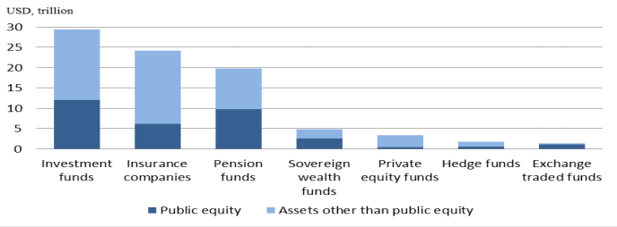
Source: McKinsey Global Institute
Basing on the chart above, we can see that in terms of total investment value, the most important are investment funds, insurance companies and pension funds. Because of many investments carried out by these entities, they are the best objects to compare their influence on owned firm’s strategy. Due to the general long-term strategy of pension funds and short-term of mutual funds, we selected them to test whether these patterns are also visible in properties owned by mutual and pension funds. It’s expected that this difference is also strengthened by relationship between principals and agents of these entities, sometimes resulting in acute conflicts. I decided to focus only on mutual funds and pension funds, excluding insurance companies. Insurer’s strategy regarding long-term vs. short-term investment horizon in not as clear as in case of institutions mentioned above.

1.3.1.1 Pension funds
There are many definitions describing pensions funds, but one very intuitive [SOMO for BankTrack] states that “A pension fund is [an entity] established by a company, governmental institution or labor union to pay for the future benefits of retired workers”. These institutions are organized in a way that future pensioners pay a certain amount of their salaries in order to receive benefits during retirement. Managers of pension funds are responsible of investing money collected from members in order to generate required returns. There are 2 most common models of pension funds. First one is constructed in a way that future retirees are assured about certain return on investment in the future. However, due the market fluctuations which consequently resulted in situation where reaching targets was not possible, this type of pension funds are less common nowadays. Presently, there is a majority of pension funds which require certain amount of payment for members, while not guarantying fixed rate of return. [Ballard, Strum. 1978]. Nevertheless, all type of funds, despite their form, have the same goal – earning desirable returns on their investments and paying pensions for participants of particular pension fund.
In terms of type of investment, pension funds focus on two of them: fixed income investments and equity investments [Andonov, Kok, Eichholtz. 2013]. In the first group, the majority of them are corporate bonds and treasury bonds. In the second one, most common are shares and real estate investments, which are the most significant for the purpose of this research paper.
Moreover, unique trait of pension funds is the fact that they are obliged to repay benefits to pensioners after on average 30-40 years [Ballard, Strum. 1978]. Pension funds are specific entities which, unlike most companies, have a duty to realise required returns in very long investment horizon. Capital providers are not pushing funds’ managers to generate quick profits. What is more, manager’s performance is not assessed while comparing financial results of particular fund to its peers. In this case the target is repaying adequate pensions to its members. Sustainability issues are important for pension funds, because social and environmental impact also influence the future well-being of prospective retires. As research show this kind of investments contribute to higher competitiveness and economic growth. In more robust economy, it is easier for pension funds to generate benefits for future retirees which will be satisfactory to them. Thus, pension funds are willing to undertake long-term projects which generate high returns, even they are only possible to reach in distant future, and are in accordance with sustainable development. According to [World Economic Forum] this type of projects are investments with the expectation of holding an asset for an indefinite period of time by an investor with the capability to do so. Pension fund managers are focused on the generation of sustainable cash flows from quality investment earnings over the long run, rather than on unsustainable short-term capital gains [Ringrose. 2015]. What also matters is use of owned assets in a way that lowers pace of depreciation and secures income for long period of time, eventually not exploiting possessed resources. Natural consequence of this fact is meaningful interest in sustainable solutions.
Basing on facts mentioned above, it is expected that, due to their features, pensions funds are more willing to invest in projects with high levels of sustainability, which positively impact not only financial results, but also environment and social welfare. Moreover, pension fund managers’ performance is assessed in a way that promotes long-term horizons and encourages them to act in accordance with principals preferences. Pension Funds, because of their long-term strategy, sustainability preferences of members and managers who are not pushed to short-termism, are more willing to invest in companies which acquire properties with high rates of LEED Certification, compared to other institutional shareholders (notably mutual funds). It is achieved by voice mechanism, when these entities are able to influence the strategic direction of an owned company, also in terms of properties sustainability.
Pensions funds, like other institutional shareholders face situations when their managers have different and often contrary goals. This issue relates to agency problems where managers do not act in accordance with principals best interests. As a way to mitigate this conflict, within pension funds are used specific ways to measure managers performance. What is the most important, these managers are not compared to their peers on annual return basis. The key requirement for them is to provide future pensioners with enough financial means. In this setting managers have the same goal as principals – generating significant returns in long term in durable way. Although some quantitative measurements are being used, to great extent managers are assessed on qualitative base. In this type of evaluation, there are included different variables which influence the final effect, reaching further than simple profitability analysis. As a most typical qualitative analysis is test whether given undertaking is consistent with the business mission, strategy and plan of particular company [Thamhain. 2014]. In this case managers are working under lower pressure compared to managers of other entities, allowing them focus on healthy growth and implementing fund’s strategy. Due to that, pension funds managers are more inclined to undertake sustainable investments which are natural consequence of long-term preferences. While real estate is being, 4th most important asset class of pensions funds and this share is continuously growing, we might expect that these type of institutional shareholder is also more inclined to acquire sustainable buildings, which is certified by high LEED certificate grade, proving such features of the property.

1.3.1.1 Mutual funds

“A mutual fund is a company that brings together money from many people and invests it in stocks, bonds or other assets. The combined holdings of these items are known as its portfolio. Each investor in the fund owns shares, which represent a part of these holdings” [U.S. Securities and Exchange Commission].
Likewise pension funds, mutual funds are managed by professionals who are in charge of investing money collected from both persons and companies. Mutual funds are completely voluntary; they gather investors who want to participate in undertakings which demands significant amount of funds. Many projects carried out by mutual funds are very capital intensive, therefore only thanks to them, minor investors are able to take part in large projects as owners of particular share which relates to their money input.
Mutual funds diversify their portfolios in order to reduce risk and reach required return on investment. Nonetheless, most of them specialise in particular investments, which managers understand profoundly and participants want to carry out. We can find funds which are focused on high-tech industry, emerging markets or real estate. Currently real estate is quite important component of most of the mutual fund’s portfolios, even if they do not specialise in this asset class. It is caused by several factors which make real estate a desirable position in portfolio. The most important are: inflation shield, stable positive cash flows and constant growth of value in long-term. According to [Blakely, Lynch, Skudrna. 1985] in the last decade, most commercial real estate investments have outperformed securities and government bonds with respect to inflation. Moreover, this type of investments is less volatile compared to different assets.
Key strategic objectives of this mutual funds is to generate meaningful gains for those who put money in these investment vehicles. Although participants of mutual funds, as well as managers declare their willingness to long-term horizons of investment, very often it is not achieved [Totaram. 2006]. There are several drivers of this phenomenon, but according to [Totaram. 2006] the most influential are “stress and anxiety emanating from regular performance charts in which managers are rated against their peers and the emphasis given to it by the media, consultants, multimanager, financial advisors, pension fund trustees and others. Managers of mutual funds are assessed while comparing their peers in this industry. Moreover, as a measurement of their performance, most frequently are used annual or even monthly financial statements and returns achieved compared to previous years [Keynes. 1938]. It is caused by the fact, that due to investment horizons, principals of mutual funds have no access to qualitative monitoring in contrary to pension funds. Mutual funds rely mostly on quantitative monitoring, which embraces all analytical approaches to evaluate performance on such basis like Return on Investment, cost – benefit or pay-back-period. When required results are not achieved, managers do not receive salary bonuses or are even made redundant. In this environment, managers focus on investments which generate quick returns which might satisfy principals. They acquire miscellaneous assets and then resell them shortly, to capture the benefit from value increase due to market fluctuations. In this setting, sustainable solutions, which positive impact may be reached only in long-term, are perceived as excessive expenses.
Consequently, it may result in situation that earnings of members of particular mutual funds will be not durable in long-term because of managers opportunism – their incentives are related to short-term gains. In such setting managers undertake decisions which brings profits quickly, without analysing their impact in distant future. This situation is contrary to pension funds, where managers are not pushed to that and have an opportunity to set longterm goals. It has an impact on strategies of those two types of institutional shareholders.
Managers of mutual funds pursue short-term investment strategy due to the way how their performance is assessed. Because of being constantly compared to peers and graded on yearly financial results, managers of these entities have much lower preference of sustainable investments, meeting financial demands together with environmental and social issues. It is a typical agency conflict, in which managers are not acting in accordance with principals interest, because they are motivated to undertake different activities than expected. In this circumstances sustainability solutions are perceived by managers as redundant expenses. In mutual funds, similarly like in pension funds, real estate constitutes comparable share of their portfolios.
Therefore, we might expect, that general investment preferences of mutual funds, where short-termism is prevalent, are also applied in real estate projects. In this case I assume that due to that, mutual funds are less interested in buildings with top-level LEED certification, due to their higher prices caused by implementation of sustainable solutions. While it deteriorates short-term gains, these type of funds abandon more often purchases of such properties. Mutual funds, because of their strategies and high pressure on managers, are less willing to invest in properties which scored high levels of LEED certification (compared to pension funds). It is because implementation of sustainable solutions is expensive and it deteriorates short-term financial results, whereas possible benefits are irrelevant from mutual fund managers point of view, due to their short investment horizons. Higher ownership level by mutual funds of given company, negatively impacts rates of LEED certification of buildings owned by this company.
Research Question: How an institutional investor can diversify its Private Equity portfolio and what kind of diversification is the most relevant?

1.3.2 Diversification at Fund Level
We start by looking at diversification strategies from the perspective of a PE firm selecting its portfolio companies. Ljungkvist and Richardson (2003) study a sample of 73 U.S. PE funds to test the relationship between their performance and a number of explanatory variables, including the number of invested companies and diversification across industries. They do not find evidence of diversification having a significant effect on the returns.
Lossen (2006) focuses more specifically on diversification strategies and identifies five dimensions of portfolio diversification for a PE fund: (1) number of companies in the portfolio (“naïve” diversification), (2) diversification across time (“dynamic” diversification), (3) diversification across financing stages (“systematic” diversification), (4) diversification across industries, and (5) diversification across countries.
To assess the impact of these diversification strategies on the performance of a fund, Lossen (2006) performs a multivariate analysis on a sample of 100 European PE funds corresponding to 34 PE firms, which exhibit very different levels of diversification. The paper finds partial evidence in favour of positive impact of industry diversification and the number of portfolio companies on the fund performance, whereas diversification across financing stages is associated with a decline in the rate of return. Diversification across countries and time appears to have no systematic effect. The statistical significance of the results, however, varies with the model specification.
Research Question: How important in quantitative terms are the potential benefits from diversification on Private Equity fund level?

1.3.3. Impact of diversification on risk & return in PE
We will now consider diversification from the perspective of an LP for whom private equity constitutes a component of the portfolio.
From a practitioner’s point of view, The European Private Equity & Venture Capital Association (2011) notes that in the long-term, diversification across funds reduces the risk of the portfolio, but that during market downturns, funds’ returns across different geographies can become highly correlated, which reduces the gains from portfolio diversification.
In academic literature, Weidig and Mathonet (2004) emphasize the importance of PE portfolio diversification. They look at 200 European funds and 50,000 simulated funds of funds and find that whereas the probability of total loss for a direct investment is 30%, it is drastically reduced for a PE fund, and, furthermore, a fund of funds has a small probability of any loss at all.
Schmidt (2003) studies 123 PE funds from 37 PE firms and observes that “there is a high marginal diversifiable risk reduction of about 80% when the portfolio size is increased to include 15 investments”, but further on, the marginal effect from diversification is rapidly diminishing, as management expenditure increases. As far as asset class allocation is concerned, Schmidt (2003) estimates optimal weight for PE at 3% to 65%, depending on the choice between minimizing portfolio variance and maximizing performance ratios.
Idzorek (2007) remarks that the uncertainty about historical returns of PE prevents investors from basing the portfolio weights on true values, and that the fragmented structure of the PE industry makes it impossible for investors to fully diversify away from firm-specific risk, which means that PE investments are at the same time exposed to the PE asset class and private company specific risk. Browne (2006) also points out that the extent of possible diversification is limited, and suggests that the performance of a PE investment strategy is above all defined by the quality of the selected managers and not by the “strategic design”.
Lerner et al. (2007) compare the performance of different types of institutional investors and establish that in terms of annual returns, endowments outperform other institutions by 14%, which demonstrates that fund selection and diversification can play a significant role in the PE portfolio returns.
Finally, Gottschalg et al. (2015) perform a detailed analysis on PE portfolio diversification based on 771 European and North American funds, and, similarly to Schmidt (2003), find that investing in multiple PE funds decreases capital risk, but that the marginal returns are reduced with the size of the portfolio. They also reveal a relationship between the diversification degree and the fund size: subject to the investors’ ability to select and access above-average performing funds, optimally diversified small-/mid-cap portfolio yields returns superior to those of a more concentrated of larger funds.
Research Question: What are the risk/return profiles of different categories of PE funds?

1.4. Defining research gap and research questions
The main research gap of the thesis id about the place of Private Equity in the institutional investors’ portfolio based on risk and return.
In the Chapter 1.3 academic literature review was analysis about three main components:
- Institutional shareholders – analysis of the way, how these type of investors act and are research about the place of PE in their portfolio or not.
- Diversification at fund level analysis demonstrate qualitative description in most of analytics and previous research, but didn’t demonstrate benefits of diversification in quantitative terms
- Impact of diversification on risk and return in PE – there wasn’t analysis about risk/return profiles of different categories of PE funds

Chart 1. Defining research gap
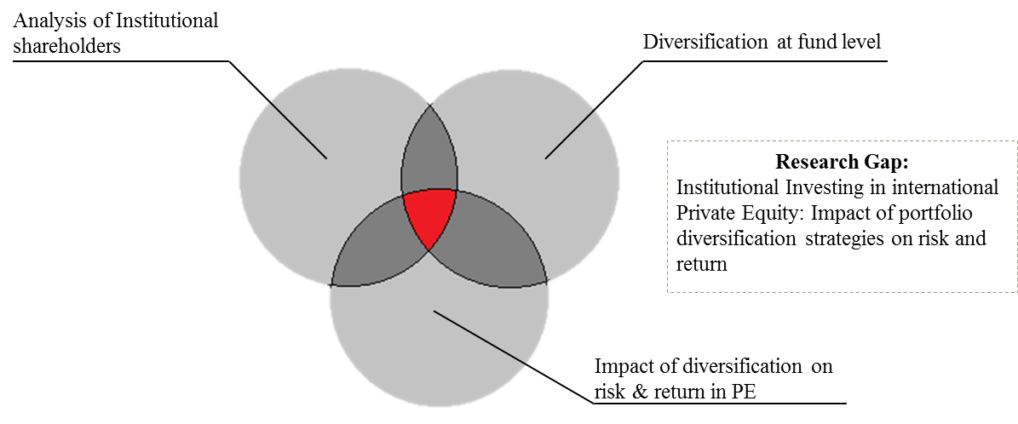
To fill this research gap in this thesis several research question will be analysed:
- (RQ1) What are the risk/return profiles of different categories of PE funds?
- (RQ2) How an institutional investor can diversify its Private Equity portfolio and what kind of diversification is the most relevant?
- (RQ3) How important in quantitative terms are the potential benefits from diversification on Private Equity fund level?

Summary of Chapter 1
The literature review of institutional investing in international private equity, which is presented in the first chapter, is conducted thematically. It consists of three parts:
- Analysis of institutional shareholders
- Diversification at fund level;
- Impact of diversification on risk and return in PE
In the first part was analysed the problem of institutional investors and deeply discussed two main categories – Pension and Mutual funds.
Secondly, the problem of the evidence of diversification having a significant effect on the returns described. Additionally, different types of diversification strategies and their place in fund’s performance also mentioned.
Last, but not the least, correlation of fund’s returns across different geographies described. It identified how to minimize the risk of the investing from the side of institutional investors. In addition, different types of funds were presented and it was shown that there is no optimal diversification strategy how to increase the probability of the successful investment with lower risk probability.
From the literature review it was determined that there are plenty of studies referring to different diversification strategies, but there are no studies regarding institutional investing in international Private equity, especially in emerging economies.
All of the above mentioned indicates that there is a research gap in the topic of impact of portfolio diversification strategies in risk and return in institutional investing in international Private equity and this topic can be investigated in this master thesis.

CHAPTER 2. METHODOLOGY

2.1. Key research considerations
In this paper, we investigate the performance and risk of investing in Private Equity funds, and specifically the impact of diversification on portfolio returns, using performance data on 1,549 funds obtained from PERACS. In the context of this study, we tried to answer 3 main questions:
- (RQ1) What are the risk/return profiles of different categories of PE funds?
- (RQ2) How an institutional investor can diversify its Private Equity portfolio and what kind of diversification is the most relevant?
- (RQ3) How important in quantitative terms are the potential benefits from diversification on Private Equity fund level?
There is a number of ways to introduce diversification into a private equity portfolio. The most obvious way is to invest in a number of private equity funds managed by different firms, which allows for a diversification on the level of GPs. In addition, a portfolio could be diversified based on a number of PE funds’ characteristics, such as: the vintage year, the industry focus, the strategy, stage, size and geographic focus.
In this section we will briefly introduce these diversification strategies before elaborating in more detail on the impact of some of these strategies on portfolio risks and returns in chapter 3.

2.1.1. Diversification by vintage year
It is important for PE investors to consider allocating their capital across funds with different vintage years, as it allows to reduce LPs exposure to economic downturns. As a matter of fact, the performance of underlying companies in a PE fund and the success of exit strategies are dependent on the health of the public markets and the economy in general. However, because of the long-term investment horizon in PE, it is difficult to determine in advance which vintage years in particular to invest in. Therefore, the common practice is to make new investments across every vintage year, knowing that the performance of some vintages would be more or less affected by the respective macroeconomic background. In addition, if investors decide to pull back from investing in certain vintage years with the same PE firm, they incur the risk of losing access to the managers whose funds they declined.

2.1.2. Diversification by industry
Most of the PE funds, especially in the buyout category, don’t have a well-defined industry focus and have no obligation to ensure a specific level of exposure to particular industries. Thus, the selection of the target companies would be most often determined by investment opportunities at any given time and by a temporary popularity of any particular sector. Thus, industry diversification in PE is mostly realized not on the fund, but on the portfolio company level, which limits LPs ability to control this type of diversification. On the other hand, some categories of PE funds tend to have a higher exposure to certain industries. Indeed, venture capital funds would most often invest in the tech sector or life sciences, whereas buyout funds would most likely favor large mature industries, such as media & telecoms, retail, industrials, energy etc. Based on this observation, an LP has a way to manage his exposure to various industries by maintaining a certain mix of buyout and venture capital funds in the investment portfolio.

2.1.3. Diversification by strategy
A major factor of diversification within a LP’s portfolio, fund strategies vary from more traditional buyout and venture capital funds to funds focusing on narrower subjects such as distressed debt, real estate or funds of funds. Venture and buyout funds however remain the primary focus of many LPs, as evidenced by figure 1, outlining LPs attitudes towards different fund types. As a matter of fact, 59% of interviewed investors were seeking to invest in Small and Mid-Market Buyouts over the following year; 31% - in Large buyouts and 29% - in Venture Capital.
Fig 1. Investor Attitudes towards Different Fund Types, as of June 2014
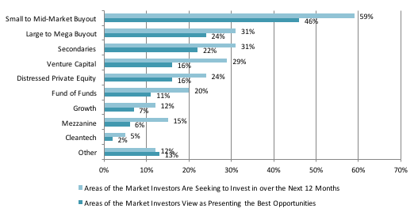
Source: Preqin Investor Interviews, June 2014
We will discuss the potential benefits of portfolio diversification among Buyout and Venture Capital funds in more detail in section 3.1.

2.1.4. Diversification by Stage
Investors can further diversify within venture capital and buyout portfolios by stage of investment.
In venture capital, this is typically achieved through investments in early stage and balanced venture capital funds. There are in fact significant differences in return and risk expectations for these two categories of venture capital funds. Early Stage funds usually support a step-up in capabilities of the companies that are able to begin operations, but are not yet at the stage of commercial manufacturing and sales. Note that within Early Stage category, there is a further diversification between start-up financing (support of product development and initial marketing) and first stage financing (capital is provided to initiate commercial manufacturing and sales).
In buyouts, diversification can be sought through investment across small and mid- market or large buyouts, using fund size as a proxy. The impact of this kind of portfolio diversification on risk and return is further examined in section 3.3.

2.1.5. Diversification by geographic focus
Many investors diversify their portfolios with commitments to both US and non-US PE funds, the main markets for non-US Private Equity being Europe and Asia Pacific. This is evidenced by Figure 2, showing annual Buyout fundraising by region between 2008 and Q1 2016. Europe has the most developed non-US private equity market, Asia is still an emerging market for Private Equity, frequently with a specific pool of investors allocating capital to Asia focused PE funds.
Fig 2. Annual Buyout fundraising by Geographic focus, 2008-2016 YTD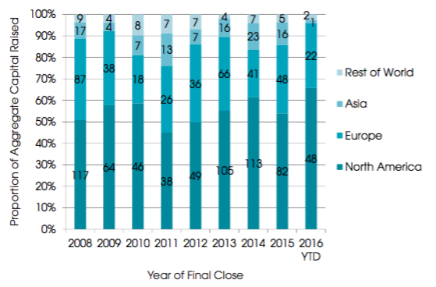
Source: Preqin Private Equity online
Interestingly, the gap in terms of development and performance seems to be larger among US and EU Venture Capital funds (with European VC funds significantly lagging behind), than between US and EU buyout funds. In line with this observation, North America accounts for the majority of venture capital investors (56%), followed by Europe (25% and Asia (11%), as per Preqin study in 2014. Figure 3 showing the regions LPs are targeting for VC investments confirms this trend.
Fig 3. Regions Investors are targeting for venture capital investments, as of June 2014
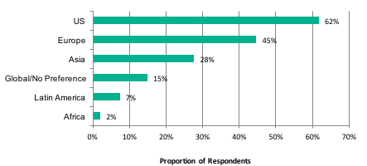
Source: Preqin Investor Interviews, June 2014
We further develop the impact of diversification between US and EU BO and VC funds in section 3.2., and prove that benefits of geographic diversification differ depending on the region and the category of funds targeted.

2.2. Data construction, methodology and potential sample biases
This section describes which databases we use, how we select the funds in our sample, which methodology and metrics we rely on in our empirical study and, finally, which biases might occur in our data.

2.2.1. Data Sample
In general, data on private equity is kept private and is very difficult to get. Previous researchers in private equity performance have either worked together with industry insiders or used individual fund cash flow information from such databases and Preqin or Thomson Venture Economics.
TVE & Cambridge Associates collect financial information on a confidential basis from institutional investors and from managers, which they then aggregate into a database for calculating performance benchmarks, without identifying fund or firm names. While this kind of benchmarks can be useful for LPs in order to evaluate the relative performance of the funds they are exposed to, this information was however not sufficient for the purposes of this study.
The data we use in our empirical research was obtained from a confidential database provided by PERACS, which offers information on more than 7,000 different funds established between 1969 and 2016. From this database, we constructed a performance sample taking funds set up between 1998 and 2012. To ensure representativeness of fund performance, we confine our dataset to funds set before 2013, as younger funds are most likely still in their investment stage and have not yet started to realize returns. We further divide our sample into several sub samples based on fund characteristics: Strategy (Buyout and Venture Capital), Geographic focus (US and EU), Market size for Buyouts (Small and Medium size: < USD800m; and Large: > USD800m) and Stage for Venture Capital (Generalist and Early Stage). The table 1 resumes the main features of our sample.
Table 1. Key characteristics of the performance sample used in the study
 |  |  | Number of Funds | Avverage TVPI | Min. TVPI | Max. TVPI
 | All |  | 1549
Strategy | Buyout |  | 1055 | 1,65 | 0,02 | 5,88
 |  | Upper Median | 545 | 2,06 | 1,16 | 5,88
 |  | Lower Median | 510 | 1,22 | 0,02 | 2,39
 | Venture Capital |  | 494 | 1,28 | 0,03 | 19,86
 |  | Upper Median | 261 | 1,76 | 0,68 | 19,86
 |  | Lower Median | 233 | 0,74 | 0,03 | 1,62
Region | US |  | 1059
 |  | Buyout | 681 | 1,67 | 0,02 | 5,58
 |  | Venture | 378 | 1,34 | 0,03 | 19,86
 | Europe |  | 490
 |  | Buyout | 374 | 1,63 | 0,24 | 5,88
 |  | Venture | 116 | 0,09 | 0,08 | 2,84
Fund size | Buyout
 |  | Large | 355 | 1,60 | 0,06 | 3,17
 |  | Medium | 593 | 1,62 | 0,02 | 5,88
 |  | Small | 108 | 1,98 | 0,26 | 5,58

2.2.2. Methodology: Constructing Portfolios
As Weidig et al. (2004) point out, analysing fund portfolios – or funds of funds – is problematic due to lack of data available. Furthermore, even data on individual funds is scarce, which usually results in the limited size of the sample that can be examined. Finally, Browne (2006) observes that PE returns are skewed with high kurtosis, which means that the normal distribution assumption of the Modern Portfolio Theory does not hold. To tackle these issues, it has become standard practice in the academic literature to simulate a large number of portfolios of funds and then draw statistical inferences from these artificial samples.
For instance, Schmidt (2003) constructs pure private equity and mixed-asset portfolios using the bootstrapping technique described by Efron and Tibishirani (1993). This approach allows to address the small size of the sample: the observed data set is regarded as a non-parametric estimate of the population. For selected portfolio sizes contained between one and 500 data points, Schmidt (2003) draws 5,000 bootstrap samples by resampling the empirical distribution with replacement (i.e. allowing for a given data value to occur more than once in the bootstrap sample). Schmidt (2003) then obtains estimates of portfolio returns and their standard deviation.
In similar fashion, Weidig et al. (2004) use a Monte Carlo simulation technique to construct 50,000 funds of funds consisting of up to 50 funds. However, they choose to resample without replacement (i.e. they only draw each fund once). Weidig et al. (2004) also remark that ideally one would have to exhaust all the possible combinations, which is computationally complex. Nevertheless, as the number of iterations increases, the simulated distribution approaches the population.
Our paper closely follows Gottschalg et al. (2015) who use a Monte Carlo simulation with replacement. We randomly construct 500 portfolios of funds which are composed of 5, 10, 30, or 50 underlying funds based on the total data sample and then use the same methodology for sub-samples based on fund strategy (Buyouts vs. Venture Capital), Venture capital fund stage (Early Stage vs. Traditional Venture Capital), Buyout fund size (Small & Mid-sized vs. Large) and geographic focus (US vs. Europe focused).

2.2.3. Methodology: metrics selection
We will now discuss a number of ways to measure the performance of funds and portfolios of funds in terms of risk and return.
Internal Rate of Revenue. Internal Rate of Revenue (IRR) is probably the most commonly known metric used to report the performance of funds in the PE industry. It is a metric that shows a theoretical discount rate that would set the net present value of a project to zero. In practice, interim IRRs communicated by PE funds are based on assumptions about the timing of capital returns and are not particularly informative (Ljungqvist and Richardson, 2003). Actual IRR can only be calculated upon the liquidation of the fund (Weidig et al., 2004). Lossen (2006) emphasizes that IRR makes an implicit assumption that interim cash flows are immediately reinvested at the same rate, which is not possible in real world.
Total Value to Paid-In. Total Value to Paid-In (TVPI) is a multiple that compares total cash returned to total cash invested. It can be calculated as the sum of Distributions to Paid-In (DPI) and Residual Value to Paid-In (RVPI), where
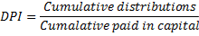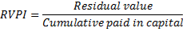
Following Weidig et al. (2004) and Gottschalg et al. (2015), we use the TVPI multiple as the main return metric for the purposes of our analysis, because it is the simplest and the most intuitive one. However, as TVPI is calculated without discounting, it does not account for the opportunity costs of capital (Weidig et al., 2004).
PERACS Risk Curve and PERACS Risk Coefficient. PERACS, the quantitative analytics provider for the PE industry, has recently developed a new metric to measure the capital risk of a PE portfolio.
The starting point is the calculation of the net profit contribution of each investment which is defined as:
Profit contribution = Cash received by investors (incl. unrealized profits) – capital paid by investors
The PERACS Risk Curve, starting at (0,0) and ending at (1,1), is a graphical representation of the returns distribution within a portfolio, where cumulative proportion of investments on the x-axis is plotted against the cumulative proportion of their contribution to the portfolio on the y-axis.

Fig 4. PERACS Risk Curve of a typical PE portfolio 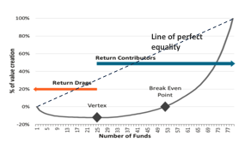
Source: PERACS. (2015). Available at: http://peracs.com/2015/10/understanding-the-underlying-risk-in-pe-portfolios/
The downward sloping part of the curve up until the vertex (where the first-order derivative is zero) represents the investments that have a negative profit contribution (“return drags”), while the upward sloping fragment plots the “return contributors” with a positive contribution. The break-even point indicates the point where the portfolio is neither loss- nor profit-making.
The line of perfect equality is a line at 45° where all the investments contribute equally to the portfolio. The PERACS Risk Coefficient is the area between the PERACS Risk Curve and the line of perfect equality. In the two extreme cases, it is equal to 0 when the portfolio is perfectly diversified, and to 1 when the portfolio is perfectly concentrated in terms of profit contribution.
Following Gottschalg et al. (2015), we use the PERACS Risk Curve to measure risk return profile of our sample portfolios, as this measure takes into account the contribution of each fund to the total portfolio returns, based on the performance multiple of each fund on the amount invested in each fund.

2.2.4. Potential sample biases
The characteristics of our selected sample as well as the methodology chosen for our analysis may give way to a number of biases. First of all, biases may reside on the level of the database used to source our sample. As already mentioned, information on PE funds’ performance is mainly communicated by Limited partners or Fund managers. However, this data provided may not be fully representative of the asset class as a whole, as not all funds’ performance is taken into account. The potential biases thus include the database reporting bias, the survivorship bias (poor performing and terminated funds are typically not present in the databases). This have led many researchers to conclude that the performance results in such databases are biased towards better performing funds.
We also have to keep in mind that the performance figures of funds that are not liquidated yet can be somehow biased. We decided to set an upside limit to our sample at the 2012 vintage year, based on a 5.5 years average lifespan of a private equity fund and the fact that most funds start returning money to investors at the end of a 4 year period. However, we cannot deny the fact that funds in our sample that are younger than 5 years may present biased performance figures.
Finally, a certain risk is related to the fact that we use TVPI multiple as our main performance metric. However, this measure does not account for the duration of the investment in Private Equity and for the time value of money, and therefore may sometimes be misleading.

Summary of Chapter 2
The second chapter consisted of the research methodology, which will be the basis for the research. The thesis is based on qualitative research approach, which are chosen according to stated research goal and allows to investigate research questions.
Secondary data collection and analysis of these data are used in the thesis. In general, data on private equity is kept private and is very difficult to get, so the main source of the information was aggregate data to do a quantative research. Thus, triangulation principle is fulfilled since data from different sources and different research methods are used, which allows to decrease level of subjectivism and bias, which is typical for qualitative research. During the study it was verified that the research has both construct and external validity and reliability in the thesis is also established.

CHAPTER 3. EMPIRICAL ANALYSIS AND RESULTS
This section presents descriptive statistics and results of our portfolio simulations based on different fund characteristics.

3.1. Diversification by fund strategy: Buyouts and Venture Capital
As mentioned earlier, among different fund strategies, buyout and venture capital funds remain the primary focus of many investors, while exposure to other categories of funds remains relatively limited.
In order to assess the benefits of combining venture capital and buyout investments, the historical returns for 494 US and European venture capital and 1055 buyout funds in vintage years 1998-2012 were reviewed. As follows from the table below and not surprisingly, Venture Capital funds are characterized by less systematic returns and a higher investment risk: thus, the average and the median are closer to each other for LBO than for VC funds; the standard deviation of average multiple in our VC sample is 1.12 versus 0.67 for buyouts; and the probability of a partial loss (i.e. TVPI multiple < 1) is almost twice as high for VC than for buyouts. Although it must be said that we didn’t observe cases of total loss in our sample.
Table 2. Comparing the risk/return profile of Buyout and Venture Capital Funds
 | Buyout | VC
Average Multiple | 1,65 | 1,28
Median Multiple | 1,57 | 1,17
Standard Deviation | 0,67 | 1,12
Probability of a loss | 12% | 37%
Average loss given a loss | 26% | 40%
Risk-return ratio | 1,0 | 0,3

Similar remarks could be made based on the following graphs that show for buyout and VC funds the probability of a return multiple occurring. In the case of venture capital funds, the returns are largely distributed and more skewed than in the case of buyouts, with a higher proportion of above average return multiples.

Fig. 5. Buyout funds Historical TVPI multiples | Fig. 6. Venture capital funds Historical TVPI multiples

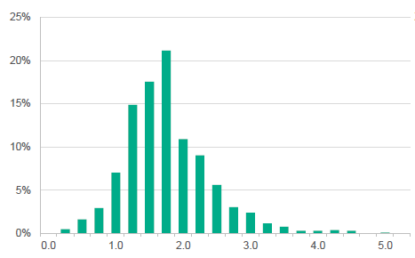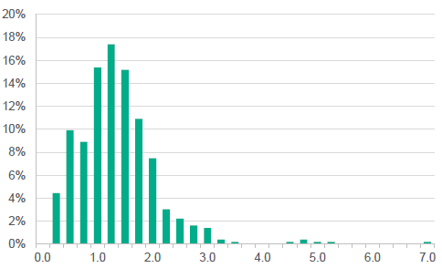

Based on the above, we can assume that a 100% BO portfolio would have a lower risk profile, but also lower returns, while the 100% VC portfolio would have higher return expectation, but also a significantly higher risk profile. Thus combining the two asset classes should allow to produce an optimal set of portfolios.
In order to determine whether the fact of diversifying an investment portfolio by allocating portions of capital between LBO and VC funds would be beneficial for LPs from the risk/return perspective, we need to evaluate the correlation of returns between the two asset classes. By plotting the historical returns of LBO and VC funds, both in terms of average IRR and average TVPI (figures 7 and 8), we find little correlation between these two sub-asset classes, and can thus assume that LPs would benefit from this kind of diversification.
Fig 7. Buyout vs. Venture average historical TVPI | Fig 8. Buyout vs. Venture average historical IRR
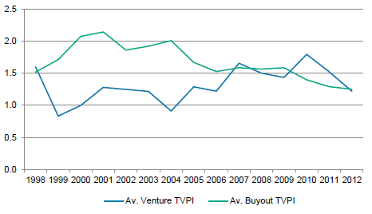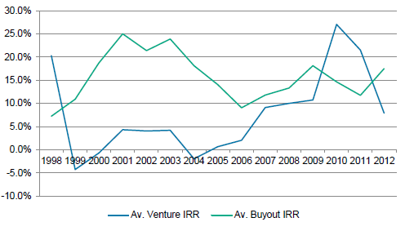

Source: Bloomberg
Some researchers went further and attempted to determine relative weights for buyout and venture capital funds within an optimal institutional investor’s portfolio.
Thus, Kathleen R. Browne (2006) determined an efficient frontier based on a series of IRR returns for US BO and VC with 1958-2000 vintages (Figure 9), stating that a portfolio weighted 52% buyout and 48% venture capital yields the same level of risk as an 100% buyout portfolio, but with a higher expected return.
Fig 9. US VC-BO Portfolio Risk/Return (vintages 1985-2000) 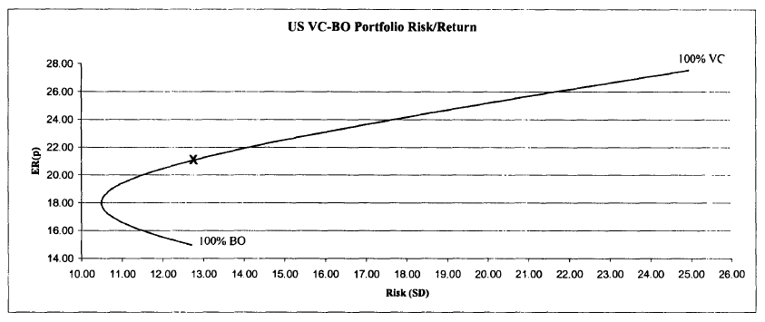
Source: Kathleen R.Browne (2006), VentureXpert, Bloomberg
In order to determine how capital allocation between BO and VC funds impacts investment risk and return we simulated 10,000 portfolios of funds based on historical returns from our sample of US and EU funds. Simulated portfolios vary by the number of underlying funds (6, 10, 30, 50), as well as by the percentages of underlying BO or VC funds within each portfolio (100% BO; 80% BO and 30% VC; 50% BO and 50% VC; 20% BO and 80% VC; 100% VC). The results are presented in the figures 10 to 13.
Fig 10. Av. Returns on portfolios of 6 BO & VC funds | Fig 11. Av. Returns on portfolios of 10 BO & VC funds
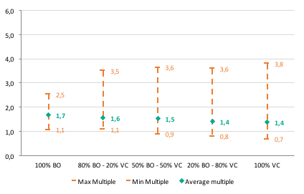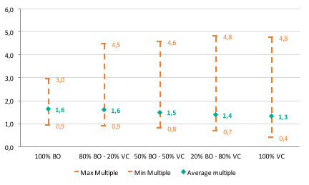

Fig 12. Av. Returns on portfolios of 30 BO & VC funds | Fig 13. Av. Returns on portfolios of 50 BO & VC funds
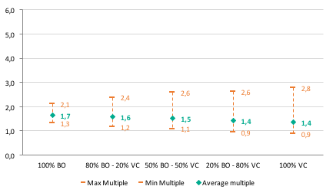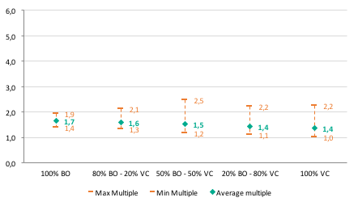
Following Gottschalg et al (2015), we find that an increase in the number of primary funds in a 100% buyout portfolio significantly reduces the returns dispersion (while the level of average returns of portfolios remains stable), therefore effectively reducing investment risk. Thus, the range between the worst and the best possible outcomes of 500 simulates portfolios with 6 underlying funds goes from 0.9x to 3.0x, while this range is reduced to [1.4x, 1.9] in a portfolio of 50 funds. However, the effect of this kind of diversification becomes weaker, as we increase the number of funds in our portfolios. This positive impact of diversification by number of underlying funds appears to be even more true in case of 500 simulated all-venture capital portfolios, as the range between the worst and the best possible returns is [0.4x, 4.8x] for a portfolio of 6 underlying VC funds and [1.0x, 2.2] for a portfolio of 50 VC funds, with the same mean returns of around 1.4x.
As we compare average, minimum and maximum returns of our simulated portfolios with a mix of buyout and venture capital funds, we find out that there is indeed a diversification benefit from including both BO and VC funds in an investor’s portfolio. As a matter of fact, integrating an 80% stake of buyouts and a 20% stake of venture capital in a portfolio of 6 underlying funds enables an investor to increase the possibility of getting higher returns (4.5x max. TVPI multiple vs. 3.0x in case of an all-buyout portfolio), while keeping the same level of downside risk (min. TVPI of 0.9x) and the same average returns (mean TVPI of 1.6x). This is also true for portfolios composed of 10, 30 and 50 underlying funds with an 80% BO – 20% VC split. Depending on the target performance and appetite for risk of any particular LP, he opt for an even split between buyout and venture capital funds in his portfolio, as this allow for a slightly lower average and minimum returns on the simulated portfolios, but also leaves more room for higher maximum returns. We find that this is particularly true for portfolios with a larger number of underlying funds, thus, the possible outcomes of 500 simulated 50%-50% portfolios composed of 30 underlying BO and VC funds range between 1.1x and 2.6x (vs [1.2x, 2.4x] for a 80% BO and 20% VC portfolios). Similarly, the range of possible returns of 500 simulated 50%- 50% portfolios composed of 50 underlying BO and VC funds is [1.2x, 2.5x] vs [1.1x, 2.1x] for a 80%-20% split.
Fig 15. PERACS risk curve - portfolios of 5 BO & VC funds | Fig 16. PERACS risk curve – portfolios of 50 BO & VC funds
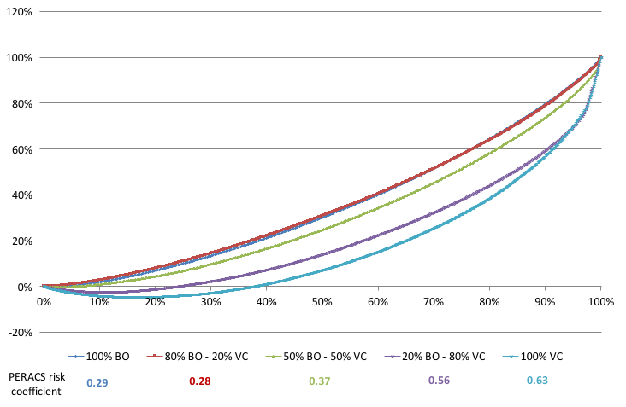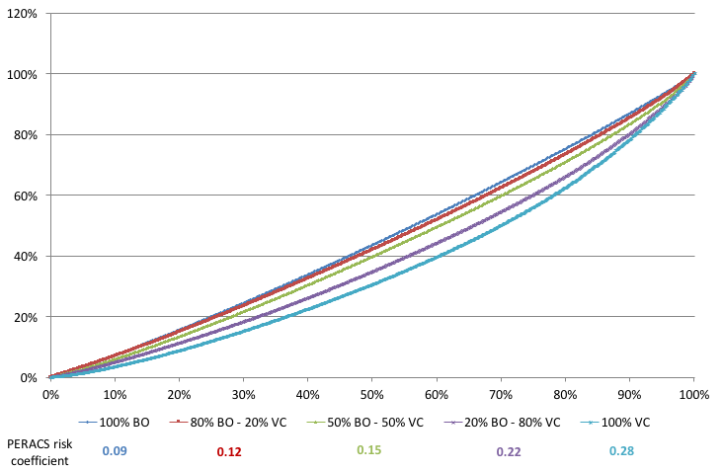

Source: PERACS
Similar conclusions can be drawn if we plot the returns from our simulated portfolios of 6 and 50 underlying BP and VC funds on the PERACS risk curve (see figures 15 and 16). Not surprisingly, we observe an increasing PERACS risk coefficient, as the proportion of underlying Venture capital funds in a mixed BO-VC portfolio increases. Thus, the risk coefficient goes from 0.29 for all buyout portfolios containing 6 funds to 0.63 for 100% venture capital portfolios. Portfolios composed of 5 BO funds and 1 VC funds seem to be the most favourable from the risk-return point of view with a 0.28 PERACS risk coefficient. Note however that this doesn’t seem to be true for portfolios with a larger number of underlying funds: for instance, the risk coefficient for a portfolio composed of 40 BO funds and 10 VC funds amounts to 0.12 vs. 0.09 for a portfolios composed of 50 BO funds.
Based on these findings we can conclude that by incorporating a small proportion of venture capital funds (max. 20%) in a Private Equity portfolio an LP can increase its possibility of getting higher returns, without significantly (or not at all) increasing the investment risk.

3.2. Diversification by stage
In this section we examine the potential diversification benefit from introducing different categories of venture capital and buyout funds in a Limited Partner’s PE portfolio. Namely, we analyse the risk return profile of early stage and traditional venture capital funds, and the effects of their combination within a PE portfolio. We also examine how the mix of buyout funds with different market size in a portfolio may affect investment risk and return.

3.2.1. Early Stage and Traditional Venture capital funds
As historical returns for 258 early stage (seed and start-up stage combined) and 494 general venture capital funds presented in the Table 3 suggest, there are significant differences in return and risk expectations for these two categories of VC funds. Early stage funds appear to have lower average returns (1.13x multiple vs. 1.28x for general VC), as well as lower median, they also have higher risk expectations with 41% probability of a loss (vs. 37% for general VC).
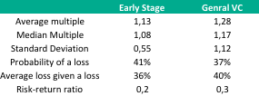
Table 3. Comparing the risk/return characteristics of General Venture Capital and Early Stage Funds
We can evaluate the consistency of historical returns for Early stage and generalist VC funds by plotting the results from our samples according to the probability of each multiple occurring (figures 17, 18). As suggested by these graphs, early stage funds tend to deliver slightly lower multiples on average, however the returns seem to occur with more consistency (0.55 standard deviation vs. 1.12 in traditional VC). Generalist VC funds results present a longer tail of above average returns (5.0x and even 7.0x), but may also lead to a higher loss in case of a loss (40% vs. 36% in early stage category).
Fig 17. Early Stage funds Historical TVPI | Fig 18. Venture Capital funds Historical TVPI multiples multiples
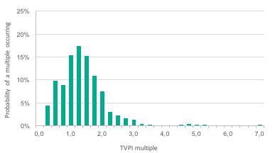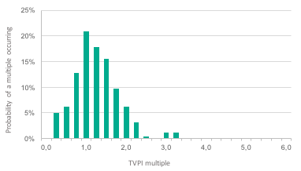

In addition, there doesn’t seem to be an important correlation between returns of early stage and traditional venture capital funds, as evidenced by figure 19 showing the net IRR by vintage year for the two sub-asset classes.
Fig 19. Top Quartile Boundary net IRR for Early Stage and traditional VC by vintage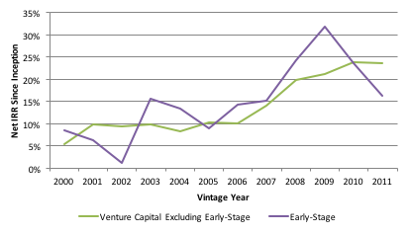
Source: Preqin Performance analyst
In order to find out whether investors may benefit from including a mix of venture capital funds by stage in their portfolio, we have performed simulations of 10,000 portfolios varying by the number of underlying funds and by the mix of early stage and general venture capital funds in these portfolios. The results are presented in figures 20 to 23.
Fig 20. Av. Returns on portfolios of 6 Early Stage & Traditional VC funds | Fig 21. Av. Returns on portfolios of 10 Early Stage & Traditional VC funds
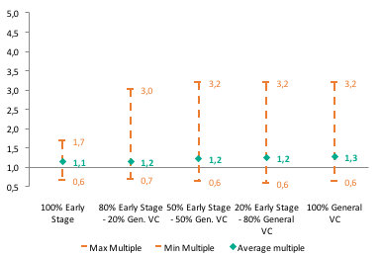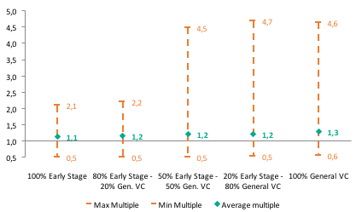
Fig 22. Av. Returns on portfolios of 30 Early Stage & Traditional VC funds | Fig 23. Av. Returns on portfolios of 50 Early Stage & Traditional VC funds
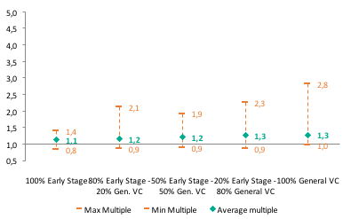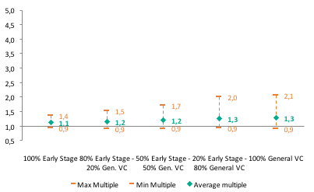

The obtained results suggest that, from the risk-return perspective there is no strong reason for adding early stage funds into an investor’s venture capital portfolio. As a matter of fact, the minimum return multiple across portfolios of 6 underlying funds don’t seem to be impacted by the mix of early stage and traditional VC funds in these portfolios (stable min. TVPI of 0.5x), not does the average multiple (relatively stable between around 1.2x), however portfolios with a larger proportion of general VC funds seem to offer bigger potential for high returns. Thus, 500 simulated portfolios of 6 underlying funds with a 80%-20% split between Early Stage VC and Traditional VC respectively return an average multiple of 1.2x, a minimum multiple of 0.5x and a maximum multiple of 2.2x, while 500 simulated portfolios of 6 funds with an inversed split deliver an average multiple of 1.3x, a minimum multiple of 0.6x, but offer headroom for bigger returns with a 4.7x maximum TVPI. The same trend is true for simulated portfolios of 10, 30 and 50 underlying funds.
Figures 24 and 25, presenting PERACS risk curves for portfolios of 6 and 50 underlying funds with a different mix between Early Stage and Traditional Venture Capital funds, confirm our conclusions on higher incremental risk related to early stage investments. Thus, we find that portfolios composed at 100% of traditional VC funds display a better PERACS risk coefficient than portfolios containing a certain proportion of early stage venture capital funds: 0.66 and 0.29 for portfolios of 6 and 50 underlying funds respectively, versus 0.69 and 0.30 for portfolios with a 50%-50% split between early stage and traditional venture capital.
Fig 24. PERACS risk curve - portfolios of 6 Early Stage | Fig 25. PERACS risk curve – portfolios of 50 Early Stage VC funds & VC funds
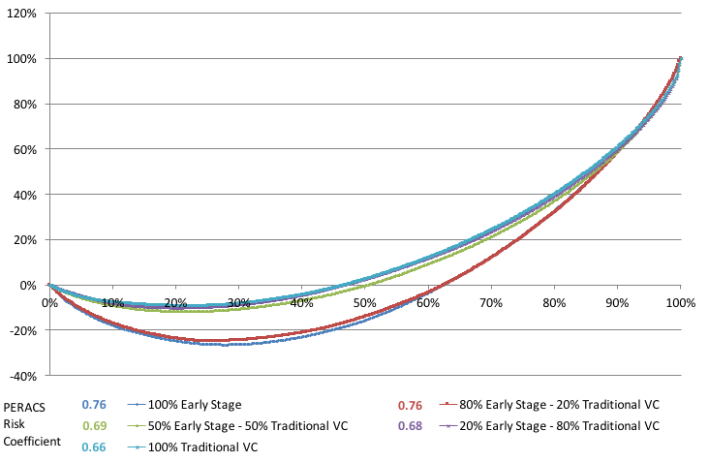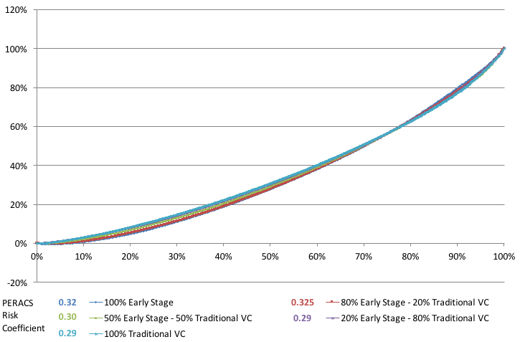
Source: PERACS
Although our findings do not suggest that portfolio diversification between early stage venture capital and mature venture capital funds offers a material benefit for LPs from a risk/return perspective, seed and start-up stage focused venture funds have been increasingly raising capital. As a matter of fact, in 2013, US based VC funds focused on early stage investing raised USD9.37 billion (51% more than in 2012), while the US venture capital firms overall raised 10% less that same year than the year before. This suggests that there are a number of other considerations that might encourage LPs to invest in this sub-category.
For example, by investing into early stage venture capital funds, LPs establish a privileged relationship with fund managers and get an easier access to later stage venture capital funds, often managing the same portfolio companies as at the early stage. In that way, LPs can eventually benefit from the above-average returns of successful underlying companies within the portfolio.
However, it is worth mentioning that, according to a survey of LPs conducted by Upfront Ventures in early 2016, 66% of the respondents confirmed that would fund Early Stage (namely Seed) venture capital funds, but that they were very discerning on which GPs they will fund. In fact, what seems to matter more for LPs in this particular case is not as much the stage of VC investment, as the quality of the managers in question. The same survey suggests that many LPs were in fact indifferent as to whether the venture capital fund they invested in was stage-specific versus diversified, as they considered the quality of the fund manager are the most important factor.

3.2.2. Small, Mid-Sized and Large Buyout funds
Buyout funds were analysed by fund size and split into two categories as follows: Small and Medium Buyouts with target size below USD800m (sample of 699 funds) and Large Buyouts of over USD800m (sample of 355 funds). The data from our sample presented in the Table 4, suggests that medium size funds produce slightly more attractive average returns (1.68x mean TVPI vs. 1.60x for Large buyouts), although Large BO funds’ performance seems to be more consistent (0.50 Standard deviation vs. 0.74 for Small & Medium buyout funds) with lower probability of a loss (8% vs. 14% for Small & Medium BO funds).
Table 4. Comparing the risk/return characteristics of Large and Small & Medium Buyout Funds
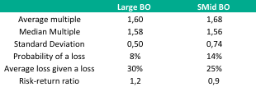
By looking at Figures 26 and 27 that present the probability distribution of a certain TVPI multiple occurring in our samples of Large BO and Small & Medium BO funds, we can notice that investing in Small & Medium buyouts indeed offers bigger chance of earning above average returns at 4-6x multiples, as the distribution is characterized by a long tail. However, we notice that the probability of earning returns within a 1.2x-1.8x range is higher in case of Large BO funds. This suggests that the quality of returns for an LP who decides to invest into Small and Medium BO funds is strongly dependent on the quality of the managers the investor can access, the top quartile S-Mid BO funds recording much higher returns than the average. This is true for Large Buyouts as well, but to a lesser degree.
Fig 26. Large BO funds Historical TVPI multiples | Fig 27. S-Midcap BO funds Historical TVPI multiples
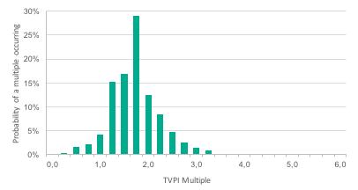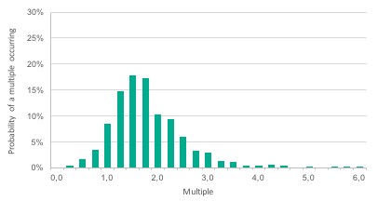

The correlation of small and medium sized funds to large sized funds appears to be low, which allows us to consider diversification by BO fund size as a possibility to potentially improve the risk/return profile of a PE portfolio.
In order to determine an optimal combination of Small, Mid-Size and Large buyouts in a portfolio, we run a simulation randomly creating 10,000 portfolios of 6, 10, 30 and 50 funds with different mix (100%, 80%-20%, 50%-50%) of Small & Medium sized (combined) and Large buyout funds.
Fig 28. Av. Returns on portfolios of 6 Large & S-Midcap | Fig 29. Av. Returns on portfolios of 10 Large & S- BO funds Midcap BO funds
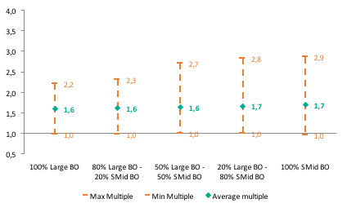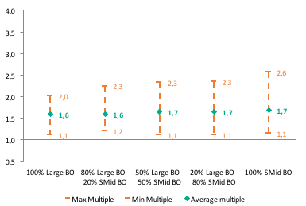

Fig 30. Av. Returns on portfolios of 30 Large & S-Midcap | Fig 31. Av. Returns on portfolios of 50 Large & S- BO funds Midcap BO funds
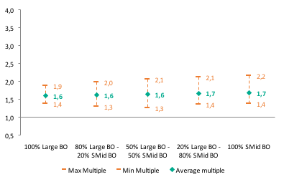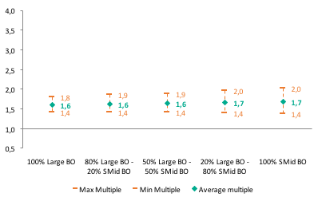

The results presented in Figures 28 to 31 confirm once again that returns dispersion is indeed lower in a portfolio composed at 100% of Large buyout funds as compared to portfolios that include Small & Medium sized BO funds, this being true independently from the number of underlying funds in the portfolio. However, it is interesting to notice that portfolios entirely composed of Large BO funds and portfolios entirely composed of Small & Mid-sized buyouts present the same downside risk on investment, which we evaluate in terms of Minimum TVPI multiple. Thus, 500 simulated portfolios of 6 underlying Large buyout funds display the same min. return multiple of 1x as 500 simulated portfolios of 6 underlying Small & Mid- sized funds. The same is true for larger portfolios with 30 underlying funds’ portfolios returning a minimum multiple of 1.4x, independently of whether they are composed of only large or only Small & Mid-sized buyout funds. At the same time, portfolios composed at 100% of Small & Medium BO funds seem to offer higher upside opportunity for returns with maximum TVPI multiples of 2.9x, 2.6x, 2.2x and 2.0x for simulated portfolios of 5, 10, 30 and 50 underlying funds respectively. Based on these findings, we would suggest that, when presented with a choice of investing in either Large or Small & Mid-sized buyouts, an investor should lean towards the second option, provided that he is sure of his ability of accessing the best-performing managers. Our findings also suggest that introducing both Large and Small & Mid- sized buyouts in an investment portfolio may prove beneficial from the risk return perspective, especially if Small and Medium sized funds compose at least 50% of this portfolio.

Fig 32. PERACS risk curve - portfolios of 6 Large & S- Midcap | Fig 33. PERACS risk curve – portfolios of 50 Large & S- Midcap BO funds Midcap BO funds
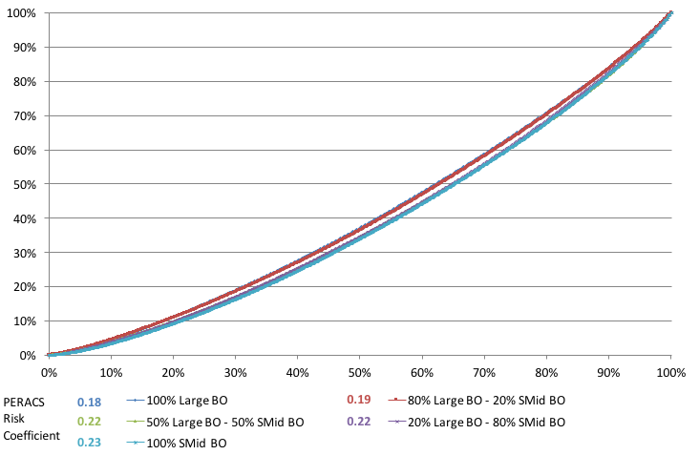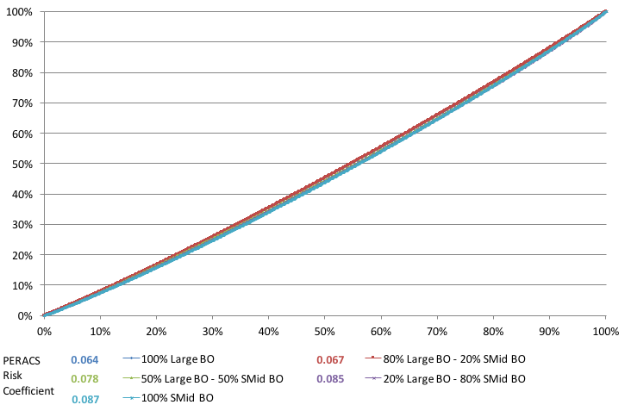

Source: PERACS
Figures 32 and 33 present the risk curves for simulated portfolios of 6 and 50 underlying Large and Small & Mid-Sized buyout funds. We note that the risk coefficients for portfolios with a different mix of Large and Small & Medium buyout funds are quite close to each other: 0.18 risk coefficient for a 100% Large BO portfolio of 6 funds vs. a 0.23 risk coefficient for an all Small & Medium BO funds. This corroborates our earlier observations about a bigger distribution and volatility of returns within Small & Mid-sized BO portfolios. Thus, the extent to which an LP would incorporate this kind of funds it his portfolio, in order to increase the upside potential for returns, would depend on whether or not that investor is willing to tolerate a slightly higher investment risk.

3.3. Diversification by geography: US and Europe focused funds.
In this section we examine the risk/return profile of US and Europe focused buyout and venture capital funds, based on historical returns in our selected sub-samples. Table 5 resumes the main characteristics of returns in our sub-samples assembling returns of 681 US focused and 374 Europe focused Buyout funds, as well as of 378 US focused and 116 Europe focused Venture Capital funds.

Table 5. Comparing the risk/return profile of Buyout and Venture Capital Fund 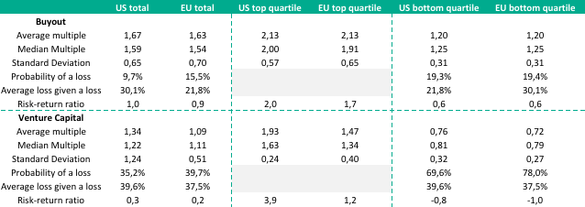
From the information given in the table we can infer that US venture capital funds produce significantly higher returns than their European peers (1.34x average multiple vs. 1.09x for EU funds) and lower risk of loss on investment (35% probability of a loss vs. 40% for EU venture capital funds), albeit with higher volatility of returns (1.24 Standard deviation of returns for US focused VC funds vs. 0.51 for EU focused VC funds). This holds true with respect to the top and bottom quartile returns as well. Figures 34 and 35 presenting the probability distribution of historical returns on investment in US and EU focused venture capital funds also show that there is a higher overall probability of getting a return above a 1.5x multiple by investing into US focused VC funds rather than in their European peers.
Fig 34. US focused VC funds Historical TVPI | Fig 35. EU focused VC funds Historical TVPI multiples
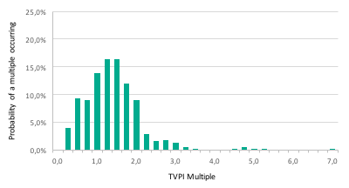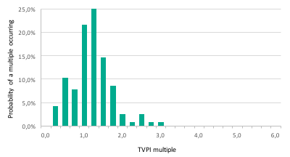

The situation is different however as far as the buyout funds are concerned. As a matter of fact, Europe focused buyout funds seem to have performed as well or better than their US peers. Our samples of US and EU focused BO funds return the same average multiple with almost the same median and standard deviation. Despite the fact that probability of a loss seems to be slightly higher for European buyouts than for their American peers (15.5% vs. 9.7%). Looking and figures 36 and 37, we can also notice that the probability distributions are very similar for US and EU focused buyout funds.
Fig 36. US focused BO funds Historical TVPI | Fig 37. EU focused BO funds Historical TVPI multiples
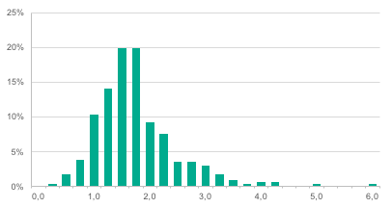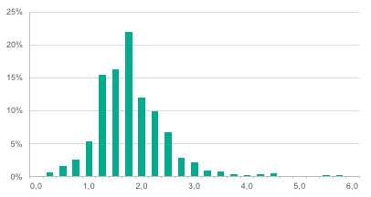

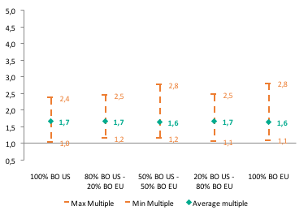
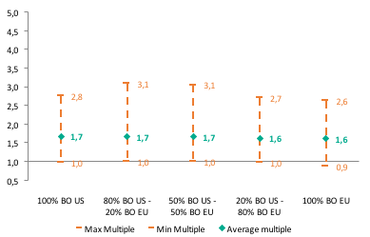
Given that the correlation of historical returns between US and EU focused funds appears to be quite low, we suppose that the diversification between these two categories of funds could then be beneficial. We simulate 10,000 randomly selected portfolios of 5, 10, 30 and 50 underlying funds, with a different mix between US and EU focused buyout funds.
Fig 38. Av. Returns on portfolios of 6 US & EU BO funds | Fig 39. Av. Returns on portfolios of 10 US & EU BO funds

Fig 40. Av. Returns on portfolios of 30 US & EU BO funds | Fig 41. Av. Returns on portfolios of 50 US & EU BO funds
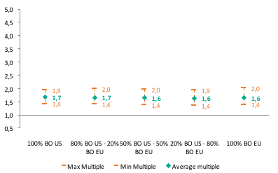
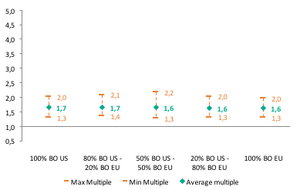
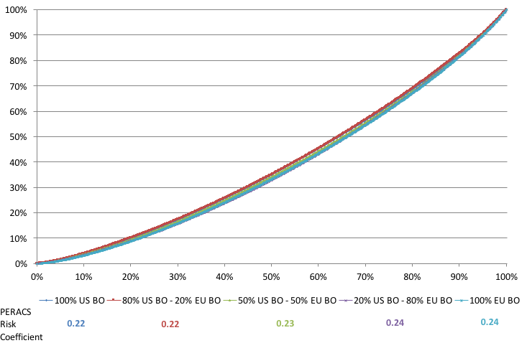
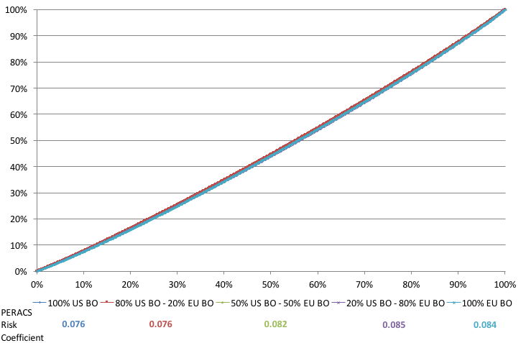
The results presented in figures 38 to 41 confirm the conclusions made earlier, as randomly generated portfolios composed of only US or only EU focused buyouts appear to return very similar average, minimum and maximum TVPI multiples. Thus 500 simulated portfolios of 5 underlying US buyout funds return a multiple of 1.7x on average with a minimum of 1.0x and a maximum of 2.8x, while these numbers are slightly lower at 1.6x, 0.9x and 2.6x for portfolios of 5 European buyout funds. This similarity in returns appears to be even stronger as the number of underlying funds in simulated portfolios increases, thus returns on portfolios of 30 US or 30 EU focused buyouts are spread across the same range of [1.3x, 2.0x] with average multiples of 1.7x and 1.6x respectively. According to our findings, portfolios that appear to be the most interesting from the risk/return perspective correspond to a 50%-50% split between US and EU focused buyouts, as these portfolios appear to return the best combination of maximum, minimum and average multiples. We find this to be true across simulated portfolios, independently from the number of underlying funds.
Fig 42. PERACS risk curve - portfolios of 6 US & EU BO | Fig 43. PERACS risk curve – portfolios of 50 US & EU funds BO funds
Source: PERACS
PERACS Risk curves for portfolios of 6 and 50 underlying funds with a mix of US and Europe focused buyout funds further show that the risk profile is quite similar for the two categories of funds. Thus, a 100% US focused portfolio of 6 underlying buyout funds reports a Risk coefficient of 0.22, while this coefficient is only slightly higher for a Europe focused portfolio – 0.24. Therefore, we can assume that portfolio diversification between US and European funds in the buyout sub-asset category, could offer an upside potential for the returns, while maintaining a very similar level of risk.
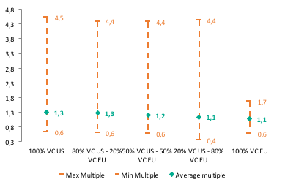
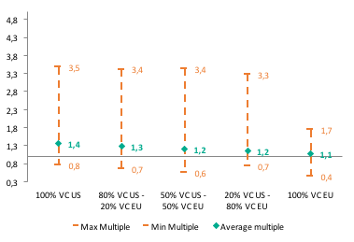
Despite the fact that based on historical returns of US and European Venture Capital funds mentioned earlier, there seems to be little argument from a risk/return perspective for diversifying a predominantly US-based venture capital portfolio with EU venture capital investments, except on opportunistic basis.
Fig 44. Av. Returns on portfolios of 6 US & EU VC funds | Fig 45. Av. Returns on portfolios of 10 US & EU VC funds
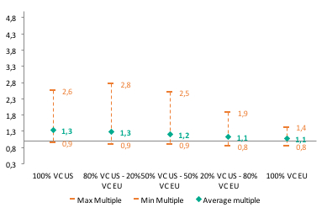
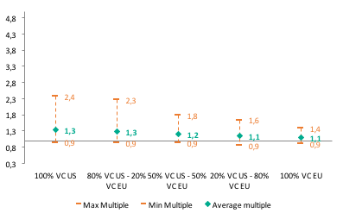
Fig 46. Av. Returns on portfolios of 30 US & EU VC funds | Fig 47. Av. Returns on portfolios of 50 US & EU VC funds

This observation is confirmed by portfolio simulations we conduct, combining different number of underlying funds in a portfolio and a different number of US and EU focused VC funds by portfolio (Figures 44 to 47). As a matter of fact, for the same level of risk, measured by the minimum TVPI of simulated portfolios, average and maximum returns seem to be higher for a 100% US Venture Capital funds portfolio than for a portfolio composed of EU and US venture capital funds or of only EU venture capital funds. This holds for simulated portfolios with different number of underlying funds, except for portfolios with 30 funds where an 80% US - 20% EU split appears to generate higher potential returns. However, this observation is probably not sufficient to
Fig 48. PERACS risk curve - portfolios of 6 US & EU VC | Fig 49. PERACS risk curve – portfolios of 50 US & EU funds VC funds
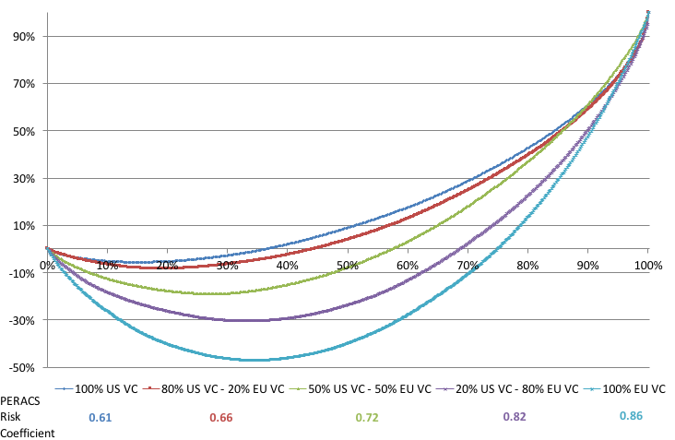
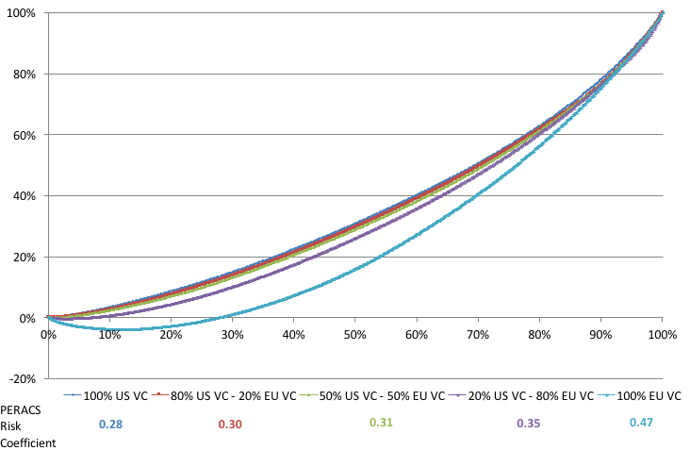
draw any affirmative conclusion.
Source: PERACS
Figures 48 and 49 show the risk curves for the returns obtained on our simulated portfolios of 6 and 50 underlying funds with a different mix of US and Europe focused venture capital funds. These results confirm us in the thinking that European Venture capital funds present a considerably riskier profile. As a matter of fact, portfolios of 6 underlying US focused VC funds are characterized by a 0.61 PERACS Risk coefficient, vs. 0.86 risk coefficient for portfolios of their European peers. The investment risk seems to increase with the proportion of European VC funds in the portfolio.
6.4. Challenges for diversification in a Private Equity portfolio
Having outlined, based on performed simulations, potential benefits of PE portfolio diversification by strategy, stage and geographic focus of funds, we consider it important to point out that this kind of purely theoretical diversification (and this the benefits associated with it) may not always be achievable on the practical level.
As a matter of fact, a number of limitations are likely to compromise LPs’ ability to achieve optimal diversification without risking the quality of the General Partners selected for the portfolio. These constraints include: limited access to the top performing managers, limitations on the amount of capital that can be placed with a specific fund, and the human resources required. In this section we take the opportunity to briefly describe these constraints.
First of all, most LPs are not always able to access the best managers, their investment options would thus always be limited by the quality of GPs they can access.
It must be noted that the ability to select and access top performing funds in a Private Equity space is determining for returns and investment risk LPs would incur on their investments, as returns vary significantly by quartile (see Figure 50). Selection ability of institutional investors may thus enhance positive effect from portfolio diversification, as well as attenuate it.
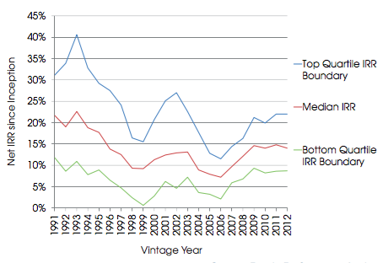
Fig 50. All Private Equity – All Regions: Median Net IRRs and Quartile boundaries by Vintage Year
Source: Preqin Performance analyst
The quality of the managers a LP is able to access is of particular importance in the case of Venture capital investing, because the returns in this sub-asset class vary dramatically between top quartile and lower quartile funds, with the bottom quartile funds often generating a loss (as evidenced by figure 51). Therefore, the fact of investing in the top performing funds potentially has a much bigger impact on the investment risk, than in the case of other categories of PE funds.
Fig 51. Venture Capital – Median Net IRRs and Quartile Boundaries by Vintage Year
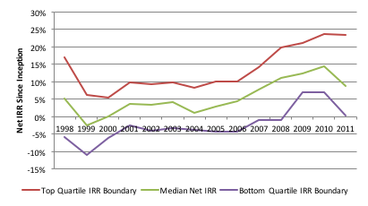
Source: Preqin Performance analyst
Another constraint is related to the amount of capital that an institutional investor can put into a specific PE firm/fund. Funds are generally fixed in size and cater to a pool of regular investors, which makes it difficult for any particular LP to place substantial amounts with a specific selection of funds. Investment opportunity and the amounts associated are often conditioned by the relationship between LPs and a given fund, as well as by their previous collaborations.
Finally, an institutional investor needs to deploy significant human capital in order to identify and reach the best performing GPs. This requires a certain number of highly qualified professionals with a very particular skill set to be part of the investment team. Their role is not limited solely to the selection of the best GPs, but also involves monitoring the PE funds’ performance and building and maintaining relationships with the fund managers, which constitutes an important input for future decision making, and, equally importantly, gives priority in investing in the successive funds.
Taking into account these limitations of the illiquid asset class that private equity is, it becomes rather difficult for an LP to conduct an optimal investment strategy with predetermined exposures to funds with different strategies, sizes, stages, geographic focus etc. An investor might be forced to pick lower tier funds in order to achieve these fixed targets, which in its turn would not be without consequence on the quality and volatility of returns. The desired portfolio design may thus not always be possible to implement in reality.

3.4 Overview of diversification strategies of several large LPs
In this section we conduct a brief qualitative analysis of private equity investment policies of several large Limited Partners, and, more precisely, of diversification strategies they apply when investing in this asset class. For this purpose, we have examined compliance and policy documents provided by the LPs, as well as their historical investments in private equity and relevant returns.
Table 6 resumes main characteristics of Private Equity investment programs of 5 large North American pension funds: CalPERS, Teachers Retirement System of Texas, Indiana Public Retirement System, CPP investment board and CalSTRS.
Table 6. Private Equity programs of 6 large Limited Partners
 | CalPERS | Teachers Retriment System of Texas (TRS) | Indiana Public retirement System | Canada Pension Plan Investment Board | California State Teachers retirement System (CalSTRS)
Type | Pension fund | Pension fund | Pension fund | Pension fund | Pension fund
PE current allocation | $28.8bn | $16.2bn + additional 5% of total funds allocated to Energy & Natural Resources | $4.8bn | $56.3bn | $15.97m
as % of total capital under management | 9.12% | 12.6% | 13% | 16% | 8.3%
Target PE allocation | 10% | 13% | 10% |  | 9.0%
Purpose of the Private Equity program | 1) Maximize risk-adjusted rates of return and enhance the equity return to the Fund. | 1) develop a diversified portfolio that would enhance the overall risk-return profile of the Total Fund and to reduce risk within the PE Portfolio. | 1) Earn risk-adjusted returns in excess of public markets. 2) decrease the volatility of total assets through the diversification benefits of having lower correlations with other asset classes. | 1) seek opportunities that will outperform comparable passive public alternatives. | 1) generating high rates of return. 2) Diversification is considered an ancillary benefit
Forms of PE investments | Limited partnerships, Limited liability companies (LLCs), | Direct investments, General partnerships, Secondaries | Limited partnerships, group trusts, limited liability companies, co-investments, secondaries | Limited partnerships, Direct investments, Secondaries | Limited partnerships, Direct investments, Secondaries
Attributes considered in PE diversification | Geography, Industry, Vintage Year, Strategy | Strategy, Geography, Industry, Size of investment, Vintage | Industry, Business cycle stage, General Partner diversification | Strategy, Geography, Industry, Vintage | Industry, Vintage, Strategy, Geography
Diversification by fund strategy | Buyouts (60%), Credit Related (15%), Venture Capital (1%), Growth & Expansion (15%), Opportunistic (10%) | Buyouts, Venture Capital & Growth, Debt & Special Situations, Energy & Natural Res ources |  | Buyouts, Growth Equity | Buyouts (70%), Venture Capital (5%), Debt related (15%), Equity Expansion (10%)
Diversification by Geographic Region |  | Global presence. An office established in London to develop relationships with local PE inves tors | International private market investments shall not exceed 50% of the PM Program. | Global presence. PE funds relationship teams based in London and Hong Kong | US (75%), Non-US (25%)

Source: Bloomberg, Limited Parters
As follows from the table above, large LPs allocate on average around 10%-15% of their capital to private equity asset class through limited partnerships, direct investments, co-investments and secondary investments. We notice that the primary purpose for the Private Equity program, as announced by LPs, seems to be the generation of returns in excess of public markets, while the diversification benefits come in second. Nevertheless, all investigated LPs recognize the importance of diversification by vintage, strategy, industry, business cycle stage within their PE funds portfolio.
Many institutional investors announce target capital allocations among different categories of funds within their PE portfolio. The biggest chuck of capital is generally assigned to buyout funds (c.60-70%), followed by Distressed debt and Mezzanine funds (c.15%), Growth funds (c.10%) and Venture Capital (c.5%). In terms of target geographic diversification, most of the capital of Large American LPs generally goes to US focused funds (c.70-75%), while non-US investments rarely exceed c.25%.
However, keeping a certain level of flexibility within the private equity investment policy remains a priority for most of the funds. For this reasons LPs generally set a permitted investment range for any particular sub-asset class in Private Equity, reviewed on regular basis, as well as arrange for special conditions that allow them to conduct opportunistic PE investments. In addition, as CalSTRS points out in its Private Equity policy, “investments shall not be approved for the sole purpose of aligning one specific diversification range. Projected rate of return, risk, and other policies shall receive consideration in addition to diversification”8. This principle refers us back to the discussion we raised in the previous chapter regarding the feasibility and potential “costs” of diversification in PE.
Fig 52. PERACS risk curve – Teachers Retirement System of Texas | Fig 53. PERACS risk curve – CalPERS
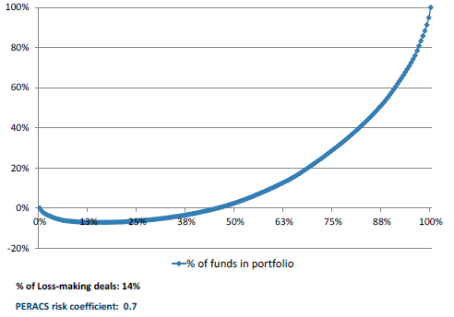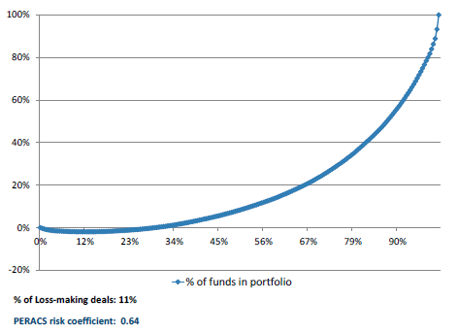
Fig 54. PERACS risk curve – Indiana public retirement system | Fig 55. PERACS risk curve – CalSTRS
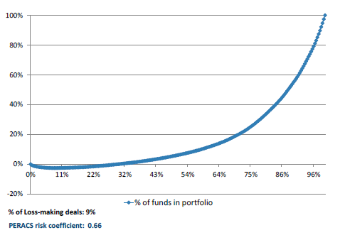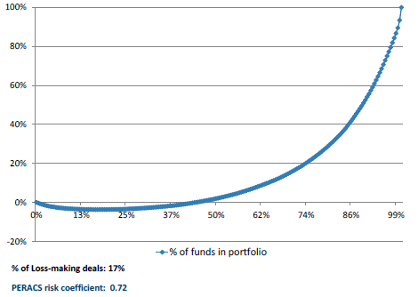Source: PERACS, Bloomberg
In order to evaluate the risk profile of Private Equity portfolios of the selected large LPs in question, we assembled data on their historical investments: types of funds, amounts invested and returns. PERACS Risk Curves constructed based on this information (figures 52 to 55) show similar risk coefficients for PE portfolios of given LPs (in the range of 0.6 – 0.7), and c. 30%-50% of profit generating funds within a portfolio. This is most probably related to similar Private Equity investment policies among large North American pension funds. Based on this observation, it could be assumed that similar investment and diversification strategies within the private equity asset class could lead to similar risk profiles of Limited Partners’ PE portfolios.

3.5 PE investments in Asia
Asian private equity remains a younger and less developed market when compared to the established industry centres of North America and Europe, but nonetheless it continues to play a major role within the global private equity landscape. 2014 saw increased levels of private equity fundraising and investment, with a healthy level of LP and GP interest towards the continent still apparent. As the asset class matures in Asia, and the longer term macro tailwinds continue to drive Asia’s wider economic development, Asian private equity is expected by many investors to provide attractive opportunities and act as a solid option for those trying to diversify their investments.
There are currently 667 active private equity investors based in Asia, accounting for 11% of the global private equity investor universe. This represents an increase of 22% in the number of active Asia- based investors tracked from the same time in 2014. The largest proportions of Asia-based investors are located in China (25%) and Japan (24%), which is unsurprising given Japan’s mature and developed economy and China’s size, coupled with ever increasing local regulatory changes looking to open up the market for private equity. The most prominent investor type among Asia-based LPs remains corporate investors, which account for a fifth of all LPs based in the continent (Fig. 56). Despite this, corporate investors have aggregate assets under management (AUM) of just $1.48tn, which only represents 6% of the total AUM of Asia- based investors.
Fig 56. Breakdown of Asia-Based Investors by Type

It is likely that those investors with a preference for investing in Asia, especially China, will have increased interest in illiquid alternative assets following the stock market crash in China. LPs will be looking for alternative ways to put their capital to work as public market returns in Asia’s largest economic market fall, despite seeing notably strong performance only last year. So far in 2015, Asia-based LPs have not shown significant levels of activity, with only 27% of survey respondents having made commitments to private equity funds in H1 2015. However, more promisingly, 58% of Asia-based LP respondents are under allocated to the asset class, meaning that these LPs will be looking for private equity investment opportunities in the near future in order to hit allocation targets.
As shown in Fig. 57, the number of Asia-focused funds closed in recent years has fallen year on year since 2011, yet the amount of capital raised in 2014 reached its highest amount since 2008, with $73bn secured by just 194 vehicles. As a result, the average fund size was $437mn in 2014, the highest annual average fund size of all time for predominantly Asia-focused private equity fundraising.
Fig 57. Annual Primarily Asia-Focused Private Equity Fundraising, 2008 - 2015

As the Asian private equity market matures further, and the Asian economies themselves continue to develop, we would expect to see a slight shift in the composition of fundraising to a more buyout-centric style that mirrors the markets of North America and Europe. Since 2012, the amount of capital raised by buyout funds targeting Asia has increased year on year from $7.0bn to $22.9bn in 2014, the largest amount of all time. As Fig. 57 shows, the proportion of overall Asia-focused fundraising accounted for by buyout funds reached its highest level in 2014 in the period 2008-present. Since then, Asia-focused buyout fundraising has been very slow, with just $1.4bn raised by five funds in 2015; however, three of the six largest funds in market focusing on Asia are multi-billion-dollar buyout funds (Fig. 58), and with 375 vehicles currently on the road seeking to collect over $115bn, both buyout and general Asia-focused fundraising may yet improve.
Fig 58. Primarily Asia-Focused Private Equity Fundraising by Fund Type, 2008 - 2015

Table 7. Largest Asia-Focused Private Equity Funds Currently in Market
Fund | Firm | Target Size (mn) | Fund Type
GSR Global M&A Fund | GSR Ventures | 5,000 USD | Buyout
RRJ Capital Master Fund III | RRJ Capital | 5,000 USD | Buyout
Mount Kellett Capital Partners III | Mount Kellett Capital Management | 4,000 USD | Special Situations
CICC Qianhai Development Fund | China International Capital Corporation Private Equity | 20,000 CNY | Growth
China Ocean Economy Capital Fund I | China Bright Stone Investment Management Group | 3,000 USD | Growth
PAG Asia II | PAG Asia Capital | 3,000 USD | Buyout

43% of LPs see venture capital funds as offering the best opportunities in the industry. This is broadly in line with the fundraising landscape, with more venture capital funds reaching a final close than any other type in 2015. This has remained consistent with 2014’s full year figures, where 62 Asia-focused venture capital funds reached a final close. Despite falling behind venture capital funds in this respect, growth funds have actually collected the most capital of all fund types since the start of 2014, accumulating $28.6bn, $4bn more than buyout funds.
Today there are 1,289 private equity firms based in Asia, with estimated dry powder of $140bn (Fig. 59). This is the largest amount of dry powder that the region has ever seen, and is in line with the wider industry trend of rapidly increasing dry powder levels. Despite having concerns over their ability to fundraise, 61% of Asia-based GPs have seen an increase in LP appetite for private equity over the past year compared to the previous 12 months. This bodes well for Asia-based GPs looking to come to market in the near future with new fund launches.
Fig 59. Total Estimated Dry Powder of Asia-Based Private Equity Fund Managers, 2003-2015

Preqin’s Performance Analyst has full performance metrics for 545 Asia-focused private equity vehicles. As shown in Fig. 60, with regard to median net IRRs, Asia-focused funds outperformed North America- and Europe-focused vehicles from 1998 until 2001, and again from 2010 to 2012, the most recent vintages with meaningful IRR data points. The Asian financial crash in the early 2000s led to a severe fall in median IRRs, from a high of 31.0% in 2001 to just 5.9% in 2004. The wide range in returns demonstrates the relative volatility of Asia-focused fund returns, compared to North America- and Europe-focused vehicles, which seem to have been less affected by macroeconomic market conditions. However, it is important to note the outperformance seen by Asia-focused funds of certain vintage years, most notably 2001, 2010 and 2011.
Fig 60. Median Net IRRs by Primary Geographic Focus and Vintage Year

Referring back to Fig. 6, it should be clear that the positive 300 performance of Asia- and Europe-focused fund vintages prior to the Global Financial Crisis (GFC) has been a key driver of this; however, North America-focused funds have been the strongest performers post-GFC. Hence Fig. 60 shows the PrEQIn Index rebased to 100 at December 2007. This shows the strong performance of US private equity over this period, with Europe and Asia recovering significantly less strongly from the GFC.
The number of private equity-backed buyout deals in Asia has fallen for three consecutive years, from a post financial crisis high of 436 deals in 2011, to just 307 in 2014 (Fig. 61). Notably, the ASEAN region saw the largest number of deals in one year in 2014, with 54 transactions (see page 14 for more detailed analysis of this sub-region). The aggregate private equity-backed buyout deal value in Asia, at $46.5bn, was at an all-time high in 2014, an 81% increase on the aggregate deal value seen in 2013. This was driven by a number of blockbuster deals that brought an end to flat aggregate deal values seen since 2011. The largest Asian deals of 2014 were the PIPE transaction involving Halla Visteon Climate Control Corp. ($3.6bn), the buyout of Sinopec Marketing Co., Ltd. (CNY 21.92bn) and the privatization of Giant Interactive Group, Inc. ($3bn).
Fig 61. Number and Aggregate Value of Private Equity-Backed Buyout Deals in Asia, 2008 - 2015

For venture capital deals, both the number and value of deals have been on the rise. 2014 witnessed both the highest number of deals and aggregate deal value in the period since 2008, with 1,783 transactions accounting for $22bn (Fig. 62). The number of venture capital deals in bv887 deals in Greater China and 497 in South Asia. The number of deals for South Asia in 2014 is only surpassed by the number of transactions seen in 2015 YTD, with this year already witnessing 529 deals. Recent developments in Asia fuelling these trends include the introduction of central government policies encouraging angel investments and the development of start- ups in China, as well as the rise of accelerators and a budding entrepreneur ecosystem in South Korea. India continues to account for the majority of activity in the South Asian countries, with a fairly established reputation as a venture capital hub in Asia. Since the institutionalization of the venture capital industry in the 1980s and the IT boom in the 1990s, firms from across the world have poured a glut of venture capital financing into promising early stage Indian companies.
Fig 62. Number and Aggregate Value of Venture Capital Deals* in Asia, 2008-2015

The outlook for 2015’s final full year statistics is exciting, given that by the end of August 2015, the aggregate venture capital deal value had already surpassed the record $22bn seen in 2014 by a significant 41%. This is largely thanks to three separate deals completed this year so far with a value of $1bn or more, as well as 12 other deals at a value of between $500mn and $1bn.
The main concern for the region’s private equity landscape is the general health of the wider economy. For example, at the time of printing, there has been widespread commentary in the financial media citing China’s trouble with slowing economic growth rates, a tumbling stock market and concerns over the performance of the manufacturing sector. If this uncertainty continues to spread across the region, we may see some LPs and GPs turn away from Asia in search of a safer option. It remains to be seen whether this will turn into a problem across the whole continent, but the economic health of China will remain a bellwether for the entire Asian economy.

Summary of Chapter 3
The third chapter of the thesis consists of the empirical analysis of current diversification strategies and overview of diversification strategies of several large LPs. It was revealed in the first and second chapters, which hypothesis and tests should be done to fulfill the research gap. Hence, for all these solutions secondary data analysis was conducted. For the research of diversification strategy in institutional investors’ portfolio five international institutional investors were chosen. These companies were chosen based on specific criteria, i.e. different size of capital allocation forms of PE investments and diversifications by fund strategy and geography presents. In addition, the possible limitations and requirements for future companies were analyzed.

RESEARCH FINDINGS AND DISCUSSIONS
Despite the growing importance of institutional investments in the corporate world [Damanhouri, Hashmi, Rana. 2015], there was a clear gap regarding insesting in PE of institutional shareholders. While the general topic of this paper was related to the influence of institutional shareholder on firm’s strategy I decided to investigate the area of impact of portfolio strategy diversification on risk and return. Basing on available literature, it might be concluded that mutual funds are less willing than pension funds to invest in this type of projects. This assumption was based on differences between governance systems of pension and mutual funds. Mutual funds’ agents are assessed on quarterly basis and compared to their peers while pension funds’ agents are assessed more on qualitative basis [Totaram. 2006]. In this case pension fund managers are less pressured to generate quick returns, thus they have more flexibility to invest in long-term horizon projects to which sustainable real estate is included. Therefore, my hypothesis was that due to mechanisms used in monitoring systems of mutual funds, which lead to agency conflicts [Eisenhardt. 1989], mutual funds agents are not willing to invest in this type of properties while pension funds’ managers are incentivized to do so.
The primary purpose of this study was to fill the gap in analysis of the portfolio diversification strategies, which are used according to Modern Portfolio Theory. This problem was a white space in research materials, which were analyzed.
The relevance of filling this gap was discussed in first chapter of the thesis. To achieve the goal, the study was supposed to provide an answer for 3 research questions:
- (RQ1) What are the risk/return profiles of different categories of PE funds?
- (RQ2) How an institutional investor can diversify its Private Equity portfolio and what kind of diversification is the most relevant?
- (RQ3) How important in quantitative terms are the potential benefits from diversification on Private Equity fund level?
For this purpose, the primary literature analysis was done to discover research gap in the area of the place of Private equity in an institutional investor’s portfolio. From the literature review it was determined main reasons that encourage institutional investors to increase their exposure to Private Equity:
- Low correlation with other asset classes, such as public equity or fixed income;
- Higher profitability;
- Attractive risk profile and lower volatility as compared to public equity;
- Liquidity level compatible with the constraints of the asset;
- Opportunity to invest into local companies.
Empirical research of the thesis which consisted performance and risk of investing in Private Equity funds, and specifically the impact of diversification on portfolio returns, using performance data on 1,549 funds obtained from PERACS.
Within empirical analysis were tested 4 main areas:
- Diversification by fund strategy: Buyouts and Venture Capital
Based on the findings we can conclude that by incorporating a small proportion of venture capital funds (max. 20%) in a Private Equity portfolio an LP can increase its possibility of getting higher returns, without significantly (or not at all) increasing the investment risk.
- Diversification by fund stage
Our findings do not suggest that portfolio diversification between early stage venture capital and mature venture capital funds offers a material benefit for LPs from a risk/return perspective, seed and start-up stage focused venture funds have been increasingly raising capital.
- Diversification by geography
From the analysis we can infer that US venture capital funds produce significantly higher returns than their European peers (1.34x average multiple vs. 1.09x for EU funds) and lower risk of loss on investment (35% probability of a loss vs. 40% for EU venture capital funds), albeit with higher volatility of returns (1.2 Standard deviation of returns for US focused VC funds vs. 0.51 for EU focused VC funds).
- Challenges for diversification in Private equity portfolio
It becomes rather difficult for an LP to conduct an optimal investment strategy with predetermined exposures to funds with different strategies, sizes, stages, geographic focus etc. An investor might be forced to pick lower tier funds in order to achieve these fixed targets, which in its turn would not be without consequence on the quality and volatility of returns. The desired portfolio design may thus not always be possible to implement in reality.
Thus, it can be concluded that all research questions of the thesis were answered, different diversification strategies and approached were defined and tested on the basis of the performance of 1,549 international funds. As a result, the research goal was achieved.

LIMITATIONS AND PROSPECTS FOR FUTURE RESEARCH
My master thesis was subjected to various limitations. Although I had taken adequate measures and due diligence to get the most accurate results, because of several factors I was unable to eliminate all the possible flaws.
Moreover, based on the research we arrived at the conclusion that a certain degree of diversification within a portfolio of private equity funds would enable Limited Partners to attain better risk-adjusted returns. What is the more, research was done with the data mainly US and European funds, as others individually are not significant. It can be recommend to conduct the further research based on the Asian institutional investors and Private Equities and compare results. It can discover interesting finding in the ways how these deals are provided in different regions. Additionally, there was a limitation referred to confidentiality issues. Since the implementation process of different investment strategies, which are used by institutional investors is considered as a confidential one, some of the details of the analysis cannot be presented in the research.
Finally, since there were just 3 main geography there are certain limitations with regard to number of this diversification. It can be recommended to analyze more international different markets, especially EMEA.
Despite all the mentioned limitations the master thesis holds both theoretical and practical value and it was possible to analyze how institutional investors provide the investment in Private equity.
Although my study finds answer on several questions, it also raises new one. It is widely confirmed that according to their statements, increasing number of all institutional shareholders are more and more willing to invest in PE, to which certified real estate is included [Damanhouri, Hashmi, Rana. 2015]. Nevertheless we can observe many deviations from this trend. Basing on available literature, I described the factors which possibly had an impact on this situation. Nevertheless, there is a need for further research in this area to confirm my findings. First of all, there should be carried out another study regarding European buildings with BREEAM certification and their relationship to European pension funds. Moreover, taking into consideration new datasets, with buildings with on- going certification process would help to track further changes in funds’ managers investment decisions. In next years, the pool of certified buildings will be much larger and it could allow to get eventually more accurate results. What also could have very positive effect on explaining obtained results would be conducting interviews with both pension fund and mutual fund managers and asking them directly about their preferences related to investing in Private Equity.

CONCLUSION
In this paper we attempted to present a brief overview of main considerations concerning private equity investments, more precisely we touched upon main diversification strategies within a portfolio composed of private equity funds, as well as the effect of these diversification strategies on portfolio risk and returns.
Thus, for the purposes of this study we identified several axes of diversification, such as: by fund’s vintage year, by industry focus, by fund strategy, by stage and by geographic focus. Following Weidig et al (2004), we used TVPI multiples as our main performance metrics for measuring return on investment and, in line with Gottschalg et al (2015), we use the PERACS risk curve to assess the investment risk of private equity portfolios. Using historical returns of Private Equity funds from our sample of 1,549 funds and by applying the bootstrapping method, we randomly generated 50,000 portfolios characterized by a different number of underlying funds (6, 10, 30 or 50), as well as by a different split among various categories of funds. Thus, we compared performance and investment risk of portfolios with a different mix of buyout and venture capital funds, small & medium and large buyout funds, early stage and traditional venture capital funds, as well as US or EU focused buyout and venture capital funds.
Based on these findings we arrived at the conclusion that a certain degree of diversification within a portfolio of private equity funds would enable Limited Partners to attain better risk-adjusted returns. This is true in particular for combined portfolios of buyout and venture capital funds, where a small allocation to VC (up to 20%) allows to increase the expected return on the portfolio without significantly increasing investment risk. This also holds for portfolios combining US and Europe focused buyouts, as well as for portfolios composed of Small & Mid-sized and Large Buyout funds, where an allocation to small & mid-sized funds (20-50%) allows to drive up the level of maximum possible returns while keeping a similar level of risk.
The conclusions are less straightforward for the venture capital sub-asset class. As a matter of fact, when evaluating diversification of Venture Capital funds by stage, we don’t observe significant benefits of including early stage VC funds in the portfolio, as these funds don’t seem to offer a higher level of upside potential for the same level of risk compared to traditional VC funds. Similarly, portfolios of US focused VC funds seem to offer more favourable risk adjusted returns than portfolios including both US and Europe focused venture capital funds.
We also found that the conclusions we made based on our portfolio simulations were in line with Private Equity diversification policies of several large North American Limited Partners. As a matter of fact, we analysed historical capital allocation within private equity portfolios of several large LPs and their current private equity investment policies, and were able to observe several diversification strategies that also proved beneficial through our portfolio simulation. Thus, large LPs generally allocate capital between buyout and venture capital funds in a proportion of 6:1, which is consistent with our findings. Many LPs also make efforts to diversify their PE investments geographically, with European buyouts being the primary target. The strategy that also proved efficient from the risk / return perspective in our simulation. The fact that we observed similar risk coefficients of PE portfolios of selected 5 large North American LPs that practice resembling PE investment policies also corroborates the benefits of the above-mentioned PE portfolio diversification strategies.
It should be mentioned, however, that achieving certain target diversification levels within private equity portfolios can be sometimes challenging for institutional investors, if not impossible. The difficulties come from the specificities of the private equity asset class: the absence of a replicable market index; the primary importance of the GP’s quality any particular LP can access; as well as significant financial and human resources an investor must deploy in order to outsource and reach new managers, as well as to maintain the relationship with the existing ones. Thus, despite potential positive impact of diversification on PE portfolio risk adjusted returns, there is a number of limitations that a Limited Partner should take into consideration (quality of available managers, availability of funds etc.) when deciding on his Private Equity investment strategy. This should allow an investor to avoid any costs of “unreasonable” diversification and to ensure that every investment strategy undertaken is beneficial from the risk / return perspective.

REFERENCES
- Armstrong, C., Davila, A. & Foster, G. Venture-backed private equity valuation and financial statement information (2006)
- Arcot, S., Fluck, Z., Gaspar, J.-M. & Hege, U. Fund managers under pressure: Rationale and determinants of secondary buyouts. Journal of Financial Economics 115, 102–135 (2015)
- Bain & Company, Global Private Equity Report (2016). Available on: http://www.bain.com/publications/business-insights/global-private-equity-report.aspx
- Barth, M. E., W. R. Landsman, & J. M. Wahlen. Fair value accounting: effects on banks’ earnings volatility, regulatory capital, and value of contractual cash flows, Journal of Banking 19, 577–605 (1995)
- Bernstein, Lerner, Sorensen and Stromberg (2008) Private Equity and Industry Performance. HBS Working Paper
- Beuselinck, C. & Manigart, S. Financial Reporting Quality in Private Equity Backed Companies: The Impact of Ownership Concentration. Small Bus Econ 29, 261–274 (2007)
- Booz&Company Pharmaceutical Companies in the Economic Storm Navigating from a Position of Strength, 2009
- Bottazzi, Laura, & Peri, Giovanni. (2007). The International Dynamics of R&D and Innovation in the Long Run and in The Short Run. Economic Journal, 117(518), 486-511
- Browne, Kathleen R. (2006). Appropriateness and Feasibility of Targeted Diversification in a Private Equity Portfolio. M.B.A. thesis, Massachusetts Institute of Technology, Sloan School of Management. Available on: https://dspace.mit.edu/handle/1721.1/37125
- Cressy, Munari, Malipiero. (2007). Playing to their strengths? Evidence that specialization in the private equity industry confers competitive advantage
- Cochrane, J. (2005). The Risk and Return of Venture Capital, Journal of Financial Economics 75. Available on: http://www.nber.org/papers/w8066
- Cumming, D. & Walz, U. Private equity returns and disclosure around the world. Journal of International Business Studies 41, 727–754 (2010)
- Efron, Bradley, Robert J. Tibishirani. (1993). An Introduction to the Bootstrap. Chapman & Hall/CRC.
- European Private Equity & Venture Capital Association (EVCA). (2011). Private Equity Fund Risk Management Guidelines: Measuring The Value at Risk of Portfolios of Interests in Private Equity and Venture Capital Funds – Exposure Draft for Consultation. Available on: http://www.investeurope.eu/uploadedFiles/Home/Public_And_Regulatory_Affairs/Co nsultations/Consultation_Paper_EVCA_Risk_Measurement_Guidelines.pdfGilligan, J. and Wright, M. (2014): “Private Equity Demystified: an explanatory guide”, Financing Change. Available on: http://www.icaew.com/en/technical/corporate- finance/financing-change/private-equity-demystified-an-explanatory-guide-160216
- EVCA - Reporting Guidelines 2006 - 075-private-act.pdf. Available on: http://www.eesc.europa.eu/resources/docs/075-private-act.pdf.
- Gambardella. (2005). Economic and Social Value of Patents in the EU, Università Bocconi, Milan
- Gottschalg, O., Gleisberg, R., and Derungs, R. (2015). Size Matters – Small is Beautiful: The Impact of Portfolio Diversification and Selection on Risk and Return in Private Equity. Available on: http://ssrn.com/abstract=2630915
- Grimaldi et al. (2014). The patent portfolio value analysis: A new framework to leverage patent Information for strategic technology planning.
- Idzorek, Tom. (2007). Private Equity and Strategic Asset Allocation. Ibbotson Associates. Available on:
https://corporate.morningstar.com/ib/documents/MethodologyDocuments/IBBAssociates/IbbotsonPrivateEquity.pdf
- IFRS - 404. Available on: http://www.ifrs.org/use-around-the- world/education/fair valuem/documents/educationfairvaluemeasurement.pdf
- Invest Europe - Who we are. Available at: https://www.investeurope.eu/about-us/who-we-are/
- IPEV. “International Private Equity and Venture Capital Valuation Guidelines.” 2010. Available on: http://www.privateequityvaluation.com/
- IPEV. “2015-16 Annual Investment Report”. 2017. Available on https://www.calpers.ca.gov/page/investments/about-investment-office/investment-financial- reports
- Jones, C., & Rhodes-Kropf, M. (2003). The price of diversifiable risk in venture capital and private equity. working paper. Columbia University. Available on: http://ssrn.com/abstract=342841
- Kaplan, S., & Schoar, A. (2005). Private equity performance: returns, persistence and capital flows. Journal of Finance 60 , 1791-1832. Available on: http://www.nber.org/papers/w9807
- Kaplan, Per Strömberg. (2009). Leveraged Buyouts and Private Equity
- Lerner (1995) Venture Capital and the Oversight of Private Firms, Journal of Finance 50, 301-318
- Lerner, Sorensen and Stromberg (2011) Private Equity and Long-Run Investment: The Case of Innovation, Journal of Finance 66 (2), 445-477
- Lerner, J., Schoar, A., Wong, W. (2007). Smart Institutions, Foolish Choices: The Limited Partner Performance Puzzle. Journal of Finance, 62, (2), 731–764.
- Ljungqvist, A., Richardson, M. (2003). The Cash Flow, Return and Risk Characteristics of Private Equity, NYU Finance Working paper No. 03-001. Available on: http://www.nber.org/papers/w9454
- Lossen, U. (2006). The Performance of Private Equity Funds: Does Diversification Matter? Munich Business Research Working Paper Series No. 2006-14. Available on: http://ssrn.com/abstract=916702
- Meulbroek, L. K., & Mitchell, M. L. (1990). Shark Repellents and Managerial Myopia: An Empirical Test. Journal of Political Economy, 98(5), 1108-1117
- Mollica and Zingales (2007) The Impact of Venture Capital on Innovation and the Creation of New Businesses, mimeo
- Oriani, Raffaele, & Sobrero, Maurizio. (2003). A Meta-analytic Study of the Relationship between R&D Investments and Corporate Value. In Corporate governance, market structure and Innovation (pp. 177-199)
- Phallipou, L. (2007). Investing in Private Equity Funds: A Survey. Available on: http://ssrn.com/abstract=980243
- Phalippou, L. (n.d.). Risk and return of private equity: An overview of data, methods and results. Available on: http://ssrn.com/abstract=1352351
- Phalippou, L., Gottschalg, O. (2008). The performance of private equity funds. Review of Financial Studies, (2009) 22 (4): 1747-1776.
- Private Equity Trend Report 2016, Unlocking Value in Turbulent Times, PWC
- Rice, M. (2012). Private Equity: The Role of Private Equity in Diversified Portfolios. DiMeo Schneider & Associates, L.L.C. Available on: http://www.dimeoschneider.com/documents/Research-the-role-of-private-equity-in-diversified-folders-429.pdf
- Schmidt, D. (2003). Private Equity-, Stock- and Mixed Asset-Portfolios: A Bootstrap Approach to Determine Performance Characteristics, Diversification Benefits and Optimal Portfolio Allocations. Center for Financial Studies Working Paper No. 2004/12. Available on: https://www.ifk-cfs.de/fileadmin/downloads/publications/wp/04_12.pdf
- Schneider A., Riedl J., Chen J. (2015). A Mile Wide or a Mile Deep ? The Diversification Opportunity Facing Private Equity, BCG study. Available on: https://www.bcgperspectives.com/content/articles/private-equity-mile-wide-mile-deep-diversification-opportunity-facing-private-equity/?chapter=2
- Strength and Opportunity 2013, HM Government, The landscape of the medical technology, medical biotechnology, industrial biotechnology and pharmaceutical sectors in the UK
- Weidig, T., Mathonet, P.-Y. (2004), The Risk profiles in Private Equity. Available on: http://ssrn.com/abstract=495482
- Weidig, T., Kemmerer, A., Born, B. (2004). The Risk Profile of Venture Capital Funds-of-Funds. Available on: http://ssrn.com/abstract=540524
- Welch, Kyle T. (2016). Private Equity's Diversification Illusion. Available on: http://ssrn.com/abstract=2379170

AFIC, Les investisseurs institutionnels face au capital investissement, 2004. Avalable at: http://www.google.fr/url?sa=t&rct=j&q=&esrc=s&source=web&cd=1&cad=rja&uact=8&ved=0ahUKEwio5ajM3q3PAhXJmBoKHdErDhUQFggcMAA&url=http%3A%2F%2Fwww.afic.asso.fr%2Fdl.php%3Fta ble=ani_fichiers%26nom_file=AFIC-cdp-les-investisseurs-institutionnels-fahttp://www.google.fr/url?sa=t&rct=j&q=&esrc=s&source=web&cd=1&cad=rja&uact=8&ved=0ahUKEwio5ajM3q3PAhXJmB
Preqin Investor Outlook, Private Equity, H1 2016. Available at: https://www.preqin.com/research/archive/9/0
Bain & Company, Global Private Equity Report, 2016. http://www.bain.com/publications/articles/global-private-equity-report-2016.aspx
BCG Study, A Mile Wide or a Mile Deep ? The Diversification Opportunity Facing Private Equity. Available at: https://www.bcgperspectives.com/content/articles/private-equity-mile-wide-mile-deep- diversification-opportunity-facing-private-equity/?chapter=2
Now known as Invest Europe.
Preqin Special Report : Venture Capital, November 2014 : https://www.preqin.com/docs/reports/Preqin-Special-Report-Venture-Capital-November-14.pdf
Gottschalg et al. (2015)
California State Teachers Retirement System, Private Equity Investment Policy, July 2014. Available on : http://www.google.fr/url?sa=t&rct=j&q=&esrc=s&source=web&cd=2&cad=rja&uact=8&ved=0ahUKEwj4otyMhrDPAhUISRoKHeOcDo4QFggmMAE&url=http%3A%2F%2Fwww.calstrs.com%2Fsites%2Fma in%2Ffiles%2Ffile-attachments%2Fi_-_private_equity_investment_policy_7- 2014.pdhttp://www.google.fr/url?sa=t&rc

