St. Petersburg University
Graduate School of Management

Master in Corporate Finance

A STUDY OF IPO ACTIVITY: EVIDENCE FROM RUSSIA

Master's Thesis by 2nd year student
Concentration – Corporate Finance
Fedor Setkov
Research advisor:
Associate Professor, Yulia B. Ilina

St. Petersburg
2017
ЗАЯВЛЕНИЕ О САМОСТОЯТЕЛЬНОМ ХАРАКТЕРЕ ВЫПОЛНЕНИЯ
ВЫПУСКНОЙ КВАЛИФИКАЦИОННОЙ РАБОТЫ
Я, Сетков Федор Васильевич, студент второго курса магистратуры направления «Менеджмент», заявляю, что в моей магистерской диссертации на тему «Исследование активности российских компаний по размещению акций в процессе IPO», представленной в службу обеспечения программ магистратуры для последующей передачи в государственную аттестационную комиссию для публичной защиты, не содержится элементов плагиата. Все прямые заимствования из печатных и электронных источников, а также из защищённых ранее выпускных квалификационных работ, кандидатских и докторских диссертаций имеют соответствующие ссылки. Мне известно содержание п. 9.7.1 Правил обучения по основным образовательным программам высшего и среднего профессионального образования в СПбГУ о том, что «ВКР выполняется индивидуально каждым студентом под руководством назначенного ему научного руководителя», и п. 51 Устава федерального государственного бюджетного образовательного учреждения высшего профессионального образования «Санкт-Петербургский государственный университет» о том, что «студент подлежит отчислению из Санкт-Петербургского университета за представление курсовой или выпускной квалификационной работы, выполненной другим лицом (лицами)».
_________________(Подпись студента) _________________________ (Дата)
STATEMENT ABOUT THE INDEPENDENT CHARACTER OF THE MASTER THESIS I, Fedor Setkov, (second) year master student, program «Management», state that my master thesis on the topic « A study of IPO activity: evidence from Russia », which is presented to the Master Office to be submitted to the Official Defense Committee for the public defense, does not contain any elements of plagiarism. All direct borrowings from printed and electronic sources, as well as from master theses, PhD and doctorate theses which were defended earlier, have appropriate references. I am aware that according to paragraph 9.7.1. of Guidelines for instruction in major curriculum programs of higher and secondary professional education at St.Petersburg University «A master thesis must be completed by each of the degree candidates individually under the supervision of his or her advisor», and according to paragraph 51 of Charter of the Federal State Institution of Higher Professional Education Saint-Petersburg State University «a student can be expelled from St. Petersburg University for submitting of the course or graduation qualification work developed by other person (persons)».
__________________________(Student’s signature) _______________ (Date)
АННОТАЦИЯ
Автор | Сетков Федор Васильевич
Название магистерской диссертации | Исследование активности российских компаний по размещению акций в процессе IPO.
Факультет | Высшая Школа Менеджмента
Направление подготовки | Корпоративные финансы
Год | 2017
Научный руководитель | Ильина Юлия Борисовна
Описание цели, задач и основных результатов | Цель исследования – выявить взаимосвязь экономических факторов и активности российских компаний при размещении акций в процессе IPO.  Основные задачи исследования:  - Рассмотреть понятие и сущность IPO;  - Систематизировать факторы, влияющиe на IPO;  - Определить основные тенденции мирового рынка IPO, проанализировать состояние российского рынка IPO, в том числе малых и средних российских компаний;  - Исследовать взаимосвязь основных экономических факторов и активности российских компаний при подготовке к размещению акций в процессе IPO.  Результат:  Выявить взаимосвязь основных экономических факторов и выхода российских компаний на IPO.
Ключевые слова | Рынок IPO, компании России, взаимосвязь, факторы

ABSTRACT
Master Student's Name | Fedor Setkov
Master Thesis Title | A study of IPO activity: evidence from Russia
Faculty | Graduate School of Management
Main field of study | Corporate Finance
Year | 2017
Academic Advisor’s Name | Ilina Y.B.
Description of the goal, tasks and main results | The purpose of the study is to investigate the relationship between economic factors and IPO activity of Russian companies.  The main objectives of the study:  - To analyze the concept and essence of the IPO;  - To systematize the factors influencing on the IPO;  - Identify the main trends of the global IPO market, analyze the state of the Russian IPO market, including small and medium-sized Russian companies;  - Investigate the relationship between the main economic factors and the activity of Russian companies in preparing for the placement of shares in the IPO process.  Result:  Identify the relationship between major economic factors and IPO performance by Russian companies.
Keywords | IPO market, Russian companies, relationship, factors

Contents
Introduction 7
1. THEORETICAL BACKGROUND OF IPO 10
1.1. The essence and concept of IPO 10
1.2. Preparing the company for an IPO 14
1.3. Factors that impact initial public offerings 18
1.4. Assessment of the IPO performance 23
2. ANALYSIS OF THE IPO MARKET 29
2.1. Current trends in the global IPO market 29
2.2. Russian IPO market 32
2.3. Analysis of IPO and SPO of small and medium-sized companies in Russia 45
2.4. The relationship between economic factors and the activity of Russian companies in preparing for the placement of shares in the IPO process 55
Conclusion 76
References 80
Appendix 1 Weighted average interest rates on loans provided by credit organizations to non-financial organizations in United States dollars (RF in total) 86
Appendix 2 Cost estimates for the IPO 87
Appendix 3. Cost estimates for IPO 88
Appendix 4. Estimates of the capacity utilization factor for individual activities, industry Unit No. 1 89
Appendix 5. Estimates of the capacity utilization factor for individual activities, industry Unit No. 2 90
Appendix 6. Estimates of the capacity utilization factor for individual activities, industry Unit No. 3 91
Appendix 7 Location and interaction of global and regional stock exchanges 92
Appendix 8 The main advantages and disadvantages of stock exchanges 93
Appendix 9 Time series methods 94
Appendix 10 The abbreviations used in section 2.4 95
Appendix 11 The autocorrelation and autocorrelation function values for model 2 96
Appendix 12 Confidence intervals for the model 4 (number of IPOs). 97
Appendix 13 Confidence intervals for the model 8 (amount of SPO). 97
Appendix 14 Mean estimation of difference between initial data and predicted values for number of IPOs. 98
Appendix 15 Mean estimation of difference between initial data and predicted values for number of SPOs 98

Introduction
Credits are the traditional source of raising funds for the development of Russian companies. In world practice, there is another source of financing for innovative development of the enterprise, which allows it to successfully implement its development strategies. This is the initial public offering of shares of the company on the stock exchange (IPO - Initial Public Offering), which is developing rapidly in countries with the high level of economy. This tool has been actively used by Russian companies only in the recent ten years, three quarters of all placements of shares have been performed during this period in the history of the Russian IPO market.
Relevance of the subject of the final qualification work is determined primarily by the fact that at the present stage of development of the economy and the Russian stock market, during the liquidity crisis, the cost of resources is increasing and the company's opportunities to attract them are decreasing. The liquidity crisis has an additional impact on the IPO market and, because of the low prices in the market, companies are postponing the placement of their shares.
Today the relationship between the number of the IPO and macroeconomic factors remains a poorly studied direction of the IPO process. And against the background of almost complete halt of placement of the shares by the companies in the recent two or three years and lack of reaction of the regulator to a situation in the market of the IPO, there is a need to clarify relationship of macroeconomic factors and IPO activity.
In addition, the process of preparation of Russian companies for holding IPO remains undeveloped and quite difficult to implement. In the current economic conditions, it is very important to make the right choice of the IPO scheme, the proper stock exchange and underwriter. It is also important to be able to properly disclose information about the company during and after the IPO. It is also necessary to minimize expenses on preparation and implementing the placement of shares.
It should be noted that research in the field of IPO is necessary and important for Russia exactly at current moment of time. It is related to the fact that many Russian companies have already gone through a stage of formation, and the complicated and unstable political situation in the world makes top managers reconsider the strategy of business development. In this respect, the primary task for many Russian companies is maximizing of capitalization. It requires them to establish the status of a public company and maintain the image at a high level. Relatively recently, Russian companies have begun to use this tool to raise funds, which leads to underestimation of the positive and negative aspects of the process by top managers and business owners.
Nevertheless, despite the fact that representatives of large, medium and small businesses in Russia constantly need to raise funds, importance of IPO, performed by Russian companies, for the Russian economy as a whole is clearly underestimated.
The purpose of the study is to investigate the relationship of economic factors and the activity of Russian companies.
The main objectives of the study:
- To analyze the concept and essence of the IPO;
- To systematize the factors influencing on the IPO;
- To identify the main trends of the global IPO market, analyze the state of the Russian IPO market, including small and medium-sized Russian companies;
- To study the relationship between the main economic factors and the activity of Russian companies in preparing for the placement of shares in the IPO process.
The object of research – the companies of Russia.
The subject of the study – the process of entering the IPO market for companies.
The degree of scientific development of the theme of the master thesis is presented by the works of both foreign and Russian scientists. Nevertheless, there are many debatable and completely unstudied problems in the scientific literature nowadays. In the study of the IPO process, it is possible to identify the main directions which are of greatest interest to scientists and economists. They include the following:
- Definition of the concept of IPO: Welch I. & Ritter J. (2002), Geddes R. (2007), Rosenberg, JM (1997), Davidenko L. & Balakirev N. (2013), Napol'nov A. (2011), Lucashov A. (2008);
- Preparing the company for an IPO: Davidenko L. & Balakirev N. (2013), Geddes R. (2007), Saltykov A. et al. (2010), Lucashov A. (2008), Glavina, S. (2012);
- Factors influencing on IPO: Pagano M., Panetta F., Zingales L. (1998), Kim W. & Weisbach SM (2005), Huygbegaert N. & Hulle V. (2006), Loughran T. & Ritter J. (1995), Pastor L. & Veronesi P. (2005), Benninga S. & Helmantel M. (2005), Lucashov, A. (2008), Prosfirina, II (2005), L'vutin P. (2007);
- IPO efficiency assessment: Pozdyshev V. (2016), L'vutin P. (2007), Pereverzev, H. (2006), Patrusheva, E. (2007);
- Relationship of economic factors influencing on the companies' preparation to perform IPO: Pagano M. (1997), B. Gill de Albornoz & PF Pope (2004), Chorruk J. & Worthington A. (2010), Boubaker A. & Mezhoud M. (2012), Breinlinger L. & Glogova E. (2002), Blum R. (2011), and others.
Methodological bases of the research. To solve the tasks and achieve the goal, general scientific and special methods were used in the work. The method of aggregated statistics (tabular representation, graphic representation, calculation of statistical indicators) was used in the analysis of the placement of shares by Russian companies while holding IPOs in the period 1996-2016. The method of analytical statistics allowed to draw conclusions on the main tendencies in the IPO market. The method of regression analysis was used to determine the impact of the main economic factors on the activity of Russian companies when performing IPO.
The scientific novelty of the study is to identify the influence of economic factors on the activity of Russian companies when performing an IPO. In our work, when presenting macroeconomic factors for further research, the problem of short time series has been solved by using more frequent, quarterly data. This allowed us to use multi-factor regression analysis and expand the list of factors considered. The use of multi-factor regression analysis in studies allowed to trace the cause-and-effect relationships among the main economic factors influencing on IPO and activity of Russian companies.
The results obtained in the work can be used by the regulator of financial markets for more effective management of the securities market. In addition, the results of the study can equally be interesting for Russian and foreign investors for a more accurate forecast of the IPO activity of Russian companies. The conducted researches can be useful as recommendations to top-managers of the Russian companies for making management decision on reasonability of IPO.
The thesis consists of an introduction, two chapters, a conclusion, a list of used literature (references) and appendixes. In the first chapter, the concept and essence of an IPO is revealed. It also examines the stages of the initial public offering; the main groups of factors, influencing on the IPO process are formed; correspondence between the concepts of Russian and foreign legislation systems in the placement of shares is examined; stages of calculating the effectiveness of the IPO are analyzed, the advantages and disadvantages of the IPO are given.
The second chapter analyzes the global IPO market. The main macroeconomic indicators of the Russian economy which influence on the development of the stock market are: the dynamics of the composite index of business activity in PMI industrial sector (Project Management Institute), the dynamics of the consumer price index (CPI), the dynamics of the basic consumer price index (BCPI) and historical estimates of trend inflation. An analysis of the current situation in the Russian IPO market, including small and medium-sized enterprises, is made. The collected data and the conducted multi-factor regression analysis made it possible to find the relationship of economic factors and the activity of Russian companies when performing an IPO. In conclusion, the main findings of the study are given.

THEORETICAL BACKGROUND OF IPO

The essence and concept of IPO
In developed countries, IPO (Initial Public Offering) is one of the most common methods of attracting investors for the development of companies. IPO has a simple nature, however, despite this, there are several approaches to its definition. This leads to inaccuracies and some difficulties during the collection and processing of statistical material. There are inconsistencies in the statistics provided by participants in the securities market, which can cause errors in determining the volume of placements and the choice of the class of primary public offerings for a particular transaction.
The study of the world experience makes it possible to distinguish the classical approach in determining the IPO - this is the initial public offering of shares in the stock market, which are offered to an unlimited number of persons. In the literature, there are various approaches to the definition of IPOs which are proposed to be considered.
On the official website of the US Securities and Exchange Commission (SEC), an IPO is defined as the initial public offering of shares in the stock market by an issuing company that uses the services of professional organizers (underwriters, managers).
According to the results of Welch I., Ritter J. (2002, 5), an IPO should be understood as a way to attract investments through the sale of securities on the open exchange market, which can contribute to the growth of liquidity of the enterprise and this is performed for the first time. It is important to note that the authors of the work pay great attention to the opportunities provided by the IPO for the development of existing enterprises and young promising companies. The initial public offering of shares of the company allows you to obtain more economic benefits and benefits for owners than the ordinary sale of your business, its lending or the use of other tools for innovative development.
P. Gulkin & T. Terebynkina (2002, 17) define the IPO as "the process of placing ordinary or preferred shares on an open exchange market for the first time, undertaken by a company with the aim of attracting of additional investments in the share capital of the company".
R. Geddes (2007, 3) pays much attention to issues of IPO and further placement of shares of enterprises on the stock exchange. In his view, the IPO is "the first public sale of company shares and listing on the stock exchange."
N. Balakirev (2013, 6) in the training manual gives the following definition of the IPO: "... the first public offering of shares on the market, made on behalf of the issuer by the issuer himself or on his behalf by brokers (underwriters)".
A. Napolnov (2011, 15) presents his own vision in the results of his work on the basis of studying world experience. He defines IPO as follows: "... the shares are offered for the first time to a wide range of investors, and the company receives listing on the stock exchange".
In his terminological dictionary on investments, JM Rosenberg (1997, 167) describes the initial public offering as "... the first offering of the company's securities to a broad range of investors."
J. Mirkin (2006, 216) considers IPO as an effective form of attracting investments for the development of the enterprise and does not focus on the fact that this is a complex process. In his opinion, the initial public offering is "the attraction of financing on the basis of the company's first entry into the open market and the placement of shares among primary investors."
However, not all scientists, practitioners and experts adhere to the classical approach in defining the IPO described above. There is also a second approach, which is available in open sources. It assumes that the IPO includes not only an initial public offering of shares, but also an additional one.
For example, on the official website of the London Stock Exchange (LSE), an IPO is understood to mean all placements of shares of companies first offered at open tenders, even if the issuer previously participated in trading and conducted the IPO procedure on other exchanges.
A. Lukashov (2008, 6) in his book examines in detail the essence of IPO and what it gives to modern enterprises. In his work, an IPO can also mean an additional public offering by a company of its shares after listing on the stock exchange.
It should be noted that in the world practice, the initial American understanding of the term IPO was widely accepted, which implies that the initial public offering of shares in the stock market really takes place only when shares are offered to unlimited number of investors for the first time. Each additional public offering of shares after the IPO, as N. Balakirev (2013, 9) writes, is an additional placement (Follow-on) and is considered as an additional issue of shares of the company, which shares are already circulating on the stock exchange. In the event of a subsequent transfer of ownership of securities, the term SPO (Secondary Public Offering) is used for secondary placement of shares, which involves placing shares on the exchange belonging to existing shareholders.
Furthermore, depending on the number of investors and the place of offering of shares in world practice, as A. Lucashov says (2008, 6), the following terms are used: A private offering (Private Offering) and a direct public offering of shares DPO (Direct Public Offering). The private offer (offering) of shares is made to a narrow group of investors (known in advance) in the stock market or a marketplace. Direct placement of shares implies the direct offering of the issuing company to a specific investor, without involving the underwriter in this process.
It should be noted that despite the existence of various approaches in understanding and defining IPOs, as well as the use of more complex designs in the framework of the placement of shares in Russian literature, the more traditional translation of this term is "initial public offering".
Based on the above opinions, there is a variety of definitions of IPOs (Fig.1.1). The difference in the understanding and definitions of the IPO leads to the fact that different analytical agencies give different statistics for the same period of time, which in turn leads to different results in the analysis of the IPO market.

Fig.1.1 Interpretation of the term of initial public offering
Not an IPO
Russian definition of IPO
Classic IPO

Initial Public Offering
Follow-on
Secondary
Public
Offering
Direct Public Offering
Placing
Private
Offering

Source: by the author

Based on the analysis of the above approaches in the definition of an IPO, let us dwell on the definition proposed by A. Napolnov (2011, 18): "... it’s the offer of shares by the issuing company or selling by shareholders to an unlimited range of investors, involving the transformation of the business from private to public, listing on the stock exchange. "
Considering the advantages and disadvantages of an IPO, it is necessary to take into account the fact that each company has its own specifics. It may be a drawback for one company and advantage for another. Therefore, an IPO can be a development method in one case, and in the other it is contraindicated as a pre-loss scenario. Nevertheless, the initial public offering of its shares on the stock exchange gives the company certain advantages:
- access to the instruments of the stock market to attract long-term capital, primarily foreign;
- increasing the market value of the company and increasing capitalization, which is especially important in the current conditions of operation and gives an additional opportunity to gain access to cheaper financial resources;
- improving the liquidity of the company's shares and trading them on prestigious foreign stock exchanges allows using these shares as collateral means for obtaining debt financing, as well as buying valuable market players.
In addition, according to N. Balakirev (2013, 13) IPO market is very important for the development of the country's economy as a whole. It implements the most main functions, which can be formulated as follows:
Firstly, it is the stimulation of the economic growth of the national economy by attracting investments, including foreign ones, which makes it possible to move from the nature of inertial growth to the stage of technological breakthrough;
Secondly, the massive financial transfusion between various enterprises and industries, which stimulates their development, contributes to the structural reorganization of the economy, as well as the development of processing and knowledge-intensive industries;
Third, the information function, which is an indicator of the state and perspective development of the economy;
Fourth, the IPO market serves as a deterrent to inflation;
Fifth, the IPO market increases the capitalization of the national economy as a whole, contributes to the increase in the turnover of trades and significantly expands the range of liquid instruments;
Sixth, there is a direct link between the IPO market and venture financing, i.e. the development of the IPO market creates an effective way for a venture investor to exit the business.
In Russia, the IPO market is relatively young and continues to form. As a result, there are different views of specialists on the understanding of the essence of IPO and the prospects for development of this market in Russia. In addition, there is no unified approach to the interpretation of terms, and Russian companies have recently used initial public offering to raise funds. Therefore, for proper understanding and successful implementation of the IPO process, it is necessary to establish the correspondence between terminology in foreign sources and Russian legislation. Such a comparison of concepts (Fig. 1.2) was suggested in his work by N. Balakirev (2013, 12).

Fig. 1.2 Comparison of Russian and foreign legislation when placing shares

Ways to place shares

Russian legislation
Foreign terminology
Type of income and its recipient
Open subscription
Closed
subscription
The issuer's income from the issue of additional shares
The income of shareholders from the sale of
their shares
IPO
Follow-on
Private Offering
DPO
SPO

Source: N. Balakirev (2013, 12).

According to Art. 2 of the Federal Law "On the Securities Market" (No. 39-FZ, Article 2 of 22.04.1996), the primary and secondary public offering of securities is classified as one category.
This Federal Law defines the basic concepts necessary for the formation and full operation of the securities market in Russia. The placement of equity securities implies their alienation by the first owner (issuer) by concluding civil transactions. Public offering of securities presumes their placement through open subscription, including organized auctions (stock exchanges). Public circulation of securities is the circulation of securities on organized trades or their circulation by offering to an unlimited number of persons. Also, the Federal Law "On the Securities Market", specifies that securities circulation is not an initial public offering of securities if they are intended for qualified investors regardless of the form of the tender.
Also, it should be noted that according to the Law of the Russian Federation "On Joint Stock Companies" (No. 208-FZ, Article 39 of 26.12.1995), securities can be placed by open subscription and by means of a closed offer, and the offering of additional shares is performed with the use of an open or closed subscription.

Preparing the company for an IPO
To perform successful offering on stock exchange it is supposed to be carefully thought out, prepared and planned. Conventionally there are three main stages to be distinguished:
- Preparation for IPO, which includes preliminary planning, IPO readiness assessment (IPO-diagnostics) and preparation of a plan for the implementation of the IPO;
2) IPO implementation (access to the exchange, organization of the project, IPO);
3) the period after the IPO (introduction of changes to ensure the effective functioning of the company as a public one).
The company's entry into the stock exchange requires fulfillment of the obligatory condition - the publicity of its activity. The criterion of publicity involves the placement of securities by open subscription, regardless of their placement. Or it is trading on stock exchanges or other actions on the securities market. This approach implies an unlimited number of investors. As Balakirev notes (2013, 8), the public offering of shares is a multi-stage, lengthy, costly and complex process consisting of certain actions and stages in the placement of securities. The main participants in the IPO process are several parties: the issuing company, investors and the underwriter bank.
R. Geddes (2007, 45) in his work "IPO and subsequent placement of shares" proposes a more complete list of participants involved in the IPO process, they are: the issuer, new investors, other advisers, lawyers, accountants, stock brokers and / or syndicate, regulators, the investor relations department, analysts and stock sellers, current shareholders. Based on the world experience, the period of the IPO process of the company before the bidding can last from 2 to 4 years. At the same time, all the participants of the IPO have different purposes and motives.
The issuing company strives to maximize its profits, increase its reputation and liquidity, and seize new market segments. The investor tries to acquire the maximum number of shares at a bargain price (preferably a controlling stake) and maximize their profitability. The underwriter bank is trying to conduct a successful transaction under its leadership and maximize its revenues.
As a result of our research it is necessary to reveal the influence of economic factors on the activity of Russian companies. Therefore, we will consider the aspects of public offering of shares and the influence of factors with respect to the issuing company.
The IPO organization requires a significant amount of resources for the company, both temporal and financial. First of all, it is the management of employees of the company, the attraction of investment bankers, stockbrokers, intellectual property advocates, attorneys and other experts. All these actions require financial expenses, which can reach up to 10% of the total value of placed securities on the stock exchange. The main purpose of the initial public offering is to ensure the attraction of funds at a price that, on the one hand, will satisfy the seller's expectations (the issuing company), and on the other, will be beneficial for the buyer (investor).
More detailed stages of preparation of the company for IPO are presented by N. Balakirev (2013,19) (Fig. 1.3).

Fig.1.3 Stages of preparation of the company for IPO

1st stage. Preliminary work
Long-term training: - development of a business plan; - preparation of financial statements
Team building and general meeting:
- selection of an investment bank, legal entity and auditor;
- drawing up an IPO schedule;
- distribution of duties
Development of the prospectus:
- preparation of information about the company;
- the analysis of the company by underwriters;
- submitting a preliminary version to the registration commission;
- selection of the syndicate;
- preliminary dispatch of the prospectus
"Road show":
- presentation of the company to investors;
- the formation of a book of offers - coordination of the issue volume and the share price;
- the final version of the prospectus is printed;
- distribution of shares among investors
2nd stage. Entrance to the exchange

3rd stage. Work after the placement of shares
Preparation and approval of the report on the results of the issuing, publication of information about the fact
Registration of the report on the results of the issuing
Stabilization
SPO
Working with investors
Establishment of the price of shares
The announcement of the entry into force of the IPO
Distribution of shares between syndicate members, brokers, customers
Trading by company shares

Source: N. Balakirev (2013,19)

The first stage (Fig. 1.3) of the company's long-term preparation for an IPO (according to experts) begins about two years before entering the public market. The company should develop a business plan and financial statements as close as possible to the requirements of IFRS, form a team, select a leading investment bank, develop a prospectus and hold a general meeting 6-8 weeks before its official registration, and distribute responsibilities among team members. It should be noted that officially the IPO process begins with a general meeting.
The preliminary prospectus developed at the preparation stage is used by underwriters (managers) to study the company's activities. A thorough analysis of the information of auditors and legal advisors is conducted. The preliminary version of the prospectus is printed and submitted for inspection to the registration commission, after which a syndicate is selected and a preliminary dispatch to institutional investors is made.
"Road show" is the most important part of the preparation stage, which includes a set of measures aimed at persuading potential investors to purchase the company's shares. During the "road show" underwriters form a book of offers, and at the end the company's management meets with investment bankers to agree on the final volume of shares and determine their prices. The final version of the prospectus is printed and after its approval, the shares are distributed among investors.
After the release of the final version of the company's prospectus, the second stage of IPO preparation begins - placement of shares on the stock exchange. A year before the proposed IPO date (in the opinion of analysts), the issuing company must decide with the underwriter, select an exchange site, determine the range of the possible offering price and the size of the block of shares, as well as the desired structure of investors. Experts recommend choosing a strategy for waiting for a favorable market situation and only after that place the company's shares and start trading on the stock exchange.
Then the final price for shares of the company is agreed and the IPO enters into force, but not earlier than two days after the publication of the final version of the prospectus. Usually, this procedure is carried out after the auction, and the company's stock trade begins on the Stock Exchange the day after the announcement of the start of the IPO. Some shares are distributed among members of the investment syndicate, brokers and their clients. The leading underwriter organizes trade and ensures the price stability of the company's shares.
The third stage begins after the completion of the underwriting transaction, when the issuing company has transferred its shares to the underwriter and received money from it onto its current account. Seven days later, an announcement is made that the company's IPO has taken place, and 25 days after the commencement of the trade, the period of silence ends and the members of the syndicate, the underwriters can make public forecasts in which they determine the value of the company and give recommendations to investors. Many companies consider the IPO to be their goal or the end of the way, but on the contrary, according to analysts, this is the beginning of a new stage in their development.
A typical schedule for the issue and placement of securities of issuers is proposed on the website of the global network of PWC (2015, 6) (Fig. 1.4) in the review of requirements for the listing of domestic companies on the main stock market of Russia - the Moscow Stock Exchange.

Fig. 1.4 A typical schedule for the issuing and placement of securities (shares / corporate bonds)
Approval by the Central Bank
of Russia
Documentation
Verification from the side
TSB RF

Marketing
Placement
Preparation of the prospectus and other issues
Legal documentation
20 days
pre-inspection
Preliminary marketing
Preparation of a presentation for a road show and / or an investment memorandum
10 days final inspection
Preparation of a supplement to the prospectus

Roadshow
Preparation of the report on the results of the issuing
30 days

Approval by the
Board of directors
or shareholders
2-6 months

Approval by the Central Bank
of Russia

3-10 days

Determination
of price and placement
Source: PWC (2015, 6)

Factors that impact initial public offerings
Many foreign and Russian authors are studying the influence of various factors on IPO performance by companies. P. Levutin & O. Fettser give a survey of a number of approaches and reasons for companies to perform IPO in their work "Initial Public Offering of Shares: A Survey of Research" (2007, 169 - 177).
So in the work with reference to the work "Why Do Companies Go Public? " Pagano, Panetta, Zingales (1998, 27 - 64), the authors propose to create a probit-model for revealing the reasons that have influenced on the IPO, where the probability of public offering depends on a number of factors, such as a company size, capital investments, growth rates, return on assets, etc.
Another conclusion comes from Kim & Weisbach (2005, 17) in the article "Do Firms Go Public to Raise Capital?". The result obtained in the work is that capital attraction is an important reason for doing IPO.
Huygbegaert & Hulle (2006, 296 - 320), using regression analysis, came to the conclusion that often the owners perform the company’s IPO with a view to its further sale.
With the analysis of long-term profitability, Ritter (1991, 3 - 27) and Loughran & Ritter (1995,23-51) show that companies choose the issuing time so that they can use "opportunity windows" to obtain the most attractive stock prices.
Pastor & Veronesi in their work (2005, 1713 - 1757) developed an optimal time model for an IPO, depending on the market conditions to which they relate the expected market return, the expected overall profitability, and the uncertainty regarding the return on an IPO with values over the market ones.
A study conducted by Brau & Fawcett (2006, 399 - 436) shows that the management of companies when entering an IPO is rather guided by the market situation and the industry profitability in the stock market than the overall situation in the IPO market.
According to the world experience, the main factors influencing on the probability of a company to perform IPO, remain unchanged: the company's growth potential in the industry and the need for additional capital (investments) for its development. In addition, it is necessary to make good use of successful market conditions, which makes it possible to increase the market value of the company and attract additional investments.
When making a managerial decision on the feasibility of entering a company the IPO market, the ability to properly assess the impact of internal and external factors is important. Benninga, Helmantel, Sarig (2005, 115 - 132) are considering the question of the optimal timing to enter the market from the standpoint of the owner. The owner takes the company to the market if there is a possibility that investors will pay for the company more than the owner estimates himself.
An important factor in increasing the company's market value is its innovative activity. According to experts from developed countries according to the results of I. Prosfirina's research "Intellectual capital of Russian enterprises: assessment and prospects" (2007, 169), the value of intellectual capital in the total value of the company varies from 7% to 15%, and in high-tech companies it exceeds the mark Two thirds of the total cost. However, according to financial reports of Russian enterprises, the share of intellectual capital in them does not exceed 1%, which negatively affects the general opinion of investors, their final decision and closes access of these companies to foreign financial markets.
Of particular importance in the successful implementation of the IPO is the ratio of the offering price of shares and the price of the stock at the close of trading on the first day. The relative price change on the first day is called the "first day trading profitability" or "initial returns". In this relation, P. Lvutin (2007, 169) considers the phenomenon of underestimation of IPO, which implies an excess of the closing price of the first trading day over the offer price. Thus, the higher the percentage ratio of this value is, the greater the comparative loss of the company will be, so as, for a number of reasons, the underwriter of the company has offered the price lower than it could be claimed by the market.
According to various estimates by Russian experts, the underestimation of IPO in Russia is more than 4%, and this factor strongly stimulates the selection of an exchange platform outside of Russia.
The determining factor in the success of placement is the share price, but one should remember that the structuring of the initial public offering remains an equally major area of work. The application of transaction structuring in financial practice allows the parties involved into the exchange to achieve their goals while observing the balance of interest. IPO is a type of transaction in the capital market, and that means that companies need to pay more attention to the structuring of this transaction.
When deciding on the purchase of company shares, investors are interested in the level of its management and forecast the prospects for such an investment. One of the key indicators for assessing the financial condition of an enterprise is the profitability of assets. To do this, the ROA (Return of assets) coefficient is used, which shows the financial return on the use of the assets of the enterprise. The purpose of its use by experts is to increase its value (but taking into account, of course, the liquidity of the enterprise). With its help, you can quickly analyze the structure of the assets of the enterprise and assess their contribution to the generation of total revenue. This is a relative indicator of the economic efficiency of companies, and the IPO success also depends on its value. The study of the works of researchers and practitioners in the sphere of initial public offering gives grounds to identify the main groups of factors that influence on the success of the company's IPO. The analysis of these results became the basis for identification of groups of factors, as suggested below.
The first group of factors are factors which are directly related to the geographical location of the company planning an IPO:
The positive factors for an IPO in a particular country are:
- increase in GDP,
- investment plan for the development of the country's infrastructure,
- government program of privatization of state-owned enterprises,
- stable profitability of national companies,
- growth in the number of multinational companies in the market;
- growth (expectation of growth) of the secondary securities market;
- expansion of the market of public offerings in different industries in the country and
its various regions;
- cost of the listing procedure in the Russian market is lower than in the European one and in the United States.

Negative factors are:
- low liquidity of the domestic market;
- significant underestimation by underwriters of the real estimated value of shares;
- imperfection of national legislation;
- weakness of domestic institutional investors.
The second group of factors depends on the correct choice of the exchange site for the placement of securities (shares). The optimal placement is achieved by minimizing costs and maximizing returns, which is measured by the amount of funds raised as a result of the sale of shares to a large number of investors.
Factors that must be considered when selecting a particular exchange site taking into account the opinion of PWS specialists (2011, 23) can be grouped as follows:
- The volume of the offering. A large planned level of investor involvement presumes the offerings on Exchanges of developed countries (NYSE, LSE, Deutsche Börse). Smaller stock markets will not be able to provide the necessary volume, the structure of investors will not meet the specific needs of the company or its criteria.
- Target structure of investors. To obtain a good initial share price, the company's assessment should be made by industry investors who know the specifics of the industry, the main trends of it, and are capable to really appreciate the development prospects of the issuing company.
- Regulatory and legislative requirements. The success of an IPO is highly dependent on the depth of the development of national legislation regulating stock markets and performance of corporate law. In the national legislation, there can be positive and negative points that stimulate and support the development of the domestic stock market, protecting the interests of national companies or vice versa. It also should be studied, to which extent attitudes to foreign investors and issuing companies are liberal.
- Expenses. IPO is a complex and costly process. According to experts, the cost of an initial public offering, depending on the stock exchange, can range from 2% to 10% of the IPO cost. Therefore, the issuing company must choose the country that will offer it the best price for listing.
- Geographical position of the stock exchange. Each stock exchange has its main development directions by industry, as well as the accepted customs of business proceedings, which directly affects the success of the IPO. In addition, it is necessary to take into account the liquidity of the host country's market.
- Liquidity of the market. The company should be sure that now is the most appropriate time to perform IPO.
- Prestige. The prestige of the selected Stock Exchange (recognition of the World Investment Society) is important for the IPO company.
The third group of factors is, as A. Luсashov names them (2008, 12), the factors of success. The following can be referred to them:
- availability of a well-developed corporate governance system and an effective management system for the issuer;
- The Board of directors should have more than 50 per cent of the independent directors and their total number should be at least 3 persons;
- the time of market entry should be chosen properly and the choice should be justified
- the offering price is the optimal price;
- currently the company is the leader in its market;
- the company owns a real-life business that investors can see;
- sufficient level of the company's openness and the opportunity to get acquainted with its financial statements for several years;
- the absence of such offers in the stock market at the time when company enters it;
- an attractive dividend policy declared by the issuer after the IPO (according to experts it is more than 15% of net profit);
- the presence of a scientific unit in the structure of the company with promising developments, as well as: the availability of patents, know-how, scientific testing ground (the company is a participant or co-founder of an industrial park, technology park, scientific park, etc.);
- provision of sound marketing forecasts that will ensure a steady growth of the company's capitalization in the long term;
- the presence of a clear strategy of the company;
- in recent years, the company has a steady rate of business development;
- the company belongs to an industry that has high growth rates;
- the company has an excellent promoted brand; its products or services are easily recognizable by consumers and favorably different in the market;
- sustainable growth rates of profitability of the company or its innovative goods and services are demonstrated;
- The company is engaged in innovative activities, which generates an additional market capitalization.
It should be noted that the third group of factors (success factors) is almost entirely dependent on the company itself, therefore they can be attributed to internal factors which significantly affect its capitalization.
Based on the obtained research results, the sequence of making managerial decisions on feasibility of entering the IPO market at a certain time and in the prescribed segment is suggested (Fig. 1.5), which can be used by top managers of Russian companies.

Fig.1.5 The sequence of decision-making on the appropriateness of the IPO.
Deciding on an IPO
Defining the goals and objectives of the IPO
Planned amount of funds attraction
Preparing for an IPO
Holding an IPO
The need to attract investment for the development of the company
Analysis of criteria affecting the success of an IPO
Company Size
The possibility of attracting the required amount of funds
External factors of the company
Internal factors of the company
Volume of the block of shares for sale
Transparency of business
Dynamics of the company's development
Company credit history
Understanding IPO goals
The level of corporate governance in the company
Company image
Level of competition
Evaluation of the feasibility of entering the IPO market
Yes
No
Other investment tools
No

Source: by the author

Assessment of the IPO performance
An important factor that influences on the company's decision to perform IPO is the conditions for lending by domestic banks. Despite changes in the regulatory framework of the Bank of Russia over the past 3 years, the real value of credit funds according to the information and analytical materials of the Central Bank of Russia for the 2-3 quarter of 2016 (2016, 33 - 37) remains, for the most part, an expensive pleasure that will be a heavy burden for the company. As noted by the Deputy Chairman of the Bank of Russia V. Poszyshev (2017, 9 - 17) in 2016, the Bank of Russia carried out changes in the field of banking regulation, here are the main of them:
- the highest rate of Russian regulation of banking risks was obtained in accordance with the standards of the Basel Committee for the RCAP program;
- successful passing of the regular assessment for compliance with Basel principles of the fundamental banking supervision under the FSAP program;
- the Russian banking sector has been prepared to introduce proportional regulation;
- prudential approaches have been developed to avoid a schematic capital formation;
- preparations have been made for the transition to a new mechanism for financial recovery; the H25 (maximum risk of bank-related persons) has been prepared and implemented.
According to the Central Bank of the Russian Federation for the year 2016, the weighted average interest rates on loans provided by credit institutions to non-financial organizations in US dollars, depending on the month, were within the range: 5.42-11.33 %% (Table 1.1, Appendix 1).

Table 1.1 Weighted average interest rates on loans provided by credit institutions to non-financial organizations in 2016 (Russian Federation as a whole)
Months | Total |  | Including small and medium-sized entrepreneurs
 | Up to 1 year, including "to be called for" | More than one year | Up to 1 year, including "to be called for" | More than one year
Average value, dollars USA | 5.83 | 6.69 | 9.47 | 8.26
Average value, rubles | 12.59 | 13.04 | 15.69 | 14.92

However, despite the Bank of Russia's statement on improving the Russian banking system, it is still costly and unprofitable for domestic companies to take credit for developing their business. Today, world banks are willing to lend for their development at a rate of 2% to 3% annual, which is sufficiently below offers in the Russian market.
Based on table 1.1, the average loan rate in currency for more than one year in 2016 was 6.69% for all non-financial organizations. For small and medium-sized businesses this indicator is higher and equals to 8.26%. It should be noted that for the period 2014-2015, domestic enterprises once again felt the negative impact of loans in foreign currency on their business due to significant ruble inflation. Therefore, it would be more profitable for Russian companies to get loans for their own development in rubles.
Let's consider how profitable it is to take loans for development for Russian enterprises in domestic currency. According to data from the Central Bank of the Russian Federation for 2016, the weighted average interest rates on loans provided by credit institutions to non-financial organizations in rubles, depending on the month, ranged from: 11.70-16.46 %% (Table 1.1).
According to Table 1.1, we can conclude that the interest rate in rubles is almost two times higher than the interest rate in US dollars, which significantly complicates the company's ability to repay the loan, without violating the terms of the contract. In addition, there are other overhead costs in taking a loan from a bank, for example, credit risk insurance, which today in Russia is within 0.2-0.6% of the loan volume, assessment services for the preparation of property pledges, notary fees etc. In addition, Russian insurance companies are currently not economically ready to get actively engaged in insurance of banking risks.
For example, let’s consider the terms of lending to small businesses in VTB 24, which is a vivid representative of the Russian credit market. According to the website of VTB 24 (2017), the interest rate is 21-29 % per annum, depending on the maturity of the loan. In addition, VTB 24 offers entrepreneurs several more banking services at the following interest rates: Overdraft - 11% per annum, Revolving Credit - 10.9% per annum, Investment Loan 11.1% per annum.
Based on the above data, it is obvious that due to high interest rates on lending by Russian banks, domestic companies are forced to look for other forms of raising funds for their development. One of such prospectful tools can be IPO.
IPO performance by a company, as we have seen before, is a complex and lengthy process (from 2 to 4 years), which involves costs and is subject to risks. However, in general, if the company has a transparent business, it is profitable. Let’s consider what administrative costs associated with the initial public offering of shares are implied to the company.
Administrative costs for an IPO: underwriter costs, registration fees, etc. In addition to the one-time costs for placement, there are also annual expenses for audit, certificates, disclosure of accounting information, exchange fees. Many of these costs are growing disproportionately to the size of the company and therefore more burdensome for smaller companies. P. Levutin (2007, 169) notes in his article "Initial public offerings of shares: a survey of studies" that according to Rieter's estimate in the USA fixed costs are equal to 250 thousand dollars USA, and there is a variable part equal to 7% of the cost of IPO.
Let us consider two examples. The company needs to attract the equivalent of $ 1,000,000 or 10,000 thousand dollars US to develop its business, on conditions to reimburse the entire loan at the end of the term (simple interest rate), i.e. in the fifth year of using the loan. To simplify the calculations, inflation is not taken into account. The results of the calculations are given in Table 1.2.

Table 1.2 The cost of obtaining additional financing for a period of 5 years
View | Investments | Bank lending |  |  |  |  | IPO
 |  | % per year credit | Amount of interest in 5 years | Bank interest,  up to 1.5% | Insurance, up to 0.7%, thousands | Total  amount | Fixed expenses, thousand dollars USA | Variable part,  7%, thousand dollars USA
Bank credit, dollars USA | 1000 | 6.69 | 334.5 | 15 | 7 | 356.5 | - | -
Bank credit, rubles | 60000 | 13.04 | 39120 | 900 | 420 | 40440 | - | -
Bank credit, dollars USA | 10000 | 6.69 | 3345 | 100 | 70 | 3565 | - | -
Bank credit, rubles | 600000 | 13.04 | 391200 | 9000 | 4200 | 404400 | - | -
IPO | 1000 | - | - | - | - | - | 250 | 70
IPO | 10000 | - | - | - | - | - | 250 | 700

Analyzing the data of Table 1.2 it is obvious that only large enterprises can perform IPO, because fixed costs are about 250 thousand dollars US, apart from the variable costs, which amount to 7%. Raising funds for its development in the amount of 1,000 thousand dollars USA, will cost a company 320 thousand. A bank loan of the same amount will require an additional cost of about 356.5 thousand dollars USA. And if the company takes a loan in rubles (the equivalent of $ 1,000,000), then its maintenance will cost 40,440 thousand rubles, which, when recalculating at a rate of $ 1 - 60 rubles, will be 674 thousand dollars USA, which is not economically viable today.
The costs of the company performing IPO are divided into direct (directly accompanying) and indirect (determined by the requirements of publicity - the establishment of proper corporate governance, increasing the tax burden in this regard, etc.). An example of a cost estimate is offered in the work "The methodology for estimating the effectiveness of IPO" by N. Pereverzev (2006, 10) (see Appendix 2).
E. Patrusheva (2007, 1) in her article "Analysis of the effectiveness of public offering of shares" notes that "Venture financing for innovation projects is organized, as a rule, by entering investors into the business with subsequent sale of their stock with increased value. In addition to this financing option, the company's accumulated profit or IPO can be used, i.e. additional emission of new shares into open market"
E. Patrusheva (2007, 2) suggests taking into account the following points to assess the effectiveness of issuing:
1. The price of capital is an objective indicator for the company. It characterizes the profitability of the investment, which is of interest to investors, taking into account the risk of investing. Therefore, the price of capital is proposed to be calculated without taking into account the actual costs incurred by the company, because some of these costs will directly be associated with emissions, which will reduce the amount of capital attracted by the company, increasing its price. The total amount of capital raised by the company will be less than its market value by the amount of the emission costs.
2. Comparison of the weighted average price of the capital before the issue with the price of capital attracted at IPO is incorrect. After all the company continues to use the combined capital and only expands the list of elements of own capital, being not satisfied with the accumulated profit. As a result, the weighted average (marginal) price of capital is higher. However, this is not a proof of the futility of emission.
3. As a result of the IPO process, the company receives a number of additional positive changes, for example: attracting new portions of equity; innovative projects increase the price of capital; Restructuring of capital in favor of its own; Ensuring company's publicity etc.
The final result of the emission should be considered a change in the company's value.
The income of investors will increase due to the introduction of new investment projects financed by IPO, and the price of capital may either decline or grow. In the latter case, to increase the value of the company, the rate of growth in the price of capital should not exceed the growth rate of income, otherwise the emission will not be effective.
Based on the use of the formulated provisions, E. Patrusheva (2007, 3) proposes to do the following to assess the effectiveness of the IPO:
1. Calculation of the weighted average price of capital before the issuing;
2. Adjusting the price of capital taking into account the decrease in the risk of corporate governance after the issuance and the recalculation of the weighted average price;
3. On the basis of perceptions of the effectiveness of the investment involved, the profitability of all invested capital before and after emission is calculated. In doing so, the increase in "publicity charges" in the form of increasing the current costs (profit) of the company should be taken into account.
4. The amount of economic profit is determined, the value of which can be judged on the appropriateness of the initial public offering.
Thus, the effectiveness of the IPO should be assessed on the basis of economic returns, that is, the comparison between the profitability of the invested capital and its emission price, and the determination of an increase in the value of the company at IPO, will be the efficiency (internal rate of return) of capital-financed investments.
According to N. Pereverzev (2006, 10) "the main task to be solved during the public offering of shares is to attract financing for the implementation of the company's strategic projects". In his work, he offers a methodology for assessing the effectiveness of IPOs:
1. Determination of the company's weighted average cost of capital;
2. Calculation of the cost of equity on the basis of the valuation model of financial assets;
3. Evaluation of the cost of IPO. To estimate the cost of performing an initial public offering, an estimate of costs is made (Appendix 3).
In addition, it should be borne in mind that it is possible to assess the appropriateness of using a particular source of financing only by comparing many different factors based on a certain goal of the company. The availability of alternative sources of financing provides an opportunity for choice. It should be noted that private shareholdings usually have to share control, and credit will have to be given sooner or later. Public offering allows to keep control and avoid the growth of the debt burden, as well as it facilitates the possibility of attracting additional funds in the future by improving the capital structure.

ANALYSIS OF THE IPO MARKET

Current trends in the global IPO market
Moving from consideration of the IPO as a process to its analysis, it is necessary to clarify that the IPO is a segment of the securities market where the issuer attracts capital, and selling shareholders monetize their shares in the company's shareholders capital. Demand in this market is formed by institutional and retail investors who participate in the acquisition of shares at the stage of IPO, and the offer is formed by issuers who need money resources.
In 2016, there were negative trends in the global IPO market. This is especially noticeable in the European segment (Fig. 2.1). According to experts, a sharp decline in the number of transactions is associated with a European referendum, which leads to uncertainty in the future, which means that investors are waiting.

Fig. 2.1 Trends in the European IPO market
Source: https://www.pwc.co.uk/audit-assurance/assets/pdf/pwc-ipo-watch-europe-q2-2016.pdf

The present unprecedented level of geopolitical uncertainty significantly constrains the activity of the main players in the stock market. According to analysts, 2016 was unsuccessful for the global IPO. This is confirmed by the results of the studies, rendered in the report EY Global Trends in the IPO Market in Q3 2016 (EY Global IPO Trends: 2016 3Q):
- In the third quarter, the number of transactions in the global IPO market slightly decreased compared to the second quarter, but increased by the same period of the last year.
- The share of international listings reached a historical minimum of only 6%.
- The Asia-Pacific region will lead in the fourth quarter, and in 2017 the United States and the EMEIA region (Europe, Middle East, India and Africa) will be the most attractive.
The total amount of funds that could be attracted for the period from January to September 2016 amounted to 79.4 billion dollars USA. This indicator is 39% lower than the same for 2015. Moreover, the number of transactions decreased by 23%, which amounted to 704 deals. If we compare the third quarter of 2016 with the previous (Q2), the amount of funds attracted by the IPO worldwide increased by 16% to 35.4 billion dollars USA. But at the same time, the number of transactions decreased by 4% (252 deals were realized), which indicates their consolidation. If we compare the performance of the third quarter of 2016 to 2015, then the volume of raised capital grew by 84%, and the number of transactions by 21% (EY Global IPO Trends: 2016 3Q).
In the third quarter of 2016 the leader was the Asia-Pacific region (APR). The countries of this region demonstrated outstanding results: firstly, there was a sharp increase in the value of transactions relative to the second quarter, by almost 138% and reached a level of $ 24.2 billion USA; secondly, the number of transactions (total 176) increased by 41%; thirdly, it should be noted that in the third quarter this region maintained a stable positive trend in both indicators: the quantitative and cost value of the IPO (INVenture, 2016).
According to the statistics for 2016 in the APR 69% of the total number of IPOs in the world were performed, and the attracted capital was 53% in the total volume of the initial public offering. China remains the leader. There is a revival in other countries of the Asia-Pacific region: Japan, Australia and South Korea. Japan in the third quarter of 2016 demonstrated an increase in the number of transactions by 6% (from 18 to 19) and an increase in the amount of funds raised by almost 37% (from 1.1 billion US dollars to 1.5 billion US dollars).
In his comments, Ringo Choi, the head of EY's IPO practice in the Asia-Pacific region, said: "Investors’ mood is the result of sufficient liquidity in the developing markets and the upcoming launch of the Shenzhen-Hong Kong Stock Connect program on merging of the stock exchanges of Shenzhen and Hong Kong. Apparently, the latest developments in the global economy have not undermined investor confidence, and we forecast a stable IPO market dynamics in the region until the end of the year "(EY Global IPO Trends: 2016 3Q).
Positive trends can be traced in the EMEIA region. The IPO market is recovering as the overall situation in the global economy improves. However, in the third quarter of 2016, the IPO in the region resulted in the attraction of 4.4 billion dollars USA, which is 69% less than in the previous quarter (14 billion dollars US raised). Also, there was a significant reduction in amount of transactions from 97 to 40 (a decrease of 60%). If we compare the third quarter of 2016 with the same in 2015, then it is obvious that a huge recession fell on European companies, which concluded 38% less deals and attracted 19% less funds. Compared to the second quarter of 2016, the third drop was 72% (value and quantity). Positive dynamics can be traced in the Indian IPO market, which demonstrates a 20% increase in the number of transactions and it is expected to sustain business activity due to the improvement of the economic situation. In addition, business support from political forces is demonstrated.
According to Martin Steinbach, the head of EY's practice of IPO transactions in the EMEIA region: "Private companies are postponing making decisions on the right time for listing, which is due not so much to the withdrawal of the UK from the EU and the election race in the US, but to the political uncertainty inherent in these events. In addition, companies attract investors both in the country hosting the IPO, and in other countries, so uncertainty extends far beyond the boundaries of one region. Nevertheless, against the background of the stabilization of the political situation at the end of this year and early 2017, an increase in activity is expected in the IPO market due to a number of factors - a calm market situation, flexible monetary policy, low interest rates, consistently high valuations of shares and low volatility "(EY Global IPO Trends: 2016 3Q).
The US IPO market is showing a lull. In the third quarter of 2016, 35 deals were made in the US IPO market for a total of $ 6.4 billion USA. This is not a significant amount for that market. From January to September, American companies performed 79 transactions totaling 13.4 billion dollars USA. If we compare this indicator with that for the same period in 2015, the number of transactions decreased by 44%, and the volume of attracted capital by 49%. According to Jackie Kelly, head of EY's IPO practice in the Northern and Southern America: "Despite the exceptionally high performance of companies that first entered the IPO market this year (the price of their shares today exceeds the average price by 31.7 per cent), most private companies and financial investors take a wait-and-see attitude. Direct investments are kept at record high rate, and managers use the most diversified corporate policy to attract funding – against this background, companies and investors are preparing to resume activity in 2017, which will help to resolve the uncertainty surrounding the political situation and interest rates by the end of the year. As a result, there will be favorable conditions for performing successful IPO transactions" (EY Global IPO Trends: 2016 3Q).
According to analysts' forecasts in 2017, the world IPO market should intensify. The role of developing markets has been underestimated over the past five years, and they have not worked at full capacity. Now IPO market in countries with developing economies is beginning to gain momentum, as it gives them access to alternative sources of financing and makes their markets accessible and attractive (EY Global IPO Trends: 2016 3Q).
Experts predict that the Asia-Pacific region will be the leader in the IPO. China will stabilize its stock markets, which will make it possible to implement the planned large transactions. Also, it is expected that there will be sustained activity in the Indian market. Companies from developed countries suspended their trading in 2016 for a number of reasons and focused their attention on preparing deals in 2017. If we compare the overall IPO market indicators for 2016, they are inferior to similar indicators for 2015, which gives grounds for an optimistic forecast for 2017. This is facilitated by an improvement in the state of the world economy, high quotes, a decrease in volatility, which creates a positive mood in the IPO market. Also, experts are inclined to believe that the 2014 indicators in the IPO market can not be subdued, but nevertheless, the indicators in 2017 will be higher than those for 2015 (INVenture, 2016).

Russian IPO market
However, for a deeper understanding of the processes which are taking place in the Russian economy, including ones in the stock market, it is necessary to analyze the economic indicators in the world economy. The results can be useful, and used to make a forecast, as well as prepare recommendations for companies planning to perform IPO in the next 2-3 years.
The consequences of the decline in oil prices in late 2014 and early 2015, which the global economy felt, were intensified by the existing uncertainty in the stock market (EY Global IPO Trends: 2016 3Q). All this significantly inhibits business activity (PMI, Project Management Institute) and can be seen in Fig. 2.2.

Fig. 2.2 Dynamics of the PMI composite index, index points
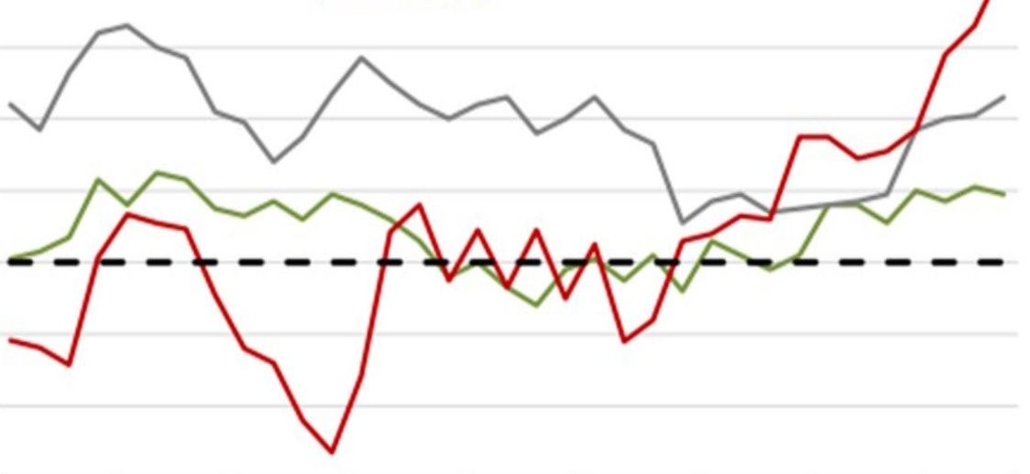
Developing countries
Developed countries
Russia
Source: Bloomberg Finance L.P., Rosstat, DIP calculations

The second wave (late 2015 - early 2016) was less tangible and painless for the global economy, the countries tried to take the maximum possible measures and stabilize the situation. The dynamics of the Russian index PMI resembles the dynamics of the indices of both developed and developing countries. First there was a slow decline with periodic fluctuations, and then there was an acceleration of business activity, and it began a little earlier, even than in developed countries. According to analysts, such trend is related to the adaptation of the Russian economy and the growth of oil prices, as well as the revival of the economies of the developing and developed countries in the second half of 2016. It is important to note that China and the eurozone dominate in Russia's foreign trade turnover. However, the dynamics of the growth of the Russian PMI index significantly exceeds the growth of similar indicators in other countries.
The first company in Russia, which performed an IPO, was VimpelCom. It offered the ADR (American Depositary Receipt) of the third level on the New York Stock Exchange (NYSE) in 1996 (Telecommunications and IT branch). The format of placement is an open subscription, the beginning of placement is October 20, 1996, the end of placement is November 13, 1996, the volume of placed shares is 5,880,000, and the total amount of attracted funds was $ 127.5. The initial public offering of shares is conducted to raise funds for expanding the business and reducing the company's existing debts (reducing the debt burden). Therefore, VimpelCom raised the attracted funds in the course of the placement of shares: 14% of debt repayment, 7% purchase of lines, CB Impuls 5%, purchase of equipment - 7%, financing of other expenses - 7% (FINAM, 2017).
The first IPO in Russia was performed in 2002 by OJSC RBC Information Systems simultaneously on two Russian stock exchanges of RTS (Russian Trading System) and MICEX (Moscow Interbank Currency Exchange).
Global trends and the overall state of the national economy are important factors which influence on Russian IPO market in 2017. According to the Bank of Russia bulletin, inflation remains within the forecasted dynamics. Foreign economic and financial conditions are moderately favorable. Economic activity for 2016 demonstrated steadily positive trends, confirming the optimism of leading indicators. Inflation in 2017 went to the trajectory of 4%, these figures indicate the growth of the economy, monetary conditions remain moderately strict. The annual trend inflation rate in January 2017 declined to 7.2%, which gives hope for a further weakening of inflationary pressure in the current year (Fig. 2.3).

Fig. 2.3 Dynamics of CPI, BICC and historical estimates of trend inflation, % per year
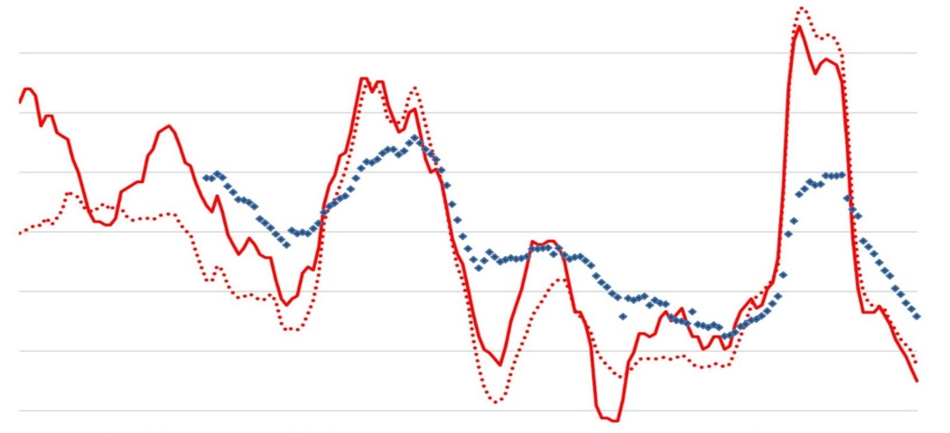
CPI
BCPI
Estimates of trend inflation
Source: Bloomberg Finance L.P., Rosstat, DIP calculations

According to the Department of Research and Forecasting of the Central Bank of Russia (2017), according to a Bloomberg poll, in January 2017, the decline in inflation in Russia is expected to reach 4.4% (4.5% in December 2016). A similar survey, conducted by Reuters, showed the expectation of a decline in inflation in January 2017 to 4.3%.
The conclusion about the positive dynamics of economic activity is also confirmed by the results of market surveys conducted by the Institute for Economic Policy named after E.T. Gaidar. This is indirectly evidenced by the outlined positive trend in reducing the assessment by enterprises of the level of unavailability of loans (Fig. 2.4). Over the past two years, this indicator has decreased from 45% (February 2015) to below 15% (January 2017) and is approaching the minimum level over the past 17 years. Such positive changes contribute to the increasing of business development, because they provide an opportunity for domestic enterprises to gain access to an additional source of financing, which is necessary for their development.

Fig. 2.4 Level of unavailability of loans for Russian industry, 2000-2017, %
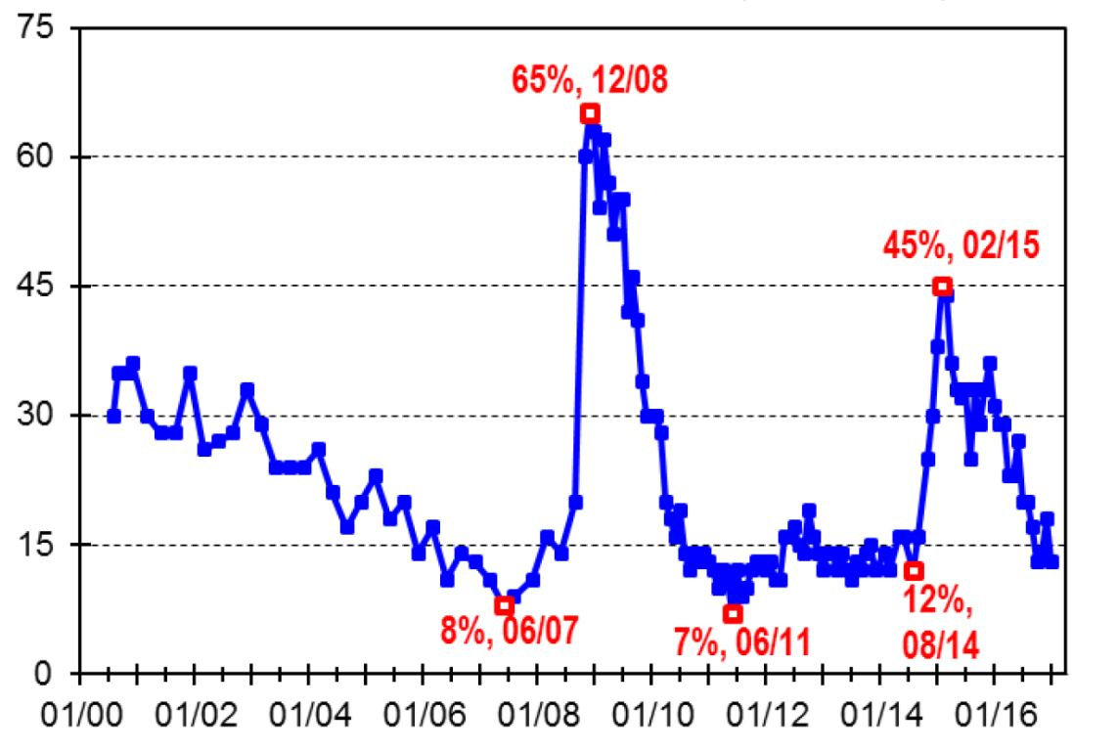year
Source: IEP

There has been a significant improvement in business activity in the private sector of the Russian economy, which should be emphasized. There is a steady increase in new orders from the domestic market, which shows that the average historical level of the study has been exceeded. This trend contributes to the development of enterprises which main activity is aimed at satisfying the demand of domestic consumers. However, it should be noted that the volume of export orders is not increasing (Fig. 2.5).

Fig. 2.5 Dynamics of quarterly GDP growth rates and the total PMI production index
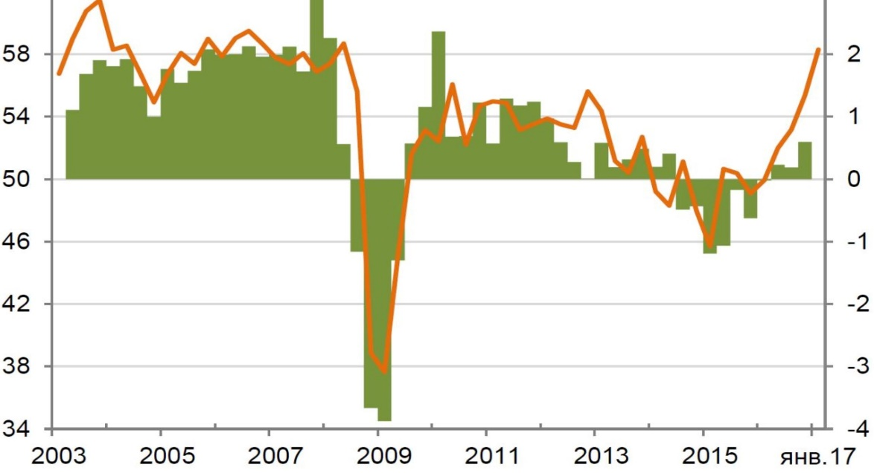
GDP growth rate, % (l. axis)
Aggregate index of production of PMI, items
Source: Bloomberg Finance L.P., Rosstat, DIP calculations

In 2016, positive trends are observed in most of the manufacturing industries. In the food, light and woodworking industries, the production assets were modernized, which gives the potential for further development of these enterprises, including the use of stock market instruments (Fig. 2.6).
Other enterprises are characterized by positive dynamics of capacity utilization level (Fig.2.6), which allows to produce competitive products and belong to the following branches: chemical, pulp and paper industry, production of rubber and plastic products, leather and footwear, machinery and equipment.
As V. Salnikov notes (2016, 56) in his analysis of the most important structural characteristics of the manufacturing capacities of the Russian manufacturing industry, enterprises from the metallurgy sector and technically simple assembly plants (production of vehicles and electrical equipment) were among the industries in which the production volume was decreasing. Thus, following the results of 2016 (Fig. 2.6), the enterprises of the represented groups of industries can be conditionally grouped as follows.

Fig. 2.6 The growth rate of output of manufacturing industries in 2016
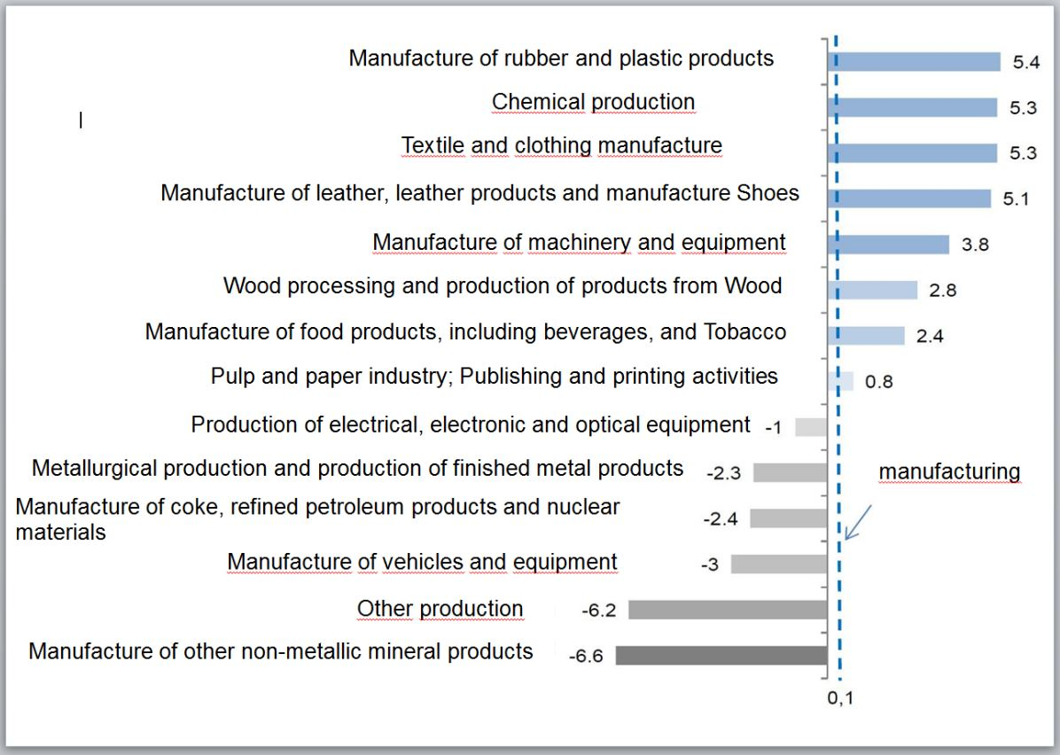
Source: Rosstat

The first group includes industries that have increased production and have the potential for further growth due to the reloading of existing capacities: food, woodworking, textile and clothing industries. They have good prospects for doing IPO due to the ongoing processes aimed at import substitution and are characterized by a high intensity of capacity upgrades (Appendix 4). As a result, the average age of the equipment is 7-9 years. Moreover, the share of non-competitive capacities is relatively low 9-14%, and the potential for growth in output due to re-loading is 10-15%.
The second group is the industries which demonstrated growth in 2016, but they have limitations in their potential to increase their own production, which is due to insufficiency in production capacity (Appendix 5). These enterprises may also be of interest to investors under a certain political and economic situation. This is the production of rubber and plastic products, chemical and pulp and paper industries, leather and footwear industry, the production of machinery and equipment.
The third group includes industries in which negative trends are traced, but the potential for growth remains. These include metallurgy, the production of construction materials, the transport and equipment sector. Despite the overall decline of 3% in some countries in 2016, a significant increase in capacity is observed (Appendix 6).
The fourth group includes the sectors that showed negative dynamics in 2016 and have limited potential for their growth in the future period - the production of electrical equipment, coke and petroleum products.
The history of Russian companies on foreign stock markets began in 1996. The growth of activity in the domestic IPO market has been traced since 2005 (PwC, 2016) (Fig. 2.7), and its peak is observed in 2007 - it is 32 transactions and 32949 million dollars. (Fig. 2.8), which is the highest in the history of the stock market in Russia (PwC, 2011).

Fig. 2.7 IPO and SPO offerings by years

Source: The drawing is made independently on the basis of the official websites: PREQVECA PAGE http://www.preqveca.ru, LLC "BKS Company" https://bcs.ru, "FINAM" Holding http://www.finam.ru, PwC http://www.pwc.ru.

It should be noted that the first classical public offering on the Russian market was performed by the company RBC Information Systems in 2002. A competent and successful IPO has become an excellent example in raising funds on the domestic stock market, demand was five times higher than supply. However, the crisis phenomena in the world financial market in 2008-2009 corrected quantitative and qualitative indicators. The total number of transactions decreased by 640% (more than 6 times) and amounted to 5 deals in 2008 and 2009. And the amount of funds raised in 2009 fell to $ 537 million USA (by 61 times in relation to 2007) (PREQVECA PAGE, 2017).

Fig. 2.8 The amount of borrowed funds, when IPO and SPO are performed

Source: The drawing is made independently on the basis of the official websites: PREQVECA PAGE http://www.preqveca.ru, LLC "BKS Company" https://bcs.ru, "FINAM" Holding http://www.finam.ru, PwC http://www.pwc.ru.

But at the same time, SPO figures (Fig. 2.7) remain optimistic, and deals are observed to increase by 40% (from 5 to 7), which is maintained in 2009, and the volume of raised funds in 2009 amounted to 8594 million dollars USA, which is 36 times higher than in 2006 (Fig. 2.8). And only in 2010 there is a significant failure in the SPO market. The number of transactions decreased slightly from 7 to 5, but there was a significant decrease in the amount of raised funds to 839 million dollars USA, which is more than 10 times less than the same indicator for 2009 ($ 8.894 million). The IPO indicators for 2010-2011 remain optimistic (IPO - 14 deals, and SPO - 9 deals in 2011). Since 2012, negative trends and a drop-in emission activity have been traced. The political factors and the crisis in the oil market had a particularly strong impact on the stock market. In 2014, by one IPO and SPO transaction were conducted. A small revival began in 2015. But the lowest figure of funds raised by IPO over the past 10 years in 2016 is $ 251 million USA.
An important indicator in the analysis of the Russian IPO market is the geographical distribution of domestic companies in the largest exchanges for 1996-2016 (Fig. 2.9). Currently, there are two generally recognized Trade Point depository sites: London Stock Exchange (LSE, London) and the New York Stock Exchange NASDAQ OMX and NYSE (USA). Experts estimate that their market capitalization is $ 3613 billion, $ 4.931 billion and $ 15.57 billion, respectively. Also, it is worth mentioning the Tokyo Stock Exchange, which is capitalized at $3827 billion US, although Russian companies are not interested in it today. (PREQVECA PAGE, 2017).
Fig. 2.9 IPOs and SPOs distribution by exchange

Source: The drawing is made independently on the basis of the official websites: PREQVECA PAGE http://www.preqveca.ru, LLC "BKS Company" https://bcs.ru, "FINAM" Holding http://www.finam.ru, PwC http://www.pwc.ru.

The largest number of IPOs and SPOs of Russian companies for the period 1996-2016 is accounted for the LSE (34%). The second place (22%) is taken by the Moscow International Financial Fund (Russia). 14 per cent are distributed between RTS (Russia) and AIM Listing (London). NASDAQ OMX (USA) is preferred by 5% of domestic companies and NYSE (USA) is preferred by 4%. The rest of the stock exchanges was preferred by 1% to 2% of Russian companies. Thus, LSE is most popular among Russian companies.
It should be noted that at present the structure of global capital markets has already formed in the world economy, in which there are two types of stock exchanges: global and regional. Each type of exchange has its market niche and economic specialization, which must be taken into account when selecting exchange sites, which locations and interactions are given in Appendix 7. In addition, as noted by Balashov (2008,336), regardless of the selected exchange, issuers should take into account the factors directly influencing on the success of the IPO: the amount of costs referring to compliance with legal requirements of the selected stock platform; corporate governance requirements; liquidity of the market; location of key investors; geographical location of the stock exchange; size of the company; time required to carry out the offering; sectoral structure of the market; level of recognition and prestige of this exchange in the global investor community. In Appendix 8, the main positive and negative aspects of various stock exchanges are given, taking into account the above-mentioned factors.
Some Russian organizations simultaneously do their IPOs to gain access to a greater number of investors and the ability to trade in different time zones. Simultaneous offers of Russian companies on several exchanges are presented in Fig. 2.10.

Fig. 2.10 Simultaneous IPO and SPO offerings by Russian companies on several exchanges

Source: The drawing is made independently on the basis of the official websites: PREQVECA PAGE http://www.preqveca.ru, LLC "BKS Company" https://bcs.ru, "FINAM" Holding http://www.finam.ru, PwC http://www.pwc.ru.

The specifics of the Russian IPO and SPO market are shown in Fig. 2.11.

Fig. 2.11 IPO and SPO placement by industry
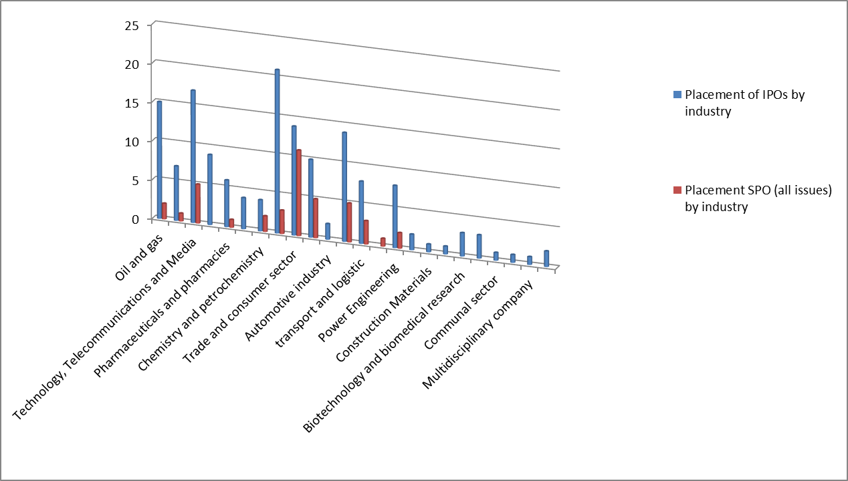
Source: The drawing is made independently on the basis of the official websites: PREQVECA PAGE http://www.preqveca.ru, LLC "BKS Company" https://bcs.ru, "FINAM" Holding http://www.finam.ru, PwC http://www.pwc.ru.

Analyzing the industry specifics of the Russian IPO and SPO market for the period 1996-2016 (Fig. 2.11), we can state that Trade and the consumer sectors are leading - 14% of the total IPO and SPO. 13% belongs to Metallurgy and mining. Technology, telecommunications and media - 12%. Companies providing financial services make up 10 per cent of total transactions, 9% - oil and gas companies, 8% - real estate and development, 6% - transport and logistics, 5% of transactions are carried out by food industry representatives and energy companies. Enterprises engaged in gold and diamond mining performed 4% of total offerings, as well as the pharmaceutical and pharmacy industry.
Over the past ten years, writes S. Gvardin (2007, 121), there has been a qualitative change in the role of the stock market for the Russian economy. Despite the fact that the domestic IPO market is still young, which is primarily due to the imperfection of the legislative base and the insufficient development of the exchange infrastructure, it has become a real mechanism that provides long-term financing for a number of large and medium-sized domestic enterprises (O.Bolomytseva, 2014).
Some Russian companies have repeatedly placed their shares on the stock market (up to 4 times), which indicates their interest and real prospects for the development of the IPO market in Russia (Fig. 2.12).

Fig. 2.12 Single and multiple placements of shares by one company

Source: The drawing is made independently on the basis of the official websites: PREQVECA PAGE http://www.preqveca.ru, LLC "BKS Company" https://bcs.ru, "FINAM" Holding http://www.finam.ru, PwC http://www.pwc.ru.

The leader in the number of placements of its shares in the stock market (4 times) is the chain of stores "Magnit" (Krasnodar). The main activity of this network is the distribution of goods of everyday demand. Retail trade is conducted in the format of a "shop near the house", with low prices and convenient location. Four companies additionally placed their shares 3 times after the IPO - Globaltrans, Pharmacy Chain 36.6, VTB and Synergy. The two-time placement was used by 7 companies: Mail.ru Group, QIWI Plc, Bank Saint Petersburg, Razgulay Group, Dixy Group, Open Investments and Lenta hypermarket chain. 38 Russian companies have offered their shares twice.
It should be noted that, given the existing potential of the domestic food, woodworking, textile and clothing industries (Group 1) discussed earlier (Fig. 2.6), there are good prospects for them to do IPO and SPO in 2017. The average age of their equipment is 7-9 years old, including the share of non-competitive capacities of 9-14% (according to experts, a good indicator), and the potential for increasing the production of new products through the additional loading may come up to 10-15 %.
In addition, the preliminary forecasts on prospects for Russian companies in the IPO market in 2017 can be made with the use of information provided by Reuters.
A conducted study of the Russian IPO market and a survey of public sources allow us to formulate the main reasons which prevent Russian companies from attracting additional capital using the IPO mechanism. These include:
1. The complexity of legislative regulation of the securities market. Today two organizations are engaged in market regulation: The Federal Service for Financial Markets (FSFM) and the Central Bank of the Russian Federation (Central Bank of the Russian Federation), which functions are useful to distinguish.
2. The tax legislation of Russia does not stimulate IPO performance on Russian sites, since taxes are levied on the market value of shares (clause 3 of Article 280 of the Tax Code of the Russian Federation), not on a nominal one. This is one of the reasons why a significant number of IPO transactions are conducted where the authorities reduce the level of taxation.
3. In the Russian market there is an excessive concentration of turnover of valuable securities. Today, more than 90% of all transactions in the organized stock market are carried out with securities of 8-10 largest issuers. In countries with a developed stock market, the value of this indicator does not exceed 20-30%.
4. The Russian market is characterized by low free-float (the volume of securities in free circulation). According to the latest research, for the eight largest corporations in Russia this indicator does not exceed 12% on average, while in the whole market it is in the range of 25-30%, and in developed market countries this indicator reaches 80-90%.
5. IPO on Russian stock exchanges is currently a complex and lengthy process from the point of its legal aspect, so it is much easier and faster to do it abroad.
6. Publicity of the company after performing IPO in Russia, unlike the western countries, does not allow to reduce the total cost of capital, including by the means of increasing access to credit at lower rates.
7. The lack of alternative trading platforms for small companies with minimum disclosure requirements, which are similar to London AIM.
8. Weak development of Russian institutional investors: pension, mutual and insurance funds.
9. Extremely low participation of the population in operations on the stock market. Today, only less than one percent of Russians are represented on the stock market, whereas in many developed countries this figure reaches 20%, and in the USA - 60%.
The collapse of oil prices and the low ruble exchange rate in 2014-2015 provoked an outflow of foreign capital and a decline in the investment market. However, from the middle of 2016 there was a turning point. The sale of Alrosa's packages for 52.2 billion rubles and Rosneft for 692 billion rubles revived the market. Foreigners turned their faces to the Russian stock market. According to media reports (2017), companies that did IPO in 2016 managed to raise 1080 billion USD, and in the first quarter of 2017 970 billion dollars USD were attracted.
Prospects of the Russian stock market in 2017 are evaluated positively. The fundamentally sound level, according to the models of analysts of Promsvyazbank, is 2,760 points on the MICEX index and 1,530 points on the RTS. However, given the large number of risks in 2017, they set a more conservative benchmark for the market's movement at the level of 2,570 points of the MICEX.
The main factors for the growth of the stock market will be:
1. The continuing economic recovery, primarily due to the growth of oil prices. After two years of recession, Russia's GDP in 2017 is forecasted to grow up to 1.5 percent.
2. The cheapness of the cost of shares. The Russian stock market will be attractive for investors, oriented on the classical understanding of value. Russian companies that form basic indices are "cheap" and are now traded at a P / E multiplier (price / earnings) at 6.5-7, while Polish banks are at the level of 12, Brazilian - 10, American - 12, European - 14.
3. Dividend payments. The average returns of Russian assets are higher than that of analogues. In 2016, the dividend payout ratio of the MSCI Russia index rose to 41% and has the potential to increase in 2017-2018 on the background of the introduction of a mandatory dividend payment rate of 50% of net profit for a number of state-owned companies.
4. Capital flows. The outflow of capital from Russia has slowed, dividends and cheapness of the market can attract investors at the beginning of the year due to lowering of the key rate by the Bank of Russia.
5. Financial results of Russian companies. In the next 12 months, according to the consensus forecast of Bloomberg, earnings per share for companies included in the MICEX index may increase by 34%.
6. Privatization and IPO. In 2017, a lot of interesting corporate stories can appear on the primary market, both within the framework of privatization (Sovcomflot, VTB), and primary private offerings (Yulmart, Sovcombank, EN + Holding, Polyus, Pipe Metallurgical Company).

Analysis of IPO and SPO of small and medium-sized companies in Russia
The market economy assumes simultaneous functioning of large, medium and small enterprises. Most often, the size of enterprises depends on the specifics of the industry in which it operates, technological features, scale of business. It is important to note that there are industries for which small and medium-sized enterprises are preferable. Modern economy is characterized by a complex combination of different in scale industries. Large ones are basically monopolies, and small and medium ones develop under the influence of many factors. Therefore, it is necessary to separately conduct an analysis of the activity of small and medium-sized enterprises in Russia when performing IPO in connection with their important role for the development of a modern economy.
According to information provided by E.Laricheva & E.Sklyar (2013), with reference to the Annual Report on European SMEs, the contribution of the SME sector to GDP (Fig. 2.13) in most developed countries varies between 50% and 60% (in the EU, on average, 57.8%). In Russia, SMEs provide only 21% of GDP. The SME sector of the EU makes up 99.8% of the EU enterprises and provides jobs for 66.5% of the employed population in Europe. In Russia - 27% (Fig. 2.14). Therefore, if we want to achieve success in the economy, it is necessary to develop small and medium-sized businesses. This is reflected in the development strategy of Russia for the period until 2020.

Fig. 2.13 Share of SMEs in the country's GDP

Source: Laricheva E.A. & Sklyar E.N. (2013)

Fig. 2.14 Employment in the SME sector

Source: Laricheva E.A. & Sklyar E.N. (2013)

Before starting the analysis of trends in the small business market, it is necessary to determine the criteria according to which a sample of statistics will be made. So far, there are no universally accepted criteria and / or common standards that clearly determine whether a company is a small or a medium-sized business. Russian legislation provides the classification by size and identification of micro-enterprises as well as small and medium-sized enterprises and companies. For these objects, three numerical criteria for their identification are provided (two main and one additional): the number of employees (personnel), the volume of annual revenue and / or the book value of assets in special cases. Classification and identification by the size of relatively small enterprises and companies of Russia is established by the law of the Russian Federation No. 209 - FZ of 24.07. 2007 "On the development of small and medium-sized businesses in the Russian Federation", with amendments introduced since August 1, 2016.
According to Art. 14.06.1995 N 88-FZ "Small business entities are understood to be commercial organizations, which statutory capital has shares of the Russian Federation, constituent entities of the Russian Federation, public and religious organizations (associations), Charitable and other funds do not exceed 25 percent, the share belonging to one or several legal entities that are not small businesses does not exceed 25 percent and in which the average number of employees for the reporting period does not exceed the following limit levels (small enterprises): in industry - 100 people; in construction - 100 people; in transport - 100 people; in agriculture - 60 people; in scientific and technical sphere - 60 people; in wholesale trade - 50 people; in retail trade and consumer services of the population - 30 people; in the remaining industries - 50 people."(N 88-FZ of 14.06.1995).
In 2007, the Federal Law "On the Development of Small and Medium-Sized Enterprises in the Russian Federation" of July 24, 2007, No. 209-FZ, SMEs are determined by the main financial indicators - their annual turnover should not exceed: for microenterprises - 60 million rubles; small businesses - 400 million rubles; medium - 1000 million rubles.
Decree of the Government of the Russian Federation of 04.04.2016 N 265 "On the marginal values of income received from the implementation of entrepreneurial activities for each category of small and medium-sized businesses" in accordance with paragraph 3 of Part 1.1 of Art. 4 of the Federal Law "On the Development of Small and Medium-Sized Enterprises in the Russian Federation" establishes new limit values of income received from the performance of entrepreneurial activities for the previous calendar year: microenterprises - 120 million rubles; small enterprises - 800 million rubles; average - 2 ml. rub.
When selecting statistical data on IPO and SPO performing by small enterprises by the years shown in Fig. 2.15, as well as in the further analysis, the criteria for determining SMEs (small and medium-sized enterprises) were used in accordance with the requirements of Russian legislation at the time of the availability of this data.

Fig. 2.15 Small enterprises IPO and SPO by years

Source: The drawing is made independently on the basis of the official websites: PREQVECA PAGE http://www.preqveca.ru, LLC "BKS Company" https://bcs.ru, "FINAM" Holding http://www.finam.ru, PwC http://www.pwc.ru.

The first Russian enterprise that falls under the definition of SMEs performed IPO in 2003 - is OJSC Pharmacy Chain 36.6. The type of subscription is open, amount of offered securities – 1600000, the volume of attracted investments - 14 million USD (Fig. 2.16). OJSC "Pharmacy Chain 36.6" is the first public Russian company in the retail sector for health and beauty products. The Company's shares are included in the quotation list "B" of the RTC (ticker APTK) and admitted to trading on the MICEX. The market capitalization of the Company on April 24, 2009 was $ 38 million (according to RTS data). Pharmacy Chain 36.6 operates more than 1,000 pharmacies in 29 regions and 90 Russian cities (PREQVECA PAGE, 2017).
Fig.2.16 Amount of attracted funds of SMEs in relation to IPO and SPO

Source: The drawing is made independently on the basis of the official websites: PREQVECA PAGE http://www.preqveca.ru, LLC "BKS Company" https://bcs.ru, "FINAM" Holding http://www.finam.ru, PwC http://www.pwc.ru.

Peak of activity of small enterprises in the IPO market is observed in 2007 (attracted $ 1,722 million). However, since 2008, there has been a sharp drop in the number of initial offerings, which demonstrates the virtual absence of IPO transactions. This is partly compensated by the secondary offerings on the Russian stock market, which made it possible to raise $ 857 million USA in 2008. But at the same time, very low numbers of IPOs (1-2 transactions) are observed during 2009-2011. Relative stability in quantitative indicators of SPO is observed for five years (2007-2011). Although the amount of borrowed funds from SPO deals has negative trends. So, in 2009, the amount of borrowed funds from SPO decreased by more than 23% compared to the previous year and amounted to 654 million dollars USA. And in 2010 this figure was equal to 523 million dollars. Which is 20% less than in 2009. And only in 2011, the amount of funds raised from SPO amounted to 899 million dollars USA, which is 5% higher than in 2008. However, starting from 2012 and until 2016 there was a significant decline in the number of IPO and SPO. In addition, there are negative trends in the amount of funds raised from these transactions. An exception is the only SPO transaction conducted in 2013 by NOMOS-BANK, thanks to which it was possible to attract $ 596 million USA. In 2015, for the fourth time, shares of Magnit were offered, which made it possible to raise $ 143 million USA for the development of the chain.
Having analyzed the quantitative indicators and the volume of attracted funds of SMEs in the period from 1996-2016, it became clear that the choice of the stock exchange for the company is one of the key tasks, and the success of IPO and/or SPO depends on properly made choice. It should be noted that exchanges differ in the requirements for issuers, technical parameters, regulatory standards, reporting system.
On data analysis on the selection of stock sites by Russian SMEs, represented in Fig. 2.17 it can be concluded that during the period of 2003-2016 in most cases, the issuers gave preference to MICEX (IPO-10, SPO-10) and RTS (IPO-5, SPO-11). Ten percent of the deals were made in the London Stock Exchange and by one deal on the AIM Listing (London) and NASDAQ OMX.

Fig.2.17 IPO and SPO offerings by small enterprises by exchanges

Source: The drawing is made independently on the basis of the official websites: PREQVECA PAGE http://www.preqveca.ru, LLC "BKS Company" https://bcs.ru, "FINAM" Holding http://www.finam.ru, PwC http://www.pwc.ru.

In the course of research and analysis, there have been cases of simultaneous IPO and SPO offerings made by small enterprises on several exchanges, as reflected in Fig. 2.18.

Fig. 2.18 Simultaneous IPOs and SPOs offerings by small enterprises on several exchanges

Source: The drawing is made independently on the basis of the official websites: PREQVECA PAGE http://www.preqveca.ru, LLC "BKS Company" https://bcs.ru, "FINAM" Holding http://www.finam.ru, PwC http://www.pwc.ru.

Using the services of several exchange sites simultaneously, the issuing company gets more opportunities to attract capital. It is especially important to use this approach if the Russian stock market for some reason is not able to meet the needs of certain industries. However, in that case, when the company goes to a foreign exchange, the Russian infrastructure does not participate in this process and foreign intermediaries earn an IPO or SPO, which slows down the development of the domestic stock market.
Based on the analysis of the collected data on the number of Russian companies which performed IPO, it is estimated that the share of SMEs in the total volume is 9% (Fig. 2.19).

Fig. 2.19 Share of SMEs which performed IPO in the total amount of Russian enterprises

Source: The drawing is made independently on the basis of the official websites: PREQVECA PAGE http://www.preqveca.ru, LLC "BKS Company" https://bcs.ru, "FINAM" Holding http://www.finam.ru, PwC http://www.pwc.ru.

Analysis of trends in the IPO market shows that now it is difficult for domestic SMEs to meet the requirements on stock exchanges, both foreign and domestic. In addition, given the fact that the IPO is a complex and lengthy process for small Russian companies, it is too difficult to find the necessary resources for the successful placement of their shares.
The weak activity of representatives of small and medium-sized businesses on the securities market in Russia has its negative consequences. The share of SMEs which performed SPO in the total volume of transactions of Russian enterprises for the entire period of the study (1996-2016) is 17% (Fig. 2.20).

Fig. 2.20 The share of small enterprises which performed SPO in the total number of Russian enterprises

Source: The drawing is made independently on the basis of the official websites: PREQVECA PAGE http://www.preqveca.ru, LLC "BKS Company" https://bcs.ru, "FINAM" Holding http://www.finam.ru, PwC http://www.pwc.ru.

During the analysis of IPO and SPO trends of small enterprises, it is very important to trace the industry structure of participants in this market segment, as suggested in Fig. 2.21. The most active enterprises are representatives of the food industry, only 8 deals, 2 of them - IPO and 6 - SPO. Four transactions were carried out by enterprises in the sectors "Pharmaceuticals and Pharmacies" and "Technologies, Telecommunications and Media". 3 deals are realized in the real estate and development sector. Representatives of "Other branches" - 2 transactions. The rest of the participants made by one deal - these are the branches: Metallurgy and Mining, Trade and Consumer Sector, Biotechnology and Biomedical Research, Communal Sector, Financial Services.
Fig. 2.21 Small enterprises IPO and SPO by industry

Source: The drawing is made independently on the basis of the official websites: PREQVECA PAGE http://www.preqveca.ru, LLC "BKS Company" https://bcs.ru, "FINAM" Holding http://www.finam.ru, PwC http://www.pwc.ru.

It should be noted that despite the existing potential for its development and performing IPO or SPO (Fig. 2.6), enterprises producing rubber and plastic products, chemical and pulp-and-paper industries, leather and footwear industry, machinery and equipment manufacture do not show proper activity, although they demonstrated in 2016 growth in the main economic indicators. These enterprises have limitations in increasing their own production. Public offering provides good prospects for their development. However, the imperfection of Russian legislation hinders this process. Therefore, given the existing potential of SMEs, today the Russian stock market shows very low IPO and SPO. Moreover, SMEs in 14 industries have never performed IPO.
Based on the conducted studies of the essence of the IPO, analysis of the main trends in the stock market in the world and Russia, the study of Russian legislation regulating the activities of small and medium-sized enterprises of the Russian Federation, it can be concluded that SMEs do not perform IPO for the following reasons.
First, the study of trends in the Russian stock market showed that most companies that successfully performed an IPO or SPO are industry leaders and mostly large enterprises. They are well known to Russian and foreign investors, which is a significant plus for the public offering of their shares. Therefore, the access to the stock market of Russian companies of small and medium capitalization remained in the shadow and few people were interested in it. The specialists paid little attention to them.
Secondly, the requirements for issuers put forward by stock exchanges for SMEs are difficult to implement because of the limited nature of their own resources. Compliance with the requirements set by stock exchanges forces the company to make internal changes in preparation for publicity, especially with respect to bringing international standards in line with existing norms and rules, which entails significant financial and non-material costs. As a result, their own funds and bank loans remained the main sources of financing for Russian SMEs.
Thirdly, the stock market requires a serious attitude, understanding and relevant knowledge from the leaders of enterprises and their environment. To our great regret, today there are not enough high-level specialists on the Russian stock market who possess information about stock exchanges and their devices, which is necessary for making investment decisions. Besides, in order to encourage small capitalization companies to actively offer their securities on the stock market, a well-developed infrastructure and special sites for SME representatives should be developed.
Fourth, the IPO requires a "transparent" business. This includes publicly available information on company owners, the history of origin of initial capital, the publicity of financial results from previous activities, the implementation of the prescribed financial reporting and internal control procedure, transparency in corporate governance and tax payments, the existence of an appropriate corporate structure, etc. So, today, some business owners are not prepared for such a step and, as a result, use other tools to develop their business.
Fifth, the analysis of major trends in the Russian IPO market shows low liquidity, especially in the SME segment. In addition, there is a great potential for a significant underestimation of the value of shares of Russian companies planning their offering.
Sixth, the study of Russian legislation regulating the activity of the stock market makes it possible to conclude that it is imperfect. The non-smoothness of the processes of corporate relations increases the costs of companies, reduces motivation and significantly complicates the listing procedure, especially for small and medium enterprises of the Russian Federation. It is also desirable that the existing legislation should provide incentives for SMEs to invest in long-term investment.
Seventh, we can see the weakness of domestic institutional investors, who today are not able to fully meet the needs of Russian companies wishing to perform IPO, and listing on the world's leading exchanges for Russian SMEs is too expensive.
Eighth, studies have shown that there is a relationship between the development of the Russian IPO market and the weak liquidity of most small and medium-sized enterprises present on it. This situation creates negative precedents for potential new participants of the Russian stock market planning to perform IPO.

The relationship between economic factors and the activity of Russian companies in preparing for the placement of shares in the IPO process

The traditional aspect in studying whether the company is ready to perform IPO is value assessment. A lot of scientific literature has been devoted to this aspect. Another, not less important aspect, but still poorly studied, is the question of how companies make the decision to do IPO. It is important to note that studying this problem requires a detailed database of all companies in the economy: those that went public, and those which remained private. Unfortunately, for most markets, data is available only for those companies which performed IPO, and that greatly limits the possibilities for analysis.
One of the first works which examine the individual characteristics of companies and the success of the placement of shares is the article by Pagana et al. (1998, 27-64), in which the authors examine firms in Italy. According to their results, the most significant factor is the size of the company - the bigger the company, the higher the probability for it to perform IPO. The second most important factor was the ratio of the market price of the company and its book value.
Albornoz & Pope (2004, 22) study the UK IPO market - Europe's largest stock market. The article studies the logistic model in which the dependent variable is a dummy variable equal to 1 if the company did IPO, and it is equal to 0 otherwise. As independent variables, the following variables were used: firm size, capex, firm leverage, profitability, relation of market price to book value of similar companies in the industry (M / B), and total value of intangible assets. According to the results of the survey, the size of the company, capex, the rate of M / B and the volume of intangible assets are significantly and positively correlated with the probability of the company to hold IPO. The debt leverage and the profitability of the company significantly and negatively affect the likelihood of an IPO.
The work by Chorruk & Worthington, (2010, 543 - 559) uses an extensive database of companies in Thailand, some of which became public in the period from 2001 to 2007. The authors showed that the size of the company positively and significantly influences on the company's probability to perform IPO. Significant and negative factors are: the age of the company, the debt leverage and the interest rate. Similar results were obtained for the French stock market in the article by Boubaker & Mezhoud (2012,166-180).
As we can see from the references given above, the characteristics of the company play a huge role in decision-making to issue shares. However, in addition to the state of the company's readiness for such a serious step, it is necessary to choose the right moment to enter the market in the optimal way. As we will see later, macroeconomic factors play an equally important role in making such decisions.
Six different European countries are examined in the article by Breinlinger & Glogova (2002, 87-106), for the existence of a correlation between the activity of IPOs in the economy and macroeconomic indicators. As factors, the authors choose the following: the rate of GDP growth, the profitability of a broad index of shares and the growth rate of savings. The measure of IPO activity in the article is the total amount of funds raised during the IPO. The results obtained by them testify that the rate of GDP growth and the profitability of the stock market significantly and positively influence on the activity of the IPO. This indicates that firms are looking for financing in those periods when the economy is experiencing recovery and the stock market has a pronounced bullish trend.
In the article by Blum (2011, 28), the American market of companies which performed IPO in the period from 1990 to 2010 was investigated. The final sample includes 5856 IPOs. As a measure of IPO activity, the author uses 2 variables: the number of IPOs and the total amount of funds raised for a quarter. Independent macroeconomic factors are: the GDP growth rate, the volatility index, the interest rate and population number. According to their results, the rate of GDP growth positively and significantly influences on the activity of the IPO. The volatility index, the interest rate in the economy and the population size are significantly and negatively correlated with the activity of the IPO. It is worth noting that the last two factors turned out to be significant only for the total amount of funds raised.
In a number of articles, Glavina S. and co-authors examine the activity of IPO in the Russian market. Using the annual data in the period from 1996 to 2015, the authors identify the following significant factors: the rate of GDP growth and the refinancing rate. The rate of GDP growth positively influences on the activity of the IPO, while the refinancing rate has negative impacts. Unfortunately, due to the very short length of the time series, the authors were not able to conduct a deep multi-factor analysis. In addition to these significant factors, the authors tried to explain the activity of the IPO in the Russian market using the index of industrial production, the growth of the index of the Exchange and the growth of investments in fixed assets. All the mentioned factors turned out to be insignificant for the authors.
Based on the above review of the literature, all the empirical facts that can explain the variability and timing of the IPO can be represented in the form of the following table 2.1.

Table 2.1 The main empirical facts described by the authors in the literature.
Characteristics of the company | Association with IPO readiness | State of the economy | Association with IPO readiness
The size | positive | GDP growth rate | positive
Age | negative | Profitability of a broad share index | positive
Сapex | positive | The growth rate of depositary savings | negative
Debt leverage | negative | Interest rate | negative
Profitability | negative | The expected volatility index | negative
Intangible assets | positive | - | -
Cost of loan | negative | - | -

Let's consider some of the factors in more detail.
The size of the company. Larger companies tend to be more stable players in the market, with the potential to attract more investors while performing IPO. In addition, large companies are more recognizable and able to cover significant fixed costs when entering the market. All of the above leads to a positive relationship between the size of the company and its activity when IPO is held.
Age. Since young companies, as a rule, are not yet sustainable, their expectations about their future are more uncertain than those of mature companies. This leads to the fact that young companies rarely go public.
Capex. This measure can serve as a proxy for the growth rate of the company. With intensive growth, the company more often needs additional investments, which stimulates them to undertake IPO.
Profitability. The high profitability of the company allows it to remain sustainable without third-party financing and as a consequence to remain private.
GDP growth rate. The rate of GDP growth reflects the growth of the entire economy as a whole. In the period of rapid growth, so-called boom, companies on average grow or are prone to expansion. This calls for additional funding. The latter leads to an increase in entering the market, as one of the ways to attract investment. On the contrary, during the economic recession, the profitability of the company falls, which requires them to optimize existing processes, rather than expand their business. The IPO activity in such periods is lower.
Profitability of a broad share index. The dynamics of the stock market is key to determining one of the three trends: bearish, bullish and stagnant. In the case of a bearish trend, the market shows negative dynamics, which suggests that investors are pessimistic about the future. In this state of the economy, investors will tend to underestimate the transaction price at IPO booking, trying to hold it along the lower corridor. This is especially true for Russia, where IPOs at the booking stage are traditionally overvalued in relation to Western countries. Obviously, companies will try to protect themselves from holding an IPO in these conditions. The bullish trend, on the contrary, favors the owners of companies. In this state of the economy, the stock market is growing, investors are optimistic, which increases the chances of placing on the upper border of the corridor. Thus, the higher the rate of return on the stock market, the higher the activity of the IPO.
The growth rate of deposits. This value reflects the propensity of the population to place deposits. If the agents are prone to save more in the form of deposits, and do not consider the shares as possible investments, this is reflected in insufficient IPO bookings. Weak investor interest is associated with a lower IPO activity.
Interest rate. This indicator is one of the most ambiguous. On the one hand, the growth rate in the economy leads to an increase in the cost of debt borrowing, which pushes companies to sell their share in the open market. This leads to an increase in IPO activity. On the other hand, with the growth of the risk-free rate, the discount factor increases, which, in turn, leads to a lower real value of the company. The latter indicates that when carrying out an IPO in such conditions, the company's value will be lower, which is obviously disadvantageous for the owners. Moreover, high rates in Russia are traditionally associated with great uncertainty in the economy, increasing volatility in the stock market, etc. The latter again indicates the negative relationship between the stake and the activity of the IPO. Another reason for the negative relationship is the benefit for investors: at a higher rate of interest, it may be more profitable for investors to invest in deposits and other conservative instruments, while at low rates entry to the stock market may be preferable.
Index of expected volatility. The expected volatility index is based on the volatility of financial instruments based on option prices. This measure allows you to roughly assess the mood of investors regarding future market fluctuations. The higher the uncertainty in the future, that is, the higher the volatility of the market, the less investors tend to invest in view of the increasing risks. This leads to a less active entry into the IPO market.
Having studied the merits and demerits of methods for studying time series (Appendix 9), let us dwell on regression analysis, which makes it possible to determine the relationship between the resulting variable and a set of external factors.
Regression analysis is one of the modern statistical methods actively used for economic applications. The strength of the method is that it is aimed not just at studying changes, but at determining the influence of each factor separately and their combined effect on the modeled indicator. In other words, regression analysis answers the question: "Does one or several variables (potential causes) influence on a different variable (result) and, if so, to which extent?"
Thus, regression analysis is a statistical method of investigating the dependence of the random variable Y on the variables Xj (j = 1, 2, k) considered as deterministic values. The linear regression model has the form γ = α + α 1X1 + α 2X2 + ... + α kXk
The factors described in the scientific literature which influence on IPO can be divided into two groups: the indicators characterizing the company and the macroeconomic indicators characterizing the economy. Choosing the factors for analysis, in this study, we will focus on macroeconomic factors which correlate with the activity of IPOs (SPO) of Russian companies.
When choosing the number of macroeconomic factors, the number of "degrees of freedom" was considered. With a small number of observations (even if we were able to "stretch" the time series using quarterly data), the use of more factors would inevitably lead to a deterioration in results.
In determining the time interval for analysis, the stages of economic development which the Russian economy has undergone were considered. Since the beginning of its birth, the country's economy has experienced a serious decline, inflation, an increase in external debt, a decrease in household incomes, instability in macroeconomic indicators and many other negative phenomena. By the beginning of the 2000s, economic reforms had been implemented, and a recovery began, which continued until the end of 2007. The crisis of 2008 manifested itself in the collapse of the stock market, the depreciation of the Russian currency, the decline in production, the volume of GDP, the incomes of the population, and the growth of unemployment. The data of the Russian IPO market confirm the relationship of economic factors and the activity of the IPO. If, starting from 1996 to its peak in 2006-2007, there was an upward trend in the IPO, then during the crisis year 2008 the volume of IPO decreased by 91.8% compared to 2007. In 2009, the volume of IPO was further reduced (by 58.7% compared to the previous year).
In accordance with the above-mentioned arguments and the dynamics of the Russian macroeconomic indicators, two time periods will be considered below in examining the relationship between economic factors and IPO indicators: from 2002 to 2007 and from 2008 to 2016.
Our database includes quarterly data on IPO activity in Russia and macroeconomic variables in the period from the 2nd quarter of 1996 to the 4th quarter of 2016. Data on SPO is available starting from the 2nd quarter of 2006. (PREQVECA PAGE http://www.preqveca.ru, LLC "Company BKS" https://bcs.ru, Holding "FINAM" http://www.finam.ru, PwC http://www.pwc.ru). For convenience, some abbreviations have been adopted in the study (Appendix 10).
In this study, the following variables are used as a measure of IPO (SPO) activity: the number of companies which have performed IPO (SPO) and the total amount of funds raised.
Based on the above review of the literature, the list of macroeconomic factors includes: growth rates of real GDP (Blum, 2011, 28), semi-annual profitability of the MICEX index (Breinlinger & Glogova 2002, 87-106), and interbank rate (Boubaker & Mezhoud, 2012, 166 - 180). Not all of the considered factors were found for Russia with a quarterly frequency in the review of the literature, so we decided to supplement the set with the following factors: the unemployment rate (Birz & Lott, 2011, 2791-2800) and the growth rate of total real investment in fixed assets (Samuelson & Nordhaus, 2005, 389-397).
The growth rate of real GDP and the growth rate of investments in fixed assets initially had a pronounced seasonal component presented in Fig.2.22.

Fig. 2.22 Seasonality effects in real GDP growth rates and fixed investment.
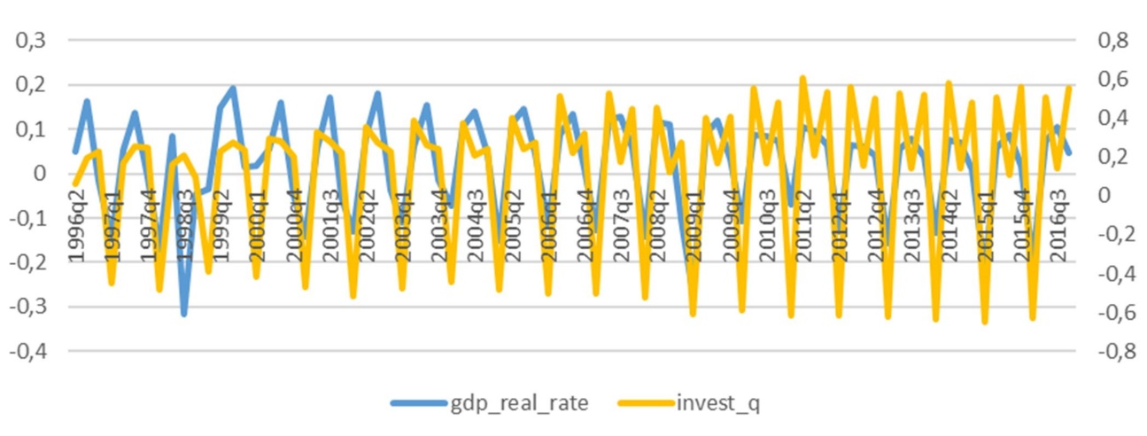

To clear these variables from seasonality, regression analysis was used, where the dependent variable is the corresponding variable, and independent variables are dummies for each quarter except the first one. The purification was carried out in the STATA 12 package using linear regression analysis. The results of the regressions are given below (Table 2.2). The residuals derived from these regressions are seasonally adjusted variables.

Table 2.2 Purification of variables from the seasonal component.
- | (1) | (2)
VARIABLES | gdp_real_rate | invest_q
_Iquarter_2 | 0.214*** | 0.936***
 | (10.34) | (25.73)
_Iquarter_3 | 0.236*** | 0.732***
 | (11.38) | (20.13)
_Iquarter_4 | 0.139*** | 0.877***
- | (6.692) | (24.12)
Constant | -0.131*** | -0.531***
 | (-8.843) | (-20.40)
Observations | 83 | 83
R-squared | 0.666 | 0.914
t-statistics in parentheses |  | -
*** p<0.01, ** p<0.05, * p<0.1 |  | -

Thus, in the following analysis, the following variables are used:
- res_gdp_real seasonal quarterly growth rates of real GDP measured in shares;
- res_invest quarterly growth rates of real investments in fixed assets, cleared from seasonality;
- unemp - quarterly unemployment rate in% of the population;
- return_micex_hy - quarterly profitability of the MICEX index;
- mezbank_q - quarterly interbank rate data in%.
Descriptive statistics of the final sample are given in Table 2.3.

Table 2.3 Descriptive statistics of the final sample.
variable | mean | p50 | sd | p5 | p25 | p75 | p95 | N
num_ipo_q | 1.971 | 1 | 2.632 | 0 | 0 | 3 | 7 | 70
vol_ipo_q | 1171.94 | 156.50 | 2734.00 | 0.00 | 0.00 | 952.00 | 7299.00 | 70
num_of_spo | 1.36 | 1 | 1.51 | 0 | 0 | 2 | 4 | 42
vol_of_spo | 977.36 | 237.50 | 2184.48 | 0.00 | 0.00 | 607.00 | 6220.00 | 42
res_gdp_real | 0.00 | 0.00 | 0.04 | -0.07 | -0.02 | 0.03 | 0.06 | 70
res_invest | 0.02 | 0.01 | 0.10 | -0.12 | -0.07 | 0.09 | 0.18 | 70
unemp | 7.28 | 7.10 | 1.77 | 5.10 | 5.70 | 8.30 | 10.60 | 70
return_micex_hy | 0.10 | 0.05 | 0.25 | -0.25 | -0.04 | 0.24 | 0.57 | 70
mezbank_q | 6.60 | 5.65 | 4.19 | 1.55 | 3.73 | 8.20 | 13.42 | 70

As can be seen from Table 2.3, during the period under review, an average by 2 IPOs per quarter were conducted with an average total amount of attracted funds equal to $ 1,172 million. During the same period, an average of 1.4 SPOs per quarter was conducted with an average total amount of raised funds of $ 977 million.
Let’s consider the relationship between the selected variables in different time periods (Table 2.4).
Table 2.4 Relationship between macroeconomic indicators in different time periods on the number of IPOs.
Factors/Period | 1996-2002 |  | 2003-2007 |  | 2008-2016
- | coef. | sign.value | coef. | sign.value | coef. | sign.value
res_gdp_real | -0.2666 | 0.4282 | -0.4434 | 0.0572 | 0.1221 | 0.5129
res_invest | -0.1545 | 0.6501 | 0.4534 | 0.0512 | 0.3505 | 0.0532
unemp | 0.1439 | 0.673 | -0.7044 | 0.0008 | 0.1936 | 0.2968
return_micex_hy | -0.024 | 0.9442 | 0.1958 | 0.4218 | 0.0683 | 0.7149
mezbank_q | -0.3252 | 0.3291 | -0.3339 | 0.1624 | -0.2725 | 0.1381
L.num_ipo_q | -0.0702 | 0.8375 | -0.3326 | 0.1641 | 0.0488 | 0.7942

Correlation table 2.4, formed on the basis of the selected variables in the period from 1996 to 2002, shows the absence of relations between them. This is explained by the instability of the Russian economy at the stage of reforms and the 1998 crisis before the beginning of its recovery.
In the period from 2002 to 2007, the market economy begins to operate, GDP, production volumes and labor productivity are growing. During the period of economic stability, the growth rates of real GDP, investment growth rates and unemployment rate have a significant linear dependence on the activity of the IPO.
In the period 2008-2016, the growth rate of investments in fixed assets is observed at the stage of economic recovery after the crisis of 2008-2010.
However, the correlation tables show only the relationship between the variables, but do not allow us to assess the influence of macroeconomic indicators on the number of IPOs. To do this, we make a model in which we include all the main variables and some first lags (Table 2.5).

Table 2.5 Regression model 1 (number of IPOs).
num_ipo_q | Coef. | t | P>|t| | Number of obs | 60
res_gdp_real | -7.000 | -0.600 | 0.550 | F( 10, 49) | 2.84
res_gdp_real L1. | 5.560 | 0.550 | 0.588 | Prob > F | 0.0072
res_invest | 3.822 | 0.580 | 0.565 | R-squared | 0.3671
res_invest L1. | -6.127 | -0.920 | 0.362 | Adj R-squared | 0.238
unemp | -0.438 | -0.640 | 0.527 | Root MSE | 2.3735
unemp L1. | -0.459 | -0.710 | 0.481
return_micex_hy | 2.660 | 1.600 | 0.115
mezbank_q | -0.390 | -2.360 | 0.023
num_ipo_q L1. | 0.208 | 1.500 | 0.141
mezbank_q_1 | 0.266 | 1.610 | 0.115
cons | 9.506 | 2.530 | 0.015

The primary regression analysis showed the insignificance of almost all coefficients except for the interbank rate since the beginning of 2008. Also, the interbank rate can be called almost significant with p-values = 0.115 in the period before the end of 2007. The remaining indicators are insignificant at current values.
Since the IPO process is lengthy and the decision to place shares is made on the basis of some indicators in the periods preceding the placement (Ritter & Welch, 2002, 1-45), for further research, we consider part of the explanatory variables at the same time when IPO is held, and part of the variables with the lag 1 and with the lag 2. Since the process is long, it was expected that large lags would be applied, but this reduces the number of degrees of freedom. Further in the work we will use the following abbreviations:
- l.res_gdp_real seasonal quarterly growth rates of real GDP measured in shares, shifted by one value;
- l2.res_gdp_real seasonal quarterly growth rates of real GDP measured in shares, shifted by two values;
- l.res_invest quarterly growth rates of real fixed capital investments, shifted by one value, cleared of seasonality;
- l2.res_invest quarterly growth rates of real fixed capital investments, cleared from seasonality, shifted by two values;
- l.unemp - quarterly data of the unemployment rate in% of the population, shifted by one value;
- l2.unemp - quarterly data of the unemployment rate in% of the population, shifted by two values;
- L.num_ipo_q - quarterly IPO number (quantity) data, shifted by one value;
- mezbank_q_1 - dummies of quarterly interbank rate data in% before 2007.
Table 2.6 shows the indicators of a partial correlation between the number of IPO performed with variables at the current time and with their lags, as well as with the lag of the most dependent variable in the period 2002-2016.
Table 2.6 Partial correlation of different lags of macroeconomic indicators on the number of IPO.
2002-2016 current values
- | coef. | sign.value
res_gdp_real | -0.0994 | 0.4746
res_invest | 0.2703 | 0.0481
unemp | -0.2211 | 0.108
return_micex_hy | 0.1811 | 0.19
mezbank_q | -0.3311 | 0.0145
L.num_ipo_q | 0.2062 | 0.1347
mezbank_q_1 | 0.2443 | 0.075
2002-2016 L1
- | coef. | sign.value
L.res_gdp_real | 0.0712 | 0.6087
L.res_invest | -0.2813 | 0.0394
L.unemp | -0.3042 | 0.0253
return_micex_hy | 0.2177 | 0.1139
mezbank_q | -0.3311 | 0.0145
L.num_ipo_q | 0.2241 | 0.1033
mezbank_q_1 | 0.2077 | 0.1318
2002-2016 L2
- | coef. | sign.value
L2.res_gdp_real | -0.1187 | 0.3926
L2.res_invest | 0.2358 | 0.0861
L2.unemp | -0.2662 | 0.0517
return_micex_hy | 0.1595 | 0.2493
mezbank_q | -0.391 | 0.0035
L.num_ipo_q | 0.2036 | 0.1397
mezbank_q_1 | 0.284 | 0.0374

From the table above, it is seen that the higher the order of the lag is, the higher the relationship of lagged values to the current IPO values is. This corresponds to the fact that CFOs of companies in the decision-making are guided by the macroeconomic indicators of the previous periods (Brau & Fawcett, 2006, 399-436).
With respect to the factors under study, it can be said that between the decision to start preparing for placement, stimulated by previous GDP growth, and the result in the form of IPO registration, a long period of time passes. Forms of investment (property acquisition, new construction, reconstruction, modernization, etc.) take time. The unemployment rate returns to a long-term equilibrium approximately six months after a negative shock (Vakulenko, 2015, 25).
At the same time, the market responds promptly to the MICEX index, as the most objective indicator of the Russian securities market, calculated in real time, and the interbank interest rate, as an indicator of the value of money, which changes rapidly when the situation in the financial market changes.
In accordance with this, it seems natural to evaluate the regression model using the second lags for some macroeconomic factors and the lag value of the IPO number (Table 2.7).

Table 2.7 Regression model 2 (number of IPOs).
num_ipo_q | Coef. | t | P>|t| | Number of obs | 60
res_gdp_real L2. | -8.559 | -0.860 | 0.393 | F( 10, 49) | 3.96
res_invest L2. | 6.876 | 1.750 | 0.086 | Prob > F | 0.0015
unemp L2. | -0.831 | -1.990 | 0.052 | R-squared | 0.3478
return_micex_hy | 1.787 | 1.170 | 0.249 | Adj R-squared | 0.26
mezbank_q | -0.445 | -3.060 | 0.003 | Root MSE | 2.339
num_ipo_q L1. | 0.199 | 1.500 | 0.140
mezbank_q_1 | 0.366 | 2.140 | 0.037
cons | 9.268 | 2.680 | 0.010

As can be seen from the regression results, the growth rate of real investment in fixed assets has a positive significant impact (Samuelson & Nordhaus, 2005, 389-397) on the number of IPOs in the following six months. When the growth rate of real investments doubles, the number of IPOs performed in half a year will increase by almost seven units.
The unemployment rate has a negative impact on the number of IPOs (Birz & Lott, 2011, 2791-2800). With the drop in the unemployment rate by one percentage point, the number of companies that have performed the IPO in the following six months will increase by an average of 0.83.
The interbank rate has a negative significant impact on the number of IPOs, which is logical and expected, since such an effect is described by Chorruk & Worthington, (2010, 543-559).
The indicator "number of IPOs" reacts instantly to changes in the interbank interest rate. Until 2007, to perform one IPO, the interbank rate had to fall by almost 12 percentage points, and after 2007 it was enough to reduce it by only two percentage points.
The constructed model is correctly specified and quite satisfactory in terms of quality indicators: regressors explain the variation of the dependent variable by approximately 35%, the value of F-statistics shows that the coefficients are jointly significant.
To fulfill the Gauss-Mark theorem, there should be no autocorrelation in the remainders. Appendix 11 shows the values of the autocorrelation and partial autocorrelation functions, which revealed the autocorrelation of the second order.
In this regard, we are making the ARMA model (Table 2.8), but the insufficiency of the number of degrees of freedom forces us to choose MA (2) model from all possible specifications, which gives the most satisfactory results with the most economical use of degrees of freedom. The second-order moving average process shows that there are some unobservable factors which reflect the impact on the number of IPOs, at least six months before the placement.

Table 2.8 Regression model 3 (number of IPOs).
ARIMA regression
Sample: 2002q1 - 2016q4
num_ipo_q | Coef. | z | P>|z| | Number of obs | 60
res_gdp_rea L2. | -2.075 | -0.300 | 0.765 | Wald chi2(7) | 83.19
res_invest L2. | 4.055 | 1.600 | 0.110 | Prob > chi2 | 0
unemp L2. | -0.872 | -2.810 | 0.005
return_micex_hy | 0.964 | 0.760 | 0.446
mezbank_q | -0.445 | -2.960 | 0.003
mezbank_q_1 | 0.407 | 2.320 | 0.021
cons | 10.045 | 3.940 | 0.000
ARMA ma L2. | 0.633 | 5.470 | 0.000
sigma | 1.782373 | 9.38 | 0

The significance of the indicators in comparison with the previous model did not change significantly, but the coefficients themselves changed at some extent.
As can be seen from the regression results, the growth rate of real investment in fixed assets became less significant.
The effect of the unemployment rate and its significance remained virtually unchanged.
In this model, the effect of the influence of the interbank rate before 2007 significantly decreased, which corresponds to the economic situation of the period when the interbank rate was unstable. After 2007, the effect remained at the same level and with the same significance. In this case, the bank rate, as an indicator of the value of money, confirms that the attraction of capital remains an important reason for performing IPO (Kim & Weisbach, 2005, 17), but for the Russian economy this effect only appears after 2007.
The insignificance of some economic indicators (real GDP growth rate and MICEX index) for IPO activity does not necessarily mean absence of influence, and may be a consequence of the existence of mutually opposite effects. For example, in the case of the stock market, according to Aymen Belgacem (2013, 26-27), "the lack of reaction does not mean the independence of the values, since in a detailed analysis the correlation is detected. The problem is that the macroeconomic factor can influence on the stock index from several sides simultaneously, which, in the end, does not change the value of the market indicator. "
Using the MA (2) process, our model takes into account factors which we do not observe or about which we do not have data. These include external factors, such as indicators of the world financial markets, world oil prices (Hayo & Kutan, 2005, 373-393), foreign policy situation, as well as legislative and tax regulations and other factors which, in economic terms, should influence on the activity of the IPO.
This model also includes the collapse of the stock market in 2008-2009. This was the period of "the cancellation of the vast majority of announced placements. In 2008, only two companies decided to conduct significant transactions in terms of shareholder value: GlobalTrans and TGK-7. 32 companies announced their entry to the stock exchange in 2009, five companies planned to enter the stock exchange in the same year or later, and more than 60 companies - in the period from 2009 to 2012. All these transactions were postponed "(PNB Company, 2009, 25).
In relation to the unprecedented period of instability, we will try to restructure the ARIMA model taking into account the peculiarities of 2008-2009.
The beginning of the crisis of 2008 and its first consequences in 2009 are significant factors for the Russian economy, including for the IPO market, therefore, for economic reasons, we need to include variables which somehow describe that period. From statistical considerations, in order to avoid the multicollinearity problem, we introduce only one dummy variable (dummy_2008_09), which takes the value "1" in the period 2008-2009 and "0" in other periods, and one cross product of this variable with interbank interest rate. We made attempts to build a cross-product of this dummy with other factors, but as expected, the greatest effect is manifested only with the interbank rate. Thus, having lost only 2 degrees of freedom, we modify the model to the following form.

Table 2.9 Regression model 4 (number of IPOs).
ARIMA regression
Sample: 2002q1 - 2016q4
num_ipo_q | Coef. | z | P>|z| | Number of obs | 60
res_gdp_real L2. | -2.457 | -0.350 | 0.727 | Wald chi2(9) | 82.38
res_invest L2. | 4.271 | 1.650 | 0.098 | Prob > chi2 | 0
unemp L2. | -0.858 | -2.630 | 0.009
return_micex_hy | 1.177 | 0.870 | 0.383
mezbank_q | -0.475 | -3.270 | 0.001
mezbank_q_1 | 0.404 | 2.090 | 0.037
dummy_2008_09 | -1.149 | -0.380 | 0.701
mezbank_q_08_09 | 0.236 | 0.410 | 0.685
cons | 10.055 | 3.880 | 0.000
ARMA ma L2. | 0.631 | 5.100 | 0.000
sigma | 1.772 | 9.250 | 0.000

Although the above regression results show that the coefficients with the additional variables introduced were insignificant, but since the need to take into account the 2008 crisis and its consequences was justified above, the dummy variable for 2008-2009 (dummy_2008_09) and its cross product with the value of the interbank interest rate (Mezbank_q_08_09) should remain in the model.
The insignificance of the coefficients under these variables suggests that the observed effect of reducing the number of IPO placements (the dummy coefficient is negative) is caused by some specific process in the market during the crisis which we cannot observe.
An additional argument in support of the fact that the latter model is more successful is that our lagged variables have become more significant.
As a result, the following regression model with the dependent variable "IPO quantity" is used: $y=α_{0}+α_{1}{res_gdp_real}_{t-2}+α_{2}{invest}_{t-2}+α_{3}{unemp}_{t-2}+α_{4}r{eturn_micex_hy}_{t}+α_{5}{mezbank}_{t}+α_{6}{mezbank_q}_{t}*dummy_2007+α_{7}dummy_2008_09+α_{7}{mezbank}_{t}*dummy_2008_09$
- l2.res_gdp_real quarterly growth rates of real GDP measured in shares, cleared from seasonality, shifted by two values;
- l2.res_invest quarterly growth rates of real fixed capital investments, cleared from seasonality, shifted by two values;
- l2.unemp - quarterly data of the unemployment rate in% of the population, shifted by two values;
- return_micex_hy - quarterly profitability of the MICEX index; current values
- mezbank_q - quarterly interbank rate data in%, current values
-dummy_2007 - dummy variable that equals 1 before 2007q4 and 0 after that period.
-dummy_2008_09 - dummy variable that equals 1 in the period between 2009q1 and 2009q4.

Table 2.6 shows the indicators of a partial correlation of the number of IPO performed with variables at the current time and with their lags, as well as with the lag of the most dependent variable in the period 2002-2016.
This model, being more economically meaningful in terms of quality indicators, is not inferior to the previous one. The Wald statistics for our ARMA model, which is an analog of the F-statistics, confirms the joint significance of all coefficients.
The confidence interval for the forecast value of our model is rather narrow and the fitted values show good congruence with the initial data (Appendix 12).
To test the work of the model, we introduce the value of the interbank rate and the MICEX profitability in the first quarter of 2017. The result is 0.3. At a confidence level of 95%, we can say that in the first quarter of 2017 IPO will be performed by not more than two Russian companies. The received result corresponds to the truth, since it is valid in the first quarter of 2017 and a public offering of shares has been performed by the network of children's goods "Children's World" with the amount of placement 355 million USD.

Let’s consider the second significant indicator which describes the activity of Russian companies when performing an IPO - the amount of funds raised at IPO. In the study, we apply the same logics as in the case of IPO: first, we evaluated the model, where the explanatory factors are the current values of macroeconomic indicators together with their first lags, as well as the lag of the dependent variable (the amount of funds raised during an IPO) (Table 2.10).

Table 2.10 Regression model 5 (amount of funds raised at IPO).
vol_ipo_q | Coef. | t | P>|t| | Number of obs | 60
res_gdp_real | -6474.613 | -0.510 | 0.612 | F( 10, 49) | 2.57
res_gdp_real L1. | -9992.445 | -0.900 | 0.373 | Prob > F | 0.0139
res_invest | 4460.830 | 0.630 | 0.532 | R-squared | 0.3439
res_invest L1. | -573.861 | -0.080 | 0.935 | Adj R-squared | 0.21
unemp | -257.644 | -0.350 | 0.731 | Root MSE | 2589
unemp L1. | -435.467 | -0.630 | 0.532
return_micex_hy | 983.089 | 0.540 | 0.590
mezbank_q | -362.310 | -2.060 | 0.044
vol_ipo_q L1. | 0.369 | 2.770 | 0.008
mezbank_q_1 | 308.050 | 1.640 | 0.107
cons | 7044.566 | 1.720 | 0.092
The interbank rate has a negative significant impact on the amount of funds raised during an IPO. The lag of the variable itself has a positive effect on the dependent variable. This is a trivial effect, as it shows that successful placements in the previous period allow new players to expect successful placement as well. The other factors are not significant.
By analogy with the study of the relationships among the number of IPO placements we consider a model with a lag of a larger order for some independent variables (Table 2.11).

Table 2.11 Regression model 6 (amount of funds attracted with IPO).
vol_ipo_q | Coef. | t | P>|t| | Number of obs | 60
res_gdp_real L2. | -6628.047 | -0.610 | 0.546 | F( 7, 52) | 3.58
res_invest L2. | 3841.145 | 0.920 | 0.362 | Prob > F | 0.0032
unemp L2. | -739.255 | -1.620 | 0.110 | R-squared | 0.3255
return_micex_hy | 653.833 | 0.390 | 0.700 | Adj R-squared | 0.2347
mezbank_q | -337.265 | -2.200 | 0.032 | Root MSE | 2548.2
vol_ipo_q L1. | 0.351 | 2.700 | 0.009
mezbank_q_1 | 341.683 | 1.720 | 0.091
cons | 7269.360 | 1.990 | 0.052

Using a second-order lag for some of the independent variables did not result in the expected improvement. Since both: current values and lags of some of the macroeconomic indicators turned out to be equally insignificant, and the momentary impact on the amount of funds attracted is economically more justified.
In the following model, we will not use lags.
At the same time, Lowery & Schwert (2002, 1171-1200) prove that the high profitability of recent placements on the first trading day encourages other companies to perform IPO. Therefore, we made the assumption that the amount of attracted funds at the IPO is affected by the results of previous successful placements (the number of placements in the previous quarter).
In view of the above arguments, the following model was formed (Table 2.12).

Table 2.12 The regression model 7 (the amount of funds raised during an IPO).
vol_ipo_q | Coef. | t | P>|t| | F( 7, 52) | 4.31
res_gdp_real | -7520.018 | -0.630 | 0.534 | Prob > F | 0.0008
res_invest | 6627.780 | 1.680 | 0.098 | R-squared | 0.3672
unemp | -430.926 | -1.160 | 0.251 | Adj R-squared | 0.282
return_micex_hy | 721.643 | 0.430 | 0.668 | Root MSE | 2468.1
mezbank_q | -165.389 | -1.110 | 0.272
num_ipo_q L1. | 480.944 | 3.530 | 0.001
mezbank_q_1 | 295.416 | 1.910 | 0.062
cons | 3474.692 | 1.120 | 0.267
As expected, the indicator of the number of IPOs for the previous period, included in the model instead of the lag of the amount of funds raised, is a positive and significant factor. This suggests that "companies prefer to place shares in periods when other good companies are ready to perform IPO" (Choe et al., 1993, 3-31).
This more correct approach led to the fact that the rate of growth of real fixed investment in this specification influences positively and significantly on the amount of funds raised during IPO, as confirmed by a study by Pagano et al. (1998, 27-64).
As a result, the model of the volume of attracted funds at IPO is following:
$$y=α_{0}+α_{1}{res_gdp_real}_{t}+α_{2}{res_invest}_{t}+α_{3}{unemp}_{t}+α_{4}{return_micex_hy}_{t}+α_{5}mezbank_{q}+α_{6}{num_of_ipo}_{t-1}+α_{7}mezbank_{q}*dummy_2007$$
- res_gdp_real quarterly growth rates of real GDP measured in shares, cleared from seasonality;
- res_invest quarterly growth rates of real fixed capital investments, cleared from seasonality;
- unemp - quarterly data of the unemployment rate in% of the population,
- return_micex_hy - quarterly profitability of the MICEX index; current values
- mezbank_q - quarterly interbank rate data in%, current values
-l.num_of_spo- number of performed IPOs, shifted by 1 value.
-dummy_2007 - dummy variable that equals 1 before 2007q4 and 0 after that period.

We would like to draw your attention to the fact that the interbank interest rate for the volume of attracted funds at the IPO after 2007 (during the period of market recovery after the crisis) is insignificant, which is consistent with economic logic (Boubaker & Mezhoud, 2012, 166-180), as the amount of revenues is influenced by demand, not related to the interbank interest rate. The significance of the interbank interest rate in the period 2002-2007 (the period of stable economic growth) is explained by the fact that buyers compared the profitability of a bank deposit and investing in shares.

Let's start studying the effect of the selected macroeconomic factors on the results of activity and volume of the SPO market.
Similar to IPO, it takes some time to float shares, so the current values are not taken into account when making the model. But due to the fact that the company is already public and we need less time to float the SPO than when we float IPO, when creating the model, we consider only the first lags of some macroeconomic variables (Table 2.13). Data on SPO is available since 2006.

Table 2.13 Regression model 8 (amount of SPO).
num_of_spo | Coef. | t | P>|t| | Number of obs | 42
res_gdp_real L1. | 14.298 | 1.950 | 0.060 | F( 6, 35) | 1.42
res_invest L1. | -5.924 | -2.270 | 0.030 | Prob > F | 0.2334
unemp L1. | -0.130 | -0.440 | 0.661 | R-squared | 0.1962
return_micex_hy | 1.368 | 1.120 | 0.272 | Adj R-squared | 0.0584
mezbank_q | -0.051 | -0.490 | 0.626 | Root MSE | 1.4665
mezbank_q_1 | -0.189 | -1.190 | 0.241
cons | 2.792 | 1.200 | 0.238

The growth rate of real GDP and the growth rate of investments in fixed assets were significant.
The growth rate of real GDP has a positive significant impact on the placement of SPO: this is a colleteral effect of overall economic growth. With an increase in GDP growth rate by ten percentage points, the average amount of SPO will be approximately 1.4.
The rate of investment growth has a negative impact on the placement of SPOs: with the increase in market investments, the need for SPO decreases. If the rate of investment growth increases by 20 percentage points, then the average amount of SPO will decrease by approximately 1.18 units.
Despite the fact that macroeconomic indicators are closely related, multicollinearity is absented in the model (Table 2.14).

Table 2.14 Multicollinearity of factors influencing on the amount of SPO.
Variable | VIF | 1/VIF
mezbank_q | 2.13 | 0.470
unemp L1. | 1.92 | 0.521
res_gdp_real L1. | 1.86 | 0.538
return_micex_hy | 1.39 | 0.721
res_invest L1. | 1.36 | 0.737
mezbank_q_1 | 1.18 | 0.846
Mean VIF | 1.64

Although the growth rate of investment and the growth rate of real GDP are individually significant, in general explanatory power of the model 8 Table 2.14 (the amount of SPO) is small: R-squared = 0.1962. F (6.35) = 1.42 F-statistics does not allow to reject the hypothesis of joint insignificance of the coefficients.
Model 8 (the amount of SPO) shows a fairly wide confidence interval for the average forecasted number of SPO (Appendix 13), which also indicates that the selected macroeconomic indicators do not influence or affect insignificantly on the placement of SPOs, and companies are guided by other factors.
The average absolute deviation from the actual values (mean linear approximation error) is 1,001 with an average SPO value in the quarter of 1,357. That is, only 27% of cases can explain the model. In other words, the remaining part is explained by some other factors.
Table 2.15 shows the results of the regression analysis, where the dependent variable is the total amount of funds raised during the SPO. None of the factors considered was significant at any reasonable level of significance.

Table 2.15 Regression model 9 (amount of funds raised at SPO).

vol_of_spo | Coef. | t | P>|t| | Number of obs | 42
res_gdp_real L1. | 4190.119 | 0.370 | 0.715 | F( 6, 35) | 0.47
res_invest L1. | -2665.164 | -0.660 | 0.515 | Prob > F | 0.8261
unemp L1. | -195.745 | -0.430 | 0.671 | R-squared | 0.0745
return_micex_hy | 1745.186 | 0.920 | 0.365 | Adj R-squared | -0.0842
mezbank_q | -124.814 | -0.780 | 0.442 | Root MSE | 2274.5
mezbank_q_1 | -337.695 | -1.370 | 0.179
cons | 3253.265 | 0.900 | 0.373

The amount of borrowed funds in the SPO process is independent of the previously considered macroeconomic factors, as well as the previously indicated number of SPO placements.
One of the possible factors explaining the amount of borrowed funds in the SPO process may be the number of SPO placements in the previous period, since the amount of funds raised during the SPO process may depend on the number of SPO placements.
The table below (Table 2.16) does not support this hypothesis.

Table 2.16 The regression model 10 (the volume of attracted funds at SPO).
vol_of_spo | Coef. | t | P>|t| | Number of obs | 41
res_gdp_real | -17033.930 | -1.140 | 0.264 | F( 7, 33) | 0.94
res_invest | 663.534 | 0.160 | 0.873 | Prob > F | 0.4881
unemp | -420.099 | -1.010 | 0.321 | R-squared | 0.1666
return_micex_hy | 2798.401 | 1.220 | 0.233 | Adj R-squared | -0.0102
mezbank_q | -328.567 | -1.930 | 0.062 | Root MSE | 2219.7
mezbank_q_1 | -400.313 | -1.590 | 0.122
num_of_spo L1. | -358.419 | -1.350 | 0.185
cons | 6302.721 | 1.950 | 0.060

With a high price of money, the purchasing power of the market is shrinking, as can be seen from the negative significant interbank rate ratio.
In general, from the two previous models, we can conclude that macroeconomic indicators have little effect on the activity of companies in the SPO process.
As an additional check, we decided to evaluate the correlation matrix for all the IPO and SPO activity variables. The assessment takes place between 2006 and 2016 according to quarterly data. As can be seen from Table 2.17, a high correlation is only presented between different IPO and SPO activity levels, 0.6634 and 0.56, respectively. However, the correlation between the number of IPOs and SPOs is only 0.0949, and a similar value for volumes is -0.1539. Such a close to zero correlation requires an explanation. Together with the results of regression analysis for IPOs and SPOs, it can be concluded that the decision to perform IPO and SPO for a company is made in different ways. If in the case of an IPO, macroeconomic factors play a significant role, in the case of a SPO, their role in decision-making is considerably limited.

Table 2.17 Correlation matrix of IPO and SPO activity
- | num_ipo_q | vol_ipo_q | num_of_spo | vol_of_spo
num_ipo_q | 1 | - | - | -
vol_ipo_q | 0.6634 | 1 | - | -
num_of_spo | 0.0949 | -0.0719 | 1 | -
vol_of_spo | -0.0705 | -0.1539 | 0.56 | 1

The IPO and SPO have similar features as well as pronounced differences. Similar properties should include the same basic need of the company - additional financing (Kim & Weisbach, 2005, 17). In preparation to perform IPO, the company remains private, which suggests that it is less transparent to investors. This leads to the fact that the true value of the company to anyone other than its owners may be unknown. If the price is unknown, then the question of choosing the right moment to enter the market becomes a key task for business owners (Ritter, 1991, 3-27). Such successful moments include: expectation of a bullish trend in the market, a great interest in this industry, favorable market conditions and so on.
This is the key difference between IPO and SPO. During SPO, the company is already a public one, which means that its cost can be calculated taking into account the market quotation of its shares. Stock quotes reflect all the information on the company and the market as a whole, including investors’ mood, their attitude to the industry and other factors due to the hypothesis of a perfect market. In the absence of uncertainty in the sale price of the company's share, the owner takes the company to the market if there is a possibility that investors will pay more for the company than the owner himself estimates (Benninga et al., 2005, 115 - 132) without waiting for the optimal moment to enter the market. The latter suggests that companies perform SPO focusing on their internal reasons, and paying little attention to macroeconomic factors.

Conclusion
The Russian stock market can be considered as the developing one. There is an obvious benefit from holding IPO on foreign sites, namely: improving the company's image and acquiring international status. However, at present, according to experts, the best way to perform IPO for Russian companies is to place shares in Russia.
Planned GDP growth, cheap value of the shares of Russian companies, high dividend payments, financial results of Russian companies, privatization of 2017 will become the major factors of growth of the Russian stock market in 2017.
It is important for the state that Russian companies hold IPO in Russia. In this regard, there is a task of general understanding of the ongoing processes both from the point of view of the state, represented by the regulator, and from the point of view of the company. The regulator should understand, by which methods it is possible to stimulate the companies to go public, and the companies should understand the future market conditions, according to actions undertaken by the regulator.
It follows from the literature review that there has been an increase in research interest in the problems of companies which performed IPO in recent decades. This problem has been thoroughly studied by foreign scientists for over 20 years and in the recent decade it has attracted attention of Russian researchers. Relationship between economic indicators and the activity of Russian companies when they hold IPO is still unresolved issue.
Studying of existing approaches in determining the nature and understanding of the initial public offering of shares has made it possible to compare Russian and foreign legislations, regulating the procedure for companies to hold IPO.
The analysis of foreign and Russian research literature allowed to determine the groups of main factors positively and negatively influencing on the successful initial public offering. Three groups of factors are shown, which influence on the success of companies performing IPOs, which were formulated on the basis of literature analysis. These are the factors related to the geographical location of the company, the choice of an exchange site for IPO placement and the company's internal factors influencing on its capitalization.
The work presents the results of calculations of average interest rates on loans provided by credit organizations to non-financial organizations in 2016 for the Russian Federation as a whole. An example of a comparative choice of the investment instrument (bank credit in foreign currency, bank credit in rubles, expenses for IPO) is given. This material can become the basis for making a primary management decision when choosing the tools for attracting investments for the development of the company.
In the second section data sets, publicly available on the official websites of the FINAM Holding, PREQVECA PAGE, the global network of PWS, the Central Bank of the Russian Federation, the London Stock Exchange, VTB 24, the Moscow Interbank Currency Exchange (MICEX), The Russian Trading System (RTS) and other sources, were used for analysis. For further analysis, the primary information was processed, and the data was structured and described.
The analysis of the dynamics of the composite purchasing managers' index (PMI) is made, the level of inaccessibility of loans for the Russian industry is analyzed. The dynamics and forecasts of financial analysts regarding the CPI, the BCPI and historical estimates of trend inflation are considered. Growth rates of а the volume of goods produced by Russian enterprises in manufacturing industries in 2016 were analyzed.
The range of data collected from public sources, has allowed to use it to determine the key trends of the IPO market in Russia. It contains indicators from 1996 to 2016. This provided an opportunity to analyze all aspects related to the placement of IPOs by Russian companies for the mentioned period.
One of the sections of the study is devoted to the analysis of the activity of IPOs and SPOs of small and medium-sized Russian companies which have a significant impact on the development of the national economy, meet the needs of the population and provide additional jobs. SMEs fill those niches which are not available to large businesses, so the study clarified the reasons for the low activity of small and medium-sized enterprises of the Russian Federation in the IPO and SPO market. Sampling and analysis of SMEs are made for 2003-2013.
The study conducted a multifactor regression analysis on quarterly data to identify the interrelationship of economic factors and the activity of Russian companies in the IPO placement.
Practical significance of the work. The results of the research can be useful to the financial market regulator, potential investors, top managers of Russian companies and financial consultants in the practice of initial public offering.
In the process of research, the following results are obtained, representing the applied importance:
1. Based on the practical and theoretical results presented in the study, as well as the recommendations of the authors, the sequence of making a managerial decision on the necessity and possibility of performing an IPO was developed.
2. Analysis of the number and activity of small and medium-sized Russian companies which performed IPO, was made for the first time. The results of this analysis can be used by representatives of SMEs to design their own development strategies.
3. During the study, a set of sound regression models was constructed to reflect the relationship between the major economic factors and the activity of Russian companies when holding IPO. The model with the greatest explanatory power is indicated, which allows to forecast the number of IPOs under certain economic conditions.
Evidence, found earlier in the research literature, was proved on the following:
- significant positive impact of the growth rates of real investment when Russian companies perform IPO;
- significant negative impact of the unemployment rate on the activity of companies during the initial public offering of shares;
- significant negative impact of the interbank interest rate on the dynamics of IPO placement.
The interrelation of the interbank interest rate with the activity of Russian companies in the IPO process is traced not only with respect to the number of IPO placements, but also the volume of attracted funds. However, under the conditions of the Russian economy, its effect is noticeable only in the post-crisis period (2008-2016).
For the verification of the model, the number of IPO placements for the first quarter of 2017 was forecasted. The result showed that at 95% confidence level, we can claim that in the first quarter of 2017 IPO will be performed by not more than two Russian companies. The received result is correct, because in the first quarter of 2017 the network of children's goods "Detskiy Mir" really held public offering of shares with the amount of placement of 355 million USD.
4. The regression model allowed to obtain confidence intervals of the forecast values, which allow the potential issuers to get an idea on the number of IPO placements in the future period. Such data allows companies to make decisions about timing. Confidence intervals allow to see the time when IPOs, held by companies, will be the only ones in the market, and, accordingly, they will be able to get a higher price for their shares.
5. The study showed that there are some unobservable factors which influence on the activity of Russian companies in preparing for the offering of their shares, at least six months before the placement. This indicates that in making the final decision on IPO underwriting, top managers and owners of the company take into account, alongside with Russian macroeconomic factors, indicators of the world financial markets, world oil prices, foreign policy situation, legislative and tax regulation, and other factors, which, in economic terms, should influence on the IPO activity.
6. During the work, there was a near zero correlation between the activity of IPO and SPO in Russia. The latter says that despite the similarity of these phenomena, their timing is arranged in different ways. The influence of macroeconomic factors explaining the variability of SPO was not significant. This is the key difference between the IPO and SPO processes. The obtained results when making decisions about SPO suggest that companies are not guided or poorly guided by macroeconomic factors. The key explanation of this phenomenon is that the company's value at the time of additional placement is already determined by the market. Thus, the decision to attract additional financing within the framework of the SPO is determined mainly by the individual characteristics of the company and its needs, which does not presume the choice of the optimal time to enter the market. The latter suggests that data should be used at the company level to assess the likelihood of attracting additional financing within the SPO.
7. Studies conducted in the work showed that macroeconomic factors described in foreign literature and influencing on the activity of companies when holding IPO in Russia do not work well. This implies that other indicators which influence on the stock market should be found. Most likely they are among the institutes of stock market regulation.
8. The results of regression analysis allow the regulator to understand how its current policy can influence on the IPO activity and encourage companies to place shares. The regulator cannot influence on all regressors, but he has the opportunity to take them into account in order to better understand the reasons for the companies' activity when performing IPO. Based on this, the regulator can adjust not only its macroeconomic dynamic models for a more accurate forecast of IPO activity, but also the behavior of the entire market as a whole. The regulator can assess the future activity of the IPO at different times using its own expectations of the state of the economy. The regulator can also use scenario analysis of the economy for various reforms. Scenario analysis will allow the regulator to make more accurate forecasts of the state of the economy and financial markets and to correct economic policy more efficiently and in a timely manner.
The results obtained in the work allow the regulator and potential investors to understand the market mechanism of formation of IPO and SPO activity in the stock market. The use of more detailed data within the framework of the constructed model can allow more effective management of the industry as a whole.
Besides, understanding the importance of the identified macroeconomic factors will allow institutional investors to more effectively manage the funds directed to participate in the IPO booking.
Our research highlights the importance of macroeconomic indicators of the state of the economy when deciding to hold an IPO.

References
- Aggarwal Reena, Prabhala R Nagpurnanand & Puri Manju. Institutional Allocation in Initial Public Offerings: Empirical Evidence. The Journal of Finance, Vol. LVII, № 3 (2002), pp. 1421—1442.
- Afonasova, M.A. «Management of formation of knowledge-based integrated structures in innovatively active regions Basic research». (Tomsk state University of control systems and Radioelectronics, Tomsk, Russia, 2009): 111-112.
- Aymen Belgacem. Explaining the Stock Market’s Reaction to Macroeconomic Announcements// Bankers, Markets & Investors 2013 № 123 March-April? p.26-27.
- Birz G., Lott J. R. The effect of macroeconomic news on stock returns: New evidence from newspaper coverage // Journal of Banking & Finance. - 2011. - Т. 35. - №. 11. - С. 2791-2800.
- Brau James & Fawcett Stanley. Initial Public Offerings: An Analysis of Theory and Practice. The Journal of Finance, Vol. LXI, № 1 (2006), pp. 399—436.
- Brav Alan & Gompers A. Paul. Myth or reality? The long-run underperformance of Initial Public Offerings: Evidence from venture and nonventure capital-backed companies. The Journal of Finance, Vol. LII, № 5 (1997), pp. 1791—1821.
- Benninga Simon, Helmantel Mark, Sarig Oded. The timing of initial public offerings. Journal of Financial Economics, 75 (2005), pp. 115–132.
- Blum R., IPO Timing Determinants, Duke University Durham, North Carolina 2011, р.28.
- Belomytceva O.S., Antonyan D.G. "To the issue of development of IPO in reference to Russian companies" (Accounting and finance problems, 2014): 1-5. http://cyberleninka.ru/article/n/k-voprosu-o-razvitii-ipo-rossiyskih-kompaniy
- Boubaker A., Mezhoud M., Determinants of the IPO Decision: French Context, 2012, Journal of Business Studies Quarterly, Vol.4, No. 1, pp. 166-180.
- Breinlinger L., Glogova E., Determinants of Initial Public Offerings – A European Time-Series Cross-Section Analysis, 2002, Financial Stability Report, issue 3, pages 87-106.
- Choe, Masulis H., Nanda, R. V. (1993)? Common Stok Offerings Across The Business Cycle: Theory and Evidence, Journal of Finance, 1 (10993), 3-31
- Chorruk J., Worthington A., Firm-specific determinants and outcomes of initial public offerings in Thailand, 2001-2007. Journal of the Asia-Pacific Economy, vol. 18, issue 4, 2013, p. 543-559.
- Davidenko L. P., Balakirev N. N. «Procedure for performing IPO in Russia: Training handbook». (St. Petersburg branch. — М. Nat. Research Un-ty Graduate School of Economics, 2013): 65.
- Gvardin, C. «IPO: Strategy, prospects and experience of Russian companies» (Moscow, Vershina, 2007): 121.
- Geddes, R. «IPO and subsequent offerings» (Moscow Olympus-Business – Ekmos, 2007): 352.
- Glavina, S.G. «Selection of the platform to hold the IPO. Analysis of the selection of Russian issuers Young scientist». (2012): 1-9.
- Glavina, S.G. Globalization impact on regional capital markets: evidence from the Warsaw Stock Exchange / European Research Studies. №4. 2014.
- Idrus, I.A., Glavina, S.G. IPO in the Arab States of the Gulf (GCC) / Miscellanea Geographica Regional Studies on Development, Vol 20, №2. 2016.
- Gul'kin P.G., Terebyn'kina T.A.., Evaluating and price formation in venture investment and at the introduction into IPO market. (St. Petersburg Analytical Center Alpari St. Petersburg, 2002): 17.
- Gill de Albornoz B., Pope P.F., The determinants of the going public decision: evidence from the U.K., 2004, Working paper, WP-AD 2004-22.
- Hayo B., Kutan A. M. The impact of news, oil prices, and global market developments on Russian financial markets // Economics of Transition. - 2005. - Т. 13. - №. 2. - С. 373-393.
- Huyghebaert Nancy & Van Hulle Cynthia Structuring the IPO: Empirical evidence on the portions of primary and secondary shares. Journal of Corporate Finance, 12 (2006), pp. 296 – 320.
- Irikov V.A., Ivanova S.I., Margolit G.R., Balashov V.G. «IPO and value of Russian companies». Fashion and Reality (Business, the Academy of the National Economy, St. Petersburg 2008): 336.
- Klyushnev, T. Teplova, D. Panchenko, D., «United States Stock Market for beginners» (Moscow Mann, Ivanov and Ferber 2016): 224.
- Kotalawala Liyanage Wasantha Perera, Evaluation of Market Performance of Initial Public Offerings (IPOs) and Its Determinants: Evidence from Australian IPOs, 2014, PhD thesis, College of Business, Victoria University.
- Kim Woojin & Weisbach S. Michael. Do Firms Go Public to Raise Capital? NBER Working Paper № W11197 (2005), p.17.
- Lucashov A., Mogin A. -2nd ed., Crin. and DOP. «IPO from I to O»: Handbook for financial directors and investment analysts (Moscow Alpina Business Books, 2008): 361.
- Lykov I.A., Ohotnikov S.A., «Impact of the change of Hurst's function on economic forecasting» (2013): 1539-1544.
- Lvutin, O.V. Fetzer, Initial Public Offering of shares: "Survey of studies" (Corporate Finance journal. 2007): 145-189.
- Lowery, Schwert M, GW, IPO market cycles: Bubbles or consistent training? Journal of Finance. Volume 57. (2002) p. 1171-1200
- Loughran Tim & Ritter R. Jay. The new issues puzzle. The Journal of Finance, Vol. L, № 1 (1995), pp. 23—51.
- Mandelbrot B. Behavior of Markets: «A Fractal View of Financial Turbulence» (Hardcover, 2004): 352.
- Mirkin, B Ya. M. Ya. Mirkin. «English-Russian Explanatory dictionary for banking, investment and financial markets. More than 10 000 terms». – (Мoscow Alpina Business Books, 2008): 424.
- Meluzin T., Zinecker M., Kovandova S., IPO timing determinants: empirical evidence on the polish capital market, 2013, Acta Universitatis Agriculturae et Silviculturae Mendelianae Brunensis, 61(7): 2499-2506.
- Napol'nov, A.V. «Structuring of the initial public offerings of shares of Russian companies» (Moscow. Financial University under the Government of Russian Federation, 2011): 221.
- Novikova, N. B. «Fractal methods and the concept of economic minimum production systems in the management of innovation» (Herald of the SRSTU (NPI), 2011): 162-166.
- Pagano, M., Panetta, F. and Zingales, L. (1998). Why do companies go public? An empirical analysis, Journal of Finance 53(1), 27—64.
- Prosvirina I.I. Intellectual capital of Russian enterprises: assessment and prospects // Innovations. 2005. № 10. 5.
- Pastor Lubos & Veronesi Pietro. Rational IPO Waves. The Journal of Finance, Vol. LX, № 4 (2005), pp. 1713—1757.
- Ritter J., Welch I., A review of IPO Activity, Pricing, and Allocations, 2002, The Journal of Finance, Vol. LVII, No.4. P. P
- Ritter R. Jay. The Long-Run Performance of Initial Public Offerings. The Journal of Finance, Vol. XLVI, № 1 (1991), pp. 3—27.
- " Review of financial stability "Information and Analysis No. 2016 II-III quarters (2016): 1-69. Central Bank of the Russian Federation [electronic resource] – Access mode: http://filearchive.cnews.ru/img/forum/2016/12/06/tsb_ib.pdf
- Sal'nikov V.A., Scientific revision by Sal'nikov V.A., «Analysis of the most important structural characteristics of the manufacturing capacity of Russia». Center of Strategic Development. (MOSCOW 2017): 185 [Electronic resource] – access mode: http://csr.ru/wp-content/uploads/2017/01/Doklad_promyshlennye-moshhnosti.pdf, free – Caps. from screen.
- ПР Samuelson P., Nordhaus V. Economy: Trans. With Eng. .: 16th ed .: Publishing House "Williams", 2005. - p. 389-397.
- Vakulenko E., Gurvich E. Relationship of GDP, unemployment and employment: an in-depth analysis of Oaken's law for Russia // Issues of Economics. 2015.
- Welch I., Ritter J. «A review of IPO activity, pricing and allocations», Yale ICF Working Paper, (NATIONAL BUREAU OF ECONOMIC RESEARCH 1050 Massachusetts Avenue Cambridge, MA 02138 February 2002): 1-45.
- «Capital Markets in 2025: The future of stock markets. Publishing of the IPO Center PWC» (2011): 1-28. [Electronic resource] – access mode: http://www.pwc.ru/en/capital-markets/publications/assets/capital_markets_in_2025_rus.pdf
- Credit and guarantees to business, fiscal service, acquiring, deposits for legal entities [electronic resource] // VTB 24 [Electronic resource] – access mode: https://www.vtb24.ru, free – Caps. from the screen.
- «EY Global IPO Trends: 2016 3Q» (2016): 1-16, [Electronic resource] – Access mode: http://www.ey.com/Publication/vwLUAssets/ey-3q-2016-global-ipo-trends-report/$FILE/ey-3q-2016-global-ipo-trends-report.pdf, free – Caps. from the screen.
- Guryanov, P.A. «Small and Medium Business Measurement criteria Economics, Business and law». (St. Petersburg, 2011):3-12. Url: http://bgscience.ru/lib/8851/
- Holding "Finam" [Electronic resource] – Access mode: http://www.finam.ru/investments/ipo0000B000A0/default.asp, free. – Capt. from screen
- «Interest rates and structure of emergency of credits and deposits» [Central Bank of the Russian Federation [Electronic resource] – Access mode: http://www.cbr.ru/statistics/?PrtId=int_rat#QA_PAR_31232, free. – Capt. from screen.
- «IPO Watch Europe Q2 2016 PWC» (2016): 1-16. [Electronic resource] – access mode: http://www.pwc.com/ee/et/publications/pub/IPO%20Watch%20Europe %20Q2%202016.pdf, free – Caps. from the screen.
- «IPO and SPO companies in the Russian Federation in 2017» LLC "Company BCS" [Electronic Resource] – Access mode: http://bcs-express.ru/novosti-i-analitika/ipo-i-spo-kompanii-rf-v-2017-godu, free – Caps. from the screen.
- London Stock Exchange, LSE [electronic resource] – access mode: http://www.londonstockexchange.com, free – Caps. from the screen.
- Listing of domestic companies in Russia. Publishing of the IPO Center PWC [Electronic resource] – access mode: http://www.pwc.ru/ru/capital-markets/publications/listing_a_domestic_company_in_russia.html
- On state support for small businesses in the Russian Federation: Law of the Russian Federation from 14.06.1995 N 88-FL [Electronic resource] – Access mode: http://www.consultant.ru/document/cons_doc_LAW_6857/
- On the limit values of income earned from the business activities, for each category of small and medium-sized enterprise: Law of the Russian Federation from 14.04.2016 N 265 [Electronic resource] – Access mode: http://www.consultant.ru/document/cons_doc_LAW_196415/
- On the development of small and medium-sized enterprises in the Russian Federation: The law of the Russian Federation of 24.07.2007 N 209 -FL, [Electronic resource] – Access mode: http://www.consultant.ru/document/cons_doc_LAW_52144/
- On the stock market: The law of the Russian Federation of 22.04.1996. N 39-FL, art. 2 [Electronic resource] – access mode: http://base.garant.ru/10106464/1/#block_100#ixzz4XnPzOu9x
- On Joint Stock Societies: Law of the Russian Federation of December No. 208-FL, art. 39 [Electronic Resource] - access mode: http://www.consultant.ru/document/cons_doc_LAW_8743/
- «Private Equity and Venture Financing industries in Russia, Ukraine, Kazakhstan and other countries» [Electronic resource] –Access mode: http://www.preqveca.ru, free – Caps. from the screen.
- Patrusheva, E. «Analysis of the effectiveness of the public offering of shares» [Electronic resource] – Access mode: http://www.finman.ru/articles/2007/4/4924.html, free. – Capt. from screen.
- Pereverzev, H. "Methodology for evaluating the effectiveness of IPO". Financial director. (2006): № 2. 10-17. [Electronic resource] –access mode: http://www.ippnou.ru/article.php?idarticle=004350, free. – Capt. from screen.
- Pozdyshev, V.A. «Banking regulation 2016-2017: Major changes and development prospects» (2016): 1-9. [Electronic resource] – access mode: http://www.cbr.ru/publ/moneyandcredit/pozdishev_01_17.pdf
- Publishing of the IPO Center PWC (2016): 1-32 [Electronic resource] – access mode: http://www.pwc.ru/ru/capital-markets/assets/ipo-markets-for-technology.pdf
- Rosenberg, J. M. «Investment. Terminology dictionary». (Moscow Infra-M, 1997): 167. «Successful implementation of IPO: Markets for technology-sector companies».
- Saltykov A., Derevjakin, D. Nosirov A., «IPO small and medium capitalization companies. Key issues on the way to listing» (Moscow 2010): 1-22. [Electronic resource] – access mode: http://files.marchmont.ru/presentations/28/saltyikova_alla_-_ipo_kompanij_maloj_i_srednej_kapitalizatzii.pdf , free. – Capt. from screen.
- US SECURITIES AND EXCHANGE [electronic resource] – access mode: https://www.sec.gov/answers/ipodiff.htm, free – Caps. from the screen.
- Uncertainties in the IPO market in 2016 inhibit business activity, but in 2017, the number of transactions is expected to grow, Ernst & Young Global Limited: [Electronic Resource] – Access mode: http://www.ey.com/ru/ru/newsroom/news-releases/news-ey-uncertainty-puts-ipos-on-hold-in-2016-but-pipeline-is-strong-for-2017, free – Caps. from the screen.
- Uncertainties in the IPO market in 2016 inhibit business activity, but in 2017, the number of transactions is expected to grow, INVenture Investment portal [Electronic resource] – Access mode: https://inventure.com.ua/analytics/investments/obzor-rynka-ipo-neopredelennost-na-rynke-ipo-v-2016-godu-sderzhivaet-delovuyu-aktivnost, free – Caps. from the screen.
- «What the trends say». Macroeconomics and markets February 2017 Bulletin of the Department of Research and Forecast No. 1 (13) (Central Bank of the Russian Federation 2017): 1-63. [Electronic resource] – access mode: http://www.cbr.ru/ec_research/wps/bulletin_17-01.pdf, free. – Capt. from screen.
- The PNB Company. "Russian IPO Pioners-4", 2009, p.25 (Quoted by Rubtsov B. B. Napolnov AB "World and Russian IPO Markets: Analysis of Trends and Development Prospects" Journal of Effective Anti-Crisis Management., Issue No. 5/2011).

Appendixes

Appendix 1 Weighted average interest rates on loans provided by credit organizations to non-financial organizations in United States dollars (RF in total)
Months | Total |  | Including small and medium-sized entrepreneurs
 | Up to 1 year, including "to be called for" | More than one year | Up to 1 year, including "to be called for" | More than one year
January | 5.25 | 6.93 | 9.09 | 10.09
February | 6.19 | 7.65 | 11.33 | 9.59
March | 5.34 | 8.01 | 9.93 | 8.81
April | 6.24 | 7.74 | 10.72 | 8.39
May | 5.87 | 7.45 | 9.45 | 7.73
June | 5.17 | 5.6 | 11.10 | 7.2
July | 5.44 | 7.10 | 8.68 | 8.26
August | 5.20 | 5.31 | 10.03 | 8.43
September | 5.87 | 6.08 | 8.94 | 9.17
October | 8.63 | 6.65 | 7.35 | 7.17
November | 4.52 | 5.42 | 8.02 | 7.01
December | 6.23 | 6.37 | 9.02 | 7.26
Mean value | 5.83 | 6.69 | 9.47 | 8.26

Weighted average interest rates on loans provided by credit organizations to non-financial organizations in rubles (RF in total)
Months | Total |  | Including small and medium-sized entrepreneurs
 | Up to 1 year, including "to be called for" | More than one year | Up to 1 year, including "to be called for" | More than one year
January | 13.37 | 13.67 | 16.46 | 15.73
February | 13.41 | 13.32 | 16.35 | 15.78
March | 13.24 | 13.78 | 16.14 | 15.44
April | 13.00 | 13.88 | 16.36 | 15.67
May | 13.06 | 13.97 | 16.31 | 15.66
June | 12.71 | 13.67 | 15.99 | 15.56
July | 12.44 | 12.97 | 15.62 | 15.47
August | 12.19 | 12.98 | 15.51 | 14.93
September | 12.07 | 12.76 | 15.13 | 14.30
October | 12.07 | 11.90 | 14.95 | 13.75
November | 11.72 | 11.82 | 14.89 | 13.72
December | 11.83 | 11.70 | 14.53 | 13.03
Mean value | 12.59 | 13.04 | 15.69 | 14.92

Appendix 2 Cost estimates for the IPO
Cost items for the IPO | Comments | Cost
 |  | Minimal | Average | Maximal
Direct costs
Investment bank services (project Coordination, assessment, financial status of the company, Business Plan approval, development of an investment Brand, analysis of information for registering in information memorandum, etc.), % of emission amount | per cent of issues | 5 | 7 | 9
Legal Adviser's services - compilation and evaluation of shares prospectus, information memorandum, expertise of the treaty base and other documentation (including contracts, statutes, etc.), thousands $ USA | Depending on complexity and volume of work | 50 | 1 25 | 200
Auditor's services - audit of financial statements, audit of interim financial statements, financial due diligence, issuance of a letter from the independent auditor (Comfort letter), examination and signature of the share prospectus and information memorandum, thousands $ USA |  | 200 | 250 | 300
Creation of a compulsory reporting unit for the public company, thousands $ USA | 3-5 Employees | 4.5 | 12.25 | 20
Disclosure costs to public investors (advice disclosure policies, corporate site content, printing and distribution of corporate reports), thousands $ USA | Depending on complexity and volume of work | 10 | 30 | 50
Indirect costs
Increase in the tax burden resulting from the creation of a "transparent" financial model (% of payments to the budget prior to the IPO) | Depending on the new financial model | 170 | 225 | 280
Tax losses in the construction of a legal structure (liquidation of mutual obligations, elimination of interpersonal legal entities, etc.) | % of implementation Volume | 0.5 | 2.75 | 5
Implementation of the corporate information and analysis system for financial Reporting (IAS, GAAP), thousands $ USA | Depending on the functionality of the system | 500 | 3250 | 6000
Reorganization and improvement of corporate governance procedures (salaries of independent directors, development of a code of corporate behavior, management regulations, description of the procedures of shareholder meetings, etc.) $ USA | Depending on the consultants recruited | 50 | 85 | 120
Establishment of a Committee on compensation and rewards, thousands $ USA |  | 12 | 36 | 60
Establishment of an internal control committee, thousands $ USA |  | 20 | 50 | 80
Establish strategic planning Service, thousands $ USA |  | 20 | 50 | 80
Establishment of an investor relations service, thousands $ USA |  | 80 | 240 | 400
The cost estimate is performed by the author on the basis of the analysis of the market for services provided by agents, legal and audit firms. The analysis was carried out for a multi-sectoral holding consisting of two interdependent legal entities and working under a contract for the processing of raw materials. The management company sells finished products, manages its production and supplies the production company with raw materials. Annual revenue without VAT – $ 100 million US, market value is about $180 million USA. It was anticipated that a group of companies would be funded through the IPO of $45 million US (value of the share blocking stock)

Appendix 3. Cost estimates for IPO
No. | Cost items | Amount, thousands $ USA
1 | Direct costs | -
1.1 | Investment bank services (project coordination, assessment of the financial status of the company, Business Plan approval, development of an investment Brand, analysis of information for registering in information memorandum, etc. (7% of emission amount) | 3150
1.2 | Legal Adviser's Services (compilation and evaluation of the prospectus, information memorandum, expertise of the Treaty base) | 125
1.3 | Audit of financial reporting, evaluation and signing of the stock and information memorandum | 250
1.4 | Establishment of a reporting division compulsory for the public company (acquisition of office automation and annual staff salaries) | 17, 25
1.5 | Disclosure costs to public investors (Filing and registering policy in the sphere of information disclosure, corporate site, printing and distribution of corporate reports) | 30
2 | Indirect costs
2.1 | Implementation of the corporate information and analysis system for financial Reporting (IAS, GAAP), thousands $ | 3250
2.2 | Tax losses in the reconstruction of the legal structure (liquidation of mutual obligations, elimination of affiliation between legal entities and so on). | 2750
2.3 | Increase in tax burden as a result of the implementation of the transparent financial model (averaging 1.7 to 3.5 times) | 7316, 345
2.4 | Reorganization and improvement of corporate governance procedures (salaries of independent directors, development of a code of corporate behavior, description of the procedures of shareholder meetings, etc.) | 85
2.5 | Establishment of a Committee on compensation and rewards | 36
2.6 | Establishment of an internal control committee | 50
2.7 | Formation of a strategic planning service | 50
2.8 | Establishment of an investor relations service | 240

Appendix 4. Estimates of the capacity utilization factor for individual activities, industry Unit No. 1
Mining | Manufacturing industries
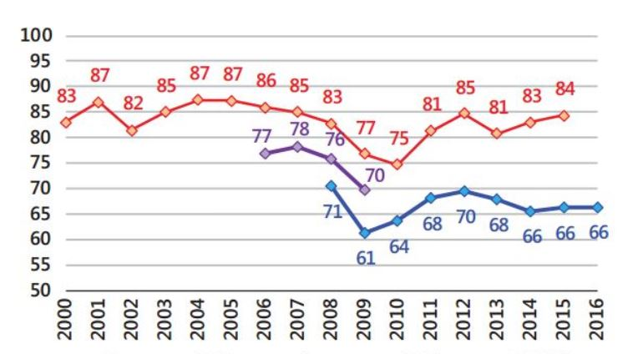 | 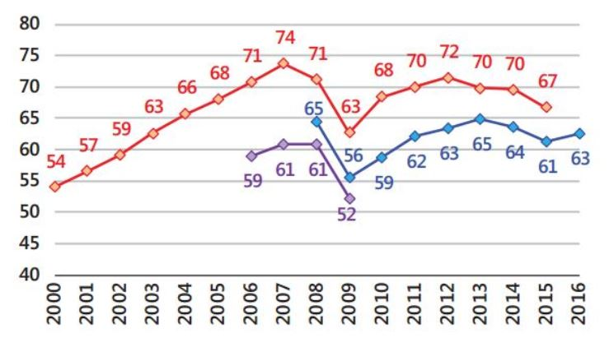
Rosstat since 2009  Rosstat until 2009  Center for Macroeconomic Analysis and Short-Term Forecasting (CMACC) | Rosstat since 2009  Rosstat until 2009  CMACC
Extraction of fuel and energy minerals | Extraction of minerals, except for fuel and energy
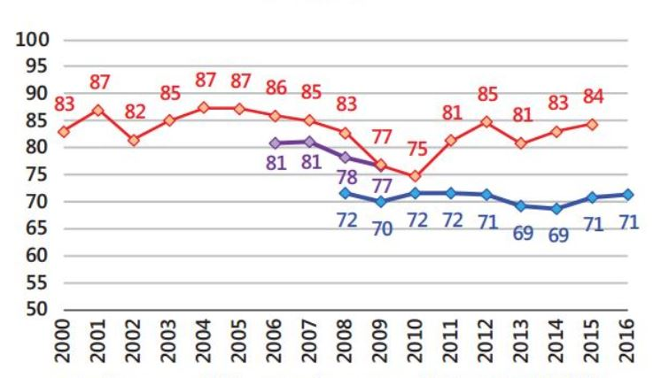 | 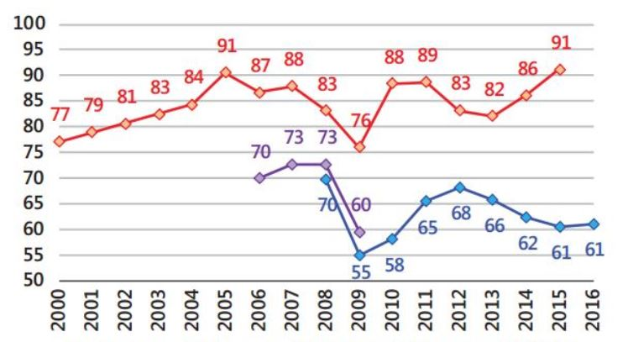
Rosstat since 2009  Rosstat until 2009  CMACC | Rosstat since 2009  Rosstat until 2009  CMACC
Manufacture of food products, including drinks and tobacco | Textile and clothing manufacture
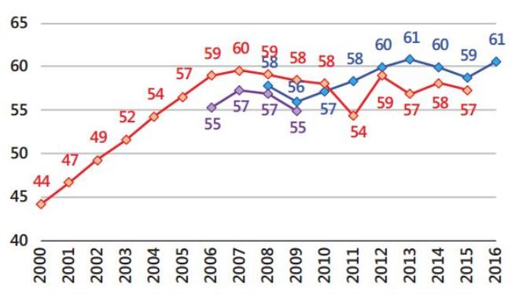 | 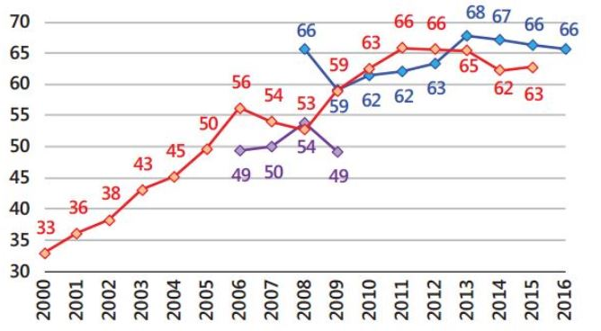
Rosstat since 2009  Rosstat until 2009  CMACC | Rosstat since 2009  Rosstat until 2009  CMACC

Appendix 5. Estimates of the capacity utilization factor for individual activities, industry Unit No. 2
Manufacture of coding, products from coding and production of footwear | Wood processing and production of wood products
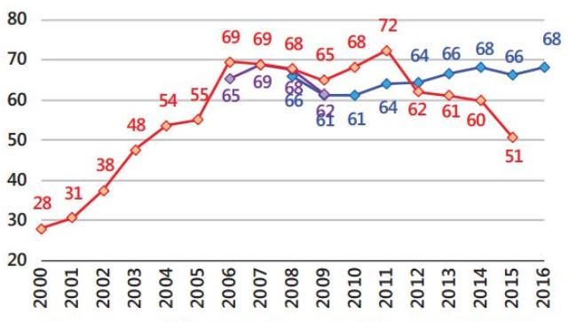 | 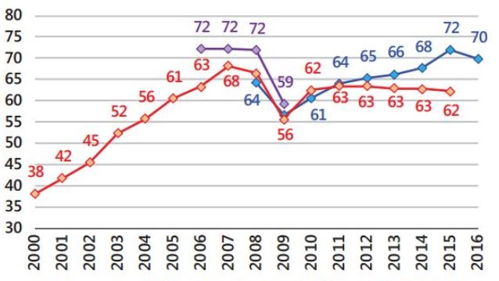
Rosstat since 2009  Rosstat until 2009  Center for Macroeconomic Analysis and Short-Term Forecasting (CMACC) | Rosstat since 2009  Rosstat until 2009  CMACC
Pulp and paper industry; Publishing and printing | Manufacture of coke, refined petroleum products and nuclear materials
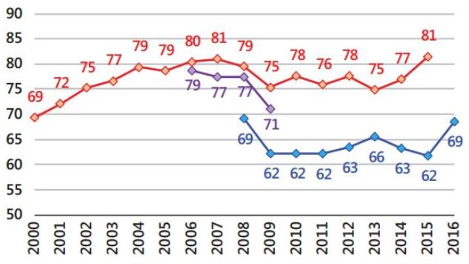 | 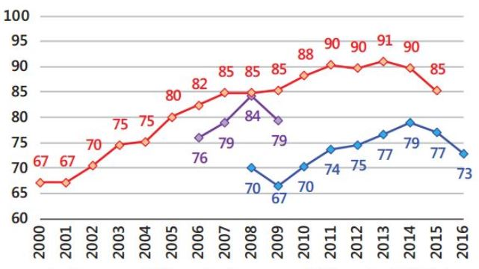
Rosstat since 2009  Rosstat until 2009  CMACC | Rosstat since 2009  Rosstat until 2009  CMACC
Chemical production | Manufacture of rubber and plastic products
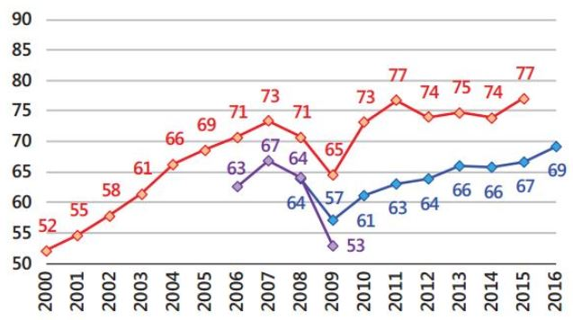 | 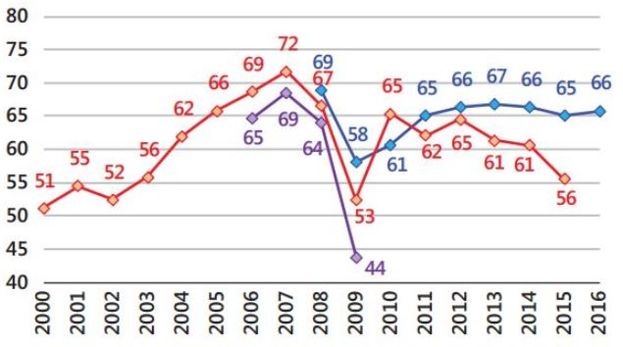
Rosstat since 2009  Rosstat until 2009  CMACC | Rosstat since 2009  Rosstat until 2009  CMACC

Appendix 6. Estimates of the capacity utilization factor for individual activities, industry Unit No. 3
Manufacture of other non-metallic mineral products | Metallurgical production
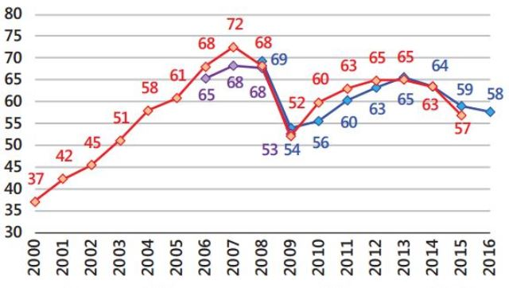 | 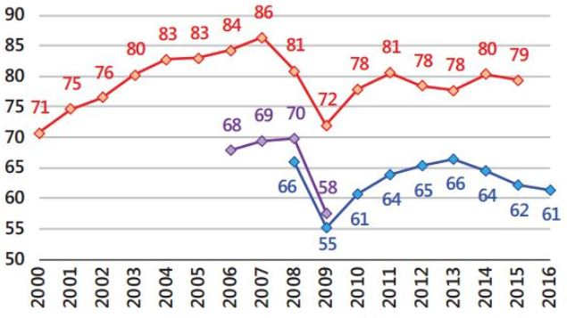
Rosstat since 2009  Rosstat until 2009  Center for Macroeconomic Analysis and Short-Term Forecasting (CMACC) | Rosstat since 2009  Rosstat until 2009  CMACC
Manufacture of machinery and equipment | Production of electrical, electronic and optical equipment
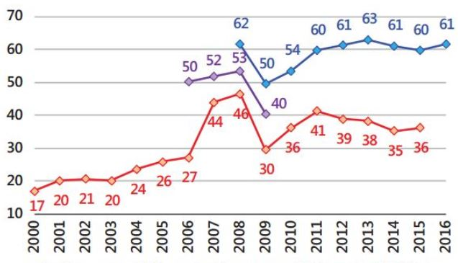 | 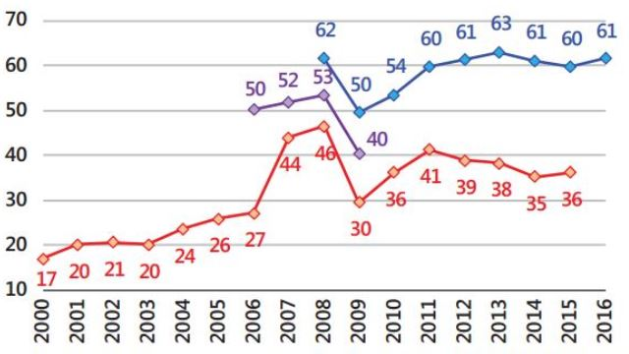
Rosstat since 2009  Rosstat until 2009  CMACC | Rosstat since 2009  Rosstat until 2009  CMACC
Manufacture of vehicles and equipment | Other production
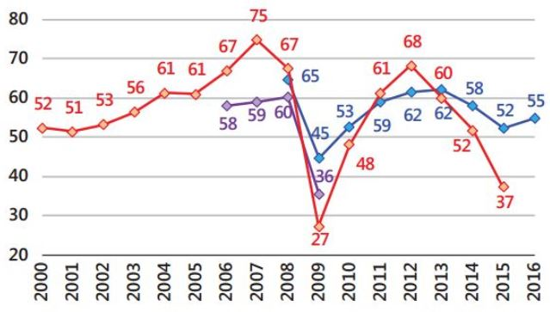 | 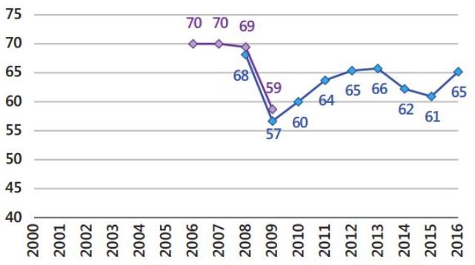
Rosstat since 2009  Rosstat until 2009  CMACC | Rosstat until 2009  CMACC

Appendix 7 Location and interaction of global and regional stock exchanges

Appendix 8 The main advantages and disadvantages of stock exchanges
AIM LSE  (United Kingdom) | NYSE, NASDAQ  (USA) | Euronext, Deutsche Börse (Europe) | MICEX, RTS  (Russia)
Advantages
Existence of a broad range of investment groups | The largest and most extensive investor base | Availability of all European investors. Profitable for companies which are oriented for European investors, since it has the potential to further develop business relations | Investors are perfectly oriented on the Russian market. The company doesn't need to spend more on its image.
Large and liquid market | High liquidity of the market | Sufficiently high market liquidity | -
Ability to use different listing options | Single tender system (auction market and centralized Book of orders) | Ability to run the listing in one country and then trade through the integrated site | -
On AIM shares of free circulation are not limited | - | - | Number of shares in free circulation is not limited
- | - | - | Corporate governance requirements are fairly liberal
Number of shareholders not limited | - | Number of shareholders not limited | Number of shareholders not limited
Liberal regulatory requirements of the exchange | - | - | Liberal regulatory requirements of the exchange
Short time to enter the secondary market (up to 7 days) | Short time to enter the secondary market (up to 7 days) | Short time to enter the secondary market (up to 7 days) | -
Disadvantages
- | Strict listing requirements | Strict listing requirements | -
- | - | Less liquid market than LSE and NYSE | Weak liquid market in comparison with foreign markets
High offering costs for SMEs | High offering costs for SMEs | - | -
Tight Corporate governance requirements | Tight Corporate governance requirements | Independent directors required | -
Uncertain bidding for Russian issuers  (SET/SEAQ/IOB) | - | - | -
Free circulation must be more than 25 per cent of the shares | Free circulation must be for the sum of more than $5 million dollars. | - | -
- | Number of shareholders is at least 400 | - | -
Fund Transaction Tax | - | - | -

Appendix 9 Time series methods
Model | The essence of the method | Advantages and disadvantages
Moving average (MA) | It is based on replacing the original levels of the time series with the average arithmetic value within the selected time interval. The value obtained refers to the middle of the selected time period. In the calculations, all levels of the series with the same weights are involved. | Pluses:  - allows you to eliminate random fluctuations and obtain values corresponding to the influence of the main factors.  Disadvantages:  - the smoothed row is shorter than the original row at (m-1), where m is the value of the anti-aliasing interval, valuable "fresh" data are lost;  - applicable only for series having a linear tendency
Weighted moving average (WMA) | The main idea is to give more weight to new observations, and less weight to older observations, in contrast to the previous method.  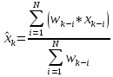,- the weight with which the indicator is used . | Pluses:  - allows to smooth out abrupt deviations;  - more accurately determine the direction of the trend, since the latest data is assigned a greater specific gravity.  Disadvantages:  - delay at the entrance to the trend and at the exit from the trend (but less than the simple sliding;
The method of exponential smoothing (Exponential smoothing) | At the heart of the idea is a constant revision of the forecast values as the actual ones arrive. The ES model assigns exponentially decreasing weights to observations as they age. Basic formula:  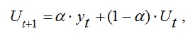  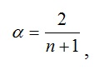 N is the number of observations; T is the period preceding the forecast; T + 1 is the forecast period; Ut + 1 - predicted indicator; Α is the smoothing parameter; Yt - the actual value of the indicator under study for the period preceding the forecasted one; Ut - exponentially weighted average for the period preceding the forecast. | Pluses:  - Reduces the delay due to the fact that it gives the latter prices more weight than the earlier one, allows you to obtain estimates of trend parameters that describe not the average level of the phenomenon, but the trend that has developed by the time of the last observation;  - allows to smooth sharp deviations, to establish a direction of the developed trend.  Disadvantages:  - lagging indicators, moving averages from true dynamics;  - for "short" series (15-20 observations), if the growth and growth rates are large, the method does not "manage" to reflect all the changes.
Exponential smoothing with a trend in mind - double exponential smoothing-Holt method (double exponential smoothing)) | Based on where α (0 < α < 1), β (0 < β < 1)- constant smoothing | Pluses:  - Flexibility, it is always possible to choose such α and β, which will improve the accuracy of the forecast.  Disadvantages:  - require fine-tuning of smoothing functions.
Autoregressive moving average (ARMA) | The assumption is that the value of the process Z (t) depends linearly on a number of previous values of the same process Z (t -1), ..., Z (t -p). Summarizes the autoregressive model (AR) and the moving average model (MA) | Pluses:  - simplicity and uniformity of their analysis and design;  - Transparency of modeling.  Disadvantages:  - a large number of parameters, the identification of which is ambiguous;  - low adaptability of models;  - linearity and lack of ability to model nonlinear processes.
Regression models | Based on the definition of a linear or nonlinear relationship between the resulting variable and a variety of external factors. The regression coefficients can be determined by the least squares or the maximum likelihood method X (t). | Pluses:  - the simplicity, uniformity of their analysis and design, fast results;  - Transparency of modeling and availability for the analysis of intermediate calculations.  Disadvantages:  - difficulty in determining the type of functional dependence;  - low adaptability of linear models and lack of ability to model nonlinear processes.
Fractal analysis  (Hörst's normalized range method) | The classical Hurst method is based on an analysis of the normalized R / S span function and the finding of a certain average H for systems of different nature. | Pluses:  - stability;  - contains minimal assumptions about the object under study;  - makes it possible to distinguish a random time series from a nonrandom one even if it is not Gaussian.

Appendix 10 The abbreviations used in section 2.4
1 | Real GDP growth rate, quarterly | gdp_real_rate
2 | Growth rate of real capital investment, quarterly | invest_q
3 | Dummies of the 2nd quarter of each year | _Iquarter_2
4 | Dummies of the 3rd quarter of each year | _Iquarter_3
5 | Dummies of the 4th quarter of each year | _Iquarter_4
6 | Number of IPOs per quarter | num_ipo_q
7 | Total amount of attracted funds within the IPO, quarterly | vol_ipo_q
8 | Number of SPOs per quarter | num_of_spo
9 | Total amount of raised funds within the SPO in the quarter | vol_of_spo
10 | The real GDP growth rate, cleared from seasonality, quarterly | res_gdp_real
11 | The growth rate of real investment in fixed assets, cleared of seasonality, quarterly | res_invest
12 | Unemployment rate, % of population, quarterly | unemp
13 | Profitability of the MICEX index, quarterly | return_micex_hy
14 | Interbank rate, %, quarterly | mezbank_q

Appendix 11 The autocorrelation and autocorrelation function values for model 2
. corrgram res_L2ar1, noplot

LAG AC PAC Q Prob>Q
-----------------------------------------
1 0.0448 0.0448 .15839 0.6906
2 0.3595 0.3594 10.513 0.0052
3 -0.0993 -0.1091 11.314 0.0101
4 0.2605 0.1787 16.901 0.0020
5 -0.0223 0.0241 16.942 0.0046
6 0.0841 -0.1071 17.541 0.0075
7 0.0192 0.0833 17.573 0.0141
8 0.0953 0.1075 18.364 0.0187
9 -0.0503 -0.1183 18.588 0.0289
10 0.0889 0.0565 19.297 0.0366
11 -0.2227 -0.2065 23.822 0.0135
12 -0.0138 -0.1191 23.84 0.0214
13 -0.2867 -0.0487 31.576 0.0028
14 0.0041 -0.0019 31.578 0.0046
15 -0.1972 0.0264 35.358 0.0022
16 0.0303 0.0516 35.449 0.0034
17 -0.1151 -0.0564 36.78 0.0036
18 -0.0318 -0.1061 36.883 0.0054
19 -0.1895 -0.1777 40.62 0.0027
20 -0.0792 -0.0912 41.285 0.0034
21 -0.1831 -0.0178 44.899 0.0018
22 -0.0727 -0.0699 45.48 0.0023
23 -0.1713 -0.1118 48.762 0.0013
24 -0.0489 -0.1774 49.035 0.0019
25 -0.1207 -0.1081 50.728 0.0017
26 0.0921 0.1525 51.735 0.0019
27 -0.0570 0.0443 52.127 0.0026
28 -0.0470 -0.3173 52.4 0.0034
29 -0.1243 -0.2782 54.348 0.0029
30 0.0428 0.1091 54.584 0.0040
31 -0.1320 -0.1989 56.881 0.0031
32 0.0835 -0.1486 57.82 0.0034
33 0.0002 0.0563 57.82 0.0048
34 0.2082 0.0755 63.936 0.0014
35 0.0548 0.2082 64.37 0.0018
36 0.1879 0.2644 69.603 0.0007

Appendix 12 Confidence intervals for the model 4 (number of IPOs).
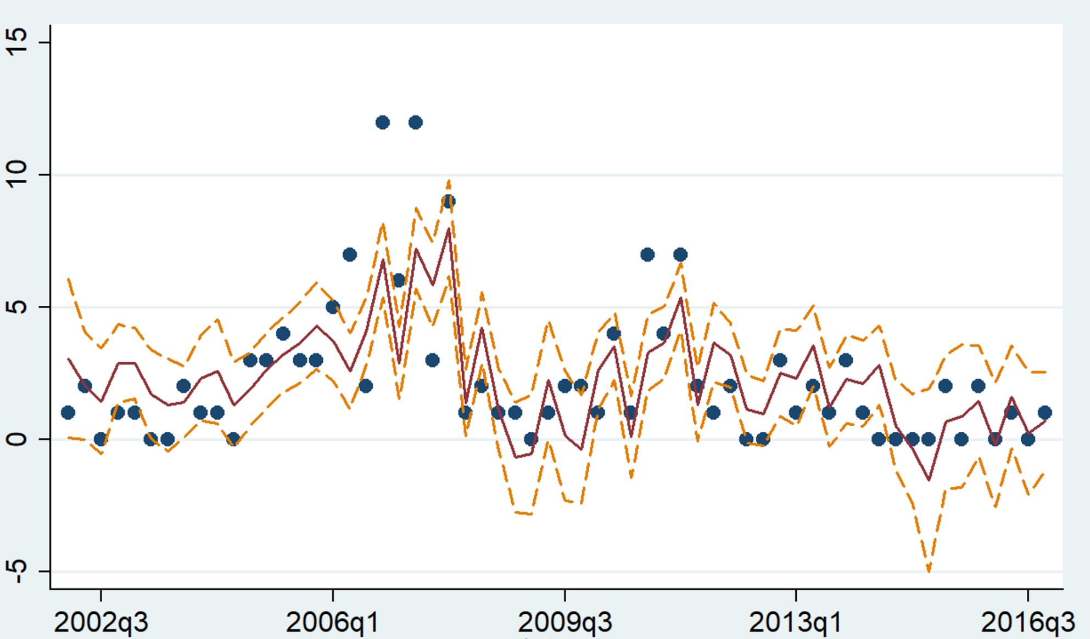
number of IPOs placed
forecasting the number of placed IPOs
upper bound of confidence interval
lower bound of confidence interval

Appendix 13 Confidence intervals for the model 8 (amount of SPO).
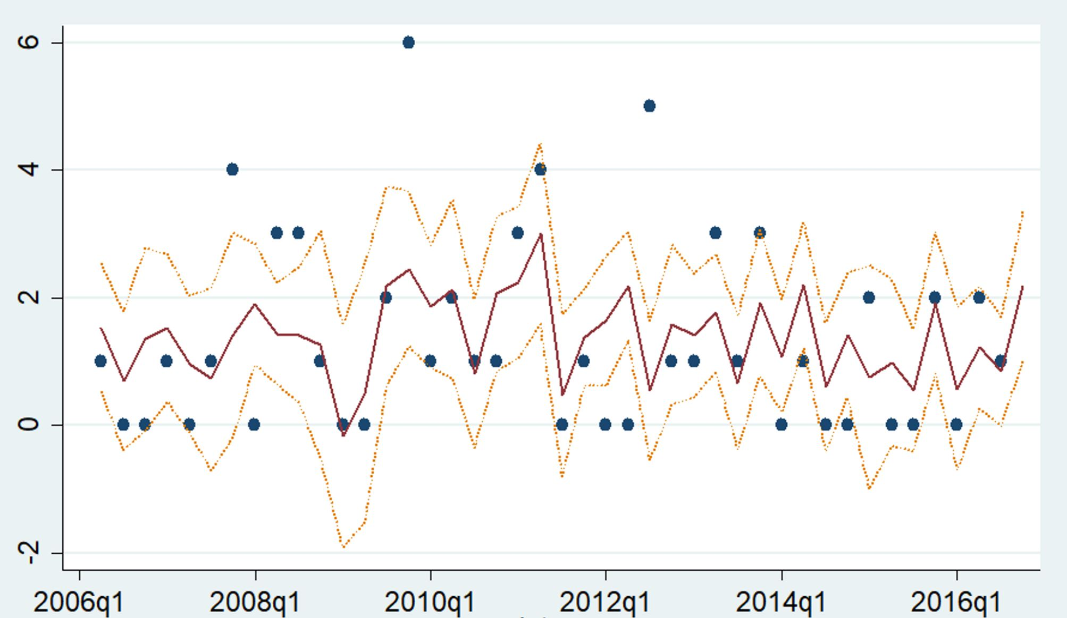
number of SPOs placed
forecasting the number of placed SPOs
upper bound of confidence interval
lower bound of confidence interval

Appendix 14 Mean estimation of difference between initial data and predicted values for number of IPOs.
Mean estimation Number of obs = 60

--------------------------------------------------------------
| Mean Std. Err. [95% Conf. Interval]
-------------+------------------------------------------------
d_ma2 | 1.407811 .1444085 1.11885 1.696772

Mean estimation Number of obs = 60

--------------------------------------------------------------
| Mean Std. Err. [95% Conf. Interval]
-------------+------------------------------------------------
num_ipo_q | 2.283333 .3510208 1.580942 2.985724

Appendix 15 Mean estimation of difference between initial data and predicted values for number of SPOs

Mean estimation Number of obs = 42

--------------------------------------------------------------
| Mean Std. Err. [95% Conf. Interval]
-------------+------------------------------------------------
d_spo1 | 1.001211 .1387854 .7209281 1.281494

Mean estimation Number of obs = 42

--------------------------------------------------------------
| Mean Std. Err. [95% Conf. Interval]
-------------+------------------------------------------------
num_of_spo | 1.357143 .2331958 .8861944 1.828091

In the framework of this study, we analyze correlation links, not cause-and-effect relationships.

