St. Petersburg University
Graduate School of Management

Master in Management Program

CORPORATE BRAND DEVELOPMENT WITH THE INSTRUMENTS OF CORPORATE SOCIAL RESPONSIBILITY: EXAMPLE OF JETBRAINS COMPANY

Master’s Thesis by the 2nd year student
Concentration — general track
Tikhomirov Stanislav

Research advisor:
Yury E. Blagov, Associate Professor

St. Petersburg
2017

ЗАЯВЛЕНИЕ О САМОСТОЯТЕЛЬНОМ ХАРАКТЕРЕ ВЫПОЛНЕНИЯ ВЫПУСКНОЙ КВАЛИФИКАЦИОННОЙ РАБОТЫ
Я, Тихомиров Станислав Викторович, студент второго курса магистратуры направления «Менеджмент», заявляю, что в моей ВКР на тему «,Развитие бренда компании через инструменты корпоративной социальной ответственности: пример компании JetBrains» представленной в службу обеспечения программ магистратуры для последующей передачи в государственную аттестационную комиссию для публичной защиты, не содержится элементов плагиата.
Все прямые заимствования из печатных и электронных источников, а также из защищенных ранее выпускных квалификационных работ, кандидатских и докторских диссертаций имеют соответствующие ссылки.
Мне известно содержание п. 9.7.1 Правил обучения по основным образовательным программам высшего и среднего профессионального образования в СПбГУ о том, что «ВКР выполняется индивидуально каждым студентом под руководством назначенного ему научного руководителя», и п. 51 Устава федерального государственного бюджетного образовательного учреждения высшего профессионального образования «Санкт- Петербургский государственный университет» о том, что «студент подлежит отчислению из Санкт-Петербургского университета за представление курсовой или выпускной квалификационной работы, выполненной другим лицом (лицами)».

____________________________________________________________ (Подпись студента)

27.09.2017 (Дата)

STATEMENT ABOUT THE INDEPENDENT CHARACTER OF THE MASTER THESIS
I, Tikhomirov Stanislav Viktorovich, (second) year master student, program «Management», state that my master thesis on the topic «Corporate Brand Development with the Instruments of Corporate Social Responsibility: Example of JetBrains Company», which is presented to the Master Office to be submitted to the Official Defense Committee for the public defense, does not contain any elements of plagiarism.
All direct borrowings from printed and electronic sources, as well as from master theses, PhD and doctorate theses which were defended earlier, have appropriate references.
I am aware that according to paragraph 9.7.1. of Guidelines for instruction in major curriculum programs of higher and secondary professional education at St.Petersburg University «А master thesis must be completed by each of the degree candidates individually under the supervision of his or her advisor», and according to paragraph 51 of Charter of the Federal State Institution of Higher Professional Education Saint-Petersburg State University «a student can be expelled from St. Petersburg University for submitting of the course or graduation qualification work developed by other person (persons)».

____________________________________________________________ (Student's signature)

09/27/2017 (Date)
АННОТАЦИЯ

Автор | Тихомиров Станислав Викторович
Название ВКР | Развитие бренда компании через инструменты корпоративной социальной ответственности: пример компании JetBrains
Направление подготовки | Менеджмент
Год | 2017
Научный руководитель | Благов Юрий Евгеньевич
Описание цели, задач и основных результатов | Работа посвящена интеграции корпоративной социальной деятельности и корпоративного брендинга компании. Задачами работы являлись анализ существующей литературы в области корпоративной социальной деятельности и брендинга, определение методологии исследования, разработка нового артефакта и его тестирования на примере компании JetBrains. Основным результатом работы является модель Стратегического Корпоративного Ответственного Брендинга, который позволяет организациям развивать корпоративный бренд компании через корпоративную социальную деятельность.
Ключевые слова | Корпоративная социальная ответственость, корпоративная социальная деятельность, стратегическая КСО, корпоративный бренд, корпоративный брендинг.

ABSTRACT

Master Student's Name | Tikhomirov Stanislav Viktorovich
Master Thesis Title | Corporate Brand Development with the Instruments of Corporate Social Responsibility: Example of JetBrains Company
Main field of study | Management
Year | 2017
Academic Advisor's Name | Blagov Yury Evgenievich
Description of the goal, tasks and main results | This work is devoted to integration of corporate social performance and corporate branding of the company. The task of research are to analyze existing literature in the areas of corporate social performance and branding, define research methodology, develop new artifact and test it in the context of JetBrains company. The main result of the research is the model of Strategic Corporate Responsible Branding, which allows companies to develop corporate brand through corporate social performance.
Keywords | Corporate social responsibility, corporate social performance, strategic CSR, corporate brand, corporate branding.

Table of Contents

INTRODUCTION 5
1. LITERATURE REVIEW 7
1.1 Corporate Social Responsibility: development of the topic 7
1.2 Strategic CSR 11
1.3 Brands and corporate branding 15
1.4 Research gap 19
2. METHODOLOGY 31
3. RESULTS DISCUSSION 43
3.1 Problem scope awareness 43
3.2 Artifact construction 59
CONCLUSIONS 79
LIST OF REFERENCES 82
APPENDIX 1 91
APPENDIX 2 93

INTRODUCTION
Today corporate social responsibility becomes an imperative for any organization, disregarding its size and industry. In making their purchasing decisions, consumers become increasingly conscious of ethical, environmental, and social issues, which they expect to see addressed in one way or another in the goods and services that they chose to buy (Crane, 2005). This “ethical consumerism” cause the development of corporate social performance within organizations - the system of processes that should be aimed at building relationships with relevant stakeholder groups. However, the vague definition of CSR among with multiple cases of CSR failure and accusations in hypocrisy resulted in either very limited view on CSR as corporate ecological sustainability or denial of value of corporate social performance and disengagement of companies from CSR practices. The outcome is the same: companies do not want to or do not know how to engage into corporate social performance, thus ignoring the needs of consumers, employees, communities and society in a whole on the one hand, and rejecting from the big chunk of value CSR generates on the other.
To address this practical problem, as well as the research gap in the current theoretical literature, the objective of this work is to develop a conceptual framework that would integrate corporate social performance of organization with corporate branding - organizational function that pursues the same strategic objectives as corporate social performance, but contrary to the latter is widely used in modern management practice. To achieve the stated goal, this research has the following tasks:
- Analyze the theory of corporate branding and corporate social performance to identify the research gap
- Define methodology to ensure scientific approach to research
- Apply methodology to develop conceptual framework
- Test conceptual framework in real business context
- Provide conclusions and generalization of research results
The particularity of this research that it studies the phenomena that is extremely rare. As a result, traditional scientific approaches cannot be applied because they aim at deriving scientific knowledge from phenomena that exists through explaining, describing, exploring, or predicting. Thus, this work incorporates design science research as methodology, with the goal to develop tangible artifact that contains scientific knowledge. This artifact should comply with the following requirements that have been developed throughout this work:
- The artifact should provide organization and its stakeholders with clear and mutually agreed definition of corporate social responsibility
- The artifact should link corporate social performance to business activity of organization
- The artifact should provide organization with tools to measure social and business value of corporate social responsibility
- The artifact should provide an effective approach to stakeholders’ management and engagement
- The artifact implementation should lead to CSR empowerment within organization
As a result, the object of this research is corporate branding and corporate social performance of organization, while research subject is integration of corporate social performance and corporate branding into unifying system that is aimed at achieving specific strategic goals.
This work is structured as follows. The first chapter provides literature review on the topics of corporate social responsibility, corporate social performance, strategic CSR, brand and branding with identification of research gap. The second chapter defines methodology of design science research. The third chapter initiates research process with identification of problem scope and formulating artifact requirements and describes the process of artifact construction. The final chapter draws research conclusions and gives a vector of future research.
This work provides theoretical contribution to the existing theory of corporate social responsibility and branding. In addition, the adjusted methodology of design science research and the whole work can be used as a reference material in any other research that follows design science principles. Finally, this work can be used as a guideline for companies to implement effective corporate social performance and corporate branding systems that can be used to generate both business and social value.

1. LITERATURE REVIEW

1.1 Corporate Social Responsibility: development of the topic
“Capitalism is under siege… Diminished trust in business is causing political leaders to set policies that sap economic growth… Business is caught in a vicious circle…” Thus begins an article by Michael Porter and Mark Kramer, in which the authors first present their concept of creating shared value (Creating Shared Value, hereinafter CSV) as a completely new alternative to conventional corporate social responsibility concept. Although the appearance of this article is rather a response to the increasing spread of the ideas of pragmatism in the original concept than the lack of theoretical basis of previous studies, this only confirms the fact that in the beginning of 21st century interest in the phenomenon of CSR showed a significant increase on the part of academics and business. On the other hand, it is impossibility to solve all the accumulated problems related to the negative impact of business on the environmental and social spheres of society, by conventional tools of strategic management, marketing, finance and human resource management has led to a growing implementation of CSR practices in the activities of companies, as it is this concept to the greatest extent describing the processes of interaction between business and society.
Discussion on CSR in academic circles has been conducted since the 1950s. The first attempts at systematic scientific studies have been undertaken by the American scientist H. Bowen in his work "Social responsibilities of the businessman" published in 1953. Since then, a fruitful process of conceptualization of CSR phenomenon lasted for the entire second half of the 20th century led to the creation of a significant amount of theoretical material, corresponding to two interrelated issues that were raised at the beginning of the discussion: what exactly is meant by CSR and what are its sources? It should be noted that such a lengthy discussion was caused by a number of reasons, the main of which is a nontrivial central category - corporate social responsibility. Firstly, the very CSR term can be decomposed into three components: the responsibility, which, in turn, under the category of "moral responsibility" can take three interpretations (responsibility as a virtue, responsibility as a duty - deontological meaning, responsibility as a guilt - causal meaning); social responsibility, which can also be understood in a broad sense (as the responsibility to the society as a whole), or in a narrower sense (as a liability in the "social sphere", i.e. to the least socially protected strata of society); and corporate social responsibility, which defines a corporation as the main subject of analysis. Secondly, the concept of terminological base was exposed to substantial transformation. Thus, the term "social responsibility of business" and "social responsibility of businessman", widely used in discussions in 1950-1970 years, have been superseded by the term "corporate responsibility" as the one most adequately reflecting the link between the company's strategy and CSR activities. The variety of terms "corporate social responsibility", "corporate social sensitivity", "corporate social activities", "business ethics", "corporate philanthropy", "social problems", "corporate social integrity," "corporate social policy process", "management stakeholders", "corporate citizenship", "sustainable development”, "corporate sustainability", etc. was also the result of an active debate about the nature of CSR. Thirdly, the very essence of the concept of CSR involves covering issues in various fields such as philosophy, law, sociology, economics and management. Each of these disciplines has its own tools and research terminology, which is also dynamic in terms of their development and which also have different interpretations within their own science. Thus, the task to answer the fundamental questions about the study of CSR (which is to be understood by CSR and what are its sources) has been replaced by an attempt to analyze the following question: "What responsibility (corresponding to the three statutory interpretation) within the community (with all its space-time features) corporation should have as a specific institution?”
It should be noted that the main discussion in the end was reduced to a description of the two sources of CSR, presented implicitly in the above-mentioned article by Bowen: the social contract between society and the business that matches the goals and values of the two parties and serves as a source of legitimacy of the latter, and firm itself as a moral agent, which is associated with the individual and can have all three types of responsibility. And since from the point of view of the latter approach researchers (such as J. Ladd, P. French, J. Danley, K. Goodpaster, J. Matthews Jr. and M. Velasquez) succeeded to prove the existence of certain organizational moral responsibility to society (and, as a consequence, the need to develop CSR activities), many researchers of the first approach concluded that the sole responsibility of the firm to society is getting profit and / or business existence in general (such as Th. Levitt and M. Friedman). On the one hand, such a view is true, as the business itself meets the demand of consumers, creates jobs, pays taxes, etc. On the other hand, further research has shown that "some socially responsible business decisions in the course of a long, complex process of analysis can be "justified" as representing a good opportunity for the company long-term economic benefit." Integrated approach, finalizing discussion in the framework of the social contract as a source of CSR, was developed by A. Carroll as a model in which CSR was represented as a multi-level structure in the form of a pyramid, which was based on economic responsibility (the basic task is to be a profitable organization), followed by legal responsibility (following formal laws and regulations), then - the ethical responsibility (following informal regulatory standards), and on the top of the pyramid is the philanthropic responsibility (to be a good "corporate citizen", sacrifice resources to the community to improve the quality of life). This model has gained immense popularity, but the problem of discrete nature of its components resulted that in practice the function of the CSR organization, which should have to manage the entire pyramid of responsibility deals only with philanthropic responsibility, while the top management (Directors / Shareholders Board) ruled economic responsibility, the company's lawyers took the legal liability issues, and ethical responsibility remains on the conscience of individuals within the organization. As a result, many CSR initiatives have been separated from the basic idea of business, making them some tools of PR.
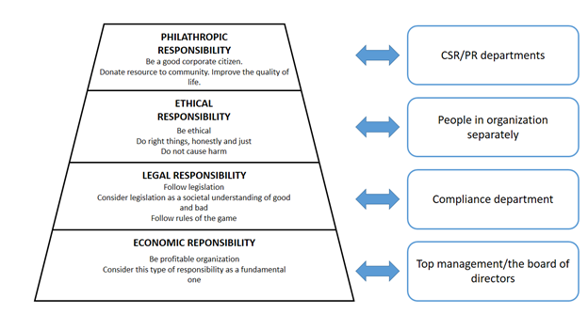
Figure 1 Correspondence between types of corporate social responsibility and organizational functions.
Further study of the CSR concept was going in the direction of formation of the system paradigm “Corporate Social Responsibility as principles, CSR-1 - Corporate Social Responsiveness as processes, CSR-2 - Corporate Social Performance as a system , CSP”, which allowed not only to consolidate the processes of research, attributable to the different sciences, but also made more responsive CSR-oriented practices, and created the basis for the formation of alternative theories, such as the concept of stakeholders. The research of corporate social responsiveness topic shifted the discussion of CSR from questions “what is corporate social responsibility and what are its sources” to question “how actually companies should realize corporate social responsibility in practice”, with corporate social responsiveness determined as ability of corporation to respond to interactions with society. Being initiated by R. Ackerman (Ackerman, 1973), who linked the problems of corporate management in decentralized organizational structures with practical implementation of CSR, the discussion covered stages of organizational involvement into the process of corporate social responsiveness (Ackerman, Bauer, 1976), analysis of corporate reaction on external pressure (Sethi, Votaw, 1969), business strategies aimed on aiming the “legitimacy gap” (Sethi, 1979), continuum of corporate social responsiveness that includes reactive, defensive, adaptive and proactive responses (Carroll, 1979) and was finalized by W. Frederick, who introduced a concept of corporate social responsiveness - CSR-2 - and finally switched the focus to managerial perspective of the problem with the “hope that less attention will be paid to the “moral standing” of a company and more to its tangible activities as a social responsive entity” (Frederick, 1994). Overall, development of new concept that was oriented more on linking CSR to practical organizational issues rather than normative discussion of CSR nature was the first step to introduction of pragmatic approach to corporate social responsibility. However, CSR-2 set a new directive in research of corporate social responsibility towards the development of complex model that should have integrated previously developed concepts as elements of system. The resulted model called Corporate Social Performance (CSP) was the result of evolution from initial representations of corporate behavior as reaction of external pressure and social responsiveness of corporation to the needs of society (Sethi, 1975), system of corporate social responsibility (economical, legal, ethical and discretionary), corporate social responsiveness (reactive, defensive, adaptive and proactive) and social issues (consumerism, ecology, discrimination, product and labor safety, shareholders) (Carroll, 1979), system of principles, processes and policies (Wartick, Cochran, 1985) to the system of principles of corporate social responsibility, processes of corporate social responsiveness and results of corporate behavior (Wood, 1991). As a result, the model of corporate social performance allowed to explain why companies should behave in particular way (based on CSR-1 principles), how actually company is acting (implementing CSR-2 processes) and what performance this activity has (because results of corporate social responsiveness are the only measurable characteristics of the system). Later, the model of corporate social performance was adjusted with the implementation of organizational value processes of economizing, ecologizing and mutualistic economizing (Swanson, 1995); however, the initial definition by Wood became the prevalent view on corporate social responsibility as a system of corporate social performance that integrates principles, processes and results, which boosted the development of adjacent topics, such as theory of stakeholders (Freeman, 1984; Carroll, 1991; Mitchell, Agle, Wood, 1997; Trevino, Weaver, 1999; Freeman, Velamuri, 2006).
At the same time as a result of active research and development of such a large number of different views and concepts has led to different interpretations of the term CSR not only among academics but, more importantly, in the business community. Even in 1973, CSR researcher D. Votaw said: "The term (CSR) is simply delicious; it means something, but not for everybody the same." (Votaw, 1973) This situation continues till the present day. Many organizations (particularly in developing countries and / or in crises) deny the importance of CSR as a business development tool, and frequent isolation of the organizational functions of corporate social performance does not achieve any significant effects, not only for business, but also for society. Finally, the global financial crisis of the mid-2000s again forced to pay attention to the academic and business communities to the place of CSR in the organization's strategy.

1.2 Strategic CSR
Key definitions attributable to CSR field of study were also the subject of research of strategic management theory from the very beginning of its own development. The initial research dedicated to planning as a core paradigm implicitly covered topics of interactions between business and society as a determinants of firm’s strategy. For example, Ansoff in addition to corporate, business and functional levels of strategy proposed the high-level independent enterprise strategy, which should aim at addressing issues of social-political legitimacy of business, new consumer preferences, social control and changing role of firm in society (Ansoff, 1979). Moreover, firm’s strategy should integrate organization with broad environment, which is frequently out of control, in order to realize dedicated role in society (Schendel, Hoffer, 1979). The emergence of stakeholders’ concept, which allowed to personify social expectations, put relevant social issues as a determinant factor of corporate strategy definition, thus linking business value creation with external expectations satisfaction (Freeman, 1984). Later this idea was elaborated into a more complex definition of corporate strategy as a process describing the way how company striving to its own legitimization is creating added value for its stakeholders. The resulting classification of strategies was determined by which stakeholders’ firm targets (economical, non-economical or both) and which value added it creates (economical, non-economical or combined), thus addressing all approaches to CSR implementation (Meznar, Chrisman, Carroll, 1990). As a result, the main research question shifted to more specific definition “how adequately does strategy correspond to firm’s competences and stakeholders’ expectations”, thus bringing the discussion of CSR-related issues to positioning and resource-based view on firm’s strategy.

 |  |  | Stakeholders
 |  |  | Economic only | Both |  | Social only
 |  |  |  | Narrow | Broad
Benefits | Economic only |  | Classical | X | X | X
 | Both | Economic and Lower Social Cost | X | Defensive narrow | Defensive broad | X
 |  | Economic and Higher Social Good | X | Offensive narrow | Offensive broad | X
 |  | Economic & Higher Social Good + Lower Social Cost | X | Accommodative narrow | Accommodative broad | X
 | Social only |  | X | X | X | Not-for-profit
Table 1 Classification of firm’s strategies.
The discussion of the role of CSR in company’s strategy within the positioning concept was aimed at targeting of CSR approaches to external factors, with the approach to the development, implementation and management of CSR, developed by M. Porter, together with M. Kramer considered as a kind of "mainstream" of all interpretations of CSR in the framework of the concept of positioning. Together with the works of W. Werther and D. Chandler, considering CSR as a "filter" to assess the impact of strategic decisions on stakeholders (Werther, Chandler, 2006), and study of B. Van de Ven and R. Jeurissen linking CSR strategy to the specifics of competition in the industry (Van de Ven, Jeurissen, 2005), Porter's and Cramer’s approach is based on the assumption that corporate social activity becomes strategic in nature, when its initiatives impact on the external sources of creation competitive advantages. In addition, if the early stages of the study were of a normative character, and research question was the following: "When CSR itself becomes a strategic", in later studies major problem has become more pragmatic: "How CSR can create a competitive advantage for the company?". In this case, the company's CSR activities considered in the context of its business strategy aimed at strengthening the competitive position of firms in the industry, thus tying the beneficial effects for society generated by corporate social activities, with economic benefit for the company, arising due to the strengthening of its competitiveness. Originally considering CSR as narrow “corporate philanthropy”, Porter and Kramer addressed non-systematic nature of activity as a main problem, and proposed to use philanthropy to improve the company's competitive context - the quality of the business environment in the geographical region or regions where the company operates that comprises of factor and demand conditions, context for strategy and rivalry and related/supporting industries. According to the authors, the use of philanthropy to improve this context contributes to aligning the problems of society and business with each other, also improving the company's competitiveness in the long term at the same time. Moreover, such an approach to philanthropy allows companies to use as donations not only money, but also its ability, knowledge and network, which is especially important on the background of the dichotomy of "public expectations of a significant effect on the CSR / creation of additional value for the shareholders" (since such "intangible" resources of the company are able to create more positively perceived "intangible" value for society with minimal financial costs) and the problem of irrational use of charitable funds (Porter, Kramer, 2002). In the next publication, Porter and Kramer expanded their original definition of CSR, describing the process of moving the CSR to the strategic level as a comprehensive analysis of the internal organizational and external social environment with the search of points of intersection. The resulting issues then are split into 3 levels:
- Generic social issues can be quite important for the society at the moment, but nor are not affected significantly by corporate activity, neither by the long-term competitiveness of the company
- Value chain social impacts significantly affected by the company’s activities in normal operation
- Social dimensions of competitive context are environmental factors that significantly affect the company's competitiveness drivers in the regions of its operation
Based on the type of addressed issues, Porter and Kramer defined 2 types of integration: "responsive CSR," which implies conformity to the image of a "good corporate citizen" (which includes general support of society and non-strategic philanthropy) and reducing the negative impact of the company's operations on the environment; and "strategic CSR", aimed at the transformation of the value chain in order to meet society's needs and strategic philanthropy, which aims to impact on specific elements of a competitive context (Porter, Kramer, 2006). To finalize this discussion, Porter and Kramer introduced the concept of creating shared value (CSV) as a set of techniques and organizational practices that enhance the competitive position of the company and at the same time improve the economic and social conditions of the communities in which it operates. In other words, following the concept of CSV companies should take existing social issues as a center point of corporate strategy and focus CSR efforts on reconceiving products and markets, redefining productivity in the value chain and enabling local cluster development (Porter, Kramer, 2011). Despite the obvious weaknesses of CSV approach and critics by academics, it became extremely popular in corporate world, since it provided clear (though limited) definition of CSR and simple guiding principles of corporate social performance. Still, positioning approach to strategic CSR could not be taken as a prevalent, since it was limited to the external factors and does not take into account existing internal ones.
Within the concept of resource-based view on the firm and strategic management the discussion of CSR-related issues was initiated with the introduction of natural-resource-based view approach, which was tightly connected with the development of corporate sustainability concept. Based on this approach, specific strategic capabilities that are aimed at solving ecological issues (such as nature contamination prevention, product usage management and sustainable development) are able to create competitive advantage for firm (Hart, 1995). Later this statement was confirmed empirically, with “corporate ecological performance” having a long-term impact on company performance as long as the resources and capabilities it is based on are unique (Russo, Fouts, 1997). More advanced approach to resource-based view on strategic CSR determined specific dimensions (centrality, specificity, proactivity, voluntarism, visibility) that determine the rate at which CSR can generate value and, as a result, become strategic (Burke, Longsdon, 1996). In the following discussion these dimensions were redefined, with view on “strategic CSR as the firm’s ability to 1) provide a coherent focus to a portfolio of firm resources and assets (centrality); 2) anticipate competitors in acquiring strategic factors (proactivity); 3) build reputation advantage through customer knowledge of firm behavior (visibility); 4) ensure that the added value created goes to the firm (appropriability)” (Husted, Allen,2007). Regarding development of appropriate capabilities, the most well-known was the model of stages of organizational learning, which included 5 stages of developing a sense of corporate responsibility: defensive, compliance, managerial, strategic, civil (Zadek, 2004). The research in this field finalized the discussion of CSR interpretations within the framework of resource-based view.
The concept of dynamic capabilities was primarily used to create a framework for discussion in two areas: 1) to transform the stakeholders’ theory into the distinctive theory of strategic management and 2) to discover innovational potential of corporate social performance. The first area was broadly elaborated throughout the “Redefining the corporation” project, where corporation was defined as a central point of wide network of various stakeholders which generates societal value through competences, capabilities and relational assets. At the same time, stakeholders can be divided into groups of resource base (employees, customers, shareholders), industrial structure (partners, unions, suppliers and regulative bodies) and social-political environment (citizens, communities, governments, NGOs) (Post, Preston, Sachs, 2002). The resulting model allowed to implement shareholders concept to successfully integrate positioning and resource-based view approaches within the framework of dynamic capabilities, with the ability to develop relational assets as a key managerial competence used to generate sustainable long-term competitive advantage. Regarding the second area of research, the above-mentioned concept of creating shared value (CSV), though being limited to external response, provided a well-reasoned justification for using CSR as innovative source of competitive advantage through reconceiving products and markets, redefining productivity in the value chain and enabling local cluster development (Porter, Kramer, 2011). Later the concept of CSV got a process perspective with stages of embedding a social purpose, defining the social need, measuring shared value, creating the optimal innovation structure and co-creating with external stakeholders (Pfitzer, Bockstette, Stamp, 2013). Another model proposed new typology of corporate social performance consisting of “philanthropy” (traditional discretional philanthropy), “CR-integration” (sustainable business operations) and “CR-innovation” (business innovations connected with solving particular social issues) (Halme, Laurila, 2008). Looking at corporate social performance as a portfolio of these 3 types of activities, authors stressed CR-innovation as the one that is able to create maximum value for both business and society, thus putting innovations and development of dynamic capabilities as a center point of the whole system of corporate social performance and firm’s strategy.
To conclude discussion on strategic CSR it can be noted that CSR issues were discussed in all major concepts of strategic management with the area of dynamic capabilities as describing the best the responsibility of modern organization as its ability to develop and sustain competitive advantage. At the same time, the whole discussion followed the original logic of Corporate Social Responsibility as principles, CSR-1 - Corporate Social Responsiveness as processes, CSR-2 - Corporate Social Performance as a system, CSP. That is why the development of CSR topic within the framework of strategic management got a positive reaction from the corporate world, since 1) it partially got rid of ambiguity in CSR definitions and 2) was linked not to some discretionary activity of organization, but to its core strategy and business processes.

1.3 Brands and corporate branding
Theory of brands, as a subset of marketing theory, was developing as a response to changing paradigms and logic for marketing, with focus shifting from transactions to relationships and from tangible resources to intangible ones (Vargo, Lusch, 2004). As a result, the new concept provided a framework for virtuous integration of communicated functional values of branded entity, its symbolic (emotional) values and promised experience of using branded entity, thus bringing the company-product-customer relations to a completely new level (Park, Jaworski, MacInnis, 1986). The consecutive research of brands, initiated with focus on company-sender as a sole owner of brand that uses it as a mean of one-way communication of particular promise, gradually shifted to focus on consumer-receiver as the one who creates perceived personality of the brand and later to the power of brands to affect context of environment and its culture (Heding, Knudtzen, Bjerre, 2009). As a result, brand was elaborated into multifaceted concept with numerous definitions. The extensive overview of various definitions of brand was conducted by de Chernatony (2001, 2006), who determined 3 big groups of interpretations of brand: input perspective (defining brand as a product of organizational activity), output perspective (defining brand as a product of external perception) and time perspective (defining brand as an evolving entity). At the same time, author stated that efficient brand strategy should incorporate all three levels of conceptual definitions to strengthen the chances of longevity. The resulting definition of successful brand (i.e. the one that allows to achieve defined organizational goals) is determined as “an identifiable product, service, person or place, augmented in such a way that the buyer or user perceives relevant, unique, sustainable added values which match their needs most closely” (de Chernatony, McDonald, 2003). This definition expands the long-lasting traditional definition by American Marketing Association as “name, term, design, symbol, or any other feature that identifies one seller's good or service as distinct from those of other sellers" and original view on brands as a logo that visually differentiates one branded entity from another or as a legal instrument acting as legally enforceable statement of ownership, and put more stress on brand as a tool of delivering specific internal corporate values to external receiver in the form of brand promise experience.
The majority of definitions of branding and brand management are interchangeable and define the process of management as creation, communication and maintenance of brand as a holder of differentiation factor with the aim of increasing brand value - financial benefits of brand. The American Marketing Association does not define branding and brand management, but define brand manager as the one “responsible for developing marketing plans, coordinating implementation of the plans by the functional departments, and monitoring performance of their assigned products”. Canadian Marketing Association defines brand management (branding) as “the strategic development and management of differentiation through a unique identity”, i.e. the brand. Kapferer (2008) defines brand management as a process of delivering high-level symbolic brand vision and purpose to low-level functional product attributes. Wheeler’s definition includes building awareness and extending customer loyalty (i.e. elements of brand equity) through development of brand identity (Wheeler, 2009). However, the essence of brand management expands when the branding entity is not the product or product line, but the company itself. De Chernatoni distinguishes corporate brand as a specific input-based interpretation of brand as the general concept and defines it as “a projection of the amalgamated values of a corporation that enable it to build coherent, trusted relationships with stakeholders”, which has a function to flag ”to stakeholders a set of principles that the organization stands for and that add value to the ongoing relationships” (de Chernatony, 2001, 2006). As a result, corporate branding projects product branding process to corporation on one hand (as branded entity) and its stakeholders (as receivers) on the other through communication of corporate brand values. This definition echoes the one by Kotter and Heskett (1992) as a signaling corporate culture to external environment, and by Fan (2005) as developing and managing the relationship between the organization and its various stakeholders as well as the general public. Hence, corporate branding can be defined as the process of managing stakeholders’ expectations by the means of brand identity as a container of corporate values, with designing brand identity, developing brand equity and growing brand value (i.e. brand building) as main activities.
A comprehensive study of branding as the process of brand building and consecutive management was conducted by Kujala, Penttilä and Tuominen (2011) within their effort to create conceptual model for building responsible brands (this particular article will be discussed here in details later). The analysis of 8 resources was structured to determine stages, elements or themes in brand building, key concepts discussed and main viewpoint of each research. The resulting summary of brand building models is presented below.
Author | Stages, elements or themes in brand building | Key concepts | Viewpoint
Aaker &  Joachimsthaler  2000 | 1. Create visibility  2. Build associations and create differentiation  3. Develop deep customer relationships | Brand identity defined as a vision of how the  brand should be perceived by its target audience | Brand identity
Aaker 2002 | 1. Strategic brand analysis  2. Brand identity system  3. Brand identity implementation system | Brand defined as a strategic asset that is the  key to long-term performance and should be so  managed | Brand identity
de Chernatony  2003 | 1. Brand vision  2. Organisational culture  3. Brand objectives  4. Audit brandsphere  5. Brand essence  6. Internal implementation  7. Brand resources  8. Brand evaluation | A successful brand defined as an identifiable  product, service, person or place, augmented  in such a way that the buyer or user perceives  relevant, unique, sustainable added values which  match their needs most closely | An integrated brand,  co-ordinating all value adding  activities
Urde 2003 | 1. Mission  2. Vision  3. Organisational values  4. Core values  5. Brand architecture  6. Product attributes  7. Personality  8. Brand positioning  9. Communication strategy  10. Internal brand identity | A corporate brand and its value foundation  where the nature, role, and function of core  values are considered as a central part | Core values
Schultz 2005 | 1. Stating  2. Organising  3. Involving  4. Integrating  5. Monitoring | Corporate branding defined as a process where an organisation can continually work out its purpose that is meaningful to people inside and outside the organization | Organisational change
Wheeler 2006 | 1. Conducting research  2. Clarifying strategy  3. Designing identity  4. Creating touchpoints  5. Managing assets | A brand defined as the promise, the big idea,  and the expectations that reside in each  customer’s mind about a product, service, or  company | Brand identity
Ghodeswar 2008 | 1. Positioning  2. Communicating  3. Delivering  4. Leveraging | A brand defined as a distinguishing name and/or symbol intended to identify the goods or services of either one seller or a group of sellers, and to differentiate those goods or services from those of competitors | Brand identity
Merrilees &  Miller 2008 | 1. Re-visioning  2. Ensuring commitment  3. Implementing | Corporate rebranding defined as disjunction or change between an initially formulated corporate  brand and a new formulation | Rebranding
Table 2 Summary of brand building models.
The analysis of these resources can uncover the common stages, which are attributable to branding as a brand-building and brand management process: envisioning (defining brand purpose and corresponding values), stakeholders analysis (defining needs, expectations and values of target audience), designing brand identity (augmentation of symbolic and functional values into promise of experience), developing brand equity (brand awareness, reputation, perceived personality, values and imagery) and monitoring brand performance (assessment of brand strength and generated brand value). In addition, the majority of resources clearly state that the process of brand building is not sequential, but iterative and should be adjusted to changing environment.

1.4 Research gap
As it can be seen from the previous analysis of the literature, the two topics of branding and CSR frequently go hand-in-hand and discuss linked issues, but from the different perspectives. Both concepts address the importance of managing stakeholders’ perception/expectations by signaling with specific corporate actions. In addition, both concepts (branding in particular and CSR in its strategic perspective) are used as a differentiation factor in market competition, thus becoming a strategic issue for company management. Plus, both concepts evolved from static perspective (what is the essence of the concept) to system perspective (how the concept takes its representation in continuum of activities with given input, transformation and results). Thus, in practice, since both CSR and branding faced the similar and/or complementary types of organizational objectives, they frequently were mixed together, which resulted in research on adjacent topics.
However, first of all it is important to understand two levels of conceptualization of discussed topics. Throughout the development of any management theory, the research is gradually shifting from descriptive research and abstract conceptualization (what is the essence of research object), thus creating static concept perspective, to applied research and practical implementation (how actually companies implement the research object in everyday activities), thus creating dynamic concept perspective, which can be focused either on process perspective (which organizational activities are related to research object) or system perspective (how different research objects within the research topic are integrated in organization) (since the ultimate goal of any management theory is to contribute to managerial decision making within the specific organizational context). As a result, the research on brands was evolving from static perspective on brand (what is brand) to branding as a dynamic process or system (how brands are managed), while research on CSR followed the same path: from research on CSR as static perspective on corporate responsibility (what is corporate social responsibility) to Corporate Social Responsiveness as a dynamic process (how CSR is represented in organizational activities) and Corporate Social Performance as a dynamic system (how different elements of CSR are integrated within the organization). From the practical viewpoint, these two levels of conceptualization are taking the form of “tool” (static) – i.e. concept as a set of distinctive characteristics and principles – and of “function” (dynamic) – i.e. concept as a set of organizational activities. This distribution of levels of conceptualization can help to structure the following analysis of existing research on integration of branding and CSR.

 |  | Corporate Social Responsibility
 |  | Static (“tool”) | Dynamic (“function”)
Branding | Static (“tool”) | Topic discussed: societal branding tools  Research question: how ethical dimension in brand is perceived | Topic discussed: CSR communication  Research question: how brand is used to communicate corporate social performance
 | Dynamic (“function”) | Topic discussed: ethical branding  Research question: how ethical dimension affects branding process | Topic discussed: CSR- branding integration  Research question: how corporate social performance and branding are integrated
Table 3 Four perspectives on CSR-branding integration.
Static CSR - static branding: integration of principles of corporate social responsibility and branding. The existence of intertwined objectives that were addressed to both marketing and CSR resulted that marketing practitioners started trying to integrate the social dimension in their marketing campaigns. As a result, this evolved in the development of societal marketing concept, firstly introduced by P. Kotler, who put an idea of "long-run consumer welfare", stating that marketing efforts should be focused on achieving long-term well-being of consumers and society, not short-term desires. Later, with the development of corporate social responsibility theory, the notion of responsible responsibility was gradually being put in the context of marketing; at the same time, with the appearance of new marketing tools, that incorporated principles of both marketing communications and corporate social responsibility (like cause-related marketing, sponsorship and ethical co-branding), there was an emerging of specific branch of research, that studied mainly the customer perception of these new techniques in different economic and cultural contexts and their effect on brand image (Robinson, Irmak, Jayachandran, 2012; Kobal, 2014; Minsker, 2014; Westberg, Pope, 2011; Landreth, Garretson, 2007; Ellen, Mohr, Webb, 2000, naming few). The main research question in these researches was usually the same: which attributes of campaigns are perceived better/worse in specific condition. As it can be seen, the research in this branch never went further descriptive causality analysis at defined situational snapshot; in addition, the perspective of research was mostly externally-based (meaning the research of customers behavior, in contrast to internally-based perspective with focus on company behavior). While there is still room for future fundamental research, this work will not focus here due to limitations of applicability of branding and CSR within the confines of static conceptualization.
Static CSR - dynamic branding: integration of principles of corporate social responsibility and process of branding. Another branch of research on societal marketing focused on integration of ethical principles of responsibility of company with the marketing process. Due to the public pressure on companies and widespread acceptance of view on the organization as a holder of conscience and, thus, subject to ethical judgement, practitioners started to apply the principle of CSR, such as different levels of responsibility, corporate stakeholders’ management and sustainability, not only to brand as an intangible representation of organizational promise to stakeholders, but as a continuum of activities that company engages into that allow to achieve defined organizational goals. The research followed the same way, with the questions about necessity of integration of CSR principles in branding process raised by Ying Fan, who tried to give definition to ethical branding and discussed the links between branding, corporate social responsibility and corporate reputation. In addition, the diversity of definition of CSR led to the same kind of diversity of definition of responsibility in branding, with the emerging of concepts like “citizen brand” (Willmott, 2003); “ethical brand” (Brunk, 2010; Szmigin et al., 2007; Crane, 2005; Maio, 2003) and “sustainable brand” (Maio, 2003). Still, the research in this branch put a branding as a process to be a central object of research with the aim to apply CSR principles to achieve better sustainability of organization. Carrigan, Attalla (2001) discussed the externally-based perception of consumers towards ethical principles in marketing. Maio (2003) provided guidelines for alignment of branding and existing principles of CSR in organization, introducing framework that allowed to plot brand according to CSR focus (risk managing, sustainability-based, ethics-based, life enhancing) and brand affect (functional, emotional or inspirational). Crane (2005: 226) discussed the process of ethical branding as “ethical differentiation”, which he described as: “... essentially a process of creating an ethical image, a good reputation or what marketers typically refer to as a socially responsible or ethical brand.” Polonsky and Jevons (2009) highlighted the clusters of factors that should be considered when management wants to integrate CSR principles into branding at the global level. While the research of this topic is still in progress, this area was particularly well studied and does not create an interest for this paper.
Dynamic CSR - static branding: promotion of CSR activities through branding. While the adoption of CSR practices among companies was increasing, there was a necessity to properly communicate CSR activities and results of such activities for the target stakeholder groups. The first answer to this question was to use an established marketing communication channels; however, such approach concealed a pitfall: the philanthropic essence of corporate social responsibility is not aligned with profit-oriented essence of marketing activities. In addition, the involvement of ethics put marketing communications under ethical judgement more as usual. Being unable to solve this dilemma, some organizations engaged in CSR activities decided to follow “silence - speaks - louder - than - words - policy”; however, as van de Ven (2008) states, “if companies do not inform consumers properly about the CSR initiatives they take, they will not, or to a lesser extent, reap the benefits of their investments in CSR”. Following the need for scientific resolution, researchers in this field have developed a broad and well-thought research branch of CSR communications. A comprehensive review of literature on this topic was performed by Crane and Glozer (2016), who aggregated 125 scientific researches on CSR communications across 5 streams: CSR, organization studies, corporate communication, social accounting and marketing. As a result of analysis, researchers stated that the arena of CSR communication research is a complex one, consisting of multiple intersecting fields, with divergent fundamental theoretical, epistemological and ontological underpinnings that covers a wide range of phenomena, communicative forums and artefacts. In addition, a rich base of empirical research on the subject, including its relation to branding (e.g. Becker-Olsen, Taylor, Hill, Yalcinkaya, 2011; Lii, Wu, Ding, 2013; Türkel, Uzunoğlu, Kaplan, Vural, 2016) make this area a very difficult one for significant scientific contribution.
Dynamic CSR - dynamic branding: integration of branding processes with corporate social performance. Going back to the literature analysis of previous 2 types of concepts integration, it can be seen that when research covers the dynamic level of particular topic, it is usually led by the practitioners, who are experts in this topic (Kotler, Maio in marketing/branding; Crane, van de Ven in CSR/ethics). However, when it comes to integration of both topics on the dynamic level of conceptualization, it may look like that there is not enough researchers, who are knowledgeable enough to understand both branding and CSR from process/system perspective and, thus, create an integrated dynamic concept that incorporates both activities of branding and corporate social performance. From the first glance the one can think that such kind of research may be unnecessary; however, the reality shows that CSR function often emerges within organization as a response to external market-driven factors (e.g. necessity to establish legitimate social contract to obtain “license to operate” or get a differentiating factor to win competition). In this case, such a market-driven CSR (in contrast to internally-driven, e.g. when company wants to fulfill pure philanthropic endeavours or CSR policy is dictated by will and vision of proprietors/top management) usually starts as a specific division of marketing function and later transforms into complex corporate social performance system. The main problem that managers face here is that such a market-driven activity should be tied to market performance; however, the performance valuation of CSR is one of the most complicated issues because 1) CSR is meant to create positive externalities, which cannot be internalized by conventional means because of the “philanthropic” element of each activity, 2) the results of CSR are taking intangible form of reputational and social effects that are hard to quantify, and 3) the results of CSR are usually deferred in time, thus creating different perception among different stakeholders (Савченко, 2009) and inability to link benefit to the cost. As a result, managers do not understand clearly the benefits of engaging in CSR activities and limit themselves to societal marketing tools (cause-related marketing, sponsorship) or infrequent unsystematic philanthropic actions. However, the strategic approach to CSR (i.e. that integrates CSR principles, processes and results in the way that contributes to the competitiveness of the company) was proved to be a beneficial for achieving strategic goals of organizations by both academia (Porter, Kramer, 1999, 2006, 2011; McElhaney, 2009; Halme, Laurila, 2009; Crane, 2014; Porter, Hills, Pfitzer, 2014; Pfitzer et al, 2013) and real business cases of Dow Chemicals, Novartis, Nestle, Mars, Intel, IBM. Hence, there is a high demand for concepts that would be able to integrate marketing process with corporate social performance, especially for companies that are willing to engage into CSR activities, but at the same time want to gain tangible benefits from them. From this perspective, integration of branding process and corporate social performance may seem a logical conclusion, since the practical orientation of branding can leverage ambiguity of CSR.
After the extensive search of the literature that addresses integration of CSR and branding from the process perspective, only 3 conceptual articles were found. The first one is “The CSR Brand Positioning Grid” by Bart Brüggenwirth, where the author used means-end chain marketing technique as a base for the development of the framework that allowed to integrate CSR activities into process of branding that would allow to express corporate social responsibility in brand identity. Means-end chain, elaborated by T.Reynolds and J. Olsen (2001), allows to ascertain the reasons underlying consumers’ purchase decisions and consists of:
- Attributes (concrete, often physical or tangible aspects of a product or company: product features, competencies, systems)
- Consequences or benefits (the solutions the product or company offers)
- End values (values people live by; lifestyles)
In line with this approach, Brüggenwirth developed a positioning grid consisting of 4 quadrants located across 2 dimensions:
- Identity based (‘what do we offer?’) – market based (‘what’s in it for me?’)
- Intrinsic elements – added associations or beliefs
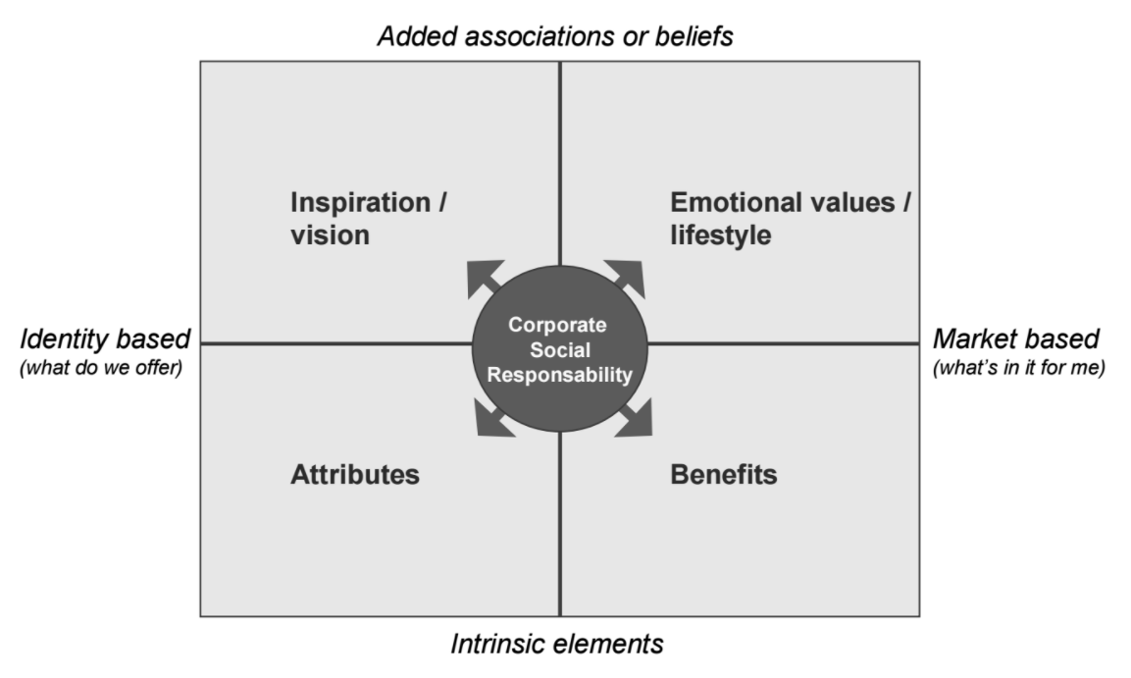
Figure 2 The CSR brand positioning grid.
This framework is then used to position corporate social performance system of the company in brand identity throughout 3 consecutive stages of branding:
- Defining the importance of CSR in brand positioning. On this stage, when the brand is being developed, the main question is how exactly the notion of corporate responsibility should resonate with the identity of the brand. Attributable positioning focuses on characteristics of the product, that reflect responsible activities of the company (e.g. product has an organic or natural composition and doesn’t contain any artificial components). Inspirational positioning links product with corporate identity or its philosophy of corporate responsibility (e.g. product is produced with environmentally friendly processes, thus reflecting company’s commitment to environment preservation). Beneficial positioning focuses on product characteristics that contribute to the welfare of its users (e.g. product provide balanced nutrition to reflect company’s commitment to healthy society and responsible consumption). Finally, emotional positioning targets the specific sectors of consumers with defined set of values and behavior, thus aligning company’s CSR principles with expectations of specific customer groups (e.g. product targeting people with environmentally-conscious lifestyle). After the identification of relevant options and the process of trade-off, company should be able to define the brand positioning, and since the described types of positioning are the extremes, company may choose more than a one in order to cover multiple segments of customers.
- Exploring CSR opportunities to support brand positioning. The same framework can be also used to identify relevant CSR issues that can be used to promote created brand. Based on the previously done brand-CSR positioning, company can focus either on responsible product development (attributable positioning), corporate social responsibility communication in mission statement (inspirational positioning), addressing relevant social issues in product development (beneficial positioning) or promoting a particular behavior among its customers (emotional positioning). As in the previous stage, company can address multiple issues at the same time.
- Developing a campaign to express the CSR of the brand. Based on previous analysis and chosen approaches to brand-CSR positioning, 4 elements of the framework can also define the principles of promotional campaigns, thus translating CSR into an attractive and effective key message by means of branding communications.
All in all, this article has provided a practical framework for reflecting corporate social performance of organization in the branding process. However, this framework has several flaws. First, one of its main assumptions is that organization should already have established corporate social performance system in place (so that the goal of framework is to put CSR in the context of branding); as a result, the problems may arise if company does not know, which stakeholder issues it should address. Second, framework defines activities, that comprise only the part of the whole process of branding and corporate social performance, focusing more on integrating CSR principles in branding than processes or results. Third, the framework does not exactly integrates corporate social performance and branding processes, but rather describes an opportunity when two functions can work together to leverage each other.
The second article on the topic of process integration of CSR and branding is “Creating a Conceptual Model for Building Responsible Brands” by J. Kujala, K. Penttilä, P. Tuominen. The authors addressed the lack of research on internal (company) perspective of responsible brand building. After the analysis of common brand building models and deriving 6 stages, authors integrated corporate social performance processes with it, thus extending defined stages to cover issues that are usually addressed by CSR function.
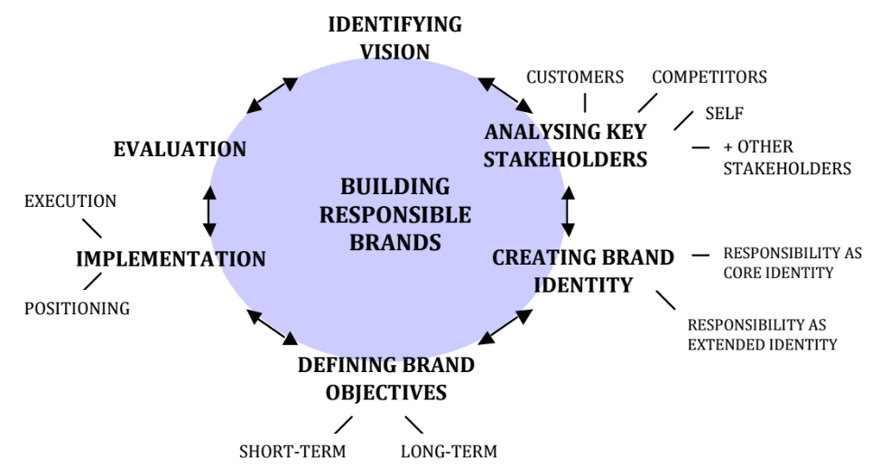
Figure 3 Conceptual model for building responsible brands.
From the first glance, it may seem that this framework fits better the conceptual integration “static CSR - dynamic branding” by adding an ethical dimension to branding process. However, the resulting brand building process perfectly fits the essence of corporate social performance, with existence of principles (that are defined at “identifying vision” stage), processes (stakeholders analysis, brand identity creation, definition of brand objectives and implementation) and results (that are expected at “evaluation” stage), thus resulting in full-scale integration of branding and corporate social performance, which may be extremely useful as a first step of CSR development within the company. Still, the main problem of this research is that it does not go further embedding corporate social performance into branding on the static perspective of principles, giving an answer to question “which principles should company follow throughout responsible brand building process”, but not giving answers to question “what actually companies should do to build responsible brand”. From this point of view, one can be misleaded in understanding the core idea of the article, perceiving it as a guideline to building “green” brands, not as framework to leverage branding by corporate social performance.
The third article is “Strategically Leveraging Corporate Social Responsibility: A Corporate Branding Perspective” by C. Vallaster, A. Lindgreen and F. Maon. The authors have taken the perspective of corporate branding (i.e. communication of corporate identity, not product one) and addressed the issue of using CSR as a long-term, sustainable differentiator for corporate brand by integrating corporate social performance activities into branding process. Analyzing 10 company cases, the authors defined 4 factors that determine CSR activities in branding:
- Initiators and drivers. Two main types of triggers drive awareness of CSR as a brand tactic: market-based, stakeholder-led factors (such that companies anticipate or respond to key stakeholder expectations and market needs) and values-based, management-led factors (usually resulting from the aspirations and efforts of individuals or groups within the company).
- Objectives. There are two types of objectives that companies pursue when engaging in CSR branding: value generation (both economic and social) and value protection (mostly economic through obtaining “license to operate”).
- Level of integration. Companies integrate CSR into branding as ingrained activity (thus embedding CSR values and principles into culture and strategy) or as add-on activity (thus remaining peripheral and being communicated only when necessary).
- Level of corporate involvement in CSR. This factor determines the perceived significance of CSR issues and, thus, attitude for reactive response (low significance) or proactive engagement (high significance).
By combining these 4 factors, authors developed Strategic CSR Brand Framework, that answered the question “how companies integrate corporate social performance into their corporate branding” and derived 4 types of CSR brands: CSR Entrepreneurs, CSR Performers, Vocal CSR Converts and Quietly Conscientious.
- CSR Entrepreneurs are brands that design their corporate identity around CSR. Usually such companies have been founded with the idea of solving a particular social issue (so-called social entrepreneurs) or they embrace the notion of corporate responsibility on organization wide level and dedicate themselves to contributing to society or their CSR endeavors are determined by the passion, vision and personality of founders. Companies that practice CSR following the Porter’s definition of creating shared value also fall into this category. In these companies CSR is an integral part of any organizational feature, including corporate brand; all their strategic agenda is determined by CSR issues.
- CSR Performers normally are established, highly visible brands, with core environmental and social responsibility values, as well as the scale and ambition to transform their industries. Although CSR principles are ingrained in their organizational culture, in many cases they engage in CSR activities not for values-based, internal reasons but rather in response to stakeholder expectations. As a result, branding and corporate social performance work hand-in-hand in order to leverage each other: branding is used to communicate CSR to target stakeholders’ groups, while corporate social performance obtains “license to operate” for brands. In this case, these two systems are not integrated, but work in parallel, thus complementing each other.
- Vocal CSR Converts are the brands that only start to fully embrace CSR in reaction to growing CSR imperative, but not yet integrated it at a systemic level. These companies have underdeveloped corporate social performance system that is perceived as an add-on activity; yet, it is market driven and determined by strategic issues of the company. As a result, they do not have a substantial credibility and may become a subject of stakeholders’ skepticism and unfavorable ethical judgement. As a result, branding becomes a supportive force in corporate social performance development, aimed at creating the identity of credible corporate commitment to responsibility and managing stakeholders’ expectations. According to research, this type of brands is usually found in companies that have a focused product portfolio (like Coca-Cola) or in companies that limit their CSR activities to creating shared value only (like Nestle).
- Quietly Conscientious follow the “silence - speaks - louder - than - words” approach and have well-set corporate social performance system, but they do not communicate it explicitly and do not reflect CSR in corporate brand. Instead, they communicate CSR on the intra-organizational level in order to enhance reputation as an employer and raise morale of personnel or use limited and specific communications targeting particular stakeholder groups based on the urgency, legitimacy and power of their claims.
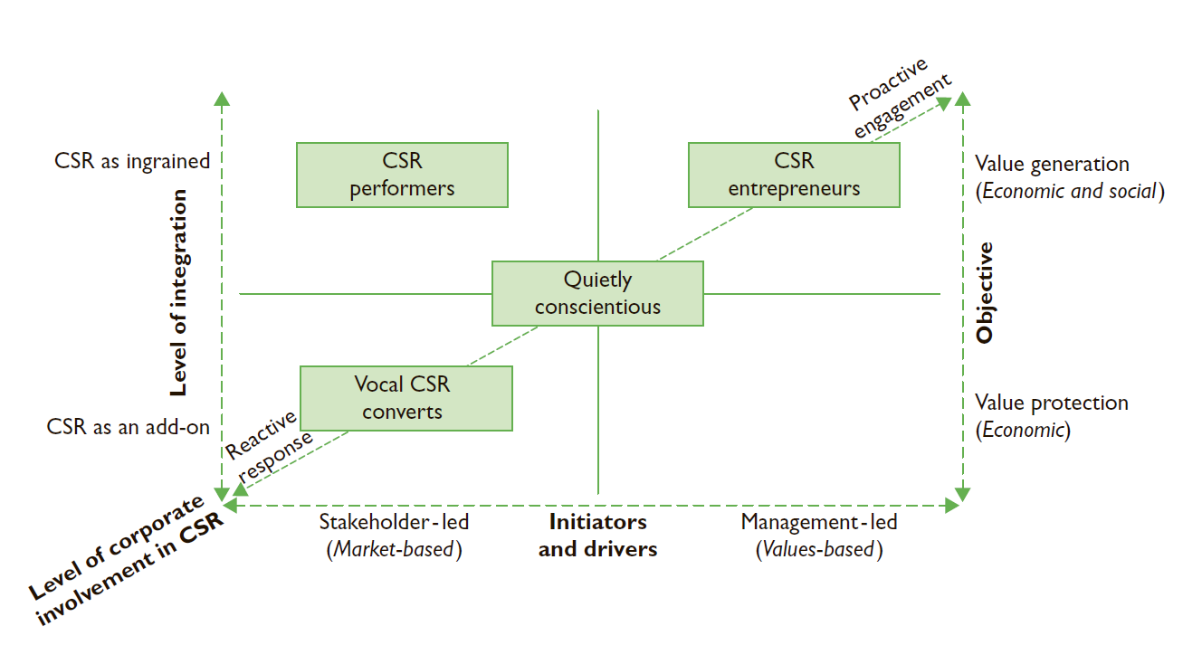
Figure 4 Strategic CSR brand framework.
This framework provided a great approach to identifying the current state of integration of corporate social performance and branding, allowing to link current practices to several factors. However, the static nature of framework, which only provides a snapshot of strategy, does not explain how actually companies can move between different strategic options. In addition, authors make a rather controversial statement that integration of branding and corporate social performance makes sense only for some companies and depends on the nature of the industry, the nature of the product offering, and the corporate culture and ethos.
To sum up the literature review on conceptual integration of branding and corporate social performance, there is a clear gap in analysis of these two topics in dynamic level, both in conceptual and empirical research. On the other hand, there is a strong demand from companies, who are willing to engage in corporate social performance, but are unable to do so due to the lack of comprehensive tools. Since the dynamic integration of brands and CSR may lead to the development of organic corporate social performance system, that is aligned with company strategy, resulting in development of advanced organizational entity that is able to generate both economic and social value, this paper will focus primarily on this branch of research. In addition, due to the strong demand from management, the current research aims to develop an integrated concept that focuses on intra-organizational perspective (how companies should develop this activity) with corporate level (not the product one) as a base for research. Thus, the research question addressed in this work can be formulated as following: how corporate social performance (as a system of CSR principles, corporate social responsiveness and corresponding results) is integrated with corporate branding (as a process of building, communicating and maintaining brand identity) within organization.

2. METHODOLOGY
The traditional paradigm of science is aimed at explaining, describing, exploring, or predicting phenomena and their relationships with each other. Management science, as a part of social science, follows this traditional paradigm, with the goal of research to explain, describe, explore or predict particular phenomena within the context of organization as an environment of managerial activities. However, unlike nature, where universal laws are able to hold true throughout millennials, organizations are more distinct and dynamic entities that constantly evolve, thus making the knowledge received from research in one context inappropriate or unreliable in another. In addition, management as system has a clear purpose of problem solving in contrast to nature, which is able to exist without purpose. As a result, any managerial phenomena evolve as a response of management system to some particular discrepancy in reality; however, this discrepancy is subjectively perceived, making it hard to link one phenomenon to another and make rigorous conclusion on their nature. All this makes traditional research in management either unreliable, or irrelevant to current objectives of management. In addition, taking into consideration the objective of this research, the identified research gap is a result of not lack of research efforts in particular domain, but merely an inability of companies to implement particular approach of integrating corporate branding and CSR at systemic perspective, and then provide a case for traditional scientific research. The non-existing phenomena is not a subject of traditional science; however, the managerial problem is in place and is not resolved. At the same time, management science should generate knowledge that contributes to problem-solving, and the modern realities demand this knowledge to be applicable and innovative, since while the process goal of management is problem-solving, the strategic goal of management is to increase competitiveness of company. Thus, traditional research method is not applicable here, since it will not allow to achieve current research objective.
Alternative to traditional science is so called design science. Originally evolved in areas of information systems, medicine and engineering, this approach was also adopted in social sciences as well. Design science was proposed by Herbert Simon, who inspired the distinction between exploratory sciences (traditional science) and the sciences of the artificial—Design Science—in his seminal work on this subject, The Sciences of the Artificial, published in 1969 (Dresch, Pacheco Lacerda, Valle Antunes Jr., 2015). The argument used by Simon to differentiate these sciences was that understanding phenomena, systems, and problems is not sufficient. Instead, a science interested in how things should be is what needed. “Design, on the other hand, is concerned with how things ought to be, with devising artifacts to attain goals” (Simon, 1969, p. 198). Artifacts are man-made entities that “can be characterized in terms of functions, goals, adaptation. Artificial things are often discussed, particularly when they are being designed, in terms of imperatives as well as descriptives” (Simon, 1969, p. 28). On the other hand, in addition to creating knowledge for further application, design science generates knowledge about “how to design”. Thus, the aim of design science is not to discover universal law that explains certain phenomena, but to discover the “cognitive process by which the design that defines them was developed” (Le Moigne 1995). But above all, the purpose of design science is to develop and design solutions for existing problems, improve systems and create new artifacts that help to achieve higher performance (Dresch, Pacheco Lacerda, Valle Antunes Jr., 2015). Another notion of design science is that it is not looking for one-to-fit-it-all optimal solution: any problem is specific, so the resulting optimal solution to this problem will be linked to its context and lacking generalization. Instead, Simon defines satisfactory solutions as “solutions that are sufficient for problems in which the optimal solution is inaccessible or impractical to be implemented” to be the main output of design science (Simon, 1969). The generalization of solutions is done to a particular class of problems - the generalized domain that represents similar types of problems (e.g. production planning and control, cost measurement, problem analysis, project management, etc.). Classes of problems are the organization that guides the trajectory of knowledge development in the design science context through consolidation of knowledge (Dresch, Pacheco Lacerda, Valle Antunes Jr., 2015). The main concepts of design science are presented below.
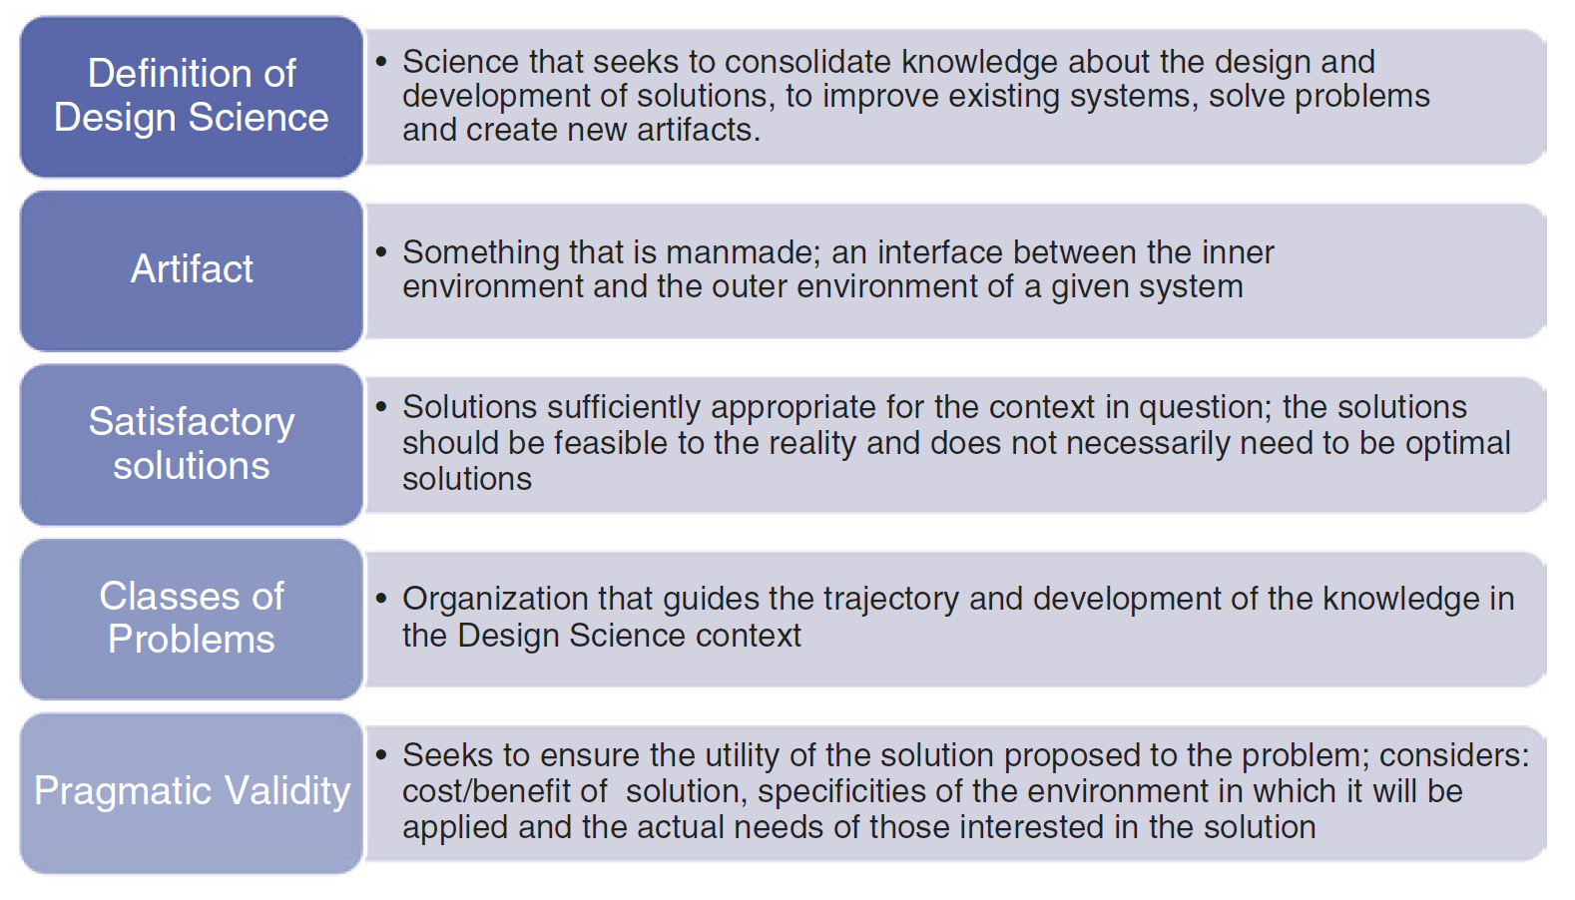
Figure 5 Main concepts of design science.

Artifacts, despite their artificial origin, should be subject to natural laws to be able to be researched in traditional science. In addition, according to Simon the problem solution comprises relationship between 3 entities: the purpose/goal, character of artifact and environment in which this artifact is applied. Moreover, artifact acts as an interface between his substance and organization (inner environment) and surrounding it context (outer environment) (Simon, 1969). Another approach of defining artifacts include 3 artifact spaces: design space, where requirements for problem solution are defined, construction space, where feasibility, value, representation of artifact are defined and artifact is being built, and use space, where usage and testing requirements are determined (Gill, Hevner, 2011). The integrated view on artifacts developed by Dresch, Pacheco Lacerda, Valle Antunes Jr. is based on approach by March and Smith (1995) and presents artifact as an entity that evolves as its applicability and internal conceptual base grows:
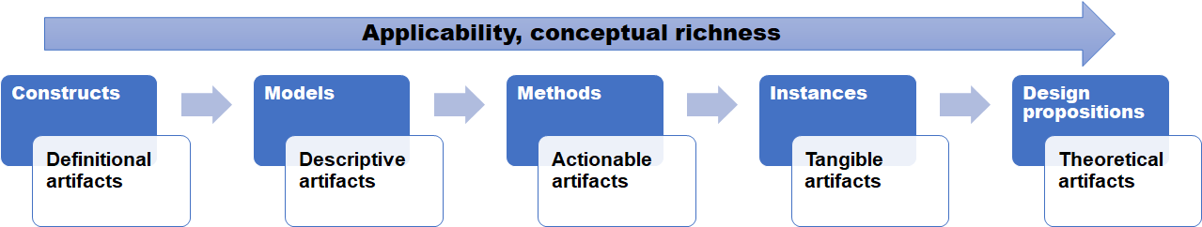
Figure 6 Integrated view on design science artifacts.
- Constructs (or concepts) are the vocabulary of domain that describe problems within the domain and specify their solutions. Moreover, constructs “define the terms used when describing and thinking about tasks”, and they can be valuable for both professionals and researchers (March, Smith 1995, p. 256).
- Models are sets of propositions that define relationships between different constructs. Being the representation of systems, models define system variables and relationships between them. However, models in design science should not necessarily describe the system accurately, but instead must be of high practical utility.
- Methods are sets of steps necessary to perform certain tasks. Methods operationalize model into actionable artifact that is aimed at specific transformation of the particular system and can be graphically represented or encapsulated in heuristics and specific algorithms.
- Instance is method realized in environment. Instance is tangible artifact that operationalizes other artifacts within the system in order to demonstrate its own feasibility and effectiveness. Instance informs users on how to implement and use artifact and its effects through providing instantiation case.
- Design proposition is instance generalized to class of problems. Design proposition provide theoretical contribution and corresponds to a generic template that can be used to develop solutions for a particular class of problems (van Aken 2011). As a result, design proposition can be later elaborated in another research to create an artifact in situation corresponding to the same class of problems or can be transformed to cover other classes of problems.
Design science is the epistemological basis for the study of what is artificial. Design science research is a method that establishes and operationalizes research when the desired goal is an artifact or a recommendation. Research based on design science can be performed in an academic environment and in an organizational context (Dresch, Pacheco Lacerda, Valle Antunes Jr., 2015). There are seven criteria that define research as a part of design science (Hevner et al, 2004):
- Design as artifact - the final product of design science research should be a viable artifact in form of construct, model, method or instance
- Problem relevance - since design science is aimed at development of scientific knowledge devoted to solution of problem, design science research produces artifacts that are relevant for identified problems
- Design evaluation - artifact should be validated for utility, quality and efficacy by means of well-executed evaluation methods
- Research contribution - despite being application-oriented, design science research must provide verifiable scientific contribution regarding the artifact, the process of its development and problem-solving, and should be grounded in theory
- Design as a research process - development of artifact should be performed within the laws governing the environment in which the problem is being studied
- Communication of the research - results of the research should be presented appropriately for both practitioners and academia
After the extensive study of existing approaches to conducting design science research, Dresch, Pacheco Lacerda, Valle Antunes Jr. (2015) propose a 11-step methodology to run design science research:
- Identification of the problem. The problem to be investigated by design science research primarily arises from the researcher’s interest in (i) a new or interesting piece of information; (ii) an answer to an important question; or (iii) a solution to a practical problem or to a class of problems. The problem relevance should be justified by researcher and then be clearly and objectively understood and defined. The output of this step is the formalized research question.
- Awareness of the problem. Before starting building the solution, the problem itself should be understood. In this step, the researcher must gather all possible information, making sure that he or she has an extensive understanding of every aspect of the problem. The researcher must understand the context of the problem, including its causes and functionalities, expected performance and operational requirements of the future artifact. To support understanding, researcher may use systematic literature review to consult the theoretical research base. The main output of the awareness step is the formalization of the aspects of the problem to be solved and requirements for artifact.
- Identification of the artifacts and configuration of the classes of problems. Since during the conduction of systematic literature review researcher may encounter already developed artifacts, these findings should be structured in order to understand, which artifacts can be used or enhanced in order to develop a better solution. In addition, existence of artifacts may uncover the existence of specific class of problems; thus, the researcher should thoughtfully understand class of problems to be able to use best practices and at the same time make research relevant to specific class of problems. The output from this stage is structured set of artifacts and classes of problems.
- The proposition of artifacts to solve a specific problem. The resulting set of artifacts developed on the previous stage may be very generic to problem discussed; that is why researcher should adapt existing knowledge for defined environment. The artifact proposition process is essentially creative, therefore abductive reasoning, previously conceptualized, is adequate for this step. The output from this stage is formalized artifact proposition.
- Design of the selected artifact. The artifact design includes the detailed description of artifact’s components and internal relationships of the artifact’s functioning, along with its limits and its relationship with the outer environment. In addition, researcher should propose clear procedures for artifact construction and evaluation, thus specifying artifact requirements and expected performance. The output from this stage is artifact design.
- Development of the artifact. At this stage researcher performs activities to construct tangible artifact, where its inner environment is being developed. There are two outputs from this stage: artifact in its functional state and construction heuristics formalized from the artifact development. It is important to know that while artifact itself is contribution of design science for problem solution, construction heuristics is contribution to science and advancing knowledge.
- Evaluation of the artifact. When artifact is built, it can be evaluated in the context of environment where problem exist. The outputs of the evaluation step include the duly evaluated artifact and the formalization of the contingency heuristics. The researcher will be able to state the limits of the artifact and its usage conditions through contingency heuristics, i.e., the relationship of the artifact with the outer environment in which the artifact will operate.
- Clarification of learning achieved. The objective of this step is to ensure that the research will be useful as reference and support for knowledge generation in both practical and theoretical fields. For this purpose, the researcher must explicitly identify the factors that have positively contributed to the research success along with the elements that have failed. The output of this step is formalized learning.
- Conclusion. This step should formally end the research process and show the results of the research and the decisions made during its conduction, as well as limitations.
- Generalization to a class of problems. The resulting artifact should be projected on the larger class of problems. This generalization allows the knowledge generated in a specific situation to be later applied in similar situations that may be faced by different organizations.
- Communication of results. The knowledge generated should be disseminated to interested parties and frequently done in form of publication in journals, trade magazines, seminars, conferences.
All in all, the whole process may be split in 3 large groups of stages: problem scope awareness (identification of problem, awareness of problem, identification of the artifacts and configuration of the classes of problems), artifact construction (the proposition of artifacts to solve a specific problem, design of the selected artifact, development of the artifact, evaluation of the artifact) and results discussion (clarification of learning achieved, conclusion, generalization to a class of problems, communication of results). At the same time, while the first and third groups are well defined, the second group of artifact construction is quite ambiguous. Thus, an adjusted approach to artifact construction will be used in this research, which is based on evolutionary view on artifact.
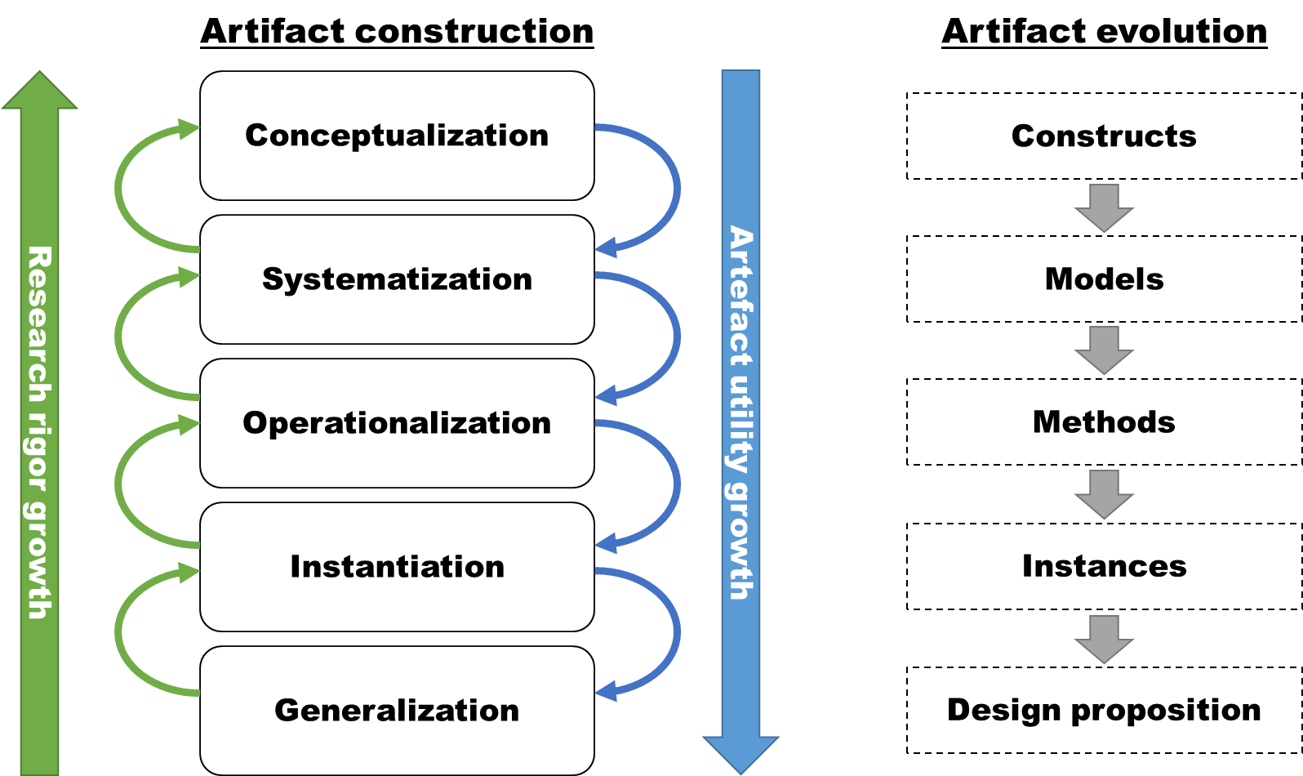
Figure 7 Artifact construction process.
- At conceptualization stage, necessary constructs are developed. Constructs are important to define or to give name to elements of system of future research product, thus becoming a theoretical underlying for the artifact at its more advanced level of evolution.
- Systematization included the aggregation of developed constructs with identification of corresponding relationships between them into a single system. The resulting system - artifact model - is theoretically proven integrative representation of phenomenon, that will appear if artifact to be implemented in real context.
- Operationalization redefines the model into the form of steps that should be performed in order to solve the stated problem. The resulting sets of steps i.e. methods are actionable artifacts that have prescriptive nature, but at the same time are based on logic and conceptual base of previously developed models.
- Instantiation operationalizes methods in specific context so that the tangible artifact is produced - instance. Instantiation includes not only the construction of specific instance, but also its evaluation. As a result, instantiation is not only the artifact in its functional state, but also results from artifact evaluation.
- Generalization corresponds to “Generalization to a class of problems” stage from the previous approach and is aimed at creating design proposition - a generalized artifact instance that can be applicable within the specified class of problems.

Conceptualization, systematization and operationalization stages produce construction heuristics i.e. requirements for the proper functioning of the inner environment of the artifact, according to the outer environment. Instantiation stage produces contingency heuristics, i.e. the context in which the artifact can be used and its performance limits. Generalization stage produces design proposition, which later should be identified with particular class of problems, which in turn contributes to the structuring of generated knowledge. Important notes should be made regarding transition between different stages: the top-down transitions (blue lines on scheme) drive artifact evolution, thus increasing its problem-solving utility, while bottom-up transitions (green lines on scheme) increase rigor of research through constant review of artifact elements. As a result, artifact construction process is iterative in its nature.
Additional notes should be made regarding artifact validation. The fragmented nature of artifact in originally proposed research process makes it unclear, which part of artefact (constructs, models, methods, instances or design proposals) should be validated. In order to make results of research viable, the researcher should demonstrate that 1) artifact is useful in problem solution and 2) artifact has logical integrity and was coherently developed. As a result, during evaluation there are two types of possible validation statements that may be made:
Validation statement 1: artifact utility is sufficient to solve the problem or class of problems. This hypothesis should be validated by artifact instance testing because:
- Constructs require validation only in terms of logical coherence and theoretical back up. The quality of constructs depends on quality of theory review (conducted e.g. by means of literature review). Thus, assuming that the corresponding theory review was adequate and sufficient, then constructs may be positively validated.
- Models do not require validation because they are results of design process and if rigor logic was used, then model will be consistent. Models should be validated when they reflect the existing phenomenon; thus, main hypothesis is that model reflects phenomenon adequately i.e. model’s variables reflect elements of phenomenon system elements and relationships between variables reflect corresponding relationships between elements of phenomenon system. However, in design science there is no phenomenon to validate against (it is the artifact that will cause a phenomenon, but analysis of this resulting phenomenon will be out of scope of design science research). Thus, model cannot and should not be validated.
- Methods are based on previously developed model, so they are a priori consistent. In addition, methods are of prescriptive nature, so their adequacy can be validated only by resulting product (instance).
- Instance must be validated. Instance validation will support the quality of all previous elements, because instance is a product of methods that are based on models. Thus, assuming that design science research was consistent (i.e. logical), the quality of instance will depend on quality of methods and underlying models. Hence, instance validation is also validation of methods and models. In case validation is negative, the process should be returned to designing models with review of constructs.
- Design proposition do not require validation because it is the generalized representation of instance, that is already validated. Design proposition should be appropriate regarding generalization process. The hypothesis is that design proposition corresponds to identified class of problems, i.e. that design proposition can be applied to design artifacts to solve issues in the same class of problems. This hypothesis can be validated only in consequent research, so it is out of scope of original design science research.
Validation statement 2: artifact was constructed with rigor process. This hypothesis should be validated by artifact construction process review. Thus, researcher may attract external audit of research process, or make the whole construction process transparent and well-documented to let third parties to validate research. In this case, the construction process can be validated by e.g. research reviewer.
The artifact construction model presented above corresponds to the requirements of design science because 1) its main goal is to develop artifact, 2) it ensures that resulting artifact is applicable and valuable for problem solution and 3) it ensures the rigor of research process. Thus, this research will use the design science research process proposed by Dresch, Pacheco Lacerda, Valle Antunes Jr. with application of modified artifact construction and validation approaches. The outline of research process is presented below.

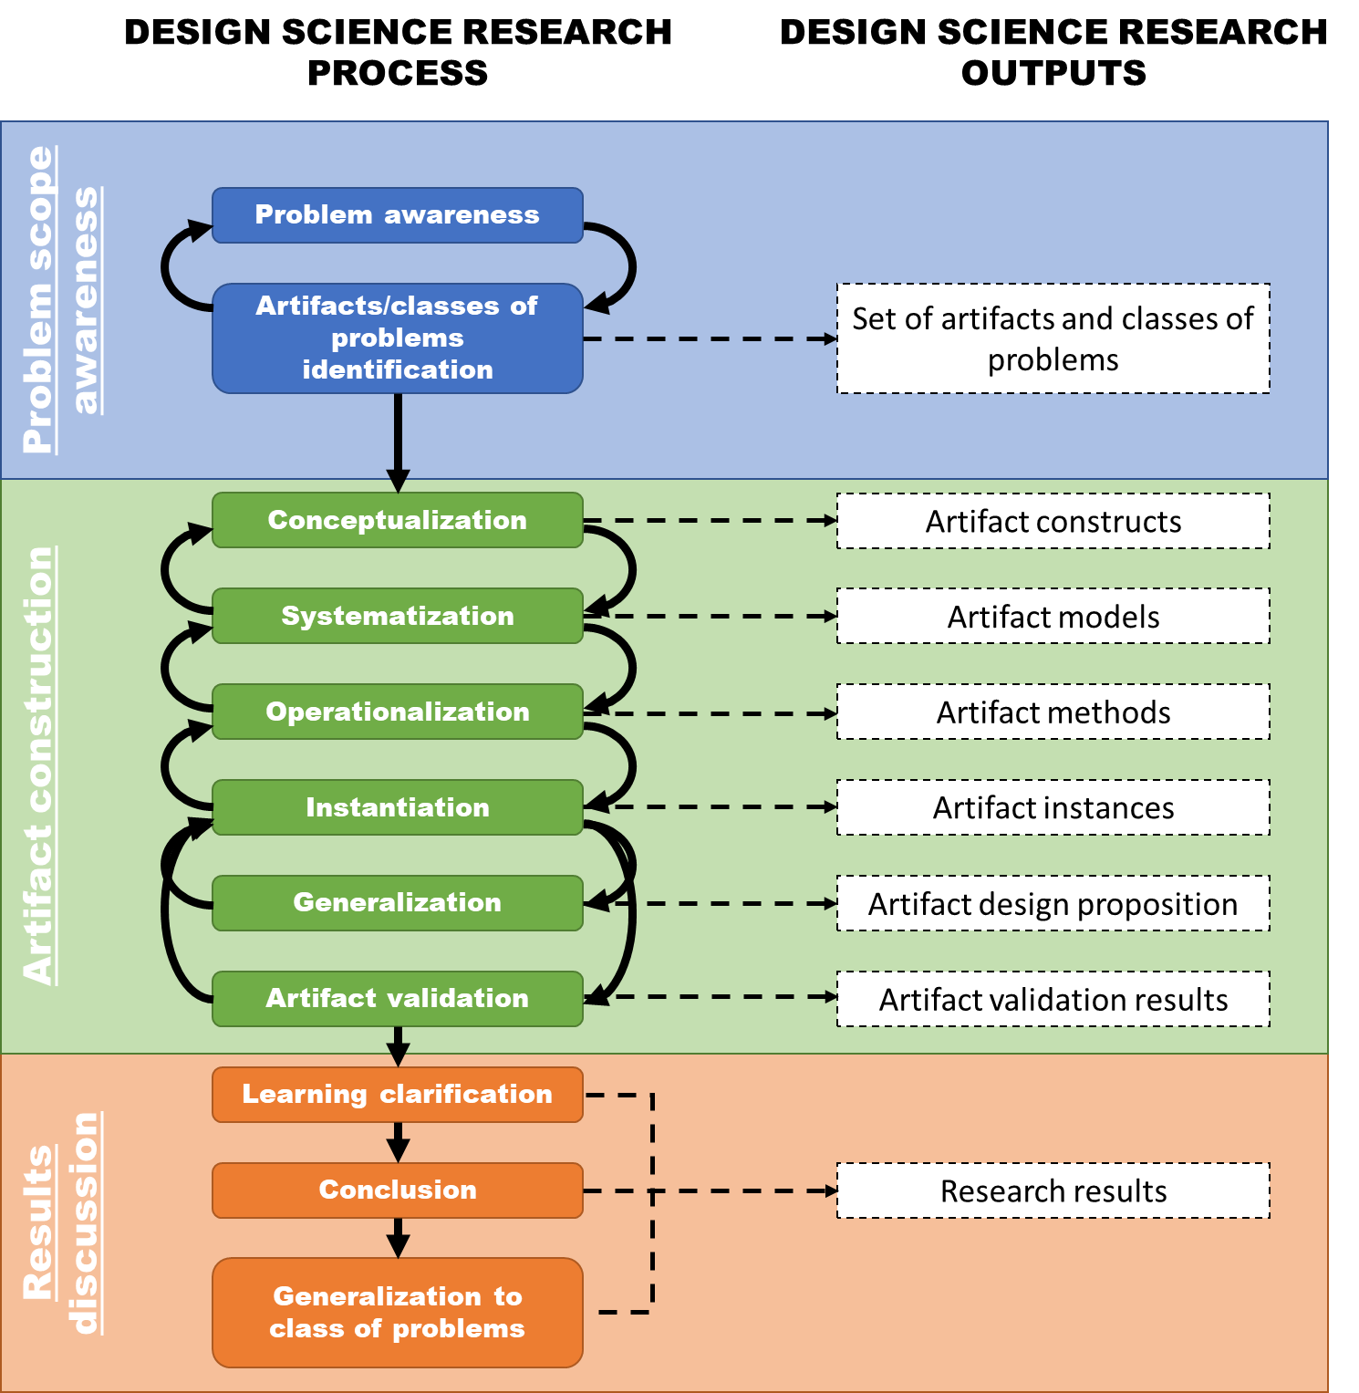
Figure 8 Design science research process.
- In the first stage “Problem scope awareness”, the qualitative content analysis of internet publications will be used with generic search queries “reasons companies do not do CSR” and “reasons of CSR failure”. The analysis of internet publications seems an appropriate method here because 1) unlike scientific works they do not require costly scientific approaches so their publications may be a more timely response to uncovered phenomenon, 2) they focus on wider public so their content is always generalized and 3) they are always based on secondary research, expert opinion or real cases to prove validity of the content. In addition, the content analysis of existing artifacts in research field will be used to identify the existing developments and classes of problems.
- In the second stage “Artifact construction”, the first 3 sub-stages will be done with heuristic techniques to design the constructs, system and methods of future artifact. The next 2 sub-stages will be performed as following:
  - The “Instantiation” will use JetBrains company as a context of artifact instantiation. This is multinational private software company that provides a very challenging case for the research. From the one hand, companies in the software industry usually have very small environmental footprint; as a result, sustainability measures are taken usually in the domain of energy consumption. In addition, being private company means that the traditionally powerful group of stakeholders - investors - are not relevant in this case. From the other hand, JetBrains was seeking to structure its fragmented philanthropy activities; however, due to the fact that the majority of company management have technical, not managerial, background, it was very hard to agree on the common approach that would be clear for everyone. Still, this company is seeking the ways to engage into activities that would develop strong relations between company, its customers and employees.
  - In “Validation” sub-stage, an expert survey will be used to test artifact instance. According to P. Pffermann, O. Levina, M. Schönherr and U. Bub (2009), expert survey, along with case study/action research and laboratory experiment, provides a reliable method to artifact validation in design science research. Moreover, the reliability of results of validation may be increased if the artifact being tested contains the features of the testing context and is evaluated by experts, who 1) belong to the testing context, 2) frequently face practical problems that artifact is aimed to solve and 3) have the power to initiate change within the testing context. In addition, since the practical problem studied in this research is that organizations cannot/do not want to engage into corporate social performance, then the solution to this problem should, first of all, stimulate this engagement, thus driving the change of organizational perception towards CSR and corporate social performance. Due to limitations of this work, this change of perception will be the object of validation, and expert surveying will provide a reliable approach to artifact validation. The survey included five Likert-scale questions, each of them assessing the quality of the artifact and first 3 artifact requirements, questions that assess the relevance and potential utility of brand for selected stakeholders’ groups and questions that assess the willingness to engage into corporate social performance. The respondents were chosen to match the following criteria:
    - The respondent should interact on a daily basis with target stakeholder groups
    - The respondent should have authority to perform activities that contribute to the development of relations with target stakeholder groups
    - The respondents should have power to initiate and drive change within organization
The functional positions of respondents included product marketing managers, production team leads, community managers, managers of special projects, PR managers and evangelists. However, due to the specifics of selected organization, company software developers were also included into target respondent group. As a control variables, functional role and place of residence were chosen. The questionnaire is presented in Appendix 1.
The final stage of design science research process “Results discussing” should summarize the main findings and developments and deliver the generalized view on artifact and the whole design science research. This stage will be discussed in conclusions to this research.

3. RESULTS DISCUSSION
Research results will be described in this chapter following the methodology defined before. The first sub-chapter will contain results from the first stage of design science research process “Problem scope awareness”, while the second sub-chapter will contain results from “Artifact construction” stage. The last part of design science research process “Results discussion” will be delivered in the next chapter.

3.1 Problem scope awareness
The previous literature review shows that there is a substantial gap in research of integration of branding and corporate social development as dynamic concepts. As it was discussed before, such phenomenon may be explained by inability of companies to effectively organize and integrate together two functions (brand management and corporate social performance management) because of their separate theoretical and practical background: while branding emerged from marketing as a reaction to changing paradigm of company-product-customer relations, corporate social performance resulted from long-lasting discussion about business ethics and place of the corporation in society. However, this inability is more attributable to corporate social performance issues rather than branding issues. The concept of brand represents a very tangible entity, which is easily understandable by company management in terms of essence and purpose; as a result, company is able to organize branding function as a system with clear elements and relationships between them, resulting in well-aligned function that follows “principles-processes-results” paradigm. In contrast, corporate social responsibility as a concept has very big ambiguity; as a result, company management either do not see any benefits and application of corporate social performance or do not understand it completely. The outcome is the same: companies are reluctant at engagement in corporate social performance and usually limit themselves to very infrequent and unsystematic philanthropy. This situation has worsened nowadays, with very active promotion and dissemination of healthy lifestyle, green products and sustainability, which from the one hand increased heavily environmental consciousness of consumers and raised expectations for corporate social responsibility, but from the other hand limited the perception of corporate social responsibility to environmental sustainability by management. As a result, companies that by nature of their business have small environmental footprint do minimal effort in developing corporate social performance. However, this perspective is incorrect, because corporate social performance addresses issues of various types of stakeholders, both external and internal, and environmental organizations and green products adepts represent only small part of them.
The applicability gap between branding and corporate social responsibility can be demonstrated by the comparison of evaluation of two activities. In branding literature, there are definitions of brand equity - set of characteristics of brand that are grounded in customers’ perception, and brand value - benefits that brand creates for corporation. Among with qualitative metrics like brand image, brand equity also defines quantitative metrics such as brand market share, while brand value frequently linked to company financial performance and measured as an amount of revenue attributable to brand. As a result, brand falls into definition of asset (resource owned by company that is able to generate economical value). In contrast, evaluation of corporate social performance is still a big issue because, as it was discussed before, 1) CSR is meant to create positive externalities, which cannot be internalized by conventional means because of the “philanthropic” element of each activity, 2) the results of CSR are taking intangible form of reputational and social effects that are hard to quantify, and 3) the results of CSR are usually deferred in time, thus creating different perception among different stakeholders and inability to link benefit to the cost. As a result, the Forbes list of top brands has a numerical “brand value” field, while the list of companies with best CSR reputation by the same Forbes is a photo gallery of images.
However, with growing concerns among consumers about the ethics of companies’ behavior, developed corporate social responsibility becomes an imperative for company of any type. The resulting core practical problem then is not just about integration of branding and corporate social performance, but rather that companies do not understand how to engage into corporate social performance considering the context of their market and organizational space. Branding here can be a mean to development of corporate social performance activity because, firstly, branding as a concept is well-grounded in management practice and, secondly, as it was discussed before, branding and corporate social performance address the common organizational objectives and use similar methods, but have different underlying logic. Theoretical question can be interpolated in the same way: from specific one of “how corporate social performance and branding are integrated” to more generic one of “how companies build corporate social performance system”.
The previously stated problem that companies do not understand how to engage into corporate social performance can arise from two types of cases: either company was unable to establish a proper corporate social performance system and ended up with abandoning the initial idea, or company somehow (personally or by observation of others) experienced failure of corporate social performance. These two types of cases could result in situation, when manager is uncertain about the value of CSR principles and processes; on the other hand, studying these two types may put a light on underlying reasons of originally stated problem. The list of publications observed with corresponding reasons uncovered is presented in the table below.
Article | Reasons (original definitions)
Why Corporations Fail to Do the Right Thing | - People lie  - People don’t talk to each other  - Safety and responsibility cost money—and no one gets rewarded for disasters averted  - Few people bear witness  - No one knows what corporate responsibility is  - Consumers won’t pay more
Why Don’t More Companies Invest in CSR? | - Wall Street incentivizes short-term profits as opposed to long-term sustainability  - The financial benefits of CSR are hard to measure  - “We already give back to the community”
Arguments for and Against Corporate Social Responsibility | - Skeptics often claim that businesses should focus on profits and let the government or nonprofit organizations deal with social and environmental issues  - Another argument is that companies are meant to create products or provide services rather than handle welfare activities.  - Also, if managers are concentrating on social responsibilities, they are not performing their primary duties for the company at full capacity.  - Finally, being socially responsible damage a company in the global marketplace. Cleaning up the environment, ensuring product safety, and donating money or time for welfare issues all raise company costs. In the end, this cost will be passed on to the consumer through the final prices of the product or service.
The problem with corporate social responsibility | The problem with an approach that lets business define corporate responsibility is that it is not grounded in a set of principles about what it means to be a responsible business. Corporate social responsibility is whatever companies want it to be, and often, what is most convenient.
5 Reasons Why Apple’s CSR Strategy Doesn’t Work | - Lack of stakeholder engagement strategy  - Lack of triple bottom line thinking  - No CSR leadership or team  - Low level of transparency  - Dated approach – Apple still doesn’t have a holistic approach when it comes to sustainability.
Six Reasons Corporate Social Responsibility Campaigns Fail | - They don’t choose causes or campaigns which naturally align with their operations, services, or message.  - They have conflicts of interest in what they promote vs. what they do (a good example of this is banks who tout “green initiatives” while still investing in projects that contribute to global environmental decline.  - Organizations place corporate social responsibility campaigns in silos or treat them as “after thoughts” vs. integrated into the company values and vision.  - Marketing and promotion of corporate social responsibility campaign is the biggest component of it.  - Measurement on actual value is absent.  - There is no effort at employee buy-in.
Corporate Social Responsibility Is Irresponsible | - First, the concept is impossibly vague  - Second, CSR is not “socially responsible” it’s an operating tax.  - Third, CSR takes support of nonprofits out of the realm of good business and into the anti-business territory of mandates and compliance.  - Fourth, companies have a fiduciary responsibility to stockholders.
Why CSR Strategies Fail: The Top 3 Myths | 1. Senior Leadership  2. Communications  3. Resources
Why You Shouldn't Jump on the CSR Bandwagon | - Lack of trust  - Wrong reasons for doing CSR  - No CSR leadership within company  - Lack of long-term orientation
Advantages and Disadvantages of Corporate Social Responsibility | - Shift from the Profit-Making Objective  - Company Reputation takes a hit  - Customer Conviction  - Increase in Cost of Production
Arguments for and against Corporate Social Responsibility | Most arguments both for and against CSR are based on how a company's attempts to be socially responsible affect its bottom line.  - Milton Friedman and other conservative critics have argued against CSR, stating that a corporation's purpose is to maximize returns to its shareholders  - Other critics, rather than targeting the concept of CSR, point to examples of weak CSR programs.
Volkswagen And The Failure Of Corporate Social Responsibility | - we are asking companies to self-regulate  - majority of people see CSR as superfluous, a luxury that mustn’t get in the way of making profits  - The people who head these (CSR) departments must be made responsible for their companies’ actions  - board of directors is irresponsible
Unilever And The Failure Of Corporate Social Responsibility | - CSR activities were not supported by partnering NGOs  - focus on social matters distracts from addressing core business challenges  - CEO’s eagerness to put superficial feel good policies ahead of sound business decisions
Table 4 Overview of researched publications.
The analysis of reasons uncovered from internet publications indicates that there are common points in all of them. Firstly, the definition of corporate social responsibility remains ambiguous not only for company stakeholders (which partly may be caused by improper communications), but also for company management, which is a more complex problem. As a result, company usually follows the most “trendy” or “easy” definition of CSR such as philanthropy, cause-related marketing, green product development or, in the best case, sustainability, but without taking into consideration organizational context and real expectations of stakeholders. Secondly, CSR is usually perceived as the discretionary activity that has anything in common with the main goal of business of making profits. This corresponds to M. Friedman’s view on corporate responsibility dated back to 1970; however, this view still provides an argument for not engaging into corporate social performance. As a result, CSR exists on organizational periphery with no connection to business itself (Porter, Kramer, 2011). Linked to this is the third point: there are difficulties in measuring impact of corporate social performance. Managers are struggling to link expenditures on CSR to financial indicators of performance, while stakeholders are unable to see clear value for society. As a result, corporate social performance is viewed as cost center, with final customers bearing this cost of corporate responsibility. The fourth point is improper or insufficient stakeholders’ management. Companies are unable to identify relevant stakeholders, their expectations and usually fail at their proper engagement into corporate social performance. As a result, CSR initiatives address wrong issues and do not achieve set objectives, with costs being perceived as wasted. Finally, the last point addresses the problem of CSR leadership within the company. Corporate social performance affects the whole organization, so C-suite involvement is an imperative, intra-organizational communications and change management are the necessity and CSR department empowerment to be implemented. The lack of CSR leadership or unwillingness to engage into it certainly leads to corporate social performance failure.
The discussed problems above should become a basis for the development of the artifact aimed to solve the original problem. This basis can be described in a set of high level requirements for functional features of the future artifact:
- The artifact should provide organization and its stakeholders with clear and mutually agreed definition of corporate social responsibility
- The artifact should link corporate social performance to business activity of organization
- The artifact should provide organization with tools to measure social and business value of corporate social responsibility
- The artifact should provide an effective approach to stakeholders’ management and engagement
- The artifact implementation should lead to CSR empowerment within organization
The identified list of artifact requirements can be used to structure the overview of existing artifacts and corresponding classes of problems.
The artifact should provide organization and its stakeholders with clear and mutually agreed definition of corporate social responsibility
As it can be seen from the literature review, the active discussion of the essence of corporate social responsibility resulted in multiple views on CSR and its ambiguous perception by both management and stakeholders. As a result, companies engaging into corporate social performance were trying to formalize their understanding of CSR as a set of principles documented in a code of conduct that becomes a base for CSR policy.
There are numerous guidelines for developing an effective code of conduct, which are usually elaborated by management consultancies, business ethics research institutions and associations or government regulators. For example, Deloitte Corporate Governance Services define the following recommended elements of code of conduct:
- An introductory letter from the senior leadership team or CEO that sets the tone at the top and defines the importance of ethics and compliance to each employee and the company
- The company’s mission statement, vision, values, and guiding principles that reflect the company’s commitment to ethics, integrity, and quality
- An ethical decision framework to assist employees in making choice
- A listing of available resources for obtaining guidance and for good faith reporting of suspected misconduct
- A listing of any additional ethics and compliance resources and/or the identification of supplementary policies and procedures and their location.
- Enforcement and implementation mechanisms that address the notion of accountability and discipline for unethical behavior.
- Generic examples of what constitute acceptable and unacceptable behavior could be included to further explain risk areas
Network for Business Innovation and Sustainability (NBIS) defines 12 steps of code of conduct implementation:
- Endorsement
- Integration
- Circulation
- Personal Response
- Affirmation
- Contracts
- Regular Review
- Enforcement
- Training
- Translation
Institute of Business Ethics has its own IBE 9 Step Model for developing and implementing a code of conduct:
- Understand your context
- Establish board level support
- Articulate your core (ethical) values
- Find out what bothers people
- Choose your approach
- Draft your code
- Test it
- Launch it
- Monitor it
Administration of New South Wales (Australia) provides a following checklist for code of conduct of public sector agencies:
- Does your organization have a code of conduct?
- Was your organization’s code of conduct developed in consultation with a range of staff from various areas of the organization, and with key external stakeholders?
- Was your organization’s code of conduct negotiated in good faith with relevant union bodies or staff associations?
- Does your code include the standard topics from the Premier’s Department Model Code of Conduct?
- Have you included additional topics to meet the particular needs of your organization?
- Does the code provide a range of practical examples and guidance for dealing with ethical issues?
- Is the code written in clear, straightforward language?
- Does the code have a personal and positive tone rather than a focus on compliance and discipline?
- Do you clearly communicate the content of the code to all staff and stakeholders on a regular basis?
- Do senior managers actively promote the code and lead by example with regard to ethical conduct?
- Is the code actively reinforced throughout the organization using promotional strategies?
- Are new provisions included in the code as the need arises?
- What methods do you use to assess the use staff make of the code and how has it affected the ethical culture of the organization?
- Do you regularly review your code of conduct and update it when necessary?
The well-formulated and communicated code of conduct, thus, should become a tangible container of CSR principles identified by management, that should be used to deliver the clear definition of corporate social responsibility, thus avoiding ambiguity of this term.
The artifact should link corporate social performance to business activity of organization
Creating Shared Value (CSV) concept developed by M. Porter and M. Kramer represent the most popular and mainstream approach to corporate social performance, that explicitly links principles of corporate social responsibility to business activities. From the first publication on strategic philanthropy, authors addressed the problem of discretionary nature of corporate social performance and gap between CSR issues and business performance. The process of building a well-focused philanthropy strategy Porter and Kramer divide into five stages:
- Examine the competitive context in each of the company’s important geographic locations
- Review the existing philanthropic portfolio to see how it fits this new paradigm
- Assess existing and potential corporate giving initiatives against the four forms of value creation
- Seek opportunities for collective action within a cluster and with other partners
- Rigorously track and evaluate results
In the next publication, Porter used his two previous developments - value chain and “diamond” model - as tools of mapping social issues, which can be addressed by company to raise its own competitiveness, thus creating business value through strategic CSR.
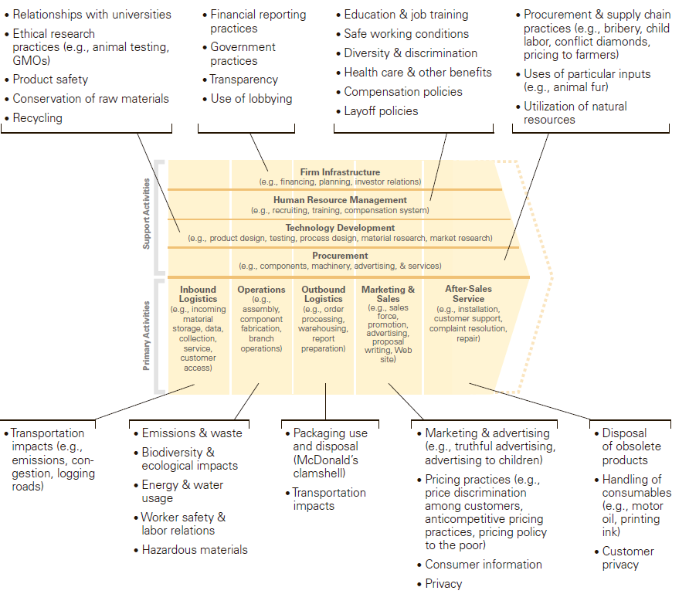
Figure 9 Mapping the social impact of the value chain.
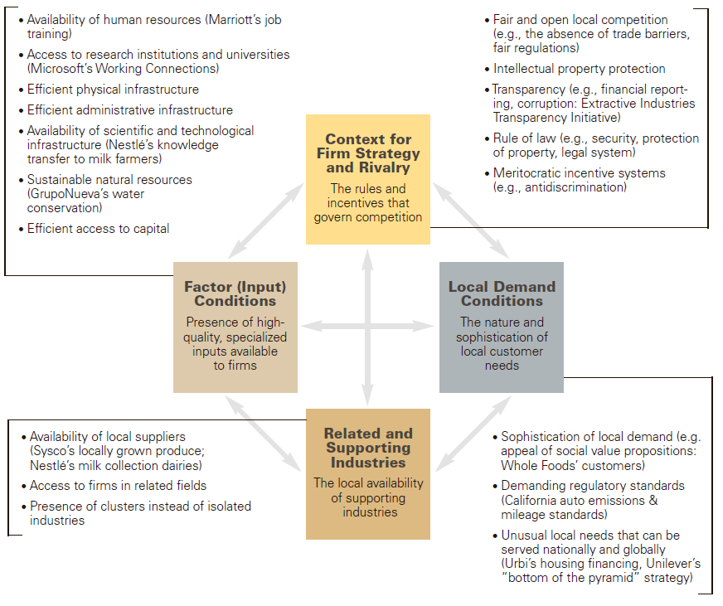
Figure 10 Social influences on competitiveness.
The concept of CSV itself provides a framework to generate business value by solving social issues through:
- Reconceiving products and markets - instead of using marketing communication to create demand for the product and stimulate consumption, companies can turn their attention to the problems and demands of society and to offer products that meet these needs (Danone useful food products for health, Intel and IBM solutions in the field of energy saving, microcredit)
- Redefining productivity in the value chain - the company can avoid the social problems that affect the efficiency of the value chain and create internal costs through their decisions (reduction of fresh water consumption of Dow Chemicals, Nestle strategy towards suppliers of coffee beans)
- Enabling local cluster development - the company can invest in solving the problems of the region in which they operate in order to achieve synergies (Nestlé’s support of coffee producers, Yara’s investment in transport infrastructure in Africa)
Later, the consultants of Foundation Strategy Group (a consultancy established by Porter to promote CSV concept) M. Pfitzer, V. Bockstette and M. Stamp developed a framework for implementing CSV organization:
- Embedding a social purpose
- Defining the social need
- Measuring shared value
- Creating the optimal innovation structure
- Co-creating with external stakeholders
It should be noted that any theory of strategic CSR can be used to justify the link between corporate social performance and company business performance. However, it is the approach developed by Porter and Kramer that got a wide popularity and practical implementation among large corporations.
The artifact should provide organization with tools to measure social and business value of corporate social responsibility
Non-financial reporting got a wide applicability among corporations to structure and communicate results of corporate social performance. To fulfill a demand for structured and accepted approach to deliver a reliable and trusted non-financial reports, several organizations developed well-defined international standards of non-financial reporting. For example, GRI’s Sustainability Reporting Standards defines the disclosure of the following elements:
- Economic: economic performance, market presence, indirect economic impacts, procurement practices
- Environmental: materials, energy, water, biodiversity, emissions, effluents and waste, products and services, compliance, transport, supplier environmental assessment, environmental grievance mechanisms
- Social: labor practices and decent work, human rights, society, product responsibility
The Sustainability Accounting Standards Board (SASB) provides another framework for non-financial reporting, which includes disclosure guidance and accounting standards on sustainability topics for use by US and foreign public companies in their annual filings (Form 10-K or 20-F) with the U.S. Securities and Exchange Commission (SEC). SASB’s disclosure guidance identifies sustainability topics at an industry level which —depending on the specific operating context of a company — may be material to a company within that industry. SASB’s accounting standards provide companies with standardized metrics to account for performance on industry-level sustainability topics. CDP provides framework for reporting of environmental initiatives for climate change, supply chain, water and forests.
Foundation Strategy Group, mentioned above, also contributed to issue of measuring results of corporate social performance by providing conceptual framework that has the following steps (Porter, Hills, Pfitzer, Patscheke, Hawkins, 2013):
- Identify the social issues to target
- Make the business case
- Track progress
- Measure results and use insights to unlock new value
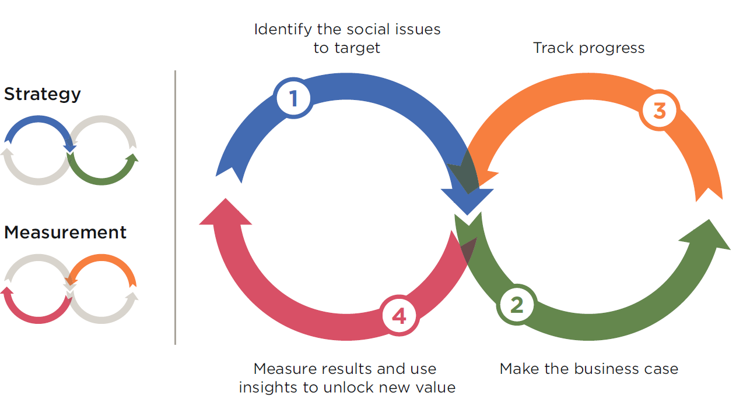
Figure 11 Integrating Shared Value strategy and measurement.
McKinsey’s consultants Tracey Keys, Thomas W. Malnight, and Kees van der Graaf (2009) developed a matrix that should help companies to plot business and social benefits of corporate social performance according to their time frame (long term-short term) and ability to quantify (tangible-intangible). This matrix should help not only in planning stage, but also in future measurement of corporate social performance results for both business and society.
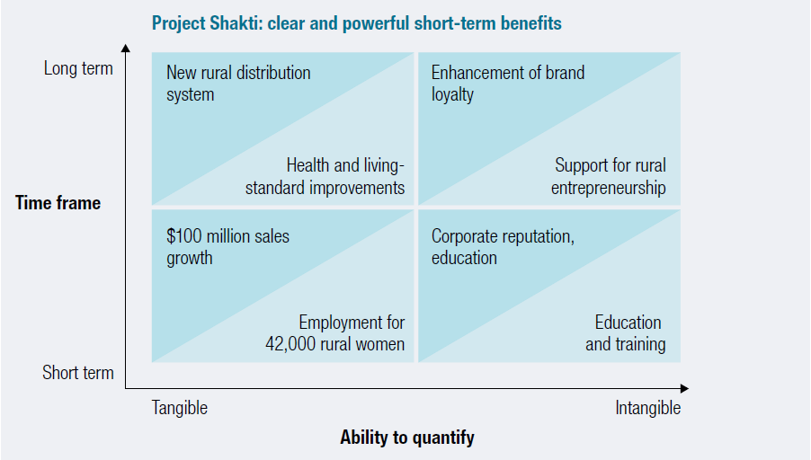
Figure 12 Plotting the benefits.
To sum up, CSR evaluation is still a very complicated topic with underdeveloped instruments of measurement of business and social benefits of corporate social performance.
The artifact should provide an effective approach to stakeholders’ management and engagement
The discussed in literature review dynamic capabilities perspective on strategic CSR (Post, Preston, Sachs, 2002) provides a holistic approach at identification of main groups of stakeholders that company has. According to model, stakeholders can be divided into groups of resource base (employees, customers, shareholders), industrial structure (partners, unions, suppliers and regulative bodies) and social-political environment (citizens, communities, governments, NGOs), with corporation as the central element of stakeholders’ network. In conjunction with traditional classification of stakeholders according to their power, legitimacy and urgency of claim (Mitchell, Agle, Wood, 1997), this model can be used in analysis and prioritization of company’s stakeholders.
AccountAbility AA1000 Stakeholder Engagement Standard provides guidelines for stakeholders’ engagement, which are based on AA1000 AccountAbility Principles Standard, and consist of iterative cycle with the following steps:
- Plan: Profile and map stakeholders, Determine engagement level(s) and method(s), Identify boundaries of disclosure, Draft engagement plan, Establish indicators
- Prepare: Mobilize resources, Build Capacity, Identify and prepare for engagement risks
- Implement the engagement plan: Invite stakeholders to engage, Brief Stakeholders, Engage, Document the engagement and its outputs, Develop an action plan, Communicate engagement outputs and action plan
- Review and improve: Monitor and evaluate the engagement, Learn and improve, Follow up on action plan, Report on engagement
There are also numerous professional recommendations how to engage specific groups of stakeholders. For example, SustainAbility experts propose the following approach to engage company’s investors:
- Foster an alliance with your company’s Sustainability / CSR / Citizenship team
- Identify intersections between sustainability issues and your business model
- Ask investors what language and metrics they use
- Prioritize which surveys to respond to
- Build on existing tools and channels
- Be proactive
All in all, the main objective of effective stakeholders’ engagement is 1) identification of relevant stakeholders’ groups and their issues and 2) establishing proper channels of communication.
The artifact implementation should lead to CSR empowerment within organization
It is a common practice to empower specific people or departments within organization that drive the development of corporate social performance system. However, in this case the effective development will depend on the adequacy of competences of CSR leaders. The study by E. Osagie, R. Wesselink, P, Runhaar, M. Mulder (2017) that was focused on competence development of corporate social responsibility leaders uncovered the fact that that CSR leaders most often engage in learning activities that involve “learning through social interactions” (like discussions and collaborations). In addition, learning goal orientation might play a central role in promoting the competence of CSR leaders in leading the CSR implementation process. Authors make proposition that by facilitating self-directed learning by CSR leaders, companies can help nourish external learning networks. Also, companies should recruit employees with a strong learning goal orientation in order to drive the changes needed for CSR implementation.
R. du Preeze and L. van Zyl (2015) in pursue to develop a questionnaire to assess CSR leadership identified the following competences necessary for CSR leaders:
- Monitoring the external CSR environment
- Monitoring the internal CSR environment
- Developing a challenging CSR vision
- Conceptualizing CSR strategy
- Developing CSR performance plans
- CSR leader self-discovery, reflection and self-awareness
- CSR leader personal growth and development
- Empowering organizational members
- Optimizing processes and structures
- Articulating the CSR vision
- Inspiring and motivating organization members
- Building trust and demonstrating integrity 12
- Demonstrating decisiveness and hardiness
- Acting entrepreneurial
- Displaying sound interpersonal skills
- Facilitating interdepartmental coordination
- Influencing across external boundaries
- Reviewing CSR performance
- Acknowledging and celebrating CSR performance
P. Hind, A. Wilson and G. Lenssen (2007) while analyzing the development of CSR leaders introduced the concept of “reflective abilities” i.e. some “keys” mediating between quality of leadership and leader behavior as combinations of emotional and intellectual capacity and identified these abilities attributable to effective CSR leaders:
- systemic thinking;
- embracing diversity and managing risk;
- balancing global and local perspectives;
- meaningful dialogue and developing a new language; and
- emotional awareness
Thus, existing research and publications demonstrate that for proper CSR empowerment within organization the development of CSR leaders is needed. The identified competences can become a basis for the development of corresponding leadership programs within organization.
To finalize the analysis of existing artifacts, classes of problems for each artifact group can be identified. The consolidated result is presented in the table below.

Requirements group | Artifacts | Classes of problems
The artifact should provide organization and its stakeholders with clear and mutually agreed definition of corporate social responsibility | Deloitte Corporate Governance Services Guidelines, NBIS Guidelines, IBE 9 Step Model, governmental guidelines for code of conduct composition | Code of conduct development and communication
The artifact should link corporate social performance to business activity of organization | Creating Shared Value, Value Chain, Diamond Model | Strategic CSR implementation
The artifact should provide organization with tools to measure social and business value of corporate social responsibility | GRI’s Sustainability Reporting Standards, The Sustainability Accounting Standards Board (SASB) standards, CDP standards, FSG valuation model of CSV, McKinsey CSR benefits matrix | CSR measurement
The artifact should provide an effective approach to stakeholders’ management and engagement | Dynamic capabilities strategic CSR model, AccountAbility AA1000 Stakeholder Engagement Standard | Stakeholders’ management
The artifact implementation should lead to CSR empowerment within organization | CSR leadership competences, reflective abilities | CSR leadership development
Table 5 Summary of artifact requirements, research existing artifacts and classes of problems.

3.2 Artifact construction
Conceptualization
The five requirements for artifact discussed in the previous chapter indicate that the solution of the stated problem may lay in integration of branding at the corporate level with corporate social performance. First of all, corporate brand is a representation of values that company wants to deliver to its target audience. The principles of corporate social responsibility can be easily embedded into brand value system, while brand as a powerful communication tool can effectively deliver this principles to stakeholders. Secondly, corporate brand has the objective of company differentiation and, as a result, increasing company competitiveness, which makes corporate branding issues of strategic importance, i.e. that is able to generate differentiated value for relevant stakeholders in a long-term perspective. Thus, linking corporate social performance to corporate branding will link the former to business itself. Thirdly, brand as a more or less tangible and quantifiable entity could be used for corporate social performance measurement as well, with brand equity and brand value as a base performance indicator. Fourthly, brand is a highly visible entity, which besides functional values also incorporates emotional values. As a result, better stakeholders’ engagement can be achieved if not only rational “functional” dimension of engagement, but also emotional one as well. Finally, multifunctionality of corporate branding within organization may lead to wider intra-organizational involvement, and if corporate social performance is linked to branding, CSR leadership may be accepted faster, thus leading to better CSR empowerment.
The base concept for artifact construction proposed here is named Strategic Corporate Responsible Branding (SCRB), which incorporates the previously discussed concepts of corporate social responsibility, corporate social performance, strategic CSR and branding. Strategic Corporate Responsible Branding is a managerial approach to corporate social performance (defined as a system of CSR principles, organizational processes and corresponding results) by the means of corporate branding (defined as a process of building corporate brand identity to raise corporate brand value) in a way that provides generation of differentiated value for relevant stakeholders of the company. The four elements that make up the concept are defined as follows:
- Strategic means that the main objective of process is to solve strategic (i.e. corresponding to doing things differently from competitors and addressing needs of relevant stakeholders’ groups) issues
- Corporate means that the subject of the process is corporation as a whole (not product)
- Responsible means that the company accepts that it bears particular type of responsibility towards its stakeholders and is subject to ethical judgement, with the goal of establishing corporate social performance system as a system of CSR principles, organizational processes and corresponding social and business results
- Branding means that the ultimate goal of the process is to define, build, communicate brand identity and to manage brand equity in order to create an emotional and relational connection between company and its target stakeholders, which later should be transformed into brand value.
The main output of the process is Strategic Corporate Responsible Brand - an entity that integrates company identity with functional values (values associated with utility benefits of stakeholders’ identification with brand), emotional values (values associated with any type of non-functional social, personal or professional benefits of stakeholders’ identification with brand) and corporate social responsibility, thus delivering the promise of functional, emotional and ethical experience. While functional and emotional experience definitions here are used in traditional interpretation derived from existing branding literature, ethical experience is a new concept, that can represent a subset of both functional and emotional benefits, that are resulted from stakeholders’ identification with corporate social responsibility values of the company. For example, consumers may benefit their health by using products of the company that are produced with principles of dedication to natural components (functional experience), at the same time, they may enjoy green processes that company wants to establish because of their eco-consciousness (emotional experience). Or investors may become wealthier due to company’s orientation to strong financial performance (functional experience) and enjoy company’s efforts of establishing responsible labor practices (emotional experience). In both cases, Strategic Corporate Responsible Brand delivers ethical promise to stakeholders, that addresses their needs and, thus, fulfills their expectations. However, while Strategic Corporate Responsible Brand is a touchpoint between company and its stakeholders, implementation of corporate social performance activities within Strategic Corporate Responsible Branding will ensure that ethical experience promise will be actually fulfilled by company. As a result, Strategic Corporate Responsible Branding should align the whole company organizational system and management to provide quality products and/or services, emotional benefits and ethical value proposition to stakeholders, thus benefiting to society, and strong differentiating factor for company’s competitiveness, thus benefiting to company.
The following generic concepts are taken from their original research areas and will be used to support the conceptual basis of the proposed Strategic Corporate Responsible Branding concept.
- Corporate social responsibility - deontological responsibility that is attributable to corporation towards the specific societal groups
- Corporate social performance - the system of CSR principles, corporate social responsiveness and corresponding results that contributes to the development of corporate social responsibility of the company
- Strategic perspective - the perspective that addresses the creation, delivery and capturing differentiated value for relevant stakeholders’ groups
- Stakeholders - the specific group that affects and/or is affected by company’s performance
- Brand - augmented identity of specific entity that incorporates functional and emotional values and is aimed at delivering promise of experience to relevant stakeholders
- Branding - the process of brand identity building and delivery, brand equity development with the goal of brand value generation
- Brand equity - awareness, reputation, perceived personality, values and imagery of brand that contribute to brand value generation
- Brand value - the business benefits that are generated by brand
The discussed above concepts are the structural representation of the artifact being developed in this design science research. In the next stage, the model that integrates the discussed concepts (constructs) into a unified system will be elaborated.
Systematization
The model of Strategic Corporate Responsible Branding incorporates 4 perspectives of integrative branding/corporate social performance process, that follows the well-established paradigm of principles-processes-results: organizational perspective, brand perspective, stakeholders’ perspective and value perspective. The resulting model, then, integrates them all into a single system, with organizational perspective setting up principles and providing processes of creating, communicating and managing Strategic Corporate Responsible Brand; brand perspective representing the tangible output of previous organizational processes, the container of previously defined principles and point of interaction between company and its stakeholders; stakeholder perspective containing the processes of stakeholders’ interaction with Strategic Corporate Responsible Brand; and value perspective defining the generation and dissemination of value resulting from interaction with Strategic Corporate Responsible Brand. The high-level model of Strategic Corporate Responsible Branding is presented below.
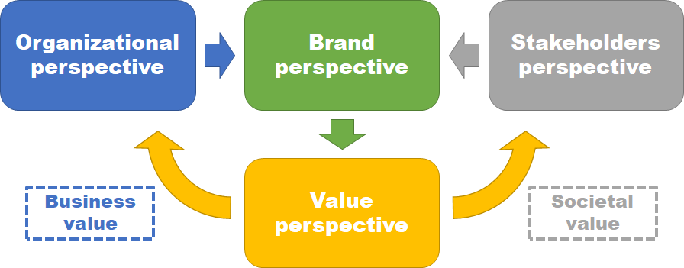
Figure 13 High-level model of Strategic Corporate Responsible Branding.
As it was discussed before, corporate branding and corporate social performance address the same organizational issues and solve the same strategic objectives, which can be summarized to the following: establishing and maintaining strong relationship with stakeholders by addressing relevant needs and expectations. The difference between two functions is the approach: while branding defines value proposition based primary on internal organizational resources, competences and capabilities, corporate social performance defines value proposition in response to external needs and expectations of relevant stakeholders groups. However, the integration of these two functions may create a holistic approach to stakeholders’ management that unites both internal capabilities-based and external expectations-based perspectives. As a result, through branding process, which is based on previously defined branding principles, company will engage in corporate social performance based on previously defined CSR principles, which in turn should contribute to the branding process and development of Strategic Corporate Responsible Brand. This cyclical process will deeply embed corporate social performance and CSR principles into corporate branding process and branding principles, thus leading to:
- Clarification and objectification of corporate social responsibility in corporate brand
- Linking corporate social performance to corporate brand performance and, thus, organizational performance
- As a consequence of the latter, ability to measure corporate social performance by the means of brand equity and brand value assessment
- Integration of stakeholders’ value proposition communications within unified channel
- Linking the development of corporate social performance to the development of corporate branding, thus making it easier to promote and empower CSR
As it can be seen, the resulting effect of corporate social performance/corporate branding integration corresponds to the five artifact requirements elaborated earlier. Thus, this approach can be used to solve the originally stated problem. The organizational perspective on Strategic Corporate Responsible Branding is presented in scheme below.
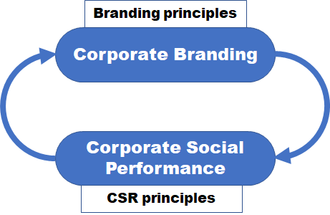
Figure 14 Organizational perspective on Strategic Corporate Responsible Branding.
The output of Strategic Corporate Responsible Branding process within organization is Strategic Corporate Responsible Brand - the tangible representation of value proposition and main touch point between organization and its stakeholders. As it was discussed before, Strategic Corporate Responsible Brand is an entity that integrates company identity with functional values (values associated with utility benefits of stakeholders’ identification with brand), emotional values (values associated with any type of non-functional social, personal or professional benefits of stakeholders’ identification with brand) and corporate social responsibility, thus delivering the promise of functional, emotional and ethical experience. At the same time, functional and emotional values in their pure form are based on branding principles that are previously defined by corporate branding, while CSR values are based on CSR principles developed throughout corporate social performance. Moreover, these three types of values can interact with each other, thus creating mixes of functional-ethical (e.g. environmentally friendly ingredients that contribute to health), emotional-ethical (e.g. sustainable operations that contribute to well-being of planet and humanity) and functional-emotional (nutritious products that are associated with particular lifestyle) combinations of values and corresponding experiences. However, the central element should be the corporate identity, so that stakeholders could associate the delivered experience with the company itself. Strategic Corporate Responsible Brand, being connected to Strategic Corporate Responsible Branding organizational process, should generate the same effects that correspond to artifact requirements, thus contributing to solution of originally stated problem. The outline of brand perspective on Strategic Corporate Responsible Branding is presented below.
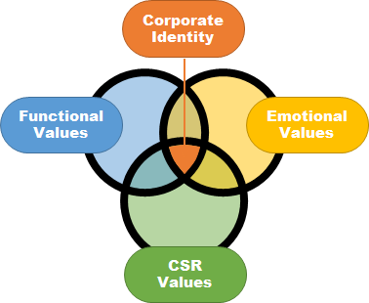
Figure 15 Brand perspective on Strategic Corporate Responsible Branding.
The scope of stakeholders’ perspective on Strategic Corporate Responsible Branding is the process of stakeholders’ interaction with values and identity delivered by Strategic Corporate Responsible Brand. On the one side, stakeholders have specific personal needs (defined resulting from discrepancy between expected and perceived states of reality) and corresponding expectations about company’s behavior, that are determined by their value orientation. On the other side, the values of brand stakeholders interact with are personificated and objectified into certain experience, which hold functional (extracting functional utility from interaction with brand), emotional (extracting social, personal or professional benefits) and ethical (extracting benefits from alignment of personal ethical values with the ones proposed by organization i.e. association with social responsibility) nature. The interaction between these two elements is done in a form of alignment of existing stakeholder’s needs, expectations and values with delivered functional, emotional and ethical experiences, which results in stakeholder’s identification (in case of successful alignment) or disintegration (in case of unsuccessful alignment) with brand and corporate identity. As a result, Strategic Corporate Responsible Brand engages stakeholders not only in branding process, but also in corporate social performance. This perspective addresses the requirements of CSR definition communication and stakeholders’ management through branding. The stakeholders’ perspective on Strategic Corporate Responsible Branding is presented below.
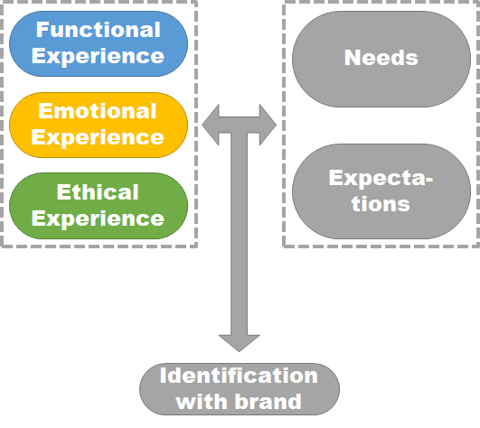
Figure 16 Stakeholders’ perspective on Strategic Corporate Responsible Branding.
Finally, stakeholders’ identification with brand and, thus, engagement into underlying activities that have defined brand value proposition will generate two value streams. The first stream represents the development of brand equity - awareness, reputation, perceived personality, values and imagery of brand. The developed brand equity will generate brand value in terms of customers loyalty, employees’ motivation, suppliers’ preferences and general corporate image, which, in turn, creates business value of increased revenues and decreased costs. The second stream results from fulfillment of needs and realization of expectations of stakeholders. Since stakeholders actually represent the personification of relevant to company social (in broad definition) issues, through addressing stakeholders’ issues company addresses relevant social issues, thus generating social value. As a result, Strategic Corporate Responsible Branding delivers both business and social value; moreover, the assessment of these two types of value can be linked as well (because brand equity will not develop without stakeholders’ needs fulfillment; thus, assessment of brand equity can be used to assess needs fulfillment and, ultimately, amount of social value generated). Thus, this perspective addresses the requirements of linking corporate social performance to business activity of organization and measurement of social and business value of corporate social responsibility. The value’ perspective on Strategic Corporate Responsible Branding is presented below.
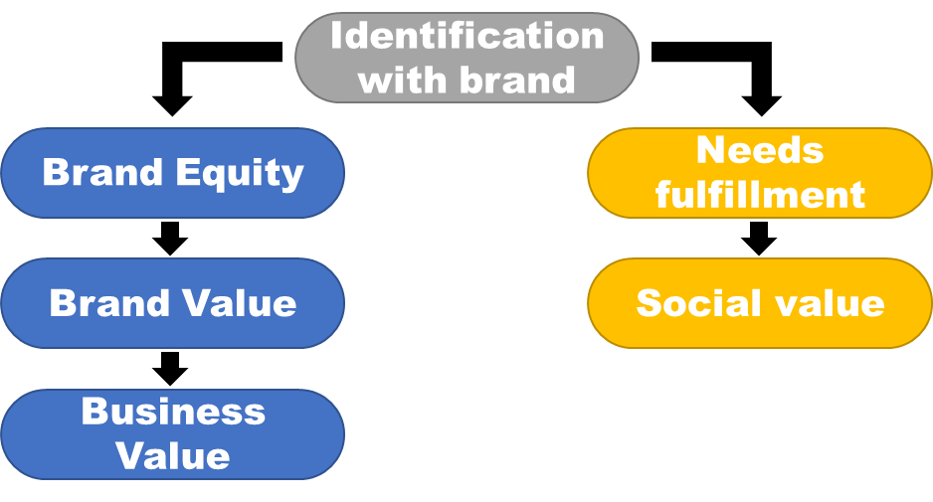
Figure 17 Value perspective on Strategic Corporate Responsible Branding.
To sum up, the resulting model of Strategic Corporate Responsible Branding defines the system that includes organization, its stakeholders, corporate brand as the touch point between them and generated streams of business and social value, thus following the paradigm “principles-processes-results” and integrating internal organizational and external stakeholders’ environments. The outline of detailed model of Strategic Corporate Responsible Branding is presented below.
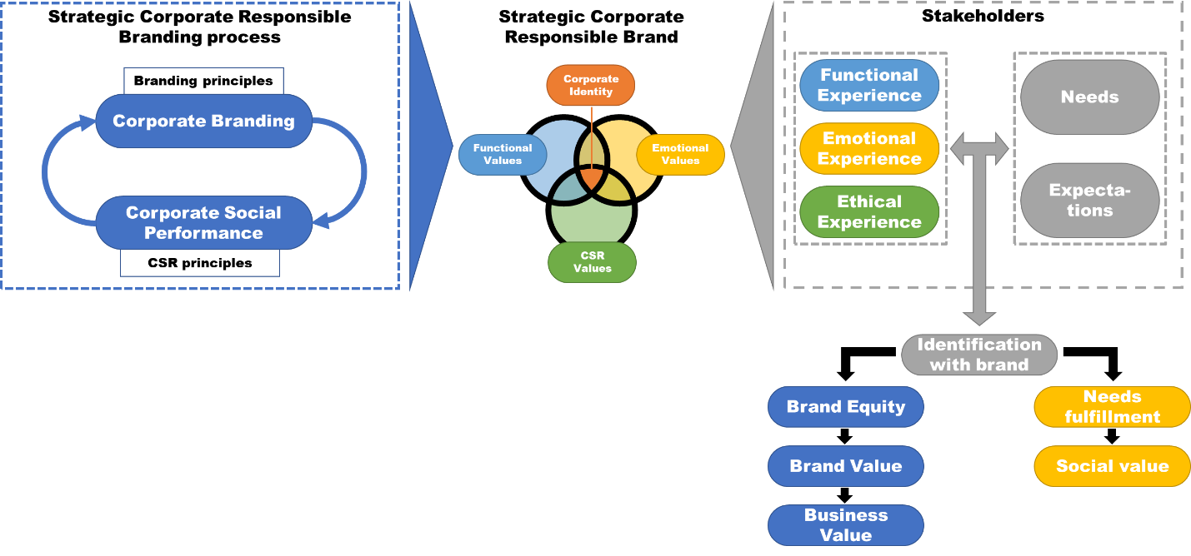
Figure 18 Strategic Corporate Responsible Branding model.
Operationalization
In order to be able to build the Strategic Corporate Responsible Branding system, the previous model should be operationalized in a form of methodology. This stage of artifact construction should provide practical prescriptive guidance that is grounded in scientific base developed on previous stages of design science research, thus bridging theoretically focused artifact concepts and artifact model and practice focused artifact instance.
- Defining brand strategic objectives
Any initiative that holds strategic nature such as developing corporate brand should have well defined objectives, that should have both short-term and long-term objectives. However, in terms of branding and corporate social responsibility, long-term objectives should have higher priority due to the longevity of the development process and higher returns and power of well-established brand equity, which is deeply grounded in stakeholders’ minds. At the same time, short-term objectives can be set to achieve preliminary results and should be used merely to track the overall development process and to make necessary adjustments than to reap quick profits or fragmented social impacts. At this stage two departments - corporate branding and corporate social performance - should agree on the common vision of the future Strategic Corporate Responsible Brand and negotiate on the interaction mechanisms that will be established to manage Strategic Corporate Responsible Branding process. The more specific agenda should be formulated within departments separately, with corporate branding defining more business-related objectives of future brand and corporate social performance defining objectives that are related to the development of corporate social responsibility of organization. The reason for this separation is justified by the expertise level that the professionals of two department frequently have; in addition, separate goal setting should facilitate in formulation of two sets of objectives, that are not biased by each other. However, since the target output has strategic importance, the engagement of top management and management of lines of business is a must; as a result, it will contribute to the empowerment of corporate branding/CSR within organization, which is one of the essential requirements. The resulting output from this stage is a formulated set of business and CSR objectives with preliminary milestones, which are backed up by defined strategic vision, mission and underlying values.
- Defining brand value proposition mix
Once the objectives are set, the development of brand identity can be started from definition of its value proposition mix, that consists of functional, emotional and ethical values. However, since the success of the brand will be defined on organizational opportunity to deliver these value and associated experiences to relevant stakeholders, the thorough analysis of organizational resources, capabilities and competences on the one hand, and analysis of stakeholders’ needs and expectations on the other are required.
In majority of cases organizations that are willing to develop corporate brand and corporate social responsibility should already know what core competences they have. In this case, these competences should become a base for development of functional brand values and relevant emotional brand values that can be derived from existing knowledge and relational experience with customers/suppliers/partners. The important point here is that any brand values are perceived by brand user as corresponding experience promise; thus, each defined value should be based on organizational ability to deliver experience related to this value. As a result, the value formulation process should be performed in close collaboration with business functions that will deliver product or services to the final consumers to ensure that corresponding experience can actually be delivered. In case when organization does not know its own core competences, then the appropriate research should be done. Moreover, the results of the analysis may lead to some adjustments in the way company performs; thus, the corporate branding can become a leading transformational force that will contribute to shaping new strategy of organization.
The analysis of stakeholders’ environment represents a more complex task for organization. Firstly, the stakeholder perspective today is developed and used primarily in big corporations, whose diverse stakeholders’ groups require management to adopt stakeholders’ management practices, while medium and small companies have smaller impact on society and, thus, have limited number of powerful stakeholders’ groups, whose issues they address in the course of normal operations. Secondly, identification of needs and expectations requires a careful analysis of stakeholders’ current issues and underlying motivation; the advanced profiling techniques, such as personas, can be effectively used here. Thirdly, the prioritization of stakeholders is a long-lasting problem in stakeholders’ management: different stakeholders usually have different, frequently contradicting to each other, needs (e.g. consumers expect prices to be low while employees demand high salaries and shareholders - high returns); thus, it is a prerogative of organization to define, which stakeholders’ claims to address and which - to decline. However, if needs and expectations of relevant stakeholders are defined, they will become a strong foundation for elaborating ethical and relevant emotional values that can be used in brand value proposition mix.
- Building brand identity
Strategic Corporate Responsible Branding is very distinctive approach to developing corporate brand in a sense that it follows the principle that corporate brand can generate value only if organization is able to deliver the appropriate experience that is promised by brand values to brand users. Thus, Strategic Corporate Responsible Brand identity (defined as distinctive brand characteristics that objectivize embedded brand values) should be developed with engagement of practically whole organization. Corporate branding department should be responsible for the design part of brand identity development i.e. taking corporate identity, functional, emotional and ethical values and objectivizing them into tangible brand identity elements such as brandmarks, sequence of cognition, wordmarks, letterform marks, pictorial marks, abstract marks, emblem, characters and look and feel that are supported by defined brand identity vision, meaning, authenticity and differentiation. At the same time, to support functional and related emotional value proposition, corresponding lines of business should work to deliver expected experience for brand users (e.g. product development departments should implement expected functionality in the product or customer support should deliver expected quality of service), while to support ethical and related emotional value proposition the department responsible for corporate social performance should develop and implement appropriate CSR initiatives. As a result, Strategic Corporate Responsible Brand aligns the whole organization to fulfill the needs of relevant stakeholders through deliverance of differentiated functional, emotional and ethical benefits. At the same time, brand identity is built not only with “traditional” business operations such as production of goods and services, but also with corporate social performance. This statement provides a strong justification for using corporate social performance to solve strategic issues of organization.
- Implementing brand identity
After brand identity was defined and value proposition supporting activities have been established, company can start brand implementation stage. Here, companies should consider performing two big groups of tasks: brand positioning and brand communication. Brand positioning refers to the development of unique vision by brand users on brand that makes brand perception distinctive from the brands of competitors. In other words, brand positioning should ensure that the message that brand delivers to its users is clear and differs from the ones of competitors. The great approach to brand positioning is proposed by B. Brüggenwirth in article, that was discussed in literature review. Following the concept of means-end chain, Brüggenwirth developed a positioning grid consisting of 4 quadrants located across 2 dimensions:
- Identity based (‘what do we offer?’) – market based (‘what’s in it for me?’)
- Intrinsic elements – added associations or beliefs
The great benefit of this model is that it can actually be used not only to position ethical dimension in brand, but also to position functional and emotional dimensions as well. Thus, pure attributable positioning can be used in cases, when stakeholders are more interested in specific features of entity than the entity in a whole (product ingredients, philanthropy campaigns details). Pure inspirational positioning will be useful when company goal is to create a community around its identity, while pure beneficial positioning can be used when stakeholders are demanding to see clear benefits of identification with brand, both functional, emotional and ethical. Finally, pure emotional positioning will be useful in cases when company wants to build tight bonds with existing community or to identify itself with specific culture. As it can be seen, attributable and beneficial choices of brand positioning are stakeholders-driven, while inspirational and emotional choices are company-driven.
Figure 19 The CSR brand positioning grid.
Brand communication can be performed with conventional marketing techniques, such as advertising, social media marketing, direct marketing, integrated marketing communications, etc. However, the communication of ethical value proposition should be performed with great caution due to the risk of being perceived as hypocrisy or “greenwashing”. On the other hand, numerous researches in this area (put here references) demonstrate that the main cause of such negative perception is either that the promoted ethical values are not in line with needs and expectations of relevant stakeholders, or that corporate social performance activities have fragmented and unsystematic nature. Thus, the through preliminary analysis of stakeholders’ needs and following the model of Strategic Corporate Responsible Branding in organization of corporate social performance will solve this issue.
- Evaluating brand
Evaluation is always the most complicated issue in any managerial practice, including branding and corporate social performance. However, adoption of Strategic Corporate Responsible Branding approach can provide a structural base for development of assessment frameworks, that should be later adjusted for the requirements and context in each specific case. This structural base is the statement that Strategic Corporate Responsible Branding generates two streams of value: business and social. Business value can be defined as positive effects, that ultimately lead to either increase in revenues and/or decrease of costs. The easiest approach to assess business value is to use brand evaluation techniques, that in their most general definitions consist of measuring brand performance through assessment of brand equity features (how well awareness, reputation, perceived personality, values and imagery of brand are developing) and measuring brand value through analysis of causal relations between brand equity features and business effects (customer attraction/retention, sales dynamics, employee turnover, supplier contract conditions etc.). The observed business effects can be easily converted into financial representation, and confirmed causal relations will link brand performance with financial performance of the company. Social value measurement is much complicated issue because, as it was discussed before, 1) CSR is meant to create positive externalities, which cannot be internalized by conventional means because of the “philanthropic” element of each activity, 2) the results of CSR are taking intangible form of reputational and social effects that are hard to quantify, and 3) the results of CSR are usually deferred in time. However, given the consideration that all business value is concentrated in brand equity and brand value, the task of measuring social value is focusing to continuous monitoring, discovering and communicating social effects of Strategic Corporate Responsible Branding. As a result, the above-mentioned problems of CSR valuation are being solved because 1) the business effect is internalized in brand equity with social effects remaining externally, 2) business effects are quantified with brand assessment while social effects are measured qualitatively and 3) continuity of brand monitoring and social effects monitoring will help to uncover both short-term and long-term business and social value. Thus, integration of corporate branding and corporate social performance according to the model of Strategic Corporate Responsible Branding will give a clear understanding of generated benefits, with business value internalized by brand, and social value remaining in external environment.
Instantiation
In order to test the validity of research, the artifact instance should be constructed. Instance is a method realized in real context. As a result, artifact instance is a single case of artifact implementation; thus, it is the subject to bias and subjectivity which result from the specificity of the context instance is put into. However, being developed following the methods that, in turn, are based on theoretical model developed before, artifact instance should contain all underlying theoretical knowledge. As a result, artifact instance can be considered as a valid object for future assessment of the artifact in general.
The artifact instance is a presentation-proposal of new Strategic Corporate Responsible Brand “JetBrains Unite”, that should become the base for the whole Strategic Corporate Responsible Branding process. The instance contains the basic points regarding brand strategic objectives, brand value proposition mix, approaches to valuation, as well as brand identity designed. In addition, some clarifications were given on the process how actually this brand was constructed and how it can be used to generate value. As a result, practically all stages of Strategic Corporate Responsible Branding methodology were covered (“Defining brand strategic objectives”, “Defining brand value proposition mix”, “Building brand identity” - with limitations, “Evaluating brand” - with limitations). Due to sensitivity of some information that was used the whole presentation will not be included in this work. The sample slide is presented in Appendix 2.
Validation
The survey was distributed digitally with presentation-proposal through specialized channels in corporate messenger. Respondents were asked to look through the presentation and to complete the survey at the end. Out of 125 non-unique clicks, 52 entered the survey with 43 completing it (82.7% completion rate). The functional roles distribution of respondents and their physical location are presented below.
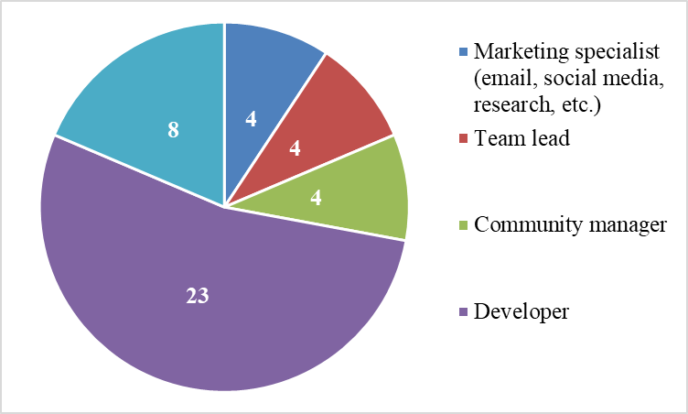
Figure 20 Respondents functional roles distribution.
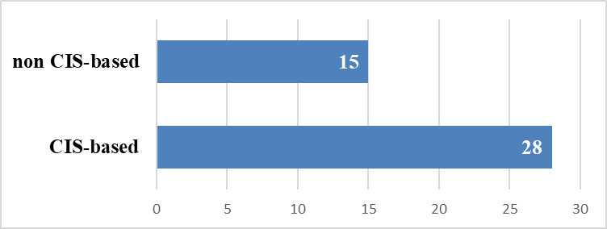
Figure 21 Respondents physical location distribution
The responses on the block of questions that define the quality of developed artifact instance are presented below.
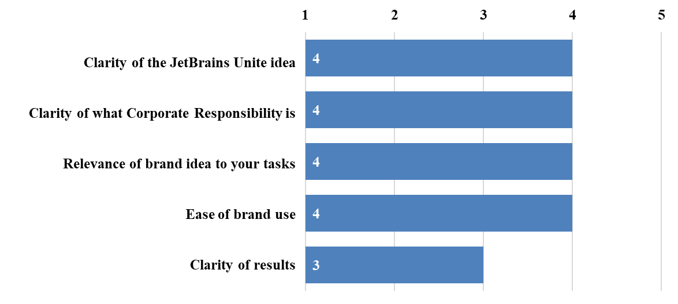
Figure 22 Survey results on artifact instance quality (medians, n=43).
The responses on the assessment of selected groups of stakeholders and potential impact of new brand implementation are presented below:

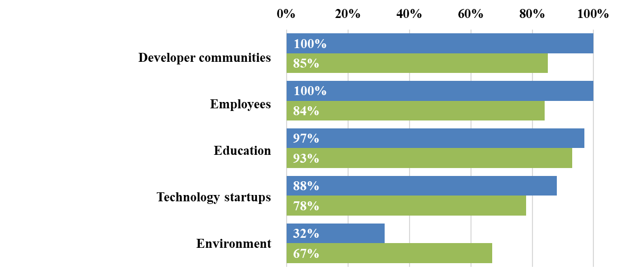
Figure 23 Survey results on stakeholders’ relevance (blue bars) to company and brand potential utility (green bars) for stakeholders (% of positive responses, n=43).
The summarized results of the responses on willingness to engage into corporate social performance by participation (passively) and by initiatives organization (actively) are presented below.
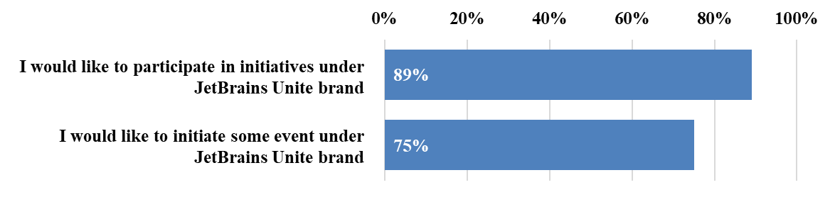
Figure 24 Survey results on predisposition to passive and active engagement into corporate social performance (% of positive responses, n=43).
To sum up, the developed artifact instance received high scores on majority of quality control questions (with median value of 4 out of 5 maximum value); in addition, due to the fact that the majority of surveyed respondents do not have any managerial education, such a high results demonstrate that the concept of Strategic Corporate Responsible Branding is able to deliver clear idea, purpose and definition of CSR to wider audience, thus supporting the first artifact requirement. Moreover, clear relevance of new brand to tasks of respondents indicate that its potential CSR initiatives will be relevant to business performance, thus supporting second artifact requirement. The moderate responses on “clarity of results” show that there is still space for further improvements regarding social and business value assessment; however, due to the fact that only high-level approach to value assessment was presented along with the sensibility and complexity of the topic, the third artifact requirement can be considered fulfilled with certain limitations. Positive responses on stakeholders’ relevance and brand potential utility demonstrate that Strategic Corporate Responsible Branding allows to identify most relevant stakeholders’ groups and develop an approach that will generate value and address their real needs and expectations. Thus, the fourth artifact requirement can be supported. Finally, positive responses on passive and active engagement into corporate social performance demonstrate that Strategic Corporate Responsible Branding is able to motivate organization to develop and execute corporate social performance system; thus, the last artifact requirement is also supported.
The results that are discussed above do not take into consideration any control variables (functional role and physical location). The main reason for this approach is that the professional and behavioral profile of JetBrains employees is consistent across the whole organization (which is very typical for modern software companies). However, to test this assumption, Mann-Whitney non-parametric test was used to check whether there are any differences in scores between different functional groups (empowered with decision-making: marketing specialists, team leads and product marketing managers; and not empowered with decision making: developers) and between the different context of residence (CIS and non-CIS). Tests were performed using IBM SPSS software. The results show that there are significant (at .05 significance level) differences only for brand relevance to tasks between empowered and non-empowered roles (which can be explained by the fact that only empowered roles use branding in their everyday tasks) and for brand idea clarity between CIS and non-CIS residents (this can be attributable to organizational specifics). In other cases, there was no significant difference in responses between different groups of respondents. The results of tests are presented below.
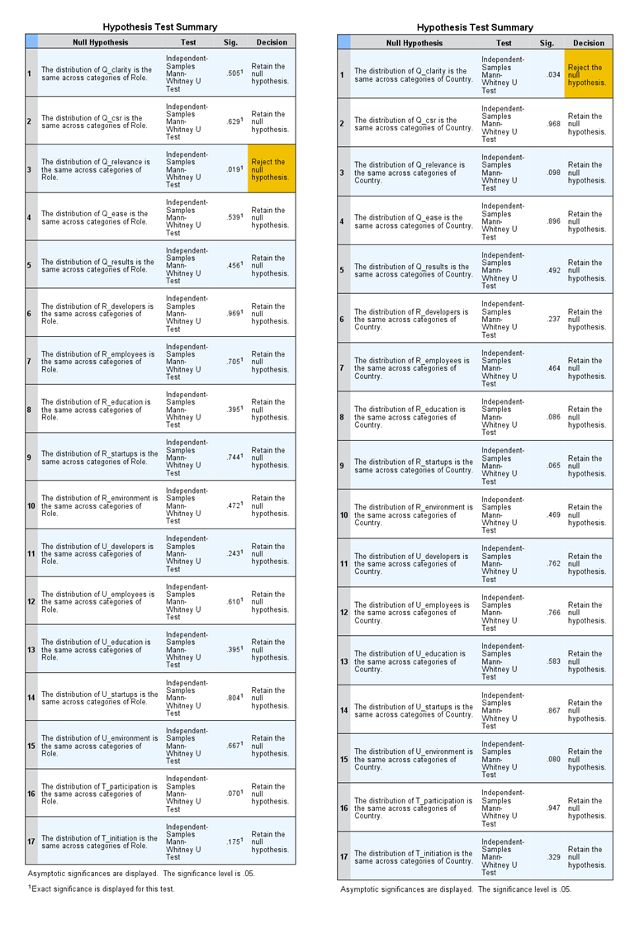
Figure 25 Results of Mann-Whitney non-parametric tests for different functional roles (left) and place of residence (right).

To sum up, results of artifact validation prove its high quality and support the hypothesis that Strategic Corporate Responsible Branding is able to provide a holistic approach to engagement into corporate social performance.
Generalization
Generalization is actually an answer to the research question that design science is aimed to address. The research question of this work was derived from the literature gap and was defined as “how corporate social performance and branding are integrated”. Following the artifact construction heuristics, it can be seen that object that integrates corporate social performance and corporate branding is Strategic Corporate Responsible Brand, which, in comparison to traditional approaches to brand as a container of functional and emotional values that communicate the promise of functional and emotional experience, adds third “ethical” dimension to brand with corporate social responsibility of organization as a base for brand ethical value proposition and corresponding ethical experience promise. As a result, since this promise should be always supported by real actions, organization finds a justification to engage into corporate performance with the help of corporate branding; hence, two functions start to work hand-in-hand to achieve common strategic goals.
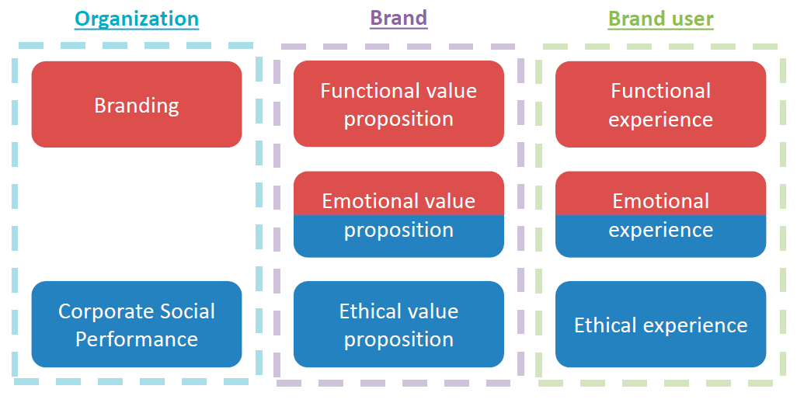
Figure 26 Strategic Corporate Responsible Branding generalization.

CONCLUSIONS
The process of research demonstrated that the theory underlying the concept of corporate social responsibility and corporate social performance is too diverse to create the unifying approach to the existing managerial problems. Thus, it is important to give clear and explicit statements of all related definitions, such as corporate social responsibility, corporate social responsiveness, corporate social performance, ethics, stakeholders, needs, social impact/value. Without these statements, the researcher may get lost in his own research. Second factor that contributed to design science research process of this work is a system thinking to the phenomena being studied. Because problem scope awareness should identify a “root” practical problem and artifact construction evolves from static perspective on constructs and models to dynamic perspective on methods and instances, the phenomena being studied should be perceived as system, with more focus in research on relationships and causal connections rather than separate elements of the system. Another important point is that all design science research, despite the fact that it is the scientific method that should create generalized knowledge, should be performed with keeping in mind the context where phenomena exists. All in all, the results of design science research should be practically applicable, and sometimes some particularities of context can generate new ideas for artifact construction. As a result, practices like Toyota’s Genchi Genbutsu (現地現物, “Go and See”) or Design Thinking can contribute a lot to research heuristics, as well as researcher’s practical experience in the field of study. However, the key to success here is to find balance between practical applicability and theoretical reliability. Finally, approach to artefact validation should be chosen wisely and reflect the objectives and desired outcome of research.
The objective of this research was to develop a conceptual framework that would allow to integrate corporate branding with corporate social performance of organization. Following design science research, a multilevel artifact named Strategic Corporate Responsible Branding was constructed, which includes definition of core concepts, multiperspective systemic model, methodology for planning, designing, delivering and evaluating by organization, instance that can be applicable in specific context and generalized scientific knowledge that can be used in the following research. The “Validation” and “Generalization” stages of artifact construction process deliver the following results:
- Strategic Corporate Responsible Branding is able to integrate corporate social performance and corporate branding into organic organizational system that would work towards achieving the goal of establishing and maintaining strong relations between organization and relevant stakeholder groups. As a result, Strategic Corporate Responsible Branding can be used to help organizations to engage into corporate social responsibility development
- Strategic Corporate Responsible Branding provides scientific contribution to the theory of corporate social responsibility and corporate branding by giving insights on the phenomena of integration of corporate social performance (defined as the system of CSR principles, corporate social responsiveness and corresponding results that contributes to the development of corporate social responsibility of the company) and branding (defined as the process of brand identity building and delivery, brand equity development with the goal of brand value generation) into the system that is aimed at development of relations between company and relevant stakeholder groups by the means of embedding ethical value proposition and ethical experience promise into brand.
Another contribution of this work is the design science research methodology that was used here. Due to the very vague definitions of approaches to design science research, this work provides an improved methodology that is mainly based on the evolutionary nature of artifact. Thus, this work can be used as a reference material on how to use design science research.
However, this work is a subject to several limitations. Firstly, the artifact validation used very high-level approach of expert survey, which, though being reliable, provides only evaluation of change of perception towards CSR. More advanced validation techniques such as case study, action research or experiment can be used to test, whether the relationships described in the model will remain the same in real context. Secondly, artifact validation was performed in single context; thus, future research may focus on implementation cases in multiple context for proof of validity. Thirdly, Strategic Corporate Responsible Branding provides only general approach to assessment of business and social value generation. As a result, the future research may discover more specific approaches for value assessment. In addition, Strategic Corporate Responsible Branding does not define the change management process that should take place through framework adaptation within organization. The development of approaches to effective cultural and organizational transformation will provide a great contribution to this work. Lastly, another big chunk of research may be dedicated towards the implementation of Strategic Corporate Responsible Branding principles in the domain of product branding.
This work can be used to solve several big classes of problems. Firstly, it addresses issues of corporate social responsibility/corporate social performance development by giving insights on how management can introduce these new processes into organization. Secondly, this work deals with issues of corporate brand development by providing guidelines on creating specific version of corporate brand, that addresses the needs of larger stakeholder groups. Lastly, this work gives insights on one of the most challenging topics of CSR problematics - CSR valuation - by describing generated value streams and providing general approaches to value assessment.

LIST OF REFERENCES
- Ackerman R. W. 1973. How companies respond to social demands. harvard Business review 51 (4): 88-98.
- Ackerman R. W., Bauer R. A. 1976. Corporate social responsiveness: the modern dilemma. harvard University Press: Cambridge (MA).
- Anna Blombäck, Christina Scandelius, (2013) "Corporate heritage in CSR communication: a means to responsible brand image?", Corporate Communications: An International Journal, Vol. 18 Issue: 3, pp.362-382, https://doi.org/10.1108/CCIJ-07-2012-0048
- Ansoff H. 1979. The changing shape of strategic problem. Journal of General Management 4 (4): 42–58.
- Bader, Cristine. "Why Corporations Fail to Do the Right Thing", The Atlantic. Accessed September 21, 2017. https://www.theatlantic.com/business/archive/2014/04/why-making-corporations-socially-responsible-is-so-darn-hard/360984/
- Barone, Michael & Norman, Andrew & Miyazaki, Anthony. (2007). Consumer response to retailer use of cause-related marketing: Is more fit better?. Journal of Retailing. 83. 437-445. 10.1016/j.jretai.2007.03.006.
- Bowen, H. Social responsibilities of business. New York: Harper & Row, 1953.
- Brüggenwirth B. 2006. The CSR Brand Positioning Grid. In: Jonker J., de Witte M. (eds) Management Models for Corporate Social Responsibility. Springer, Berlin, Heidelberg
- Brunk, K. H. 2010. Exploring the Origins of Ethical Company/Brand Perceptions – A Consumer Perspective of Corporate Ethics, Journal of Business Research, Vol. 63 No. 3, pp. 255–262.
- Burke L., Logsdon J. 1996. How corporate social responsibility pays off. Long Range Planning 29 (4): 495–502.
- Carrigan, M. and Attalla, A. 2001. The Myth of the Ethical Consumer – Do Ethics Matter in Purchase Behaviour?, Journal of Consumer Marketing, Vol. 18 No. 7, pp. 560–577.
- Carrol A. B. 1979. A three-dimensional conceptual model of corporate performance. Academy of Management review 4 (4): 497-505.
- Carrol A. B. 1991. The pyramid of corporate social responsibility: towards the moral management of organizational stakeholders. Business Horizons 34 (4): 39-48.
- Chowdhury, T. G., & Khare, A. 2011. Matching a cause with self-schema: The moderating effect on brand preferences. Psychology and Marketing, 28(8), 825-842. DOI: 10.1002/mar.20414
- Crane, A. , Palazzo, G., Spence L. J., Matten, D. Contesting the Value of "Creating Shared Value". California Managemnt Review, 56/2 (Winter 2014): 130-153
- Crane, A. and Glozer, S. 2016. Researching Corporate Social Responsibility Communication: Themes, Opportunities and Challenges. Jour. of Manage. Stud., 53: 1223–1252. doi:10.1111/joms.12196
- Crane, A. Meeting the Ethical Gaze: Challenges for Orienting to the Ethical Market. London: Sage, 2005.
- Daineal Parker. "Why CSR Strategies Fail: The Top 3 Myths", RealizedWorth. Accessed September 1, 2017. https://www.rlzdwrth.com/2014/09/why-csr-strategies-fail-the-top-3-myths.html
- Danley, J. 1984. Corporation moral agency: the case for anthropological bigotry. In: Business ethics: readings and cases in corporate morality. Ed. By M. Hoffman and J.M. Moore. McGraw-hill: N.Y.: 173-179.
- De Chernatony L., McDonald M. 2003. Creating Powerful Brands in Consumer, Service and Industrial Markets. Elsevier/Butterworth-Heinemann.
- de Chernatony, L. 2003. From Brand Vision to Brand Evaluation: Strategically Building and Sustaining Brands, Elsevier Butterworth Heinemann, Oxford.
- Drea DeFoe. "Arguments for and Against Corporate Social Responsibility", HubPages. Accessed September 21, 2017. https://toughnickel.com/business/Arguments-for-and-Against-Corporate-Social-Responsibility
- Dresch, Aline & Lacerda, Daniel & Antônio Valle Antunes Jr, José. 2014. Design Science Research: A Method for Science and Technology Advancement. 10.1007/978-3-319-07374-3.
- Du Preez, R., & Van Zyl, L.T. (2015). Toward the development of a corporate social responsibility leadership questionnaire: An adaptation of the LBI-2. SA Journal of Industrial Psychology/SA Tydskrif vir Bedryfsielkunde, 41(1), Art. #1256, 18 pages. http://dx.doi.org/10.4102/sajip.v41i1.1256
- Ellen, Pam & A Mohr, Lois & J Webb, Deborah. 2000. Charitable Programs and the Retailer: Do They Mix?. Journal of Retailing. 76. 393-406. 10.1016/S0022-4359(00)00032-4.
- Enrique Dans. "Volkswagen And The Failure Of Corporate Social Responsibility", Forbes. Accessed September 21, 2017. https://www.forbes.com/sites/enriquedans/2015/09/27/volkswagen-and-the-failure-of-corporate-social-responsibility/#43ff07d54405
- Fan, Y. 2005. Ethical Branding and Corporate Reputation, Corporate Communications: An International Journal, Vol. 10 No. 4, pp. 341–350.
- Frederick W. C. 1994. From CSR-1 to CSR-2: the maturing of business-and-society thought. Business and Society 33 (2): 150-164.
- Freeman R. E. 1984. Strategic management: a stakeholder approach. Pitman Publishing: Marshfield (MA).
- Freeman R. E., Velamuri S. R. 2006. A new approach to CSR: company stakeholder responsibility. In: Corporate social responsibility: reconciling aspiration with application. Ed. by A. Kakabadse and M. Morsing. Palgrave Macmillan: N.Y.: 9–23.
- French, P. 1979. The corporation as a moral person. American Philosophical Quarterly 16 (3): 207-215.
- Friendam M. 1970. Capitalism and freedom. university of Chicago Press: Chicago (IL).
- Gill, T. G., & Hevner, A. R. 2011. A fitness-utility model for design science research service-oriented perspectives in design science research. 6th International Conference, DESRIST 2011. Anais...Milwakee: Springer.
- Goodpaster K. E., Matthews, Jr. J. B. 1982. Can a corporation have a conscience? Harvard Business review 60 (1): 132-141.
- Grau S. L. and Garretson Folse J. A. 2007. Cause-Related Marketing (CRM): The Influence of Donation Proximity and Message-Framing Cues on the Less-Involved Consumer. Journal of Advertising, Vol. 36, No. 4 (Winter, 2007), pp. 19-33.
- Greg Doyle. "Why Don’t More Companies Invest in CSR?", Triple Pundit. Accessed September 21, 2017. http://www.triplepundit.com/2016/01/dont-companies-invest-csr/
- Halme M., Laurila J. 2009. Philanthropy, integration or innovation? Exploring the financial and societal outcomes of different types of corporate responsibility. Journal of Business Ethics 84 (3): 325–339.
- Hart S. 1995. A natural-resource-based view of the firm. Academy of Management Review 20 (4): 986–1014.
- Heding T., Knudtzen C. F., Bjerre, M. 2009. Brand Management: Research, Theory and Practice. NY: Routledge.
- Hevner, A. R., et al. 2004. Design science in information systems research. MIS Quarterly, 28(1), 75–105.
- Hind, P., Wilson, A., & Lenssen, G. 2007. Developing leaders for sustainable business. Corporate Governance, 9(1): 7-20
- Husted B., Allen D. 2007. Strategic corporate social responsibility and value creation among large firms. Long Range Planning 40: 594–610.
- Joanne Bauer. "The problem with corporate social responsibility", openDemocracy. Accessed September 21, 2017. https://www.opendemocracy.net/joanne-bauer/problem-with-corporate-social-responsibility
- Kapferer J. 2009. The New Strategic Brand Management: Creating and Sustaining Brand Equity Long Term. Kogan Page Publishers.
- Karen L. Becker-Olsen, Charles R. Taylor, Ronald Paul Hill, Goksel Yalcinkaya (2011) A Cross-Cultural Examination of Corporate Social Responsibility Marketing Communications in Mexico and the United States: Strategies for Global Brands. Journal of International Marketing: June 2011, Vol. 19, No. 2, pp. 30-44.
- Keys, Tracey; Malnight, Thomas W.; van der Graaf, Kees. "Making the most of corporate social responsibility", McKinsey. Accessed September 21, 2017. http://www.mckinsey.com/global-themes/leadership/making-the-most-of-corporate-social-responsibility
- Kobal, N. 2014. How to increase brand exposure and consumer loyalty through cause marketing. Journal of Academic Research in Economics, 2014, vol. 6, issue 3 (November), pp.381-397.
- Kotler, P. 1972. What consumerism means for marketers, Harvard business Review 50(3), 48-57
- Kotter, J. P., J. L. Heskett. 1992. Corporate Culture and Performance. New York: Free Press.
- Kujala J., Penttilä K., Tuominen P. 2011. Creating a Conceptual Model for Building Responsible Brands. Electronic Journal of Business Ethics and Organization Studies, Vol. 16, No. 1, pp. 6-12.
- Ladd, J. 1970. Morality and the ideal of rationality in formal organizations. The Monist 54: 488-516.
- Laura Petrolino. "Six Reasons Corporate Social Responsibility Campaigns Fail", Spinsucks. Accessed September 21, 2017. https://spinsucks.com/communication/corporate-social-responsibility-failures/
- Le Moigne, J. -L. 1995. Le constructivisme tome 2: Des épistémologies. Paris: ESF Editeur.
- Levitt Th. 1958. The dangers of social responsibility. harvard business review. 36 (5): 41-50.
- Lii, Y.-S., Wu, K.-W. and Ding, M.-C. (2013), Doing Good Does Good? Sustainable Marketing of CSR and Consumer Evaluations. Corp. Soc. Responsib. Environ. Mgmt., 20: 15–28. doi:10.1002/csr.294
- Lii, Yuan-shuh & Lee, Monle. (2012). Doing Right Leads to Doing Well: When the Type of CSR and Reputation Interact to Affect Consumer Evaluations of the Firm. Journal of Business Ethics. 105. 69-81. 10.1007/s10551-011-0948-0.
- Maio, E. 2003. Managing Brand in the New Stakeholder Environment, Journal of Business Ethics, Vol. 44 Nos. 2/3, pp. 235–246.
- March, S. T., & Smith, G. F. 1995. Design and natural science research on information technology. Decision Support Systems, 15, 251–266.
- McElhaney, K. (2009), A strategic approach to corporate social responsibility. Leader to Leader, 2009: 30–36. doi:10.1002/ltl.327
- Meznar M., Chrisman J., Carroll A. B. 1990. Social responsibility and strategic management: toward an enterprise strategy classification. Academy of Management Best Papers Proceedings: 332–336
- Michal Strahilevitz, John G. Myers; Donations to Charity as Purchase Incentives: How Well They Work May Depend on What You Are Trying to Sell, Journal of Consumer Research, Volume 24, Issue 4, 1 March 1998, Pages 434–446, https://doi.org/10.1086/209519
- Minsker, M. 2014. The 3 cardinal rules of cause marketing. CRM Magazine, pp 24-28.
- Mitchell R. K., Agle B. R., Wood D. J. 1997. Toward a theory of stakeholder identification and salience: defining the principle of who and what really counts. Academy of Management review 22 (4): 853–886.
- Nicole Fallon. "Why You Shouldn't Jump on the CSR Bandwagon", Business News Daily. Accessed September 21, 2017. http://www.businessnewsdaily.com/6475-csr-brand-authenticity.html
- Osagie, E.R., Wesselink, R., Runhaar, P. et al. 2017. Unraveling the Competence Development of Corporate Social Responsibility Leaders: The Importance of Peer Learning, Learning Goal Orientation, and Learning Climate. J Bus Ethics, pp 1-16. https://doi.org/10.1007/s10551-017-3638-8
- P. Pffermann, O. Levina, M. Schönherr and U. Bub. 2009. Outline of a Design Science Research Process. DESRIST '09 Proceedings of the 4th International Conference on Design Science Research in Information Systems and Technology, Article No. 7.
- Park C., Jaworski, B. J., MacInnis D. J. 1986. Strategic Brand Concept-Image Management. Journal of Marketing; Oct 1, 1986; 50, 4; ProQuest pg. 135.
- Pfitzer, M., Bockstette, V. and Stamp, M. 2013. Innovating for Shared Value. Harvard Business Review, 91, 100-107.
- Polonsky, M. and Jevons, C. 2006. Understanding Issue Complexity When Building a Socially Responsible Brand, European Business Review, Vol. 18 No. 5, pp. 340–349.
- Porter M., Kramer M. 1999. TPhilanthropy's new agenda: creating value. Harvard Business review, Nov-Dec;77(6):121-30, 216.
- Porter M., Kramer M. 2002. The competitive advantage of corporate philanthropy. Harvard Business Review. 80 (12): 56–68.
- Porter M., Kramer M. 2006. Strategy and society: the link between competitive advantage and corporate social responsibility. Harvard Business Review 84 (12): 78–92.
- Porter M., Kramer M. 2011. Creating Shared Value Harvard Business Review 89 (1): 62-77.
- Porter, M.; Hills, G.; Pfitzer, M.; Patscheke, S. & Hawkins, E. 2012. Measuring Shared Value: How to Unlock Value by Linking Social and Business Results. FSG.
- Post J., Preston L., Sachs S. 2002. Redefining the corporation: stakeholder management and organizational wealth. Stanford University Press: Palo Alto (CA).
- Raz Godelnik. "5 Reasons Why Apple’s CSR Strategy Doesn’t Work", Triple Pundit. Accessed September 21, 2017. http://www.triplepundit.com/2012/05/5-reasons-apples-csr-strategy-doesnt-work/
- Rebecca O'Neill. "Six Ways Investor-Relations Teams Can Better Engage Investors on Sustainability", SustainAbility. Accessed September 21, 2017. http://sustainability.com/our-work/insights/six-ways-investor-relations-teams-can-better-engage-investors-on-sustainability/
- Russo M., Fouts P. 1997. A resource-based perspective on corporate environmental performance and profitability. Academy of Management Journal 40: 534–559.
- Sethi S. P. 1975. Dimensions of corporate social performance: an analytical framework. california Management Review 17 (3): 58-64.
- Sethi S. P. 1979. A conceptual framework for encvironmental analysis of social issues and evaluation of businessresponse patterns. Academy of management review 4 (1): 63-74.
- Sethi S. P., Votaw D. 1969. Do we need a new corporate response to a changing social environment? California Management review 12 (2): 3-31.
- Simon, H. A. 1996. The sciences of the artificial (3rd ed.). USA: MIT Press.
- Stefanie Rosen Robinson, Caglar Irmak, Satish Jayachandran. 2012. Choice of Cause in Cause-Related Marketing. Journal of Marketing: July 2012, Vol. 76, No. 4, pp. 126-139.
- Strategic management: a new view of business policy and planning. 1979. Ed. by D. Schendel and C. Hoffer. Little, Brown and Co.: Boston (MA).
- Swanson D. L. 1995.Addresing a theoretical problem by reorienting the corporate social performance model. Academy of Management Review 20 (1): 43–64.
- Szmigin, I., Carrigan, M. and O ́Loughlin, D. 2007. Integrating ethical brands into our consumption lives, Brand Management, Vol.14 No. 5, pp. 396–409.
- Thomas J. Reynolds, Jerry C. Olson. 2001. Understanding Consumer Decision Making: The Means-end Approach To Marketing and Advertising Strategy. Taylor & Francis.
- Tom Borelli. "Unilever And The Failure Of Corporate Social Responsibility", Forbes. Accessed September 21, 2017. https://www.forbes.com/sites/econostats/2017/03/15/unilever-and-the-failure-of-corporate-social-responsibility/#1c8f7406498d
- Treviňo L. K., Weaver G. R. 1999. The stakeholder research tradition: convergent theorists — not convergent theory. Academy of Management review 24 (2): 222–227.
- Türkel, S., Uzunoğlu, E., Kaplan, M. D., and Vural, B. Aı. (2016) A Strategic Approach to CSR Communication: Examining the Impact of Brand Familiarity on Consumer Responses. Corp. Soc. Responsib. Environ. Mgmt., 23: 228–242. doi: 10.1002/csr.1373.
- Vallaster, C., Lindgreen, A., & Maon, F. 2012. Strategically Leveraging Corporate Social Responsibility: A Corporate Branding Perspective. California Management Review, 54(3), 34-60. DOI: 10.1525/cmr.2012.54.3.34
- Van Aken, J. E. 2011. The research design for design science research in management. Eindhoven.
- Van de Ven B., Jeurissen R. 2005. Competing responsibly. Business Ethics Quarterly 15 (2): 299–317.
- Van de Ven, B. 2008. An Ethical Framework for the Marketing of Corporate Social Responsibility. Journal of Business Ethics, Volume 82, Issue 2, pp 339–352.
- Vargo S. L., Lusch R. F. 2004. Evolving to a New Dominant Logic for Marketing. Journal of Marketing: January 2004, Vol. 68, No. 1, pp. 1-17.
- Velasquez M. 2003. debunking corporate moral responsibility. Business Ethics Quarterly 13 (4): 531-562.
- Vlachos, Pavlos A. and Koritos, Christos D. and Krepapa, Areti and Tasoulis, Konstantinos and Theodorakis, Ioannis G, Containing Cause-Related Marketing Skepticism: A Comparison across Donation Frame Types (February 23, 2016). Corporate Reputation Review, 2016, 19(1), 4-21.
- Votaw D. 1973. Genius becomes rare: a comment on the doctrine of social responsibility. Part. II. California Management Review 15 (3): 5–19.
- Wartick S. L, Cochran P. L. 1985. The evolution of the corporate social performance model. Academy of Management Review 10(4): 758–769
- Werther, Jr. W. B., Chandler D. 2006. Strategic corporate social responsibility: stakeholders in a global environment. Sage Publications: Thousand Oaks (CA).
- Westberg, K., Pope, N. 2011. Building brand equity with cause-related marketing: A comparison with sponsorship and sales promotion. Journal of Marketing Communications, Vol. 20, Issue 6, pp. 419-437.
- Wheeler, A. 2009. Designing Brand Identity: a Complete Guide to Creating, Building and Maintaining Strong Brands, John Wiley and Sons, Hoboken.
- Wood D. J. 1991. Corporate social performance revisited. Academy of Management Review 16 (4): 691–718.
- Youn, Seounmi & KIM, HYUKSOO. 2008. Antecedents of Consumer Attitudes toward Cause-Related Marketing. Journal of Advertising Research - JAR. 48. . 10.2501/S0021849908080136.
- Zadek S. The path to corporate responsibility. 2004. Harvard Business Review. 2004. 82 (12): 125–132.
- "AA1000 STAKEHOLDER ENGAGEMENT STANDARD 2011", AccountAbility. Accessed September 21, 2017. https://www.respact.at/dl/OtOKJKJMnMlJqx4LJK/AA1000SES_2011_Stakeholder_Engagement.pdf
- "Advantages and Disadvantages of Corporate Social Responsibility with Examples", MyAssignmentHelp. Accessed September 21, 2017. https://myassignmenthelp.com/blog/corporate-social-responsibility-advantages-disadvantages/
- "Arguments for and against Corporate Social Responsibility", Boundless. Accessed September 21, 2017. https://www.boundless.com/management/textbooks/boundless-management-textbook/ethics-in-business-13/corporate-social-responsibility-98/arguments-for-and-against-corporate-social-responsibility-459-10563/
- "B Resource Guide: Creating a Code of Ethics", B Corporation. Accessed September 21, 2017. http://nbis.org/nbisresources/human_resources/howto_create_employee_code_ethics_corp.pdf
- "Conceptual Framework", Sustainability Accounting Standards Board. Accessed September 21, 2017. https://www.sasb.org/wp-content/uploads/2013/10/SASB-Conceptual-Framework-Final-Formatted-10-22-13.pdf
- "Disclosing as a company", DP Worldwide. Accessed September 21, 2017. https://www.cdp.net/en/companies-discloser
- "Global Sustainability Standards Manual", Global Reporting Initiative. Accessed September 21, 2017. https://www.globalreporting.org/resourcelibrary/GRIG4-Part2-Implementation-Manual.pdf
- "Guidelines for developing and implementing a code of conduct", Department of Premier and Cabinet. Accessed September 21, 2017. http://arp.nsw.gov.au/sites/default/files/Guidelines_for_Developing_and_Implementing_a_Code_of_Conduct%20%281%29.pdf
- "Suggested Guidelines for Writing a Code of Ethics/Conduct", Deloitte Corporate Governance Services. Accessed September 21, 2017. https://www2.deloitte.com/content/dam/Deloitte/il/Documents/risk/CCG/other_comittees/932__suggested_guidelines_writing_code_ethics_conduct0805.pdf
- "The Companies With the Best CSR Reputation in the World", Forbes. Accessed September 21, 2017. https://www.forbes.com/pictures/57d97ebd31358e16c589967a/the-companies-with-the-be/#49d21ce7154c
- "The IBE 9 Step Model for developing and implementing a code", Institute of Business Ethics. Accessed September 21, 2017. http://www.ibe.org.uk/the-ibe-9-step-model-for-developing-and-implementing-a-code/103/52
- "The World's Most Valuable Brands", Forbes. Accessed September 21, 2017. https://www.forbes.com/powerful-brands/list/
- Благов, Ю.Е. Корпоративная социальная ответсвенность: эволюция концепции. СПб: Высшая школа менеджмента, 2011.
- Савченко A. A. 2009. К методологии оценки корпоративной социальной деятельности. Вестник Санкт-Петербургского университета. Серия 8. Менеджмент. – 2009. №4. C. 76-106

APPENDIX 1
Artifact validation survey
Based on the presentation you viewed, please, evaluate the idea of JetBrains Unite brand by completing this short survey.
1. Please, rate the following aspects of presentation
- Clarity of the JetBrains Unite idea
- Clarity of what Corporate Responsibility is
- Relevance of brand idea to your tasks
- Ease of brand use
- Clarity of results
2. Please, define how relevant/irrelevant is the following target audience to JetBrains: (relevant/irrelevant/not sure)
  - Developer communities
  - JetBrains employees
  - Education
  - Technology startups
  - Selected environmental issues
3. Please, define how initiatives under JetBrains Unite brand are potentially useful/not useful for the following target audience (e.g. to organize a charity run, to launch a company musical contest or to organize a student visit to JetBrains office): (useful/not useful/not sure)
  - Developer communities
  - JetBrains employees
  - Education
  - Technology startups
  - Selected environmental issues
4. Would you like to participate in initiatives under JetBrains Unite brand (e.g. to organize a charity run, to launch a company musical contest or to organize a student visit to JetBrains office):
- Of course, why not?!
- Probably, yes
- Probably, no
- Never in life
- Don’t know
5. Would you like to initiate some event/activity under JetBrains Unite (e.g. to organize a charity run, to launch a company musical contest or to organize a student visit to JetBrains office)?
- Of course, why not?!
- Probably, yes
- Probably, no
- Never in life
- Don’t know
6. What is your role in JetBrains?
- Developer
- Team lead
- Product marketing manager
- Community manager
- Marketing specialist (email, social media, research, etc.)

APPENDIX 2
Sample slide of JetBrains Unite brand proposal presentation.
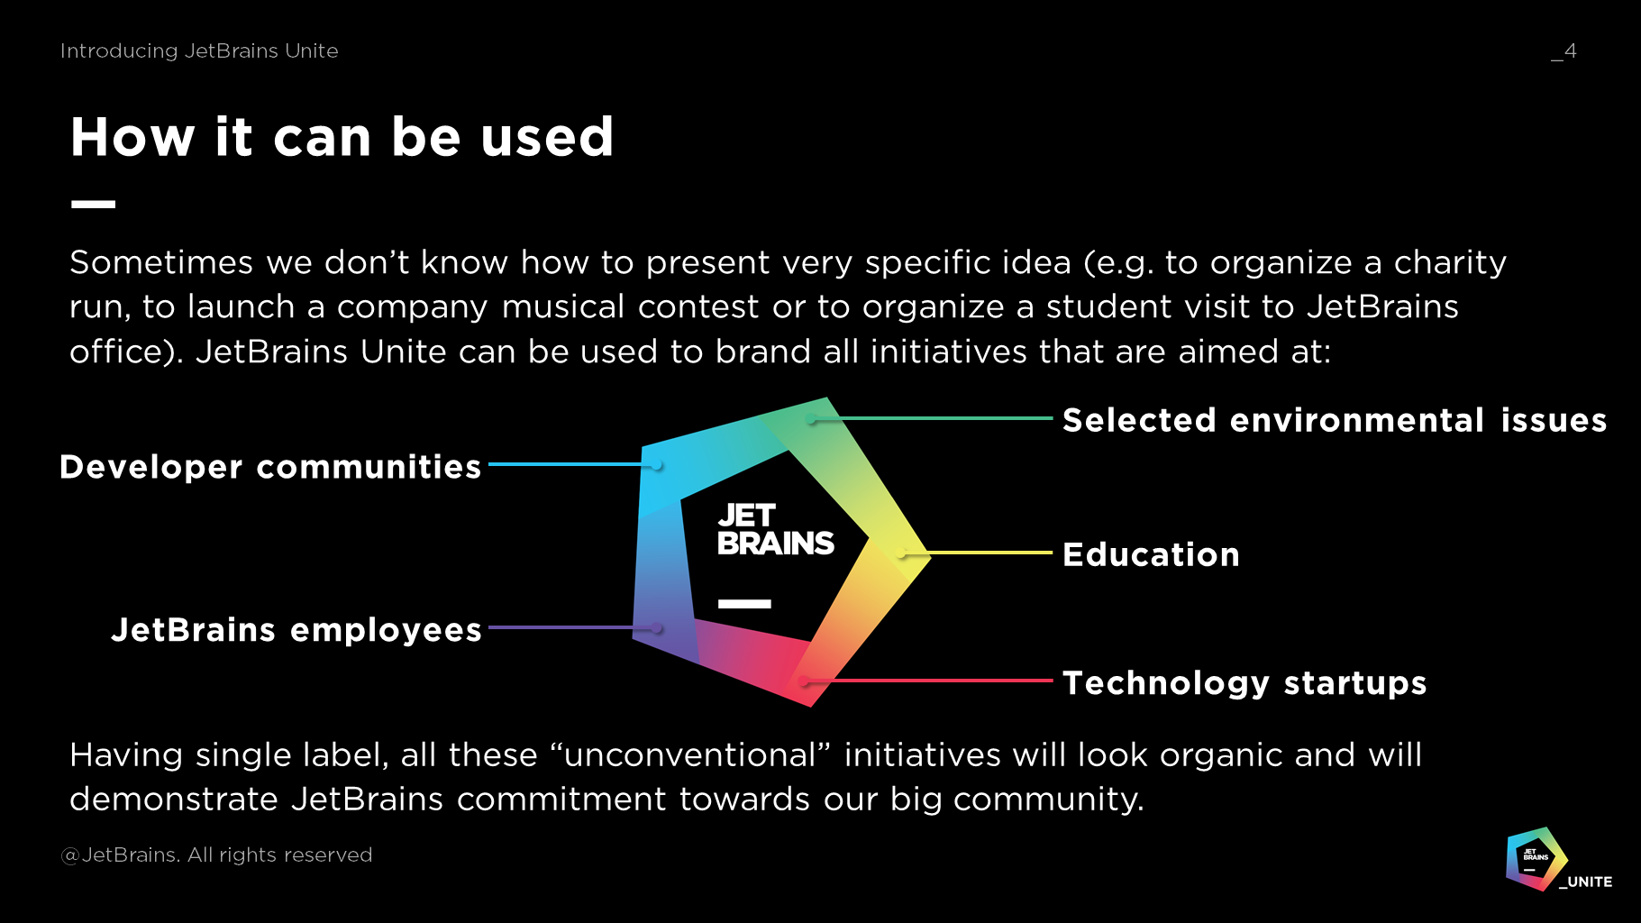

The statement about “external” nature of stakeholders’ needs may be considered wrong because of existence of internal stakeholders, such as employees. However, according to the current approaches to stakeholder management, these types of stakeholders may be part of organization, but are not organization itself in a sense that they are not the holders of corporate social responsibility. As a result, their needs and expectations are represented externally from the perspective of CSR.

