St. Petersburg University

Graduate School of Management

Master in Corporate Finance

**LOGIC OF LBO-ANALYSIS:**

**INTERNATIONAL EXPERIENCE**

Master’s Thesis by the 2nd year student

Master in Corporate Finance

**Monika Sarkisian**

Research advisor:

**Professor, Bukhvalov A.V.**

St. Petersburg

2017





**АННОТАЦИЯ**

|  |  |
| --- | --- |
| Автор | Саркисян Моника Мурадовна |
| Название магистерской диссертации | «Логика ЛБО-анализа: международный опыт» |
| Факультет | Высшая Школа Менеджмента |
| Направление подготовки | 080200 “Менеджмент” (Профиль: Корпоративные финансы) |
| Год | 2017 |
| Научный руководитель | Бухвалов А.В. |
| Описание цели, задач и основных результатов | В связи с повышенным вниманием к проведению ЛБО, а также важностью ЛБО-анализа в сделках данного типа, существует множество академической и деловой литературы, посвященной анализу различных аспектов ЛБО и ЛБО-анализа. Однако, вся литература в основном сосредоточена на анализе позитивных экономических моделей, в то время изучение нормативных моделей также представляет большой интерес с точки зрения всех участников LBO-сделки. Таким образом, существует явный пробел, связанный с нехваткой анализа нормативных моделей на тему ЛБО. В данной работе делается попытка заполнить этот пробел, путем построения алгоритма LBO-анализа на основе позитивного сценария развития отрасли и прогнозов развития компании.  Целью данной магистерской диссертации является создание инструмента ЛБО-анализа, для выбора ЛБО-мишени и последующего завершения ее ЛБО-анализа.  Работа дает комплексное представление о процессе ЛБО-анализа.     С одной стороны, она будет полезна для инвесторов, поскольку предложенный инструмент обеспечивает интегральный подход анализа и принимает во внимание основные задачи инвестора. С другой стороны, она будет полезна для новичков, желающих войти в инвестиционно-банковскую сферу или сферу прямых инвестиций и служить вводным образовательным инструментом в их попытке освоить технику ЛБО-анализа.  Международный опыт LBO-анализа выражается в предложенном алгоритме, который объединяет лучшие практики анализа, используемые ведущими международными инвестиционными банками. |
| Ключевые слова | ЛБО, ЛБО-анализ, ЛБО-модель, выкуп долговым финансированием |

**ABSTRACT**

|  |  |
| --- | --- |
| Master Student's Name | Sarkisian Monika |
| Master Thesis Title | «Logic Of LBO-analysis: International Experience» |
| Faculty | Graduate School of Management |
| Main field of study | 080200 “Management” (specialization: Master of Corporate Finance) |
| Year | 2017 |
| Academic Advisor’s Name | Bukhvalov A.V. |
| Description of the goal, task and main results | Given the current popularity of LBOs and importance of LBO-analysis in these types of transactions, there is a plenty of academic and business literature devoted to analyzing and describing different aspects of LBOs and LBO-analysis. However, academic literature is mostly concentrated on building and analyzing positive economic models. Yet, building and analyzing normative models presents a great matter of interest as well from the point of all LBO transaction participants. At the same time, information presented in business literature is very limited due to confidentiality: LBO-analysis tools presented there are either simple or flawed. Therefore, there is a clear gap in both academic and business literature, connected with lack of normative models related to LBO. In this work, there is done an attempt to fill this gap by building an LBO-analysis algorithm based on positive scenario of industry development and performance forecasts of the target company.  The goal of this master thesis is to build an LBO-analysis tool aiming to choose an LBO-target and further complete its LBO-analysis. To achieve this goal, the following objectives were set:  study theoretical aspects of the levered buyouts; study theoretical aspects of LBO-analysis, build an LBO-analysis tool; apply this tool on a real company.  This paper will give a firsthand perspective and understanding of how the LBO-analysis process works. On the one hand, it will be useful for investors, conducting LBO-analysis, as it will provide an integral approach in analysis by addressing their main prior LBO objectives at once: choosing an LBO-target and evaluating the target. On the other hand, it will be useful for a novice wanting to get enter the investment banking or private equity field. The work may serve as an introductory educational tool in their attempt to create their own analyses.  The international experience of the LBO-analysis is expressed by the algorithm used to perform the LBO-analysis. In fact, the work integrates the best practices used by the leading international investments banks in one entity. |
| Keywords | LBO-analysis, LBO-model, LBO, levered buyout |

**CONTENTS**

CHAPTER 1. THEORETICAL BACKGROUND AND LITERATURE REVIEW 12

1.1. Theoretical background on levered buy outs 12

1.1.1. What is an levered buyout 12

1.1.2. Key Participants of LBO 14

1.1.3. Characteristics of a strong LBO candidate 19

1.1.4. Possible LBO financing structure 22

1.1.5. LBO transaction scheme 24

1.2. Review of academic literature on LBO-analysis 27

1.3. Review of business literature on LBO-analysis 31

Summary of Chapter 1 36

CHAPTER 2. LBO-ANALYSIS TOOL 38

2.1. Introduction to LBO-analysis 38

2.2. The logic of LBO-analysis 42

2.3. LBO-screener 44

2.4. LBO-model algorithm 52

2.5. Applying LBO-analysis tool on real companies 62

2.5.1. Running LBO-screener for a set of potential LBO-targets 62

2.5.2. Building LBO-model for Ingenico Group 64

Summary of Chapter 2 74

CHAPETR 3. LIMITATIONS OF THE LBO-ANALYSIS TOOL 75

Summary of Chapter 3 77

CONCLUSION 78

REFERENCES 80

Appendix 1. Bloomberg screening tool for LBO-candidates 84

Appendix 2. Flaws of the publicly available LBO-models 85

Appendix 3. The LBO-screener algorithm 87

Appendix 4. The list of companies used in LBO-screener 88

Appendix 5. Industry specific leverage levels 93

Appendix 6. The LBO-model algorithm, part 1 94

Appendix 7. Financial performance of Ingenico Group, 2005-2016 96

Appendix 8. Control premium value depending on different factors 97

Appendix 9. Building debt schedule for Ingenico Group 98

Appendix 10. Building Income Statement for Ingenico Group 99

Appendix 11. Building Balance Sheet for Ingenico Group 100

Appendix 12. Building cash flow statement for Ingenico Group 101

Appendix 13. Return analysis for Ingenico Group 102

INTRODUCTION

*Topicality*

Levered buyout (LBO) – is an acquisition of a company or its part with the use of borrowed funds (“out-of-the-pocket money”) to finance the most of the transaction value. At the same time, borrowed funds are attracted under the provision of target’s tangible assets and future cash flows, which are used as a collateral. The main economic benefit of LBO is to increase the return on investment through the use of debt.

As relatively new phenomena, and a “derivative of traditional takeovers”,[1] LBOs emerged in the late 1980s as a result of proliferation of private investment vehicles, availability of debt, over liquidity in the stock market, and immediately became a source of considerable controversy, and an object of increased attention from researchers since the late of 20th century. Once called "dubious and strange"[2], various aspects of the LBO became controversial issues discussed at international level and regularly highlighted in the professional literature due to the steep increase in the size and number of leveraged buyouts conducted since the early 1980s. The analysis of researches, especially in foreign academic and professional publications, suggests that this trend is accompanied by an increase in research activity on the topic of LBO, which peaked in the mid-2000s[3] due to upsurge and growth in investor activity. The increased attention to this topic is determined by the activation of financial investors in conducting buyouts, as well as the growth of LBO market in both quantitative and qualitative terms.

The figure below shows the dynamics of the number of LBO transactions conducted between 1980 and 2014 globally (Fig. 1).

If before the 80's only a few transactions were concluded, in 2014 their number exceeded 2000. The peak of LBO's activity fell on 2006-2007, when the global volume of transactions reached $ 800 billion. Levered buyouts have shown to be successful in both rising and falling markets, and this might be one explanation have become so popular.[4] Despite un unstable economic situation that followed after and the bankruptcy of many private equity funds, as well as the economic recession of 2007-2009, market received signs of an increasing growth of financial investors' activity and LBO revival since 2009. Namely, only in 2014 was carried out by 20% more transactions than in 2013 (Figure 1). In general, the number of LBOs held increased 210 times since the 1980s.

Fig.1 Dynamics of the global LBO transactions number conducted between 1980 and 2014.

[Created by the author based on data from the Thomson Reuters database]

In addition to the growth in the number of transactions, there was also an increase in their size (Fig. 2). If before 2000 the total volume of conducted transactions did not exceed $ 100 billion, the size of individual transactions exceeded $ 30-40 billion in late 2000s. During the last 3 years, transactions of a particularly large size were made, each of which exceeded $ 20 billion. For example, in 2013, was made a $28 billion worth LBO of Heinz[5], and $ 25 billion worth MBO of Dell.[6] Moreover, in the list of 15 largest LBO in the history, all 15 were completed by the middle 2000's.[7] Among them, TPG bought by Goldman Sachs for $ 44.37 billion, Equity Office Properties, purchased by Blackstone for $ 38.9 billion, and the Hospital Corp. of America, acquired by Bain, KKR and Merrill Lynch for $ 32.7 billion.

At the same time there took place a geographical spread of LBO activities. If before, LBO was a phenomena inherent to USA market only, now there is another wave LBO growth in the European and emerging markets. Successful buyouts of the British retail chain Morrison Supermarkets in 2014[8] and mobile operator EE, with a volume of more than $ 10 billion each, gave a confidence to investors, and therefore bankers predict further growth of the European LBO market.[9] Increased popularity of LBOs is also noted in the Asian regions. Despite the relatively small size, a special role in it played the purchase of Focus Media for $ 1.7 billion in 2013, which became the largest LBO in China. According to CEO Industrivärden, Anders Nyrén, this transaction should lead to a series of larger transactions in the Asian market, particularly in Hong Kong.[10] Interest to LBO is also growing in the Korean market.[11]

Fig. 2 Dynamics of the global LBO transactions volume in 1980-2014.

[Created by the author based on data from the Thomson Reuters database]

The two waves of post-LBO bankruptcies in late 1990s and mid-2000s, which brought most of most of the early highly levered portfolio companies to default and ceased public to private transactions success[12], gave a rise to concerns about the potential determinants of post-LBO bankruptcies.

In fact, there are a number of factors that determine the success of the LBO transaction, such as the purchase price, the after-purchase company performance and the company exit strategy. Frequently, preliminary analysis of the LBO, which includes choosing an LBO-target and evaluating this target, and is the part of the so-called transactional phase, is key, since the quality of the preliminary works is one of the factors, that determines the entire transaction outcome at the exit.

LBO-analysis – is the core analytical tool used to analyze the target and the potential deal outcome ex-ante. It is a complex methodology, which requires specialized knowledge of financial modeling, leveraged debt capital markets, M&A, and accounting. At the center of an LBO-analysis is a financial model (the “LBO-model”), which is usually constructed with the flexibility to analyze a given targets’ performance under different assumptions, for example, multiple financing structures and operating scenarios. The structure of LBO-analysis instruments is very similar across different private equity companies and investment banks. The purpose of LBO-analysis is to analyze the attractiveness of potential LBO candidates by calculating investor rate of return.[13]

Leading Investment Banks, such as Goldman Sachs, UBS, Morgan Stanley, Deutsche Bank, regularly make researches on this topic (Credit Suisse (2007a), Credit Suisse (2007b), Deutsche Bank (2007), Goldman Sachs (2007), Morgan Stanley (2003), UBS (2007)), since the importance of LBO-analysis is vital.

*Problem statement*

Given the current popularity of LBOs and importance of LBO-analysis in these types of transactions, there is a plenty of academic and business literature devoted to analyzing and describing different aspects of LBOs and LBO-analysis.

However, academic literature is mostly concentrated on building and analyzing positive economic models. Yet, building and analyzing normative models presents a great matter of interest from the point of all LBO transaction participants.

At the same time, information presented in business literature is very limited. In real life, professional investors use their own and internally developed LBO-analysis schemes and models. In the world of finance, these models are often referred to as “hard currency”, since they reflect the core competence of the investment company.[14] Frequently the differences in models explain why some investors are more successful than others, hence the practical parts of this models are highly confidential, they are treated as corporate secrets and not revealed to public. That is why it is hard for an “outsider” to get a hold of accurate LBO-analysis tools used in the industry today.

Therefore, there is a clear gap in both academic and business literature, connected with lack of normative models related to LBO. In this work, there is done an attempt to fill this gap by building an LBO-analysis algorithm based on positive scenario of industry development and performance forecasts of the target company.

**The goal of this master thesis** is to build an LBO-analysis tool aiming to choose an LBO-target and further complete its LBO-analysis.

To achieve this goal, the **following objectives were set:**

* Study theoretical aspects of the levered buyouts;
* Study theoretical aspects of LBO-analysis
* Build an LBO-analysis tool;
* Apply this tool on a real company.

*Managerial application*

This paper will give a firsthand perspective and understanding of how the LBO-analysis process works. On the one hand, it will be useful for investors, conducting LBO-analysis, as it will provide an integral approach in analysis by addressing their main prior LBO objectives at once: choosing an LBO-target and evaluating the target. On the other hand, it will be useful for a novice wanting to get enter the investment banking or private equity field. The work may serve as an introductory educational tool in their attempt to create their own analyses.

The international experience of the LBO-analysis is expressed by the algorithm used to perform the LBO-analysis. In fact, the work integrates the best practices used by the leading international investments banks in one entity.

In the first chapter of the master thesis an overview of fundamentals of leveraged buyouts is provided. In this part are discussed the main concept of LBO, key LBO participants, characteristics of a strong LBO candidate, possible financing structure and the scheme of LBO transaction. Moreover, a review of academic and business literature on LBO-analysis is preformed.

Second chapter focuses on building an LBO-analysis tool, including an LBO-model and LBO-screener. The LBO-model is created based on fundamental tools used by leading investment banks and private equity funds worldwide and publicly available models, including ones developed by Rosembaum and Pearl, Paul Pignataro. After that the tool is applied on the set of real companies.

In the third chapter, main limitations of the proposed LBO-analysis tool are analyzed.

# CHAPTER 1. THEORETICAL BACKGROUND AND LITERATURE REVIEW

## Theoretical background on levered buy outs

### What is an levered buyout

A leveraged buyout – is an acquisition of a company, division, business or a portfolio of assets (or any other “target”), by a group of internal or external financial or strategic investors (sponsors) with the use of debt (out-of-the-pocket money)[15] to finance a relatively large portion of the purchase price. At the same time, borrowed funds are attracted under the provision of the assets base and the future cash flows of the company being redeemed and are documented on its balance sheet.

The remaining portion of the purchase price is financed by the buyer's own funds. In the financing structure of a traditional LBO, debt obligations can comprise from 60% to 70% of the transaction value, and, accordingly, the share of own funds ranges between 30% to 40%.[16] It is important to understand that these are only approximate values, each specific transaction has its own financing structure. As a rule, financial investors try to attract as much borrowed funds as possible, so the share of debt can reach 90%.[17]

Within the LBO-deal, sponsors can buy out broad range of businesses both public and non-public companies, as well as their subsidiaries or divisions. The ultimate goal of a financial sponsor is to get a return (usually more than 20%) to exit the deal by initial public offer of a target or by reselling it to a strategic or financial investor, usually within the next 5-7 years. High required yields are determined by high risks arising from large obligations of debt payment that fall on the target.

The main economic benefit of LBO from the point of the investor is to increase the return on investments through debt financing of the transaction, as compared to the return for a standard acquisition financed from equity funds only. This system works because the use of debt allows the sponsor to extract value through tax shield. The more debt the sponsor can attract, the less amount of equity the investor will have to invest, and, accordingly, the greater benefit from participating in the transaction will be.

During the time holding time (between time from which sponsor acquires the target until its exit) cash flows are used to service and repay the debt thereby increasing the equity portion in capital structure. At the same time, the investors aim to improve the financial performance of the company and increase the enterprise value in order to exit the deal with highest multiple possible. Therefore, an appropriate LBO financing structure as well as corporate governance must balance the ability of target to repay the debt and the need to use the generated cash to finance business growth.

The primary source of debt in LBO is the issuance of different forms of debt, securities, and other loan instruments classified by their security status and seniority in the capital structure. The condition of the current debt market, availability and the cost of debt play the key role in determining leverage levels in the financing structure. The equity portion of the financing is usually sourced from a pool of capital (‘fund’) managed buy buyer side. This finds size may range from millions to tens billions of dollars depending on each particular investor pull.

Since the debt repayment obligations fall on the target company, a number of certain requirements are presented to this companies from creditor side. Among them are stable cash flows necessary to pay off the debt and strong asset base necessary for getting a bank loan (the least expensive source of debt financing), and acting as guarantor of debt repayment in case of bankruptcy. Thus, companies with stable and predictable cash flows, as well as a strong material base, appear to be an attractive target for LBO.

There are several types of LBO transactions. In case when a team of target managers initiates the buyout, for example, as a protection from a hostile takeover, it will be called Management Buyout (MBO). Most of the transactions conducted between 2000 and 2007 can be attributed to this category.[18] Very often the MBO is hold with the support of an equity partner (such as financial sponsor), who provides capital support and access to debt financing through established investment banking relationships. The basic logic behind an MBO is that management believes it will be able to create more value running the company under their own ownership. Another rationale is that MBO structure eliminates the agency problem between the management team and the board of directors, since the owner-managers are able to run the company as they see it. Of course, other LBO scenarios also exist, for example management buys out a division or subsidiary believing that it will more effectively be ran when separated from the parent company.

In case when a team of third-party managers decide to make a buyout in order to further displace the current management team, it will be called Management Buyin (MBI). At first glance, MBO and MBI are similar, since the initiator of the transaction in both cases is management. Nevertheless, since the level of information transparency concerning the target company will vary significantly, these two types of transactions are divided. In addition, MBIs are hostile takeovers in fact, as they are based on the belief that the management is unable to fully realize the potential of the company. Another type of LBO transactions is Institutional Buyout (IBO), in which only institutional investors or LBO-firm become new owner of the company. If they decide to retain the current management team in the target company, then, as a rule, a share-based compensation system is introduced. The main difference between MBO and IBO is whether the target management receives its income by being the investor of the buy-out (MBO), or within the compensation package (IBO).

Finally, in the article Salvatore & Olsen (2003), another subtype of LBO transactions is discussed. In fact, it is a combination of MBI and MBO - BIMBO, in which the buyout is initiated by a group of managers, which can include both current and third-party managers. Other types may include Management Employee Buyouts, where both employees and management of the company act as investors and participate in the financing of the transaction.

In general, we can say that the entire LBO system is analogous to the acquisition of real estate under mortgage lending. Acquired real estate becomes a security for the loan, just as some of the borrowed financing for the acquisition of the target company is guaranteed by its assets. The cash flows of the target company will be used to service the debt obligations involved in its acquisition. Similarly, rental payments from the rental of purchased real estate will serve as a source of repayment of a mortgage.

### Key Participants of LBO

The key participants of LBO transactions are financial sponsors, investment banks, banks and institutional lenders, bond investors, target management and the target company itself. The general scheme of key parties’ relationships is presented in the picture below (Pic. 1).

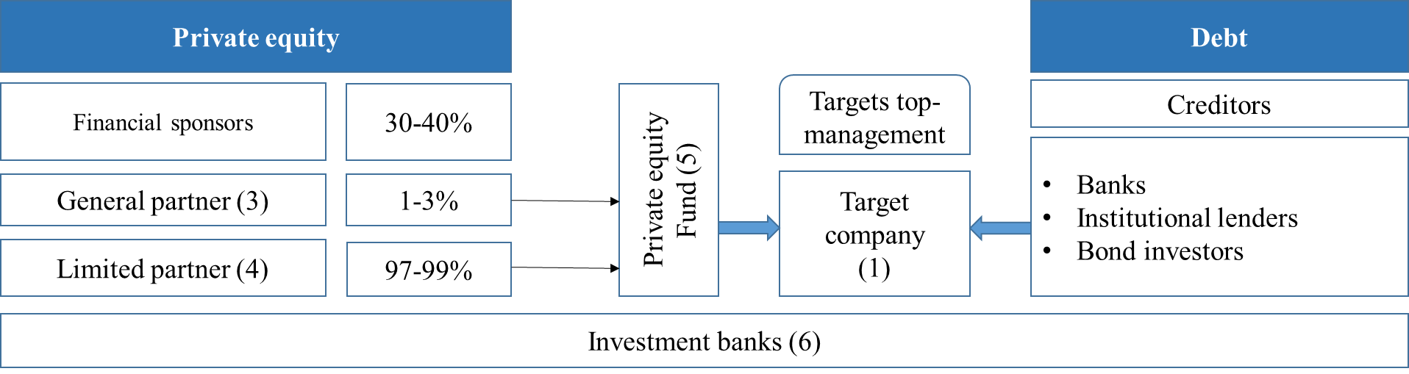

Pic 1. Key participants of an LBO transaction

* **The target**

Both public or private entities can serve as a potential LBO-target. In case if it is public, it is first being delisted, yet the bond securities and preferred stocks can continue being traded on the stock market. The target can be presented by a company, subsidiary, a division or branch, belonging to a larger entity. In the least case, the transaction is called a divisional buy out (1).

* **Financial sponsors**

Financial sponsors represent the buy side in the LBO transaction scheme, whose main function is providing equity financing (2). They are the main actors in the LBO system, since they are the one to initiate of the transaction. In addition, these are investors who extract the main economic benefit of purchase by debt financing and disclose the essence of LBO - increasing the return on investments as compared to the return of a standard acquisition financed by private equity funds only. There are two main groups of financial sponsors, which can be classified into strategic and financial investors.

Strategic investors are guided in their decisions by strategic motives. Their primary purpose is to create and extract synergies from the acquisition of the target, such as vertical integration, horizontal integration, expansion to new geographical markets, increase of market share, defense from hostile takeover etc.

Financial investors are sponsors presented by financial entities. This term usually refers to a traditional private equity firm, hedge funds, venture capital funds or special purpose entities (SPAC - special purpose acquisition companies). PE firms, hedge and venture funds raise their money from third party investors usually represented by public and corporate pension funds, insurance companies, endowments and foundations, sovereign wealth funds, and wealthy families/individuals. They may also invest their own money to finance the transaction. In case if financial investor is a private equity fund, which is specialized in such kind of transactions by its definition, is usually referred to as an LBO-firm.

Financial investors are guided in their decisions by only financial motives. Typically, they aim to buy the company, significantly improve the inner business processes to increase the enterprise value and then resell the company in 5-7 years of holding period. Within this period, they may employ such improvements as improving the operating efficiency of the target, improving its business strategy, reducing the costs or changing the organizational culture. Thus one of the most important objectives for financial investors is to perform a detailed study of the target company and conduct the so-called due diligence in order to understand if the company has the needed potential. Due-diligence is the process of collecting and studying all available information about the company being redeemed as much as possible. The main aspects analyzed usually are business, financial, tax, legal, regulatory, environmental aspects. Financial investors use due diligence to create financial models, justify the purchase assumptions and price, determine the structure of financing. Most often, due diligence is performed by third parties, such as investment banks.

There are two types of financial investors in PE: general partner (3) and limited partners (4). The capital of the financial investors is organized into funds that are typically established as a limited partnership (5). Most of the funds in such a partnership are attracted from third parties. They are structured as fixed-life investment vehicles, in which the general partner manages the fund and the limited partners act as passive investors. That is why this pulls are very frequently referred to as a “bling pulls” since the LP subscribe without a specific knowledge about how the funds are going to be managed in particular. Limited partners compensate GP for managing the fund by paying a management fee usually around 1-2% a year on committed capital (Pic. 2).

Even though the relationships between the GP and LP are managed according to some pre-agreed terms, LP transfer the money to GP only when it is ready with a new investment opportunity. LP do not know how exactly the funds are going to be invested and managed, but being informed about fund’s general strategy, they may impose some restrictions on investing in certain companies or industries.

97-99% of the funds capital is formed by LP investments, and the rest 1-3% is constributed by GP. The benefit distribution is standardized for all transactions. A limited partner receives 80% of the profits and the general partner thus receives the remaining 20%.

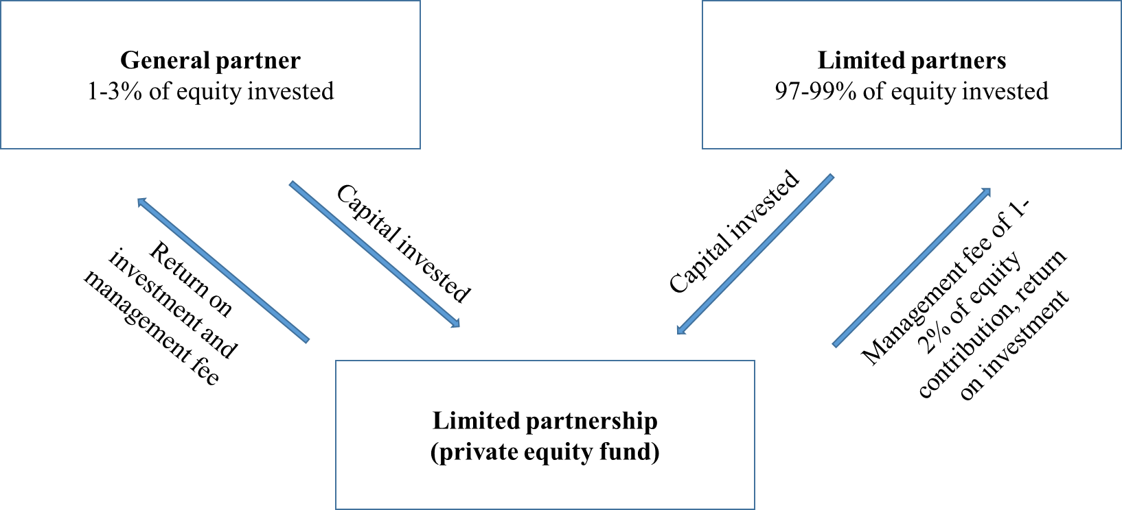

Pic. 2. Structure limited partnership

[Created by the author based on Almgren, Haland, 2006]

Financial sponsors vary in fund size, industry focus and investment strategy. The size of the fund, which can range from tens of millions to tens of billions of dollars (depending on their ability to attract capital), helps determine the parameters of investment. Some investors have industry specialization (for example, industrial companies or media), while others specialize on specific situations (companies in a difficult financial situation, corporate divestitures). Yet some funds with generalist strategy also exist, who take into account all the spectrum of opportunities across multiple industries and strategies.

Recently there has been a rise of public attention to financial investors, followed by increase of their competitiveness in the market of mergers and acquisitions. If before, realizing the long-term synergy effect from the acquisition, strategic investors could always offer a higher purchase price and traditionally had an advantage over financial investors at the auctions, in recent years financial investors have become significantly more competitive, due to the emergence, for example, of such a tool as junk bonds and the availability of money. A recent survey conducted by British researchers on the London Stock Exchange showed that 61% of the largest companies expect increased competition from Private Equity firms in the M & A market. Rothschild's vice president, Roger Kimmel, and John A. Katzenberg, managing director of Citigroup, also note the trend in which strategic buyers lose their advantage in the struggle to acquire a target company and are under pressure, being unable to outbid LBO-firms. According to the well-known industrialist Runa Andersson, LBO-firms are on average willing to pay 30-40% higher than strategic buyers.[19]

* **Investment banks**

Investment banks (6) traditionally play a key role in LBO transaction, serving as creditors, as well as/or M&A advisors on both sell and buy sides. Firstly, they help sponsors, who heavily rely on investment banks to assess the target and choose the appropriate financing structure for a particular transaction. Once the sponsor selects the appropriate financing, which frequently appears to be the compilation of the best terms of proposals from different advisors, the deal team presents its to the banks internal credit committee for final approval. Very frequently in huge deals, several investment banks are attracted as consultants simultaneously. It is done in order to have different points of view on one question and choose the best option, for example regarding the financing. Moreover, several IB can be attracted to provide financing jointly. In this case a loan provided by a group of several banks (syndicate) is called a syndicated loan. In addition, they may perform due-diligence and go through an extensive internal credit process in order to validate the targets business plan. Investment banks may also underwrite the debt financing for the target.

* **Bank and institutional lenders**

Bank and institutional lenders are the providers of capital (bank debt) in LBO financing structure. Even though they are very similar, the difference is that banks provide debt of the highest level of subordination (amortizing term loans), while institutional lenders provide financing of the lowest level of subordination (limited amortization term loans).

Bank lenders typical can typically be presented by commercial banks, savings and loan institutions, finance companies, and the investment banks serving as arrangers. The institutional lender base is largely comprised of hedge funds, pension funds, mutual funds, insurance companies, and structured vehicles such as collateralized debt obligation funds (CDOs).

As with investment banks lenders perform a detailed analysis of the target (due-diligence) and undergo an internal credit process before participating in an LBO financing. The analysis is performed with a focus on targets credit history profile and cash flow generation ability, in order to make sure the lender will be able to provide all future interest payments and principal payment in time. Lenders also look forward to mitigate their downside risk by requiring covenants and collateral coverage. However, there might be a lot of external aspects are also factored when making decision to participate in an LBO, for instance, prior experience with a given sector.

* **Bond investors**

Bond investors are those who purchase the debt issued by target within LBO. They are usually presented by institutional investors, such as high yield mutual funds, hedge funds, pension fund, insurance companies or CDOs. In order to make a decision regarding the purchase bond investors attend the so called road-show presentation, during which the senior executives present the investment merits of the company and the proposed transaction. Depending on the size and the scope of the transaction roadshow presentation may be a 3-14 day long process, during which the bakers from the lead underwriter (and generally the representative of general partner) accompany the target’s management on meeting with potential investors. This meeting may have an informal format and be organized as breakfasts or lunches. The typical US roadshow is conducted across the main financial centers of the country with stops in New York, Boston, Los Angeles, San Francisco. Prior to roadshow meetings all potential bond investors receive a preliminary document with the detailed description of the target, called preliminary offering memorandum (OM). It is a legal document in its essence and it must satisfy a higher degree of legal scrutiny and disclosure.

* **Target’s top management**

Management plays a key role in the marketing of the target, attracting both potential buyers and creditors, working in close cooperation with bankers and preparing all the marketing and financial information. Management is the main representative of the target and it is at his responsibility to articulate the investment merit and attractiveness of the deal. Consequently, in LBO, a strong management team can create a tangible value for the company.

Management, as a rule, has a significant capital interest in the company after the transaction, investing in the business along with financial sponsors. Representatives of several levels of target management have the opportunity to participate in a remuneration program, usually tied to a set of financial indicators that characterize the target at the close of the transaction. These compensation incentives can account for up to 15% of the company's share capital. This structure of the compensation package provides a full-fledged management of the economic performance of the company, as it helps to link the performance of managers with the value of the company.

Top managers of the target company play a key role in negotiations with both financial investors and creditors. They hold presentations for potential creditors, as they have internal insider information and have a better idea of ​​the company's performance and development prospects. In most cases, managers remain executives of the repurchased company after LBO, as financial investors are rarely interested in changing the management team.

### Characteristics of a strong LBO candidate

According to Gagliano & Olsen (2003), there are a number of characteristics of a potential target company that make them suitable for an LBO. In fact, financial sponsors are very flexible investors seeking investment opportunities across multiple industries, companies, geographies and situations.

While there are few steadfast rules about which company to invest, certain common traits emerge among traditional LBO candidates. As it was already mentioned, since LBO obligations on debt repayment fall on the target, a number of certain requirements from creditors are presented to it. During due diligence, the sponsor thoroughly studies the candidate’s key strengths and risks. Often LBO candidates are identified among non-core or non-profitable divisions of large companies or distressed companies with great growth potential. In other cases, the target is simply a solidly performing company with a stable business model and financial position. In this situation the sponsor believes that the company is undervalued by the market and recognizes growth opportunities which are not exploited by current management. Regardless of the particular situation, the target is attractive if “it can be purchased at a price and utilizing a financing structure that provides sufficient returns with a viable exit strategy”.

Among the main criteria presented for the target company, it is necessary to distinguish the ability to generate stable cash flows, a leading and stable competitive position, the potential for increasing the efficiency of operations, the low required level of capital expenditures and investments, the company's growth potential and the reliability of the management team.

* **Ability to generate stable cash flows**

Strong and predictable cash flow generation ability is the most important and critical criterion for LBO-target candidates, given the highly levered capital structure. It tells about the company's solvency and ability to make regular interest payments and service the debt over the life of loans and securities. That is why business characteristics that prove predictability of cash flows increases the company's attractiveness as a target for LBO. Very often targets are found in niche industries with stable customer demand and end markets. Such companies may have a strong and recognizable brand, a largely established customer base, long-term sales contracts. Prospective sponsors seek to confirm the target’s cash flow generation potential to gain comfort with projections. Thus, they are frequently stress-tested, based on historical volatility and potential future business and economic conditions to support the ability to survive under challenging circumstances.

* **Leading market position**

Leading and strong positions in the market reflect, in general, relationships with customers, brand awareness, superior quality of products and services, and other advantages over competitors. The presence of competitive advantages in various areas, for example, in relations with consumers, low costs or differentiation of the product, makes a significant contribution to the stability of product sales and, accordingly, to the stability of cash flows. Depending on the sponsors’ familiarity with the industry and the level of available information about the candidate, they can attract external consultants to conduct independent research of the target.

* **Growth potential**

The growth potential that sponsors look for might be both organic and through future bolt-on acquisitions. Profitable top line growth at above-market rates helps drive outsized returns, generating greater cash available for debt repayment while also increasing EBITDA and enterprise value. The estimation of the company's market value at the exit is based on EBITDA multiple. Thus, the growth potential leads to higher returns for investors at the close of the deal, since as company grows, the EBITDA is also increasing, so the enterprise value estimate based on EV/EBITDA multiple is consequently growing as well.

The company’s potential to develop and expand the scale of operations is very much affected by the LBO financing structure. The cheaper the sources of funds are, the more financing is available for growth. This is why the sponsors some time do not pursue the strategy of attracting as much debt as possible, to save flexibility for the growth strategy. A study performed on the Swedish private equity market[20] showed that ability of the fund to estimate the future development is a key issue when looking for a suitable candidate.

* **Opportunities to improve the efficiency of the company**

While it is essential that the LBO candidate has a strong business model, the investors still seek targets providing opportunities for operational improvements. Usually it is referred to cost savings. Traditional cost saving measures include reducing corporate overhead, headcount optimization initiatives, operations streamlining, implementing IT systems, selling non-core assets, introducing lean manufacturing, six sigma process, etc. Another direction is negotiating with current or finding new corporate partners (suppliers, customers). For these initiatives investors may attract external consultants or industry experts to assist during the due-diligence as well as assess the opportunity represented by establishing “best practices” at the target. The proper implementation of business process improvement initiatives is in fact the key determinant of equity value increase post acquisition. As a result of these and other restructuring efforts, one would expect an increase in EBITDA multiple.

At the same time, sponsors should be careful not to jeopardize current sales or attractive opportunities for growth. Radical measures regarding marketing, capital investment or research can reduce the company's growth potential. In this regard, cost reduction should be carried out by reducing transaction costs, rather than reducing the cost of marketing or R&D.

* **Low capex requirement**

Other things being equal, a low level of capital expenditures increases the company's cash flow generation ability. In this regard, better LBO candidates tend to have a limited need for capital expenditures. Nevertheless, a company with large capital expenditure requirements may by interesting for investors if their growth potential is very high. During due-diligence investors differentiate between those expenditures deemed necessary to continue operating the business (“maintenance capex”) from those that are discretionary (“growth capex”). The first type is used to maintain the existing assets, mainly property plant and equipment, whereas growth capex is used to purchase new assets.

* **Strong asset base**

Strong assets serves as collateral to secure the loan and increase the likelihood of principal repayment in case of bankruptcy (and liquidation). The target company's asset base is especially important in the credit market, where the creditor willingness to provide funds depends on the value of assets. The asset strength is defined as the asset size as well as the quality of the asset base. Short-term assets, such as account receivable and inventory, are considered high quality assets given their liquidity, whereas long-term assets, for instance, PP&E are low quality assets.

* **Strong Management Team**

A strong management team with a good business reputation increases the company's attractiveness as an LBO candidate. Talented managers are extremely important and necessary in the case of the LBO given the need to operate under a highly levered capital structure and ambitious targets. Prior experience in managing company in stressed conditions, such as restructuring, integrating acquisitions, is especially appreciated by sponsors. A strong management team is crucial for driving company performance going forward and helping the sponsor meet its investment objectives.[21]

Certainly, the exact criteria for an LBO target may vary depending on the particular investor. Below are summarized the criteria developed by Morgan Stanley company[22]:

*Table 1.* LBO-target characteristics developed by Morgan Stanley

|  |  |
| --- | --- |
| Financial characteristics | Business characteristics |
| * Ability to maintain above average profit margins * Strong, predictable cash flows * Readily separable liquid assets | * Strong management team * Well-known brand name and strong market position * Low costs * Potential for growth * Products are not subjects to rapid technological change |

Financial investors also track for specific key ratios, such as EV/EBITDA, EV/EBITA, EV/Sales, EV/Cash flow and (EV-CAPEX)/Cash flow.[23]

* “A good deal has an EV/EBITDA entry multiple between 6X-10X.”
* “We avoid companies with EV/Sales above 2X.”
* “EV/Cash flow should not be more than 10X.”

This metrics are used as a sanity check of the target. If key ratios are ok, soft factors such as industry, management, business model, market position etc. are often the ones deciding whether to take on the investment or not.

### Possible LBO financing structure

LBO-firms make a lot of effort to determine the optimal financing structure, as it must balance the company's ability to service and repay debt with the need to use cash flow to support the business growth. Academic studies usually describe some predetermined financing structure in LBO transactions. For example, Axelson et al (2010)[24] note that funds typically use debt comprising up to 70% of the transaction value. Yet practitioners will commonly say that they will try to use as much debt as possible to maximize the return on investment. There are four main groups of LBO fascinating

* Bank loans
* High-yield bonds
* Mezzanine financing
* Private equity of investors

In general, the higher the position of a particular source of financing in the above list, the lower the risk, meaning the lower cost of capital for the borrower. Yet, the cost of a certain capital is inversely proportionate to the to the flexibility permitted by the applicable debt instrument.

* **Bank loan**

Bank credit is one of the main sources for financing in LBO, due low cost and low risk. It is frequently referred to as “senior secured credit facilities” since it has the highest order of subordination and, as a rule, consists of a revolving credit facility (which can be borrowed, repaid and reborrowed) and one or more term loan credit tranches (which may not be reborrowed once paid). The bank loan is issued in the private market and, therefore, is not subject to SEC regulation and disclosure requirements. Nevertheless, there are certain covenants imposed on the debtor, which can be divided into three categories:

* Active - requiring the borrower to perform certain actions, such as the regular provision of regular reporting, regular disclosure of information on the directions of business development;
* Passive - imposing restrictions on the borrower's activities, for example, restrictions may be placed on the opportunity of reselling assets, on the minimum level of cash on the balance sheet or on the total amount of the company's debt;
* Requiring the maintenance of certain values ​​of financial indicators, for example, a certain level of liquidity, the ratio of debt to EBITDA.

Typically quarterly interest is charged on a bank loan at a certain benchmark rate (usually LIBOR or the Base Rate) plus an applicable margin (“spread”), determined based on the borrower characteristics, such as creditworthiness, quality of assets. This type of debt is often called floating, because its value varies in accordance with changes to the underlying benchmark rate.

* **High-yield bonds**

High yield bonds are non-investment grade debt securities (BBB in accordance with the Standard & Poor's methodology and Fitch or below Baa on Moody's scale) that obligate the issuer to make interest payments to bondholders on regular basis (typically semiannually) and repay the principal at the maturity date. This type of debt is characterized with unsecured position, longer maturity, less restrictive incurrence covenants. Because of that they have higher coupon rate than do bank debt to compensate to investors higher risks. The average yield on high-yield bonds may be 10-15%. These bonds have always played an important role in financing the LBO transaction, because they are more available, providing possibility to significantly increase leverage, decreasing the equity contribution. Moreover, high-yield bonds give the company a much greater degree of freedom than bank loans, due to higher flexibility, the almost total absence of covenants, lack of mandatory amortization. The interest on high yield bonds is typically fixed, and priced at the issuance of bonds on the basis of a spread to a benchmark Treasury. This means that the interest rate is constant throat the bond lifespan. Even though high yield bonds with floating rate coupon are also commonly used, they are not typical for LBO transactions.

* **Mezzanine debt**

Mezzanine is a debt instrument that actually lies between traditional debt and equity. For the sponsor, the attraction of mezzanine financing makes it possible to increase leverage at a rate lower than the cost of equity when other sources of funds are unavailable or utterly used. For example, the mezzanine debt may substitute or supplement the high yield bond financing when the markets re not favorable. For the investor the mezzanine debt offers higher rate of return that higher rate of return than traditional high yield bonds and can be structured to offer equity upside potential in the form of purchased equity or detachable warrants that are exchangeable into common stock of the issuer. [25]

* **Equity financing**

The remaining small portion of the LBO financing structure is formed by equity contribution of investors. The portion of equity in the capital structure varies from case to case depending on the debt market conditions, type of the company, and the purchase multiple paid. For very big transactions several investors may gather together to form a consortium of investors (“club deal”), in order to reduce individual equity contribution and increase personal return. It also reduces the risk of investors in case of bankruptcy.

### LBO transaction scheme

At the moment there is no systematic approach to understanding the whole LBO process. However, the analysis of academic papers, suggested there are three main phases of an LBO transaction from the point investor: transaction phase, the holding phase, and the closing phase.

* **Transaction Phase**

The transaction phase is the one to open the deal process and it consist of three main sub stages: target identification, target evaluation and target acquisition.

Target identification involves screening sources of information, as well as performing a preliminary analysis of the most attractive, from the financial sponsor's point of view, companies. The purpose of the screening is to identify a potential target. The screening process is usually followed by an indicative bid on the target by the LBO firm. The purpose with this bid, which is not binding, is to demonstrate for the seller that the LBO firm is interested enough to get a closer look at the target.

In target evaluation investor usually performs a two-step analysis of the candidate: internal analysis and due diligence. The primary goal of target valuation is to form a decision making ground for bidding process and determine the highest price that can be offered without causing any economic loss for the investor. Alongside with the target valuation also the deal price is being valued, which may include not only the price of target, but also deal additional costs: cost of raising capital, consultant’s fees, investments banks’ fees, etc. Another purpose of valuation is to get a deep understanding about the mechanisms that drive the target value.

Investors have different valuation approaches. While strategic buyers mostly use the discounted cash flow model as the main valuation technique, LBO firms use an LBO-model. The difference in the methods used is determined by goals pursued by the sponsors. In the first case, the priority is given to estimating the fundamental company value and the synergy from acquisitions. In the second case, investors are interested in economic returns coming from subsequent resale, and as both purchase and resale are carried out at market value, market values as used.

During target acquisition road-show presentations are completed, the transaction price is confirmed, the final session of negotiations on the forthcoming transaction has been held and the contract is signed.

* **Holding phase**

The holding phase is the most extensive for a financial investor. As already mentioned, it can last from three to ten years, depending on the private equity fund's strategy. A study performed on the holding phases of Nordic region private equity finds revealed that the typical holding period today is between 3-7 years.[26] Yet, it used to be a way shorter 10 years ago (3-5 years).

The goal of investors is to increase the value of the company to extract profit from subsequent resale or IPO, for which a set of measures is carried out. Previously, LBO-companies made efforts primarily to maximize cash flows generated by companies. However, with the transformation of economic relations, the development of stock markets, and increased competition, the focus of optimization processes has shifted from operational improvements to improving the firm's competitiveness. A study conducted by McKinsey & Co emphasizes the crucial importance of initiatives implemented in the following three areas:

* Increasing the efficiency target’s management;
* Improvement of the target’s business strategy;
* Increasing target’s productivity/efficiency.

Damodaran mentions that after an acquisition, management usually tries to create shareholder value by a variety of actions such as:[27]

* Investments in new products and sales force to increase sales;
* Cost reductions, e.g. elimination of inefficiencies, reduction of overstaffed workforce; outsourcing, moving operations to countries with lower labor costs;
* Reduction of tax burden, e.g. moving operations to tax havens;
* Improvement of inventory and accounts receivable and payable management;
* Divestment or redeployment of poorly performing assets;
* Replacement of outdated equipment and labor by more efficient equipment;
* Reassessing capital expenditure plans and associated payoffs;
* Distribution of excess cash to the new owners.
* **Close of transaction and primary exit strategies**

The financial returns from a leveraged buyout are not truly realized until the business is exited, or sold. When deciding upon a suitable exit strategy, private equity funds develop “dual track” schemes before the acquisition in order to find the best possible exit strategy. This can be realized by three main options: sale to a strategic investor (usually referred to as a “strategic sale”), sale to a financial investor, initial public offering (IPO), dividend recapitalization.

* *Sale of business to a strategic investor.* Traditionally, sponsors are doing their best to sell the company to strategic investors, as they represent the most attractive potential bidders due to ability to realize the potential synergy from the purchase, and, therefore, are willing to pay a higher price. Strategic buyers in general have better understanding of how value is created, thus realizing the future synergy they can always offer a higher price.
* *Sale to financial investor.* The development of private equity market made sale to financial sponsor increasingly commonplace phenomena. Financial investors experience an increase of negotiating power as compared to strategic bidders.
* *Initial Public Offering*. In an IPO exit strategy, investor will sell the portion of the target shares to the public. The main disadvantage of this exit strategy is that the seller cannot exit 100% of the company at once[28] since the full exit in this case comes with subsequent follow-on equity offerings until the eventual sale of the company. This may done to create confidence among new shareholders. In this regard, unlike the sale of business, an IPO does not allow a financial investor to fully monetize the value of LBO quickly. Yet, due to its dependence on equity capital markets, an IPO strategy may offer a compelling valuation premium to the sale.[29]
* *Dividend recapitalization*. Even though it is not a clear “exit strategy” dividend recap is a way for a fund to receive liquidity from their business investments, which also provides the investor with a feasible option to monetize the investment prior to exit. In dividend recapitalization the target raises additional debt in order to pay dividends to the current shareholders.

## Review of academic literature on LBO-analysis

Currently there are no academic papers devoted to normative models regarding LBO. Yet, there is a plenty of academic literature focused on building and analyzing different positive models.

Steven N. Kaplain and Rickard S. Ruback(1995) analyze the market value of levered transactions and compare it with the discounted cash flow valuation and three multiple based methods: company comparable, transaction comparable and industry comparable. As a comparable companies, companies with similar cash flow growth and associated risk are used. As comparable transactions, transactions of the similar value and industry are taken. As for industry comparable multiples they are found using four digits SIC codes. The research provides a clear evidence of a strong relationship between the market value of the LBO transactions and the corresponding DCF valuation of the target company. The DCF valuations were on average within 10% of the market value of the completed transaction. Kaplan and Ruback concludes that the DCF based approach perform at least as well as valuation methods using comparable companies and transactions.

Andrade and Kaplan (1998) analyze 31 levered buyouts that eventually defaulted in the late 1980s. In their terms, financial distress is when “the first year a firm either has EBITDA less than interest expense, attempts to restructure its debt or defaults”. They distinguish between two main types of distress: resulting from inappropriate financing structure and resulting from issues related to firms operations (underperformance). Andrade and Kaplan specifically study the factors that drive leveraged buyouts into bankruptcy and discover that high leverage is the primary cause of distress while the underlying economic performance of the firm and the industry is of less importance. In fact, their sample firms all have positive operating margins in distress and even better margins than industry averages. Moreover, they find that distress costs are lower for transactions of higher value and in the cases where larger fractions of the debt are owed to banks.

Alexen et al (2007) Perform an empirical analysis of financing structures of large LBOs. Authors collect detailed and comprehensive data on financings of 153 LBOs with value over 1 billion dollars. Firstly, they describe the way leverage is used in financing buyouts: they document the financing structures and then attempt to explain those structures by existing capital structure theories. Secondly, assuming that GPs optimize the capital structures in the moment of purchase, authors compare level and the cross-sectional distribution of capital structures of public and private companies, and discuss possible reasons for observed differences. Third, they consider the relation between leverage and transaction multiples, and try to estimate the extent to which the ability of debt markets to provide financing impacts the pricing of deals. The results suggest that the availability of deal-level financing appears to impacts the investment process in private buyouts in ways unlike public firms.

Hotchkiss et al. (2010) collect exit and entry multiples data on 2156 LBOs conducted between 1997 and 2010 finds that bankruptcies are more common among private equity-backed firms than non-private equity backed firms (5,1% versus 3%). Yet, the least default with a lower frequency. Secondly, they discover that when in default private equity backed firms are more likely to remain independent firms post default than non private equity owned firms. Hotchkiss et al. (2010) argue this is because “PE-backed firms being more likely to survive when they are only financially rather than economically distressed, while firms with unprofitable operations are more likely to be sold or liquidated when they are PE-backed.” These findings echoes Andrade and Kaplan (1998) results and suggest private equity backing “improves the screening process in bankruptcy, increasing the likelihood that economically viable firms are successfully reorganized”. They also find that when a company is private equity backed recovery rates to creditors are lower “due to a lower recovery to bonds for the private equity backed defaults”. These findings are consistent with the findings of Kaplan and Stein (1993) “who show that junk bond investors bore the majority of the credit losses after the late 1980’s buyout boom”.

Wilson and Wright (2010) studies the determinants of failure, defined as entering the bankruptcy process, in a dataset of companies in the UK over the period 1995-2009. Their research studies a range of financial and non-financial factors (such as director characteristics). Authors come to the conclusions similar to previous studies: “a greater likelihood of failure is significantly associated with higher leverage”. They also conclude that management buyins are more likely fail than management buyouts. Moreover, Wilson and Wright 2010 assess that private equity backed deals completed post 2003 are not riskier than the population of non buyouts, which implies that high leverage is not isolated to private equity. They conclude that they “do not find support for the view that higher failure rates due to higher leverage are a specific feature of private equity backed buyouts” and end their paper by suggesting “private equity backed companies as well as targeting better buyout prospects are in a better position, because of active ownership and governance, to adjust capital structure over the economic cycle and, therefore, manage insolvency risk”

Ann-Kristin et al. (2013) employ control right theory to study the structure and the determinants of covenants on levered buy outs. Authors do it on the sample of 130 German transaction conducted between 2000 and 2008, which cover almost half of the LBO market of that period (by volume). Concerning the structure of protective covenants authors conclude that they are more or less standardized and more conservative than in USA. Moreover, covenants are designed in a hierarchical manner, with the Debt to EBITDA covenant being the first to breach in early years. Authors say that they are the first to apply a direct measure of financial covenant restrictiveness, which is the real negotiated item between lead arrangers and sponsors. Results show that financial covenant restrictiveness is significantly negatively related to the size of the private equity group, which serves as a proxy for reputation. Also they say that target-related factors, like growth and profitability, have a strong impact on financial covenant restrictiveness.

Frederik Gardefos and Henrik Viderberger in their work “Private Equity Valuation” (2011) analyze three LBO-analysis techniques: adjusted present value model (APV), multiple valuation model and levered buy out model (LBO-model) in analysis of levered buyouts. Authors employ these three models to value a set of 24 LBOs. The data that they use is assembled from internal private data of completed transactions on the Swedish private equity market. Comparing the factual value of the leveraged transactions with the ones predicted by models, authors come to a conclusion contradicting the results of Kaplan & Ruback (1995). Gardefos and Viderberger conclude that the multiples valuation perform significantly better that cash flow based APV model and LBO-model. Regarding the LBO-model their valuations that are much closer to the market value than they able to find using APV. Still, the value obtained with LBO valuation is significantly above market value, 147% of it, which means that LBO-model calculates an enterprise value nearly 1.5 times as high as the actual purchase price. Authors argue that the dataset used by Kaplan & Ruback (1995) may be flawed, since it is complied on data found in fairness opinions. Gardefors and Viderberder use actual data that was used to value the company by each private equity fund instead.

Kreuter at al. (2004) found support for the importance of extensive research by LBO firms when identifying suitable targets. According to their study, buyouts that originated from other sources than publicly known deals generated superior returns. However, this does not conclude that it should affect their ability to outbid strategic buyers. Instead, it rather points to the importance of their deal sourcing capability to generate value to the investment. The study further found that deals originating from advisors had superior returns to deals sourced from the LBO firms’ network. One could therefore argue that the importance of their network have less impact in the early transaction phase of an LBO

According to Gagliano & Olsen (2003), there are a number of characteristics of a potential target company that make them suitable for an LBO. First, the company should have a capital structure that allows them to take on a large amount of debt, which often is characterized by a strong and wealthy balance sheet with a relative low level of debt. In order to be able to service the new debt, a firm should have stable and predictable cash flows. Such firms generally have a strong market position with low risk of new entrants. Strong cash flows can also come from a low future capital requirements and the possibility to sell off assets that do not fit into the company’s business model. Furthermore, the firm should be able to take on cost cut programs in order to increase the profitability. As the investment period is limited, it should be possible to identify a number of attractive exit opportunities.

Mattias Almgren and Karl Håland (2010) identify and discuss the factors affecting an LBO firm’s relative competitiveness and hence ability to outbid strategic buyers. Authors identify 14 factors have been identified. In their work authors provide a detailed description of the preliminary qualitative LBO-analysis that should be done by investors to analyze the LBO return potential. According to the author, there are four main stages of LBO-analysis: sourcing, screening, evaluation and valuation.

Carl-Johan Standberg in his work “Levered buyout: an LBO valuation model” (2011) conducts a series of interviews with seven private equity funds in attempt to collect and reveal how LBO-analysis is conducted in reality. In his interview Stranbergs asks PE funds such questions as what is the average amount of premium payed for in transactions, how long is the holding period, what exit strategies do PE funds prefer and why, what financing structure they use in LBO-analysis, etc.

As a result he creates an LBO-valuation model and a qualitative framework for finding a suitable LBO-target. The framework for finding a suitable LBO-target integrates techniques used in most distinguished private equity firms active in Sweden. The LBO-model, it its turn, is created in cooperation with DCM (debt capital markets) division at one of the leading investment banks of the Nordic region. In order to show how his LBO-analysis logic works the author applied the technique on a retail company - Björn Borg. Finally, to verify the accuracy of the framework, calculated return from the model is analyzed and compared to the indications given by the framework. The authors says that LBO-firms primarily use LBO-models in their analysis. DCF valuation model is rarely used by PE companies, as its output is too sensitive to changes in the perpetuity growth rate. It can be used only if only data on peers is not available. “An LBO model has a practical approach and reflects reality as opposed to the DCF model which is strictly theoretical. We do not use the DCF model in our daily work. The LBO model tells us how much money we will make on the deal. The DCF model does not.”

Francos grimaud and patric Legland (2015) – “What is the impact of Private Equity Funds on the LBO value creation?” This paper studies the role of Private Equity funds in LBO value creation. Our approach begins with a literature review, addressing how the Private Equity sponsors can intervene in the management and the financial optimization of their target. Then we propose a quantitative framework to measure the value creation in a LBO development, for the different stakeholders. We observe the importance of approaching the value creation through a multicriteria analysis, taking into account the temporal aspect and a peers control sample for the company. We finally apply this framework to the Legrand case study, a French manufacturer of electrical products, acquired in 2002 by Wendel and KKR. For this case study, we conclude that value has been created for both the firm, the shareholders and the debtholders, notably thanks to an active and long-term involvement of the sponsor and the managers.

## Review of business literature on LBO-analysis

As mentioned before all the information about LBO-analysis techniques is very much confidential. The knowledge about LBO-modelling in business literature is limited to two types of sources:

* Professional books and practical guides (“Equity Valuation: Models from Leading Investment Banks”byWiley and Sons, *“*Levered Buyouts” by Paul Pignataro, “Investment Banking” by Rosembaum and Pearl etc.);
* Self-study resources (interview preparation materials).

**Rosembaum and Pearl “Investment Banking”**

In professional book and practical guide by Rosembaum and Pearl “Investment Banking”, authors provide a sound introduction into LBO-analysis and its broad applications. While, as said before, there are multiple ways of performing LBO-analysis and building LBO-models, they have developed five step LBO-analysis scheme and performed an illustrative analysis using and imaginary company as an LBO target. The steps suggested by the authors are described in detail below.

*Step I. Locating and Analyzing the Necessary Information*

The authors suggest starting LBO-analysis with collecting all the available information about the target and the sector it operates in. The data should be taken from CIM, data room, management presentations, SEC filings, research reports, the Internet, etc. Authors say that it is necessary in order to develop the initial set of financial projections. Rosembaum and Pearl do not mention how to quantitatively compare several LBO targets under given transaction assumptions before starting the LBO-modeling itself. They only provide hints on sources of information about potential LBO-targets and on ways to qualitatively assess those targets.

*Step II. Build the Pre-LBO Model*

The second step proposed by the authors is building a pre-LBO model – a basic three-statement financial projection model (income statement, balance sheet, and cash flow statement) that initially excludes the effects of the LBO transaction. It includes building historical and projected income statement through EBIT, inputting opening balance sheet and projecting balance sheet items, and building cash flow statement through investing activities. Authors propose doing projections for to ten years to match the maturity of the longest tenured debt instrument in the capital structure. The projections of the income statement are based on forecasts of each item of the statements. Rosembaum and Pearl propose freezing 5th year forecasts to frame the outer year projections. It is important to note, that authors use three scenario forecasts – management case, base case, sponsor case – in order to reflect more or less conservative operating scenarios. The “Base Case” is generally premised on management assumptions, but with adjustments made based on the deal team’s independent due diligence, research, and perspectives. “Sponsor case” is the operating scenario that the deal team ultimately uses to set covenants and market the transaction to investors is provided by the sponsor. “Management case” is based solely on target’s management assumptions. Authors built the model with functionality to input into financial statements changes resulting from LBO itself, in order to provide the most comprehensive analysis. This changes are resulting from financing fees (which are amortized), and the new capital structure of the target.

*Step III. Input Transaction Structure*

This step is about entering purchase price assumptions, entering financing structure and linking Sources and Uses to Balance Sheet Adjustments Columns. For determining the price of the company authors propose using multiples paid for similar LBO targets in precedent transactions. No market premium is assumed when determining the equity vale. In determining the financing structure authors do not pay attention to the leverage levels. They assume 30/70 debt to equity ratio and develop four possible financing structures in the model.

*Step IV. Complete the Post-LBO Model*

In the next step authors, build debt schedules, complete pro forma income statement, balance sheet and cash flow statement of the target. The debt schedule is constructed in accordance with the security and seniority of the loans, securities, and other debt instruments in the capital structure

(i.e., beginning with the revolver, followed by term loan tranches, and bonds). As detailed in the following pages, we began the construction debt schedule by entering the forward LIBOR curve, followed by the calculation of annual projected cash available for debt repayment (free cash flow). We then entered the key terms for each individual debt instrument in the financing structure (i.e., size, term, coupon, and mandatory repayments/amortization schedule, if any).

*Step V. Perform the LBO Analysis*

Last step consists of five sub-steps: analyzing LBO Financing Structure, performing return analysis, determining valuation and creating transaction summary page. Different financing structures are analyzed using the four developed financing structure options. In return analysis authors calculate the IRR assuming no additional cash inflows (dividends to the sponsor) or outflows (additional investment by the sponsor) during the investment period, IRR and cash return are calculated on the basis of the sponsor’s initial equity contribution (outflow) and the assumed equity proceeds at exit (inflow). Finally, the sensitivity analysis is performed based on Entry and Exit Multiples, and exit multiple and exit year drivers.

**“Equity Valuation: Models from Leading Investment Banks”, John Wiley & Sons**

This book is written from the perspective of practitioners, and the editors have chosen leaders in the field who can describe the theory and implementation behind their various valuation approaches. In Part VI of the book, Jan Viebig, Daniel Stillit and Thorsten Poddig provide readers with a glimpse into LBO-analysis. The authors do not present a deep description on how to build an LBO-model, yet they make a solid introduction into its mechanics and its main underlying assumptions. After that, they discuss the key LBO parameters and run the reader step-by-step through LBO analysis of Continental AG – one of the world’s leading automotive industry suppliers, with extensive operations in rubber, tire, braking technology, driving dynamics control, electronics, sensor systems and telematics.

Firstly, the author describes the key details of the transaction – key assumptions related to timing, prices, control premium, etc. In calculation of equity value the control premium is assumed to be 20%. Interestingly the management fees are included in the calculation of enterprise value. Then they set out the capital structure for the buyout. The leverage level is based on the average leverage for European LBO financings. In debt split only one financing structure is assumed.

Further, the authors make financial statement projections and construct pre-LBO sales and profit and cash flow statement items. Compared to Rosembaum and Pearl, John Wiley and Sons do not make full projections of financial statements, instead they chose to proxy these by consolidated business drivers, such as gross sales, EBIT margin, depreciation, CAPEX. After that they create debt repayment schedule and perform IRR analysis. IRR analysis shows the range of IRRs for three different exit multiples and four potential exit years. Sensitivity analysis is based on proportions of debt consideration and premium paid.

**“Levered Buy Outs”, Paul Pignataro**

This book seeks to give any investor the fundamental tools to help analyze a leveraged buyout and determine if the potential returns are worth the investment. The tool presented by authors is used by investment banks and private equity funds worldwide. Author evaluates the potential leveraged buyout of the H.J. Heinz Company, determining its current financial standing, projecting its future performance, and estimating the potential return on investment using the exact same methods used by the bulge bracket investment banks and top private equity firms.

Paul Pignataro distinguished between three main steps in performing LBO-analysis: obtaining the purchase price, estimating the sources and uses of funds and calculating investor rate of return.

To calculate the purchase price author suggests to use different methods including fundamental valuation. Yet, in the model market value plus control premium is used. Market premium is assumed to be 20%.

Once a purchase price has been established, we need to determine the amount of funds we actually need to rise to complete the acquisition (uses) and we need to know how we will obtain those funds (sources). The uses of funds are comprised of purchase price, net debt and transaction fees. As to sources of funds author does not explain how to specify the leverage level and the financing structure of the transaction. After that author starts with financial statement projections. In their projections authors use only one scenario.

**Self-study resources**

The last category of LBO-models are presented in self-study resources and YouTube tutorials, which both usually refer to different interview preparation materials. There are dozens of such models in the Internet, the examples may include ones, published on [www.streetofwalls.com](http://www.streetofwalls.com), <https://breakingintowallstreet.com/>, <https://www.wallstreetprep.com/>, [www.mergersandinquisitions.com/](http://www.mergersandinquisitions.com/). All these models share the same flaws, determined by the fact they are “short-form” simple LBO-models. They include only basic and minimum calculations that suffice for performing a basic returns analysis. A short-form LBO model uses an abbreviated cash flow statement and debt schedule in place of a full balance sheet with working capital typically calculated as a percentage of sales. In equity valuation they do not consider types of shares outstanding (diluted or basic) in calculation of equity value and do not take into account whether the target is public or private (different equity valuation formula should be used for each case). Moreover, they do not provide explanation for chosen financial leverage and the financing structure, use only one scenario in financial statement projections. In forecasts usually fixed growth rate is applied and only main financial statement drivers are analyzed instead of full statements. Finally, this LBO-models do not include sensitivity analysis.

It is important to say a few words about models with regard to two main investor objectives prior LBO: target identification and target evaluation.

While there are few steadfast rules, certain common traits emerge among traditional LBO candidates, as outlined in the characteristics of a strong LBO candidate.

Usually, investors are considering a number of potential LBO-targets at once.[30] However, building an LBO-model for all of them is very costly. These costs are usually involved in transaction fee item of the LBO-model and can comprise to 5% of the transaction value.[31] Because of these investors run quantitative screens for a range of potential LBO-targets. Deep analysis of available information in business, as well as academic literature on this topic suggests that there are no publicly available instruments, giving an opportunity to quantitatively compare several LBO targets under given assumptions prior building individual LBO-model. This can be proved by several facts:

* There are no citations of LBO-screening tools in Scopus;
* Professional books and practical guides mention only qualitative assessment of LBO candidates prior LBO-modelling (Paul Pignataro (2014), Whiley and Sons (2008), Rosembaum and Pearl (2013)).
* There is only one publicly available tool for screening multiple LBO candidates at once, which is presented on Bloomberg. It provides a screening tool to algorithmically identify potential LBO candidates based on company characteristics (Appendix 1).
* Series of interviews performed by Carl-Johan Strandberg with seven of the biggest European private equity funds, revealed that financial investors run large screens of targets to choose one, however many of the approached firms were reluctant to reveal information about it.

As soon as there are no publicly available tools giving an opportunity to quantitatively screen and compare several LBO targets, it was concluded that there is a need for developing such. This tool will help the investors in their decision making process as whether to proceed with building an LBO model.

As for LBO-models. The practical part in an LBO valuation model is made as secrecy in the financial industry. All investment banks have their own way of calculating and do not wish to share their thoughts with others. [32] However, the structure of this models are very similar across different PE companies and investment banks. When it comes to LBO valuation it is all about determining the attractiveness of the target, which is quantified by its investor rate of return (IRR).

All models that we have now are either simple or flawed. The flaws of the publicly available LBO-models are summarized in the Appendix 1. As a criteria for a flaw detection were used the best practices of LBO-modelling techniques used by leading Investment Banks (Goldman Sachs, UBS, Morgan Stanley, Deutsche Bank). This techniques are described in the researches conducted by this companies (Credit Suisse (2007a), Credit Suisse (2007b), Deutsche Bank (2007), Goldman Sachs (2007), Morgan Stanley (2003), UBS (2007)) and presented in the book “Equity valuation : models from leading investment banks” by Jan Viebig, Thorsten Poddig, and Armin Varmaz. In the last column, the solution to the mentioned flaws is proposed. Thus, it was concluded that there is a need to improve publicly available LBO-models.

# Summary of Chapter 1

The topic of the leveraged buyouts has become an object of increased attention since the late of 20th century. LBO is the acquisition of a company or its part by a group of external or internal investors with the use of to finance a relatively large portion of the purchase price. Debt is attracted under provision of tangible assets and future cash flows of the target company, which are used as a collateral. The main economic benefit of LBO from the point of investor is increasing return through the use of debt.

The success of the LBO close is based on the ability of the financial investor to attract the necessary financing for the acquisition of the target. Sources of debt used for LBO are the issuance of various forms of debt and other instruments classified by their status and seniority, as well as the attraction of loans. The financing structure of a levered buyout is individual for each transaction, but as a rule, financial investors try to attract as much debt as possible to increase the return on investment.

Since the debt repayment obligations fall on the target company, a number of certain requirements are presented to this companies from creditor side. Among them are ability to generate stable cash flows, leading market position, growth potential, opportunities to improve efficiency, low CAPEX requirement, strong asset base, proven management team. From this point of view, a very important task is search and selection of a target company, for which due diligence is conducted.

During LBO investors are interested in acquiring a company, increasing its value over the next few years, and then reselling it. To maximize the value of the target company, investors implement a number of measures during the holding period, such as increasing operating efficiency, improving the business strategy, optimizing costs, etc. Financial investors require an IRR of least 20%.

Ultimately, most sponsors tend to exit the transaction or monetize their investments within 5-7 years. The primary exit strategies are sale to a financial investor, sale to a strategic investor and initial public offering. Another way to monetize the levered buy out is a dividend recapitalization.

After deep analysis of information about LBO-analysis tools, several conclusions were made.

Given the current popularity of LBOs and importance of LBO-analysis, there is a plenty of academic and business literature devoted to analyzing and describing different aspects of LBOs and LBO-analysis. However, academic literature is mostly concentrated on building and analyzing positive economic models. Yet, building and analyzing normative models presents a great matter of interest from the point of all LBO transaction participants.

At the same time, information presented in business literature is very limited to qualitative assessments. For quantitative analysis professional investors use their own and internally developed LBO-analysis schemes and models, which are often referred to as “hard currency”, since they reflect the core competence of the investment company. Thus this models are highly confidential, they are treated as corporate secrets and not revealed to public.

Firstly, there are no publicly available tools giving an opportunity to screen and quantitatively compare several LBO targets prior building individual LBO-models. Secondly, all publicly available LBO-models have flaws. As a criteria for a flaw detection were used the best practices of LBO-modelling techniques used by leading Investment Banks. This techniques are described in the researches conducted by this companies (Credit Suisse (2007a), Credit Suisse (2007b), Deutsche Bank (2007), Goldman Sachs (2007), Morgan Stanley (2003), UBS (2007)) and presented in the book “Equity valuation: models from leading investment banks” by Jan Viebig, Thorsten Poddig, and Armin Varmaz.

Therefore, it was concluded there is a clear gap in both academic and business literature, connected with lack of normative models related to LBO. Creation and publication of an LBO-analysis tool should be of great interest for all participants of an LBO-transaction, as well as for an “outsider” willing to get a hold of an accurate LBO-analysis tools used in the industry today.

# CHAPTER 2. LBO-ANALYSIS TOOL

## Introduction to LBO-analysis

LBO-analysis is a core analytical tool used by investors to assess investment opportunities in LBO. It is a complex methodology, which requires specialized knowledge of financial modeling, leveraged debt capital markets, M&A, and accounting. At the center of an LBO-analysis is a financial model (the “LBO-model”), which is usually constructed with the flexibility to analyze a given targets’ performance under different assumptions, for example, multiple financing structures and operating scenarios. The structure of LBO-analysis instruments is very similar across different private equity companies and investment banks. The purpose of LBO-analysis is to analyze the attractiveness of potential LBO candidates by calculating investor rate of return.

LBO-analysis is a part of transaction phase of the levered buy out and it consists of two parts: target identification and target evaluation processes. Usually, investors use qualitative and quantitative assessments to achieve each of this objectives.

***Target identification***

*Qualitative analysis*

As for qualitative analysis of target identification, the very process of finding a target company involves screening sources of information, as well as performing a preliminary analysis of the most attractive, from the financial sponsor's point of view, companies. The purpose of the screening is to identify a potential target. The screening process is usually followed by an indicative bid on the target by the LBO firm, in order to demonstrate for the seller that the LBO firm is interested enough to get a closer look at the target. The primary sources of information for target identification are:

* Public transactions – transactions that are known to the entire industry. Due to market efficiency, rumors about planned transactions and candidates are rapidly spreading. This is the most important and capacious source of information;
* Proposals from third parties – targets offered by the third party intermediaries, often by investment banks;
* Network deals – offers available to financial investors through existing network, personal contacts or organizational relationships;
* Accumulated knowledge and proactive deals - information available to LBO-company, due to its narrow specialization in certain sectors of the economy or industries. They usually initiate the deals in a proactive manner by approaching potentials target companies.

*Quantitative analysis*

For qualitative analysis in target identification, investors usually run large quantitative screens for a list of companies, in order to quantitatively compare the possible outcome from multiple potential LBO-targets.

***Target evaluation***

*Qualitative analysis*

As soon as the target is identified, we move to target evaluation. As for target evaluation it also starts with a qualitative analysis. Market characteristics and the targets form of ownership (public or private) as well as the situation on the market determine the availability of the information to the sponsors. Typically, LBO-firms perform a two-step qualitative analysis of the candidate: internal analysis and due diligence.

* Internal analysis – is an in-house research conducted by investors with a purpose to create a better understanding about the company, industry. The information is gathered through phone calls, databases, articles, media, and personal contacts;
* Due diligence – is an analysis aimed at forming an objective view about the candidate. Includes an assessment of investment risks, in-depth study of the company's activities, a comprehensive check of its financial condition and competitive position on the market.

Such an analysis can be carried out not only for mergers and acquisitions, but also before starting any kind of cooperation with potential partners. Often external consultants are involved in conducting due-diligence. In order to ensure the integrity and comprehensiveness of the research, the entire process is divided into several different blocks: financial analysis, strategic analysis, legal analysis of commercial activities, operational analysis, analysis of the environmental impact, market analysis. It is important to note that the information used for research should be collected from very diverse and independent sources, as information providers often distort it. For example, it often turns out that the seller is not interested in providing full information in the provision, since some actual data may adversely affect the price of the transaction towards its decrease. In this regard, almost always, all relevant data must be extracted independently, or continuously verified on reliability.

The result of the assessment of the attractiveness of the target company becomes an investment memorandum, in which the proposal from the financial sponsor is formulated. The draft of a memorandum, as a rule, practically means the final decision on the purchase of a business.

The main purpose of qualitative analysis is to understand, whether the target company corresponds to the main characteristics of a strong LBO-candidate, mentioned in Chapter 1.

*Quantitative analysis*

Final step of LBO-analysis is quantitative analysis of the target company. Its primary goal is to form a decision making ground for main bidding process and determine the highest price that can be offered without causing any economic loss for the investor. Alongside with the target valuation also the deal price is being valued, which may include not only the price of target, but also deal additional costs: cost of raising capital, consultant’s fees, investments banks’ fees, etc. Another purpose of valuation is to get a deep understanding about the mechanisms that drive the target value and the potential return on investment.

Investors have different LBO-analysis approaches. While strategic buyers mostly use the discounted cash flow model as the main valuation technique, LBO firms use an LBO model. This is where actually the LBO-modelling takes place in LBO process. The difference in the methods used is determined by goals pursued by the sponsors. In the first case, the priority is given to estimating the fundamental company value and the synergy from acquisitions. In the second case, investors are interested in economic returns coming from subsequent resale, and as both purchase and resale are carried out at market value, the fundamental value of the company does not play a leading role here.

*Table 2.* LBO-analysis matrix for an LBO-firm

|  |  |  |
| --- | --- | --- |
|  | Target identification | Target evaluation |
| Qualitative | Analysis of primary sources of information: public deals, proposals from third parties,  network deals, accumulated knowledge | Internal analysis  Due-diligence |
| Quantitative | Models for quantitative comparison of large screens of LBO-targets | LBO-model |

In real life, professional investors use their own and internally developed LBO-analysis schemes and models. In the world of finance, these models are often referred to as “hard currency”, since they reflect the core competence of the investment company.[33] Frequently the differences in models explain why some investors are more successful than others, hence the practical parts of this models are highly confidential, they are treated as corporate secrets and are not revealed to public. That is why it is hard for an “outsider” to get a hold of accurate financial models used in the industry today.

Above we discussed LBO-analysis from the point of financial investor. Yet, it should be mentioned, that the main idea of LBO-analysis and main purpose of its usage may vary depending on a specific side performing it. Possible objectives could be:

* *Determining a fair valuation for a company (including an ability-to-pay analysis);*

LBO-analysis is used in order to determine the valuation range for the target. This provides an ability to set price expectations for the seller, as well as buyer in order to further use it in subsequent negotiations.

* *Determining the equity returns*

LBO-analysis is also used to calculate IRR for the investor, that can be achieved if a company is taken private, grown, and ultimately sold or taken public.

* *Determining the financing structure of the transaction*

On the financing side, the bankers use this model in order to propose, analyze and choose the most viable financing structure, including the portion of debt and equity contribution as well as specific structure of debt resources. The model output enables the bankers to analyze a given financing structure on the basis of cash flow generation, debt repayment, credit statistics, and investment returns over a projection period.

*Determining the effect of recapitalizing the company* through issuance of debt to replace equity;

* *Determining the debt service limitations* of a company from its cash flows.

The structure of LBO-analysis tools is very similar across different private equity companies and investment banks. The purpose of LBO-models is to analyze the attractiveness of potential LBO candidates by calculating investor rate of return (IRR).[34] The investor rate of return is the main metric on which sponsors rely when deciding to invest in a target company or not. The IRR takes into account the return on the invested capital, including all additional contributions made during the investment period.

In calculation of IRR investors assume that they pay an initial investment CF0, receive possible cash flows CFt in the form of dividends during the holding period, and then receive the final CFT at the time of LBO exit. Taking this into consideration, the IRR can be solved by obtaining NPV equation set as zero.

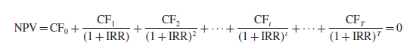

*Formula 1*. IRR

However, using IRR to estimate the attractiveness of LBO has several drawbacks.[35]

* IRR often overestimates the attractiveness of LBO;
* Comparing IRRs of different LBOs ignores the fact that buyout companies usually do not bear the same risk;
* There can be many solutions when solving the NPV equation for the IRR.[36]

In order to overcome these limitations, practitioners assume, that there are only two cash flows at the beginning and the end of the interim period and that no dividends are paid to the new owners during it, and no cash inflows take place. Thus, the following formula is used to calculate the investor rate of return in LBO-analysis:[37]

*Formula 2*. Investor rate of return

Where:

Equity Value exit – is the equity value of the target at the exit;

Equity contribution – is the equity contribution in the financing structure of the LBO deal;

T – length of the holding period.

Despite the fact that in an LBO model, the attractiveness of a leveraged buyout is usually measured by a single measure, some private equity houses will also focus on an additional things, such as the money multiple, or the equity value and flows received over the lifetime of the deal.

## The logic of LBO-analysis

The proposed LBO-analysis tool is build based on publicly available information about LBO-modelling techniques. In fact, it integrates different methodologies used by leading international investment banks (Goldman Sachs, UBS, Morgan Stanley, Deutsche Bank). This techniques are described in the researches conducted by this companies (Credit Suisse (2007a), Credit Suisse (2007b), Deutsche Bank (2007), Goldman Sachs (2007), Morgan Stanley (2003), UBS (2007)) and presented in the book “Equity valuation: models from leading investment banks” by Jan Viebig, Thorsten Poddig, and Armin Varmaz.

The proposed analytical tool is designed in a way that the user my enter the input cells only and get the final product of LBO-analysis. Yet, each step of the model will be described in detail.

As soon as investors have two main objectives in LBO-analysis and LBO-analysis consists of two parts (target identification and target evaluation), the proposed analytical tool is built to address both of this objectives and consists of two parts:

* LBO-screener, designed to quantitatively compare series of potential candidates and choose an LBO target under certain assumptions;
* LBO-model, designed to analyze the chosen target in a greater detail.

As it is supposed to be, the LBO-analysis tool analyzes the attractiveness of potential LBO candidates by calculating investor rate of return (IRR) with the use of formula (2). It is important to mention that in fact this formula is a matter of great uncertainty, which introduces a number of limitations into the LBO-analysis tool (are discussed in the Chapter 3). The equity value of the target company at the exit is utterly unpredictable, and the LBO-analysis tool does not deal with modeling this uncertainty. Moreover, the model is concerned only with quantitative side of the LBO-analysis, yet in real life qualitative analysis also should be done.

The logic of the proposed LBO-analysis tool is presented in the block scheme below.

The process starts with running the LBO-screener (0). It requires the manual inputs of company data (1) and the inputs of LBO-model assumptions (2). After that, the LBO-screener will calculate IRRs for the companies (3) and rank them by implied IRR (4). On step (5) first decision-making has to take place: based on the LBO-screener output the investor has to compare a number of potential LBO-targets and make a decision about for which company to make a detailed LBO-model. If the investor is not willing to proceed with more detailed analysis, the process ends (6). If the investor wants to perform the more detailed analysis, he runs second block of LBO-analysis tool – LBO-model (7). Again, it requires inputs of company data and model assumptions (8). After that, the LBO-model will perform return analysis and calculate IRR (9). The results of return analysis have to be compared with investor expectations regarding the deal outcome (10). If he is satisfied with the result, he makes the decision to invest in the LBO-target and the process comes to the end (11). If the investor is not satisfied with the results of analysis, he may be willing to analyze another potential LBO-target (12). In this case the process starts over with the stage (5) – choosing and LBO-target and continues until the process comes to the end (13).

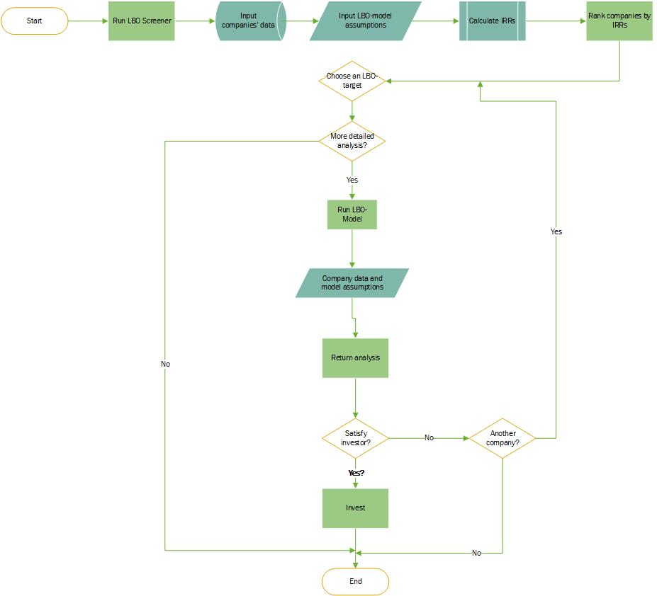

(12)

(11)

(10)

(7)

(5)

(9)

(8)

(4)

(3)

(2)

(0)

(1)

(13)

(6)

*Pic 3.* The logic of LBO-analysis

As outlined in the previous section of this chapter, before running the LBO-screener a preliminary qualitative assessment of the range of companies should take place. Accordingly, before running the LBO-model a deep analysis of the target company should be done (internal analysis, due-diligence).

## LBO-screener

The LBO-screener is an analytical tool giving the investors an opportunity to quantitatively compare series of LBO targets under certain assumptions and then choose an LBO-target based on IRR. Investors usually run LBO screens on a large universe of potential LBO candidates, however as mentioned before, no information about such screeners is available to public.

The LBO-screener is built in Excel with the use of VBA programming tools. As soon as the algorithm of the model is very complex, it was presented in the block scheme below.

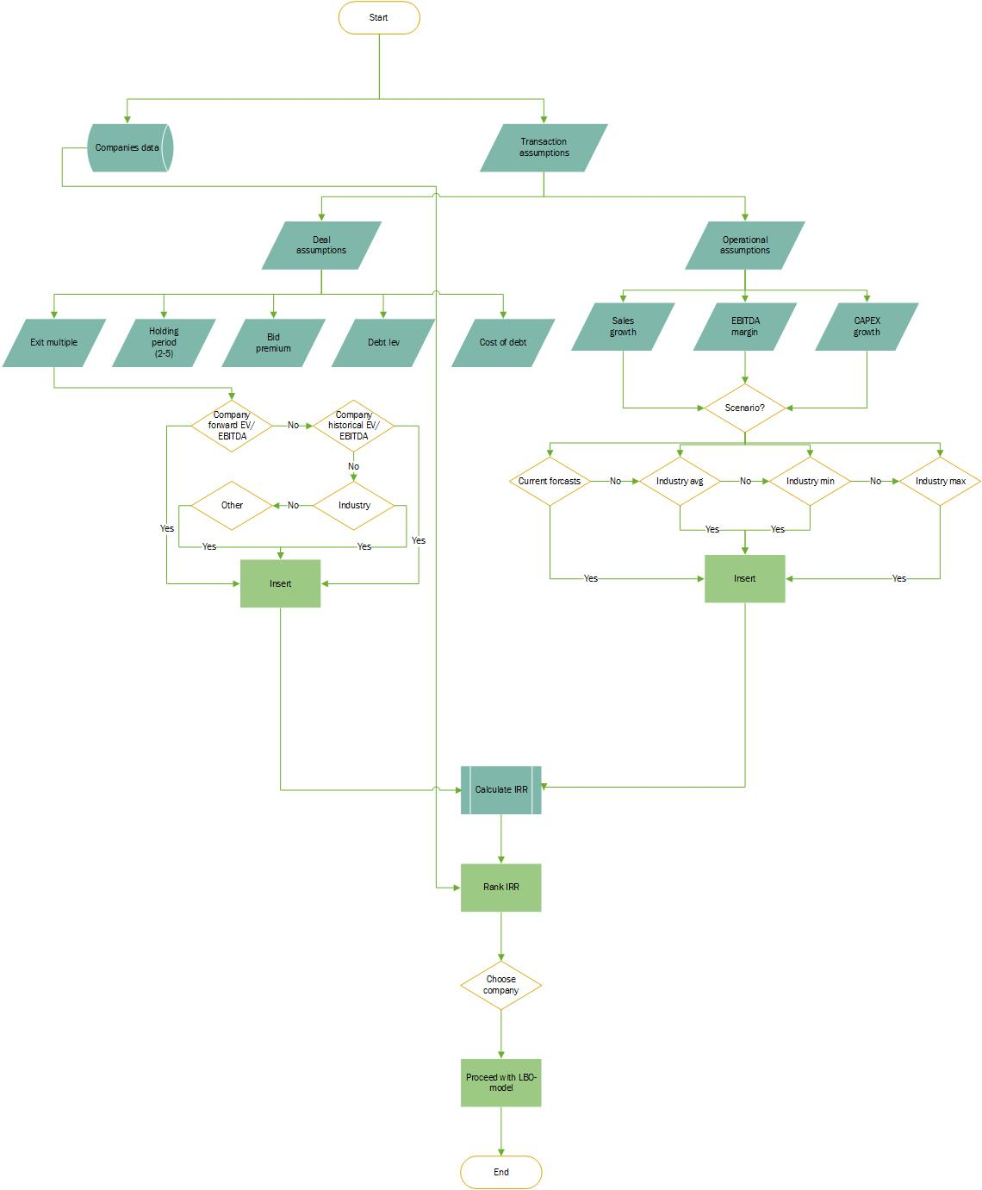

(20)

(23)

(22)

(21)

(19)

(18)

(18)

(17)

(16)

(15)

(14)

(13)

(12)

(11)

(10)

(9)

(8)

(7)

(6)

(5))

(4)

(3)

(2)

(1)

*Pic 4.* The LBO-screener algorithm

It is important to mention, that some operations are aggregated into bigger blocks, so as to be readable. More precise scheme of LBO-screener in provided in the Appendix 3.

The algorithm starts with inputs of data, which are divided into two main parts: company data (1) and transaction assumptions (2).

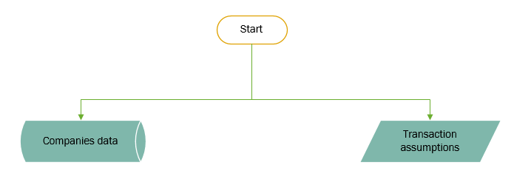

Pic 5. Main inputs of LBO-screener algorithm

The company data consist of the basic information about the companies that are going to be screened with the use of proposed instrument. In order to input the company data one has to make a database from potential LBO-targets and company characteristics: industry, current rating, share price, number of shares outstanding; and collect data on three main financial statements – balance sheet, income statement, cash flow statement. The information needed for the financial statements is limited to key financial statement items, which are necessary in order to calculate the target internal rate of return. These key drivers are presented in the table below:

*Table 3.* Key drivers of financial statements

|  |  |  |  |
| --- | --- | --- | --- |
| Income statement | Balance sheet | Cash flow statement | General information |
| Revenues  EBITDA  Depreciation and amortization  EBIT  Interest expenses  Net income | Equity  Current assets  Net fixed assets  Total assets  Net debt  MV associates  Leases (capitalised)  Unfunded pensions | CAPEX | Industry  Current rating |

The data should be collected for over all projection period.

Transaction assumptions are vital here. As soon as LBO-screener is a tool for preliminary analysis and is designed to compare multiple targets, the assumptions made here are limited as compared to assumptions made in detailed LBO-model (will be discussed in the next section). They are comprised of deal assumptions (3) and operational assumptions (4).

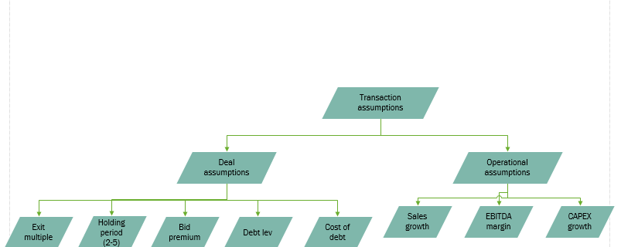

Pic 6. Transaction assumptions

Deal assumption refer to different characteristics of the transaction that we assume in order to calculate the implied investor rate of return. They consist of four groups of assumptions: exit multiple (5), holding period (6), bid premium (7), debt leverage (8), cost of debt (9).

* ***Holding period.*** When modeling LBOs and comparing several LBO targets, analysts typically assume as base case that private equity investors exit after five years and calculate five-year IRRs accordingly.[38] Thus, the holding period assumption can be chosen in the drop-down list from 2-5 years. The projection period here is also designed to be 5 years, based on the same fact. However, usually, the length of projection period and the holding period is typically set at seven to ten years so as to match the maturity of the longest tenured debt instrument in the capital structure. As soon as we are comparing multiple a large screen of companies the cost of debt is assumed without a detailed financing structure and debt schedule, there is no need to make longer projections. A financial sponsor, however, may only use a five-year projection period in its internal LBO model so as to match its expectations for the anticipated investment horizon.
* ***Market premium assumption.***Investors usually have to pay a premium to gain control of a target company.[39] A control premium is the amount that a buyer is willing to pay over and above the current market price in order to acquire a controlling interest in that specific company.[40] There are three reasons why LBO targets are usually bought with control premiums. Firstly, private equity firms seeking to acquire attractive targets usually compete with other financial and strategic investors, that is why they bid higher offers. Another reason lies behind the concept of control premium. Gaining control the acquirer receives power to elect executive officers, set wages, announce dividends, liquidate or sell a company, and gives access to the target firm’s cash flows, and the control of the strategy and operations. Control premiums are typically seen in takeover bids of public companies, but can be present in situations where shareholders of private businesses pay a premium to obtain majority interest or a controlling position in a company. Finally, it is necessary to take into account control premium, since current owners of the target may be against selling their shares. The market premium assumption will be discussed in a greater detail in LBO-model section. Here we have to say that in LBO-screen this cell is designed with a full flexibility to insert the desirable market premium. Once chosen, the same market premium will be applied to all of the companies in the data set.
* ***Debt-leverage*.** Identifying the financing structure of the LBO starts with choosing a proper debt to equity ratio. This may actually depend on a lot of factors, including the reputation of the private equity fund, availability of the debt and the strategy of the private equity fund. To simplify matters, financial analysts usually apply financial ratios to determine the leverage potential of an LBO candidate. Analysts at Goldman Sachs, for example, use sector specific debt/EBITDA ratios to determine the initial debt level.[41] Their colleagues at Deutsche Bank apply interest coverage ratios to determine the maximum amount of debt a company can carry.[42] Analysts at Morgan Stanley simply assume as base case that private equity firms finance LBO transactions with 30% equity and 70% debt.[43] UBS uses sector specific debt/EBITDA multiples and interest coverage ratios but adjusted to allow for an acceptable long-term debt repayment schedule and deal size.[44] All three metrics are subject to flux and are market determined. Different companies require different capital structures. There is not a single capital structure that fits for all leveraged buyouts.[45] In the proposed model, specific debt burden assumptions are used. The debt burden leverage is based on Goldman Sachs research carried in 2007, and is presented in the Appendix 5. However, the model is designed with a flexibility to change the financial leverage depending on investor preferences if needed.
* ***Cost of debt*.** Modeling an LBO, financial analysts have to formulate assumptions not only on the degree of leverage but also on the cost of debt. As the base case for its standardized LBO model, Goldman Sachs assumes that 60% of debt is bank debt at LIBOR plus 250 basis points, 30% senior debt at LIBOR plus 375 basis points and 10% subordinated debt at LIBOR plus 500 basis points.[46]To identify the cost of debt, normally, the financing structure of the levered buy out should be known. The success of the LBO close is based on the ability of the financial investor to attract the necessary financing for the acquisition of the target. We know that financial investors try to attract as much debt as possible to increase the return on investment, however, the financing structure of a levered buyout is individual for each transaction. The condition of the current debt market, availability and the cost of debt play the key role in determining leverage levels in the financing structure. Again, because, we are analyzing a large screen of companies simplifying matter was applied. The model is designed with a flexibility to insert the desired cost of capital.
* ***Exit multiple.***When building an LBO-model, analysts assume that at the exit the company will be sold at least with the same multiple as it was purchased. Private equity investors usually exit their investment by selling the acquired company to new investors or listing it on a stock exchange in an initial public offering after a few years. The final cash flow to the private equity sponsor equals the exit enterprise value less net debt in the exit year T. Most financial analysts use average EV/EBITDA exit multiples of a comparable peer group of companies to determine the ex-ante unknown enterprise value EV of a potential buyout candidate j at the exit date T:[47]

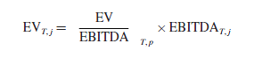

*Formula 3*. Identifying exit multiple

The choice of the exit multiple is highly subjective. Like other valuation multiples, EV/EBITDA multiples expand and compress over time. Some financial analysts use long-term historic average EV/EBITDA multiples, some apply current multiples to calculate the exit enterprise value. Financial analysts can apply company specific or industry specific exit multiples. LBO-screener is designed in a way that it gives an opportunity to choose the exit multiple assumption from the drop down list. The available options are (10):

* Industry forward EV/EBITDA;
* Company historical EV/EBITDA (3 years);
* Other EV/EBITDA multiple.

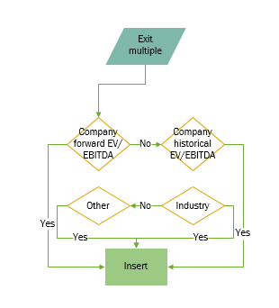

Pic 7. Exit multiple assumption

The second group of transaction assumptions is operational assumptions (4). They consist of three types of assumptions in their turn: sales growth (11), EBITDA margin (12), CAPEX growth (13). The chosen drivers are core, to be included in IRR calculation. These items can be forecasted in a multiple ways (14). The drop down list gives an opportunity to choose one of the following options: Industry average (15), industry minimum (16), industry maximum (17), current company forecasts (18).

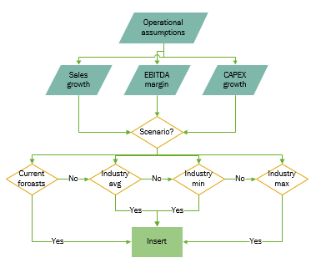

Pic 8. Operational assumptions

It is important to note here that the projection of the future financial performance of the company depends on the effectiveness of the management measures of the PE Fund, aimed at increasing the value of the company. Forecasting the financial position of the company is relevant specifically from the point of view of these aggressive measures, and not from the point of view of the basic functioning of the company and not from status quo. Since we do not know these measures in advance, and since the goal of this work is not the development of measures to increase the cash flows of the targets, is this work all projections are made based on the assumption that during the holding period the companies will demonstrate operational performance at least on the same levels as before LBO. Individual current forecasts of the companies have to be collected as well and linked to the company database mentioned before.

After deal assumptions are set (18) and the transaction assumptions are set (19), the screener should be run. It will calculate implied investor rate of return under the chosen assumptions (20) and then rank the companies by IRR (21). Along with IRR, LBO-screener will put out key characteristics of the analyzed companies: company, its industry, current rating, bid price, entry EV/EBITDA, exit EV/EBITDA. The LBO-screener works based on a number of macros developed with the use of VBA programming. The exact formula used to calculate IRR is complex. It was simplified and now can be seen on the scheme below:

*Pic 9*. IRR calculation in LBO-screener

On step (22) an important decision making process should take place: from the list of the analyzed companies, he has to choose a suitable target based on the calculated IRR.

How exactly the output parameters are calculated can be seen in the LBO-screener as well. This tool provides an opportunity to manipulate the actual model and analyze the companies in a greater detail. (List 4 in the Excel file). The companies can be chosen from the drop down list. After that all the cells of the screener will automatically update. Apart from IRR calculation, this tool makes an IRR sensitivity analysis based on different parameters: based on entry-exit multiples, margin improvement assumptions etc.

## LBO-model algorithm

The purpose of LBO-model is to perform a return analysis for a given target, which involves IRR calculation and sensitivity analysis. It is quite similar to LBO-screener. LBO-model differs from LBO-screener by the fact that it is performed for an individual company and that it includes the following things:

* *Detailed financial statement projections*. If investor is serious about buying a company, there is a need to complete projections with every line item in the income statement, cash flow statement, and balance sheet;[48]
* *Balance sheet adjustments*. We will soon discuss the importance of showing the balance sheet after the investment has been made including all the new debt and equity used to fund the purchase;
* *Detailed financing structure*;
* *Debt schedule*. The full-scale LBO-model contains a debt schedule, which calculates interest expense and flows into the three statements.

As it was mentioned, LBO-models are or a high secrecy in the industry, they are highly confidential and never revealed to public. In fact, there come models that can be found in the open sources, but they are either simple or flawed.

As a criteria for a flaw detection were used the best practices of LBO-modelling techniques used by leading Investment Banks (Goldman Sachs, UBS, Morgan Stanley, Deutsche Bank). This techniques are described in the researches conducted by this companies (Credit Suisse (2007a), Credit Suisse (2007b), Deutsche Bank (2007), Goldman Sachs (2007), Morgan Stanley (2003), UBS (2007)) and presented in the book “Equity valuation: models from leading investment banks” by Jan Viebig, Thorsten Poddig, and Armin Varmaz. The summary this flaws is presented below. Publicly available models:

* Do not consider types of shares outstanding (diluted or basic) in calculation of equity value;
* Do not take into account whether the target is public or private (different equity valuation formula should be used for each case);
* Do not provide explanation for chosen financial leverage and the financing structure;
* Use only one scenario in financial statement projections;
* Apply fixed growth rate in financial statement projections;
* Forecast only main financial statement drivers instead of full statements;
* Do not include transaction fees in calculation of the transaction value or don’t amortize them;
* Do not include sensitivity analysis.

It was concluded that there is a need to improve publicly available LBO-models, thus in the proposed model, there was done an attempts to improve those, by taking into consideration the best practiced of LBO-modelling techniques presented in the publicly available sources.

The full logic behind the LBO-model is presented in the Appendix 6. In order to be able to describe how the LBO-model works, some of its logical parts were aggregated into bigger groups and presented below.

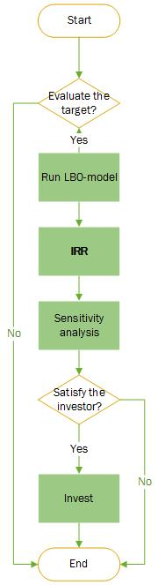

Pic 10. The logic of LBO-model algorithm

Any LBO-model starts with a decision to carry a return analysis for a given company (1). If the investor is not willing to do it, the process comes to the end (2). If the investor is interested in performing the return analysis he will run the LBO-model (3). As soon as the model is started it will calculate the IRR (26) and perform the sensitivity analysis (27). The result of the analysis should be compared with the investor’s expectations regarding the deal outcome. If he is satisfied, then the proceeds with the investment, of not, then the process ends. It is important to mention that before quantitative analysis qualitative analysis of the company and the industry it operates in should take place. It will help to build assumptions and conduct the further analysis. Here the company should be qualitatively analyzed on the matter of correspondence to main characteristics of a strong LBO-target as mentioned in Chapter 1.

***LBO-model inputs***

Model inputs are comprised of company data and assumption based inputs.

***Company data***

Company data should be inputted into the model at the next step (4). The company data consists of historical balance sheet (5), income statement (6) and cash flow statement (7). Three year historical data should be used, if possible. Moreover, it is also needed to choose the company industry from the drop down list (8) and choose the company’s ownership form (9). In case if company is public, current number of fully diluted shares outstanding and current share price have to be inserted (10, 11). In case if company is private, comparable P/E multiple should be input (12).

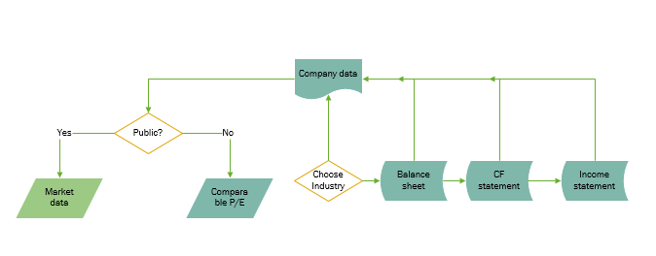

Pic 11. Company data inputs

On the next step, assumptions based cells should be filled in. Like any other model, proposed LBO-model is based on simplifying assumptions. Within this work, the assumptions were grouped into three categories: basic model assumptions, sources of funds and uses of funds assumptions and operational assumptions. The model assumptions are its main drivers, and the output of the model itself is very much sensitive to this inputs.

Assumption based inputs are the following: financing structure (sources of funds), operational assumptions, debt schedule, fees amortization schedule, purchase assumptions (uses of funds), exit multiple.

***Uses of funds assumptions***

Uses of funds are comprised of three components – company purchase price, financing fees and other expenses (13).

*Purchase price*

The purchase price is formed by company value, financing fees and other expenses.

* + *Company value*

In order to conduct a leveraged buyout analysis, we first need to obtain a potential purchase price of the entity, and calculate purchase EV/EBITDA multiple. Based on this multiple the investor makes a decision about the desired exit multiple. For example, knowing that today the company is traded at 7.5x EBITDA, the investor can focus on reselling the company in the future with at least the same multiple.

The equity purchase price of the company should be calculated differently for private and public companies (9). For a public company it is found as the market value of equity – fully diluted company shares * number of shares (10). Since LBO transactions are carried out on the basis of market, rather than fundamental value, conducting a fundamental analysis of equity is irrelevant.

For a private company we do not have a current market value, thus we need to use multiples to establish an estimated purchase price (12). Multiples of a private company can be based on public company’s comparables or historical transaction multiples. In the proposed model price to earning multiple is used, since it is most commonly used multiple in LBO-transactions. The proposed model takes into account the difference in the ownership form. The user should enter "public" for a public target and "private" for a private target. The LBO model template will automatically update the labels and calculations for each selection.



Pic 12. Calculating company value

To eventually determine the company value the net debt is added to equity value.

*Control premium assumption*

As mentioned in the LBO-screener part, investors usually have to pay a premium to gain control of a target company.[49] A control premium is the amount that a buyer is willing to pay over and above the current market price in order to acquire a controlling interest in that specific company. The price of the company's shares, including the premium for control, is determined by the following formula (17):

Current share price * (1 + control premium)

Defining the value of control premium is an extremely important thing in LBO-analysis, since the output of LBO-model is highly sensitive to assumed transaction prices.[50] Defining the appropriate premium for control has become an issue of a strong controversy among scholars. Some authors say a figure of close to 20% should be used.[51] According to RSM Bird Cameron’s 2017 Control Premium Study, control premiums are influenced by a number of factors including target’s industry sector, toehold (extent of acquirers existing holding in the target), size and market capitalization of the target, financing structure, the presence of the buyer's share in the target company, the quality of the current management, the unrealized potential of the company, the strength of the synergetic effect from the merger, etc. [52]

Control premiums can be also based on statistical data on comparable transactions. Financial analysts usually model the expected control premium using the historical deal premiums offered or paid for a comparable peer group of companies, which recently received buyout bids.[53]

However, the proposed model also gives an opportunity to plug in the current market price plus a premium into the model and see, subject to operating and capital structure assumptions, what IRR emerges.

* + *Transaction fees*

Transaction fees are assumed as the sum of the costs of different debt components.

* + *Other expenses*

Other expenses, such as transaction fees (25) have to be assumed as well. Transaction fees are very important item of the analysis. These are expenses related to the pursuit and close of the buyout. Lawyers and investment bankers need to get paid for their services in helping the deal come together. The fees can run from a small retainer to a percentage of the transaction size. The amount depends on negotiations and firm wide policy. Main categories of transaction fees are: investment banking fees, legal fees, due-diligence costs, environmental assessment costs, human resources costs, debt fees, equity fees.

***Sources of funds assumptions***

Sources of funds assumption consists of two main parts: assumptions regarding the financial leverage (18) and assumptions regarding financing structure (19) of an LBO transaction. Financial leverage assumption is made according to the same rule as in LBO-screener: model uses sector specific debt/EBITDA ratios to determine the initial debt level.

As for financing structure the designed model broadly mirrors the financing of a typical buyout. That is, it comprises a mix of three tiers of senior debt, A, B and C tranches, a tier of subordinated high yield (junk) debt and higher yielding, more subordinated, mezzanine debt. The A, B and C tiers are usually seven, eight and nine years’ maturity. Buyouts in the last two years have increasingly utilized a tier of second lien debt, so-called for its subordination to the three tiers of senior debt, which have a first lien on the assets of the credit. A, B and C tranches are modelled as amortizing, which provides some cushion of comfort as in practice repayment is likely to be a bullet. The maturities involved require cash flow forecasts 10 years out.

Along with the assumptions regarding the financial leverage and debt structure, an assumptions about the debt schedule should be made (24).

***Operational assumptions***

In order to build the LBO-model, it is necessary to build the projections of the targets’ financial statements (20). The forecasting period for the company's reports usually depends on many factors, for example, such as the expected closing date of the transaction or the time to maturity of the longest debt instrument. The model is designed so as to forecast up to 10 years.

The forecast of the company's performance was carried out through the prediction of the growth rates of the main drivers of the company's financial performance. Within each financial statement, the following drivers of key indicator growth were identified:

*Table 4*. Key value drivers of financial statements

|  |  |
| --- | --- |
| Financial statement | Main drivers |
| Income statement | Sales (% YoY growth)  Cost of Goods Sold (% margin)  SG&A (% sales)  Other Expense / (Income) (% of sales)  Depreciation & Amortization (% of sales)  Interest Income  Tax Rate  Cost savings as % of SG&A |
| Balance sheet | *Current Assets*  Days Sales Outstanding (DSO)  Days Inventory Held (DIH)  Prepaid and Other Current Assets (% of sales)  *Current Liabilities*  Days Payable Outstanding (DPO)  Accrued Liabilities (% of sales)  Other Current Liabilities (% of sales) |
| Cash flow statement | Capital Expenditures (% of sales) |

In their LBO models, firms usually use a couple of scenarios. In order to evaluate the transaction to its fullest extent they typically use a base case (21), a management case (22), an sponsor case (23). The base case is used in order for the PE firm to evaluate the deal. The management case is based on numbers given from the management of the portfolio company and the ambition case is used as a best-case scenario. The bank case has a somewhat pessimistic setup of inputs. Therefore, it gives a lower result. Due to this, the bank case is used when presenting the deal to the lending bank. This assures that the covenants set up by the bank will be somewhat low and therefore possible to adhere with.

Using different cases is an important thing in LBO, since it reduces the uncertainty connected with the forecasts of the target’ equity value at the exit of the transaction. Here a decision making process should take place: investor has to choose under which operating assumptions to conduct the further analysis. Depending on it, the model will adjust the projections of the financial statements.

The last assumption to be made is the assumption regarding the exit multiple. When building an LBO-model, analysts assume that at the exit the company will be sold at least with the same multiple as it was purchased.

Private equity investors usually exit their investment by selling the acquired company to new investors or listing it on a stock exchange in an initial public offering after a few years. The final cash flow to the private equity sponsor equals the exit enterprise value less net debt in the exit year T. Most financial analysts use average EV/EBITDA exit multiples of a comparable peer group of companies to determine the ex ante unknown enterprise value EV of a potential buyout candidate j at the exit date T:[54]



The choice of the exit multiple is highly subjective. Like other valuation multiples, EV/EBITDA multiples expand and compress over time. Some financial analysts use long-term historic average EV/EBITDA multiples, some apply current multiples to calculate the exit enterprise value. Financial analysts can apply company specific or industry specific exit multiples.

After all the assumptions are inserted the model will make all the necessary calculations to obtain the internal rate of return for the given target (26). The scheme of IRR calculation is schematically showed on the picture below.

*Pic 13.* IRR calculation in LBO-model

Let’s look at this formula closer.

The IRR is defined as the internal rate of return of the LBO transaction, assuming there were no dividend payments and cash outcome during the holding period, and thus there are only two cash flows: the value of equity contribution at the start of the transaction (27) and the equity value of the target company at the closing date of the transaction (28).

The equity contribution at the start of the transaction (27) is found as the total transaction value (29) minus debt contribution for the purchase of the target (30).

The total transaction value (29), in its turn, is calculated as company value (31), plus financing fees (32) and other expenses, such as transaction fees (25).

Company value (31) is found differently for a public and private companies. For public companies it is calculated as the number of fully diluted shared outstanding * the purchase share price, which is found with market premium. For a private company, the market value is found with the use of comparable company P/E multiple.

Quite often, in addition to the purchase price, a buyer is responsible for raising additional funds to pay off the target company’s outstanding debt obligations. This can also include other liabilities such as capital lease obligations. The need to pay down such obligations is dependent on several factors including whether the company is public or private.

In case the company is public, acquiring a company, in addition to its assets and capital, the buyer also acquires its debts (pay for them), removing the responsibility for their payment in the future. Therefore, enterprise value is calculated based on the data on the company's capitalization and the amount of net debt, according to the formula:

EV = MV + Net Debt

Where:

EV - company value;

MV - market capitalization;

Net Debt - net debt of the company: debt net of cash and cash equivalents.

The logic behind using the net debt, instead of a common debt, is that by acquiring a company, we also acquire its cash that can be used to pay off debts. Usually performing LBO-analysis investors assume that only long-term debts will be payed off, so short-term debts are not taken into account when calculating the acquisition price of the company. They will be used to finance working capital.

Thus financial analysts usually model the expected transaction value paid in an LBO by adding (net) debt, D0,to the product of the current market capitalization times one plus a historical deal premium, DP, offered or paid for a comparable peer group p of companies which recently received buyout bids. The following equation shows how analysts usually model the expected transaction or enterprise value, EV, of an LBO target j:



*Formula 4.* EV calculation

The terms P, S and D represent the current market price, the current number of shares outstanding and the current amount of debt and debt-deemed liabilities of a potential LBO candidate. Financial analysts usually multiply current earnings before interest, taxes, depreciation and amortization, or EBITDA, by a historical EBITDA multiple paid in recent LBO transactions to check if the assumed transaction price is realistic:

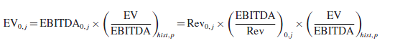

*Formula 5.* Check of EBITDA validity

The calculation of the second part of the IRR – equity value at the exit (28), is more difficult. This value is a matter of a great uncertainty, since we never know how the company will behave in 5-7 years of the holding period. It is found as the enterprise value at the exit (29) minus net debt at the exit (30).

Enterprise value at the exit is found as EBITDA at exit (31) multiplied the assumed exit multiple (32).

Regarding the net debt at the exit (30), this value is derived from the balance value at the exit (32) and the cash at the exit (33). Balance value at the exit depends on the series of the assumption that are made at the beginning of the model. All the assumptions regarding Sales (% YoY growth), Cost of Goods Sold (% margin), SG&A (% sales), Other Expense / (Income) (% of sales), Depreciation & Amortization (% of sales), Interest Income, Tax Rate, Cost savings as % of SG&A, as well as interest expenses taken from debt schedule are included in the calculation of Income, used to further find the shareholder equity value (33). Other assumptions such as Days Sales Outstanding (DSO), Days Inventory Held (DIH), Prepaid and Other Current Assets (% of sales), Days Payable Outstanding (DPO), Accrued Liabilities (% of sales), Other Current Liabilities (% of sales) are used in the calculation of the shareholder equity.

As for the value of cash at the exit (32) it is derived from cash flow from operating activities (34) (based on net income, Depreciation assumptions, and amortization of financing fees), cash flow from investing activities (35) (based on CAPEX assumptions) and cash flow from financing activities (36) (based on debt structure and debt schedule assumptions).

At the end of all this algorithm the investor rate of return for a given year is calculated (26) and the sensitivity analysis is performed (37). After that an important decision making should take place: based on the return analysis the investor has to compare the outcome with the target IRR and make a decision whether to invest in the company or not. If the investor is satisfied with the results of the analysis (38) he may proceed with investment and the algorithm ends. If the investor is not satisfied with the results, he may choose to conduct the LBO-analysis again on a different company of on the same company buy with a different set of assumptions.

## Applying LBO-analysis tool on real companies

### Running LBO-screener for a set of potential LBO-targets

In this section there is made an attempt to apply the developed LBO-analysis tool of the set of real companies. The developed analytical tool starts with the following page:

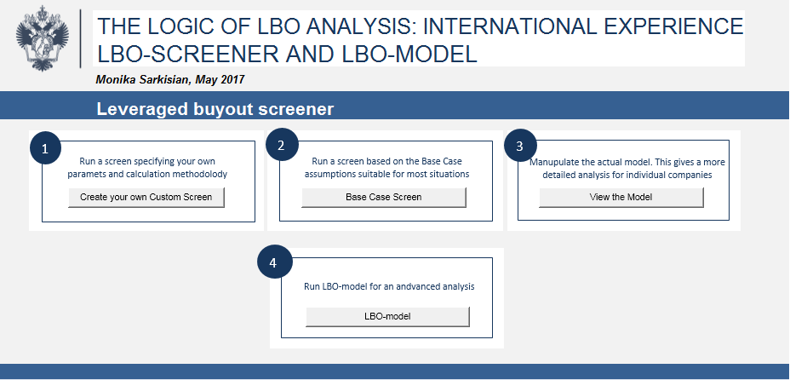

*Pic 14.* Home page of the developed LBO-analysis tool

There are four main functions presented here:

1. Run a LBO-screener specifying parameters and calculation methodology;
2. Run a screen based on Base Case assumptions suitable for most situations;
3. Manipulate the actual LBO-screener;
4. Run LBO-model for an advanced analysis.

To access the needed function the user has to push the corresponding button.

The first function represents the actual LBO-screener. It gives an opportunity to set specific desirable assumptions and then evaluate and compare companies as potential LBO candidates. The model performs preliminary LBO-analysis potential targets and then ranks the companies by implied IRR.

As it was mentioned, in order to run the screener firstly the data on companies has to be collected. For this purposes a data file from 760 companies was created and all the requited information on these companies was collected. The list of the used companies can be seen in the Appendix 4. Moreover, for the chosen companies the industry sector was identified, and then all the information regarding the industry growth rate was also obtained. The list of industries is presented below. All the data regarding the companies and the industries were collected from the Thompson Reuters database.

*List 1*. List of industries used in LBO-screener

Aerospace/defense

Airlines

Airports

Alternative energy

Automobiles

Banks

Beverages

Biotechnology

Business services

Chemicals

Consumer products

Construction

Diversified financials

Electrical equipment

Entertainment/ leisure

Environmental services

Food

Gaming

Gas

Hardware

Healthcare services

Industrials

It Services

Lodging

Logistics

Machinery

Media

Medical technology

Metal and Mining

Multi-Industry

Oil

Oil services

Packaging

Paper and forest

Pharmaceuticals

Power

Real Estate

Restaurants

Retail

Satellite

Semiconductors

Shipping

Software

Finance

Steel

Surface

Telecom services

Tobacco

Travel

Utilities

After collection company and industry data the transaction assumptions were set. As a base case were used most commonly used assumptions:

* Bid premium: 20%;
* Leverage: sector specific;
* Cost of debt: 10%;
* Exit EV/EBITDA: company historical EV/EBITDA;
* Sales growth: current forecasts;
* EBITDA margin: current forecasts;
* CAPEX growth: current forecasts.

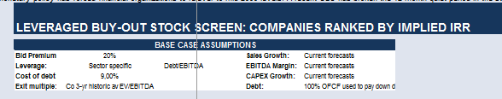

Pic 15. Setting assumptions for LBO-screener

After that the LBO-screener was run. As a result, IRR for all of the companies was calculated and then the companies were ranked by implied IRR. The output of the LBO-screener can be seen on the screenshot below.

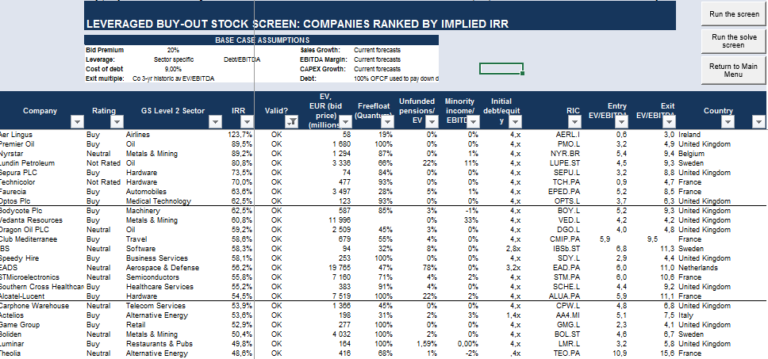

*Pic 16.* LBO-screener output under base case assumptions

For the actual manipulation of the model we move to the 3rd page of the LBO-analysis tool. It also refers to the LBO-screener.

In the drop down list of the screener we should choose a company, which we would like to analyze more precisely. The model will immediately and automatically update all the cells with company data and forecasts and show how the calculation of investor rate of return was made. Moreover, here is an opportunity to make a detailed IRR sensitivity analysis, which also updates depending on chosen assumptions and the chosen company.

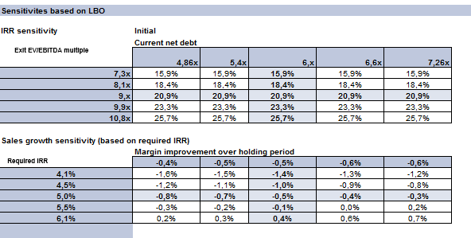

*Pic 17.* Example of IRR sensitivity analysis

Further a decision making process has to take place regarding in which of the following companies to invest. This decision will depend on a lot of factors such as the preferences of the investor of private equity fund, the strategy of private equity fund etc.

### Building LBO-model for Ingenico Group

In order to proceed with building an LBO-model Ingenico Company was chosen. As it was already noted, the success of the LBO transaction is largely based on the ability of a financial investor to find a suitable target company and to justify the attractiveness of investments. To do this a qualitative analysis of the target company is made. Here special emphasis is made on the mandatory characteristics of the LBO target, since if the analysis reveals that the company does not have sufficient potential for growth and development, then the target company's evaluation is not performed, and investors withdraw their participation in the transaction.

In this section, an LBO-model for Ingenico Group company is build. Before that a qualitative analysis if the company is made. All this process is structured into 6 main steps:

1. Locating and analyzing relevant information about Ingenico Group
2. Formulating LBO-model assumptions
3. Building preliminary LBO-model
4. Introducing the formulated model assumptions into the LBO-model
5. Building final LBO-model
6. Conducting return analysis.

In order to build the LBO-model, year 2016 was taken as the starting point and the holding period was assumed to be 10 years.

#### Step 1. Locating and analyzing relevant information about Ingenico Group

Ingenico Group SA, founded in 1980, is a leading global provider of solutions in the field of payment technologies and acquiring services. Its main operation areas are development and sale of electronic payment terminals and related software, terminal maintenance, security services, consulting services, value added services. Ingenico Group is a suitable candidate for an LBO transaction, as it meets all the basic requirements of a strong LBO target. Summary tables with corresponding calculations of financial indicators are presented in Appendices. Certainly, this kind of analysis has to be done in a grate detail. However, as soon as qualitative assessment of the company is not the topic of this master thesis, only preliminary qualitative analysis is made.

The company was analyzed on the subject of correspondence to the main criteria of a strong LBO candidate: the ability to generate stable cash flows, a leading and stable competitive position, the potential for increasing the efficiency of operations, growth potential, low CAPEX requirements and the reliability of the management team. The ability to generate net cash flows is proved by sustained revenue CAGR at 17% over the past 10 years, stable and increasing cash flows, high proportion of operating profit margins, and outstanding financial performance (Appendix 7) and financial position. Leadership positions are confirmed by the presence of strong competitive advantages in market share (47%), operational efficiency (above industry profit margin, significantly less costs in the sales structure), and relations with consumers, which contributes to the stability of product sales and, consequently, to the stability of cash flows. The company's growth potential is supported by growth of the electronic payment systems market, in particular in emerging markets, the synergy effect from the recent acquisition of Globalcollect, the optimization of the product portfolio and the upcoming intruduction of new products and services. The potential for increasing the efficiency of operations is confirmed by the tendency to reduce general and administrative expenses. In general, it can be concluded that the Ingenico Group is a suitable target candidate for the LBO deal.

On this step, all the necessary information about the company was collected: balance sheet, income statement, cash flow statement. All data was collected for the prior three years.

#### Step 2. Formulating the model assumptions

All assumptions were classified into three categories: basic model assumptions, assumptions about the uses of funds and about the sources of funds.

*Uses of funds assumptions*

In this case, the uses of funds are comprised of company purchase price, financing fees and the transaction fees. The purchase price is found with use of formula for the public companies (including the market premium). The at the end of 2016 was 87,28 euros. When estimating the market premium for Ingenico Group, the following information was taken into consideration (see Appendix 8):

* The median market premium in the electronics industry amounted to 38.4% from the Mergerstat study and 39% from the RSM Bird Cameron survey (Figures 1 and 2);
* The median value of the control award for transactions financed by both debt and equity is 29.4% (Figure 3);
* The buyer does not own the company's property, which corresponds to a 24% premium to the market (Figure 4);
* The premium to the market for companies with a market capitalization of more than $ 500 million is on average 21.4% (Figures 5 and 6);
* Median and average control premium for countries with a developed stock market are in the range of 30-40%;
* The size of the acquired stake in the company is 100%, in the ownership structure there are shareholders with shares of more than 10%.

Based on this information, a premium of 28% was set for Ingenico Group as one of the model assumptions, and the acquisition price of the company's stock was calculated at $ 111.72 (Pic 18). After completing the LBO analysis, the model design allows manipulating this assumption to analyze the sensitivity of the IRR.



Pic 18. Share price valuation

[Created by author]

Valuation of equity is based on the company's market capitalization (MV) and is calculated as the current share price multiplied by the total number of fully diluted shares (15).

As it is known, the number of shares presented in the company's profit and loss statement can be either basic or diluted. The basic shares outstanding are all issued and outstanding shares, both in the hands of investors and in free float. Unlike basic outstanding shares, fully diluted shares include all possible sources of conversion to outstanding shares, such as convertible bonds, stock options, stock warrants and convertible preferred stock or debt, assuming these securities were exercised.[55] Using the number of diluted shares to calculate the purchase price of the company seems to be the most appropriate, since it allows you to take into account the dilution of capital as a result of the realization of all rights, and provides the worst estimate of the value of the stock (for the buyer) in terms of scenario analysis.

The number of diluted shares outstanding as of the end of 2016 was 60,001,095, of which 5,743,984 shares consisting of rewarded shares (0.013%) and convertible bonds (0.98%) are "diluted". Thus, based on the information on the number of shares and the purchase price of the share, the purchase price (the company's equity estimate) was found:



*Pic 19.* Equity valuation for Ingenico

[Created by author]

After, the market value of the company was calculated.



*Pic 20.* EV valuation for Ingenico

[Created by author]

*Exit of EV / EBITDA multiple assumption*

Very often, when building an LBO-model, it is assumed that when a deal is closed, the company will be sold at least with the same multiple as it was purchased. EBITDA of the company for 2016 amounted to 345 million euros, so the purchase EV/EBITDA is 19,4. However, taking into account that today Ingenico is overvalued, an adjustment was made to the value at the close of the transaction, and it is assumed that the company will be sold at a price of 15x EBITDA. It should be noted that this is a fairly bold correction, usually the EBITDA multiplier corrections are in the range of ± 2 points.

*Holding period assumption*

It was assumed that the management of the PE fund will be carried out for 10 years and the year of closing of the deal 2026. Among the basic assumptions of the model, we also note that during the period of ownership of the company, investors will not receive dividends for invested capital, other additional outflows and inflows will be made.

*Sources of funds assumptions*

In this paper, the following structure of financing was assumed:

Total

Total



Pic 21. Sources of funds and uses of funds

Other characteristics of the debt financing are shown in Pic. 22. Among them - the share of each instrument in the overall structure of financing, cost of debt, financing fees, the repayment rate of the body of the loan.



Total

Cost of debt

Principal repayment

Cost of debt

Debt

Fees

Pic. 22 Characteristics of the financing structure

Among the main directions uses of funds, we note the company purchase price, the repayment of the long-term debt (repay existing debt), the payment of advisory services to the investment bank (other fees and expenses). The total amount of required investment is $ 7,859,989,375. It is important that the commission and costs of raising funds are depreciated. In Pic. 23 depicts the depreciation schedule for these model variables, taking into account the long-term nature of each of the instruments. The linear method of depreciation is used.



Pic 23. Depreciation schedule of financing fees

The total amount of the use of funds should be equal to the amount of sources of funds.

*Operational assumptions*

The fill set of operational assumptions of financial statements with estimated values ​​are presented on the corresponding appendix. When predicting the growth rates of individual drivers, the following facts were taken into account:

* According to the information provided in the company's press release on February 14, 2017, Ingenico has set quite ambitious KPIs to increase the main indicators of financial performance for the next three years. Thus, the company expects a significant growth in all indicators in 2017, caused by a synergistic effect from the merger with GlobalCollect, which, according to analysts' forecasts, will fully reveal itself within 5 years;
* Among the main drivers of short-term and long-term growth are the growth potential of the e-commerce market, including in developing regions and the introduction of new products and services;
* Forecasting of various indicators takes into account the historical trend of growth of these indicators;
* Forecasting of all balance sheet items and the profit and loss statement is based on the forecasts of analysts.

Usually, the predictions of the effectiveness of determining measures to increase the value of a company within the LBO process are based on the opinions of analysts and information presented in a special document, which in terms of the M & A market is called a confidential information memorandum of the company. This document is used by the selling party to interact in the M & A market with potential buyers. Usually this document includes a detailed description of the business and activities of the company, information about the industry and opportunities in the market, financial information, including analysis of historical results and forecasts for the future. Since the forecasts are usually up to the next five years, within the framework of the LBO analysis it is customary to freeze the growth rate of 5 years, assuming it remains unchanged until the end of the investment horizon.

For making assumptions three cases of assumptions were developed: base case, management case, sponsor case. For LBO-analysis the base case was used.

#### Step 3. Building preliminary LBO-model

At this stage, we mean the construction of three main financial statements of the target company - the balance sheet, the profit and loss statement and the cash flow statement, excluding the effect of the LBO transaction. Forecasting of the articles was carried out for 10 years, since, according to the assumptions of the model formulated in Step 2, the management of the PE fund company will keep the company for 10 years. The result at this stage was the completed tables of the company's financial statements, minus the amendments to the funding involved. To build each of the financial reports, in addition to the traditional articles, lines were added that are relevant to each specific funding instrument. The reporting area corresponding to information on debts and interest paid in applications with reports is colored in gray.

#### Step 4. Introducing the formulated model assumptions into the LBO-model

The most important step in forecasting the company's balance sheet is the introduction of corrections related to the acquisition of the company. In other words, we are interested in the structure of the balance sheet at the time of the acquisition of the company. For this purpose a separate column was created in the model, where these corrections were later introduced. They were taken from the data on the sources of financing the transaction and the uses of funds. Since the use of funds and sources of financing are equal, after the amendments the balance should equal, as can be seen in Appendix 11. The main corrections were the following:

* The company's cash was used to pay off its long-term debt, so the existing 426 million euros are recorded under the "-" column in the correction area (-426);
* The company generates goodwill equal to the difference between the carrying amount of equity and the acquisition price of the company's equity (+5 629.4);
* There are deferred financial assets equal to the total amount of required investments, minus the cost of the company itself: commissions, financing costs, etc. (+120.6);
* The Company's current long-term debt (-1,036.1)
* There are additional debts in connection with the attraction of loans. These debts are included in the lines corresponding to each of the elements of the debt under the sign "+";
* Own capital is reduced by the current equity -1,073.3) and the company is increased by an amount equal to the invested capital from financial investors (+ 1,948).

After the amendments, the balance of the company "After the transaction" converges, as well as "Before the transaction" (Pic 24).



**2016**

**2016**

After deal

Adjustments

Before deal

Pic. 24. Corrections introduced into the balance sheet

[Compiled by the author]

The final balance sheet of the company, taking into account the amendments introduced, is presented in Appendix 11. In the period from 2015-2024, the balance does not converge. This is due to the fact that the debt repayment schedule is not created yet.

#### Step 5. Building LBO-model

*Building debt repayment schedule*

The debt repayment schedule is a scheme for repaying the company's debt. For each of the elements of the financing structure, an individual repayment schedule was created. Also, for each of the elements of the financing structure, the amount that would be subsequently entered in the "interest expense" columns in the cash flow statement, and the end balance of the debt were calculated. The constructed debt repayment schedules are presented in Appendices 11-12.

*Building final financial statements*

After the debt repayment schedule was created, it is important to pay attention to how the financial statements change. The company's profit and loss report shows that despite the debts, the company is able to provide a stable income to its owners, as the profit in all years between 2016 and 2026 is positive (Appendix 10).

In the cash flow statement (ODDS), one should pay attention to the last item - cash at the end of the year (Appendix 12). In the first, 2016, Ingenico could not cope with the increased credit load - the value of cash in this year is negative. This may be due to the fact that all the company's money, according to the assumptions of the model, during the zero period were used to repay the debt. In this regard, in the coming year, the company did not have enough working capital to finance its normal operations, so we see a negative value. Nevertheless, in the period from 2016-2024, taking into account the need to pay interest on loans and repay the body of debt, the company has positive cash flows, which indicates the company's solvency and the ability to timely and fully pay interest. The area corresponding to the balance of debts on the balance accounts was also filled. Here it is necessary to pay attention to the fact that the balance equals.

#### Step 6. Return analysis

This step assumes the analysis of return on investments from the point of view for the financial investors (Appendix 13). As it was r noted, investors usually aim on IRR of at least 20%. If the return on investment is below the specified value, this is a signal to investors that it is necessary to review the financing structure and the acquisition price of the company. To do this, the opposite task of determining the purchase EV/ EBITDA should be solved. Taking as a basis that the value of exit multiple is equal to 15x EBITDA (according to the assumptions of the model), the company's value at the output in each year was determined as the product of the EBITDA of the corresponding year by the set multiple. Then, based on the data on the balance of cash and debts on the balance accounts, the value of the company's equity capital at the closing date was calculated as the difference between the company's value and net debt (Pic 24).



Pic 25. Calculation of the exit equity value

Further, the return on investment was calculated for each of the exit scenarios (Pic 26)



Pic 36. IRR calculation

Based on the results of the LBO analysis, it was concluded that investing in Ingenico Group is attractive. The most favorable exit year, which provides the maximum return on investment, is 2020. Investing in the company in 2016 and closing the deal in 2020 will provide IRR investors with a level of 31.96% (Pic 36), given the assumptions of the model.

The graph shows that IRR is sensitive exit year date. As we move along the time axis, the value of equity and IRR increase, which is explained by the increasing profit and the diminishing balance of debts on the accounts. However, starting in 2021, the IRR begins to fall (Pic. 36). This can be explained by the decrease in revenue growth rates with an increasing level of costs. Interestingly, the result is consistent with the observations of the authors Rosembaum, Pearl on the classic resale practice of the company in the fifth year of the investment horizon.

It should be noted that these IRR values ​​are not final. They reflect the return on investment only under the assumptions of the model on the acquisition of the company at a price of 19x EBITDA, resale at 15x EBITDA, the specified financing structure, the main characteristics of the debt, as well as the specified scenario of the company's development. In the future, the flexibility of the model allows you to manipulate the basic assumptions and analyze the return on investment in the task of assessing the investment attractiveness of the transaction under different scenarios of operational development of the target company and model parameters.

Pic 37. IRR sensitivity analysis

# Summary of Chapter 2

LBO-analysis is a core analytical tool used by investors to assess investment opportunities in LBO. It is a complex methodology, which requires specialized knowledge of financial modeling, leveraged debt capital markets, M&A, and accounting. At the center of an LBO-analysis is a financial model (the “LBO-model”), which is usually constructed with the flexibility to analyze a given targets’ performance under different assumptions, for example, multiple financing structures and operating scenarios. The structure of LBO-analysis instruments is very similar across different private equity companies and investment banks. The purpose of LBO-analysis is to analyze the attractiveness of potential LBO candidates by calculating investor rate of return.

LBO-analysis usually consist of two parts: target identification and target evaluation. To achieve each of this purposes financial investors perform series of qualitative and quantitative analysis based on internally developed models and instruments. This LBO-analysis instruments are confidential and are never revealed to public.

In this chapter an LBO-analysis tool, including a instrument for finding an LBO-target (LBO-screener), and a tool for detailed analysis of the individual companies (LBO-model) was build with the use of VBA programming. The LBO-analysis tool is based on methodologies used by leading Investment Banks, which are presented in the book “Equity valuation: models from leading investment banks” by Jan Viebig, Thorsten Poddig, and Armin Varmaz.

After that the built instrument was applied on the set of real companies. With the use of LBO-screener a set of 760 potential LBO-targets was analyzed. After that Ingenico Group was chosen as a target to proceed with detailed LBO-analysis. To do this an algorithm consisting of 6 steps was used. As a result of the analysis it was concluded that Ingenico Group is an attractive candidate for an LBO-transaction. Based on the results of building the LBO model and carrying out the LBO analysis, a closing strategy was proposed, implying reselling the company or going public for the fifth year of the investment period. Thus, investing in the company in 2016 and closing the deal in 2022 will provide to investors a return of 31.96%.

On the example of this company it was shown, how the LBO-analysis tool works in practice.

# CHAPETR 3. LIMITATIONS OF THE LBO-ANALYSIS TOOL

The proposed LBO-analytical tool has a clear set of advantages. Firstly, it integrated different methodologies, used by leading investment banks in conducting LBO-analysis. Secondly, it attempts to level the flaws present in publicly available LBO-analysis tools. However, it possesses a number of limitations that make the model weak and should be a matter of the further improvements.

* *Limitation 1. LBO-analysis tool does not deal with uncertainty*

In fact, the proposed model can be used only in regular situations since it cannot take into account the bankruptcy scenario of the LBO. The IRRs are modelled without taking into consideration the risks that are connected with its calculation. In fact the formula that is used to find the IRR is a matter of great uncertainty. Equity value at the exit of the transaction is almost an unexpected thing, which cannot be modelled properly in advance. IRR largely depends on the effectiveness of the management measures of the general partner of the private equity fund aimed at increasing the value of the company that it carries out during the holding period. Among them can be, for example, such as increasing the efficiency of the current management of the target company, improving the business strategy, increasing productivity and efficiency. This is achieved by launching various types of optimization processes, as well as measures to aggressively increase the value of the company. In other words, investors are trying to maximize the EV / EBITDA multiplier at the closing date. Forecasting the financial position of the company is relevant specifically from the point of view of these aggressive measures, and not from the point of view of the basic functioning of the company and not from status quo. Those measures are not included in the LBO-analysis tool, since they are uncertain.

* *Limitation 2: LBO-analysis tool ignores that companies share different types if risks*

As mentioned before, from theoretical point of view the use of IRR to measure the attractiveness of an LBO has several drawbacks, discussed in Brealey et al. (2006)[56]. Comparing IRRs of different LBOs, the analytical tool ignores the fact that buyout companies usually do not bear the same risk. The criteria that investors use to choose potential LBO candidates are usually the same, discussed in Chapter 1.Yet, only few investors will agree that two LBOs with a same IRR are equally attractive. In fact, even if IRR are identical the targets will be differently attractive since they bare different risks, which is ignored by IRR analysis and the LBO-analysis tool.

* *Limitation 3. Accuracy of the LBO-analysis tool is flawed*

The IRR often materially overestimates the attractiveness if LBO. When calculating IRR, financial investors assume that the interim cash flows can be reinvested to boost the IRR. Yet in reality, investors use them only if alternative opportunities exist. And if the calculated IRR is higher than the available the true rate at which private investors can reinvest interim cash flows, the IRR overestimates the attractiveness of an LBO. By definition, the opportunity cost of capital – not the IRR – is the expected rate of return which investors can achieve elsewhere on a comparable investment with the same characteristics. Therefore, the opportunity cost of capital and not the IRR is the correct reinvestment rate from a theoretical perspective. [57]

Moreover, LBO valuations usually appear to be higher than they actually are and explanation for that is likely to be found when one studies the type of a buyer that we are dealing with. Private equity firms are usually over confident in that they will be able to improve the financial performance of the company. In fact they perceive themselves as value generators.[58]

*Limitation 4. Lack of flexibility of the LBO-analysis tool*

The LBO-analysis tool requires a regular update of the linked database. This limitation of the model is connected with the fact that the LBO-analysis tool is not linked to any external sources of information and does not automatically update in case if come changes in the company or industry data take place. In order to use the model and run the screener, firstly the data on companies has to be collected. For this purposes a data file from a list of companies should be created. Moreover, for the chosen companies the industry sector should be identified, and then all the information regarding the industry growth rates should be obtained and finally linked to the LBO-screener. All this model “inputs” change over time, thus the model requires a regular update of all the prerequisite data used for return analysis. Among such inputs are – companies’ market value, the industry sales, capex and EBITDA margin growth rate, industry specific debt levels, etc. Finally, the list of analyzed companies is always different for any investors and requires a regular update. Since a lot of things have to be done manually, this tells about a low flexibility of the build LBO-analysis instrument. Ideally, specific scripts should be developed so as the model is linked to some external data bases, from with it will update all the cells on the regular basis.

*Limitation 5. Incompleteness of the LBO-analysis tool*

The final limitation refers to LBO-screener. It is connected with the fact that it does not include the following things:

* Detailed financial statement projections. If investor is serious about buying a company, there is a need to complete projections with every line item in the income statement, cash flow statement, and balance sheet;
* Balance sheet adjustments. We will soon discuss the importance of showing the balance sheet after the investment has been made including all the new debt and equity used to fund the purchase;
* Detailed financing structure;
* Debt schedule. The full-scale LBO-model contains a debt schedule, which calculates interest expense and flows into the three statements.
* *Limitation 6. Quantitative nature of the LBO-analysis tool*

The last limitation of the LBO-analysis tool is connected with its quantitative nature. As it was several times mentioned before, in target identification and target evaluation both qualitative and quantitative analyses should be used, however, this particular tool does not provide any directions or frameworks for qualitative analysis.

# Summary of Chapter 3

In this chapter, the main limitations of the proposed LBO-analysis tool were discussed. Among those limitations were named: lack of flexibility, incompleteness, as well as the accuracy of the model was questioned. The main flaw of the developed LBO-model is that it the IRRs are modelled without taking into consideration the risks that are connected with its calculation. In fact the formula that is used to find the IRR is a matter of great uncertainty, which is not included here. Moreover, comparing IRRs of different LBOs, the analytical tool ignores the fact that buyout companies usually do not bear the same risk.

# CONCLUSION

Levered buyout (LBO) – is an acquisition of a company or its part with the use of borrowed funds to finance the most of the transaction value. The main economic benefit of LBO is to increase the return on investment through the use of debt. Currently, there are signs of growth of financial investors’ activity in conducting LBOs in both qualitative and quantitative terms. The picture below shows the steep increase in the size and number of leveraged buyouts conducted since 1980s.

The two waves of post-LBO bankruptcies in late 1990s and mid-2000s, which brought most of most of PE funds to default, gave a rise to concerns and discussions of different techniques of LBO-analysis. LBO-analysis – is the core analytical tool used to analyze the target and the potential deal outcome ex-ante. It is a complex methodology, which integrates specialized knowledge of financial modeling, leveraged debt capital markets, M&A, and accounting.

LBO analysis usually consists of two parts – target identification and target evaluation. To achieve each of this objectives investors conduct qualitative and quantitative analysis, with the use of internally developed instruments and models.

Both academic and business literature highlight the importance of preliminary analysis of the LBO. They say that it is a key, since the quality of the preliminary works is one of the determinants of the entire success of transaction. At the same time leading Investment Banks, such as Goldman Sachs, UBS, Morgan Stanley, Deutsche Bank, regularly make researches on this topic (Credit Suisse (2007a), Credit Suisse (2007b), Deutsche Bank (2007), Goldman Sachs (2007), Morgan Stanley (2003), UBS (2007)), since the importance of LBO-analysis is vital.

Given the current popularity of LBOs and importance of LBO-analysis, there is a plenty of academic and business literature devoted to analyzing and describing different aspects of this issue.

However, academic literature is mostly concentrated on building and analyzing positive economic models. Yet, normative models presents a great matter of interest from the point of all LBO transaction participants. At the same time, information presented in business literature is very limited, since LBO-analysis tools are often referred to as “hard currency”: they reflect the core competence of the investment company, are confidential and never revealed to public. Therefore, there is a clear gap in both academic and business literature, connected with lack of normative models related to LBO. In this work, was done an attempt to fill this gap by building an LBO-analysis algorithm based on positive scenario of industry development and performance forecasts of the target company.

In the first chapter of the master thesis an overview of fundamentals of leveraged buyouts is provided. In this part are discussed the main concept of LBO, key LBO participants, characteristics of a strong LBO candidate, possible financing structure and the scheme of LBO transaction. Moreover, a review of academic and business literature on LBO-analysis is preformed.

The second chapter focuses on building LBO-analysis tool.

In the third chapter focuses on building an LBO-analysis tool. In this chapter an LBO-analysis tool, including an instrument for finding an LBO-target (LBO-screener), and a tool for detailed analysis of the individual companies (LBO-model) was build with the use of VBA programming. The LBO-analysis tool is based on methodologies used by leading Investment Banks, which are presented in the book “Equity valuation: models from leading investment banks” by Jan Viebig, Thorsten Poddig, and Armin Varmaz. After that the built instrument was applied on the set of real companies, to show how it works in practice.

The third chapter focuses on the limitations of the built model.

This work attempts to fill in the gap in academic and business literature connected with the lack of normative models. This paper will give a firsthand perspective and understanding of how the LBO-analysis process works. On the one hand, it will be useful for investors, conducting LBO-analysis, as it will provide an integral approach in analysis by addressing their main prior LBO objectives at once: choosing an LBO-target and evaluating the target. On the other hand, it will be useful for a novice wanting to get enter the investment banking or private equity field. The work may serve as an introductory educational tool in their attempt to create their own analyses.

.

# REFERENCES

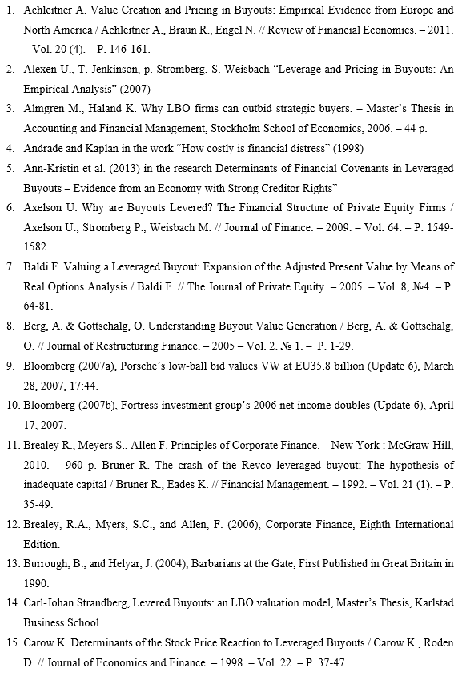

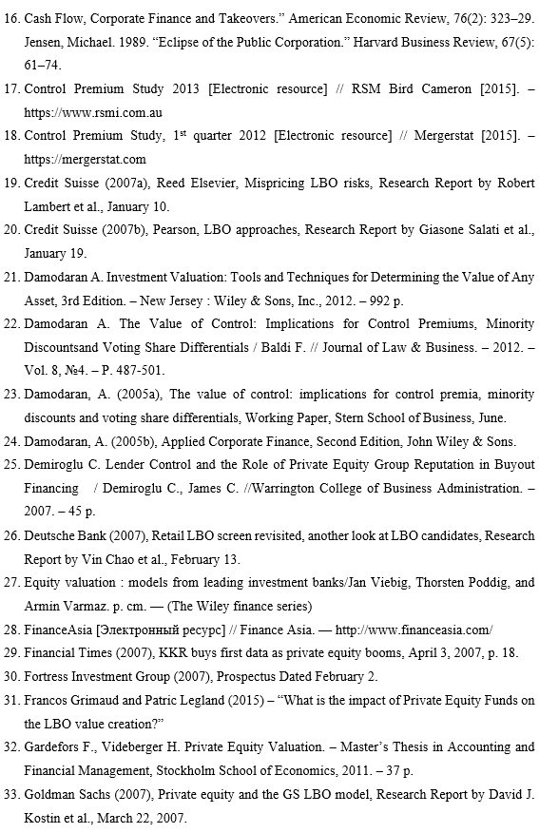

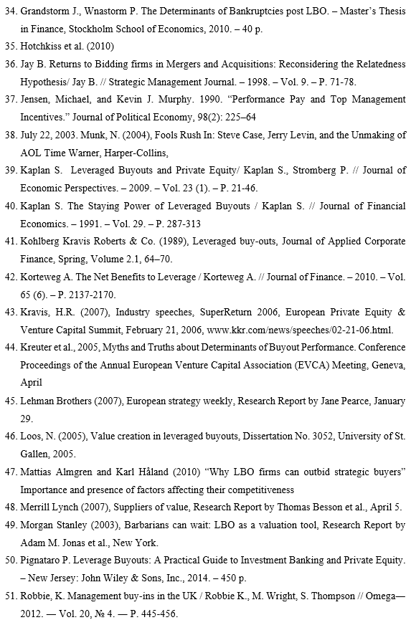

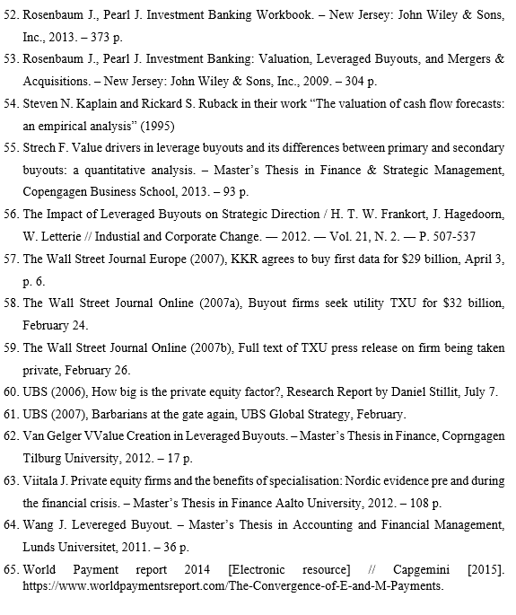

# Appendix 1. Bloomberg screening tool for LBO-candidates

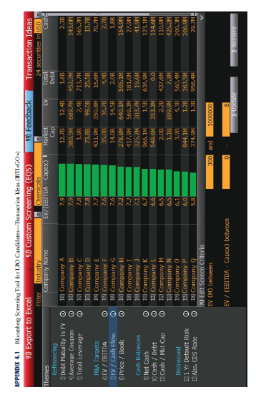

# Appendix 2. Flaws of the publicly available LBO-models

*Table.* Flaws of the publicly available LBO-models

|  |  |  |  |  |  |
| --- | --- | --- | --- | --- | --- |
|  | **Rosembaum and Pearl, “Investment Banking”** | **Paul Pignataro, “Levered Buyouts”** | **John Wiley and Sons, “Equity valuation”** | **LBO-analysis tool presented in other sources** | **Proposed improvements** |
| **Pre analysis** | * LBO targets are not quantitatively compared with each other | | | | * Multiple potential LBO targets are screened under chosen assumptions before conducting detailed LBO-analysis |
| **Uses of funds** | *Equity valuation*   * Does not take into account market premium | *Equity valuation*   * Does not take into account whether the target is public or private * Market premium is assumed 20% | *Equity valuation*   * Market premium is assumed to be 20% * Does not types of shares outstanding * Does not take into account whether the target is public or private * Transaction fees are included in calculation of enterprise value and are not amortized | *Equity valuation*   * Does not take into account market premium * Transactions fees are not taken into account and are not amortized | * Takes into account whether the target is public or private * Control premium is calculated * Transaction fees are included in calculating the deal value * Transaction fees are amortized |
| **Sources of funds** | *Financial leverage*   * Financial leverage is not analyzed (Assumed 30/70)   *Financing structure*   * Only 4 possible financing structures are assumed | No explanation for financial leverage and the financing structure | *Financial leverage*   * Uses average multiple for European LBO financings   *Financing structure*   * Only one possible financing structure is used | No explanation for financial leverage and the financing structure | * Uses debt burden table * Is designed with flexibility to choose an appropriate financial structure |
| **Exit multiple** | * Assumed subjectively | | | | * Uses average EV/EBITDA exit multiples of a comparable peer group of companies |
| **Operational projections** | *Projections*   * Projections are very detailed * Based on 3 year historical data * Only 3 scenarios are used * The forecasts of the 5th year are frozen to frame the outer year projections   *Horizon*   * 10 years |  | *Projections*   * Only one scenario is used * A fixed growth rate is applied for all years * Only main business drivers are forecasted * Transaction fees are not amortized   *Horizon*   * 5 years | * Assumed constant growth rate * Only one scenario is used | *Projections*   * Uses simulation modeling to simulate future projections   *Horizon*   * Designed to match the maturity of the longest tenured debt instrument in the capital structure |
| **Sensitivity analysis** | * Based on entry and exit multiples * Exit year – exit multiple |  | * Based on exit year and exit multiple * Based on proportions of debt consideration and premium paid | * Not performed | * Performed on basis of different variables |

# Appendix 3. The LBO-screener algorithm

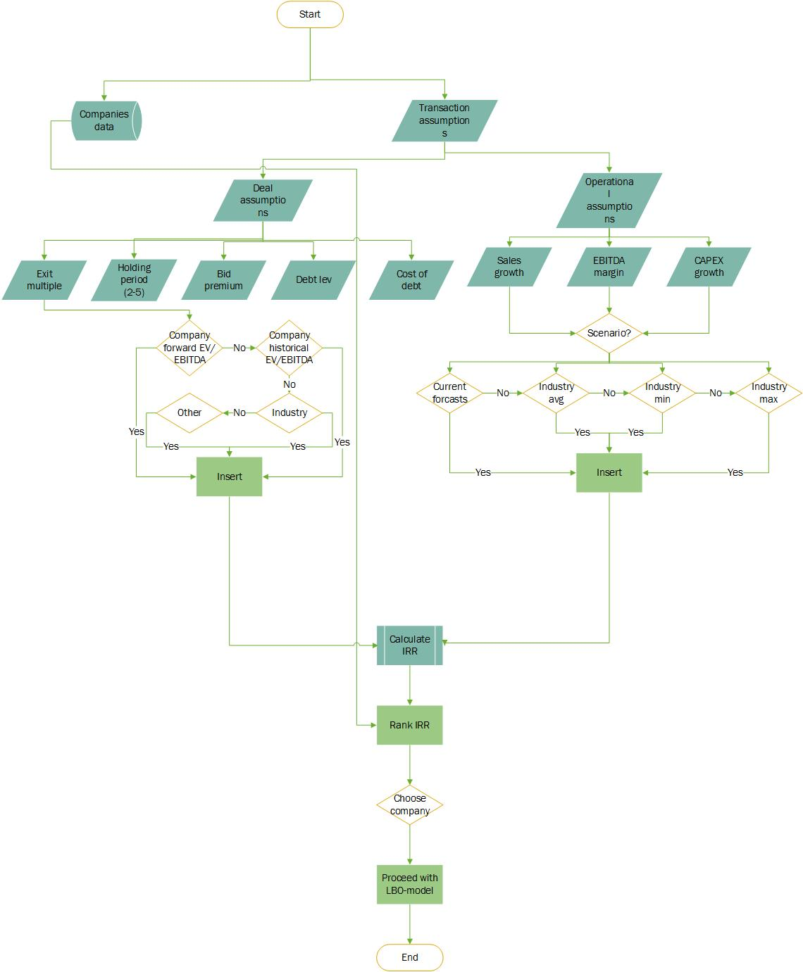

# Appendix 4. The list of companies used in LBO-screener

|  |  |
| --- | --- |
| 1 | 888 Holdings |
| 2 | A.P. Moeller-Maersk |
| 3 | A2a SPA |
| 4 | ABB Ltd |
| 5 | Abengoa |
| 6 | Aberdeen Asset Management |
| 7 | Acciona SA |
| 8 | Accor |
| 9 | Acergy |
| 10 | Acerinox |
| 11 | ACS |
| 12 | Actelios |
| 13 | Adecco |
| 14 | adidas |
| 15 | Aegis Group PLC |
| 16 | Aer Lingus |
| 17 | Aeroports de Paris |
| 18 | AGA Rangemaster Group |
| 19 | Agrana |
| 20 | Ahold |
| 21 | Air France-KLM |
| 22 | Air Liquide |
| 23 | Aixtron |
| 24 | Aker ASA |
| 25 | Aker Solutions |
| 26 | Akzo Nobel |
| 27 | Alcatel-Lucent |
| 28 | Alfa Laval |
| 29 | ALK Abello |
| 30 | Alstom |
| 31 | Amec Plc |
| 32 | Amer Sports |
| 33 | Amplifon |
| 34 | Andritz AG |
| 35 | Anglo American plc |
| 36 | Anheuser-Busch InBev |
| 37 | Ansaldo STS |
| 38 | Antena3 |
| 39 | Antofagasta plc |
| 40 | ArcelorMittal |
| 41 | ARM Holdings plc |
| 42 | Arriva |
| 43 | Aryzta |
| 44 | Ashmore Group |
| 45 | ASM International NV |
| 46 | ASML Holding NV |
| 47 | ASOS plc |
| 48 | Assa Abloy B |
| 49 | Associated British Foods |
| 50 | AstraZeneca |
| 51 | A-TEC Industries AG |
| 52 | Atlas Copco |
| 53 | Atos Origin |
| 54 | Audika |
| 55 | Austriamicrosystems AG |
| 56 | Austrian Post |
| 57 | Autoliv Inc. |
| 58 | Autonomy |
| 59 | Aveva |
| 60 | Axel Springer AG |
| 61 | Axis-Shield |
| 62 | Babcock International |
| 63 | BAE Systems |
| 64 | Balfour Beatty |
| 65 | Bang & Olufsen |
| 66 | Barco NV |
| 67 | Barratt Developments |
| 68 | BASF SE |
| 69 | Bauer AG |
| 70 | Bayer AG |
| 71 | Beiersdorf |
| 72 | Belgacom |
| 73 | Bellway |
| 74 | Benetton Group |
| 75 | Beni Stabili |
| 76 | Berkeley Group |
| 77 | Betsson AB |
| 78 | BG Group |
| 79 | BHP Billiton Plc |
| 80 | Big Yellow |
| 81 | Bilfinger Berger |
| 82 | bioMerieux |
| 83 | Bloomsbury Publishing |
| 84 | BMW |
| 85 | Bodycote Plc |
| 86 | Boliden |
| 87 | Bolsas y Mercados Espanoles |
| 88 | Bouygues |
| 89 | Bovis Homes Group |
| 90 | BP plc |
| 91 | Brisa |
| 92 | British Airways |
| 93 | British American Tobacco |
| 94 | British Land |
| 95 | British Sky Broadcasting |
| 96 | BSS Group |
| 97 | BT Group |
| 98 | Bucher Industries |
| 99 | Bulgari S.p.A. |
| 100 | Bunzl |
| 101 | Burberry |
| 102 | Bureau Veritas |
| 103 | Buzzi Unicem |
| 104 | bwin Interactive Entertainment |
| 105 | BWT AG |
| 106 | C&C Group |
| 107 | CA IMMO |
| 108 | Cable & Wireless |
| 109 | Cairn Energy PLC |
| 110 | Capgemini |
| 111 | Capita Group |
| 112 | Cardo AB |
| 113 | Care UK PLC |
| 114 | CareTech Holdings PLC |
| 115 | Carillion |
| 116 | Carlsberg |
| 117 | Carpetright |
| 118 | Carphone Warehouse |
| 119 | Carrefour |
| 120 | Casino |
| 121 | Castellum |
| 122 | CEGID |
| 123 | Celesio AG |
| 124 | Central European Media Enterprises |
| 125 | Centrica |
| 126 | Centrosolar |
| 127 | Centrotherm Photovoltaics AG |
| 128 | CEPSA |
| 129 | Ceramic Fuel Cells |
| 130 | Ceres Power |
| 131 | Cermaq ASA |
| 132 | CEZ |
| 133 | CFAO SA |
| 134 | CGGVeritas |
| 135 | Charles Voegele |
| 136 | Charter |
| 137 | Christian Dior |
| 138 | Cineworld Group Plc |
| 139 | Citycon |
| 140 | Clariant |
| 141 | Close Brothers Group |
| 142 | Club Mediterranee |
| 143 | Cobham |
| 144 | Cofinimmo |
| 145 | Coloplast |
| 146 | Colruyt |
| 147 | Compagnie Industriali Riunite Spa |
| 148 | Compass Group |
| 149 | Conergy AG |
| 150 | Continental |
| 151 | conwert Immobilien Invest AG |
| 152 | Cookson Group |
| 153 | Corio |
| 154 | Corporacion Financiera Alba |
| 155 | CRH |
| 156 | Criteria CaixaCorp SA |
| 157 | CropEnergies |
| 158 | Crucell |
| 159 | CSR plc |
| 160 | CTC Media |
| 161 | Curanum AG |
| 162 | D S Smith |
| 163 | Daily Mail and General Trust (A) |
| 164 | Daimler AG |
| 165 | Dairy Crest |
| 166 | Dana Petroleum Plc |
| 167 | Danieli |
| 168 | Danieli (Savings) |
| 169 | Danisco |
| 170 | Danone |
| 171 | Dassault Systemes |
| 172 | Davide Campari |
| 173 | Davis Service Group |
| 174 | De La Rue Plc |
| 175 | Debenhams |
| 176 | Delhaize |
| 177 | Demag Cranes |
| 178 | Derichebourg SA |
| 179 | Derwent London |
| 180 | Deutsche Boerse AG |
| 181 | Deutsche Post |
| 182 | Deutsche Telekom |
| 183 | Deutz |
| 184 | Diageo |
| 185 | Diasorin Spa |
| 186 | Dignity Plc |
| 187 | Dolphin Capital Investors |
| 188 | Domino's Pizza |
| 189 | Douglas Holding AG |
| 190 | Dragon Oil PLC |
| 191 | Drax Group Plc |
| 192 | DSG International |
| 193 | DSM |
| 194 | Dufry |
| 195 | E.ON |
| 196 | EADS |
| 197 | eaga plc |
| 198 | Easyjet |
| 199 | EDF |
| 200 | EDF Energies Nouvelles S.A. |
| 201 | Edison SpA |
| 202 | EDP Renovaveis SA |
| 203 | Eiffage |
| 204 | Electrocomponents |
| 205 | Electrolux |
| 206 | Elekta AB |
| 207 | Elisa Corporation |
| 208 | Elringklinger |
| 209 | emgs |
| 210 | Enagas |
| 211 | Endesa SA |
| 212 | Enel SpA |
| 213 | Energias de Portugal |
| 214 | ENI |
| 215 | Eniro AB |
| 216 | Enterprise Inns plc |
| 217 | ERG |
| 218 | Ericsson |
| 219 | Essilor |
| 220 | Eurazeo |
| 221 | Eurocommercial |
| 222 | Eurofins Scientific |
| 223 | Eutelsat Communications |
| 224 | Exact Holding |
| 225 | Experian |
| 226 | Fabege AB |
| 227 | Fastweb |
| 228 | Faurecia |
| 229 | FCC |
| 230 | Fersa Energias |
| 231 | Fiat |
| 232 | Fielmann |
| 233 | Finmeccanica |
| 234 | Finnair |
| 235 | FirstGroup |
| 236 | FLSmidth & Co. A/S |
| 237 | Flughafen Wien |
| 238 | Flughafen Zurich |
| 239 | Fluidra SA |
| 240 | Folli Follie |
| 241 | Foncière des Régions |
| 242 | Fortum |
| 243 | France Telecom |
| 244 | Fraport AG |
| 245 | Fresenius Medical Care |
| 246 | Fresenius SE (pref) |
| 247 | Frontline Ltd |
| 248 | Fugro NV |
| 249 | GAGFAH |
| 250 | Galenica |
| 251 | Galp |
| 252 | Game Group |
| 253 | Gamesa Corp Tecnologica SA |
| 254 | Gas Natural |
| 255 | GDF SUEZ |
| 256 | GEA Group |
| 257 | Geberit Holding AG |
| 258 | Gecina |
| 259 | Gemalto |
| 260 | Georg Fischer |
| 261 | Geox |
| 262 | Getinge |
| 263 | GfK SE |
| 264 | Givaudan |
| 265 | GKN |
| 266 | GlaxoSmithKline |
| 267 | GN Store Nord |
| 268 | Go-ahead |
| 269 | Golar LNG Ltd |
| 270 | Golden Ocean Group Ltd |
| 271 | Gottex Fund Management |
| 272 | Great Portland Estates |
| 273 | Greencore |
| 274 | Greene King |
| 275 | Greentech Energy Systems |
| 276 | Greggs |
| 277 | Grifols |
| 278 | Group 4 Securicor |
| 279 | Groupe Beneteau |
| 280 | Groupe Bruxelles Lambert |
| 281 | Groupe Eurotunnel SA |
| 282 | Groupe SEB SA |
| 283 | Gurit |
| 284 | Halfords Group |
| 285 | Halma |
| 286 | Hammerson |
| 287 | Hansen Transmission |
| 288 | Havas |
| 289 | Hays plc |
| 290 | Headlam Group plc |
| 291 | HeidelbergCement |
| 292 | Heineken |
| 293 | Hellenic Duty Free Shops |
| 294 | Hellenic Petroleum |
| 295 | Henderson Group |
| 296 | Henkel (pref) |
| 297 | Hennes & Mauritz |
| 298 | Heritage Oil |
| 299 | Hermes International |
| 300 | Hexagon AB |
| 301 | HMV Group |
| 302 | Hochschild Mining Plc |
| 303 | Hochtief AG |
| 304 | Holcim |
| 305 | Holidaybreak |
| 306 | Holmen B |
| 307 | Home Retail Group |
| 308 | Hufvudstaden |
| 309 | Huhtamaki |
| 310 | Husqvarna AB |
| 311 | Iberdrola Renovables SA |
| 312 | Iberdrola SA |
| 313 | Iberia |
| 314 | IBS |
| 315 | Icade |
| 316 | ICAP plc |
| 317 | IFS |
| 318 | IG Group Holdings |
| 319 | Iliad |
| 320 | Illovo Sugar Limited |
| 321 | IMI plc |
| 322 | Imperial Tobacco |
| 323 | Indesit Co SpA |
| 324 | Inditex |
| 325 | Indra |
| 326 | Industrivarden AB |
| 327 | Infineon |
| 328 | Informa |
| 329 | Ingenico SA |
| 330 | Inmarsat Plc |
| 331 | Intercell |
| 332 | InterContinental Hotels Group PLC |
| 333 | Intermediate Capital Group |
| 334 | International Personal Finance |
| 335 | International Power |
| 336 | Interseroh |
| 337 | Intertek Group |
| 338 | Intralot |
| 339 | Invensys |
| 340 | Investor AB |
| 341 | IPSOS |
| 342 | Italcementi |
| 343 | Italmobiliare S.p.A. |
| 344 | ITE Group |
| 345 | ITV plc |
| 346 | IVG Immobilien |
| 347 | J Sainsbury |
| 348 | JCDecaux |
| 349 | Jeronimo Martins |
| 350 | John Wood Group Plc |
| 351 | Johnson Matthey |
| 352 | Johnston Press |
| 353 | Jungheinrich |
| 354 | K+S |
| 355 | Kappahl Holding AB |
| 356 | Kazakhmys |
| 357 | KBC ANCORA |
| 358 | Keller Group |
| 359 | Kerry |
| 360 | KESA |
| 361 | Kier Group |
| 362 | Kingfisher |
| 363 | Kingspan Group |
| 364 | Kinnevik Investment AB |
| 365 | Klepierre |
| 366 | KONE Corporation |
| 367 | Konecranes |
| 368 | Kontron AG |
| 369 | Korian SA |
| 370 | Krones AG |
| 371 | Kudelski SA |
| 372 | Kuehne & Nagel |
| 373 | Kungsleden |
| 374 | Kuoni Reisen Holding |
| 375 | L E Lundbergforetagen AB |
| 376 | Ladbrokes |
| 377 | Lafarge |
| 378 | Lagardere |
| 379 | Laird Group |
| 380 | Land Securities |
| 381 | Lanxess AG |
| 382 | Legrand |
| 383 | Leoni |
| 384 | Leroy Seafood Group ASA |
| 385 | Liberty Global, Inc. |
| 386 | Liberty International |
| 387 | Linde AG |
| 388 | Lindt & Sprungli |
| 389 | Loewe AG |
| 390 | Logica |
| 391 | Logitech |
| 392 | London Stock Exchange |
| 393 | Lonmin |
| 394 | Lonza Group |
| 395 | L'Oreal |
| 396 | Lottomatica |
| 397 | Lufthansa |
| 398 | Luminar |
| 399 | Lundin Petroleum |
| 400 | Luxottica (Italy) |
| 401 | LVMH Moet-Hennessy Louis Vuitton |
| 402 | M6 - Metropole Television |
| 403 | Maire Tecnimont |
| 404 | Majestic Wine PLC |
| 405 | MAMUT |
| 406 | MAN AG |
| 407 | Manitou |
| 408 | Manz Automation |
| 409 | Marine Harvest |
| 410 | Marks & Spencer |
| 411 | Marshalls Plc |
| 412 | Marston's Plc |
| 413 | Martifer |
| 414 | Mayr-Melnhof |
| 415 | McBride plc |
| 416 | Mediaset |
| 417 | Meggitt |
| 418 | Mercialys |
| 419 | Merck KGaA |
| 420 | Metro |
| 421 | Metrovacesa |
| 422 | Metso OYJ |
| 423 | Meyer Burger |
| 424 | Michael Page International |
| 425 | Michelin |
| 426 | Micro Focus |
| 427 | Micronas Semiconductor Holding AG |
| 428 | Millennium & Copthorne Hotels |
| 429 | Mitchells & Butlers Plc |
| 430 | Mitie Group PLC |
| 431 | Mobistar |
| 432 | MOL |
| 433 | Mondi Group |
| 434 | Morgan Crucible |
| 435 | Morrison (Wm) |
| 436 | Motor Oil Hellas |
| 437 | Mouchel |
| 438 | M-real |
| 439 | MTU Aero Engines |
| 440 | N Brown Group |
| 441 | National Express |
| 442 | National Grid |
| 443 | Nationale A Portefeuille |
| 444 | Nemetschek |
| 445 | Neopost |
| 446 | Neste Oil |
| 447 | Nestle |
| 448 | Nexans |
| 449 | Next |
| 450 | Nobel Biocare |
| 451 | Nokia |
| 452 | Nokian Renkaat |
| 453 | Nordex |
| 454 | Norsk Hydro |
| 455 | Norske Skog Industrie |
| 456 | Northern Foods |
| 457 | Northgate |
| 458 | Northumbrian Water Group |
| 459 | Norwegian Air Shuttle |
| 460 | Novartis |
| 461 | Novo Nordisk |
| 462 | Novozymes |
| 463 | Nutreco |
| 464 | Nyrstar |
| 465 | Oce NV |
| 466 | OMV |
| 467 | OPAP |
| 468 | Opera Software |
| 469 | Optos Plc |
| 470 | Oriola KD |
| 471 | Orkla ASA |
| 472 | ORPEA SA |
| 473 | OTE |
| 474 | Outokumpu |
| 475 | Outotec |
| 476 | Paddy Power |
| 477 | PagesJaunes |
| 478 | Palfinger AG |
| 479 | Panalpina |
| 480 | Pargesa Holding S.A. |
| 481 | Parrot |
| 482 | Partners Group |
| 483 | PartyGaming plc |
| 484 | Pearson |
| 485 | Pennon |
| 486 | Pernod Ricard |
| 487 | Persimmon |
| 488 | Petrofac |
| 489 | Petroleum Geo Services ASA |
| 490 | Petroplus Holdings |
| 491 | Peugeot |
| 492 | PGE |
| 493 | Philips Electronics |
| 494 | Phoenix Solar AG |
| 495 | Pinault Printemps-Redoute |
| 496 | Pirelli |
| 497 | PKN |
| 498 | Playtech |
| 499 | PNE Wind |
| 500 | Porsche (pref) |
| 501 | Portucel |
| 502 | Portugal Telecom |
| 503 | Praktiker |
| 504 | Premier Farnell |
| 505 | Premier Foods |
| 506 | Premier Oil |
| 507 | Promotora de Informaciones S.A. |
| 508 | Prosafe |
| 509 | Prosafe Production |
| 510 | ProSiebenSat.1 |
| 511 | Protonex |
| 512 | Provident Financial |
| 513 | Prysmian |
| 514 | PSP Swiss Property |
| 515 | Public Power Corporation SA |
| 516 | Publicis |
| 517 | Puma |
| 518 | Punch Taverns plc |
| 519 | PV Crystalox |
| 520 | PZ Cussons |
| 521 | Q-Cells AG |
| 522 | Qinetiq |
| 523 | Rallye |
| 524 | Randstad Holdings |
| 525 | Rank Group |
| 526 | Rational AG |
| 527 | Ratos AB |
| 528 | Realia Business |
| 529 | Reckitt Benckiser |
| 530 | Recylex |
| 531 | Red Electrica de Espana |
| 532 | Redrow |
| 533 | Reed Elsevier (NL) |
| 534 | Reed Elsevier (UK) |
| 535 | Regus Group PLC |
| 536 | Remy Cointreau |
| 537 | Renault |
| 538 | ReneSola |
| 539 | Renewable Energy Corporation |
| 540 | Renewable Energy Generation |
| 541 | Renovo |
| 542 | Rentokil Initial |
| 543 | REpower Systems |
| 544 | Repsol YPF |
| 545 | Restaurant Group PLC |
| 546 | Rexam |
| 547 | Rexel |
| 548 | Rhodia |
| 549 | Rhoen-Klinikum |
| 550 | Richemont |
| 551 | Rieter Holding AG |
| 552 | Rightmove Plc |
| 553 | Rio Tinto plc |
| 554 | Robert Walters |
| 555 | Roche |
| 556 | Rolls-Royce |
| 557 | Roth & Rau |
| 558 | Rotork PLC |
| 559 | Royal Dutch Shell plc (A) |
| 560 | Royal KPN NV |
| 561 | Royal Vopak |
| 562 | RPS Group Plc |
| 563 | RWE |
| 564 | Ryanair |
| 565 | SABMiller |
| 566 | Sacyr-Vallehermoso S.A. |
| 567 | Safran |
| 568 | Saft |
| 569 | Sage Group |
| 570 | Saint-Gobain |
| 571 | Saipem |
| 572 | Salamander Energy PLC |
| 573 | Salmar |
| 574 | Salzgitter |
| 575 | Sandvik |
| 576 | sanofi-aventis |
| 577 | SAP (Ordinary Share) |
| 578 | Saras |
| 579 | SAS Sverige |
| 580 | SBM Offshore |
| 581 | SCA (Svenska Cellulosa) |
| 582 | Scania |
| 583 | Schindler Holding AG |
| 584 | Schneider Electric |
| 585 | Schoeller-Bleckmann |
| 586 | Schulthess Group |
| 587 | Scottish and Southern Energy |
| 588 | Seat Pagine Gialle |
| 589 | Séché Environnement |
| 590 | Sechilienne-Sidec |
| 591 | Securitas AB |
| 592 | SEGRO Plc |
| 593 | SeLoger.com |
| 594 | Semapa |
| 595 | Sepura PLC |
| 596 | Serco |
| 597 | SES SA |
| 598 | Sevan Marine |
| 599 | Severn Trent |
| 600 | SFC Smart Fuel Cell |
| 601 | SGL Carbon Group |
| 602 | SGS |
| 603 | Shaftesbury |
| 604 | Shanks Group |
| 605 | Shire |
| 606 | Siemens AG |
| 607 | SIG |
| 608 | Signet Jewelers |
| 609 | Sika |
| 610 | Silic |
| 611 | Skanska |
| 612 | SKF |
| 613 | Sky Deutschland AG |
| 614 | SMA Solar Technology AG |
| 615 | Smith & Nephew |
| 616 | Smurfit Kappa Group |
| 617 | Snam Rete Gas SpA |
| 618 | Société BIC |
| 619 | Societe FFP |
| 620 | Soco International Plc |
| 621 | Sodexo |
| 622 | Soitec |
| 623 | Solar Millennium |
| 624 | Solaria Energia |
| 625 | SolarWorld AG |
| 626 | SOLON SE |
| 627 | Solvay |
| 628 | Sonae SGPS SA |
| 629 | Sonova Holdings |
| 630 | Southern Cross Healthcare |
| 631 | Spectris |
| 632 | Speedy Hire |
| 633 | Spirax-Sarco Engineering |
| 634 | Sponda |
| 635 | Sportingbet plc |
| 636 | Sports Direct International Plc |
| 637 | SSAB |
| 638 | SSL |
| 639 | Stagecoach |
| 640 | Stallergenes |
| 641 | Statoil |
| 642 | SThree |
| 643 | STMicroelectronics |
| 644 | Stockmann |
| 645 | Stora Enso |
| 646 | Strabag |
| 647 | Stratec Biomedical |
| 648 | Straumann AG |
| 649 | Subsea 7 |
| 650 | Suedzucker AG |
| 651 | Suez Environnement |
| 652 | Sulzer AG |
| 653 | Swedish Match |
| 654 | Swisscom |
| 655 | Syngenta |
| 656 | Synthes Inc |
| 657 | Tandberg |
| 658 | Tate & Lyle |
| 659 | Taylor Wimpey |
| 660 | Tecan Group AG |
| 661 | Technicolor |
| 662 | Technip |
| 663 | Ted Baker |
| 664 | Tekla |
| 665 | Tele2 (B) |
| 666 | Telecinco |
| 667 | Telecom Italia |
| 668 | Telefonica |
| 669 | Telekom Austria |
| 670 | Telenet |
| 671 | Telenor |
| 672 | TeliaSonera |
| 673 | Terna |
| 674 | Tesco |
| 675 | TF1 |
| 676 | TGS Nopec |
| 677 | Thales |
| 678 | The Swatch Group (Bearer share) |
| 679 | Theolia |
| 680 | Thomas Cook Group Plc |
| 681 | ThyssenKrupp |
| 682 | Tieto |
| 683 | Titan Cement |
| 684 | TNT |
| 685 | Tod's |
| 686 | Tognum |
| 687 | Tomkins plc |
| 688 | Tomra Systems |
| 689 | TomTom |
| 690 | Topps Tiles |
| 691 | TOTAL SA |
| 692 | Tour Eiffel |
| 693 | TradeDoubler |
| 694 | Trevi Finanziaria Spa |
| 695 | Trinity Mirror |
| 696 | TUI AG |
| 697 | TUI Travel Plc |
| 698 | Tullett Prebon Plc |
| 699 | Tullow Oil Plc |
| 700 | Tupras |
| 701 | TVN S.A. |
| 702 | Ubisoft Entertainment |
| 703 | u-blox Holding AG |
| 704 | UCB |
| 705 | Ultra Electronics |
| 706 | Umicore |
| 707 | Unibail-Rodamco |
| 708 | Unibet Group Plc |
| 709 | Unilever (NV) |
| 710 | Unit 4 Agresso |
| 711 | United Business Media |
| 712 | United Drug Plc |
| 713 | United Internet |
| 714 | United Utilities |
| 715 | UPM-Kymmene |
| 716 | Uponor OYJ |
| 717 | Valeo |
| 718 | Vallourec |
| 719 | Valora Holding AG |
| 720 | VastNed Retail |
| 721 | Vedanta Resources |
| 722 | Veolia Environnement |
| 723 | Verbund |
| 724 | Vestas Wind Systems |
| 725 | Vinci |
| 726 | Virgin Media Inc. |
| 727 | Vivendi |
| 728 | Vodafone |
| 729 | Voestalpine |
| 730 | Volkswagen (Pref) |
| 731 | Volvo |
| 732 | Vossloh AG |
| 733 | VTG |
| 734 | Wacker Neuson |
| 735 | Wartsila (B) |
| 736 | WAVIN |
| 737 | Weir Group |
| 738 | Wendel |
| 739 | Wereldhave |
| 740 | Wetherspoon (JD) |
| 741 | WH Smith |
| 742 | Whitbread |
| 743 | Wienerberger |
| 744 | William Demant Holding A/S |
| 745 | William Hill |
| 746 | Wincor Nixdorf |
| 747 | Wolfson Microelectronics Plc |
| 748 | Wolseley |
| 749 | Wolters Kluwer |
| 750 | WPP Group plc |
| 751 | WS Atkins |
| 752 | Xchanging |
| 753 | Xstrata plc |
| 754 | Yara |
| 755 | Yell Group |
| 756 | YIT Corporation |
| 757 | YOOX |
| 758 | Zardoya Otis |
| 759 | Zon Multimedia |
| 760 | Zumtobel |

# Appendix 5. Industry specific leverage levels

|  |  |
| --- | --- |
| **Industry** | **Debt/EBITDA** |
| Aerospace & Defense | 4,6x |
| Airlines | 4,6x |
| Airports | 4,6x |
| Automobiles | 4,4x |
| Beverages | 4,5x |
| Biotechnology | 3x |
| Branded Consumer Goods | 5x |
| Brokers & Asset Managers | 5x |
| Business Services | 5,6x |
| Capital Goods | 4,6x |
| Chemicals | 4,6x |
| Communications Technology | 5x |
| Construction | 4,6x |
| Consumer Products | 5x |
| Electrical Equipment | 4,6x |
| Food | 4,5x |
| Gaming | 3x |
| Gas | 5x |
| Hardware | 5x |
| Healthcare Services | 5x |
| IT Services | 5x |
| Lodging | 5x |
| Machinery | 4,6x |
| Media | 5x |
| Medical Products | 5x |
| Metals & Mining | 5x |
| Oil | 5x |
| Oil Services | 5x |
| Packaging | 4,6x |
| Paper & Forest | 5x |
| Pharmaceuticals | 3x |
| Power | 5x |
| Alternative energy | 3x |
| Real Estate | 5x |
| Restaurants & Pubs | 5,6x |
| Retail | 4,9x |
| Semiconductors | 5x |
| Software | 5x |
| Specialty Finance | 5x |
| Steel | 5x |
| Surface | 5x |
| Telecom Services | 5,5x |
| Textile, Apparel & Footwear | 5x |
| Tobacco | 5x |
| Travel | 5x |
| Utilities | 5x |

# Appendix 6. The LBO-model algorithm, part 1

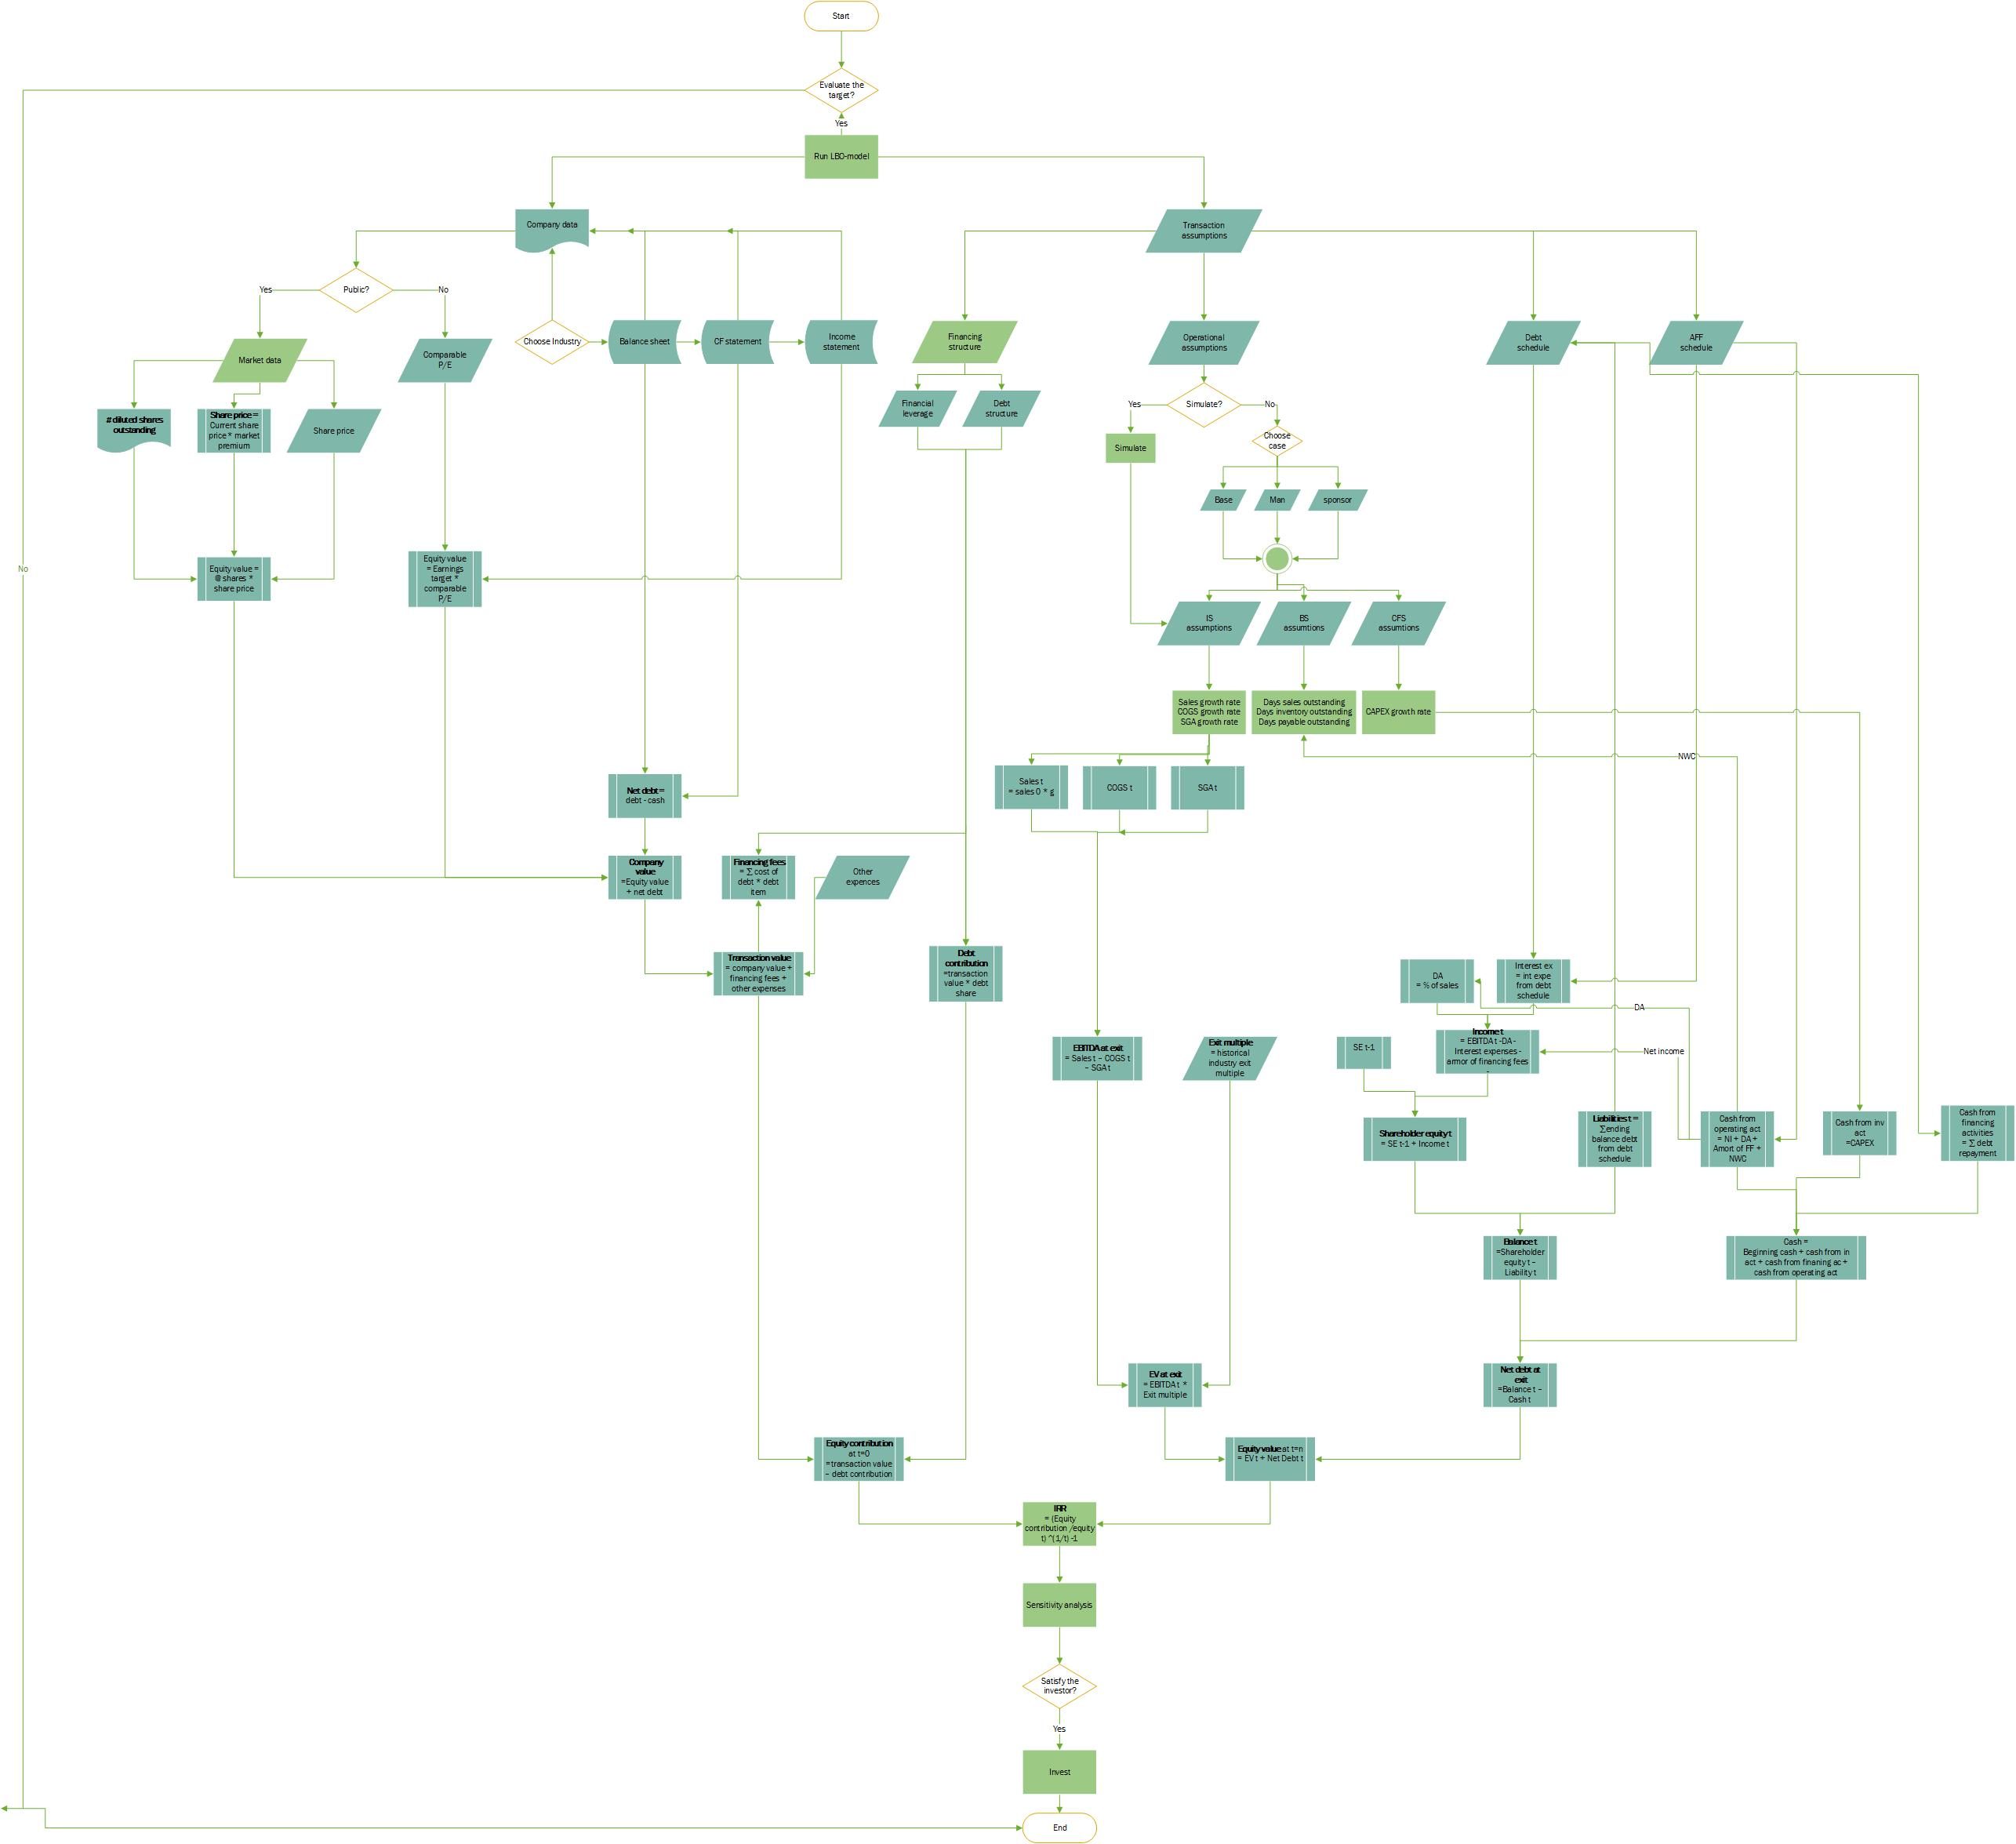

(25)

(25)

(24)

(22)

(21)

(23)

(20)

(19)

(18)

(17)

(13)

(12)

(11)

(10)

(9)

(8)

(7)

(6)

(5)

(4)

(3)

(2)

(1)

**The LBO-model algorithm, part 2**



(37)

(26)

(33)

(31)

(29)

(27)

(36)

(35)

(34)

(32)

(31)

(32)

(30)

(25)

(32)

(31)

(30)

(29

(28)

# Appendix 7. Financial performance of Ingenico Group, 2005-2016

Sales, m euros

EPS, euros

Operational income, m euros

# Appendix 8. Control premium value depending on different factors

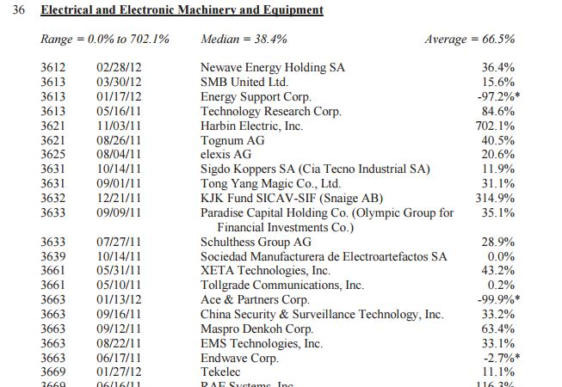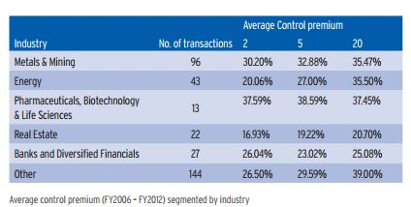

Pic. 1. Market premium depending on industry Pic. 2. Market premium depending on industry

[Mergerstat, Control Premium Study, 2013] RSM Bird Cameron, Control Premium Study, 2014]

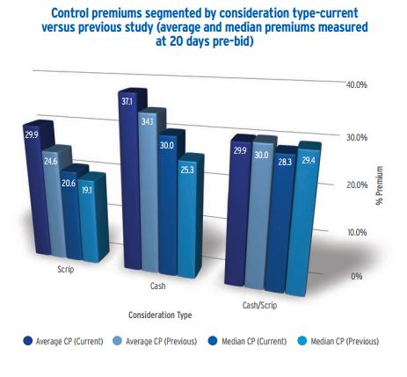 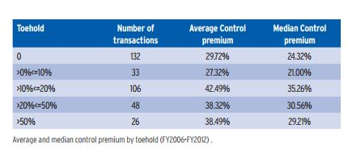

Pic. 3. Marget premium depending on D/E ratio Рic. 4. Market premium depending on investor share

[RSM Bird Cameron, Control Premium Study, 2014]

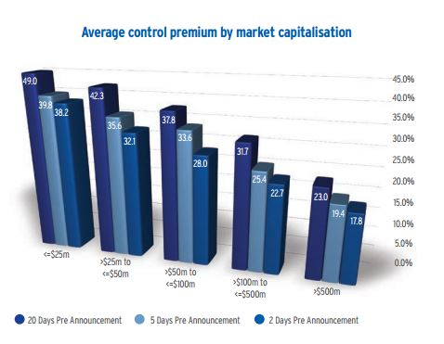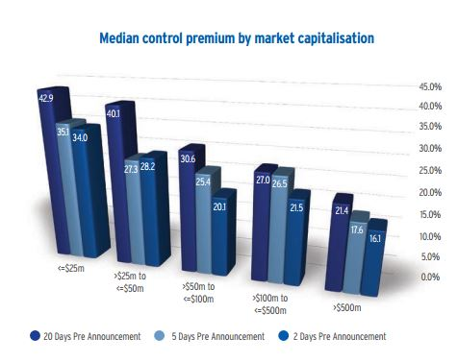

Pic. 5. Market premium depending on market capitalization

[RSM Bird Cameron, Control Premium Study, 2014]

# Appendix 9. Building debt schedule for Ingenico Group



# Appendix 10. Building Income Statement for Ingenico Group



# Appendix 11. Building Balance Sheet for Ingenico Group



# Appendix 12. Building cash flow statement for Ingenico Group



# Appendix 13. Return analysis for Ingenico Group



1. Pignataro P. Leverage Buyouts: A Practical Guide to Investment Banking and Private Equity. – New Jersey: John Wiley & Sons, Inc., 2014. – 450 p.
2. Cao J. The Performance of Reverse Leveraged Buyouts / Jennifer Palthe // Journal of Education for Business. — 2013. — Vol. 88, Issue 2. — p. 41-49
3. Grandstorm J., Wnastorm P. The Determinants of Bankruptcies post LBO. – Master’s Thesis in Finance, Stockholm School of Economics, 2010. – 40 p.
4. Carl-Johan Strandberg, Levered Buyouts: an LBO valuation model, Master’s Thesis, Karlstad Business School
5. Buffett’s Kraft Heinz Bet Valued at $24 Billion in Debut – https://www.bloomberg.com/news/articles/2015-07-06/buffett-s-kraft-heinz-bet-valued-at-24-billion-in-debut
6. Dell Completes $24.9 Billion Leveraged Buyout – https://www.bloomberg.com/news/articles/2013-10-29/dell-completes-24-9-billion-leveraged-buyout
7. The Biggest Private Equity Buyouts in History – http://en.wikipedia.org/wiki/Leveraged_buyout
8. Big European leveraged buyouts back on the agenda – http://www.reuters.com/article/us-lbo-loans-idUSBREA1N13R20140224
9. Zhilenkov М.О., Innovations in organization of M&A financing: world trends and Russian perspectives // Innovations. ― 2007. ― № 6. ― p. 47-50
10. Almgren M., Haland K. Why LBO firms can outbid strategic buyers. – Master’s Thesis in Accounting and Financial Management, Stockholm School of Economics, 2006. – 44 p.
11. FinanceAsia – http://www.financeasia.com/Country/236,asia.aspx
12. Kaplan S. Leveraged Buyouts and Private Equity/ Kaplan S., Stromberg P. // Journal of Economic Perspectives. – 2009. – Vol. 23 (1). – P. 21-46.
13. Pignataro P. Leverage Buyouts: A Practical Guide to Investment Banking and Private Equity. – New Jersey: John Wiley & Sons, Inc., 2014. – 450 p.
14. Carl-Johan Strandberg, Levered Buyouts: an LBO valuation model, Master’s Thesis, Karlstad Business School
15. Pignataro P. Leverage Buyouts: A Practical Guide to Investment Banking and Private Equity. – New Jersey: John Wiley & Sons, Inc., 2014. – 450 p.
16. Kohlberg Kravis Roberts & Co. (1989), Leveraged buy-outs, Journal of Applied Corporate Finance, Spring, Volume 2.1, 64–70.
17. Almgren M., Haland K. Why LBO firms can outbid strategic buyers. – Master’s Thesis in Accounting and Financial Management, Stockholm School of Economics, 2006. – 44 p.
18. Kohlberg Kravis Roberts & Co. (1989), Leveraged buy-outs, Journal of Applied Corporate Finance, Spring, Volume 2.1, 64–70.
19. Marc Martos-Vila, Matthew Rhodes-Kropf, Jarrad Harford, Financial vs. Strategic Buyers, 2014
20. Pignataro P. Leverage Buyouts: A Practical Guide to Investment Banking and Private Equity. – New Jersey: John Wiley & Sons, Inc., 2014. – 450 p.
21. Rosenbaum J., Pearl J. Investment Banking Workbook. – New Jersey: John Wiley & Sons, Inc., 2013. – 373
22. Kohlberg Kravis Roberts & Co. (1989), Leveraged buy-outs, Journal of Applied Corporate Finance, Spring, Volume 2.1, 64–70.
23. Pignataro P. Leverage Buyouts: A Practical Guide to Investment Banking and Private Equity. – New Jersey: John Wiley & Sons, Inc., 2014. – 450 p.
24. Axelson U. Why are Buyouts Levered? The Financial Strucrute of Private Equity Firms / Axelson U., Stromberg P., Weisbach M. // Journal of Finance. – 2009. – Vol. 64. – P. 1549-1582
25. Loos, N. (2005), Value creation in leveraged buyouts, Dissertation No. 3052, University of St. Gallen, 2005.
26. Carl-Johan Strandberg, Levered Buyouts: an LBO valuation model, Master’s Thesis, Karlstad Business School
27. Damodaran, A. (2005a), The value of control: implications for control premia, minority discounts and voting share differentials, Working Paper, Stern School of Business, June.
28. Carl-Johan Strandberg, Levered Buyouts: an LBO valuation model, Master’s Thesis, Karlstad Business School
29. Carl-Johan Strandberg, Levered Buyouts: an LBO valuation model, Master’s Thesis, Karlstad Business School
30. Equity valuation Equity valuation : models from leading investment banks / Jan Viebig, Thorsten Poddig, and

    Armin Varmaz. p. cm. — (The Wiley finance series)
31. Almgren M., Haland K. Why LBO firms can outbid strategic buyers. – Master’s Thesis in Accounting and Financial Management, Stockholm School of Economics, 2006. – 44 p.
32. Charlotte Jonson Leveraged Buyout - A Case Study on Unibet Group Plc
33. Carl-Johan Strandberg, Levered Buyouts: an LBO valuation model, Master’s Thesis, Karlstad Business School
34. Pignataro P. Leverage Buyouts: A Practical Guide to Investment Banking and Private Equity. – New Jersey: John Wiley & Sons, Inc., 2014. – 450 p.
35. Brealey, R.A., Myers, S.C., and Allen, F. (2006), Corporate Finance, Eighth International Edition.
36. Equity valuation Equity valuation : models from leading investment banks / Jan Viebig, Thorsten Poddig, and

    Armin Varmaz. p. cm. — (The Wiley finance series)
37. Pignataro P. Leverage Buyouts: A Practical Guide to Investment Banking and Private Equity. – New Jersey: John Wiley & Sons, Inc., 2014. – 450 p.
38. Equity valuation : models from leading investment banks/Jan Viebig, Thorsten Poddig, and Armin Varmaz. p. cm. — (The Wiley finance series)
39. Equity valuation : models from leading investment banks/Jan Viebig, Thorsten Poddig, and Armin Varmaz. p. cm. — (The Wiley finance series)
40. https://www.divestopedia.com/definition/5064/control-premium
41. Goldman Sachs (2007), Private equity and the GS LBO model, Research Report by David J. Kostin et al., March 22, 2007, pp. 21–26.
42. Deutsche Bank (2007), Retail LBO screen revisited, another look at LBO candidates, Research Report by Vin Chao et al., February 13. p. 12.
43. Morgan Stanley (2003), Barbarians can wait: LBO as a valuation tool, Research Report by Adam M. Jonas et al., New York., p. 3.
44. UBS (2006), How big is the private equity factor?, Research Report by Daniel Stillit, July 7. p. 22.
45. Kohlberg Kravis Roberts & Co. (1989), Leveraged buy-outs, Journal of Applied Corporate
46. Goldman Sachs (2007), pp. 24f.
47. Goldman Sachs (2007), p. 26, Morgan Stanley (2003), p. 3, Deutsche Bank (2007), p. 13, UBS (2006), p. 22.
48. Pignataro P. Leverage Buyouts: A Practical Guide to Investment Banking and Private Equity. – New Jersey: John Wiley & Sons, Inc., 2014. – 450 p.Paul Pignataro (2008)
49. Equity valuation : models from leading investment banks/Jan Viebig, Thorsten Poddig, and Armin Varmaz. p. cm. — (The Wiley finance series)
50. Same resource
51. Same resource
52. Control Premium Study 2013 [Electronic resource] // RSM Bird Cameron [2015]. –https://www.rsmi.com.au
53. Carl-Johan Strandberg, Levered Buyouts: an LBO valuation model, Master’s Thesis, Karlstad Business School
54. Goldman Sachs (2007), p. 26, Morgan Stanley (2003), p. 3, Deutsche Bank (2007), p. 13, UBS (2006), p. 22.
55. http://www.investopedia.com/ask/answers/061715/whats-difference-between-basic-shares-and-fully-diluted-shares.asp
56. Brealey, R.A., Myers, S.C., and Allen, F. (2006), Corporate Finance, Eighth International Edition.
57. Equity valuation : models from leading investment banks/Jan Viebig, Thorsten Poddig, and Armin Varmaz. p. cm. — (The Wiley finance series)
58. Francos Grimaud and Patric Legland (2015) – “What is the impact of Private Equity Funds on the LBO value creation?”