St. Petersburg University

Graduate School of Management

Master in Management Program

CONSUMER BEHAVIOR IN MORTGAGE MARKET: EVIDENCE FROM RUSSIA

Master’s Thesis by the 2nd year student

Concentration — MIM, General Track

Simbarskaia Anna

Research advisors:

Associated Professor Kiran V. Zhukova

Doctor of Science, Professor Ari Jantunen

St. Petersburg

2016

**ABSTRACT**

|  |  |
| --- | --- |
| **Author:** | Anna Simbarskaia |
| **Title of thesis:** | Consumer Behavior in Mortgage Market: Evidence from Russia |
| **Faculty:** | Graduate School of Management (St.-P. State University)  School of Business (LUT) |
| **Major Subject:** | Master in Management  Strategy, Innovation and Sustainability |
| **Year:** | 2016 |
| **Master’s Thesis:** | Saint-Petersburg State University / Lappeenranta University of Technology  67 pages, 14 figures, 10 tables, 1 appendix |
| **Examiners:** | Asc. Prof. Kiran V. Zhukova (GSOM)  Prof. Ari Jantunen (LUT) |
| **Keywords:** | Consumer behavior, mortgage market, crisis, Russia |

The purpose of this master thesis is to identify behavioral patterns of potential borrower in mortgage market in crisis conditions and to link mortgage products available on Russian market with potential borrowers segments in dependence of detected patterns. Empirical results achieved through 172 answers of potential borrowers allowed to classify them in four groups in dependence of respondent perceptions about mortgage and future. On the basis of literature review and currently state of Russian mortgage market particular mortgage products were suggested to each of four clusters of potential borrowers. Then, recommendations for Russian banks how to apply received results were developed. Current master thesis has strong both academic and managerial contributions. It it adds significant value to existing consumer behavior studies; and provides practical recommendations for Russian banks how to understand mortgage borrower behavior in order to increase trust to mortgage among population.

|  |  |
| --- | --- |
| **Автор:** | Симбарская Анна Игоревна |
| **Название:** | Consumer behavior in Mortgage market: Evidence from Russia |
| **Факультет:** | Высшая Школа Менеджмента (СПБГУ)  Школа Бизнеса (ЛТУ) |
| **Программа:** | Менеджмент  Стратегия, инновации и устойчивое развитие |
| **Год:** | 2016 |
| **Магистерская диссертация:** | Санкт-Петербургский Государственный Университет / Лаппеенрантский Технологический Университет  67 Стр., 14 рис., 10 табл., 1 приложение |
| **Руководители:** | Жукова К.В., доцент  Ari Jantunen, профессор (ЛТУ) |
| **Ключевые слова:** | Поведение потребителя, рынок ипотечного кредитования, кризис, Россия |

# АННОТАЦИЯ

Цель данной магистерской работы заключается в определении особенностей поведения потенциального заемщика на рынке ипотечного в условиях кризиса и выявлении ипотечных продуктов, соответствующих тому или иному сегменту заемщиков. Эмпирические результаты, достигнутые в результате опроса 172 потенциальных заемщиков, позволили классифицировать потенциальных заемщиков на четыре группы в зависимости от представлений респондентов об ипотеке и будущем. На основании обзора литературы и состояния российского ипотечного рынка каждому из четырех кластеров были предложены определенные ипотечные продукты. Данная работа вносит весомый вклад в существующие исследования о поведении потребителя. Также работа имеет практическую значимость, поскольку предоставляет практические рекомендации для Российских банков, нацеленные на повышение доверия к ипотеки среди российского населения.

# ACKNOWLEDGEMENTS

# I would like to express my sincere and deep gratitude to all people who were involved in the process of this master thesis writing.

# Firstly, I would like thank my Russian research supervisor – associate professor Kiran V. Zhukova for being more than research advisor, unforgiven experience and everyday support. She did not left me in difficult times and helped me to discover myself a lot.

# Secondly, I would like to thank my Finnish supervisor – professor Ari Jantunen for support and understanding of situation.

# Thirdly, I would like to express my gratitude to senior lecturer – Alkanova Olga N. for finding direction of my research.

# Then, I thank my family and friends who made me not give up and finish this master thesis and were always near to me.

# Finally, I would like to thank all GSOM people, who helped me to conduct my survey, consult me or just support me in this time.

Content

1. INTRODUCTION 7

1.1. Research Background and motivation 7

1.2. Research Gaps in existing consumer behavior studies 8

1.3. Research problem, goal, questions and scope 9

1.4. Research strategy and organization of study 10

2. CONSUMER BEHAVIOR THEORETICAL FRAMEWORK 12

2.1Consumer behavior models overview 12

2.1.1. Factors that affect consumer behavior 18

2.1.2. Consumer decision making process 20

2.2. Consumer behavior in crisis 22

2.3. Сonsumer behavior on mortgage market 25

2.4. Relationships between bank and mortgage borrower in Russia 28

Summary of chapter 2 31

3. METHODOLOGY AND DATA COLLECTION 33

3.1. Research Philosophy, research approach and research design 33

3.2. Data collection 34

3.2.1. Primary data collection: potential borrower behavioral factors 34

3.2.2 Secondary data collection on Russian mortgage market 34

3.3. Measurement of consumer behavioral variables 34

3.4. Data Analysis 38

3.4.1. Factor analysis of potential borrower perceptions 38

3.4.2 Cluster analysis of potential borrowers 41

Summary of chapter 3 42

4. EMPIRICAL FINDINGS ON CONSUMER BEHAVIOR IN RUSSIAN MORTGAGE MARKET 44

4.1. Research results on potential borrower profiles 44

4.2. Research findings on correspondence of mortgage products to potential borrower profiles….. 46

4.2.1 Analysis of mortgage products on Russian mortgage market 46

4.2.2. Suggested mortgage products for consumer profiles 52

Summary of chapter 4 55

5. DISCUSSION AND CONCLUSIONS 56

5.1. Discussion of empirical findings in context of consumer behavior studies 57

5.2. Theoretical contribution to consumer behavior theory 59

5.3. Managerial implications of potential borrower profiles for Russian banks 60

5.4. Limitations and further researches 61

REFERENCES: 62

APPENDIX 1. Questionnaire on consumer behavior in mortgage market 66

**LIST OF FIGURES**

Figure 2.1. Decision-making process…………… 15

Figure 2.2 The Engel-Kollat-Blackwell 16

Figure 2.3 Nicosia Model 17

Figure 2.4 Stimuli-Response Model 17

Figure 2.6 Crisis influence on consumer behavior 23

Figure 2.7 Stimuli-response model on mortgage market from banking point of view 30

Figure 2.8 Consumer behavior on mortgage market theoretical framework 32

Figure 3.1 Research Design 43

Figure 4.1 Potential borrower profiles 44

Figure 4.2 Annuity monthly payments 47

Figure 4.3 Differentiated monthly payments 48

Figure 4.4 Share of foreign currency mortgage in total volume of mortgage lending in Russia 2010-2016…………………………………………………………………………………………………………………………….……49

Figure 4.5 Volume of past-due mortgage debt in foreign currency mortgage in Russia

2010-2016 49

Figure 4.6 Reverse stimuli-response model 56

**LIST OF TABLES**

Table 3.1 Correlation coefficients…………………………………………………………………………….………….………………..38

Table 3.2 KMO and Bartlett’s Test …………………………………………………………………………………….…………………39

Table 3.3 Rotate component matrix: factor loadings ………….…………………………………….……….…….……...….40

Table 3.4 Reliability Test….………………………………………………………………………..……….………….…………...…………40

Table 3.5 Final centers of clusters….………………………………………………………………….…….……..………..………..….41

Table 3.6 Description of potential borrower profiles……………………………………….…….……………………….…...42

Table 3.7 Scales of cultural, psychological and personal factors ……………….…….…………....………….………43

Table 4.1 Monthly savings due to lump sum payment/ interest rate option………..…………….….….….…….50

Table 4.1 Monthly savings due to lump sum payment/ interest rate option over loan periods…………51

Table 4.3 Mortgage products offered by Russian mortgage leaders banks (2016) …………….........…..…52

# 1. INTRODUCTION

# 1.1. Research Background and motivation

Consumer behavior plays the most significant role on every market as its understanding is crucial to identify and fulfill needs of customers. Discovering consumer behavior particularities is a base for effective marketing strategy. Understanding consumer behavior on markets that are overfilled by products or services with insignificance differences between each other allows creating a strong competitive advantage (Gilaninia, Taleghani, Aziz, 2013). To such overfilled markets the banking sector could be referred (Lipowski, 2003). The more risky and uncertain is a product/service offered by bank the more crucial place take consumer behavioral patterns in bank performance. Therefore, understanding consumer behavior in mortgage market is an inherent part of effective bank functioning. Under crisis conditions this issue takes dramatic character and lead to consumer behavior changes that need to be responded (Pandelica, 2008).

The mortgage lending in Russia is almost the only way to buy own house as Russian house market is one of the least affordable market for population in the world. However mortgage market is also characterized by low affordability and need for continuous development. However borrow beliefs of mortgage lending are negative: high interest rates, long formal procedures, mistrust to banks, low level banking service (Ibragimova, 2012).

Currently procedures of borrower profiles consideration are too limited as the main focus of Russian banks is to evaluate solvency of the borrower, applying scoring system of assessment, based on borrower income and credit history. (Skiba, Loyko, 2012)

However, banks neglect the fact that wrong proposed mortgage product could lead to borrower frustration or even to borrower bankruptcy. It is also necessary to mention that in Russiaт financial services are dictated by banks, but is not conscious client decision (Alikperova Yarasheva, 2015). In its turn, negative experience will significantly affect the borrower perceptions about loans and may in the future stop them to take other loans from these banks. Moreover, spreading negative emotions through media, “world of mouth” or other channels will increase bad beliefs among all population, like snowball.

Therefore banks have great potential and scope to form borrower loyalty. To increase loyalty among potential borrowers it is necessary to strength strong relationships with bank through high quality servicing. Thus understanding consumer behavior is a crucial for Russian banks on mortgage market.

# 1.2. Research Gaps in existing consumer behavior studies

Consumer behavior on this very market is crucial for Russian banks to understand what consumers want and to satisfy their needs increasing this way the mortgage volume lending and the Russian mortgage market development. As Russian mortgage market could be considered as emerging market but that was built on foreign practices, understanding consumer behavior on Russian market could have significant contribution to existing theories from cross-cultural point of view. Moreover, it is actual to consider mortgage consumer behavior in context of financial crisis. There are plenty of literature that investigates buying behavior on mortgage market, that try to understand why people chose this or another type of loan choosing and bank selection. However, there is no investigations what could be consumer profiles in crisis context.

The most important article in the field of consumer behavior is ”The seven sins of consumer psychology” by Pham M.T. The main aspects that need to be taken into account are lacks of consumers theories that the author highlights.

The first lack of current consumers studies is that it has a narrow scope. Consumer behavior includes several steps :

1. Desire. It defines what the customer wants and needs , what are his interests and tastes.
2. Acquisition. This aspect includes the searching process, selection process, decision making process, willingness to pay etc.
3. Use/consumption. Here main areas are: storage, sharing, maintenance, consumption, enjoyment, satisfaction, possession e.t.c
4. Disposal/divestment includes: discarding, recycling, reusing, replacement.

The point is that consumer behavior theories focus mainly on the acquisition stage, leave without attention other consumer behavior stages. The author calls in question that this very stage is the area of business interests. He is sure that businesses want to pay attention the desire stage to understand what consumers want and need, what motivate them to do this. Most of academic researches are based on the assumption that consumer wants and needs are given already, that is at variance with the reality. Also Pham M.T mentions that little attention in consumer behavior theories is paid to usage and consumption, other ways of acquisition (like sharing, borrowing, gifting) and last stage of consumer behavior - disposal and divestment.

Next drawback of consumer behavior studies is “narrow lenses”. The author main idea here is that consumer behavior basis consists of 3 paradigms: cognitive psychology, social psychology and behavioral decision theory, while other aspects are out of scope. The author uses a concept “a concentric perspective on consumer behavior theory” that defines areas that consumer behavior researches mainly focus on. The first is mechanical core that has enough investigated and embrace attention, memory, inference-making etc. Then comes the affective layer that include emotional aspects. After affective layout is a motivational layout - consumer goals and needs. Next is socio-relational background and the last one is cultural context that includes history, language, economic system particularities. So, the concentric view of consumer theory considers attentively mechanistic aspects of consumer behavior.

Another serious gap in consumer behavior theory is overgeneralization. This problem touches researchers as well as readers and reviewers. Researchers like to interpret their results, achieved during investigation, as reliable and robust for every case. In social psychology such behavior took the name “fundamental attribution error”. From the reader point of view generalization could be provoked by author authority and popularity. It is a common mistake also to interpret results in beyond the investigation context.

Considering literature discussing consumer behavior on mortgage market the same gaps could be identified. There are plenty of studies which investigate borrower choice between different mortgage products and banks (Statman, 1982; Alm and Follain, 1984; Stanton and Wallace, 1999; Campbell and Cocco, 2003; Paiella and Pozzolo, 2007; Koijen et al., 2009). However there is lack of framework dedicated to understanding very potential borrower profiles.

Therefore the research gap could be formulated as lack of understanding of consumer “black box” in Russian mortgage market in context of financial crisis.

# 1.3. Research problem, goal, questions and scope

Russian housing market is one of the least affordable among the world. Therefore, mortgage lending is the only way to buy own house. However borrow, beliefs of mortgage lending are negative (Ibragimova, 2012). Therefore continuous search for ways that will increase the popularity of mortgage among population and provide stable growth of mortgage lending volumes is required. One of such way could be understanding potential borrowers behavior in order to satisfy their needs. However Russian mortgage banks analyze consumer behavior taking into account age, gender, income, occupation and other personal factors (Skiba, Loyko, 2012). Russian banks on mortgage market neglect consumer behavioral factors, hidden in consumer “black box” (Alikperova, Yarasheva, 2015; Kotler, 2008). This leads to providing borrowers wrong mortgage product and therefore, provokes mistrust to banks and negative perceptions about mortgage among Russian population. Thus, the goal is to link mortgage products available on Russian market with potential borrowers segments in dependence on their behavioral "black boxes".

To achieve this goal two research questions could be posed:

1. What are profiles of potential borrower in Russia?
2. What are products that correspond to potential borrower profiles?

Research Tasks:

1. To analyze what factors influence the consumer behavior.
2. To modify them in context of mortgage market and crisis.
3. To develop potential borrower profiles in Russia.
4. To overview Russian mortgage market.
5. To analyze what mortgage products correspond to what profile.
6. To develop recommendations how profiles of potential borrowers could be applied.

This study will be focused only on mortgage loans, eliminating other banking products. cultural background and psychological layer of consumer behavior. As a cultural background only crisis conditions will be considered. As a psychological layer potential borrower perceptions under crisis situation will be taken into account. Some personal characteristics will be included. Other layers of consumer behavior will be eliminated.

Study is dedicated only to Russian population and will examine not borrower behavioral patterns but potential borrower behavior.

Conducted research contributes both to academic and business practice. It adds significant value to existing consumer behavior studies and received findings could be applied by Russian banks in real practice.

# 1.4. Research strategy and organization of study

The research uses abductive approach starting from general consumer behavioral theories, then narrowing to consumer behavior under crisis and consumer behavior on financial markets. However, during the research theoretical framework was several times reconsidered and modified in dependence on achieved results as this very research is new of hits nature in consumer behavior theory.

As a research strategy the survey was chosen. Primary data were collected through questionnaire. Received data were analyzed using SPSS 22.0 applying statistical methods: factor and cluster analysis. To answer the second research question secondary data were analyzed.

The structure of the thesis is the following. Firstly, consumer behavior theories were analyzed to build theoretical framework of the study. This chapter includes analysis of decision-making process, buying behavior models, consumer behavioral patterns under crisis and consumer behavioral particularities on financial markets. Secondly, empirical part was provided. It includes the methodology part where all methods were described in details. Next part of second chapter answers on the first research question: “What are profiles of potential borrower in Russia?”. Next Russian mortgage market overview is presented to answer the second research question: “What are products that correspond to potential borrower profiles?”

Finally, discussion of the findings, theoretical contribution, practical implications, where recommendations for banks are developed and limitations and directions for further research are presented.

# 2. CONSUMER BEHAVIOR THEORETICAL FRAMEWORK

# 2.1Consumer behavior models overview

Firstly proposed official definition of consumer behavior was developed by Belch, 1988: ‘the process and activities people engage in when searching for, selecting, purchasing, using, evaluating, and disposing of products and services so as to satisfy their needs and desires’

However, first models discussing consumer behavior took their development much more earlier. There are numerous frameworks which are dedicated to understand consumer behavior: Andreason, A.R (1965), Nicosia (1976), Solomon, (1996), Horton, (1984), Schiffman and Kanuk (1997), Howard, and Sheth,(1969), Engel , Blackwell, and Miniard (1995), Bettman (1979), Sheth, Newman, and Gross (1991), Mathieson and Wall (1982) e.tc. In this chapter only the most importanty of them will be highlighted.

Behavioral level and policy level are two main dimensions that explain the meaning of consumer behavior. From the behavioral level of view consumer behavior focus on how consumer collect, choose, use, evaluate and deal with product to satisafy his needs and wants. From the policy level consumer behavior definition includes “all consumer’s action involved in the process of acquire, consume and process product or service, it also include all decisions before or after the operation” (Engel, Kollat and Blackwell (1993). Consumer can act as initiator, influencer, decision maker, buyer, user in different situations.

Consumer behavior could be also investigated from macro level, focusing on consumer characteristics such as demographic traits, attitudes, activities, view – and micro level that investigate decision making process, purchase intentions, attitudes, awareness of consumer.

The are two main consumer behavior investigation approaches: positivist and the Marxist one. Positivist approach based on the division consumer buying process into several stages: perception, cognition, attitude, decision making and feedback. Postmodern or Marxist approach suggests that consumer behavior influenced and changes in dependence of circumstances and aimed to mix together environment and consumer particularities together.

**Traditional Micro approaches**

*Economic model*

Economists were pioneers who try to understand consumer behavior. Economic approach took the first concepts development as far back as Adam Smith wrote his “The Welth of Nations”. Model is based on the assumption that every consumer tend to maximize benefits or self-utility and minimize his costs. By the end of 19th century Marshal and Hyrvonss developed marginal utility concept that became a ground for Marshal or economic model. According to the model consumer makes always rational exactly planned choice that is rarely encountered in the reality.

*Learning Model*

Learning model claims that consumer behavior is a result of consumer desire to satisfy his basic and learned needs. The most popular learning model is Pavlov model. According to this approach purchase decision is related to consumer psychology. Russian psychologist detected four main components that affect consumer behavior:

1. Need or motive, that in its turn are divided into primary and acquired motives.
2. Attribute or implication that create consumer perception of the product.
3. Response or behavior
4. Reinforcement. It occurs when consumer satisfies his initial demands

*Freud Model or Psychoanalytic model*

This model investigate human behavior based on Unitarian theory. Model relates human behavior to psychosexual factors. In other words this approach pays attention to conscious and subconscious mind. Psychologists try to research real reasons that make consumer to buy. However, they suggest that only assumptions could be made as it is impossible to understand real psychological consumer intentions. Model indetify such factors as motives, perception and learning.

*Sociological or Fiblin model*

The model approach consider consumer as a social being whose behavior are provoked by his culture particularities, sub-culture factors and his communication environment. Fiblin suggests that consumer behavior can’t be considered independently of his social environment in other words people act as act their social groups members. Fiblin’s approach itself contains some drawbacks: for example, he doesn’t consider the fact that some individuals don’t want to belong to particular social class, but need to this, in this case they will not behave as other members. Modern scientists modified this model and apply it as a base.

**Macro-approaches**

*The Howard-Sheth model*

This is one of the most comprehensive model. It investigate consumer behavior from various aspects and factors. It aims to understand consumer defined choice among other available alternatives. Three main consumer behavior components are

Motivating inputs demonstrate brand significance and affected by social consumer environment. External factors are social consumer characteristics that are remained during long period such as knowledge, personal traits, social and financial status. Last groups represents consequential factors that is an output from two previous components.

All these components are interconnected with perception and learning. Perception includes gathering information through five senses and decoding to recognizable form understandable for the individual. Perception process is composed of search information, sensitivity to information and perceptual bias. This approach pays attention to correspondence between information and consumer perceptions and highlights the significance of information for consumer behavior. Learning process concerns with half-permanent changes in consumer behavior due to learning new knowledge, information, experience.

Learning aspect consists of six elements: motives (specific and non-specific), awareness (trademarks, rejected and equity groups), situation, intermediate factors, obstacles and satisfaction. This model contains a variety advantages as well as disadvantages for applying. It is very appropriate of multibrands products and services, can be adapted to different contexts. However, as purchasing decision due to its complex nature isn’t always systematic that go beyond the model concept. The decision making process is comparable to the previous model it includes: problem identification, evaluation of alternatives, selection process and evaluation outputs.

The Howard-Sheth model was several times revised and modified. More recent versions try to explain consumer choice in limited and constrained information availability. Learning dimension involves 3 levels: extensive problem-solving, limited problem solving and the routinized one. The first level alludes that people have are not aware about brands (figure 2.1). Consumer is prone to deep information searching. Limited problem-solving appears when consumer has perceptions and beliefs about brands but they don’ have exactly established preferences. Routine problem solving implies that individual has clear established knowledge of brand and preferences.

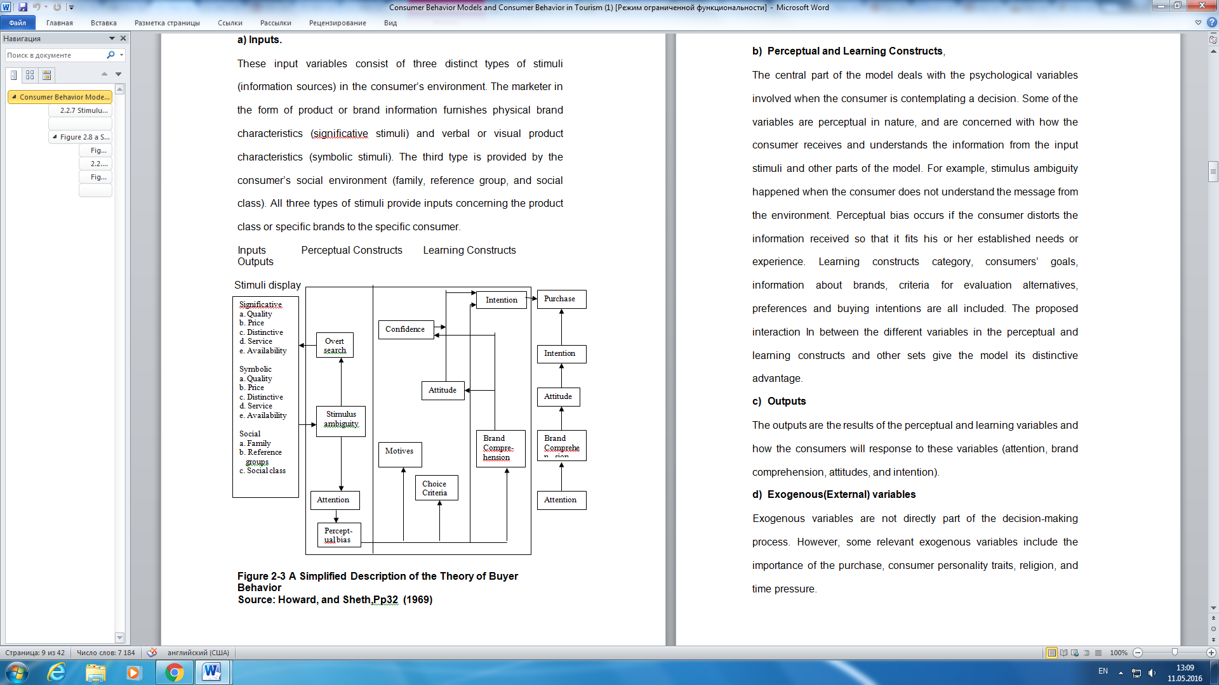

Figure 2.1. Decision-making process. Howard-Sheth, 1969

*The Engel-Kollat-Blackwell Model*

This learning model aims to solve challenges related to consumer behavior. The Engel-Kollat-Blackwell Model is an expansion of Howard-Sheth model. It consists of 5 decision-making process: problem recognition, search of alternatives, alternate evaluation, purchase and outcomes (figure 2.2). However it is mentioned that it is not obligatory for consumer to pass all steps in decision-making process. Environmental factors, external and internal, have impact on every decision making stage. Internal variables are basic and acquired needs. Environmental factors concern with marketing actions. There are two possible outputs: satisfaction and frustration. On the basis on this model were also developed.

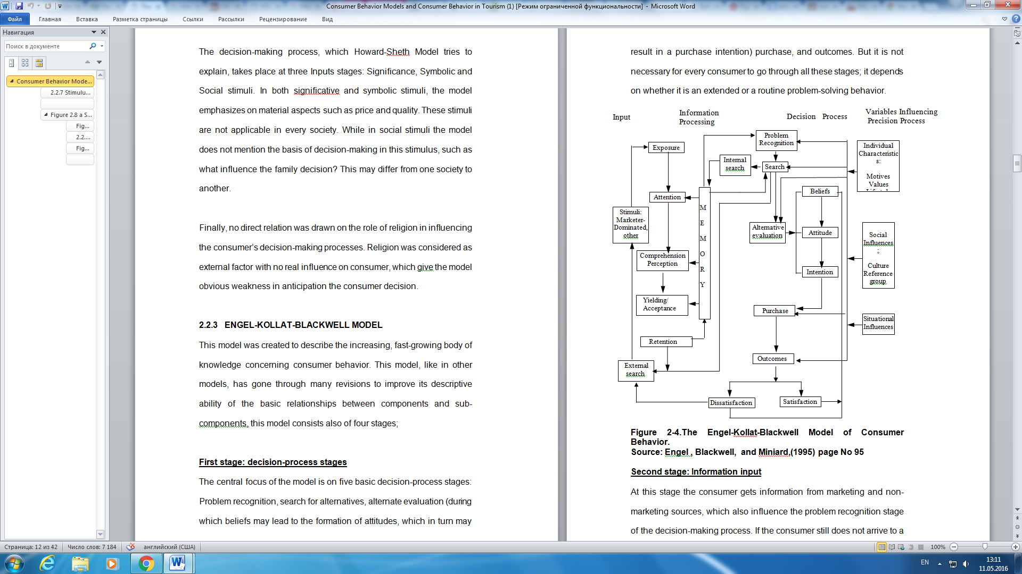

Figure 2.2 The Engel-Kollat-Blackwell Model, 1968

*The Nicosia Model*

In the ground of this model lie relationships between organizational behavior and the individual. Basic assumptions suggest that organization’s message aims to make customer aware of unfamiliar products that he can compare it with other products. First field includes two sub-fields consumer and firm’s attributes (figure 2.3).. It is suggested that company message will achieve consumer attributes. The second field concerns with searching and evaluating processes. The third field discovers how the consumer makes a purchase. The last fourth field is applied as output to get feedback on company sales performance.

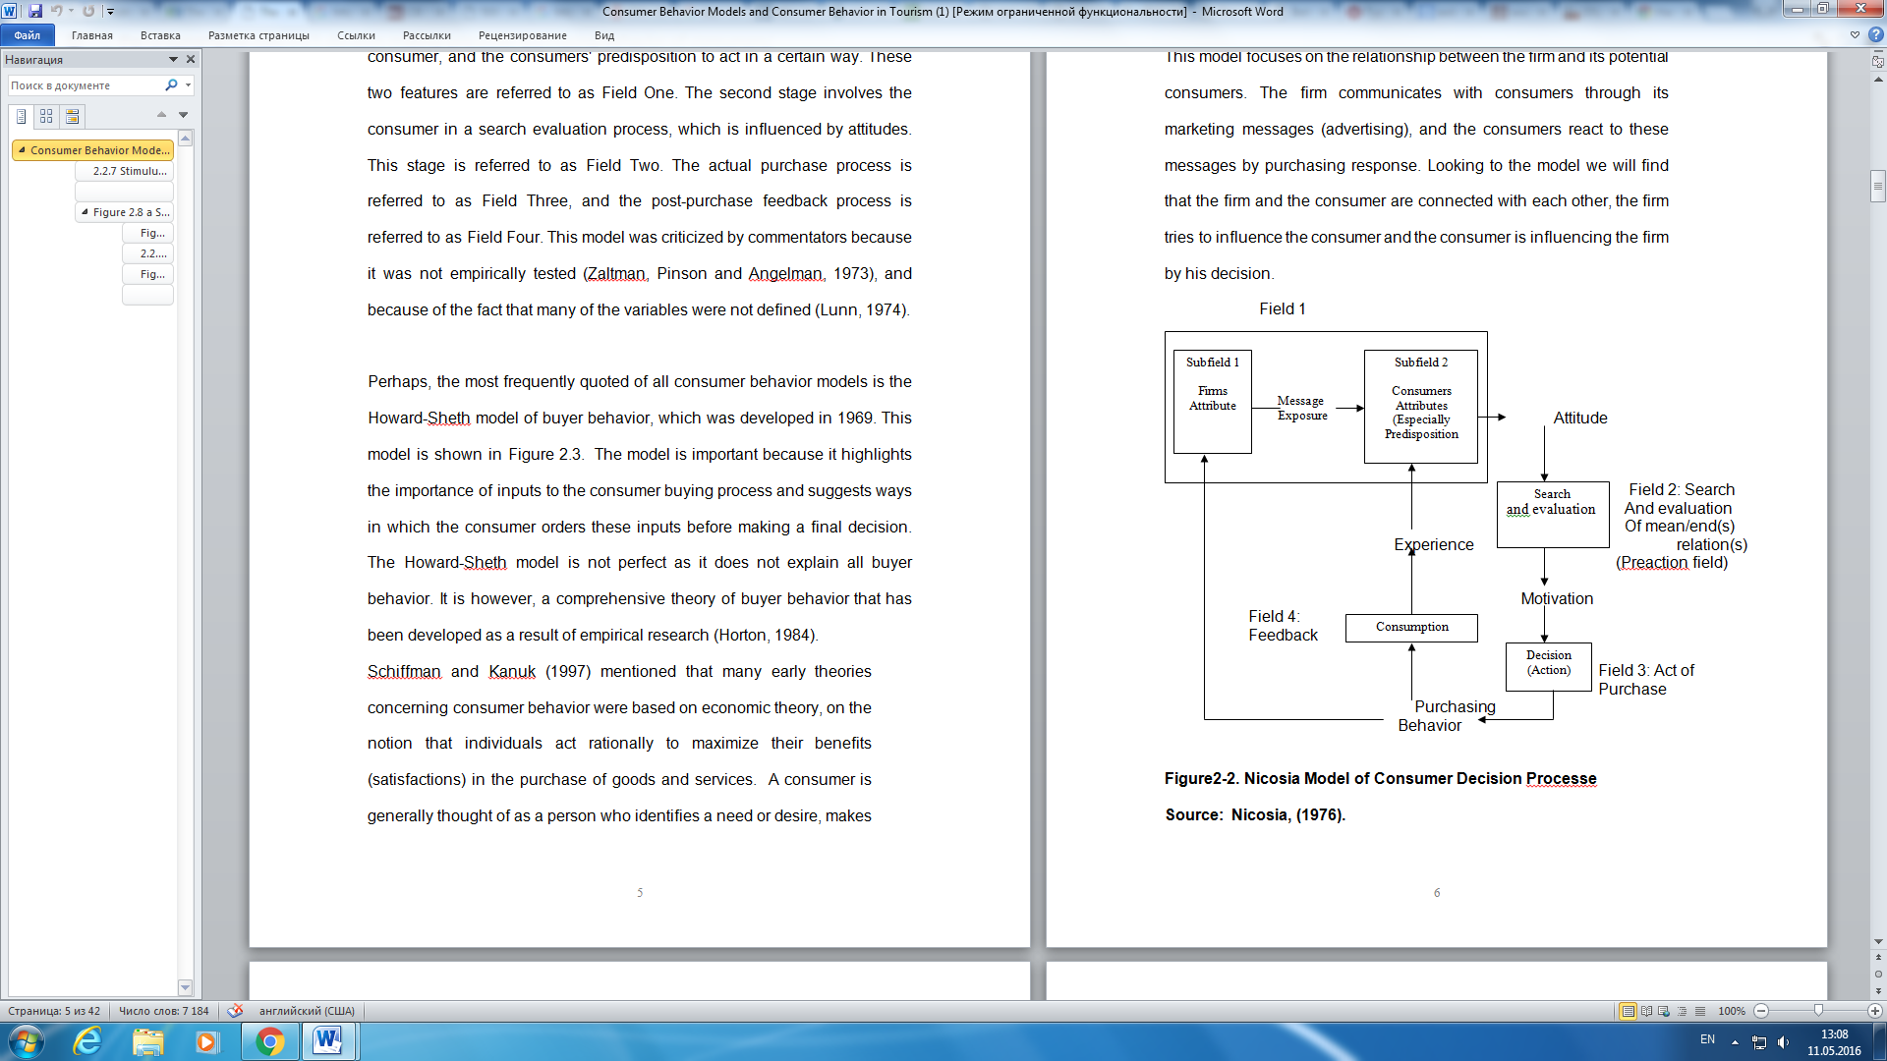

Figure 2.3 Nicosia Model, 1976

*Stimuli-Response Model*

The model is built on “black box” concept. To make people buy defined products marketing and other stimuli have to get inside consumer “black box” which contains consumer characteristics and decision process, to understand what is inside and how to motivate people to response (Figure 2.4).

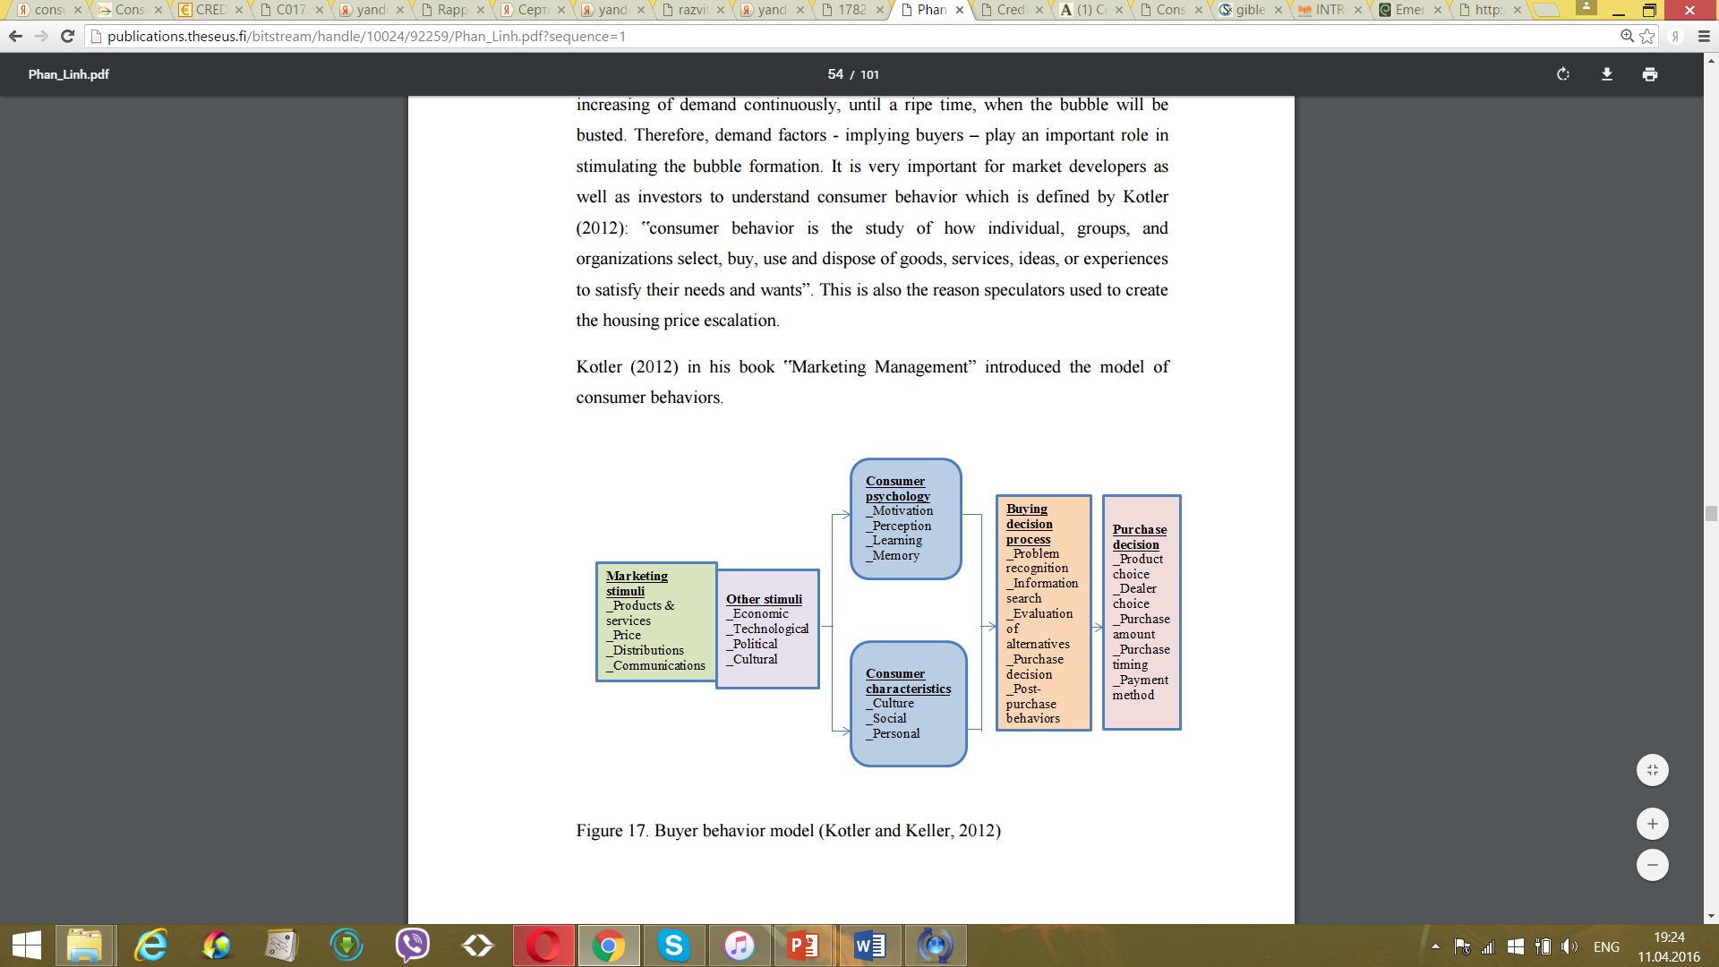

Figure 2.4 Stimuli-Response Model. Kotler, 1999

Marketing mix refer to different components that company needs to analyze to satisfy customer needs. Traditional marketing mix consists of 4 elements: product, price, place and promotion (Jobber and Fahy, 2009).

Product is a core part of marketing mix. If company fails to provide product that fulfill consumer needs other marketing mix components would not improve situation. Concept of product involves such characteristics as variety, quality, design brand, features, packaging, services and warranties (Kotler et al., 2008). Product also could be divided by the level to which it belongs: core product, actual product and augmented product.

Price is responsible for generating profit for the company. To set price company should consider extremal (competitive environment) and internal (cost and marketing strategy) factors (Kotler et al., 2008).

Promotion is a set of activities aimed to link benefits of products to consumer needs. It consists of advertising, sales promotions, direct marketing, personal sales and public relation (Kotler et al., 2008). Advertising deals with spreading company message through impersonal media such as TV, radio, Internet and so on. Sales promotions are short-term events undertaken by companies to encourage demand fro product or service. Personal selling’s goal is to strength relationships with customer through personal presentation. Public relationships concern with setting and maintenance of communications with all company stakeholders.

Place refers to the form in which product is provided to customers (Kotler et al., 2008). This component involves distribution channels and means of physical distribution. Distribution channels include people, companies and institutions that serve as a mean of offering services and products. Means of physical distribution concerns with mechanisms that aimed to reduce physical distance between company and its clients.

# 2.1.1. Factors that affect consumer behavior

Generally factors that determine consumer buying behavior could be divided into 5 groups: cultural factors, social factors, personal factors, physical factors and marketing mix (Kotler et al., 2008)

*Social Factors*

It is generally accepted to include into social aspect following dimensions groups, family roles and status.

As consumer is a human and belongs to to different groups, his behavioral frames significantly affected by groups norms: regulations, habits, morals. A good example of how companies groups and consumer behavior connections is personal hygiene advertisement that claims that in the case if individual will not use their products he will be ostracized. (Cant et al. 2009)

Reference groups are such groups that affect person’s behavior in direct or indirect way. Opinion leaders, (celebrities, sport figures, actors) who could persuade other members opinion are the target audience of company marketing. There are 3 types of reference groups affect – informational influence, utilitarian influence and value-expressive influence. Informational influence suggest that consumer search information from some professional groups. Utilitarian influence means that consumer purchase decision strongly affected by the closest social environment. When person wants to get respect of others through purchase is a value-expressive influence.

*Family* usually is the most important and significant social institution for every individual. The most influence are spouse in daily consumption and children.

*Roles and status*

Every person has different roles and status in dependence on different social groups. The role estimation by society give to person status. For example, high job position provides to the individual status higher than the status of husband, therefore he will try to show his the highest status through purchase.

*Personal factors*

To this group belongs life-style stage, economic circumstances, occupation, personality and self-concept.

Consumer behavioral patterns change over time along with age and life-cycle change. Family life-cycle is also very significant for consumer behavior. Some family life cycle perioda are young singles, young married, with/without children e.t.c

Occupation directly affect consumer behavior, the simpliest example is if we compare CEO and teacher purchasing behavior, where CEO will prefer more expansive and premium barnd than the teacher.

Economic situation in this case means income of a buyer. The influence of disposal individual income is obvious.

Lifestyle is a mode of living that person choose in dependence of his activities and interests.

Personality is explained by human internal traits like self-confidence, dominance, aggressiveness etc. People tend to buy products that the mostly match their personality. Self-concept is emotions that human feel to him-self.

*Psychological factors*

The most important psychological factors are motivation, perception, beliefs and attitudes, learning.

Motivation is need that motivate person to make a defined purchase. There are different levels of needs according to Maslow: physiological needs, safety needs, social needs, esteem needs and self-actualization needs.

Perception is “selecting, organizing and interpreting information in a way to produce a meaningful experience of the world is called perception”. (There are three types of perceptual processes: selective attention, selective retention and selective distortion. Beliefs and attitudes form brand image of the company.

*Learning* concerns with the process when consumer changes his behavioral patterns in dependence on previous experience and purchases.

*Cultural factors*

Cultural aspect involves values, customs, norms, rituals and defines consumer behavior.

Culture dimension include subcultures and social class dimensions. Subcultures are specific groups that differ from general population. Social class is a group of people that have similar behaviors, lifestyles etc. Each culture provides defined hierarchy of social classes: upper middle class, middle class, lower middle class, working class and lower class (Meidan, 1996)

According to Pham cultural background include language, economic and political factors, cross-cultural differences, cultural norms, stereotypes.

# 2.1.2. Consumer decision making process

There are 4 types of decision making views:

1. Economic view. This approach assumes that consumer decision making process is based on utility function. Consumer decision is made after evaluating all possible alternatives.
2. Passive view. Consumer decision making is determined by marketing efforts.
3. Emotional view. In the ground of this type lie feelings and emotions.
4. Cognitive view. Consumer selects that product or service that satisfies his needs mostly.

As it was previously discussed there different points of view on number of stages in decision-making process. Some authors suggest 7 stages decision-making process:

1. Need recognition.
2. Search for information.
3. Pre-purchase evaluation of alternatives.
4. Purchase.
5. Consumption.
6. Post-consumption evaluation.
7. Disinvestment.

Other authors proposes 5 stages:

1. Problem recognition
2. Information search
3. Evaluation of alternatives
4. Purchase decision
5. Postpurchase evaluation.

5 stages decision-making process is the mostly commonly used among researchers.

To make decision consumer could apply decision rules to avoid excessive stress in evaluating every characteristic of service or product. This rules called heuristics. There are several types of heuristic rules. The first one is compensatory decision rule when consumer chooses the product with best score, weighting every attribute in defined way. Positive attributes could cover that ones with low score. Non-compensatory decision rule contrary eliminate attributes of even one attribute has been negatively evaluated. Conjunctive rule assumes that every attribute has its own minimum level of acceptance. Attributes below this level are eliminated. Next heuristic rule is disjunctive one. The main difference from the previous decision-making rule is that instead of minimal level of acceptance there is cut-off level for every attribute. Lexicographic decision rule provides ranking attributes in dependence on significance of each other for the consumer. Affect referral decision rule, the last one, doesn’t focus on attribute individually it estimates overall product or service score.

**Involvement in decision-making process**

Consumer involvement brings together customer control, participation and degree of contact. Uncertainty in its turn explained by risk perception that consists of the purchasing product complexity and degree of future uncertainty

In dependence on consumer involvement degree in decision making process consumers demonstrate different extents of their DM process and information search. The perceived importance of evaluated product/service, risk perception and the probability of make a mistake, emotional appeal – are the most important factors that determine the consumer involvement degree (Meidan, 1996) There are three types of consumer involvement: low level, when attributes are not important to consequences, medium level, high level, when consumer perceives that attributes are strongly contributed to stated purposes. Main factors that provoke high degree of consumer involvement are: cost of product in comparison with income, amount of time for the ownership, degree of which the purchase shows the self-image.

Based on involvement concept three types of consumer decision-making are developed (Shelth, 1969):

Extensive problem solving occurs when degree of consumer involvement is high. Consumer spend a lot of time for information searching, product is new for him and his risk perception and level of uncertainty is high

Limited problem solving corresponds to consumers who have defined expectations about the product and already have experience with product. However he is not certain about the brand and model, options which will fulfill his needs.

Routinized response behavior deals with everyday purchases and characterizes low consumer involvement in decision making process. Consumer does not need specific research or information to make a choice

# 2.2. Consumer behavior in crisis

Consumers are very sensitive to dramatic changes in economic environment such as economic crisis. It is crucial issue for companies to understand how customers will react on crisis and how they will change their behavioral habits to successfully survive during the crisis (Kotler and Caslione, 2009).

During financial crisis people don’t want to spend money on premium products and tend to choose necessary products. Consumer behavior patterns move from limited decision-making buying behavior to extensive decision making. Limited decision-making is characterized by low searching amount time before taking a decision, while extensive decision-making buying behavior involves much more time for information searching.

Central concept in consumer behavior under crisis takes a concept of perceived risk. Risk could be identified as consumer perceptions about the probability that his decision will have negative consequences it concerns with the consumer uncertainty (Tsiotsou, 2008). Six main components of risk could be defined: financial, psychological, performance, social, safety and time convenience loss.

Some authors suggest the difference between risk perceptions of product and risk perceptions of services (Davis et al., 1979). Services perceived as riskier than products and deal with financial, social and psychological risks. Numerous studies are dedicated to investigation of relationships between perceived risk and consumer involvement in decision-making process (Tsiotsou, 2008).

Consumer behavior during the crisis highly depend on risk attitude and risk perception that every individual interpret in his own way. Consumers make subjective judgment about their job stability, purchase power, potential financial losses (Figure 2.6). These judgments provoke defined emotions like panic, fear, anxiety. Emotions in its turn form the risk attitude that lead to feelings like mistrust in companies, government or future (Pandelica, 2008).

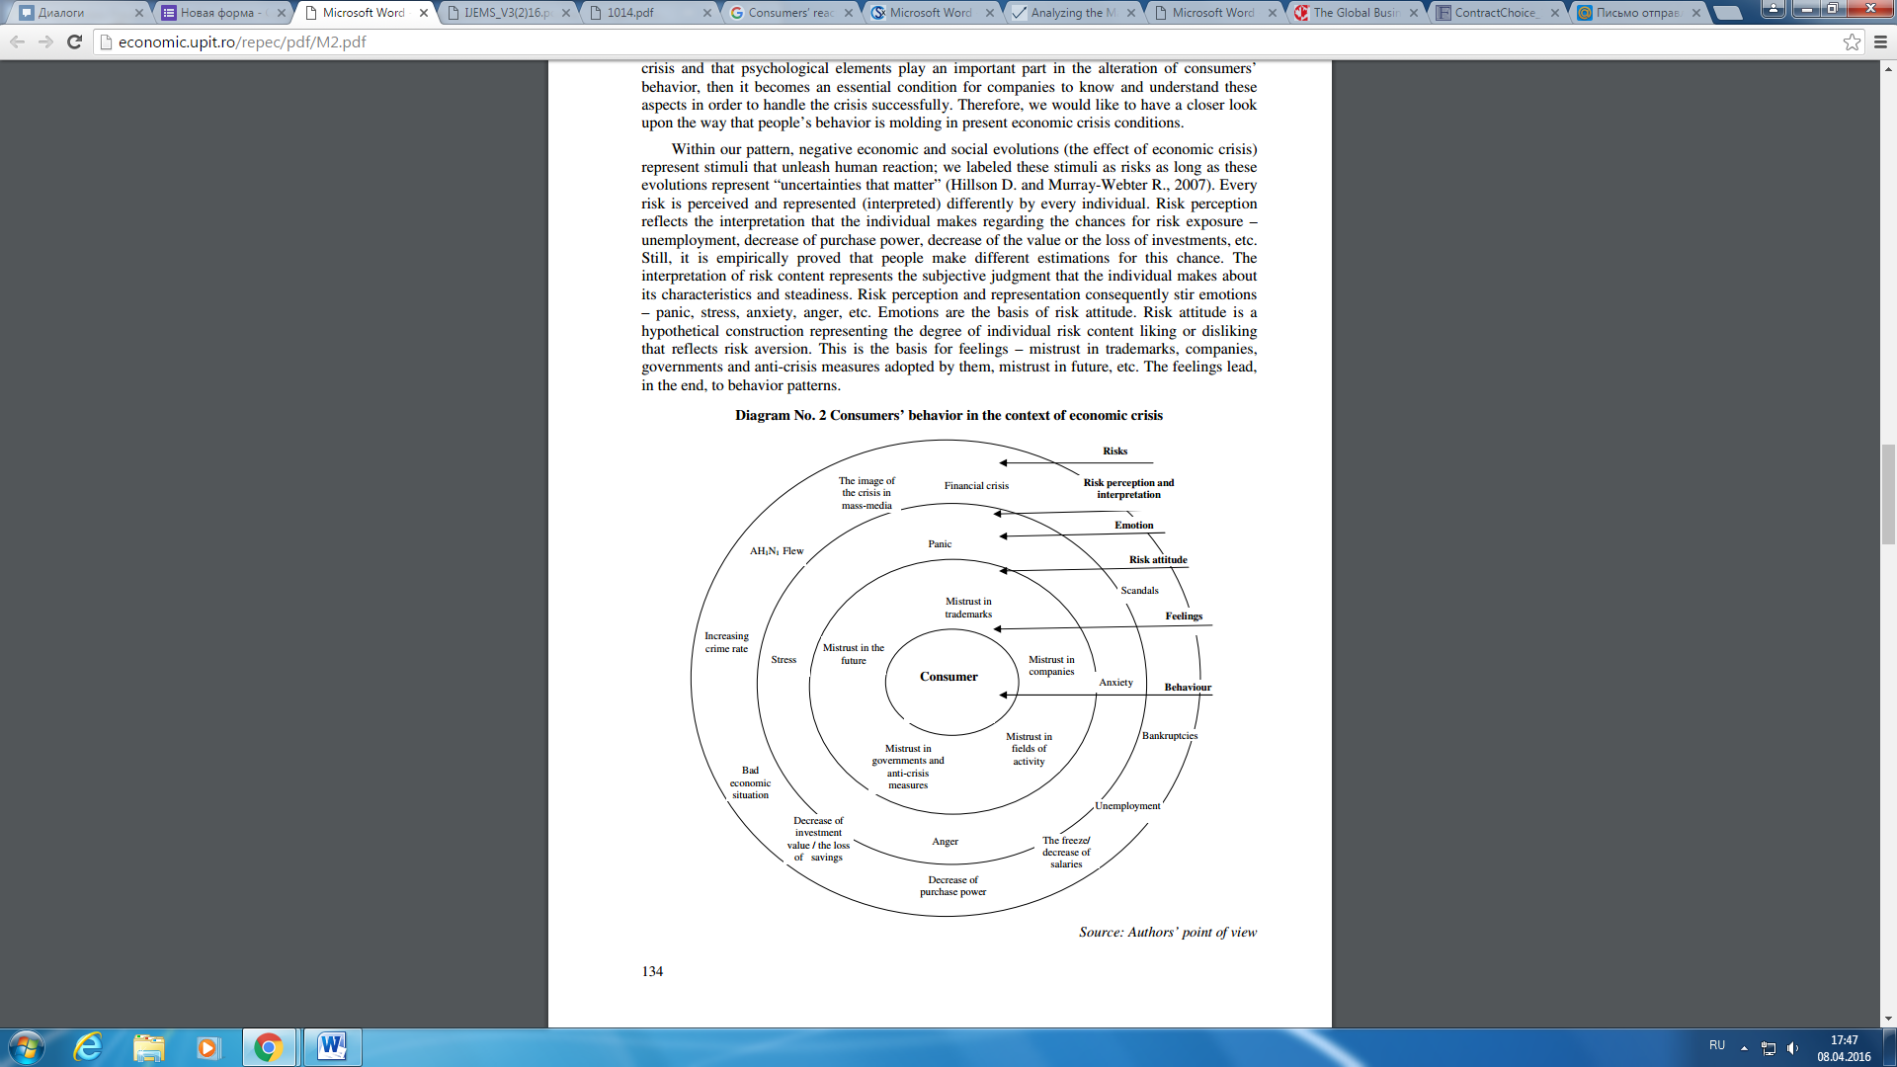Pandelica (2008) highlights 4 types of consumers according to their risk attitudes and risk perceptions.

Figure 2.6 Crisis influence on consumer behavior. Pandelica, 2008

First type – panicked consumers with high both risk attitude and risk perception, are sure that current economic changes will significantly affect on their life. Usually these consumers tend to irrational actions. To these groups belong low income unemployed population. Panicked consumer tend to reduce dramatically their expenditures and try to find products with lowest price.

Cautious consumers have high risk attitude, but low risk perception, they realize difficult economic situation, but don’t think that crisis will touch them significantly. Such people have positive perceptions about their job stability and try to rationally spend money. They tend to postpone big purchases.

Concerned consumers have low risk attitude but high risk perception and expect that economic changes will affect them. They make major purchases only in the case if it is necessary.

Rational consumers with low risk aversion and perception remain their behavior before crisis. They usually have high income and don’t fear that they will loose their jobs.

It is detected 4 main points on consumer behavior changes due to financial crisis in China. Firstly, he mentions that consumers become less confident and tend to spend less on home products, personal care good, food and drink and entertainment related goods and services. They also postpone make major purchases. Secondly, consumer become more rational in their decision making process and more significantly react on price changes. This motive them to choose domestic products rather than the foreign ones. Moreover, they elongate the information searching process before purchase making. Thirdly, during the crisis consumers seek in advertising the detailed information about product costs, value, functionality et.c. Finally, during the crisis people use the Internet not only as information resource but also to make purchases online.

Katona (1974) claims that when people expect that in the nearest future prices will increase and spend more money on necessities and postpone desirable but not urgent purchases.

One of the first framework that investigate consumer behavior changes during the crisis was provided by Leller and Schewe (1974) which focus was on American stagflation 1973-1974 (Kotler and Caslione, 2009). Authors analyzed consumption and savings tendencies, postponing important purchases, change in lifestyles and extensive credit usage. Some main conclusions were: decreasing buying desire, postponing purchases, increasing purchase duration. Fizbain et al. (2003) identified 3 types of strategies according to household type during Latin American crisis. First group, adaptive strategies, relate to reactive response of households. The second type or active strategy involve the increasing of house good production to sell and increasing working time and labor supply. Social network, the third strategy group, includes mainly searching for living support. Robles et al. (2002) Zurawicki and Braidon (2005) investigating the same crisis concluded that consumers tend to avoid long-term financial commitment and therefore postpone major purchases, expanding of basic products consumption.

Pikturnien (2009) suggests that there are 6 types of consumer response:

1. Remain the same behavioral strategy, is the most appropriate for high income consumers.
2. Limit spending to survive
3. Reduce spending to save
4. Increase “today” quality of life
5. Consume more products and services
6. Consume more high quality products and services.

# 2.3. Сonsumer behavior on mortgage market

Financial products could be classified into 3 groups:

1. Intangible (loans and saving products)
2. Physical (mortgage and insurance)
3. Body and mind assets (financial advise)

Problem recognition on financial markets significantly differs from product to product as different attractiveness of financial services (e.g. mortgage vs. loan). Financial market particularity in comparison with other markets is that financial products aren’t usually a goal in themselves. Monitoring and adjustment stage is crucial for financial decision-making process as some financial products are long-term and could be modified over time. It is provided four types of decision-making styles: self-controlled, ambitious, advice-dependent and convenience-seeking.

Meidan (1996) categorized factors that influence financial consumer buying behavior in internal factors that involve psychological and personal determinants, external (cultural and social) and purchasing procedures.

Beckett et al. (2000) provides a classification of financial services consumer in dependence of their involvement: repeat-passive, rational-active, relational-dependent and no purchase. This model does not pay any attention to risk perceptions despite its high significance on financial market.

Tsiotsou (2008) classified financial services consumers into 3 groups in dependence on their needs: traditional, consumers who but transaction products, conformists – consumers of insurance products and “gambler” – consumers of investment products. These categories demonstrate different risk perceptions and involvement in decision-making process. Last type of consumers have the highest risk perceptions and show high involvement. It is assumed that investment products as they are intangible and complicated lack the consumer confidence. This type of consumers demonstrate extensive problem-solving and even spend additional money to search information. Author suggest that for such type of consumers companies must provide well-trained sales force, publicity, and mass advertising .

Consumer behavior on mortgage market could be divided in two main directions: type of loan choosing and bank selection.

Besides different variations such as fixed-rate vs. adjustable rate loans there are a plenty of combinations of interest rate/ discount points inside the program. In academic literature borrower mortgage choice is popular subject for discussions. (Mugerman and Moran, 2013) Generally, FRM vs. ARM is explained by borrowers characteristics: income, prepayment decision, borrowing constraints – and external economic factors like inflation (Statman, 1982; Alm and Follain, 1984; Stanton and Wallace, 1999; Campbell and Cocco, 2003; Paiella and Pozzolo, 2007; Koijen et al., 2009).

Basel and Biger (1990) and Statman (1982) investigate the borrower incentives to choose between fixed-rate and index-rate mortgages. Statman provide a model that link borrower choice with two types of relationshiops: rate of changes in income with inflation and house net value with inflation. Alm and Follain (1984) consider two directions: the inflation influence on mortgage choice and the dependence between housing demand and alternative mortgage instruments. Cambell and Coco found out that borrower prefer ARM when house value is significantly lower than their income, when income is stable over time and when they have plan to move soon.

Jan K. Brueckner (1993) made a fundamental analysis of the mortgage points by using economic tools like indifference curves, zero-profit loci, regression. In the paper the trade off discount points/interest rate is considered. Its existence is proved by the regression model. Data selected from the Home Financing Housing Database, demonstrate mortgage loans that had been taken for 4 years 1981-1985. The information about a quantity of bought mortgage points is available for each observation. High-points contract are divided in two groups to avoid a bias; one of them defines mortgages with points greater than 200, the other one – greater than 250.

In the result, the regression equation shows the significance correlation between points and rate: each point reduces rate approximately by 9.5 basis points. In addition in this framework are indentified conditions at which mortgage points’ purchase was profitable for the borrower. In the author's opinion all borrowers can be divided in two groups: one of them is low-mobile, the other one – high mobile. Dunn and Spatt at introduced the first, the borrower mobility concept. 1988. It suggests that borrowers who is going to refinance or in other words move in the nearest future tend to choose options with low points. Each of them has his-own indifference curve and utility function, depending on their fixed payments in two periods (I0, I1). The author proves that, borrowers, whose probability of the movement is high choose mortgage contracts, where I0 < I1 and vice versa. Thus, high-mobility borrower prefers not to buy points now, but to have a higher interest rate. Low-mobility borrower in the points/rate trade off chooses a point purchase. This assumption is proved by the linear regression, where independent value is purchase/refuse of purchase of mortgage points and the dependable variable is a movement of the borrower. AHS database presents an information about mortgage contracts in 1984 and 1985 and observations about the same borrowers in 1989, which demonstrates whether the borrower had moved or not.

But there is a contrary research of Charles A. Stone, Anne-Marie Zissu (1990). Authors apply the expected monetary value (EMV) algorithm. Obtained results show that the purchase (or not) of the mortgage points depends on

1) Tax bracket of the mortgagor.

2) Time over which he/she expects the effective cost of mortgage capital to remain.

3) Probability a mortgagor attaches to the event that interest rates change at time.

For instance, if mortgagor expects, that the interest rate falls, he would rather take advantage of his prepayment option. Authors confirm that high and low mobility borrowers may make same choice. And, conversely, the choices will differ if mortgagors in the same tax bracket and with the same expected tenure in the mortgaged property have different expectations about the future cost of mortgage capital.

**Banking marketing mix**

Marketing mix concept has particularities in dependence on industry where company exists. In context of banking industry product component could be defined as any service proposed by bank: loans, deposits, cash-transactions, credit cards (Lipowski, 2003). Quality of the offered banking service plays the most significant role for bank, as it is one of the most important competitive advantages among huge variety of similar services proposed by huge amount of banks. Packaging in context of banking sphere refers to packaging of contracts in branded folder. Advisory services belong to service component of product concept in marketing mix. The first level of product – core product – in simple words is division of banking services in accordance with their types: loans, credit cards, mortgages and so on. Actual products specify banking service to concrete features: interest rate, type of loan, loan period and so on (Lipowski, 2003). To augmented banking service the quality of information provided by bank could be referred.

Price in banking sphere includes interest rates, commissions and fees taken by bank. The price is defined in dependence of loan period, type of loan redemption and banking risks. From the customer point of view price very often take the first place in bank selecting.

Promotion of banking services could be split into two groups by their objectives. First type aimed to inform customers about bank and its offering to attract clients through advertising and personal selling. Public relations form the second group of promotion activities to ensure and maintain positive brand image of bank.

Bank distribution channels involve several types such as traditional distribution (in banking office), non-stationary distribution – visits of banking staff consumer mobile places, electronic distribution channels. The selection of one or another distribution tool goes along with consumer segment.

# 2.4. Relationships between bank and mortgage borrower in Russia

Some empirical findings claim that 60% of Russian banks apply income information and some criteria of client relationships with bank, however, to reliable and deeper analysis it is necessary to conduct multiple-factors analysis, involving borrower risk profiles and other significant socio-economic factors (Knyazeva, 2011). Banking products need to be developed in dependence of detected client profiles. Traditional approach is based in the majority on such factors as age, income, occupation, social status, today this approach needs to be extended and modified to strategic-oriented approach. It will allow bank to understand and analyze motives of client in selecting one or another bank, financial literacy and preferred channels of communication (Skiba and Loyko, 2012).

The main focus of Russian banks is to evaluate solvency of the borrower, applying scoring system of assessment, based on borrower income and credit history. (Skiba and Loyko, 2012)

Potential borrowers could be divided in several groups in dependence of classification criteria:

1. By income: high-income borrower, medium-income borrower, low-income borrower.
2. By occupation: employed, unemployed
3. By age: 20-25, 25-30, older than 50 years old.
4. By behavioral patterns: living for the day, adventurists, realists, tend to be in the movement (Knyazeva, 2011).

Mistrust to banks is one of the factors that provoke mistrust and dissatisfaction on mortgage market. In crisis conditions this issue takes more crucial character, However, this factor does not significantly considered in banking context (Ibragimova, 2012). Therefore banks have great potential and scope to form borrower loyalty. To increase loyalty among potential borrowers it is necessary to strength strong relationships with bank through high quality servicing. For 29% of respondents the banking staff competence is the most significant factor, 16% claimed that they estimate the readiness of banking employee solve problem in the fastest way (Alikperova and Yarasheva, 2015).

It is also necessary to mention that in Russia financial services are dictated by banks, but is not conscious client decision (Alikperova and Yarasheva, 2015).According to NAFI investigation conducted in 2012 38% of respondents claimed that bank makes them to purchase insurance with selected financial service. This leads to unwillingness to pay for credit products. Moreover, respondents (21%) claimed that they do not like banking advertisement as it usually deceive. Such perceptions are the result of previous negative experience.

To increase loyalty among clients of banks some suggestions could be formulated:

1. Increase of financial literacy.
2. Transparency of information.
3. Detailing explanation of every financial service.
4. Judicial security of client.

Taking into account previously analyzed issues stimuli-response model from the banking point of view could be built. Russian banks take into consideration only personal factors of potential borrowers as age, income, social status, but neglect borrower psychology and decision-making process. This lead to financial mistakes made by borrower in bank and product selection, that leads to borrower dissatisfaction, mistrust to banks and prohibit mortgage market development in long-term perspective (Figure 2.7).

# 

Figure 2.7 Stimuli-response model on mortgage market from banking point of view

*Source: by author*

# Summary of chapter 2

After extensive literature review was provide the theoretical framework could be summarized in this part of chapter (Figure 2.8).

Basing on stimuli-response model we will focus on psychological layer of potential mortgage borrowers. Factors that are included in psychological group are selected taking into consideration financial market particularities and crisis conditions (Alekperov and Yarasheva. 2015; Beloglazova and Krolivetskaya, 2010; Pandelica A., 2008). The most important psychological factors are motivation, perception, beliefs and attitudes. Cultural background affects the psychological layer through feelings and emotions: risk attitude and risk perception. That in their turn leads to mistrust in future, companies, government, fields of activities (Pandelica A., 2008). Favorability of Russian market for major purchases. (Pikturnien, 2009, Robles et al., 2002 Zurawicki and Braidon 2005, Leller and Schewe 1974, Katona, 1974, Pandelica, 2008). Tendency to save. (Leller and Schewe,1974, Pikturnien, 2009, Kholi and Jaworski, 1993). This framework covers motivation, perception and beliefs and attitudes in terms of mistrust to mortgage and mistrust to future. As motivation the need for housing conditions was selected as in the majority this is the most crucial reason that motivates people to take mortgage is dissatisfaction with current housing conditions. (Aymaletdinov, 2013, Prosvirin, 2008).

Perception, beliefs and attitudes: Trust to future (Aymaletdinov, 2013), trust to mortgage (Kondrashov, 2012; Ivasenko, 2006; Ivanova, 2010).

Personal factors of potential borrowers are also included, based on classical factors that are considered by banks. Demographics play significant role in consumer behavior patterns and belongs to personal layer. To narrow the scope to mortgage market particularities 3 the most critical factors have been chosen: age, gender, subjective assessment of income. (Aymaletdinov, 2013). Personal factors also concern with economic situation, occupation, education, lifestyle e.tc.

Financial literacy is a crucial fact in taking financial decisions (Kivetz, 2000; Meidan, 1996). There are several ways to measure financial literacy, this research would consider two items: education, existence of mortgage (Aymaletdinov, 2013). Education. Existence of mortgage. (Kivetz, R., 2000; Meidan A., 1996). Next point that is covered by this study is a decision-making process we will try to understand borrower involvement in decision-making process in dependence of borrower profile. Products, place and promotion were selected from 4P’s marketing mix, as price is beyond this study scope.

**Stimuli-response model**

**Other stimuli**

Borrower black box

**Cultural layer: crisis conditions**

Borrower psychology

Perceptions

Unemployment;

Inflation;

Political instability

sanctions

**Mistrust to future**: economic stability, future income, labor market stability

**Mistrust to mortgage:**

Transparency of information

Borrower judicial security

Easy to access to mortgage

Mistrust to banks

**Decision-making process**

Involvement in decision-making process

Problem-solving

**Russian mortgage market context**

# 

High interest rates, strong requirements, intrusion;

long formal procedures

Motivation

Learning & memory

# 

**Personal factors**

Age

Subjective assessment of income

Gender

Education

Family

Figure 2.8 Consumer behavior on mortgage market theoretical framework

*Source: by author*

# 3. METHODOLOGY AND DATA COLLECTION

# 3.1. Research Philosophy, research approach and research design

Among five major philosophies: positivism, critical realism, interpretivivsm, postmodernism and pragmatism – the last one was chosen for this framework. (Saunders et al.2009). This philosophy is the most convenient in this research context as it is impossible to apply a single philosophy. Pragmatism assumes that the research could be based not on just one research philosophy. Pragmatic research considers ideas, concepts, and findings in their relevance for practice in particular context. The main goal of such frameworks is a practical contribution that discloses the future. (Saunders et al.2009). So, in terms of this master thesis pragmatism fit its idea in the best way.

As an approach the abductive one was applied. Starting from general consumer behavior theory we move to consumer buying behavior than to consumer behavior under crisis and consumer behavior on financial markets then some assumptions were made. However, the goal of this framework was not to test hypothesis and exploratory design significantly undermines the idea of deductive approach (Saunders et al.2009). Inductive approach is also not favorable for this research as the consumer behavior is widely discussed in the literature. However, there is far less information in the particular investigated patterns. The most convenient here is abductive approach. It is widely applied to understand consumer behavior and does not contradict using exploratory design (Haig, 2005). This approach is resistance for constraints that possess deductive and inductive methods and effectively combines both of them.

The exploratory research design has been chosen to answer research questions. This design is applied when the researcher aims to understand nature of phenomena. The goal of the framework is to provide insights in consumer behavior on mortgage markets that ideally fit the purpose of the exploratory design. Exploratory design is used in cases when stated problem need to be more precisely explained. Another reason for the exploratory design choice is that the information the consumer behavior in particular conditions is poorly defined. Moreover applied methods are the most appropriate for this type of design (Malhotra, N.K., 2012). Quantitative exploration was applied (figure 3.1).

# 3.2. Data collection

# 3.2.1. Primary data collection: potential borrower behavioral factors

To answer first research question: “What are profiles of potential borrower?” – primary data were collected. To collect primary data survey techniques was used. This method was chosen by several reasons. First of all, it allows to gather information in short time and easy way. Secondly, achieved data are consistent as questions “are limited to the alternatives” (Malhotra, 2012). Finally 172 answers were collected. In the questionnaire the majority of questions are fixed-response questions that reduce the variability of gathered data.

The traditional sampling method was used: online survey as it is the fastest method. As a sampling techniques the non-probability one was applied: snowball and convenience. Questionnaire was posted in groups related to mortgage social networks as vkontakte.ru, friends were asked to answer, questionnaire was sent by email to one of the Russian bank and big gas and oil company.

The choice could be explained by the nature of this framework. The goal is to understand not the buying behavior, but the consumer behavior. The sampling method could provide some biases, so the researcher focuses on absolutely different persons. Non-probability sampling could not give results on which objective conclusions will be made, so the representative of sample is undermined. However, non-probability sampling techniques are recommended and convenient for exploratory design (Malhotra, 2012). Than statistical procedures were conducted – exploratory factor analysis and k-means cluster analysis, using SPSS 22.0 Statistics.

# 3.2.2 Secondary data collection on Russian mortgage market

To answer second research question: “What are products that correspond to potential borrower profiles?” – secondary data were collected. External secondary data were analyzed. The information was searched in computerized online databases provided by Agency of House Mortgage Lending (www.ahml.ru), Russian Statistics Committee (http://www.gks.ru/), National Agency of Financial Investigations (http://nacfin.ru/) and different banking forums including sites of Russian banks.

# 3.3. Measurement of consumer behavioral variables

Questionnaire was constructed on the basis of different sources as it is exploratory design (Appendix 1). The main purpose of the questionnaire was to fit factors initially claimed: psychological and cultural background in context of crisis. (Pandelica., 2008). Almost all questions have 5 points balanced scale: likert and semantic differential in the majority (from 1to 5, as negative and positive answers could create positive response tendency) (Saris, Gallhofer, 2007, Malhotra, 2012). In case of factor data analysis scales 5 points scale is enough (Table 3.7). All questions have been asked with positive intention (Malhotra, 2012).

**Cultural Background: consumer behavior under Crisis**

The first block involves 2 items are dedicated to understand the consumer behavior under crisis, in general, not on mortgage market in Russia: favorability of Russian market for major purchases and tendency to save.

*Favorability of Russian market for major purchases.* First question aimed to detect respondents perceptions about the favorability of Russian market for major purchases, as numerical frameworks discussing consumer behavior under crisis, claimed people tend to postpone major purchases. (Pikturnien, 2009, Robles et al., 2002 Zurawicki and Braidon 2005, Leller and Schewe 1974, Katona, 1974, Pandelica, 2008).

*Tendency to save.* Under crisis people tend to save money and this was the sense of the third question (Leller and Schewe,1974, Pikturnien, 2009, Kholi and Jaworski, 1993). These questions are semantic differential scaled with two bipolar points: “strongly disagree” and “strongly agree”

**Psychological factors**

The most important psychological factors are motivation, perception, beliefs and attitudes, learning. Cultural background affects the psychological layer through feelings and emotions: risk attitude and risk perception. That in their turn leads to mistrust in future, companies, government, fields of activities (Pandelica, 2008). This questionnaire covers motivation, perception and beliefs and attitudes in terms of mistrust to mortgage and mistrust to future.

**Perception, beliefs and attitudes**

**Trust to future**

Second block is about future perceptions or trust future. It consists of three items: expectations about future economic situation, expectations about future of labor market and expectations about future income. (Aymaletdinov, 2013). All this questions are semantic differential scaled with two bipolar points: “strongly disagree” and “strongly agree” and the neutral point in the middle.

**Trust to mortgage**

Next block consider perceptions about mortgage and includes 4 items: trust to banks, easy to access to mortgage, the judicial security on mortgage market and the transparency of information provided by banks. As there is no previous research papers devoted to this very topic this block was constructed on the major problems of mortgage lending in Russia, retrieved from literature, banking forums and sites. All questions in this block are single-choice and have semantic differential scale “strongly disagree” and “strongly agree” and the neutral point in the middle.

*Trust to banks.* Under crisis in dependence on risk perception and risk attitude consumers perceptions of companies and, thus banks, become more negative (Ivasenko, 2006; Kondrashov, 2012).

*Easy to access to mortgage.* High interest rates, difficult and long procedure of application consideration, high requirements to the borrower make the access to mortgage sophisticated and complicated that (Kondrashov, 2012).

*The judicial security on mortgage market.* The judicial side of mortgage market isn’t also developed: there is a lack of strong and unified law system, poor handling of rights to use dwelling, lacks or rules and regulations for mortgage securities aimed to attract more investors on the market (Ivanova, 2010). So perceptions about the judicial security on mortgage market could have significant affect on consumer behavior.

*The transparency of information provided by banks.* This problem was driven after analyzing different banking forums and banking site. Just several banks provide easy to access transparent information on their sites. Moreover, there are some judicial cases, when the borrower accuse bank of implementing hidden fees.

**Motivation**

**Housing conditions**

In the majority the most crucial reason that motivates people to take mortgage is dissatisfaction with current housing conditions. This block includes 3 items: necessity to improve housing conditions, quantity of family members living in the same apartment and the type of respondent apartment: own or rented. (Aymaletdinov, 2013, Prosvirin, 2008).

*The necessity of improving housing conditions.* This is semantic differential scale question with two bipolar labels: “strong necessity for housing conditions improving” and “absolutely no necessity for housing conditions improving” And neutral point in the middle.

*Number of family members living in the same apartment.* This single-choice close-ended question with 5 possible alternatives, including 0 – “live alone” and 5 – “live with more than 4 family members together”.

*Type of respondent apartment: own or rented.* This is dichotomous question – “own flat” or “rented flat” with open-ended option “other”. Answers were coded in dummy variables: 0 was given for respondents who do not live in their own apartment and 1 for those, live in their own apartment.

**Personal factors**

Demographics play significant role in consumer behavior patterns and belongs to personal layer. To narrow the scope to mortgage market particularities 3 the most critical factors have been chosen: age, gender, subjective assessment of income. (Aymaletdinov, 2013). Personal factors also concern with economic situation, occupation, education, lifestyle e.tc.

**Financial literacy**.

Financial literacy is a crucial fact in taking financial decisions (Kivetz,, 2000; Meidan, 1996). There are several ways to measure financial literacy, this research would consider two items: education, existence of mortgage (Aymaletdinov, 2013).

*Education*. This is a structured single choice question. The level of education was divided as: only school education, secondary vocational education and higher education. Received answers were coding in interval variables starting from 1 to 3 respectively.

*Existence of mortgage.* Some researches prove that people with credit history in the past tend to be more financial literacy and more opened and familiar with credits (Kivetz, 2000; Meidan, 1996). As mortgage is a very specific type loan we will consider only the existence of mortgage. This is dichotomous question. Then it was coding 0 for answer “No, I don’t have a mortgage and 1 for “yes. I have a mortgage”

**Demographics**

*Age.* This is single choice question. For respondents 4 options were provided: under 18, 18-21, 22-30, 31-45, over than 45. The decision to split age in such a way was led by the fact that there are different mortgages options for different age groups. (www.ahml.ru) For instance, people from 22 to 30 years old could be considered as young family and therefore, government subsiding mortgage could be proposed for them. Then answers were coded in interval variables for 1 to 4, respectively.

*Gender.* This is dichotomous question. Answers were coded in dummy variables: 0 was given for female and 1 for male.

*Subjective assessment of income.* The decision to use the assessment of income but not the amount of income was driven by the framework of Aymaletdinov T.A. (2013). The goal is not to understand the nominal income of respondent but his perception about its sufficiency. This is structured 5 points likert scale question. (1- extremely insufficient to 5 – more than sufficient)

Last question in questionnaire measures the desire to act in this case take a mortgage in the neasrest 5 years. This question belongs to semantic differential scale, with two bipolar adjectives: “definitely not” and “definitely yes”.

# 3.4. Data Analysis

# 3.4.1. Factor analysis of potential borrower perceptions

First exploratory factor analysis was run to check and identify initially claimed dimensions for further cluster analysis. The first point is to analyzing the sample. There is no common rule what is the ideal sample size for factor analysis. Some authors claim that 300 cases is the most appropriate size, others suggests that 100 cases or even 50 cases is the minimum threshold (Williams et al, 2010). More robust technique to identify the optimal sample size is to calculate sample to variable ration – N:p, where N is a number of participants and p is a number of variables. The ideal ratio could also vary from 3:1 to 20:1. In our case sample to variable ration equal 24:1, as only 7 variables: trust to banks, easy to access to mortgage, the judicial security on mortgage market, the transparency of information provided by banks, expectations about future economic situation, expectations about future of labor market and expectations about future income.

These amount was chosen after correlation analysis, after which some variables, which correlation coefficient is less than 0,3 with the majority of variables, were excluded from factor analysis. (Tabachnick and Fidell, 2007)The minimum recommended number of items in one factor is 3, as 2 items may just be highly correlated between each other that undermine the sense of factor analysis. High correlation coefficient is also demonstrates that factor analysis is not appropriate. In this case all selected variables are convenient for factor analysis (Table 3.1)

Table 3.1 Correlation coefficients

|  |  |  |  |  |  |  |  |
| --- | --- | --- | --- | --- | --- | --- | --- |
|  | Expectations about future income | Trust to banks | Easy to access to mortgage | The transparency of information provided by banks | Expectations about future of labor market | The judicial security on mortgage market | Expectations about future economic situation |
| Expectations about future income | 1 | ,094 | ,035 | ,131 | **,417\*\*** | ,185* | **,395\*\*** |
| Trust to banks | ,094 | 1 | ,**331\*\*** | **,307\*\*** | ,050 | **,336\*\*** | ,193* |
| Easy to access to mortgage | ,035 | **,331\*\*** | 1 | **,348\*\***  Continue of Table 3.1 Correlation coefficients | ,177* | **,392\*\*** | ,174* |
| The transparency of information provided by banks | ,131 | ,**307\*\*** | **,348\*\*** | 1 | ,281** | **,305\*\*** | ,286** |
| Expectations about future of labor market | **,417\*\*** | ,050 | ,177* | ,281** | 1 | ,249** | **,688\*\*** |
| The judicial security on mortgage market | ,185* | **,336\*\*** | **,392\*\*** | **,305\*\*** | ,249** | 1 | ,260** |
| Expectations about future economic situation | **,395\*\*** | ,193* | ,174* | ,286** | **,688\*\*** | ,260** | 1 |

*Source: modified SPSS output*

Then Kaiser-Meyer-Olkin measure of sampling adequacy and Bartlett’s test of sphericity were conducted. The KMO index excess the commonly used minimum – 0,5 therefore sample could be considered as suitable for factor analysis. The Bartlett’s test is significant (Chi2 – 267,129, df 21, p<.000) and proves the same suggestion (Table 3.2).

Table 3.2 KMO and Bartlett’s Test

|  |  |  |
| --- | --- | --- |
| **KMO and Bartlett's Test** | | |
| Kaiser-Meyer-Olkin Measure of Sampling Adequacy. | | 0,713 |
| Bartlett's Test of Sphericity | Approx. Chi-Square | 267,12 |
| df | 21 |
| Sig. | 0 |

*Source: modified SPSS output*

As an extraction method the principal component analysis has been chosen (Costello A.B., Osborne J.W., 2005; Frösén J. et al., 2013). As a rotation method the varimax was chosen and 0.5 was set as a minimum factor loading (Frösén J. et al., 2013; Table 3.3).

Table 3.3 Rotate component matrix: factor loadings

|  |  |  |
| --- | --- | --- |
| **Rotated Componant matrix** | | |
|  | Component | |
| Factor 1 | Factor 2 |
| Expectations about future income | 0,716 |  |
| Trust to banks |  | 0,718 |
| Easy to access to mortgage |  | 0,759 |
| The transparency of information provided by banks |  | 0,633 |
| Expectations about future of labor market | 0,864 |  |
| The judicial security on mortgage market |  | 0,68 |
| Expectations about future economic situation | 0,828 |  |

*Source: modified SPSS output*

All variables exceed the minimum threshold set. Two factors were rotated that fit initially set dimensions and could be interpreted as factor 1: beliefs about future, let call it trust to future and beliefs about mortgage, let name it trust to mortgage.

Then, the reliability test was conducted. The Cronbach’s Alfa exceeds the minimum threshold – 0,6 (Table 3.4). The value is not very high, however this could be explained by the fact that this coefficient highly depends on number of items in factor (Kristoff, 1963; Feldt, 1965)

|  |  |  |
| --- | --- | --- |
| **Reliability Test for 1 factor**  Table 3.4 Reliability Test | | |
| Cronbach’s Alfa |  | N |
| 0,669 | 0,67 | 4 |
| **Reliability test for 2 factor** | | |
| Cronbach’s Alfa |  | N |
| 0,732 | 0,75 | 3 |

*Source: modified SPSS output*

# 3.4.2 Cluster analysis of potential borrowers

Then the cluster analysis was conducted to identifiy potential borrower profiles in dependence of two identified dimensions: trust to mortgage and trust to future. The non-hierarchical k-means algorithm with Euclidean distance was applied, as it is the most commonly used method and is easy to future interpretation. (Hair et al.,2006,). The number of clusters was identified based on logic, 4 clusters were created (Table 3.5). Number of cases in each cluster doesn’t significantly differ, therefore 4 clusters could be considered as right decision.

Table 3.5 Final centers of clusters

|  |  |  |  |  |  |  |  |
| --- | --- | --- | --- | --- | --- | --- | --- |
|  | | Cluster | | | | | |
| 1 | | 2 | | 3 | 4 |
| Fututre | | -0,6665 | | -1,04416 | | 0,94445 | 0,76825 |
| Mortgage | | -0,77535 | | 0,80496 | | -0,7357 | 0,90892 |
| Number of Cases in each Cluster | | | | |
| Cluster | 1 | | 51,000 | |
| 2 | | 40,000 | |
| 3 | | 44,000 | |
| 4 | | 36,000 | |
| Valid | | | 171,000 | |
| Missing | | | 0,000 | |

**

As factor scores range from -3 to 3, then negative values demonstrate negative perceptions and positive value – positive perceptions. To find differences among clusters cross-tabulation were used with applying chi-square statistic (Table 3.6). After this procedure it could be concluded that following variables differ between clusters:

1. Education
2. Number of family members
3. Necessity to improve housing conditions
4. Age
5. Tendency to save
6. Plan to take mortgage
7. Existence of mortgage

Gender, type of respondent apartment (own or rented) and favorability of Russian market for major purchases were excluded from further analysis as the number of cases in clusters is statistically equal.

Table 3.6 Description of potential borrower profiles

|  |  |  |  |  |  |
| --- | --- | --- | --- | --- | --- |
| Criteria | Options of answer | Cluster 1 (%) | Cluster 2 (%) | Cluster 3 (%) | Cluster 4 (%) |
| Education (p<000) | School education | 47.1 | 2.5 | 36.4 | 13.9 |
| secondary vocational education | 47.1 | 22.5 | 45.5 | 58.3 |
| Higher education | 5.9 | 65.0 | 9.1 | 50.0 |
| Family members living in the same apartment (p<0.003) | Live alone | 0.0 | 15.0 | 9.1 | 19.4 |
| Live with 1 family member | 15.7 | 32.5 | 15.9 | 41.7 |
| Live with 2 family members | 21.6 | 22.5 | 34.1 | 25.0 |
| Live with 3 family members | 25.5 | 10.0 | 20.5 | 25.0 |
| Live with 4 family members | 25.5 | 7.5 | 4.5 | 5.6 |
| More than 4 family members | 11.8 | 2.5 | 6.8 | 5.6 |
| Necessity to improve housing conditions (p<0.004) | High need | 9.8 | 7.5 | 6.8 | 0.0 |
| As soon as possible | 25.5 | 15.0 | 34.1 | 22.2 |
| Can not say | 3.9 | 2.5 | 2.3 | 8.3 |
| Possibly, but not necessary | 43.1 | 37.5 | 47.7 | 41.7 |
| No need | 17.6 | 27.5 | 0.0 | 50.0 |
| Age (p<0.000) | 18-21 | 3.9 | 0.0 | 0.0 | 0.0 |
| 22-30 | 72.5 | 72.5 | 70.5 | 13.9 |
| 31-45 | 17.6 | 12.5 | 18.2 | 41.7 |
| Older than 45 | 5.9 | 5.0 | 2.3 | 66.7 |
| Tendency to save (Last years you try to save money?) (p<0.000) | Absolutely disagree | 37.3 | 22.5 | 15.9 | 13.9 |
| Partly disagree | 35.3 | 7.5 | 11.4 | 8.3 |
| Can not say | 3.9 | 7.5 | 6.8 | 11.1 |
| Partly agree | 17.6 | 37.5 | 34.1 | 52.8 |
| Strongly agree | 5.9 | 15.0 | 22.7 | 36.1 |
| Do you plan to take a mortgage (p<0.437) | Definitely no | 37.3 | 22.0 | 34.4 | 13.9 |
| Very unlikely | 41.2 | 22.5 | 44.6 | 18.6 |
| Can not say | 7.8 | 21.5 | 11.0 | 17.5 |
| Very likely | 11.8 | 19.7 | 5.5 | 25.0 |
| Definitely yes | 2.0 | 14.3 | 4.5 | 25.0 |
| Existance of mortgage (p<0.000) | Don’t have a mortgage | 68.6 | 57.5 | 70.5 | 41.7 |
| Have a mortgage | 31.4 | 32.5 | 20.5 | 80.6 |

**

# Summary of chapter 3

To achieve research goal and answer research questions abtuctive approach was used in context of pragmatism research philosophy. Study has exploratory design and both primary and secondary data were collected. To collect primary data questionnaire was chosen as a method (Figure 3.1, table 3.7). Then factor an cluster analysis were conducted (Table 3.3; table 3.5)

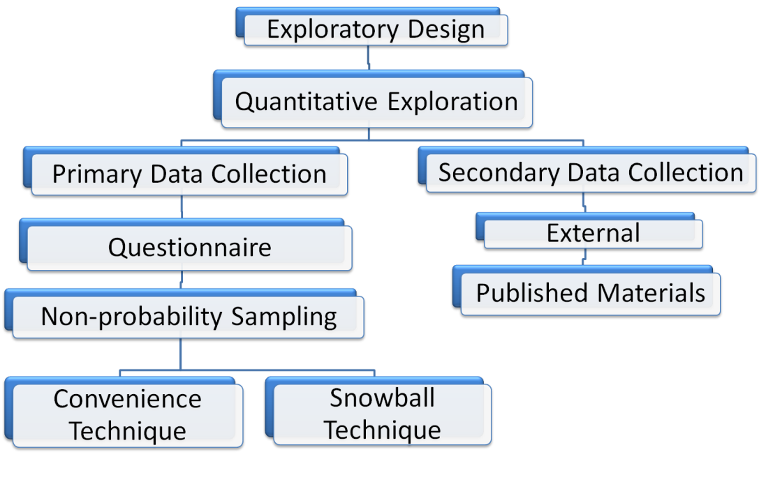

Figure 3.1 Research Design. Source: author

|  |  |  |  |
| --- | --- | --- | --- |
| Cultural layer: crisis context | 2 items | 5-points semantic differential scale | Pikturnien, 2009; Robles et al., 2002; Zurawicki and Braidon 2005; Leller and Schewe 1974; Katona, 1974; Pandelica, 2008; Leller and Schewe,1974; Kholi and Jaworski, 1993 |
| Psychological layer | Perceptions, beliefs and attitudes: 7 items | 5-points semantic differential scale | Aymaletdinov T.A., 2013  Ivasenko A.G.,2006; Kondrashov V.A., 2012; Ivanova D.G., 2010; Prosvirin A. V., 2008 |
| Motivation: 3 items | 5-points semantic differential  Interval scale  Dichotomous scale | Aymaletdinov T.A., 2013; Prosvirin A. V., 2008 |
| Personal characteristics | Financial literacy: 2 items | Dichotomous scale  Nominal scale, coded to interval variables | Kivetz, R., 2000; Meidan A., 1996; Aymaletdinov T.A., 2013 |
| Demographics: 3 items | 5-points semantic differential  Interval scale  Dichotomous scale | Aymaletdinov T.A., 2013 |

Table 3.7 Scales of cultural, psychological and personal factors

*Source: author*

# 4. EMPIRICAL FINDINGS ON CONSUMER BEHAVIOR IN RUSSIAN MORTGAGE MARKET

This chapter describes received research results on consumer behavior of potential borrower in Russia, based on factor (Table 3.3) and cluster analysis (Table 3.6). This chapter includes two parts. The first one – research findings: potential borrower profiles – answer the first research question and concerns with received clusters descriptions (Figure 4.1). In the second part – research findings: correspondence of mortgage products to potential borrower profiles – the second research question. Subchapter involves 2 parts. The first one overviews mortgage market in Russia to identify available mortgage products and analyze their particularities (Table 4.3). In the second subchapter analyzed mortgage products are suggested to potential borrower profiles (Figure 4.6) on the basis of empirical results and academic literature.

# 4.1. Research results on potential borrower profiles

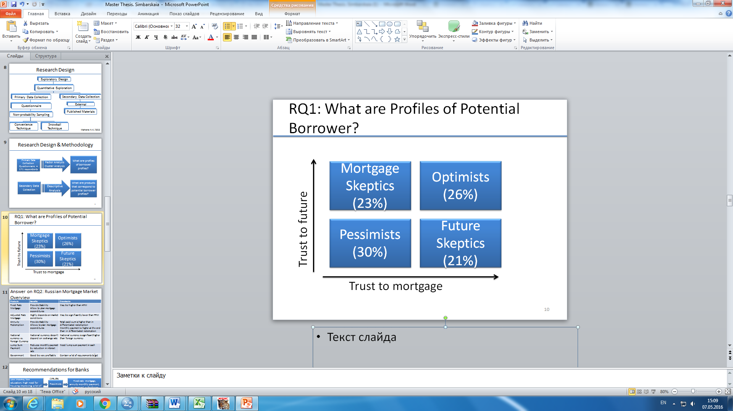

Figure 4.1 Potential borrower profiles. Source: by author

*Cluster 1(30%):* First cluster represents people that don’t trust mortgage and don’t trust the future, so they have bad perceptions about banks and don’t think that mortgage is affordable for population. They have bad expectations about future income and tendencies on labor and economic markets. This is the biggest cluster, 14% in it plan to take mortgage and 8% aren’t sure about the decision. (Table 3.6) These people usually have low level of education – only 5.9% of them have higher education (Table 3.6). They have high need to improve their housing condition and live with a lot of family members, however, they evaluate their income as low. Let’s name them pessimists as they don’t trust anything (Figure 3.2).

*Cluster 2:* They have bad expectations about future while believe that mortgage lending in Russia could be a good way to buy a house. In the majority their education is of high level. This is the youngest cluster 90% of its representatives are 22-30 years old and estimate their income as normal. 34 % of them is going to take a mortgage in the nearest future and 21,5% aren’t sure about it (Table 3.6). Let them name future skeptics (Figure 3.2).

*Cluster 3:* The opposite to cluster 2 to the third cluster belong people that believe in positive tendencies in economics, labor market and their future income, but have bad perceptions about mortgage lending system in Russia. They usually have low level education: secondary vocational or only school, estimate their income as normal and sometimes more than sufficient and nobody have a mortgage already (Table 3.6). Only 11% plan to take mortgage in the nearest future and the same percent hesitate to make a strong answer (Table 3.6). Let name this cluster as mortgage skeptics (Figure 3.2).

*Cluster 4:* This is the most optimistic cluster as represents people that have good expectations and perceptions about both future and mortgage. The majority of them have already a mortgage. They estimate their income as very high, they tend to save money. To this cluster belong people who are older than 30 years. This the “oldest” cluster (Table 3.6). 50% of them plan to take mortgage in the nearest future and 17,5% aren’t sure about the decision (Table 3.6). Logically that could be defined as optimists (Figure 3.2).

Some conclusions could be made at this step of empirical analysis. Statistically number of people who plan to take mortgage among clusters doesn’t vary among clusters. This means that despite the fact that some clusters don’t have bad expectations they plan to take mortgage because it is crucial for them. It could be observed that more significant for people is a trust to mortgage than to the future because there is differences between second and third clusters. It could be also concluded that a key role play education and taken mortgage already or in other words financial literacy that was mentioned in literature.

# 4.2. Research findings on correspondence of mortgage products to potential borrower profiles

# 4.2.1 Analysis of mortgage products on Russian mortgage market

There are several types of mortgage products classification: by type of interest rate, redemption and currency and by type of housing markets. Last one will not be considered in this study, as the choice is depended mostly on borrower preferences and could vary among clusters. Moreover some special offers as government subsiding mortgages and lump sum payment/interest rate options are available in some banks.

**Fixed-Rate Mortgage vs. Adjusted-Rate Mortgage**

The first type that will be considered is a classification by interest rate. There are two main possible option here: fixed-rate and adjusted rate mortgages. Fixed rate mortgage remains the same interest rate during whole loan period, while the ARM changes over time. The ARM is defined by the market conditions and significantly depends on it, while fixed-rate mortgage allows the borrower to plan his mortgage expenditures. ARM value could be based of every market interest rate like LIBOR or MosPrime. However, if overall market rates decline fixed-rate option becomes more costly in comparison with adjusted-rate mortgage. In Russia the ARM is not too popular as it too complicated for Russian borrower, usually this type of mortgages use borrower with high financial literacy and understanding that such a mortgage could bring them a profit Just several banks propose such mortgages. In 2016 AHML run adjusted rate mortgages to increase its popularity among Russian population it consists of fixed components equals 4,9% and adjusted components that is calculated as average inflation rate over three months. (http://realty.rbc.ru/) Moreover some banks provide hybrid type of mortgage rate that allows borrower to pay fixed sum at the beginning and then switch to adjusted rate mortgage. Hybrid mortgages allow banks to provide to borrower more profitable conditions as it reduce banking interest rate.

**Redemption Type**

The next type of mortgage products classification is by type of monthly payments: annuity redemption and differentiated redemption.

Annuity monthly payment provide such method of redemption that the monthly payment sum remains the same during all loan period/ This sum consists of two components: principal redemption and interest redemption (formula 4.2.1, formula 4.2.2). While the total sum of monthly payment remains stable, these two components vary. Payments aimed to principal redemption increase over time (Figure 4.2).

This lead to monthly reducing in principal debt and, therefore, reducing in interest redemption sum.

$A=K*S$ (4.2.1)

A – annuity monthly payment,

K- annuity coefficient,

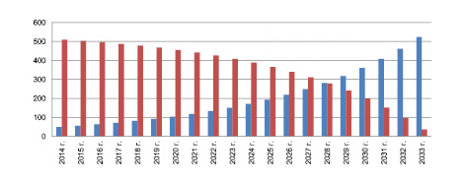S – loan sum

Figure 4.2 Annuity monthly payments. Source: www.banki.ru

$K= \frac{i*{(1+i)}^{n}}{{(1+i)}^{n}-1}$ (4.2.2)

Differentiated monthly payments evaluate every month. Interest here is paid for remaining loan. The monthly payment sum decreases over time, while principal redemption component remains the same and interest redemption component decreases (Figure 4.3, formula 4.2.3, formula 4.2.4, formula 4.2.5, formula 4.2.6).

$D=b+i$, (4.2.3)

D – differentiated monthly payment,

b – principal redemption component (monthly),

i – interest redemption component (monthly)

$b= \frac{S}{N}$, (4.2.4)

b – principal redemption component,

S – loan sum

N – number of payment periods

$i=Sn*I/12$, (4.2.5)

Sn – remaining loan sum,

I – annual interest rate

$$Sn=S-\left(b*n\right) (4.2.6)$$

S – loan sum,

n – number of already paid periods

b – principal redemption component

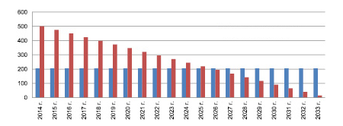

Figure 4.3 Differentiated monthly payments. Source: www.banki.ru

Thus, some advantages of annuity redemption type could be concluded:

1. Common usual and equal payments, that ensures stability for borrower and allows to plan expenditures.
2. At the beginning the annuity payment sum is significantly lower than in differentiated payment case.
3. Bank requirements for borrower who chooses annuity redemption are significantly lower.

Main disadvantages of annuity redemption type are:

1. At the end of loan period monthly payment sum is significantly higher than in differentiated redemption type.
2. The overpaid amount is significantly higher than in differentiated redemption type.

**National Currency Mortgage vs. Foreign Currency Mortgage**

The majority of mortgages are taken in rubbles, however some bank also offer it in foreign currency (USD, EUR in the majority). Financial crisis and the dramatic national currency devaluation significantly undermined currency mortgage: their share in total mortgage lending volume from 5% to less than 1%, moreover the amount of past-due mortgages has increased from 2010 year (Figure 4.4, figure 4.5).

Figure 4.4 Share of foreign currency mortgage in total volume of mortgage lending in Russia 2010-2016. Source: www. ahml.ru

Figure 4.5 Volume of past-due mortgage debt in foreign currency mortgage in Russia 2010-2016. Source: www. ahml.ru

However, foreign currency mortgages have essential benefits with national currency mortgages. Firstly interest rates for currency mortgages are significantly lower than for national currency mortgages. Secondly, this allows to borrower take a higher loan sum, as it is calculated based on percent of loan payment to borrower income. Thirdly, the overpaid amount is also significantly lower than that one in national currency mortgages. The main drawback for such mortgages is that it highly depends on market situation.

**Lump Sum Payment/ Interest Rate Option**

This option could nor referred to previously discussed classififcations. This option has been recently introduced by Russian banks in practice. Some banks offers the possibility to borrower to reduce his initial interest rate in return for lump sum payment that is equal defined percent of some. For instance, Deltacredit bank proposes a program “Make your own rate”. This program provides 3 options: “Optima”, “Media”, “Ultra”. The first one offers borrower to reduce the basic rate by 0,5 points and pay for it 1% of the loan. Program “Media” allows borrower to reduce Basic interest rate by 1% in return for 2,5% of the loan. Last option provide interest rate reduction by 1,5% for 4%.

The table below (Table 4.1, table 4.2) demonstrates the amount of money that borrower could save in annuity monthly payments in comparison with the initial fixed interest rate. (in case with annuity redemption type) The breakeven point comes over 3 years in average and than borrower could earn money. However this option isn’t too popular in Russia and is provided just by several banks. Borrower profit could vary in dependence on interest rate type and redemption type.

Table 4.1 Monthly savings due to lump sum payment/ interest rate option.

Table 4.1 Monthly savings due to lump sum payment/ interest rate option.

|  |  |  |  |  |  |  |
| --- | --- | --- | --- | --- | --- | --- |
| Basic Rate (%) | Reduced Rate (%) | Basic monthly payment (RUB) | | Reduced Monthly payment (RUB) | | Savings in monthly payments (RUB) |
| Down Payment – 15%-30% | | | | | | |
| 15,00 | 14,5 | 41 700 | 40 688 | | 1 012 | |
| 14,75 | 14,25 | 41,193 | 40,185 | | 1 008 | |



|  |  |  |  |  |
| --- | --- | --- | --- | --- |
| Basic Rate (%) | Reduced Rate (%) | Prepayment after 5 years (RUB) | Prepayment after 10 years (RUB) | Prepayment after 15 years (RUB) |
| Down Payment – 15%-30% | | | | |
| 15,00 | 14,5 | 25720 | 86440 | 147160 |
| 14,75 | 14,25 | 25480 | 85960 | 146440 |

Table 4.2 Monthly savings due to lump sum payment/ interest rate option over loan period.



To overview previously discussed mortgage products 13 mortgage leaders banks were chosen (www.rusipoteka.ru). The majority of banks proposed fixed-rate mortgages in national currency with annuity type of redemption. Only two of investigated banks offer adjusted-rate or hybrid-rate mortgages. 4 banks proposed differentiated monthly payments. Only one bank have a mortgage offer in foreign currency. 5 banks offer lump sum payment/interest rate option (Table 4.3). Down payments do not vary among banks significantly. Average mortgage interest rate ranges from 11to 17%.

Table 4.3 Mortgage products offered by Russian mortgage leaders banks (2016)

|  |  |  |  |  |  |  |  |  |
| --- | --- | --- | --- | --- | --- | --- | --- | --- |
|  | Bank | Mortgage volume lending in 2015 (mln.rub) | Interest rate | The minimum down Payment | Number of Mortgage programs | Lump sum payment/interest option | Monthly Payment  method | Currency |
| 1 | Sberbank | 661 800 | 12- 14, 75 | 15-25% | 12 | No | Annuity | RUB |
| 2 | VTB 24 | 198 368 | 12-16% (FRM, ARM and Hybrid) | 20, 40% | 8 | No | Annuity | RUB |
| 3 | Rosselkhozbank | 37 748 | 11,9 – 16% | 15,20% | 5 | No | Annuity and differentiated | RUB |
| 4 | Deltacredit | 29 819 | 13,75-17,5% (FRM, ARM and hybrid) | 10- 30% | 11 | Yes | Annuity | RUB |
| 5 | Bank of Moscow | 28 274 | 11,75-14% | 20% | 6 | Yes | Annuity, Diff | RUB |
| 6 | Gazprombank | 26 839 | 11-17 | 15, 20% | 10 |  | Annuity, differentiated | RUB |
| 7 | Absolut Bank | 14 973 | 11,95 - 19,95 | 20, 40% | 9 | No | Annuity | RUB |
| 8 | St. Petersburg | 13 189 | 12-18% | 20-35% | 24 | No | Annuity | USD RUB EUR |
| 9 | Vozrojdenje | 11 189 | 8,75-16% | 10-30% | 15 | No | Annuity | RUB |
| 10 | Sviaz-Bank | 10 566 | 11,25-21,5% | 20% | 7 | No | Annuity | RUB |
| 11 | Transcapital Bank | 9 544 | 11,9 – 22% | 20, 25% | 8 | Yes | Annuity, Differentiated | RUB |
| 12 | Otkrytye | 8 580 | 11,4 – 17,75% | 10-30% | 15 | Yes | Annuity, differentiated | RUB |
| 13 | Bank Zhilfinans | 8 034 | 14,89 – 15,99% | 20% | 2 | Yes | Annuity | RUB |

# 

# 4.2.2. Suggested mortgage products for consumer profiles

On the basis of investigated literature and received consumer profiles it could be identified now target audience of one or another mortgage product.

Pessimists demonstrate low trust neither the future neither the mortgage. They believe that their future income will reduce over time, therefore the most appropriate for such type of borrower will be such products that will ensure them stability. In addition these borrowers have low level of education and, therefore, have low financial literacy, thus too complicated mortgage product could evoke frustration and may increase mistrust to mortgage. Therefore the best possible options for them are the following:

1. Fixed-rate mortgage, as the interest rate remains the same over loan period.
2. Annuity type of monthly payment, as it allows to plan mortgage expenditures and budget. Moreover, this product is intuitively more understandable and commonly used. In addition, low income pessimists would be appropriate for differentiated redemption type as it provide stronger requirements for income.
3. National currency mortgage. Under current crisis foreign currency, namely for such type of borrower, is senseless (Figure 4.6).

We suggest to avoid proposition for pessimists lump sum payment/ interest rate option as it could be difficult to understand and require initial lump sum payment, that is impossible with low level borrowers.

Pessimists are expected to demonstrate high involvement in decision-making process, as mortgage is a long-term, high risky and costly purchase for them. Therefore, they would tend to extensive problem solving, spend a lot of time for information searching and put a lot of efforts to evaluate alternatives. Therefore, banks need to provide deep, transparent and detailed information not only through personal contact, but through Internet too.

Future skeptics are highly educated young people in the majority. They, however, don’t have good expectations about future and believe that their income wouldn’t increase in the nearest future. For such borrowers, lump sum payment/interest rate option could be excellent option, as it could bring them benefits in the future and significantly reduce their monthly payments. Moreover, for future skeptics, of course if they satisfy banking requirements, variant could be differentiated monthly payment, as they reduce over time and total overpaid sum is significantly lower than with annuity payment. In addition, considering the fact that future skeptics are highly educated, these products would be understandable for them. Foreign currency and adjusted-rate mortgages are not appropriate in this case, as they do not ensure certainty, confidence and stability. Future skeptics expected to demonstrate medium involvement and limited problem solving, as they are more aware of what they want and what the mortgage is, therefore they will spend less time for information searching and personal contact with banking staff are more important for them (Figure 4.6).

Mortgage skeptics do not trust mortgage, but have good expectations about future. Like pessimists mortgage skeptics have a low level of education, but have medium or in some cases high income. Best mortgage choice for them could be the following:

1. Annuity monthly payment or differentiated monthly payment. It is difficult to make exact suggestion which redemption type would be the most appropriate for mortgage skeptics. On the one side, annuity type is more explicable and understandable, but on the other side, differentiated redemption could be convenient as such borrowers have enough income to pay for monthly payments at the beginning. So, banking staff needs to pay attention to such a borrower and try to understand his psychology through personal contact.
2. Adjusted-rate mortgage could be good option for them, as they are confident about their future, and moreover, it could brings benefits for them. However, detailed and transparent explanations of all procedures are required.
3. National currency is the best choice under current crisis. However, some borrowers from this cluster could have earnings in foreign currency or be opened to take mortgage in currency even under such conditions; therefore, foreign currency mortgage could be also an option to propose (Figure 4.6).

Mortgage skeptics are expected to demonstrate both high and medium involvement in decision-making process. From the one point of view, for them mortgage is less costly and risky than for pessimists, from the other point of view, they are not financially educated and, therefore, would spend a lot of time for information searching. Extensive problem solving is more probable for them, so this profile require transparent and detailed information from different sources.

Optimists with high income, high financial literacy may be seek mortgage options that will bring them benefits. They have already a mortgage and do not have high necessity for housing conditions improving. Therefore, following mortgage products could be recommended for them:

1. Differentiated type monthly payments as they have enough money to pay higher sum at the beginning and furthermore, this could bring some saving for them in the future.
2. Adjusted-rate mortgage as pessimists are confident of their future and this mortgage is less costly than fixed-rate mortgage, that could attract profit-seeking borrowers.
3. Foreign currency mortgage could also be appropriate for them as some borrowers for this profile could have earnings in foreign currency (Figure 4.6).

Optimists are expected to demonstrate limited problem solving and may be sometimes routine response behavior, as this purchase for them is less costly and risky. They would spend a little amount of time for information searching and would expect to receive detailed information about which mortgage product is the best option for them.

# Summary of chapter 4

To sum up research results we now could build new stimuli-response model (Figure 4.6). This model moves from borrowers black boxes toward suggested products in dependence of borrower profile particularities. This in its turn influences borrower memory and learning ensuring positive experience. Positive experience lead to increasing borrower loyalty, positive “world-of-mouth” that in long term would lead to transforming potential borrowers, who now do not plan to take mortgage, in real borrowers. In long-term perspective, applying received results in practice, would lead to reducing in past-due debts, increasing banks profitability, as mortgage borrower could become client of other banking services and increasing in mortgage lending volumes.

Understanding consumer behavior and effective applying this knowledge in real banking practice will lead to changes in borrower perceptions, increase trust to financial institutes and financial literacy. Therefore, stimuli-response model would change along with consumer black box would be discovered more and more (Figure 4.6).

**Product**: FRM, annuity monthly payment, national currency

**Place**: easy to access to site, very detailed information through personal contact

**Pessimist DM**

**Pessimist Psychology:**

*Motivation*– high need for housing conditions improvement

*Perception*: low trust to mortgage and to future

*Learning*: didn’t have a mortgage

**Pessimist characteristics:**

Low income;

low education;

a lot of family members

- High involvement in DM

- Extensive problem solving

- Extensive information search

**Borrower response**

Right choice of product

Right choice of bank

Borrower satisfaction and loyalty

Positive learning and memory

Positive “world-of-mouth

Trust to banks

Trust to mortgage

Reducing of past-due mortgages

Increasing of mortgage volume

lending

**Product Mix**

**Future Skeptic Black Box**

**Product**: FRM, differentiated/annuity monthly payment, LSP/IR

**Place**: well established personal contact, explaining all benefits of suggested option

**F. Skeptic DM**

**F. Skeptic Psychology:**

*Motivation*– need for housing conditions improvement

*Perception*: low trust to future, high trust to mortgage

*Learning*: didn’t have a mortgage

**F. skeptic characteristics:**

Normal income;

Higher education

Age – 22-30

- Medium involvement in DM

- Limited problem solving

- Focus on option that will fulfill his needs

**Product Mix**

**Mortgage Skeptic Black Box**

**Product**: ARM, differentiated/annuity monthly payment, foreign currency

**Place**: easy to access to site, very detailed well established through personal contact

**M. Skeptic DM**

**M. Skeptic Psychology:**

*Motivation*– low need for housing conditions improvement

*Perception*: low trust to mortgage, high trust to future

*Learning*: didn’t have mortgage

**M. Skeptic characteristics:**

Normal or high income;

Low education

- High /medium i.

- Extensive /limited p.s

- Extensive information search/focus on option that will fulfill his needs

**Product Mix**

**Optimist Black Box**

**Product**: ARM, differentiated/annuity monthly payment, foreign currency, LSP/IR

**Place**: easy to access to site, very detailed well established through personal contact

**Optimist DM**

**M. Skeptic Psychology:**

*Motivation*– no need for housing conditions improvement

*Perception*: low trust to mortgage, high trust to future

*Learning*: have a mortgage

**M. Skeptic characteristics:**

High income;

Age - > 30 years

- Low involvement in DM

- Limited/ routine p.s.

- Spend little time on information search

# 5. DISCUSSION AND CONCLUSIONS

Figure 4.6 Reverse stimuli-response model. Source: by author

Firstly, this chapter discusses in which degree received findings correspond to previously analyzed literature related to consumer behavior under crisis. Theoretical and practical contributions of this investigation will be provided. Finally limitations of the study and directions for further research will be discussed.

# 5.1. Discussion of empirical findings in context of consumer behavior studies

The research goal of this study was to link mortgage products available on Russian market with potential borrowers segments in dependence on their behavioral "black boxes". To reach the goal two research questions were stated. The first research question is:

1. What are profiles of potential borrower in Russia?

To answer this research question potential borrowers were divided into 4 groups in dependence of their perceptions of mortgage and future (Figure 4.1). Some previous studies was also conducted segmentation of customers (Aymaletdinov, 2013; Pandelica, 2008 ). This study aligns with Pandelica (2008) framework that identified consumer profiles in dependence on risk attitude and risk perception. However this master thesis narrows these dimensions to mistrust to future and mistrust to mortgage and moreover ensures investigation on particular market. Identified profiles in some ways correspond to that of Pandelica (2008): cautious consumers as mortgage skeptics have good expectations about future income; panicked consumers with high both risk perception and risk attitude have low income as pessimist identified in this study (Table 3.7)

Aymaletdinov (2013) analyzed potential borrower pre-purchasing behavior in dependence of decision-process time through segmentation of potential borrowers in 4 factors. Pragmatic borrowers in his study as mortgage skeptics and pessimists need lot of time to make a decision and require providing of detailing information (Figure 4.6).

Research findings align with traditional potential borrower estimation and also involves such variables as age and income (Skiba, Loyko , 2012). However this study investigates potential borrower psychology and decision-making process bringing high academic value.

The second research question is:

2. What are products that correspond to potential borrower profiles?

To answer this research question, firstly, Russian mortgage market overview was conducted (Table 4.3). Then, basing on particularities of one or another potential borrower profile, logic and previously discussed literature about decision-making process mortgage products were suggested to identify profiles (Figure 4.6). It is assumed that different profile potential borrower will demonstrate different type if involvement in decision-making process and their problem solving will also vary. However, in the literature it is stated that on high risky mortgage market only high involvement and extensive problem-solving could be possible. The assumption was made as different profiles have different intensity of perceived risk and different income. In comparison with pessimists optimists are expected to demonstrate low involvement in decision-making process and more limited problem solving.

Considering existing USA literature dedicated to borrower mortgage product choice analysis insignificant similarities could be detected as previously only buying behavior on mortgage market was investigated (Statman, 1982; Alm and Follain,1984; Stanton and Wallace, 1999; Campbell and Cocco, 2003; Paiella, M., Pozzolo A.F., 2007; Koijen et al.,2009). Therefore this study cover significant gap in consumer behavior theory.

It was discussed above under crisis people tend to postpone their major purchases and tend to save money. (Pikturnien, 2009; Robles et al., 2002; Zurawicki and Braidon, 2005; Leller and Schewe, 1974; Engel, Kollat and Blackwell, 1993). This investigation, however, demonstrates that this rule doesn’t work on Russian mortgage market. Despite the fact, that the majority of respondents do not believe that current market, generally, is favorable for big deals, the amount of people who plan to take mortgage in the nearest future is almost the same among clusters. Only, optimists start to save money last years. Such result could be explained by the fact that the majority of such respondents have a high need for housing improvement.

This research shows the importance of financial literacy in mortgage market that corresponds to previous findings (Kivetz, 2000; Meidan, 1996). People with low level of education and those, who have not ever have a mortgage previously, demonstrate level trust to mortgage. It also proves that age is that personal factor, which has significant influence on the consumer behavior on mortgage market: age varies between some clusters.

Necessity for housing conditions improvement, as it was stated in the literature, is the most significant factor that makes people to take a mortgage loan even if they have mistrust both to future and to mortgage (Aymaletdinov, 2013).

Research findings go along with the consumer behavior under crisis theoretical framework, which claims that under crisis risk perception and risk attitude provoke mistrust in companies and future, which in their turn define patterns of consumer behavior. (Pandelica, A., 2008) This proves that cultural level of consumer, economic crisis in our context, affect psychological consumer layer that support main assumption of consumer behavior theories.

However, it contradicts to the empirical Russian investigation, where findings suggest that population have good expectation about future (Aymaletdinov, 2013). The majority of respondents believe that in the nearest future positive tendencies in Russian economy and on labor market are not expected.

# 5.2. Theoretical contribution to consumer behavior theory

This master thesis provides an investigation of consumer behavior in mortgage market in Russia under crisis conditions. It has strong theoretical contribution to existing consumer behavior theories.

Firstly, it covers the first gap, stated in the introduction: lack of empirical studied that explain consumer behavior (Pham, 2013). The majority of currently existing studies consider the buying behavior, focusing on the acquisition stage of consumer behavior. However, for business more important is to understand consumer behavior. This research is focused on analysis of potential borrower profiles. It takes into consideration also people who do not plan take a mortgage in the nearest future. It is assumed that these people could become borrowers or they have necessity to take a mortgage, but do not have good beliefs about mortgage lending in Russia.

Secondly, previously studies related to consumer behavior on mortgage market, which, in generally, are limited by following patterns of buying behavior: choice between banking products or choice between different banks investigated (Statman, 1982; Alm and Follain,1984; Stanton and Wallace, 1999; Campbell and Cocco, 2003; Paiella, M., Pozzolo A.F., 2007; Koijen et al.,2009). This master thesis aimed to analyze potential borrower profiles and then provide recommendations which products for which profile could be suggested.

Thirdly, this investigation covers the lack of empirical studies conducted on macro level (Pham, 2013). Previously examined literature is dedicated mostly to understanding consumer behavior in dependence on his beliefs, motivation, perceptions about product or service, personal factors. In this framework crisis, in other words final cultural layer was taking into account.

Moreover, it provides investigation conducted on Russian market, overcoming lack of cross-cultural studies and studies in emerging market. Every market has its own particularities, however, consumer behavior researchers tend too overgeneralize received finding for every market, that is impossible (Pham, 2013)..

In addition, this thesis investigates consumer behavior in mortgage market in specified and narrow dimensions: trust to future and trust to banks, there are no previously literature on this very topic.

# 5.3. Managerial implications of potential borrower profiles for Russian banks

In accordance with previous analysis of mortgage market in Russia some banks provide only fixed-rate mortgages, but offer a possibility to choose between annuity and differentiated monthly payments (Table 4.3). Potential borrowers of such banks could be future skeptics. Therefore for these banks it is crucial to provide well-established personal contact to provide benefits of suggested mortgage products (Figure 4.6).

Those banks which offer different types of mortgages in dependence of interest rate, but have only annuity mortgage programs (Table 4.3) need to focus also on well-established personal contact and also provide clear, transparent and easy to access information through other channels.

Those banks which offer lump sum payment/interest rate option expect to attract future skeptics and optimists (Table 4.3, figure 3.7). Both types of potential borrower profiles need for detailing and good explanation why this very product will fulfill their needs.

Potential clients of the only bank with foreign currency mortgage could be mortgage skeptics and optimists (Table 4.3, figure 4.6). These borrowers could demonstrate the same behavior and involvement in decision-making process as well as mortgage skeptics may demonstrate high involvement and extensive problem solving. Therefore, such banks need to pay attention to different channels.

Banks that provide only classical mortgage products as fixed-rate and annuity mortgages could be the choice of pessimists who require very detailing information about all products and nuances (Table 4.3, figure 4.6).

To sum up some general recommendations could be provided expand and modify the process of borrower profile consideration: pay attention to education, motivation, financial literacy not only to calculate the loan sum. Learn banking staff to do this: trainings, deeper surveys. Ensure the information transparency through different channels: internet, personal contact.

Therefore, taking into consideration borrower characteristics to understand potential behavioral patterns is crucial for banks not only to stay competitive on highly competitive mortgage market but also to ensure increase volumes of mortgage lending in Russia in long-term perspective. To achieve it some recommendations could be developed, except those provided in previous chapters:

1. To learn banking staffs how to deal with particular borrower profile. Some special trainings could be provided. In addition, bank could conduct its own more deeper survey among clients or employees to narrow results achieved in this research.
2. To provide transparent information. It touches not only contracts or detailed information given through personal contact but also require easy to access and transparent information presented on the banking site or by telephone consultation.
3. To expand borrower consideration taking into account subjective assessment of income, number of family members living together, level of education and so on.

# 5.4. Limitations and further researches

There several limitations those create possibilities for further researches. Most of them are related to the exploratory research design. The first one is related to sampling method, as non-probability sampling method significantly undermines the validity and reliability of research. Therefore, it is necessary to conduct more deep and structured survey in further researches with bigger number of respondents.

Moreover, it is necessary to understand how consumer will behave under normal conditions as it was proved that crisis significantly affect consumer behavior in mortgage market. Furthermore, it will be interesting to build a regression model and determine what factors determine the consumer decision to take a mortgage beyond the obvious ones as need to housing improving. We made our research considering factors as given from previously discussed literature, however, taking into account Russian mortgage market particularities, made assumptions could be stated in the wrong way.

This study mostly was focused on psychology component in potential borrower “black-box” making conclusions of decision-making characteristics as subjective assumptions. So, another direction for further research could be advanced investigation of potential borrower decision-making process.

To expand practical implication potential borrower profiles could be build on greater amount of variables. Financial literacy here consists only of 2 component to get more reliable result more variables could be included to detect financial literacy factor.

Another limitation of received findings is that they could become out-of-date in short-term perspective as consumer behavior tends to change over time. Moreover, every crisis has its own particularities and could have different influence on behavioral patterns. Therefore, similar survey needs to be conducted again from time to time.

# REFERENCES:

Alikperova, N.V., and Yarasheva, A.V. 2015. The public trust – the Foundation of stability of functioning of financial institutions. *Finance and credit* 8 (80): 1-10.

Andeason, A.R. 1965. Attitudes and Consumer Behavior: A Decision Model in New Research in Marketing. *Journal of Real Estate Finance and Economics* 20(3): 323-341.

Ayamaletdinov, T.A. 2013. Views of Russians on Mortgage as a way to improve living conditions. *Monitoring of social opinion: economic and social changes* 3 (115): 116-128.

Belch, G. E. 1978. Belief Systems and the Differential Role of the Self-Concept. *Association for Consumer Research* 5: 320-325.

Bostic, W. R., and Surette, J.B. 2001. Have doors opened wider? Trends in homeownership rates by race and income*. Journal of Real Estate Finance and Economics* 23(3): 411-434.

Brueckner, J. K. 1986. The Pricing of Interest Rate Caps and Consumer Choice in the Market for Adjustable Rate Mortgages. *Housing Finance Review* 16: 119-136.

Brueckner, J. K., and Follain, J. R. 1988. The Rise and Fall of the ARM: An Econometric Analysis of Mortgage Choice. *The Review of Economics and Statistics* 70: 93-102.

Campbell, J., and Cocco J. 2003. Household Risk Management and Optimal Mortgage Choice. *Quarterly Journal of Economics* 118: 1449-1494.

Carrigan, M., and Attalla A. 2001. The myth of the ethical consumer - do ethics matter in purchase behaviour? *Journal of Consumer Marketing*, 18(7): 560-577.

Collis, J., and Hussey, R. 2003. B*usiness Research: A Practical Guide for Undergraduate and Postgraduate Students*. 2nd ed. Basingstoke: Palgrave Macmillan

Costello, A.B., and Osborne, J.W. 2005. Best practices in exploratory factor analysis: four recommendations for getting the most from your analysis. *Practical Assessment Research and Evaluation*, 10(7): 1-9.

Deighton, J., MacInnis, D., McGill, A., and Shiv, B. 2010. Editorial: Broadening the scope of consumer research. *Journal of Consumer Research* 36(6): 5-7.

Feldt, L. S. 1965. The approximate sampling distribution of Kuder-Richardson reliability coefficient twenty. *Psychometrika*, 30: 357-371.

Foret, M., Prochazka, N. (2007). Buying behavior of households in the Czech Republic. *Agricultural Economics*, 53(7): 318–324.

Frösén J., Tikkanen H., Jaakkola M., and Vassinen A. 2013. Marketing performance assessment systems and the business context. *European Journal of Marketing* 5(6): 715-737.

Furaiji, F. 2012. An Empirical Study of the Factors influencing Consumer Behaviour in the Electric Appliances Market. *Contemporary Economics* 6(3): 76-86.

Gilaninia S., and Taleghani M., Aziz N. 2013, Marketing Mix and Consumer. Journal of Business and Management Review, 2(12): 53-58.

Griskevicius, V., and Kenrick, D. T. 2013. Fundamental motives: How evolutionary needs influence consumer behavior. *Journal of Consumer Psychology*, 23(3): 372–386.

Gyulavári, T., and Kolos, K. 2015. The Impact of Proactive Strategies on Market Performance in Economic Downturn: the Case of Hungary. Convergence and Divergence in the New Europe: Marketing Challenges and Issues, September 16-18 2015, Vienna, Austria.

Haig, B.D. 2005. An abductive theory of scientific method. *Psychological Methods* 10(4): 371–388.

Hann, J. G. 1980. A Typology of Consumer Needs. *Research in Marketing* 3: 83-104.

Howard, J. A, and Sheth, J. N. 1969. The Theory of Buyer Behavior, New York: John Wiley and Sons. pp. 9-28.

Ibragimova D. H. 2012. O doverii naseleniya finansovyim institutam*. Dengi i kredit*, 4: 65–71.

Ivanova, D.G. 2010. Problems and Contradictions on The Way of Mortgages Development. *Economic Science*, 2(63): pp. 85-87.

Ivasenko, A. G., and Bondarenko V. V. 2006. Stimulating consumer demand in the field of mortgage lending. *Interexpo Geo –Siberia* 6: 67-78.

Jisana, T.K. 2014. Consumer behaviour models: an overview. *Sai Om Journal of Commerce & Management: A Peer Reviewed National Journal* 1(5): 34-43.

Hair, J. F., Black, W. C., Babin, B. J., Anderson, R.E., and Tatham, R.L. 2006. *Multivariate Data Analysis*, 6th ed., London: Prentice Hall.

Hansen, T. 2005. Perspectives on Consumer Decision Making: an Integrated Approach. Journal of Consumer Behavior, 4(6), pp. 420–437.

Hassan, S.A. 1995. Marketing Principles and Strategies. *Riyadh King Saud. University* 59-61

Jobber, D., and Fahy, J. 2006. Foundations of Marketing. New York: McGraw-Hill Education.

Katona, G. 1974.Psychology and Consumer Economics. Journal of Consumer Research1(1): 1-9.

Kivetz, R. 2000. The effects of incomplete information on consumer choice. Journal of Marketing research, 37(4): 27 – 448.

Knyazeva. O. V. 2011. Segmentation of the Russian market ob bankcreditd in sphere of lending of physical persons. Audit and financial analysis 6: 371-375.

Kondrashov, V.A. 2012. Reasons constraining development of banking innovation in modern Russia Vector Nauka TSU. 3: 170-173.

Kotler, P., Armstrong, G., Wong, W., and & Saunders, J. 2008. Principles of Marketing. London: Prentice Hall

Kotler, P., and Caslione, J. 2009. How Marketers Can Respond to Recession and Turbulence. Journal of Consumer Behavior. 8(2): 187-191.

Kristoff, W., 1963. The statistical theory of stepped-up reliability coefficients when a test has been divided into several equal parts. Psychometrika, 282: 21-238.

Lipowski, M. (2003). Marketing bankowy. Lublin: Wydawnictwo Uniwersytetu Marii-Curie Skłodowskiej.

Lunn, J.A . 1974. Consumer Decision Process Models in Models of Buyer Behaviour (ed N. Sheth Jagdish). Harper and Row , New York, 34-69

Malhotra, N.K., Birks, D.F., and Wills, P.A. 2012. Marketing Research: An Applied Approach. 4th edition, Prentice Hall.

Muathe, M., 2014. Effects of Perceived Attributes, Perceived Risk and Perceived Value on Usage of Online Retailing Services. Journal of Management Research 6 (2): 140-161

Meidan, A. 1996, Marketing Financial Services, Macmillan Press Ltd, London.

Mylonakis, J. 2007. A bank customer analysis and mortgage services evaluation: Implications of market segmentation policies. Banks and Bank Systems 2: 157–157.

Nicosia, F.M., and Robert, W. 1976. Consumer Behavior Toward Sociology Of Consumption. Journal of Consumer Research. 3(2): 65-75.

Oliver, R.L. 1980. A Cognitive Model of the Antecedents and Consequences of Satisfaction Decisions. Journal of Marketing Research 17(4): 460-469.

Paiella, M., and Pozzolo A.F., 2007. Choosing Between Fixed and Adjustable Rate University of Molise, Dept. SEGeS, Economics and Statistics Discussion Papers.

Pandelica, A. 2008. The psychology behind the economic crisis. Economic Sciences 9 (15): 131-138.

Petrova, T.V., and Arkhipova, E.M. 2014 Faktory determining choice ipotech - ing programmy Fundamentalnye issledovania. 5(3): 555-559

Prosvirin, A.V.,2008 Mortgage lending toolkit. Vestnik TSU 6: 164-168.

Pham, M.T. 2013. The seven sins of consumer psychology, Journal of Consumer Psychology. 23 (4): 411-423.

Tsiotsuo, R. 2008. An integrated taxonomy of consumers of financial services: the role of perceived risk, effort and involvement. Risk Assessment and Management 9(1): 135-147

Rook, W.D., 1987. The buying impulse. Journal of Consumer Research, 14 (2): 189-199

Saunders, M., Lewis, P., and Thornhill, A., 2016. Research Methods for Business Students. 7th ed. Pearson Education Limited.

Skiba, S.A., Loyko, V.I. 2012, Sovremennyiy podhod k otsenke platezhesposobnosti klienta pri kreditovanii. Nauchnyiy zhurnal KubGAU 81(7): 1-11

Stávková, J., Stejskal, L., and Toufarová, Z. 2008. Factors Influencing Consumer Behavior. Agricultural Economics – Czech, 54(6): 276-284.

Statman, M., 1982. Fixed rate or Index-linked Mortgages from the Borrower's point of view: A Note. Journal of Financial and Quantitative Analysis 17: 451-457.

Taylor, J.W. 1974. The role of risk in consumer behavior. Journal of Marketing 38(2): 54–60.

Tabachnick, B.G., and Fidell, L.S. 2007. Using Multivariate Statistics. Boston: Pearson Education.

Zaborovskaya, A.E., Tendencies of development of mortgage lending in Russia. Journal Financial analytics: problems and solutions 19 (205): 44-60.

Zhang, L., Tan, W., Xu, Y., and Tan, G. 2012. Dimensions of consumers’ perceived risk and their influences on online consumers’ purchasing behavior. Communications in Information Science and Management Engineering 2(7): 8-14.

Williams, B., Brown, T., and Onsman, A. 2010. Exploratory factor analysis: A five-step guide for novices Journal of Emergency Primary Health Care (JEPHC), 8 (3), 1-12

Wood, M. 2005. Discretionary Unplanned Buying in Consumer Society. Journal of Consumer Behaviour, 4 (4): 268–281.

Agency of housing mortgage lending (2016). Statistics. Retrieved from: http://www.ahml.ru

Banki.ru (2016). Mortgage products. Retrieved from: http://www.banki.ru

Deltacredit. Mortgage Bank (2016). Mortgage calculator Retrieved from: https://www.deltacredit.ru

National Agency of Financial Investigations (2016). Retrieved from: http://nacfin.ru/

Russian Statistics Committee (2016). Retrieved from: http://www.gks.ru/

# APPENDIX 1. Questionnaire on consumer behavior in mortgage market

1. Do you consider the conditions of the Russian market today are suitable for major purchases and transactions?

|  |  |  |  |  |
| --- | --- | --- | --- | --- |
| Absolutely Disagree | Partly Disagree | Can not say | Patrly Agree | Absolutely Agree |

1. Please indicate whether you agree or disagree with the following statements (1- Absolutely , 2 - Partly Disagree, 3 – Can not say, 4- Partly Agree, 5 - Absolutely Agree)

|  |  |  |  |  |  |
| --- | --- | --- | --- | --- | --- |
|  | 1 | 2 | 3 | 4 | 5 |
| The last few years you try to lay by for a rainy day the part of your personal income. |  |  |  |  |  |
| You expect the increase of Your personal income in the next 5 years |  |  |  |  |  |
| You trust Russian banks |  |  |  |  |  |
| Mortgage is an affordable way of buying housing in Russia |  |  |  |  |  |
| Russian banks on the mortgage market are characterized by transparency, completeness and easy accessibility of the information about the products and services they offer |  |  |  |  |  |
| In the nearest future it is reasonable to expect the positive trends on the labor market |  |  |  |  |  |
| In the nearest future it is reasonable to expect the positive trends on the Russian economy. |  |  |  |  |  |
| From the legal point of view the borrower on the mortgage market in Russia is completely protected. |  |  |  |  |  |

1. Select your gender:

* F
* M

Select your age:

1. Please select your age

* 18-21
* 22-30
* 31-45
* Over 45

1. How do you define the total income of your family? (1 – insufficient, 5- more than enough)

|  |  |  |  |  |
| --- | --- | --- | --- | --- |
| 1 | 2 | 3 | 4 | 5 |

1. Select your education level:

* School
* secondary education
* Higher education

1. Select your place of residence

* own living space (apartment, room, so on
* rental accommodation
* Other

1. Indicate the number of family members residing with You on the same living area (if You live alone select 0)

* 0
* 1
* 2
* 3
* 4
* Over 4

1. Rate the need to improve housing conditions in the nearest future?

|  |  |  |  |  |
| --- | --- | --- | --- | --- |
| Strong need | As soon as possible | Can not say | Not high need | Absolutely no need |

1. Do you take out (took out in the past) the mortgage?

* Yes
* No

1. Do you plan to get the mortgage in the next 5 years?

|  |  |  |  |  |
| --- | --- | --- | --- | --- |
| Definitely Not | Probably Not | Undecided | Very Probably | Definitely |