St. Petersburg University
Graduate School of Management

Master in International Business Program

Determination of strategic role of investments into timber-transporting infrastructure for development of wood industry companies

Master’s Thesis by the 2nd year student
Concentration — Management
Sergei Galustov

Research advisor:
Associate professor, K.V.Krotov

St. Petersburg
2016

АННОТАЦИЯ

Автор | Галустов Сергей Арнольдович
Название магистерской диссертации | Определение стратегической роли инвестиций в лесторанспортную инфраструктуру для развития компаний лесопромышленного сектора
Факультет | Высшая Школа Менеджмента
Направление подготовки | Менеджмент
Год | 2016
Научный руководитель | Константин Викторович Кротов
Описание цели, задач и основных результатов | В условиях усиливающейся международной конкуренции на рынке продуктов лесной промышленности и роста интереса к развитию отечественной лесной промышленности необходимо определить ключевые конкурентные преимущества. Одним из ключевых факторов конкурентоспособности является обеспечение низких издержек на производство. В российских условиях одним из наиболее недооцененных путей повышения эффективности является инвестирование в транспортную инфраструктуру. Целью данного исследования является определение роли инвестиций в лесотранспортную инфраструктуру. В рамках данного исследования была предложена модель оценки инвестиций для создания конкурентного преимущества. На основе двух кейсов были выявлено влияние строительства лесных дорог на достижение стратегических целей компании.
Ключевые слова | Управление цепями поставок, транспортная инфраструктура, лесная промышленность
ABSTRACT

Master Student's Name | Sergei Galustov
Master Thesis Title | Determination of strategic role of investments into timber-transporting infrastructure for development of wood industry companies
Faculty | Graduate School of Management
Main field of study | Management
Year | 2016
Academic Advisor’s Name | Konstantin V. Krotov
Description of the goal, tasks and main results | In increasing competition level in forest industry and increased attention to development of this industry in Russia it is important to understand key competitive advantages in this market. One of the key factor to provide competitive is to maintain low production costs. In Russia one of the most underestimated source of performance enhancement are private investments into transportation infrastructure. The goal of current research is to define role of investments into timber transport infrastructure In the framework of current research a model to assess competitive advantages created by investments were developed. On the basis of two cases the impact of forest road construction on achievement of corporates’ goals were identified.
Keywords | Supply chain management, transport infrastructure, forest industry

Table of content
Introduction 7
Chapter I. Literature review 10
Supply chain management and its interrelation with corporate strategy 10
Commodities and their supply chains. Lean approach 15
Role of transportation in supply chain 17
Approach to investment analysis. 19
Chapter II. Research methodology 22
Research method 22
Research Sample 22
Data collection 24
Chapter III. Case study. 25
Supply chain processes in wood industry 25
Problem definition 26
Waste identification 28
Impact of transportation infrastructure on companies’ competitiveness 32
Result discussion and limitations 38
Conclusion 40
References 42
Appendixes 46
Appendix 1. Dynamics of pulp price and operational margin of 10 major pulp and paper companies 46
Appendix 2. Cost structure of pulpwood 47
Appendix 3. Dynamics of wood consumption, harvesting and seasonal wood yard during the year. 48
Appendix 4. Role of various means of transport in wood transportation 49

Introduction
Forest industry has an important role in economy of the Russian Federation. About 5% of exports and 2% of Gross Domestic Product accounts for forest related industries (Ministry of Agriculture of the Russian Federation). According to Food and Agriculture Organization of the United Nations (FAO, 2015), Russia has the largest forested area in the world, disposing 20.5% of world forest surface. However, occupies only fourth place in wood harvesting 6.6% that is 2.2 times less than in leading India.
During previous years production volume of forest goods such as pulp, sawn goods and wooden panels has modestly grown however it is still lower, than world’s average (FAO, 2014). The major competition in this market represented by Canada, USA and Scandinavian countries. Russian manufacturers were pushed back in the beginning of 1990s as a result of industry disintegration, break of supply chain links and lack of necessity financial resources that lead to industrial restructuring, equipment obsolescence, resource base exhaustion and bankruptcy of large companies in the industry.
Investors resilience to support development of forest industry were discussed during international paper forum (Pap-For, 2014) where experts highlighted relatively low margins, long payback period and high risks as the main constraints. However, since that period investment climate changed. Significant oil prices drop and reduction of public income may serve as a reason of changing investment target towards more stable and predictable industry like wood-processing companies. Recently industrial leaders announced a number of large investment decision. Among them acquisition of Segezhskaya pulp and paper mill, 30% capacity increase of Ilim Pulp and paper, construction of greenfield wood-processing factories and reconstruction of existing ones.
Increased international competition makes companies invest not only into capacity increase, but also create competitive advantage that will make manufacturing more effective and sustainable. In order to achieve it company should either invest into either higher margin product development, which requires deployment of absolutely new business lines with acquisition of new foreign technologies, or into optimization of current technologies and operations and increase their efficiency.
Worth mentioning, that many scholars (Gerasimov, Shegoleva) and Finish Forest Research Institute (2012) stipulated that extensive utilization of timberlands is one of the main constraint of Russian forest industry development that exhaustion of merchantable wood close to roads and wood-processing factories due to. Therefore, development of marginal product without solution of root problem is not reasonable as would bring to the current state of affairs. Due to this factors current paper will be devoted to creation of competitive advantage of forest companies through intensification of forest utilization and analysis of feasibility of investments into forest roads as its key element. Moreover, we will develop a theoretical framework that will allow to assess strategic importance of investment.
The goal of the paper is to evaluate whether investments into coated forest roads allow companies within forest industry approach strategic configuration of supply chains.
To achieve this research goal we will answer the following research questions:
- Should corporate’s strategy be linked with supply chain?
- Which supply chain configuration is most appropriate for wood-processing companies?
- How transportation infrastructure allows to reduce supply chain wastes and cost?
- Which criteria should be met to consider strategic importance of investments?
In order to answer current research questions, the following objectives were developed:
- To analyse current role of supply chain within corporate’s strategy;
- To explore current approaches to developing supply chain strategies and define the main parameters that should be included into the one of wood-processing company;
- To analyze the decision making process for strategic investments;
- To define whether investment into timber transportation fits criteria for strategic investment;
- To conduct qualitative research in order to verify feasibility and importance of investments into timber transportation infrastructure.
The current master thesis consist of introduction, three chapters, conclusion, reference list and appendixes. The structure of the paper reflects the research objectives stated above:
In the first chapter conceptual and empirical studies related to supply chain management concept are discussed. In this part we will research the connection between supply chain and corporate strategy, especially of manufacturing and wood-processing industries. Moreover we will understand current approaches to infrastructure as a key tool of implementation relevant supply chain configuration. Finally, we will discuss what kind of investments can be considered as strategic.
The second chapter of the current research paper proposes the methodological framework of the study including the research design, research methods, data collection and data analysis approaches.
In the third chapter we will analyze the process of two companies – pulp & paper and plywood company. We will apply our framework in order to define, whether investment into transport infrastructure can be considered strategic. We will model various scenarios to understand what configuration of road network better solve strategic needs of case companies. Moreover we will discuss the applicability of this research and its limitations.
In conclusion the main finding will be summarized.

Chapter I. Literature review
The goal of this chapter is to provide an overview of recent researches of the supply chain management concept, develop clear understanding of supply chain configurations that allow to gain competitive advantage of a firm and role of transport infrastructure in it. The review specifically focuses on analysis of studies that are applicable to wood-processing companies.

Supply chain management and its interrelation with corporate strategy
The term “supply chain management” arouse in 1980s in American industry consultant community however the concept has been of great importance and interest even in the beginning of 20th century (Jain et al., 2010). Since then researchers paid more attention to this topic it is still under considerable debate and development of academics and practitioners. Usually SCM concept is described as a melting pot of different aspects such as: logistics, transportation, warehousing, material management, operations, distribution and quality management, procurement and information management. Ideally, the all-encompassing philosophy of SCM should consider all above-mentioned functions in order to develop supply chain strategy that would boost firm’s performance (Croom et al. 2000; Wisner and Tan 2000). Usually researches of SCM concept are focused on optimization of one element of the chain or only one factor of supply chain performance.
The most common and widespread definition is given by Council of Supply Chain Management Professionals and describes it as the process of “planning and management of all activities involved in sourcing and procurement, conversion, and all logistics management activities.” It also highlights the importance of collaboration among all the links of the chain like suppliers, partners, service providers and customers to integrate supply and demand management. We should note that nowadays SCM is studied as process that incorporates operations and business processes into one chain. Thus, we can figure out two main components of SCM: logistics which is responsible for material flow and relationship management as integration and communication process.
Actually examination of SCM concept is determined by advanced development of information and internet technologies. Current era of SCM development can be defined as SCM 2.0 that means deeper collaboration and faster exchange of information that enables supply chain to react faster to any changes in consumption and/or supply. However, such agility is not important for every industry.
Both academics and practitioners assent the importance of further examination of supply chains in order to increase their efficiency and meet requirements of both shareholders and stakeholders. Recent research of Gartner consultancy shows that consumers show increasing tendency to recognize value of supply chain, its quality and service level. Buyers more often make their choice based on product value rather than on price only. Such companies as Procter & Gamble, Dell, Apple, Nike, Inditex have the most advanced supply chains and outperform their competitors (O’Marah and Hofman, 2010). researches stipulate more about competition between supply chains rather than companies, brands or products.
Prior to further discussion of strategic role of supply chain management in achievement of a firm’s strategic goals we should define how companies compete in the market and how companies gain their competitive advantages. The most famous concept in corporate strategies is a model of Harvard’s economist Michael Porter who defined two basic categories of competitive advantages: cost efficiency and differentiation. Combining them with scope of firm’s activity he derives with three generic strategies: cost leadership, differentiation and focus (Porter, 1980). The choice of strategy by company is based on number of factors including consumers’ perception of product, access to resources (tools, materials, intellectual capital), presence of competitors and substitutes and other factors. But in any case profitability and efficiency company may be achieved through alignment of supply chain’s strategy and goals with competitive strategy of a company. Otherwise, unnecessary operations that do not contribute to customer value will arise. It will consume resources, incur additional costs and therefore operational performance of the company will decrease.
To define which strategy of supply chain is more appropriate for wood-processing companies let us appeal to an article of Fisher (1997) who developed a framework which allows link corporate strategy with supply chain design. Moreover he highlights that presence of some operations within supply chain may vary from company to company. It is claimed that supply chain strategy depends on industry within which company operates. The framework describes two generic strategies: physically efficient and market-responsive supply chains. The decision of which strategy implement in each separate case is based on product nature and purchasing drivers of customers. The author distinguishes functional and innovative products. Description of each product type and relevant supply chain strategy is represented in table below (Table 1)

 | Functional (predictable demand) | Innovative (unpredictable demand)
Product life cycle | More than 2 years | 3 months – 1 year
Contribution margin | 5-20% | 20-60%
Product variety | Low (10-20 options in category) | High
Average margin of error in the forecast at the time production is committed | 10% | 40-100%
Average stockout rate | 1-2% | 10-40%
Average forced end-of-season markdown as percentage of full price | 0% | 10-25%
Lead time required for made-to-order products | 6 months – 1 year | 1 day – 2 weeks
 | Physically efficient supply chain | Market-responsive supply chain
Strategy goal | Meet customers demand with the lowest possible cost | To fulfil customers demand immediately
Product design strategy | Increase production output, increase capacity utilization to minimize cost | Product modularity which allows produce large number of customized product quickly
Customer driver | Minimal price due to low product differentiation and high competition | Uniqueness of product. Price is not a driver. Availability of product on shelf is an issue
Logistics strategy | Minimize costs | Increase speed and reliability of deliveries
Product example | Commodities | High-tech products
Table 1. Product categories and relevant generic supply chain strategies (Fisher, 1997)
In the article, Fisher only gives a direction of supply chain attributes or criteria, according to which strategy should be designed and he does not describe tools for its achievement. Moreover, the author does not analyse supply chain processes. To fill up this gap Cristopher (2005) proposed further development of generic supply strategies, focusing more on lead time of product and predictability of demand. In addition to Fisher’s framework the characteristics of supply chains are described in more details.
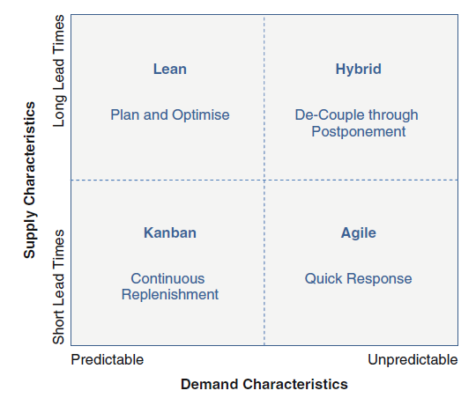
Figure 1. Generic supply chain strategies (Christopher, 2005)
Some researchers argue that operational excellence cannot be viewed as a strategy (Porter, 1996), supporting their arguments with discussion, that any company can be copied by the competitors and achieved through process optimization. He argues that strategy should be based on unique activities while operational excellence is performing the same activities better. However, the opposite view of Hayes and Upton (1998) exist who argue that ‘Operations role is larger than just that of implementer of strategy; it is the foundation for – indeed, the driver behind – successful strategic attacks and defences. The important implication for company leaders: companies that fail to exploit fully the strategic power of operations will be both hampered in their own attacks and vulnerable to those of competitors that do exploit this power’. The researchers examine case of Australian paper manufacturers to support their point that new-comers with more advanced and efficient supply chains win competition with traditional manufacturers in spite of their strong presence on market and well-known brand.
Another argument in favour of supply chain strategy as a crucial component of corporates competitive advantage and necessity of alignment this two strategies is provided by comprehensive research held by PricewaterhouseCoopers. 500 manufacturing and service companies from different industries participated in the survey of the consultancy, which was devoted to identification of leaders’ thoughts towards supply chain, new trends and theirs effect on company’s performance. One of the main findings of the survey shows that supply chains allow to achieve corporates’ goals and build competitive advantages. The results demonstrate that companies that consider supply chain to be strategic asset perform 70% better than the ones that do not. Supply chain leaders also crate competitive advantage through cost minimization and profit maximization of theirs supply chains.
Let us define is there the one generic supply chain strategy that can fit all companies within forest industry. To answer this objective we will appeal to the analysis of wood-processing industry made by Chubinskiy (Table. 2) and margin statistics of the largest wood-processing companies (Appendix 1) that show that the majority of products of the industry are functional and produced by firms that can be referred as manufacturing companies. Moreover, the majority of this goods are highly standardized and are traded on goods exchange and can be referred as commodity goods.
Product | Share in wood consumption
Pulp | 40-70%
Sawn goods | 21-31%
Wood-based panel | 2-17%
Fuel pellets | 0-6%
Other (including furniture) | 1-10%
Table 2. Structure of products in wood consumption (Chubinskiy, 2009)
Production in wood-working companies is a very lengthy and technological process, that requires special preparation of raw material before it is used in manufacturing. It results in increased lead time that varies from a few weeks for “simple products” like pellets and sawn goods to several months for complex technology-intensive products like pulp, paper wood-based panels and furniture. Considering these facts articles studied above we can conclude that the main characteristic supply chains in this industry is to be physically efficient or cost efficient. Further we will analyze approaches that are most appropriate to development of supply chain in commodity production.

Commodities and their supply chains. Lean approach
As we derived from previous discussion the majority of goods are functional, that requires cost-efficient supply chain. However, researches made in commodities supply chains stipulate that even commodities can be differentiated (Levitt, 1980, Peters and Austin, 1985). Indeed, closer analysis of such goods like paper or steel shows that there are a lot of standards, and characteristics of finished products (from perspective of pulp or still manufacturer) that are crucial for customers. For instance, paper sold on goods exchange is represented by few standards, while currently paper mills offer thousands of different types of paper (depending on type of wood, paper whiteness, coating, format, package and other factors). Analysis of industrial literature shows that majority of manufacturing industries have similar process of raw material transformation into finished goods, that allows to customize product as closer to customer as possible. Traditionally manufacturers use very limited number of core raw material from which they produce few intermediate products (pulp, molten metals or metal bricks) that can easily be transformed into that type of goods that are required by customers (schematically this process is illustrated in Figure. 2).
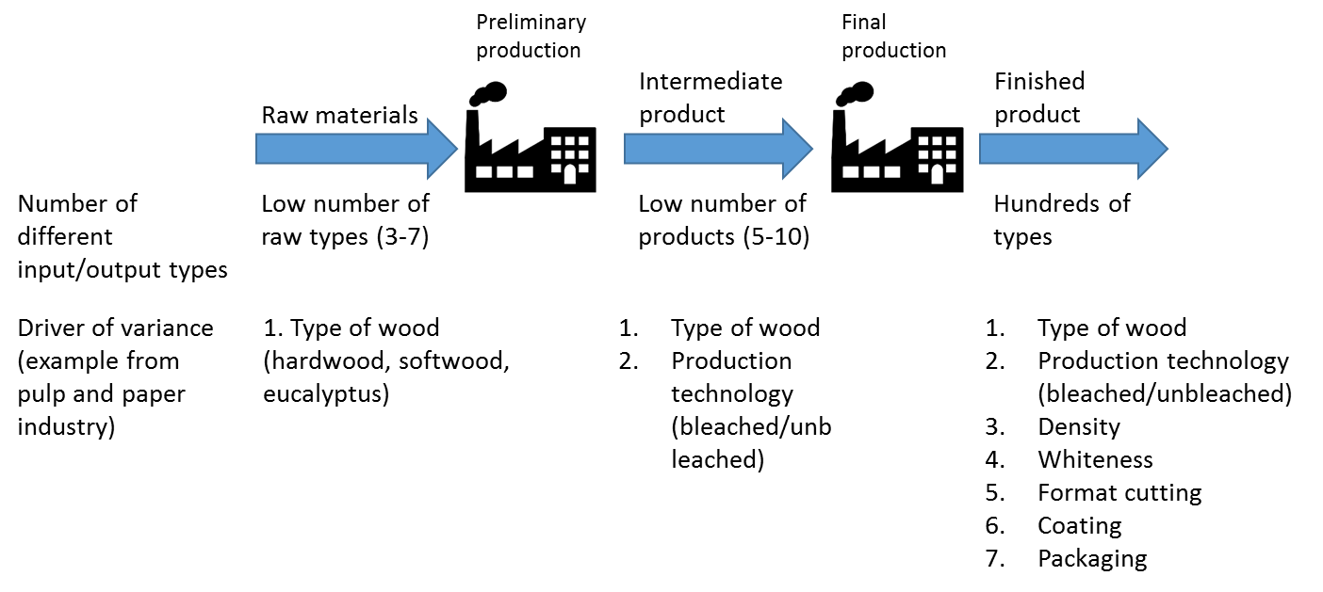
Figure 2. Process of raw transformation into finished goods. Example of pulp and paper industry. (prepared by author, based on reviews of industrial practices).
In this process we can notice clash of different requirements to supply chain from perspective of intermediate product mill and finished good producer. Considering the fact that hundreds types of finished goods may be manufactured from each type of intermediate product we can assume that fluctuation in demand for finished goods has lower effect on demand for intermediate product and for raw material. It gives us a ground to consider intermediate product to be more functional while finished goods has more traits of innovative goods independently from industry.
This statement above can be supported by work of Cetinkaya (2011) who stipulates that ‘best practice companies do not focus on just one, fixed supply chain strategy’ and research of PwC (2013) that identifies usage of four different configurations of supply chains within one company. Despite of the distribution and customer relation strategy that can be influenced by a great number of factors the part of supply chain from raw material to intermediate product will have the same preferable configuration independently of external factors. Therefore, understanding how companies may increase efficiency of this part of supply chain will allow to apply results of the research independently from the industry.
Researchers agree that ‘knocking a couple of percentage points off production costs has far more strategic impact than all the weapons the marketer could employ in these [commodity] industries’ (Bennett & Cooper, 1979). According to Porter (1980) and Christopher (2011) a firm operating with commodity product may achieve competitive advantage only through implementation of cost leadership strategy. Porter and Kiechel (1981) argued that the key principle of success cost leadership is to heavily invest into building the largest and most modern plants in the industry. Current researches also highlight additional requirements that allow to achieve competitive advantage through this strategy – increase capacity utilization, asset turnover and synchronization of supply and other process (Christopher, 2011). This change in approach shows that modern approach to gaining efficiency is not only produce more, but produce it with most tailored process and with minimization of unproductive waste (Towill et al., 2002).
According to recent researches (Christopher, 2011; Jasti and Kodali, 2015) lean production methodology is most efficient and appropriate in realization of cost leadership strategy. The main focus of this methodology is to eliminate non-value added activity, or manufacture product without waste. According to Ohno, waste can be classified into seven categories (Monden 1998). These are: over production, waiting, transportation, unnecessary inventory, inappropriate processing, defects and unnecessary motions.
The main principles of lean production are: minimization of inventory through implementation of Just-in-time methodology and synchronization of processes. Working with low inventory may be very risky for new industries or for companies with volatile demand, but may be used in traditional industries that has no foreseen changes on demand/supply side or with high control over supply chain. Analysis of recent studies of trend in lean production researches show that the main focus of researchers is to control defect level and reduce if unnecessary inventory wastes. Dhandapani, Potter, and Naim (2004), Sahoo et al. (2008) and Domingo et al. (2007) identified that manufacturing industries suffer from excess inventory, large lead times and high level of defects in final product.
For long time lean production has been studied as a method to optimize production within four walls and recent trend is to develop application of lean in the whole supply chain. The most promising and profound topics for research are lean transportation and warehousing (Jasti and Kodali, 2015). Considering high transportation cost we will go deeper into study of transportation.

Role of transportation in supply chain
Researchers stipulate, that development of cost leadership strategy for resource-intensive manufacturers require favourable access to raw materials that needs high availability. Researchers of SCM (Tan et al, 1998; Trunick, 1999) came to agreement that transportation has become integral part of supply chain and current logistic systems are intolerant to delays in deliveries. High importance in maintenance of operational stability level can be achieved either by careful planning of site, or the configuration of existing routing network.
The role of inbound transportation (moving raw materials from the supplier to the producer) cannot be overestimated. The quality of inbound transport can be evaluated by different indicators: reliability of delivery, meeting time window, delivery time, cost of transportation, etc. The quality of the service has a strong effect on stock level, downtime and number of labour utilized on loading/unloading operations. (Bowersox et al. 1992). Efficiency of inbound transportation affects not only supply chain productivity, but the possibility of company to meet customers’ needs. (Trunick, 1997).
Hines and Samuel (2004) compared traditional and modern approaches to supply chain management. Their findings highlight different goals of temporary theory regard transportation as a collaborative process, added value of which to the business operations is more important than costs of moving goods and materials from one point to another. Transportation is considered as strategic and operational tool, efficiency of which has strong impact on business performance. The authors also propose that transport should be managed jointly with other business functions focusing on long-term collaboration rather than achieving quick wins.
Freight transportation is undoubtedly one of the most studied issues in the scientific logistics literature to date, mainly because of the high costs that this component typically generates compared with total logistics costs faced by any kind of industry. According to the 23rd annual CSCMP State of Logistics Report, in 2011 transportation costs in the USA represented 64% of the total logistics costs, inventory costs 33%, and administrative costs 4%. These proportions indicate that the analysis of the transportation function is indeed highly justified, and it should be carefully considered because freight transportation is strongly related to the economic development of nations.
Recent studies of transportation can be divided according to the aspects reviewed by author:
Group | Aspects, reviewed
Supply chain decisions faced by models | - Location  - Inventory decisions (include inventory policy decisions)  - Allocation decisions (not inventory nor product allocation)  - Production quantities  - Purchased quantities  - Products to be shipped  - Delivery time  - Number of shipments  - Distance traveled  - Number of vehicles  - Routing to suppliers  - Routing to customers/retailers
Objective functions | - Transport time MIN  - Flow – time MIN  - Distance MIN  - Order delay costs MIN  - Profit – benefit – net present value MAX  - Costs MIN  - Transportation costs MIN  - Transportation + inventory costs MIN  - Transportation + location/allocation costs MIN  - Transportation + environmental costs MIN  - Inventory + transportation + location costs MIN
Transportation data | - Transport frequency (how many trips to make, time between trips, when to visit a customer, retailer, DC, plant)  - Lead time (more than transportation time)  - Loading and unloading times  - Time windows to serve customers  - Transport distance  - Truck speed  - Truck acceleration  - Road angle (according to road topography)
Table 3. Systematization of current researches in transportation. (prepared by author on the basis of literature analyzed)
As we can figure out from the table above, recent researchers focus attention on logistics optimization, increase in utilization rate of trucks, but the gap between supply chain integration and transportation exist. In this research we will try to fulfil this gap by considering supply chain as a whole system, where transportation has an integral role to control inventory, production and supplier costs. Therefore we will assess the following system by combination of approaches proposed above.
Researchers usually consider transport infrastructure (roads) as something what exists. Russian researchers (Sokolov et al., 2014; Davidkov et al., 2013; Gerasimov, 2010, 2011) consider these investments as public one, and focus on density of roads required to eliminate seasonality in harvesting, on technologies, choice of equipment and do not analyse option of private investment into the infrastructure. However, road construction is formally obligatory of forestry and local authorities, they rarely have enough resources to execute it. Thus to fulfil research gap I will assess the costs, which company will suffer and benefits which company will have from it and analyse whether companies within the industry should invest in it.

Approach to investment analysis.
Investment decision is a comprehensive and complex process that requires tailoring to the strategic needs of each company. According to capital investment theory, any investment whose return/profitability is higher than the cost of capital for the potential investor should be decided upon, and when there is competition between investments, the one with the highest return should be decided upon. This theory has developed various analytical tools—known as capital budgeting tools1—to evaluate investment profitability. (Cooremans, 2011).
Recent studies show that payback of investments is not the only factor that should be considered while making investment decision (Alkaraan and Northcott 2006; Burcher and Lee 2000; Butler et al. 1991). Strategic factors play higher importance in making decision rather than just investment payback. It means that strategic investment should create competitive advantage to the firm. Cooremans highlights three key characteristics of competitive advantage, based on analysis of relevant literature, that are: value, cost, risk. It means that chosen activities should emphasize firm’s core competences and increase firm’s value to key stakeholders. It should be achieved with minimum cost possible and with risk minimization to a firm. Depending of each case
As we derived previously the main strategic focus of manufacturing industries is to reduce cost to produce intermediate product. Therefore, achievement of positive effect on cost-side of supply chain with relevant lower investments will be considered as a key strategic goal of investment, while two others dimension may be either blocking factor in case of their significance in each individual industry or serve as additional criteria in making decision among several options. Considering that cost reduction of investments will come through waste reduction in supply chain we may calculate impact on cost side as follows:
$Change in production cost={DCF}_{n} of reduced wastes due to investment-investments$,
where n – period during that a firm reduced wastes due to the investment
While making investment decision in forest industry we should consider society as one of the key stakeholder. Recent researches show increasing attention of society to sustainable and environmental-friendly utilization of biological resources (Cambero, Sowlati, 2014). According to Lunna et al (2013) ‘sustainable use of forest biomass resources requires that all the benefits obtained from their current use do not compromise the ability of future generations to benefit from them in a similar manner’. Considering abovementioned sustainability of forest production may also be considered as long-standing strategic value in terms of provision of a firm with resources and provision higher standard of life to the society of operational region.
In terms of risks practitioners (Gerasimov, 2011) highlight possibility of loose or break costly equipment during thaw period. Absence of hard coated roads require to bring heavy harvesting complexes from woodland before beginning of the thaw. Delay may lead to impossibility to relocate the equipment and leave it in forest for uncertain period. Loose of any harvesting complex will increase risks of being undersupplied.
Considering the basic model of assessing strategic investments and abovementioned peculiarities of forest industry we come up with a framework of assessment investments into timber transportation infrastructure highlighting. We will evaluate whether investments into forest roads will allow to reduce cost of production without deterioration of biological resources and reduce risks of being undersupplied.
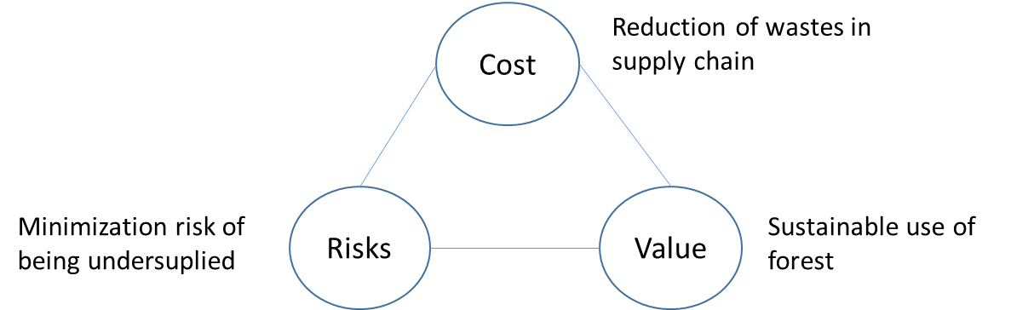
Figure 3. Key elements of strategy investment assessment in forest industry (prepared by author, adopted from
***
In this chapter we have analysed current trends in supply chain management and identified that nowadays successful firms consider supply chains as strategic asset that allows achieve corporate goals and develop competitive advantage in the market. Alignment of supply chain with corporate strategy is crucial.
Manufacturing companies should create competitive advantage through cost minimization in their supply chain (excluding the part of supply chain where intermediate product is customized for customer). One of the most efficient way to achieve it is to implement lean practices and eliminate wastes in supply chains. The most promising areas for waste elimination are transportation and warehousing. Logistics optimization is usually solved isolated from production and does not consider the option of reducing production and other supply chain costs through increased investments into transportation. Lack of forest roads with hard surface disallows synchronise harvesting with production and increase non-value added operations in supply chain.
To prove strategical importance of investment into forest roads we will test whether this investment allow to create competitive advantage to companies through cost optimization of supply chain, value creation by maintenance sustainability of resources and risk minimization to the production.

Chapter II. Research methodology

Research method
The chosen method for theoretical framework application is a qualitative research. This method is used as it gives ability to receive experience point of view on given issue (Hafner, 2012). Moreover, it allows to receive personal attitude toward each problem and unveils intangible factors such as socioeconomic and ethic norms. In current research it is crucial to receive professional.
Application of case method is relatively new approach in researches of supply chain and its popularity is increasing. (Kotzab, et al., 2006) According to Yin (2009) case study is the most suitable approach to define roots of current processes, operation and state of affairs. As in the paper we analyse reasons of current position of pulp and paper companies, and try to investigate core cost drivers, case study will perfectly meet the goals of the research.
As the topic of current master thesis aims to identify the role of investments within an industry we will apply multiple case study method. According to Eisenhardt (1989) the significance of multiple case method may be achieved through analysis of cases that represent opposite sides of one phenomenon. This type of research will be implemented through identification of similarities and differences between case companies. Cross-case analysis allows to achieve different perspectives on the same issue and receive more accurate results and conclusions.
The orientation of current research will be exploratory one with the goal to understand the approach to supply chain design, role of transportation within it and its impact on the system. As the industry is homogenous in terms of corporate strategies of main players but with different requirements toward various parameters of supply chain we will focus on two companies from different subsectors and different technologies of wood-procession in order understand its supply processes, obstacles, cost drivers and will isolate corporate peculiarities from industrial trends by comparison company with findings from literature review and observation of industrial practices and approaches, represented in open sources.

Research Sample
In order to achieve our goal and be able to generalize the results of the research we will implement judgmental sampling (Saunders, Lewis, Thornhill, 2003). It is one of the most often applied technic used in case method. Moreover we will apply theoretical sampling because all the cases are selected on the theoretical and analytical basis (Eisenhardt, 1989)
For selecting the needed sample some criteria were elaborated. According to these criteria the companies should be:
- Large enterprise
- Vertically integrated (obtain control over supply chain costs)
- Cover the majority cases
- Run operations in the same industry
Main target of interest for the research are large companies that have transparent cost structure of production and supply operations. Moreover in terms to reduce technological bias that can arise through research of a company in one industry multiple cases from various industries and different technological process have been chosen. The most interesting companies represented pulp and paper and plywood industries as 80% of wood harvested in Russia is consumed by this industries.
The most interesting companies for research were Mondi, Ilim group and Sveza. However, the industry is very competitive and shadowed that makes company reluctant to disclose their financial data, structure of supply chain and development strategy. In terms to collect data and prepare this research companies have preferred to stay anonym and not to disclose their names.
In current research two companies have provided their data and information:
Pulp and paper mill with annual consumption of 6.000.000 m3 of wood annually situated in north-western region of Russia. Company has a long-term renting agreement for cutting areas. Harvesting operations and transportation are in-house.
Pulp and paper mill with annual consumption of 2.000.000 m3 of wood annually situated in north-western region of Russia. Company has a long-term renting agreement for cutting areas. Harvesting operations and transportation are in-house.
For the empirical study two companies from pulp and paper and plywood industry were chosen due to the following factors:
- Both companies operates with their own cutting areas and have their own fleet of trucks and wood cutting equipment that gives them full control over their supply chain and transparency of costs that is crucial for this research.
- Companies represent industries with different requirements towards raw material quality, e.g. pulp production can use virtually any kind of timber regardless of its quality. However, plywood can be made only from specific part of a timber that meets high standards. Therefore, this companies cover the majority of scenarios of timber consumers.
- Both firms run their operations in North-Western region of Russia – the region where the major Russian wood processing companies are located.
All these factors will guarantee that the data gathered is representative and will allow to understand the problems of the similar companies that represent wood-processing industry,

Data collection
We used different approaches in data collection in order to receive deep and wide information on the phenomena studied.
The main research methods that are implemented in this paper are: Interviews and Documentary analysis.
Interview
In order to provide flexibility of research and cover all possible topics the semi-structured interviews were conducted. Questions intentionally were open that allow to receive more information and have more personal approach.
The aim of the interview is to obtain the profound knowledge of company’s processes and create a value-stream map.
The interviews as means of data collecting can be justified because there is a need to receive a deep understanding of the research question. The interview will be structured to six sigma project management approach – DMAIC and will cover lean approach in order to identify wastes.
All the interviews were documented in order to check correctness of data recorded analyse and conduct additional reviews or receive additional information. It is also important to take written notes during the interview in order to analyse personal perception of interviewer towards the question and minimize bias of the research. According to Eisenhardt (1989) it is important to make notes of any emotions occurred in order to eliminatethe chance of sifting out something important.
Company representatives that have been interviewed mainly are subject experts and represented middle and top level of management (head of transportation and forest departments).
In terms of documentary analysis in both case companies the researcher received technical, processual and financial data that have been used in order to develop calculation of different investment scenarios.

Chapter III. Case study.

Supply chain processes in wood industry
The majority of goods produced by wood processing industry such as: pulp and paper, saw-materials, plywood and wood-chip boards are functional and have a little differentiation. These goods are considered as commodities that imply that the competition on the market will take place on the ground of prices to the client. As Martin Cristopher mentioned nowadays the rivalry lies within supply chains, meaning that the companies with supply chain that is tailored to meet customers’ requirements will be more competitive on the market then the other ones.
From 44 to 74 percent of wood goods cost accounts for timber cost. That means that reduction of this cost will have higher impact on the price of finished goods and therefore will allow to reduce price and increase competitiveness of this goods. In wood processing industry the cost of wood is considered as all cost incurred to deliver timber to production, description of wood cost will be described further in this chapter.

Figure 5. Cost structure of selected forest goods.
In this chapter we will research the factors in supply chain that lead to an increase of wood price and will examine how the investments into enhancement of timber transportation infrastructure will result on cost of wood goods. Moreover, we will analyze other non-quantified factors (value and risks) that are dependent on presence of timber-transportation infrastructure.
In order to test theoretical framework, developed in the first chapter we will make analysis of three factors:
- Cost-efficiency of investment. Considering our finding that supply chain strategic configuration for wood-processing companies should strive for production cost reduction, this factor for investment will be crucial and most important. Worth mentioning, that the length of roads constructed directly correlate with the surface of forest lands to be processed and consequently with amount of timber to be transported during the processing period. Usually it takes from 1 to 4 months to process one timberland, therefore to meet requirement on cost efficiency this investment should have a payback period that does not exceed one year, otherwise the cumulative economical effect will be negative.
- Values to stakeholders – as it was discussed in the first chapter stakeholder’s value creation and satisfaction of their requirements is important for achieving competitive advantage. As we derived previously, that the main requirement of customers in this market is to provide customer with cheap product, than this need is met through cost reduction. However, requirements of a number of other stakeholders will be identified and discussed. Among these groups of stakeholders we can distinguish local population, employees and shareholders.
- Risks. Sustainable competitive advantage cannot be built with vulnerable and risky business process. Therefore, in this part of the chapter we will define the role of infrastructure on mitigation current risks of the companies.
Research is based on implementation of DMAIC (Define-Measure-Analyze-Improve-Control) approach to problem solving and process improvement.

Problem definition
Stage of issue definition is based on unstructured interviews with company representatives. Manager from wood procurement and transportation departments of both companies participated in interviews.
The overall supply chain process does not differ significantly for pulp and paper and plywood companies. Therefore the aggregated review of this process is presented below:
  - The production process of wood goods starts from wood-cutting sites, where a tree is fallen and can be exposed to primary processing (limbing and sorting) depending on the technology used. Case companies utilize the most advanced cut-to-length logging. In it the process of felling, delimbing, bucking and sorting (pulpwood, sawlog, etc.) is done at the stump area. Companies of different wood-working specialization use different parts of tree in their operations (e.g. pulp and paper mills are not so particular about quality of the raw material and usually use the cheapest higher part of a tree or whole non-mature trees – pulp wood. Bottom parts of mature trees are suitable for production of saw materials and plywood – sawlogs (or veneering log). Market price of sawlogs is on average twice as high as of pulpwood and therefore are used in pulp production only if transportation to other consumers is not economically feasible). According to the interviews held with representatives of wood-working industry of North-Western region of Russia, the cut-to-length technology is dominant in region as it allows to distinguish transportation flows of wood to different consumers and optimize further logistics.
- After a tree is fallen, limbed and cut into logs a special small (capacity of 6-8 m3 of round wood) trucks - forwarders sort logs and deliver them to upper lumber yards. Such lumber yards are side with timber-roads and serve as trans-shipping point from low-capacity off-road forwarders to road trucks with higher capacity (up to 55 m3) and lower fuel consumption per ton-kilometer.
- From the upper lumber yard timber is transported either to industrial yards:
  - Industrial yards are projected to reduce dependency of factories from external factors that may have negative effect on uninterrupted operations, e.g. unpredictable weather conditions that may disallow lumbering operations in tree-cutting areas. At the same time industrial lumber yards increase flexibility of production to make mixture of hardwood and softwood with different physical and chemical features from various cutting-areas. Industrial yards usually can stock wood for 3-10 weeks of consumption.
  - Another role of industrial yard is to reduce seasonality in wood supply and stock enough material to supply factory during thaw period. During this period cutting sites become unavailable for staff and timber transportation due to melt of winter timber transportation roads (spring thaw) and erosion of soil roads (autumn thaw).
Nowadays the processes in supply chains of companies within research are non-rhythmic and designed to build up a stock of timber for thaw period during winter and summer periods. To achieve this goal extensive amount of resources are allocated during operational period that are not utilized during thaw periods. In order to measure losses of industry from seasonal harvesting and to identify potential sources of reducing cost the interviewees were asked to identify wastes of different types according to lean methodology. We will focus our research on application of lean approach as the one which is aimed to reduce unproductive work and increase value added to the goods.

Waste identification
To understand the losses of industry from seasonality the potential losses in supply chain are structured according to seven types of wastes in logistics described by Goldsby and Martichenko. These types of wastes are as following:
- The waste of inventory
- The waste of Transportation
- The waste of Space and Facilities
- The waste of Time
- The waste of Packaging
- The waste of Administration
- The waste of Knowledge
The interviews with representatives of pulp and paper and plywood industry were held in order to identify wastes in each of these categories and evaluate economical losses and root of the problems.

The waste of inventory
Lambert and Douglas M. in the work The Development of an Inventory Costing Methodology: A Study of the Costs Associated with Holding Inventory provide comprehensive structure of elements that compose waste of inventories (adapted structure was provided in Lean Six Sigma logistics by Goldsby and Martichenko).
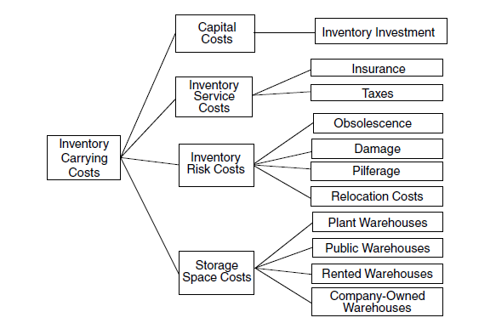
Figure 5. Structure of wastes in inventories. Source: Goldsby and Martichenko, Lean six sigma logistics.
Case companies operate with their own forest resources (in long-term rent) and all the cost related to inventory increase comes from the harvesting and transportation costs and does not imply any additional expenditures. Due to the nature of the wood theses goods are not subject to additional service costs.
Two companies have participated in the research with different requirements towards quality of raw materials that led to presence of different inventory risks and their cost to the case companies. According to interviews with representatives of a plywood company and statistics from industrial researches wood deteriorates during seasonal stocking. The volume of saw-goods (including veneering wood that is used in plywood production) per log declines that reduces its value for non-chemical processing and increases volume of throw-outs. Therefore, the ratio value/cost declines due to seasonal harvesting. According to estimation of wood processing manager plywood company have to cut and stockpile 5-10% more wood than it is required in case when wood is stored for less than 3 weeks.
Traditionally wood-cutting industry operates with open-air warehouses and the only investments required to organize seasonal stock of wood – land rent or opportunity cost of this land. Also we can assume that potentially the land used for wood stocking may be utilized differently and bring additional value to company. However, due to the specificity of wood-cutting industry production facilities are situated in distant areas and has no demand from the market. Currently case companies have no additional needs to use freed land therefore we are unable to estimate any losses in storage space for case companies.

The waste of Transportation
Transportation of timber from cutting areas to factories has significantly changed during last decades – share of wood transported by road increased while maritime and railroad transportation nowadays in rarely used by case companies due to deforestation of areas side with rivers used for maritime transportation and cost inefficiency of railroad transportation.
Extensive development of cutting areas led to quality reduction of easily accessible harvesting areas and enlarging of transportation leg. Both case companies stipulated that average transportation leg has been 200-210 km in 2015 and tends to increase in next periods if the approach to development of harvesting areas remains the same. However, huge amount of wood is stored in locations close to factories but inaccessible due to lack of forest roads. According to industrial expert’s estimation 17,2 meters of forest roads should be constructed to develop 1 ha of currently inaccessible cutting areas. Length of transportation leg for developed cutting areas may be reduced up to 60 kilometers in case companies.

The waste of Space and Facilities
Due to inaccessibility of cutting areas during thaw period utilization of harvesting equipment and timber trucks is lower than projected. On average each harvesting complex and trucks are utilized for 270 days per year therefore the availability rate of vehicle is 74%. As equipment requires high investments, 26% of idle time can be considered as substantial loss.

The waste of Time
Current situation for both companies represent that delivery schedule with narrow delivery windows cannot be met due to the breakdown, frequent accidents in non-coated forest roads that are subject to deterioration and decline of surface quality in case of bad weather conditions. Arrival of trucks to unloading gate is chaotic and unpredictable. Limitations of unloading procedure lead to appearance of queues at factory’s gate.
However this problem was strongly highlighted only by pulp and paper factory, where average waiting time is 20 minutes. Application of queue theory with parameters identical to the factory proves chaotic nature of trucks arrivals projecting about 22 minutes waiting in line. As pulp and paper factory was projected to be mainly supplied by water and railroad its capacity and design of wood yard is not tailored for high volumes of road deliveries.
Plywood factory has better design to serve timber trucks and have average waiting time of 2.5 minutes before being unloaded.

The waste of Packaging
As wood is transported unpacked this type of wastes is not applicable to case companies in terms of timber transportation.

The waste of Administration
Increased number of drivers, harvesting personnel and other production workers, high ration of temporary workers increase workload for supportive functions such as HR, Finance, IT. However, as these costs are not directly avoidable and require additional analysis of its amount we cannot estimate value of waste in administration. Moreover, interviewees accepted that the size of such expenses is insignificant and can be omitted in this research.

The waste of Knowledge
Currently the timber transportation in case companies is not knowledge intensive and does not have any special know-how in transport organization. No knowledge management system in field of transportation is applied.
To sum up the findings from the interviews and compare cases of different industries the following table has been prepared
Source of wastes | Pulp and Paper production | Plywood production
Inventories | Company does not have any direct additional (recurrent) costs due to increased size of inventories. Storage space cost will not change as currently all seasonal wood-yard is located on factory’s premises that cannot be utilized other way. | Company has additional expenses arisen from seasonal warehousing. Quality of the raw material drops during the keeping period and output volume of plywood per timber reduces significantly. On average, company have to use 10% more wood in order to prevent material shortage from quality drop.
Transportation | Low accessibility of cutting areas and extensive approach to harvesting increases transportation leg. Average leg length approaches to 210 km, while intensification of harvesting operations would allow to decrease it up to 60 km
Space and Facilities | Highly investment-intensive equipment is underutilized. On average equipment is used for 74% of its capacity
Time | Long queues due to impossibility to follow delivery schedule and factory limitations. Average time in line – 20 minutes | Meeting delivery schedule is still difficult, however average time in line – 3 minutes thanks to excess capacity of unloading gate
Packaging | Not applicable
Administration | Insignificant. Requires additional deep analysis. Out of scope of current research
Knowledge | Not applicable
Table 4. Identified wastes within the case companies

Impact of transportation infrastructure on companies’ competitiveness
In order to prove strategic role of investments we will apply framework, developed in Chapter I and therefore analyze three key factors: financial efficiency of investments into road construction, identification of risks connected with execution of this initiative and additional value for stakeholders.
To analyze current expenses of case companies to harvest and deliver timber from cutting areas additional information was asked from case companies. The information was structured into three blocks: technical information of equipment used, process information and financial data. Both companies use one of the most modern and efficient harvesting complexes produced by John Deere and Ponsse. Transportation fleet is represented by road trucks manufactured by Mercedes and Volvo. As difference between this equipment is insignificant average data will be used.
Tables 5a and 5b. Processual and technical information
Table 5c. Financial information regarding purchasing prices
Based on data provided and information obtained from interviews analysis of financial feasibility has been developed. Three scenarios have been considered:
- Scenario 0 – analysis of current annual expenses of both case companies. In this case we consider that all the timber required to meet factories’ demand is transported by road and no coated forest roads are constructed.
- Scenario 1 – coated forest roads are constructed only to minimize seasonal specificity of harvesting operations. In this case we consider amount of roads to be constructed based on estimation of industrial experts – 17.2 m/ha that will allow to reduce transportation leg during the thaw to 60 km.
- Scenario 2 – total intensification of harvesting operations. All forest roads are coated that allows to reduce average transportation leg to 60 km and meet delivery schedule, that mean no waiting in line at truck unloading.

Table 6a. Calculation of different scenarios of impact of road construction on operations of pulp and paper case company

Table 6b. Calculation of different scenarios of impact of road construction on operations of pulp and paper case company

Table 3a. Calculation of financial result of various scenarios implication in pulp and paper case company

Table 3b. Calculation of financial result of various scenarios implication in pulp and paper case company
As seen from the calculations above in both cases construction of forest roads with hard surface allows to reduce wastes in supply chain and consequently reduce cost of production. In Scenario 1 we can notice that investment into road construction are fully covered by savings from reduced number of harvesting complexes and in system. It signifies that seasonality in harvesting brings higher losses to companies than the cost of infrastructure required to solve it. Positive effect on Opex is explained by reduced distance of wood transported due to possibility of use closer woodlands with soil quality unfavourable for non-road transportation.
Scenario 2 shows lower effect on cost reduction. From one point of view development of high-quality road network eliminate more wastes than scenario 1 (waiting, excessive transportation). The root of the problem lies in capitalized expenditures, where we see no changes in spending on harvesting complexes, relatively significant reduction in freight vehicle expenditures. Also we see significant reduction of operational expenditures due to shorten transportation leg. However, increase of additional investments into roads are much higher than additional savings.
After receiving financial prove of feasibility implementation of road construction initiative additional non-financial benefits have been discussed with representatives of case companies. Both companies indicated that development of transport infrastructure will allow to reduce risks and increase stakeholders’ value created.
In terms of value increase the interviewees highlighted the following:
- Maintenance of sustainable forest resource consumption. Currently reforestation process is made only shortly after harvesting without any tendency after the planting as access to this areas becomes complicated. Lack of control and care disallow companies to control quality of trees and makes reforested areas wild that makes period of tree maturity larger than in case with appropriate control and care. For example, average period for tree to become mature in Russian forest varies from 70 to 90 years depending on wood type. At the same time in Scandinavian countries with highly developed forest network periodical environmental or intermediate cutting allows to reduce maturity period to 60-70 years. Reducing this period does not give any feasible results in short term but allows to provide factory with high-quality and accessible resources in long-term period.
- Construction of reliable infrastructure to the woodlands will increase mobility of workers that will have better impact on their morality and will ensure their security in case of emergency.
Due to the similarity of core harvesting processes both companies have identified the same risks within their supply chains. The discussion of possible impact of road construction have brought us to the following results:
- All wood-working companies that operate harvesting areas have to provide fire control of rented forest areas. Only fast actions and timely localization of fire allows to minimize consequences. Lack of roads makes access to inflaming epicenter difficult and disallow to localize fire with use of vehicles and heavy equipment. Losses of industry and society is difficult to estimate.
- Elimination of negative effect of thaw period will make transportation indifferent to unpredictable changes of weather conditions like earlier snowmelt.

Result discussion and limitations
As we see from the results, investments into timber transportation allows to achieve competitive advantage in financial and non-financial aspects. Producing goods cheaper, conducting intensified forest operations, increasing stakeholders’ created value and risk reduction will positively affect business performance and its sustainability.
The research unveiled that wood-working industry in Russia dramatically suffers from seasonality of harvesting operations. Interviews held with representatives of plywood and pulp and paper industry showed that road construction allows to eliminate wastes and costs that arise in supply chain from seasonal harvesting.
Interviews with representatives of wood-working industry highlighted the problem of non-rhythmical harvesting operations that lead to increased investments into unutilized equipment, longer logistics cycle and higher costs.
The modelling of various scenarios showed that construction of roads allows to achieve the main strategic goal of supply chain – reduce production costs. Anisochronous processes brings approximately 130 mln Roubles annually of additional costs into excessive harvesting equipment.
Moreover, enhanced forest infrastructure assist to create non-financial competitive advantages through risk reduction related to conduction of seasonal harvesting, protect business from non-controlled losses.
As we found out from analysis of situations within case companies the higher results are achieved in scenario with seasonality elimination. We should mention that the effect of the second scenario is based mostly on reduction of average transportation leg. At the same time we have noticed that during previous five years average leg has increased from 180 to 210. If this tendency remains for future periods than the results should be recalculated with updated parameters. However, reduction of demand for wood from distant timberlands will also provide slower exhaustion of them and therefore will reduce the pace of leg increase that will give additional long-standing benefit.
The results show that companies should consider private investments into timber-transportation infrastructure in order to increase competitiveness with relatively low spendings.
Current research has a number of limitations that should be considered in order to implement the results in other companies. The first limitation comes from the nature of qualitative research. According to Pratt (2009) the findings may be lacking an agreed significance level. Also it is impossible to prove absence of bias from interviewers within the company. As all interviews were held with representative of one functional department result may be subjective
Secondly, results of empirical study can significantly vary depending on harvesting and transportation technologies utilized in each case, length of thaw period and other dependent variables. However, as theoretical and financial models take all this variables into consideration the results may be adapted to every case individually.
The goal of this research was to receive deeper knowledge of how investments into transportation infrastructure allow to achieve strategic goals of company, and the results achieved fully satisfy the goal stated.

Conclusion
This research focuses on problem concerning lack of transport infrastructure as a main barrier of international competitiveness of forest processing companies from northern countries and regions with seasonal forest supply. The cost of wood production highly depends on price of transportation due to its resource intensity.
Wood industry products are low marginal and in majority of cases, customers are price sensitive therefore it may be considered as commodities. However recently customers started to demand additional services which make companies implement dual supply chain strategy: cost leadership jointly with some aspect of differentiation. To provide low cost company should have competitive advantage such as “favourable access to raw materials” (Porter, 1985) Therefore, the general supply chain strategy of companies within industry should be lean in intermediate production and agile in production of finished goods. It can be achieved by easy access to raw materials (woodland), minimized wastes.
Favourable access to raw materials is possible only when transport infrastructure is well developed. Case study unveiled us the problem of high volatility of material flow which incur additional losses on inventories, operations and transportation.
Such instability in raw material supply is explained by seasonal availability of woodlands due to absence of all-year wood-roads. Creation of such roads is obligation of forestry and local authorities, but due to lack of financial resource this sphere is underinvested. Companies rarely consider it as investment into strategic asset and prefer use uncoated roads.
Analysis of case companies allowed us to evaluate the losses of companies or additional expenditures, which occur as a result of instability of material flows. Impossibility to deliver materials during long period increases spending of supply chain on a number of processes: lumbering, excessive transportation and material handling, reduced productivity of timber trucks due to waiting for handling and spoilage of raw materials due to its seasonal storing.
In this research we analysed, that the losses abovementioned appear due to seasonal factor of transportation and uncertainty of material deliveries due to bad wood-road conditions. This factor also led to frequent truck breakdowns, overturns and sticking, and as consequence it makes woodland unavailable until the accident is not dealt with.
Calculation of return on private investments into wood-roads proved, that the whole supply chain, from lumbering to production, reduces its cost. Amount of benefits overweight the investment required for coping with seasonality and volatility in material flow. Moreover it brings additional benefits, which were discussed in previous chapter. Therefore the strategic role of investments into timber transport infrastructure is porved.
However this study has limitations due to analysis the most popular transport in the industry – road transport, it has limitations concerning applicability of multi-modal scheme. Thus, the further researches may include observation of multi-modal transportation as a mean of seasonality reduction.
The goal and objectives of the research were achieved, recommendations developed.

References
Blanchard, David. Supply Chain Management Best Practices. 2nd ed. United States: John Wiley, 2010.
Blanchard, David. Supply Chain Management: Best Practices. United States: John Wiley & Sons, 2007.
Bowersox, Donald J., Patricia J. Daugherty, and Cornelia L. Droge. LOGISTICAL EXCELLENCE: IT’S NOT BUSINESS - Don Bowers - Hardcover. United Kingdom: Butterworth-Heinemann, 1991.
Bravo, Juan José, and Carlos Julio Vidal. ‘Freight Transportation Function in Supply Chain Optimization Models: A Critical Review of Recent Trends.’ Expert Systems with Applications 40, no. 17 (2013)
Chopra, Sunil, and Peter Meindl. Supply Chain Management: Strategy, Planning, and Operation. 5th ed. Boston: Prentice Hall, 2012.
Christopher, Martin. Logistics and Supply Chain Management: Creating Value - Adding Networks. 3rd ed. Harlow, England: Financial Times Prentice Hall, 2004.
Daganzo, Carlos F. A Theory of Supply Chains. New York: Springer-Verlag Berlin and Heidelberg GmbH & Co. K, 2003.
Dyason, M. D., and M. M. Kaye. ‘Achieving a Competitive Edge through Continuous Quality Improvement.’ Total Quality Management, 1995.
Estampe, Dominique. ‘Supply Chain Performance and Evaluation Models’, 2014.
Fiore, Clifford. Lean Strategies for Product Development: Achieving Breakthrough Performance in Bringing Products to Market. Milwaukee, Wisc.: ASQ Quality Press, 2003.
Fisher, Marshall. ‘What Is the Right Supply Chain for Your Product?’ Harvard Business Review, 1997.
Gartner, William B., and Michael E. Porter. ‘Competitive Strategy.’ The Academy of Management Review 10, no. 4 (1985).
George, Michael L. Lean Six Sigma Combining Six Sigma Quality with Lean Speed. New York: McGraw-Hill Companies, The, 2002.
Gerasimov, Yuri, Victor Senkin, and Kari Väätäinen. ‘Productivity of Single-Grip Harvesters in Clear-Cutting Operations in the Northern European Part of Russia.’ European Journal of Forest Research 131, no. 3 (2011)
Gerasimov, Yuri, Sergei Senko, and Timo Karjalainen. ‘Prospects of Forest Road Infrastructure Development in Northwest Russia with Proven Nordic Solutions.’ Scandinavian Journal of Forest Research 28, no. 8 (2013)
Gerasimov, Yuri, and Anton Sokolov. ‘Ergonomic Evaluation and Comparison of Wood Harvesting Systems in Northwest Russia.’ Applied Ergonomics 45, no. 2 (2014)
Gerasimov, undefined Y., and undefined T. Karjalainen. ‘Energy Wood Resources in Northwest Russia.’ Biomass and Bioenergy 35, no. 5 (2011)
Green, Kenneth W., Dwayne Whitten, and Anthony R. Inman. ‘The Impact of Logistics Performance on Organizational Performance in a Supply Chain Context.’ Supply Chain Management: An International Journal 13, no. 4 (2008): 317–27.
Gulyani, Sumila. ‘Effects of Poor Transportation on Lean Production and Industrial Clustering: Evidence from the Indian Auto Industry.’ World Development 29, no. 7 (2001): 1157–77.
Hines, P., and D. Samuel. ‘An Explanatory Model of Integrated Supply Chain Management’, 248–56, 2004.
Ilinitch, Anne Y., Richard A. D’Aveni, and Arie Y. Lewin. ‘New Organizational Forms and Strategies for Managing in Hypercompetitive Environments.’ Organization Science 7, no. 3 (1996): 211–20. doi:10.1287/orsc.7.3.211.
Karjalainen, Timo, Lasse Jutila, Timo Leinonen, and Yuri Gerasimov. ‘The Effect of Forest Policy on the Use of Forest Resources and Forest Industry Investments in Russia.’ Resources and Technology 2, no. 10 (2013): 90–101. doi:10.15393/j2.art.2013.2181.
Karnani, Aneel. ‘Generic Competitive strategies—An Analytical Approach.’ Strategic Management Journal 5, no. 4 (1984): 367–80. doi:10.1002/smj.4250050406.
Kruger, Stephen, and Hans W. Ittmann. ‘Scientific Contributions in the Field of Transport and Supply Chain Management.’ Journal of Transport and Supply Chain Management 8 (2014). doi:10.4102/jtscm.v8i1.163.
‘Marshall L. Fisher.’ Production and Operations Management 19, no. 6 (2010). doi:10.1111/j.1937-5956.2010.01088.x.
Mason, Robert, Chandra Lalwani, and Roger Boughton. ‘Combining Vertical and Horizontal Collaboration for Transport Optimisation.’ Supply Chain Management: An International Journal 12, no. 3 (2007): 187–99. doi:10.1108/13598540710742509.
Oliver, Keith R., and Michael D. Webber. ‘Supply-Chain Management: Logistics Catches up with Strategy.’ Logistics: The Strategic Issues, 1982, 63–75. doi:10.1007/978-3-642-27922-5_15.
Porter, Michael E. Competitive Advantage: Creating and Sustaining Superior Performance. 5th ed. New York: The Free Press, 1985.
Sharp, Byron. ‘Competitive Marketing Strategy: Porter Revisited.’ Marketing Intelligence & Planning 9, no. 1 (1991): 4–10. doi:10.1108/02634509110139556.
Tan, Keah‐Choon, Vijay R. Kannan, Robert B. Handfield, and Soumen Ghosh. ‘Supply Chain Management: An Empirical Study of Its Impact on Performance.’ International Journal of Operations & Production Management 19, no. 10 (1999): 1034–52. doi:10.1108/01443579910287064.
Tompkins, James A, and Dale Harmelink, eds. The Supply Chain Handbook. Raleigh, NC: Tompkins Press, 2004.
Tracey, Michael, Jeen‐Su Lim, and Mark A. Vonderembse. ‘The Impact of Supply‐chain Management Capabilities on Business Performance.’ Supply Chain Management: An International Journal 10, no. 3 (2005): 179–91. doi:10.1108/13598540510606232.
Trunick, P.A. ‘The Truth about Location.’ Transportation & Distribution. 40 (October 1999): 5.
Vokurka, Robert J., and Rhonda R. Lummus. ‘The Role of Just‐In‐Time in Supply Chain Management.’ The International Journal of Logistics Management 11, no. 1 (2000): 89–98. doi:10.1108/09574090010806092.
Williamson, G., and M. Nieuwenhuis. ‘Integrated Timber Allocation and Transportation Planning in Ireland.’ Journal of Forest Engineering 5, no. 1 (1993): 7–15. doi:10.1080/08435243.1993.10702649.
Wright, Peter, Mark Kroll, Howard Tu, and Marilyn Helms. ‘Generic Strategies and Business Performance: An Empirical Study of the Screw Machine Products Industry.’ British Journal of Management 2, no. 1 (1991): 57–65. doi:10.1111/j.1467-8551.1991.tb00016.x.
https://cscmp.org/sites/default/files/user_uploads/resources/downloads/glossary-2013.pdf?utm_source=cscmpsite&utm_medium=clicklinks&utm_content=glossary&utm_campaign=GlossaryPDF
http://www.mckinsey.com/Insight/MGI_Reverse_the_curse_Full_report.pdf
http://www.mckinsey.com/Insight/MGI_Lean_Russia_Sustaining_economic_growth_full_report.pdf
http://www.fao.org/docrep/ARTICLE/WFC/XII/0750-B1.HTM

Appendixes

Appendix 1. Dynamics of pulp price and margin of 10 major pulp and paper companies

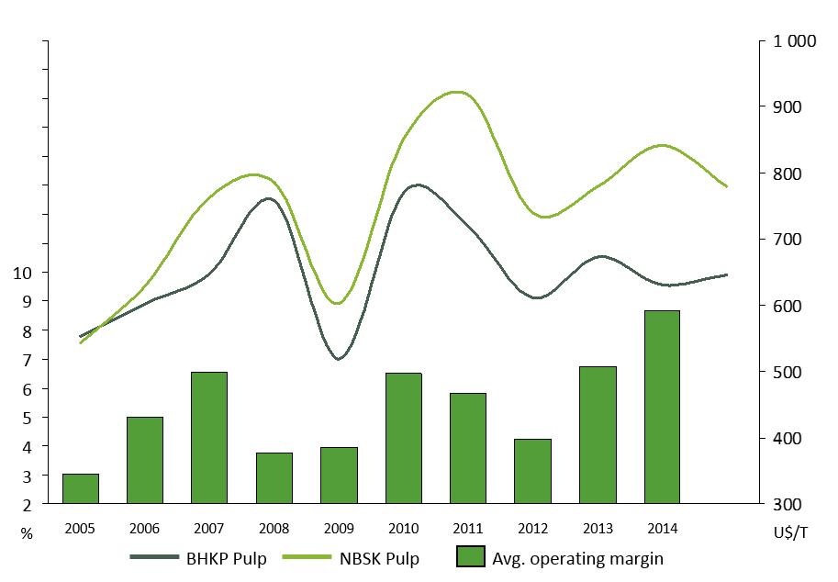

Appendix 2. Cost structure of pulpwood

Appendix 3. Dynamics of wood consumption, harvesting and seasonal wood yard during the year.

Appendix 4. Role of various means of transport in wood transportation

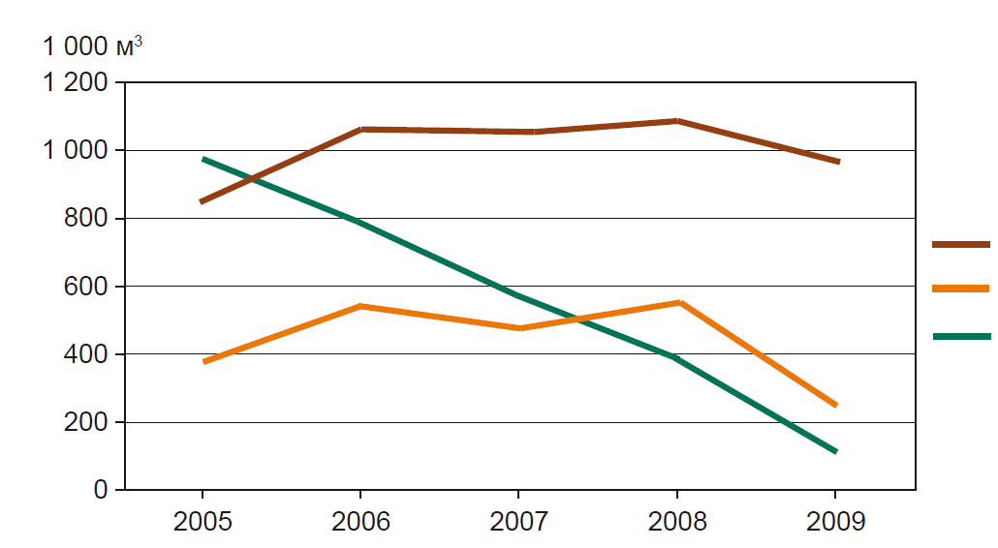
c
b
a
a – road transport; b – railroads; c – maritime transport

