St. Petersburg State University
Graduate School of Management
Master in International Business Program

ESSENCE OF RISK MANAGEMENT TOOLS IN INTERNATIONAL LOGISTICS

Master’s Thesis by the 2nd year student
Concentration – Logistics and Supply
Chain Management
Danil Antonov

Research advisor:
Vitally I. Cherenkov, professor

St. Petersburg
2016

ЗАЯВЛЕНИЕ О САМОСТОЯТЕЛЬНОМ ХАРАКТЕРЕ ВЫПОЛНЕНИЯ
ВЫПУСКНОЙ КВАЛИФИКАЦИОННОЙ РАБОТЫ
Я, Антонов Данил Александрович, студент второго курса магистратуры направления «Менеджмент», заявляю, что в моей магистерской диссертации на тему «Сущность инструментов управления рисками в международной логистике», представленной в службу обеспечения программ магистратуры для последующей передачи в государственную аттестационную комиссию для публичной защиты, не содержится элементов плагиата.
Все прямые заимствования из печатных и электронных источников, а также из защищенных ранее выпускных квалификационных работ, кандидатских и докторских диссертаций имеют соответствующие ссылки.
Мне известно содержание п. 9.7.1 Правил обучения по основным образовательным
программам высшего и среднего профессионального образования в СПбГУ о том, что
«ВКР выполняется индивидуально каждым студентом под руководством назначенного ему научного руководителя», и п. 51 Устава федерального государственного бюджетного образовательного учреждения высшего профессионального образования «Санкт-
Петербургский государственный университет» о том, что «студент подлежит отчислению
из Санкт-Петербургского университета за представление курсовой или выпускной квалификационной работы, выполненной другим лицом (лицами)».

________________________________________________ (Подпись студента)
________________________________________________ (Дата)

STATEMENT ABOUT THE INDEPENDENT CHARACTER
OF THE MASTER THESIS
I, Danil A. Antonov, second year master student, Master in International Business program «Management», state that my master thesis on the topic «Essence of Risk Management Tools in International Logistics” which is presented to the Master Office to be submitted to the Official Defence Committee for the public defence, does not contain any elements of plagiarism.
All direct borrowings from printed and electronic sources, as well as from master theses, PhD and doctorate theses which were defended earlier, have appropriate references.
I am aware that according to paragraph 9.7.1. of Guidelines for instruction in major curriculum programs of higher and secondary professional education at St. Petersburg University «A master thesis must be completed by each of the degree candidates individually under the supervision of his or her advisor», and according to paragraph 51 of Charter of the Federal State Institution of Higher Professional Education Saint-Petersburg State University «a student can be expelled from St. Petersburg University for submitting of the course or graduation qualification work developed by other person (persons)».

________________________________________________ (Student’s signature)
________________________________________________ (Date)
АННОТАЦИЯ

Автор | Антонов Данил Александрович
Название магистерской диссертации | Сущность инструментов управления рисками в международной логистике
Факультет | Высшая Школа Менеджмента
Направление подготовки | Международная логистика и управление цепями поставок
Год | 2016
Научный руководитель | Черенков Виталий Иванович
Описание цели, задач и основных результатов | Основная цель:  - Определить источники рисков в международной логистике, классифицировать их и разработать инструкцию для логистов международных компаний для управления этими рисками  Задачи:  - Раскрыть предмет международной логистики и набора логистических функций/операций  - Классифицировать риски в международной логистике, используя соответствующие научные работы, а также источники первичной и вторичной информации  - Разработать интструкцию (чек-лист) для менеджеров по логистике международных компаний  Основные результаты:  - Описание концепции оценки логистических рисков и основных этапов данного процесса  - Оценка восприятия менеджерами рисков в международной логистике  - Инструкция для менеджеров по логистике для минимизации ключевых логистических рисков
Ключевые слова | Международная логистика, Управление Глобальными Цепями Поставок, Риски в Международной Логистике, Управление Рисками, Маркетинговый Аудит, Восприятие рисков

ABSTRACT

Master Student's Name | Danil Antonov
Master Thesis Title | Essence of Risk Management Tools in International Logistics
Faculty | Graduate School of Management
Main field of study | Management
Year | 2016
Academic Advisor’s Name | Vitally I. Cherenkov, Professor
Description of the goal, tasks and main results | The main goal:  - Discover the nature of risks in international logistics, classify them, and elaborate a manual for a logistics manager charged with arranging international operations  Main tasks:  - Clarify the subject of International Logistics and a set of logistics functions/operations  - Classify international logistics risks taking in consideration relevant academic works as well as secondary and primary data acquired  - Develop a manual (set of check-lists) for logistics managers of international company  Main results:  - Logistics risk assessment concept and its key stages description  - Assessment of managers’ perception of key international logistics risks  - Manual for logistics manager to minimize major logistics risks
Keywords | International Logistics, Global Supply Chain Management, Risks in International Logistics, Risk Management, Marketing Audit, Risk Perception

Table of Contents
INTRODUCTION 7
CHAPTER 1. SUBJECT OF INTERNATIONAL LOGISTICS 10
1.1 Marketing Approach to Defining International Logistics 10
1.2 Subject of International Logistics 12
1.3 International Logistics Functions 19
1.3.1 International Logistics Mix 19
1.4 Theoretical outcomes 21
CHAPTER 2. INTERNATIONAL LOGISTICS DISRUPTIONS 23
2.1 Nature of Risks in International Logistics 23
2.2 Risk management in IL 27
2.3 IL risk assessment framework 30
2.4 Methodology 39
CHAPTER 3. FINDINGS OF THE EMPIRICAL RESEARCH 44
3.1 Classification of international logistics risks 44
3.2 Managers’ perception of international logistics risks 45
3.3. Empirical research outcomes and recommendations 47
3.3.1 Managerial implications and research limitations 48
3.3.2 Theoretical implications 49
DISCUSSION AND CONCLUSIONS 51
LIST OF REFERENCES 54
APPENDICES 59
Appendix 1 59
Appendix 2 60

INTRODUCTION
Most business related operations and activities are exposed to specific types of risks. Multiple studies have been carried out in this area. First academic papers on risk management in business date back to 1950s. The concept of risk management may be found in many subjects concerning business. Risk management frameworks are discussed and applied in various subjects, such as strategic management, finance, legislation etc. Despite this, there is a shortage of academic research on risk management in supply chain management, general logistics and especially in international logistics. The reason for that is relative novelty of these subjects and uncertainty regarding the subject of international logistics and its relation to supply chain management.
The total globalization process, based on the global transport and virtual networking and underpinned by the worldwide liberalization of international relationships (of any nature) (Cherenkov. 2005), has drastically boosted Russian companies’ involvement in international business operations. The core item of successful internationalization is presented by their global competitiveness on the world market. Searching for sources to increase the competiveness due to international transaction costs reduction the Russian companies are forced to pay attention to international logistics costs.
Speaking about international logistics risks we have to highlight following two items. First, the proper “international logistics”, what does it mean in the frame of any convenient scientific/practical definition; and in general, does this “convenient definition” exist? Second, what is the place and role of international logistics among other international business disciplines related to marketing, management, finance, law, etc? The second item, taking into account that international logistics manage almost all flows in any business (material, financial, and intellectual, personified included; internal and external; inbound and outbound; forward and reverse; domestic and global), could convert the subject of international logistics into something like a meta-science covering all things and finding difficulty in explaining anything. Therefore, defining the subject of international logistics they have to find out the essence of this multidimensional phenomenon.
As a result, in accordance with a set of international logistics definitions (e.g., Nelson & Toledano, 1979; A Handbook of World Trade, 2004; Harrison & van Hoek, 2005) analyzed by the author, the most significant determinants were determined. The antecedents of international logistics risks are the uncertainty and disruptions in global supply links between trading countries. These disruptions arise as a result of differences between national marketing environments and logistics mixes of countries involved in international trade (Cherenkov, 2010). As it was noted in a recent survey at Global 1000 companies (Green, 2004), supply chain disruptions were perceived as the biggest threat to their companies’ revenue streams.
In order to facilitate flows of trade between countries, multiple issues have to be solved in the first place. Even countries of the same region may have a lot of similarities, there is still a series of discrepancies that may hamper trade between countries. Among most distinct challenges are: level of economic development, difference in currency and exchange rate fluctuations, multiple legal procedures etc.
There are multiple logistics functions which together form logistics support. Movement of goods or services within borders of a country does not encounter distortion of logistics functions, since the environment within one country is more or less equal regardless of destination. However, challenges start to arise in case of international trade. Distortions appear when a flow of goods or services crosses national borders. The degree of distortion is linked directly to diversity of trading countries. In case, when goods cross international border of countries from the same region with similar language and identical currency (e.g. Austria and Germany, European Union), the discrepancy is at minimum. On the opposite, when the trade flow crosses the border between two substantially different countries, let’s say Russian and China, tremendous discrepancies arise due to multiple factors:
- Difference in currency;
- Infrastructural differences – railroad track width is different;
- Infrastructural limitations – inability to process required amount of containers
Thus, due to substantial differences between logistics environments of trading countries multiple distortions occur, which pose many challenges and risks for logistics manager.
Nowadays, networks of production and marketing are mostly based on outsourcing and globalization. These networks are represented by highly sophisticated and interconnected supply chain flows. As a result, any disruptions in the network (its flows) will result in adverse consequences for organizations which comprise these global supply chains. According to the famous words of Oskar Wild, there is no existence of ‘common sense’. Not a single person shares the same common perception or view of a single matter. And this concept is also may be extrapolated to risk analysis and risk management. Each manager has his own view, attitude or opinion based on personal experience on risks faced by an organization. Thus, this makes any risk perception theoretically subjective (Slovic, 1992), there is no objective risk. It is essential how managers perceive and assess international logistics risks. By the end of the day, it is the corresponding manager who estimates the risks and comes up with a strategy, a set of reactive and proactive measures or risk management.
The goal of this master thesis is to discover the nature of risks in international logistics, classify them, and elaborate a manual for a logistics manager charged with arranging international operations. The purpose of this manual is to minimize potential risks which may arise in case of international logistics.
The subject of this research are differences of national logistics environments, discrepancies arising as a result and instruments to match these environments.
Objects of this master thesis include international logistics risks and perception of these risks by logistics managers. For research purposes a number of representatives from third-party logistics providers have been interviewed. Pool of companies consists of national service providers as well as foreign firms. Operations of these firms encounter challenges crossing borders of various countries. Examples include import, export and transit operations.
In order to achieve the above mentioned goal, the author of this research aims to answer the following research questions:
- What is the subject of international logistics?
- What are the sources of risks in international logistics and how to classify them?
- How do logistics managers perceive logistics risks and how to mitigate them?
The purpose of the first chapter is to clarify the subject of International Logistics and a set of logistics operations involved. The second chapter is devoted to classification of International Logistics Risks, based on the academic works and primary data acquired from managers of third-party logistics operators, and Logistics risks management tools. In order to facilitate mitigation of risks in international logistics, a manual (or set of check-lists) will be developed for logistics managers of international company in the third chapter.

CHAPTER 1. SUBJECT OF INTERNATIONAL LOGISTICS
The main goal of this thesis is to elaborate a manual for managers of international logistics in order to reduce the dissimilarities in logistics environments of trading countries. However, prior to embarking on this goal, we need to clarify the subject of international logistics. As mentioned in the introductory part of this research paper, academic literature is littered with variety of definitions of the subject of ‘international logistics’. There is still no consensus on the relationship between the subject of logistics in comparison to supply chain management, which makes it even more complicated to clearly define ‘international’ logistics. Thus, this chapter will give the most appropriate definition for ‘international logistics’ (in author’s opinion) and clarify the subject of this matter as well as outline key functions of IL and introduce the term ‘logistics mix’.

1.1 Marketing Approach to Defining International Logistics
In the context of this research it is essential to clarify a polysemic term ‘approach’. One of the most concise definitions states that ‘approach’ is a set of techniques related to someone or something, examining something or interrelation of objects. It is believed that the biggest part of theory in terms of volume derives from conclusions of the theorem, propositions, principles, concepts, terms etc. (Novikov, 2007). Thus, we may conclude that the proof of theoretical and conceptual affinity of (international) marketing and logistics should serve as a foundation for defining the subject of international logistics. In addition, these theoretical outcomes will justify utilization of approaches, theoretical models and concepts which have been tested within framework of international marketing.
Genetic affinity of marketing and logistics
Having analyzed literature on Supply Chain Management for better clarity and visibility of the subject, an evolutionary model of SCM subject is presented in Figure 1.1. This picture reflects the genesis of SCM and can serve as evidence of affinity of marketing and logistics. It reflects close relationship between marketing and logistics activities in marketing channels (Sweeney, 2006). This idea is supported by authoritative opinion of many well-known authors of marketing theory (Swenson, 2002) as well as ‘natural indivisibility’ of marketing and logistics (Bartels, 1976a). As mentioned before, theoretical analysis (Bartels, 1976b, summarized by Hermans, 2010) has shown emergence of natural dichotomy in 1960s of previously single subject (marketing), which resulted in development of two directions – physical (logistics) and social (marketing) (Larson, Halldorsson, 2004).
The ‘genetic affinity’ of marketing and logistics will be used to clarify the subject of logistics as a part of marketing approach. This allows to use concepts, models and methods such as ‘marketing mix’, ‘marketing ecology’, comparative analytical approach’ – which is essential for better comprehension of this chapter (Moutinho, Chien, 2008). In other words, this is an
1960s
Fragmentation
1980s
Integration Development
1990s
Total Integration
2000s
etc
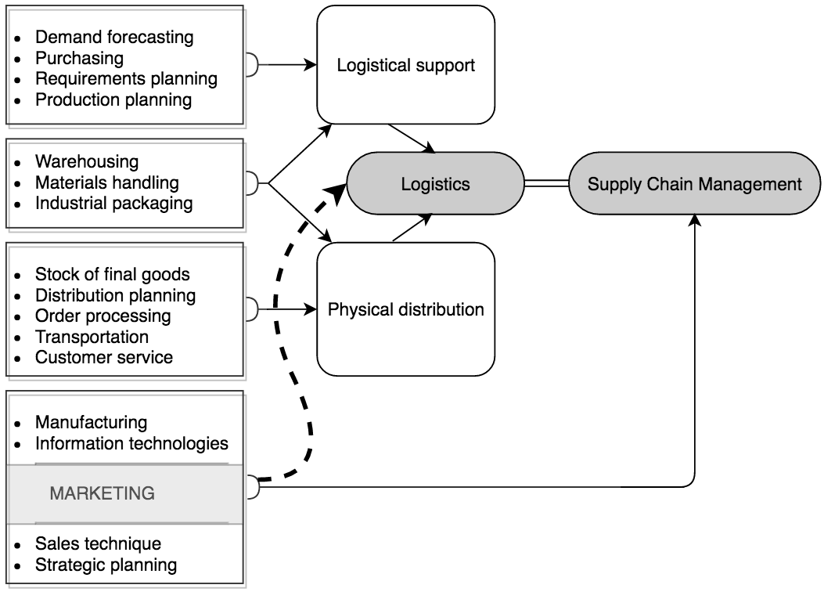
Figure 1.1 Evolutionary model of Supply Chain Management subject (Battaglia, 1994)
attempt to explicate a more mature theoretical and conceptual apparatus of (international) marketing into the subject area of (international) logistics. This approach based on international marketing (Cherenkov, 2001) can be used to define the subject area of international logistics. As mentioned above, dominant positivistic approach to defining international logistics is not adequate to the current environment as the basis for differentiation between ‘general’ and ‘international’ logistics is the fact of ‘logistics flows crossing at least one national border’.
Shifting towards subject of international logistics
An important theoretical and methodological problem is the definition of domain of international logistics for further implementation of concepts of SCM paradigm. Indeed, ‘the degree of agreement (or disagreement) among existing academic community with regard to theoretical content and dominant research paradigm’ (Fedotov, Krotov, 2011) is of great importance for further development of subject of international logistics. It is commonly believed that scientific paradigm embodies an indisputable generally accepted knowledge about the researched area of events. This “purified from oddities and enhanced” knowledge is further included in the textbooks; which future academicians will use to research their field of study. This factor contributes to further clarification of the subject of study and thus specifying the range of problems which have meaning and solution (Lebedev, 2004).
This provision is very important from a methodological point of view. For those just embarking on the study and especially the research in the field of international logistics, it is important first to get into the scope of a recognized scientific paradigm, embodying the undisputed, generally accepted knowledge about the studied area. It helps both understanding of the problems and streamlining the research, even if later the new researcher will have to revolutionize this paradigm. In addition, an attempt to define the subject area of this business discipline is necessary for the conversion of the discipline from the collection of more or less related facts and judgments into science. Understanding the subject of international logistics makes it possible to:
• analyze from the historical and logical points of view the process of defining the domain of international logistics (international logistics management), among other business disciplines;
• identify trends and outlines the following publications and the development of work programs of educational disciplines (RPUD) International Logistics (International Logistics Management);
• provide guidelines for structuring and reasonable reduction of redundancy in the preparation of follow-up training and teaching materials on these subjects;
• formulate approximate the expected topics of student final works (WRC), master's theses and research postgraduate students in such a complex and fascinating area of ​​business knowledge, as "International Logistics".
To date, logistics bibliography includes many units, content and functional affiliation of which determine the interdisciplinary nature of modern logistics, perceived as an applied science that uses the knowledge of other sciences. It was defined above, how important and diverse this ubiquitous discipline in the international business.

1.2 Subject of International Logistics
Academic literature is littered with variety of definitions of ‘logistics’ and ‘international logistics’. What makes this field rather complicated is that many definitions are semantically close to each other, others – differ substantially. In addition to that, many experts do not differentiate ‘Supply Chain Management’ and ‘Logistics’ when it comes to an international perspective. Thus, the first step should be to clarify the definition of international logistics. In order to fulfil this objective, an in-depth study and comparison and systematization of most relevant definitions should be in place.
Thorough analysis of the academic and research papers of foreign origin as well as 30 relevant Russian academic sources, leads to a conclusion that there is lack of consensus regarding which topical areas or concepts should be included into logistics or supply chain management. This notion is supported by literature review carried out by Schramm and Juga (2009). When it comes to international or global logistics and supply chain management, there is lack of unanimity regarding topical area, concepts and themes, that should be included into these subjects. Despite growing interest towards this topic, there is scarcity of textbooks on international or global logistics and/or supply chain management. In some cases, books which are dedicated to an international aspect of logistics or SCM, mostly reflect general matters. Besides, it is not so easy to differentiate concepts and topical areas of international and global logistics. Academic literature on international business contains conflicting definitions of these concepts (Schramm, Juga, 2009).
Current status of development of a conventional definition for international logistics is not much different from the statement above. Much more attention is paid to demarcation and right of precedence of logistics and SCM. International (global) logistics (logistics management), on the other hand, virtually stays behind (Niine, Koppel, 2014). Understanding, along with the majority of the representatives of the marketing community, a large part of discipline ‘Marketing’ as a business philosophy encourages the search for possibilities of application of the marketing approach to the definition of the subject of international logistics. However, before applying the theoretical and conceptual marketing tools to the definition of the subject and the development of concepts of international logistics, prior experience should be analyzed (Cherenkov, 2009).
Common approach to addressing this issue may be represented by two steps. First step - select the most authoritative definition of logistics; for example, worked out in 1998 by the Council of Logistics Management (Council of Logistics Management): (Enarsson, 2009).
Logistics – is part of the process in the supply chain, which is responsible for planning, implementation and management of effective and efficient flow of goods and services, as well as information relevant to them, starting from point of origin to point of consumption, and also provides storage, in order to meet customer requirements.
The second step - a comparison with any widely accepted definition of international logistics (e.g., What is ..., 2015), which is essentially formed by the formal "internationalization" of the previous definition by emphasizing the fact that in this case, supply chain crosses the national border.
International logistics includes management of these resources (materials and end-products) in the supply chain of the company, crossing at least one national (state) border.
This formally derived definition doesn't contain any significant characteristics of international logistics, besides mentioning obvious fact that intersection of at least one national border. Fundamentally, the definition of international logistics was devised by addition of latent notion of its international aspect – “…crossing at least one national border…”. In other words, the term corresponding to the concept of ‘international logistics’ is a tautological definition in this case. The same phenomenon can be found in the oft-cited ‘military’ definition of international logistics (Dictionary of Military …, 2005).
Negotiation, planning and implementation of measures to support the construction of logistics between two countries, their (armed) forces and (state) agencies. This includes the provision of logistic support (most important end-products, materials and/or services) or receiving logistical support from one or more allying foreign governments, international organizations or armed forces. It also includes planning and other activities related to the organization of close cooperation between major departments, operations, and elements of military logistics systems or US procedures with equally important departments, operations and elements of military logistics systems or procedures of one or more foreign governments, international organizations or armed forces on a temporary or permanent basis. In addition, this includes planning and actions associated with the use of logistic policies, systems and/or procedures of the United States to meet the needs of one or more foreign governments, international organizations or armed forces.
This atypically long definition is cited here in order to emphasize following points:
- the first appearance of logistics is connected with the art of war (Wood et al., 2002) and it still bears its traits as a vital source of competitive advantage (Abrahamsson, Sandberg, 2011)
- such a definition is a typical example of "tautological definition" or "recursion."
Another factor, contributing to the importance of development and application of a definition for the subject of international logistics, is the comparison of two definitions (general logistics and international logistics) from the same source (David, Stewart, 2010). It is clearly noticeable that the transition from the definition of general to global logistics is rather formalistic (Figure 1.2).
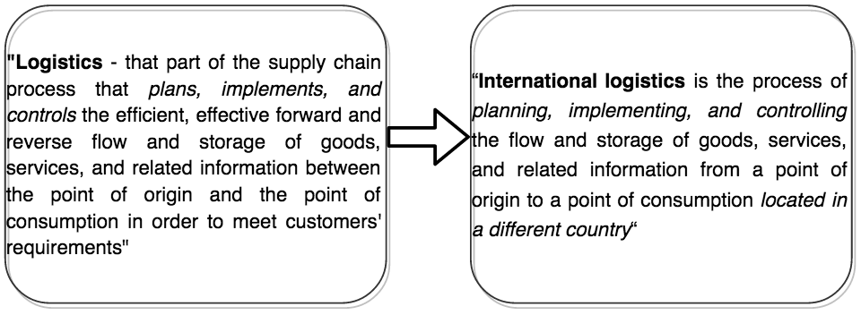
Figure 1.2 Example of formalistic approach to definition of ‘international logistics’
(Cherenkov, 2010)
Integration of global supply chains – main goal of international logistics
It is obvious that the only difference between the two given definitions lies in a group of words in italics in the right definition of international logistics – 'located in a different country'. However, if you take, for example, the supply chain between the Russian seaport of Kaliningrad as a point of origin and Moscow as a destination (consumption), then all the international nature of this supply chain, consisting of rail or road transit through the territory of the Republic of Lithuania, it does not satisfy the attribute of destination – 'located in a different country'. Same situation could be observed in case of the United States organizing supply chains over land between the point of origin in the state of Alaska and destinations - Texas. Thus, the condition 'located in another country' should be considered as necessary but not sufficient to give a complete definition of the subject of international logistics. Also (perhaps, the most important point), the above mentioned definitions are rather partial description of what is included within the (international) logistics, than the definition of what actually needs to be the subject of international logistics. At the same time, despite lack of suitable definitions for narrowing the domain of international logistics, we find (Wood et al., 2002) the most important and essential feature of international logistics – 'integration'.
Global SCM refers to the complex integration of processes, necessary for managing materials from their point of origin to final customers through processing and transportation (or even beyond it - in case of recycling).
Factor of 'integration' has become quite popular in the community of supply chain management (SCM) immediately after the concept of SCM had emerged (Cooper et. al., 1997). However, it should be noted that SCM-community mainly takes into account inter-organizational integration (Stadtler, 2005). Thus, under this approach, cross-boundary distortions or disruptions in logistics functions of global supply chains remain untapped. It should not be overlooked that the most important task of international logistics is to ensure that the structure and content of logistics functions (operations) should be in accordance with the requirements of all factions of the global marketing environment, which are crossed by the considered supply chain. It is regarded (Stading, Kauffman, 2006) as a very important task, since global supply chains may suffer from bottlenecks or even disruptions. In case of international trade transaction, integration can be considered as completed, in terms of integration of the parties (organizations), when the customer accepted the offer details of the seller or, in extreme cases, after signing of the contract by both parties. Since then, the product is legally sold and ownership of goods legally transferred to the buyer, or a person designated by him. However, the physical transfer of the goods also depends on the fulfilment of the transportation and a number of formalities, which may be unintentionally overlooked by the parties. Usually, this may occur due to absence of proper understanding of the differences in marketing environments of the seller and buyer respectively.
The exceptional complexity of international logistics, accompanied by a high degree of uncertainty in taking managerial decisions, requires that prior to defining the object of international logistics, the object of (general) logistics should be clarified. General logistics is referred to as an internal or national (based on economic and geo-economic space) logistics.
The above mentioned ‘military’ origin of international logistics is regarded as commonplace for majority of academic textbooks (Wood et al., 2002). All ‘civilian’, ‘non-military’, ‘new logistics’ or ‘business logistics’ initially (1970s) was grounded on military concept and covered mainly physical movement of goods (David, Stewart, 2010). It was mainly limited to transportation and storage. Currently, ‘logistics’ concept is more wide (Gudehus, Kotzab, 2012) and covers not only issues of physical movement of goods in space and time (i.e., execution of transportation and storage), and totality of inbound (procurement) and outbound (sales) activities, but also management of interactions between the focal company and its suppliers and buyers (i.e., information and financial flows).
Defining the domain of logistics generally, tasks of designing, aligning and optimization of systems that produce physical goods and intangible services, should be included. It is alleged that these tasks (logistics) are interconnected with production planning, technological processes, industrial engineering, operational research and other areas of technology and economics, as well as with carrying out purchasing and sales. The latter areas of logistics disclose such disciplines as ‘Procurement Logistics’ (e.g., Taderera, 2010) and ‘Marketing Logistics’ (e.g., Christopher, Peck, 2010). Existence of such subject as ‘Marketing Logistics’ (in classic textbooks usually limited to physical distribution (e.g., Stanton et al., 1991; Kotler, Armstrong, 2001; Gripstrud, 2004) confirms the the idea about ‘genetic’ relationship between logistics and marketing. In accordance with principles of unity of historical and logical approach, an insight into earlier academic papers on logistics and marketing is necessary. The emergence of explicit interest from marketing community regarding physical movement of goods from the producer to the buyer can be traced back to the 1960s. The following definition of marketing was developed in this period: ‘a set of actions that entail the movement of goods and transfer of proprietary rights” (Gripstrud, 2004). At this point a dichotomy of marketing subject may be observed which procreated two branches of research: physical and socio-legal.
Analysis of semantic field in publications related to logistics (Table 1.1) shows, that on one hand, logistics studies capture large areas of what is considered to be the subject of marketing area. On the other hand, there is a clear terminological disorder in logistics paradigm. The following conclusion may be drawn: ‘There has been an extension of marketing concept to incorporate the physical support of goods and services’ (Bartels, 1976b, summarized by Hermans, 2010).
Let us turn to the following original definition of marketing (Gripsrud, 2004). First formulated by the American Marketing Association in 1935, and reads as follows: "Marketing is a system of actions, which are involved in the organization of the flow of goods from the production to the point of consumption." The second was published in 1948 in the Journal of Marketing: "Marketing is the performance of business activities that direct the flow of goods and services from producer to consumer or user".
After familiarizing with these definitions, it is necessary to go back to the above mentioned modern definition of logistics, which was accepted by the Council of Logistics Management. Both definitions are almost identical. It can be assumed that after this fact there should be no doubt in ‘genetic’ relationship between logistics and marketing (Tek, 2013).
Thus, having risen from the isolation of the subject areas of marketing and logistics, both disciplines have found a place in the integral task - ensuring the smooth and economical operation of the supply chain (Juttner et al, 2010). As a result, subject areas of marketing and logistics are so intertwined that the subject of international logistics in terms of its positivist definition expands and becomes so vague, that attempts to define it using the positivist approach are meaningless.

Table 1.1 Semantic field of logistics in relevant publications of the 1960s
Terms, captioned in the headings of publications on logistics
Physical distribution
Physical distribution systems
Physical distribution management
Business logistics
Business logistics management
Marketing logistics
Marketing logistics and distribution planning
Principles of logistics management
Logistics management
Types and objects of logistics activities
Order processing | Transportation
Storage | Containerization
Packaging | Manufacturing and Converting capacity
Information flows
Market forecasting | Transit insurance
Supply scheduling | Communication control
Materials handling | Freight transportation
 | Customer service
Movement service
Source: Bartels, 1976b, summarized by Hermans, 2010
Summarizing all the information presented above, it should be mentioned, that there is a clear affinity between ‘marketing’ and ‘logistics’ which were historically separated due to natural dichotomy. In addition to that, the subject area of international logistics was degraded due to loss of scope by the academicians and abundance of tautological definitions (“…crossing at least one border…”). Therefore, a clear definition of international logistics is necessary. After the analysis of semantic field of the subject of logistics and having proven a clear relationship between marketing and logistics an appropriate definition was elaborated. It was suggested by Professor Vitally I. Cherenkov:
International Logistics is a movement of goods from supplier (producer or seller) to consumer (buyer or customer) which provides (Cherenkov, 2012):
- quick adaptation of logistics operations while switching between national links of international supply chain;
- minimization of relevant risks of international business;
- establishment of long-term and win-win relationships between suppliers and consumers.

The above mentioned definition incorporates the essence of international logistics as a subject of matching logistics environments of different countries within international supply chain, thus minimizing relevant risks. Therefore, the role of international logistics is to identify mismatches of national logistics environments along the international supply chain and harmonize them in order to reduce disruptions and risks associated with logistics flows crossing national borders. This interpretation of international logistics will be further used in order to define the risks related to the subject area and tools to mitigate them.

1.3 International Logistics Functions
The results of the above mentioned literature review (analysis) has shown that marketing and logistics are closely related. What is more, international logistics seems to manage almost entire totality of flows in business – financial, intellectual, physical (material), legal (laws and regulations), external and internal, outbound and inbound, reverse and forward, national and global). This may result in delusion of the subject of international logistics and transform it into a new science covering all things which will make it difficult to explain.
There is a great variety of logistics functions, however, not all of them should be defined as a subject of international logistics. Thus, the purpose of this paragraph is to identify and define key functions which are relevant to international logistics. The discussed functions are a subject for discussion in academic textbook “International Logistics” (Wood et al, 2002) and conference report on “International Logistics Management” by Cherenkov V.I.

1.3.1 International Logistics Mix
Effectiveness and efficiency of international logistics management is dependent upon properly arranged and well-performed logistics functions, such as (Encyclopedia Britannica, 1993): demand forecasting; parts/service support; documentation flow; production scheduling; customer service; purchasing; traffic management; handling returns; waste disposal; inventory management (inbound, plant, and outbound); inter-plant movements; handling of materials; order processing; plant and warehouse site selection; protective packaging; and warehouse and distribution centre management. As it was mentioned above, not all of these functions are equally specific for the international logistics management and some of them (more specific in this sense) are highlighted in italics herein. In case of international logistics – due to such simple and the most important factor of international trade as crossing borders – demands to add to the list of italicized items above some other items defined by the sense and scope of the three-fold international logistics channel (Wood et al, 2002):
- the transaction channel, which handles the buying, selling and collection of payment (could also be referred to as “financial”);
- the distribution channel, through which the good moves physically; and
- the documentation/communications channel (also may be referred as “contractual”).
As mentioned before, logistics functions can be split into three groups: outbound, inbound and overall logistics functions. Majority of manufacturing companies certainly do not overlook inbound logistics functions, but they tend to emphasize and pay more attention to outbound logistics activities since they bear more costs. Therefore, by focusing on management of outbound logistics functions companies may substantially boost performance and thus their market share. The totality of outbound logistics functions is represented by: demand forecasting, order processing, packaging, labeling, documentation, customer service, parts and service support.
Inbound logistics is comprised of three key functions such as production scheduling purchasing, and handling of returned products. Every company regardless of it being a retail chain or manufacturer, should concentrate on demand forecasting as a first step, which will allow for a more precise production and inventory scheduling for a certain period. As a next step, it is necessary to estimate required amount of raw materials (including inventory) which is necessary for a planned number of products for a certain period of time. From international perspective, handling of returned products could be perceived more as a matter of domestic operations, because it may damage or diminish competitive advantage of any producer from abroad.
It should be noted that majority of logistics functions are hard to allocate either to import issues or to export issues. For instance, terms of payment are applicable to buyer and seller equally. Traffic management, transportation of people, interplant movements, site selection for warehouse, materials handling – are other functions which were mentioned in this paragraph. However, thorough discussion of each and every of them is outside the scope of this research paper.
Overall, the totality of international logistics functions can be defined as an international logistics mix. Performance of all these functions altogether facilitates movement of goods and services from seller to buyer (Table 1.2). Cherenkov V.I. and Dikalo D. (2012) gave a definition to their concept of logistics mix: “…a set of contracts, supplementary documents and also procedures that provide the legal and unimpeded movement of goods and relevant to these goods information between the seller and the buyer, while passing through a frontier”.

Table 1.2 The key structure of international logistics functions/operations
 | Logistics flows
 | Inbound | Outbound
Functions | Operations
Precontractual | - Supplier selection  - Issuing a request  - Offer analysis  - Issuing the counteroffer  - Acceptance/rejection of the offer | - Customer selection  - Issuing the offer  - Analysis of the counteroffer
Contractual | - Analysis of terms of the contract  - Contract entering and follow-up
Documentary | - Preparation/verification/obtaining of documents  - Document transfer
Transportation | - Conclusion of a transportation contract
- Packaging
- Labeling
Warehousing | - Inventory management (dispatching)  - Cargo handling
Financial | - Contract settlement operations  - Payment of fines
Control | - Goods receipt (quality/quantity) | - Goods inspection (quality/quantity)
Cross-border | - Customs import clearance | - Export customs clearance
 | - Safety clearance
Source: Cherenkov & Dikalo, 2012

1.4 Theoretical outcomes
This chapter was dedicated to clarifying the subject area of the international logistics. Authors have identified that many academicians perceive Supply Chain Management and Logistics as similar concepts and do not differentiate them clearly. There are three main views on this subject: inclusionist, evolutionist and intersectionist. All of them are based on the historical relation of logistics and SCM, it is perceived as a part of SCM, or a preliminary stage prior to SCM development or as an intersection of subject areas of Logistics and SCM. Thus, it is very easy to get lost. For the purpose of this research paper, an inclusionist view has been adopted.
In addition to that, there is an abundance of various definitions of “logistics”, some of them are similar to some extent, others differ a lot. Literature review on this matter revealed lack of convenient understanding of the term “international logistics”. International logistics is considered to be a collection of vital functions that support any international business, however its subject didn’t have any convenient definition till today. Good knowledge of International Logistics should provide international trade managers with means for mitigating corresponding risks (Cherenkov & Dikalo, 2012).
The authors analyzed authoritative definitions of “international logistics” and came to a conclusion, that it was developed by simple addition of the “international” part by “…point of origin and point of destination located in different countries…”. Results of studies of semantic field of international logistics facilitated creation of a new clearer (to authors mind) definition of “international logistics” (Cherenkov, 2012): International Logistics is a movement of goods from supplier (producer, seller) to consumer (buyer, customer), which provides:
- quick adaptation of logistics operations while switching between national links of international supply chain
- minimization of relevant risks of international business
- establishment of long-term and win-win relationships between suppliers and consumers
As a next step, a set of key international logistics function was defined as its crucial components. These components in total form national logistics mix. Supposedly, they are the key sources of international logistics risks as major mismatches between home country logistics mix and host country logistics mix cause disruptions. These disruptions occur due to differences in marketing environments of trading countries. Very often logistics managers neglect these dissimilarities and do not adjust their logistics mix as a result of human factor. Therefore, the author of this research sees the target function of international logistics management as “…adjusting the home country’s logistics mix to the dissimilarities of the host country’s dimensions of marketing environment that are significant for transferring goods through the frontier between those home and host countries for the purpose of decreasing (minimizing) transaction costs and risks of international trade (business)” (Cherenkov, 2012).
Chapter 2 of this thesis is dedicated to a concise overview of major international logistics risks. After that it is important to develop a risk management framework relevant to the subject of international logistics. It is a preliminary stage for development of a tool for managing dissimilarities between home and host countries’ marketing environments. In conclusion to chapter two, the author describes the research method applied for an empirical part, as well as tools for gathering data and its processing.

CHAPTER 2. INTERNATIONAL LOGISTICS DISRUPTIONS
So far, it was established that the subject of logistics risk management is lacks sufficient research, which makes it vital to take a closer look at gaps in this field that were mentioned in the first chapter. Having devised a clear and concise definition of international logistics (to authors mind) and identified logistics mix as a set of inbound, outbound and general logistics functions, set a background for development of a logistics risk management methodology and its further application.
The main objective of second chapter is to develop a methodology of international logistics risk assessment. As a first step, the author will discuss the nature of risks in international logistics and existing frameworks for their management and assessment. The result of the chapter would be the methodology, which would be used further on for assessment of risk perception by logistics managers and a framework for creation of a tool to match national marketing environments’ mismatches. At the end of this chapter the author describes the methodology for the empirical research.

2.1 Nature of Risks in International Logistics
Globalization of international business has shown that economic and political events in various countries and regions have a significant impact on extension and deepening of the set of business relate risks faced by international companies. In addition to global financial and economic crises, global terrorism poses real threat to international companies in terms of personnel safety and business operations’ performance. Political risks also have a negatively impact international business operations. Latest example are the economic and political sanctions which were imposed on Russia in 2014 by the EU countries, USA, Canada, Australia and Japan. This resulted in disruptions in multiple global supply chains. Various companies suffered substantial losses both – in Russia and in countries which initiated the sanctions.
The survival task of business, largely identified with the achievement and preservation of global competitive advantage, can be represented in economic terms as the task of establishing marketing ecologic balance (Cherenkov, 2002). In this case, every single business (unit) is represented as a complex global integrated marketing channel (Cherenkov, 2003b), which includes at least two channels (e.g. exporter and importer) with a logistics flows (physical, financial and informational) between them (Alesinskaya, 2005). It is important to mention that the structure of modern world global economic network predetermines the distribution of not just logistics flows but international business risks as well (Cherenkov, Belotserkovtsev, 2006).
Therefore, even in case of such simple and common business operation as export (Figure 2.1), superposition of international business risks should be considered. It is represented by three fractions of global marketing environment (Cherenkov, 2003a): domestic, host country and international (or regional).
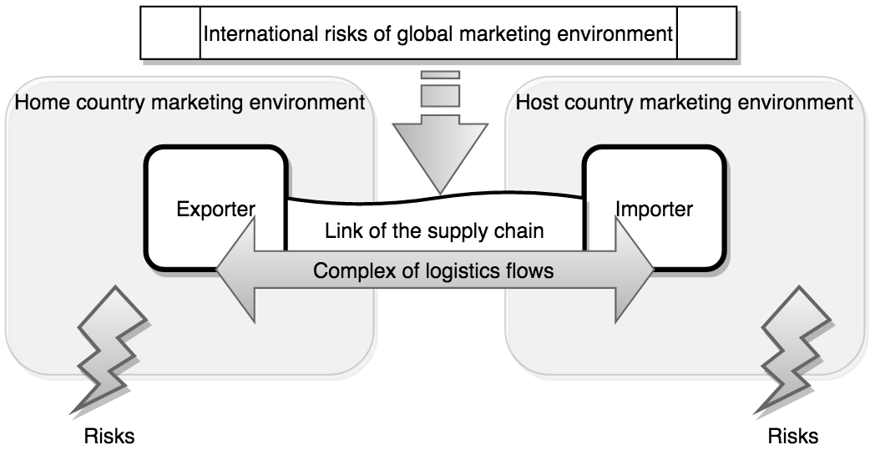
Figure 2.1 Position of international business risks effect on logistics flows
In modern conditions of total globalization, world economy appears as a meta-system of business networks with macro (regions, states) and meso level (MNCs, production and marketing clusters). Moving branches of global supply chains across borders of national/regional marketing environments almost always bears a potential threat of risks in international logistics. The discrepancy between the components of the domestic ‘logistics mix’ and the corresponding dimensions of the marketing environment of the recipient country, leads to distortions and gaps in logistics functions, this is, in fact, is a source of international logistics risks – origin for risks in international business. It is noted, that risks in the logistics chain of a company imply complications for risk management (Smith, Fischbacher, 2009). In modern conditions risks, which are provisionally classified below, show the most complicated pattern of interinfluence. A prime example of this is the current tension between Russia and Ukraine and its consequences for gas supplies to Europe. This crisis has led to disruptions in global marketing environment network and resulted in legal (bankruptcy) and even physical elimination of micro economic entities as well as elements of production and marketing infrastructure (the result of military operations in the Ukraine).
Taking into account the fact that risk has many underlying causes, relevant determinants and relationships for which are not fully known, the economists also use a probabilistic approach to assess possible outcomes arising from the same particular event. The probability of occurrence of adverse events is one of the two main risk perception factors by logistics managers of international companies (Cherenkov, Dikalo, 2012). On the other hand, for most logistics managers risk, probabilistic nature of which derives from the uncertainty, is perceived through such a critical characteristic of any business as profit or loss.
Despite the fact that with regard to perception of risk for international logistics probability of its occurrence and the result are of almost equal importance, uncertainty still remains as a prevailing factor - an inherent feature for any business, as well as for all the phenomena of the material world (Ibid). Therefore, the first step for any risk management system should be reduction of the uncertainty. This is particularly relevant in the case of international business, where due to cross-country (as well as cross-cultural) differences accurate assessment of risk and selection of adequate technology/instruments for risk management are hindered. Prediction of emergence of a risk in a certain fraction of the global marketing environment is hampered as well.
Ultimately, the nature of the risks of international logistics lies in the logistics managers’ lack of awareness about the state, as well as about the changes in logistics dimensions of those national fragments of the global marketing environment (Fig. 2.2), which should cross the logistic flows of the global supply chain. Lack of such knowledge - regardless of whether its source is a low qualification or negligence of managers of international companies, or unexpected changes in the logistic dimensions of relevant fragments of the global supply chain - produces a diverse set of risks. Both the probability of occurrence and the importance (‘weight’) of individual risks together represent a great variety, constituting the complex problem of risk management in international logistics. Naturally, this state of the subject has given rise to a lot of approaches to the solution of this problem, however, the first step should start with classification of international logistics risk.
Mainly the international logistics risks are associated with transporting goods from one country to another. However, keeping in mind that in the very common sense international logistics is about cross-border moving goods (and other production/marketing resources) in space and time, international logistics managers are to arrange and get executed following kinds of contracts. Risk is an important concept in many business fields. There is a huge volume of literature on risk covering a range of disciplines from mathematics to psychology. Each of approach to international logistics risks can contribute to a better understanding of how these risks are constructed, perceived and managed by international logistics managers. Risk is a very interesting topic to be discussed and many authors try to present an assess risk problems. However, a task of reviewing logistics risk related literature (made by authors before) is out of the frame of the present paper.

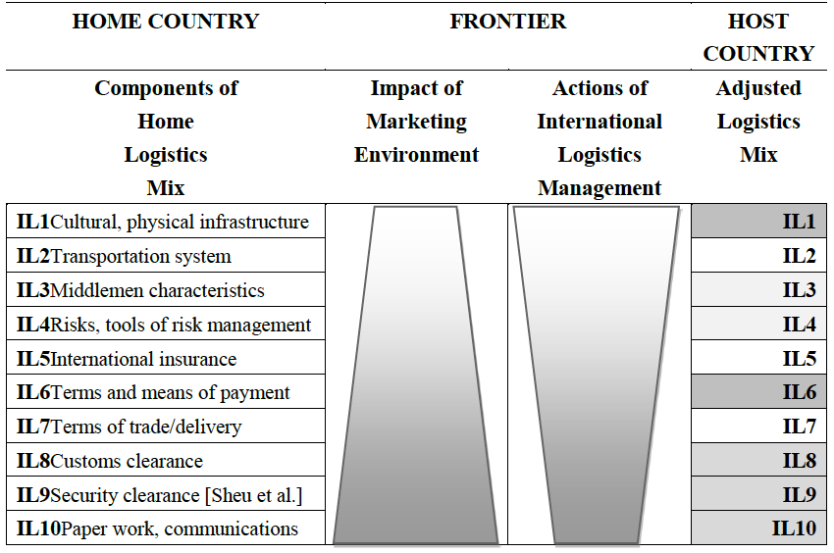
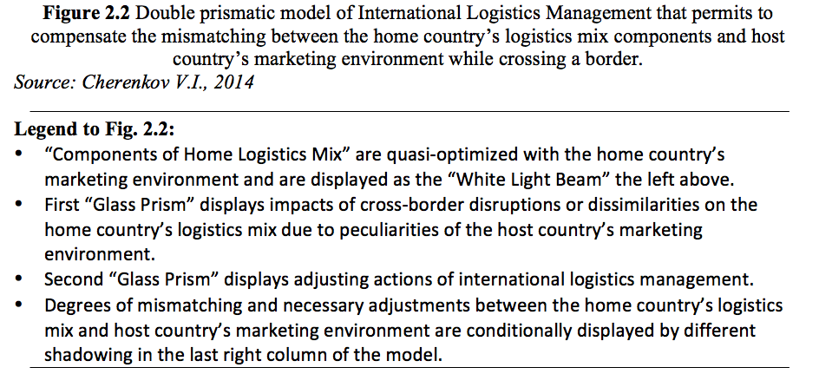
One of features of international trading is the fact that executing any international sale-purchase contract means factually means to execute three interrelated transactions that have to grant: 1) the physical movement of the merchandise, where manager meet much more complicated task and higher risk than in the case of a domestic movement because there are, as minimum, many not-well-known terminals and transshipments in an international shipment than in a domestic one; 2) the title transfer using financial document transaction including very sophisticated and risky to make errors work with bank commitment letters, drafts, letter of credits, insurance policy, bid bond, performance bond, certificate of deposits, letter of guarantee etc.; 3) huge and demanding high competencies “paper work” with international trade documents: commercial documents (invoice, packing list, quality inspection and etc.), official documents (health certificate, import license, certificate of origin, and etc.), transportation documents (bill of lading, trucker bill, railways bill, airway bill, ocean carrier bill, and etc.).
In accordance with the main goal of our study the conceptual model of overall perceived international logistics risks is presented herein (Figure 2.3). Antecedents of international logistics risks leading to disruptions in global supply chains are split here into two clusters: 1) logistics management related antecedents derived from contract, payment, and delivery uncertainties; and 2) market dissimilarities antecedents derived from not-well-known and/or fast changeable non-controllable marketing variables.
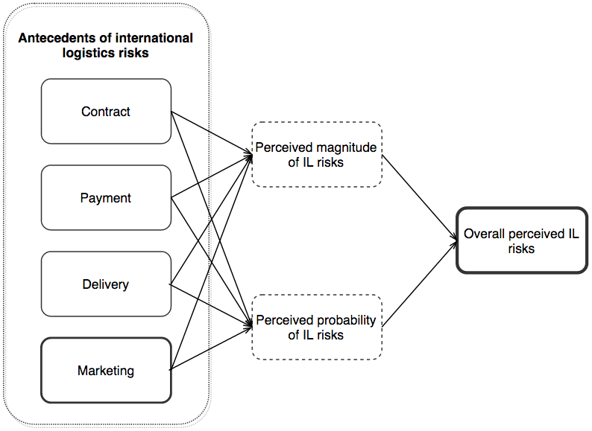
Fig. 2.3 Conceptual model of overall perceived international logistics risks

2.2 Risk management in IL
As it was mentioned in previous paragraph, implementation of a proper risk management practice is an essential step to fulfill corporate goals and objectives and cope with risks that company encounters. After a number of substantial corporate crises and bankruptcy cases that led to drastic financial losses and even economic downturns of whole country, a series of acts and regulations were adopted. Most developed countries nowadays have specific regulatory requirements in place regarding proactive and reactive actions, compliance, monitoring and analysis of risks (Kajüter, 2003). This led to a boost of importance of compliance functions within organizations, with Chief Compliance Officer (CCO) and Chief Risk Officer (CRO) now coordinating operations throughout the whole company. Their job is to build-up risk resiliency of a company – enabling certain frameworks to overcome or mitigate risk events and keep the business heading towards its goals. One of the most common frameworks for risk management process is comprised of four steps (e.g. Terry, 1972): risk identification, risk assessment, risk mitigation and control.
Risk identification
The first step of the above mentioned risk management framework is concerned with identification of risk which will be later managed. This makes this step the most important as it lays the foundation for all further steps of risk management. Critically, it is hardly possible to identify all possible potential risks due to their nature and abundance of factors behind them. Another important issue to mention is that risk identification itself results in costs, thus it is crucial to estimate benefits of managing certain risks and costs associated with their identification. In addition to that, minor risks may be harmless on their own, however, when accumulated they pose substantial threat. Continuous risk identification as well as risk management process is vital, since companies face perpetual changes both inside the organization and supply chain and external environment (Eberle, 2005; Singer, 2012).
Academic literature is littered with various methods for risk identification. According to Romeike (2003a), checklists, interviews, SWOT analysis (strengths, weaknesses, opportunities and threats) are concerned with current and rather obvious risks. On the other hand, brainstorming, brainwriting as well as failure mode and effects analysis (FMEA) facilitate identification of future (potential) and unknown risks. Thus, combination of methods may be found optimal (Eberle, 2005). Taking into account the applied method of risk identification, risk classification may facilitate the process step. This means that there are multiple ways to classify risks. Various academicians have their own classifications. For example, Narasimhan and Sahasranam (2007) distinguish strategic, operational risks and tactical on the planning level, while Tummala and Leung (1996) stress out critical, catastrophic, negligible and marginal risks with regard to severity. Another example is presented by Rogler (2002) who underlines production, supply, financial, distribution and personnel risks, while Christopher and Peck (2004) concentrate on business function or operation – demand, supply, process, environmental and control risks. Risk classification can go even further into details and split transportation risks, which are part of both supply and distribution risks, into quantitative (partial destruction during transportation), default (loss of entire cargo), costs (increase in transportation costs), quality (damage during transportation) and time (delay or earliness of delivery).
Risk assessment
Just as in case of risks classification, there are various approaches to risk assessment. However, there two most common factors of risk perception – the likelihood of occurrence and potential damage in case the risk takes place. Evaluation of risk perception can be carried out either qualitatively or quantitatively. While quantitative methods provide a more precise estimation of risks, it requires substantial amount of historical data for projections to be made. This data is rarely stored or collected, especially taking into account uncertainty about which events and which characteristics of these events should be tracked. Qualitative methods usually are perceived as subjective because they are based on managers’ perception of risks which are subjective by nature. However, the latter require less time and effort.
Such instruments as brainstorming or FMEA mentioned above, may also be used for risk assessment. Application of several tools may be found sensible as was mentioned by Romeike (2003b), Ziegenbein (2007) and Singer (2012). A good tool for visualizing certain risks is perceptual mapping. The map consists of two axes “probability of occurrence” and “severity of damage”. Scaling for these axes is set either qualitatively or quantitatively (Kajüter, 2003). After risk assessment technique is employed and carried out, risks are prioritized and are ready for the next step – mitigation strategy.
Risk mitigation
The third step of the risk management framework is represented by mitigation strategy. With regard to the type of risk, the organization, its supply chain and goals, company’s management are to devise a set of measures or strategy to avoid, transfer, share or accept the prioritized risk. Much like with risk identification and assessment, elaborating on the risk mitigation actions, costs of implementing these measures as well as potential recurrence of this risk should be taken into account. A certain strategy may be comprised of a set of different measures - “… the creation of a unique and valuable position, involving a different set of activities” (Porter, 1998). Thus, there is an abundance of various actions aimed at handling risks.
Risk control
As a final step of risk management framework, it is essential to monitor and control, whether necessary actions were taken and whether they had positive effect. Usually, further actions need to be taken, since the external and internal environment of the company are constantly changing and have to be taken into consideration. One of the most popular methods of risk control is balanced scorecard, which was mentioned in academic papers of Kajüter (2003) and Singer (2012). Thus, iteration of risk management framework is essential due to fluctuations and constant changes within and outside the organization over time (Eberle, 2005).

2.3 IL risk assessment framework
There are various approaches to analysis of logistics risks and authors perceive the process in very different ways. The frameworks still pursue one goal and have similar general structure. Figure 2.4 presents the steps needed to make to achieve stated goal which was formalized by Cohen and Kunreuther (2007). Authors state that amongst all the elements of the supply chain risk analysis framework, first of all, it is about the risk perception, risk assessment and vulnerability analysis. These two issues focus their impact mostly on affecting risk management strategies formalization. As soon as the strategy is formalized, it is to be followed by evaluation of the strategy. Following part of the chapter would be based on the existing approaches of assessing the logistics risks.
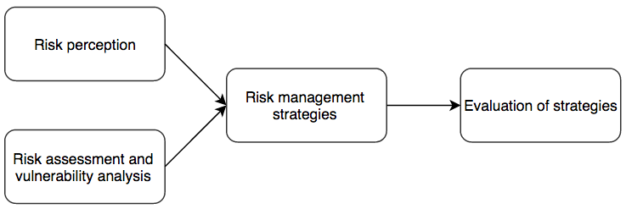
Figure 2.4 Supply chain risk analysis framework (Cohen &Kunreuther, 2007)
The procedure of supply chain risk assessment cannot be carried without answering two questions that arise as soon as one understands what the logistics risk assessment means (Harland, et al., 2003; Zsidisin, 2003a). First question to answer is the probability of occurrence of a certain event that is considered as a risk. Second question is the importance of consequences of the event that is considered.
This step with answering these two questions is vital for logistics risk assessment and is a starting point. Mistakes in this part may make the whole further steps useless and make companies lose time. There are evidence in articles that successful companies do pay much attention to assessing the logistics risks. Example of that can be IBM company (Gautam, et al., 2007). Still, vast majority of academicians claim that companies are reluctant to accepting this to their daily practices (Kouvelis, et al. (2006); Zsidisin et al., 2004).
Variety of tools and approaches of assessing different types of risks is another issue that needs to be taken into consideration, as it brings to different results, different representation of results and they all are hard to fit in one database. When thinking of approaches, first variants that come to one’s mind are based on historical data, but this is often impossible due to lack of such information. Taking into account the complexity and width of the external environment of the supply chain, it is rather complicated to select a certain approach or tool for risk assessment (Juttner et al., 2003).
As a next step, managers need to assess likelihood of risk occurrence and its potential consequences (damage or losses) with regard to certain geographical location (Knemeyer, et al., 2009). It should be mentioned, that prior to risk assessment (probability and severity), risks have to be identified in the first place. This step is called risk identification (Norrman & Jansson, 2004).
It facilitates identification of risks relevant for the company and its supply chain and as a next step these types of risks will be assessed and prioritized. There are various researches that were conducted in order to summarize available approaches to assessing the supply chain management risks (Norrman and Jansson ,2004; Zsidisin, Ragatz, Melnyk, 2004; Zsidisin, Ellram et al., 2004).
The conceptual methodology is meant to represent a research methodology that describes basic, fundamental concepts on supply chain risk management. Descriptive is a methodology that descripts, formulates, and creates models in supply chain risk management. Empirical methodology is one in which the data for study is taken from existing database, case study, literature review, taxonomy or typology approaches. Exploratory cross-sectional is a methodology where the information is collected at one point in time through survey. Exploratory longitudinal is a survey methodology where data collection is done at two or more points over time in the same organizations.
There exist today numerous approaches to assessment of risks. The vast majority of them have their origin in several basic methods. To begin with, Check Lists, they are arranged in a form of questionnaires, that are distributed amongst people that are in the system. Answers that are gathered estimate security level that is present. Disadvantage of this method is high level of subjectivity, gives no financial data and are strictly limited to the issues that are included in questionnaires and may lose attention over some other specific factors. Delphi-technique is carried with the help of a group of experts from the organization that is brainstorming together a certain topic. The results of using this method are often trustworthy, though bases on very subjective opinions.
Estimation of frequencies of threats, expected damage costs are the numerical outcomes of the analysis. To have more exact results in order to secure the supply chains there are taken into consideration different factors and issues. This method and those that were mentioned above, are general and let develop on their basis some more specific and exact ones.
In order to use resources in a smart way and not waste the capital of the company, evaluation of key issues and problems that are faced in the supply chain, should be done for specific arts of the chain, prioritizing them. There should be highlighted the most common threats that are met and discussed the probability of their occurrence. Best approach here is the expert opinions, but when using such approach here rises the risk of over subjective opinion of low quality of service as companies tend to save money on such issues. One of methods that uses expert opinions is Delphi technique, which lets take out of the group of experts most of the knowledge and data that they have via multiple steps of the Delphi method. Another approach is the combination of yet expert opinions with historical data that is available. (Zsidisin,et. al, 2000). Examples of such methods can be extreme value theory or bounding methods.
Supply chain is not a single entity, it consists of several companies and has risks in all of them. Interconnection of the companies make them depend on each other highly. This brings to the fact that companies need to assess network risks, as it is mentioned by Juttner (2005). The assessment of this kind can be carried with the help of soft tools or of classical risk management techniques. Still, there are opinions like that of Hallikas et al. (2002), who state that for better understanding of risk qualitative risk assessment tools are better not be ignored as they bring to better understanding of supply chain and logistics risks. There are common and often used techniques, probability ratings, impact of risks on the scale of 1 – 5, simulation modeling in order to evaluate impact the disturbances have on supply chain is general and specifically and, finally, expert opinions (Hallikas, et al., 2002; Norrman and Jansson, 2004; Knemeyer, et al., 2009; Vanany, et al., 2008).
Risk perception
Settling probabilities of risks can be a problematic issue due to the problem of subjectivity. For the results of assessments to be more trustworthy, there can be carried cross - functional and cross-company approach. Used methodologies should be updated constantly.
Perception of risks by managers is of high dependency on psychological and emotional characteristics of each person (Cohen and Kunreuther, 2007). Very often managers base their perception of risks not on its probability, consequences, but on their personal issue that make them make this or that decision (Slovic, Finucane et al., 2002). Distortion of perception is most often met in situation with high consequence risks with low probability. These risks are most of all misunderstood and misperceived.
Therefore, it is critical to understand how managers can cope with such problems. Company's strategies creation can suffer from manager’s underestimation of any risks. Risk observation is the main intensity that keeps companies moving. There are not many researches that can cover this field broadly in logistics sphere. It is vital to collect different opinions about any risks (Ellis et al., 2010, Cohen and Kunreuther, 2007; Zsidisin 2003b).
Managers perception of risks and understanding of their importance often becomes the driving force in future decision making processes. If risk is underestimated on primary stages, it causes mistakes on all further levels (Cohen and Kunreuther, 2007).
Even when managers want to take into consideration risks of low probability, it is quite difficult for them, as they have low expertise in it, have low informational support.
There is evidence in literature that proves that managers often have very diverse attitude to risks and approaches to its assessment. Most commonly, managers tend to lose track of risks and prefer not to assess them or their consequences (Tang, 2010). This brings often to situations where risks in general are underestimated and companies being not ready to face risks, lose time, money and reputation. Unwillingness to accept high probability of risks occurrence may ruin the company. Mitigation of risks and especially consideration of this in advance is hard to implement. It is as well difficult to evaluate the efforts of the manager that were made in process in order to reward the manager (Ellis et al., 2010; Seshadri et al., 2005).
However, some academic papers on psychology of risk perception by managers suggest that managers tend to concentrate on risks with low probability in case they may incur severe damage or loss for organization. Managers tend to base their decisions and strategies on the extent of probability, but not the consequences, which they do not evaluate often (Lovallo & Kahneman, 2003). As soon as managers see that risk has low probability of occurrence, they try to stay positive and ignore costs that they might face.
Psychological aspect of risk perception is of high importance as misunderstanding and undervaluing risks and their consequences are widespread among managers. This problem is offered to be tackled via cognitive dissonance theory, which is presented by Knemeyer (2009) and covers all the problems and ways of communicating in case there arise two contradicting attitudes and ideas that workers share, but do not notice and let themselves be misled, causing problems to companies that they are working for. It is known commonly that very often perception of probability and price to pay in terms of risks are perceived in a wrong way. Managers see low probability of risk occurrence and do not consider the amount of losses and costs they would have to pay in case the problem arises and it all makes them chose wrong strategies (Ellis et al., 2010).

Risk sources and risk classification
Any approach to making strategic and operational decisions in international business includes, in addition to strategic decisions on the choice of ‘product – market’, a task to assess the risk (or rather, set of risk factors, or risk vector) of a planned international business transaction. The monosyllables term ‘risk’ has a considerable popularity and is widely used, ranging from the definition and use of informal risk assessments in everyday life to the philosophical problems of determining the nature of the risk. Hardly any recent academic paper on the problems of the world economy and politics goes without at least a short notice of the risks. At the same time, the academic approach to the definition of risk is not always evident in these works, thus, this subject needs to be clarified. We will apply a marketing approach to international logistics. This will allow to use one of the definitions for international business risk - the possibility of occurrence of an unknown or partly known event, the outcome of which is negative for the development/existence of a separate business as a whole or for one of its transactions. In the case of international business such event is most likely to happen in the external marketing environment of the company on its meta-level (global economy as a whole) or on a macro level (national or regional economic system). Assessment of risk is related to both the completeness of obtained marketing information and correctness of its interpretation as well as with the subjective psychological perception of the risk by management of international company. Range of perceptions often includes positive expectation of big benefit in case of high risk.
Considering the possible existence of a single and universal risk assessment tool (e.g., in the form of some kind of a complete and self-sufficient system of criteria), its existence is questionable and the search for such tool is rather complicated. It is due to the fact that the uncertainty of risk occurrence is amplified by the uncertainty of its perception by the management. In other words, the posing danger changing object of the external marketing environment of a company have to be assessed by a subjective tool, i.e. in accordance with the subjective criteria devised by the management. Each manager making decisions applies his own self reference criterion (SRC), which means he instinctively refers to his own system of accumulated cultural values, experience and knowledge as a basis for decision making. It is on the basis of this criterion that logistics and marketing managers differentiate countries or markets and outline a decisive information regarding a particular product (market, competitor etc). Possessing sufficient experience in certain markets, managers do it almost intuitively, without resorting to extensive and abundant formal marketing research. However, the complexity of the detection problem and interpretation of risks should not be a valid argument in terms of impossibility to anticipate (to some extent) and adequately (to some extent) respond to these risks. It is well-known (Vujacic et al, 2013), that the process of risk management consists of four key steps:
- risk identification;
- risk assessment;
- risk management itself;
- risk monitoring.
Thus, the classification of risks in international logistics, being the basic tool for their identification (also setting the direction for further steps), is the original and integral part of any risk management system including international logistics management.
Modern literature on risk management is rich in risk classification systems, where the principles and criteria for classification depends on the industry sector, and often on author's position (Degtyareva, 2006). In any case, it is difficult to argue, for example, against such obvious statement (Brodetsky et al, 2010), that the diversity of the risks can be divided into two types:
- risk of losses (real damage)
- risk to miss opportunity (loss of opportunity)
Based on perception of the key role of international logistics as a "binding framework" of international business, it is possible to identify most common approaches to classification of international business risks. Thus, depending on the expected impact (or outcome of a risk event), risks can be divided into two major groups: pure and speculative risks:
- pure risks imply the possibility of a negative or zero result. These risks include natural, environmental, political, transport and part of commercial risks (property, production and trade). Pure risks are typically a subject to insurance, whereby the risk is transferred to the insurance company;
- speculative risks are characterized by a possibility of a positive or negative outcome (for example, stock market). These risks include financial risks, which are part of a large group of commercial risks (Table 2.1).

Table 2.1 Classification of financial risks of a company
Classification criterion | Kind of risk
Possibility of insurance | - Insurable risk;  - uninsurable risk
Possible consequences | - Causing financial loss;  - loss of potential profit;  - causing losses or additional income
Losses with regard to company’s financial condition | - Acceptable risk;  - critical risk;  - irretrievable risk
The object of occurrence and scale | - Risk of a certain financial transaction;  - risk of various types of financial activities;  - risk of financial activity of a company in general
Scope of occurrence with respect to the company | - External risk;  - internal risk
Possibility of further consequences of risk | - Simple risk;  - complex risk
Duration | - Constant risk;  - temporal risk
Ability to anticipate | - Predictable risk;  - unpredictable risk
Source: Skamay, 2000
Commercial risks represent the danger of losses within financial activity. They imply uncertainty of the outcomes of a particular business deal. Based on structure and meaning commercial risks are divided into property, operational (production), trade and financial:
- property risks - probability of loss of property as a result of theft, sabotage, negligence, overload of technical and technological systems, etc;
- operational (production) risks - associated with losses due to suspension of production as a result of impact by various factors, first and foremost - with the loss or damage of fixed and current assets (equipment, raw materials, transport, etc.), as well as risks associated with the introduction of new techniques and technology;
- trade risks - associated with a loss due to delayed payments, non-payment of goods during transport, non-delivery of goods, short supply of goods, the non-acceptance of the goods, etc .;
- financial risks - probability of loss of financial resources (cash). As a first approximation, financial risks can be divided into two types: the risks associated with purchasing power of money and risks associated with capital investment (investment risks).
The next group of risks is related to such phenomena as price volatility of securities and exchange rate of national and foreign currencies. This group is represented by inflation risks, deflation risks, currency risks and liquidity risks:
- inflation risk - devaluation of real purchasing power of money income at a rate that exceeds their nominal growth, thus the entrepreneur suffers real losses;
- deflation risk - risk that deflation is followed by falling price level, deteriorating economic conditions and reducing business income;
- currency risk - associated with foreign exchange losses due to exchange rate fluctuations, during foreign trade operations, credit and other currency-related transactions;
- liquidity risk - possibility of losses associated with conversion of securities or other products due to changes in perception of their quality and consumer value on the stock market and/or in the OTC (over-the-counter) trade.
Monetary and financial terms of the international purchase and sale contracts, as well as the settlement of these contracts, play a critical role in international logistics. Indeed, financial risks are at the forefront of international logistics, as the system of international logistics management involves a contractual trinity:
- Sale and purchase agreement (SPA) itself – definition of conditions of a legal transfer of the ownership of the goods.
- Shipping contract - determines the conditions of physical movement of goods from the seller to the buyer (or the person designated by the purchaser), supported by a set of title and shipping documents, which can be divided into the following groups:
- commercial documents (invoices, packing lists, quality inspection instruments, etc.);
- official documents (phytosanitary certificates, import licenses, certificates of origin, etc.);
- transport documents (bills of lading, motor waybills, consignment notes, air waybills, etc.).
- Monetary and Financial Provision of contract execution, formalized by means of financial documents (such as letters of credit, bank guarantees, drafts, deposits, insurance policies, etc.).
Monetary and financial security plays a critical role in international logistics, this can be supported by the following quote: "After all, any sale is a gift, until the payment is received. Understanding how to ensure the payment of export transactions is especially critical, since your buyer can be 10 000 miles away from you” (Chrisbaum, 2003).
In addition to the discussion about the role of monetary settlements in international logistics, it is possible to expand the list of financial risks on investment risks, since, in practice, any of them could influence, if not directly, then indirectly, the logistics flows of international business.
Investment risks include the risks of loss of profit (opportunity costs), profitability downside risks and risks of direct financial losses:
- Profit risk - the risk of indirect (side) financial damage (lost of profit) as a result of failure to exercise a sort of investment, speculative or protective financial and credit measures (insurance, hedging, investment, etc.).
- Downside risk - the result of interest and dividends reduction on portfolio investment, on deposits and loans; this includes the risk of interest rate risks and credit risks:
  - interest rate risks - the risk of losses by commercial banks, credit institutions and investment institutions, which occur due to excess interest rates paid on funds raised by them, over the rates on loans;
  - Credit risk - the risk of non-payment by the borrower of the principal (the principal) and interest (interest) owed to the lender;
- Risks of direct financial losses include the following varieties: market risk, selective risk, the risk of bankruptcy.
  - stock market risks - the risk of losses from unfortunate stock exchange transactions (commercial transactions’ non-payment, non-payment of commission, etc.);
  - adverse selection risks – the wrong choice of types of capital investment, the type of securities for investment in comparison with other types of securities when building a portfolio;
  - bankruptcy risks - the risk of a wrong choice of the recipient of the invested capital, total loss of the entrepreneur's equity, and his inability to meet the obligations.

2.4 Methodology
The research methodologies applied in management science can be split in two large categories: qualitative and quantitative research. The major approaches to research in supply chain management (see figure 1) consist of surveys, case studies, action research and modeling supply chain (Kotzab et al, 2006). First three methods correspond mostly to qualitative research and modeling supply chain refers to quantitative research.
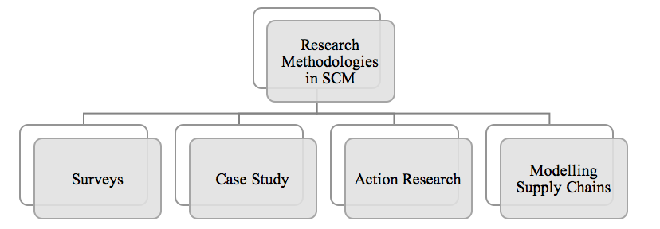
Figure 2.5 Research Methodologies in Supply Chain Management
The first field of research in supply chain management corresponds to surveys. According to Larson & Karen who have examined all editions of Transformational Journal, surveys contribute to 30-60% of all research articles (2006). The survey-based research can be split into self-administrated surveys and interviewer administered (Kotzab et al, 2006). Self-administered surveys split into online, postal and delivery & collection questionnaires. The interviewer-administered surveys divide into structures interview and telephone questionnaire. The second method widely used is the case study method. A case study can be identified as “an empirical inquiry that investigates a contemporary phenomenon within its real life context” (Yin, 2003: 13).
The popularity of applying case study method in the field of supply chain has risen significantly in the field of supply chain management for the last decade. The major advantage of this method is that it allows identification and description of critical variables (Stuart et al., 2002). According to Yin case study method is an appropriate research method when complex, unstructured problems are being analyzed through mapping of major variables (2003). Yin classifies three types of case studies (2003: 3):
- An exploratory study aiming at defining hypothesis or testing hypothesis’ feasibility
- A descriptive study of a phenomenon within its context
- An explanatory study of cause-effect relationships
The third method of research in supply chain management refers to the action research, which focuses on practical situation. In this type of research the researcher himself act as an agent of change (Gummenson, 2000). The steps of the action research are the following: first, the particular problem and the desired state is defined, than data-gathering, feedback, analysis and action planning is done, after that the implementation and implementation stages follow, the final step is monitoring the results (Coughlan & Coghlan, 2002). The action research is very practice oriented and usually are used for highly unstructured problems (Coughlan & Coghlan, 2002).
Quantitative research in supply chain management is mostly model-driven (Kotzab et al, 2006). Modeling supply chains consist of the following steps: conceptualization, modeling, model solving and implementation. Supply chain modeling is mostly based on few concepts: strategic simulations in supply chain, object oriented simulation of supply chain dynamics, cooperative game theory for supply chain managements, facility location modeling, contract typology for supply chain analysis, recovery network design and modeling of energy flows within supply chain (Kotzab et al, 2006).
Research focus
This paragraph is devoted to the focus of the research paper at stake is defined. It was previously concluded that the subject of international logistics is rather vague (based on the literature research) and thus the scope of this research paper needs to be specified. The implications for research methodology are discussed herein. All necessary terms and concepts were defies in chapter one and partly – second chapter.
In order to clarify the focus of the research, it is worth mentioning key goal and objectives of this paper. Thus, the main goal of this research paper is as follows: “Discover the nature of risks in international logistics, classify them, and elaborate a manual for a logistics manager charged with arranging international operations”. The structure of methodology of this research paper is predetermined by the tasks, which were set in the introductory part of the thesis:
- clarify the subject of International Logistics and a set of logistics functions/operations;
- classify international logistics risks taking in consideration relevant academic works as well as secondary and primary data acquired;
- develop a manual (set of check-lists) for logistics managers of international company.
Let us set the scope of subject and object of this research paper. The object of this master thesis is risk mitigation strategies and tools applied in international logistics in order to bring into accordance mismatches in logistics environments between trading countries. International logistics risks as well as their perception by logistics managers are the subjects of this paper.

Research method
This empirical research takes qualitative approach due to the character of investigated questions. Qualitative method was chosen for the purposes of this paper as the subject may be perceived as a process or phenomena taking place in business environment (Blaxter et al., 2006). In order to gather necessary data, a qualitative research method, discovery-oriented as well as exploratory, was employed by the author. The main goals of the empirical part are to classify international logistics risks, understand managers’ perception to these risks and elaborate risk management tools to minimize or mitigate consequences of these risks. The data gathering tools are described below.
Research structure
The first objective (first step) of the empirical part is to define how to classify the plurality of international logistics risks. This objective is reached by means of preliminary interview with senior managers. Taking into account the multidimensional and not-well-understood structure of complex international logistics risks the research was arranged in two-fold body. In the very beginning a few open interviews with senior managers of Russian logistics companies involved into international business were conducted. The said interviews were devoted to identify the risk items that are the most significant ones for international logistics managers. As a result, a clear set of risks is devised; based on this list further steps of empirical research will be undertaken.
The second objective (2nd step) of the empirical part is to develop a risk perception questioner. The questioner developed and used in the present study has a pairwise question structure; i.e., every category of international logistics risk is to be assessed by manager in a two-fold manner – from probability and magnitude (for surviving deal or business) viewpoints. The range of assessment is chosen as a set of inters from 1 to 7. There are, also, questions permitting to acquire some personal but anonymous data for the next stage of the present research.
As a next step, the above mentioned questionnaire was run. The questionnaire was designed via internet tools in a digital form and distributed via e-mails. Approximately 400 addresses of international logistics companies were gathered on a random basis. Sometimes e-mailing shots were supported/boosted by very polite phone reminding with a delay from 3 to 5 days. For the period of two months 71 filled questions were received from 400 sent.
The filled out questionnaires were processed and outputs were extracted. For this stage of research the simplest technique of data processing was used. Namely, every kind of risk was assessed as a simple average (A_{RPP}, A_{RMP}); then this indicator was normalized using extreme indicators in the probability and magnitude columns; overall risk perceptions were received as the following products N_{ORP} = N_{RPP} * N_{RMP} and then ranked. Results of this step required interpretation.
As a final step, managers which were interviewed at the initial stage of empirical part, are interviewed once again. In contrast with the first sampling (Step 2) these managers are planned to be chosen in accordance with the pattern of respondents’ sample described in terms of size and nature of their companies.
Data collection
As it was mentioned above, empirical data will be collected by means of such tools as demi-structured interviews (initial and final) and semi-structured surveys. The research interview is one of the most important collection methods for qualitative data (Qu and Dumay, 2011). The semi-structured interview comprises pre-prepared questions guided by a framework of themes. It is effective, flexible and capable of bringing out important and commonly hidden facets of organizational behavior. It is based on human conversation, allowing the interviewer to modify the style and order of questions. Most importantly, a semi-structured interview allows interviewees to provide answers on their own terms (Qu and Dumay, 2011). In this research, the semi-structured interviews were conducted by phone, skype or in person, either in English or in Russian depending on the nationality of interviewee.
The authors of this research managed to perform initial and repetitive interviews with 12 respondents. Interviewees were comprised of logistics managers of foreign as well as Russian logistics service providers or manufacturing companies. The main criteria were that companies either had to deal with cross-border shipments or with export and import activities.
The interview themes, including the concept, background, management and process of international logistics risks, its benefits and objectives, and future plans and challenges, are derived from the research questions and objectives. All interviewees were involved in international logistics. The interviews were analyzed by classifying and thematizing the information and compressing the procedures of risk management in international logistics. The answers of interviewees were compared to each other. Standard questions for interviews were combined in a list and are presented in Appendix 1.
For the purpose of collecting data via questionnaires, approximately 400 e-mail addresses of logistics managers were selected and contacted. Companies at stake operated in various business spheres, such as food producers, auto manufacturers, FMCG companies, oil and gas and 3PL companies. The questionnaire was available both in English and Russian for better comprehension and consisted of 26 questions. The main body of the questionnaire was devoted to assessment of managers’ perception of the probability and magnitude of the risks with regard to companies. As it was mentioned, survey was conducted via internet source which further accumulated all data in MS Excel format. The structure and contents of the questionnaire is presented in Appendix 2.
Overall steps, undertaken for the purposes of the research part are presented by the flowchart below (see Fig. 2.6).
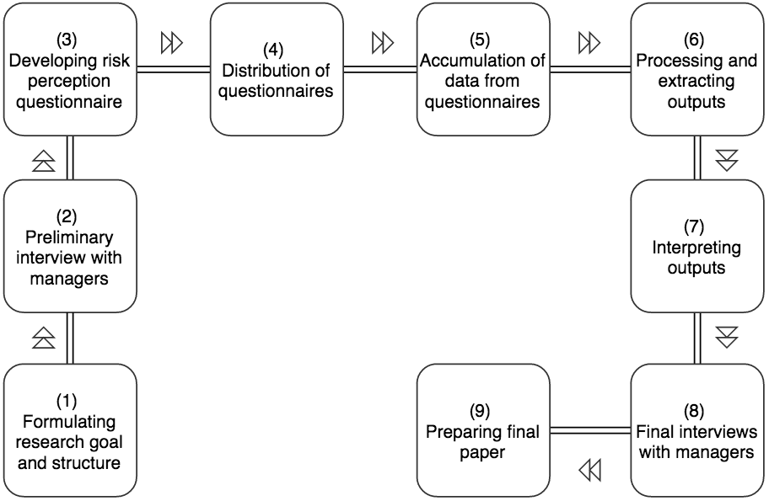
Figure 2.6 Flowchart of research on international logistics risk perception by logistics managers

CHAPTER 3. FINDINGS OF THE EMPIRICAL RESEARCH
In this chapter the author is going to process and analyse the data, retrieved from expert opinion interviews and come up with a classification of international logistics risks represented by a set of groups and subgroups of risks. This classification is later used for on-line survey design for the second step of empirical data collection and analysis. The above mentioned survey will give an insight on managers’ perception of these risks in terms of probability and magnitude with regard to their companies’ business performance. Based on the results of the survey analysis a foundation for the final stage (iteration of interviews) will be made. As a result, expert opinion will be combined with survey outcomes to develop a manual for a logistics manager charged with arranging international operations.

3.1 Classification of international logistics risks
In this part is summarized the information in relation to the logistics risk assessment process of the international logistics risks, which was collected throughout 12 interviews and consultations with international logistics managers and representatives of foreign and Russian companies that engaged in import, export or transit activities. Answers to the questions that were stated to the companies helped to analyze approaches to categorization of risks related to international logistics. The list of general questions can be seen in the Appendix 1. To reach the aim of this chapter was followed the methodology that was formalized in Figure 2.4.
The main goal of the analysis was to obtain data from the company concerning:
- Information peculiarities on typical logistics risks;
- Risk classification and categorization;
- Risk mitigation strategies and procedures, etc.
First conclusion from the initial set of interviews with logistics managers was that majority of these companies do not have a clear logistics risk assessment framework in place. Much like it was mentioned in academic literature, managers tend to take decisions based on the past experience within the company or on their own expertise (perception of the risk). The majority of the interviewees stated that they do not run any qualitative or quantitative risk assessment framework. The most common obstacle for quantitative analysis is the lack of historical data on risk events or losses. Identified risks are usually dealt with simultaneously, regardless of their correlation or interdependency.
For gathering the analytical data, there were analysed answers of twelve different companies that regularly engage in import/export or transit activities. Companies differ in the amount of goods they transport, types of goods and the conditions that are needed for the transportation.
As it was mentioned before, the most important factors whilst making decisions concerning risk management or organization of transportations, are experience of the managers and their expertise. In fact, the interviewed companies do not assess risks from two major points of view – likelihood of occurrence and potential damage (losses) they may incur. Thus, there are no proactive measures in place for the purpose of avoiding negative outcomes which already took place in the past. This all makes work of the managers tough and stressed, making companies lose money.
Companies claimed types of risks that they face and in this paper they were classified into seven categories: transit risks (loss of load, partial cargo loss, damage to cargo, delay in cargo delivery, risk damage to vehicle), environmental risks (natural disasters, environmental regulations, violation of safety regulations), political risks (customs barriers, threat to terrorism, strikes, riots in the country), financial risks (penalties above the norm, warehousing demurrage, limits of carrier’s liability for payment of SDRs, the risk of not paying contractors services or goods, administrative violations), information risk (violation in the documents circulation, violation in the information channel), risk of human factors (accident prevention, low qualification, malicious intent) and contract risks (misusing INCOTERMS, hidden costs, deliberate contract manipulation). The issue that companies need to take care of are the consequences of each risk. As for the consequences of the faced risks, they can be either financial or non-financial. The derived categorization of international logistics risks is further used for purposes of survey.
It should be noted that a number of telephone calls and e-mails resulted in managers’ rejection to provide necessary information. Despite the fact, that they would like to support the research and were interested in results, the subject turned out to be too sensitive. Managers were not authorised to give information on the matter of logistics risks management.

3.2 Managers’ perception of international logistics risks
As it was stated above, companies nowadays do not run numerical risk assessment of logistics risks, which is an important part of the company’s activities, as it can let them avoid risky situations and let cope with inevitable with lower amount of losses. Thus, in case companies introduce this activity in their daily operations, it would decrease rate of appearing undesired uncertainties and facilitate better match of national logistics mix with the host country’s mix.
In the empirical part of the quantitative risk assessment there was used a basic numerical analysis of responses about probability and magnitude of particular international logistics risks.
To run quantitative assessment of logistics risks, the research was based on data that was gathered from manufacturing companies as well as logistics service providers located in Russia. At the moment there were 72 valid responses information from whom was analysed. The interviewees were employed or operated in the following business areas:
- procurement (administration);
- supply chain management (administration);
- logistics (administration);
- controlling (administration);
- business management or member of the management board.
The size definition of enterprises was based on EU approach (European Commission, 2006). Twenty-eight replies were from small, seventy-seven from medium and twelve from large enterprises. Smaller number of replies came from small or large enterprises, while medium enterprises provide the majority.
The respondents were asked to indicate the probability and magnitude of the categories of risks, which were defined after expert opinion interviews. Thus, respondents indicated two main factors of risk on a Likert scale ranging from 1 to 7 for the following risk categories: transport risks, environmental risks, political risks, financial risks, information risk, risk of human factors and contract risk.
In his empirical research the author supposes that magnitude and risk probability are perceived by international logistics managers with equal weight. Therefore, the overall perceived international logistics risk can be formally defined as a multiplication of two normalized perceptions – of probability and magnitude or in other terms: Risk = Consequence * Predicted Frequency.
After aggregating data, simple averages were calculated for risk probability perception (Arpp) and risk magnitude perception (Armp). These averages were then normalized according to Likert scale. The results of calculations are summarized in Table 3.1. After the overall risk perception indicators were calculated (by means of multiplication of Nrpp and Nrmp), risk categories were ranked in the rightmost column.
According to the answers of the companies, transport, environmental and political risks are most likely to happen. However, top three risks in terms of magnitude are: transport, environmental and risk of human factor.
The research was limited to the data obtained from the respondents and calculations that were carried out on them. In total there were analysed 72 replies. Table 3.1. summarizes the outcomes of a survey.
Table 3.1 Overall international logistics risks perception by international logistics managers
Risk Category | Risk Sub-Categories | Risk  probability perception |  | Risk  magnitude perception |  | Overall  risk  perception
 |  | A_{RPP} | N_{RPP} | A_{RMP} | N_{RMP} | N_{ORP} | R_{RC}
transport risks | - loss of load  - partial loss  - damage to cargo  - delay in cargo delivery  - risk damage to vehicle | 3,97 | 0,57 | 4,62 | 0,66 | 0,38 | 1
environmental risks | - natural disasters  - environmental regulations  - violation of safety regulations | 3,91 | 0,56 | 4,38 | 0,63 | 0,35 | 2
political risks | - customs barriers  - threat of terrorism  - strikes, riots in the country | 3,48 | 0,50 | 4,17 | 0,60 | 0,30 | 3
financial risks | - penalties above the norm warehousing demurrage  - limits the carrier's liability for payment of SDRs,  - the risk of not paying contractors services or goods  - administrative violations | 2,32 | 0,33 | 2,46 | 0,35 | 0,12 | 6-7
information risk | - violation in the documents circulation  - violation in the information channel | 3,35 | 0,48 | 3,93 | 0,56 | 0,27 | 5
risk of human factors | - accident prevention  - low qualification  - malicious intent | 3,18 | 0,45 | 4,32 | 0,62 | 0,28 | 4
contract risks | - misusing INCOTERMS  - hidden costs  - deliberate contract manipulation | 2,24 | 0,32 | 2,50 | 0,36 | 0,12 | 6-7
 | TOTAL: | 22,45 |  | 26,38
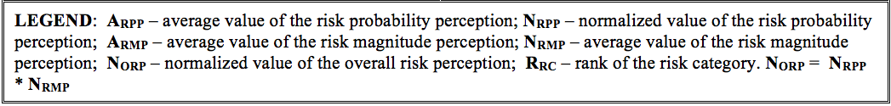

3.3. Empirical research outcomes and recommendations
Quantitative assessment facilitates prioritization of types of risks based on their overall risk score. However, the limitation is that majority of the companies do not possess either precise estimation of the likelihood of the risks or its source.

3.3.1 Managerial implications and research limitations
The objective of this dissertation was to discover the nature of risks in international logistics, classify them, and elaborate a manual for a logistics manager charged with arranging international operations.
Developed methodology is applicable to any region. This methodology is a valuable tool in assessment of risks due to its ability to adapt to regions and their problems and its very thorough approach to risk assessment and analysis from different angles and via combination of different approaches.
The results of the research have important implications for many parties. The ones who are primarily interested in the methodology that was developed, are:
- Logistics companies;
- Manufacturing companies;
- Service users;
- Insurance companies;
- Entrepreneurs.
that have most financial benefits from the very beginning of their work in the sphere of international transportations. The companies get short-term and long-term benefit and financial support, as fast and easy integration of international service would bring additional return through diversification of services and provision of services that in pricing policy insignificantly differ from local rates.
Finally, the methodology is of high interest for the entrepreneurs that can take advantage over the underdeveloped part of the industry and can conquer the niche by being the first to introduce the services, making customers more loyal to them and more responsive.
Despite the fact that the model still can be modified and developed further, it is of high value and importance and covers existing gaps of the risk management in international logistics. It can be successfully applied to any region of Russia and many others, letting the company of any geographical origin and improve in most proper way.
As examples of main limitations and fields for further work on the model, the following ideas can be mentioned. First of all, the model can be enriched with introduction of more criteria and measurements. It would reflect more trustworthy results. Secondly, the model can be tested on different product categories and not only on food. There can be assessed risks of other regions with different categories of risks. A valuable step forward could be made if there would be accessible official documentation on the transportations from regions and risks that are being faced within each shipment.
Limitations
The number of respondents involved into answering process (144 managers) does not permit, to our mind, to consider the present research as a completely adequate to tasks formulated in the beginning or at the stage “Perception of international logistics risks by managers”. However, the flowchart of research (Fig. 2.6) foresees a possibility of iterations and adjustments. Practically most common trends in international logistics managers’ risk perception were revealed and assessed only.
Nevertheless, it appears that the methodology developed and applied during the research is a workable one. Besides, the testing of the developed questioner helped to improve its structure and content for the next stages of this research. Finally, it is necessary to say that the said research should be considered rather as a pilot-project or the first step of a future complex research for a particular market in the Graduate School of Management St. Petersburg State University.

3.3.2 Theoretical implications
Given the continuing growth of international business in the Era of Globalization the clear understanding of nature and meaning of international business disciplines are very important for teaching and researching. As proposed throughout the paper, the subject of International Logistics is to be clearly understood due to its interdisciplinary nature and a role of integrator for other disciplines necessary for those who are involved into an international business. It is shown that methodological studies demand to attract more attention and work from the side of academia because they have real practical outputs – such as, increasing effectiveness and efficiency of teaching/learning processes as well as providing future international logistics manager with necessary knowledge and skills.
Defining the subject of International Logistics and its target function should help to focus teaching/learning on items of connecting/ matching national segments of international supply chains to reduce transaction costs and risk and, consequently, increase competitiveness of international businesses.
Despite the fact that the model still can be modified and developed further, it is of high value and importance and covers existing gaps of the subject of international logistics. It can be successfully applied to any company or region.
As examples of main limitations and fields for further work on the model, the following ideas can be mentioned. First of all, the model can be enriched with introduction of more criteria and measurements. It would reflect more trustworthy results. Secondly, assessment of risks of other regions with different categories of risks may be performed. A valuable step forward could be made if there would be accessible official documentation on the transportations from regions and risks that are being faced.

DISCUSSION AND CONCLUSIONS
The objective of this dissertation was to discover the nature of risks in international logistics, classify them, and elaborate a manual for a logistics manager charged with arranging international operations.
The literature review suggested highlighting following two items. First, the proper “international logistics”, what does it mean in the frame of any convenient scientific/practical definition; and in general, does this “convenient definition” exist? Second, what is the place and role of international logistics among other international business disciplines related to marketing, management, finance, law, etc? The second item, taking into account that international logistics manage almost all flows in any business (material, financial, and intellectual, personified included; internal and external; inbound and outbound; forward and reverse; domestic and global), could convert the subject of international logistics into something like a meta-science covering all things and finding difficulty in explaining anything. Therefore, defining the subject of international logistics they have to find out the essence of this multidimensional phenomenon.
Having run the in-depth literature review on the subject of logistics and international logistics, the author encountered great variety of definitions for general logistics, international and supply chain management. As an outcome, the term ‘international logistics’ was clearly defined as well as the subject area of it. It turned out that academicians are still unclear regarding relationship between supply chain management and logistics, however, the author concluded that inclusionist point of view is prevailing. In addition to that, the author proved a close relationship between marketing and logistics. The split between these two business areas was due to a dichotomy in 1960s when the two were split. This fact enables employment of marketing tools with regard to logistics. Out of abundance of logistics functions, those relevant to international logistics subject area were selected. These functions comprise the totality of logistics mix. Each trading country has its own logistics mix and marketing environment (external). Dissimilarities of these marketing environments lead to disruptions in the logistics flows (supply chain) of the trading countries. For the purposes of keeping the scope of this research paper clear and concise, the variety of intermediaries was not described in fine details as it was unnecessary. A short definition of parties involved in international logistics process was given in chapter 2.
The above described processes (disruptions due to marketing environment dissimilarities) is clearly defined and described in the upcoming academic book by professor Vitally I. Cherenkov. The so called prismatic model describes the phenomena of disruptions in supply chain of trading companies. This model was used as a theoretical foundation for this research paper. According to this model, the logistics mix represents a link of the supply chain (or complex of logistics flows) between two trading countries. Due to differences in marketing environments of these countries, the logistics flow crosses the border and this is where disruptions occur. Thus, the author assumes that it is possible to adjust these disruptions in order to mitigate or avoid international logistics risks.
Having established a proper theoretical framework, as a second objective an adequate tool for managing risks associated with international logistics needed to be found. As the author proved the relationship between logistics and marketing and established that disruptions occur due to dissimilarities in marketing environments of trading companies, an adequate instrument for managing international logistics risks would be a check-list. It is one of the most essential but rather overlooked instruments of marketing audit. Marketing audit is a subject area yet undeveloped in Russia. As disruptions are result of differences in national marketing environment, a proper marketing audit of this environment is necessary. This check-list would reflect major factors, influencing the supply link between trading countries. Jumping ahead, it will be a self-audit checklist with seven major categories of risks and subcategories. Ideally, a manager would follow this list and perform a self-audit concerning his own operations and would make sure he is assessing all the risk areas.
There are various frameworks for managing risks to be found in academic literature. The author found the framework of four steps to be the most adequate: risk identification, risk assessment, risk mitigation and risk control. The first and the most important step was to identify key risks for their further assessment and mitigation. Risk identification as well as assessment may be carried out on a qualitative or/and quantitative base. The major obstacle – lack of historical data on risk events and their consequences predetermined the selection of qualitative approach with a trait of quantitative assessment.
Thus, for risk identification purposes an interview with 12 representatives of companies involved in international logistics was set up. These companies were from four groups: national logistics providers, foreign logistics providers, local manufacturing companies and foreign manufacturing companies. The major requirement was that companies had to be involved in international trade. Having conducted initial interviews, the author was able to form risks into seven major categories (risk identification): transport, environment, political, financial, information, risk of human factor and contract risk. This was the foundation for further assessment of the identified risks. For this purpose, an online questionnaire was conducted with 117 companies. As a final step, a check list of seven major risk categories and their risk value (probability*severity) perceptions by managers were assessed.
In conclusion it is essential to mention that the execution of the risk assessment framework in this paper is considerably far from being perfect. There are multiple limitations such as the distribution of respondents with regard to the size of the company, geographical location and status of the manager. The goal of this paper is rather to lay the foundation for further development of the subject of international logistics among students and academicians in Russian Federation. In addition, the author would like to mention that the area of marketing audit is yet untapped in the academic literature of leading business schools in Russia, which as a result leads to lack of sophisticated practice of these risk management tools in Russian business.

LIST OF REFERENCES
- Новиков, А. М., & Новиков, Д. А. (2007). Методология.
- Управление рисками в логистике : учеб. пособие для студ. учреждений высш. проф. образования / Г.Л.Бродецкий, Д.А.Гусев, Е.А.Елин.— М.: Издательский центр «Академия», 2010. — 192 с. — (Непрерывное профессиональное образование: Логистика
- Bartels, R. (1976). Marketing and distribution are not separate. International Journal of Physical Distribution, 7(1), 22-29.
- Battaglia, A. J. (1994). Beyond logistics: supply chain management. CHIEF EXECUTIVE-NEW YORK-, 48-48.
- Bernstein, P. (1996), Against the Gods – The Remarkable Story of Risk, Wiley, Chichester.
- Blackhurst, J., Craighead, C.W., Elkins, D. and Handfield, R.B., (2005) An empirically derived agenda of critical research issues for managing supply–chain disruptions, International Journal of Production Research, Vol. 43, No. 19, pp. 4067–4081.
- Blos, M.F., Quaddus, M., Wee, H.M. and Watanabe, K. (2009) Supply chain risk management (SCRM): a case study on the automotive and electronic industries in Brazil, Supply Chain Management: An International Journal, Vol. 14, No. 4, pp. 247– 52.
- Cheng, S.K. and Kam, B.H. (2008) A conceptual framework for analyzing risk in supply networks, Journal of Enterprise Information Management, Vol. 22, No. 4, pp. 345–360.
- Cherenkov, V.I. (2003) Global Marketing Environment: Essay on Conceptual Integration, St.
- Cherenkov, V.I. (2009) History and Development of SWOT Concept and Techniques, Mar- 113 keting and Marketing Researches, #6, Moscow (in Russian)
- Cherenkov, V.I., and Dikalo, D. (2012), International Logistics Risks: Essays on their Classification and Perception by Russian Managers, in Proceedings of the 12th Annual International Conference on Marketing in Istanbul, Turkey, 2012, Kemerburgaz University, Istanbul.
- Chopra, S. and Sodhi, M. (2004), Managing risk to avoid supply chain breakdown MIT-Sloan Management Review, Vol. 46 No. 1, pp. 53-61
- Christopher, M. and Lee, H. (2004), Mitigating supply chain risk through improved confidence, International Journal of Physical Distribution & Logistics Management, Vol. 34 No. 5, pp. 388-96
- Christopher, M. and Peck, H. (2010) Marketing Logistics (Chartered Institute of Marketing), Butterworth-Heinemann, Amsterdam, etc.
- Christopher, M., Mena, C, Khan, O. and Yurt, O. (2011) Approaches to managing global sourcing risk, Supply Chain Management: An International Journal, Vol. 16, No. 2, pp. 67–81.
- Cohen, M., & Kunreuther, H. (2007). Operations Risk Management: Overview of Paul Kleindorfer's Contributions. Production and Operations Management, 16(5), 525-541
- Craighead, C.W., Blackhurst, J., Rungtusanatham, M.J., and Handfield, R.B. (2007) The severity of supply chain disruptions: design characteristics and mitigation capabilities, Decision Sciences, Vol. 38, No. 1, pp. 131–156.
- David, P.A., and Stewart, R.D. (2010), International Logistics: The Management of International Trade Operations, Cengage Learning, Maison, USA.
- Definition of logistics // Council of Logistics Management, available at: http://global.britannica.com/EBchecked/topic/346430/Council-of-Logistics-Managem ent (accessed March 4, 2014)
- Dictionary of Military and Associated Terms (2005), US Department of Defense, available at: http://www.thefreedictionary.com/international+logistics (accessed April 14, 2012).
- Dzhingarov, D. (2014) Is There A Connection Between Marketing And Logistics? // B2B Marketing, available at: http://www.b2bmarketing.net/blog/posts/2014/04/05/there-connection-between-market ing-and-logistics (accessed March 4, 2014).
- Encyclopedia Britannica (1993), Chicago, Encyclopedia Britannica, Inc., Vol. 28
- Evangelista, P., & Sweeney, E. (2006). Technology usage in the supply chain: the case of small 3PLs. The International Journal of Logistics Management, 17(1), 55-74.
- Finch, P. (2004), Supply chain risk management, Supply Chain Management – An International Journal, Vol. 9 No. 2, pp. 183-96
- Fuchs H., Wohinz J.W., (2009), Risk Management in Logistics Systems, Advances in Production Engineering & Management 4, pp 233-242
- Gaonkar, R. and Viswanadham, N. (2004), A conceptual and analytical framework for the management of risks in supply chains, Proceedings of the 2004 IEEE International Conference on Robotics and Automation, April 26-May 1, Vol. 3, pp. 2699-704.
- Germain, R. N., Fedotov, Y. V., & Krotov, K. V. (2011). Outsourcing and vertical integration: Research propositions from an organizational perspective.
- Göran Svensson, (2002) A conceptual framework of vulnerability in firms’ inbound and outbound logistics flows, International Journal of Physical Distribution & Logistics Management, Vol. 32 Iss: 2, pp.110 – 134
- Gudehus, T. and Kotzab, H. (2012), Comprehensive Logistics, Springer-Verlag, Berlin Heidelberg, Germany. Knowledge Subject, Philosophy as a Science (1995), available at: http://studopedia.ru/view_filosofiya.php?id=95 (accessed March 4, 2012), (in Russian).
- Harland, C., Brenchley, R. and Walker, H. (2003), Risks in supply networks, Journal of Purchasing & Supply Management, Vol. 9 No. 2, pp. 51-62.
- Harrison A., van Hoek R. I. Logistics management and strategy. – Pearson Education, 2005.
- Joseph L. Cavinato, (2004) Supply chain logistics risks: From the back room to the board room", International Journal of Physical Distribution & Logistics Management, Vol. 34 Iss: 5, pp.383 – 387
- Jüttner, U. (2005), Supply chain risk management: Understanding the business requirements from the practitioners perspective, International Journal of Logistics Management, vol. 16, no.1, pp. 120-141.
- Jüttner, U., Christopher, M., & Godsell, J. (2010). A strategic framework for integrating marketing and supply chain strategies. The International Journal of Logistics Management, 21(1), 104-126.
- Jüttner, U., Peck, H., & Christopher, M. (2003). Supply chain risk management: outlining an agenda for future research International Journal of Logistics, 6 (4), 197-210
- Jyri Vilko, (2012) Approaches to Supply Chain Risk Management: Identification, Analysis and Control, Dissertation Lappeenranta University of Technology, 276 pages
- Kajuter P., (2003) Risk Management in Supply Chains, Strategy and Organization in Supply Chains, p. 321-336
- Kersten, W., Schröder, M., Singer, C., & Feser, M. (2012). Risk management in logistics: Empirical results from the Baltic Sea Region from 2010 until 2012. CASH.
- Khan, O. and Burnes, B. (2007), Risk and supply chain management: creating a research agenda, International Journal of Logistics Management, Vol. 18 No. 2, pp. 197-216.
- Kleindorfer, P.R. and Saad, G.H. (2005), Managing disruption risks in supply chains, Production and Operations Management, Vol. 14 No. 1, pp. 53-68
- Kotler, P., Armstrong, G., & Saunders, J. (2001). Principals of marketing. Harlow: Prentice Hall, Third European Edition.
- Kouvelis, P., Chambers, C. and Wang, H. (2006), Supply chain management research and production and operations management: review, trends and opportunities, Production and Operations Management, Vol. 15 No. 3, pp. 449-69
- Larson, P. D., & Halldorsson, A. (2004). Logistics versus supply chain management: an international survey. International Journal of Logistics: Research and Applications, 7(1), 17-31.
- Liubov Fedotova (2011) Risk assessment in the passing goods in the supply chain, available at http://logistika-prim.ru/sites/default/files/fedotova.pdf
- Lv, Z., Tek, A., Da Silva, F., Empereur-Mot, C., Chavent, M., & Baaden, M. (2013). Game on, science-how video game technology may help biologists tackle visualization challenges. PloS one, 8(3), e57990.
- Manuj, I. and Mentzer, J.T. (2008), Global Supply Chain Risk Management, Journal of Business Logistics, vol. 29, no.1, pp. 133-155.
- Moutinho, L. and Chien, Ch. (2008) Problems in Marketing: Applying Key Concepts and Techniques, SAGE Publications Ltd., Los Angeles, etc.
- Nelson, P. T., & Toledano, G. (1979). Challenges for international logistics management. Journal of Business Logistics, 1(2), 1-21.
- Niine, T., & Koppel, O. (2014). Competence in logistics–designing a meta-model of logistics knowledge areas. DAAAM International Scientific Book, 543-556.
- Pfohl, H., Kuhler, H., & Thomas, D. (2010). State of the art in supply chain risk management research: empirical and conceptual findings and a roadmap for the implementation in practice. Logistics Research, 2(1), 33-44
- Rao, S. and Goldsby, T.J. (2009), Supply chain risks: a review and typology, The International Journal of Logistics Management, vol. 20, no.1, pp. 97-123.
- Shaer, S. and Goedhart, J. (2009) Risk and the consolidated supply chain: rethinking established best practices, APICS Magazine, July/August, pp. 41–3.
- Shashank Rao and Thomas J. Goldsby (2009) Supply Chain Risks: a review and typology. The International Journal of Logistics Management Vol. 20 No. 1, 2009 pp. 97-123
- Slovic, P. (1992). Perception of risk: Reflections on the psychometric paradigm.
- Sodhi M, B.G. Son, C. Tang (2012), Researchers' Perspectives on Supply Chain Risk Management, Production & Operations Management, 21(1), p.1-13
- Stading, G. and Kauffman, R.G. (2006), A Framework for Management of Supply Chain Disruption, in Proceedings of the 92nd Annual International Supply Management Conference, available at: https://www.ism.ws/files/Pubs/Proceedings/FDStadingKauffman.pdf (accessed May 14, 2013).
- Taderera, F. (2010). Shipping Management and Logistics Strategy: Shipping, Logistics, Supply Chain. LAP Lambert Academic Publishing.
- Tang, C.S. (2006), “Perspectives in supply chain risk management”, International Journal of Production Economics, Vol. 103 No. 2, pp. 451-88
- Trkman, P. and McCormack, K. (2009) Supply chain risk in turbulent environments – A Conceptual model for managing supply chain network risk, International Journal of Production Economics, Vol. 119, No. 2, pp. 247–258.
- Tummala, R and Schoenherr, T. (2011) Assessing and managing risks using the Supply Chain Risk Management Process (SCRMP), Supply Chain Management: An International Journal, Vol. 16, No. 6, pp. 474–483.
- Vanany, et. al, (2009) Supply Chain Risk Management: Literature Review and Future Research; International Journal of Information Systems and Supply Chain Management, 2(1), 16-33,
- Verstrepen, S., Cools, M., Cruijssen, F., & Dullaert, W. (2009). A dynamic framework for managing horizontal cooperation in logistics. International Journal of Logistics Systems and Management, 5(3-4), 228-248.
- Wagner, S. and Bode, C. (2008), An empirical investigation into supply chain vulnerability, Journal of Purchasing & Supply Management, Vol. 12 No. 6, pp. 301-12
- What Is International Logistics? - Definition, Lesson & Quiz // Education Portal, available at: http://education-portal.com/academy/lesson/what-is-international-logistics-definition-l esson-quiz.html#lesson (accessed June 6, 2014). Wood, D.F., Barone, A.P., Murphy,P.R., and Wardlow, D.L. (2002), International Logistics, AMACOM, a division of American Management Association, New York, etc
- Wood, D.F., Barone, A.P., Murphy,P.R., and Wardlow, D.L. (2002), International Logistics, AMACOM, a division of American Management Association, New York, etc. – p.7.
- World Trade Organization, World Trade Organization. Secretariat, & World Trade Organization. Legal Affairs Division. (2004). A handbook on the WTO dispute settlement system: a WTO secretariat publication. Cambridge University Press.
- Wu, T., Blackhurst, J., & Chidambaram, V. (2006) A model for inbound supply risk analysis”; Computers in Industry, 57(4), 350-365
- Zsidisin et. Al, (2003) Managerial perceptions of supply risk. Journal of Supply Chain Management; 39, 1; ABI/INFORM Global pg. 14

APPENDICES

Appendix 1
Interview structure
1. Can you identify the logistics risks in your business?
2. In what form do you face them?
3. Can you estimate the maximum damage of each risk?
4. Are you taking any actions to reduce the occurrence of these risks?
5. Is there any seasonality in terms of the emergence of logistics risks?
6. The risks appear regularly or are spontaneous?
7. What are the main consequences of risks? Do they significantly affect the profit or reputation?
8. Are you trying to manage the risks that lie on the company?
9. Is there a regular review of the policy of identifying new risks or changes in existing ones?
10. Who makes the decision to reduce the risks?
11. Do you do risk monitoring?
12. Do you use the services of local or logistics companies from other locations (if yes / no, why?)
13. What is the reason you use the services of private carriers?
14. What limitations do you see in this type of transportation?
15. Do the risks faced by the load for such transport change?
16. Out of 10 transportations, on average, how many of them get to the destination with injuries, arrives late or do not reach it at all?
17. Who is liable for damages that occur with the load or with the car carrier?
18. Do you need to have reserve funds in case of unforeseen expenses on logistics operations?
19. On what basis is the carrier hired, is there a contract with him?
20. Do you insure the goods for private carriages? If yes, how much does this service cost?
21. How much money are you willing to spend for service of an international logistics transportation company?

Appendix 2
Questionnaire
- Please provide information about yourself:
- gender
- age
- How much experience do you have in the field of international trade or logistics?
- 1-3 years
- 3-5 years
- 5-10 years
- more than 10 years
- How long have you been working for this company?
- 1-3 years
- 3-5 years
- 5-10 years
- more than 10 years
- Please choose the origin of your company (multiple options possible):
- Russian
- Foreign
- Please choose the type of your company (multiple options possible):
- trading company
- transportation/logistics
- manufacturing
- other (please specify)
- How many employees does your company have (please specify)?
- How does your company treat logistics functions (1-7 scale)?
- complete outsourcing (1) – autonomous (7)
- Which groups of products do you transport over the border (multiple options possible)?
- consumer goods (food, alcohol, tobacco, pharmacy, clothing, shoes, durable goods)
- industrial
- raw materials
- semi-finished goods
- parts and tools
- finished products
- other (please specify)
- Which countries do you operate on? (please specify)
- Please estimate (7 point scale) your attitude towards possibility of transportation risk (loss of cargo, partial loss of cargo, cargo damage, delivery delay, damaging of the transport) in your business activity
- lowest probability (1) – highest probability (7)
- Please estimate (7 point scale) the magnitude of consequences of transportation risks (loss of cargo, partial loss of cargo, cargo damage, delivery delay, damaging of the transport) in your business activity
- negligible consequences (1) – significant consequences (7)
- Please estimate (7 point scale) your attitude towards possibility of environmental risk (natural disasters, environmental regulations, violation of safety regulations) in your business activity
- lowest probability (1) – highest probability (7)
- Please estimate (7 point scale) the magnitude of consequences of environmental risks (natural disasters, environmental regulations, violation of safety regulations) in your business activity
- negligible consequences (1) – significant consequences (7)
- Please estimate (7 point scale) your attitude towards possibility of political risk (customs barriers, threat of terrorism, strikes, riots in the country) in your business activity
- lowest probability (1) – highest probability (7)
- Please estimate (7 point scale) the magnitude of consequences of political risks (customs barriers, threat of terrorism, strikes, riots in the country) in your business activity
- negligible consequences (1) – significant consequences (7)
- Please estimate (7 point scale) your attitude towards possibility of financial risk (penalties above the norm, warehousing demurrage, limits the carrier’s liability for payment of SDRs, the risk of not paying contractors services or goods, administrative violations) in your business activity
- lowest probability (1) – highest probability (7)
- Please estimate (7 point scale) the magnitude of consequences of financial risks (penalties above the norm, warehousing demurrage, limits the carrier’s liability for payment of SDRs, the risk of not paying contractors services or goods, administrative violations) in your business activity
- negligible consequences (1) – significant consequences (7)
- Please estimate (7 point scale) your attitude towards possibility of information risk (violation in the documents circulation, violation in the information channel) in your business activity
- lowest probability (1) – highest probability (7)
- Please estimate (7 point scale) the magnitude of consequences of information risks (violation in the documents circulation, violation in the information channel) in your business activity
- negligible consequences (1) – significant consequences (7)
- Please estimate (7 point scale) your attitude towards possibility of human factor risk (accident prevention, low qualification, malicious intent) in your business activity
- lowest probability (1) – highest probability (7)
- Please estimate (7 point scale) the magnitude of consequences of human factor risks (accident prevention, low qualification, malicious intent) in your business activity
- negligible consequences (1) – significant consequences (7)
- Please estimate (7 point scale) your attitude towards possibility of contract risk (INCOTERMS misuse, hidden costs, deliberate contract manipulation) in your business activity
- lowest probability (1) – highest probability (7)
- Please estimate (7 point scale) the magnitude of consequences of contract risks (INCOTERMS misuse, hidden costs, deliberate contract manipulation) in your business activity
- negligible consequences (1) – significant consequences (7)
- Which problems, risks in international logistics do you consider most important (please specify)?
- Please share your ideas on supply chain disruptions mitigation, preventive measures adopted in your company (please specify)
- Thank you very much for participation! In case you have any questions, please feel free to contact Danil Antonov (antonov_da@outlook.com)

