Saint Petersburg State University

Graduate School of Management

**Master Thesis**

***Corporate Social Responsibility in   
State-Owned Enterprises (SOEs) vs Non-State-Owned Enterprises (non-SOEs):   
Comparative Analysis of Russia and China***

Master’s Thesis by the 2nd year student:

Yohei Ogawa

Research advisor:   
Associate Professor, Department of Strategic   
and International Management   
  
Yulia Nikolaevna Aray

Saint Petersburg

2024

**ЗАЯВЛЕНИЕ О САМОСТОЯТЕЛЬНОМ ХАРАКТЕРЕ ВЫПОЛНЕНИЯ ВЫПУСКНОЙ КВАЛИФИКАЦИОННОЙ РАБОТЫ**

Я, Давлетбаева Амалия Азатовна, студентка второго курса магистратуры направления «Менеджмент», заявляю, что в моей ВКР на тему «Факторы формирования пользовательского опыта в приложениях для здоровья», представленной в службу обеспечения программ магистратуры для последующей передачи в государственную аттестационную комиссию для публичной защиты, не содержится элементов плагиата.

Все прямые заимствования из печатных и электронных источников, а также из защищенных ранее выпускных квалификационных работ, кандидатских и докторских диссертаций имеют соответствующие ссылки.

Мне известно содержание п. 9.7.1 Правил обучения по основным образовательным программам высшего и среднего профессионального образования в СПбГУ о том, что «ВКР выполняется индивидуально каждым студентом под руководством назначенного ему научного руководителя», и п. 51 Устава федерального государственного бюджетного образовательного учреждения высшего образования «Санкт-Петербургский государственный университет» о том, что «студент подлежит отчислению из Санкт-Петербургского университета за представление курсовой или выпускной квалификационной работы, выполненной другим лицом (лицами)».



11.03.2024

**STATEMENT ABOUT THE INDEPENDENT CHARACTER OF THE   
MASTER THESIS**

I, Amaliia Davletbaeva, second year master student, program «Management», state that my master thesis on the topic «Factors Affecting User Experience in Health Applications», which is presented to the Master Office to be submitted to the Official Defense Committee for the public defence, does not contain any elements of plagiarism.

All direct borrowings from printed and electronic sources, as well as from master theses, PhD and doctorate theses which were defended earlier, have appropriate references.

I am aware that according to paragraph 9.7.1. of Guidelines for instruction in major curriculum programs of higher and secondary professional education at St.Petersburg University «A master thesis must be completed by each of the degree candidates individually under the supervision of his or her advisor», and according to paragraph 51 of Charter of the Federal State Institution of Higher Education Saint-Petersburg State University «a student can be expelled from St.Petersburg University for submitting of the course or graduation qualification work developed by other person (persons)».

図形

22.05.2024

**CONTENT**

Introduction 1

Chapter 1. Theoretical Background 3

*1-1.* *Theories on CSR* 3

*1-2.* *Benefit of CSR to Enterprise* 6

*1-3.* *Communication of CSR with Stakeholder* 8

*1-4.* *Influence of Ownership on CSR* 10

Chapter 2. Background on CSR and Role of State in Russia and China 13

*2-1.* *Russia and China: choice of countries for analysis* 13

*2-2.* *CSR and role of the state in Russia* 15

*2-3.* *CSR and role of the state in China* 16

Chapter 3. Empirical Research 21

*3-1.* *Hypothesis* 21

*3-2.* *Research Methodology and Data Collection* 24

*3-3.* *Result and Discussion* 27

Chapter 4. Conclusion 50

Reference 53

# Introduction

In today's era where resilient and sustainable businesses are increasingly demanded in VUCA (volatile, uncertain, complex, ambiguous) environments, corporate social responsibility (CSR) has gained significant importance. There is growing attention on how companies balance their economic growth with their impact on the environment and societal responsibilities.

The recognition of the importance of such environmental considerations can be traced back to the concept of ESG (Environmental, Social, and Governance) investments, which were advocated by the United Nations' Principles for Responsible Investment (PRI) in 2006. The enforcement of the Paris Agreement in 2015 and the adoption of the Sustainable Development Goals (SDGs) further highlighted the global trend for companies to consider their environmental impact. Additionally, according to the Global Footprint Network (2019), there's an urgent and significant issue with human consumption and waste surpassing the Earth's sustainable limits.

In response to these challenges, the need to balance economic development with environmental impact has become increasingly emphasized, highlighting the importance of sustainability in corporate management efforts.

Corporate social responsibility (CSR) principles guide companies towards the concept of the triple bottom line, which includes economic, social, and environmental care (Fatima et al., 2022). Positive correlations between CSR and Corporate Financial Performance (CFP) have been found in British companies (Homayoun et al., 2023). CSR has been shown to influence how employees perceive their workplace and job, increasing their engagement (Cunha et al., 2022). Furthermore, CSR has been claimed to significantly enhance a company's sustainable innovation capabilities (Yan R et al., 2022). Pursuing CSR initiatives has been confirmed to make companies more resilient and contribute to sustainability.

As seen from the discussion above, the benefits of CSR have been acknowledged. However, it is equally important to consider the initiation of CSR initiatives, not just the enhancement of existing ones. In recent years, the role of governments in initiating and facilitating CSR has gained attention (Dentchev et al., 2015; Jackson et al., 2020). Specifically, governments are seen not only as key stakeholders in CSR but also as providers of an enabling environment for CSR (Fox et al., 2002). Furthermore, it is noted that governments can significantly impact corporations, as corporate ownership structures influence the adoption of various corporate strategies (Beiner et al., 2004; Joh, 2003). State-owned enterprises (SOEs) are believed to align CSR priorities with governmental agendas.

The goal of the paper is to define the influence of corporate ownership structures (state-owned vs. non-state-owned enterprises) on CSR disclosure of such enterprises. Additionally, as Lu et al. (2023) suggest, in countries with significant government influence, corporations are expected to engage in social activities either to serve the political objectives of the state or to address government deficits, regardless of their business relevance. Therefore, through a comparative analysis of Russia and China, which are examples of countries with substantial government influence, this study seeks to expand the literature in this field.

The objectives of the paper are:

to examine the relationship between corporate ownership structure and CSR disclosure, identify key factors influencing CSR disclosure, and compare these dynamics in Russia and China. This analysis seeks to determine whether state-owned enterprises lead to higher CSR disclosure and to reveal how other variables such as company age, ROA, industry sector, and number of independent directors interact with ownership structure to influence CSR practices.

The subject is:

focuses on the CSR disclosure practices of state-owned and non-state-owned enterprises in Russia and China, exploring how ownership structure influences the scope and nature of their CSR activities and reporting.

The object is:

to determine the extent to which ownership structure influences CSR disclosure, identify moderating factors that strengthen or weaken this relationship, and compare these influences in the two major economies where state involvement in corporate governance is prominent.

The paper is based on the analysis of the annual reports of leading in sustainability agenda companies from Russia and China, as well as other secondary data collected sustainability reports in these countries. The data will be analyzed by content analysis and statistical tests to validate the hypotheses and draw meaningful conclusions about the determinants of CSR disclosure in different ownership contexts.

# Chapter 1. Theoretical Background

## *Theories on CSR*

CSR is interpreted in various ways by many authors, and the theories that attempt to explain it are equally diverse. However, among these, the most widely accepted are stakeholder theory, legitimacy theory, and resource-based theory, which this research will focus on.

Within the adopted theoretical framework, stakeholder theory focuses on the expectations of specific stakeholder groups, legitimacy theory addresses the expectations of the general society, and resource-based theory emphasizes a company's competitive advantage.

The theoretical framework of stakeholder theory is explained by Freeman (1984). Freeman's (1984) book, "Strategic Management: A Stakeholder Approach," is described by many as a classic book (Laplume et al. 2008; Weber and Wasieleski 2003; Minoja 2012) and is considered the formal academic beginning of stakeholder theory (Donaldson and Preston 1995).　Freeman (1984) saw the need for a framework that included not only customers, owners, employees, and suppliers but also governments, competitors, consumer advocates, environmentalists, special interest groups, and the media. This resulted in the well-known "stakeholder view of the firm," where the company is placed at the center, separate from the stakeholders, and their collaboration is symbolized with arrows (see Figure 1). The definition of a stakeholder is any group or individual who can "affect or is affected by the achievement of the firm's objectives."

*Figure 1. The stakeholder view of the firm*

Source: Helena. 2017.”Stakeholder management theory meets CSR practice in Swedish mining”. *Mineral Economics 30(1):1-15*

He contends that every organization has stakeholders and must consider these groups to succeed in both the present and future environments. "Stakeholder management" denotes the need for an organization to actively manage its relationships with its stakeholder groups.

R. Edward Freeman initially developed the Stakeholder Theory of organizational management and business ethics, focusing on the morals and values involved in managing an organization. This theory emphasizes the interconnected relationships between a business and its customers, suppliers, employees, investors, communities, and other stakeholders. It posits that a company should generate value for all stakeholders, not just shareholders. Freeman asserts that “The 21st Century is one of ‘Managing for Stakeholders.’ The task of executives is to create as much value as possible for stakeholders without resorting to trade-offs. Great companies endure because they manage to get stakeholder interests aligned in the same direction.”

As stakeholder interest grows, there has been an increasing demand for companies to actively pursue CSR activities in recent years (Jordan et al., 2022) While this is an example specific to the United States, according to Tim (2021) at Harvard Business School Online, 77% of consumers express a willingness to purchase from companies actively striving to make the world a better place, and 73% of investors state that commitments to environmental and social improvement contribute to their investment decisions. These findings underscore the increasing significance of CSR activities across various stakeholder groups.

In light of this trend, in which shareholders, employees, customers, creditors, and suppliers alike are actively seeking engagement in a company's social and environmental initiatives, it is understandable for company to intensify and disclose their CSR efforts in response.

Regarding legitimacy theory, it has become one of the most cited theories in the field of Corporate Social Responsibility Disclosure (CSRD) and environmental accounting (Patten & Crampton, 2004; Deegan, 2002; Neu et al., 1998). Suchman (1995) defines legitimacy as

“A generalized perception or assumption that the actions of an entity are desirable, proper, or appropriate within some socially constructed system of norms, values, beliefs, and definitions" In other words, legitimacy theory is based on the concept of a social contract between organizations and society. This suggests that companies need to operate in alignment with societal values and norms to maintain their legitimacy.

Legitimacy theory shares a close association with corporate social responsibility as it explains the social contract between the company and the community. If the community perceive a breach in this contract by the company, it could jeopardize the company's survival. Additionally, occurrence of dissatisfaction within the community towards the organization's operations could result in the revocation of the social contract (Handoko, 2014). Legitimacy theory posits that for a company to get legitimacy from its surrounding community, companies must disclose their social responsibilities. Beyond averting undesirable outcomes, legitimacy can enhance company value. This theory underscores the strategic significance of companies engaging in sustainability reporting to seek legitimacy (Haniffa et al., 2005).

Resource-based theory, initially introduced by Wernerfelt (1984) and later expanded by Barney (1991), asserts that when “the resources and capabilities are valuable, rare, inimitable and non-substitutable, they can constitute a source of sustainable competitive advantage”. Consequently, a firm should possess certain intangible resources that are not easily replicable or purchasable by competitors. A firm with such intangible resources can achieve a competitive edge in the market (Cho and Pucik, 2005). According to Castelo and Lima (2006):

[…] resources include the assets that the firm uses to accomplish the activities they are engaged in to convert inputs into outputs and can be classified as tangible or intangible,

Regarding resources-based theory, as studied by Hart (1995), CSR can be considered a resource or capability that leads to a sustained competitive advantage for a company. Other authors, such as McWilliams et al. (2002), suggest that CSR practices, supported by political strategies, can be utilized to create sustainable competitive advantages. Hedstrom et al. (1998) believes that CSR practices represent the greatest opportunity for achieving greater success in the business world. This rationale justifies why companies engage in and disclose CSR activities.

Theories explained in this section, provide a logical explanation for why companies undertake and disclose CSR initiatives. This paper will develop its arguments based on these theories.

## *Benefit of CSR to Enterprise*

CSR can be defined in various ways, but it generally refers to how a company addresses and manages its environmental, social, corporate governance, and economic impacts, as well as how these impacts may affect the company's stakeholders. The focus on sustainability (CSR/ESG) has been demonstrated to positively affect both the company and its stakeholders.

As a result, CSR offers companies the opportunity to strengthen their business through cost savings, risk mitigation, and value enhancement, while also contributing to society by focusing on key areas of interaction with stakeholders and integrating value-creating actions into the company's strategy (Noam Noked et al., 2013).

In other words, it is because, by engaging in CSR, companies can meet the expectations of their stakeholders, who have become increasingly sensitive to sustainability in recent years, as we have confirmed in the previous section. In this section, we will review examples of benefits to main stakeholders - investors, customers, and employees.

In the case of investor, Matthew Bell (2021), who works in EY, explains that Investors increasingly believe companies that perform well on ESG are less risky, better positioned for the long term and better prepared for uncertainty. According to Jay et al., (2023) in McKinsey & Company, in the survey to Chief Investment Officer, bout 85 percent of the chief investment officers we surveyed state that ESG is an important factor in their investment decisions. Sixty percent of respondents review their overall portfolio for ESG considerations, and about 80 percent assess individual company positions in the context of how ESG affects forecasted cash flows.

Regarding investors, Matthew Bell (2021) from EY explains that investors increasingly believe companies with strong ESG performance are less risky, better positioned for long-term success, and more prepared for uncertainty. According to Jay et al. (2023) from McKinsey & Company, approximately 85 percent of the chief investment officers surveyed consider ESG an important factor in their investment decisions. 60 percent of respondents review their entire portfolio for ESG considerations, and around 80 percent evaluate individual company positions based on how ESG impacts forecasted cash flows. (see Figure 2)

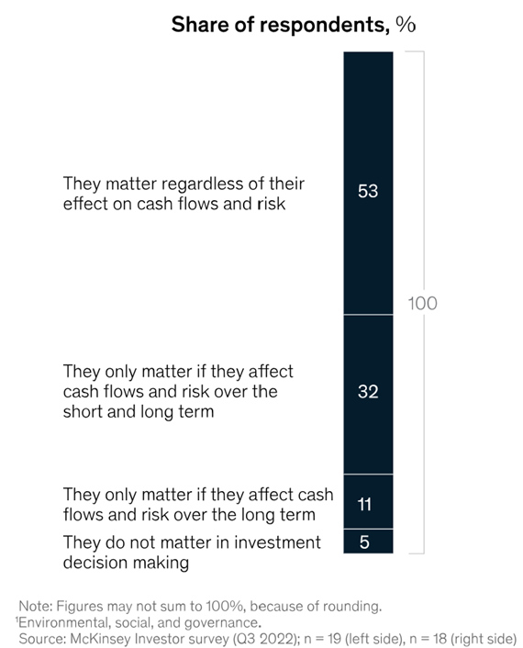*Figure 2. Importance of ESG initiatives in investment decision making*

Source: Jay et al. 2023. “Investors want to hear from companies about the value of sustainability”. *McKinsey & Company website*

Regarding employees, the Marsh McLennan website states that their study found that top employers, measured by employee satisfaction and talent attractiveness, have significantly higher ESG scores than their peers. Furthermore, with Millennials and Gen Z projected to make up 72 percent of the global workforce by 2029, compared to 52 percent in 2019, these generations prioritize environmental and social concerns more than their predecessors and will expect more from employers on these issues.

As for customers, Boufounou et al. (2023) examined whether a company's performance on environmental, social, and governance (ESG) indicators influences customer choice. Their study revealed that a company's performance on ESG factors does influence consumer choice, with particular emphasis on environmental and social indicators. It also demonstrated that a company's social performance is relevant to both urban and suburban customers.

## *Communication of CSR with Stakeholder*

There are several ways of CSR communications for the company. According to a summary by SOMPO, a Japanese company, these ways are organized along two axes: Concise vs. Comprehensive and Non-Financial vs. Financial (see Figure 3). In this classification, items positioned as Non-Financial and Comprehensive include the “Sustainability Report” and “Sustainability Website”.

*Figure 3. Overview of Sustainability Communication*

Source: SOMPO website. “Overview of Sustainability Communication”

The Sustainability (or CSR) Report can be a key component of a company’s stakeholder engagement strategy (Noam Noked et al., 2013). main points are following:

* It offers the company an opportunity to communicate its CSR activities to stakeholders and to discuss successes and challenges on a wide range of CSR issues, such as corporate governance, climate change, employee and supplier diversity initiatives, and community investments and partnerships, all within a single document.
* It serves as a medium for transparency, which often enhances the company’s reputation with stakeholders, particularly shareholders, employees, suppliers, and communities where the company operates. It is also used as an effective public relations tool as part of ongoing shareholder relations campaigns.
* It provides CSR information to assist existing and potential investors in analyzing their investment decisions.

Another measure of a company's sustainability efforts is its ESG rating. According to Deloitte’s website “ESG Ratings: Do They Add Value? How to Get Prepared?”, ESG ratings provide a foundation for understanding a company's business environment and identifying comparable peers. Moreover, major investors expect their investees to adopt an active and responsible ESG approach and are more interested in financing the ones demonstrating good ESG performance - with 65 percent of investors report using ESG assessments regularly.

There is no one-size-fits-all methodology for analyzing ESG data used by rating agencies. Reports and rating methodologies, scopes, and coverage vary greatly among providers. Currently, numerous agencies operate in the market, often issuing different ratings for the same entity, as well as many providers encourage input and engagement with the companies they rate to improve or sometimes correct data (Betty et al., 2017). There are different methodologies among rating agencies, however, according to a summary of major rating agencies by Deloitte Polska (2022), it is shown that almost all agencies reference CSR/sustainability reports by each company.

In summary, the Sustainability (CSR) report serves as a key component of a company’s stakeholder engagement strategy. It provides a transparent account of the company’s successes and challenges across a wide range of CSR issues to its stakeholders. Furthermore, it is utilized by rating agencies as a primary source of information for ESG scores, which investors rely on for making investment decisions.

## *Influence of Ownership on CSR*

According to the OECD (2020), many OECD member countries believe that state-owned enterprises (SOEs) can and should play a leading role in their respective sectors, promoting good practices among all market participants. Increasingly, these governments are integrating sustainable development goals into their ownership policies, publicly expressing their sustainability expectations, and establishing mechanisms for their implementation. Furthermore, as regulators, governments can encourage positive actions by assuming a leading role in social and environmental responsibility. Ensuring alignment between general sustainability policies and SOE-specific goals, while creating a level playing field for private enterprises, is crucial for maintaining efficiency. Here are some examples of national practices:

* Finland’s ownership policy, outlined in the "Government Resolution on State Ownership Policy of 13 May 2016," mandates that companies exemplify value leadership and corporate social responsibility as integral components of their corporate values, and obligates them to "contribute to the long-term development and renewal of society."
* In 2018, the South Korean government identified “public institutions as a driving force for achieving social values,” incorporating this into one of the 100 key national tasks in its five-year administrative plan. The government has established a set of indicators to assess the performance of SOEs and new public institutions in areas such as human rights, ethical management, occupational safety, environmental conservation, and social integration.
* In Switzerland, the Federal Council issued an official position paper on corporate social responsibility in 2015, titled "RSE - Position et Plan d’Action du Conseil Fédéral." This document asserts that the Swiss Confederation should serve as a role model when exercising ownership rights over state-owned companies.
* In New Zealand, the SOE Act requires every SOE to demonstrate social responsibility by considering the interests of the communities in which they operate and by striving to accommodate or encourage these interests whenever possible. SOEs are expected to set and report on CSR objectives with the same level of importance as their financial objectives.
* In Peru, one of the country’s most vulnerable to climate change, high governance standards for SOEs are central to their efforts. When the central ownership unit was established, addressing sustainability issues was explicitly highlighted. Within a broader ownership framework, the ownership unit focuses on 1) impact analysis of SOE sustainability programs, 2) developing project frameworks to enhance SOE sustainability, and 3) providing technical support for SOEs to develop sustainability programs.

***Summary of the chapter***

* 1. **Theories on CSR**

Corporate Social Responsibility (CSR) is interpreted through various theoretical lenses, with stakeholder theory, legitimacy theory, and resource-based theory being the most prominent. Stakeholder theory, as articulated by Freeman (1984), emphasizes the importance of managing relationships with all groups affecting or affected by the firm's objectives. This theory asserts that businesses must generate value for all stakeholders, not just shareholders. Rising interest in CSR activities is driven by stakeholder demands, with significant percentages of consumers and investors favoring companies committed to social and environmental improvements.

Legitimacy theory revolves around the concept of a social contract between businesses and society, positing that companies must align their operations with societal values and norms to maintain legitimacy, justifying transparency in CSR activities.

Resource-based theory, introduced by Wernerfelt (1984) and expanded by Barney (1991), highlights the competitive advantage derived from unique, valuable, and inimitable resources. CSR practices, viewed as intangible resources, can provide a sustainable competitive edge, reinforcing the rationale for businesses to engage in and disclose CSR initiatives.

* 1. **Benefits of CSR to Enterprises**

CSR activities offer numerous benefits, including cost savings, risk mitigation, and value enhancement. For investors, companies with strong ESG performance are perceived as less risky and better positioned for long-term success. Surveys indicate that a majority of chief investment officers consider ESG factors in their investment decisions. For employees, higher ESG scores correlate with better satisfaction and talent attraction, especially among Millennials and Gen Z, who prioritize environmental and social concerns. For customers, a company's ESG performance can influence consumer choices, particularly regarding environmental and social indicators.

* 1. **Communication of CSR with Stakeholders**

Effective CSR communication is critical for engaging stakeholders. Sustainability reports and ESG ratings are key components. Sustainability reports offer transparency and detail a company's CSR activities, enhancing reputation and aiding investors in decision-making. ESG ratings, which rely on these reports, provide a comparative understanding of a company's sustainability performance, with many investors using these ratings in their investment processes.

* 1. **Influence of Ownership on CSR**

State-owned enterprises (SOEs) in OECD countries are increasingly seen as leaders in promoting sustainable practices. Governments integrate sustainable development goals into their ownership policies, ensuring SOEs align with societal expectations. Examples from Finland, South Korea, Switzerland, New Zealand, and Peru show how national practices mandate SOEs to prioritize CSR alongside financial objectives, often serving as models for private enterprises.

**Conclusion**

The theories and practices outlined in this chapter provide a robust framework for understanding why companies engage in and disclose CSR activities. The integration of stakeholder expectations, the pursuit of legitimacy, and the leveraging of unique resources underscore the strategic importance of CSR in contemporary business environments. This theoretical foundation will guide the subsequent analysis and arguments in this research.

# Chapter 2. Background on CSR and Role of State in Russia and China

## *Russia and China: choice of countries for analysis*

Mohd (2007) examined the effect of ownership structure on corporate social responsibility (CSR) disclosure in Malaysian companies' annual reports (CARs). Using a CSR disclosure checklist, the study assessed the extent of CSR disclosure and analyzed the relationship between ownership structure and CSR disclosure through multiple regression analysis. The findings revealed that firms with a high proportion of director ownership (owner-managed firms) disclosed significantly less CSR information, whereas companies with substantial government ownership disclosed significantly more CSR information in their annual reports.

Nugraheni et al. (2022) investigated the influence of ownership structure on CSR disclosure in Indonesian companies. This study categorized ownership structure into managerial ownership, institutional investor ownership, general investor ownership, and foreign ownership. Conducted on companies listed on the Indonesia Stock Exchange within sensitive industry categories from 2017 to 2019, CSR disclosure was measured using the Global Reporting Initiative (GRI). The results indicated that institutional investor ownership positively impacted CSR disclosure, while managerial ownership, foreign ownership, and general investor ownership did not significantly affect CSR disclosure.

Irina (2020) conducted a content analysis of corporate social responsibility (CSR) reports of Chinese state-owned enterprises (SOEs) and non-state-owned enterprises (non-SOEs). The analysis revealed an overall homogeneity in CSR reporting between Chinese SOEs and non-SOEs. This can be explained by coercive isomorphism on a national scale, where a complex system of incentives has been created to encourage both SOEs and non-SOEs to engage in socially responsible behavior and disclosure.

The existing literature provides two different instances where state-owned enterprises (SOEs) have a greater influence on CSR than non-SOEs, and where this is not necessarily the case, resulting in unclear impact of ownership of company on CSR disclosure .

Furthermore, in an analysis conducted by Hsu et al. (2021) based on comprehensive data on the nationalization of publicly traded companies in 44 countries from 2004 to 2017, it was shown that state-owned enterprises (SOEs) have a higher capacity to address environmental issues overall (see Figure 4). Specifically, SOEs achieved higher scores in environmental performance - in emissions reduction, product innovation, and resource reduction. This effect is more pronounced in economic areas lacking energy security and stringent environmental regulations, as well as in companies with significant domestic government ownership. These findings indicate that SOEs can play a useful role, especially in addressing environmental externalities. In this context, Hsu et al. (2021) noted, “Especially from a Western perspective, SOEs often have a bad reputation, but this is partially offset by some SOEs that care about the environment …Therefore, the policy implication here is that SOEs have a certain leading role...Our research suggests evidence that SOEs can help address negative business impacts, such as pollution and climate change.” In addition, modern SOEs in the Asia-Pacific region appear to be more effective than their private counterparts in addressing market failures, particularly issues related to environmental externalities. They achieve better outcomes without sacrificing shareholder returns.

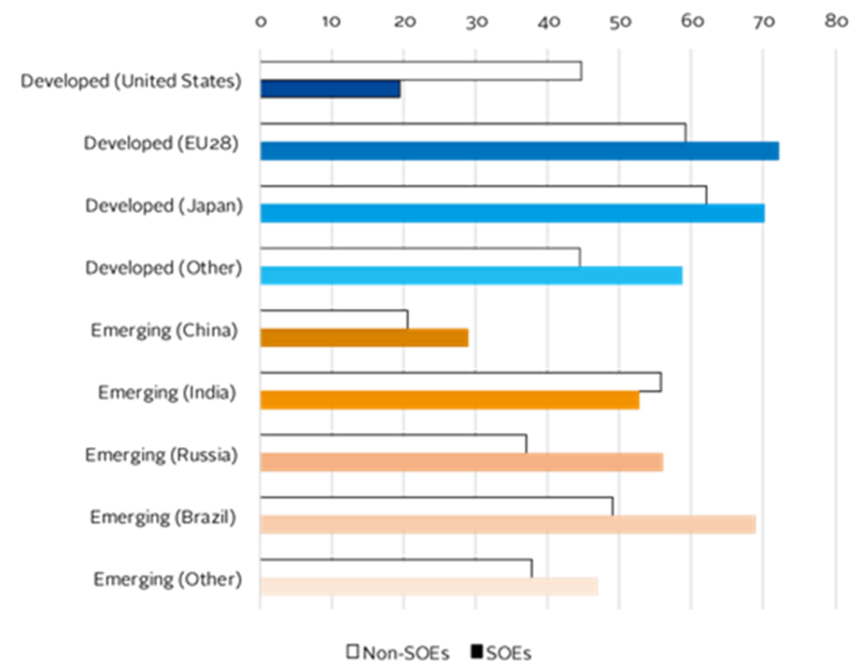*Figure 4.* *Univariate comparison of average environmental scores   
of SOEs and non-SOEs*

Based on this observation, my research will expand on the fragmented CSR analyses of SOEs in emerging countries, specifically China and Russia, where government influence is considered stronger than in developed nations, as well as these countries were found to have SOEs with a higher capacity to address environmental externalities compared to non-SOEs in research.

## *CSR and role of the state in Russia*

Regarding the development of CSR in Russia, scholars argue that "distinctive characteristics of corporate social responsibility in Russian businesses" (Polishchuk, 2009; Kuznetsov et al., 2009). These characteristics stem from a history where a strong absolutist state has dominated all aspects of social life.

For instance, during the USSR era, the state provided social guarantees to citizens, and people's welfare often heavily depended on the enterprises they worked for. The term "concern for workers' demands" was common. Soviet enterprises were responsible for providing housing, food, medical care, and leisure activities for their workers. They owned the housing where workers used to live, hospitals, children's summer camps, rest houses, and cultural centers. These "benefits" were available not only to enterprise workers but also to residents of neighboring communities. By 1980, statistics indicated that 32 million people lived in apartments owned by enterprises, 30 million received medical care from enterprise-owned facilities, and 1.5 million children vacationed in summer camps that belonged to enterprises. (Zavyalova et al., 2020).

Structurally, Russia inherited a high concentration of production from the Soviet Union, where the economic welfare of cities could depend on a single industry or even a single large enterprise (Polishchuk, 2009). According to Zavyalova et al. (2020), several reasons explain why CSR-related activities are primarily within the domain of large enterprises. First, only large enterprises have the additional financial resources to spend on socially significant programs. Second, large enterprises are more involved in the state's socially significant projects. Finally, large enterprises place greater importance on social (and political) stability and are willing to pay for it.

In recent years, Russia has witnessed a significant recentralization of governmental power, making local governments responsible for economic development and social welfare, yet providing them with few financial means to fulfill these responsibilities. In this situation, local governments have come to rely on nominally “voluntary” corporate social investment which is ensured by threat of various economic sanctions (Avtonomov, 2006; Polishchuk, 2009).

Simultaneously, Russia's transition process has brought about the internationalization of lifestyles, attitudes, and knowledge following the fall of the "Iron Curtain" (Apressyan, 1997). Consequently, Russian companies have faced pressure from global CSR trends.

Given those situations, in 2003, six major international conferences on CSR were held in Moscow, providing practical advice to corporate executives and government officials. That same year, President Putin called on companies to increase their efforts in CSR at the annual meeting of the Russian Union of Industrialists and Entrepreneurs, a call that has been repeated several times since. Some large Russian companies, particularly those seeking an international reputation, responded quickly, announcing various initiatives to improve transparency, support communities, and enhance environmental reporting (Kuznetsov et al., 2009).

For example, 2004 saw the signing of the first global framework agreement by global trade union federation, a Russian trade union and a Russian company, namely by the International Federation of Chemical, Energy, Mine and General Workers’ Unions (ICEM), the Russian Oil, Gas and Construction Workers’ Union (NGSP) and OAO Lukoil (Soboleva, 2006).

## *CSR and role of the state in China*

The history of CSR in China is long-standing, with some Chinese scholars believing that the fundamental concepts of CSR can be traced back to the Spring and Autumn period, approximately 2500 years ago (Ren, 2006). In the Chinese context, the concept of CSR is deeply related to the Confucian virtue of *Yi*, which signifies righteousness: using the principles or norms of obtaining and distributing benefits (Lu, 1997).

The antonym of *Yi* is *Li*, which denotes profit or gain themselves. The relationship between *Yi* and *Li* is best explained from the Confucian perspective, where a noble person understands *Yi*, while a lesser person knows only *Li*. A businessman characterized by *Li* pursues short-term profits and self-interest, whereas a businessman characterized by *Yi* considers long-term and broader benefits. Thus, in this respect, ancient Chinese CSR philosophy (favoring *Yi* over *Li*) is ethical rather than profit-oriented and can be interpreted as reflecting values seen in Western CSR theories (Zhang et al., 2014). In practice, however, CSR in China has always been considered an "ideological and political work" of the administrative departments (Jiang et al., 2014; Jensen, 2006).

The Chinese government frequently conducts awareness campaigns to promote corporate social responsibility. For example, it has organized conferences with slogans like "serve the people" and "socialist spiritual civilization". The slogan "harmonious society" was introduced at the 16th Plenary meeting of the Chinese Communist Party (CCP) in 2004 (Shi, 2013).

According to Zhang et al. (2014), the evolution of CSR in modern China is linked to economic reforms and can be divided into two periods:

1. The socialist planned-economy period (1950–1978)
2. The transitional period when China launched its transformation from a socialist planned economy to a socialist market economy.

During the planned economy, the concept of sustainability held significant importance. In 1955, Chairman Mao Zedong advocated for green policies because they would benefit agriculture, industry, and other aspects of society (Li, 2010). Equality and social justice were also key goals in Mao's China (Li et al., 2006).

When the People's Republic of China was first established, Mao introduced the slogan "serve the people," calling on state institutions to be socially responsible. As the representatives of the state, SOEs were to support people from birth to death, providing free housing, education, medical services, and affordable food to employees and their families. Workers' rights were central, and CSR was very high in both urban and rural areas during this period (Zhang, 2012).

During this time, due to the socialist nature of enterprises, CSR was highly politicized, with the central concern being adherence to state directives and serving employees (Zhang et al., 2014).

In 1998, 17,000 schools (30% of the total) in China were operated by SOEs. These schools educated over 7 million students and employed 626,000 staff. In addition to investing in school infrastructure, SOEs spent 6.4 billion yuan (about $773 million) annually to run these schools. In the same year, one-third of China’s medical services (about 91,000 institutions) were also operated by SOEs, with total annual expenditures of 3.1 billion yuan ($370 million) (Zhang et al., 2014).

Three decades after China opened its doors to the world, a legal system for regulating corporations and financial markets was established, based on Chinese company law. Since the Sixth Plenary Session of the Sixteenth Central Committee of the CCP in 2006, the emphasis on "building a harmonized society" has been adopted as a long-term goal of Chinese socialism. From a corporate perspective, these policy statements hold symbolic importance for promoting CSR in China (L.W. Lin, 2010). Regulating corporate behavior through politically legitimate means is seen as an effective way to achieve these goals (Jingchen, 2014).

Since 2005, the idea of building a harmonious society - "scientific development concept" (Hu, 2006) has emerged, shifting China's primary focus from purely economic growth to a more balanced Confucian approach that addresses social issues while maintaining economic growth (J.P. Gies et al., 2009). This indicates that the Chinese government views CSR adoption as a crucial step, emphasizing policies that support sustainable development, corporate competitiveness, corporate image, and China's global reputation.

In summary, both Russia and China have deep-rooted traditions of CSR shaped by their historical and political contexts. In Russia, CSR originates from the Soviet era, where enterprises provided extensive social benefits to employees and communities. This practice continues, with large enterprises playing a significant role in social programs, supported by government encouragement. In China, CSR concepts are linked to ancient Confucian principles emphasizing righteousness over profit. During the socialist planned-economy period, SOEs provided comprehensive social services. The Chinese government has consistently promoted CSR through campaigns and policies, focusing on creating a harmonious society and sustainable development.

Given these histories, both countries have a strong foundation for CSR driven by state influence.

***Summary of the chapter***

1. **Russia and China: Choice of Countries for Analysis**

The examination of CSR in Russia and China is motivated by their unique historical and political contexts. Studies by Mohd (2007), Nugraheni et al. (2022), and Irina (2020) shed light on the relationship between ownership structure and CSR disclosure, with a particular focus on state-owned enterprises (SOEs). In Russia, large enterprises inherit a tradition of providing extensive social benefits, influenced by the strong presence of the state. Similarly, in China, the concept of CSR is deeply rooted in ancient Confucian principles, with SOEs historically playing a central role in social welfare. Meanwhile, Hsu et al. (2021) emphasize the environmental capacity of SOEs, highlighting their potential to address environmental issues more effectively. This research aims to build on these insights, especially focusing on the role of government influence in shaping CSR practices in emerging economies like China and Russia, where SOEs exhibit significant environmental capabilities compared to non-SOEs.

1. **CSR and Role of the State in Russia**

Russian CSR is deeply influenced by historical legacies, particularly from the Soviet era, where state-controlled enterprises provided extensive social benefits. Recentralization of governmental power has shifted responsibility to local governments, leading to increased reliance on corporate social investment. Despite this, international pressures and government initiatives have prompted some large Russian companies to engage in CSR activities, emphasizing transparency and environmental reporting. This chapter underscores the evolving landscape of CSR in Russia, characterized by a blend of historical legacies, international influences, and government encouragement.

1. **CSR and Role of the State in China**

In China, CSR practices are rooted in ancient philosophy and shaped by state intervention. Confucian principles emphasize righteousness over profit, aligning with the traditional Chinese approach to CSR. State-owned enterprises historically played a crucial role in providing social services, reflecting Maoist ideals of serving the people. Over time, economic reforms and government initiatives have aimed to promote CSR, with a focus on building a harmonious society and achieving sustainable development. This section highlights the evolving nature of CSR in China, influenced by historical traditions, economic reforms, and government policies aimed at achieving social harmony and global competitiveness.

**Conclusion**

The examination of CSR in Russia and China underscores the complex interplay between historical legacies, government intervention, and global influences. While both countries exhibit deep-rooted traditions of CSR, shaped by their unique socio-political contexts, they also face evolving challenges and opportunities in the modern era. The role of state-owned enterprises emerges as a significant factor, with their capacity to address environmental issues and their historical role in providing social welfare. Moving forward, understanding the dynamics of CSR in these countries can provide valuable insights into the evolving landscape of corporate responsibility in emerging economies.

# Chapter 3. Empirical Research

In the following section, I will develop an explanation of CSR disclosure by selecting highly relevant factors that influence CSR disclosure based on the theoretical framework presented in the previous chapter. For each variable, the anticipated relationship with CSR disclosure will be discussed, based on existing literature.

## *Hypothesis*

**Ownership Structure (SOEs / non-SOEs)**

According to stakeholder theory, the actions of SOEs should align with the expectations of their stakeholders. The organization's ownership structure and dependence can be determinant factor of a few large investors or numerous investors affecting disclosure policies (Tagesson et al., 2009; Cormier et al., 2005), since enterprise implementing CSR are perceived as more attractive to investors (Coffey & Fryxell, 1991). In the cases of higher levels of state-owned enterprise, it can be argued that management actively try to respond to external demands, including the current trend of CSR. Based on these assertions, the following hypothesis is proposed:

*H1. State ownership of enterprises is positively related to their CSR disclosure.*

**Influence of the industry type**

According to legitimacy theory, companies operating in environmentally sensitive industries or those well-known to the public with significant environmental impacts tend to disclose more social responsibility information (Reverte, 2009). Deegan & Jeffry (2006) indicate that companies belonging to different industries exhibit significant differences in the level and type of disclosure. And various empirical studies have found a positive and significant relationship between CSR disclosure and industry type (Wanderley et al., 2008). High resource industries (i.e., oil, mining industry) are more environmentally harmful, and the moderation is stronger, than for low resource industries. This could potentially impact CSR disclosure performance. Based on these assertions, the following hypothesis is proposed:

*H2. Industry type positively moderates the relationship between SOE and CSR disclosure, such that in resource intensive industries this relationship becomes stronger.*

**Size of commissioners (independent directors)**

The size of the board of independent directors can be moderator variable related to CSR. According to Sembiring (2005), the more independent directors there are, the more effective the control and monitoring conducted by the CEO will be. And the presence of independent directors further enhances the effectiveness of supervision.

From the perspective of stakeholder theory, a larger board with more independent directors is likely to incorporate a wider range of perspectives and stakeholder opinions, thereby increasing the likelihood of effective CSR implementation and disclosure. Although if there is a leadership with a high moral sense, it is likely that the company is properly implementing CSR, if the leadership is solely focused on shareholder satisfaction or personal performance achievements, CSR policies might only serve as a pretense. Having more independent directors on the board would be a greater the opportunity for the company to disclose social information, with influencing managers to disclose such information. This is consistent with Sembiring's (2005) findings that the proportion of independent directors impacts the degree of corporate responsibility disclosure. Based on these assertions, the following hypothesis is proposed:

*H3. Number of independent directors positively moderates the relationships between SOE and CSR disclosure, such that in companies with high number of independent directors this relationship becomes stronger.*

Control Variables

**Age of Firm**

The age of a company may function as a control variable when evaluating differences in CSR disclosure performance of enterprise. This factor signifies the duration for which a company has been operational. Organizational legitimacy is enhanced when it is accepted and reflects desirable norms, standards, and values (Suchman, 1995). According to stakeholder theory, as companies mature, they are anticipated to cultivate relationships with a broader spectrum of stakeholders. With this expanded stakeholder base, the importance of CSR disclosure as a means of engaging with stakeholders may rise, potentially enabling the organization to provide more or better resources and returns for success and survival (Parsa & Kouhy, 2008). This could impact CSR disclosure performance. Incorporating this variable in control variable, allows for isolating the impacts stemming from variations of corporate age.

**Financial Performance**

High financial performance can furnish more resources for CSR activities, whereas weak financial performance may constrain CSR initiatives. As per Sembiring (2005), there is a positive correlation between corporate CSR performance and financial performance, indicating that as companies yield profits, they may engage in a broader array of CSR initiatives to maintain or enhance legitimacy. Incorporating this variable in control variable, allows for isolating the impacts stemming from variations in corporate financial performance.

*Figure 5. Hypothetical conceptual framework*

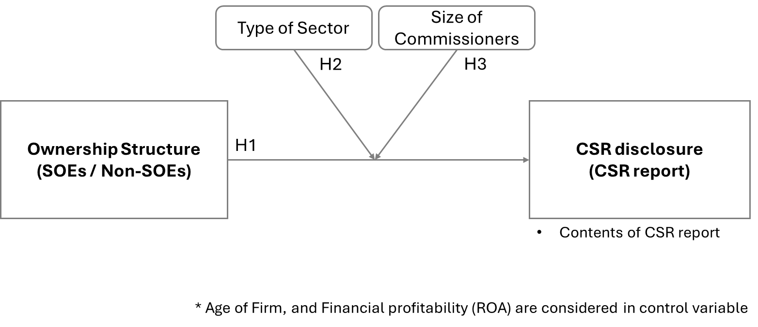

## *Research Methodology and Data Collection*

This study consists of annual / sustainability reports spanning three years from 2020 to 2023 from around 77 Russian and Chinese SOEs and non-SOEs companies, and were analyzed, with using multiple regression analysis. Companies that did not have complete sustainability reports or targeted data available were discontinued or excluded.

In this paper, quantitative content analysis was adopted to examine relationship between ownership structure of company (SOEs and non-SOEs) and CSR disclosure levels, with consideration of moderator and control variables, in Russia and China. Content analysis involved extracting and analyzing the textual content from sustainability and annual reports of sample companies. Previous researchers have suggested that content analysis provides effective results for CSR disclosure in both developing countries (Ali & Frynas, 2018; Belal & Cooper, 2011) and developed countries (Ali et al., 2017; Gamerschlag et al., 2011). The texts of sustainability reports, annual reports, and CSR reports were analyzed using SPSS software.

**Dependent variable**

The disclosure index developed in this study measures the extent of qualitative information disclosure in sustainability reports and annual reports. Specifically, the study identifies the presence of disclosure items in each report. That is, once an instance of a specific checklist item is found, the search for that item stops immediately. The index adopts a binary approach - 0/1, to scoring each disclosure item because it is concerned with the presence of disclosure, not just the frequency of data. This binary method aligns with many previous studies. Additionally, the study employs an unweighted approach to scoring each disclosure item, assuming that all items are of equal importance. In this method, to assess the level of quality in CSR reports, nine criteria were identified in the relevance category of information disclosed by SOEs. Adopting this framework enables the calculation of indicators of disclosure quality. The evaluation of CSR disclosure quality is presented in Figure 6, which combines different types of information and can be used as a valuable tool to assess the overall quality of corporate reporting practices, as argued by Bouten et al. (2011). Similar to the study by Prado-Lorenzo et al. (2008), each item was considered through a dummy variable, assigning a value of 1 if the corresponding initiative exists in the company and 0 if it does not. The quality level for each company is determined by the sum of numerical 1s for each item.

*Figure 6. Checklist of CSR Disclosure Information*

テーブル

**Independent Variable**

Ownership of companies (OWN) indicates whether government ownership is present, which is coded as 1, or private ownership, coded as 2. Sector type (SEC) takes a value of 1 if SOEs operate in environmentally sensitive sectors, and 0 otherwise. Size of Commissioners (COM) represents the number of independent directors serving on the board, while Age of Firm (AGE) denotes the number of years since establishment. Financial Performance (FPER) corresponds to the Return on Assets (ROA) value for the relevant year.

$$\text{SUM }\text{(}\text{CSRD}\text{)}i= β0+ β1OWNi+ β2COMi+β3 SECi+ \\ β4AGEi +β5 FPERi+ εi$$

For company i, SUM (CSRD) represents the dependent variable, while the independent variables include OWN, COM, SEC, AGE, and FPER. β0 represents the constant, and β1 through β8 denote the coefficients of each independent variable calculation. ε represents the error term, and i denotes the company number.

## *Result and Discussion*

In this section, the analysis primarily focuses on the combined data of Russia and China. Additionally, supplementary analyses for each country individually are included later pages.

***China and Russia***

In this analysis, both correlation and causality are examined through data from both Russia and China combined. Additionally, as a step of converting data into a binary value, "1" to China and "2" to Russia are assigned in the variable of Country.

***Descriptive Statistics***

In CSR disclosure (SUM), the average value is 7.68, which is relatively high, and the standard deviation is 1.322, indicating variability in CSR disclosure scores among companies exists.

In Ownership structure (T_OWN), the average value is 1.44, which is close to the midpoint between non-state-owned and state-owned enterprises. The standard deviation is 0.5, indicating moderate variability in the ownership structure of the companies.

As for Country (T_COUNTRY), the average value is 1.42, and the standard deviation is 0.496, suggesting that there is an almost equal number of companies from China and Russia, as well as moderate variability in the nationality of the companies.

Regarding Age of firm (AGE), the average value is 39.34 years, indicating that the companies have been established for several decades in average. The standard deviation is 29.451 years, showing wide variability in the age of the companies.

About ROA (Return on Assets), the average value is 7.849%, which is considered relatively healthy depending on the industry. However, the standard deviation is 13.1804%, indicating significant variability in ROA among companies.

In Independent director (DIRECTOR), the average value is 4.18, indicating that each company typically has about 4 independent directors. The standard deviation is 1.364, showing some variability in the number of independent directors.

Regarding Type of industry (INDUSTRY), the average value is 0.40, indicating that a majority of companies are in industries not sensitive to CSR. However, the standard deviation is 0.494, indicating a moderate variability in types of industries. (see Figure 7)

*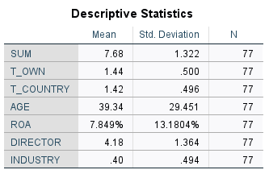Figure 7.*

***Correlation***

For Ownership revision and CSR disclosure (SUM), the Pearson correlation coefficient is 0.220, indicating a weak positive relationship between ownership structure and CSR disclosure. And the significance level of 0.027 suggests that this correlation is statistically significant.  
For Country and CSR disclosure, the Pearson correlation coefficient is - 0.393, indicating a weak negative relationship between country and CSR disclosure. And the significance level of 0.000 suggests that this correlation is statistically significant.

For Age of Firm and CSR disclosure, the Pearson correlation coefficient is 0.97, indicating a strong positive relationship between company age and CSR disclosure, but not statistically significant with a significance level of 0.20.

For ROA and CSR disclosure, the Pearson correlation coefficient is - 0.10, indicating a very weak negative relationship, and not statistically significant with a significance level of 0.464.

For Independent director and CSR disclosure, the Pearson correlation coefficient is 0.121, indicating a weak positive relationship, but not statistically significant with a significance level of 0.148.

For Type of Industry and CSR disclosure, the Pearson correlation coefficient is - 0.039, indicating a very weak negative relationship, and not statistically significant with a significance level of 0.368. (see Figure 8)

These results show weak positive and negative correlations between each variable and CSR disclosure. But variables of statistically significant correlation being observed are with the Ownership revision, and Country.

*Figure 8.*

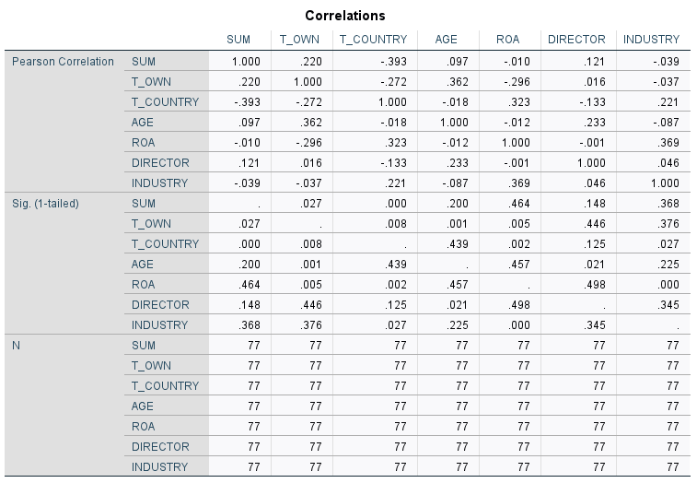

***Model***

The model's R (correlation coefficient) is 0.474, indicating a moderate positive relationship between independent variables and the dependent variable. The R Square (coefficient of determination) is 0.225, indicating that the independent variables explain approximately 22.5% of the variation in the dependent variable.

From these results, it can be concluded that while there is a moderate positive relationship between independent and dependent variables, the correlation is statistically small. Therefore, the independent variables may not have a significant impact on CSR disclosure. (see Figure 9)

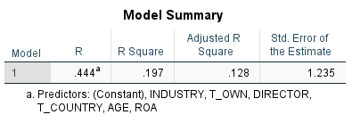*Figure 9.*

***Causality***

For Ownership revision, the unstandardized coefficient B is 0.401, indicating that a one-unit change in ownership structure (from non-SOE to SOE) increases the CSR disclosure score by an average of 0.401 points. However, with a t-value of 1.201 and a p-value (Sig.) of 0.233, this coefficient is not statistically significant.

For Country, the unstandardized coefficient B is - 1.053, indicating that a one-unit change in country decrease the CSR disclosure score by an average of 1.053 points. With a t-value of -3.328 and a p-value (Sig.) of 0.001, this coefficient is statistically significant.

For Age of Firm, the unstandardized coefficient B is 0.01, indicating that a one-unit change in company age increases the CSR disclosure score by an average of 0.01points. With a t-value of 0.182 and a p-value (Sig.) of 0.856, this coefficient is not statistically significant.

For ROA, the unstandardized coefficient B is 0.017, indicating that a one-unit change in ROA increases the CSR disclosure score by an average of 0.017 points. With a t-value of 1.326 and a p-value (Sig.) of 0.189, this coefficient is not statistically significant.

For Independent director, the unstandardized coefficient B is 0.059, indicating that a one-unit change in the number of independent directors increases the CSR disclosure score by an average of 0.059 points. With a t-value of 0.543 and a p-value (Sig.) of 0.589, this coefficient is not statistically significant.

For Type of Industry, the unstandardized coefficient B is - 0.021, indicating that a one-unit change in industry type decreases the CSR disclosure score by an average of 0.021 points. With a t-value of - 0.066 and a p-value (Sig.) of 0.948, this coefficient is not statistically significant.

A regression model was created to examine whether the independent variables have an impact on CSR disclosure. The results indicate that none of these independent variables but only Country has a statistically significant impact on CSR disclosure (see Figure 10).

*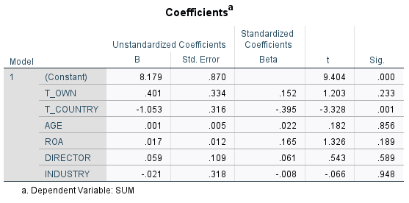Figure 10.*

***Multicollinearity statistics***

Considering the possibility that the large number of independent variables may increase statistical significance, we conducted a multicollinearity diagnosis. As a result, the Collinearity statistics show that all VIF values are below 10 (every value is around 1), indicating that the possibility of multicollinearity is low. (see Figure 11)

*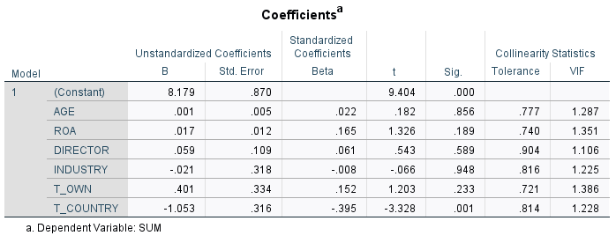Figure 11.*

Although multicollinearity was not observed previously, it is possible that statistical significance is not being properly displayed due to other reasons (i.e., model overfitting). In light of this, I reduced the number of independent variables and conducted regression analysis using only “Ownership”, “Type of Industry”, “Number of Independent Directors”, and “ROA”. As a result, statistical significance was observed between Ownership and CSR disclosure (0.048), with the t-value also being greater than 2 in absolute terms. Furthermore, the unstandardized coefficient B was 0.637, indicating that a one-unit change in ownership increases the CSR disclosure score by an average of 0.637 points. (see Figure 12)

*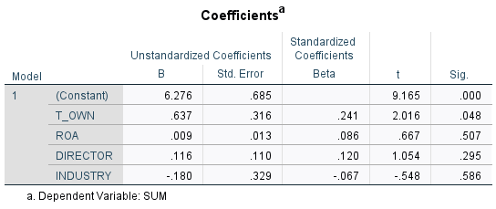Figure 12.*

***Moderation analysis***

Regarding the moderation analysis of the relationship between ownership structure and CSR disclosure by the industry variable, a new variable (Interaction_OWN_INDUSTRY) was generated by calculating variable of “ownership structure” times “type of industry”. This variable, along with ownership structure and type of industry, are used as independent variables to conduct a moderation analysis.

As Model Summary, the model's R (correlation coefficient) is 0.222, indicating a moderate relationship between independent variables and the dependent variable. The R Square (coefficient of determination) is 0.49, indicating that the independent variables explain approximately 4.9 % of the variation in the dependent variable.

From these results, it can be concluded that while there is a moderate relationship between independent and dependent variables, the correlation (R Square) is statistically small. Therefore, the independent variables may not have a significant impact on CSR disclosure. (see Figure 13)

*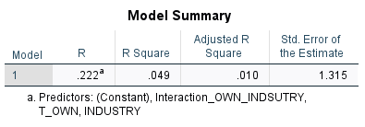Figure 13.*

Regarding the coefficient of this analysis,

Regarding Constant (B = 6.875, p < 0.001), the constant term is significant, suggesting that when all independent variables are zero, the baseline level of CSR disclosure is 6.875.

About Ownership Structure (T_OWN) (B = 0.578, p = 0.060), the coefficient for ownership structure is 0.578. This suggests that being a state-owned enterprise (SOE, coded as 2) is associated with a 0.578 increase in the CSR disclosure score compared to non-SOEs (coded as 1), holding other factors constant. However, this effect is not statistically significant at the conventional 0.05 level.

Concerning Type of Industry (INDUSTRY) (B = -0.084, p = 0.786), the coefficient for industry type is -0.084 with no statistically significant (0.786). This indicates that being in a CSR-sensitive sector does not have a significant impact on CSR disclosure scores when other variables are controlled.

In regard to Interaction Term (Interaction_OWN_INDUSTRY) (B = -0.018, p = 0.906), the interaction term between ownership structure and industry type has a coefficient of -.018, but not statistically significant (p = 0.906). This suggests that the type of industry does not significantly moderate the relationship between ownership structure and CSR disclosure. (see Figure 14)

*Figure 14.*

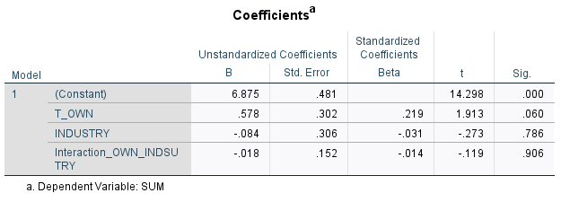

Regarding the moderation analysis of the relationship between ownership structure and CSR disclosure by the number of independent director variable, in a manner similar to the previous investigation, a new variable (Interaction_OWN_INDEPENDENT) was generated by calculating variable of “ownership structure” times “number of independent directors”. This variable, along with ownership structure and number of independent directors, are used as independent variables to conduct a moderation analysis.

As Model Summary, the model's R (correlation coefficient) is 0.222, indicating a moderate relationship between independent variables and the dependent variable. The R Square (coefficient of determination) is 0.49, indicating that the independent variables explain approximately 4.9 % of the variation in the dependent variable.

From these results, it can be concluded that while there is a moderate relationship between independent and dependent variables, the correlation (R Square) is statistically small. Therefore, the independent variables may not have a significant impact on CSR disclosure. (see Figure 15)

*Figure 15.*

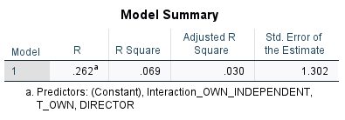

Regarding the coefficient of this analysis,

Regarding Constant (B = 6.346, p < 0.000), the constant term is significant, suggesting that when all independent variables are zero, the baseline level of CSR disclosure is 6.346.

About Ownership Structure (T_OWN) (B = 0.575, p = 0.058), the coefficient for ownership structure is 0.575. This suggests that being a state-owned enterprise (SOE, coded as 2) is associated with a 0.578 increase in the CSR disclosure score compared to non-SOEs (coded as 1), holding other factors constant. However, this effect is not statistically significant at the conventional 0.05 level.

Concerning Number of independent director (DIRECTOR) (B = 0.119, p = 0.281), the coefficient for industry type is 0.119, and is not statistically significant (p = 0.281). This indicates that number of independent directors does not have a significant impact on CSR disclosure scores when other variables are controlled.

In regard to Interaction Term (Interaction_OWN_INDEPENDENT) (B = 0.109, p = 0.475), the interaction term between ownership structure and number of independent directors has a coefficient of 0.109, but not statistically significant (p = 0.475). This suggests that the number of independent directors does not significantly moderate the relationship between ownership structure and CSR disclosure. (see Figure 16)

*Figure 16*

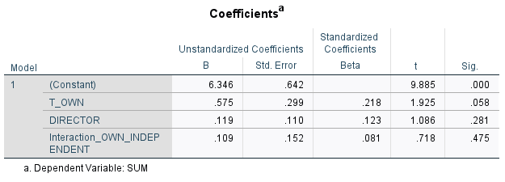

***Result***

Regarding Hypothesis H1, the above results show that in the correlation analysis, weak positive correlations were observed between Ownership and CSR disclosure (0.220), with statistical significance of 0.027.

In the causality analysis, initially, a comprehensive model was developed with independent variables - including ownership structure, country, age of the firm, ROA, number of independent directors, and type of industry, and the dependent variable being CSR disclosure. This model did not yield statistically significant (p = 0.2333). However, a refined model - reducing the independent variables to ownership structure, ROA, number of independent directors, and type of industry, did show statistical significance for ownership structure (p = 0.048), with the unstandardized coefficient B being 0.637, indicating that a one-unit change in ownership increases the CSR disclosure score by an average of 0.637 points.

The lack of significance in the initial comprehensive model suggests that when a broader range of variables is considered, the individual impact of ownership structure on CSR disclosure may be obscured by other factors. However, upon reducing the number of variables, the positive relationship between state ownership and CSR disclosure becomes evident. This indicates that state ownership does indeed play a significant role in CSR disclosure, but its effect is more distinct when fewer variables are included in the model. Thus, Hypothesis H1, stating that *State ownership of enterprises is positively related to their CSR disclosure*, is confirmed.

For Hypotheses H2 and H3, the coefficients were not statistically significant in moderation analysis. Therefore, the null hypotheses for H2, stating that *industry type positively moderates the relationship between SOE and CSR disclosure in resource-intensive industries*, and H3, stating that *the number of independent directors positively moderates the relationship between SOE and CSR disclosure in companies with a high number of independent directors*, are also rejected.

***China***

As a supplementary analysis, data of each country is also analyzed separately. In this analysis, both correlation and causality are examined.

***Descriptive Statistics***

In the CSR disclosure (SUM), the mean CSR disclosure score is 8.11, with a standard deviation of 1.210. This indicates that CSR disclosure scores of companies in this sample are moderately high, with relatively little variation from the mean score.

About ownership structure, the mean value for the coded ownership structure, with non-SOEs coded as “1” and SOEs as “2”, is 1.56, suggesting that non-SOEs are more common in this sample. The low standard deviation of 0.503 indicates limited variation in ownership structure within this group.

Regarding the age of firms, the mean number of years since establishment is 39.78, with a standard deviation of 25.584, indicating a wide range of company ages in the sample.  
In ROA, the mean asset profitability rate is 4.287%, with a standard deviation of 5.9383%, indicating a wide range of ROA values across the sample.

In terms of the number of independent directors, the mean value is 4.33, with a standard deviation of 1.108, suggesting a relatively little variation.

Regarding the type of industry, where CSR-sensitive sectors are coded as “1” and non-sensitive sectors as “0”, the mean value is 0.31, indicating that the majority of companies in this sample belong to non-sensitive sectors regarding CSR. (see Figure 17)

From these findings, it can be concluded that in the Chinese sample, most companies are non-SOEs, with many being less sensitive to CSR. Additionally, there is wide variation in the establishment years and ROA among companies, while CSR disclosure and the number of independent directors is little variation.

*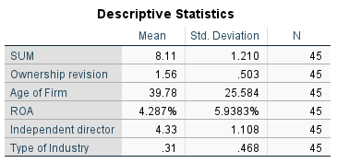Figure 17.*

***Correlation***

For Ownership revision and CSR disclosure (SUM), the Pearson correlation coefficient is 0.195, indicating a weak positive relationship between ownership structure and CSR disclosure. However, the significance level of 0.099 suggests that this correlation is not statistically significant.

For Age of Firm and CSR disclosure (SUM), the Pearson correlation coefficient is 0.320, indicating a moderate positive relationship between company age and CSR disclosure, but not statistically significant with a significance level of 0.016.

For ROA and CSR disclosure (SUM), the Pearson correlation coefficient is 0.240, indicating a very weak positive relationship, but not statistically significant with a significance level of 0.056.  
For Independent director and CSR disclosure (SUM), the Pearson correlation coefficient is 0.158, indicating a weak positive relationship, but not statistically significant with a significance level of 0.15.  
For Type of Industry and CSR disclosure (SUM), the Pearson correlation coefficient is 0.058, indicating a very weak positive relationship, but not statistically significant with a significance level of 0.353. (see Figure 18)

These results show weak to moderate positive correlations between each variable and CSR disclosure. However, the only statistically significant correlation observed is with the age of the firm.

*Figure 18.*

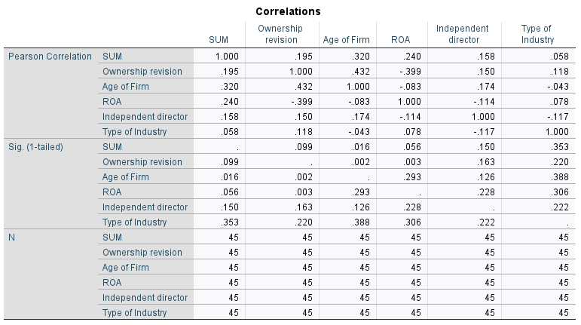

***Model***

The model's R (correlation coefficient) is 0.474, indicating a moderate positive relationship between independent variables and the dependent variable. The R Square (coefficient of determination) is 0.225, indicating that the independent variables explain approximately 22.5% of the variation in the dependent variable.

From these results, it can be concluded that while there is a moderate positive relationship between independent and dependent variables, the correlation is statistically small. Therefore, the independent variables may not have a significant impact on CSR disclosure. (see Figure 19)

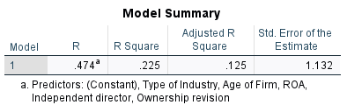*Figure 19.*

***Causality***

For Ownership revision, the unstandardized coefficient B is 0.510, indicating that a one-unit change in ownership structure (from non-SOE to SOE) increases the CSR disclosure score by an average of 0.510 points. However, with a t-value of 1.211 and a p-value (Sig.) of 0.233, this coefficient is not statistically significant.

For Age of Firm, the unstandardized coefficient B is 0.011, indicating that a one-unit change in company age increases the CSR disclosure score by an average of 0.011 points. With a t-value of 1.486 and a p-value (Sig.) of 0.145, this coefficient is not statistically significant.  
For ROA, the unstandardized coefficient B is 0.073, indicating that a one-unit change in ROA increases the CSR disclosure score by an average of 0.073 points. With a t-value of 2.273 and a p-value (Sig.) of 0.029, this coefficient is statistically significant.

For Independent director, the unstandardized coefficient B is 0.141, indicating that a one-unit change in the number of independent directors increases the CSR disclosure score by an average of 0.141 points. With a t-value of 0.892 and a p-value (Sig.) of 0.378, this coefficient is not statistically significant.

For Type of Industry, the unstandardized coefficient B is 0.079, indicating that a one-unit change in industry type increases the CSR disclosure score by an average of 0.079 points. With a t-value of 0.211 and a p-value (Sig.) of 0.834, this coefficient is not statistically significant.   
A regression model was created to examine whether the independent variables have an impact on CSR disclosure. The results indicate that none of these independent variables but only ROA have a statistically significant impact on CSR disclosure (see Figure 20).

*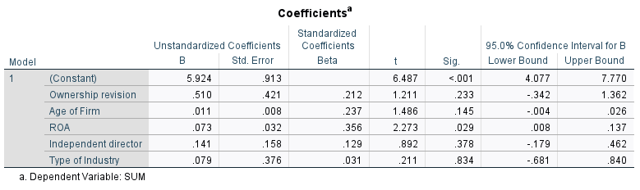Figure 20.*

***Result***

In the correlation analysis, a moderate positive correlation (0.320) between Age of Firm and CSR disclosure was observed and found to be statistically significant (0.016). Although weak positive correlations were found between Ownership, Industry type, Number of independent directors, and CSR disclosure (0.195, 0.058, and 0.159, respectively), none of these were statistically significant.

In the causality analysis, the Unstandardized Coefficients B for all independent variables showed positive values, indicating positive relationships, but only ROA was statistically significant. Based on these findings, the null hypothesis H1, that state that *ownership of enterprises is positively related to their CSR disclosure*, is rejected.

Regarding hypotheses H2 and H3, the coefficients were not statistically significant. Therefore, the null hypotheses H2, which states *that industry type positively moderates the relationship between SOE and CSR disclosure, making this relationship stronger in resource-intensive industries*, and H3, which states that *the number of independent directors positively moderates the relationship between SOE and CSR disclosure, making this relationship stronger in companies with a high number of independent directors*, are rejected.

As a supplementary note, when comparing coefficients with control variables of Ownership, ROA, and Age of firm (see Figure 21), adding independent director as a control variable (see Figure 22), and adding type of industry as a control variable (see Figure 23), the unstandardized coefficients B for ownership decrease when including independent director and type of industry.

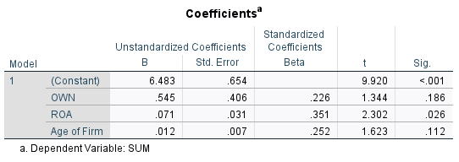*Figure 21.*

*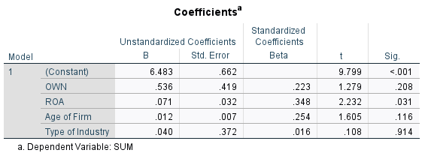Figure 22.*

*Figure 23.*

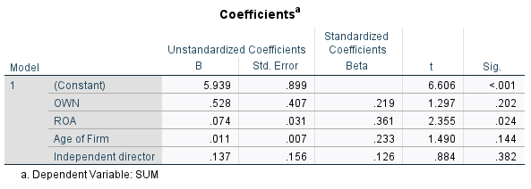

**Russia**

***Descriptive Statistics***

For CSR disclosure (SUM), the average value is 7.06, with a standard deviation of 1.243. This indicates that the CSR disclosure scores of the companies in this sample are moderately high and do not vary widely from the mean.

Regarding ownership structure (OWN), where non-SOEs are coded as “1” and SOEs as “2”, the average value is 1.28. This suggests that non-SOEs are more common than SOEs in this sample. The low standard deviation of 0.457 indicates limited variation in ownership structure within this group.

For ROA (Return on Assets), the average value is 12.858% with a standard deviation of 18.2081%. This shows a wide range in ROA among the companies in this sample.

The average number of independent directors is 3.97, with a standard deviation of 1.656. This suggests that the number of independent directors in the companies in this sample does not vary widely from the mean.

Regarding the age of the firm, the average number of years from establishment to the present is 38.72, with a standard deviation of 34.594 years. This indicates a wide range in the age of the companies in this sample. This indicates a wide range in the age of the companies in this sample.  
For industry type, coded as “1” for CSR-sensitive sectors and “0” for non-sensitive sectors, the average value is 0.53. This suggests that a majority of the companies in this sample belong to CSR-sensitive sectors (see Figure 24).

From these findings, it is evident that in the Russian sample, the majority of companies are non-SOEs, and many belong to CSR-sensitive industries. Additionally, while the establishment year and ROA of companies vary widely, CSR disclosure and the number of independent directors does not vary significantly from the mean.

*Figure 24.*

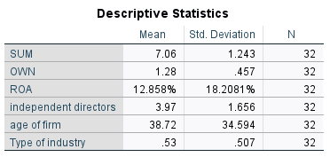

***Correlation***For ownership structure (OWN) and CSR disclosure (SUM), the Pearson correlation coefficient is 0.025. This indicates almost no correlation between these two. The significance level is 0.446, which exceeds the common thresholds (e.g., .05 or .01), indicating that this correlation is not statistically significant.

For ROA and CSR disclosure (SUM), the Pearson correlation coefficient is 0.112, suggesting a weak positive correlation between ROA and CSR disclosure. However, the significance level is 0.271, which exceeds common thresholds, indicating that this correlation is not statistically significant.  
For the number of independent directors and CSR disclosure (SUM), the Pearson correlation coefficient is 0.001, indicating almost no correlation. The significance level is 0.498, which exceeds common thresholds, indicating that this correlation is not statistically significant.  
For the age of the firm and CSR disclosure (SUM), the Pearson correlation coefficient is -0.127, indicating a weak negative correlation. The significance level is 0.244, which exceeds common thresholds, indicating that this correlation is not statistically significant.

For industry type and CSR disclosure (SUM), the Pearson correlation coefficient is 0.048, indicating almost no correlation. The significance level is 0.397, which exceeds common thresholds, indicating that this correlation is not statistically significant.

These results show that while there are weak to moderate positive and negative relationships between each variable and CSR disclosure, none of the correlations are statistically significant (see Figure 25).

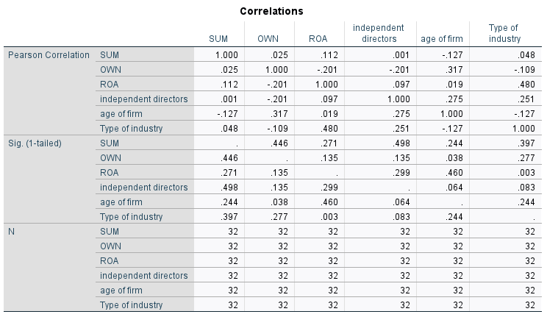*Figure 25.*

***Model***   
the model shows an R (correlation coefficient) of 0.211, indicating a weak positive relationship between the independent and dependent variables. The R Square (coefficient of determination) is 0.045, indicating that the independent variables explain about 4.5% of the variation in the dependent variable.

These results suggest that while there is a weak positive relationship between the independent and dependent variables, this relationship is statistically very small. Therefore, it is possible that the independent variables do not have a significant impact on CSR disclosure (see Figure 26).

*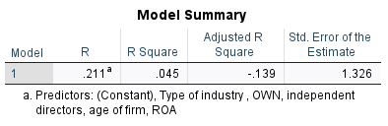Figure 26.*

***Causality***

As for the analysis results in causality, the unstandardized coefficient (B) for ownership structure (OWN) is 0.360, indicating that a one-unit change in ownership structure (from non-SOE to SOE) would increase the CSR disclosure score by an average of 0.360 points. The t-value for this coefficient is 0.602, and the p-value (Sig.) is 0.552. These values indicate that this coefficient is not statistically significant.

The unstandardized coefficient (B) for the age of the firm is -0.007, indicating that a one-unit change in the firm's age would decrease the CSR disclosure score by an average of 0.007 points. The t-value for this coefficient is -0.899, and the p-value (Sig.) is 0.377. These values indicate that this coefficient is not statistically significant.

The unstandardized coefficient (B) for ROA is 0.011, indicating that a one-unit change in ROA would increase the CSR disclosure score by an average of 0.011 points. The t-value for this coefficient is 0.727, and the p-value (Sig.) is 0.474. These values indicate that this coefficient is not statistically significant.

The unstandardized coefficient (B) for the number of independent directors is 0.063, indicating that a one-unit change in the number of independent directors would increase the CSR disclosure score by an average of 0.063 points. The t-value for this coefficient is 0.376, and the p-value (Sig.) is 0.710. These values indicate that this coefficient is not statistically significant.  
The unstandardized coefficient (B) for industry type is -0.156, indicating that a one-unit change in industry type would decrease the CSR disclosure score by an average of 0.156 points. The t-value for this coefficient is -0.272, and the p-value (Sig.) is 0.788. These values indicate that this coefficient is not statistically significant.

A regression model was created to examine whether the independent variables have an impact on CSR disclosure. The results indicate that none of these independent variables have a statistically significant impact on CSR disclosure (see Figure 27).

*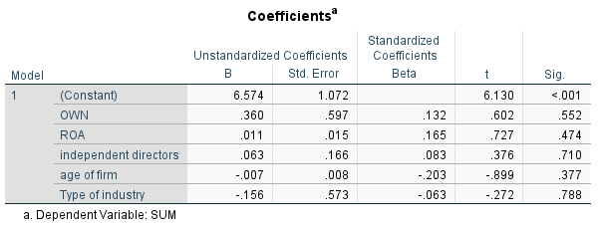Figure 27.*

***Result***  
Regarding Hypothesis H1, the above results show that in the correlation analysis, weak positive correlations were observed between Ownership, Industry type, Number of independent directors, and CSR disclosure (0.025, 0.048, 0.001, respectively), but none were statistically significant. In the causality analysis, the unstandardized coefficients for age of the firm and type of industry were negative, while the others were positive. However, none of these results were statistically significant. Therefore, the null hypothesis for H1, stating that *state ownership of enterprises is positively related to their CSR disclosure*, is rejected.

For Hypotheses H2 and H3, the coefficients were not statistically significant. Therefore, the null hypotheses for H2, stating that *industry type positively moderates the relationship between SOE and CSR disclosure in resource-intensive industries*, and H3, stating *that the number of independent directors positively moderates the relationship between SOE and CSR disclosure in companies with a high number of independent directors*, are also rejected.

As a supplementary note, regarding the causal relationship, comparing patterns of control variables of Ownership, ROA, Age of the firm (see Figure 28), adding independent director as a control variable (see Figure 29), and adding type of industry as a control variable (see Figure 30), the unstandardized coefficients B for ownership increased with the independent director but showed no change with the type of industry.

*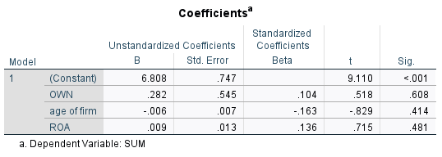Figure 28.*

*Figure 29.*

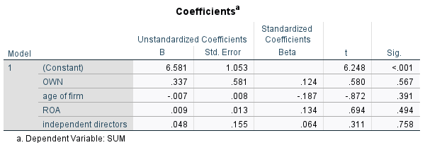

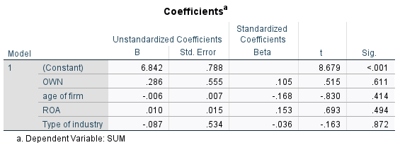*Figure 30.*

# Chapter 4. Conclusion

In this study, I utilized publicly available data obtained from the annual reports and sustainability reports of companies in Russia and China to investigate the relationship between CSR disclosure and various independent variables through content analysis and statistical tests. As a result, significant insights into the dynamics of CSR disclosure in different national contexts were gained.

In Hypothesis 1 (H1) of this study, regression analysis was conducted on integrated data of China and Russia, with State Ownership, ROA, Number of independent directors, and Type of industry as independent variables. In the case of Ownership, the Unstandardized Coefficient B showed 0.637, with statistical significance (P=0.048). This implies that when the ownership structure shifts from non-state-owned enterprise to state owned enterprise, the total CSR disclosure increases by 0.637 points.

On the other hand, Hypotheses 2 (H2) and 3 (H3) demonstrated that the type of industry and the number of independent directors does not significantly moderate the relationship between ownership structure and CSR disclosure. These results suggest that while ownership structure is significant as a determinant of CSR disclosure, factors such as industry type and the number of independent directors do not play a mediating role in this relationship.

However, in each separated study of Russia and China, there are no statistical significance on these hypotheses although, in the case of China, there are correlation between Firm age and CSR disclosure, and causal relationship between ROA and CSR disclosure, with statistical significance.

***Implication***  
The findings of this study provide several important implications for policymakers and researchers. For policymakers, it is indicated that to promote CSR disclosure, state-owned has impact. This mechanism can be understood that in Russia and China, the CSR priorities of state-owned enterprises align with government agendas, leading to an increase in CSR disclosure movements in state-owned enterprises. However, attention should not only be directed towards state-owned enterprises but also consider other company characteristics and external pressures. Especially in countries like Russia, where factors under investigation showed no significant influence, tailored strategies may be necessary for this case. In the case of China, a positive correlation was observed between the establishment year of the company and CSR disclosure, and furthermore, a causal relationship was confirmed between ROA and CSR disclosure. Therefore, to promote CSR, it is necessary to understand how these factors influence CSR disclosure and develop strategies to enhance CSR disclosure while considering these factors.

Theoretically, this study provides a new perspective on the relationship between ownership structure and CSR disclosure. The conclusion that state-owned enterprises play an important role in CSR disclosure, which aligns with many previous studies. Additionally, it is suggested that to understand the relationship between CSR disclosure and various predictive factors, other factors such as external factors should be considered according to each country's situation.

***Future Research***

Future research is recommended in three main areas. First, exploring additional external factors that may influence CSR disclosure, such as market competition, regulatory pressure, and stakeholder activities, could provide a more comprehensive understanding of the drivers of CSR disclosure.

Second, a deeper investigation into factors showing correlation or causality with CSR disclosure, such as the positive correlation between company age and CSR disclosure or the positive causal relationship between ROA and CSR disclosure, is needed. Future research should investigate into what specific elements within company age and ROA, impact CSR disclosure.

Third, additional longitudinal studies focusing on Russian companies are recommended. The recent availability or lack of data from Russian companies may be influenced by recent geopolitical situation, affecting profitability and investment in CSR activities. Continuous research is needed to clarify trends in Russia.

***Limitation***

Focusing on companies in Russia and China may limit the generalizability of the results. Different countries with varied regulatory and cultural environments might yield different outcomes. Although content analysis was used to measure CSR disclosure, this method may not capture the full scope of CSR activities undertaken by companies. Employing more detailed and diverse assessment methods could offer a richer understanding of CSR practices.

***Summary***

This study contributes to understanding the determinants of CSR disclosure in SOEs and non-SOEs in Russia and China. It emphasizes the complexity of this relationship and suggests that further extensive and detailed research is necessary for a complete understanding. Policymakers and corporate managers are shown to be able to indeed proceed with more effective CSR disclosure while considering the role of state-owned enterprises in CSR disclosure. The insights gained from this study pave the way for further exploration based on these findings, revealing the multifaceted nature of CSR in different contexts for future research.

# Reference

* Global Footprint Network (2019). Earth Overshoot Day 2019 is July 29th, the earliest ever.<https://www.footprintnetwork.org/2019/06/26/press-release-june-2019-earth-overshoot-day/>
* Fatima T, Elbanna S. Corporate Social Responsibility (CSR) Implementation: A Review and a Research Agenda Towards an Integrative Framework. J Bus Ethics. 2023;183(1):105-121. doi: 10.1007/s10551-022-05047-8. Epub 2022 Feb 2. PMID: 35125567; PMCID: PMC8807959.
* Homayoun, S.; Mashayekhi, B.; Jahangard, A.; Samavat, M.; Rezaee, Z. The Controversial Link between CSR and Financial Performance: The Mediating Role of Green Innovation. Sustainability **2023**, 15, 10650. <https://doi.org/10.3390/su151310650>
* Cunha, Sara & Proença, Teresa & Ferreira, Marisa. (2022). Employees Perceptions about Corporate Social Responsibility—Understanding CSR and Job Engagement through Meaningfulness, Bottom-Up Approach, and Calling Orientation. Sustainability. 14. 10.3390/su142114606.
* Yan R, Li X and Zhu X (2022) The Impact of Corporate Social Responsibility on Sustainable Innovation: A Case in China’s Heavy Pollution Industry. Front. Psychol. 13:946570. doi: 10.3389/fpsyg.2022.946570
* Dentchev, N. A., Haezendonck, E. and van Balen, M. (2015). The role of governments in thebusiness and society debate. Business & Society doi.org/10.1177/0007650315586179.
* Jackson, G., Bartosch, J., Avetisyan, E., Kinderman, D., & Knudsen, J. S. (2020). Mandatory non-financial disclosure and its influence on CSR: An international comparison. Journal of Business Ethics, 162, 323-342.
* Fox, T., H. Ward and B. Howard: 2002, Public Sector Roles in Strengthening Corporate Social Responsibility: A Baseline Study (The World Bank, Washington).
* Beiner, S., Drobetz, W., Schmid, M.M., Zimmerman, H., 2004. An integrated framework of corporate governance and firm valuation. Eur. Financ. Manag. 12 (2), 249–283.
* Joh, S.W.(2003). Corporate governance and firm profitability: evidence from Korea before the economic crisis. J. Financ. Econ. 68, 287–322.
* Lu ,J. W., G e J., W u, W. & Y an, S. (2023). Attention to Whom? State, Market, and the Scope of Corporate Social Responsibility Activities . Paper presented at the Academy of Management Conference , Boston
* Freeman RE (1984) Strategic management: a stakeholder approach.

Pitman Publishing, Boston

* Minoja M (2012) Stakeholder management theory, firm strategy, and ambidexterity. J Bus Ethics 109:67–82
* Donaldson T, Preston LE (1995) The stakeholder theory of the corporation:　concepts, evidence, and implications. Acad Manag Rev 20:65-91
* Jordan Bar Am et al., 2022. “How to prepare for a sustainable future along the value chain”. McKinsey & Company Website.

<https://www.mckinsey.com/industries/consumer-packaged-goods/our-insights/how-to-prepare-for-a-sustainable-future-along-the-value-chain>

* Tim Stobierski (2021) 15 EYE-OPENING CORPORATE SOCIAL RESPONSIBILITY STATISTICS. <https://online.hbs.edu/blog/post/corporate-social-responsibility-statistics>
* Patten, D. M., & Crampton, W. (2004). LEGITIMACY AND THE INTERNET: AN EXAMINATION OF CORPORATE WEB PAGE ENVIRONMENTAL DISCLOSURES. Advances in Environmental Accounting and Management,2, 31–57. doi: https://doi.org/10.1016/S1479-3598(03)02002-8
* Deegan, C. (2002). The legitimising effect of social and environmental disclosures: A theoretical foundation. Accounting, Auditing and Accountability Journal, 15(3), 282–311. https://doi.org/https://doi.org/10.1108/09513570210435852
* Neu, D., Warsame, H., & Pedwell, K. (1998). Managing Public Impressions: Environmental Disclosures in Annual Reports. Accounting, Organizations and Society,23(3), 265–282. doi: https://doi.org/10.1016/S0361-3682(97)00008-1
* Suchman, M. (1995). Managing legitimacy: Strategic and institutional approaches. Academy of Management Review, 20(3), 57l–610. doi: https://doi.org/10.5465/amr.1995.9508080331
* Corporate Social Responsibility: Grasping Legitimacy, Reaching Sustainability Y. Handoko, “Implementasi Social and Environmental Disclouse dalam Perspektif Teoritis,” J. JIBEKA, vol. 8, no. 2, 2014.
* Haniffia et al, “The impact of culture and governance on corporate social reporting,” J. Account. Public Policy, vol. 24, no. 5, pp. 391–430, 2005.
* Wernerfelt, B. (1984), “A resource based view of the firm”, Strategic Management Journal, Vol. 5, pp. 171-80.
* Barney, P. (1991), “Firms resources and sustained competitive advantage”, Journal of Management, Vol. 17, pp. 99-120.
* Cho, H. and Pucik, V. (2005), “Relationship between innovativeness, quality, growth, profitability, and market value”, Strategic Management Journal, Vol. 26, pp. 555-75.
* Castelo, M. and Lima, L. (2006), “Corporate social responsibility and resource-based perspectives”, Journal of Business Ethics, Vol. 69, pp. 111-32.
* Hart, S. (1995), “A natural resource-based view of the firm”, Academy of Management Review, Vol. 20, pp. 986-1014.
* McWilliams, A., Van Fleet, D. and Cory, K. (2002), “Raising rivals costs through political strategy: an extension of the resource-based theory”, Journal of Management Studies, Vol. 39, pp. 707-23.
* Hedstrom, G., Poltorzycki, S. and Strob, P. (1998), “Sustainable development: the next generation of business opportunity”, available at: www.resourcesaver.com (accessed May 5, 2008).
* Noam Noked et al. (2013), “The Corporate Social Responsibility Report and Effective Stakeholder Engagement”, Harvard Law School Forum on Corporate Governance.

<https://corpgov.law.harvard.edu/2013/12/28/the-corporate-social-responsibility-report-and-effective-stakeholder-engagement/>

* Matthew Bell (2021), “Why ESG performance is growing in importance for investors”, EY website, <https://www.ey.com/en_us/insights/assurance/why-esg-performance-is-growing-in-importance-for-investors>
* Jay et al. (2023), “Investors want to hear from companies about the value of sustainability”, McKinsey & Company website, <https://www.mckinsey.com/capabilities/strategy-and-corporate-finance/our-insights/investors-want-to-hear-from-companies-about-the-value-of-sustainability>
* Marsh McLennan website, “ESG AS A WORKFORCE STRATEGY” <https://www.marshmclennan.com/insights/publications/2020/may/esg-as-a-workforce-strategy.html>
* Boufounou, P., Moustairas, Ι., Toudas, K. et al. ESGs and Customer Choice: Some Empirical Evidence. Circ.Econ.Sust. 3, 1841–1874 (2023). <https://doi.org/10.1007/s43615-023-00251-8>
* SOMPO Website. “Overview of Sustainability Communications and Policy”.

<https://www.sompo-hd.com/en/csr/communications/policy/>

* Deloitte Website. “ESG Ratings: do they add value? How to get prepared?”.   
  <https://www2.deloitte.com/ce/en/pages/about-deloitte/articles/esg-ratings-do-they-add-value.html>
* Betty Moy Huber et al. (2017), “ESG Reports and Ratings: What They Are, Why They Matter” Harvard Law School Forum on Corporate Governance. <https://corpgov.law.harvard.edu/2017/07/27/esg-reports-and-ratings-what-they-are-why-they-matter/#1>
* Deloitte Polska (2022). “Comparing rating agencies and ESG methodologies”. <https://www2.deloitte.com/content/dam/Deloitte/ce/Documents/about-deloitte/ce_table_ratings_esg_eng.pdf>
* OECD (2020). “State-owned enterprises, sustainable finance and resilience”. OECD Business and Finance Outlook 2020 : Sustainable and Resilient Finance. <https://www.oecd-ilibrary.org/sites/5ad33666-en/index.html?itemId=/content/component/5ad33666-en>
* Mohd Ghazali, N.A. (2007), "Ownership structure and corporate social responsibility disclosure: some Malaysian evidence", Corporate Governance, Vol. 7 No. 3, pp. 251-266. <https://doi.org/10.1108/14720700710756535>
* Nugraheni, P., Indrasari, A., & Hamzah, N. (2022). The Impact of Ownership Structure on CSR Disclosure: Evidence from Indonesia. Journal of Accounting and Investment, 23(2), 229-243
* Irina Ervits (2020). “CSR reporting in China’s private and state‑owned enterprises: A mixed methods comparative analysis”. Asian Business & Management (2023) 22:55 - 83
* Hsu et al. (2021). “Leviathan Inc. and Corporate Environmental Engagement”. <https://pubsonline.informs.org/doi/abs/10.1287/mnsc.2021.4064>
* Polishchuk, L. (2009), ‘‘Corporate social responsibility or government regulation? An analysis of institutional choice’’, Problems of Economic Transition, Vol. 52 No. 8, pp. 73-94.
* Kuznetsov, A., Kuznetsova, O. and Warren, R. (2009), ‘‘CSR and the legitimacy of business in transition economies: the case of Russia’’, Scandinavian Journal of Management, Vol. 25 No. 1, pp. 37-45.
* Zavyalova, Elena & Ostrovskaya, Elena (2020). Corporate social responsibility in Russia. SHS Web of Conferences. 89. 06008.
* Avtonomov, V. (2006), ‘‘Balancing state, market and social justice: Russian experiences and lessons to learn’’, Journal of Business Ethics, Vol. 66 No. 1, pp. 3-9
* Apressyan, R.G. (1997), ‘‘Business ethics in Russia’’, Journal of Business Ethics, Vol. 16 No. 14, pp. 1561-70.
* A. Kuznetsov, O. Kuznetsova, R. Warren, CSR and the legitimacy of business in transition economies: The case of Russia, Scandinavian Journal of Management, Volume 25, Issue 1, 2009
* Soboleva, I. (2006), ‘‘Corporate social responsibility: global context and Russian realities’’, Problems of Economic Transition, Vol. 49 No. 8, pp. 82-95.
* Ren, F. The evolving thoughts of sustainable development and its use for reference in contemporary China. *Technol. Econ.* **2006**, *7*, 5–7.
* Lu, X. Business ethics in China. *J. Bus. Ethics* **1997**, *16*, 1509–1518
* Zhang, Dongyong, Stephen Morse, Uma Kambhamptati, and Bingjun Li. 2014. "Evolving Corporate Social Responsibility in China" Sustainability 6, no. 11: 7646-7665. <https://doi.org/10.3390/su6117646>
* Jiang, Q.; Zhang, D.; Ma, X.; Li, B. Drivers for food risk management and corporate social responsibility; a case of Chinese food companies. *J. Clean. Prod.* **2014**, *66*, 520–527.
* Jensen, M.H. *Serve the People! Corporate Social Responsibility (CSR) in China*; Asia Research Centre, CBS, Copenhagen discussion paper 2006–6; Asia Research Center Cophenhagen Business School: Frederiksberg, Denmark, 2006.
* Shi, Y. Seven reasons why the Chinese Dream is different from the American Dream. In *Qiushi*; Central Party School: Beijing, China, 2013. (In Chinese)
* Li, H. Research on the evolving idea of sustainable development in China. *Econ. Law* **2010**, *12*, 396–397. (In Chinese)
* Li, X.; Fan, J. An analysis of Mao Ze-dong’s thought on equality. *J. Xuchang Coll.* **2006**, *1*, 23–25.
* Zhang, D. Corporate accountability (China). In *The Encyclopedia of Sustainability*; Geall, S., Liu, J., Pellissery, S., Eds.; Berkshire Publishing: Great Barrington, MA, USA, 2012; pp. 74–78.
* L.W. Lin, 'Corporate Social Responsibility in China: Window Dressing or Structural Change' (2010) 28 Berkeley Journal of International Law 64 at 88.
* Jingchen Zhao. (2014). “Corporate Social Responsibility in Cotemporary China”. Edward Elgar Publishing Limited.
* J.P. Gies and B. Holt, 'Harmonious Society: Rise of the New China' (2009) Strategic Studies Quarterly 75.
* Hu Jintao, 'Scientific Outlook Development', Lecture for Yale University, 24 April 2006
* Tagesson, T., Blank, V., Broberg, P., & Collin, S.-O. (2009). What explains the extent and content of social and environmental disclosures on corporate websites: A study of social and environmental reporting in Swedish listed corporations. *Corporate Social Responsibility and Environmental Management*, [16](https://doi.org/https:/doi.org/10.1002/csr.194)([6](https://doi.org/https:/doi.org/10.1002/csr.194)), 352–364. [https://doi.org/https://doi.org/10.1002/csr.194](https://doi.org/https:/doi.org/10.1002/csr.194)
* Cormier, D., Magnan M., & Van Velthoven B. (2005). Environmental disclosure quality in large German companies: Economic incentives, public pressures or institutional conditions? European Accounting Review,14(1), 3–39
* Coffey, B.S., & Fryxell, G.E. (1991). Institutional ownership of stock and dimensions of corporate social performance: An empirical examination. *Journal of Business Ethics*,[10](https://doi.org/10.1007/BF00382826)([6](https://doi.org/10.1007/BF00382826)), 437–444. doi:<https://doi.org/10.1007/BF00382826>
* Reverte, C. (2009). Determinants of corporate social responsibility disclosure ratings by Spanish listed firms. *Journal of Business Ethics*,[88](https://doi.org/10.1007/s10551-008-9968-9)([2](https://doi.org/10.1007/s10551-008-9968-9)), 351–366. doi:<https://doi.org/10.1007/s10551-008-9968-9>
* Deegan, C., & Jeffry, U. (2006). *Financial Accounting Theory*. Berkshire: McGraw-Hill Education
* Wanderley, L. S. O., Lucian, R., Farache, F., Filho, J., & Mde, S. (2008). CSR information disclosure on the web: A context-based approach analysing the influence of country of origin and industry sector. *Journal of Business Ethics*, [82](https://doi.org/https:/doi.org/10.1007/s10551-008-9892-z)([2](https://doi.org/https:/doi.org/10.1007/s10551-008-9892-z)), 369–378. [https://doi.org/https://doi.org/10.1007/s10551-008-9892-z](https://doi.org/https:/doi.org/10.1007/s10551-008-9892-z)
* Sembiring, E. R. (2005), Karakteristik Perusahaan dan Pengungkapan Tanggung Jawab Sosial: Study Empiris pada Perusahaan Yang tercatat di Bursa Efek Jakarta. In Simposium Nasional Akuntansi 8 (pp. 379–395)
* Suchman, M. (1995). Managing legitimacy: Strategic and institutional approaches. *Academy of Management Review, 20*(3), 57l–610. doi:<https://doi.org/10.5465/amr.1995.9508080331>
* Parsa, S., & Kouhy, R. (2008). Social Reporting by Companies Listed on the Alternative Investment Market. *Journal of Business Ethics*,[79](https://doi.org/10.1007/s10551-007-9402-8)([3](https://doi.org/10.1007/s10551-007-9402-8)), 345–360. doi:<https://doi.org/10.1007/s10551-007-9402-8>
* Sembiring, E. R. (2005), Karakteristik Perusahaan dan Pengungkapan Tanggung Jawab Sosial: Study Empiris pada Perusahaan Yang tercatat di Bursa Efek Jakarta. In Simposium Nasional Akuntansi 8 (pp. 379–395).
* Ali, W., & Frynas, J. G. (2018). The role of normative CSR-promoting institutions in stimulating CSR disclosures in developing countries. *Corporate Social Responsibility and Environmental Management*, [25](https://doi.org/https:/doi.org/10.1002/csr.1466)([4](https://doi.org/https:/doi.org/10.1002/csr.1466)), 373–390. [https://doi.org/https://doi.org/10.1002/csr.1466](https://doi.org/https:/doi.org/10.1002/csr.1466)
* Belal, A. R., & Cooper, S. (2011). The absence of corporate social responsibility reporting in Bangladesh. *Critical Perspectives on Accounting*, [22](https://doi.org/https:/doi.org/10.1016/j.cpa.2010.06.020)([7](https://doi.org/https:/doi.org/10.1016/j.cpa.2010.06.020)), 654–667. [https://doi.org/https://doi.org/10.1016/j.cpa.2010.06.020](https://doi.org/https:/doi.org/10.1016/j.cpa.2010.06.020)
* Ali, W., Frynas, J. G., & Mahmood, Z. (2017). Determinants of corporate social responsibility (CSR) disclosure in developed and developing countries: A literature review. *Corporate Social Responsibility and Environmental Management*, [24](https://doi.org/https:/doi.org/10.1002/csr.1410)([4](https://doi.org/https:/doi.org/10.1002/csr.1410)), 273–294. [https://doi.org/https://doi.org/10.1002/csr.1410](https://doi.org/https:/doi.org/10.1002/csr.1410)
* Gamerschlag, R., Möller, K., & Verbeeten, F. (2011). Determinants of voluntary CSR disclosure: empirical evidence from Germany. *Review of Managerial Science*,[5(2/3](https://doi.org/10.1007/s11846-010-0052-3)), 233–262. doi:<https://doi.org/10.1007/s11846-010-0052-3>
* Prado-Lorenzo, J., Gallego-Alvarez, I., Garcia- Sanchez, I., & Rodriguez-Dominguez, L. (2008). Social responsibility in Spain: Practices and motivation in firms. *Management Decisions*, [46](https://doi.org/https:/doi.org/10.1108/00251740810901417)([8](https://doi.org/https:/doi.org/10.1108/00251740810901417)), 1247–1271. [https://doi.org/https://doi.org/10.1108/00251740810901417](https://doi.org/https:/doi.org/10.1108/00251740810901417)
* Bouten, L., Everaert, P., Liedekerke, L. V., & De Moor, L. (2011). Corporate social responsibility reporting: A comprehensive picture. *Accounting Forum*, [35](https://doi.org/https:/doi.org/10.1016/j.accfor.2011.06.007)([3](https://doi.org/https:/doi.org/10.1016/j.accfor.2011.06.007)), 187–204. [https://doi.org/https://doi.org/10.1016/j.accfor.2011.06.007](https://doi.org/https:/doi.org/10.1016/j.accfor.2011.06.007)