Saint Petersburg State University

Graduate School of Management

Master of Smart City Management

Master thesis

**Social Media Analysis Using Natural Language Processing Tools for Decision-Making in the Healthcare Sector:**

**The Case of St. Petersburg**

Iolanta A. Chomag

22.М03: Smart city Management

Andrey E. Ivanov, Associate Professor

St. Petersburg

2024

**Abstract**

As urbanization is expected to increase to 85% in the 2080s (Clark, 2020), the complexity of urban systems requires innovative approaches for service evaluation. One of such approaches, smart governance, is defined as participative and citizen-centered decision process (Granier and Kudo, 2016). Citizen centricity approach implies that public opinion is an essential part of evaluation of the city services. One of the key areas which requires citizens opinion is healthcare. Traditional methods, like web polling used for medical service evaluation, have limitations, including subjectivity and reliability issues. Social media offers a new, cost-effective alternative for collecting public opinion data, providing real-time, comprehensive feedback. The large amount of data on social media can be automatically analyzed with the help of Natural Language Processing (NLP) tools. One of the commonly used type of NLP is Aspect-Based Sentiment Analysis (ABSA). This study utilizes the ABSA tool developed by Yandex.Maps geo-platform to analyze public opinion for healthcare service evaluation in St. Petersburg. We collect aspect-based sentiment scores for selected medical organizations, assign weights to the scores based on public priorities identified through a survey, and integrate the scores into a composite rating to compare it with the rating made by the St. Petersburg Healthcare Committee. The research aims to assess the accuracy, comprehensiveness, and potential benefits of using ABSA over traditional survey methods. Findings indicate that while social media-based ABSA can provide valuable insights, it complements rather than replaces surveys.

*Keywords:* healthcare,natural language processing, aspect-based sentiment analysis, public opinion, social media

**Аннотация**

Стремительная урбанизация, которая по прогнозам составит до 85% к 2080-м годам, требует новых подходов к оценке услуг в рамках сложных городских систем. Один из таких подходов, умное управление, определяется как ориентированный на участие и вовлечение граждан процесс принятия решений (Granier and Kudo, 2016). Такой подход предполагает что мнение граждан является важной составляющей оценки городских сервисов. Одним из важнейших сфер нуждающихся в мнениях граждан является здравоохранение. Традиционные методы, такие как веб-опросы, используемые для оценки качества услуг медицинских организаций имеют ограничения, включая субъективность и проблему надежности. Социальные сети предлагают новую, экономически эффективную альтернативу для сбора данных общественного мнения, предоставляя оперативную и всестороннюю обратную связь. Большие объемы данных в социальных сетях могут быть проанализированы при помощи инструментов обработки естественного языка (NLP). Одним из распространённых видов NLP является аспектный анализ тональности (ABSA). Данное исследование использует готовое ABSA-решение разработанное гео-платформой Yandex.Maps для анализа общественного мнения о качестве медицинских услуг в г. Санкт-Петербург. Мы собрали оценки аспектов с Yandex.Maps для избранных медицинских организаций, присвоили им веса, выявленные через опрос граждан, и затем интегрировали оценки в рейтинг, который был сравнен с рейтингом Комитета по здравоохранению Санкт-Петербурга. Цель исследования — оценить точность, полноту и потенциальные преимущества использования инструментов ABSA по сравнению с традиционными методами опросов. Результаты показывают, что анализ тональности на основе социальных сетей может предоставить ценные инсайты, дополняя, а не заменяя существующие опросы.

*Ключевые слова:* здравоохранение, обработка естественного языка, анализ тональности на основе аспектов, общественное мнение, социальные сети

ЗАЯВЛЕНИЕ О САМОСТОЯТЕЛЬНОМ ХАРАКТЕРЕ ВЫПОЛНЕНИЯ

ВЫПУСКНОЙ КВАЛИФИКАЦИОННОЙ РАБОТЫ

Я, Чомаг Иоланта Андреевна, студент второго курса магистратуры направления «Управление умным городом», заявляю, что в моей магистерской диссертации на тему «Анализ социальных медиа с помощью инструментов обработки естественного языка для принятия решений в секторе здравоохранения (на примере Санкт-Петербурга)», представленной в службу обеспечения программ магистратуры для последующей передачи в государственную аттестационную комиссию для публичной защиты, не содержится элементов плагиата. Все прямые заимствования из печатных и электронных источников, а также из защищенных ранее выпускных квалификационных работ, кандидатских и докторских диссертаций имеют соответствующие ссылки.

Мне известно содержание п. 9.7.1 Правил обучения по основным образовательным программам высшего и среднего профессионального образования в СПбГУ, что «ВКР выполняется индивидуально каждым студентом под руководством назначенного ему научного руководителя», и п. 51 Устава федерального государственного бюджетного образовательного учреждения высшего образования «Санкт-Петербургский государственный университет» о том, что «студент подлежит отчислению из Санкт-Петербургского университета за представление курсовой или выпускной квалификационной работы, выполненной другим лицом (лицами)».

_______________________________________________ (Подпись студента)

02.06.2024(Дата)

STATEMENT ABOUT THE INDEPENDENT CHARACTER OF

THE MASTER THESIS

I, Chomag Iolanta Andreevna, second year master student, program «Smart City Management», state that my master thesis on the topic «Social Media Analysis Using Natural Language Processing Tools for Decision-Making in the Healthcare Sector: The Case of St. Petersburg», which is presented to the Master Office to be submitted to the Official Defense Committee for the public defense, does not contain any elements of plagiarism.

All direct borrowings from printed and electronic sources, as well as from master theses, PhD and doctorate theses which were defended earlier, have appropriate references.

I am aware that according to paragraph 9.7.1. of Guidelines for instruction in major curriculum programs of higher and secondary professional education at St. Petersburg University «A master thesis must be completed by each of the degree candidates individually under the supervision of his or her advisor», and according to paragraph 51 of Charter of the Federal State Institution of Higher Education Saint-Petersburg State University «a student can be expelled from St. Petersburg University for submitting of the course or graduation qualification work developed by other person (persons)».

________________________________________________(Student’s signature)

02.06.2024 (Date)

**TABLE OF CONTENT**

**INTRODUCTION 5**

**Research problem 8**

**Research gap 8**

**Research question 8**

**Research aim and objectives 9**

**1. LITERATURE REVIEW 9**

**1.1 Defining social media 9**

**1.2 Social media as a source of public opinion on healthcare services 11**

**1.3 Social media analysis with NLP in public domain 14**

**1.4 Aspect-based sentiment analysis as a type of NLP 16**

**1.5 Aspect-based sentiment analysis tools 18**

**2. RESEARCH METHODOLOGY AND RESEARCH APPROACH 21**

**2.1 Description of the independent medical organizations evaluation 21**

**2.4 Recommendations** 28

**3. Conclusion 30**

**References 31**

**Glossary 37**

**Appendix A 38**

**Appendix B 40**

# 

# INTRODUCTION

A city consists of multiple systems (Akkaya, 2023, as cited in Berry et al., 1964) with their natural environments, transportation networks, functional areas: such as housing, education, and health, and their residents. Urbanization is expected to increase to 85% in the 2080s, while only 45% of the world’s population lived in cities in the 1980s (Clark, 2020). Therefore, many planning studies focus heavily on cities and their residents to make cities more liveable, comfortable, productive, and innovative with different concepts, theories, and models. Various concepts such as smart cities, data-driven cities, and digital cities have been developed recently in parallel to technological advancements. The smart city concept is explained mainly concerning the integration of information and communication technology (ICT) and traditional infrastructure to create cities that are more coordinated, well-performing, and have a high quality of life (Silva, 2018). However, a smart city should be more than a technology layer. A city can only be described as a smart city when it understands cities and citizens, generates agile, long-term or strategic solutions to their problems, discovers potential, meet expectations, and addresses needs. Smart governance is one of the smart city components. Granier and Kudo (2016) define smart governance as a citizen-centered, participative, and practical decision-making process where knowledge and power are transferred to the public.

One of the key areas of urban life is healthcare. Healthcare plays a crucial role in public activities by providing essential services that ensure the well-being and health of the population. Access to quality healthcare is fundamental for maintaining public health, preventing diseases, and managing chronic conditions, which in turn supports economic stability and community resilience (World Health Organization, 2022). Strengthening efficiency in health service delivery for improving the population health and increasing life expectancy is one of the key tasks of the socioeconomic development strategy of St. Petersburg (Social and economic development strategy of St. Petersburg until 2035, approved in 2018).

People are key stakeholders in healthcare systems (Bruni, 2008). Therefore, their feedback is invaluable for the continuous improvement of healthcare services. According to Simone M. Schneider, 2020, the general public’s healthcare ratings provide a broad and composite assessment of a healthcare system (as cited in Hudak & Wright et al., 2000) and express the public’s support for it. Scholars say these ratings help to assess the ‘subjective’ performance of healthcare systems (as cited in Busse et al., 2013; Busse et al., 2012), and they can drive policy change (as cited in Kohl & Wendt et al., 2004). In some countries, patient satisfaction is one of the determinants of the funding that medical organizations receive (CMS, 2023).

One of the most popular ways to gather the public opinion are surveys and polls. In recent years, web poling has emerged. It presents a faster and cheaper alternative to traditional paper-based polls (Xuefan, 2021, as cited in Shaeer et al., 2016). In St. Petersburg, web polling is used by the public medical organizations in order to conduct an independent evaluation of their services. The results of the polls are evaluated and then published each year on the official St. Petersburg Healthcare Committee website in a form of rating. However, polling has certain disadvantages, like subjectivity in sample selection, reliability, and accuracy problems (McGregor, 2019).

Social media is a new alternative way to conduct comprehensive analysis of the citizens’ opinions. It is a source of huge amount of opinion data, which is freely available and shows more comprehensive picture with higher cost efficiency. In past decades, social media-based public opinion (SMPO) analysis has been conducted in various fields, showing high interest and considerable effectiveness (Xuefan, 2021). Using social media as a data source for public opinion collection can subvert some underlying methodological limitations of traditional surveys (Murphy, 2014, Adams-Cohen, 2020). As the content produced by Internet users helps organizations to get valuable data to assess the users’ thoughts and opinions on a specific topic (Janjua, 2021), it can be utilized by public entities to assess the citizens’ opinions about various services quality, particularly in such an important sector as healthcare.

The most common form of data shared on social media is textual data, and it can be analyzed in many different ways. There is a growing set of text classifiers that are built by natural-language-processing (NLP) specialists and linguists to uncover relevant underlying textual patterns (Murphy, 2014). One of the most commonly used applications of NLP is sentiment analysis. It can, as the name implies, examine the emotional tone conveyed by the author in a piece of text. Businesses use sentiment analysis tools to assess the sentiment value of their brands, goods, or services. Customers' emotions/sentiments can be analyzed and evaluated using sentiment analysis software (Dey, 2011).

Aspect-based Sentiment Analysis (ABSA) is a fine-grained type of sentiment analysis that identifies aspects and their associated opinions from a given text. With the surge of digital opinionated text data, ABSA gained increasing popularity for its ability to mine more detailed and targeted insights (Hua, 2023). This technique divides the text data and defines its sentiment based on its aspects. It analyzes consumer feedback data by correlating emotions to different aspects of a product or service (Dey, 2011). There is abundance of ABSA tools overseas, but quite modest amount in Russia, which can be due to the smaller amount of research made on sentiment analysis in Russian texts. According to Google Scholar data for 2019, approximately 28,000 papers were published on sentiment analysis of Russian-language texts, compared to around 43,000 publications for English-language texts. Additionally, sentiment analysis in Russian shows relatively low accuracy compared to English, which is attributed to the complex structure of the Russian language (Dvoynikova, 2020).

Still, there are ABSA solutions emerging on the Russian market. One of the examples of existing ABSA tools in a public sector is a customized solution of the Russian Smart City project under the national Digital Economy Program (Smart City, 2023). Some prime examples in a private sector include Brand Analytics and Yandex.Maps. Both provide evaluation by customizable aspects (like cleanliness, waiting time, etc.), which depend on the industry. Yandex.Maps offers free evaluation by a number of aspects, publicly accessible. For the purposes of our study, we chose Yandex, as it is free of charge, and can be easily accessible by the researchers, the service providers, and the public.

This study collected the scores of four aspects’ from Yandex.Maps for 10 medical organizations, randomly taken from the ranking of medical organizations published on the St. Petersburg Healthcare committee website in 2022. These scores were assigned the coefficients in accordance with the conducted survey and integrated into a single rating of medical organizations, which was compared to the rating provided by the St. Petersburg Healthcare Committee.

## Research problem

The public healthcare, being one of the most important sectors, requires constant evaluation to spot the existing problems to improve the service. Web polls used by public medical organizations have certain limitations such as subjectivity, reliability, and accuracy issues. This study seeks to explore the potential of NLP tools, specifically ABSA tools, for analyzing the public opinion shared on the social media, to overcome these limitations and provide a more detailed and accurate assessment of healthcare service quality.

## Research gap

While online content is already in use in the public healthcare sector as a source of data for public opinion, there is a lack of comprehensive research on whether and how ABSA tools can be utilized. There is a gap in understanding how this data can be harnessed to evaluate healthcare services and whether it can aid the existing traditional methods.

## Research question

Can an aspect-based sentiment analysis (ABSA) tool provide insights that align with, complement, or potentially improve upon traditional methods of healthcare service evaluation conducted by the city healthcare committee in St. Petersburg?

## Research aim and objectives

The aim of this study is to utilize NLP tool for analyzing social media data to enhance decision-making in the healthcare sector in St. Petersburg. Specifically, the study aims to compare the effectiveness of ABSA with the web polling conducted by the St. Petersburg Healthcare Committee in evaluating public opinion on healthcare services.

To achieve the aim, the following objectives will be pursued:

- conduct a comprehensive literature review to identify use cases of analyzing public opinion on social media with Natural Language Processing (NLP) techniques and tools for decision-making;

- examine the quality of the existing method of healthcare service evaluation used by the healthcare committee in St. Petersburg;

- gather aspect-based sentiment scores from Yandex.Maps for selected medical organizations to identify key themes and areas of concern or satisfaction among the public;

- integrate ABSA scores into a composite rating and compare this rating with that from the St. Petersburg Healthcare Committee;

- evaluate the accuracy, comprehensiveness, and potential benefits of using ABSA over traditional survey methods for public opinion analysis in healthcare.

# LITERATURE REVIEW

The main purpose of this section is to identify areas of prior scholarship to prevent duplication of effort in the future research, reveal the gaps that exist in the literature, and illustrate the capabilities and high potential of social media analysis with NLP techniques. The main criteria for analyzing and comparing literature:

- most recent studies relevant to smart cities and social media data usage;

- a balanced coverage of available literature;

- adequate number of citations with respect to the date of publication.

## 1.1 Defining social media

Social media have been broadly defined to refer to the many relatively inexpensive and widely accessible electronic tools that enable anyone to publish and access information, collaborate on a common effort, or build relationships (Murthy, 2013, as cited in Jue et al., 2010). According to Kaplan & Haenlein (2010), social media is a group of Internet-based applications that build on the ideological and technological foundations of Web 2.0, and that allow the creation and exchange of user generated content. There are two key concepts in this definition which can be seen as characteristics of social media:

1) Web 2.0 represents a platform where content and applications are continuously modified by all users in a participatory and collaborative fashion.

2) User generated content (UGC) can be seen as the sum of all ways in which people make use of social media (Kaplan & Haenlein, 2010). UGC needs to fulfill three basic requirements (OECD, 2007):

* it needs to be published either on a publicly accessible website or on a social networking site accessible to a selected group of people;
* it needs to show certain amount of creative effort;
* it needs to have been created outside professional routines and practices.

These conditions exclude content exchanged in e-mails or instant messages; replications of already existing content; and all content that has been created with a commercial market context in mind (Kaplan & Haenlein, 2010).

There is one more characteristic identified by scholars (Obar, 2015):

3) User profiles created for a platform or application designed by a social media service. These profiles typically contain personal information, user-generated content, and social connections, enhancing the interactivity and personalization of the platform. It is worth noting that such data contained in user profiles is sensitive and subject to privacy laws and regulations, which govern how this information can be collected, stored, and used legally (Federal Law of the Russian Federation No. 152-FZ on Personal Data, 2006).

Review platforms are also considered social media because they allow users to create accounts, share their experiences, and interact with other users' content. These platforms include sites like Yelp, Google Maps, TripAdvisor, and Yandex.Maps, etc. In healthcare, popular industry-specific review platforms include Prodoctorov, Napopravky, Sberhealth, MEDSIDE, Doctu (Markway, 2023).

For the purpose of this study, we chose the geo-service platform which and review platform Yandex.Maps, where users can leave reviews and ratings for various locations and services. This platform allows users to create profiles, share their experiences, and access information about different places. Yandex.Maps is particularly beneficial for research on public opinion for several reasons:

1) Unlike social media platforms like VKontakte, which host a wide range of content types and topics, Yandex.Maps is specifically designed for reviews and location-based information, making the data more structured, relevant and easier to analyze for specific purposes.

2) There are about 40% more reviews for ten randomly chosen medical organizations on Yandex.Maps than on one of the most popular platforms for healthcare review platforms, Prodoctorov, which leaves us with more data for analysis.

3) According to application stores statistics, Yandex.Maps has significantly more uploads than healthcare industry-specific applications. The statistics for Yandex.Maps and industry-specific applications uploads is as follows:

* Yandex.Maps > 100 million on Google Play, > 600 thousand on RuStore;
* Napopravky > 500 thousand on Google Play, > 3 thousand on RuStore;
* Sberhealth > 20 thousand on Rustore.

Other industry-specific review platforms, such as Napopravku, MEDSIDE, and Doctu do not even provide mobile application, which means that they do not reach a huge portion of the potential audience. Mobile devices are used to access the Internet by 92% global (Digital 2023: Global Overview Report) and 91% Russian users (MinTsifry Rossii The Internet in Russia in 2022-2023). Obviously, mobile applications provide more opportunities for user engagement and allow collecting reviews more easily and in larger amounts.

## 1.2 Social media as a source of public opinion on healthcare services

The citizen participation is viewed as an essential part of public management and state development. In Russia, engaging citizens in public management is defined as a priority area for enhancing the quality of state governance (Priority activities of the Government of the Russian Federation for the period through to 2024, approved September 29, 2018).

One of the key domains which needs the public feedback is healthcare. Healthcare is defined as a set of organizational measures and processes aimed at maintaining the living standards and health of the population, enabling it to meet its own needs, as well as to foster the socio-economic development of society. For this reason, healthcare is considered one of the key sectors of societal activity, without which the development of civilization would not be possible (Yablonsky, 2019).

Bruni (2008) names 4 reasons why the public engagement is important in health care:

1) First, because the public funds and uses the health care system, citizens are the most important stakeholders of the health care system. Thus, legitimacy and fairness demand that they be at the priority-setting table.

2) Second, greater involvement of the public in policymaking is in keeping with the principles of democracy.

3) Third, empowering people to provide input in decisions that affect their lives encourages support for those decisions, which in turn improves the public's trust and confidence in the health care system.

4) Fourth, public involvement provides a crucial perspective about the values and priorities of the community, which should lead to higher quality, or at least greater acceptance of, priority-setting decisions.

Patient experience is an essential indicator of quality of health care, and may inform health personnel and policymakers about the strengths and weaknesses of health care delivery, and identify areas for improvement (Doyle, 2013). In some countries, patient experience and satisfaction is one of the determinants of the amount of funding a hospital receives from the state entity. For instance, The Centers for Medicare & Medicaid Services (CMS) in the United States uses patient satisfaction as a key metric in its Hospital Value-Based Purchasing (VBP) program. Hospitals are rewarded or penalized based on their performance on a variety of measures, including patient satisfaction scores from the Hospital Consumer Assessment of Healthcare Providers and Systems (HCAHPS) survey (CMS, 2023). In Russia, there was a suggestion in 2021 by The Federal Fund of Compulsory Health Insurance to include patient satisfaction in a list of criteria of the amount of funding distributed among the medical organizations (TASS, 2021). This initiative has not been put into practice yet. However, the evaluation of the medical services could help to decrease inefficient spending among the public hospitals.

Surveys have long been the most predictive and accurate tools for collecting and measuring opinion. In recent years, the digital transformation has significantly impacted the way citizens interact with state bodies and institutions. This shift has reinforced the transition to digital technologies in interactions between citizens (or business) and state bodies and institutions (Roslyakova, 2023). Traditional paper-based surveys have now evolved into web surveys and web polling, which allow for a broader reach and quicker turnaround times, providing real-time data collection and analysis capabilities (Evans & Mathur, 2005).

In St. Petersburg, web polling is used by public medical organizations to conduct independent evaluations of their services. The results of these polls are evaluated and then published annually on the official St. Petersburg Healthcare Committee website in the form of ratings. However, polling has certain disadvantages, such as subjectivity in sample selection, reliability, and accuracy problems (McGregor, 2019), which is confirmed by our study. There’s also a possibility of so-called “volunteer” samples (Evans & Mathur, 2005). With “volunteer” samples, people visit websites and proactively sign up to participate in surveys. One of the main issues of “volunteer” sampling is self-selection bias. Participants who volunteer for studies often have specific characteristics or motivations that distinguish them from the general population. For instance, they might be more interested in the research topic, have more free time, or have stronger opinions. Because participants are not randomly selected, the sample may not accurately represent the broader population, leading to skewed results.

As social media users represent more than half of the world’s population (Digital 2023: Global Overview Report) and more than 97% of the Russia’s population (MinTsifry Rossii The Internet in Russia in 2022-2023), it is not surprising that social media’s role in public opinion research is evolving. Social media platforms offer an alternative method to traditional web polling, providing real-time reactions to different socio-economic events. They can cover opinion change more rapidly, thus reacting faster to events, which is almost impossible for surveys. While surveys measures of public opinion are constrained by the scope of the questionnaires and provide little room for spontaneous expressions of opinion, social media expands the societal and collective components of opinions (Reveilhac, 2022). These platforms provide a wealth of user-generated content that can be analyzed to gauge public sentiment and opinions on healthcare services. By utilizing social media, public entities can collect continuous and real-time feedback, which is crucial for timely and effective decision-making.

Furthermore, social media, as a subtype of big data (Couper, 2013), can effectively address the challenges faced by the state management, specified in the Strategy for digital transformation of sectors of the economy, the social sphere, and public administration in Saint Petersburg:

- increasing the efficiency of the state management system through the use of digital technologies for decision-making and interaction between government bodies and citizens, and ensuring the growth of the “digital maturity” level of the industry, including to reduce decision-making times;

- use of “big data” technology in the activities of government bodies, building on their basis the information architecture of state information systems for management decisions. (Saint Petersburg's Strategy for Digital Transformation of the economy, social sphere, and public administration, section 4.5. State Management).

## 1**.3 Social media analysis with NLP in public domain**

The Internet is rich with information and can represent an efficacious instrument to inform decision-making (Hodorog, 2022). With the available data processing tools, this rich information can be structured to provide decision-makers with the critical information. In order to gain insights into preferences expressed through reviews, the large volume of digital text necessitates automated solutions for identifying, extracting, and classifying subjects and their associated opinions. Natural Language Processing (NLP) is used to automate the identification, extraction, and classification of subjects and their associated opinions from the raw text, handling the large volume of digital content efficiently.

There are many examples of how NLP is being used in various fields in the public domain. All the findings can contribute to the better management of smart cities in various areas. The papers under review cover the following domains:

- crime detection and crime evidence;

- disease outbreak prediction;

- event prediction;

- traffic conditions;

- public health trends and behaviors;

- dissemination of health information;

- online radicalization detection.

Whilst not all of them are directly associated with the field of healthcare, they give us a picture of how NLP can be used to analyze public opinion from social media. NLP helps to deliver meaningful insights from social media with high accuracy and enable predictive analysis for events like disease outbreaks, despite facing challenges with misinformation, content biases, and the dynamic nature of social media (see Appendix A for the main problems and findings). Researches take into account the citizens’ role in smart cities, by studying their sentiments (Abir, 2021), or taking into account their possible reaction to the news (Clément, 2021).

Having provided a general overview of studies describing the application of social media data (SMD) across various areas of public life, we now turn our attention specifically to those studies with a concentration on healthcare. The examined studies include the following fields:

- pharmacovigilance;

- mental health;

- ophthalmology;

- immunization;

- ethics in health-related research.

The main problems and finding can be found in the Table 1.

**Table 1**

*Problems and findings in papers dedicated to analyzing social media with NLP in healthcare sector*

| **Author(s)** | **Problem/Research question(s)** | **Findings/Results** |
| --- | --- | --- |
| Golder, S., Chiuve, S., Weissenbacher, D., Klein, A., O’Connor, K., Bland, M., Malin, M., Bhattacharya, M., Scarazzini, L. J., & Gonzalez-Hernandez, G. | Assess the feasibility of using social media data (SMD) as an alternative source for pregnancy surveillance for regulatory decision-making. | SMD provided information on medication intake and birth defects. However, the information obtained cannot replace pregnancy registries. |
| Coppersmith, G., Leary, R., Crutchley, P., Fine, A. | Detect quantifiable signals around suicide attempts, and describe designs for an automated system for estimating suicide risk. | The creation of an automated model for analysis and estimation of suicide risk from social media data. |
| Cook, N., Mullins, A., Gautam, R., Medi, S., Prince, C., Tyagi, N., Kommineni, J. | Reporting the results of using SML (social media listening) to understand patients’ experiences of living with dry eye disease (DED). | SML approach contributed effectively in generating insights of patients with DED. |
| Li, L., Zhou, J., Ma, Z., Bensi, MT, Hall, MA, Baecher, GB. | Explore the utility of social media data to render quick indication of COVID-19 vaccine acceptance. | The national VAI (vaccine acceptance index) was easily calculated from the number of positive and negative posts. It can be tracked over time to assess changes. |
| Ford, E., Shepherd, S., Jones, K., Hassan, L. | Bring together a comprehensive body of opinion, views, and recommendations to understand relevant ethical issues related to social media data mining. | Authors recommend improving ethical standards in health-related research by increasing transparency of the purpose of research, data access, and analysis methods. |

From the Table 1, we can see the high potential of using SMD in the healthcare sector. However, there are also important considerations to keep in mind while utilizing SMD. first, the studies highlight the need for greater ethical standards when conducting social media data mining research (Ford, 2021). Second, SMD can not always fully replace the existing sources of information, such as medical registries, but rather complement them (Golder, 2019). While data gathered from social media is beneficial, it does not replace conventional methods due to its incomplete nature. Therefore, very often NLP analysis of public opinion on social media does not aim to replace opinion surveys, but aim to provide a broader context for interpreting opinion, which will then serve to improve the quality of survey questions (Reveilhac, 2022).

## 1.4 Aspect-based sentiment analysis as a type of NLP

One of the most actively developing types of NLP is sentiment analysis (SA). Its goal is to identify sentiment components within a text (Semina, 2020). A sentiment is basically an opinion that a person expresses towards an aspect, entity, person, event, feature, object, or a certain target (Pang & Lee, 2008). Sentiment analysis enables the examination of the subjective specifics of large volumes of text in a very short time. This capability is applied in many areas of science and industry. This technology is already used for monitoring public opinion, supporting marketing efforts, analyzing news streams, and various types of forecasting (Barkovich, 2023). Influential groups and business organizations, like, Google, Microsoft, SAP and SAS, have designed their own in-house capabilities that support them in decision-making and assist them in developing better business applications to track and predict evolving market trends (Nazir, 2022).

The applications created to analyze social networks have evolved to the point where today they enable companies to carry out two key functions: to obtain information of great interest about their market and customers and to communicate commercial and marketing information, effectively. From this perspective, there are many commercial tools available today, either for purchase or free, that allow companies to approach this new form of bidirectional communication by making intensive use of social networks. Depending on the target market, very large companies have traditionally opted for customized developments and powerful tools that are often provided in conjunction with consulting services. According to the Gartner Group, the main players in this field are IBM, SAS, Microsoft, and SAP Gartner Group Inc, 2021, Blanco, 2021 (Rodríguez-Ibánez 2023).

Sentiment analysis can be done at various levels: document, sentence, aspects, entities, and events. The document level involves analyzing the entire text, identifying one subject (usually the author), one object, and one overall sentiment. This level is suitable for relatively short texts like tweets or texts with strong sentiment, such as reviews. There are numerous systems operating at this level, employing different approaches. Sentence-level analysis involves dividing the source text into sentences and analyzing each one separately (Semina, 2020).

Aspect-level analysis (ABSA) provides more detailed information about user attitudes not towards the object as a whole, but towards its “aspects” — individual components of the object that can have their own sentiment. For example, in a sentence “Doctors are really professional, but the waiting time in the hospital is too long”, the key aspects to extract are “doctors” and “waiting time”, classified with a positive and negative sentiment, respectively.

ABSA helps to understand the problem of SA better comparatively, because it directly focuses on sentiments rather than language structure (Nazir, 2022). Identifying sentiment towards aspects rather than the object as a whole is a crucial task in data mining because a text may express positive sentiment towards one aspect but negative sentiment towards another, which is important for some tasks. This level of analysis is complicated by the need to create a list of aspects and then match the identified sentiment with the highlighted aspects. Often, experts manually compile the list, and for subsequent analysis, each aspect may be associated with a list of terms that represent the aspect in the text (Semina, 2020).

One of the most frequently used NLP models currently available is BERT (Bidirectional Encoder Representations from Transformers). BERT-based deep neural language models are widely used for ABSA (Marcacini, 2021, as cited in Song et al., 2019; Zeng et al., 2019; Rietzler et al., 2020; Karimi et al., 2020b;a). It is able to enhance context understanding and offers a pre-trained language model that is quick and simple to modify for a range of downstream uses. There are also pre-trained models accessible in various languages. As a result, BERT has emerged as a game-changer in sentiment analysis, addressing the gaps left by conventional methods and altering the way businesses harness the power of customer sentiment for strategic decision-making and product enhancement (Sayeed, 2023).

## 1.5 Aspect-based sentiment analysis tools

Aspect-based sentiment analysis (ABSA) tools have gained significant traction due to their ability to provide detailed insights by analyzing specific aspects of a subject rather than overall sentiment. This chapter explores some of the prominent ABSA tools available, including those specifically used in healthcare. First, we will look at the list of solutions used in various fields:

1) Yandex.Maps is a widely-used GPS and navigation platform in Russia that allows users to leave reviews and ratings for various locations and services. This tool provides aspect-based reviews, which are highly useful for extracting detailed public opinions on specific attributes such as cleanliness, service quality, waiting times, etc. Yandex.Maps uses BERT language model mentioned in the section 1.4, which allows for better search of keywords related to the aspect.

**Figure 1**

*Demonstration of Yandex.Maps ABSA (Yandex.Maps, 2024)*

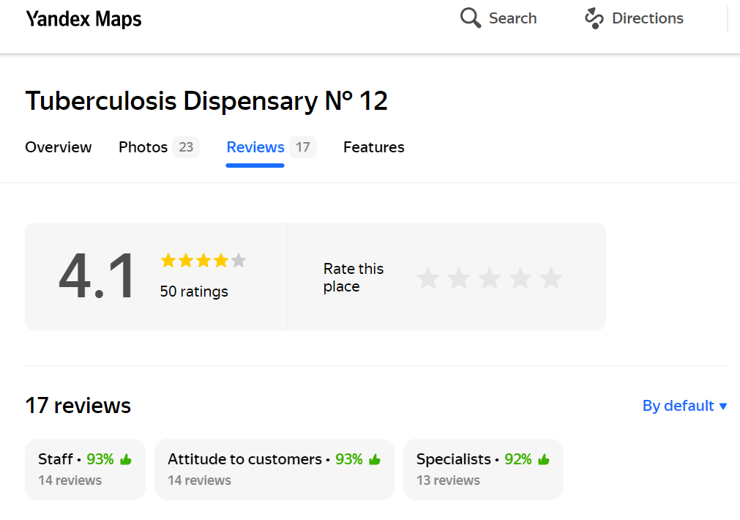

*Note*. Aspects are evaluated separately from the overall rating and are not integrated into the star rating. Thus, key issues with the service can be easily identified even if the overall rating is satisfactory. Overall positivity/negativity score of the aspect is the average sentiment of all the keywords and phrases related to the aspect.

2) Brand Analytics is a robust ABSA tool that offers comprehensive solutions for monitoring and analyzing brand sentiment across various digital platforms. The tool provides insights into different aspects of brand perception, helping companies to understand consumer feedback in detail and to make informed decisions based on this analysis.

**Figure 2**

*Demonstration of Brand Analytics ABSA (Brand Analytics, 2023)*

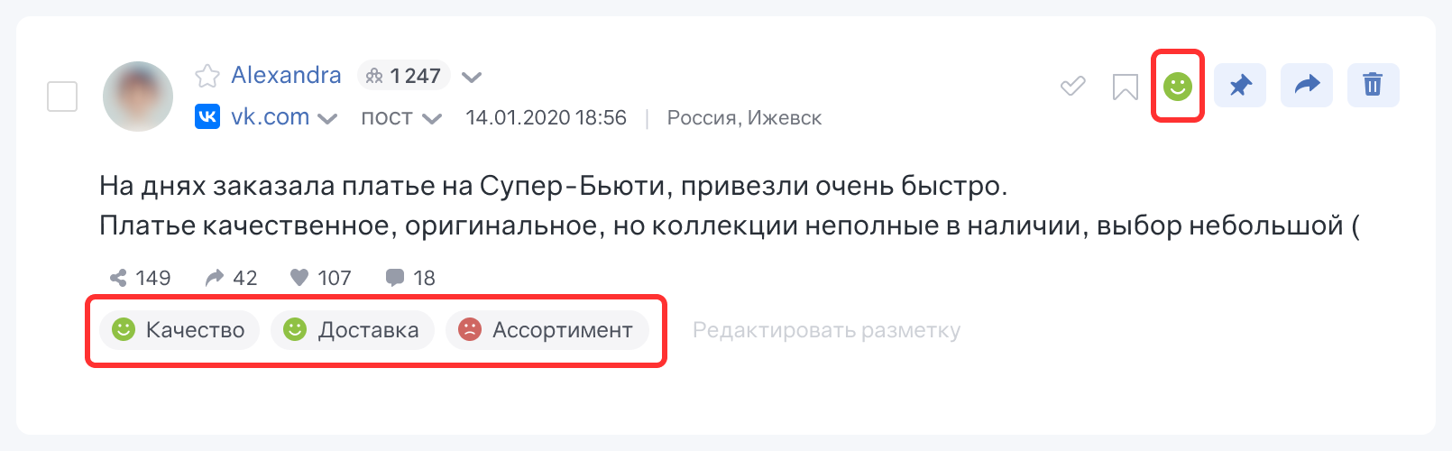

*Note.* The user comment on the picture: “The dress that I ordered on Super-Beauty was delivered really quickly. This dress is sophisticated and of high quality. However, the collection is not full, there is a small selection of clothing”. The aspects below the comment, from left to right: “quality”, “delivery”, “assortment”.

3) MonkeyLearn describes itself as a machine learning platform for text analysis. It allows users to extract data from raw text. For example, users can detect topic or sentiment expressed in texts like tweets, chats, reviews, articles, and more (MonkeyLearn, n.d.).

**Figure 3**

*MonkeyLearn sentiment insights visualization (MonkeyLearn, 2024)*

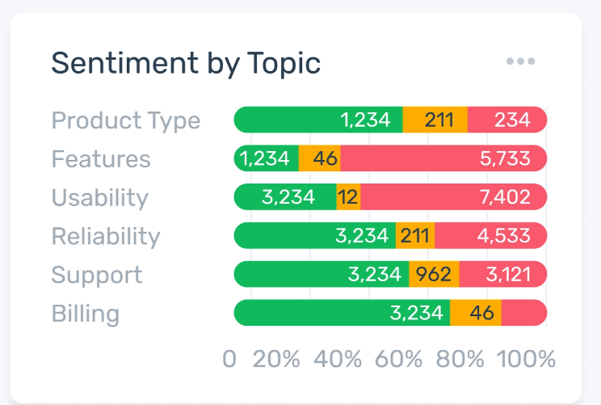

4) Prodoctorov is a specialized tool with ABSA functionality used specifically in the healthcare sector. This platform allows patients to leave detailed reviews and ratings for medical professionals and healthcare facilities. By automatically analyzing these reviews, Prodoctorov provides insights into various aspects of healthcare services, such as doctor-patient communication, treatment effectiveness, and facility conditions.

**Figure 4**

*Prodoctorov sentiment insights visualization for a hospital (Prodoctorov,2024)*

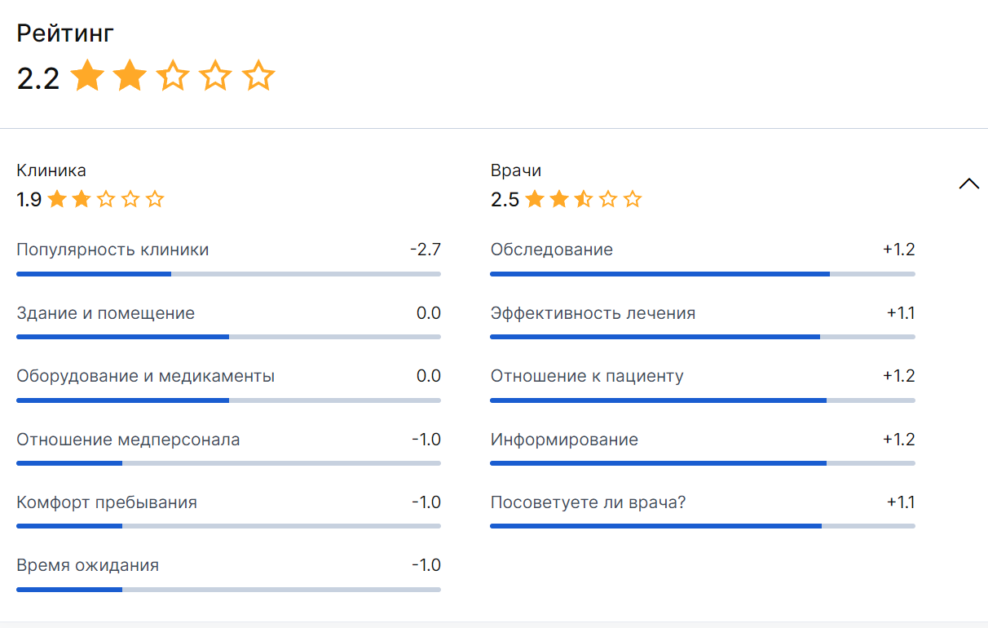

*Note*. Unlike Yandex.Maps, Prodoctorov integrates aspects evaluation into the overall star rating. On the screenshot, the overall star rating consists of two aspects: “clinics” and “doctors”. Each aspect in their turn consists of a number of other aspects, enumerated below. For “clinics”, the following aspects are taken into account: “popularity”, “building and interior”, “equipment and medicine”, “staff attitude”, “comfort”, “waiting time”. For “doctors”, the following aspects are taken into account: “physical examination”, treatment efficiency”, “attitude towards the patient”, “information sharing”, “likeliness to recommend the doctor”.

# RESEARCH METHODOLOGY AND RESEARCH APPROACH

The research approach for our study combines qualitative and quantitative data collection and analysis. The key steps of our research include:

1. Describe the existing method of the evaluation of medical organizations (MO), as well as the rating based on this evaluation conducted by the St. Petersburg Healthcare Committee (the Committee), and identify the drawbacks of the rating.

2. Calculate the rating based on the chosen NLP-tool:

- collect scores for different aspects from the chosen NLP-tool;

- conduct a survey to find out public priorities;

- apply linear scoring by assigning weights to different aspects based on the public priorities;

3. Compare the rating based on the NLP-tool to the healthcare committee’s rating.

4. Propose recommendations for healthcare policymakers and administrators on integrating NLP-tools into their evaluation and decision-making processes.

The *object* of our research is the rating of MO based on the independent evaluation carried out by the St. Petersburg Healthcare Committee.

The *subject* of our research is an application of NLP-tool (specifically, ABSA) for public opinion analysis on social media.

We used the following research methods in our work:

- analysis of primary data sources (NLP-tool and the Committee’s rating);

- public survey on the priorities while receiving medical care services;

- interviews with the top-managers of the hospitals where the independent evaluation was carried out.

## 2.1 Description of the independent medical organizations evaluation

In St. Petersburg, the independent evaluation of the quality of services provided by MO is carried out in accordance with Federal Law No. 323-FZ “About principles of citizen's health care in Russian Federation”, dated November 21, 2011. This evaluation is a form of a public control and is carried out with the purpose to provide citizens with the information about the quality of services provided by MO, as well as to improve the quality of the MO operations.

The evaluation includes assessing the conditions of service provision based on general criteria such as:

- the openness and accessibility of information about the MO;

- the comfort of the conditions under which medical services are provided, including waiting time;

- the accessibility of the services for the disabled;

- the friendliness, politeness, and competence of the MO staff;

- and patient satisfaction with the services received.

Each of the criteria consists of three indicators with the assigned weights. Two out of three indicators for the criteria “the openness and accessibility of information about the medical organization” are evaluated by the Public Council, while one criteria is evaluated automatically according to the public answers. The rest of the criteria are evaluated based on the public answers, except for “the accessibility of the services for the disabled” — if no answers are collected for certain questions, the Public Council should assess the conditions provided for the disabled in a hospital. Table 2 presents the rating for a sample of 10 MO.

**Table 2**

*The rating of medical organizations published by the St. Petersburg Healthcare Committee*

| **Medical organization** | **Total** | **No.**  **of questionnaires** | **Criteria** | | | | |
| --- | --- | --- | --- | --- | --- | --- | --- |
| **Information openness**  **and accessibility** | **Comfort,**  **incl. waiting time** | **Accessibility for**  **the disabled** | **Staff friendliness, politeness,**  **and competence** | **Satisfaction with**  **services** |
| Neuropsychiatric Dispensary № 4 | 100 | 1580 | 100 | 100 | 100 | 100 | 100 |
| Dermatovenerologic dispensary № 5 | 100 | 1315 | 100 | 100 | 100 | 100 | 100 |
| Dermatovenerologic dispensary № 7 | 100 | 764 | 100 | 100 | 100 | 100 | 100 |
| Nevsky dermatovenerologic dispensary | 100 | 1170 | 100 | 100 | 100 | 100 | 100 |
| Tuberculosis dispensary № 11 | 100 | 713 | 100 | 100 | 100 | 100 | 100 |
| Tuberculosis dispensary № 12 | 100 | 1030 | 100 | 100 | 100 | 100 | 100 |
| Tuberculosis dispensary № 16 | 100 | 806 | 100 | 100 | 100 | 100 | 100 |
| Tuberculosis dispensary № 4 | 100 | 601 | 100 | 100 | 100 | 100 | 100 |
| Tuberculosis dispensary № 8 | 100 | 1082 | 100 | 100 | 100 | 100 | 100 |
| Neuropsychiatric Dispensary № 6 | 100 | 613 | 100 | 100 | 100 | 100 | 100 |

The list of medical organizations participating in the independent evaluation are determined by the Public Council, which should not include the representatives from medical organizations, but is able to consult them in the process of conducting evaluation (Federal Law No. 323-FZ, 2011).

Patients can evaluate a preferred medical organization from the list through the web poll, which is placed in the form of a banner on the Committee’s website as well as on each evaluated organization’s website. The results are published annually on the official website of the St. Petersburg Health Committee in a form of rating.

**2.2 Identified drawbacks of the rating based on the independent evaluation**

We studied the existing ratings for the years 2020, 2021 and 2020, and also carried out interviews with the top-managers of medical organizations which participated in the evaluation, and found out several drawbacks:

1. Each year, different organizations are evaluated, thus leaving *no opportunity of assessing long-term trends* and dynamics within specific organizations. Figure 4 contains ratings for years 2021, 2022, and 2020. Highlighted with red color are hospitals, which were evaluated only in one of the three years. Highlighted with yellow color are hospitals, which were evaluated in two years, however, not consecutive ones (see Appendix B for the whole table).

Unfortunately, this limitation is partially caused by the regulations of the Federal Law No. 323-FZ, according to which “the independent evaluation of the services provided by medical organizations should be conducted not more than once a year, but not less than once in three years for each organization”. It provides a loophole for the local authorities to arrange evaluation of different medical organizations each year. The absence of panel data makes it impossible to track the progress of medical organizations over time. As a result, it is more challenging to implement long-term strategies for quality enhancement.

**Figure 5**

*Medical organizations from the ratings for years 2021, 2022, and 2020*

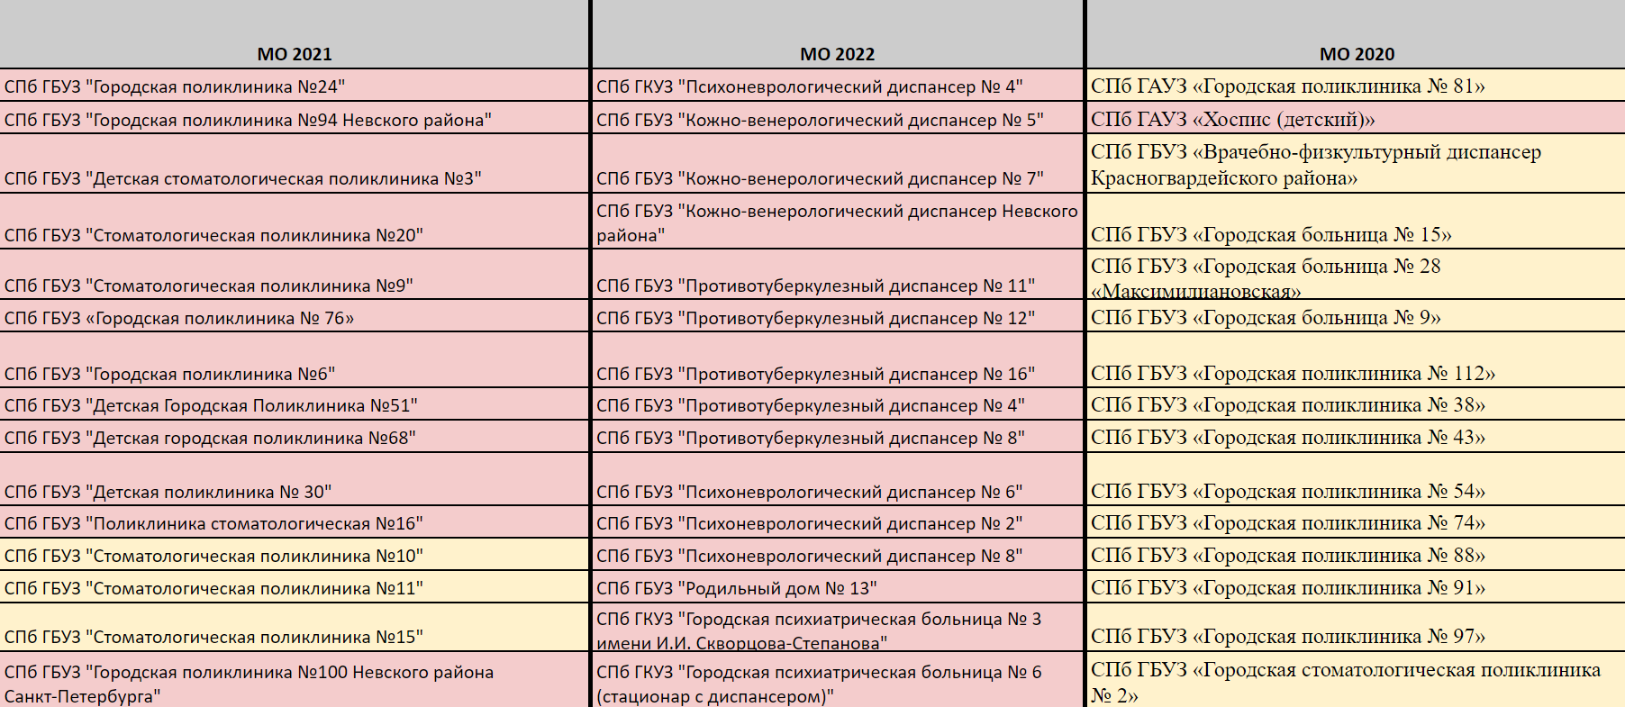

2. After finishing the poll, we attempted to answer the questions the second time from the same device. The attempt was successful. Apparently, the web poll has *no IP address identification*, which leaves space for dishonest behavior, such as multiple survey-taking by one individual. From the interviews with the hospitals’ top-mangers we learned that indeed, in some medical organizations the staff made several attempts with the poll, because they did not have a required number of answers from patients by the time the results should have been submitted to the Committee.

3. According to the hospitals’ top-mangers, sometimes the staff intentionally asked to answer the poll’s question the patients which satisfied with the services. This practice *skews the results* towards positive feedback, which leads to an inaccurate representation of the service quality.

4. The exact period of time during which the results of the poll are collected each year is not clear. The managers of the hospitals we interviewed are not aware of the exact dates either. The lack of transparency in the evaluation process raises a question of the credibility and reliability of the results​​.

**2.3 Calculation of the rating based on the NLP-tool**

For the purposes of this study, we chose geo-platform Yandex.Maps with an integrated NLP-tool, specifically ABSA-tool. Our choice is motivated by the platform’s popularity, accessibility, and availability of automated aspect-based analysis (also, we outlined the benefits of Yandex.Maps in the section 1.1).

On Yandex.Maps we collected aspect scores for 34 medical organizations with the score 99,2 and higher according to the Committee’s rating in 2022. A sample is presented in the Table 3 (for the whole table see Appendix C).

**Table 3**

*A sample of data gathered from Yandex.Maps*

| **Medical organization** | **Aspects** | | | | | | |
| --- | --- | --- | --- | --- | --- | --- | --- |
| **Attitude** | **Staff** | **Specialists** | **Waiting**  **time** | **Health**  **certificates** | **Treamtment**  **quality** | **Cleanliness** |
| Neuropsychiatric Dispensary № 4 | 57% | 59% | 59% | 69% | 71% | 58% | 100% |
| Dermatovenerologic dispensary № 5 | 67% | 70% | 80% |  | - | 87% | - |
| Dermatovenerologic dispensary № 7 | 49% | 59% | 60% | 36% | - | 66% | - |
| Nevsky dermatovenerologic dispensary | 65% | 75% | 79% | 62% | - | 84% | - |
| Tuberculosis dispensary № 11 | 38% | 44% | 58% | - | - | - | - |
| Tuberculosis dispensary № 12 | 92% | 92% | 92% |  | - | - | - |
| Tuberculosis dispensary № 16 | 29% | 34% | 27% | 38% | 27% |  | - |
| Tuberculosis dispensary № 4 | - | - | - | - | - | - | - |
| Tuberculosis dispensary № 8 | - | - | - | - | - | - | - |
| Neuropsychiatric Dispensary № 6 | 29% | 29% | 22% | 18% | - | - | - |

The following aspects were collected: “Attitude”, “Staff”, “Specialists”, “Waiting time”, “Health certificates”, “Treatment quality”, “Cleanliness”, “Tests”, “Renovation”, “Equipment”, “Location”, “Service”, “Food”, “Atmosphere”, “Walking”, “Massage”. Some MO (as can be seen from the Table 3) have empty spaces for all aspects. The reason is that there are too few reviews for the Yandex.Maps ABSA tool to identify any trends. This is one of the limitations of the tool, as it will not show the evaluated aspects if people left very few reviews (less than around 20 reviews, according to our research).

The aspects vary depending on the type of the MO and what patients mention in their reviews. For example, if a patient identifies an issue with cleanliness, it will be automatically calculated towards the sore of the aspect “Cleanliness”. We identified the following trends:

1) Most of the MO from the sample have the “Attitude”, “Staff”, “Specialists”, “Waiting time”, “Health certificates”, “Treatment quality”, as these aspects are the basic for all the types of MO.

2) Some aspects are unique to the MO of a specific type. For example, sanatoriums for children have such aspects as “Service”, “Food”, “Atmosphere”, “Walking”, as these aspects are important specifically for health resorts for children.

3) MO with overall high scores at “Specialist” perform more poorly at the aspect “Waiting time” and “Attitude”. Waiting time, for instance, is one of the indicators of the comfort in the Committee’s rating. We see, that it might be more useful to evaluate this aspect separately, not within a criterion, because people mention it a lot.

At the next step, we surveyed people about what they prioritize when visiting a hospital. Respondents were asked to rank three factors in order of importance:

- qualification of medical and nonmedical staff;

- waiting time;

- the attitude of medical and nonmedical staff.

Four aspects with the higher frequency among various MO were chosen for the purpose of formulating three factors: “Attitude”, “Staff”, “Specialists”, “Waiting time”. Two of them were united in one — “Specialist” and “Staff” united into “qualification of medical and nonmedical staff”. According to the responses of 173 people, the ranking is as follows:

1. Qualification of medical and nonmedical staff.

2. Attitude of medical and nonmedical staff.

3. Waiting time.

Next, we assigned the weights to the factors, in accordance with their ranking, which are presented in Table 4.

**Table 4**

*Three factors of visiting a MO weighted according to their rankings*

| **Factor** | **Rank** | **Points** | **Weights** |
| --- | --- | --- | --- |
| **Qualification of medical and nonmedical staff** | 1 | 3 | 3/6 |
| **Attitude of medical and nonmedical staff** | 2 | 2 | 2/6 |
| **Waiting time** | 3 | 1 | 1/6 |
| Total | | 6 | 1 |

For the ease of calculations, we used the decimal equivalents of the fractions from the Table 4:

1. Qualification of medical and non-medical staff — 0,5.

2. Attitude of medical and non-medical staff — 0,33.

3. Waiting time — 0,16.

These weighs were multiplied to the scores obtained from Yandex.Maps. We included a sample of 8 MO into our calculations and created a rating, which was compared to the Comittee’s rating for the year 2022. Table 5 includes both ratings.

**Table 5**

*Rating based on aspects versus the Committee’s rating*

| **Medical**  **organization** | **Rating based**  **on aspects** | **Committee's Rating** |
| --- | --- | --- |
| Neuropsychiatric Dispensary № 4 | 59,35 | 100 |
| Tuberculosis dispensary № 15 | 43,1 | 99,8 |
| Dermatovenerologic dispensary № 7 | 51,68 | 100 |
| Nevsky dermatovenerologic dispensary | 69,87 | 100 |
| Tuberculosis dispensary № 5 | 61,08 | 99,8 |
| Neuropsychiatric Dispensary № 5 | 38,91 | 99,8 |
| Tuberculosis dispensary № 16 | 30,9 | 100 |
| Neuropsychiatric Dispensary № 6 | 25,2 | 100 |

We can see that the rating based on the aspects obtained from Yandex.Maps significantly differ from the Committee’s rating. The same organizations, which received the highest score with the Committee, have a much lower score in the created rating. For instance, Neuropsychiatric Dispensary № 6 has a score which is 75 points lower than the Committee’s score. These differences might be partially caused by the rating inefficiencies described in the section 2.2., which led to an inflated rating for some MO. We suggest that a more comprehensive approach to evaluating healthcare services is needed, combining both user-generated feedback and formal assessments.

## 2.4 Recommendations

Based on our research, we propose the following recommendations for different entities.

*Recommendations for Hospital Top Managers*

Yandex.Maps is one of currently a more popular social media platform where patients leave their feedback, when compared to other review platforms for healthcare. The top-managers are advised to use this fact to their advantage and regularly monitor Yandex.Maps reviews to identify specific issues identified in their MO. Aspect-based sentiment analysis integrated in Yandex.Maps can help to quickly determine particular areas of concern and assist managers in making decisions which will improve that area. For example, if the aspect “Waiting time” has a score of 50% and lower, management can investigate and implement measures to streamline patient flow and reduce wait times.

Another point to consider is staff training for improvement of their soft skills. As we found out that MO had generally lower score on “Attitude” compared to “Specialist”, this is an indication that the communicative skills of staff requires improvement.

*Recommendations for the St. Petersburg Healthcare Committee*

According to the weaknesses identified in the existing process of MO rating creation, we propose several changes, rated from low to high depending on the efforts required, which can be seen in Table 6. We suggest starting from the changes requiring the low effort, which can be easily implemented, and head towards the changes with higher effort, if possible. The changes requiring low effort, if implemented, will already result in a more honest MO evaluation.

**Table 6**

*Changes proposed for the St. Petersburg Healthcare committee*

| **Proposed change** | **Level of effort required** |
| --- | --- |
| Establish clear and consistent evaluation periods to ensure data transparency | Low |
| Evaluate the same MO every year so that the progress of MO can be compared over time | Low |
| Set an IP address identification for the existing web polling to prevent the distortion of results caused by answers made by the same individuals | Medium |
| Integrate the Yandex.Maps-based aspect ratings into the existing evaluation framework to provide a more comprehensive perspective of patient satisfaction and service quality | High |

*Recommendations for The Territorial Fund of Compulsory Health Insurance*

In order to stimulate a more fair evaluation of MO, and motivate MO to improve their services, we propose that the evaluation should impact the amount of funding that MO receives each year. St. Petersburg Territorial Fund of Compulsory Health Insurance can llocate additional funding to hospitals that achieve high integrated ratings from both the St. Petersburg Healthcare Committee and the Yandex.Maps-based evaluations. This can incentivize hospitals to maintain and improve their service quality.

**3. Limitations**

While Yandex.Maps offers valuable insights through user-generated reviews and aspect-based sentiment analysis, several limitations must be acknowledged:

- There are issues with sample sizes and representativeness for some MO. Many medical organizations have too few reviews to generate reliable data, resulting in incomplete aspect analysis. Reviews may not represent the general patient population, as those with extreme experiences are more likely to leave feedback, skewing the sentiment.

- the reviews were collected for several years, because Yandex.Maps does not prove the functionality of viewing reviews and aspects for a certain period of time. This limitation can be overcome by either communicating to Yandex.Maps with the request to add a new feature allowing for the time period filtration, or by manual scraping of the review and then analyzing them with the help of the NLP-specialist.

- From the interviews with the hospital top-managers, we also learned that some patients are asked to leave a review, especially if it is obvious that the patients are satisfied with the services; such actions can lead to skewed results, and might require a deeper analysis of the review and an application of special methodologies which spot the outliers.

# **3.** CONCLUSION

To overcome the drawbacks of the existing MO rating, we propose social media with integrated ABSA tools for receiving medical services evaluation from patients. Compared with survey polls, social media can yield a better and more comprehensive understanding of public perceptions of special topics in a more scientific manner (Xuefan Dong, 2021)

The review of existing literature underscores the potential utility of social media data in contributing to decision-making across various sectors, most notably in the healthcare domain.

The overview of the existing researchers proves that social media can serve as a great source of information for decision-making in different areas. The data from social and news media are a useful tool in smart city management as they provide us with an oversight of the situation and help in making informed decisions.

Several studies indicate that social media data can be instrumental in smart city management by providing valuable insights that inform better decision-making. Furthermore, health, safety, and transportation emerge as priority areas where social media data application warrants focused exploration. Recent findings illustrate that social media data mining can contribute to a variety of health-related fields.

This research focused on utilizing Natural Language Processing (NLP) tools, specifically Aspect-Based Sentiment Analysis (ABSA), to analyze social media data for evaluating healthcare services. By leveraging the ABSA tool developed by Yandex.Maps, this study collected aspect-based sentiment scores for ten selected medical organizations. These scores were then weighted according to public priorities identified through a survey and integrated into a composite rating.

Comparing the Yandex.Maps-based ratings with those provided by the St. Petersburg Healthcare Committee revealed significant discrepancies, highlighting the potential inefficiencies in the current evaluation system. The differences in ratings indicate that user-generated feedback on social media can provide valuable insights that might be overlooked by traditional methods. However, these findings also suggest that social media-based ABSA should complement, rather than replace, traditional evaluation methods.

# References

1. Adams-Cohen, N. J. (2020). Policy Change and Public Opinion: Measuring Shifting Political Sentiment With Social Media Data. American Politics Research, 48(5), 612–621. https://doi.org/10.1177/1532673x20920263.
2. Adikari, A., & Alahakoon, D. (2021). IEEE Transactions on Industrial Informatics, 17(4), 2743-275.
3. Agarwal, S., & Sureka, A. (2015). Using KNN and SVM based one-class classifier for detecting online radicalization on Twitter. In Proceedings of the 11th International Conference on Distributed Computing and Internet Technology (ICDCIT 2015) (pp. 431-442). https://doi.org/10.1007/978-3-319-14977-6_39.
4. Akkaya, M., Özçevik, Ö., & Tepe, E. (2023). A machine learning application to Google Maps reviews as a participatory planning tool. Department of Urban and Regional Planning, Istanbul Technical University. Retrieved from https://www.researchgate.net/publication/343967345
5. Azzaoui, A. E., Singh, S. K., & Park, J. H. (2021). SNS Big Data Analysis Framework for COVID-19 Outbreak Prediction in Smart Healthy City. Sustainable Cities and Society, 71, 102993.
6. Barkovich, A. A. (2020). Sentiment Analysis: Linguistic Potential of Preprocessing Regimentation. Minsk State Linguistic University, Minsk, Belarus. https://orcid.org/0000-0001-8469-8431
7. Bruni, R. A., Laupacis, A., & Martin, D. K. (2008). Public engagement in setting priorities in health care. CMAJ, 179(1), 15-8. https://doi.org/10.1503/cmaj.071656.
8. Clark, G. (2020). The Future of Cities: Middle East, North Africa, and Turkey. https://associationhubs.org/wp-content/uploads/2020/06/Greg-Clark-2020-MENATcities-C19-report-1.pdf
9. CMS.gov. (2023). Hospital Value-Based Purchasing Program. Retrieved from https://www.cms.gov/medicare/quality/initiatives/hospital-quality-initiative/hospital-value-based-purchasing
10. Cook, N., Mullins, A., Gautam, R., Medi, S., Prince, C., Tyagi, N., & Kommineni, J. (2019). Evaluating Patient Experiences in Dry Eye Disease Through Social Media Listening Research. Ophthalmol Ther, 8(3), 407-420. https://doi.org/10.1007/s40123-019-0188-4.
11. Coppersmith, G., Leary, R., Crutchley, P., & Fine, A. (2018). Natural Language Processing of Social Media as Screening for Suicide Risk. Biomedical Informatics Insights, 10. https://doi.org/10.1177/1178222618792860.
12. Couper, M. P. (2013). Is the Sky Falling? New Technology, Changing Media, and the Future of Surveys. Survey Research Methods, 7(3), 145–156. https://doi.org/10.18148/srm/2013.v7i3.5751
13. Decuzzi, F. (2024). What is MonkeyLearn? MonkeyLearn Help Center. Retrieved May 26, 2024, from https://help.monkeylearn.com/en/articles/2174206-what-is-monkeylearn
14. Dey, S., & Bhattacharyya, S. (2021). An introduction to data mining in social networks. ABC Publisher.
15. Digital 2023: Global Overview Report. We Are Social, Meltwater, Datareportal. (2023, January 26). Retrieved from https://datareportal.com/reports/digital-2023-global-overview-report
16. Doyle, C., Lennox, L., & Bell, D. (2013). A systematic review of evidence on the links between patient experience and clinical safety and effectiveness. BMJ Open, 3, e001570. https://doi.org/10.1136/bmjopen-2012-001570
17. Dvoynikova, A. A., & Karpov, A. A. (2020). Analytical review of approaches to Russian text sentiment recognition. Informatsionno-upravliaiushchie sistemy [Information and Control Systems], 2020(4), 20-30. https://doi.org/10.31799/1684-8853-2020-4-20-30.
18. Evans, J. R., & Mathur, A. (2005). The value of online surveys. Internet Research, 15(2), 195–219.
19. Federal Law No. 323-FZ “About principles of citizen's health care in Russian Federation,” dated November 21, 2011. Retrieved from http://zdrav.spb.ru/media/filebrowser/фз_от_21_ноября_2011_г._№_323-фз.pdf
20. Federal Law of the Russian Federation No. 152-FZ on Personal Data. (2006).
21. Ford, E., Shepherd, S., Jones, K., & Hassan, L. (2021). Toward an Ethical Framework for the Text Mining of Social Media for Health Research: A Systematic Review. Front Digit Health, 2, 592237. https://doi.org/10.3389/fdgth.2020.592237.
22. Golder, S., Chiuve, S., Weissenbacher, D., Klein, A., O’Connor, K., Bland, M., Malin, M., Bhattacharya, M., Scarazzini, L. J., & Gonzalez-Hernandez, G. (2019). Pharmacoepidemiologic evaluation of birth defects from health-related postings in social media during pregnancy. Drug Safety, 42(4), 389-400.
23. Granier, B., & Kudo, H. (2016). How are citizens involved in smart cities? Analyzing citizen participation in Japanese “Smart Communities”. Information Polity, 21(1), 61–76. https://doi.org/10.3233/IP-150367
24. Hodorog, A., Petri, I., & Rezgui, Y. (2022). Machine learning and Natural Language Processing of social media data for event detection in smart cities. Sustainable Cities and Society, 85.
25. Hua, Y. C., Denny, P., Taskova, K., & Wicker, J. (2023). A systematic review of aspect-based sentiment analysis (ABSA): Domains, methods, and trends [Preprint]. School of Computer Science, The University of Auckland. Retrieved from https://arxiv.org/pdf/2311.10777v4.
26. Janjua, S. H., Siddiqui, G. F., Sindhu, M. A., & Rashid, U. (2021). Multi-level Aspect-Based Sentiment Classification of Twitter Data: Using Hybrid Approach in Deep Learning. PeerJ Comput Sci, 7, e433.
27. Kaplan, A. M., & Haenlein, M. (2010). Users of the world, unite! The challenges and opportunities of social media. Business Horizons, 53(1), 59-68.
28. LAW OF SAINT PETERSBURG. On the Strategy for Socio-Economic Development of Saint Petersburg for the Period Until 2035. Approved by the Legislative Assembly of Saint Petersburg on December 19, 2018. Retrieved from https://docs.cntd.ru/document/551979680
29. Lee, L., & Pang, B. (2008). Opinion mining and sentiment analysis. Foundations and Trends in Information Retrieval, 2(1–2), 1-135.
30. Li, L., Zhou, J., Ma, Z., Bensi, M. T., Hall, M. A., & Baecher, G. B. (2022). Dynamic assessment of the COVID-19 vaccine acceptance leveraging social media data. J Biomed Inform, 129, 104054. https://doi.org/10.1016/j.jbi.2022.104054.
31. Marcacini, R., & Silva, E. (2021). Aspect-based Sentiment Analysis using BERT with Disentangled Attention. https://doi.org/10.52591/2021072410
32. Markway. (2023, April 19). Sayty otzyvov o vrachakh: Kak rabotat' s ploshchadkami [Review sites about doctors: How to work with platforms]. Markway. Retrieved from https://markway.ru/blog/sajty-otzyvov-o-vrachah-kak-rabotat-s-ploshhadkami/
33. McGregor, S. (2020). Social media as public opinion: how journalists use social media to represent public opinion. Journalism, 20, 1070-1088. https://doi.org/10.1177/1464884919845458.
34. MinTsifry Rossii. The Internet in Russia in 2022-2023.
35. Murphy, J. (2020). Social media in public opinion research executive summary of the AAPOR task force on emerging technologies in public opinion research. Public Opinion Quarterly, 78, 788-822. https://doi.org/10.1093/poq/nfu053.
36. Murthy, D. (2013). Twitter: Social communication in the Twitter age. Polity Press, Cambridge.
37. Nazir, A., Rao, Y., Wu, L., & Sun, L. (2022). Issues and Challenges of Aspect-based Sentiment Analysis: A Comprehensive Survey. IEEE Transactions on Affective Computing, 13(2), 845-863. https://doi.org/10.1109/TAFFC.2020.2970399
38. Nicolasa, C., Kim, J., & Chi, S. (2021). Natural language processing-based characterization of top-down communication in smart cities for enhancing citizen alignment. Sustainable Cities and Society, 66, 102674.
39. Obar, J. A., & Wildman, S. (2015). Social media definition and the governance challenge: An introduction to the special issue. Telecommunications Policy, 39(9), 745-750. https://doi.org/10.1016/j.telpol.2015.07.014
40. OECD. (2007). Participative web and user-created content: Web2.0, wikis, and social networking. Paris: Organisation for Economic Co-operation and Development.
41. Paul, M. J., & Dredze, M. (2021). You Are What You Tweet: Analyzing Twitter for Public Health. ICWSM, 5(1), 265-272.
42. Prodoctoros. Поликлиника №114 Приморского района. Retrieved from https://prodoctorov.ru/spb/lpu/11104-gorodskaya-poliklinika-114/#rating
43. Radinsky, K., & Horvitz, E. (2013). Mining the web to predict future events. In Proceedings of the sixth ACM international conference on Web search and data mining (pp. 255-264).
44. Reveilhac, M., Steinmetz, S., & Morselli, D. (2022). A systematic literature review of how and whether social media data can complement traditional survey data to study public opinion. Multimedia Tools and Applications, 81, 10107–10142. https://doi.org/10.1007/s11042-022-12101-0
45. Roslyakova, M. V. (2023). Sotsial'nye seti kak instrument vovlecheniya grazhdan v upravlenie (na primere ofitsial'nykh stranits mestnykh administratsiy gorodov T︠S︡FO) [Social networks as a tool for engaging citizens in governance (using the example of official pages of local administrations of Central Federal District cities)]. Sotsiodinamika, 7, 1-18. https://doi.org/10.25136/2409-7144.2023.7.43708.
46. Sayeed, M. S., Mohan, V., & Anbananthen, K. (2023). BERT: A Review of Applications in Sentiment Analysis. HighTech and Innovation Journal, 4, 453-462. https://doi.org/10.28991/HIJ-2023-04-02-015
47. Schneider, S. M. (2020). Beyond endogeneity in analyses of public opinion: Evaluations of healthcare by the foreign born across 24 European countries. PloS One, 15(6), e0233835. https://doi.org/10.1371/journal.pone.0233835.
48. Scanfeld, D., Scanfeld, V., & Larson, E. L. (2010). Dissemination of health information through social networks: Twitter and antibiotics. American Journal of Infection Control, 38(3), 182-188. https://doi.org/10.1016/j.ajic.2009.11.004.
49. Semina, T. A. (2020). Sentiment analysis: modern approaches and existing problems. Sotsialnye i gumanitarnye nauki. Otechestvennaya i zarubezhnaya literatura. Seriya 6: Yazykoznanie. Referativnyy zhurnal, (4), 47–64. Retrieved from https://www.elibrary.ru/icgxzf
50. Silva, B. N., Khan, M., & Han, K. (2018). Towards sustainable smart cities: A review of trends, architectures, components, and open challenges in smart cities. Sustainable Cities and Society, 38, 697–713. https://doi.org/10.1016/j.scs.2018.01.053
51. Smart city. (2023). Automated analysis of public opinion through social network on a chosen topic. Retrieved from https://russiasmartcity.ru/solutions/79.
52. TASS. (2021). The time of arrival of the ambulance and the complaints of patients will be the criteria for the distribution of CHI funds. The Federal Compulsory Medical Insurance Fund has developed a draft criteria for the allocation of medical care among medical institutions. TASS, July 8. Available at: https://tass.ru/obschestvo/11851089 (accessed 20 March 2022).
53. Dragun, A. (2023). Aspects and aspect-based sentiment analysis: How to set up automated product analysis in Brand Analytics. Retrieved from https://brandanalytics.ru/blog/aspects-settings-instruction/
54. Yablonsky, K. P. (2019). Otsenka effektivnosti deyatel'nosti meditsinskikh organizatsiy [Evaluation of the effectiveness of medical organizations]. Sankt-Peterburg.
55. Yandex.Maps. (2024).
56. Xuefan, D., & Ying, L. (2021). A review of social media-based public opinion analyses: Challenges and recommendations. Technology in Society, 67, 101724. https://doi.org/10.1016/j.techsoc.2021.101724.

# **Glossary**

**NLP** — natural language processing, a branch of artificial intelligence that helps computers understand, interpret and manipulate human language.

**Aspect-based sentiment analysis (ABSA)** — a text analysis technique that categorizes data by aspect and identifies the sentiment attributed to each one.

**Social media** — a group of Internet-based applications that build on the ideological and technological foundations of Web 2.0, and that allow the creation and exchange of user generated content (Kaplan & Haenlein, 2010).

**Big data** — extremely large data sets that can be analyzed computationally to reveal patterns, trends, and associations, especially relating to human behavior and interactions.

**Public healthcare** — healthcare services provided by the government to its citizens, often funded through taxes and aimed at ensuring public health and well-being.

**SMPO**— social media-based public opinion.

# **Appendix A**

**Problems and findings in the reviewed papers**

| **Author(s)** | **Problem/Research question(s)** | **Findings/Results** |
| --- | --- | --- |
| Zeinab, S., Yung-Cheol, B. | How to improve the efficiency and security of the DF (digital forensics) analysis of the information shared on social media? | Integration of NLP techniques improve the performance of digital forensic. |
| Hodorog, A., Petri, I., Rezgui, Y. | How can we leverage NLP techniques to make sense of the abundant stream of social media data in a smart city context? | Extraction of meaningful insight from social media by leveraging NLP techniques AWD-LSTM and ULMFiT with 88.5% accuracy. |
| El Azzaoui, A., Singh, S. K., & Park, J. H. | Predict potential future cases and virus outbreak hotspots based on the users' openly shared data including location and symptoms; detect false information and suppress its spread. | Analyzing data from social media platforms enabled predicting future outbreaks several days earlier, and scientifically reduce the infection rate in a smart sustainable healthy city environment. |
| Nicolasa, C., Kim, J., Chi, S. | Characterize the top-down communication efforts of smart city governments based on NLP framework. | The proposed NLP framework could analyze the top-discourse of smart cities as a reflection of wider political strategies. Furthermore, this framework analyzed whether communication strategies were appropriately tailored. |
| Muguro, J., Njeri, W., Matsushita, K., Sasakiam M. | Tackle data shortage on traffic safety, practices, and cultures in the country. Identify the interlinks between traffic practices and policies using user-generated data to derive an overview of traffic conditions in the country. | The research identified PSV (public service vehicle), policing, and traffic flow as a triad that accurately summarizes the issues affecting the transport industry in the country and that need urgent attention. |
| Adikari, A., & Alahakoon, D. | Use the publicly available social media conversations to convey citizens' emotions and perceptions. | A developed AI framework enabled the capture and representation of the emotional pulse of the city. Created an overview of citizens’ emotions related to smart city initiatives. |
| Paul, M. J., & Dredze, M. | What public health information can be learnt from social networks? | Using Ailment Topic Aspect Model (ATAM+) the paper explores several aspects of public health, including temporal and geographic impacts on medical wellbeing, and investigations into how the public treats illness. |
| Scanfeld, D., Scanfeld, V., EL Larson. | Understanding the dissemination of health information related to antibiotics through social networks. The authors aim to analyze the content and quality of information shared on social media platform regarding antibiotics, and to explore the potential for using social media platforms to improve public understanding of antibiotic use and resistance. | 1. A significant proportion of the posts on social media platform (45.5%) contained misinformation or misunderstanding about antibiotic use. 2. The majority of posts (52.3%) were related to personal experiences or opinions about antibiotics, while only a smaller proportion (20.7%) shared general information or news articles about antibiotics. 3. Users who provided accurate information about antibiotics had a higher number of followers, which suggests that accurate information has the potential to reach a wider audience through social network. 4. There are several challenges in using social media platforms to disseminate accurate health information, including the prevalence of misinformation and the limited space for providing detailed explanations of complex topics. |
| Radinsky, K., Horvitz, E. | Predicting future events by mining the web, specifically by extracting and analyzing textual content. The authors aim to determine if it is possible to predict various types of events, such as disease outbreaks, riots, and elections, by analyzing the content of web pages. | 1. Temporal patterns in web content could be identified and used to predict future events. For example, the frequency of certain terms related to flu outbreaks increased prior to the actual outbreak, which allowed the system to predict the event. 2. The developed system was able to predict different types of events with varying levels of accuracy. 3. The authors identified several challenges in predicting future events, including dealing with noisy data, overcoming biases in the content of web pages, and handling the inherent uncertainty of predicting the future. |
| Agarwal, S., Sureka, A. | Detecting online radicalization on social media, specifically identifying users and content promoting extremism and radical ideologies. The authors aim to develop machine learning classifiers to analyze tweets and user profiles to identify radical content and users, which can help governments and law enforcement agencies in monitoring and combating online radicalization. | Using both user profile information and posts content as features in their classifiers improved the detection performance compared to using either feature set alone.  The study highlights the challenges in detecting online radicalization, such as the dynamic nature of social media content, the large volume of data to be analyzed, and the varying definitions of radicalization. |

# 

# **Appendix B**

**Medical organizations from the ratings for years 2021, 2022, 2020**

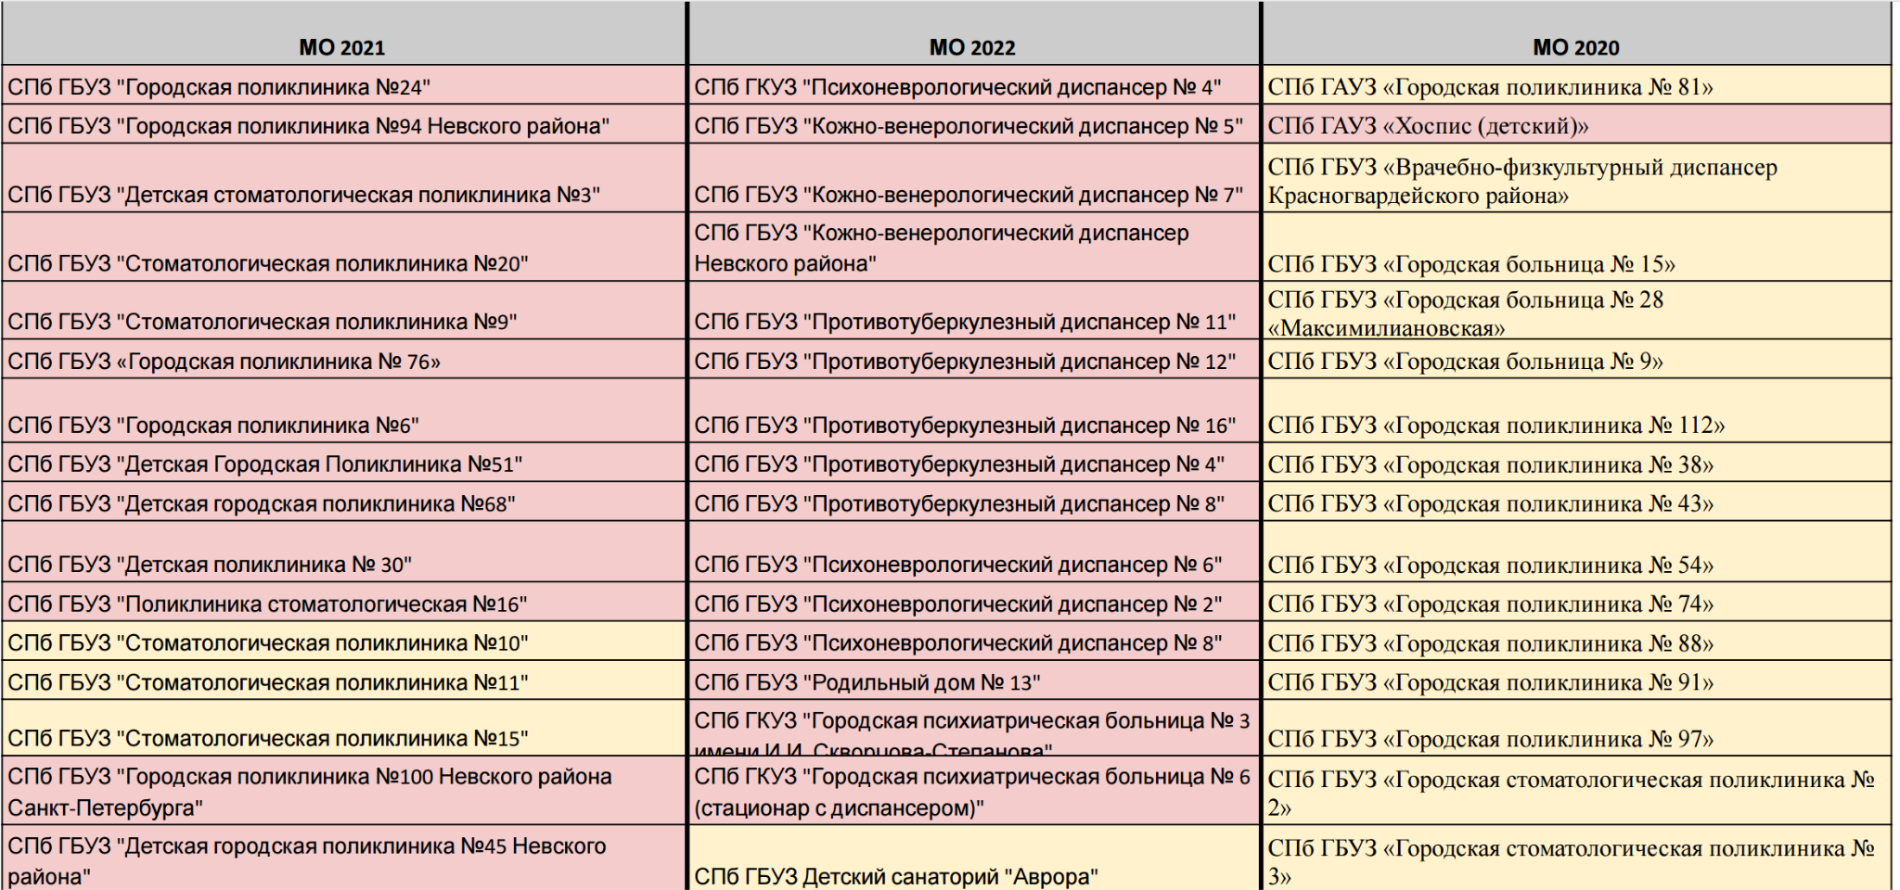

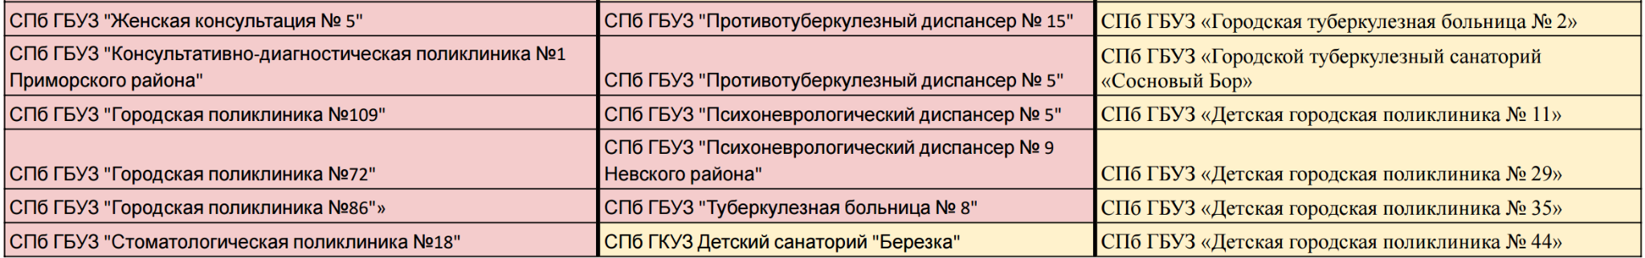

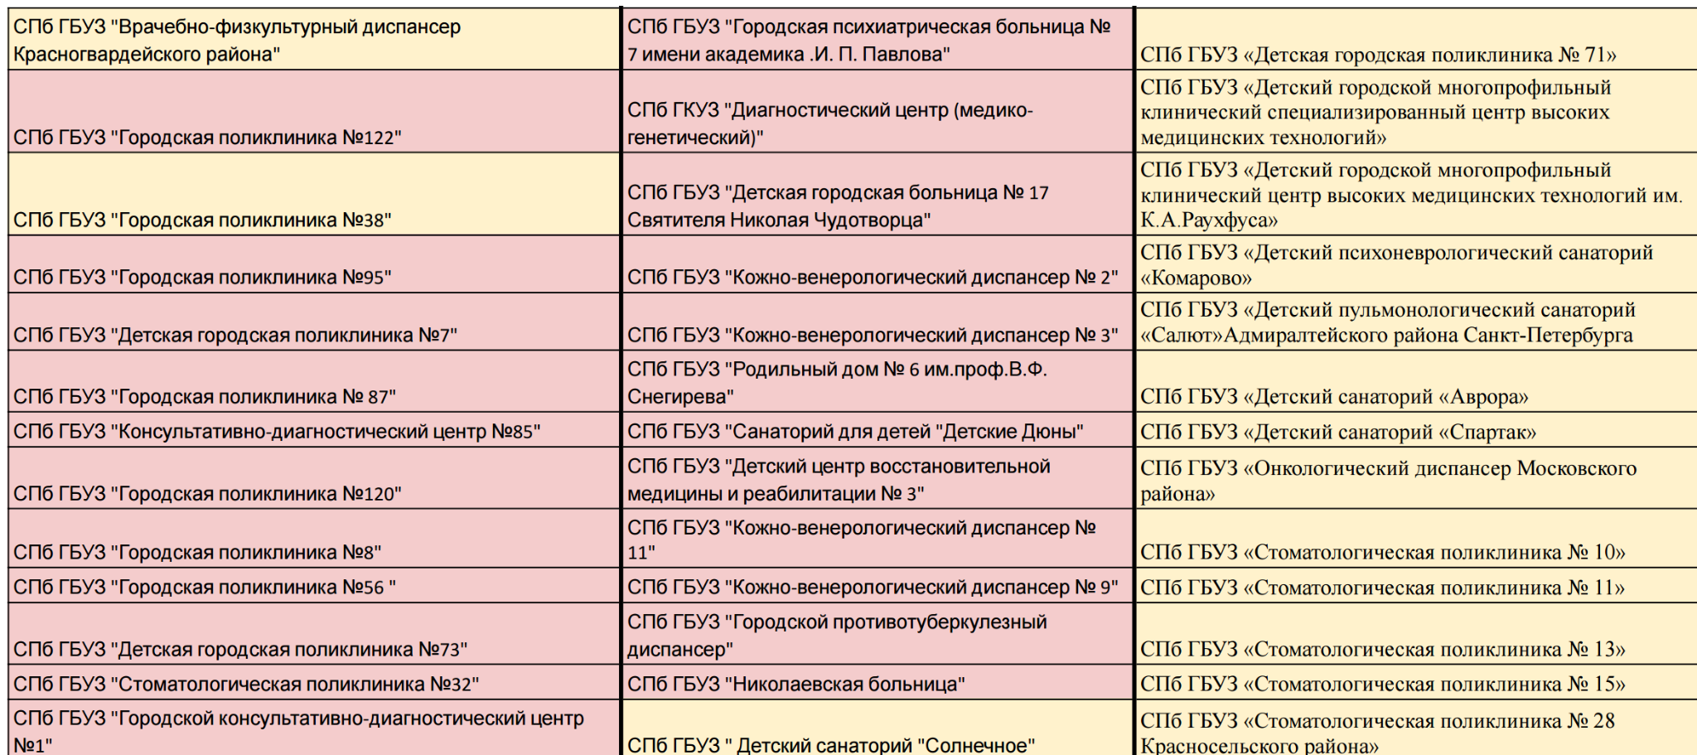

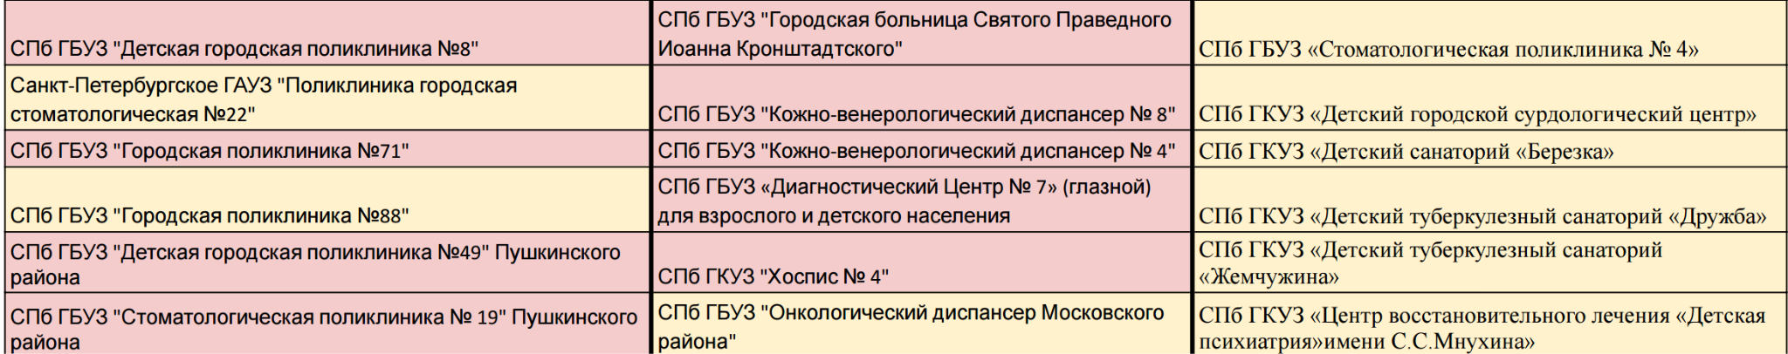

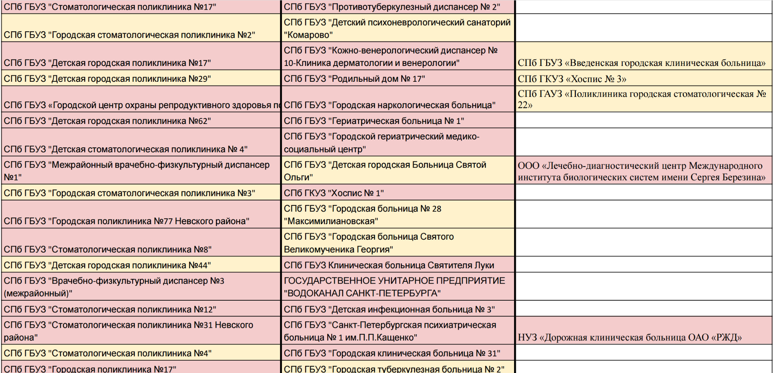

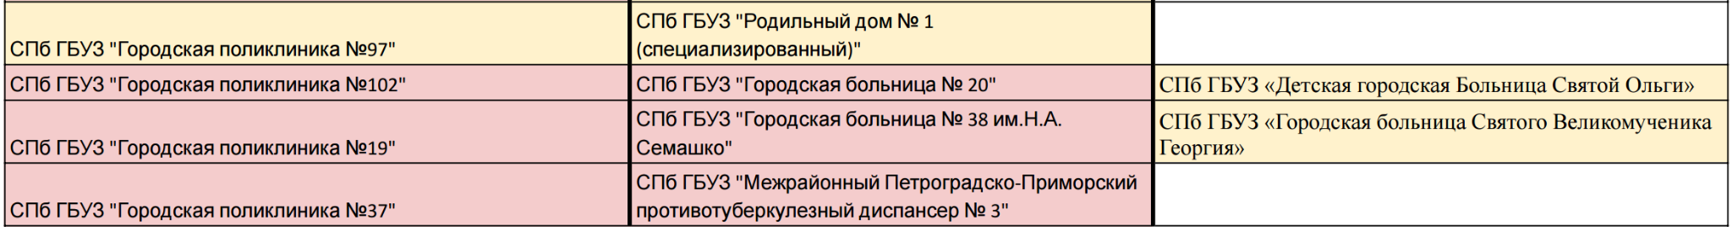

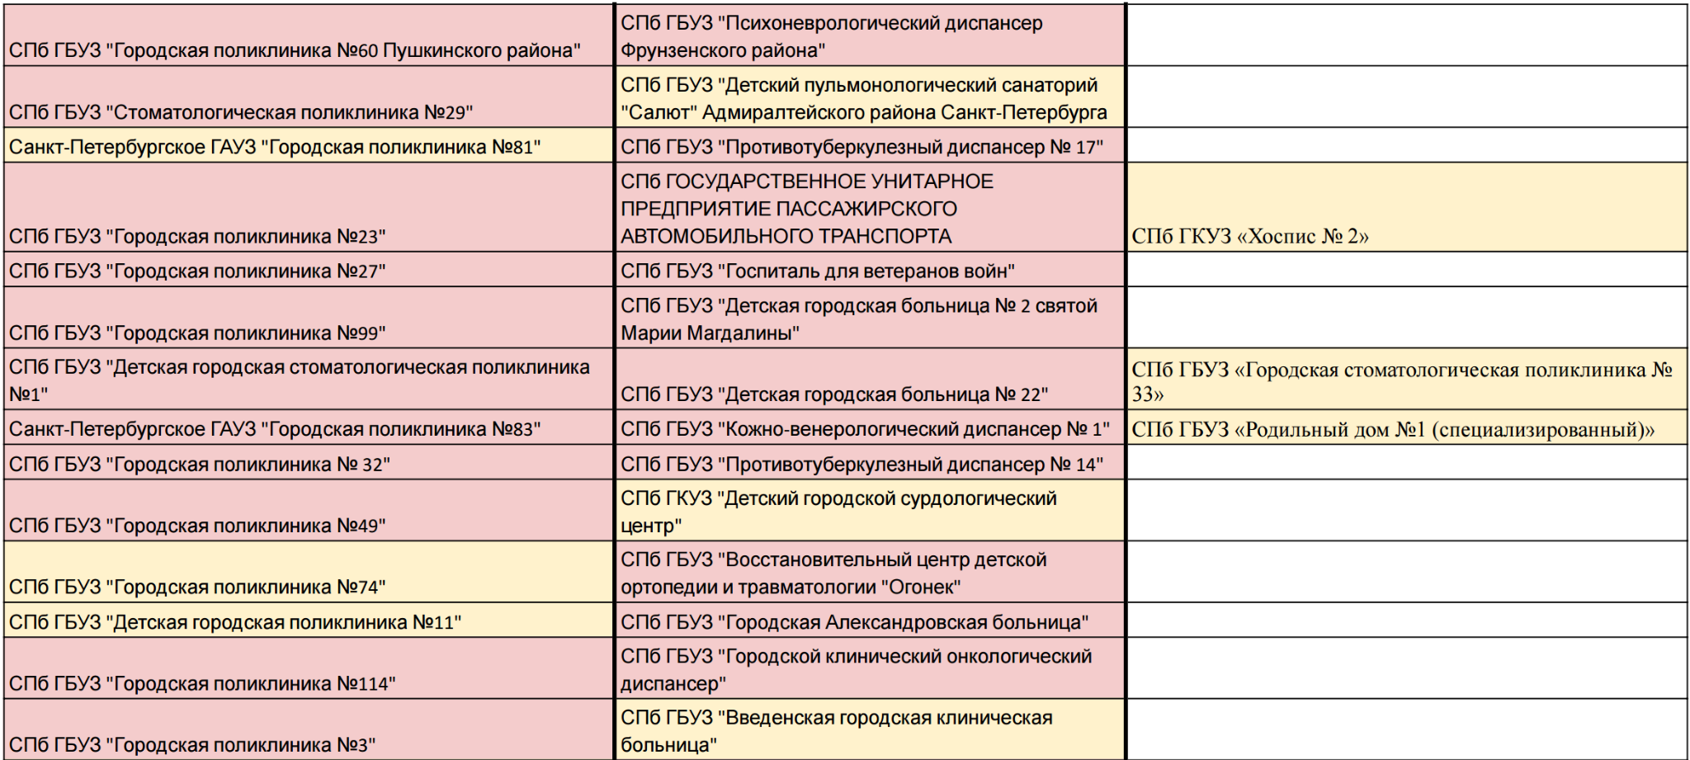

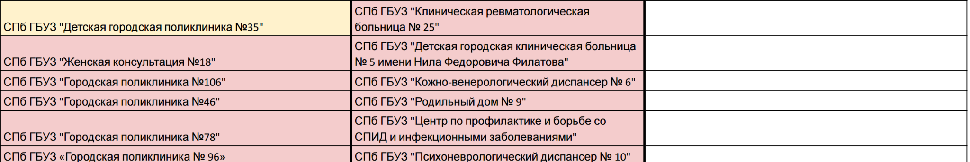

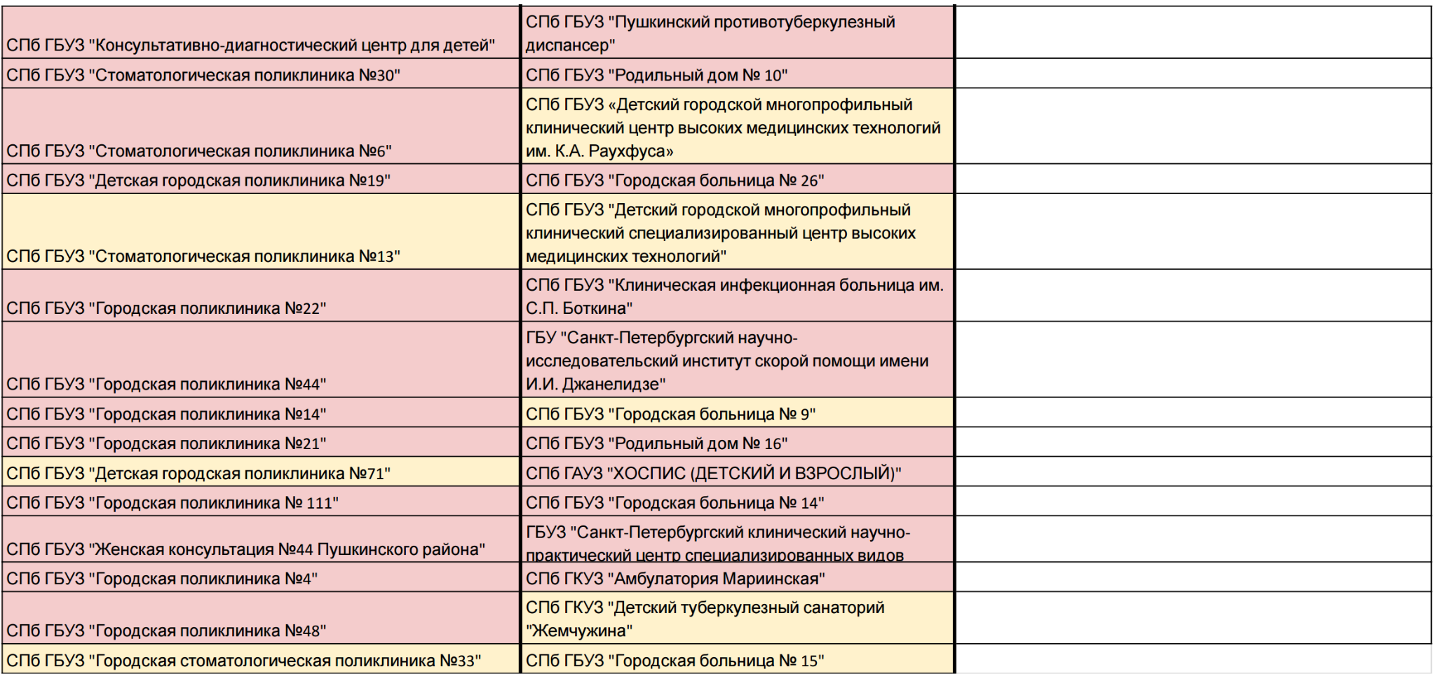

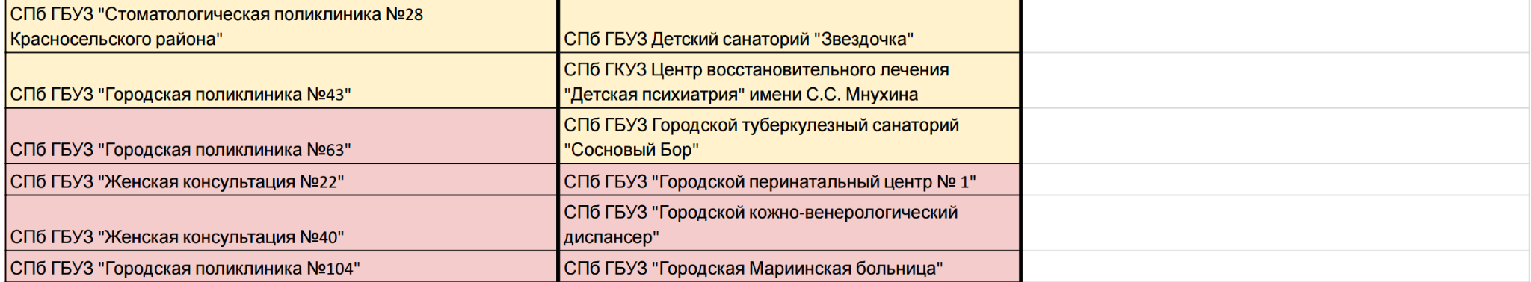

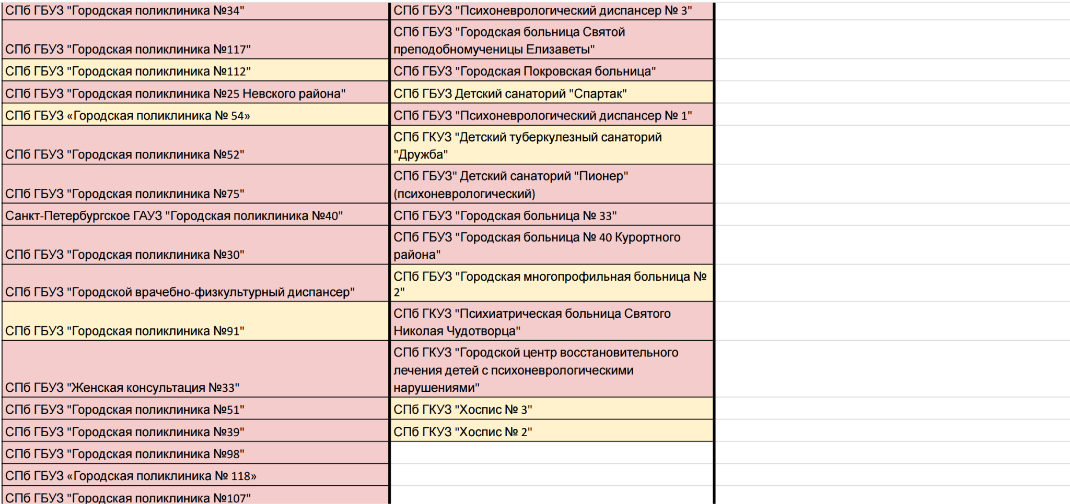



**Appendix C**

| **Наименование медицинской организации** | **Отношение к клиентам** | **Персонал** | **Специалисты** | **Время ожидания** | **Cправки** | **Качество**  **лечения** | **Чистота** | **Анализы** | **Ремонт** | **Оборудование** | **Расположение** | **Еда** | **Атмосфера** | **Прогулки** | **Массаж** |
| --- | --- | --- | --- | --- | --- | --- | --- | --- | --- | --- | --- | --- | --- | --- | --- |
| **"Психоневрологический диспансер № 4"** | **57%** | **59%** | **59%** | **69%** | **71%** | **58%** | **100%** |  |  |  |  |  |  |  |  |
| **"Кожно-венерологический диспансер № 5"** | **67%** | **70%** | **80%** |  |  | **87%** |  |  |  |  |  |  |  |  |  |
| **"Кожно-венерологический диспансер № 7"** | **49%** | **59%** | **60%** | **36%** |  | **66%** |  | **60%** |  |  |  |  |  |  |  |
| **"Кожно-венерологический диспансер Невского района"** | **65%** | **75%** | **79%** | **62%** |  | **84%** |  | **75%** |  |  |  |  |  |  |  |
| **"Противотуберкулезный диспансер № 11"** | **38%** | **44%** | **58%** |  |  |  |  |  |  |  |  |  |  |  |  |
| **"Противотуберкулезный диспансер № 12"** | **92%** | **92%** | **92%** |  |  |  |  |  |  |  |  |  |  |  |  |
| **"Противотуберкулезный диспансер № 16"** | **29%** | **34%** | **27%** | **38%** | **27%** |  |  |  |  |  |  |  |  |  |  |
| **"Противотуберкулезный диспансер № 4"** |  |  |  |  |  |  |  |  |  |  |  |  |  |  |  |
| **"Противотуберкулезный диспансер № 8"** |  |  |  |  |  |  |  |  |  |  |  |  |  |  |  |
| **"Психоневрологический диспансер № 6"** | **29%** | **29%** | **22%** | **18%** |  |  |  |  |  |  |  |  |  |  |  |
| **"Психоневрологический диспансер № 2"** | **52%** | **62%** | **61%** | **53%** | **47%** | **76%** |  |  |  |  |  |  |  |  |  |
| **"Психоневрологический диспансер № 8"** | **22%** | **33%** | **40%** | **16%** | **11%** | **41%** |  |  |  |  |  |  |  |  |  |
| **"Родильный дом № 13"** | **78%** | **85%** | **85%** | **49%** |  | **76%** | **75%** | **55%** | **48%** | **79%** | **38%** |  |  |  |  |
| **"Городская психиатрическая больница № 3 имени И.И. Скворцова-Степанова"** | **50%** | **55%** |  | **50%** |  | **59%** | **63%** |  |  |  |  |  |  |  |  |
| **"Городская психиатрическая больница № 6 (стационар с диспансером)"** | **36%** | **43%** | **38%** | **36%** | **41%** | **42%** |  |  |  |  |  |  |  |  |  |
| **Детский санаторий "Аврора"** |  | **88%** |  |  |  |  |  |  |  |  |  |  |  |  |  |
| **"Противотуберкулезный диспансер № 15"** | **38%** | **47%** | **49%** | **41%** |  |  |  |  |  |  |  |  |  |  |  |
| **"Противотуберкулезный диспансер № 5"** | **58%** | **63%** | **67%** | **59%** | **59%** | **87%** | **94%** |  | **100%** |  |  |  |  |  |  |
| **"Психоневрологический диспансер № 5"** | **33%** | **38%** | **44%** | **47%** | **25%** | **50%** |  |  |  |  |  |  |  |  |  |
| **"Психоневрологический диспансер № 9 Невского района"** | **32%** | **43%** | **46%** | **30%** | **34%** | **38%** |  |  |  |  |  |  |  |  |  |
| **"Туберкулезная больница № 8"** |  |  |  |  |  |  |  |  |  |  |  |  |  |  |  |
| **Детский санаторий "Березка"** |  | **78%** |  |  |  |  |  |  |  |  |  | **79%** | **97%** |  |  |
| **"Городская психиатрическая больница № 7 имени академика .И. П. Павлова"** | **63%** | **73%** |  |  |  | **77%** |  |  |  |  |  |  |  |  |  |
| **"Диагностический центр (медико-генетический)"** | **68%** | **84%** | **84%** | **44%** |  | **83%** | **93%** | **55%** | **17%** | **100%** | **63%** |  |  |  |  |
| **"Детская городская больница № 17 Святителя Николая Чудотворца"** | **71%** | **76%** | **79%** |  |  | **82%** |  |  |  |  |  |  |  |  |  |
| **"Кожно-венерологический диспансер № 2"** | **48%** | **59%** | **63%** | **41%** |  | **68%** |  | **58%** |  |  |  |  |  |  |  |
| **"Кожно-венерологический диспансер № 3"** | **37%** | **50%** | **52%** |  |  | **59%** |  |  |  |  |  |  |  |  |  |
| **"Родильный дом № 6 им.проф.В.Ф.Снегирева"** | **77%** | **87%** | **87%** | **65%** |  | **76%** | **45%** | **56%** | **13%** |  | **64%** |  |  |  |  |
| **"Санаторий для детей "Детские Дюны"** |  | **75%** |  |  |  |  | **80%** |  |  |  |  | **85%** | **85%** | **90%** |  |
| **"Детский центр восстановительной медицины и реабилитации № 3"** | **87%** | **93%** | **94%** | **77%** |  | **90%** |  |  | **18%** |  |  |  |  |  | **93%** |
| **"Кожно-венерологический диспансер № 11"** | **90%** | **93%** | **92%** | **80%** |  | **95%** |  |  |  |  |  |  |  |  |  |
| **"Кожно-венерологический диспансер № 9"** | **69%** | **74%** | **76%** | **62%** |  | **85%** |  | **58%** |  |  |  |  |  |  |  |
| **"Городской противотуберкулезный диспансер"** | **54%** | **61%** | **68%** | **43%** | **25%** | **79%** |  | **36%** |  |  |  |  |  |  |  |
| **"Николаевская больница"** | **26%** | **43%** | **42%** | **22%** |  | **41%** | **59%** | **42%** |  |  |  |  |  |  |  |