St. Petersburg University

Graduate School of Management

Master in Management Program

Predicting Young Candidates' Future Success: The Role of Basic Life Skills

Master’s Thesis by the 2nd year student

Grigorutsa Dmitrii

Research advisor

Dr. Ioannis P. Christodoulou

St. Petersburg

2024

STATEMENT ABOUT THE INDEPENDENT CHARACTER OF

THE MASTER THESIS

I, Grigorutsa Dmitrii, second year master student, program «Master in Management»,

state that my master thesis on the topic «Predicting Young Candidates' Future Success: The Role of Basic Life Skills», which is presented to the Master Office to be submitted to the Official Defense Committee for the public defense, does not contain any elements of plagiarism. All direct borrowings from printed and electronic sources, as well as from master theses, PhD and doctorate theses which were defended earlier, have appropriate references.

I am aware that according to paragraph 9.7.1. of Guidelines for instruction in major curriculum programs of higher and secondary professional education at St. Petersburg University «A master thesis must be completed by each of the degree candidates individually under the supervision of his or her advisor», and according to paragraph 51 of Charter of the Federal State Institution of Higher Professional Education Saint-Petersburg State University «a student can be expelled from St. Petersburg University for submitting of the course or graduation qualification work developed by other person

Дата: 31.05.2024 Подпись:

ЗАЯВЛЕНИЕ О САМОСТОЯТЕЛЬНОМ ХАРАКТЕРЕ ВЫПОЛНЕНИЯ

ВЫПУСКНОЙ КВАЛИФИКАЦИОННОЙ РАБОТЫ

Я, Григоруца Дмитрий Владимирович, студент второго курса магистратуры направления «Менеджмент», заявляю, что в моей магистерской диссертации на тему «Прогнозирование будущего успеха молодых кандидатов: Роль базовых жизненных навыков», представленной в службу обеспечения программ магистратуры для последующей передачи в государственную аттестационную комиссию для публичной защиты, не содержится элементов плагиата. Все прямые заимствования из печатных и электронных источников, а также из защищенных ранее выпускных квалификационных работ, кандидатских и докторских диссертаций имеют соответствующие ссылки.

Мне известно содержание п. 9.7.1 Правил обучения по основным образовательным программам высшего и среднего профессионального образования в СПбГУ о том, что «ВКР выполняется индивидуально каждым студентом под руководством назначенного ему научного руководителя», и п. 51 Устава федерального государственного бюджетного образовательного учреждения высшего образования «Санкт-Петербургский государственный университет» о том, что «студент подлежит отчислению из Санкт-Петербургского университета за представление курсовой или выпускной квалификационной работы, выполненной другим лицом (лицами)».

Дата: 31.05.2024 Подпись:

**ABSTRACT**

|  |  |
| --- | --- |
| Master student’s name | Dmitrii Grigorutsa |
| Master thesis title | Predicting young candidates’ future success: The role of basic life skills |
| Faculty | Graduate School of Management |
| Major subject | Master in Management |
| Year | 2024 |
| Academic Advisor’s name | PhD, Dr. Ioannis P. Christodoulou |
| Description of the goal,  tasks and main results | The goal of this study is to help organizations to increase the workforce quality by furthering the understanding of life skills and identifying those that are less acknowledged, or unconventional, but have become crucial, especially for young employees.  The study uses mixed methods under exploratory framework. The quantitative part is irreplaceable in getting statistically confirmed correlation of the chosen unconventional life skills and quick professional growth. The qualitative part then continues the discussion, digging deeper into how each significant skill helps employees in overcoming professional hurdles, and also it investigates the assessment and development approaches for HR specialists.  Main results:   1. Identified eight key unconventional life skills that predict professional growth: Strategic Thinking, employability, Career Planning, Financial Literacy, Wise use of Resources, negotiation, Health and Wellbeing Maintenance, and AI Application; 2. Got a deep understanding on how these skills help in professional environment, making a separate list with obstacles mitigation of each skill; 3. Collected different selection methods and possible methods that can be used to evaluate the listed skills; 4. Developed a framework, that organizations can use in order to refine selection and development practices.   Theoretical contribution:   1. The work expands the concept of life skills by introducing and validating unconventional life skills, thereby enhancing Human Capital theory; 2. Introduces the term “Life Mastery Skills” that encompass essential competencies for managing day-to-day tasks, which are vital for young employees; 3. Aligns the new term with fundamental theories, such as Maslow’s Hierarchy of Needs, Positive Psychology and others, proving its importance; 4. Provides empirical evidence linking life skills development with Workforce Agility and Learning Organizations; 5. Provides a robust empirical basis for further investigations into the role of life skills in professional development.   Managerial implication:   1. The study encourages HR departments to include unconventional skills in their selection processes to improve talent acquisition and reduce turnover; 2. Depending on the resource availability, recommends comprehensive assessment methods such as case interviews, situational judgment tests, and AI tools to evaluate crucial skills; 3. Suggests implementing targeted development programs to help employees enhance crucial life skills, improving overall workforce quality; 4. Proposes to use the new ISSR framework to refine selection and development practices; 5. Recommends educational institutions to incorporate life skills training into their curricula and policymakers to support systemic changes that embrace a broader spectrum of essential skills for the 21st-century economy |
| Keywords | Life skills, workforce quality, professional growth, young professionals, success, skill-based hiring, selection methodologies, unconventional life skills, employee quality, employee growth, organizational improvement |

**АННОТАЦИЯ**

|  |  |
| --- | --- |
| Автор | Григоруца Дмитрий |
| Название магистерской диссертации | Прогнозирование будущего успеха молодых кандидатов: Роль базовых жизненных навыков |
| Факультет | Высшая школа менеджмента |
| Специальность | Менеджмент |
| Год | 2024 |
| Научный руководитель | Доктор наук, Христодоулоу Иоаннис |
| Описание цели, задач и основных результатов | Цель этого исследования - помочь организациям повысить качество рабочей силы путем углубления понимания жизненных навыков и выявления тех, которые менее известны или нетрадиционны, но имеют решающее значение, особенно для молодых сотрудников.  В исследовании используются смешанные методы в рамках исследовательского подхода. Количественная часть незаменима для получения статистически подтвержденной корреляции между выбранными нетрадиционными жизненными навыками и быстрым профессиональным ростом. Затем обсуждение продолжается в качественной части, где более подробно рассматривается то, как каждый важный навык помогает сотрудникам преодолевать профессиональные препятствия, а также рассматриваются подходы к оценке и развитию специалистов по персоналу.  Основные результаты:  1. Определены восемь ключевых малоисследованных жизненных навыков, которые способствуют профессиональному росту: стратегическое мышление, навыки трудоустройства, планирование карьеры, финансовая грамотность, разумное использование ресурсов, ведение переговоров, грамотность в области здравоохранения, а также грамотность в области искусственного интеллекта;  2. Получено глубокое представление о том, как эти навыки помогают в профессиональной среде, и составлен отдельный список с указанием препятствий, которые могут быть решены с помощью каждого навыка;  3. Собраны различные методы отбора и возможные методики, которые могут быть использованы для оценки перечисленных навыков;  4. Разработана структура, которую организации могут использовать для совершенствования методов отбора и разработки.  Теоретический вклад:  1. Работа расширяет концепцию жизненных навыков, вводя и подтверждая нетрадиционные жизненные навыки, тем самым развивая теорию человеческого капитала;  2. Вводит термин “Навыки управления жизнью”, который охватывает основные компетенции для решения повседневных задач, особенно важные для молодых сотрудников;  3. Приводит новый термин в соответствие с фундаментальными теориями, такими как Иерархия потребностей Маслоу, позитивная психология и другие, доказывая его важность;  4. Предоставляет эмпирические данные, подтверждающие связь развития жизненных навыков с гибкостью рабочей силы и обучением организаций;  5. Обеспечивает надежную эмпирическую основу для дальнейших исследований роли жизненных навыков в профессиональном развитии.  Управленческие рекомендации:  1. Исследование рекомендует отделу кадров включать перечисленные навыки в свои процессы отбора, чтобы улучшить привлечение талантов и снизить текучесть кадров;  2. В зависимости от наличия ресурсов рекомендует комплексные методы оценки, такие как тематические интервью, ситуационные тесты и инструменты искусственного интеллекта для оценки важнейших навыков.;  3. Предлагает внедрять целевые программы развития, помогающие сотрудникам развивать важнейшие жизненные навыки и улучшающие общее качество рабочей силы.;  4. Предлагает использовать новую структуру ISSR для совершенствования методов отбора и разработки;  5. Рекомендует образовательным учреждениям включить обучение жизненным навыкам в свои учебные планы, а директивным органам поддержать системные изменения, которые охватывают более широкий спектр необходимых навыков для экономики 21-го века. |
| Ключевые слова | Жизненные навыки, качество рабочей силы, профессиональный рост, молодые сотрудники, успех, подбор на основе навыков, методы отбора, нестандартные жизненные навыки, качество сотрудников, рост сотрудников, улучшение организации |

Table of Contents

1. Introduction 8

1.1 Relevance of the study 8

1.2 Research aim and research questions 9

1.3 Research steps 10

2. Literature review 11

2.1 Definition and importance of life skills 11

2.1.1 Detailed definition of life skills 11

2.1.2 Life skills significance in professional development and career progression 12

2.2 Life skills relevant for HR in candidate analysis 15

2.2.1 Overview of key life skills valued by HR 15

2.2.2 Skill-based hiring and the trends 17

2.3 Defining unconventional life skills 19

2.4 Life Mastery Skills description and importance justification 20

2.5 Life skills as a predictor for success 21

2.5.1 Synthesis of literature that considers multiple life skills as predictors of professional success 21

2.5.2 Detailed examination of studies focusing on single life skills as success predictor 24

2.6 How to measure life skills? 27

2.7 Conclusion of literature review 29

3. Research methodology 32

3.1 Research design 32

3.2 Research methods 32

3.3 Data collection process 33

3.4 Preparing for data collection 34

3.4.1 Quantitative component 34

3.4.2 Qualitative component 39

3.5 Data analysis 40

3.5.1 Quantitative component 40

3.5.2 Qualitative component 48

3.6 Conclusion of research part 54

4. Empirical results discussion and implications 56

4.1 Discussion on the empirical study results 56

4.2 Theoretical contribution 60

4.3 Managerial implication 61

4.4 Limitations and opportunities for future research 65

References 67

Appendix A 70

Appendix B 72

Appendix C 73

Appendix D 76

Appendix E 79

# Introduction

## 1.1 Relevance of the study

In our journey through life, many of us don’t pay much attention to life skills, focusing instead on academic and technical knowledge. However, these abilities are highly essential for a successful job carrier or even leading a happy and healthy lifestyle. The present thesis explores the crucial role of basic life skills in predicting future success among young professionals, specifically quick professional growth, which eventually leads to better understanding of workforce quality growth. The findings are valuable for both employees and employers.

The shift to skill-based hiring (Boston Consulting Group, December 2023) underscores a changing labor market where employers value practical competencies above formal education alone. This emerging trend underlines how important certain life skills are in securing jobs as it concentrates on finding individuals who can solve problems effectively, communicate and adapt to new challenges or situations in any organization. Those are some of the skills that make employees stand out from the rest in tough competition within the job market today that obviously contrasts with past trends where degrees were more emphasized.

This research aims to expand the discussion on life skills beyond the conventional, acknowledging the lack of comprehensive studies in this area. Therefore, a crucial aspect of the study is to distinguish between traditional, or the most acknowledged life skills, and unconventional, or those that are left without proper attention in the professional environment. The study aims at exploring such competences as Strategic Thinking, negotiation skills, Financial Literacy, and many others, which would provide a broader understanding of the necessary skills essential in managing complexities of modern lives. We will also explore the significance of AI Application as a crucial skill that enhances job adaptability and accelerates career growth. This is increasingly important as the AI market and its professional application are experiencing tremendous growth, with CAGR 17.3% (Statista, October 2023).

Moreover, the passage from campus life to the job-market is often marked by stumbling blocks, not only in securing a suitable position within one’s abilities and dreams but also on how to go about various aspects of life changes such as relocation, personal finance and administrative chores. The University of Waterloo article “10 challenges you may encounter at university” details the common problems affecting students in their first year at university, which can be mirrored with those faced by persons newly entering the job market. They all have common challenges such as adjusting to different settings and balancing between personal and financial duties. The right life skills can, however, make these tasks easier to handle and less overwhelming.

Several stakeholders are affected by the findings of this research. It contributes to the academic discourse by presenting a more subtle understanding of how skills contribute to career progression. This research fills a huge gap in the contemporary literature, providing a robust framework for future investigations and practical assessments within HR practices. For HR professionals, the insights into skill-based hiring trends and the identification of key competencies beyond academic qualifications provide a strategic advantage in talent acquisition and development, fostering a more adaptable and skilled workforce. Additionally, these insights pave the way for organizations to tailor or introduce specific educational programs aimed at fostering young professionals' adaptability and accelerating their growth within the professional realm.

In regards to young professionals and students, the dissertation explores life skills significance among current job market complexities. It empowers these individuals with knowledge on which competencies to develop for better career outcomes, encouraging self-improvement and proactive learning. For Educational Institutions, the study offers a compelling case for curriculum reform. It highlights the necessity of incorporating life skills training into academic programs to bridge the gap between traditional education and the demands of the contemporary workplace. Furthermore, the study's implications extend to policymakers and educational administrators, emphasizing the need for systemic changes that embrace a broader spectrum of skills essential for the 21st-century economy.

Despite its importance there is a remarkable gap in literature about this topic especially on their role towards early career development and management of personal lives by young adults. As such, this study aims to provide insights into the various ways through which these skills impact on professional accomplishments and personal satisfaction. The lack of extensive studies on the roles of life skills in young candidates’ lives presents an opportunity for significant contributions to academic and practical understanding.

In conclusion, life skills are highly significant in today's world. This thesis will offer useful insights into the multidimensional nature of competences by analyzing their role in professional settings, personal life changes, and solving current research gaps. This study intends to emphasize the significance of life skills needed by young professionals through a comprehensive examination, and suggests enhancing the acknowledgment and incorporation of these abilities in educational and professional development programs.

## 1.2 Research aim and research questions

In this study, we seek to further our understanding of life skills that are widely regarded as predictors of success and identify those that are less acknowledged, or unconventional, but have become very important in today’s generation of young professionals. Our research will differentiate between commonly-valued skills and those not typically highlighted, aiming at bringing out the hidden factors contributing to professional growth and personal satisfaction. Understanding these skills will provide insights into improving workforce quality and organizational performance, hence ensuring that firms can realize the full potential of their young professionals. Consequently, it would help organizations achieve success and sustainability in a competitive market. Through our research questions, we want to discuss both theoretical and practical significance of these skills focusing on their effect on professional development, and personal development among the youth. This approach will help us generate useful contributions to general discussions about skill development in relation to successful career building.

**Research questions:**

1. Which unconventional life skills serve as predictors of quick professional growth in young candidates?
2. How do identified unconventional life skills facilitate overcoming professional adaptation hurdles?
3. What methodologies can HR departments use to evaluate crucial unconventional skills?

## 1.3 Research steps

To ensure clarity and structure in the presentation of research methodology, the following steps have been outlined:

1. A thorough literature review was conducted to establish a comprehensive understanding of the field, identify existing gaps, and define unconventional life skills.
2. Quantitative research was carried out to evaluate the importance and value of identified unconventional life skills among a selected population.
3. Qualitative research was undertaken to obtain deeper insights and perspectives on the most valued unconventional life skills.
4. Practical recommendations for organizations and other stakeholders were developed based on the findings from both the quantitative and qualitative research stages.

# Literature review

## 2.1 Definition and importance of life skills

### 2.1.1 Detailed definition of life skills

Learning life skills is key not just for personal growth but also for professional success. In the world of work, people who have strong life skills are often seen as more mature and independent, qualities that are highly valued in any professional setting. These skills help young individuals tackle challenges head-on, making them more resilient and adaptable. The idea behind this thesis is that there is a strong link between being good at life skills and doing well in your career. This research aims to show that mastering life skills is not just useful but essential for young people who want to achieve great things in their jobs.

There are so many definitions for life skills. The definition really depends on the context and needs for a certain stakeholder. Let’s look through the most common definitions.

According to World Health Organization (WHO) (World Health Organization, 2020), life skills are “abilities for adaptive and positive behaviour that enable individuals to deal effectively with the demands and challenges of everyday life”. These skills are crucial for maintaining both physical and mental well-being, allowing individuals to navigate through life’s ups and downs smoothly. WHO defines core life skills as following: Critical thinking, Problem solving, Decision making, Creative thinking, Effective communication, Interpersonal skills, Self-awareness, Empathy, Coping with emotions and Coping with stress.

The International Bureau of Education (IBE) defines life skills as « personal management and social skills which are necessary for adequate functioning on an independent basis”. UNICEF gives following definition: «psychosocial and interpersonal skills that are generally considered important”.

The book “Life skills education for youth: critical perspectives” (DeJaeghere, Murphy-Graham, 2022) explores the pivotal role of life skills in fostering career success and identifies several key life skills essential for such success. The author mentions three discourse communities that emphasize life skills (Table 1).

In the book, life skills are recognized for their importance in enabling individuals to thrive beyond traditional academic abilities, highlighting the need for skills that enhance living well and career advancement. Particularly, social and emotional skills, alongside cognitive abilities like critical thinking, are emphasized as crucial for success. These skills are not only fundamental for personal development but also for achieving transformational changes in society. It provides empirical evidence, based on the previously conducted life skills training programs, supporting the hypothesis that early development of specific life skills plays a significant role in predicting professional success.

Table 1 **–** Summary of three discourse communities that emphasize life skills

|  |  |  |
| --- | --- | --- |
| **Discourse community** | **Goals** | **Life skills emphasized as…** |
| Prevention and protection (Public Health/ Social Work) | Life skills for healthy choices Protection from risky behavior (e.g. drug use, unprotected sex, gang involvement) | Decision-making  Communication Resist peer pressure  Self-knowledge and care |
| Labor market outcomes (Economics) | Life skills for labor market outcomes including employment, productivity, job quality, entrepreneurship, earnings | ‘Big five’ personality domains (conscientiousness, openness, extraversion, agreeableness, neuroticism/emotional stability)  Teamwork  Communication  Problem-solving |
| Quality education (Education) | Life skills for range of well-being outcomes & meeting day to day challenges and making informed decisions | Leadership Communication Critical thinking Social and emotional competencies Twenty-first century skills |

Source: (DeJaeghere, Murphy-Graham, 2022)

The examination of life skills' definition highlights a consensus on the critical role these skills play in personal development and professional success. These skills are foundational for overcoming life and career challenges. Precisely defining life skills is vital for research clarity and operationalization, allowing for a focused empirical examination to substantiate their predictive value in professional settings, despite the challenge posed by their broad and varied definitions.

### 2.1.2 Life skills significance in professional development and career progression

Continuing the previous discussion, the book (DeJaeghere, Murphy-Graham, 2022) underscores the significance of developing capabilities such as managing emotions, stress, and planning and time management skills, which are integral for balancing daily tasks and advancing in one's career. Functional job search skills, including Career Planning, employing diverse job search strategies, building customized CVs and online profiles, and mastering interviewing techniques, are also highlighted as critical for career success. These skills collectively contribute to an individual's ability to secure and excel in employment, underscoring their relevance in the labor market and professional environments.

The article "Importance of life skills for the professionals of 21st century" by Ajit Kumar Kar emphasizes the critical role of life skills in navigating the complexities of both personal and professional life. It argues for a holistic approach to life skills education, underlining its significance in achieving a balanced life. The five most important life skills mentioned are Decision Making Skills, Interpersonal Skills, Self-Worth Skills, Problem Solving Abilities, and Effective Communication Skills. These skills are foundational for personal and professional growth, offering pathways to effective problem-solving, improved interpersonal relations, and self-assessment. Figure 1 contains a list with life skills.

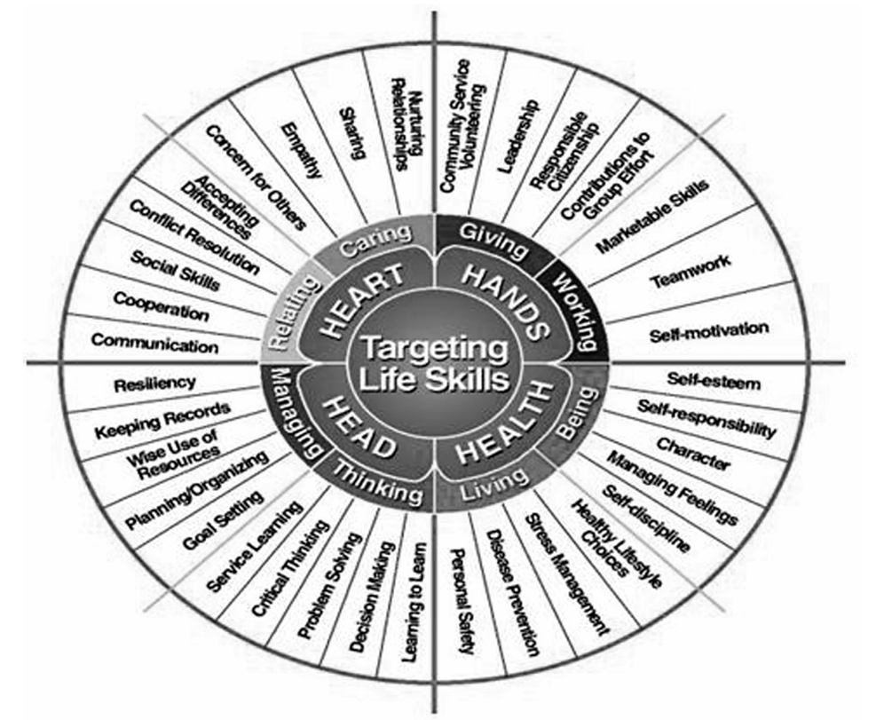

Figure 1 – List of life skills (Kar, 2011)

Relevance of this article to the thesis theme lies in its comprehensive overview of life skills that are necessary for success in the present professional environment. It gives an insight into how these skills can be developed and utilized to promote professionalism and personal growth. However, this approach by the article towards skills development may limit its application within practical HR contexts as it focuses on broad concepts without specific empirical examples and detailed strategies. Nonetheless, it adopts useful perspective by linking between personal well-being and professional success which shows how life skills facilitate general career development.

Another work (Nasheeda, Abdullah, Krauss, Ahmed, 2019) provides a holistic examination of the global effectiveness of life skills education with distinction between developed and developing nations. The importance of systematic life skills education programs in youth is underlined while pointing out that most programs lack systematic implementation, evaluation or monitoring in many developing countries. To deal with day-to-day challenges among adolescents in order to create positive input into the community often requires psychosocial, emotional, cognitive as well as behavioral competences which come from good quality education like life skill training.

An article entitled "A qualitative research study on the importance of life skills on undergraduate students’ personal and social competencies" (Nair, Fahimirad, 2019) stresses the significance of life skills in boosting self-efficacy and competence amongst university undergraduates. It argues that these academic futures shaping life skills are centered on self-awareness, self-regulation, empathy, relationship management, and competent communication. These attributes are known for building a person’s employability quotient develop-mental adaptability to professional environments. The study also argues that such integration can significantly improve student’s personal growth, school performance and commitment to their learning. This method discloses the subjective values attached with life skill training especially by students who claim that they have gained more confidence in using these skills in their other courses.

Moving forward, Mitashree Tripathy’s paper entitled "Relevance of soft skills in career success", explores how important soft skills are for a successful professional journey and job satisfaction. It asserts that in addition to hard skills like writing abilities or computer expertise, many other soft skills encompass effective global communications; leadership traits; emotional intelligence; team spirit; stress management among others essential for success at work place. Furthermore, an organization safety net could be established through interpersonal relationships. In her analysis Tripathy shows how technical competency is augmented by soft-skill competencies thereby underscoring the importance of employability as well as career development.

It is very important that the article goes deeper into how these skills can help in job obstacles. For problem-solving and creating positive work environments, self-awareness and strong communication are necessary, which impacts directly on job satisfaction and commitment. Adaptability as well as constructive attitudes at work contribute significantly to business achievements by helping them respond to changes and face challenges accordingly in their contexts. Effective prioritization through time management ultimately leads to higher job satisfaction. Stress management abilities are essential for dealing with workplace problems that might hinder an individual’s success at work. Lastly, it is highlighted that teamwork and dedication play a crucial role in achieving group objectives, increasing overall performance and maintaining organizational loyalty​​.

Now, with a clear understanding of life skills' paramount importance for young employees' career progression and personal development, we turn to a deeper exploration from the HR perspective.

## 2.2 Life skills relevant for HR in candidate analysis

### 2.2.1 Overview of key life skills valued by HR

We start this section with few theories, which may additionally explain the HR reasoning and processes, when making decision on certain life skills.

The theories of Workforce Agility and Learning Organizations are critical in understanding how modern HRM practices require unconventional life skills. The concept of dynamic capabilities, as put forward by David J. Teece in his famous article “Dynamic Capabilities and Strategic Management” (1997), underscores the need for an organization’s ability to integrate, build and reconfigure both internal and external competences so as to adapt fast changing environments. Modern organizations must embrace this notion of agility if they are to survive competition from their rivals within turbulent markets. By fostering a workforce that possesses agility, firms can enhance their adaptability or responsiveness hence enabling them to capitalize on varied individual employee skills including atypical life abilities like Strategic Thinking and AI Application.

Additionally, Peter M. Senge covers the significance of continual learning and development within an organization through his discussions on learning institutions particularly in “The Fifth Discipline: The Art and Practice of the Learning Organization” (1990). This augments Peter M. Senge’s work on learning organizations especially in his book titled “The Fifth Discipline” where he emphasizes on continuous learning within organizational structures. Personal mastery, mental models, shared vision, team learning, systems thinking are five key aspects mentioned by Senge which forms the environment where employees can constantly gain knowledge as well as apply it in practice.

In order to get the relevant and holistic knowledge in this area, it is pivotal to take a look at a foundational understanding of the candidate evaluation process, as this directly impacts the identification and development of essential life skills for professional success. Which ones are appraised and what determines their significance for an employer? – this is our first question.

“Who: The A method for hiring” (Smart, Street, 2008) brings in the basis of this position, giving a sequential method that enhances mission alignment with job outputs, as well as competencies with organizational goals. The book’s worth lies in its revelation on how human resource procedures can recognize, assess and cultivate soft skills which relate to success at individual levels and organization level. These qualities reveal an employee’s potential for both short-term growth within his or her current role as well as long-term development towards contributing to the culture and objectives of the organization. The analysis will provide a perspective from which to understand broader implications of life skills on professionalism that will then be followed by examining life skill development within HRM practices.

This book lists all vital abilities tested when hiring employees. Such basic skills include Efficiency, Flexibility, Communication, Organization and planning Attention to details etc. At this point, we start collecting skills in Appendix A.

The article by Rios, Ling, Pugh, Becker, Bacall (2020) largely contributes in showing how mastery over basic literacy can be used in predicting young candidates’ future success based on identification of critical twenty-first century skills (Figure 2) needed for workplace competency through analyzing job adverts online. The study underscores oral and written communication; collaboration; problem solving; as well as critical thinking as crucial competences for employers’ consideration in employment ads emphasized by organizations seeking new recruits. Thus these findings capture the importance of these areas towards career-oriented professionals implying that advanced knowledge acquired at early stages reveals subsequent competence.

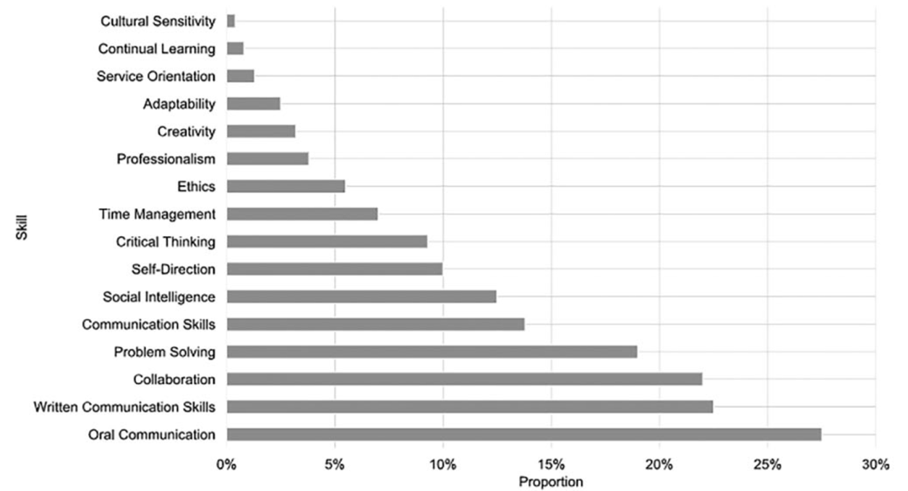

Figure 2 – Skills demand defined from the advertisments (Rios, Ling, Pugh, Becker, Bacall, 2020)

The author provides empirical evidence that supports the hypothesis that life skills, most importantly those related to effective communication, teamwork and problem-solving are key aspects of professional success. The strength of this study lies in its large-scale empirical approach where it analyzed more than 142,000 job advertisements to establish employer skill demands.

In their article “7 life skills for career success” (Indeed Editorial Team, 2023), the authors discuss some of the important life skills required for workplace success such as communication, resiliency, decision-making, cooperation, accepting constructive feedback, time management and technology. Resiliency involves seeing challenges as opportunities for growth and keeping motivated despite adversity. Accepting constructive feedback entails having self-awareness and a willingness to improve in order to learn better technologies abilities incorporate being familiar with basic office software and equipment and keeping abreast with industry advancements. These abilities serve as a foundation for navigating professional environments; fostering personal development; and enhancing career advancement.

The next one discusses your qualities that can make you get a job offer. Hogan et al.’s work "Employability and career success: bridging the gap between theory and reality" offers an extensive examination of the factors impacting employability and career success on top of traditional cognitive abilities or academic qualifications. It suggests that social skills adaptability interpersonal effectiveness are given equal if not higher preference by employers compared to technical skills education achievement grades etc. As written by them, employability includes candidates’ ability to be rewarding (positive) human beings who can learn any specific task (able), as well as hardworking individuals who want to succeed (willing). This perspective is close to our hypothesis which is about early development of emotional intelligence among other life skills like adaptability, empathy or even flexibility as potential indicators of future candidate’s achievements in their future occupation.

With this knowledge about what HR looks out for regarding the main competencies, we are now concerned with the place and importance of these skills in relation to current hiring trends, especially skill-based recruitment. This change reflects a growing emphasis on life skills beyond traditional qualifications as an increasingly important aspect for candidates’ consideration. The next part will demonstrate how these trends show the need for individuals to acquire and enhance their life skills thereby highlighting new recruitment system paradigms. As methods of hiring evolve to prioritize skills over traditional credentials, it emphasizes the growing relevance of life skills in securing professional success.

### 2.2.2 Skill-based hiring and the trends

The article from BCG, titled "Competence over credentials: the rise of skills-based hiring", discusses the shift toward evaluating job candidates based on their skills rather than traditional academic qualifications. It highlights the benefits of this approach, including increased loyalty and longer tenure among employees hired for their skills. This trend is driven by the rapid pace of technological change and the need for a workforce that can continually upskill.

Furthermore, McKinsey article "Taking a skills-based approach to building the future workforce" points out some of the advantages of skill based hiring for employers as well as employees that show how it can enlarge talent pools, increase employee retention and equalize job opportunities. Therefore it also presents practical tools and strategies for implementing skills-based hiring such as job progression tools and training programs, and also explains some of the positive outcomes associated with adopting such practices in terms of workforce development. To get more information about this you can visit McKinsey website directly.

The both articles from the giants of consulting provide equal message – good life skills are essential for a candidate. There is no need to cover in all details the article, as to prove the shift toward skill-based hiring. Now, let’s continue with an investigation of the skills, that will prevail in the future.

Another article from McKinsey & Company (McKinsey & Company, 2021) explores the future skills needed for the workforce, identifying 56 foundational skills across cognitive, digital, interpersonal, and self-leadership categories (Figure 3). These skills aim to enable citizens to add value beyond what automated systems can do, thrive in digital environments, and adapt to new work ways. Key findings suggest that higher proficiency in these skills correlates with higher employment rates, incomes, and job satisfaction. The research emphasizes the importance of adaptability, digital literacy, and interpersonal skills, which align closely with the life skills of interest for your thesis, such as problem-solving, critical thinking, and emotional intelligence. It underscores a shift towards higher cognitive, social, and emotional, and technological skills as manual and basic cognitive abilities decline in demand due to automation and digital transformation.

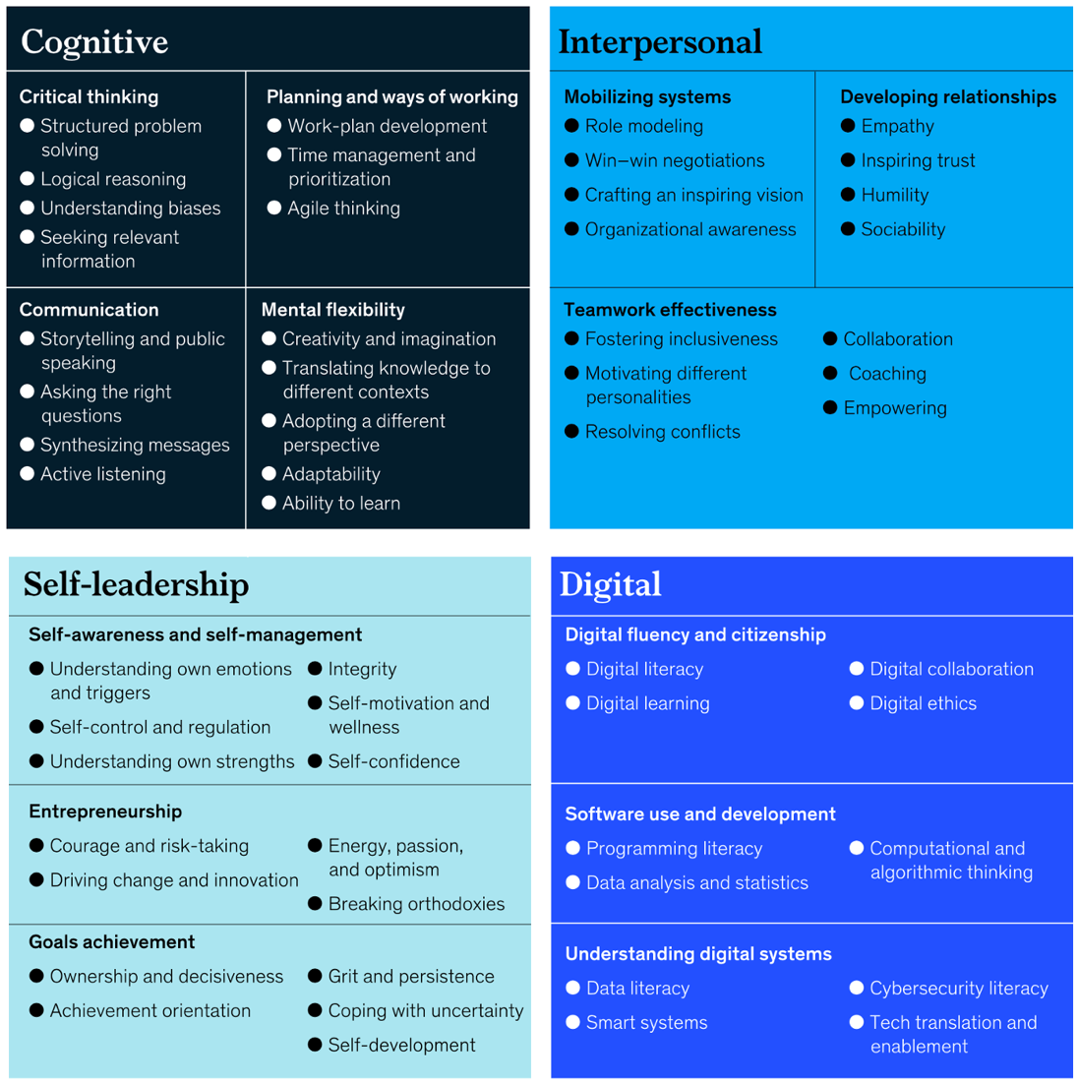

Figure 3 – Skills that will help citizens to thrive (McKinsey & Company, 2021)

The rapid technological advancements and the shortening half-life of skills necessitates urgent workforce reskilling, as outlined in an article “Reskilling the Workforce for the Future” by BCG headed by Harvard’s Digital Reskilling Lab. These include five key factors for reskilling: Strategic imperative, inclusion of all leaders and managers, treating it as a change management exercise, joining hands with staff willingness to change and acknowledging how important collaboration is among others. This wide-ranging approach underscores the significance of adaptability, continuous learning and collective action in preparation for future job challenges.

Articles by BCG and McKinsey have revealed this pivotal shift towards skill-based hiring that stresses evaluating candidates based on life skills rather than traditional academic qualifications. This trend, which is driven by swift technological changes and a call for adaptable skilled workforces, emphasizes the growing importance of adaptability as well as digital literacy plus interpersonal skills in today’s job market. Having understood the significance of life skills within professional development and changing criteria in HR practices we shall now look at more analytical content. The next section will deal with “Life skills as a predictor for success” employing statistical data such as numbers and regression analyses.

## 2.3 Defining unconventional life skills

Now that we've explored the realm of life skills, it's time to delve into the concept of unconventional skills. These are the skills that fall outside the area of what's commonly discussed in mainstream discourse. They encompass a variety of competencies that are often overlooked in traditional educational and training settings. But at the same time, such skills may influence the traditional life skills indirectly and play a vital role in every young worker life.

To effectively distinguish between traditional and unconventional life skills, we propose two criteria:

**Lack of Professional Discussion**: Unconventional life skills often do not feature prominently in professional or academic discourse.

**Lack of Empirical Data**: There is a notable scarcity of empirical research or data on how unconventional life skills directly impact an individual's success, whether in personal development or career advancement.

We will categorize all the skills that we find during research into 2 categories: Traditional or empirically confirmed unconventional skills, and Unconventional skills. On this basis, we now can clearly distinguish the two categories and add skills that we find during the research into one single table [Appendix A].

After establishing these categories, the next step involves a thorough analysis of existing research on life skills. This not only helps in identifying which skills have been extensively covered but also allows us to understand the methodologies used in these studies. Such an analysis is critical for identifying gaps in the current literature and for paving the way towards a more holistic understanding of life skills that are pertinent in the 21st century.

## 2.4 Life Mastery Skills description and importance justification

Life Mastery Skills encompass a broad spectrum of competencies essential for navigating daily life and enhancing one's basic understanding of routine tasks. The new concept combines conventional competencies like communication skills, digital literacy with unconventional ones to enhance peoples’ ability to deal with practical issues in their everyday lives. These skills, ranging from financial management to navigating government services, form a crucial subset of life skills. Such skills may contribute to overall personal development and enhancing personal independence, thereby facilitating a smoother transition into professional environments.

From the theoretical justification, we may start with Maslow’s Hierarchy of Needs (Maslow, 1943) and ERG (Alderfer, 1969) theories. Life mastery skills play a pivotal role in reducing mental load and strain by providing individuals with the knowledge to tackle routine life tasks confidently. By addressing basic psychological and safety needs, such as financial security, health awareness or relocation, these skills lay a solid foundation that enables individuals to pursue higher-level goals, such as career advancement and personal fulfillment, with decreased stress and increased focus. From the management perspective, we need workers to focus on the job and not on the personal issues, such as how to find a place to live or how to use internet safely.

Moving next, Herzberg’s Two-Factor theory (Herzberg, Mausner, Snyderman, 1959) also provides quite the same justification. The theory elaborates on how life mastery skills not only alleviate job dissatisfaction by addressing hygiene factors but also bolster motivators. Skills such as Career Planning enhance job satisfaction by enabling individuals to navigate their careers more effectively, contributing to a sense of achievement and recognition in their professional lives.

As we have already discussed the move toward skill based approach, the Human Capital Theory (Becker, 2009) should be addressed. From the perspective of this theory, life mastery skills contribute significantly to an individual's economic value and productivity. For instance, digital literacy skills enhance a person's adaptability and competence in the modern digital economy, whereas Financial Literacy skills may facilitate specific finance issue and basic understanding in the workplace. Moreover, by enriching an individual's skill set, life mastery skills bolster other competencies, fostering a more versatile and valuable workforce.

Last but not least, Positive Psychology (Seligman, Csikszentmihalyi, 2000) also helps in understanding the importance of such skills. This approach emphasizes the importance of life mastery skills in fostering well-being, resilience, and happiness. By equipping individuals with the means to efficiently manage life's demands, these skills contribute to a positive outlook and greater personal satisfaction. The emphasis here is on the holistic contribution of life mastery skills to an individual’s ability to thrive both professionally and personally, enhancing overall life satisfaction and success.

An exploratory survey was conducted prior to the main research phase to ascertain general perceptions regarding the importance of life mastery skills. The survey, which garnered responses from a sample size of 25 individuals, aimed to evaluate the significance attributed to skills such as Home Maintenance, Financial Literacy, Personal Development, Career Advancement, Health Maintenance, and Computer Proficiency, without limiting the context to professional environments exclusively.

The findings reveal [Appendix B] that the majority of respondents (96%) consider mentioned skills to be essential for both personal development and professional success. Among these, Financial Literacy, personal development, and health maintenance were identified as the most critical. Furthermore, 67% of participants acknowledged encountering situations in which a deficiency in one or more of these skills negatively affected them.

This preliminary investigation reinforces the idea that proficiency in these life mastery skills is not only crucial for daily living but also plays a significant role in enhancing job performance and career progression.

As we already got a proper understanding of what should be found and how to categorize skills, we can move forward to the specific literature. In the next section, we will take a closer look at literature, that describes how specific life skills predict success.

## 2.5 Life skills as a predictor for success

### 2.5.1 Synthesis of literature that considers multiple life skills as predictors of professional success

This section sets out to measure the influence of life skills on professional success, theoretically asserting that having a handle on some specific aspects of these life skills can lead to significant improvements in career experiences. Our discussion will also be supported by empirical evidence through examining the relationship between life skill competence and measures of professional accomplishment. This part is concerned with discussing the literature about many life skills rather than one.

The article “Life-skills as a predictor of academic success: an exploratory study” (Currie, Pisarik, Ginter, Glauser, Hayes, Smit, 2012) explores how life skills impact academic performance beyond such traditional indicators as SAT scores and high school GPA. It identifies four main categories of life-skills: interpersonal communication/human relations (β = -0,17), problem-solving/decision-making (β = 0,05), physical fitness/health maintenance (β = 0,23), and identity development/purpose in life (β = 0,21). The findings indicate that these life skills are good predictors of college GPA; these add approximately 9.4% to the amount of variability explained by traditional measures such as total variance explained – almost 30%. Nevertheless, since it is enough to assume that academic achievement mostly determines job success since universities are designed for preparing employees who would have theoretical background and practical experience necessary for performing their duties during their working lives.

This research highlights the importance of considering broader developmental variables in predicting academic success, suggesting a valuable perspective for HR professionals evaluating potential candidates. By considering what students can do outside of classrooms like team work, creativity etc., this holistic approach may give the employers insight about a candidate’s potential achievements in both learning institutions and places where they will be employed later. However, future research is needed due to several limitations such as small homogeneous sample size and over-reliance on self-reporting survey methods used in this study which was however exploratory in nature. Whatever its limitations might be though this study provides pioneering data pointing towards the role of life skills in academic and perhaps career success that may be further investigated in management and HR.

The study “Students’ life quality prediction based on life skills. Procedia-Social and Behavioral Sciences” (AhmadiGatab, Shayan, Tazangi, Taheri, 2011) discusses the relationship between life skills and quality of life among students. A descriptive-correlational research design was used by Golzari Life Skills and World Health Organization Life Quality questionnaires for data collection in this study. It also deals with various dimensions of life skills such as emotional, interpersonal, problem-solving and decision-making abilities as well as personal and social capabilities. Otherwise, physical and psychological health includes “relationship autonomy level, communicating with the environment, noumenon, and personal thoughts”. There are different dimensions of life skills: emotional and interpersonal qualities; ability to solve issues or make decisions; personal influence or social communication. The results obtained show that there is a significant link between life skills and quality of life i.e. when students are more aware about their life skill they enhance their general life quality (life skill accounted for 32% variance in the students’ quality of lives). This research emphasizes on how crucial life skills are in improving individuals’ personal influences or social communications suggesting that education on these skills could play a major role in developing a stronger character, better relationships with others as well as higher levels of satisfaction with one's own existence according to the conclusions made by this study.

Additionally, the article "Young people's life-kills and the future" (Powney, Lowden, Hall, 2000) gives an extensive examination of essential life skills for young people, including how they view such skills and how this relates to their careers in future lives. The article highlights some of the most critical life skills as communication and inter-personal skills, problem-solving and critical thinking abilities, information and communication technology (ICT) literacy/competence, creative and aesthetic skills as well as physical coordination skills. Such abilities have been recognized to be important not only for employability but also in developing individuals that can adapt to different situations in life.

A thorough understanding is presented on how young people perceive acquisition or importance of life skills with a focus on practical experiences like work experience or family influence. It also shows the gap between young people’s confidence in spontaneous development of ICT vs. demands from employers highlighting it as a potential area for attention in education. It is valuable to mention that young people also acknowledge skills required by the empoyer.

The article "The predictors of career success" (Alzyoud, 2017) is a discussion about the relationship between career commitment, perceived organizational support (POS), and career values in relation to career success. It highlights career commitment, POS and career values as important but moderate predictors of career success accounting for about 61% variance in job performance outcomes. Regression analysis showed that each predictor was positively associated with career success, with standardized coefficients of .29, .23 and .32 respectively which were all significant at p < 0.01 level. In this study, the author shows that understanding these factors may help individuals succeed in their careers by supporting employees to match their valued careers with organization’s goals.

Despite the fact that the article does not mention specific life skills, we may infer that such skills as Problem solving, Interpersonal skills, Workplace knowledge and Career Planning, Time management and others could at least partially explain career values and commitment variables.

Having started with a global outlook on life skills as determinants of career success, we shift our attention towards particular predictors. In next chapter, wee explore the specific influence of personal life skills on work-related achievements by screening what part of those skills is most likely to contribute to making it in a given profession. By taking this approach, we will get more insights about how each life skill affects individual professional directions and can better appreciate its significance for one’s own progress and HR interventions aiming at developing careers.

### 2.5.2 Detailed examination of studies focusing on single life skills as success predictor

This section intends to identify relevant studies and dwell on how a particular life skill may forecast success of an applicant in the job market. We have established that life skills are important because they affect one’s professional life but we still do not know how much influence they actually have.

Let us begin with one of the most essential skills – critical thinking. The article “Critical analytic thinking skills: do they predict job-related task performance above and beyond general intelligence?” (Elson, Hartman, Beatty, Trippe, Buckley, Bornmann, ... Sprenger, 2018) explores how critical thinking, apart from general intelligence, can be used to predict job performances among government analysts. This highlights the essence of critical thinking as a separate skill for evaluating complex situations, making informed decisions and solving problems in business practice effectively. An investigation establishing the importance of critical thinking in predicting job effectiveness and underlining its relevance for HR processes and training courses aimed at enhancing analytical capabilities in today’s labour force is widely examined by this study. It examines ways of assessing and developing critical thinking skills comprehensively pointing out its value when it comes to forecasting work related performance hence supporting hypothesis that such life-skills as problem-solving or analytical-thinking are synonymous with career-success.

The study explains three models. The first model showed that 18% additional variance was accounted for by CATS (total - 28%)and β = 0,51 . In the second model, CATS added another 11%(total – 25%)and β = 0,39. Lastly, in a more comprehensive model which controlled for a broader set of characteristics, variables entered in first step explained 23% variance in overall product ratings with cat scores accounting for an additional 13% variance (total – 36%) , β = .50. These findings underscore the significant predictive power of critical analytic thinking skills for job-related performance,distinct from general cognitive abilities’ contributions.

The research article entitled “A relational model of career adaptability and career prospects: The roles of leader–member exchange and agreeableness” by Xuhua Yang et al. scrutinizes how career adaptability affects career prospects via leader-member exchange (LMX), moderated by agreeableness. It shows that individuals with high levels of career adaptability are more likely to establish a connection with their supervisors that may enhance their future careers. In addition, this effect was found to be stronger for agreeable employees, which implies that those who are cooperative and considerate could have more benefits from their adaptability in terms of work and job related attitudes. In this regard, the study suggests that a combination of individual characteristics like interpersonal skills such as being agreeable and ability to adapt is crucial for professional growth and success.

Accordingly, the intraclass correlation coefficient (ICC) analysis indicated that 41% of the total variance in LMX and 42% in career prospects were within groups showing the impact of being rated by similar supervisor. In fact, when we estimate these effects using conventional statistical methods, it was determined statistically significant (B = .15; 95% CI [.08, .22]). Thus, findings from this study indicate that there is considerable relationship between an individual’s level of flexibility within his or her vocation as well as leader member exchanges in forecasting personnel accomplishments at workplace setting. However, this context-specific nature might limit applicability to other cultural settings because it focused on China workers alone.

Then we would like to know how career resilience impacts. The paper "The mediating role of career resilience on the relationship between career competency and career success" (Ahmad, Latif, Bilal, Hai, 2019) examines the importance of career competencies and resilience in the pursuit of a successful profession. Some of the key life skills that it highlights include, problem solving and decision making abilities, adaptability and flexibility, leadership, interpersonal communications skills as well as self-organization. This study confirms that career resilience acts as a significant precursor for career competency, which in turn is a major predictor for future job outcomes. Its findings also indicated that with respect to its relationship with both a job competency and success of an individual’s work life in general, there is mediation by a person’s ability to deal with difficulties encountered in their line of duty. The results provided insight into how resilience affects the link between career competence and triumph over adversity experienced throughout one’s professional life. Thus, it offers significant practical implications for HR practices showing that promoting careers related competences can improve workers’ resiliency hence they can succeed ultimately.

The study describes a significant positive relationship between career competency and career resilience (β = 0.557, R2 = 0,309), and between career resilience and career success (β = 0.389, R2 = 0,151). Additionally, career resilience mediated the relationship between career competency and career success (β = 0.221). These findings emphasize the significance of developing careers related skills including resilience if individuals are to achieve success in their various occupations.

The article "The contribution of emotional intelligence to career Success: beyond personality traits" (Urquijo, Extremera, Azanza, 2019) covers the effect of Emotional Intelligence (EI) on career success, which differentiates itself by considering extrinsic success factors (e.g. salary) and intrinsic success factors (e.g. job satisfaction) among early versus later career graduates. It underscores via incremental validity how EI predicts career outcomes better than traditional personality variables. Some significant life skills include emotional intelligence, proactive personality and Big Five personality traits with a particular emphasis on how EI improves job satisfaction and to a lesser extent, salaries. The findings imply that EI can be applied in personal growth and counseling for careers hence indicating future directions for research on EI’s significance in careers.​​.

The hierarchical multiple regression analyses detail that while demographic factors and proactive personality significantly influence salary, explaining up to 44% of the variance, EI's addition to salary prediction is not statistically significant. Conversely, EI explains a modest but significant 2% of the variance in job satisfaction, even when controlling for demographic variables, the Big Five personality traits, and proactive personality. This nuanced contribution underscores the importance of EI in achieving job satisfaction, suggesting its potential as a critical focus for personal development and career counseling, despite its complex relationship with financial success indicators.

The article "Creativity and resilience as predictors of career success" (Fernández-Díaz, Gutiérrez-Ortega, Llamas-Salguero, Cantón-Mayo, 2021) investigates how one’s creativity and resilience are related to their level of career success. Based on the attributes of creativity and resilience, it noted that people with higher qualities within them experience greater professional achievements both in objective (e.g., salary, prestige) and subjective (personal fulfillment and satisfaction) terms. The study highlights resilience as a crucial predictor of career success, showing a strong positive correlation with both objective (r = 0.39) and subjective (r = 0.31) career outcomes. Contrarily, creativity's impact on career success is less pronounced, with minimal correlation to objective (r = 0.13) and subjective (r = -0.09) success. The author employs the techniques of questionnaires among 200 participants from diverse occupational groups in Spain. However, there are limitations such as sample size or cross-sectional design which might require further research like longitudinal studies to help understanding these variables cause-effect relationships.

The article "The importance of digital literacy on the labour market" written by Predrag Bejakovic and Zeljko Mrnjavac explains why digital literacy is essential for employability thus necessitating policy interventions for promoting digital literacy towards socio-economic development. It uses Eurostat data to prove statistically significant relation between digital skills and employment rates (Figure 4) across EU countries’ labor markets. The investigation shows that computer literacy should be treated as a critical life skill enhancing employability in different populations while addressing the gap in digital skills acquisition processes.

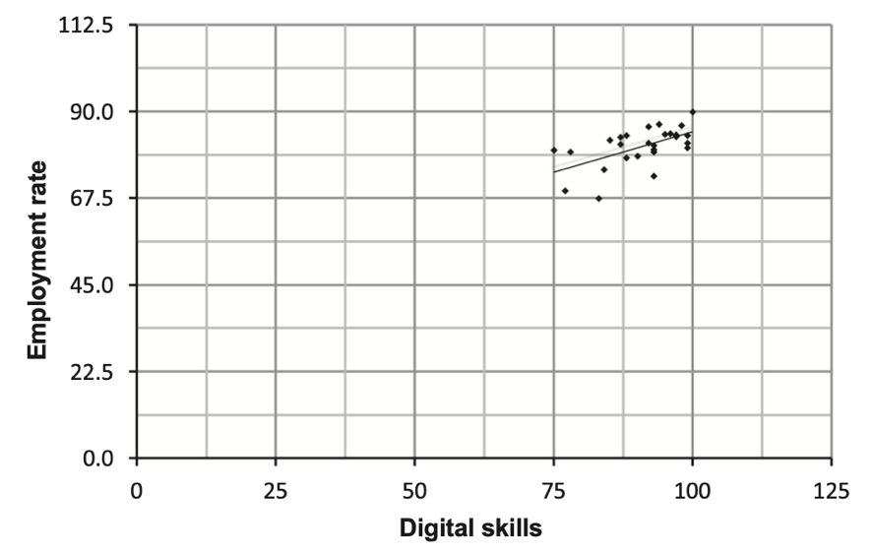

Figure 4 - Digital skills and employment rate of population aged 25–54 in EU 2017 (Bejakovic, Mrnjavac, 2020)

Statistically, the paper presents Pearson’s correlation coefficients showing a significant relationship between digital skills and employment rates, especially among older populations, with coefficients of 0.59 (p=0.00078) for prime age cohorts and 0.62 (p=0.0003), increasing to 0.77 (p=0.000002) excluding an outlier, for older generations. This analysis underscores digital literacy not only as a pivotal life skill but also as an essential factor for employability, advocating for broad educational and policy efforts to bridge the digital skills gap.

Despite the scarcity of literature specifically quantifying the impact of individual life skills on career success, we've identified and analyzed a few key skills with substantial empirical backing, including critical thinking, career adaptability, resilience, emotional intelligence, creativity, and digital literacy. These analyses provide concrete models illustrating the significant predictive power of these life skills in professional settings. Unfortunately, only few of the skills covered in this part may be named as unconventional. Having covered the broad importance of life skills, skills highly valued by HR, and empirical research on specific life skills, we now proceed to explore how to assess life skills.

## 2.6 How to measure life skills?

In order to measure and analyze the effects of life skills on a number of outcomes such as educational attainment, personal growth, and job success, evaluating life skills is essential. However, their evaluation is hindered by the absence of standardized indicators and the diversity of life skills. This part presents and examines seminal articles that contribute towards development and validation of comprehensive instruments for assessing life skills and measuring subjective career success.

Starting with the first one, the article "The life skills assessment scale: the construction and validation of a new comprehensive scale for measuring life skills" (Subasree, Nair, Ranjan, 2014) focuses on creating a comprehensive tool for evaluating life skills among adolescents, identifying ten core life skills: Self Awareness, Empathy, Effective Communication, Interpersonal Relationships, Creative Thinking, Critical Thinking, Decision Making, Problem Solving, Coping with Emotions, and Coping with Stress. It emphasizes the importance of a standardized approach to assessing these skills for better educational and developmental interventions. Aims at developing as well as validating a comprehensive instrument for assessing life-skills grounded on the World Health Organization’s list of 10 core life skills. The scale consists of 100 items, covering dimensions like Self Awareness, Empathy, Effective Communication, etc., using a 5-point Likert scale. It was standardized through a meticulous process involving expert consultations, item analysis, and pilot testing with a diverse sample of Indian adolescents, ensuring the scale's reliability and validity for assessing life skills among this demographic. The scale demonstrated high reliability with a Cronbach's alpha coefficient of .84, indicating its potential utility in research and practical settings for identifying training needs and evaluating the effectiveness of life skills programs. However, the study's focus on a specific demographic limits its generalizability, and further research might be needed to adapt the scale for broader populations.

Furthermore, the journal article “Measuring life skills: standardizing the assessment of youth development indicators” (Duerden, Witt, Fernandez, Bryant, Theriault, 2012) stresses on the significance of life skills in youth development by pointing out such key areas as communication, team work, self-responsibility, critical thinking, decision making, leadership and problem solving. The absence of standardized measures for these skills is highlighted and efforts are made to validate instruments with a view to creating a more unified approach towards life skill development. To standardize the scales used in this study they went through a thorough process that involved conducting an extensive review of literature on each of ten life skill areas; assessing available instruments; and identifying one particular instrument for further investigation based on its appropriateness to children and young people’s settings. The study’s results have great importance to this area since it has provided validated measures for different types of youth populations suggesting how gender and ethnicity might influence development of such skills and supporting need for standardized conceptualization and measurement of life skills. One more merit of this research is that it offers precious scales for each of 10 skills.

What is even more interesting is to acquire the holistic view of the methods, that are used during the hiring process. The source (Eklavvya, 2022) outlines various candidate hiring assessments, emphasizing their importance in aligning candidates’ skills with organizational needs. These assessments are pivotal for evaluating a wide range of competencies, including technical skills, personality traits, leadership qualities, and domain-specific knowledge. It sticks with the idea of skill-based hiring, which eventually breaks the rules of conservative hiring approach. The table from the Appendix C shows the methods, which can be used to assess candidates.

A good addition, that enriches the mentioned table, would be an article of 4 Corner Resources (2023), that describes some other valuable methods, eventually making the table holistic. One of the most interesting tests is the Situational Judgment test, which asks a candidate to fulfil a certain scenario with his/her answers.

The exploration of these articles highlights the ongoing efforts to standardize the assessment of life skills and to align the selection methods with the modern trends and best practices. The development of comprehensive scales and inventories represents a significant advancement in the field, providing researchers and practitioners with tools to systematically evaluate and harness the potential of life skills. On the other hand, vast list of different assessment methods provides the HR department with a holistic approach, that can truly identify lots of useful points in a candidate.

## 2.7 Conclusion of literature review

During this meticulous research, we delved into the pivotal role of life skills for young professional and their significance for HR departments, focusing on the emerging trend of skill-based hiring. During the analysis of the literature regarding current HR practices, we uncovered a huge list of skills, which are tested and valued by employers. The theories of Workforce Agility and Learning Organizations were described, so that to better understand the motivation for HR selection. Also, the trend toward skill-based hiring and technological revolution is going to change the hiring approach – HR will focus on skills, instead of regalia, and new ones will appear. The articles gave additional food for thought and enriched the list of potential skills to evaluate, such as AI Application.

The concepts of unconventional skills and life mastery skills were introduced, providing a comprehensive approach towards essential competencies. We understood from a theoretical basis, such as Maslow’s Pyramid of Needs, Positive Psychology and others, why life mastery skills are also important for the quick professional growth. A critical review of existing literature has identified many traditional key skills reported in the studies, so that there is no necessity to analyze them further. Instead, the focus of this study is on skills, which are still not examined deeply in the literature, or unconventional skills. This part was extremely valuable for the research, as it also showed how other researches made the analysis in the same field and which techniques they used.

Furthermore, we also discussed how skills can be standardized and measured so as to make them practically applicable at workplace rather than just being theoretical concepts, as well as the methods of selection process. These concepts will eventually help to understand how identified unconventional life skills may be analyzed during the hiring process. The standardized scales could be enlarged with the new skills, eventually enriching the predicting ability of the scales. At the same time, there definitely are certain methods that seems to be more applicable for different skills. This groundwork facilitates a transition into empirical research, aiming to explore the impact of unconventional and life mastery skills on professional success and HR practices.

In the literature review, we uncovered a series of interconnected research gaps that directly inform the focus of our investigation:

1. Overall, the research landscape reveals a notable scarcity of literature on many skills, indicating an underexplored area and suggesting the need for a more holistic approach to understanding their role in the workforce.
2. Next, there is a scarcity of empirical studies measuring the impact of life skills on young professionals' career success, highlighting a critical area for further exploration.
3. This absence is compounded by a lack of research into the specific life challenges young candidates face, such as relocation issues or workplace adaptation, which undeniably influence their professional pathways.
4. Additionally, the evolving trend towards skill-based hiring underscores the urgency for studies on how HR departments can effectively evaluate these competencies during selection, a process still not clearly defined in current practices.
5. Finally, the development and systematic evaluation of life skills within educational and organizational frameworks remain underexplored, pointing to a significant opportunity for our research to contribute meaningful insights.

The analysis reveals that several aspects of the initial research questions remain unexplored. Furthermore, there are new paths for inquiry as stated in the literature review which is fascinating and important for a complete understanding of the topic.

Firstly, life mastery skills is an area of interest that needs exploration and detailed examination as it unquestionably comes under unconventional skills. This exploration will examine ways through which managing individual and daily life challenges effectively can help free up resources like time and effort thus causing individuals to align more with their professional growth. By streamlining the management of day-to-day activities, these life mastery skills not only show one’s maturity but also improve his/her capacity to maneuver within various professions’ intricacies.

Secondly, some specific skills were identified by the literature review as being particularly relevant and deserving further investigation. The importance of AI Application for career success cannot be overemphasized. It is interesting to investigate whether people who are proficient in this discipline might have access to more job opportunities since companies continue to incorporate AI systems in their operations. These abilities are therefore essential in career advancement. Moreover, Strategic Thinking ability is believed to significantly enhance young professionals’ career progression chances. They can predict future trends in their industry, coordinate activities towards long-term goals, and efficiently overcome any hurdles posed by their profession by adopting this approach.

In this regard, we seek to transition into the empirical phase of our study where we aim at exploring these newly identified areas alongside responding to questions set forth at the beginning. Our research seeks to map out unconventional skills landscape while focusing on its relationship with professional achievements. Subsequent enquiries will assess how these skills aid employees in dealing with professional challenges and explore HR practices responsible for identifying, measuring and growing these competencies among prospective workers. This method aims at unfolding how knowledge about career dynamics turns into practical use at workplaces thus bridging between theoretical knowledge about career development and workplace realities.

# Research methodology

## 3.1 Research design

To ensure the selection of an appropriate research methodology and process, this study will adhere closely to the authoritative guidance provided by Saunders, Lewis, and Thornhill (2019).

The uncharted nature of this area demands an **exploratory framework**, that is used to fully understand how unconventional life skills affect professional achievements. Explanatory Sequential Design is selected to methodically identify key variables and analyze them in depth later on. This implies that our methodology is aligned with our objectives as we employ a sequential approach to first quantify statistically vital life skills associated with successful work performance and then qualitatively probe the impact of such abilities on it.

**Explanatory Sequential Design** research design is chosen for its ability first to quantify the significance of various life skills through a quantitative phase and then delve deeper into these findings with a qualitative phase. It is vital to first select the skills that have some weight on the dependent variable. Starting from broad quantitative data collection, the sequential design allows comprehensive exploration leading to identification of significant correlations. Subsequently, the qualitative phase provides an in-depth examination of these correlations, offering rich insights into how specific unconventional life skills affect career professional success and facilitate overcoming obstacles. Therefore, this framework ensures coherent transition from identification of potential relationships between variables towards understanding their substantive implications which make it a suitable tool for investigating complex social phenomena.

By utilizing the Explanatory Sequential Design within an exploratory framework, our study aims to illuminate the underexplored influence of unconventional life skills on professional achievement. This methodological approach guarantees the flexibility needed to navigate the complexities of our research topic, allowing for adaptations based on initial findings to deepen our understanding.

## 3.2 Research methods

As the sequential design was chosen, the combination of qualitative and quantitative methods is used. Our research design takes into account two types of methodologies: 1) quantitative approaches that rely on surveys or experiments to identify broad trends or detect patterns; and 2) qualitative approaches that focus on understanding individual experiences within a particular social context. **Mixed method (**Teddlie, Tashakkori, 2009) provides space for thorough examination of complex phenomena through first coming up with empirical connections.

Quantification enables examination of big sample, establishing correlations and identifying trends while qualification provides detailed narratives about application of unconventional skills in different professional settings. This integration not only addresses the exploratory nature of our study but also aligns with the complexity of evaluating soft skills in the workforce, ensuring a holistic view that encompasses the multifaceted dimensions of professional success. Thus, by merging empirical insights together with nuanced interpretations our research seeks to contribute towards deeper understanding on how non-conventional life-skills may affect career success.

There are several reasons why this research must use mixed methods. First of all, it enables the possibility to cross check data from various sources and methods in order to increase the reliability and validity of results. Secondly, it overcomes limitations of single-method studies by counterbalancing their weaknesses with strong sides of another one. For instance, surveys can be quantitative and identify general patterns and correlations among large population but they might lack depth into understanding underlying reasons behind these patterns. On the other hand, qualitative interviews can be used to provide rich, detailed insights into individual experiences and contextual factors but these may not generalize to a larger population. Therefore, using both methods will help in carrying out an extensive evaluation that will take into account both breadth and depth of unconventional life skills effects on career improvement. This approach guarantees that the findings are solid, subtle, and universally applicable while offering a direction for future researches as well as practical implications in educational as well as professional settings.

## 3.3 Data collection process

It is essential to choose appropriate data collection methods in mixed-method research, in order to facilitate a comprehensive analysis for both the qualitative and quantitative sections. According to the “Research methods for business students”, surveys are recommended due to their capacity of acquiring expansive numerical data that enable to estimate how various nontraditional life skills correlate with career success among individuals from different communities. Semi-structured interviews complement this by offering deep qualitative insights, allowing for an exploration of personal experiences and nuanced understanding of how such skills impact professional development. This combination ensures a holistic view, balancing breadth with depth in understanding the phenomena under study. Now, let’s cover it deeper.

Surveys serve as an invaluable tool for gauging the influence of unconventional life skills on professional achievements among young workers during the stage of quantitative exploration. We will estimate quantitatively the degree to which these skills relate to professional success, specifically quick professional growth, among young people by amassing numerical information across varied populations. To facilitate this process, the questionnaire was developed that was broadly distributed amongst professionals from various industries aimed at determining what kinds of unconventional skills were most valued and seen as crucial for career development. In the next part, we will discuss the exact variables, that were chosen for analysis. The approach enables us to gather empirical evidence on the significance of these skills in achieving professional success.

Qualitative research phase, through semi-structured interviews, is aimed at exploring the depths of how unconventional life skills come into play in overcoming professional challenges. These interviews are tailored to young professionals to reveal their own experiences, opinions or practical application of these skills in work places. These interviews are particularly aimed at addressing the second and third research questions, focusing on how identified unconventional life skills aid in overcoming professional adaptation hurdles and exploring the methodologies HR departments can employ to evaluate these skills in young candidates. Moreover, the insights gained from these interviews will enrich our understanding and interpretation of the survey results, offering a holistic view of the impact of unconventional life skills on professional success.

## 3.4 Preparing for data collection

### 3.4.1 Quantitative component

In order to prepare for the survey and interviews, it is vital to decide the input variables, questions and other aspects.

Starting with the quantitative part, there is a need in deciding, which unconventional skills, defined previously during the literature review step, are the most crucial and should be analyzed further. So, the first step is to make a shorter and relevant set of skills.

The methodology for selecting skills used in the quantitative analysis is designed to minimize overlap and ensure that each skill chosen has something unique to contribute about how young professionals succeed in their careers. As a result, when there is an appearance of overlapping skills or they belong to the same domain, preferences went towards those that cover wider areas or those applying at a higher level, thereby creating a varied array of variables. For example, while both "Financial Literacy and Management" and "Tax Literacy and Preparation" are important, "Financial Literacy and Management" encompasses tax literacy among other competencies thus providing greater understanding of financial acumen in relation to professional success. Also, the decision was to include some of the currently trending and vital work force skills as well as those that affect both personal and professional spheres, influencing general life happiness and productivity.

Strong predictors of swift professional growth are such skills as Strategic Thinking, AI Application, Career Planning, Wise use of Resources, Negotiation and Employability since they all directly affect work productivity, involvement and overall performance. Efficiency in these domains for employers does not only imply employees’ existing abilities but is a good sign that they are capable of realizing their potentiality in future. These competencies enable individuals to approach tasks with foresight, leverage technology for innovation, plan their career trajectory strategically, utilize resources effectively, excel in negotiations, and adapt to new roles with ease—all traits that contribute to accelerated growth and productivity in the workplace.

Speaking about less obvious skills, let’s look at how Negotiation skill impact the quality of employees. It significantly benefits organizational dynamics by fostering effective collaboration, streamlining conflict resolution, and enhancing resource allocation efficiency, even if indirectly.

Moving next, although HR departments usually evaluate Employability skills more deeply, reviewing it reveals its role in advancing individual careers as well as overall effectiveness within organizations. Skills such as professional engagement, self-awareness and effective communication are instrumental in enabling employees to quickly fit into new roles and contribute to their teams. The ability for staff members to present themselves well means that they can rapidly show their worth within a team leading to quicker adaption and recognition among peers. Workers who articulate what they have achieved and their capabilities clearly are more likely to get noticed therefore increasing opportunities for consideration in advanced projects or promotions too. Furthermore, people skilled in this area tend to be good at identifying personal skill gaps early enough which makes them ready for complex tasks faster thus speeding up professional growth while still being self-confident about it. Also when an employee masters self-presentation it gives them confidence needed so that they can readily embrace challenges as well as leadership opportunities which ultimately accelerates one’s career development while still fostering robust paths for its members’ careers throughout organizations of all types This wide-ranging ability ensures that the workforce is always flexible enough to meet changing business requirements but also creates strong avenues for career progression within the company itself.

Meanwhile, skills like Financial Literacy, Health Awareness, Home Maintenance, and understanding Government Services, while perhaps more personal in nature, indirectly contribute to an employee's efficiency and engagement at work. By effectively managing personal challenges and responsibilities such as renting a flat or maintaining good health employees can dedicate their full attention and energies towards their professions. When people have mastered these areas, it means they have a hold on the practical aspects of life making them best placed in focusing on career development thereby impacting positively on work output hence influencing speed at which individuals grow professionally.

Now, let’s cover the dependent variable – Quick Professional Growth. The selection of "Salary Growth," "Responsibility Increase," "Number of Promotions," and "Years Working" as sub-variables captures the complex nature of career success. This approach ensures a comprehensive analysis of how unconventional life skills impact tangible outcomes like salary and promotions, as well as intangible, providing a nuanced understanding of professional development.

The summary of skill selections is presented in Table 2.

Table 2 – variables used in the survey

|  |  |  |
| --- | --- | --- |
| **Variable block** | **Argumentation** | **Variables** |
| Dependent Variable | Captures career success metrics (salary, responsibilities, promotions) for a focused analysis on how skills impact professional growth. | Quick professional growth |
| Core Independent Variables | **Strong Predictors of Professional Growth**  Key skills driving professional growth, enhancing productivity, strategic planning, innovation, and workplace adaptability. | Strategic Thinking, AI Application, Career Planning, Wise use of Resources, Employability, Negotiation Skills |
| Additional Independent Variables | **Supporting Skills for Organizational and Personal Efficiency**  Skills enhancing efficiency and adaptability, indirectly supporting career development. | Financial Literacy, Rental Processes Literacy Literacy, Government Services navigation, Health and Wellbeing Maintenance, Home Maintenance Literacy |

The survey questions for this study were crafted within the context of an uncharted topic, acknowledging the novelty of exploring unconventional life skills' impact on professional growth without direct precedents in existing literature. Initially, the questions for the survey were made as close as possible to the existing assessment scales, used in other researches. The questions were in a form of mini tasks or direct evaluation of current knowledge on certain topic, but the pilot testing among 6 respondents showed, that such an approach is terrifically demanding, as there are more than 10 variables, leading to more than 50 questions. This existing assessment scales, while informative, were too detailed for our focused needs. The respondents did not want to solve such a great number of demanding tasks; thus, the decision was to make the survey easier, but at the same time informative.

The literature review offered a great understanding that inspired the creation of more targeted questions relevant to our research. As a reference, the author used examples of scales from the articles of the part “2.5 Life skills as a predictor for success”, as well as the articles “Measuring life skills: standardizing the assessment of youth development indicators” (Duerden, Witt, Fernandez, Bryant, Theriault, 2012) and “Strategic Thinking Self-Assessment” (Harvard Business School, 2021). The primary aim of these questions is to identify correlations between selected skills and quick professional growth, directly addressing the study's exploratory nature. The queries were carefully designed so as to match with our objectives; thus, provide accurate data collection instruments that facilitate answering our proposed questions. This tactic makes certain that the survey is relevant and meaningful and serves as a solid background for revealing insights into various aspects influencing how young people take up jobs or start off their careers in various fields by using unconventional life skills.

The final survey is presented in Appendix D. The Quick professional growth variable reflects the changes in salary, promotion and responsibilities during last 5 years of working experience. Also, the current level of unconventional skills was assessed, not the one 5 years ago, due to the following reasons:

* It reduces cognitive load on respondents and errors associated with memory bias and ensures more reliable data
* Some of the skills significantly evolved during the last 5 years, such as AI Application. Current assessment reflects the lates understanding of skills and skill-based hiring
* As the nature of the research is exploratory, we do not need rigorous assessment methods, because it is crucial to first shed light on the unknown area, and then be more specific and conduct longitudinal studies
* It aligns with the current assessment of Quick professional growth
* The method allows for a clear and straightforward correlation
* The decision to conduct interviews after the survey can compensate for some of the drawbacks of only assessing current skills

The drawbacks of such a method may include that the study does not capture the development of skills and causality issues, as we cannot be sure that one impact the other. But due to the time limits, complexity, mixed methods and exploratory nature of the study, we still opt in the current assessment of skills.

The target audience of the survey is working people aged from 22 to 30, ensuring that we address young people at the beginning of their career, but with approximately 5-year experience, so that we can track their growth. The respondents are Russia citizens across various industries without any specific preference. The survey is distributed in the internet through Anketolog web app. Using Anketolog for the survey and compensating respondents employs Self-Selection Sampling, a non-probability method where individuals volunteer to participate, often influenced by incentives. This approach was chosen due to the time constrains and the dependence of future steps on the survey.

The final quantitative analysis stage is to statistically validate the influence of different unconventional skill on quick professional growth. In doing so, we aim at using multi factor analysis, which will take into account objective and subjective parts, as to explore the area from different angles. The objective part will contain correlation analysis and the analysis of the last questions for each variable, which actually contains information about personal experience and not about skill level. The subjective part will include the analysis of people perception regarding such skills – what they think is important and what they would like to acquire. Also, there will be open questions, which may shed some light too.

The data is going to be initially refined, involving conducting certain initial tests like outliers and reliability appraisals, to make sure that the survey instrument accurately measures what it is intended for and consistently gives stable results. Afterwards, weights of each question will be analyzed so as to understand their importance and contribution towards each skill.

Opting not to use regression analysis but instead a multi-factor analysis for this study was a deliberate choice, reflecting its exploratory aim to uncover how life skills impact professional success. This research prioritizes qualitative insights, seeking to understand the complex ways in which life skills influence quick professional growth. The study integrates variables that provide rich qualitative depth, capturing detailed, context-specific insights that go beyond the scope of regression models.

Moreover, there are several reasons why the regression model itself may not be the best for this study:

* The impacts of life skills on professional success could involve interactions or mediation effects that are better examined through methods created explicitly for those purposes.
* The Likert scales used to measure life skills are ordinal, not interval. Regression supposes that differences between values are meaningful, so it can lead to misinterpretation when applied to ordinal data.
* The assumptions of residuals normality and homoscedasticity might be violated because of ordinal data from Likert scales.
* Using complex regression techniques in exploratory research is unnecessarily time-consuming and resource-intensive, necessitating an alternative survey approach at first.

Given these points, we will use correlation instead because:

* It uses ranks rather than values to measure the strength of a monotonic relationship, which is perfect for Likert scales.
* Spearman does not assume normal distribution or equal variances, thus overcoming common problems with ordinal data.
* Spearman's correlation provides a quick and simple way of assessing associations; therefore, focusing more on exploratory analysis without complex model assumption burden
* We don’t need a model but rather understand how variables relate.

### 3.4.2 Qualitative component

To make the interview valuable, there is a need to create a framework and decent questions, that answer right questions. During this part, we will mainly focus on the research question 2 – which obstacles do the skills solve. We will deeply analyze the value of the skills for adaptation and quick professional growth.

We use Homogeneous Purposive Sampling in order to focus on young professionals who have between 1 to 5 years of experience, as to get a clearer and less mixed picture. Also, the respondents portray different industries, from marketing to medicine. With this parameter, people can remember events better and the events themselves should be more relevant, since the world is changing very quickly. It enables a deep exploration of the shared experiences and viewpoints by the group, particularly concerning the influence of unconventional life skills on their professional success. Consequently, it is possible to target specific data that is highly relevant and specific to our research questions, hence enabling us to have a better understanding about how unconventional life skills affect early professional development and growth.

As we apply the mixed methods design and qualitative component provides a description of a certain part of the research, specifically research question 2 and perhaps 3, there is no need to gather a vast list of respondents. For qualitative part, we will target 30-40 employees from different companies. There is no need to be very selective and specific, as the main parameter of our research is experience, whatever company it is.

Semi-structured interviews help discovering how these traits shape career paths among the respondents. By examining both collective insights and distinctiveness within this identical sample, the research aims at presenting meaningful findings on the role as well as appraisal of unconventional life skills in professional contexts. This method is not only consistent with the research goals but also enhances validity, and generalizability of findings by conducting an extensive analysis on impacts of unconventional life skills for young professionals` careers.

The interview itself will contain 5 parts:

* Introduction with basic demographic information
* Most important skills estimation
* Next important skills estimation
* Ideas and own experience on the HR assessment
* Summary

The questions themselves will try to gauge the value of each skill at the start of the work and now. Such approach will additionally fill in the gaps of the survey, providing a dynamic review of the skills changes and impacts. Also, the questions and the design will depend on the quantitative results of the first step of the research, so that we will enlarge this part after.

The interview design is presented in Appendix D.

## 3.5 Data analysis

### 3.5.1 Quantitative component

The total number of questionnaires collected was 117. Before moving to the next stage of analysis, first outliers and extreme values in the data need to be checked and variables for future analysis should be selected.

Outliers and extreme values were removed in two steps. Initially, obvious cases were deleted from Anketolog platform. Then, the data was exported to SPSS for meticulous analysis. Fortunately, during SPSS analysis there were not many outliers thus only 102 proper cases were left.

The survey itself is composed of 54 questions; 12 variables (or skills); 3-5 questions per each variable; one of the variable’s questions that is not considered in correlation analysis but gives a sense on whether this variable influences a person success or not; age question; years working question; gender question; and open-ended questions.

The whole survey can be divided into 4 parts:

1. Correlation: 2-4 questions in each variable that are used for correlation analysis
2. Extra Question: additional question to Correlation pool, but used separately and asks directly whether a lack of certain skill negatively affected the career
3. Personal: question that asks to rank the skills from most vital
4. Desired: question that asks to share which skill or skills a person would like to get earlier

At the beginning it is interesting to look at “Do the respondents think that early adoption of unconventional skills could help in professional growth and work satisfaction?” (Figure 5).

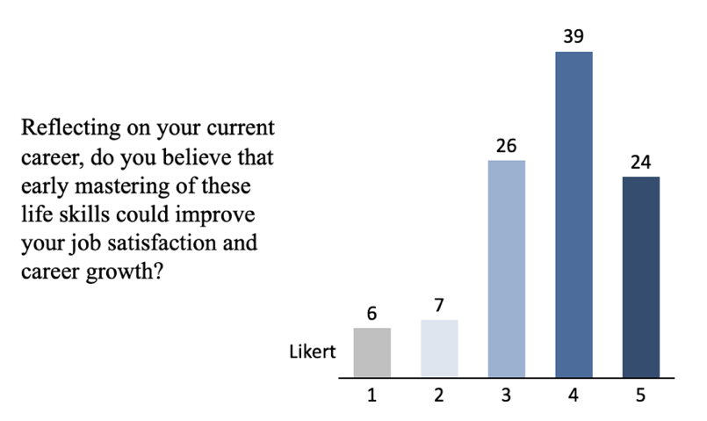

Figure 5 – Respondents overall perception, where:   
1 - I don’t think it would have any effect  
5 - I’m sure it would significantly improve

From figure 5, the majority believes that early adoption may help in professional growth and satisfaction.

Continuing with the correlation analysis, each variable contains eventually from 2 to 4 questions and the next step is to analyze the reliability of the variables, using Cronbach’s Alpha (Table 3). Each of questions has the same weight, as the questions have almost similar impact on the variable, so that the variables are constructed as the average of relevant questions for each skill. The table below shows the reliability analysis of new variables. Finally, ambiguous answers led to exclusion of only the first question within an independent variable ‘quick professional growth’ as it appears unreliable.

Table 3 – Reliability of the variables

|  |  |  |  |  |
| --- | --- | --- | --- | --- |
| **Skill name** | **Reliability** | **Number of variables** | **Adjusted reliability** | **Number of variables** |
| Quick professional growth | 0,311 | 3 | 0,742 | 2 |
| Strategic Thinking | 0,774 | 4 | 0,774 | 4 |
| AI Application | 0,793 | 4 | 0,793 | 4 |
| Financial management | 0,82 | 4 | 0,82 | 4 |
| Career Planning | 0,931 | 4 | 0,931 | 4 |
| Health and Wellbeing Maintenance | 0,79 | 4 | 0,79 | 4 |
| Home Maintenance literacy | 0,825 | 4 | 0,825 | 4 |
| Wise use of Resources | 0,878 | 4 | 0,878 | 4 |
| Employability | 0,812 | 2 | 0,812 | 2 |
| Rental Processes Literacy | 0,67 | 2 | 0,67 | 2 |
| Government Services Navigation | 0,813 | 2 | 0,813 | 2 |
| Negotiation | 0,818 | 2 | 0,818 | 2 |

The reliability test shows that each variable after adjustment is reliable. Let’s look at description statistics (Table 4).

Table 4 – Descriptive statistics

|  |  |  |  |  |
| --- | --- | --- | --- | --- |
| **Skill name** | **Minimum** | **Maximum** | **Mean** | **Std. Deviation** |
| Strategic Thinking | 1,25 | 5,00 | 3,41 | 0,93 |
| AI Application | 1,00 | 5,00 | 3,29 | 1,01 |
| Financial Literacy | 1,00 | 5,00 | 3,33 | 0,96 |
| Career Planning | 1,00 | 5,00 | 3,52 | 1,15 |
| Health and Wellbeing Maintenance | 1,33 | 5,00 | 3,68 | 0,89 |
| Home Maintenance | 2,00 | 5,00 | 3,96 | 0,83 |
| Wise use of Resources | 1,67 | 5,00 | 3,68 | 0,88 |
| Employability | 1,00 | 5,00 | 3,52 | 1,08 |
| Rental Processes Literacy | 1,00 | 5,00 | 3,74 | 0,91 |
| Government Services Navigation | 1,50 | 5,00 | 3,77 | 0,97 |
| Negotiation | 1,00 | 5,00 | 3,55 | 1,11 |

The descriptive statistics reveal a spectrum of proficiency levels across different professional skills, with mean scores ranging from 3.29 for AI Application to 3.96 for Home Maintenance, indicating no skills fall into the low proficiency category (below 3), yet there's a noticeable variation in self-assessed competence. Higher proficiency scores, particularly for Health and Home Maintenance, suggest respondents feel more adept in these areas. Meanwhile, Strategic Thinking, AI Application and Financial Literacy have lower scores, indicating that improvement is particularly applicable to them.

Before conducting the next steps, we want to acquire the standardized values for the variables, as to clearly see all of them on the same scale.

Continuing with normality test, the Shapiro-Wilk (Table 5) test is generally recommended for its higher power and sensitivity to detect deviations from a normal distribution in such sample sizes. While the K-S test is more versatile and can be used for larger samples, the Shapiro-Wilk test is specifically designed for normality testing and tends to provide more accurate results for sample sizes up to a few hundred cases.

Table 5 – Test of normality

|  |  |  |  |
| --- | --- | --- | --- |
| Variable name | Shapiro-Wilk | | |
| Statistic | df | Sig. |
| QPG | 0,921 | 102 | 0,000 |
| Strategic Thinking | 0,963 | 102 | 0,006 |
| AI Application | 0,971 | 102 | 0,025 |
| Financial Literacy | 0,977 | 102 | **0,070** |
| Career Planning | 0,926 | 102 | 0,000 |
| Health and Wellbeing Maintenance | 0,955 | 102 | 0,002 |
| Home Maintenance | 0,927 | 102 | 0,000 |
| Wise use of Resources | 0,956 | 102 | 0,002 |
| Employability | 0,924 | 102 | 0,000 |
| Rental Processes Literacy | 0,950 | 102 | 0,001 |
| Government Services Navigation | 0,919 | 102 | 0,000 |
| Negotiation | 0,931 | 102 | 0,000 |

If all the p-values from the normality test are less than 5% (p < 0.05), it indicates that the data significantly deviate from a normal distribution across the variables tested. We can clearly see that only Financial Literacy has a normal distribution, which leads to non-parametric methods.

Now, let’s conduct correlation analysis (Table 6) so we could know what variables are most correlated with Quick Professional Growth. In this case, I have chosen Spearman’s Rank Correlation as my assumption regarding such connection was based on Likert scale data. Considering its ordinal nature and divergence from normality (which is typical for Likert type data), Spearman’s method appears to be a suitable choice for such analysis as it does not require linearity or normal distribution assumptions thereby dealing directly with skewness of dataset.

Table 6 – Correlation analysis with dependent variable – Quick Professional Growth

|  |  |  |  |
| --- | --- | --- | --- |
| **Skill name** | **Spearman** | **Significance** | **Pass** |
| Strategic Thinking | 0,432 | 0,000 | Yes |
| Employability | 0,28 | 0,004 | Yes |
| Career Planning | 0,277 | 0,005 | Yes |
| Wise use of Resources | 0,255 | 0,010 | Yes |
| Negotiation | 0,232 | 0,019 | Yes |
| Financial Literacy | 0,224 | 0,023 | Yes |
| Government Services Navigation | 0,211 | 0,033 | Yes |
| Health and Wellbeing Maintenance | 0,199 | 0,045 | Yes |
| Rental Processes Literacy | 0,149 | 0,134 | No |
| AI Application | 0,146 | 0,142 | No |
| Home Maintenance | -0,08 | 0,389 | No |

Looking at the correlation analysis, we may clearly see that 3 of the variables are not significant.

The next step is to make a qualitative and quantitative analysis of other questions, or those not included into correlation analysis. Creating separate extra question for each variable, we aim to delve into the specific impacts and contexts in which a skill, or its absence, directly affects job performance or career progression. This additional dimension enriches the analysis by providing qualitative insights into the skill's practical significance in professional scenarios. This approach not only establishes the presence or absence of statistical relationships but also reveals the real-world relevance of these skills, leading to a deeper, multifaceted understanding and informed conclusions.

The pie charts of the responses for extra questions are presented in the Appendix E. Extra question is an additional question for each variable that shows whether the lack of skill negatively affected the professional life of the respondent. Let’s make a table (Table 7) with key conclusions from extra question analysis.

Table 7 – Extra questions analysis

|  |  |  |
| --- | --- | --- |
| **Skill name** | **Impacted** | **Not impacted** |
| Strategic Thinking (Q1) | 88% | 12% |
| Health and Wellbeing Maintenance (Q5) | 87% | 13% |
| Financial Literacy (Q3) | 84% | 16% |
| Wise use of Resources (Q7) | 75% | 25% |
| Career Planning (Q4) | 69% | 31% |
| Employability (Q8) | 65% | 35% |
| Negotiation (Q11) | 63% | 37% |
| AI Application (Q2) | 56% | 44% |
| Home Maintenance (Q6) | 51% | 49% |
| Government Services Navigation (Q10) | 50% | 50% |
| Rental Processes Literacy (Q9) | 37% | 63% |

From the Table 7, we can clearly see that lack of Strategic Thinking, Financial Literacy, Health and Wellbeing Maintenance, and Wise use of Resources seriously affected the professional life of respondents. Also, the overweight can be noticed in Career Planning, Employability, and Negotiation. The AI Application also shows a slight overweight, but this variable is more complex and needs additional investigation. Government Services Navigation, Home Maintenance show the equal distribution. The lack of Rental Processes Literacy don’t really affect the career.

One of the questions asked the participants to rank the given skills from the most important to the less important for quick professional growth at the beginning of career. Let’s take a look at the finalized weighted table of ranks (Table 8). The Average Rank column was made as the weighted average of the Mean rank (40%) and Moda rank (60%).

Table 8 – Average ranks, according to participants rankings (Personal Ranks)

|  |  |  |  |  |  |  |
| --- | --- | --- | --- | --- | --- | --- |
| **Skill name** | **Mean** | **Moda** | **N moda** | **Mean rank** | **Moda rank** | **Average rank** |
| Strategic Thinking | 4,9 | 1 | 18 | 3 | 1 | **1** |
| Employability | 4,6 | 1 | 17 | 2 | 2 | **2** |
| Negotiation | 4,6 | 2 | 22 | 1 | 3 | **3** |
| Financial Literacy | 5,2 | 3 | 13 | 5 | 4 | **4** |
| Career Planning | 5,1 | 4 | 16 | 4 | 6 | **5** |
| Wise use of Resources | 5,2 | 3 | 15 | 6 | 5 | **6** |
| Government Services Navigation | 6,6 | 7 | 13 | 7 | 7 | **7** |
| AI Application | 6,7 | 8 | 14 | 8 | 8 | **8** |
| Health and Wellbeing Maintenance | 7,3 | 9 | 21 | 9 | 9 | **9** |
| Rental Processes Literacy | 7,6 | 10 | 22 | 10 | 10 | **10** |
| Home Maintenance | 8,3 | 11 | 27 | 11 | 11 | **11** |

The participants averagely rank Strategic Thinking, Employability and Negotiation skills as the most important for quick professional growth.

The last question of the survey was an open ended, asking which skill, from the presented, would the participant like to learn at the beginning of his career, so that to achieve the quick growth. The table with the distribution is below Table 9. Few of the skills are highlighted in gray, as we don’t analyze them in this research.

Table 9 – Which skill would the participant like to learn at the beginning of career (Desired Ranks)

|  |  |  |
| --- | --- | --- |
| **Skill name** | **Number of Mentions** | **Rank** |
| Strategic Thinking | 18 | 1 |
| Negotiation | 17 | 2 |
| AI Application | 12 | 3 |
| Financial Literacy | 12 | 4 |
| Career Planning | 5 | 5 |
| Wise use of Resources | 5 | 6 |
| Health and Wellbeing Maintenance | 2 | 7 |
| Not interested in learning new skills | 2 | - |
| Conflict management and resolution | 1 | - |
| Foreign language proficiency | 1 | - |
| Home Maintenance | 1 | 8 |
| Rental Processes Literacy | 1 | 9 |
| Patience and resilience | 1 | - |
| Government Services Navigation | 1 | 10 |
| Employability | 0 | 11 |

The last question provides a new distribution of skills. Strategic Thinking is still the most important skill, according to the respondents, but now we also may notice the AI Application skill among the leaders.

Now, we can move forward to the final weighted analysis.

In order to make a comprehensive evaluation, the decision was to incorporate both **Objective** and **Subjective** parts into the final evaluation. Together components offer a holistic view of the factors contributing to career success. The objective side, with Correlation Ranks and Extra Questions Ranks, provides a solid foundation, evaluating direct relationships between skills and career outcomes, and broader influences that may not be immediately recognized. The subjective side, with Personal Ranks and Desired Ranks, brings personal experiences and aspirations into play, highlighting the skills individuals deem crucial from their own journeys and those they wish to have developed sooner. The mix of these two parts not only provides an objective analysis but also involves individual perspectives towards career development thus making a comprehensive assessment on which we can rely upon the impact that is measured quantitatively and those that underlie professional aspirations. Table 10 contains the final ranks.

Table 10 – Final ranks for each skill

|  |  |  |  |  |  |  |  |
| --- | --- | --- | --- | --- | --- | --- | --- |
| Skills | **Objective** | | | **Subjective** | | | **Final Ranks** |
| Correlations Ranks | Extra questions Ranks | **Weighted average** | Personal Ranks | Desired Ranks | **Weighted average** |
| Strategic Thinking | 1 | 1 | 1 | 1 | 1 | 1 | 1 |
| Employability | 2 | 6 | 2 | 2 | 11 | 5 | 2 |
| Career Planning | 3 | 5 | 3 | 5 | 5 | 4 | 3 |
| Financial Literacy | 6 | 3 | 5 | 4 | 4 | 3 | 4 |
| Wise use of Resources | 4 | 4 | 4 | 6 | 6 | 6 | 5 |
| Negotiation | 5 | 7 | 7 | 3 | 2 | 2 | 6 |
| Health and Wellbeing Maintenance | 8 | 2 | 6 | 9 | 7 | 8 | 7 |
| AI Application | 10 | 8 | 9 | 8 | 3 | 6 | 8 |
| Government Services Navigation | 7 | 10 | 8 | 7 | 10 | 8 | 9 |
| Rental Processes Literacy | 9 | 11 | 10 | 10 | 9 | 10 | 10 |
| Home Maintenance | 11 | 9 | 11 | 11 | 8 | 11 | 11 |

For the **objective ranks**, allocating 60% to Correlation ranks and 40% to Extra question ranks with an overall emphasis of 60% reflects a prioritization of tangible, empirical evidence in understanding career success. The higher weight for correlation ranks underscores the importance of direct, measurable relationships between skills and career advancements, highlighting quantifiable outcomes as primary indicators of success.

For the **subjective ranks**, the distribution is 60% to Personal Ranks and 40% to Desired Ranks, constituting 40% of the overall evaluation and highlighting a distinction between the skills that individuals recognize as important and those they personally wish they had learned earlier. This part is valued less, as objective one provides a more reliable foundation for assessing the impact of skills on career growth. The predominance of Personal Ranks underscores the skills that individuals have empirically found crucial for their career advancement, offering an evidence-backed hierarchy of skills essential for professional growth. On the other hand, Desired Ranks focuses toward aspirational learning, providing a clear, actionable target for enhancing future professional development initiatives.

At this point, it’s time to decide which variables should not be included into the qualitative part. Home Maintenance and Rental Processes Literacy failed almost all analyses, so these two variables will be skipped. In order to focus on the most valuable skills, we also will skip the Government Services Navigation variable, as it is still not at a high place.

AI Application is an important skill, despite having quite low place in the final table. Firstly, we need to admit that this is an emerging trend. The reasoning is that people are still not engaged properly in AI solutions. Figure 6 shows that 25% of the respondents still do not use the AI technologies, for 7% AI is not applicable or they don’t know how to use it properly. 40% (26+14) take the best from AI and know the potential of the technology, as it helps to solve complex tasks. Delving deeper into analysis, we may interfere that the companies still don’t use the AI properly and in full capacity, as it has low rank in the objective part. But nonetheless, looking at the Desired ranks, people are willing to learn this skill and believe that AI Application could provide a better professional growth.

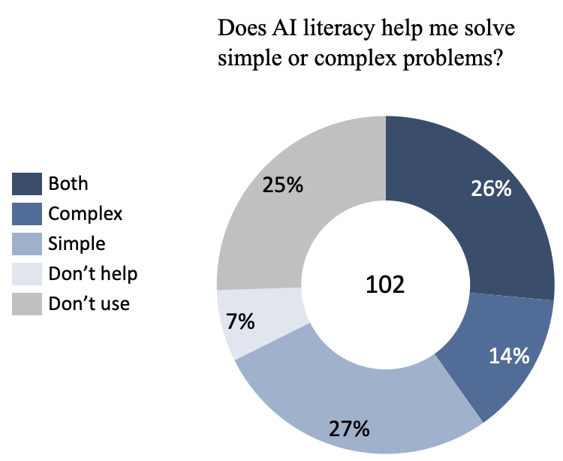

Figure 6 – Usage of AI solutions

We should now take a decision on which variables to use in the interview part eventually. We will differentiate all skills into two levels.

According to our analysis, the first level contains crucial skills. The most important variables here are Strategic Thinking, Employability, Career Planning, Financial Literacy and Wise use of Resources. During the interview, we will majorly focus on those competencies.

On the second level, we will describe some skills that are also essential but they rank lower. These competences may take lesser time but there is definitely an association between a skill and rapid professional growth. This level consists of Negotiation, Health and Wellbeing Maintenance, and AI Application.

### 3.5.2 Qualitative component

During this part, 11 respondents out of 34 were eager to participate in the semi-structured interview, thus resulting in 32% response rate. The next step is to deeply investigate each skill, so that to answer research question 2. After brief evaluation, we will proceed to HR practices, mentioned by the respondents.

**Strategic Thinking**

Professionals with Strategic Thinking skills can tackle complex, long-term planning in an orderly way to provide focus and confidence when dealing with problems at work. Those who were interviewed said that they are able to manage uncertainty by engaging in Strategic Thinking that enables them to organize workflow thus ensuring individual and organizational success. For organizations, a workforce that has been provided with Strategic Thinking ability will be better prepared to cope up with market changes as well as internal shifts which in turn ensures sustainability and competitive advantage.

Facilitated Obstacles:

* Overcoming short-sightedness in projects and initiatives
* Managing change effectively with foresight and readiness
* Ensuring continuity and consistency in organizational goals
* Reducing anxiety related to uncertainty and unstructured challenges, especially during the company adaptation process
* Enhancing interlinked skills such as Career Planning, thus resolving related issues and advancing professional growth
* Helps to keep moving forward as the strategy is already outlined and all transitional points are visible

**Employability**

Employability skills do not only enable one to secure a job but also help them become outstanding professionals who discern their roles within an organization and the larger market. These capabilities assist a person in effectively communicating his/her worthiness, thus facilitating promotions at both a personal and corporate level. Employability skills enhance self-presentation and self-awareness, allowing employees to showcase their value and potential within competitive job environments and to adapt swiftly to organizational cultures and demands. This not only ensures that in-house applicants are proactive but also empowers them through the organization’s engaged workforce aimed at achieving company objectives by undertaking proper future career development.

Facilitated Obstacles:

* Navigating the job market successfully, which broaden the opportunities and helps to find the most motivating position
* Understanding of selection processes, which may stop from getting a job even if you are the one the department needs
* “Selling” yourself, which is extremely important for career growth
* Overcoming fears related to job selection and performance expectations
* Building resilience in communication and negotiation during job interviews
* Proactively identifying and addressing skill gaps, which ensures continuous professional development and readiness for advancement
* Enhancing adaptation to organizational culture, which allows for quicker integration and effective team collaboration

**Career Planning**

Career Planning enables professionals to map out their career trajectories, foresee challenges, and prepare adequately, which can significantly influence their adaptability and success. From the interviews, it is evident that Career Planning helps individuals align their personal goals with organizational objectives, ensuring both personal satisfaction and contributing to corporate strategy. Early learning of this skill would have accelerated career development and provided better and more interesting experiences for many respondents. For organizations, employees adept in Career Planning are likely to be more proactive, focused, and motivated, leading to improved retention and enhanced career progression within the company.

Facilitated obstacles:

* Identifying and preparing for future career opportunities and requirements
* Saves time and resources for both the individual and the company, as neigher employee nor employer spend time on useless growth
* Anticipating and overcoming career and industry-specific challenges and changes
* Enhanced motivation due to employee-organization fit
* Making strategic decisions about job changes or promotions
* Balancing work and personal life to maintain overall well-being and job satisfaction

**Financial Literacy**

Financial Literacy helps people understand how their money works when changing lifestyles or taking new financial responsibilities as part of a particular occupation. Critically important when transitioning to independent living. None of the respondents are proficient, but almost all would like to acquire and consider it important. This contributes towards overall satisfaction about work which is influenced by informed financial decisions, clear financial goals, cost of work understanding and many other aspects. A financially literate staffs means lesser breaks in the flow of work due to financial stress and sound use of company resources leading to improved decision-making.

Facilitated obstacles:

* Avoiding debts and financial mismanagement that can lead to stress and distraction
* Making informed decisions on resource allocation and expense management; overall and to enjoy the benefits from the work compensation
* Assessing the financial implications of career choices and business decisions
* Managing salaries and benefits wisely to ensure personal financial stability
* Addressing and mitigating financial risks that could impact personal life, career progression and organizational growth

**Wise use of Resources**

Resource management is important in maximizing efficiency and maintaining balance between various work demands and personal needs. A key factor for successful and happy career advancement. The participants emphasized that effective resource management creates an enabling environment for work productivity through optimum use of time, and other resources that directly impact on work output as well as stress levels. Having employees who manage their resources well ensures smooth operations for organizations, less waste, and more flexibility with project management and daily operations.

Facilitated obstacles:

* Preventing burnout by managing workload and deadlines effectively
* Work-life balance
* Juggling multiple tasks and responsibilities without losing focus
* Prioritizing tasks to ensure critical objectives are met first
* Adapting to increased work demands without additional resources
* Maintaining high productivity levels even under resource constraints

**Negotiation**

It is important to have negotiation skills in order to articulate personal career goals within organizational frameworks. From interviews, it was concluded that individuals who possess these skills are able to negotiate better job positions, salaries or working conditions hence feeling satisfied by their output as well as career development. Most of the respondents everyday experience the need to negotiate with somebody as to promote his/her idea, communicate in team effectively and so on. Employees with negotiation skills are beneficial since they can handle both internal and external issues which may arise thus resulting into more business deals favorable outcomes and good team relationships for better results.

Facilitated obstacles:

* Achieving agreements that meet personal career goals and organizational needs
* Improves motivation, pleasure, and productivity
* Helps defend ones project or idea, which leads to satisfaction and motivation
* Boosts confidence, which is very important for career advancement
* Handling conflicts and disputes with confidence and diplomacy
* Securing resources and support necessary for project and personal success
* Advocating for oneself or the team in discussions with higher management or customers
* Building and maintaining professional relationships that support long-term career growth

**Health and Wellbeing Maintenance**

This involves looking after physical health along with mental health because one’s body condition affects how they perform professionally thereby influencing resilience. According to interviews, healthy workers have adequate energy levels as well as focus required for proper adjustment over time like fitting into one’s role effectively. Some placed this skill first among others. Especially important early in the career due to the presence of many new problems and the necessity to learn how to solve them and ultimately perform. As such, organizations that do not encourage employees’ wellness may experience increased sick leaves disdained low output times; thus leading to an unhealthy workplace environment besides increasing the overall insurance bills.

Facilitated obstacles:

* Managing stress effectively to prevent burnout and maintain productivity
* Overcoming physical health challenges that can impact daily work capabilities
* Sustaining mental focus and clarity under high-pressure situations
* Improves motivation, pleasure, and productivity
* Balancing workload to prevent health issues and maintain a positive work-life balance
* Ensuring that personal health issues do not interfere with professional responsibilities, especially for highly responsible jobs
* Helps love your job and not work in depression, which affects the overall perception and emotional memory of the work

**AI Application**

As digital transformation continues its pace across sectors AI Application is becoming more essential. The interviews showed that AI Application helps professionals use technology properly, which improves their adaptability as well as efficiency. On this note, organizations have skilled employees in AI who can enhance innovation, run efficient operations and maintain competitive advantage through staying ahead of technological advancements. Still highly dependent on the field. In some areas, it is not needed and will not be needed for a long time (energy, medicine).

Facilitated obstacles:

* Enhancing personal job performance through the use of AI-driven tools and applications
* Staying competitive in a rapidly evolving digital marketplace
* Helps adapt and solve problems related to lack of work knowledge, lack of knowledge and experience
* Helps cope with monotonous tasks and focus on more important ones
* Reduces working time and improves creativity and productivity
* Helps quickly understand complex topics, increasing value as a specialist

For young professionals who want fast-track career progression, the possession of diverse skills like Strategic Thinking, employability, Financial Literacy and the rest are very important. These abilities enable them to cope with changing work exigencies and strategically manage their careers. Having such attributes therefore help individuals proactively handle changes in their environment by articulating their worth that not only set them apart as candidates but also accelerates promotion.

From an organizational point of view, employing a workforce with such diverse skills yields considerable benefits. These skills make for a flexible and resistant labor pool capable of keeping the organization going even when market conditions are unpredictable. This is because they think strategically about how to go about planning their careers and resources management; adapt financially which helps to stabilize and grow their firms. They improve operational efficiency, reduce costs through effective resource utilization, create sustainable competitive advantage through cultivating a proactive Strategic Thinking workforce aligned with long-term goals of the organization.

**HR practices**

Furthermore, the participants shared their HR selection ideas and examples. At first they were asked to think of skills, which are currently evaluated by HR departments, and the current methods of evaluation (Table 11). In order to make it easier for them to remember, we sometimes list possible methods from Appendix C.

Table 11 – Current assessment methods for unconventional skills from the perspective of respondents

|  |  |
| --- | --- |
| **Skill** | **Current assessment method** |
| Strategic Thinking | A commonly required skill, not always assessed. Assessed using case studies, questions, tests, and stress resistance evaluations through time-limited complex tasks |
| Employability | Not discussed |
| Career Planning | Frequently but not deeply assessed. Questions about career goals and ambitions are typically asked to understand a candidate's future planning and commitment |
| Financial Literacy | Not tested at all |
| Wise use of Resources | Tested less directly and not deeply. Assessed through questions about time and efforts allocation and stress resistance evaluations through time-limited complex task |
| Negotiation | Prominently tested. Evaluated for speech articulacy, logical reasoning, persuasiveness, and confidence |
| Health and Wellbeing Maintenance | Not tested at all. Some questions may be asked for Wise use of Resources, in order to understand the stress management |
| AI Application | Not explicitly tested unless job-specific |

The respondents were also asked to provide their ideas for how such skills can be evaluated during selection process (Table 12).

Table 12 – Potential methods proposed by the respondents

|  |  |
| --- | --- |
| **Method** | **Description** |
| Structured Interviews/Behavioral Questions | Useful across various skills to probe deeper into the candidates' past experiences and hypothetical scenarios that demonstrate Strategic Thinking and negotiation abilities |
| Assessment Centers | Utilize a wide range of exercises, role plays and activities which can evaluate Strategic Thinking, negotiation ability and maybe financial acumen in a controlled environment that is job simulative |
| Reference Checks | Interacting with the previous colleagues and supervisors of the prospective candidate gives an opportunity to assess their negotiation skills as well as Strategic Thinking capabilities |
| Drawing a Balance Matrix | This is a technique used in evaluating how well a candidate can manage different aspects of life and career balancing thereby showing his/her resource allocation or strategic abilities |
| Stress and Time-Limited Task | These tasks are employed to examine the ability of candidates to think strategically whereby they are given extremely tough jobs with very little time for completion. This would help check on their stress limit as well as priority setting |
| Group Dynamics and Collaborative Problem Solving | It involves simulating scenarios where multiple candidates work together to solve problems. This method can be vital in testing the applicants’ negotiation skills among other things like interacting with others |
| Use of Technology in Assessments | Incorporating AI tools and simulations to test various candidates’ skills, knowledge and many other aspects. Also, the company may give AI tasks to complete, in order to check the ability to handle new technologies |
| Scenario-Based and Situational Judgement Tests | These tests pose hypothetical, job-related situations to candidates to evaluate their decision-making process and suitability for the role |

There is a difference in evaluating unconventional skills among HR departments according to an analysis of HR practices based on feedback from participants. For instance, Strategic Thinking and negotiation are recognized and assessed while Financial Literacy and health maintenance are often ignored. Current techniques are not used consistently across different skills, so that the majority of modern methods of evaluation, listed in Appendix C, are not used at all. Moreover, the list of skills greatly depends on the working area itself – companies that seize every opportunity for growth tend to assess more skills.

The suggestion made by methods for evaluating skills proposes moving towards more dynamic and scenario-based assessments. Structured interviews, assessment centers or technology-driven tests can be used as techniques since they aim at providing a candidate with practical abilities evaluation that is comprehensive and simulated in nature. These modern approaches enable organizations to align their HR practices better with the changing needs of employees thereby ensuring thoroughness when judging candidates’ abilities strategically.

## 3.6 Conclusion of research part

The section clearly describes a mixed-methods approach used to study how unconventional life skills affect professional success. First, a quantitative method was employed which included the use of surveys to gather data from professionals across different industries. This phase aimed at establishing the prevalence and perceived importance of these skills in workplaces.

In the quantitative stage, it was found that there were positive statistically significant correlations between the majority of unconventional life skills with quick professional growth variable. Additionally, a compound multicomponent analysis enabled to capture complex quantitative and qualitative data from survey so that it is holistic and deep. These initial findings supported the assumption that these abilities are vital if not fundamental for thriving in today’s fast changing business world. The information gave solid ground and identified main skills, ranked by importance, which can be further researched on how they promote adaptation at work among other things. Table 10 provides the ranked list with variables, with 8 skills listed as significant and Government Services Navigation, Rental Processes Literacy and Home Maintenance – as non-significant.

After finishing with quantitative researches, there was need for more insights hence qualitative design adopted next. In this stage, semi-structured interviews were conducted among selected participants. Through qualitative method it became possible to understand better where and how those abilities can be applied practically within professional setting thereby giving detailed accounts on their impact towards day-to-day activities as well long term career path development. We managed to get not only a thorough evaluation of the unconventional skills perceived by respondents, but also their views and suggestions on the HR selection processes.

The narratives derived from the interviews enriched the quantitative data, illustrating the practical implementation and benefits of unconventional life skills. Respondents frequently mentioned Strategic Thinking, health maintenance and negotiations being instrumental towards achieving goals in their jobs or careers overall. The other valuable aspect is that we got a detailed overview of each skill and obstacles that it may facilitate, especially during first job. This qualitative perspective provided more context around findings from numerical side thus indicating practical outcomes related with adoption/usefulness of these abilities within professional context.

Having conducted comprehensive research, the thesis moves to the discussion phase where findings are examined in light of broader implications for best practice within professions. This part seeks to identify areas where HRM can be modified so as to enhance recruitment and development of employees possessing such skills. Its aim is also inform debates on necessary competencies required within contemporary workplaces by providing workers with evidence based recommendations that match their needs while at same time giving employers guideline towards recognizing potential talents among job applicants.

# Empirical results discussion and implications

## 4.1 Discussion on the empirical study results

Firstly, there is a need to understand which skills eventually are the best predictors for quick professional growth for young candidates.

During the quantitative multi component analysis, 8 out of 11 skills were chosen, as those that have greater impact on professional growth: Strategic Thinking, Employability, Career Planning, Financial Literacy, Wise use of Resources, Negotiation, Health and Wellbeing Maintenance, AI Application. Both objective and subjective parts were analyzed, providing valuable insight that align with the exploratory nature of research. Strategic Thinking showed an outstanding result, taking the first places in each test. The interesting thing is that the ranks of skills slightly differ for subjective and objective parts, which basically means that people want to acquire one skill, but actually they need the other one first. For instance, Wise use of recourses is acknowledged as sixth most important in subjective ranking, while being the fourth in objective ranking. Moreover, AI Application has the lowest total rank among the important skills, albeit there is still a low level of usage among organizations and employees.

Despite the fact that survey analysis was done thoroughly, including many aspects, the deeper investigation during the interviews gave slightly different picture. The majority put Health and Wellbeing Maintenance at the first place, because without thorough control of your health you cannot function normally. Respondents admitted that Strategic Thinking is a crucial skill, that also covers others and is as important as Health and Wellbeing Maintenance. Negotiation skill is also extremely important for quick professional growth, as it allows to have better compensation and faster promotion, even if one lacks hard skills. The rest of the skills were also perceived as very important, which do facilitate adaptation process and quick professional growth.

There is a slight contrast between expected results and empirical findings. As for today, the need for AI skills strongly depends not only on the industry, but on the job positions as well. In more conservative and slower growing industries, such as energy or medicine, there is no need in AI advanced technologies for common usage. On the other hand, the workers of modern and advanced companies utilize AI driven solutions on daily basis and in every task, which eventually leads to a growth in performance and satisfaction. Then, the importance of Financial Literacy and Health and Wellbeing Maintenance skills are also quite interesting. Initially, the author did not expect that people do experience a huge lack of financial management skills, which eventually leads to stress and lower performance. According to Figure 13, only 16% of respondents have never experienced stress or missed opportunity due to lack of financial skills. Also, the research showed a certain level of interconnections among skills. For example, Strategic Thinking is also presented in Career Planning and Wise use of Resources.

During the research part, I have illuminated a previously unexplored area. Not only we got the understanding of relative importance of unconventional skills, but also a detailed analysis of their application and how exactly they can help. The variety of obstacles, listed in the Data analysis part, that are solved with the help of unconventional skills is outstanding. A brief discussion on practical significance of each skill is presented below:

* *Strategic Thinking* is the key skill for professionals to manage long-term business strategies effectively. It means following a structured way of addressing challenges in the workplace which allows people to anticipate changes and be ready for them. Strategic thinkers help organizations become more resilient and flexible by envisaging different scenarios and developing plans that are in line with immediate and future corporate goals. This ensures competitiveness as well as continuity through market fluctuations and internal dynamics with foresight. For HR professionals, Strategic Thinking is invaluable because it promotes innovative thought within the organization while also fostering retention of staff who proactively respond to industry demands.
* *Employability* skills are important since they enable an individual to sell themselves properly within a competitive job market. These range from interpersonal skills such as communicating well with others, being adaptable or managing oneself among others all of which contribute greatly towards personal development as well career growth. People who have strong employability tend to get promotions faster than those without because this shows that one can add value wherever they are placed hence increasing chances of moving up within an organization hierarchy. From human resource perspective having employees with high level employability guarantees that there will always be competent candidates available for promotion thereby minimizing turnover costs associated with external recruitment.
* *Career Planning* is about setting goals for your professional life and coming up with actionable steps towards achieving them. It helps individuals identify what they need to do in order progress their careers by looking at opportunities for growth or required competencies vis-a-vis organizational needs (aspirations alignment). When employees know where exactly they want reach along their career path then satisfaction levels increase since clarity breeds motivation plus direction thus making it easier for people achieve aims at work places. Robust workforce Career Planning also supports talent management systems which can include succession planning initiatives aimed at ensuring presence all round leaders ready take over various critical positions whenever vacancy arises within establishment.
* *Financial Literacy* enable one make informed decisions managing personal finances as well appreciate economic aspects associated with different career choices. Financial Literacy is important because it equips employees on how best to handle salaries and benefits so that they reduce financial strain while at same time increasing job satisfaction among workers. So, when an employer promotes this knowledge within a company there are high chances that most staff will utilize their packages wisely hence minimizing turnover rates caused by monetary issues; also such moves support organization’s wellness schemes leading more committed workforce financially stable.
* *Wise use of Resources* enables individuals to accomplish tasks without wasting much time or energy. It involves using available tools and techniques efficiently in order meet set goals within minimum required period. Professionals who can effectively manage their resources tend be more productive thus able achieve work-life balance leading increased levels of happiness at work place even reduction burnout rates among employee . On the other hand, HR departments should ensure that all members staff learn how allocate various types materials including people power appropriately so as enhance flexibility among other things which would ultimately translate into improved performance levels throughout entire organization.
* *Negotiation* is very important to articulate and achieve personal career goals within the organizational context. This includes being able to represent your own interests well while recognizing the needs of an organization – for instance negotiating over roles, duties or wages. Such a skill helps one to get better terms thereby leading to job satisfaction and general advancement in career. When people have good negotiation skills at work it can foster more effective internal conversations within HR departments; this in turn leads into stronger conflict resolutions among members of staff which eventually align employee’s goals with those set by the company resulting in retention of key talent who feel valued and fairly treated.
* *Health and Wellbeing Maintenance* management cannot be overlooked as it contributes largely towards increased levels of performance. It caters for physical as well as mental states of individuals hence ensuring fitness necessary for efficient discharge of duties by employees. More so healthy workers exhibit high levels of energy coupled with improved concentration thus raising productivity while reducing absenteeism rates too. From a human resource viewpoint therefore; employee health should be given priority which will help create stronger teams that can handle any adverse effects arising from illnesses among staffs besides cutting down on costs related with medical cover schemes (employee benefits). In addition, this move would also improve organizational culture leading to morale boost amongst workers.
* *AI Application* is increasingly becoming a crucial skill, as technology, becomes more integrated into daily business operations. This helps workers to make good use of AI tools and apps thereby increasing their productivity as well as improving the quality of work done. Employees become more innovative in their jobs, leading to increased competitiveness and improved business performance through optimization of operations and introduction new skills among others that may be necessary for organization growth.

Continuing our discussion with HR assessment, the majority of the mentioned skills are not tested at all. Albeit Negotiation, Employability and Career Planning may be evaluated during the interview and Strategic Thinking during the tests and case studies, the other valuable skills remain untouched. Moreover, respondents expressed their own negative opinions on the selection process, because some could not win an offer, despite the absolute fit with the department they are interested in. The reason lies in strict selection policies which are not aligned with the needs of other departments. In addition, respondents shared own ideas about the selection methods.

During the research, the author successfully addressed all the research questions.

First of all, the study effectively answered the first research question «Which unconventional life skills serve as predictors of quick professional growth in young candidates?», identifying significant unconventional life skills that impact quick professional growth. The results confirm that the mentioned skills are highly important for young professionals in reaching their career goals and becoming effective at work. Quantitative data showed a strong correlation of these skills with rapid professional growth, while qualitative insights brought a deeper understanding of the actual practice of these skills in real life. This gives practical applicability and provides a firm basis for further research.

The work also answered the second research question, «How do identified unconventional life skills facilitate overcoming professional adaptation hurdles?». Through a detailed examination of each significant unconventional life skill, the study demonstrated how these skills help young employees overcome professional adaptation challenges. The qualitative insights, which were obtained from the semi-structured interviews, enriched the quantitative data, offering a full understanding of how such skills facilitate professional adaptation and growth obstacles. This mixed-method approach ensured a robust analysis, which illuminate the practical benefits of these skills in various professional contexts.

Finally, the third research question, «What methodologies can HR departments use to evaluate crucial unconventional skills?» was answered by combining the experience of the respondents and a deep literature review, which gave an idea about new methods of evaluation, their use, and applicability. The quality of selection process was also described, pointing out differences and deficiencies in current methodologies. The rich analysis of selection methods shows practical steps that HR departments can utilize to better assess and develop crucial skills.

Overall, the current study not only answers the research questions but also emphasizes the importance of unconventional life skills for professional growth and adaptation. The findings have important implications for HR area and highlight that focus on these skills can improve talent selection and development practices. Also, this work is valuable for its theoretical contribution, which we will discuss in the next part.

## 4.2 Theoretical contribution

The research sheds light on the largely underexamined impact of unconventional life skills, highlighting the pivotal role these skills play in modern human resource practices. While organizations increasingly prioritize skills rather than conventional qualifications, it is important to know how different life abilities foster individual and corporate development.

The study addresses the scarcity of research on various life skills, which are still crucial for both employee and employer. The extensive analysis and empirical evidence of the significance of unconventional life skills fill the current gap in life skills comprehension. Not only the study provides insights on the unconventional life skills, but also stands as a firm ground for future research in this area.

In this study, we introduced the term “Life Mastery Skills”, which encompasses a wide spectrum of competencies necessary for managing day-to-day tasks and increasing overall effectiveness in personal and professional lives. The concept is extremely important for young professionals, who in most cases lack the family or school education on such topics and eventually enter the job and maturity unprepared. We critically assessed the importance and influence of such skills through quantitative and especially qualitative research and found them indispensable to the success of young professionals.

The findings show that Life Mastery Skills – such as Financial Literacy and health literacy – are essential in reducing stress and increasing focus, whereby they are consistent with the Hierarchy of Needs (Maslow, 1943), ERG (Alderfer, 1969) theories, which cater to basic psychological and safety needs. These skills also resonate with Herzberg's Two-Factor Theory (Herzberg, Mausner, Snyderman, 1959) since they reduce job dissatisfaction and build motivators through increased Career Planning. Notably, these skills also feed into Positive Psychology by encouraging well-being, resilience, and personal satisfaction, which together contribute to a holistic notion of life success. By such critical evaluation, it is possible to underscore the foundational significance of Life Mastery Skills in theoretical and practical domains; this increases knowledge of their impact on professional development and overall life satisfaction, connecting to other fundamental theories and expanding them to work domain.

Additionally, the study addresses other identified gaps. Using quantitative and qualitative analyses, the research broadly describes which life skills really impact career growth, and offers a detailed examination of how identified unconventional life skills help young employees overcome professional adaptation challenges.

Also, the work breaks new ground in skill-based recruitment and development by including unconventional life skills such as Strategic Thinking, AI Application and health/wellness literacy within Human Capital (Becker, 2009) theory’s wider framework. Not only does this synthesis broaden the notion of “capital” in HR but also highlights these abilities as essential components fostering individual career success within an organization – thus ensuring its prosperity too.

By connecting the development of unconventional life skills with theories of Workforce Agility (Teece, 1997) and Learning Organizations (Senge, 1990), the thesis proposes that unconventional skills are crucial for adapting to rapidly changing work environments. This theoretical extension implies that employees who possess these capabilities would be most likely to contribute towards organizational learning and innovation, which eventually leads into competitive advantage within dynamic markets.

Furthermore, the study addresses the gap within HR selection processes and which methods can be used in order to assess the unconventional life skills.

Another point to cover is that during the research a thorough list of skills and evaluation methods was collected from different sources, which eventually provides a holistic vision in this area.

## 4.3 Managerial implication

The managerial implications are divided into selection and development parts.

From the selective perspective, the first aspect to cover is revised skill spectrum, focusing not only on well-known skills, but on unconventional as well. This recommendation may sound as a challenge for many companies, as it requires better preparation and time spending for each candidate, but the outcomes definitely outweigh the expenses. The major outcome of such changes is the enhanced talent acquisition, which is a crucial aspect for modern companies. By focusing on broad spectrum of skills, a company can identify the most promising candidates, eventually increasing the workforce and decreasing turnover.

Continuing with the preparation itself, not all the companies do engage in selection techniques that could be valuable in assessing not only unconventional skills, but the conventional as well. For many companies, CV screening and one interview remain the only methods for selecting candidates. Thus, to better assess the whole spectrum of crucial skills, there should be thorough assessment methods, such as case interviews, situational judgment test, assessment center, stress and time-limited tasks, collaborative problem solving and expanded structured interview. If the company cannot afford expensive techniques, the expanded structured interview that incorporates questions that embrace unconventional skills as well is the first step to refine the HR practices. The part «2.6 How to measure life skills?» introduces standardized scales and different selection methods, which could tremendously benefit the organization.

Moreover, the technological advances lead also to an advance in selection processes, incorporating AI tools for faster and more productive assessments. AI can easily not only check the subtle variables during the interview and CV screening, but also create one or multiple tests that can easily assess the mentioned skills.

On the other hand, we should not focus only on the methods, but also on the whole approach to select candidates. It is indeed crucial to align with the needs of other departments, as HR work is done for them. Every single candidate should also be evaluated by one of the department’s employees.

With all in mind, here is a developed Integrated Skills Selection and Development (ISSD) framework (Figure 7) that may help a company to refine the selection process and eventually the workforce quality. The framework starts with a categorization of all the needed skills into directly and indirectly influencing, enlarging the conventional approach.

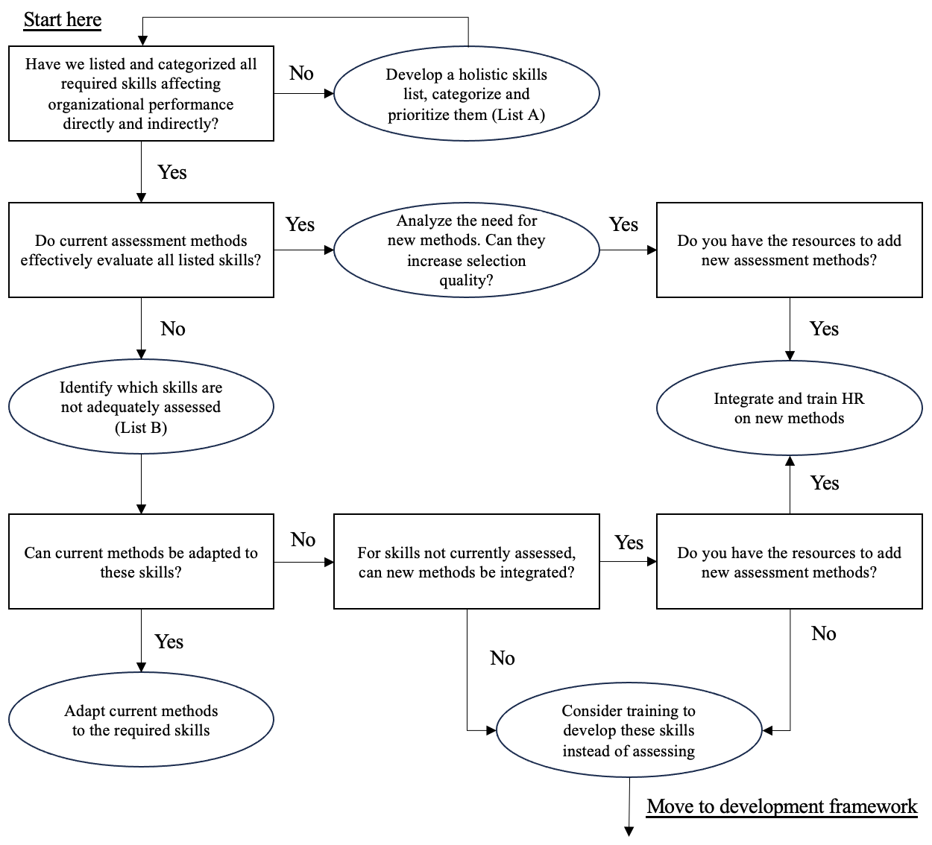

Figure 7 – Integrated Skill Selection and Development Framework (Part 1)

It is suggested to use as a reference point lists A and B. For list A (integral list of skills) and list B (integral list of selection methods), one can use the insight and data collection of this research, such as Appendix A and C, or make additional search, that fits better the organizational context and needed hard skills.

Finishing the selection part, the author also recommends to engage in gamification, developing a game, which can be used for selection purposes. A great example is McKinsey Solve game (MyConsultingCoach, 2020) – a video game, which asks to solve some problem. Participants complete tasks such as building ecosystems or defending plants from invaders within a set time limit. The assessment scores both the final solutions (product score) and the methods used to arrive at these solutions (process score). The video game evaluates a broad skills spectrum, which can be even broader. In case of McKinsey, the game primarily evaluates the problem solving and decision-making skills, but we spectrum can be easily enlarged, so as to measure the needed for your company spectrum. Also, such a technology can greatly help not only for selection, but for workforce development as well. An improvement of the game may be the incorporation of AI driven technologies, which would facilitate not only task creation, but also the evaluation process.

Once the hiring process is done, it’s necessary to focus on fostering the growth of employees.

Even though young people are well connected in terms of technology and social media, they usually lack important life skills. In a way, they seem to be unready and lack family and school education on such topics. Such basic life skills include financial management, health, and other Life Mastery skills, as well as discussed unconventional ones. Companies can easily help in this with comprehensive training on life skills so that young workers can better cope with the personal and professional challenges they will inevitably encounter. Such support can greatly ease the stress and ambiguity young professionals face in their new role and provide a more effective and contented workforce.

A good starting point for organizations might involve setting up individual training programs designed to develop life skills.

The first recommendation is to create an online course centered around unconventional life skills. Such a course should cover the basics of each skill, not only introducing their definitions but also demonstrating how they can be applied within professional contexts. Moreover, modules delivered via internet this will enable workers to go through these materials at their own speed hence grasping them better.

Speaking about life mastery skills, such as financial and health literacy, those skills can be improved with a use of different mobile applications, that not only teach but also monitors your life attributes. It can indeed help young employees, and not only, to delegate the cognitive pressure to an application and focus on job tasks.

Furthermore, principles underpinning these life-skills can be easily interwoven with other existing organizational development frameworks such as:

*Workshops* – regularly hold workshops where participants are given hands-on experience coupled with simulated real-life situations that require application of life skills under controlled settings.

*Coaching sessions* – include life skill aspects into one-on-one coaching sessions so that staff members may get personalized recommendations on how best they can improve these abilities in line with their career objectives.

*Management feedbacks* – revise management feedback policies so as to incorporate specific mention of life-skill development. Managers should give constructive feedback about the extent to which these competencies are put into practice and suggest areas for further improvement.

Finishing the ISSD framework, we add the development part (Figure 9), taking into account covered points.

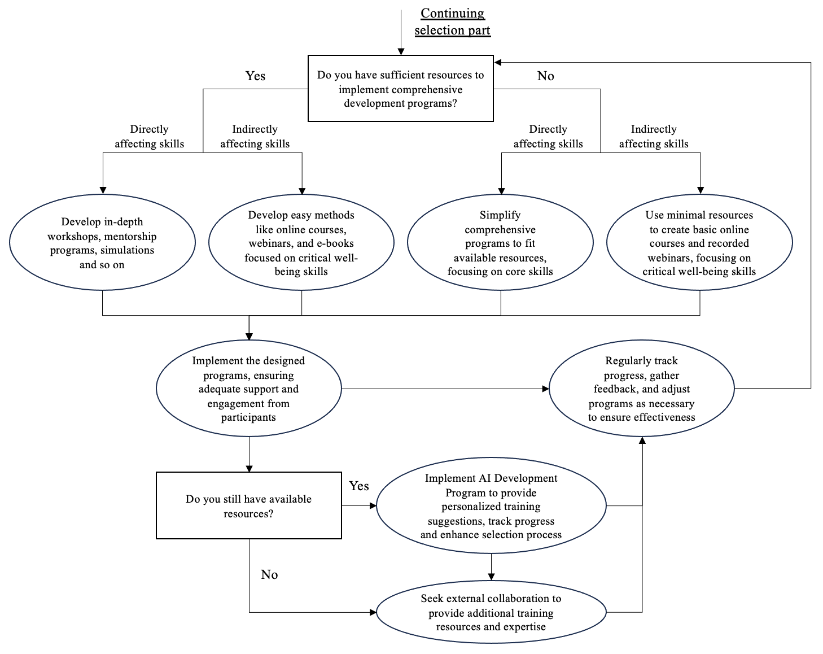

Figure 8 - Integrated Skill Selection and Development Framework (Part 2)

Highlighting one more time, young employees are frequently feeling pressure and ambiguity on the new position. Thus, for companies it is crucial to offer a comprehensive support for both directly and indirectly influencing aspects.

Speaking about other stakeholders, the research intends to suggest how life skill developing can be incorporated into the curricula of educational institution, thereby bridging the gap between traditional education and modern workplaces. Institutions should include unorthodox ways of life such as Financial Literacy, negotiation, and employability in their programs. Moreover, this can be achieved by providing additional facultative sessions or online courses that help students understand them better and retain them efficiently. Furthermore, organizing Career Planning workshops with professionals contributing their experience can give practical knowledge to students about real world application of these skills.

Other suggestions include that policymakers and educational administrators should push for systemic changes which encompass a wider range of skills crucial for the 21st-century economy. Standardized life skills assessments ensure uniform evaluation across institutions thus identifying areas requiring improvement. Continuously reinforcing interactive learning approaches throughout one’s entire education may also improve student engagement and retention in such a manner. This approach might involve more lessons or virtual courses dedicated to showing high school teens why life skills are important while they would see it fit to use.

## 4.4 Limitations and opportunities for future research

The thesis may have limits with respect to the size and variety of the sample. If a study uses a small or uniform sample, it could restrict the applicability of findings thereby indicating that results may not accurately represent how life skills affect career success among young professionals in different populations. Related thing is that the research was conducted only among Russian population, so that the results may not be applicable to other parts of the world.

Moreover, there could be limitation for this research regarding the breadth of life skills that were studied. By focusing on certain ones, other equally important skills necessary for professional growth might be left out, despite a thorough analysis during literature review. This choice may fail to reflect all-encompassing understanding about which abilities are required for successful careers.

Furthermore, temporal constraints emanating from using cross-sectional design in this study may hinder ability to see how life-skills and careers change over time. This design gives just one view of things at a particular moment, thus failing to capture dynamic changes involved when professionals grow into different levels within their career paths.

Also, because of the snapshot of current skill level used in the survey, it is difficult to analyze the causality of the variables. This approach is more suited for identifying correlations, which might not definitively indicate that skills lead to professional advancement.

Furthermore, some factors, such as personal motivation, external economic conditions, or company culture, which may influence professional growth, are not accounted for.

There are several ways through which future researchers can build upon what has been achieved by this dissertation. For example, longitudinal studies would be invaluable because they can track progression in personal skills against work performance outcomes over extended periods thus enhancing our knowledge on these impacts.

Future research should address these limitations by including a more diverse and larger sample to ensure the findings are broadly applicable across different populations.

Additionally, broadening scope beyond investigated areas can enable to gain more comprehensive insights regarding factors contributing towards success in today’s labor market.

Employing methodologies capable of establishing causality will help clarify the direct impacts of life skills on professional advancement. Valuable research in this area would be to investigate the exact relationship between professional growth and all the variables, including traditional and unconventional ones. It is crucial to track the time changes of professional success and skills, which can be a great task for longitudinal study. Taking thorough panel data regression modeling and putting all the skills at the same plate, the researches could make a great model, capable to predict a potential success of the candidate in a company.

Cross-cultural studies could examine how different cultural contexts influence the development and effectiveness of life skills, enriching the current understanding of how life skills operate across diverse environments.

Finally, collaborative studies involving academia, industry, and educational policymakers could lead to the creation of targeted life skill development programs that align closely with the actual needs of the job market. Such studies may enhance the applicability and impact of educational programs on professional success. These collaborative efforts could help in formulating educational strategies that are pragmatic, timely, and beneficial for a wide range of stakeholders.

# References

1. AhmadiGatab, T., Shayan, N., Tazangi, R. M., & Taheri, M. (2011). Students’ life quality prediction based on life skills. Procedia-Social and Behavioral Sciences, 30, 1980-1982.
2. Ahmad, B., Latif, S., Bilal, A. R., & Hai, M. (2019). The mediating role of career resilience on the relationship between career competency and career success: an empirical investigation. Asia-Pacific Journal of Business Administration, 11(3), 209-231.
3. Alderfer, C. P. (1969). An empirical test of a new theory of human needs. Organizational Behavior and Human Performance, 4(2), 142-175.
4. Alzyoud, A. A. Y. (2017). The predictors of career success. International Review of Management and Marketing, 7(2), 22-26.
5. Becker, G. S. (2009). Human capital: A theoretical and empirical analysis, with special reference to education. University of Chicago press.
6. Bejaković, P., & Mrnjavac, Ž. (2020). The importance of digital literacy on the labour market. Employee Relations: The International Journal, 42(4), 921-932.
7. Boston Consulting Group. (2023, December 11). Competence over Credentials: The Rise of Skills-Based Hiring. Retrieved https://www.bcg.com/publications/2023/rise-of-skills-based-hiring
8. Boston Consulting Group. (2023, September 22). Reskilling the workforce for the future. Retrieved from https://www.bcg.com/publications/2023/reskilling-workforce-for-future
9. Currie, L. K., Pisarik, C. T., Ginter, E. J., Glauser, A. S., Hayes, C., & Smit, J. C. (2012). Life-skills as a predictor of academic success: an exploratory study. Psychological reports, 111(1), 157-164.
10. DeJaeghere, J., & Murphy-Graham, E. (2022). Life skills education for youth: Critical perspectives (p. 276). Springer Nature.
11. Duerden, M. D., Witt, P. A., Fernandez, M., Bryant, M. J., & Theriault, D. (2012). Measuring life skills: Standardizing the assessment of youth development indicators. Journal of youth development, 7(1), 99-117.
12. Eklavvya. (2022, June). 15 practical ways to Assess Candidates Before Hiring. Retrieved from <https://www.eklavvya.com/blog/candidate-hiring-assessments/#12_Project_Management_Assessment>
13. Elson, S. B., Hartman, R., Beatty, A., Trippe, M., Buckley, K., Bornmann, J., ... & Sprenger, A. (2018). Critical Analytic Thinking Skills: Do They Predict Job-Related Task Performance Above and Beyond General Intelligence?. Personnel Assessment and Decisions, 4(1), 2.
14. Fernández-Díaz, J. R., Gutiérrez-Ortega, M., Llamas-Salguero, F., & Cantón-Mayo, I. (2021). Creativity and resilience as predictors of career success. Sustainability, 13(8), 4489.
15. 4 Corner Resources. (2023, April). Methods of recruitment & selection. Retrieved from <https://www.4cornerresources.com/blog/methods-of-recruitment-selection/>
16. Harvard Business School. (2021). Strategic Thinking Self-Assessment. Retrieved from <https://qappd.com/wp-content/uploads/2021/07/Strategic-Thinking-Self-Assessment.pdf>
17. Herzberg, F., Mausner, B., & Snyderman, B. B. (1959). The Motivation to Work (2nd ed.). John Wiley & Sons.
18. Hogan, R., Chamorro-Premuzic, T., & Kaiser, R. B. (2013). Employability and career success: Bridging the gap between theory and reality. Industrial and Organizational Psychology, 6(1), 3-16.
19. Indeed Editorial Team. (2023, April 4). 7 Life Skills for Career Success (And How To Improve Them). Indeed. Retrieved from https://www.indeed.com/career-advice/career-development/life-skills
20. Kar, A. K. (2011). Importance of Life Skills for the Professionals of 21st Century. IUP Journal of soft skills, 5(3).
21. Maslow, A. H. (1943). A theory of human motivation. *Psychological Review*, 50(4), 370-396.
22. McKinsey & Company. (2021). Defining the skills citizens will need in the future world of work. Retrieved from https://www.mckinsey.com/industries/public-sector/our-insights/defining-the-skills-citizens-will-need-in-the-future-world-of-work
23. McKinsey & Company. (2022, November 15). Taking a skills-based approach to building the future workforce. Retrieved from <https://www.mckinsey.com/capabilities/people-and-organizational-performance/our-insights/taking-a-skills-based-approach-to-building-the-future-workforce>
24. MyConsultingCoach. (2020). A in-depth guide to the McKinsey Problem Solving Game. Retrieved from https://www.myconsultingcoach.com/mckinsey-problem-solving-game
25. Nair, P. K., & Fahimirad, M. (2019). A Qualitative Research Study on the Importance of Life Skills on Undergraduate Students' Personal and Social Competencies. International Journal of Higher Education, 8(5), 71-83.
26. Nasheeda, A., Abdullah, H. B., Krauss, S. E., & Ahmed, N. B. (2019). A narrative systematic review of life skills education: effectiveness, research gaps and priorities. International Journal of Adolescence and Youth, 24(3), 362-379.
27. Powney, J., Lowden, K., & Hall, S. (2000). Young people's life-skills and the future. Edinburgh, UK: Scottish Council for Research in Education.
28. Rios, J. A., Ling, G., Pugh, R., Becker, D., & Bacall, A. (2020). Identifying critical 21st-century skills for workplace success: A content analysis of job advertisements. Educational Researcher, 49(2), 80-89.
29. Saunders, M., Lewis, P., & Thornhill, A. (2019). Research methods for business students. Pearson education.
30. Seligman, M. E., & Csikszentmihalyi, M. (2000). Positive psychology: An introduction (Vol. 55, No. 1, p. 5). American Psychological Association.
31. Senge, P. M. (1990). The Fifth Discipline: The Art and Practice of the Learning Organization. Doubleday/Currency.
32. Smart, G., & Street, R. (2008). Who: The A method for hiring. Ballantine Books.
33. Statista. (2023, October). Comparison of the market size and revenues from artificial intelligence worldwide in the period from 2018 to 2030, in billions of US dollars. Retrieved from https://www.statista.com/statistics/941835/artificial-intelligence-market-size-revenue-comparisons/
34. Subasree, R., Nair, A. R., & Ranjan, R. (2014). The Life Skills Assessment Scale: the construction and validation of a new comprehensive scale for measuring Life Skills. IOSR Journal of Humanities and Social Science (IOSR-JHSS), 19(1), 50-58.
35. Teddlie, C., & Tashakkori, A. (2009). Foundations of Mixed Methods Research: Integrating Quantitative and Qualitative Approaches in the Social and Behavioral Sciences. Sage.
36. Teece, D. J., Pisano, G., & Shuen, A. (1997). "Dynamic Capabilities and Strategic Management." Strategic Management Journal, 18(7), 509-533.
37. Tripathy, M. (2020). Relevance of soft skills in career success. MIER Journal of Educational Studies Trends and Practices, 91-102.
38. University of Waterloo. (2020). 10 challenges you may encounter at university. Retrieved from https://uwaterloo.ca/future-students/missing-manual/student-life/10-challenges-you-may-encounter-university
39. Urquijo, I., Extremera, N., & Azanza, G. (2019). The contribution of emotional intelligence to career success: Beyond personality traits. International journal of environmental research and public health, 16(23), 4809.
40. World Health Organization. (2020). Life skills education school handbook. Prevention of Noncommunicalbe Diseases.
41. Yang, X., Guan, Y., Zhang, Y., She, Z., Buchtel, E. E., Mak, M. C. K., & Hu, H. (2020). A relational model of career adaptability and career prospects: The roles of leader–member exchange and agreeableness. Journal of Occupational and Organizational Psychology, 93(2), 405-430.

# Appendix A

**Collection of skills with categorization**

Table 13 – Skills collection and categorization

|  |  |
| --- | --- |
| **Traditional or empirically confirmed unconventional skills** | **Unconventional skills** |
| Critical Thinking  Creative Thinking  Problem Solving  Decision Making  Effective Communication  Self-awareness  Empathy  Coping with Emotions  Coping with Stress  Self-Management  Social Awareness  Relationship Management  Teamwork  Self-Responsibility  Leadership  Resilience  Adaptability  Accepting Constructive Feedback  Time Management  Efficiency  Flexibility  Organization and Planning  Attention to Details  Persistence  Proactivity  Work Ethic  High Standards  Listening Skills  Openness to Criticism and Ideas  Persuasion  Emotional Intelligence  Physical Fitness/Health Maintenance  Sharing  Nurturing Relationships  Community Service Volunteering  Responsible Citizenship  Contributions to Group Effort  Marketable Skills  Self-Motivation  Self-Esteem  Character  Self-Discipline  Disease Prevention  Personal Safety  Learning to Learn  Service Learning  Goal Setting  Planning/Organizing  Resiliency  Cooperation  Conflict Resolution  Accepting Differences  Concern for Others  Self-Confidence  Digital Literacy (including Computer Literacy)  Information and Communication Technology (ICT) Proficiency  Data Analysis and Statistics  Cybersecurity Literacy  Interpersonal Skills | Financial Literacy and Management  Workplace Knowledge and Career Planning  Tax Literacy and Preparation  Rental Process and Tenant Rights  Car Purchasing and Ownership  Health and Wellbeing Maintenance  Understanding Insurance  Estate Planning  Navigating Government Services  Consumer Rights and Protection  Sustainable Living Practices  Home Maintenance and Repair  Home Routine  Negotiation Skills for Personal and Professional Scenarios  Healthy Lifestyle Choices  Critical Consumerism  Civic Engagement and Participation  Wise use of Resources  Keeping Records  Programming Literacy  Strategic Thinking/Visioning  AI Application |

Source: collected during literature review from multiple sources

# Appendix B

**Preliminary Life Mastery Skills mini-survey**

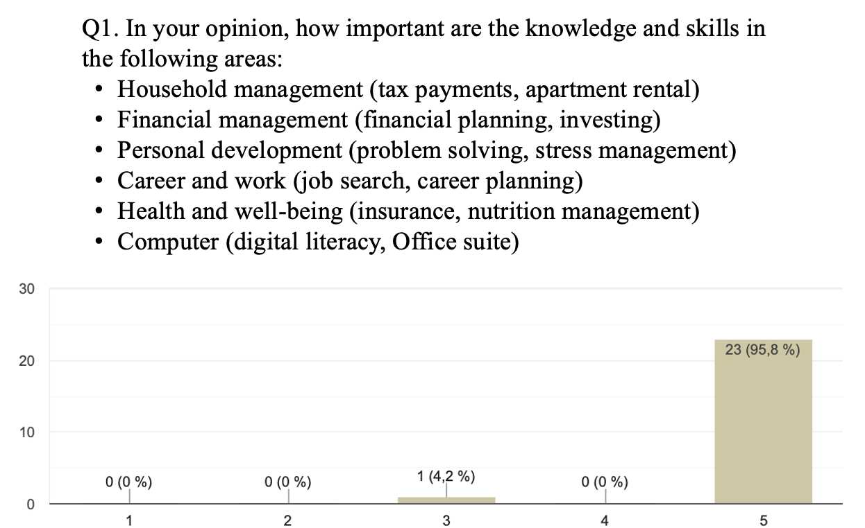

Figure 9 – First question of preliminary mini-survey

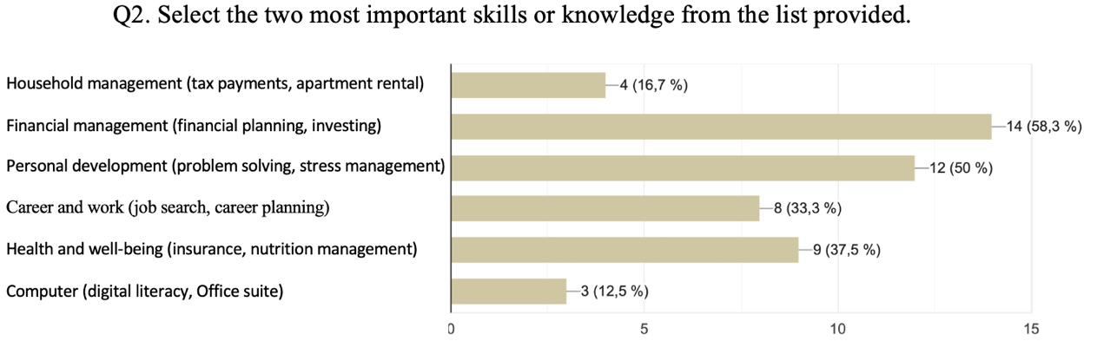

Figure 10 – Second question of preliminary mini-survey

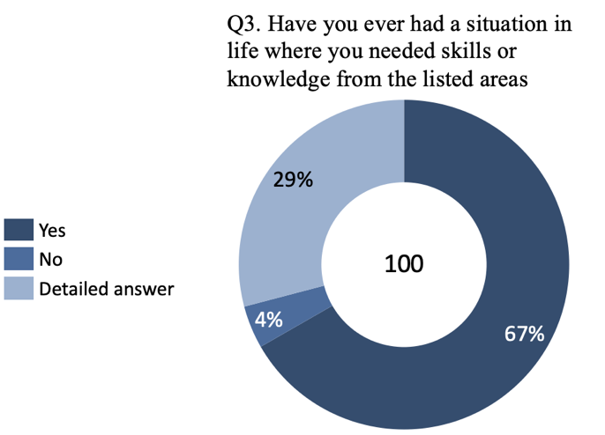

Figure 11 – Third question of preliminary mini-survey

# Appendix C

**Collection of selection methods**

Table 14 – Selection methods collection

|  |  |
| --- | --- |
| **Method** | **Description** |
| Generative AI Skill Test | Utilizes advanced AI technology for interactions with a live bot, assessing problem-solving ability, domain knowledge, technical depth, and communication skills through content, scenarios, or case studies. AI generates unique ratings and feedback, offering an innovative method for evaluating skills such as communication, customer interaction, and project management through interactive sessions. |
| Personality Test | Evaluates an individual's personality, understanding their thought processes, mentality, and compatibility with the company's culture. It assesses aspects like handling pressure, temperament, morals, and principles, aiming to match the candidate’s personality with the organization’s requirements. |
| Domain Knowledge Test | Focuses on a candidate's deep understanding of their specific field, evaluating their comprehensive knowledge and expertise. This test is crucial for roles requiring specialized knowledge, such as programming or engineering, helping organizations gauge the depth of a candidate's understanding in the required area. |
| Leadership Test | Assesses leadership qualities by evaluating traits like clarity, determination, courage, passion, and humility. Designed for senior positions, it puts candidates in scenarios to showcase their leadership skills, analyzing their ability to lead, influence followers, and remain committed and humble. |
| Entrepreneurship Ability Test | Evaluates business acumen, including management, teamwork, communication, financial, analytical, and organizational skills. It assesses whether a candidate has the mindset and skills to succeed as an entrepreneur, focusing on their ability to innovate and manage a business effectively. |
| Programming Test | Assesses computer programming skills, including coding, knowledge of computer languages, and technical skills like code maintenance and debugging. It helps identify candidates capable of delivering bug-free software and demonstrates problem-solving abilities in technical contexts. |
| Voice Assessments/Voice-based Interviews | Records candidates' spoken answers for later evaluation, assessing knowledge, communication skills, and confidence. AI can analyze audio responses, providing a novel way to evaluate candidates' abilities in a more dynamic and interactive format. |
| Video-based Interviews | Mimics face-to-face interviews through recorded video responses, allowing evaluators to assess body language, communication skills, and knowledge, offering a comprehensive view of the candidate's suitability for the role. |
| Writing Skill Test | Online assessments of writing abilities, focusing on grammar, punctuation, and communication effectiveness. Essential for roles involving extensive written communication, helping identify candidates with strong writing skills. |
| Listening Skill Test | Online tests to evaluate listening skills, essential for effective communication and teamwork. Helps filter candidates who lack strong listening abilities, improving hire quality. |
| SQL Skill Assessment | Evaluates SQL coding skills, including query writing and database management, critical for roles like Database Administrator or SQL Developer. Enhances hiring accuracy by assessing technical proficiency without an interviewer. |
| Project Management Assessment | Custom assessments for evaluating project management skills, including team leadership, task execution, and communication. Uses scenario-based questions or simulated projects to gauge competency in managing projects. |
| Data Analysis Skill Test | Online assessments for data analysis skills, including statistical methods, data visualization, and machine learning. Crucial for roles in data science, helping identify candidates capable of insightful data interpretation. |
| English Language Aptitude Test | Assesses English language proficiency, evaluating comprehension, analysis, and grammatical knowledge. Essential for ensuring candidates can effectively communicate in a globalized workplace. |
| Case Study Based Assessment | Presents candidates with real-world scenarios to solve, using AI for tailored follow-up questions. Evaluates problem-solving and practical knowledge, ideal for leadership or roles requiring strong analytical skills. |
| Resume Screening | The initial step where a hiring manager or recruiter scans a candidate’s resume to quickly gauge their skills and experience, determining if they qualify for a closer look. |
| Phone Screening | A preliminary assessment via phone (or sometimes video) by someone other than the hiring manager, focusing on high-level questions about the candidate’s background and experience. |
| Interview | A detailed assessment involving one or more conversations, usually in person, with hiring decision-makers to explore a candidate’s qualifications, job experience, and accomplishments. |
| Group Interview | An interview format where multiple candidates are interviewed at the same time, allowing hiring managers to observe how they interact with others. |
| Panel Interview | A candidate meets with multiple interviewers at once. This format is useful for involving several decision-makers without prolonging the interview process, and it tests how candidates handle pressure. |
| Skills Assessment | Tests candidates’ technical capabilities for positions where it’s challenging to assess skills through an interview alone, providing an objective comparison and helping eliminate bias. |
| Personality Assessment | Identifies candidate characteristics beyond technical skills, such as communication style and work preferences, useful for roles where certain personalities may excel. |
| Mock Assignment / Job Audition | Candidates complete a task similar to what they would do in the job, offering hiring managers insight into an applicant’s skills before making a hiring decision. |
| Reference Check | Conducted in the final hiring stages, these checks can uncover significant concerns, such as discrepancies in the candidate’s job history. |
| Background Check | Used to ensure that there are no major issues with a candidate before making an offer, focusing on preventing hiring the wrong person rather than selecting the right one. |
| Situational Judgment Test | A behavioral examination presenting work scenarios to candidates, followed by multiple-choice responses on how they might react. It helps hiring managers understand a candidate's potential reaction to everyday situations, conflicts, or high-energy events. This test is particularly useful for managerial positions that require decision-making skills and interpersonal aptitudes. It's also used in healthcare organizations to assess medical professionals' responses to patients' needs. |

Source: collected during literature review from multiple sources and interview

# Appendix D

**Survey and interview design**

**Survey**

Table 15 – Survey design

|  |  |
| --- | --- |
| **Variable** | **Questions** |
| Quick professional growth | 1. Over the past 5 years, how would you rate your salary growth percentage? % 2. On a scale of 1 to 5, how much have your responsibilities increased during the same period? (1-5) 3. How many promotions have you received in the past 5 years? Number |
| Strategic Thinking | 1. I regularly engage in long-term planning. (1-5) 2. I can easily identify opportunities and threats in various scenarios. (1-5) 3. Applying Strategic Thinking has directly contributed to my professional success. (1-5) 4. Reflecting on past outcomes, I adjust my strategic approach accordingly. (1-5) 5. Has a lack of Strategic Thinking led to inefficiencies in managing personal or professional tasks? (1-5) |
| AI Application | 1. How important do you believe AI Application is for staying competitive in the current job market? (1-5) 2. How proactive are you in learning about AI trends, applications, and their implications for your field? (1-5) 3. I utilize AI technologies to enhance efficiency. (1-5) 4. AI Application helps me solve simple (1) or complex (5) problems. (1-5) 5. Has a gap in AI Application ever caused challenges in completing tasks efficiently and in deadline? (1-5) |
| Financial Literacy | 1. I am confident in managing finances. (1-5) 2. I understand investment options and their benefits. (1-5) 3. Financial planning is part of my routine. (1-5) 4. I make informed financial decisions for long-term benefits. (1-5) 5. Has a lack of Financial Literacy ever led to financial stress or missed opportunities? (1-5) |
| Career Planning | 1. I set clear career goals and review them regularly. (1-5) 2. Career Planning has positively impacted my professional trajectory. (1-5) 3. I use career milestones to measure my progress. (1-5) 4. I seek feedback and opportunities for career development. (1-5) 5. Has inadequate Career Planning ever impacted your professional growth negatively? (1-5) |
| Health and Wellbeing Maintenance | 1. I prioritize Health and Wellbeing Maintenance in daily routines. (1-5) 2. Managing work-related stress is something I do effectively. (1-5) 3. I make lifestyle choices that support long-term health. (1-5) 4. Regular physical activity is part of my routine. (1-5) 5. Has neglecting Health and Wellbeing Maintenance ever affected your ability to perform tasks and/or general well-being at work? (1-5) |
| Home Maintenance literacy | 1. I possess skills necessary for basic Home Maintenance. (1-5) 2. DIY Home Maintenance tasks are something I can handle confidently. (1-5) 3. I plan and budget for Home Maintenance effectively. (1-5) 4. Managing Home Maintenance tasks does not significantly disrupt my daily routines. (1-5) 5. Has a lack of Home Maintenance skills ever led to unnecessary distractions or expenses? (1-5) |
| Wise use of Resources | 1. I prioritize and allocate resources (time, money, effort) efficiently. (1-5) 2. I make decisions on resource use that reflect my priorities and goals. (1-5) 3. I seek ways to optimize resource use in daily tasks. (1-5) 4. Resource management strategies help me achieve better outcomes. (1-5) 5. Has inefficient resource use ever caused significant setbacks in personal or professional areas? (1-5) |
| Employability | 1. How confident are you in your ability to create a CV that effectively showcases your skills and experiences? (1-5) 2. How prepared do you feel for job interviews, including your ability to answer questions effectively and present yourself professionally? (1-5) 3. Has a lack of certain employability skills ever limited your job opportunities? (1-5) |
| Rental Processes Literacy literacy | 1. How knowledgeable are you about where and how to find suitable rental properties? (1-5) 2. How confident are you in identifying potential obstacles or deceptions during the rental process and in asserting your tenant rights? (1-5) 3. Has dealing with rental issues ever significantly diverted your time and effort away from your professional responsibilities? (1-5) |
| Government Services Navigation | 1. I efficiently navigate government services for personal needs. (1-5) 2. I am aware of the government services available to me and how to access them. (1-5) 3. Has difficulty in accessing or using government services ever caused complications in your personal or professional life? (1-5) |
| Negotiation | 1. I effectively use negotiation skills in various scenarios. (1-5) 2. My negotiation skills have helped me achieve favorable outcomes. (1-5) 3. Has a lack of negotiation skills ever resulted in less advantageous outcomes in personal or professional situations? (1-5) |
| Personal part | Could you, please, rank all the mentioned skills from the most important to the less one. |
| Desired part | Reflecting on your career journey, which non-traditional life skill do you wish you had learned earlier, and how do you believe it would have impacted your professional growth? Please share your thoughts. (Open) |

**Inteview**

**Level 1 skills (according to the survey analysis) (15 min)**

**(Strategic Thinking, employability, Career Planning, Financial Literacy, Wise use of Resources)**

Q1: Reflecting on your early career challenges, can you discuss how specific non-traditional life skills (e.g., Strategic Thinking, Financial Literacy) helped you navigate these obstacles? **Examples**

Q2: Of the skills you've found crucial in addressing these challenges, which ones do you wish you had acquired earlier in your career? How do you think they would have impacted your professional growth? **Examples**

Q3: Reflecting on your experiences, which of these skills do you find most essential for thriving in the career? **Examples/Argumentation**

**Level 2 skills (according to the survey analysis) (8 min)**

**(Negotiation, Health and Wellbeing Maintenance, AI Application)**

Q1: How do you perceive the importance of these level 2 skills in comparison to the level 1 skills for professional growth? Do you believe each of them is crucial for professional thriving?

Q2: How each skill helped you overcoming obstacles at the start of your career?

Q3: How each skill helps you now?

**HR level (7 min)**

Q1: From your perspective, how are non-traditional life skills evaluated during the hiring process, if at all? Can you provide examples from your job application experiences?

Q2: What suggestions do you have for HR professionals to better identify and assess these skills in candidates, especially considering the challenges faced by young workers? Any tools you can recommend?

Table 16 – Respondents for interview

|  |  |  |
| --- | --- | --- |
| **Name** | **Working experience** | **Industry** |
| Vladimir | 2 years | Energy (Power energy) |
| Natalia | 1.5 years | Consulting, Product Development |
| Daria | 2 years 5 months | Marketing, Project management |
| Diana | 3 years | Management, Project Management |
| Ekaterina | 3 years | Audit, Consulting, Project Management |
| Andrei | 2.5 years | Energy (Power energy) |
| Anna | 6 years | Business Coaching, FinTech |
| Polina | 1 year | Healthcare (Maternity Hospital) |
| Ruslan | 3 years | Business Development |
| Uliana | 1.5 years | Marketing Analytics |
| Ilya | 3 years | Business Analytics |

# Appendix E

**Survey extra question charts**

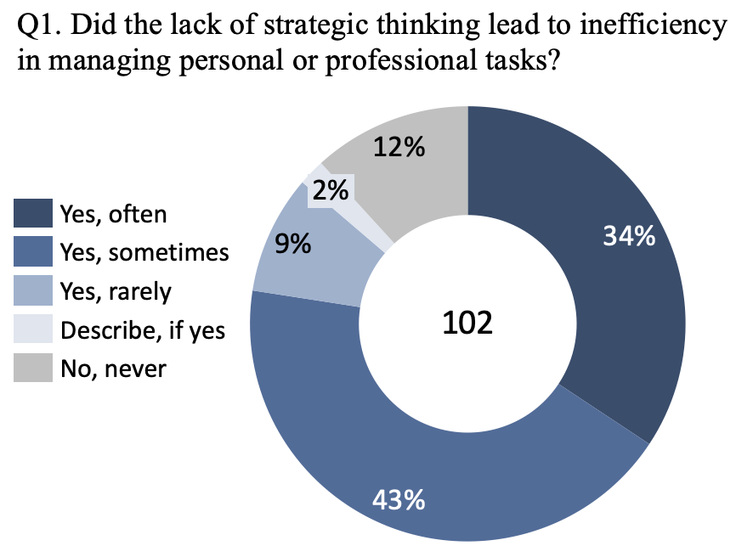

Figure 12 – Extra question for Strategic Thinking

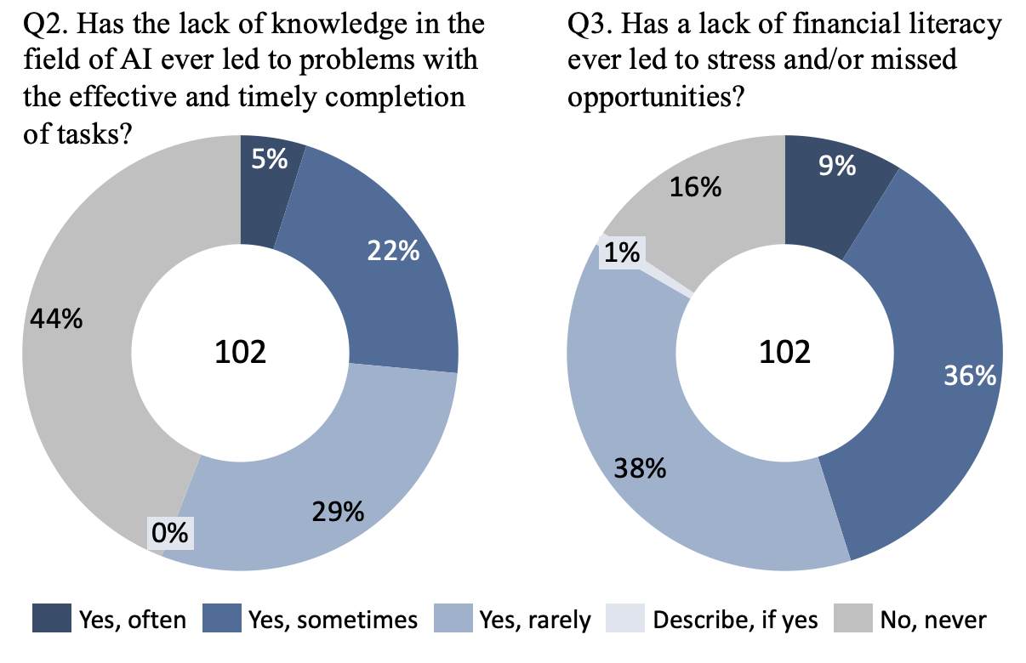

Figure 13 - Extra questions for AI Application and Financial Literacy variables

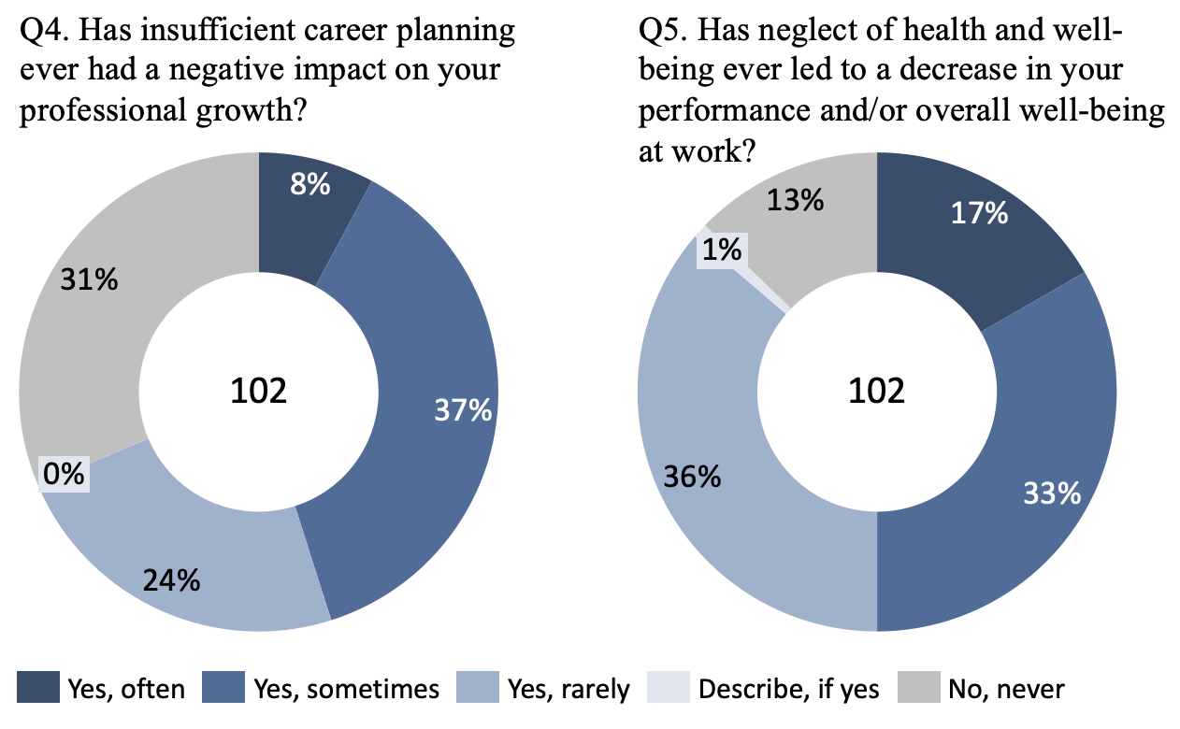

Figure 14 - Extra questions for Career Planning and Health and Wellbeing Maintenance variables

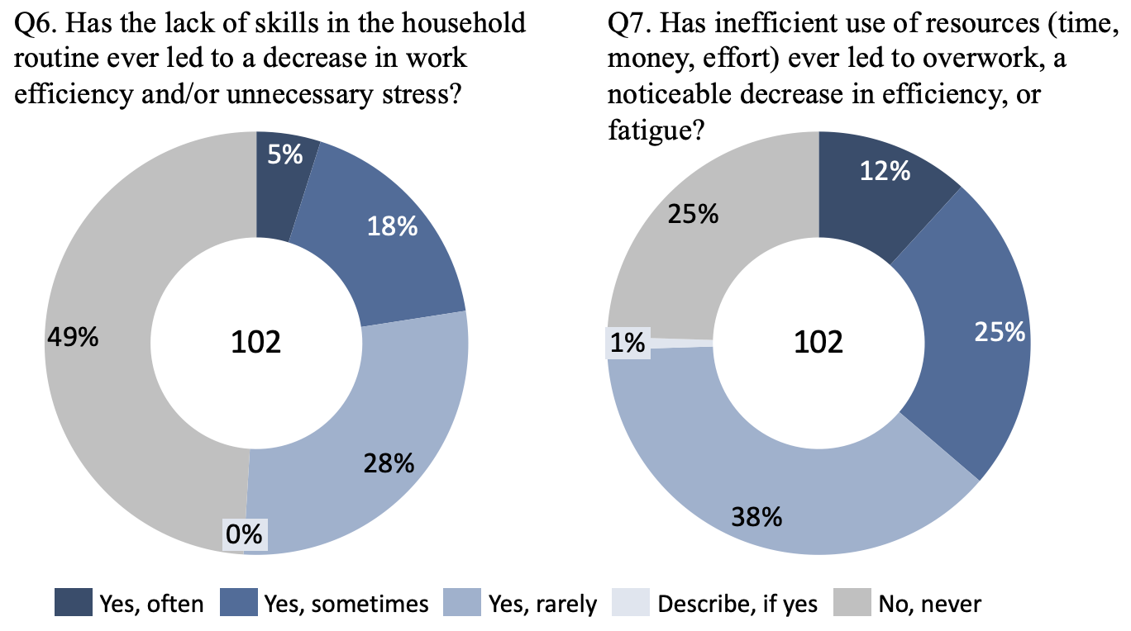

Figure 15 - Extra questions for Home Maintenance and Wise use of Resources variables

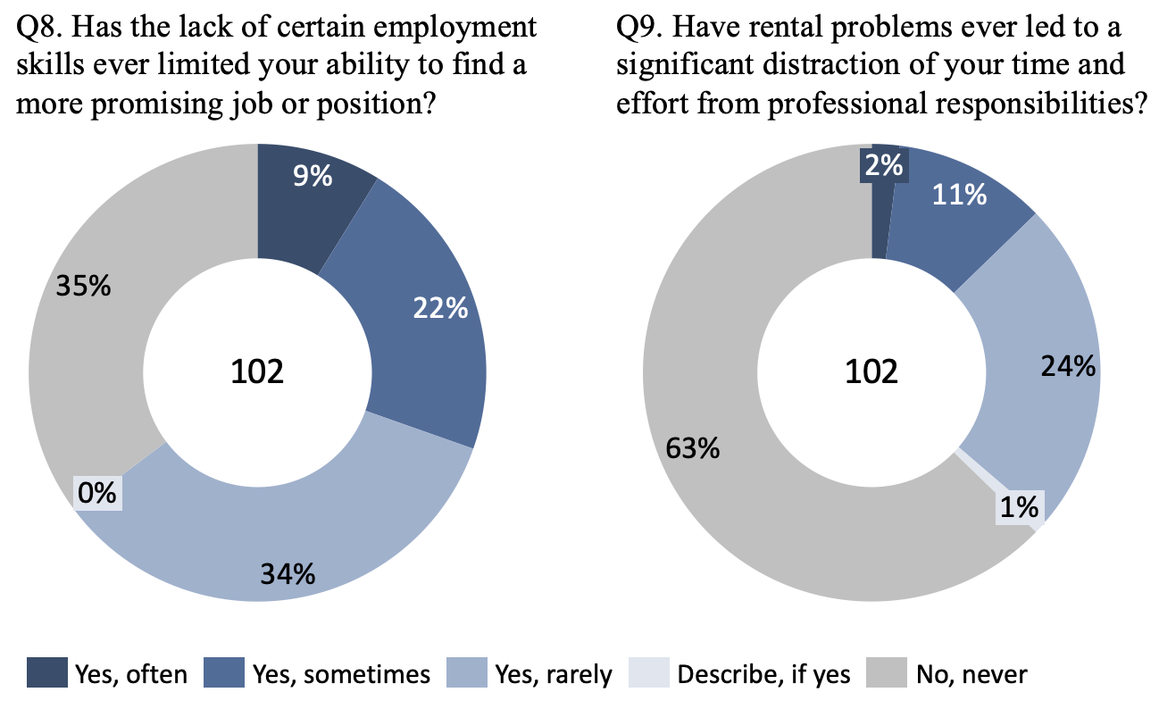

Figure 16 - Extra questions for Employability and Rental Processes Literacy variables

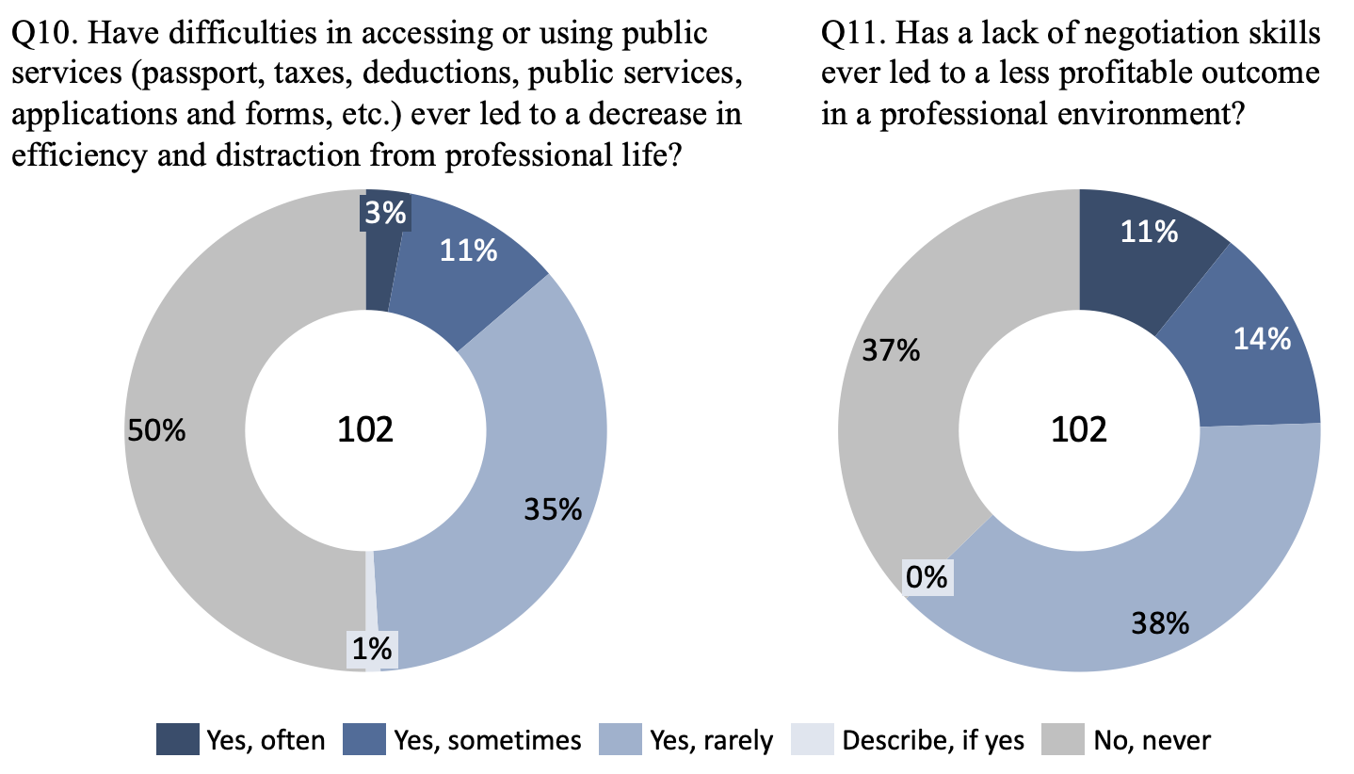

Figure 17 - Extra questions for Government Services Navigation and Negotiation variables