Federal State Institution of Higher Professional Education
Saint-Petersburg University
Graduate School of Management

Bachelor thesis
Corporate Social Responsibility Strategy for FBS Company

Made by
the 4th year student of bachelor program
“International Management”,
group Б08-вшм,
Knyazeva Alisa

Scientific advisor:
Candidate of Science, Associate Professor, Strategic and International Management Department, Academic Director of Master in Management Program
Yuliya Nikolaevna Aray


Saint-Petersburg
2024

The statement about the independent nature of graduate qualification work
Me, Knyazeva Alisa, a student of the 4th course of the Graduate School of Management, St. Petersburg State University, “Management” direction, “International management” program, confirm that my graduate qualification work on the thesis “Corporate Social Responsibility Strategy for FBS Company”, which will be presented for public defense in June 2024, does not contain elements of plagiarism.
All direct loans from printed and electronic sources as well as from presented earlier course projects and graduate works candidate and doctoral dissertations have corresponding references.
I am familiar with the current Graduate School of Management, SPBU regulations of the educational process, according to which the detection of plagiarism (direct borrowing from other sources without provision of links) is the basis for “F” estimation of work.

/Князева А.C. 27.05.2024.

Table of contents
Introduction 4
CHAPTER 1: THEORETICAL BACKGROUND OF CSR 7
1.1. Typology of CSR practices 8
1.2. Value chain analysis for CSR strategy development 10
Summary of Chapter 1 12
CHAPTER 2: CURRENT STATE OF CSR IN FBS 13
2.1. Overview of FBS CSR Initiatives 13
2.1.1. Description of the existing CSR practices and initiatives undertaken by FBS 14
2.1.2. The systematic analysis of current CSR approach and initiatives at FBS 20
2.2. Industry Analysis 22
2.2.1. CSR practices of main competitors 22
2.2.2. Key Success Factors 31
Summary of Chapter 2 36
CHAPTER 3: CSR STRATEGY DEVELOPMENT AND RECOMMENDATIONS 38
3.1. PESTEL-analysis 38
3.2. Sustainability SWOT-analysis 49
3.3. Strategies and recommendations identification 53
3.3.1. The secondary sustainability SWOT 53
3.3.2. Key recommendations for CSR strategy implementation at FBS 56
3.4. Recommendations Implementation 59
3.4.1. Materiality Matrix for FBS 59
3.4.2. Porter's Value Chain model for FBS 64
3.4.3. Timeframes for recommendations’ implementation 70
3.3.4. Action Plan for initiatives’ implementation 72
3.4.5. Risk Analysis 74
Summary of Chapter 3 77
Conclusion 78
References 81
Appendix 87

Introduction
Nowadays more and more companies implement CSR practices as one of their usual activities. The fact is that in today's business world, the idea of Corporate Social Responsibility (CSR) is not just a trend, it is a crucial part of how modern companies operate. This bachelor thesis explores the development of CSR strategy at FBS, a leading global broker, highlighting the importance of these practices in the current corporate scene. In the context of this bachelor thesis on "Corporate Social Responsibility Strategy for FBS Company'', the term "strategy" refers to a comprehensive plan or set of actions designed to achieve specific long-term goals. It involves the deliberate selection of practices and initiatives that align with the company's overall objectives, especially in enhancing its social, environmental, and economic impact. When discussing the development of CSR strategy within FBS, it includes both the formulation and implementation of approaches that integrate CSR deeply into FBS’s core business operations.
The relevance of this research arises from a growing expectation that companies do more than just make money - they should also play a positive role in society and the environment. Specifically, CSR allows companies like FBS to show they care by dedicating resources to good causes, effectively boosting their reputation and trust among customers and partners. According to a study, 76% of companies report on CSR as a way to reduce brand reputation risk, and 83% of employees would consider leaving their job if the company displayed irresponsible CSR practices (Eser, 2024). Furthermore, 64% of CEOs believe that CSR is core to their business strategy, emphasizing the strategic importance of CSR in today's corporate world (Eser, 2024).
FBS, a well-known broker that operates globally in over 150 countries, is actively enhancing its CSR mission. With its wide range of financial services and an impressive annual trading volume that goes well beyond $8.9 trillion, FBS's influence in the financial market is significant. Moreover, FBS is the Official Partner of Leicester City Football Club.
Under the framework of Corporate Social Responsibility (CSR) by Porter & Kramer (2006), which is an approach for generating economic value while at the same time addressing the expectations of shareholders and stakeholders, FBS actively contributes through initiatives that support Quality Education and Sustainable Cities and Communities, designed to address the specific needs of the communities it operates in. In regions with diverse challenges like Malaysia and South Africa, there is a high need for CSR initiatives that address specific local needs. FBS is keen on integrating its CSR efforts with the broader aims of economic and educational development in these communities, thereby strengthening its position in the market and building lasting loyalty among both new and existing customers.
Considering the crucial role CSR plays in modern business strategies, the existing approaches often remain isolated from core business operations, leading to missed opportunities for companies to benefit society and themselves. Also, Porter and Kramer (2006) observed in the Harvard Business Review that "The prevailing approaches to CSR are so disconnected from business as to obscure many of the greatest opportunities for companies to benefit society."
The managerial problem is that currently FBS faces challenges in optimizing its CSR initiatives to enhance social impact and improve business performance. Recognizing this gap, this research aims to delve deeper into CSR at FBS, examining how it can be more effectively integrated into the company's fundamental strategy and operations, thus ensuring that FBS not only fulfills its social responsibilities but also capitalizes on the inherent value that these efforts bring to the business and its stakeholders.
Research Goal: The main goal of this bachelor diploma paper is to create recommendations for CSR strategy development and its implementation for FBS company.
Research Object and Subject: This research takes a closer look at CSR strategy development and its implementation as a research subject, and FBS as the corporate entity as an object.
Research Objectives: The main objectives are the following:
- Review internal and external sources to provide a detailed assessment of FBS’s current CSR positioning.
- Analyze the competitive position of the company in terms of CSR.
- Identify gaps within FBS's current CSR initiatives through thorough analysis.
- Define strategic directions for CSR development at FBS based on the company's resources, capabilities, and both internal and external environments.
- Create recommendations for implementation aimed at achieving CSR goals at FBS.
Research Data Characteristics:
- Primary Data: This includes the interview with FBS's PR Head and CSR Manager, discussions with partners from charitable organizations, and a review of documents related to the company's CSR activities.
- Secondary Data: This part of the research is based on available information about FBS's CSR activities and CSR practices across the global brokerage industry; journal articles and case studies highlighting best practices in corporate social responsibility initiatives.
The research consists of three chapters, starting with the theoretical background and concluding with the proposed CSR strategy and recommendations for implementation at FBS. Each chapter includes several sections that follow a logical order. The first chapter lays the foundation with key theoretical concepts of CSR, the second chapter analyzes the current CSR state at FBS and its industry, and the final chapter presents strategic recommendations and detailed plans for enhancing CSR practices at FBS.

CHAPTER 1: THEORETICAL BACKGROUND OF CSR
Within the rapidly changing field of global business, the concept of Corporate Social Responsibility (CSR) transitioned from a peripheral activity to a core strategic imperative. This transformation is supported by a recognition of the mutual interdependence between corporations and society - a principle concisely described by Michael E. Porter and Mark R. Kramer in their seminal work on aligning strategy and CSR (2006). The idea that CSR initiatives should be integrated with a company’s core business strategy, rather than treated as separate or peripheral activities, is central to understanding the theoretical foundations of effective CSR. Porter and Kramer argue that companies achieve the greatest social impact and business benefit when they identify and leverage the points of intersection between societal needs and their own strategic goals. For FBS, this implies an approach to CSR that goes beyond philanthropy or compliance to view CSR as a source of competitive advantage and innovation. The concept of 'Creating Shared Value' presented by Porter and Kramer (2011) marks a pivotal shift from traditional CSR. Unlike conventional CSR, which focuses mostly on reputation and has only a limited connection to the business, making them hard to justify and maintain over the long run, CSV is integral to a company’s profitability and competitive position. It leverages the unique resources and expertise of the company to create economic value by creating social value. This concept expands the traditional focus on profit maximization to include the social impacts of a company's operations, pushing businesses to reevaluate their practices and innovate in ways that contribute to society.
Another crucial framework to be considered here is The Triple Bottom Line (TBL or 3BL) framework introduced by John Elkington in 1994. It further enriches the conceptual landscape of corporate social responsibility that Porter and Kramer (2006; 2011) have laid out. TBL provides a comprehensive model that urges companies to extend their accountability beyond the traditional bottom line of profitability to include social and environmental aspects. In this sustainability framework, a company's success is measured not just by the economic value it generates but also by its environmental responsibility and social impact. Integrating the TBL framework within the strategic CSR initiatives of a company such as FBS involves a balanced focus on three critical performance areas: economic, environmental, and social. This approach pushes companies to run operations that are ecologically and socially responsible in addition to being profitable. It is a method that acknowledges the complex interactions that exist between a firm's financial performance, its contributions to society, and the preservation of the environment in which it operates.
Incorporating insights from the International Journal of Management Reviews (IJMR) (Shuili Du and CB Bhattacharya; 2010), the role of CSR activities in fostering favorable attitudes and behaviors among stakeholders is a crucial aspect of modern corporate strategy. This aspect aligns with the previously discussed frameworks of CSV and TBL by emphasizing the importance of CSR in making a positive corporate image and reinforcing stakeholder-company relationships.
Businesses like FBS may use Corporate Social Responsibility (CSR) as a strategic tool to increase stakeholder loyalty and trust, and, subsequently, promote favorable behaviors such as investing, job searching and purchasing. Strategic implementation of CSR activities will help FBS transform the perceptions and behavior of its stakeholders. By taking part in CSR, FBS can create an image of being a good corporate citizen, which can have a big impact on advocacy and customer loyalty. Customers that understand and recognize FBS's CSR commitments are more likely to be brand loyal, act as brand ambassadors and show resilience in the face of negative publicity (Du et al., 2010). In making this kind of customer relationship, FBS can influence its brand reputation and establish a team of brand ambassadors that help to enhance the company's image in the market.

1.1. Typology of CSR practices
In the analysis of Corporate Social Responsibility (CSR) initiatives at FBS, the framework developed by Minna Halme and Juha Laurila (2009) is essential for understanding how corporations can integrate socially responsible practices into their core operations. While the specific activities classified by Halme and Laurila - philanthropy, CR Integration, and CR Innovation provide a structured approach to CSR, it is important to discuss the theoretical implications of each category for understanding the strategic and operational dimensions of the Corporate Social Responsibility. Their framework defines three primary types of CR as presented in Picture 1:
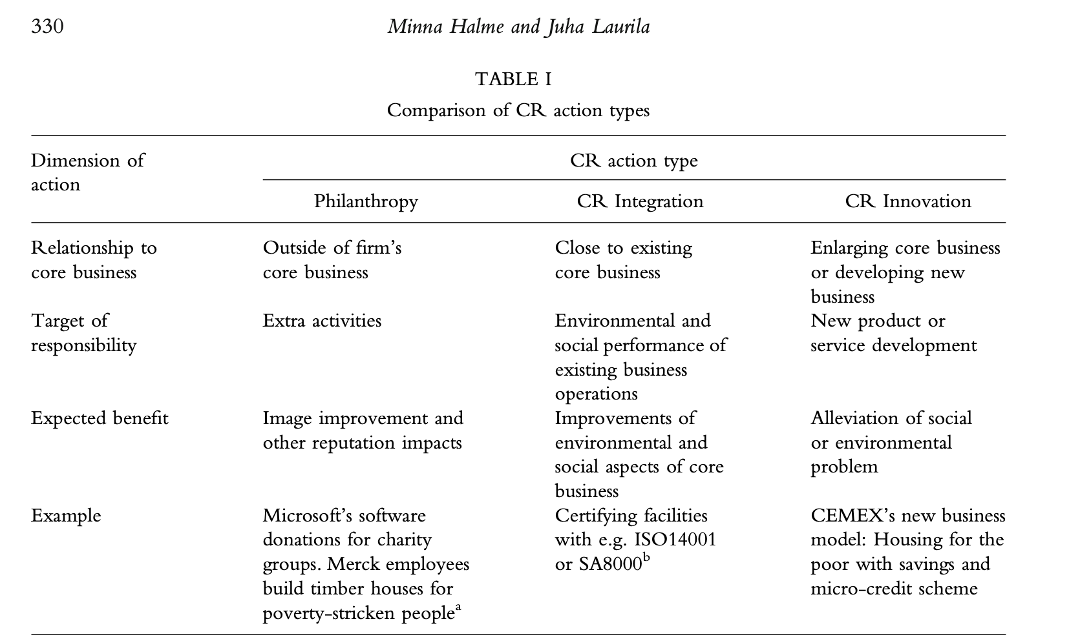
Picture 1. The classification of CR action types according to Halme and Laurila, 2009
Philanthropy: This type emphasizes charitable actions, including donations, sponsorships, and employee volunteerism. It represents the traditional view of corporate responsibility, where companies contribute financial resources or services to social and environmental causes without a direct link to their core business operations. In essence, the charitable activities take place outside of the firm’s immediate business and no direct business benefits are sought from them. Indirectly, a company can seek to minimize intrusive public policy or improve its reputation and market opportunities with philanthropic activity (Halme and Laurila, 2009; Godfrey, 2005).
CR Integration: Unlike philanthropy, CR Integration focuses on conducting existing business operations in a more responsible manner. This approach attempts to combine responsibility aspects with the day-to-day business practices, decision-making processes, and corporate strategy. CR Integration aims to mitigate negative impacts and enhance positive contributions to society through responsible business conduct, aligning with the principles of sustainable development.
CR Innovation: The most forward-thinking among the three, CR Innovation emphasizes the development of new business models specifically designed to address social and environmental challenges. This approach goes beyond traditional CSR practices by leveraging corporate innovation and entrepreneurship to create solutions that have a purpose of achieving commercial success while delivering substantial societal benefits. CR Innovation represents a paradigm shift, where CSR becomes a core element of generating shared value for both the company and the community.
Later, in the second chapter, the current CSR approach at FBS will be analyzed through this theoretical framework with the help of proposed dimensions. This analysis will help understand how FBS's CSR activities align with the categories of philanthropy, CR Integration, and CR Innovation, providing insights into their impact on both the company and society.

1.2. Value chain analysis for CSR strategy development
To provide a relevant CSR strategy implementation plan for FBS, an analysis of its value chain was conducted using Porter's Value Chain model. This approach is crucial for understanding how the company's activities can align with sustainability goals and where improvements can be made to integrate CSR more deeply into its core operations.
The analysis is based on the ideas from "Why Sustainability Is Now the Key Driver of Innovation" by Ram Nidumolu, C.K. Prahalad, and M.R. Rangaswami, which details how companies progress through the particular stages of sustainability integration, which include viewing compliance as opportunity, making value chains sustainable, designing sustainable products and services, developing new business models, and creating next-practice platforms. According to the study, organizations often face various challenges that require tailored solutions to ensure successful implementation of sustainability strategies. Particularly at the second stage of making value chains sustainable, corporations work intensively with suppliers and retailers to develop eco-friendly raw materials and components while also aiming to reduce waste. In addition to enhancing the company's reputation, this stage aims to achieve major operational improvements that may result in cost savings or possibly the creation of new business opportunities. Therefore, this analysis ensures that sustainability efforts are deeply integrated into organization's operations, enabling companies to achieve its CSR objectives effectively while also driving economic benefits.
Michael Porter introduced the value chain concept in his seminal work "Competitive Advantage" in 1985. He suggested a generic value chain model as a powerful analysis tool for organizations to examine their internal activities and understand how they are interconnected. According to Porter, the way these activities are carried out can significantly influence costs and impact profitability. The value chain framework emphasizes a system-level approach, focusing on how inputs are transformed into outputs that consumers value, rather than merely examining individual departments or cost accounts. Porter categorizes these activities into two main types: primary and support activities as it is shown in Picture 2. Primary activities are directly involved in the creation of the product, its sale and transfer to the buyer, and after-sales support. Support activities, on the other hand, provide the necessary background support to enhance the effectiveness and efficiency of primary activities.
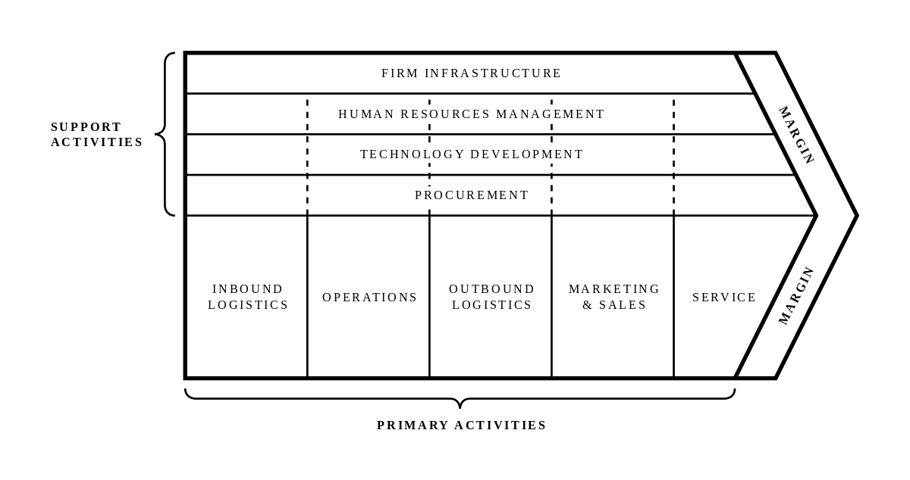Picture 2. Porter's Value Chain model
Such a view applied to the value chain of FBS is essential for this thesis on 'Corporate Social Responsibility Strategy for FBS' because it allows for identifying specific areas where sustainability initiatives can be integrated more effectively. It provides a structured framework to recommend strategic initiatives that enhance FBS's CSR profile and ensure that these initiatives are viable, sustainable, and aligned with the company’s overall business objectives. This analysis will help demonstrate how FBS can use its CSR initiatives as a fundamental component of its business strategy that creates long-term competitive advantage and sustainability, rather than only for compliance or marketing purposes.

Summary of Chapter 1
To sum up, key theoretical foundations of Corporate Social Responsibility (CSR) used in the research has been introduced. The frameworks by Michael E. Porter and Mark R. Kramer, particularly the concepts of 'Creating Shared Value' and the Triple Bottom Line by John Elkington, highlight the importance of integrating CSR into core business strategies. These frameworks emphasize that effective CSR practices not only address societal needs but also create competitive advantages and drive innovation. Additionally, the Halme and Laurila framework (2009) categorizes CR activities into Philanthropy, CR Integration, and CR Innovation, which helps to systematically analyze a company's CSR approach. The value chain analysis based on Porter's model further assists in identifying where CSR initiatives can be integrated into a company's operations to enhance sustainability. These theoretical insights may help FBS create a strong CSR strategy that supports sustainable development, builds stakeholder trust, and is in line with its business goals. Building on these principles, the next chapters will examine FBS's current CSR activities and suggest strategic recommendations for implementation.

CHAPTER 2: CURRENT STATE OF CSR IN FBS
This chapter explores the existing CSR practices and initiatives undertaken by FBS. Then, these practices will be organized using the Halme and Laurila framework. Additionally, it will review the CSR practices of FBS's main competitors and support this with an analysis of key success factors.

2.1. Overview of FBS CSR Initiatives
In its CSR efforts, FBS focuses on its alignment with the United Nations Sustainable Development Goals, particularly focusing on Goal 4: Quality Education, and Goal 11: Sustainable Cities and Communities. These goals form the foundation of FBS's philanthropic activities, guiding its charitable efforts towards enhancing educational opportunities and fostering sustainable community development. FBS remains committed to supporting charitable initiatives that contribute to social welfare and economic empowerment in developing countries. These efforts are also aligned with the national development plans of the participating countries, such as the Shared Prosperity Vision 2030 in Malaysia, Indonesia’s 2045 Vision, and Nigeria’s National Development Plan 2021-2025. They are striving for a prosperous and equal society, and each stakeholder, including private companies such as FBS, can contribute to achieve that national agenda. Since 2014, FBS has been actively engaged in charitable activities during Ramadan, raising and donating around $1.3 million to more than 30 organizations in Southeast Asia, Africa, and the Middle East. These donations, which have benefited many groups, demonstrate FBS's commitment to making a meaningful difference in the lives of those in need. At the beginning of 2024, as FBS celebrated its 15th anniversary, the company highlighted its CSR achievements. According to the internal information from employees (Appendix 2), over these 15 years, FBS has organized 40 charity events, donated $1,350,000 to various causes, supported 35 organizations, and reached out to 20 countries.
The main purpose of CSR activities for FBS is a long-term and regular contribution to strengthening the reputation of a reliable and socially responsible brand. By engaging in regular charitable activities, FBS aims to develop local communities in Tier-1 regions, including Indonesia, Thailand, Malaysia, Africa (SA, Nigeria, Kenya), Brazil. Furthermore, every CSR initiative that FBS takes on has a strategic marketing goal as stated by the top-management of the company. Beyond the primary objective of performing charitable acts, these initiatives are carefully designed to produce engaging content that emphasizes the company's involvement and impact. The company efficiently increases its visibility and brand awareness by sharing information through eye-catching images, videos, and mentions of the FBS brand on internal and external media platforms. Additionally, legal regulations in some Tier-1 countries like Indonesia and Malaysia are very strict, that is why legal advisors are cautious and closely monitor PR and marketing efforts in jurisdictions deemed high-risk. This careful approach is a result of a more general regulatory framework that often prohibits or closely examines the promotion and discussion of trading and brokerage services. As a result, publishers are hesitant to write about brokers and trading, even when it is paid for. Local media sources typically consider Corporate Social Responsibility (CSR) projects more favorably than they do traditional marketing campaigns. Publishers are willing to cover stories about good deeds and great community impacts on a voluntary and complimentary basis, as they present a narrative that highlights the positive roles that firms play in society. So, this dynamic offers a strategic advantage for FBS, as a company operating in tightly regulated markets.
Summing up, FBS currently initiates CSR projects from the perspective of an efficient PR tool. The evaluation of the effectiveness of current CSR efforts within the company is primarily based on PR effects, particularly outreach. However, the company aspires to progress to a new stage by developing its CSR direction. From the perspective of FBS's top management, the enhancement and expansion of the CSR strategy is recognized as a vital step towards strengthening the company’s market position as well as fostering deeper connections with its customer base and the broader community. By advancing its CSR initiatives, FBS wants to go beyond a public relations tool to make social responsibility an integral part of the corporate identity.

2.1.1. Description of the existing CSR practices and initiatives undertaken by FBS
Since 2014 FBS has continuously shown that it is committed to social welfare through a variety of charitable initiatives. Every year FBS takes part in charity initiatives during the month of Ramadan. Only starting from the autumn of 2023, FBS developed a dedicated approach to Corporate Social Responsibility (CSR) with the creation of a CSR & Events team in the PR Department. This period was a strategic shift towards focusing on charitable projects in the fields of education and community support.
Recognizing the essential value of these initiatives, top-tier media outlets have covered FBS's charitable activities free of charge, taking into account the non-commercial nature of these events to attract attention and engagement. One example of this kind of media interaction is a feature on Investing, a leading investment and trading platform, which has a monthly user base exceeding 19 million. This coverage illustrates the impactful reach of FBS's CSR efforts. Additionally, FBS's efforts have attracted organic coverage on a significant news and information portal in Malaysia, which reaches almost 1 million people each month, increasing the visibility and influence of its philanthropic initiatives.
Furthermore, special initiatives are a unique component of FBS's CSR approach, as seen by a cooperative CSR effort with Education Africa. As a result of this collaboration, The Citizen portal published an article and a podcast with James Urdang, CEO of Education Africa, and Diego Lima, FBS Business Development Manager for the African region. The main topic of discussion was the value of corporate funding for nonprofit educational initiatives, especially those that focus on STEM (science, technology, engineering, and mathematics) disciplines. From the interview, several key points about the strategic direction of FBS's Corporate Social Responsibility (CSR) initiatives were highlighted. FBS's decision to support Education Africa was based on an in-depth understanding of the critical role that education plays in social responsibility and development. The partnership of FBS and Education Africa has been successful because of its strong commitment to education, particularly in terms of youth support. Moreover, the partnership strategically places a high emphasis on preparing learners for the tech market. This focus is driven by FBS's understanding of its role within this sector and the importance of fostering a skilled future workforce. Consequently, the objectives of this collaboration are centered around providing quality education and equipping children with the necessary skills to become future leaders. Lastly, the focus on STEM (Science, Technology, Engineering, and Mathematics) education aligns closely with FBS's identity as a global fintech entity. STEM disciplines are foundational to both FBS's operational strategies and its core corporate values, highlighting the synergy between FBS's business objectives and its CSR commitments.
These interactions and media placements extend FBS's reach and enhance its brand visibility and credibility. Such publications are invaluable due to the platforms' popularity and because they facilitate the construction of a positive brand image in regions with strict financial services regulations, thus reinforcing FBS's commitment to responsible corporate citizenship and impactful community engagement.
Currently, FBS has already established its partnerships with the following organizations to enhance its CSR impact:
- FBS & Education Africa
In September 2023, FBS and nonprofit education organization Education Africa announced their partnership to provide STEM (science, technology, engineering, and mathematics) education for children and teenagers in Johannesburg, South Africa. Education Africa is a non-profit organization which was established in 1992. It provides education focused on economic skills, while also offering opportunities to those most in need. This approach helps improve their access to relevant education and enable children to be fully engaged in the global economy and remain competitive in the job market. Education Africa has registered self-sustainable offices in the USA, the UK, Austria and in Germany, that all assist Education Africa South Africa in achieving its mission.
As part of this partnership, FBS makes monetary contributions to support the students of Masibambane College, the main source of educational advancement founded by Education Africa in Orange Farm. Since 2019, Masibambane College and Education Africa drive STEM education in the local area. The collaboration has achieved an impressive media outreach, engaging over 64 million individuals across several campaigns, demonstrating the partnership's big impact and its successful role in promoting STEM education within the community. The first donation from FBS was used to acquire essential school supplies used by 80 students of Masibambane College. These goods equipped young students with the preliminary resources to continue their STEM education. Additionally, the FBS Team visited Masibambane School in September 2023 to meet learners and give them a positive experience and gifts, symbolizing the start of a collaborative process towards making STEM education accessible in the Orange Farm area. In the end of 2023, FBS continued its philanthropic commitment through a second charitable event with Education Africa. This event was held on December 18th at the John Wesley Community Centre in Etwatwa, one of the poorest communities near Johannesburg. Representatives of Education Africa and FBS, including Asya Zaitseva, the Head of Public Relations and Events, visited the center with approximately 100 children and 32 adults. The purpose of their visit was to distribute essential food parcels and FBS-branded merchandise, aiming to provide support and spread cheer among the community members during the Christmas season. Lastly, the recent significant effort was made in February 2024. This time, the collaboration focused on the restoration of the school clock at Masibambane College located in Orange Farm. The restoration of the FBS Clock at Masibambane College helped students to follow their schedules and be always on time. The newly restored clock was named "The FBS Clock," symbolizing FBS's timely support and commitment to enhancing educational environments. Naming the clock tower after FBS reinforces the visibility of FBS's contributions and strengthens its reputation. The initiative's PR impact was increased by the media attention it received. Publications and media outlets covering this story reached an outreach of over 6.1 million (Appendix 3), effectively broadcasting FBS's community-focused activities to a broad audience. Therefore, the current FBS's CSR strategy of enhancing brand recognition is achieved through various desired PR effects.
- FBS & Dignity for Children
One more partner of FBS is Dignity for Children Foundation, a non-governmental organization that provides holistic care and education for urban poor children in Kuala Lumpur, Malaysia. Dignity is now a learning center with more than 2,300 children (from over 25 nationalities) ranging from 2-19 years old. During this partnership, FBS funded a classroom refurbishment project at the Dignity Education Center located in Kuala Lumpur in October 2023. The monetary donation provided by FBS enabled the school to install air conditioners, video projectors, and school furniture. In addition to the classroom improvements, FBS provided gifts, including backpacks, t-shirts, caps, workbooks, and more. This contribution was aimed to minimize the financial burden on families, boost students' confidence, and empower them on their educational journey. To celebrate the opening of the refurbished school facilities, a representative from FBS even paid a visit to the Dignity Education Center on October 9. FBS’s representative in Malaysia Aizzat Arfa also greeted the young learners and handed over the gifts from FBS.
- FBS & SUKA Society
Another key partner of FBS in the CSR mission is SUKA Society, a non-governmental organization free from religious or political affiliations, that is registered with the Registrar of Societies in Malaysia. Its mission is complex, focusing on improving access to education for Orang Asli children, protecting trafficked women and children, developing alternatives to detention, and promoting children’s rights through public awareness and advocacy. The educational gap for indigenous children in Peninsular Malaysia is big, with a significant portion lacking pre-school education. Reports from the Jabatan Kemajuan Orang Asli (JAKOA) and the Centre of Orang Asli Concerns (COAC) highlight the severe educational and socio-economic challenges faced by these communities. Specifically, JAKOA's 2007 statistical figures reveal that 7,029 indigenous children in Peninsular Malaysia have never been to school. Consequently, this lack of foundational education significantly hinders their ability to follow the national school syllabus, leading to high dropout rates. According to a 2006 report by Centre of Orang Asli Concerns (COAC), for every 100 Orang Asli children who enter Standard One, only about six will be expected to reach Form Five eleven years later. Without access to proper education, many indigenous communities will continue to struggle with becoming independent and be involved in the never-ending cycle of poverty.
In November 2023, this partnership began with a significant initiative to rebuild a school classroom in the Sabah Region. This project involved demolishing an old, deteriorated classroom and constructing a new, more spacious, and modern learning area. On November 12, 2023, a grand opening ceremony attended by FBS and SUKA Society members, alongside students, parents, and teachers from the Kampung Kipouvo Community Learning Center was organized. In recognition of FBS's contribution, the newly constructed classroom was named after the organization to honor the brand’s contribution to the local community. In January 2024, the partnership's focus shifted to the sponsorship of the 2024 academic year syllabus for six preschools as part of the Empowered2Teach program by SUKA Society. Under this initiative, FBS and SUKA Society provided vital teaching resources to support the educational process of indigenous children in remote villages, preparing them for formal primary education. The contribution aimed at breaking education barriers included purchasing teaching resources for schools located in Slim River, Gopeng, Tapah, Gua Musang, and Kuala Rompin. These materials were designed to foster comprehensive development in children, focusing on their language abilities, numeracy skills, motor functions, as well as their emotional well-being and social competencies. The final initiative between FBS and SUKA Society took place between the 1st and 2nd of March 2024. This event, known as the FBS-sponsored English Children Camp, was held in Tapah, under the facilitation of SUKA Society, and brought together approximately 80 children living in remote villages of Batang Padang District. Over the two-day program, the young learners practiced their English language skills and engaged in educational entertainment activities designed to make learning both enjoyable and effective.
Throughout their collaboration, FBS and SUKA Society undertook three charitable activities, all of which were focused on increasing educational opportunities for the underprivileged communities in Malaysia. This partnership resulted in an impressive total media outreach of 37,343,400 individuals from November 2023 to March 2024 (Appendix 4-6), demonstrating that through such activities FBS achieves its current CSR goals.
- FBS & HSDF
Additionally, FBS expands its Corporate Social Responsibility (CSR) mission to Nigeria, Africa. In November 2023 FBS collaborated with the charity organization Helpers Social Development Foundation (HSDF) to improve the educational experience for students at Community Primary School Imezi-Olo in Ezeagu Local Government Area, Nigeria. Following their joint mission to foster learning environments for communities in need, FBS and HSDF equipped five classrooms at Community Primary School Imezi-Olo with whiteboards. The charity donation also included the provision of two hundred textbooks for English and Mathematics, school uniforms, bags, and stationery items. This collaboration as well underscores FBS’s commitment to fostering learning environments and serves as a powerful PR tool. The initiative got significant media attention, achieving an outreach of 14,650,600 (Appendix 7). This extensive coverage significantly enhanced FBS’s brand visibility and reinforced its reputation as a socially responsible company dedicated to educational causes. This strategic exposure aligns with FBS’s broader goals to strengthen its market presence and showcase its impactful contributions to community development.
- Ramadan 2024
As it was noted earlier, FBS has donated around $1.3 million to more than 30 organizations during Ramadan since 2014. In 2024, FBS sent philanthropic support to needy families across Malaysia during the holy month of Ramadan 2024. Dignity for Children Foundation and SUKA Society each received $5,000 in donations from FBS, enabling them to implement various programs and assist disadvantaged families. Through partnerships with Dignity for Children Foundation and SUKA Society, FBS collectively helped over 900 people nationwide. With the FBS’s support, on-site Ramadan gift-giving initiatives were organized. Donations from FBS were used for essential grocery packages and festive hot meals for more than 400 Malaysian families facing challenging life circumstances. Ramadan gifts ranged from indispensable kits to vital food supplies, offering financial relief to families in need and enabling them to celebrate the holy season. By funding essential programs and support initiatives, FBS's donations have made a significant difference at the sacred time of the year and got the media outreach of 6,472,200 (Appendix 8).
Overall, FBS's current CSR activities are strategically planned in collaboration with organizations within Tier-1 regions, aiming to maximize media outreach and measure the effectiveness of these initiatives. By partnering with well-established entities and focusing on high-impact CSR projects, FBS ensures substantial media coverage, which currently serves as a primary metric for assessing the success and impact of its charitable efforts. This approach fosters community development and supports educational initiatives, also it significantly enhances FBS's visibility and reputation in key markets.

2.1.2. The systematic analysis of current CSR approach and initiatives at FBS
In the analysis of Corporate Social Responsibility (CSR) initiatives at FBS, the framework developed by Minna Halme and Juha Laurila (2009) was chosen as the guiding methodology. This decision is rooted in the framework's comprehensive approach to categorizing CR activities, which distinguishes between philanthropy, CR Integration, and CR Innovation. This classification resonates with my objective to provide a complex assessment of FBS's CSR practices, providing a framework through which to evaluate the company's efforts across different dimensions of social responsibility.
Taking into consideration the proposed framework by Halme and Laurila, it is evident that currently, FBS's Corporate Social Responsibility (CSR) initiatives predominantly align with the Philanthropy type of CSR action. This categorization is explained by the nature of FBS's CSR activities that are outside the firm's core business functions, and the expected benefit that is generally reputation impacts. The philanthropic approach adopted by FBS is shown in its commitment to supporting charitable initiatives, particularly those focused on education and community development. For instance, FBS's annual participation in Ramadan charity events and its collaboration with non-profit organizations like Education Africa and Dignity for Children Foundation highlights a traditional philanthropic outlook. These initiatives demonstrate FBS's dedication to making financial contributions and offering support that have no direct impact on the company's day-to-day operations. Moreover, the nature of FBS's CSR activities underlines a philanthropic strategy aimed at enhancing the company's reputation and fostering goodwill among stakeholders. FBS's charitable contributions during Ramadan, which have raised and donated substantial amounts to organizations across Southeast Asia, Africa, and the Middle East, serve to position FBS as a socially responsible brand committed to societal well-being. This approach aligns with the philanthropy dimension of CSR, where indirect benefits such as reputation enhancement and market opportunities may arise from these charitable efforts (Godfrey, 2005).
As Halme and Laurila note, philanthropy rarely assumes a strategic form in practice (Burke and Logsdon, 1996; Porter and Kramer, 2002, 2006), limiting its potential to contribute meaningfully to a firm's mission and long-term sustainability. The microeconomic analysis by Husted and De Jesus Salazar (2006) underscores the greater profitability of a strategic approach to CSR, defined as one that supports core business activities and enhances the firm’s effectiveness. In contrast to philanthropy, CR Integration and Innovation are more closely tied to a company's business operations and objectives, offering specific benefits rather than merely contributing to collective goods. This close relationship to the core business allows the firm to capitalize on the unique advantages of CSR programs, presenting a compelling case for shifting towards these more integrated and innovative CSR approaches (Burke and Logsdon, 1996; Porter and Kramer, 2006).
Moreover, as it is shown in Picture 3, strategic CSR approaches - Integration and Innovation - have been shown to yield superior financial outcomes and more substantial societal benefits compared to traditional philanthropy (Halme & Laurila, 2009). This is attributed to the strategic orientation of these CSR types, which ensures that CSR activities are embedded within and contribute to the firm's core business practices. The disconnection of philanthropic activities from corporate operating units limits their potential impact and sustainability, especially in times of economic hardship, where such activities are more likely to be abandoned. In contrast, strategically aligned CSR initiatives, being integral to the business model, face fewer risks of being abandoned during an economic crisis.
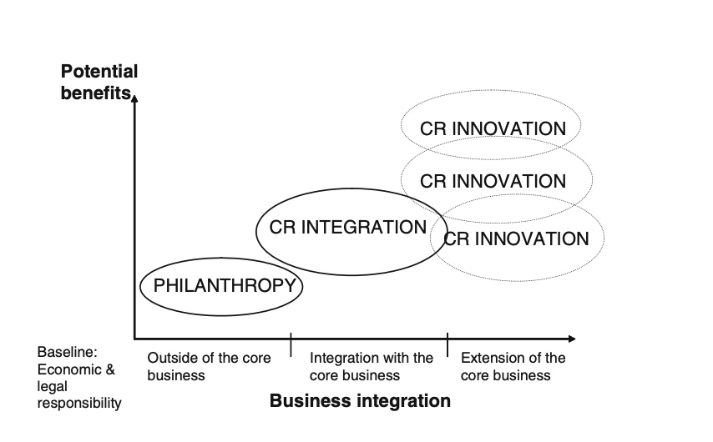
Picture 3. Level of business integration of CR types and the potential for expected financial and social benefits
Given this analysis, this traditional form of CSR, as practiced by FBS, does not fully leverage the potential for CSR to drive corporate innovation, enhance competitiveness, and secure long-term sustainability. The shift towards CR Integration and Innovation promises more significant financial returns and deeper societal impacts. FBS's CSR initiatives must be reevaluated in order to closely link its social responsibility initiatives with its operational and strategic goals. Such a transformation would not only mitigate the risks associated with economic downturns, where philanthropic activities are often the first thing to go, but also benefit from the inherent synergies between FBS’s business model and its ability to contribute to societal welfare.

2.2. Industry Analysis
In this part, the CSR practices of the main competitors and key industry trends will be explored. Following this, the Key Success Factors (KSF) analysis will be done to understand how companies are integrating social responsibility into their operations and what makes them successful in this competitive industry.

2.2.1. CSR practices of main competitors
Initially, companies are chosen based on recommendations from company representatives. Furthermore, the primary selection of competitors involves their presence in key geographical locations that match with FBS's Tier-1 regions. This criterion ensures that the CSR efforts of each entity address similar socio-economic contexts and challenges, providing a more accurate benchmarking perspective. Additionally, competitor selection is influenced by their visibility and popularity on digital platforms, specifically Google Play. This approach leverages the number of application downloads and user ratings as indicators of the competitors' market reach and user engagement, which indirectly reflect on their brand influence and capacity for CSR impact. Moreover, only those competitors with explicit CSR programs are included in this analysis. With this emphasis, the benchmarking approach is guaranteed to assess organizations that have shown their commitment to Corporate Social Responsibility (CSR), providing a meaningful comparison of initiatives, strategies, and impacts. Therefore, following the advice of company staff and meeting these criteria, four main competitors were selected for the analysis: Exness, XM, Octa, and Olymp Trade. This allows to compare companies that share similar market environments and are committed to Corporate Social Responsibility. In Table 1 the competitors are presented with the main characteristics, such as global reach and presence in Tier-1 regions, user ratings according to Google Play, the number of downloads and if there is the CSR program in the company.

Factor | FBS | Exness | XM | Octa | Olymp Trade
Global reach/  presence in Tier-1 regions | 150+ countries/yes | 150+ countries/yes | 190+ countries/yes | 180+ countries/yes | 130+ countries/yes
User ratings | 4,6 / 96.3K reviews | 4,4 / 127 K reviews | 4,1/44.8K reviews | 4,3/223K reviews | 4,1/941K reviews
Downloads | 10M+ | 10M+ | 5M+ | 10M+ | 100M+
CSR program | yes | yes | yes | yes | yes
Table 1. Main competitors of FBS
In total, there are 4 main competitors and each of them implements CSR activity:
- EXNESS
Exness is a global multi-asset broker that was founded in 2008 with the mission to reshape the online trading industry. The company's growth is evidenced by its monthly trading volume exceeding $4 trillion, a community of over 700,000 active traders, and a dedicated workforce of more than 2,100 employees. Exness offers forex, cryptocurrency, stocks, indices, metals and energies, all of which can be traded on the proprietary Exness trading terminal.
In its Corporate Social Responsibility mission Exness focuses on creating positive change in three key areas - providing educational opportunities, protecting the environment, and helping those affected by emergencies (Social Responsibility | Exness Careers, 2024). This commitment is reflected in Exness's significant achievements, including the awarding of 53 scholarships across five countries, the donation of four fire trucks and three drones to enhance the firefighting capabilities of the Cyprus fire department, and the provision of €1.1 million in COVID-19 medical support. Furthermore, Exness has initiated over 30 CSR projects, donated 350 classroom boards to schools in Seychelles, supplied 14,000 liters of free drinkable water through its water station, and made a positive impact in 10 countries worldwide through its comprehensive CSR initiatives. Thus, the company commits to impacting society and the environment in a positive way with a clear mission and vision, deeply rooted in its corporate culture and reflected in the leadership's active engagement and transparent communication regarding its CSR activities.
A dedicated section of the Exness website provides a clear and thorough summary of the company's efforts to have a positive influence by carefully describing its CSR objective, major areas of concentration, and examples of projects. This section gives stakeholders insight into Exness's values and the actual contributions it makes to improving society, in addition to stating the company's commitment to social responsibility. The visibility and proactive involvement of Exness's leadership in advocating for its CSR initiatives further reinforce the company's commitment to making a meaningful difference. Petr Valov, the Chief Executive Officer, publicly expresses the company's belief in the dual role of business in society - to bear responsibility and seize the opportunity to positively impact the world (Picture 4). His statement, prominently featured on the official website along with his photograph, represents the company's philosophy, emphasizing that helping others is an integral part of Exness's DNA.
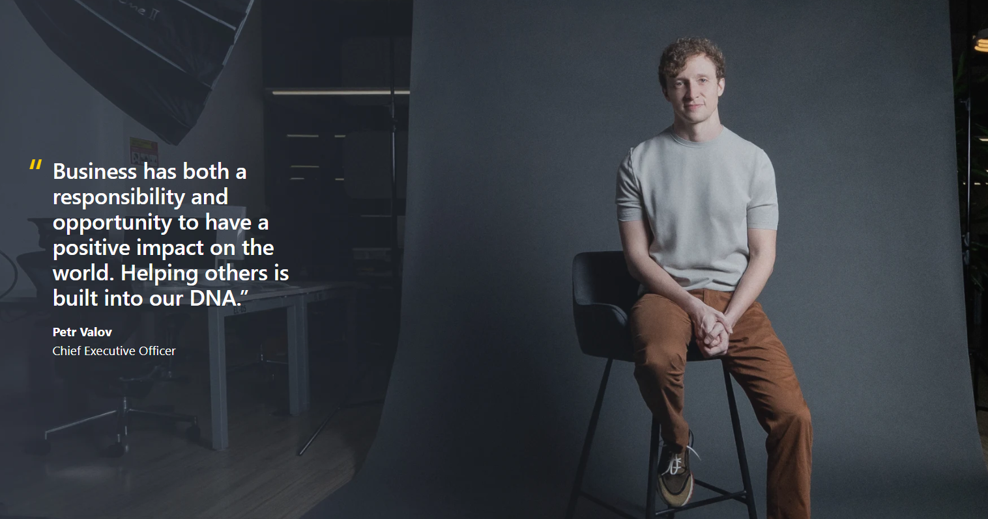
Picture 4. The Exness' CEO quote on the official website
Moreover, the involvement of Exness's Chief Customer Officer, Damian Bunce, in popular events such as the 2023 United Nations Climate Change Conference (COP28), held in Dubai, United Arab Emirates, demonstrates the company's active engagement in global discussions on sustainability and social responsibility. Bunce's insights during the conference highlight Exness's strategic approach to CSR, focusing on environmental protection and education enhancement, and exemplify the company's willingness to collaborate with authorities and communities to address critical challenges, such as the wildfires in Cyprus. In his interview he shared that the company formed a community division to develop effective Corporate Social Responsibility (CSR) action. Also, Exness’ Bunce highlighted how innovations in the sector not only enhance efficiency but also foster a greener future. Digital financial solutions are reducing the consumption of physical resources, promoting paperless transactions, and fostering transparency in supply chain management. As online trading is reliant on data centers, Mr. Bunce emphasized Exness’ commitment to partnering with data center suppliers that share the same vision for sustainability. The company’s collaboration with data centers that target 100% carbon neutrality by 2030, ensures that its data-driven operations have minimal to zero carbon footprint. Dedicated to transparency, the broker also acknowledges the importance of extending its sustainability targets with more eco-friendly collaborations and solutions. This includes partnering with blockchain systems that favor proof-of-stake instead of proof-of-work algorithms.
Additionally, Exness's CSR activities include a tech-driven approach to social contributions, with initiatives ranging from funding reforestation programs to developing advanced surveillance systems for wildfire detection. This innovative perspective extends to the company's operational practices, with a commitment to partnering with data centers targeting carbon neutrality and supporting blockchain systems that are more eco-friendly.
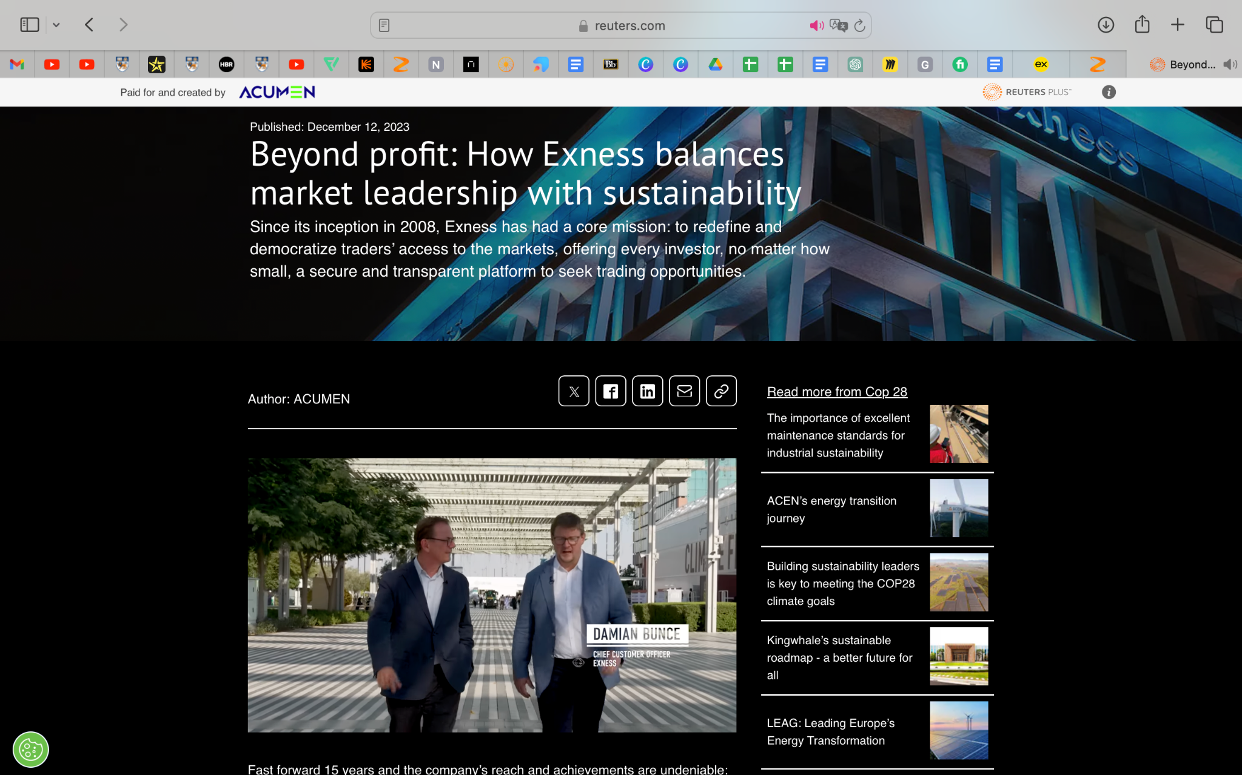
Picture 5. The interview of Exness's Chief Customer Officer, Damian Bunce
The company's CSR activities are well-documented and shared with the public through various media outlets, enhancing Exness's transparency and stakeholder engagement. Interviews with top management and coverage of CSR projects in publications such as African Business (93,2K outreach) and Finance Magnates (207K outreach) serves to boost the credibility and public image of Exness's social contributions. Furthermore, Exness uses social media platforms like Facebook to share updates on ongoing initiatives, such as the tree planting activity in the village of Eptagonia, engaging a wider audience in its CSR efforts.
- XM
XM has had over 10,000,000 clients from over 190 countries since it was founded in 2009. XM has grown to a large and well-established international investment firm and has become the industry leader. Currently, XM is built of more than 900 professionals with long-year experience in the financial industry. With XM's vision to make a positive impact on the quality of life of people across the world, the company is dedicated to its humanitarian mission, which is prominently featured on the XM website. The section not only highlights the company's CSR initiatives but does so with transparency, offering regular news updates complete with releases, photos, and video reports with all dates and locations to ensure accountability and openness.
XM's CSR efforts are focused on five principal areas as it is presented in Picture 6: Education and Skills Development, Research and Development, International Aid, Healthcare and Wellbeing, and Environmental Sustainability (XM, 2019). XM's commitment to social responsibility extends across numerous regions, including Pakistan, Iraq, Sri Lanka, Malaysia, Cyprus, Greece, Mexico, and more, demonstrating its global approach to making a tangible difference.
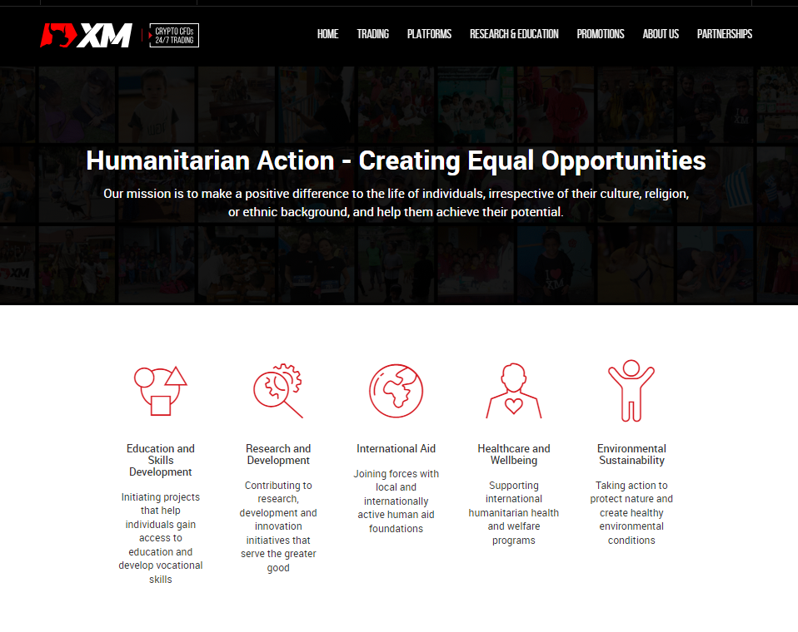
Picture 6. XM CSR webpage
XM also has interesting projects that do not require significant financial investments and engage company employees in charitable acts. For example, in 2023 XM' teams in Cyprus and Greece donated their unwanted clothes, making a significant impact on the lives of those in need. They collected children’s and adults’ clothes to support two remarkable charities: PASYKAF and Theofilos. Pancyprian Association of Cancer Patients and Friends (PASYKAF) provides free health and emotional support services to cancer patients. They also focus on prevention and raising awareness of early signs of the disease. Theofilos, operating in Greece, supports families in need with three and more children. They provide food, clothing, school supplies, and other necessities to help these families raise and educate their children. Both charities received substantial donations of clothing that will support cancer patients and large families during challenging times.
CSR events are regularly covered on internal resources, news, and social media. The news section dedicated to CSR is updated once or twice a month, which clearly and transparently showcases the company’s activities, timelines, and collaborations. Additionally, some events receive coverage by the media with significant outreach. Salary.sg wrote about the XM's contribution to improving the lives of senior citizens in Singapore, with an outreach of 107K. As part of its commitment to sustainable development, XM has partnered with the Singapore Red Cross to assist vulnerable elderly individuals living alone. XM's contribution to the Red Cross ElderAid program was aimed to provide essentials including medical goods (first aid kits) and other necessities. The ElderAid initiative strives to reduce senior citizens’ vulnerability and overcome loneliness. Also, BrokerXplorer covered the collaboration between XM and EDF to support education for disadvantaged students in Thailand, achieving an outreach of 18.2K. This new partnership with the Education for Development Foundation (EDF) through the "My Future, My Dream" Career program, focuses on developing and empowering underprivileged youth with professional skills. The broker donated funds to selected schools to facilitate skills development and comprehensive training sessions. Previously, forex broker XM hosted Volunteer Day on October 30, 2023, enabling staff and teams to interact directly with students at flea market events. The broker's staff in Cyprus and Greece supported and promoted products presented by students utilizing the skills acquired.
- OCTA
Octa has been a global broker providing online trading services worldwide since 2011. It offers commission-free access to financial markets and a variety of services already utilized by clients from 150 countries with more than 21 million trading accounts. It provides free educational webinars, articles, and analytical tools to help clients reach their investment goals. The company is involved in a comprehensive network of charitable and humanitarian initiatives, including the improvement of educational infrastructure and relief projects supporting local communities and small to medium enterprises.
The broker's past CSR activities were varied, providing crucial support to 1,855 individuals and 46 small businesses in emergency situations, primarily during natural disasters. Beyond immediate crisis response, Octa placed a substantial emphasis on education, supporting the educational initiatives of 4,452 students and 50 schools and organizations. This support includes scholarships, funding for extracurricular workshops, professional courses, and the renovation and construction of educational facilities. Additionally, Octa enables the provision of computers and essential educational equipment. CSR projects from Octa's CSR initiatives include the construction of computer classrooms in India, financial support for university students in Malaysia, humanitarian aid in Indonesia following an earthquake, health and education improvement projects in Pakistan, ICT training for unemployed youth in Nigeria, and the sponsorship of an Empowerment Program benefiting elementary students in Mexico. These projects demonstrate the wide scope of Octa's CSR activities and their global reach, impacting lives in India, Indonesia, Malaysia, Mexico, Nigeria, and Pakistan.
OctaFX's support for the Bali Sports Foundation (BSF), which aids disabled sportsmen in Bali and East Indonesia through programs like wheelchair basketball, rugby, and disabled sailing, further illustrates the company's diverse approach to CSR. BSF improves the lives of those with disabilities in Bali and East Indonesia by using the power of sport and play for development, health, and peace. This initiative highlights the use of sport as a powerful tool for improving the lives of those with disabilities, promoting development, health, and peace.
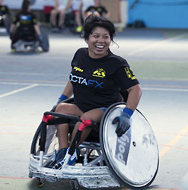
Picture 7. Octa’s support for the Bali Sports Foundation (BSF)
Moreover, Octa has annually produced professional-grade video content to honor the spirit of Ramadan, with a video like a short film that narrates a meaningful story. The 2023 Ramadan video campaign conveys powerful messages urging viewers to "Time to slow down. To pause and give back. Give this time to others. Save it for the precious moments. Devote this to what is important." By creating this kind of content, Octa's creative approach to CSR, and its commitment to cultural sensitivity and community support are highlighted. The company effectively uses storytelling to inspire action and reflection during a period of significant spiritual importance. These Ramadan-specific activities by Octa illustrate the company's thoughtful and inventive engagement with CSR, reflecting a deep understanding of the communities it serves. Therefore, Octa demonstrates a diverse approach to CSR and enhances its visibility and connection with stakeholders around the globe.
- OLYMP TRADE
Olymp Trade, an online trading platform, was founded in 2014, reaching 89 million traders across 130 countries. Olymp Trade's fundamental belief is that "everyone, regardless of their social background and economic standing, has the right to a decent life".
Olymp Trade’s mission is to enable people to realize this right by both achieving financial independence and having all the basic means and resources for comfortable living, sustainable growth, and success. The company aims to provide individuals with the means and resources necessary for a comfortable and sustainable life, thereby promoting overall success and growth. This goal is supported by their Corporate Social Responsibility (CSR) program that is described on the Olymp Trade Blog, which, although not highlighted through a dedicated segment on the official website. Olymp Trade has shown its commitment to CSR by launching a number of prominent programs that benefit disaster-affected areas immediately and promote sustainable development through campaigns for awareness, education, and health. Their CSR initiatives are defined by their impact and agility, with a dual focus on long-term community improvement and instant help.
Olymp Trade's approach to Corporate Social Responsibility (CSR) is demonstrated through a number of activities across various regions that are intended to mitigate the effects of natural disasters, the COVID-19 epidemic, and to advance health and education. In Indonesia, through a collaboration with the Rumah Zakat Foundation, Olymp Trade provided food supplies to households most affected by the pandemic by distributing essential aid kits in many locations. Similarly, in India, Olymp Trade joined forces with the Smile Foundation during the Ganesha Chaturthi festival to offer aid kits with food and hygiene products to low-income families in Chennai, underscoring themes of generosity and prosperity. The platform also responded to severe floods. For example, in early 2021, South Kalimantan, Indonesia, experienced devastating floods, prompting Olymp Trade to partner with DT Peduli to supply displaced families with food, hygiene products, school supplies, and baby essentials. Furthermore, in Egypt, the trading platform worked alongside the Egyptian Red Crescent to support care home residents through hygiene and social distancing campaigns and direct health interventions, including flu vaccinations. Addressing food insecurity in Mumbai and Delhi, Olymp Trade and the Akshaya Patra Foundation set up field kitchens to distribute meals and grocery kits to the most vulnerable sectors of the population, affected by nationwide lockdowns. Through these initiatives, Olymp Trade has demonstrated a focused commitment to supporting communities in need, with a particular emphasis on preventing disaster consequences.
Based on the overview of CSR practices among key competitors in the online trading industry, including Exness, XM, Octa, and Olymp Trade, it is seen that competitors realize a diverse range of CSR initiatives that extend beyond just donating money. A notable example comes from XM’s initiative, where XM's teams in Cyprus and Greece made a profound impact by donating unwanted clothes to support charities like PASYKAF and Theofilos. This involves minimal financial investment and engages employees in meaningful charitable activities. Taking this into consideration, a broader CSR approach could significantly increase its social impact and brand reputation.

2.2.2. Key Success Factors
The concept of key factors for the success of an industry refers to the crucial elements of an organization's activities that secure its competitive advantages in the market. These success factors form the foundation of any business strategy, as focusing efforts on one or several aspects of its operations allows an organization to achieve substantial success in a competitive field. As it was mentioned previously, the companies for the analysis are chosen based on the interview results with the representatives of the company. Taking into account the goal of this bachelor thesis, it is important to consider both general business success factors and those specifically linked to CSR. Also, key success factors for the analysis are selected based on the expectations of consumers and ways of competition. Therefore, companies will be compared by the following factors - global market reach, brand recognition and reputation, transparency, sustainability initiatives, the scope of CSR initiatives and technological innovation in CSR. The Table 2 demonstrates the results of the KSF analysis, considering the assessment, which is based on the following criteria:
- The company has a high level of development of this factor: “+++”
- The company has a medium level of development of this factor: “++”
- The company has a low level of development of this factor: “+”
- The absence of development: “-”
Factor | FBS | Exness | XM | Octa | Olymp Trade
Global Market Reach | ++ | ++ | +++ | +++ | ++
Brand Recognition and Reputation | ++ | +++ | +++ | ++ | +
Transparency | ++ | +++ | +++ | ++ | +
Sustainability Initiatives | ++ | +++ | ++ | ++ | +
Scope of CSR Initiatives | ++ | ++ | +++ | ++ | +
Technological innovation into CSR | - | ++ | + | - | -
Table 2. Key Success Factors (KSF) for CSR Strategy

Now every factor and all results will be considered in more detail:
- Global Market Reach
This factor is important, because it reflects a company's ability to operate across diverse geographies while enhancing its growth potential and the ability to attract a broad client base worldwide. Moreover, expanding and maintaining a global presence is crucial for financial service providers due to the inherently global nature of finance. According to Yip (1989), a broad market reach enables firms to exploit global efficiencies and adapt to local differences. Additionally, Deloitte also emphasizes the transformative potential of global market reach, noting that financial service institutions are poised to drive significant changes across the industry and economy through their global operations​. For FBS, a wide-reaching market presence is vital for diversifying market risks, accessing diverse client bases, and enhancing the brand’s international reputation. This factor is especially relevant in the volatile world of forex trading, where global reach can stabilize operations against localized economic downturns.
- FBS: (++) Presence in more than 150 countries
- Exness: (++) Presence in over 150 countries
- XM: (+++) Presence in over 190 countries
- Octa: (+++) Presence in over 180 countries
- Olymp Trade: (++) Presence in over 130 countries
- Brand Recognition and Reputation
This factor is significant because a strong brand can earn customer loyalty, attract new clients, and differentiate the company from competitors. Also, the strength of a brand’s recognition and its reputation significantly influence customer and investor decisions. Fombrun and Shanley (1990) highlight that a positive reputation enhances a company’s ability to attract resources at lower costs, boosting profitability. In the competitive forex trading industry, where trust is a major determinant of customer acquisition and retention, strong brand recognition is crucial.
- FBS: (++) FBS has a strong brand recognition in the online trading industry, frequently associated with reliable services and good customer support, which significantly contributes to its CSR image and trustworthiness. 4.1 out of 5 points (according to FX Empire)
- Exness: (+++) 4.6 out of 5 points (according to FX Empire)
- XM: (+++) XM has high brand recognition, like Exness. 4.5 out of 5 points (according to FX Empire)
- Octa: (++) 4.3 out of 5 points (FX Empire)
- Olymp Trade: (+) Olymp Trade has good brand recognition, particularly in specific markets, but doesn't reach the global prominence of Exness or XM. Not present in international Forex broker ratings.
- Transparency
Transparency is key to building trust with stakeholders, including investors, clients, and regulatory bodies. It helps in demonstrating accountability and fostering a positive corporate image, which can also influence investment decisions and customer retention. For companies operating in sectors that deal with financial services, transparency is critical to maintaining regulatory compliance and stakeholder trust. Eccles, Ioannou, and Serafeim (2014) demonstrate that transparent reporting practices correlate with higher market valuation and investment efficiency. Therefore, CSR transparency ensures stakeholders that the company is ethical and accountable, increasing investor trust in the company and consumer confidence.
- FBS: (++) FBS has medium level of transparency in its CSR reporting, with clear documentation available to stakeholders but still room for improvement in regularity and detail. As internally, all CSR efforts are covered only in the news section on the website.
- Exness: (+++) Exness demonstrates excellent transparency in its CSR activities, providing detailed and frequent updates and reports on the dedicated CSR section on the website.
- XM: (+++) XM provides transparent reporting, as Exness it has a dedicated website CSR section with a stated mission and CSR strategy.
- Octa: (++) While OctaFX effectively shares its CSR contributions through the news section on its website, it lacks a dedicated CSR page in contrast to XM and Exness, which maintain specific sections for CSR on their websites.
- Olymp Trade: (+) Olymp Trade offers some transparency, but it is less comprehensive and less frequent in updates compared to others.
- Sustainability Initiatives
The relevance of sustainability initiatives as a Key Success Factor (KSF) emphasizes the Triple Bottom Line (TBL) framework with the focus on three critical performance areas - environmental, social, and economic. Focusing on sustainability is increasingly important for addressing environmental and social issues. Companies with proactive sustainability practices are likely to appeal to the growing number of consumers and investors who prioritize corporate responsibility in their decision-making. Involvement in sustainability initiatives is increasingly seen as a necessary aspect of corporate responsibility and a driver of innovation. Epstein and Roy (2001) suggest that sustainability efforts are not only ethically important but also provide operational and strategic benefits, including cost savings, enhanced brand image, and compliance with environmental regulations. Consequently, prioritizing sustainability initiatives can lead to improved operational efficiencies and alignment with global trends toward environmental and social governance, thereby appealing to a broader segment of ecologically and socially conscious stakeholders.
- FBS: (++) FBS is actively involved in sustainability but still in the process of integrating these efforts deeply into its core business strategies.
- Exness: (+++) Exness shows a high level of commitment to sustainability, with comprehensive initiatives that are well integrated into their business operations and CSR strategies.
- XM: (++) XM participates in sustainability efforts, however, these initiatives are not as central to their business strategy as Exness.
- Octa: (++) Octa has a medium level of the development of sustainability initiatives because it is not so developed and integrated compared to Exness.
- Olymp Trade: (+) Olymp Trade is involved in sustainability but to a lesser extent compared to the others, with fewer initiatives that are publicly documented.
- Scope of CSR Initiatives
The scope of CSR initiatives is chosen as one of the Key Success Factors (KSF) due to its significant impact on corporate performance and stakeholder engagement. A diverse range of CSR activities allows companies to address various stakeholder concerns, from environmental sustainability to community development, which can lead to increased loyalty and trust among customers, employees, and investors (Carroll & Shabana, 2010).
- FBS: (++) FBS demonstrates a medium level of development in the scope of its CSR initiatives. The company focuses on Goal 4: Quality Education, and Goal 11: Sustainable Cities and Communities under the United Nations Sustainable Development Goals. FBS's CSR initiatives look limited compared to competitors, as it primarily concentrates on monetary contributions and immediate community impacts.
- Exness: (++) Exness focuses on three key areas - providing educational opportunities, protecting the environment, and helping those affected by emergencies. However, its scope could be further expanded to include additional areas of social responsibility beyond these three focus areas.
- XM: (+++) XM demonstrates a high level of development in the scope of its CSR initiatives. XM's CSR efforts are focused on five principal areas: education and skills development, research and development, international aid, healthcare and wellbeing, and environmental sustainability. This allows XM to address various societal challenges and contribute to sustainable development across multiple areas.
- Octa: (++) The company primarily focuses on the improvement of educational infrastructure and relief projects supporting local communities. So, Octa has a medium level of the factor as it primarily concentrates on educational support and disaster relief efforts.
- Olymp Trade: (+) The scope of its CSR initiatives is really narrowed as the company's priority is the immediate after-disaster support to households struck by floods, cyclones, or droughts. Compared to competitors it is really limited, as it primarily concentrates on emergency support rather than broader societal development areas.
- Technological innovation into CSR
The inclusion of technological innovation into CSR as a Key Success Factor (KSF) is highly relevant, especially for companies operating in the technology-driven sectors. According to Potocan (2021), technology enables companies to deliver targeted interventions and improve accountability, fostering a more sustainable and socially responsible business model. By implementing advanced technologies into CSR strategies, companies can meet the growing expectations of stakeholders for transparency and commitment to ethical practices.
- FBS (-): FBS demonstrates an absence of development in integrating technological innovation into its CSR initiatives. The company's CSR activities primarily focus on monetary contributions and immediate community impacts, with less emphasis on technology for innovative social contributions or environmental sustainability initiatives.
- Exness (++): The company mentioned a tech-driven approach to social contributions by developing advanced surveillance systems for wildfire detection, demonstrating its commitment to leveraging technology for environmental protection. Additionally, Exness emphasizes its partnership with data centers targeting carbon neutrality and support for blockchain systems that are more eco-friendly.
- XM (+): XM highlights its commitment to research, development, and innovation initiatives on the website. However, specific examples of how it integrates technology into its CSR activities are not explicitly provided on its website, so there is a lack of clarity on how it specifically applies technological innovation to enhance its CSR efforts.
- Octa (-): Octa has an absence of development in integrating technological innovation into its CSR initiatives.
- Olymp Trade (-): The company is not integrating technology into its CSR efforts, primarily focusing on providing immediate support to households affected by natural disasters.
These assessments are based on the companies' public CSR reports, market presence, and perceived engagement with stakeholders in CSR activities. Each company's rating reflects its relative performance in these areas, highlighting strengths and areas for potential improvement.

Summary of Chapter 2
To summarize, this chapter provides a thorough analysis of the current state of Corporate Social Responsibility (CSR) in FBS, which examines both internal practices and the external competitive environment. The focus is primarily on how FBS aligns with the United Nations Sustainable Development Goals, in particular Goal 4: Quality Education and Goal 11: Sustainable Cities and Communities. These goals define the company's initiatives in the field of social responsibility and emphasize the importance of education and sustainable development of communities in their charitable activities. The FBS approach to CSR has traditionally been used as an effective public relations tool, with each initiative strategically aimed at increasing the company's market awareness and brand reputation through broad media coverage. This is evident in FBS's collaboration with various partners in Tier-1 regions such as Education Africa, Dignity for Children, SUKA Society and HSDF. These partnerships are aimed at providing educational support and community development, which is consistent with the company's stated goals and makes a positive contribution to public welfare. Moreover, the analysis conducted using the concept of Halme and Laurila shows that the current philanthropic approach, although useful in terms of PR and direct social impact, does not fully exploit the potential of CSR to stimulate corporate innovation, increase competitiveness and ensure long-term sustainability. Therefore, the results obtained indicate that FBS's CSR activities are to some extent unrelated to the firm's core business strategies. Such a mismatch can reduce the strategic value and sustainability of these initiatives, especially in times of economic downturns, when such charitable activities are often abandoned. The chapter also provides a competitive analysis that compares the social responsibility practices of FBS and its main competitors. This comparison shows CSR practices in the industry, providing FBS with a clear guideline for improving its own CSR strategy. The industry analysis section examines in more detail the key success factors that affect the effectiveness of CSR, such as global market reach, brand awareness and transparency of CSR practices. In conclusion, while FBS is making significant efforts to support social goals through its CSR initiatives, there is a need to reevaluate and align these initiatives more fully with its operational and strategic objectives. By moving to a more comprehensive and innovative approach to CSR, FBS can not only reduce the risks associated with economic downturns, but also benefit from the synergies inherent in its business model and its ability to contribute to public welfare. This strategic shift promises to increase the financial returns and societal impacts of FBS’s CSR activities, strengthening its position as a socially responsible leader in the financial services industry.

CHAPTER 3: CSR STRATEGY DEVELOPMENT AND RECOMMENDATIONS
Chapter 3 is the final chapter of the thesis, which describes in detail the proposed Corporate Social Responsibility (CSR) strategy for FBS, as well as provides key recommendations for implementation. At the beginning, the chapter is devoted to the PESTEL analysis, which evaluates the external factors affecting the financial services industry, providing a basis for strategic planning. After that, a sustainability SWOT analysis is conducted, combining the findings of PESTEL and internal assessments based on the analysis of key success factors (KSF). This approach provides a balanced view of the FBS's strengths, weaknesses, opportunities, and threats associated with sustainability. Based on this analysis, the chapter identifies strategic directions and specific recommendations for FBS. These recommendations are carefully designed to fit perfectly into the FBS operations according to the value chain model developed by Porter. This model helps to understand how to add value through CSR initiatives at various stages of a company's business. A materiality matrix is also used to prioritize actions based on their impact and relevance to stakeholders. This tool helps to highlight the aspects of CSR that are most important to both stakeholders and businesses. The chapter then describes in detail the stages of implementation of these strategies, including setting a timeframe for each CSR initiative and developing a detailed action plan. Then, at the end, a risk analysis is provided, which describes the potential risks to ensure the effective realization of the proposed CSR activities.

3.1. PESTEL-analysis
PESTEL analysis for FBS is used to effectively formulate and refine strategies in the competitive environment of the financial services industry. This framework facilitates a comprehensive study of the macro-environment factors affecting the organization and provides information that is crucial for strategic alignment and operational planning. The PESTEL analysis covers political, economic, social, technological, environmental, and legal aspects and helps to assess current conditions, as well as predict changes that may affect the company's future. In addition, in order to increase the effectiveness of the PESTEL analysis and ensure its relevance to the strategic planning of FBS, it is important to define the boundaries of the analyzed market. This analysis will specifically focus on the financial services industry within key geographical regions where FBS operates, especially its Tier-1 regions.
Political factors influence FBS, determining the regulatory framework within which it should operate. These include government policies, political stability or instability in key markets, and foreign trade policies that may either limit or facilitate its global operations. Understanding these factors helps FBS navigate the complexities of international financial legislation and regulatory requirements, ensuring their compliance and strategic positioning in the international market. Economic factors are important because they directly affect the core business operations of FBS. These include economic trends such as economic downturns and currency volatility. Analyzing these factors helps FBS predict market changes and adapt its strategies to reduce risks and exploit growth opportunities. Social factors include demographic trends, cultural influences, and changing consumer behavior that may affect customer engagement and the services offered by FBS. By understanding the social dynamics, FBS can adapt its marketing strategies so that they better meet the needs of existing and potential customers, increasing their satisfaction and loyalty. Technological factors are especially important for FBS as a company operating in the financial technology sector. Technological innovations can fundamentally change the way FBS does business, from improving operational efficiency to offering customers new and improved services. Following technological advances allows FBS to maintain a competitive advantage in a rapidly developing industry. Environmental factors have grown in importance as stakeholders increasingly prioritize sustainability. FBS’s commitment to reducing its environmental impact can influence its reputation and operational practices. Legal factors include the diverse legal landscapes of the markets in which FBS operates. Compliance with laws and regulations, particularly those concerning financial transactions, data protection, and corporate governance, is fundamental for maintaining FBS’s operational legality and protecting its corporate image.
Therefore, the PESTEL analysis is used in FBS's strategic planning process as it provides a structured way to scan these external factors that are likely to impact the business. Moreover, it also supports the SWOT analysis process by clarifying external opportunities and threats that could affect the company's strengths and weaknesses. Results of the PESTEL analysis are presented in Table 3:
Factor | Assessment | Influence
Political
Strong regulations in certain regions | - | Strong regulations towards trading and broker licenses in Tier 1 and other regions limit the scope of market operations.
Trade policies | + | Favorable trade policies enhance FBS's ability to operate internationally, expanding market access and reducing operational restrictions across borders.
Economic
Economic downturns | -/+ | Economic downturns may reduce trading volume, but this instability also can increase trading activity and opportunities for profit in the forex market.
Currency volatility | -/+ | Poses risks for financial stability but attracts advanced traders who aim to profit from these quick changes.
Social
CSR awareness | + | Growing consumer demand for responsible business practices enhances brand loyalty and attracts socially conscious investors.
Demographic shifts | + | Younger, tech-savvy investors are more likely to engage with innovative, digital-first platforms like FBS, expanding the customer base.

Technological
Fintech innovations | + | Incorporation of blockchain and AI can streamline operations and improve customer experience, enhancing competitive advantage.
Cybersecurity | - | Increasing threats require significant investment in security measures to protect client data and maintain trust.
Environmental
Environmental regulations | + | Compliance can enhance the company’s reputation and operational efficiencies, opening up environmentally conscious markets.
Energy consumption | - | High energy usage from data centers could lead to regulatory and reputational risks, necessitating investments in green technologies.
Legal
Financial regulations | - | Compliance with strict financial regulations can be costly and complex but is essential for legal operation and maintaining trust.
Data protection | - | Adherence to GDPR and other privacy laws can restrict some operations but is essential to ensure customer trust and legal compliance in operations across regions.
Table 3. PESTEL-analysis
Further, all the results are explained with the argumentation:
- Political
FBS operates within a complex regulatory environment that is influenced by government policies, political stability, and regulatory frameworks across different regions. This landscape includes considerations of foreign trade policies, tax regimes, and trends in regulation and deregulation, all of which can significantly impact the scope of market operations. Particularly stringent are the regulations that govern trading and brokerage licenses in Tier-1 regions, imposing operational limitations and necessitating compliance measures. FBS holds multiple financial licenses, yet it operates outside of areas in which it holds local licenses. The brand leverages an FSC license by Belize FSC (Finance Service Commission, Belize - ex. IFSC) to offer cross-border services. This operational model requires a sophisticated risk assessment strategy to handle these different government policies and industry regulations inherent to each country it operates in. For regions where FBS lacks a local license, operations are realized through a combination of the FSC license and legal opinions from local law firms, ensuring compliance and mitigating legal and reputational risks. These include increased operational costs due to the need for specialized legal advice and the potential reduction in market opportunities due to restrictive trade practices and licensing requirements. Consequently, such a challenging regulatory landscape is considered a negative factor in the PESTEL analysis, as it directly limits the company’s flexibility and capacity to innovate and grow within the global market, thus impacting its overall competitive edge.
Additionally, favorable trade policies significantly enhance FBS's operational capabilities on an international scale. These policies, often established through bilateral or multilateral agreements, facilitate smoother cross-border transactions and financial exchanges. For FBS, which operates in the dynamic and globally interconnected financial markets, such trade liberalizations reduce the barriers to market entry and decrease the costs associated with regulatory compliance. Trade policies that favor open markets and deregulation provide a good environment for financial services firms to extend their reach into new territories without dealing with high tariffs or stringent local financial regulations. Research from global economic organizations such as the International Monetary Fund (IMF) supports the notion that liberal trade policies significantly enhance financial market participation. These policies promote increased market liquidity and financial inclusivity, enabling firms to access new and previously unreachable markets, which can lead to increased economic activity and growth.
- Economic
The global economy has a complex influence on forex trading platforms like FBS. Economic downturns often lead to a contraction in trading volumes as investors become cautious, potentially reducing the revenues for platforms that depend on active trading and transaction fees. This contraction can unfavorably affect the liquidity and profitability of trading platforms. However, forex markets are unique in that they also offer heightened opportunities during volatile economic conditions. Economic instability often leads to significant fluctuations in currency values as investors seek safety or speculate on currency movements. This environment can increase trading activity significantly, as traders look to capitalize on the volatility for potential profits. Research by the Bank for International Settlements noted that forex trading volumes typically rise during periods of significant global financial uncertainty, such as the Russian invasion into Ukraine. This increase in trading volume during volatile economic periods is underpinned by both speculative activities and hedging strategies. Speculators engage more as they anticipate larger than usual movements in currency prices, while hedgers seek to protect their assets from unforeseen market shifts, as detailed by Menkhoff and Taylor in their research on currency speculation and market strategies. This dual impact makes the global economic condition a critical factor with both negative and positive consequences for FBS.
Currency volatility, while related to global economic conditions, specifically refers to the rapid fluctuations in exchange rates that can occur independently of broader economic trends. For FBS, currency volatility can be seen from both perspectives - positive and negative. On the negative side, high volatility can increase the risk of currency trading, as rapid changes in exchange rates may lead to large losses before positions can be adjusted. This unpredictability can discourage more conservative investors and traders, potentially decreasing the user base and the volume of trades. Positively, currency volatility can attract advanced traders who aim to profit from these quick changes. The research shows that traders frequently use volatility to implement high-frequency trading strategies (Markets Committee & Debelle, 2011). These strategies can boost profitability for both the traders and FBS that see benefits from increased transaction volumes. Additionally, Bollerslev and Melvin in the "Journal of International Money and Finance" have shown that increased volatility is linked with higher trading activity as traders look to capitalize on these price movements for potential gains.
- Social
The social factor of CSR awareness is crucial in the PESTEL analysis for FBS due to the growing consumer demand for responsible business practices, which significantly enhances brand loyalty and attracts socially conscious investors. This positive impact is evidenced by the fact that 87% of consumers are more likely to purchase from companies advocating for issues they care about (Cone, 2017). Investor attraction is equally influenced by CSR, as the rise in socially conscious investing has led to a surge in sustainable investment assets, reaching $30.3 trillion in 2023 according to the Global Sustainable Investment Alliance ​​(Gsifadmin Dbuser, 2023). This trend highlights the increasing scrutiny by investors of companies' social responsibilities, emphasizing the importance of CSR in securing investment and supporting shareholder engagement.
The demographic shift towards younger, tech-savvy investors represents a significant social factor in the PESTEL analysis for FBS, underlining a positive trend as these individuals are increasingly drawn to innovative, digital-first platforms. This inclination is justified by the digital nativity of younger demographics, who prefer engaging with financial services that offer technological sophistication and seamless digital experiences. Research indicates that millennials are significantly inclined towards investing in cryptocurrencies and tech firms. For example, a study by Capitalize found that 54% of millennials include cryptocurrency or NFTs as part of their retirement strategy, which is substantially higher than older generations​ (Simon, 2024)​. This preference for digital and tech-focused investments is also reflected in their favoring of investment products offered by technology companies, with a majority of millennials preferring to buy financial products through tech firms, as highlighted by a survey conducted by Calastone​​.​
- Technological
The technological landscape within the financial services sector is significantly shaped by innovations in fintech, particularly through the adoption of blockchain and artificial intelligence (AI). These technologies offer substantial benefits to FBS by streamlining operations and elevating the customer experience, thereby enhancing the competitive advantage. Blockchain technology is renowned for its ability to provide transparent, secure, and efficient transactions. According to a report by PwC, blockchain has the potential to increase global gross domestic product (GDP) by $1.76 trillion over the next decade through its varied applications across multiple industries, including financial services. Similarly, AI is transforming customer interactions in the financial sector. A study by Business Insider Intelligence estimates that AI could lead to an annual cost savings of $447 billion in 2023 for banks and financial services firms. These technological innovations improve operational efficiencies and significantly enrich the user experience, leading to increased client satisfaction and retention.
In the context of the technological environment for financial services, cybersecurity emerges as a critical factor for FBS. Although addressing cybersecurity threats necessitates substantial investment, these efforts are imperative to safeguard client data and maintain trust, which are essential for sustaining long-term business viability. The financial sector remains one of the most targeted industries for cyber-attacks due to the sensitive nature of the data handled. According to a report by Cybersecurity Ventures, cybercrime damages are projected to cost the world $10.5 trillion annually by 2025, marking an increase from $3 trillion in 2015 (Freeze, 2023). Enhanced security measures strengthen customer confidence and are a critical selling point in attracting and retaining clients. A survey by IBM Security found that respondents prioritize security features in their service providers the most, particularly for financial applications and accounts. They are notably more likely to switch providers after a security breach, especially if their personal information was compromised. Furthermore, strong cybersecurity measures support compliance with increasingly stringent global data protection regulations, such as the GDPR in Europe and similar laws worldwide. This reality makes cybersecurity a crucial but often costly concern for financial businesses (FBS). The financial burden and the need to allocate resources to keep up with changing cybersecurity threats can put a strain on an organization's finances and distract from other important areas like innovation and growth.
- Environmental
Environmental regulations, often viewed as constraints, offer substantial benefits for FBS. By adhering to environmental laws and standards, FBS can enhance its reputation and improve operational efficiencies, which opens opportunities in markets that prioritize environmental consciousness. Sustainability and corporate responsibility are increasingly being characterized by adherence to environmental standards. Companies that demonstrate commitment to environmental standards are often viewed more favorably by consumers, investors, and other stakeholders. According to recent research by McKinsey & Company, products with environmental, social, and governance (ESG)-related claims not only meet consumer expectations but also experience notable growth in sales. This underscores a clear business case for sustainability as products that promote social responsibility and environmental preservation tend to perform better commercially​​. Additionally, embracing environmental regulations can encourage innovation, leading to the development of new products and services that meet or exceed sustainability standards. A study published in the "Journal of Business Research" found that companies that integrated higher standards of environmental compliance into their operations tended to innovate more, driving both product and process improvements (Hu et al., 2022).
High energy consumption in data centers presents a critical challenge, primarily due to the associated regulatory and reputational risks. These risks necessitate strategic investments in green technologies, which, while initially costly, can mitigate long-term operational and reputational damage. Data centers, essential for the operations of digital-first companies such as FBS, are significant energy consumers. The energy demands of maintaining 24/7 operations, especially in high-traffic financial services, can lead to substantial energy consumption, which has both financial and environmental repercussions. According to the International Energy Agency, data centers globally are estimated to use nearly 1-1.5% of global electricity demand. From a regulatory perspective, there is increasing pressure on companies to reduce their carbon footprint, with governments worldwide imposing stricter regulations and penalties on energy consumption and emissions. Non-compliance with these regulations can result in hefty fines and sanctions, directly affecting the bottom line. Moreover, failure to adhere to environmental standards can also lead to restrictions on business expansion and operational scope. From a reputational perspective, high energy consumption can negatively impact a company’s public image, especially as consumers and investors increasingly favor businesses with sustainable practices. A negative perception can lead to a decrease in customer base, difficulties in attracting environmentally conscious investors, and potential loss of partnerships with other companies prioritizing sustainability.
- Legal
Compliance with strict financial regulations represents a significant challenge for FBS, primarily due to the associated costs and complexity. However, adherence to these regulations is essential for legal operation and maintaining trust with stakeholders. Financial regulations are designed to ensure transparency, fairness, and security within the financial markets. For companies operating in the financial sector, these regulations dictate many aspects of their operations, from how client funds are handled to how products are marketed and sold. The rigorous nature of these regulations aims to protect consumers and maintain the integrity of financial markets. Non-compliance can lead to legal penalties, including fines, sanctions, or even the revocation of licenses to operate, which would significantly impact the company’s ability to do business. From a cost perspective, compliance requires significant investment in both technology and human resources. Companies must often upgrade their systems to ensure they meet the latest standards for data security and transparency, and they need to hire and train staff to manage compliance effectively. According to a survey by Thomson Reuters, there is an expectation that the volume of regulatory changes will continue to increase, further complicating compliance efforts (Greggwirth, 2023). Additionally, the survey highlights the struggle of managing cost pressures while simultaneously balancing competitive and compliance demands. These challenges underscore the complex environment in which financial institutions operate.
Also, adherence to data protection laws such as the General Data Protection Regulation (GDPR) presents challenges by potentially restricting some business operations, but compliance with these regulations is crucial for ensuring customer trust and maintaining legal compliance across various regions. While these requirements can limit certain business practices, for instance, restricting the scope of marketing initiatives or the use of automated decision-making systems, they are essential for mitigating risks associated with data breaches and misuse of personal information. The consequences of non-compliance can be severe, including fines and damage to the company's public image. According to a report by the International Association of Privacy Professionals (IAPP), fines under GDPR have exceeded billions of euros, highlighting the significant financial risk of non-compliance.
In conclusion, the PESTEL analysis highlights several main aspects that form the external environment for FBS. Politically, navigating complex regulatory environments presents challenges but also opportunities for growth. Economically, while economic downturns may pose risks, volatile conditions can also create opportunities for increased trading activity. Socially, the growing demand for responsible business practices and the demographic shift towards tech-savvy investors underscore the importance of CSR awareness and technological innovation. From a technological point, innovations like blockchain and AI can enhance operational efficiencies but also require attention to cybersecurity. Environmentally, adherence to environmental regulations can enhance reputation and foster innovation, while energy consumption presents real challenges. Legally, compliance with financial regulations and data protection laws is essential for legal operation and maintaining trust with stakeholders, despite the associated costs and complexities. Overall, understanding and effectively managing these factors are crucial for FBS to navigate the dynamic landscape of the financial services industry and maintain its competitive edge.

3.2. Sustainability SWOT-analysis
After conducting a thorough analysis of the trading industry's macroclimate using PESTEL analysis, along with evaluating its competitive dynamics and key players through KSF analysis, a primary SWOT matrix focused on sustainability was developed. Table 4 represents the overall results of a sustainability-focused SWOT analysis, with the clear assessment of strengths and weaknesses within FBS's sustainability practices, alongside the opportunities and threats, outgoing from the external environment.
Strengths | Weaknesses
- Existing Sustainable Practices  - Significant Market Influence  - Strong Strategic Partnerships | - Disconnected CSR Initiatives  - Lack of Technology in CSR  - Limited Visibility of CSR Commitments  - Narrow Range of CSR Activities
Opportunities | Threats
- Emphasis on ESG  - Fintech innovations  - Expanding CSR scope | - Competitive CSR approaches  - Market volatility and regulatory changes  - Rising consumer expectations

Table 4. The Sustainable SWOT-analysis for FBS
- Strengths
Existing Sustainable Practices: FBS has established a strong foundation in corporate social responsibility, particularly highlighted through initiatives in education and community support, spreading across various regions (Tier-1) and achieving significant media coverage with millions in reach. The investment in these areas aligns with global sustainability trends and responds to increasing stakeholder demands for corporate accountability and ethical business practices.
Significant Market Influence: With the significant market presence of FBS (Global Market Reach from KSF) and with its substantial annual trading volume and number of international awards and clients, FBS possesses considerable influence in the market. This scale of operation provides a unique opportunity to drive meaningful change and set industry standards for sustainability and social responsibility.
Strong Strategic Partnerships: The collaboration with high-profile entities, like Leicester City Football Club, extends FBS's reach beyond the financial services sector. These partnerships offer a platform to promote its CSR efforts, enhancing the company's social impact and visibility. Additionally, FBS partners with various charitable organizations such as SUKA Society and Education Africa to conduct CSR activities in Tier-1 regions. It is the way to engage with broader audiences, foster community relations, and enhance the brand's commitment to societal welfare.

- Weaknesses
Disconnected CSR Initiatives: FBS has engaged in CSR activities that are detached from the company's core business strategy. This separation limits the integration of CSR into everyday business operations and decision-making, potentially diminishing the initiatives' impact on operational and strategic objectives. CSR initiatives that are not close to the business strategy decrease its effectiveness (Halma & Laurila, 2009).
Lack of Technology in CSR: FBS does not leverage technology in CSR efforts despite its position as a fintech company (Technological innovation into CSR from KSF). The concept of strategic CSR (Porter & Kramer, 2006) argues that CSR should be aligned with a company’s business strategy and core competencies to create shared value. By not leveraging its technological expertise in its CSR efforts, FBS misses the opportunity to align its CSR initiatives with its strategic business objectives and core competencies, potentially limiting the strategic value of its CSR activities.
Limited Visibility of CSR Commitments: Currently the presentation of CSR commitments on FBS's website is limited (Transparency from KSF), with CSR activities primarily detailed within the "News" section. The absence of a dedicated CSR section or a detailed presentation of CSR initiatives on the homepage significantly restricts the visibility of these activities.
Narrow Range of CSR Activities: Current CSR initiatives are too focused on immediate community impacts and less on long-term environmental sustainability, which limits the company's appeal to environmentally conscious stakeholders.
- Opportunities
Emphasis on ESG: The global shift towards prioritizing Environmental, Social, and Governance (ESG) values presents an opportunity for FBS to strengthen its commitment to sustainability (Social PESTEL). According to the research, a substantial 83% of consumers believe companies should actively shape ESG best practices (Hopkinson, 2024). Aligning the company's operations and strategy with ESG principles can enhance FBS's attractiveness to socially conscious investors and customers. Moreover, this alignment can drive long-term sustainability and profitability by mitigating risks and capitalizing on new market opportunities related to sustainable development.
Fintech Innovations: The rapid advancements in fintech offer new approaches to addressing CSR challenges (Deloitte, 2022). FBS could leverage these innovations to enhance the efficiency and impact of its CSR initiatives (Technological PESTEL). The fact is that blockchain technology can improve transparency in charitable donations, while AI and big data analytics can optimize resource allocation for sustainability projects. Embracing fintech can lead FBS to more scalable and effective CSR solutions and set a benchmark in the financial sector.
Expanding CSR Scope: The current focus on global sustainability challenges presents FBS with the opportunity to broaden its CSR activities beyond traditional philanthropy. Integrating sustainability into the core business model through initiatives like sustainable investing, eco-friendly operational practices can significantly improve FBS's CSR image. This strategic integration can create shared value (Porter&Kramer, 2011), benefiting both the company and society.
- Threats
Competitive CSR Approaches: As highlighted earlier, the trend that competitors also adopt and develop their CSR strategies poses a challenge to FBS. To maintain and enhance its competitive edge, FBS needs to evolve its CSR practices to be more embedded in its business strategy, offering clear value propositions that differentiate it from others.
Market Volatility and Regulatory Changes: Market volatility and regulatory changes, particularly in Tier-1 regions with strict trading rules, represent a significant threat to CSR activities for several reasons (Economic and Legal PESTEL). First, market volatility can lead to unpredictable financial results, potentially limiting the available resources for CSR initiatives. In periods of downturn, companies might prioritize core business activities over CSR investments, which could be viewed as non-essential. Secondly, regulatory changes can impose new compliance costs or restrict certain business practices, further straining the resources allocated for CSR.
Rising Consumer Expectations: As consumers become more socially and environmentally conscious (Hopkinson, 2024), there is a growing demand for companies to demonstrate real, impactful CSR outcomes. FBS faces the threat of negative public perception if it fails to meet these expectations and presents a more transparent and outcome-focused approach to CSR.
To summarize the analysis, FBS has strong points like its well-established CSR activities and significant market influence, boosted by strategic partnerships that increase its visibility and impact. However, the SWOT analysis also points out areas where FBS could improve. For instance, the CSR activities are not closely tied to the core business strategies as well as they are very narrowed, which might weaken their impact. Additionally, FBS has not fully used technology in its CSR efforts, missing out on opportunities to integrate these initiatives more closely with its business operations. The visibility of FBS's CSR efforts is also limited because the information is demonstrated only in the news section of its website instead of being prominently displayed. On the opportunities side, the growing global focus on Environmental, Social, and Governance (ESG) standards offers FBS a chance to better align its operations with these important principles and expand its CSR scope. This could attract investors and customers who value sustainability. Additionally, advancements in fintech provide new ways to improve CSR efforts, like using blockchain for more transparent charity donations. Nevertheless, there are threats as well. Other companies are developing their CSR directions more deeply into their business strategies, which could put FBS at a competitive disadvantage if it does not adapt. Market changes and strict regulations could also make it harder for FBS to carry out its CSR initiatives. Lastly, as people increasingly expect companies to have a real social impact, FBS could face criticism if it does not meet these expectations.

3.3. Strategies and recommendations identification
In this part the CSR strategies for FBS are developed along with recommendations. The focus is on aligning these strategies with the company's broader business objectives and the specific needs of its stakeholders.

3.3.1. The secondary sustainability SWOT
The secondary sustainability SWOT analysis for FBS is aimed at leveraging the insights from the initial SWOT analysis to formulate specific and actionable strategies. This analysis delves deeper into how FBS can utilize its identified strengths to capitalize on opportunities and mitigate threats while addressing its weaknesses. This secondary analysis presented in Table 5 seeks to outline key CSR strategies for FBS that not only address immediate CSR concerns but also position the company for the long-term contribution and competitive advantage in the fintech industry.

Internal Environment  External Environment | Strengths (S) | Weaknesses (W)
 | - Existing Sustainable Practices  - Significant Market Influence  - Strong Strategic Partnerships | - Disconnected CSR Initiatives  - Lack of Technology in CSR  - Limited Visibility of CSR Commitments  - Narrow Range of CSR Activities
Opportunities (O) | S-O Strategy: Utilizing Strengths to Capitalize on Opportunities  S2+O2: Integration of Fintech Innovations into CSR | W-O Strategy: Overcoming Weaknesses by Capitalizing on Opportunities  W1+O3: Align Disconnected CSR Initiatives to be integral to FBS's core business strategy  W3+O1: Improve Visibility of CSR Commitments
- Emphasis on ESG

- Fintech innovations

- Expanding CSR scope
Threats (T) | S-T Strategy/Analysis: Utilizing Strengths to Mitigate Threats  S1+T3: Differentiating with Innovative CSR Initiatives  S3+T1: Using Strategic Partnerships to Counter Competitive CSR Approaches | W-T Strategy/Analysis: Minimize Weaknesses and Avoid Threats  W1+T3: Enhance CSR Impact in Face of Rising Consumer Expectations
- Competitive CSR approaches

- Market volatility and regulatory changes

- Rising consumer expectations
Table 5. Matrix of primary sustainability SWOT-analysis
Based on the analysis, the following strategies have been selected for CSR development at FBS:
- S2 + O2 (Integrate Fintech Innovations into CSR): The integration of fintech into CSR, specifically through initiatives like real-time tracking of charitable donations, underscores FBS's commitment to leveraging its financial and technological expertise for societal benefit. FBS's broad client base and a strong presence in the financial market ensures that any fintech solution introduced by FBS for enhancing CSR efforts has a higher potential for rapid adoption and impact.
- W1 + O3 (Align Disconnected CSR Initiatives to be integral to FBS's core business strategy): The strategy is to align CSR efforts more deeply into FBS’s product offerings by offering special trading options, where a fixed percentage of trading fees goes towards environmental sustainability projects. It will address the weakness of disconnected CSR initiatives and seize the opportunity to expand CSR scope.
- W3 + O1 (Improve Visibility of CSR Commitments): FBS should enhance the visibility of its CSR program. It could be realized through FBS’s main channels. For example, the official website, where now it is not translated well. For example, revamping the FBS website can highlight CSR achievements and fintech innovations, addressing the limited visibility of CSR commitments and capitalizing on the growing importance of ESG in the industry.
- S3 + T1 (Use Strategic Partnerships to Counter Competitive CSR Approaches): Enhance existing partnerships and form new alliances with organizations focused on environmental sustainability to differentiate FBS from competitors and leverage its strategic partnerships to set new CSR standards in the financial sector.
- S1 + T3 (Differentiating with Innovative CSR Initiatives): It is important to use FBS’s established practices to develop CSR initiatives that directly meet rising consumer expectations for transparency and impact. By integrating innovative CSR activities that clearly communicate their benefits, FBS can effectively respond to the increasing demand for ethical practices and sustainability in business. Therefore, it mitigates the threat of negative public perceptions and enhances FBS’s reputation as a leader in corporate responsibility.
- W1 + T3 (Enhance CSR Impact in Face of Rising Consumer Expectations): Consumers are increasingly informed and sensitive to corporate social responsibility (Hopkinson, 2024), and their expectations for ethical business practices are higher than ever. Integrating CSR deeply into FBS’s business model can help meet these expectations, thereby enhancing customer trust and loyalty.

3.3.2. Key recommendations for CSR strategy implementation at FBS
Key recommendations for enhancing FBS's CSR initiatives were developed, taking into account the strategic insights from the secondary sustainability SWOT analysis. These recommendations are designed to align CSR deeply with FBS's business model, involving both internal strengths and external opportunities to foster long-term sustainability and competitive advantage in the fintech industry.
Under the S-O Strategy that is the integration of fintech innovations into CSR activities, 2 recommendations were developed. The first one is to develop blockchain-based CSR tracking. Implementing blockchain technology to create transparent and verifiable tracking systems for all CSR activities, especially charitable donations, will enhance transparency and boost stakeholder trust by providing real proof of CSR initiatives and their impacts. According to a 2016 Deloitte report by Rozman and Nassim, blockchain applications can reduce fraud, increase transparency, and create a direct link between donations and outcomes, thereby strengthening stakeholder trust in the company’s CSR claims. Secondly, artificial intelligence can be used to optimize the effectiveness of CSR activities, ensuring that resources are directed towards initiatives that deliver the highest impact and meet stakeholder expectations. AI can identify patterns and insights from large datasets that are not immediately obvious. Research published in the journal Corporate Social Responsibility and Environmental Management (Khan et al., 2024) also reveals positive relationships between AI applications and both process optimization and sustainability performance. This research highlights AI's strategic role as a resource to improve operational effectiveness and environmental responsibility. Therefore, this capability allows FBS to continuously improve its CSR strategies based on real-world data and enhance both the efficiency and the effectiveness of its social projects.
Moving to the first W-O strategy which is about aligning disconnected CSR initiatives to be integral to FBS's core business strategy, integration of CSR into product offerings should be realized to increase profitability and societal benefits (Halme & Laurila, 2009). FBS can introduce CSR-focused financial products, such as eco-friendly investment funds or bonds where a portion of the transaction fees supports community projects. The suggestion is carefully in line with the results of the sustainability SWOT analysis and the Halme and Laurila framework. This strategy recommendation addresses the need for greater CSR integration within FBS's business model as well as growing consumer expectations. Taking into account the next W-O strategy on improving the visibility of CSR commitments, the development of a CSR section on the FBS website is a proposed recommendation. Revamped FBS website and marketing materials can include an interactive and detailed section on CSR efforts, outcomes, and ESG scores. FBS could benefit from a dedicated CSR section on its website to outline its CSR mission, ongoing projects, and impact in detail. The clear statement of CSR goals can foster a sense of accountability and trust among stakeholders, from customers and employees to investors and community partners. The theoretical framework of stakeholder theory (Freeman, 1984) supports this approach, emphasizing that successful businesses are those that effectively manage and balance the interests of all their stakeholder groups. Transparency, as facilitated through a dedicated CSR webpage, directly contributes to this balance by keeping stakeholders informed and engaged, thus building trust and loyalty. Therefore, it would inform stakeholders about ongoing projects, their impacts, and enable the tracking progress.
The annual CSR report is the next recommendation that contributes to differentiating with innovative CSR initiatives under S-T Strategy. This implies clear, open reporting of CSR actions and results. After a detailed analysis of key competitors, it was found that they do not use annual transparency reports, so this opens a unique opportunity for FBS. Moreover, research has shown that companies with high levels of transparency, especially in their CSR activities, are perceived as more trustworthy and ethical, which can lead to increased customer loyalty and employee satisfaction (Morsing & Schultz, 2006; Du et al., 2010). Consequently, FBS can develop an annual CSR transparency report that includes detailed accounts of initiatives, expenditures, and impacts, verified by third-party auditors. This approach meets the rising expectations of consumers for clear and honest communication and addresses the potential threat of negative perceptions, helping to build and maintain a trustworthy brand image. Strategic partnerships for enhanced CSR impact is the next relevant recommendation based on the research. By creating new partnerships with other organizations and NGOs, FBS can help develop and support big projects like renewable energy initiatives and programs to improve communities. An important example of this is FBS’s partnership with Leicester City Football Club. This partnership goes beyond just sponsorship, allowing FBS to connect with a wider audience and promote its CSR efforts worldwide. Research by PwC (2021) shows that partnerships with well-known sports teams can improve how people see a brand and increase engagement, especially when linked to social causes. Additionally, FBS already works with NGOs like SUKA Society and Education Africa to carry out specific CSR activities that meet the unique needs of communities in Tier-1 regions. These partnerships give FBS the local knowledge needed to manage effective and meaningful projects, making sure they are helpful and appropriate for the local culture and situation. So, developing existing partnerships and creating new ones is a key to heightened trust and loyalty from stakeholders.
Finally, the last recommendation for the CSR strategy of FBS is integrating CSR into FBS’s corporate culture. The recommendation aligns with the W-T strategy that is about enhancing CSR impact in face of rising consumer expectations. It includes implementing internal CSR training programs for all employees, which will boost their understanding of and engagement with FBS's CSR philosophy. By involving employees in CSR decision-making and initiatives, FBS can strengthen a workplace environment that supports active participation and commitment to the company's social responsibility goals. Moreover, integrating CSR into the corporate culture is crucial as it directly impacts employee loyalty. When employees are actively involved and believe in the company’s CSR efforts, they are more likely to stay committed to the company and contribute positively to its objectives. A study by Cone Communications (2016) found that nearly 88% of employees find their job more fulfilling when they are provided with opportunities to make a positive impact at work. This data supports the idea that a strong CSR-focused work culture can improve employee satisfaction and retention. Furthermore, today's consumers are more informed and sensitive to how companies manage their CSR practices. Research by PwC (2024) showed that consumers are willing to spend more on a product if it comes from a sustainable brand. This alignment can significantly mitigate the threat of negative public perception and build a more trustworthy and appealing brand image.
Summing up, seven recommendations are proposed for the CSR strategy of FBS. Each of them is justified by thorough analysis and corresponds to the company's plans to enhance sustainability, improve transparency, and meet rising consumer expectations while strengthening its market position:
- Develop blockchain-based CSR tracking
- Implement artificial intelligence (AI) to optimize CSR activities
- Integrate CSR into product offerings
- Develop a CSR section on the FBS website
- Introduce an annual CSR report
- Develop strategic partnerships for enhanced CSR impact
- Integrate CSR into corporate culture

3.4. Recommendations Implementation
For the implementation of recommended actions, a materiality matrix was first created to identify the crucial aspects for both the organization’s strategy and its various stakeholders. Then, the value chain of FBS was analyzed from a sustainability perspective to determine at which stage of the value creation process each proposed recommendation can be integrated. After these steps, the recommendations were prioritized based on the timeframe in which they should be executed. The next step was to develop a detailed action plan for implementation. Lastly, the risk scenario matrix was used to evaluate potential risks.

3.4.1. Materiality Matrix for FBS
The Materiality Matrix is a framework to detect what is important for the organization’s strategy and for its different stakeholders. It has been constructed to identify and prioritize the most significant Environmental, Social, Economic aspects from a company and key stakeholders’ perspective. According to the International Integrated Reporting Council (2013), materiality in this context is defined as any information that could substantively affect the organization’s capacity to create value in the short, medium, and long term. This emphasizes the importance of addressing issues that are not only immediate but have lasting impacts on the company’s strategic direction and sustainability. Further, the Global Reporting Initiative (2019) expands on this definition by identifying material aspects as those that reflect significant economic, environmental, and social impacts of the organization, or substantially influence the assessments and decisions of its stakeholders.
The Materiality Matrix for FBS's CSR strategy has been built with consideration of two factors: the importance of various issues to the company's stakeholders and their impact on FBS's business operations. The stakeholders of FBS, including clients, employees, investors, and regulatory bodies, play a crucial role in shaping the CSR focus. For clients, the primary expectation is that FBS operates ethically, maintains transparency, and offers services that contribute positively to societal and environmental outcomes. Employees, on the other hand, can seek fair employment practices, opportunities for professional development, and a workplace that supports diversity and inclusivity. Investors are increasingly directing their capital towards companies demonstrating strong sustainability efforts, expecting transparency that ensures long-term value creation. The PwC 2023 Global Investor Survey highlights that while investors are concerned about unsupported claims in sustainability reporting, they still prioritize transparency and are looking for clearer and more consistent reporting from companies. This indicates a strong investor demand for genuine and effective sustainability practices (PwC, 2023). Moreover, regulatory bodies around the world are increasing their demands for compliance with sustainability standards. This includes more detailed disclosures which help mitigate the risk of "greenwashing" – where companies make misleading claims about their environmental efforts. As noted by S&P Global, new rules and disclosure standards in 2023 are aimed at enhancing transparency on sustainability-related issues, although they also bring challenges such as increased complexity and a lack of global alignment (S&P Global, 2023).
Picture 8 shows the results of Materiality Matrix for FBS company:
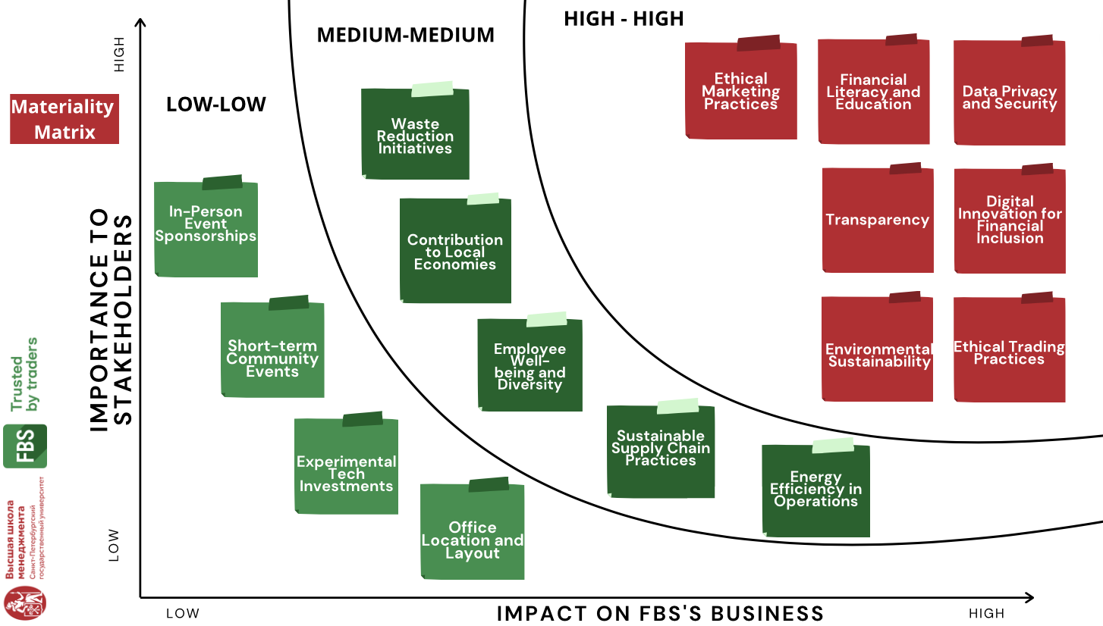
Picture 8. Materiality Matrix for FBS
- High priority areas for FBS CSR:
Environmental Sustainability: This is a high-priority area due to its significance to stakeholders who prioritize eco-friendly practices and its substantial impact on FBS's commitment to reducing its carbon footprint. The prioritization is reinforced by environmental regulations identified in the PESTEL analysis, enhancing FBS's reputation and operational efficiencies. Furthermore, FBS's performance in sustainability initiatives, as indicated in the Key Success Factors, demonstrates its capability and commitment in this area. This alignment is further supported by global shifts towards sustainability, highlighted in the SWOT analysis, making it a strategic focus for the company to leverage for continued growth and stakeholder engagement.
Data privacy and security: This area is of high priority because it is critical for maintaining customer trust and directly impacts FBS's reputation and operational security. The importance of data privacy and security is underscored by strict legal requirements, such as GDPR compliance, highlighted in the PESTEL analysis, which requires strong data protection measures. This priority is also supported with the Key Success Factors, where the commitment to transparency and trust building is highlighted as a crucial element. Additionally, the PESTEL analysis identifies increasing cybersecurity threats as a significant concern, emphasizing the need for FBS to enhance its data protection strategies to safeguard customer information and maintain its market integrity.
Ethical trading practices: These practices are a high priority due to the intense concern from stakeholders regarding the ethics of trading, which significantly influences FBS’s brand integrity and customer loyalty. Adherence to strict political and legal standards, as noted in the PESTEL analysis, is essential for compliance and maintaining a competitive edge. This strengthens FBS’s position in the Key Success Factors, where ethical practices promote brand integrity and help businesses to stand out from competitors. The SWOT analysis further underscores the importance of ethical trading, highlighting it as crucial for avoiding reputational risks and enhancing customer trust.
Financial Literacy and Education: This crucial area directly impacts societal well-being and economic stability by empowering individuals to make informed financial decisions. Through PESTEL analysis, the growing social demand for financial services highlights the importance of such initiatives, which elevate public financial literacy and support regulatory requirements for consumer protection. By enhancing the financial literacy of its customers, FBS fosters trust and loyalty and contributes to the broader goal of creating a more informed and financially savvy consumer base.
Digital Innovation for Financial Inclusion: This high-priority area leverages cutting-edge technologies to enhance access to financial services, significantly broadening FBS's market reach and aligning with stakeholder expectations for inclusivity. Analyzed through the PESTEL framework, technological advancements support FBS's capacity to innovate in digital finance, which is crucial for expanding financial inclusion. Additionally, as identified in the SWOT analysis, the opportunity for fintech innovation offers FBS the potential to lead the market in delivering inclusive financial products and services, thereby enhancing its competitive position and contributing to societal progress.
Transparency: Transparency is a really important factor for both stakeholders and the business itself. As the KSF, transparency has shown itself as one of the main priorities nowadays. People perceive the companies with high levels of transparency as more trustworthy and ethical, which increases the customer loyalty and employee satisfaction (Morsing & Schultz, 2006; Du et al., 2010).
Ethical marketing practices: Ethical marketing is highly valued by stakeholders for fostering transparency and building trust, therefore making it a critical factor in the high-high aspect of the materiality matrix. Moreover, the impact of ethical marketing on FBS's business is significant. FBS can improve its reputation in the market, attract and retain a more loyal customer base by implementing ethical marketing strategies. This, in turn, can lead to increased customer acquisition and retention rates, directly contributing to the company's financial performance and competitive advantage in the market.
- Medium priority areas for FBS CSR:
Waste reduction initiatives: Waste reduction resonates with stakeholders concerned about environmental sustainability, but it is not in the rank as high as direct product or service-related impacts. For FBS, implementing waste reduction strategies promises cost savings and improved operational efficiencies, yet these benefits are not directly related to its core financial services operations, positioning them at a medium level of impact and importance.
Employee well-being and diversity: Employee well-being and diversity are highly valued by internal stakeholders and contribute positively to the company culture and innovation capacity. However, these aspects are often seen as supplementary to the primary business functions from an external stakeholder perspective, thus influencing FBS’s operations to a moderate extent.
Contribution to local economies: Contribution to local economies has medium importance to stakeholders because, while they value corporate social responsibility and appreciate efforts to support community development, they often prioritize other factors like ethical practices and environmental sustainability. For FBS, the impact on business is moderate because while local economic contributions can enhance reputation and foster community goodwill, they do not directly influence core financial operations as significantly as factors like service quality and financial performance.
Sustainable chain practices: Sustainable supply chain practices are important for mitigating risks and enhancing compliance with sustainability standards. For FBS, a service-oriented entity, the direct impact of these practices on day-to-day operations remains medium as its reliance on physical supply chains is less intense than in more goods-centric industries.
Energy efficiency in operations: Energy efficiency is a growing concern among stakeholders due to its environmental implications. In FBS’s case, where operations are not heavily energy-dependent like those in manufacturing, improvements in energy efficiency lead to moderate operational cost savings and have a medium impact on the business’s overall sustainability profile.
- Low priority areas for FBS CSR:
In-person event sponsorship: In-person event sponsorship typically attracts limited ongoing attention from stakeholders, particularly in businesses like FBS where digital interactions predominate. While such sponsorships can enhance local visibility temporarily, they often do not significantly affect the company's broader strategic goals or operations, resulting in a low impact on the business and low importance to stakeholders who prioritize long-term and far-reaching CSR impacts.
Short-term community events: Short-term community events are often localized and do not sustain prolonged engagement or visibility. For FBS, whose operations are global and primarily online, these events might contribute to community goodwill momentarily but do not substantially influence the company’s overall CSR strategy or its operational effectiveness.
Experimental tech investments: Investments in experimental technology have a high risk of non-materialization, making them of limited immediate concern to stakeholders focused on proven impacts and outcomes. For FBS, while these investments could potentially lead to innovation, their current impact on core business activities and CSR commitments remains low, reflecting a more exploratory and less strategic nature.
Office location and layout: The physical location and layout of offices typically have minimal influence on the core operations and strategic direction of digital-centric companies like FBS. Stakeholders are generally more concerned with the company's service quality and operational efficiencies rather than the physical setup, which minimally affects the company’s performance or stakeholder perceptions, especially in a predominantly online business environment.

3.4.2. Porter's Value Chain model for FBS
As it was mentioned in the first chapter, the Porter's Value Chain model is used to identify at which stage of the value creation process each suggested recommendation can be integrated. It is particularly relevant to FBS as it highlights that moving towards sustainable practices across the value chain is not merely about improving public image or compliance but about embedding these practices into every aspect of the business to drive innovation, reduce costs, and create new opportunities for growth, even during economic downturns. The critical stage of 'Making Value Chains Sustainable' shows that realigning the value chain for sustainability can offer substantial strategic benefits (Nidumolu et al., 2013). For FBS, this means evaluating how each activity, from inbound logistics handling data instead of physical goods, through operations that ensure secure and efficient data processing, to outbound logistics that manage client data dissemination, can be optimized to enhance sustainability. These areas impact not only environmental outcomes but also operational efficiency and customer satisfaction. Additionally, marketing and sales strategies need to be aligned with CSR goals to ensure that FBS's commitment to sustainability is effectively communicated and resonates with both current and potential clients. Similarly, after-sales services should reflect the company's dedication to long-term customer support and environmental stewardship.
For FBS, applying Porter’s Value Chain analysis involves a detailed assessment of both primary and support activities to enhance understanding of how value can be created within the organization. Picture 9 shows the opportunities to integrate sustainability into aspects of its business:
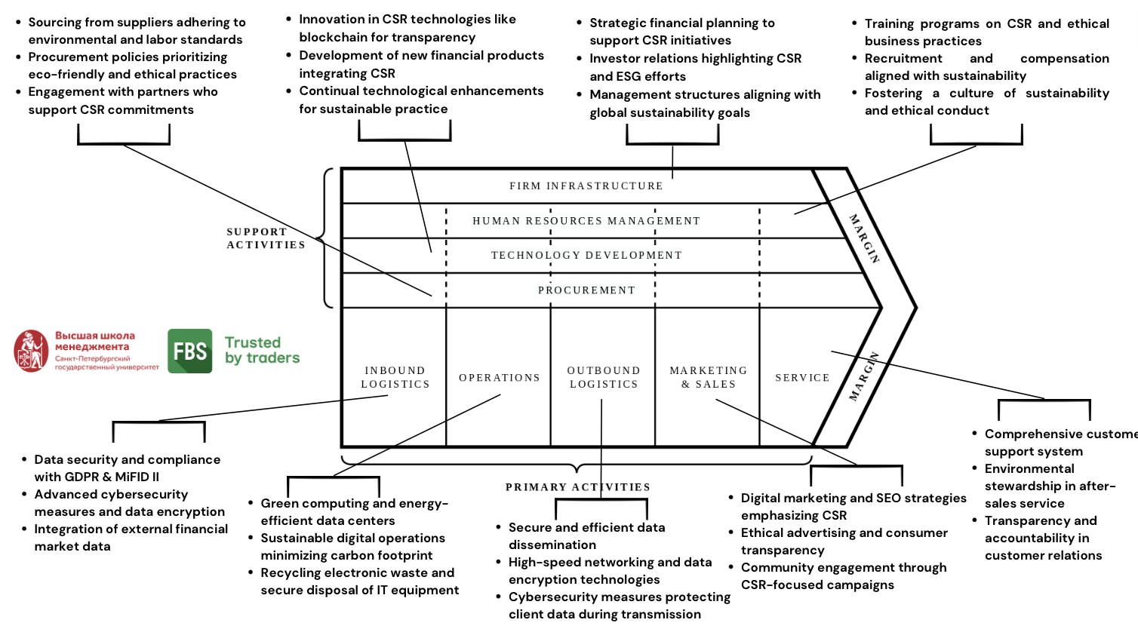
Picture 9. Value chain analysis for FBS
The analysis begins with primary activities which include inbound logistics, operations, outbound logistics, marketing and sales, and service. Each of these activities represents a step in the process from receiving resources to delivering the final service to the consumers, focusing on efficiency and value creation at each point.
Primary Activities
Inbound logistics typically involves the receipt, warehousing, and inventory management of raw materials needed for production. However, for a financial services company like FBS, which primarily deals with digital services and not physical products, inbound logistics takes on a different aspect. In FBS's case, inbound logistics can be understood as the management of data and information that is necessary for providing trading services and customer support.
FBS requires many systems for collecting, storing, and managing vast amounts of financial data, which includes real-time market data, historical trading data, and client information. Effective data management systems ensure that this data is available to be processed accurately and swiftly, which is crucial for maintaining the integrity and efficiency of trading operations. Also, considering the sensitivity of financial data, inbound logistics must also encompass advanced cybersecurity measures to protect against unauthorized access and data breaches. This includes secure data transmission protocols, encrypted storage solutions, and regular security audits. Moreover, compliance with financial regulations is critical in the inbound logistics of data. FBS needs to ensure that the data collection and management practices comply with international finance regulations such as GDPR, MiFID II, and others that apply to financial services. This includes mechanisms for data reporting, transparency, and client data protection. Collaborating with financial market data providers, technology vendors, and other partners requires seamless integration of external data into FBS’s systems. Efficient processes must be in place to ensure that incoming data from these sources is integrated without discrepancies, maintaining data integrity and operational continuity. In the financial trading industry, the value of information is highly time sensitive. FBS must have capabilities for real-time data processing to enable timely updates to trading platforms and ensure that traders have access to the latest market information.
Analyzing the Operations segment of Porter's Value Chain for FBS, particularly in the context of sustainability, involves focusing on areas that affect both the environment and operational efficiency. Given FBS's role as an online financial services provider, the operational sustainability impacts are primarily tied to digital operations rather than traditional industrial operations. Emissions and waste management at FBS primarily involve addressing the energy consumption of data centers that support their trading platforms. While direct emissions are minimal, there is a notable environmental footprint associated with the electricity usage of these digital infrastructures. FBS's strategy can include efficient energy use and handling electronic waste by ensuring proper recycling and disposal of outdated hardware to minimize environmental harm. Regarding biodiversity and ecological impacts, FBS's operations do not directly interfere with natural habitats due to its digital nature. However, the company can still contribute positively by adopting corporate policies that support sustainable infrastructure projects or biodiversity initiatives. Energy optimization is also crucial, particularly in data centers. FBS can enhance its sustainability by implementing green computing practices such as using energy-efficient hardware and opting for cloud services provided by green data centers. Conducting regular energy audits and investing in renewable energy sources for operations can significantly lessen the environmental impact. Lastly, managing hazardous materials mainly involves the safe disposal of IT equipment like electronic components and batteries. FBS can establish policies for handling these materials responsibly and partner with certified e-waste recyclers to manage disposal effectively, reflecting its commitment to environmental stewardship.
The Outbound Logistics for FBS involves a series of sophisticated processes designed to deliver services and information efficiently and securely to clients. Unlike traditional businesses where outbound logistics may involve physical shipment and distribution, FBS's logistics are digital, including the management of data flow rather than tangible goods. The core of FBS's outbound logistics involves the strategic deployment of information technology to manage the seamless transmission of financial data, trading insights, and user communications. This includes everything from the execution of trades on their platform to the real-time dissemination of market analysis and financial news to traders globally. The efficiency of these processes is pivotal, as even minimal delays can affect the timeliness and relevance of information, directly impacting client trading strategies and outcomes. To ensure these digital deliveries are both rapid and reliable, FBS utilizes state-of-the-art data centers equipped with the latest in high-speed networking and data encryption technologies. These facilities are designed to handle large volumes of data with minimal latency, supporting the swift execution of trades, which is crucial in the high-stakes environment of financial trading where seconds can mean significant financial differences. Moreover, FBS invests in cybersecurity measures to safeguard these transmissions, a critical component of outbound logistics in the digital space. Protecting client data from unauthorized access during transmission is a top priority, addressed through advanced encryption protocols and continuous security upgrades. This not only secures the data flow but also enhances client trust in the platform, a crucial asset for maintaining and growing a user base in the competitive financial services sector. Thus, the outbound logistics for FBS are fundamentally about optimizing the digital infrastructure to ensure that every transaction and communication is executed flawlessly. This digital execution strategy is essential for maintaining the reliability and integrity of the trading experience offered by FBS, underscoring its commitment to excellence in every aspect of its service delivery.
In the Marketing and Sales segment of Porter's Value Chain, FBS engages in a comprehensive set of activities tailored to promote its brand and drive sales effectively. This segment is critical for establishing FBS's position in the competitive online trading industry, where effective communication of the brand’s value proposition and customer engagement directly influence business growth. FBS implements a strong marketing strategy that integrates online advertising, content marketing, influence marketing, and strategic partnerships with prominent entities in sports and others. This approach is aimed at building a strong and recognizable brand that appeals to a diverse client base, from beginning traders to professional ones. The marketing efforts are further supported by digital marketing tactics such as search engine optimization (SEO), pay-per-click (PPC) advertising, and active engagement on social media platforms. These efforts ensure FBS maintains high visibility and relevance in a densely populated online marketplace. At this stage, there are several opportunities for integrating CSR initiatives deeply. First of all, incorporating CSR-related keywords and content into digital marketing strategies can enhance SEO efforts. Highlighting FBS's commitment to sustainable practices and community support in online content can improve search engine rankings and attract socially conscious consumers. Secondly, FBS can leverage ethical advertising practices that emphasize transparency about its operations and CSR activities. This approach builds trust with clients and aligns with the growing consumer demand for honesty and corporate responsibility. Finally, partnering with other companies or non-profit organizations to launch community engagement campaigns can significantly enhance FBS's brand image. These campaigns can focus on local community development, educational programs, or environmental initiatives, showcasing FBS's dedication to making a positive impact.
FBS's after-sales service is structured around a comprehensive customer support system that addresses various client needs, from technical assistance and account inquiries to educational support. The service is accessible through multiple channels, including live chat, email, and phone support, ensuring that clients can reach out through their preferred means at any time. This flexibility is crucial in the online trading environment, where timely support can directly impact trading decisions and outcomes. Customer support at FBS is proactive. The platform offers extensive resources such as FAQs, troubleshooting guides, and tutorial videos, which empower clients to resolve common issues independently. This approach optimizes the efficiency of the support team, allowing them to focus on more complex queries. Complaint resolution is another critical component of FBS's after-sales service. The company maintains a transparent and structured process for handling complaints, ensuring that issues are addressed promptly and effectively. This process is vital for maintaining trust and satisfaction, as it demonstrates the company’s commitment to accountability and continuous improvement. Additionally, environmental stewardship is already integrated into FBS's after-sales service. The company prioritizes eco-friendly practices, such as digital documentation to reduce paper waste and promoting the use of energy-efficient technologies in their support operations. This further enhances the overall service by aligning with broader corporate social responsibility goals and catering to environmentally conscious clients.
SUPPORT ACTIVITIES
Support activities within Porter's Value Chain provide essential aspects that enhance the effectiveness and efficiency of primary activities in an organization. For FBS, a company deeply engaged in the digital financial services sector, these supportive activities are crucial to sustaining competitive advantage and ensuring alignment with Corporate Social Responsibility (CSR) goals.
Firm Infrastructure: FBS’s firm infrastructure includes its strategic financial planning, investor relations, and overall management structures that support the company's operations globally. Effective financial management ensures that FBS remains strong against market volatility and is well-positioned to invest in CSR initiatives that require long-term funding. Investor relations are managed to keep shareholders informed and engaged with FBS's CSR commitments, fostering transparency and enhancing investor confidence. This infrastructure supports the company’s ability to respond to environmental, social, and governance (ESG) criteria, which increasingly influence investor decisions (PwC, 2023).
Human Resource Management: Human resource management at FBS is centered around recruiting top talent, providing comprehensive training programs, and developing a compensation system that incentivizes sustainable and ethical business practices. Training programs can be particularly designed here to enhance employee awareness and engagement with CSR initiatives, ensuring that the workforce is aligned with the company’s social and environmental goals. By integrating CSR into the core HR processes, FBS fosters a culture that values sustainability and ethical conduct, which are critical for attracting and retaining employees who are passionate about making a positive impact.
Technology Development: In the rapidly evolving fintech industry, continuous technology development is crucial. At FBS, this involves the design and testing of new financial products, the enhancement of trading platform functionalities, and ongoing material research to ensure data security measures. Market research is regularly conducted to keep abreast of the latest trends in financial technology and customer expectations, which guides the development of technologies that not only improve service delivery but also contribute to sustainable practices. Innovation in CSR technologies like blockchain for transparency also allows FBS to provide clear and verifiable records of its CSR initiatives, building trust with stakeholders. For example, by investing in blockchain technology, FBS can enhance the transparency and efficiency of its CSR activities, such as charitable donations or carbon credit trading. The development of new financial products integrating CSR principles can also attract socially conscious investors and customers, expanding FBS's market reach. These opportunities highlight how FBS can leverage technological development to align with its sustainability goals, thereby enhancing its competitive edge in the fintech industry.
Procurement: The procurement process at FBS involves the strategic sourcing of components, machinery, and services that comply with the company’s CSR standards. This includes selecting suppliers who adhere to environmental best practices and labor laws, which reduces the risk of reputational damage and supports the company’s commitments to sustainability. The procurement strategy is aligned with CSR by opting for eco-friendly office supplies, energy-efficient electronics, and engaging with advertising partners who prioritize ethical marketing practices.
In conclusion, the analysis of FBS's value chain through Porter's framework reveals clear chances to bring sustainability into certain parts of its operations. By embedding CSR initiatives within its value chain, FBS does more than just meet ethical standards, it uses them to boost efficiency and stay competitive. By fully integrating these practices, FBS shows it is committed to making a positive impact on society while growing its business sustainably.

3.4.3. Timeframes for recommendations’ implementation
In order to provide the effective implementation of recommendations outlined earlier, it is essential to establish clear timeframes that align with the significance of each recommendation from Materiality Matrix and its position within the value chain from Porter's Value Chain analysis. Timeframes provide structure and guidance for the correct execution of these recommendations and enable the organization to prioritize initiatives based on their urgency and impact. Therefore, recommendations are categorized into three groups: short-term initiatives, which are to be implemented within 0-6 months; medium-term initiatives, with a timeframe of 6-18 months; and long-term initiatives, spanning 18-36 months. The results are demonstrated in the Picture 10:
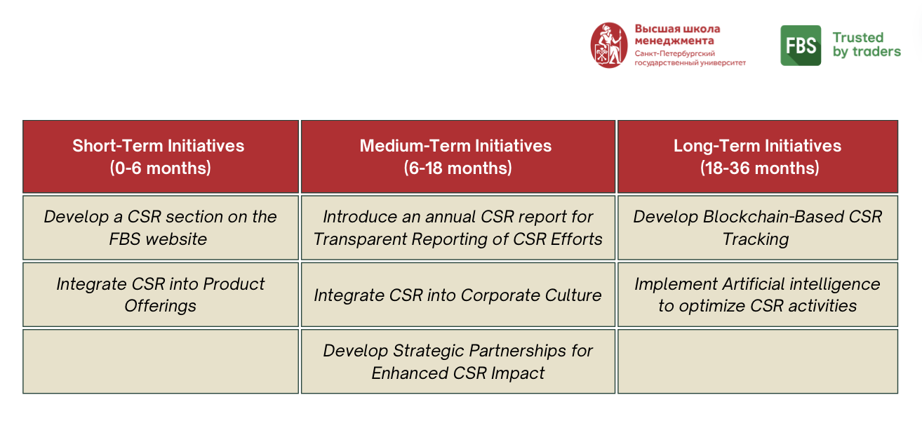Picture 10. Timeframes for recommendations’ implementation
Short-Term Initiatives (0-6 months)
- Develop a CSR section on the FBS website
  - Justification from Materiality Matrix: Addresses Environmental Sustainability, Transparency, and Ethical Marketing Practices.
  - Value Chain Stage: Marketing and Sales.
  - Reasoning: Enhancing the CSR section on the website is a direct way to increase transparency and engage with stakeholders about FBS’s sustainable practices and ethical commitments. This can be achieved relatively quickly and will significantly boost the company’s public CSR profile.
- Integrate CSR into Product Offerings
- Justification from Materiality Matrix: Focuses on Ethical Trading Practices.
- Value Chain Stage: Technology Development.
- Reasoning: Through the integration of CSR principles into its product offerings, such as introducing a special program, where a portion of the trading fees collected is allocated to social and environmental projects, FBS uses its technological capabilities to link CSR directly with its core business functions. This process is part of supportive activities and aligns with the company’s strategic capabilities, making it feasible within a short timeframe.
Medium-Term Initiatives (6-18 months)
- Introduce an annual CSR report
- Justification from Materiality Matrix: Supports Ethical Marketing Practices, Transparency, Environmental Sustainability, and Contribution to Local Economies.
- Value Chain Stage: Marketing and Sales.
- Reasoning: Developing an annual CSR report for Transparent Reporting of CSR Efforts is complex and requires gathering detailed information across various domains. It needs time to collect, verify, and present this data effectively. This effort enhances trust and fulfills stakeholder expectations for in-depth information.
- Integrate CSR into Corporate Culture
- Justification from Materiality Matrix: Employee Well-Being and Diversity.
- Value Chain Stage: Human Resource Management.
- Reasoning: This initiative aims to deepen the CSR understanding and engagement among employees and foster a workplace that values sustainability and inclusivity. This takes time as it involves cultural shifts and development of regular training programs. Furthermore, implementing CSR into corporate culture requires developing new policies and procedures, conducting continuous monitoring, and ensuring alignment with the company's strategic goals.
- Develop Strategic Partnerships for Enhanced CSR Impact
- Justification from Materiality Matrix: Contribution to Local Economies and Ethical Marketing Practices.
- Value Chain Stage: Marketing and Sales.
- Reasoning: Developing new partnerships, especially with NGOs and other organizations, requires careful planning and numerous approvals. Meanwhile, enhancing existing partnerships can be accelerated and can utilize already established connections.
Long-Term Initiatives (18-36 months)
- Develop Blockchain-Based CSR Tracking
- Justification from Materiality Matrix: Considered under Experimental Tech Investments.
- Value Chain Stage: Technology Development.
- Reasoning: This technology initiative involves creating a transparent tracking system for CSR activities. Given its complexity and low level from Materiality Matrix, it is considered a lower priority and requires substantial time to develop and implement effectively.
- Implement Artificial intelligence to optimize CSR activities
- Justification from Materiality Matrix: Also categorized under Experimental Tech Investments.
- Value Chain Stage: Technology Development.
- Reasoning: Using AI to optimize CSR activities is an innovative way to increase the effect of CSR projects. Like blockchain, its development is complex and involves experimental technology, placing it in the long-term category.

3.3.4. Action Plan for initiatives’ implementation
To effectively implement the CSR strategy at FBS, each recommendation is aligned with specific activities within Porter's Value Chain model. This implies that CSR is integrated into operational aspects and enhances the overall strategic objectives of the company. Here is a detailed plan for each recommendation:
- Develop of a CSR section on the FBS website. The recommendation to develop a CSR section on the FBS website falls under the Marketing and Sales stage of the value chain, which is a part of primary activities. The initial step involves collecting and organizing all relevant data on FBS’s CSR activities. Then, it is essential to design and develop a specific CSR section on the website that highlights FBS’s commitments, ongoing initiatives, and their impacts. It should have a user-friendly design that aligns with the overall aesthetics of the FBS website. To make the section engaging, interactive features such as videos, infographics, and downloadable reports should be added. Additionally, the CSR-related content needs to be optimized for search engines to improve its visibility and accessibility. Before the official launch, thorough testing should be conducted to address any technical issues and ensure a seamless user experience. Finally, to promote the new CSR section, marketing campaigns can be launched on social media and through email newsletters.
- Integrate CSR into Product Offerings. Integrating CSR into product offerings should be realized through the Technology Development step in the value chain. First of all, there is the need to develop financial products with CSR benefits, such as eco-friendly investment funds or bonds where a portion of the transaction fees supports community or environmental projects. This development phase should involve researching market trends and customer preferences to identify which CSR-focused financial products would have the most impact. Secondly, it is important to work closely with product development teams to make sure these offerings meet both financial and CSR criteria. Also, sales teams should be trained on the benefits and details of these new products to ensure they can effectively communicate them to clients. Lastly, the acceptance and impact of these products should be monitored and reported as part of regular business reviews.
- Develop an annual CSR report. Developing an annual CSR report is part of the Marketing and Sales stage of the value chain. The initial task involves gathering information about past events, and then creating a detailed report that covers CSR initiatives, spending, outcomes, and future plans. To ensure the report's credibility, it is advisable to engage third-party auditors for verification. After the report is finalized, it can be shared through multiple channels, including the company website, social media platforms, and email newsletters, to maximize its reach. Also, incorporating these reports into annual investor presentations and public disclosures can help in reaching a wider audience. Additionally, organizing webinars and Q&A sessions after the report's release will provide an opportunity to address stakeholder questions and gather feedback effectively.
- Integrate CSR into Corporate Culture. To integrate CSR into corporate culture, the focus shifts to the Human Resources Management stage of the value chain. Primarily, the task includes developing and launching a series of CSR training modules specifically for employees at all levels. These modules should cover the company's CSR goals, the importance of social responsibility, and practical ways employees can contribute to these initiatives. Then, it is crucial to include CSR performance as a component in employee appraisal systems to foster engagement and encourage contributions. Furthermore, organizing CSR days where employees actively participate in CSR activities can help establish a personal connection to the initiatives. Lastly, establishing a feedback poll where employees can contribute ideas for new CSR activities or improvements to existing ones will foster a sense of involvement in the CSR efforts.
- Develop Strategic Partnerships for Enhanced CSR Impact. To leverage partnerships and expand the reach of CSR initiatives, the focus lies within the Marketing and Sales. Firstly, it involves identifying and engaging with NGOs and other organizations that resonate with FBS’s CSR objectives, exploring potential partnerships. The next step is to develop joint projects that capitalize on shared expertise and resources, particularly focusing on community development initiatives. Additionally, creating a structured framework for continuously evaluating and optimizing the effectiveness of these partnerships is essential. Finally, it is crucial to control that partnerships are prominently featured in CSR communications and reporting and collaborative efforts are showcased.
- Develop Blockchain-Based CSR Tracking. The process of implementing blockchain-based CSR tracking should be realized through the Technology Development stage of the value chain. To start with, it is important to conduct research to identify suitable blockchain technology compatible with the existing CSR tracking systems. Following this, there should be the testing of the technology in a small-scale project to refine its implementation before full deployment. During this phase, it is crucial to gather feedback from all involved stakeholders to optimize the system. Next, staff members should receive training on utilizing the technology and understanding its benefits. This training should cover both the technical aspects of the system and its benefits, such as enhanced transparency and trust in CSR reporting. Then, the final step is to launch the blockchain system to track all CSR activities, offering stakeholders real-time access to verified data.
- Implement Artificial Intelligence for Optimizing CSR. Last recommendation to implement artificial intelligence for optimizing CSR aligns with the Technology Development stage of the value chain. The first action step is to develop AI tools to analyze large datasets related to CSR activities for insights into effectiveness and areas for improvement. Then, integrate AI tools with existing data management systems to enhance decision-making processes. This integration will enhance decision-making processes by providing real-time data analysis and predictive insights. AI can help identify trends, forecast outcomes, and suggest optimal strategies for CSR initiatives. After this, it is important to regularly review this to understand AI’s impact and refine its applications based on ongoing results. Also, it will be beneficial to communicate AI-driven enhancements in CSR efforts to stakeholders to demonstrate the company's commitment to innovation in its CSR efforts.
Each action step is strategically planned to ensure that CSR initiatives are sustainable and impactful, resonating throughout FBS’s value chain and stakeholder network.

3.4.5. Risk Analysis
Finally, to effectively implement the recommendations proposed for the CSR strategy of FBS, a risk assessment is conducted. This assessment is based on the risk scenario matrix with two axes: the probability of the risk occurring and the severity of its impact. The first axis evaluates how likely it is that the risk will happen, ranging from rare to almost certain. The second axis measures the severity of the outcomes if the risk does occur, ranging from insignificant to severe. Picture 11 reveals the results of the risk scenario matrix, taking into consideration each proposed recommendation:
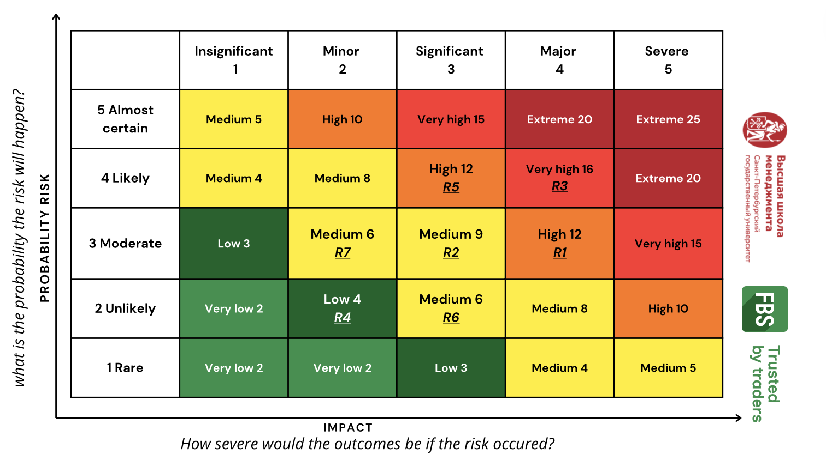

Picture 11. Risk Scenario Matrix for recommendations’ implementation
  - Recommendation 1: Develop Blockchain-Based CSR Tracking
- Risk Level: High (12)
- Probability: Moderate - The implementation of blockchain technology has moderate probability as it involves technical challenges and requires stakeholder buy-in, which can be unpredictable.
- Impact: Major - Any failure in implementing blockchain for CSR tracking could damage stakeholder confidence. Blockchain is often associated with transparency and reliability. Therefore, a failed implementation or security breach could lead to a loss of trust from stakeholders, negatively impacting the company's reputation and stakeholder relationships.
  - Recommendation 2: Implement Artificial Intelligence to Optimize CSR Activities
- Risk Level: Medium (9)
- Probability: Moderate – Integrating AI involves complex data management and analytics, which might face technical and ethical challenges.
- Impact: Significant – The impact is significant because errors or biases in AI algorithms could have substantial consequences. Misallocated resources due to incorrect AI predictions or decisions can result in inefficient CSR activities, wasting both time and money. Moreover, if stakeholders perceive the AI system as biased or unfair, it could damage the company's reputation and damage trust, especially if the AI decisions negatively impact certain groups or fail to meet ethical standards.
  - Recommendation 3: Integrate CSR into Product Offerings
- Risk Level: Very High (16)
- Probability: Likely – This recommendation implies altering existing products or creating new ones, which carries a significant risk of customer rejection or market misfit.
- Impact: Major – Failure in successfully integrating CSR into products could result in substantial financial loss and damage to brand image.
  - Recommendation 4: Develop a CSR Section on the FBS Website
- Risk Level: Low (4)
- Probability: Unlikely – The development and maintenance of website content are typically well within a company’s control.
- Impact: Minor – While important for transparency, the direct impact on the company’s operational or financial status is relatively limited.
  - Recommendation 5: Introduce an Annual CSR Report
- Risk Level: High (12)
- Probability: Likely – Gathering comprehensive and accurate CSR data annually is a complex task that involves coordination across various departments and external parties.
- Impact: Significant – The annual report plays a crucial role in how stakeholders perceive the company’s commitment to CSR. Inaccuracies or omissions can significantly affect the company's reputation.
  - Recommendation 6: Develop Strategic Partnerships for Enhanced CSR Impact
- Risk Level: Medium (6)
- Probability: Unlikely – While forming partnerships involves negotiation, the risks are generally lower as both parties aim to benefit mutually.
- Impact: Significant – Strategic partnerships can greatly increase the effectiveness of CSR activities, but mismatches in goals or failures in cooperation can negatively impact project outcomes.
  - Recommendation 7: Integrate CSR into Corporate Culture
- Risk Level: Medium (6)
- Probability: Moderate – Changing corporate culture is a gradual process that faces inherent resistance and requires ongoing commitment.
- Impact: Minor – Initially, the impact on day-to-day operations may be not seen at first, but over time, a strong CSR culture can lead to improved employee morale and brand loyalty.
From a business perspective, the risks associated with CSR initiatives are not severe. CSR is a supportive activity that enhances the company's brand, builds stakeholder trust, and aligns with sustainable development goals. Each recommendation's risks can be mitigated through well-planned strategies, such as appropriate training, reliable data management, ongoing monitoring and evaluation. The successful implementation of these recommendations will not only fulfill FBS’s social responsibilities but also create long-term value for the company and its stakeholders. By addressing these risks proactively, FBS can ensure its CSR initiatives contribute positively to both its business performance and social impact.

Summary of Chapter 3
Coming to the end, Chapter 3 of this thesis provides a detailed look at the proposed Corporate Social Responsibility (CSR) strategy for FBS. It starts with a PESTEL analysis, exploring external factors that influence the financial services industry. This provides better strategic planning and is essential to accurate SWOT-analysis. Following that, a Sustainability SWOT analysis is conducted, combining findings from the PESTEL and KSF analyses to reveal FBS's strengths, weaknesses, opportunities, and threats in terms of sustainability. Based on these analyses, the chapter outlines strategic directions and specific recommendations for FBS's CSR activities. These recommendations are carefully designed to fit within the company’s operations, guided by Porter's Value Chain model. This model helps understand where CSR efforts can be best integrated into the company's processes to add the most value. The Materiality Matrix is also introduced. This tool helps prioritize CSR activities by showing which are most important to both stakeholders and the business. The chapter then details how to implement these strategies, setting timelines for each CSR initiative and creating a detailed action plan. Finally, potential risks with the help of risk scenario matrix are revealed. This ensures FBS is prepared to handle challenges that might come up as it implements its CSR strategies. In summary, Chapter 3 has a structured approach to integrate CSR into FBS's core strategies, aiming to enhance business value and build trust with stakeholders. By aligning CSR with the company's strategic goals and the insights gained from various analytical tools, FBS is set to meet its stakeholders' evolving expectations and secure sustainable growth and competitiveness in its sector.

Conclusion
In conclusion, this diploma paper on 'Corporate Social Responsibility Strategy for FBS Company' has provided an in-depth understanding of the current CSR landscape within FBS and proposed strategic recommendations to enhance its effectiveness. This research was structured to address several key aspects, including the theoretical foundation of CSR, the current state of FBS’s CSR initiatives, industry analysis, and the development of a strategic CSR framework, taking into account FBS’s operational context.
Recognizing the managerial problem that FBS currently faces challenges in optimizing its CSR initiatives to enhance social impact and improve business performance, the present study sought to explore CSR at FBS with a focus on understanding how to integrate it further and better into the firm's strategies and operations. The main goal of this bachelor diploma paper was to create recommendations for CSR strategy development and its implementation for FBS.
At the beginning of the thesis, the main theoretical concepts to CSR which would be used further were introduced. Prominent researchers by Porter and Kramer (2007; 2011), and Halme and Laurila (2009) were highlighted as well. After the theoretical background, a detailed overview of the current CSR state at FBS was provided, considering all the internal materials and interview takeaways. It revealed that FBS focuses on its alignment with the United Nations Sustainable Development Goals, particularly focusing on Goal 4: Quality Education, and Goal 11: Sustainable Cities and Communities. The main goal of the current CSR efforts now is to enhance brand awareness, increase its outreach on top media outlets and strengthen the company's market position. Moreover, FBS has several partners in Tier-1 regions with the help of which it realizes its CSR activities: Education Africa (South Africa), Dignity for Children (Malaysia), SUKA Society (Malaysia), and HSDF (Africa). The activities under each partnership were described in more detail in the paper.
To get a systematic analysis and a clear picture of FBS's current state of CSR, the framework developed by Minna Halme and Juha Laurila (2009) was chosen as the guiding methodology. Taking into consideration the proposed dimensions for classifying CR types, it was found out that currently, FBS's Corporate Social Responsibility (CSR) initiatives predominantly align with the Philanthropy type of CR action. However, according to Halme and Laurila (2009), this traditional form of CR does not fully leverage the potential to drive corporate innovation, enhance competitiveness, and secure long-term sustainability. Therefore, the shift towards CR Integration and Innovation promises more significant financial returns and deeper societal impacts.
After understanding and analyzing current CSR activities at FBS, the CSR practices of the main competitors were discovered. Following the advice of company staff during the interview, four main competitors were selected for the analysis: Exness, XM, Octa, and Olymp Trade. Later, the KSF analysis was performed to assess how the companies compete in the market, considering both general business success factors and those specifically linked to CSR. During the analysis, it revealed that FBS is at a medium level for each factor except technological innovation, in which there is an absence of development. Although a lot has been done by FBS in support of social causes through its CSR initiatives, there is a need to reevaluate and realign such initiatives in a manner that they are closely related to operational and strategic objectives.
In Chapter 3, key recommendations for the Corporate Social Responsibility (CSR) strategy at FBS were proposed. The analysis of the external environment was conducted with the help of PESTEL. It provided the foundation for a SWOT analysis that was developed after conducting a thorough analysis of the trading industry's macroclimate, its competitive dynamics, and the key players. The sustainability type of analysis was chosen as it corresponds to the goal of the research, where strengths and weaknesses were found out as well as the opportunities and threats. The secondary sustainability SWOT is crucial to identify and come up with relevant strategies. Six strategies for CSR at FBS were formulated: Integrate Fintech Innovations into CSR, Align Disconnected CSR Initiatives to be integral to FBS's core business strategy, Improve Visibility of CSR Commitments, Use Strategic Partnerships to Counter Competitive CSR Approaches, Differentiate with Innovative CSR Initiatives, and Enhance CSR Impact in Face of Rising Consumer Expectations. Then, under each strategy, the recommendations were proposed and their relevance was justified: develop blockchain-based CSR tracking, implement artificial intelligence (AI) to optimize CSR activities, integrate CSR into product offerings, develop a CSR section on the FBS website, introduce an annual CSR report, develop strategic partnerships for enhanced CSR impact, and integrate CSR into corporate culture.
To identify the crucial aspects for both the organization’s strategy and its various stakeholders, a materiality matrix was created. It was used to detect what is important for the organization’s strategy and for its different stakeholders, and also to identify and prioritize the most significant aspects for FBS. Then, the value chain analysis using Porter's Value Chain approach was conducted to identify at which stage of the value creation process each suggested recommendation can be integrated. This framework includes primary activities from inbound logistics to service and support activities from procurement to firm infrastructure. After that, the timeframes for recommendations implementation are also elaborated on in the thesis. Taking into account the results of the materiality matrix and value chain analysis, each recommendation was distributed to one of the following intervals: short-term initiatives, which are to be implemented within 0-6 months; medium-term initiatives, with a timeframe of 6-18 months; and long-term initiatives, spanning 18-36 months. Under short-term initiatives, there is the recommendation to develop a CSR section on the FBS website and integrate CSR into product offerings, which is crucial and can be realized considering the usual processes at the company. Then, under medium-term initiatives, they are introducing an annual CSR report, integrating CSR into corporate culture, and developing strategic partnerships for enhanced CSR impact. Finally, blockchain-based CSR tracking and artificial intelligence in CSR activities are long-term activities as they are considered a low priority and require substantial time to develop and implement effectively.
Lastly, it is critical to understand the risks to effectively implement recommendations. For this task, the risk scenario matrix was used as it provides the background with the probability of the risk occurring and the severity of its impact. Elaborating on results, it is seen that the lowest risk has the recommendation to develop a CSR Section on the FBS Website and the highest the Integration of CSR into Product Offerings as failure in successfully integrating CSR into products could result in substantial financial loss and damage to brand image. Coming to the end, the goal of the research is achieved with the thorough analysis and proposed recommendations for the CSR strategy. The frameworks used in the paper are justified and align with the research objectives. The results were presented to company representatives, including the Head of PR under which the CSR currently exists, and received positive feedback. Some of the strategies, including the short-term ones, are already under development.

References
- Eser, A. (2024, January 16). Corporate Social Responsibility Statistics in 2024. ZipDo. https://zipdo.co/statistics/corporate-social-responsibility/
- Michael E. Porter and Mark R. Kramer. (2006). Strategy and Society: The link between competitive advantage and corporate social responsibility. In Harvard Business Review. https://www.hbr.org
- Porter, M. E., & Kramer, M. R. (2011). Creating shared value. In Harvard Business Review: Vol. January–February.
- Du, S., Bhattacharya, C., & Sen, S. (2010). Maximizing business returns to Corporate Social Responsibility (CSR): the role of CSR communication. International Journal of Management Reviews, 12(1), 8–19.
- Halme, M., & Laurila, J. (2009). Philanthropy, integration or innovation? Exploring the financial and societal outcomes of different types of corporate responsibility. Journal of Business Ethics (Print), 84(3), 325–339.
- Godfrey, P. C. (2005). The relationship between corporate philanthropy and shareholder wealth: A Risk Management perspective. the Academy of Management Review, 30(4), 777–798.
- Nidumolu, Ram, Coimbatore K. Prahalad, and Madhavan R. Rangaswami. "Why sustainability is now the key driver of innovation." Harvard business review 87.9 (2009): 56-64.
- Porter, M. E. (1985). Competitive advantage: creating and sustaining superior performance. http://ci.nii.ac.jp/ncid/BA00852365
- FBS and Education Africa Join Forces to Empower Youth in Orange Farm. (2023). Investing.com. https://za.investing.com/news/fbs-and-education-africa-join-forces-to-empower-youth-in-orange-farm-2873123
- Why Businesses Need to Support STEM – The FBS’s Case. The Citizen. (2023, November 1). https://www.citizen.co.za/news/why-businesses-need-to-support-stem-the-fbss-case/
- SUKA Society. (2016). Empowered2Teach Report 2016. http://www.sukasociety.org/wp-content/uploads/2015/08/Empowered2Teach-Report-2016.pdf
- Burke, L., & Logsdon, J. M. (1996). How corporate social responsibility pays off. Long Range Planning, 29(4), 495–502.
- Husted, B. W., & Salazar, J. (2006). Taking Friedman seriously: maximizing profits and social performance*. Journal of Management Studies, 43(1), 75–91.
- Social responsibility | Exness Careers. (2024). https://exness-careers.com/social-responsibility/
- Apofeed. (2023, May 31). Exness gives Scholarships to three University of Cape Town students. African Business. https://african.business/2023/05/apo-newsfeed/exness-gives-scholarships-to-three-university-of-cape-town-students
- Fm. (2023, November 24). Exness donates Fire-Detecting drones to protect Cyprus forests. Financial and Business News | Finance Magnates. https://www.financemagnates.com/thought-leadership/exness-donates-fire-detecting-drones-to-protect-cyprus-forests/#
- XM. (2019, July 29). XM Corporate Social Responsibility | XM CSR. XM – Global Broker in Forex and CFD Trading. https://www.xm.com/xm-csr
- Bryan. (2023, September 4). XM contributes to the betterment of senior citizens in Singapore | Salary.SG - Your Salary in Singapore. Salary.sg - Your Salary in Singapore | All About Income, Jobs, Career, and Investment in Singapore. https://www.salary.sg/2023/xm-contributes-to-the-betterment-of-senior-citizens-in-singapore/#google
- Yocelyn, K. (2024, April 11). XM Collaborates with EDF to Support Education for Disadvantaged Students. Brokerxplorer. https://www.brokerxplorer.com/news/xm-collaborates-with-edf-to-support-education-for-disadvantaged-students-5738
- Forex broker ECN, online Forex trading, stock trading — Octa. (2024). Octa. https://www.octafx.com/
- The latest CSR trend in fintech: how technological companies help build a more sustainable future. (2023, February 9). Media Outreach. https://www.media-outreach.com/news/malaysia/2023/02/09/198004/the-latest-csr-trend-in-fintech-how-technological-companies-help-build-a-more-sustainable-future/
- Baliprod. (2023, April 26). BALIPROD x OCTAFX Ramadan Campaign. YouTube. https://www.youtube.com/watch?v=I2RIQ8ZcfsU
- Team, O. T. (2022, August 16). Charity Activities from Olymp Trade – Official Olymp Trade Blog. https://blog.olymptrade.com/community/charity-activities-from-olymp-trade
- FSI predictions 2023. Deloitte Insights. https://www2.deloitte.com/us/en/insights/industry/financial-services/financial-services-industry-predictions.html#product-innovations
- Fombrun, C. & Shanley, M. (1990). What’s in a name? Reputation building and corporate strategy on JSTOR. (1990). www.jstor.org. https://www.jstor.org/stable/256324
- The Impact of Corporate Sustainability on Organizational Processes and Performance. (2014). Management Science Journal. https://www.hbs.edu/ris/Publication%20Files/SSRN-id1964011_6791edac-7daa-4603-a220-4a0c6c7a3f7a.pdf
- Epstein, M. J., & Roy, M. (2001). Sustainability in Action: Identifying and measuring the key performance drivers. Long Range Planning, 34(5), 585–604. https://doi.org/10.1016/s0024-6301(01)00084-x
- Carroll, A. B., & Shabana, K. M. (2010). The Business Case for Corporate Social Responsibility: A review of concepts, research and practice. International Journal of Management Reviews, 12(1), 85–105. https://doi.org/10.1111/j.1468-2370.2009.00275.x
- Potocan, V. (2021). Technology and corporate social responsibility. Sustainability, 13, 8658. https://doi.org/10.3390/su13158658
- Global Trade Liberalization and the Developing Countries -- An IMF issues brief. (2001, November 8). https://www.imf.org/external/np/exr/ib/2001/110801.htm#:~:text=URL%3A%20https%3A%2F%2Fwww.imf.org%2Fexternal%2Fnp%2Fexr%2Fib%2F2001%2F110801.htm%0AVisible%3A%200%25%20
- The global foreign exchange market in a higher-volatility environment. (2024). https://www.bis.org/publ/qtrpdf/r_qt2212f.htm
- Lessons for the foreign exchange market from the global financial crisis. (2009, November 6). CEPR. https://cepr.org/voxeu/columns/lessons-foreign-exchange-market-global-financial-crisis
- Markets Committee, & Debelle, G. (2011). High-frequency trading in the foreign exchange market. In Bank for International Settlements, Bank for International Settlements. https://www.bis.org/publ/mktc05.pdf
- Bollerslev, T., & Melvin, M. (1994). Bid—ask spreads and volatility in the foreign exchange market. Journal of International Economics, 36(3–4), 355–372. https://doi.org/10.1016/0022-1996(94)90008-6
- 2017 Cone Communications CSR STUDY. (2017). Cone Communications. https://www.cbd.int/doc/case-studies/inc/cs-inc-cone-communications-en.pdf
- Gsifadmin_Dbuser. (2023). Global Sustainable Investment Review finds US$30 trillion invested in sustainable assets. https://www.gsi-alliance.org/global-sustainable-investment-review-finds-us30-trillion-invested-in-sustainable-assets/
- Simon, J. (2024, January 10). Most millennial and Gen Z investors say crypto is part of their retirement strategy. Money. https://money.com/gen-z-millennials-invest-crypto-retirement/
- Millennials prefer investing through tech firms. (2021, September 3). FTAdviser. https://www.ftadviser.com/investments/2021/09/03/millenials-prefer-investing-through-tech-firms/
- PricewaterhouseCoopers. (2020). Blockchain technologies could boost the global economy US$1.76 trillion by 2030 through raising levels of tracking, tracing and trust. PwC. https://www.pwc.com/gx/en/news-room/press-releases/2020/blockchain-boost-global-economy-track-trace-trust.html
- Business Insider (2021b, May 3). intelligence/winning-strategies-for-ai-in-banking. https://www.businessinsider.com/intelligence/winning-strategies-for-ai-in-banking?international=true&r=US&IR=T
- Freeze, D. (2023, January 11). Cybercrime to cost the world 8 trillion annually in 2023. Cybercrime Magazine. https://cybersecurityventures.com/cybercrime-to-cost-the-world-8-trillion-annually-in-2023/
- IBM Security. IBM Security: Future of identity Study. https://espas.secure.europarl.europa.eu/orbis/system/files/generated/document/en/security-ibm-security-solutions-wg-research-report-22012422usen-20180124.pdf
- Consumers are in fact buying sustainable goods: Highlights from new research. (2023, May 18). McKinsey & Company. https://www.mckinsey.com/industries/consumer-packaged-goods/our-insights/consumers-are-in-fact-buying-sustainable-goods-highlights-from-new-research
- Hu, J., Wu, H., & Ying, S. X. (2022). Environmental regulation, market forces, and corporate environmental responsibility: Evidence from the implementation of cleaner production standards in China. Journal of Business Research, 150, 606–622. https://doi.org/10.1016/j.jbusres.2022.06.049
- Data centres & networks - IEA. (2023). IEA. https://www.iea.org/energy-system/buildings/data-centres-and-data-transmission-networks
- Greggwirth. (2023, May 25). 2023 Cost of Compliance Report: Regulatory burden poses operational challenges for compliance officers - Thomson Reuters Institute. Thomson Reuters Institute. https://www.thomsonreuters.com/en-us/posts/investigation-fraud-and-risk/2023-cost-of-compliance-report/
- Listed, N. (2023, January 30). EU authorities issued 1.6B euros in GDPR fines over past year. International Association of Privacy Professionals. https://iapp.org/news/a/eu-authorities-issue-1-6b-in-gdpr-fines-over-past-year/
- Hopkinson, I. (2024, February 5). 50 ESG statistics you need to know in 2024. KEY ESG. https://www.keyesg.com/article/50-esg-statistics-you-need-to-know-in-2024
- Deloitte. (2022). Fintech, sustainability, and ESG reporting: Is now the time for fintechs to become early movers in adopting a formal ESG strategy? https://www2.deloitte.com/content/dam/Deloitte/us/Documents/audit/us-audit-fintech-sustainability-and-esg-reporting.pdf
- Blockchain: Democratized trust. (2016). Deloitte Insights. https://www2.deloitte.com/us/en/insights/focus/tech-trends/2016/blockchain-applications-and-trust-in-a-global-economy.html
- Khan, A., Mehmood, K., & Ali, A. (2024). Maximizing CSR impact: Leveraging artificial intelligence and process optimization for sustainability performance management. Corporate Social-responsibility and Environmental Management. https://doi.org/10.1002/csr.2832
- Morsing, M., & Schultz, M. (2006). Corporate social responsibility communication: Stakeholder information, response and involvement strategies. Business Ethics: A European Review.
- PwC. (2021). PWC’s Sports Survey 2021. PwC. https://www.pwc.ch/en/insights/sport/sports-survey-2021.html
- Cone Communications. (2016). 2016 Cone Communications Millennial Employee Engagement Study. https://calisanbagliligi.files.wordpress.com/2019/10/75bb1-2016conecommunicationsmillennialemployeeengagementstudy_pressreleaseandfactsheet.pdf
- PricewaterhouseCoopers. (2024). Consumers willing to pay 9.7% sustainability premium, even as cost-of-living and inflationary concerns weigh: PwC 2024 Voice of the Consumer Survey. PwC. https://www.pwc.com/gx/en/news-room/press-releases/2024/pwc-2024-voice-of-consumer-survey.html#
- International Integrated Reporting Council. (2013). Materiality Background Paper. https://integratedreporting.ifrs.org/wp-content/uploads/2013/03/IR-Background-Paper-Materiality.pdf
- The Global Reporting Initiative (GRI). (2019). The GRI Standards: A Guide for Policy makers. In The GRI Standards: A Guide for Policy Makers. https://www.globalreporting.org/media/nmmnwfsm/gri-policymakers-guide.pdf
- PricewaterhouseCoopers. (2023). 94% of investors believe corporate reporting on sustainability performance contains unsupported claims: PwC 2023 Global Investor Survey. PwC. https://www.pwc.com/gx/en/news-room/press-releases/2023/pwc-2023-global-investor-survey.html
- Key sustainability trends that will drive decision-making in 2023. S&P Global. https://www.spglobal.com/esg/insights/featured/special-editorial/key-sustainability-trends-that-will-drive-decision-making-in-2023
- Morsing, M., & Schultz, M. (2006). Corporate social responsibility communication: Stakeholder information, response and involvement strategies. Business Ethics: A European Review.

Appendix
Appendix 1: Interview Script
The interview was held via Google Meet conference on February 18. My colleagues, Asya Zaitzeva, the Head of PR & Events, and Maria Schukina, CSR & Events manager answered my questions about CSR activity at FBS. Moreover, after the meeting they provided all necessary internal documents for my diploma paper on "Corporate Social Responsibility Strategy for FBS Company".
Interviewer: Dear colleagues, my first question is about the current state of CSR at FBS and why there is a need to optimize it, as you mentioned earlier?
Asya Zaitzeva: Right now, FBS is facing challenges in optimizing its CSR initiatives to boost social impact and improve business performance. We need to find better ways to integrate CSR into the company’s core strategy and operations. This way, FBS can fulfill its social responsibilities and also benefit the business and its stakeholders.
Interviewer: Thank you, Asya. What are the key areas FBS focuses on?
Asya Zaitzeva: In our CSR efforts, FBS mainly focuses on promoting quality education and building sustainable cities and communities. We concentrate on these areas to make a meaningful impact and align with our company values.
Interviewer: When did FBS start organizing CSR activities in a structured way?
Maria Schukina: Since 2014, FBS has shown a strong commitment to social welfare through various charitable initiatives. Every year, we participate in charity events during Ramadan. However, it was only in the autumn of 2023 that we developed a more structured approach to CSR by creating a CSR & Events team within our PR Department.
Interviewer: What is the main purpose of CSR in the company currently?
Maria Schukina: The main purpose of CSR activities at FBS is to strengthen our reputation as a reliable and socially responsible brand. So, each CSR initiative has a strategic marketing goal as stated by top management, and they are aiming at PR effects, with success measured by outreach.
Interviewer: In which regions do you organize your CSR activities?
Maria Schukina: We focus on Tier 1 regions.
Interviewer: Who are your partners for organizing events?
Maria Schukina: We work with several partners, mainly nonprofit organizations in our key regions. I will share more detailed information about each activity and our partners after the meeting.
Interviewer: Thanks a lot, Maria. What was the best CSR activity by FBS that you liked the most?
Maria Schukina: One of the most significant efforts was in February 2024 with Education Africa. We focused on restoring the school clock at Masibambane College in Orange Farm. The restoration of "The FBS Clock" helped students keep track of their schedules. It's a proud moment to know that objects named after our company are on the other side of the world.
Interviewer: I totally agree with you. I am really proud to be part of FBS and support making people happier and the world better. I have one last question - can you name the main competitors of FBS that are relevant to consider during the competitive analysis?
Asya Zaitzeva: Our main competitors are Exness, XM, Octa, and Olymp Trade. They are all direct competitors and leaders in the industry. They also have CSR initiatives as I know.
Interviewer: Thanks a lot for this interview and all the details provided.
Maria Schukina: Feel free to reach out! As promised, we are ready to send you all the materials you need.
Appendix 2:

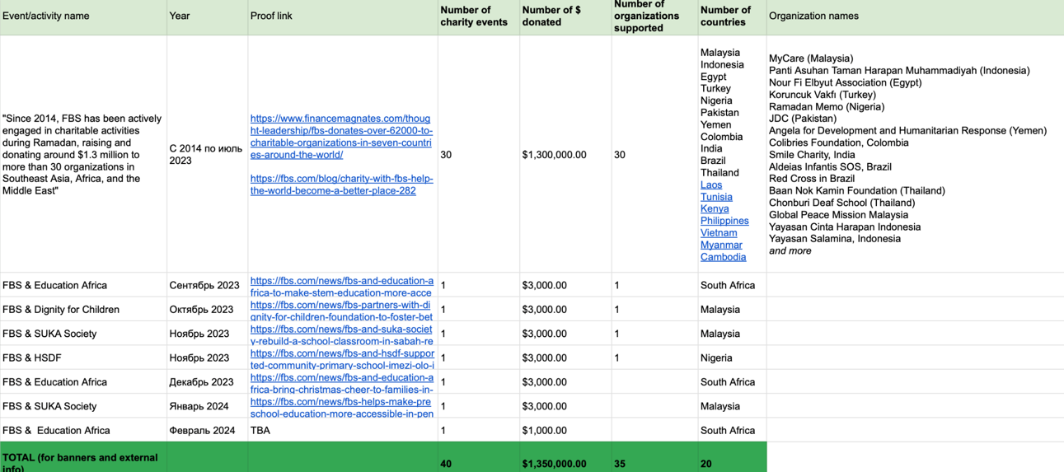

Appendix 3:
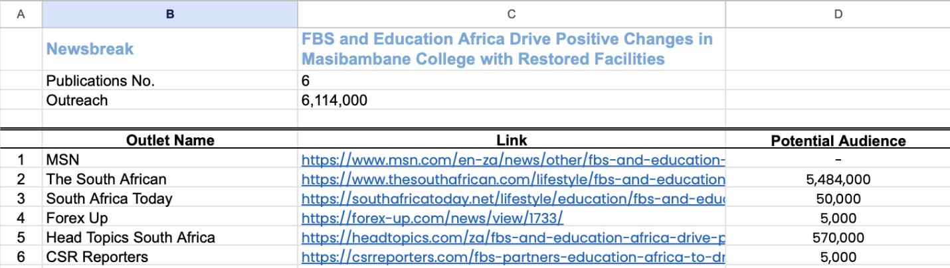
Appendix 4:
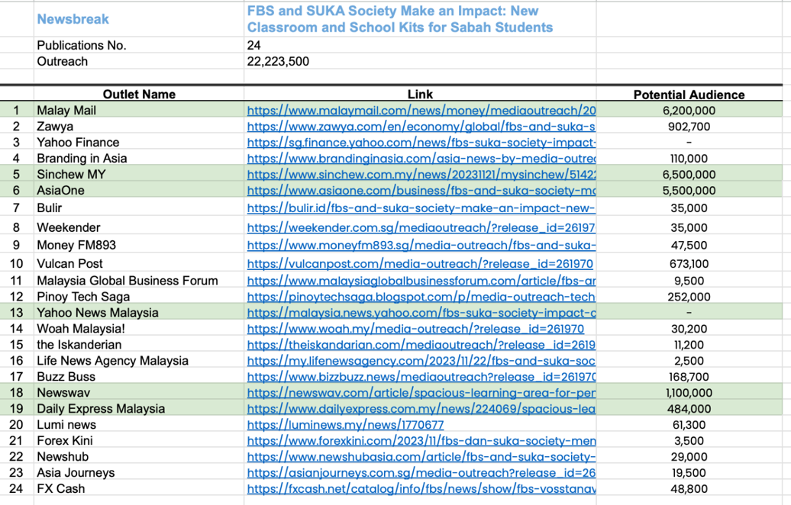
Appendix 5:
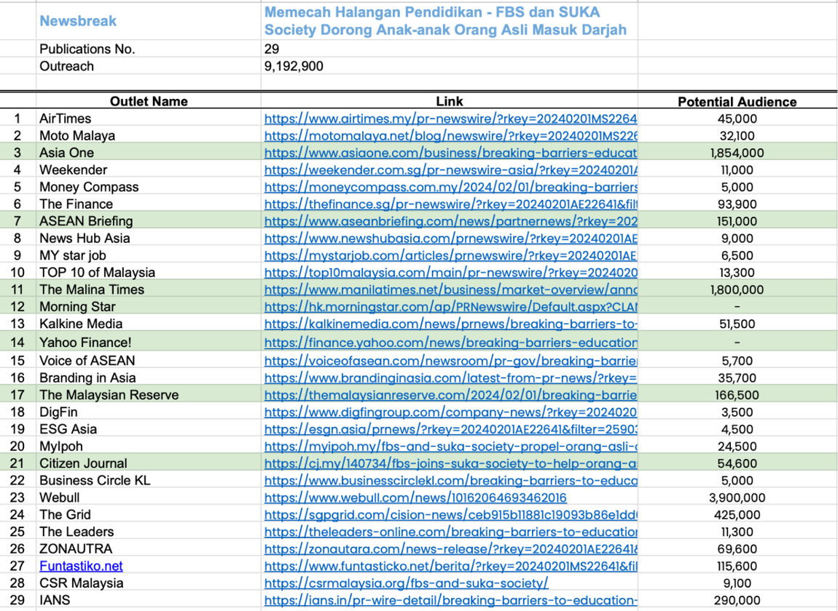
Appendix 6:
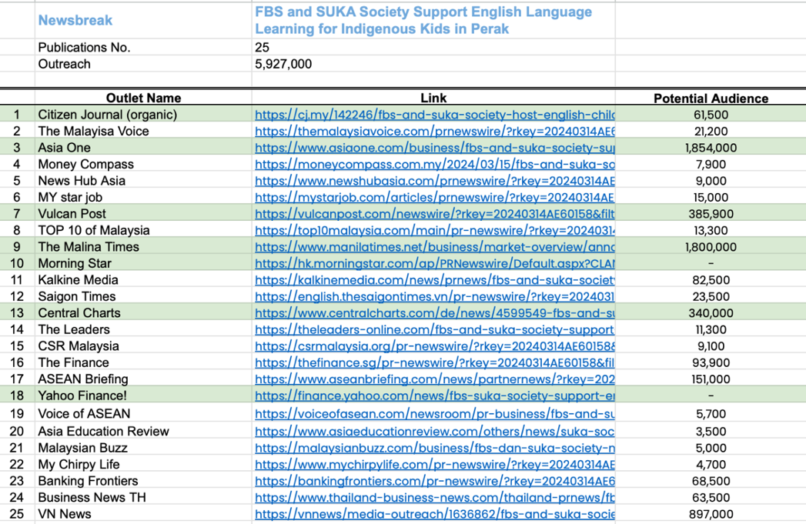
Appendix 7:
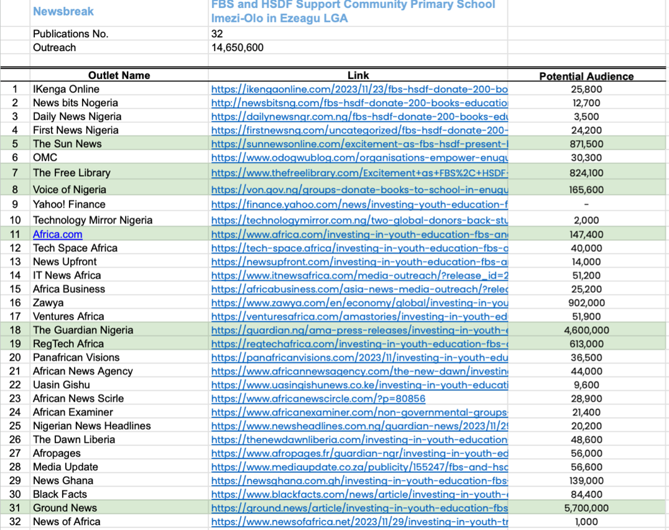

Appendix 8:
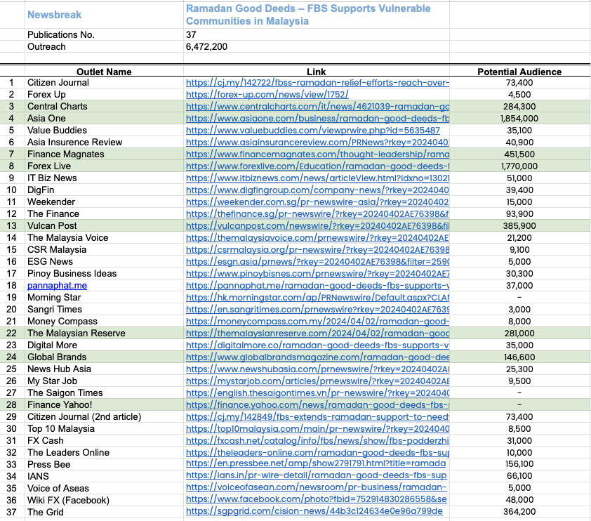

Eser, A. (2024, January 16). Corporate Social Responsibility Statistics in 2024. ZipDo. https://zipdo.co/statistics/corporate-social-responsibility/
Michael E. Porter and Mark R. Kramer. (2006). Strategy and Society: The link between competitive advantage and corporate social responsibility. In Harvard Business Review. https://www.hbr.org
Porter, M. E., & Kramer, M. R. (2011). Creating shared value. In Harvard Business Review: Vol. January–February.
Du, S., Bhattacharya, C., & Sen, S. (2010). Maximizing business returns to Corporate Social Responsibility (CSR): the role of CSR communication. International Journal of Management Reviews, 12(1), 8–19.
Halme, M., & Laurila, J. (2009). Philanthropy, integration or innovation? Exploring the financial and societal outcomes of different types of corporate responsibility. Journal of Business Ethics (Print), 84(3), 325–339.
Godfrey, P. C. (2005). The relationship between corporate philanthropy and shareholder wealth: A Risk Management perspective. the Academy of Management Review, 30(4), 777–798.
Nidumolu, Ram, Coimbatore K. Prahalad, and Madhavan R. Rangaswami. "Why sustainability is now the key driver of innovation." Harvard business review 87.9 (2009): 56-64.
Porter, M. E. (1985). Competitive advantage: creating and sustaining superior performance. http://ci.nii.ac.jp/ncid/BA00852365
FBS and Education Africa Join Forces to Empower Youth in Orange Farm. (2023). Investing.com. https://za.investing.com/news/fbs-and-education-africa-join-forces-to-empower-youth-in-orange-farm-2873123
Why Businesses Need to Support STEM – The FBS’s Case. The Citizen. (2023, November 1). https://www.citizen.co.za/news/why-businesses-need-to-support-stem-the-fbss-case/
SUKA Society. (2016). Empowered2Teach Report 2016. http://www.sukasociety.org/wp-content/uploads/2015/08/Empowered2Teach-Report-2016.pdf
Burke, L., & Logsdon, J. M. (1996). How corporate social responsibility pays off. Long Range Planning, 29(4), 495–502.
Husted, B. W., & Salazar, J. (2006). Taking Friedman seriously: maximizing profits and social performance*. Journal of Management Studies, 43(1), 75–91.
Social responsibility | Exness Careers. (2024). https://exness-careers.com/social-responsibility/
Apofeed. (2023, May 31). Exness gives Scholarships to three University of Cape Town students. African Business. https://african.business/2023/05/apo-newsfeed/exness-gives-scholarships-to-three-university-of-cape-town-students
Fm. (2023, November 24). Exness donates Fire-Detecting drones to protect Cyprus forests. Financial and Business News | Finance Magnates. https://www.financemagnates.com/thought-leadership/exness-donates-fire-detecting-drones-to-protect-cyprus-forests/#
XM. (2019, July 29). XM Corporate Social Responsibility | XM CSR. XM – Global Broker in Forex and CFD Trading. https://www.xm.com/xm-csr
Bryan. (2023, September 4). XM contributes to the betterment of senior citizens in Singapore | Salary.SG - Your Salary in Singapore. Salary.sg - Your Salary in Singapore | All About Income, Jobs, Career, and Investment in Singapore. https://www.salary.sg/2023/xm-contributes-to-the-betterment-of-senior-citizens-in-singapore/#google
Yocelyn, K. (2024, April 11). XM Collaborates with EDF to Support Education for Disadvantaged Students. Brokerxplorer. https://www.brokerxplorer.com/news/xm-collaborates-with-edf-to-support-education-for-disadvantaged-students-5738
Forex broker ECN, online Forex trading, stock trading — Octa. (2024). Octa. https://www.octafx.com/
The latest CSR trend in fintech: how technological companies help build a more sustainable future. (2023, February 9). Media Outreach. https://www.media-outreach.com/news/malaysia/2023/02/09/198004/the-latest-csr-trend-in-fintech-how-technological-companies-help-build-a-more-sustainable-future/
Baliprod. (2023, April 26). BALIPROD x OCTAFX Ramadan Campaign. YouTube. https://www.youtube.com/watch?v=I2RIQ8ZcfsU
Team, O. T. (2022, August 16). Charity Activities from Olymp Trade – Official Olymp Trade Blog. https://blog.olymptrade.com/community/charity-activities-from-olymp-trade
FSI predictions 2023. Deloitte Insights. https://www2.deloitte.com/us/en/insights/industry/financial-services/financial-services-industry-predictions.html#product-innovations
Fombrun, C. & Shanley, M. (1990). What’s in a name? Reputation building and corporate strategy on JSTOR. www.jstor.org. https://www.jstor.org/stable/256324
The Impact of Corporate Sustainability on Organizational Processes and Performance. (2014). Management Science Journal. https://www.hbs.edu/ris/Publication%20Files/SSRN-id1964011_6791edac-7daa-4603-a220-4a0c6c7a3f7a.pdf
Epstein, M. J., & Roy, M. (2001). Sustainability in Action: Identifying and measuring the key performance drivers. Long Range Planning, 34(5), 585–604. https://doi.org/10.1016/s0024-6301(01)00084-x
Carroll, A. B., & Shabana, K. M. (2010). The Business Case for Corporate Social Responsibility: A review of concepts, research and practice. International Journal of Management Reviews, 12(1), 85–105. https://doi.org/10.1111/j.1468-2370.2009.00275.x
Potocan, V. (2021). Technology and corporate social responsibility. Sustainability, 13, 8658. https://doi.org/10.3390/su13158658
Global Trade Liberalization and the Developing Countries -- An IMF issues brief. (2001, November 8). https://www.imf.org/external/np/exr/ib/2001/110801.htm#:~:text=URL%3A%20https%3A%2F%2Fwww.imf.org%2Fexternal%2Fnp%2Fexr%2Fib%2F2001%2F110801.htm%0AVisible%3A%200%25%20
The global foreign exchange market in a higher-volatility environment. (2024). https://www.bis.org/publ/qtrpdf/r_qt2212f.htm
Lessons for the foreign exchange market from the global financial crisis. (2009, November 6). CEPR. https://cepr.org/voxeu/columns/lessons-foreign-exchange-market-global-financial-crisis
Markets Committee, & Debelle, G. (2011). High-frequency trading in the foreign exchange market. In Bank for International Settlements, Bank for International Settlements. https://www.bis.org/publ/mktc05.pdf
Bollerslev, T., & Melvin, M. (1994). Bid—ask spreads and volatility in the foreign exchange market. Journal of International Economics, 36(3–4), 355–372. https://doi.org/10.1016/0022-1996(94)90008-6
2017 Cone Communications CSR STUDY. (2017). Cone Communications. https://www.cbd.int/doc/case-studies/inc/cs-inc-cone-communications-en.pdf
Gsifadmin_Dbuser. (2023). Global Sustainable Investment Review finds US$30 trillion invested in sustainable assets. https://www.gsi-alliance.org/global-sustainable-investment-review-finds-us30-trillion-invested-in-sustainable-assets/
Simon, J. (2024, January 10). Most millennial and Gen Z investors say crypto is part of their retirement strategy. Money. https://money.com/gen-z-millennials-invest-crypto-retirement/
Millennials prefer investing through tech firms. (2021, September 3). FTAdviser. https://www.ftadviser.com/investments/2021/09/03/millenials-prefer-investing-through-tech-firms/
PricewaterhouseCoopers. (2020). Blockchain technologies could boost the global economy US$1.76 trillion by 2030 through raising levels of tracking, tracing and trust. PwC. https://www.pwc.com/gx/en/news-room/press-releases/2020/blockchain-boost-global-economy-track-trace-trust.html
Business Insider (2021b, May 3). intelligence/winning-strategies-for-ai-in-banking. https://www.businessinsider.com/intelligence/winning-strategies-for-ai-in-banking?international=true&r=US&IR=T
Freeze, D. (2023, January 11). Cybercrime to cost the world 8 trillion annually in 2023. Cybercrime Magazine. https://cybersecurityventures.com/cybercrime-to-cost-the-world-8-trillion-annually-in-2023/
IBM Security. IBM Security: Future of identity Study. https://espas.secure.europarl.europa.eu/orbis/system/files/generated/document/en/security-ibm-security-solutions-wg-research-report-22012422usen-20180124.pdf
Consumers are in fact buying sustainable goods: Highlights from new research. (2023, May 18). McKinsey & Company. https://www.mckinsey.com/industries/consumer-packaged-goods/our-insights/consumers-are-in-fact-buying-sustainable-goods-highlights-from-new-research
Hu, J., Wu, H., & Ying, S. X. (2022). Environmental regulation, market forces, and corporate environmental responsibility: Evidence from the implementation of cleaner production standards in China. Journal of Business Research, 150, 606–622. https://doi.org/10.1016/j.jbusres.2022.06.049
Data centres & networks - IEA. (2023). IEA. https://www.iea.org/energy-system/buildings/data-centres-and-data-transmission-networks
Greggwirth. (2023, May 25). 2023 Cost of Compliance Report: Regulatory burden poses operational challenges for compliance officers - Thomson Reuters Institute. Thomson Reuters Institute. https://www.thomsonreuters.com/en-us/posts/investigation-fraud-and-risk/2023-cost-of-compliance-report/
Listed, N. (2023, January 30). EU authorities issued 1.6B euros in GDPR fines over past year. International Association of Privacy Professionals. https://iapp.org/news/a/eu-authorities-issue-1-6b-in-gdpr-fines-over-past-year/
Hopkinson, I. (2024, February 5). 50 ESG statistics you need to know in 2024. KEY ESG. https://www.keyesg.com/article/50-esg-statistics-you-need-to-know-in-2024
Deloitte. (2022). Fintech, sustainability, and ESG reporting: Is now the time for fintechs to become early movers in adopting a formal ESG strategy? https://www2.deloitte.com/content/dam/Deloitte/us/Documents/audit/us-audit-fintech-sustainability-and-esg-reporting.pdf
Blockchain: Democratized trust. (2016). Deloitte Insights. https://www2.deloitte.com/us/en/insights/focus/tech-trends/2016/blockchain-applications-and-trust-in-a-global-economy.html
Khan, A., Mehmood, K., & Ali, A. (2024). Maximizing CSR impact: Leveraging artificial intelligence and process optimization for sustainability performance management. Corporate Social-responsibility and Environmental Management. https://doi.org/10.1002/csr.2832
Morsing, M., & Schultz, M. (2006). Corporate social responsibility communication: Stakeholder information, response and involvement strategies. Business Ethics: A European Review.
PwC. (2021). PWC’s Sports Survey 2021. PwC. https://www.pwc.ch/en/insights/sport/sports-survey-2021.html
Cone Communications. (2016). 2016 Cone Communications Millennial Employee Engagement Study. https://calisanbagliligi.files.wordpress.com/2019/10/75bb1-2016conecommunicationsmillennialemployeeengagementstudy_pressreleaseandfactsheet.pdf
PricewaterhouseCoopers. (2024). Consumers willing to pay 9.7% sustainability premium, even as cost-of-living and inflationary concerns weigh: PwC 2024 Voice of the Consumer Survey. PwC. https://www.pwc.com/gx/en/news-room/press-releases/2024/pwc-2024-voice-of-consumer-survey.html#
International Integrated Reporting Council. (2013). Materiality Background Paper. https://integratedreporting.ifrs.org/wp-content/uploads/2013/03/IR-Background-Paper-Materiality.pdf
The Global Reporting Initiative (GRI). (2019). The GRI Standards: A Guide for Policy makers. In The GRI Standards: A Guide for Policy Makers. https://www.globalreporting.org/media/nmmnwfsm/gri-policymakers-guide.pdf
PricewaterhouseCoopers. (2023). 94% of investors believe corporate reporting on sustainability performance contains unsupported claims: PwC 2023 Global Investor Survey. PwC. https://www.pwc.com/gx/en/news-room/press-releases/2023/pwc-2023-global-investor-survey.html
Key sustainability trends that will drive decision-making in 2023. S&P Global. https://www.spglobal.com/esg/insights/featured/special-editorial/key-sustainability-trends-that-will-drive-decision-making-in-2023
Morsing, M., & Schultz, M. (2006). Corporate social responsibility communication: Stakeholder information, response and involvement strategies. Business Ethics: A European Review.

