Federal State Institution of Higher Professional Education

Saint-Petersburg University

Graduate School of Management

**A strategy to improve the operational efficiency of the procurement function of the company LLC "Center Stroitelnoy Keramiki"**

Made by

the 4th year student of bachelor program,

direction International Management,

group 20.Б09-вшм,

**Levin Nikita**



__________________________________

**Signature**

Scientific Advisor

Associate Professor, Operations Management Department

**Pavel S. Sharakhin**

__________________________________

**Mark of scientific advisor on coursework compliance and**

**dated signature**

Saint-Petersburg

2024

# Statement on the substantive character of the course paper preparation

I, Levin Nikita Radimovich, the 4th year student of bachelor program in St. Petersburg State University, Graduate School of Management, direction International Management, group 20.Б09-вшм, confirm that my coursework on the topic of “Improving the efficiency of procurement function in the LLC "Center Stroitelnoy Keramiki"” does not contain elements of plagiarism.

All direct citations and quotations from printed and electronic sources, as well as previously defended coursework and graduation qualification papers, candidate and doctoral dissertations, have corresponding links.

I am familiarized with the educational process regulations in force at the Institute “Graduate School of Management” of St. Petersburg State University, according to which the detection of plagiarism (direct borrowing from other sources without appropriate links) can become the basis for setting the grade “Fail” for annual course paper.

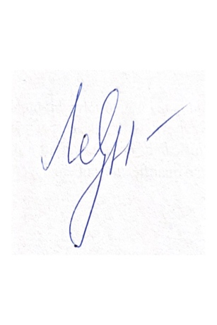

**Levin Nikita**

05.04.2024

TABLE OF CONTENT

Statement on the substantive character of the course paper preparation 2

INTRODUCTION 4

LITERATURE REVIEW 6

The role of the procurement function in the company's business processes 6

The concept of a company's operational efficiency and how it is measured 7

Factors influencing supplier selection and evaluation methods 8

The role of suppliers in the business process 10

Types of procurement 12

Methods of procurement 13

Conclusion 16

CHAPTER 1. COMPANY charachteristics and managerial problem statement 17

1.1 Establishment of the company and business description 17

1.2 Managerial problem statement 19

CHAPTER 2. RESEARCH METHODOLOGY 22

2.1 Research methodology 22

2.2 Kraljic Matrix 30

2.3 Safety Stock 32

2.4. Reorder Point 33

2.5. Supply maturity phases 34

CHAPTER 3. Strategy to improve operational efficiency 38

3.1 Porter's concept of strategy 38

3.2 Current strategy of the company CSK 41

3.3 Recommendations to improve the company's procurement activities 41

List of references 46

APPENDIX 49

# INTRODUCTION

The strategy for increasing the operational efficiency of the company's procurement function is primarily aimed at improving CSK's procurement activities and developing new approaches to the execution of procurement processes. In many companies, the processes related to procurement are, if not the most important, then one of the most important processes that require constant attention. Therefore, companies try to introduce new approaches to their processes in order to make procurement activities more efficient for themselves.

The company "Center Stroitelnoy Keramiki" Ltd. is one of the most famous suppliers of foreign products of clinker bricks, clinker tiles, facing materials, floor tiles and steps. The company practically does not co-operate with local suppliers and all products are purchased from foreign suppliers from the European Union countries (Germany, Belgium, Netherlands). Despite the difficult relations with European partners and sanctions imposed on trade turnover between the Russian Federation and the European Union, the company manages to continue successful co-operation.

The main purpose of this study is to establish the problems associated with the company's current procurement activities and develop strategy to eliminate these problems and improve CSK's procurement activities as a whole.

The object of research in this thesis is the company “CSK” (Center Stroitelnoy Keramiki). The subject of this study is the procurement operational activity of the company “CSK”.

The research goal for this paper is to create a strategy for improving current procurement activities of the “CSK”.

Based on the formulated research goal, the following list of objectives was composed:

1. Characterization of the company and its activities
2. To establish managerial problem
3. To review theoretical methods of development of procurement function
4. To analyze the company’s current procurement activities
5. To develop strategies for improvement of “CSK” procurement activities

This thesis consists of three parts. The first part contains general information concerning the activities of the company "CSK". In addition, this chapter describes managerial problem of the research. The second chapter describes research methodology, results of conducted interview with company representative, results of a survey among the company's employees involved in the procurement process and application of toolkits for inventory management techniques. The final chapter contains information regarding a possible strategy to optimize the current procurement processes for CSK and how this strategy can be applied in practice.

In order to conduct an in-depth analysis of the company's activities and minimize the risks of making a mistake, both primary and secondary data have been used in this thesis work. In addition, the thesis also presents information from official documents of the company "CSK", but it is quite rare, because almost all information on the company that is not contained in public sources is confidential. As for the primary information, in the course of my work, I conducted interviews with representatives of the company, in particular with O. Kim- (Deputy Head of the Logistics and Procurement Department Division), who agreed to assist me in writing my thesis and answer my questions concerning the current state of affairs in the company regarding procurement activities. As secondary data, I used information from various open sources, checking it in advance for quality and objectivity. These included: scientific and news articles (for example, devoted to organization of procurement process in different companies), company annual reports, company documentation, which is freely available, concerning work with suppliers (universal transfer document, invoice, delivery note, etc.)

# LITERATURE REVIEW

## **The role of the procurement function in the company's business processes**

Nowadays, due to the increasing dynamism of the business environment and the expansion of logistics networks, the number of participants involved in the processes of supply, production and distribution of products is increasing. The ability to competently build the correctness of business processes, due to the responsiveness to market changes, allows, among other things, with the choice of supplier in accordance with the changing needs of the organization and the market. (Alukhanyan, 2019)

From an enterprise perspective, procurement logistics is one of the most important components that plays a huge role in the interaction between all the participants in the supply chain. Without a clearly organized process, a company cannot function properly.

Sanjeev Aggarwal talks about the importance of the procurement function based on the fact that first of all, a properly structured procurement scheme allows a company to save money, especially for those companies that have a limited budget. In addition, procurement helps to maintain the quality of goods and services. Choosing reliable suppliers ensures that services are delivered on time and on quality. In addition, the role of procurement is important in terms of risk management for the company. When a company conducts due diligence on suppliers, it allows it to identify weaknesses in advance and address them before they become a threat to the business. (Aggarwal, 2023)

Procurement management involves a large number of actions aimed at structuring and making the process efficient. These actions may include acquiring raw materials and products for further sales, searching and selecting suppliers for the company, agreeing terms and conditions and concluding contracts with suppliers, etc. (Savina, Dusheiko, & Rozova, 2021)

In their work K. Barmuta, A. Borisova, O. Dymchenko say that the main tasks of procurement logistics are to determine the number of suppliers, to build a clear system of evaluation of their results and to select the most qualified of them. (Barmuta, Borisova, & Dymchenko, Improving the supplier evaluation technique in the company's procurement logistics, 2022)

## **The concept of a company's operational efficiency and how it is measured**

For the management of any organization, regardless of its size or type of activity, it is very important to understand how efficient the company is and how to measure this indicator at all. As Y.V. Fedotov noted in his work, in theoretical and applied research on management the issues of efficiency measurement are of key importance. One of the most important issues in the study of efficiency are the issues of organizational performance (organizational effectiveness), the so-called performance management/measurement or business performance management. (Fedotov, 2012)

This characteristic allows us to understand the overall success of a company. Efficiency is not only an object for the attention of the company's management, but also for other stakeholders, because on the basis of this characteristic it is possible to conclude whether to invest in this company or not.

As a rule, in management studies, the objects of performance evaluation are most often production processes, operations or projects that are implemented by the company or its subdivisions. Each of these operations or processes has its own characteristics, thanks to which it is possible to measure the type of efficiency that is of interest to the subject of the evaluation.

When building the concept of organizational effectiveness, it is very important to understand the difference between effectiveness and efficiency of company's activity. The first measures the extent to which the organization's objectives have been achieved. The second, by comparing the results obtained by the analyzed unit with the values of factors (usually resource inputs) at which they were achieved, gives an idea of how economically it functions. (Fedotov, 2012).

Due to the possibility of measuring the efficiency of the company through the analysis of the productivity of its activities, the final results have a number of universal properties that are not related to a specific type of organization, nor to the specifics of the activities for which the assessment is carried out. Such properties include:

1. *The systemic nature, or integrity, of the assessment:* it shows the overall level of performance of the entire organization.
2. *Definiteness on a numerical or ordinal scale:* the assessment is expressed using numbers or ranks, for example through linguistic variables such as performance or reliability.
3. *Content specificity:* the assessment takes into account the organization's specific performance, method of analysis and quantitative analysis techniques.

Speaking about the first property it should be emphasized that it means that the determination of the level of efficiency is based on the results of the entire economic system, not individual units. But at the same time, it should be taken into account that in some cases it is advisable to analyze the efficiency of individual units that are part of the system under consideration.

## **Factors influencing supplier selection and evaluation methods**

There are a number of certain factors that companies should pay attention to and be guided by when selecting suppliers. It is clear that for each company the criteria will be different, but in general there is a certain algorithm that the company can use in its work. A.A. Khaled, Sanjoy Kumar Paul, Ripon Kumar Chakraborty, Md. Salahuddin Ayuby in their work on how to choose suppliers using different criteria consider a number of factors that affect the choice of suppliers. (Khaled, Paul, Chakrabortty, & Ayuby, 2011)

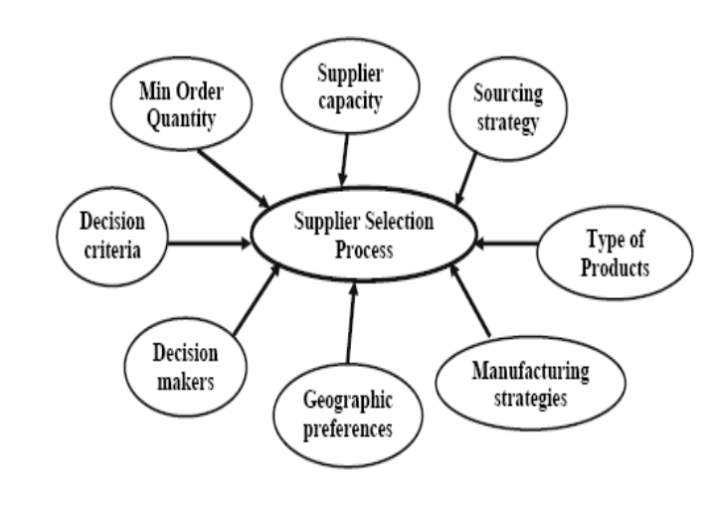

*Pic. 1. Factors affecting supplier selection*

Karine Barmuta offers another algorithm for finding suppliers in her research paper. She proposes to use an algorithm that allows you to evaluate the performance of suppliers and, based on it, select only the right ones that meet all the criteria.

At the first stage, the company's procurement activities are defined. That is, depending on the industry in which the company operates, the further points of the algorithm will vary. Further, there is a preliminary analysis and selection of suppliers for evaluation. At the third stage there is a sheet with the criteria that will be taken into account when making an assessment.

There are a total of 5 blocks into which the criteria are categorized. These include: technical, logistical, financial, customer relations and others not included in any of the previous categories. (Barmuta, Borisova, & Dymchenko, Improving the supplier evaluation technique in the company's procurement logistics, 2022)

Potential Evaluation Criteria:

1. Technical

* Quality of the supplied products;
* Product breadth;
* Quality and Method of packaging;
* Supplier’s production capabilities;
* Warranty service.

2. Logistical

* Geographical location of the supplier;
* Timeliness of deliveries;
* Completeness of deliveries;
* Order confirmation time;
* Order lead time;
* Reliability of supply;
* Logistics capabilities of the supplier.

3. Financial

* Prices of products supplied;
* Terms of payment;
* Discount policy;
* Supplier’s financial situation

4. Customer Relationship

* Document’s accuracy;
* Efficiency of communication with the supplier and resolution of disputes;
* Claim management;
* Convenience of placing an order.

5. Other Criteria

Once the criteria have been defined, supplier data is collected for further evaluation. Then, the evaluation itself takes place, which includes:

* Application of the scoring method based on the evaluation
* Supplier categorization based on evaluation
* Calculation of selected indicators for additional evaluation and correction

Ultimately, it is on the basis of this assessment that the supplier is selected.

The criteria may vary depending on the company's profile and its own expectations of suppliers, but in general the structure remains roughly the same. In this way, the company will have a complete record of possible suppliers, how they operate and what possible risks may arise when dealing with them.

Recently, there are more and more new modern approaches to supplier selection issues. One such approach is ABC analysis.

Mark Edward Pickering introduces the concept of ABC-analysis as a method of stock and inventory management that is used to categorize goods based on how important they are to the company. There are a total of three categories of goods: category A goods, category B goods and category C goods.

Category A items are items that have an importance score between 70 and 80 per cent. Generally, these goods have the highest value because they make up the largest share of the total inventory value.

Category B goods are goods that have a medium proportion of the total value of the stock and their importance score ranges from 15 to 25 per cent. Commodities generally have a medium value.

Finally, Category C goods are those that are represented in the largest number but have the smallest share of the total value of goods. Their significance score is between 5 and 10 per cent.

Based on this analysis, it is possible to understand which suppliers and goods are key and carry the most profit for the company. Consequently, the company understands with which suppliers it is more profitable to co-operate and in what volumes. (Pickering, 2023)

The paper written by Joel Strand and Louise Strandänger describes in detail how ABC analysis can be applied to make the procurement process more efficient and how it can be used to identify supplier selection risks. In their case study of an online furniture retailer, they decided to investigate how ABC analysis could be used to improve their purchasing processes. The conclusion was that ABC analysis, which takes into account the cost, frequency of sales and quantity of goods, identified those that are the most profitable and those that are not profitable. In addition, by comparing the importance of the goods with the reliability level of the suppliers, some risks were found to be associated with the late delivery of orders. Therefore, to solve such a problem, it is suggested to reduce the number of suppliers and increase the number of buffer stocks so that in case of unforeseen situations there will be no problem in giving orders to customers. In general, to summarize, this analysis helps to manage risks as well as increase the profitability of the company. (Strand & Strandänger, 2016)

## **The role of suppliers in the business process**

Suppliers are one of the most important components for any company's business process. R.W. Griffin describes a supplier as an organization that provides resources to other organizations. (Griffin, R.W. (2004). Fundamentals of organizational management.)

Suppliers are allocated to different categories.

Biesok & Jezusek offer this classification: (Biesok & Jezusek, 2015)

Organizations belonging to the group of suppliers are:

* service providers (e.g. logistics, transport, marketing services, accounting services);
* suppliers of raw materials;
* suppliers of products sold under the customer’s brand name
* entities cooperating within the scope of outsourcing;
* social economy entities;
* after-sales service companies;
* recyclers, waste treatment companies;
* wholesalers, distributors, retailers;
* franchisees;
* network partners;
* any other entity cooperating with the company.

Suppliers play an important role in the entire chain between the manufacturer and the retailer. Suppliers provide the necessary inputs such as raw materials, components, finished products, or specialized services required for different stages of the supply chain. (Ansari & Modarress, 1994)

Also, suppliers play a critical role in the smooth operation of the supply chain, influencing product quality, lead times, cost management and sustainability. (Masnita, Triyowati, & Rasyawal, 2017)

All suppliers are responsible for the timely and accurate fulfilment of their obligations to their customer. They must also take into account laws and regulations relating to product safety, environmental standards and labor laws, providing documentation and certificates to demonstrate compliance. (Perkins & Shekhar, 2024)

In almost every major project, there is a need for large quantities of raw materials, supplies and services and therefore suppliers to be engaged in these activities. When engaging large numbers of suppliers, a company should be mindful of the fact that there is no activity that is risk free. Therefore, the company should calculate possible risks by means of risk management. (Feofanov & Turapin, 2014)

Risk management is a system for assessing risk, managing risk and financial relationships arising in the course of business. The importance of risk management becomes higher when third party organizations are involved in production. (Teterina, Feofanov, & Turapin, 2016)

Even with a complete list of possible risks associated with a supplier of materials or services, a company manager faces the problem of assessing the probability of a particular risk. For the most accurate assessment of risk probability, statistical models built on the basis of the company's work with other suppliers can be used.

In some situations, companies themselves introduce a functional model for organizing the supplier evaluation and development function. One example of introducing such a function is the Intel case study which decided to use local suppliers when it entered the Malaysian market in 1972 and developed a seven-step supplier development program that began with identifying capable and development-ready suppliers and culminated in the granting of 'global supplier' status. (Chao, 2001)

## **Types of procurement**

The term ‘'make-or-buy decision' refers to the fundamental choice that a firm has to make about the procurement of materials required for its business operations: manufacturing or buying. The business can also choose to outsource its procurement duties, which will free it up to concentrate on its main competencies. The basic categories of procurement are outlined below:

1. *Individual procurement:* The supplier starts production as soon as it receives a specific order from a client (Heiserich, Helbig, & Ullmann, 2011)
2. *Acquisition of inventory:* Products are routinely replenished without explicit orders from customers. Maintaining a minimal stock level helps achieve this. When production is finished, a predetermined amount of stock needs to be on hand before the following customer order. The procurement procedure begins if the stock drops below this level. Although this approach offers flexibility and demand forecasting, it can be expensive (Heiserich, Helbig, & Ullmann, 2011)
3. *Vendor Managed Inventory (VMI):* Under this arrangement, the supplier is in charge of restocking the client's business. Effective procedures, flexibility, and cost savings are made possible by the intimate relationship between the supplier and the client.
4. *Just-in-time procurement:* Minimum stock levels are used to determine the supply of goods. A strong relationship between the supplier and the customer is essential for just-in-time procurement success as it facilitates cost savings and streamlined procedures.
5. *Just-in-sequence procurement:* The delivery of items one after the other at predefined intervals in a predetermined order. This kind of procurement is very lean and efficient.
6. *Ship-to-line:* Requires little logistical actions. From the supplier's ultimate value-added site, goods are sent to the customer's point of value addition. (Heiserich, Helbig, & Ullmann, 2011)

## **Methods of procurement**

There are six main procurement methods, each with unique benefits and considerations. These methods include: (KEGENBEKOV, 2023)

1. Open tendering
2. Restricted tendering
3. Request for proposal (RFP)
4. Two-stage tendering
5. Request for quotations
6. Single-source procurement

*Open tendering*

This procedure, in which vendors contend for a contract through open competition, is also known as competitive bidding. When a business uses open bidding, it needs to:

* Post a notice in your community or get in touch with the required vendors.
* Give logical and objective technological specifications.
* Establish impartial standards for evaluation.
* Take into account every eligible provider.

Because of the procedural aspects of this strategy, it is not always suitable for complex procurements, even though it frequently promotes successful competition by placing an emphasis on price. It does not emphasize rigorous adherence to standards, but rather the manufacturing process. (Maiti & Almeida, 2023)

*Restricted tendering*

Although there are some significant distinctions, this procurement approach is fairly similar to the open bidding procedure. Restrictive tendering limits the number of bidders rather than inviting all willing vendors. Since suppliers are carefully and specifically picked, they are also known as selective tendering.

Restrictive tendering involves competition just like open tendering, except it is restricted to vendors who have been invited in advance. This enables the buying business to pick carefully from the pool of pre-selected individuals.

The business should explicitly outline the primary standards and guidelines that will direct the supplier selection process in order to guarantee a more effective one.

One of the primary advantages of this strategy is the potential to secure a purchase from the most qualified supplier, which can ultimately improve the quality and efficiency of the project or process, as well as the potential to save time and money through a more focused selection process. (Hassan & Athambawa, 2020)

*Request for proposal (RFP)*

In the current business world, where competition is only going to get more intense, it's critical to have every advantage you can get in order to attract clients and close lucrative agreements. Making a high-quality offer becomes crucial to a business's strategy in this situation. The proposal offers solutions for the particular demands of the customer in addition to showcasing the company's capabilities and resources.

The primary means of obtaining data regarding possible suppliers and their offers is through the request for proposals approach. Customers can assess several possibilities and choose the best supplier by using this strategy. For suppliers, it's a chance to showcase their knowledge, creativity, and affordability.

However, the capacity to efficiently manage service quality is just as important to participation in requests for proposals as technical and financial factors. Even if a supplier has somewhat higher prices, the quality of the proposal can sway the customer's decision in favor of that source. This is because offering top-notch products and services fosters trust.

Therefore, it's critical to understand that the lowest price isn't necessarily the determining factor in a tender's success. The selection procedure heavily weighs the offer's quality, suitability for the customer's needs, creative solutions, and supplier dependability.

Thus, in order to succeed in the market and attract clients, businesses and suppliers must work hard to produce high-quality offers. (Ochieng, 2022)

*Two-stage tendering*

Two procedures, each having two stages, are included in this procurement technique. It is sufficiently flexible to enable communication and mutual understanding between the parties. On the other hand, if the procurement team is pressed for time, it may not be as convenient.

The request for proposal method is akin to the initial step of the procurement process. Suppliers who fulfill the procurement department's requirements submit technical bids through this method. In order to come to a consensus, the best suggestion is invited to continue the conversation. Following approval of the technical proposal, the vendor advances a cost estimate for additional contract negotiations.

Rather than presenting the entire technical proposal at the second stage, only a portion of it is presented for review and potential changes. Following the selection of the most qualified supplier, he is asked to provide a complete technical specification and an estimate of the associated costs. The vendor is chosen after a thorough assessment of the technical and financial bids.

The bids are now examined and contrasted in order to identify the best and most cost-effective option for the company. The agreement is concluded and the work or delivery of the items starts once the vendor has been chosen and the terms and conditions of the contract have been authorized. This approach allows both technical and financial aspects to be taken into account when making a decision, helping to achieve optimal results for all parties. (Ryan, Yund, & Jin, 2011)

*Request for quotations*

The simplest and fastest method of procurement is the Request for Quotation, or RFQ. It is less paper-intensive than other methods and is typically utilized for inexpensive goods or services. Formal proposals are not made, and parties usually do not create extensive paperwork. Instead, to choose the most qualified supplier, the purchasing team chooses at least three preferred suppliers and evaluates their terms and conditions as well as costs. With this approach, you may acquire the products or services you require fast, effectively, and without needless red tape. (O'Connor & Bellamy, 2021)

*Single-source procurement*

This kind of procurement, referred to as non-competitive procurement, is employed when a business chooses to purchase products or services from a single vendor, granting that vendor the sole authority to complete the order. It is typically applied in dire circumstances or when there is just one source who can fulfill the criteria. This strategy ensures that the necessary products or services will be acquired in a market with little rivalry, but because there is less competition, there may be a slight increase in transaction risk and expense. (International, 2016)

## **Conclusion**

The role of procurement in a company's business processes is multifaceted and crucial for its success in today's dynamic business environment. Procurement logistics, as highlighted by Sanjeev Aggarwal, plays a significant role in cost savings, maintaining quality, and managing risks associated with supplier relationships.

Procurement management involves various actions aimed at structuring and optimizing the procurement process, including acquiring raw materials, selecting suppliers, and negotiating contracts. Karine Barmuta emphasizes the importance of supplier evaluation in procurement logistics, outlining criteria such as technical, logistical, financial, and customer relationship factors.

Supplier selection is influenced by several factors, as discussed by A.A. Khaled et al. and Karine Barmuta, and can be facilitated through methodologies like ABC analysis introduced by Mark Edward Pickering. ABC analysis categorizes goods based on their importance to the company, aiding in identifying key suppliers and optimizing procurement processes.

The role of suppliers in the business process is vital, as they provide resources essential for different stages of the supply chain. Suppliers influence product quality, lead times, cost management, and sustainability, necessitating effective supplier management and risk assessment.

Various procurement methods, such as open tendering, restricted tendering, request for proposal (RFP), two-stage tendering, request for quotations, and single-source procurement, offer companies flexibility in acquiring goods and services. Each method has its benefits and considerations, allowing companies to adapt their procurement strategies based on specific needs and circumstances.

Overall, effective procurement practices and supplier management are essential for companies to optimize costs, maintain quality, manage risks, and sustain competitive advantage in today's business landscape.

# CHAPTER 1. COMPANY charachteristics and managerial problem statement

## **1.1 Establishment of the company and business description**

The company "Center Stroitelnoy Keramiki" (hereinafter referred to as "CSK") is one of the most renowned suppliers of foreign products of clinker bricks, clinker tiles, cladding materials, floor tiles and steps. The company has been operating since 2007 and during this time has managed to establish itself as a reliable distributor. For many years of work the company has managed to prove itself as a reliable distributor.

In 2023, the company achieved revenue of RUR 146.02 million, which is 7.09 (less than in the previous year. 4.63% (All-Russian Business Centre, 2024) The main reason that influenced the decrease of this indicator is the increasing complexity of work with foreign partners, which are mostly the main ones. Foreign companies are reluctant to co-operate with Russian partners, which reduces the volume of products purchased by CSK.

The main office of the company is located in St. Petersburg, at the address: Leninskiy Ave., 140, lit. E, where the official shop of the company is also located. Despite the fact that the main activity is carried out from St. Petersburg, the company also has an office in Moscow and several warehouses for quick delivery of products to customers residing not only in the North-West region. The main supply chain extends to the North-Western region, but at the same time there is delivery to other regions, so this is not any difficulty. The total number of employees of the main office is 35 people. (Center Stroitelnoy Keramiki, About company, 2024)

Because of the company's small workforce, the management opted for a linear organizational management structure, which allows the CEO to keep an eye on all important activities and make necessary adjustments without making mistakes.

In the absence of superiors, the General Director's deputy oversees the work. Furthermore, the organization comprises multiple departments that carry out distinct functions and assignments:

*The logistics department* handles processing primary documentation, sending product delivery invoices, liaising with courier services, and creating UPDs (universal transfer documents).

*The sales department* handles processing orders, interacting with clients, and responding to any queries they may have.

*Accounting Department* handles preparing of estimates, calculating of financial activities of the company, resolving issues related to the payment of fines, taxing costs and other payments.

*Marketing Department* handles developing the website, checking the website, updating current information, creating advertising offers and implementing them.

During the seventeen-year period of work, the company can boast of working in many major projects. As an example, the company took an active part in the interior finishing works of the “Europolis” shopping center in St. Petersburg, in addition to providing products for the development of retail premises at Pulkovo Airport. This is not the whole list of the company's projects; its products were also used for facing and interior works of buildings in many Russian cities, such as Moscow, Samara, Stavropol, Krasnodar, Nakhodka, Bryansk and others. (Center Stroitelnoy Keramiki, Realised Projects, 2024) The company can also boast of projects abroad, for example in Kazakhstan (Kostanay) and Kyrgyzstan (Bishkek).

As it was mentioned earlier, despite the sanctions from the European Union countries and deterioration of co-operation with European partners, the company continues to sell building elements manufactured in European countries. The company's clients are used to high quality of services rendered and therefore "CSK" strives to maintain the same approaches to the choice of products to satisfy the needs of its clients.

Speaking about the company's foreign partners we can highlight the list of most famous one’s such as:

* “Feldhaus Klinker” — is a large clinker brick factory in Germany. The company has been operating since the end of the 19th century, more precisely since 1857. During this time, the company has established itself as a reliable manufacturer of quality products that will last for many years. The company in the manufacture of its products applies its own methodology associated with the addition of minerals in the composition of the product, which increases its strength. (Feldhaus, 2024)
* “Stroeher” — is a high-tech German company which is a manufacturer of clinker ceramics. The company was founded 128 years ago and during this time it has not only maintained traditional approaches to clinker production, but also adds more and more new elements to achieve an even higher quality product. Using a variety of compositions from over 50 quality clays, Stroeher creates natural products fired to shape and design that are cut from moist, malleable clay blocks and then sintered in a high temperature firing process. Needless to say, it's environmentally friendly and energy efficient. (Stroeher, 2024)
* “Laumans” — is also a German company that is mainly engaged in the production of clinker tiles. The company was established in 1856 and advocates the preservation of previous approaches to clinker production, emphasising on the quality of products. The company values its reputation, so absolutely all of its products are high-tech and long-

lasting. (Laumans, 2024)

CSK strives to find more and more new partners every year to offer its customers the greatest variability in their choices.

It is also worth noting that CSK also actively participates in a variety of exhibitions and conferences dedicated to the construction business. One of the most recent was the MosBuild exhibition last March at Moscow's Crocus Expo. This is an international exhibition that attracts representatives of various sectors of the construction business from CIS countries and beyond. In 2023, more than 800 companies from 20 countries participated. For CSK, such events are not only an opportunity to tell people about its products, but also an opportunity to establish new partnership agreements with foreign partners.

**“CSK” development plans**

Nowadays, the company is planning to open another shop in St. Petersburg and Moscow, as contracts with some Russian suppliers of clinker bricks will be concluded soon and the option of opening new outlets is being considered for a more convenient sales process. In addition, the company is considering options for finding partners in the Asian market, as every year this market is more and more in demand and in some regions of Asia weather conditions allow the use of clinker of the type sold by CSK for the construction of buildings.

**“CSK” values**

The most important values for the company above all are quality, reliability and professionalism. "CSK strives to ensure high quality of products that reach the consumer, so it co-operates only with partners who have many years of experience in the industry and can boast high results in this. "CSK" strives to ensure reliability in the supply of products, so it chooses only trusted carriers to minimize the possibility of defective goods in transit to the customer. In addition, much attention in the company is paid to customer focus. In case of unforeseen circumstances that may affect the time of arrival of goods to the client or damage to the goods themselves, the company strives to find a solution to the problem that would first of all satisfy the client, because the company values each of them.

## **1.2 Managerial problem statement**

"CSK" is currently looking for more and more markets to sell its products, as mentioned earlier. The company is looking to expand its shop network and for this reason is currently reorganizing many departments within the company. In addition, due to the fact that the current market is highly susceptible to change due to the unstable economic situation in the world, the company is endeavoring to find ways to sell products to customers at low prices and therefore, the procurement activities that the company has undertaken in the past need to change. For this reason, CSK needs to review its approach to procurement and implement more efficient procedures. In the summer of 2022, I was doing an internship at this company and thanks to my contacts with the head of the marketing department, the company asked me to help them with this issue.

The company carried out a detailed analysis of each department and came to the conclusion that changes should be implemented, as the old concept is only suitable for small-sized enterprises. As CSK seeks to expand its network, it is therefore necessary to look for new approaches to the organization of the company's work.

As for the above-mentioned analysis, it was conducted by the company on its own, without my participation. The results cannot be presented in full, as I have a non-disclosure agreement and can only share that the procurement department is one of the most inefficient and requires new approaches to work.

Having received information about which department needs to be optimized, the process of finding the issues that need to be highlighted in the first place began, as based on them it is possible to understand the current picture of what is happening and decide what methods and new approaches can be introduced to improve the procurement process. Below is a list of the issues that were explored in the first instance when interacting with the company representative:

1. How is the procurement process organized in the company?
2. What are the company's main suppliers?
3. How is the company's order tracking system structured?
4. How do the buyers, in this case CSK, control when goods arrive and whether they are late?
5. How is the percentage of tardiness by suppliers calculated and what does it equal?
6. How do buyers determine the monthly KPI?

By answering these questions, a clear picture of what the company's procurement department looks like now and what points are worth paying attention to first. A detailed description of each of the questions will be given later in the thesis.

In addition to gleaning data from the interview with the purchasing representative, I also researched academic literature to add new factors to consider when deciding which strategy to choose. In the study conducted by O. Yu. Kirillova, A. Ya. Geller "Theoretical Principles of Organizing Control over the Process of Purchasing" raises the question of what factors should be paid attention to when choosing a strategy for optimizing the purchasing function. This article argues that procurement should be categorized by the nature of its objectives for effective management, risk mitigation and quality contract performance. Procurement should also be organized in such a way as to combine the stages of procurement initiation and execution, with particular attention to the control of the contracting authority during execution. These are important aspects to consider when choosing optimization options. (Kirillova & Geller, 2022)

# CHAPTER 2. RESEARCH METHODOLOGY

## **2.1 Research methodology**

A research methodology is defined as the means by which a researcher obtains knowledge and for this reason it represents a fundamental stage of any research. It is very important for researchers to understand the implications of a method or technique and its overall relevance to the study. (Vitale, 2023) In business, three types of research are distinguished such as: exploratory research, descriptive research and causal research. (Sachdeva, Mandlik, & Shitole, Business Research Methods, 2014)

*2.1.1 Exploratory research*

When a researcher has little expertise or understanding of a research topic, exploratory research is an initial investigation carried out to define and clarify the nature of a problem.

Gathering preliminary information that will help to study the problem in the future and propose hypotheses is the main focus of an exploratory study. (Sachdeva, Business Research Methodology, 2008) When the research problem is not clearly defined, that is, there are no specific factors supporting the problem, this study helps to determine the method of data collection, and the design of future research itself. Sachdeva notes that "exploratory research relies on secondary research such as a review of available literature and data, or qualitative approaches such as informal conversations with consumers, employees, and more formal methods - in-depth interviews, focus groups, case studies." Various research techniques can be used to arrive at the final result. There are both quantitative and qualitative research methods. Quantitative research methods include: questionnaires, surveys, and data analysis. Qualitative methods include: observation, interviews with company representatives. In the context of this paper, qualitative research methods are more appropriate.

*2.1.2 Qualitative research*

In this paper, I use qualitative data collection method because it primarily allows me to establish an in-depth understanding of an existing problem related to the company's procurement activities. One example of a qualitative method of data collection is the interview with O. Kim, a representative of the purchasing department of CSK, which provided me with information about the company's internal processes in the area of my interest. In addition, this approach provided me with internal company documentation such as the universal transfer document, invoice and declarations, which gave me an insight into the current process of order processing and creation in the company.

I believe this method is the most appropriate as this research is about creating a strategy to optimize the company's current procurement activities and the most accurate information is found internally.

*2.1.3. Data collection method*

This thesis utilizes both primary and secondary data collection methods.

The primary method of data collection is the data that is provided directly from the company. That is, in this case, it is information that was obtained through an interview with a representative of CSK. Primary data is considered a more reliable source because it is collected directly and not through third parties. At the same time, secondary data collection methods were also used during the writing of the paper. These include information collected from open sources on the internet and academic journals.

*2.1.4 Method of direct observations*

Observation is also an excellent way to obtain data about a company. As stated by Sachdeva: "observation is a scientific inquiry when it is conducted specifically to answer a research question. It is systematically planned and executed, uses proper controls, and provides reliable and valid account of what happened".

As mentioned earlier, I had a summer internship with the company in 2022 in the marketing department, but I was also partially involved in the logistics department and therefore had a general knowledge of what goes on in that department of the company. In order to understand the current situation in the company, I did a mini-internship of three days in the company to get an inside look at the situation. I studied the entire purchasing process, from the dispatch of the order to the manufacturer's factory to the final arrival of the product. I believe that these observations helped me in writing my thesis.

*2.1.5 Interview*

In qualitative methodologies, an interview is a method of collecting primary data. “Interview varies based on the number of people involved during the interview, the level of structure: the proximity of the interviewer to the participant, and the number of interviews conducted during the research”. (Sachdeva, Business Research Methodology, 2008)

Three main types of interviews are distinguished:

1. Structured
2. Semi-structured
3. Unstructured interview

A structured interview involves a situation in which the interviewer follows predetermined questions without going beyond them. That is, there is no opportunity to develop the topic in any way if it has not been previously discussed.

A semi-structured interview is a mixture of structured and unstructured interviews. The interview is usually conducted in a fairly relaxed format, with the structure of the questions being maintained, but both the interviewer and the interviewee have the opportunity to depart from the topic in order to develop their own thoughts in some way.

Unstructured interview involves a free-form interview that is not pre-determined, i.e. questions are asked depending on what topics are covered in the conversation. The interviewee chooses what he or she wants to talk about. The interviewer's role here is only to set the program for the conversation.

In this case, a semi-structured interview was conducted. It allowed for flexibility and structure in the conversation. I was sent a list of questions I wanted to get answers to in advance, but the conversation also covered other topics related to procurement that had not been discussed before.

*2.1.6 Primary data from interview*

Primary data on CSK's procurement activities was collected by me through a qualitative interview. The purpose of this interview was to gain an understanding of the company's current activities in my area of interest, as well as comments from the company representative on what they would like to change in the current approach, if they had any thoughts on this.

The interview questions were formulated on the basis of the chosen topic: "Strategy for improving the operational efficiency of the procurement function of the company "Centre of Construction Ceramics", as well as on the basis of my mini-internship and the scientific literature I had read on the topic. The interviewee was warned in advance of the purpose for which the interview was being conducted. The questions were designed to move smoothly from general information about the company's procurement activities to the specific nuances of this department.

A total of 5 main questions were asked regarding the topic of procurement activities. The first question asked the interviewee to give brief information on how the procurement process is organized in the company. The representative of the company gave a detailed answer to this question, describing in detail how the structure of order creation and processing looks like and how relations with suppliers are built.

The second question was: "How is the order tracking system built in the company?". The purpose of this question was to understand how the order processing and management process is structured.

The third question was: "How do the buyers, i.e. CSK, control the orders, how does the purchasing department understand where the goods are and what are the delivery deadlines?” The difference with the previous question was that before the focus was on what the order system itself looks like, but here it was specifically on the interaction between the supplier and the recipient of the order, on the part of CSK.

The fourth question was: “What is the process for tardiness on the part of suppliers?” In any company that has a purchasing department, there is a possibility that some goods will not be delivered on time. It is very important to understand what percentage these delays represent of the total number of deliveries, so that you can analyze in detail whether something needs to be changed.

The last main question was related to the estimation of the monthly KPI of the purchasing department. This indicator is the most important for understanding how successful a department is and what its productivity level is.

The interviewer answered each of the questions in detail, adding additional comments on each of the questions. The interview was conducted in Russian, as the company's activities are directly related to work in the Russian Federation and this language was chosen for convenience.

The interview was conducted with O. Kim, a representative of the purchasing department of LLC "Centre Stroitelnoy Keramiki" through personal communication. The interviewee has been working in the company for more than 10 years and knows very well how the work and functioning of the department is organized.

*2.1.8 Results of an interview*

Based on the results of the interview with the company representative, it was possible to form a base of answers, which was used as a basis for further strategy development. When answering the first question regarding how the procurement process is organized in the company, the interviewee gave information that:

* The initial step is to record the order from the customer in the company's order database. The procedure is the same for individuals and for private persons. The order database is located in the 1C application. After the order is placed, an invoice is generated.
* In the next stage, the order is placed with the product supplier at the company's warehouse. The process of checking the goods for stock availability takes place and, if available, the goods are booked and shipped to the buyer after payment of the invoice, having previously issued a power of attorney to the logistics company that handles the transport.
* In case of lack of goods in stock, a request is made to the manufacturing plant with a specific indication of the quantity of products required. After that, an invoice is issued to CSK for payment of the products, after payment of which the goods are sent to the warehouse and the process is repeated as described in the previous paragraphs.

Answering the second question regarding how the order is tracked in the company, it was answered that the main platform for work is 1C. This program is designed to automate any business processes in the company. In CSK company this platform is used for automation of accounting and management accounting, as well as for organizational activities of the company.

As for the third question, it can be noted that communication between the supplier and the customer takes place directly via email, where the sender informs the recipient about when he sent the goods and the estimated delivery time. In addition, the dispatched shipment is equipped with a tracker, and through the application it is convenient to track the location of the shipment. As for the delivery time, it usually takes no more than 1.5-2 weeks, depending on where the goods come from. If the goods are ordered from foreign suppliers, the terms can be up to 1 month due to the current situation at customs points. If the goods are in a warehouse in Russia, the delivery process is much faster, up to a few days.

In response to question 4, the interviewee noted that in case of tardiness on the part of suppliers, they undertake to cover a penalty of 0.5% of the order value every day until the order is delivered. In the event of a defect in the transport or the integrity of the product is compromised, since the company issues a power of attorney to the logistics company that handles the transport, it is this company that will cover all costs.

As for the last question, the answer to this question has not been fully answered. The company does not calculate KPIs for the purchasing department as such, and this is one of the main problems. Since there are no clear norms on the basis of which the performance of the department can be tracked, this is one of the topics I would like to focus on in this paper.

To summarize all of the above, it can be noted that:

* Regarding procurement processes, orders are initially recorded in the company's database, followed by placement with suppliers and shipment arrangements.
* The primary platform for tracking orders is 1C, utilized for automation and organizational tasks.
* Communication between suppliers and customers occurs via email, with shipment tracking facilitated through a tracker-equipped application.
* Delivery times vary based on the origin of goods, ranging from days for domestic to weeks for international orders.
* Suppliers face penalties for tardiness, while transportation-related issues are handled by the logistics company.
* Notably, the company lacks a defined Key Performance Indicator (KPI) for procurement, highlighting an area for improvement in monitoring departmental performance.

*2.1.9 Primary data from survey*

In addition to the interview with a representative of the procurement department, I conducted a survey among the company's employees who were in any way involved in procurement-related activities. The survey included representatives not only from the main office, but also employees from the Moscow division of the company. In total, 17 people took part in the survey. The survey consisted of 8 questions of different orientation, but related to the topic of procurement in the company.

The questions were formulated to assess the current state of the procurement department of a company selling clinker bricks. The questions were designed to identify the overall level of employee satisfaction, the effectiveness of the procurement processes and the specific challenges faced by the department. Assessing the frequency of delivery delays and the quality of materials helped to understand the reliability of suppliers and the suitability of their products to the company's requirements. Questions about supplier collaboration and the use of procurement management tools provided insight into the current level of collaboration and the effectiveness of the systems in use. Additionally, the survey included questions about working conditions, stress levels and career opportunities to understand the overall level of employee satisfaction and identify areas for improvement. The information obtained allowed for a focused approach to developing methods that are part of a strategy to improve the company's procurement activities.

The list of questions and the percentage of responses among the employees are given in the appendix of the paper.

*2.1.10 Results of the survey*

As it was mentioned earlier, the interview consisted of 8 questions of different orientation, but at the same time related to the topic of procurement in the company.

1. The first question was: “How do you assess the current state of the procurement department's performance?” The purpose of this question was to get an overview of how employees perceive the current performance of the department. The majority of employees (52,9%) indicated that they rated the level as satisfactory, i.e. they realize that the procurement activities in the department are not at the highest level, but all existing problems are not critical. The second most popular response was to say that the current situation is bad and often the problems that exist in this area prevent normal assignments from being completed.

2. The second question was: “How effective do you think your company's procurement process is?” The difference between the first and the second question was that the first question reveals the general perception of the department's work, while the second question allows assessing technical aspects and identifying needs for process optimization. Having analyzed the answers, it was possible to understand that employees almost equally divided their votes between the answers:

* Effective: most of the processes are automated and optimized. (35,3%)
* Medium: some processes require improvement and optimization. (23,6%)
* Inefficient: a lot of manual labor, errors occur frequently. (23,6%)

Summarizing this question, it can be noted that in general employees believe that the current procurement process in the company can be called effective, but at the same time it requires changes for more successful work.

3. The third question was: “What problems do you see in the current procurement process?” Interviewees were asked to select from a list the response options that they considered most appropriate to answer this question. Each survey participant had the opportunity to choose an unlimited number of answers to this question. The three most popular answers were: lack of automated processes, poor communication within the department and logistical problems, and long waiting periods for deliveries. All of these responses were taken further into account when compiling the overall picture in the company's procurement area.

4. The fourth question was: “How often are there delays in deliveries?” In response, staff noted that there are supply disruptions, but they are not frequent, so it can be considered in the context of the problem, but not singled out as a major one.

5. The fifth question was: “How closely and effectively do you cooperate with your suppliers?” This question seeks to identify how successful the current process of interaction between the company and its suppliers is. According to the results of the answers, it was revealed that 64.8% of the respondents believe that relations with suppliers are very successful the process of cooperation is quite effective.

6. The six question was: “How convenient is it to use the current procurement management tools?” The purpose of the question was to understand to what extent the current tools that the company uses in its work are convenient for employees. According to the results, it became clear that the majority of employees (53%) believe that these tools are not convenient to use and should be modernized.

7. The next question was: “What changes or improvements would you suggest to improve the procurement process?” As with the third question, employees had the opportunity to select an unlimited number of answer choices when voting. The most common answers to these questions were: optimize logistics, reduce order processing time and improve software or implement new software.

8. The last question sounded like: “How satisfied are you with the working conditions in your department?” The purpose of this question was to find out how satisfied employees are with their current working conditions (workplace, team atmosphere and equipment). The answer to this question was that employees mostly consider the current working conditions to be satisfactory, but they would like to amend and improve some aspects.

Summarizing the results of the survey, we can say that, in general, the results were quite structured and clear. It became clear which areas are worth paying attention to first and which issues are of concern to the company's employees. The employees who took the survey were honest in their answers and did not refuse to help me in writing this paper.

After collecting data from a representative of the procurement department through interviews, a survey among employees involved in the procurement activities of the company and on the basis of my own experience in the procurement department of the company "CSK", I proceeded to analyze the obtained data and develop a strategy to improve the efficiency of the procurement function.

*2.1.11 Secondary data from open resources*

In addition to the interviews conducted, information from open sources on the Internet was also used to draw theoretical conclusions on the given topic. The work exclusively uses scientific articles and publications that were written by specifically identified authors. Each borrowing from these sources is referenced, a list of which is attached at the end of the paper. The data used provided a good theoretical basis for the work on the chosen topic, as it allowed me to look at examples of companies that had difficulties with the purchasing department and managed to optimize their production, and the information from such sources provided theoretical proof of the strategy I chose for the company "CSK".

## **2.2 Kraljic Matrix**

In order for a company to develop strategies to interact with its suppliers there is a tool such as the Kraljic Matrix. Kraljic stated that the general idea behind the portfolios approach is to ‘‘minimize supply vulnerability and make the most of potential buying power’’. (Caniëls & Gelderman, 2005) He also believed that the relative power and dependent position of buyers and suppliers would be the factors that would be important in explaining the conditions affecting the choice of purchasing strategy in each quadrant. The Kraljic matrix is based on two parameters: Business Impact (the value of expenditures on purchasing goods) and Supply Complexity (the complexity of the supplier market). The first indicator, the value of procurement costs, is key because it is directly related to value added, marginal profit, and also affects total costs.

Kraljic identified 4 main types of procurement strategies, combining high and low values of parameters of all procured goods.

1. Strategic Items- These product categories are very susceptible to supply disruptions and have a significant effect on financial performance. Typically, they are valuable or uncommon goods. These categories have no alternatives, therefore supply interruptions may result in shortages that take time to replenish. These products are crucial from a strategic standpoint because without them, manufacturing could halt or, in the case of retail chains, consumer traffic might decline because there wouldn't be enough appropriate inventory on the shelves. Such circumstances involve a high degree of interdependence and a balance of market power between the vendor and the buyer. The goal of the procurement strategy for these products is to work in close partnership and cooperation with suppliers, enlisting their early participation in the business's activities.
2. Leverage Items- Products in this category have a significant influence on the financial performance of the business, but they also carry little supply risk. There is very little chance of a disruption in supply because there are a lot of these products available and it is always possible to find a new provider. Additionally, these are some of the company's most profitable goods. To cut expenses, competitive bidding or tenders are the best methods for their procurement. Because they account for the largest share of both overall demand and supply when compared to other categories, these products are known as basic goods. These products have uniform quality, so switching suppliers doesn't affect the company's output. In market relations, the buyer has a preference, as he can easily change the supplier if he is not satisfied with the terms of the contract. The level of interdependence in this relationship is moderate.
3. Bottleneck Items- Even though the economy of the company is not greatly affected by these kinds of products, purchasing them shouldn't be entirely discontinued. The danger of supply is considerable because of scarce technologies and limited output. Suppliers are frequently dispersed over many nations or regions. In order to guarantee supply chain continuity, one must either form partnerships with multiple suppliers and foster competition among them, or begin manufacturing comparable goods on an independent basis. This will lessen reliance on present vendors. It is also advised that these categories establish an inventory management system with the supplier serving as the manager and sign insurance contracts covering the volume of deliveries. It is necessary to make more inventory. Due to the lack of quality standards and the small number of providers, suppliers have the upper hand when it comes to market power, forcing buyers to accept disadvantageous terms. In this instance, interdependence will be moderate, nevertheless.
4. Non-critical Items- The category's name sums up its essence: these are products that are produced in excess for the market and have no bearing on financial performance. There will never be a shortage of these products. Typically, they are purchased to guarantee effective operations. Since it costs more to transport, load, and unload these commodities than their value, the approach in this instance will be to simplify and lower the cost of management and logistical procedures. There will be relatively little interdependence and a balance of market power.

The Kraljic matrix is needed to highlight the main tasks and optimize the use of company resources in order to rationalize the use of company resources and time, as well as maximise profits and minimize costs. Below I give an example of what this matrix looks like.

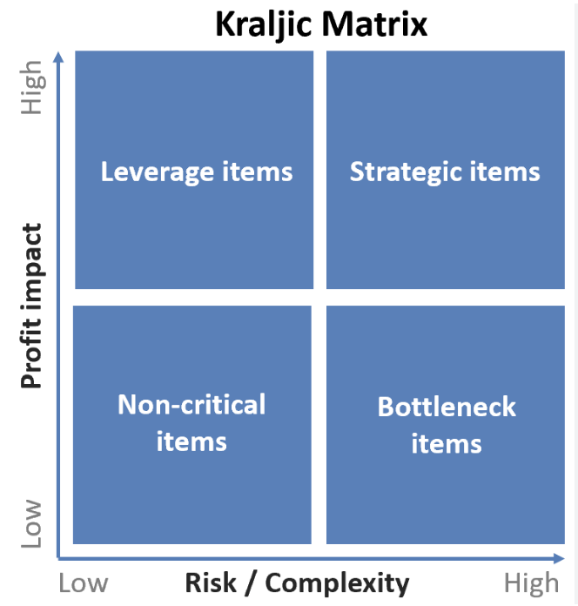

Pic. 2. Kraljic Matrix

As for CSK, they do not rely on the Kraljic matrix in their procurement activities. There is no categorization of products in the company, which negatively affects the current procurement function of the company. For this reason, one of the recommendations that will be discussed in chapter three will be the implementation of such a matrix in the work of the procurement department.

## **2.3 Safety Stock**

In order to gather even more information about how a company's purchasing activities are organized I decided to use additional methods of inventory management in the company. The first stock management method I have used in my work is Safety Stock.

Safety Stock is an additional quantity of goods that is kept in stock in order to prevent out-of-stock situations. It basically serves as a kind of insurance against possible fluctuations in demand. In the context of inventory management, Safety Stock is used to have some solution in case an organization faces uncertainty in demand for its products or any external factors interfere with the process. Safety stock helps in avoiding the problem of loss of demand. The safety stock increases the level of inventory in the company's warehouses. Consequently, it will cause the cost of storing the products to increase as well. But the use of safety stock will allow the company to guarantee a continuous production process even in situations where external factors will affect the process.

Even though some companies do not face problems with suppliers, i.e. all orders are delivered on time and waiting times are not critical, there is still a risk that in some cases the situation may change. Therefore, it is very important for a company to have so-called buffer stocks, so that in case of emergency it does not suffer from a shortage of products in warehouses.

The following formula is usually used to calculate Safety Stock:



*Pic. 3. Safety Stock Formula*

Based on the data received from CSK it is possible to calculate Safety Stock.

Max. Daily Usage = 265 tons

Max. Lead Time = 17 days

Average Daily Usage = 180 tons

Average Lead Time = 15 days

Safety Stock = (265 tons * 17 days) – (180 tons * 15 days) = 1800 tons

Thus, the company should keep an additional 1,800 tons of product in its warehouses to compensate for delays in deliveries or periods of high demand for its products.

## **2.4. Reorder Point**

A company's inventory is important in order to be able to cover fluctuations in demand as well as fluctuations in the production of the product itself. Stocks are usually managed at the optimum point so that they are not too high, so that they do not become stale in the warehouse, but at the same time so that the company does not have a situation where a customer demands a product but it is not in stock. If a company keeps too much product in its warehouse, it will lead to the fact that the working capital will become too high and therefore it will negatively affect the financial position of the company, and at the same time, based on the opposite situation, when the warehouse will have a low volume of products, the company runs the risk of reducing the number of sales of products and consequently customers will leave the company. It is for this reason that a company needs to manage its own inventory so that it is at the optimal point at all times. In order to do this, it is necessary to understand at what point the company should create a new purchase order for products in order to keep the inventory at an optimal level. (Umry & Singgih, 2019)

Reorder Point is a certain level at which it is necessary to replenish stocks. In other words, by identifying this metric, it is possible to understand when a company should place an order to prevent stock depletion. I need this metric in order to understand how the situation is now in the company with the replenishment of stocks and in case of problems with this indicator it will allow to optimize stocks so that they can be replenished at the right time and meet the market demand, without allowing the lack of goods in stock.

I used a formula to calculate the Reorder Point score:

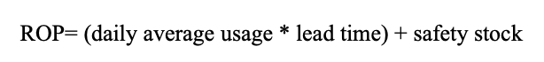

*Pic. 4. Determining ROP with safety stock*

In this case, I need this formula because it is suitable for organizations that keep additional stocks on hand in case of unforeseen circumstances. In the case of CSK, this calculation is the most suitable because there is a rather high risk of supply disruptions, as in the current realities, trade with European countries is difficult and force majeure situations can occur.

By analyzing the average clinker brick sales per day, the average delivery period from the supplier to the company's warehouse and the excess inventory for unexpected costs, it was possible to calculate the ROP.

The average daily clinker brick sales per day was 180 tons.

The delivery period takes an average of 15 days.

In case of unforeseen costs, the company reserves 10 days.

***ROP= (180*15) + (180*10) = 4500 tons.***

The obtained figure indicates that the order for the next batch of products should be placed when 4500 tons of clinker bricks remain in the company's warehouse.

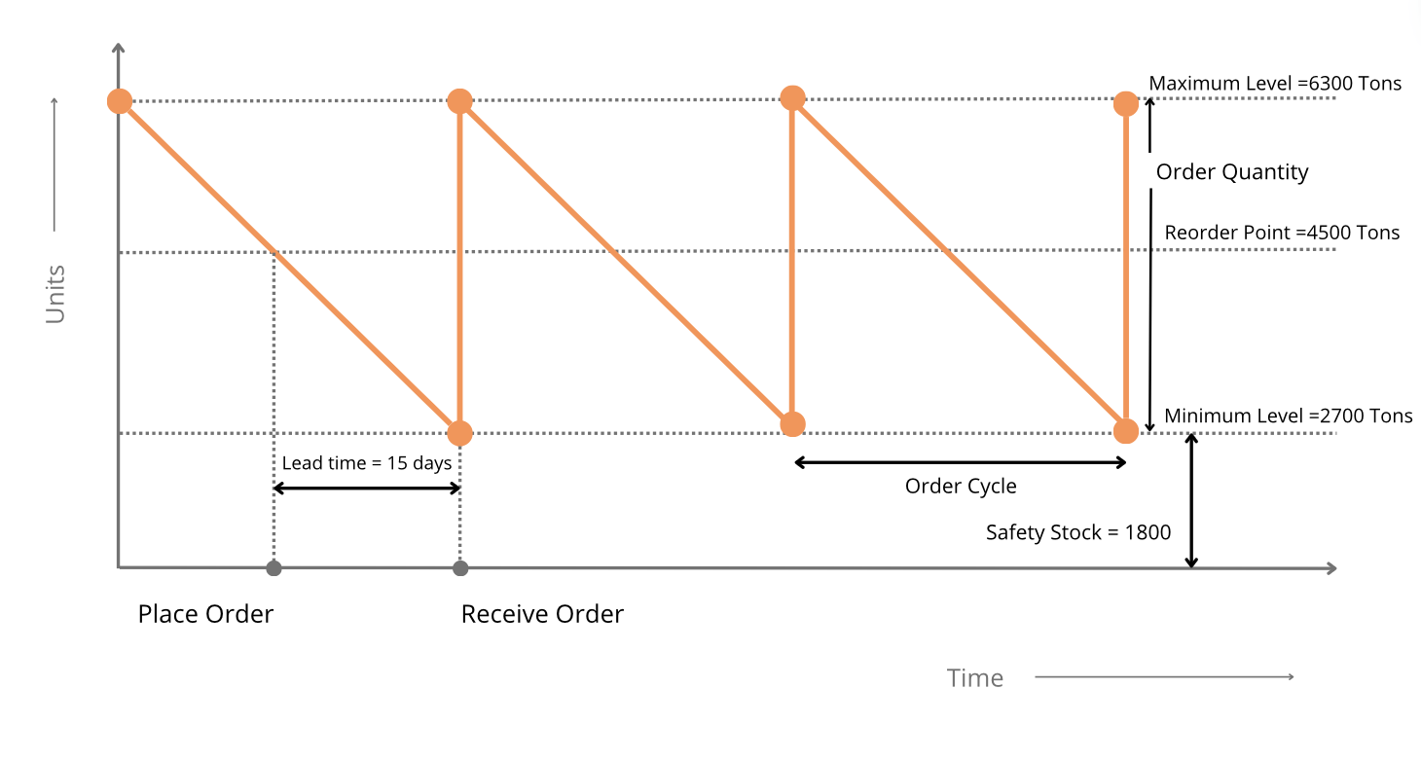

*Pic. 5. Reorder Point Graph*

In this graph, the maximum level is equal to the sum of the clinker brick reserve stock in tons and the ordered quantity. Once the remaining stock reaches the reorder level of 4,500 tons, CSK should place a new purchase order with the supplier. A minimum level of 2,700 tons will help fulfill orders until the ordered stock enters the warehouse. Once the new order reaches the warehouse, the stock level will return to the maximum level of 6300 tons.

## **2.5. Supply maturity phases**

Another tool that I have used in my work is the definition of supply maturity phases. These phases serve to assess where the supply chain is at in the company and, if necessary, help identify options on how to improve it.

There are different interpretations of how these phases are divided. In this case, I investigated the variant proposed by R. Gene Richter, who distinguished 4 main phases, as well as another variant consisting of three phases, on the basis of which it is possible to draw a conclusion about the level of maturity of the company's procurement department.

Richter distinguished 4 main phases, such as: Phase 1(Initiation), Phase 2 ("Where would you like to be when asking for additional funds"), Phase 3 ("Where would you like to be during the performance review") and Phase 4 ("Near perfection"). (Rudzki, Smock, Katsaorke, & Stewart, 2014)

In order to understand which phase is inherent to a company we need to refer to the characteristics of each phase.

Phase 1 is characterized by:

* A significant number of disjointed purchases (orders for materials and services without reference to contracts awarded); and materials and services without regard to contracts awarded);
* Minimal coordination between decentralized procurement organizations;
* Signing of several large contracts per year;
* The need to ask suppliers about the amounts spent over the last year on various materials and services;
* The company does not believe that legal services or advertising as procurement.

Phase 2 is characterized by:

* Most basic goods are purchased after negotiation and on a postpaid basis;
* Minimized the number of disjointed purchases;
* Most operations are automated;
* Training for procurement professionals is starting to pay off;
* Supplier prices are under control and in line with payments on invoices;
* Staff start to come up with reasons not to the procurement department when it comes to acquiring legal services or advertising.

Phase 3 is characterized by:

* Most sourcing decisions are based on multiple factors, not just price;
* The number of suppliers is reduced to five or fewer for each general product category;
* All categories are managed by a cross-functional, multidisciplinary team (led by the Procurement Officer);
* There is an established sourcing strategy for each cost category and this strategy is being implemented;
* The procurement department is required to be involved at an early stage in the design or project development process;
* There are virtually no cases of unbundled purchases.

Phase 4 is characterized by:

* All procurement decisions are fully aligned with corporate goals and objectives;
* In each category, the percentage of participation of any supplier corresponds to its ranking;
* Suppliers consider your company their best (but not easiest) customer;
* Other departments in your company have 80-90% approval of the supply chain department;
* Consistently high level of labor discipline (key KPIs are met regularly and in full).

In my opinion this phase classification is quite cumbersome and contains a lot of boundary concepts, which can make it quite difficult to understand what phase the company is in at the moment. For this reason, I think the second classification is more appropriate. It seems to me more logical to distinguish three main phases and to saturate the last one with elements from the 4 phases that Richter suggested.

Ultimately, the phases will look like this:

*1 level- Indications of the initial maturity level of the procurement department:*

1. Decentralization of procurement activities (fragmentation)
2. The simplest operations of a procurement or supply specialist
3. Lack of procurement procedures and processes
4. Lack of functional communication within the company
5. Absence of qualification selection of the supplier
6. Low purchase price- is the main criterion

*2 level- Indications of the coordination maturity level of the procurement department:*

1. Centralization of procurement - emergence of a corporate center
2. Procurement coordination within the company becomes sustainable
3. Implementation of procurement procedures and processes
4. Introduction of supplier qualification selection
5. Partial implementation of category management
6. Segmentation of suppliers according to certain criteria
7. Purchase price, timeliness, quality are the main criteria

*3 level- Indications of the integration maturity level of the procurement department:*

1. Implementation of the procurement strategy in the form of a separate document
2. Procurement strategy is embedded in the company's strategy
3. Deep collaboration and cooperation with suppliers
4. Regular training of purchasing department employees
5. Full categorization of purchases
6. Status of the procurement department at partner level
7. The procurement manager is a top manager of the company
8. The principle of continuity and leadership is outlined

Based on this classification, it is possible to determine the maturity level of the company in order to understand what methods should be selected in order to optimize the procurement process in the company, as well as to implement these methods in the company's work processes.

Taking into account CSK, it is worth noting that the company is at a *coordinated maturity level*, as the company has a centralized office that directly deals with orders and deliveries of products. The purchasing activities of the company can be characterized as stable, as the company has been cooperating with mainly the same suppliers for a long period of time. In addition, analyzing the last point it should be noted that it is very important for the company that the purchase price remains acceptable, there are no delays in deliveries and the quality of products is at a high level.

# CHAPTER 3. Strategy to improve operational efficiency

## **3.1 Porter's concept of strategy**

Before proceeding to the creation of a strategy for the procurement function it is very important to define the main strategy of the company itself, because the procurement strategy should be subordinated to the main strategy of the company. In order to define the strategy, the concept of strategy, which was given by M. Porter, was used.

According to M. Porter there are three main ways in which a company can achieve sustainable competitive advantage. These ways include the following:

1. Cost leadership strategy
2. Differentiation strategy
3. Focusing strategy.

In order to understand which of these three strategies is best suited for CSK we need to understand what each strategy is.

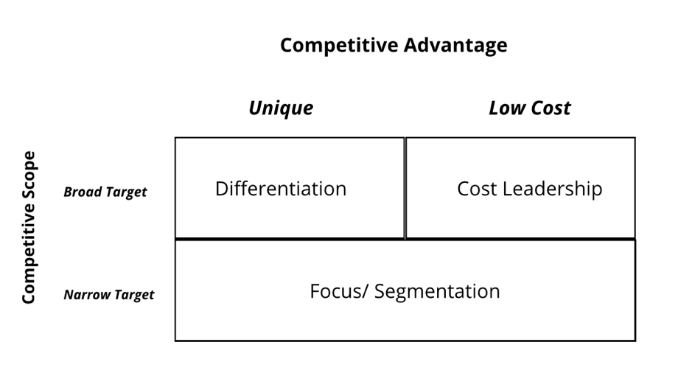

*Picture 6. Three Generic Strategies by M. Porter*

*3.1.1 Cost leadership strategy*

The essence of this strategy is that the company seeks to take advantage of economies of scale while producing large volumes of standardized products. As a rule, companies here mainly focus on a basic product that is easy to produce at a relatively low cost and therefore will be available to a large number of customers. In order to successfully implement this strategy companies should constantly look for different ways to reduce costs in all their business processes. The company should have a significant advantage in the market as well as favorable access to raw materials, as otherwise competitors can make it difficult for the company.

The main key aspects in Cost Leadership are highlighted such as:

* Cost efficiency
* Economics of scale
* Streamlined operations
* Value-based pricing
* Barriers to entry

*Cost efficiency:* the goal here is to reduce costs along the entire value chain, from procurement to distribution.

*Economics of scale:* in this case, companies seek to gain economies of scale while producing higher volumes to achieve lower product costs.

*Streamlined operations:* the strategy is based on optimizing the company's processes, reducing its revenues and increasing operational efficiency to reduce production costs.

*Value-based pricing:* despite the desire to cut costs, successful companies that follow a cost leadership strategy offer goods or services that customers find valuable. This allows them to compete on price without compromising quality.

*Barriers to entry*: in this case, the company will have an advantage over its competitors, as it will be very difficult to replicate the cost effectiveness due to lack of experience and the right resources. (Jerab & Mabrouk, 2023)

*3.1.2 Differentiation strategy*

The concept of differentiation strategy means that a company seeks to create a product or service in the market that will be perceived by consumers as unique. In this case, it refers to the characteristics of the product, i.e. its design, technology, or the brand image itself. Thanks to the differentiation strategy, companies have the opportunity to earn profits above the average in a particular industry, because customers will develop brand loyalty and, consequently, they will have reduced price sensitivity, i.e. the company will be able to independently regulate the pricing policy it pursues. As for the competitor companies, this strategy will create difficulties for them because in order to compete successfully in the market with the company that applies differentiation strategy, they need to develop their own distinctive feature, and this requires a lot of investment.

According to research, differentiation strategy has an advantage over cost leadership strategy as it is more likely to bring higher level of revenue for the company as differentiation creates a better entry barrier. But at the same time all the cost leadership strategy will bring higher market share for the company because in this case the company is focusing on reducing the cost of the product to make it affordable to most of the customers.

*3.1.3 Focus/ Segmentation strategy*

If this strategy is used, the company seeks to concentrate on a few target markets. The essence of this strategy is that the company focuses its efforts on one or two narrow market segments, and then by adapting to these segments the company will be able to meet the needs of the target market. In this case, the company emphasizes on its efficiency rather than effectiveness. Speaking of this strategy, it is important to note that it is most suitable for relatively small companies, but at the same time it is versatile and therefore applicable for use by larger companies. Two variants of such a strategy are usually distinguished:

1. When a firm makes a cost focus, it seeks to gain a cost advantage in its target segment.
2. When a company emphasizes on differentiation, it seeks separation in its target segment.

It is also worth noting that segmentation greatly helps the company in building specific value chain activities for specific groups and hence creates a perfect synchronization in maintaining the organization's value chain for each target segment. (Bose, 2012)

When a company focuses on a particular market segment, it automatically has lower risks and costs that are associated with expanding into the entire market. In the context of this, it should be noted that those companies that concentrate their efforts on niche market segments can gain advantages such as:

* Companies can dominate the market without paying attention to their competitors. Even though the size of the company may not be comparable to the size of competitor companies, there will still be a high demand for the company's products.
* Companies will have more opportunity to become an expert in the field.
* Niche markets are less price sensitive.

To sum up, it can be noted that the cost leadership strategy involves minimizing costs to offer products at the lowest price, which is relevant in markets with high price competition, but requires quality control and continuous cost reduction. As for the differentiation strategy, it focuses on creating a unique offering that provides high value to customers, which allows for premium pricing but requires significant investment in innovation and marketing. Finally, the focus strategy aims at a narrow market segment where the company can better meet specific customer needs, which reduces competition but limits growth potential.

## **3.2 Current strategy of the company CSK**

Having taken into account the strategies proposed by M. Porter and having analyzed the information about the company's current activities in the field of procurement we can conclude that CSK is currently using *Cost Leadership Strategy.* CSK as it was mentioned earlier is engaged in distribution of clinker bricks and roofs in Russia. Due to the fact that the economic situation in the world has changed a lot in recent years, most of the competitor companies started to cooperate with local clinker suppliers. Due to this, companies started to sell clinker at a lower price than CSK, which mostly cooperates with foreign suppliers. For this reason, it is very important for CSK to make sure that it has the opportunity to reduce the price below the level of its competitors in order not to lose customers while remaining profitable. In addition, it is very important for the company at the moment to reduce costs in order to be more resistant to lower market prices in order to maintain its profitability in the economic crisis. Another factor is that as more and more Russian competitor companies are now appearing in the market, it is very important for the company to make significant progress in reducing costs in order to reduce the possibility of other companies to compete with CSK.

Since the strategy chosen by the company is aimed at reducing costs, the strategy concerning the company's procurement activities, which I propose, should also be aimed at reducing the company's procurement costs. In my choice I am guided by the strategic goals of the company. The company aims to reduce its costs as much as possible and this will be its competitive advantage against other companies in the same industry. Procurement must also support this strategy, so the priorities will be to reduce inventory levels, but at the same time, to keep them below a level that will allow the company to work successfully with its customers and not lose them because of out-of-stocks. Basically, this means that the goal will be to provide customer valuability. And to do that, my job is to develop tools that the company can apply in order to realize its goals.

## **3.3 Recommendations to improve the company's procurement activities**

Having analyzed the company's current procurement activities using the tools discussed in the previous chapter, I have developed a number of recommendations that I believe will enable the company to improve its current procurement activities and be competitive against other competitors. Below is a list of the recommendations themselves:

*1. Categorization of goods*

I found that CSK does not have a clear procurement strategy. The company has been working with the same suppliers for many years, paying attention only to the quality of the products themselves and not to their cost. Due to well-established relationships with supplier companies, the company does not risk to look for new options in search of suppliers abroad, being content with what it has. This is despite the fact that there may be other organizations that also offer high quality products at a reduced cost.

For this reason, I think it is very important for a company to categorize its products to understand which ones are more important so that it can choose suppliers based on this. The company does not have supplier attestation, so one of my recommendations would be to categorize items into 4 categories, according to Kraljic's matrix. Below is the Kraljic matrix itself for CSK. The matrix I have proposed is approximate, as a more detailed and precise analysis requires more time and a detailed analysis of the entire product range of the company. The company can take this classification of goods as a basis and if any items from the matrix do not suit it, it can be improved to obtain a more accurate result.

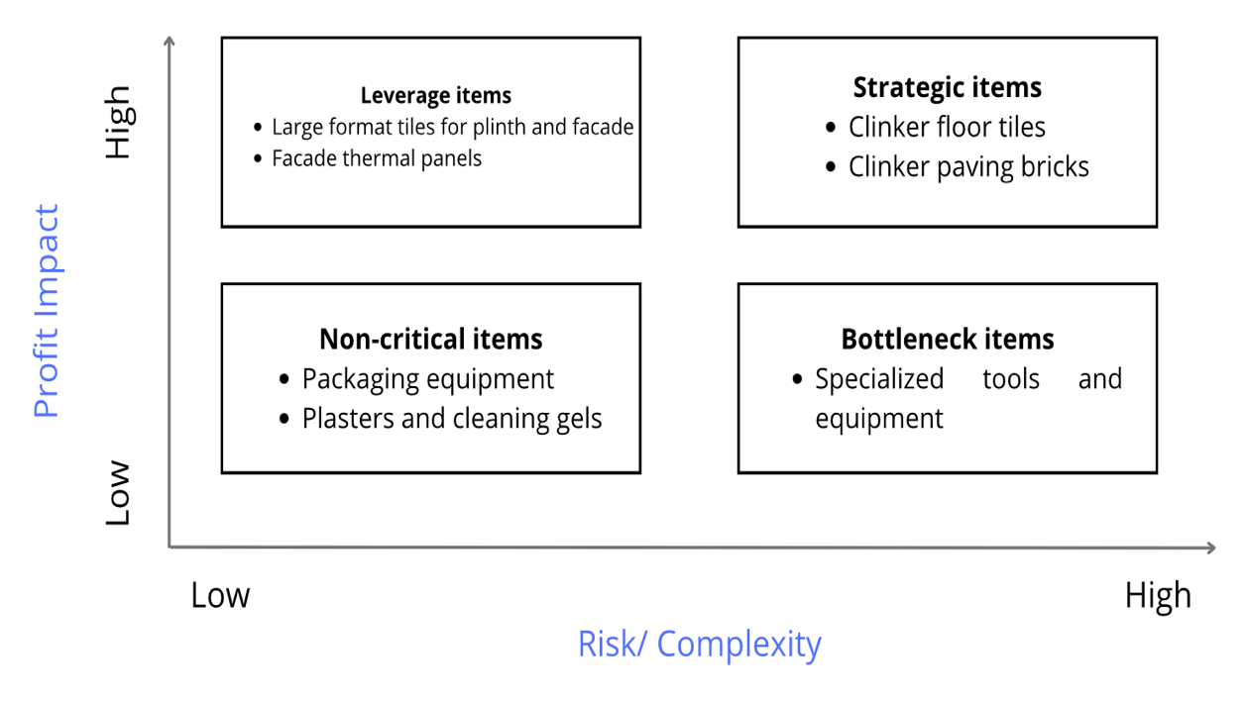

Pic. 7. Kraljic matrix

Based on this division into 4 categories, it is possible to draw conclusions on how a company should build its future relationships with suppliers. *Leverage items* are those product categories where the company can reduce its costs. One option to consider is to enter into framework agreements or use other market mechanisms to get better terms for purchasing these products.

*Strategic items* are the core goods for the company. Here it is very important to continue building long-term relationships with suppliers, but it is also very important to pay attention to product quality and cost.

*Bottleneck items* are goods that should always be available, but the company should not focus on working with specific companies, even when the price of the product does not suit it. It is important to find substitute companies on the market that offer high quality products at a reduced price.

*Non-critical items* are those products that do not have a major impact on the company. In other words, they can be called ancillary items. In this case we can include packaging equipment and cleaning products for cladding. These products are easily substitutable, so the company can easily minimize the time and resources spent on this product category.

To summarise, this division will greatly help a company to understand which products are worth spending more attention and money on, and which deserve less attention. Thanks to this, the company will be able to understand which suppliers are the first priority and which ones can be saved on.

*2. Implementation of KPI indicators*

After an interview with a company representative, it was learnt that the company does not have a clearly structured system for assessing the effectiveness of the procurement department. For this reason, it is very difficult to assess how successful the department has been over a period of time and to understand which indicators need to be changed immediately. In my opinion, the KPI indicator in procurement is one of the most important ones, as it directly affects the motivation system of the company's procurement department and, consequently, the procurement activity as a whole.

The KPIs that I propose to implement are based on the orientation to the core strategy of the company that was previously established, this is the so-called cost-leadership. It is very important to make the procurement strategy correlate with the core strategy, because otherwise the required result will not be obtained.

I propose to look at three KPI's that a company can implement. These indicators are:

1. Zeroing out inventory
2. Obsolete inventory or Illiquid.
3. Reduction of input costs

These three indicators are in my opinion very important as they underpin the cost reduction strategy that the company is pursuing. Zeroing out balances is very important, because in this case there will be no extra goods lying in the company's warehouses and the company will incur surpluses. How to calculate the quantity of the required goods and the calculation itself was shown in the Reorder Point.

The illiquidity indicator is very important because it helps to understand how many goods that have lost their relevance are in the company's warehouses. The presence of a large number of such goods leads to a loss of funds spent on both purchase and storage, so it is very important for the company to make sure that this indicator is at a low level.

Reducing input costs refers to reducing the costs associated with acquiring goods, raw materials and services required for a production process or business. This can include proper sourcing, needs analysis, optimizing product volumes and others.

To summarise, it is important to note that the development of a complete KPI requires additional research, these criteria are only of a recommendatory nature. For this reason, the company needs to conduct a more detailed analysis of its procurement system and finalize them. However, it is safe to say that the introduction of such an indicator as KPI will really have a positive impact on the efficiency of CSK's procurement department.

*3. Implementation of supplier rating*

Since we are talking about co-operation with suppliers, another recommendation is to implement a supplier rating system for CSK. Until now, the company did not have such a system, and the only penalty in case of any problems with product delivery was a fine. But for the most part, the company continued to co-operate with the supplier. For this reason, it seems to me that the introduction of supplier rating will help the company to assess how well a particular supplier is doing its job and in case of low performance, the company will be able to make a decision to sever relations with this supplier. The main metrics that will make up the supplier rating are:

* Product quality
* Price
* Delivery time
* Supplier reliability
* Established communication process in case of unforeseen situations
* Loyalty level

By implementing a supplier rating, the company will be able to minimize the risk of receiving low-quality materials, reduce the likelihood of cargo delays, and be able to assess the efficiency of suppliers' logistics processes, thereby systematizing the supplier selection process.

**CONCLUSION**

In conclusion, it is worth noting that the analysis identified several key issues and suggestions for solutions to improve CSK's procurement activities. CSK did not have a clear procurement strategy and relied on established relationships with suppliers without considering opportunities to reduce costs. Implementing product categorization using Kraljic's matrix should help the company manage its supplies more effectively. Categorizing goods into strategic, leveraged, bottleneck and non-critical will allow the company to allocate resources more efficiently and select suppliers based on the importance and value of the goods. This will improve the quality of procurement, reduce costs and minimize supply risks.

It was also found that the lack of a structured performance measurement system for the procurement department makes it difficult to assess its success. The introduction of key performance indicators (KPIs) such as stock zeroing, level of obsolete stock and reduction in inbound spend should enable the company to more accurately measure and improve its procurement activities. These metrics support a cost reduction strategy and help to optimize procurement processes, reduce excess inventory and minimize losses from illiquid goods.

Implementing a supplier rating system based on such metrics as product quality, price, delivery time, supplier reliability, communication process and loyalty level will allow CSK to objectively evaluate suppliers and make informed decisions about continuing or terminating co-operation. This will minimize the risks of receiving substandard materials, delayed deliveries and improve overall procurement efficiency.

Thus, the proposed measures to categorize goods, introduce KPIs and create a supplier rating system will significantly improve CSK's procurement activities, increase its competitiveness, reduce costs and ensure stable quality of supplied materials and services.

# List of references

Aggarwal. (2023, May 2). *Why Is Procurement Important in Business?* Retrieved from Linkedin: https://www.linkedin.com/pulse/why-procurement-important-business-sanjeev-aggarwal/

All-Russian Business Centre. (2024). *CSK's Annual Report*. Retrieved from Vbankcenter: https://vbankcenter.ru/contragent/1089847283756

Alukhanyan, B. P. (2019, 09). *Risk management of innovative Russian companies in the context of interregional integration.* Retrieved from IOP Science: https://iopscience.iop.org/article/10.1088/1755-1315/403/1/012044

Ansari, & Modarress. (1994, September). *Quality Function Deployment: The Role of Suppliers.* Retrieved from Wiley: https://onlinelibrary.wiley.com/doi/abs/10.1111/j.1745-493X.1994.tb00271.x

Barmuta, Borisova, & Dymchenko. (2022, December). *Improving the supplier evaluation technique in the company's procurement logistics.* Retrieved from ResearchGate: https://www.researchgate.net/publication/366276067_Improving_the_supplier_evaluation_technique_in_the_company's_procurement_logistics

Barmuta, Borisova, & Dymchenko. (2022, December). *Improving the supplier evaluation technique in the company's procurement logistics.* Retrieved from ResearchGate: https://www.researchgate.net/publication/366276067_Improving_the_supplier_evaluation_technique_in_the_company's_procurement_logistics

Biesok, & Jezusek. (2015, June). *Supplier assessment in the quality management system.* Retrieved from ResearchGate: https://www.researchgate.net/publication/317904445_Ocena_dostawcow_w_systemie_zarzadzania_jakoscia

Bose, T. K. (2012, May). *Market Segmentation and Customer Focus Strategies and Their Contribution towards Effective Value Chain Management.* Retrieved from ResearchGate: https://www.researchgate.net/publication/267825810

Center Stroitelnoy Keramiki. (2024). *About company*. Retrieved from OOOCSK: https://ooocsk.ru/about/

Center Stroitelnoy Keramiki. (2024). *Realised Projects*. Retrieved from OOOCSK: https://ooocsk.ru/info/objects/

Chao. (2001). *Intel Technology Journal Q1, 2001.* Retrieved from Intel: https://www.intel.com/content/dam/www/public/us/en/documents/research/2001-vol05-iss-1-intel-technology-journal.pdf

Fedotov. (2012). Measuring the Effectiveness of Organizational Performance: Features of the DEA Method (Data Envelopment Analysis). *Russian Journal of Management*, 51-62.

Feldhaus. (2024). *History of the company*. Retrieved from Feldhaus Klinker: https://www.feldhaus-klinker.com/company/history/

Feofanov, & Turapin. (2014). *Current approaches to supplier risk management.* Retrieved from Cyberleninka: https://cyberleninka.ru/article/n/aktualnye-podhodyk-upravleniyu-riskom-postavschika/viewer

Hassan, & Athambawa. (2020, December). *The Determinants of the Traditional Procurement Method.* Retrieved from ResearchGate: https://www.researchgate.net/publication/349053623_The_Determinants_of_the_Traditional_Procurement_Method

Heiserich, Helbig, & Ullmann. (2011). *Logistics : A practice-oriented introduction.* Retrieved from EconBIZ: https://www.econbiz.de/Record/logistik-eine-praxisorientierte-einführung-heiserich-otto-ernst/10009363099

International, T. (2016). *Single Sourcing. A multi-country analysis of non-competitive defence procurement.* Retrieved from Ti-Defence: https://ti-defence.org/wp-content/uploads/2016/03/140910-Single-Sourcing.pdf

Jerab, D. A., & Mabrouk, T. (2023, September). *Achieving Competitive Advantage through Cost Leadership Strategy: Strategies for Sustainable Success.* Retrieved from Research Gate: https://www.researchgate.net/publication/374000449_Achieving_Competitive_Advantage_through_Cost_Leadership_Strategy_Strategies_for_Sustainable_Success

KEGENBEKOV. (2023). *Analysis of methods for optimizing the procurement system at the enterprise.* Retrieved from Vestnik Turan: https://vestnik.turan-edu.kz/jour/article/download/3416/1577

Khaled, Paul, Chakrabortty, & Ayuby. (2011, January). *Selection of Suppliers through Different Multi-Criteria Decision Making Techniques.* Retrieved from ResearchGate: https://www.researchgate.net/publication/236858295_Selection_of_Suppliers_through_Different_Multi-Criteria_Decision_Making_Techniques

Kirillova, & Geller. (2022). *Theoretical Principles of Organizing Control over the Process of Purchasing.* Retrieved from Vestnik of the Plekhanov Russian University of Economics: https://vest.rea.ru/jour/article/view/1388?locale=en_US

Laumans. (2024). *Laumans company history*. Retrieved from Laumans Klinker: https://www.laumans.de/en/history/

Maiti, & Almeida. (2023, April). *Discussion of procurement methods in the construction industry.* Retrieved from ResearchGate: https://www.researchgate.net/publication/370310010_Discussion_of_procurement_methods_in_the_construction_industry

Masnita, Triyowati, & Rasyawal. (2017, January). *Supply chain practices impact on supplier performance: The mediating role of market-based and operational performance.* Retrieved from ResearchGate: https://www.researchgate.net/publication/322615325_Supply_chain_practices_impact_on_supplier_performance_The_mediating_role_of_market-based_and_operational_performance

Ochieng. (2022, August). *Completing a Request for Proposal (RFP) .* Retrieved from ResearchGate: https://www.researchgate.net/publication/362647036_Completing_a_Request_for_Proposal_RFP

O'Connor, & Bellamy. (2021, January). *Organizing an efficient Request for Quotation.* Retrieved from ResearchGate: https://www.researchgate.net/publication/349924193_Organizing_an_efficient_Request_for_Quotation

Perkins, & Shekhar. (2024, February). *Horizontal Mergers and Supplier Power.* Retrieved from ResearchGate: https://www.researchgate.net/publication/378553122_Horizontal_Mergers_and_Supplier_Power

Pickering. (2023, August). *Beyond complex accounting systems: ABC as an analysis framework.* Retrieved from ResearchGate: https://www.researchgate.net/publication/376717684_Beyond_complex_accounting_systems_ABC_as_an_analysis_framework

Rudzki, R., Smock, D., Katsaorke, M., & Stewart, S. (2014, May 09). *Supply Maturity Phases.* Retrieved from School of Procurement by Natalia Urazova: https://urazova.com/blog/fazy-zrelosti-snabzheniya/

Ryan, Yund, & Jin. (2011, January). *Design and analysis of two stage procurement processes.* Retrieved from ResearchGate: https://www.researchgate.net/publication/288699282_Design_and_analysis_of_two_stage_procurement_processes

Sachdeva. (2008). *Business Research Methodology.* Retrieved from WorldCat: https://search.worldcat.org/title/Business-Research-Methodology/oclc/808086965

Sachdeva, Mandlik, & Shitole. (2014, August). *Business Research Methods.* Retrieved from ResearchGate: https://www.researchgate.net/publication/362680502_Business_Research_Methods

Savina, Dusheiko, & Rozova. (2021, September). *The essence of the logistics activities of the enterprise in modern business conditions .* Retrieved from Media Neliti: https://media.neliti.com/media/publications/548812-the-essence-of-the-logistics-activities-65a2afad.pdf

Strand, & Strandänger. (2016). *A case study on how an e-tailer can use a multiple criteria ABC analysis to identify risk in the selection of suppliers.* Retrieved from Diva: https://www.diva-portal.org/smash/record.jsf?pid=diva2%3A940144&dswid=6825

Stroeher. (2024). *About company*. Retrieved from Stroeher Klinker: https://www.stroeher.com/unternehmen/

Teterina, Feofanov, & Turapin. (2016). *Automated system for identifying and analysing risks when changing suppliers of raw materials based on situational expert assessments.* Retrieved from Infra: https://naukaru.ru/ru/nauka/article/29323/view

Umry, T. F., & Singgih, M. L. (2019). *Inventory Management and Reorder Point (ROP) Strategy Using ABC Analysis Methods in Textile Manufacture.* Retrieved from IPTEK Journal of Proceedings: https://www.smartmoses.com/wp-content/uploads/11-2019-Inventory-Management-and-Reorder-Point-ROP-Teuku-Faisal-Umry.pdf

Vitale. (2023, May 18). *Understanding Supply Chain Digitalization Through Actor-Network Theory.* Retrieved from SpringerLink: https://link.springer.com/chapter/10.1007/978-3-031-30988-5_3

# APPENDIX

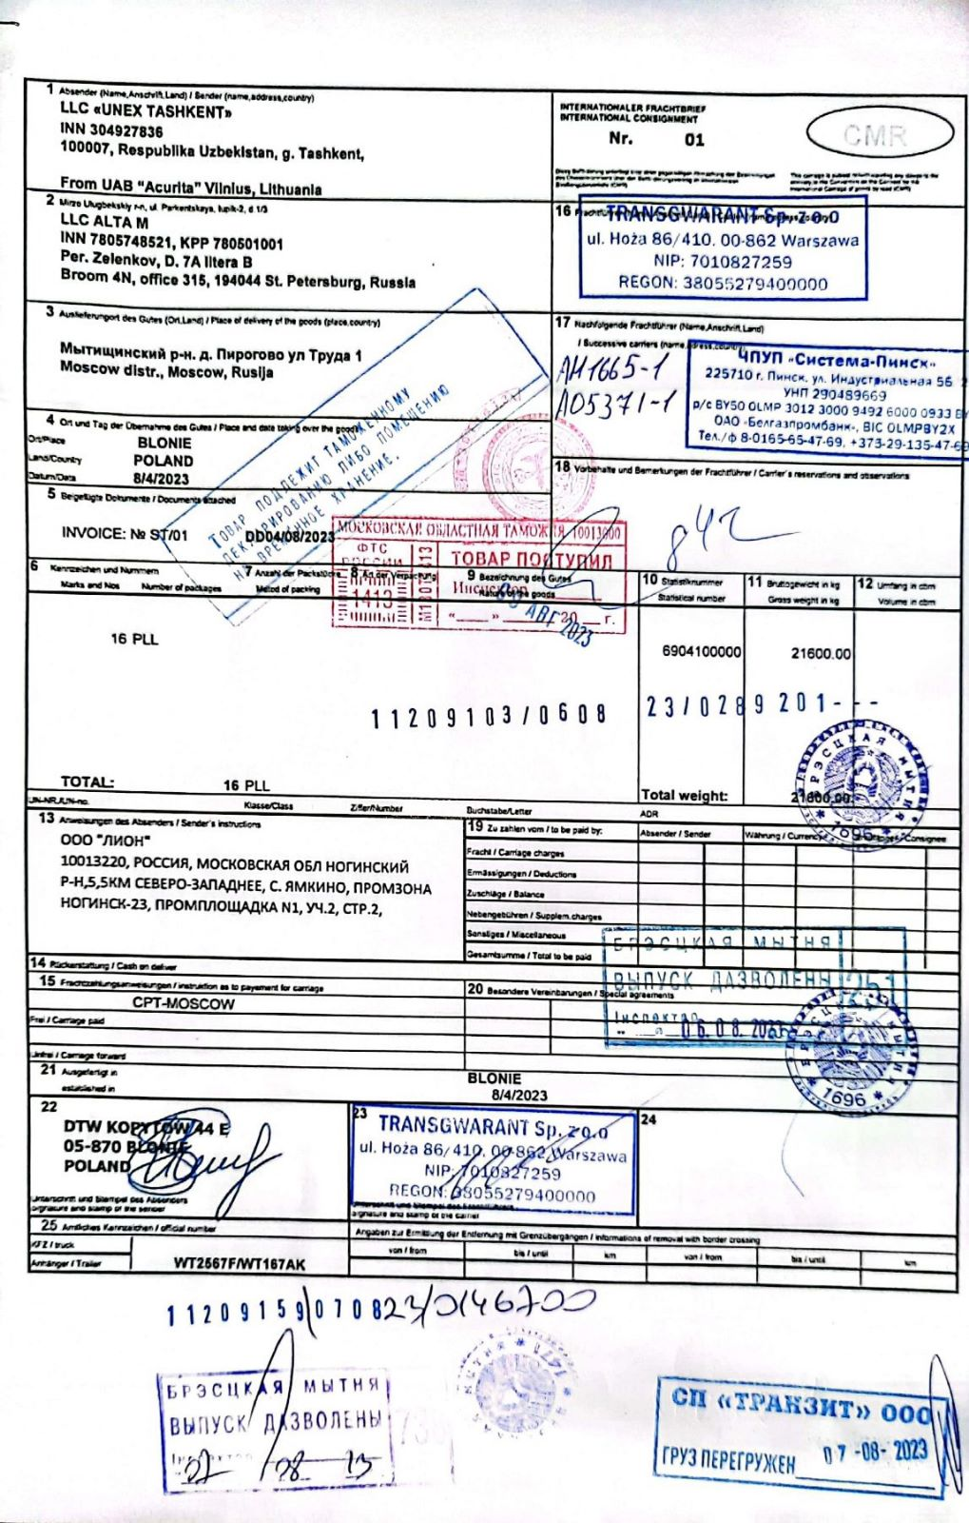

**Pic. 8. An example of CMR**

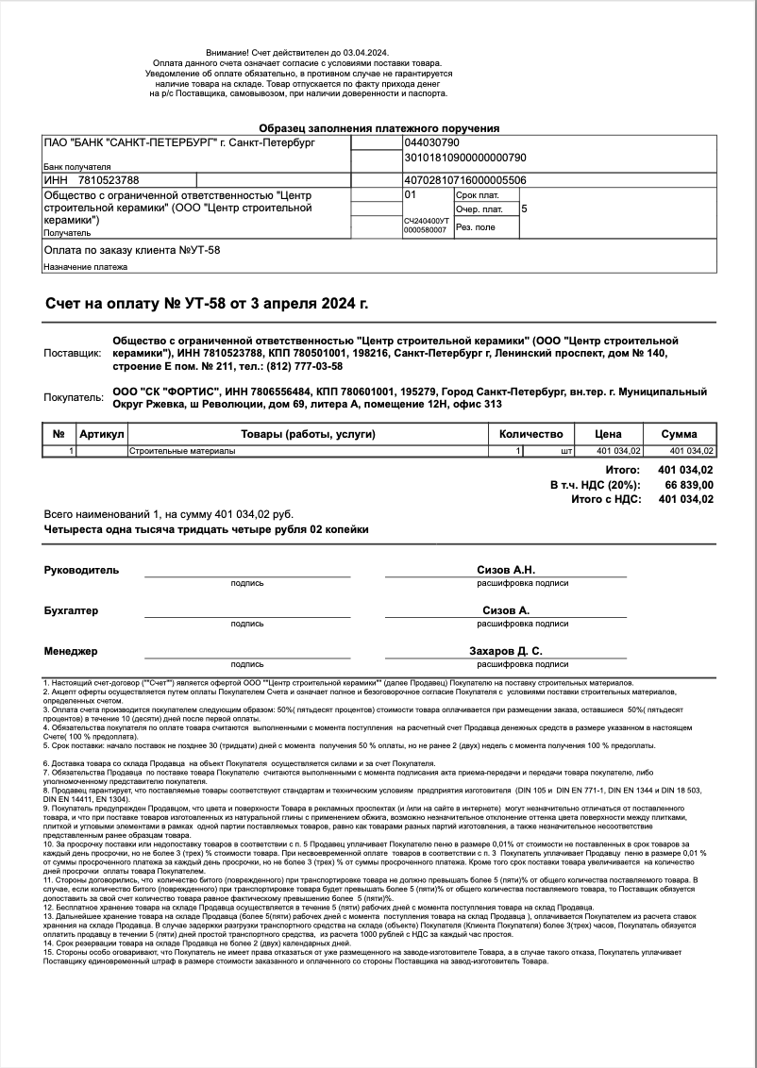

**Pic. 9. An example of company’s invoice**

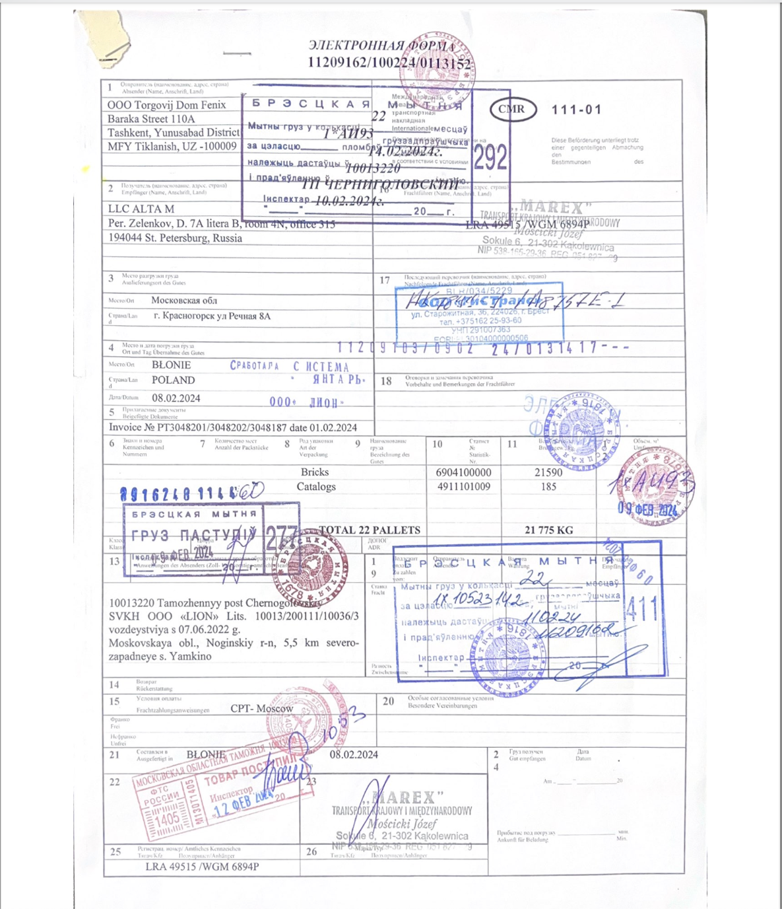

**Pic. 10. An example of company’s CMR**

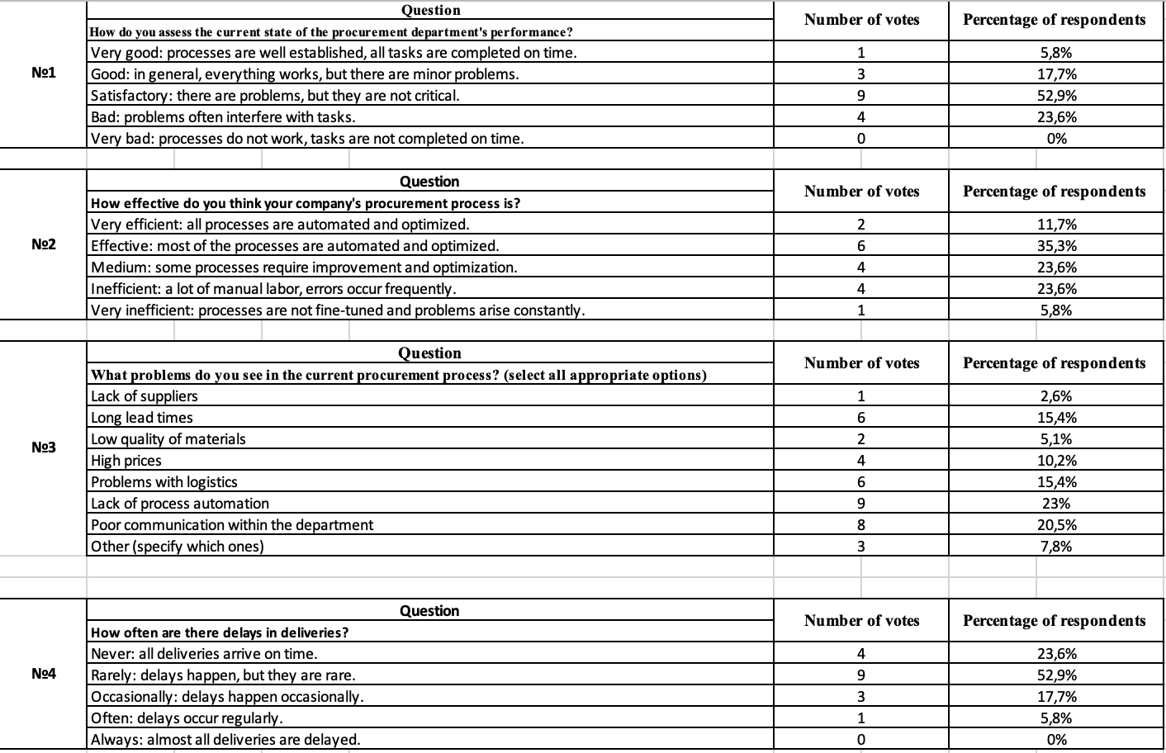

**Pic. 11. Results of the survey (1)**

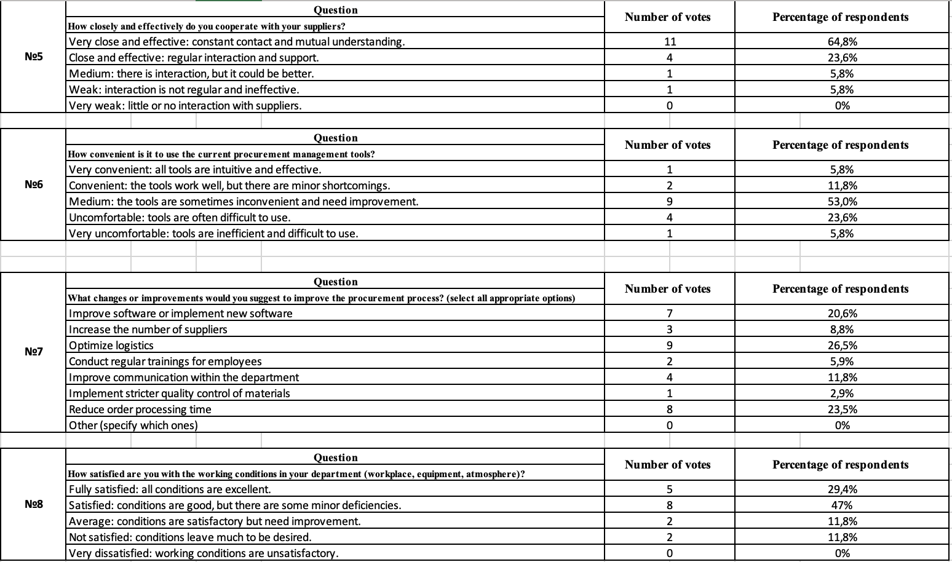

**Pic. 12 Results of the survey (2)**

