REFERENCE
on the Thesis prepared by 2nd year student of
St. Petersburg University Graduate School of Management
Student: Gleb Vorobev
Topic: Provision of Russian Regions with Medical Staff:
Efficiency and Effectiveness Analysis
38.04.02 “Management” Master program

Student manifestation of autonomy and initiative when working on the Thesis: | - The student has shown initiative in the formulation of the managerial problem, goal and objectives of the Thesis
The intensity of interaction with the supervisor: | - Continuous interaction
Respecting the schedule of the Thesis workflow: | - Fully compliant
Timeliness of the final submission of the Thesis to the supervisor: | - Three days or more before the deadline for the Thesis submission
The degree of achievement of the Thesis goal: | - Fully achieved
Compliance of the Thesis content with the requirements: | - Fully compliant
Compliance of the Thesis layout with the requirements: | - Fully compliant
Special Comments:
- The author accurately formulates the goal and objectives of the study, provides justification of its purpose. The research problem is clearly formulated and operationalized.
- The author applied advanced research instruments of quantitative analysis (Data Envelopment Analysis and Stochastic Frontier Analysis models) to measure efficiency and effectiveness of Federal Budget support to the regions to ensure provision regional healthcare with qualified medical staff.
- The empirical data used in the study is unique as it is obtained from the RF Ministry of Healthcare.

General Conclusion: The work by student GLEB VOROBEV meets the requirements for Matser diploma thesis in the area of studies 38.04.02 “Management” Master program.
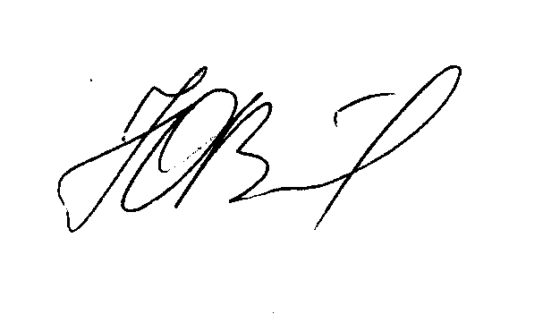

Scientific Advisor: Associate Professor Yuri V.Fedotov
Date: June 7, 2024

