Federal State Educational Institution

of Higher Professional Education

Saint Petersburg State University

Institute ‘Graduate School of Management’

PROVISION OF RUSSIAN REGIONS WITH MEDICAL STAFF: EFFICIENCY AND EFFECTIVENESS ANALYSIS

Master thesis of 2-nd year student of MiM programme

**VOROBEV GLEB P.**



(*подпись*)

Academic advisor,

Associate Professor

FEDOTOV YURI VASILIEVICH

(*signature*)

|  |  |
| --- | --- |
|  | 31.05.2024 |

Saint Petersburg

2024

ЗАЯВЛЕНИЕ О САМОСТОЯТЕЛЬНОМ ХАРАКТЕРЕ ВЫПОЛНЕНИЯ ВЫПУСКНОЙ КВАЛИФИКАЦИОННОЙ РАБОТЫ

Я, ВОРОБЬЕВ ГЛЕБ ПАВЛОВИЧ, студент второго курса магистратуры направления «Менеджмент», заявляю, что в моей выпускной квалификационной работе не содержится элементов плагиата.

Все прямые заимствования из печатных и электронных источников, а также из защищенных ранее выпускных квалификационных работ, кандидатских и докторских диссертаций имеют соответствующие ссылки.

Мне известно содержание п. 51 Устава федерального государственного бюджетного образовательного учреждения высшего образования «Санкт-Петербургский государственный университет» о том, что «студент подлежит отчислению из Санкт-Петербургского университета за представление отчета о производственной практике, курсовой или выпускной квалификационной работы, выполненной другим лицом (лицами)».



(Подпись студента)

(Дата) 31.05.2024

STATEMENT ABOUT THE INDEPENDENT CHARACTER OF

THE GRADUATION QUALIFICATION WORK

I, VOROBEV GLEB, second year master student, program «Management», state that my graduation qualification work does not contain any elements of plagiarism.

All direct borrowings from printed and electronic sources, as well as from master theses, PhD and doctorate theses which were defended earlier, have appropriate references.

I am aware that according to paragraph 51 of Charter of the Federal State Institution of Higher Education Saint-Petersburg State University «a student can be expelled from St.Petersburg University for submitting of the internship report, course or graduation qualification work developed by other person (persons)».



(Student’s signature)

(Date) 31.05.2024

**ABSTRACT**

|  |  |
| --- | --- |
| Master Student's Name | Gleb P. Vorobev |
| Academic Advisor’s Name | Yuri V. Fedotov |
| Master Thesis Title | Provision of Russian Regions with Medical Staff: Efficiency and Effectiveness Analysis |
| Description of the goal, tasks and  main results the research | The goal of the study is to estimate the regions’ efficiency of using federal budget funds to provide regional healthcare with qualified medical staff, and to evaluate the effectiveness of the initiatives of the Government which aim to help regional healthcare systems to solve problems of medical staff shortages. Seven research tasks help to achieve this goal:   1. To explore the legal aspects of the problem, i.e. the regulation for providing federal budgeting and staffing hospitals. 2. To survey international practices of provision national healthcare systems with qualified staff. 3. To develop a framework for efficiency analysis of regions’ performance in attracting and retaining medical staff, compared to the volume of federal financial support. 4. To collect relevant data and determine the methodology of the research. 5. To classify regional healthcare systems to assure homogeneity of empirical samples used for efficiency estimation. 6. To estimate the regions’ efficiency and identify the best units in the classers and provide benchmarks for inefficient regions. 7. To evaluate the effectiveness of the Governmental initiatives in force.   Results of the study show that five core efficient subjects of the Russian Federation could be benchmarks for other regions, and that two initiatives of the Government can be effective in reducing shortages of doctors. However, the model for effectiveness analysis in general is not valid and cannot be used for further research. |
| Keywords | Efficiency, healthcare systems, provision with medical staff, efficiency of using federal funding, Data envelopment analysis, effectiveness |

**АННОТАЦИЯ**

|  |  |
| --- | --- |
| Автор | Воробьев Глеб Павлович |
| Научный руководитель | к.э.н., доцент, Федотов Юрий Васильевич |
| Название ВКР | Обеспечение российских регионов медицинским персоналом: анализ экономичности и результативности |
| Описание цели, задач и  основных результатов исследования | Цель данной работы состоит в том, чтобы оценить экономичность использования средств федерального бюджета субъектами РФ с целью обеспечения региональных систем здравоохранения квалифицированным медицинским персоналом, а так же оценить результативность исполнения Постановлений Правительства РФ, направленных на поддержку систем здравоохранения с целью увеличения числа медицинских работников. Семь исследовательских задач помогают в достижении этой цели.   1. Изучение правовых аспектов проблемы, а именно регулирование в сферах предоставления федерального финансирования и укомплектования больниц персоналом. 2. Исследовать международные подходы к обеспечению национальных систем здравоохранения квалифицированным персоналом. 3. Выработать концепцию для анализа эффективности деятельности российских регионов по привлечению и удержанию медицинских кадров с учетом объема федеральной финансовой поддержки. 4. Собрать актуальные данные и определить методологию исследования. 5. Классифицировать региональные системы здравоохранения для обеспечения однородности эмпирических выборок, используемых для оценки эффективности. 6. Оценить эффективность регионов и найти наиболее эффективные регионы в подвыборках, а так же выявить эталоны (бенчмарки) для неэффективных регионов. 7. Оценить результативность Постановлений Правительства РФ, направленных на решение проблемы нехватки медицинских кадров.   Результаты исследования подтверждают высокую экономичность пяти российских регионов, которые могут быть признаны лучшими практиками для остальных субъектов РФ. Два Постановления Правительства могут частично смягчать проблемы нехватки медицинского персонала. Однако модель анализа результативности не валидна и не может применяться в дальнейших исследованиях. |
| Ключевые слова | Экономичность, системы здравоохранения, обеспечение медицинским персоналом, эффективность использования средств Федерального бюджета, анализ методом свертки данных, результативность. |

**CONTENTS**

**INTRODUCTION** 6

**PART 1. THEORETICAL FOUNDATIONS OF THE STUDY** 11

**1.1.** **Efficiency analysis: a review of methodologies** 12

**1.2.** **Provision of healthcare with medical staff** 15

**1.2.1. Provision of healthcare with doctors: international practices** 16

**1.2.2. Provision of health care with doctors: empirical research** 21

**1.3.** **Legislative background of the problem** 24

**PART 2. RESEARCH METHODOLOGY** 27

**2.1. Description of the sample** 27

**2.2. Description of the model and variables** 29

**PART 3. RESULTS OF THE STUDY** 37

**3.1.** **Descriptive statistics of the variables** 37

**3.2. Analysis of efficiency estimations** 41

**3.3. Alternative specifications of the model** 47

**3.4. Effectiveness analysis** 52

**CONCLUSION** 58

**REFERENCES** 60

**APPENDICES** 63

# **INTRODUCTION**

The shortage of medical staff is a serious problem for the Russian system of healthcare. Even big cities, like Moscow or Saint Petersburg, experience shortages of qualified doctors and nurses. Moreover, today the shortage of qualified personnel in healthcare is a globally known problem. Governments and private organizations in different countries act to reduce the shortages of qualified labor force by providing additional financial incentives, improving labor conditions and offering other types of non-financial support.

Russian healthcare system does also experience a shortage of qualified doctors and nurses for the last years and even decades. Diversity between the subjects of the Russian Federation makes this problem especially acute in regions where demographic, geographic or economic conditions are not attractive for qualified labor force. Doctors belong to a profession, where perspectives of professional development are particularly important. Less populated regions cannot always provide doctors with such opportunities. Big cities and populated regions have advantages for attracting and retaining qualified doctors and nurses, but still their number should be much bigger than is present in these regions today. The Government of the Russian Federation offers additional programs of support for doctors and nursing staff to increase the number of doctors and nurses employed across all regions and improve the healthcare system in general. The main research question is whether these initiatives are efficiently implemented in different subjects of the Russian Federation.

To address a problem of shortage of human resources in healthcare in Russia, in particular of qualified employees of medical institutions across Russian regions, an efficiency analysis using Data envelopment analysis technique is conducted. This technique helps to analyze complex systems with multiple inputs and outputs. Healthcare systems of the subjects of the Russian Federation are a good example of such systems. Although Data envelopment analysis has its advantages and disadvantages, it was chosen because it is the most powerful tool for efficiency analysis of complex systems on big data samples. The analysis of effectiveness of regional healthcare systems is conducted with two tools: Stochastic Frontier Analysis and regression analysis. One metric of effectiveness is selected to run analysis using SFA and regression analysis.

The problem of shortage of qualified labor force over recent years has been one of the most acute for the economy of the Russian Federation. This problem is relevant for both governmental organizations and private companies. However, this problem is most difficult in those sectors of the economy that require high qualifications and long-term training, for example, in public health care and private medicine. In particular, this study looks at regional healthcare systems across Russia and tries to find out where efficiency in stimulating doctors is high and what regions could be named a benchmark for less efficient subjects of the Russian Federation.

The data on all subjects of the Russian Federation is collected to run this analysis. The time frame of this research is 2022 and 2023. The data on 2022 and 2023 is collected because of two main reasons. First, this data is the most relevant and can give clear understanding of the current problems of Russian healthcare. Second, there were different initiatives of the Government in force in 2022 and in 2023. This gives an opportunity for comparative analysis.

It is suggested that a significant increase in population mortality in Russia during the COVID-19 outbreak in 2020 and in 2021 (19% and 36% increase in mortality rate respectively, compared to 2019) to a large extent was a consequence of insufficient availability of medical care for general population due to shortages of medical personnel [Ulumbekova et al., 2023].

Governmental medical institutions are seeking to extend training and educational programs for future doctors and attract medical staff to join healthcare systems through financial incentives and other support measures. Despite various measures aimed at stimulating medical staff, the medical sector still needs additional recruitment, and the staffing of medical institutions leaves much to be desired. The national healthcare system in Russia is predominantly run by state. Hence, the Government is the key actor which aims to resolve problems related to shortages of medical staff.

The budget of the Russian Federation provides numerous measures to support and stimulate medical personnel, the number of which is growing almost every year. It is often the case that the Federal budget is the additional (and sometimes, major) source of financing for regions of Russia to attract and stimulate medical personnel in the institutions in those regions. Federal financing of the healthcare system in terms of incentives for medical staff is generated from several sources, in addition to the main component – the salaries of doctors and medical personnel. This main component, i.e., salaries of doctors and medical staff, is usually sourced from the regional and local budgets across the country. Although regional budgets take up the major part of this financial burden, the Federal budget also assigns huge payments to the regional budgets to provide additional support of regional health care. In this regard, the question of the efficiency and effectiveness of various measures and individual payments both for healthcare in the Russian Federation as a whole and for the medical sectors of individual regions is relevant.

The main question of this study is the following: how do the subjects of the Russian Federation apply federal budget funds to solve problems with medical personnel shortages from the efficiency and effectiveness perspectives? In order to answer this question, two parts of the research are conducted. The first part of the study measures Russian regions’ efficiency of using the provided federal budget funds to equip regional healthcare systems with qualified medical personnel. This part of the research should answer the first part of the question mentioned above. The second part of the research aims to evaluate the effectiveness of the initiatives of the Government which aim to help regional healthcare systems to solve problems of medical staff shortages. These initiatives are implemented by the subjects of the Russian Federation, so the effectiveness will also be estimated on their level. From the efficiency perspective, subjects of the Russian Federation are considered Decision Making Units (DMUs), and their levels of efficiency are estimated and analyzed. From the effectiveness perspective, a single metric for estimating the effectiveness of governmental initiatives is offered, and subjects of the Russian Federation are also the object of the research. In addition, the effectiveness is estimated by Stochastic Frontier Analysis and regression analysis, whereas efficiency analysis is run with the help of Data Envelopment Analysis. Thus, two perspectives of this research apply different methodologies to the same data set.

It is clear that the motivations for this research are predominantly practical, judging by the nature of the data and typical contribution of such papers which had been published before. In addition, new methodology for estimating the regional healthcare systems’ efficiency is going to be created and can be used by other researchers in the future. This framework should establish a range of metrics which can be used to describe inputs and outputs of Russian healthcare system. Having said that, the goal and tasks of the research can be formulated.

The **goal** of this study is to estimate (measure) Russian regions’ efficiency of using the provided federal budget funds to equip regional healthcare systems with qualified medical personnel, and to evaluate the effectiveness of the initiatives of the Government which aim to help regional healthcare systems to solve problems of medical staff shortages. The problem of provision of healthcare systems with doctors is very big, which forces the Russian Government to propose initiatives which additionally stimulate medical personnel from a financial perspective. The research is based on the official data, so that the results could correspond to the relevant problems of Russian healthcare and be used as a supporting information for decision making process.

The research goal can be subdivided into several main tasks. First, the legal (or regulatory) aspects of the problem have to be studied. These include all relevant information regarding the governmental initiatives and legislation determining the labour conditions of doctors and medical staff.

Second, international practices of provision of national healthcare systems with qualified medical staff should be surveyed. The existing research on the topic is also very important, because existing research helps to look at the problem from a global perspective. It is obligatory to identify practices that can be used in the Russian context and can help to increase efficiency of using federal funding by regions of the Russian Federation.

The third objective of this paper is to develop a framework for efficiency estimation of the Russian regions’ performance in attracting and retaining medical staff. It is highly unlikely that any existing models can be applied to the Russian context, because of the specific features of national healthcare systems of every country, including Russia. Researches of other countries’ healthcare, therefore, could not provide this study with a relevant valid model to conduct a research on the data collected in Russia.

The fourth task of this research is to choose a set of metrics which can be proxy variables for inputs and outputs of the healthcare system, especially regarding the number of medical staff employed, and to collect relevant data. As has been said above, the methodology has to be valid and consistent with the collected data. This is the reason for combining these two tasks together in one research objective.

The fifth objective of this study is to classify regional systems of healthcare to assure the homogeneity of empirical samples used to estimate efficiency levels. The diversity of subjects of the Russian Federation may present problems for traditional analysis of the collected sample. The results could be obtained if the sample is divided into subsamples according to a defined classification. This is due to a requirement for homogeneity of DMUs included in the sample.

The sixth objective of this paper is to estimate efficiency scores of all regions (or decision making units), and identify the best units within obtained classers. These best units shall be analysed and the benchmarks for inefficient regions shall be found among them. This task suggests that inefficient regions should look into benchmark regions’ activities and find best practices that can be adopted for inefficient regions’ healthcare systems. This objective can be shortly called best practice identification.

The last objective of the research is to identify the sources of inefficiency in regional healthcare systems and to explain challenges that these systems encounter. This task could potentially lead to important policy implications, which could improve the performance of the subjects of the Russian Federation. These policy implications could be adopted by the Government and be advised for all or some regions to enhance their performance.

This research consists of several main stages which had been conducted to fulfil the goal and tasks of the study. The first stage of the study is dedicated to investigating theoretical foundations of the study, including the governmental regulation of the problem, international practices of managing funding used for attraction and retention of qualified doctors and empirical studies on efficiency of using funds in the healthcare. The second part of the research determines and describes the methodology of the research and describes the data sample collected. The type of the model and its particular form is justified in this part. The third part of this research summarizes the obtained results, describes and interprets them to make conclusions from the study. Practical managerial and policy implications shall also be formulated in this part.

The structure of this paper simply follows the outlined three stages of the research. The first part covers theoretical and legislative aspects of the provision of medical staff in the Russian Federation. The second part of the paper describes the chosen methodology of the research. The third part summarizes the obtained results and aims to formulate practical implications from them.

# 

# **PART 1. THEORETICAL FOUNDATIONS OF THE STUDY**

From a theoretical perspective, the field of efficiency analysis of healthcare organizations and systems can be divided into three main groups. First, there is the academic background related to efficiency analysis itself, related to methods, tools, and concepts that can be used for efficiency estimation. This academic background has to be studied to get an understanding about the topic of performance assessment, basic instruments and the range of results which these instruments can give. Second, the fundamental legislative acts, which are currently in force, should be studied in order to understand the regulation behind the topic. Since the problems are practical and real data is collected, it makes sense to study the legislation which forms policies that are aimed to solve problems of lack of medical personnel. Regional healthcare systems in Russia operate in the conditions, created by this legislation. Hence, it is very important to survey the current legislation so as to understand what can be studied and measured. Third, there is a wide range of practice-oriented papers in the field of medicine that must be studied to find the research gap and to get enough practical information, regarding existing ways to solve problems with qualified medical staff. It is obligatory to survey such international practices of providing national healthcare systems with qualified medical staff. This literature may address the current problems on the labour market of qualified medical personnel, or other sensitive issues on the contemporary stage of development of Russian and global healthcare systems.

The literature review aims to survey existing research and legislative background of the problem to find answers to several key questions of this paper. If existing research does not address the questions which are mentioned below, it means that there is a gap in the existing knowledge of the problem, and this research will address these questions.

First, what factors can be used to explain the performance of regional healthcare systems in applying federal budget funds to attract and retain medical staff? In particular, this research is done in the Russian context, but there might be existing research of the problem in other contexts, and it is worth surveying.

Second, what ‘exit’ variables should be used to specify the output of regional healthcare system’s effort to increase the number of doctors and nurses in a region? While the first question is about potential independent variables (‘inputs’) of the model, the second aims to determine the hypothetical list of dependent variables (‘outputs’). This list could include number of doctors in the regional healthcare system or life expectancy in a particular region as a general feature which shows the regional healthcare’s results in the long term.

Third, which regions of the Russian Federation are the most efficient in utilization of the federal funding to attract qualified medical personnel? Which regions are inefficient and to what extent? The most efficient regions could potentially represent a benchmark for some inefficient regions.

Fourth, what are the benchmarks (the best practices) for the inefficient regions? Although this study addresses only the particular issue of stimulating medical staff, the problem of fulfilment of production potential in this sense is also very important. Low efficiency in using funds to attract and retain medical staff may suggest that other tasks in healthcare are also completed with low efficiency levels. This can lead to further research of the problem regarding a range of practices that can be adopted and can potentially increase efficiency in regions that fall behind. This may be a direction for further research.

Fifth, what is the level of effectiveness of the initiatives of the Government established to increase availability of medical care and number of doctors and nurses in regions of Russia? In particular, the effectiveness of the Government Decrees No. 2568, No. 1985, No. 1910 and 1610(5) is estimated.

The first part of the literature review will be focused on the basics of efficiency analysis and the contemporary research which is based on methods like Data envelopment analysis. The second part investigates the international practices of provision of healthcare systems with medical staff and empirical studies of health care efficiency. The third part of the review describes the current legislative environment, which determines the Russian health care practices of stimulating medical staff.

## **Efficiency analysis: a review of methodologies**

The topic of performance assessment of Decision-Making Units (DMUs) is relatively new in the business and management literature. It boosted in recent years because of the latest developments of frontier analysis models, for example Data envelopment analysis (DEA). The modelling was actively developed by scientists since the 1950s. As mentioned in [Pidd, 2010], OR/MS model (Operations Research/Management Science) is ‘an external and explicit representation of part of reality as seen by the people who wish to use that model to understand, to change, to manage and to control that part of reality’. Models which are built and used in this research do also contain a part of reality and aim to consider some exogeneous factors that can affect the model. A part of reality is represented in the model as real data collected from open sources.

The approach towards performance assessment used in this research is based on the famous definition given by A. Neely: ‘Performance measurement can be defined as the process of quantifying the efficiency and effectiveness of action’ [Neely et al., 1995]. In this paper, the performance assessment of regional healthcare systems in Russia is also divided into two distinct parts. The first part relates to efficiency analysis of using federal financing to improve the performance of healthcare systems by reducing shortages of personnel. The second part of the study is devoted to analysis of effectiveness of initiatives which aim to attract and retain doctors on a national level.

The aim of this research is to measure the performance (the level of efficiency) of a wide sample of regional healthcare systems in Russia across all regions. The cornerstone of efficiency estimation lies between the concepts of technical efficiency and allocative efficiency for production, proposed by a fundamental study [Farrell, 1957]. These concepts suggest that there is a production frontier (certain level of output) that is achievable for a certain number and quantity of inputs. It is assumed that more outputs produced is better than less outputs, which is the main assumption for outputs in this paper. The second part of this study describes the methodology, including this particular aspect.

The terms ‘efficiency’ and ‘performance’ are rather vague and their definitions are rare in scientific literature, although words themselves tend to be very popular. Perhaps, the majority of authors suggest that terms are clear to the target audience without giving definitions. For example, in [March, Sutton, 1997] exact definitions are omitted. Some authors, on the other hand, give definitions to the terms indirectly, for instance through questions, like ‘how realistic are the goals of an organization?’, ‘how well were the directions for further development chosen?’ and so on, as in [Lichiello, Turnock, 1999].

Total Factor Productivity (technical efficiency) is another concept used to assess performance and efficiency. It is a more distinct concept, which is suitable for achieving aims of this paper. Applying this term supposes that an organization or a system has ‘inputs’ – resources and ‘outputs’ – results and performance is assessed, based on achieving the best possible results, given the resources available to this organization or system [Fedotov, Iablonskii, Vitaliueva, 2017]. This paper is also focused on Total Factor Productivity as a concept for estimating the efficiency levels of subjects of the Russian Federation. In this research the resources used for stimulating medical staff are assumed to be ‘inputs’, and the number of doctors attracted, their salaries and life expectancy in a region are considered ‘outputs’.

Technical efficiency analysis is often carried out using tools like Data envelopment analysis (DEA). Data envelopment analysis is based on the concepts of technical and allocative efficiency, but it belongs to a range of approaches which incorporate convexity assumptions. DEA measures the efficiency relative to a non-parametric, maximum likelihood estimate of an unobserved true frontier, conditional on observed data resulting from an underlying data-generating process [Simar, Wilson, 2007]. A use of a non-parametric frontier guarantees the opportunity to analyse complex systems with multiple ‘input’ and ‘output’ variables. Hence, DEA is one of the best techniques to investigate the performance of regional healthcare systems as complex multiple output structures.

The review of methodological approaches by a group of researchers [Katharakis et al., 2013] observes empirical studies which use either DEA or SFA technique to estimate efficiency in healthcare in order to identify and critically review the differences of existing applications of frontier techniques. The two alternatives both estimate efficiency of a decision-making unit against a certain frontier, but SFA is a parametric approach, while DEA is a non-parametric approach and can incorporate multiple output factors. The systematic review found that there had been a rapid growth of the number of efficiency studies being published in 10 years prior to the review was published, overall more than 210 papers. Over 50% of articles were devoted to the US or UK contexts, and as small as 9,52% of papers were written about the Spanish context, being the third most researched country. The analysis shows that DEA and SFA produce divergent results in roughly 48% of articles, whereas similar results between methods are found only in 19% of efficiency studies.

**Table 1.** Percentage of articles by results of comparing DEA and SFA methods [adopted from: Katharakis et al., 2013]

|  |  |  |  |  |  |  |
| --- | --- | --- | --- | --- | --- | --- |
| Results of the analysis (DEA vs. SFA) | Similar results between methods | Divergent results between methods | Divergent results due to inputs-outputs availability | Divergent results due to model validity | Divergent results due to statistical noise | Divergent results due to environmental factors introduction |
| Percentage (from total 100%) | 19,06% | 47,62% | 4,76% | 9,52% | 9,52% | 9,52% |

The table above shows how many divergent and similar results are observed across studies, which used Data envelopment analysis and Stochastic frontier analysis.

The reasons for difference between the results might be explained by input and output definition, statistical noise and data availability [Katharakis et al., 2013]. This review shows that Data envelopment analysis and Stochastic frontier analysis might be used together to confirm the results of each other, but specific data samples usually require one of the approaches to get better efficiency estimations. The reason behind that is that only one of five SFA efficiency estimations produces the same results as DEA estimations, as can be seen from the table above.

Data envelopment analysis has its own disadvantages and advantages as a research method. As for disadvantages, DEA can be weak when dealing with samples with outliers, which is a downside of this tool, because the results are quite sensitive to outlier values. Secondly, DEA helps to measure relative efficiency, which means that the technique is suitable for comparative analysis of decision-making units’ efficiency. Traditional DEA can deal with limited sample sizes, which also decreases the attractiveness of this tool for researchers. On the other hand, Data envelopment analysis has several strong advantages. First, it does not require any assumptions about the production frontier, i.e. no mathematical specification of the production function is required. This makes DEA a relatively accessible tool, which can be used without any deep knowledge of mathematics. Second, DEA is an appropriate technique to investigate the impact of exogenous variables, and it suggests benchmarks and recommendations for an inefficient decision-making unit. Other advantages of DEA include its ability to deal with complex systems with multiple inputs and outputs, which is a big advantage of this instrument [Simar, Wilson, 2007; Stefko et al., 2018].

Having said that, Data envelopment analysis can be considered a powerful tool for efficiency analysis, which is often used to study national and regional healthcare systems, both for the aims of comparative analysis and individual efficiency estimations. The disadvantages of Data envelopment analysis are not significant for this study for two reasons. First, the sample size is not that big and the sample can be divided into several subgroups. Second, the outliers are easily identified and can be excluded from the sample. Overall, Data envelopment analysis is a methodology which can be applied to solve problems of this research and has been applied to solve similar problems by many authors in recent years.

## **Provision of healthcare with medical staff**

The healthcare systems and individual public hospitals require qualified medical staff, including doctors, nurses and other junior medical personnel. The problem of shortage of qualified medical staff is acute in Russia and almost everywhere around the globe. This problem is associated with problems of measuring and managing efficiency of attracting and retaining qualified medical staff. There is an extensive empirical research of these problems and a lot of qualitative studies which address the problems that healthcare systems encounter. The last type of studies can be a source of many valuable international practices, used in various regions of the planet to improve efficiency of stimulating medical staff. This part of the literature review is subdivided into two parts, which investigate international practices and existing empirical research respectively.

### **1.2.1. Provision of healthcare with doctors: international practices**

The object of the research are healthcare systems in the regions of the Russian Federation. On a large scale it takes a great deal of resources and efforts to create an efficient healthcare system. For many countries the balanced economic development together with satisfying the populations’ needs in education and healthcare is a difficult challenge [Lega, Prenestini, Spurgeon, 2013]. The authors of the recent research showed that the public concern about the quality of the medical help is growing in almost every country [Lega, Prenestini, Spurgeon, 2013]. In Russia these concerns do also exist. This makes the research of the performance of the regional healthcare systems in Russia challenging and valuable for all stakeholders: management of HCOs (Healthcare Organizations), regional governments, employees and the Federal Government, as well as people who use the services of medical organizations in the regions.

Some qualitative analyses tried to distinguish between different types of national healthcare systems. As one study points out, there can be identified at least three types of national healthcare systems, namely Beveridge model, Bismark model and a free-market private insurance model. The main features of these systems are highlighted in the table below.

**Table 2.** Models of Healthcare Systems. adopted from: [Donev, Kovacic, Laaser, 2013]

|  |  |  |  |  |
| --- | --- | --- | --- | --- |
| **Model of Healthcare** | **Countries** | **Source of funding** | **Main features** | **Type of providers** |
| *Beveridge model* | UK, Norway, Findland, Denmark, Australia, Italy | Budget of the Government | Access to all healthcare services for all citizens of a country;  Comprehensive coverage with basic health benefits;  Underfunding and rigidness. | Predominantly public providers with governmental ownership;  National healthcare systems as key players |
| *Bismark model* | Germany, Switzerland, Austria, Belgium, Israel | Compulsory health insurance | Health care as an insured good, covering 60-80% with ‘basic’ health services;  High costs, difficult to control;  State regulating the system. | Mixed public and private providers with dominant public ownership; |
| *Free-market private insurance model* | USA | Private insurance and funding | Health care as a commodity;  Weak state control; | Predominantly private providers with autonomy; |

The systems of health care shown in the table are divided according to two main criteria: the sources of funding and degrees of state intervention. This classification does not evaluate the level of efficiency inherent to every type of healthcare system. The authors of the paper suggest that the Soviet healthcare system was the first to be created as completely centralized and state-controlled model, but post-Soviet countries, including Russia, are considered to belong to the ‘Bismark model’ [Donev, Kovacic, Laaser, 2013]. There are evidently many features that characterize the Russian health care as ‘Bismark’, e.g. state regulation of the system, a system of compulsory medical insurance or high expenditures on the health care, which include compensation payments to doctors and nurses. Relatively high costs are a hypothetical sign of a system’s low efficiency, which may also apply to use of federal funding for compensation of employees.

These three types of healthcare systems are not the only classification of various approaches to health care that are offered by a scientific community. [Bohm et al., 2013] classified OECD countries’ healthcare systems into five types: National Health Service (UK or Denmark), National Health Insurance (Canada, Australia), Social Health Insurance (Germany, Austria), Etatist Social Health Insurance (Poland, Israel) and Private Health System (USA). The main criteria for this classification are regulation, financing and service provision. In particular, what actors create the regulation, provide financing and health services. Actors can be either governmental (public), societal or private, and these distinctions partly explain different levels of efficiency [Lee, Kim, 2018]. The Russian Federation is not an OECD country, so it is unlikely that this classification should be adopted for the aims of this research. However, this example shows that there are different healthcare systems across the world. Every healthcare system can potentially offer some best practices for another one, which may cope with inefficiencies it encounters. This potential of discovering new practices makes the study of various healthcare systems and their specific features beneficial for the aims of this research.

It may seem that lack of funding for medical systems might be experienced in countries with free-market private insurance model, where state funding does not support the healthcare system. However, the same study provides contradictory information on per capita spending on the healthcare systems, in particular, the US healthcare system spent $ 8,233 on health per person, while the rest of developed OECD countries’ average spending amounted to only $ 3,268 per capita [Donev, Kovacic, Laaser, 2013]. These figures could not provide any insights about the efficiency of healthcare systems in these countries, but rather can help to evaluate different models of health care.

The medical institutions and public healthcare systems have been in the focus of public attention since their emergence, however, in the last decades this attention has been only growing. The ageing of population makes the medical help demanded by a greater number of people. The scarcity of financial resources even for the medical sphere complicates the operations of the healthcare systems. For instance, the Russian federal budget deficit amounted to 3,3 trillion dollars in the first quarter of 2023 [RBC, 2023]. This deficit may be partly covered by reducing the expenditures on the national healthcare system. The financial constraints and growing demand, together with the demand for higher quality of medical services, compel the medical services providers to work effectively and use modern managerial techniques. Performance measurement is undoubtedly one of the most important fields of modern knowledge, which can be used to efficiently operate the medical institutions. The main reason for this is that performance measurement is a cornerstone of performance management, which can be adopted by regional governments or healthcare departments to manage their performance and improve quality.

The development and implementation of the performance measurement systems, systems of KPIs and metrics is acknowledged as a powerful instrument for monitoring quality of medical services and for making changes on the national level of healthcare [Zidarov, Poissant, Sicotte, 2014]. Such systems can be developed after a publication of a systematic work on the overall performance of hospitals or on a base of empirical works, which analyse particular medical institutions and their performance. This paper will investigate the performance of a sample of Russian hospitals, so it can be considered a macro-level study. On a level of a particular healthcare organization, it can be used as an impetus for improving the quality of services or as a way to establish the internal (or Governmental) system of metrics to measure performance.

Attraction and retention of qualified medical personnel are important pain points of healthcare systems across the world. The key goal of management of the healthcare systems and organizations is often just to keep the number of qualified employees at a certain satisfactory level and not let it drop lower than it. One-third of respondents of a study by McKinsey said that they are working on ensuring a certain number of qualified doctors is present across different medical institutions. The systems tend to focus more on increasing workforce satisfaction and well-being of medical staff to enhance retention of existing employees and attraction of new ones [Levine et al., 2024]. This particular research by McKinsey studies the performance of academic medical centres and financial problems they encounter. However, the same problems are relevant for other medical institutions and systems, and it is remarkable that workforce optimization is named the first operational area for improvement for medical centres in this study [Levine et al., 2024].

This example shows that attraction, retention and number of employees working in healthcare systems are an important concern for the management of these systems, both private and public. Increasing operational efficiency in the sphere of attracting and retaining workforce is seen as one of the tools to enhance the fiscal health of medical organizations.

The problem of shortages of qualified medical staff is extensively investigated in the U.S. and other OECD countries contexts. It is evident that the shortages of medical staff are a serious challenge even in the U.S. McKinsey surveyed the frontline nurses’ willingness to leave work in 2020 and in 2022. While a high reported likelihood of nurses to leave their jobs in 2020 could have been explained by the COVID-19 pandemic, 31% of nurses might still leave their jobs in 2022, according to the latest survey [Berlin et al., 2023]. The authors of this study are optimistic despite that relatively high number, because they suggest the decrease of that number during this two-year period is a positive result of some practices implemented by the healthcare organizations [Berlin et al., 2023].

The polling showed that inadequate compensation is the most common reason to leave the work that nurses mentioned, along with a feeling that they are not valued by the organization. While the second factor cannot be easily changed or affected from a regional level of healthcare system’s management, the level of compensation can be a target for the management to achieve in order to motivate nurses to stay in their current positions. In addition, the study suggests that hospitals can increase nurses’ well-being and willingness to work if they offer them flexible working hours [Berlin et al., 2023]. Job flexibility may also be a contributing factor for higher retention rates, and can be potentially adopted by Russian regions to increase the number of doctors and nurses employed.

As has been already mentioned, the COVID-19 pandemic made the problem of qualified medical personnel’s shortages more acute than ever before. Perhaps, this is the reason for many members of the academic community to work on this issue in recent few years. For instance, the research [Artificion et al., 2020] not only stated there is a nursing shortage in one of Philippines provinces, but also confirmed that nurses start to commit failures and errors when they are exhausted at work. A quantitative-descriptive approach was used to survey 243 frontline nurses. It is suggested that employment nationwide is also negatively affected by a lack of qualified nurses in the health care [Artificion et al., 2020]. Overall, the shortages of qualified medical personnel can be observed in almost any country of the world, and extensive research of these problems prove their urgency. However, the literature review and survey of empirical researches have not yet found numerous articles devoted to the same problems in the Russian context, where shortages of doctors and medical staff is a high social and political priority. The official statistics show that the health care lacks at least 30 thousand doctors and 60 thousand medical staff. The problem of providing the healthcare of Russia was set as one of the biggest questions for the new Minister of Healthcare by the Federal Parliament in May, 2024 [RBC, 2024].

Another McKinsey survey [Patel, Singhal, 2023] studies the American healthcare market. The survey aims to determine the growth level of the healthcare industry in the next few years, and identify key challenges that may prevent the US health care from increasing profits at a high rate. Labour shortages are considered one of the main challenges for the US healthcare system in 2023 and beyond. The authors conclude that healthcare systems need to improve efficiency and address labour challenges to achieve anticipated growth. Higher demand for healthcare services is seen as one of supporting factors to improve efficiency and confront shortages of doctors and nurses [Patel, Singhal, 2023].

A group of researchers surveyed 76 health system executives in the US in 2022 [Azzoparde et al., 2022]. The majority of executives opt for diversifying their healthcare businesses, and this diversification can be one of the major drivers to increase the efficiency of these healthcare systems. On the other hand, rising operating costs make healthcare systems more vulnerable to economic downturns, so operating efficiency strongly concerns health care executives [Azzoparde et al., 2022]. From the demand perspective, another McKinsey research [Charumilind et al., 2024] found out that the consumer demand for price transparency in healthcare is very high. Transparent prices shall include all information regarding the labour costs and efficiency of efforts aimed at stimulating medical staff. Since prices for healthcare services in the US substantially vary (scientists observe up to 40% difference), it is important for customers to understand the roots of these discrepancies [Charumilind, 2024]. As has been mentioned above, US healthcare system is predominantly private, hence competition is quite fierce, which should hypothetically increase efficiency. Russian healthcare system is very different, because the Government plays a major role in regulating it. However, price and cost transparency are still critically important for the Government, as it can decrease costs in the healthcare system by optimizing workforce and find new ways to counter labour challenges.

A range of papers among studies of international practices of health care efficiency and management is devoted to particular segments of health care services and certain types of healthcare systems. For example, a study by a group of authors aimed to create a framework for assessing efficiency of behavioural healthcare, as a narrow segment of health care [Aday et al., 1999]. The study uses the concept of allocative efficiency, and builds a framework consisting of structure – process – intermediate outcomes – multiple outcome elements. The central idea of the framework that there are multiple outcomes that determine the efficiency of a healthcare system is central for this research as well [Aday et al., 1999]. Unfortunately, the proposed framework is not suitable for efficiency analysis on the regional or national levels, but a few key conceptual ideas can be adopted from it.

### **1.2.2. Provision of health care with doctors: empirical research**

The empirical studies of performance in healthcare are largely focused on measuring technical efficiency with the help of frontier analysis models. The first group of these studies examine the national healthcare systems on the national or governmental levels and aim to measure technical efficiency of the whole healthcare systems. One of the recent works [Tigga, Mishra, 2015] was devoted to measuring the technical efficiency of the Indian national healthcare. The methodology of this paper was based on Data Envelopment Analysis (DEA). Data envelopment analysis is a powerful non-parametric tool that can measure the level of efficiency of decision-making units according to the constructed model that can include more than one input and more than one output variables. As a group of researchers point out, Data envelopment analysis is ‘a non-parametric approach, [which] analyses the efficiency of groups (commonly referred to as decision-making units (DMUs)) with an idea that efficient DMU produces more output than others with the same amount of input [Lee, Kim, 2018]. These authors estimate how healthcare system efficiency is associated with policy factors for public health in OECD countries. Quite surprisingly, they found that the social health insurance system showed the lowest efficiency score compared to other types of systems.

Many studies are devoted to the efficiency analysis on the national level. For example, [Stefko et al., 2018] investigate the national health care in the Slovak Republic. In particular, data on regional systems of healthcare facilities across years 2008-2015 is analysed using extended DEA window analysis under conditions of constant and variable returns to scale. CCR model of Data envelopment analysis is run under the condition of constant returns to scale, whereas variable returns to scale is an assumption for the BCC model of DEA. The study shows that estimated efficiency levels of regional healthcare systems in the Slovak Republic do not significantly differ between each other. Moreover, it is observed that regions with low values of the variables over time have tend to achieve high efficiency levels. On the other side, regions that have high values of the variables do tend to perform poorer in terms of their efficiency [Stefko et al., 2018].

Different empirical studies use different approaches to the selection of factors, which account for ‘input’ and ‘output’ variables. Some researchers apply the total number of medical staff, including doctors, nurses, and other junior medical personnel, as an output factor for the healthcare system. For example, a study [Maestre et al., 2015] considers a total number of employees in the health care as the basic indicator of the economic output of this system. Additionally, this group of authors, as well as some other researchers, does not divide medical employees into subgroups, but rather tracks the total number of medical employees as a single group [Maestre et al., 2015]. Apart from the study that has been mentioned above, the total number of employees of a hospital or a healthcare system is commonly used as a proxy factor of an output variable [Stefko et al., 2018].

On the other side, some researchers use the total number of healthcare system’s employees as an input variable. For example, an empirical study [Cheng et al., 2016] introduced numbers of doctors, nurses and administrative staff as an input variable. The same study applied DEA bootstrap approach, which has recently become a popular technique to estimate efficiency across healthcare industries. The authors apply the output-oriented DEA models, due to limited control of the inputs by the management of a healthcare system and control of the main investments and recruitment decisions from the Government. These reasons forced the researchers to build an output-oriented DEA model, including a bootstrap version [Cheng et al., 2016].

Authors from the second group of the works usually make particular HCOs the object of their researches, like in [Valdmanis et al., 2017]. In this paper authors measure technical, overall and scale efficiency of a particular type of the medical institutions – home health care agencies. This paper also uses Data Envelopment Analysis, and examines healthcare systems of one particular governmental type. This paper will focus on one segment of the medical institutions in terms of the homogeneity of ‘inputs’ and ‘outputs’, and in this sense this paper belongs to the first group of empirical studies on the performance assessment.

The second group of studies explores the technical efficiency of samples of medical institutions in various segments. The number of these studies is quite limited, which makes this group the smallest one.

As for the ‘inputs’ in models for measuring technical efficiency, they mostly include material and medical costs, labour costs and capital expenditures. The ‘outputs’ are usually comprised of the number of cured patients and the quality of the treatment. Some authors focus on analysing the efficiency of healthcare at the regional level or country-level. For example, [Turlea, Borisov, Cicea, 2012] examine the healthcare systems in European Union countries, comparing the efficiency of new members of the EU, which joined after 2004, with other EU countries that had been members before. Authors apply Data envelopment analysis technique to estimate efficiencies of healthcare systems and to find out benchmarks and implications on countries’ policies. This paper uses traditional metrics as outputs of the model, which are life expectancy at birth and infant mortality rate [Turlea, Borisov, Cicea, 2012].

There are some authors who undertake meta-studies of the research landscape of the topic of efficiency in healthcare globally. Researchers mostly focus their attention on the efficiency of particular hospitals, as one meta-study across 317 papers [Hollingsworth, 2008] shows. According to this meta-analysis, 52% of authors look at the individual hospital level, while only 4% of papers address the same efficiency problem on a cross-country level. As long as the majority of studies focus on analysing efficiency of individual hospitals, there should be a substantial research gap in studying the efficiencies of healthcare on a regional and national levels. This potential is also enhanced by a lack of studies dedicated to the analysis of the Russian context. Most studies focus either on developed OECD countries, or on growing economies like India, Bangladesh and others.

The Indian health care has been researched for the last decades. One of the first efficiency studies was conducted as a comparative analysis of Indian private, public and mixed-owned organizations. A researcher applied the BCC algorithm within DEA approach to identify the least and the most efficient decision-making units [Majumdar, 1996]. The results of this research contradicted the previous studies finding no performance differences between private and public organizations. The author found that the efficiency of private organizations is higher than of organizations with mixed ownership, whereas government-owned public organizations are even less efficient [Majumdar, 1996].

Another research focused on estimating efficiency of Indian healthcare on an individual hospital level, and found that roughly 30 per cent of hospitals are efficient. Apart from Data envelopment analysis, the study applied Malmquist productivity index (MPI) to assess total factor productivity. MPI is based on DEA and assesses the productivity change of units over a period of time and decomposes changes into technological and technical efficiency changes. Using these methods, the researchers were able to identify robust hospitals, which can be benchmarked as the best performing ones [Gandhi, Sharma, 2018]. A list of best performing hospitals is an important practical result of empirical studies, as long as practical recommendations which can help to improve the efficiency of healthcare systems.

To conclude the review of empirical studies, it is worth noting that the majority of performance assessment studies are devoted to researching US, UK or other non-Russian contexts. This fact suggests that the gap in existing literature devoted to studying the Russian health care might be quite substantial.

## **1.3.** **Legislative background of the problem**

As long as the study is based on real data, one of the most important parts of the literature review is the information on the legislative acts of the Russian Government, such as the Government decree 2568 which regulates the special social payments in 2023 and onwards.

The details about each legislative act will be given in the methodology section, because they largely influence the data that is gathered for the purposes of the study. However, the legislative acts are still on paper, and shall be included in the literature review as a theoretical foundation of the real world that is analysed.

First, there are so-called ‘May decrees’ of the President of Russia, issued in May 2012. These decrees formed a broad vision of development of the country for the next decade. The decree No. 598 of May 7, 2012 ‘On improving state policy in the field of healthcare’ [Decree No. 598 of the President of Russia, 7.05.2012] had established goals for the development of public healthcare for the upcoming years. This decree had established the term of ‘basic (or target) salary’ for doctors and medical staff. This basic salary has to be at least twice bigger than the average salary in a particular region. For example, if an average salary in Belgorod region is 100,000 rubles, the Government of this region shall aim to pay doctors at least 200,000 rubles. As of today, the regulation considers all additional payments to medical staff a constituent part of doctors’ salaries, which is potentially a problem. Regional governments may try to reach a level of target salaries by adding special payments from the Federal Government to doctors’ actual income, while reducing their main salary. Although policies related to the target salary might be further improved, this decree was one of the first substantial steps from the Government to increase attractiveness of the healthcare system as a destination for students and potential employees.

Other legislative acts described in this paragraph create a legislative framework for particular governmental initiatives for additional stimulation of employees of medical organizations. For example, special social payments were introduced by the Government Decree No. 2568 of December 31, 2022. As the Decree was published in the very end of year 2022, special social payments had been paid out only since the beginning of 2023. Regional authorities should provide compensation to medical employees in 2023 higher than in 2022, given special social payments and other types of support [Decree of the Government No. 2568, 31.12.2022] This is a vivid example how legislation forms the data that is included in the row of variables in the model. Crucial information about each legislative act, its aims, amounts of funding and time of implementation is presented in the table below.

**Table 3.** Description of initiatives of the Government to support and stimulate medical staff

|  |  |  |  |  |
| --- | --- | --- | --- | --- |
| **Government Initiative** | **‘Zemskii Doctor’ Program** | **Decree No. 1910 of 27.12.2019** | **Decree No. 2568 of 31.12.2022** | **Decree No. 1985 of 24.11.2023** |
| Time frame | Since 2018 (2022 and 2023) | Since 2020 (2022 and 2023) | Since 2023 (2023 only) | Since 2023 (2023 only) |
| Aim / target group | To additionally stimulate medical staff who moves to small or remote settlements | To co-finance salary costs of regional healthcare systems, i.e., support budgets | To make remuneration for medical staff in 2023 higher than in 2022 | Additional interbudgetary transfers to support regional healthcare systems in 2023 |
| Conditions | Doctors and nurses shall work for 5 years or more in remote settlements with population less than 50,000 people | Healthcare institutions should provide the Federal Government with lists of employees whose salaries need co-financing | Regional healthcare systems should account for providing special social payments to medical staff and for their level of remuneration | Regional budgets should receive additional support from the Federal fund to support and stimulate medical staff in the end of 2023 |
| Volume of Financing | Up to 2 million rubles for doctors, up to 1 million for medical staff, depending on the qualification of an employee and type of an area | Depends on requests of regional healthcare systems to co-finance salaries. | Special social payments to medical staff - up to 18,500 rubles for doctors, up to 4,500 rubles for junior medical personnel. Overall – 150 billion rubles. | Roughly 30 billion rubles for all regional budgets, divided according to the Governmental Decree |

The Government Decree No. 1910 of December 27, 2019 regulates the rules of providing the interbudgetary transfers to regional Ministries of Healthcare. Depending on the size of the region and its economy, the transfer for a period could be bigger or smaller than in other regions. The main task of these transfers is to co-finance salary expenses of the regional budgets.

The program ‘Zemskii Doctor’ was introduced as a part of the National Programme ‘Development of the Healthcare’. It is described in application No. 5 to the Government Decree No. 1640 of December 26, 2017, which established the National Programme. This program gives a lot of benefits to those doctors who start working in remote settlements and small cities.

The Decree of the Government of the Russian Federation No. 1985 of November 24, 2023 regulates the rules for providing additional special transfer to the regions in the end of 2023. As with Decree No. 2568, it is provided in the form of interbudgetary transfers to regional healthcare departments from the Federal compulsory health insurance fund.

Thus, the regulatory framework of the problem consists of five main Decrees of the President and the Government of Russia. Other features are determined by broader legislation of the Russian Federation, specific regional attributes and structure of the healthcare systems. This wider context is also considered in this research, but the main legislative framework of the problem is set by the Decree mentioned above.

# **PART 2. RESEARCH METHODOLOGY**

## **2.1. Description of the sample**

The first step of data collection includes searching for information on four initiatives of the Government aimed to provide additional financing to regional healthcare systems, basic salary and actual income of doctors in 89 regions of the Russian Federation, number of doctors employed in healthcare systems and life expectancy in the regions, and preliminary analysis of this information. Therefore, regional healthcare systems (or departments) are considered the object of this research. The first stage of data collection revealed that four subjects of the Russian Federation, which had been united with Russia in the end of 2022, do not provide enough information for the analysis of their health care. Quite naturally, data on these regions for 2022 is missing almost completely, since no information had been gathered by the public authorities. Even information on 2023 is very scarce. The lack of information about the performance of regional healthcare systems of Zaporozhie, Kherson, Donetsk and Luhansk regions made their removal from the sample necessary for further qualitative analysis.

The second stage of data collection was to synthesize information on all variables mentioned above across 85 regions of the Russian Federation in 2022 and in 2023. Data sample includes information for 2022 and 2023, because different variables are analysed. The list of regions is not provided here, because it is rather long. In addition to data collected for all variables, information on density of population across regions was collected. Density of population could be used as a parameter to classify subjects of the Russian Federation. The graph below demonstrates how Russian regions are distributed according to the population density.

**Figure 1.** Density of population in the subjects of the Russian Federation [own estimations]

It is evident from the graph that regions’ density of population is extremely uneven. Moscow and Saint Petersburg are absolutely extreme values in terms of this metric, with 5116 and 3991 men per square kilometre respectively. As a consequence, the healthcare systems of these regions are saturated with medical staff quite well. However, the lack of qualified doctors and nurses is acute even in these biggest cities. On the other hand, such regions as Republic of Saha, Krasnoyarsk or Chukotka have the lowest density of population, mostly settled in and around big cities. Healthcare systems in these regions have an atomic structure, following the distribution of population in the regions. Big hospitals and qualified medical staff are usually present only in relatively big settlements. The Program ‘Zemskii Doctor’ is especially relevant for such regions with low density of population and atomic structure of the health care. The first graph shows that the sample is really diverse. The subjects of the Russian Federation are very different from each other, and even basic parameters show this difference.

The second graph below shows the distribution of regions according to density of population, after extreme observations were deleted from the sample. The procedure of deleting outliers was conducted with the help of Stata MP package.

**Figure 2.** Density of population in the subjects of the Russian Federation [own estimations]

The second graph shows that difference between the least and the most populated regions is still dramatic. The ‘long tail’ of less populated regions seems to dominate the whole sample. It seems reasonable to divide the sample into four or five equal groups according to the population density. The first subsample may include the least populated regions, the second and the third – regions with moderate population, e.g. Kurgan and Ryazan’ regions, and the fourth and the fifth subsamples may include the most populated regions. Some options within Data envelopment analysis, for example CCR model, are good at dealing with small subsamples, and the analysis on small subsamples might prove to be effective.

Having said that, there are several features of the sample that can be formulated to conclude this paragraph. First, subjects of the Russian Federation are very different, and the structure of healthcare systems of the regions does also vary widely, from atomic structure in less populated regions to dense network structures in the biggest cities. These differences have to be taken into account during the course of the study, especially when results are going to be obtained. Second, analysis on subsamples is probably relevant for confirmation of results’ validity. Third, the fact that the sample consists of observations for two different years can make the obtained results convincing. The reason behind this is that there were additional initiatives of the Government, introduced in 2023, which shall also be analysed. Moreover, adding new variables in the model in 2023 shall increase the validity of the model as a whole.

## **2.2. Description of the model and variables**

Efficiency assessment is carried out using the DEA-solver analysis package, with the following set of variables to assess the operational (technical) efficiency of entities in terms of using federal budget funds to provide medical institutions in the region with doctors.

‘Inputs’, i.e. the independent variables of the model, are presented below. It is assumed that any changes of independent variables should result in some changes of the dependent variables of the model.

1. Basic (target) average monthly salary of a doctor in the region i (i=1,85) in year t (t = 2022,2023), regulated by the Decree of the President No. 598 of May 7, 2012– ${X1}_{it}$;
2. Payments to the region i (i=1,85) for ‘additional state social support for medical personnel of medical organizations included in the state and municipal health care systems and participating in the basic compulsory health insurance program or territorial compulsory health insurance programs’ (t = 2022,2023), regulated by the Russian Government Decree No. 2568 of December 31, 2022) – ${X2}_{it}$;
3. Compensation payments to the region i (i=1,85) from the Federal budget to cover the wages of additionally attracted doctors in year t (t = 2022.2023), regulated by the Russian Government Decree No. 1910 of December 27, 2019 – ${X3}_{it}$;
4. Payments to the region i (i=1,85) within the framework of the “Zemskii Doctor” program in year t (t = 2022,2023), regulated by the Russian Government Decree No. 1640 of December 26, 2017 – ${X4}_{it}$,
5. Payments to the region i (i=1,85) for a separate transfer from the Federal budget in year t (t = 2023), regulated by the Russian Government Decree No. 1985 of November 24, 2023 – ${X5}_{it}$.

‘Outputs’, or three dependent variables of the model, are presented below.

1. Average monthly salary of a doctor in the region i (i=1,85) in year t (t = 2022.2023) – ${Y1}_{it}$;
2. The number of doctors in the region i (i=1,85) in year t (t = 2022.2023) – ${Y2}_{it}$;
3. Life expectancy in the region i (i=1,85) in year t (t = 2022.2023) – ${Y3}_{it}$.

The density of population in a particular region is introduced as a free parameter of the model. Density of population in a region helps to differentiate regions between each other. For example, Republic of Yakutia is large and populated not densely. The number of doctors needed for this region is not that high, but it is still very difficult to attract doctors, given the weather conditions and the distances in this region. If compared with Moscow, where population is much more densely located, the task of attracting and retaining medical staff seems too different. That is the reason for building clusters for analysis using the parameter of population density.

Inputs (independent variables) of the model include the basic average monthly salary of doctors and a number of additional payments introduced at different times in order to encourage medical personnel to work in medical institutions in the regions of the Russian Federation. The basic (target) average monthly wage is the wage level set as a target for regions in specific industries, including healthcare. The basic salary for the public healthcare was set by the Decree of the President of Russia No. 598 of May 7, 2012. This Decree had established a goal for doctors’ wages according to the observed average level of wages in a certain region of Russia. The basic salary of qualified medical staff should be twice bigger than the average salary across all industries. Employers in public healthcare are expected to strive to provide this level of wages to their employees. Thus, the target level of wages for doctors and medical personnel should influence the level of actual wages in the region and the staffing level of medical personnel and the quality of medical services. Based on this assumption, the basic (target) average monthly salary is used as the first independent variable of the model.

Other variables of the model reflect the collected data on additional payments designed to attract doctors and encourage other categories of medical personnel to work in medical institutions in various regions. Often, the real average monthly salary lags behind the target indicators, so additional social payments are introduced by the Government of the Russian Federation to further stimulate doctors in the regions and achieve target indicators. This study is designed to evaluate the effectiveness of payments in accordance with Government Decrees dated December 26, 2017 No. 1640 (and within the framework of the Order of the Ministry of Health dated March 4, 2021 No. 166n), dated December 27, 2019 No. 1910, dated December 31, 2022 No. 2568, dated November 24, 2023 No. 1985.

The second variable of the model reflects the dynamics of special social payments to medical personnel within the framework of Government Decree No. 2568 of December 31, 2022. The regulation came into force on January 1, 2023, so this variable is not included in the model for 2022. However, in 2023, the amount of funding for the regions under Resolution No. 2568 was significant, which makes it possible to measure the efficiency of the use of these funds by the regions and introduce this variable into the model. The resolution specifies that the level of remuneration of medical staff in 2023 should not be lower than the level of 2022, taking into account wage indexation and special social benefits.

Special social payments are made monthly based on data from medical institutions and through other interbudgetary transfers from the Federal Compulsory Health Insurance Fund. Regional compulsory medical insurance funds (hereinafter referred to as compulsory health insurance) distribute the funds received among medical institutions in the region. The amount of payments depends on the qualifications and specialty of doctors. The range of medical specialties that are eligible for payments is quite wide: for example, the maximum payment to doctors is 18,500 rubles. The maximum amount of payment to doctors with higher non-medical education is 14,500 rubles or 11,500 rubles, providing medical care or participating in intravital cytological studies, respectively. For emergency department doctors, the maximum payment was also to be 11,500 rubles, according to the Resolution. The maximum payment to medical personnel of central district and district hospitals with secondary medical education is 8,000 rubles. Specialists with secondary medical education who work with doctors and provide primary health care are entitled to receive a monthly payment of up to 6,500 rubles. Paramedics and nurses at emergency medical aid stations are entitled to receive payments of up to 7,000 rubles. Junior medical staff of hospitals and nurses responding to emergency medical calls - up to 4,500 rubles.

The special social payment is carried out by the Pension and Social Insurance Fund of the Russian Federation at the expense of other interbudgetary transfers provided by the Federal Compulsory Medical Insurance Fund. Every month, the authorities acting as founders of medical organizations submit to the Ministry of Health a list of medical organizations whose employees can receive special social payments. In addition to data on medical organizations, the list includes data on each medical worker to whom a special payment will be made. The Territorial Pension and Social Insurance Fund makes payments to employees of medical institutions according to the received register within 7 days after receiving the register. Thus, Decree No. 2568 assumes that a special social payment is paid to a wide range of medical personnel, based on their level of qualifications, on a monthly basis and with the aim of further motivating medical staff.

The amount of funding allocated under Resolution No. 2568 is quite large in each individual region, so the relative efficiency of using these payments in different regions is of particular research interest.

The third variable includes data on Decree No. 1910 of December 27, 2019. According to this Resolution, the Federal Compulsory Medical Insurance Fund provides interbudgetary transfers to territorial compulsory medical insurance funds in order to co-finance the costs of medical organizations for the salaries of doctors and paramedical personnel. According to the Resolution, territorial compulsory medical insurance funds transfer funds to medical organizations in the region that have entered into agreements to provide the rationed insurance stock of the territorial fund for the purposes specified by the Resolution, namely to co-finance the costs of paying doctors and paramedical personnel.

At the same time, funds for co-financing expenses used by a medical organization for other purposes must be returned to the budget of the territorial compulsory medical insurance fund in accordance with budget legislation.

Resolution No. 1910 of December 27, 2019 also regulates the amount of interbudgetary transfers in favor of individual regions. According to the formula presented below, the Federal Compulsory Medical Insurance Fund provides the following interbudgetary transfers to territorial funds:

$P_{i}=\left(P_{V_{i}}+O_{V_{i}}\right)*H+\left(P_{M_{i}}+O_{M_{i}}\right)*H$,

where $P_{i}$ is the amount of interbudgetary transfer provided to the i-th region;

$P_{V_{i}}$– annual amount of funds for remuneration of doctors in the i-th subject of the Russian Federation;

$O_{V_{i}}$– the amount of funds required to pay for the vacation of doctors in the i-th subject of the Russian Federation;

*H* – coefficient reflecting the costs of a medical organization for paying insurance premiums, taken equal to 1.302, according to Resolution No. 90 dated January 30, 2021;

$P_{M_{i}}$– annual amount of funds for remuneration of paramedical personnel in the i-th region of the Russian Federation;

$O_{M_{i}}$– the amount of funds required to pay for the vacation of paramedical personnel in the i-th region of the Russian Federation.

The amounts of funds for remuneration of doctors and paramedical personnel are indicated based on the required amounts of funds for co-financing from the Federal Compulsory Medical Insurance Fund. In addition to presenting the methodology for calculating transfers to territorial funds, the Resolution regulates other aspects of the allocation of funds by the Federal Compulsory Medical Insurance Fund, including methods for calculating individual indicators.

Resolution No. 90 of January 30, 2021 further increased the H coefficient, which should have affected the volume of co-financing of medical organizations in 2022 and 2023. Thus, the volume of co-financing of medical organizations within the framework of Resolution No. 1910 has increased in recent years compared to previous years when the Resolution was in force. In this regard, the relevance of assessing the effectiveness of the use of these funds by regions is only increasing.

The fourth variable of the model contains data on the amount of funding allocated to the regions for the implementation of the ‘Zemskii Doctor’ Program. Payments under the ‘Zemskii Doctor’ program are regulated by Decree No. 1640 dated December 26, 2017 in part of Appendix No. 5, which established the amount of payments to medical personnel in small localities, and Order of the Ministry of Health dated March 4, 2021 No. 166n, regulating the list of medical specialties falling within this program. The ‘Zemskii Doctor’ program provides support measures for doctors and paramedical personnel who come to work in towns and cities with a population of less than 50 thousand people. Attracting qualified medical personnel to small towns and rural areas is especially problematic, so the program provides special support measures for newly arrived doctors in such areas.

Basic conditions for inclusion of a doctor or paramedic in the ‘Zemskii Doctor’ Program:

1. Arrive for work in rural settlements or cities with a population of up to 50 thousand people.
2. Work for 5 years under an agreement with a medical institution subordinate to a constituent entity of the Russian Federation or a local government body. If a medical worker has not worked in a rural medical institution for 5 years, he must return part of the financial assistance provided to him during the Program to the budget of the subject of the Federation or local government. The amount of money returned to the budget of the constituent entity of the Russian Federation, i.e. part of the compensation payment, is determined in proportion to the unworked period in the medical institution, relative to the total 5-year period.
3. General requirements, because have Russian citizenship, do not have unfulfilled financial obligations under an agreement on targeted training, enter into a full-time agreement with a medical organization of a constituent entity of the Russian Federation or a local government body.

If a medical worker meets the above criteria, he can count on the following payments under the Zemstvo Doctor program:

1. 2 million rubles for doctors and 1 million rubles for paramedics and paramedical personnel who came to work in the Far North and the Far Eastern Federal District.

2. 1.5 million rubles for doctors and 0.75 million rubles for paramedical personnel and paramedics who come to work in rural settlements and towns in remote and hard-to-reach areas, the list of which is approved by the Government of a constituent entity of the Russian Federation.

3. 1 million rubles for doctors and 0.5 million rubles for paramedics and paramedical personnel who come to work in rural settlements, urban settlements or cities with a population of up to 50 thousand people.

Compensation payments under the Program are provided to the employee at a time, and a subject of the Russian Federation can provide payment to the employee even if the employee does not meet all the criteria for participation in the Program (for example, has unfulfilled obligations under a targeted training agreement), but the medical institution is staffed with less than 60%. Thus, in cases of particularly acute staff shortages, the conditions for participation in the Program can be expanded for medical employees who are ready to start working in rural areas and small towns.

The last input variable of the model takes into account data from Government Decree No. 1985 dated November 24, 2023. This Decree regulates the rules for allocating interbudgetary transfers to territorial compulsory medical insurance funds for additional financial support of medical care in 2024 and 2025, but a separate transfer to territorial compulsory medical insurance funds was made already in 2023. Like the second variable, the fourth variable cannot be taken into account in the model in 2022, and is taken into account only in 2023. The model does not exclude these variables from consideration in 2022, but only replaces them with a dummy variable within 2022.

The amount and size of interbudgetary transfers under Resolution No. 1985 is determined by the formula specified in the text of the Resolution:

$D_{i}=P_{O}*\frac{S_{i}}{S_{O}}*K_{i}$,

where $D_{i}$ is the amount of other interbudgetary transfer allocated to region i;

$P_{O}$– the total volume of additional financial support for medical care provided to persons insured under compulsory medical insurance as part of the implementation of territorial compulsory medical insurance programs in 2023;

$S_{i}$– the amount of the subvention to the budget of the territorial fund of the i-th subject of the Russian Federation for 2023, determined by the Federal Law ‘On the budget of the Federal Compulsory Medical Insurance Fund for 2023 and for the planning period of 2024 and 2025’;

$S_{O}$– the total amount of subventions from the budget of the Federal Fund, directed to the budgets of territorial funds to financially support the expenditure obligations of the constituent entities of the Russian Federation;

$K_{i}$– coefficient of the ratio of wages of workers in the economy of the i-th subject of the Russian Federation as a whole to the average value for the Russian Federation;

Thus, the maximum possible payments are determined for each region separately. Territorial compulsory medical insurance funds are obliged to use the funds for their intended purpose or return them to the Federal Fund.

The dependent variables of the model consist of the average monthly salary of a doctor (actual) in the region, the number of doctors in the region and such a calculated indicator as life expectancy. The first variable, the actual average monthly salary of a doctor, is a resulting indicator that shows the current level of earnings of doctors in the region. The real level of doctors' salaries in the region reflects how interested specialists are in working in medical institutions in the region. A modification of this factor, actual relative income, is also applied to the effectiveness analysis. The difference actual average monthly salary and actual relative income is that the latter is a relative metric. So actual relative income is the actual average monthly salary divided by the average income in a region. The actual average monthly salary is applied to efficiency analysis in this part of the research.

The number of doctors in a region is the most important indicator, which directly depends on the ability of regional and local authorities to attract and retain doctors in medical organizations in a region or a specific territory. Incentive payments and targeted salaries should help increase the number of doctors in the regions.

Life expectancy is an indicator that evaluates the effectiveness of the health care system at the output. The indicator estimates the number of years that a person born at the current time in a certain region can live, at mortality rates considered constant for future periods. Increasing life expectancy is the most important goal of the healthcare system. The independent variables of the model, influencing the efficiency of attracting medical personnel, indirectly affect the life expectancy of citizens.

The Data Envelopment Analysis methodology allows to assess the efficiency of using federal budget funds to attract medical staff and conduct a comparative analysis of the subjects of the Russian Federation in terms of their level of efficiency of implementing Governmental Decrees and using federal financial support.

# 

# **PART 3. RESULTS OF THE STUDY**

## **Descriptive statistics of the variables**

Initially collected data includes information on the variables across all 89 regions of the Russian Federation in years 2022 and 2023. There are several specific features of the sample which need to be mentioned here.

First, four new subjects of the Russian Federation became part of Russia in September of 2022, which means that data on many variables is largely missing. This is the reason that makes analysis of the descriptive statistics for these subjects of the Russian Federation almost useless. These regions were excluded from the further analysis, as has been mentioned in paragraph 2.1. There are also several outliers in terms of the density of population, which can damage the overall understanding of descriptive statistics. Hence, descriptive statistics for both years, namely 2022 and 2023, is calculated after outliers are deleted from the sample. The procedure of eliminating outliers is conducted with the help of statistical package Stata MP.

The table No. 4, which is shown below, demonstrates descriptive statistics of the variables after the procedure of deleting outliers for the year 2022. It seems reasonable to analyze data after deleting outliers, since analysis of ‘raw’ data is difficult and does not have any practical meaning, and this analysis will follow after the table.

**Table 4.** Descriptive statistics of the variables after deleting outliers, year 2022

|  |  |  |  |  |  |
| --- | --- | --- | --- | --- | --- |
|  | **Mean** | **Median** | **St. deviation** | **Min.** | **Max.** |
| **Basic Salary** | 89261,8 | 75646 | 39228,2 | 50398 | 246352 |
| **Payments under 1910** | 37365318 | 25691910 | 56891049 | 0 | 358616620 |
| **‘Zemskii Doctor’** | 71765325 | 60525000 | 49175175 | 0 | 279630000 |
| **Actual Income** | 90497,9 | 77491,6 | 38536,3 | 51210,8 | 251481,8 |
| **Number of doctors** | 7110 | 5670 | 5864 | 215 | 34801 |
| **Life expectancy** | 70,2 | 69,9 | 2,2 | 65,4 | 81,7 |

The data sample that was collected initially included data on 89 regions of Russia. After deleting regions with insufficient information and outliers, the sample consisted of 83 DMUs (subjects of the Russian Federation). Descriptive statistics of the variables across these objects can give the first notion of how Russian healthcare systems worked in 2022. Descriptive statistics for wo variables – payments under Decrees No. 2568 and 1985 – are excluded from the table, because these initiatives were not in force in 2022.

First, the deviation of basic salary values is quite significant in 2022. Minimum basic salary is almost five times less than its maximum level observed. This confirms the idea of the author that subjects of the Russian Federation are very different from each other, even without outliers in the sample. Observations across other variables do also suggest that regions differ a lot.

Second, payments to doctors, medical institutions and regional healthcare systems are also very different. For example, payments under Decree No. 1910 have standard deviation equal to 56 million rubles. While some regions have got zero payments according to this Decree, maximum payments amount to 358 million rubles.

Payments under the ‘Zemskii Doctor’ program seem to be quite similar to Decree 1910. Standard deviation is also significant, and minimum and maximum money received by medical staff vary dramatically in different regions. On average, though, ‘Zemskii Doctor’ is the most financed initiative in 2022, with almost 72 million rubles paid to doctors and nurses across regional healthcare systems.

Fourth, actual income of medical staff is also very diverse in terms of regional heterogeneity. More importantly, it is obvious that actual income is closely correlated with basic salary levels. This observation suggests that regional healthcare departments do as much as they could to fulfil the Decree of the President and make real income as close to basic salary as possible. Minimum and maximum values are also almost similar to those of basic salary.

Average number of doctors is 7110 people in a region, which seems to be a substantial number, but its variance across different regions is also very big. Minimum number of doctors in a region is only 215, whereas maximum is equal to 34801 people. As other variables, number of doctors as a metric fluctuates a lot. High standard deviations and range of values across almost all variables suggest that dividing the sample into subsamples can be useful to fulfil analytical objectives of the study.

Perhaps, life expectancy is the only variable, which descriptive statistics do not vary too much, with mean and median being equal to 70,2 and 69,9 respectively. The range between minimum and maximum is considerable (65 and 81 years), but acceptable, mostly due to relatively universal longevity, at least in the Russian Federation.

The analysis of descriptive statistics shows that the sample is very heterogeneous. Almost every variable has big standard deviations, and the range of values variables can take is very broad. The implication of this heterogeneity is that further investigation of the problem should probably include analysis on the subsamples, divided according to a particular criterion.

The second table, provided below, demonstrates descriptive statistics of the variables for the year 2023. In addition to 6 variables featured in the first table, there are two more variables, which correspond to two new initiatives of the Government, considered important input factors. In addition, the table shows descriptive statistics for density of population, which can be used as a parameter for dividing the sample on the next stage of the research.

**Table 5.** Descriptive statistics of the variables after deleting outliers, year 2023

|  |  |  |  |  |  |
| --- | --- | --- | --- | --- | --- |
|  | **Mean** | **Median** | **St. deviation** | **Min.** | **Max.** |
| **Basic Salary** | 93725 | 79428 | 41190 | 52918 | 258670 |
| **Payments under 2568** | 774475827 | 585714449 | 638063756 | 20866045 | 3930767656 |
| **Payments under 1910** | 41292619 | 29262290 | 44448839 | 0 | 307830410 |
| **‘Zemskii Doctor’** | 70320204 | 58410000 | 47147841 | 2375000 | 239700000 |
| **Payments under 1985** | 360880968 | 227649300 | 247987056 | 22526900 | 1489894100 |
| **Actual Income** | 94629 | 82805 | 39391 | 52637 | 251182 |
| **Number of doctors** | 7248 | 5671 | 5989 | 216 | 35188 |
| **Life expectancy** | 72,2 | 72,1 | 2,42 | 65,8 | 79,4 |
| **Density of population** | 36,85 | 21,88 | 75,48 | 0,07 | 646,15 |

Descriptive statistics of the variables for 2023 demonstrates the same tendencies as did the previous table for 2022.

First, basic salary and actual income are interconnected. It seems that regional healthcare systems strive to outperform basic salary levels, but this goal is not easy to achieve. Hence, actual income is only slightly different from the respective levels of basic salary. As an assumption, some model specifications can exclude either basic salary or actual income from the list of variables, since they can complement each other.

Second, the range between minimum and maximum observations in 2023 is also very significant. Maximum to minimum ratio is almost 5 for basic salary, 187 for payments under 2568 Decree, 100 times for ‘Zemskii Doctor’ program, 66 times for special transfer under Decree No. 1985, etc. The same applies to number of doctors, but not to density of population. As in 2022, number of doctors varies across the subjects of the Russian Federation, with standard deviation equal to 39391. The range between minimum and maximum numbers of doctors in a region is also quite big, amounting to 163 times difference. Such differences are inevitable due to variability in the size of regions, density of population, economic attractiveness of a particular region, and so forth.

The density of population is a parameter which is not considered a variable of the model. Alternative specifications of the model may require a free parameter to divide the sample into homogeneous subsamples, and density of population can be used for that. The range between minimum and maximum values for density of population is also very significant: from 0,07 to 646,15. While the average density is rather low (only 36,8 men per square kilometer), standard deviation is twice bigger than the mean. It means that high variability characterizes density of population as well.

Overall, the analysis of descriptive statistics proves that the sample is heterogeneous. This would probably demand conducting additional stages of the research, which will be described in the paragraph 3.3. Heterogeneity of the variables, reflected by descriptive statistics, suggests that regional healthcare systems can be very different in terms of their performance. In other words, efficiency of particular regions can significantly vary, as long as descriptive statistics are highly variable. However, efficiency levels of particular regions are not yet identified. The next two paragraphs should help to assess the efficiency of all regions and try to build alternative models to complete the tasks of the research.

Next two stages of the analysis will be run with the help of Data envelopment analysis, and will estimate efficiency of using federal funding by the subjects on the whole sample and on subsamples. Alternative specifications of the model will also be built in paragraph 3.3.

## **3.2. Analysis of efficiency estimations**

The preliminary results were obtained for the sample of 85 regions of Russia, including Moscow and Saint Petersburg. However, descriptive statistics had showed that Moscow and Saint Petersburg are outliers in terms of the values, observed across many variables. The analysis using DEA-solver package was carried out using BCC model, which is one of the possible options within the framework of Data envelopment analysis. After extreme values were deleted from the sample, the efficiency scores were estimated once again. The first obtained result for the year 2022 across 83 subjects of the Russian Federation is presented in the table below.

**Table 6**. Efficiency scores and ranks of the regions in 2022

|  |  |  |
| --- | --- | --- |
| **Subject of the Russian Federation** | **Score** | **Rank** |
| Nenetsk autonomous region 1 | 1 | 1 |
| Sevastopol 1 | 1 | 1 |
| Republic of Dagestan 1 | 1 | 1 |
| Republic of Ingushetiya 1 | 1 | 1 |
| Republic Kabardino-Balkariya 1 | 1 | 1 |
| Republic of Northern Osetiya - Alaniya 1 | 1 | 1 |
| Republic of Chechnya 1 | 1 | 1 |
| Stavropol' region 1 | 1 | 1 |
| Yamalo-Nenetskii autonomous region 1 | 1 | 1 |
| Republic of Altai 1 | 1 | 1 |
| Sakhalin region 1 | 1 | 1 |
| Chukotka autonomous region 1 | 1 | 1 |
| Evreiiskaya autonomous region 1 | 0,9821 | 15 |
| Kurgan region 1 | 0,9797 | 16 |
| Chelyabinsk region 1 | 0,9793 | 17 |
| Ivanovo region 1 | 0,9784 | 18 |
| Republic of Mordoviya 1 | 0,9774 | 19 |
| Republic of Karachaevo-Cherkessiya 1 | 0,9772 | 20 |
| Kaluga region 1 | 0,974 | 21 |
| Magadan region 1 | 0,9668 | 22 |
| Hanty-Mansiiskii autonomous region 1 | 0,9665 | 23 |
| Republic of Saha (Yakutiya) 1 | 0,9568 | 24 |
| Penza region 1 | 0,9529 | 25 |
| Rostov region 1 | 0,9518 | 26 |
| Kamchatka region 1 | 0,9518 | 26 |
| Moscow region 1 | 0,9513 | 28 |
| Volgograd region 1 | 0,9508 | 29 |
| Tula region 1 | 0,9479 | 30 |
| Altaiskii region 1 | 0,9465 | 31 |
| Vologda region 1 | 0,9448 | 32 |
| Kaliningrad region 1 | 0,9434 | 33 |
| Leningrad region 1 | 0,9429 | 34 |
| Republic of Tatarstan 1 | 0,9416 | 35 |
| Republic of Chuvashiya 1 | 0,941 | 36 |
| Primorskii region 1 | 0,941 | 36 |
| Tyumen' region 1 | 0,9407 | 38 |
| Republic of Kalmykia 1 | 0,9369 | 39 |
| Novosibirsk region 1 | 0,9367 | 40 |
| Tambov region 1 | 0,9365 | 41 |
| Republic of Crimea 1 | 0,936 | 42 |
| Khabarovsk region 1 | 0,9343 | 43 |
| Pskov region 1 | 0,9329 | 44 |
| Astrakhan region 1 | 0,9313 | 45 |
| Krasnodar region 1 | 0,9281 | 46 |
| Sverdlovsk region 1 | 0,9236 | 47 |
| Republic of Hakasiya 1 | 0,9223 | 48 |
| Nizhnii Novgorod region 1 | 0,9208 | 49 |
| Republic of Buryatiya 1 | 0,9193 | 50 |
| Orenburg region 1 | 0,9189 | 51 |
| Voronezh region 1 | 0,9182 | 52 |
| Republic of Bashkortostan 1 | 0,9176 | 53 |
| Republic of Adygea 1 | 0,9174 | 54 |
| Lipetsk region 1 | 0,9167 | 55 |
| Novgorod region 1 | 0,9166 | 56 |
| Saratov region 1 | 0,9164 | 57 |
| Archangelsk region 1 | 0,9163 | 58 |
| Yaroslavl' region 1 | 0,916 | 59 |
| Belgorod region 1 | 0,9158 | 60 |
| Kirovsk region 1 | 0,9154 | 61 |
| Samara region 1 | 0,9143 | 62 |
| Republic of Udmurtiya 1 | 0,9142 | 63 |
| Ryazan' region 1 | 0,9125 | 64 |
| Bryansk region 1 | 0,9122 | 65 |
| Orel region 1 | 0,9117 | 66 |
| Ulianovsk region 1 | 0,9105 | 67 |
| Tomsk region 1 | 0,9093 | 68 |
| Republic of Komi 1 | 0,9091 | 69 |
| Perm' region 1 | 0,9091 | 69 |
| Kemerovo region 1 | 0,909 | 71 |
| Republic of Marii El 1 | 0,908 | 72 |
| Republic of Karelia 1 | 0,9079 | 73 |
| Tver' region 1 | 0,9049 | 74 |
| Krasnoyarsk region 1 | 0,9048 | 75 |
| Omsk region 1 | 0,9047 | 76 |
| Smolensk region 1 | 0,9037 | 77 |
| Kostroma region 1 | 0,903 | 78 |
| Irkutsk region 1 | 0,9026 | 79 |
| Vladimir region 1 | 0,9025 | 80 |
| Murmansk region 1 | 0,8949 | 81 |
| Amurskaya region 1 | 0,8941 | 82 |
| Kursk region 1 | 0,8899 | 83 |
| Republic of Tyva 1 | 0,858 | 84 |
| Zabaikalskii region 1 | 0,843 | 85 |

As the table shows, there are 12 efficient regions in 2022 according to the BCC-O model. It means that all twelve regions can be seen as a benchmark in terms of efficiency of applying financial resources to resolve the problems with human resources in public healthcare for some inefficient regions. Nenetsk autonomous region is the best according to the obtained results. This could be explained by economic attractiveness of Nenetsk autonomous region for various groups of workers in different industries. Ten least efficient regions are quite big and not densely populated, e.g. Zabaikalskii or Omsk region, and smaller regions in the Central Russia, e.g. Smolensk and Vladimir regions, where inefficiency might be explained by poor management of healthcare organizations and systems. Surprisingly, Moscow region has proved to be inefficient with the 26-th place in the rank. Although it has the best efficiency score (result) among the inefficient subset, it is still surprising how Sevastopol or Stavropol’ regions got ahead of it. Again, this may be due to the technical inefficiency in the management of Moscow region’s healthcare system or other reasons.

The lowest efficiency score estimated is 0,843. This efficiency score is estimated for Zabaikalskii region. It is still a relatively big efficiency score, which suggests that inefficiency in regional healthcare systems is not dramatic. However, this table included only the data from the year 2022, and the results for 2023 may be quite different.

The table below shows efficiency scores (1 – efficient) and ranks (1 – the highest rank corresponds with efficiency score 1) across the same regions in 2023.

Table 7. Efficiency scores and ranks in 2023

|  |  |  |
| --- | --- | --- |
| **Subject of the Russian Federation** | **Score** | **Rank** |
| Nenetsk autonomous region 2 | 1 | 1 |
| Republic of Kalmykia 2 | 1 | 1 |
| Sevastopol 2 | 1 | 1 |
| Republic of Dagestan 2 | 1 | 1 |
| Republic of Ingushetiya 2 | 1 | 1 |
| Republic Kabardino-Balkariya 2 | 1 | 1 |
| Republic of Karachaevo-Cherkessiya 2 | 1 | 1 |
| Republic of Northern Osetiya - Alaniya 2 | 1 | 1 |
| Republic of Chechnya 2 | 1 | 1 |
| Stavropol' region 2 | 1 | 1 |
| Hanty-Mansiiskii autonomous region 2 | 1 | 1 |
| Yamalo-Nenetskii autonomous region 2 | 1 | 1 |
| Chelyabinsk region 2 | 1 | 1 |
| Republic of Altai 2 | 1 | 1 |
| Magadan region 2 | 1 | 1 |
| Sakhalin region 2 | 1 | 1 |
| Evreiiskaya autonomous region 2 | 1 | 1 |
| Chukotka autonomous region 2 | 1 | 1 |
| Volgograd region 2 | 0,9997 | 21 |
| Voronezh region 2 | 0,9939 | 22 |
| Astrakhan region 2 | 0,993 | 23 |
| Kurgan region 2 | 0,9914 | 24 |
| Altaiskii region 2 | 0,9886 | 25 |
| Kaluga region 2 | 0,9853 | 26 |
| Moscow region 2 | 0,9853 | 26 |
| Pskov region 2 | 0,9809 | 28 |
| Kamchatka region 2 | 0,9759 | 29 |
| Novosibirsk region 2 | 0,974 | 30 |
| Tyumen' region 2 | 0,9733 | 31 |
| Republic of Adygea 2 | 0,9732 | 32 |
| Ivanovo region 2 | 0,9697 | 33 |
| Republic of Mordoviya 2 | 0,9687 | 34 |
| Leningrad region 2 | 0,9662 | 35 |
| Republic of Saha (Yakutiya) 2 | 0,9658 | 36 |
| Krasnodar region 2 | 0,9639 | 37 |
| Tambov region 2 | 0,9635 | 38 |
| Republic of Tatarstan 2 | 0,9624 | 39 |
| Republic of Crimea 2 | 0,962 | 40 |
| Orenburg region 2 | 0,9593 | 41 |
| Republic of Chuvashiya 2 | 0,9566 | 42 |
| Penza region 2 | 0,9563 | 43 |
| Kaliningrad region 2 | 0,9545 | 44 |
| Belgorod region 2 | 0,9529 | 45 |
| Primorskii region 2 | 0,9522 | 46 |
| Khabarovsk region 2 | 0,9478 | 47 |
| Ryazan' region 2 | 0,9448 | 48 |
| Rostov region 2 | 0,9427 | 49 |
| Lipetsk region 2 | 0,9416 | 50 |
| Saratov region 2 | 0,9398 | 51 |
| Tomsk region 2 | 0,9394 | 52 |
| Republic of Bashkortostan 2 | 0,9374 | 53 |
| Vologda region 2 | 0,9371 | 54 |
| Tula region 2 | 0,9363 | 55 |
| Republic of Udmurtiya 2 | 0,9355 | 56 |
| Sverdlovsk region 2 | 0,9354 | 57 |
| Bryansk region 2 | 0,9339 | 58 |
| Republic of Marii El 2 | 0,9309 | 59 |
| Yaroslavl' region 2 | 0,9304 | 60 |
| Krasnoyarsk region 2 | 0,9284 | 61 |
| Vladimir region 2 | 0,9263 | 62 |
| Kursk region 2 | 0,9259 | 63 |
| Samara region 2 | 0,9249 | 64 |
| Republic of Komi 2 | 0,9215 | 65 |
| Republic of Hakasiya 2 | 0,9213 | 66 |
| Smolensk region 2 | 0,9212 | 67 |
| Omsk region 2 | 0,9212 | 67 |
| Ulianovsk region 2 | 0,9207 | 69 |
| Kirovsk region 2 | 0,9202 | 70 |
| Nizhnii Novgorod region 2 | 0,9198 | 71 |
| Kemerovo region 2 | 0,9189 | 72 |
| Novgorod region 2 | 0,9186 | 73 |
| Archangelsk region 2 | 0,9185 | 74 |
| Kostroma region 2 | 0,9179 | 75 |
| Murmansk region 2 | 0,9168 | 76 |
| Irkutsk region 2 | 0,9165 | 77 |
| Orel region 2 | 0,9148 | 78 |
| Tver' region 2 | 0,9147 | 79 |
| Republic of Karelia 2 | 0,9103 | 80 |
| Republic of Buryatiya 2 | 0,9087 | 81 |
| Perm' region 2 | 0,9065 | 82 |
| Amurskaya region 2 | 0,8988 | 83 |
| Republic of Tyva 2 | 0,8718 | 84 |
| Zabaikalskii region 2 | 0,8638 | 85 |

As for the year 2023, the table shows that more regions became efficient (efficiency score equals 1) than in 2022. Overall, there are 20 efficient regions, including 12 regions which were efficient in 2022. The picture below shows how efficient regions are distributed on the graph compared to the inefficient ones.

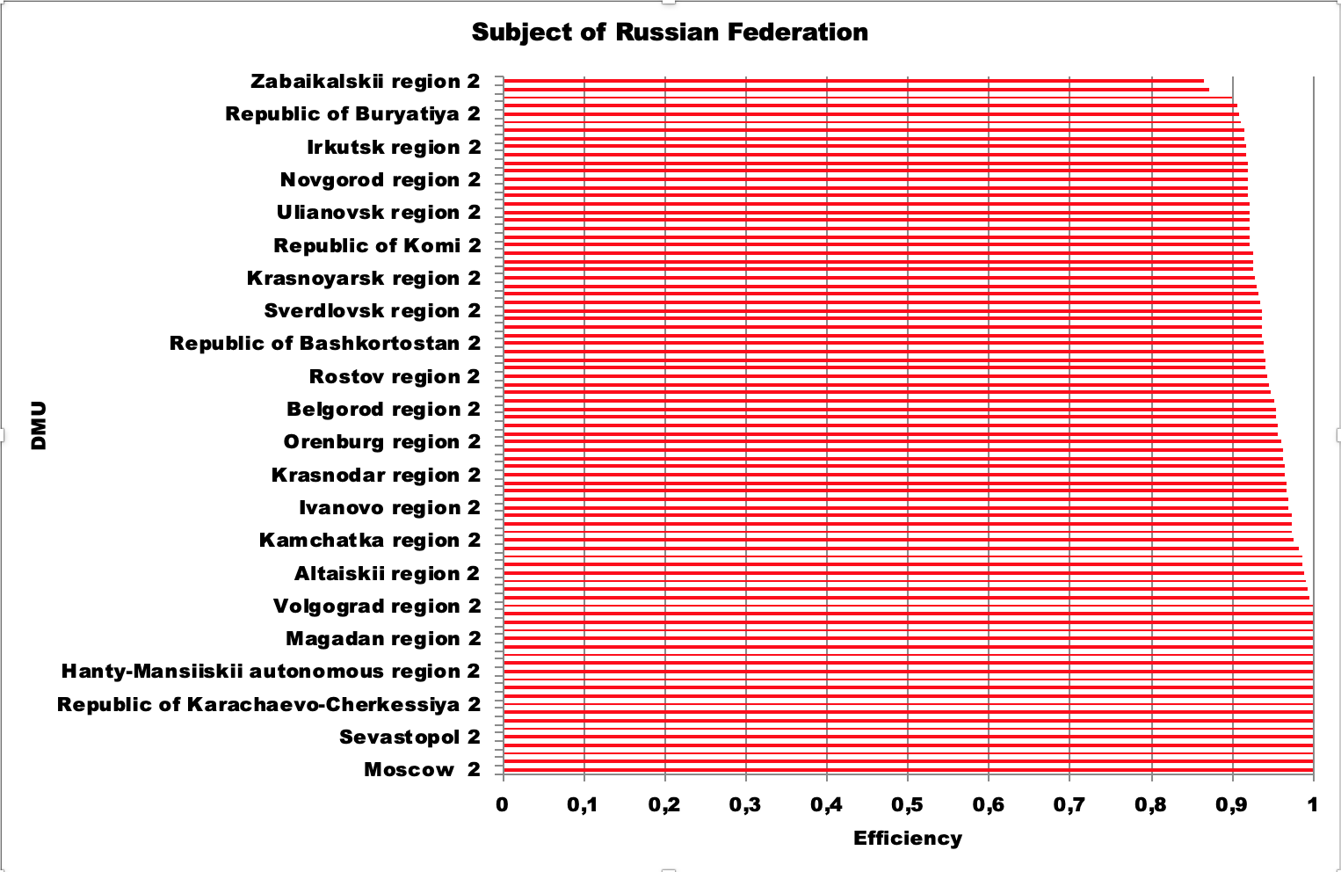

**Figure 1.** Distribution of regions by efficiency in 2023

It can be seen from the table and from the graph that the efficient subset is quite similar to the subset of 2022. This may support the idea that the efficient subset is relatively constant. The question is, what features determine higher efficiency of these particular regions in attracting doctors with additional state financing.

Almost the same is the list of inefficient DMUs ranked low. This also implies that inefficient subset is relatively stable in 2022 and 2023, probably because of poor management or objective characteristics of the region.

The preliminary analysis of the data calculated through BCC-O model demonstrates relative stability in the efficient and inefficient subsets. This can hypothetically lead to identification of the best practices, used in various efficient regions. This can prove to be the bigger result of the study. However, it is only possible after several other attempts to analyze data, by applying other models like CCR model within DEA-solver program or by deleting potential outliers like Moscow or Saint Petersburg. After these types of analyses would be carried out, more precise knowledge about the sample and the core efficient subset would be obtained. Then it would be possible to find out the features that determine high efficiency of these particular units.

## **3.3. Alternative specifications of the model**

Descriptive statistics of the variables showed that the sample is heterogeneous. Hence, the results of efficiency estimations according to the basic model, i.e. the whole sample, might provide information about efficient and inefficient subsets, however, these results may be distorted by the heterogeneity of the sample. Therefore, there are five alternative specifications of the initial model which are described in this paragraph. There are three types of changes which are made to the basic model: some variables can be substituted with others or excluded from the model, the sample may be divided into two or five subsamples and different methods of frontier analysis can be applied to estimate efficiency differently.

Having said that, there are several alternative specifications, suggested to enhance the explanatory power of the model. First, the sample was divided into 5 subsamples, according to the density of population, so that the first subsample includes regions with the lowest density, and the fifth subsample – the most populated regions.

The same model as in paragraph 3.2., which includes all independent and dependent factors, does not work well on subsamples. The results obtained with the help of DEA BCC model demonstrate that too many regions are efficient in all subsamples. The range of efficiency scores that is estimated is between 0,9677 and 1, which is equivalent to the efficient DMU. Hence, this specification of the model is not valuable for completing the tasks of the research. The discriminatory power of the model should be bigger than in this case.

The first valid specification of the model estimates efficiency on 5 subsamples as well, but two factors are excluded from the analysis: basic salary and life expectancy. Basic salary is excluded because it is strongly correlated with actual income, and life expectancy seems to be too general outcome of healthcare systems’ activities. Hence, the model consists of four independent variables and two dependent factors in 2023, and two independent factors and two dependent variables in 2022. The first two subsamples include 16 subjects of the Russian Federation, whereas subsamples 3,4 and 5 include 17 regions. The subsamples from 1 to 5 are presented according to the density of population in the regions, in the ascending order.

The table below provides the results of efficiency estimations both for 2022 and 2023.

**Table 8.** Efficiency estimation on 5 subsamples using DEA BCC-O model

|  |  |  |  |
| --- | --- | --- | --- |
| **Subsample** | **Number of efficient regions** | **Number of inefficient regions** | **Range of efficiency scores estimated** |
| **2022** | | | |
| 1 (16 DMUs) | 7 | 9 | 0,3702 - 1 |
| 2 (16 DMUs) | 7 | 9 | 0,4922 - 1 |
| 3 (17 DMUs) | 9 | 8 | 0,9125 - 1 |
| 4 (17 DMUs) | 7 | 10 | 0,8449 - 1 |
| 5 (17 DMUs) | 7 | 10 | 0,8064 - 1 |
| **2023** | | | |
| 1 (16 DMUs) | 9 | 7 | 0,8297 - 1 |
| 2 (16 DMUs) | 9 | 7 | 0,8739 - 1 |
| 3 (17 DMUs) | 13 | 4 | 0,9027 - 1 |
| 4 (17 DMUs) | 10 | 7 | 0,8388 - 1 |
| 5 (17 DMUs) | 5 | 12 | 0,8132 - 1 |

The analysis of the efficient subsets in models, both for 2022 and 2023, can provide a refined version of efficient subsets, identified in paragraph 3.2. Although the efficient subset found by this alternative model is bigger than that determined by traditional model, the overall efficient subset can be refined by synthesizing both groups of results.

Another specification of the model analyzes two subsamples of the initial sample. The subsample 1 consists of 41 subjects of the Russian Federation, whereas the 2nd subsample consists of 43 DMUs in 2022 and in 2023. As for the variables, the model does also exclude Basic salary and Life expectancy factors from the analysis.

The table below represents results of efficiency estimations according to the second specification of the model on two subsamples for the years 2022 and 2023.

**Table 9.** Estimation of efficiency on two subsamples using DEA BCC-O model

|  |  |  |  |
| --- | --- | --- | --- |
| **Subsample** | **Number of efficient regions** | **Number of inefficient regions** | **Range of efficiency scores estimated** |
| **2022** | | | |
| 1 (41 DMUs) | 12 | 29 | 0,4699 - 1 |
| 2 (43 DMUs) | 10 | 33 | 0,7514 - 1 |
| **2023** | | | |
| 1 (41 DMUs) | 15 | 26 | 0,6514 - 1 |
| 2 (43 DMUs) | 8 | 35 | 0,7377 - 1 |

Both BCC-O models, which estimate efficiency on 5 and on 2 subsamples, provide valuable results, according to a range of efficiency scores that is quite broad. These tables provide only a general overview without analysis of particular efficient or inefficient units identified.

The next table provides the information on results of efficiency estimations on 5 subsamples, using the third alternative specification of the model: DEA CCR-O option, which has a strong discriminatory power and can be useful for analysing small subsamples.

Table 10. Efficiency estimation on 5 subsamples using DEA CCR-O model

|  |  |  |  |
| --- | --- | --- | --- |
| **Subsample** | **Number of efficient regions** | **Number of inefficient regions** | **Range of efficiency scores estimated** |
| **2022** | | | |
| 1 (16 DMUs) | 3 | 13 | 0,0039 - 1 |
| 2 (16 DMUs) | 6 | 10 | 0,3003 - 1 |
| 3 (17 DMUs) | 5 | 12 | 0,4805 - 1 |
| 4 (17 DMUs) | 2 | 15 | 0,3165 - 1 |
| 5 (17 DMUs) | 2 | 15 | 0,1524 - 1 |
| **2023** | | | |
| 1 (16 DMUs) | 8 | 8 | 0,6458 - 1 |
| 2 (16 DMUs) | 6 | 10 | 0,613 - 1 |
| 3 (17 DMUs) | 7 | 10 | 0,6915 - 1 |
| 4 (17 DMUs) | 8 | 9 | 0,7575 - 1 |
| 5 (17 DMUs) | 4 | 14 | 0,4828 - 1 |

As the table shows, the discriminatory power of the CCR-O model is much bigger than that of the BCC-O model applied to the same group of subsamples. Number of identified efficient regions is less than number of efficient DMUs identified by the previous models. This suggests that the CCR-O model can be a source of strong benchmarks for the inefficient regions.

The fourth alternative model is a BCC-O which considers 3 input variables and 1 output variable for the year 2022: Payments under ‘Zemskii Doctor’ and Decree 1910, actual relative income as independent variables, and number of doctors as a dependent variable. Actual relative income of medical staff is calculated as a ratio of actual income in a particular region to average income across different industries in this region. The table below provides information on results of efficiency estimations using this model.

Table 11. Efficiency estimations on 2 subsamples using 1 dependent variable

|  |  |  |  |
| --- | --- | --- | --- |
| **Subsample** | **Number of efficient regions** | **Number of inefficient regions** | **Range of efficiency scores estimated** |
| **2022** | | | |
| 1 (41 DMUs) | 10 | 31 | 0,106 - 1 |
| 2 (43 DMUs) | 9 | 34 | 0,1437 - 1 |
| **2023** | | | |
| 1 (41 DMUs) | 19 | 22 | 0,5268 - 1 |
| 2 (43 DMUs) | 9 | 34 | 0,4573 - 1 |

The table demonstrates a strong discriminatory power of this model. However, there are enough efficient regions as well. The question is how different these results are from the previously obtained results.

Given a variety of results obtained by introduction of several specifications of the initial model, which are provided above, and initially obtained results of efficiency estimations, the analysis has to be conducted to compare all these results. The next table aims to synthesize the results, obtained with the help of general model in paragraph 3.2, and results of estimating efficiency using alternative options of the model. The first column shows regions, which are efficient according to the main DEA model, estimating efficiency on the whole sample. Other columns of the table contain information of efficiency estimation for the same regions by different models. This table can help to compare the results obtained using different models and probably to determine the core efficient subset.

**Table 12.** Comparative analysis of efficiency estimations

|  |  |  |  |  |
| --- | --- | --- | --- | --- |
| Efficient regions, according to the basic model | BCC-O model, 5 subsamples | BCC-O model, 2 subsamples | CCR-O model, 5 subsamples | BCC-O model, 2 subsamples, 1 dependent factor |
| Nenetsk autonomous region | **Efficient\*** | **Efficient\*** | **Efficient\*** | **Efficient\*** |
| Sevastopol | **Efficient\*** | **Efficient\*** | **Efficient\*** | **Efficient\*** |
| Republic of Dagestan | efficient | efficient | - | efficient |
| Republic of Ingushetiya | efficient | efficient | efficient | efficient |
| Republic of Kabardino-Balkariya | - | - | - | - |
| Republic of Northern Osetiya - Alaniya | **Efficient\*** | **Efficient\*** | **Efficient\*** | **Efficient\*** |
| Republic of Chechnya | - | - | - | - |
| Stavropol' region | **Efficient\*** | **Efficient\*** | efficient | **Efficient\*** |
| Yamalo-Nenetskii autonomous region | **Efficient\*** | efficient | efficient | - |
| Republic of Altai | **Efficient\*** | **Efficient\*** | **Efficient\*** | **Efficient\*** |
| Sakhalin region | **Efficient\*** | **Efficient\*** | **Efficient\*** | **Efficient\*** |
| Chukotka autonomous region | **Efficient\*** | efficient | **Efficient\*** | efficient |

The table 12 features the results of searching for the efficient subset among all options of the initial model. The subjects of the Russian Federation listed in the first column were identified as the efficient subset by the basic model in paragraph 3.2. Other columns of the table shows whether these regions are efficient according to alternative specifications of the model or not.

Regions that have ‘Efficient*’ sign in the table have proved to be efficient in both years, 2022 and 2023, of analysis and their efficiency level can be called strong.

Regions which are marked ‘efficient’ without asterisk are efficient according to a certain model, but only in one year, i.e., one observation of two is efficient. These regions can be considered partly efficient.

Regions which are marked with ‘-‘ are not efficient neither in 2022, nor in 2023. These regions can be excluded from the efficient subset right away.

Overall, the core of the efficient subset can be represented by Nenetsk autonomous region, Sevastopol, Republic of Northern Osetiya-Alaniya, Republic of Altai and Sakhalin region. These regions are efficient in using federal budget funds to provide regional healthcare systems with medical staff according to all specifications of the model.

## **3.4. Effectiveness analysis**

The parametric regression models are applied to analyze the effectiveness of the initiatives of the Russian Government. The regression analysis methodology is the cornerstone of effectiveness analysis. In addition, the Stochastic Frontier Analysis is applied to determine technical efficiency of the units (regional healthcare systems) compared to maximum level of effectiveness observed. The initiatives of the Government provide additional financial support to the subjects of the Russian Federation and are implemented by regions of the Russian Federation. The purpose of these initiatives is to increase the number of doctors and nurses who can provide medical care to citizens in those regions. It is obvious that increasing the number of doctors in a region is equivalent to reducing shortages of medical personnel in a healthcare system. As has been already mentioned in this paper, Russian health care in general experiences huge shortages of medical staff, which are assessed as more than 30,000 of doctors and more than 60,000 medical staff [RBC, 2024].

Effectiveness is the ability to achieve a desired outcome or goal, so, as put by Peter Drucker, it relates to getting the right things done [Drucker, 2006]. In this study, it is the ability of the Governmental initiatives to resolve a problem of medical staff shortages, or, more precisely, to increase the number of doctors in the regions. The initiatives of the Government provide financial support to regional healthcare systems in two ways. Money could be sent either to regional compulsory health insurance funds or directly to individuals: doctors and medical personnel.

The cause-effect model for effectiveness analysis is altered to account for significant distinctions between efficiency and effectiveness analysis. The main regression model for the year t [t=2022,2023] is specified below.

$$N_{it}=β_{0}+β_{1}{SP}_{it}+β_{2}{ZD}_{it}+β_{3}{ARI}_{it}+ β_{4}{P2568}_{it}+ ε_{it}\text{,}$$

where $N_{it}$- Number of doctors, employed in region i in year t.

- Special Payments to medical staff in region i in year t,

${ZD}_{it}$– Financial support for medical staff participating in ‘Zemskii Doctor’ Program in region i in year t,

- Actual Relative Income of medical staff in region i in year t[1],

– special social payments under Decree No. 2568 in region i in year t,

$β_{0}, …,β_{4}$– the parameters of the estimated regression model,

$ε_{it}$– standard error of the model.

In 2023, the model includes one additional independent variable – payments under Decree 2568, which had been started in 2023. As for payments in 2022, there are only two types which were in force: ‘Zemskii Doctor’ Program and payments under Decree No. 1910, provided to regional funds as interbudgetary transfers. The model assumes that number of doctors and nurses employed is the right output metric for evaluating the effectiveness of the initiatives of the Government. Independent variables include two (or three) types of payments to doctors and medical staff and actual relative income, which is a metric showing how much doctors are paid in a region relative to an average income across industries in that region. Actual relative income can show how does a region perform in terms of achieving a target level of salaries for doctors, set by the Decree of the President No. 597 of May 7, 2012. If actual relative income in a region is equal to 2, this means that this region performs well, or the basic salary of doctors is bigger than average in a region by 100%.

Two basic models are applied to evaluate effectiveness of the Governmental initiatives. The first model is the Cobb-Douglas specification of the main regression model, which uses the log data. The second model is built as a linear regression model, which was shown above. Both models are altered to make the results more valid, and specifications do also include different independent variables, constraints to a free parameter of the models, which can be set equal to zero or not. This stage of research should validate the model and evaluate the effectiveness of the measures which are proposed by the Federal Government to change the situation in the regions. Validity of the model should be confirmed as many modelling specifications help to correctly estimate parameters.

The table below represents the models and their specifications which had been built in order to structure further analysis.

|  |  |  |  |
| --- | --- | --- | --- |
| **Model** | **Functional form** | **Year** | **Variables** |
| Model 1 | Cobb-Douglas regression, c≠0 | 2023 | ${ARI}_{it}$, ${P2568}_{it}$, ${SP}_{it}$, ${ZD}_{it}$, $N_{it}$ |
| Model 2 | Cobb-Douglas regression, c=0 | 2023 | ${ARI}_{it}$, ${P2568}_{it}$, ${SP}_{it}$, ${ZD}_{it}$, $N_{it}$ |
| Model 3 | Cobb-Douglas regression, c≠0 | 2023 | ${ARI}_{it}$, ${P2568}_{it}$, $N_{it}$ |
| Model 4 | Cobb-Douglas regression, c≠0 | 2023 | ${SP}_{it}$, ${ZD}_{it}$, $N_{it}$ |
| Model 5 | Linear regression, c≠0 | 2023 | ${ARI}_{it}$, ${P2568}_{it}$, ${SP}_{it}$, ${ZD}_{it}$, $N_{it}$ |
| Model 6 | Linear regression, c≠0 | 2023 | ${P2568}_{it}$, ${SP}_{it}$, $N_{it}$ |
| Model 7 | Linear regression, c≠0 | 2023 | ${ARI}_{it}$, ${ZD}_{it}$, $N_{it}$ |
| Model 8 | SFA, half normal distribution | 2023 | ${ARI}_{it}$, ${P2568}_{it}$, ${SP}_{it}$, ${ZD}_{it}$, $N_{it}$ |
| Model 9 | SFA, truncated normal distribution | 2023 | ${ARI}_{it}$, ${P2568}_{it}$, ${SP}_{it}$, ${ZD}_{it}$, $N_{it}$ |
| Model 10 | Deterministic Cobb-Douglas production frontier | 2023 | ${ARI}_{it}$, ${P2568}_{it}$, ${SP}_{it}$, ${ZD}_{it}$, $N_{it}$ |
| Model 11 | Cobb-Douglas regression, c≠0 | 2022 | ${ARI}_{it}$, ${SP}_{it}$, ${ZD}_{it}$, $N_{it}$ |
| Model 12 | Cobb-Douglas regression, c=0 | 2022 | ${ARI}_{it}$, ${SP}_{it}$, ${ZD}_{it}$, $N_{it}$ |
| Model 13 | Linear regression, c≠0 | 2022 | ${ARI}_{it}$, ${SP}_{it}$, ${ZD}_{it}$, $N_{it}$ |
| Model 14 | Linear regression, c=0 | 2022 | ${ARI}_{it}$, ${SP}_{it}$, ${ZD}_{it}$, $N_{it}$ |
| Model 15 | SFA, half normal distribution | 2022 | ${ARI}_{it}$, ${SP}_{it}$, ${ZD}_{it}$, $N_{it}$ |
| Model 16 | SFA, truncated normal distribution | 2022 | ${ARI}_{it}$, ${SP}_{it}$, ${ZD}_{it}$, $N_{it}$ |
| Model 17 | Deterministic Cobb-Douglas production frontier | 2022 | ${ARI}_{it}$, ${SP}_{it}$, ${ZD}_{it}$, $N_{it}$ |

The following tables summarize the results of models’ coefficients estimations in MS Excel using regression analysis tool and Stochastic frontier analysis technique. The dependent variable remains the same in all specifications and models, while independent variables change; some models include all 5 independent variables into analysis, others include 2 independent and one dependent variables. Both regression and stochastic frontier analysis do not allow to analyse models with multiple outputs. Hence, several specifications of each model are analysed, but number of doctors in a region is considered the output which best reflects the effectiveness of measures aimed to alleviate shortages of medical staff.

The next table shows results of testing models in 2023, when all initiatives, which had been implemented by the Government, were in force.

**Table 13.** Estimation of the parameters of the models in 2023

|  |  |  |  |  |  |
| --- | --- | --- | --- | --- | --- |
| **Models/Coefficients** | **Actual Relative Income** | **Payments by Decree 2568** | **Social payments (other)** | **Zemskii Doctor** | **Intercept, c** |
| Model 1 | 0,52 | **0,76\*** | **0,35\*** | **-0,07\*** | **-12,5\*** |
| Model 2 | **-4,17\*** | **0,803\*** | 0,07 | **-0,34\*** | 0 |
| Model 3 | 0,41 | **1,02\*** | - | - | **-12,34\*** |
| Model 4 | - | - | **1,09\*** | -0,05 | **-11,61\*** |
| Model 5 | 1442,8 | 0,000 | **6,88\*** | -0,000 | -2829,78 |
| Model 6 | - | **0,00\*** | **0,00\*** | - | -32,49 |
| Model 7 | 10256,19 | - | **-** | **0,000\*** | -19043,98 |
| Model 8 | -1544,1 | **0,000\*** | **0,000\*** | **-0,000\*** | 3600,4 |
| Model 9 | -1302,76 | **0,000\*** | **0,000\*** | **-0,000\*** | 3253,2 |
| Model 10 | 0,521 | **0,758\*** | **0,351\*** | **-0,07\*** | **-12,08\*** |

Estimation of the parameters of the models leads to several conclusions regarding the relationship of each of five factors of the model with the dependent variable.

First, the effect of actual relative income on the number of doctors in the regions is not proven, since the coefficient is statistically significant only in one model. The estimated coefficient is negative in that model, so actual relative income cannot be recognized as a factor which has a positive relationship with the dependent variable. On the contrary, if there is an effect of actual relative income on the number of doctors in a region, it should be negative. This can be partly explained by the nature of this metric. The denominator of the metric is average salary in a region. Hence, economically developed regions, which can attract medical staff quite easily, can have lower ARI due to a bigger average salary in a region. However, in general, actual relative income cannot be recognized as an effective instrument for reducing shortages of medical staff.

Second, payments under Decree 2568 tend to be an efficient tool to increase number of doctors. The estimated coefficient is more than zero in all models. It is suggested that direct payments to medical staff, like payments under Decree 2568, can help to increase the number of doctors employed in a region and decrease the shortages of medical staff. However, estimated coefficients are not statistically significant in all models. This suggests that the general model represented in this paragraph might be flawed. It is important to notice that payments to medical staff under Decree 2568 are not included into the salary, so it is not considered when the basic salary (target level of salaries) for a region is calculated. This means that payments under Decree 2568 are not subject to manipulations with basic salary levels and directly increase the income of doctors in a region. Hence, doctors can be rather effectively attracted by this type of financial support. In addition, the volume of financial support provided by Decree 2568 is quite significant (around 150B rubles) and bigger than other types of financial support. This means that this initiative has quite a big scale, which does also imply bigger effectiveness due to bigger returns to scale.

Third, financial support to regional healthcare budgets in a form of interbudgetary transfers according to the Decree 1910 is also a factor which has a positive relationship with the number of doctors in the regions. It can be concluded that co-financing salary costs of regional budgets under Decree 1910 is a relatively effective type of support that can result in increasing the availability of medical care. However, it is less effective than that provided by the Decree 2568, as estimated coefficients tend to be smaller in the majority of the models.

Fourth, the coefficients estimated for the ‘Zemskii Doctor’ Program are negative in all models. Hence, this Program could not be considered effective tool for reducing shortages of medical staff. Indeed, ‘Zemskii Doctor’ is not a program that aims to increase number of doctors in a region, but rather to sustain a certain level of medical care for people living in remote settlements. This means that regions where significant resources are spent on the ‘Zemskii Doctor’ Program can attract medical staff under conditions of the Program, but the overall number of doctors in the region can simultaneously decrease, due to outflow of qualified doctors. It is evident that this Program might be useful to solve other problems, related to ensuring basic medical care in regions where healthcare structure is close to atomic.

The majority of estimated free parameters of the models are not statistically significant. Hence, it does not make sense to analyze these estimates from a statistical perspective or interpret them from an economic perspective. In general, this study does not succeed in building a valid model for effectiveness analysis. It may occur that some significant variables are not included in the analysis or the effectiveness of the Governmental initiatives in

Overall, the results of estimations of the models 1-9 show that special social payments (by Decree 2568) and social payments (Decree 1910) are effective to increase the number of doctors in a region. Hence, it is evident that financial support provided by these Decrees could be an effective tool to reduce shortages of medical staff, including doctors. Actual relative income and financial support under ‘Zemskii Doctor’ Program do not prove to be effective for these purposes.

The table below features the results for the year 2022.

**Table 14.** Estimation of the parameters of the models in 2022.

|  |  |  |  |  |
| --- | --- | --- | --- | --- |
| **Models/Coefficients** | **Actual Relative Income** | **Social payments (1910)** | **Zemskii Doctor** | **Intercept, c** |
| Model 11 | 1,153 | **0,218\*** | **0,183\*** | 0,864 |
| Model 12 | 1,846 | **0,219\*** | **0,203\*** | 0 |
| Model 13 | 5289,79 | **0,000\*** | **0,000\*** | -8787,93 |
| Model 14 | 1026,4 | **0,000\*** | **0,000\*** | 0 |
| Model 15 | **-16633,55\*** | **0,000\*** | -0,000 | **33852,84\*** |
| Model 16 | -16633,54 | 0,000 | -0,000 | 33866,93 |
| Model 17 | 1,153 | **0,218\*** | **0,183\*** | 1,901 |

The results of testing linear regression models and frontier models for the year 2022 mostly agree with results obtained for 2023. The only significant contradiction is that payments for the ‘Zemskii Doctor’ program do seem to have a positive effect on the dependent variable in 2022, which is the case for 2023. Nevertheless, ‘Zemskii Doctor’ Program cannot be considered to have neither positive nor negative relationship with the number of doctors as a dependent variable. The same applies for actual relative income as another independent variable of the model. Only additional financial support aimed either at individual doctors or at healthcare budgets of the regions matters: metrics of payments under Decrees 2568 and 1910 tend to have a positive relationship with the number of doctors in the regions.

The effectiveness analysis is considered valid, because 17 different models have been analysed and the results quite consistently prove effectiveness of two types of financial support and reject the hypothesis that actual relative income and ‘Zemskii Doctor’ are initiatives which can help to attract and retain medical staff in the regions. However, the model is not suitable for effectiveness analysis of the regional healthcare systems in general. A big share of the estimates is not statistically significant. Hence, the quality of the model in general is quite low.

It is still suggested that two Governmental initiatives can be considered relatively effective based on the results of effectiveness estimations. Their effectiveness is limited due to values of estimated coefficients, which tend to be very small.

# **CONCLUSION**

The social role of public healthcare is tremendous for the Russian Federation. The President and the Government admit the problem of shortages of medical staff, and strive to resolve it by increasing the range of measures which should support doctors and nurses and increase attraction and retention of medical personnel. This study aimed to evaluate a range of Governmental initiatives from two standpoints: the effectiveness of these initiatives and the efficiency of implementing them by the regions of the Russian Federation.

From the efficiency perspective, this study shows that there are five subjects of the Russian Federation, which are efficient in all models: Nenetsk autonomous region, Sevastopol, Republic of Northern Osetiya - Alaniya, Republic of Altai, Sakhalin region. Other regions are not efficient in some or even all models. This means that five core efficient regions could represent a benchmark for inefficient subjects of the Russian Federation. Other subjects of the Russian Federation should aim to improve their efficiency of using federal financial support, which could also be done with the help of best practices adopted from the benchmarks (efficient subjects of the Russian Federation comparable to some of the rest of the regions).

From the effectiveness perspective, this paper founds that not all variables of the model are positively related with the number of doctors in the regions. In particular, actual relative income and payments under ‘Zemskii Doctor’ Program prove not to have any statistically significant effect on the number of doctors in the subjects of the Russian Federation. Adding to that, Payments under Decree 2568 and Decree 1910 tend to have a positive relationship with the number of doctors in a region, but still many estimates are not statistically significant. Overall, the model suggested for effectiveness analysis cannot be considered to be of good quality. Hence, this model could not be used for further research in this or related fields.

The results of the study show that the certain level of basic salary (target level of salaries) should not be achieved by adding special social payments and other additional federal financing to actual income level. The Government shall clarify rules for using federal funding. The financial support under the Decree 2568, which is not considered a part of the basic salary, has the biggest effect on increasing the number of doctors in a region. When additional supporting measures are not added to the ‘basic salary level’, observed results are better than in other cases.

As was mentioned above, the biggest contribution of this research is practical and practice-oriented. The best possible practical contribution for decision making is the list of identified best practices, which can help inefficient regions to become and stay efficient in attracting and retaining qualified labor by learning from the efficient regions (benchmarks).

The managerial implications of this study mostly relate to the policy aspect of decision making. Policy implications of this study include the importance of developing scalable Governmental initiatives which provide financial support to medical staff, and determining a set of programs and initiatives that can be useful to reduce shortages of medical staff.

It is suggested that direct financial support provided to doctors and medical staff is more effective than interbudgetary transfers, which do not assume providing direct financial incentives to medical staff. Payments under Decree 2568 exemplify such direct financial support. Financial support provided by the Decree 2568 has the strongest direct relationship with the number of doctors as a metric reflecting the current level of shortages of medical staff in a region. However, this type of financial support’s estimated coefficients do not suggest that the effectiveness of reducing shortages of medical staff with this instrument is big enough to change the situation for the better. In terms of effectiveness analysis, the main implication of this study relates to the fact that financial incentives on their own can hardly change the situation. The Government should consider a wider range of non-financial incentives, which can motivate doctors and nurses to join a particular healthcare system.

Another important insight may reside in differences between regions of Russia, their objective characteristics, e.g. density of population, economic size, etc., and influence of these specific features on the attractiveness of the region for the labor force. This study contributes to better practical understanding of regional specificities and how to overcome them. The most important difference between regions lies in the structure of the healthcare systems existing in each region: the least populated regions tend to have an atomic structure of healthcare systems, while big cities and densely populated subjects of the Russian Federation have rather developed nets providing health care. This research demonstrates, however, that relatively small or not densely populated regions of Russia can have high efficiency levels. For example, Sakhalin region could be a benchmark for some regions to improve efficiency, while it does not have big population or the biggest economic potential.

From a theoretical perspective, this study contributes to the research of the problems related to public medicine and attracting and retaining human resources in industries where high level of expertise is expected. This topic is poorly explored in academic literature, at least within the Russian context, where lack of professional doctors is openly manifested. This research shows that direct financial support could become an effective tool for reducing shortages of qualified staff, but more non-financial initiatives and incentives should probably be introduced.

# **REFERENCES**

1. Aday, L. A., Begley, C. E., Lairson, D. R., Slater, C. H., Richard, A. J., Montoya, I. D. A Framework for Assessing the Effectiveness, Efficiency, and Equity of Behavioral Healthcare // *The American Journal of Managed Care.* – 1999. – Vol. 5, special issue. – pp. 25-41.
2. Artificion, J., Guce, D., Ilagan, C., Adarlo, L. M. Shortage of Nurses: a Challenge to Health Care Setting // *Asia Pacific Journal of Allied Health Sciences.* – 2020. – Vol. 3 (1). – pp. 39-47.
3. Azzoparde, J., Malani, R., Rao, N., Singhal, S. US Health Systems: Diversify to Thrive // *McKinsey & Company. Healthcare Practice.* – 2022. November.
4. Berlin, G., Burns, F., Essick, C., Lapointe, M., Murphy, M. Nursing in 2023: How Hospitals are Confronting Shortages // *McKinsey & Company. Healthcare Practice.* – 2023. May.
5. Bohm, K., Schmid, A., Gotze, R., Landwehr, C., Rothgang, H. Five Types of OECD Healthcare Systems: Empirical Results of a Deductive Classification // *Health Policy.* – 2013. – Vol. 113. – pp. 258-269.
6. Charumilind, S., Han, K., Ruff, J., Shah, A., Swaiman I. How Price Transparency Could Affect US Healthcare Markets // *McKinsey & Company. Healthcare Practice*. – 2024. April.
7. Cheng Z., Cai M., Tao H., He Z., Lin X., Lin H., Zuo Y. Efficiency and productivity measurement of rural township hospitals in China: a bootstrapping data envelopment analysis // *BMJ Open.* – 2016. – Vol. 6 (11). – pp. 1–11.
8. Donev, D., Kovacic, L., Laaser, U. The Role and Organization of Health Care Systems // *Health: Systems – Lifestyles – Policies.* – 2013. October.
9. Drucker, P. F. The Effective Executive. The Definitive Guide to Getting the Right Things Done // Collins. – 2004.
10. Farrell, M. The Measurement of Productive Efficiency // *Journal of the Royal Statistical Society: Series A.* – 1957. – Vol. 120 (3). – pp. 253-281.
11. Fedotov, Yu. V., Iablonskii, K. P., Vitaliueva, M. A. Production Frontier Analysis and Organizational Performance Assessment in St. Petersburg Healthcare System // *Vestnik of Saint Petersburg University. Management*. – 2017. – Vol. 16 (4).
12. Gandhi, A. V., Sharma, D. Technical Efficiency of Private Sector Hospitals in India Using Data Envelopment Analysis // *Benchmarking: an International Journal.* – 2018. – Vol. 25 (9). – pp. 3570-3591.
13. Hollingsworth, B. The Measurement of Efficiency and Productivity of Health Care Delivery // *Health Econ*. – 2008. – Vol. 17. – pp. 1107-1128.
14. Katharakis, G., Katharaki, M., Katostaras, T. SFA vs. DEA for Measuring Healthcare Efficiency: a Systematic Review // *International Journal of Statistics in Medical Research.* – 2013. – Vol. 2. – pp. 152-166.
15. Lee, S., Kim, C. Estimation of Association between Healthcare System Efficiency and Policy Factors for Public Health // *Applied Science*. – 2018. – Vol. 8.
16. Lega, F., Prenestini, A., Spurgeon, P. Is Management Essential to Improving the Performance and Sustainability of Health Care Systems and Organizations? A Systematic Review and a Roadmap for Future Studies // *Value in Health*. – 2013. – Vol. 16 (1).
17. Levine, E., Malani, R., Odden, A., Schulz, J. Ensuring the Financial Stability of Academic Medical Centers // *McKinsey & Company. Healthcare Practice.* – 2024. April.
18. Lichiello P., Turnock B. J. *Guidebook for Performance Measurement*. – 1999. – USA: Turning point.
19. Maestre, A. M., Oliveira M. D., Barbosa-Povoa A. P. Location–allocation approaches for hospital network planning under uncertainty // *European Journal of Operations Research.* – 2015. – Vol. 240 (3). – pp. 791–806.
20. Majumdar, S. K. Assessing Comparative Efficiency of the State-owned, Mixed and Private Sectors in Indian Industry // Public Choice. – 1998. – Vol. 1 – pp. 1-24.
21. March J. G., Sutton R. I. Organizational performance as a dependent variable. *Organization Science.* – 1997. **– 8** (6): pp. 698–706.
22. Neely. A., Gregory, M., Platts, K. Performance Measurement System Design. A Literature Review and Research Agenda // *International Journal of Operations & Production Management*. – 1995. – Vol. 15(4). – pp. 80-116.
23. Patel, N., Singhal, S. What to Expect in US Healthcare in 2023 and Beyond // *McKinsey & Company. Healthcare Practice.* – 2023. January.
24. Pidd, M. Why Modelling and Model Use Matter // *The Journal of the Operational Research Society*. – 2010. – Vol. 61 (1). – pp. 14-24.
25. Simar, L., Wilson, P. W. Estimation and Inference in Two-stage, Semi-parametric Models of Production Processes // *Journal of Econometrics*. – 2007. – Vol. 136 (1). – pp. 31-64.
26. Stefko, R., Gavurova, B., Kocisova, K. Healthcare Efficiency Analysis Using DEA Analysis in the Slovak Republic // *Health Economics Review.* – 2018. – Vol. 8(6). – pp. 1-12.
27. Tigga, N. S., Mishra, U. On Measuring Technical Efficiency of the Health System in India: An Application of Data Envelopment Analysis // *Journal of Health Management*. – 2015. – Vol. 17 (3). – pp. 285-298.
28. Turlea, C., Borisov, D., Cicea, C. DEA Model for Assessing Efficiency in Providing Health Care and Management Decisions // *Management Research and Practice*. – 2012. – *Vol. 1.*
29. Ulumbekova, G., Vlasov, Ya., Domnikov, A., Gaponova, E. Scientific justification for the need to increase wages for medical workers in the Russian Federation // *OrgZdrav: News, Opinions, Learning. Vestnik VSHOUZ*. – 2023. – Vol. 9(1). – pp. 4-25.
30. Valdmanis V., Rosko, M., Leleu, H., Mukamel, D. Assessing overall, technical, and scale efficiency among home health care agencies // *Health Care Management Science*. – 2017. – Vol. 20 (2).
31. Zidarov, D., Poissant, L., Sicotte, C. Healthcare executives' readiness for a performance measurement system: a rehabilitation hospital case study // *Journal of Hospital Administration*. – 2014. – Vol. 3(4).
32. RBC (2023). – Electronic source. Available at: <https://www.rbc.ru/economics/23/03/2023/641c52c89a79477c8ab0fa50>. (Accessed 2 April, 2023).
33. RBC (2024). – Electronic source. Available at: <https://www.rbc.ru/rbcfreenews/663e0f069a7947f7cc694741?from=newsfeed>. (Accessed May 12, 2024).
34. Decree of the Government of the Russian Federation of 31.12.2022 No. 2568. – Available at: <http://publication.pravo.gov.ru/Document/View/0001202301090003?index=1> [Electronic source]. – Accessed 15.02.2024.
35. Decree of the Government of the Russian Federation of 27.12.2019 No. 1910. – Available at: <http://publication.pravo.gov.ru/Document/View/0001201912310038?index=9>. – [Electronic source]. – Accessed on 15.02.2024.
36. Decree of the Government of the Russian Federation of 26.12.2017 No. 1640. – Available at: <http://publication.pravo.gov.ru/Document/View/0001201712290017?index=7>. – [Electronic source]. – Accessed on 15.02.2024.
37. Decree of the Government of the Russian Federation of 24.11.2023 No. 1985. – Available at: <http://publication.pravo.gov.ru/document/0001202311300065>. – [Electronic source]. – Accessed on 15.02.2024.
38. Decree of the President of Russia of 07.05.2012 No. 598. – Available at: <http://publication.pravo.gov.ru/document/0001201205070022?index=2>. – [Electronic source]. – Accessed on 24.02.2024.

# **APPENDICES**

1. Results of efficiency estimations on five subsamples for the year 2022 (BCC-O model).

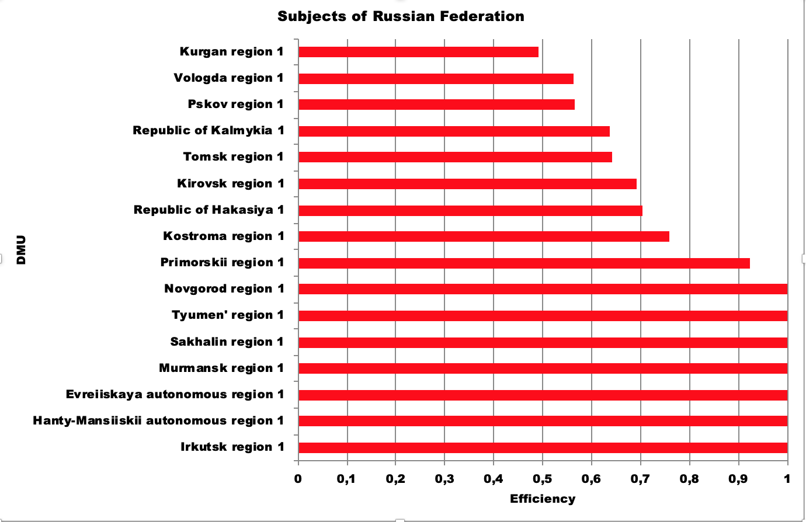

**Figure 3**. Example of efficiency estimations on small subsamples for 2022

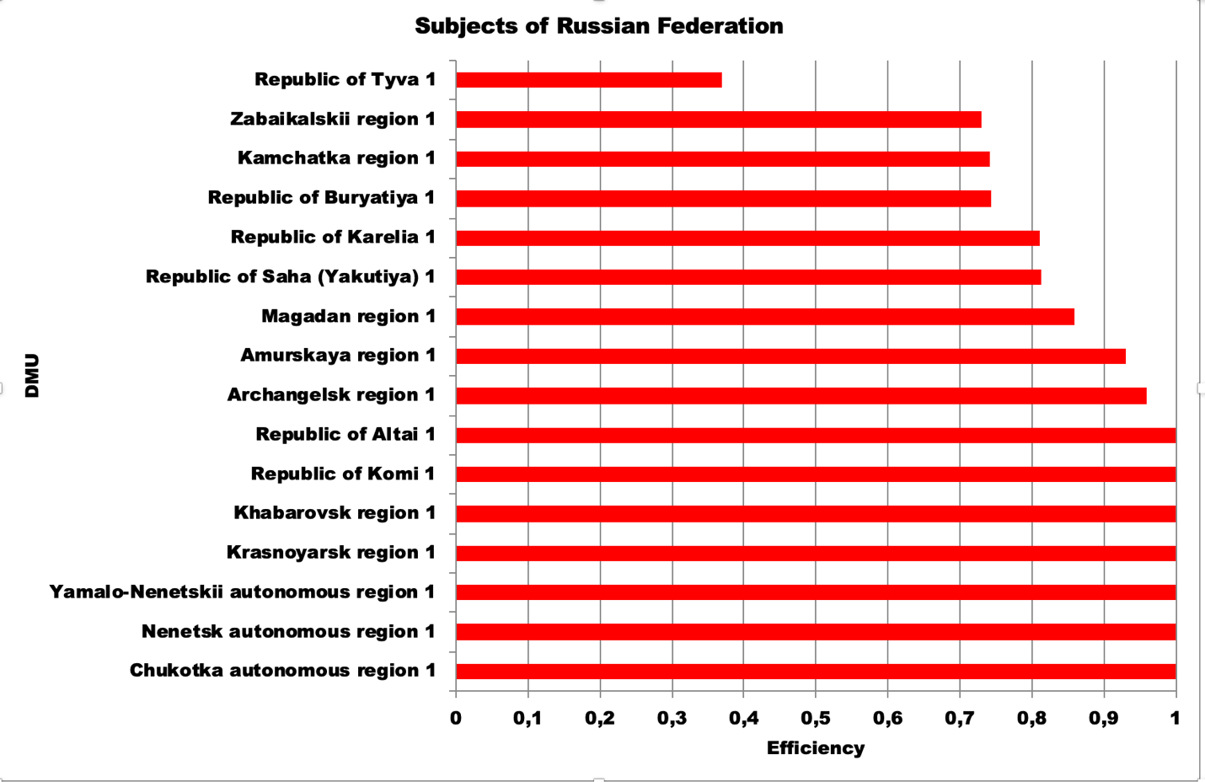

**Figure 4.** Example of efficiency estimations on small subsamples for 2022(2)

1. Results of efficiency estimations on small subsamples in 2023 (BCC-O model).

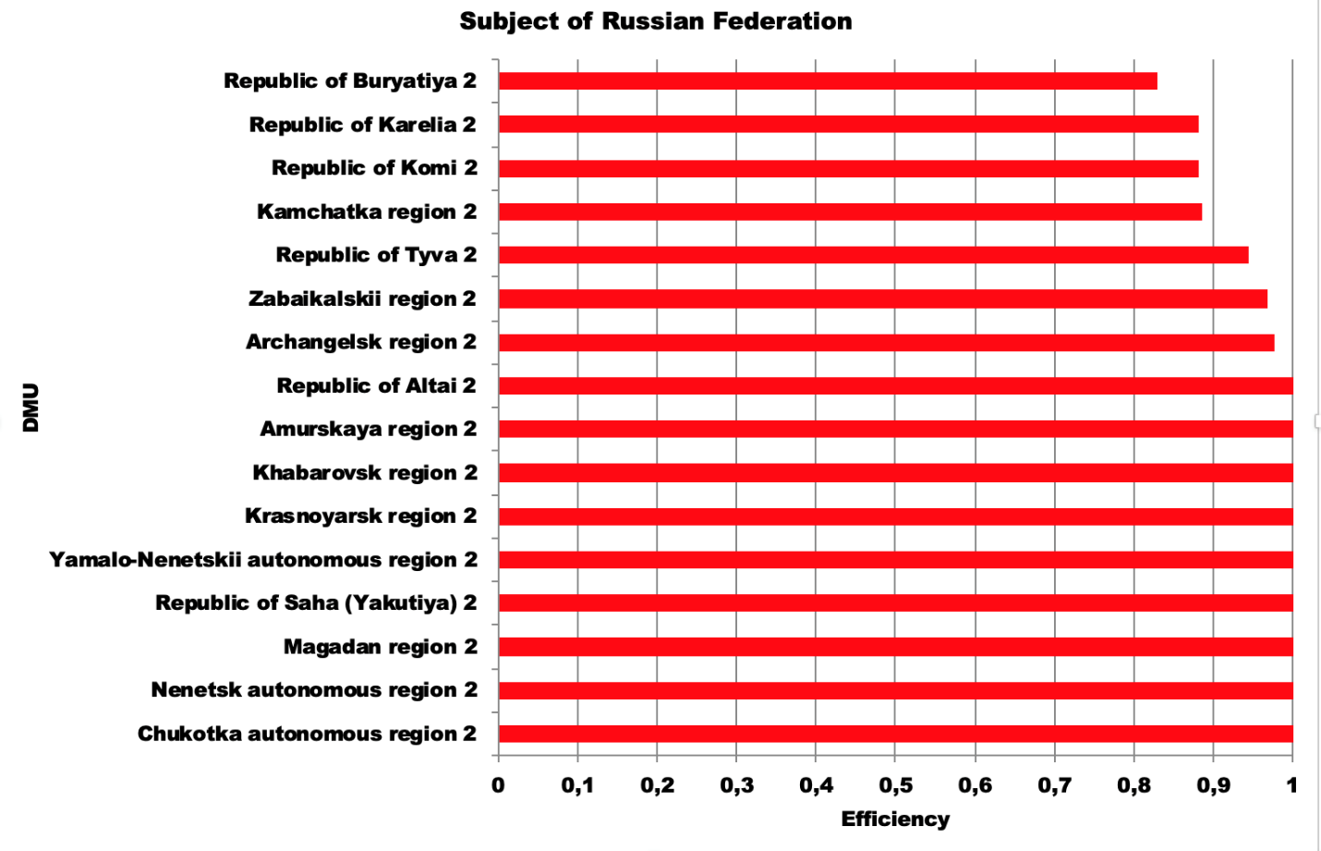

**Figure 5**. Example of efficiency estimations on small subsamples for 2023.

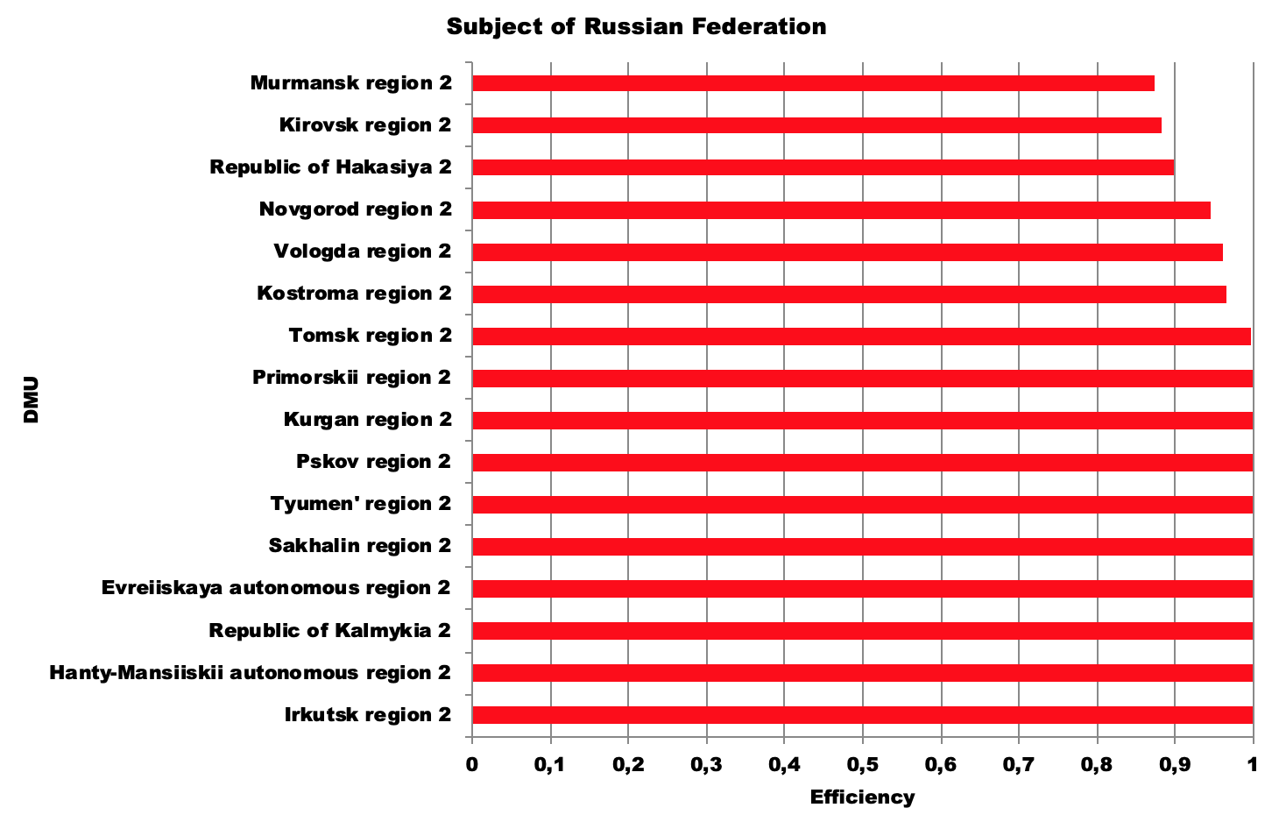

**Figure 6**. Example of efficiency estimations on small subsamples for 2023

1. The results of conducting regression analysis (Cobb-Douglas functional form, year 2022, basic model).

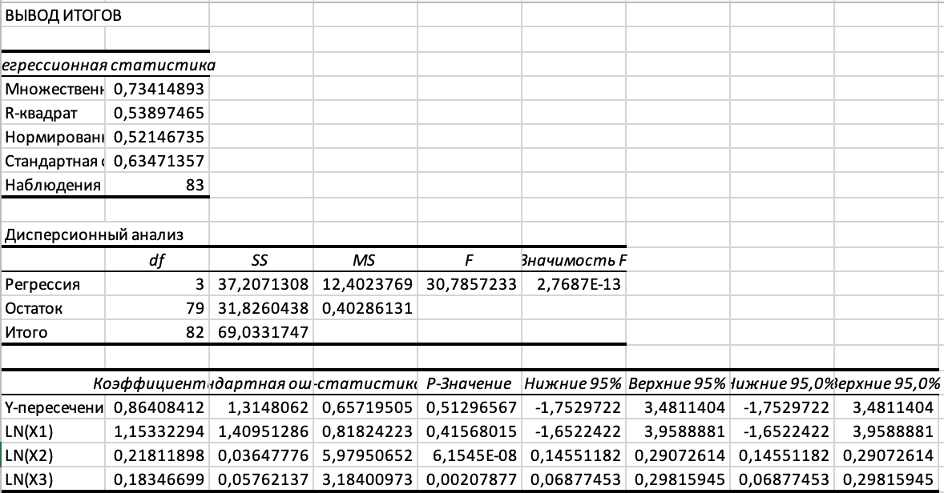

1. The results of conducting regression analysis (Cobb-Douglas functional form, year 2023, basic model).

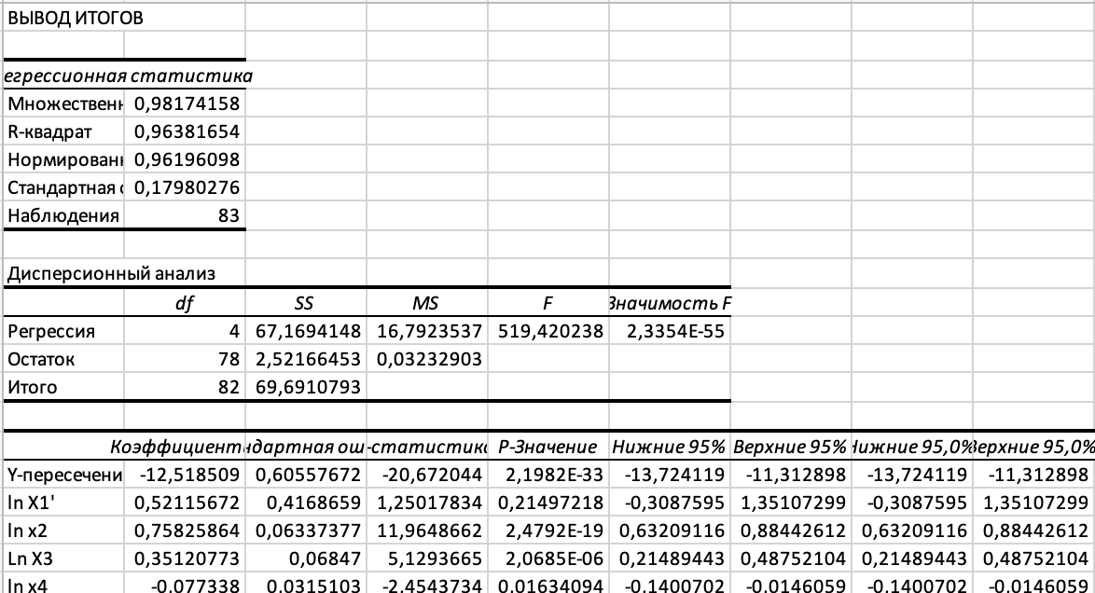

1. The results of conducting regression analysis (Linear functional form, year 2022, basic model).

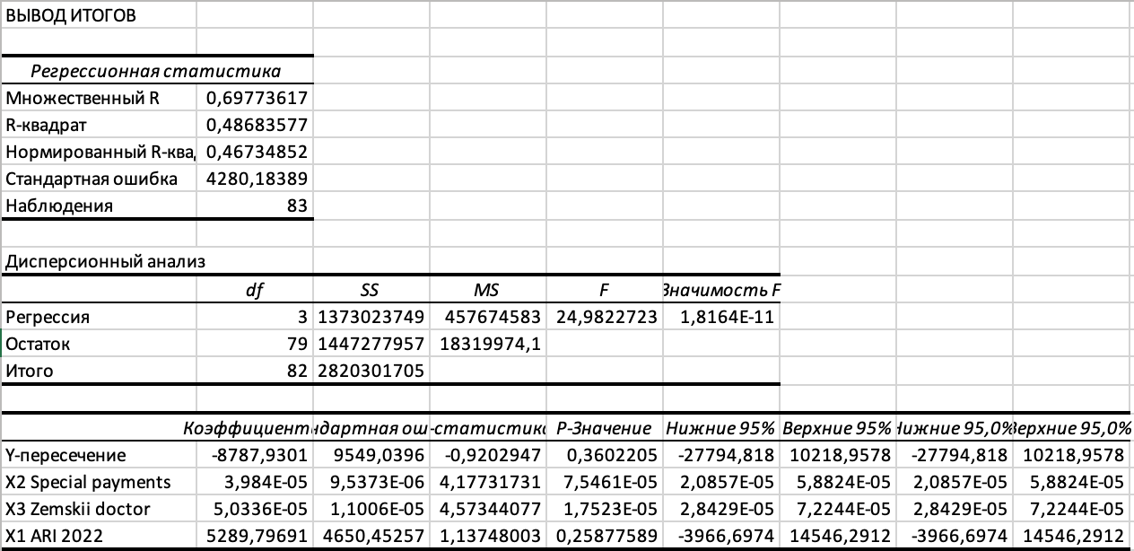

1. The results of conducting regression analysis (Linear functional form, year 2023, basic model).

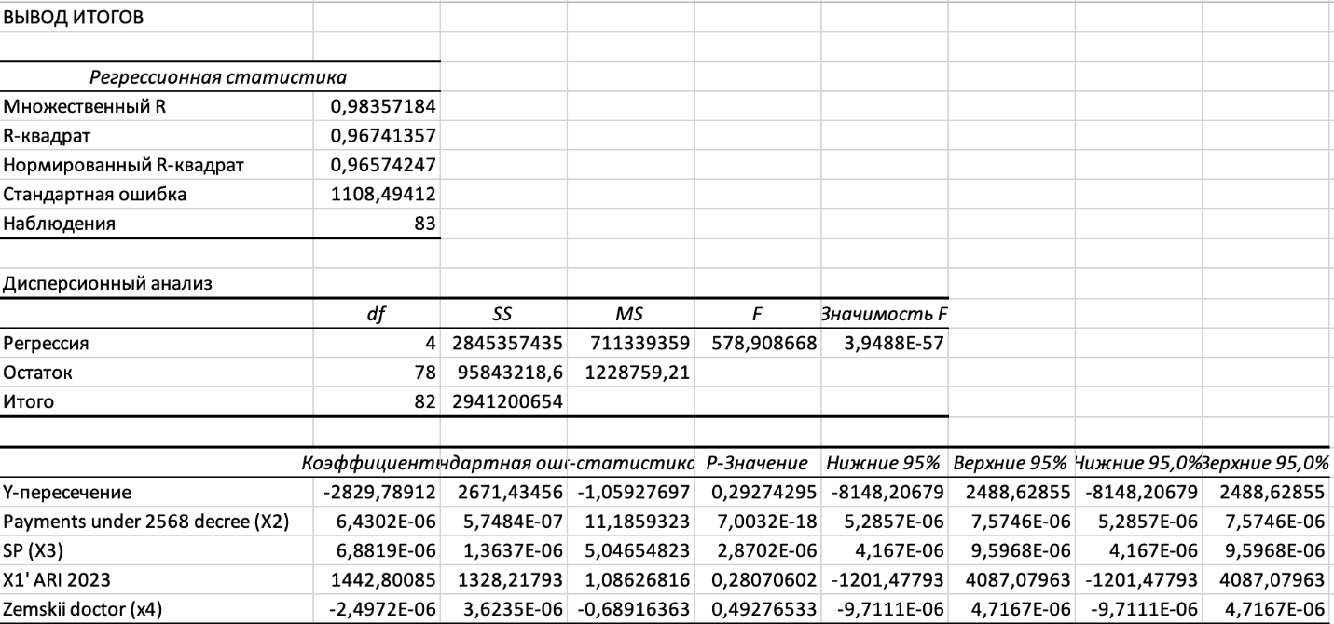

1. The results of conducting Stochastic Frontier Analysis (half normal distribution, year 2023).

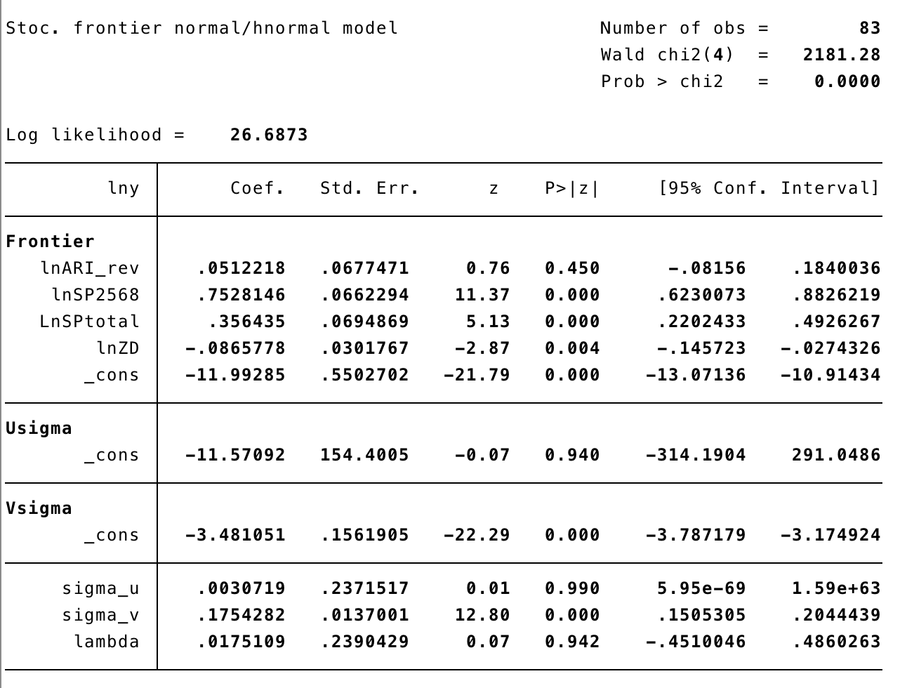

1. The results of conducting Stochastic Frontier Analysis (truncated normal distribution, year 2023).

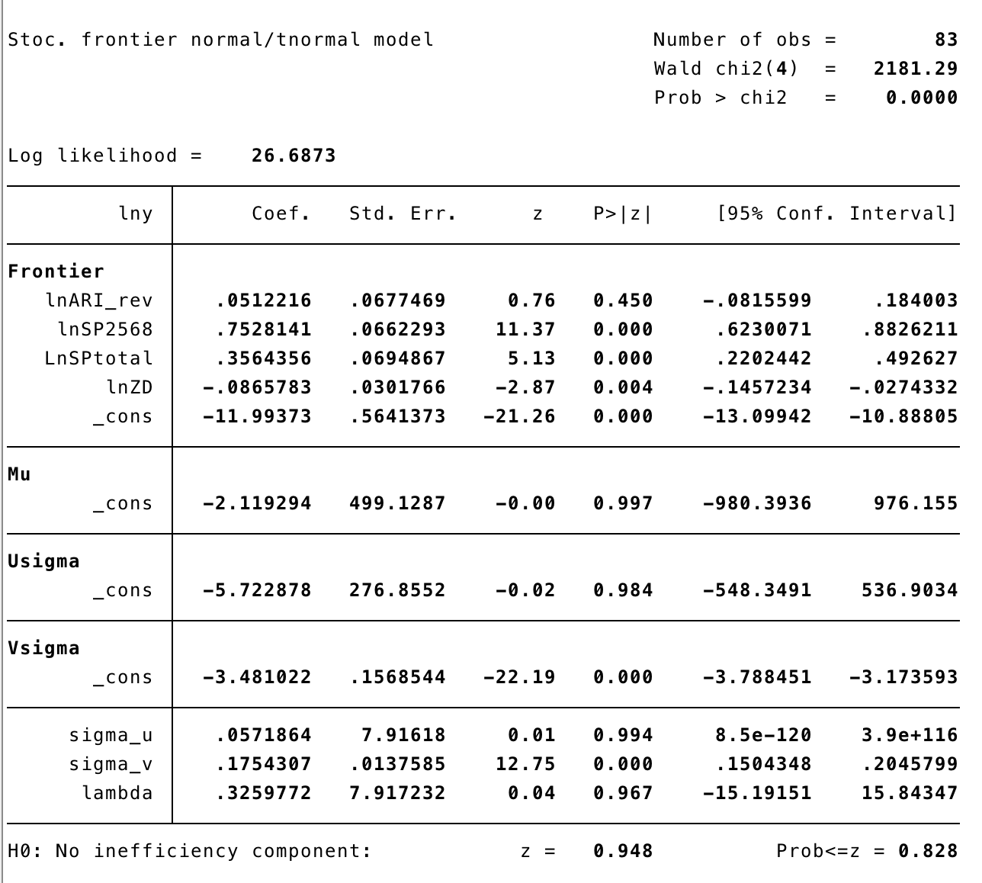

1. The results of conducting Stochastic Frontier Analysis (half normal distribution, year 2022).

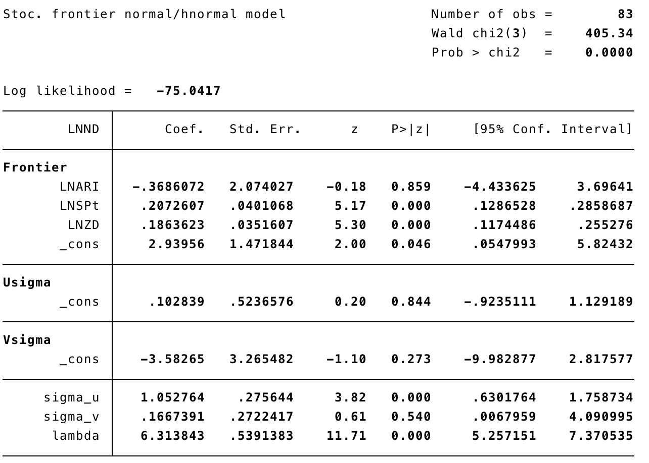

1. The results of conducting Stochastic Frontier Analysis (truncated normal distribution, year 2022).

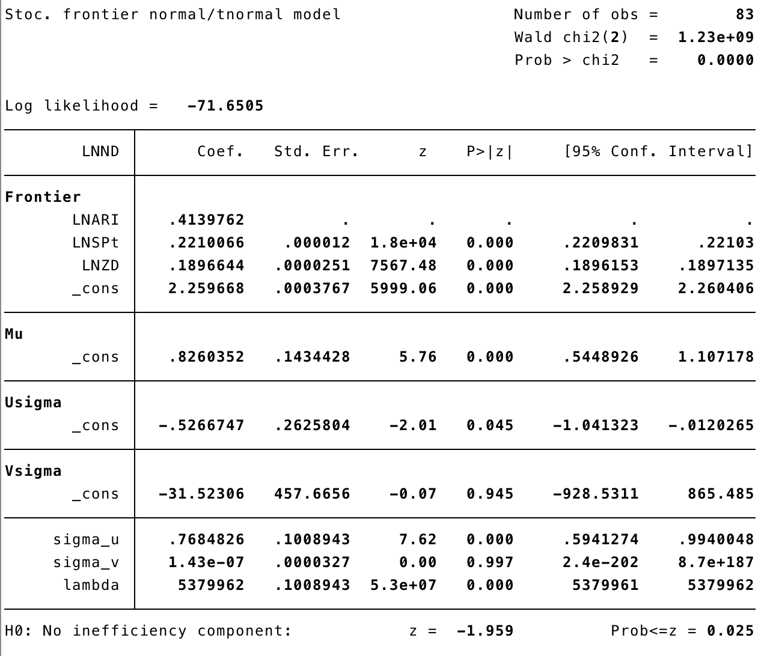

1. Actual Relative Income is calculated as average salary of doctors in a region (variable specified in § 2.2) divided by the average income in a region in different industries.