Saint Petersburg State University

***Viktoriia KHOMIAKOVA***

**Master Thesis**

***LAKE VOSTOK WATER BALANCE AND HYDROLOGYCAL REGIME BASED ON WATER AND ICE ISOTOPIC COMPOSITION***

05.04.06 Ecology and environmental management

BM.5527.2021 Master Program Polar and Marine Sciences POMOR

Saint-Petersburg

2024

Санкт-Петербургский государственный университет

***ХОМЯКОВА Виктория Андреевна***

**Выпускная квалификационная работа**

***ВОДНЫЙ БАЛАНС ОЗЕРА ВОСТОК НА ОСНОВЕ ДАННЫХ ОБ ИЗОТОПНОМ СОСТАВЕ ВОДЫ И ОЗЕРНОГО ЛЬДА***

Уровень образования: *магистратура*

Направление *05.04.06 Экология и природопользование*

Основная образовательная программа *ВМ.5527.* «Полярные и морские исследования (ПОМОР)»*

Санкт-Петербург

2024

**Lake Vostok water balance and hydrological regime reconstruction based on water and ice isotopic composition**

Khomiakova Viktoriia Andreevna

Master Program Polar and Marine Sciences POMOR / 05.04.06 Ecology and environmental management

**Supervisor:**

Associate Professor Dr. Dmitry V. Bantsev, Institute of Earth Sciences, Saint Petersburg

State University

**Reviewer:**

Dr. Vladimir Ya. Lipenkov, Arctic and Antarctic research institute, Saint-Petersburg, Russia

**Abstract.** Lake Vostok is the largest of known subglacial lakes. The study is dedicated to refinement of the knowledge of its water balance and also includes the speculation about the circulation patterns. The balance-based model of water isotopic composition was used. Data of the accreted ice isotopic composition was used as a target for reconstruction. As a result, the improved values of the water balance components were obtained.

**Водный баланс подледникового озера Восток на основе данных об изотопном составе воды и озерного льда**

Иванов Иван Иванович

ВМ.5527.* «Полярные и морские исследования (ПОМОР)» / 05.04.06 Экология и природопользование

**Научный руководитель:**

Банцев Дмитрий Вадимович, к.г.н., Институт наук о Земле, Санкт-Петербургский государственный университет

**Рецензент:**

Липенков Владимир Яковлевич, к.г.н, Арктический и Антарктический институт, г. Санкт-Петербург

**Аннотация.** Озеро Восток – самое большое из известных подледниковых озер. Настоящая работа посвящена уточнению имеющихся сведений о компонентах его водного баланса. Помимо этого, в работе содержатся размышления на тему возможной циркуляции воды в озере. Для реконструкции водного баланса озера была использована простая изотопная модель, основанная на уравнениях водного и изотопного балансов. В качестве основного источника информации был использован изотопный профиль озерного льда. В результате были получены уточненные величины компонентов водного баланса.

**Introduction**

Subglacial lake Vostok is known widely. It is the largest subglacial lake, and the most investigated one. The critical interest is invoked by the fact, that the lake body was isolated from the daylight for thousands of years. This environment is usually considered to be similar to alien ones (probably Martian).

As a result of the extensive investigation, highly reliable morphometrical and topographical characteristics of the lake were obtained. It provided an opportunity to draw the first conclusions about its hydrological regime. These conclusions were further deepened, expanded and supplemented through the direct investigations of the lake ice cores. However, up to now there are no techniques to penetrate the lake. Thus, a little is known definitely about the lake.

The major scientific directions concerning the lake Vostok are: i) thermodynamics in a bedrock – water – ice sheet system; ii) microbial life and its distribution; iii) development and approbation of methods of subglacial waterbodies investigation and approaching these remote environments. One of the first-order things to know is the water circulation patterns in LV and the components of water it`s budget.

There are several ways of subglacial lakes investigation, most of them indirect. Only a few lakes had been unsealed. The first unsealing of lake Vostok took place in 2012. The core of accreted ice was obtained. The availability of accreted ice provides a great opportunity for investigations. Lake water characteristics are preserved in accreted ice, making it an archive of their spatial and temporal variability.

Isotopic composition of water is actually the content of heavy stable isotopes of hydrogen and oxygen (oxygen-18, deuterium). In hydrology, this characteristic helps to distinguish between waters of different origin. In case of ice, stable isotopic composition can also help to reconstruct the freezing conditions. For the Vostok lake this characteristic is important, since the ice was formed very slowly and freezing took place in the process of ice sheet movement across the lake.

This way, fluctuations of heavy isotope content in the lake ice possibly reflect changes of local freezing conditions together with hydrological conditions in the lake (meaning the income of slightly different water to the freezing front). That`s why interpretation of isotopic variability in the accreted ice can provide valuable insights into the lake hydrological regime.

However, the complete reconstruction of water circulation in the lake is barely possible due to lack of direct observations. We hope, that even minor insights into the nature of the lake are important. It can shed the light on the water turnover processes relevant for subglacial lakes. It would also be useful for reconstruction of the conditions which form such a unique habitat for living organisms.

Hydrological net of Antarctica, which was hardly believed to exist 70 years ago, is under intense investigation nowadays. Up to now, there are more than 400 lakes reliably known. Specific character of Antarctic water objects requests approbation and development of new hydrological research methods. Lake Vostok is among the first one where the new techniques will be approbated.

Our knowledge about these hidden objects is still far from being complete and we still know a little about their functioning. The lake Vostok, being a one of the biggest discoveries of a twentieth century, worths all the powers directed to uncover it`s mysteries.

**Study object**

*Investigation history*

Lake Vostok existence was evidenced in 1960s. It was a Russian aviator R.V. Robinson who for the first time had noticed a plain spot amid the East-Antarctic relief. His hypothesis was soon strengthened by theoretical investigations by I.A. Zotikov, who had proved the opportunity of melting at the ice-sheet base. However, the first man who had established lake Vostok existence was an English glaciologist G. Robin (Kotlyakov, 2016).

Extensive systematic investigations started at the end of XX century from the research of A. Kapitsa (Kapitsa, 1996). Later, in 1995-2008, large-scale geophysical survey was carried out by Polar Marine Geosurvey Expedition. The major results are following: i) a map of LV shoreline and surrounding topography; ii) ice sheet thickness scape over the lake and vicinities; iii) LV bathymetrical map. Italian and US geophysical surveys also took part in the first-order investigations.

On the basis of information on the sink outline and depths the first suggestions about the geological origin of the lake were made (Leitchenkov, 2004). Some years later, data on aerogravity and magnetic field in the lake vicinity provided an opportunity to draw new conclusions (Studinger, 2003).

The ice movement velocities over the lake Vostok was measured several times (Kwok, 2000; Tikku, 2004; Richter, 2014) by the means of GNSS. The flow line was obtained by Salamatin (2009) who has used glaciological modelling for this purpose. It was established that ice originates at the Dome b and flows generally eastwards.

The most recent researches are made by Winebrenner (2018) and Litvinenko (2019). The first one discusses the rates of melting and accretion at the lake lid based on the data of radiowave attenuation. The second one gives an insight about sediments thickness. It is important, since the sediments layer thickness can show us whether the lake was formed before the ice sheet formation or not.

*Deep drilling at the Vostok station*

Another important part of investigations is dedicated to the Vostok ice core. In its deepest part, the ice core contains ice of lake water origin. Thus, scientists can make some conclusions on the characteristics of this water.

The deep drilling has been conducted at the Russian station Vostok since 1970. The lake existence was not proved those days. The station has been founded in 1957. It is situated on the southern geomagnetic pole, not far from the pole of inaccessibility.

Deep drilling continued till 1998. When the borehole reached the upper layers of lake ice for the first time, drilling was stopped. Since that time, two more boreholes were drilled, which resulted in unsealing of the lake in 2012 and 2015.

As a result, three partly replicate cores became available for the analysis, providing a revalidated data on the lake ice characteristics (Lipenkov et al, 2016). The ice was a subject for petrographic (Lipenkov, 2016), gas (Lipenkov, Istomin), chemical (de Angelis), isotopic (Ekaykin) and microbiological (Bulat, 2005) analysis.

De Angelis noted, that the lake ionic “fingerprint” is different from that of the glacier ice. He and his co-authors suggested the water input from upland in the vicinities of the island Islet. Gas hydrates are the indicator of an unusual freezing process, presumably occurred in the northeastern part of the lake. This process is characterized by the freezing of frazil ice with the formation of “water pockets”. Presence of water pockets is important for understanding of characteristics of initial water.

Isotopic analysis can be very important since the isotopic composition of water molecules reflects both the changes in freezing process and changes of water properties. It means, that any kind of isotopic variations in the ice stratigraphy can be explained and give us insights on what is happening in the lake.

Microbiological investigations of the lake ice aimed to find the signs of life. However, it is not that easy, because the laboratory conditions should be the cleanest of ever. In 2004, the part of DNA of thermophilic bacteria *Hydrogenophilus thermoluteolus* was found in the ice. This specie occurs in thermal springs in New Zeland. This is the strongest argument for the thermal springs existence in the lake bottom.

*Lake Vostok*

Lake Vostok is situated in the Eastern Antarctica. It is remoted from the sea for more than 3000 km. The lake ceiling lies 3750 m beneath the ice surface and 25 m below the sea level. The origin of the lake is not yet understood, neither it is it`s age. The sink is of tectonic origin but there are different points of view on when and how it was originated.

LV has an elongated shape with 15790 km2 area (including 365 km2 of islands) (Lipenkov, 2011). The west shore line is complicated by several bays and peninsulas, while the eastern one is almost straight.

Bathymetrically, the lake can be subdivided into two basins. The northern one is much shallower than the southern, where maximum depth reaches 1500 m (1200 m below the sea level). The sides of the sink are folded with ledges, which frames the tectonically originated structure.

The overlaid ice sheet bottom is inclined (Masolov, 2010) because of its thickness. The difference between the ice thickness over the southern and the northern lake margins is about 600 m. This feature has a crucial importance for the lake. The melting point temperature is pressure dependent. Thus, the ice thickness difference above the lake (and, consequently, pressure difference) creates a thermal flux asymmetry. In a result, the ice sheet melting occurs in the northern part, while the new ice accretes on the lake ceiling in the southern part. This is supposed to cause a water circulation (Siegert, 2011). It is also suggested, that a part of melt water moves directly to the accretion zone not being involved in deep circulation because the ultra-fresh melt water has a lower density than the resident lake water.

In addition, there are a number of researches which show that melting and accretion are not the only components of LV water balance. Microseismological, geological and microbiological signs point out a supplementary water input, presumably, though a hydrothermal spring (or a number of springs) (Studinger 2003, Leitchenkov 2005, Ekaykin 2010). The subglacial streams inflow is also hypothetically suggested on the basis of gravitational aspects data (Klokocnik, 2018). But, regarding LV long-lasting steady state, all the hypotheses are challenged (Richter, 2014).

*Accreted ice*

The accreted ice was formed along the movement track of the ice sheet. The reconstructed flow-line of the ice sheet can be found on the picture 1. The age scale was constructed on the basis of ice sheet movement. The age of the uppermost layer is about 40 kyrs (Salamatin et al, …).

The core consists of two parts with different properties. The upper one (Lake Ice 1) is between 3539 and 3618 m depth and the lower one (Lake Ice 2) is below 3618 m. (Lipenkov et al, 2016). The layers were demarcated on the basis of differences in ice structure, mineral inclusions content, gas content and isotopic composition.

The common explanation of such a stratigraphy refers to the path of ice movement. According to modelling results [*Salamatin et al, 2009*], the ice flow line passing through the Vostok drilling site (VFL – Vostok Flow Line) crosses the shallow strait and an island at the south-western part of LV. This is where the Lake Ice 1 is believed to be formed. As for the Lake Ice 2, it is likely to be formed over the deep southern part of the lake. One of the supportive arguments is the high concentration of mineral inclusions in Lake Ice 1 compared to Lake Ice 2, which is clear and transparent [*Lipenkov et al, 2016*].

Although the accreted ice was a subject for the detailed multidisciplinary investigations, only the several key points will be illuminated here. First of all, it worth to say that all the studied characteristics of the ice reflect the significant variability of local freezing conditions and/or lake`s hydrological regime [*Lipenkov et al, 2016*]. Freezing conditions changes are well pronounced in ice crystals structure and orientation. By this way it was shown, that Lake Ice 1 formation was associated with frazil ice and water pockets formation. This assumption is confirmed by the high gas hydrates content in the layer. In contrast, the Lake Ice 2 is likely to be formed in a process of slow orthotropic crystal growth. This theory corresponds to the ice crystals shape and size as well as the low amounts of gas in the Lake Ice 2. The short-term variability reflected in the Lake Ice 2 stratigraphy is likely to have an origin in LV water circulation.

**Data**

For our research we`ve used the data on isotopic composition of the accreted ice. By the term of isotopic composition we mean oxygen-18, oxygen-17 and deuterium content in the ice samples. We use the delta notation to present the values of this content:

$$δQ= \frac{R_{s}-R_{st}}{R_{st}}×1000,$$

where Q denotes either deuterium, oxygen-18 or oxygen-17 Rs stands for the isotope content in a sample, Rst stands for that in the VSMOW-2 standard (Vienna Standard Mean Ocean Water-2) , and 1000 is a coefficient to get the value in permilles.

Samples of ice were measured in the Climate and Environmental Research Laboratory (AARI, Saint-Petersburg) on a Picarro L2140-i laser analyzer. 10 % of the samples, randomly selected, were subjects to replicate measurements. The mean standard deviation for the repeated measurements amounted to ±0.05 ‰ for δ18O, ± 0.5 ‰ for δD an … for δ17O. Until the analysis, samples were kept cool sealed in plastic tubes.

Each sample presents an integral isotopic composition for the 0.5 m interval. Since there are three replicate cores of the accreted ice, each data point is a composite. The triple values were averaged and the outliers removed. There are 460 values of isotopic content in total.

The accreted ice was formed by the congelation of the lake water while the ice sheet was crossing the lake. The vertical structure of the ice preserves the information about spatial and temporal variability of lake water and ice formation conditions.

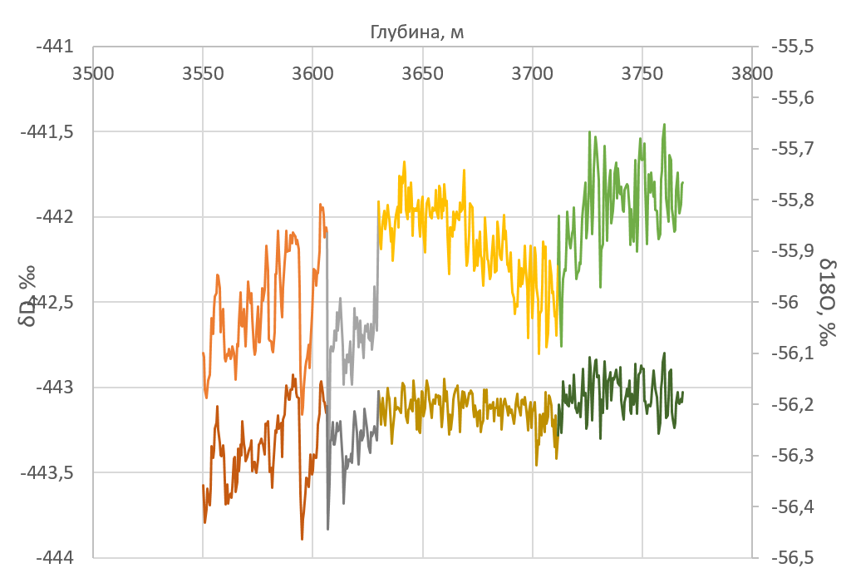

Fig 1. Isotopic profile of lake Vostok congelation ice

The isotopic composition of lake ice is characterized by variability in the range from -443.1 ‰ to -441.5 ‰ for deuterium and from -56.5 ‰ to -56.1 ‰ for oxygen-18 (Fig. 1). The deuterium kurtosis value is 7.5 ‰, which is not typical for atmospheric ice in this region. Reduced deuterium kurtosis indicates either non-equilibrium fractionation conditions in the water-ice system (Souchez et al, 2000) or the involvement of an additional food source with a heavier oxygen isotopic composition (Souchez et al, 2004; Ekaykin et al, 2010). Since lake ice 2 formed under conditions of slow freezing (close to equilibrium), it was assumed that Lake Vostok had additional water from groundwater sources (Souchez et al, 2004). This assumption was later confirmed by hydrochemical studies of lake ice (de Angelis et al, 2004).

**Methods**

*Model description*

The isotope model of Lake Vostok is based on the water balance and heavy isotope balance equations (Fig. 2). This approach was first proposed by Royston-Bishop in 2005. It was conceptualized in Ekaykin et al (2010).

Glacial melt water enters the lake in its northern part and, due to the density difference, rises along the inclined surface of the glacier base to the southern part of the lake. It is supposed, that the melt water partially mixes with resident lake water, and then freezes, forming the lake ice. At the bottom of the lake there are hydrothermal springs that are fed by resident lake water and/or groundwater coming from outside the lake basin.

A significant difference between the improved version of the model and the previous one is that it includes the geochemical oxygen cycle 17.

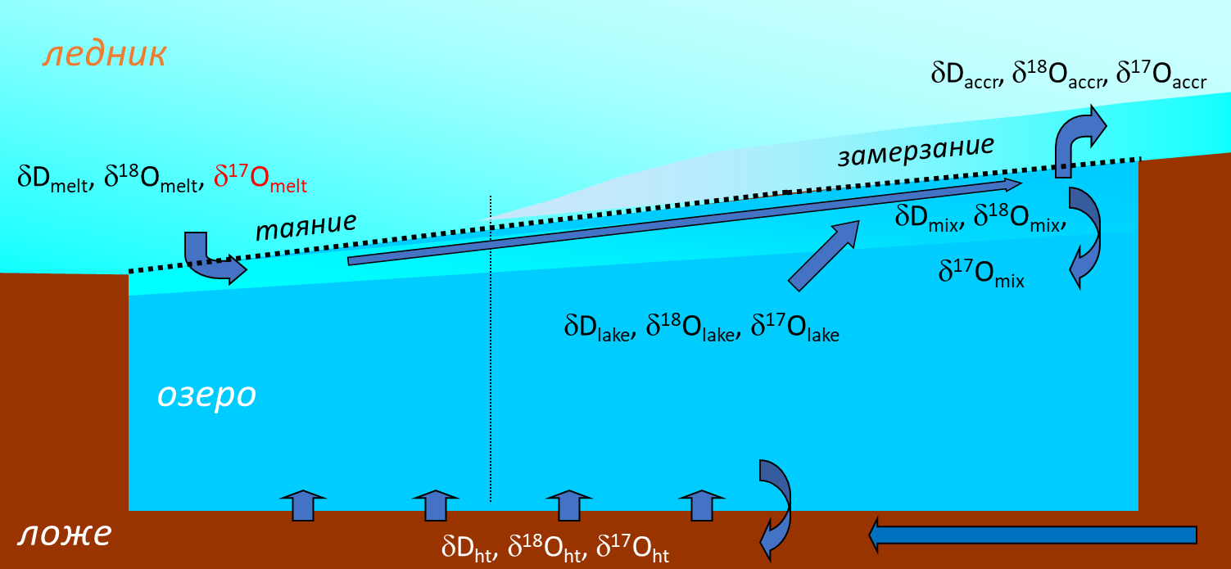

Fig. 2. Scheme of the mass and isotope balance of subglacial Lake Vostok.

The model includes four blocks. The first block characterizes atmospheric ice melting in the northern part of the lake. The second block directly characterizes the water in the lake. The third block describes ice freezing in the southern part of the lake. Finally, the fourth block describes the proposed underground source.

The model is based on the water balance and heavy isotope balance equations (Ekaykin et al, 2010):

$$\frac{{dM}_{lake}}{dt}=M_{melt}-M_{accr}$$

$$\frac{{d(M}_{lake}R_{lake})}{dt}=M_{melt}R_{melt}-M_{accr}α\left[R_{melt}\left(1-σ\right)+R_{lake}σ\right]+M_{ht}R_{ht}$$

where *Mlake*, *Mmelt*, *Maccr* are the masses of water in the lake, melting ice and freezing ice (per calculation step), respectively; *Rlake*, *Rmelt* – content of heavy isotopes (deuterium, oxygen 18 or oxygen 17) in lake water and melting ice, respectively; α is the effective fractionation coefficient during the transition of water from liquid to solid state, σ is the mixing parameter, *Mht* and *Rht* are the mass of water and the content of heavy isotopes in the waters of the supposed underground source.

*Determination of the isotopic composition of melting ice*

According to the results obtained in (Salamatin et al, 2009), ice melting in the northern part of Lake Vostok forms in the area of ​​the “old Dome B”, and then moves to the melting site along a flow line parallel to the Vostok Flow line. Thus, to estimate the isotopic composition of melting ice, one must know the isotopic composition of the ice formed on Dome B.

There are two ways to estimate this isotopic composition. The first (Royston-Bishop et al, 2005) involves calculating the gradient in the north-south direction using data from the Vostok - Komsomolskaya profile (Souchez et al, 2004). The second is to reconstruct the isotope series for Dome B based on correlation with core from Vostok station (Ekaykin et al, 2010) or EPICA Dome C station (EDC). In 1998, a 30,000-year-old core was obtained from Dome B, which allows such a correlation to be calculated.

In this work, we used the Dome B–EDC series relationship because the latter series includes data from the surface to the glacier bed and the lower layers are free of damage caused by glacier flow. The resulting curve, reflecting the expected fluctuations in the content of heavy isotopes in the lower part of the core from Dome B, was approximated by a sine wave. The series was adjusted to a melt rate of 1.2 cm/yr. The resulting curve is shown in Figure 3.

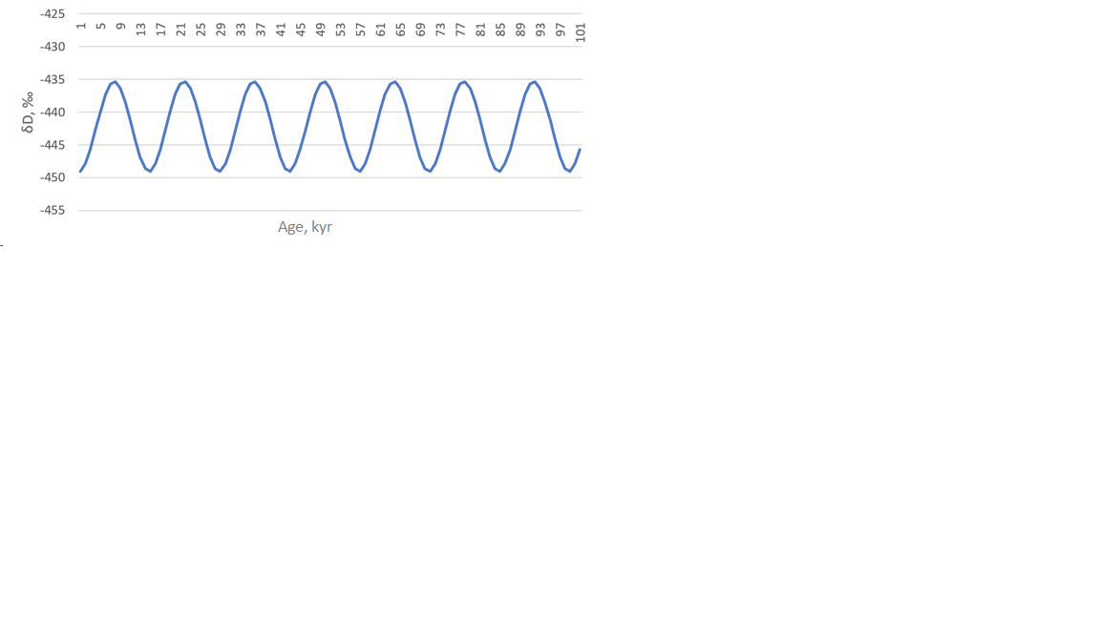

Fig. 3. Reconstructed profile of melt ice isotopic signal

Since only the deuterium content of the EDC core is publicly available, it is necessary to reconstruct the deuterium kurtosis value to obtain the heavy oxygen content. The deuterium kurtosis value was taken as the average for the Vostok core data (14.9 ‰).

The initial values ​​of the isotopic composition of water in Lake Vostok were taken as the average for one climate cycle. They amounted to -442.23‰ for deuterium and -56.72‰ for oxygen 18.

*Parametrization*

The model includes a number of independent adjustable parameters. These parameters are listed in Table 1. The parameters responsible for the flow volume (Vmelt, Vice, Vht) are calibrated according to data from available publications. Thus, the volumes of melting and freezing are estimated from 0.058 km3/year to 0.19 km3/year in (Winebrenner et al, 2018) and (Royston-Bishop et al, 2005), and the volume of possible underground inflow is estimated to be from 0 to 0.068 km3 /year. We decided to expand the latter range to the upper limit of the flow rate of underground sources in tectonically weakly active areas. This flow rate was taken to be 5 m3/sec (taking into account that the groundwater output may be dispersed). Thus, the upper limit of the underground recharge value was set equal to 0.15 km3/year.

Deuterium kurtosis for groundwater was taken to be from 0.0 to 7.5 ‰. As is known, as a result of long-term interaction in the water-rock system (if we are talking about carbonate-containing rocks), oxygen fractionation occurs, causing a decrease in dxs relative to local meteoric waters. There is every reason to assume that groundwater in Antarctica interacts with the rock for a long enough time for it to affect its isotopic composition. In addition, in zones of tectonic faults, the participation of juvenile waters is possible, whose dxs, as a rule, is from 2 to 4 ‰ (Budantseva et al., 2011).

The sigma parameter (σ) characterizes the degree of mixing of waters arriving as a result of surface melting with the resident water of the lake.It is adjusted using the least square deviation method to best match the simulated values ​​with the original data. Taking into account the presence of climatic cycles in melting ice, it can be assumed that the parameter σ is close to unity, that is, almost complete mixing of the newly arriving water with the internal waters of the lake is assumed. Otherwise, the fluctuations in the isotopic composition in freezing ice would be much greater.

Other limiting parameters in the model were the relative areas of melting and freezing, as well as the rates of melting and freezing. Their meanings should not go beyond those proposed in the literature. Thus, the ratio of the melting area to the total area cannot be more than 2/3 and less than 1/15. The melting rate cannot go beyond 1 - 5 cm/year.

*Table 1*. Model parameters

|  |  |  |  |
| --- | --- | --- | --- |
| Параметр | Denoting | Units | Limits |
| **Volumes of water** | | |  |
| - income of melt glacier water | *Vmelt* | km3/y | ≤ 0,19 |
| - outcome with accretion | *Vice* | km3/y | ≤ 0,19 |
| - income from the spring | *Vht* | km3/y | ≤ 0,15 |
| Underground waters deuterium excess | *dxsht* | ‰ | From 0 to 7,5 |
| Mixing parameter | *σ* | n/d | From 1 to 0 |
| **Constants** |  | | |
| Th lake volume | 5200 km3 | | |
| Equilibrium fractionation coefficients |  | | |
| - oxygen-18 | 1,003 | | |
| - deuterium | 1,0208 | | |

*Numerical experiments*

The improved model of Lake Vostok allows for a number of independent experiments. The parameters proposed in the works of Royston-Bishop et al, (2005) and Winebrenner et al (2018) were chosen as input parameters for the experiments.

In the first work, the authors assumed that the volume of freezing completely compensates for the volume of melting and amounts to 0.19 km3/year. The participation of additional power sources is not expected.

Winebrenner et al (2018) calculated melt/freeze rates for the entire lake-glacier interface using geophysical methods. According to the results obtained, the area where freezing is observed is more than 10 times larger than the melting area. Freezing and thawing rates range from 0 to 1.2 cm/year. The volume of freezing is up to 0.072 km3/year.

Two additional experiments were set up with arbitrary parameters so that the modeled lake ice isotopic composition curves best matched the observed data (Figures 8 and 9).

*Table 2*. Experimental settings

|  |  |  |  |  |  |
| --- | --- | --- | --- | --- | --- |
| Number of experiment | **Vmelt** | **Vice** | **Vht** | **dxsht** | **sigma** |
| 1 | 0,19 | 0,19 | 0 | - | 1 |
| 2 | 0,0049 | 0,058 | 0,0531 | 7,05 | 0,95 |
| 3 | 0,019 | 0,044 | 0,025 | 4,6 | 0,95 |
| 4 | 0,026 | 0,037 | 0,011 | -0,2 | 0,95 |
| 5 | 0,008 | 0,08 | 0,072 | 6,9 | 0,95 |
| 6 | 0,015 | 0,15 | 0,135 | 6,9 | 0,95 |

*Table 3.* Experimental settings

|  |  |  |  |  |  |
| --- | --- | --- | --- | --- | --- |
| Number of experiment | Melting rate, cm/year | Accretion rate, cm/year | Area of melting (relative), % | Area of accretion (relative), % | Spring discharge, m3/sec |
| 1 | 5,0 | 1,86 | 27 | 73 | 0 |
| 2 | 1,0 | 0,43 | 4 | 96 | 1,683 |
| 3 | 1,0 | 0,36 | 14 | 86 | 0,792 |
| 4 | 1 | 0,32 | 19 | 81 | 0,348 |
| 5 | 1,0 | 0,61 | 6 | 94 | 2,283 |
| 6 | 1,0 | 1,2 | 11 | 89 | 4,280 |

**Results**

*Experiment # 1 (Royston-Bishop)*

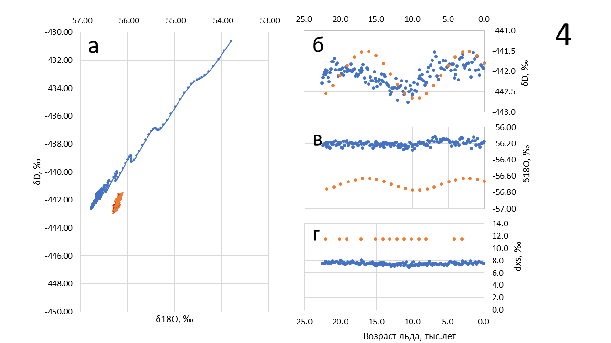

Age scale, kyr

Fig. 4. Results of numerical modeling of the isotopic composition of the congelation ice of Lake Vostok: a) on the δ18O vs δD diagram; b) hydrogen isotopic composition profiles (δD); c) oxygen isotopic composition profile (δ18O); d) deuterium excess profile (dxs)

The difference between this experiment and the experiment conducted by Royston-Bishop and colleagues in 2005 is in the raw data used. The authors of this report used the isotopic series for Dome B reconstructed from the EDC core data (see above). The other parameters are taken from the corresponding article without modification. According to the results obtained (Fig. 4), it can be seen that the lake is indeed in equilibrium state, but the balance of isotope-oxygen composition is not observed and cannot be explained due to the nonstationarity of water mass in the lake. Thus, if the lake were in a nonequilibrium state, we would observe a distinct downward trend both on the δ18O vs δD diagram and on the profile of the isotopic composition of lake ice, but this is not observed.

*Experiment # 2 (Winebrenner 1)*

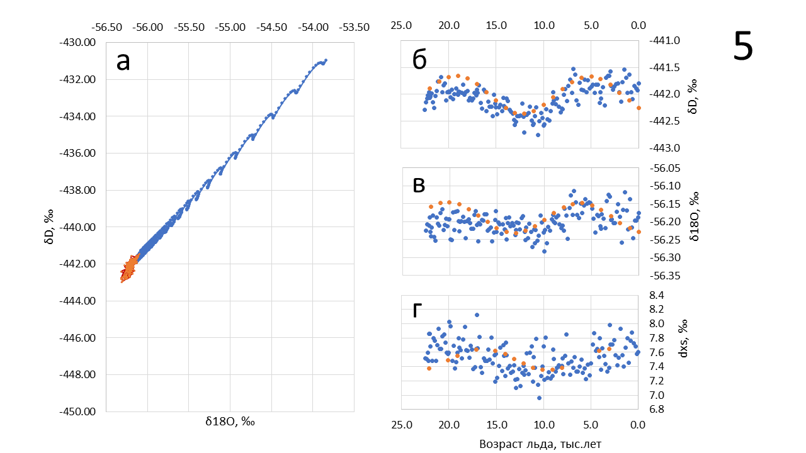

Age scale, kyr

Fig. 5. Results of numerical modeling of the isotopic composition of the congelation ice of Lake Vostok: a) on the δ18O vs δD diagram; b) hydrogen isotopic composition profiles (δD); c) oxygen isotopic composition profile (δ18O); d) deuterium excess profile (dxs)

According to Winebrenner et al (2018), the volume of intrusion is 0.058 km3/year, while the volume of melting is more than 10 times smaller. With this ratio of melting and intensification, the water deficit can be compensated by a groundwater source with a total flow rate of 1.683 m3/sec with a deuterium excess of 7.05 ‰ (Fig. 5). The source with such a flow rate can be classified as a giant source, which is not typical for tectonically low-active areas. However, given the large area of the lake and the deep incision of its basin, we can assume the presence of a dispersed groundwater outlet with sources of different flow rates, which can be observed in highly dissected mountain areas and lake basins of tectonic origin (Oil and Gas Hydrogeology, 2010). As for the deuterium excess, such a value is likely if we assume that the groundwater source waters are a mixture of isotopically altered meteoric waters and (possibly) waters of magmatic origin.

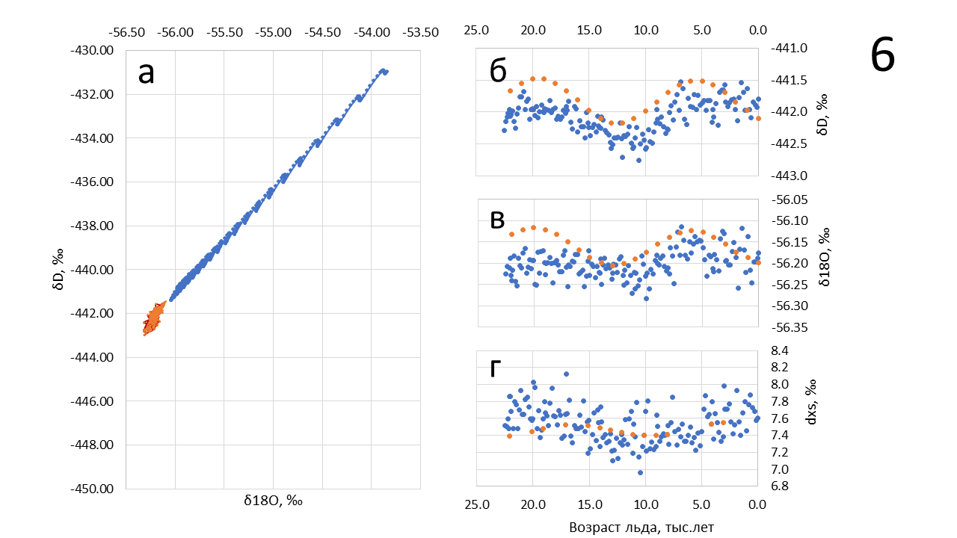

Age scale, kyr

Fig. 6. Results of numerical modeling of the isotopic composition of the congelation ice of Lake Vostok: a) on the δ18O vs δD diagram; b) hydrogen isotopic composition profiles (δD); c) oxygen isotopic composition profile (δ18O); d) deuterium excess profile (dxs)

Winebrenner et al (2018) also provide other estimates based on the accumulation rate and surface air temperature from Ekaykin et al (2004). According to the first of them, the volumes of melting ice, ice intrusion, and balance disequilibrium are 0.019 km3/year, 0.044 km3/year, and 0.025 km3/year, respectively. Thus, the volume of melting is 43% of the volume of ice intrusion, and the remaining 57% is compensated by groundwater source. Thus, the underground source flow rate should be 0.792 m3/sec, with dxs equal to 4.6 ‰. Such deuterium excess is characteristic of waters of juvenile or magmatic origin. Figure 6 shows that the modeled isotopic composition at such characteristics does not quite correspond to the observed isotopic composition of congelation ice.

*Эксперимент 4 (Winebrenner 3)*

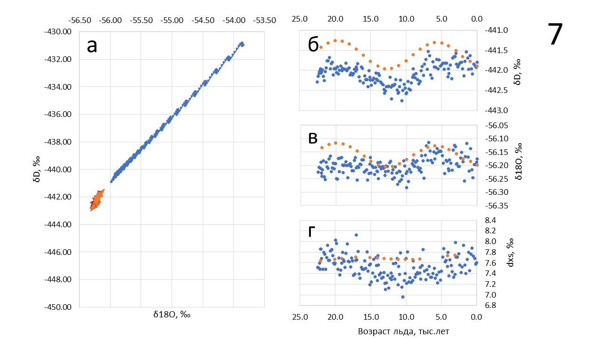

Age scale, kyr

Fig. 7. Results of numerical modeling of the isotopic composition of the congelation ice of Lake Vostok: a) on the δ18O vs δD diagram; b) hydrogen isotopic composition profiles (δD); c) oxygen isotopic composition profile (δ18O); d) deuterium excess profile (dxs)

This experiment was set up using the third dataset from Winebrenner et al, where the ratios of melting ice, freeze-up ice, and balance disequilibrium are described as 0.026 km3/yr, 0.037 km3/yr, and 0.011 km3/yr. Figure 7 shows that at this ratio the modeled isotopic composition of lake water does not correspond to the observed isotopic composition of lake ice.

*Эксперимент 5 (рис. 8)*

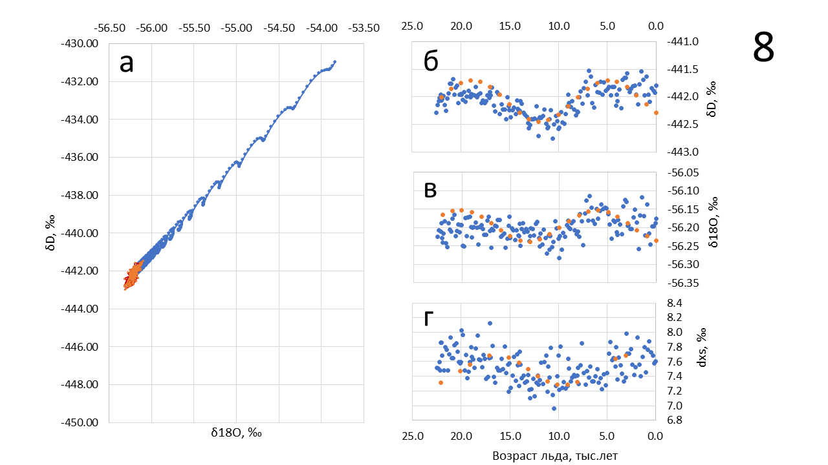

Age scale, kyr

Fig. 8. Results of numerical modeling of the isotopic composition of the congelation ice of Lake Vostok: a) on the δ18O vs δD diagram; b) hydrogen isotopic composition profiles (δD); c) oxygen isotopic composition profile (δ18O); d) deuterium excess profile (dxs)

*Эксперимент 6 (рис. 9)*

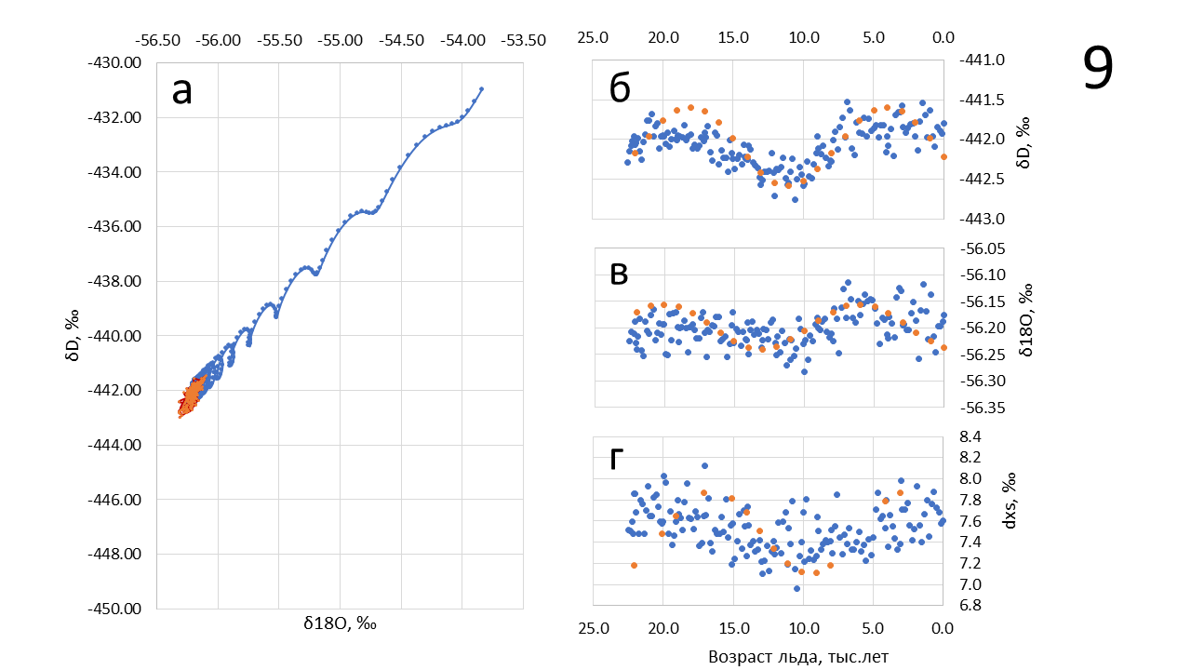

Age scale, kyr

Fig. 9. Results of numerical modeling of the isotopic composition of the congelation ice of Lake Vostok: a) on the δ18O vs δD diagram; b) hydrogen isotopic composition profiles (δD); c) oxygen isotopic composition profile (δ18O); d) deuterium excess profile (dxs)

**Discussion**

Obviously, the result equally corresponding to the observed data can be obtained at different ratios of the source water dxs and its flow rate. Taking into account the constancy of water mass in the lake, it is possible to construct an experimental curve reflecting the relationship between the source water dxs and the ratio of melting and freezing ice volumes (Figure 10). The figure shows that when the ratio of melting to freezing volume is less than 0.45, the deuterium excess for groundwater source waters will be less than 4.0, indicating that these waters are almost exclusively of juvenile or magmatic origin. Given that the Lake Vostok area is not a magmatically active region, the involvement of such waters is unlikely. This supports the conclusion that the volume of intensification is several times greater than the volume of melting and suggests the presence of springs with a sufficiently large flow rate.

In addition, the analysis of Figures 6 and 7 shows that at a small ratio of the source flow rate to the volume of freezing ice, the dxs curve on the experimental profile turns out to be largely smoothed, which does not reflect the real picture of dxs distribution in lake ice. Thus, the curve is most consistent with the real distribution at a ratio of 1:10:9 (melting : freezing : groundwater source, respectively). This corresponds to a source dxs of 6.9 ‰.

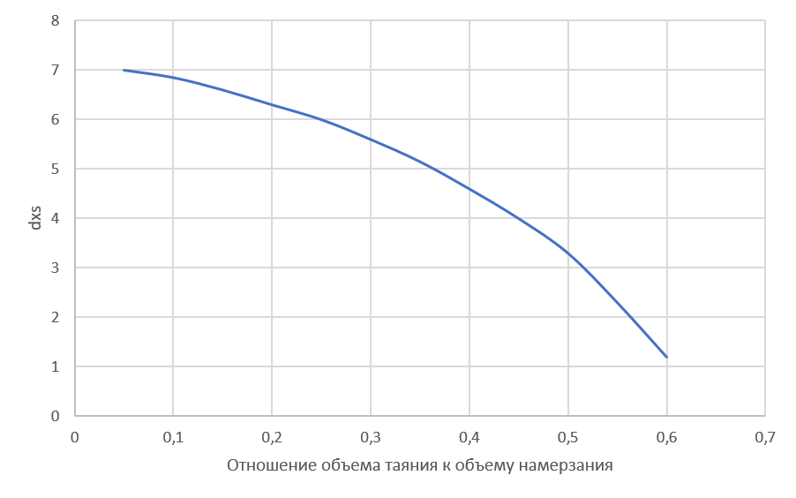

Melting-accretion Volume ratio

Fig. 10. Deuterium excess of water of compensating groundwater source for different ratios of melting and intrusion volumes.

However, not any volumes corresponding to the obtained ratio will equally reflect the real isotopic composition of lake ice. Figure 11 shows that larger volumes of intentionality (on the order of 0.3 km3/yr) would result in a larger scatter of points on the δ18O vs δD plot, while smaller volumes (on the order of 0.07 km3/yr) would result in a much smaller scatter. This means that the Winebrenner et al (2018) (0.058 km3/yr) estimates are slightly underestimated and the Royston-Bishop et al (2005) (0.19 km3/yr) estimates are slightly overestimated relative to the real values.

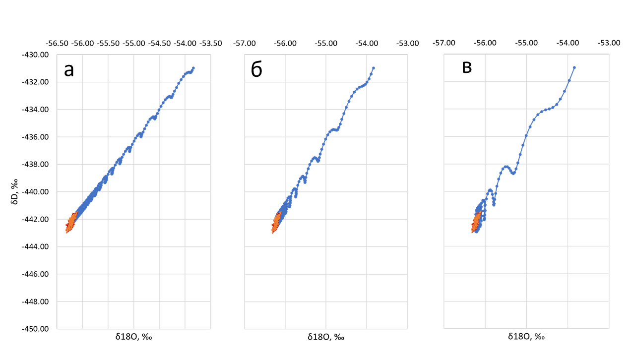

Fig. 11. Modeling results of Lake Vostok isotopic composition in the δ18O vs δD diagram; a) Vice = 0.07 km3/yr; b) Vice = 0.15 km3/yr; c) Vice = 0.30 km3/yr.

As for the parameter σ, its values are most likely close to unity. Figure 12 shows the δ18O vs δD diagram for values of this parameter from 0.9 to 1.0. It can be seen that at low values of the parameter, the variations in isotopic composition in ice would be much larger than those we observe. For example, the amplitude of variability in the isotopic composition of lake ice 2 is only 0.085 ‰ for oxygen 18 and 0.51 ‰ for deuterium. At σ = 1 and Vice = 0.1 the amplitude for oxygen 18 is 0 ‰, and at σ = 0.9 its value reaches 0.09 ‰, which is already larger than what we observe. An important conclusion follows from this that the water melting in the northern part of the lake is more than 90% mixed with the resident lake water before reaching the freezing state at the water-lake ice interface.

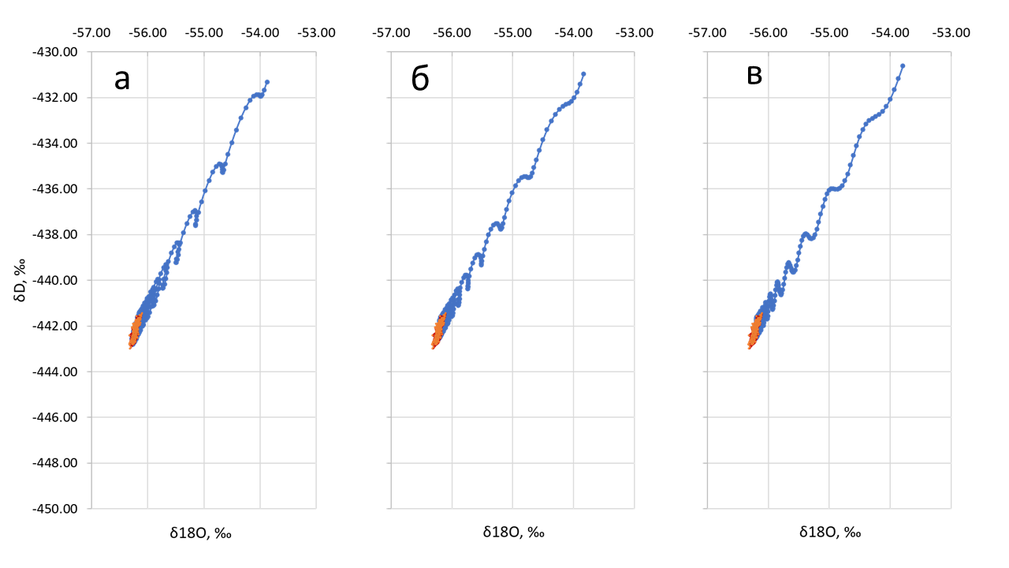

Fig. 12. Results of modeling the isotopic composition of Lake Vostok on the δ18O vs δD diagram; a) σ = 1.0; b) σ = 0.95; c) σ = 0.90

However, it can be assumed that ice of different ages melts in the melting zone at the same moment of time, and this levels out the variations of the initial isotopic composition. If the variations are leveled out completely, the profile of the isotopic composition of lake ice is an artifact of the spatial variability of the isotopic composition of lake water. The spatial variability can only be the result of lake water circulation. It is possible to establish the fact of circulation only by physical modeling, which was not within the aims and objectives of the present work.

Another issue worth highlighting is the presence of a linear trend in the data. If the lake were outside of mass equilibrium, there would be a pronounced linear downward trend in the isotopic profile of congelation ice. However, this is not observed; instead, a weakly pronounced upward trend is observed (Fig. 1). This may be related, for example, to long-period fluctuations in the thickness of the overlying glacier, which may cause a shift of the equilibrium point in the freeze-thaw system and be the cause of nonstationarity of these two flows.

**Conclusion**

An improved model of the formation of the isotopic composition of the congelation ice of subglacial Lake Vostok has been developed, taking into account the inflow of geothermal water into the lake from an independent source and including the geochemical cycle of oxygen 17.

The model considers the isotopic composition (including oxygen 17 concentration) of lake water and the congelation ice formed from it. Using this model, new data on the peculiarities of the hydrological regime of the subglacial water body were obtained based on the results of isotopic studies of the lake ice core.

The numerical experiments made it possible to draw the following conclusions:

1. the lake is most likely in a state of mass equilibrium;
2. the volume of ice freezing at the water-ice boundary significantly exceeds the volume of melting of the overlying glacier; the volume ratio was roughly estimated as 1:10;
3. the lack of water in the lake is most likely compensated by groundwater sources with deuterium excess close to 7.0 ‰;
4. the cumulative flow rate of the springs may be first meters cubic per second;
5. the volume of freezing ice is about 0.1 - 0.15 km3/year;
6. glacial meltwater is largely mixed with resident lake water, which suggests that the congelation ice column can be considered representative for studying lake water characteristics.

The currently available oxygen 17 data are insufficient to utilize this parameter to refine the hydrologic cycle of Lake Vostok.

In the future, it is necessary to carry out modeling of the lake state under conditions of non-stationarity of melting and freezing flows, as well as under conditions of unsteady flow rate of groundwater sources. It is also necessary to improve the accuracy of reconstruction of the isotopic composition of melting ice.

**References**

Bulat S.A., Alekhina I.A., Blot M., Petit J.-R., de Angelis M., Wagenbach D., Lipenkov V.Y., Vasilyeva V.P., Wloch D.M., Raynaud D. and Lukin V.V. (2004) DNA signature of thermophilic bacteria from the aged accretion ice of Lake Vostok, Antarctica: implications for searching for life in extreme icy environments International Journal of Astrobiology 3 : 1–12

Paola Cianfarra & Francesco Salvini (2013) Intraplate Transtensional Tectonics in the East Antarctic Craton: Insight from Buried Subglacial Bedrock in the Lake Vostok—Dome C Region International Journal of Geosciences, 4, 1275-1284

De Angelis M., Petit J.-R., Savarino J., Souchez R., Thiemens M.H. (2004) Contributions of an ancient evaporitic-type reservoir to subglacial Lake Vostok chemistry Earth and Planetary Science Letters, 222, 751– 765

Ekaykin A.A. Stable water isotopes in glaciological studies. 2016 Ed. Lipenkov V.Y., SPb: AARI, 2016, 64 p. [In Russian]

Ekaykin A.A., Lipenkov V.Y., Petit J.R, Johnsen S., Jouzel J., Masson-Delmotte V. (2010) Insights into hydrological regime of Lake Vostok from differential behavior of deuterium and oxygen-18 in accreted ice. J. Geophys. Res. 115, 1–14. (doi:10.1029/2009JC005329)

Ekaykin AA, Lipenkov VY, Kozachek AV. 2012 Isotopic regime of subglacial Lake Vostok from the deep ice core studies. Ice Snow 4, 78–85. [In Russian.]

Ekaykin, A. A., V. Y. Lipenkov, I. N. Kuzmina, J. R. Petit, V. Masson-Delmotte, and S. J. Johnsen (2004), The changes in isotope composition and accumulation of snow at Vostok station, East Antarctica, over the past 200 years, Ann. Glaciol., 39, 569–575.

H. Ewert, S. V. Popov, A. Richter, J. Schwabe, M. Scheinert and R. Dietrich (2012) Precise analysis of ICESat altimetry data and assessment of the hydrostatic equilibrium for subglacial Lake Vostok, East Antarctica. Geophys. J. Int. doi: 10.1111/j.1365-246X.2012.05649.

Jouzel J. et al. (2007) Orbital and Millennial Antarctic Climate Variability over the Past 800,000 Years. Science 317, 793 DOI: 10.1126/science.1141038

Leitchenkov, G. L., et al. (2005), Geological nature of subglacial Lake Vostok in East Antarctica [in Russian], Mater. Glyatsiol. Issled., 98, 81–91.

Lipenkov, V.Y., A. A. Ekaykin, E. V. Polyakova, D. Raynaud. 2016 Characterization of subglacial Lake Vostok as seen from physical and isotope properties of accreted ice, Phil. Trans. R. Soc. A 374, 20140303, doi:10.1098/rsta.2014.0303

Lipenkov V.Y., Lukin V.V., Bulat S.A., Vasiliev N.I., Ekaykin A.A., Leytchankov G.L., Masolov V.N., Popov S.V., Savatugin L.M., Salamatin A.N., Shibaev Y.A. 2011 Scientific outcomes of subglacial lake Vostok studies in the IPY, Polar Cryosphere and Continental Waters, M.: Paulsen, 2011., pp. 17-47. [In Russian]

Litvinenko V.S., Leitchenkov G.L., Vasilieva N.I. (2018) Anticipated sub-bottom geology of Lake Vostok and technological approaches considered for sampling. Geochemistry.

Masolov V.N., Popov S.V., Lukin V.V, Popkov A.M. (2010) The Bottom Topography and Subglacial Lake Vostok Water Body, East Antarctica. Doklady Earth Sciences, 2010, Vol. 433, Part 2, pp. 1092–1097

Petit J.R., Alekhina I.A., Bulat S. (2005) Lake Vostok, Antarctica: Exploring a Subglacial Lake and Searching for Life in an Extreme Environment. Chapter in a book Lectures in Astrobiology pp. 227-282.

Richter, A., S. V. Popov, L.Schröder, J. Schwabe, H. Ewer t, M. Scheinert, M. Horwath, and R. Dietrich (2014), Subglacial Lake Vostok not expected to discharge water, Geophys. Res. Lett., 41,6772–6778, doi:10.10 02/2014GL061433.

Royston-Bishop G., Tranter M., Siegert M.J., Lee V., Bates P.D. (2004) Is Vostok lake in steady state? Annals of Glaciology, 39. pp. 490-494

Salamatin A.N., Tsyganova E.A., Popov S.V., Lipenkov V.Y. (2009) Ice flow line modeling in ice core data interpretation: Vostok Station (East Antarctica). In Physics of ice core records, vol. 2 (ed. T Hondoh), pp. 167–194. Sapporo: Hokkaido University Press.

Salamatin, A. N., V. Y. Lipenkov, N. I. Barkov, J. Jouzel, J. R. Petit, and D. Raynaud. 1998 Ice core age dating and paleothermometer calibration based on isotope and temperature profiles from deep boreholes at Vostok Station (East Antarctica), J. Geophys. Res., 103(D8), 8963–8977, doi:10.1029/97JD02253.

Siegert M, Popov S, Studinger M. 2011 Subglacial Lake Vostok: a review of geophysical data regarding its physiographical setting. In Subglacial Antarctic aquatic environments (eds M Siegert, C Kennicutt, B Bindschadler), pp. 45–60. AGU Geophysical Monograph 192. Washington, DC: AGU.

Souchez R., Petit J.-R., Tison J.-L., Jouzel J., Verbeke V. (2000) Ice formation in subglacial Lake Vostok, Central Antarctica Earth and Planetary Science Letters, 181, 529-538

Souchez, R., Petit J.-R., Jouzel J., de Angelis M., Tison J.-L. (2003) Reassessing Lake Vostok`s behaviour from existing and new ice core data. Earth and Planetary Science Letters, 217. 163-170.

Studinger M et al. 2003 Ice cover, landscape setting, and geological framework of Lake Vostok, East Antarctica. Earth Planet. Sci. Lett. 205, 195–210. (doi:10.1016/S0012-821X(02)01041-5)

Winebrenner D.P., Kintner P.M., MacGregor J.A. (2010) New Estimates of Ice and Oxygen Fluxes Across the Entire Lid of Lake Vostok from Observations of Englacial Radiowave Attenuation Journal of Geophysical Research, 115, C05003. doi:10.1029/2009JC005329