Saint Petersburg State University
Graduate School of Management
Master in Management Program

THE MEDIATING ROLE OF ENGAGEMENT AND INTRINSIC MOTIVATION IN THE RELATIONSHIP BETWEEN LEADERSHIP STYLES AND ORGANIZATIONAL CITIZENSHIP BEHAVIOR AMONG YOUNG EMPLOYEES

Master’s Thesis by the 2nd year student — Master in Management Program, Belonozhko A.S.
Research advisor: Associate Professor, Zamulin A.L.

Saint-Petersburg
2023
ЗАЯВЛЕНИЕ О САМОСТОЯТЕЛЬНОМ ХАРАКТЕРЕ ВЫПОЛНЕНИЯ
ВЫПУСКНОЙ КВАЛИФИКАЦИОННОЙ РАБОТЫ
Я, Белоножко Антон Сергеевич, студент(ка) второго курса магистратуры направления «Менеджмент», заявляю, что в моей магистерской диссертации на тему “Посредническая роль вовлеченности и внутренней мотивации в связи между стилями лидерства и организационным гражданским поведением среди молодых сотрудников”, представленной в службу обеспечения программ магистратуры для последующей передачи в государственную аттестационную комиссию для публичной защиты, не содержится элементов плагиата.
Все прямые заимствования из печатных и электронных источников, а также из защищенных ранее выпускных квалификационных работ, кандидатских и докторских диссертаций имеют соответствующие ссылки.
Мне известно содержание п. 9.7.1 Правил обучения по основным образовательным программам высшего и среднего профессионального образования в СПбГУ о том, что «ВКР выполняется индивидуально каждым студентом под руководством назначенного ему научного руководителя», и п. 51 Устава федерального государственного бюджетного образовательного учреждения высшего образования «Санкт-Петербургский государственный университет» о том, что «студент подлежит отчислению из Санкт-Петербургского университета за представление курсовой или выпускной квалификационной работы, выполненной другим лицом (лицами)».
Белоножко А.С. (Подпись студента)
31.05.2023(Дата)

STATEMENT ABOUT THE INDEPENDENT CHARACTER OF
THE MASTER THESIS
I, Belonozhko Anton Sergeevich (second) year master student, program «Management», state that my master thesis on the topic “The mediating role of engagement and intrinsic motivation in the relationship between leadership styles and organizational citizenship behavior among young employees”, which is presented to the Master Office to be submitted to the Official Defense Committee for the public defense, does not contain any elements of plagiarism.
All direct borrowings from printed and electronic sources, as well as from master theses, PhD and doctorate theses which were defended earlier, have appropriate references.
I am aware that according to paragraph 9.7.1. of Guidelines for instruction in major curriculum programs of higher and secondary professional education at St. Petersburg University «A master thesis must be completed by each of the degree candidates individually under the supervision of his or her advisor», and according to paragraph 51 of Charter of the Federal State Institution of Higher Education Saint-Petersburg State University «a student can be expelled from St. Petersburg University for submitting of the course or graduation qualification work developed by other person (persons)».
Belonozhko A.S. (Student’s signature)
31.05.2023(Дата)

ABSTRACT
Master Student's Name | Belonozhko Anton Sergeevich
Academic Advisor’s Name | Zamulin Andrey Leonidovich
Master Thesis Title | The mediating role of engagement and intrinsic motivation in the relationship between leadership styles and organizational citizenship behavior among young employees
Description of the goal, tasks and  main results the research | Research Goal:  This study investigates the influence of perceived leadership styles on Organizational Citizenship Behavior (OCB) among young professionals, focusing on the mediating role of intrinsic motivation and engagement.  Research Tasks:  - Determine direct impact of leadership styles on OCB-O.  - Examine indirect effects of leadership styles on OCB-O through engagement.  - Investigate indirect effects of leadership styles on OCB-I through intrinsic motivation.  - Identify leadership styles that promote OCB among young professionals.  - Identify leadership styles that engage and motivate young professionals.  - Formulate recommendations for effective leadership styles.  Main Results:  - Results show that visionary-coaching and pacesetting leadership styles have a positive direct impact on OCB-O. Commanding style has direct and indirect effects on OCB-O through engagement. Democratic style influences OCB-O indirectly through engagement and intrinsic motivation.  - Cluster analysis reveals variations in OCB-O, intrinsic motivation, and engagement among clusters with strong, weak, and average leaders. No significant differences were found in OCB-I across clusters. Employees of strong leaders exhibit higher levels of OCB-O, intrinsic motivation, and engagement compared to weak leaders.
Keywords | Perceived leadership styles, Goleman's model, Organizational Citizenship Behavior, OCB-O, OCB-I, intrinsic motivation, engagement, mediation analysis, cluster analysis, factor analysis.

АННОТАЦИЯ
Автор | Белоножко Антон Сергеевич
Научный руководитель | Замулин Андрей Леонидович
Название ВКР | Посредническая роль вовлеченности и внутренней мотивации в связи между стилями лидерства и организационным гражданским поведением среди молодых сотрудников
Описание цели, задач и  основных результатов исследования | Цель исследования:  В этом исследовании исследуется влияние воспринимаемых стилей лидерства на организационное гражданское поведение (OCB) среди молодых специалистов с акцентом на опосредующую роль внутренней мотивации и вовлеченности.  Задачи исследования:  Определить прямое и косвенное (через вовлеченность и внутреннюю мотивацию) влияние стилей руководства на проявление OCB-O и OCB-I среди молодых специалистов.  Определить стили лидерства, которые привлекают и мотивируют молодых специалистов.  Сформулировать рекомендации по эффективному стилю руководства.  Основные результаты:  Результаты показывают, что стили лидерства, ориентированные на дальновидность и задающие темп, оказывают прямое положительное влияние на OCB-O. Командный стиль оказывает прямое и косвенное влияние на OCB-O через вовлеченность. Демократический стиль влияет на OCB-O косвенно через вовлеченность и внутреннюю мотивацию.  Кластерный анализ выявил различия в OCB-O, внутренней мотивации и вовлеченности среди кластеров с сильными, слабыми и средними лидерами. Никаких существенных различий в OCB-I между кластерами обнаружено не было. Сотрудники сильных лидеров демонстрируют более высокий уровень OCB-O, внутренней мотивации и вовлеченности по сравнению со слабыми лидерами.
Ключевые слова | Воспринимаемые стили лидерства, модель Гоулмана, организационное гражданское поведение, OCB-O, OCB-I, внутренняя мотивация, вовлеченность, посреднический анализ, кластерный анализ, факторный анализ.

Оглавление
Introduction 7
Chapter 1. Theoretical foundations of leadership 9
§1.1. Leadership 11
§1.2. Contemporary Leadership Theories 14
§1.3. Leadership styles according to Goleman’s framework 16
§1.4 Relationship of leadership styles and OCB 18
Chapter 2. Organizational Citizenship Behavior 21
§2.1 Definition and main approaches 21
§1.2 Relationship of OCB with staff motivation and engagement 23
Chapter 3. Research methodology 26
§3.1. Research hypothesis and objectives 26
§3.2. Research Design 27
Chapter 4. Empirical study 33
§4.1. Descriptive statistics 33
§4.2. Factor analysis of Perceived leadership styles construct 34
§4.3. Cluster analysis 35
§4.4. Mediators 37
§4.5. Conclusion of Hypotheses Testing 39
Chapter 5. Discussion on findings 40
§5.1. Managerial implication 40
§5.2. Academic contribution 41
§5.3. Conclusion 42
§5.4. Limitations and suggestions on future research 43
References 45
APPENDIX 1: DEVELOPMENT OF THE QUESTIONNAIRE 50
APPENDIX 2: DESCRIPTIVE STATISTICS 54
APPENDIX 3: DENDROGRAM 58
APPENDIX 4: INDEPENDENT SAMPLES TEST 59
APPENDIX 4: EFFECT SIZE 60
APPENDIX 5: SOBEL TEST FOR MEDIATION 61

Introduction
Organizations thrive on effective leadership and their employees' discretionary behaviors, which are referred to as Organizational Citizenship Behaviors (OCB). OCBs are extracurricular behaviors that go above and beyond formal job requirements and contribute to organizational effectiveness. (Smith, Organ, & Near, 1983). These behaviors have a significant impact on job performance, organizational commitment, productivity, and overall organizational effectiveness when facilitated by various leadership styles.
Leadership is a complicated and ever-changing concept that is heavily influenced by various perspectives and theories. Early theories recognized the impact of situational factors on leadership effectiveness, such as Fiedler's Contingency Theory and House's Path-Goal Theory, implying that effective leadership is not a one-size-fits-all proposition. (Stogdill, 1948). Similarly, Hersey and Blanchard's Situational Leadership Theory emphasized the importance of leaders adapting their style based on follower readiness, reinforcing the idea that effective leadership necessitates flexibility and responsiveness to follower needs.
Modern leadership theories have evolved beyond these fundamental concepts to meet the needs of diverse organizations and employees. For example, transformational leadership motivates employees through intellectual stimulation and individualized consideration, whereas authentic leadership emphasizes leaders' self-awareness, ethics, and transparency. (Bass, 1978). These contemporary perspectives emphasize the importance of leaders in creating an environment that encourages employees to participate in OCBs.
Daniel Goleman's framework, which identifies six leadership styles and their varying effects on employee behaviors and organizational outcomes, has received significant attention among the various leadership models. (Goleman, 2017). Goleman's framework, when combined with his work on Emotional Intelligence (EI), emphasizes the critical role of emotional competencies such as self-awareness, self-regulation, empathy, and relationship management in leadership effectiveness.
However, there has been little research into the relationship between Goleman's leadership styles and OCB. Further research is needed to understand how different leadership styles influence OCB and the mediating role of engagement and intrinsic motivation.
This study aims to fill that void by focusing on young professionals, a group known for their dynamism and high engagement potential. Its goal is to identify specific leadership styles that promote OCB and make recommendations to leaders who work with young professionals. According to the hypotheses proposed, leadership styles have indirect effects on OCB, which are mediated by engagement and intrinsic motivation.
Finally, this study will delve into the complexities of OCB, with a focus on its relationship with employee motivation and engagement. Both theoretical and empirical literature support the impact of leadership styles on motivation, engagement, and, ultimately, OCB. The study will delve into these details in order to gain a better understanding of the complex interplay between leadership, engagement, motivation, and OCB among young professionals.
Finally, the purpose of this study is to provide a better understanding of leadership and its relationship to OCB, engagement, and motivation. Its findings are intended to provide useful insights and actionable recommendations to leaders working with young professionals in today's dynamic organizational landscape.

Chapter 1. Theoretical foundations of leadership
The concept of organizational citizenship behaviors (OCB) has received a lot of attention in the field of organizational behaviors. It refers to voluntary behaviors that go above and beyond an individual's formal job requirements and contribute to the overall effectiveness of the organization. Helping colleagues with tasks, volunteering for extra duties, and participating in activities that support the organization's goals and values are examples of such behaviors.
Organ (1988), who first introduced the concept of Organizational Citizenship Behavior (OCB), conducted research that sheds light on the significant impact of OCB on various aspects of organizational functioning. OCB has been linked to positive effects on job performance, organizational commitment, productivity, and overall organizational effectiveness, according to Organ's findings. According to the study, employees who exhibit OCB make valuable contributions that lead to improved organizational performance and effectiveness. Additionally, a review by Furthermore, a review by Podsakoff et al. supports the positive influence of OCB in various domains. According to the review, OCB rates labor productivity, organizational-oriented factors, operational efficiency, and overall organizational efficiency favorably. The authors emphasize the importance of scientific research in understanding the contextual factors and mechanisms that underpin this relationship. Furthermore, a subsequent meta-analysis conducted by Podsakoff, Whiting, Podsakoff, and Blume (2009) not only confirms the positive relationship between OCB and individual-level outcomes such as job satisfaction and performance, but also establishes its beneficial effects at the organizational level. This includes improved organizational performance, lower absenteeism, and higher customer satisfaction. These findings collectively support the notion that OCB plays a critical role in driving positive outcomes at both the individual and organizational levels. The study emphasizes the importance of investigating the contextual factors and mechanisms that contribute to this relationship, arguing for more scientific research in this area.
While OCB has been shown to have numerous organizational benefits, such as increased productivity and job satisfaction, it is important to note that not all employees engage in OCB to the same extent. Research suggests,,, that leadership styles can play a significant role in shaping employee attitudes and behaviors, including their propensity to engage in OCB. According to Daniel Goleman's leadership style model, there are six distinct styles: coercive, authoritative, affiliative, democratic, pacesetting, and coaching. Each style has a different impact on employee behaviors and organizational outcomes, and as previously stated, some styles are more effective than others in promoting OCB. However, the effectiveness of various leadership styles may vary depending on the specific organizational context, emphasizing the importance of leaders being adaptable and flexible in their approach. Daniel Goleman's leadership style model provides useful insights into the various approaches that leaders can use to influence employee behaviors and organisational outcomes. However, depending on the specific organisational context, the effectiveness of these styles in promoting Organisational Citizenship Behaviour (OCB) may vary. This emphasises the importance of adaptability and flexibility in leaders. Situational Leadership Theory (SLT) provides a framework that aligns well with this adaptability requirement. According to SLT, effective leaders adjust their leadership style based on the level of readiness or maturity of their followers. According to SLT, there is no such thing as a one-size-fits-all approach to leadership, and leaders must adapt their behaviours to best support and develop their followers. According to the theory, readiness is an important factor that is determined by the follower's competence (knowledge, skills, and abilities) and commitment (motivation and confidence). According to SLT, effective leaders understand their followers' readiness level and adjust their leadership style accordingly.
This paper recognises the importance of Hersey and Blanchard's Situational Leadership Theory in understanding the dynamic nature of leadership by investigating the impact of different leadership styles on the manifestation of OCB. The theory emphasises the importance of leadership flexibility and adapting to the needs of followers. Leaders who can assess follower readiness accurately and tailor their leadership style accordingly can effectively develop their followers, improve performance, and achieve organisational goals.

§1.1. Leadership
Definition and main approaches
Throughout history, scholars, practitioners, and organisations have been captivated by the concept of leadership. Its evolution and development reflect the modern world's ever-changing demands and complexities. Different perspectives and theories have emerged over time, shaping our understanding of what it means to be a leader and how leadership affects individuals, teams, and organisations. The purpose of this chapter is to trace the evolution of the leadership concept from early theories to contemporary frameworks. We seek to uncover the essence of this multifaceted concept by examining the key ideas, research, and theories that have shaped our understanding of leadership. Finally, leadership can be defined as the process of influencing and inspiring others to achieve common goals, which includes a variety of behaviours, traits, and styles that guide individuals and groups to success..
Stogdill's seminal article "Personal Factors Associated with Leadership: A Survey of the Literature" (1948) has played a critical role in shaping the understanding of personal characteristics that contribute to effective leadership. Stogdill examines a wide range of personal factors, such as intelligence, self-confidence, determination, integrity, and sociability, to determine their relationship with successful leadership by conducting an exhaustive review of various research studies, theories, and empirical evidence related to leadership traits. Stogdill's findings draw several important conclusions. He emphasises that no single set of characteristics can predict leadership effectiveness universally, as the importance of specific characteristics varies depending on situational factors and the nature of the leadership role. Furthermore, he contends that effective leadership is dependent on a combination of personal characteristics rather than solely on individual traits. Furthermore, Stogdill recognises the impact of situational factors on leadership effectiveness, emphasising the importance of considering the interplay between personal traits and the context in which leadership occurs. He contends that effective leaders demonstrate adaptability and flexibility in response to changing circumstances. Stogdill's article, in essence, provides an invaluable synthesis of the literature on personal factors associated with leadership. It describes the complexities of leadership, emphasising the dynamic interaction between personal characteristics and situational variables. This groundbreaking work laid the groundwork for subsequent leadership research and theories, including the development of behavioural theories of leadership.
Behavioural leadership theories, such as those developed by Fleishman (1953) and Katz and Kahn (1951), shed light on the understanding of leadership behaviours and their impact on organisational outcomes. Fleishman's research looks at two aspects of leadership behaviour: consideration (people-oriented) and initiating structure (task-oriented). According to the findings, effective leadership includes both task-oriented and people-oriented behaviours, emphasising their independent contributions to leadership effectiveness. According to Katz and Kahn's research, there are two types of leadership styles: employee-centered (people-oriented) and job-centered (task-oriented). According to the findings, an employee-centered leadership style that prioritises human relationships and employee well-being is associated with higher levels of job satisfaction, morale, and productivity. In contrast, job-centered leadership, which focuses primarily on task completion, is associated with lower levels of employee satisfaction and morale. These leadership theories emphasise the importance of both task-oriented and people-oriented behaviours in effective leadership. The study conducted by Fleishman, Katz, and Kahn emphasises the importance of considering the interplay between task completion and human relationships in order to improve organisational outcomes.
Early theories of leadership, such as Fiedler's Contingency Theory (1967) and House's Path-Goal Theory (1971), laid the groundwork for understanding how situational factors can influence leadership effectiveness in the field of organisational behaviour. Fiedler's seminal work pioneered the concept of the "least preferred coworker" (LPC) scale, arguing that a leader's efficacy is dependent on the interaction of their leadership style and situational favorability. This theory emphasised the significance of task-oriented leaders in highly favourable or unfavourable situations, and relationship-oriented leaders in moderately favourable situations, emphasising the critical importance of matching leadership styles to situational contexts. Similarly, House's Path-Goal Theory (1971) emphasised the role of the leader in clarifying goals, removing obstacles, and assisting followers in achieving their goals. According to this theory, effective leaders adapt their behaviours, such as directive, supportive, participative, and achievement-oriented, based on situational factors and the needs of their followers. In line with the contingency perspective, Hersey and Blanchard (1969) developed Situational Leadership Theory (SLT) to emphasise the importance of adapting leadership behaviours based on followers' readiness or maturity levels. SLT identified four leadership styles: directing, coaching, supporting, and delegating, emphasising the importance of tailoring leadership approaches to various stages of follower development.
More recent theories on leadership styles, such as Transformational and Transactional Leadership, have emerged as research on leadership styles has progressed. In contrast to transactional leadership, which focuses on exchanges and rewards, Burns' Concept of Transformational Leadership emphasised the leader's ability to inspire and create a shared vision. This concept established the groundwork for the study of transformational leadership, emphasising the significance of inspiring followers to pursue collective goals and higher ideals. Positive outcomes have been linked to transformational leadership, including increased follower satisfaction, motivation, and performance. Bass' Transformational Leadership Theory expanded on transformational leadership by adding four components: idealised influence (both attributed and behavioural), inspirational motivation, intellectual stimulation, and individualised consideration. This theory emphasised transformational leaders' significant impact on followers, fostering higher levels of motivation, commitment, and performance. Avolio and Bass created the Multifactor Leadership Questionnaire (MLQ) to assess the presence of transformational leadership behaviours. The MLQ assesses four aspects of transformational leadership: the leader's role as a role model, their ability to align behaviours with the values of their followers, their ability to inspire and motivate, and their encouragement of creativity and critical thinking. This widely used questionnaire provides useful insights into the relationship between transformational leadership and a variety of outcomes, including employee engagement, satisfaction, and performance. Notably, the MLQ includes a section that assesses transactional leadership behaviours, recognising the concurrent development of transactional leadership theory. The MLQ evaluates transactional leadership dimensions such as contingent reward and management by exception (active and passive). Overall, transformational leadership has been found to positively influence follower satisfaction, motivation, and performance through inspiration, shared vision, and consideration for individual needs.
Burns, best known for his work on transformational leadership, also popularised the idea of transactional leadership. This leadership style emphasises the importance of interactions between leaders and followers, with an emphasis on clarifying roles, setting goals, and providing rewards or punishments based on performance. Burns' concept of transactional leadership emphasises the importance of transactional exchanges and contingent rewards in the leader-follower relationship, acknowledging that transactional leadership behaviours can be effective for accomplishing specific objectives and maintaining organisational functionality in certain situations. Bass' Transformational and Transactional Leadership Theory provides a more comprehensive perspective, acknowledging both transformational and transactional leadership styles. According to this theory, transformational and transactional leadership behaviours are not mutually exclusive; rather, leaders can exhibit a combination of both styles, either simultaneously or at different times, depending on situational factors and the needs of their followers. According to Bass' theory, transactional leadership is important as a complementary style to transformational leadership. It emphasises the idea that effective leadership may involve a combination of transformational and transactional behaviours, with transactional leadership providing a framework for achieving goals and maintaining performance and transformational leadership inspiring and motivating followers to exceed expectations.

§1.2. Contemporary Leadership Theories
Leadership theories have evolved significantly in recent years to accommodate a wide range of organisational and employee needs. It is critical to understand contemporary leadership perspectives as we delve into the nuanced interplay between leadership styles and the mediating roles of engagement and intrinsic motivation (Northouse, 2022).
Transformational leadership is one of the most well-studied theories, emphasising leaders' roles as change agents (Bass & Riggio, 2006). Employees are inspired by these leaders through motivation, intellectual stimulation, and individualised consideration, creating an environment conducive to high engagement and intrinsic motivation. Recent critical assessments, however, argue that, while transformational leadership is beneficial, it may not fully cover the multidimensionality of leadership (Van Knippenberg & Sitkin, 2013). As a result, leadership theories must incorporate more diverse perspectives, such as those discussed below.
Authentic leadership emphasises self-awareness, moral/ethical behaviour, and transparency in leaders' relationships with followers (Avolio, Walumbwa, & Weber, 2009). This leadership style appeals to young employees, who frequently seek authenticity and transparency from their leaders, resulting in increased engagement and Organisational Citizenship Behaviour (OCB).
According to adaptive leadership theory, successful leadership is dependent on flexibility and adaptability to changing circumstances (Yukl & Mahsud, 2010). Adaptive leaders are well-positioned to engage their employees by responding to their needs in a flexible manner and adapting to shifting organisational priorities. Employees' adaptability may foster a sense of purpose, enhancing intrinsic motivation.
Another recent theory that emphasises the role of leaders in setting ethical standards, demonstrating ethical behaviours, and promoting an ethical organisational culture is ethical leadership (Brown & Trevio, 2006). Ethical leaders command respect and instill trust in their teams, influencing employees' intrinsic motivation and civic behaviour.
The full-range leadership theory combines transformational, transactional, and laissez-faire leadership styles, resulting in a broad spectrum for understanding leadership behaviours (Antonakis & House, 2013). The theory's breadth allows for a nuanced examination of how different leadership styles may mediate engagement and intrinsic motivation, thereby influencing OCB among young employees.
Each of these contemporary theories has distinct implications for leadership development (Day & Dragoni, 2015). It is critical to emphasise the importance of continuous leadership development, as leaders are expected to evolve and grow in response to changing workforce dynamics and expectations (Petrie, 2011). Leaders who deliberately develop their capabilities are more likely to effectively engage their employees, fostering a high level of intrinsic motivation that fuels OCB.
The various contemporary leadership theories presented herein all have one thing in common: leadership is no longer limited to power and authority. Empathy, ethics, flexibility, authenticity, and emotional intelligence are qualities that young employees value and that foster engagement, motivation, and OCB.
As we move on to the next chapter, we'll look at Daniel Goleman, a pivotal figure in the study of leadership styles. Goleman's seminal work on leadership styles and emotional intelligence, (Goleman, 2021; Goleman, 2017) sheds light on the complex relationship between leadership, engagement, and intrinsic motivation. His work, including his collaboration with Boyatzis and McKee (2021), emphasises the importance of emotional intelligence as a key leadership characteristic. These findings will be extremely useful as we continue to investigate the impact of leadership styles on young employees' engagement, intrinsic motivation, and OCB.

§1.3. Leadership styles according to Goleman’s framework
The study of emotional intelligence and Goleman's Leadership Styles has emerged as a promising area of inquiry as leadership style research continues to evolve. The seminal article by Salovey and Mayer (1990) introduced the concept of emotional intelligence (EI) and its relevance to effective leadership, emphasising the importance of perceiving, understanding, and managing emotions in oneself and others. "Emotional Intelligence: Why It Can Matter More Than IQ" by Daniel Goleman (1995) popularised the concept of emotional intelligence and its impact on leadership effectiveness by delving into its role in self-awareness, self-regulation, empathy, and relationship management. These foundational works imply that leaders with higher levels of emotional intelligence are better able to understand and manage their own emotions, as well as navigate interpersonal dynamics, resulting in improved communication, teamwork, and overall organisational effectiveness. Goleman introduced six leadership styles based on emotional intelligence in his article "Leadership that Gets Results" (2000): visionary, coaching, affiliative, democratic, pacesetting, and commanding. Each style is distinguished by distinct leadership behaviours and approaches, with varying effects on organisational outcomes. By articulating a compelling vision for the future, visionary leaders inspire and motivate their followers, fostering enthusiasm, commitment, innovation, and organisational growth. Coaching leaders place an emphasis on developing their team members' skills and capabilities, promoting continuous learning, professional development, and personal growth, which ultimately leads to improved employee performance, skill enhancement, and increased job satisfaction. Affiliative leaders value collaboration, empathy, and emotional connections and prioritise building positive relationships and fostering a sense of harmony within the team. This work style fosters a supportive work environment, trust, and open communication, boosting employee morale, teamwork, and well-being, which can improve productivity and job satisfaction. Democratic leaders include team members in decision-making processes, emphasising inclusiveness, participatory decision-making, and consensus-building. This approach promotes employee ownership and empowerment, resulting in increased employee motivation, commitment, loyalty, creativity, and innovation. Leaders who set the pace set high performance standards, boosting productivity and efficiency. However, if not balanced with support and recognition, this style may create a high-pressure work environment, leading to potential burnout or low employee morale. Commanding leaders take charge and give clear instructions to their team members, making independent decisions and expecting immediate compliance. While this style is effective in crisis situations or when quick decisions are required, it may stifle employee autonomy, creativity, and intrinsic motivation. The impact of each leadership style on organisational outcomes is determined by factors such as the organisational context, team member characteristics, and the specific situation. Effective leaders frequently modify their leadership style to meet the needs of their team and the situation at hand. The incorporation of emotional intelligence into leadership styles has greatly advanced the field's understanding of how leaders can improve employee engagement, productivity, and overall organisational performance. Goleman's leadership styles emphasise the importance of emotional intelligence as a critical factor in leadership effectiveness, building on the work of Salovey and Mayer. However, there is little research on the impact of Goleman's leadership styles on the manifestation of Organisational Citizenship Behaviour (OCB). As a result, the goal of this research is to investigate and provide a deeper understanding of this relationship. Based on this objective, the main hypothesis can be formulated as follows:
Hypothesis 1. Visionary, coaching, democratic, pacesetting, affiliative, and commanding leadership styles have a positive direct impact on the manifestation of OCBO among young professionals.
Hypothesis 2. Visionary, coaching, democratic, pacesetting, affiliative, and commanding leadership styles have a positive direct impact on the manifestation of OCBI among young professionals.
And the specific objectives of the study are:
- To identify which specific leadership styles within Goleman's framework are more likely to promote OCB among young professionals.
- To form recommendations for leaders regarding the applied leadership styles
By addressing these objectives, the study aims to contribute to the existing literature on leadership and OCB, shedding light on the specific impact of Goleman's leadership styles on the manifestation of OCB among young professionals.

§1.4 Relationship of leadership styles and OCB
Liden, R. C., Wayne, S. J., Zhao, H., and Henderson, D. (2008) delivered a comprehensive exploration into the realm of servant leadership, underpinning its importance and consequential influence on Organizational Citizenship Behavior (OCB). This type of leadership encapsulates a service-oriented paradigm where the core focus is the promotion of others' welfare, both personal and professional. Servant leadership has been shown to create an atmosphere that propels individuals to engage more readily in citizenship behaviors, thus nurturing a sense of community and shared responsibility within an organization. By accentuating the value of individual growth and facilitating a supportive environment, servant leaders essentially drive the formation of a work climate conducive to fostering OCB.
Parallel to this, Walumbwa, F. O., Orwa, B., Wang, P., and Lawler, J. J. (2005) turned their investigative lens towards another pivotal leadership style: transformational leadership. Their research indicated a positive correlation between transformational leadership and OCB. Transformational leaders, with their innate ability to inspire and motivate, stimulate their subordinates to transcend their formal job roles and responsibilities. They are known to trigger increased commitment and heightened engagement, resulting in the proliferation of OCB behaviors within the organization.
Furthering this understanding, Avolio, B. J., Zhu, W., Koh, W., and Bhatia, P. (2004) delved deeper into the interplay between transformational leadership and OCB, introducing the mediating effect of psychological empowerment. Their study elucidated that transformational leadership positively impacts OCB, with psychological empowerment acting as a critical mediating mechanism. By embracing transformational behaviors, leaders can instill a sense of empowerment in their employees, subsequently amplifying the prevalence of OCB.
To supplement the aforementioned investigations, Ehrhart, M.G. (2004) conducted a study examining the relationship between leadership style and OCB, noting that leadership style profoundly influences employees' propensity to engage in OCB. The research emphasized that leaders have the power to shape the organization's culture, impacting employees' behavior and their willingness to engage in OCB.
In another influential study, Dirks, K. T., and Ferrin, D. L. (2002) focused on the importance of trust in leadership and its impact on OCB. The study concluded that the level of trust employees has in their leaders significantly impacts their willingness to go beyond their assigned duties. In essence, a strong correlation exists between the level of trust established by leaders and the level of OCB within the organization.
The reviewed papers highlight the key role of leadership styles and their impact on OCB. Both servant and transformational leadership, along with important elements of trust and empowerment, contribute to a positive organizational environment that supports active employee participation in the OCB, which ultimately contributes to the overall success and well-being of the organization.

Chapter 2. Organizational Citizenship Behavior

§2.1 Definition and main approaches
Organisational Citizenship Behaviour (OCB) refers to voluntary, discretionary behaviours displayed by employees that extend beyond their formal job roles and contribute to the organization's effective functioning and success. Helping colleagues, volunteering for extra tasks, and supporting organisational goals are all examples of OCB. Although not explicitly required or rewarded, these behaviours play an important role in fostering a positive work environment and improving organisational outcomes. Organisations recognise the importance of OCB in achieving their goals in today's highly competitive and dynamic business landscape. OCB can lead to increased teamwork, job satisfaction, employee well-being, and overall organisational performance. Employees who engage in OCB are frequently regarded as valuable assets because they actively contribute to the organization's smooth operation and foster a positive organisational climate.
Organ (1988) initially proposed five dimensions of OCB: Altruism, Conscientiousness, Sportsmanship, Courtesy, and Civic Virtue. Altruism constitutes discretionary behaviors directed towards specific individuals within the organization, with an aim to assist them in an organizationally relevant task or problem. This may involve actions such as aiding a coworker in a difficult task or volunteering to assist team members in time-critical projects. It reflects a sense of empathy, compassion, and willingness to assist others for the collective good of the organization. Conscientiousness reflects a dimension where an employee exceeds the minimum role requirements, demonstrating a high level of diligence and dedication. This involves adherence to organizational rules, regulations, and procedures beyond what is merely required, showcasing a responsible and reliable approach towards work commitments. Sportsmanship, on the other hand, involves maintaining a positive and constructive attitude, even in the face of challenges and problems. It embodies the capacity to tolerate minor inconveniences and irritations without complaining and holding a non-cynical, optimistic outlook towards the organization and its affairs. Courtesy involves conscious actions aimed at preventing work-related conflicts. This could involve communication behaviors that help in averting potential issues or misunderstandings, such as giving prior notice before making decisions that could affect others or taking time to clarify instructions or tasks. Finally, Civic Virtue entails active involvement and interest in the organization's life. Employees demonstrating civic virtue stay informed about organizational matters, attend meetings, and engage actively in the decision-making process. They view themselves as integral members of the organization and act responsibly towards collective interests.
Research by Podsakoff, MacKenzie, Paine, and Bachrach (2000) extended Organ's original framework and proposed seven dimensions of OCB. These included Helping Behavior, Sportsmanship, Organizational Loyalty, Organizational Compliance, Individual Initiative, Civic Virtue, and Self-Development. While most of these dimensions align with Organ's original ones, Individual Initiative, which refers to proactive and change-oriented behaviors, and Self-Development, which involves voluntary behaviors aimed at improving one's knowledge, skills, and abilities, were new additions to the framework.
OCB-O and OCB-I
"Organisational Citizenship Behaviour: Its Nature and Antecedents," a seminal study by Smith, Organ, and Near (1983), laid the groundwork for the conceptualization and understanding of Organisational Citizenship Behaviour (OCB). The study proposed five OCB dimensions: altruism, conscientiousness, sportsmanship, courtesy, and civic virtue, which represent various aspects of employee behaviours that go beyond their formal job requirements and benefit the organisation and its members. The presence of the proposed dimensions was confirmed through statistical and factor analysis using surveys and data on employee behaviours and perceptions from various organisations. They contributed significantly to our understanding of OCB by providing evidence for its validity and reliability. However, empirical research has shown that managers frequently struggle to differentiate between these OCB dimensions because they tend to overlap (Farh, 1990). In response, William and Anderson (1991) proposed a different conceptualization of OCB based on the behavior's direction. OCB is classified into two types, according to them: OCB-I and OCB-O. OCB-I refers to behaviours that benefit another person, such as assisting a colleague with a task or providing emotional support to a coworker. OCB-O, on the other hand, refers to behaviours that benefit the organisation, such as suggesting ideas for process improvement, attending company-sponsored events, or promoting the organisation to others.

§1.2 Relationship of OCB with staff motivation and engagement
The theoretical underpinnings of motivation and engagement come from a variety of perspectives in the field of organisational psychology. Internal and external factors that stimulate and direct individuals to pursue specific goals or perform specific behaviours are referred to as motivation. There are several motivation theories that emphasise the role of intrinsic and extrinsic motivators in driving human behaviour, such as Maslow's hierarchy of needs, Herzberg's two-factor theory, and self-determination theory. Engagement, on the other hand, is a multidimensional construct that includes an individual's cognitive, emotional, and behavioural aspects of involvement and commitment to their work. Vigour, dedication, and absorption in one's tasks characterise high levels of engagement.
In both theoretical and empirical literature, the relationship between motivation, engagement, and OCB has been established. Employees who are highly motivated and engaged are more likely to exhibit OCB,, because they have a stronger emotional connection to their work and organisation and are more committed to achieving organisational goals. Motivation and engagement psychological states such as satisfaction, commitment, and intrinsic motivation are critical drivers of discretionary behaviours that go beyond formal job requirements. Empirical studies have looked into the effects of motivation and engagement on OCB. The role of individual dispositions, motivation, and commitment in driving OCB was highlighted in Organ's (1988) study on the link between motivation and OCB. In order to foster OCB within organisations, Organ's work emphasised the importance of understanding the factors that influence employees' motivation and engagement. Podsakoff, MacKenzie, Paine, and Bachrach (2000) conducted a meta-analysis to investigate the relationship between engagement and OCB. Their analysis of previous research findings revealed a strong positive relationship between employee engagement and OCB, supporting the notion that highly engaged employees are more likely to engage in citizenship behaviours.
Overall, motivation and engagement are important antecedents of OCB, with a strong theoretical and empirical foundation. Understanding the role of leadership in motivating and engaging employees is critical for fostering OCB. The master thesis will contribute to a deeper understanding of how leadership can effectively promote OCB and enhance organisational effectiveness by examining the impact of various leadership styles on motivation and engagement. The research findings will provide valuable insights for both scholars and practitioners in the field of organisational behaviour and leadership, as well as practical recommendations for organisations looking to cultivate an OCB culture through effective leadership practises.
Given the body of literature highlighting the relationship between motivation, engagement, leadership styles, and the manifestation of Organisational Citizenship Behaviour (OCB), it is plausible to suggest that engagement and motivation may act as mediators in the relationship between leadership styles and OCB. As a result, the goal of this study is to investigate the role of engagement and motivation as mediators. The following hypotheses are formulated:
Research hypothesis:
Hypothesis 3. Visionary, coaching, democratic, pacesetting, affiliative, and commanding leadership styles have an indirect effect on the manifestation of OCBO among young professionals, mediated by engagement.
Hypothesis 4. Visionary, coaching, democratic, pacesetting, affiliative, and commanding leadership styles have an indirect effect on the manifestation of OCBO among young professionals, mediated by engagement.
Hypothesis 5. Visionary, coaching, democratic, pacesetting, affiliative, and commanding leadership styles have an indirect effect on the manifestation of OCBI among young professionals, mediated by intrinsic motivation.
Hypothesis Visionary, coaching, democratic, pacesetting, affiliative, and commanding leadership styles have an indirect effect on the manifestation of OCBI among young professionals, mediated by intrinsic motivation.
And the specific research objectives:
- To identify which specific leadership styles within Goleman's framework are more likely to promote OCB among young professionals.
- To identify which specific leadership styles within Goleman's framework are more likely to engage and motivate young professionals.
- To form recommendations for leaders regarding the applied leadership styles
The study's goal is to uncover the underlying mechanisms that influence OCB by testing these hypotheses. It aims to investigate the role of engagement and intrinsic motivation as mediators in this relationship. This study's findings will help us better understand the complex interplay between leadership styles, employee engagement, intrinsic motivation, and the manifestation of OCB. After developing hypotheses, we can now present the final model framework, which includes Goleman's framework-based leadership styles as the independent variable, Engagement and Motivation as mediators, and Organisational Citizenship Behaviour (OCB) as the dependent variable. This model captures the interaction of leadership styles, engagement, motivation, and OCB manifestation, providing a comprehensive understanding of the relationships and pathways involved.

Chapter 3. Research methodology

§3.1. Research hypothesis and objectives
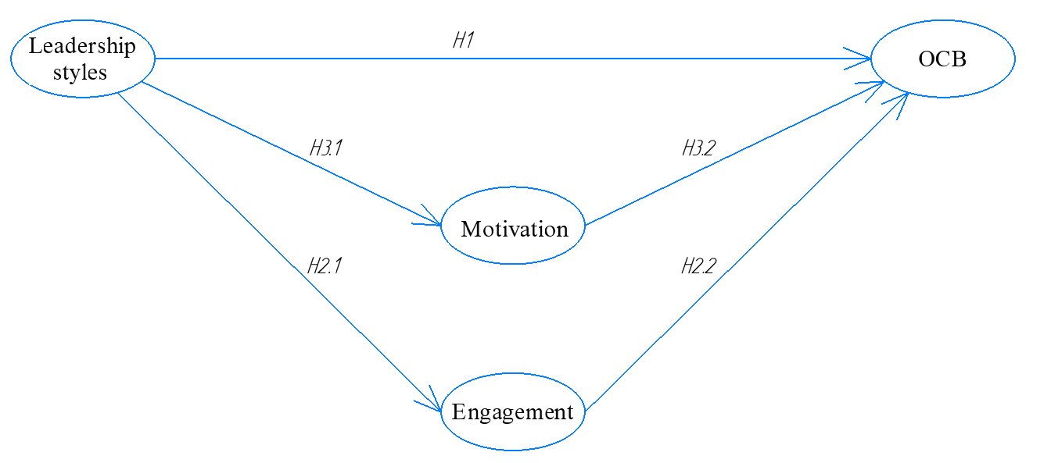
Figure 1. Research model
The purpose of this study is to look into the impact of various leadership styles on the manifestation of organizational citizenship behavior (OCB) among young professionals. Furthermore, the study intends to investigate the role of engagement and motivation as mediators in this relationship.
Research hypothesis:
Hypothesis 1. Visionary, coaching, democratic, pacesetting, affiliative, and commanding leadership styles have a positive direct impact on the manifestation of OCBO among young professionals.
Hypothesis 2. Visionary, coaching, democratic, pacesetting, affiliative, and commanding leadership styles have a positive direct impact on the manifestation of OCBI among young professionals.
Hypothesis 3. Visionary, coaching, democratic, pacesetting, affiliative, and commanding leadership styles have an indirect effect on the manifestation of OCBO among young professionals, mediated by engagement.
Hypothesis 4. Visionary, coaching, democratic, pacesetting, affiliative, and commanding leadership styles have an indirect effect on the manifestation of OCBO among young professionals, mediated by engagement.
Hypothesis 5. Visionary, coaching, democratic, pacesetting, affiliative, and commanding leadership styles have an indirect effect on the manifestation of OCBI among young professionals, mediated by intrinsic motivation.
Hypothesis 6. Visionary, coaching, democratic, pacesetting, affiliative, and commanding leadership styles have an indirect effect on the manifestation of OCBI among young professionals, mediated by intrinsic motivation.
Research Objectives:
- To identify which specific leadership styles within Goleman's framework are more likely to promote OCB among young professionals.
- To identify which specific leadership styles within Goleman's framework are more likely to engage and motivate young professionals.
- To form recommendations for leaders regarding the applied leadership styles

§3.2. Research Design
Justification for choosing empirical methods
The use of empirical methods to investigate the influence of perceived leadership style according to Goleman's model on the manifestation of organisational citizenship behaviour (OCB) is justified. Empirical research collects and analyses quantitative data, providing objective insights into the relationships between variables of interest (Eisenbeiss, Knippenberg, & Boerner, 2008).
Eisenbeiss et al. (2008)'s study serves as an example of empirical methods for investigating the impact of leadership style on employee behaviour. It supports the use of empirical methods in studying the impact of perceived leadership style on OCB manifestation in young professionals. This study demonstrates the efficacy of empirical approaches in studying the relationship between leadership styles and employee outcomes, laying the groundwork for future research.
Justification for choosing quantitative methods
Quantitative methods are well-suited to investigating the relationships between perceived leadership style, intrinsic motivation, engagement, and OCB manifestation. These methods entail the collection of numerical data, which allows for statistical analysis and the identification of relationships between variables. (Field, 2018). This is consistent with the goal of the current study, which is to investigate the quantitative relationships between perceived leadership style, intrinsic motivation, engagement, and OCB among young professionals.
Field (2018) explains how to use quantitative methods with IBM SPSS statistics software. It is a comprehensive resource for researchers who want to use quantitative techniques in their studies, such as regression analysis and multivariate statistics. This source supports the use of quantitative methods to investigate the relationship between perceived leadership style, intrinsic motivation, engagement, and OCB. This reference adds to the methodological justification by emphasising the practical guidance available for implementing quantitative analysis in the current study.
Tabachnick and Fidell (2019) offer a comprehensive introduction to multivariate statistics, providing insights into various quantitative techniques, such as factor analysis and MANOVA. This source advocates for the use of quantitative methods to investigate the relationships between perceived leadership style, intrinsic motivation, engagement, and OCB in young professionals. The current study can effectively examine the multivariate relationships between the variables of interest by incorporating the concepts and techniques outlined in this reference, increasing the depth of the analysis.
This study aims to provide robust and statistically grounded insights into the influence of perceived leadership style on the manifestation of OCB, taking into account the mediating role of intrinsic motivation and engagement. These methodological choices, backed up by relevant references, will improve the study's rigour and validity, allowing for a more complete understanding of the relationships between the variables of interest (Eisenbeiss et al., 2008; Field, 2018; Tabachnick & Fidell, 2019).
Research Approach
This study's research method is quantitative, which allows for the verification of existing correlations and testing of the hypotheses stated. Using a quantitative approach allows researchers to collect numerical data and analyse the relationships between variables, providing a solid foundation for understanding the relationships between leadership styles, engagement, motivation, and Organisational Citizenship Behaviour (OCB).
Research Type
Correlational research is used because all of the stated links in the model under study have already been discovered in previous works. This research design is appropriate for investigating the relationships between variables and determining the extent to which they are related to one another.
The research will be carried out in St. Petersburg, Russia, in the spring of 2023. Data will be collected quickly to ensure that no external events introduce differences within the sample, preserving the study's internal validity.
The data for this study were collected at a single point in time, using a cross-sectional design. This method provides a snapshot view of the variables in the study's relationships, providing a clear picture of their associations at the time of data collection.
Sampling Strategy
The research will be conducted at two Russia, Saint Petersburg. Participants must be between the ages of 19 and 35, have a bachelor's degree or higher, and have at least three months of work experience, including internships and traineeships. The age limit is set by Federal Law No. 489-FZ of December 30, 2020, "On the Youth Policy of the Russian Federation."
Data Collection Methods
To reduce the number of missing values, data will be collected using an online questionnaire, with all questions required to be completed. Respondents will be advised at the start of the questionnaire to rely on their current or most recent (if currently unemployed) manager when answering questions.
According to Goleman's framework, the Leadership style variable will consist of six constructs that describe each of the six leadership styles. Each construct will include three verbal descriptions of a particular leadership style. Using a 7-point Likert scale ranging from 1 (strongly disagree) to 7 (strongly agree), respondents will be asked to rate the degree of applicability of these descriptions to their manager.
Variables and Measures
To reduce the number of missing values, data will be collected using an online questionnaire, with all questions required to be completed. Respondents will be advised at the start of the questionnaire to rely on their current or most recent (if currently unemployed) manager when answering questions.
The independent variable in this study is perceived leadership styles, the mediators are engagement and motivation, and the dependent variable is Organisational Citizenship Behaviour (OCB).
Motivation will be measured using the shortened and corrected Work Extrinsic and Intrinsic Motivation Scale (WEIMS) developed by Richard Ryan and Edward Deci. The study will focus specifically on intrinsic motivation. The questionnaire consists of four items, and respondents will rate their agreement on a 7-point Likert scale ranging from 1 (strongly disagree) to 7 (strongly agree). The specific items related to intrinsic motivation will be included in the questionnaire:
- Because I derive much pleasure from learning new things.
- For the satisfaction I experience from taking on interesting challenges.
- For the satisfaction I experience when I am successful at doing difficult tasks.
Organizational Citizenship Behavior (OCB) will be measured using parts of the questionnaire developed by Williams and Anderson (1991), specifically focusing on OCBO (Organizational Citizenship Behavior - Organization) and OCBI (Organizational Citizenship Behavior - Individual). Respondents will rate their agreement on a 7-point Likert scale ranging from 1 (strongly disagree) to 7 (strongly agree). The specific items related to OCBO and OCBI will be included in the questionnaire:
OCBI (Organizational Citizenship Behavior - Individual):
- I help others who have been absent.
- Helps others who have heavy workloads.
- Assists the supervisor with his/her work when not asked.
- Takes time to listen to co-workers' problems and worries.
- Goes out of the way to help new employees.
- Takes a personal interest in other employees.
- Passes along information to co-workers.
OCBO (Organizational Citizenship Behavior - Organization):
- Attendance at work is above the norm.
- Gives advance notice when unable to come to work.
- Takes undeserved work breaks (Reversed).
- Complains about insignificant things at work (Reversed).
- Adheres to information rules devised to maintain order.
Engagement will be assessed using a shortened questionnaire developed by Schaufeli, Salanova, González-Romá, and Bakker (2002). Respondents will rate their agreement on a 7-point Likert scale ranging from 1 (strongly disagree) to 7 (strongly agree). The questionnaire consists of items related to three dimensions of engagement: Vigor (VI), Dedication (DE), and Absorption (AB). The specific items for each dimension will be included in the questionnaire:
- I feel energized and motivated when I start my workday
- I approach my work with a high level of enthusiasm and vitality
- My job inspires me to give my best effort every day
- I find great satisfaction and fulfillment in the work that I do
- When I am working, I become fully absorbed and lose track of time
- I feel completely engrossed and deeply involved in my work tasks.
Processing of variables and confirmation of the mediation effect will be carried out using IBM SPSS software, allowing the researchers to analyze the data and draw conclusions about the relationships between leadership styles, engagement, motivation, and Organizational Citizenship Behavior (OCB). The use of SPSS software ensures rigorous statistical analysis and facilitates the examination of mediation effects.Processing of variables and confirmation of the mediation effect will be carried out using IBM SPSS software, allowing the researchers to analyze the data and draw conclusions about the relationships between leadership styles, engagement, motivation, and Organizational Citizenship Behavior (OCB).

Chapter 4. Empirical study

§4.1. Descriptive statistics
The descriptive statistics chapter provides an overview of the data set and variables being analyzed. This chapter aims to present the demographic characteristics of the sample, including age, work experience, education, gender, and industry. Additionally, it discusses key measures of central tendency and dispersion to provide a comprehensive understanding of the data set.
Descriptive Statistics Measures
The demographic characteristics of the sample are presented to provide insights into the composition of the respondents. The age distribution reveals that the majority of respondents fall into the 18-24 (44.6%) and 25-34 (34.8%) age groups, while smaller proportions are observed in the older age categories. In terms of work experience, a considerable number of respondents have 1-2 years of experience (42.9%), followed by those with 2 years or more (33.9%), and those with 3-12 months (23.2%).
Regarding education, the largest group holds a Bachelor's degree (52.7%), followed by those with a Master's degree (42.9%). A small proportion of respondents possess a Doctoral degree (2.7%) or a Professional degree (1.8%). The gender distribution indicates a nearly equal representation of males (46.4%) and females (50.0%), with a few respondents preferring not to disclose their gender (2.7%) or identifying as other (0.9%).
Furthermore, the industry breakdown reveals that Technology and Software has the highest representation (28.6%), followed by Marketing and Advertising (21.4%), Management/Consulting (17.9%), and Finance and Accounting (8.9%). The remaining industries account for smaller percentages.
Sample Size and Missing Data
The total sample size of the study after data cleaning is 112 respondents. It is important to note that missing data were present in the dataset, specifically related to the respondents' work experience. These missing values were handled by excluding the corresponding cases from the analysis, ensuring data integrity and accuracy. Moreover, the analysis identified several outliers where respondents provided the same or nearly identical responses for all or most of the questions. These outliers were considered and addressed appropriately to prevent any undue influence on the descriptive statistics and subsequent analyses.

§4.2. Factor analysis of Perceived leadership styles construct
The reliability and validity of the perceived leadership styles construct were assessed in this study. Cronbach's Alpha, a measure of internal consistency, was calculated for the entire construct and found to be 0.922, indicating high data reliability and suggesting that the construct is robust.
Factor extraction was performed using the maximum likelihood method. Bartlett's test, which assesses the suitability of the data for factor analysis, yielded a significant result, indicating that the data were appropriate for this analysis. The overall Kaiser-Meyer-Olkin (KMO) statistic, a measure of sampling adequacy, was found to be 0.837, exceeding the recommended threshold of 0.5. This indicates that the sample size was sufficient for factor analysis. Additionally, the KMO values for individual variables were all greater than 0.5, further supporting the suitability of the data for factor analysis.
Four factors were extracted, explaining a cumulative variance of 65.8%. The determination of the number of factors was based on eigenvalues greater than 1 and the examination of the scree plot.
Based on the rotated component matrix table, the factor loadings for each item on each factor were determined. The items related to Visionary and Coaching leadership styles were assigned to the first factor, while the items related to Democratic leadership style were assigned to the second factor. The items describing Pacesetting leadership style were assigned to the fourth factor, and the items related to Commanding leadership style composed the third factor. However, the items related to the Affiliative leadership style did not form a coherent construct and were dispersed across different factors. Specifically, Affil-1 loaded on the fourth factor with a loading of 0.502, Affil-2 loaded on the second factor with a loading of 0.587, and Affil-3 loaded on the fourth factor with a loading of 0.420.
Factor 1 represents the Visionary-Coaching leadership style, with a Cronbach's Alpha of 0.856, indicating good internal consistency and reliability. The items for Factor 1 include statements such as "My manager often communicates the vision, strategy, and goals of the company to his team" and "My supervisor justifies decisions or actions and links them to larger goals."
Factor 2 represents the Democratic leadership style, including the item Affil-2, with a Cronbach's Alpha of 0.835, indicating good reliability. The items for Factor 2 describe behaviors such as engaging the team in important organizational decisions, showing empathy for team members, initiating personal contacts, and giving personal recognition to team members.
Factor 3 represents the Commanding leadership style, with a Cronbach's Alpha of 0.891, indicating good reliability. The items for Factor 3 include statements such as "My manager gives direct clear instructions," "In general, my manager acts decisively," and "My manager sets clear performance standards."
Factor 4 represents the Pacesetting leadership style, including the items Affil-1 and Affil-3, with a Cronbach's Alpha of 0.775, indicating good reliability. The items for Factor 4 include statements such as "My manager informs his employees about organizational issues that affect them," "My manager encourages high performance by providing positive feedback and a reward system," and "My manager delegates tasks that are not associated with a high risk for the company."
In conclusion, the reliability and validity of the perceived leadership styles construct were supported by the high Cronbach's Alpha values and the factor loadings. The factor analysis revealed four distinct factors representing Visionary-Coaching, Democratic, Pacesetting, and Commanding leadership styles.
For further analyses, new variables were created to represent each factor derived from the factor analysis. These new variables were calculated by averaging the scores of the individual items that comprised each factor.

§4.3. Cluster analysis
Based on the analysis conducted by dendrogram (APPENDIX 2: DENDROGRAM), it has been determined that the optimal number of clusters in the data sample is 3. This finding aligns with the results obtained from the "Direct marketing" extension in IBM SPSS, which also identified the presence of 3 distinct clusters.
To describe each cluster, we compared the average values of variables related to perceived leadership styles, intrinsic motivation, engagement, Organizational Citizenship Behavior towards Others (OCBO), and Organizational Citizenship Behavior towards Individuals (OCBI). The table 1 presents the mean values for these variables.
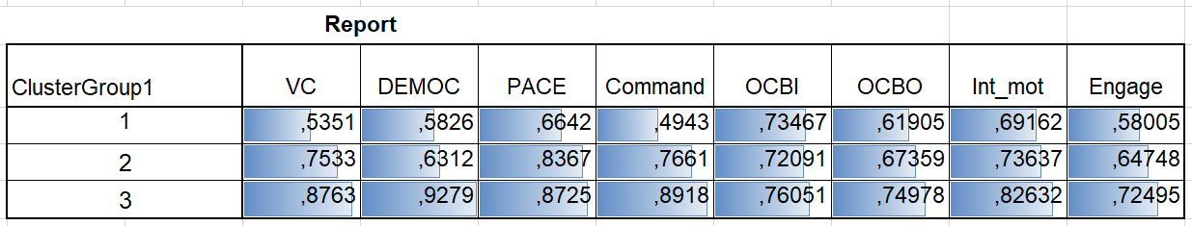
Table 1. Mean values
Based on the values in the table, it can be inferred that Cluster 1 consists of respondents with the lowest average values in variables related to leadership styles, while Cluster 3 consists of respondents with the highest average values. To further examine these differences, independent samples t-tests were conducted (APPENDIX 4: INDEPENDENT SAMPLES TEST).
However, it should be noted that Levene's Test for Equality of Variances was significant for the variable representing Democratic leadership style. This indicates that we cannot rely on the results of the t-test for this particular variable. For all other variables, except OCBI, statistically significant differences between clusters were observed. Therefore, we have formed clusters that can be characterized as having strong (Cluster 3), weak (Cluster 1), and average leaders (Cluster 2), as perceived by the respondents.
Furthermore, when comparing the averages pairwise for all three clusters in the OCBI variable, no statistically significant differences were found, despite the fact that the variances were classified as equal across all clusters. Consequently, it can be concluded that the manifestation of Organizational Citizenship Behavior towards Individuals is consistent among clusters with strong and weak leaders. However, the manifestation of OCBO, intrinsic motivation, and engagement differs and is higher among clusters with strong leaders.
Based on the aforementioned tests, it is evident that the clusters exhibit statistical dissimilarity across all components of relevance, except for OCBI. To assess the effect size (APPENDIX 4: EFFECT SIZE), a regression analysis was conducted, which affirmed the statistical disparity between the clusters. Notably, the effect size was estimated to be 8.9% in the OCBO variable, 7.6% in intrinsic motivation, and 5.5% in the engagement variable.

§4.4. Mediators
Mediation effects were examined based on the following variables: Independent variables included Visionary-Coaching leadership style, Democratic leadership style, Pacesetting leadership style, and Commanding leadership style. The dependent variable of interest was Organizational Citizenship Behavior towards Others (OCBO). The mediators in the analysis were Engagement and Intrinsic motivation.
First, it was found (APPENDIX 5: SOBEL TEST FOR MEDIATION) that all independent variables had statistically significant effects on the dependent variable, OCBO. This means that each leadership style variable had a direct influence on OCBO.
Additionally, the influence of the independent variables on the mediators, Engagement and Intrinsic motivation, was examined. It was observed that both Democratic and Commanding leadership styles had statistically significant effects on both mediators. This indicates that these leadership styles directly impacted the level of Engagement and Intrinsic motivation among individuals.
However, when assessing the direct effect of Democratic leadership style on OCBO, it was found to be statistically non-significant. In order to determine if there was an indirect effect through the mediators, a Sobel test was conducted. The Sobel test indicated a statistically significant result, suggesting that Democratic leadership style influenced OCBO only through its impact on the mediators, Engagement and Intrinsic motivation.
On the other hand, Commanding leadership style had both a direct and indirect effect on OCBO. The direct effect was statistically significant, indicating that Commanding leadership style directly influenced OCBO. Additionally, the Sobel test revealed a significant indirect effect through the mediators, confirming that Commanding leadership style influenced OCBO both directly and indirectly through Engagement and Intrinsic motivation.
Lastly, it was found that Visionary-Coaching leadership style and Pacesetting leadership style had significant direct effects on OCBO, but no significant indirect effects through the mediators. This suggests that these leadership styles directly influenced OCBO without the need for mediation through Engagement and Intrinsic motivation.
In summary, the mediation analysis indicated that Democratic leadership style influenced OCBO only through the mediators, Engagement and Intrinsic motivation. Commanding leadership style had both direct and indirect effects on OCBO, while Visionary-Coaching leadership style and Pacesetting leadership style influenced OCBO directly without mediation.

§4.5. Conclusion of Hypotheses Testing
The testing of hypotheses in this study yielded illuminating results regarding the impact of different leadership styles on the manifestation of Organisational Citizenship Behaviour towards the Organisation (OCBO) among young professionals.
The findings validate the following hypotheses:
- The Visionary-Coaching leadership style has a direct and positive influence on the manifestation of OCBO in young professionals. This finding lends credence to the hypothesis that this leadership style, which emphasises empathy, long-term thinking, and employee development, effectively fosters OCBO in young professionals.
- The Commanding leadership style has a direct positive impact on the manifestation of OCBO in young professionals. This finding supports the hypothesis that, despite its authoritative nature, the Commanding leadership style can directly stimulate OCBO, particularly among young professionals who value clear direction and decisive leadership.
- The Democratic leadership style has no direct impact on OCBO manifestation. However, it has a significant impact on OCBO via an indirect effect mediated by engagement. This finding lends credence to the hypothesis that Democratic leadership fosters an environment conducive to employee engagement, which promotes OCBO among young professionals.
- Despite its direct impact, the Commanding leadership style influences OCBO indirectly through a mediated effect of engagement. This finding supports the hypothesis that this leadership style can influence OCBO both directly and indirectly by increasing employee engagement.
- The indirect effect of Democratic leadership style on the manifestation of OCBO, mediated by intrinsic motivation, was also confirmed. This lends support to the hypothesis that, while Democratic leadership does not have a direct impact, it fosters intrinsic motivation, thereby indirectly promoting OCBO among young professionals.
- In addition, the Commanding leadership style has an indirect effect on the manifestation of OCBO, which is mediated by intrinsic motivation. This finding supports the hypothesis that, in addition to its direct effect, the Commanding leadership style indirectly aids OCBO by increasing intrinsic motivation among young professionals.

Chapter 5. Discussion on findings

§5.1. Managerial implication
A thorough understanding of the role of engagement and intrinsic motivation as mediators in the relationship between leadership styles and Organisational Citizenship Behaviour (OCB) provides invaluable insights for managers. Notably, these insights can help them tailor their leadership approaches, fostering higher levels of intrinsic motivation and engagement, which encourages OCB.
Particularly relevant for young specialists who are still finding their footing in the professional landscape, a higher degree of directiveness from leaders is beneficial. As per research, (Mumford et al., 2007; Van Vugt, Hogan & Kaiser, 2008), these young professionals tend to be future-oriented and therefore benefit from clear directives and guidance as they develop their skills and roles within the organization.
Given this, our findings suggest that all of the leadership styles investigated - Visionary-Coaching, Democratic, Pacesetting, and Commanding - have direct effects on Organisational Citizenship Behaviour towards the Organisation (OCBO), indicating their profound influence on the behaviours of young employees. The precise nature of the direct and indirect effects these styles have on OCBO via engagement and intrinsic motivation, on the other hand, varies.
Democratic and Commanding styles have a significant impact on both engagement and intrinsic motivation. Notably, while the Democratic style does not directly impact OCBO in a statistically significant manner, its influence becomes discernible when engagement and intrinsic motivation come into play as mediators. This suggests that managers adopting a Democratic leadership style could enhance OCBO by focusing on boosting employee engagement and intrinsic motivation,(Deci & Ryan, 2000; Kahn, 1990).

§5.2. Academic contribution
The Commanding leadership style has a direct and indirect impact on OCBO. It has an impact on OCBO regardless of whether engagement or intrinsic motivation mediate the process. Thus, managers who use this style should be aware of its dual impact and use it strategically to foster positive organisational outcomes.
Visionary-Coaching and Pacesetting styles have a direct effect on OCBO without the need for engagement or intrinsic motivation. Because of their direct influence on OCBO, these styles are especially effective in situations where rapid behavioural changes are desired. (Larson & LaFasto, 1989).
Managers can make informed decisions about which leadership style is best for their team's needs and desired outcomes if they understand the nuanced effects of different leadership styles on young employees' behaviours. Managers should also focus on developing strong leadership skills and modelling effective leadership behaviours, as these can contribute to positive organisational outcomes.
Furthermore, understanding the manifestations of Organisational Citizenship Behaviour towards Individuals (OCBI) can help managers foster positive relationships and interactions within the organisation (Williams & Anderson, 1991). This knowledge can be used to help create an organisational culture that encourages cooperation and mutual support, resulting in improved team dynamics and overall productivity.
The importance of engagement and intrinsic motivation as mediators in the relationship between leadership styles and OCBO cannot be overstated. Managers should strive to instill high levels of these characteristics in their teams. This can be accomplished by ensuring open and effective communication, providing meaningful work, recognising employee contributions, promoting a supportive and inclusive culture, and providing meaningful work. (Rich, Lepine & Crawford, 2010; Ryan & Deci, 2000).
Managers can effectively stimulate OCB by leveraging these insights, resulting in a positive work environment that boosts employee engagement, motivation, and overall organisational performance. Finally, managers can foster a culture of citizenship behaviour that benefits both individuals and the organisation as a whole by understanding the intricate dynamics between leadership styles, engagement, intrinsic motivation, and OCB.

§5.3. Conclusion
According to our findings, different leadership styles have both direct and indirect effects on OCB towards the Organisation (OCBO), which is mediated by employee engagement and intrinsic motivation. All four leadership styles studied - Visionary-Coaching, Democratic, Pacesetting, and Commanding - have been found to have a direct influence on OCBO. Employee engagement and intrinsic motivation are significantly influenced by the Democratic and Commanding styles, with the Democratic style's effect on OCBO being primarily mediated by these two factors. The Commanding style, on the other hand, was discovered to have an indirect and direct impact on OCBO via engagement and intrinsic motivation. Without the mediating influence of engagement and intrinsic motivation, visionary-coaching and pacesetting styles had direct effects on OCBO.
These findings are useful for managers who want to promote OCB in their organisations. Recognising the differences in the effects of leadership styles on employee behaviours, as well as the mediating factors, can help managers tailor their leadership approaches more effectively. They can consciously choose a leadership style that will most likely foster engagement, intrinsic motivation, and, as a result, OCB in their specific context.
This study adds to the existing literature by emphasising the complex relationships between leadership styles, engagement, intrinsic motivation, and OCB. It emphasises the importance of promoting OCB by using appropriate leadership styles and cultivating an environment of engagement and motivation.
It should be noted, however, that understanding the precise mechanisms of these relationships in different contexts necessitates additional research. Future research may look into the effects of other leadership styles or other potential mediating variables. This would contribute to the growing body of knowledge in this critical area of organisational behaviour and leadership research.
The study's findings emphasise the importance of leadership development programmes that cultivate a variety of leadership styles and skills for organisations. This will allow leaders to adapt to the unique needs of their teams and foster an organisational culture marked by high levels of engagement, intrinsic motivation, and OCB, ultimately contributing to overall organisational success.

§5.4. Limitations and suggestions on future research
Every research study, no matter how thorough, has limitations, and this master's thesis is no exception. The primary limitations encountered during this research revolved around issues related to measuring Goleman's leadership styles, differentiating between specific leadership constructs, and the sample size. It is critical to recognise these limitations because they affect the interpretation and generalisation of the research findings.
1. Difficulty Distinguishing Between Constructs of Visionary and Coaching Leadership Styles:
Goleman's model distinguishes six distinct leadership styles, two of which are Visionary and Coaching. Despite their distinct characteristics, there is significant overlap between these two styles, making differentiation difficult in practise. Coaching leaders focus on developing individuals for future success, whereas visionary leaders articulate a compelling vision for the future. Both of these approaches place a premium on the future, long-term development, and growth. This overlap may make it difficult to distinguish these styles when they are in use. This potential ambiguity may have an impact on the accuracy of the research findings concerning these two leadership styles.
2. Lack of Validated Questionnaire for Goleman's Leadership Styles:
There is currently no validated questionnaire available to assess leadership styles using Goleman's model. In the absence of such a questionnaire, our assessments of these leadership styles may be less accurate and reliable. It necessitates the use of proxies or the development of new measures, both of which may fail to capture the essence of Goleman's constructs. Future research could concentrate on developing and validating a questionnaire designed specifically to measure Goleman's leadership styles, thereby improving the accuracy of studies in this area.
3. Insufficient Number of Respondents:
The sample size is another significant limitation of this study. The number of people who took part in the study may not be large enough to fully confirm the results. Because of this limitation, while the findings of this study provide important insights into the relationship between leadership styles, engagement, intrinsic motivation, and Organisational Citizenship Behaviour, they should be interpreted with caution. It is important to remember that larger sample sizes frequently result in better representation and more robust conclusions. As a result, future research should aim for a larger sample size to improve the reliability and validity of the findings.
Despite these limitations, this study provides important insights into the interactions of leadership styles, employee engagement, intrinsic motivation, and Organisational Citizenship Behaviour. It lays the groundwork for future studies that will build on these discoveries while also addressing the limitations of the current study. Future research could delve deeper into these relationships, utilising more differentiated measures, validated tools, and larger sample sizes, in order to improve our understanding of these critical organisational dynamics.

References
Smith, C. A., Organ, D. W., & Near, J. P. (1983). Organizational citizenship behavior: Its nature and antecedents. Journal of applied psychology, 68(4), 653.
Stogdill, R. M. (1948). Personal factors associated with leadership: A survey of the literature. The Journal of psychology, 25(1), 35-71.
Burns, J. M. (1978). Leadership. Harper & Row.
Goleman, D. (2017). Leadership that gets results (Harvard business review classics). Harvard Business Press.
Organ, D. W. (1988). Organizational citizenship behavior: The good soldier syndrome. Lexington books/DC heath and com.
Podsakoff, P. M., MacKenzie, S. B., Paine, J. B., & Bachrach, D. G. (2000). Organizational citizenship behaviors: A critical review of the theoretical and empirical literature and suggestions for future research. Journal of management, 26(3), 513-563.
Podsakoff, N. P., Whiting, S. W., Podsakoff, P. M., & Blume, B. D. (2009). Individual-and organizational-level consequences of organizational citizenship behaviors: A meta-analysis. Journal of applied Psychology, 94(1), 122.
Podsakoff, P. M., MacKenzie, S. B., Paine, J. B., & Bachrach, D. G. (2000). Organizational citizenship behaviors: A critical review of the theoretical and empirical literature and suggestions for future research. Journal of management, 26(3), 513-563.
Podsakoff, N. P., Whiting, S. W., Podsakoff, P. M., & Blume, B. D. (2009). Individual-and organizational-level consequences of organizational citizenship behaviors: A meta-analysis. Journal of applied Psychology, 94(1), 122.
Bolino, M. C., & Turnley, W. H. (2003). Counternormative impression management, likeability, and performance ratings: The use of intimidation in an organizational setting. Journal of Organizational Behavior: The International Journal of Industrial, Occupational and Organizational Psychology and Behavior, 24(2), 237-250.
Macky, K., & Boxall, P. (2007). The relationship between ‘high-performance work practices’ and employee attitudes: an investigation of additive and interaction effects. The International Journal of Human Resource Management, 18(4), 537-567.
Dirks, K. T., & Ferrin, D. L. (2002). Trust in leadership: meta-analytic findings and implications for research and practice. Journal of applied psychology, 87(4), 611.
Goleman, D. (2017). Leadership that gets results (Harvard business review classics). Harvard Business Press.
Hersey, P., & Blanchard, K. H. (1969). Life cycle theory of leadership. Training & Development Journal.
Northouse, P. G. (2021). Leadership: Theory and practice. Sage publications.
Stogdill, R. M. (1948). Personal factors associated with leadership: A survey of the literature. The Journal of psychology, 25(1), 35-71.
Fleishman, E. A. (1953). The description of supervisory behavior. Journal of applied psychology, 37(1), 1.
Lieberson, S., & O'Connor, J. F. (1972). Leadership and organizational performance: A study of large corporations. American sociological review, 117-130.
Fiedler, F. E. (1967). A THEORY OF LEADERSHIP EFFECTIVENESS. MCGRAW-HILL SERIES IN MANAGEMENT.
House, R. J. (1971). A path goal theory of leader effectiveness. Administrative science quarterly, 321-339.
Hersey, P., & Blanchard, K. H. (1969). Life cycle theory of leadership. Training & Development Journal.
Burns, J. M. (1978). Leadership. Harper & Row.
Avolio, B. J., & Bass, B. M. (2004). Multifactor leadership questionnaire (TM). Mind Garden, Inc. Menlo Park, CA.
Northouse, P. G. (2021). Leadership: Theory and practice. Sage publications.
Bass, B. M., & Riggio, R. E. (2006). Transformational leadership.
Van Knippenberg, D., & Sitkin, S. B. (2013). A critical assessment of charismatic—transformational leadership research: Back to the drawing board?. The Academy of Management Annals, 7(1), 1-60.
Avolio BJ, Walumbwa FO, Weber TJ. Leadership: current theories, research, and future directions. Annu Rev Psychol. 2009;60:421-49. doi: 10.1146/annurev.psych.60.110707.163621. PMID: 18651820.
Yukl, G., & Mahsud, R. (2010). Why flexible and adaptive leadership is essential. Consulting Psychology Journal: practice and research, 62(2), 81.
Brown, M. E., & Treviño, L. K. (2006). Ethical leadership: A review and future directions. The leadership quarterly, 17(6), 595-616.
Antonakis, J., & House, R. J. (2013). The full-range leadership theory: The way forward. In Transformational and charismatic leadership: The road ahead 10th anniversary edition (pp. 3-33). Emerald Group Publishing Limited.
Day, D. V., & Dragoni, L. (2015). Leadership Development: An Outcome-Oriented Review Based on Time and Levels of Analyses. Annual Review of Organizational Psychology and Organizational Behavior, 2, 133-156.
Petrie, N. (2011). Future trends in leadership development. Center for Creative Leadership white paper, 5(5), 36.
Goleman, D. (2017). Leadership styles. Harvard Business Review, 95(5), 1-13.
Goleman, D. (2021). Emotional intelligence: Leadership's ultimate advantage. Harvard Business Review Press.
Goleman, D., Boyatzis, R. E., & McKee, A. (2013). Primal leadership: Unleashing the power of emotional intelligence. Harvard Business Press.
Perloff, R. (1997). Daniel Goleman’s Emotional intelligence: Why it can matter more than IQ.
Goleman, D. (2017). Leadership that gets results (Harvard business review classics). Harvard Business Press.
Liden, R. C., Wayne, S. J., Zhao, H., & Henderson, D. (2008). Servant leadership: Development of a multidimensional measure and multi-level assessment. The leadership quarterly, 19(2), 161-177.
Walumbwa, F. O., Orwa, B., Wang, P., & Lawler, J. J. (2005). Transformational leadership, organizational commitment, and job satisfaction: A comparative study of Kenyan and US financial firms. Human resource development quarterly, 16(2), 235-256.
Mayer, D. M., Aquino, K., Greenbaum, R. L., & Kuenzi, M. (2012). Who displays ethical leadership, and why does it matter? An examination of antecedents and consequences of ethical leadership. Academy of management journal, 55(1), 151-171.
Farh, J. L., Podsakoff, P. M., & Organ, D. W. (1990). Accounting for organizational citizenship behavior: Leader fairness and task scope versus satisfaction. Journal of management, 16(4), 705-721.
Williams, L. J., & Anderson, S. E. (1991). Job satisfaction and organizational commitment as predictors of organizational citizenship and in-role behaviors. Journal of management, 17(3), 601-617.
Maslow, A. H. (1943). A theory of human motivation. Psychological review, 50(4), 370.
Herzberg, F. (2017). Motivation to work. Routledge.
Ehrhart, M. G. (2004). Leadership and procedural justice climate as antecedents of unit‐level organizational citizenship behavior. Personnel psychology, 57(1), 61-94.
Deci, E. L., & Ryan, R. M. (2008). Self-determination theory: A macrotheory of human motivation, development, and health. Canadian psychology/Psychologie canadienne, 49(3), 182.
Kahn, W. A. (1990). Psychological conditions of personal engagement and disengagement at work. Academy of management journal, 33(4), 692-724.
Organ, D. W. (1988). Organizational citizenship behavior: The good soldier syndrome. Lexington books/DC heath and com.
Eisenberger, R., Cummings, J., Armeli, S., & Lynch, P. (1997). Perceived organizational support, discretionary treatment, and job satisfaction. Journal of applied psychology, 82(5), 812.
Podsakoff, N. P., Whiting, S. W., Podsakoff, P. M., & Blume, B. D. (2009). Individual-and organizational-level consequences of organizational citizenship behaviors: A meta-analysis. Journal of applied Psychology, 94(1), 122.
Eisenbeiss, S. A., Van Knippenberg, D., & Boerner, S. (2008). Transformational leadership and team innovation: integrating team climate principles. Journal of applied psychology, 93(6), 1438.
Field, A. (2013). Discovering statistics using IBM SPSS statistics (4th ed.). SAGE Publications.
Tabachnick, B. G., Fidell, L. S., & Ullman, J. B. (2013). Using multivariate statistics (Vol. 6, pp. 497-516). Boston, MA: pearson.
Федеральный закон от 30 декабря 2020 г. N 489-ФЗ "О молодежной политике в Российской Федерации"
Tremblay, M. A., Blanchard, C. M., Taylor, S., Pelletier, L. G., & Villeneuve, M. (2009). Work Extrinsic and Intrinsic Motivation Scale: Its value for organizational psychology research. Canadian Journal of Behavioural Science/Revue canadienne des sciences du comportement, 41(4), 213.
Williams, L. J., & Anderson, S. E. (1991). Job satisfaction and organizational commitment as predictors of organizational citizenship and in-role behaviors. Journal of Management, 17(3), 601-617.
Schaufeli, W. B., Salanova, M., González-Romá, V., & Bakker, A. B. (2002). The measurement of engagement and burnout: A two-sample confirmatory factor analytic approach. Journal of Happiness Studies, 3, 71-92.
Mumford, T. V., Campion, M. A., & Morgeson, F. P. (2007). The leadership skills strataplex: Leadership skill requirements across organizational levels. The leadership quarterly, 18(2), 154-166.
Van Vugt, M., Hogan, R., & Kaiser, R. B. (2008). Leadership, followership, and evolution: some lessons from the past. American psychologist, 63(3), 182.
Deci, E. L., & Ryan, R. M. (2000). The" what" and" why" of goal pursuits: Human needs and the self-determination of behavior. Psychological inquiry, 11(4), 227-268.
Kahn, W. A. (1990). Psychological conditions of personal engagement and disengagement at work. Academy of management journal, 33(4), 692-724.
Larson, C. E., & LaFasto, F. M. (1989). Teamwork: What must go right/what can go wrong (Vol. 10). Sage.

APPENDIX 1: DEVELOPMENT OF THE QUESTIONNAIRE
Introductory screen to the study:
Dear Respondent,
Thank you for participating in our survey. Please base your responses on your first work experience and answer all questions accordingly. Please note that for the purposes of this survey, we would like you to rely on the LEADER UNDER WHOM YOU CURRENTLY WORK OR THE LAST LEADER YOU WORKED WITH, if you are currently unemployed.
Thank you for taking the time to complete our survey. We value your input and look forward to hearing your perspective.
Demographic questions:
1. What is your age?
- 18-24
- 25-34
- 35-44
- 45-54
- 55 or older
2. What is your gender?
- Male
- Female
- Prefer not to say
- Other
3. What is the highest educational degree you have obtained?
- High school diploma/GED
- Associate degree
- Bachelor's degree
- Master's degree
- Doctoral degree
- Professional degree (e.g. MD, JD)
4. What is your work experience? (filter question to remove from surveys of respondents without work experience)
- No experience
- 3-12 months
- 1-2 years
- 2 years or more
5. In which industry do you work?
- Management Consulting
- Marketing and Advertising
- Finance and Accounting
- Economics and Policy
- Technology and Software
- Retail and Consumer Goods
- Healthcare and Pharmaceuticals
- Energy and Utilities
- Education and Non-Profit
- Other
Next section contains questions about organizational citizenship behavior toward individuals. If you have/had multiple jobs - please stick to one current organization while filling this survey. Please indicate how much you agree with each of the following statements (1 - strongly disagree, 7 - strongly agree)
- I help others who have been absent
- I assist coworkers who have heavy workloads
- I offer to help my supervisor with their work even when not asked
- I go out of my way to help new employees
Next section contains questions about organizational citizenship behavior toward organization. If you have/had multiple jobs - please stick to one current organization while filling this survey. Please indicate how much you agree with each of the following statements (1 - strongly disagree, 7 - strongly agree)
- I consistently attend work above the norm
- I give advance notice when unable to come to work
- I refrain from taking undeserved work breaks (reversed)
- I refrain from complaining about insignificant things at work (reversed)
- I adhere to the information rules devised to maintain order
Next section contains questions about your motivation and engagement. If you have/had multiple jobs - please stick to one current organization while filling this survey. Please indicate how much you agree with each of the following statements (1 - strongly disagree, 7 - strongly agree)
- I feel energized and motivated when I start my workday
- I approach my work with a high level of enthusiasm and vitality
- My job inspires me to give my best effort every day
- I find great satisfaction and fulfillment in the work that I do
- When I am working, I become fully absorbed and lose track of time
- I feel completely engrossed and deeply involved in my work tasks
- I derive much pleasure from learning new things
- I feel a sense of satisfaction when taking on interesting challenges
- I experience satisfaction when I am successful at doing difficult tasks
Main section, it contains questions about leadership styles of your subordinator
If you have/had multiple jobs - please stick to one current organization while filling this survey
(Coaching leadership style)
- My manager sets professional development goals for his employees
- My manager supports the professional development of employees
- My manager advises employees on their professional development and periodically reviews progress
(Visionary leadership style)
- My manager often communicates the vision, strategy and goals of the company to his team
- My supervisor justifies decisions or actions and links them to larger goals
- My manager tells each person what they are doing well and what is not so good and what can be improved
(Democratic leadership style)
- 7. My manager shows empathy for other team members
- 8. My manager initiates personal contacts with the team/other teams
- 9. My manager gives personal recognition to team members/other teams
(Commanding leadership style)
- 10. My manager gives direct clear instructions
- 11. In general, my manager acts decisively
- 12. My manager sets clear performance standards
(Pacesetting leadership style)
- 13. My manager delegates tasks that are not associated with a high risk for the company
- 14. In general, my manager is result oriented
- 15. My manager offers help when he sees that an employee needs advice or help
(Affiliative leadership style)
- 16. My manager informs his employees about organizational issues that affect them
- 17. My manager engages the team in important organizational decisions
- 18. My manager encourages high performance by providing positive feedback and a reward system

APPENDIX 2: DESCRIPTIVE STATISTICS
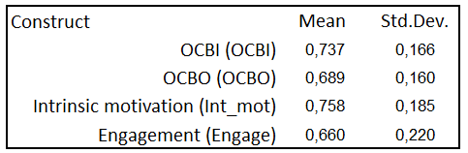
Table 2.1 Average values and standard deviations
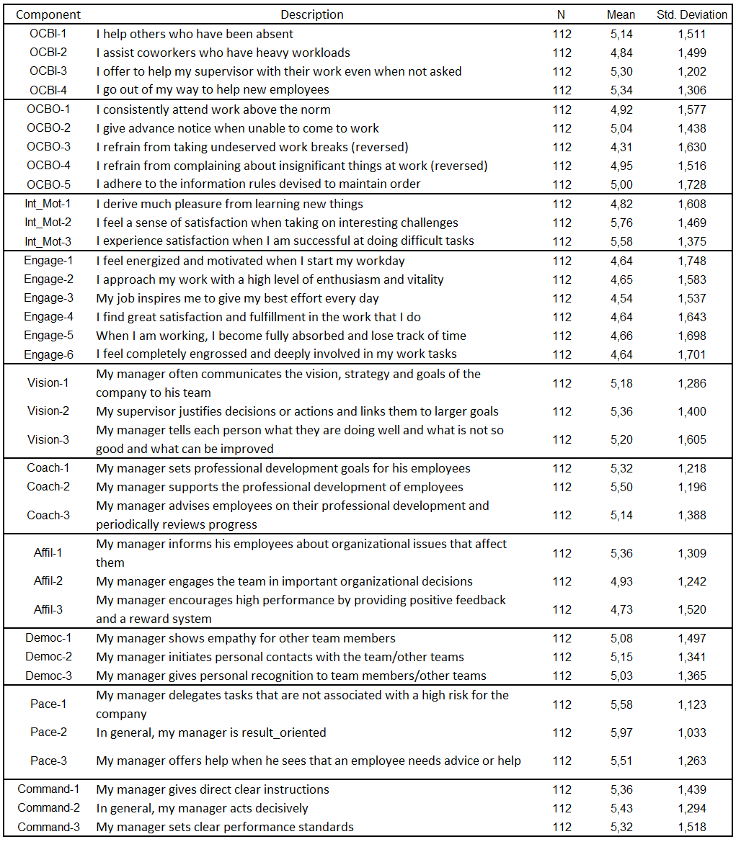
Table 2.2. Mean values and standard deviation
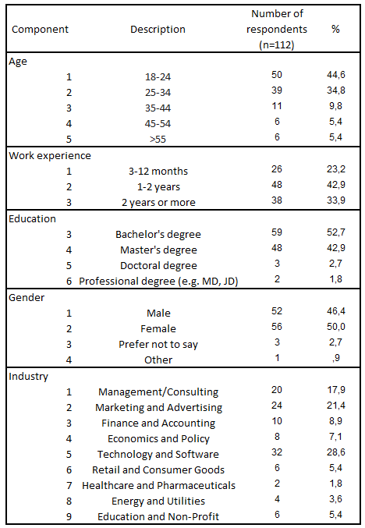
Table 2.3 Socio-demographic characteristics of the sample
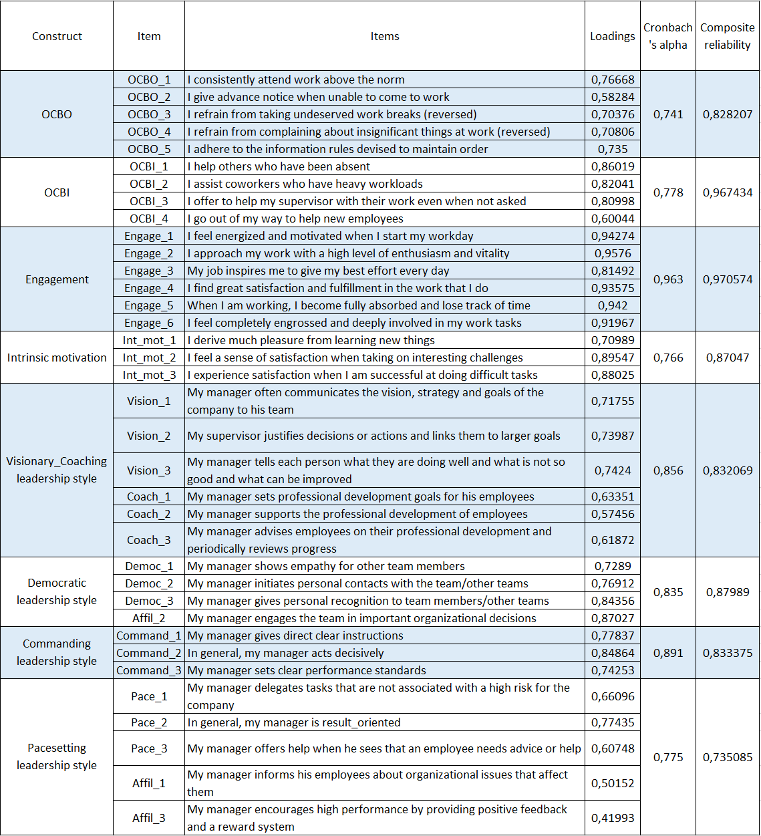
Table 2.4 Factor loadings and construct’s reliability

APPENDIX 3: DENDROGRAM
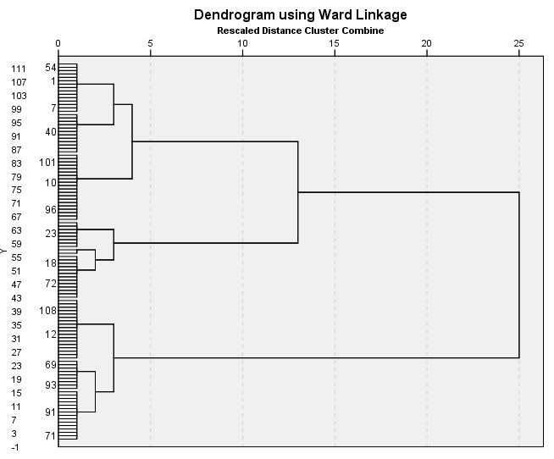
Illustration 3. Dendrogram

APPENDIX 4: INDEPENDENT SAMPLES TEST
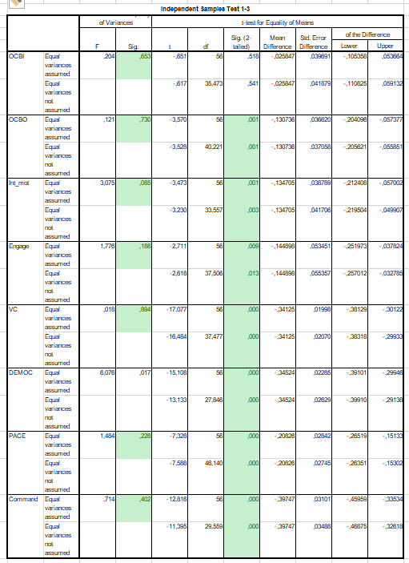
Table 4. Independent sample t-tests

APPENDIX 5: EFFECT SIZE
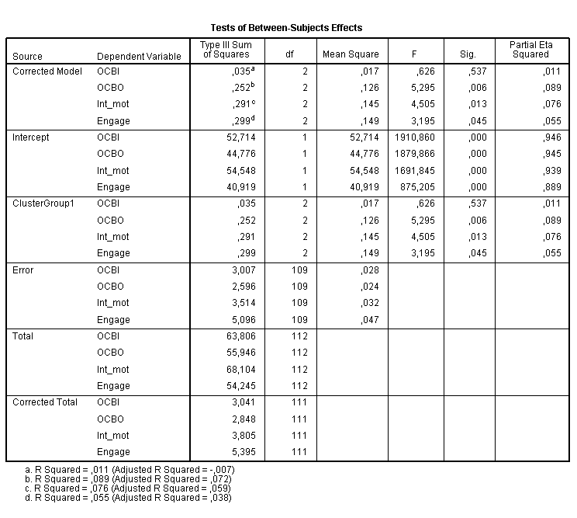
Table 5. Effect size

APPENDIX 6: SOBEL TEST FOR MEDIATION
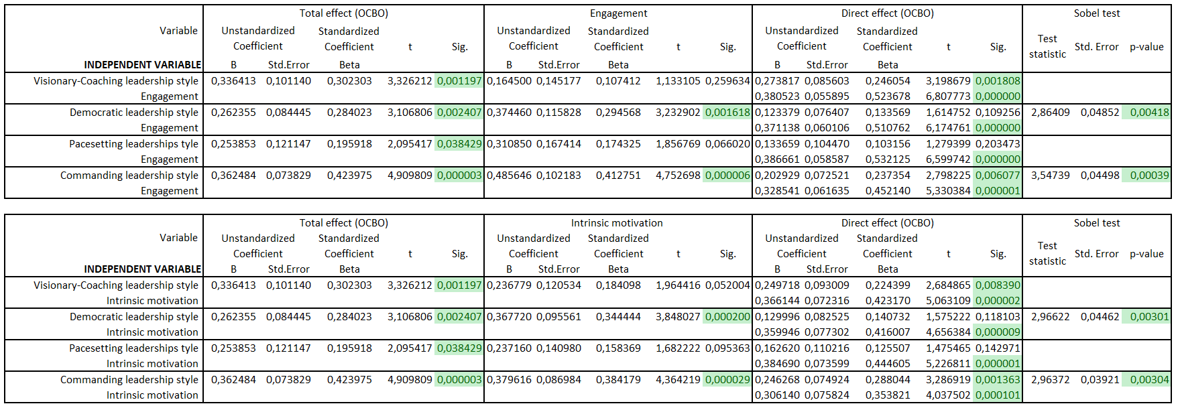
Table 6. Mediation testing

Smith, C. A., Organ, D. W., & Near, J. P. (1983). Organizational citizenship behavior: Its nature and antecedents. Journal of applied psychology, 68(4), 653.
Stogdill, R. M. (1948). Personal factors associated with leadership: A survey of the literature. The Journal of psychology, 25(1), 35-71.
Burns, J. M. (1978). Leadership. Harper & Row.
Goleman, D. (2017). Leadership that gets results (Harvard business review classics). Harvard Business Press.
Organ, D. W. (1988). Organizational citizenship behavior: The good soldier syndrome. Lexington books/DC heath and com.
Podsakoff, P. M., MacKenzie, S. B., Paine, J. B., & Bachrach, D. G. (2000). Organizational citizenship behaviors: A critical review of the theoretical and empirical literature and suggestions for future research. Journal of management, 26(3), 513-563.
Podsakoff, N. P., Whiting, S. W., Podsakoff, P. M., & Blume, B. D. (2009). Individual-and organizational-level consequences of organizational citizenship behaviors: A meta-analysis. Journal of applied Psychology, 94(1), 122.
Podsakoff, P. M., MacKenzie, S. B., Paine, J. B., & Bachrach, D. G. (2000). Organizational citizenship behaviors: A critical review of the theoretical and empirical literature and suggestions for future research. Journal of management, 26(3), 513-563.
Podsakoff, N. P., Whiting, S. W., Podsakoff, P. M., & Blume, B. D. (2009). Individual-and organizational-level consequences of organizational citizenship behaviors: A meta-analysis. Journal of applied Psychology, 94(1), 122.
Bolino, M. C., & Turnley, W. H. (2003). Counternormative impression management, likeability, and performance ratings: The use of intimidation in an organizational setting. Journal of Organizational Behavior: The International Journal of Industrial, Occupational and Organizational Psychology and Behavior, 24(2), 237-250.
Macky, K., & Boxall, P. (2007). The relationship between ‘high-performance work practices’ and employee attitudes: an investigation of additive and interaction effects. The International Journal of Human Resource Management, 18(4), 537-567.
Goleman, D. (2017). Leadership that gets results (Harvard business review classics). Harvard Business Press.
Hersey, P., & Blanchard, K. H. (1969). Life cycle theory of leadership. Training & Development Journal.
Northouse, P. G. (2021). Leadership: Theory and practice. Sage publications.
Stogdill, R. M. (1948). Personal factors associated with leadership: A survey of the literature. The Journal of psychology, 25(1), 35-71.
Fleishman, E. A. (1953). The description of supervisory behavior. Journal of applied psychology, 37(1), 1.
Lieberson, S., & O'Connor, J. F. (1972). Leadership and organizational performance: A study of large corporations. American sociological review, 117-130.
Fiedler, F. E. (1967). A THEORY OF LEADERSHIP EFFECTIVENESS. MCGRAW-HILL SERIES IN MANAGEMENT.
House, R. J. (1971). A path goal theory of leader effectiveness. Administrative science quarterly, 321-339.
Hersey, P., & Blanchard, K. H. (1969). Life cycle theory of leadership. Training & Development Journal.
Burns, J. M. (1978). Leadership. Harper & Row.
Avolio, B. J., & Bass, B. M. (2004). Multifactor leadership questionnaire (TM). Mind Garden, Inc. Menlo Park, CA.
Northouse, P. G. (2021). Leadership: Theory and practice. Sage publications.
Bass, B. M., & Riggio, R. E. (2006). Transformational leadership.
Van Knippenberg, D., & Sitkin, S. B. (2013). A critical assessment of charismatic—transformational leadership research: Back to the drawing board?. The Academy of Management Annals, 7(1), 1-60.
Avolio BJ, Walumbwa FO, Weber TJ. Leadership: current theories, research, and future directions. Annu Rev Psychol. 2009;60:421-49. doi: 10.1146/annurev.psych.60.110707.163621. PMID: 18651820.
Yukl, G., & Mahsud, R. (2010). Why flexible and adaptive leadership is essential. Consulting Psychology Journal: practice and research, 62(2), 81.
Brown, M. E., & Treviño, L. K. (2006). Ethical leadership: A review and future directions. The leadership quarterly, 17(6), 595-616.
Antonakis, J., & House, R. J. (2013). The full-range leadership theory: The way forward. In Transformational and charismatic leadership: The road ahead 10th anniversary edition (pp. 3-33). Emerald Group Publishing Limited.
Day, D. V., & Dragoni, L. (2015). Leadership Development: An Outcome-Oriented Review Based on Time and Levels of Analyses. Annual Review of Organizational Psychology and Organizational Behavior, 2, 133-156.
Petrie, N. (2011). Future trends in leadership development. Center for Creative Leadership white paper, 5(5), 36.
Goleman, D. (2017). Leadership styles. Harvard Business Review, 95(5), 1-13.
Goleman, D. (2021). Emotional intelligence: Leadership's ultimate advantage. Harvard Business Review Press.
Goleman, D., Boyatzis, R. E., & McKee, A. (2013). Primal leadership: Unleashing the power of emotional intelligence. Harvard Business Press.
Perloff, R. (1997). Daniel Goleman’s Emotional intelligence: Why it can matter more than IQ.
Goleman, D. (2017). Leadership that gets results (Harvard business review classics). Harvard Business Press.
Liden, R. C., Wayne, S. J., Zhao, H., & Henderson, D. (2008). Servant leadership: Development of a multidimensional measure and multi-level assessment. The leadership quarterly, 19(2), 161-177.
Walumbwa, F. O., Orwa, B., Wang, P., & Lawler, J. J. (2005). Transformational leadership, organizational commitment, and job satisfaction: A comparative study of Kenyan and US financial firms. Human resource development quarterly, 16(2), 235-256.
Mayer, D. M., Aquino, K., Greenbaum, R. L., & Kuenzi, M. (2012). Who displays ethical leadership, and why does it matter? An examination of antecedents and consequences of ethical leadership. Academy of management journal, 55(1), 151-171.
Ehrhart, M. G. (2004). Leadership and procedural justice climate as antecedents of unit‐level organizational citizenship behavior. Personnel psychology, 57(1), 61-94.
Dirks, K. T., & Ferrin, D. L. (2002). Trust in leadership: meta-analytic findings and implications for research and practice. Journal of applied psychology, 87(4), 611.
Smith, C. A., Organ, D. W., & Near, J. P. (1983). Organizational citizenship behavior: Its nature and antecedents. Journal of applied psychology, 68(4), 653.
Farh, J. L., Podsakoff, P. M., & Organ, D. W. (1990). Accounting for organizational citizenship behavior: Leader fairness and task scope versus satisfaction. Journal of management, 16(4), 705-721.
Williams, L. J., & Anderson, S. E. (1991). Job satisfaction and organizational commitment as predictors of organizational citizenship and in-role behaviors. Journal of management, 17(3), 601-617.
Maslow, A. H. (1943). A theory of human motivation. Psychological review, 50(4), 370.
Herzberg, F. (2017). Motivation to work. Routledge.
Deci, E. L., & Ryan, R. M. (2008). Self-determination theory: A macrotheory of human motivation, development, and health. Canadian psychology/Psychologie canadienne, 49(3), 182.
Kahn, W. A. (1990). Psychological conditions of personal engagement and disengagement at work. Academy of management journal, 33(4), 692-724.
Organ, D. W. (1988). Organizational citizenship behavior: The good soldier syndrome. Lexington books/DC heath and com.
Eisenberger, R., Cummings, J., Armeli, S., & Lynch, P. (1997). Perceived organizational support, discretionary treatment, and job satisfaction. Journal of applied psychology, 82(5), 812.
Podsakoff, N. P., Whiting, S. W., Podsakoff, P. M., & Blume, B. D. (2009). Individual-and organizational-level consequences of organizational citizenship behaviors: A meta-analysis. Journal of applied Psychology, 94(1), 122.
Eisenbeiss, S. A., Van Knippenberg, D., & Boerner, S. (2008). Transformational leadership and team innovation: integrating team climate principles. Journal of applied psychology, 93(6), 1438.
Field, A. (2013). Discovering statistics using IBM SPSS statistics (4th ed.). SAGE Publications.
Tabachnick, B. G., Fidell, L. S., & Ullman, J. B. (2013). Using multivariate statistics (Vol. 6, pp. 497-516). Boston, MA: pearson.
Федеральный закон от 30 декабря 2020 г. N 489-ФЗ "О молодежной политике в Российской Федерации"
Tremblay, M. A., Blanchard, C. M., Taylor, S., Pelletier, L. G., & Villeneuve, M. (2009). Work Extrinsic and Intrinsic Motivation Scale: Its value for organizational psychology research. Canadian Journal of Behavioural Science/Revue canadienne des sciences du comportement, 41(4), 213.
Williams, L. J., & Anderson, S. E. (1991). Job satisfaction and organizational commitment as predictors of organizational citizenship and in-role behaviors. Journal of Management, 17(3), 601-617.
Schaufeli, W. B., Salanova, M., González-Romá, V., & Bakker, A. B. (2002). The measurement of engagement and burnout: A two-sample confirmatory factor analytic approach. Journal of Happiness Studies, 3, 71-92.
Mumford, T. V., Campion, M. A., & Morgeson, F. P. (2007). The leadership skills strataplex: Leadership skill requirements across organizational levels. The leadership quarterly, 18(2), 154-166.
Van Vugt, M., Hogan, R., & Kaiser, R. B. (2008). Leadership, followership, and evolution: some lessons from the past. American psychologist, 63(3), 182.
Deci, E. L., & Ryan, R. M. (2000). The" what" and" why" of goal pursuits: Human needs and the self-determination of behavior. Psychological inquiry, 11(4), 227-268.
Kahn, W. A. (1990). Psychological conditions of personal engagement and disengagement at work. Academy of management journal, 33(4), 692-724.
Larson, C. E., & LaFasto, F. M. (1989). Teamwork: What must go right/what can go wrong (Vol. 10). Sage.

