Federal State Institution of Higher Professional Education

Saint-Petersburg University

Graduate School of Management

Bachelor thesis:

Business Model Innovation as a strategic response to the global crisis: case of Russia-based international transportation SME.

Made by: Pavlova Alisa

the 4th year International Management student of bachelor program

Signature:



Scientific advisor: Anastasia K. Laskovaya Associate Professor, Department of Strategic and International Management

Saint-Petersburg

2023

**The statement about the independent nature of the bachelor thesis.**

I, Pavlova Alisa Sergeevna, 4th year student of the Graduate School of Management, St. Petersburg State University (direction "Management", Department "international management"), confirm that in my bachelor diploma thesis on the topic “Business Model Innovation as a strategic response to the global crisis: case of Russia-based international transportation SME”, which will be presented for public defence in June 2023, does not contain elements of plagiarism.

All direct borrowings of printed and electronic sources as well as from previously presented term-papers, diploma papers, candidate and doctoral dissertations, have appropriate links.

I am familiar with the current Graduate School of Management, SPBU regulations of the educational process, according to which the detection of plagiarism (direct borrowing from other sources without provision of links) is the basis for “non-satisfactory” estimation of work.

Name : Pavlova Alisa

Signature :



Date : 31/05/2023

**Table of Contents**

Introduction 4

Chapter 1. Theoretical background on business model innovation 7

1.1 Overview of Business Model Innovation as a process. 7

1.1.1 Definition of Business Model 7

1.1.2 Components of Business Model 9

1.1.3 Definition of Business Model Innovation 13

1.1.4 Defining criteria for BMI accomplishment 14

1.1.5 What is enabled by Business Model Innovation? 15

1.2 Types of Business Model Innovation 17

1.3 Steps of Business Model Innovation 21

1.3.1 Defining the scope of future BM’s scenarios 24

1.3.2 Assessment of the scope of future BM’s scenarios and the outcomes of BMI 26

1.4 Factors affecting the process of BMI 27

1.4.1 Company's size 28

1.4.2 Strategic objectives of SMEs 29

1.4.3 Dynamic capabilities and internal resources 30

1.4.4 Managerial ties and competencies 32

1.4.5 The context of environmental uncertainty 34

1.5 Statement of theory-based model and research questions 34

Chapter 2. Research Methodology. 36

2.1 Data collection 36

2.2 Structure of case analysis 38

2.3 Case description 40

Chapter 3. Case Analysis. 42

3.1 Summary of pre-crisis Business Model 42

3.2 Assessment of newly emerged conditions of external and internal business environments 47

3.3 Business Model Innovation performed by XXX 50

3.3.1 Step 1. Initiation 51

3.3.2 Step 2. Ideation 51

3.3.3 Step 3. Integration 57

3.3.4 Step 4. Implementation. 61

Chapter 4. Discussion of obtained results 65

4.1 Factors affecting choice of BMI scenario 65

4.1.1 Context of external business environment 65

4.1.2 Firm’s strategic objectives and executives’ past personal experiences 67

4.1.3 Managerial ties 68

4.1.4 Firm capabilities and resources 68

4.2 Contribution to previous studies 69

4.3 Limitations of the research 71

4.4 Further research directions 71

Conclusion 73

References 75

Appendixes 85

# Introduction

The ongoing global crisis, dated to the 24th February 2022, has had a tremendous impact on the global economic and political conditions, especially in essence of hindering post-Pandemic business’s recovery and further development[1]. Referring to the state of the Russian economy, the emerged conditions have created a number of threats, particularly, the country has faced severe prohibitions on international trade, cooperation, and financial operations imposed by other countries as well as withdrawal of numerous foreign companies from the market[2], which resulted in supply chains’ disruption, inability to perform full scope of export- and import-related activities, scarcity of products and services in the market, increasing prices, businesses’ inability to work with foreign partners and suppliers, and declining consumer purchasing power[3].

Although the absolute majority of sectors of Russian economy have faced increasingly turbulent business environments, the industry of international logistics can be clearly referred to as one of the most affected. The combination of ten sanction packages, which were introduced by the EU in the face of the ongoing Russian-Ukrainian conflict, has taken the key position in terms of hindering activities of Russia-based international transportation companies[4].

Taking into account the emerging circumstances, Russia-based transportation companies providing international logistics services with focus on European markets were generally disabled to continue performing their activities if adhering to their primary business models. The literature on innovation-tied solutions for companies operating in the context of turbulent business environment suggests that, in general, there are several forms of business innovation enabling to adapt to such conditions. Particularly, researchers distinguish product innovation, value proposition innovation, strategy reformulation by performing acquisitions and/or moving to other markets[5], and Business Model Innovation[6]. As long as the first three business innovation forms have been exhaustively studied, the topic of Business Model Innovation, although being addressed by numerous academic papers, still lacks precision and understanding by both researchers and practitioners in the field of management (Foss and Saebi, 2017[7]).

As long as, in our case, investing into product or customer insights’ development or changing strategic orientation solely would not improve the situation due to the general inaccessibility of the target markets and territories, the only feasible way to adapt to the newly appearing market conditions is captured in performing substantial changes in a company’s underlying business model, which can be referred to as Business Model Innovation (BMI).

As long as observing such market conditions and resulting implications for firms that decided to perform BMI in order to overcome the existential risks, it was compelling to uncover the factors that influenced the performed innovations as well as their impact on the selection of particular BMI strategies.

In the framework of this paper, we address the uncovered issue of identifying factors shaping the choice of BMI strategies by SMEs operating in highly uncertain and turbulent environments. The study was performed based on a single in-depth case study of a Russia-based international transportation SME, which has successfully performed Business Model Innovation aimed at adapting to the emerged disruptive business environment.

The goal of this paper is to identify factors that shape the choice of business model innovation strategies of small and medium-sized enterprises (SMEs) in the logistics industry in the context of turbulent and uncertain environments.

The object of the research is defined as Russian transportation SMEs in the industry of international logistics. The research subject is defined as factors affecting the choice of BMI strategies.

To achieve the outlined goal, the following objectives were formulated:

1. Review Business Model Innovation-related literature and distinguish useful BMI-related frameworks, models, and classifications
2. Create a model defining and categorizing the factors of choice of BMI strategies based on the reviewed studied literature sources
3. Conduct the analysis of the external business environment in Russia after Feb. 24, 2022, and define its implications for Russia –based international transportation firms
4. With the use of qualitative research (interview-based), investigate how logistics SME managed to overcome disruption in operations via Business Model Innovation
5. Based on the in-depth case study, identify the set of factors that were observed to obtain direct impact on the process of decision-making and selection of the final BMI strategy
6. Compare the results of case analysis with the pre-formulated model of factors of choice of BMI strategy
7. Develop propositions on the impact of certain factors on the choice of particular BMI scenarios
8. Define the research limitations as well as suggestions for further research directions

The paper is organized in the following manner. In the first chapter, the current findings on the topic of BMI, including yet identified factors affecting the choice of BMI strategies, are observed, and based on the uncovered information, a theoretical model and research questions are formulated. The second chapter outlines the research methodology, provides details on the research method and design, and introduces the studied case. The third chapter focuses on case analysis itself, whereas the fourth chapter summarizes results obtained from the performed case study, compares them to the pre-developed theoretical model, highlights the factors which were observed to obtain direct impact on the choice of BMI strategies, and represents corresponding propositions regarding their effects on the strategy-selection process.

# Chapter 1. Theoretical background on business model innovation

## Overview of Business Model Innovation as a process.

Prior to the discussion of business model innovation as well as related frameworks and types of process designs, it is crucial to define the key terms on this topic.

### Definition of Business Model

Starting from the basics, business model itself is defined quite differently in various academic papers. Below you can see the list of definitions proposed by scholars in classical business model innovation-related academic papers:

1. A business model is a conceptual tool containing a set of objects, concepts and their relationships with the objective to express the business logic of a specific firm (Osterwalder, Pigneur and Tucci, 2005)[8];
2. A business model is the bundle of specific activities that are conducted to satisfy the perceived needs of the market, including the specification of the parties that conduct these activities (i.e., the focal firm and/or its partners), and how these activities are linked to each other (Zott, Christoph and Raphael Amit, 2010)[9];
3. Business model is a heuristic logic that connects technical potential with the realization of economic value (Chesbrough, Henry and Richard Rosenbloom, 2002)[10];
4. Business model is the content, structure, and governance of transactions designed to create value through the exploitation of business opportunities. Transaction content refers to what is being exchanged, transaction structure refers to how the exchanges are linked, and transaction governance refers to issues of control (Amit and Zott, 2010)[11]
5. Business model is an overarching concept that takes notice of the different components a business is constituted of and puts them together as a whole (Joan Magretta, 2002[12]);
6. A business model (BM) is a rationale of how an organization creates, delivers and captures value (Alexander Osterwalder and Yves Pigneur, 2010)[13].

As long as definitions (1), (2), (3), and (5) seem to be rather general as they do not let us to establish any basis for identification of particular elements of a business model, definitions (4) and (6) seem to be quite close to each other from the perspective of their overall logic as well as the extent to which they provide us with a basis of defining the subsequent components of a business model. However, although the definition (6) by Amit and Zott provides a more in-depth degree of explanation of those BM elements, it misses out the notion of two-sided value flow between a business and its customers.

Hence, in the framework of this paper *we define a business model (BM) as a rationale of how an organization creates, delivers and captures value (Alexander Osterwalder and Yves Pigneur, 2010).*

Further on, in order to prevent the confusion related to the idea of an Innovative Business Model, which is oftentimes mistakenly associated with Transformative Business Model. According to the paper by Kavadias et al. (2016[14]), a Transformative Business Model can be generally described as a business model that is capable of reshaping the entire competition by its novelty and non-imitability, hence, making the competition itself a lot considerable (or even irrelevant) for the company’s success in the market by implying at least three of the following six features:

1. A more personalized product / service
2. A closed-loop process
3. Asset sharing
4. Usage-based pricing
5. A more collaborative eco-system
6. An agile and adaptive organization

In contrast, based on the definition of Business Model Innovation, which was discussed earlier in this chapter, in the framework of this paper, we can define an Innovative Business Model as any new BM which was recreated from its preceding version by performing substantial changes in Customer Value Proposition as well as at least one other component of the older BM (thus, Key Resources, Key Processes, or Profit Formula).

### 1.1.2 Components of Business Model

Proceeding with the discussion of BM concept, in order to select the appropriate framework for Business model innovation, it is crucial to primarily identify the components of a business model, which could be innovated.

Starting from the classical approach to explanation of a business model and its viable components, we will refer to the conceptualization by Frankenberger et al., ￼ which is made up from the following dimensions:

* Who? - defines a target customer’s characteristics
* What? - defines the set of the products / services a company sells out as well as the value they possess for the customer
* How? - defines the combination of processes and resources engaged in creating and delivering value to the customer
* Why? - defines how the company makes profits

Such a BM composition, although rather general, offers a rather simple way to understand the general way a business functions and delivers value. However, as long as utilizing this framework, individuals are at risk of missing out important components of a BM due to the lack of both structure and precision in this model.

Moving onto other approaches, according to the paper by Mark W. Johnson et al. (2008)[15], a business model consists of 4 interconnected components, namely, Consumer Value Proposition (CVP), Profit Formula, Key Resources, and Key Processes (fig. 1).

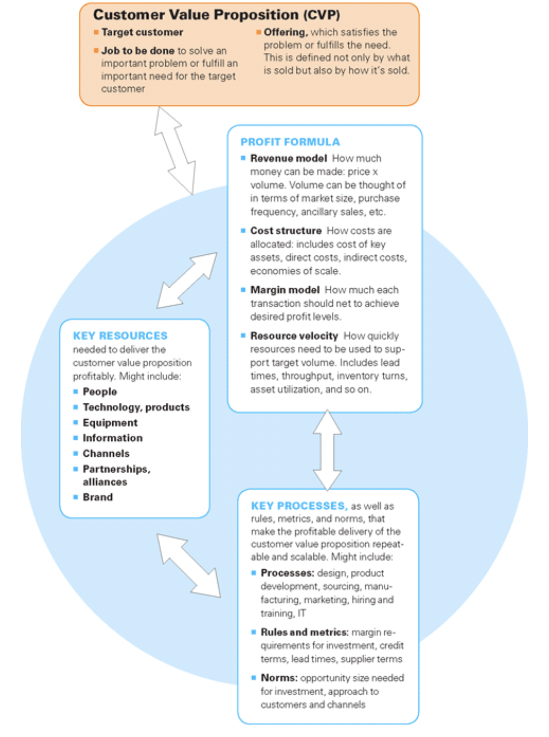

*Figure 1. Components of BM by Johnson et al., 2008*

Referring to the previously selected definition of BM, we can align the elements of a business model with the ones from the definition in the following way:

* CVP corresponds to the way an organization creates value,
* Profit formula corresponds to the way an organization captures value,
* Key resources and processes correspond to the way and organization delivers value.

Such an approach is not only rather detailed, especially when compared with the previously described model, but also clearly represents the dynamic nature of a BM by clearly reflecting the connections between its’ elements. At the same time, the framework is rather simple and clear for understanding and development.

However, as the internal aspects of each element of a BM are not clearly defined, this model implies sufficient variation of interpretation and execution, which is likely to be based on an individual’s subjective judgements, hence, by utilizing it, we risk missing out important components of a BM. For instance, although partnerships might not be classified as a key asset for a particular firm (hence, those are likely to be missed out when summarizing its’ BM using the framework above), they may still play an important role, thus, should still be noted.

In the framework of this paper, the business model composition framework by Johnson et al. will be utilized for the purpose of defining whether BM innovation has truly occurred or whether a change was too insignificant to claim for one. This will be discussed further in the chapter.

Another model, which proposes a different approach to BM composition and representation, was suggested by Alexander Osterwalder and Yves Pigneur in their “Business Model Generation” book in 2010. “Business Model Canvas” represents a combination of nine blocks, which constitute a business model, namely, Customer Segments, Value Propositions, Channels, Customer Relationships, Revenue Streams, Key Resources, Key Activities, Key Partners, and Costs (fig. 2).

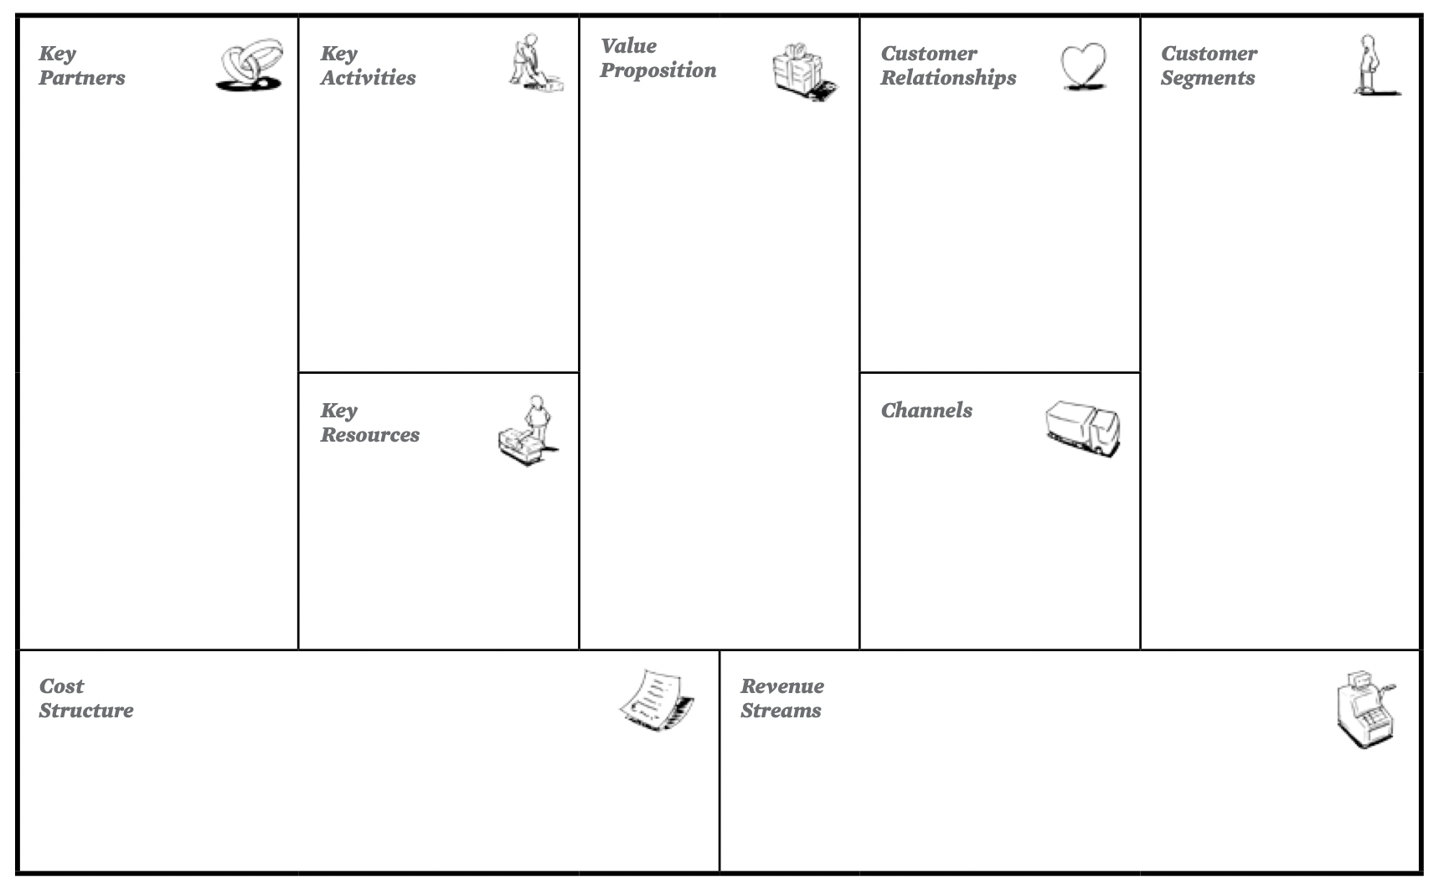

*Figure 2. Business Model Canvas*

Below you can find a brief description of each of the elements of a BM according to the Business Model Canvas framework:

1. “Customer Segments” block – identifies a scope of consumers and/or business entities a firm intends to reach and serve
2. “Value Propositions” block – identifies a firm’s collection of products and services which are aimed at providing value to consumers
3. “Channels” block – describes the way that a company delivers its Customer Value Proposition to consumers
4. “Customer Relationships” block – defines the kinds of relations a company establishes with its customers
5. “Revenue Streams” block – illustrates how company derives profits from its customer segments
6. “Key Resources” block – identifies viable internal assets that support the full scope of a company’s activities
7. “Key Activities” block – defines the viable actions that a company has to perform in order to continue its operations
8. “Key Partnerships” block – describes a company’s suppliers which support its activities
9. “Cost Structure” block – describes the costs which a company faces when performing its business activities

The model above is both clear for understanding and seems to be capturing all of the possible aspects of a business model. Moreover, it provides us with a clear guidance on what has to be noted when describing / designing a BM as well as is rather useful for representing a BM visually is a structured way. If compared to the framework by Johnson et al. (fig. 1), the Business Model canvas is as comprehensive (as it captures all the elements from the previous model) as long as being more precise on exact components of a BM that have to be captured.

Hence, in the framework of this paper, we will use BM framework by Johnson et al. in order to distinguish whether BM innovation has occurred (will be discussed in more detail further in this chapter) as well as Business Model Canvas by Alexander Osterwalder and Yves Pigneur in order to summarize business model prior to and after business model innovation has occurred.

### 1.1.3 Definition of Business Model Innovation

Moving onto Business Model Innovation itself, it is important to define this process as well as establish criteria for the statement of its accomplishment. First of all, we will refer to the definitions of Business Model Innovation from related academic papers:

1. A business model innovation can be defined as a novel way of how to create and capture value, which is achieved through a change of one or multiple components in the business model (Frankenberger et al., 2013[16])
2. Business model innovation is defined as “designed, novel, and non-trivial changes to the key elements of a firm’s business model and/or the architecture linking these elements (Foss and Saebi, 2017[17])
3. Business model innovation is the art of enhancing advantage and value creation by making simultaneous—and mutually supportive—changes both to an organization’s value proposition to customers and to its underlying operating model (BCG, 2008[18])
4. BMI is identified as a process of refining existing BM, which often results in lower cost of increased value to customers (Teece, 2010, p.181[19])

In the framework of this paper, the definition by BCG will be chosen for characterizing the business model innovation as it both highlights the complexity of this process and provides a basis for establishing the criteria for the accomplishment of BMI, which are crucial to distinguish it from minor changes in a business model. Moreover, the BCG’s definition is the most suitable in the context of the crisis-provoked BMI, which is aligned with the specifics of our research, as, in the instance of the performed case study, the turbulence of the business environment created the need for the company to perform changes not only in the Customer Value Proposition but also in the BM’s underlying operational processes.

### 1.1.4 Defining criteria for BMI accomplishment

As it was previously mentioned, it is vital to define the criteria for accomplishment of Business Model Innovation by a company in order to distinguish it from minor changes in a business model.

Referring to the related academic literature, there are different perspectives concerning those standards (in the statements 1-3 below, academics refer to the following elements of a BM: value proposition, profit formula, key resources, key processes):

1. As it was stated in the article by Frankenberger et al. (2013[20]), a change in one of the components of a BM is enough to consider such as Business Model Innovation
2. Based on the paper by Wirtz et al. (2010[21]), a change in a company’s business model can be classified as Business Model Innovation only in case when two or more elements of the BM have undergone substantial changes
3. According to Johnson et al. (2008[22]), all four elements of an existing BM have to be modified in order to claim for Business Model Innovation
4. Referring to the article by Mitchell and Coles (2003[23]), the process of Business Model Innovation implies changes in at least one of the following aspects of a BM: “who,” “what,” “when,” “why,” “where,” “how,” or “how much”.

As we can see, researchers have not yet managed to find common ground regarding the number of components to be changed in order to consider the process of BMI to be accomplished.

In the framework of this paper, it was decided to go for the middle ground, hence, combining the chosen definition of BMI with the reviewed approaches to criteria of BMI accomplishment, it will be considered that, in order to claim for Business Model Innovation, a company has to perform substantial changes in its Customer Value Proposition as well as any other (at least one) component of the BM (Key Resources, Key Processes, or Profit Formula) simultaneously.

Hence, as it was already mentioned in preceding sections, we will use BM composition model by Johnson et al. (2008[24]) in order to distinguish the accomplishment of Business Model Innovation.

### 1.1.5 What is enabled by Business Model Innovation?

Proceeding with the discussion of BMI process, it is crucial to determine what pushes companies towards one. Referring to the “Business Model Innovation” article by BCG[25], we can generally claim for two major reasons for BMI, such as:

1. Defend against industry decline or disruption (including crises)
2. Aspire for breakout growth

Otherwise, Pisano et al. (2015[26]) suggest that Business Model Innovation is mostly provoked by either technological trends or socioeconomic factors. Additionally, the paper highlights the role of a ”New Customer”, who is increasingly interested in a business’s moral aspect.

The point related to the importance of technological trends among the BMI drivers was also supported by Henry Chesbrough (2010[27]), who states that one of the most remarkable reasons for a company to innovate its business model is to be able to ”take [a new technology] to the market” in a distinctive from competitors' way and thus achieve improved economic outcomes.

Another perspective is proposed by Wrigley and Straker (2016[28]), who inspect the BMI process from the standard point of a company’s opportunities to overcome its’ rivals by establishing an efficient system of operations, highly distinctive Customer Value Proposition, etc.:” Business model innovation can itself be a pathway to competitive advantage if the model is sufficiently differentiated and hard to replicate for incumbents and new entrants alike”. This point can be further developed by referring to Lin et al. (2020[29]), who suggest that BMI can not only enable a firm to overcome its competitors at a given time but also reach sustained competitive advantage in spite of the dynamic and complex nature of the modern business environment.

Other approach is suggested by Amit and Zott (2010[30]), who propose to perceive BMI as a tool, which enables a company to either expand its activities to new markets or capture new opportunities in the market of presence.

In order to obtain a deeper understanding of the drivers of BMI as well as the goals the companies are generally trying to achieve as a result of BMI, it was decided to combine the summarized approaches, supplement them, and visualize in the form of a comprehensive model (fig. 3).

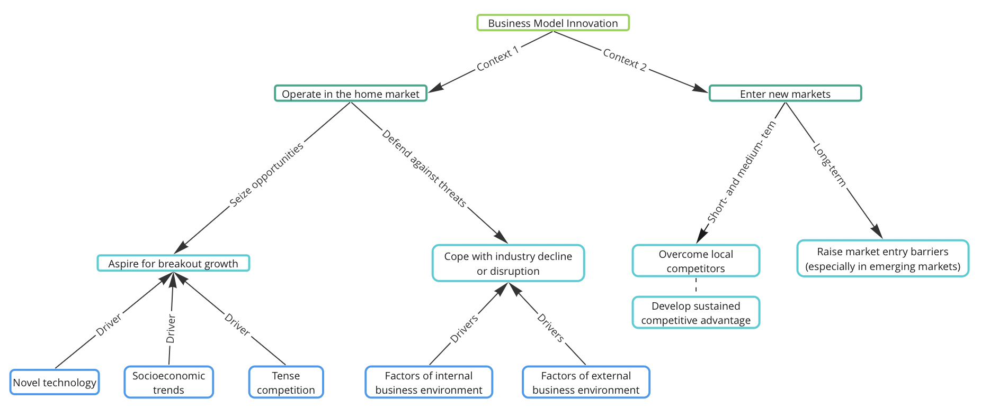

*Figure 3. BMI objectives and drivers developed by author*

The model above serves as a structured representation of the potential prerequisites of BMI as well as associated objectives of a company. It is suggested that the objectives and of a firm, which decided to go for BMI, as well as the BMI drivers can be distinguished based on the market that is targeted. In case of staying in the home market, a firm’s BMI can be provoked by either opportunities or threats that emerged in the business environment where it operates. Furthermore, the BMI objectives tend to be consistent with the state of the business environment: as long as being represented with opportunities, firms aim at breakout growth, whereas threatening environments lead to BMIs that are aimed at coping with industry decline or disruption. Considering the case of entering new markets, the BMI objectives are distinguished between short- / medium-term and long-term ones. Generally, in the short- and medium- term, the companies, which undergo BMI as long as entering new markets, aim at building competitive position and, further on, reaching sustained competitive advantage. As for the long-term objectives, they are tied to changing the market conditions themselves in order to raise market entry barriers for “latecomers”.

## 1.2 Types of Business Model Innovation

Prior to conducting an in-depth case study, we will set up a classification method in order to be able to define the nature of a particular BMI process. Although it seems to be a rather basic issue, this matter has not been mush well discussed in the related theoretical papers yet as the majority of researchers neglect the question of development of precise characteristics, which correspond to a certain type of a BMI process.

Currently there are two main approaches to BMI classification. First one was established by Wrigley and Straker (2016[31]), who propose five typologies of innovative business model design (hence, five typologies of BMI process):

1. Customer led strategy

Customer led strategy investigates the various potential lying within previously untapped client segments, as well as the appearance of a new business model based on these new consumer groups.

The starting point can be represented by finding a new consumer segment to target. As a result, it is expected to obtain a variety of business model possibilities that are capable of creating and delivering value in novel ways for new markets.

1. Cost driven strategy

Cost driven strategy is performed by cutting costs for the purpose of uncovering new opportunities. Although focusing at limiting expenses usually does not result in growth, it is claimed that doing business in a low-cost market can lead to unique opportunities for a company and frequently results in the development of a distinctive value proposition.

Having reformulated the costs’ structure, the designer then starts to develop a business model that is motivated by this shift and assesses the emerging opportunities for creation of distinctive CVP.

1. Resource led strategy

Resource Led Strategy can be summarized as capturing new by utilizing the same mix of resources, though having them linked differently. The starting point can be represented as listing out a firm’s resources and capabilities and is further followed by searching for a new infrastructure of matching those. As a result, a business can derive untouched value from the same mix of resources.

1. Partnership led strategy

Partnership led strategy can be described as a way to transform a business model in the sense of either capturing growth opportunities or defending against threats via generating new value from partnership-inspired synergies.

1. Price led strategy

Price led strategy suggests performing Business Model Innovation by repositioning a company as a price leader in a given market. The result is likely to be represented by a business model with a full scope of expenses brought to its minimum, which is still capable of delivering the same offering but cheaper.

A company with such a pathway to BMI can end up targeting a different customer group, utilizing channels with increased cost-effectiveness, or entering partnerships with sufficient cost-cutting synergies implied.

Each strategy is supplemented by a matching Business Model Canvas-based framework for the BM transition’s analysis, which can be seen in the appendixes. It is crucial to point out that each of the listed typologies corresponds to the previously chosen method of distinction of BMI from minor changes in a business model. Hence, each of the presented categories implies substantial modification of both Customer Value Proposition and at least one other aspect of a BM (Key Resources, Key Processes, or Profit Formula).

Although the model above seems to be rather comprehensive, we believe that, based on the emerging ESG and CSR agenda, it should be supplemented by CSR Driven Strategy. Referring to the paper by Michelini and Fiorentino (2012[32]), CSR driven strategy can be performed by "integrating a social perspective into the core frameworks that are used [by companies] to understand competition and develop business strategy”.

In order to pursue the value driven strategy, we believe that a firm should primarily map up the full cycle of its activities, and then either identify the steps where it either acts “unethically” from the standard point of CSR or search for the ones where it could put in additional value by leveraging one of the pillars of CSR (i.e., Social, Economic, or Environmental). Obviously, as it was previously mentioned, in order to claim for BMI, value-driven strategy must result in a chance in CVP as well as at least one other component of BMI (i.e., Key Resources, Key Processes, or Profit Formula).

As for the assessment of the extent to which the new business model corresponds to the idea CSR, referring to Breton-Miller and Miller[33], it is crucial to verify that it contains the following elements: sustainable values, pro-active multi-stakeholder management, and a long-term approach.

Moving one another approach to the classification of BMI, Pisano et al. (2015[34]) suggest categorization based on Business Model Innovation epicentres, which are distinguished from Business Model Canvas[35]. The following typologies are proposed:

1. Infrastructure driven

Infrastructure driven strategy suggests that BMI can be derived from following blocks of Business Model Canvas: activities, key resources or key partners.

1. Customer driven

Customer driven strategy refers to building out BMI process out of one (or several) of the following blocks of Business Model canvas: value propositions, channels, customer segments, or new customer relationships

1. Finance driven

Finance driven strategy suggests that BMI can be derived from rethinking either cost structure or revenue streams.

In general, the approach above covers the same innovation drivers as the typologies by Wrigley and Straker (2016[36]), however, the classification of BMI by Pisano et al. lacks statement of the precise directions of innovation. Particularly, referring to the example of Price led strategy by Wrigley and Straker and corresponding Finance driven strategy by Pisano et al., the first one is described as a bundle of innovations aimed at becoming a price leader in a given market, whereas Finance driven strategy vaguely suggests to ether cut costs or search for new revenue streams without precising any objectives of such a change. Utilization of the second strategy, although allowing a more flexible approach to BMI, in practice, is likely to confuse and mislead an entrepreneur due to the general complexity of the BMI process, in this case, accompanied by the lack of precision of its final goal.

Hence, in the framework of this paper, as long as aiming at categorizing a particular case of BMI, we will refer to the six-typology approach discussed previously in this chapter, which is based on the classification by Wrigley and Straker (2016[37]). According to the developed framework, we will be considering the following typologies of Business Model Innovation:

1. Customer led strategy
2. Cost driven strategy
3. Resource led strategy
4. Partnership led strategy
5. Price led strategy
6. CSR driven strategy

## 1.3 Steps of Business Model Innovation

Although the previously discussed classification model provides researchers and entrepreneurs with an outline of the “plan of actions”, it is still rather vague, hence, unclear. As the process of Business Model Innovation is rather complex itself and, obviously, is likely to provoke uncertainty among those responsible for leading it, we believe that it is crucial to develop a step-by-step approach that would define the outline of BMI process as well as guide researchers through it. Hence, the aim of this section is to provide an answer to the following question: “What steps have to be undertaken in order to conduct and accomplish Business Model Innovation?”.

Despite being a fundamental aspect of BMI, yet researchers have mostly denied the issue of development of precise steps of Business Model Innovation. The reasons for such can be summarized as follows:

1. Business Model Innovation is a non-completable and non-static process, which implies uninterrupted creation and testing of new business models (based on the primary one)[38], hence, it is impossible to define particular steps of BMI due to its continuous nature;
2. Outcomes of BMI cannot be predicted as its implementation is the matter of trial and error[39], hence, we cannot define precise steps of this process prior to its accomplishment;
3. Business Model Innovation is a highly personalized activity based on the initial BM of a company, the peculiarities of an industry, the underlying motives, etc., hence, it is impossible to develop a universal action plan.

However, as it was mentioned above, a framework describing BMI steps would be increasingly valuable for both practitioners and theoretics. In spite of the general lack of attention towards this subject, some researchers have attempted to establish frameworks summarizing stages of BMI, which will be further reviewed.

The first attempt to develop a structured view of BMI was performed by Pateli et al. (2005[40]), who identifies the phases of development of BMI process inspired by the emergence of new technological solutions. The framework with the underlying steps is summarized in the image below (fig. 4).

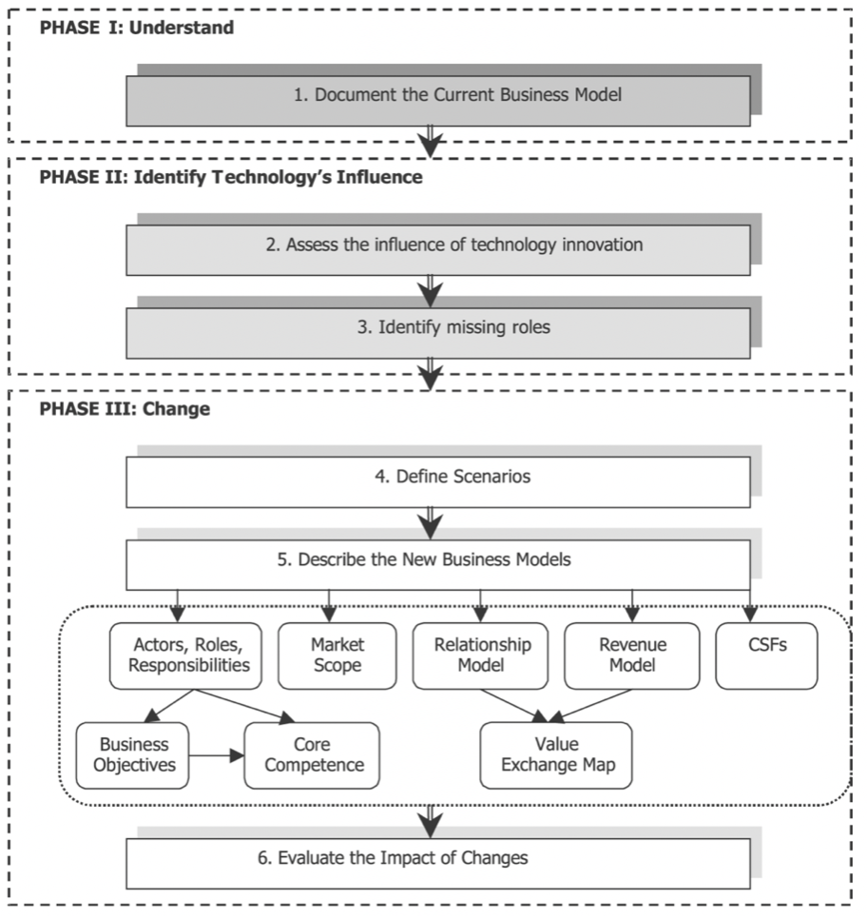

*Figure 4. Methodology of technology-provoked BMI (developed by Pateli et al., 2005[41])*

Although the model above suggests a quite precise set of steps to be undertaken as long as performing Business Model Innovation, it cannot be utilized in the framework of this paper due to the significant difference in BMI drivers as, in our case, the need for BMI was provoked by industry disruption due to global crisis, whereas the methodology above was developed specifically for technology-provoked BMIs.

Next, a structured approach to BMI process was proposed by Frankenberger et al. (2013[42]), who suggest that Business Model Innovation consists of the following phases:

1. Initiation

Initiation, as a starting point, can be defined as realization of necessity of Business Model Innovation. The drivers of such prerequisites of such a decision were previously illustrated (fig. 3).

1. Ideation

Ideation step refers to the moment when a company starts developing possible solutions for a renewed business model. The aim of this phase is to note out all the possible configurations of a future BM, hence, those BM scenarios are typically preliminary and not yet assessed.

1. Integration

At this stage, all the pre-defined scenarios are assessed and the most suitable and potentially successful one(s) are selected. Next, the selected option(s) is/are considered more thoroughly and further integrated into the context of a given business environment.

1. Implementation

Finally, after having chosen the alternative(s) of the primary BM and developed plan for their establishment, the new solution(s) is/are brough to the market during the Implementation phase.

The BMI steps by Frankenberg et al. were developed by synthesizing information about phases of innovation processes from related academic papers by the following researchers: Cooper (1990[43]), Rothwell (1994[44]), Van de Ven et al. (1999[45]), Cormican and O’Sullivan (2004[46]), Tidd and Bessant (2005[47]), and Hansen and Birkinshaw (2007[48]).

As we can see, although the approach to BMI steps by Frankenberger et al. (2013) is rather general and provides very limited explanation of which actions to perform during each phase of the process, as for now, it is the only “universal” approach yet developed, hence, we will stick to it in the framework of this paper.

Furthermore, in order to improve the extent to which the selected framework could be utilized in practice by both entrepreneurs and researchers, it was decided to make an attempt to clarify the following issues:

1. How to define the scope of possible scenarios of the future business model?
2. How to assess the defined scenarios of future BM?
3. How to assess the final outcomes of BMI?

All those questions will be discussed further in this chapter.

### 1.3.1 Defining the scope of future BM’s scenarios

Referring to the BMI phases by Frankenberger et al. (2013), at a result of the ideation stage, a company is expected to obtain a number of future BM’s scenarios, which are further assessed and, as a result, a new BM is obtained.

However, it might be tricky for one to come up with even one innovative scenario not to mention a number of those. This issue could be partly resolved by supplementing the chosen framework by a model proposed by Sinfield et al. (2012[49]). The model suggests that the alternative BM solutions could yield from the answers to the following questions:

1. Who is the target customer?
2. What needs of the customer should be satisfied?
3. Which offering is capable of satisfying those needs?
4. How can the customer access our offering?
5. What role should the business play in supplying the offering to the customer?
6. How can the business earn profit?

In order to inspire for alternative BM scenarios, the answers to the questions above have to be different if compared to the ones corresponding to the primary version of the BM. After having provided several possible answers to each of the questions above, one can construct a decision-making model represented by grouped options of answers, which are interlinked with each other. Each set of interlinked answers represents one of the possible future BM solutions. The explain model is represented below (fig. 5).

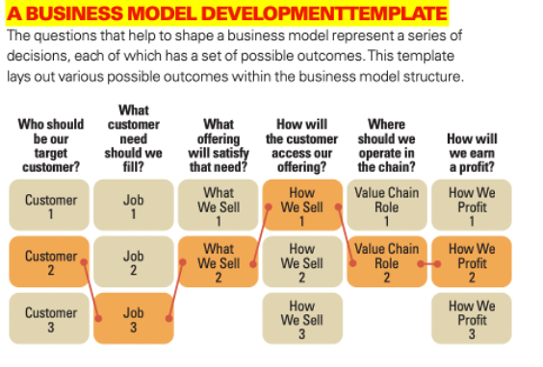

*Figure 5. Development of possible future BM solutions (by Sinfield et al., 2012[50])*

Hence, having performed the actions outlined above, one will complete the Ideation phase of BMI and will be capable of moving forward to the in-depth investigation of predefined scenarios and their subsequent assessment, which will be discussed further in this chapter.

### 1.3.2 Assessment of the scope of future BM’s scenarios and the outcomes of BMI

As it was previously mentioned, all of the pre-defined BM scenarios have to be thoroughly assessed and, as a result, the most promising model(s) will be chosen. At the same time, although the criteria of such assessment are strongly tied to the specific case, it is important to provide both researchers and entrepreneurs with the general idea of factors, which have to be taken into account when choosing between the BM options.

1. Industry-related factors (Pateli and Giaglis, 2005[51])

* Industry structure – This factor covers the nature of the market where the future BM will be implemented, hence, monopolistic, oligopolistic, or competitive.
* Balance between transaction and internal development costs (Li and Whalley, 2002[52]) - This factor covers the extent to which, within a given industry, it is reasonable to outsource some of the processes, resulted from BMI, if compared to the development of firm’s own capabilities and resources aimed at internalizing those processes from the point of view of related costs.
* Type of players – This factor covers the nature of the organizations which dominate the market, hence, either private or public ones. It is claimed that their nature has a direct impact on the extent to which the company’s rivals are motivated to adapt innovative decisions aimed at gaining competitive advantage.

1. Firm-specific factors (defined by Pateli and Giaglis, 2005[53])

* Strategic objectives – This factor covers the firm’s strategic direction as well as the alignment of the company’s overall strategic goals with the expected results from a particular BMI scenario.
* Firm capabilities and resources – Based on the assessment of the company’s resources and capabilities, this factor uncovers whether it is capable of developing the BMI-provoked processes itself or it is forced to outsource some of the novel activities. Although this factor seems to be rather similar to “balance between transaction and internal development costs”, here we discuss whether the firm is generally able to develop those essential abilities, whereas in the industry-related factors the question of outsourcing was discussed from the perspective of the underlying costs and their justification

1. Factor of personal attitude (Sinfield et al., 2012[54]) - this factor suggests that, as long as choosing between BM scenarios, the representatives of a firm’s management team are likely to have personal predisposition, both positive and negative, to certain BMs. Those predispositions can be defined as the ones based on subconscious beliefs rather than substantiated facts. Sinfield et al. suggest dividing the scenarios into the following categories: desirable, discussable, and undesirable. Hence, one can clearly distinguish potentially feasible scenarios from the clearly unwanted ones.

Finally, moving onto the post-BMI period, according to the currently available academic studies, it is not yet defined which criteria one should follow as long as assessing the outcomes of BMI. The only claims in that sense were made by Johnson et al. (2008[55]), who stated that the only viable indicator of a successfully conducted BMI is the resulting profitable business model.

## 1.4 Factors affecting the process of BMI

At this point, we will discuss the currently reached understanding of the factors, which can serve as drivers or barriers to BMI itself, predetermine the resulting efficiency and/or profitability of implementation of a particular BMI scenario, or affect the BM components undergoing major changes as a result of a BMI. As long as reviewing the related literature, we were able to identify five groups of factors obtaining notable impact on the process of SMEs’ BMI.

### 1.4.1 Company's size

Starting from the internal factors, numerous research in the field have come to the point that size of an SME obtains direct impact on the process of its BMI. According to Heider et al. (2021[56]), the profitability of the chosen BMI scenario depends on the primary input of the firm’s size. Particularly, small firms are observed to be mostly benefiting from implementing strategies that are built around reconsideration of initial resources’ configurations, hence, in order to retrieve a more favourable solution, substantial changes in “key resources” block should be performed. Moving onto medium-sized firms, authors suggest that these companies tend to receive higher profits in case of choosing BMI path related to building and/or strengthening ties with external stakeholders.

At the same time, referring to Alcalde-Heras et al. (2018[57]), it was uncovered that smaller companies tend to perform more frequent development of ambidextrous strategies in the context of economic recession if compared to larger firms. Hence, as ambidexterity itself serves as a vital factor for planning and performing BMI[58], it can be stated that, considering SMEs, smaller firms more inclined to performing BMI in the context of environmental turbulence if compared to medium-sized ones.

To sum up, it can be clearly seen that the size of an SME obtains impact on both its predisposition to performing BMI in the context of economic recession and the profitability of the chosen BMI strategy.

### 1.4.2 Strategic objectives of SMEs

A number of research papers were trying to interlink strategy, business models, and BMI. Starting from a study by Casadesus-Masanell and Ricart (2010[59]), it was acknowledged that a BM itself results from the company’s strategy. This finding could have been hypothetically extended onto the dependence of a firm‘s BMI orientation on its strategy, however, more evidence was required. A different study performed by Doz and Kosonen (2010[60]) on the topic of interconnectivity of BMI and strategy suggests that strategic agility serves as a major condition required in order to perform business model transformation and renovation.

Referring to the paper by Marikka Heikkilä, Harry Bouwman, and Jukka Heikkilä (2018[61]), it was discovered that strategic objectives, which a company pursues by performing BMI, have a notable impact on the resulting components of the BM that are subject to change. The research distinguishes three directions of SMEs’ strategic objectives with subsequent changes in the BM components:

1. Firms within the first category are addressed as “growth seekers”, hence, those are companies that perform BMI mainly for the purpose of the business scale’s growth. Heikkilä et al. (2018[62]) claim that, as a result of the performed BMI, the novel BMs of such firms are characterized by changes observed in the BM components that are located on the right-hand side of Business Model Canvas[63], particularly, customer relationships, customer segments, value propositions, and channels. At the same time, in some cases, the "partnerships” block is subject to change as long as searching for external streams of value proposition.
2. Next, “profitability seekers”, thus, firms that pursue increase in profits via BMI, are claimed to obtain resulting BMs characterized by substantial changes observed among the BM components located on the left-hand side of the Business Model Canvas[64], particularly, key activities, key resources, key partners, and cost structure.
3. In turn, “new businesses”, hence, newly established firms, tend to perform cyclical changes in their primary BM by pursuing the following order of BM components’ modifications: customer segments --> value propositions --> key partners --> key resources and/or cost structure --> key activities --> revenue streams.

Although the paper clearly demonstrates the impact of strategic objectives of companies on the process of performed BMI, which massively contributes to the theoretical base on BMI, the authors do not provide complete scope of possible strategic directions with corresponding BMI strategies. For instance, referring to our case, the context of stability of business activities was neglected as no such objective as “securing long-term performance”, which is likely to appear in the context of environmental turbulence, and corresponding BMI scenarios were not addressed. The question of impact of “securing long-term performance” as a strategic goal on the subsequent BMI will be developed further in the paper.

### 1.4.3 Dynamic capabilities and internal resources

1. Dynamic capabilities

The issue of dynamic capabilities as a driver of BMI has been largely investigated by researchers in the field. Dynamic capabilities of a firm can be defined as three distinct though interrelated components. Primarily, a company has to analyse and recognize the utility of its present resources; next, it is supposed to be capable of sensing and seizing external opportunities; finally, a firm has to be capable of efficiently realigning its existing resources and incorporating new ones simultaneously[65]. Hence, Dynamic Capabilities offer companies with a possibility to determine the future value of its current resources, sensing and seizing opportunities by identifying potential utility of external resources, and, finally, pursue novel strategic directions by recombining current resources and supplementing them with new ones.[66]

According to Heider et al. (2021[67]), two out of three dynamic capabilities are observed to obtain impact on BMI. Particularly, a company’s capability to sense and seize external opportunities by identifying potential utility of external resources contributes to its BMI by improving the innovativeness of the newly emerging Customer Value Proposition, hence, the firms with such a capability pursue greater degree of innovativeness when performing substantial changes in their CVP. Moreover, the capability of pursuing novel strategic directions by recombining current resources and supplementing them with new ones improves the value capture of the BM and boosts the pace of transformation.

1. Internal resources

As for now, the impact of sufficiency of the primary internal resources on the upcoming BMI, including its possible scenarios, was not much discussed in academic literature. As for the general capacity of value provision and its further reconsideration, referring to the paper by Dasí et al. (2015[68]), SMEs are limited in value creation by scarcity of internal resources. Moreover, their activities are characterized by higher cost of failure (up to existential risks) in case of slack of organizational resources[69].

At the same time, referring to the degree of specificity of resources, according to the results obtained by Kim & Kwon (2017[70]), overinvesting in specific resources hinders a firm’s dynamic capability of sensing and seizing opportunities outside its scope of activities due to the limited base of internal competencies, which subsequently hinders BMI.

Hence, the impact of internal resources on BMI can be summarized in the following statements:

* SMEs characterized by high fractions of investments dedicated to specific resources are likely to be experiencing difficulties when performing BMI due to the insufficiency of the competence base.
* We may initially assume that scarcity of primary internal resources hinders BMI in some way. However, this statement is not backed up by any proven evidence yet and will be developed further in this paper.

### 1.4.4 Managerial ties and competencies

Starting from the impact of managers’ connections with third parties, managerial ties can be defined as “executives’ boundary-spanning activities and their associated interactions with external entities” (Geletkanycz & Hambrick, 1997, p. 654[71]). In comparison with resources, managerial ties are not utilized for the purpose of performing business related activities or achieving benefits for business itself, rather, they serve the executives’ personal advantage. At the same time, although managerial ties are primarily not subject to addressing business-related issues, in some cases, they can serve as channels via which companies can reach out for acquisition of organizational resources[72].

Managerial ties are proven to obtain positive effect on the process of BMI, which is performed by SMEs, in the following ways:

1. The presence of managerial ties promotes organizational learning via experimentation[73], which can be explained by an improved sense of embeddedness[74];
2. Managerial ties help SMEs to enhance the capability of recognition of external opportunities (Guo et al.,2017[75]). This, in turn, eases abandoning previously set planning and innovation in business models[76], which subsequently enables firms to develop the capability of flexibility[77];
3. Managerial ties are oftentimes directly interlinked with institutional support, which, in turn, decreases existential risks in case of BMI’s failure (Bashir et al., 2023[78]).

Moving on, referring to Alcalde-Heras et al. (2018[79]), it was uncovered that the capability of managers to acknowledge the presence of environmental turbulence as well as the capacity to cooperate with external parties as long as searching for resources to support new value streams perform the function of drivers of SMEs’ ambidexterity, which subsequently enhances the process of BMI.

As long as the impact of both managerial ties and competencies on the process of BMI can be clearly traced, there is yet no evidence regarding how managerial ties influence the choice of particular BMI strategies. At the same time, there has yet been no research on how past personal and/or professional experiences of top-management teams can influence the BMI and its scenarios, which represents a clear research gap. These issues will be addressed further in the paper.

### 1.4.5 The context of environmental uncertainty

Finalizing the issue of factors that contribute to BMI of SMEs, surprisingly, the context of uncertain business environment has not been largely studied from the point of view of its impact on the process of BMI yet. Among the few mentions, Amit and Zott (2010[80]) proposed that the context of economic crisis increases the willingness to bear costs associated with BMI due to the emergence of existential risks in case of neglecting BMI as such, as well as augmented perception of attractiveness of alternative value streams enabled by BMI.

However, from the perspective of general logic, one may argue that, in case of environmental uncertainty, business generally see cost-cutting as a primary vital action, which contradicts the BMI-related survival strategy. The issue of the impact of turbulent environment on BMI, including its potential scenarios, will be discussed further in this paper.

## 1.5 Statement of theory-based model and research questions

Having reviewed the related academic papers, including the analysis of factors of assessment of BMI scenarios and factors affecting the process of BMI, in the framework of this paper, we have created our own model summarizing the factors of choice of BMI strategy, which is represented below (fig. 6). The represented model is based on the idea that the combination of assessment of BMI scenarios and consideration of factors affecting the process of BMI determines the final choice of BMI strategy. The model distinguishes the following groups of factors shaping the selection of BMI strategy: industry-related factors, firm-specific factors, and executives-related factors.

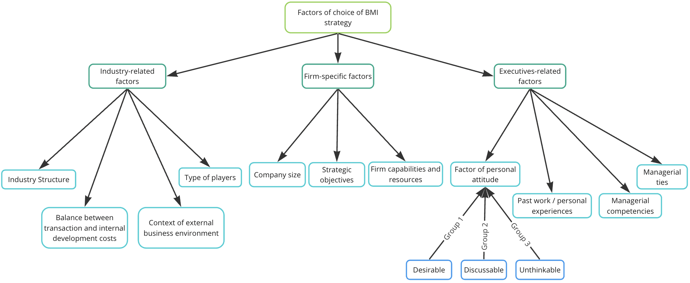

*Figure 6. Factors of choice of BMI strategy*

To sum up, although the current state of the academic literature on the topic of BMI enables us to generally identify corresponding drivers and barriers, there is very little information on how specific conditions shape the choice of particular BMI strategies by SMEs. As it was mentioned above, as long as developing the case analysis, the following research questions will be addressed:

1. How “securing long-term performance” objective shape the choice of subsequent BMI scenario?
2. What specifics of primary internal resources affect selection of future BMI strategies?
3. How past personal and/or professional experiences of top-management team can influence the selection of BMI strategy?
4. In what way does the context of the turbulence of business environment affect the decision of undertake BMI?
5. How managerial ties affect the choice of BMI strategies?

# 

# Chapter 2. Research Methodology.

Having identified both the research stream and the state of the current development of the theoretical base, the research will be conducted via single in-depth case study. We will consider the case of a Russian-based international transportation company, which was mostly focusing on performing international logistic services in the B2B segment prior to the emergence of the global crisis starting at 24th February 2022. As for now, the company is capable of continuing its operations in the same field owing to the results of the performed BMI.

## 2.1 Data collection

In order to collect the data about the case, we will perform triangulation by, first of all, searching for the information about the company in the open sources including its publicly available corporate reports and, secondly, conducting series of unstructured interviews with the company’s C-level management team. Owing to the complexity of the BMI process itself, the prolonged period of its implementation, and the extent of the desired precision of information, prolonged close communications were essential in order to ensure the accomplishment of the defined research goal and objectives. The method of unstructured interviews was chosen in order to receive the most relevant and up-to-date information as well as enable further clarification of details and updates on the latest state of the company’s performance in the market, which is obviously impossible to reach via single interview. The sample questions from the conducted interviews are represented in Appendix 1.

The series of unstructured interviews were performed in order to accomplish the following objectives:

1. Collect general data about the company’s organizational structure, history, key clients, competitive position, etc.
2. Gather information about the company’s BM and its performance prior to the emergence of 2022 global crisis
3. Identify the precise conditions of external business environment which led to the inability to operate using previous BM
4. Identify the peculiarities of the performed BMI and its outcomes
5. Discuss the details of the decision-making process regarding choice BMI strategies from the scope
6. Identify the main factors that shaped the choice of finally selected BMI paths
7. Gather information about the company’s post-BMI performance and market position

Additionally, as it was previously mentioned, the research design is represented by single (embedded) case study (hence, involving one unit of analysis[81]). Its choice can be explained by some of single case study’s peculiarities aligned with corresponding specifics of this paper.

First of all, referring to Robert K. Yin (1994[82]), the choice of the single case design can be justified by its representative and typical nature. As the research goal was defined as "identifying factors that shape the choice of business model innovation strategies of small and medium-sized enterprises (SMEs) in the logistics industry in the context of turbulent and uncertain environments”, and the chosen company performed a typical set of actions undertaken by such firms in the context of emerging environmental turbulence, the selected design enables us to uncover related insights owing to the case’s representativeness in the framework of the studied industry and conditions of external business environment.

Secondly, the single case study design proposes a number of benefits, which are aligned with the nature of this research. According to Johanna Gustafsson (2017[83]), the single case study research design enables the writer to obtain a deeper understanding of the examined subject, which is essential in our paper due to the complexity of the analysed topic as well as the associated depth of the information that has to be obtained. Additionally, it is mentioned that single case studies tend to produce more precise and accurate theory and, as this research is aimed at creating a mostly theoretical contribution to the understanding of BMI and related issues rather than practical one, the choice of single case study design is valid.

As for the qualitative nature of the research, due to the fact that, as for now, very few empirical literatures covering the factors of choice of BMI strategies have been developed, the research area, which corresponds to this paper, can be defined as emerging. The novelty of the area contributes to the choice of qualitative research as of the most suitable research design.

## 2.2 Structure of case analysis

In order to accomplish the pre-identified goal and objectives of the paper, it is crucial to thoroughly define the steps to be undertaken as well as the corresponding tools to be utilized, which will be taken from the previous chapter.

Step 1. Summary of pre-crisis BM

At this stage, we will broadly describe the company’s primary BM using Business Model Canvas and summarization framework by Johnson et al., 2008[84] (fig. 1). The Business Model Canvas will be utilized for the purpose of in-depth depth BM understanding, whereas the framework by Johnson et al. Will enable us to assess the extent to which pre-BMI and post-BMI business models differ, hence, verify the assumption of realization of BMI, which is based on the statement that, in order for a BMI to be accomplished, substantial changes in at least two components, including Customer Value Proposition, have to occur.

Step 2. Assessment of newly emerged conditions of external and internal business environments.

At this step, we will provide the evidence of the critical changes in the business environment, which led to the firm’s inability to utilize its primary BM. In order to assess the outcomes of the occurred events in terms of their impact on the internal and external business environments and, particularly, implications for the company under analysis, we will analyse the newly emerged conditions, their impact on the industry and players in the market, and define particular prerequisites of future BMI by referring to the previously developed model (fig. 3).

Step 3. Assessment of the conducted BMI, including the scope of potential BM scenarios and BMI outcomes

At this point, we will define the actions undertaken by the company during its Business Model Innovation. The entire process will be reviewed based on the BMI phases by Frankenberger et al. (2013[85]), particularly, it will be divided into initiation, ideation, integration, and implementation stages.

As long as the initiation step will be described mainly by referring to the previous steps of the analysis, at the ideation phase the scope of the potential BMI solutions will be represented by means of the framework by Sinfield et al., 2012[86] (fig. 5). Moreover, at this step, the essence of each of the proposed BMI scenarios will be thoroughly described and, based on that, each strategy will be classified according to the following BMI typologies (for more in-depth explanation please see “Types of Business Model Innovation” section):

1. Customer led strategy
2. Cost driven strategy
3. Resource led strategy
4. Partnership led strategy
5. Price led strategy
6. CSR driven strategy

At the integration step, we will dive into the process of assessment of BMI scenarios, define the arguments in favour or against each of them, and identify the underlying factors shaping the process of assessment and selection of resulting BMI scenarios.

Finally, at the implementation step, we will state the chosen BMI paths. The resulting BM will be defined and summarized via framework by Johnson et al., 2008[87] (fig. 1) in order to confirm the accomplishment of BMI by referring to the pre-developed criteria (substantial changes in at least two components, including Customer Value Proposition, are required). Also, the extent to which the resulting BM enabled the company to successfully operate in the market now will be assessed.

Further on, having performed case analysis, we will compare the model of factors of choice of BMI strategies, which was preciously created on the basis of examined literature, with the evidence from the practical section of the research. Based in that, we will both verify the model’s validity and define propositions on the particular effects of defined factors on the selection of BMI strategies. The propositions themselves will subsequently set the directions for further research on the topic.

## 2.3 Case description

As for the case study itself, a Russia-based transportation company, namely “XXX” LLC (the name of the firm was changed at executives’ request for the purpose of non-disclosure of sensitive information), performing international B2B logistic services since 1990s was selected. The company has employed 95 people and consists of Logistic, Accounting, and Transportation departments. XXX owns 50 truck tractors and 70 semi-trailers. The entire auto park is formed from Volvo vehicles. Although providing logistic services within numerous European countries, XXX was mainly performing transportation services between Finland and Russa.

Prior to the emergence of conditions of Feb 24th, 2022, XXX was performing international (in 80% of cases) and domestic logistic operations by transporting all sorts of “non-dangerous goods”, including consumer goods, technological equipment, engines’ components, etc. Additionally, the company was providing other logistics firms in St. Petersburg with drivers’ pre-transportation medical examination by licensed specialist, which was perceived as a supplementary source of profit.

Among their most loyal and long-term clients, the company’s representatives named such firms as Bombardier Recreational Products, Sella, Yusen Logistics, and Astra Logistic. Referring to the peculiarities of the relations between the company and its customers, XXX was mostly performing transportation services on the basis of long-term contracts, the majority of which fixed a ten-year period, with both its Russia-based and foreign clients.

Starting from the emergence of the global crisis dated to 24th February 2022, XXX, as well as all the Russian transportation companies, were banned from entering the territory of any countries within the European Union by the 5th sanctions package[88]. As a response to such actions, Russian government has announced reactive measures, which subsequently banned European transportation companies from crossing Russian boarders.

As the company was only performing road transportation with a large-scale focus on providing international logistic services, taking into account the specifics of its pre-crisis activities and the conditions of the external business environment, it becomes obvious that its primary business model was no longer viable.

Having analysed the situation, the company’s executives have performed Business Model Innovation, which will be broadly covered in the upcoming chapter. The scope of three alternative Business Models was considered and, having assessed each of them, two strategies were implemented. At this point, the company continues to perform it activities by providing international transportation services between Russia and EU, domestic logistic services within Russian boarders, and drivers’ pre-transportation medical examination for other transportation companies in the region.

# Chapter 3. Case Analysis.

## 3.1 Summary of pre-crisis Business Model

Referring to the case itself, first of all, we will outline the pre-crisis BM of XXX LLC by utilizing the framework by Johnson et al. (2008)[89], according to which a business model can be divided into the following interrelated components: Customer Value Proposition (CVP), Key Resources, Key Processes, and Profit Formula (fig. 1). The description of each component of XXX’s BM can be viewed below.

1. Customer Value Proposition

Target customer:

XXX, which was operating uniquely in the B2B segment, obtained a rather broad range of target customers. Due to the duality of services provided, the target customers could be characterized by either business in need of transportation of non-dangerous cargos within Russia and/or between European countries and Russia or logistics companies in St. Petersburg in need of professional pre-transportation medical examination of drivers. As for provision of logistics services, as it was previously mentioned, the company mostly performed its operations within Finland and Russia, however that was not caused by the limitations from the side of the company but rather by the company’s recognition among Finnish B2B clients and its decent reputation in the region.

Job to be done: XXX was solving the problem of well-organized, fast, and safe transportation of non-dangerous goods across the borders or within Russia. Also, XXX solved the problem of professional medical examination of drivers for other logistics firms, which did not have an employed doctor in the team.

Offering: XXX solved the problems of customers in two dimensions.

* First of all, the company was providing trustworthy transportation services, the quality of which was ensured by the company’s experience in the market, deep level of understanding of cross-border transportation regulations, and fully equipped team, which consisted of experienced employees with sufficient professional knowledge and skills. Moreover, the company paid increased attention to the professional well-being of its drivers and strictly monitored the conditions of safe long-distance driving. Additionally, XXX emphasised the vitality of documentation's compliance with regulations in the field of international transportation and ensured its precise monitoring prior to and during the transportation itself. As a final point, company’s offering was enhanced by provision of personalized customer service (available for privileged clients).
* Secondly, referring to provision of services of medical examination, XXX solved customers’ problem by ensuring professional-grade medical check-ups of drivers performed by experienced doctor, including provision of corresponding documentary evidence.

1. Profit Formula

Revenue model: XXX relies on the direct payments from its B2B customers, which are fixed by corresponding contracts and are performed after either accomplishment of cross-border / domestic transportation services or performing medical check-ups of drivers.

Cost Structure: The company’s costs are represented by the following categories:

* Purchase and maintenance of transportation vehicles
* Maintenance of premises
* Marketing and promotion expenses
* HR expenses
* Taxes
* Cost of licensing and certification

Margin model and Resource velocity are not represented in this paper due to the company’s reluctance to provide corresponding information for public access.

1. Key Resources

Auto Park: One of the company's core resources is the 100% ownership of a sufficient number of transportation vehicles. First of all, the possession of such a number of expensive transportation items (50 Volvo truck tractors and 70 Volvo semi-trailers) guarantees the firm’s solvency in case of extreme cases as, at any point of time, few of those assets could be sold out in order to cover the company’s debt. Secondly, the availability of such a scope of transportation vehicles signifies XXX’s capability of performing multiple routes simultaneously, hence, serving the needs of several clients at a time, which obviously contributes to its competitive advantage and ensures the company’s ability to meet its customers’ needs in a shorter term.

Premises: As a part of supporting business activities, the company performs vehicles’ maintenance and repair, stockpiling of cargos, customer reception (for the purpose of conducting meetings with clients), and other related activities. Hence, XXX’s premises serve as a key resource, which enables the company to perform the full scope of logistics and logistics-related services.

People: Next, the professionalism of the team is one of the company's main resources due to the degree of the responsibility which it bears. As XXX is financially responsible for both organization of the transportation itself (including its alignment with predefined timescale) and the safety and preservice of the cargo on the way to its destination, its employees at all levels of the organizational structure must comply with the principles of increased self-organization, professionalism, and sense of responsibility. Moreover, the presence a doctor employed on the full-time basis enabled XXX to diversify supplement its profit sources by providing services of medical examination for other logistics firms in the region.

Brand reputation: As it was already stated, the company used to perform the majority of its services on the routes between Finland and Russia due to its trustworthy reputation among local businesses. Due to the peculiarities of the performed services (both transportation- and medical examination- related), obtaining a trustful reputation was key to self-promotion, hence, brand reputation was considered to be one of the most vital resources for the company’s success in the market.

1. Key Processes

Organization of transportation and assurance of compliance: As it was previously mentioned, the organizational part of providing logistics services is both one of the most complex and critical due to the need of both meeting the terms of pre-arranged contracts and sustaining the reputation of a trustworthy service provider. Prior to the crisis, the direct transportation of cargos was arranged by the logistic department, which was fully responsible for the corresponding preparation of documentation for customs and transportation timings.

Maintenance of vehicles: Finally, as the auto park itself was selected as a key resource, it becomes obvious that the maintenance of vehicles has to be considered as a key process. As, prior to the crisis, XXX was only performing transportation of non-dangerous goods, its vehicles were not subject to enhanced security standards[90], however, in order to preserve the security of cargos and safety of drivers, the company was closely monitoring the state of its vehicles by emphasizing the obligation of drivers to perform daily checks of their truck tractors in accordance with corresponding guidelines as well as conducting regular in-depth check-ups at the service stations.

Drivers’ training & tracking: As the quality of logistic services is highly dependent on the state of both employees’ skills and drivers’ physical state, it was vital for the company to ensure not only sufficient training of employees on peculiarities of organization of cross-border transportation, associated norms and regulations, and preparation of corresponding documents but also drivers’ knowledge in proper treatment of transportation vehicles and different types of cargos. Moreover, it was crucial to monitor drivers’ compliance with safety rules regarding their own physical state, driving style, cargo handling, etc. Hence, as XXX’s main value proposition was captured in the quality of provided services, the management team emphasized that educating and monitoring employees was one of the most prioritized internal activities.

Professional medical examination of drivers: As one of the profit sources of XXX was linked to provision of medical check-ups for drivers of different logistics companies in St. Petersburg, professional medical examination of drivers has to be distinguished as a separate key process. The activity was enabled due to the presence of a certified doctor on the full-time basis in the team. The check-ups were performed on a contractual basis by arrangement of pre-scheduled appointments on the territory of XXX’s premises.

Further on, in order to achieve a deeper understanding of the initial BM, it will be summarized by means of Business Model Canvas[91] (fig. 7).

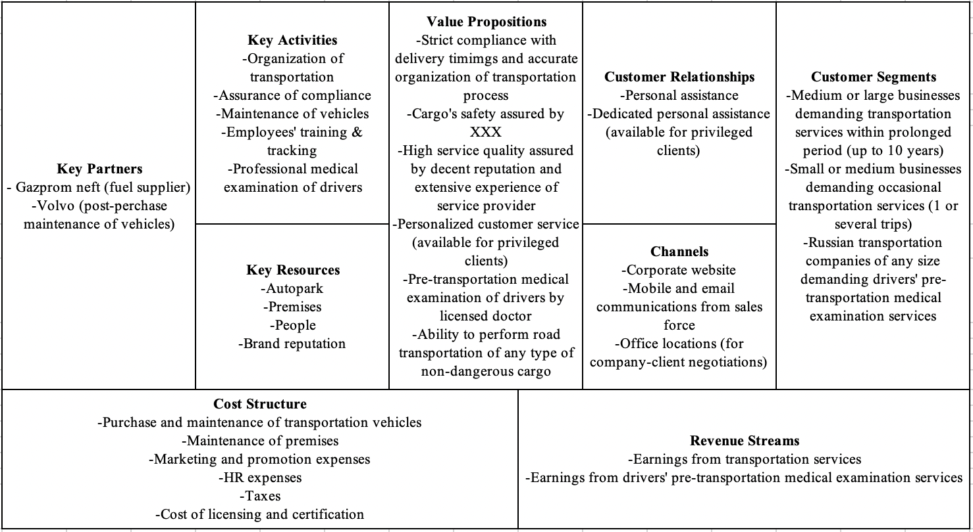

*Figure 7. Pre-crisis BM of XXX systematized via Business Model Canvas*

*Table 1. Customer segments and related value propositions*

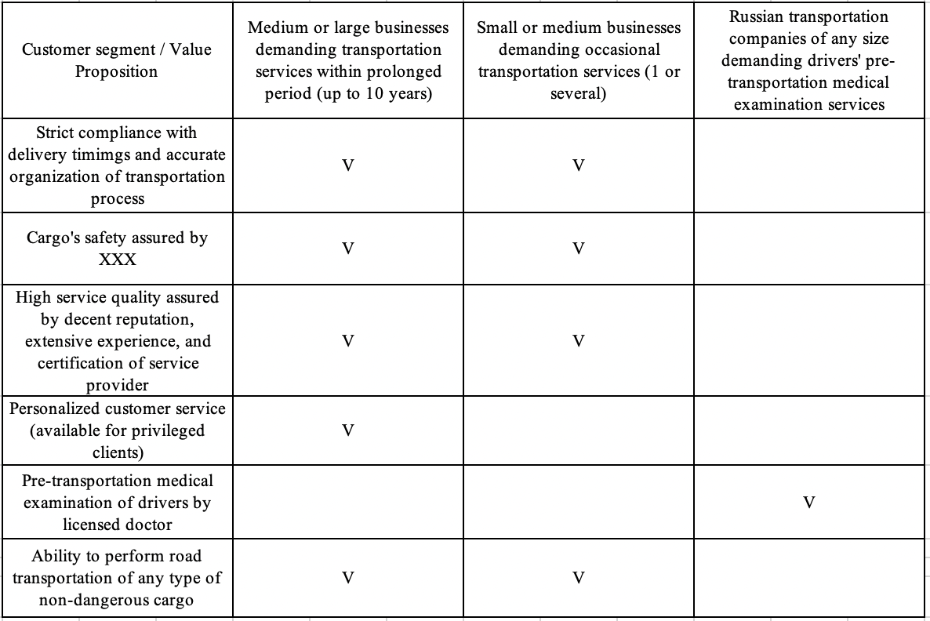

## 3.2 Assessment of newly emerged conditions of external and internal business environments

At this point, we will move onto the analysis of the occurred events, their implications for Russian market for logistics services and its players, and, based on those, we will be able to define the drivers and objectives of XXX’s Business Model Innovation. The analysis will be performed solely for the Russian industry of road freight transportation

Starting from the introduced regulations[92], after the beginning of the Russia-Ukrainian conflict, the European Union has been introducing sanction packages, aimed at destabilization of the Russian economy, and the logistics sector was one of the most hindered. Starting from the 2nd sanction package, the European Union banned the supplies of dual-use products to Russia, which include spares from transportation vehicles.

Next, the 4th package of sanctions created notable obstacles for financial operations with foreign entities by excluding Russian banks from SWIFT system. The situation became even more threatening when Visa and Master suspended their operations in Russia[93], hence, completely disconnected Russia from the global financial markets and made it impossible to perform online transfers of money from Russian bank accounts to foreign ones.

Further on, the 5th package of sanctions, which implied banning Russian trucks from crossing the EU boarders, has become one of the most problematic for the industry of international road transportation as it generally disabled Russia-based international logistics companies, which focused on transportation services between Russia and EU, to perform their business activities. However, the restrictive didn’t touch on the transit transportation performed by European carriers via Russian territories.

After the introduction of the 5th sanction package, as a part of countermeasures, the Russian government banned international cargo road transportation on the territory of the Russian Federation by freight vehicles registered in the countries, which have introduced sanctions in the field of international road transport of goods[94].

Moreover, the 6th sanction package, introduced by the EU in April 2022, prohibited European companies from supplying Russia with medium-duty trucks up to 15 tons, truck tractors, trailers and semi-trailers, which was further accompanied by suspension of business operations of automobile companies.

Additionally, apart from the restrictions touching on the transportation companies directly, the EU sanctions banned export of numerous categories of goods to Russia, which decreased the global demand for those products by Russian consumers due to the import substitution measures promoted by the Russian government and producers simultaneously, which obviously decreased the demand for transportation of those goods.

The emerged conditions resulted in the following implications for the Russian industry of road transportation:

1. The non-accessibility of vehicles and their spare parts from official producers and dealers leveraged their prices up to 59%[95], which either disabled or significantly obfuscated the process of replenishment and maintenance of auto parks for Russian transportation companies.
2. The restriction imposed on Russian banks resulted in inability of Russian logistics firms to pay and receive money from their foreign partners, clients, etc. In order to overcome the issue, Russian firms had to perform additional actions and dedicate extra financial resources in order to find a way to perform transactions with external parties.
3. The introduction of partial mobilization resulted in induction of a number of specialists in logistics, drivers, mechanics, etc., which created additional obstacles for performing business operations from the perspective of specialists’ shortage.
4. As Russian logistics firms began to turn to eastern directions, the transport infrastructure of the Far East region, including land border crossings, became overloaded. This noticeably lengthened the delivery time through all channels[96].
5. The prolonged logistics routes caused the timescale of performing transportation to increase by up to 70%[97].
6. The prices for transportation services, particularly considering cross-border logistics, grew tremendously[98]. Particularly, according to the information from XXX’s COO, the prices for their services rose by up to 400%.
7. The general decline in demand for cross-border transportation occurred due to the ban on import of numerous goods’ category to Russia as well as efforts of Russian government and producers dedicated to import substitution activities[99].
8. Due to the turbulence of business environment, numerous companies in the domain of provision of logistics services have shut down, which decreased the competition within the industry[100].
9. At the same time, in spite of prices augmentation, it was uncovered that Russian businesses in need of cross-border logistics services began to neglect the factor of cost. Thus, clients are ready to pay nearly any price in order for the cargos to be transported[101].

Thus, taking into account the specifics of the occurred events, we can state that the general objective of the performed BMI was to adapt to the emerged turbulent market conditions. Particularly, referring to the claims of representatives of XXX’s management team, the following was stated: “Due to the conditions associated with the beginning of Special Military Operation, the only way not to shut down was to reshape the company’s BM completely. That is why, despite all the costs, we agreed to go for BMI”. According to the results of the performed analysis, we can claim that the main drivers of the performed BMI are the factors of external business environment.

Hence, referring to the framework of “BMI objectives and drivers”, which was developed by author in the first chapter, the core BMI objectives and drivers are highlighted below (fig. 8)

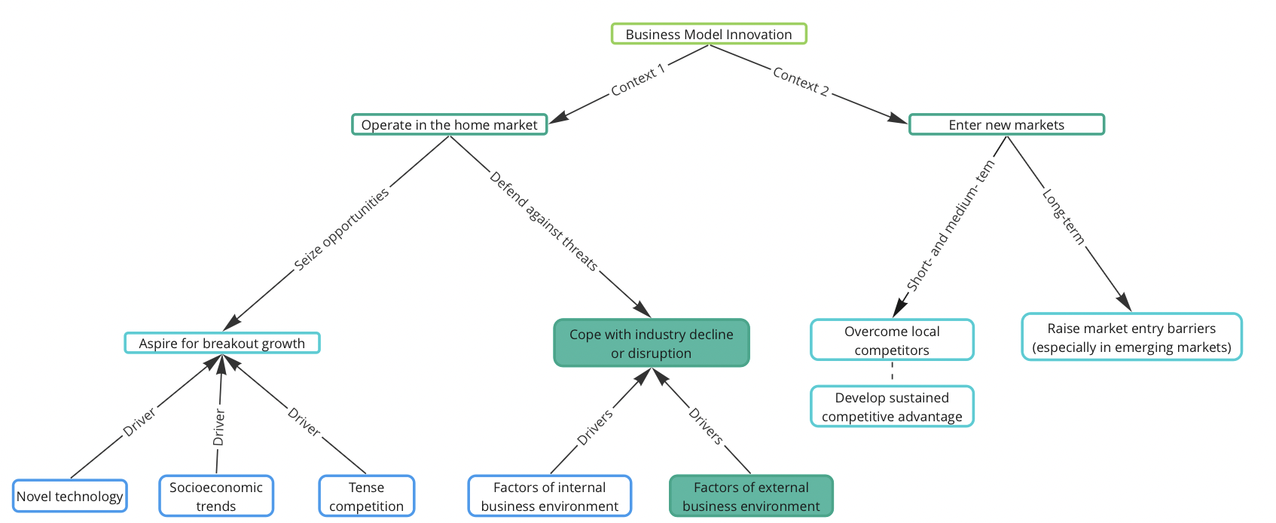

*Figure 8. Objectives and drivers of XXX’s BMI*

## 3.3 Business Model Innovation performed by XXX

Having identified the main objectives and drivers of the performed BMI, we will move onto the analysis of the process of Business Model Innovation itself. As it was previously mentioned, the decision-making process will be divided into BMI steps corresponding to the structure of BMI defined by Frankenberger et al. (2013[102]). Particularly, the following phases of the conducted innovation will be considered: initiation, ideation, integration, and implementation.

As it was mentioned previously, prior to the crisis, among the main sources of company’s profits there were both domestic and international transportation services, and even though the crisis has put some restrictions on international aspect, the firm was not considering the option of limiting the entire scope of business activities by performing domestic transportation solely. This decision was provoked by corresponding market’s characteristics, such as surplus in services’ suppliers, hence, intense competition and high bargaining power of buyers.

### 3.3.1 Step 1. Initiation

As it was previously mentioned, Initiation phase corresponds to the moment of realization of the necessity of performing Business Model Innovation. Referring to the previous section of the paper, it was identified that the main objective of the performed innovation was to cope with industry disruption, whereas the factors of external business environment served as the major drivers.

Owing to the crisis severeness and the corresponding extent of the turbulence of the environment, generally, the company ended up in the situation where it was disabled to continue performing its business activities in case of neglecting BMI as, considering the previously described context, any other sorts of innovation, such as product innovation, value proposition innovation, or strategy reformulation by acquisition and/or moving to other markets[103], would not help to overcome the crisis conditions. Particularly, product innovation, value proposition innovation, or strategy reformulation by acquisition, performed individually, would not impact the company’s disability to continue their operations as it was provoked by externally imposed restrictions, which are predetermined by XXX’s market of activities rather than by the state of the firm’s competitiveness. As for the strategy reformulation by moving to other markets, due to both strong personal ties of management team with the country of origin and long-term experience and in-depth knowledge solely in the logistics industry, the firm’s executives denied changing either geographical market or industry of operations.

Hence, the turbulence of business environment, accompanied by ties with the country of origin and industry of duties, performing BMI was the only option for XXX to survive the emerging crisis.

### 3.3.2 Step 2. Ideation

Moving on, as it was highlighted in previous chapters, Ideation phase implies defining the scope of possible BMI solutions, which have to be subsequently assessed Integration step. In order to summarize all the potential BMI paths, which were primarily proposed by the company’s management, we will utilize the BMI scenarios’ summarization model proposed by Sinfield et al., 2012[104] (fig. 5). The outline of the primarily considered BMI strategies can be seen below (fig. 9). Each of the illustrated BMI paths was defined by referring to the corresponding typology. The classification of BMI strategies was developed by author in previous chapters based on the model by Wrigley and Straker (2016[105]).

Additionally, it is crucial to consider that, as long as developing the scenarios represented below, XXX’s team was not relying on any sorts of supportive frameworks, its executives were formulating potential BMI strategies by referring to untouched demand created by external conditions, practices undertaken by foreign companies in similar conditions, and business models undertaken by competitors, Particularly, the customer led strategy resulted from the presence of untouched demand in the market, resource led strategy was derived from an existing business model undertaken by Monopoly.Business[106], and partnership led strategy was inspired by actions performed by Belorussian transportation companies after the beginning of crisis dated to 24th February 2022.

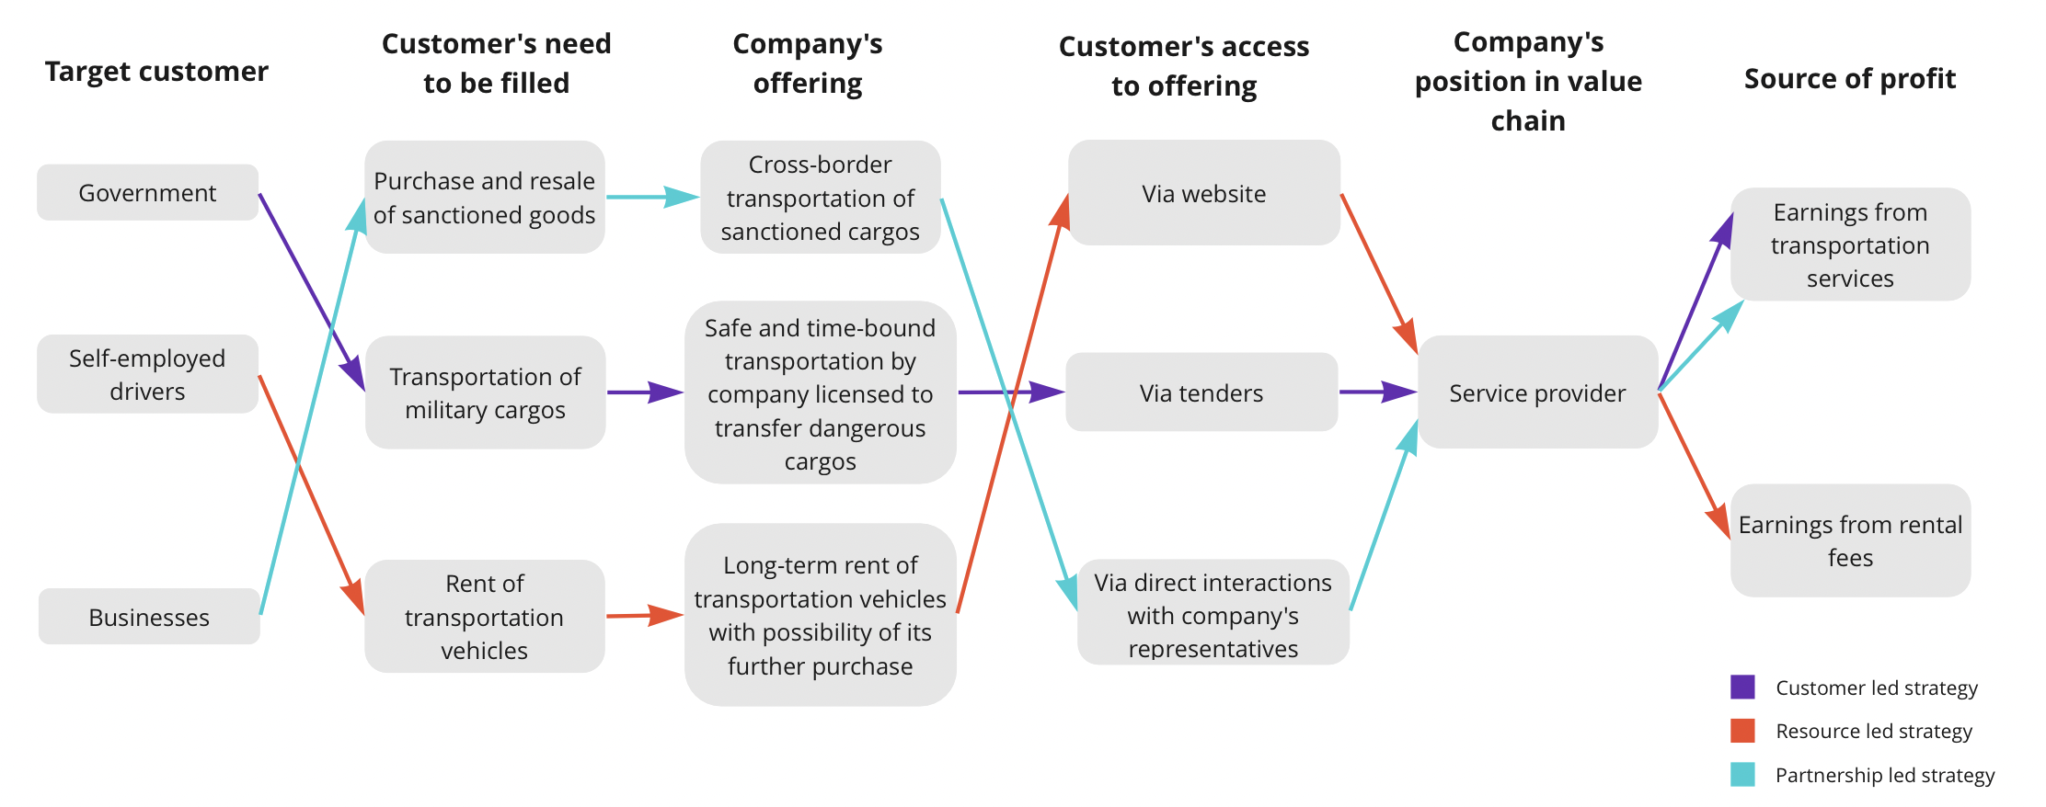

*Figure 9. Potential BMI strategies considered by XXX*

At this point, a more comprehensive description of each considered BMI strategy will be provided.

1. Partnership led strategy

The essence of partnership led BMI is captured in transforming business model via deriving new value from collaboration with partners. Obviously, the most valuable resource in case of such a BMI strategy is represented by established partnerships, which enable a firm to recreate its primary BM in a more efficient way.

Addressing to XXX’s case, due to the externally imposed limitations and inability of import of sanctioned goods, prohibition of entry of Russian transportation vehicles on the EU territory, and corresponding prohibition of entry of European transportation vehicles on the Russian territory, in spite of the attempts of the government to substitute the imported items, the market ended up with tremendous shortage of both sanctioned and not sanctioned goods, which used to be imported prior to the crisis.

Due to the fact that, prior to the crisis, XXX had multiple trustful long-term B2B clients in Finland, some of which were represented by European logistics firms in need of transportation of cargos either from Russia to Finnish boarder areas or in reverse direction, XXX obtained a possibility of addressing those companies with business-related suggestions without being refused in the first place due to negative predisposition towards the firm’s origins.

By studying international practices of firms in similar conditions, namely, observing actions performed by Belarusian logistics firms, as well as working closely with the company’s lawyer, XXX’s executives came up with a strategy on how to perform import of both sanctioned and non-sanctioned goods, which would comply with Russian laws and regulations. The solution was strongly tied to collaboration with European logistics firms and would not be feasible in case of absence of trustful relationships with European transportation companies established prior to the emergence of crisis conditions. Moreover, as, for one of the developed actions plans, collaboration with Georgian firms in other than logistics domains was required, its implementation was supported by amical relationships between XXX’s executives and some of Georgian business owners. The names of both European and Georgian partners are not disclosed for the purpose of privacy.

Elaborating on the developed solution for import of non-sanctioned goods, as, although European vehicles are disabled to operate on the Russian territory, they are still allowed to enter frontier zone[107] in order to leave cargos, XXX developed the following action plan:

1. XXX’s truck tractor with connected semi-trailer arrives to Russian-Finnish border zone from the side of Russia.
2. At the same time, a truck tractor of European partner (company Y) crosses Finnish-Russian border and arrives to border zone on the territory of Russia
3. XXX’s semi-trailer is disconnected from its truck tractor and further connected to company Y’s truck tractor
4. Company Y’s vehicle crosses Russian-Finnish border, enters Finland, and follows through the EU territory to the cargo’s consignor, picks up the cargo by loading it on the semi-trailer, and goes back to the border zone located on the territory of Russia. As long as going through the Finnish-Russian customs, the cargo’s target location is documented as Russia (as the transported goods, in this case, are not sanctioned)
5. The semi-trailer with cargo is disconnected from company Y’s truck tractor and is further connected to XXX’s truck tractor

The export of goods across Finnish border could be performed similarly:

1. XXX’s truck tractor with connected semi-trailer, which is loaded with cargo, arrives to Russian-Finnish border zone from the side of Russia.
2. At the same time, a truck tractor of European partner (company Y) with its empty semi-trailer crosses Finnish-Russian border and arrives to border zone on the territory of Russia
3. The cargo is offloaded from XXX’s semi-trailer and further loaded to company Y’s semi-trailer
4. Company Y’s vehicle crosses Russian-Finnish border and delivers cargo to is recipient

As a result of such activities, XXX is enabled to import and export any non-sanctioned goods via Russian-Finnish border.

Now, we will review XXX’s action plan on importing sanctioned goods. As it was previously mentioned, the developed strategy complies with Russian laws and regulations, however, is obviously inconsistent with the ones of EU. The performed steps are quite close to the ones that were previously described, and the main difference between two approaches is captured in the documents prepared for border-crossing.

1. XXX establishes a non-contractual agreement with its Georgian partners (company Z), which implies that company Z purchases goods, which are demanded by XXX, from a European provider.
2. XXX’s truck tractor with connected semi-trailer arrives to Russian-Finnish border zone from the side of Russia.
3. At the same time, a truck tractor of European partner (company Y) crosses Finnish-Russian border and arrives to border zone on the territory of Russia
4. XXX’s semi-trailer is disconnected from its truck tractor and further connected to company Y’s truck tractor
5. Company Y crosses Russian-Finnish border, enters Finland, and follows through the EU territory to the cargo’s consignor, picks up the cargo by loading it on the semi-trailer, and heads back to the Finnish-Russian border.
6. At Finnish border-crossing point, company Y shows documents stating that the cargo’s target location is Georgia (as the purchase of the cargo was primarily made by Georgian company Z). As developed prohibitions still allowing transit of sanctioned goods through Russia, the vehicle with cargo is enabled to pass through.
7. As long as company Y’s vehicle has passed through the Finnish border-crossing point and hasn’t yet reached Russian border crossing point, company Z resells the cargo to XXX.
8. As company Y’s transportation vehicle enters Russian border crossing point, its driver demonstrates the documents on both primary and renewed destinations as well as purchase agreement between XXX and company Z. Obviously, all the documents are prepared in advance, prior to the purchase of goods by company Z. As Russian laws do not prohibit import of goods, which were sanctioned by the EU, the transportation vehicle of company Y with cargo is enabled to pass through.
9. Company Y’s truck tractor with semi-trailer arrives to the border zone on the side of Russia.
10. The semi-trailer with cargo is disconnected from company Y’s truck tractor and is further connected to XXX’s truck tractor.

Having executed the described chain of actions, XXX is capable of performing import of sanctioned goods on the territory of Russia by collaborating with foreign companies focusing on provision of logistics services.

1. Customer led strategy

The essence of the customer led BMI is captured in targeting previously untouched customer segments and developing a novel business model that would satisfy their needs. The starting point of customer led BMI is represented by searching for a new customer group(s) to be addressed.

In our case, due to the beginning of the Special Military Operation, the Russian government faced a necessity to transfer vast amounts of military-oriented goods across the country and, essentially, the demand for such services appeared in the market.

Owing to the managerial ties with the government’s representatives, XXX’s executives were aware of such an unmet demand, hence, in case of pursuing customer led BMI, the presence of demand for novel services was assured. As for the key changes to be undertaken, in order to shift focus onto transportation of dangerous goods, the company had to perform large-scale educatory activities in order to assure future safety transportation for both cargos and people involved, obtain a license for transportation of dangerous goods, and ensure XXX’s access to long-term contracts with government-related entities for transportation of dangerous cargos.

1. Resource led strategy

The core of the resource led strategy is captured in business model’s recreation as long as utilizing the same bundle of resources and aligning them differently if compared to the primary BM.

Referring to XXX’s case, as it was previously stated, one of company’s core resources is its auto park. The company owns 50 truck tractors and 70 semi-trailers, which were all purchased from Volvo, each of which is valuable due to its market price. Particularly, on average, a price of an already exploited Volvo truck tractor starts from 10 million rubbles[108], and, as for semi-trailer's price, although the offers on the web are rather diverse in terms of the prices, according to the information from XXX’s representatives, an average price of a pre-used Volvo item is, on-average, four million rubbles.

At the same time, as company’s management is closely involved in tracking employees’ activities, hence, performs direct communications with employees, including drivers, on a weekly basis, the executives understood that those drivers, who are positively predisposed to performing business activities on their own, hence, as performing logistics services as self-employed drivers, are, in most cases, unable to do so due to the expensiveness of the inventory required (thus, due to high prices of truck tractors and semi-trailers). At the same time, as long as analysing competitors’ activities, XXX’s executives noted one of business branches of GC “Monopoly”[109], namely, Monopoly.Business[110], which provides self-employed drivers with a possibility to rent out transportation-aimed vehicles with an optional right of its further redemption.

Due to the fact that XXX LLC, first of all, owns a rather extensive auto park and, secondly, is (and was) solvent enough to perform further purchases of transportation vehicles, the management team was considering an option of either completely changing the company’s orientation to providing self-employed drivers with transportation vehicles via rental services or establishing a new business branch that would focus on such activities.

The described BMI path is claimed to be resource led as the company’s possibility to go for such a strategy is based on the primary availability of physical (i.e. auto park) and financial resources as well as implies realigning them in order to recreate CVP.

### 3.3.3 Step 3. Integration

Having represented the primarily designed possible BMI paths, we will dive into the process of assessment performed by the firm’s management team. The evaluation of each of the BMI scenarios, which were represented above, will be discussed. Moreover, the factors affecting the final decision on each strategy will be uncovered and classified by referring to the “Factors of choice of BMI strategy” model, which was previously developed in the framework of this paper (fig. 6).

1. Partnership led strategy

As it was previously mentioned, in case of XXX, partnership led strategy implies cross-border transportation of both sanctioned and not sanctioned goods and is enabled by close collaboration with European logistics companies and Georgian businesses in other domains.

The first factor that obtained impact on the decision regarding the strategy is the potential lack of possibility of its long-term realization. As the action plan on transportation of sanctioned goods implied documenting cargos as ones headed to Georgia with transit through Russia, XXX’s executives were largely concerned regarding the potential of banning transportation of sanctioned goods through Russian territories, which is currently being discussed by heads of EU’s states[111]. As such, import of sanctioned goods has a potential of becoming a limited-term strategy, hence, XXX’s executives initially understood that they cannot rely in such a BMI path solely. At the same time, considering import and export of non-sanctioned goods across Russian-Finnish border, it is not subject to such possible restrictions as, in this case, the developed action plan complies with both international and Russian laws and regulations.

Secondly, the presence of demand for such services was considered. According to the information provided by XXX’s representatives, demand for transportation of sanctioned goods is much higher than the one for non-sanctioned ones as, in this case, the supply in the market is much more limited. Hence, speaking of transportation of sanctioned cargos, XXX could count on extensive demand, enabling the company to manipulate prices and earn higher profit margins in spite of the need to pay income portions to foreign partners. At the same time, although demand for transportation of non-sanctioned goods is lower if compared to sanctioned ones, it is still sufficient and, as the activity is unlikely to be prohibited in the short-term, the strategy was considered as a more feasible one with correspondingly attractive profit margins.

Next, referring to transportation of sanctioned goods, one of considered factors was the extent of unfairness of the activity. As the service is illegal from the standard point of the international law in presence of restrictions from the side of the EU, XXX’s managers were quite concerned on the topic of “being caught” by customs officers, which would imply loss of cargo delivered at a time, hence, potential loss of reputation in the eyes of a customer. However, as the cross-border transportation was performed by XXX’s partners rather than the company itself, and XXX’s vehicles were prohibited from entering EU zone in either way, the company was not expecting any risks of any other further restrictions imposed on performing such an activity.

Finally, the factor worth consideration in case of pursuing such a BMI strategy was the possibility to enter into partnerships with both European logistics firms and Georgian non-logistics companies. As XXX had established trustful business-related relationships with EU logistics companies prior to the emergence of crisis (as those forms used to perform the role of customers prior to the conflict of Feb. 24th, 2022), and, at the same time, XXX’s executives obtained personal connections with multiple Georgian business holders, the firm had a capability of overcoming this resource barrier.

1. Customer led strategy

Referring to customer led strategy, which implies targeting B2G sector by shifting focus to transportation of dangerous cargos, the primary obstacle touched on the CEO’s predisposition to performing such activities. Due to the presence of personal background related to surviving armed conflicts, the XXX’s chief executive was primarily strongly opposing the idea of performing transportation of military cargos for the needs of the Russian government.

Another requirement for selection of customer led BMI was the need to conduct large-scale preparation for performing such activities. Particularly, XXX’s management team and office employees would experience the need to dig into the subject of documentation of such transportation as well as state’s requirements on such activities. The company had to provide drivers with in-depth training on transportation of dangerous cargos, leverage the degree of transportation security, and ensure general compliance with corresponding regulations.[112] Additionally, in order to secure XXX’s trustfulness in this area, the company had to get a corresponding license, which implied undergoing numerous administrative controls[113].

Lastly, aiming at ensuring the profitability of providing services of transportation of dangerous cargos, XXX’s management understood the need to “access demand” as, due to the specifics of services to be provided, a corresponding need of participating it tenders appears. Owing to the B2G market specifics in Russia, the tenders are oftentimes won not by the company with the most attractive bid but rather by the one, executives of which obtain personal ties with the government-related authorities. In case of XXX, due to executives’ ties with local authorities, the company was ensured to be granted with contracts in case of compliance with official safety requirements, which were described in the previous paragraph.

To sum up, as, in case of XXX, customer led BMI ensured long-term orientation (especially if compared to transportation of sanctioned goods, which corresponds to a fraction of partnership led BMI) and stable access to contracts due to the pre-developed managerial ties with local authorities. In spite of the CEO’s personal negative attitude towards such a BMI path as well as difficulties associated with compliance with regulatory requirements, the potential financial profits overcame the related concerns, and, as a result, partnership led BMI was approved as one of the solutions to overcome environmental turbulence.

1. Resource led strategy

As for resource led strategy, in case of XXX, such a BMI implied redirecting activities onto serving self-employed drivers by providing them with a possibility to rent out transportation vehicles with an option of further purchase.

The case of resource led strategy is quite different from pre-described BMIs as it was contemplated prior to the emergence of crisis dated to 24th February 2022. At a time when XXX obtained a relatively stable market position, its executives uncovered the presence of corresponding untouched demand in the region and were performing primary analysis on the initiative. The firm’s management team was thinking on establishing the second branch of business that would focus on targeting self-employed drivers in need of transportation vehicles, however, due to the emergence of COVID-19 pandemic, the strategy consideration was postponed.

Moving onto strategy deliberation in the context of the ongoing crisis, although this BMI path was based on the initial bundle of resources, though differently aligned, XXX’s executives considered the strategy to be “the most innovative” among other discussed scenarios as it implied the most significant change in CVP, including target customers, job to be done, and offering, as well as completely novel and previously untouched risks.

Although the strategy had already been discussed prior to the crisis and was one of favoured scenarios at that time, due to the combination of its high degree of innovativeness, accompanied by high degree of environmental turbulence and uncertainty, XXX’s executives decided to neglect this BMI path and go for less revolutionary solutions.

### 3.3.4 Step 4. Implementation.

Having performed assessment of pre-developed scope of scenarios, XXX moved onto implementation. As it was previously stated, the management team decided to go for two BMI scenarios simultaneously, hence, establish the resulting business model based on customer led and partnership led strategies. As such, the company expected to decrease the degree of riskfulness and secure their market position by diversification of business activities. At the same time, some fractions of pre-crisis business activities, which did not imply performing any changes in the BM, were preserved

As a result of the conducted BMI, XXX was divided into several branches. The first one focused on providing services in B2G market by performing transportation of military cargos. As expected, the major implementation-related difficulties were tied to digging into nuances of working with dangerous cargos, including training employees and obtaining licenses. In case of this strategy, personal concerns of CEO were surpassed by long-term orientation of the strategy accompanied by extensive demand, which was ensured by “privileged” access to contracts through unfair tenders guaranteed by pre-developed interrelations with authorities.

The second branch focused on performing transportation of both sanctioned and non-sanctioned goods from EU to Russia across Finnish-Russian border. Implementation of such a BMI path was enabled majorly by existence of pre-developed relationships with Finnish logistics firms, who used to be XXX’s clients prior to the crisis, as well as personal ties of executives with Georgian business owners. As it was previously mentioned, due to the partly fraudulent nature of cross-border transportation of sanctioned cargos as well as reputational risks for XXX, it was decided to offer this service solely to privileged group of clients, which was characterized by high level of trustfulness. Moreover, in case of performing such activities, XXX’s representatives informed clients of potential risks of losing cargo on the border and communicated the absence of guarantees on cargo’s safety. As for transportation of non-sanctioned goods, the activity is performed on a regular basis and is available to all customer segments.

The third branch preserved provision of services related to transportation of cargos within Russia for B2B clients, and was fully based on the corresponding fraction of the pre-crisis BM. However, this area of business activities was dedicated with the least attention if compared to other branches due to high competition and low to moderate demand.

As a part of additional profit sources, XXX continued provision of services related to professional pre-transportation medical examination of drivers employed at other logistics companies in the region. In this case, again, no changes were made if compared to pre-crisis BM.

In order to understand the company’s involvement in provision of each of the services, the corresponding fractions of revenues from total revenue prior to and after accomplishing BMI are represented below:

*Table 2. Sources of profit in pre-BMI BM*

|  |  |
| --- | --- |
| Service / Associated revenue fraction | Pre-BMI revenue fraction |
| Cross-border transportation of non-dangerous cargos | 80% |
| Transportation of non-dangerous cargos within Russia | 12% |
| Pre-transportation medical examinations of drivers from other logistics companies in the region | 3% |

*Table 3. Sources of profit in post-BMI BM*

|  |  |
| --- | --- |
| Service / Associated revenue fraction | Post-BMI revenue fractions |
| **Transportation of military cargos (B2G market)** | 35% |
| **Cross-border transportation of non-sanctioned goods (import and export)** | 20% |
| **Cross-border transportation of sanctioned goods (import)** | 12% |
| Transportation of cargos within Russia | 5% |
| Pre-transportation medical examinations of drivers from other logistics companies in the region | 3% |

As a final step of case analysis, we will provide evidence of BM components that are observed to be subject to substantial changes as a result of the performed innovation. As such, we will prove that the performed innovation can be truly classified as BMI rather than a combination of minor changes.

Referring to the theoretical background of the paper, it was identified that, in order to claim for Business Model Innovation accomplishment, a company has to perform substantial changes in its Customer Value Proposition as well as any other (at least one) component of the BM (Key Resources, Key Processes, or Profit Formula) simultaneously. In this statement, the BM components correspond to the ones from the framework of BM summarization by Johnson et al. (2008)[114].

The post-BMI BM will be demonstrated by means of framework by Johnson et al., 2008[115] (table 4). As the resulting BM consists of several branches, those that are observed to obtain substantial changes (if compared to pre-BMI BM) in the underlying components will be considered. The ”cross-border transportation of non-sanctioned goods” and ”cross-border transportation of sanctioned goods” business activities will be merged due to the similarity of underlying concepts. The components, which were subject to significant modifications, are highlighted with green.

*Table 4. BMs of XXX’s post-BMI-introduced branches (via framework by Johnson et al., 2008[116])*

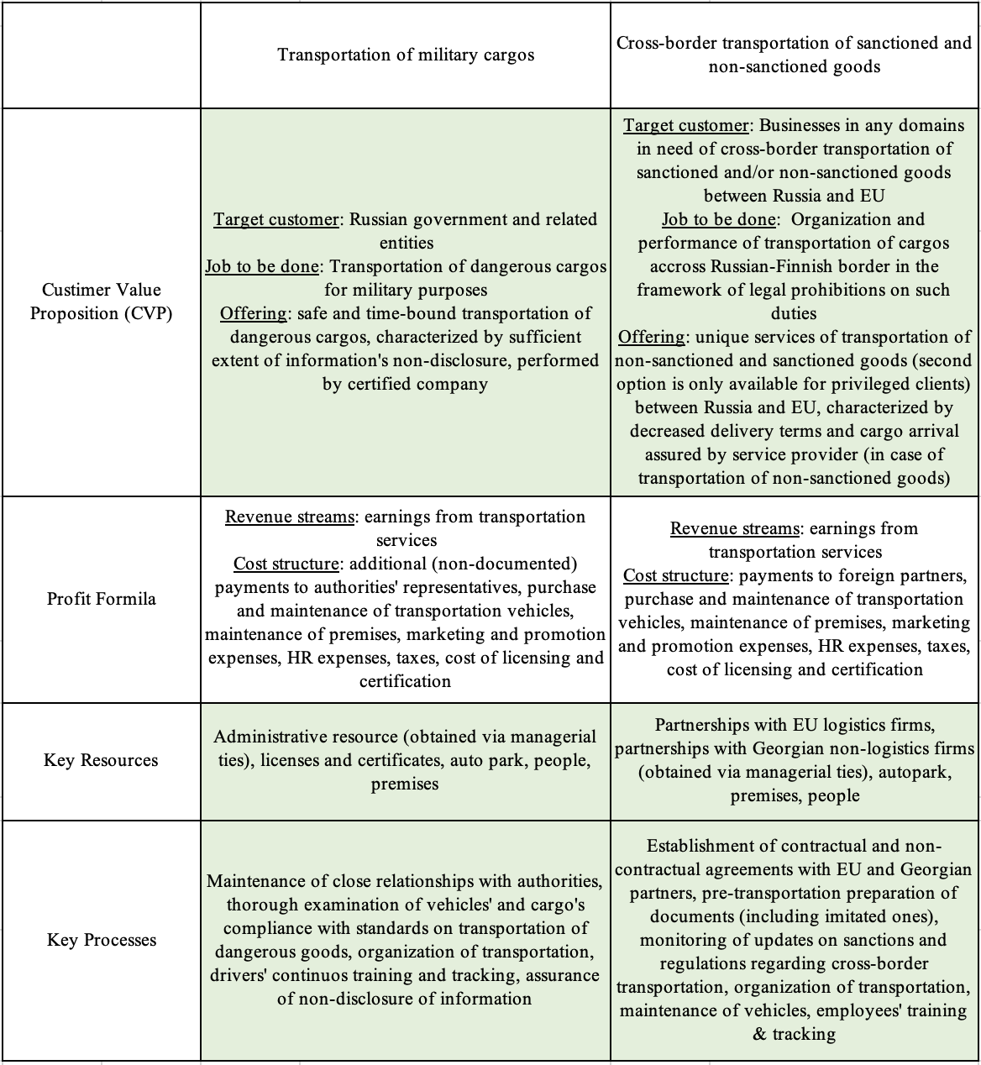

Indeed, as we can see from the table above, as the resulting BM changes implied substantial changes in XXX’s CVP, key resources, and key processes, the performed innovation can be characterized as BMI.

# Chapter 4. Discussion of obtained results

## 4.1 Factors affecting choice of BMI scenario

At this point, based on the previously performed case analysis, we will compare the initially developed model “Factors of choice of BMI strategy” (fig. 6) with results obtained by studying BMI performed by XXX. The model with highlighted factors, which obtained notable effect on the process of decision-making regarding XXX’s BMI strategies, is displayed below (fig. 10). The impact of each of those on the final choice of novel BM will be further discussed.

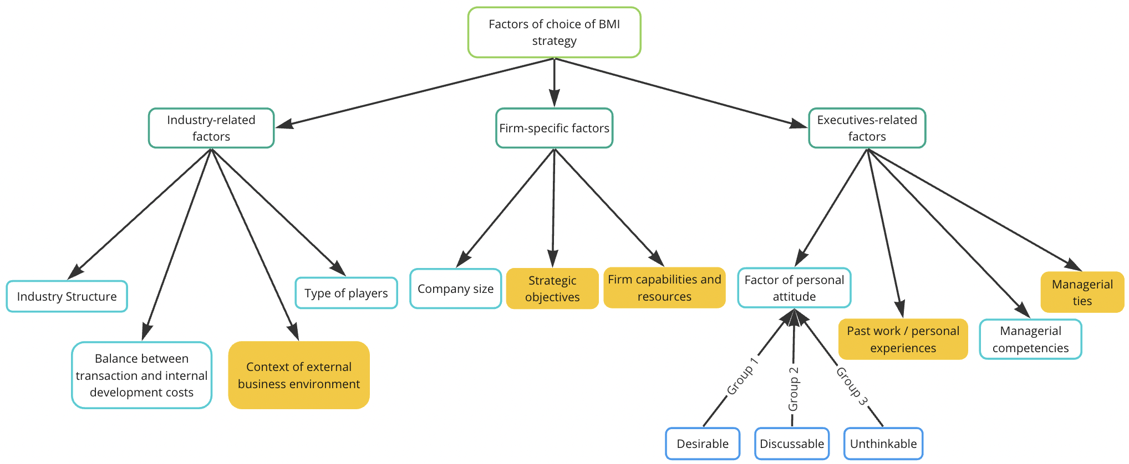

*Figure 10. Factors affecting choice of XXX’s BMI strategies.*

### 4.1.1 Context of external business environment

As we can see from the results of the case analysis, the context of emerged environmental uncertainty and turbulence obtained direct impact on decisions regarding selection of strategies. Starting from the rejected BMI path, resource led strategy was the only one that had been considered by XXX’s executives prior to the crisis, hence, was initially favoured due to the pre-crisis desire to implement such. However, among the scope of all scenarios, the resource led BMI was characterized by XXX’s representatives as “the most innovative” one due to the high degree of novelty of CVP, including target customer, job to be done, and offering, as well as previously untouched key processes and associated risks. Taking into account such features, resource led BMI was not selected due to the turbulence of business environment. The firm’s COO claimed that, although the strategy was initially perceived as an attractive option, in the context of environmental turbulence, the management team was not ready to deal with completely novel BMs, rather, they would prefer adhering to BMI paths that are somewhat similar to the pre-crisis BM in order to minimize the potential of existential risks.

It is noteworthy that the obtained results touching on the decreased degree of innovativeness of BMI strategies selected in presence of high environmental uncertainty, confirm evidence from the research on the topic of firm strategic decision-making in the context of economic crisis, performed by Laskovaia et al. (2018[117]).

*Proposition 1a. High environmental uncertainty leads to the choice of less innovative BMI strategies*

At the same time, although the context of environmental uncertainty led to rejection of the most innovative scenario, it pushed XXX towards selection of a more far-reaching solution. As it was previously mentioned, although XXX had been considering pursuit of resource led BMI prior to the crisis, the company planned for a much less complex and comprehensive innovation. Rather, it was expected to adopt a novel BM within a separately established branch dedicated with rather limited budget and resources in order to decrease the costs associated with performed BMI in case of its failure. in the “trial and error” mode so that it wouldn’t imply significant costs and risks in case of failure.

However, from the point when the conditions of external business environment disabled execution of pre-crisis BM and provoked existential risks for XXX, the company had no other way to survive than performing a large-scale and in-depth BMI, touching on the core of the business activities. As such, due to the emergence of existential risks, the company was pushed to choosing more costly and complex BMI strategy by conditions of external business environment. This finding supplements the results obtained by Amit and Zott (2010[118]), who proposed that the context of economic crisis increases the willingness to bear costs associated with BMI due to the emergence of existential risks in case of neglecting BMI as such.

*Proposition 1b. High environmental uncertainty leads to the choice of more complex and costly BMI strategies*

### 4.1.2 Firm’s strategic objectives and executives’ past personal experiences

Although firm’s strategic capabilities and executives’ past personal experiences are naturally perceived as unrelated to each other factors, in case of XXX’s BMI we could clearly observe a conflict between their impacts on the choice of BMI strategy.

Considering customer led BMI, as it was uncovered during the interviews, XXX’s CEO was strongly opposed to implementation of this strategy due to its military nature. As XXX’s CEO obtains personal background related to surviving armed conflicts and was negatively predisposed towards being somehow related to the ongoing Russian-Ukrainian conflict, he had a strong negative predisposition towards customer led BMI.

However, taking into account rejection of resource led BMI, short-term orientation of partnership led BMI, and insignificance of demand for other services offered by the company, in case of rejection of customer led BMI, XXX was not capable of accomplishing its BMI-related objectives, which implied obtaining a long-term oriented solution that would ensure company’s stable position in the market.

Hence, as customer led BMI was finally approved in spite of CEO’s opposing concerns, which were provoked by corresponding personal past experience, we can can claim that, in case of XXX, BMI scenario’s long-term orientation, which was aligned with XXX’s general strategic objectives, overcame the impact of executive’s personal past experience on the choice of final BMI strategy.

Additionally, as long as comparing impacts of strategic objectives and executive’s personal background on the choice of BMI strategies, it is crucial to take into account specifics of business environment as, in case of not meeting its strategic objectives, XXX faced existential risks due to the turbulence of conditions. It is possible to hypothesize that, in case of absence of such a major threat, the forces between two factors would have been distributed differently. However, we cannot claim for such due to the absence of the evidence in the analysed case.

*Proposition 2. In the context of presence of existential risks, strategic goals obtain a stronger impact on the choice of BMI strategies than executives’ past personal experiences*

### 4.1.3 Managerial ties

Starting from the impact of managerial ties on the choice of BMI scenarios, referring to the peculiarities of assessment and implementation of customer led BMI, it was evident that the strongest arguments in favour of its selection were directly linked to the presence of managerial ties, which were developed by XXX’s executives prior to the emergence of crisis conditions. The firm executives’ managerial ties with the country’s authorities enabled the company to get an access to the required organizational resources. Particularly, they permitted XXX to ensure granted access to service contracts with state’s representatives, which was unlikely to be obtained otherwise due to the fraudulent nature of the B2G sector in Russia. The ability of obtaining such resource ensured the strategy’s long-term nature and profitability, hence, formed its attractiveness in the eyes of decision-makers.

Moreover, addressing partnership led strategy, particularly, its part related to import of sanctioned goods, managerial ties of executives with Georgian business owners enabled XXX to gather strategic partnerships with those. The presence of such a resource significantly eased implementation of partnership led BMI, hence, made the strategy seem more attractive and obtained corresponding effect on decision-making process. This evidence supports our argument regarding the impact of managerial ties on the choice of BMI strategies via simplification of access to organizational resources.

The observation supplements the findings of Alcalde-Heras et al. (2018[119]), claiming that the capability of managers to cooperate with external parties as long as searching for novel resources drives SMEs’ ambidexterity and obtains corresponding impact on BMI.

*Proposition 3. Managerial ties positively affect selection of related BMI strategies by easing access to required organizational resources*

### 

### 4.1.4 Firm capabilities and resources

Moving onto firm capabilities and resources, we were able to track the impact of presence of pre-crisis international business connections, which are classified as XXX’s organizational resource, on the choice of the corresponding BMI strategy (partnership led). It is worth consideration that, in case of partnership led BMI, pre-crisis relationships with EU firms are classified as a resource rather than managerial ties due to the fact that these interrelations were based on cooperation between businesses and obtained corresponding impact on business-related activities. In contrast, as it was mentioned in the first chapter, managerial ties are not utilized for the purpose of performing business related activities or achieving benefits for business itself, rather, they serve the executives’ personal advantage.

Referring to the case analysis, prior to the crisis, XXX was serving European logistics firms, some of which used to be the company’s long-term and trusted clients. As such, after the emergence of crisis, those foreign clients could have been easily transformed into XXX’s partners, which performed a role of the key argument as long as assessing partnership led BMI. In case of absence of those pre-crisis interrelations with EU logistics firms, the strategy implementation would have been either much less efficient or impossible at all. Hence, we can clearly observe that the availability of primary organizational resources (i.e., pre-crisis business ties with EU companies) affected the decision regarding partnership led BMI by making it more favourable.

*Proposition 4. Presence of B2B interrelations developed prior to BMI favours selection of partnership led BMI strategy by leveraging associated efficiency*

## 4.2 Contribution to previous studies

***Theoretical contribution***

The performed research contributes to prior studies on the topic of BMI in a number of ways.

First of all, having reviewed the literature touching on BMI drivers, a comprehensive model of BMI objectives and drivers (fig. 3), summarizing and structuring previous findings on the topic as well as supplementing those by new components, was developed.

Secondly, the strategies of Business Model Innovation the latest available classification of BMI strategies, proposed by Wrigley and Straker (2016[120]), was enhanced by supplementing it with CSR driven BMI.

Further on, an exhaustive model, summarizing factors affecting choice of BMI strategies, was developed and tested on XXX’s case. Among the listed factors, the context of external business environment, company’s strategic objectives, firm capabilities and resources, executives’ past personal experiences, and managerial ties were observed to obtain direct impact on the selection of BMI strategies in the performed case study.

Moreover, the effect that each of the listed factors obtained on the choice of BMI strategies in case of XXX was distinguished. Based on that, the following propositions were developed:

1. High environmental uncertainty leads to the choice of more comprehensive BMI strategies
2. High environmental uncertainty leads to the choice of less innovative BMI strategies
3. In the context of presence of existential risks, strategic goals obtain a stronger impact on the choice of BMI strategies than executives’ past personal experiences
4. Managerial ties positively affect selection of related BMI strategies by easing access to required organizational resources
5. Presence of B2B interrelations developed prior to BMI favours selection of partnership led BMI strategy by leveraging associated efficiency

***Managerial implications***

As for the practical contributions associated with the performed research, first of all, the paper enhances the classification of BMI strategies, hence, provides practitioners with a broader scope of possible BMI solutions, which can be considered at the “ideation” step of BMI, thus, as long as developing the scope of potential BMI solutions

Secondly, the paper presents professionals in the domain of management with a comprehensive model of factors, which can be considered as long as developing criteria of assessment of BMI scenarios from the considered scope. As such, practitioners are provided with guidance over the perspectives to be taken into account when choosing between BMI scenarios, hence, are less likely to misinterpret the possibilities and risks associated with particular strategies.

Finally, the research provides clear evidence of the significance of well-developed managerial ties and international partnerships for overcoming environmental turbulence and uncertainty by implementing associated BMI scenarios. As such, it may be expected that, owing to the represented research results, practitioners' motivation for contribution to international collaboration and development of managerial ties will increase.

## 4.3 Limitations of the research

The performed research is characterized by several limitations, which could have affected the analysis as well as associated findings.

The first limitation is related to the peculiarities of the performed sires of interviews with the company’s representatives. First of all, as all interviews were conducted after completion of the BMI-associated processes, we were not capable to capture all aspects that obtained impact on decision-making as well as could not track the group dynamics of decision performers. Additionally, as the interviews were conducted solely with representatives of XXX’s management team, the observations of linear employees were not considered, which decreased the scope of input data for performing further analysis.

The second limitation is associated with the research object. As the study implied investigation of a single case study, the obtained data and corresponding findings might be biased due to individual specifics of XXX’s case. In order to obtain more reliable insights on the aspects that shape the choice of BMI strategies as well as the peculiarities of those effects on the decision-making process, the proposed model as well as resulting propositions have to be tested on the cases of firms pursuing BMI.

Finally, due to the qualitative design of the research, the third limitation is captured in the inability to perform statistical generalization of the findings. The only way to reapply the obtained results on other cases is to perform theoretical generalization, appropriateness of which is rather limited and is highly dependent on the similarity of the observed cases.

## 4.4 Further research directions

The performed research outlines a number of novel research directions on the topic of BMI.

First of all, the proposed model summarizing Factors of choice of BMI strategy can be challenged in various aspects by applying it to other cases of firms undergoing BMI. We assume that, as long as performing broader analysis of the topic, the model is likely to be either supplemented by additional groups of factors and/or factors or restructured differently.

Next, each of the represented propositions can be debated. It is considered that, in order to challenge those, it would be reasonable to perform quantitative analyses by testing each proposition on representative samples of firms in different domains.

Moreover, as the performed research did not succeed in representing the role of industry-related factors in the choice of BMI strategies, separate research in that field would be essential in order to either confirm or disprove significance of their effects on the choice of BMI scenarios.

Additionally, as the majority of factors from the model were not discussed from the standard point of their precise impact on the assessment of and final decisions regarding each type of BMI strategies (i.e., partnership led, cost driven, customer led, resource led, CSR driven), further research in this direction could uncover other drivers of decisions on the choice of BMI paths.

Finally, as it was uncovered that the context of environmental turbulence does affect the resulting BMI strategies, it would be interesting perform a similar study on the case of a firm operating in the context of a less hazardous external business environment in order to reveal the peculiarities of such conditions on the process and results of the BMI.

# 

# Conclusion

Business Model Innovation is a complex process performed by companies operating in different contexts and characterized by correspondingly different objectives. It also represents one of the innovation-related solutions for firms trying to cope with turbulence and uncertainty of business environment.

As long as pursuing such an innovation, businesses face a number of novel challenges as well as subsequent necessity to adapt from multiple perspectives. At the same time, the topic of BMI has not been comprehensively studied by researchers yet, which provides practitioners with a rather limited base of knowledge for addressing. Particularly, referring to the goal of this research, very little information on factors affecting selection of BMI strategy was available. Moreover, no attempts to identify precise effects of certain factors on characteristics of correspondingly selected BMI strategies were made. At the same time, due to the complexity of the process of BMI as well as wide range of contexts associated with its implementation, it is difficult to identify the entire scope of factors shaping choice of strategy as well as categorize those.

As a result of the conducted inductive study, a comprehensive model summarizing factors of choice of BMI strategy was developed. The proposed model proposes the following groups of factors: industry-related, firm-specific, and executives’ related. The performed study clearly demonstrates the contingence of choice of BMI strategy on firm-specific and executives-specific groups of factors. As for industry-related factors, more research on the topic is needed to uncover their effects on prioritization of BMI scenarios.

The obtained findings resulted in propositions regarding the effects of such factors as environmental uncertainty, firm’s strategic objectives, executives’ past personal experiences, managerial ties, and firm’s resources on the characteristics of the chosen BMI strategies. Particularly, it was uncovered that environmental uncertainty leads to selection of less innovative and more costly and complex strategies, firm’s strategic objectives obtain greater effect on the BMI strategy choice than executives’ past personal experiences, managerial ties obtain positive effect on selection of related strategies by easing access to novel resources, and availability of resources in the form of partnerships leads to probable selection of related BMI strategy.

The evidence from the performed research outline a novel stream of theoretical examination of BMI. The developed model and propositions provide researchers in the field with multiple opportunities for testing and supplementing obtained results and by reapplying those onto different cases.

# References

World Bank. (2022, October 4). Russian invasion of Ukraine impedes post-pandemic economic recovery in emerging Europe and Central Asia [Press release]. Retrieved from <https://www.worldbank.org/en/news/press-release/2022/10/04/russian-invasion-of-ukraine-impedes-post-pandemic-economic-recovery-in-emerging-europe-and-central-asia>

Biryukov, A. (2022, March 15). The Russian economy after the start of the special operation: consequences and solutions. Forbes. <https://www.forbes.ru/biznes/458959-rossijskaa-ekonomika-posle-nacala-specoperacii-posledstvia-i-resenia>

RBC. (2023, February 24). Mass inspections of organizations for the presence of foreign capital began in Russia. RBC. <https://www.rbc.ru/economics/24/02/2023/63f204ec9a794789ef65aeac>

TASS. (2022, November 1). 10 EU sanction packages. TASS. <https://tass.ru/ekonomika/17142747/amp>

Hartley, J. (2006), Innovation and its contribution to improvement: A review for policymakers, policy advisers, managers and researchers, London, UK. Retrieved from <https://www.scie-socialcareonline.org.uk/innovation-and-its-contribution-to-improvement-a-review-for-policy-makers-policy-advisers-managers-and-researchers/r/a11G00000017ytdIAA>

Sinfield et al., How to Identify New Business Models. MIT Sloan School of Management (2012). Retrieved from <https://radio.shabanali.com/how-to-identify-new-business-models-MIT.pdf>

Foss, N. J., & Saebi, T. (2017). Fifteen Years of Research on Business Model Innovation: How Far Have We Come, and Where Should We Go? Journal of Management, 43(1), 200–227. <https://doi.org/10.1177/0149206316675927>

Osterwalder, A., Pigneur, Y., & Tucci, C. (2005). Clarifying Business Models: Origins, Present, and Future of the Concept. Communications of the Association for Information Systems, 16, pp-pp. <https://doi.org/10.17705/1CAIS.01601>

Zott Christoph and Raphael Amit, “Business Model Design: An Activity System Perspective,” Long Range Planning, Special Issue on Business Models, 43/2-3, April/May 2010, pp. 216-226. Retrieved from <https://www.sciencedirect.com/science/article/abs/pii/S0024630109000533>

Chesbrough, Henry and Richard Rosenbloom, “The Role of the Business Model in Capturing Value from Innovation: Evidence from Xerox Corporation’s Technology Spinoff Companies,” Industrial and Corporate Change, 11/3 June 2002, pp. 533–534. Retrieved from <https://www.hbs.edu/ris/Publication%20Files/01-002_07351ae8-58be-44e5-a6d8-205cbf5b4424.pdf>

Amit, Raphael H. and Zott, Christoph, Business Model Innovation: Creating Value in Times of Change (July 2, 2010). IESE Business School Working Paper No. 870, Available at SSRN: <https://ssrn.com/abstract=1701660> or [http://dx.doi.org/10.2139/ssrn.1701660](https://dx.doi.org/10.2139/ssrn.1701660)

Osterwalder, A., & Pigneur, Y. (2004). Why business models matter. Long Range Planning, 43(2-3), 36-48. <https://www.researchgate.net/publication/11346909_Why_Business_Models_Matter>

Stelios Kavadias, Kostas Ladas, and Christoph Loch (2016, October). The transformative business model. Harvard Business Review. <https://hbr.org/2016/10/the-transformative-business-model>

Johnson, M.W., Christensen, C.M., & Kagermann, H. (2008, December). Reinventing your business model. Harvard Business Review. <https://hbr.org/2008/12/reinventing-your-business-model>

Business Model Innovation. (n.d.). BCG Global. <https://www.bcg.com/capabilities/innovation-strategy-delivery/business-model-innovation>

Teece, D. J. (2010). Business Models, Business Strategy and Innovation. Long Range Planning, 43(2–3), 172–194. <https://doi.org/10.1016/j.lrp.2009.07.003>

Frankenberger, K., Weiblen, T., Csik, M., & Gassmann, O. (2013). The 4I-framework of business model innovation: a structured view on process phases and challenges. International Journal of Product Development, 18(3/4), 249. <https://doi.org/10.1504/ijpd.2013.055012>

Wirtz, B. W., Schilke, O., & Ullrich, S. (2010b). Strategic Development of Business Models. Long Range Planning, 43(2–3), 272–290. <https://doi.org/10.1016/j.lrp.2010.01.005>

Mitchell, D. and Coles, C. (2003), "The ultimate competitive advantage of continuing business model innovation", Journal of Business Strategy, Vol. 24 No. 5, pp. 15-21. <https://doi.org/10.1108/02756660310504924>

Pisano, Paola, Pironti, Marco and Rieple, Alison. "Identify Innovative Business Models: Can Innovative Business Models Enable Players to React to Ongoing or Unpredictable Trends?" Entrepreneurship Research Journal, vol. 5, no. 3, 2015, pp. 181-199. <https://doi.org/10.1515/erj-2014-0032>

Chesbrough, H. (2010). Business Model Innovation: Opportunities and Barriers. Long Range Planning, 43(2–3), 354–363. <https://doi.org/10.1016/j.lrp.2009.07.010>

Wrigley, C., & Straker, K. (2016). Designing innovative business models with a framework that promotes experimentation. Sydney. <https://www.academia.edu/21334891/Designing_innovative_business_models_with_a_framework_that_promotes_experimentation>

Lin, P., Zhang, X., Yan, S., & Jiang, Q. (2020). Dynamic Capabilities and Business Model Innovation of Platform Enterprise: A Case Study of DiDi Taxi. Scientific Programming, 2020, 1–12. <https://doi.org/10.1155/2020/8841368>

Michelini, L., & Fiorentino, D. (2012). New business models for creating shared value. Social Responsibility Journal, 8(4), 561–577. <https://doi.org/10.1108/17471111211272129>

Breton-Miller, Isabelle Le & Miller, Danny, 2016. "[Family firms and practices of sustainability: A contingency view](https://ideas.repec.org/a/eee/fambus/v7y2016i1p26-33.html)," [Journal of Family Business Strategy](https://ideas.repec.org/s/eee/fambus.html), Elsevier, vol. 7(1), pages 26-33.

Alexander Osterwalder and Yves Pigneur, Business Model Generation: A Handbook for Visionaries, Game Changers, and Challengers. (2010, June 29). Wiley.com. <https://www.wiley.com/ensg/Business+Model+Generation:+A+Handbook+for+Visionaries,+Game+Changers,+and+Challengers-p-9780470876411>

Pateli, A.G. and Giaglis, G.M. (2005), "Technology innovation‐induced business model change: a contingency approach", Journal of Organizational Change Management, Vol. 18 No. 2, pp. 167-183. <https://doi.org/10.1108/09534810510589589>

Cooper, R. G. (1990). Stage-gate systems: A new tool for managing new products. Business Horizons, 33(3), 44–54. <https://doi.org/10.1016/0007-6813(90)90040-i>

Rothwell, R. (1994), "Towards the Fifth‐generation Innovation Process", International Marketing Review, Vol. 11 No. 1, pp. 7-31. <https://doi.org/10.1108/02651339410057491>

Van De Ven, A.H., Polley, D.E., Garud, R. and Venkataraman, S. (1999), The Innovation Journey, Oxford University Press. Retrieved from <https://www.semanticscholar.org/paper/The-innovation-journey-Ven-Polley/f0fff2b17cad88cbd7a6dae4f19768bc34e69446>

Cormican, K., & O’Sullivan, D. M. (2004). Auditing best practice for effective product innovation management. Technovation, 24(10), 819–829. <https://doi.org/10.1016/s0166-4972(03)00013-0>

Tidd, J., Bessant, J. and Pavitt, K. (2005), Managing innovation: integrating technological, market and organizational change 3rd ed., Wiley. Retrieved from <https://nibmehub.com/opac-service/pdf/read/Managing%20innovation%20_%20integrating%20technological.pdf>

Hansen, M. T. (2014, August 1). The Innovation Value Chain. Harvard Business Review. <https://hbr.org/2007/06/the-innovation-value-chain>

Li, F. and Whalley, J. (2002), “Deconstruction of the telecommunications industry: from value chain to value networks”, Telecommunications Policy, Vol. 26 Nos 9/10, pp. 451-483. Retrieved from <https://pureportal.strath.ac.uk/en/publications/deconstruction-of-the-telecommunications-industry-from-value-chai>

[Alcalde-Heras, H.](https://www.emerald.com/insight/search?q=Henar%20Alcalde-Heras), [Iturrioz-Landart, C.](https://www.emerald.com/insight/search?q=Cristina%20Iturrioz-Landart) and [Aragon-Amonarriz, C.](https://www.emerald.com/insight/search?q=Cristina%20Aragon-Amonarriz) (2019), "SME ambidexterity during economic recessions: the role of managerial external capabilities", [Management Decision](https://www.emerald.com/insight/publication/issn/0025-1747), Vol. 57 No. 1, pp. 21-40. <https://doi.org/10.1108/MD-03-2016-0170>

Armin Anzenbacher & Marcus Wagner, 2020. "[The role of exploration and exploitation for innovation success: effects of business models on organizational ambidexterity in the semiconductor industry](https://ideas.repec.org/a/spr/intemj/v16y2020i2d10.1007_s11365-019-00604-6.html)," [International Entrepreneurship and Management Journal](https://ideas.repec.org/s/spr/intemj.html), Springer, vol. 16(2), pages 571-594, June.

Casadesus-Masanell, R., & Ricart, J. E. (2010). From Strategy to Business Models and onto Tactics. Long Range Planning, 43(2–3), 195–215. <https://doi.org/10.1016/j.lrp.2010.01.004>

Doz, Y. L., & Kosonen, M. (2010). Embedding Strategic Agility. Long Range Planning, 43(2–3), 370–382. <https://doi.org/10.1016/j.lrp.2009.07.006>

[Heikkilä, M.](https://www.emerald.com/insight/search?q=Marikka%20Heikkil%C3%A4), [Bouwman, H.](https://www.emerald.com/insight/search?q=Harry%20Bouwman) and [Heikkilä, J.](https://www.emerald.com/insight/search?q=Jukka%20Heikkil%C3%A4) (2018), "From strategic goals to business model innovation paths: an exploratory study", [Journal of Small Business and Enterprise Development](https://www.emerald.com/insight/publication/issn/1462-6004), Vol. 25 No. 1, pp. 107-128. <https://doi.org/10.1108/JSBED-03-2017-0097>

DaSilva, C., & Trkman, P. (2014). Business Model: What it is and What it is Not. Long Range Planning, 47(6), 379–389. Retrieved from <http://boilingice.com/wordpress/wp-content/uploads/2020/01/BP-DaSilva-Trkman-Business-Model.pdf>

Kump, B., Englemann, A., Kessler, A., & Schweiger, C. (2019). Towards a Dynamic Capabilities Scale: Measuring organizational sensing, seizing, and transforming capacities. Industrial and Corporate Change, 28(5), 1149–1172. Retrieved from <https://www.researchgate.net/publication/327602283_Toward_a_dynamic_capabilities_scale_measuring_organizational_sensing_seizing_and_transforming_capacities>

Anne Heider, et al., (2018). Journal of Business Research, <https://doi.org/10.1016/j.jbusres.2020.04.051>

Dasí, Àngels & Iborra, María & Safón, Vicente, 2015. "[Beyond path dependence: Explorative orientation, slack resources, and managerial intentionality to internationalize in SMEs](https://ideas.repec.org/a/eee/iburev/v24y2015i1p77-88.html),"International Business Review, Elsevier, vol. 24(1), pages 77-88.

Gulati, Ranjay, and Nitin Nohria. ["Is Slack Good or Bad for Innovation?"](https://www.hbs.edu/faculty/Pages/item.aspx?num=30977) Academy of Management Journal 39, no. 5 (October 1996): 1245–1264. (A shorter version of this paper appeared in Academy of Management Best Papers Proceedings, 1995.)

Kim, S. J., & Kwon, I. (2017). On a Focusing-Balancing Dilemma in SMEs. In Academy of Management Proceedings (Vol. 2017, No. 1). Briarcliff Manor, NY 10510: Academy of Management.

Geletkanycz, M. A., & Hambrick, D. C. (1997). The External Ties of Top Executives: Implications for Strategic Choice and Performance. Administrative Science Quarterly, 42(4), 654–681. <https://doi.org/10.2307/2393653>

Gao, Y., Shu, C., Jiang, X., Gao, S., & Page, A. L. (2017). Managerial ties and product innovation: The moderating roles of macro- and micro-institutional environments. Long Range Planning, 50(2), 168–183. <https://doi.org/10.1016/j.lrp.2016.11.005>

Sosna, M., Trevinyo-Rodríguez, R. N., & Velamuri, S. R. (2010). Business Model Innovation through Trial-and-Error Learning. Long Range Planning, 43(2–3), 383–407. <https://doi.org/10.1016/j.lrp.2010.02.003>

Chowdhury P., Lau K. H., & Pittayachawan S. (2016). Supply risk mitigation of small and medium enterprises: A social capital approach. The proceedings of 21st international logistics symposium on logistics (pp. 37 - 44). Centre for Concurrent Enterprise, Nottingham University. Retrieved from <https://www.researchgate.net/publication/307474765_Supply_risk_mitigation_of_small_and_medium_enterprises_A_social_capital_approach>

Wang, D., Guo, H. and Liu, L. (2017), "One goal, two paths: How managerial ties impact business model innovation in a transition economy", Journal of Organizational Change Management, Vol. 30 No. 5, pp. 779-796. <https://doi.org/10.1108/JOCM-09-2016-0178>

Bashir, M., Alfalih, A. A., & Pradhan, S. (2023). Managerial ties, business model innovation & SME performance: Moderating role of environmental turbulence. Journal of Innovation & Knowledge, 8(1), 100329. <https://doi.org/10.1016/j.jik.2023.100329>

Blyler, M., & Coff, R. W. (2003). Dynamic capabilities, social capital, and rent appropriation: Ties that split pies. Strategic Management Journal,24(7), 677–686. Retrieved from <https://www.researchgate.net/publication/227616116_Dynamic_Capabilities_Social_Capital_and_Rent_Appropriation_Ties_That_Split_Pies>

Yin, R. K., (1994). Case Study Research Design and Methods: Applied Social Research and Methods Series. Second edn. Thousand Oaks, CA: Sage Publications Inc. Retrieved from <http://www.sciepub.com/reference/59519>

Gustafsson, J. (2017). Single case studies vs. multiple case studies: A comparative study. <https://www.semanticscholar.org/paper/Single-case-studies-vs.-multiple-case-studies%3A-A-Gustafsson/ae1f06652379a8cd56654096815dae801a59cba3>

UNECE. (2019). Recommendations on the transport of dangerous goods: Manual of tests and criteria (Rev.19). United Nations. <https://unece.org/DAM/trans/danger/publi/unrec/rev19/Rev19r_Vol_I.pdf>

TASS. (2022, March 1). Russians will have to pay for the war. Retrieved May 31, 2023, from <https://tass.ru/ekonomika/17142747>

BBC News. (2022, March 6). Visa and Mastercard suspend Russian operations. BBC News. <https://www.bbc.com/news/business-60637429>

Ministry of Justice of the Russian Federation. (2021). Resolution of the Government of the Russian Federation of February 12, 2021 No. 163 "On Approval of the Rules for State Registration of Transactions with Real Estate". Retrieved May 31, 2023, from <http://publication.pravo.gov.ru/Document/View/0001202210010004?index=0&rangeSize=1>

Kommersant. (2022, May 31). Gasoline prices in Russia have reached new highs. Retrieved May 31, 2023, from <https://www.kommersant.ru/doc/5667257>

RIA Novosti. (2022, December 26). Logistics: What to expect in 2023?. Retrieved May 31, 2023, from <https://ria.ru/20221226/logistika-1841292929.html>

Noble, P. J. (2022, May 12). The Ukraine-Russia War’s Impact On The Supply Chain: Why MRO Optimization Is A Top Priority. Forbes. <https://www.forbes.com/sites/paulnoble/2022/05/12/the-ukraine-russia-wars-impact-on-the-supply-chain-why-mro-optimization-is-a-top-priority/?sh=578f80af6d2e>

International Logistics in 2022: How Goods Are Imported into Russia Now. (n.d.). РБК Pro. <https://pro.rbc.ru/demo/62be96649a79475a7838f774>

Monopoly.ru. (n.d.). Business. Retrieved May 31, 2023, from <https://monopoly.ru/platform/business/>

Monopoly.ru. (n.d.). Retrieved May 31, 2023, from <https://monopoly.ru/>

RBC. (2022, December 15). Russia to extend the ban on entry of trucks from the EU until July 2023. Retrieved May 31, 2023, from <https://www.rbc.ru/business/15/12/2022/63998fa89a79474fddc66302>

Auto.ru. (n.d.). Sale of used Volvo FH tractors in St. Petersburg. Retrieved May 31, 2023, from <https://auto.ru/sankt-peterburg/artic/volvo/fh_tractor/used/?page=2>

Vedomosti. (2023, May 4). Possible ban by the EU on transit of goods. Retrieved May 31, 2023, from <https://www.vedomosti.ru/business/articles/2023/05/04/973697-vozmozhnii-zapret-es-na-tranzit-tovarov>

CNTD. (2022). Order of the Ministry of Transport of Russia of April 11, 2022 No. 127 "On Approval of the Rules of the Road". Retrieved May 31, 2023, from <https://docs.cntd.ru/document/468217166#:~:text>

CNTD. (n.d.). Document. Retrieved from <https://docs.cntd.ru/document/9046341>

Laskovaia, A., Marino, L., Shirokova, G., & Wales, W. J. (2019). Expect the unexpected: examining the shaping role of entrepreneurial orientation on causal and effectual decision-making logic during economic crisis. Entrepreneurship and Regional Development, 31(5–6), 456–475. <https://doi.org/10.1080/08985626.2018.1541593>

# 

# Appendixes

Appendix 1. Sample questions from series of unstructured interviews.

Part 1. Collection of general information about the company

1. When was the company founded?
2. How many employees do you have?
3. What departments are there in the company? What are their functions?
4. How many transportation vehicles do you own? What are they? How much did they cost?
5. How can you describe the industry where the company operates?
6. What are (and were) your main competitors?

Part 2. Assessment of pre-crisis BM

1. Which services were provided by the company prior to the beginning of Special Military Operation?
2. How were the company and proposed services different from other options in the market?
3. What were your target customer segments?
4. How did you reach your target customers? How was the brand awareness built among them?
5. What were the examples of your privileged clients and reasons for such a status?
6. What peculiarities were implied by “privileged” status of a client
7. What were your major resources?
8. Did you have any partners? If yes, please describe them.
9. What were your expenses represented by?
10. How did you earn profit?
11. What peculiarities of your services were favored by customers? Why?

Part 3. Assessment of emerged conditions of external business environment and their implications for the firm

1. Can you describe the events that disabled you to perform business activities in a regular form?
2. What sanction packages obtained the strongest impact on the firm?
3. How other firms in the market reacted to the emerged conditions?
4. What issues have you faced after the beginning of Russian-Ukrainian conflict?
5. Were there any ways other than BMI that you considered as a potential reaction to the emerged events?
6. What are the implications of the emerged events for European transportation companies?

Part 4. Details of the performed BMI and its outcomes

1. When did you realize the need for BMI?
2. Why was BMI necessary?
3. What scenarios did you consider? Please describe each of them.
4. What were the difficulties associated with each of the potential strategies?
5. What were the advantages of each of the strategies considered?
6. What strategies were finally selected?
7. What critical changes were undertaken to shift onto novel BM?
8. Were aby of the scenarios discussed prior to the crisis? Please elaborate on that.
9. Do you consider the performed BMI to be successful? Why?
10. Do you plan any further BMI-related actions?

Part 5. Details of the decision-making process

1. Please describe the process of decision-making on each of the BMI strategies.
2. Were there any oppositions between decision-makers as long as discussing BMI strategies?
3. What factors forced you to reject resource led BMI?
4. What factors forced you to approve customer led BMI?
5. What factors forced you to approve partnership led BMI?
6. What were the advantages and disadvantages of each of the strategies?
7. Are there any present risks associated with the implemented BMI paths?

1. World Bank. (2022, October 4). Russian invasion of Ukraine impedes post-pandemic economic recovery in emerging Europe and Central Asia [Press release]. Retrieved from <https://www.worldbank.org/en/news/press-release/2022/10/04/russian-invasion-of-ukraine-impedes-post-pandemic-economic-recovery-in-emerging-europe-and-central-asia>
2. Biryukov, A. (2022, March 15). The Russian economy after the start of the special operation: consequences and solutions. Forbes. <https://www.forbes.ru/biznes/458959-rossijskaa-ekonomika-posle-nacala-specoperacii-posledstvia-i-resenia>
3. RBC. (2023, February 24). Mass inspections of organizations for the presence of foreign capital began in Russia. RBC. <https://www.rbc.ru/economics/24/02/2023/63f204ec9a794789ef65aeac>
4. TASS. (2022, November 1). 10 пакетов санкций ЕС. TASS. <https://tass.ru/ekonomika/17142747/amp>
5. Hartley, J. (2006), Innovation and its contribution to improvement: A review for policymakers, policy advisers, managers andresearchers, London, UK. Retrieved from https://www.scie-socialcareonline.org.uk/innovation-and-its-contribution-to-improvement-a-review-for-policy-makers-policy-advisers-managers-and-researchers/r/a11G00000017ytdIAA
6. Sinfield et al., How to Identify New Business Models. MIT Sloan School of Management (2021). Retrieved from https://radio.shabanali.com/how-to-identify-new-business-models-MIT.pdf
7. Foss, N. J., & Saebi, T. (2017). Fifteen Years of Research on Business Model Innovation: How Far Have We Come, and Where Should We Go? *Journal of Management*, *43*(1), 200–227. <https://doi.org/10.1177/0149206316675927>
8. Osterwalder, A., Pigneur, Y., & Tucci, C. (2005). Clarifying Business Models: Origins, Present, and Future of the Concept. Communications of the Association for Information Systems, 16, pp-pp. <https://doi.org/10.17705/1CAIS.01601>
9. Zott, Christoph and Raphael Amit, “Business Model Design: An Activity System Perspective,” Long Range Planning, Special Issue on Business Models, 43/2-3, April/May 2010, pp. 216-226. Retrieved from https://www.sciencedirect.com/science/article/abs/pii/S0024630109000533
10. Chesbrough, Henry and Richard Rosenbloom, “The Role of the Business Model in Capturing Value from Innovation: Evidence from Xerox Corporation’s Technology Spinoff Companies,” Industrial and Corporate Change, 11/3 June 2002, pp. 533–534. Retrieved from https://www.hbs.edu/ris/Publication%20Files/01-002_07351ae8-58be-44e5-a6d8-205cbf5b4424.pdf
11. Amit, Raphael H. and Zott, Christoph, Business Model Innovation: Creating Value in Times of Change (July 2, 2010). IESE Business School Working Paper No. 870, Available at SSRN: <https://ssrn.com/abstract=1701660> or [http://dx.doi.org/10.2139/ssrn.1701660](https://dx.doi.org/10.2139/ssrn.1701660)
12. Osterwalder, A., & Pigneur, Y. (2004). Why business models matter. Long Range Planning, 43(2-3), 36-48. <https://www.researchgate.net/publication/11346909_Why_Business_Models_Matter>
13. Osterwalder, A., & Pigneur, Y. (2010). *Business model generation*. John Wiley & Sons. Retrieved from <https://citeseerx.ist.psu.edu/document?repid=rep1&type=pdf&doi=b32c224f2812629004fee7ec72d475213265023b>
14. Stelios Kavadias, Kostas Ladas, and Christoph Loch (2016, October). The transformative business model. Harvard Business Review. <https://hbr.org/2016/10/the-transformative-business-model>
15. Johnson, M.W., Christensen, C.M., & Kagermann, H. (2008, December). Reinventing your business model. Harvard Business Review. <https://hbr.org/2008/12/reinventing-your-business-model>
16. Frankenberger, K. (2013). *The 4I-framework of business model innovation: a structured view on process phases and challenges*. <https://www.semanticscholar.org/paper/The-4I-framework-of-business-model-innovation%3A-a-on-Frankenberger-Weiblen/ebfd30dc5008c9126fa894b4b754857b5c3bb9d6>
17. Foss, N. J., & Saebi, T. (2017). Fifteen Years of Research on Business Model Innovation. *Journal of Management*, *43*(1), 200–227. <https://doi.org/10.1177/0149206316675927>
18. *Business Model Innovation*. (n.d.). BCG Global. <https://www.bcg.com/capabilities/innovation-strategy-delivery/business-model-innovation>
19. Teece, D. J. (2010). Business Models, Business Strategy and Innovation. *Long Range Planning*, *43*(2–3), 172–194. <https://doi.org/10.1016/j.lrp.2009.07.003>
20. Frankenberger, K., Weiblen, T., Csik, M., & Gassmann, O. (2013). The 4I-framework of business model innovation: a structured view on process phases and challenges. *International Journal of Product Development*, *18*(3/4), 249. <https://doi.org/10.1504/ijpd.2013.055012>
21. Wirtz, B. W., Schilke, O., & Ullrich, S. (2010b). Strategic Development of Business Models. *Long Range Planning*, *43*(2–3), 272–290. <https://doi.org/10.1016/j.lrp.2010.01.005>
22. Johnson, M. W. (2020, October 22). *Reinventing Your Business Model*. Harvard Business Review. <https://hbr.org/2008/12/reinventing-your-business-model>
23. Mitchell, D. and Coles, C. (2003), "The ultimate competitive advantage of continuing business model innovation", Journal of Business Strategy, Vol. 24 No. 5, pp. 15-21. https://doi.org/10.1108/02756660310504924
24. Johnson, M. W. (2020b, October 22). *Reinventing Your Business Model*. Harvard Business Review. <https://hbr.org/2008/12/reinventing-your-business-model>
25. *Business Model Innovation*. (n.d.-b). BCG Global. <https://www.bcg.com/capabilities/innovation-strategy-delivery/business-model-innovation>
26. Pisano, Paola, Pironti, Marco and Rieple, Alison. "Identify Innovative Business Models: Can Innovative Business Models Enable Players to React to Ongoing or Unpredictable Trends?" *Entrepreneurship Research Journal*, vol. 5, no. 3, 2015, pp. 181-199. <https://doi.org/10.1515/erj-2014-0032>
27. Chesbrough, H. (2010). Business Model Innovation: Opportunities and Barriers. *Long Range Planning*, *43*(2–3), 354–363. <https://doi.org/10.1016/j.lrp.2009.07.010>
28. Wrigley, C., & Straker, K. (2016). Designing innovative business models with a framework that promotes experimentation. *Sydney*. <https://www.academia.edu/21334891/Designing_innovative_business_models_with_a_framework_that_promotes_experimentation>
29. Lin, P., Zhang, X., Yan, S., & Jiang, Q. (2020). Dynamic Capabilities and Business Model Innovation of Platform Enterprise: A Case Study of DiDi Taxi. *Scientific Programming*, *2020*, 1–12. <https://doi.org/10.1155/2020/8841368>
30. Amit, Raphael H. and Zott, Christoph, Business Model Innovation: Creating Value in Times of Change (July 2, 2010). IESE Business School Working Paper No. 870, Available at SSRN: <https://ssrn.com/abstract=1701660> or [http://dx.doi.org/10.2139/ssrn.1701660](https://dx.doi.org/10.2139/ssrn.1701660)
31. Wrigley, C., & Straker, K. (2016b). Designing innovative business models with a framework that promotes experimentation. *Sydney*. <https://www.academia.edu/21334891/Designing_innovative_business_models_with_a_framework_that_promotes_experimentation>
32. Michelini, L., & Fiorentino, D. (2012). New business models for creating shared value. *Social Responsibility Journal*, *8*(4), 561–577. <https://doi.org/10.1108/17471111211272129>
33. Breton-Miller, Isabelle Le & Miller, Danny, 2016. "[Family firms and practices of sustainability: A contingency view](https://ideas.repec.org/a/eee/fambus/v7y2016i1p26-33.html)," [Journal of Family Business Strategy](https://ideas.repec.org/s/eee/fambus.html), Elsevier, vol. 7(1), pages 26-33.
34. Pisano Paola & Pironti Marco & Rieple Alison, 2015. "[Identify Innovative Business Models: Can Innovative Business Models Enable Players to React to Ongoing or Unpredictable Trends?](https://ideas.repec.org/a/bpj/erjour/v5y2015i3p181-199n1.html),"[Entrepreneurship Research Journal](https://ideas.repec.org/s/bpj/erjour.html), De Gruyter, vol. 5(3), pages 181-199, July.
35. Alexander Osterwalder and Yves Pigneur, *Business Model Generation: A Handbook for Visionaries, Game Changers, and Challengers*. (2010, June 29). Wiley.com. <https://www.wiley.com/en-sg/Business+Model+Generation:+A+Handbook+for+Visionaries,+Game+Changers,+and+Challengers-p-9780470876411>
36. [Wrigley, C.](https://www.emerald.com/insight/search?q=Cara%20Wrigley) and [Straker, K.](https://www.emerald.com/insight/search?q=Karla%20Straker) (2016), "Designing innovative business models with a framework that promotes experimentation", [*Strategy & Leadership*](https://www.emerald.com/insight/publication/issn/1087-8572), Vol. 44 No. 1, pp. 11-19. <https://doi.org/10.1108/SL-06-2015-0048>
37. [Wrigley, C.](https://www.emerald.com/insight/search?q=Cara%20Wrigley) and [Straker, K.](https://www.emerald.com/insight/search?q=Karla%20Straker) (2016), "Designing innovative business models with a framework that promotes experimentation", [*Strategy & Leadership*](https://www.emerald.com/insight/publication/issn/1087-8572), Vol. 44 No. 1, pp. 11-19. <https://doi.org/10.1108/SL-06-2015-0048>
38. [Wrigley, C.](https://www.emerald.com/insight/search?q=Cara%20Wrigley) and [Straker, K.](https://www.emerald.com/insight/search?q=Karla%20Straker) (2016), "Designing innovative business models with a framework that promotes experimentation", [*Strategy & Leadership*](https://www.emerald.com/insight/publication/issn/1087-8572), Vol. 44 No. 1, pp. 11-19. <https://doi.org/10.1108/SL-06-2015-0048>
39. Chesbrough, H. (2010b). Business Model Innovation: Opportunities and Barriers. *Long Range Planning*, *43*(2–3), 354–363. <https://doi.org/10.1016/j.lrp.2009.07.010>
40. [Pateli, A.G.](https://www.emerald.com/insight/search?q=Adamantia%20G.%20Pateli) and [Giaglis, G.M.](https://www.emerald.com/insight/search?q=George%20M.%20Giaglis) (2005), "Technology innovation‐induced business model change: a contingency approach", [*Journal of Organizational Change Management*](https://www.emerald.com/insight/publication/issn/0953-4814), Vol. 18 No. 2, pp. 167-183. <https://doi.org/10.1108/09534810510589589>
41. [Pateli, A.G.](https://www.emerald.com/insight/search?q=Adamantia%20G.%20Pateli) and [Giaglis, G.M.](https://www.emerald.com/insight/search?q=George%20M.%20Giaglis) (2005), "Technology innovation‐induced business model change: a contingency approach", [*Journal of Organizational Change Management*](https://www.emerald.com/insight/publication/issn/0953-4814), Vol. 18 No. 2, pp. 167-183. <https://doi.org/10.1108/09534810510589589>
42. Frankenberger, K., Weiblen, T., Csik, M., & Gassmann, O. (2013b). The 4I-framework of business model innovation: a structured view on process phases and challenges. *International Journal of Product Development*, *18*(3/4), 249. <https://doi.org/10.1504/ijpd.2013.055012>
43. Cooper, R. G. (1990). Stage-gate systems: A new tool for managing new products. *Business Horizons*, *33*(3), 44–54. <https://doi.org/10.1016/0007-6813(90)90040-i>
44. [Rothwell, R.](https://www.emerald.com/insight/search?q=Roy%20Rothwell) (1994), "Towards the Fifth‐generation Innovation Process", [*International Marketing Review*](https://www.emerald.com/insight/publication/issn/0265-1335), Vol. 11 No. 1, pp. 7-31. <https://doi.org/10.1108/02651339410057491>
45. Van De Ven, A.H., Polley, D.E., Garud, R. and Venkataraman, S. (1999), The Innovation Journey, Oxford University Press. Retrieved from <https://www.semanticscholar.org/paper/The-innovation-journey-Ven-Polley/f0fff2b17cad88cbd7a6dae4f19768bc34e69446>
46. Cormican, K., & O’Sullivan, D. M. (2004). Auditing best practice for effective product innovation management. *Technovation*, *24*(10), 819–829. <https://doi.org/10.1016/s0166-4972(03)00013-0>
47. Tidd, J., Bessant, J. and Pavitt, K. (2005), Managing innovation: integrating technological, market and organizational change 3rd ed., Wiley. Retrieved from <https://nibmehub.com/opac-service/pdf/read/Managing%20innovation%20_%20integrating%20technological.pdf>
48. Hansen, M. T. (2014, August 1). *The Innovation Value Chain*. Harvard Business Review. <https://hbr.org/2007/06/the-innovation-value-chain>
49. Sinfield et al., How to Identify New Business Models. MIT Sloan School of Management (2012). Retrieved from <https://radio.shabanali.com/how-to-identify-new-business-models-MIT.pdf>
50. Sinfield et al., How to Identify New Business Models. MIT Sloan School of Management (2012). Retrieved from <https://radio.shabanali.com/how-to-identify-new-business-models-MIT.pdf>
51. [Pateli, A.G.](https://www.emerald.com/insight/search?q=Adamantia%20G.%20Pateli) and [Giaglis, G.M.](https://www.emerald.com/insight/search?q=George%20M.%20Giaglis) (2005), "Technology innovation‐induced business model change: a contingency approach", [*Journal of Organizational Change Management*](https://www.emerald.com/insight/publication/issn/0953-4814), Vol. 18 No. 2, pp. 167-183. <https://doi.org/10.1108/09534810510589589>
52. Li, F. and Whalley, J. (2002), “Deconstruction of the telecommunications industry: from value chain to value networks”, *Telecommunications Policy*, Vol. 26 Nos 9/10, pp. 451-483. Retrieved from https://pureportal.strath.ac.uk/en/publications/deconstruction-of-the-telecommunications-industry-from-value-chai
53. [Pateli, A.G.](https://www.emerald.com/insight/search?q=Adamantia%20G.%20Pateli) and [Giaglis, G.M.](https://www.emerald.com/insight/search?q=George%20M.%20Giaglis) (2005), "Technology innovation‐induced business model change: a contingency approach", [*Journal of Organizational Change Management*](https://www.emerald.com/insight/publication/issn/0953-4814), Vol. 18 No. 2, pp. 167-183. <https://doi.org/10.1108/09534810510589589>
54. Sinfield et al., How to Identify New Business Models. MIT Sloan School of Management (2012). Retrieved from <https://radio.shabanali.com/how-to-identify-new-business-models-MIT.pdf>
55. Johnson, M. W. (2020c, October 22). *Reinventing Your Business Model*. Harvard Business Review. <https://hbr.org/2008/12/reinventing-your-business-model>
56. Anne Heider, et al. (2018), Journal of Business Research, <https://doi.org/10.10>16/ j.jbusres.2020.04.051
57. [Alcalde-Heras, H.](https://www.emerald.com/insight/search?q=Henar%20Alcalde-Heras), [Iturrioz-Landart, C.](https://www.emerald.com/insight/search?q=Cristina%20Iturrioz-Landart) and [Aragon-Amonarriz, C.](https://www.emerald.com/insight/search?q=Cristina%20Aragon-Amonarriz) (2019), "SME ambidexterity during economic recessions: the role of managerial external capabilities", [*Management Decision*](https://www.emerald.com/insight/publication/issn/0025-1747), Vol. 57 No. 1, pp. 21-40. <https://doi.org/10.1108/MD-03-2016-0170>
58. Armin Anzenbacher & Marcus Wagner, 2020. "[The role of exploration and exploitation for innovation success: effects of business models on organizational ambidexterity in the semiconductor industry](https://ideas.repec.org/a/spr/intemj/v16y2020i2d10.1007_s11365-019-00604-6.html)," [International Entrepreneurship and Management Journal](https://ideas.repec.org/s/spr/intemj.html), Springer, vol. 16(2), pages 571-594, June.
59. Casadesus-Masanell, R., & Ricart, J. E. (2010). From Strategy to Business Models and onto Tactics. *Long Range Planning*, *43*(2–3), 195–215. <https://doi.org/10.1016/j.lrp.2010.01.004>
60. Doz, Y. L., & Kosonen, M. (2010). Embedding Strategic Agility. *Long Range Planning*, *43*(2–3), 370–382. <https://doi.org/10.1016/j.lrp.2009.07.006>
61. [Heikkilä, M.](https://www.emerald.com/insight/search?q=Marikka%20Heikkil%C3%A4), [Bouwman, H.](https://www.emerald.com/insight/search?q=Harry%20Bouwman) and [Heikkilä, J.](https://www.emerald.com/insight/search?q=Jukka%20Heikkil%C3%A4) (2018), "From strategic goals to business model innovation paths: an exploratory study", [*Journal of Small Business and Enterprise Development*](https://www.emerald.com/insight/publication/issn/1462-6004), Vol. 25 No. 1, pp. 107-128. <https://doi.org/10.1108/JSBED-03-2017-0097>
62. [Heikkilä, M.](https://www.emerald.com/insight/search?q=Marikka%20Heikkil%C3%A4), [Bouwman, H.](https://www.emerald.com/insight/search?q=Harry%20Bouwman) and [Heikkilä, J.](https://www.emerald.com/insight/search?q=Jukka%20Heikkil%C3%A4) (2018), "From strategic goals to business model innovation paths: an exploratory study", [*Journal of Small Business and Enterprise Development*](https://www.emerald.com/insight/publication/issn/1462-6004), Vol. 25 No. 1, pp. 107-128. <https://doi.org/10.1108/JSBED-03-2017-0097>
63. Alexander Osterwalder and Yves Pigneur, *Business Model Generation: A Handbook for Visionaries, Game Changers, and Challengers*. (2010, June 29). Wiley.com. <https://www.wiley.com/en-sg/Business+Model+Generation:+A+Handbook+for+Visionaries,+Game+Changers,+and+Challengers-p-9780470876411>
64. Alexander Osterwalder and Yves Pigneur, *Business Model Generation: A Handbook for Visionaries, Game Changers, and Challengers*. (2010, June 29). Wiley.com. <https://www.wiley.com/en-sg/Business+Model+Generation:+A+Handbook+for+Visionaries,+Game+Changers,+and+Challengers-p-9780470876411>
65. DaSilva, C., & Trkman, P. (2014). Business Model: What it is and What it is Not. Long Range Planning, 47(6), 379–389. Retrieved from http://boilingice.com/wordpress/wp-content/uploads/2020/01/BP-DaSilva-Trkman-Business-Model.pdf
66. Kump, B., Englemann, A., Kessler, A., & Schweiger, C. (2019). Towards a Dynamic Capabilities Scale: Measuring organizational sensing, seizing, and transforming capacities. Industrial and Corporate Change, 28(5), 1149–1172. Retrieved from https://www.researchgate.net/publication/327602283_Toward_a_dynamic_capabilities_scale_measuring_organizational_sensing_seizing_and_transforming_capacities
67. Anne Heider, et al., Journal of Business Research, https://doi.org/10.1016/j.jbusres.2020.04.051
68. Dasí, Àngels & Iborra, María & Safón, Vicente, 2015. "[Beyond path dependence: Explorative orientation, slack resources, and managerial intentionality to internationalize in SMEs](https://ideas.repec.org/a/eee/iburev/v24y2015i1p77-88.html),"[International Business Review](https://ideas.repec.org/s/eee/iburev.html), Elsevier, vol. 24(1), pages 77-88.
69. Gulati, Ranjay, and Nitin Nohria. ["Is Slack Good or Bad for Innovation?"](https://www.hbs.edu/faculty/Pages/item.aspx?num=30977) Academy of Management Journal 39, no. 5 (October 1996): 1245–1264. (A shorter version of this paper appeared in Academy of Management Best Papers Proceedings, 1995.)
70. Kim, S. J., & Kwon, I. (2017). On a Focusing-Balancing Dilemma in SMEs. In Academy of Management Proceedings (Vol. 2017, No. 1). Briarcliff Manor, NY 10510: Academy of Management.
71. Geletkanycz, M. A., & Hambrick, D. C. (1997). The External Ties of Top Executives: Implications for Strategic Choice and Performance. *Administrative Science Quarterly*, *42*(4), 654–681. <https://doi.org/10.2307/2393653>
72. Gao, Y., Shu, C., Jiang, X., Gao, S., & Page, A. L. (2017). Managerial ties and product innovation: The moderating roles of macro- and micro-institutional environments. *Long Range Planning*, *50*(2), 168–183. <https://doi.org/10.1016/j.lrp.2016.11.005>
73. Sosna, M., Trevinyo-Rodríguez, R. N., & Velamuri, S. R. (2010). Business Model Innovation through Trial-and-Error Learning. *Long Range Planning*, *43*(2–3), 383–407. <https://doi.org/10.1016/j.lrp.2010.02.003>
74. Chowdhury P., Lau K. H., & Pittayachawan S. (2016). Supply risk mitigation of small and medium enterprises: A social capital approach. The proceedings of 21st international logistics symposium on logistics (pp. 37 - 44). Centre for Concurrent Enterprise, Nottingham University. Retrieved from https://www.researchgate.net/publication/307474765_Supply_risk_mitigation_of_small_and_medium_enterprises_A_social_capital_approach
75. [Wang, D.](https://www.emerald.com/insight/search?q=Donghan%20Wang), [Guo, H.](https://www.emerald.com/insight/search?q=Hai%20Guo) and [Liu, L.](https://www.emerald.com/insight/search?q=Lu%20Liu) (2017), "One goal, two paths: How managerial ties impact business model innovation in a transition economy", [*Journal of Organizational Change Management*](https://www.emerald.com/insight/publication/issn/0953-4814), Vol. 30 No. 5, pp. 779-796. <https://doi.org/10.1108/JOCM-09-2016-0178>
76. Bashir, M., Alfalih, A. A., & Pradhan, S. (2023). Managerial ties, business model innovation & SME performance: Moderating role of environmental turbulence. *Journal of Innovation & Knowledge*, *8*(1), 100329. <https://doi.org/10.1016/j.jik.2023.100329>
77. Blyler, M., & Coff, R. W. (2003). Dynamic capabilities, social capital, and rent appropriation: Ties that split pies. Strategic Management Journal,24(7), 677–686. Retrieved from https://www.researchgate.net/publication/227616116_Dynamic_Capabilities_Social_Capital_and_Rent_Appropriation_Ties_That_Split_Pies
78. Bashir, M., Alfalih, A. A., & Pradhan, S. (2023). Managerial ties, business model innovation & SME performance: Moderating role of environmental turbulence. *Journal of Innovation & Knowledge*, *8*(1), 100329. <https://doi.org/10.1016/j.jik.2023.100329>
79. [Alcalde-Heras, H.](https://www.emerald.com/insight/search?q=Henar%20Alcalde-Heras), [Iturrioz-Landart, C.](https://www.emerald.com/insight/search?q=Cristina%20Iturrioz-Landart) and [Aragon-Amonarriz, C.](https://www.emerald.com/insight/search?q=Cristina%20Aragon-Amonarriz) (2019), "SME ambidexterity during economic recessions: the role of managerial external capabilities", [*Management Decision*](https://www.emerald.com/insight/publication/issn/0025-1747), Vol. 57 No. 1, pp. 21-40. <https://doi.org/10.1108/MD-03-2016-0170>
80. Amit, Raphael H. and Zott, Christoph, Business Model Innovation: Creating Value in Times of Change (July 2, 2010). IESE Business School Working Paper No. 870, Available at SSRN: <https://ssrn.com/abstract=1701660> or [http://dx.doi.org/10.2139/ssrn.1701660](https://dx.doi.org/10.2139/ssrn.1701660)
81. Yin, R. K., (1994). Case Study Research Design and Methods: Applied Social Research and Methods Series. Second edn. Thousand Oaks, CA: Sage Publications Inc. Retrieved from http://www.sciepub.com/reference/59519
82. Yin, R. K., (1994). Case Study Research Design and Methods: Applied Social Research and Methods Series. Second edn. Thousand Oaks, CA: Sage Publications Inc. Retrieved from http://www.sciepub.com/reference/59519
83. Gustafsson, J. (2017). *Single case studies vs. multiple case studies: A comparative study*. <https://www.semanticscholar.org/paper/Single-case-studies-vs.-multiple-case-studies%3A-A-Gustafsson/ae1f06652379a8cd56654096815dae801a59cba3>
84. Johnson, M. W. (2020d, October 22). *Reinventing Your Business Model*. Harvard Business Review. <https://hbr.org/2008/12/reinventing-your-business-model>
85. Frankenberger, K., Weiblen, T., Csik, M., & Gassmann, O. (2013c). The 4I-framework of business model innovation: a structured view on process phases and challenges. *International Journal of Product Development*, *18*(3/4), 249. <https://doi.org/10.1504/ijpd.2013.055012>
86. Sinfield et al., How to Identify New Business Models. MIT Sloan School of Management (2012). Retrieved from <https://radio.shabanali.com/how-to-identify-new-business-models-MIT.pdf>
87. Johnson, M. W. (2020d, October 22). *Reinventing Your Business Model*. Harvard Business Review. <https://hbr.org/2008/12/reinventing-your-business-model>
88. TASS. (2022, November 1). 10 пакетов санкций ЕС. TASS. <https://tass.ru/ekonomika/17142747/amp>
89. Johnson, M. W. (2020e, October 22). *Reinventing Your Business Model*. Harvard Business Review. <https://hbr.org/2008/12/reinventing-your-business-model>
90. UNECE. (2019). Recommendations on the transport of dangerous goods: Manual of tests and criteria (Rev.19). United Nations. <https://unece.org/DAM/trans/danger/publi/unrec/rev19/Rev19r_Vol_I.pdf>
91. Alexander Osterwalder and Yves Pigneur, *Business Model Generation: A Handbook for Visionaries, Game Changers, and Challengers*. (2010, June 29). Wiley.com. <https://www.wiley.com/en-sg/Business+Model+Generation:+A+Handbook+for+Visionaries,+Game+Changers,+and+Challengers-p-9780470876411>
92. TASS. (2022, March 1). Russians will have to pay for the war. Retrieved May 31, 2023, from <https://tass.ru/ekonomika/17142747>
93. BBC News. (2022, March 6). Visa and Mastercard suspend Russian operations. *BBC News*. <https://www.bbc.com/news/business-60637429>
94. Ministry of Justice of the Russian Federation. (2021). Resolution of the Government of the Russian Federation of February 12, 2021 No. 163 "On Approval of the Rules for State Registration of Transactions with Real Estate". Retrieved May 31, 2023, from http://publication.pravo.gov.ru/Document/View/0001202210010004?index=0&rangeSize=1
95. Kommersant. (2022, May 31). Gasoline prices in Russia have reached new highs. Retrieved May 31, 2023, from https://www.kommersant.ru/doc/5667257
96. RIA Novosti. (2022, December 26). Logistics: What to expect in 2023?. Retrieved May 31, 2023, from https://ria.ru/20221226/logistika-1841292929.html
97. Noble, P. J. (2022, May 12). The Ukraine-Russia War’s Impact On The Supply Chain: Why MRO Optimization Is A Top Priority. *Forbes*. <https://www.forbes.com/sites/paulnoble/2022/05/12/the-ukraine-russia-wars-impact-on-the-supply-chain-why-mro-optimization-is-a-top-priority/?sh=578f80af6d2e>
98. RIA Novosti. (2022, December 26). Logistics: What to expect in 2023?. Retrieved May 31, 2023, from https://ria.ru/20221226/logistika-1841292929.html
99. *Международная логистика в 2022 году: как сейчас ввозят товары в Россию*. (n.d.). РБК Pro. <https://pro.rbc.ru/demo/62be96649a79475a7838f774>
100. *Международная логистика в 2022 году: как сейчас ввозят товары в Россию*. (n.d.). РБК Pro. <https://pro.rbc.ru/demo/62be96649a79475a7838f774>
101. RIA Novosti. (2022, December 26). Logistics: What to expect in 2023?. Retrieved May 31, 2023, from https://ria.ru/20221226/logistika-1841292929.html
102. Frankenberger, K., Weiblen, T., Csik, M., & Gassmann, O. (2013d). The 4I-framework of business model innovation: a structured view on process phases and challenges. *International Journal of Product Development*, *18*(3/4), 249. <https://doi.org/10.1504/ijpd.2013.055012>
103. Sinfield et al., How to Identify New Business Models. MIT Sloan School of Management (2021). Retrieved from https://radio.shabanali.com/how-to-identify-new-business-models-MIT.pdf
104. Sinfield, J. V. (2012, December 21). *How to Identify New Business Models*. MIT Sloan Management Review. <https://sloanreview.mit.edu/article/how-to-identify-new-business-models/>
105. Wrigley, C., & Straker, K. (2016b). Designing innovative business models with a framework that promotes experimentation. *Sydney*. <https://www.academia.edu/21334891/Designing_innovative_business_models_with_a_framework_that_promotes_experimentation>
106. Monopoly.ru. (n.d.). Бизнес. [Business]. Retrieved May 31, 2023, from <https://monopoly.ru/platform/business/>
107. RBC. (2022, December 15). Russia to extend the ban on entry of trucks from the EU until July 2023. Retrieved May 31, 2023, from https://www.rbc.ru/business/15/12/2022/63998fa89a79474fddc66302
108. Auto.ru. (n.d.). Sale of used Volvo FH tractors in St. Petersburg. Retrieved May 31, 2023, from <https://auto.ru/sankt-peterburg/artic/volvo/fh_tractor/used/?page=2>
109. Monopoly.ru. (n.d.). Retrieved May 31, 2023, from <https://monopoly.ru/>
110. Monopoly.ru. (n.d.). Business. Retrieved May 31, 2023, from <https://monopoly.ru/platform/business/>
111. Vedomosti. (2023, May 4). Possible ban by the EU on transit of goods. Retrieved May 31, 2023, from https://www.vedomosti.ru/business/articles/2023/05/04/973697-vozmozhnii-zapret-es-na-tranzit-tovarov
112. CNTD. (2022). Order of the Ministry of Transport of Russia of April 11, 2022 No. 127 "On Approval of the Rules of the Road". Retrieved May 31, 2023, from https://docs.cntd.ru/document/468217166#:~:text
113. CNTD. (n.d.). Document [Web page]. Retrieved from <https://docs.cntd.ru/document/9046341>
114. Johnson, M. W. (2020e, October 22). *Reinventing Your Business Model*. Harvard Business Review. <https://hbr.org/2008/12/reinventing-your-business-model>
115. Johnson, M. W. (2020e, October 22). *Reinventing Your Business Model*. Harvard Business Review. <https://hbr.org/2008/12/reinventing-your-business-model>
116. Johnson, M. W. (2020e, October 22). *Reinventing Your Business Model*. Harvard Business Review. <https://hbr.org/2008/12/reinventing-your-business-model>
117. Laskovaia, A., Marino, L., Shirokova, G., & Wales, W. J. (2019). Expect the unexpected: examining the shaping role of entrepreneurial orientation on causal and effectual decision-making logic during economic crisis. *Entrepreneurship and Regional Development*, *31*(5–6), 456–475. <https://doi.org/10.1080/08985626.2018.1541593>
118. Amit, Raphael H. and Zott, Christoph, Business Model Innovation: Creating Value in Times of Change (July 2, 2010). IESE Business School Working Paper No. 870, Available at SSRN: <https://ssrn.com/abstract=1701660> or [http://dx.doi.org/10.2139/ssrn.1701660](https://dx.doi.org/10.2139/ssrn.1701660)
119. [Alcalde-Heras, H.](https://www.emerald.com/insight/search?q=Henar%20Alcalde-Heras), [Iturrioz-Landart, C.](https://www.emerald.com/insight/search?q=Cristina%20Iturrioz-Landart) and [Aragon-Amonarriz, C.](https://www.emerald.com/insight/search?q=Cristina%20Aragon-Amonarriz) (2019), "SME ambidexterity during economic recessions: the role of managerial external capabilities", [*Management Decision*](https://www.emerald.com/insight/publication/issn/0025-1747), Vol. 57 No. 1, pp. 21-40. <https://doi.org/10.1108/MD-03-2016-0170>
120. Wrigley, C., & Straker, K. (2016). Designing innovative business models with a framework that promotes experimentation. *Sydney*. <https://www.academia.edu/21334891/Designing_innovative_business_models_with_a_framework_that_promotes_experimentation>