Federal State Institution of Higher Professional Education
Saint-Petersburg University
Graduate School of Management
Strategic Recommendations to Increase Domestic and International Competitiveness for a Football Club: the Case of Manchester United
Diploma Thesis made by:
the 4th year student of the bachelor program “International Management”,
Daniel Mladenov

Scientific advisor:
Associate Professor, Department of Strategic and International Management
Ph.D. Karina Alexandrovna Bogatyreva
k.bogatyreva@gsom.spbu.ru

Saint-Petersburg
2023
Table of Contents
Statement on the independent completion of the course work 3
Introduction 4
Literature review 7
Chapter 1 – Competitive Analysis of Manchester United 10
1.1. PEST Analysis 10
1.1.1. Political Factors: 10
1.1.2. Economic Factors: 11
1.1.3 Socio-cultural Factors: 13
1.1.4. Technological Factors: 13
2.1. Porter’s 5 Forces Analysis 14
3.1. Key Success Factors 18
4.1. Primary SWOT Matrix 21
5.1. Data Analysis 29
Chapter 2 – Mixed Method Analyses of Manchester United’s transfer policy 37
2.1. Quantitative approach – Player Evaluation Model (PEM) 37
2.2. Mixed data-based approach – Survey among Manchester United’s supporters 47
Strategic Recommendations 54
Current state-of-the-art at Manchester United 54
Strategic recommendations outline 56
Strategic Recommendations 59
Appendix 66
Bibliography 68

Statement on the independent completion of the course work
I, Daniel Mladenov, a student of the 4th course of the Graduate School of Management, St. Petersburg State University, “Management” direction, “International Management” program, confirm that in my annual course work on the topic Strategic Recommendations to Increase Domestic and International Competitiveness for a Football Club: the Case of Manchester United” which will be presented for public defense in June 2023, does not contain elements of plagiarism.
All direct borrowings of print and electronic sources, as well as from final ranking works and previously protected term-papers, candidate, and doctoral dissertations, have appropriate links.
I am familiar with the current Graduate School of Management, SPBU regulations of the educational process, according to which the detection of plagiarism (direct borrowing from other sources without provision of links) is the basis for “F” estimation of work.

___________________________________________ 29th May 2023
(Signature from the student with a transcript) (Date)

Introduction
Manchester United Football Club was initially founded in 1878 under the name Newton Heath Lancashire and Yorkshire Railway. The current name was obtained in 1902 when the club was saved right on the edge by John Henry Davies and ever since this year, the club has always been called Manchester United. The club is based in Manchester, United Kingdom, and ever since the season 1909/1910, the club has called the stadium Old Trafford its home. United is also the most successful club in England – the Manchester club has won the Premier League (or Division One, prior to 1992) 20 times, which is more than any other English club. They have won the Football Association (FA) Cup 12 times, which is second best. The English League Cup they have won 5 times and they have been crowned English Super Cup winners 21 times (more than anybody). Some of the most famous players in the history of the sport have played for the Red Devils (Manchester United’s nickname) – Cristiano Ronaldo, Eric Cantona, George Best, Sir Bobby Charlton, David Beckham, Wayne Rooney, Peter Schmeichel, Dennis Law, Ryan Giggs, Paul Scholes, etc. These are all players who are regarded as legends of the game of football in general, with most of them being ranked amongst the best players in their respective positions of all time. Four of them have been crowned with the biggest individual award in football – the Ballon d’Or (Best, Charlton, Law, Ronaldo).
And although Manchester United is the most successful English club and has always been regarded as one of the most feared football clubs and a top 3 football club in the world, Manchester United lacks European success. Although they are one of the most respected and regarded as one of the elite, clubs of all time, United does not have as much European success as other clubs such as Real Madrid, Barcelona, AC Milan, Bayern Munich, and their biggest rivals – Liverpool have. There could be many reasons for this – pressure in the final stages, shifted focus on other competitions (this one is essential, as the legendary manager of Manchester United – Sir Alex Ferguson has always believed that the Premier League is a bigger competition than the UEFA Champions League), and crises and tragedies.
Perhaps the biggest tragedy that has ever struck the club is the Munich air crash in 1958, when the club was coming back from a match in the European Cup (UCL nowadays) in Belgrade, Yugoslavia. The plane stopped at Munich to re-fill but due to worsening climate conditions, the takeoff was done with not enough power, which ultimately led to the fatal crash, where in total 23 people lost their lives, 8 of them being Manchester United players, and 3 being from the coaching staff.
Currently, Manchester United hasn’t won any trophy, or any tournament since 2017, and although this is not as big of a crisis compared to the one in 1958, for the biggest club in England this is unacceptable, especially since Manchester United has spent the most money on player acquisitions since 2010 with a net transfer balance of -1,3 billion EUR (Transfermarkt, 2023). This has only helped them win 2 Premier League titles (2011 & 2013) and no UEFA Champions Leagues, but the club managed to win the second most prestigious European tournament – the UEFA Europa League. From 2012 to 2022, United also holds the prize of being the biggest spenders on the transfer market with a net spend of -1 billion EUR (see Appendix). As mentioned above, 2017 was the year United last won a trophy, and ever since then Manchester United has had the highest net spend on football players, yet 0 trophies added to show for it. This implies that there is something wrong with the way Manchester United conducts business, as it is rather strange for a club to invest as heavy as United and to haven’t been able to win a trophy in the last 5 years, despite investing more than the second most active club on the transfer market for the same period (2017 – 2022) by some 50 million EUR. It is needless to say that for a club of United’s caliber, competitiveness is defined by winning games and adding trophies to their trophy cabinet, not by participating in them, especially if they are the most engaged club in the process of trying to achieve this.
Research goal and objectives:
The research goal of this thesis is to provide strategic recommendations to Manchester United that would increase its domestic and international competitiveness. To achieve this research goal, the following objectives are set: 1) To introduce the company and its core managerial problem – the lack of recent success and competitiveness, despite major investments; 2) To describe the methodological process and its limitations; 3) To conduct external environment analysis of the football industry in the UK; 4) To prepare a SWOT analysis, in order to understand the club’s competitive position; 5) Using regression analysis, to identify which are the key variables to success domestically in England; 6) To quantitatively analyze Manchester United’s transfer policy in time-frame of interest (5-10 years) against the success variables from the regression analysis, and to later identify key areas for improvement; 7) To conduct a survey and get a better understanding of the key areas that need to be improved; 8) To recommend strategic solutions to target the key issues at the club, based on the findings found from the first 7 objectives.
Methodology:
The used methodology in this diploma thesis is a combined approach between quantitative and qualitative findings. The quantitative findings are going to be gathered from football databases, such as transfermarkt.com, fbref.com, whoscored.com, and other statistics on finance in football, statistics on transfers, etc. These databases are chosen as they are the biggest football databases and cover most of the statistical data, needed to conduct a quantitative analysis. These databases have a limitation, however, and that is the fact that for many statistics they are not available past a certain point in time, which could limit the scope of the research. A ranking players model will be created based on the stats from the databases, and the regression model, in order to create a method that would rank how the players performed and find weak points. The qualitative data, on the other hand, will include relevant secondary data sources, football-related academia articles and publications, relevant football articles from various professionals within the industry, football news and coverages, as well as other football-related content, such as blogs, videos, polls, etc. A limitation of this methodological approach is subjectivity and recency bias. Also, primary qualitative data will be gathered as well, through the form of a survey focused on the supporters of Manchester United, since there are variables that cannot be quantified. One major limitation that could be faced during the survey is the bias and prejudice that some of the respondents might have in answering the question. One of the ways to remove such bias is to look for outliers and to specifically make sure that only Manchester United supporters answer the questions, so the results are not skewed and are as objective as possible.
Research subject and research object:
The research object of this thesis is Manchester United. The research subject, on the other hand, is Manchester United’s competitiveness.

Literature review
Success in football, or largely in almost anything, is based on having enough resources, enough power, and enough reputation. According to Gasquez and Royuela (2016) from the University of Barcelona, international (national) football success largely depends on the countries’ demographic and economic situations, alongside their geography and football institutions. Obviously, club football differs from international football a lot and there are many things that are different – from the atmosphere to the number of matches played, to time under stress and styles of play, and most importantly – international football teams not being able to replace their existing players with better ones (Whitmore, 2021). And although differences between the two exist, if we use Szymanski’s (2013) analysis of the business of football it can be observed that the leading cause for a better position (more success) in the English Premier League from 2002 to 2012 was wage expenditure, which in short implies that the more money you spent on players, the better the chances are that they bring a lot of quality, and the better the chances are that this will result in better team performance, as the R squared of this relationship is over 90%, making the correlation between players’ wages and league position really strong. Having this in mind, it seems that Gasquez and Royuela’s (2016) conclusion doesn’t only apply to international football, but to club football as well, which Szymanski’s (2013) analysis also supports. And although per Gasquez and Royuela (2016) and Szymanski (2013) the more you spend on talent acquisition (more spare resources) leads to better results and more success, Grimditch (2022) argues that modern football clubs win games and succeed due to flawless and smooth processes, rather than equipping their squads with superstar players only. This implies that although more spending always leads to more success if the money is spent on superstars only, success will exist, of course, but will not overperform football clubs who would spend the same number of resources on building processes.
In a study concerning foreign players’ performances in England’s top 2 professional divisions between 2014 and 2017, Banos (2018) found that foreign players increase English clubs’ goal-scoring opportunities and in general increase the creativity and flair of the club. Banos (2018) suggests that in a team with 100% foreign players, the effect is inverse, as they are inferior to English players when it comes to the defensive side of the game. Gasquez and Royuela (2019) conducted research on the overall influence that foreign players have on the success of football clubs from 71 leagues in the world. Their findings suggest that leagues with a higher proportion of foreign players are the leagues where the best-performing clubs are from. The authors also imply that the more foreign players a football club has, the better it performs on the international stage against teams from different countries. It is, however, important to mention that clubs’ success, fundamentally, depends on money before anything.
According to Shakina et al. (2020), brand perception in football is not based on economic reasons, but on emotional ones, implying that football fans are ready and willing to support their football teams no matter what, even when it is unsupported by conventional economics and finance. Hardy (2019) suggests that for the period 2015 – 2019, English Premier League clubs have paid some £130 million in sacking compensations, implying that managerial expectations are sky-high and club owners are ready to pay, even if the price is high, to make sure that their clubs are managed accordingly. Obviously, on an individual basis, there could be examples of non-merit sackings, i.e., sacking a manager because a better one just became available, or a new owner had taken control of a club and wants to implement their ideas from top to bottom, but the general point view highlights the high expectations that football coaches have, especially in the English topflight. Bell et al. (2013) found that managerial sackings in the EPL have a strong connection to clubs’ performance on the stock market. For the most part, their findings suggest that sackings correlate negatively with stocks volatility, however, sacking managers on the basis of a prolonged bad run of form actually results in positive performances on the stock exchange, meaning that such managerial turnover is valued high due to more and positive expectations for the future.
The UK sports betting industry is immense as it makes up 23% of the European sports betting market as a whole. Although for the period 2017 – 2021, the market size of the UK betting industry fell from $7,2 billion in 2017 to “only” $5,4 billion in 2021, the main reasons are COVID-19 which decreased disposable income, and also the lack of sporting events during the lockdowns (GlobalData, 2021). A big reason for the existence of football betting is expectancy/predictions. Scholars Forrest & Simmons (2000) suggest that football tipsters are not the best at forecasting football events, which implies that people who are constantly betting money on sporting events are presented with inadequate odds, which then leads to higher-than-usual expectations from the teams or players that they have placed bets on. And this also translates to the non-betting people, who are constantly informed about odds and probabilities, even though they are not personally interested in betting, but just supporting their teams and having expectations. Andersson et al. (2009) also suggest that tipsters are unable to adequately gather, present, and incorporate all of the publicly available information on any given sporting event, which, as mentioned above, leads to higher expectations. Bernile & Lyandres (2011) also confirm the suspected over-estimation.
Students at the University of Manchester (2019) created a unique model which predicts how much time (in terms of matches played) would signings from France, Spain, Italy, Germany, and the Netherlands need to adapt to the English Premier League. The study was broken down into three different sets of positions – forwards, midfielders, and defenders. The students developed the model in an attempt to both improve the scouting system that English football clubs use to acquire talent, as well as to manage expectations (fans and clubs’). It turns out that English clubs need to be most careful when searching for attacking talent, as they need the most time to adapt to the intensity, physicality, and skills of English clubs.
According to Prinz and Thiem’s (2021) paper on the value-maximization of football clubs, Tobin’s q value could be used to determine whether football clubs “overinvest” or “underinvest” in talent acquisition, which is shown by the difference between the clubs’ future profits (market value) and the cost of replacement (book value). Out of the 14 clubs Prinz and Thiem (2021) studied, only one (AC Milan) had Tobin’s q under 1, meaning this is the only club of the study that overinvested in football players during the timeframe of interest. For clubs that do not overinvest, to maximize the value of the football club, selling shares of the club could be perceived as an effective option. On the contrary, the authors suggest that overinvesting clubs need to sell players, in order to bring back the balance up.
Although Prinz and Thiem (2021) provided in-depth quantitative research on the value-maximization of football clubs, their research focused solely on the quantitative (market and book value, prices, revenues, etc.), a qualitative perspective on this matter is also needed, i.e., perception of marketing campaigns and marketable players playing for the audience’s favorite club. Sedky et al. (2020) conducted research on how sport marketing campaigns change the perception of Egyptians on less popular sports. As Egypt is a very football-heavy country, in terms of popularity and support, Sedky et al. (2020) managed to prove that effective marketing campaigns do attract a lot of new audiences to less popular sports, even in such a football-heavy country as Egypt. The implications of their study could also be found in football – effective marketing campaigns and interactions with new audiences do attract more attention and potential customer to lesser-known football clubs. Venezia FC is a prime example of that, as although they are a miniature football club, they managed to attract football and non-football fans to their club by offering a unique proposition – luxury football kits (Rappaport, 2023). And although the club isn’t good (Venezia FC got relegated to the second Italian division), it still manages to attract customers, as they are able to buy a luxury item for the price of an ordinary football kit, as well as to be able to identify with the club’s most marketable person – the model representing the kit (Rappaport, 2023).

Chapter 1 – Competitive Analysis of Manchester United
Manchester United is England’s most or second most successful club, alongside Liverpool, as in some instances the English Super Cup is counted, in other it isn’t. One thing is certain, however, and that is that Manchester United’s one of the royal European clubs, as it is the only English club to win a treble, and one of the only 7 unique clubs to do so (UEFA, 2022). On top of that, as mentioned above, United is the club with the most domestic trophies in England. To analyze Manchester United’s competitive position, Porter’s 5 Forces, PEST, Key Success Factors, and SWOT analyses will be conducted, to see how the club compares in terms of its strong and weak sides, as well as how much the club’s future could be shaped by the footballing industry. The market of interest in England, the UK, and the industry is the footballing industry in England.

1.1. PEST Analysis

1.1.1. Political Factors:
1.1.1.1. BREXIT – Brexit has had a strong influence over the football industry in the UK, as nowadays English (British) football clubs face challenges that they have never had to face previously, connected with player and managerial acquisitions, due to visa and work-permit related issues (Sogut & Khan, 2022). The authors also suggest that English football clubs are forced to pay a Brexit-premium tax when buying players, as well as to better comply with the UK’s homegrown talent criteria. The English Premier League’s CEO, Richard Masters, also suggests that PL clubs are forced to spend more after Brexit (Reuters, 2023). Back in 2020, Han et al. (2020) created a model predicting the effects on the English Premier League that Brexit will oppose – the results imply that English clubs will need to pay a premium on players’ wages in order to lure them from EU leagues, and because of scarcity and difficulty, domestic players will also demand higher than usual wages. When we look at the most expensive transfers in world football ever since Brexit, English clubs comfortably occupy almost all spots. For season 2020/2021, right after Brexit, 5 of the top-10 most expensive transfers were done by English clubs. For season 2021/2022, the number jumped to 6. And finally, 8 out of the top 10 most expensive acquisitions for this season were done by English clubs, implying the increasing burden Brexit has had on English clubs when it comes to spending more than they should. Out of those 3 years, only 3 out of the total 19 top-tier English transfers, an English club has paid less than market value to acquire certain talent. Brexit will also harm the ability of player training and development when it comes to young foreign players, as foreign youngsters U-18 are prohibited from signing with English clubs (The UK Law Societies, 2021).
1.1.1.2. Continued ease to do business in the UK – as of 2019, the UK is number 8 on the scale of ease to do business (The World Bank, 2019). Obviously, the data from the World Bank is not updated and the rankings are not Brexit-adjusted, but the UK government has the power to not let the country become a nightmare for foreign investors and businesses.

1.1.2. Economic Factors:
1.1.2.1. Volatile GDP – Since 2015, the UK’s GDP (current $US) has been very volatile, as for 4 out of the 6 years the country experienced negative GDP growth, the steepest being in 2016 when the economy declined by almost 8% (The World Bank, 2022). Such volatility and susceptibility to decline are bad news to any investors, as businesses are susceptive to insolvency difficulties, FDI’s could begin to dry up and investors could begin to withdraw their money from the country. Moreover, the state could impose regulations that are unfavorable to certain investors and areas of investments (specific industries).
1.1.2.2. Decline in inward FDI – Since 2005, the total amount of inward FDI into the UK economy has declined by almost 8 times (from ~£183 billion to £23 billion). Figure 1 shows that the decline in the country’s FDI inflows has been a slow but steady occurrence, implying that the country is no longer seen as one of the places where your business must invest. What’s also interesting from this graph is that the amount of money that UK companies invest abroad has also been on the decline. This could imply a more “closed” economy, as a potential outcome for the UK, given that there were strong declines in both categories since the Brexit vote in 2016.

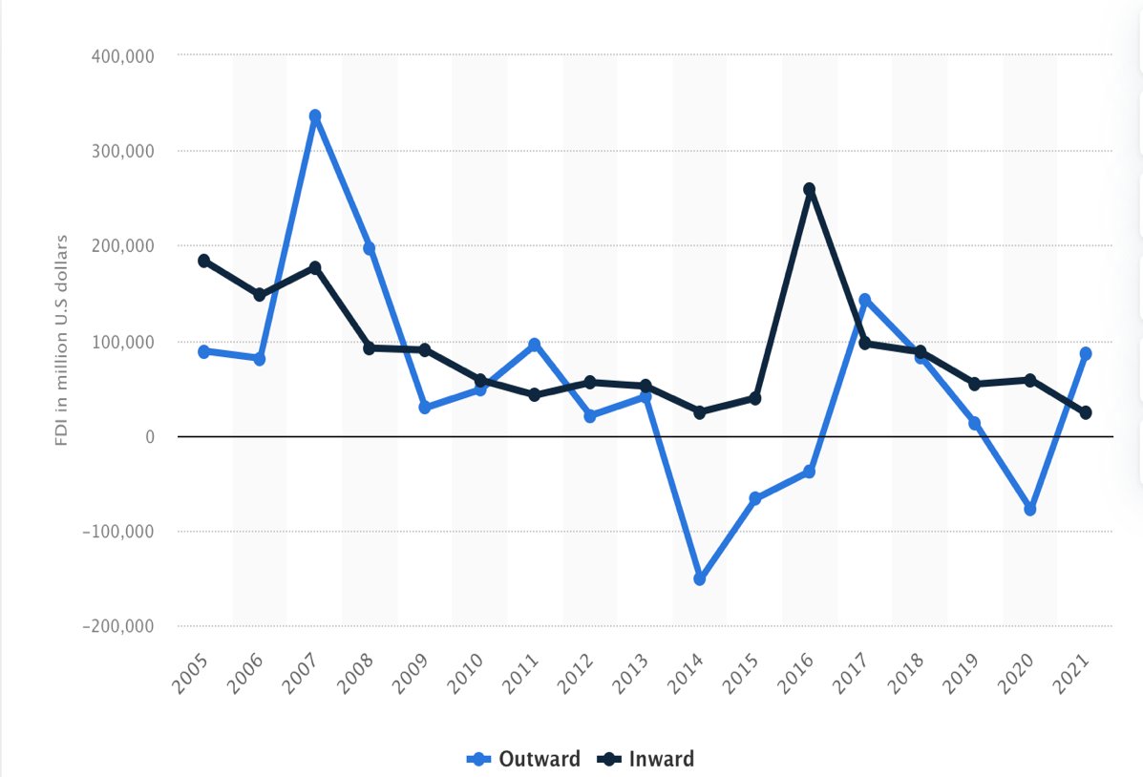
Figure 1. Value of foreign direct investment (FDI) outward and inward flows in the United Kingdom from 2005 to 2021; Source: Statista

1.1.2.3. Interest rates on the rise – As of March 9, 2023, the Bank of England base rate is at 4% (Bank of England, 2023). For compassion, during the COVID-19 pandemic, the rate was just 0,1%. This 40-fold increase in the space of about 3 years has severely increased the risk of default, as rising rates are always connected with issues regarding servicing debt (Glaze, 2023). Glaze (2023) also suggests that such increases often lead to layoffs and other cost-cutting decisions, in an attempt to battle the big interest payments and slow growth.
1.1.2.4. Decline in household disposable income – Every business relies on its customers to be able to purchase its products. This, however, strongly depends on the customers’ disposable income situation. Inman (2022) suggests that the projected decline in household disposable income in the UK for 2023 is 3,8%. For instance, Inman (2022) claims that for 2022, household disposable income fell by 3,3%, implying an increase in that regard. Should, however, interest rates continue to rise (as implied by the BoE), this project number could rise, leaving people with less money that they are able to spend on activities outside of the circle of necessity.

1.1.3 Socio-cultural Factors:
1.1.3.1. Steady population growth – since the turn of the millennium, the UK’s population has been steadily increasing – from 58,8 million in 2000 to 67,7 million now. In those 22 years, the population increased by around 9 million, or over 400 000 per year since the new millennium began. The population is projected to grow another 4 million by 2050 to over 71 million people. A big part of the increase could be attributed to migration to the UK, as the country is home to over 9,3 million immigrants that make up 13,8% of the total UK population. The most important thing, however, connected to this population growth, is the fact that there will be more economic actors that will be contributing to the UK economy in general, allowing it to grow in the long term.
1.1.3.2. The UK’s vivid sports culture – According to Altman Solon’s (2022) study, the percentage of people in the UK considering themselves monthly sports viewers grew from 43% in 2020 to 57% in 2022. Also, the majority (80%) of the UK respondents in the study have indicated that they prefer watching sports live, rather than just the highlights or short clips on social media (Altman Solon, 2022). When it comes to the preferences of sports watchers in the UK, 83% of them are football viewers, making football the most popular sport in the UK (YouGov, 2020). IBIS World (2022) estimates that around 61% of the UK’s 16 and above population participate in sports each week.

1.1.4. Technological Factors:
1.1.4.1. Increased usage of data analytics in football – ever since the famous movie Moneyball, there have been more and more use cases for data analytics in sports, as this approach allows clubs to get a deeper understanding of what’s happening on the field. There are many things that couldn’t be caught by the naked eye, and only advanced analytics can help to “see” them. Vimal (2023) claims that the increased usage of data analysis in football has not only helped clubs search for the competitive edge in terms of players’ performance and in-game strategy, but also in terms of injury management and prevention, something as important as the other two.

2.1. Porter’s 5 Forces Analysis
2.1.1. Threat of new entrants – There are 4 professional and 5 non-professional football leagues in England, as well as hundreds of local amateur football leagues, making England one of, if not the country with the most professional and amateur football competition in Europe. Technically, creating the football club, sorting every procedure, and applying it to the English Football Association is the easy part. Some estimates suggest the number of clubs registered on a professional, non-professional, amateur, and association level in England is 40 000, organized into 600 different leagues. The hard part is actually “entering” the market from the point of view of making a name for yourself and starting to climb up the football ladder. The main reason is that there are simply too many football clubs and divisions and tournaments that a newly founded club must face, and eventually win, in order to start being considered as a threat to the established football clubs in the top divisions of English football. The difference in ability gets exponentially higher, the better and higher the division the clubs play in. As mentioned earlier, to win the FA Cup, a club must come on top of 700+ clubs that are also trying to win the most prestigious domestic trophy in England, after the Premier League. And even if a newly established club manages to somehow win some games and sneak into the latter stages of the tournament, the rest of the clubs will have so much more experience and so much more to lose than the new club, that the new club’s chances will be approximately 0. Considering all of the above, it is safe to say that the threat of new entrants (especially to clubs from the 4 professional leagues in England) is very slim. Overall strength of the force: 0,5/5
2.1.2. Rivalry among existing competition – As mentioned in the introduction and in the previous section, there are 4 professional and 5 non-professional football leagues in England. To this number, we must add the total amount of regional and amateur leagues in the country and the number simply becomes too big. The number of professional teams in the English Football League system is 96, 20 of them playing in the first division – the English Premier League. Also, according to the rules of the Premier League, the top-4 EPL clubs qualify for the UEFA Champions League proper, the 5th and winner of the FA Cup qualify for the UEFA Europa League proper, and lastly, the winner of the English League Cup qualifies for the UEFA Europa Conference League. Technically, if some of the prior conditions are not met (i.e., the FA and EL cups are won by clubs that will play in the UEFA Champions League proper, the next highest-ranked team qualifies for each of the tournaments, the 6th and 7th, usually). Taking, for instance, season 2019/2020, 7 English clubs played in European competitions, and their average revenue for the season was $503 million, whereas the remaining 13 clubs had an average revenue of $155 million. In England’s second division, the Championship, for the same season, the 24 clubs had an average revenue of £28.3 million. The difference is striking and the competition for the higher positions is fierce, as this could make or break any club’s season. Moreover, for the same season (2019/2020), as per Carrera’s (2021) comparisons, the TV broadcasting money for clubs in the PL was £2,3 billion, whereas for the Championship was only £330 million. Basically, given the number of professional and non-professional clubs in England that any new competition must beat to reach the top, plus the striking difference in money that the clubs at the pinnacle of English football earn, the logical conclusion is that the rivalry between the existing competition is very high. Overall strength 5/5
2.1.3. Bargaining power of suppliers – The suppliers in the football industry (for the football clubs) could be seen as the providers of equipment and sponsorship deals. Moreover, according to Manoli (2014), in addition to the equipment providers, sponsors, and media, football players and non-playing staff should also be considered as suppliers to the football industry, given that said industry is intangible driven. As it is known, the bargaining power of suppliers relies on their position (i.e., whether they outnumber or are less than the potential number of buyers), the switching costs of both suppliers and buyers and on the dependence on a given supplier’s sale to a given buyer. For the current season, the 20 clubs in the EPL have 7 different kit providers. Score and Change (2022) also report that this is an increase from season 2018/2019 when there were 6 providers, but a decrease from 2021/2022 when there were 10 different providers. Also, it is important to mention the dominance of Nike and Adidas which combined sponsor 45% of the clubs in the EPL for this season. For comparison, in the Championship – England’s second division, there are 24 clubs but only 9 different kit providers. The combined figures for both divisions are as follows – 44 clubs and 11 different kit providers. This implies that, from this perspective, the power of suppliers is high, as there are more buyers than suppliers which are ready to supply the football industry in England. As mentioned earlier, there are 20 clubs in the EPL and 24 in the Championship. There are 534 registered players in the EPL, ~69% of them being foreigners. When it comes to the Championship, there are 629 registered players, 50% of them being foreigners. It is also reported that there are over 5000 professional English-born football players. This theme suggests that, from the point of view of football players as suppliers, their power is low, given that they are much more than the football clubs they play for, numerically. When it comes to the backroom staff of football clubs, it is hard to estimate how many there are in each football club, given that this is not information that is of much public attention and coverage. Transfermarkt provides information on the backroom staff of Premier League clubs and if we take a look at Tottenham Hotspur, they have 12 members of the coaching staff (the manager included), 1 sporting director, 9 members of the scouting department, 1 nutritionist, and 2 other members of staff. It is probably safe to assume that other clubs have the same number of staff, +-5 members depending on the club’s position in the football hierarchy and their revenue. From that point of view, the suppliers outnumber the buyers as well, implying a weak power again. When it comes to other sponsorship deals, on the other hand, it is important to mention that football clubs are able to have negotiations with different businesses, industries, etc., meaning that the potential number of suppliers is still higher than those of the buyers. It is probably right to evaluate the strength of this force as in the middle, because although on most fronts the number of suppliers is higher than the buyers, the switching costs for the buyers, on the other hand, are lower, some suppliers are not dependent on the sale of their services to the interested party, and also – quantity doesn’t equal quality, implying that sometimes clubs will have hard times replacing suppliers (players, staff, sponsors) because of the quality and the tailor-made value they bring, despite them having, as observed, a lot of options. Overall strength: 3/5
2.1.4. Bargaining power of buyers – buyers in the football industry are the football clubs themselves, given the nature of the suppliers, that is, an argument supported by Manoli’s (2014) paper. The bargaining power of buyers is high when the relative number of buyers to suppliers is small when the switching costs for buyers are low, when buyers are able to purchase in bulk and the products they’re buying are not differentiated. As already stated, when it comes to suppliers in the form of football players, backroom staff, and available sponsorship deals, there are fewer buyers than there are suppliers, implying that, from this point of view, the buyers have high bargaining power. If we, however, look at the other criteria, product differentiation, it could be observed that this is not the case. For starters, there are 11 different positions in football. Moreover, the quality of each footballer varies so much that it is impossible to replicate one’s skillset. Different players bring different skills, value, different marketability, different work rate, etc. This criterion shows that the power of buyers is not high, as there is a big player differentiation, and it is hard to substitute one player for another without experiencing any trade-offs. In many instances the trade-off experienced is really big, leaving the club in a worse position, from the point of view of on-the-pitch ability, albeit they have managed to secure a financial gain. This said the switching costs for buyers could be both high and low, depending on the type of suppliers. Changing the suppliers, in terms of changing players is easy, although the results might be worse, changing kit suppliers is harder, given that they are less than the amount of football clubs they supply, and that they don’t depend on the sale to individual buyers, as could those individual buyers depend on them. Also, when it comes to changing skilled and experienced players and backroom staff, the switching costs are rather high, given all the uncertainty that this brings, given the time-consuming process until the right replacements are actually found, and also given the fact that some coaches deploy certain tactics and instructions, finding replacements could prove to be difficult and costly, as well as inefficient, although the amount of players is very high, as stated in the previous section. Given all the above, the strength of the bargaining power of buyers’ force is on the low side. Overall strength: 2/5
2.1.5. Threat of substitutes – When it comes to substitute goods/services, it is important to understand what substitutes in the football industry actually are. From the clubs’ perspective, they could substitute their sponsors/providers of equipment, football players, and backroom staff. As mentioned above, although there is a limited number of kit providers in England’s top two divisions, there still is a choice. Moreover, clubs can negotiate with whoever when it comes to partnership deals. When it comes to players and staff, on the other hand, the problem of subpar quality substitution exists, but the number of players and coaches each club can choose from is big, really big. Moreover, we observed that around 69% of the players in the EPL are foreigners, and even though there are over 5000 professional English players, they could really be (and are) substituted by the foreign-born talent that is perceived to be better. The same thing applies to coaches and other non-playing staff. Unlike other industries, where it is able to substitute a product with a product from another industry, when it comes to football clubs and the football industry – one’s not able to swap their manager for a basketball coach or their striker for a golfer, implying that even the substitutes are very specific, and as mentioned earlier – could be hard to find a quality one, even with such a large pool of players to choose from. For the established clubs in the English Premier League, finding a new sponsorship deal, with more or less the same terms, if not better, shouldn’t be a hard task, given their ability to turn over large amounts of money per season, be it from merchandise, from TV broadcasting, from marketing, etc. From the point of view of consumers of the football industry (fans and casual spectators), the English Premier League could be substituted for other football leagues in Europe, for other sports (basketball, American football, volleyball, pool, tennis, etc.), or for other leisure activities (going to the cinema, watching TV series, etc.). For comparison, for the 2020/2021 season, the EPL drew in over 3 billion viewers during the course of the season, or 79 million people per week. The National Football League (American football), for the same season “only” managed to lure 17 million people to watch the league per week (The Blizzard, 2022). Lisubila (2022) compared the viewership between the EPL and La Liga (Spain’s top division), as they are naturally the two most popular football leagues in the world, with his reports stating that for season 2019/2020 the EPL managed to lure in 3,2 billion viewership, compared to only 650 million viewers of La Liga, implying how much more popular and desired the English Premier League is. So, to conclude, the players, non-playing staff, and sponsors are able to substitute clubs from the English Premier League for other clubs, but the quality will be subpar, and the popularity, viewership, and desirability will also be much less, given how much of a giant the English football really is. Therefore, the strength of this force is on the low side. Overall strength: 1,5/5

3.1. Key Success Factors
Every company, operating within any industry, must have certain characteristics in order to compete with its rivals, and establishing themselves in a better competitive position. Here, we will analyze the KSF for Manchester United, a club operating within the football industry in England. This analysis will consider clubs from the English Premier League. The following success factors were chosen by combining the findings from the UEFA Club Benchmarking Licensing Report and one of the original defining points in the topic of Key Success Factors – the article by John Rockart, adapted to the football industry, that is.
Club  KSF | Manchester United | Liverpool | Manchester City | Arsenal | Tottenham | Chelsea
Contemporary Success | - | +++ | +++ | + | - | ++
Financial Prowess | +++ | +++ | +++ | ++ | ++ | +++
Infrastructure | +++ | ++ | ++ | ++ | ++ | ++
Youth Development | +++ | ++ | +++ | +++ | ++ | +++
Ability to Attract Top Talent | +++ | ++ | +++ | + | + | +++
Fan Engagement | +++ | +++ | + | +++ | ++ | ++
Table 1. Key Success Factors, English Premier League
Table 1 shows the Key Success Factors for the English Premier League. The Big Six clubs in England were chosen to benchmark against Manchester United, as they are the most representative of English footballing success. The reason why United is benchmarked only against English clubs, rather than other European ones, is because to enter the European club tournaments, one needs to be the best or among the best clubs in the country, in order to qualify for the UEFA Champions League – the pinnacle of pan-European club competitions. If we look at the UEFA Club coefficients, a ranking of the best clubs in Europe, based on their performances within European club tournaments, 4 of the top 10 ranked clubs are from England, with 3 of them being in the top 4. During the last 5 editions of the UEFA Champions League, every season, bar season 2019/2020, there has been an English team participating in the final of the competition, and in two of the instances (2018/2019 & 2020/2021) the final was played between English clubs. In both finals, different English teams met – in 2019 was Tottenham vs. Liverpool; in 2021 Chelsea vs. Manchester City.
Contemporary success shows every club’s competitive position right now, as well as how well their current financial position is reflected. Moreover, contemporary success can also contribute to a club’s market position and brand perception, which are variables that could additionally contribute to overall success. Teams that are good right now are able to lay the foundations for future success better.
When it comes to financial prowess, the club has been constantly ranked within the first 3 or 5 clubs in Europe for revenue, as well as the ability to spend money on the transfer market. During the last 5 years, United’s rank on the Deloitte Money League ranking has looked like this: (2017 to 2022) 3rd, 3rd, 4th, 5th, and 4th. And this is despite the club’s inability to win tournaments, domestic or European. For instance, for the 5 years prior to that, their rankings have been: (2012 to 2016) 4th, 2nd, 3rd, 1st, and 1st. If United had a better culture around winning those past years, they would’ve probably still been 1st or 2nd, but even though they haven’t had one, this makes it even more remarkable, as to how financially powerful the club is, despite not being able to add more revenue from tournaments won, and all the perks that come with them.
Having a modern and suitable infrastructure allows clubs to train at elite training facilities, to attract more people to their stadiums and offer them better experiences, which ultimately lead to better results and to better fan engagement. To determine the overall infrastructure and the clubs’ ranking, the section was divided into 3 subsections, each weighing 33%. In short, the variables were stadium capacity and average attendance, training ground ranking, and stadium experience. A breakdown of this can be found in the Appendix. United scored a 3/3 in each subsection, as the club has the biggest club stadium in England which is consistently being filled at 99%, their training ground has been ranked among the best 2 or 3 in England constantly by independent reviewers, and the fan experience, reviewed independently as well, has also been among the top 2 or 3 in the country, implying that although United’s stadium was built back in 1910, it still allows the club to maintain an elite position, when it comes to infrastructure. However, although the stadium still ranks at the top, it is visible that it needs to be repaired, having in mind the many talks about possible renovations that are going to cost a lot. Flintham (2022) suggests that United needs to invest more than £1,5 billion in order to rebuild Old Trafford, so it doesn’t get left behind the other stadiums in England. He also says that the building was last repaired in 2006, and although it is still the “Theater of Dreams”, the need for a rebuild is visible. Given the amount of money United has spent in the last decade, it is strange that the club has left its home in a position where any repairs (some experts are even saying that a whole new stadium should be built) will cost them more than £1 billion. The overall infrastructure of the club is great, but the negligence and the dire need for a renovation of Old Trafford cannot be classified as a strength, no matter how high it is ranked.
Every club needs to have a proper youth academy, as those players that graduate from them usually go on to play for the first team. Having a youth academy that is competitive should, in theory, allow the club to have a smoother transition between the different generations of players and managers, as the young players coming from the academy already know what is like to play at the club, know and embody the culture, play with passion, and don’t cost millions upon millions to recruit from competing teams all over England and Europe. Similar to the infrastructure, to determine the rank of each club’s youth development, two independent rankings were used, both weighing 50%, with United getting a 3 out of 3 from both reviewers. More information can be found in the Appendix.
The ability to attract talent showcases the clubs’ brand position, being seen as a marketable place, and a place that could allow them to progress their careers further. To be able to attract top-end talent, one needs to have the ideal environment around themselves – a mixture of money, fans, culture and history, marketability, surrounding players, etc. United, given all the transfer records broken, and overall money spent on recruitment, can be said to be one of the pinnacles of European clubs, a place where players desire to go and play their prime years. Manchester United has 5 of the top 25 most expensive transfers in football, most of any English club, and only second to Barcelona (6) overall. The transfer of Paul Pogba in 2016 broke the transfer record at that time, and the transfer of Harry Maguire in 2019 is still the most expensive transfer for a defender ever, implying that United are able and do indeed attract elite talent, and as it can be imagined – being able to recruit the best players will always give a competitive advantage.
Finally, fan engagement is a success factor that shows how loyal the fans of a football club are, and how attractive said football club is to new fans. This overall criterion was also broken down into two sub-criteria, each weighing 50%. The criteria were number of fans overall and average attendance at clubs’ home games. United, again, scored 3 out of 3 for each subcategory. More information will be found in the Appendix.

4.1. Primary SWOT Matrix

STRENGTHS | WEAKNESSES
1. Elite financial capabilities | 1. Lack of contemporary competitiveness and success
2. Established global presence and brand reputation | 2. Infrastructural negligence compared to overall investments in players
3. Excellent youth planning, ensuring the club’s future
OPPORTUNITIES | THREATS
1. Constant increase in overall sports engagement | 1. Ever-growing competitiveness for talent acquisition and resources
2. Population growth, allowing for financial and youth development improvements | 2. Brexit’s uncertainties regarding recruiting
3. Advancements in data-driven solutions for better planning and decision-making | 3. Worsen economic conditions
4. Progress in marketing opportunities and adaptations
Table 2. Primary SWOT Matrix
4.1.1. Strengths:
1. Elite financial capabilities – As mentioned in the KSF, Manchester United, despite their lack of on-field success, are one of the most financially powerful clubs in world football, given their large and diverse revenue streams. From 2017 to 2022, Manchester United is the club that has the biggest net spend in England and in world football in general. Moreover, United’s been ranked in the top 3 and top 5 in each of the last 10 years in the Deloitte Money League (a ranking on football clubs’ revenue and financial capabilities), with the period 2013 to 2016 being much stronger for the club, as they had occupied top spot for several years during that timeframe.
When it comes to United’s revenue streams, they are divided into three categories: commercial revenue, broadcasting revenue, and matchday revenue, with each contributing a certain share of the total. Figure 2 shows how the club’s revenue streams composition from 2009 to 2022, as per Statista. The overall picture shows an upwards trend for the whole period, apart from 2020 when the club’s financials were struck by COVID-19 and the subsequent lockdowns that followed into 2021 as well. Since then, the club has been in a recovery period, still shy of its 2019 record figures of around $800 million.
The biggest share of the club’s revenue comes from commercial deals, and the amount of money this segment has brought the club was constantly rising throughout the years, with its peak being in 2018 when it reached almost $400 million. What’s interesting about Figure 2 is the fact that for 2021 Manchester United had almost no revenue coming for matchday ticket sales due to the fact that almost all games that year were played behind closed doors, i.e., without any fans in the stands.
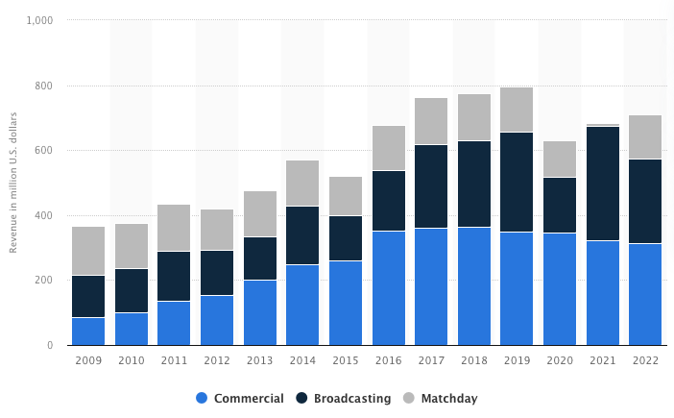
Figure 2. Breakdown of Manchester United's revenue streams in million USD; Source: Statista
Another interesting observation is that Manchester United managed to shift its biggest revenue provider from broadcasting rights to commercial revenue during said period of time.
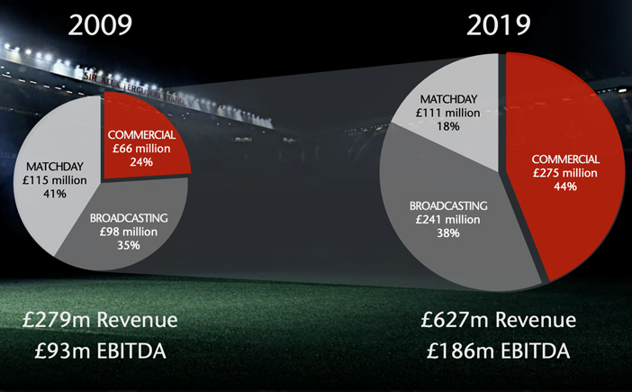
Figure 3. Comparison in Manchester United's revenue structure in 2009 and 2019; Source: manutd.com
Figure 3 shows how that shift happened. Back in 2009, Manchester United was much more reliant on their revenue coming from matchday ticket sales (41%) and broadcasting rights (35%), with the commercial sector being much less utilized, whereas in 2019, the situation is quite the opposite, as commercial revenue made up 44% of the club’s total revenue for the year, whereas matchday revenue only contributed 18%, implying how heavily marketed and efficiently run the club is, in terms of marketability.
Moreover, to show how great the club is situated to make money, from the clubs in the top 10 of the Deloitte Money League, only Liverpool (27%) and Tottenham (29%) have a higher year-on-year growth in total revenue than Manchester United (23%).
2. Established global presence and brand reputation – As mentioned above, Manchester United is responsible for 5 of the 25 most expensive transfers in football history. Moreover, they’re the club more that’s been engaged in transfer activity the most over the past 5 years. United is also regarded as the most supported football club in the world, and the club itself claims that the global community which supports it amounts to over 1 billion people. Moreover, we have already established that Manchester United’s the most successful English club and one of the most successful European ones in general.
All of these confirm the premise that the club’s brand reputation is one of if not its biggest strengths, and frankly speaking, United doesn’t need to provide much more evidence, in order to be seen as one of the most influential and supported football clubs in the world.
3. Excellent youth planning, ensuring the club’s future – Manchester United’s set the record for the most consecutive games in which a player who has graduated from the club’s academy has featured in the matchday squad, and what a record that is, since 1937, or over 4000 consecutive games in the club’s history there has been at least 1 youth player from the academy that has featured in the club’s matchday squad (Kenmare, 2022).

4.1.2. Weaknesses:
1. Lack of contemporary competitiveness and success – The last piece of silverware that Manchester United won was back in 2017. Frankly speaking, this is unacceptable for a club of United’s magnitude. Also, during a couple of campaigns in the English Premier League, the Manchester giant didn’t even finish inside the top 4 and missed out on playing in the UEFA Champions League. To top it all off, the last time United won the English Premier League was in season 2012/2013, which means that it’s been 10 years since the most successful English club sat down on its hard earn throne. In that time, United saw its biggest rivals – Liverpool and Manchester City win the English Premier League, win the Champions League, and overall be much more competitive and have much more success than United. Its international competition – Real Madrid, Barcelona, and Bayern Munich have also been playing much better than United and subsequently achieving more than them. Moreover, as observed from the yearly Deloitte Money League reports, due to its lack of success, United lost the top spot for being the richest club in the world. Yes, Manchester United are still one of the most financially powerful clubs in the world, all things considered, but they once held the top spot for years before they started to fall off, in terms of being competitive in England, and in Europe.
2. Infrastructural negligence compared to overall investments in players – The last reconstruction at Old Trafford, Manchester United’s playing ground, was done in 2006 and it’s estimated that any new repair job done on Old Trafford would cost upwards of £1 billion. This estimate, for instance, is comparable to United’s net spend on players since 2010 – 1,3 billion EUR. Indeed, as already established, Manchester United’s an elite club, probably the most elite, when it comes to financial prowess, but the amount of money they need to spend to do the much-needed repairments on its home turf, would mean that the club will need to adjust their spendings a bit, in order to accommodate such a hefty investment. Robertson (2021) reports that in the last 11 years (up until 2021), 5 Premier League clubs have spent more money on infrastructural development than Manchester United (in United’s case is cosmetical repairs); those clubs are Tottenham, Manchester City, Liverpool, Brighton, and Arsenal. Yes, Old Trafford is a majestical piece of infrastructure, but as with every single thing, it needs upgrades, and given how long the stadium hasn’t been repaired, how many teams have invested more in infrastructure, how many teams have won more trophies than United despite spending much less, one has to point that United’s investment activities for the past 5-10 years have not been the wisest, especially having considered the end-results.

4.1.3. Opportunities:
1. Constant inflow of more sports engagement – England and the UK, in general, are notorious for their sports culture, with “King” football comfortably sitting on top and being unreachable for other sports. As reported in the PEST analysis, the percentage of people who’d consider themselves monthly sports viewers grew by 14% between 2020 and 2022. That’s a great increase in the space of just two years, considering that there was a pandemic and that many sporting events and competitions were shut down for certain amounts of time during this timeframe. Moreover, it’s established that the level of competition in the football industry in England is fierce, and the more competitive something is, the more enjoyable it becomes both to neutral and not-so-neutral fans and supporters. The English football clubs have been the best in Europe for the past several years, resulting in two all-English UEFA Champions League finals and two more finals where one of the sides was English all within the past 5 years.
When you combine fierce competition and elite performance capabilities with a vivid and ever-growing sports culture of a country – you get an ideal situation that any sports organization can benefit from. If more people continue engaging with football as fans, the more likely they are to become eventual customers of the sports organization in question. And unlike normal business, customers, or better put, sports fans, are notorious for their loyalty, even when their beloved team doesn’t perform up to the standard that fans might expect to see.
2. Population growth, allowing for financial and youth development improvements – It’s known to almost everyone that most of the advanced economies are faced with a demographic crisis in the coming years. Fortunately, for the UK at least, they are one of the countries that has seen its population steadily increase. The UK “added” some 9 million people to its population figures since the turn of the millennium. Moreover, the current projections for 2050 suggest that the UK will continue to grow, adding around 4 million people to its current population. Migration is indeed one of, if not the biggest, contributor to this increase, but this increase will nevertheless help the British economy.
Combining the optimistic news about the increasing sports engagement with the even more optimistic views on the UK’s population, the football industry could definitely feel upbeat about the prospects that the future holds. More people living in the country with more people who consider themselves sports fans will allow the club to expand its commercial reach, to collaborate more with both businesses and supporters’ trusts. If clubs manage to capitalize on the new pool of customers and turn them into loyal supporters of their organization, this is bound to increase their commercial and matchday revenues, given the loyalty of football and sports fans in general. Furthermore, the clubs will also be able to capitalize on the rising youth population by creating more and more youth academy initiatives that encourage children and young adults to join their youth academies.
3. Advancements in data-driven solutions for better planning and decision-making – The approaches and methodologies from the famous “Moneyball” movie starring Brad Pitt are being implemented in the football world nowadays, in unprecedented volumes. Many data-driven companies such as Wyscout, Opta, SkillCorner, Statsbomb, FBref, and Transfermarkt are now available to sports organizations providing them with full-range of different services that cover every single step of the supply chain in the world of football. If you need information about a player’s market value – you go to Transfermarkt where a team of professionals has created a model that best estimates a player’s fair value; if you need information about his wages or about where he ranks amongst his position peers for a certain football metric – you go on FBref and dive deep into the scouting reports. If one cannot be satisfied with statistics only, in order to determine a player’s ability, one can go on Wyscout and watch endless video materials on that player highlighting his good and bad qualities. The same applies to every other company that provides data analytics solutions for the world of football. Having the ability to use so much data in every aspect of the game and business of football allows the organizations to have more detailed and objective information in front of their eyes, and to be presented with more accurate input that can be used to create a business-developing output.
4. Progress in marketing opportunities and adaptations – As seen in the part about United’s strengths, commercial deals now contribute the most to the club’s revenue streams, and as per Deloitte’s Money League reports, this is also true for most of the best and highest earning clubs on the planet. Nowadays, different sponsors from different industries battle for real estate on football teams’ jerseys. Apart from the usual jersey providers – Nike, Adidas, Puma, and other sportswear brands, the rest of the football shirt can be occupied by virtually any business, as long as they have money, with no limitations about the real estate of the football shirt, i.e., as long as there is space on it, businesses could, in theory, battle for a sponsorship deal that would see their brand logo put on the shirts. Moreover, football teams now engage a lot with their supporters on social media, as they have recognized the need for an online presence. The football teams are now “running” commercial platforms that see them collaborate with different businesses in the most unimaginable, yet profitable ways.

4.1.4. Threats:
1. Ever-growing competitiveness for talent acquisition and resources – As established in Porter’s 5 Forces analysis, football in England is the literal embodiment of the word competitiveness, as the quantity of teams and leagues is as high as it can possibly get. Moreover, the English teams are one of the most successful and most respected teams in the world, not to mention the richest and strongest financially. The English teams are also currently the best in Europe, given their recent performances in the European competitions and the influential English Premier League imply that they are best positioned to sign the best talent in the world. The “selling” teams fully acknowledge this and are not shy of asking for premium rates for their players, even if this means that they don’t immediately sell an unsettled player. The English Premier League is famous for its big 6 (Man United, Man City, Liverpool, Arsenal, Chelsea, and Tottenham) but it can only provide 4 spots for guaranteed participation in the UEFA Champions League, therefore, two of the best teams in the country are forced to miss out on the luxurious tournament. The threat of missing this pan-European tournament is certainly one of the biggest talking points that each of the big 6 begins their seasons with. And even without the big 6, the English Premier League is still home to great teams that are able to disrupt the existing hierarchy here and there, and in the case of Leicester City in 2015, to even win the league title and be crowned the champions of the strongest and most competitive football league in the world – the English Premier League. Doyle (2022) reports that climbing up one spot, i.e., going from 6th to 5th, and so on for the rest of the 20 positions in the EPL, results in an improved payday for the EPL clubs – each climbed position allows them to earn £2 million additionally. So, given all the competitive perks that the better positions give the clubs, the battle for higher positions is also driven by monetary needs, further highlighting the fierce competitive mindset of each of the competing teams.
2. Brexit’s uncertainties regarding recruiting – Since Brexit became official, it has become a little bit more difficult to recruit players from the EU, as the UK is no longer of the European Economic Area, and the movement of people is not free, therefore creating slight bureaucratic complications which lead to the need for working visas. The implication of this decision made by the UK government for football teams is that they’re no longer able to recruit youth players from other EU countries before they have turned 18 years, something that wasn’t necessary a couple of years ago. This could have an impact on how English clubs recruit talent from countries within the European Union in the long run and might force said clubs to settle for mostly using and acquiring domestic talent from all over the United Kingdom.
If Brexit does indeed complicate recruitment for clubs from the EPL, this will pose many challenges and will ultimately require whole new recruitment strategies and might put the English at a competitive disadvantage to their peers from mainland Europe in the European club competitions.
3. Worsen economic conditions – The UK, as well as most of the world, is currently going through a rough economic period, kickstarted by the COVID-19 pandemic. The country’s GDP has been volatile for a while now. Moreover, the country’s seen a decline in inward FDI, and given that many clubs in England are sponsored by businessmen from abroad, should the economic climate in Britain continue to look foggy, outside investors might stop putting as much money into English football as they do now. Some implications from this might be lowered revenues from commercial deals and matchday ticket sales, as households are seeing a drop in their disposable incomes. If that’s the case, clubs might be forced to reshape their investment strategies for the short-term and utilize youth player development over expensive recruitment from abroad.

5.1. Data Analysis
This section will be used to compare and understand which variables determine success in English football.
Firstly, to test Szymanski’s (2013) and Gasquez and Royuela’s (2016) findings on how wage bill and economic resources (in this scenario, the market value of the football club, as it is the closest metric to economic output) against the final league position of the clubs in the English Premier League from season 2013/2014 to season 2021/2022. The idea behind this regression is to understand whether, for the English Premier League, buying expensive and top-end talent alone can make a team more competitive and increase domestic success, or as per Grimditch (2022) success requires building processes, instead of meaninglessly spending money on the best and most expensive players in the world.
The dependent variables, selected for this test, are market value (in million EUR) and annual wage bill (in million EUR). Market value data for each season was gathered through Transfermarkt, whereas the information about clubs’ annual wage bill was collected via FBref.com. Market value of a football clubs shows how much the clubs’ assets (players) are valued at a point in time, whereas annual wage bill shows how expensive it was to assemble the team, given the wages that said club pays to its players. Both dependent variables test whether success in the English Premier League could be “bought” by simply pouring money into assembling the most expensive team.
The independent variable is the English Premier League clubs’ final league position between 2013 and 2022.
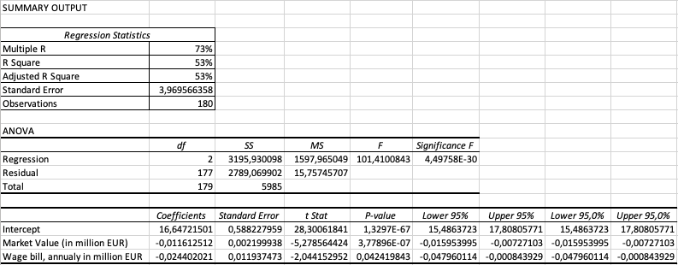
Figure 4. Regression Analysis; Market Value and Wage Bill against Final League Position
As it can be seen, the model does indeed prove that there is a correlation between the two variables and the final league position of the English Premier League clubs within the studied period. The results were gathered through transfermark.com (Market Value) and fbref.com (Wage Bills). The adjusted R squared is only 53%, however, implying that, yes, there is a correlation between the studied variables, however, these two variables alone are not enough to determine the final position of the clubs in the English Premier League during those years. This brings us to the limitations of this regression – 1) football is unpredictable, and luck is involved one too many times. A prime example of this is Leicester City’s title campaign in 2015/2016, where they had the 17th biggest wage bill and the 11th most expensive squad in the league, in terms of market value, and still won the league. This campaign will forever be remembered for one thing – Leicester won the Premier League, despite having 5000/1 odds to do so, the single biggest upset in football history. This is an event that simply is impossible to predict, especially having in mind that the club was facing relegation the season prior. Luck plays an unbelievable amount in the eventual results; 2) the second limitation is injuries. Although they were included in the model at first, they were excluded later, as they didn’t have an effect on the results. The number of injuries alone cannot be used to predict performance, as it is very possible that the club with the most injuries still end up winning the league. This is possible, for instance, if all their bench or rotation players constantly get injured, but none of their best players are injured, the team is still in a good position to perform well. On the other hand, for some clubs even a single injury could damage their season – imagine that Club X signed a new and expensive player A to replace player B who has left the club. Player A gets injured in the second game of the season and only comes back in the last game of the season. Although the market value and wage bill of this Club X increased, the player responsible for this didn’t play the whole season and didn’t contribute at all, in fact, the club was worse off because now the backup player to the one who was replaced for the better player A had to play all season, effectively meaning that the backup of the backup became a starter; 3) Number of managerial changes – as mentioned in the literature review, clubs usually change managers when they feel that they are bound to perform better under new management. This variable was added to the model, but it had 0 effect, as it is a limitation. For instance, a club could make 5 managerial changes throughout the season and still win it; if their market value and wage bill are much higher than the rest of the teams, this shouldn’t be a problem. On the other hand, many of the teams that don’t perform well stick to one manager all season, irrespective of their market value and wage bill, the fact that they didn’t change their manager wouldn’t imply a better finish. There are so many things that managers bring, that are not connected with their amount – style of play, tactics, player relationship, culture, etc. It’s impossible to quantify any of those.
So, when it comes to club performance on the basis of buying the best and most expensive talent, this will guarantee success, but not always, and not always the success they are looking for, as there are many other things that contribute to the final outcome. And, unfortunately, those things cannot be quantified. Other excluded from the model variables include the average age of the players, squad size, number of foreign players, percentage of foreign players, etc. None of them influenced the model, in fact, tried with market value and wage bill they were usually statistically insignificant. The most likely cause for this is multicollinearity – as stated by Banos (2018), foreign players do indeed increase English clubs’ creativity and technical ability, but to a certain extent, as the closer to 100% the percentage of foreign players, the more inverse the relationship becomes. Therefore, to better understand which are the variables that do indeed have a positive effect on English clubs’ final league position, a closer examination of player performance must be done because, at the end of the day, no matter how expensive the players are, if their performances are subpar, having them wouldn’t matter.

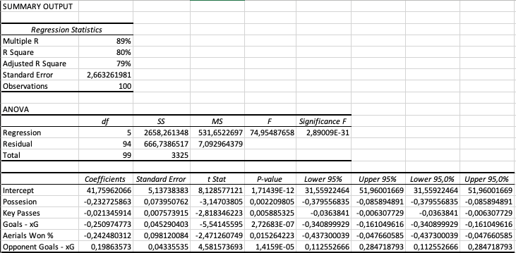
Figure 5. Regression analysis on player performance variables against final league position.
Figure 5 shows the summary output of the regression analysis between these key performance variables against final league position.
Dependent variables - possession of the ball, key passes, Goals minus Expected Goals (xG), percentage of aerial duels won, and Opponent Goals minus Expected Goals (xG). All variables were collected via FBref.com, however, the data only covers seasons 2017/2018 through 2021/2022. Prior data wasn’t available anywhere, which is the first limitation of the study. The variables were chosen on the following principle – possession of the ball demonstrates a club’s ability to control the game, its distribution, and its tempo. The more a club holds possession of the ball, the more control they have, and the better their chances to win are. Things that contribute to more possession include the number of attempted passes, the percentage of successful passes, how fast a team is able to regain control of the ball, etc. The metric key passes, on the other hand, illustrates a club’s ability to create chances, to open the game, and to break defenses down, in an attempt to score more goals. The more key passes a club makes, the more shots it usually makes (given that the definition of a key pass is a pass that leads to a shot at the opposition goal), and this would normally lead to more goals or attempts at goal. Goals minus xG showcase how effective certain clubs have been when it comes to finishing their chances – if a team has scored 60 goals but has had xG of 70, it means that it should’ve scored at least 10 more goals, implying that this club’s attack wasn’t effective, rather wasteful, and has probably cost them better performances and final league position. The bigger the difference, the better, as this implies clinical attack, and proven goalscorers who know how to perform under pressure. The % of aerial duels won suggests how likely a team is to win first and second balls launched to their own half. Also, this metric differentiates the teams who play more defensively and must win more aerial duels from those who play more offensively and need to be less engaged in the defensive side of the game. It’s a relative metric showing the efficiency when it comes to needing to win aerial duels. Opponent goals minus xG illustrate the exact opposite – how effective a defense has been in terms of keeping as many goals away as possible – if a club has received an opponent xG of 55 but has only conceded 40 goals, it means that their defense has been very effective at defending the goal, and has prevented their team from conceding at least 15 more goals, which in most cases would result in a very different final league position for said club. The smaller the number is (negatives included), the better and the more efficient the defense of the club is. Other variables such as passes attempted, % of successful passes, shots on target, % of shots being on target, tackles, clearances, and goalkeeping individual performance were also tested against final league position, included in the model that is, but failed to improve the model, rather they made it worse, with most of the mentioned variables being statistically insignificant, largely due to them being mutually correlated with those that were included in the final model. The idea of the model presented is to illustrate English football clubs’ performance in each area of the game so that a more comprehensive model is made in order to understand which variables actually have more weight on the eventual performance. Although some of the limitations and excluded variables were mentioned, it is important to mention one more – individual quality. The players of the highest calibers are often able to influence some games on their own, understandably so. With an adjusted R squared of 79%, it could be argued that the predictive model is quite good, as it leaves very little room for other variables to influence the final league position of EPL teams. Such variables could include luck (in the form of unlikely results from your team’s side), unlikely results from competing teams, individual class of bought players, injuries, managerial changes, etc.
The independent variable, in this regression model, is the English Premier League clubs’ final league position between 2017 and 2022, for a total of 5 seasons.
So, focusing more specifically on Manchester United and the regression model, in order to adapt it and get any findings on the club’s performance, both expected and actual.
Club | Season | Possession % | Key Passes | Goals - xG | Aerials Won % | Opponent Goals - xG | League Position
Man United | 2017/2018 | 54,7 | 377 | 11,3 | 55,6 | -14,7 | 2
Man United | 2018/2019 | 54,7 | 381 | 3,6 | 55,5 | 0,4 | 6
Man United | 2019/2020 | 55,8 | 402 | 2,8 | 52,1 | -2,7 | 3
Man United | 2020/2021 | 55,7 | 414 | 9,9 | 56,9 | 0,5 | 2
Man United | 2021/2022 | 52,7 | 407 | 0,2 | 55,6 | 1 | 6
Table 3. Breakdown of Manchester United's performance by performance variables
So, as it can be seen, United’s performance statistics have been all over the place during the last 5 seasons. The club has definitely improved in terms of being able to control the tempo of the game, as there was a constant increase in possession of the ball up until last season. Similar things could be said about the club’s ability to unlock the defenses of other teams and create more chances at goal. On the contrary, a negative trend could be observed – the club gradually became very inefficient in front of the opposition goal, as the players started to need much more chances to convert into goals, which is something no team wants. Similarly, its defense has regressed a lot – the team gradually started conceding more goals than it should’ve, implying an inefficient defensive performance from the team. The team’s final position in the league has also been very inconsistent. After a very poor 2018/2019 season, the club gradually improved its position two years in a row, before going back to square one again. It must be said, however, that although from this table it could be seen that the club’s performances have been inconsistent, this could be due to an overall inconsistency in the whole league. The only consistent thing from United during those five seasons has been their ability to win aerial duels, which helps with both the defensive efficiency, as well as controlling the tempo and direction of games.
Rank within league | Possession % | Key Passes | Goals - xG | Aerials Won % | Opponent Goals - xG
2017/2018 | 6th | 6th | 2nd | 2nd | 1st
2018/2019 | 6th | 6th | 5th | 1st | 10th
2019/2020 | 5th | 5th | 6th | 4th | 10th
2020/2021 | 5th | 4th | 3rd | 2nd | 12th
2021/2022 | 6th | 5th | 11th | 1st | 8th
Average | 6th | 5th | 5th | 2nd | 8th
Table 4. Breakdown of Manchester United's performance by performance variables; Rank within league
As it can be seen, United’s inconsistencies have been fairly consistent, in terms of average ranking within the English Premier League. In terms of possession, the club has a consistent 6th position, whereas, for key passes, United’s average rank is 5th. Both indicators suggest that United has had issues with controlling the game and having a constant supply of good scoring opportunities. The latter has affected the club’s efficiency in front of the opposition goal, especially their last season where they had the 11th most efficient attack in the league – quite the disappointment for a team with so many resources and talent. The real issue of the club has been its defense – after season 2017/2018, where Man United was the best defensive team in the league, there has been a constant regress, something that is unacceptable. On the other hand, United have been elite when it comes to the percentage of aerial duels won, as they have always been 1st or 2nd in this category, implying that, from this part of the game, they already have elite performers and perhaps don’t need many improvements. However, given all these rankings, and despite the elite % of winning aerial duels, we can say that the club has not been close to the top, where the amount of money they have spent should’ve put them. In fact, they have been quite far from having the best team in the league, quality-wise, as the variables suggest. Simply looking from this table, it can be concluded that United need improvements in each zone if they want to challenge for the league title. Their biggest deficiencies are in defense and in being able to control the game (possession), looking at these findings.
Season | Predicted Final Position | Final Position
2017/2018 | 2nd | 2nd
2018/2019 | 7th | 6th
2019/2020 | 6th | 3rd
2020/2021 | 4th | 2nd
2021/2022 | 7th | 6th
Table 5. Manchester United's predicted and final league position
Table 5 shows us United’s predicted and actual league position during the time frame of interest. The predicted final position was calculated via the regression analysis model and the statistics from Table 3. The formula, derived from the prediction model looks like this:
y= 30,47444795 + (Possession * -0,239071203) + (Key Passes * -0,022982811) + (Goals – xG * -0,25303028) + (Aerials Won % * -0,242480312) + (Opponent Goals – xG * 0,216392165). The key takeaway from the model is that increased levels of possession, key passes, and efficient attack increase the likelihood of a positive final league position. This model will play a key role later in the strategic recommendations part when it comes to player suggestions to exploit weak zones of the club.
As it can be observed from the model, United have, for the most part, outperformed their expected final league positions in almost all seasons of interest. And even though this is the case, they have still finished in a non-desired position, given their spending. What is meant by this is that it’s unacceptable to have a top 5 squad in the league (from a market value point of view), and still be expected to finish 7th on multiple occasions, given the team’s performance.
Season | Market Value, rank within league
2017/2018 | 4th
2018/2019 | 5th
2019/2020 | 5th
2020/2021 | 4th
2021/2022 | 4th
Average | 4th
Table 6. Manchester United's market value ranked within league
Table 6 shows how Manchester United ranked among its peers in the league, in terms of the squad’s market value. To have the 4th most expensive to assemble squad, on top of having invested the most money in transfers, and still be expected to finish 7th on a couple of instances, as well as 6th is very unacceptable. On top of that, as mentioned above, United had to mostly outperform their expected position to finish in the positions they did, implying that there are many wrong things with how the squad is assembled. The biggest takeaway from this and the previous table is that Manchester United have artificially inflated the market value of their squad by spending much more than they have needed to, given the mediocre performances of their players. Not only did Manchester United not buy suitable players that would help them improve their performance, but those players were also bought on a premium. One could argue that United did well, given their expected and eventual results, and that the players they bought were efficient. Fair argument, but as seen, relying on individual class is not sustainable as it brings zero consistency. Obviously, to play for the biggest club in England, and for United to be ready to pay a premium for your services, a player must possess a lot of individual class, which does indeed skew performances in a positive direction. But the sheer fact that after having a negative net spend of more than 500 million EUR in this period (50 million more than the club in 2nd and 150 million more than the 3rd), and to still rely on individual class, rather than a consistent set of players, bought to deliver a process, is a bad sign for United’s management. Individual class is obviously a limitation of this model and could play a great deal in being better than a club should be, but in the long run, it won’t lead to great performances, due to its inconsistencies. On top of that, United’s individual class didn’t even manage to get the team into much better places than the predicted ones, implying that United not only spent very heavily and built nothing, in terms of a processual football team, but the individual class of the players the buy is not making them that much better.
These results and takeaways from United’s finding confirm Grimditch’s (2022) claims that no matter how many expensive players a club buy, by default they won’t be able to deliver as much as their price tag suggests, given that building processes plays a much more important role in determining club success. United have been buying players at a premium, but this premium that they have come with hasn’t translated onto the pitch, not from a process-building point of view.

Chapter 2 – Mixed Method Analyses of Manchester United’s transfer policy

2.1. Quantitative approach – Player Evaluation Model (PEM)
This chapter serves the purpose of analyzing Manchester United’s transfers during the last 5 football seasons, in accordance with the regression analysis done in the previous part. In short, all of the big and expensive transfers that the club has made since 2017 will be observed individually, in an attempt to understand whether the players that were bought were the right ones – i.e., cross-player comparisons will be made to understand how said players ranked among their peers during their spell at the club, to see whether they have justified the amount paid for them. The main idea is to understand whether those players were the right ones to buy, if not, then why has the club overspent so much on talent acquisition and achieved so little. If, however, those players did indeed perform well and ranked among the top percentiles for their positions, then where are the issues coming from? A limitation of the quantitative approach is that the data, used to build the model, is not available before 2017, hence why the model might not be as accurate and objective as possible. On the other hand, this could be interpreted as a good thing because the data is representative of the most recent trends and play styles in football, which is important as clubs need to adapt to what is being used now, not 20 years ago.
Both regression analysis and survey data will be used in order to obtain as much insight as possible.
Beginning with the quantitative approach, as mentioned, the big and most expensive transfers that United have made will be analyzed individually. The main idea behind this approach, and not covering every talent acquisition, is that those are the transfer that should’ve, in theory, put United over the line. When a club spends big, it is usually on top-end talent, that is acquired to improve the team. Since expensive transfers are subjective, i.e., they depend on the club’s resources, a fair way to determine which individual transfers to analyze is to take the 25 most expensive transfers in Manchester United history, and filter those before 2017 out, so they fit the model. Only one exception is made for this – the transfer of Paul Pogba in 2016, as it became the most expensive transfer at that time, with the transfer fee being 105 million EUR. So, according to transfermarkt.com, 12 out of the top 25 most expensive transfers of United have occurred between 2017 and 2022. Adding Paul Pogba’s transfer from 2016, as it was a record-breaking deal, gives us a sample size of 13 individual signings that have been added to United’s record arrival list for the past 5 years, roughly 2,5 per season.
To begin with, here is a breakdown of each individual transfer by market value at the time of purchase and actual fee paid, as well as the total amount, all in million EUR.
Player | Age | Season | Market Value at the time, in million EUR | Fee Paid, in million EUR
Paul Pogba | 23 | 2016/2017 | 70 | 105
Anthony | 22 | 2022/2023 | 35 | 95
Harry Maguire | 26 | 2019/2020 | 50 | 87
Jadon Sancho | 21 | 2021/2022 | 100 | 85
Romelu Lukaku | 24 | 2017/2018 | 50 | 84,7
Casemiro | 30 | 2022/2023 | 40 | 70,65
Bruno Fernandes | 25 | 2019/2020 | 60 | 63
Fred | 25 | 2018/2019 | 32 | 59
Lisandro Martinez | 24 | 2022/2023 | 32 | 57,37
Aaron Wan-Bissaka | 21 | 2019/2020 | 35 | 55
Nemanja Matic | 28 | 2017/2018 | 35 | 44,7
Raphael Varane | 28 | 2021/2022 | 70 | 40
Donny van de Beek | 23 | 2020/2021 | 44 | 39
 |  | Total, in million EUR | 653 | 885,42

Table 7. Breakdown of Manchester United's most expensive arrivals post-2017; Source: transfermarkt.com
As it can be seen, Manchester United have very much overpaid to acquire these 13 players by more than 220 million EUR combined. There are exceptions, however, highlighted in green, but there are only 3. In comparison, in some instances – Anthony’s, Maguire’s, Lukaku’s, Casemiro’s, Fred’s, and Martinez’s, the club almost paid twice as much as they were valued, by transfermarkt.com estimates. One possible explanation for this is that, apart from Casemiro, Matic, and Varane, all the players were bought at a rather young age. This could obviously influence how valuable the previous clubs perceived their players to be, and given United’s history of overpaying on transfers, it shouldn’t be far from reality to think about them trying to get as much value out of their players as possible. There’s obviously nothing wrong with trying to get as much value for your players as possible, the previous clubs can only be praised for how well they have managed to negotiate with United for their players. The criticism should be directed at Manchester United for having overpaid as much on talent acquisition, and as mentioned earlier, not being able to show any positive return on investment, from a success point of view.
Each player will be individually cross-examined against his peers from that season in the Premier League, with the idea to see how they ranked in the respective categories. The ranking will be done on a percentile-based approach. Depending on their respective percentile for each year, they will be given points, ranging from 1 to 5. The maximum (5) points will be given if a player’s rank was between 90th and 99th percentile; 80th to 89th gives 4,5; 70th to 79th scores 4; 60th to 69th gives 3,5; 50th to 59th gives a 3; 40th to 49th percentile scores a 2; and everything lower than the 40th percentile score a 1. The scores are adapted using fbref.com scouting report differentiations. Apart from the goalkeeper position (which is omitted due to United not having signed a GK), there are three general position divisions in football: defenders, midfielders, and attackers. We will, however, use fbref.com division, which is defenders, fullbacks (wide defenders), midfielders, attacking midfielders/wingers, and attackers. The distinction needs to be made, as midfielders who play in the role of a defensive midfielder are expected to score in the lower percentiles for goals and overall creatives statistics, as that is not a role they are required to fulfill, making it unfair for them to be compared with attacking players, due to skewness in results. The percentile scores, mentioned above, will each have a different weight, based on the players’ positions. As mentioned in Chapter 1, there are 4 main variables that were identified to predict final league position: possession, key passes, goals – xG, opponent goals – xG. Currently, fbref.com provides the following distinct categories in their scouting report feature: shooting, passing, pass types, goal and shot creation, possession, defense, and misc. We, however, won’t be using all of them, as this will fall outside the scope of this paper, as it will become a football analytics dissertation before all. On fbref.com scouting reports section, there is a standardized sample that basically divides all the above-mentioned categories into three: attack, midfield, and defense. This is what it will be used.
Now, moving onto the calculations and evaluations themselves. Figure 6 breaks down the approach that will be used for calculating each player’s overall grade for a single season, cross-comparing them with players from their position.
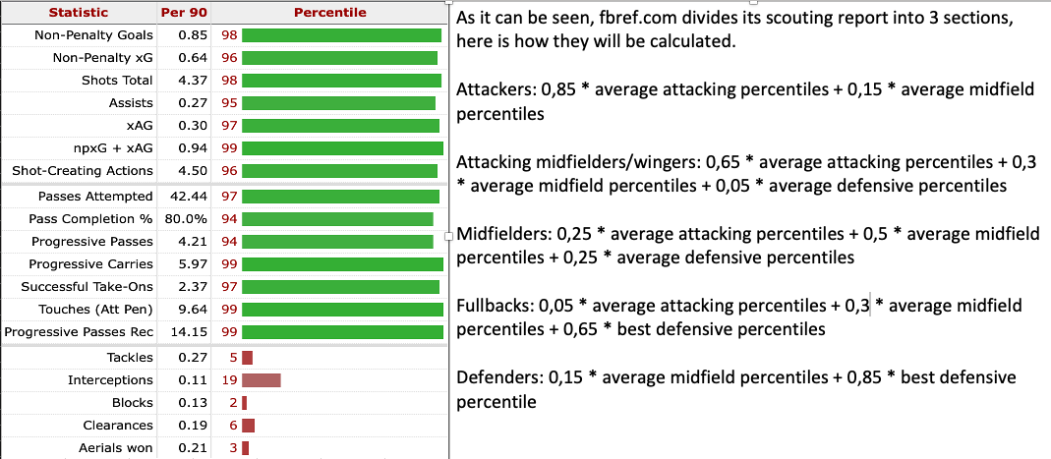
Figure 6. Breakdown of how each player will be evaluated
Basically, there is no available methodology or approach on how to do this, hence why it needed to be created from scratch. The problem with creating something from scratch is that it needs to be referenced to something, a thing from the industry, if possible, in order to make any sense. No approaches are available online (it is safe to say that each football club has its own individual approach on how to grade players, based on scouting reports, but they are not available publicly, as it will interfere with intellectual property). Hence why I had to create from scratch and had to use the very next best approach – to reference how the most popular football game (FIFA) does their ratings, as they are experts in the field of ranking players by ability. Basically, in the game of FIFA, players’ rating (1 to 99) is determined by their breaking down their individual attributes and giving them weight, e.g., for defenders, only defensive and small midfield attributes are allocated and evaluated in the overall rating formation. It makes sense to evaluate defenders by their defensive stats, not by how many goals they score and how well they dribble the ball, correct? The exact same logic goes for attackers: why would we judge an attacker’s rating, based on how well they are able to defend? It doesn’t make sense. The same approach (fbref.com & FIFA ratings) was used to determine the rest of the scoring system for the other positions. However, on the defenders’ part, it must be said that evaluating defenders by their absolute defensive actions (stats) is a very flawed method since those defenders who play for the best teams in England and internationally don’t have to make the same number of defensive contributions, in absolute terms, as defenders from weaker teams, simply because their teams are not attacked as often as the defenders of the weaker clubs. And if the defenders were solely judged based on absolute defensive statistics, it’s safe to assume that those who play at the best clubs wouldn’t play there since other defenders who need to do much more in that part of the game are having more productive seasons, in absolute terms. Moreover, defenders usually play different roles – if a team has 4 defenders on the pitch, each of them will be having a different role, hence why some defenders are tasked to tackle and intercept the ball, others to clear it, third to win aerial duels, etc., which makes comparisons between defenders really difficult, as one cannot simply say that the defender who made more tackles is better than the one who made more blocks, as their roles are simply different. That’s why evaluating their best defensive statistical attribute is a better measurement of their contribution to the overall defensive performance of their teams than averaging out all of their defensive statistics. On top of the five defensive categories presented in the defensive section on the scouting report, one more will be looked into, only for defenders, however. That’s % of aerial duels won, as the variable has shown to have a positive impact on the overall effectiveness of the regression analysis model, and it has an R squared of 13% alone, when measured against final league position. It’s not much indeed but is an improvement that could be seen as important for teams willing to better themselves in the final EPL standings, and this is a good score for a sole variable.
Finally, to evaluate final player performance, each player will be assigned a grade between 1 and 5, with 5 being the highest and 1 the lowest. After applying the formula for each of their seasons (given their statistical performance in each category), they will be given a grade for each season, and then their individual season’s grades will be averaged to get their average grade for their spells at Manchester United.
So, after this long methodological explanation, it’s only natural to begin with Manchester United’s transfer policy evaluation.
Paul Pogba – Paul Pogba was actually a Manchester United youth academy graduate but was let go to join Juventus for free in 2012, before being brought back in 2016 for the then record-breaking 105 million EUR. His second spell for United lasted from 2016 to 2022, when he was let go to join Juventus for free. Again. So, using fbref.com scouting report, the following table illustrates Paul Pogba’s average attacking, midfield, and defensive percentiles during this 5-year spell.
SEASON | AVG ATTACK | AVG MIDFIELD | AVG DEFENSE
2017/2018 | 95 | 86 | 36
2018/2019 | 88 | 83 | 35
2019/2020 | 77 | 74 | 37
2020/2021 | 80 | 75 | 66
2021/2022 | 87 | 80 | 39
Table 8. Paul Pogba's average percentiles per category
Applying the formula for midfielders, as Pogba is classified as a central midfielder, we get the following total percentiles and grades for each season: 2017/2018 – grade of 3,75/5; 2018/2019 – grade of 3,63/5; 2019/2020 – grade of 3,25 out of 5; 2020/2021 – grade of 4 out of 5; and 2021/2022 – grade of 3,63/5. The overall score is calculated as the average of the grades just presented, which means that Paul Pogba’s 5-year spell at Manchester United could be evaluated as 3,6/5. Basically, it can be concluded that Pogba’s tenure at United was, overall, above average. His main issues related to his defensive duties, as his peers in the Premier League were far more helpful defensively to their teams than he was. Apart from his penultimate season, all other seasons, defensively speaking, were bad, very bad actually. This lack of defensive ability, or duty coverage, is what brings his overall performance down. If it were any other player, any player that wasn’t bought for a record-breaking 105 million EUR, the performances could’ve justified the price tag. But paying so much for a player whose overall performance could be evaluated as above average is not enough. It is not enough to spend that much on a midfielder who is basically unable to participate and help his team defensively. And here we don’t talk about him being the best defender in the whole England. The idea is to be a great defender among your midfield peers, something that Pogba didn’t succeed in. This, plus a couple of bad seasons in what is supposedly his strong side, were the overall determinants of a spell that could be defined as “not-enough”. It can never be enough to be classified as above average, not when a record amount of money was paid for your services.
Player | Age at Transfer | Bought, Season | Years Spent | Average Grade
Paul Pogba | 23 | 2016/2017 | 6 | 3,6
Harry Maguire | 26 | 2019/2020 | 3 | 4,5
Jadon Sancho | 21 | 2021/2022 | 1 | 2,7
Romelu Lukaku | 24 | 2017/2018 | 2 | 3,4
Bruno Fernandes | 25 | 2019/2020 | 3 | 3,6
Fred | 25 | 2018/2019 | 4 | 3
Aaron Wan-Bissaka | 21 | 2019/2020 | 3 | 4,3
Nemanja Matic | 28 | 2017/2018 | 5 | 2,8
Raphael Varane | 28 | 2021/2022 | 1 | 4,1
Donny van de Beek | 23 | 2020/2021 | 2 | 3,1
Table 9. Player Evaluation Model applied to the rest of Manchester United's signings of interest from 2017 to 2022
Table 9 shows the average grades that the rest of Manchester United’s signings of interest between 2017 and 2022 received. It must be noted that Antony, Casemiro, and Lisandro Martinez weren’t included in this table as they were signed in the summer of 2022 for the 2022/2023 season, and their grades will be evaluated individually later in the paper.
Player | Season | Position | Leading DEF Attribute | Percentile | Avg MID | Avg ATT | Grade
Harry Maguire | 2019/2020 | Central Defender | Interceptions | 88 | 76 |  | 4,43
 | 2020/2021 |  | % of Aerials Won | 98 | 78 |  | 4,85
 | 2021/2022 |  | % of Aerials Won | 87 | 62 |  | 4,35
Aaron Wan-Bissaka | 2019/2020 | Fullback | Tackles | 96 | 68 | 32 | 4,28
 | 2020/2021 |  | Blocks | 94 | 70 | 46 | 4,50
 | 2021/2022 |  | Interceptions | 85 | 69 | 18 | 3,98
Raphael Varane | 2021/2022 | Central Defender | % of Aerials Won | 88 | 44 |  | 4,13
Table 10. Breakdown of Manchester United's defensive signings grading process
So, beginning the breakdown for the defensive players (Harry Maguire, Aaron Wan-Bissaka, and Raphael Varane) as their grading criteria differs a bit from the rest of the players, as grading defenders is simply a much harder task than rating other outfield players.
Harry Maguire’s leading defensive attribute for two of the three seasons was his percentage of aerial duels won, and from what could be seen, he was very consistent in that department, although it is notable that his third season at Manchester United definitely took a hit and he regressed a bit, but his average grade for his Man United spell is 4,5 out of 5, as per the Player Evaluation Model (PEM). The formula used for him and the other two players who play in defense is the following: 0,85*leading DEF attribute + 0,15*AVG MID percentiles. Each season his defensive attributes have gotten Maguire a grade of 4,5 or higher on the defensive end + the high midfield percentiles, implying his involvement in the possession phase of the game of United. This overall grade makes Harry Maguire the highest-rated signing by Manchester United during the period of interest.
Aaron Wan-Bissaka, on the other hand, is a fullback bought from Crystal Palace in 2019 for 55 million EUR, making him one of the “cheapest” signings that United has made recently. What is interesting about his game is that each season his leading defensive attribute was different, but he excelled in each of them, making him a very solid defender for the club, no matter the role he needed to fulfill. And although his grade is also one of the highest received by a United player, his offensive output drags his grade down, as it still plays a role in the grade calculation for his position, he was unable to successfully produce going forward, making his overall score suffer. A very solid transfer for United, as per the PEM, who needs to improve his offensive output to boost his game even more.
Raphael Varane is a center-back, bought from Real Madrid in 2021 for approximately 40 million EUR. Unlike other players who’ve had multiple seasons to analyze, Varane only has 1. Varane’s leading defensive statistic for last season was his % of aerial duels won, which participated greatly in his overall grade of 4,1 for the season. It could be seen that an area of improvement for the French defender could be his involvement in the second phase of the game (midfield), as his defensive peers in the Premier League were mostly better than him, given his average percentile score.
Overall, one could argue that United’s defensive players have been playing very consistently, given their high grades, and that United’s best bit of recruitment business has been done exactly in the defensive area of the game. This, however, strongly contradicts with the defensive efficiency rank of Manchester United of the last 5 seasons, shown in Table 4. Perhaps the bad defensive rating of the club could be attributed to all players, not only to the defenders. It all depends on the point of view, as well as on a deeper analysis on Manchester United’s defensive performance from 2017 to 2022, with the latter, however, falling outside the scope of this research. And although deeper analytical research on United’s defensive troubles is outside the scope of research, it definitely appears as an interesting research question. It also must be said that the limitations of the Player Evaluation Model (PEM) are mostly felt by defensive players, as the overall game of said players is difficult to be monitored by statistics alone, an opinion shared by Derby County FC’s leading scout back in 2017. Yes, the model accounts for some of the concerns shared by McClaren by considering the different roles that defensive players might play, but the limitations are still there and must be acknowledged.
Player | Season | Position | AVG DEF | AVG MID | AVG ATT | Grade
Jadon Sancho | 2021/2022 | Winger | 31 | 83 | 44 | 2,7
Romelu Lukaku | 2017/2018 | Forward |  | 51 | 73 | 3,9
 | 2018/2019 |  |  | 53 | 53 | 3
Bruno Fernandes | 2019/2020 | Attacking Mid/Winger | 55 | 48 | 78 | 3,4
 | 2020/2021 |  | 67 | 51 | 84 | 4,0
 | 2021/2022 |  | 63 | 46 | 73 | 3,4
Fred | 2018/2019 | Midfielder | 59 | 59 | 53 | 3
 | 2019/2020 |  | 65 | 60 | 46 | 3,1
 | 2020/2021 |  | 64 | 55 | 47 | 2,9
 | 2021/2022 |  | 67 | 51 | 54 | 3,1
Nemanja Matic | 2017/2018 | Midfielder | 72 | 63 | 22 | 3
 | 2018/2019 |  | 61 | 54 | 20 | 2,6
 | 2019/2020 |  | 71 | 56 | 24 | 2,8
 | 2020/2021 |  | 70 | 69 | 24 | 3
 | 2021/2022 |  | 72 | 57 | 38 | 2,8
Donny van de Beek | 2020/2021 | Midfielder | 51 | 62 | 63 | 3,4
 | 2021/2022 |  | 71 | 42 | 58 | 2,8
Table 11. Breakdown of the rest of Man United's players’ grading process
Table 11 shows how the average grading of the rest of United’s recruitments could be broken down for each season of their spells at the club. At first glance, the most obvious thing is that only one player (Bruno Fernandes) has been given a grade of 4 or more out of 5 for a single season. On the contrary, one could argue that although none of those players received a spectacular grade, almost all of them were very solid performers, giving consistent performances to the club.
Jadon Sancho’s only spent a season at Manchester United (two with the current one) and what could be said about him is that, given his 85 million EUR price tag, it was a very disappointing season. Despite his great midfield percentiles, his offensive output for an attacking player was very poor and given that attacking midfielders and wingers get 65% of their final grade from their average attacking percentiles, it’s an understatement why his grade is so low. One assumption, however, which could be turned into a limitation for evaluating attacking midfielders/wingers, is that given that they’re tasked with being the creative players in a team, i.e., to take risks in order to create chances, if the risks they take don’t fully correlate with offensive output, this could lead to them having a skewed grade, entirely in terms of statistical output. What I mean is that although they might be playing excellently, their grade might not 100% reflect this, as from a statistical point of view their grade might be skewed to the left, as the number of risks they take and the consequences they bring might not be 1:1 covered by offensive output. Hence why this also needs consideration when evaluating such players.
When it comes to Romelu Lukaku’s 2-year spell at the club, we could see that he had a relatively good first season at Old Trafford, but his second was very average, as his offensive output was no match for what he did in year 1. What could be said about him, the players analyzed before him, and those who will be analyzed later is that, although they had relatively average/above-average seasons, given the enormous price tags paid for them, this is probably not enough. United spent close to 85 million EUR for the services of Lukaku and it’s quite safe to assume that they expected more than average/above-average performances for 2 seasons only.
Bruno Fernandes, bought for 65 million EUR from Sporting Club de Portugal in 2019, has been one of the better performers at the club, as he’s the only one of the non-defensive players who has struck a season grade of 4 or more. However, him being an attacking midfielder/winger, similar to Sancho, means that his grade might be a little downplayed by the nature of the position he plays in.
Fred has probably been the most consistent player, as all his seasons at the club have hovered just around grade 3/5. Bought for 59 million EUR from Shakhtar Donetsk in 2018, United probably expected a little more from him but at least they cannot complain about him being inconsistent.
Nemanja Matic, just like Fred, has had a little deviation from his average grade for his 5-year spell at the club. The Serbian, bought from Chelsea for 45 million EUR has been given an average grade of 2,8 for his services. Although his seasons have been very consistent, they are far from elite and probably some at the recruitment department at United had expected more.
Finally, Donny van de Beek is one of the signings who’s played the least number of minutes for the club, as per FBref. However, whenever he has played, his statistical output suggests that he has been more or less above average.
This is probably the biggest takeaway from the grading of United’s recruitment over the last 5 years. It’s definitely been either average or above average but given the astronomical amount of money they’ve spent on all these players, alongside the rest who weren’t analyzed, one could definitely argue that Manchester United has failed in this department, as it’s not normal to have spent the most amount of money of every club in Europe since 2017, and to still only get average performances from your players. Yes, there are limitations to the model, especially when it comes to creative players and defenders. Yes, the sample size is not as large as one could want, but still – the numbers suggest that United need to improve when it comes to its recruitment system, or if they feel its scouting process is good – they need to be able to negotiate better, as constantly buying on premium for mediocre services is a recipe for failure. Even at an institution like Manchester United.

2.2. Mixed data-based approach – Survey among Manchester United’s supporters
As mentioned above, survey data will be used to gather insight into Manchester United’s transfer policy, as well as the overall experiences of the club’s fans during the period 2017-2022. Using a questionnaire is vital as it allows for a deeper understanding of the current problems at the club, and what could be done to overcome them, from the fans’ perspective.
163 people in total responded to the survey, which was distributed in an official Manchester United supporters’ group on Facebook with around 1800 members. The supporters’ group is to be officially credited by Manchester United F.C. in the upcoming weeks/months, as per an official statement by one of the admins/creators of the supporters’ trust.
So, beginning with the demographic description of the respondents, as it could be guessed, almost all of them are male – 94,5% vs 5,5% female respondents (154 male vs 9 female respondents in absolute terms). When it comes to age distribution, the biggest share (49,7%) are between the ages of 30 and 49, with the second biggest share (41,1%) is of ages between the ages of 19 and 29; just over 6% of the respondents were under the age of 18.
Figure 7 shows the distribution among the surveyed sample, in terms of when they began supporting the club. The biggest share (38%) is of people who have been supporting United for the past 16 to 25 years, the second biggest (27,6%) for 11 to 15 years, and the third biggest (22,2%) for 26 to 39 years. It’s a rather diverse range, which implies that the supporters who took part in the survey have experienced both similar and different emotions during their fandom of the club. Almost all of them have been involved emotionally with the club for a large part of their lives. The longer they have been engaged with the club emotionally, the more they have gone through and the wider their horizon, in terms of what has gone wrong at the club since they have seen both the good, the bad, and the ugly while supporting it.
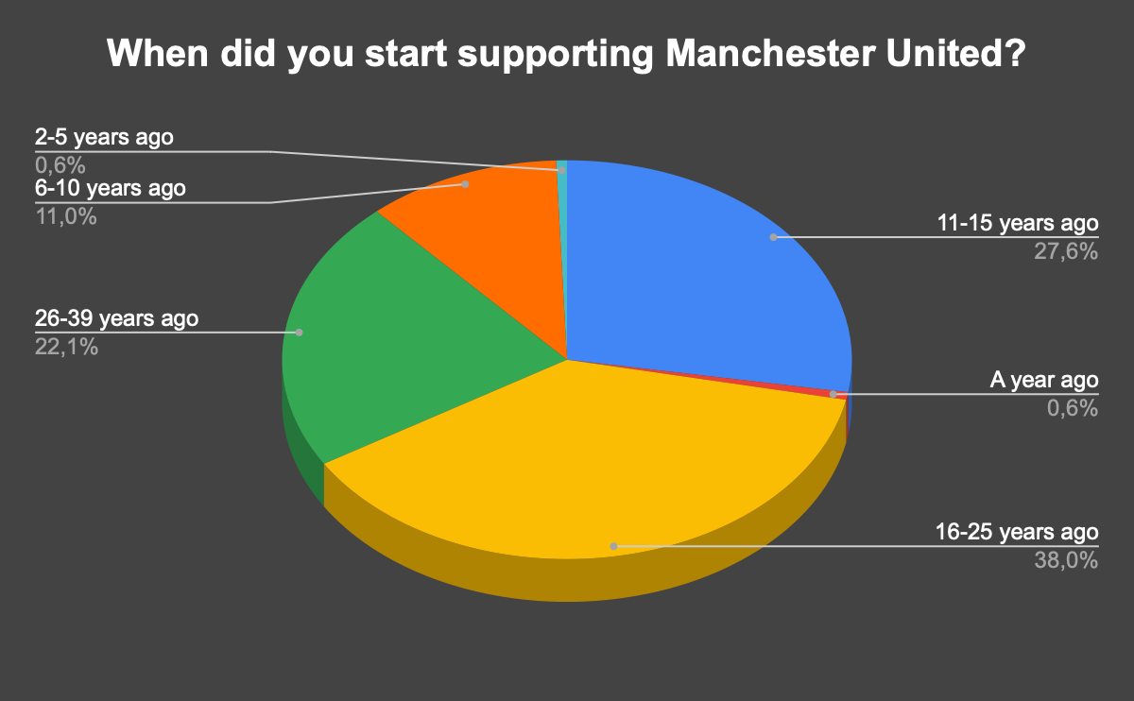
Figure 7. Breakdown of when respondents began supporting Manchester United.
Although the respondents became fans of Manchester United at different stages of their lives, a very large number of them share the same reason as to why they began supporting the club – it’s football players.
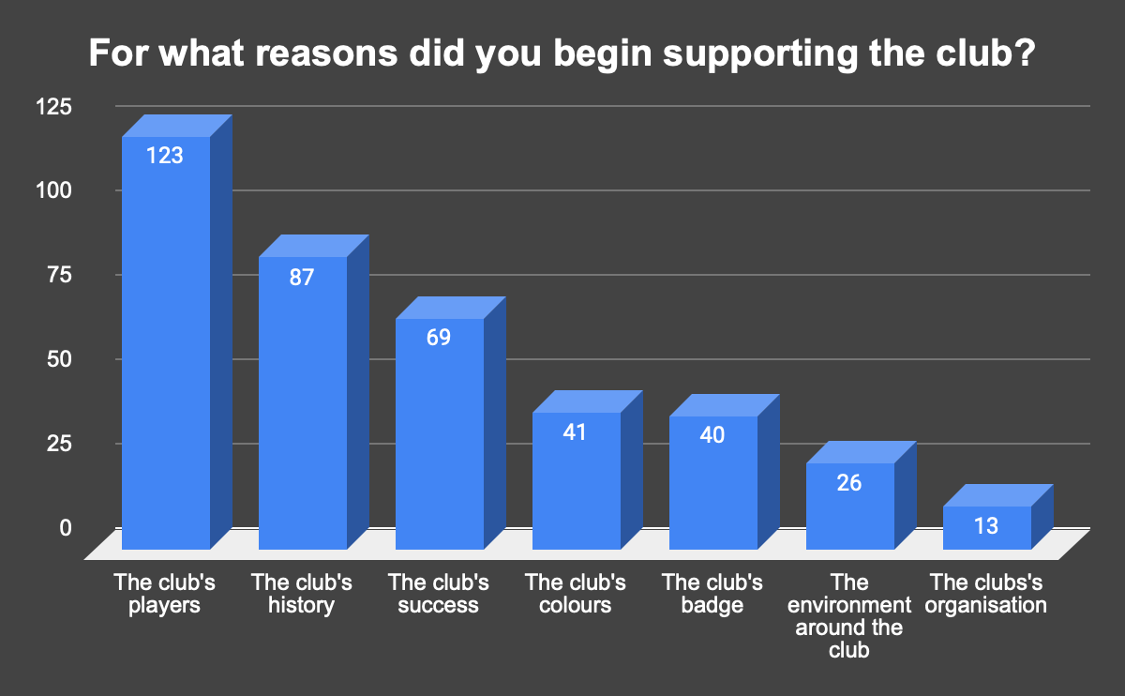
Figure 8. Breakdown of the reasons to support Man United
This question allowed for any answers (it was open ended and answers were divided into separate categories by keywords), and the club’s players and historical achievements were the key reasons as to why they became United fans in the first place. One could argue that the first three leading reasons could be described as “aura”, and that United’s aura is why the club is so well-supported, even in not-so-good times for it. Moreover, these reasons imply, or better put, solidify the premises from the SWOT analysis that United’s brand awareness is one of the best in the football world, given that the club is able to attract the best players, which in turn attract more and more fans, which lead to better financial performance, in terms of revenue from merchandise and matchday revenue.
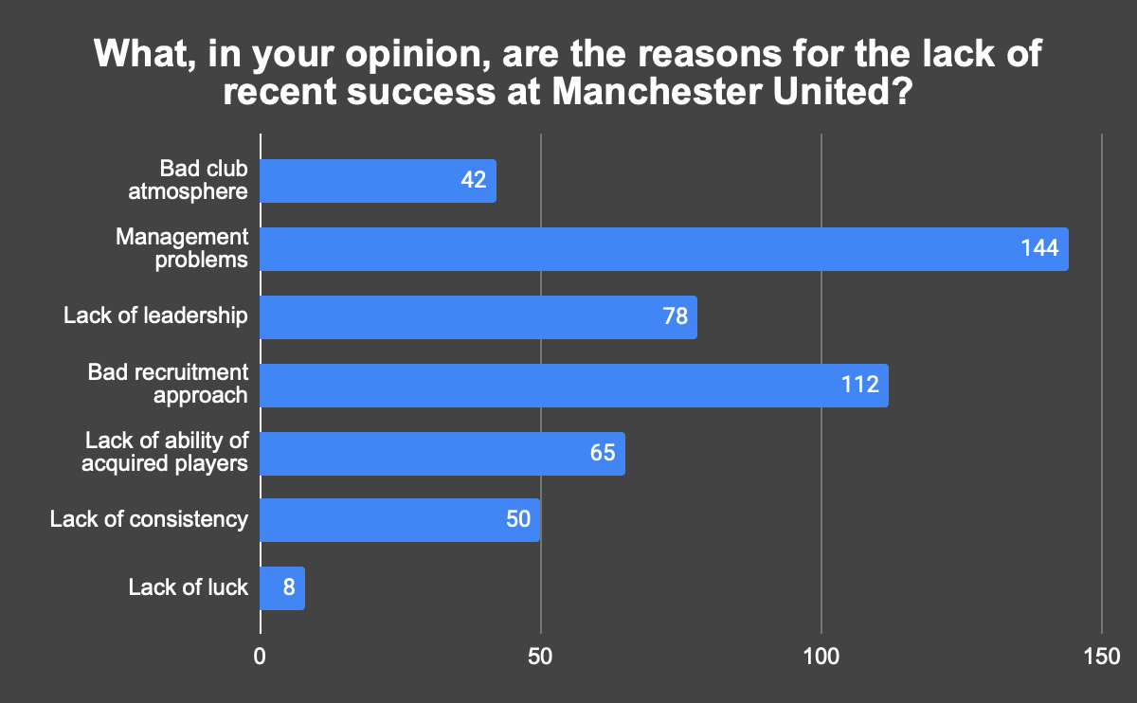
Figure 9. Breakdown of the reasons for the lack of recent success at Man United
Figure 9 shows what the surveyed supporters feel are the major reasons for the lack of success at Manchester United, despite the heavy investment in the last 5 years. Almost all (88%) respondents have in one way, or another indicated that the core issues that stop United from being successful on the pitch are within the management of the club. Other heavily indicated reasons include bad recruitment approach, lack of leadership (on and off the field), and lack of ability of recruited players. What could be extracted as conclusions from this graph is that United’s evident problems of not being able to recruit correctly are also felt by the fans of the club, not only by the statistics. One could argue that United’s inadequate recruitment approach has led to the signing of not-so-good players, which, consequently, harms the club’s competitiveness, as well as brand awareness. As per Figure 8, United’s great players are the main reason for the club to gain a lot of fans. If, nowadays, the players recruited are not up to the desired level, this means that the club loses its ability to be as attractive to the neutral fans, as they once were. Moreover, it also messes with the expectations of the players about the players the club buys, as well as the club itself. What is implied here is that if the club consistently buys players on a premium, it artificially inflates fans’ expectations about the players’ ability and what could be expected from the club for that particular year. And when the season ends, the drop, from the fans’ perspective, from expectations to reality is much bigger than it should be. Moreover, given that this is not a phenomenon, but rather a very consistent seeing for the last 5-10 years, it could be argued that Manchester United’s supporters are now having much less expectations of the club in general, and are much more susceptible to be satisfied with a top-4 finish than they were 15 years ago, when they were constantly winning the English Premier League and advancing to the final stages of the UEFA Champions League. It’s also interesting to note that around half of the respondents have suggested that there is a lack of leadership among Manchester United’s players and managers. This could be used as a “filter” when recruiting for new talent, i.e., recruiting for more experienced players, maybe even on the older side. Given all technologies that are now being implemented in football, signing older and more experienced players is definitely a much more viable and logical option nowadays, as player nutrition and health optimization are on a level that’s never been seen before. What could be derived from this graph, in terms of future suggestions, is that the club should prioritize smart recruitment, ideally buying more leaders who can constantly perform, and focus on improving the way the management of the club functions. One could argue that all these are linked and interdependent, which is a valid point, and could mean that fixing one might allow for the rest to fall in place as well.
The main takeaways from the survey results so far show that Manchester United’s supporters unite around the idea that there are crucial issues that need addressing around the club’s management and recruitment system, as one of the main strengths of the club (their football players) is not as strong, in terms of being able to attract as many new fans as it used. Moreover, the fans also agree that the expectations around the club are not the same as they once were.
The respondents of the survey were also tasked with evaluating the performance of the same players whose performances were evaluated by the PEM. More specifically, the respondents were informed about each player’s grade received by the PEM, and they had to choose whether they agreed with said grade, and if not – they were able to put a grade that best describes their evaluation of said player’s performances for Man United.
Table 12 shows each player evaluated by PEM and how the respondents evaluated the PEM, in terms of percentage of agreement with each grade.

Player Name | Position | Grade | I Agree %
Paul Pogba | Midfielder | 3,6 | 51,6%
Harry Maguire | Central Defender | 4,5 | 7,8%
Romelu Lukaku | Attacker | 3,4 | 62,7%
Jadon Sancho | Att Midfielder/Winger | 2,7 | 55,3%
Bruno Fernandes | Att Midfielder/Winger | 3,6 | 23,3%
Fred | Midfielder | 3 | 73,3%
Aaron Wan-Bissaka | Fullback | 4,3 | 68,8%
Nemanja Matic | Midfielder | 2,8 | 58,6%
Raphael Varane | Central Defender | 4,1 | 83,5%
Donny van de Beek | Midfielder | 3,1 | 47,7%
 |  | Average | 53,3%
Table 12. Respondents' evaluation of United players' grades by PEM
On average, more people (53,3%) agreed with the evaluation model’s grades for each player. The more people agree, the better and closer to the “truth” the model is. However, it must be said that the respondents’ own evaluation could be very subjective and biased, thus making it less reliable. It’s also quite impossible to understand whether each respondent evaluated each player’s performance as objectively as possible or based on their own subjective view. Moreover, some players might be evaluated objectively, while others subjectively – many fans have prejudice against certain players, so it’s possible that they didn’t put the bias aside when evaluating said players.
One interesting thing about Table 12 is that the assumptions made when disclosing the characteristics of the Player Evaluation Model (PEM) – that attacking midfielders/wingers and central defenders are the hardest position to objectively, solely based on statistical output, assess, as many of things these players do aren’t recorded on the statistical sheet, and in the case of the attacking midfielders/wingers – the things they don’t do (mainly evaluating the risk versus award). Bruno Fernandes’ and Harry Maguire’s grades weren’t deemed accurate by the fans taking part in the survey, which confirms the hypothesis that players from these positions might be more difficult to evaluate solely using statistics. Obviously, a single instance from players from both positions doesn’t entirely confirm nor deny a hypothesis, but given the small sample size of players evaluated, it’s worth considering, given that there were 163 people who felt the same.
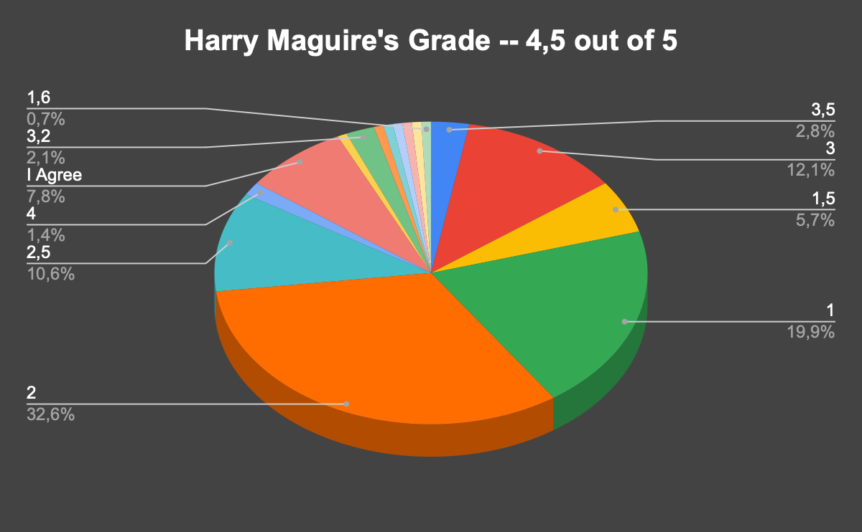
Figure 10. Breakdown of how the respondents evaluated Harry Maguire's grade
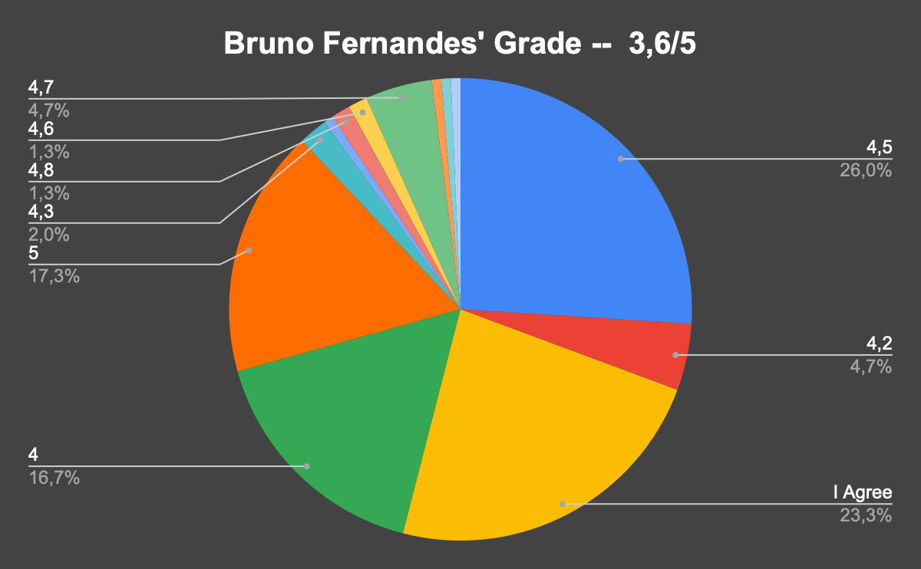
Figure 11. Breakdown of how the respondents evaluated Bruno Fernandes' grade
Figures 10 and 11 show how Maguire and Fernandes were rated by the survey respondents. And although there are many different grades for both players, there are clear patterns: Maguire’s grade of 4,5 out of 5 is way too high for what he deserves, as per the fans. Just over 58% of the supporters who took part in the survey believe that Maguire deserves a grade between 1 and 2, which is much lower than what the PEM gave him, based on his statistical output. Prejudice could definitely be a cause for this low rating, but it must be noted that only 9,2% feel that a grade between 4 and 4,5 (his actual grade) would be justified and all of the rest feel that he is nowhere worthy of such a high grade. When it comes to Bruno Fernandes, the situation is quite the opposite – almost all fans believe that he has been underdone by the PEM and he deserves much more recognition for his performances than what his statistical output would suggest. Just over 50% of all respondents suggest that a grade between 4,5 and 5 is a much more accurate estimate of his spell at Manchester United.
Obviously, taking Maguire and Fernandes out of the equation will increase the average percentage of people who agree with the grades set by PEM. And although this could make sense, given that the positions they play are those where the PEM faces limitations, simply taking them out defeats the purpose of the whole statistical evaluation. Statistics and data analysis, as a whole, are growing in popularity and usage in the world of football management/recruitment, but such decisions can’t solely be made based on statistics. Solutions and decisions made via data analysis could, in theory, outweigh what is seen by our own eyes when it comes to management/recruitment, but it can’t be the only tool used. The well-known “eye test” (evaluation based on what is seen) is still very much needed as it allows managers and scouts to see what the statistics can’t tell – the small things that are not recorded on the stats sheet. All of the PEM’s limitations can be “solved” by simply watching the player of interest.
Evaluating the Player Evaluation Model is important in terms of being able to analyze its flaws and to see whether it could match what is being seen through the eye test. The more people are in general agreement with the grades that each player has received through PEM, the better. This implies that the tool could be used to supplement the traditional scouting tools when making recruitment decisions. In addition to this, the more people agree with the grades, the better the understanding of the players’ performances get, and the more useful the insights for the management of the club are.
The final question that the respondents needed to answer related to their recommendations for Manchester United, i.e., what would they recommend changing for the club to restore back to its glory days, but its results will be shown in the last section.

Strategic Recommendations

Current state-of-the-art at Manchester United

As of Manchester United’s 34th game week, May 7th, the club is currently in 4th position in the English Premier League, hovering in the last spot that gives qualification to the UEFA Champions League for season 2023/2024. They have 4 more games to play until the end of the season in the EPL. They have also qualified for the FA Cup final on June 3rd where they will be facing the other Manchester giant – Manchester City.
As far as the current season is concerned, here is how Manchester United have measured against their competition in the English Premier League.
Club | Season | Possession % | Key Passes | Goals - xG | Aerials Won % | Opponent Goals - xG
Man United | 2022/2023 | 54,1 | 408 | -8,1 | 51,8 | -5,3
Table 13. Descriptive breakdown of Manchester United's season based on key performance variables
Club | Possession | Key Passes | Goals - xG | Aerials Won % | Opponent Goals - xG
Man United | 6th | 4th | 17th | 6th | 7th
Table 14. Rank within league; Manchester United's key performance variable.
Although United have had a very good campaign in terms of key passes (chance creation), they have been largely disappointing offensively, implying the need for quality attacking players. The club might also benefit from a new defender/defensive player that will help the team become more efficient defensively. Moreover, although United has been “consistent” in terms of finishing 6th for possession, the ability to keep hold of the ball for longer periods is one of, if not the most significant contributors to the regression model, which highlights the importance for a club to be able to control the ball, and subsequently be in control of the games. And although the amount of time a club keeps hold of the ball could be a tactical decision by the coaches of the club, United could definitely benefit from adding a midfielder who is a specialist in keeping the ball under his club’s control, as the importance of this variable is quite high.
If we apply the regression model equation, in order to determine what the statistics say about where Manchester United should’ve finished the season, versus where they are about to finish it, we get the following:

Club | Season | Expected Position | Final Position
Man United | 2022/2023 | 9th | 4th
Table 15. Manchester United's expected vs. final league position in England, based on regression model.
A lot can be said about United’s current season as well, but the most important thing to mention is that United is probably over-relying on its footballers’ individual class. The club spent a lot of money this season as well, but it’s still a lot of pieces away from competing both in England and in Europe as well. Simply based on statistics, United’s had a very terrifying season, as it’s visible that the club is still buying players, rather than building processes with all the money they spend on the transfer market. If the club doesn’t change that, the individual class of its football players might not be enough for them to achieve such overperformances for longer, as the football players get older, they might get injured and be unavailable for longer periods of time, and lastly – the luck might not be on their side for big portions of the season. All of these variables are hard to predict (bar the players’ ages) and assess the possible effect they might have over the outcome of United’s performances.
As mentioned earlier in the paper, United’s new signings for season 2022/2023 – Lisandro Martinez, Antony, and Casemiro – will be examined separately.
Player | Season | Position | Leading DEF Attribute | Percentile | Avg MID | Avg ATT | Grade
Lisandro Martinez | 2022/2023 | Central Defender | Blocks | 96 | 54 | - | 4,7
Table 16. Lisandro Martinez's evaluation breakdown
Player | Season | Position | AVG DEF | AVG MID | AVG ATT | Grade
Antony | 2022/2023 | Winger | 34 | 68 | 63 | 3,4
Casemiro | 2022/2023 | Midfielder | 93 | 43 | 64 | 3,1
Table 17. Antony and Casemiro's evaluation breakdown
So far, Lisandro Martinez’s been the best-performing signing that Manchester United made last summer with a grade of 4,7 out of 5. On the other hand, Casemiro and Antony, based on their statistical outputs, seem to be more of above-average acquisitions. Nothing wrong with being above average but given their price tags (Antony was bought for 95 million EUR and Casemiro for 70 million EUR) one ought to expect a little bit more. Perhaps they need more time to fully adapt and integrate to the English Premier League, but they will need to do that soon, as United’s had another season of severe statistical underperformance, all the while relying on its players’ individual class to make the season look good on paper. The club’s management needs to focus on the issue of underperforming, yet costly to recruit players.

Strategic recommendations outline

Manchester United’s management could be faced with slight complications in terms of recruiting foreign players due to Brexit, as the club’s management now needs to issue work visas for all incoming players, regardless of whether they’re from the EU or not. This, obviously, doesn’t mean that they won’t be able to recruit anybody outside the UK, but it could make the negotiations slightly more difficult and inefficient. There is an easy fix for this – United could, in theory, exclusively focus on bringing in players from England/the UK. There are, indeed, trade-offs that are to be experienced should such a decision is taken, as the literature suggests (given the high number of foreign players playing the English Premier League) that foreign talent is perceived to be of more quality than domestic one. Should United focus on recruiting more domestic talent, this could help the club financially, especially if the hypothesis that foreign players exceed domestic ones in terms of quality. This absence of financial loss can allow Manchester United to invest the surplus in their infrastructure, given that this is a significant weakness of the club.
United’s biggest weakness (in terms of team performance) this season has been their inefficiency in front of the opposition goal, as they have scored 8 goals less than expected, which ranks the club 17th in the league for that category. Therefore, they are in dire need of an efficient striker that can score a lot of goals. This is priority number 1 for Manchester United. The club’s leading goal scorer this season is Marcus Rashford with 16 league goals, hence why one of the criteria will be to search for a striker with a positive Goals minus xG, and with a goal tally of around 15 or more league goals, which is similar to Rashford’s.
Secondly, United need to improve their midfield by adding a player that significantly increases the club’s average possession of the ball. That could be done through recruiting for midfielders who rank very high (in terms of percentile) for touches and percentage of completed passes per 90 minutes. It’s also a bonus if said player ranks high in the department of key passes because that way United will be able to improve two different areas of their game with a single recruitment.
Thirdly, the club is in big need of a new defender as the defensive performances of the last few seasons haven’t been good enough. It’s worth looking for a defender that ranks very high in one of the major defensive categories, as per FBref, as well as has a very high percentage of aerial duels won. Again, with such recruitment, we are trying to cover two problematic areas with a single acquisition.

Figure 12 breaks down the list of recommendations that the supporters who took part in the survey indicated. The respondents were able to identify any potential solutions that they would want to see implemented, but almost all of them had a very clear opinion – they think that changing United’s management and the recruiting system it implements would be the best recommendations to ensure the club’s future well-being and success.
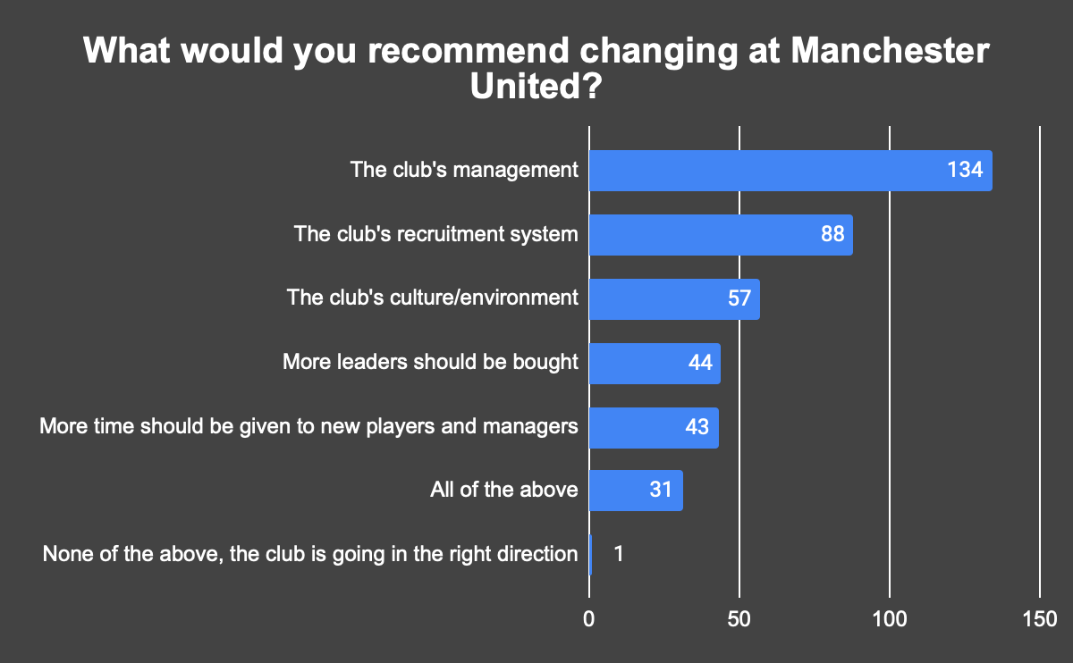
Figure 12. Manchester United supporters' recommendations
The major things learned from the fans are that the club’s management needs to change the way they recruit players, and, perhaps, focus on buying more players that would be bringing leadership traits, something the fans have identified to be missing at United. The supporters feel that the club could use a change of culture inside the dressing room, and frankly speaking, recruiting experienced players that United hasn’t broken the bank for will definitely change the culture inside the club, as 1) it will numerically increase the number of leaders and experienced players in the club; and 2) will better (in terms of a realistic point of view) manage the expectations of the players recruited, as well as the club as whole. The second point is particularly important because when a club spends 100 million EUR for a player, everyone will expect that player to perform as a player for 100 million EUR, not taking into account that said player’s market value is 50 million EUR, twice as low, and that his abilities might be nowhere near enough for the price tag that the club has paid for him. If players are bought for reasonable prices, and prices close to their market value, the expectations from the player and the club will be much different, and much more objective, perhaps.
From the perspective of Manchester United’s management, it’s important to deliberate on the fact that almost all supporters share a feeling that the management hasn’t done a good enough job to ensure Manchester United’s competitive position in the past several years, as United have been trying to establish themselves as one of England’s best teams, but with no success to show for it. Moreover, the club’s infrastructure has been quite neglected and United are trailing their biggest rivals in that area. All these combined, do, indeed, point towards change at the top of the club’s hierarchy. Moreover, 20% of the fans feel that the current or new management will have a lot of work to do, as they believe that all of the options above should be undertaken by the United’s management, if the club wants to return to the top of English and international (European) football.
With everything being said, it’s impossible to suggest concrete managerial changes at Manchester United given the nature of the situation the club is currently in – United just appointed a new first-team manager in Erik ten Hag last summer, and so far, the Dutchman is doing a very decent job, managing United to a top-4 position that gives them a chance to qualify for the UEFA Champions League. Moreover, there are many rumors that Manchester United F.C. is on the verge of a takeover – nothing decided on who will take over the club, when that will happen, and what the new managerial structure will look like. There are two main bidders for the club of Manchester – Sir Jim Ratcliffe (England’s richest man) and Qatar’s Sheik Jassim. Both sides offer different deals that will see a completely different structure being implemented into the management of the club – Sir Ratcliffe wants to buy a controlling stake at United and swiftly phase out the current owners of the club in the next couple of years, whereas Sheikh Jassim wants to buy 100% of the club right now (Jackson, 2023). The valuation of both offers is between £5 million and £6 million. A deal seems imminent, however, there are not enough details and information on who is going to be the new owner of the club and what the internal processes will be, when they will take place, etc. Hence why any exact recommendations on changes in the management structure/personnel cannot be made, due to them most likely becoming obsolete in the very near future.
In conclusion, Manchester United’s management needs to recruit players (and recruit them smarter than usual) that play in three different positions: Attacker, Midfielder, and a Defender. Each signing comes with a criterion for each position, implying the search for a specific profile of players. The pool of players is the Big 5 leagues of Europe (England, Spain, Italy, Germany, and France). It is reported that Manchester United is going to have somewhere around 100 million EUR in transfer budget for the summer unless they sell current players. Given that it is unknown which players are going to be sold and for how much, the recommendations for player recruitment will be done based on a budget of only 100 million EUR, not more. A couple of desired but not critical criteria are for the players to be over the age of 27, and to be English, if applicable.

Strategic Recommendations

Finally, after taking into account the club’s current state-of-the-art and the strategic recommendations outline, we come to the recommendations that will be made to Manchester United’s management, in order to increase the club’s competitive positions domestically and internationally.
- Manchester United’s management must implement a new recruitment system, as the one they have been currently implementing does not add any added value, no matter how much of a premium they pay, in order to lure in talent from other clubs. Manchester United needs to decrease either the amount of money they invest in players in general, or to restrict themselves to one big/record signings on a sporadic, and not constant basis. The club’s added two more players on average to the list of their most expensive signings each year since 2017, and currently have 5 of the 25 most expensive recruitment deals of all time. Yet, the results that one could expect from such investment deals are nowhere to be found. Although undoubtedly the club uses data analysis to gather intel on potential signings and to evaluate their current squad, the club might benefit from adding more emphasis on advanced analytics to make their recruitment deals, i.e., focus on players might not entirely suit the playing system when watching them, but suit the team from an advanced statistics point of view. Obviously, it’s very circumstantial as to what exactly the club needs to change, i.e., when grading a player which analysis should weigh more (data analysis versus live watching the player), but United must do something about their recruitment strategy because the club’s been spending way too much, yet zero success to show for it. They have been buying players, and not processes, and even the players they’ve bought weren’t rated as high both by the Player Evaluation Model and by the supporters of the club – which implies that they have “failed” both the stats and live watching tests.
- The club’s management must search for and recruit a new striker this summer because for the last two seasons (2021/2022 & 2022/2023) the club has been extremely inefficient when converting chances into goals, and as we know, you cannot win games in football without scoring goals. Not winning games leads to bad results, and the bad results mean that the management of the club is facing pressure, as it hasn’t done its job when constructing the team. One could find themselves in this vicious circle of bad results, a lot of pressure, and high spending, which fully describes Manchester United’s position since 2017. Following the criteria from the quantitative pre-recommendations, here is a proposed list of strikers and their statistical outputs until May 7th that Manchester United’s management can choose from, in order to improve their results offensively. Two of the recommendations will be for English players, and for players that are over the age of 27, and two for players that are not English and of any age, in order to cover every possible preference of the club:
  - Harry Kane – the Englishman has 26 goals and has outscored his expected output by almost 7 goals in the EPL. He is 29 years old and is the captain of the English national team, hence he ticks the leadership checkbox as well. The only issue is that he plays for Tottenham Hotspur and his estimated market value by Transfermarkt is 90 million EUR. If Man United only have 100 million EUR to spend in the summer, it’s unlikely they will be able to sing him, unless they sell other players first. If the club, however, has more money to spend in the summer, my recommendation to the club’s management will be to sign Harry Kane, as he is the most prolific striker out of the recommended.
  - Callum Wilson – the English striker has scored 15 league goals in the EPL this season and has outperformed his expected output by 1,5 goals, up until May 7th. He is 31 years old and has an estimated value of 18 million EUR making him very accessible to recruit. He also checks the leadership box. If United’s management has to operate on a tight budget this summer, my recommendation to it is to sign Callum Wilson, as he fits the profile of the player in need of the club.
  - Terem Moffi – the Nigerian striker has scored 17 goals this season in the French league, outperforming his expected output by 3,6 goals. He is 23 years old, which means that United can use him for the short and long terms, should he hit the ground running at Old Trafford. Transfermarkt estimates his market value at 20 million EUR.
  - Victor Osimhen – the Nigerian striker has scored 23 league goals in the Italian Serie A for Napoli. He is 24 years old and has outperformed his expected output by 4,1 goals this season. Transfermarkt estimates his market value at 100 million EUR, and just like with Harry Kane, unless Manchester United sell players of value first, it might be difficult to lure into Old Trafford, especially considering that they might have to pay a premium to Napoli for his services, given his age, output, and potential.
- The next player-related recommendation to Manchester United’s management is to sign a quality defender that can make the club’s defense as solid and efficient as possible. If United continue to let their opponents score more goals against them than they’re expected to, this only makes the club’s ideal of success even harder to reach. Having in mind the prerequisites from the quantitative pre-recommendations, here is a list of possible defensive acquisitions Manchester United can make to improve their defensive performances. The same criteria from the previous paragraph applies here too, i.e., two English players and two non-English, two players over the age of 27, and two of any age:
  - Willi Orban – the Hungarian central defender is 30 years old and plays for RB Leipzig in the German Bundesliga. He checks the box for being a player with a leadership status. He is one of the very best defenders, in terms of total tackles + interceptions, as well as for having won more than 50% of his aerial duels. Moreover, he is one of the central defenders with the highest number of touches, implying that he is able to help the team both defensively and in the control phase of the game, as United have struggled there in that zone as well. What could be made from this is that he is a very aggressive, but very assured defender given the high number of defensive activities, in a team that likes to hold the ball a lot. Moreover, quantity and quality seem to go hand in hand in his scenario, implying his qualities as a defender. His market value is at 10 million EUR by Transfermarkt. My recommendation to Manchester United’s management is to exactly sign Willi Orban, as he is both an experienced player with a lot of leadership, and one of the leading defenders in the areas that the club needs to strengthen.
  - Hiroki Ito – the 24-year-old Japanese central defender plays for Stuttgart in the German Bundesliga and is one of the better well-rounded defenders, apart from Orban. He ranks very high for total blocks and total tackles and interceptions (both 80th percentile), as well as being one of the defenders with one of the highest number of touches (93rd percentile). Just like Orban, he plays in a very aggressive and defensively engaged roles, all the while being a defender who is comfortable in controlling the ball, assuring that his team keeps possession. His market value is at 7,5 million EUR by Transfermarkt.
  - Chris Mepham – the 25-year-old Welsh central defender plays for Bournemouth in the English Premier League, and just like the previous two defenders, he ranks very highly in percentage of aerial duels won, as well as being in the 88th percentile for blocks and 99th for clearances this season. Unlike Orban and Ito, however, Mepham is not that good in possession, as he only ranks in the middle of the pack (56th percentile), but in the right system, the homegrown talent could improve this sphere of his game and prove to be a valuable member of United’s squad. His market value is estimated to be around 6 million EUR.
  - Chris Smalling – the 33-year-old English defender plays for AS Roma in the Italian Serie A and will most certainly being a surprising target for the United, given that he used to play at Old Trafford and is of a very advanced age. However, the Englishman ranks very high in terms of blocks among all defenders from the top 5 leagues (83rd percentile), as well as being one of the best all-around English defenders, given from the pool of English defenders he ranks in the 93rd percentile for total touches, i.e., engagement in the control of game. He is also the English defender with the most clearances and interceptions, implying that he could be a valuable addition to Manchester United, despite his age. One thing should be said however, the English defenders rank lower than other nationalities in the defensive percentiles, i.e., although Smalling ranks in the 93rd percentile for total touches of the ball among English defenders, he only ranks in around the 56th for total touches among all defenders. Hence why United need to thread carefully when choosing a defensive player, with signing with a foreign nationality seems as the more reasonable option. Smalling’s market value is of 8 million EUR by Transfermarkt.
- Manchester United, for the past 6 seasons, including the current one, have been struggling to increase their average possession stats and have always hovered around the 6th spot for average possession per game. Yes, it must be said that sometimes the amount of possession a team has is down to its tactics and preferences, but as the regression model has indicated, being able to stay in control of games is an extremely powerful tool to help improve a club’s overall position in the English Premier League. Therefore, Manchester United’s management needs to plan for recruiting a midfielder in the summer, that is one of the leading players in the world for being able to control the game, dictate the tempo, and not let the opponents have the ball for long periods of time. Applying the criteria from above, here is a list of the possible midfield recommendations to the club’s management that would see improvements in United’s overall game:
  - Joshua Kimmich – The 28-year-old German national plays for Bayern Munich in the German Bundesliga. Kimmich is a player that ranks very high for successful passes and for overall touches per game, implying that he is a very skilled player who can help United to keep more possession of the ball than they do now. He also ranks in the 98th percentile for assists among all midfielders and in the 98th for key passes, hence, should United decide to recruit him, the club will be able to check two boxes off with his signature. Kimmich’s market value is at 80 million EUR per Transfermarkt.
  - Enzo Le Fee – the 23-year-old French midfielder plays for Lorient in France and ranks in the 89th percentile for total touches, showcasing his ability to dictate the tempo of a game when he plays. Moreover, Le Fee ranks in the 88th percentile for assists and in the 95th for key passes, making a very reasonable transfer target that will see United’s game improve in two areas with his recruitment. Le Fee is valued at 15 million EUR per Transfermarkt. Should Manchester United’s management need to operate on a limited budget for recruitment this summer, I would recommend to the club’s management to sign Le Fee as he checks every box that the club’s needs to fill in, and is also very young with a lot of room to grow.
  - Declan Rice – the 24-year-old English midfielder plays for West Ham in England and is one of the best English midfielders overall. Rice ranks in the 81st percentile for percentage of successful passes and in the 73rd for total touches. He is also great at winning the ball aerially, but unlike Kimmich and Le Fee, he isn’t that creative and probably won’t add as much creative value as the other two. Rice’s market value is estimated to be around 80 million EUR.
  - James Ward-Prowse – the 28-year-old English Midfielder plays at Southampton in the English Premier League. Ward-Prowse is not as a controller of the game as the others, as he only ranks in the 69th percentile for total touches, but it’s important to remember that this statistic might be influenced by how his Southampton plays tactically. On the other hand, the Englishman ranks in the 92nd percentile for key passes and in the 93rd for goals, implying that out of the four midfielders suggested, he is the one most likely to help Manchester United creatively, but the least in terms of controlling the game and its tempo. Ward-Prowse is valued at around 38 million EUR by Transfermarkt’s estimations.
- Manchester United and its management should focus on utilizing their strong youth system and promote more players to their first team from within, rather than continue buying the biggest stars in world football for astronomically high prices. The club is facing the threat of Brexit making recruitment from Europe more complicated, from a bureaucratic/administrative point of view, and one way to eliminate this threat is to give more chances to the young players that play in the club’s academy. As mentioned, United holds the record for having played youth academy players the most in football history and given some of the names that their academy has produced, it’s worth considering. Moreover, this could save the club some extra finances, which can be spent on its infrastructure, something that the club’s management strongly needs to work on.
- Although Manchester United is one the most commercially developed, if not the most, clubs in the world they shouldn’t prioritize marketability over data-backed ability when recruiting. Yes, the commercial opportunities are endless right now and not utilizing them is wrong, but United’s management is perhaps over-relying on them, as although the club’s signed many high-profile players, the fans don’t seem as connected to them as they once were. In addition, the club’s focus has shifted from success on the pitch to commercial success, and in fairness, United is one of the clubs that has enjoyed the highest share of commercial revenue, but the club’s seen its position amongst its peers on the Deloitte Money League drop because of their lack of success on the pitch since 2017. Whenever they sign players, they should start prioritizing footballing ability over marketability again, in case they want to return to the top.

Appendix
Club | Net Balance in million EUR (2012 to 2022)
Man Utd | -€ 1018,33
Man City | -€ 1013,74
PSG | -€ 889,15
Arsenal | -€ 616,98
Barcelona | -€ 543,16
Juventus | -€ 481,45
AC Milan | -€ 470,66
Chelsea | -€ 427,10
Liverpool | -€ 388,61
Bayern Munich | -€ 369,20
Tottenham | -€ 260,23
Inter Milan | -€ 259,99
Real Madrid | -€ 138,80
AS Roma | -€ 118,85
Table 18. Net Balance in million EUR of selected European Football Clubs; 2012 - 2022; Source: Transfermarkt
Club | Capacity | Training ground | Stadium experience | Total Infrastructure
Man Utd | 3 | 3 | 3 | 3
Liverpool | 2 | 3 | 2 | 2,3
Man City | 2 | 3 | 2,5 | 2,5
Arsenal | 2 | 3 | 1 | 2
Spurs | 3 | 1 | 3 | 2,3
Chelsea | 1 | 3 | 2 | 2
Table 19. Breakdown of infrastructure as key success factors based on several variables.
The infrastructure as a key success factor was evaluated based on articles and reviews from Odhiambo (2022); McNulty (2022) and Viquez (2022). Each category weighs 33% and for a club to receive the highest grade, it needs to rank within the top 5 of the EPL for each category.

Club | Youth Ranking 1 | Youth Ranking 2 | Total Youth Development
Man Utd | 3 | 3 | 3
Liverpool | 2 | 3 | 2,5
Man City | 3 | 3 | 3
Arsenal | 3 | 3 | 3
Spurs | 3 | 2 | 2,5
Chelsea | 3 | 3 | 3
Table 20. Breakdown of how youth academy was evaluated as a key success factor based on two independent rankings.
The youth academy as a key success factor was ranked based on independent reviews from HITC Sevens (2022) and Schneider-Weiler & Austin (2022). Each category weighs 50%.
Club | Number of Fans | Avg Attendance | Total Engament
Man Utd | 3 | 3 | 3
Liverpool | 3 | 3 | 3
Man City | 1 | 2 | 1,5
Arsenal | 3 | 3 | 3
Spurs | 2 | 3 | 2,5
Chelsea | 2 | 2 | 2
Table 21. Breakdown of how global presence and fans’ support was calculated as a key success factor, based on independent reviews on the number of fans, and average attendance on football stadiums per Transfermarkt
The fan engagement and presence as a key success factor was evaluated based on an independent ranking on the number of fans that each club possesses by Smith (2022) + the average attendance figures gathered by Transfermarkt.

Bibliography
Altman Solon. (2022, September). Growth in new fan-focused technologies, women’s sports creates exciting opportunities for global sports. Altman Solon. https://www.altmansolon.com/insights/growth-in-new-fan-focused-technologies-womens-sports-creates-exciting-opportunities-for-global-sports/
Andersson, P., Memmert, D., & Popowicz, E. (2009). Forecasting outcomes of the World Cup 2006 in football: Performance and confidence of bettors and laypeople. Psychology of Sport and Exercise, 10(1), 116–123. https://doi.org/10.1016/j.psychsport.2008.07.008
Bank of England. (2023). Interest rates and Bank Rate. Bank of England; Bank of England. https://www.bankofengland.co.uk/monetary-policy/the-interest-rate-bank-rate
Banos, K. (2018, May 11). The Impact of Foreign Players on the Performance of a Football Club - Statathlon. Statathlon: Intelligence as a Service. https://statathlon.com/the-impact-of-foreign-players-on-the-performance/
Bell, A. R., Brooks, C., & Markham, T. (2013). Does Managerial Turnover Affect Football Club Share Prices? ProQuest, 2–20. https://www.proquest.com/docview/1506899212
Bernile, G., & Lyandres, E. (2011). Understanding Investor Sentiment: The Case of Soccer. Papers.ssrn.com. https://papers.ssrn.com/sol3/papers.cfm?abstract_id=1343685
Carrera, K. (2021, November 28). Premier League vs Championship: FINANCIAL COMPARISON. SQaF. https://sqaf.club/premier-league-vs-championship-money/
Clark, D. (2022, November 21). UK FDI flows 2021. Statista. https://www.statista.com/statistics/935245/uk-fdi-flows/
Conlon, R. (2017, August 8). Derby scout explains how clubs use stats to identify and analyse defenders. Planet Football; Planet Football. https://www.planetfootball.com/in-depth/derby-scout-explains-clubs-use-stats-identify-analyse-defenders/
Doyle, C. (2022, April 10). Premier League Prize Money by Position [2021/22]. SQaF. https://sqaf.club/premier-league-position-prize-money/
English Premier League. (n.d.). European qualification for UEFA competitions explained. Www.premierleague.com. https://www.premierleague.com/european-qualification-explained
FBref. (n.d.). Scouting Reports Explained. FBref.com. https://fbref.com/en/about/scouting-reports-explained
Flintham, J. (2022, March 20). Manchester United facing “£1.5bn bill” to rebuild Old Trafford. Manchester Evening News. https://www.manchestereveningnews.co.uk/sport/football/football-news/old-trafford-expensive-united-rebuild-23445262
Forrest, D., & Simmons, R. (2000). Forecasting sport: the behaviour and performance of football tipsters. International Journal of Forecasting, 16(3), 317–331. https://doi.org/10.1016/s0169-2070(00)00050-9
G, M. (2011, November 26). Manchester United and 15 Best Supported Clubs in World Football. Bleacher Report. https://bleacherreport.com/articles/865275-manchester-united-and-15-best-supported-clubs-in-world-football
Gasquez, R., & Royuela, V. (2016, March). The Determinants of International Football Success: A Panel Data Analysis of the Elo Rating. https://www.researchgate.net/publication/298901587_The_Determinants_of_International_Football_Success_A_Panel_Data_Analysis_of_the_Elo_Rating
Glaze, A. (2023, January 31). Council Post: How Rising Interest Rates Can Hurt—Or Help—Businesses. Forbes. https://www.forbes.com/sites/forbesfinancecouncil/2023/01/31/how-rising-interest-rates-can-hurt-or-help-businesses/?sh=4b38ba5624f0
GlobalData. (2022, November). Market Size of the Sports betting Industry in the UK (2017-2021, $ Billion). Www.globaldata.com. https://www.globaldata.com/data-insights/travel-and-tourism/market-size-of-the-sports-betting-industry-in-the-uk/
Grimditch, J. (2022, March 15). The Galácticos: how not to forge identity in a changing football climate. Varsity Online. https://www.varsity.co.uk/sport/23371
Han, C., Vu, N., & Andås, C. (2020). How will Brexit affect the English Premier League? https://oda.oslomet.no/oda-xmlui/bitstream/handle/11250/2824185/Vu_CamillaHanNgoc-Andas_Christopher.pdf?sequence=1&isAllowed=y
Hardy, M. (2019, March 13). The last four seasons Premier League-clubs have paid £130 million in compensation to sacked managers | Off The Pitch. Offthepitch.com. https://offthepitch.com/a/last-four-seasons-premier-league-clubs-have-paid-ps130-million-compensation-sacked-managers
HITC Sevens. (2022, October 2). Ranking EVERY Premier League Academy From Worst to Best. Www.youtube.com. https://www.youtube.com/watch?v=NAElplES4Uo
IBIS World. (2022, April 29). IBISWorld - Industry Market Research, Reports, and Statistics. Www.ibisworld.com. https://www.ibisworld.com/uk/bed/sport-participation/44182/
Inman, P. (2022, December 30). “Groundhog year”: UK disposable incomes to fall by 3.8% in 2023. The Guardian. https://www.theguardian.com/business/2022/dec/30/groundhog-year-uk-disposable-incomes-to-fall-by-38-in-2023
Jackson, J. (2023, April 28). Sheikh Jassim and Sir Jim Ratcliffe lodge final Manchester United bids. The Guardian. https://www.theguardian.com/football/2023/apr/28/sheikh-jassim-manchester-united-bid-glazers-ratcliffe
Kelly, R. (2021, April 21). Who are the Premier League “big six”? Top English clubs & nickname explained | Goal.com. Www.goal.com. https://www.goal.com/en/news/who-are-premier-league-big-six-top-english-clubs-nickname-explained/130iokmi8t8dt1k3kudou73s1k
Kenmare, J. (2022, October 30). Man Utd have named an academy graduate in their squad for the last 85 years. SPORTbible. https://www.sportbible.com/football/man-utd-premier-league-west-ham-squad-academy-20221030
Lisubila, S. (2022, November 10). Premier League vs La Liga: Which is the best football league and why? SportsBrief - Sport News. https://sportsbrief.com/facts/bio/27039-premier-league-la-liga-football-league/
MacroTrends. (2022). U.K. Population Growth Rate 1950-2020. Www.macrotrends.net. https://www.macrotrends.net/countries/GBR/united-kingdom/population-growth-rate
Manchester United. (2019). About Manchester United. Manutd.com. https://ir.manutd.com/company-information/about-manchester-united.aspx
Manchester United. (2020). Business Model. Manutd.com. https://ir.manutd.com/company-information/business-model.aspx
Manoli, A. (2014). The football industry through traditional management theories. http://sportstudies.org/wp-content/uploads/2014/11/093-109_vol_5_2014_manoli.pdf
McCambridge, E. (2023, May 5). Manchester United’s transfer budget “only” £100m this summer, even if Qatari owners arrive - report. Yahoo Sports. https://sports.yahoo.com/manchester-uniteds-transfer-budget-only-124234282.html
McNulty, P. (2022, August 5). Ranking the 2022/2023 Premier League Stadiums. 13th Man Sports. https://13thmansports.ca/2022/08/05/ranking-the-2022-2023-premier-league-stadiums/
Migration Policy Institute. (2021). Top 25 Destinations of International Migrants. Migrationpolicy.org. https://www.migrationpolicy.org/programs/data-hub/charts/top-25-destinations-international-migrants
Odhiambo, H. (2022, March 3). Ranking the best training grounds in England 2023 with their cost. SportsBrief - Sport News. https://sportsbrief.com/facts/top-listicles/12155-ranking-training-grounds-england-top/
Prinz, A., & Thiem, S. (2021). Value‐maximizing football clubs. Scottish Journal of Political Economy. https://doi.org/10.1111/sjpe.12282
Rappaport, S. (2023, February 14). How to Win in Football Despite Losing Matches. Bloomberg.com. https://www.bloomberg.com/news/articles/2023-02-14/how-venezia-fc-became-most-fashionable-football-team-in-the-world#xj4y7vzkg
Reuters. (2023, March 2). English clubs spending more after Brexit changed immigration system - Masters. Reuters. https://www.reuters.com/lifestyle/sports/english-clubs-spending-more-after-brexit-changed-immigration-system-masters-2023-03-02/
Robertson, J. (2021, May 5). Mike Ashley v the other Premier League clubs - Infrastructure spend since 2010. NUFC the Mag. https://www.themag.co.uk/2021/05/mike-ashley-v-the-other-premier-league-clubs-infrastructure-spend-since-2010-newcastle-united/
Rockart, J. (1979, March). Chief Executives Define Their Own Data Needs. Harvard Business Review. https://hbr.org/1979/03/chief-executives-define-their-own-data-needs
Royuela, V., & Gásquez, R. (2019). On the influence of foreign players on the success of football clubs. https://diposit.ub.edu/dspace/bitstream/2445/135458/1/683643.pdf
Schneider-Weiler, J., & Austin , S. (2022, October 13). Training Ground Guru | 2021/22 Academy Productivity Rankings: Chelsea top for first time. Training Ground Guru. https://trainingground.guru/articles/2021/22-academy-productivity-rankings-chelsea-top-for-first-time
Score and Change. (2022a, August 3). Overview of the 2022/2023 Premier League sponsors￼. Score and Change. https://www.scoreandchange.com/overview-of-the-2022-2023-premier-league-sponsors/
Score and Change. (2022b, August 15). Overview of the 2022/2023 Championship sponsors. Score and Change. https://www.scoreandchange.com/overview-of-the-2022-2023-championship-sponsors/
Sedky, D., Kortam, W., & AbouAish, E. (2020, December 7). The role of sports marketing in attracting audiences towards less popular sports. https://www.emerald.com/insight/content/doi/10.1108/JHASS-04-2020-0059/full/html#sec014
Shakina, E., Gasparetto, T., & Barajas, A. (2020, May 15). Football Fans’ Emotions: Uncertainty Against Brand Perception. https://www.frontiersin.org/articles/10.3389/fpsyg.2020.00659/full
Smith, C. (2022, September 16). 9 Premier League Teams With The Best Fans (2023 Rankings). Soccerprime. https://soccerprime.com/premier-league-teams-with-the-best-fans-2/
Sogut, E., & Khan, J. (2022, April 10). The Impact of Brexit on Football and its Players, Coaches and Clubs. Dr. Erkut Sögüt. https://erkutsogut.com/the-impact-of-brexit-on-football-and-its-players-coaches-and-clubs/
Sohns, J. (2021, August 22). FIFA Ratings Explained: How Is The Overall Rating Created? EarlyGame. https://earlygame.com/fifa/fifa-ratings-explained-overall-rating
Statista. (2020). Premier League clubs by revenue 2016/17 | Statistic. Statista; Statista. https://www.statista.com/statistics/566666/premier-league-clubs-by-revenue/
Statista. (2022a). Manchester United revenue by segment 2009-2020. Statista. https://www.statista.com/statistics/267743/revenue-segmentation-of-manchester-united/
Statista. (2022b). Professional male football players by country 2021. Statista. https://www.statista.com/statistics/1283927/number-pro-soccer-players-by-country/
Szymanski, S. (2013). Stefan Szymanski on the business of football. OpenLearn. https://www.open.edu/openlearn/money-management/management/business-studies/stefan-szymanski-on-the-business-football
The Blizzard. (2022, July 27). Battle of the “football” leagues: Which is bigger the EPL or NFL? The Blizzard. https://theblizzard.co.uk/battle-of-the-football-leagues-which-is-bigger-the-epl-or-nfl/news/
The UK Law Societies. (2021, August 31). Brexit Impact on Football Player Transfers. LS Brussels. https://www.lawsocieties.eu/news/brexit-impact-on-football-player-transfers/6001959.article
The University of Manchester. (2019, July 25). University students accurately track time taken for new Premier League stars to find their feet. University Students Accurately Track Time Taken for New Premier League Stars to Find Their Feet. https://www.manchester.ac.uk/discover/news/university-students-accurately-track-time-taken-for-new-premier-league-stars-to-find-their-feet/
The World Bank. (2019, May). Rankings. World Bank. https://archive.doingbusiness.org/en/rankings
The World Bank. (2022). GDP (current US$) - United Kingdom | Data. Data.worldbank.org. https://data.worldbank.org/indicator/NY.GDP.MKTP.CD?end=2021&locations=GB&start=2015
Tranfermarkt. (2022). Top transfers (2021/2022). Www.transfermarkt.co.uk. https://www.transfermarkt.co.uk/transfers/saisontransfers/statistik/top/plus/0/galerie/0?saison_id=2021&transferfenster
Transfermarkt. (n.d.-a). Callum Wilson - Player profile 22/23. Www.transfermarkt.com. Retrieved May 20, 2023, from https://www.transfermarkt.com/callum-wilson/profil/spieler/123682
Transfermarkt. (n.d.-b). Chris Mepham - Player profile 22/23. Www.transfermarkt.com. Retrieved May 20, 2023, from https://www.transfermarkt.com/chris-mepham/profil/spieler/480987
Transfermarkt. (n.d.-c). Chris Smalling - Player profile 22/23. Www.transfermarkt.com. Retrieved May 20, 2023, from https://www.transfermarkt.com/chris-smalling/profil/spieler/103427
Transfermarkt. (n.d.-d). Declan Rice - Player profile 22/23. Www.transfermarkt.com. Retrieved May 22, 2023, from https://www.transfermarkt.com/declan-rice/profil/spieler/357662
Transfermarkt. (n.d.-e). Enzo Le Fée - Player profile 22/23. Www.transfermarkt.com. Retrieved May 22, 2023, from https://www.transfermarkt.com/enzo-le-fee/profil/spieler/633992
Transfermarkt. (n.d.-f). Harry Kane - Player profile 22/23. Www.transfermarkt.com. Retrieved May 20, 2023, from https://www.transfermarkt.com/harry-kane/profil/spieler/132098
Transfermarkt. (n.d.-g). Hiroki Ito - Player profile 22/23. Www.transfermarkt.com. Retrieved May 20, 2023, from https://www.transfermarkt.com/hiroki-ito/profil/spieler/353892
Transfermarkt. (n.d.-h). Joshua Kimmich - Player profile 22/23. Www.transfermarkt.com. Retrieved May 22, 2023, from https://www.transfermarkt.com/joshua-kimmich/profil/spieler/161056
Transfermarkt. (n.d.-i). Terem Moffi - Player profile 22/23. Www.transfermarkt.com. Retrieved May 20, 2023, from https://www.transfermarkt.com/terem-moffi/profil/spieler/538874
Transfermarkt. (n.d.-j). Willi Orbán - Player profile 22/23. Www.transfermarkt.com. Retrieved May 20, 2023, from https://www.transfermarkt.com/willi-orban/profil/spieler/93740
Transfermarkt. (2021). Top transfers (2020/2021). Www.transfermarkt.co.uk. https://www.transfermarkt.co.uk/transfers/saisontransfers/statistik/top/plus/0/galerie/0?saison_id=2020&transferfenster=alle&land_id=&ausrichtung=&spielerposition_id=&altersklasse=&leihe=
Transfermarkt. (2023a). Championship 22/23. Www.transfermarkt.co.uk. https://www.transfermarkt.co.uk/championship/startseite/wettbewerb/GB2
Transfermarkt. (2023b). Premier League - Attendance figures (Detailed view). Www.transfermarkt.co.uk. https://www.transfermarkt.co.uk/premier-league/besucherzahlen/wettbewerb/GB1/saison_id/2022/plus/1
Transfermarkt. (2023c). Premier League 22/23. Www.transfermarkt.co.uk. https://www.transfermarkt.co.uk/premier-league/startseite/wettbewerb/GB1
Transfermarkt. (2023d). Top transfers (2022/2023). Www.transfermarkt.co.uk. https://www.transfermarkt.co.uk/statistik/saisontransfers
Transfermarkt. (2023e). Tottenham Hotspur - Staff. Www.transfermarkt.com. https://www.transfermarkt.com/tottenham-hotspur/mitarbeiter/verein/148
Transfermarkt. (2023f). TRANSFER INCOME AND EXPENDITURE (2010 - 2023). Transfermarkt.co.uk. https://www.transfermarkt.co.uk/transfers/einnahmenausgaben/statistik/plus/0?ids=a&sa=&saison_id=2010&saison_id_bis=2022&land_id=&nat=&kontinent_id=&pos=&altersklasse=&w_s=&leihe=&intern=0&plus=0
Transfermarkt. (2023g). TRANSFER INCOME AND EXPENDITURE (2017 - 2023). Transfermarkt.co.uk. https://www.transfermarkt.co.uk/transfers/einnahmenausgaben/statistik/plus/0?ids=a&sa=&saison_id=2017&saison_id_bis=2022&land_id=&nat=&kontinent_id=&pos=&altersklasse=&w_s=&leihe=&intern=0&plus=0
UEFA. (2020). The European Club Footballing Landscape Club Licensing Benchmarking Report Financial Year 2018. https://www.footballbenchmark.com/documents/files/UEFA%20Club%20Licensing%20Benchmarking%20report_2020_FY%202018.pdf
UEFA. (2022a). Finals | History | UEFA Champions League. UEFA.com. https://www.uefa.com/uefachampionsleague/history/winners/finals/
UEFA. (2022b, May 17). Has any team ever won the quadruple? Who’s won the treble? UEFA.com. https://www.uefa.com/uefachampionsleague/news/0251-0e99b1ba85da-ec8053dc0a29-1000--has-any-team-ever-won-the-quadruple-who-s-won-the-treble/
UEFA. (2023). Club coefficients | UEFA Coefficients. UEFA.com. https://www.uefa.com/nationalassociations/uefarankings/club/#/yr/2023
Vimal, V. (2023, March 7). The Power of Analytics in Football: How Data is Revolutionizing the Sport. Www.linkedin.com. https://www.linkedin.com/pulse/power-analytics-football-how-data-revolutionizing-sport-varun-vimal/
Viquez, M. (2022, December 19). Stadium Journey Premier League Stadium Ranking. Stadium Journey. https://www.stadiumjourney.com/stadiums/epl-stadium-rankings-2023
Whitmore, J. (2021, July 22). 5 Key Differences Between International and Club Football. The Analyst. https://theanalyst.com/eu/2021/07/five-differences-between-international-and-club-football/
Wikipedia. (2023, March 21). Deloitte Football Money League. Wikipedia. https://en.wikipedia.org/wiki/Deloitte_Football_Money_League#Summary_performance_timeline
YouGov. (2020, September 15). Who are Britain’s sport addicts? | YouGov. Yougov.co.uk. https://yougov.co.uk/topics/sport/articles-reports/2020/09/15/who-are-britains-sport-addicts
‌

See Net Transfer Balance (2017 – 2022); Transfermarkt; https://www.transfermarkt.co.uk/transfers/einnahmenausgaben/statistik/plus/0?ids=a&sa=&saison_id=2017&saison_id_bis=2021&land_id=&nat=&kontinent_id=&pos=&altersklasse=&w_s=&leihe=&intern=0&plus=0
See Transfermarkt (2021), Top transfers section, https://www.transfermarkt.co.uk/transfers/saisontransfers/statistik/top/plus/0/galerie/0?saison_id=2020&transferfenster=alle&land_id=&ausrichtung=&spielerposition_id=&altersklasse=&leihe=
See Transfermarkt (2022), Top transfers section, https://www.transfermarkt.co.uk/transfers/saisontransfers/statistik/top/plus/0/galerie/0?saison_id=2021&transferfenster
See Transfermarkt (2023), Top transfers section, https://www.transfermarkt.co.uk/statistik/saisontransfers
See MacroTrends (2022); https://www.macrotrends.net/countries/GBR/united-kingdom/population-growth-rate
See Migration Policy Institute (2021); https://www.migrationpolicy.org/programs/data-hub/charts/top-25-destinations-international-migrants
See the Premier League’s Website on European qualification: https://www.premierleague.com/european-qualification-explained
See Statista (2021); https://www.statista.com/statistics/566666/premier-league-clubs-by-revenue/
See Carrera (2021) and the comparison between the two leagues; https://sqaf.club/premier-league-vs-championship-money/
Score and Change (2022); https://www.scoreandchange.com/overview-of-the-2022-2023-premier-league-sponsors/
Score and Change (2022); https://www.scoreandchange.com/overview-of-the-2022-2023-championship-sponsors/
See Transfermarkt (2023), detailed view on players and nationalities; https://www.transfermarkt.co.uk/premier-league/startseite/wettbewerb/GB1
See Transfermarkt (2023), detailed view on players and nationalities; https://www.transfermarkt.co.uk/championship/startseite/wettbewerb/GB2
See Statista (2022); https://www.statista.com/statistics/1283927/number-pro-soccer-players-by-country/
See Transfermarkt (2023), Tottenham Hotspur’s backroom staff; https://www.transfermarkt.com/tottenham-hotspur/mitarbeiter/verein/148
See UEFA’s Benchmarking Report (2020); https://www.footballbenchmark.com/documents/files/UEFA%20Club%20Licensing%20Benchmarking%20report_2020_FY%202018.pdf
See “Who are the Big Six in England”; Kelly (2021); https://www.goal.com/en/news/who-are-premier-league-big-six-top-english-clubs-nickname-explained/130iokmi8t8dt1k3kudou73s1k
See UEFA Club Coefficients (2023); https://www.uefa.com/nationalassociations/uefarankings/club/#/yr/2023
See UEFA (2022); Champions League Finals; https://www.uefa.com/uefachampionsleague/history/winners/finals/
See Transfermarkt, section transfer records; https://www.transfermarkt.co.uk/statistik/transferrekorde
See BR’s article on most supported football clubs; Source: https://bleacherreport.com/articles/865275-manchester-united-and-15-best-supported-clubs-in-world-football
See Manchester United’s website; Investor Relations section; Source: https://ir.manutd.com/company-information/about-manchester-united.aspx
See Manchester United record arrivals; Transfermarkt; https://www.transfermarkt.co.uk/manchester-united/transferrekorde/verein/985/saison_id//pos//detailpos/0/w_s//altersklasse//plus/1
See how scouting report is made; FBref; https://fbref.com/en/about/scouting-reports-explained
See how FIFA 22 ratings are made; Sohns (2021); https://earlygame.com/fifa/fifa-ratings-explained-overall-rating
See Conlon (2017) & his interview with Joe McClaren; https://www.planetfootball.com/in-depth/derby-scout-explains-clubs-use-stats-identify-analyse-defenders/
See McCambridge (2023); Man United transfer budget; Source: https://sports.yahoo.com/manchester-uniteds-transfer-budget-only-124234282.html
See Harry Kane’s profile and market value; Source: https://www.transfermarkt.com/harry-kane/profil/spieler/132098
See Callum Wilson’s profile and market value; Source: https://www.transfermarkt.com/callum-wilson/profil/spieler/123682
See Terem Moffi’s profile and market value; Source: https://www.transfermarkt.com/terem-moffi/profil/spieler/538874
See Willi Orban’s profile and market value; Source: https://www.transfermarkt.com/willi-orban/profil/spieler/93740
See Hiroki Ito’s profile and market value; Source: https://www.transfermarkt.com/hiroki-ito/profil/spieler/353892
See Chris Mepham’s profile and market value; Source: https://www.transfermarkt.com/chris-mepham/profil/spieler/480987
See Chris Smalling’s profile and market value: Source: https://www.transfermarkt.com/chris-smalling/profil/spieler/103427
See Joshua Kimmich’s profile and market value; Source: https://www.transfermarkt.com/joshua-kimmich/profil/spieler/161056
See Enzo Le Fee’s profile and market value; Source: https://www.transfermarkt.com/enzo-le-fee/profil/spieler/633992
See Declan Rice’s profile and market value; Source: https://www.transfermarkt.com/declan-rice/profil/spieler/357662
See James Ward-Prowse’s profile and market value; Source: https://www.transfermarkt.com/james-ward-prowse/profil/spieler/181579

