\Federal State Institution of Higher Professional Education
Saint-Petersburg University
Graduate School of Management

Final bachelor thesis
Improving the efficiency and productivity of production processes at GPI (Graphic Packaging International) based on domestic and foreign experience

Made by
the 4th year student of bachelor program,
group IM,
Khruskin Artem

Scientific advisor:
Associate Professor of the Department of International Management
Klemina T. N.

Saint-Petersburg
2023

The statement about the independent nature of graduate qualification work
I, Khruskin Artem, the 4th year student of the Graduate School of Management, St. Petersburg State University, "Management” direction, "International management" program, confirm that my graduate qualification work on the thesis “Improving the efficiency and productivity of production at GPI (Graphic Packaging International) based on domestic and foreign experience”, which will be presented for public defense in June 2023, does not contain elements of plagiarism.
All direct borrowings from printed and electronic sources, as well as from previously curated and final qualification works, candidate and doctoral dissertations have relevant references.
I know that according to paragraph 12.4.14 of the "Rules of Education at the GSOM SPbU Bachelor's Program" "the discovery in the WRC of the student of elements of plagiarism (contextual or direct borrowing of text from printed and electronic original sources, as well as from previously protected final qualification papers, Ph.D. dissertations without appropriate references) is the basis for the presentation of the HAC evaluation "unsatisfactory".

/Khruskin A.S.
(Signature of the student with transcript)
30.05.2023
(Date)

Table of Contents
The statement about the independent nature of graduate qualification work 2
Working plan 4
INTRODUCTION 5
CHAPTER 1: Description of the problem and its manifestation in GPI in the Russian market 8
1.1. Description of the issue of efficiency and productivity of production 8
1.2. Description of the company and manifestation of the problem in GPI in the Russian market 11
1.3. RCC and national project «Labor Productivity» 12
1.4. The first stages of the national project «Labor Productivity» at GPI 14
1.5.Implemented methods to achieve the national project targets at GPI 31
Production analysis 31
The 5 Why's method 34
Effective Infocenter 34
Competence matrix 36
Standardized work on the Eagle DW2 37
Objective tree 39
SMART methodology 43
KPI maps and target setting 43
5S system 44
SMED quick changeover 46
TPM (Total Productive Maintenance) 47
1.6. Examples of solutions of the problems identified in the implementation of the action plan to achieve the targets 50
1.7. The results of the national project «Labor Productivity» at Graphic Packaging International 52
Conclusion for the Chapter 1 58
CHAPTER 2: Analyzing Graphic Packaging International's manufacturing operations, methods and practices in international markets. 60
Conclusion for the Chapter 2 67
Chapter 3: Benchmarking Competitor Companies: Analyzing Productivity Solutions and Tools. 68
Huhtamaki 68
Smurfit Kappa 74
Tetra Pak 77
WestRock 80
Conclusion for Chapter 3 82
Chapter 4: Development a set of recommendations for Graphic Packaging International to improve productivity of production processes in the Russian market 83
Methods of implementation for rotogravure printing area (cigarette production) 83
Methods of implementation for double-wall cup production 86
Methods of implementation for both production areas (rotogravure printing and double-wall cup) 87
Conclusion 89
References 91

Working plan

Introduction:
Explanation of the existing problem of low labor productivity, definition of the object and subject of the work, description of the objectives of the work, indication of primary and secondary sources of information.

Chapter 1:
Description of the problem, its root causes, the manifestation of the problem in the company Graphic Packaging International in the Russian market, an analysis of the company, what led to this problem, the causes, the project activities to improve performance, the main problems and their solutions, a comparison of key indicators before and after the implementation of tools.

Chapter 2:
Analysis of Graphic Packaging International in the foreign market. Implementation of their tools, their experience in solving production problems.

Chapter 3:
Benchmarking: analysis of competitor companies. The manifestation of this problem in other production territories. Their solutions and their tools.

Chapter 4:
Based on the analysis of the problem of low productivity of production processes in Graphic Packaging International in the Russian and foreign markets, and conducting benchmarking, developing a list of recommendations for the company GPI in the Russian market.

Conclusion:
Summing up, the goal of the work has been achieved, the objectives have been met.

INTRODUCTION
Every business strives to build a high-performance company team. Their effectiveness contributes to organizational success and economic growth. What happens when a team is demotivated and this affects their productivity? We often hear CEOs and managers say that low levels of productivity will lead to a lack of time management, lower efficiency, missed deadlines, inaccurate work, and therefore a lack of growth. Many companies spend a lot of time and money talking to productivity experts to make the business more efficient. For example, a recent Hubspot study found that low productivity costs employers around the world about $1.8 billion a year. Low productivity creates many problems. When there are problems with workflow or poor decision-making it can lead to low morale for company’s entire team. Employees will not intend to waste their time. If a project moves very slowly, they often lose interest. This is a serious problem for business growth and needs to be controlled in time.
This work is research, as we analyze the efficiency and productivity of production at GPI (Graphic Packaging International) based on domestic and foreign experience and develop a set of recommendations for GPI to improve the efficiency and productivity of production in the Russian market. The origins of today's AR Packaging can be traced back to 1929. At that time Erik Okerlund and Reuben Rausing founded a food packaging company in the United States. AR Packaging, part of Graphic Packaging International, is a leading provider of packaging solutions for food and consumer goods, cosmetics and hygiene products, confectionery and tobacco products, pharmaceutical and medical products, food service and more. The main activity of the company is the production of corrugated paper and cardboard, paper and cardboard containers. In 2021, the company took a big step forward and joined Graphic Packaging International.
Graphic Packaging International is one of the leaders in the production of consumer packaging, the company has a strong position in the Russian market. But due to the failure to achieve the key indicators of the project due to the economic situation in the country, decrease in the quality of the products due to the lack of imported raw materials and the withdrawal from the market of the main consumers of the products due to the start of the special operation in Ukraine, the company has problems related to the optimization of the production process of two-layer cups. Therefore, the overall goal of the work is to develop recommendations to improve the efficiency and productivity of production processes for the GPI company based on the analysis of already conducted projects by the company in the Russian market, analysis of the company's activities in foreign markets and the analysis of the use of various tools by competing companies. The main objectives of the work are:
- Identification of what is the problem of low productivity in the company. Identifying specific areas of production, possible problems and causes, identifying the benchmark areas that most need to be addressed.
- Analysis of implemented projects to improve production efficiency at GPI in the Russian market: comparison of key indicators before and after, tools implemented.
- Analysis of GPI's production process in foreign markets: tools and practices implemented, projects carried out.
- Benchmarking. Analysis of experience in solving this problem in other competing companies. In the context of solving a particular problem, benchmarking entails researching and analyzing how other competing companies have successfully addressed a similar problem, including their approaches, strategies, and outcomes.
- Development of a set of recommendations for GPI to improve the efficiency and productivity of production in the Russian market.
The object of my research work is Graphic Packaging International company, the subject - possible ways to solve the problem of low efficiency and productivity of production processes at GPI in the Russian market.
In the first chapter we will describe the problem, its impact on the companies and operational management processes. Additionally, we will describe the manifestation of the problem in Graphic Packaging International in the Russian market, an analysis of the company's operations, what led to the problem, the causes, project measures to increase productivity, the main problems and ways to solve them, a comparison of key indicators before and after the implementation of tools. In the second chapter we will look at the manifestation of Graphic Packaging International's problem in the foreign market. The introduction of their tools, their experience in solving production problems. We will also look at this problem in competitor companies. The manifestation of this problem in other manufacturing territories. Their solutions and their tools. On the basis of two chapters, we will need to make conclusions, and in the third chapter we will present possible solutions to increase productivity in GPI company in the Russian market.
With regards to primary sources, in preparation for this thesis, an interview was considered with the director of the plant in St. Petersburg, Shaternikov V. I. and the general director of the company in Russia, Skvortsov K. A.. The interview was conducted in the form of a personal conversation in February 2023. Also, during the writing of the thesis, I used my personal observations and my personal participation in the project «Optimization of the production process of double-layer glasses». The National Productivity Project works to increase the competitiveness of Russian goods and services by creating a culture of high productivity and efficiency among employees of organizations in every region of Russia. This project at the enterprise lasted for half a year, from September 2022 to February 2023, with the support of experts from the FCC. A team of 9 GPI employees was formed, namely, the plant manager, customer relations specialist, production manager, quality control manager, chief engineer, rotogravure production manager, 2 molding machine operators, and process manager. I acted as the manager of this project and process manager at Graphic Packaging. The Federal Competence Center literature was also used in training and made available to all project participants on the "Производительность.рф" platform. The secondary sources, mentioned in the work, include publications by professors studying the problem of the efficiency and productivity of production, articles from various reliable sources (GPI, EBSCO and many others), reports from international organizations, articles, books, as well as other sources.

CHAPTER 1: description of the problem and its manifestation in GPI in the Russian market

Description of the issue of efficiency and productivity of production
Low productivity in the workplace refers to a condition in which one or more workers perform tasks, processes, production, or sales inefficiently. Productivity and efficiency are two related but different concepts. Productivity refers to the amount of output produced per unit of input. In other words, it measures how much work is accomplished for each unit of time, effort, or resources expended. For example, a worker who can produce 10 cups in an hour is more productive than a worker who can only produce 5 cups in the same time. Efficiency, on the other hand, refers to the ratio of output to input. It measures how efficiently resources are used to achieve a particular goal. For example, an efficient worker may produce 10 glasses in an hour, but if he also wastes a lot of materials or takes frequent breaks, his efficiency may be lower than a worker who produces 8 glasses in an hour but uses fewer resources to do so. Both of these concepts are important for measuring and improving efficiency in different production process environments. Low productivity has a number of negative consequences for the workplace, including economic consequences for profitability and systemic consequences for employee morale. Productivity and profitability are closely related. The people and equipment needed to produce cost a certain amount of money. When these resources produce relatively few goods, services, or sales for the money spent on them, the profitability of the company is low. What are the causes of this problem?
- Poor management
Low productivity at work can be the result of managers lacking the leadership skills to motivate employees and keep them performing at their best. Poor management is often characterized by inconsistent communication and micromanagement. The manager does not take steps to implement the most productive way of doing things. When employees are productive, they either do more work in less time or spend fewer hours doing the work. This helps reduce operating costs. As a result, less labor is needed to produce the same product, which in turn increases profitability. Also, managers assign low-priority or routine administrative tasks to a highly skilled workforce. The best employees strive for success, but they can't do their best if other team members can't keep up with them. High-profile stars can soon become incredibly frustrated. When this happens, they are more likely to leave and use their skills at other companies.
- Toxic workplace behavior
Toxic workplace behavior occurs because some employees try to manipulate the work environment. This can be seen in large organizations, where some employees use devious methods to advance their careers and climb higher up the career ladder. This type of behavior will make affected team members dissatisfied, making them question their position in the company in the long run. Toxic behavior among employees can ultimately lead to stress and a lack of workflow, work ethic and productivity. According to a 2019 SHRM survey known as "The High Cost of a Toxic Workplace Culture," one in five employees leave their jobs because of a poor work environment. The loss of inspiring team members can also discourage those who stay with the company. Demoralization can lead to a domino effect: more absenteeism and more missed deadlines. Managers are the cause of 58% of employees who quit their jobs because of corporate culture. The cost of these losses is estimated at $223 billion over the past five years.
- Lack of training for employees
One reason for low productivity is that employees are not properly trained. When workers are not properly trained, it automatically makes time and resource management difficult. They will need supervisors or managers to oversee their tasks. The company, in turn, will need other employees to correct and review their work for errors. Untrained employees will consume more time and resources than necessary and will result in a drop in your productivity numbers.
- Suboptimal use of the workforce
Even if employees are nearly 100% utilized, that doesn't mean they are productive. There is a chance that they are wasting their time on routine administrative tasks or unpaid activities. This will further reduce their productivity. Other employees will also be at risk of overburdening themselves with high-priority paid tasks.
- Inefficient organizational structure
In some cases, a low-performing employee becomes a victim of an organizational structure that does not allow him or her to make the most of his or her skills and talents. This usually happens when managers fail to optimize workflow in the best possible way. Very often there are situations, especially in large organizations, where there is a lack of consistency between departments. All the separate parts of the same company have to work toward the same goal. Even if there is a little confusion about who is responsible for what, the likelihood of having low productivity in the workplace is greatly increased.
- Equipment failure
One of the most common productivity obstacles in this industry is mechanical failure. Unplanned downtime costs manufacturers $50 billion a year when repair costs and lost production time are factored in.
- Injuries and illnesses
Employee injuries and illnesses also limit manufacturing productivity. In 2020 alone, there were more than 135 injuries and illnesses in the manufacturing industry that left people unable to work.
- Product defects
Defects can occur in many areas. They seem minor at first, but they can pile up, having a significant impact. Although individual defects do not take much time, each one means that manufacturers must produce another product to replace it. Over time, this can lead to a significant loss of time.
- Logistics challenges
Some productivity losses in manufacturing occur outside the production plant. Delays and disruptions in the supply chain can lead to shortages, surpluses and delays that upset the balance of production.
The impact of low productivity and production efficiency can be a significant blow to a business.
- Increased costs
Inefficient processes and low productivity can lead to increased costs due to losses, errors, and delays.
- Decreased competitiveness
Companies with low productivity and efficiency may struggle against more efficient competitors in the marketplace.
- Customer dissatisfaction
Delays and errors can lead to customer dissatisfaction, which can damage a company's reputation and cause it to lose business or lose key customers.
- Reduced profitability
Low productivity and efficiency can lead to lower profits, making it difficult for businesses to grow and succeed.

Description of the company and manifestation of the problem in GPI in the Russian market
Graphic Packaging Holding Company is an American company offering a wide range of cellulose-based packaging products. The company was established in December 1992 and is headquartered in Marietta, Georgia. Graphic Packaging is one of the leading vertically integrated suppliers of environmentally friendly packaging products made from pulp. The company manufactures paper and cardboard food packaging, beverage cups, microwave trays, folding carton boxes, wrapping paper, recycled coated and kraft paperboard, and multi-layer bags. In Russia this company is represented in two regions of the country in St. Petersburg and in Timashevsk. The production branch of GPI in St. Petersburg has existed since 2005. The number of employees of the branch is 110 people. GPI in Timashevsk has extensive experience in developing packaging solutions for a variety of companies, as it has existed since 1999. The number of employees is about 320 people. GPI's customers include such major players as Vkusno I Tochka, Nestle, British American Tobacco, Imperial Tobacco, Burger King, PepsiCo, KFC, and DoDo Pizza. The Graphic Packaging holding company operates in a very competitive packaging and container industry. Major competitors include WestRock, Tetra Pak, Smurfit Kappa, Huhtamaki, YUTO packaging, Pratt industries, Packaging Corporation of America, Tetra Laval and Silgan Holdings. Due to the technical capabilities of the production facilities (flexo, offset and rotogravure printing), there are three completely different approaches to printing, different consumables. Unlike sheet-fed offset presses, flexographic printing presses can not only print, but also finish - embossing, creasing, die-cutting, perforation, longitudinal and transverse cutting, etc. Flexography dominates when printing on polymeric materials, while offset is stronger in the cardboard and paper sector. Flexographic printing can be used for high-speed printing on roll materials. Rotogravure technology is practical for complex drawings and large print runs. the company's production facilities in Russia allow us to produce packaging products for food, tobacco products, personal care products and cups. Due to the failure to achieve the key indicators due to the economic situation in the country, the decline in product quality due to the lack of imported raw materials and the withdrawal of the main consumers of the products from the market, the company had problems related to the optimization of the production process of two-layer cups.

RCC and national project «Labor Productivity»
The infrastructure of the national project "Labor Productivity" has been created in Russia: The Federal Competence Center (FCC) and Regional Competence Center (RCC) established in 60 regions help companies to implement lean production, improve management, logistics and product sales. Presidential Decree № 474 of 21.07.2020 "On the national goals and strategic objectives of the development of the Russian Federation for the period up to 2030" defines the achievement of national development goals of the Russian Federation. To implement the Decree of the President of the Russian Federation at the federal level, the National Project "Labor Productivity and Employment Support" was developed and approved (Minutes of 24.09.2018 № 12), which included federal projects:
- "Systemic measures to increase labor productivity";
- "Targeted support for increasing labor productivity at enterprises";
- "Employment support and increasing labor market efficiency to ensure labor productivity growth".
Subsequently, the National Project "Labor Productivity" was renamed. It is aimed at increasing labor productivity in medium- and large-sized enterprises of the basic non-resource industries. The goal of this national project is to ensure that by 2024 the growth rate of labor productivity in medium- and large-sized enterprises in basic non-resource industries will be at least 5% per year, and the growth rate of labor productivity will be more than 20%.At each enterprise, a sample production flow is created and a team of employees is formed to implement the changes and then work independently. Participation in the national project helps businesses follow productivity to increase revenues. From 2019 to 2021, more than 2,300 participating businesses increased added value by 383 billion rubles, showing a 24% increase in labor productivity (which is 5% higher than businesses not participating in the national project). At the same time, the efficiency indicators have improved on average during the period of participation in the project: the output has increased by 46%, the work-in-progress inventory has decreased by 36%, the time to produce a product has decreased by 35%. To become a participant of this national project company has to meet the following criteria:
- Revenues of the enterprise from 400 million rubles per year;
- The enterprise is a part of priority branches (manufacturing, agriculture, transport, construction, trade);
- Share of tax residents of foreign countries in the authorized (share) capital of legal entity not exceeding 50%;
Companies that meet these criteria become participants in this national project and receive subsidies from the state for the implementation of project activities in the production areas. Since the share of tax residents of foreign countries in the authorized (sweet) capital of the company GPI is above 50% and accounts for almost 100%, the company was not initially selected for this project. Since GPI is one of the key companies in the region with a large number of large customers, the administrative government of St. Petersburg decided that this project is a huge prospect both for the company and for the region as a whole. Thus, the government of St. Petersburg became a sponsor and allocated funds for GPI’s participation in the national project "Labor Productivity".

The first stages of the national project «Labor Productivity» at GPI
In September 2022, a close collaboration between GPI and RCC began. This project lasted at GPI for six months and ended in February.
3 months
Joint work of RCC with the company
DIAGNOSTICS
IMPLEMENTATION
Individual work of the company
3 months
2.5 years
Replication of approaches to other processes

- Project phases
The first stage was training at the enterprise. Participants in the training included current trainers of enterprises and Regional Competence Centers. The training included the following programs:
- "Effective Infocenter" - a goal decomposition tool used for visual management of production and economic and management processes, which allows you to identify problems and increase the speed of management decision-making through effective production meetings and rapid communications, as well as forming high-quality channels of constant feedback for managers of different levels of management.
- "Mapping" or process mapping is a visual tool that helps team members form a unified understanding of the main steps of a process, its boundaries, losses, overlapping functions and bottlenecks. Mapping is done based on how the process happens in real life, not by documents; even if the process is generally consistent with the document, in practice many subtleties are discovered that end up making the process ineffective. Mapping allows you to: see the real flow of value creation from the raw material stage to the finished product stage; determine the boundaries of the flow, identify the customer and supplier, describe customer requirements; identify losses and delays of material and information flows, find sources of losses; eliminate factors that increase the time of the process; develop an action plan to minimize losses.
- "5S in production" - a system of organizing a safe and efficient workplace. 5S - sort, set in order, shine, standardize, sustain. The 5S system makes it possible to reduce losses caused by unnecessary movements of the worker almost without costs; saves effort; makes it a habit to keep the workplace clean and tidy; makes working conditions as safe and comfortable as possible, preventing accidents and injuries. Also increases labor productivity, reduces the risk of accidental defects in production, allows you to detect and correct equipment failures in time, ensuring the stability of the production process. Allows you to maintain a clean environment by sorting and separating waste, saving energy, eliminating sources of pollution in the surrounding area.
- "Production analysis" - evaluation of the implementation of the production plan and identifying the causes of its deviations. The purpose of the production plan is to respond to deviations arising in the implementation of the production plan in a timely manner in order to minimize losses.
- "Goal decomposition" is the process of dividing an upper-level goal into lower-level goals so that the decomposed lower-level goals achieve the upper-level goal. One of the tools of goal decomposition is the creation of a goal tree. Goal tree is a set of decomposed goals built according to the hierarchical principle and displayed graphically, which allows to determine the relationship between the chains at all levels of management of the enterprise and distribute responsibility for their achievement between the managers of the enterprise.
- "Standardized work" is a method of work focused on pinpointing losses and continuous process improvement. A detailed study of the production process on the scale of the employee's actions allows for gradual improvement, eliminating losses.
- "OEE, Autonomous Maintenance. " Overall Equipment Effectiveness (OEE) is a system of analysis of overall equipment performance, designed to monitor and improve production efficiency, based on the measurement and processing of specific production indicators.
In parallel with the 2-week training on these programs, the SWOT - analysis for Graphic Packaging International was developed in order to analyze more thoroughly the industry and to study external and internal environment with identification of weaknesses and strengths of the company, prospects for development and threats. The organization identifies internal and external factors relevant to the goal and strategic directions of development, which may affect the achievement of the planned results of the management system. The SWOT analysis was developed by a project working group that consisted of 9 people of the following positions: the plant manager, customer relations specialist, production manager, quality control manager, chief engineer, rotogravure production manager, 2 molding machine operators, and process manager. Thanks to the identified factors the company's employees, as well as the trainers of the Regional Competence Center have a common understanding of what needs to be worked on, where a deeper analysis should be conducted, what the main emphasis should be placed on within the implementation of the project. Below is the SWOT - analysis of Graphic Packaging International (Table 1):

Strength | Weaknesses
- Ten acquisitions over the past five years have helped the company expand into new geographic markets and product categories.  - The image of a stable and reliable supplier and extensive experience in the production of cardboard packaging.  - Certificates of compliance with international standards ISO 9001, FSSC  - The possibility of backup production within the group in case of unforeseen situations | - Product marketing leaves a lot to be desired  - Low product range  - Limitations in the selection of suppliers  - Limited space for increased production
Opportunities | Threats
- New and modern technologies in production  - Availability of large potential customers  - High level of competition | - Leaving the market of large companies due to the situation with the “military operation in Ukraine”  - Low-quality raw materials also pose a threat to the finished products of Graphic Packaging Holding Company  - Basic tools and equipment of foreign origin.  - Inflation increases the cost of raw materials.
- SWOT-analysis of Graphic Packaging International

Source: The SWOT-analysis was developed by the GPI project team

Strength:
Ten acquisitions over the past five years have helped the company expand into new geographic markets and product categories. Ten acquisitions over the past five years have helped the company expand into new regions and new product categories: this acquisition was an important part of Graphic Packaging Holding's growth strategy. The company's acquisition portfolio includes Americraft Carton Inc., AR Packaging Group, Quad/graphics Inc. and Grief, among others. AR Packaging Group is the second largest consumer packaging group in Europe. The acquisition included 30 operating plants in 13 countries. This acquisition helped the company expand its operations in Europe.
The image of a stable and reliable supplier and extensive experience in the production of cardboard packaging. The company, with its dedicated customer relationship management department, has been able to achieve a high level of satisfaction among existing customers and a good brand reputation among potential customers. The company manufactures products for companies such as Vkusno I Tochka, Nestle, British American Tobacco, Imperial Tobacco, Burger King, PepsiCo, KFC, and DoDo Pizza.
Certificates of compliance with international standards ISO 9001, FSSC. The ISO 9001 Certificate of Conformity is a document issued according to the results of the expert review and attests that the organization quality management system (QMS) conforms to the international ISO 9001 standard "Quality Management Systems. The ISO 9001 Certificate of Conformity not only documents conformity to the standard, but also becomes a significant contribution to the company's reputation capital. In Russia certification to this standard is voluntary. Nevertheless, in any sphere of business it is customary to give preference to companies with a certified QMS. Foreign market is more demanding and often the certificate becomes a mandatory condition for cooperation. FSSC stands for Food Safety System Certification. FSSC 22000 is a food safety system certification standard that is based on international ISO standards. The outcome of FSSC 22000 certification is: recognition by international organizations (GFSI, EA, FDE, GMA); recognition by major market players (partners, investors, retailers)
The possibility of backup production within the group in case of unforeseen situations. In case of equipment failure, suspension of printing of some products due to unforeseen circumstances in St. Petersburg, the company has the ability to transfer the release of these orders to the city of Timashevsk. In this case, the company does not lose customers and does not suspend services to key customers.

Weaknesses:
The marketing of the product leaves a lot to be desired. I identified this factor based on my personal observations and experience. Although the product is successful in terms of sales and customers, its positioning and unique selling proposition are not clearly defined, which can lead to attacks in this segment from competitors.
Low product assortment. I also identified this factor based on my personal observations and experience. The company supplies its customers with the products they need. The lack of a choice of their products specifically can give a new competitor the opportunity to gain a foothold in the market.
Limitations in the selection of suppliers. Due to the "military operation in Ukraine," the supply of raw materials to production areas in Russia has been significantly reduced. There are not many alternative suppliers of appropriate quality. The consequences of this are a lack of proper quality in products and customer complaints.
Limited space for increased production. In the territories of production in Russia, namely in the city of Timashevsk and in the city of St. Petersburg, the areas are fully occupied. Part of the territory is intended for production (large part), part for storage and shipment of products. For the expansion of production requires more space for the placement of new pieces of equipment. Various measures are taken, including the reduction of storage space.

Opportunities:
New and modern technologies in production. I singled out this factor on the basis of my personal observations and work experience. Graphic Packaging has two production facilities in Russia (St. Petersburg and Timashevsk). Now the company is investing money in buying new production equipment. For example, by the end of 2022 the production in Timashevsk was equipped with new machines whose main function is the production of baskets for KFS (see Fig. 1). Before that, the production of these baskets had been carried out only in St. Petersburg and with a huge number of problems (machine breakdowns, driver downtime due to unprepared products). With the purchase of this equipment and its delivery to Timashevsk, Graphic Packaging solves the problem of logistics (the cost of finding machines and the cost of delivering baskets to Timashevsk) and the problem of equipment that has fallen into disrepair in St. Petersburg. (Since the production of baskets is being transferred to Timashevsk, all the logistics will be from that production. The equipment in St. Petersburg will remain only in case the new machines break down).
- KFC Basket

Availability of large potential customers. Despite the departure from the Russian market of the company's major loyal customers such as MC Donald's. The company is in demand on the market among a huge number of customers. They include both large companies such as Burger King, KFS, Vkusno and Tochka, as well as private clients.
High level of competition. Due to competition, the company is constantly growing and developing. New technologies are being introduced. Modern products appear on the market. There is an improvement in service. If there are many competitors, customers are attracted by service and offers. Graphic Packaging Holding Company operates in a very competitive packaging and container industry. Key competitors include WestRock, Huhtamaki, Tetra Pak, Smurfit Kappa, YUTO Packaging, Pratt Industries, Packaging Corporation of America, Tetra Laval and Silgan Holdings. Graphic Packaging is one of the leading vertically integrated suppliers of environmentally friendly cellulose-based consumer packaging. Graphic Packaging's primary advantage over its competitors is reducing the environmental impact of its packaging. The shift from plastic-based products to eco-friendly products means a tailwind for the company's future revenue growth, as customers will continue to look for eco-friendly alternatives.

Threats:
Exit of large companies from the market due to the situation with the "military operation in Ukraine". Because of the departure of international companies due to the "military operation in Ukraine" Graphic Packaging is also losing its regular customers in both the catering and tobacco industries, which undoubtedly affects the company's production and revenues.
Poor-quality raw materials are also a threat to Graphic Packaging's finished products. This factor was also highlighted from my own observations and my experience. Graphic Packaging actively works with Chinese suppliers of raw materials, namely cardboard rolls. This cardboard is supplied to the company in large batches, and about 40 percent of these rolls come in low quality. Producing products from such raw materials undermines the trust of the company's loyal customers, which may also affect their termination of cooperation.
Basic tools and equipment of foreign origin. Since there are very few specialists in imported equipment in Russia, there are various problems with setting up, operating, maintaining, and repairing equipment.
Inflation increases the cost of raw materials. The inflation situation has further deteriorated because of Russia's military operation in Ukraine. In January 2023, Russia's inflation rate was 11.76%, 0.17 less than a month earlier. Inflation affects prices of commodities such as fuel, metals, food, spices, etc. Rising commodity prices affect businesses that use these materials as raw materials. As the price of materials increases, the cost is passed on to consumers. A graphic packaging holding company depends on different raw materials and materials to produce its products. Among raw materials, it depends on paper pulp, resins, etc. to produce its products. An increase in the prices of raw materials will affect the cost of the company's products. The cost of the product will rise, and the company may have to pass the cost on to its customers, otherwise it will affect the size of the company's profits.
The SWOT-analysis helped the organization determine what changes might be necessary for its development and what the barriers to that development might be. Overall, the SWOT-analysis is useful for any organization that is looking for ways to improve its performance and achieve its goals.
After analyzing internal and external factors in the company, the project team together with the trainers chose a pilot project – «optimization of the production of two-layer cups». The criteria for selecting the pilot project were as follows: the need to increase the volume of produced cups by 30%; the need to reduce the cost of production by improving the efficiency of equipment and personnel. GPI manufactures many other products, but since two-layer cups account for about 62% of production, the company decided to apply various tools to increase efficiency and productivity specifically to the production of this product. To track the effect of this project, the following metrics were selected:
- Process Flow Time - the time it takes for people or items (tools, materials) to travel (move) along the value stream route from start to finish.
- The volume of incomplete production is products that have not passed all the stages of processing required by the technological process, or have not passed the technical control department, i.e. are not ready for sale.
- Output - labor productivity, a direct indicator of the level of labor productivity.
- OEE of all machines (Overall Equipment Effectiveness). OEE is the product of the indicators A, P and Q (OEE = A * P * Q), where A is an estimate of the actual availability of equipment compared to the planned work time. P - evaluation of the actual rate of production compared to the estimated (standard) capacity of the equipment. Q - evaluation of the share of conditioned (good from the first presentation) products in the total volume of production.
There is only one way to identify losses in production - to go step by step through the whole path of product manufacturing from customer order to shipment of finished goods; to visualize and analyze the entire flow of value creation as it is at the moment. To do this, the company used the "mapping" tool. Properly conducted mapping provides an opportunity to visually see and understand how the process works, where value is created, where losses occur. This is how the current map of the production of double-layer cups was created. Development of a map of the current state, indicating all operations and states, the required time, number of employees, information flows, stocks, etc. It indicates what is actually there on the basis of direct observations and measurements at the production site. I collected information on all operations, tracked the movement of material flows, clarified the rules of the launch of production and information that accompanies the materials throughout the flow from receipt of raw materials to the shipment of finished products.

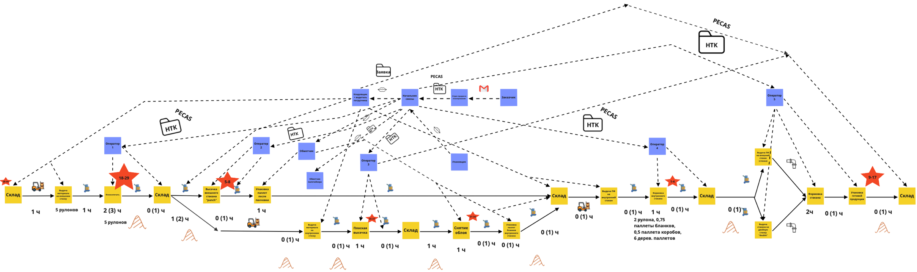
- The current map of the production of double-layer cups
Source: The current two-layer cup production map was developed by the author

This map shows the entire process of production of glasses from the issuance of semi-finished products from the warehouse to the production, to the shipment of finished products. The entire process of creating a double-layer cup is not that simple and involves five pieces of equipment. Initially, the material is dispensed to the FLEXO closed ink application system with a doctor blade - a continuous pump fills the closed chamber with ink. The ink is transferred to the anilox roller and the excess ink is removed by the doctor blade. The ink cycles in and out of the closed system during printing. Next, the outer cup is die-cut on the Punch machine. The immediate task is to prepare the paper forms for shaping the cups by die-cutting them from the unwinding roll. The punch machine consists of two main units: a feeding line and a die-cutting press. The paper roll is mounted on the unwinding station, positioned by means of two lateral pneumatic cylinders, hydraulic is an option. The product can only work with an external air pressure supply, a compressor is optional. The sheet is levelled by a series of roller presses and holding rollers. All rolls are steel with polymer coating. Feed speed is controlled by an inverter. Then goes flat die cutting (machine skm-105). This machine is designed for punching from the roll blanks in the production of paper cups. Can be knocked out blanks for one and two-ply cups. Accuracy of die registration is carried out by photo mark. Conventional plywood-based molds are used for die cutting. After flat die cutting the semi-finished product goes to the deburring process. Deburring is excess material remaining on the product after processing. Deburring is a process performed by 1 person on a special work table (physical labor, not automated). This is followed by the molding of the inner cup on Eagle 1-5 machines. Next step is the gluing of the double wall of the cup, which is done on the DoubleWall machine. The final stage is packaging the finished product on the automatic palletizer.
In order to analyze the entire flow of the creation of a double-layer cup, a typical order of 595,000 pieces of 0.3 liters was taken. The analysis included measurements of the process time in minutes, the volume of incomplete production involved (rubles), OEE (%) and output (units/number of workers*hour). Then a project card was made up, which included current, target and ideal indicators. Current indicators are those indicators that were obtained through measurements at the beginning of the project (September 2022). Target indicators - the result to which the company should reach at the end of the project (February 2023). Ideal metrics - those metrics that can be achieved by fully automating the equipment (2026 has been assigned). According to the GPI code, I cannot show specific numbers in my work to protect against competitors, so I will denote current performance through X, target, ideal performance and difference will be shown in %.

№ |  |  | Current | Target | Ideal
 | Indicator name | Units of measure | 30.09.2022 | 20.02.2023 | 24.02.2026
1 | Process Flow Time | Min. | X | X - 11% | X – 70%
2 | Volume of incomplete production | Rub. | X | X - 32% | X – 76%
3 | Output | Units/number of workers*hour | X | X + 8% | X + 21%
4 | OEE of all machines | % | X | X + 3,7 % | X + 40%

- Project goals and planned effect

During the analysis of the production process of a typical order of 595,000 pieces and the current map, 44 problems were identified at different stages of production (marked with a red star on the map). The most significant of these problems were:
- Lack of experience among newly hired employees;
- Failure to comply with standard work regulations;
- Lack of proper attention to the movement of semi-finished products;
- Unnecessary movement of materials and personnel;
- Leakage of glasses due to incorrect silicone feeding;
According to these bottlenecks that were detected, the action plan was made in order to eliminate the detected problems. A responsible person was assigned to each activity, and deadlines were set so that these problems would be solved by the end of the project.

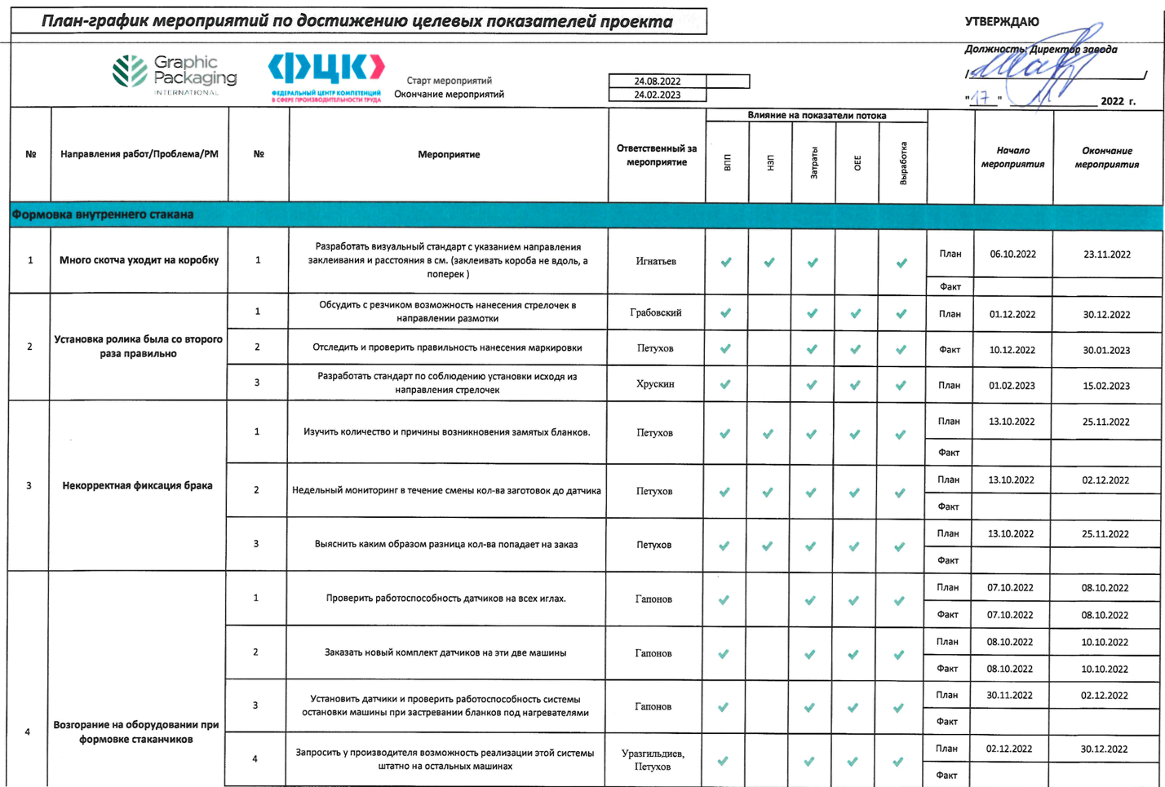
- Plan-schedule of activities to achieve the target indicators of the project

Source: The schedule of activities to achieve the target indicators of the project was developed by the author

Taking into account the analysis of the current production situation of 595,000 double-layer cups, the problems identified and the target plan to solve them, two more maps were made: a target and an ideal.

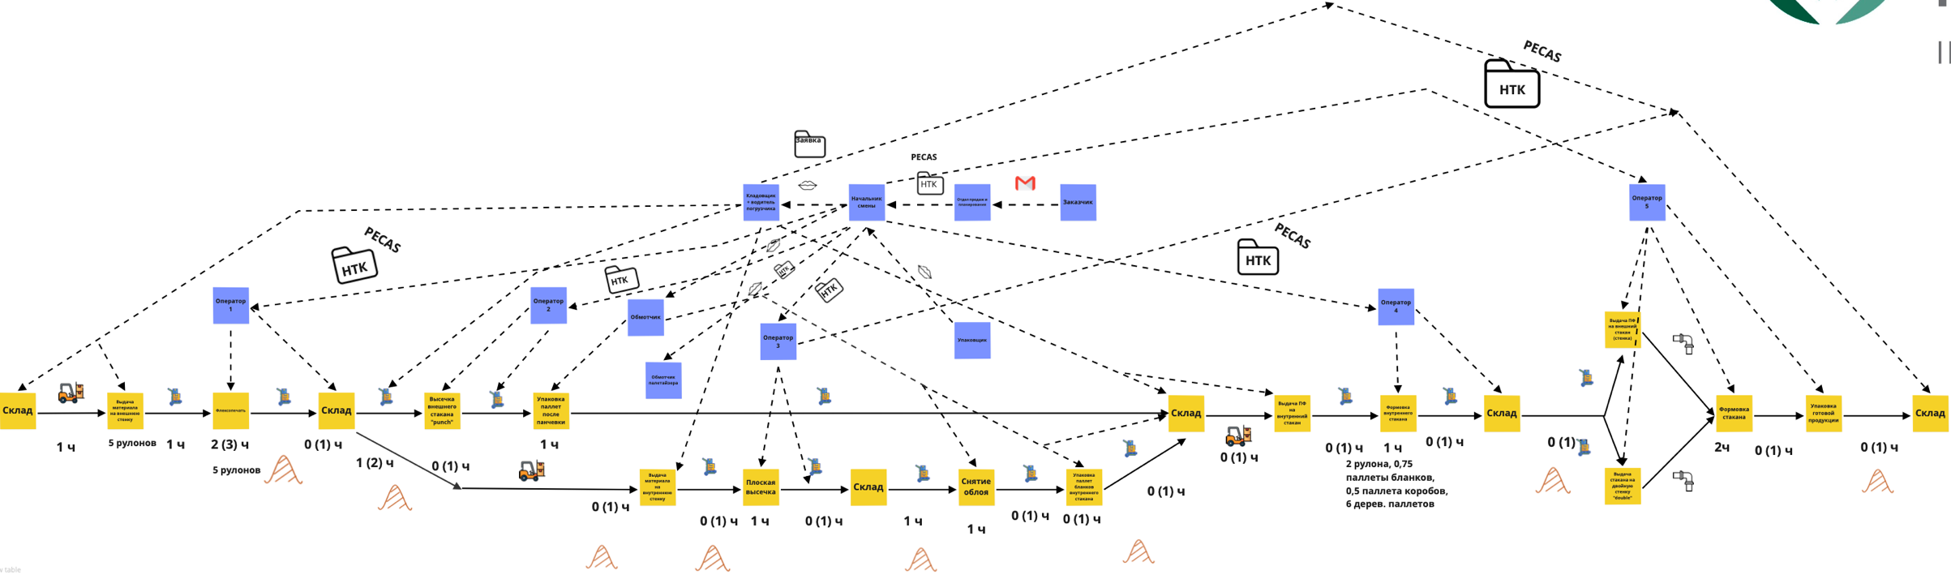

- Target map of the production of double-layer cups

Source: The target two-layer cup production map was developed by the author

The target state map is a comparison of the production opportunities identified in the analysis with the necessary requirements for maximum process efficiency. The target state map differs from the ideal state map in that it does not include goals that cannot be achieved at this stage based on the available resources. To transform the flow, an action plan is made to transform the current flow state into the target state. The key difference between the current and target maps is the absence of identified problems (red stars on the current map). If these problems are solved, the key indicators, namely process time, volume of incomplete production, OEE, and output, will increase accordingly.
The ideal state is the state of the process, in which material and information flows move without jamming. This is the "dream" of a perfect lossless process. We rely on high technology, the best performance of industry leaders and competitors to create the ideal state map. The ideal map shows fully automated production with the presence of conveyors and other modern pieces of equipment. If the company can achieve the target figures without high investments, the ideal map also requires additional investments, so this map is the company's goal for the future. The ideal map is shown below:
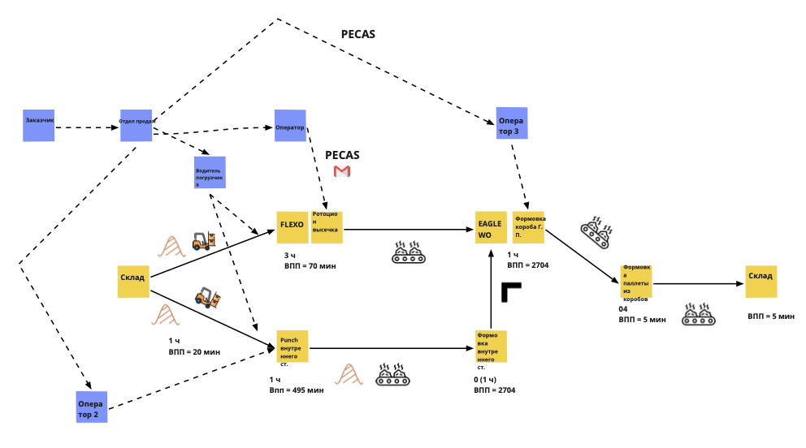
- The ideal map of the production of double-layer cups

Source: The ideal two-layer cup production map was developed by the author

A planning solution was developed to equalize flows, reduce unnecessary movements and unnecessary inventory - the "Spaghetti" diagram. Diagram "Spaghetti" is a schematic representation of the trajectory of product movement along the flow. The "Spaghetti" diagram makes it possible to visually assess the whole tangle of lines and losses associated with transportation and movement, and to understand, for example, how rationally, from the point of view of flow, the equipment is placed. The diagrams show the physical movements of the product and operators moving along the value stream. By analyzing the map and timing of these movements, you can determine how to reduce losses, movements and transports. The Spaghetti Chart gets its name from the resemblance of the finished visualized form to a plate of spaghetti. GPI has developed 2 separate "Spaghetti" diagrams of the current state – product and semi-finished product movement and operator movement.
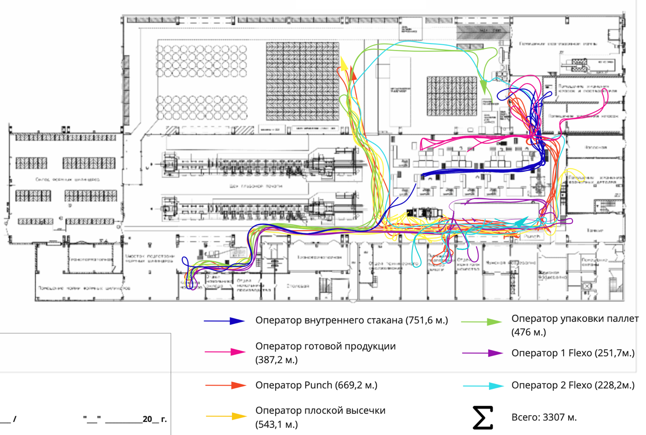
- Current "Spaghetti" chart of operator movement

Source: Current "Spaghetti" chart of operator movement was developed by the author

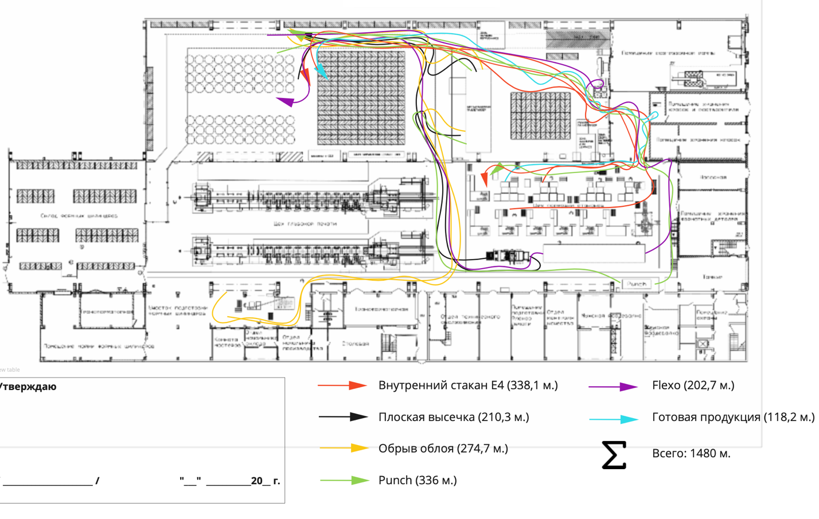
- Current "Spaghetti" diagram of product and semi-finished product movement

Source: Current "Spaghetti" chart of product and semi-finished product movement was developed by the author

Next, based on the analysis of the current state map, it was decided to select a reference site. The reference site is the production area that requires the most time, effort, and various methods to improve efficiency. GPI, in conjunction with RCC, selected the double-wall cup production area as the reference area (DW2). Going back to the current state map, we can see that this area has the most problems (red star), so it was chosen as the reference area. Site selection criteria:
- The need to increase finished product output;
- Possibility to use and implement Lean production tools;
- High percentage of downtime for this technological stage;
- A bottleneck in the flow due to the need to balance capacity for double wall and inner cups.

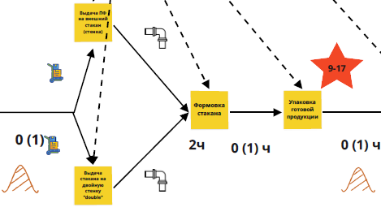
- Map of the reference site at the beginning of the project
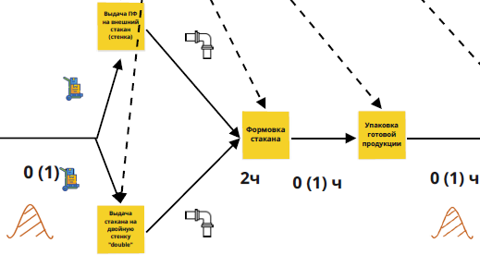
- Map of the reference site at the end of the project
The key difference in these two maps is to eliminate the identified problems at this site by the end of the project and arrive at the following indicators:

 | Before | After
Process Flow Time, min. | X | X - 17%
OEE DW2, % | X | X + 2%
Volume of incomplete production, rub. | X | X - 56%
Output, units/number of workers*hour | X | X + 15%
- Benchmark site goals and planned effect

In order to achieve the targets, specific activities were planned to achieve the target state of the reference site. Each improvement was clearly formulated for each problem, indicators were established, deadlines were set, and people responsible for their implementation were assigned. The solutions developed to eliminate losses are consolidated in an itemized action plan for the reference site (similar to the overall action plan).

Implemented methods to achieve the national project targets at GPI

Production analysis
The first method of implementation to achieve the project targets GPI used production analysis. Production analysis - evaluating the execution of the production plan and identifying the reasons for its deviations. Allows you to plan and track the process of the production program based on real data. It can be performed at the level of a cell, section/department, workshop. Production analysis is one of the most important tools of lean production, aimed at obtaining timely and accurate actual data on the implementation of the production program at any stage of product manufacturing and rapid resolution of problems arising in production. The results of production analysis should be documented, visualized and clear to any participant of production process. Production analysis should be conducted in conjunction with an effective problem-solving procedure. Without a problem-solving procedure, searching for and eliminating the root causes, the production analysis will not be effective, and the processes will not improve. As part of the project, it was decided to implement production analysis in the reference area, the double wall cup manufacturing area (DW2). Once the project is complete, it is planned to implement production analysis on all units of GPI equipment, viz: FLEXO machine, Punch machine, Eagle 1-5, skm-105. Production analysis on the reference site (DW2) allows to fix, analyze reasons of failures and deviations from the production plan, to develop an action plan to eliminate them.
Problems on the section of making double-walled cups:
- Equipment settings related to: the quality of materials, technical condition of the equipment, qualification of operators
- Jamming of cups
- Misfeeds of blanks
- Crooked blanks
- Long machine changeovers
The production analysis sheet was designed specifically for DW2 machine operators. Their task was to record the number of machine stops in minutes and the reason for downtime. The next step is to compare the results from the production analysis sheet and the results from the GPI PECAS Vision ERP software. After that, following graphs are developed: Pareto downtime DW2 and Downtime analytics DW2.

- Number of downtime due to reasons in minutes, DW2 (November)

- Number of downtime due to reasons in minutes, DW2 (December)

- DW2 downtime analytics, in minutes (November-December)

Source: Production analysis was developed by the author

Month | Number of days analyzed | Available time per month, min | Downtime per month, min | Downtime per month, %
November | 13 | 16380 | 2731 | 17
December | 19 | 23940 | 3623 | 15
- Comparison of downtime over 2 months

Through this analysis, GPI analyzes and records the time and number of identified causes of downtime for the month, develops measures to eliminate them and tracks the impact of implemented tools to eliminate the causes in the next month.
Received:
- Revealed in November improper production analysis. We had a conversation with the operators, started to record deviations more correctly.
- Identified about 20 types of deviations not allowing to fulfill the production plan.
- Developed corrective actions to correct problems (including using the 5 Why method to find root causes and implementing autonomous equipment maintenance).
Expectations:
- Increase output of finished cups by 7 %
- OEE increase by 3 %

The 5 Why's method
The 5 Why's are a simple and practical tool for going beyond the visible symptoms of a problem to its root cause. The root cause is the very essence of the problem, its root, its root cause. The method is to ask the question, "Why?" at least five times. The fifth answer will be the root cause. If the problem is too deep, more iterations may be necessary. When the "Why?" question does not produce any meaningful new answers, that is the root cause of the problem. In the process of answering the "Why?" question, it is necessary to keep the focus on keeping the named causes out of the zone of influence.

Problem | Equipment downtime | Blanks jammed
Why? | The shell is stuck in the pipe | Warping of blanks after die-cutting
Why? | The glass didn't fit in the rim | The rectifier is missing
Why? | Shell sensor does not work correctly | The rectifier shaft does not move up and down enough
Why? | Sensor incorrectly set | Not provided by design
Solution | Check the performance of the sensor, develop instructions for setting up the sensor, familiarize the personnel | Conduct experimental work on the improvement of the clamping unit
- The 5 Why’s method

Effective Infocenter
Infocenter is a goal decomposition tool used for visual management of production and economic and management processes, which allows to identify problems and increase the speed of management decision-making through effective production meetings and fast communications, and forms high-quality channels of constant feedback for managers of different levels of management. The main function of the information center is to ensure the efficiency of processes by identifying, visualizing and eliminating deviations from targets. Visual presentation of information on production processes (process status, workplace) makes the work of the organization transparent, understandable to all and eliminates unreliable information. The main tasks of infocenters:
Visualization and unified information field:
- Collection, concentration and visualization of operational management information in a certain place accessible to all employees or a certain group of employees (e.g., division, shop, small group) depending on the tasks to be performed - a single information space on the key areas of the enterprise.
- Availability of operational information for regular monitoring of actual deviations of indicators from planned values by managers.
- The relevance of operational data on the state of processes at all levels of management (from the daily control of production, rhythm and quality of processes to the quarterly results of management accounting).
- Operational detection of problems through visualization of deviations.
- Formation of the channel of constant feedback with employees of different management levels.
Operational acceptance of management decisions:
- Organization of current work of subdivisions of all levels according to the PDCA cycle (Plan, Do, Check, Act).
- Making balanced, fact-based decisions at each management level.
- Improvement of processes through regular analysis of the causes of detected deviations.
- A clear and transparent mechanism of step-by-step escalation of problems from the small group level to the enterprise director level (problem management bench).
- Monitoring of key business indicators and progress of project implementation.
- Regular analysis of the causes of detected deviations.
- Reduction of time to implement management decisions on the identified deviations.
Increased cross-functional communication:
- Aggregation of information from different functional areas, visualization of existing relationships between them.
- Identification of problems and disagreements among participants of operational meetings (including different interpretations of situations and status).
- Elimination of the reasons of the revealed problems directly in the places of their occurrence.
Reducing the amount of reporting:
- Ensuring that the amount of management reporting between function heads is reduced.
- Confirming the execution of plans and budgets by managers, informing about the status of tasks and processes.
The system of work with infocenters is based on regular meetings and meetings at all levels of management: at the enterprise level, at the shop and site level. The main purpose of using the infocenter is to hold operational meetings near it.
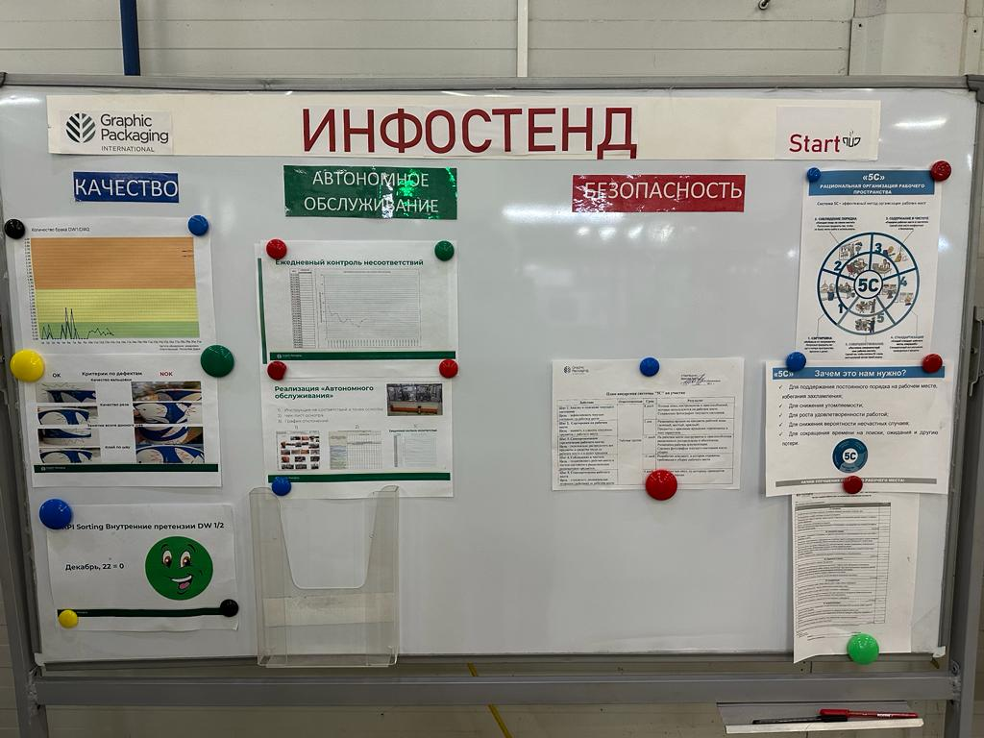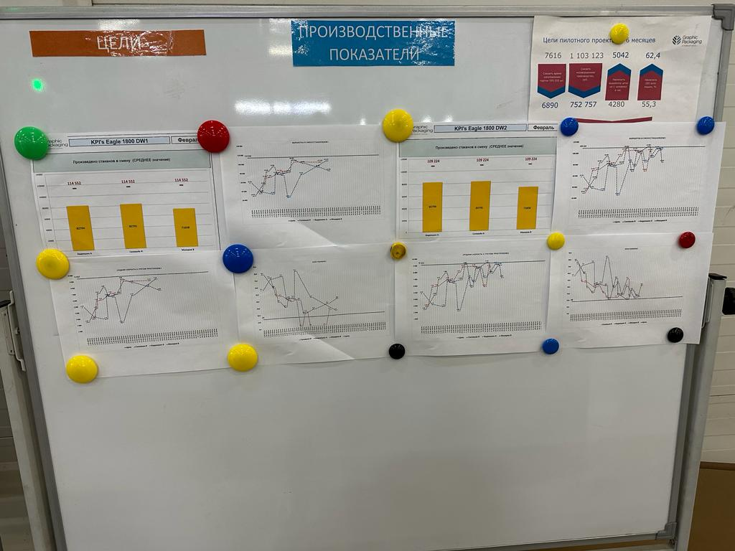
- Infocenter of GPI
Source: Infocenter of GPI was developed by the author

Competence matrix
Everything should be transparent and predictable in the enterprise. People are one of the production resources, but they are the most difficult to monitor and control. In most cases, to solve this problem, detailed process descriptions and instructions to performers are prepared. But in this case one of the main points is missed: the criteria for the selection of the right performer. If the person does not have the necessary knowledge and skills for the operation, the desired result will not be achieved. At this point there is a need to evaluate the staff in terms of professionalism and performance. To do this, a competency matrix of production personnel is used, a tool to visualize the skills each worker has and the skills they lack in order to understand who is capable of performing a particular task. Competences are special knowledge and skills necessary for effective problem solving in production activity, i.e., criteria of professionalism. The benefits of using this tool in an enterprise:
- An accurate description of skills created based on the content of workplace activities. This makes it possible to understand what competencies employees lack in order to work on existing equipment or perform production operations.
- Quickly find replacements. With the tool you can implement the principle of universal interchangeable personnel, in which the absence of an employee due to illness or dismissal does not have a negative impact on the production process.
- Complete information about the skills of each employee. Thanks to the matrix it is possible to determine exactly who is able to perform certain operations, who can train others, who can be trusted with adaptation of newcomers. In addition, it is possible to identify the need for training, which will allow to get qualified performers, and to improve the quality of production at a certain stage of operations.

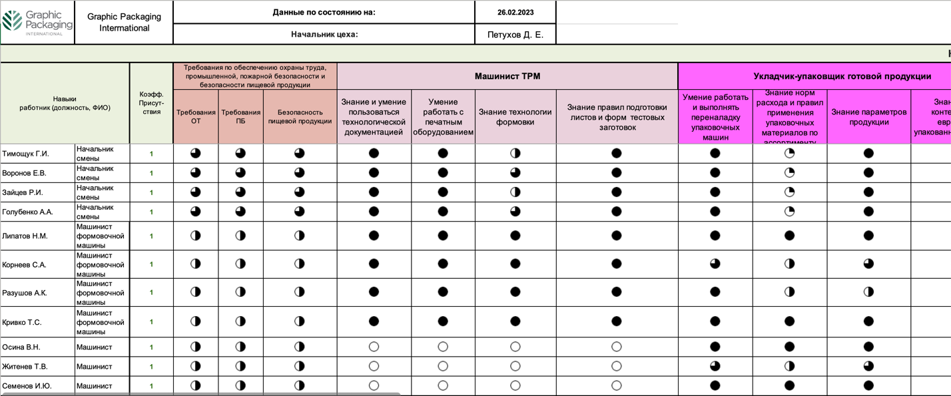
- Competence matrix of GPI
Source: Competence matrix of GPI was developed by the author and RCC

Standardized work on the Eagle DW2
Standardized work is a set of defined procedures that establish the application of optimal work methods and sequence of operations for each process and each worker, guaranteeing the safety and quality of output.
Standardized work is a means of diagnosing production efficiency, which allows you to identify problems and implement further improvements. The application of standardized work helps to standardize the execution of processes and eliminate losses from them.
What tasks standardized work solves:
- Ensuring target uniform staffing and required production volumes
- Identifying problems (deviations from the standard)
- Training of staff
- Improving process efficiency by reducing losses
- Ensuring safe execution of work
- Ensuring the required volume of output of the required quality

Standardized work makes it possible to determine the optimal level of workers and equipment utilization which best corresponds to consumer demand. This level is determined by careful calculations, making it possible to perform any operation in any area at the required rate of production.
Benefits for the company:
- Increased production stability
- Reduced losses
- Reduced costs
- Higher product quality
- Decrease in production turnaround time
Benefits for workers:
- Easier learning of new operations
- Easier transition to performing different types of operations in their cell(s) or in other production areas, lines or work zones
- Understanding problem situations
- Suggesting solutions to improve one's performance
Standardized work is a method of work focused on pinpointing losses and continuous process improvement. Detailed study of the production process on the scale of the employee's actions allows to improve it gradually, eliminating losses.
Conditions for the implementation of the method of standardized work:
- Taсt time work - taсt time value should be calculated and be a constant value in the work (not change during a certain time).
- Standard sequence of operations - repeatable sequence of operator's actions. Before applying standardized work, make sure that the standardized operations have a periodic repeatable sequence of actions, that the actions are not performed chaotically, and that their consistent performance is not affected by unpredictable external factors.
- Standard inventories - untimely delivery destabilizes standardized operations by violating the first two conditions. Therefore, make sure there is a minimum inventory and a stable replenishment.
Detected deviations:
- Fluctuations in the rate of output of finished goods, up to 20% of the norm
- Unnecessary movements and operator downtime.
- Incorrect control of the quantity and causes of rejects
- Inconvenient feeding of inner cups
- Uncoordinated actions of operators during machine readjustment
- Process of jammed cups during packing
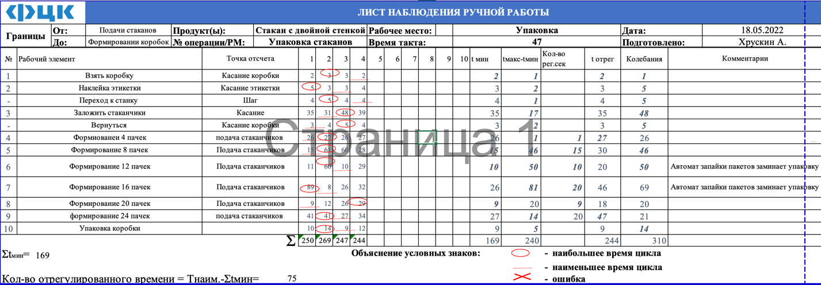
- Standardized work on the Eagle DW2
Source: Standardized work on the Eagle DW2 was developed by the author

Objective tree
The objective tree is a tool that allows you to explicitly "build a bridge" between the goals of the highest level and the goals of the employees of the enterprise. When building the goal tree, a systematic approach to decomposition of goals and distribution of responsibility for them is applied. Indicators of the goal tree are the basis for the formation of qualitative KPI maps of managers. Qualitatively constructed tree of goals covers all activities of the enterprise and fixes the responsibility of managers for achieving the goals. The construction of the goal tree is based on the method of MECE (Mutually Exclusive, Collectively Exhaustive) - the goals in the goal tree must be mutually exclusive (goals are not duplicated) and collectively exhaustive (cover all activities of the enterprise). In the process of building the goal tree, there may be a situation where there are indicators that have no responsible persons or, conversely, there are several responsible persons for one indicator. In such situations, the organizational structure is updated and/or the authority of managers is reviewed.
Operational cash flow is taken as the upper-level goal of the goal tree, and further goal decomposition is based on it. Operational cash flow is the amount of cash received by the enterprise from operating activities. It is important to emphasize that we are only talking about cash flows from operating activities, but cash flows from financial and investment activities are considered. (The sum of cash flows from operating, financial and investing activities constitutes the free cash flow of the enterprise, which, in accordance with accounting standards, is formed as part of the Cash Flow Statement)
The top-level goal decomposition structure consists of: marginal profit, fixed costs, other income/expenses, change in working capital. Each branch is further subdivided into additional branches peculiar to each item (e.g., revenue or general production expenses).
The marginal profit is the difference between revenue and variable costs of the enterprise. The value of the marginal profit in absolute terms is directly proportional to the volume of sales, and in specific (per unit of production) terms is unchanged. In this regard, the product margin is an indicator that allows to compare different products/groups of products among themselves in terms of efficiency regardless of the sales volume.
Fixed costs, unlike variable costs, have no direct dependence on the volume of production and include general production, general business, commercial and other fixed costs such as: maintenance and operation of buildings and equipment, repair of buildings and equipment, rent of premises and fixed assets, utility costs, salaries of management and personnel not engaged in the production process, travel expenses, consulting expenses, taxes on property, land, transport, security. Fixed costs do not include expenses related to financing and investing, as the top-level goal is operating cash flow.
The "other expenses/income" section includes income and expenses not related to the company's core business.
Working capital is the difference between the amount of current assets of the enterprise and the amount of its short-term liabilities. Current assets of the enterprise consist of accounts receivable, including enterprise prepayments (mainly for raw materials), and inventories, including stocks of raw materials and materials, finished products, and work in progress. Short-term liabilities consist of accounts payable, including prepayments received by the enterprise for products. The amount of working capital affects the length of a company's financial cycle (cash cycle), that is, the smaller the working capital, the shorter the financial cycle and the faster the company will turn around its cash.
GPI's objective tree is presented below (Due to the commercial secret of the enterprise, the objective tree is presented without financial turnover; due to the large volume of GPI's objective tree, only a partial top-level structure of objective decomposition is presented below):
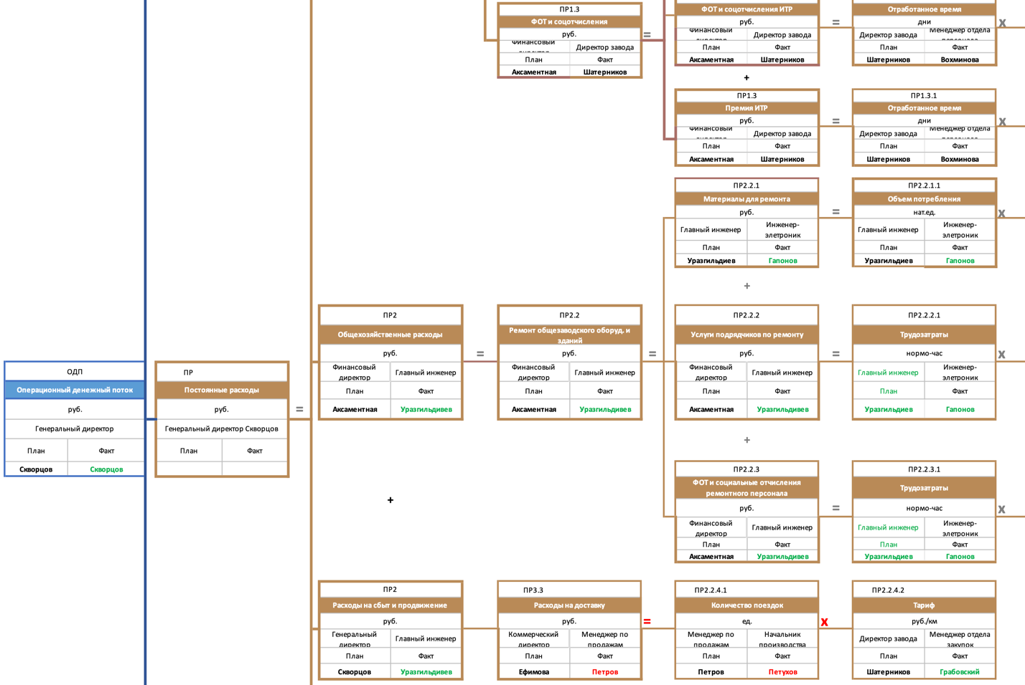
- Operational cash flow and fixed costs
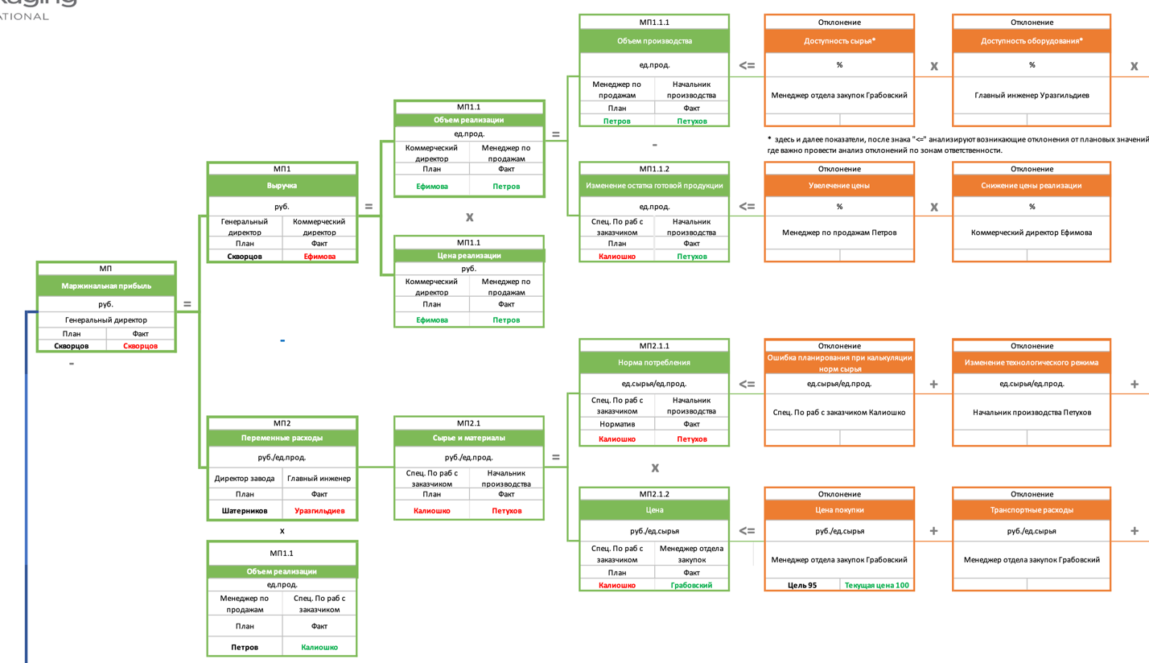
- The marginal profit
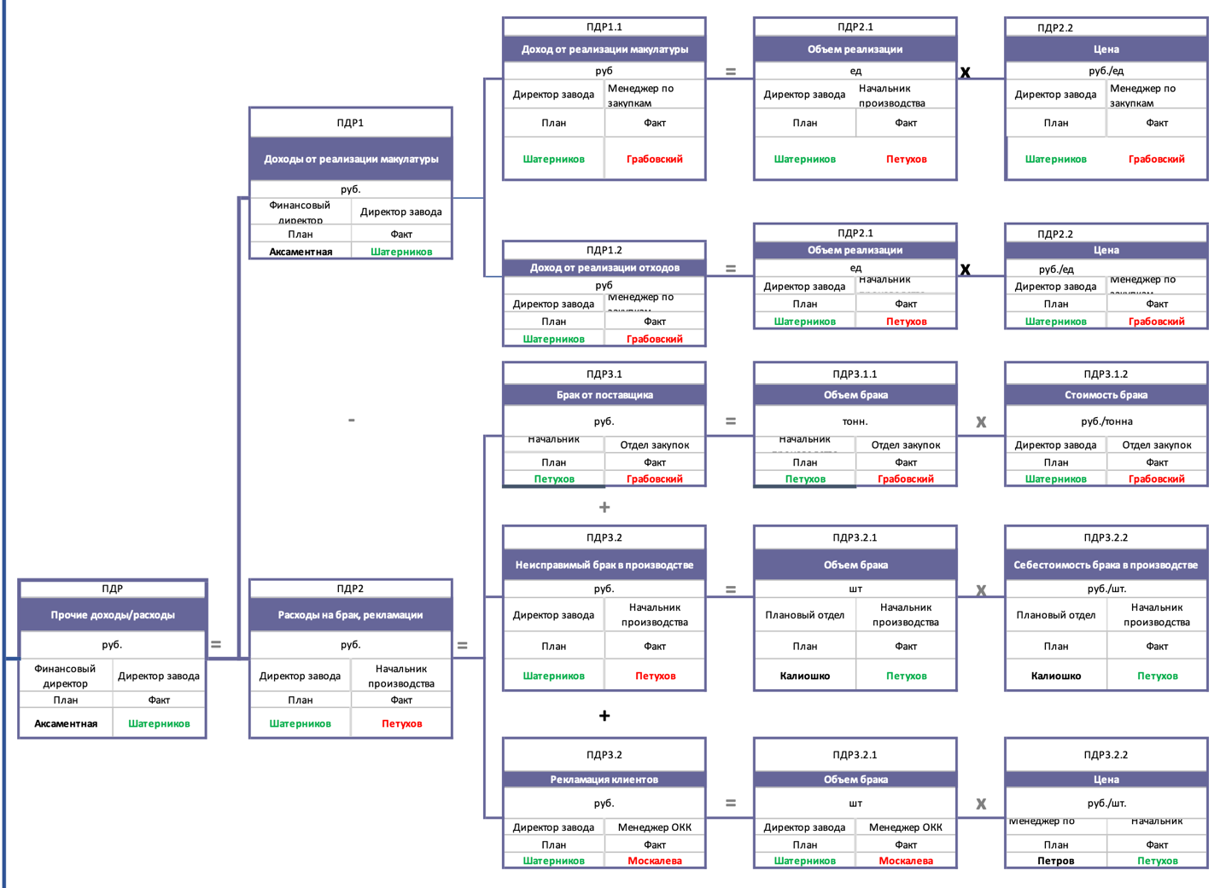
- other expenses/income
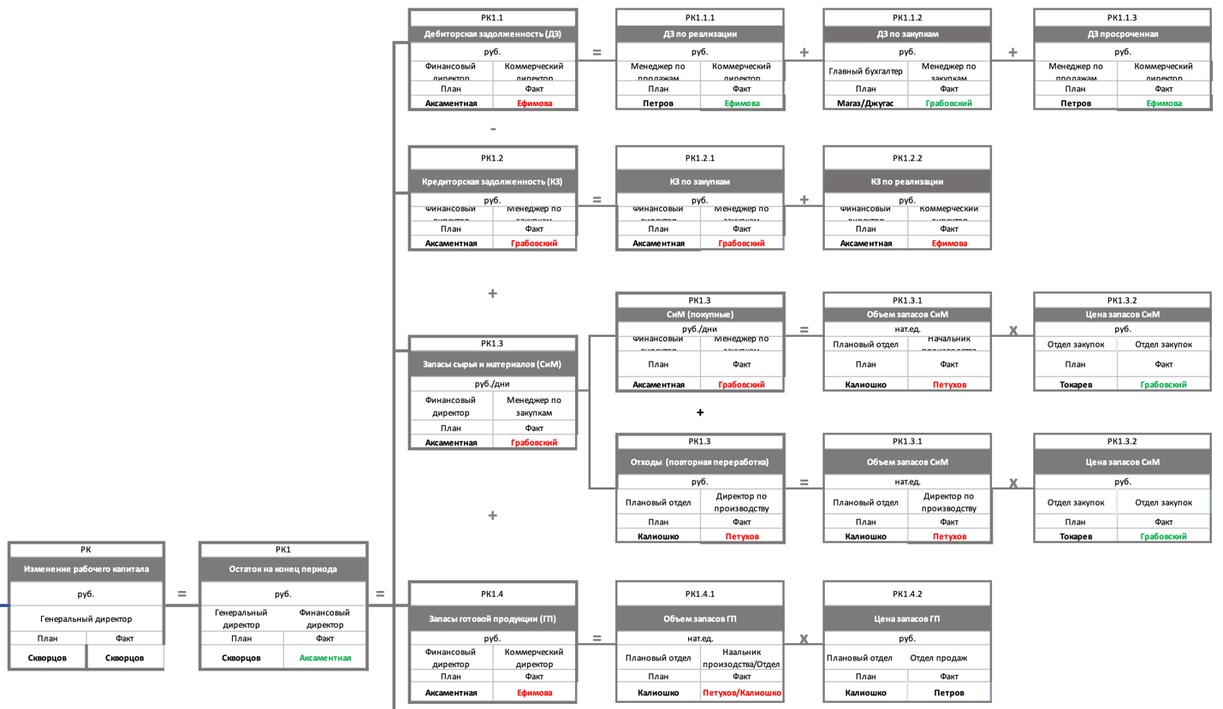
- Change in working capital
Source: Objective tree of GPI was developed by the author

SMART methodology
In developing the key performance indicators GPI used a proven methodology SMART, the name of which each letter has meaning and the use of which is not limited to the development of KPIs, its use allows including the formation of correctly formulated and unambiguously interpreted objectives in the preparation of strategic plans and details of the project activities of the enterprise.
The essence of this methodology is as follows:
S (Specific) - in setting goals precisely defined result, which is required to achieve (a specific formulation of the desired results).
M (Measurable) - when setting a goal precisely defined quantitative or qualitative characteristics of goal achievement (money, %, feedback, etc.).
A (Achievable) - the goal must be achievable, this requires correlation of available resources and opportunities with the desired result. The achievability of the goal influences the performer's motivation.
R (Relevant) - the goal should be relevant/valuable for the company, which will ensure effective use of resources to achieve it.
T (Time-bound) - the goal should be set for a specific period, by the end of which the planned results are expected to be achieved.

KPI maps and target setting
In accordance with the business plan and indicators of the objectives tree KPI cards of managers with target values for the reporting period are formed. KPI is an important tool that shows how effectively the staff works in achieving the goals of the company. There is no strictly defined KPI classification, each organization independently develops types of KPIs based on existing practices and personal requirements for KPIs. The KPI map below is based on the work of RCC experts and Graphic Packaging International.
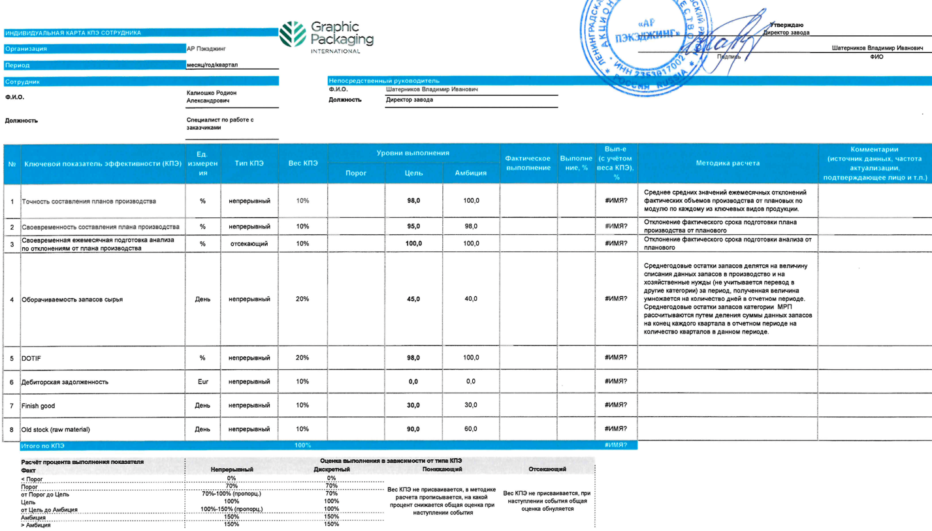
- Customer Service Specialist KPI Card
Source: KPI maps of GPI was developed by the author

5S system
The 5S System is a system of safe and efficient workplace organization. 5S – sort, set in order, shine, standardize, sustain. A workplace can be called both a room and a plant as a whole. The use of the 5S system does not require large financial investments and quickly proves its effectiveness for the enterprise and employees.
Advantages of 5S implementation for the enterprise:
- Increase in labor productivity and overall efficiency of operations
- Reduced loss of working hours, compliance with delivery dates
- Decrease in production of defective products
- Decrease in warehouse space
- Decrease in expenses
The benefits of implementing 5S for employees:
- Creation of a safe and comfortable workplace
- Decrease of fatigue
- Decrease of injuries in the workplace
- Increased job satisfaction
- Reducing the probability of accidents
- Better work organization

It all starts with the local workplaces of the personnel. The employee works with the assigned equipment and improves it. GPI decided to create "Before"/"After" documents. One Point Lessons (OPL) are visual instructions used to convey the key points of a task. They are usually short, visual, and designed to briefly convey the expected process of executing a standard operating procedure (SOP). One-point lessons are important lean manufacturing and continuous improvement training tools used by manufacturers to ensure safety, quality, equipment operation and maintenance.

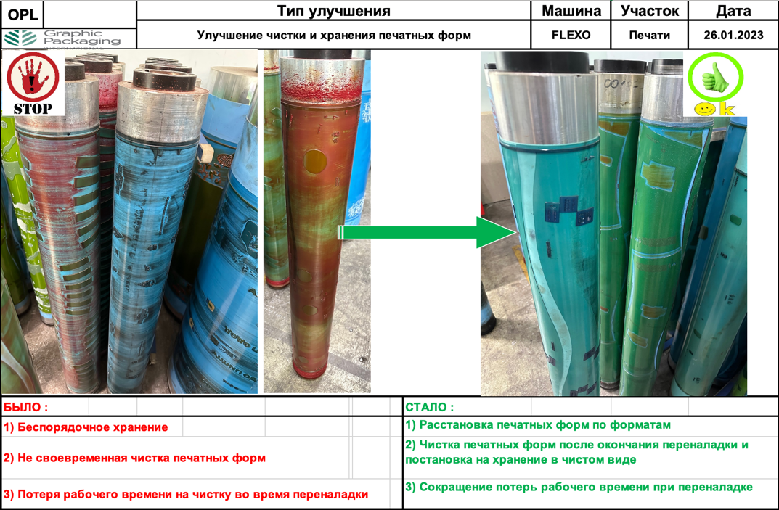
- OPL 1 - Improvements in plate cleaning and storage
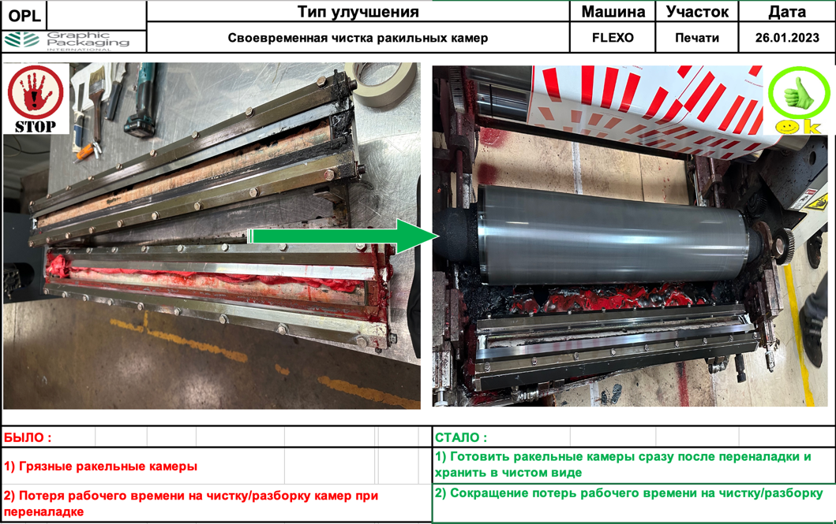
- OPL 2 - Timely cleaning of the flaker chambers
Source: OPL of GPI was developed by the author

As part of the project at GPI with the support of RCC trainers, 2 employees of the company were accredited. The manager for occupational safety and environmental protection and the manager of the production of the deep press have been trained on the 5S system. Currently, these certified employees of the company provide training in the following areas:
- Basics of Lean Manufacturing.
- Types of losses in processes and tools to eliminate them
- How to effectively organize the workplace according to the 5S principle
- How to implement a process improvement project
- Using the mapping tool
To date, 14 people of working personnel have been trained at GPI.

SMED quick changeover

SMED is a set of practical and theoretical methods to reduce setup and changeover time by up to 10 minutes. The goal of SMED is to safely achieve the shortest possible changeover time by reviewing all tasks until the job is stable and reliable. SMED is an acronym for Single Minute Exchange of Dies. One of the tools of lean production, which allows you to reduce the time costs for the changeover of equipment. Originally this system was developed to optimize die replacement and changeover operations of the equipment concerned, but the principles of "quick changeover" have found their application in the most diverse production processes. SMED reduces losses such as:
- Overproduction (inventories of semi-finished and finished products)
- Excess inventory and maintenance
- Expectations (downtime of equipment and operators during changeover)
- Rejects (during readjustment and adjustment of equipment)
- Searches (tools, rigging)

Changeover operations can be divided into two categories:
- Internal changeover operations, i.e., operations that are performed after the equipment has stopped
- External changeover operations, i.e., operations that can be performed while the equipment is running.

GPI applied 7 steps to implement SMED:
- Fixing all the changeover operations and the time of their execution
- Separation of internal and external changeover operations
- Transfer of work from internal readjustment to external readjustment
- Reduced internal changeover time
- Reduced set-up time
- Reduced external set-up time
- Standardization of changeover

TPM (Total Productive Maintenance)
Total Productive Maintenance - an important method to avoid equipment downtime, applied in lean production, associated with breakdowns, unplanned stops, as well as the release of scrap. The downtime associated with failure and technical condition of the equipment on the reference area (DW2) is 1700 minutes recorded in the period from 14.11.2022 to 09.12.2022.
Measures taken:
- Introduction of elements of autonomous maintenance of equipment (instructions of daily maintenance);
- Distribution of areas of responsibility between O&M (Operation and Maintenance) service and operators;
- Implementation of checklists for control of the main assemblies of Eagle DW2;
- Development of a competence matrix and a schedule of training employees in equipment maintenance and repair;
As a result, it is planned to reduce emergency downtime by 20-25%.
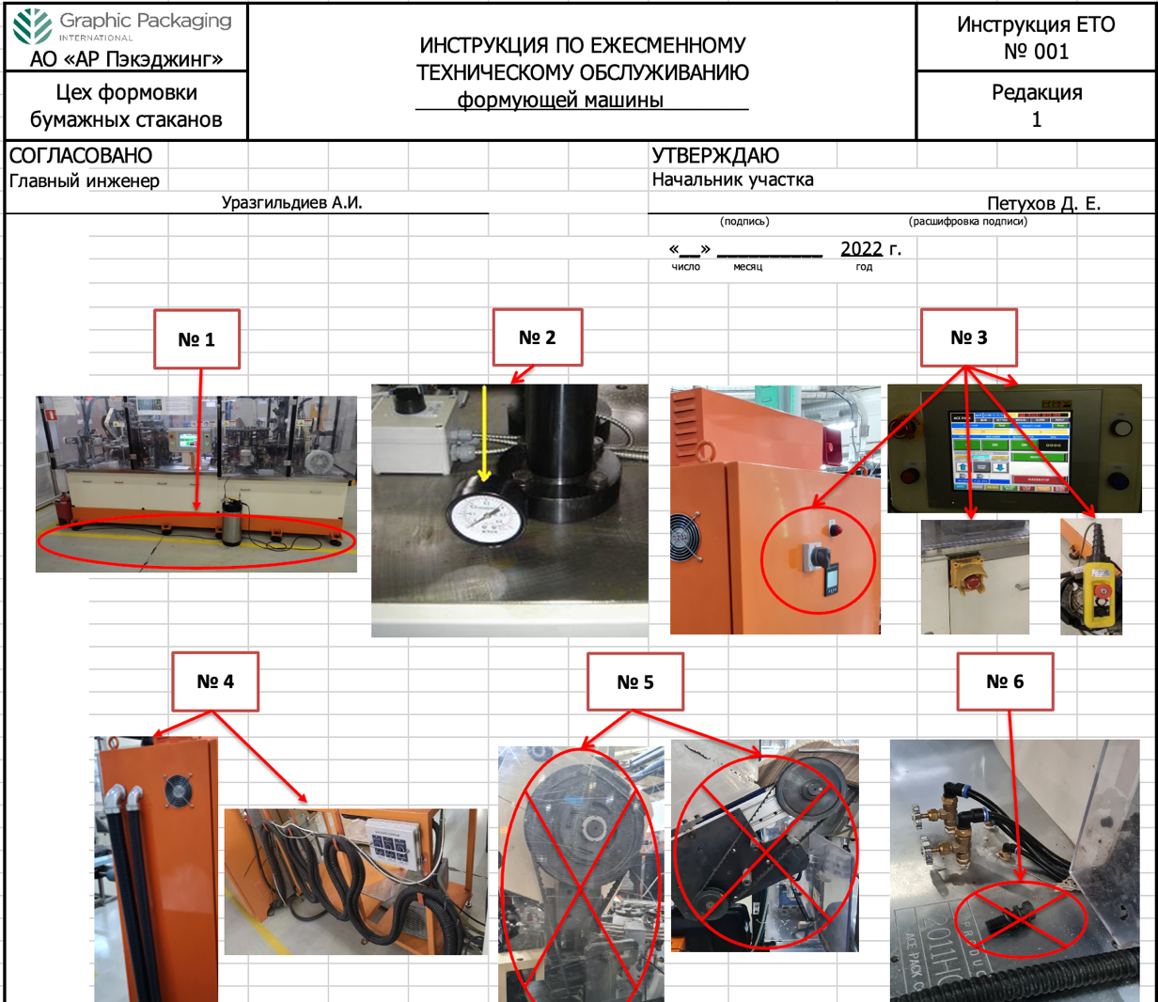
- Instructions for daily maintenance of the forming machine
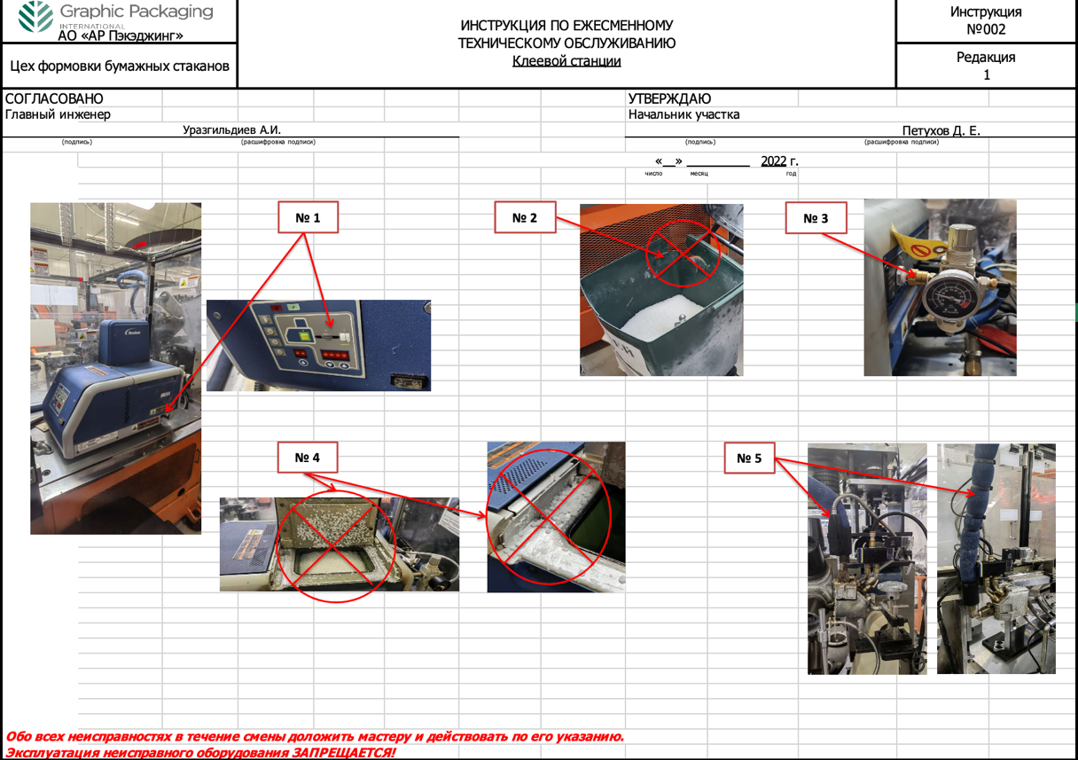
- Instructions for the daily maintenance of the glue station
Source: Instructions for the daily maintenance was developed by the author

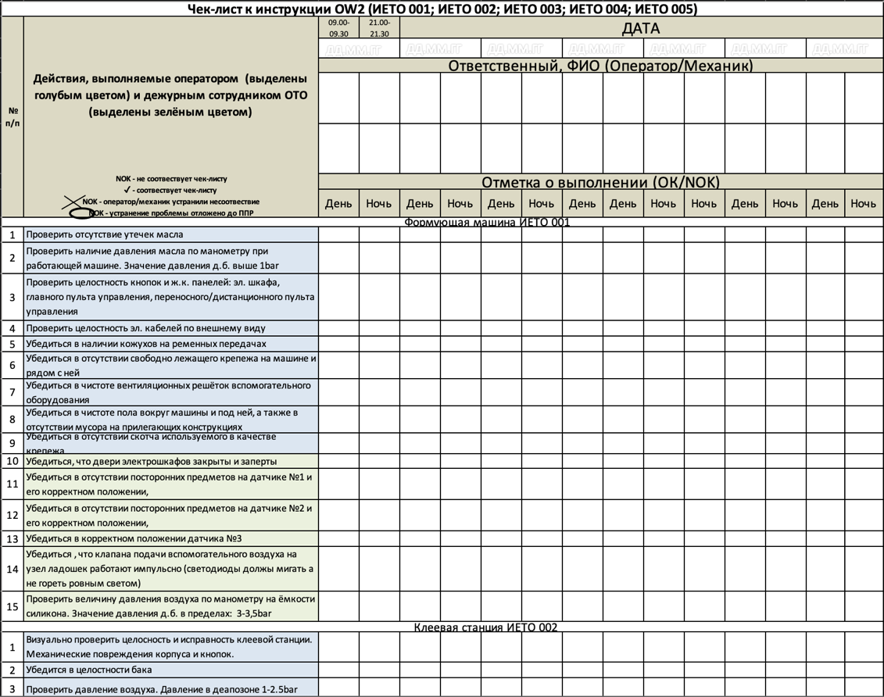
- Checklist for control of the main assemblies of Eagle DW2
Source: Checklist for control of the main assemblies of Eagle DW2 was developed by the author

Examples of solutions of the problems identified in the implementation of the action plan to achieve the targets
As a result of the work carried out as part of the project with RCC trainers at GPI enterprise, the following key problems were identified and solutions to eliminate them were developed:
- Problem №1: Congested aisles; lack of space for pallets, finished and semi-finished products; lost time finding needed semi-finished products; reduced time to release finished products.
Solution: Identified zones for placing semi-finished and finished products; marked the zones; changed the order of operators and driver when giving out materials and working with finished products.
Result: Time for wrapping of 1 pallet with preparation was reduced by 25% in minutes; time for search of semi-finished products in a shift was reduced by 100% in minutes, operators do not waste time on searching for necessary semi-finished products;
- Problem №2: No possibility to roll small diameter rolls on Punch and flat die cutting machines; loss of operator time.
Solution: We determined the order of operators with small-diameter rolls, created OPL.
The result: The time for rolling on the Punch was reduced by 83% in minutes.
- Problem №3: Time-consuming tear-off of blanks; difficult working conditions for the packer (it is difficult to separate the scrap from the blanks); unnecessary waste of materials.
Solution: We ordered new stamps for all formats on flat die-cutting (after flat die-cutting, the blanks get to the tear of the ashes); made new zonal template gluing; removed unnecessary waste to facilitate tear of the ashes; it became possible to work on smaller widths of cardboard.
Result: Time per pallet break was reduced by 9% in minutes; carton consumption per month was reduced by 1% in tons (savings of 14,500 euros per year).
- Problem №4: Frequent machine stoppages due to cups jamming on the carton packer.
Solution: We changed the position of the storage unit by raising it by 3 cm.
Result: Downtime per month was reduced by 90% in minutes.
- Problem №5: Long changeover time on the flat die-cut (finding the right tool); the air brake can't handle it.
Reasons: Lack of storage space for PPE (personal protective equipment) and tools; untimely maintenance.
Solution: Optimized the brakes on the machine; equipped the workplace with a toolbox.
Result: The process time at the flat die cutting decreased by 6% in minutes; the output increased by 8% in units/person*hour.
- Problem №6: Long ink searches; long setup times for flask chambers; long changeover times on the FLEXO machine.
Causes: Chaotic ink storage, unsigned drains; each operator does the changeover in his own way; preparation of squeegees and rollers takes place during the changeover.
Solution: Optimized ink storage process, standardized the process of work with drains (used first); allocated space for storage of printing rollers; preparation of squeegees is carried out in advance.
The result: Changeover time on the FLEXO was reduced by 48 percent in minutes; process time on the FLEXO was reduced by 22 percent in minutes.
- Problem №7: Frequent downtime on the Double-Wall 2; low output.
Cause: Lack of analysis of downtime problems.
Solution: Developed production analysis; monthly tracking of downtime, analysis and troubleshooting.
Result: DW2 process time was reduced by 22% in minutes; production output was increased by 20% in units/person*hour.
- Problem №8: Frequent equipment failures on the Double-Wall 2 and disagreements between production and mechanics about the causes.
Reason: Lack of a maintenance schedule.
Solution: Implemented daily maintenance instructions.
Result: 4% increase in OEE on DW2 machine.
- Problem №9: Crooked blanks coming out of the Punch machine.
Reason: Inadequate bending angle of the paperboard on the Punch.
Solution: Installation of 2 additional rollers.
Result: Blank jam downtime on the Double-Wall 2 was reduced by 100% in minutes from the December-February production analysis; process downtime on the DW2 was reduced by 21% in minutes.

The results of the national project «Labor Productivity» at Graphic Packaging International

Key changes by indicators of the whole site
At the beginning of the project, targets were set for the results that the company was going to achieve by the end of the project at the enterprise. The implementation of the lean production methods described above and the development of solutions to the key flow problems allowed to achieve results quite above the targets. The table below shows the difference between the targets at the beginning of the project and the actual results at the end of the project. As a result of the implementation of the national project "Labor Productivity" at GPI in conjunction with the RCC on February 20, 2023, the following results were achieved:
 |  | Before the project | Target | After the project | Difference in %
Indicator name | Units of measure | 30.09.2022 | 30.09.2022 | 20.02.2023
Process Flow Time | Min. | X | X - 11 % | X - 15 % | 4 %
Volume of incomplete production | Rub. | X | X - 32 % | X - 32 % | 0 %
Output | Units/number of workers*hour | X | X + 8 % | X + 21 % | 13 %
OEE of all machines | % | X | X + 3,7 % | X + 4,6 % | 0,9 %
- Indicators of the target, before and after project implementation

Indicators of the production flow of double-layer cups:
OEE of all machines, %
Process Flow time, min.
Volume of incomplete production, rub.
Output, units/number of workers*hours

- Indicators of the target, before and after project implementation

Key changes by reference site indicators (DW2)
In the benchmark area, namely the double-wall cup production area (DW2), the performance also exceeded the target. A great effect was obtained from the "output" indicator, the output percentage increased by 21 % compared to the initial result. This improvement shows that the methods and solutions that were implemented at the reference site during the project were very necessary and brought the right results.

Indicator name | Before the project | Target | After the project | Difference in %
Process Flow Time, min. | X | X - 17% | X – 21% | 4%
OEE DW2, % | X | X + 2% | X + 4% | 2%
Volume of incomplete production, rub. | X | X - 56% | X - 56% | 0%
Output, units/number of workers*hour | X | X + 15% | X + 22% | 7%
- Target, before and after indicators of the benchmark site (DW2)

Key changes in personnel, product, and semi-finished product movements («Spaghetti» diagram)
Going back to the «spaghetti» diagram, analyzing the current map and the time of these movements, the company determined how to reduce losses, movements and transports of product and operators. After the necessary work was done and at the end of the project, 2 target "spaghetti diagrams" of product and operator movements were developed:
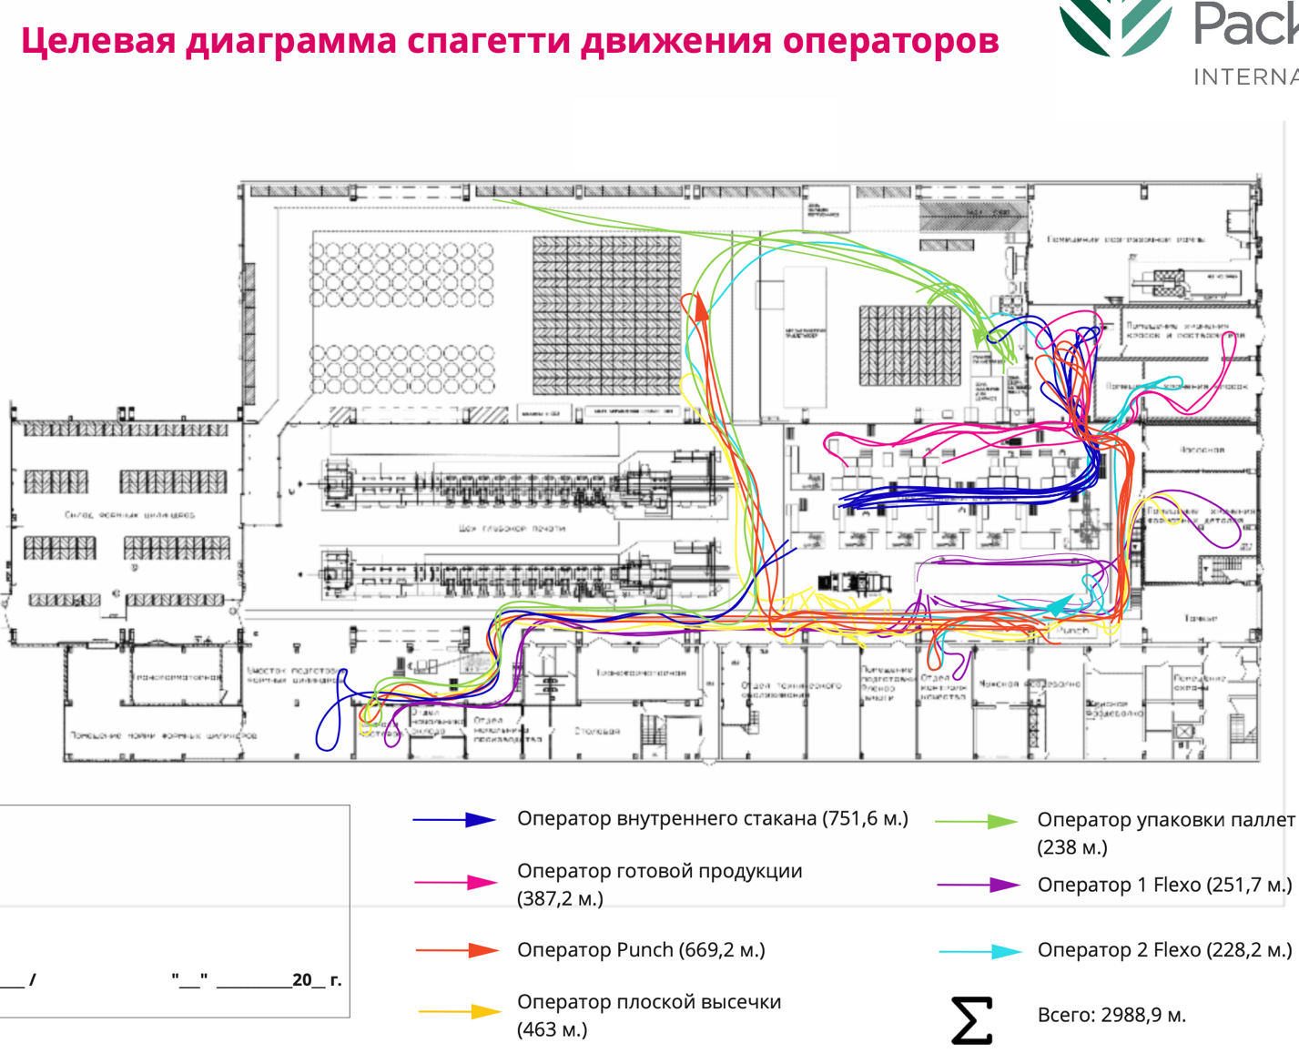
- Target "Spaghetti" diagram of operator movement
Source: Target "Spaghetti" chart of operator movement was developed by the author

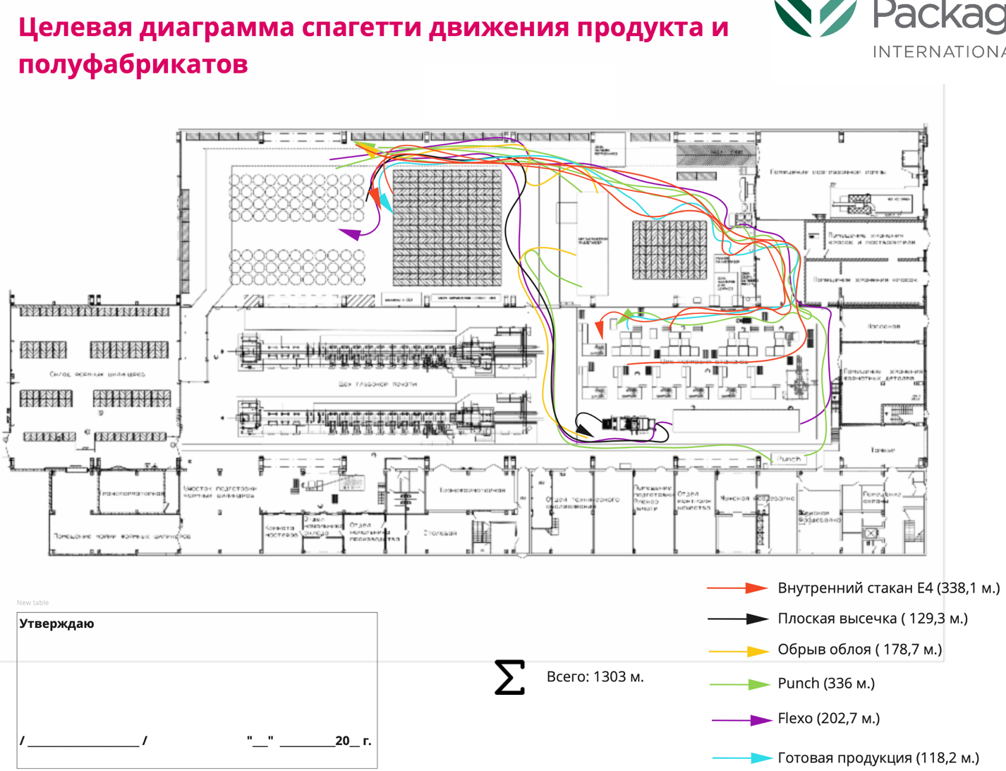
- Target «Spaghetti» diagram of product and semi-finished product movement
Source: Target "Spaghetti" chart of product and semi-finished product movement was developed by the author

On the target «spaghetti» diagram of operator movements, it can be seen that in total operator movements were reduced by 318 m. The flat die cutting operator played a special role in the reduction of movements, his route was reduced by 80 m., and the pallet packaging operator, his movements were reduced by half (by 238 m.). Regarding the target «spaghetti» product movement diagram, the movements were reduced by a total of 177 m. Particular changes occurred on the following machines: on the flat die cutting, the product movement was reduced by 81 m., on the rip cutting, the product movement was reduced by 96 m.

Key changes in the organizational structure of the GPI enterprise
As I mentioned above, in some cases the ineffective employee becomes a victim of an organizational structure that does not allow him or her to make the most of his or her skills and talents. Sometimes these situations arise, especially in large organizations where there is a lack of consistency between departments. GPI is no exception. Disagreement between the production staff and the office staff was present in the company. As part of the project, with the support of RCC experts, GPI revised the organizational structure of the company. At GPI, one person was responsible for the management of the cup production and the rotogravure printing and cup production technologies. Being a manager, managing production personnel and technologist at the same time is quite difficult, because there is too much to do on the shoulders of one person. So, it was decided to hire and appoint a completely new manager for management of production of glasses manufacturing, and to keep the previous one as a technologist with the same salary. Thus, the company was able to retain an employee, while the management of the company managed to adjust the relationship of production workers and office workers, divide responsibilities between the two employees, which in the shortest time began to bring the proper result.
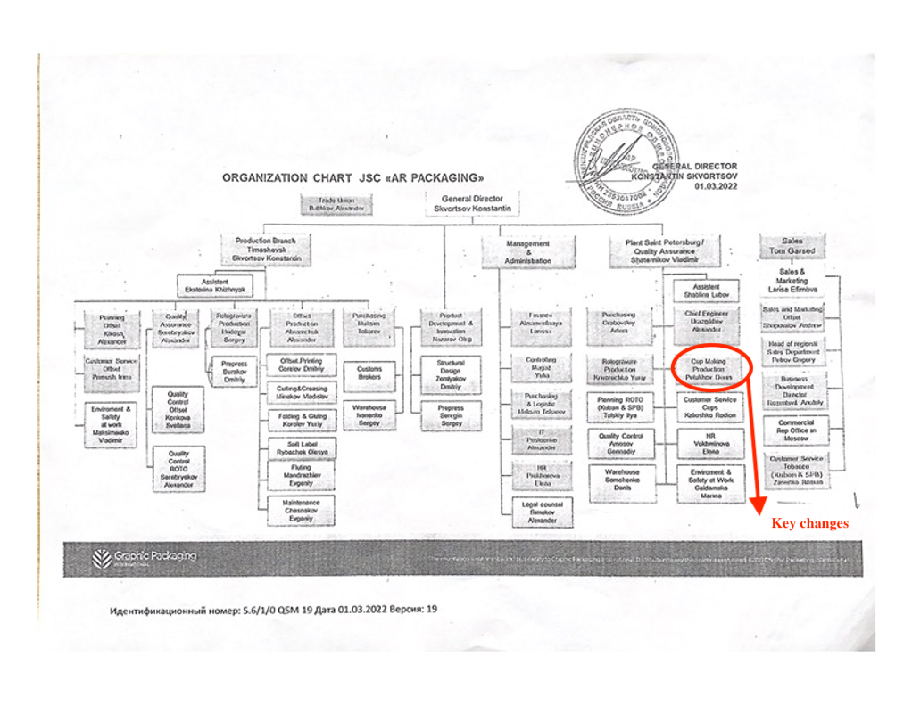
- Organization chart of JSC «AR Packaging» on March, 01.2022
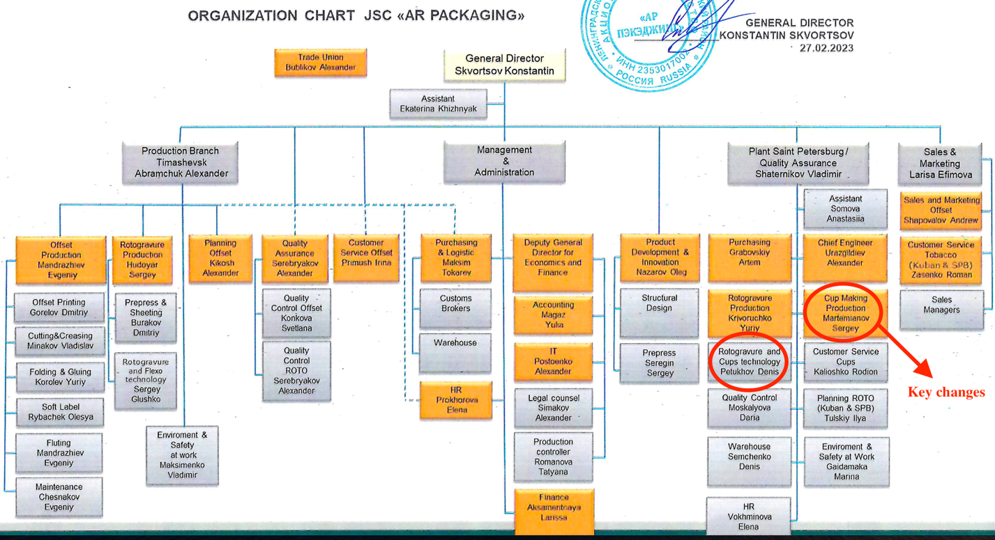
- Organization chart JSC «AR Packaging» on February 27,2023

Conclusion for the Chapter 1
In the first chapter we described in detail what is the problem of low productivity in production, recalled the causes and effects of this problem. We also looked at the manifestation of this problem at Graphic Packaging International in the city of St. Petersburg. We described the work carried out at the enterprise as part of the National Project "Labor Productivity" with the support of experts from the Federal Center of Competences. Increasing labor productivity at an enterprise is impossible without optimizing production and office processes. Improving processes is first and foremost about solving problems and eliminating losses that hide reserves in production. During the project, the experts trained the company's employees in lean production techniques and tools that helped the company reach a new level of management and ensured a steady increase in productivity and competitiveness. In my opinion, the most important thing for GPI by the end of the project is to create conditions for continuous increase in labor productivity, to make labor productivity the same habitual indicator as, for example, revenue or profit. Thus, the application of lean production principles, methods and tools will significantly increase GPI's competitiveness in the field of packaging solutions. The upcoming chapters will delve into the operations of Graphic Packaging International in the international market, including the implementation of tools to address productivity issues. Additionally, I will examine how this problem has been observed in the production territories of other companies. After such analysis, a set of recommendations will be developed for GPI to improve their operations in the Russian market.

CHAPTER 2: Analyzing Graphic Packaging International's manufacturing operations, methods and practices in international markets
One of the problems GPI has faced in international markets is downtime. Downtime is a serious problem for companies because it can have a number of negative impacts on productivity, profitability, and customer satisfaction. Some of the possible causes of production downtime:
- Technical problems: Machinery and equipment in production can malfunction, resulting in production downtime. For example, equipment breakdowns, unscheduled maintenance, problems with power lines, lack of raw materials, etc.
- Personnel problems: The company may face employment problems, including a decrease in headcount, lack of qualified workers, lack of experience, or lack of personnel in general.
- Problems in raw material supply: If a company depends on certain suppliers for raw materials, there may be supply problems, such as delays in delivery, quality of raw materials, or shortages of raw materials in general.
- Changes in the market situation: Changes in the economic situation can lead to a reduction in demand for the company's products, which can lead to production downtime.
- Logistical problems: Logistical problems may arise in the delivery of finished goods to customers or in the delivery of components and materials to production.
To address downtime, companies can employ a variety of solutions, such as improving maintenance practices, investing in new equipment or technology, and implementing better planning and scheduling processes. By reducing downtime, companies can increase productivity, reduce costs and increase customer satisfaction. As part of a project at GPI's St. Petersburg facility, the company was able to reduce downtime on various pieces of equipment using production analysis, the TPM (Total Productive Maintenance) method, and changes in equipment design. In this chapter, I want to draw attention to the problems that GPI has encountered overseas that affect productivity and how the company's managers have been able to solve these problems.
Graphic Packaging International solved downtime problem with humidification, resulting in $40,000 a month savings. John McKeough was a plant manager at Graphic Packaging International in Cincinnati, a city in southwest Ohio, USA. In the process, he encountered the problem of seasonal downtime, which was costing his company $40,000 per month for at least five months of the year. When he found a solution to the problem, it increased plant capacity and throughput by more than 20 percent and paid for itself in less than a year. The plant's biggest downtime problems were occurring on the folding and gluing lines, where problems with feeding curled paperboard were frequently causing equipment to jam and stop, followed by downtime when the messes were cleaned up and the stock feed restarted. The problems, which had occasionally occurred in the past, were exacerbated by installation of a new robotic system feeding stock to the plant's six right angle gluers, with high-speed eagle feeds. The plant manager understood that the "culprit" was dried board that had developed an asymmetrical, transverse curl in the complex die-cut parts while they waited to be sent for folding and gluing. According to McKeough, "The problem occurred very quickly in the downstream handling. There was little or no curl before the stock was printed, or even after die cutting. The press runs four times as fast as the gluers, so the pieces typically sat waiting for an hour or two before folding and gluing. That's when the curl set in. You could almost see the board curling. You might get some pieces folded and glued before the curl set in, but usually not all of them." GPI has sales of about $2.4 billion. The company employs about 8,200 people. GPI's 26 plants produce some of the most innovative and original beverage and consumer product packaging on the market today for customers such as Kraft Foods, Mars Incorporated, Anheuser-Busch, General Mills, Coors Brewing, Miller Brewing, Sara Lee, Campbell Soup and numerous Coca Cola and Pepsi Bottlers. The seasonal problem of dry air in conversion plants is a common occurrence. Dry air often leads to static electricity, product shrinkage and print quality problems, as well as die-cutting, folding and gluing problems.
Most plants experience problems when the relative humidity drops below 35%. Ideal printing and converting conditions occur when the relative humidity is 40% to 55% at 68°F to 72°F. Because such problems tend to be seasonal, dry air problems are often misdiagnosed. Problems are blamed on a bad batch of raw materials or equipment calibration problems. Experienced managers, in turn, understand that problems are caused by dry air, and are relatively easy to solve. John McKeough was not new to dry air issues. At another company, he had encountered persistent static electricity problems caused by air that was too dry. While searching for solutions, John McKeough learned about the need for constant humidity levels. After researching the issue, he purchased an engineered high-pressure ML System humidification system from Condair. The static problems quickly disappeared. Although the symptoms were very different at Graphic Packaging, McKeough’s past experience with dry air led him to believe that the problems with curling boards had the same cause: low relative humidity, and the same treatment: constant humidity. GPI purchased an engineered ML system with the ability to remotely monitor and adjust humidity levels in three zones at the Cincinnati plant. Once the ML system was up and running, the relief was quick and complete. McKeough says cardboard curl improved within hours and virtually disappeared within two days. Feeding and jamming problems also disappeared. The number of breakdowns dropped from dozens a day to a few a day or less. According to John McKeough, the installation of Condair's ML system has also resulted in improved equipment reliability, longer run times and more than 20 percent higher productivity and throughput. And the ROI on the system came in less than a year. The biggest problem of GPI Cincinnati's downtime was solved quickly, completely and permanently. The new system has also resulted in lower dust levels in the plant, fewer sick days and better working conditions for employees. When installing the equipment, GPI was also guided by the Sterling Diagram, which shows how relative humidity affects health and well-being and shows that the optimal level of humidity for humans is between 40 and 60% relative humidity. This zone of optimal humidity minimizes human health risks from biological contaminants and pathogens. Colds, viruses, respiratory infections, dry eyes, itchy and chapped skin are all symptoms that tend to prevail during the cold, dry winter months when the relative humidity indoors is lowest. Keeping the relative humidity indoors at 40-60% will keep your employees healthy all year long.
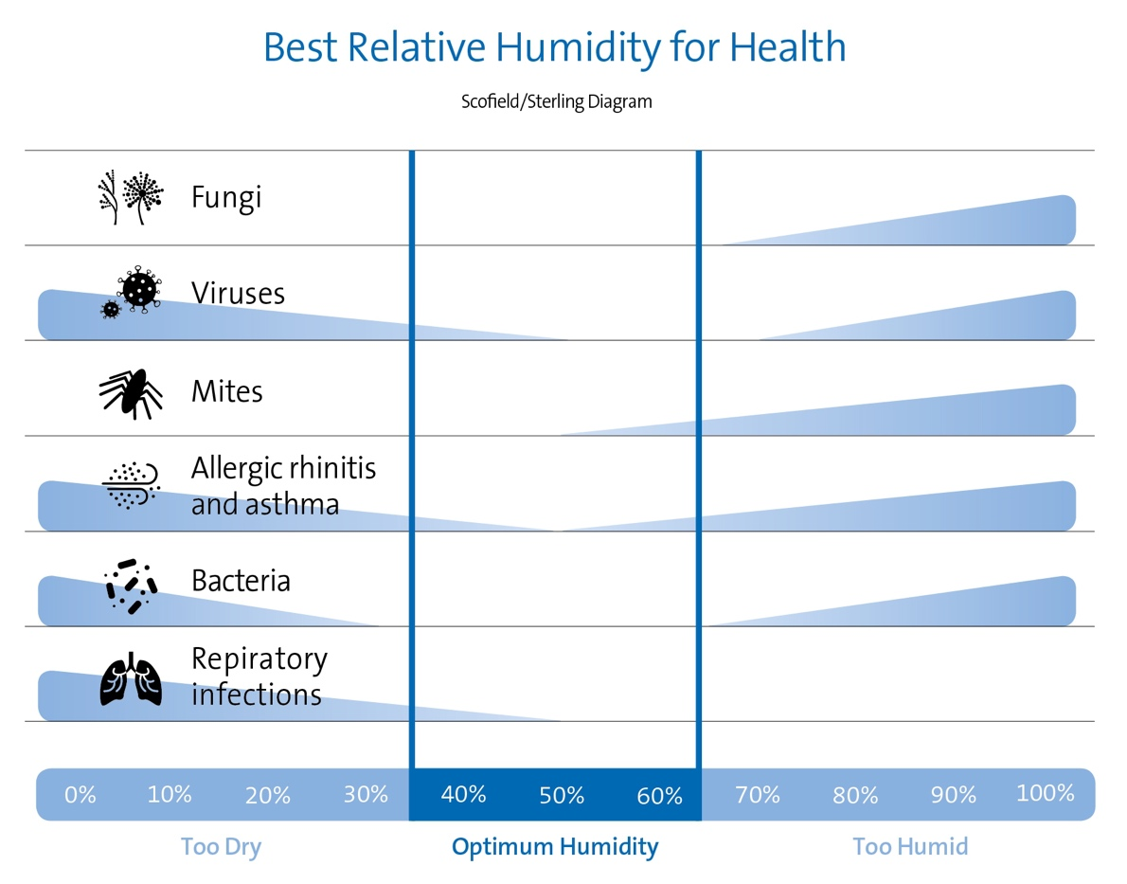
- Sterling Diagram
The next problem faced by GPI in the US is workforce optimization. Workforce optimization is the process of improving the efficiency and productivity of workers in an organization. Graphic Packaging International is a leading provider of carton packaging solutions, including folding cartons and specialty bag packaging. The company serves a well-known customer base from Kellogg's and Betty Crocker to Kimberly-Clark and MillerCoors. In order to improve production processes within the company, GPI challenged Bastian to develop and implement a unique palletizing solution that streamlined the company's manual palletizing process. Bastian was given the following business objectives:
- Optimization of the labor force required for manual palletizing on five production lines and the transfer of these workers to various skilled positions;
- Use reverse fold crate handling and palletless palletizing;
- Use of 44 unique palletizing schemes and up to 10 different pallet sizes;
To accomplish the task, Bastian used modern technologies such as:
- Hytrol low pressure infeed conveyor;
- Safe conveyor slide gate table top chain conveyor;
- 90-degree rotation conveyor;
- Row forming conveyor;
- Pallet conveyor;
- Layer building table;
- Shuttle car system;
- Series 4000 and series 4002 palletizers;
- Bastian gantry palletizing system with a specialized End of Arm Tool (EoAT);
- Wulftec stretch wrapper;
- Rockwell Automation controls;
The company achieved the desired result, which was as follows:
- Optimization of workforce by reducing manual palletizing by more than 50%;
- The final design allowed the traditional palletizing system to process 8 crates/min. with 50 unique styling patterns.
The expansion project, Sneek, Netherlands. Graphic Packaging International (GPI) has expanded its production facility in Sneek, the Netherlands with a €20 million ($22 million) investment over two years. The expansion project aims to meet the increasing demand for environmentally friendly packaging and will double the company's production capacity by installing a new printing press. In addition to creating more than 50 new jobs, the plant will produce a new cardboard packaging solution to reduce the environmental impact. However, the expansion project not only addresses the environmental impact issue, but it also enhances productivity and equipment efficiency by introducing advanced technology. This is a strategic plan to expand GPI's production capacity in Europe in order to increase the company's productivity and meet the growing demand for packaging solutions in the region. As part of this project, the company plans to introduce new technologies and automated systems to optimize production processes and increase efficiency. GPI's production facility in Sneek combines packaging expertise with innovative design ideas and technology as one of the company's four global innovation centers. The new 11-color printing press has replaced two existing machines, increasing annual productivity, print speed, and improving lead times. Moreover, the new flexographic press replaces rotogravure machines to meet changing customer and market needs. The first phase of the program includes a 5,000-square-foot expansion of the building, while the second phase will introduce a new folding and gluing line and install two new die-cutting machines and solar panels for renewable energy in 2020. The investment is expected to increase GPI's production capacity by $40 million, supporting the transition from plastic to cardboard.
A highly innovative system for beverage packaging equipment, Munich, Germany. Graphic Packaging International, a leading manufacturer of eco-friendly packaging products, has introduced ClipCombo™, an innovative beverage packaging system that offers beverage manufacturers and packers the ability to use two different clip packs on one machine, allowing them to optimize production efficiency and differentiate between premium and standard clip packs. With the ability to switch between two pack types in just minutes, the ClipCombo system is incredibly flexible and can reach a maximum speed of up to 400 packs per minute, depending on the configuration and application. ClipCombo™ allows you to speed up the packaging process and increase productivity thanks to the following features:
- Reduced time required to change packaging formats. ClipCombo™ can easily adjust to different package sizes without having to stop the production line. This reduces downtime and increases the number of products produced.
- Optimization of material consumption. ClipCombo™ provides more accurate packaging, which allows you to reduce material consumption and increase the quantity of packaged products.
- Improved quality of packaging. ClipCombo™ uses "quality packaging" technology, which reduces the number of rejected products and reduces recycling costs.
This system is compatible with both multi-pack cans and PET bottles, which reduces the capital investment required for beverage packers by eliminating the need for multiple installations. Additionally, ClipCombo frees up space in the plant and reduces the number of operators required.
- Beverage multipack machinery innovation: ClipCombo™

Graphic Packaging International enjoys reduced lead times and improved prepress efficiency with ArtPro+, USA. Graphic Packaging International (GPI) has partnered with Esko to improve their prepress operations and reduce lead times. GPI was facing several challenges, including time-consuming prepress processes, inconsistent files from different locations, and the need for more efficient communication between different teams. Esko provided GPI with a suite of prepress automation tools, including Automation Engine, WebCenter, and ArtPro+, to streamline their workflows and improve efficiency. As a result of the partnership, GPI has experienced significant improvements in lead times and prepress efficiency. Company has also seen reduced errors, improved consistency in files, and better communication between teams. GPI's partnership with Esko can increase productivity by using innovative technologies such as WebCenter, ArtiosCAD and Automation Engine to help automate packaging design and production processes. For example, using WebCenter can speed up the design approval process and Automation Engine can automate the printing and packaging processes. This can significantly reduce production time and improve overall process efficiency. The partnership can also provide access to a broader range of packaging production equipment and materials, which can provide the opportunity to improve product quality and reduce costs.

Conclusion for the Chapter 2
In conclusion, our study of Graphic Packaging International's manufacturing operations in international markets showed that the company has implemented a number of tools and techniques to improve efficiency and productivity. By implementing a variety of tools and techniques, including lean manufacturing and automation, GPI has been able to optimize its processes. In addition, the company has invested in new technologies, such as ClipCombo™, to improve its packaging solutions and expand its manufacturing capabilities. GPI's partnerships with companies such as Esko have also made it possible to integrate advanced software and automation systems to optimize workflows. Finally, completed projects, such as the Sneek plant expansion in the Netherlands, demonstrate GPI's commitment to continuous improvement and growth. Overall, GPI's commitment to innovation and manufacturing efficiency has enabled the company to achieve continued success in the competitive packaging industry. The following chapters will focus on the manifestation of this problem in production territories of other companies. Based on the analysis, a set of recommendations will be developed for GPI to improve their operations in the Russian market.

Chapter 3: Benchmarking Competitor Companies: Analyzing Productivity Solutions and Tools
Productivity projects in companies include activities that help improve the efficiency and effectiveness of production processes and increase the overall productivity of the company. Such projects can include automating production, improving logistics and supply chain, optimizing production processes, introducing new technologies and tools, improving staff skills, and improving management and coordination of department and team activities. Productivity improvement projects can be based on different methodologies and approaches, such as Lean, Six Sigma, Total Quality Management and others. They can be lengthy and involve many steps, from analyzing the current situation and identifying problems, to implementing changes and evaluating results. The results of such projects can be significant, as they can lead to cost reductions, improved product quality, and improved company competitiveness. In this chapter I would like to look at how and by what methods Graphic Packaging International's main competitors such as Huhtamaki, Smurfit Kappa, Tetra Pak and WestRock are dealing with low productivity problems.

Huhtamaki
Huhtamaki is a Finnish company founded in 1920 that specializes in the production of packaging materials. The company offers a wide range of packaging solutions including cartons, plastic containers, bags, paper cups and more. Huhtamaki has more than 80 plants in 35 countries and holds leading market positions in Europe, Asia, North and South America.The company has a broad portfolio of customers, including companies in a variety of industries such as the food, medical, household cleaning, etc. Huhtamaki and Graphic Packaging International (GPI) are competitors in the packaging materials industry. Both companies produce a wide range of packaging solutions for various industries, including food, medical and industrial. Huhtamaki works hard to improve the productivity and efficiency of its processes, using Lean methodology and other quality and productivity management tools. This enables Huhtamaki to maintain its position in the market and ensure the high quality of its products. The company has a strategy called the "Huhtamaki Production System" (HPS), which is a systematic approach to business management that incorporates the use of Lean methodology, focusing on creating maximum customer value and efficiency in internal processes. Strategic direction, goals and corresponding actions are implemented and communicated throughout the company. KPIs and annual goals are agreed upon, approved and communicated as part of the annual planning process. Achievements are tracked monthly and quarterly at performance review meetings held with line management in all business segments and business units. Key operational performance indicators are monitored on an ongoing basis. The main process controls are aimed at identifying risks and developing preventive and proactive controls. Corrective actions are implemented and monitored by the management of business segments and business units. These actions must comply with company policies and standards. Internal controls related to quality, safety and environmental processes and procedures are audited both internally and by external service providers.
Huhtamaki applies the Lean Six Sigma process in all business segments to identify and implement continuous improvement projects. Huhtamaki attributes some margin improvement to the application of a management model called Lean Six Sigma. Lean Six Sigma is a team-oriented management approach that aims to increase productivity by eliminating wasted resources and defects. It combines Six Sigma methods and tools with lean manufacturing philosophy. It focuses on eliminating waste of physical resources, time, effort and talent while ensuring the quality of manufacturing and organizational processes. Lean Six Sigma teaches that any use of resources that does not create value for the end customer is considered waste and must be eliminated.
- Lean Six Sigma
The lean management concept focuses on reducing and eliminating eight types of waste known as DOWNTIME, an acronym formed by the words: defects, overproduction, waiting, non-utilized talent, transportation, inventory, motion, and extra-processing. Lean refers to any methods, measures, or tools that assist in identifying and eliminating waste.
The term "Six Sigma" refers to tools and techniques that are used to improve manufacturing processes. The strategy focuses on identifying and eliminating causes of defects and deviations in business and manufacturing processes. DMAIC Six Sigma phases are used in Lean Six Sigma. The acronym stands for define, measure, analyze, improve, and control. It is a five-step, data-driven method for improving, optimizing and stabilizing business processes and manufacturing processes.
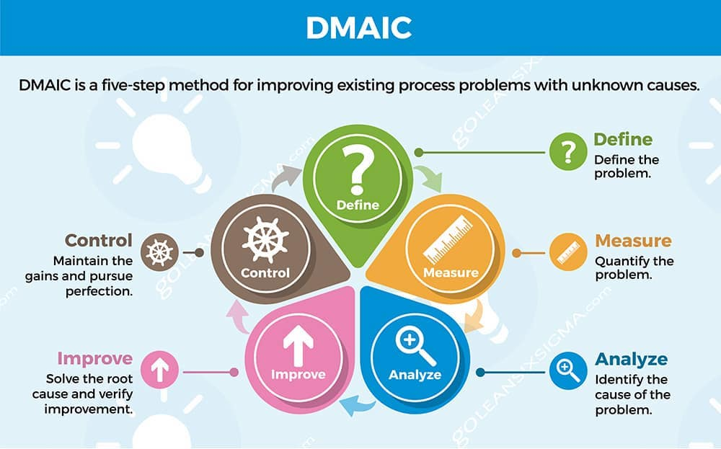
- DMAIC Six Sigma phases

The Lean Six Sigma approach, which combines Lean strategy and Six Sigma tools and techniques, identifies processes prone to waste, defects and variation and then reduces them to ensure improvements in the company's operational processes.
Lean Six Sigma training uses Lean Six Sigma Experience Belts. The exact characteristics of each belt may vary depending on which organization is certifying.
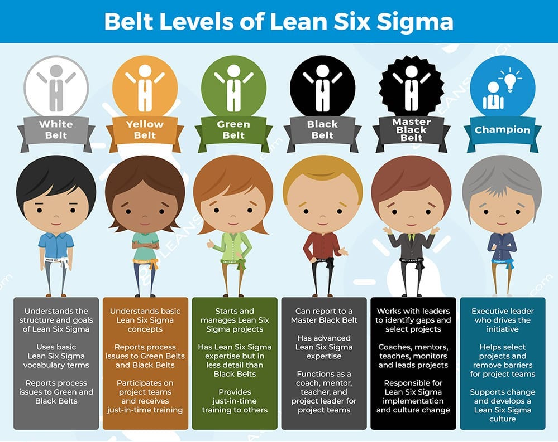
- Belt Levels of Lean Six Sigma
- White - Understands the meaning and purpose of Lean Six Sigma and knows the terms associated with the methodology.
- Yellow - Understands basic Lean Six Sigma concepts, tools and techniques; can be part of project teams and receive Just-In-Time (JIT) training.
- Green - Has some experience with Lean Six Sigma strategies; can run and manage Lean Six Sigma projects and provide JIT training to others. Focuses on using tools and applying DMAIC and Lean principles.
- Black Belt - Advanced level of Lean Six Sigma knowledge; can be a full time cross-functional project team leader and coach or mentor for Green Belts. Responsible for implementing Lean Six Sigma changes.
- Black master - has extensive knowledge of Lean Six Sigma; usually responsible for the Lean Six Sigma initiative. May act as a coach or mentor and oversee projects. Works with company leaders to identify performance gaps and training needs.

Huhtamaki faces rising costs and new challenges every day. Lean Six Sigma provides a competitive advantage in the following ways:
- Streamlining processes leads to better customer service and increased customer loyalty
- Developing more efficient processes leads to improved bottom line
- Moving from defect detection to defect prevention reduces costs and eliminates waste
- Standardizing processes leads to "nimbleness" in the organization and the ability to respond quickly to daily challenges
- Reducing turnaround time increases productivity and profitability
- Employee engagement boosts morale and accelerates staff development.
Lean Six Sigma is suitable for organizations of all sizes. The same success that large businesses have had can also be achieved by small and medium-sized businesses. Smaller organizations can be nimbler with fewer employees and less bureaucracy to overcome. This method is suitable for businesses looking for a road map to effectively achieve their strategic goals. Its application helps increase revenues and reduce costs, freeing up resources to add value where the organization needs them most. Ultimately, the company's customers benefit as they receive consistent, reliable products and services. Lean Six Sigma not only improves profit margins, it also positively impacts employees by engaging them to improve their own processes. Because employees are closest to the real work of the organization - delivering products and services - their in-depth knowledge makes them the best resources to analyze and improve the efficiency and effectiveness of those processes. By participating in successful Lean Six Sigma activities, employees build confidence and become increasingly valuable assets to the business. Studies show that employees who feel they can positively impact the organization perform better, are more responsible and live happier lives. By quickly mastering the basic skills of Lean Six Sigma, they will continually standardize work, identify problems and eliminate waste in the organization.
In addition to Lean Six Sigma, Huhtamaki has joined forces with Stora Enso to launch a new paper cup recycling initiative, The Cup Collective. The program, the first in Europe, aims to recycle and benefit from used paper cups on an industrial scale. The EU has set a paper and carton recycling goal of 85% by 2030. Paper cups can be recycled, but they need to be collected before being turned into new paper products. Cup Collective's initiative will create the necessary collection infrastructure to significantly increase the recycling rate of wood fiber in paper cups. First and foremost, the program will make it as easy as possible for consumers and businesses to collect used paper cups that will be recycled into valuable secondary raw materials. "Huhtamaki is a world leader in the design and manufacture of recyclable fiber products. Every cup is important to the company. The company wants to take the next step and ensure that recyclable cups are efficiently recycled.

Smurfit Kappa
Smurfit Kappa is a leading supplier of environmentally friendly packaging solutions with operations in Europe, North and South America and Asia. The company produces a wide range of packaging products, including corrugated boxes, bags and pouches as well as paper and cardboard. Smurfit Kappa's packaging solutions are used in a variety of industries, including food and beverage, healthcare and e-commerce. Founded in Ireland in 1934, Smurfit Kappa has grown into a global leader in the packaging industry with approximately 46,000 employees and operations in more than 30 countries. The company continues to grow, with more than 48,000 employees at 370 facilities in 36 countries and a turnover of $12.8 billion in 2021. It is headquartered in Dublin, with regional headquarters in Amsterdam and Miami.
Smurfit Kappa and Graphic Packaging International (GPI) are major players in the packaging industry. To stay afloat in such a competitive environment, the company is taking various effective actions to increase the productivity and efficiency of its production facilities. "Smerfit Kappa Russia in October 2019 set a record in production and sales of corrugated cardboard packaging - 33 million square meters of products were produced in a month at the facilities in Moscow, Vsevolozhsk and Kommunar. Smerfit Kappa Russia's overall sales growth in January-October 2019 to the same period last year was 7%, with its own productivity records broken by the enterprises in Vsevolozhsk and Moscow. One of the reasons for the production growth was a set of works on the commissioning of new production facilities and implementation of the Smurfit Kappa management system, which allowed to achieve a 25% increase in sales for 10 months compared to the same period last year. From month to month, the factory team showed an increase in productivity, and as a result, the factory produced and sold 20% more finished products in 2019 than it did in 2018.
The main factors that contributed to this result:
- Reduced organizational and emergency downtime by working with personnel, changing the bonus system and shift schedule. A competent and stable team was formed in the technical service. Communication between the departments has been established. Employees adopted the Smurfit Kappa philosophy and operating principles.
- New Asahi Göpfert equipment was commissioned, which enabled to attract new clients and to increase sales volume in this segment by more than 100%.
- Automatic feeder on the Martin 616 processing line was installed. Martin 616 was installed, eliminating the need for manual feed and hence alleviating the workload of the employees.
- A new packaging line was installed, reducing production downtime by 10%.
Other projects were also implemented:
- The fire extinguishing pump station was launched.
- The steam condensate system at the corrugator was replaced.
- Sprinkler fire-extinguishing system of waste paper area was installed.
- The park of lift trucks was renewed.
- «Escada» - an automatic quality control system is put into operation.
- SAP is implemented. SAP or System Analysis and Program Development is a program for managing the business processes of the company: procurement of goods, introduction of customer bases, inventory, financial reporting. The system consists of program modules. Each is responsible for a specific business process. This program, which allows to conduct different business processes of the company: procurement, sales, production and so on. But SAP is not one specific product, but a software package, which consists of modules. Each module is responsible for a separate business process. When transiting to SAP, the business connects those modules which are necessary in its work. Configured modules automate processes, due to which less errors occur in the work of the employees, and the tasks are solved faster.
Smurfit Kappa has modernized its Russian production facilities to increase the company's productivity. CJSC Smurfit Kappa St. Petersburg - the enterprise of Smurfit Kappa Group, one of the world leaders in corrugated cardboard packaging production, has completed the next stage of technical modernization of its production facilities in the Leningrad region. The purpose of the equipment renovation was to expand the company's capabilities to produce SRP packaging and multipoint bonded products, as well as to increase labor safety and operator comfort. As part of the technical re-equipment program at the beginning of last year the corrugator at the company's Vsevolozhsk production facility was modernized, and in December 2014 the new multipoint gluing machine was installed. The new machine allows to fold boxes from "E", "B", "C", "EB" and "BC" flute, as well as to perform their 1, 3, 4 and 6-point gluing. Furthermore, a new double gluing station BHS (Germany), as well as an automatic gluing kitchen SRP (Holland) were installed at the Kommunar plant. They have significantly improved the productivity of the corrugator, increased the quality of production, reduced power and water consumption, and made the operators' work more comfortable and safer. Besides that, two converting machines were equipped with the most modern glue application systems HHS (Germany), which allowed to increase the quality of production and decrease the production waste. The implementation resulted in a significant increase in labor productivity. In particular, in Q3 2014 Smurfit Kappa plants in Vsevolozhsk and Kommunar set records in terms of finished product output - in September 2014 about 16.9 million m2 of products were produced and shipped, and in October - more than 17.8 million m2. At the same time, a significant part of the company's production was SRP, or ready-to-shelve packaging, which is in growing demand among Russian retailers. Such packaging allows to put several units on the shelf at once, thus reducing the cost of storage and internal logistics of the store, and is also an effective channel of interaction with the consumer and a tool to influence his choice in the purchasing process.
Also, the company will continue to invest in the modernization of production in the Russian territories to increase productivity. At St. Petersburg International Economic Forum (SPIEF-2021) "Smerfit Kappa RUS" and the government of the Leningrad region signed an agreement of intent to invest in modernization and expansion of production facilities in Kommunar and Vsevolozhsk (Leningrad region) for a total amount of 1.1 billion rubles. It is planned to reconstruct and modernize the existing production workshops, as well as to update the existing and purchase new equipment to improve productivity and quality of products. That will make it possible to increase the output of the finished product by 23 million square meters or 25% of the current capacity by 2026. In addition, investments will be used to introduce innovative technologies, increase productivity and ensure a high level of occupational safety, as well as to improve environmental safety. In addition, at SPIEF-2021 an agreement on cooperation with the Government of Moscow was signed, under which the authorities will assist in the implementation of the investment project of JSC "Smerfit Kappa Rus", aimed at the development of industrial production. The agreement also assumes the development and implementation of joint activities to improve and increase the availability of industrial support programs for entrepreneurs.

Tetra Pak
Tetra Pak is an international company specializing in food and beverage packaging. The company offers innovative packaging solutions and technologies for food preservation, protection and distribution. Tetra Pak was founded in 1951 in Sweden. Since then the company has significantly expanded its range of products and services and has become one of the world leaders in packaging. Tetra Pak offers a wide range of packaging solutions, including paper and carton packaging, filling and sealing systems, packaging equipment and food processing technology. They work with various sectors of the food industry, such as dairy, beverages, juices, soups, sauces and other products. Tetra Pak is a company actively engaged in sustainability and applying lean manufacturing methods to its operations.
One of the areas of Tetra Pak's Strategy 2020 is to reduce customers' overall production costs. Understanding the urgency of reducing customers' production costs, Tetra Pak has made the development of new solutions in this area one of its development priorities for the coming years. Among them is the optimization of the customer's spare parts warehouse. Tetra Pak offers a unique way to reduce costs in this area - projects for efficient spare parts logistics. Within the framework of these projects Tetra Pak provides its customers with a complex of services, including:
- Organization of a spare parts warehouse with the implementation of specialized software;
- Optimizing inventory and business processes;
- Training of company employees in warehouse replenishment planning methods;
- long-term consulting with the customer, monitoring the results, analyzing them and making a plan for further action.
Tetra Pak's solution implies stage-by-stage optimization of the customer's logistics processes, with each step already contributing to a reduction in operating costs as a whole.
Warehouse organization:
Competent organization of the warehouse using modern equipment greatly simplifies the process of turnover and accounting of spare parts. Tetra Pak provides its customers with consulting support in the selection of warehouse equipment and software. For effective stock management Tetra Pak offers to install the e-PIMS (Parts Inventory Management System) program, supported by the company on a global scale. The customer, having full statistics on consumption, can see how many and what kind of parts go to a particular production line. At this stage, the manufacturer can achieve a reduction in equipment downtime due to the lack of necessary parts in stock.
Reducing the logistics chain:
A large number of links in the administrative chain is one of the most common causes of poor warehouse efficiency. The more employees are involved in replenishing it, the more time it takes to replace faulty parts on equipment. Consequently, the risk of disruption to the production plan increases. Together with the customer's specialists, Tetra Pak analyzes logistics business processes, determines the most important areas and eliminates unnecessary ones, freeing up human and time resources.
Creating a balanced warehouse:
Ordering spare parts only after they are urgently needed is the least efficient way to run a warehouse. The same can be said about purchasing large batches of parts "just in case", because storing them requires additional costs. The statistical analysis methods implemented by Tetra Pak allow the customer to make replenishment forecasts and, on the basis of these forecasts, purchase only those parts that will actually be needed in the near future. This is done by regularly calculating the MIN (replenishment point) and MAX (upper level of stock maintenance) parameters. The introduction of the forecasting system helps reduce the cost of purchasing and storing spare parts and increase the service level of the warehouse.
Personnel training:
The human factor has a great impact on the efficiency of logistics processes. Logistics requires specialists both the ability to work with warehouse programs and strategic thinking. Tetra Pak has developed a special seminar for its customers to train warehouse employees in modern inventory management methods. An important part of the seminar is an introduction to the mathematical planning model and gaining practical skills in its application.
The results of the joint project with Tetra Pak on implementation of lean production methods at the plant of "SanFruit" company have more than tripled the target indicators: for two years of work the total efficiency of the enterprise equipment was increased by 17.8% instead of the target 4.9%. The goal of the OCR CI project ("Operational Cost Reduction. Continuous Improvement"), which Tetra Pak offered to implement in 2012, was to ensure sustainable and continuous reduction of operational costs at the customer's production site. The two-year project had to achieve a 2.3% reduction in operating costs (including the reduction of packaging material and product losses), instill a culture of teamwork for continuous performance improvement, and implement a system of key performance indicators (KPIs). The plant's overall equipment efficiency rose from 56.8% to 66.9%, while the target was 59.6%. A key target for project success was to increase the plant's Overall Equipment Effectiveness (OEE - Overall Equipment Effectiveness) by 4.9% to meet the growing production plan.
The methodological basis for the project was based on five priority areas of work:
- Maintaining Efficiency;
- Incremental improvements;
- Targeted improvements;
- Organizing workplaces according to the 5S system;
- Autonomous service.
Performance for each was measured by specific KPIs, which included:
- Plan execution;
- Equipment productivity;
- Mechanical efficiency of line operation (MEE);
- Number of stoppages;
- Mean time between failures;
- Mean time to recover from failure (MTTR).
Packaging material losses were reduced by 21% and product losses by 3%. The fundamental mechanism of the project implementation was the introduction of a daily management system (DMS - Daily Maintenance System), which made it possible to control employees' KPIs and react to their changes on time. Another technique aimed at preventing unplanned outages is Autonomous Maintenance (AM). It helps to establish a closer cooperation between operators and mechanics. Together, they form standards for the basic condition of the equipment, which are then maintained by the operators.

WestRock
WestRock is an international company specializing in packaging and paper products. They offer a wide range of innovative packaging solutions and products for various industries. WestRock was formed in 2015 through the merger of two large companies, MeadWestvaco and RockTenn. The merger of the two companies allowed WestRock to become one of the world's leading providers of packaging solutions. WestRock offers a wide range of packaging products, including cardboard boxes, corrugated cardboard, specialty packaging for food, beverage, pharmaceutical, personal care and other industries. WestRock actively implements lean manufacturing techniques to reduce its environmental footprint and improve the efficiency of its production processes.
WestRock turned to Performance Solutions by Milliken for help in adopting its own, unique version of the Milliken Performance System (MPS). This award-winning system is designed to complement, update and accelerate current performance systems to achieve new levels of success. The Director of Business Improvement serves as a conduit, interacting with the plant teams, managing the relationship with Performance Solutions and communicating the information to the company's steering committee. The Performance Solutions approach focuses heavily on how the organization implements the Performance System and, on the flip side, on the actual performance it gets from the system. "As part of the Milliken process, we're trying to get our plants to think about OEE as an exit mechanism. How well we operate our equipment, how well we train our employees, how well we take care of our equipment, how well we prepare our inventory-all of that leads to results," says the director of operational excellence.After about a year, work on processes at WestRock has begun to move the organization across unprecedented performance thresholds, delivering double-digit improvements in speed, OEE and reliability. The company created the equivalent of 3 full sites of capacity. The financial implications go far beyond the balance sheet and are beginning to influence decisions such as capital investment and space rationalization.
WestRock Packaging Company shows significant productivity and efficiency gains after investing in a training program from BOBST. The die-cutting operators at WestRock Dublin were trained for 12 months to improve their skills and meet performance targets. After the training, machine set-up time was reduced by an average of 16 minutes and downtime was reduced by 15 percent. At the same time, productivity, expressed in sheets per man-hour, increased by more than 30%. The improvements in set-up times had the biggest impact on customer relations, with customer complaints dropping by about 50 percent since the training began. On top of that, our senior employees have more time to devote to other tasks and responsibilities. For example, the training has taught them how to handle the most difficult type of tooling job, zone dressing. The benefits WestRock has received demonstrate how the investment in training really pays off.

Conclusion for Chapter 3
The analysis of competitive companies examined the various methods and tools used to improve productivity. Graphic Packaging International (GPI) was investigated in the context of its competitors, who also used lean production methods. One such competitor, Huhtamaki, is known for its Huhtamaki Production System and implementation of the Lean 6 Sigma Method. WestRock is also one of GPI's main competitors. It applies productivity improvement methods by investing in employee training and using the Milliken Performance System (MPS). Tetra Pak is also known for their Tetra Pak's Strategy 2020, which helps apply lean manufacturing methods to increase productivity. Smurfit Kappa, for its part, is also actively working to improve productivity and strive for sustainable production. Competitor analysis of the use of lean manufacturing techniques provides valuable insights into how various companies are working to improve their efficiency. This analysis can serve as the basis for developing own productivity improvement strategies and applying lean manufacturing techniques in the GPI context.

Chapter 4: a set of recommendations for Graphic Packaging International to improve productivity of production processes in the Russian market
At the current stage of my thesis work I would like to make strategic recommendations for Graphic Packaging International to increase production productivity in the Russian market.
Based on the analysis of this problem, the methods taken to prevent this problem in the national project "Labor Productivity", the methods of GPI solutions in international markets and the solutions of competitor companies, I came to the conclusion that a lot of work has been done to improve productivity in the company. GPI was able to achieve the "Target" goals of the national project in the double-wall cup production area. The company also has "Ideal" goals, which cannot be achieved without large investments in equipment and process chains, but with additional methods that I will suggest, GPI will be able to bring its performance closer to the "Ideal" goals, namely to increase productivity and OEE, reduce process flow time and volume of incomplete production in the double-wall cup production area. Moreover, based on the analysis of the "Labor Productivity" project, I will propose methods to increase the productivity of production processes not only in the double-wall cup production area, but also in the rotogravure printing area (cigarette production). For the convenience of developing recommendations, I divided the application of methods into 3 categories: for rotogravure printing, for double-wall cup production, and for both areas.

4.1. Methods of implementation for rotogravure printing area (cigarette production)
GPI in St. Petersburg produces not only cups, but also cigarette packaging by rotogravure printing. Two pieces of equipment (Lem 625 and Lem 1003) are used for rotogravure printing.

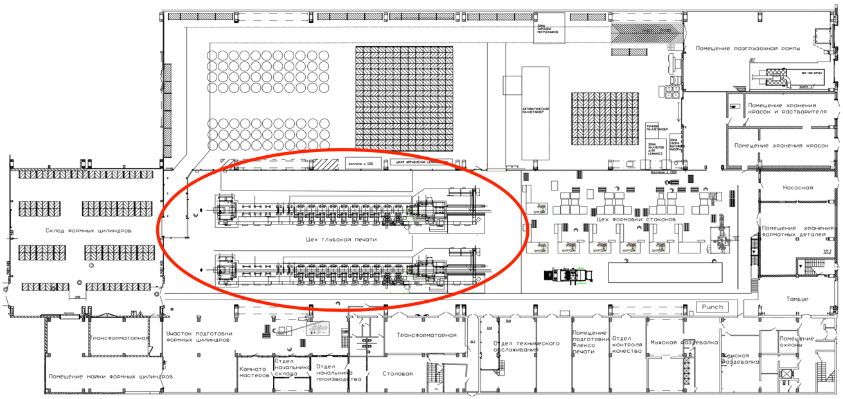
- Production plan and dedicated rotogravure printing shop
There are also problems with downtime and long changeovers in this area. For example, in 2022 the target for set-up of 2 pieces of equipment was 1.5 hours and the target for downtime was 8.5%. The company was unable to meet the 2022 target. Lem 625's set-up was 1.6 hours and Lem 1003's changeover was 1.7 hours. The downtime percentage on both machines was 9.3%.

 | 2022 target |  | 2022 actual |  | 2023 target
KPI’s | Set-up time (h.) | Down Time (%) | Set-up time (h.) | Down Time (%) | Set-up time (h.) | Down Time (%)
Lem 625 | 1,5 | 8,5 | 1,6 | 9,3 | 1,33 | 8,5
Lem 1003 | 1,5 | 8,5 | 1,7 | 9,3 | 1,33 | 8,5
- KPI targets for rotogravure department

Therefore, in order for GPI to improve the productivity of its production processes, it needs to turn its attention to other areas, namely the production of cigarette products and use the methods and tools that helped the company achieve the target results of the national project "Labor Productivity" in the production area of double-walled cups. Graphic Packaging should use the same metrics to track effect, namely output, OEE, process flow time, and the volume of incomplete production. It is also necessary to outline the "Target" result that the company is going to achieve at the end of a certain period of time. Thus, the employees of the company will have a time frame in which they need to achieve the intended goal. Using the "SMART" method, the goals of the company will be objective and achievable. The "Target" plan will also help the company meet its 2023 set-up and downtime targets of 1.33 hours for set-up and 8.5% for downtime on both machines.

 |  | Before the project | Target | Ideal
Indicator name | Units of measure | Starting date | 6 months after start | 4 years after start
Process Flow Time | Min. | X | X – …% | X - … %
Volume of incomplete production | Rub. | X | X – … % | X - … %
Output | Units/number of workers*hour | X | X + … % | X + … %
OEE of all machines | % | X | X + … % | X + … %
- A goal-setting table for rotogravure printing area.

Based on the experience of the national project «Labor Productivity» in the double-walled cup production area, 6 months is enough time to apply lean production methods and achieve the intended goal. "Ideal" targets are a longer way to achieve, as additional measures in the production processes of the company are required.
By analyzing the entire flow of cigarette production from receipt of raw materials to shipment of finished material, the company will be able to identify problems that affect output, OEE, and other indicators. The next step will be the need to develop a plan-schedule to eliminate the identified problems. For each problem, it is necessary to assign people responsible, to set deadlines. In addition, the company should use a tool such as the "Spaghetti" diagram. This diagram will help to equalize flows, reduce unnecessary movements of product, operators, and unnecessary inventory. This tool will allow company to more clearly assess the whole tangle of lines and losses associated with transportation and relocation, to understand how rationally the equipment is placed. There are two pieces of equipment on the production line of the rotogravure printing area. It is necessary to implement such method as "production analysis" on each equipment. This analysis will identify deviations that affect the output, OEE and process flow time. To effectively find solutions to the problems identified, the company can use a method such as the "5 Why's". A "standardized work" should be performed on each unit of rotogravure printing equipment. This method will determine the optimal level of employee and equipment utilization that best meets customer demand. Next, it is necessary to implement the 5S (sort, set in order, shine, standardize, sustain) system on each workstation of the gravure printing area. The 5S system does not require large financial investments and quickly proves its efficiency for the company and employees. Together with the 5S GPI system, One Point Lessons (OPL) should be created. This tool will help to ensure the safety, quality of operation and maintenance of equipment at the workplace. The next step is to apply the SMED (Single Minute Exchange of Dies) method. The company should go through the same 7 steps it went through when applying this tool to the double wall cup production area:
1. Fixing of all operations on changeover and time of their fulfillment
2. Separation of internal and external changeover operations
3. Transfer of work from internal changeover to external changeover
4. Reduced internal changeover time
5. Reduced changeover time
6. Reduced external changeover time
7. Standardization of changeover
Total Productive Maintenance (TPM) is another method that should be implemented in the rotogravure printing area. This tool will help the company avoid equipment downtime. In this method, I propose to include the following measures:
- Implementation of autonomous equipment maintenance elements (daily maintenance instructions);
- The distribution of areas of responsibility between the O&M service (operation and maintenance) and operators;
- Introduction of checklists to monitor the major components of rotogravure printing equipment;
- Development of competence matrix and training schedule for equipment maintenance and repair;
Implementing lean manufacturing techniques in GPI's rotogravure section can bring a number of significant benefits and results. Lean production will help to optimize processes and eliminate inefficient steps, leading to a reduction in wasted materials and waste. For example, the use of accurately measured paint quantities and paint management will reduce redundancy and overuse. Lean manufacturing aims to improve processes and use resources efficiently. This can result in increased productivity in the gravure printing area, reduced set-up times and improved overall throughput. Lean methods can also help identify and eliminate the causes of defects and failures in the gravure printing area. Better process control and optimization will help achieve higher print quality and lower defect rates. Process optimization and reduction of wasted materials and time will also reduce costs in the gravure press section. This can include reducing the cost of raw materials, energy and equipment maintenance. Implementing lean manufacturing can go hand in hand with streamlining the workplace, improving organization and cleanliness, and adopting safe and ergonomic working practices. This can lead to higher levels of safety and comfort for employees.

4.2. Methods of implementation for double-wall cup production
As I mentioned earlier, GPI was able to achieve numbers above the «Target» goals that the company had set for itself during the national project «Labor Productivity». Now, to bring those numbers closer to the "Ideal" goals, the company needs to continue to work in the same direction on the DoubleWall 2 machine and implement the same methods, namely production analysis, standardized work, diagram «Spaghetti», 5S, SMED, TPM on the remaining pieces of equipment.

 |  | Before the project | Target | After the project | Ideal
Indicator name | Units of measure | 30.09.2022 | 30.09.2022 | 20.02.2023 | 24.02.2026
Process Flow Time | Min. | X | X - 11 % | X - 15 % | X – 70 %
Volume of incomplete production | Rub. | X | X - 32 % | X - 32 % | X – 76 %
Output | Units/number of workers*hour | X | X + 8 % | X + 21 % | X + 21 %
OEE of all machines | % | X | X + 3,7 % | X + 4,6 % | X + 40 %
- Project goals, results and planned effect

The process of making a double layer cup involves 5 pieces of equipment. These are the FLEXO machine, the Punch machine (die-cutting of the outer cup), the skm-105 machine (flat die-cutting), the inner cup on the Eagle 1-5 machines and the gluing of the double wall cup which is done on the DoubleWall machine. The company needs to identify problems on each piece of equipment, create a schedule-plan to fix those problems using the "5 Why's" method and the SMART system. On the DoubleWall 2 machine, the optimisation process should not stop either. The presence of important problems such as "unnecessary operator movements when loading the inner cup" and "operator distraction from loading the finished product" make the company continue to work in this direction. Thus, the company decided to redesign the table at the DoubleWall 2 operator workstation. The short table makes it impossible to accommodate the required number of cups. The company decided to retrofit the workbench with a loading box.
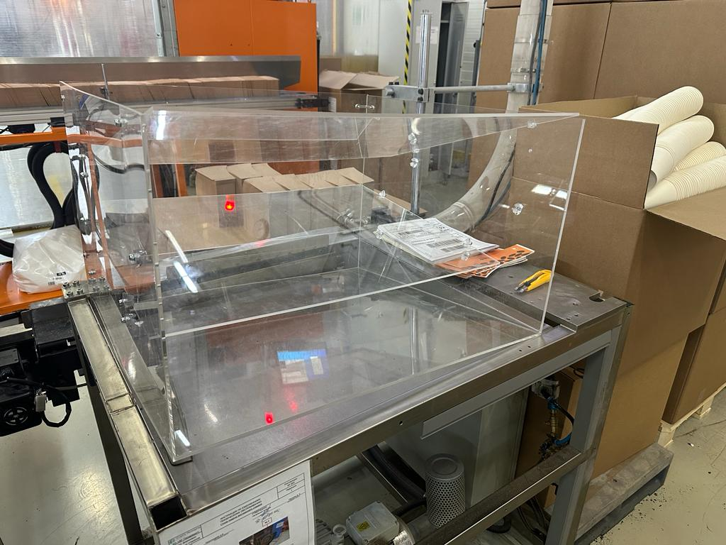
- Loading box
This solution is in the process of being implemented. I in turn advise the company to complete this action, as it will reduce the operator's movement frequency from once a minute to once every 8 minutes. This in turn will have an impact on process flow time and output. By applying lean production methods to the double-walled cup production area during the project, the company was able to achieve figures much higher than the «Target». If these methods were applied to every piece of equipment, the result would also be evident. Apply the above-described methods of lean production, then the figures can double or even triple the results obtained after the end of the national project "Labor Productivity".

4.3. Methods of implementation for both production areas (rotogravure printing and double-wall cup)
In addition to implementing lean methods on all pieces of equipment in both production areas, GPI also needs to add a tool such as Lean Six Sigma. When analyzing competitor companies, I found out that Huhtamaki applies Lean Six Sigma process in all business segments, which is reflected in the increase of the company's margin and gives the company a competitive advantage. By applying Lean Six Sigma together with the lean manufacturing methods that I described above, there is an opportunity to have a significant impact on the productivity of Graphic Packaging International's (GPI) manufacturing processes. Lean Six Sigma can improve GPI performance in the following ways:
- Eliminate redundancy and waste: Lean Six Sigma helps identify and eliminate redundancy, unnecessary operations and waste in the production process. This optimizes work flow and reduces time spent on tasks, which in turn increases overall productivity.
- Defect and Error Reduction: Lean Six Sigma provides tools and methodologies for analyzing and eliminating the causes of defects and errors in production processes. This improves product quality, reduces scrap and rework, and improves overall process efficiency. Improved product quality enhances company reputation, customer confidence and satisfaction.
- Process optimization: Lean Six Sigma helps analyze and optimize manufacturing processes to eliminate redundancy, improve throughput and increase productivity. Applying Lean Six Sigma techniques can identify inefficient steps, improve sequencing of operations and optimize resource utilization.
- Improving communication and collaboration: Lean Six Sigma also supports the development of communication skills and collaboration among employees. Through the use of standard methods and terminology, Lean Six Sigma creates a common platform for sharing knowledge, ideas and expertise, which helps improve process efficiency and productivity. Employees become more aware of processes and look for continuous opportunities to optimize and improve their work, which ensures continuous growth and development of the company.
- Continuous Improvement: One of the core principles of Lean Six Sigma is continuous process improvement. This means that GPI can continually analyze and optimize its production processes to achieve ever-increasing productivity and efficiency.

As stated earlier, during the implementation of the national project "Labor Productivity" at Graphic Packaging in St. Petersburg, 2 employees were accredited with the ability to train staff on the 5S system. So far, only 14 employees of the workforce have been trained. I suggest that Graphic Packaging continue to train all employees in both areas of production in such ways as:
- Basics of Lean Manufacturing.
- Types of losses in processes and tools for eliminating them
- How to effectively organize the workplace according to the 5S principle
- How to implement a process improvement project
- Using the mapping tool
There are several important reasons and benefits to training company's employees in the 5S system methods. The methods of the 5S system are aimed at creating a clean, neat and organized workspace. Training employees in these methods helps create a pleasant and safe work environment that promotes comfort and efficiency. A clean and orderly workspace helps reduce the time spent searching for tools, materials and information. This results in increased productivity, less downtime and improved overall work efficiency. The 5S system also helps identify and eliminate redundancies and waste in work processes. Training employees in 5S methods allows them to be more aware of the causes of waste and loss and to take steps to eliminate them, which helps reduce costs and streamline processes. Also, 5S training helps employees be aware of the risks associated with unorganized and cluttered workspaces and take steps to prevent accidents.
During the national project, 2 employees, namely the gravure manager and the health and safety manager, were certified to conduct training at the company. During the project, 14 employees were trained in 5C methods in the production of double-walled glasses. I suggest that the company continues to train the operators in the production of cups and to implement 5C training in the gravure production. The company holds daily meetings with company employees. The meetings usually take no more than 20 minutes, so it is possible to include training immediately after the daily rallies. The form of the training can be in the form of a presentation and practical exercises, where employees can put what they have learned into practice. This procedure will take exactly one hour so that employees are not distracted from their duties, while they can gain skills and knowledge in lean manufacturing to improve each workplace in the production chain.
Another suggestion would be the introduction of software such as ArtPro+. As we already found out, Graphic Packaging already uses this software in the U.S. market. As a result of the collaboration, GPI has seen significant improvements in turnaround times and prepress efficiency. The company also noted a decrease in errors, better file consistency and improved communication between teams. The GPI enterprise does not currently use such software in the enterprise. The introduction of ArtPro+ will help the company check and correct colour schemes, object layout, fonts and other aspects of design to ensure high quality printing. ArtPro+ is a PDF editor for packaging design and prepress layout creation for packaging industry professionals. ArtPro+ includes the tools company need to meet the needs of today's packaging design and prepress professionals. ArtPro+ is ideal for packaging designers and prepress professionals who do not yet have a dedicated design and prepress tool. With ArtPro+ users get an easy-to-use solution with a short learning curve that allows them to professionally and expertly create fully finished packaging and conduct full label prepress. To get the most out of ArtPro+ can be integrated with an automated workflow, allowing repetitive tasks to be performed in the background. Increased automation will free the operator from mundane and repetitive "Push Button" type tasks, allowing them to focus on quality control and handling unapproved items. The savings in training time for ArtPro+ operators is estimated at 28%. This and other efficiencies ensure a quick return on investment for users and improved productivity for the editor's existing customers.
In order to implement all of the lean practices described above, a company needs to establish a project team and delegate responsibilities between employees. The team should include employees in positions such as: Plant Director, Work Team Leader, Customer Service Specialist, Production Manager, Quality Control Manager (QCM), Production Controller, Chief Engineer, Deep Print Production Manager, Process Engineer. These positions have been involved in the national project in the production of double walled glasses. Consequently, they have the knowledge and competence to apply the extra measures and lean production methods to all areas of production. The project team may encounter problems such as long machine downtime, low production output, raw material random storage and other important issues when implementing the above activities. Additional methods of solving problems can be the revision of workplace reconstruction, retrofitting, and replacement of consumables on equipment.
Summing up, all of the above, we note the following key points:
- Based on the analysis of the national project "Labor Productivity" conducted in the production area of double wall glasses, I advise Graphic Packaging to implement the methods and tools that were involved during the project, namely mapping, SMART method, "Spaghetti" diagram, «Production analysis», «5 Why's» method, 5S system (OPL), SMED method, TPM method in the rotogravure printing area (cigarette products)
- Next, I advise Graphic Packaging to continue to work in the same direction on the DoubleWall 2 machine and implement the same methods and tools such as mapping, SMART method, "Spaghetti" diagram, "Production analysis", "5 Why's" method, 5S system (OPL), SMED method, TPM method on the remaining pieces of equipment in the double wall cup production area
- In conjunction with the implementation of lean tools, Graphic Packaging should implement the important Lean Six Sigma method in both production areas, namely in the production of double-wall cups and in the rotogravure printing area.
- I also advise GPI to continue the 5S training internally and train all employees at both production areas in the following ways:
- Basics of Lean Manufacturing
- Types of losses in processes and tools for eliminating them
- How to effectively organize the workplace according to the 5S principle
- How to implement a process improvement project
- Using the mapping tool
- Last but not least, Graphic Packaging should also incorporate software such as ArtPro+ into its production and office processes

Conclusion
The purpose of the work was to develop recommendations to improve the efficiency and productivity of production processes for the GPI company based on the analysis of already conducted projects by the company in the Russian market, analysis of the company's activities in foreign markets and the analysis of the use of various tools by competing companies. All objectives were achieved:
- Identification of what is the problem of low productivity in the company. Identifying specific areas of production, possible problems and causes, identifying the benchmark areas that most need to be addressed.
- Analysis of implemented projects to improve production efficiency at GPI in the Russian market: comparison of key indicators before and after, tools implemented.
- Analysis of GPI's production process in foreign markets: tools and practices implemented, projects carried out.
- Benchmarking. Analysis of experience in solving this problem in other competing companies. In the context of solving a particular problem, benchmarking entails researching and analyzing how other competing companies have successfully addressed a similar problem, including their approaches, strategies, and outcomes.
- Development of a set of recommendations for GPI to improve the efficiency and productivity of production in the Russian market.

Recommendations for Graphic Packaging International include additional measures to increase productivity of production processes in the Russian market. The conclusion of the analysis is that this problem is relevant not only for GPI in the Russian and foreign markets, but also for most other major players in the packaging segment industry. Graphic Packaging International, in turn, has gone a long way to eradicate this problem from the chain of its office and production processes, and has achieved a good result. Nevertheless, the company needs to supplement the measures already taken with additional and improved recommendations in order to achieve the figures well above.

References

- Cox, Lindsay Kolowich. “How to Stop the Most Common Productivity Prohibitors [Infographic].” HubSpot Blog. HubSpot, June 10, 2021. https://blog.hubspot.com/marketing/productivity-prohibitors.

- “GPI - Our Story.” AR Packaging. Accessed February 12, 2023. https://www.ar-packaging.com/our-business/our-story.

- Lewis, Jared. “How to Deal with Incompetent Managers.” Small Business - Chron.com. Chron.com, November 21, 2017. https://smallbusiness.chron.com/deal-incompetent-managers-32678.html.

- Mirza, Beth. “Toxic Workplace Cultures Hurt Workers and Company Profits.” SHRM. SHRM, May 13, 2022. https://www.shrm.org/resourcesandtools/hr-topics/employee-relations/pages/toxic-workplace-culture-report.aspx.

- Zaheer, Fida-E, Fida-E Zaheer, and Read 5 mins. “Low Productivity Levels: Top 5 Causes.” Syncoria Inc., February 3, 2022. https://www.syncoria.com/blog/causes-of-low-productivity-levels/.

- “8 Causes of Lost Productivity in Manufacturing and How Managers Can Address Them in 2022.” ManufacturingTomorrow. Accessed February 13, 2023. https://www.manufacturingtomorrow.com/story/2022/03/8-causes-of-lost-productivity-in-manufacturing-and-how-managers-can-address-them-in-2022/18384/.

- “САНКТ-ПЕТЕРБУРГ .” AR. Accessed March 21, 2023. https://www.ar-packaging.com/ru-ru/career/plants/st-petersburg.

- “Тимашевск, Россия.” AR. Accessed March 21, 2023. https://www.ar-packaging.com/ru-ru/career/plants/timashevsk.

- Шатов, Евгений. “Graphic Packaging: Investing.com.” Investing.com Россия. Investing.com, December 22, 2021. https://ru.investing.com/analysis/article-200289008.

- Group, Adagio Media. “Принципиальные Отличия Флексографской, Ротогравюрной и Офсетной Печати.” Полиграфическая компания Люкс-Принт. Accessed February 17, 2023. https://luxe-press.ru/info/fleksopechat-i-ofsetnaja-pechat-v-chem-zhe-otlichie.html.

- “Packaging - Our Story.” AR. Accessed February 13, 2023. https://www.ar-packaging.com/ru-ru/our-business/our-story.

- “Национальный Проект ‘Производительность Труда.’” О Национальном проекте "Производительность труда" - паспорт, информация. Accessed March 21, 2023. https://xn--b1afjhrgvdfla9hb.xn--p1ai/national-project.

- “Национальный Проект «Производительность Труда».” Accessed February 17, 2023. https://www.economy.gov.ru/material/directions/nacionalnyy_proekt_proizvoditelnost_truda/.

- Федеральный центр компетенций в сфере производительности труда. Accessed February 17, 2023. https://xn--b1aedfedwqbdfbnzkf0oe.xn--p1ai/national-project/about_project/.

- “Graphic Packaging Mergers and Acquisitions Summary.” Mergr. Accessed February 13, 2023. https://mergr.com/graphic-packaging-holding-acquisitions.

- “Packaging - НАШИ ПОДРАЗДЕЛЕНИЯ И БИЗНЕС-СЕГМЕНТЫ.” AR. Accessed February 13, 2023. https://www.ar-packaging.com/ru-ru/our-business/our-divisions-and-business-segments.

- “Сертификат ИСО 9001-2015.” Сертификат ISO 9001-2015 (2008) СМК. Accessed February 16, 2023. https://rossertcentr.ru/sertifikaciya-iso-9001-2015.

- “FSSC 22000 - Что Это Такое, и Для Чего Оно Нужно?” Центр сертификации в Минске - Стандарт качества, December 11, 2019. https://standartno.by/blog/articles/the-first-section/food-products/fssc-22000-chto-eto-takoe-i-dlya-chego-ono-nuzhno/.

- Миниханова, Ольга “Полный Список Компаний, Ушедших Из России На Сегодня – Обновляемый Список 2022.” sovcombank.ru. Совкомбанк, Accessed February 13, 2023. https://sovcombank.ru/blog/umnii-potrebitel/polnii-spisok-kompanii-ushedshih-iz-rossii-na-segodnya--obnovlyaemii-spisok-2022.

- “Инфляция.” Инфляция в России. Accessed February 16, 2023. https://rosstat.gov.ru/ps/inflation/.

- “Graphic Packaging International Case Study - Condair.” Accessed March 25, 2023. https://www.condair.com/m/0/20-59-case-study-graphic-packaging-international.pdf

- “What Is the Sterling Chart?” What is the sterling chart. Accessed March 25, 2023. https://www.condair.com/residential/what-is-the-sterling-chart.

- “Graphic Packaging.” Graphic Packaging Case Study | Manufacturing Finished Goods Industry | Bastian Solutions. Accessed March 25, 2023. https://www.bastiansolutions.com/resources/case-studies/manufacturing/graphic-packaging/#See%20the%20results.

- “Graphic Packaging International Facility Expansion, Sneek, the Netherlands.” Packaging Gateway, October 25, 2021. https://www.packaging-gateway.com/projects/graphic-packaging-international-facility-expansion-sneek-the-netherlands/.

- Schultz, Makisha. “Graphic Packaging International Launches Their Latest Beverage Multipack Machinery Innovation: Clipcombo™.” BFBi, February 2, 2023. https://www.bfbi.org.uk/bfbi-news/graphic-packaging-international-launches-their-latest-beverage-multipack-machinery-innovation-clipcombo/.

- “Graphic Packaging International Enjoys Reduced Lead Times and Improved Prepress Efficiency with ArtPro+.” Esko. Accessed March 25, 2023. https://www.esko.com/en/company/testimonials/graphic-packaging-international-enjoys-reduced-lead-times-and-improved-prepress-efficiency.

- “Food Packaging Solutions and Supplies.” Huhtamaki. Accessed May 11, 2023. https://www.huhtamaki.com/en/.

- Remuneration report 2022 - Huhtamaki.com. Accessed May 11, 2023. https://www.huhtamaki.com/globalassets/global/investors/reports-and-presentations/en/2022/huhtamaki-oyj-remuneration-report-2022.pdf.

- Results January 1 - Huhtamaki. Accessed May 11, 2023. https://www.huhtamaki.com/globalassets/global/investors/reports-and-presentations/en/2021/huhtamaki-oyj-results-2021.pdf.

- A low-wage, low-cost, low-responsibility model of employment. Accessed May 11, 2023. https://m.usw.org/workplaces/paper/Huhtamaki-Group-report-FINAL-2.pdf.

- Kenton, Will. “Lean Six Sigma: Definition, Principles, and Benefits.” Investopedia, March 19, 2023. https://www.investopedia.com/terms/l/lean-six-sigma.asp#:~:text=our%20editorial%20policies-,What%20Is%20Lean%20Six%20Sigma%3F,lean%20manufacturing%2Flean%20enterprise%20philosophy.

- “Six Sigma Belt Level Rankings - LSS Certification .” Lean Six Sigma Online Certification & Training at Purdue University, January 26, 2022. https://www.purdue.edu/leansixsigmaonline/blog/lean-six-sigma-belt-levels/.

- GoLeanSixSigma.com. “Lean Six Sigma Process Improvement.” GoLeanSixSigma.com, July 26, 2021. https://goleansixsigma.com/what-is-lean-six-sigma/.

- Published by Simon Matthis - 14 Sep. “Huhtamaki and Stora Enso Launch Industrial Scale Recycling Programme for Paper Cups in Europe.” Hem. Accessed May 12, 2023. https://www.pulpapernews.com/20220914/13890/huhtamaki-and-stora-enso-launch-industrial-scale-recycling-programme-paper-cups.

- Smurfit Kappa. Accessed May 15, 2023. https://www.smurfitkappa.com/ru/about/our-history#:~:text=%D0%A2%D0%B0%D0%BA%20%D0%BD%D0%B0%20%D1%81%D0%B2%D0%B5%D1%82%20%D0%BF%D0%BE%D1%8F%D0%B2%D0%B8%D0%BB%D0%B0%D1%81%D1%8C%20Smurfit,%D1%80%D0%B5%D0%B3%D0%B8%D0%BE%D0%BD%D0%B0%D0%BB%D1%8C%D0%BD%D1%8B%D0%B5%20%E2%80%94%20%D0%B2%20%D0%90%D0%BC%D1%81%D1%82%D0%B5%D1%80%D0%B4%D0%B0%D0%BC%D0%B5%20%D0%B8%20%D0%9C%D0%B0%D0%B9%D0%B0%D0%BC%D0%B8.

- “‘Смерфит Каппа Россия’ Установила Производственный Рекорд.” Smurfit Kappa - Paper. Accessed May 15, 2023. https://www.smurfitkappa.com/ru/newsroom/2019/smurfit-kappa-russia-sets-a-new-production-record.

- Open smurfit kappa новости компании. Accessed May 15, 2023. https://www.smurfitkappa.com/ru/-/m/files/documents---country/russia/vsevolozhsk/open_sk_13_2020.pdf?rev=f7ebbde30f9142829dd7a7b316eb7bc3&hash=566EBEE1508EACDE17B1F96E8241D2A9.

- “SAP - Это Программа Для Управления Бизнес-Процессами Компании.” Агентство CRM-маркетинга Email Soldiers, April 13, 2023. https://emailsoldiers.ru/glossary/sap.

- Smurfit Kappa провела модернизацию российских производств. Accessed May 15, 2023. https://logistics.ru/industry/news/smurfit-kappa-provela-modernizaciyu-rossiyskih-proizvodstv.

- “‘Смерфит Каппа РУС’ Вложит 1,1 Млрд Рублей в Модернизацию Производственных Площадок в Ленинградской Области.” Smurfit Kappa - Paper. Accessed May 15, 2023. https://www.smurfitkappa.com/ru/newsroom/2021/modernization-of-production-sites-in-the-leningrad-region.

- “About Tetra Pak.” Tetra Pak. Accessed May 16, 2023. https://www.tetrapak.com/about-tetra-pak#.

- “Снижение Общепроизводственных Расходов (Стратегия-2020 Компании Тетра Пак).” ООО "Портал “Управление Производством.” Accessed May 16, 2023. https://up-pro.ru/library/logistycs/logistic_systems/snizhenie-rashodov/.

- “Бережливое Производство .” ООО "Портал “Управление Производством.” Accessed May 16, 2023. https://up-pro.ru/library/production_management/lean/sunfruit-oee/.

- “WestRock.” Innovate Boldly. Package Sustainably., March 16, 2023. https://www.westrock.com/company.

- “How WestRock Doubled Their Speed, OEE and Reliability.” Milliken. Accessed May 17, 2023. https://www.milliken.com/en-us/businesses/performance-solutions-by-milliken/blogs/how-rocktenn-doubled-their-speed-oee-and-reliability.

- Обучение от компании Bobst . Accessed May 17, 2023. https://news.unipack.ru/83893/.

Cox, Lindsay Kolowich. “How to Stop the Most Common Productivity Prohibitors [Infographic].” HubSpot Blog. HubSpot, June 10, 2021. https://blog.hubspot.com/marketing/productivity-prohibitors.
“GPI - Our Story.” AR Packaging. Accessed February 12, 2023. https://www.ar-packaging.com/our-business/our-story.
Lewis, Jared. “How to Deal with Incompetent Managers.” Small Business - Chron.com. Chron.com, November 21, 2017. https://smallbusiness.chron.com/deal-incompetent-managers-32678.html.
Mirza, Beth. “Toxic Workplace Cultures Hurt Workers and Company Profits.” SHRM. SHRM, May 13, 2022. https://www.shrm.org/resourcesandtools/hr-topics/employee-relations/pages/toxic-workplace-culture-report.aspx.
Zaheer, Fida-E, Fida-E Zaheer, and Read 5 mins. “Low Productivity Levels: Top 5 Causes.” Syncoria Inc., February 3, 2022. https://www.syncoria.com/blog/causes-of-low-productivity-levels/.
“8 Causes of Lost Productivity in Manufacturing and How Managers Can Address Them in 2022.” ManufacturingTomorrow. Accessed February 13, 2023. https://www.manufacturingtomorrow.com/story/2022/03/8-causes-of-lost-productivity-in-manufacturing-and-how-managers-can-address-them-in-2022/18384/.
“САНКТ-ПЕТЕРБУРГ .” AR. Accessed March 21, 2023. https://www.ar-packaging.com/ru-ru/career/plants/st-petersburg.
“Тимашевск, Россия.” AR. Accessed March 21, 2023. https://www.ar-packaging.com/ru-ru/career/plants/timashevsk.
Шатов, Евгений. “Graphic Packaging: Investing.com.” Investing.com Россия. Investing.com, December 22, 2021. https://ru.investing.com/analysis/article-200289008.
Group, Adagio Media. “Принципиальные Отличия Флексографской, Ротогравюрной и Офсетной Печати.” Полиграфическая компания Люкс-Принт. Accessed February 17, 2023. https://luxe-press.ru/info/fleksopechat-i-ofsetnaja-pechat-v-chem-zhe-otlichie.html.
“Packaging - Our Story.” AR. Accessed February 13, 2023. https://www.ar-packaging.com/ru-ru/our-business/our-story.
“Национальный Проект ‘Производительность Труда.’” О Национальном проекте "Производительность труда" - паспорт, информация. Accessed March 21, 2023. https://xn--b1afjhrgvdfla9hb.xn--p1ai/national-project.
“Национальный Проект «Производительность Труда».” Accessed February 17, 2023. https://www.economy.gov.ru/material/directions/nacionalnyy_proekt_proizvoditelnost_truda/.
Федеральный центр компетенций в сфере производительности труда. Accessed February 17, 2023. https://xn--b1aedfedwqbdfbnzkf0oe.xn--p1ai/national-project/about_project/.
“Graphic Packaging Mergers and Acquisitions Summary.” Mergr. Accessed February 13, 2023. https://mergr.com/graphic-packaging-holding-acquisitions.
“Packaging - НАШИ ПОДРАЗДЕЛЕНИЯ И БИЗНЕС-СЕГМЕНТЫ.” AR. Accessed February 13, 2023. https://www.ar-packaging.com/ru-ru/our-business/our-divisions-and-business-segments.
“Сертификат ИСО 9001-2015.” Сертификат ISO 9001-2015 (2008) СМК. Accessed February 16, 2023. https://rossertcentr.ru/sertifikaciya-iso-9001-2015.
“FSSC 22000 - Что Это Такое, и Для Чего Оно Нужно?” Центр сертификации в Минске - Стандарт качества, December 11, 2019. https://standartno.by/blog/articles/the-first-section/food-products/fssc-22000-chto-eto-takoe-i-dlya-chego-ono-nuzhno/.
Миниханова, Ольга “Полный список компаний, ушедших из России на сегодня – Обновляемый Список 2022.” sovcombank.ru. Совкомбанк, Accessed February 13, 2023. https://sovcombank.ru/blog/umnii-potrebitel/polnii-spisok-kompanii-ushedshih-iz-rossii-na-segodnya--obnovlyaemii-spisok-2022.
“Инфляция.” Инфляция в России. Accessed February 16, 2023. https://rosstat.gov.ru/ps/inflation/.
Process time consists of production cycle time and changeover time. Production cycle time is the time it takes for a product, material, or workpiece to travel through a process or value stream from start to finish. Changeover time - operations such as changing dies, fixtures, material used.
Units – 595 000 (constant); Number of workers - the number of people involved in a particular production process; hour - process time in hours (must be converted to minutes).
Units – 595 000 (constant); Number of workers - the number of people involved in a particular production process; hour - process time in hours (must be converted to minutes).
Units – 595 000 (constant); Number of workers - the number of people involved in a particular production process; hour - process time in hours (must be converted to minutes).
Units – 595 000 (constant); Number of workers - the number of people involved in a particular production process; hour - process time in hours (must be converted to minutes).
Units – 595 000 (constant); Number of workers - the number of people involved in a particular production process; hour - process time in hours (must be converted to minutes).
Units – 595 000 (constant); Number of workers - the number of people involved in a particular production process; hour - process time in hours (must be converted to minutes).
“Graphic Packaging International Case Study - Condair.” Accessed March 25, 2023. https://www.condair.com/m/0/20-59-case-study-graphic-packaging-international.pdf
“Graphic Packaging International Case Study - Condair.” Accessed March 25, 2023. https://www.condair.com/m/0/20-59-case-study-graphic-packaging-international.pdf
“What Is the Sterling Chart?” What is the sterling chart. Accessed March 25, 2023. https://www.condair.com/residential/what-is-the-sterling-chart.
“Graphic Packaging.” Graphic Packaging Case Study | Manufacturing Finished Goods Industry | Bastian Solutions. Accessed March 25, 2023. https://www.bastiansolutions.com/resources/case-studies/manufacturing/graphic-packaging/#See%20the%20results.
“Graphic Packaging International Facility Expansion, Sneek, the Netherlands.” Packaging Gateway, October 25, 2021. https://www.packaging-gateway.com/projects/graphic-packaging-international-facility-expansion-sneek-the-netherlands/.
Schultz, Makisha. “Graphic Packaging International Launches Their Latest Beverage Multipack Machinery Innovation: Clipcombo™.” BFBi, February 2, 2023. https://www.bfbi.org.uk/bfbi-news/graphic-packaging-international-launches-their-latest-beverage-multipack-machinery-innovation-clipcombo/.
“Graphic Packaging International Enjoys Reduced Lead Times and Improved Prepress Efficiency with ArtPro+.” Esko. Accessed March 25, 2023. https://www.esko.com/en/company/testimonials/graphic-packaging-international-enjoys-reduced-lead-times-and-improved-prepress-efficiency.
“Food Packaging Solutions and Supplies.” Huhtamaki. Accessed May 11, 2023. https://www.huhtamaki.com/en/.
Remuneration report 2022 - Huhtamaki.com. Accessed May 11, 2023. https://www.huhtamaki.com/globalassets/global/investors/reports-and-presentations/en/2022/huhtamaki-oyj-remuneration-report-2022.pdf.
Results January 1 - Huhtamaki. Accessed May 11, 2023. https://www.huhtamaki.com/globalassets/global/investors/reports-and-presentations/en/2021/huhtamaki-oyj-results-2021.pdf.
A low-wage, low-cost, low-responsibility model of employment. Accessed May 11, 2023. https://m.usw.org/workplaces/paper/Huhtamaki-Group-report-FINAL-2.pdf.
Kenton, Will. “Lean Six Sigma: Definition, Principles, and Benefits.” Investopedia, March 19, 2023. https://www.investopedia.com/terms/l/lean-six-sigma.asp#:~:text=our%20editorial%20policies-,What%20Is%20Lean%20Six%20Sigma%3F,lean%20manufacturing%2Flean%20enterprise%20philosophy.
“Six Sigma Belt Level Rankings - LSS Certification .” Lean Six Sigma Online Certification & Training at Purdue University, January 26, 2022. https://www.purdue.edu/leansixsigmaonline/blog/lean-six-sigma-belt-levels/.
GoLeanSixSigma.com. “Lean Six Sigma Process Improvement.” GoLeanSixSigma.com, July 26, 2021. https://goleansixsigma.com/what-is-lean-six-sigma/.
Published by Simon Matthis - 14 Sep. “Huhtamaki and Stora Enso Launch Industrial Scale Recycling Programme for Paper Cups in Europe.” Hem. Accessed May 12, 2023. https://www.pulpapernews.com/20220914/13890/huhtamaki-and-stora-enso-launch-industrial-scale-recycling-programme-paper-cups.
Smurfit Kappa. Accessed May 15, 2023. https://www.smurfitkappa.com/ru/about/our-history#:~:text=%D0%A2%D0%B0%D0%BA%20%D0%BD%D0%B0%20%D1%81%D0%B2%D0%B5%D1%82%20%D0%BF%D0%BE%D1%8F%D0%B2%D0%B8%D0%BB%D0%B0%D1%81%D1%8C%20Smurfit,%D1%80%D0%B5%D0%B3%D0%B8%D0%BE%D0%BD%D0%B0%D0%BB%D1%8C%D0%BD%D1%8B%D0%B5%20%E2%80%94%20%D0%B2%20%D0%90%D0%BC%D1%81%D1%82%D0%B5%D1%80%D0%B4%D0%B0%D0%BC%D0%B5%20%D0%B8%20%D0%9C%D0%B0%D0%B9%D0%B0%D0%BC%D0%B8.
“‘Смерфит Каппа Россия’ Установила Производственный Рекорд.” Smurfit Kappa - Paper. Accessed May 15, 2023. https://www.smurfitkappa.com/ru/newsroom/2019/smurfit-kappa-russia-sets-a-new-production-record.
Open smurfit kappa новости компании. Accessed May 15, 2023. https://www.smurfitkappa.com/ru/-/m/files/documents---country/russia/vsevolozhsk/open_sk_13_2020.pdf?rev=f7ebbde30f9142829dd7a7b316eb7bc3&hash=566EBEE1508EACDE17B1F96E8241D2A9.
“SAP - Это Программа Для Управления Бизнес-Процессами Компании.” Агентство CRM-маркетинга Email Soldiers, April 13, 2023. https://emailsoldiers.ru/glossary/sap.
Smurfit Kappa провела модернизацию российских производств. Accessed May 15, 2023. https://logistics.ru/industry/news/smurfit-kappa-provela-modernizaciyu-rossiyskih-proizvodstv.
“‘Смерфит Каппа РУС’ Вложит 1,1 Млрд Рублей в Модернизацию Производственных Площадок в Ленинградской Области.” Smurfit Kappa - Paper. Accessed May 15, 2023. https://www.smurfitkappa.com/ru/newsroom/2021/modernization-of-production-sites-in-the-leningrad-region.
“About Tetra Pak.” Tetra Pak. Accessed May 16, 2023. https://www.tetrapak.com/about-tetra-pak#.
“Снижение Общепроизводственных Расходов (Стратегия-2020 Компании Тетра Пак).” ООО "Портал “Управление Производством.” Accessed May 16, 2023. https://up-pro.ru/library/logistycs/logistic_systems/snizhenie-rashodov/.
“Бережливое Производство .” ООО "Портал “Управление Производством.” Accessed May 16, 2023. https://up-pro.ru/library/production_management/lean/sunfruit-oee/.
“WestRock.” Innovate Boldly. Package Sustainably., March 16, 2023. https://www.westrock.com/company.
“How WestRock Doubled Their Speed, OEE and Reliability.” Milliken. Accessed May 17, 2023. https://www.milliken.com/en-us/businesses/performance-solutions-by-milliken/blogs/how-rocktenn-doubled-their-speed-oee-and-reliability.
“How WestRock Doubled Their Speed, OEE and Reliability.” Milliken. Accessed May 17, 2023. https://www.milliken.com/en-us/businesses/performance-solutions-by-milliken/blogs/how-rocktenn-doubled-their-speed-oee-and-reliability.
Обучение от компании Bobst . Accessed May 17, 2023. https://news.unipack.ru/83893/.
Units – 595 000 (constant); Number of workers - the number of people involved in a particular production process; hour - process time in hours (must be converted to minutes).
Units – 595 000 (constant); Number of workers - the number of people involved in a particular production process; hour - process time in hours (must be converted to minutes).

