FEDERAL STATE INSTITUTION OF HIGHER PROFESSIONAL EDUCATION
SAINT-PETERSBURG UNIVERSITY
GRADUATE SCHOOL OF MANAGEMENT

DIPLOMA THESIS
” EXPATRIATE EMPLOYEES RETENTION STRATEGIES IN EMIRATES AIRLINE”

Diploma thesis is written by
Student of a bachelor program in the
Graduate School of Management,
International Management program,
EGOR V. KONOVALOV

Scientific advisor:
ANASTASIYA K. LASKOVAYA

SAINT-PETERSBURG
2023
STATEMENT OF SUBSTANTIVE CHARACTER OF THE COURSE PAPER
I, Konovalov Egor, student of the Graduate School of Management of SPbU (program "International management", group №18.Б07), confirm that the coursework “Expatriate Employees Retention Strategies in Emirates Airline” submitted for public protection in May 2023, does not contain elements of plagiarism.
All citations and quotations from printed materials, and electronic resources as well as information from other thesis statements, doctorate works have corresponding links.

CONTENTS
- Introduction – managerial problem
1. The context of UAE.....................................................................................................
1.1. Market specifics of UAE…………………………………………………………….
1.2. The Emirates airline case……………………………………………………………..
1.3. Interview analysis…………………………………………………………………….
2. Analysis of global retention strategies........................................................................................
2.1. Identification of reasons for low employee retention in Emirates................................
2.2. Modern approaches to employee motivation………………………………………….
2.3. Benchmarking of companies overcoming high turnover rates………………………
2.3.1. Case of Loong Air
2.3.1. Case of Canadian North………………………………………………….
2.3.2. Case of Korean Air……………………………………………………….
3. Conclusion……………………………...…………………………………………….........
3.1. Practical implications.…...…………………………….….......................................
3.2. Financial impact of recommendations………………………………………………
- References………………………………………………………………………………….

INTRODUCTION – MANAGERIAL PROBLEM
The United Arab Emirates draw a considerable number of international labor migrants. The country's economic potential keeps it a popular choice for anyone looking for employment abroad. As a result, foreign workers currently account for over 80% of the population of the UAE.
Employees of Еmirates airline come from a diverse range of countries, reflecting the country's diverse population. Еmirates is one of the two flag carriers of the United Arab Emirates. Dubai International Airport-based Emirates is part of the The Emirates Group, which is owned by Dubai's Investment Corporation of the United Arab Emirates. It is the Middle East's biggest airline. More than 150 destinations in 80 countries across six continents are served by a fleet of about 300 aircraft. More than 170 countriеs are represеnted by Emirates' workforce, making it one of the world's most diverse airlines.
However, with multinational staff advantages also come problems, the airline faces challenges with workforce flow – according to data from HR, most of expatriate flight crew members (pilots and flight attendants) leave the company in less than 10 years, which is significantly less than its competitors from North America and Еurope. Emirates had to reduce amount of flight to several destinations as a result of pilot shortage. Later that year things got worse for the company as they had to store 45 planes (over 15%) due to shortage of flight crews. The carrier's per capita turnovеr expenses account for 43% of the average pilot's annual income in the US. Emirates faces significant expenditures to attract, recruit, and sponsor personnel on expatriate terms, and without ability to retain them in long-term, the company carries financial losses that come with high turnover and loses its competitive advantage.
The goal of this consulting project paper is to provide practical recommendations on how to rise retention rate for foreign flight crews at Emirates.
In order to achieve the stated goal the following objectives were set:
  - Analyze the market of UAE;
  - Analyze current HR practices in Emirates airline;
  - Identify reasons for high turnover rate in Emirates;
  - Analyze global practices and cases of companies with similar background;
  - Develop practical recommendations.
The paper is divided into several parts. In the first part, the theoretical background is discussed, including the context of UAE, employment problems and prospects for expatriates there, current Emirates group recruitment practices and interview analysis. The second chapter includes reasoning for high turnover rates in the airline, practical implications and analysis. It also discusses the current methods of overcoming employee turnover and cases of other companies that successfully mitigated similar issues. The last third part gives an insight into practical outcomes of the paper, such as exact recommendations for Emirates to follow in order to overcome flight crew turnover rates.
In order to fulfil the objectives set, several methods were used. As for the primary source of information, three interviews were conducted – two with HR manager at Emirates and one with a representative of a flight crew at the company. As for the secondary sources of information, the data was collected from articles of management and aviation journals, scientific papers on the topic, and cases of the companies with similar problems and background. One of the instruments used in the research was PESTEL analysis.

- THE CONTEXT OF THE CASE
  - MARKET SPECIFICS OF UAE
Figure 1. Flag of United Arab Emirates

The United Arab Emirates is a federal state in the Middle East, consisting of seven emirates, each of which is a state - an absolute monarchy: Abu Dhabi, Ajman, Dubai, Ras al-Khaimah, Umm al-Qaiwain, Fujairah and Sharjah.
The capital of the United Arab Emirates is Abu Dhabi, while the largest city is Dubai.
The UAE is located in the southwestern part of Asia, the eastern part of the Arabian Peninsula. It borders with Saudi Arabia in the west and south, with Oman in the southeast and northeast. It is washed by the waters of the Persian and Oman Gulfs.
The population of the UAE for 2020 is 10,207,863 people, the vast majority of which are workers from foreign countries. The indigenous population is mainly represented by Sunni Muslims.
The official language of the United Arab Emirates is Arabic. English is widely used in business, business correspondence and as a means of international communication. In addition, most of the signs, information tables and road signs are duplicated on it. Due to the constant flow of immigrants from South and Southeast Asia, Hindi, Urdu and Farsi are widely spoken in the country. Tourism is widely developed in the country, so most workers in the sphere of trade, services, tourism and hotel business speak several foreign languages.
Energy reserves in the United Arab Emirates are seventh largest in the world. It is the United Arab Emirates that has the most diversified economy in the Gulf Cooperation Council. The nation has switched its economic emphasis away from oil and gas and toward tourism and business in the twenty-first century. Despite a corporate tax and a 5-percent VAT enacted in 2018, the government does not collect income taxes.
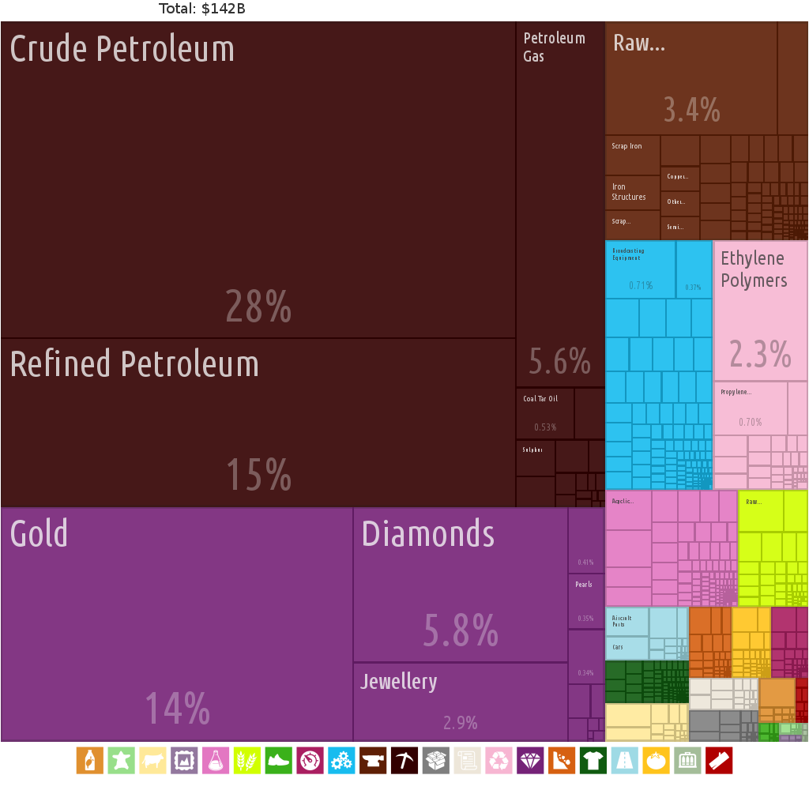
Figure 2. UAE exports by category
It is a member of the United Nations, the Arab League, OPEC, the Non-Aligned Movement, and Gulf Cooperation Council. It is also a member of the Organization of Petroleum Exporting Countries (OPEC).
Demographics
Only 10% of the population of the United Arab Emirates are local nationals; the rest are citizens of other countries. The UAE holds the world's seventh-highest net migration rate, with a 12.36 percent nett migration migration rate. Any migrant who has lived in the UAE for twenty years and has not been convicted of a crime and can speak Arabic may apply for UAE citizenship. Gender disparity is extreme in the UAE, with a male to female population ratio of 2.2 (or 2.75 among those aged 15 to 65).
South Asians account up 58% of non-UAE residents, followed by other Asians (17%) and foreign nationals from the countries of the west (8.5%). Europeans are becoming more prevalent, especially in places like Dubai. Emiratis account for roughly 11.6 percent, South Asians for approximately 59.5 percent (including Indians at 38.2 percent, Bangladeshis at 9.5 percent, Pakistanis at 9.4 percent) and other ethnic groups at 12.8 percent, according to government data from 2015.
Aside from Arabic, the UAE's populace speaks Persian, English, Hindi, and Urdu, as well as the official language of the country).
Staff turnover issues in UAE
According to the UAE Ministry of Labor’s report, expatriates account for more than 90% of the private sector's employment, totaling around 3,113,000 foreign employees employed by 260,000 enterprises with a turnover rate of 21%
Additionally, a recent survey indicated that the average monthly wage in the UAE is 10,120 dirhams ($2,750) and that the average duration of employment is 4.7 years.
According to a poll by global recruiting firm Hays, half of all employees in the UAE plan to change employment in 2021.
Zed Ayesh, executive director of Flagship Consultancy, indicates that staff turnover equates to a $2.7 billion annual cost to businesses in UAE terms of lost labor.
According to the United States Bureau of Statistics, the average yearly turnover rate in the United States is between 12 to 15%. LinkedIn reports that the average yearly global employee turnover rate is 10.9 percent, meanwhile the turnover rate in UAE is almost twice as high – 21%.

Factor | Influence | Importance | Impact on the company
Political
- Country tries to mostly stay politically neutral  - UAE is an elective monarchy;  - Decentralized government in each of 7 states of the country; | Positive | High | - As an airline from a country with good relationships and image over the world Emirates has an extensive near-worldwide route network.
Economic
- Highly developed economy with an emphasis on technology, oil and transportation;  - It is a member of the World Bank, IMF and OPEC | Positive/neutral | High | - Emirates cater to tourists and businessmen that use UAE as their business location or a transportation hub with near-worldwide route coverage.
Social
- More than 80% of the country’s population are expatriates;  - One of the most multicultural countries in the world; | Negative | High | • Lack of local Emiratis forces the company to attract foreign nationals for employment.
Technological
- One of the main IT hubs in the Middle East;  - One of the most technologically innovative countries; | Positive | Moderate | • Emirates group has several subsidiaries such as dnata that provide IT solutions for airline business and optimize Emirates operations.
Ecological
- Hot desert climate;  - Air pollution and water scarcity; | Negative | Low | - Around 1/3 of employees consider climate and ecological situation in UAE to be a negative factor in a long run.
Legal
- Country has a tight immigration policy; | Negative | Moderate | - Legal background of UAE creates challenges for the company to create preferable employment conditions (foreigners desire to have an opportunity to acquire residence permit in UAE).
- No corporate taxes | High | High | - Emirates is free of paying corporate taxes

Political factors:
The UAE is seen as a major player in the Middle East and also has significant influence on the international scene. With the United States, Saudi Arabia, India, China, and many other nations in the region and beyond, it maintains excellent diplomatic and commercial ties. However, its involvement in the conflict in Yemen has strained its ties with Iran, a significant regional force. It also played a significant role in the embargo of Qatar that got underway in 2017. It is important to note that the UAE has recently taken steps to deescalate the volatile situations in the Middle East, especially its conflicts with Iran.
Economic
The United Arab Emirates' (UAE) economic environment is an essential area of evaluation in the PESTEL analysis. The UN, World Bank, IMF, Arab League, OIC, OPEC, and GCC are just a few of the international economic and political organizations that the UAE is a member of. Its economy ranks as the 29th largest in the world. Its projected GDP for 2022 is $425 billion (Trading Economics, 2022).
The UAE's biggest exports include crude oil, refined oil, gold, diamonds, and petroleum gas. India, Japan, China, Oman, and Switzerland are its main export markets. The leading imports include gold, jewellery, automobiles, diamonds, and refined petroleum, with the majority of these items coming from China, India, Germany, the United Kingdom, and Turkey (OEC, 2022).
When it comes to per capita income, the UAE ranks among the richest nations in the world. Numerous natural resources, economic diversification, innovation, and the influx of foreign direct investment (FDI) are the main causes of its amazing economic growth over time. It has established a wide range of businesses, including tourism and real estate development that have a large positive impact on its economy and support its continued ranking as one of the richest nations in the world. Its problem is that it relies too heavily on the petroleum industry.
In general, businesses and people in the UAE do not pay taxes on their income or wealth. Major oil and gas corporations and overseas bank subsidiaries, however, are subject to corporation tax at a maximum rate of up to 55%.
Technological
The use of social media is popular among Emiratis. They log onto social media for 2.56 hours every day on average. A little more than 82% of people in the UAE have Facebook profiles, while 82% of people use YouTube. Twitter, LinkedIn, Pinterest, Instagram, and Tumblr are additional prominent social networking platforms in use.
In order to make it easier to pay for both government and non-government services, the UAE created the eDirham card in 2001. Over the years, the government has made significant investments in ICT, life science, nuclear research, and space science. In reality, the Middle East's ICT sector is currently one of the most attractive in the UAE.
Large, technologically advanced businesses and organizations can be found in the UAE. As a result, there is now a workforce that is more technically savvy and can be applied across sectors to stimulate economic growth. The information and communication technology (ICT) market in the UAE is competitive. To create a competitive knowledge economy, the government has launched a number of programs.
Environmental
One of the most travelled to nations worldwide is the UAE. There are many things that draw millions of tourists each year, including a perfect mix between traditional religious culture and modernity, opulent hotels, gorgeous retail malls, skyscrapers, crystal-clear beaches, historical ruins, indoor theme parks, and diverse food. It is also important to note that the UAE is extremely safe for female visitors travelling alone, especially since establishments like Dukes The Palm and the Jumeirah Emirates Towers hotel in Dubai have floors exclusively for women and a female staff.
Nevertheless, because the nation has grown so quickly in such a short period of time, it now faces certain environmental difficulties. The ecosystem is being greatly impacted by constant building noise, invasive species, carbon footprints, scarce water sources, overfishing, waste production, air pollution, land degradation, and desertification. As a result, the nation is making investments in renewable energy sources including solar and wind power, and it just unveiled its "Energy Strategy 2050."
Legal
The UAE, which has a low crime rate, is among the safest nations in the world, as was already mentioned. It demonstrates how rigorously the nation's laws and regulations are enforced.

  - THE EMIRATES AIRLINE CASE
Figure 3. Emirates logo

Founded in 1985 by Dubai's royal family, Emirates is the world's third-largest airline in terms of scheduled revenue passenger-kilometers flown and international passenger traffic handled.
Located in Garhoud, Dubai, United Arab Emirates, the Emirates Group is a state-owned global aviation holding business that is situated near Dubai International Airport.
Emirates Airline is the Middle East's largest airline. Emirates Airlines serves more than 150 destinations on six continents with a fleet of more than 250 wide-body aircraft. The airline has placed an order for 170 aircraft for US$58 billion. The Emirates Group is one of the largest employers in the Middle East, with a combined revenue of around $28,3 billion and a workforce of over 105,000 individuals throughout its many business divisions and affiliated enterprises. Through the Investment Corporation of Dubai and as a subsidiary of Dubai Inc., the government of Dubai has a majority stake in the company. Emirates currently flies ten Boeing 777-200LR planes, 125 Boeing 777-300ER jets, and 117 Airbus A380 planes in its fleet.
As a subsidiary of Dubai's Investment Corporation of Dubai, the Emirates Group is part of the government's investment strategy. It has been profitable every year except for one, and yearly growth has never been less than 20%. During the first 11 years of its existence, it grew at a rate of 3.5 years each year, and has continued to do so thereafter.
Emirates gave the Dubai government US$776 million in dividends in 2008 Since 1999, Emirates has paid the government Dhs3.1 billion in dividends in compensation for giving US$10 million in startup capital and an extra US$80 million in investment upon the airline was established. The government of Dubai wholly owns the company, although, it does not subside additional capital into the airline or interfere with its operation.

Emirates has grown into a variety of complementary industries, including airport services, engineering, event management, catering, and tour operator services. Emirates has four subsidiaries, while a parent company has more than 50.
68.7% of Dubai's Maritime and Mercantile International, 34.4% of Oman United Agencies, and 54.7% of Emirates Flight Catering are all owned by the Emirates Group. This airport's lone provider of airline and airport catering is Emirates Flight Catering.
Emirates airlines employed 59,519 people at the end of the fiscal year on 31 March 2020, including 21,789 cabin crew, 4,313 flight deck crew, 3,316 engineering personnel, 12,627 other personnel, 5,376 workers in abroad locations, and 12,098 employees at subsidiary firms. Emirates is one of the world's most diverse airlines, employing more than 170 nationalities.
Currently, the section procedure consists of two stages. A brief HireVue video interview, psychometric testing, an abstract thinking exam, and a live digital panel interview make up stage one of the hiring process, which is conducted remotely. Stage two is a two-day activity conducted in Dubai and includes simulator evaluations, Advanced Compass, and an Emirates medical evaluation.
After initial two stages, selected applicants are put on a probation period that lasts six months. The in-flight or operational supervisors must provide monthly reports throughout this period. Typically, 75% are confirmed for contractual contracts, 20% of probationary employees have their probation time extended, and the other 20% are the rest deemed to leave Emirates.
In case additional training is needed, before their probation period, applicant needs to complete it before probation period. In this case a training bond applies to the contract. The bond is at present 42.000 USD (154.000 AED), it is covered within 42 months.
It is also essential to understand current employment conditions offered to flight personnel in the company – table 1.
Table 1 | Current Emirates employment conditions
Pattern | Based in Dubai // 42 days annual leave
Flight time | 840 (80 month average)
Accommodation allowance | Available
Education allowance | Available
Commute allowance | Business class (upgradable to First class tickets 2 directions)
Contract finish bonus | No bonus currently
  - INTERVIEW ANALYSIS
Two interviews were conducted as a part as a part of primary research. One of the interviewee was a manager at HR department in Emirates, the second one was a representative of a flight crew of the airline, and in particular, first officer on one of the aircraft types company operates.
These candidates were chosen in particular due to several reasons. As the issue under the research is employee oriented, human resources manager is a reliable source of information on the topic. The pilot FO candidate was chosen as they can better reflect on the existing information from their point of view, as well as to provide subjective opinion and reasoning on their employment.
Both interviews were held in a semi-structured format, some of the questions were prepared beforehand and others were asked depending on the interviewee answers and flow of the dialogue. Each of the interviews were approximately one hour long. The interviewees were to answer clarifications in case they occurred through e-mail.
The interviews’ goal was to understand the corporate HR culture in the company as well as to understand the reasoning behind the low employee retention in Emirates.
Throughout the interview, insightful information was gained about HR practices at the airline. Interview results mostly corresponded to the information found in secondary sources. The HR manager has stated “pilots usually come [to Emirates] for high salaries and return back home after several years of employment”. The first officer claimed that the reason he would consider leaving the company is the cultural distance between Dubai and their home country. They also stated that they and their colleagues face issues with communication with management. The interviews helped to identify several reasons for high employee turnover at the company (communication issues, cultural differences), while others (tough working conditions) corresponded to the information gained in other sources.
The interview uncovered several problems in company’s employment policy. First of all, the was little to no “adaptivity” towards different employees needs and conditions. It is explained by the nature of a large company as well as the essence of cabin crew jobs: the company employs more than 20 thousand cabin crew members at a time, and with such high employee flow the company has, most of employment procedures are done in a “factory like” manner. The problem also worsens as the employment continues: employees do not have a system that allows them to provide employment feedback for their employment conditions to improve.

- ANALYSIS OF GLOBAL RETENTION STRATEGIES
  - IDENTIFICATION OF REASONS FOR LOW EMPLOYEE RETENTION IN EMIRATES
In order to understand the reasoning behind high employee turnover in the company, it is valuable to analyze the reasons of employee turnover in United Arab Emirates, as the market company operates in has significant influence on the company’s retention too.
5,774 employees working in MENA region were surveyed as part of the Bayt.com Middle East and North Africa Job Satisfaction study in April 2015. Some results of the poll are presented on the Figure 5. As it could be seen, the more desired yet not received benefits are medical insurance for families, accommodation and flexible working hours. The former two are covered at Emirates, however, flexible working hours are a particular problem. To some extent it is impossible for the airline to provide significant flexibility to its crew members due to the nature of business operations. However, we can see clear requests from employees for better work-life balance to be provided by employers.

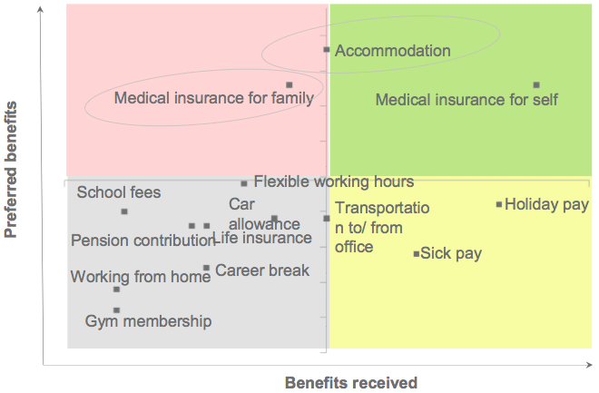
Figure 5. Benefits currently received vs preferred benefits
Source: Bayt.com Job Satisfaction in the Middle East and North Africa, April 2015

To many outsiders it may seem that employment as a cabin crew at Emirates airline is an honorable and pleasant experience. However, this are different to many in reality.
The information from the most recent survey on job satisfaction conducted by the head of HR department Mr. Abdulaziz Al Ali is following.
Working conditions and bonuses for cabin crew members:
- 68.12% of Emirates Airline cabin crew mеmbers say they are pleased with their jobs. However, Emirates Airline should not overlook the fact that a significant number of its staff members are unsatisfied with their servicе.
- 37% of examinees found working conditions on board to be good, compared to 62% who found them bad or were indifferent to the situation.
- In terms of compеnsation (wage, housing, transportation, etc.), 73.92% of airline staff are satisfied.
- According to the results, over two thirds of candidates are not happy with their rostering and flying time rеstrictions, or answered neutrally. This indicates that cabin personnel are overworked and pushed to the limit.
Crew members' opinions on management and communication:
- Almost half of cabin crew members say that their effort isn't recognised by the airline. More over two-thirds of survey-takers were unsure.
- When asked whether they are content with the way the firm conveys information to them, 66% of respondents said negative, or they stayed indifferent.
- Almost а half cabin crew mеmbers do not feel that they have the backing of their employer. 78.26% of cabin crew mеmbers are not content or do not know how to feel about the help they are receiving from their superiors or they do not want to notify their bosses about their feelings. An alarmingly high amount that requires quick action.
- Employees' ability to express their views without fear of retaliation is another harmful outcome. A dismal 71.01 % of respondеnts said they werе frightened to voice their opinions about their jobs, while 14% were uncommitted to the conversation.
- Two thirds of the airline's employees believe they have been mistreated.
Employee involvement in accomplishing organisational goals:
- 81% carеs about the company's business.
- More than two-thirds of the firm's cabin staff are pleased to work for the company.
According to the abovementioned survey results, employee dissatisfaction is common in Emirates. In order to rise employee retention rate at the company, it is appropriate to look into the reasons for worker’s dissatisfaction.
As per the data from the interview with one of HR managers at Emirates and one of flight crew members of the company, the main reason for employee complaints are:
- Distance from home country.
As majority of cabin crew members at Emirates are of foreign descent, many face personal disconnect from their homeland.
- Cultural differences between UAE and their homeland;
Distance in culture between UAE nationals and immigrants that are mainly from Europe/North America or Southern Asia. Immigrants face “not at “home” feeling while working at Dubai. Employees from Christian countries have problems adapting to predominantly Muslim country of UAE, some employees face discrimination on a cultural basis.
- Tough working schedule.
Crew scheduling is busier in Emirates in comparison to European/North American airlines. Moreover, long-haul flying makes up majority of Emirates flights, many flights last longer than 8 hours. Additionally, unlike in Europe/North America, in UAE it is more common to do flight during nighttime, which also worsens satisfaction with working conditions for employees.
- Inability to stay long-term in UAE.
The legislation of UAE is strict in the area of achieving permanent residency. For most employees, it is practically impossible to prolong their stay in the country after their employment ends. This makes it impractical for many expatriate employees to commit to work for the company in long term, as they would most likely need to leave the country after their employment ends.
- Communication issues.
Employees at Emirates face obstacles when communicating to their superiors due to several reasons, such as cultural differences with local Arab employees and inability to communicate their feedback about their employment. Native UAE citizens often mistreat expatriate employees; the company lacks mechanisms to report employment feedback to supervisors, and managers, so negative aspects of employment are often neglected.
  - MODERN APPROACHES TO EMPLOYEE MOTIVATION

This chapter describes ways a modern enterprise can foster retention among employees as a way to solve turnover issues in all the negative outcomes it causes. First, different employee motivational theories are discussed in order to understand the reasons behind worker’s “motivation to keep going”. Second, several HR theoretical strategies are suggested. However, it is essential to understand that these theories and strategies are almost exclusively developed in regards to modern companies (many of which have holacratic organizational structure) and toward employees that have a degree of freedom in their work processes. This contravenes with the case of Emirates, where the sole nature of pilot’s work does not allow for many of the factors and strategies be applied. For example, high-performance work systems (HPWS). High-performance work systems are a collection of systematic HR practices that foster an atmosphere in which employees are more invested in and accountable for the organization's success. In general, an HPWS enhances retention by involving employees in the creation, design, and implementation of procedures that improve the business and the employee. While evidently an effective tool for stimulation of employee motivation, and, consequently, retention, most of the components to these system (figure) have little to no practical worth and implications for the case of Emirates.
Pilot’s work is tightly regulated by authorities and the company itself, everything about general pilot’s work process in-flight is a subject to procedural behavior where creativity is not only not encouraged, but in many cases is forbidden (sometimes with legal consequences). On this basis, most of the components of HPWS, such as, for example, “employee’s work is rewarding” cannot be properly used in a given case (and in a suggested manner). However, we can derive the general ideas behind these components of high performance work systems. It is clear that employees prefer the company that provides opportunities for their career growth that is transparent in towards the employee and treats them with proper respect.
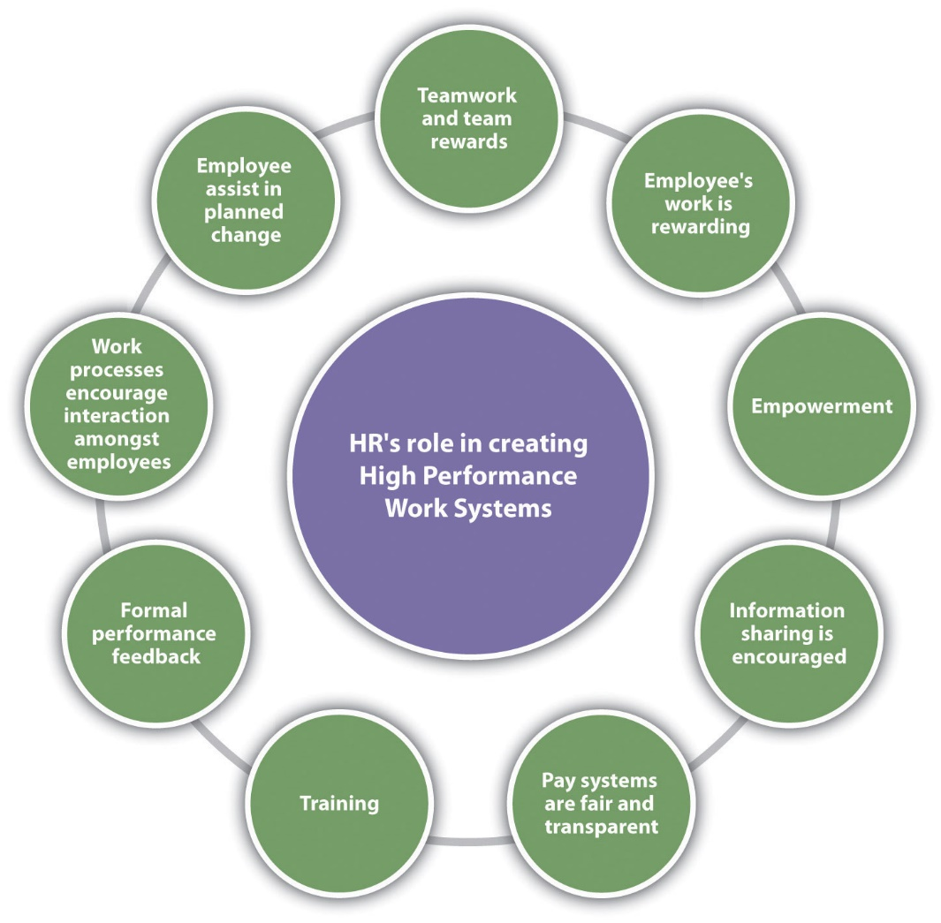
Figure 6. HR Components of a HPWS

As for the Emirates, the airline has basically top-of-the-market career growth opportunities for pilots, as it provides a one of the largest variation of destinations and fleet to its pilots, including the most modern and large aircrafts (large wide-body liners are considered to be more respectable, with higher employment requirements and pay). Moreover, the company also offers former members of its flight personnel career opportunities in other divisions, such as corporate and administration, shall they be forced or desire to change their role. However, transparency towards employees is not fully achieved. While pay and its prospects are generally relatively clear to the company’s pilots (as their salary is a subject to number of hours flown and seniority (number of years in the company), sometime pilots do not receive the corresponding amount of vacation days. Moreover, as explained in the chapter 2.1, pilots face communication problems with management, as the company does not have any regular instruments for proving employment feedback for conditions to improve. Some of the pilots also faced disrespectful behavior towards them from UAE-nationals management based on them not being local. An important takeaway from this is that Emirates should improve their communication relations with pilots that would make them feel fairly treated.

Employee satisfaction is a key indicator that an employer should rely on, creating such conditions and ensuring work activity in which an employee will be comfortable from all sides of his needs.
In order to understand the most fitting employee retention approaches for Emirates, it is necessary to understand what are the main motivational drives that make workers satisfied with their workplace. Therefore, a review of a several motivational theories is done.
One of the most used by manager’s motivational theories is an incentive (reward) theory.
According to the incentive motivational theory, humans are motivated by acknowledgment and rewards.
These are several workplace incentives:
- Bonus: Based on an employee's performance levels over time, bonus could be a reward given to an employee.
- Praise: In one-on-one settings, such as quarterly employee reviews, praise can be helpful. By complimenting an employee's performance and providing constructive criticism, a manager can strengthen their relationship with that person and foster trust.
- Opportunity: Offering employees a chance to participate in paid training may encourage them to advance their skills and expertise in a particular area.
- Promotion: Giving employees the chance to advance in their careers is frequently one of the most effective incentives a manager can provide since it can foster a sense of significance and development in a worker. An advanced job role, a new job title, or a raise in pay are all examples of promotions.
- Pay: Providing a pay rise or compensation increase is an instrument that management teams frequently use and find it to be successful.
- Recreation: Managers should take into consideration compensating staff for time off or granting them more vacation days.
As a “classical” theory, it has a broader practical application in different spheres, thus, reward theory could be used in order to determine potential salvations to employee turnover in Emirates. In particular, bonus, pay and recreation factors can be applied to the Emirates case. Bonuses for pilots in Emirates involve annual profit share bonus. Employees are paid a profit share in May if the company meets its profit goal. The amount varies annually and ranges from two to fourteen weeks of the base pay. However, the company can incentivize further extensions of contracts with a contract-signing bonus (for employees with multiple years of experience at Emirates). As for the pay, it is one of the strongest points of Emirates employment conditions. The company provides a pay way above market standards, which became the main reason for pilots to join and stay at Emirates. In terms of recreation, employees may face problems with receiving a satisfactory recreation period, in addition to vacation days sometimes being cut (for overtime work in order to meet demand). However, many employees would prefer a recreation period at a home country, something that Emirates has been reluctant to offer (exception: annual leave).

F. Herzberg's motivational theory is another essential motivational theory to consider when trying to understand reasoning behind employee’s satisfaction in their workplace. According to the theory, factors influencing the employee and forming his satisfaction and attitude to work are divided into two categories: motivational and hygienic.
Motivational factors are:
- Achievement;
- Recognition;
- The work itself;
- Responsibility;
- Advancement;
- Growth.
Hygiene factors:
- Company policies;
- Supervision;
- Relationship with manager;
- Work conditions;
- Salary;
- Relationship with colleagues.
Motivational factors include meaningful work, opportunities for personal development, professional and career growth. Hygienic factors include everything that provides working conditions: this includes proper equipment and convenience of the workplace, good relationships in the team and salary.
According to Herzberg, hygienic factors do not affect to the work motivation, they mostly provide staff loyalty, which influences retention in the company.
If the company increases wage or makes conditions more comfortable the employee will work with the same productivity but his loyalty will increase: they will recognize that they has good working conditions.
The guarantee of successful and productivity work between the organization and the staff is in transparent and understandable labor relations. Incomplete and unreliable data on working conditions, wages and functionality lead to an employee losing confidence in the organization due to unmatched expectations.
It often happens that the employer makes decisions late to retain an employee when he has already decided to leave the company. Especially when it was a qualified, experienced specialist.
The reason for the inability to retain staff is the lack of proper attention from management, feedback, rewards and training.
Herzberg theory provides essential suggestions on how to influence employee satisfaction. Main factors that interest Emirates case are hygiene ones. As stated above, motivational factors of this theory contribute to employee’s productivity, which, in the case of Emirates, is enforced (pilots cannot increase or decrease their productivity).

Another motivational theory is McClelland’s theory of needs.
We all possess three motivational factors, according to McClelland, and these factors are independent of our gender or age. We shall act mostly in accordance with one of these drives. Our life experiences affect our dominant drive.
These are the three drivers:
- Achievement: a need to attain goals and show one's abilities. High achievers appreciate assignments that let them take their own responsibility and produce outcomes based on their own efforts. They also value prompt acknowledgement of their accomplishments.
- Affiliation: a desire for love, belonging, and social acceptability. Being liked and accepted by other people is motivating for people with a high need for affiliation. They frequently participate in social events and may find disagreement uncomfortable.
- Power: a necessity to manage one's own or others' labor. High “needers” of power seek for circumstances in which they can exert control and influence over others. They tend to be more concerned with their level of influence than they are about good work performance because they aspire to positions of status and authority.
After reviewing these motivational theories, in order to derive appropriate for Emirates case practices, it was decided to base them on incentive and Herzberg's theories. It was done because of a nature of cabin crew’s work. It is tightly regulated by aviation authorities, it implies almost a total following of procedures, rules and orders, thus, some modern motivational theories are not appropriate for usage in Emirates that have a clear hierarchical structure for the reasons of nature of its business.

To retain qualified employees firm should not only have financial methods, but also it is good to understand individual characteristics, priorities, talents, values of the employees.
One of the most factor is expectations from the company at first stage when firm retain the employee. In addition, it is important that management listens to requests and wishes of subordinates, such situations shows the relationship in the company and how management ready to influence the atmosphere in the company.
For managers it is important to recognize that employee are the most valuable part of the business. Employees know organizational and technological process, corporate culture and individual characteristics of the company.
By increasing the loyalty of employees to the company, creating an effective motivational system, understandable and full information in hiring process and, accordingly, their retention, it is possible to achieve the successful development of the company and its high competitiveness.
Good retention policy gives a company revenue, progress and development. High employee turnover raises the cost of finding, recruiting, and time spent filling new vacancy. Companies spend from half to twice of employee’s wage to find new one. According to SHRM (Society for Human Resource Management), 43% of employees find new workplace to earn more money, 32% want to find career growth, 22% unsatisfied with the opportunities at their current firm. Organizations that recognize this and establish methods to solve these issues become preferred employers.

According to Powell’s research, most leaders often do not understand why employee leave the company. According to SHRM’s research employees resign for the following reasons:
- lack of professional development;
- a salary not worthy of professionalism;
- no balance between work and life;
- stress at work;
- unfair treatment.

As per SHRM study, there are several applicable approaches to employee retention:
- Implementation of an organization’s standard of communication
Most organizations operate within a multi-level of hierarchy along with a multi-network of human resources as can be seen in Table 2.

Intrapersonal Communication | Communication between within oneself.
Interpersonal Communication | Communication between self and another person
Group Communication | Communication between three or more people
Organizational Communication | Communication within a social group of people who have different strengths but a common goal
Intercultural Communication | Communication with others whose beliefs, values, norms, standards and culture is different than the individual or organization
Table 2. Communication types

Most employees should know how they fit to the organization, for these the company must have standard of communication, transparent and effective communication channels between management and employees.

- Employee inclusion and integration
Different population of company’s workers give benefits for the firm. Discrimination does not improve employee’s retention. The multigenerational companies face additional problems, which influence the retention. Managers must understand what values of each generation are.
- Assessment of employee credentials and work history
Employee retention strategy should start with understanding the personal background of the candidate and their qualifications.

Nowadays many companies, such as Meritrust Credit Union, Twin Cities Manufacturing and Sammons Financial Group consider retention a part of their budget and annual review.
These companies underline relation between employee retention with employee satisfaction. The main instrument these companies use to understand employee satisfaction is collection of appropriate employment feedback.
One of the cases is Briggs Industrial Solutions. Majority of the employees at Briggs are technicians, and in 2021, they were having trouble keeping them. They are essential to the company operations. However, the majority of them left the organization before completing 3-5 years of employment. The Briggs leadership team was aware that they needed to carefully examine any potential root causes of employee disengagement and attrition.
Multiple aspects for review were found. The disparity in compensation between tenured personnel and new hires caused resentment. The tasks given to technicians were not always in line with their abilities and talents. Additionally, there were no explicit rules about higher pay for learning new skills and training support.
As a result, Briggs added profit sharing to the ESOP (Employee Stock Ownership Plan) in 2022. For technicians, they developed a career path that made clear what had to be done in order for them to develop professionally. Rather than depending primarily on senior technicians, they offered more internal classroom training.
The adjustments made by the Briggs leadership team produced outstanding outcomes on their subsequent engagement survey:
- Recognition perceptions rose by 17 points.
- The score on the statement "senior leaders value people as their primary resource" rose 16 points.
- Trust and fairness impressions rose by 14 points.
- Fair pay perceptions rose by 14 points.
After reviewing incentive, Herzberg’s and McClelland’s theories, SHRM employee retention studies, high-performance work systems approach, reviewing a case of Briggs IS company, it is possible to derive common ideas behind all of them with regards to Emirates’ unique case environment (due to limitations in pilots work). In general, employee satisfaction depends on material and immaterial benefits each workers receives from work. As for the material benefits, Emirates provides an abundance of such – not only an above market’s average salary, but also multiple other benefits, such as accommodation allowance (on a 4 bedroom villa), education allowance for kids, travel benefits. However, the company does not fully use bonuses as an instrument to increase satisfaction. Such bonuses can be applied to a contract extension in order to incentivize employee’s retention while improving their satisfaction. As for the immaterial benefits, it is where the company’s employees face most challenges. Some of these challenges are unavoidable, largely because company’s market dictates their specificity. Many factors of employee motivation listed above cannot be used in regards to the company’s case, meaning, there are less options to control employee satisfaction. Many of the reason for employee dissatisfaction in the company that were discussed in a chapter 2.1, apply to the immaterial benefits side, understandably so, as material advantages at Emirates are extremely lucrative. Distance from home country, tough working schedule, inability to stay long-term in UAE, communication issues are all connected with immaterial benefits. In order to overcome them, several instruments were discussed, in particular SHRM study ones (P. 28) (implementation of an organization’s standard of communication, employee inclusion and integration, assessment of employee credentials and work history). These instruments are the most appropriate ones for solving communication troubles employees face throughout their employment.

  - BENCHMARKING OF COMPANIES WITH SIMILAR BACKGROUND
This chapter describes two cases of companies that face similar problems and how they mitigated those issues. Those airlines were chosen as a benchmark for Emirates’ HR practices as they operate in a similar context and their approaches to employee management are applicable to the current case of Emirates.

2.3.1. CASE OF LOONGAIR

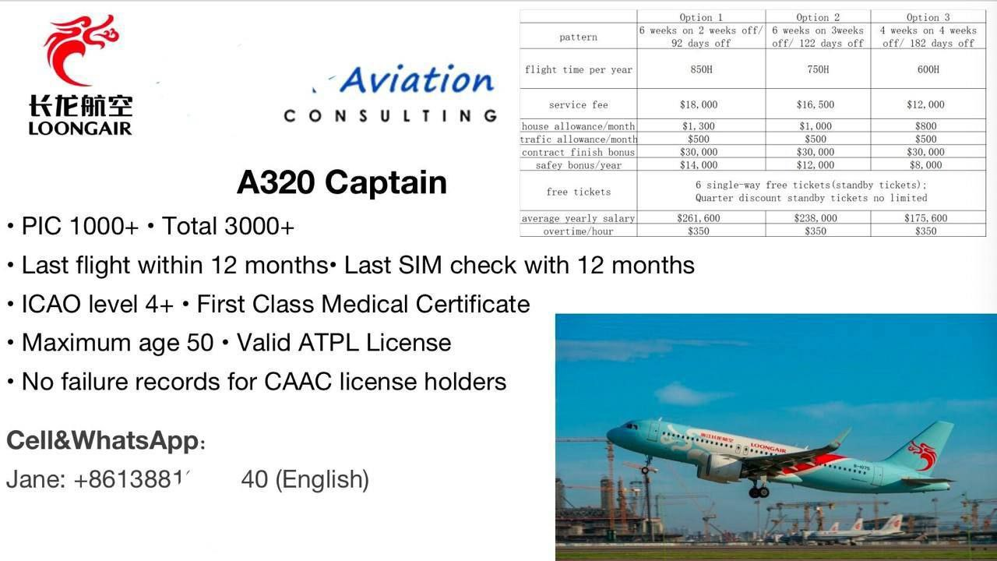
Figure 7. Loongair employment brochure

Loong Airlines Co., Ltd. was founded on April 19, 2011, and on August 9, 2012, it operated its first domestic freight trip. On December 29, 2013, it conducted its first domestic passenger flight. As the only airline with its main office in Zhejiang province, Loongair is based at Hangzhou's Xiaoshan International Airport and offers a wide range of public passenger and cargo services. Loongair has grown into a medium-large sized airline and is now one of the biggest private airlines in China. It holds a comprehensive set of air transportation permits, including domestic and international passenger and cargo service qualifications. Additionally, Zhejiang Province has classified it as an "Eagle Act" enterprise.
Loong Air an airline from a market of China, that currently has one of the highest pilot shortage rates in the world due to inability of local flight colleges supply the market that meets the demand for pilots in the fastest growing airline market in the world, according to Boeing’s Commercial market outlook 2022–2041. In such circumstances, the company has to seek for potential pilot employees abroad, similar to Emirates. In this sense, Loong air also becomes a competitor to Emirates on the job market. The conditions company provides to its pilots are displayed on the brochure (figure 7). It suggest candidates three different options of contracts with different workload, time on duty and off duty that influences the final pay. The biggest difference to employment conditions in Emirates is that Loong Air provides a possibility of commute for their employees so that they do not have to permanently relocate to company’s hub location.

    - CASE OF CANADIAN NORTH
Canadian North is Canada's regional airline operating in the passenger, charter and cargo transportation market on routes primarily in the Northwest Territory and Nunavut. The main hubs of the airline are Yellowknife and Iqaluit Airports.
Canadian North, a subsidiary of mainline carrier Canadian Airlines, was established in 1989 to serve indigenous communities in Canada's far north. When the Norterra Holding purchased Canadian North in 1998, the Inuit of Northern Canada held half of the holding and the other half was owned by the Inuvialuit Development Corporation and the Nunasi Corporation, representing the interests of the Inuit of Western Canada in the Nunavut territory.
The merger of Air Canada and Canadian Airlines in 2001 led in the creation of Canadian North, a wholly independent airline. Canadian North's current aircraft livery design was produced and approved for use by the end of 2003, after the firm had previously modified three aircraft livery designs (two for Canadian Airlines and one for Air Canada). The new design features the polar bear, the polar day sun, and the northern lights, which are all characteristics of Canada's northern regions.
This airline was chosen as a case for Emirates to consider as they both operate in unique and distant for most employee’s locations and environments. Newly hired staff would have to move to the main operational bases far away from their home in both Emirates and Canadian North.
Canadian North is an airline from Canada that mostly operates in the region of northern Canada, connecting remote communities across arctic and subarctic. This region accounts for almost a half of Canada's total land area yet has less than 1% of the country's population. Consequently, life in northern remote towns with little amount of amenities is not for everyone.
Employees in Canadian North face similar issues to Emirates that foster employee dissatisfaction, such as work distant from home. In order not to have a workforce with propensity to leave, the company makes sure both employee and employer have matching expectations. For this reason, during the recruitment process, Canadian North is conducting an additional in-person interview with candidates in order to see if they qualify to working in the north. This does not only include questions about their background (for example, experience of living/working in the north or other isolated communities), but also their suitability to life without modern lifestyle amenities, such as, for instance, knowledge of first aid procedures.
Such an interview helps Canadian North airline choose an employee fitting company’s working environment and ensure the candidate themselves would be satisfied with the working conditions.
As for the effect of these measures on employee retention, according to the Canadian North Employment Feedback Survey of 2018 (the most recent one in availability), the main drivers for employee leave are career opportunities in larger carriers and financial compensation, which implies that “distance from home” factor is successfully mitigated by choosing appropriate candidates.

    - CASE OF KOREAN AIR
The flag carrier and biggest airline of South Korea, Korean Air is a founding member of the SkyTeam alliance.
It is one of the twenty leading airlines in the world based on the number of people it carries, with a network of 128 cities in 45 countries on international routes and 12 domestic destinations. Incheon and Gimpo International Airports in Seoul serve as the airline's primary hubs. Korean Air's corporate office and primary control center are both in Seoul.
Korean Air, being a company from an increasingly growing airline market of Eastern Asia, is a case for Emirates to consider, as it is also a large airline that attracts significant amount of foreign employees from abroad and has to sustain employee satisfaction.
Several Asian airlines, in particular Korean, offer commuter contracts to foreign employees. Korean Air face employee shortage, similar to Emirates. They have to hire foreign applicants in order to fulfill demand in flight crews. However, amount of foreign pilots in the company is lower to Emirates – around 50%. In order to attract foreign employees they have to provide additional benefits other than a competitive wage, such as better employee accommodation. Thus, they offer the so-called “commuter contracts”. Such type of contract involves working at a host Asian country for a period of several weeks, with subsequent several time off work in the home country of employee.
Currently, Korean Air offers 19/11 scheduling, which means 19 days on work and 11 days of work in a home country. This lets workers have closer ties to home country and improve loyalty to the company the company they are working for. According to recent investor relation reports, employee shortage is not listed among the main challenges company faces and is not one of its main HR goals, so it is possible to say the company successfully uses commuter contracts a pilot retention strategy. This approach helps Korean Air retain their foreign staff and rise employee satisfaction and loyalty to the company in the long-term.

- CONCLUSION PART

This consulting project’s goal was to offer actionable proposal on how to improve Emirates' retention rate for foreign flight crews. In the first part of the work, case background was analyzed. UAE market analysis was followed by a review of Emirates as a company and from HR perspective, as well interview analysis was conducted. The second part of the paper starts with providing reasoning for employee turnover in the company, followed by current employee motivation and retention strategies and benchmarking of companies overcoming these issues. In the third part, an actual employee plan is provided that was developed based on the information from first two chapters, as well as financial justification of a suggested action plan reviewed.

  - PRACTICAL IMPLICATIONS

This chapter summarizes the information gained in the first two parts and connects it with final practical recommendations to Emirates.
Recommendations to Emirates described in this work can be divided into two groups: employment conditions (contract) reorganization and changes to HR practices in the company.
Currently, Emirates struggles to retain its pilots due to unsatisfactory work conditions (described in the parts 1.2, 1.3 and 2.1 of the work). Main factors contributing to this are distance from home country, cultural differences between UAE and employee’s homeland, exhausting working schedule, strict law regulations and communications issues with management.
1. Employment contract reorganization helps the company mitigate these issues.
In order to retain flight personnel, it is suggested to offer different contract conditions for flight personnel with set years of experience at Emirates. This number of years may vary depending on the turnover rate and pilot supply at a given time.
Most of the pilots are on a “training bond” conditions for the first 3 to 5 years, with the minimum of four years in Emirates to be upgraded to captain (average time at Emirates for upgrade is 5 years as per the interview conducted). At present, on average employees start leaving the company after 6.5 years of employment. At the same time, the company cannot offer such conditions to all the pilots, as it would require a total reorganization of current scheduling procedures in an unstopping operational cycle of a company with a little to no impact on actual retention.
Thus, in order to precede increasing outflow of employees from the company, number of years at the company when different contract conditions are offered is six.

 | Current Emirates employment conditions (option A) | Proposed employment conditions  (option B)
Pattern | Based in Dubai // 42 days annual leave | 19 days on // 11 days off // 36 days annual leave
Flight time | 840 (80 month average) | 840 (70 month average)
Accommodation allowance | Available | No allowance
Education allowance | Available | No allowance
Commute allowance | Business class (upgradable to First class tickets 2 directions) | 50% discount on tickets  Or economy class tickets
Contract finish bonus | No bonus currently | 70.000 AED
Table 3. Comparison of current and suggested employment conditions

Currently, the company provides employment conditions as listed in the option A. These conditions involve permanent relocation to Dubai for the period of contract, with several available benefits, in particular accommodation allowance (Emirates provides a company accommodation on villa with utilities or allowance), education allowance (for pilots with dependents, commute allowance (twice a year two-way tickets to employee’s destination of residence on business class.
In addition to this option, it is suggested to offer an option B – a contract with revised conditions that particularly target leaving pilots. The most essential change is a pattern of work: unlike option A, this type of contract allows commuting from home country to Dubai for work without relocation to UAE. The proposed pattern is 19 days on at Dubai and 11 days of at a country of residence (based on scheduling conditions of Korean Air case described in a part 2.3). Annual leave time is reduced from 42 days to 36. For this reason, accommodation and education allowances become rudimental, so these expenses can be cut. As employees would be commuting between home country and Dubai, they would need an increased number of tickets provided by the company. However, this increases company’s spending on this allowance for 600%, thus, instead of full ticket price coverage Emirates would provide a 50% discount or a downgrade to economy class tickets. In addition to this, in order to incentivize contract extension, the company would provide contract finish bonus of 70.000 AED.
Such a contract conditions revision would help create employment conditions that satisfy experienced employees that are the most prone to leaving the company. In particular, it would help overcome employment problems that come with distance from home and inability to commit long-term to UAE. Employees that are targeted by this contract option are over 35 years old (due to employment requirements it cannot be lower), large number of them also have dependents and family. Thus, for them, the question of personal matters outweighs financial compensation and other benefits, so one of the ways to overcome this is provide conditions that satisfy both company and employee. For this reason, the total amount of flight time per year does not change in order to remain equal availability of an employee for the company’s scheduling.

2. Another substantial recommendation to the company is a change of HR practices regarding the most prone to leaving employees. The most essential part of this proposal in addition of new onboarding managers to the company’s HR department.
Currently, the HR department of the company is in control of administration department, under supervision of chief administration officer.
First, it is needed to estimate the necessary number of onboarding managers.
According to Society for Human Resource Management study, number of necessary HR personnel per 100 employees varies with the size of organization.

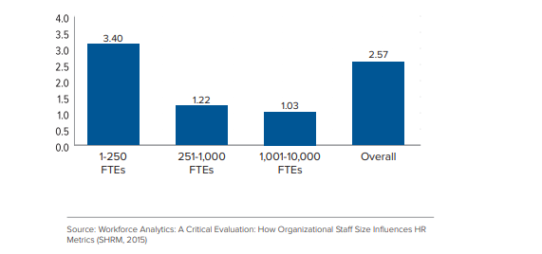
Figure 8. Number of HR staff per 100 employees ratio

The typical HR to employee ratio across all firms was 2.57. The HR-to-employee ratio, however, declines as staff size rises. For instance, compared to medium and big firms, which had ratios of 1.22 and 1.03 respectively, tiny organizations had a substantially higher HR-to-employee ratio of 3.40. a high HR-to-employee ratio for small businesses implies that a sufficient number of HR personnel are needed to provide basic HR services including hiring, benefits, and employee relations. This ratio disparity as organizational size grows occurs for a number of different causes. First, even if the ratio is lower for larger businesses, there are more HR staff members overall. With more HR personnel, it is easier to balance off peak workload needs in one HR department with personnel from another. For instance, it is simpler to temporarily shift HR managers from other functional areas for additional support during the labor-intensive recruiting process. Second, HR positions in companies with a significant number of employees typically require a higher level of specialization. In large firms, HR departments may employ a number of benefits specialists, but even within the benefits division, one manager may be exclusively responsible for handling health care management and another for managing retirement planning. Because additional roles need more effort and more time to switch between tasks that are distinct from one another, this job specificity enables greater efficiency and scale economies. Third, because they outsource HR tasks to preferred employer organizations or other HR outsourcing companies, many HR departments have fewer employees. When this happens, the HR-to-employee ratio may go down, but actual HR costs may increase to cover the costs of outsourcing.
At a given time, flight personnel of Emirates is regularly around 4000 employees (number fluctuates as flight personnel in the company is a constantly changing figure). According to SHRM study reviewed above, optimal number of HR (with specificity of the case) for the set of 4000 employees could be 1.2 per 100 employees. This equates to 48 onboarding managers the company needs.

Responsibilities of an onboarding manager include:
- Conduct interviews about candidate’s adaptability to work in Emirates;
- Organize and assist with expatriate relocation processes;
- Create orientation programs for the new hires;
- Communicate with new hires to provide any relevant information;
- Serve as an advisor to both new hires and experienced employees;
- Collect employment feedback and communicate it to HR and other corresponding departments;
- Assess retention and turnover rates;
- Conduct annual employment engagement surveys to understand level and factors that influence employee satisfaction in a company;
- Develop employee handbook;
- Process employment documentation;
- Help current staff transition to a new department or role.

Requirements and skills:
- Work experience on a comparable HR position or as an HR onboarding manager;
- Work experience on a flying position at Emirates is an asset;
- Residence in UAE for multiple years;
- Understanding of UAE labor laws;
- Familiarity of Behavioral Competency Framework;
- HRIS experience;
- Familiarity with employment documentation, including confidentiality act, terms of agreement, and fixed-term contracts;
- Excellent communication skills both in writing and speaking;
- Work ethics and confidentiality;
- Degree in HRM or a related field is an asset.

Currently, Emirates uses both own internal HR departments as well as outsourcing some of its HR duties to other companies (especially in foreign countries). However, in case of onboarding managers, outsourcing is not an option, as the nature of its role involves deep understanding of company’s processes as well as tight communication with other departments within the company. As Emirates provides assistance to their employees in their career advancement and commonly practices hiring its flight personnel on positions in corporate management, this role may be fulfilled with former cabin crew staff that could not continue their main career (for instance, in case of failing a medical examination). Their experience would be valuable on this position, however, they would need to undergo HR training in order to satisfy all the requirements.
Inside HR department of Emirates, there are several HR teams with different responsibilities and degree of expertise. At present, there is only one department that is handling flight personnel and this department’s responsibilities in practice are limited to only recruitment. It is proposed that onboarding managers would be assigned to this department and become its second subdivision (after recruitment). This would also allow for easier communication between recruitment and onboarding subdivisions, as some of their duties are dependent on each other.
This proposal particularly targets several current employment problems, such as cultural differences between UAE and homeland and communication issues with supervisors. Currently, new hires at Emirates do not undergo cultural trainings or orientation that is needed to adapt to new conditions, even though most of the workforce (over 80%) is foreign. Thus, the face challenges and general dissatisfaction with their time in Dubai (where they have to relocate permanently according to current conditions). Another issue is unrealistic expectations of both parties when it comes to employment. Candidates join the company without proper understanding of how their life is different in Dubai in comparison to life in their respective countries. The company selects candidates without understanding if these candidates are fit for life and work in Dubai, which later leads to them leaving the company earlier than expected. This can be solved via additional interview that a candidate shall undergo during their first stage of selection process that is conducted remotely by an onboarding manager (along with the main interview that is conducted by recruitment manager). Preference should be given to candidates that are more likely to stay in the country and company long-term, such as people with experience of life in foreign countries, especially Arab countries, their connections to their home country etc. Another issue is a problem in communication with management that employees face throughout their employment. As evident from the chapter 2.1 of the work, company’s processes do not presume employment feedback from the flight personnel – there is no elaborate mechanism. This creates another serious divide between employees and company’s expectations. Employees cannot solve their employment issues and provide feedback to management. On the other hand, the company does not collect this information for it to improve. Onboarding manager would solve this, as it would be their direct responsibility (and their position in company’s organizational structure suggests that). Onboarding managers would also assist with cultural difference mitigation, as one of their main requirements is being experienced with life in UAE.

3.2 FINANCIAL IMPACT OF RECOMMENDATIONS

Figure 9. Cost per seat breakdown in selected airlines (in thousands, EUR)

From the financial standpoint, currently, Emirates has one of the lowest staff costs per seat among its competitor airlines and is on par with low cost carriers such as EasyJet and Ryanair. This is a consequence of cheap workforce at lower levels of employment pyramid, where Emirates mostly employs workers from Southern and Southeast Asia, as well as absence of working union for flight crews (pilots and flight attendants) in the company. This allows Emirates to allocate bigger financial resources to mitigate consequences of employee turnover in the company, which result in much larger financial losses via cancellation of flights and removal of several routes.

3.2.1. Restructuring of contract conditions
 | Current Emirates employment conditions (option A) | Proposed employment conditions  (option B)
Pattern | Based in Dubai // 42 days annual leave | 19 days on // 11 days off // 36 days annual leave
Flight time | 840 (80 month average) | 840 (70 month average)
Accommodation allowance | ~20.240 AED  (242.880 per year) | No allowance
Education allowance | ~5.440 AED  (65,250 per year) | No allowance
Commute allowance | Business class (upgradable to First class tickets 2 directions)  ~5.500 AED a month  (66.000 per year) | 50% discount on tickets  ~16.500 AED a month  (up to 198.000 per year)
Contract extension bonus | No bonus currently | 70.000 AED
Average unit cost | 720 AED/Hour | 720 AED/Hour
Total pay | 57.600 AED  604.800 | 57.600 AED  604.800
Total company spending | 978.930 AED | 872.800 AED
Table 4. Comparison of current and suggested employment conditions

106.130 saving per contract
10% saving
106.130*200(pilots) =21.226.000 AED (annual) – savings after contract restructuring.

While the total company savings per contract in a year are not significant, estimates have been based on overestimating costs on the proposal and underestimating on present costs. Significant savings will also be forthcoming in both the training and recruitment departments.

3.2.1 Onboarding manager

In order to calculate financial consequences that come with adding onboarding managers to the company, it is needed to estimate the necessary number of onboarding managers for the set of 4000 employees (current amount of flight crew members at Emirates). According to SHRM (Society for Human Resource Management) study, optimal number of HR for the set of 4000 employees is 1.2 per 100 employees. This equates to 48 onboarding managers the company needs.
Average annual company expenses per HR manager of low to middle level are 429.900 AED (includes salary, bonuses and other expenses).
429.900*48=20.635.200 AED (annually) – expenditures on onboarding managers.
The expenditures on onboarding managers are mitigated via savings on the change of employment conditions.

3.2.3. Impact of recommendations on operational revenue

Financial impact of proposed changes to Emirates employment policy can be demonstrated through lost operational profit of the company due to cut flights as a result of employee shortage.
It can be calculated via the formula:
$$LOP=PPS×PPF×NCT$$
Where PPS – average profit per seat, PPF – average passenger carried per flight, NCT – number of cut flights.

Emirates average profit per seat can be calculated via the following formula:

$$PPS=\frac{operating profict}{number of passangers carried}=\frac{2,435m AED}{56,076m}=43,4 AED$$
Average number of passengers that the company carries per flight can be calculated:
$$PPF=APC*AFO,$$
Where APC – average Emirates plane capacity, AFO – average flight occupancy;

Average Emirates plane capacity equates to 445 seats.
Average passenger seat occupancy on the cut flights is assumed at 70.1% (on non-cut medium to high demand flights it fluctuates between 75.2-85.3%).
$$PPF=445×0,701=311,9$$

Emirates has cut 9 flights a day for the summer half of the year, the winter half of the year number of cut flights equates to 12 a day.
$$Total NCT=9×183+12×182=3.831 flights$$
3.831 cut flights (4%) a year due to a pilot shortage out of a total of 78.475 flights.

Knowing all the components, we can calculate total lost profit:
$$LOP=43,4×312×3831=51.865m AED$$

53.354/2.435=0,021=2,1% - the company loses 2.1% of its total operational income to the cut flights due to pilot shortage.

REFERENCES

- Syptak J. M., Marsland D. W., Ulmer D. Job Satisfaction: Putting Theory Into Practice URL: https://www.aafp.org/pubs/fpm/issues/1999/1000/p26.html (дата обращения: 01.06.2022).
- How Organizational Staff Size Influences HR Metrics [Electronic resource]. URL: https://www.shrm.org/resourcesandtools/business-solutions/documents/organizational%20staff%20size.pdf, access mode - free; date of the application: 21.05.2023
- Нурхамитова Д. А. Привлечение и удержание персонала в современных условиях URL: https://cyberleninka.ru/article/n/privlechenie-i-uderzhanie-personala-v-sovremennyh-usloviyah (дата обращения: 01.06.2022).
- Scontrino-Powell Top 10 Factors that Promote Job Satisfaction URL: https://scontrino-powell.com/blog/top-10-factors-that-promote-job-satisfaction (дата обращения: 01.06.2022).
- Managerial Communication, Bell, R.L. & Martin, J., pp. 23-27, 2014
- http://45.114.134.178:9000/digi/IG01/2014/IG01T0000415/IG01T0000415.pdf
- Cloutier O. и др. The Importance of Developing Strategies for Employee Retention URL: https://www.semanticscholar.org/paper/The-Importance-of-Developing-Strategies-for-Cloutier-Vie/92925a37570572fbebe93193358f7fbed27a9605 (дата обращения: 01.06.2022).
- Singh D. A Literature Review on Employee Retention with Focus on Recent Trends | Semantic Scholar URL: https://www.semanticscholar.org/paper/A-Literature-Review-on-Employee-Retention-with-on-Singh/ad40ed6bb8756d902947ca1c2324776a90d4645e (дата обращения: 01.06.2022).
- Flexible Working as an Employee Retention Strategy in Developing Countries-Indian Journals URL: https://indianjournals.com/ijor.aspx?target=ijor:jmr&volume=14&issue=2&article=001
- Kiernan K. M. Calculating the Cost of Pilot Turnover. URL: https://commons.erau.edu/jaaer/vol27/iss1/3/
- Spencer, D. G. (1986). Employee voice and employee retention. Academy of Management Journal, 29(3), 488–502. https://doi.org/10.2307/256220
- https://www.reuters.com/article/us-emirates-migrant-workers-idUSKBN18Z2DN
- https://en.wikipedia.org/wiki/Emirates_(airline)
- https://www.emirates.com/media-centre/emirates-aircraft-cover-432-million-kilometres-across-the-globe-in-six-month
- https://www.emirates.com/us/english/about-us/
- https://onemileatatime.com/emirates-pilot-shortage/
- https://onemileatatime.com/emirates-is-storing-over-45-planes-in-the-next-few-months/
- https://en.wikipedia.org/wiki/United_Arab_Emirates
- https://worldpopulationreview.com/countries/united-arab-emirates-population
- https://www.arabianbusiness.com/industries/industries-culture-society/staff-turnover-costs-uae-firms-2-7bn-year-expert-42028
- https://en.wikipedia.org/wiki/The_Emirates_Group
- https://www.bayt.com/en/research-report-24922/
- https://www.entrepreneur.com/article/246694
- Cabin crew’s job satisfaction in Emirates Airline – survey results. [Электорнный ресурс], 2015
- https://donotflyemirates.wordpress.com/2015/01/11/cabin-crews-job-satisfaction-in-emirates-airline-survey-results/
- https://ivypanda.com/essays/emirates-airlines-high-employee-satisfaction/

https://www.reuters.com/article/us-emirates-migrant-workers-idUSKBN18Z2DN
https://en.wikipedia.org/wiki/Emirates_(airline)
https://www.emirates.com/media-centre/emirates-aircraft-cover-432-million-kilometres-across-the-globe-in-six-months
https://www.emirates.com/us/english/about-us/
https://onemileatatime.com/emirates-pilot-shortage/
https://onemileatatime.com/emirates-is-storing-over-45-planes-in-the-next-few-months/
Kiernan K. M. Calculating the Cost of Pilot Turnover. URL: https://commons.erau.edu/jaaer/vol27/iss1/3/ (дата обращения: 01.06.2022).
https://en.wikipedia.org/wiki/United_Arab_Emirates
https://worldpopulationreview.com/countries/united-arab-emirates-population
Staff turnover costs UAE firms $2.7bn a year – expert [Electronic resource]. URL: https://www.arabianbusiness.com/industries/industries-culture-society/staff-turnover-costs-uae-firms-2-7bn-year-expert-42028, access mode - free; date of the application: 24.05.2023
The Emirates Airline [Electronic resource]. URL https://en.wikipedia.org/wiki/Emirates_(airline) access mode - free; date of the application: 24.05.2023
The Emirates Group [Electronic resource]. URL https://en.wikipedia.org/wiki/The_Emirates_Group access mode - free; date of the application: 24.05.2023
The Emirates Group [Electronic resource]. URL https://en.wikipedia.org/wiki/The_Emirates_Group access mode - free; date of the application: 24.05.2023
https://www.bayt.com/en/research-report-24922/
https://www.entrepreneur.com/article/246694
Cabin crew’s job satisfaction in Emirates Airline – survey results. [Электронный ресурс], 2015
https://donotflyemirates.wordpress.com/2015/01/11/cabin-crews-job-satisfaction-in-emirates-airline-survey-results/
https://ivypanda.com/essays/emirates-airlines-high-employee-satisfaction/
High performance work systems in corporate turnaround: A German case study [Electronic resource]. URL: https://www.researchgate.net/publication/262960369_High_performance_work_systems_in_corporate_turnaround_A_German_case_study, access mode - free; date of the application: 24.05.2023
Retention and Motivation: Dissatisfaction Isn’t Always about Pay [Electronic resource]. URL: https://saylordotorg.github.io/text_human-resource-management/s11-retention-and-motivation.html, access mode - free; date of the application: 24.05.2023
5 Motivation Theories To Use in the Workplace [Electronic resource]. URL: https://www.indeed.com/career-advice/career-development/motivation-theories, access mode - free; date of the application: 24.05.2023
Pilots | Emirates Group Careers [Electronic resource]. URL: https://www.emiratesgroupcareers.com/pilots/, access mode - free; date of the application: 24.05.2023
7. Syptak J. M., Marsland D. W., Ulmer D. Job Satisfaction: Putting Theory Into Practice. [Electronic resource]. URL: https://www.aafp.org/pubs/fpm/issues/1999/1000/p26.html, access mode - free; date of the application: 24.05.2023
Motivation Theories [5 Famous Motivation Theories] [Electronic resource]. URL: https://www.knowledgehut.com/tutorials/project-management/motivation-theories. (date of application: 01.06.2022).
Нурхамитова Д. А. Привлечение и удержание персонала в современных условиях. URL: https://cyberleninka.ru/article/n/privlechenie-i-uderzhanie-personala-v-sovremennyh-usloviyah (date of application: 01.06.2022).
Scontrino-Powell Top 10 Factors that Promote Job Satisfaction [Electronic resource] URL: https://scontrino-powell.com/blog/top-10-factors-that-promote-job-satisfaction (date of request: 01.06.2022).
Managerial Communication, Bell, R.L. & Martin, J., pp. 23-27, 2014 http://45.114.134.178:9000/digi/IG01/2014/IG01T0000415/IG01T0000415.pdf
Retaining talent [Electronic resource]. URL: https://www.shrm.org/hr-today/trends-and-forecasting/special-reports-and-expert-views/documents/retaining-talent.pdf, access mode - free; date of the application: 29.04.2022
Employee Retention Case Studies [Electronic resource]. URL: https://www.quantumworkplace.com/future-of-work/employee-retention-case-study, access mode - free; date of the application: 26.05.2023
9. Cloutier O. и др. The Importance of Developing Strategies for Employee Retention. URL: https://www.semanticscholar.org/paper/The-Importan ce-of-Developing-Strategies-for-Cloutier-Vie/92925a37570572fbebe93193358f7fbed27a9605
Singh D. A Literature Review on Employee Retention with Focus on Recent Trends URL: https://www.semanticscholar.org/paper/A-Literature-Review-on-Employee-Retention-with-on-Singh/ad40ed6bb8756d902947ca1c2324776a90d4645e
Flexible Working as an Employee Retention Strategy in Developing Countries // Indian Journals URL: https://indianjournals.com/ijor.aspx?target=ijor:jmr&volume=14&issue=2&article=001
Spencer, D. G. (1986). Employee voice and employee retention. Academy of Management Journal, 29(3), 488–502. https://doi.org/10.2307/256220
Brief Introduction of Zhejiang Loong Airlines [Electronic resource]. URL: https://www.loongair.cn/#/web/other/aboutUs/loongair?code=0.4.1.1, access mode - free; date of the application: 26.05.2023
Boeing Commercial Market Outlook 2022–2041. [Electronic resource] URL: https://www.boeing.com/commercial/market/commercial-market-outlook/index.page, access mode - free; date of the application: 29.05.2023
Canadian North [Electronic resource]. URL: https://ru.wikipedia.org/wiki/Canadian_North, access mode - free; date of the application: 24.05.2023
Korean Air recruitment page. URL: https://recruit.koreanair.com/, access mode - free; date of the application: 19.04.2022
How Organizational Staff Size Influences HR Metrics [Electronic resource]. URL: https://www.shrm.org/resourcesandtools/business-solutions/documents/organizational%20staff%20size.pdf, access mode - free; date of the application: 21.05.2023
HR Onboarding Manager job description [Electronic resource]. URL: https://resources.workable.com/hr-onboarding-manager-job-description, access mode - free; date of the application: 19.05.2023

