SAINT-PETERSBURG STATE UNIVERSTITY

Kseniia Danilova

Master thesis

The impact of ground public transport on well-being and
quality of life: the case of Saint Petersburg and Tel Aviv

Field of Study 39.04.01 «Sociology»
The main educational Master program
BM.5847.2021 «Studies in European Societies»

Scientific supervisor:
Nikiforova Olga Alexandrovna
Candidate of Social Sciences,
Department of Economic Sociology,
St. Petersburg State University

Reviewer:
Shcherbakova Daria Vasilievna
Candidate of Social Sciences,
Department of Customs Administration,
NWIM RANEPA – North-West
Institute of Management

St Petersburg
2023
Table of Contents:

Introduction……………………………………………………………………. 3
1. Empirical chapter: grounded theory as sociological ouroboros………….. 9
1.1 Sociological ouroboros: what is primary? …………………………… 9
1.2 Methodology, tools and sample………………………………………. 10
1.3 Saint Petersburg and Tel Aviv - the second capitals of Russia
and Israel……………………………………………………………… 15
1.4 Overview of methodologies for well-being and quality of life
indices, aspect of welfare and sustainability, and development
of interview guide ……………………………………………………. 19
1.5 Analysis of empirical data: coding, categorization, integrating………. 23
1.6 Findings……………………………………………………………….. 32
2. Theoretical chapter: transport system as urban arteries…………………. 35
2.1. Cities as a dynamic process…………………………………………... 39
2.2. Everyday life of social and technological worlds: humans
and non-humans………………………………………………………. 41
2.3. Mobilities, automobileness and social acceleration…………………… 43
2.4. The role of public ground transport in the formation of social capital
and habitualization…………………………………………………… 46
2.5. Transport system is rhizomatic structure…………………………….. 52
2.6. The conflict of reality and hyperreality……………………………… 54
2.7. Findings……………………………………………………………… 58
Conclusion……………………………………………………………………… 62
References……………………………………………………………………… 66
Appendix I: methodological framework……………………………………... 71
Appendix II: portrait of informant, interview guide, transcript…………… 73
Appendix III: analysis of empirical data and grounded theory……………. 79
Appendix IV: theoretical framework………………………………………… 83

Introduction
The concept of the world order is not linear, and is metaphorically similar to “woven colored blanket”, which consists of various cubes or fragments. Relationships between systems and actors emerge and stabilize from the movement and refrain reconstruction of everyday life.
Nowadays the everyday life is torn. The fragmentation of everyday life is due to various processes, which upside down habitual way: economic crises and poverty, environmental and natural disasters, wars and terrorism, diseases and pandemic, and etc. All these processes are global and leave holes in “woven colored blanket” of the world. Under the new realities, institutions and people have to adapt and to make patches on holes.
The goal of any system is the desire to continue their existence, driven by the instinct of self-preservation, and in the case of internal malfunctions and external instabilities – normalization. If the system becomes static, then it is dead. Movement means life. Only movement realizes the moment of transience of being.

This study considers the transport system, and in particular public ground transport, as one fragment of “woven colored blanket”, which literally represent movement and is an inseparable part of urban everyday life. The existence and normalization of various urban systems coexist with the concepts of well-being and quality of life. The significant factor for assessing well-being and quality of life as a satellite of sustainability and welfare for urban infrastructure are mobility, movement and transport system.

Well-being refers to the state of being happy, healthy and satisfaction, including physical, mental and emotional well-being. Well-being is a holistic concept that encompasses positive aspects of life, such as positive emotions, life satisfaction, fulfillment and a sense of purpose. The definition of well-being can vary depending on different perspectives and disciplines. Well-being can be considered at the microlevel as an individual or actors, and at the macrolevel - groups of people or citizens of country, but there is the interconnectedness between individual well-being and the well-being of communities. In this research, well-being extends beyond the individual and includes factors such as social connectedness, community engagement, access to basic needs, economic stability, and environmental sustainability.
Quality of life refers to the overall well-being, including physical health, mental and emotional well-being, social relationships, material conditions and personal fulfillment. Quality of life is a multidimensional concept that takes into account both objective and subjective factors that contribute to perception of life's worth and value. The perception of quality of life is highly subjective and varies from person to person based on their unique circumstances, values, and goals. It encompasses the individual's social relationships, including family, friends, and community connections, as well as their access to resources and opportunities, such as education, employment, and leisure activities. Material conditions, such as income, housing, and access to healthcare, also are important to determine one's quality of life.

The following hypothesis was put forward:
- The level of well-being and quality of life are indicators of the positive and negative functioning of the transport system;
- The transport system is a decentralized and self-regulating structure, the normalization of which impact on the urban level of well-being and quality of life.
With the help of this study, it will be possible to answer the following research question: In which way are aspects of well-being and quality of life represented in the context of ground public transport and transport system?

The aim of research is to develop the methodology for analyzing the role of the transport system for urban infrastructure in Saint Petersburg and Tel Aviv.

To achieve the aim, a set of research tasks was elaborated:
- Rethink the conceptualization of sociological research in relation to strategies and ways of order, based on the concept of grounded theory;
- Review well-being and quality of life indices and develop the methodological framework, tools and analysis model;
- Approve the developed methodology in the case of ground public transport in Saint Petersburg and Tel Aviv and analyze empirical data, using two-level categorization and comparative analysis;
- Identify relevant theoretical concepts, according to categorization, and reconsider the role of transport system for urban well-being and quality of life.

Object of research: transport system as an integral system of the city life.
Subject of research: ground public transport in Saint Petersburg and Tel Aviv.

Principles of scientific research:
- General scientific principles: the principle of objectivity, the principle of specificity, the principle of comprehensiveness.
- Integrated scientific principles: the principle of multilateralism (the study used approaches, methods and knowledge from different sciences, such as sociology, social anthropology and philosophy); the principle of unity (initial representations are comparable and united with each other).

The following scientific approaches were used to conduct the study:
- Analytical approach: review of already existing quantitative and qualitative research in the field of defining and measuring well-being and quality of life through the construction of integral indices;
- Integrated approach: digital and physical space, urban everyday life and well-being are interdisciplinary objects that require a synthesis of knowledge from the fields of sociology, social anthropology and philosophy;
- System approach: to study the transport system and develop the methodological and theoretical frameworks were needed structuring.

Research is based on qualitative research strategy and consists of:
- Semi-structured interview;
- Categorization (coding);
- Comparative analysis.

The sample includes residents of Saint Petersburg and Tel Aviv, who use ground public transport to move around the urban space.
The choice of the case of Saint Petersburg and Israel is justified by the fact that Israel can be considered as a European society. This is due to historical, cultural and political aspects. There are many migrants in Israeli society, who lived in Europe and returned to Israel. Israel's legal system, economic development and political institutions are rooted in European legal and political traditions, and this is more closely with European countries than with its Middle Eastern countries.
The use of the word "case" in the singular form, as "the case of St. Petersburg and Tel Aviv", implies that the study focuses on the collective impact of ground public transport on well-being and quality of life in both cities. It suggests that the research examines these two cities as a combined case or the collective case of both cities, considering them together rather than separately. Treating St. Petersburg and Tel Aviv as a collective case allows for the identification of common themes and insights that can be applied to other urban contexts. It enables the research to go beyond the specificities of each city and uncover underlying mechanisms and processes that may have broader implications for understanding the relationship between ground public transport and well-being. The singular form emphasizes the potential transferability of findings and the generation of knowledge that extends beyond individual cases. Using the singular form streamlines the research focus and avoids potential fragmentation of the analysis. It allows researchers to concentrate on specific research questions and key aspects of the impact of ground public transport on well-being and quality of life, rather than dispersing efforts across multiple cases.

The methodological and practical significance of the study is the methodological framework, as unique development, which can be specifically apply to research, focused on transport system. This methodology can be used by individual researchers or special institutes (such as public authorities, transport committee, statistical offices, sociological research companies) to evaluate of well-being and quality of life methodologies in the field of urban studies and to analyze poor and problematic components of urban infrastructure.

As for the structure of paper, it contains two chapters: empirical and theoretical. The logic of the study was built in accordance with the grounded theory - from empirical data to theoretical sampling, so the empirical chapter is the first, and the theoretical chapter is the second.
The first chapter “Empirical chapter: grounded theory as sociological ouroboros” contains a discussion of the relationship between theory and empirical data; explanation of the methodological framework, tools and sampling in detail; description of two urban spaces – Saint Petersburg and Tel Aviv; review of well-being and quality of life indices and development of an interview guide; analytical part of the study using two-level categorization and findings.
The second chapter “Theoretical chapter: transport system as urban arteries” theoretically conceptualizes urban space, transport system, mobility, social capital, everyday life, hyperreality and etc. All theoretical concepts were identified based on categories of empirical data analysis: urban space by Tim Ingold; actor-network theory by Bruno Latour and Madeleine Akrich; mobilities and automobileness by John Urry; social acceleration by Hartmut Rosa; social capital and habitus by Pierre Bourdieu; rhizome by Gilles Deleuze and Félix Guattari; hyperreality and simulacrum by Jean Baudrillard.
Also, the paper provides the list of references and four appendixes with additional infographic and visual materials of methodological framework, interview guide, analysis of empirical data and grounded theory, theoretical framework.

1. Empirical chapter: grounded theory as sociological ouroboros
1.1. Sociological ouroboros: what is primary?
This study, which focuses on the impact of ground public transport on well-being and quality of life, begins with the empirical chapter. Usually, researchers try to find relevant theoretical concepts in accordance with the research questions, and then begin to collect empirical data, to analyze and to make a conclusion.
Theory and empirical data have a strong connection, and it doesn’t matter, where would be start point for researcher: theory or collection of empirical data. Sociological research is a cyclical, dialectical and iterative process. The theoretical part and the empirical part correlate with each other, like ouroboros. This concept symbolized "the dual nature of existence, marked by life and death, male and female, light and dark, mortality and divinity, or Earth and heaven" [Dictionary, 2018]. Sociological research has a similar dual nature, and only harmonizes in synthesis - "sociological ouroboros". It refers to the interdependence between theory and empirical data in sociological research, where theory informs the collection and interpretation of data, and the data, in turn, evaluate and refinement of theory.
The concept of the sociological ouroboros has been discussed by various sociologists and scientists. This concept can be found in the work of Robert K. Merton, who wrote about the relationship between theory and research in sociology. Merton argued that "empirical research provides the necessary corrective to, and supplement for, theory, while theory provides the necessary guide for empirical research" [Merton, 1968, p. 39]. The sociological ouroboros has also been discussed by Pierre Bourdieu, who emphasized the interdependence between theory and empirical research: "empirical work produces theoretical work, and theoretical work produces empirical work" [Bourdieu, 1991, p. 4]. Howard S. Becker noted that "research and theory are not two separate enterprises, but different aspects of the same process" [Becker, 1998, p. 5]. Neil Gross and Robert Alun Jones discuss the relationship between theory and data in sociological research, based on the idea of the sociological ouroboros: "theory and empirical data are interdependent, and that they are best seen as co-constitutive of one another, in a manner that is fundamentally recursive" [Gross & Jones, 2015, p. 5]. It means that sociologists can approach their research from either a theoretical or an empirical perspective, and these two strategies are valid. Gross and Jones explain that theoretical ideas and empirical observations informs and reconstitutes each other: "…the cycle of interpretation and theory construction is never completed; rather, it is an ongoing process that feeds on itself " [Gross & Jones, 2015, p. 9]. The sociological ouroboros as a way to understand the interdependence of theory and data in sociological research.
The sociological ouroboros can be seen as a cycle of relationship between theory and empirical data, with complementarity and mutual formation. As sociologists develop theories to explain social phenomena, they test those theories through empirical research. The results of that research can lead to the development of new theories.
I found inspiration in metaphoric view on relation between theoretical conceptualization and empirical data, expressed by the symbol of sociological ouroboros. So, I decided to save the narration, following the path from empirical data to theory, and used grounded theory as the lighthouse.

1.2. Methodology, tools and sample
Grounded theory is a research methodology that was developed by sociologists B. Glaser and A. Strauss in the 1960s. It is a qualitative approach that aims to discover and develop a theory from the data that is collected, rather than starting with a pre-existing theory and testing it. The grounded theory approach emphasizes the importance of analyzing data inductively and allowing the theory to emerge from the data itself. In this way, grounded theory seeks to generate a theory that is grounded in the data and reflects the experiences of those being studied.
According to Glaser and Strauss, grounded theory is "a research methodology for generating theory that is grounded in data systematically gathered and analyzed" [Glaser & Strauss, 1967, p. 2]. The grounded theory approach involves a process of constant comparison, where the researcher constantly compares new data with previously collected data to identify patterns and develop categories. As Glaser and Strauss write, "theoretical sampling and constant comparison...are the two core concepts that form the foundation of grounded theory methodology" [Glaser & Strauss, 1967, p. 21].
The grounded theory approach involves several key steps, including data collection, coding, memoing, and theoretical sampling. Data collection involves gathering data through various methods, such as interviews, observation, and document analysis. Coding involves analyzing the data and assigning codes to different sections of the data based on similarities and differences. Memoing involves writing down thoughts, ideas, and reflections on the data and the coding process. Theoretical sampling involves selecting new participants or data sources based on the emerging theory and the need for further data to test and develop the theory.
Glaser and Strauss emphasize the importance of theoretical sensitivity in grounded theory. This refers to the researcher's ability to identify and conceptualize patterns and categories in the data: "the grounded theorist tries to be sensitive to what is going on and to generate concepts that will explain what he sees" [Glaser & Strauss, 1967, p. 44]. Theoretical sensitivity involves being open to the data and allowing the theory to emerge from the data itself, rather than imposing preconceived ideas or theories on the data.
One of the strengths of the grounded theory approach is its flexibility and adaptability to different research contexts. As Glaser and Strauss write, "Grounded theory methodology has been applied successfully to a wide range of substantive areas, including organizations, medicine, nursing, education, and many others" [Glaser & Strauss, 1967, p. 1]. Grounded theory allows for the development of a theory that is specific to the context of the study and reflects the experiences of those being studied.
According Glaser and Strauss, research, which has the methodological framework of the grounded theory, consist of the following stages:
- research question and data collection: "The researcher begins with a general research question and a broad area of interest, but remains open to modifying the question as data collection and analysis progress. <…> Data collection begins with open-ended interviews…" [Glaser & Strauss, 1967, pp. 41-42]. The first and preparative stage in using the grounded theory approach is to collect data on the transport system being studied. This can be done through a variety of methods, such as interviews, surveys, and observations. This clearly shows that method of grounded theory can be used in qualitative, quantitative and mixed strategies of sociological research;
- coding: "The researcher engages in line-by-line coding of the data, identifying themes and concepts that emerge from the data" [Glaser & Strauss, 1967, p. 47]. Open Coding is the second step to begin analyzing empirical data, which involves breaking down the data into smaller parts and assigning some codes to them;
- memoing and first categorization (subcategories): "The researcher begins to categorize the codes into broader concepts, looking for patterns and connections among the data" [Glaser & Strauss, 1967, p. 49]. Memoing as running notes can be field diary and used for draft of the completed analysis. Axial Coding is the third step, which means looking for connections between the different codes and creating the subcategories. This can be done by creating charts, scheme or matrices for visual representation of relations between the codes;
- second categorization (categories, which include subcategories): "The researcher uses constant comparison to compare data within and across categories, looking for similarities and differences in the data" [Glaser & Strauss, 1967, p. 54]. Selective Coding is the fourth and final stage of analytical part, which implicates identifying the categories - units of a higher order, consisting of subcategories, as units of a lower order. This is done by analyzing the data in-depth and looking for common themes and patterns;
- theoretical sampling: "The researcher develops a theoretical model that explains the relationships among the categories and concepts identified in the data" [Glaser & Strauss, 1967, p. 63]. Based on the empirical data analyzed by Open Coding, Axial Coding and Selective Coding, there are categories that are key points for characterizing the object of study in terms of theoretical conceptualization [Appendix I, Picture 1].
The methodology for this study is based on the grounded theory approach, following the stages outlined by Glaser and Strauss in " The discovery of grounded theory: Strategies for qualitative research ". This approach allows to develop a theory grounded in the data, rather than starting with preconceived ideas about the relationship between ground public transport, well-being and quality of life [Appendix I, Picture 2].
The primary tool for data collection was be semi-structured interviews, which conducted in person or via digital technologies (various digital platforms with the possibility of videoconferencing or calling - it depended on the preferences of the informants). The interview guide has been pre-designed. The interview questions will be open-ended, allowing participants to share their experiences and opinions in their own words. Russian and Hebrew are the languages in which the interviews were conducted. A total of 12 interviews were collected: 6 informants from Saint Petersburg and 6 informants from Tel Aviv.
The sample for this study consists of adults who use ground public transport regularly in Saint Petersburg and Tel Aviv. Purposive sampling strategy was used to recruit participants who represent a diverse range of ages, genders, socio-economic backgrounds and, supposably, transport habits [Appendix II, Picture 1]. Totally, summarizing the informants from Saint Petersburg and Tel Aviv, recapitulation of information was obtained: 6 male and 6 female; three age groups - 20-24 years old (4 people), 27-33 years old (4 people), 45-63 years old (4 people); professions in various fields of employment - creation (1 person), engineering (1 person), information (1 person), medicine (2 people), law (3 people), student (4 people); frequent use of public transport - almost often (3 people), often (7 people), rarely (2 people).
The proposed comparative analysis of the transport systems of Saint Petersburg and Tel Aviv may encounter some methodological difficulties that are typical for comparative sociological studies. There are three methodological difficulties:
- Small N: Small N refers to a research approach that involves studying a small number of cases or units of analysis. This approach is often used when in-depth qualitative analysis is required, focusing on the detailed examination of a limited number of cases rather than large-scale statistical analysis.
- Galton problem: The Galton problem refers to a methodological challenge in comparative social research. It arises when there is a correlation between the level of aggregation at which data is collected and the patterns observed. This challenge come from single ontological origin of the compared objects.
- Black box problem: The black box problem is a methodological challenge that arises when we have limited or incomplete understanding of the underlying mechanisms or processes that generate observed outcomes. The black box problem highlights the need to unpack and understand the inner workings of complex social phenomena to gain a deeper understanding of how and why certain outcomes occur [Goldthorpe, 1997].
When comparing the transport systems of different cities, the Galton problem was overcome, since although this is the same system with an identical purpose, the origin and appearance arose on the basis of different reasons. To overcome the black box problem, the analysis focused on identifying implementation mechanisms step by step. The problem of small N can be avoided, since the sample is not equal to the general population and there is no obsession with specific elements.
While these difficulties may arise, they do not invalidate the comparative analysis. Rather, they highlight the need for methodological rigor, careful data collection, and thoughtful interpretation to ensure the validity and reliability of the study's findings.
Overall, this methodology, tools, and sample will allow to explore the impact of ground public transport on well-being and quality of life in a way that is grounded in the experiences and perspectives of individuals who use public transport regularly. The use of grounded theory allows to develop a theory that is specific to the context of Saint Petersburg and Tel Aviv, and can be used to inform policy and practice related to public transport.

1.3. Saint Petersburg and Tel Aviv - the second capitals of Russia and Israel
Israel is not typically considered a European society due to its geographical location in the Middle East. While Israel is not geographically located in Europe, it has historical, cultural and political ties to European countries. These connections are rooted in Jewish migration and the establishment of the state of Israel. However, it is important to acknowledge that Israel's identity and societal makeup are a blend of various influences, and it remains a distinct Middle Eastern society.
However, it does have some connections and influences from Europe, both historically and culturally: "Israel's self-perception and identity are strongly tied to its Jewish European heritage, which includes both positive and negative aspects" [Ben-Porat, 2016, p. 3]. Zionist thinkers, many of whom were European Jews, played a significant role in shaping the ideology and vision of a Jewish homeland: "The European origins of Zionism and the profound impact of European ideas on the formation of the state of Israel cannot be denied" [Kedourie, 1992, p. 22].
One aspect that connects Israel to Europe is the historical presence of Jewish communities in various European countries. Jewish migration to Europe dates back centuries, and the Jewish population in Europe has had significant cultural and historical impact: "European Jewish communities have played a central role in Jewish history, contributing to the development of Jewish religious, intellectual, and cultural traditions" [Vital, 1999, p. 12].
Israel's population is diverse, with a significant number of citizens having European ancestry: "The European Jewish immigrants brought with them their European culture, languages, and intellectual traditions, which have had a lasting impact on Israeli society" [Avineri, 2013, p. 87]. Israel has experienced a continuous exchange of ideas, cultural practices, and migration with European countries. Jewish communities in Israel have maintained connections with their European heritage through cultural events, language preservation and the celebration of Jewish traditions. Israeli society embraces diverse cultural influences, including European arts, music and cuisine, which contribute to multicultural fabric.
While Israel has these connections and influences from Europe, it is essential to recognize that it is a unique society with its own distinct culture, history and regional dynamics: "Israel's complex identity is a result of a fusion of Middle Eastern, Jewish, and European elements, creating a society that defies easy categorization" [Shain, 2012, p. 56].
Israel's legal system, political institutions, and democratic principles are rooted in European legal and political traditions. The influence of European legal systems, such as British common law, is evident in Israel's legal structure. Sociologist Menachem Mautner argues that Israel's legal and political culture is closer to European models, emphasizing the rule of law, individual rights and democratic norms [Mautner, 2010]. Israel's economic development, technological advancements and living standards align more closely with European countries than with its Middle Eastern neighbors [Weiss, 2002]. Israel has a strong market economy, a well-developed infrastructure, and high levels of education and innovation, which are often associated with European societies. Israel's economic policies and market orientation reflect a Western, European approach [Weiss, 2002].
Israel's diplomatic ties with European countries and its active engagement in European initiatives demonstrate a desire for integration and collaboration within European frameworks. Israel is member in international organizations, such as:
- United Nations: Both European countries and Israel are members of the United Nations, a global intergovernmental organization. Israel became a UN member in 1949, and numerous European countries are also UN members [UN, 2023].
- World Trade Organization: Israel and many European countries are members of the WTO, which deals with global trade rules and regulations [WTO, 2023].
- International Monetary Fund: Israel and several European countries are members of the IMF, an international organization that promotes global financial stability and provides financial assistance to member countries [IMF, 2023].
- World Health Organization: Israel and many European countries are members of World Health Organization, which is responsible for international public health matters [WHO, 2023].
- Organization for Economic Co-operation and Development: Israel became a full member of the OECD in 2010. The OECD is an international organization that promotes economic growth, social well-being, and sustainable development. While the majority of OECD member countries are European, it is worth noting that the organization includes countries from other regions as well [OECD, 2023].
- European Organization for Nuclear Research: Israel is an associate member of CERN, which is one of the world's leading scientific research organizations. CERN conducts experiments in particle physics and fosters collaboration among scientists from various countries, including European nations [CERN, 2023].
These organizations serve as platforms for collaboration, dialogue, and cooperation between Israel and European countries on various issues of common interest. They provide opportunities for diplomatic engagement, policy coordination, and addressing global challenges together.
While Israel's membership in certain European international organizations can be seen as an indication of its connection to Europe, it is important to note that membership in these organizations alone does not define the societal or cultural identity of a country. Israel's participation in European international organizations is primarily based on political, economic, and diplomatic considerations.
Public ground transport systems in Tel Aviv and Saint Petersburg, as the second capitals of Russia and Israel, can be compared for a number of reasons. Both cities are large urban centers with dense populations and a significant demand for public transportation. In 2023, Tel Aviv has a population of approximately 4.4 million people [World Population Review, 2023]. While as Saint Petersburg has a population of around 5.5 million people [World Population Review, 2023]. This makes both cities important transportation hubs with significant demands for efficient and reliable public ground transport systems.
Additionally, both cities have invested in developing extensive public transport systems because it is an important aspect of everyday life for residents and tourists. The public ground transport systems in both cities must be able to accommodate large numbers of people, including tourists who may not be familiar with the city or the transport system.
The public ground transport systems in Tel Aviv and Saint Petersburg are both subject to government regulation. This can create similarities of the management and policy decisions. Efficient and reliable public ground transport systems are essential for facilitating economic activity.
However, there are also differences between the two cities that may affect their public transport systems. Saint Petersburg is a larger city than Tel Aviv and has a longer history of public transportation, dated back to the Soviet Union: well-established network of trams, buses and metro. Tel Aviv has a more modern and innovative approach to public transportation, focusing on promoting cycling and developing new forms of shared mobility, such as e-scooters and electric bicycles. In the post-pandemic period, St. Petersburg has also begun to see innovations in the mobility of city residents. Services providing electric scooters for rent have appeared, and gradually this innovation appears in the sub borough. Another important factor is the cultural context of the two cities. In Russia, public transportation is often seen as a necessary and vital-need, but sometimes uncomfortable aspect of everyday life. Governors are focusing on providing affordable and efficient transport for large numbers of people, which correlate with population of Saint Petersburg. By contrast, in Israel there is a greater emphasis on lifestyle and quality of life, providing transport options that are convenient, comfortable and sustainable.

1.4. Overview of methodologies for well-being and quality of life indices, aspect of welfare and sustainability, and development of interview guide
To develop an interview guide, it is necessary to make overview of the methodologies for well-being and quality of life indices, because there a lot of quantitative studies have already been in this scientific field: The Legatum Prosperity Index, OECD Regional Well-being, OECD Better Life Index, Gallup Global Well-Being Index, Happy Planet Index, Social Progress Index, Human Development Index, Quality of Life Index, and etc. As societies become more complex and diverse, there is a growing interest in measuring and comparing the well-being of individuals and communities around the world. Numerous organizations and institutions have developed well-being indices to measure the well-being of people in different regions and countries.
One of the main reasons to review the methodologies of well-being indices is to evaluate the strengths and limitations of these measures. Some indices may rely heavily on subjective self-reports, while others may rely more on objective data.
No index is perfect, and it may have its own limitations and weakness. Another reason to review the methodologies of well-being indices is to identify potential areas for improvement and identify similarities and differences. Furthermore, reviewing the methodologies of well-being indices can help to reveal areas of overlap across different measures for better understanding, how relationships between aspects of well-being are completable.
Reviewing the methodologies of well-being indices is crucial for gaining a comprehensive understanding of how different measures of well-being are constructed, what they measure, and how they can influent policy decisions. It is important to understand the strengths and limitations of indices, to identify potential areas for improvement, and to note similarities and differences for comparison.
The aforementioned indices provide a comprehensive framework for measuring and comparing the well-being and quality of life of individuals and societies. Transport system is one of the key aspects, and transport can be included into these indices to provide a more nuanced understanding of well-being and quality of life.
Indices of well-being and quality of life may not necessarily use such the words as "well-being" and "quality of life" in title. Researchers may name them in a different way: development, progress, prosperity, happiness, societal health, standard of living, better life, and etc. It depends on specifics and tasks of studying certain factors, such as macrolevel or microlevel. However, the contents of these indexes have similar elements:
(1) The Legatum Prosperity Index: This index measures prosperity based on both wealth and well-being. It uses nine pillars to measure prosperity, including economic quality, business environment, governance, education, health, safety and security, personal freedom, social capital, and natural environment [The Legatum Centre for National Prosperity, 2023]. It also measures subjective well-being through survey questions.
(2) OECD Regional Well-being and OECD Better Life Index: Both indexes focus on measuring well-being in OECD member countries. The Regional Well-being index measures well-being at the regional level within countries, while the Better Life Index measures well-being at the individual level [OECD, 2022]. Both indexes use a set of indicators to measure well-being, including income, jobs, housing, health, access to services, environment, education, safety, civic engagement and governance, community, and life satisfaction [OECD, 2022].
(3) Gallup Global Well-Being Index: This index measures well-being through a survey of people in over 140 countries. It uses five elements to measure well-being: purpose, social, financial, community, and physical [American Institute of Public Opinion]. The survey asks questions about things like stress, social support, financial security, and physical health.
(4) Happy Planet Index: This index measures the well-being of people in different countries based on three components: personal well-being, life expectancy, and ecological footprint [New Economic Foundation, 2018]. It uses survey data to measure personal well-being and life expectancy, and ecological footprint data to measure the impact of human activities on the environment.
(5) Social Progress Index: This index measures the well-being of people in different countries based on three dimensions: basic human needs, foundations of well-being, and opportunity [The Social Progress Imperative, 2022]. It uses indicators such as nutrition, shelter, personal safety, access to information, and personal rights to measure well-being.
(6) Human Development Index: This index measures the well-being of people in different countries based on three dimensions: health, education, and standard of living. It uses indicators such as life expectancy, education attainment, and per capita income to measure well-being [United Nations Development Programme, 2022].
(7) Quality of Life Index: This index measures the well-being of people in different countries based on eight factors: economic environment, education, health, infrastructure, natural environment, personal safety, political environment, and social environment [Economist Intelligence Unit, 2005].
The Legatum Prosperity Index includes an indicator for infrastructure, which encompasses transportation infrastructure as well as other components such as telecommunications and energy. The OECD Regional Well-being Index also includes indicators related to infrastructure, such as accessibility and availability of public transport, which are important factors for enhancing quality of life in urban and rural areas. The OECD Better Life Index includes indicators related to commuting time and mode of transportation, which are essential components of daily life that can impact well-being.
The Gallup Global Well-Being Index and the Happy Planet Index have not explicitly incorporated transportation-related indicators, but they do include indicators related to environmental sustainability and access to basic services. A well-functioning and sustainable transportation system is essential for ensuring access to basic services, such as healthcare, education, and employment opportunities, which are fundamental for achieving overall well-being.
The Social Progress Index includes indicators related to access to basic knowledge and information, personal rights, and inclusiveness, which can all be connected to transportation system. For example, access to public transportation can facilitate access to education and information, while an inclusive transportation system can ensure that individuals with disabilities or limited mobility are not left behind.
The Human Development Index and the Quality of Life Index also include indicators related to infrastructure and access to basic services, which are closely linked to the transportation system. By examining these indices and their methodologies, researchers can identify relevant indicators and develop a more comprehensive framework for measuring the impact of transportation on well-being and quality of life. The methodologies used in these indices can serve as a guide for developing a methodology or tools for researching the impact of transport system and ground public transport on well-being and quality of life.
The methodologies used in these indices can serve as a guide for developing a methodology or tools for researching the impact of transport system and ground public transport on well-being and quality of life.
Welfare and public transport are intimately connected, as access to reliable and efficient transportation is crucial for individuals to maintain and improve their overall well-being. Public transport plays a critical role in connecting people to jobs, education, healthcare. Access to public transport is positively associated with well-being indicators such as increased employment opportunities, improved educational attainment, better health outcomes, and reduced social isolation. However, the quality and availability of public transport services can vary widely depending on factors such as geography, population density, state and municipal financing. Public transport is inadequate or non-existent, making it difficult for people to access services, and it can lead to negative health and social outcomes (increased stress and emotional exhaustion, decreased mobility and movement, reduced job opportunities).
Based on the methodology of well-being and quality of life indices, some topics were selected for interviews with informants from Saint Petersburg and Tel Aviv [Appendix II, List I]. The approximate list of questions consists of 12 points, some of which include several questions.
Keywords for interview questions are: frequently, decision, purpose, costs, availability, safety, reliability, affordability, route, design, delays, physically uncomfortable, anxiety, stress, mental health, access, walking, cycling, interaction, social connections, technology, innovation, public policy. These keywords are tags that were originally set by the researcher. It is not necessary that all of these tags be articulate during the interview, as each interview is a unique case, when people are sharing own experience of their everyday life.

1.5. Analysis of empirical data: coding, categorization, integrating
The empirical material of the study consists of 12 semi-structural interviews [Appendix II, Transcript 1]. The sample list of questions in the interview guide was the basis for regulating and controlling the conversation within the topic of the transport system and public ground transport. Each interview contains codes that can be found and then categorized and integrated.

Open Coding
Open coding is a set of masses of empirical data, which consists of individual words or expressions and is not homogeneous. It can be called “material’ that will be shaped and cut. Each interview was exposed to Open Coding and codes were inserted in place of some of the expressions [Appendix III, Picture 1].

Axial Coding
Axial coding is the first categorization by which a body of encoded empirical data can be shaped. The subcategories are listed in random order and where it is necessary marked notes (memoing), in which city – Saint Petersburg (SP), Tel Aviv (TA) or both (SPTA), these codes are relevant:

- Urban Networks: road network; public transport network; stops network, route network; road police network.
- Cost: acceptable (TA); can afford it; cheap when compared to a taxi (SPTA); transport benefit (SP); benefit to change the route within an hour (SPTA); save money and forcedly walk (SP); save money and prefer to walk / walk along the coast of the sea (SPTA); it’s ok; expensive; every year more and more (SP).
- Frequency: often; rarely; only when I'm late; only when the weather is bad (SP); very often, because long distance (SPTA); almost always (SPTA); every day.
- Decision: availability; safety (SP); reliability; affordability; speed; cheapness; lack of driver's license.
- Workplace: creating new workplace; changing work specifics - mobilities controller (SP; already TA); earnings for labor migrants (SP); state control of the transport sector; stability job; high and guarantee wage.
- Fines: compassionate controllers (SP); even children pay fines (TA); sometimes steal a ride (SP); put the card to the validator when there are few passengers (SP); always pay, afraid of fines (TA).
- New Vehicles: renews the fleet of vehicles (SP); environmentally friendly vehicles (SP; already TA); buses on gas without gasoline and diesel (SP); less emissions of carbon dioxide (CO₂) (SP); trolleybuses on electricity (SP).
- Interpersonal Communication: depersonalization of the driver (SP); lack of communication with the driver - don’t sell ticket for cash or not control payment (SP; already TA); asking sits for elder people (SP); asking to translate for Russian speakers (TA); sense of community during the alarming (TA); asking about stop or route (SPTA); unspoken request to attach the card to the validator if there are a lot of people (SP); small world of random people (TA).
- Policy monopoly: all public transport is municipal (SP); no alternative (SP); economic growth (TA).
- Too much automobiles: taxis and private car (SPTA); rules for car, when tram stop in the middle of road (SP); signals by drivers to each other (SPTA); traffic accidents (SPTA).
- Traffic jam: read book; surfing in Internet; chatting; look at windows and people in the street; it’s too long (SPTA); peak hour after working / studying (SPTA); don’t like, but no choice; reduced congestion.
- Negative emotions: morning and evening crowd of people (SPTA); pushing (SP); wait a long time for the bus (SP); full; moral pressure of society to give way to children and the elderly (SPTA); indecent behavior of teenagers and migrants (SP); forced use of public transport; scared to ride (TA).
- Mental Health: moral exhaustion; panic attack; feel bad in the heat (SP).
- Physical Health: get very sick in the summer - the temperature difference (TA); fear of injury in fall or in crowd.
- Assistance: give up the seat to the elderly; help to get in and out of transport for the elderly; help with route information.
- Acceleration: traffic jam – too long way; go to one-two short stop by foot before traffic jam (SP); using a taxi so as not to experience discomfort.
- People with disabilities: Braille signage; audio announcements; bright lighting for people with low vision; wheelchair-friendly entrances, exits and doorways; adequate space for wheelchair users to maneuver.
- Migrants: cultural differences; group identity; feel danger from a group of migrants (SP); don't pay attention (SPTA); speak loudly on their language - it's annoying (SP); speak loudly, when videocall (SP).
- Environmental impact: air quality; noise pollution; less CO₂; new vehicles are more environmentally friendly.
- Fare Technology: payment by smart card; payment by bank card; payment by QR code; passengers can’t pay drivers by cash; top up smart card on the bus (TA).
- Digital infrastructure: Wi-Fi; charging stations; information displays; smart buttons (SP; already TA); air conditioner (SP; already TA).
- Video surveillance: safety of passengers; control of fare payment.
- Consequences of Covid-19: a lot of people; tourists; the end of social isolation; the feeling that the pandemic was a long time ago (SPTA); aspect of sociality; sense of community.
- Another reality: on the video on the screens inside the bus – perfect reality; advertising billboard; ideal picture; event design of stops or buses.

Informants from Saint Petersburg and Tel Aviv mentioned various networks in urban space: in addition to public ground transport, informants named roads, police, stops and routes as networks of transport system. Network of public transport extends beyond its own system and has strong links with other urban infrastructure systems.
Regarding the cost, the answers of the informants vary, but the majority answered that the price is either acceptable or just a little expensive, and that is why they try to save money and sometimes prefer to walk.
The frequency of transport use is daily, but there is an interesting point that informants would not choose public ground transport if it were not for long distances, bad weather or the possibility of being late.
The decision to choose one or another type of ground transport was justified by the aspect of safety - this is what sounded most often from informants who live in Saint Petersburg.
Informants identified the transport system as an area that could create new jobs that would be regulated by the government. In Saint Petersburg, inspectors have changed the specifics of their work: previously, in each vehicle of the urban space, there was an employee of a transport company who checked the fare payment by cards or could accept cash for fare payment. At the moment, in Saint Petersburg, controllers walk either alone or in pairs on several vehicles. They can go inside and suddenly check the payment from the passengers. Payment in cash became impossible. A similar specificity of the work of the controller has already been implemented in Israel. Another interesting point was that the Saint Petersburg informants named the transport sector as a job for migrants, while the Tel Aviv informants did not mention migrants. The transport reform has made all transport in Saint Petersburg municipal, which has both positive and negative sides, but for the authorities this is the way to regulate and control this area.
Continuing the story about controllers in public ground transport, informants from Saint Petersburg treat them not seriously, noting that passengers may not pay until the controller enters or make a performance that "I paid, but the payment was not paid" - and there will be no fines. Some passengers do not pay fares in Saint Petersburg if there are a lot of people in transport and they travel can sometimes steal a ride. However, the law provides for a fine for non-payment. For this reason, in Tel Aviv, residents pay for taking ride, because citizens are afraid of getting caught on non-payment of fares.
In both Saint Petersburg and Tel Aviv, city authorities periodically upgrade vehicles, giving preference to more environmentally friendly ones. In Saint Petersburg, after the transport reform, new buses began to appear.
Interpersonal relationships in small spaces cannot be avoided, so passengers become temporary companions. There are small acts of communication both verbally and non-verbally. For example, in Saint Petersburg, when there are a lot of people on the bus, and you can’t reach the validator, you can ask those who are standing next to the validator to pay for the fare - people who are asked to understand this gesture non-verbally and can take and attach another’s card without words passenger. Public transport in Saint Petersburg usually gives up seats to older people, in Tel Aviv there is a similar unspoken tradition, but for the most part it comes from Russian-speaking elderly people, as well as a request to help translate from Hebrew into Russian. Another characteristic that applies to Tel Aviv is frequent alarms, after which it is necessary to flee to the bomb shelter. The alarm can be heard while riding the bus, and then the passengers must go to the nearest bomb shelter. The informant from Tel Aviv noted that it can be scary, but there is a feeling of community that there are people nearby at this moment. In both Tel Aviv and Saint Petersburg, the driver does not sell tickets for cash. These duties were removed from drivers in Saint Petersburg relatively recently, along with this, we can say that drivers have been depersonalized. The driver now does not interact with passengers in any way.
Residents of Saint Petersburg have no alternative in choosing a transport company, as when ordering a taxi. The informants admit that they did not pay attention to which public transport carrier was engaged in transportation on this route. The fact of the monopolization of the transport sector indicated that there were different carriers, but now everything is controlled by the municipality. For some residents of Tel Aviv, the transport system is the face of the city; in Saint Petersburg, this thesis was not voiced, but sometimes in the words of the informants there was a desire for new vehicles, since it is pleasant to travel in such vehicles.
Residents of the two cities mentioned traffic jams, with the phrase often heard about too many cars and congestion, as well as possible road accidents that prevent fast movement. People have a tendency to speed up, and if the traffic jam is too long, they may get off at the bus stop before (these words of informants from Saint Petersburg) or begin to experience negative emotions. The behavior model during a traffic jam is similar for all people, someone will go about their business in a smartphone, someone will think that there are a lot of people and every day they have to stand in a traffic jam after work or university. People would like to see no traffic congestion and faster mobility. Some informants, who can sometimes afford to pay for this type of transportation, prefer to use taxis for personal comfort, but at the same time say that there are too many private cars. Developing a story about negative emotions and mental and physical health, we can say that any person can experience negative emotions, even if they like public land transport, which has many advantages, but at such moments when there are a lot of people, slowing down fast mobility and other things become disadvantages. People of the two cities began to recall stories when passengers with children and elderly people began to morally put pressure on the conscience of young people to give them a seat, and after a long day at work, this can be difficult to do. Informants from Saint Petersburg emphasize that they are not against giving way to these categories of passengers if they can do it. People note that they are sometimes afraid to use public transport during rush hour due to crowds or a feeling of suffocation. Some informants said that they have mental health problems and this can provoke a panic attack. Informants from Tel Aviv note that buses are very comfortable in hot weather when the air conditioner is on, but for those who are in poor health, significant temperature changes (bus and street) can cause a cold.
Speaking about help, the informants emphasize that they can suggest the route or ask passengers about it themselves, sometimes they can help the elderly. For people with disabilities, various technologies began to appear to make the urban environment more accessible. An informant from Saint Petersburg recalled a story about how he saw that a man in a wheelchair refused the help of passengers and independently lifted himself into the bus, justifying this by saying that he did not ask for help, so there was no need to touch the wheelchair. At the same time, several informants themselves voiced the fact that they had never seen blind people who would use Braille.
About migrants, residents of Tel Aviv most often cannot determine who is a migrant and who is not a migrant. In Saint Petersburg, informants were indifferent to migrants, and some showed irritation caused by a different culture of behavior (loud conversations, video calls, speaking in a different language, untidy appearance and grouping, which causes a sense of danger and a desire to distance).
Residents of Tel Aviv paid and continue to pay attention to ecology, informants in Saint Petersburg articulated the idea that recently they began to think about the dangers of the environment. New vehicles and innovations will help to reduce the impact on the air, reduce noise and become more environmentally friendly, because Saint Petersburg is a big city. In addition to reducing the negative impact on the environment, digital technologies and innovations make it possible to implement new types of mobility, comfortable conditions for using public land transport and additional opportunities (charge the phone, find out what time it is or information about the route or news). In Saint Petersburg, air conditioners began to appear in new buses, while in Tel Aviv there are air conditioners everywhere, since it is so hot weather in Israel and it would be unbearable to be inside the bus. Informants from Saint Petersburg compare the presence of an entry and exit button with Europe, that this technology was already in European countries. The informants of the two cities do not pay any attention to video surveillance, but some citizens emphasize that this technology is associated with security.
An important topic that is no longer on the agenda, but which turned the whole everyday life and had an isolating effect on sociality, is Covid-19. The pandemic has officially ended, but people independently find a comparison with what was during the restrictions during the quarantine and what is at the moment. Informants from Tel Aviv and Saint Petersburg reflect that it was quite a long time ago, as if not with them in another life.
Another reality can be expressed not only after the consequences of the pandemic, but also by digital technologies that make life easier, but at the same time show a different reality. The informants spoke about the beautiful advertisements for transport, which are broadcast on screens in the bus or in advertising posters. Informants from St. Petersburg are surprised at the high salaries of employees of the transport system, someone expresses distrust of the figures, and someone would also like to receive such a salary. Informants recall that sometimes authorities decorate vehicles or stops with memorable events or certain designs.

Selective Coding
Selective coding is the second categorization and consists in grouping subcategories into clusters [Appendix III, Picture 2]. Totally there are 6 categories:
- Category 1. System: Urban Networks, Workplace, Fines, Policy monopoly
- Category 2. Movement: Too much automobiles, Traffic jam, Acceleration
- Category 3. Everyday life: Cost, Frequency, Decision, People with disabilities, Migrants
- Category 4. Sociality: Interpersonal Communication, Negative emotions, Mental Health, Physical Health, Assistance, Consequences of Covid-19
- Category 5. Digitalization: Fare Technology, Digital infrastructure, Video surveillance, Another reality
- Category 6. Sustainability: New Vehicles, Environmental impact

These categories can be reference points for both qualitative and quantitative research about transport system, urban transport, ground public transport and etc. When developing a guide for interviews or sections of the questionnaire, researchers should pay attention to system, movement, everyday life, sociality, digitalization and sustainability.
In addition to using interview and questionnaire methods, you can conduct research at the macro level. Building a methodology based on these six aspects will help develop a new integral index, since initially the methodology of this study is based on various indices of well-being, quality of life, happiness and other phenomena (it should be noted that the names of the indices may differ, but they are all related to well-being).

1.6. Findings
The transport system is a vital component of any city's infrastructure as it provides the means for people and goods to move around efficiently and safely.
Grounded theory is a research methodology that emphasizes the importance of analyzing data inductively and allowing the theory to emerge from the data itself. It involves a process of constant comparison, theoretical sensitivity, and theoretical sampling, and allows for the development of a theory that is grounded in the data and specific to the context of the study.

The empirical chapter contains theory that has helped in a practical sense to develop a suitable methodology for studying public ground transport and its impact on well-being and quality of life.
Grounded Theory offers an approach from empirical evidence to a theoretical framework. The question is what comes first: empirical work or theoretical work? This is not a new question. The classics of sociology, as well as modern researchers, thought about this. The sociological ouroboros symbolizes the inseparability of empiricism and theory, so researchers can start research from different stage.
Then the research model was defined and the tools, methods and sample of the research were described, since the selected case of St. Petersburg and Tel Aviv is a combination, and in order to prevent fragmentation of the analysis. It is necessary to consider this as a single case, because methodological difficulties - small N, the Galton problem, the black box problem - are not typical for the compared objects.
After that, the background of the transport systems of St. Petersburg and Tel Aviv and studies in the field of well-being and quality of life were analyzed: why Israel can be considered a European society, which institutions and international organizations were engaged in the study of well-being and quality of life, what indices of well-being and quality of life exist and what elements are included in these integral indices.
The next subchapter contains a categorization and coding and a descriptive comparison of public land transport in St. Petersburg and Tel Aviv.

The result of second categorization became to get points for theoretical sampling to conceptualize the transport system and public ground transport: urban space by Tim Ingold; actor-network theory by Bruno Latour and Madeleine Akrich; mobilities and automobileness by John Urry; social acceleration by Hartmut Rosa; social capital and habitus by Pierre Bourdieu; rhizome by Gilles Deleuze and Félix Guattari; hyperreality and simulacrum by Jean Baudrillard [Appendix III, Picture 3].

The role of transport in the interpretations of respondents differs from each other - this is primarily due to professional specifics [Appendix III, Picture 4]. For example, the informant, who realizes his professional potential as an architect, mentioned that the transport system is “something without impossible to build a city”. Another example is the characterization of the informants, who specialize in medicine and biology, by associating transport system with the heart and arteries: “urban arteries” and “the heart of the city”.
An interesting point is that the phrase about arteries (another construction with the same meaning – “arteries of the cities”) is a poetic metaphor as a well-established construction, since this combination sounded more than once in an interview.
A couple of times, informants said that the transport system shows the insides of urban life: “face of the city”. Tourists are met by urban transport when they find themselves in a different urban environment from the usual.
Another association transport as movement is simple word “life” and with positive connotation: “traffic jam reduction”. There have been interpretations with negative connotations such as: “crowds, crowds, crowds” and “every day like an amusement park”. In these connotations, on the one hand, routinization is represented (every day a crowd of people follows the same route for the most cases), and, on the other hand, - surprise, which is the opposite of routine (the person does not know what to expect and what will happen this time).
Students noted that, first of all, this is transportation (“it is obvious that the transportation”) and that this place can play an important role in the life of an individual - you can meet a friend or meet someone new (“place of fateful meetings”), or transport can store personal memories from the past and be a carrier not only on the roads, but also in the head (“channel between the past and the future, between X and Y – as point of departure and point of destination”).
Another informant mentioned the word past in a different context, comparing the role of the transport system with the market, which was the center of urban life in the past: “small city “world” with own rules; place like a market for cities in the past”.
Half of the informants' interpretations are related to the communicative aspect and the person as a social being. Another part of the interpretations are metaphors that emphasize the importance of the transport system for urban infrastructure.

2. Theoretical chapter: transport system as urban arteries
Movement, space and time are constants of life. People move from childhood to oldness, can fly into space, travel around the world and immerse themselves in virtual worlds through digital technology. Financial capital moves in the world economy, while the Earth rotates on its axis. The only thing that can stop the movement is "death", which implies the failure and atrophy of systems and actors.
Movement cannot exist without matter, just as matter without movement. The essence of matter includes movement. The concept of movement is change and transformation in time and space.

Movement, as a fundamental aspect of human existence, formed perception of space and time. Philosophers throughout history have contemplated the profound significance of movement and its relationship to experiences. It is important to delve into the philosophical discourse surrounding movement, space and time, particularly emphasis on connection of these three concepts to public transport:

- Movement and Existential Freedom:
Existential philosophers such as Jean-Paul Sartre emphasize the significance of movement in relation to human existence and freedom. Sartre argues that movement is an expression of our freedom to choose and act. He states, that "I am my movement. I am not a thing which moves, but a thing which changes, which goes, which creates itself" [Sartre, 1943]. According to Sartre, movement reflects our capacity to transcend our present state and actively sculpture everyday life.

- Movement and Transformation:
Friedrich Nietzsche explores the idea of movement as a transformative process. Nietzsche contends that movement is inherent to life and that stagnant existence leads to stagnation of the spirit. He famously states: "I tell you: one must still have chaos in oneself to be able to give birth to a dancing star" [Nietzsche, 1883]. Nietzsche suggests that movement, both physical and psychological, is necessary for personal growth and the emergence of new possibilities.

- Movement and Time:
Movement is intricately linked to our perception of time. Martin Heidegger viewed movement as an essential part of our temporal existence. He writes: "Only because we can move are we capable of approaching the future, and only because we are capable of approaching the future can we be open to the present" [Heidegger, 1927, p. 439]. Public transport structures our daily routine and frames everyday life experiences within the dimension of time. The temporal nature of movement is intrinsically tied to capacity for movement. Public transport operates within specific temporal frameworks, adhering to schedules and timetables that structure our daily routines and shape our perception of time. It becomes a rhythmic element in our lives, punctuating our days with scheduled arrivals and departures.

- Movement and Temporality:
Henri Bergson delves into the temporal dimension of movement. He distinguishes between clock time, which is measurable and divisible, and lived time, which is a continuous flow. Bergson states, that: "The pure present is an ungraspable advance of the past devouring the future. In truth, all sensation is already memory" [Bergson, 1911]. According to Bergson, movement is intimately tied to our experience of time, as we are constantly situated in a dynamic present that emerges from the past and extends into the future.

- Movement and Intersubjectivity:
The philosopher Maurice Merleau-Ponty emphasizes the role of movement in social interaction and intersubjectivity. He posits that through bodily movements, we establish meaningful connections with others and share a common world. Merleau-Ponty writes, "Through movement, we reach out to the world and to others, and in turn, we are shaped by our interactions" [Merleau-Ponty, 1945]. Movement becomes a fundamental aspect of our social existence, enabling communication, empathy and the formation of social bonds.
Embodiment is central to our understanding of movement. Merleau-Ponty highlighted the inseparability of our bodies from movement, stating: "We move our body, and our body moves the world" [Merleau-Ponty, 1945]. Our bodily engagement with the world through movement influences how we navigate and interact with the spaces we inhabit. Bodies are not simply passive entities – there are active agents in the world, constantly engaging with surroundings through movement [Merleau-Ponty, 1945]. Public transport, as a mode of transportation, provides a physical experience that engages bodies and influences how we perceive and navigate the spaces we traverse.

- Movement and Embodied Cognition:
The concept of movement is also explored in the realm of embodied cognition. Philosopher and cognitive scientist Andy Clark argues that our understanding of the world is shaped by our bodily interactions and movements within it. He suggests that cognition extends beyond the confines of the brain and is distributed throughout our bodily engagement with the environment [Clark, 1997]. Movement is an integral part of our cognitive processes and knowledge acquisition.

- Movement and Space:
Space is a lived experience. Philosopher Edward Casey argues that "space is inherently plural, constituted by the multiplicity of places" [Casey, 1998, p. 53]. The concept of space goes beyond its geometric dimensions and extends to the lived realities of individuals and communities. Space consists of various places with distinct qualities and meaning [Casey, 1998]. Public transport plays a significant role in shaping our spatial experiences as it connects different places and facilitates the movement of individuals within an urban context. Public transport systems, such as buses, trains, and trams, traverse different places within a city or region, facilitating the movement of people between these spaces and contributing to the transformation and interconnectedness of urban environments.

- Movement and Social Space:
Henri Lefebvre discusses the transformative potential of public spaces, including transport systems, stating that they are "spaces of encounter, communication, and collective life" [Lefebvre, 1991, p. 36]. Lefebvre argues that public spaces, including transport systems, are sites of collective life and communication. Public transport acts as a shared space, fostering interactions and connections among diverse individuals, contributing to a sense of social cohesion and shared experiences. Transport system as social space not only facilitates individual movement but also plays a crucial role in the social fabric of communities. Public transport brings people from different backgrounds, social classes, and walks of life together, enabling social exchanges and contributing to a sense of shared experiences and social integration within urban communities.

These philosophical perspectives on movement offer insights into its existential, transformative, temporal, cognitive and social dimensions. They highlight the profound significance of movement in sculpturing everyday life experiences, perceptions and interactions with the world. Movement, space and time are aspects of public transport. Public transport becomes more than a functional system; it becomes a catalyst for movement, a facilitator of spatial connections and a platform for social engagement and inclusion. By embracing the philosophical dimensions of movement, we can further appreciate the importance of public transport as a vital component of our societal well-being and the enhancement of our quality of life.
Having considered Movement - on the one hand, and Existential Freedom, Transformation, Time, Temporality, Intersubjectivity, Embodied Cognition, Space, Social Space, - on the other hand, it is necessary to proceed to the description of the theoretical framework and observe the transport system and public transport, in particular ground public transport, in terms of the theory that was theoretically sampled in the empirical chapter: urban space by Tim Ingold; actor-network theory by Bruno Latour and Madeleine Akrich; mobilities and automobileness by John Urry; social acceleration by Hartmut Rosa; social capital and habitus by Pierre Bourdieu; rhizome by Gilles Deleuze and Félix Guattari; hyperreality and simulacrum by Jean Baudrillard [Appendix IV, Picture 1].

2.1. Cities as a dynamic process

Tim Ingold is a British anthropologist, who known for his research on the relationship between people, their environment and activities. T. Ingold emphasizes the importance of movement and flow and some of his ideas are about the city and transport system. The city is not a fixed or static entity, but a dynamic and constantly evolving system [Ingold, 2008]. He argues that cities are shaped by the movement of people and by the movement of things, and that their character is defined by the flows of people, flows of goods and flows of information, which constantly circulate. According to Ingold: "cities are not things, but processes" [Ingold, 2011, p. 13]. This focus on movement and flow extends to the role of transport in the city. Ingold suggests that the way we move through the city has impact on our experiences. Different modes of transport, such as walking, cycling or driving, can create different experiences of the city. For example, walking allows us to engage more fully with our surroundings, and to experience the city at a human scale. In contrast, driving can create a sense of detachment from the environment, as we move quickly and efficiently from one place to another.
Ingold argues that the way we move through the city is intimately connected to our sense of well-being. He suggests that the more we are able to engage with our surroundings, the more connected we feel to the world around us, and the more fulfilled we are likely to be. As Ingold writes: "movement is the means by which we engage with the environment, and through which we come to know it" [Ingold, 2011, p. 193]. This perspective has important implications for public transport in the city. Ingold suggests that public transport systems can be designed in ways that promote movement and engagement, rather than simply efficiency. For example, he argues that public transport should be designed to encourage social interaction and a sense of community, rather than simply moving people from one place to another as quickly as possible.
One way to achieve this is through the design of public transport infrastructure. Ingold suggests that public transport should be integrated into the urban fabric in ways that promote movement and engagement. This might involve creating pedestrian-friendly streets and public spaces that encourage people to walk, cycle, or take public transport. It might also involve designing public transport hubs that are welcoming and attractive, and that encourage social interaction and a sense of community.
Another important aspect of public transport is its relationship to the natural environment. Ingold argues that transport systems should be designed in ways that are sensitive to the local environment, and that promote sustainable modes of transport, such as cycling and walking [Ingold, 2013]. This is because the natural environment plays a crucial role in shaping our experiences of the city and in promoting our sense of well-being. Ingold suggests that public transport systems can be designed in ways that promote well-being, by encouraging movement, engagement, and connection to the environment. By embracing these principles, we can create cities that are not just efficient and functional, but also vibrant, dynamic, and fulfilling places to live.
It is essential that policymakers and urban planners prioritize the development and improvement of public transport systems as a means of promoting the well-being and quality of life of city residents. This requires a holistic approach that takes into account not only the technical aspects of transport infrastructure and operations but also the social and cultural dimensions of movement within the city. Such an approach should involve active engagement with local communities and stakeholders to ensure that transport systems are designed and implemented in ways that are equitable, sustainable, and responsive to the needs and aspirations of all city residents.

2.2. Everyday life of social and technological worlds: humans and non-humans
Сan things make some actions on their own? Bruno Latour would say “yes”.
Bruno Latour is a French philosopher and sociologist who is best known for his work on actor-network theory (ANT) and his contributions to the study of science, technology and society. His work has been highly influential on issues related to the relationship between humans and non-humans as complex system. Social and technological worlds collide. Things are liberated from passive essence and endowed with the ability to take some actions: actor-network theory "liberates" the object and brings it to the same level as the subject in the context of potential and actual action [Latour, 2005].
Actor-network theory is a theoretical framework that seeks to understand the complex social and technological networks that shape our world. It emphasizes the importance of non-human actors, such as technologies, infrastructure and institutions.
One area in which Latour has applied actor-network theory is the study of transport systems. He argues that transport system is not only physical infrastructure: it consists of people, technologies and institutions as complex network. Latour also emphasizes the role of non-human actors in constructing transport systems, such as the technology used in transportation, the institutions that regulate it, and the social norms regulated how people use it. According to Latour, these non-human actors are just as important as the human actors in understanding the complex networks that make them function.
One important concept in ANT is the idea of “translation”. It means the process by which actors interact with one another and negotiate the meaning and significance of their actions. In the context of public transport, translation might occur when a transit agency negotiates with a technology provider to install a new fare collection system. Through this process of translation, the agency and the provider must negotiate the technical specifications, financial arrangements, and legal agreements that will allow the new system to be installed and integrated into the overall public transport network. Another key concept in ANT is the idea of “enrollment”, which refers to the process by which actors are included into networks and become part of the overall system. For example, enrollment might occur, when a new worker is hired to drive a bus. Through this process of enrollment, the worker becomes part of the overall public transport network, and must follow the rules, procedures, and expectations that govern the operation of the system. As Bruno Latour noted: “The term 'translation' designates the process through which a vast array of heterogeneous elements - including interests, actors, and technical devices - can be progressively aligned so as to define a common purpose. (...) Actors and actants become allies because they have been enrolled in a common project, one that may have no clear origin, no fixed goal, and no established procedures” [Latour, 2005, p. 66].
Using ANT to analyze public ground transport can provide insights into the complicated and dynamic nature of public transport systems, can help to identify key actors and relationships to the functioning of the system. Meaning to an activity are formed by actor’s relations [Akrich & Latour, 1992]. By analyzing the interactions between human and non-human entities, and the processes of translation and enrollment that occur within these networks, researchers can gain a deeper understanding of how public transport systems are designed, constructed and operated. For example, an ANT analysis of a public transport system might reveal the importance of certain actors, such as technology providers or government regulators, in shaping the design and operation of the system. It might also reveal the role of non-human entities, such as fare collection systems or GPS devices, in shaping the behavior and interactions of human actors within the system.

2.3. Mobilities, automobileness and social acceleration

The actor-network theory is divided into the Paris school (Bruno Latour and Michel Callon) and the Lancaster school (John Law, Annemarie Mol and some works by John Urry), which makes it possible to understand different theoretical styles [Vakhshtein, 2005].
John Urry made significant contributions to the study of mobilities: the traditional understanding of mobility as the movement of people and goods became more complex and conceptualized as social phenomenon under influence by social structures, power and culture. J. Urry used the concept of "mobilities" in the plural, because in the context of the modern mobility paradigm, new mobilities appear in new forms. Movement is a key sociological phenomenon whose understanding of the organization of social life is through the study of the social and technical systems that enable this movement [Urry, 2007]. The "mobility turn" reflected though that mobility was becoming an increasingly important characteristic of our society, as globalization and technology, which facilitated the movement of people, goods and flow of information across borders and continents [Urry, 2007]. Urry argued that mobility was not only a physical movement but also a social and cultural process that was deeply intertwined with issues of identity, inequality and authority.
One of Urry's most influential contributions was his concept of the "tourist gaze", which referred to the ways in which tourists construct and experience their surroundings through a particular lens that is shaped by their expectations, desires, and cultural background [Cresswell, 2013]. Urry argued that the tourist gaze was reflection of broader cultural and social structures that shape our understanding of the world. Also, mobility was linked to broader social and environmental issues. The current model of mass tourism was unsustainable and called for a shift towards more sustainable and equitable forms of tourism that were sensitive to local communities and the environment.
John Urry wrote about the impact of automobile culture on society. Urry coined the term "automobility" to describe the social, economic, and cultural factors that have made car ownership and use a central feature of modern life [Sheller & Urry, 2000]. Automobileness consists in the combination of autonomous human beings and machines capable of autonomous movement along route paths, road lanes, streets and highways of any society [Sheller & Urry, 2000]. Automobility is a self-organizing, non-linear system that spreads cars, drivers, roads, gas stations, technologies and signs that did not exist before throughout the world.
Urry argued that automobility has transformed not just transportation, but also urban planning, social relationships, and even personal identity. He identified several key features of automobility, including:
- Speed and mobility: Cars allow individuals to travel quickly and easily over long distances, enabling them to participate in a wider range of activities and social interactions;
- Individualism and autonomy: Car ownership are often associated with freedom, independence, and personal control over one's movements;
- Status and identity: Owning a car can be a symbol of social status, and the type of car one drives can signal certain values, preferences, and aspirations [Urry, 1999].
However, Urry also recognized the negative consequences of automobility. He noted that car use contributes to air pollution, traffic congestion, and urban sprawl, all of which can have adverse effects on public health, social equity, and environmental sustainability. Urry argued that automobility has reinforced social inequalities and divisions, as car ownership and use are often associated with higher social status and greater economic resources. He also noted that car-centric urban planning has prioritized automobile infrastructure over public transportation, walking, and cycling, which can limit access to these alternative modes of transportation for certain populations [Urry, 1999]. Concept of automobility provides a valuable framework for understanding the complex social and cultural dimensions of transportation and mobility in contemporary society. His work continues to inform debates and policy discussions about the role of automobiles in shaping urban life and the well-being.

Hartmut Rose shows that access to the Internet does not save time, although the idea of the Internet is to simplify life and emphasize productivity, speed and efficiency. Similar examples would be email, which generates an endless stream of letters, or the construction of new roads increases traffic. The acceleration speed has become independent, so people cannot control their lives [Rosa, 2013]. Social acceleration is also characteristic of the transport system, which is expressed in ground transport routes, eliminating traffic jams through the construction of toll highways and limiting the number of private cars. Also, I should mention the projects of developed countries, the purpose of which is the creation of ground transport over the main flow traffic. H. Rosa argues that the acceleration of modern society has significant implications for transportation. According to Rosa, "acceleration, understood as an increase in the speed of change, generates pressure on the system of transportation as a whole" [Rosa, 2013, p. 36]. The constant need for speed in modern life has led to an increase in the demand for fast and efficient transportation, resulting in the development of new technologies and infrastructures. However, this acceleration also creates tensions, as transportation systems struggle to keep up with the pace of change. One example of this tension can be seen in the debate over autonomous vehicles. Proponents of self-driving cars argue that they will provide more efficient and safer transportation, while opponents are concerned about issues such as job displacement and the potential for accidents. An interesting phenomenon is observed: "the faster the pace of change, the more difficult it is for societies to manage the consequences of new technologies" [Rosa, 2013, p. 43]. Acceleration affects not only the development of transportation technology but also the ways in which we use transportation. Rosa argues that the acceleration of life has led to a "compression of experience", in which individuals are forced to fit more activities into less time [Rosa, 2013, p. 72]. This compression of experience has implications for transportation, as individuals seek to optimize their travel time and may be less willing to take slower modes of transportation such as walking or cycling.

2.4. The role of public ground transport in the formation of social capital and habitualization
Pierre Bourdieu was a prominent French sociologist who developed the concept of social capital. Bourdieu argued that social capital is the set of social resources that individuals and groups can draw on to gain advantages in society. These resources include relationships, networks, social norms, and cultural knowledge. Bourdieu's concept of social capital emphasizes the role of social connections and networks in shaping individual and group outcomes. He argued that individuals with more social capital are better able to navigate social hierarchies, access resources and opportunities, and achieve success in various spheres of life.
Social capital theory was first defined by Bourdieu as “the aggregate of the actual or potential resources which are linked to possession of a durable network of more or less institutionalized relationships of mutual acquaintance or recognition” [Bourdieu, 1986]. In other words, social capital is based on the social connections and relationships that individuals have with others in their community, and it can be used to generate a variety of benefits, including increased access to resources, social support and opportunities for collective action. These relations can exist only in the form of material and symbolic exchange, which contributes to their maintenance. It can also be socially instituted and guaranteed by a common name (for example, family, class, party, and etc.) or a set of instituting acts [Bourdieu, 1989]. Being based on indissoluble acts of material and symbolic exchange, the emergence and maintenance of which presupposes a reacknowledgement of proximity, institutionalized relationships are also partly irreducible to objective relations of proximity in physical space or even in economic and social space.
Social capital requires constant support, reproduction of existing relationships and the establishment of new relationships. Close connection with cultural and economic capital determines the essence of social capital [Bourdieu, 1986].
The value of social capital lies in the utility provided by certain benefits. Capital exists in the social field, which in turn refers to the social space: "the ability to dispose of the necessary conditions and prerequisites for practices" and "the structure of domination and power over other agents" [Bourdieu, 1989]. Social capital is a resource of power, prestige, significance and influence in the social field. Some person receives certain benefits, material and symbolic profits and other types of capital in the relevant fields.
Bourdieu also emphasized that social capital is unequally distributed in society, with some individuals and groups having more access to social resources than others. This unequal distribution of social capital reinforces social inequalities and perpetuates social stratification.
If we consider transport as a system inseparable from everyday life, then the progress, sustainability and quality of the transport system depends on social capital. Relationships between individuals, social networks and trust influence improvements in the transport sector. The role of public ground transport in the formation of social capital is a complex and multifaceted topic that has garnered attention from social scientists, urban planners and transportation experts alike. As Bourdieu notes: "The collective actors that make up the public transport system have a strategic importance in the city because they play a role in the construction of the social space of the city, in other words, in the production of social capital" [Bourdieu, 1990, p. 127]. By facilitating the movement of people and goods within the community, public transport can help to support a variety of collective activities, such as community events, festivals, and public meetings. According to Bourdieu, social capital can be seen as a form of symbolic capital, which is the accumulation of cultural resources that individuals possess and that can be used to generate economic or social benefits. Public transport can help to make possible the accumulation of symbolic capital by providing opportunities for individuals to participate in cultural activities and events. As Bourdieu write: "Public transport is not just a means of transport, it is also a means of participating in the cultural life of the city, and in this sense, it plays a key role in the accumulation of symbolic capital" [Bourdieu, 1996, p. 43]. For example, public transport can provide access to cultural institutions such as museums, theaters and art galleries, which can help to promote cultural engagement and participation. By contributing access to these institutions, public transport can help to build cultural networks and relationships that are important for the accumulation of symbolic capital.
Social capital refers to the networks of relationships and shared values that exist within a community, and it is widely recognized as a key component of a healthy and vibrant society. One of the ways in which public ground transport can contribute to the formation of social capital is by increasing social connectedness and promoting interaction between members of a community. Another way in which public ground transport can contribute to the formation of social capital is by facilitating access to key community resources and services. By providing reliable and affordable transportation options, public transport can help to connect individuals with important social institutions such as schools, healthcare facilities, and community centers. This can promote a sense of shared investment in community resources and foster a sense of collective responsibility for the well-being of the community.
Public ground transport can help to reduce social and economic inequalities by providing access to opportunities and resources that might otherwise be unavailable to certain segments of the population. For example, public transport can help to bridge the gap between low-income neighborhoods and employment centers, thereby promoting economic mobility and reducing barriers to social and economic participation. As Bourdieu notes: "transport networks, whether they be roads or public transport, provide the physical infrastructure for social networks" [Bourdieu, 1986, p. 249]. By providing opportunities for individuals to interact with others from diverse backgrounds, public transport can help to build social connections and relationships that are critical to the formation of social capital.
The link between public ground transport and social capital has been the subject of considerable research in recent years. Numerous studies have highlighted the potential of public transport to promote social connectedness, facilitate access to community resources, and reduce social and economic inequalities.
For example, a study published in the Journal of Transport Geography found that the availability of public transport in urban areas was positively correlated with social capital, as measured by indicators such as trust, participation in community activities, and civic engagement [De Vos, Schwanen, Van Acker & Witlox, 2013]. The authors argued that public transport can help to bring people from different social and economic backgrounds together, facilitating social interaction and promoting a sense of shared identity and purpose within the community.
Other studies have highlighted the importance of public transport in promoting access to key community resources such as healthcare, education, and employment. For example, a study published in the Journal of Public Transportation found that the availability of public transport was a key factor in promoting access to healthcare services for low-income and minority populations in urban areas [Deka, Ma & Zhou, 2014]. Similarly, a study published in the Journal of Urban Affairs found that the expansion of public transport in a low-income neighborhood was associated with increased access to employment opportunities and reduced rates of unemployment [Winters, Brauer, Setton & Teschke, 2012].
There is also growing evidence to suggest that public transport can play an important role in reducing social and economic inequalities. A study published in Transport Policy found that the provision of affordable and reliable public transport can help to reduce the gap between low-income neighborhoods and employment centers, promoting economic mobility and reducing barriers to social and economic participation [Graham, Glaister & Anderson, 2015].
A study published in the Journal of Transport and Health found that walking and cycling to and from public transport stops can help to promote physical activity and improve community health outcomes [Götschi, Garrard & Giles-Corti, 2017]. By making it easier and more accessible for individuals to choose active modes of transport, public transport can help to build more resilient, sustainable communities that prioritize the health and well-being of their residents.
To promoting sustainable transport choices, public transport can also play a role in promoting social inclusion and reducing social isolation. A study published in the Journal of Transport Geography found that public transport can help to reduce feelings of social isolation among older adults by providing opportunities for social interaction and community engagement [Paez, Mercado & Farber, 2013].
Similarly, a study published in the Journal of Planning Literature found that public transport can play a key role in promoting social inclusion for individuals with disabilities by providing accessible and reliable transportation options [Lucas, Bates & Agyemang, 2017].
Public transport can also promote social capital by providing opportunities for cultural exchange and intercultural understanding. A study published in the Journal of Transport Geography found that public transport can help to promote intercultural dialogue and understanding by bringing people from different cultural backgrounds together [Mazumdar, Rowe & Stone, 2014]. By providing opportunities for individuals to interact with others from diverse backgrounds, public transport can help to break down cultural barriers and promote a sense of shared identity and purpose within the community.
While the evidence linking public transport and social capital is still evolving, these studies suggest that public transport can play a vital role in promoting social connectedness, facilitating access to key community resources, and reducing social and economic inequalities. As such, it is important for policymakers and transportation planners to prioritize the development and maintenance of public transport infrastructure in a way that supports the formation of social capital and promotes the well-being of communities as a whole.

The concept of habitus, as developed by Pierre Bourdieu, provides valuable insights into understanding behaviors, preferences and practices in relation to public transport: "Habitus is a set of dispositions produced by a particular social and cultural environment, which becomes second nature and shapes the individual's perceptions, thoughts, and actions" [Bourdieu, 1977]. Habitus refers to the deeply ingrained dispositions, norms and cultural frameworks that shape perceptions, choices and actions within a given social context. In the realm of public transport, habitus plays a significant role in influencing transportation-related decisions and experiences of individuals. Bourdieu argues that habitus is a result of socialization and the internalization of social structures and values. It operates on a subconscious level, based on perceptions, tastes and practices. When it comes to public transport, different social groups develop distinct habitus that are influenced by their social backgrounds, lifestyles and experiences. These habitus shape their attitudes towards public transport, their preferences for specific modes of transportation and their behaviors within the transport system.
The concept of habitulization, introduced by Madeleine Akrich, further emphasizes the interplay between individuals, technology and the social environment. Habitulization refers to the process through which individuals integrate technologies into their everyday lives and routines. In the context of public transport, habitulization occurs as individuals adapt to the routines, rules and norms, associated with using public transport.
In addition to habitus, Bourdieu's concept of social space is relevant to understanding the dynamics of public transport. Social space represents the structured and hierarchized field in which individuals and social groups occupy positions based on their social, economic, and cultural capital. It encompasses the distribution of resources, power relations and symbolic distinctions that shape individuals' experiences within public transport systems. Bourdieu writes, that: "Social space is a field of struggle where social positions and relationships are structured and hierarchized based on various forms of capital" [Bourdieu, 1984]. Within the social space of public transport, various forms of inequality and social differentiation become apparent. Access to different transportation options, the comfort or discomfort experienced during travel, and the interactions between passengers all reflect the broader social structures and power dynamics at play. Social distinctions and hierarchies manifest in how individuals occupy and navigate public transport spaces, with different groups having varying levels of mobility and comfort within the system.
Public transport can also provide opportunities for individuals to participate in political and civic activities, which are also important for the formation of social capital. Bourdieu writes, that "Transport networks are strategic points for the construction of a civic culture, since they make possible the circulation of ideas and the meetings of people who might not otherwise have met" [Bourdieu, 1996, p. 44]. By facilitating the movement of people and ideas within the community, public transport can help to support a variety of civic activities, such as voter registration drives, political rallies, and community organizing efforts.
In addition to these cultural and civic benefits, public transport can also help to promote economic opportunities and social mobility, which are also key components of social capital. By providing access to employment opportunities and other economic resources, public transport can help to support economic growth and development, as well as greater social mobility for individuals and families.
In conclusion, the role of public ground transport in the formation of social capital is a complex and multifaceted one, with important implications for community development and well-being. According to the works of Pierre Bourdieu, public transport can help to facilitate the accumulation of symbolic, cultural, civic, and economic capital, by providing opportunities for social interaction, community engagement, and collective action.

2.5. Transport system is rhizomatic structure

The concept of the rhizome, which articulated by Gilles Deleuze and Félix Guattari, offers a new way of understanding the relationship between people and transport systems. The rhizome is a non-hierarchical, decentralized structure that grows and spreads horizontally, rather than vertically [Deleuze & Guattari, 1987]. It is a network of nodes and connections that is constantly changing and evolving.
In the context of transport systems, the rhizome offers a way of conceptualizing the complex and dynamic relationships between people, vehicles, infrastructure, and technology. Rather than seeing transport systems as centralized and hierarchical, with clear distinctions between users and providers, the rhizome emphasizes the interconnectedness and fluidity of these relationships. Users are not simply passive recipients of transportation services; they are active agents who co-create the transport system through their actions and interactions [Deleuze & Guattari, 1987].
Deleuze and Guattari argue that the rhizome "ceaselessly establishes connections between semiotic chains, organizations of power, and circumstances relative to the arts, sciences, and social struggles" [Deleuze & Guattari, 1987]. This view of connections and multiplicities can be seen in the way transport systems operate with various modes of transport connecting different areas and people together and creating a multitude of interactions and flows.
One way in which the rhizome applies to transport systems is in the development of new mobility services and technologies. Deleuze and Guattari argue that the rhizome is constantly growing and evolving, with new nodes and connections emerging. It means that new mobility services and technologies can emerge from unexpected places, driven by user demand or changes in technology. This has been seen in the growth of new transportation services such as ride-sharing and bike-sharing, which have emerged from the grassroots and disrupted traditional transportation models.
Another way in which the rhizome applies to transport systems is in the concept of mobility justice [Deleuze & Guattari, 1987]. Deleuze and Guattari argue that the rhizome is inherently just, because it is non-hierarchical and allows for the free flow of information and resources. Mobility should be accessible to all, regardless of social status, income, or location. This concept of mobility justice has become increasingly important in discussions around transportation equity, as policymakers and researchers seek to ensure that all members of society have access to safe, reliable and affordable transportation options. Concept of the rhizome challenges traditional hierarchical modes of thinking and instead emphasizes the interconnectedness and multiplicity of various components within a system.
The concept of the rhizome can provide a useful framework for understanding and analyzing the complex and dynamic nature of transport systems. By focusing on the interconnectedness and multiplicity of various components within the system, we can gain a deeper understanding of how transport impacts society and how it can be improved to better serve the needs of individuals and communities.

2.6. The conflict of reality and hyperreality
Digitalization and digital technology put into conflict reality and hyperreality. In the context of the transport system, the confrontation of “reality / hyperreality” arises from the interplay between actual physical experiences and the mediated representations of those experiences. The transport system is a fundamental aspect of everyday life. The line between the real and the simulated becomes increasingly blurred, and people lost feeling of reality into simulations and hyperreal representations.
In the realm of postmodern philosophy, Jean Baudrillard's concept of simulacrum holds particular significance. Simulacrum refers to the imitation or replication of something that never had an original to begin with. This notion intertwines with the prevalence of simulations and the emergence of hyperreality, where are no clear boundaries between reality and representations.
According to Baudrillard, we now live in a hyperreal society where simulations have taken precedence over reality itself. In this hyperreal world, images, signs, and symbols dominate our experiences, shaping our perception of reality. Baudrillard argues: "Simulation is the generation by models of a real without origin or reality: a hyperreal" [Baudrillard, 1994]. Simulations create virtual experiences that often surpass the limits of physical reality. For example, virtual reality technology transports users to simulated environments, immersing them in unreal yet seemingly authentic experiences; or advertising, also, employs simulations to entice consumers with idealized representations of products and lifestyles. The advent of simulations and the hyperreal state of society challenge traditional notions of authenticity and truth. Baudrillard supposed that hyperreality leads to a loss of referentiality, where signs and symbols no longer correspond to any underlying reality. This shift prompts reflection on the authenticity of social experiences and raises questions about the influence of mediated representations. Baudrillard remarks: "When the real is no longer what it was, nostalgia assumes its full meaning" [Baudrillard, 1994]. It is important to understand the role of simulations and engage in reflective analysis for navigation of this hyperreal landscape. Simulations possess the potential to distort perception of reality and confirm false narratives.
The reality of the transport system encompasses tangible elements such as infrastructure, vehicles and the actual experience of commuting, and this reality involves practical considerations: schedules, routes, fares, interactions with other passengers and etc. It includes functioning, accessibility, reliability and safety of public transportation services. However, the hyperreality of the transport system manifests through advertisements and online-platforms, when we can see idealized versions of the transport system. It creates a hyperreal ideal image of efficiency, comfort and convenience, and very often beautiful image detached from the everyday realities and challenges of using public transportation – people can see only idealistic image. The conflict between reality and hyperreality in the transport system can give rise to discrepancies between expectations and actual experiences. Hyperreal representations can create an inflated or distorted perception of the quality and features of the transport system. This conflict can lead to feelings of disappointment and frustration. The mediated representations of public transportation may shape people's attitudes and behaviors, influencing their choices, preferences and social dynamics within the system. To address the conflict between reality and hyperreality in the transport system, it is essential to recognize the limitations and potential distortions of hyperreal representations and aligning expectations with the actual experiences of using public transport.
At the same time, digitalization can also enable more personalized and tailored transport experiences, allowing passengers to customize their journeys based on their preferences and needs. For example, digital platforms may offer options for accessibility features, eco-friendly transportation modes, or personalized recommendations based on individual preferences and past behaviors. This customization, however, can contribute to the creation of filter bubbles, where individuals are exposed only to hyperreal representations that align with their existing preferences, potentially reinforcing their skewed perceptions of the transport system.
To navigate the relationship between digitalization, digital technology, and the conflict between reality and hyperreality in the transport system, it is crucial to maintain a critical perspective. Users should be mindful of the potential discrepancies between the idealized representations presented through digital tools and the practical realities of using public transportation. This requires being aware of the limitations and biases inherent in digital platforms and actively seeking diverse sources of information to form a more nuanced understanding of the transport system.
The concept of simulacrum can be useful in understanding the ways in which transport systems shape social reality and contribute to the construction of individual and collective identities. Simulacra can be present in various aspects of ground public transport, including its infrastructure, vehicles, and even the experience of using it.
Simulacrum can be seen in hyperreality of mobility. Social reality is formed by the design and operation of public transport systems. The experience of trip through public ground transport is not only means of getting from one place to another place, but a complex and multifaceted experience, which includes buying a ticket, going through the fare control, choosing the most convenient place inside the transport. This experience is not a reflection of a pre-existing reality, it can be called as constructed reality, because it is shaped by the technology and infrastructure.
A trace of hyperreality can be traced in the design of vehicles, stops and stations. The construction of a replica of a historic tram stops, for example, purely for the purposes of nostalgia and aesthetics, rather than functional necessity. Similarly, in some cities, public transport vehicles such as buses and trams may be painted with vibrant colors or adorned with patterns that serve no functional purpose but are designed to appeal to riders or enhance the city's branding. The bright design of vehicles can be timed to a memorable historical date or advertising a certain significant event. In terms of the experience of using public transport, simulacra may arise when the system prioritizes superficial elements over practical considerations. For instance, a public transport system that invests heavily in high-tech features like automated ticketing systems and sleek designs but fails to provide adequate accessibility for people with disabilities or reliable service may be considered a simulacrum of efficient and modern transport. Overall, the presence of simulacra in public transport systems may suggest a prioritization of appearance and branding over the practical needs and well-being of passengers.
The construction of a hyperreal transport environment by presenting an idealized and streamlined version of the system, using digital technology (smart ticketing systems, real-time table with routes information, mobile applications with map and routes, digital platforms for ride-sharing or bike-sharing services and etc.). For example, mobile applications or online platforms often showcase images of uncrowded trains, seamless connections and efficient services. While these representations may be based on actual data, they present an idealized version of the transport experience. This can create a discrepancy between the hyperreal expectations set by digital technology and the practical realities that passengers encounter in their daily commutes. The increasing integration of digital technology in the transport system also raises concerns about the potential for further detachment from physical reality. The advent of autonomous vehicles and virtual reality simulations of transport experiences brings forth new possibilities for hyperreal environments where the boundaries between physical and digital becomes even more blurred.
In the context of public transport, the concept of simulacra can also be applied to the way in which transport infrastructure and services are designed and marketed. The marketing of public transport services as "convenient" and "affordable" can be seen as a simulacrum of the actual experience of using these services. In some cases, the simulacra of public transport can have a detrimental effect on the well-being of passengers, when the design of transport infrastructure does not actually meet the needs of the community it serves. It can lead to negative feelings: people with disabilities, who may find that the infrastructure is not designed to accommodate their needs.
Simulacrum of security are constructed by the marketing of public transport services as convenient and can create a false sense of security. The simulacrum of accessibility for all hides the fact that public transport can be still expensive for some people, who living on low incomes, and additionally the cost of transportation increases every year.
In conclusion, the concept of simulacra can be a useful tool for analyzing the role of public transport in society. By recognizing the ways in which transport systems can create simulacra that do not accurately reflect the realities of public transport, we can work to improve the design and marketing of these services to better meet the needs of users and contribute to the well-being and quality of life of communities.

2.7. Findings
The theoretical conceptualization of the transport system and ground public transport draws upon a range of interdisciplinary perspectives and theories that shed light on different aspects of urban spaces, human mobility and social dynamics. Each of these theories provides valuable insights into the complexities and interconnections inherent in understanding the role and significance of transport systems in society.
Tim Ingold's concept of urban space emphasizes the relational and dynamic nature of human-environment interactions, highlighting the importance of movement and engagement with the surroundings.
Actor-network theory, as developed by Bruno Latour and Madeleine Akrich, emphasizes the agency and influence of both human and non-human actors in shaping the transport system, recognizing the intricate network of relationships and dependencies. Actor-network theory provides a valuable framework for analyzing the complex and dynamic nature of public ground transport systems. By emphasizing the importance of networks and the agency of non-human entities, ANT can help to identify key actors and relationships that are critical to the functioning of the system, and can provide insights into the processes of translation and enrollment that occur within these networks.
John Urry's work on mobilities has had a significant impact on the study of social phenomena related to movement, travel, and tourism. His insights into the complex social and cultural dimensions of mobility continue to inform contemporary debates on issues such as globalization, sustainability, and social justice. The concept of mobilities and automobileness sheds light on the diverse forms of mobility within the public transport system, including not only traditional modes such as buses, trains, and trams but also emerging forms like ride-sharing services and e-scooters. It recognizes the multi-modal nature of urban transport and the complex dynamics between different modes of mobility. Notion of "automobileness" examines the cultural, economic, and social dimensions of car dependency and its impact on mobility patterns.
The concept of social acceleration by Hartmut Rosa highlights the increasing pace and intensity of social life, which influences the ways in which people navigate and experience transport systems. Theory of acceleration highlights the complex relationship between transportation and societal change. The need for speed in modern life has led to the development of new transportation technologies, but has also created tensions as transportation systems struggle to keep up. Moreover, the acceleration of life has implications for the ways in which we use transportation, as individuals seek to optimize their time in an increasingly fast-paced world.
Pierre Bourdieu's theories of social capital and habitus shed light on the social structures and individual dispositions that formed people's interactions with the transport system, including their preferences, behaviors and social relationships. Public ground transport plays a critical role in promoting social capital, reducing social and economic inequalities, and improving community health and well-being. By providing affordable, reliable, and accessible transportation options, public transport can help to promote sustainable transport choices, reduce social isolation, promote intercultural understanding, and build stronger, more resilient communities. Ensuring that public transport is accessible to individuals with disabilities or mobility challenges becomes crucial for promoting equality and enabling their participation in urban life. Designing transport systems with accessibility in mind enhances the overall well-being and quality of life for all members of society.
The concept of rhizome by Gilles Deleuze and Félix Guattari emphasizes the decentralized and interconnected nature of transport systems, suggesting that they are composed of multiple nodes and connections rather than linear structures. It encourages us to examine the multiple connections, nodes, and flows within the system, challenging traditional linear models of understanding transport infrastructure. This perspective opens up possibilities for exploring alternative modes of connectivity and mobility in urban spaces.
Jean Baudrillard's ideas of hyperreality and simulacrum invite critical reflection on the role of media, technology and representations in constructing our perceptions of the transport system. In an era of digitalization and virtual experiences, the notion of hyperreality prompts to consider how digital technologies mediate engagement with public transport, shaping our experiences and understandings of it. The conflict between reality and hyperreality in the transport system highlights the need for individuals to navigate and negotiate their experiences with a balanced understanding of both the mediated representations and the practical realities of using public transportation.
Public ground transport can be understood as a complex and dynamic system that goes beyond mere physical infrastructure. It encompasses the social, spatial, technological and cultural dimensions of mobility in urban spaces.
Digitalization and digital technology introduce new layers of mediated experiences in the transport system, contributing to the conflict between reality and hyperreality. While these advancements enhance convenience and access to information, they also raise concerns about the potential detachment from physical reality and the creation of idealized representations. To navigate this landscape, individuals should approach digital representations critically, and policymakers should prioritize transparency and accuracy in digitalization efforts.
In summary, public transport, within this theoretical framework, is a multi-dimensional and socio-material phenomenon that encompasses the interplay between physical infrastructure, social relations, technological advancements, cultural practices, and representations. It is a complex assemblage that plays a vital role in forming urban spaces, facilitating mobility, and influencing the well-being and quality of life of individuals within cities.

Conclusion

This study focuses on the impact of surface urban transport on well-being and quality: the case of Saint Petersburg and Tel Aviv.
The urban infrastructure consists of many interdependent systems, and ground public transport is one fragment. The theoretical conceptualization has caused difficulty, so the best research way in this case is to start from known variables.
The aim of the study was to develop a suitable methodology for the study of complex systems that cannot be taken out of the context of other systems. Saint Petersburg and Tel Aviv as urban spaces have similarities, and the holistic approach allows us to consider the transport systems of these two cities as a whole in order to prevent fragmentation of the analysis.
As a result, the author's unique methodology was developed, which is applicable specifically to the transport system. This methodology reflects the importance of the social aspect, because people create a reality where there is a place for movement and its physical embodiment - the transport system.

Regarding the two hypotheses, the first hypothesis “The level of well-being and quality of life are indicators of the positive and negative functioning of the transport system” was not confirmed, and the second hypothesis “The transport system is a decentralized and self-regulating structure, the normalization of which impact on the urban level of well-being and quality of life” is correct.
Well-being and quality of life cannot be indicators of the positive or negative functioning of the transport system, because in this case these are systems of different orders. Well-being and quality of life are not characteristics, they are a separate system with its own structure. These two systems are complementary and mutually influenced. The first hypothesis concludes that the well-being and quality of the transport system can be an indicator of the well-being and quality of life of the city, but at the same time, this is a direct proportion: the higher the well-being and quality of life of the city, than the higher the well-being and quality of life of the transport system.
The transport system really has the property of self-regulation, since a strong connection with other urban infrastructure systems and inseparability from the general context keeps it at a similar level. If there is a development of other systems that are connected with the transport system, then this progress will be transferred to the transport system. The components of the transport system are actors of other systems, so this gives a decentralized effect for the development of the system. Decentralization shows that there is no main element around which the system is construct. All actors are important and can have many roles depending on which side and which system the actor is viewed from, as individuals in social relations, which have a lot of social roles and which can change one social role to another, depending on context, background and conditions.

The role of the transport system can be identified among the words and phrases of informants who are active users of public ground transport and residents of urban spaces. The informants note that the transport system is urban arteries, heart of the city, face of the city, channel between the past and the future, repository of memories, meeting place, center of city life, small world, and etc. All these phrases show that the transport system is an integral part of the urban space. Without transport - the city will not be a city, and without movement - life will not be life.

According to the findings of empirical chapter and theoretical chapter and asking the research question, there are main conclusions for reflection the role of the transport system of Saint Petersburg and Tel Aviv:

- There are 6 categories, which identified as conceptual-forming for public ground transport: system, movement, everyday life, sociality, digitalization and sustainability. These categories can be used as integral index variables specifically for studying and evaluating the transport system based on well-being and quality of life. In addition to developing an integral index, categories can become the basis for compiling methodologies for studying other systems in the urban space, creating a questionnaire as the main method of quantitative research and guides for collecting interviews as the main method of qualitative research.

- The transport system is decentralized (non-hierarchical), centralization is mobile and constantly shifting relative to conditions. This property is a characteristic of the interconnections of urban space systems, since the same components can be actors of several systems at the same time. Progress or regression is carried over from system to system, so urban infrastructure systems are approximately at the same level of development.

- Well-being and quality of life are not indicators of a positive/negative evaluation of the transport system, because the transport system and well-being/quality of life have mutually impact. Well-being and quality of life are separate systems of a different order from the transport system, and these concepts are not characteristics of the transport system.

- The higher the level of tolerance (low level of xenophobia), development of innovations and digital technologies, sustainability and maintenance of the ecology in society, than the higher the level of well-being and quality of life. This is directly proportional relationship. Tolerance, innovation, digital technologies, sustainability and ecology are phenomena of societies with a high civilizational level of development. Countries, which have taken these directions as a guide and which have the resources to pay attention to these aspects in political activity, characterize as developed countries with stable economy and mostly prosperous life for their citizenship. These directions are typical for the developed countries of Europe.

- The development of systems follows a similar path (difference in speed and minor ramifications). In Saint Petersburg, digital technologies and social practices have appeared that already existed in Israel. Israel has a higher level of prosperity and quality of life than Russia. The transport system in Saint Petersburg seems to adapt in some aspects to more developed countries. Systems have a complex path of development, so there is an adjustment of the transport system of less developed countries to the transport systems of more developed countries. If we consider the transport system as an object, then the material (as matter) is identical, since the purpose and reason for the creation of these systems is the same, which is why if you do not take into account the many paths that are branches and sometimes inhibitions (which cannot be considered as errors - this natural process of development), it can be argued that the model of development is unified.

In conclusion, I would like to note that systems are like living people. Progress and regression cannot be assessed positively or negatively. All things have their own way, which is set by the reason for creation and is realized in multiple interactions and iterations, led by destiny.

References

- Akrich, M. (1992). The De-Scription of Technical Objects. Shaping Technology/Building Society: Studies in Sociotechnical Change. Pp. 205-224.
- Akrich, M., Latour, B. (1992). A summary of a convenient vocabulary for the semiotics of human and nonhuman assemblies. In W. Bijker & J. Law (Eds.), Shaping technology/building society: Studies in sociotechnical change (pp. 259-264). MIT Press.
- Avineri, S. (2013). The making of modern Zionism: The intellectual origins of the Jewish state. Basic Books.
- Baudrillard, J. (1994). Simulacra and Simulation. University of Michigan Press.
- Becker, H. S. (1998). Tricks of the trade: How to think about your research while you're doing it. University of Chicago Press.
- Bergson, H. (1911). Creative Evolution. Dover Publications.
- Ben-Porat, G. (2016). The triumph of Israel's radical right. Oxford University Press.
- Bourdieu, P. (1984). Distinction: A Social Critique of the Judgment of Taste. Harvard University Press.
- Bourdieu, P. (1977). Outline of a Theory of Practice. Cambridge University Press.
- Bourdieu, P. (1991). The Craft of Sociology: Epistemological preliminaries. (R. Nice, Trans.). Walter de Gruyter.
- Bourdieu, P. (1986). The Forms of Capital. In Richardson, John G. ed. Handbook of Theory and Research for the Sociology of Education. New York: Greenwood.
- Bourdieu, P. (1996). The state nobility: Elite schools in the field of power. Stanford University Press.
- Bourdieu, P. (1989). Social Space and Symbolic Power. Sociological Theory. Vol. 7. No.1. Pp. 14-25.
- Casey, E. S. (1998). The Fate of Place: A Philosophical History. Routledge.
- Clark, A. (1997). Being There: Putting Brain, Body, and World Together Again. MIT Press.
- Cresswell, T. (2013). Max Weber, John Urry, and the Tourist Gaze. In Understanding Mobilities for Designing Contemporary Cities (pp. 11–24). Springer.
- De Vos, J., Schwanen, T., Van Acker, V., & Witlox, F. (2013). Travel and social networks: Evidence from collected GPS data. Journal of Transport Geography. №28. Pp 55-64.
- Deka, D., Ma, J., & Zhou, Y. (2014). The role of public transportation in promoting access to care in urban areas. Journal of Public Transportation. №17(3), Pp. 1-20.
- Deleuze, G., Guattari, F. (1987). A thousand plateaus: Capitalism and schizophrenia. University of Minnesota Press.
- Graham, D. J., Glaister, S., & Anderson, R. J. (2015). Do more economically developed countries have more affordable transport? Transportation Policy. № 44. Pp. 121-129.
- Glaser, B. G., Strauss, A. L. (1967). The discovery of grounded theory: Strategies for qualitative research. Aldine Publishing Company.
- Gross, N., Jones, R. A. (2015). The Routledge Handbook of Interpretive Sociology. Routledge.
- Götschi, T., Garrard, J., & Giles-Corti, B. (2017). Cycling as a part of daily life: A review of health perspectives. Journal of Transport and Health. №4. Pp. 209-225.
- Goldthorpe, J. (1997). Current Issues in Comparative Macrosociology: A Response to the Commentaries. Comparative Methodological Research. Methodological Issues in Comparative Science. Vol. 16. Pp. 121–132.
- Heidegger, M. (1927). Being and Time. Routledge.
- Ingold, T. (2011). Being alive: Essays on movement, knowledge and description. Routledge.
- Ingold, T. (2013). Making: Anthropology, archaeology, art and architecture. Routledge.
- Ingold, T. (2008). The life of lines. Routledge.
- Kedourie, E. (1992). Democracy and Arab political culture. Routledge.
- Latour, B. (2005). Reassembling the Social: An Introduction to Actor-Network-Theory. Oxford University Press.
- Lefebvre, H. (1991). The Production of Space. Routledge.
- Lucas, K., Bates, J., & Agyemang, G. (2017). Transport and social exclusion: Where are we now? Journal of Planning Literature. №32(4). Pp. 323-340.
- Mautner, M. (2010). Law and the culture of Israel. Oxford University Press.
- Mazumdar, S., Rowe, F., & Stone, J. (2014). Public transport and social inclusion: A review. Journal of Transport Geography. № 34. Pp. 146-155.
- Merleau-Ponty, M. (1945). Phenomenology of Perception. Routledge.
- Merton, R. K. (1968). Social Theory and Social Structure. Free Press.
- Nietzsche, F. (1883). Thus Spoke Zarathustra. Penguin Classics.
- Paez, A., Mercado, R. G., & Farber, S. (2013). The role of public transit in facilitating social inclusion for seniors in Montreal. Journal of Transport Geography. №33. PP. 20-29.
- Rosa, H. (2013). Social acceleration: A new theory of modernity. Columbia University Press.
- Sartre, J. P. (1943). Being and Nothingness. Routledge.
- Shain, Y. (2012). Marketing the American Creed Abroad: Diasporas in the U.S. and Their Homelands. Cambridge University Press.
- Sheller, M., Urry, J. (2000). The city and the car. International Journal of Urban and Regional Research. Vol. 24.4.
- Urry, J. (2007). Mobilities. Cambridge. UK: Polity.
- Urry, J. (1999). The System of Automobility. Theory, Culture & Society, 16 (1), 25–39.
- Vakhshtein, V.S. (2005). Return of the material. "Spaces", "networks", "flows" in the actor-network theory. Sociological Review. Vol. 4. No. 1. Pp. 94–115.
- Vital, D. (1999). A people apart: A political history of the Jews in Europe, 1789-1939. Oxford University Press.
- Weiss, A. (2002). The making of the Israeli economic miracle. Palgrave Macmillan.
- Winters, P., Brauer, M., Setton, E., & Teschke, K. (2012). Built environment influences on healthy transportation choices: Bicycling versus driving. Journal of Urban Affairs. № 34(1). Pp. 1-23.
- European Organization for Nuclear Research. (2023). Our Member States. CERN: https://home.cern/about/who-we-are/our-governance/member-states
- Gallup Global Well-Being Index. Gallup Organization. American Institute of Public Opinion: https://news.gallup.com/poll/126965/gallup-global-wellbeing.aspx
- Happy Planet Index. (2019). New Economic Foundation: https://happyplanetindex.org
- Human Development Index. (2022). United Nations Development Programme: https://hdr.undp.org/content/human-development-report-2021-22
- International Monetary Fund. (2023). IMF Country Information. IMF: https://www.imf.org/en/Countries
- Organization for Economic Co-operation and Development. (2023) List of OECD Member countries - Ratification of the Convention on the OECD. OECD: https://www.oecd.org/about/document/ratification-oecd-convention.htm
- OECD Regional Well-being. (2022). OECD - Organization for Economic Co-operation and Development: https://www.oecdregionalwellbeing.org/#
- OECD Better Life Index. (2020). OECD - Organization for Economic Co-operation and Development: https://www.oecdbetterlifeindex.org/#
- Social Progress Index. (2022). The Social Progress Imperative: https://www.socialprogress.org
- The Legatum Prosperity Index. (2023). The Legatum Centre for National Prosperity. Legatum Institute Foundation: https://www.prosperity.com
- Ouroboros. (2018). Meaning of the word. Pop Culture. Dictionary: https://www.dictionary.com/e/pop-culture/ouroboros/
- Quality of Life Index. (2005). Economist Intelligence Unit:
- https://www.economist.com/media/pdf/quality_of_life.pdf
- United Nations. (2023). Member States. UN: https://www.un.org/en/about-us/member-states
- World Health Organization. (2023). Countries. WHO: https://www.who.int/countries
- World Trade Organization. (2023). Members and Observers. WTO: https://www.wto.org/english/thewto_e/whatis_e/tif_e/org6_e.htm
- World Population by Country: Tel Aviv. (2023). World Population Review: https://worldpopulationreview.com/world-cities/tel-aviv-population
- World Population by Country: Saint Petersburg. (2023). World Population Review: https://worldpopulationreview.com/world-cities/saint-petersburg-population

Appendix I: methodological framework

Picture 1. Coding and categorization
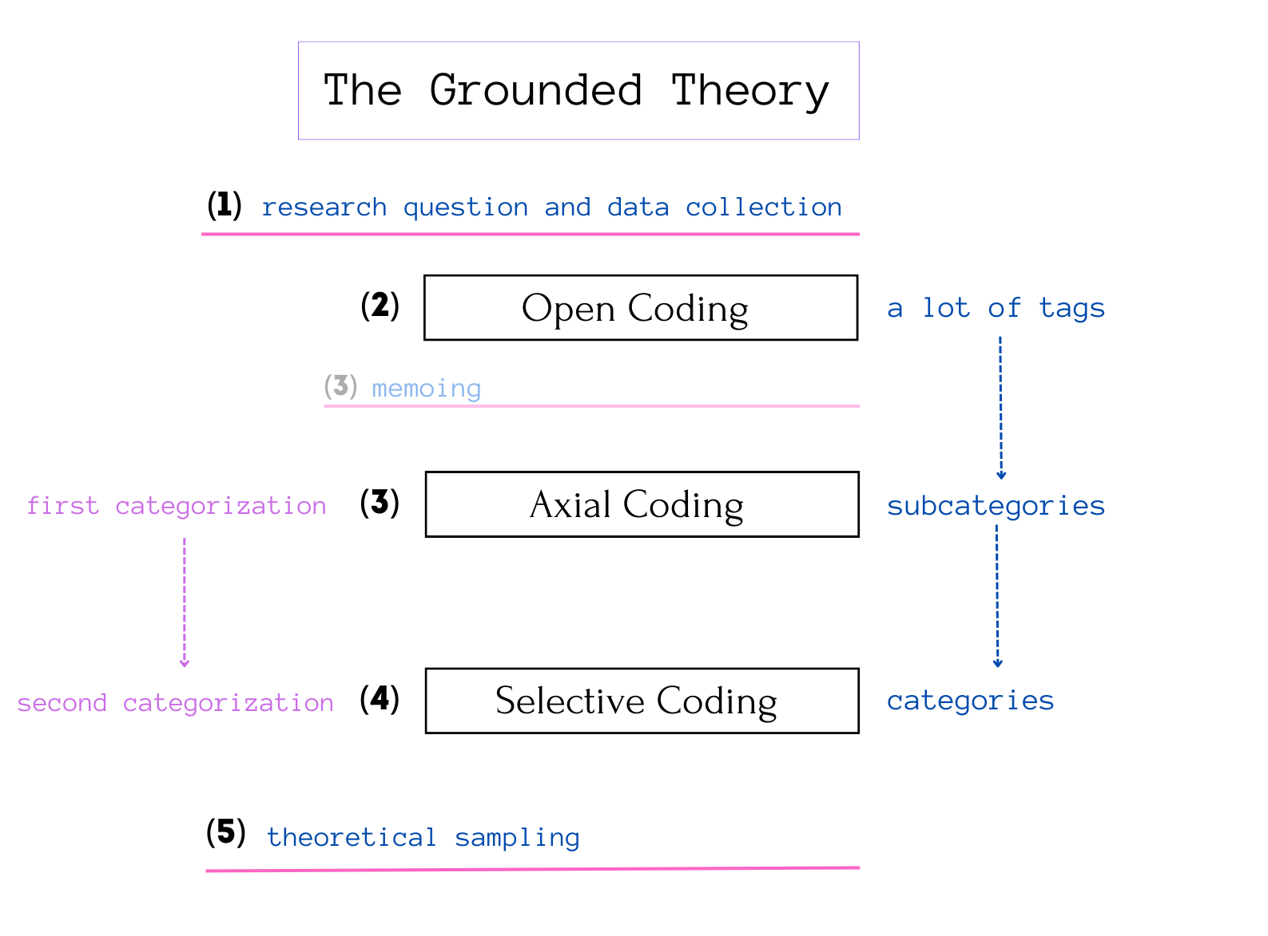

Picture 2. Research stages and sociological ouroboros

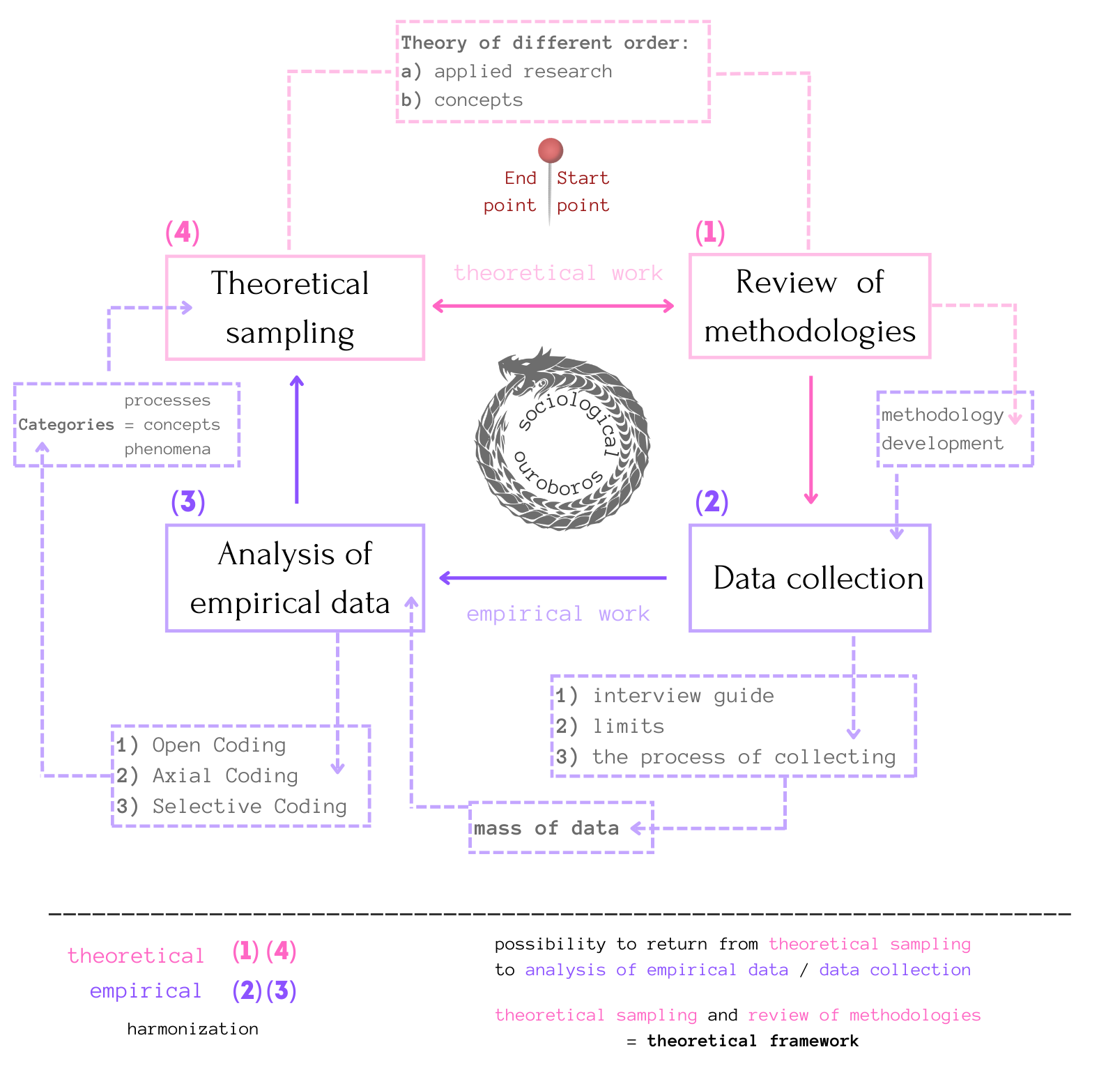

Appendix II: portrait of informants, interview guide, transcript

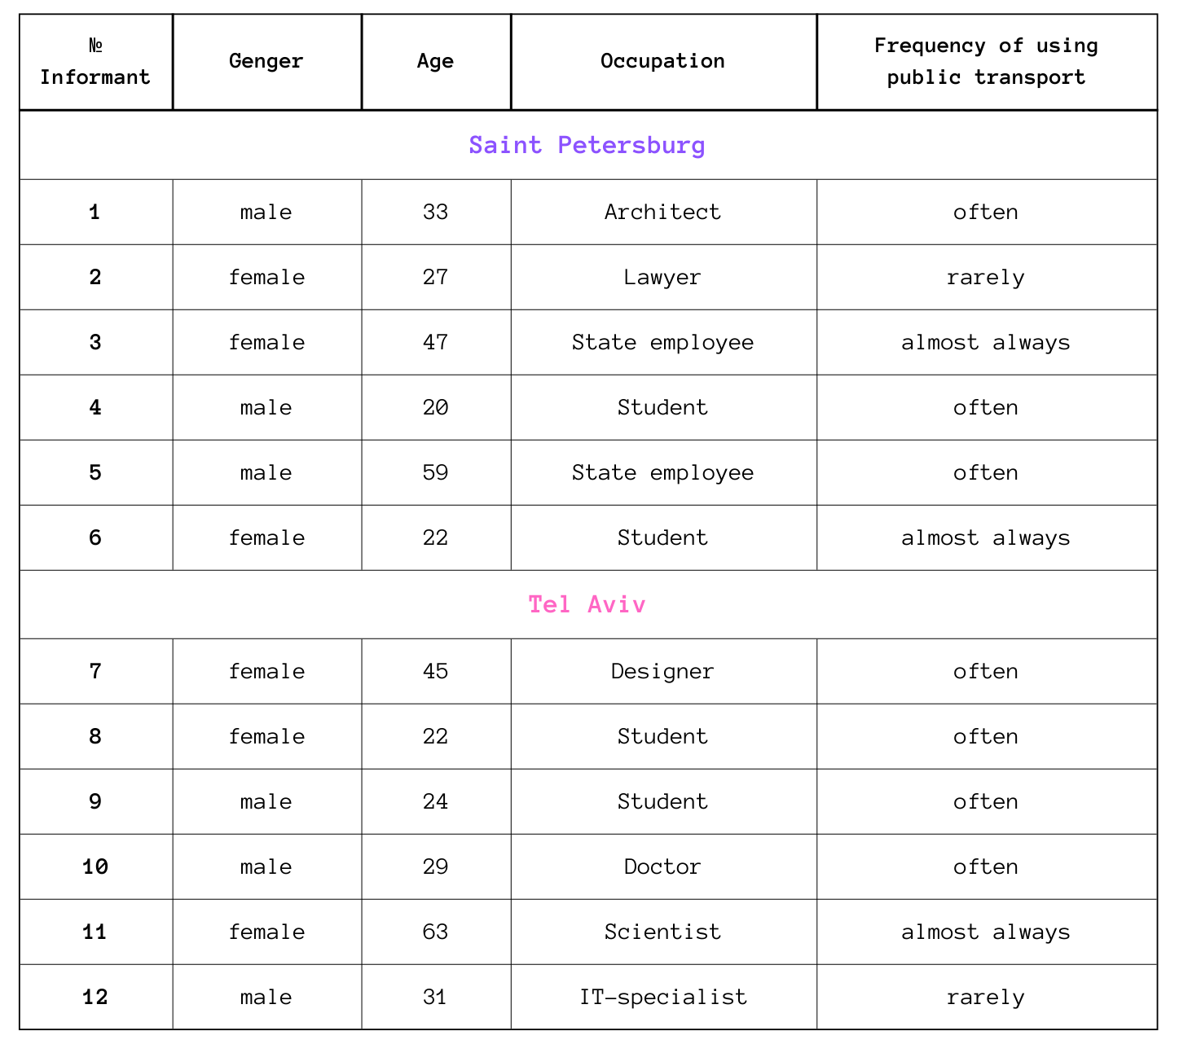
Picture 1. Portrait of informants

List 1. Sample list of interview questions:

- How frequently do you use public ground transport in your everyday life? What factors influence your decision to use public ground transport? What is the more frequent purpose of using ground urban transport: work, study, leisure and recreation? Which do you typically use?

- Do you feel that transportation options in your city are affordable and accessible to all members of the community? Have you ever experienced financial hardship related to transportation costs?

- How satisfied are you with the availability / safety / reliability / affordability of public ground transport in your area?

- Do you plan your transport route? Do you have favorite routes or is your choice of transport random?

- Do you pay attention to the design of stops, route maps at stops, buses / trams?

- How often do you experience delays or disruptions while using public transportation? Have you ever missed important appointments or events due to unreliable transportation?

- Have you ever felt physically uncomfortable due to overcrowding on public transportation? Have you ever experienced anxiety or stress related to using public transportation? Do you feel safe when you use public ground transport to get around?

- How important is access to public ground transport for your level of well-being, work or education, mental health, leisure and recreational activities, social life and relationships?

- How often do you use active transportation options, such as walking or cycling, and how does this impact your well-being? Electro scooters? Do you like walking?

- How often do you interact with others while using public ground transport? How often do you make new social connections or meet new people while using public ground transport?

- How important is technology and innovation for the future of public ground transport? Do you feel that technology has improved the quality of transportation options in your city?

- What changes in public policy or regulation could improve public ground transport in your area? Do you think that a more efficient and reliable transportation system would improve the overall quality of life in your community?

Transcript 1. Example of the interview transcription

A – Interviewer
I6 – Informant №6

Information about informant: female, 22, student from Saint Petersburg.
Interview language: Russian.
Data: 05.04.2023.
Place: in person; cafe.
Duration: 11 minutes.

A: I know that you almost always use public transport, don't you? Which do you typically use?
I6: I live on Vasilevskiy Island, so I have access to different types of transport - trolleybuses, buses, trams and metro. I prefer buses.
A: What is the more frequent purpose of using ground urban transport: work, study, leisure and recreation?
I6: I am a student, but I study part-time, so I use transport when I need to go to work.
A: Do you always pay for bus fares?
I6: Sometimes not *smiles*. I understand that only controllers can fine, and bus drivers recently don’t pay much attention to who paid and who didn’t. So, steal a ride (rabbit).
A: Why are you sometimes as free rider?
I6: After the cancellation of commercial routes, which routed very often, sometimes you will not wait for the bus, and if your long-long-long waiting, there is a risk that not enough place for all people on stops.
A: How often do you ride the bus?
I6: Every day, because it is too far to walk, by foot, to my workplace. I work in another part of SPb.
A: Do you plan your transport route?
I6: What do you mean?
A: When you leave your home or go to a bus stop, do you look at the map, do you choose the best option for planning your way from home to work?
I6: Yes, I can find some information when the bus arrives for peace of mind and for planning what I should do the next - run to the stop to be on time or not to run. How I like empty buses *laughs*.
A: Do you pay attention to the design of stops or buses…trams?
I6: It is important for me that the vehicles are new, as it is nice to get on the bus, sit by the window and look at the street, at the buildings and at the people, while listening to music. Hear the phrase – transport is face of city. Like a business card. It's relaxing to be in a new vehicle.
A: Even during traffic jams and peak hour?
I6: Sorry, I forgot the sugar for the coffee. One moment…
< pause >
I6: I don't like traffic jams when I'm late, but when I don't have to hurry anywhere, I'm sitting - why not? A crowd of people will not surprise me either, although I find it annoying.
A: Do you feel safe when you use public ground transport to get around?
I6: When I see evil people who claim one free seat - yes, I get scared *laughs*. But seriously - once, I had an accident, then I did not expect such braking and fell unsuccessfully, that then my back hurt for a long time and there was a big bruise on my arm. I remember about it. Sometimes I feel discomfort when there are too many people who are pushing, there is nothing to breathe and I just want to get there as soon as possible and get off at any stop. Sometimes I get off a little earlier if the bus is too slow, there are a lot of people in the bus.
A: How often do you interact with others while using public ground transport? How often do you make new social connections or meet new people while using public ground transport?
I6: I try not to interact with anyone on the bus.
< pause: phone rang >
A: How satisfied are you with the availability, safety, reliability, affordability of public ground transport in your area?
I6: In general, everything is fine, but I would like buses on the same route to run more often. Every 5 minutes. It would be just wonderful, because sometimes the right bus may not be available for 20-25 minutes, sometimes more in time. If the bus runs at such an interval, then there is a risk of not getting on the bus, as people at previous stops also waited a long time.
A: Would you like your own car?
I6: Maybe… one day!
A: Do you use taxi? Or Electro scooters?
I6: Rarely. Using bus is much cheaper than a taxi, although if it's quite late, evening - I can take a taxi. It would be nice if there were buses instead of the metro at night.
A: Electro scooters?
I6: No, no, in this case I prefer walking by foot.
A: I seem to have already asked this question, but could you repeat the answer if you answered?
I6: No problem.
A: Do you pay attention to the design of stops, buses, trams?
I6: I understand that this means the style of the cars, like in the subway. I saw a colored tram for a long time, and a stop too. I like it when there is something unusual, but sometimes there is too much design. It looks superfluous.
A: Last question. Do you pay attention to advertising in buses and trolleybuses?
I6: It happens when I ride standing inside the bus and cannot pick up the phone to read and watch something. In this case, I look around, sometimes I can see some kind of advertisement. Once I saw how a video about the city and drivers was being broadcast - on the screen ... you know, there are such people inside the buses. There are broadcast hours, weather or the next stop. I remembered now - there was a horoscope *laughs*!
Appendix III: analysis of empirical data and grounded theory

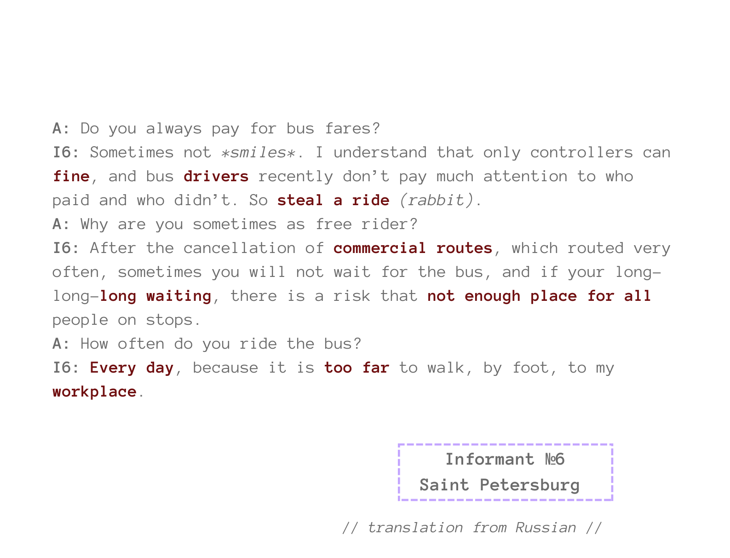
Picture 1. Example of one part from interview with coding

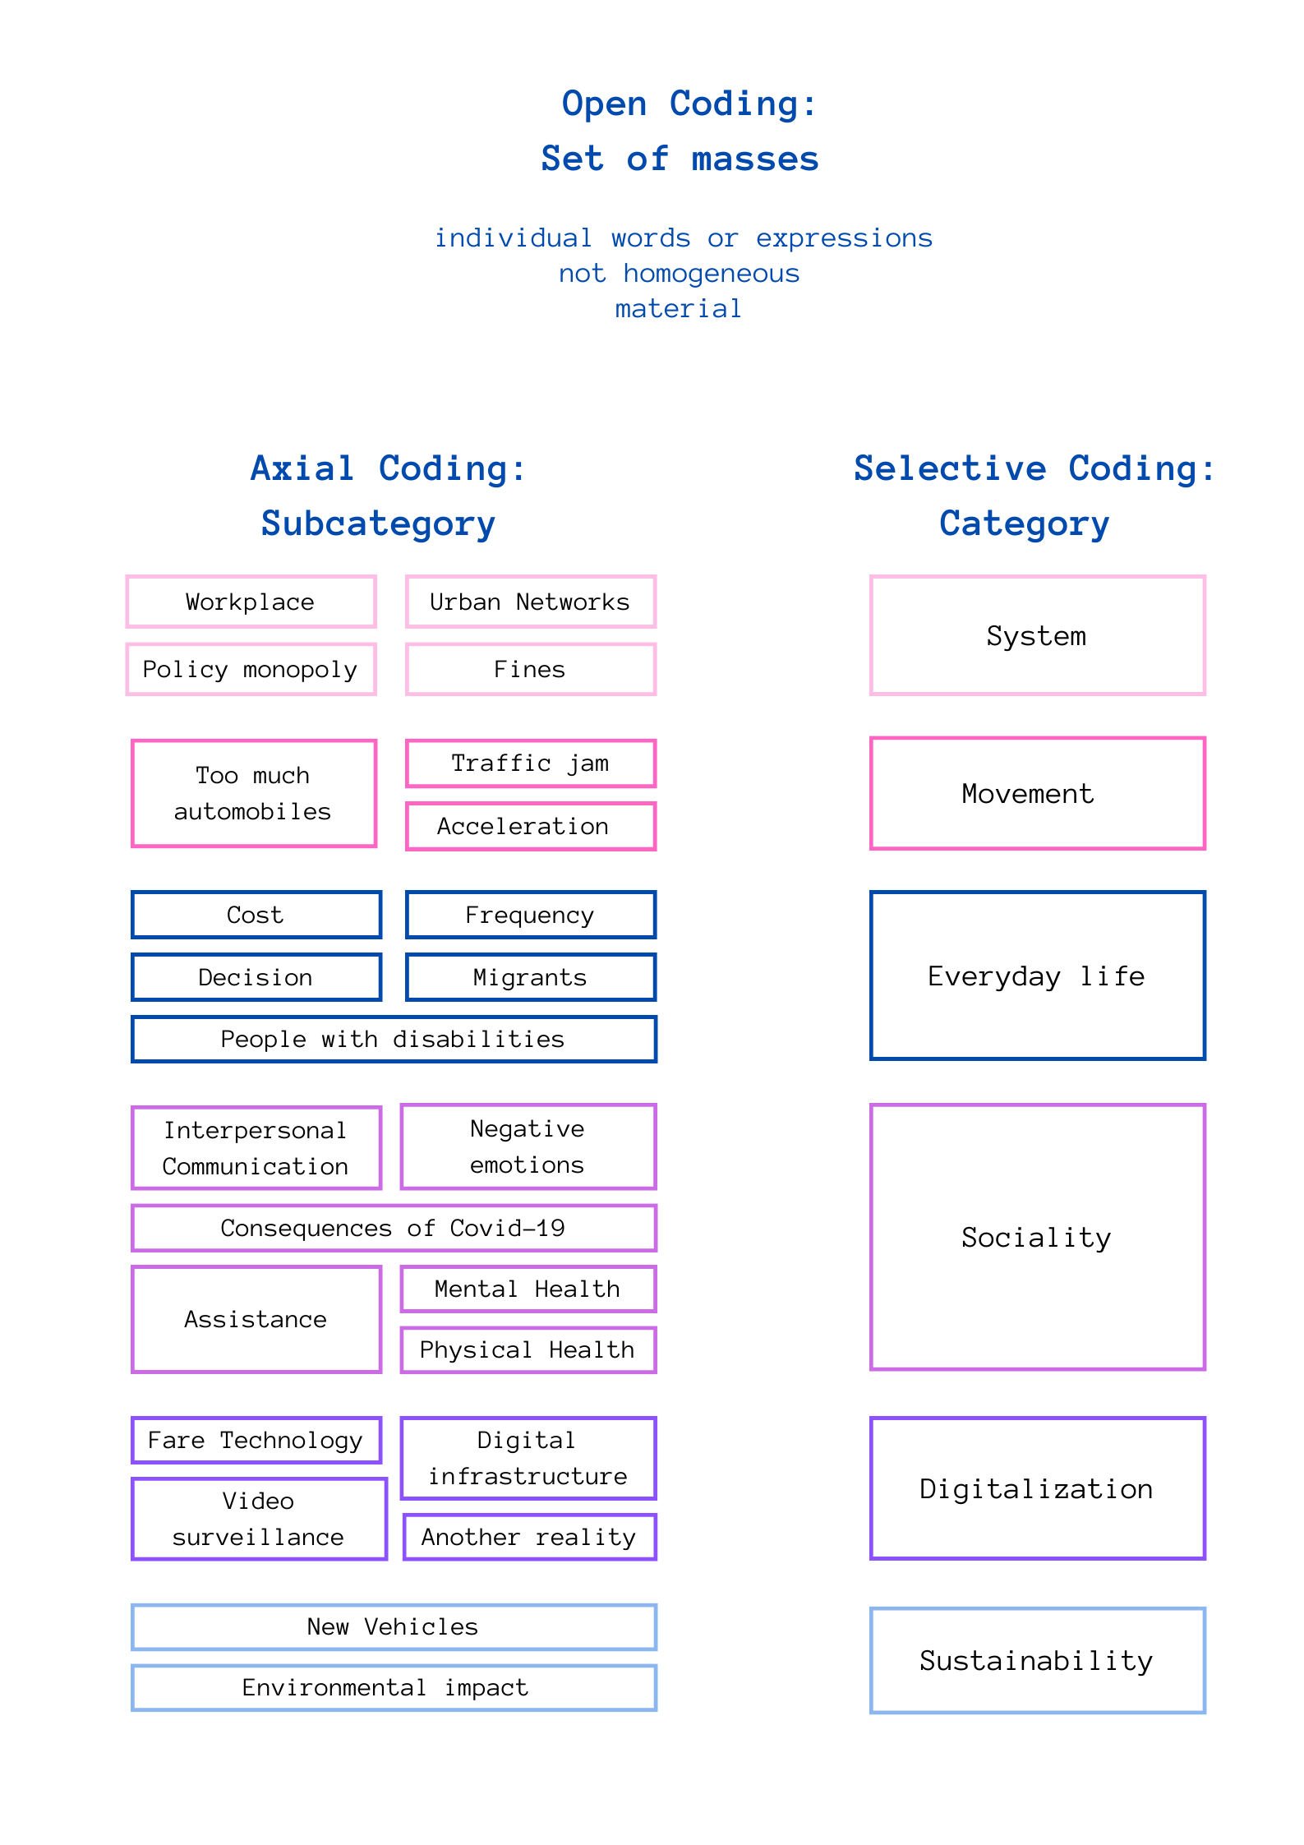
Picture 2. Categorization

Picture 3. Theoretical Sampling
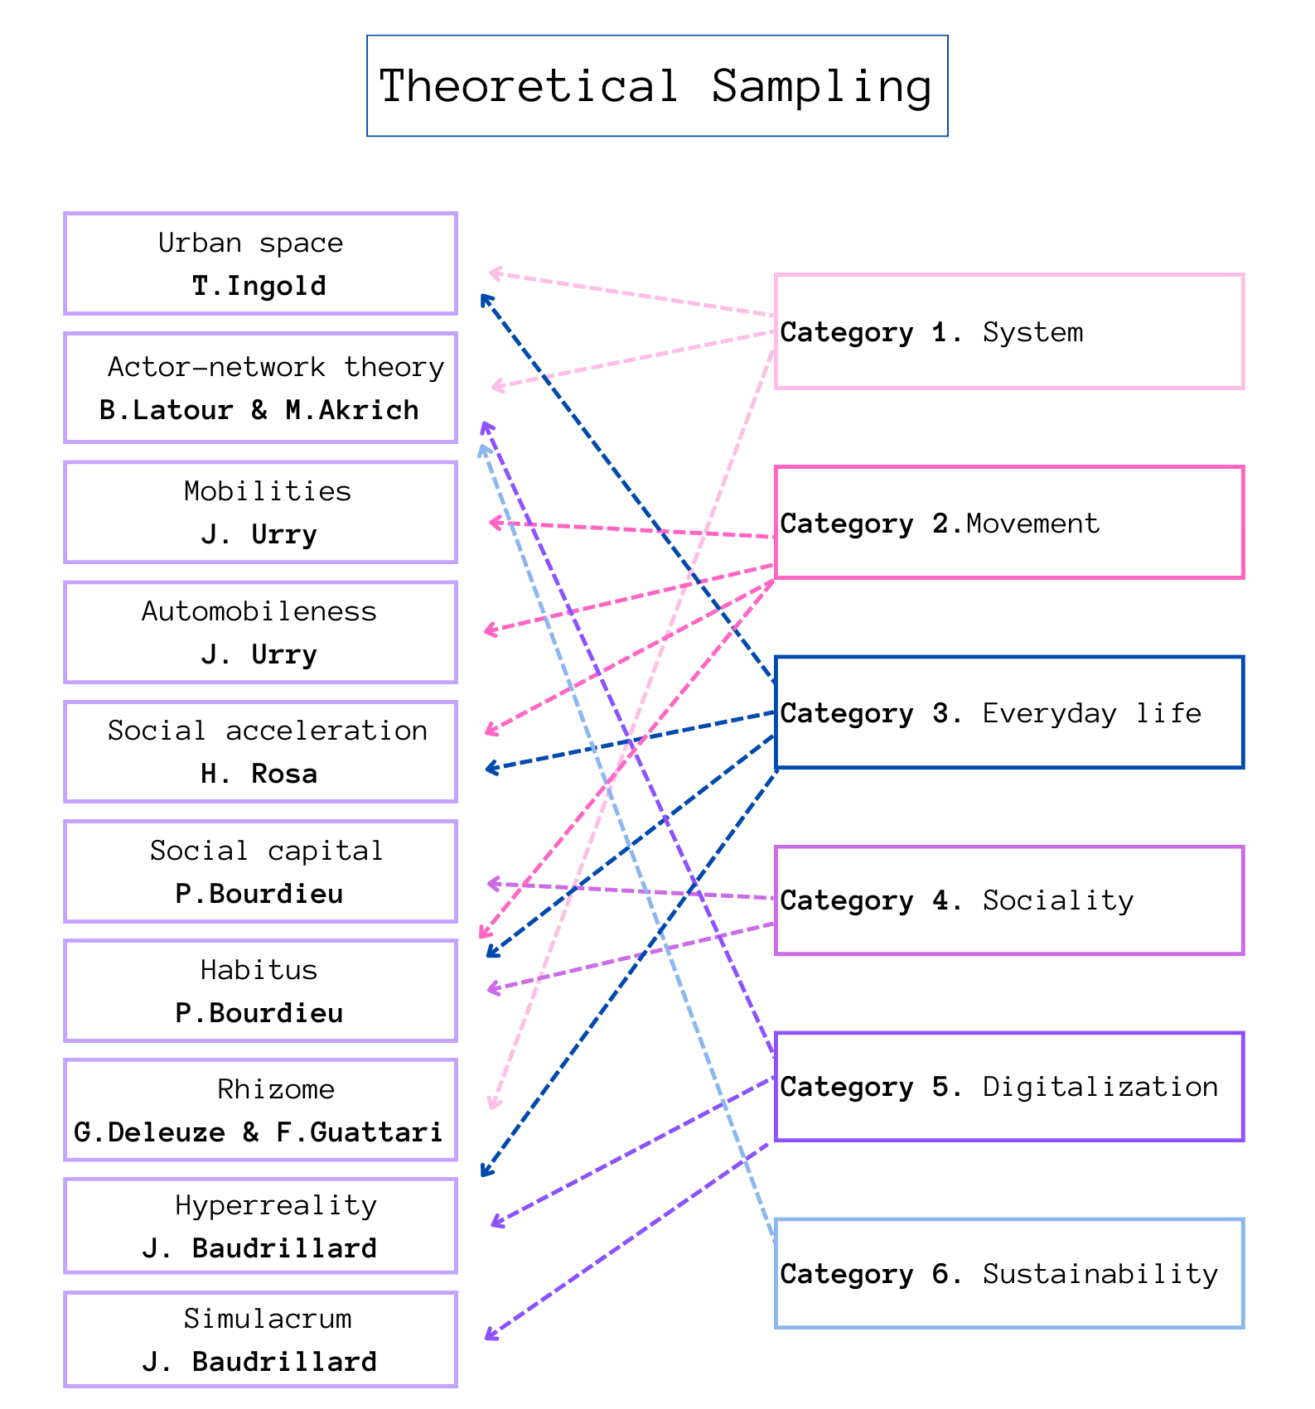

Picture 4. The role of the transport system in the interpretations of informants
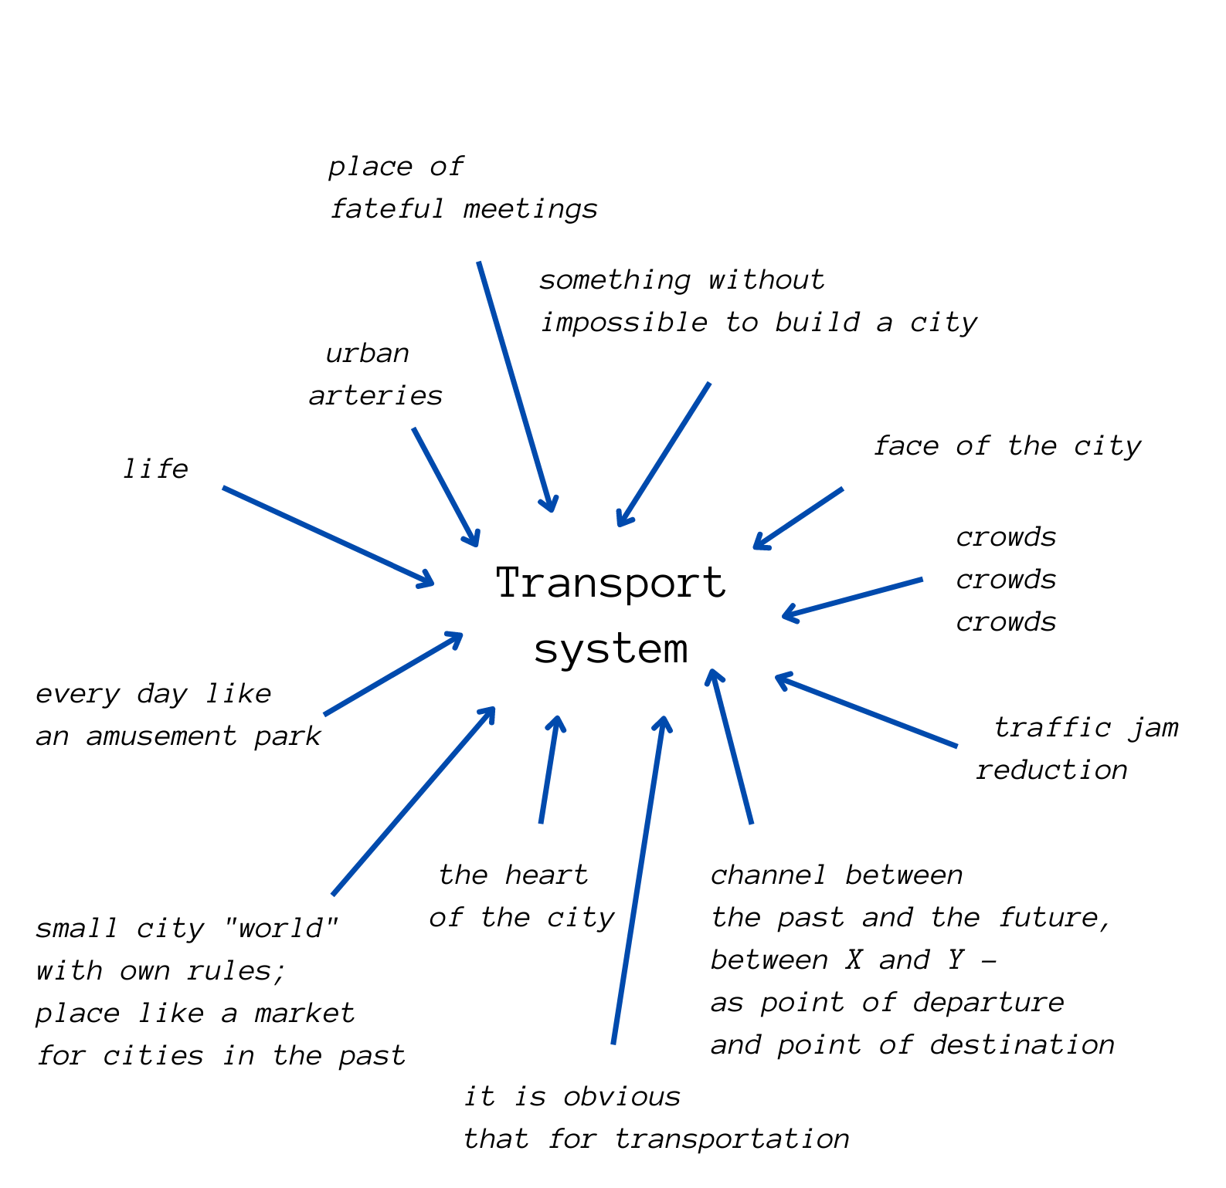

Appendix IV: theoretical model

Picture 1. Theoretical conceptualization
