Review of the supervisor .
on the final qualifying work of Pin He on the topic
"The search for a global maximum. The case of many equal extremes"

The method of simulated annealing has now proven itself as a reliable and effective method for solving large discrete optimization problems. In my recent work with my co-authors (Ermakov, Kulikov, Leora), it was pointed out that the method can be generalized to the continuous case. It was assumed that Ping He would develop these results in his master's thesis. I must say that he showed perseverance in his work and, despite certain language problems, coped with the task. He promptly and on time solved the numerical examples I proposed, which allowed me to formulate and prove a lemma justifying the application of the generalized method of simulated annealing to the problem of separating the roots of systems of equations. This lemma and the accompanying numerical examples can serve as part of the publication in the journal, because the problem of separating roots is complex, and the proposed method solves it automatically.
The disadvantage of the work is that the overview part is very extensive on the one hand, and on the other it does not fully cover the existing methods for solving both extreme problems and systems of equations. However, it wasn't enough to recycle this part of the time.
I think the work deserves a "Good" rating (B).

Scientific supervisor, Professor 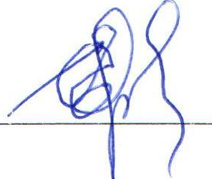 Ermakov S.M.

