Saint Petersburg State University

YING YANG

Master thesis

**Modeling of Arctic Lacustrian Ecosystem**

**Under Climate Change**

Master program ВМ.5710.

«Cold Region Environmental landscapes Integrated Science (CORELIS)»

Scientific supervisor: Dr Irina Viktorovna

Scientific consult : Dr Stefen

**Modeling of Arctic Lacustrian Ecosystem Under Climate Change**

Ying Yang

Supervisor:

Dr Irina Viktorovna, Saint Petersburg State University

# **Abstract**

Arctic lacustrian ecosystem have typical feature due to the high latitude location and more sensitive reaction as the global mean temperature increase sharply compare with last centry. About global mean temperature increase scientists have used different modeling to simulate the temperature increase route. Global warming was ≈0.7°C between the late 19th century (the earliest time at which global mean temperature can be accurately defined) and 2000, and continued warming in the first half decade of the 21st century is consistent with the recent rate of +0.2°C per decade.(James Hansen et al.,2006,p.1) To limit global mean surface temperature to 1.5°C above pre-industrial levels is always talked about in the PICC report . If limiting global temperature to 1.5°C is not ‘feasible’, it will limit it to 2.0°C even 4.0°C above pre-industrial levels. As the Arctic lacustrine ecosystem is is most vulnerable and sensitive to global temperature , so It is meaningful to do more research in Arctic region. If the global mean temperature increase 1.5 °C , 2.0°C, 4.0°C , how climate change will influence the Arctic lacustrine ecosystem is an import sentific topic.In order to estimate the effect , the one demional lake temperature model ,Flake online ,is applied to 6 lakes in Arctic region . A small lake on Gorely Island in Russian (66°17'N 33°37'E); a small lake on middle island in Russian(66°17'N,33°40'E); A big lake named Khantayskoye Lake in Russia (68°21'N, 90°59'E); A medium lake named Paanajarvi Lake in Russia(66°16'N,30°03'E); A big lake named Great bear lake in Canada (65°50′01″N 120°45′06″W); A big lake named Inari Lake in Finland( 69°04'N, 27°57'E). After modeling I get physic statistics results about lake means temperaute , ice thickness of lake, ice free Period ice on and ice off date.

Abstract 1

Introduction 3

2.1 Historical and future climate Scenario 5

2.3 Model description 6

2.3.1 Model input parameters 6

3.1 Modeling results about lake mean temperature 7

5 Results and discussion 18

5.1 Lake mean temperature change trend under climate change 18

5.2 Ice on 19

5.3 Ice off 19

5.4 Ice thickness 19

5.5 Ice free day 20

6 Conclustioon 21

Acknowledgements 21

Reference 22

# **Introduction**

The Arctic lascurain ecosystem is a unique region as it is so sensitive to climate change, the lake temperature change will be influenced by the mean temperature change .Effects of climate change on lake ecosystems have been observed globally, rising temperatures induce extensive changes in planktonic communities such as shifts toward increased cyanobacteria populations and greater toxin production.(Lisette N et.al,2007).

About global mean temperature increase scientists have used different modeling to simulate the temperature increase route. Global warming was ≈0.7°C between the late 19th century (the earliest time at which global mean temperature can be accurately defined) and 2000, and continued warming in the first half decade of the 21st century is consistent with the recent rate of +0.2°C per decade.(James Hansen et al.,2006,p.1) To limit global mean surface temperature to 1.5°C above pre-industrial levels is always talked about in the PICC report . If limiting global temperature to 1.5°C is not ‘feasible’, it will limit it to 2.0°C even 4.0°C above pre-industrial levels. As there is a strong linkage between climate and Arctic lake ecosystem, how the Arctic lake will react to climate change is an important topic that deserves more focus from researchers and scientists. Because the Arctic lascurain ecosystem is more vulnerable , climate change may change regional plants and other species or potentially also affect ecosystem stability or influence human’s life who live in the Arctic region . Climate model simulations , based on Socio-economic pathway greenhouse gas concentration and the temperature increase. The global surface temperature will continue to increase according to the results from the Coupled Model Intercomparison Project Phase 6(CMIP6), it is so interesting to solve this question that is “How temperature change in arctic lake water temperature changes under the different global warming level, global warming 1°C , global warming 2°C , global warming 4°C ?” Climate change changes the lake ice breakup date of the lake or causes the summer ice-free conditions in lakes ?” “ How will global warming influence the lake in the arctic and how will the arctic lake’s change influence the plankton in the lake ? '' Answering these questions is important as the lake ecosystem in the arctic region is an important freshwater source for local citizens. For answering these questions I use the Flake modeling online to simulate the situation of different climate scenarios. Computer models have been the primary tool for analyzing the impact of climate change on lake ecosystems (Menshutkin et al. 2014;Moe et al. 2016).

**2 Material and methods**

Totally I choose 6 lakes, lake 1 is a small lake in Gorely Island in Russian (66°17'N 33°37'E); Lake 2 a small lake on middle island in Russian( 66°17'N,33°40'E), this two lakes the physical and geographical characteristics I measure it when expedation in white sea in 2021 summer time under the help of Smagin Roman Evgenievich, Lake 3 is a big lake named Khantayskoye( 68°21'N, 90°59'E) in Russia; Lake 4 is a big lake named Paanajarvi in Russia(66°16'N,30°03'E); Lake 5 is a big lake named Great bear lake in Canada (65°50′01″N 120°45′06″W); Lake 6 is Inari Lake(big lake)(69°04'N, 27°57'E) in Finland.

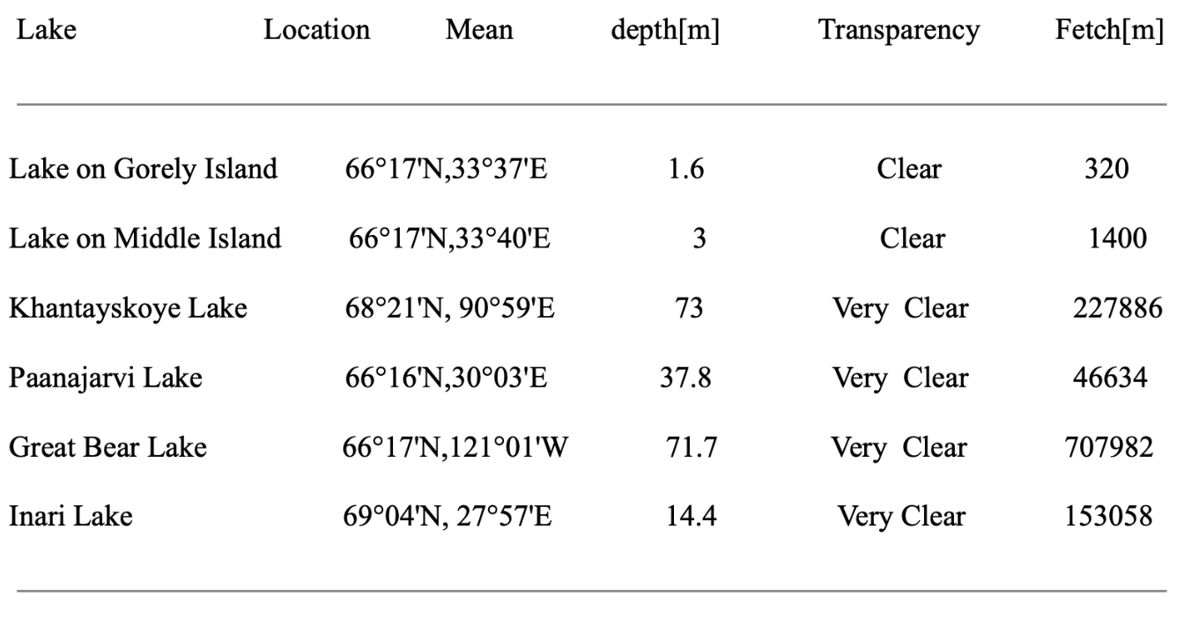

Table 1 . Physical and geographical and morphometrical characteristics of the lakesPart of data from World Lake Database, International Lake Environment Committee Foundation(ILEC).

# **2.1 Historical and future climate Scenario**

Climate model simulations , based on Socio-economic pathway greenhouse gas concentration and the temperature increase. The global surface temperature will continue to increase according to the results from the Coupled Model Intercomparison Project Phase 6(CMIP6)(table1 ) the results show that the best estimate situation in the neary term , 2021-2040 the global mean temperature will increase 1.5°C. Acrossing the 2°C global warming level in the mid-term period (2042-2060) is very likely to occur under the very high GHG emissions scenario (SSP5-8.5) and 4 °C increase change may happen in the long term, (2081-2100). So my thesis is according to 4 climate change scenarios to find the lake ecosystem’s reaction .

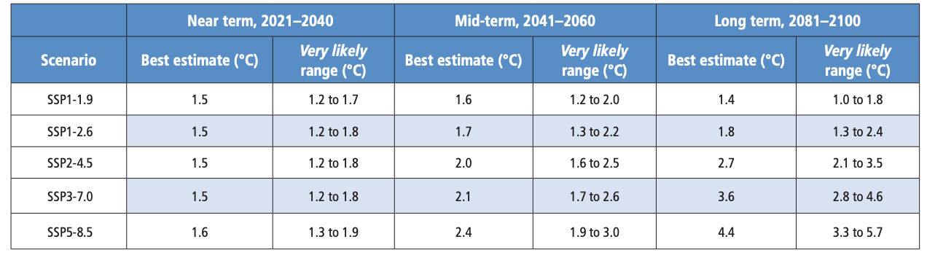

Table 2 Changes in global surface temperature, which are assessed based on multiple lines of evidence, for selected 20-year time periods and the five illustrative emissions scenarios considered.(Resources from the Sixth Assessment Report of the Intergovernmental Panel on Climate Change )

# **2.3 Model description**

I use the Flake online model((<http://www.flake.igb-berlin.de/model/run>) ) . the Flake online modeling was developed jointly by the German Meteorological Service, the Institute of Limnology of the Russian Academy of Sciences, the Leibniz-Institute of Water Ecology and Inland Fisheries (Germany), and the Northern Water Problems Institute of the Russian Academy of Sciences (Russia).The FLake model is used to solve a wide range of limnological problems, serves as a basic tool for developing models of the functioning of aquatic ecosystems.(Galina Zdorovennova et at.,2021,p.6 ). FLake is a 1-dimensional bulk hydrodynamic lake model. It simulates water temperature and Ice thickness in lakes and was specifically designed to parameterize inland waters in climate models and numerical weather prediction systems

# **2.3.1 Model input parameters**

The input includes Geographical coordinates as latitude and longitude,Mean lake depth in meters,Lake fetch, Water transparency. For simulating the different climate scenarios needed according to the global warming situation, change the coordinates . Due to the “Outside the tropics, average annual temperature declines on average 0.7℃ for each degree of latitude in the Northern Hemisphere and on average 0.5℃ for each degree of latitude in the Southern Hemisphere''(Frank A. La Sorte et.al.,2014) , I changed the latitude location to simulate global warming, global warming 1.5°C , global warming 2°C , global warming 4°C.

**3 Material and methods**

**Equations**

Simulate Coordinates of Global Warming 1.5°C 1.5*1/0.7≈2.14 Simulate Coordinates of Global Warming 2°C equation is 2*1/0.7≈2.86 Simulate Coordinates of Global Warming 4°C equation is 4*1/0.7≈5.71.

# 3.1 Modeling results about lake mean temperature

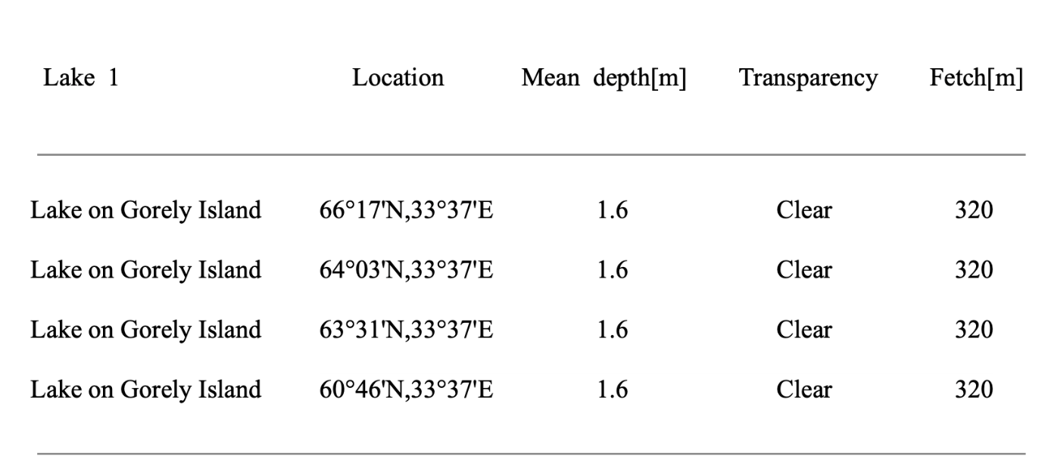

Table3. The lake on Gorely Island (66°17'N,33°37'E) is the real coordinates of the lake on Gorely Island ;(64°03'N,33°37'E) is the simulation of global warming 1.5°C;(63°31'N,33°37'E) is the simulation of global warming of 2.0°C; (60°46'N,33°37'E ) is the simulation of global warming of 4.0°C.

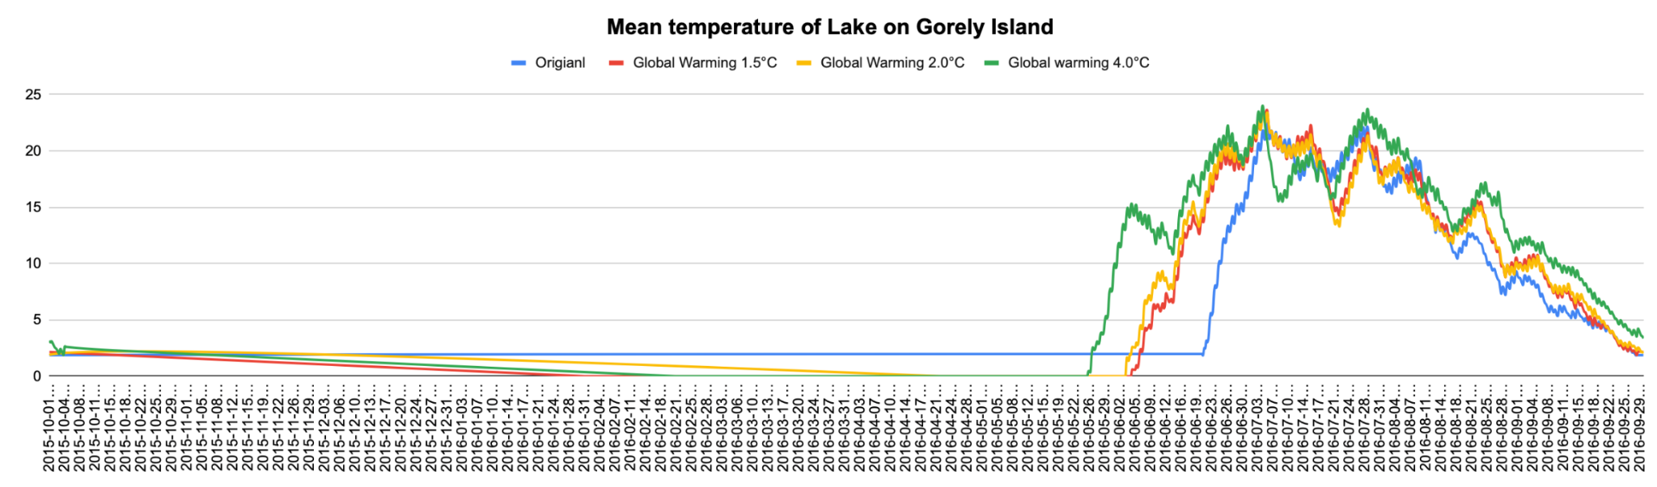

Figure 4 The mean temperature results from Flake modeling on line of different global warming situation of Lake on Gorely Island ( 66°17'N,33°37'E )

The lake on Gorely Island (66°17'N,33°37'E) is a small lake , the mean depth of the lake is 1.6m, and transparency level is clear , As the modeling results from year 2016 of the the lake on Gorely Island (66°17'N,33°37'E), the mixed-layer temperature, mean temperature of the water Column and bottom temperature increase start nearly 20th June 2016 increase shapely to 22°C in the begging of July and then keep the temperature nearly 20°C nearly one month to the beginning of August then slowly decrease temperature to start frozen nearly the late of September . As the simulation situation of global warming reaches 1.5°C the lake temperature starts to increase on the date of 4th June 2016. half month in advance compared with the real situation. the simulation of global warming 2.0*C is a litter early then global warming 1.5°C simulation, the global warming 4°C simulation is the huge difference with the real situation of the 2016, the lake increase temperature start in the late of the May, nearly 26th May 2016

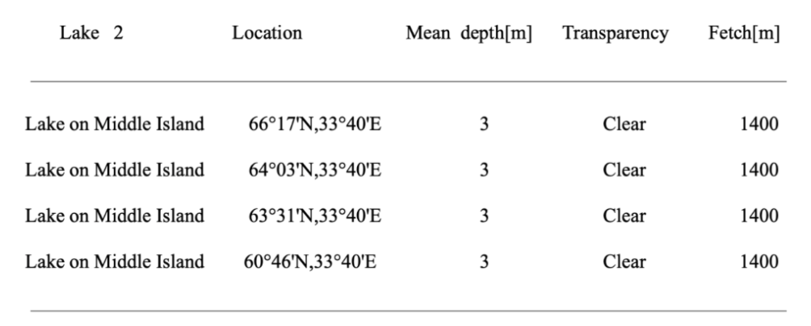

Table 4 The lake on is the real situation of the lake on Lake on Middle Island (66°17'N,33°40'E) , (64°03'N,33°40'E )is the simulation of global warming 1.5°C;( 63°31'N,33°40'E )is the simulation of global warming of 2.0°C; ( 60°46'N,33°40'E ) is the simulation of global warming of 4.0°C.

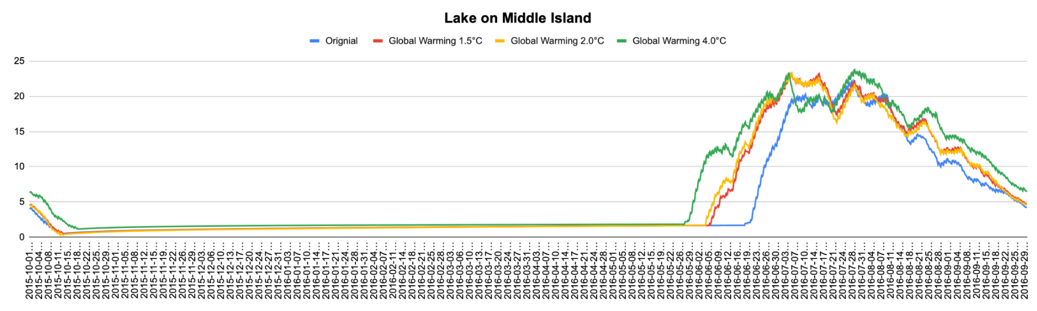

Figure 6.The mean temperature results from Flake modeling on line of different global warming situation of Lake on Middle Island (66°17'N,33°40'E )

Lake on Middle Island in Russian is a small lake ,located in 66°17'N,33°40'E , transparency is Clear , fetch is 1400m and the mean depth is 3 meters. The mean temperature change the lake mean temperature , the mean temperature on 18th June 2016 2 °C and sharply increase until to the highest temperature nearly 20 degrees, under the simulation of Global warming 1.5 situation the mean temperature starts warm in th 4 June 2016, and the highest temperature is nearly 23 degrees , the simulation results of global warming 2°C , the simulation of Global warming 4°C situation the water mean temperature start warming at the late of May, totally neary 23 days earlier then the real situation in 2016, the mean temperature warming period is longer then the real situation also .

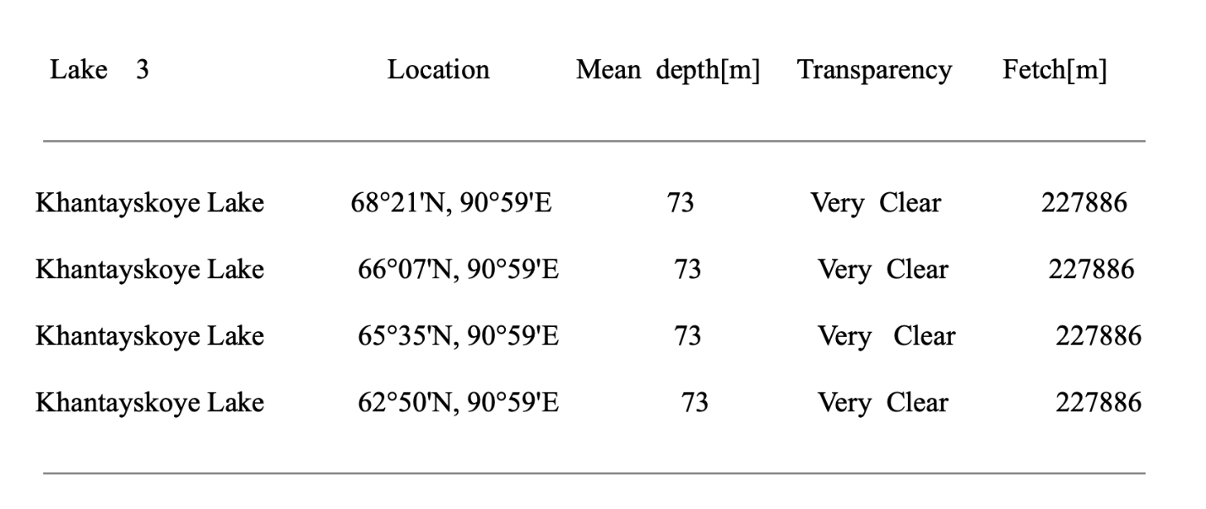

Table 5 The lake Khantayskoye 68°21'N, 90°59'E is the real coordinates of the lake. (66°07'N, 90°59'E) is the simulation of global warming 1.5°C; 65°35'N, 90°59'E is the simulation of global warming of 2.0°Ç; (62°50'N, 90°59'E )is the simulation of global warming of 4.0°C.

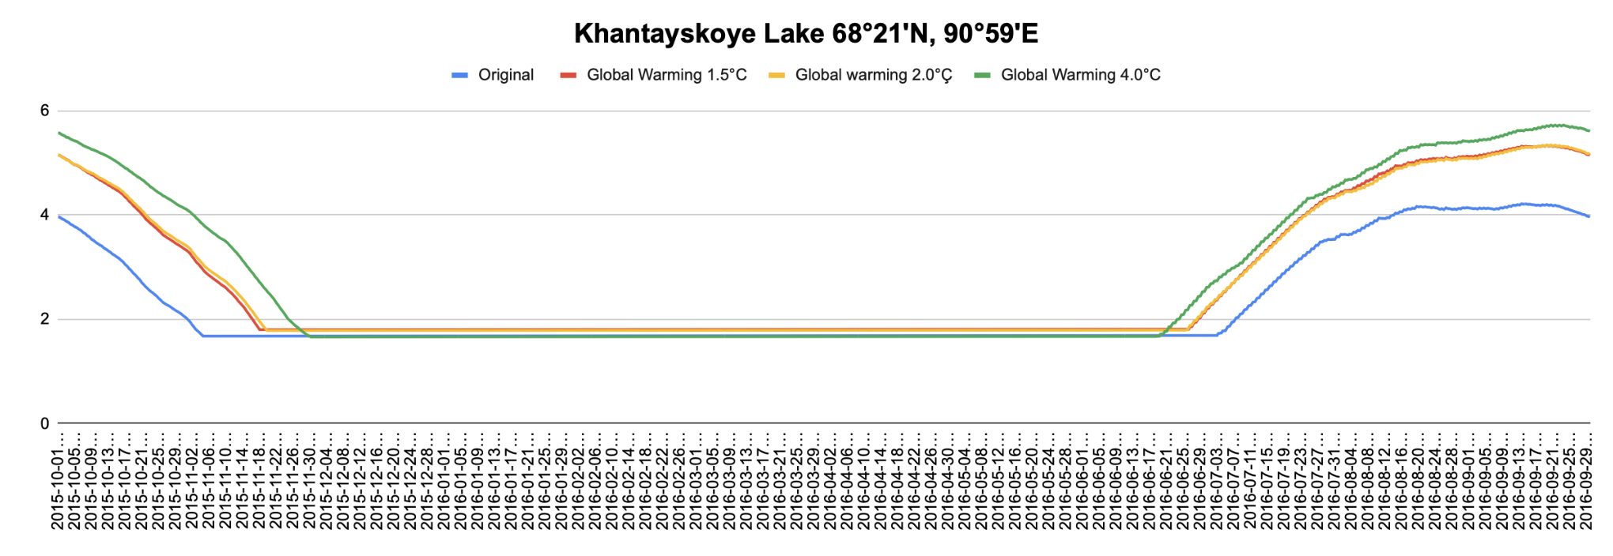

Figue 8 The mean temperature results from Flake modeling on line of different global warming situation of lake hantayskoye Lake (66°07'N, 90°59'E)

The khantayskoye lake(68°21'N, 90°59'E ) is a big lake the mean depth is 73 meters , very clear and the mean fetch is 227886 meters , For the real mean lake temperature , from 3rd July the temperature increase increase slowly until the the middle of September temperature reach the highest nealy 4 .2°C then drop to below 2 degrees on the day of 6th November , simulation of global warming 1.5 and 2 degrees is a lit bit similar , water mean temperature increase at 25th June , and the highest mean temperature increase to 5.6°Ç a then slowly drop to below 2 degrees on the day of 22th November , the huge change lake mean temperature is form the simulation of global warming 4°C , the mean temperature starts increase at the 21st of June and to the top neary 4.9 °C then slowly dorp to under 2 °C on the date of 26th November .

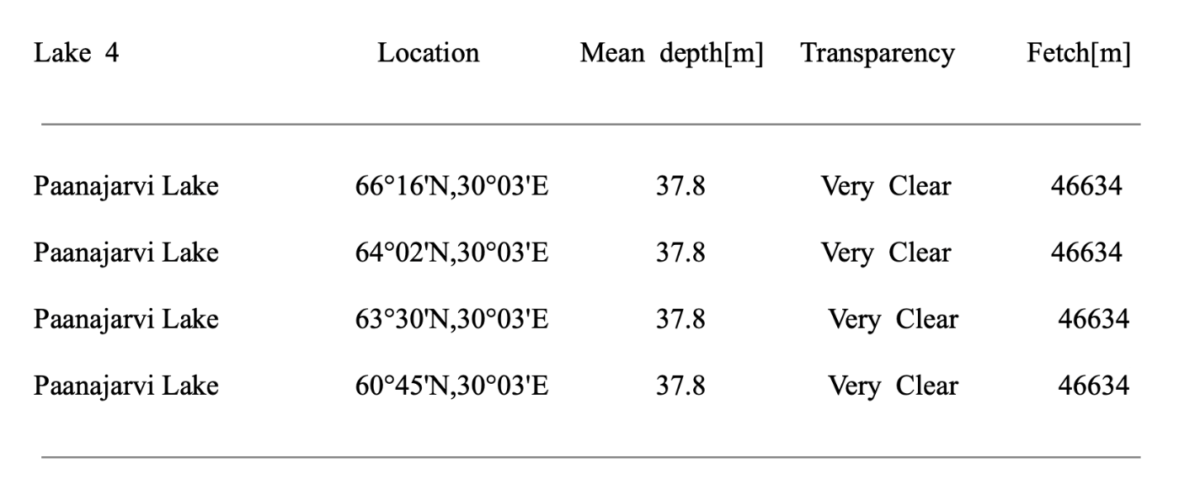

Table 6 The Paanajarvi Lake 66°16'N,30°03'E is the real coordinates of the lake. ( 64°02'N,30°03'E ) is the simulation of global warming 1.5°C; 63°30'N,30°03'"E is the simulation of global warming of 2.0°Ç; ( 60°45'N,30°03E ) is the simulation of global warming of 4.0°C.

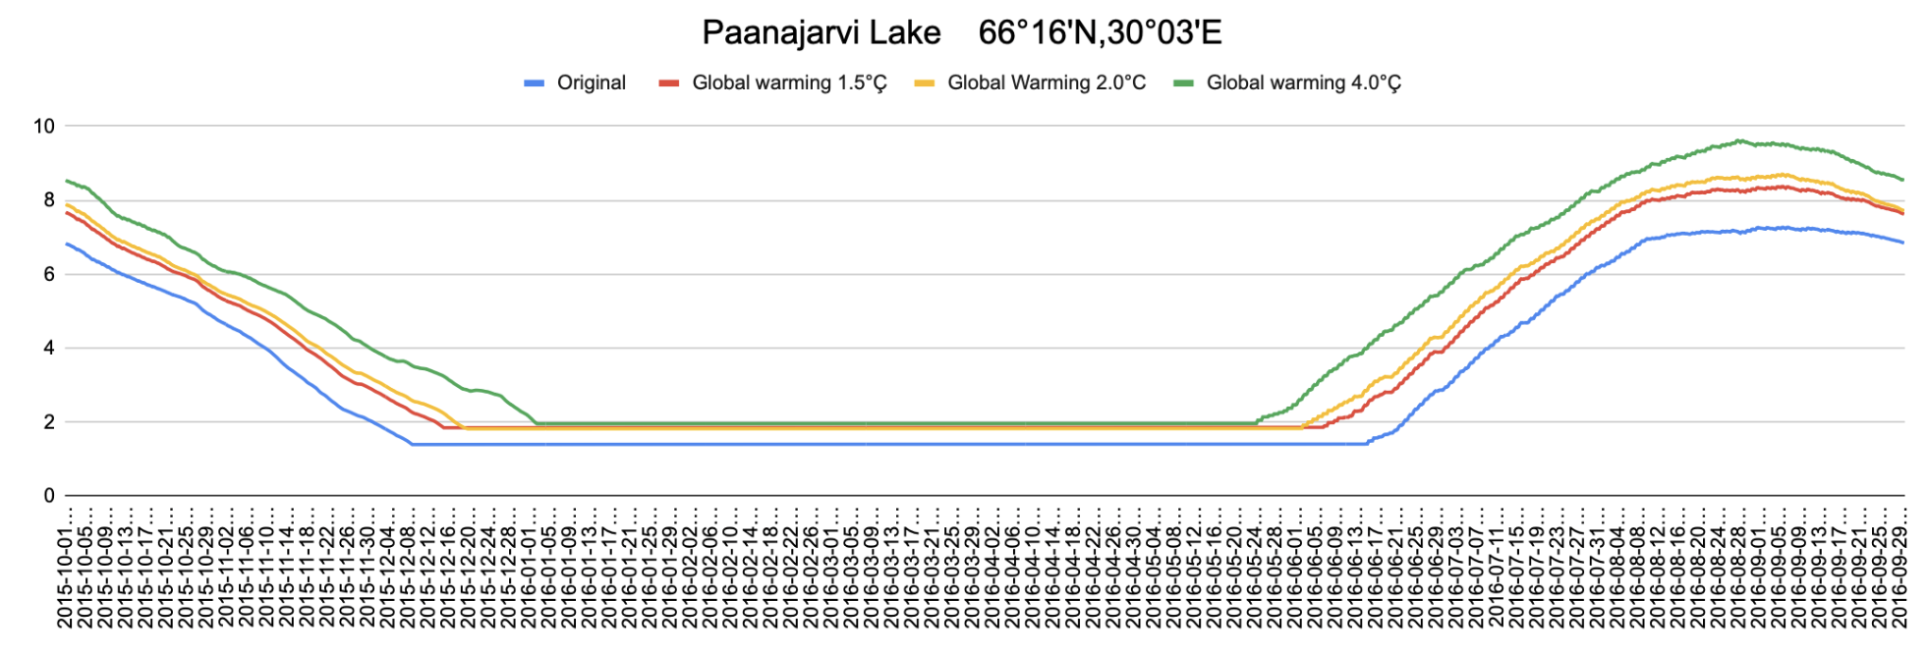

Figure 9 The mean temperature results from Flake modeling online of different global warming situations of Lake Paanajarvi Lake 66°16'N,30°03'.

The Paanajavi lake( 66°16'N,30°03'E) is a big lake 37.8 depth very clear and fetch is 46634m.For the real mean lake temperature , from 13rd June the temperature increase increase slowly until the the beginning of September temperature reach the highest nealy 7°C then drop to below 2 degrees on the day of 8th Dec, simulation of global warming 1.5 and 2 degrees is a lit bit similar , water mean temperature increase at 1st June , and the highest mean temperature increase to 6.5°Ç a then slowly drop to below 2 degrees on the day of 12th Dec, the huge change of lake mean temperature is form the simulation of global warming 4°C , the mean temperature starts increase at the 24th May and to the top neary 9.5°C then slowly dorp to2 °C on the date of 1st Jan.

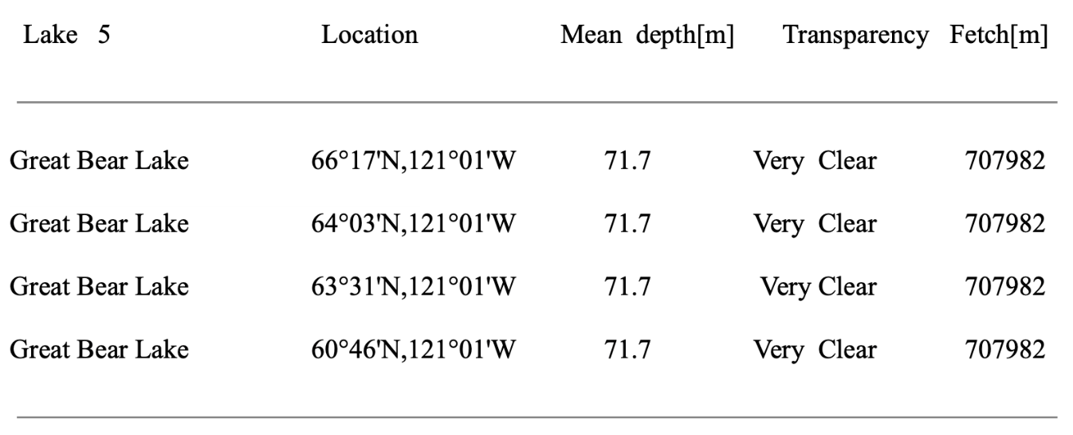

Table 7 The Great Bear Lake ( 66°17'N,121°01'W ) is the real coordinates of the lake. (64°03'N,121°01'W )is the simulation of global warming 1.5°C;( 63°31'N,121°01'W ) is the simulation of global warming of 2.0°C; ( 60°46'N,121°01'W ) is the simulation of global warming of 4.0°C

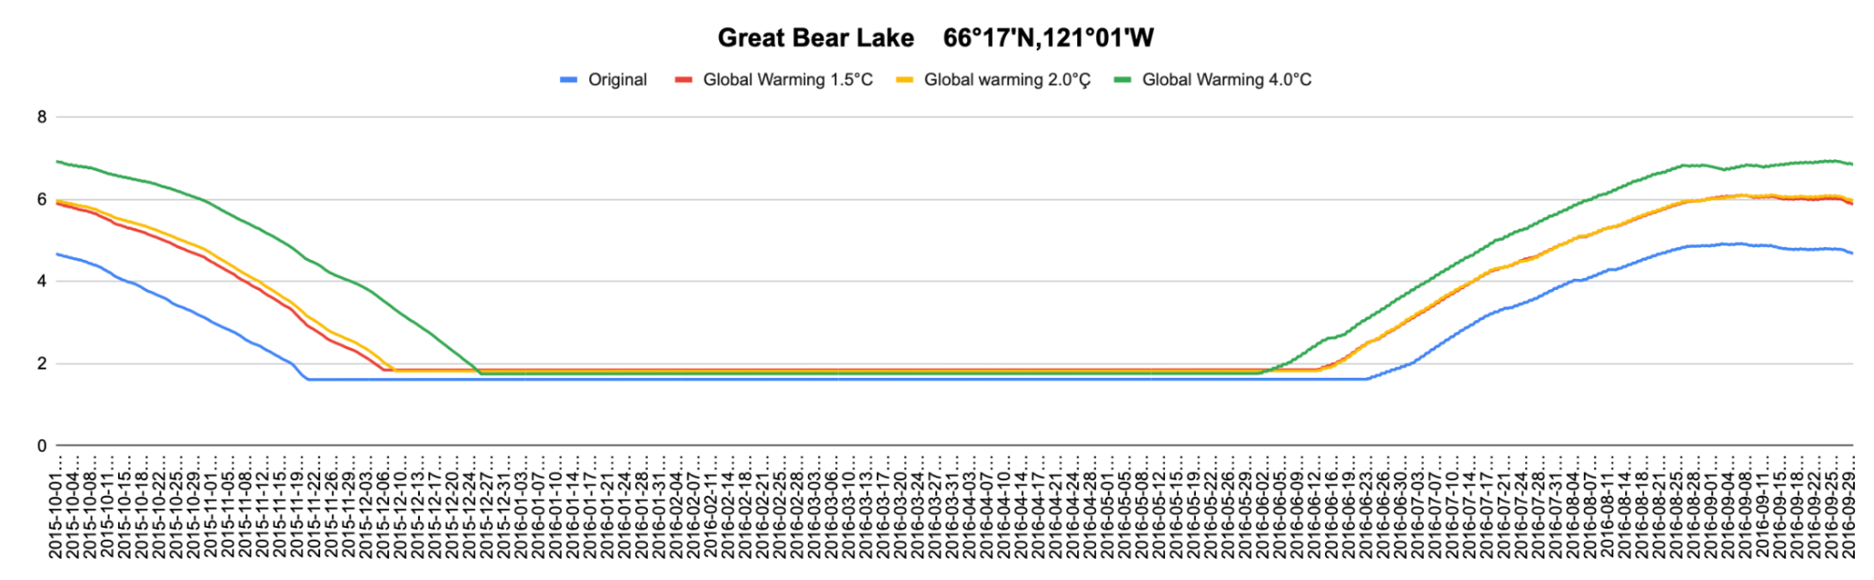

Figure 11

The mean temperature results from Flake modeling online of different global warming situation of Great Bear Lake ( 66°17'N,121°01'W)

The Great Bear lake is a big lake in Canada.lake Fetch is 707982m .Mean depth is 71.7m . Transparency is very clear. From 23rd June the temperature increase increase slowly until 1st September temperature reach the highest nealy 5°C then drop to below 2 degrees on the day of 20th Nov, simulation of global warming 1.5 and 2 degrees is a lit bit similar , water mean temperature increase at 12nd June , and the highest mean temperature increase to 6°C a then slowly drop to below 2 degrees on the day of 6th Nov, the huge change of lake mean temperature is form the simulation of global warming 4°C , the mean temperature starts increase at the 24th June and to the top neary 7°C then slowly dorp to2 °C on the date of 25th Dec.

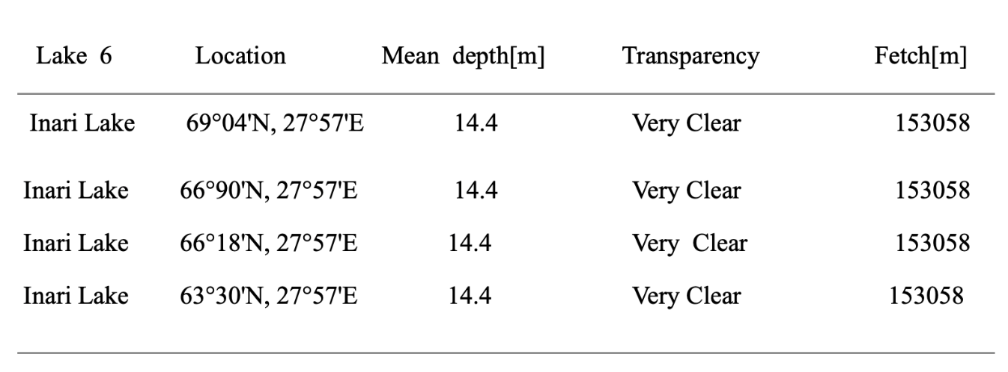

Table 8 Inari Lake 69°04'N, 27°57'E) is the real coordinates of the lake. 66°90'N, 27°57'E ) is the simulation of global warming 1.5°C; 66°18'N, 27°57'E E is the simulation of global warming of 2.0°C; ( 63°30'N, 27°57'E) is the simulation of global warming of 4.0°C.

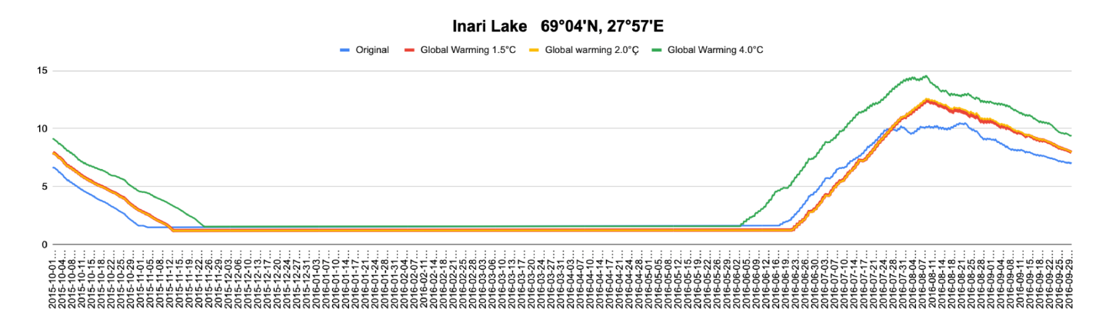

Figure 11

The mean temperature results from Flake modeling online of different global warming situation of Inari Lake ( 69°04'N, 27°57'E )

The mean lake temperature increases slowly from 23rd June the temperature until 1st September, temperature reaches the highest nealy 10°C then drops to below 2 degrees on the day of 1st Nov. Simulation of global warming 1.5 and 2 degrees is a little bit similar , water mean temperature starts increasing on 16th June , and the highest mean temperature increases to 12°C then slowly drops to below 2 degrees on the day of 12th Nov. The huge change of lake mean temperature from the simulation of global warming 4°C , the mean temperature starts increasing on 2 June and to the top neary 15°C then slowly drops to 2 °C on the date of 22th November. The global warming will increase the mean temperature of Inari Lake

For the real mean lake temperature from 23rd June the temperature increase increase slowly until 1st September temperature reach the highest nealy 5°C then drop to below 2 degrees on the day of 20th Nov, simulation of global warming 1.5 and 2 degrees is a lit bit similar , water mean temperature increase at 12nd June , and the highest mean temperature increase to 6°C then slowly drop to below 2 degrees on the day of 6th Nov, the huge change of lake mean temperature is form the simulation of global warming 4°C , the mean temperature starts increase at the 24th June and to the top neary 7°C then slowly dorp to 2 °C on the date of 25th Dec.

The frozen date also prolongs 13 days of the small lake on Middle island as the global warming 4.0 °C . The big lake of Khantayskoye lake freeze date changes a lot compared with the change of small lake , the freeze date prolongs 27 days. The medium lake of Paajarvi lake will experience 25 days prolong to freeze. The Great Bear Lake prolongs 19 days to freeze and Big lake of Inari prolongs 24 days to freeze from 6th Nov to 30 th Nov. The global warming will increase the

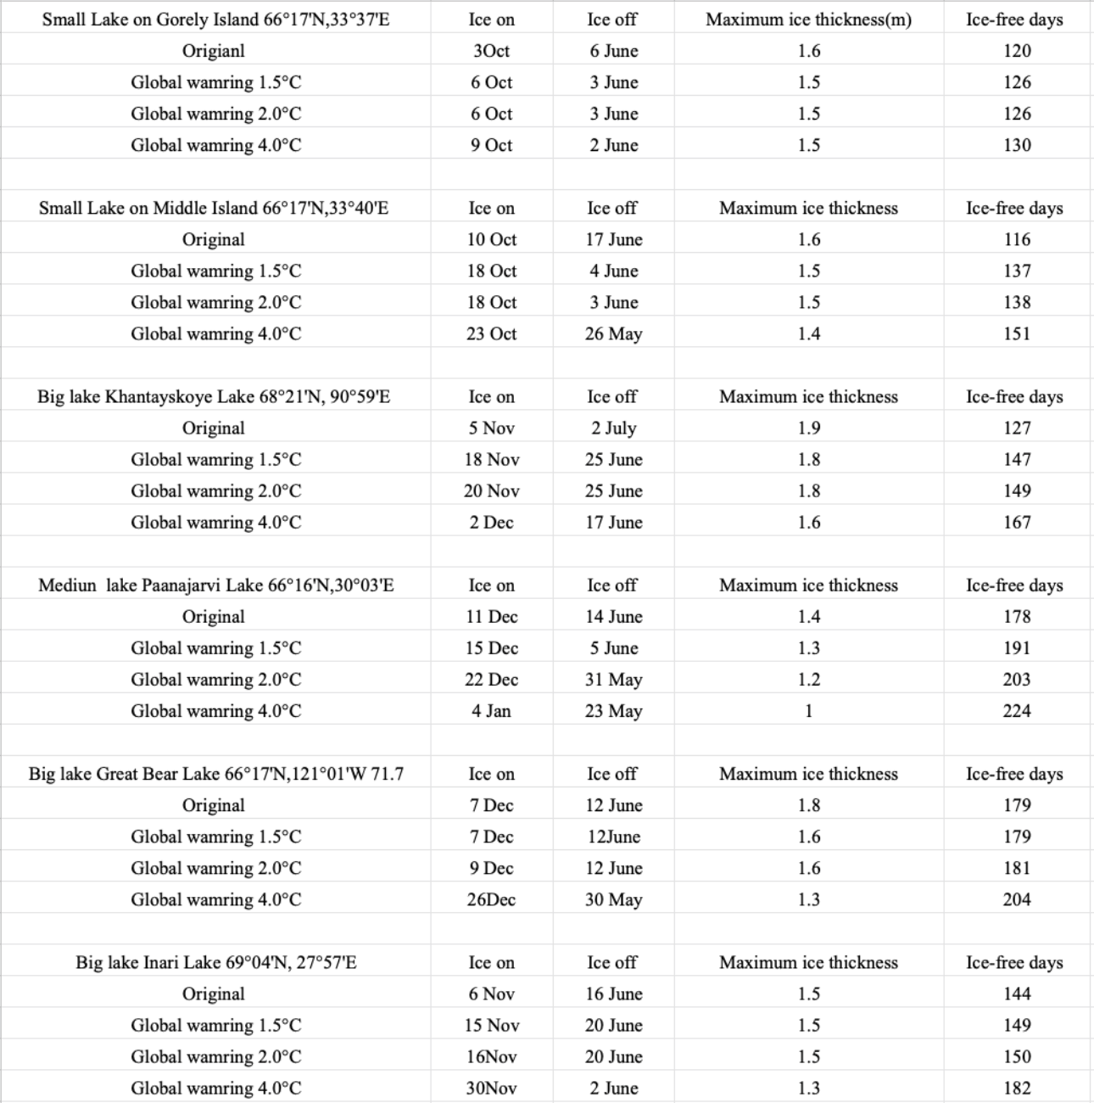

Table 9 Results of Ice off , Ice on, Maximum ice thickness and Ice free days under different simulation climate scenarios .

# **5 Results and discussion**

# 5.1 Lake mean temperature change trend under climate change

From the results of Flake molding about the mean lake temperature change , It shows the mean temperature increase with the mean air temperature . Lake 1 on Gorely Island had the highest mean tempeartue change from 23°C to 24°C due to the global warming of 4°C . Lake 2 on Middle island had the highest mean temperatue nealry 22°C increase to 24°C due to the global warming of 4°C. Lake 3 Khantatyskoye lake's highest mean temperature increases from nearly 4 °C to nearly 6 °C due to the global warming of 4°C. Lake 4 the Paajarvi lake the mean temperature increases from 7 °C to nearly 10 °C due to the global warming of 4°C

Lake 5 Great Bear Lake's highest mean temperature increases from nearly 5°C to nearly 7 °C due to the global warming of 4°C. Lake 6 Inari lake the mean temperature increases from 10 °C to nearly 14 °C. The largest change in mean water temperature is the lake 6 Inari lake increase 4 degrees

**5.2 Ice on**

According to modeling results, Arctics are responding raapidly to climate change , the physical responses of most obvious change are increased mean temperature and the loss of ice thicknesses, and the change of the ice-free day . A small lake and shadow lake in winter time quickly froze, then a deep and big lake (Table 9) Small lake on Georrely Island and Middle Island start freezing on 3rd October but other big lakes start freezing in November and December. The trends in freeze date are becoming later as the climate change , the small lake on Gorely Island froze on 3rd October in 2015 but under the global warming 4.0°C the freeze date prolongs to 9 October compared to the real situation frozen on 3 Oct in 2015 winter , nearly ten days prolong The frozen date also prolongs 13 days of the small lake on Middle island as the global warming 4.0 °C . The big lake of Khantayskoye lake freeze date changes a lot compared with the change of small lake , the freeze date prolongs 27 days. The medium lake of Paajarvi lake experiences 25 days prolong to freeze. The Great Bear Lake prolongs 19 days to freeze and Big lake of Inari prolongs 24 days to freeze from 6th Nov to 30 th Nov.

# **5.3 Ice off**

The break ice day ealier than before under the climate change , small lake on Gorely Island lake break date from 6 June to June 2 , 4 days earlier as the climate change (from the simulation results from 2015 to global warming 4 °C simulation results . The small lake on Middle Island ice off date early 17 days as the global warming 4.0°C , the Khantayskoye Lake also experiences earlier ice break up 15 days , the Paanajarvi lake break up at 24 May under global warming 4°C and 14 June ice off, the date is earlier 22 days as the climate change. The Great Bear Lake ice off on 12 June , after simulation the date changed to 30 May , 12 days earlier . The Inari Lake ice off day from 16 June to 2 June , 14 days earlier . Freeze and breakup dates of ice on lakes and rivers provide consistent evidence of later freezing and earlier breakup around the

# 5.4 **Ice thickness**

The lake ice thickness becomes thin due to Global warming , the small lake on Gorely Island thinner 0.2m . Lake on Middle Island 0.2m thinner , Lake on Khantayskoye Lake 0.3m thinner , Great Bear Lake 0.6m thinner , Inari Lake 0.2 m thinner compared results from global warming 4 °C to original results from 2015 Global warming decreases the lake ice thicness of big lakes more than small lakes .

# **5.5 Ice free day**

Ice free day aso increase in both 6 lakes, Lake on Gorely Island ince free days form 120 change to 130d ays , Lake on mIddle island change from 116 days to 151days , Khantayskoye lake change from 127days to 169 days , Paanajarvi lake ice -free days change from to 178 to 224 days , Great Bear Lake change from 179days to 204 days ,Inari lake ice free day change from 144 to 182 days . The general trend shows positive correlation the biggest change happens in a medium lake Paanajarvi Lake 66°16'N,30°03'E, the Ice -free day from 178 days the historical modeling results in 2016 change to 224 days under the global warming 4 °C, 46 days longer than the original results . The maximum ice thickness is also thin from 1.4m to 1 m . Other lakes have the same trend with lake Paanajurvi lake .

# **6 Conclustioon**

# Climate change is an inescapable fact that will happen in the near future , I use the 1 dimension modle to simulate mean temperature , ice thickness and ice-free period under four climate scenarios , the history results and global warming1.5°C , global warming 2°Ç and global warming 4°C . The results show as the global warming increase the mean temperature in arctic lake also increase . Lake ice has been shown respond to climate also .

# **Acknowledgements**

Firstly, I would like to thank my supervisor Dr. Irina Viktorovna who gave me the opportunity to work on this exciting thesis. I gratefully acknowledge her support and encouragement during this project, without which I would not have been able to complete this master thesis . I also would like to express my deep and sincere gratitude to my co-supervisor Dr. Sefen for Patiently answered all questions,which inspired me and gave me confidence. I am overwhelmed and deeply humbled by both the expertise and dedication shown in countless meetings we had to convert our ideas into something concrete. Special thanks also go to Smagin Roman Evgenievich who helped me to gather the geographic basic information on the island of Middle and island of Gorely Island in the Karelia region , Russia. It is really hard work. Never would I have imagined to find in this master’s program such caring and supporting fellows,who became very dear to my heart.

# Reference

[1]Lisette, N., Domis , D, S., Mooij, W.M., HUisman, J.2007. Climate-induced shifts in an experimental phytoplankton community: a mechanistic approach. Hydrobiologia, 584: 403–413

[2]Zdorovennova,G., Palshin,N., Golosov,S,. Efremova,T,. Belashev,B., Bogdanov,S., Fedorova, I., Zverev, I., Zdorovennov, R., Terzhevik, A. 2021. Dissolved Oxygen in a Shallow Ice-Covered Lake in Winter: Effect of Changes in Light, Thermal and Ice Regimes. Water ,13: 2324.

[3]IPCC, 2021: Summary for Policymakers. In: Climate Change 2021: The Physical Science Basis. Contribution of Working Group I to the Sixth Assessment Report of the Intergovernmental Panel on Climate Change [Masson-Delmotte, V., P. Zhai, A. Pirani, S.L. Connors, C. Péan, S. Berger, N. Caud, Y. Chen, L. Goldfarb, M.I. Gomis, M. Huang, K. Leitzell, E. Lonnoy, J.B.R. Matthews, T.K. Maycock, T. Waterfield, O. Yelekçi, R. Yu, and B. Zhou (eds.)]. Cambridge University Press, Cambridge, United Kingdom and New York, NY, USA, pp. 3−32, doi:10.1017/9781009157896.001.

[4]Jeppsen,E., Meerhoff,M., DavidsonT.A., Trolle,D., Sondergaard,M.,Lauridsen, T,L.,Beklioglu, M., Brucet, Sandra., Volta,T., Gonzalez-bergonzoni,I., Nielsen, A.2014.Climate change impacts on lakes: an integrated ecological perspective based on a multi-faceted approach, with special focus on shallow lakes.*J. Limnol., 2014; 73(s1): 84-107*

[5]Missaghi, S., Hondzo,M., Herb W. 2017 Prediction of lake water temperature, dissolved oxygen, and fish habitat under changing climate,Climatic Change.141:747–757

[6]Magnuson, J.J., Robertson, D.M., Benson, B.J., Wynne ,R.H., Livingsonte, D.M., Arai, T., Assel, R.A., Barry, R. G., Card, V., Kuusito,E., Granin , N. G., Prowse, T. D., Stewart, K. M., Vuglinski V.S.Historical Trends in Lake and River Ice Cover in the Northern Hemisphere, *Science* **289**, 1743-1746 (2000)