Federal State Institution of Higher Professional Education

Saint Petersburg State University

Graduate School of Management

**Foreign Market Entry Strategy   
for Promease Software Company**

**Bachelor Thesis**

Bachelor thesis

of the 4th year student of bachelor program,

International Management,

Vladlena A. Khabibulina

**Signature**



Scientific advisor:

Associate professor at the department of Strategic and International Management  
Olga L. Guaranine

Saint Petersburg

2022

Statement of Substantial character

of the Term paper

I, Vladlena A. Khabibulina, a student of the 4th year of Graduate School of Management of Saint Petersburg State University (International Management), confirm that there are no elements of plagiarism in my individual bachelor thesis called “Foreign Market Entry Strategy for Promease Software Company” which is prepared for public defense in June 2022.

All direct references from printed and electronic sources as well as from presented earlier course projects and graduate works, candidate and doctoral dissertations have corresponding references.

We are informed of the existing regulation of educational process in the Graduate School of Management SPbU, according to which plagiarism detection (direct borrowing from other sources without the corresponding references) is the basis for assessing the annual term paper with the grade “unsatisfactory”.



(Student’s signature)

June 1st, 2022



**Table of Content**

Introduction 4

Chapter 1. Company and Industry Characteristics 6

Company’s background 6

Company history 6

Organizational structure 7

Business model 7

Customer experience 10

Resources and Competences Analysis 14

Current market situation on Russian market 16

Managerial problem 17

Chapter 2. International Market Selection 20

Theoretical background for selection the IMS model 20

Comparison of potential markets 21

Pre-selection 21

Preliminary screening 23

In-depth screening 26

Final selection 31

PESTL 39

Porter’s Five Forces Analysis 43

Chapter 2 conclusion 45

Chapter 3. Strategic Recommendations 47

International market entry mode selection 47

Strategic recommendations 49

Technological partnership 49

Direct sales 57

Comparison of the direct sales and technological partnership effectiveness 64

Financial part 65

Conclusion on Chapter 3 66

Conclusion 67

Reference list 69

# Introduction

In the era of globalization more and more companies have an opportunity to operate not only on domestic market, but also enter foreign ones and expand there. Number of opportunities for internationalization increases as the technology development speed becomes higher. What was not possible a decade ago, today is an ordinary thing. Almost every part of the world is connected to each other, the information interchange is enormously fast. The availability of relevant information, possibilities to conduct research, connect to potential clients/partners/suppliers, deliver opportunities and many other factors allow companies to enter foreign markets much easier than it was before. Thus, new markets open for a big number of companies is now not a distant dream, it is a part of its strategic development.

There could be different reasons why a company chooses entering new market way of development. From the one hand, it can be realization of maximum potential on the current market, and in attempts to find new opportunities, the company enters foreign markets. From another hand, market maturity plays a big role in potential realization. At current moment a product offered by a company can be considered as a froward-thinking one on the home market, thus, the company starts to find new markets, where the product will be up to date.

It is market non-maturity makes Promease Software company try to find other markets for their product offering. Promease Software company is software developer, and a representative of process mining market. Process mining is a technology for business process analysis that, simply speaking, allows companies to analyze business process, create its digital copy, and then make solutions on business process optimization.

Thus, **relevance of the paper** is justified by early development stage of process mining market in Russia, readiness to implement this technology and the perception of process mining as a practically oriented tool. The Russian market growth is rather slow, and the sell cycle is long. Promease Software has already provided the software service to a number of large clients in Russia, and now aims to enter a market where demand for process mining technology is higher.

This bachelor thesis paper is a consulting project.

**Goal** is to develop a set of recommendations on a foreign market entry strategy for Promease Software.

**Objectives:**

1. To overview the company’s background
2. To make resources and competences analysis
3. To overview current market situation in Russia
4. To overview theoretical background for selection the IMS model
5. To make comparison of potential markets
6. To make selected market analysis
7. To analyze and choose a foreign market entry mode
8. To develop a set of strategic recommendations on the foreign market entry
9. To indicate risks related to the chosen foreign market entry mode

**The object –** Promease Software company; **the subject** – foreign market entry strategy development

Among the **tools** applied for analysis and strategic recommendations development are:

* Business Canvas
* Key Success Factors
* Context-specific model for international market selection (Johansson’s model)
* CAGE Analysis
* PESTL
* Porter’s 5 Forces Analysis
* OLI Framework for market entry mode choice

The following paper is divided into three chapters. The first chapter gives the information on company’s background, its history, organizational structure. For Promease business model description, Business Canvas is used. The Promease Software product description is also included in the first chapter, as well as resource and competence analysis and current Russian market situation.

The second chapter is devoted to international market selection and analysis of the chosen market. In this part, the international market model is selected, then according to it market for entrance is chosen. Then, applying PESTL and Porter’s 5 Forces Analysis the chosen market has been analyzed.

The third chapter is about strategic recommendations development. In the beginning the market entry mode is chosen based on OLI model, then the set of strategic recommendations and risks related to them is developed. Then, the conclusion of the bachelor paper thesis is done.

The resources of information used in the paper are secondary resources. They are market research reports, theoretical papers, statistics, websites. The reference list in the Reference list part in the end of the paper.

# Chapter 1. Company and Industry Characteristics

## Company’s background

### Company history

Promease Soft is a company-developer of process mining solutions for businesses. Based on the organization data, these solutions aimed to assist client companies in reconstruction and examination of real business processes digital copies. It includes creation of the process digital copy, analysis of process behavior, auditing of deviation, and predictive analytics. The Promease Soft solution is included in the Russian registry of ECM software.

In the second half of 2017 the initiative research of mathematics base of process mining was conducted. Then, after the process mining software market monitoring and research on functionality of academic and commercial process mining products, the preliminary test of Russian market was made. The test was conducted on the base of partner organization, Institute of Management, Innovation and Business, in the form of expert interviews with clients of the institute. After that, the research continued, in 2018 there were two deep research on cluster solutions ProM functionality, and Celons functionality. That time, the first technical enquiry for program design and development was made.

The period of pilot projects began in the second half of 2018. The first pilot project was consulting project on extraction and analysis of business processes. The procurement process in large state organization was analyzed. After that, two more pilot consulting projects on logistics and production were accomplished. Simultaneously, educational module on process mining was developed and included in the educational program of IMIB. In the end of 2018, the first prototype of company’s own software was developed.

In the first half of 2019, the software development continued. Besides, this year was marked by participation in large consulting projects as a chief of analytics and consultants’ group. The Promease solution was included in the Russian registry of ECM software. In 2020, MVP of the digital platform for automated extraction and business processes analysis based on process mining technology was developed. The first financing round, seed round, was made in the second half of 2020, the money was raised from private investors. Moreover, the company won the grant of the Innovation Promotion Fund. Then, the agreement with Gazprom EP International on program industrial test was made.

2021 - the sustainable release of the Promease 2.0 and release with auditing and advanced filters were launched. New pilot projects were launched for machine-building enterprise and for high-street private bank. Also purchased system forming began. Several demo-events for partners in Chile, Czech, and Netherlands were hold. In 2021, the Promease software was registered as ECM program in Federal Agency of Intellectual Property.

Since the beginning of the Promease software development in 2017, the company made a big progress not only in terms of technological side of the software, but also from the side of product implementation in real-life conditions:

* Six pilot projects in the period of 3 years. The Promease solution was applied in different industries: the procurement in large state organization, logistics and production, consulting, banking, and machine-building.
* In terms of promotion, the Promease was able to establish partnership with Gazprom EP International, hold events for partners abroad.
* Considering investments, in 2020, the company was able to attract fundings from private investors, as well as to win the grant of the Innovation Promotion Fund.

### Organizational structure

The Promease company is a representative of small business. The organizational structure is formed in the way that competences on key solution algorithms are inside the company, they are co-founders’ responsibility, while realization of different technical task is outsourced.

Its organizational structure consists of three management team members, co-founders:

* CEO – who is responsible for: strategic management, administrative, organizational, and legal aspects, and communication with partners and investors.
* CTO – responsible for strategic management, research and development, communication with partners and investors.
* CMO – responsible for organization and support of customer relationship, commercial policy development, methodological support of Promease implementation, educational and academic programs realization, Promease ecosystem development.

On the current stage of company’s development, this structure is reasonable, as all the tasks are spread across its co-founders. Co-founders are also responsible for key competences on solution algorithms, to keep the technology uniqueness. All the technical tasks are outsourced, it helps to minimize costs on payroll for different specializations employees, the need for them is justified by the product specificity. As the company will grow, the staff number for sales, R&D, commercial departments will also increase.

### Business model

To describe the business model of the company, the Business Canvas framework is applied.

*Key Partners*

One of the Promease partners is the Institute of Management, Innovation and Business[1]. It is an autonomous non-profit organization for advanced professional education. This institute realizes educational courses on organizational management, optimization of processes and production systems. Promease established a partnership with this organization to develop its own educational courses of Promease software implementation in various business spheres – auditing, consulting, and deep process analysis. Besides, by establishing partnership with the institute, Promease is able to preliminary test Russian market and conduct research based on interviews with representative of different businesses.

Another important partner of the Promease is Gazprom EP International. It is the operator of Gazprom EP projects abroad, headquartered in Amsterdam, Netherlands. The Corporate Service Center is based in Saint-Petersburg, Russia, it provides advisory support to the companies of Gazprom EP International B.V. Group.[2] The partnership between Gazprom EP International and Promease Soft was established for experimental-industrial test of Promease on the Gazprom EP International platform.

Development of partnership with companies abroad has been started in the second half of 2021. As of now, it is not accomplished, but the process continues.

*Key Activities*

The main activity of the company is to provide various enterprises with Promease software and gain profit for it. Nevertheless, to achieve this, a set of supplementary activities exists. First of all, it is research and development, to continuously improve the product, make new releases of it, and be up to date in circumstances of technological race. Not less important are marketing activities that include pricing, promotion, partnership establishing, to increase the awareness of target audience about the Promease product. The third is educational courses creation, that as well can be partly related to marketing activities, as the main aim of it is to enable potential customers to learn in what spheres they can apply it and learn how to use the software then.

*Value Proposition*

The Promease value proposition is to make easier and cheaper management task related the process analysis and optimization, thus, to provide clients with utter cost advantage. The cost advantage includes:

* the decrease of the salary fund
* the decrease of general expenses of production and general business expenses
* the decrease of the production cycle
* the decrease of the number of mistakes in business processes
* optimization of the workload on structure divisions
* optimization of supply chain
* the increase of the quality of forecasts and planning.

*Customer Relationship*

A variety of channels are used to communicate with customers. The main one is face-to-face communication, as the standardized answers via customer support are not appropriate for such type of product. Another way is email, that is indicated on the company website. The third way is communication during the educational courses, as the attendants of these courses are existing or potential company’s clients.

*Customer Segment*

The Promease customer can be any enterprise, there is no particular industry where the enterprise should operate, as well as no particular type. The software technology is universal and can be applied in any organization that use information technologies for running the business. However, the data on the international experience shows that the main industries where process mining is applied are banking, telecommunications, retail, manufacturing, consumer sector.[3] Moreover, the price of the Promease software application is the issue that influence the target audience choice. The price varies from 10mln to 20mln rubles ($100 000-$200 000)[4], thus, the customer should be able to invest this sum of money in its process development.

*Key Resources*

Among the company resources are intangible assets – software, key technologies, educational methodology, courses, and people.

*Distribution Channels*

The first distribution channel is the website and educational programs of Institute of Management, Innovation, and Business, where the process mining courses can be promoted. Another channel is events that are hold in partnership with different enterprises, where the test period on process mining analysis is offered. The next way is the partnership license agreement, where the partner is rewarded with 25% from the price of license provided, among such partners are big software integrators.

*Cost Structure*

Main expenditures are devoted to expenditures related to instant investments in IT development of the software, it also includes payments to outsourcing companies for various technical tasks. Another part of expenditures are costs for development of methodology of educational courses and conducting the courses themselves. Also, expenditures on events organization can be included in cost structure.

*Revenue Stream*

The Promease Soft revenue is mainly generated from the selling Promease software as a service to the high-end consumer. Besides, licensing provision is also a revenue stream. As well as participation in consulting projects.

### Customer experience

Potential customer can be informed about the product through business events, advertisement, word-of-mouth. The Promease software is not the product to widely advertise, it is more about general trend in business sphere, as well as company’s maturity and financial readiness. There are four ways of interaction with the Promease software after a customer gets interested in it. They can be divided into two categories. The first one is when the customer does not interact with the software by himself. It can be:

* pilot-project – in case the client wants to ensure that the Promease solution fits to its data type, so that “proof-of-concept”
* the client obtains license and hire consulting company to work out the data, analyze it, and obtain results

Another category implies the client to work with the system by himself. There are two possible variants:

* the client obtains the license and then works out the data, analyze it, and obtain results by himself
* the way when the client’s employees go to special courses to learn how to correctly work with the system

As we can see, there are a plenty of ways for any type of customer, the choice depends only on the level of customer’s competence in process mining, and the desire to outsource or to work by himself. Regardless the way choice, the interface stays the same, the difference is only in the person who operates the data, is it a client or a third party – consulting, Promease, etc. In case of self-service, the customer will work with following functions.

1. After the program is turned on, the client can see the main screen with upper menu and main working space, where the graph process (process model) is presented. It is also called “happy pass”, the most frequently happened first and last event with the most frequent transition process from first step to the last. The main screen is presented on the Figure 1.

Figure 1. Promease Main Screen

1. On the main screen the user can also open a side bar (Figure 2), where the bulk of referral

information is placed. In the bottom part of the screen (Figure 3), it also possible to set the frequency of steps and transitions. There are:

* cases – example of the process,
* unique steps in the journal,
* median process length,
* average process length,
* period,
* variability of the process (whether the process is stable or not)

Figure 2. Side Bar

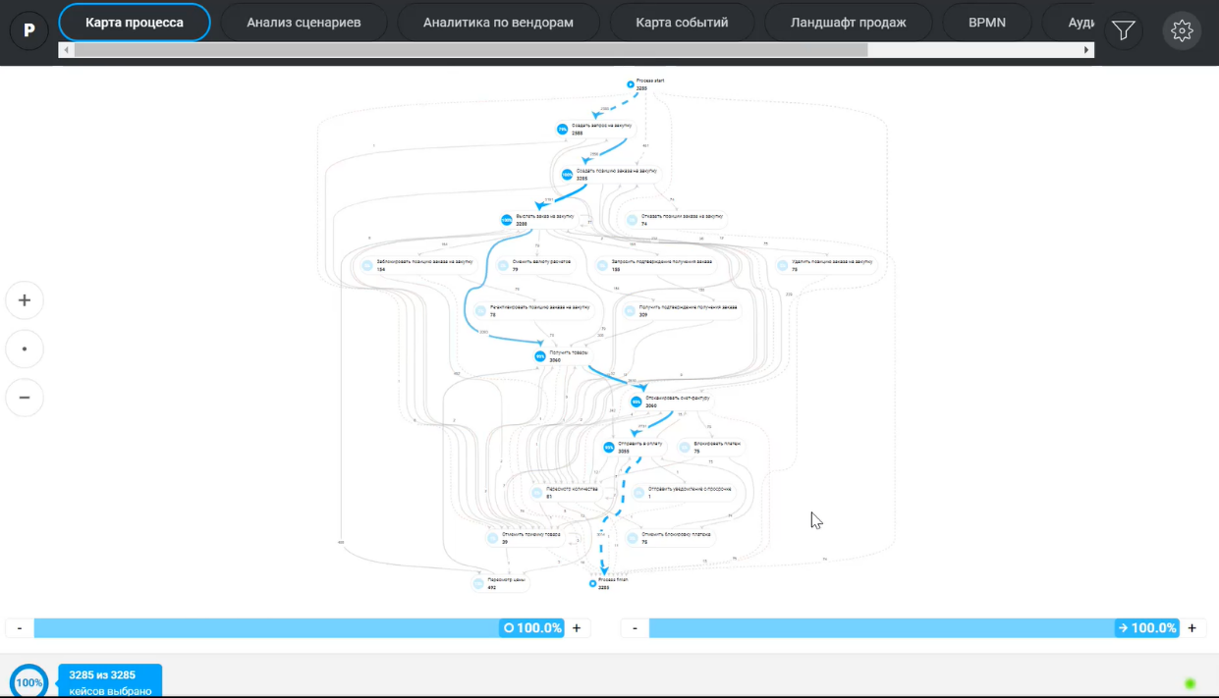

Figure 3. The Process Variety

1. After the main screen, the user shifts to the scenario analysis page (Figure 4). The system there presents the variability of the process in terms of its structure and the scenario range (from the most to the less frequent ones).

Figure 4. Scenario Analysis

1. To see additional data for enrichment of the process journal, the analytics page is presented. On the Figure 5, the vendors’ analytics example is presented. Then, the user can see the process map (Figure 6). It is a scatter plot that used to check whether the process is proportionate, or not. On the X-axis – the timeline is placed. On the Y-axis – cases, or process examples. The plot represents particular case.

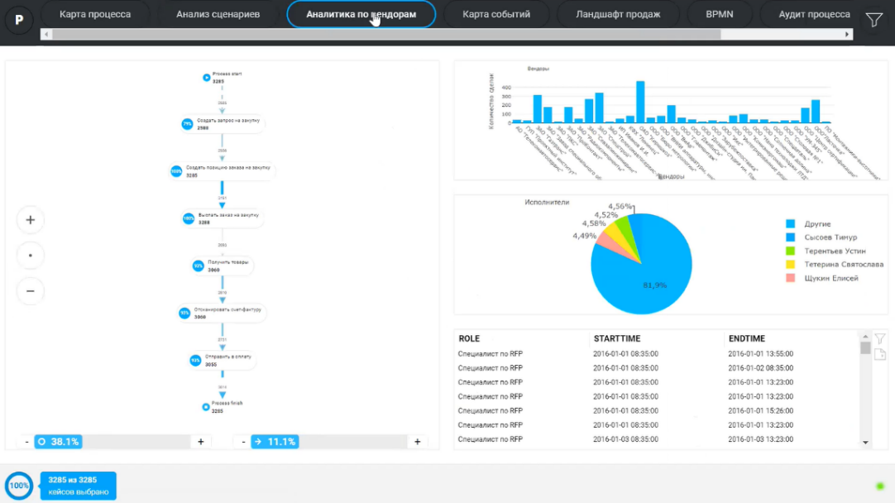

Figure 5. Vendors Analytics

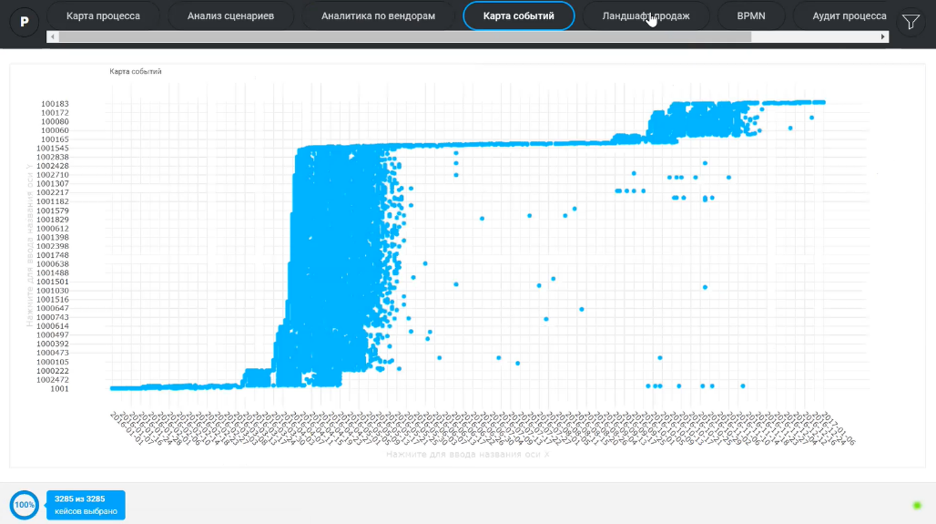

Figure 6. Process Map

1. To achieve the better process visualization, the user can open the page landscape (Figure 7). It is an analytical representation of the process.

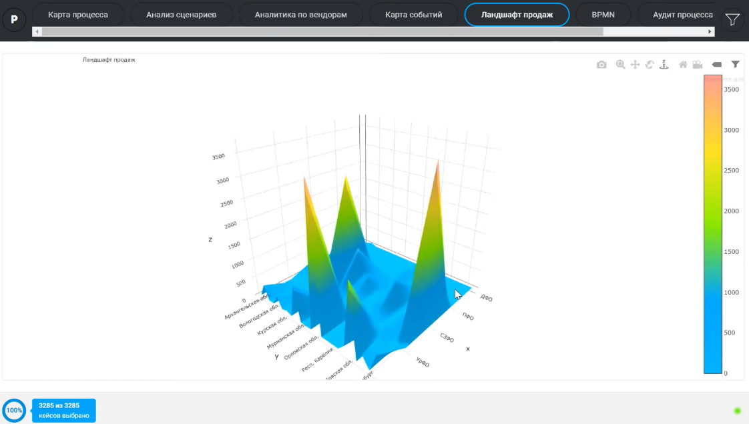

Figure 7. Page Landscape

With the set of above represented functions, the customer can work with the company data, analyze it, and achieve results. The interface of the program is user-friendly and easy to understand, the complexity of the analysis increases as the amount of data increases. The dashboards, plots, graphs, and schemes are developed in the way to make it easier for user to visualize the process of the entire company activity.

## Resources and Competences Analysis

Keysuccess factors are necessary for understanding for resource and competences analysis of Promease Soft. Most of the process mining solutions have all the basic functions; however, the depths and breadth of these functions may vary from one developer to another. There are success factors for process mining industry[5]:

1. *The Technology Sophistication* – set of solution features should be as wide as possible, the software tools should fit to different industries’ requirements that based on horizontal and vertical processes, compliance requirements, the size of user company. It also includes the number of successful large-scale deployments. Sophistication of the software should also include dynamic visualization, security, technology integration, process analytics, ease of deployment, reports, analytics.
2. *The Breadth of Use* – the capability of the software to support a wide range of organization- and industry-specific cases of use. It means that the software should be advanced in mining-related use cases. Among them are quality management, process optimization and discovery, conformance checking, process specific KPI monitoring, etc. The software can also be used in different departments – finance, marketing, IT, sales, HR, purchase, supply chain, customer support, and other. Moreover, the solution should be flexible, so that to be able to adjust to enterprise’s challenges and provide it with the customization.
3. *Integration* – seamless integration with client’s databases and systems for event logs capture. It is better when the software can integrate with analytics, reporting, and business intelligence technologies to make the KPI monitoring, analysis and reporting easier.
4. *Process Monitoring, Dashboarding, and Reporting* – ability of the process mining solution to offer sophisticated dashboards with a combination of BI and process mining tools. The user should have an opportunity to create interactive and intuitive dashboards for comparison of multiple processes using a number of statistics, metrics, multi-layered processes, models.
5. *The Sophistication of Process Simulation and Monitoring* – the essential factor that influences the effectiveness of the process mining deployment is a robust functionality for process simulation, monitoring, and optimization. It assists users in making what-if analysis and advanced scenario to get insights in estimation of costs, process optimization opportunities, resource planning and utilization, etc.
6. *Multi-Level Process Mining* – the ability of the software to map several complex processes in a single business process model. The comprehensive insights on each hierarchical level should also be provided for the process streamline.

Promease Soft company has following resources:

* *Technological*: Promease software, unique knowledge-intensive core technologies
* *Human*: management team, outsourced specialists
* *Financial*
* *Reputational:* partners, clients with pilot projects, client which obtain license

Promease Soft company has following competences:

* Provision of clients with advanced algorithm of process extraction and data filters – this is for support the speed-of-response while working with a big volume of data
* Strong consulting expertise
* Ability to develop knowledge-intensive and hard-to-copy algorithms

Among the competences of the Promease software are:

* *Competence of work with event logs* – import/export of xls, xlsx, csv files, data import from data base management system (DBMS), specific connectors and adapters, import master to create new data source, case attributes, events attributes, time marks, desktop for data source
* *Competence of process extraction*
* *Competence of basic filtration*
* *Competence of scenario analysis*
* *Competence of business analysis*

## Current market situation on Russian market

The survey of PWC and ABBY revealed that as the digital business-process analysis is young technology, management of companies in Russia has not gone deep into it yet and has not already realized its usefulness. The lack of public cases is one of the reasons for it. Only 31% of surveyed consider this technology is mature enough for implementation. The main factor that prevents from the technology implementation is non-maturity of the companies themselves, price is on the next place.[6]

More than 60% of companies do not consider the process mining technology properly adjusted for Russian market, also half of them does not even hear about successful cases of its implementation. Results of the survey is presented on the Figure 8.

*Figure 8. Technology maturity*

According to PWC survey, only 4% of companies in Russia use process mining on the daily basis. Approximately half of the survey participants is not going to apply the process mining technology at all. 30% - plan to start the pilot project in not less than 3 years[7]. The result of the survey is presented in Figure 9.

*Figure 9. PWC and ABBYY Research on Process Mining in Russia[8]*

Only oil and gas industry companies in Russia actively apply process mining technology – 75%.[9] The left is going to implement it in 3 years. 57% of banking industry companies do not intend to use the technology, as well as 47% of IT companies.[10] Results are presented on Figure 10.

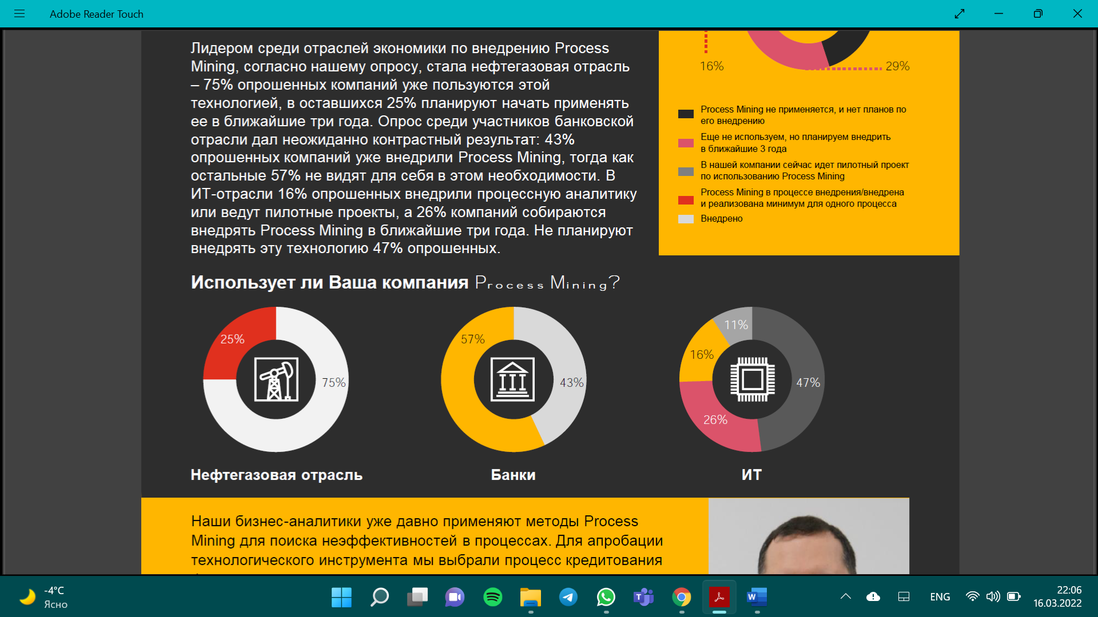

*Figure 10. Industries and process mining[11]*

The overall conclusion is that as of now, companies in Russia prefer traditional ways of process analysis, using special rules and instructions. Even facing up with difficulties during traditional process analysis, companies do not become more prepared for new technologies implementation. It is necessary to raise the inner trust to technologies which functions usually are in competence of administration.

## Managerial problem

The company set the task to conduct the analysis of potential international markets in order to select the one to enter with the Promease software and develop a set of strategic recommendations for entrance the market chosen. The reason for entering the international market is low level of development of process mining market in Russia. That is justified by following factors:

* More than 60% of companies do not consider the process mining technology properly adjusted for Russian market, also half of them does not even hear about successful cases of its implementation.
* Only 4% of companies in Russia use process mining on the daily basis.
* Approximately half of the survey participants is not going to apply the process mining technology at all. 30% - plan to start the pilot project in not less than 3 years

Meanwhile, the foreign process mining market situation is following. It is claimed that pace of process mining market growth is high and the technology itself is considered important for management of business processes. In the product lifecycle the process mining technology is in the final stage of early adoption, moving to rapid growth. It is forecasted that the market of process market licensing will reach $5.4 billion till 2024. It is tenfold increase in comparison with 2012 (Figure 11).[12]

*Figure 11. Forecast on the market of the process mining licensing*

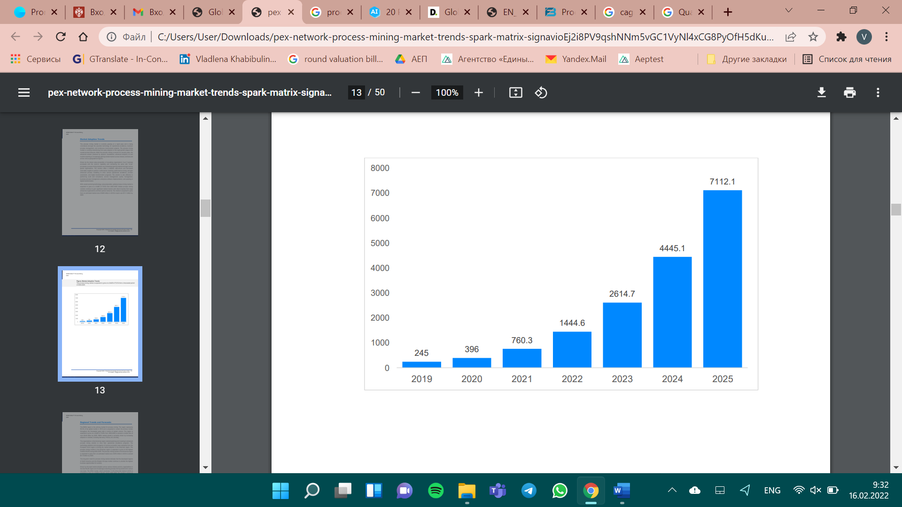The expected growth at CAGR is 75.3% up to 2025. The market size is forecasted to reach approximately $7 billion till 2025.[13] The market adoption trends statistics is presented on the Figure 12.[14]

*Figure 12. Market Adoption Trends Statistics*

Considering regional trends and forecasts, the EMEA region is a primary process mining market in terms of market volume due to increasing adoption of process mining solutions. This region is to represent 56.3% of the market in 2025, with market size of over $3.4 billion. Moreover, America’s region companies also started investing and implementing, the forecasted growth of the market is from $79 million in 2019 to $3.12 billion in 2025. In Asia-Pacific region the growth is driven by such countries as Japan, New Zealand, Australia, Thailand, and Malaysia among others.[15] Market forecast on geographical regions trend is presented on the Figure 13.[16]

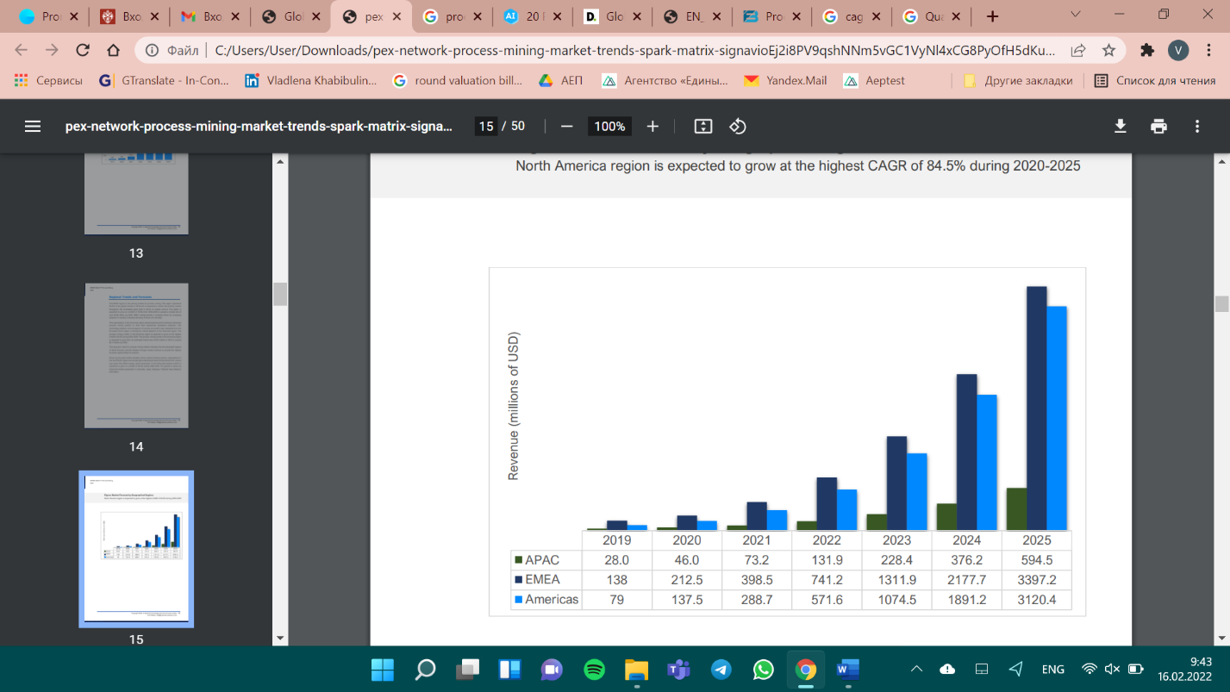

*Figure 13. Market forecast on geographical regions trend*

Due to these factors, it was decided to enter foreign market that is more developed at that moment according to information presented above. However, since the special operation of Russian Federation on the territory of Ukraine, several changes in political and economic situation happened. They are mainly related to sanctions against Russian Federation and companies originated in Russia. All these factors considered, it is necessary to choose such market that is both potentially profitable, and open for companies from Russia.

# Chapter 2. International Market Selection

In the previous Chapter 1, the background of Promease Software company, its business model, resources and competences analysis have been provided. Besides, the Russian process mining market and foreign process mining situation has been covered. In the end of the Chapter 1, the justification of Promease new market entrance has been described.

In the Chapter 2 we have covered the theoretical approach to IMS model selection. Then according to the chosen approach, the comparison of potential markets is provided. After that the selected market analysis is conducted applying PESTL analysis, Porter’s Five Forces Analysis. As a result of this Chapter 2, the new foreign market for entrance has been selected and its environment has been analyzed.

## Theoretical background for selection the IMS model[17]

Among various existing approaches on international market selection model, not all are appropriate for the company this paper devoted to. We consider several approaches with a purpose to determine the one fits mostly. They are approach by the Nordic School, the industrial network approach, and the context-specific approach.

The approach of the Nordic School proposes a model that restricts market selection by psychic distance and experiential learning.[18] Experiential knowledge is the knowledge received by personal experiments. The psychic distance means the deficiency of information and knowledge that leads to uncertainty in business actions. According to this approach the market choice is based on cultural, economic, and political closeness of countries. Nevertheless, this approach is relevant only to traditional firms, the reason is that the psychic distance explanatory power decreases more with the increase of consulting services, international HR, and IT.[19]

The industrial network approach was developed by International Marketing and Purchasing Group. According to this approach, the industrial system is the system of firms producing, distributing, and using goods and services, and relationships are established and maintained by them. The system consists of several parts: elements and processes of the interaction, the characteristics of buyers and sellers, atmosphere around the interaction, and environment where the interaction is conducted.[20]

Another approach considered in the paper is the context-specific approach. It includes a number of stages: preselection (sometimes not considered), preliminary screening, in-depth screening and final selection. On the preliminary screening a set of macro-level indicators are developed to eliminate those countries that do not fit company’s objectives. In-depth screening forms the short-list of countries based on their market attractiveness. Final selection selects countries perfectly matched objectives of the business.[21]

The selection process in this term paper is based on the context-specific approach. Taking into the current economic and political situation in the world, there is no possibility to consider the whole world as the potential market. To eliminate countries that cannot fit business objectives, it is convenient to apply the scheme of the context-specific approach. Other models are not as useful, for example, it is not enough to consider only psychic distance in the approach of the Nordic School. The approach of International Marketing and Purchasing Group is quite close to the project specificity; however, the structure of the context-specific approach fits the projects’ requirements more.

## Comparison of potential markets

Within the international market model selection, we have chosen context-specific, or Johansson’s, approach as a model for international market selection. According to this approach, the process of market choice is divided into four parts. The first part is pre-selection, within this stage we have eliminated those countries that completely do not fit requirements for international market selection. The second stage is preliminary screening, at first, we have determined target customer industries, and then we have assessed countries according to highest potential demand of target customer industries. In the third step, in-depth screening, we have developed a set of criteria for potential market choice. We have taken into account technological development in the country itself and potential demand. Within final selection, fourth step, we have applied CAGE analysis framework to make the final choice. After the international market has been chosen, it has been analyzed using PESTL and Porter’s 5 Forces Analysis.

### Pre-selection

Due to the events happened in February 2022, it is reasonable to consider the pre-selection stage as a part of the chosen international selection model – context-specific. To put it shortly, since Russia started special war operation in the Ukraine, a bulk of countries, especially in European and American regions, issues sanctions against Russian Federation. As of April 2022, there are more than 6900 sanctions that were slapped by a big number of governments around the world.[22] The sets of sanctions impact different spheres including investments, import, export, banking, diplomatic relationships, business relations among them. Regarding this factor, the aim of the pre-selection stage is to eliminate those countries, where Russian companies cannot operate on the April 2022.

As of April, leaders by the sanctions issued are Switzerland – 1 103 sanctions, the UK – 1 098, European Union – 940, France – 931, the USA – 838, Canada – 729, Australia – 642, and Japan – 620.[23] On the Figure 14, the diagram on the number of sanctions issued is presented.

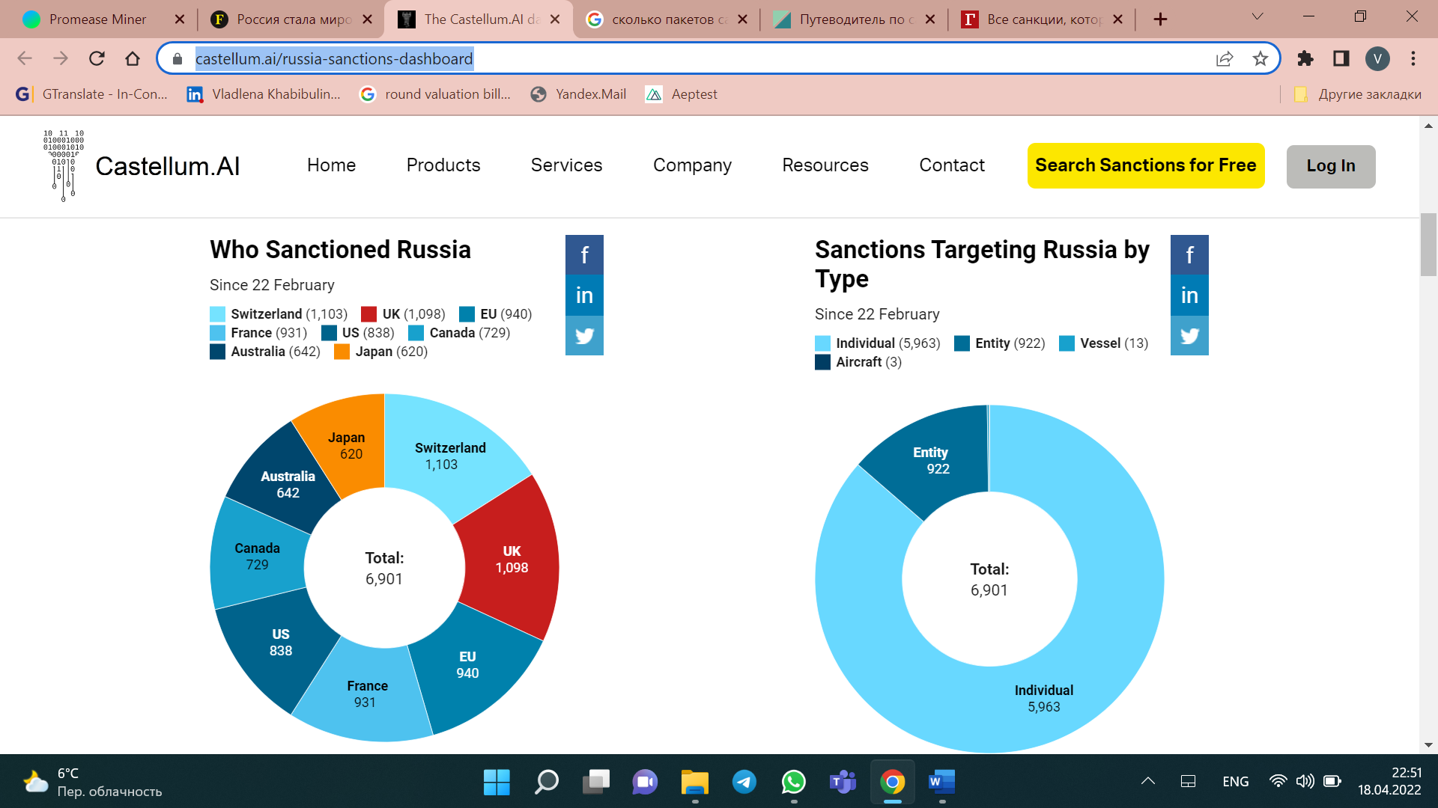

*Figure 14. Who sanctioned Russia (April 18th, 2022)[24]*

On the Figure 15, the graph on sanctions on Russia by date and country is presented.[25] It is seen that the first most powerful wave happened in the end of February, then number of sanctions issued day by day lowered. However, it is still fluctuating.

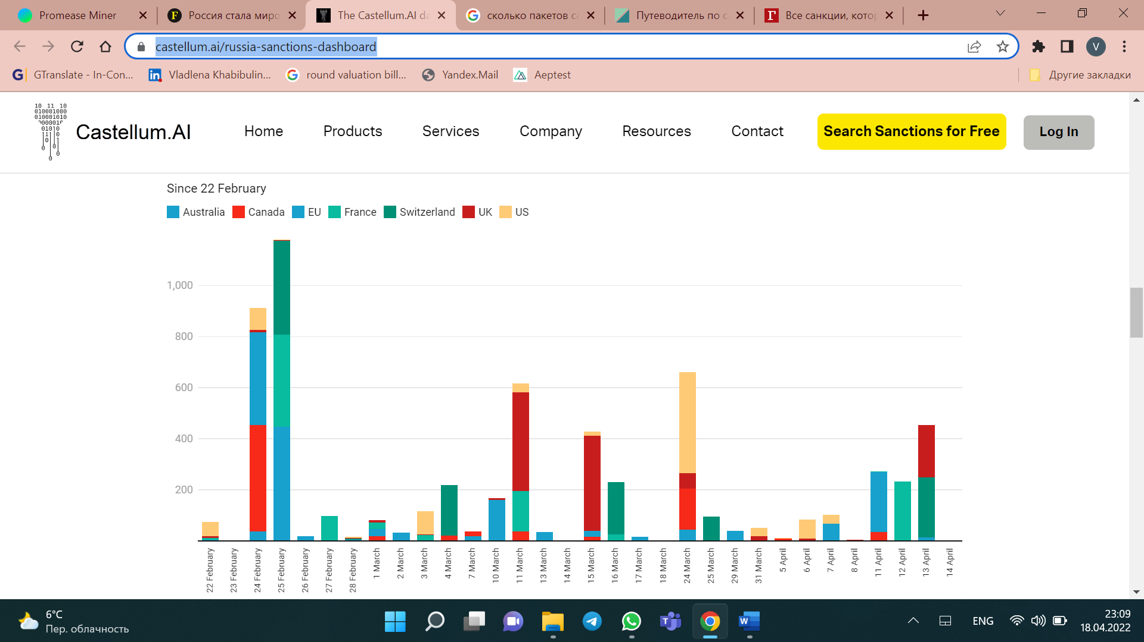

*Figure 15. Sanctions on Russia by Date & Country*

To get the full picture of countries sanctioned Russia, the map on Figure 16 is presented below.

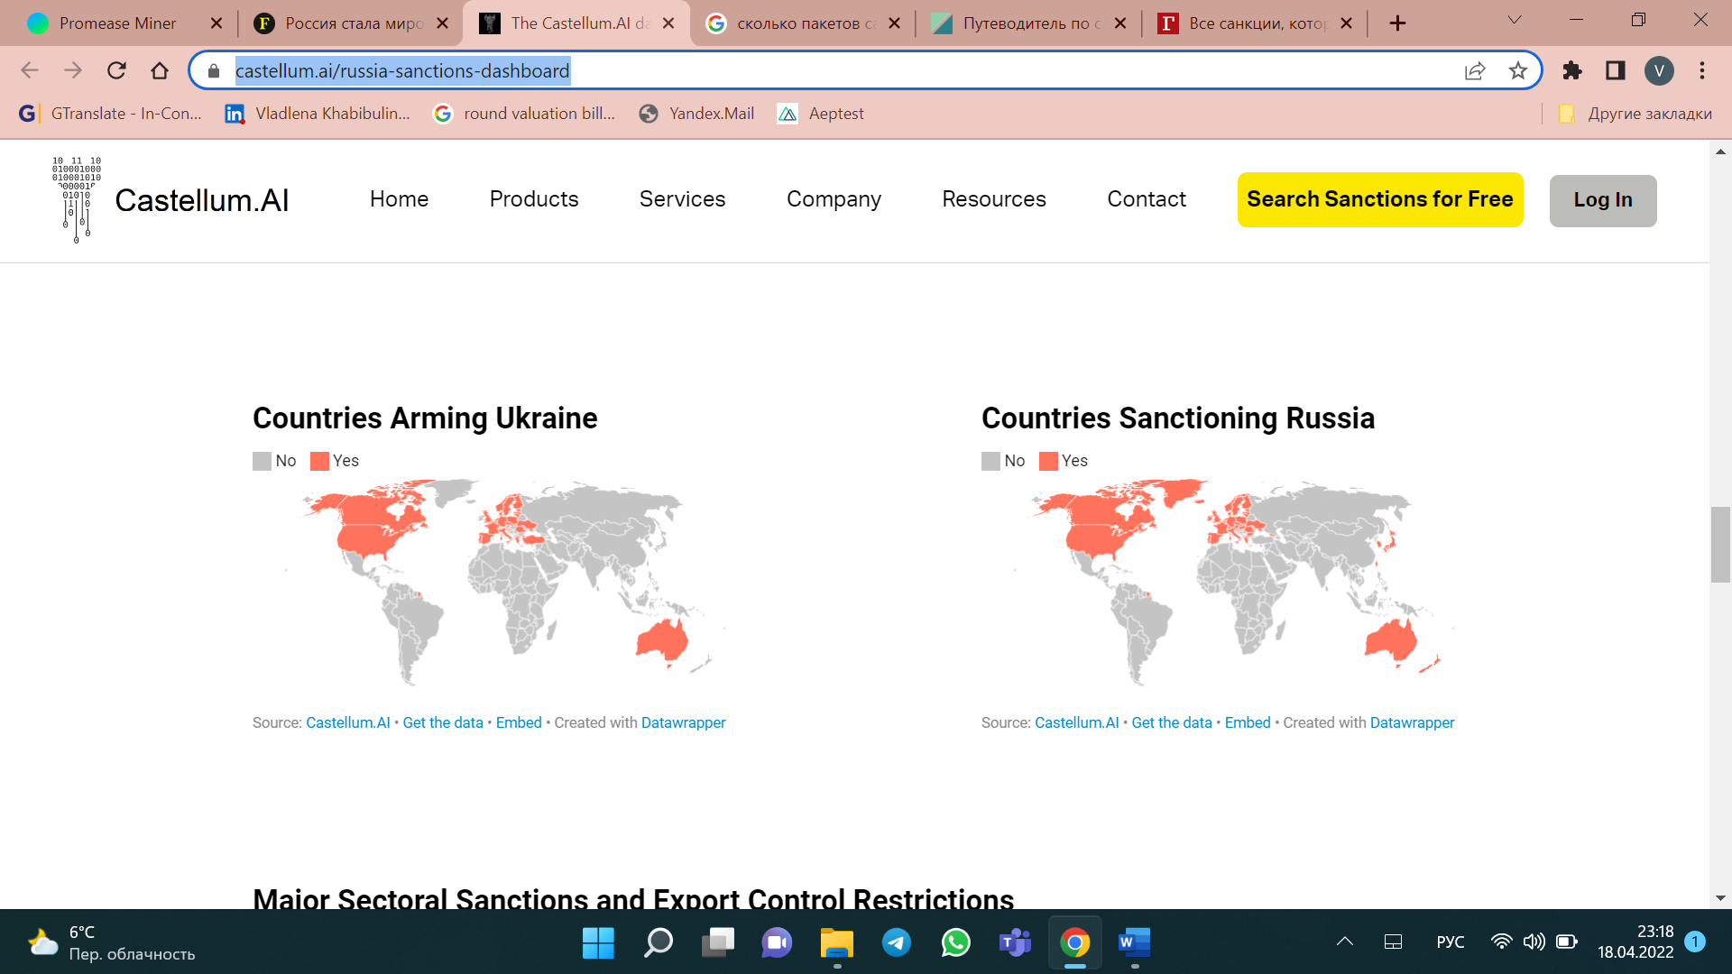

*Figure 16. Countries Sanctioning Russia[26]*

Taking into account current political and economic situation and being not ensure of what the next set of sanctions will include, it was decided to eliminate countries with not-friendly environment for Russian companies’ operations. Even if the sanctions will not be expanded and do not influence particular industry, sanctions related to the banking sector and business relations do not play in favor of business operating, as well as the environment and attitude towards Russians in this set of countries. To conclude, European Union, Australia, Japan, the USA, and Canada are excluded from the list of potential markets for international expansion.

### Preliminary screening

To begin with, it is important to consider global process mining market share by the end user, to consider those countries where the demand is the highest. Among sectors that are forecasted to implement process mining technology, the top list is following: BFSI (banking, financial services, and insurance), healthcare, retail, manufacturing, IT and telecommunications, logistics and transportation. The diagram is presented on the Figure 17.[27]

*Figure 17. Global Process Mining Software Market Share*

The BFSI is expected to become the most profitable sector according to the report.[28] The main reason for it is that process mining can help such organizations as banks deal with internal and external processes seamlessly. Moreover, updated regulations and compliances that are needed to be considered to keep the process smooth. Manufacturing is at the second place after BFSI according to forecasted process mining adoption. It can be explained similarly to BFSI sector since the process mining can provide measures and solutions for better quality. The justification of healthcare growth includes the increasing adoption of various devices, in this case process mining can assist in patient care improvement at reduced costs. Improvement in customer experience also has an effect on retail sector and its process mining application, for example it can help with customer’s waiting time reducing.[29] On the Figure 18[30] the forecasted growth up to 2028 is presented.

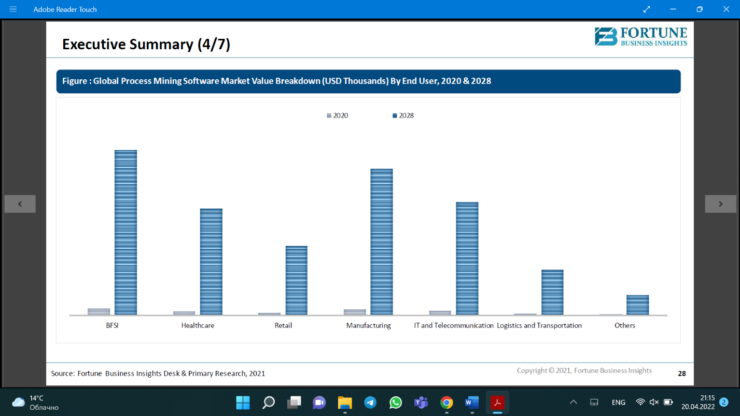

*Figure 18. Global Process Mining Software Market Value 2020-2028*

According to the report of Fortune Business Insights, geographical regions will experience the following growth. The highest growth up to 2028 is forecasted for the North America region – 51.8%, next is Asia-Pacific region with 50.2% growth. On the third place South America region – 48.6%. Then, Europe and Middle East and Africa with 47.5% and 46.4% respectively. The graph on the Figure 19 represents forecasted growth by regions.[31]

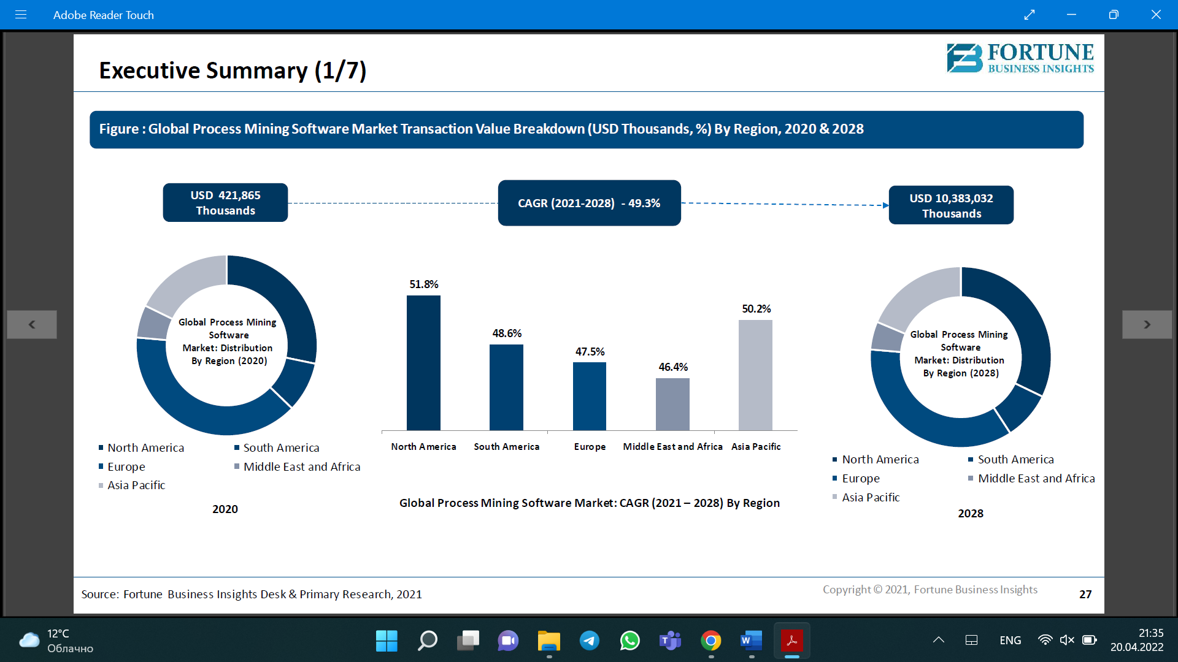

*Figure 19. Forecasted Growth of Process Mining Market, by regions*

Considering countries with the highest potential market, each region has its own top-list. North America includes – the USA on the first place, then Canada, and Mexico. For Asia-Pacific region – China, Japan, India, South Korea. South America – Brazil and Argentina. Europe – the UK, German, France, Italy, Spain. Middle East and Africa – Turkey, Israel, North and South Africa.[32]

Asit was mentioned above, in the pre-selection part, countries of the EU, the USA, Canada, Australia, and Japan are excluded from the list of potential markets for entering. Thus, this paper considers countries of Asia-Pacific region, South America, and Middle East and Africa.

Combining chosen regions with the industries where the demand is forecasted to increase, the list of countries with the highest demand for process mining by each region is compiled.[33]

* South America: Argentina, Brazil, Chile
* Asia-Pacific Region: China, India*
* Middle East and Africa: Turkey, Israel, South Africa

*Asia-Pacific: China, India, South Korea – no sense to enter the market with Russian software as they are the countries with highly protectionist policy towards technologies:

* Chinese government programs “Made in China 2025” aimed at domestic development, design, and production technologically advanced goods support.[34] “Buy Chinese” is aimed to support national producers in each sphere and motivate procurement of their goods and services.[35]
* Indian government programs “Make in India” aimed technology and innovations foster within the country, intellectual property rights protection and skills development.[36] “Startup in India” initiative was launched to nurture innovations in the country. Participants get Intellectual Property certificate, supporting funding, Income Tax Exemption for 3 years, etc.[37]

Thus, the list of countries for in-depth screening is following:

* South America: Argentina, Brazil, Chile
* Middle East and Africa: Turkey, Israel, South Africa

### In-depth screening

In this part we consider the regions according to criteria determined by customer portrait. As it was explained above, industries with the highest potential demand are BFSI, manufacturing, IT. We cannot neglect the technological maturity of industries in each of the countries. It means whether the industry is ready to implement such a technology in its processes and the level of technological progress in the country itself. Then, it is essential to mention that a potential customer needs to have enough resources to invest into the process mining implementation approximately $100 000-$200 000 (10-20 mln rubles)[38].

Thus, for this stage the following set of indicators is developed:

* Technological trends in industries
* Potential demand

South America

*Technological trends in industries*

South America is in the beginning of its technological growth; however, it is expected that the market will increase approximately 10 times due to open banking use of APIs and digital transformation facilitators. It is essential as API is used for applications integration; thus, this trend shows the desire of the market to become more and more digital. Increasing number of Latin America platforms and startups start using third-party service providers.

Previously this trend related mostly to financial and e-commerce sector, now, it goes further to insurance and marketing sector. Traditional companies such as banks, payment agencies, stock exchanges and insurance providers more and more collaborate with technological companies in attempts to digitize most of their operations. The reason is that the BFSI sector companies have their back-office infrastructure including an enormous manual efforts and cross-departmental coordination, when variety of steps are done by people, and it is hard to control each small action, thus it increases the risk unexploited customer data, transaction costs increase, and customer experience lowering. As of now, these companies tend to implement technology-based products to stay relevant with unique business models.[39]

Manufacturing sector is also marked with technological development. The infrastructures and technologies in the region are expected to be fostered during the fourth technological revolution. Due to the COVID-19, the economy becomes more and more dependent on the ability of the countries to increase efficiency and productivity; thus, adapt new operations schemes that relate to innovation, digitalization, smart production methods. Now, the aim is to provide countries in the region from digitalization acceleration. One of the examples of actions towards technological foster is a program that is developed by CAF and Deloitte, aimed to digitalize production sector in the region, consequently, boost its productivity.[40]

*Potential demand*

***Argentina***

BFSI sector – according to Moody 2021, the outlook of banking financial system has improved from negative to stable. Top 10 banks with net income from $6 billion to $30 billion.[41]

Manufacturing. Considering manufacturing sector, the GDP growth from manufacturing is forecasted, presented on the Figure 20.

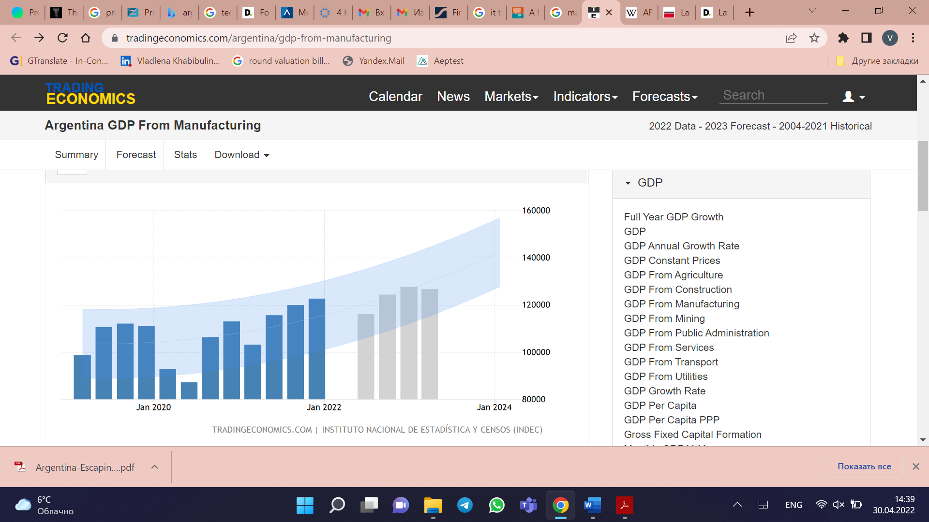

*Figure 20. GDP from manufacturing in Argentina forecasted[42]*

***Brazil***

BFSI sector – Brazil has more banking branches than any other Latin America country (approximately 20 000). Moreover, it is a headquarter for 2 most valuable banks in the region -Itau Unibanco and Banco Bradesco. Brazil is the largest country in Latin America by gross domestic product and by population, thus the banking sector there is the largest and the most sophisticated.[43]

Manufacturing production in Brazil experienced decrease since summer 2021 as it is seen on the Figure 21. However, it can play in favor of the process mining industry as it aims to optimize processes and lower costs.

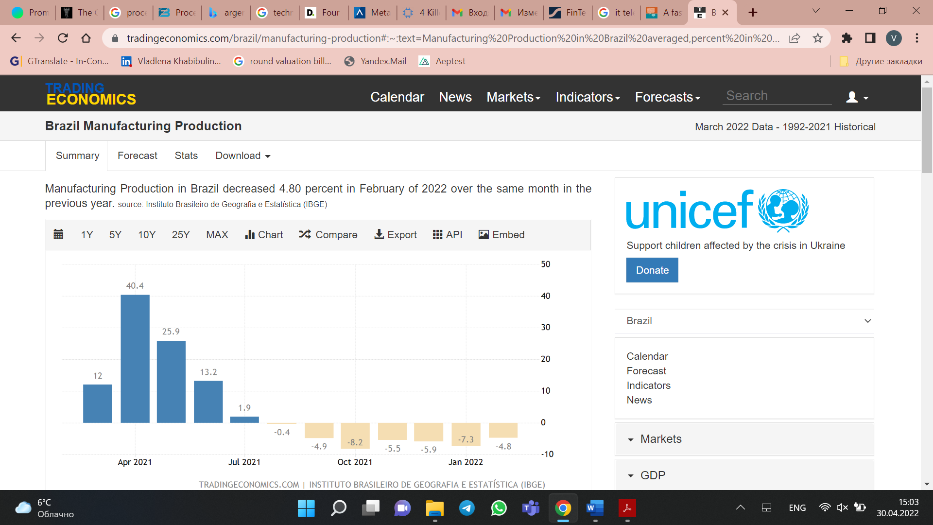

*Figure 21.* *Manufacturing production in Brazil[44]*

***Chile***

BFSI sector – banking sector in Chile is considered as a driver of growth and progress in Chile. The financial services part in GDP has constantly increased since the year of 2011, the number of deposit and savings accounts also grows. The trend to digitalization of bank is prevailed in the strategy of development, e.g., development of mobile banking, IT services, and payment methods management.[45]

Manufacturing sector in Chile has experienced fluctuations with tend do decline since October 2021. The graph is shown on Figure 22. However, it can play in favor of the process mining industry as it aims to optimize processes and lower costs.

*Figure 22. Manufacturing production in Chile[46]*

Middle East and Africa

***Israel***

*Technological trends*

During last ten years, Israel has become a global hub of innovation that produces groundbreaking tech companies. However, there is a big gap between technological innovations and day-to-day life in the country. Despite being a technological hub, Israel does not provide its citizens with feeling that they live in high-tech country. It relates to daily routine, bureaucracy, shopping. The country still is behind Western world, especially in digitization of such sectors as transportation, education, commerce, public services. No doubts, the country invests in creating innovations, however the innovation consumption, so to say, technology assimilation is low. The Global Competitiveness Index indicates that the innovation ecosystem in Israel is strong, however, digital infrastructure and technological capabilities of the population indicators are weak.[47]

Another factor that affects the technological maturity of the country is weak economic incentives for new entrants, it leads to limited competition, thus low speed of development. Moreover, regulatory environment in the sector of innovation adoption. The government now has been working on the gap elimination, however, there is still lack of national programs not only to harness the development of digitization, but also to implement the digitization into real life.[48]

*Potential demand*

BFSI sector – Israel has eight top banks with net income from $700 million to $2 billion. Moody’s Investors Service indicates Israel’s banking system as stable, also it will experience a gradual recovery in profitability after pandemic.[49]

Manufacturing sector in Israel mostly experiences fluctuations, however it tends to grow. The graph on Industrial Production in Israel is presented on the Figure 23.[50]

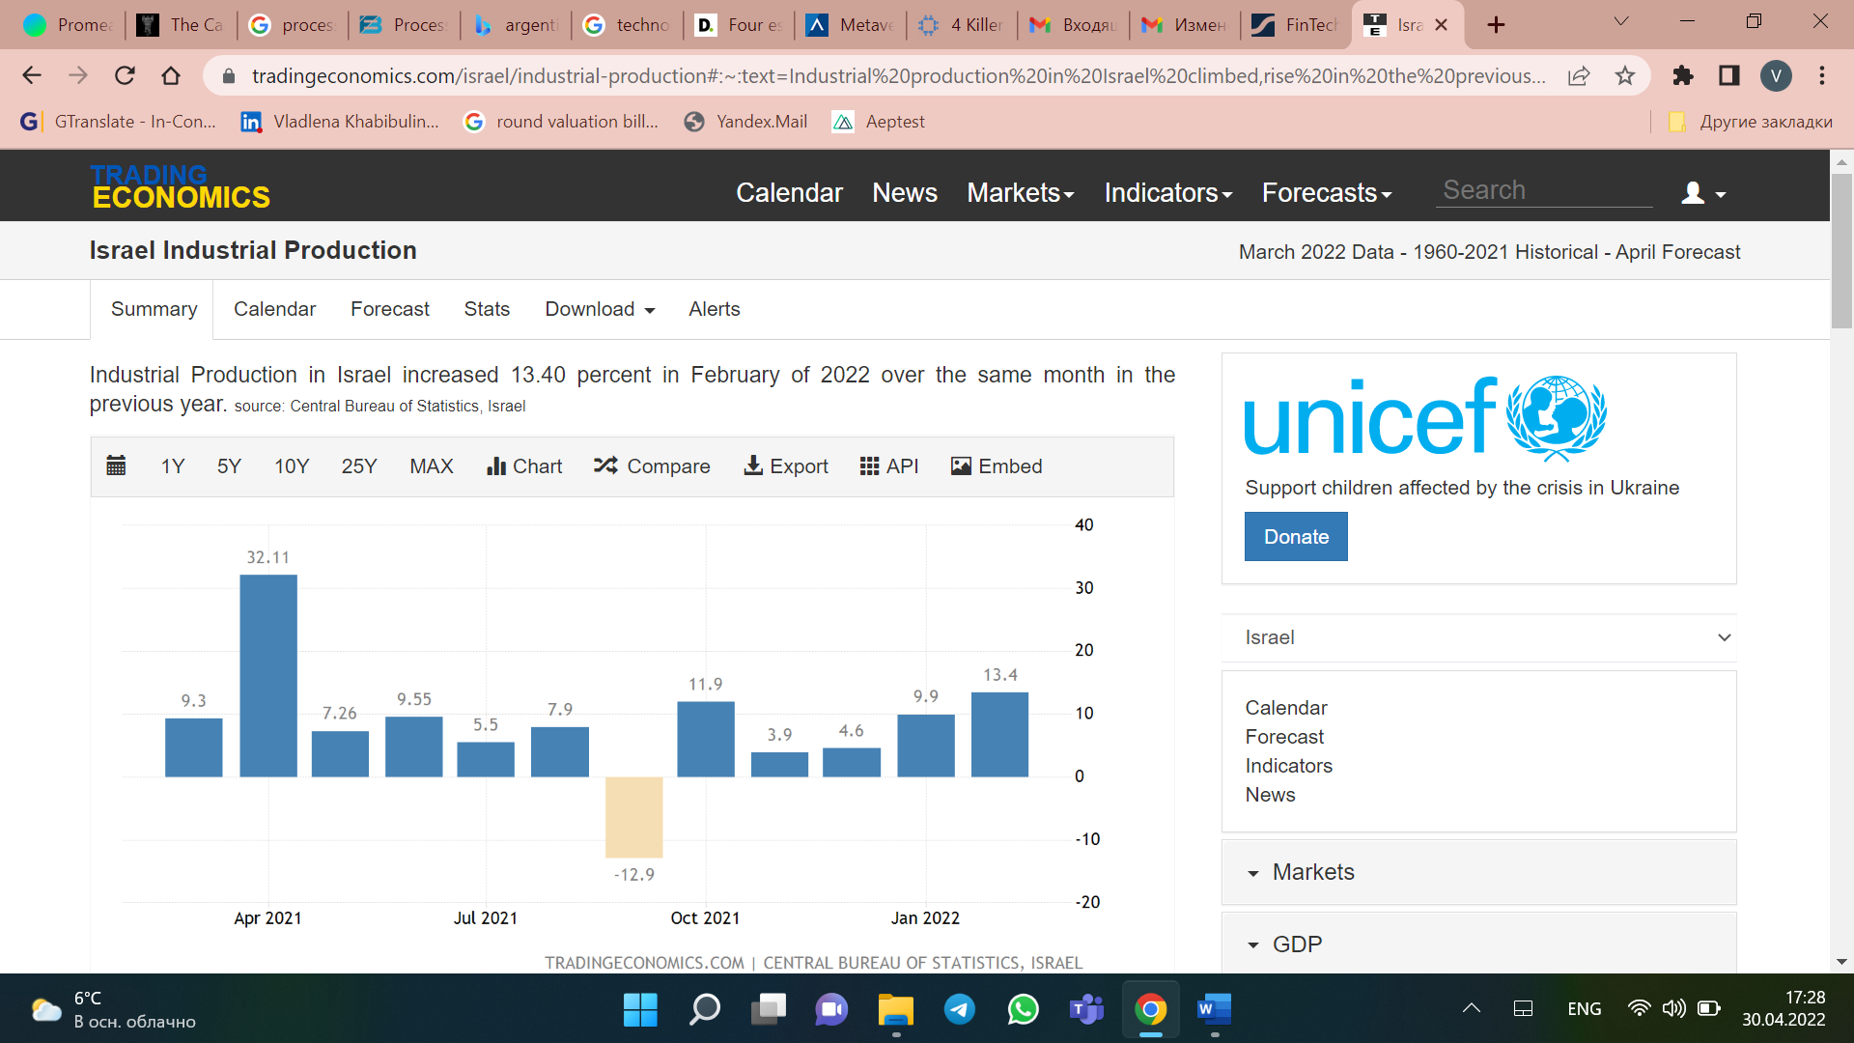

*Figure 23. Manufacturing sector in Israel*

***Turkey***

*Technological trends*

During the last decade banking sector has put a lot of efforts to technological development and innovations. The transformation of banking sector from analogue to digital lead to quick adaptation of such technologies by banking sector, which is considered to be one of the leading industries in the sphere of fintech development. As well as after COVID-19 outbreak, Turkish government introduced regulations on electronic payment systems, electronic money institutions.[51] We can see that Turkey is on the way to digital transformation, banking sector which is traditionally the indicator of country development is a leader in digital innovations adaptation. Moreover, Turkish government is also interested in country digitization, thus aiming to regulate the sector of digital payments, electronic money institutions. Overall, the situation regarding technological trend is advantageous for new technology implementing.

*Potential demand*

BFSI – as it was previously mentioned, banking sector is the leader in digitization process in Turkey, thus it could be marked as the sector that tends to digitization.[52] Considering the potential demand, the number of companies in BFSI sector is following top 10 banks with average number of branches – 1000.

Manufacturing sector in Turkey deeply declined in April 2021, however, as of now, the situation stabilizes. The graph is presented on Figure 24.[53] However, there are 7 manufacturing companies which revenue varies from $2 billion to $13 billion.

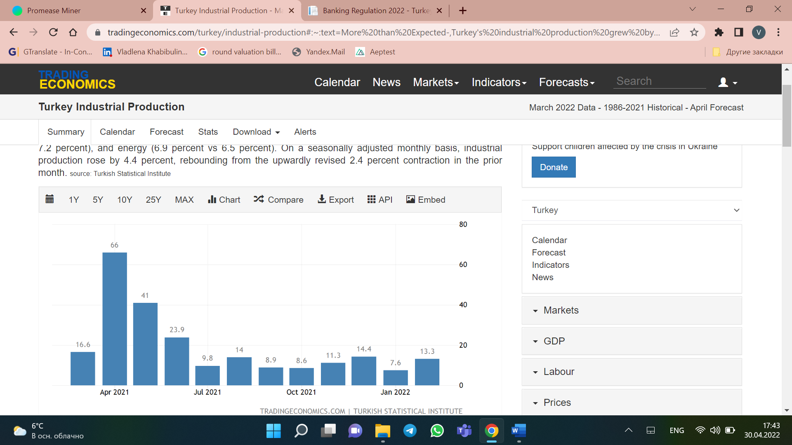

*Figure 24. Manufacturing sector in Turkey*

***South Africa***

*Technological trends*

South Africa is only at the beginning on the way of digital transformation. The government claimed that it is essential part of economic growth to develop the presence of digital in each sphere. Moreover, government launched programs toward digitization, variety of reforms including publication of the country’s draft national data and cloud policy.[54] Variety of proposals are discussed for lowering data costs which will later expand the access to digital services.

*Potential demand*

BFSI – as the overall situation in the country, the BFSI sector sets its priority to digital transformation, howeverunfamiliarity with majority of services as the main barrier to digital adaptation exists.[55]

Manufacturing – the same situation as in BFSI sector.

**Conclusion on in-depth screening:**

Based on the above-mentioned information, it has been decided to choose Brazil, Argentina, and Turkey for the final selection stage of the analysis. The reason why Israel, Chile, and South Africa have not been included in the list for the further analysis are following. Regarding Israel and South Africa, the reason is the digital transformation and technology adaptation level in these countries are not high enough for process mining company to successfully operate there during several years. The importance of familiarity with existing and new technologies, as well as level of their adaptation is high, as the process mining software cannot be implemented in companies do not mature enough for technological trends. The reason for exclusion of Chile from the list for final selection is that the demand there is not high enough for Promease Software company to reasonably choose this market for entrance.

*List of countries for final selection*:

* Brazil
* Argentina
* Turkey

### 

### Final selection

On the previous stage the following countries have been chosen for further analysis: Brazil, Argentina, and Turkey. Due to the fact that the market situation there in terms of demand and technological development is almost the same, we need to take into account such factors as cultural peculiarities, language barrier, cost for relocation, and the distance from Russia. The reason is that regardless the globalization phenomena, distances, in any sense, are still of high importance. They include cultural, administrative, geographical, and economic differences. To analyze the rest of the countries in final selection stage, we have chosen CAGE analysis with an emphasis on cultural and geographical distances.

**CAGE analysis**

CAGE analysis is an abbreviation for cultural, administrative, geographical, and economic distances between countries. The main idea of the analysis, developed by Pankaj “Megawatt” Ghemawat, is not to overestimate the attractiveness of the foreign market. Problems usually arises when businesses try to pioneer new untapped markets. GDP, level of consumer economical state and other indicators emphasize potential sales opportunity, however a variety of costs and risks are not considered in this case. These costs and risks are mainly resulted from barriers because of distance. Distance does not only mean the geographic measurement according to this framework, moreover, it has several dimensions including cultural, economic, geographical, and economic. All these factors influence the attractiveness of the market for a business.[56]

According to the research of s Jeffrey Frankel and Andrew Rose, traditional economic factors such as GDP do not play significant role in comparison with other factors related to distance. For example, the less the distance between two countries, the more effective the trade between countries is. Even larger effect is achieved with decreasing the distance in cultural and administrative dimensions. It is said that IT development makes these distances not essential for doing business and as of now the world is global homogeneous place. However, the companies still should account for distances to avoid the dangerous pitfalls.[57]

Cultural distance implies the differences in the way how people communicate with each other, with companies, with various institutions, as well as it includes different peculiarities of social life. The distance between two countries can be created by beliefs, social norms, race, languages, etc. Talking about language, it is rather easy to understand how different languages can create barriers. However, social norms are not as evident, it is the unspoken principles that people rely on withing their normal life. Thus, it is necessary to consider cultural distance while deciding on the way of communication with potential business partners, negotiation style, conditions offered, and other things.[58]

Administrative distance has two levels. The first one is basic that explains relationships between social sphere and government. The second level is an aspect of historical connections between countries. Overall, it is the difference between ways of trade agreements. Trading arrangements, political unions, and common currency can be more attractive to decide on the market for doing business. In its turn, policies of a government as well as weak institutional infrastructure can pose a variety of barriers for establishing business in foreign country.[59] Administrative distance is considered low if the legal system is the same, if one of the countries is a former colony of another, if they both use the same currency, and both are members of trade unions.[60]

Geographical distance is a coalition of such geographical factors as distance, access to the sea, common borders, countries size, etc. Easiness to travel between two countries can also be included in this list. The geographical distance affects not only the cost of transportation for tangible goods, but also it has an effect on intangible goods and services. Information infrastructure and information network should also be kept in mind.[61] Physical closeness lowers both communication and transportation costs. Even though the development of communication technologies is high, overseas operations needs hands-on help from headquarter in terms of support and localization.[62]

Economic differences include the economic state of countries as it is one of the main indicators that determine market size and potential demand. In addition, the similarity between economies of two countries plays a big role. For example, if the company’s economy relies on standardization, experience, and scale, it should focus on countries with the similar economic profile. The reason is that the company needs to replicate its business model and countries where people’s income is significantly less would not be attractive as the company will need to reconsider the production process, resources, etc.[63]

To understand what market is the most attractive among the countries chosen, we have applied CAGE framework, and have achieved following results.

***Brazil and Russia***

Cultural distance

* Different languages – Russian and Portuguese
* Different religions – Brazil is Roman Catholic; Russia is mainly Christian Orthodox

According to Hofstede model that is used to show the society’s culture and values influence society behavior and attitudes, there are several big differences between Russia and Brazil, they are:[64]

* Long-term orientation. Brazil scores 44, while Russia is 81. It means that Brazil is the country that mostly relies time-honored norms and traditions, and do not prefer any societal changes. Countries that score high in this dimension, for example Russia, are more pragmatic, they are more eager to development especially in modern education to be prepared for the future.
* Indulgence. It is the extent to which people can control their impulses and desires. For this dimension, Brazil scores 59, that means that people there tend to realize their impulses to get enjoy and fun from life. They consider essential to have a leisure time, spend money and time in the way they wish. At the same time, Russian score for this dimension is 20, that shows the big gap in attitude towards desires and impulses between these two countries. Russia is considered to be restrained society, that do not emphasize the role of desire and leisure time in life. The difference in such aspect can affect the smooth of doing business. Different attitude towards time, leisure and desire can lead to missed deadlines, distinct style of work, thus conflicts between management teams.

Administrative distance

As it has been mentioned above, the administrative system is considered to be low if one country is a former colony of another, if the currency used is the same, if the legal system is the same, and if countries are members of the same trade unions. Thus:

* Currency is different – Brazilian real and Russian ruble
* Legal system is different – both countries have civil law system, however, in Brazil custom and case law is the part of legal framework.
* Nor Brazil, nor Russia were in colony-tied relationships

Geographical distance

* Geographical distance – 14 442km
* Time zone – 6 hours difference between Moscow and Brasilia
* No borders between Brazil and Russia

Economic distance

GDP per capita Brazil – $6 796; GDP per capita Russia - $10 126.

***Argentina and Russia***

Cultural distance

* Different languages – Russian and Spanish
* Different religions – Argentina is Catholic, Protestant; Russia is mainly Christian Orthodox

According to Hofstede, there are several big differences between Russia and Argentina, they are:[65]

* Power distance – Argentina – 49, Russia – 93. It means that Russia is a very distant society, the great importance of status prevails in this country. Thus, it leads to completely different ways of doing business in both countries. While in Russia it is essential to demonstrate status within business interactions, the approach is top-down, clear mandates for every task, Argentina is the country with polar different approach.
* Long-term orientation – Argentina – 20, Russia – 81. It means that Argentina is the country that mostly relies time-honored norms and traditions, and do not prefer any societal changes. Countries that score high in this dimension, Russia, are more pragmatic, they are more eager to development especially in modern education to be prepared for the future.
* Indulgence – Argentina – 62, Russia – 20. For this dimension, Argentina scores 62, that means that people there tend to realize their impulses to get enjoy and fun from life. They consider essential to have a leisure time, spend money and time in the way they wish. At the same time, Russian score for this dimension is 20, that shows the big gap in attitude towards desires and impulses between these two countries. Russia is considered to be restrained society, that do not emphasize the role of desire and leisure time in life. The difference in such aspect can affect the smooth of doing business. Different attitude towards time, leisure and desire can lead to missed deadlines, distinct style of work, thus conflicts between management teams.

Administrative distance

* Currency is different – Argentinian peso and Russian ruble
* Nor Argentina, nor Russia were in colony-tied relationships

Geographical distance

* Geographical distance – 17 030km
* Time zone – 6 hours difference between Moscow and Buenos Aires
* No borders between Argentina and Russia

Economic distance

* GDP per capita Argentina – $8 441; GDP per capita Russia - $10 126

***Turkey and Russia***

Cultural distance

* Different languages – Russian and Turkish
* Different religions – Turkey is mainly Islam; Russia is mainly Christian Orthodox

According to Hofstede, there are several big differences between Russia and Turkey, they are:[66]

* Long-term orientation - Turkey – 46, Russia – 81. It means that Turkey is the country that mostly relies time-honored norms and traditions, and do not prefer any societal changes. Countries that score high in this dimension, Russia, are more pragmatic, they are more eager to development especially in modern education to be prepared for the future.
* Indulgence – Turkey – 49, Russia – 20. For this dimension, Turkey scores 49, that means that people there tend to realize their impulses to get enjoy and fun from life. They consider essential to have a leisure time, spend money and time in the way they wish. At the same time, Russian score for this dimension is 20, that shows the big gap in attitude towards desires and impulses between these two countries. Russia is considered to be restrained society, that do not emphasize the role of desire and leisure time in life. The difference in such aspect can affect the smooth of doing business. Different attitude towards time, leisure and desire can lead to missed deadlines, distinct style of work, thus conflicts between management teams.

Administrative distance

* Currency is different – Turkish lyre and Russian ruble

In terms of legal system, historical ties, and trade unions, the distance is not as long. Historical ties are quite close, due to a big number of wars in the past between Turkey and Russia, continuous tries to divide territories, alliances. It can be said that from historical perspective Turkey and Russia are tightly connected.

Geographical distance

* Geographical distance – 4985km

Time zone of Turkey and Moscow is the same, between countries the sea border exists.

Economic distance

* GDP per capita Turkey – $8 538; GDP Russia - $10 126

**CAGE analysis’s conclusion**:

Conducting the CAGE analysis for Russia and countries chosen – Brazil, Argentina, Turkey, we have come to following conclusions.

Comparing countries’ cultural distance with Russia, we estimate that languages and religion beliefs are different for each country. In Brazil it is Portuguese language, in Argentina – Spanish, and in Turkey – Turkish. The religion beliefs are also not the same, as for Brazil and Argentina it is Catholic, while Turkey is and Islamic country, Russia is mainly Christian Orthodox. The Hofstede model of cultural distance between countries was applied to understand how each country’s society values influence people’s behavior and how far these attitudes are from Russia. In this aspect, we have obtained following results.

There are two differences that are common for all three countries in comparison to Russia. They are long-term orientation and indulgence. Russian score of 81 means that people in this country are pragmatic, eager to development especially if their future depends on it. However, Brazil and Turkey get 44 and 46 for this dimension respectively, and Argentina is scored even less – 20. This implies that these countries are completely different in terms of their attitude to long-term perspective, they prefer not to have any societal change in life and tend to keep traditions and norms that they did get used to.

The second difference between Brazil, Argentina, Turkey, and Russia is indulgence. Indulgence measures people’s attitude towards leisure, desires and relax. Russia obtains 20 for this dimension that means that Russian people are restrained, who do not emphasize the role of desire and leisure time in life. On the contrary, Brazil, Argentina, and Turkey are scored much higher, 59, 62, and 49 respectively. As a result, while doing business in this country, different attitude towards time, leisure and desire can lead to different interpretation of deadlines, distinct style of work, thus misunderstandings between management teams.

Moreover, there is one more difference between Argentina and Russia. It is power distance. Argentina is scored 49, Russia – 93. To repeat what has been mentioned before, while in Russia it is essential to demonstrate status within business interactions, the approach is top-down, clear mandates for every task, Argentina is the country with polar different approach. It means that Russia is a very distant society, the great importance of status prevails in this country.

To conclude the comparison of cultural distance, we can estimate that Turkey is closer to Russia in this aspect. Even though it has the same category of differences as Brazil and Argentina, anyway the gap between scores is less. Moreover, Argentina has even more differences with Russia, as it also distant in terms of power.

Considering the following part of CAGE analysis – administrative, we can conclude that all the countries have different currencies – Brazil real, Argentinian peso, Turkish lyre, and Russian ruble, legal systems are rather similar, except Brazilian custom and case law. Regarding historical ties between countries, Russia and Brazil and Russia and Argentina do not have as much in common as Russia and Turkey. Within the history, Russia and Turkey was tightly connected in terms of common development, trade, wars, alliances, and territory division. Thus, in this aspect Turkey is closer to Russia, than Brazil and Argentina.

Geographical distance has been assessed according to following criteria – distance, time zones and common border. The distance between Brazil, Argentina and Russia are much longer than between Russia and Turkey. Time difference is 6 hours between Brazil and Russia and Argentina and Russia, while Turkey and Moscow are located in the same time zone. There are no common borders for Brazil and Russia and Argentina and Russia. However, there is a sea border between Russia and Turkey. In this aspect, it is evident that Turkey is geographically much closer to Russia.

Economic distance aspect shown the following results. The GDP per capita has been assessed to estimate the gap between economic state of countries. GDP per capita Brazil – $6 796, GDP per capita Argentina – $8 441, GDP per capita Turkey – $8 538, GDP per capita Russia - $10 126. As it can be seen the biggest gap is between Russia and Brazil, while Argentina and Turkey are much closer.

As a result of the GAGE analysis, Turkey was assessed as the closest country to Russia not only in terms of geographical distance, but also in terms of cultural dimension, administrative closeness, and economic state.

**Final Selection stage conclusion**

For the final selection stage, CAGE analysis has been chosen as an indicator to determine the best market to enter between Brazil, Argentina, and Turkey. The result of the CAGE analysis is Turkey as the most appropriate country for business operations. However, we consider it essential to provide several additional factors that finally justify the choice of Turkey.

It is evident that geographical closeness lowers the cost for transportation and communication not only in terms of money, but also time. Except cultural and geographical closeness, Turkey is also a country where big Russian diaspore exists. The history of Russian migration to Turkey does not begin this year. At least it started a century ago, when White Russian émigré left the country within the revolution unstable years. They brought to Turkey art, opera, theatre, symphonic orchestra. The first Turkish film has been shot by Russian director, the first ballet prime was principal performer of the Big Theatre, the first fashion house was opened by Russian artist form Saint-Petersburg, etc. A lot of restaurants was opened there by Russians, one of them Regans still works.[67]

As of now, Russians are the main buyers of real estate in Turkey, in 2020 Russians were in top-3 foreigners that have real estate in Turkey.[68] In 2021, the demand of Russians for real estate in Turkey has increased on 75%. As a result, more than 5 400 apartments were bought there in 2021.[69] Only in April 2022, more than 1000 real estate objects were bought by Russians in Turkey. In March 2022, the number was approximately 550.[70] Moreover, Turkey is considered to be one of the most popular touristic destinations for Russians – 5 million people in 2021.[71]

The number of Russians that permanently live in Turkey is approximately 1 million people. In Antalya, there are approximately 100 000 people from Russia, this number does not include Russian-speaking people from CIS.[72] A big number of them moved to Turkey during pandemic time. Almost every shop, café, and restaurants have minimum 1 Russian-speaking employee, real estate agents are obliged to learn Russian language. More and more Russian café, shops and other facilities appear every year.[73]

The factors mentioned show that there are a lot of Russian people in Turkey who buy real estate objects, move there, work, run businesses. While starting run business in new foreign market, it is beneficial to have people from the home country who live there for many years, who was able to get acquainted with necessary procedures, bureaucracy, and others. It can be helpful to avoid difficulties and problems that relate to absence of necessary knowledges. Moreover, there are many businesses that are opened in Turkey; thus, the country is prepared for new business entering. What is more, the more Russian people live and work in Turkey, the less barriers especially in terms of language that is of high importance can appear.

## PESTL

To analyze macro environment for Promease Software company, we have applied PESTL analysis. We have analyzed factors that influences the company’s operations on Turkey market.

*Political factors*

Since the beginning of Russian special operations in Ukraine, a lot of countries put sanctions on Russian Federation. However, Turkey has opposed it, and called this unrealistic. According to the political situation between Russia and Turkey, Russian people are still welcomed in the country for permanent living, doing business, and tourism.[74] In March, Turkey was the place where negotiations between Russia and Ukraine were held. However, the situation is quite unstable, and the data on the political situation is relevant in May 2022.

*Economic factors*

1. Turkey is one of the major economies in the region and its key power. It is upper-middle-income economy, the income and employment has increased since 2020, even though COVID-19 had a big impact on Turkey economy.[75]
2. The standard corporate income tax rate was 25% in 2021 which is going to be reduced to 23% for 2022.

Considering those factors related to development of industries which target audience of the product belongs to. The industries we have considered are BFSI and manufacturing sectors, as they are the industries forecasted to be the most profitable clients for process mining software.[76]

1. The number of companies in BFSI sector is following top 10 banks with average number of branches – 1000. Banks in Turkey[77]:

* Ziraat Bank - 27,149 employees, 1,752 branches in Turkey
* Isbank - 23,300 employees, 1,227 branches in Turkey, 22 branches in other countries
* Garanti Bank - 18,600 employees, 904 branches in Turkey, 7 branches in other countries
* AKBank - 12,400 employees, 770 branches, 1 branch abroad
* Yapi ve Kredi Bank - 16,900 employees, 835 branches in Turkey, 1 branch abroad
* Halkbank - 1,007 branches, 6 branches abroad
* Vakifbank - 15,700 employees, 933 branches in Turkey, 3 international branches in New York, Erbil, and Bahrein
* QNB Finansbank - 473 domestic branches, 1 branch abroad
* Denizbank - 14,100 employees, 915 branches in Turkey, 43 branches overseas
* Turkcell – revenue $2.1 billion, 24 700 employees

1. Manufacturing sector in Turkey deeply declined in April 2021, however, as of now, the situation stabilizes. The graph is presented on Figure 25.[78] However, there are several manufacturing companies which revenue varies from $2 billion to $13 billion.



*Figure 25. Manufacturing sector in Turkey*

Manufacturing companies[79]:

* Koç Holding – revenue $13.6 billion, 92 500 employees
* Yildiz Holding – revenue $7.7 billion, 65 000 employees
* Hayat – revenue $4.6 billion, 17 000 employees
* Haci Omer Sabanci Holding – revenue $4.1 billion, 64 300 employees
* Vestel – revenue $2.5 billion, 19 000 employees
* Sisecam – revenue $2.2 billion, 21 900 employees

*Social factors*

Among social factors that can influence Promease Software company operations we have highlighted following:

* Turkey is connected well to a lot of country due to its geographical locations, thus people there have an international mindset. It is beneficial for international companies, as makes easier operating business there, attract more international companies – thus beneficial for SaaS companies, as the opportunity to reach more clients increases.
* Attitude towards Russian people and businesses within the country – the factor is important as because of Russian special operation in Ukraine, number of countries has started to cancel everything that is connected to Russia and Russian people. However, as it has been discussed in the Final Selection stage conclusion, Turkey does not even cancel Russian culture and people there, even though it became the country with the highest investments in real estate from Russians, Turkey is also one of the main touristic destinations for Russian people. Moreover, more and more Turkish people learn Russian language; cafes, stores, and restaurants have at least one Russian-speaking employee.
* The size of Russian diaspore is approximately 1 million people, not counting Russian-speaking people from CIS.
* Closeness of Turkish and Russian culture according to Hofstede model. Among 6 dimensions of Hofstede model, only 2 have a big gap, while others are rather close according to the scores given. Individualism – Russia – 39, Turkey – 37; masculinity – Russia – 36, Turkey – 45; uncertainty avoidance – Russia -95, Turkey – 85.

*Technological factors*

Technological factors are of high importance for process mining market development. The technological maturity of industries in each of the countries is the factor that mostly determine the successful service sale. It means whether the industry is ready to implement such a technology in its processes and the level of technological progress in the country itself. This has been described before, in the In-depth Screening stage of International Market Selection Analysis. After COVID-19 outbreak, Turkish government introduced regulations on electronic payment systems, electronic money institutions.[80] Government invests a lot in the technological development of the country, thus Turkish people become more technologically advanced, and they get used to technology presence in every aspect of their life, thus the attractiveness of any technological innovation there is high.

*Legal factors*

There a number of laws related to Turkish IT sector governing. Among them are:[81]

* Obligations of an employer on data protection
* Regulation on not using crypto assets in payments
* Regulations on commercial advertisement
* Rights of consumer in electronic communication sector
* Protection of data in artificial intelligence system
* Regulations on biometric data
* Etc.

Thus, it can be said, that government not only invests in Turkey technological development, but also tries to control and regulate it. From the one side, it can be beneficial for companies operating in Turkish technological sector. But from another side, the bureaucracy procedures can make operating business more difficult.

According to information provided in the In-depth Screening stage of analysis: Turkey is on the way to digital transformation, banking sector which is traditionally the indicator of country development is a leader in digital innovations adaptation. Moreover, Turkish government is also interested in country digitization, thus aiming to regulate the sector of digital payments, electronic money institutions. Overall, the situation regarding technological trend is advantageous for new technology implementing.

**Conclusion on PEST analysis**

Within PEST analysis, the following conclusions on Turkish macro environment have been made. In terms of political situation Turkey government so far is not going to implement sanctions on Russia for Russian special operation. Economic factors are represented by the speed of development industries that are target audience of Promease Software company. There we can see that BFSI sector is represented by a number of banks with wide number of branches and operations. However, the situation in manufacturing sector is not the same as in BFSI, but as of now the situation there is stable. Moving on to social factors – it can be said that Turkey sis attractive for Russian people as the Russian diaspore consists of 1 million people, wide investments in real estate and business development. Considering one of the most important technological factors – it is seen that the country is on its way to digitization as the government understands the importance of such development. Turkish macro environment seems to be appropriate for operations of Promease Software company.

## Porter’s Five Forces Analysis

To analyze the process mining industry, Porter’s Five Forces analysis has been applied. For assessment, we have used score-system, where each parameter has been assessed from 1to 3, depending on the degree of threaten. Where 1 – low degree, 3 – high degree.

*The threat of substitute goods*

The process mining software is the software that helps businesses to increase efficiency of its business processes, find out gaps, bottlenecks, eliminate unimportant operations with the help of special technology that is inserted in the company-client IT system, gathers information, and then analyzed it. The substitute for the product is consulting agencies that offer the same services of analyzing efficiency of business processes. Moreover, the substitute is internal department in the company or an employee responsible for measuring the effectiveness of business processes and providing solutions to solve the bottlenecks and process gaps. Corporations mainly use such traditional tools as documentation investigation, employee interview, operations timing, etc., as well as traditional methods of business analysis e.g., Lean Six Sigma. The main task of process mining companies is to ensure potential clients to move from traditional ways of analysis to high technology solutions. That is why the power of substitutes is high and is scored 3.

*The threat of competitors*

According to research, the process mining market is in its growing stage, it has increased on 50%-100% per year, and now the market is far from saturation. The competition between players do not exist in its pure form, they do not compete for a concrete client. The main challenge is the process mining image as a technology for corporations and its application. As of now, they consider process mining rather exotic technology that does not have serious purpose. The competition character is a competition of high level, when the market development stage makes players compete not with each other, but with client product perception. The threat of competitors is 1.

*The threat of new entrants*

The threat on new entrants is high, as there are low entry barriers for a new player. The reasons are following. The first is initial cost investments are low, as the company’s main cost is software development. No need for offices, warehouses, manufacturing, employment issues. The second reason is that the industry itself is on its growing stage, and long-term growth opportunities for a new player exist.[82] Additionally, there are only several big players on the market as it has been mentioned in the part devoted to the threat of competitors. Third, the process mining software is a rather standardized product, as the main function is the same, the difference is only in additional features. The degree of threat is 2.

*Buyer’s power*

As it has been previously mentioned, the client’s perception of the product is the main challenge for process mining market companies. It is a client who, on the current stage of market development, has the highest power. Client companies have already had the solution for the problem that is solved by the process mining software. They use traditional ways of business process analysis such as documentation investigation, operations timing, employees’ interviews, and monitoring, etc. As of now, clients are satisfied with these tools, and as the price for a new solution is quite high. Thus, we have estimated the buyer’s power as 3.

*Supplier’s power*

The process mining market does not depend on suppliers because the process mining product is a software that is developed by teams of programmers and do not need any additional resources supplied. Supplier’s power is 0.

**Conclusion on Porter’s Five Forces analysis**

Within the process mining market analysis, the following conclusions have been made. The substitute and buyers have highest degree of power. The reason is that process mining technology has an image, as of now, as a technology that does not have necessary for business functionality, and existing tools cope with business process analysis perfect. So, substitutes such as internal company’s resources – a special department or employees, as well as consulting agencies that conduct such analysis and offer solutions are high-powered threats. As well as buyers, which perception of the product should be changed, also those who greatly influences the process mining market. The competition between players itself is not as high and does not have a great power on the process mining market. Also, as the market is in its growing stage and there are low barriers on entrance, the threat of new entrants is rather moderate. At the same time the supplier’s power is the lowest. The results of the analysis are presented on the Figure 26.

Figure 26. Porter’s Five Forces

## Chapter 2 conclusion

In the Chapter 2 we have conducted the international market selection for Promease Software company. Within the international market selection, we have considered context-specific approach that has been divided into four parts.

In the first part, pre-selection, we have eliminated those countries which political environment is not attractive for Russian originated companies and Russians itself. On the second stage, we have indicated industries, which company-representatives are target audience for Promease Software service. After that, we have compared potential demand in these countries, and compiled a list of countries – Brazil, Argentina, Chile, South Africa, Israel, and Turkey. In the in-depth screening, we have assessed countries not only in terms of demand forecasted, but in terms of their technological development. The list of countries for following stage – Brazil, Argentine, Chile. Indicating, that in terms of potential demand and technological development these countries are on rather the same level, CAGE analysis has been conducted to analyze these countries according to cultural, administrative, geographical, and economic distance from Russia. The final choice – Turkey.

Then, PESTL analysis has been done, to analyze political, economic, social, technological, and legal environment in the country. As a result, the environment was assessed as attractive for operating business in the country. After that Porter’s 5 Forces analysis has been conducted to understand what power influences the market most. It has been mentioned that the buyer’s power and the threat of substitute is the highest in comparison with others.

# Chapter 3. Strategic Recommendations

## International market entry mode selection

There are several most common market entry modes. They are exporting, licensing, partnering, acquisition, and greenfield.[83] We need to choose the appropriate one for Promease foreign market entry.

To begin with, export – sell of product or services sourced from the home country in foreign ones. The main advantage of such mode of entry is that there is no need for business to establish operations in foreign country. Instead of this, the firm usually distribute and market through contractual agreements with a local business. Among disadvantages are low control on operations, as well as low local knowledge for appropriate labeling, packaging, and pricing. In such type of entry mode, the company faces up with a variety of costs. Among them are transportation costs, tariffs on exporting goods, and fee for the services of contractual firm.[84]

Another type of mode is licensing and franchising. Among advantages of licensing and franchising are fast entry on international market with no need to establish operations in foreign country and low cost of entry. Despite these advantages, there are several disadvantages of this type of entry mode. Among them are low control on the product or service use, licensee may become a competitor later, moreover, there are frequently legal and regulatory environment issues on intellectual property and contract law.[85]

The third way is partnership and strategic alliance. It is a contractual agreement between two parties, a product or service provider and a local partner that aims to cooperate in a certain way to achieve particular results. To understand whether the partnership brings suitable results, firms should decide on what tangible and intangible assets the firms can bring in. Advantages are possibility to know local market, culture, and ways of doing business better. Moreover, it is beneficial if a local partner already has a reputation and recognized brand in the country. This partner is likely to have customer base that a company provider of services or products may get access to. Disadvantages are higher costs than in licensing and franchising mode, and integration of two corporate culture problems.[86]

Acquisition is another type of foreign entry mode. It is a transaction within which one firm gets control over another one by purchasing its stocks, exchanging them, or pay the purchase price to the acquired firm owner. The main advantage of acquisition is that it gives the company fast established access to a new foreign market. However, disadvantages exist, they are high costs and integration issues with home company office.[87]

A greenfield venture is a fifth way to enter the international market. It is a process of establishing completely new, wholly owned subsidiary. The main advantage is that the firm gains absolute control on all the operations. However, it is complex and potentially high-cost process of establishing a new business operation in a new foreign market.[88]

**OLI-framework**

To choose the most appropriate type of entry mode, eclectic paradigm, or OLI-framework, has been applied. OLI is an acronym for three dimensions according to which entry mode types are analyzes – Ownership, Location, Internationalization. Ownership advantage implies ownership rights and proprietary information. It typically relates to intangible assets that company has – brand, trademark, patent right, trademark, etc. – they should have value, be rare and hard-to-copy. The company should determine whether it obtains an asset to have a competitive advantage on foreign market. Location advantage relates to geographical location of the country, availability of raw materials, skilled labor force, tariffs, taxes, etc. It is necessary to determine whether it is advantageous to perform functions within a particular country. Internationalization advantage relates to understanding whether it is more advantageous to produce in-house or contract with the 3rd party. The Figure 27 represents the scheme according to which it is possible to choose perfect entry mode.

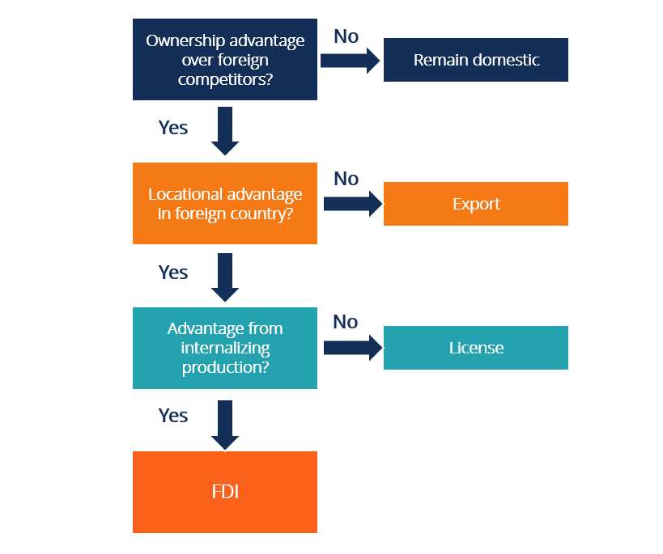

Figure 27. OLI-framework

Promease Software company has a rare, hard-to-copy technology that is its key technology on which its process mining software is based. It is a valuable intangible asset; thus, we move to location advantage. In terms of location advantage, the question is two-sided, there the company needs to understand what is more beneficial on the current stage of development. From one side, location presence gives advantage as face-to-face communication with clients, partners, etc., definitely more effective. Establishing partnership with a local company, it is possible to reach out potential clients through partner’s communication channels, marketing strategy and client base. However, the export entry mode is also possible via communicating with potential clients through own resources. Then, internationalization advantage, on the current stage of development both company and process mining industry itself, there is no sense to think about internationalization, as the potential demand is only forecasted and has not been checked yet.

For the Promease Software company foreign market entrance we have chosen two types of entry modes, as on the stage of local advantage we need to check whether it is profitable to establish partnerships with local companies. The first part is a partnership, as the advantages of the partnership are opportunity to know local market, culture, and way of doing business, in the same time gain benefits from a local partner such as a customer base, reputation and brand, that is essential for a company that makes its first steps on the foreign market entry way. The second part is direct export, or direct sales – Promease Software is offered to reach potential customers with the help of company’s own sources and strategies. Then, the set of criteria has been developed for the Promease company to be able to assess which way of entrance is more efficient after the strategic recommendations offered are implemented on practice.

## Strategic recommendations

For the Promease Software company foreign market entrance we have developed a set of strategic recommendations on entry mode. This set is divided into two parts. The first part is a partnership, as the advantages of the partnership are opportunity to know local market, culture, and way of doing business, in the same time gain benefits from a local partner such as a customer base, reputation and brand, that is essential for a company that makes its first steps on the foreign market entry way. The second part is direct export, or direct sales – Promease Software is offered to reach potential customers with the help of company’s own sources and strategies. Then, the set of criteria has been developed for the Promease company to be able to assess which way of entrance is more efficient after the strategic recommendations offered are implemented on practice.

### Technological partnership

The type of partnership suggested is technological partnership. Technological partnership is a partnership between technological companies which products can be integrated to provide end customer with a single solution. This is the partnership which allows technological companies to fill in gaps in their products and build an ecosystem.

Previously, a software was sold in a form of a package that required expensive licenses, installations, maintenance, and IT support. As of now, with the raise of API (application programing interface) economy and cloud computing, software selling is unbundled and become cost effective. For developers it is now faster and simpler to build application integrations. The trend to API economy shift makes companies to reconsider their products and grow partnership ecosystems. Partnership ecosystem is a network of partners and integrations between several companies. The reason to build up an ecosystem is that nowadays operating alone a company cannot satisfy all customers needs, even though it cannot reach all of them.

The choice for such type of partnership can be justified by trend related to unions of SaaS companies. Due to low entry barriers in the SaaS industry, it becomes highly competitive. Task of any SaaS organizations is to build a product to fulfill the whole range of customers’ needs. The partnership of this type is win-win for both parties involved.[89]

Among advantages are[90]:

* In case of technological partnership, not a single product is developed, but the entire solution. It is developed in the way of complementary solutions where IT solutions complement each other. Thus, it is possible to enter new markets, improve customer retention.
* The sales cycle is shortened, thus the less time spent on acquiring and onboarding customers, the less cost it takes.
* In case of technological partnership, partners help each other to fill product gaps within the same ecosystem.
* The result of technological partnership can be common pilot projects, acquisition of the company, or lean startup.

Technological partnership develops integrations for data exchange between different products, for help users in automation of processes, thus provides them with more valuable product experience. In case the integration solves as much customer’s cases as possible, the possibility that they will shift to a competitor company lowers. Moreover, there are following results that successful technological partnership can lead to:[91]

* Higher adoption of a product
* Go-to-market opportunities
* Competitive advantages
* Acquisitions

Technological partnership is a process of integration of products of two or more companies, including sending data, creating new workflows, creating go-to-market strategies, etc. In comparison with channel partnership that includes a vendor that creates the product and a partner who sells it, technological partnership is bidirectional. Within technological partnership, companies-participants are both vendors and partners.

Among tech partnership examples are integration, app stores, marketplaces, and plugins.[92]

* Integrations – data transfer between products, that can range from a simple data connection to a complex interface and workflow.

*Examples:* Zenefits and Human Interest: Zenefits is a human operations platform has developed an integration with Human Interest, a retirement solutions provider. The result of the integration is enabling Zenefits’s users to enroll into retirement plan of Human Interest, set up contributions and maintain compliance. Users can also synchronize their accounts with account on Human Interest to automatically send retirement plan data.

Another example is Kissmetrics and Segment. Segment is a customer data management platform that gathers data from all touchpoints of customers’ cross-platform. Then it pushes the data captured to marketing automation or email tool destination. By integrating with Kissmetrics, Segment became able to push the data in the way users can take actions. For example – send target emails, automate reports, analyze segment users’ behavior, etc.

* Marketplaces, app stores – a place where a vendor can sell its add-ons, applications, extensions, etc.

*Examples*: Salesforce AppExchange – cloud market that provides Salesforce clients with thousands of integrated solutions for their platform extension; Bullhorn Marketplace – provider of more than 100 staffing software pre-integrated solutions.

* Plugins, extensions, add-ons – data exchange that enhance existing software with a single function provided.

*Examples*: Moz and Chrome – Moz is the extension in Chrome that offers SEO research and metrics; WordPress – web plugin collection to assist customers in their blogs, websites, and applications enhancement.

***Form of technological partnership for Promease Software company***: technological partnership for Promease Software can be realized in a form of an integration, a common solution with a technological partner which activity relates to business process management and workflow management.

**Tech partners choice**

To identify potential partner, it is necessary to understand what other software is used by customers. It was decided to establish partnership with companies which activity relates to business process management and workflow management solutions. We have chosen companies that have already operated on the Turkish market. The reason is that such companies already have client base and developed marketing strategy. This way of operating is appropriate for Promease company, as it saves costs on marketing and PR, as well as makes business operating easier.

***Aim***: is to develop common solution with a technological partner already operated Turkey, then reach out as many customers as possible, using resources of a partner (customer base, marketing tools, working PR campaign, etc.)

Thus, ***criteria*** for a technological partner choice are following:

* company’s activity – business process management, workflow management solutions, and related spheres
* company has already operated on Turkish market

To find potential partners, LinkedIn social network is used. As a result, the following ***list of companies*** operated on Turkish market and which business is related to business process management solutions was compiled:

*Process Plant Design*[93] – the company specializes in process plant design, procurement, constructions supervising and Project Management of large-scale Engineering Projects. As well as provides process plant design engineering expertise throughout all phases of a Project.

*OBSS[94]* – the company specializes on IT consulting and IT services, operating mainly in banking/finance, insurance, e-commerce, retail industries.

*Trenkwalder Turkey[95]* – the company provides process management, CRM, and supply chain services, as well as HR, recruiting and payrolling.

*MBIS*[96] – the company operates in IT services and IT consulting. It provides digital solutions and services in 4 categories: digital strategy, digital transformation, digital sustainability, and digital innovation – R&D software development, robotic process automation, and artificial intelligence.

*Linktera*[97] – the company operates in IT services and IT consulting. It provides IT consulting, project management, Product & Software Development, and system integration solutions especially for financial institutions and e-commerce firms.

*Intertech Information Technology and Marketing Inc.*[98] – the company serves financial institutions with IT solutions, among its products are Infrastructure Management products, Financial Applications (Core Banking, Factoring, Leasing), Customer Relationship Management, Business Process Management, and Business Intelligence.

*Teknokon Group*[99] – is a multi-disciplinary organization serving its clientele with a full range of engineering, procurement, and construction for the industrial construction projects.

*JFORCE*[100] – the company operates in IT services and IT consulting.

*Arete Consulting*[101] – the company provides business, product, process, technology, and integration services required to ensure quick return of digital transformation.

*Eczacıbaşı Bilişim*[102] – the company operates in knowledge and business process management solutions, customer relationship management solutions, Business Intelligence consulting services, among others.

*Robusta Cognitive Automation*[103] – designs and develops a software platform to help organizations efficiently automate business processes.

*Emakin[104]* – the company provides a single comprehensive web interface that encompasses all facets of a process lifecycle – analysis, modeling, simulation, and continuous enhancement.

*ICterra Information and Communication Technologies*[105] – provides IT consulting and IT services solutions for medical and healthcare industry, avionics, telecommunication and energy industries.

*VNGRS*[106] – the company specializes on implementing following products recommendation engines, machine learning, data mining, performance optimization, quality assurance, etc.

*Pargesoft*[107] – the company offers consulting services and software development for integrated enterprise resource planning (ERP) and customer relations management (CRM) solutions to manage complicated business processes.

*Agito Software & Consulting*[108] – the company offers services in product development and implementation of core business applications in health insurance, life insurance, private pension, and property&casualty insurance solutions.

*Next4Biz (EMEA)*[109] – the company offers a cloud based digital marketing, customer service and business process management solution.

**Partners’ outreach**

Starting partnership establishment, in the beginning, Promease Software should rely on direct outreach to connect to potential partners. With the grow, more inbound leads can be attracted to establish such type of relationships.

Big technological companies frequently place a form on the website where they invite companies for partnership, other places email address. In case there is no such information on the company’s website, there is an opportunity to connect them through LinkedIn social network. Once the way to communicate with a company is found, the emails should be sent:

***The commercial offer:***

*“We are process mining software company, and recently we've launched state-of-art process mining solution Promease.*

*In the framework of business process management, process mining technology delivers clear and short time-to-value: the core of this technology allows to discover, monitor and improve real business processes by extracting knowledge from event logs of any information system. As a result, all the process performance bottlenecks, and opportunities of process improvement can be discovered and measured by our software.*

*An automated audit and real process conformance checking also deliver immediate value. Furthermore, soon we will introduce out-of-the-box predictive analytics, unlocking the capability to get early insight into the process outcome, expected performance and scenario, which is a crucial competitive advantage.*

*Please watch a short video about the solution - https://youtu.be/tMqmNM9tD_c or visit our web site https://promease.ru/en/promease.*

*We see a huge potential in joint use of workflow management software/BPM-platforms/ and process mining technology in order to get new knowledge about the processes and to get insights about their improvement, and we are looking for opportunities of cooperation.*

*In case of your interest, we would be happy to get in touch and to discuss potential cooperation.”*

Joining special clubs is also a way to find a company to establish partnership. It is the way to communicate with other organizations through special clubs that unite people and businesses related to data science, business process management, process mining, and similar fields. By joining these clubs, the network will be organized, and there will be more opportunities for academic partnership. Among these clubs are Data Istanbul, Trendyol Tech Meetup, Open-Source Analytics – Istanbul, and Ankara Big Data Meetup.

**Persuasion of a partner to join**

It is necessary to cover benefits for both parties, to be sure that such form of entering foreign market is suitable. It is also necessary to ensure potential partner that the offer is highly attractive. For this purpose, following things should be covered:

***Existing clients*** – to ensure potential partner that the company’s software is practically used in manufacturing and BFSI sector, it is necessary to provide a potential partner with the examples of usage cases - Gazprom EP International, several state organizations, large bank, machine building enterprise, Sveza – world leading plywood manufacturer.

***Benefits for a technological partner***: opportunity to provide its client not with a single product, but with a solution encompassed workflow management software and advanced and highly competitive process mining software, thus, increasing the profit by enlarging the product range offered. Price for the service – 25% from one successful deal.

***Benefits for Promease Software:*** opportunityto reach out as many customers as possible, spent the minimum cost, with no need to explore Turkish market, develop its own marketing strategy, communication channels to attract new clients.

***Resources and support offered*** by Promease Software company:

* Promease Software 2.0
* Education module on application usage for a client, including employee who conducts this education module
* Full technical support from installation and settings to technical maintenance, after sale support
* Human resources – 2 top-management representatives located in Turkey
* Competences on advanced algorithm of process extraction and data filters – this is for support the speed-of-response while working with a big volume of data
* Strong consulting expertise
* Ability to develop knowledge-intensive and hard-to-copy algorithms

There are a variety of monetization ways for technological partnership:[110]

* Revenue sharing – if the technology partnership is mature enough, it is possible to monetize it in a form of revenue share, charging a deal revenue. Another option is to take a revenue share for integration or subscription the service that are integrated into.
* Flat fee charging – a potential partner become a member of a technology partner program after fee payment.
* API usage charging – partners pay only in case customers use their integration.
* Partner purchases a service
* Related goods and services selling

Considering the **type of monetization**, it is suggested to choose usage charging – partners pay only in case customers use their integration – *25% commission fee* from the Promease software price for partner-sourced revenue. The reason is that such type of monetization is the easiest and simplest one, as well as low risky. It is beneficial for the beginning of technological partnership establishment to understand what the potential result is. With the partnership growth, it will be possible to reconsider the type of monetization.

Further, it is necessary to identify ***co-marketing obligations***, opportunities which of them are required, which are optional. They can be webpage on integration, press release, case studies, webinars, and others. From the partner it is required to be responsible for all marketing activities, thus, to sell Promease Software through its channels: to conduct email campaigns, blog posts, website, case study, work with existing customer base, etc.

**Risks related to technological partnership**

There are several risks related to technological partnership:

* The product had not been prepared for the integration developed. Launching a partnership while the product is not in mature stage can lead to product adoption issues, partnership misalignments, thus customer dissatisfaction. Moreover, this can affect partnership members’ trust and influences the revenue opportunities.
* The integration hadn’t been developed thoroughly before it was launched. Misinterpretation or lack of data, wrong data, misunderstanding of customers’ needs can lead to the useless integration.
* Conflict with a technological partner. The conflict may arise from lack of sales effectiveness, hindering sales opportunities.
* Lack of resources to support an integration. If calculations on resources needed were wrong, the situation when there were not enough employees to monitor data, resolve issues, provide customer support on time.

To mitigate risks related to insufficient preparation before product launch, the account mapping technique can be applied. Account mapping is a list of accounts that are cross-referenced with partner’s list of accounts.[111] These accounts are the information on prospects, leads, open opportunities, customers. The aim is for partners to be informed about every point of the established partnership that can both directly and indirectly affect the partnership success. It can be made in a form of a matrix, Table 1.

|  |  |  |  |
| --- | --- | --- | --- |
|  | Partner’s customers | Partner’s opportunities | Partner’s prospects |
| Promease customers | Build a tech integration, case solution | Introduction of a partner to a customer | Referral revenue |
| Promease opportunities | Get introduction from a partner | Solution selling | Co-selling |
| Promease prospects | Introduction of a partner to a customer | Co-selling | Co-selling |

Table 1. Account Mapping Matrix

Table 1 presents a matrix with a solution for each overlapping between customers, opportunities, and prospects from Promease and a partner. This account map can represent all the potential opportunities of the partnership, as well as assist on the proper solution choice. The matrix allows both parties not to waste time on the wrong strategy, and not to miss opportunities.

To mitigate the risk of conflict with a technological partner, there is a variety of tools developed to keep the partnership between companies transparent. Among them are partner relationship management tool and special programs that connect sales workflow of one company with sales workflow of another. These tools allow partners to get visibility and transparency of their relationship.

### Direct sales

While technological partnership as a source of potential clients is developed, there is also an opportunity to build up company’s own customer base. Thus, direct sales can be also considered as a part of the strategy developed. To find potential clients, the following ways are offered: searching for them on LinkedIn, Gartner, etc. In the beginning, Promease Software company target audience are companies operating in BFSI and manufacturing sector, as they are forecasted to be the most successful for process mining industry in the Chapter 2.

***Criteria*** for potential client choice:

* Sector of company’s operations - BFSI and manufacturing sector
* Companies with high number of operations – assessed by number of employees and branches/offices
* Operations abroad – for potential further expansion
* Revenue (if possible)

Potential client banks in Turkey[112]:

* Ziraat Bank - 27,149 employees, 1,752 branches in Turkey
* Isbank - 23,300 employees, 1,227 branches in Turkey, 22 branches in other countries
* Garanti Bank - 18,600 employees, 904 branches in Turkey, 7 branches in other countries
* AKBank - 12,400 employees, 770 branches, 1 branch abroad
* Yapi ve Kredi Bank - 16,900 employees, 835 branches in Turkey, 1 branch abroad
* Halkbank - 1,007 branches, 6 branches abroad
* Vakifbank - 15,700 employees, 933 branches in Turkey, 3 international branches in New York, Erbil, and Bahrein
* QNB Finansbank - 473 domestic branches, 1 branch abroad
* Denizbank - 14,100 employees, 915 branches in Turkey, 43 branches overseas

Investment and asset management companies:[113]

* ING - 207 branches, 3,656 employees[114]
* Citi – 22 branches, 1600 employees[115]
* Allianz - 2,500 employees, 12 regional management offices, 4,000 agencies, over 2,000 branches[116]

Real estate companies[117]:

* AntalyaHomes and IstanbulHomes
* SpotBlue
* PropertyTurkey
* TurkeyExpert
* TurkeyHomes
* Turyap – 350 agencies
* Re/Max – 260 agencies
* Coldwell Banker – 150 agencies
* RealtyWorld – 90 agencies, 420 real estate agents
* Keller Williams

Insurance companies:[118]

* Allianz Sigorta AŞ
* Acıbadem Sağlık ve Hayat Sigorta AŞ
* Anadolu Anonim Türk Sigorta Şirketi
* Mapfre Sigorta AŞ
* Aksigorta AŞ
* Axa Sigorta AŞ

Manufacturing companies[119]:

* Koç Holding – revenue $13.6 billion, 92 500 employees
* Yildiz Holding – revenue $7.7 billion, 65 000 employees
* Hayat – revenue $4.6 billion, 17 000 employees
* Haci Omer Sabanci Holding – revenue $4.1 billion, 64 300 employees
* Vestel – revenue $2.5 billion, 19 000 employees
* Sisecam – revenue $2.2 billion, 21 900 employees
* Turkcell – revenue $2.1 billion, 24 700 employees

***Communication channels:***

Among communication channels offered to reach out potential clients are special clubs membership and academic partnership.

**Joining special clubs**

Partnership with other organizations can be established through special clubs that unite people and businesses related to data science, business process management, process mining, and similar fields. By joining these clubs, the network will be organized, and there will be more opportunities for academic partnership. Among these clubs are Data Istanbul, Trendyol Tech Meetup, Open-Source Analytics – Istanbul, and Ankara Big Data Meetup.

**Academic partnership**

One of the channels to reach out target audience is academic partnership. In the part of this paper devoted to Porter’s Five Forces Analysis, it has been mentioned that the main threat for the process mining industry is perception of process mining process as a technology that does not have application in practice. Potential customers, as of now, are satisfied with traditional tools they use for business process analysis and efficiency increase. The main challenge is to change their mind, thus change the perception of the product. To achieve this, a special education module has been developed. It covers both theoretical and practical aspects of process mining technology, shows the benefits of application of such technologies, providing with practice using the Promease Software application.

Recently, a new trend of business community involvement in development and implementation of educational program appeared. The academic areas covered by businesses include after school programs, business engagement, career guidance, educational travel, extracurricular educational projects, internships, non-formal education.[120] The following recommendations for academic partnership development are offered.

***Form of academic partnership***: education partnership for Promease Software can be realized in a form of a free course on process mining software provided on academic partner organization facilities.

***Aim***: is to get acquainted target audience with the product, show benefits of its implementation for businesses, teach them how to implement it, thus, raise awareness of the product and increase interest on it. It is considered for the long-term perspective, as it is targeted on potential clients.

It is necessary to cover benefits for both parties, to be sure that such form of entering foreign market is suitable.

***Benefits for an academic partner***: opportunity to provide its students with courses on modern young technology, spending low or zero number of resources. Thus, providing students with a course on up-to-date technologies raises the reputation of an academic partner, demonstrating awareness of an organization about the most recent and newest technologies.

***Benefits for Promease Software:*** opportunityto establish a communication channel with potential customer base – students of business and management related faculties, to raise the awareness about the product, to increase interest on it, with minimum resources spent.

***The offered program for process mining*** education course is following:

Module 1 – Process Mining Methodology:

* process mining background
* what is process mining
* basic tasks solved by process mining
* basis of application of Promease Software

Module 2 – Process Mining – Identification and Process Analysis:

* terms “loss” and “deficiency” of the business process
* business process exploration

Module 3 – Practice using Promease Software, solving basic tasks

Module 4 – Project Management:

* project model
* project management
* examples of usage
* research tasks of process mining

To choose potential academic partners, we need to develop a set of criteria to determine the best variants. ***Criteria*** are following:

* universities with business and management educational programs/separate courses from business schools/courses from companies focused on providing business process management services
* position in ratings of educational organizations in Turkey

There are several ratings of universities that provide information about educational organizations and rank them based on various criteria. First rating to be considered is the Eduniversal rating. This rating allows for a horizontal comparison across 9 geographical regions, and then compares business schools within each country. According to this rating there are 8 top business schools in Turkey:[121]

* Koç University, Istanbul
* Istanbul University School of Business, Istanbul
* Sabanci School of Management, Istanbul
* Bilkent University, Ankara
* Galatasaray University, Istanbul
* Marmara University, Istanbul
* Girne American University, North Cyprus
* Eastern Mediterranean University, North Cyprus

Another rating provides the following rank:[122]

* Koç University, Istanbul
* Istanbul University School of Business, Istanbul
* Sabanci School of Management, Istanbul
* Bilkent University, Ankara
* Galatasaray University, Istanbul

The following rating, EduRank, ranks universities based on their performance in International Business programs:[123]

* Middle East Technical University, Ankara
* Marmara University, Istanbul
* Bilkent University, Ankara
* Yeditepe University, Istanbul
* Dokuz Eylul University, Izmir
* Bogazici University, Istanbul
* Sabanci University, Istanbul
* Istanbul University, Istanbul
* Hacettepe University, Ankara
* Istanbul Technical University, Istanbul

Based on the above-mentioned information, we noticed that most of the universities are located in Istanbul, thus we have chosen ***the following universities***:

*Koç University, Graduate School of Business, Istanbul -* Included in Financial Time Ranking, EMBA, 2021; the first and school in Turkey that has received the European Quality Improvement System (EQUIS), part of the CEMS Global Alliance in Management Education, in 2021 received AACSB Accreditation. The university has a corporate partnership with over 100 organizations. The university offers programs on Executive MBA, Full-time MBA, Tech MBA, Design MBA, Health MBA, MSc in Finance, MSc in International Management, and PhD in Business.[124]

*Istanbul University School of Business, Istanbul –* included in EUA, European Universities Association and in Balkan Universities Association; part of the United Nations Academic Impact (UNAI) initiative; member of Coimbra Group, an association of long-established European multidisciplinary universities of high international standard. The university provides students with variety of Master’s programs – Finance, Accounting, International Management, and Supply Chain. Moreover, there are Executive MBA and Part-time MBA programs.[125]

*Sabanci School of Management, Istanbul –* is the AACSB accredited university, included in Financial Time Ranking, member of CEEMAN Association. The university provides students with various business programs – Executive MBA, MBA, Professional MBA, Business Analytics for Professionals, Masters in Finance, and PhD.[126]

*Galatasaray University, Istanbul* – programs provided Master Program in Business Administration, Master Program in Strategic Communications Management, Master Program in Production Management and Marketing, Master Program in Logistics and Financial Management, and PhD.[127]

*Marmara University, Istanbul* – the university has Faculty of Business Administration.[128]

*Yeditepe University, Istanbul* – In the Business Administration Department, Double Major and Minor Programs are offered as well as undergraduate education. Also, the university has double-diploma programs with different universities.[129]

*Bogazici University, Istanbul* – offers Executive MBA, MA, MBA, and PhD programs. ACCA accredited university.[130]

*Istanbul Technical University, Istanbul* – ABET accredited university that provides students with programs on Executive MBA, MA, MBA, and PhD.[131]

### Comparison of the direct sales and technological partnership effectiveness

To compare direct sales and technological partnership effectiveness, we suggest applying a following scheme. We have divided partnership development in four stages, levels of partnership program maturity that are determined by State of the Partner Ecosystem Report.[132]

Four levels of technological partnership maturity:

Level 1 (6 months after launching). It is a stage of fast growth. On this stage partner companies establish their positions in the ecosystem created, conduct market research, launch early strategic programs, and discover new development processes. Within the first level, companies can experiment, adapt, and react on the changes happened. The criteria to understand that the partnership goes well for Promease Software are:

* Partner-sourced revenue – direct revenue from any deal attributed to a partner that is 100% responsible for the deal success – 43% from the total revenue of Promease Soft company (direct sales + partner-sourced revenue).
* Number of leads generated by a partner – number of new clients generated by partner – 40% from the total number of new clients of Promease Soft company.

Level 2 (8 months after Level 1 finishing). The partnership continues its growth. The criteria to understand that the partnership goes well for Promease Software are:

* Partner-sourced revenue – 62% from the total revenue of Promease Soft company.
* Number of leads generated by a partner – 42% from the total number of new clients of Promease Soft company.

Level 3 (10 months after Level 2 finishing). The maturity support. On this stage, Promease Software has a basis for driving and measuring results, comparing them with previous two levels. The criteria to understand that the partnership goes well for Promease Software are:

* Partner-sourced revenue – 68% from the total revenue of Promease Soft company.
* Number of leads generated by a partner – 55% from the total number of new clients of Promease Soft company.

Level 4 (12 months after Level 3 finishing). Stage of scaling.

* Partner-sourced revenue – 72% from the total revenue of Promease Soft company.
* Number of leads generated by a partner – 59% from the total number of new clients of Promease Soft company.

### Financial part

To understand whether it is profitable to enter Turkey foreign market, including all the costs and commission fee, we have counted the following financial plan. Developed strategic recommendations imply two ways of service selling. First scenario is a partner-sourced revenue, when the Promease Software service is sold through a technological partner. As we have determined the way of monetization is payment for usage, it has been indicated – 25% commission fee, in case of successful deal. The second scenario is a revenue that is received without participation of a partner, in this case, there is no commission fee.

First of all, it is necessary to count costs for relocation that are common for both scenarios. Relocation costs include transfer to Istanbul from Saint-Petersburg, rent for a flat for 6 months (the company’s management team should stay in Turkey no more than 6 months, not to lose the tax residence of Russia and to avoid bureaucracy issues in the beginning of the project), average living expenses for 6 months. The total relocation costs are provided in Table 2.

|  |  |
| --- | --- |
| **Costs for relocation** | |
| *Transport (Saint-Petersburg – Istanbul)* | $280 |
| Number of people to relocate | 2 |
| **Total transportation costs** | **$560** |
| *Accommodation (rent for a flat for 1 month)* | $300 |
| Months | 6 |
| **Total accommodation costs** | **$1800** |
| *Average living expenses for 1 month* | $1500 |
| Months | 6 |
| **Average living expenses** | **$9000** |
| **Total relocation costs** | **$11 360** |

Table 2. Relocation costs

The price of Promease Software installation is varied from $100 000 to $200 000, thus we have considered the average price of $150 000 per one deal.

Scenario 1. The revenue is partner-sourced, which means that a partner receives a commission fee of 25% in case a partner sold the Promease software to a client. Another expense is a tax on revenue that Russian tax residents need to pay – 13%. Scenario 1 net profit in case one deal is successful within 6 months after relocation is presented in Table 3.

|  |  |
| --- | --- |
| Price of Promease software | $150 000 |
| Commission fee to a partner | 25% |
| Costs for relocation | $11 360 |
| Revenue | $101 140 |
| Tax | 13% |
| **Net profit for one deal** | **$87 991** |

Table 3. Scenario 1

Scenario 2. The revenue is sourced without participation of a technological partner. No commission fee is included, the tax is the same. Scenario 2 net profit in case one deal is successful within 6 months after relocation is presented in Table 4.

|  |  |
| --- | --- |
| Price of Promease software | $150 000 |
| Costs for relocation | $11 360 |
| Revenue | $138 640 |
| Tax | 13% |
| **Net profit for one deal** | **$120 616** |

Table 4. Scenario 2

As it can be seen, even in case of one successful deal for 6 months relocation both scenarios are profitable.

## Conclusion on Chapter 3

In the Chapter 3 we have described the process of foreign market entry mode selection. We have considered entry modes, and then applying OLI framework have decided on what entry mode fits the company’s needs most. We have chosen – partnership and direct sales simultaneously. The reason for this is to assess which way of foreign market operations is more effective for Promease Software company. We have chosen technological type of partnership with business process management related companies. And for direct sales we have developed the strategic recommendations on reaching out potential customers, choosing academic partnership to kill two birds with one stone, both reach target audience of business schools and universities, and raise brand awareness not only for company, but awareness about the process mining technology itself. Then the set of criteria to assess the effectiveness of partnership has been developed. Finally, we have counted financial plan, to assess whether it is profitable to enter Turkish foreign market.

# Conclusion

Within this paper, we have made following steps:

1. Give the description of process mining market that is a technology for business process analysis that, simply speaking, allows companies to analyze business process, create its digital copy, and then make solutions on business process optimization. The object of the paper is Promease Software company that is software developer, and a representative of process mining market.
2. Provide information on company’s background, history, its business model with the help of Business Canva, organizational structure - three management team members, co-founders. Resources and competences of the Promease Software company has been covered.
3. The Russian process mining market has been analyzed in terms of its current demand and future prospects. It has been revealed that level of development of process mining market in Russia is low. That is justified by following factors:

* More than 60% of companies do not consider the process mining technology properly adjusted for Russian market, also half of them does not even hear about successful cases of its implementation.
* Only 4% of companies in Russia use process mining on the daily basis.
* Approximately half of the survey participants is not going to apply the process mining technology at all. 30% - plan to start the pilot project in not less than 3 years

1. The foreign process mining market situation has been covered to justify the reason for foreign market entry strategy development. It is claimed that pace of process mining market growth is high and the technology itself is considered important for management of business processes. In the product lifecycle the process mining technology is in the final stage of early adoption, moving to rapid growth.
2. The analysis of theoretical sources has been conducted to choose the international market selection model. The result is Johansson’s model has been chosen.
3. The international market selection analysis has been conducted, dividing on four stages^ pre-selection, preliminary screening, in-depth screening and final selection. In this part we have also applied CAGE analysis on the final selection stage. Finally, Turkey has been selected as a foreign market to enter.
4. PESTL analysis indicates that Turkey environment is advantageous in terms of political, economic, social, and technological factors. The legal aspect can be both beneficial, as the industry is not neglected by government, regulated by it. However, from another side – the bureaucracy aspect can create some difficulties to operate in Turkey technological sphere.
5. Porter’s 5 Forces analysis shows that buyers and substitutes have the highest power, as the technology mainly precepted as the one that does not have practice use, and traditional methods can solve the same tasks.
6. We have analyzed and compared different entry modes, applying OLI framework. In the strategic recommendations, we have offered two entry modes – technological partnership and direct sales.
7. Risk related to chosen entry modes has been determined and ways for mitigating them offered.
8. Academic partnership with business schools and universities has been offered as one of the communication channels with customers.
9. The set of criteria to compare the effectiveness of two entry modes has been developed.
10. Finance counting shows that the project potentially profitable, in case even one deal has been done.

The paper achieved its goal. A set of recommendations for Promease Software foreign market entry strategy has been developed. All the objectives mentioned has been also achieved.

# Reference list

Abalakin, T. (2022). *Russians are Main Investors in Turkish Real Estate*. [online] Frank RG. Available at: <https://frankrg.com/68571> [Accessed 17 May 2022].

African Business. (2022). *Digital transformation a priority for banks in 2022, says Skaleet*. [online] Available at: <https://african.business/2022/01/technology-information/digital-transformation-a-priority-for-banks-in-2022-says-skaleet/> [Accessed 29 Apr. 2022].

Aleman, X. (2021). *The hyperactive open banking market of Latin America: How the region is being APIfied*. [online] TechCrunch. Available at: <https://techcrunch.com/2021/10/15/the-hyperactive-open-banking-market-of-latin-america-how-the-region-is-being-apified/?guccounter=1> [Accessed 20 Apr. 2022].

Allianz Teknik. (n.d.). *Anasayfa | Allianz Teknik*. [online] Available at: <https://www.allianzteknik.com.tr/en/hakkimizda/allianz-sigortva-en> [Accessed 17 May 2022].

Balasingh, S. (2021). *‘Two is better than one’: How Technology Partnerships bolster SaaS organizations*. [online] FreshWorks. Available at: https://www.freshworks.com/saas/technology-partnerships-bolster-saas-blog/ [Accessed 16 May 2022].

BBVA (n.d.). *The banking sector as driver of growth and progress in Chile | BBVA*. [online] NEWS BBVA. Available at: <https://www.bbva.com/en/banking-sector-driver-growth-progress-chile/> [Accessed 1 Jun. 2022].

Bogazici University. (n.d.). *Department of Management Faculty of Economics and Administrative Sciences*. [online] Available at: <https://mgmt.boun.edu.tr/> [Accessed 20 May 2022].

Caf.com. (2022). *AF Unveils Digital Transformation Strategy for Latin America’s Productive Sectors Lima / Perú*. [online] Available at: <https://www.caf.com/en/currently/news/2020/12/caf-unveils-digital-transformation-strategy-for-latin-america-s-productive-sectors> [Accessed 20 Apr. 2022].

Castellum.AI. (n.d.). *The Castellum.AI dashboard provides consolidated Russia sanctions data. The page is updated daily.* [online] Available at: <https://www.castellum.ai/russia-sanctions-dashboard> [Accessed 18 Apr. 2022].

Central Bureau of Statistics, Israel ed., (n.d.). *Israel Industrial Production - May 2022 Data - 1960-2021 Historical - June Forecast*. [online] tradingeconomics.com. Available at: https://tradingeconomics.com/israel/industrial-production [Accessed 28 Apr. 2022].

Chambers and Partners. (2021). *Banking Regulation 2022 - Turkey | Global Practice Guides | Chambers and Partners*. [online] Available at: <https://practiceguides.chambers.com/practice-guides/banking-regulation-2022/turkey/trends-and-developments> [Accessed 28 Mar. 2022].

Citi. (n.d.). *Citi | Europe, Middle East & Africa | Turkey*. [online] Available at: <https://www.citigroup.com/citi/about/countries-and-jurisdictions/turkey.html> [Accessed 19 May 2022].

Corporate Finance Institute. (2021a). *Top Banks in Argentina - Overview, Guide to Top Banks in Argentina*. [online] Available at: <https://corporatefinanceinstitute.com/resources/careers/companies/top-banks-in-argentina/>.

Corporate Finance Institute. (2021b). *Top Banks in Israel*. [online] Available at: <https://corporatefinanceinstitute.com/resources/careers/companies/banks-in-israel/> [Accessed 26 Apr. 2022].

Corporate Finance Institute. (2021c). *Top Banks in Turkey - Overview and Guide to Top 10 Banks*. [online] Available at: <https://corporatefinanceinstitute.com/resources/careers/companies/top-banks-in-turkey/> [Accessed 19 May 2022].

Dyer, J., Godfrey, P.C., Jensen, R.J. and Bryce, D.J. (2020). *Strategic management: concepts and cases*. 3rd ed. Hoboken: Wiley.

Eduniversal Ranking. (n.d.). *University and business school ranking in Turkey*. [online] Available at: <https://eduniversal-ranking.com/business-school-university-ranking-in-turkey.html> [Accessed 19 May 2022].

EduRank. (2021). *Best International Business universities in Turkey [Rankings]*. [online] Available at: <https://edurank.org/business/international/tr/> [Accessed 18 May 2022].

FBW. (2019). *Top real estate agencies in Turkey*. [online] Available at: <https://foreignbuyerswatch.com/2019/09/06/turkey-how-to-find-a-good-real-estate-agent/> [Accessed 20 May 2022].

Fortune Business Insights Desk & Primary Research. (2020). Fortune Business Insights.

Galatasaray Üniversitesi. (n.d.). *Galatasaray Üniversitesi*. [online] Available at: <https://gsu.edu.tr/en/university/general-information/history> [Accessed 20 May 2022].

Ghemawat, P. (2001). Distance Still Matters. The Hard Reality of Global Expansion. *Harvard Business Review*. [online] Available at: <https://hbr.org/2001/09/distance-still-matters-the-hard-reality-of-global-expansion> [Accessed 30 Apr. 2022].

Glassdoor. (2022). *Top Investment & Asset Management Companies in Istanbul, Turkey Area*. [online] Available at: <https://www.glassdoor.com/Explore/top-investment-and-asset-management-companies-istanbul_II.4,35_IIND200146_IL.46,54_IM1160.htm> [Accessed 20 May 2022].

Golyashkin, N. (2022). *Turkey Claimed Sanctions against Russia are Unrealistic*. [online] Izvestiya. Available at: <https://iz.ru/1320525/2022-04-14/v-turtcii-nazvali-nerealistichnym-podkliuchenie-k-sanktciiam-protiv-rossii> [Accessed 18 May 2022].

Hofstede Insights (2017). *Country comparison - Hofstede Insights*. [online] Hofstede Insights. Available at: <https://www.hofstede-insights.com/country-comparison/argentina> [Accessed 1 May 2022].

Hofstede Insights (2021). *Country Comparison*. [online] Hofstede Insights. Available at: <https://www.hofstede-insights.com/country-comparison/brazil> [Accessed 1 May 2022].

Imiba.ru. (2015). [online] Available at: <https://www.imiba.ru/> [Accessed 1 Jun. 2022].

ING. (n.d.). *ING Wholesale Banking in Turkey*. [online] Available at: <https://www.ingwb.com/en/network/emea/turkey> [Accessed 24 May 2022].

Instituto Brasileiro de Geografia e Estatística (IBGE) ed., (2022). *Brazil Manufacturing Production - May 2022 Data - 1992-2021 Historical - June Forecast*. [online] tradingeconomics.com. Available at: https://tradingeconomics.com/brazil/manufacturing-production [Accessed 25 Apr. 2022].

Instituto Nacional de Estadística y Censos (INDEC) (n.d.). *Argentina GDP From Manufacturing - 2022 Data - 2023 Forecast - 2004-2021 Historical*. [online] tradingeconomics.com. Available at: <https://tradingeconomics.com/argentina/gdp-from-manufacturing> [Accessed 24 Apr. 2022].

Interfax-Tourism. (2022). *5 million Russian Tourists Visited Turkey in 2021*. [online] Available at: <https://tourism.interfax.ru/ru/news/articles/84976/> [Accessed 17 May 2022].

İşletme Fakültesi. (n.d.). *International Accreditation*. [online] Available at: <https://isl.itu.edu.tr/en/education/international-accreditation> [Accessed 20 May 2022].

Israel Innovation Authority ed., (n.d.). *From a high-tech industry*. [online] Israel Innovation. Available at: <https://innovationisrael.org.il/en/reportchapter/high-tech-industry> [Accessed 26 Apr. 2022].

Jenkins, J. (2020). The Beginner’s Guide to SaaS Tech Partnerships. *CROSSBEAM*. Available at: <https://www.crossbeam.com/blog/the-beginners-guide-to-saas-tech-partnerships/> [Accessed 18 May 2022].

Khabibulina, V. and Garanina, O.L. (2021). *International Market Selection for the Geoscan Gemini product*. Term-paper.

Lexology. (2022). *Technology law in Turkey: highlights from 2021*. [online] Available at: https://www.lexology.com/commentary/tech-data-telecoms-media/turkey/zdastanli-ekici-attorney-partnership/technology-law-in-turkey-highlights-from-2021 [Accessed 20 May 2022].

Koç University. (n.d.). *Rankings & Accreditations*. [online] Available at: <https://gsb.ku.edu.tr/about-gsb/rankings-accreditations/> [Accessed 20 May 2022].

Mamonova, E. (2020). *Russians are Top-3 Foreigners Investing in Turkey Real Estate*. [online] Russian Newspaper. Available at: <https://rg.ru/2020/12/10/rossiiane-voshli-v-top-3-inostrancev-pokupaiushchih-zhile-v-turcii.html> [Accessed 11 May 2022].

Mariadoss, B.J. (2019). *Core Principles of Marketing*. [online] Open Education Resources. Available at: <https://opentext.wsu.edu/cpim/front-matter/introduction/> [Accessed 23 May 2022].

Makeinindia. (2021). | Make In India. [online] Available at: https://www.makeinindia.com/ [Accessed 1 May 2022].

Martina F. Ferracane, Hosuk Lee-Makiyama, “China’s technology protectionism and its non-negotiable rationales”, European Centre for International Political Economy.

Mikhail Epstein (2019). *Business community engagement for educational initiatives*. Hershey Pa: Igi Global, Business Science Reference.

National Institute of Statistics, Chile ed., (2022). *Chile Industrial Production - May 2022 Data - 1997-2021 Historical - June Forecast*. [online] tradingeconomics.com. Available at: <https://tradingeconomics.com/chile/industrial-production> [Accessed 26 Apr. 2022].

Norrestad, F. (2022). *Banking industry in Brazil*. [online] Statista. Available at: <https://www.statista.com/topics/6898/banking-industry-in-brazil/#dossierKeyfigures>.

Pib.gov.in. (n.d.). Press Information Bureau Government of India Ministry of Commerce & Industry, March 10th, 2021. [online] Available at: https://pib.gov.in/Pressreleaseshare.aspx [Accessed 1 May 2022].

Process Mining Software. Global Market Analysis, Insights and Forecast 2017-2028. (2021). [online] *www.fortunebusinessinsights.com*. Fortune Business Insights. Available at: <https://www.fortunebusinessinsights.com/toc/process-mining-software-market-104792>.

Process Discovery & Mining, NelsonHall, 2020

PwC and ABBYY eds., (2021). *Process Mining. Coping with barriers on the way to success. Collaborative research*. Russia: PwC.

Ramirez, O. (2021a). Partnerships 101: Account Mapping. How to (Finally) Do It Without Giant, Cumbersome Spreadsheets. *CROSSBEAM*. Available at: <https://www.crossbeam.com/blog/account-mapping-how-to-finally-do-it-without-giant-cumbersome-spreadsheets/> [Accessed 20 May 2022].

Ramirez, O. (2021b). The Most Common Partnership KPIs. *CROSSBEAM*. Available at: <https://www.crossbeam.com/blog/partnership-kpis-by-company-size-maturity/> [Accessed 20 May 2022].

RBC. (2022). *Russian Demand on Turkish Real Estate Increased on 75%*. [online] Available at: <https://www.rbc.ru/business/18/01/2022/61e52e769a79470972fae8f0> [Accessed 12 May 2022].

RIA News (2022). *Russians Buy Real Estate in Turkey*. [online] RIA News. Available at: <https://ria.ru/20220103/antalyamoya-1761627181.html> [Accessed 18 May 2022].

Sabanci Business School. (n.d.). *Anasayfa | Sabanci Business School*. [online] Available at: <https://sbs.sabanciuniv.edu/en> [Accessed 2022].

Sarabyn, K. (2020). Monetize Your Technology Partnerships With These 8 Tactics. *CROSSBEAM*. Available at: <https://www.crossbeam.com/blog/monetize-your-technology-partnerships-with-these-8-tactics/> [Accessed 18 May 2022].

Smit, S. (2022). *South Africa looks to capitalise as digital economy set to grow*. [online] The Mail & Guardian. Available at: <https://mg.co.za/business/2022-03-29-south-africa-looks-to-capitalise-as-digital-economy-set-to-grow/> [Accessed 29 Apr. 2022].

Sortino, S., Dell’Orto, M., Cotroneo, G., Carbone, R. and Riccardi, P. (n.d.). *Process Mining: A DATABASE OF APPLICATIONS*. 2020th ed. [online] Bologna (Italy): HSPI S.p.A. An Italian Management Consulting public company. Available at: <https://www.hspi.it/wp-content/uploads/2020/01/HSPI_Process_Mining_Database2020.pdf> [Accessed 19 Mar. 2022].

SPARK Matrix™: Process Mining, 2020 Market Insights, Competitive Evaluation, and Vendor Rankings, 2020

Study Abroad Aide. (2020). *5 Best Business Schools in Turkey - Study Abroad Aide*. [online] Available at: <https://studyabroadaide.com/best-business-schools-turkey/> [Accessed 19 May 2022].

Tradingeconomics.com. (2019). Turkey - Economic Forecasts - 2019-2021 Outlook. [online] Available at: https://tradingeconomics.com/turkey/forecast. [Accessed 19 May 2022]

Takımı, M.Ü.B.İ.D.B.W. (n.d.). *Faculty of Business Administration*. [online] Marmara University. Available at: <https://www.marmara.edu.tr/en/academic/faculties/faculty-of-business-administration> [Accessed 2022].

TURKEY HEALTH AND MEDICAL INSURANCE MARKET - GROWTH, TRENDS, COVID-19 IMPACT, AND FORECASTS (2022 - 2027). (2021). [online] Mordor Intelligence. Available at: <https://www.mordorintelligence.com/industry-reports/turkey-health-and-medical-insurance-market> [Accessed 21 May 2022].

Turkish Statistical Institute ed., (n.d.). *Turkey Industrial Production - May 2022 Data - 1986-2021 Historical - June Forecast*. [online] tradingeconomics.com. Available at: <https://tradingeconomics.com/turkey/industrial-production> [Accessed 29 Apr. 2022].

Üniversitesi, İ. (n.d.). *İstanbul Üniversitesi | Tarihten Geleceğe Bilim Köprüsü - 1453*. [online] isletme.istanbul.edu.tr. Available at: <https://isletme.istanbul.edu.tr/en/content/our-faculty/the-mission-and-vision-of-the-school> [Accessed 20 May 2022].

Vasilyev, A. (2022). *A. Vasilyev about the First Russian Immingration*. [online] snob.ru. Available at: <https://snob.ru/entry/241126/> [Accessed 10 May 2022].

www.gazprom-international.com. (n.d.). *Gazprom EP International B.V.* [online] Available at: <https://www.gazprom-international.com/> [Accessed 1 Jun. 2022].

Yeditepe University. (n.d.). *Business Administration Department | Faculty of Economy and Administrative Sciences*. [online] Available at: <https://iibf.yeditepe.edu.tr/en/business-administration-department> [Accessed 2022].

ZoomInfo. (2022). *Top 10 Manufacturing companies in Turkey by number of employees for June 2022 | Zoominfo.com*. [online] Available at: <https://www.zoominfo.com/top-lists/top-10-companies-from-mfg-industry-in-TR-by-number-of-employees> [Accessed 20 May 2022].

1. Imiba.ru. (2015). [online] Available at: https://www.imiba.ru/ [Accessed 24 Feb. 2022]
2. www.gazprom-international.com. (n.d.). *Gazprom EP International B.V.* [online] Available at: https://www.gazprom-international.com/ [Accessed 24 Feb. 2022].
3. Sortino, S., Dell’Orto, M., Cotroneo, G., Carbone, R. and Riccardi, P. (n.d.). Process Mining: A DATABASE OF APPLICATIONS. 2020th ed. [online] Bologna (Italy): HSPI S.p.A. An Italian Management Consulting public company. Available at: https://www.hspi.it/wp-content/uploads/2020/01/HSPI_Process_Mining_Database2020.pdf [Accessed 19 Mar. 2022].
4. The price of dollar to ruble on the 27th of March
5. SPARK Matrix™: Process Mining, 2020 Market Insights, Competitive Evaluation, and Vendor Rankings, November 2020
6. PwC and ABBYY eds., (2021). Process Mining. Coping with barriers on the way to success. Collaborative research. Russia: PwC.
7. Ibid.
8. Ibid.
9. Ibid.
10. Ibid.
11. Ibid.
12. Process Discovery & Mining, NelsonHall, 2020
13. SPARK Matrix™: Process Mining, 2020 Market Insights, Competitive Evaluation, and Vendor Rankings, 2020
14. Ibid.
15. SPARK Matrix™: Process Mining, 2020 Market Insights, Competitive Evaluation, and Vendor Rankings, 2020
16. Ibid.
17. Khabibulina, V. and Garanina, O.L. (2021). International Market Selection for the Geoscan Gemini product. Term-paper.
18. Johanson, J. and Wiedersheim-Paul, F. (1975), “The internationalization process of the firm: four Swedish cases”, Journal of Management Studies, Vol. 12, pp. 305-22.
19. Luo, Y., Zhao, J.H. and Du, J. (2005), “The internationalization speed of e-commerce companies: an empirical analysis”, International Marketing Review, Vol. 22, pp. 693-709.
20. Cunnigham, M. T., (1986), “The British approach”, in Turnbull, P.W., and Valla, J.P. (Eds), Strategies for International Industrial Marketing, Croom Helm, London
21. Johanson, J. (1997), Global Marketing, Foreign Entry, Local Marketing and Global Management, McGraw-Hill, Chicago, IL
22. Castellum.AI. (n.d.). The Castellum.AI dashboard provides consolidated Russia sanctions data. The page is updated daily. [online] Available at: https://www.castellum.ai/russia-sanctions-dashboard [Accessed 18 Apr. 2022].
23. Ibid.
24. Ibid.
25. Ibid.
26. Castellum.AI. (n.d.). The Castellum.AI dashboard provides consolidated Russia sanctions data. The page is updated daily. [online] Available at: https://www.castellum.ai/russia-sanctions-dashboard [Accessed 18 Apr. 2022].
27. Process Mining Software. Global Market Analysis, Insights and Forecast 2017-2028. (2021). [online] www.fortunebusinessinsights.com. Fortune Business Insights. Available at: https://www.fortunebusinessinsights.com/toc/process-mining-software-market-104792.
28. Ibid.
29. Ibid.
30. Fortune Business Insights Desk & Primary Research. (2020). Fortune Business Insights.
31. Ibid.
32. Ibid.
33. Fortune Business Insights Desk & Primary Research. (2020). Fortune Business Insights.
34. Martina F. Ferracane, Hosuk Lee-Makiyama, “China’s technology protectionism and its non-negotiable rationales”, European Centre for International Political Economy.
35. Ibid.
36. Makeinindia. (2021). | Make In India. [online] Available at: https://www.makeinindia.com/ [Accessed 1 May 2022].
37. Pib.gov.in. (n.d.). Press Information Bureau Government of India Ministry of Commerce & Industry, March 10th, 2021. [online] Available at: https://pib.gov.in/Pressreleaseshare.aspx [Accessed 1 May 2022].
38. On the April 2022
39. Aleman, X. (2021). The hyperactive open banking market of Latin America: How the region is being APIfied. [online] TechCrunch. Available at: https://techcrunch.com/2021/10/15/the-hyperactive-open-banking-market-of-latin-america-how-the-region-is-being-apified/?guccounter=1 [Accessed 20 Apr. 2022].
40. Caf.com. (2021). AF Unveils Digital Transformation Strategy for Latin America’s Productive Sectors Lima / Perú. [online] Available at: https://www.caf.com/en/currently/news/2020/12/caf-unveils-digital-transformation-strategy-for-latin-america-s-productive-sectors [Accessed 20 Apr. 2022].
41. Corporate Finance Institute. (2021). Top Banks in Argentina - Overview, Guide to Top Banks in Argentina. [online] Available at: https://corporatefinanceinstitute.com/resources/careers/companies/top-banks-in-argentina/. [Accessed 20 Apr. 2022].
42. Instituto Nacional de Estadística y Censos (INDEC) (n.d.). Argentina GDP From Manufacturing - 2022 Data - 2023 Forecast - 2004-2021 Historical. [online] tradingeconomics.com. Available at: https://tradingeconomics.com/argentina/gdp-from-manufacturing [Accessed 24 Apr. 2022].
43. Norrestad, F. (2022). Banking industry in Brazil. [online] Statista. Available at: https://www.statista.com/topics/6898/banking-industry-in-brazil/#dossierKeyfigures.
44. Instituto Brasileiro de Geografia e Estatística (IBGE) ed., (2022). Brazil Manufacturing Production - May 2022 Data - 1992-2021 Historical - June Forecast. [online] tradingeconomics.com. Available at: https://tradingeconomics.com/brazil/manufacturing-production#:~:text=Manufacturing%20Production%20in%20Brazil%20averaged [Accessed 25 Apr. 2022].
45. BBVA (n.d.). The banking sector as driver of growth and progress in Chile | BBVA. [online] NEWS BBVA. Available at: https://www.bbva.com/en/banking-sector-driver-growth-progress-chile/ [Accessed 25 Apr. 2022].
46. National Institute of Statistics, Chile ed., (2022). Chile Industrial Production - May 2022 Data - 1997-2021 Historical - June Forecast. [online] tradingeconomics.com. Available at: https://tradingeconomics.com/chile/industrial-production [Accessed 26 Apr. 2022].
47. Israel Innovation Authority ed., (n.d.). From a high-tech industry. [online] Israel Innovation. Available at: https://innovationisrael.org.il/en/reportchapter/high-tech-industry [Accessed 26 Apr. 2022].
48. Israel Innovation Authority ed., (n.d.). From a high-tech industry. [online] Israel Innovation. Available at: https://innovationisrael.org.il/en/reportchapter/high-tech-industry [Accessed 26 Apr. 2022].
49. Corporate Finance Institute. (2021b). Top Banks in Israel. [online] Available at: https://corporatefinanceinstitute.com/resources/careers/companies/banks-in-israel/ [Accessed 26 Apr. 2022].
50. Central Bureau of Statistics, Israel ed., (n.d.). Israel Industrial Production - May 2022 Data - 1960-2021 Historical - June Forecast. [online] tradingeconomics.com. Available at: https://tradingeconomics.com/israel/industrial-production [Accessed 28 Apr. 2022].
51. Chambers and Partners. (2021). Banking Regulation 2022 - Turkey | Global Practice Guides | Chambers and Partners. [online] Available at: https://practiceguides.chambers.com/practice-guides/banking-regulation-2022/turkey/trends-and-developments [Accessed 28 Apr. 2022].
52. Chambers and Partners. (2021). Banking Regulation 2022 - Turkey | Global Practice Guides | Chambers and Partners. [online] Available at: https://practiceguides.chambers.com/practice-guides/banking-regulation-2022/turkey/trends-and-developments [Accessed 28 Apr. 2022].
53. Turkish Statistical Institute ed., (n.d.). Turkey Industrial Production - May 2022 Data - 1986-2021 Historical - June Forecast. [online] tradingeconomics.com. Available at: https://tradingeconomics.com/turkey/industrial-production [Accessed 29 Apr. 2022].
54. Smit, S. (2022). South Africa looks to capitalise as digital economy set to grow. [online] The Mail & Guardian. Available at: https://mg.co.za/business/2022-03-29-south-africa-looks-to-capitalise-as-digital-economy-set-to-grow/ [Accessed 29 Apr. 2022].
55. African Business. (2022). Digital transformation a priority for banks in 2022, says Skaleet. [online] Available at: https://african.business/2022/01/technology-information/digital-transformation-a-priority-for-banks-in-2022-says-skaleet/ [Accessed 29 Apr. 2022].
56. Ghemawat, P. (2001). Distance Still Matters. The Hard Reality of Global Expansion. Harvard Business Review. [online] Available at: https://hbr.org/2001/09/distance-still-matters-the-hard-reality-of-global-expansion [Accessed 30 Apr. 2022].
57. Ibid.
58. Ibid.
59. Ibid.
60. Dyer, J., Godfrey, P.C., Jensen, R.J. and Bryce, D.J. (2020). Strategic management, concepts, and cases. 3rd ed. Hoboken: Wiley.
61. Ghemawat, P. (2001). Distance Still Matters. The Hard Reality of Global Expansion. Harvard Business Review. [online] Available at: https://hbr.org/2001/09/distance-still-matters-the-hard-reality-of-global-expansion [Accessed 30 Apr. 2022].
62. Dyer, J., Godfrey, P.C., Jensen, R.J. and Bryce, D.J. (2020). Strategic management, concepts, and cases. 3rd ed. Hoboken: Wiley
63. Ibid.
64. Hofstede Insights (2021). Country Comparison. [online] Hofstede Insights. Available at: https://www.hofstede-insights.com/country-comparison/brazil [Accessed 1 May 2022].
65. Hofstede Insights (2017). Country comparison - Hofstede Insights. [online] Hofstede Insights. Available at: https://www.hofstede-insights.com/country-comparison/argentina [Accessed 1 May 2022].
66. Hofstede Insights (2017). Country comparison - Hofstede Insights. [online] Hofstede Insights. Available at: https://www.hofstede-insights.com/country-comparison/russia,turkey/ [Accessed 1 May 2022].
67. Vasilyev, A. (2022). A. Vasilyev about the First Russian Immingration. [online] snob.ru. Available at: https://snob.ru/entry/241126/ [Accessed 10 May 2022].
68. Mamonova, E. (2020). Russians are Top-3 Foreigners Investing in Turkey Real Estate. [online] Russian Newspaper. Available at: https://rg.ru/2020/12/10/rossiiane-voshli-v-top-3-inostrancev-pokupaiushchih-zhile-v-turcii.html [Accessed 11 May 2022].
69. RBC. (2022). Russian Demand on Turkish Real Estate Increased on 75%. [online] Available at: https://www.rbc.ru/business/18/01/2022/61e52e769a79470972fae8f0 [Accessed 12 May 2022].
70. Abalakin, T. (2022). Russians are Main Investors in Turkish Real Estate. [online] Frank RG. Available at: https://frankrg.com/68571 [Accessed 17 May 2022].
71. Interfax-Tourism. (2022). 5 million Russian Tourists Visited Turkey in 2021. [online] Available at: https://tourism.interfax.ru/ru/news/articles/84976/ [Accessed 17 May 2022].
72. RIA News (2022). Russians Buy Real Estate in Turkey. [online] RIA News. Available at: https://ria.ru/20220103/antalyamoya-1761627181.html [Accessed 18 May 2022].
73. RIA News (2022). Russians Buy Real Estate in Turkey. [online] RIA News. Available at: https://ria.ru/20220103/antalyamoya-1761627181.html [Accessed 18 May 2022].
74. Golyashkin, N. (2022). Turkey Claimed Sanctions against Russia are Unrealistic. [online] Izvestiya. Available at: https://iz.ru/1320525/2022-04-14/v-turtcii-nazvali-nerealistichnym-podkliuchenie-k-sanktciiam-protiv-rossii [Accessed 18 May 2022].
75. Tradingeconomics.com. (2019). Turkey - Economic Forecasts - 2019-2021 Outlook. [online] Available at: https://tradingeconomics.com/turkey/forecast. [Accessed 19 May 2022]
76. Process Mining Software. Global Market Analysis, Insights and Forecast 2017-2028. (2021). [online] www.fortunebusinessinsights.com. Fortune Business Insights. Available at: https://www.fortunebusinessinsights.com/toc/process-mining-software-market-104792. [Accessed 19 May 2022]
77. Corporate Finance Institute. (2021c). Top Banks in Turkey - Overview and Guide to Top 10 Banks. [online] Available at: https://corporatefinanceinstitute.com/resources/careers/companies/top-banks-in-turkey/ [Accessed 19 May 2022].
78. Turkish Statistical Institute ed., (n.d.). Turkey Industrial Production - May 2022 Data - 1986-2021 Historical - June Forecast. [online] tradingeconomics.com. Available at: https://tradingeconomics.com/turkey/industrial-production [Accessed 29 Apr. 2022].
79. ZoomInfo. (2022). Top 10 Manufacturing companies in Turkey by number of employees for June 2022 | Zoominfo.com. [online] Available at: https://www.zoominfo.com/top-lists/top-10-companies-from-mfg-industry-in-TR-by-number-of-employees [Accessed 20 May 2022].
80. Chambers and Partners. (2021). Banking Regulation 2022 - Turkey | Global Practice Guides | Chambers and Partners. [online] Available at: https://practiceguides.chambers.com/practice-guides/banking-regulation-2022/turkey/trends-and-developments [Accessed 28 Mar. 2022].
81. Lexology. (2022). Technology law in Turkey: highlights from 2021. [online] Available at: https://www.lexology.com/commentary/tech-data-telecoms-media/turkey/zdastanli-ekici-attorney-partnership/technology-law-in-turkey-highlights-from-2021 [Accessed 20 May 2022].
82. Fortune Business Insights Desk & Primary Research. (2020). Fortune Business Insights.
83. Mariadoss, B.J. (2019). Core Principles of Marketing. [online] Open Education Resources. Available at: https://opentext.wsu.edu/cpim/front-matter/introduction/ [Accessed 23 May 2022].
84. Ibid.
85. Ibid.
86. Ibid.
87. Mariadoss, B.J. (2019). Core Principles of Marketing. [online] Open Education Resources. Available at: https://opentext.wsu.edu/cpim/front-matter/introduction/ [Accessed 23 May 2022].
88. Ibid.
89. Balasingh, S. (2021). ‘Two is better than one’: How Technology Partnerships bolster SaaS organizations. [online] FreshWorks. Available at: https://www.freshworks.com/saas/technology-partnerships-bolster-saas-blog [Accessed 16 May 2022].
90. Ibid.
91. Jenkins, J. (2020). The Beginner’s Guide to SaaS Tech Partnerships. CROSSBEAM. Available at: https://www.crossbeam.com/blog/the-beginners-guide-to-saas-tech-partnerships/ [Accessed 18 May 2022].
92. Jenkins, J. (2020). The Beginner’s Guide to SaaS Tech Partnerships. CROSSBEAM. Available at: https://www.crossbeam.com/blog/the-beginners-guide-to-saas-tech-partnerships/ [Accessed 18 May 2022].
93. [Process Plant Design](https://www.linkedin.com/company/proplantdesign/)
94. [OBSS](https://www.linkedin.com/company/obss/)
95. [Trenkwalder Turkey](https://www.linkedin.com/company/trenkwalder-turkey/)
96. [MBIS](https://www.linkedin.com/company/mbis/)
97. [Linktera](https://www.linkedin.com/company/linktera/)
98. [Intertech Information Technology and Marketing Inc.](https://www.linkedin.com/company/intertech-information-technology-and-marketing-inc-/)
99. [Teknokon Group](https://www.linkedin.com/company/teknokon-a.s./)
100. [JFORCE](https://www.linkedin.com/company/jforce/)
101. [Arete Consulting](https://www.linkedin.com/company/areteconsultingtr/)
102. [Eczacıbaşı Bilişim](https://www.linkedin.com/company/eczacibasibilisim/)
103. [Robusta Cognitive Automation](https://www.linkedin.com/company/robusta-ca/)
104. [Emakin](https://www.linkedin.com/company/emakin/)
105. [ICterra Information and Communication Technologies](https://www.linkedin.com/company/icterra/)
106. [VNGRS](https://www.linkedin.com/company/vngrs/)
107. [Pargesoft](https://www.linkedin.com/company/pargesoft/)
108. [Agito Software & Consulting](https://www.linkedin.com/company/agito-software-&-consulting/)
109. [next4biz (EMEA)](https://www.linkedin.com/company/next4biz-emea/)
110. Sarabyn, K. (2020). Monetize Your Technology Partnerships with These 8 Tactics. CROSSBEAM. Available at: https://www.crossbeam.com/blog/monetize-your-technology-partnerships-with-these-8-tactics/ [Accessed 18 May 2022].
111. Ramirez, O. (2021). Partnerships 101: Account Mapping. How to (Finally) Do It Without Giant, Cumbersome Spreadsheets. CROSSBEAM. Available at: https://www.crossbeam.com/blog/account-mapping-how-to-finally-do-it-without-giant-cumbersome-spreadsheets/ [Accessed 20 May 2022].
112. Corporate Finance Institute. (2021c). Top Banks in Turkey - Overview and Guide to Top 10 Banks. [online] Available at: https://corporatefinanceinstitute.com/resources/careers/companies/top-banks-in-turkey/ [Accessed 19 May 2022].
113. Glassdoor. (2022). Top Investment & Asset Management Companies in Istanbul, Turkey Area. [online] Available at: https://www.glassdoor.com/Explore/top-investment-and-asset-management-companies-istanbul_II.4,35_IIND200146_IL.46,54_IM1160.htm [Accessed 20 May 2022].
114. ING. (n.d.). ING Wholesale Banking in Turkey. [online] Available at: https://www.ingwb.com/en/network/emea/turkey [Accessed 24 May 2022].
115. Citi. (n.d.). Citi | Europe, Middle East & Africa | Turkey. [online] Available at: https://www.citigroup.com/citi/about/countries-and-jurisdictions/turkey.html [Accessed 19 May 2022].
116. Allianz Teknik. (n.d.). Anasayfa | Allianz Teknik. [online] Available at: https://www.allianzteknik.com.tr/en/hakkimizda/allianz-sigortva-en [Accessed 17 May 2022].
117. FBW. (2019). Top real estate agencies in Turkey. [online] Available at: https://foreignbuyerswatch.com/2019/09/06/turkey-how-to-find-a-good-real-estate-agent/ [Accessed 20 May 2022].
118. TURKEY HEALTH AND MEDICAL INSURANCE MARKET - GROWTH, TRENDS, COVID-19 IMPACT, AND FORECASTS (2022 - 2027). (2021). [online] Mordor Intelligence. Available at: https://www.mordorintelligence.com/industry-reports/turkey-health-and-medical-insurance-market [Accessed 21 May 2022].
119. ZoomInfo. (2022). Top 10 Manufacturing companies in Turkey by number of employees for June 2022 | Zoominfo.com. [online] Available at: https://www.zoominfo.com/top-lists/top-10-companies-from-mfg-industry-in-TR-by-number-of-employees [Accessed 20 May 2022].
120. Mikhail Epstein (2019). Business community engagement for educational initiatives. Hershey Pa: Igi Global, Business Science Reference.
121. Eduniversal Ranking. (n.d.). University and business school ranking in Turkey. [online] Available at: https://eduniversal-ranking.com/business-school-university-ranking-in-turkey.html [Accessed 19 May 2022].
122. Study Abroad Aide. (2020). 5 Best Business Schools in Turkey - Study Abroad Aide. [online] Available at: https://studyabroadaide.com/best-business-schools-turkey/ [Accessed 19 May 2022].
123. EduRank. (2021). Best International Business universities in Turkey [Rankings]. [online] Available at: https://edurank.org/business/international/tr/ [Accessed 18 May 2022].
124. Koç University. (n.d.). Rankings & Accreditations. [online] Available at: https://gsb.ku.edu.tr/about-gsb/rankings-accreditations/ [Accessed 20 May 2022].
125. Üniversitesi, İ. (n.d.). İstanbul Üniversitesi | Tarihten Geleceğe Bilim Köprüsü - 1453. [online] isletme.istanbul.edu.tr. Available at: https://isletme.istanbul.edu.tr/en/content/our-faculty/the-mission-and-vision-of-the-school [Accessed 20 May 2022].
126. Sabanci Business School. (n.d.). Anasayfa | Sabanci Business School. [online] Available at: https://sbs.sabanciuniv.edu/en [Accessed 2022].
127. Galatasaray Üniversitesi. (n.d.). Galatasaray Üniversitesi. [online] Available at: https://gsu.edu.tr/en/university/general-information/history [Accessed 20 May 2022].
128. Takımı, M.Ü.B.İ.D.B.W. (n.d.). Faculty of Business Administration. [online] Marmara University. Available at: https://www.marmara.edu.tr/en/academic/faculties/faculty-of-business-administration [Accessed 20 May 2022].
129. Yeditepe University. (n.d.). Business Administration Department | Faculty of Economy and Administrative Sciences. [online] Available at: https://iibf.yeditepe.edu.tr/en/business-administration-department [Accessed 2022].
130. Bogazici University. (n.d.). Department of Management Faculty of Economics and Administrative Sciences. [online] Available at: https://mgmt.boun.edu.tr/ [Accessed 20 May 2022].
131. İşletme Fakültesi. (n.d.). International Accreditation. [online] Available at: https://isl.itu.edu.tr/en/education/international-accreditation [Accessed 20 May 2022].
132. Ramirez, O. (2021b). The Most Common Partnership KPIs. CROSSBEAM. Available at: https://www.crossbeam.com/blog/partnership-kpis-by-company-size-maturity/ [Accessed 20 May 2022].