Federal State Institution of Higher Professional Education
Saint-Petersburg University
Graduate School of Management

BEZZUBENKOV Nikita Ivanovich
Development of a Corporate Sustainability Strategy for International Tobacco Companies in the Russian Market
Bachelor thesis

Bachelor Thesis
of the 4th year student of bachelor program,
International Management,
Bezzubenkov Nikita Ivanovich
Signature

Scientific advisor: Associate Professor of the Department of Strategic and International Management
Director of the Center for Corporate Social Responsibility
Director of the program "Project Management in the field of social entrepreneurship", PhD,
Blagov Yuri Evgenievich

Reviewer: Associate Professor of the Department of Strategic and International Management,
Academic Director of the Master in Management program,
Arai Yulia Nikolaevna

Saint-Petersburg
2022

Statement on the substantive character of the Bachelor Thesis
I, Bezzubenkov Nikita Ivanovich, the 4th year student of bachelor program in St. Petersburg State University, Graduate School of Management, direction International Management, group 18.Б07-вшм, confirm that my Bachelor Thesis on the topic of “Development of a Corporate Sustainability Strategy for International Tobacco Companies in the Russian Market”, which is submitted for public defense on 17th of June 2022, does not contain elements of plagiarism.
All direct citations and quotations from printed and electronic sources, as well as previously defended coursework and graduation qualification papers, candidate and doctoral dissertations, have corresponding links.
I am familiarized with the educational process regulations in force at the Institute “Graduate School of Management” of St. Petersburg State University, according to which the detection of plagiarism (direct borrowing from other sources without appropriate links) can become the basis for setting the grade “Fail” for annual course paper.

Bezzubenkov N.I.
Date: 02.06.2022
Table of contents
Statement on the substantive character of the Bachelor Thesis 2
Introduction 4
Chapter 1. Analysis of CS: From basics to “up today” vision of the tool and History of CSR and Industry overview 8
Theoretical overview of tools: from CSR to CS 8
Corporate social performance 12
Business sustainability 14
Sustainable development goals (SDGs) 16
Chapter 2. Industry overview & industry analysis correlated with Business sustainability concept 18
PESTEL analysis 18
Porter’s 5 forces 26
SDGs Compass 29
Stakeholder analysis 31
Materiality matrix 33
The sustainability SWOT (sSWOT) 37
Analyzes dedicated to companies position according to BS 42
Chapter 3. Recommendations & outcomes based on the reasearch. 50
Recommendations for the industry: 50
Conclusion 58
Reference list 60

Introduction
Humanity has been conducting economic activity since time immemorial, and business, as one of the main components, has been inseparable. Throughout history, economic theories and theories of business have developed gradually and systematically. However, in modern realities, business as a phenomenon consists of many aspects that are much more complex than past generations of business development. Today, if a company wants to be sustainable in terms of business development: brand recognition, increasing demand for products, increasing profits, raising capital through public offerings, and so on, the business must adapt and learn to catch, communicate, understand and interact with all stakeholders. Such a tool in the company's management was Corporate social responsibility (CSR) and now it is transformed into corporate sustainability (CS) due to changes in the business environment and other factors affecting it.
CSR as an ingredient is quite young and was introduced only at the beginning of the 20th century. In fact, over a century, CSR as a phenomenon has been studied repeatedly and about 30 definitions have been derived.
In our time, CS is quite firmly entrenched as one of the core business parameters and is an important trend in business, since thanks to it it is possible to influence directly or indirectly the public or, more specifically, stakeholders. It is no longer possible to believe that there are only 2 interested parties (seller and buyer) today, because business is part of a person's social life, and there are many agents. However, CSR cannot stand now, due to today it is not only one of the PR tools, but also an assistant in decision-making in relations between such important parties as the state and investors and can also have a direct impact on consumers. These functions are executed by its descendant corporate sustainability (CS).
There is a significant surge in public loyalty to firms that freely offer information about their actions, as well as actively foster such trends as a healthy lifestyle, care for the environment, and concern for their country, all over the world, including Russia. In this regard, businesses should not only support or carry out particular social programs, but also include CS in their whole strategy, indicating their willingness to give back to society. When CS concepts are applied at the organizational level, incorporated into its strategy, and impact all business operations at all levels, the organization becomes more successful, efficient, and long-term sustainable.
Speaking about the economy of business and CS, there is a type of goods in the world, the sale of which is not prohibited, but in its essence raises a lot of moral questions. The category of such products can include alcohol-containing and nicotine-containing products such as alcohol and cigarettes. Of course, because of the harm today, these industries are under the control of state bodies, in fact, the new global trend is smoking cessation, therefore, in many countries, cigarettes have increased taxation (due to harm), and are being promoted by the state about the harmfulness of consumption. Today, the state is able not only to control quality and regulate other aspects of business through instruments such as excise tax, etc., but also to reduce production due to excessive pressure on business. Therefore, the reader may wonder how corporate social responsibility can correlate with this kind of product. Companies of this nature initially find themselves in a unique market situation in which, on the one hand, their product is not officially banned, but its implementation is limited (bans on sale to children under the age of 18, bans on smoking in public places, bans on advertising, and so on), and they actively promote the negative consequences of its use. In this context, implementing CS principles provides businesses with a once-in-a-lifetime opportunity to mitigate at least some of the unavoidable bad market conditions in which they operate.
The relevance of my work stems from the fact that the nature of tobacco companies' activities contradicts the CS concept's basic principles and values; however, companies are actively working to incorporate the concept's basic principles and values into their practices, raising the question of whether tobacco companies can still be socially responsible. Second, there is a need to examine transnational firms' operations in the framework of CS, because at a time of social and economic transformations, transnational corporations' contributions to improving society and the growth of Russia are particularly essential.
Finally, the incorporation of CS into corporate management means that the company's mission, as well as its strategic and functional goals, are beginning to be developed, based on CSR principles. That is, in its present and future states, the entire organization adopts a focus not only on maximum commercial efficiency, but also on attaining goals related to societal development, harmonizing interactions with diverse stakeholders and etc. Complex system of CSP management nowadays developed into corporate sustainability
In this work, I will borrow and analyze the works of many domestic and foreign authors such as Blagov Y..E., Dyllick T., Muff K., Wood D.J., Petrova-Savchenko A. A., Siltaoja M., Carroll A.
The object of the research is considered main players of tobacco industry in Russian Federation: BAT, JTI and Philippe Morris.
The subject of the research is considered Corporate sustainability strategies in Russian Federation that are exploited by main players in Russian Federation
The Goal of the research is: to develop recommendations to tobacco companies operated in Russia by integration of CS model as the part of development strategy.
To achieve the goal the following tasks are stated:
- To analyze the evolution of CSR, towards CS concept to describe the most up to day methods
- To analyze Tobacco market in Russian Federation
- To conduct several Business sustainability analyses correlated with the tobacco market
- To create recommendations
In this scientific work, it is planned to produce a serious analytical work designed to solve the problem posed in the "Goals" of the work. The author has studied and will rely on a wide range of scientific literature, business articles, corporate information from employees of tobacco manufacturers, as well as legislative acts of the Russian Federation. It is planned to introduce certain adjustments in the work according to the events that caused the crisis in 2022.
For a more detailed understanding of the system of work, below is a diagram of the tools and the logical relationship between them, which demonstrates how certain tools will correlate and contribute to each other for a more accurate understanding of understanding the problem and solving it.
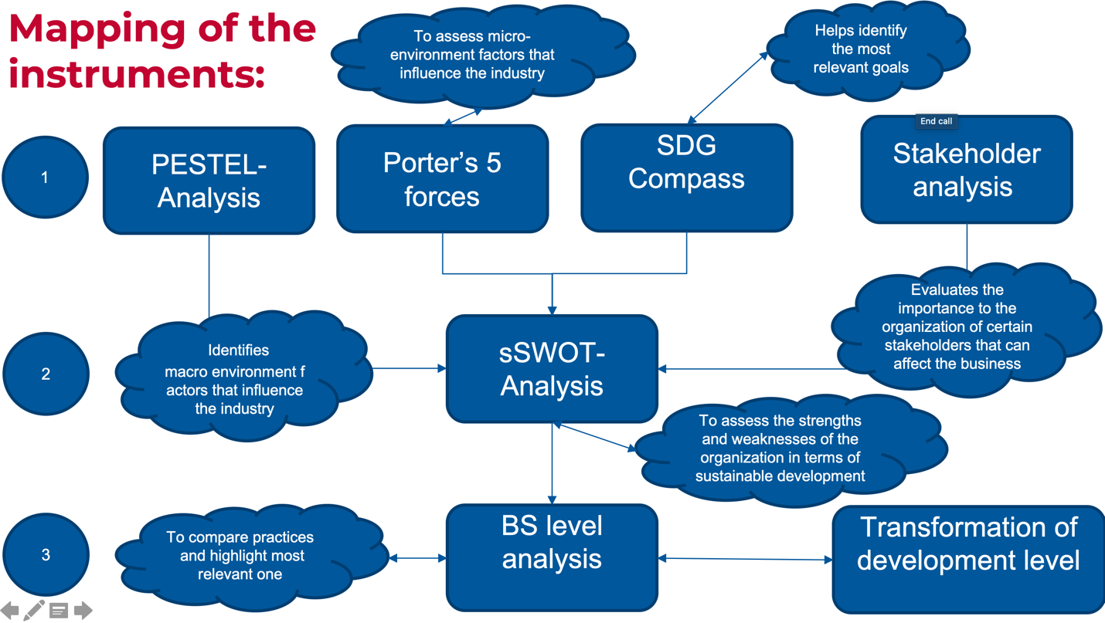
- Interconnections between tools & how they shape the paper

1) Chapter 1 is devoted to the theoretical tenets of CS, current CS concepts, as well as to the analysis of the industry in the territory of the Russian Federation at what stage of the life cycle this industry is located, the attractiveness of the Russian tobacco market for transnational corporations is assessed; competitive positions are determined, the strategies and goals of the two international companies under study are analyzed.
2) Chapter 2 will be an analytical work of the author, designed to solve the problem posed by this work. Various manager methods and tools will be used.
3) Chapter 3 is the logical end, which is necessary to summarize and put forward a proposal for a solution to the problem, based on the research from chapter number 2.

Chapter 1. Analysis of CS: From basics to “up today” vision of the tool and History of CSR and Industry overview

Theoretical overview of tools: from CSR to CS
The moment of creating the concept, or at least the foundations that served as the basis for CSR, can be called the beginning of the 20th century. In those days, in the era of the next industrial revolution, the projects of such world personalities as Henry Ford and his social program began to develop, the crucial point of which was the establishment of the highest wages for industrial workers at that time, subject to certain conditions, and the construction of small enterprises in rural areas. The main provisions of the social program, which was finalized during its implementation, were as follows: At the central automobile plant in Highland Park (a suburb of Detroit), the working day was reduced from 9 to 8 hours, but three shifts were introduced, while at local assembly plants, where fewer products were produced, the 9-hour working day was maintained. All manual laborers, including cleaners, movers, and laborers, were given the opportunity to “share in the profits” through the new wage system. In Detroit, for a worker over 22 years old, it was at least $5 per day (regardless of qualification and specialty), at assembly plants it was at least $4, with $5 being the maximum rate. In the summer of 1916, the minimum age for receiving a supplement for single workers was lowered to 21, and those who were married and had dependents were allowed to participate in the profits from 18 years old. From the fall of 1917, all workers over the age of 18, regardless of marital status, could receive the allowance, while it was only required that they lived in Detroit for at least six months before being hired. The new wages were introduced only for non-drinking, frugal and diligent workers, and the company was engaged in collecting the relevant evidence. Temporary workers were not allowed to share in the profits, while permanent workers were given a 6-month probationary period, reduced to 30 days in 1919, when the surcharge was replaced by a minimum rate of $6 per day. Ford limited the hiring of women, believing that their place was home and family, and the husband’s earnings should be enough to support the family. for various reasons fell on the shoulders of women, they were employed. In October 1916, women were equalized with men in pay. All employees who have worked for more than 6 months in production, were tested for $5 a day. During the probationary period, men and women received a higher basic rate ($3.44 a day) and two weeks of fully paid leave (those with a bonus had to rest at their own expense for one to two weeks). A voluntary savings and loan bank was established for the workers. On payday, those who wished to contribute one dollar each, but any worker, even without a contribution, could receive a loan of up to $20 at a small percentage. The International Labor Organization, which was a specialized agent of the United Nations system, was founded in 1919 with the goal of promoting the concepts of social justice, globally recognized human rights, and labor rights.
Corporate social responsibility
By the middle of the 20th centuries (50s) there is a certain trend in the development of interaction between the state and business due to the great upheavals of this century, which gives rise to certain discussions around CSR. In the postwar years, the work of the economist G. Bowen influenced the formation of the concept of CSR, who later identified him as the "father of CSR" "The Social Responsibility of a Businessman" (1953), in which the researcher defined social responsibility as "the duty of businesspeople to make those decisions and follow those activities that are desirable in terms of the goals and values ​​of society. G. Bowen defined conceptually the problem that business is a part of society to which it is responsible. But Bowen's main idea is the ability of the GDS to bring social and economic benefits to both business and society as a whole.
However, many other equally important scientists and researchers put forward several concepts that form the basis of the modern CSR theory; since the 1950s, CSR has been worked on by: A. Carroll. P. Drucker, M. Friedman, and many others.
Many different scientists tried to systematize the development of the theory and concept of CSR, however, due to the initial "decentralized" approach, it is impossible to bring everything into an individual system because of the different vision of the same processes by different scientists as well as different approaches to research.
However, in this part of the work, the founders will be described, thanks to which, as it seems to me, a certain evolution of CSR has taken place. the evolution of CSR from corporate social responsibility to corporate social performance (CSP) will be described.
Professor Archie Carroll published his pyramid model in 1991 and since then it has become quite a popular tool in business. He argued that CSR can only become a reality when managers become moral and completely eliminate immoral behavior.
The pyramid describes the hierarchy of responsibility, the steps of which create CSR: at the bottom is the economic factor, then comes the legality, then ethics, and at the very top of the pyramid is charity. Without this harmony, Caroll argued that any company would eventually fail because the world of business was changing and there would no longer be companies focused solely on profit.
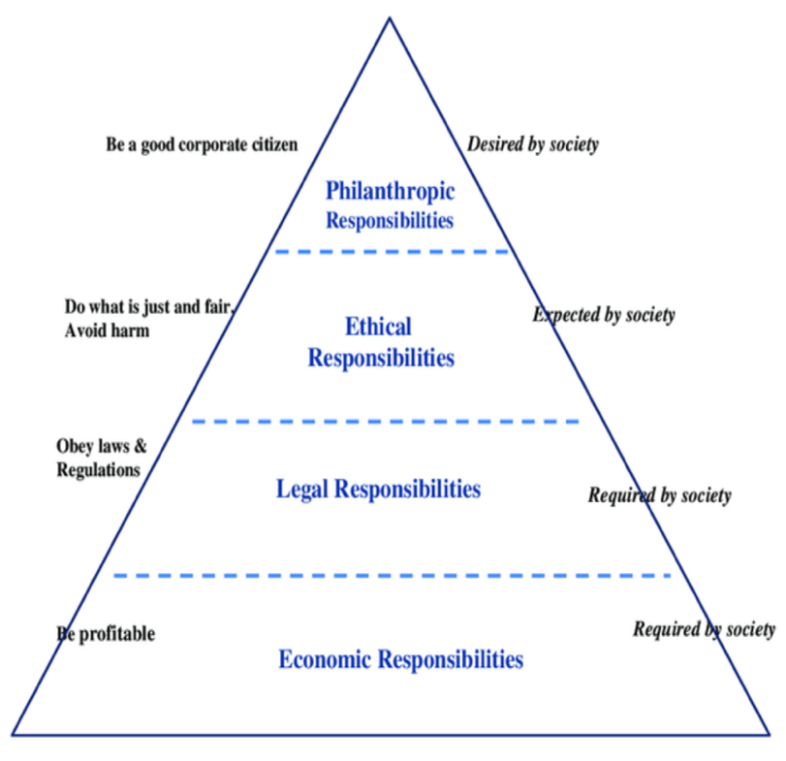
- CSR Carol’s Pyramid

The description of the pyramid will go from the bottom (basic) to the high needs for the corporate social responsibility pyramid
The first thing any company should think about their profits. The task is quite simple - minimum expenses, maximum income. When the company is firmly on its feet, you can think about investments. In this case, expenses will increase, and income will not be received immediately. The same thing happens with innovation.
The Company bears economic responsibility to its employees, investors and shareholders. It also means creating good products and services that do not adversely affect the health of your customers.
Each person in the organization must be held personally accountable for their actions. To do this, you need to work to educate your subordinates.
The minimum requirement for any business is that it must be legal. In many countries this means:
- Be honest about the products and services company sells.
- Ensure the safety of your employees and customers.
- Don't destroy the environment.
- Pay taxes.
In the world of ethical business, a company's reputation is of paramount importance. If she is caught and fined for her illegal activities, most of her clients will turn away from her.
The company must provide its employees and customers with reliable and timely information.
This element expands the obligations of the organization. Company management must determine what is good and what is bad, even if it is not required by law.
For example, by law, a company has the right to use any alloy of steel in its cars as you wish. However, if a company realizes that steel, its strength, does not meet safety requirements, then the company itself can develop and create a new alloy even if this will affect revenue due to high production costs. Or, for example, you cannot structure your company in such a way that you pay less taxes.
This is the highest commitment that the company undertakes. If the company is not doing this in order to receive tax breaks and cash in on it, then it is acting in the most humane way. If a company wants to improve the world around you, donate money to education or healthcare. The company may also allow its subordinates to volunteer. The company's expenses are rising, but it can afford it and will not lead to its collapse.
Carroll presented a four-part definition of CSR in 1979, which was contained in a CSP conceptual paradigm (Carroll, 1979). His basic argument was that in order for managers or firms to engage in CSP, they needed (a) a basic definition of CSR, (b) an understanding/enumeration of the issues for which the firm had a social responsibility (or, in modern terms, stakeholders to whom the firm had a responsibility, relationship, or dependency), and (c) a specification of the philosophy of responsiveness to the issues. He proposed that because responsibility was not a quantifiable entity, it might be replaced with a concept of performance that was more appropriate for the situation. CSP is distinct from CSR in that CSR focuses on the role of companies in society, whereas CSP focuses on how responsibility is exhibited in the context of individual organizations.
The concept of CSP is an extension of CSR that puts more emphasis on results achieved. The development of the CSP concept took place in parallel with CSR, but with a slightly different focus. Many of the scholars who have worked on the topic of CSR would have noticed that the importance of firm performance is also reflected in their concepts, but this branch was clearly manifested in the scientific literature only in the 1970s, when the authors (one of the first were Lee Preston, Sethi and Carroll) began to emphasize the aspect of efficiency rather than the aspect of responsibility. Also Carroll’s approach was taken to consider by Wartick & Cocharn (1985). In combination with Preston and Post (1975) work, in outcome Wartick & Cocharn stated 3 points of CSR as a) Economic responsibility, b) Public responsibility and c) social responsiveness.

Corporate social performance
Next stage of CSP model development was made by Donna Wood (1991), this vision of the model still be actual today. Wood expanded and refined the Carroll model and outlined the revised model, further dissecting the performance aspect. Wood argued that CSR is a combination (depending on the specific enterprise) of social responsibility principles, social reactivity processes, policies, programs, and other observable results related to the relationship of the firm and society. Wood maintained that, while prior conceptualizations had some validity, they were insufficient for 4 reasons: (1) There was a gap in the activity. (2) Social responsiveness is a collection of processes rather than a single process. (3) There was an overabundance of dependence on policies, which do not ensure responsible outcomes. (4) While every company may be judged on its performance, traditional notions of responsible and irresponsible businesses do not mesh well with CSP thinking. Also she emphasized the importance of the results of corporate efforts. (Wood D.J. (1991). Corporate Social Performance Revisited) As a result her vision of CSP is: a commercial organization as a hub for acts that have ramifications for stakeholders, society, and the company itself More crucially, the conceptualization is obviously sociological rather than managerial, economic, or philosophical, and it is based on organic open systems rather than mechanical and closed systems. In the Fig 3. Wood’s CSP model is provided:
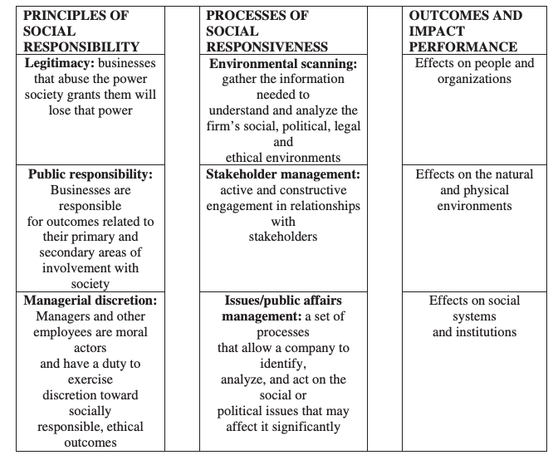
- Wood’s corporate social performance (CSP) model
Summarizing the philosophy of Carroll's concept of CSR, comparing with his idea of CSP, developed by Donna Wood, we can conclude that Donna Wood created a manager's tool, because thanks to her work, a manager can work with CSP, thanks to the ability to measure its effectiveness within the structure.
Regardless matter how present it is, the CSP model nowadays makes sense when taking into consideration sustainable development at the level of CSR principles (the first component of the model). If this is not the case, then business from the perspective of society is not legitimate. That is why Siltaoja advocated that the CSP framework's principles be changed to embrace sustainable development rather than the general concept of legitimacy, as well as to incorporate environmental and social learning into the processes of social responsiveness.

Business sustainability
Time passes, and with it, certain business processes are modified, which creates a certain reaction from all correlative sides. This did not bypass the CSP, which was transformed and explained by Dyllick and Muff in the article Clarifying the Meaning of Sustainable Business: Introducing a Typology From Business-as-Usual to True Business Sustainability. Implicitly, this structure corresponds to the concept of CSP. This is “revisited” version of the CSP concept, developed by Wood, combines the principles of social responsibility (principles/inputs), processes of social responsiveness (processes/ throughputs), as well as outcomes and impact performance (results/outputs) In this article, the authors consider 3 types of business sustainability (it is noteworthy that in the article the authors avoid using the term corporate sustainability(CS), since, from their point of view, it reflects the big business of corporations, and business sustainability is applicable to other companies, although in fact both terms mean the same and too) Scientists explore existing methodologies and create a typology of corporate sustainability, focusing on a successful contribution to long-term development. Business Sustainability 1.0 (Advanced Shareholder Value Management), Business Sustainability 2.0 (Managing for Triple Value) and Business Sustainability 3.0 are different types of business sustainability (True Sustainability). The result of their work is the creation of business sustainability typology structures (Business Sustainability of BST typologies) reader can get acquainted with it in fig 4.
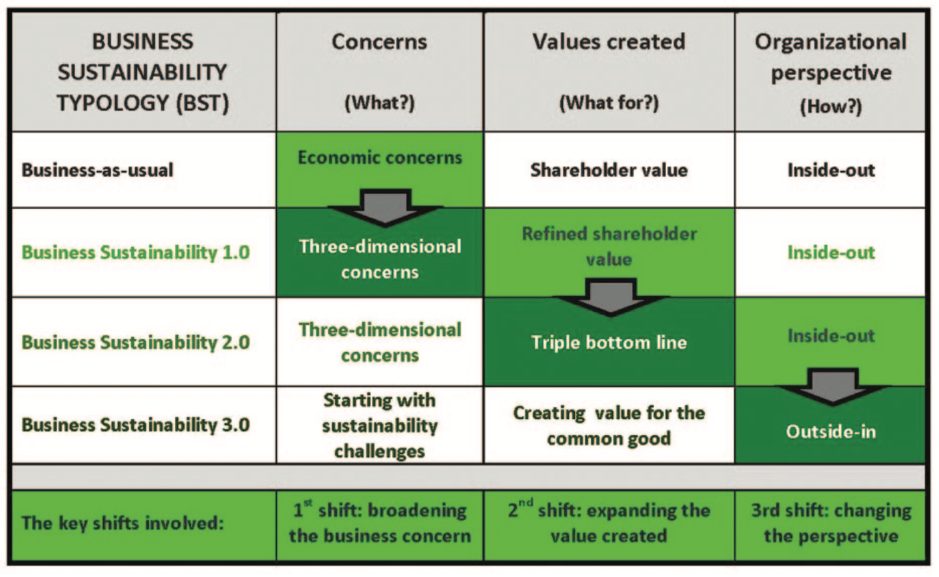
- Business Stability Typology
All of the above theories are considered general CSR theories. In general, evolution can be represented on a time interval.
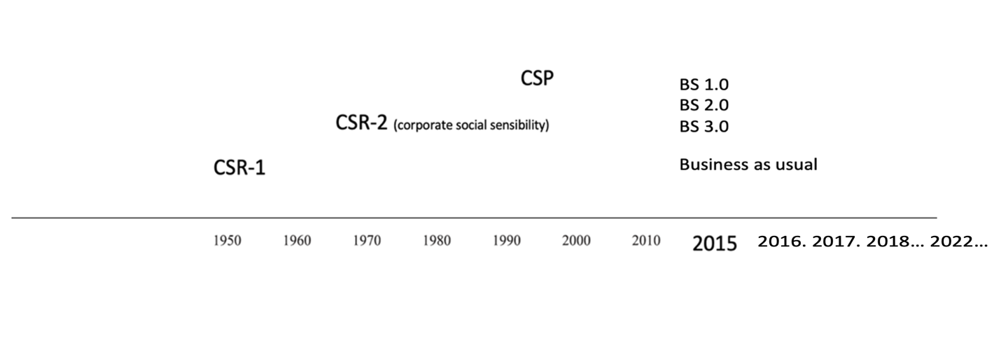
- Chronology of CSR development
However, the construction of a coherent CSR theory remains an open subject. The challenge stems from the tension between the responsibility to follow moral standards (normative approach) and the belief that socially acceptable corporate action is inextricably linked to efficiency (instrumental approach). Although scientists are continually generating new CSR concepts and interpretations, many experts are questioning whether existing CSR notions can be combined into a single theory.

Sustainable development goals (SDGs)
The Sustainable Development Goals, also known as the Global Goals, are a set of 17 interconnected global objectives that are intended to serve as a "blueprint for achieving a better and more sustainable future for everyone." The Sustainable Development Goals (SDGs) were established by the United Nations General Assembly in 2015, with the goal of achieving them by 2030. These goals are provided in the fig 6.
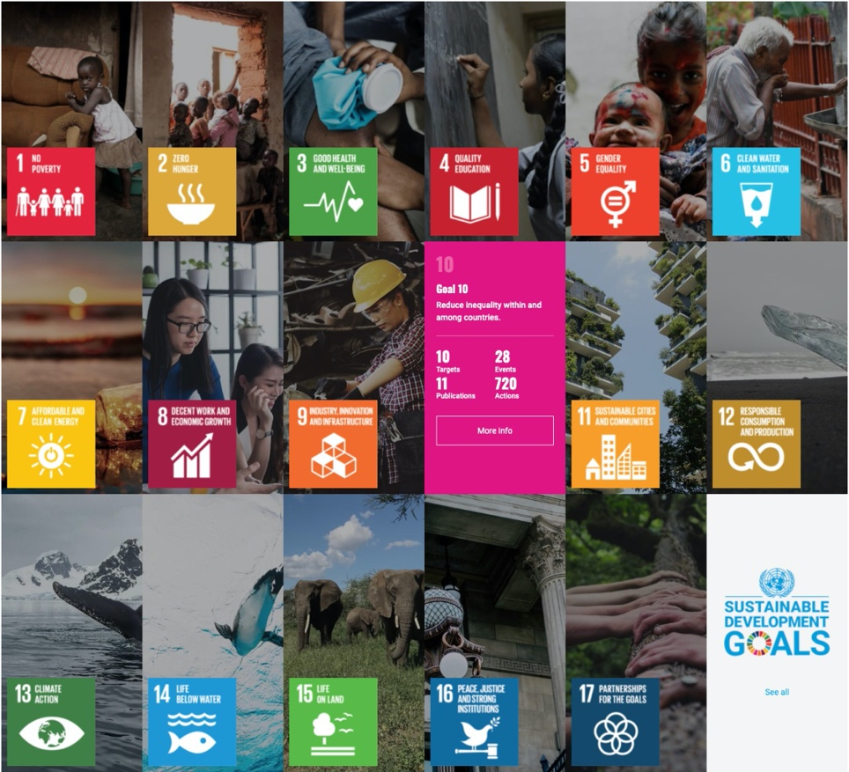
- Sustainable development goals
The SDGs are useful for following tasks:
- Identifying future business opportunities
It is the goal of the Sustainable Development Goals (SDGs) to refocus global public and private investment flows toward the issues that they represent. As a result, they define expanding markets for businesses that can provide creative solutions and dramatic change to their customers.
- Enhancing the value of corporate sustainability
While the business case for corporate sustainability is well established, the Sustainable Development Goals (SDGs) may, for example, strengthen the economic incentives for companies to use resources more efficiently or to switch to more sustainable alternatives as externalities become increasingly internalized. This is because the SDGs are designed to make the world a more sustainable place.
- Strengthening stakeholder relations and keeping the pace with policy developments
International, national, and regional policy directions are reflected in the SDGs, which represent stakeholder expectations as well as future policy direction. Those businesses that match their goals with the Sustainable Development Goals (SDGs) will see increased participation from consumers, workers, and other stakeholders, whilst those that do not will face increasing legal and reputational consequences.
- Stabilizing societies and markets
Businesses cannot thrive in civilizations that are in decline. Investing in the accomplishment of the Sustainable Development Goals (SDGs) helps to ensure the presence of key pillars of corporate success, such as rules-based markets, transparent financial systems, and non-corrupt and well-governed institutions.
- Using a common language and shared purpose
The Sustainable Development Goals (SDGs) offer a standard framework of action and language that will assist corporations in communicating with stakeholders about their impact and performance in a more consistent and effective manner. The objectives will aid in bringing together synergistic partners in order to solve the world's most pressing social issues.
Speaking about interconnection of CSR and SDGs the CSR law establishes a broad framework and provides guidance for a more sustainable future, while the Sustainable Development Goals (SDGs) provide measurable and well-defined objectives for measuring the result of operations. As an evolution from the MDGs (Millennium Development Goals), the Sustainable Development Goals (SDGs) expressly call on businesses to use their creativity and innovation to address development concerns as part of their mission. The Sustainable Development Goals (SDGs) provide increased possibilities for private sector engagement. The objectives bring together actors from all sectors in order to pursue a shared vision of sustainable development and to confront the socio-economic and environmental issues that are now facing the world.

Chapter 2. Industry overview & industry analysis correlated with Business sustainability concept
Unfortunately, according to statistics, Russia is among the leaders in the ranking of cigarette smoking statistics. 28.30% of the total population percent - the proportion of smokers in the Russian Federation, among men this percentage will be 40.90% and 15.70% among women in 2022. According to estimates in 2016, Russia ranks 9th in terms of the number of cigarettes per person from 15 years of age and older per year and this is 2,295 units.
By 1998, global businesses Philip Morris, BAT, and JTI had spent over $1.5 billion and possessed 11 cigarette facilities, allowing them to quickly enter the Russian market and begin capturing the target population, leaving Russian brands in the dust. In the light of current societal and country-wide transitions, a tobacco market study will be able to assess how desirable the Russian market is for cigarette businesses.

PESTEL analysis
In order to understand the external environment of indirect impact, it is planned to conduct a PESTEL analysis, with an analysis of political, economic, cultural & social and technological , ecological and legal factors that facilitate or hinder business in the Russian Federation. This analysis is demonstrated in the fig.5.
- PESTEL-analysis of tobacco industry in Russia
Political factors | Economic factors
- Increasing taxes on the production and sale of cigarettes  - Integration of tobacco products into the unified state automated information system  - High level of uncertainty due to the geopolitical situation, due to which international companies are forced to react by leaving the Russian Federation | - Stable contraction of the market  - Growth of the shadow market  - Exchange rate instability  - Decline in the purchasing power of the population  - Rise in the cost of logistics  - Cigarette smuggling  - Correlation with legislation policy increases price
Social factors | Technological factors
- Eco-friendly trend  - Healthy lifestyle  - Restriction of free smoking areas | - Innovations in field of classic cigarettes analogs with advantages
Ecological factors | Legal factors
- Environmental concerns | - Strict legislation & anti-tobacco policies
Composed by author on the basis of news articles

Political factors:
Increasing taxes on the production and sale of cigarettes
The claims that the tax authorities have begun to make against tobacco companies are growing. According to the results of on-site inspections, the Russian divisions of Imperial Tobacco, British American Tobacco, Philip Morris International (PMI), as well as “Donskoy Tabak” (since 2018 part of Japan Tobacco International, JTI) received an additional 60 billion rubles, a federal official said, and This does not include interest and penalties. All these manufacturers have passed or are still undergoing inspections, their employees and top managers confirmed to Vedomosti.
The Federal Tax Service (FTS) has been actively checking tobacco companies for the past two years. The service drew attention to the sharply increasing output of cigarettes in the fourth quarter, which manufacturers tried to ship to distributors affiliated with them in the same period. By artificially increasing sales, companies fixed excise rates until they were raised from the new year and thereby reduced the tax burden, a federal official told Vedomosti.
To stop this practice, amendments to the Tax Code were adopted. Since 2017, if tobacco companies in the fourth quarter work too hard for the warehouse and their production exceeds the average monthly figures of the previous year, then they will have to pay an excise tax 30% higher than usual when selling. According to Rosstat, until 2017, the production of cigarettes was constantly growing in October-December compared to July-September: in 2014 - by 25%, in 2015 - by 15.5%, in 2016 - by 4%. After the adoption of the amendments, on the contrary, it decreased.
High level of uncertainty due to the geopolitical situation, due to which international companies are forced to react by leaving the Russian Federation
On March 9, BAT announced the termination of investments in the Russian market against the backdrop of the situation in Ukraine but drew attention to the fact that it was terminating its activities.
The BAT group of companies (the Russian branch of British American Tobacco) is a manufacturer of tobacco, cigarettes, and other nicotine products under the brands GLO, Lucky Strike, Kent, Java and others. BAT has been operating in Russia since 1991.
Against the background of the "military operation" in Ukraine, which began on February 24, many companies left the Russian market. Including the temporary suspension of the announced tobacco company Imperial Brands (Davidoff, Richmond and Gitanes). Tobacco concern Philip Morris (IQOS, Parliament, Marlboro) announced the suspension of investments in Russia and the activation of plans to reduce production operations in Russia.
Japan Tobacco International (JTI) has declared that it is halting all new investment and marketing operations, as well as the planned launch of its new product, tobacco heating devices, in Russia.
"The obstacles of operating in Russia are unparalleled at this moment, and JTI need some time to examine the long-term ramifications of the scenario that all large international investors in Russia are presently confronted with." JTI "cannot rule out the potential of stopping its manufacturing activities in the nation until the operational environment and geopolitical circumstances drastically improve," the business stated in a statement on its website.
It highlights that Russia is one of JTI's most important markets. In Russia, the firm employs roughly 4,000 people and operates four plants. 1100 of them work in St. Petersburg. According to the statement, "all personnel will be kept for the foreseeable future."
Integration of tobacco products into the unified state automated information system
The Ministry of Finance advocated completing the unified state automated information system for tracking alcohol production and turnover (EGAIS). Tobacco makers and dealers will be required to upload data to the new EGAIS, according to the government.
For persons involved in the production of tobacco products there is an obligation to equip the equipment with technical means for recording and transmitting information on the volume of production and turnover of tobacco products and raw materials into a unified state automated information accounting system that will operate on the revised EGAIS accounting for the volume of production and turnover of ethyl alcohol, alcoholic, and alcohol-containing products. A similar requirement is proposed to be introduced for representatives of the wholesale trade.
Economics factors:
According to Rosstat, in 2019, the production of cigarettes in Russia decreased by 11.1%, to 229 billion pieces. Representatives of the largest manufacturers attributed this to the growth of the illegal market.
“According to our estimates, in 2019 the total market volume decreased by 8% compared to 2018,” said Sergey Slipchenko, vice president of corporate affairs in Philip Morris International (PMI) in Russia. including quitting smoking, switching smokers to alternative products with reduced risk. But the main factor is, of course, the continued growth in the volume of illegal products: according to the Nielsen agency, in the third quarter of 2019, the share of illegal products on the Russian market was already 15.6%.
The same opinion was expressed in other companies. The growing popularity of counterfeit cigarettes was explained there by the low price - an average of about 50 rubles. per pack against 115 rubles. for a legal pack. Of these 115 rubles. not less than 62 rubles. subject to excise and VAT.
From January 1, 2022, in Russia, the single minimum price (UMC) for one pack of cigarettes will be 112 rubles, it will increase by four rubles compared to 2021.
It is impossible to sell cigarettes in Russia below this price.
The unified minimum price is calculated on the basis of the minimum excise rate for one thousand pieces of cigarettes or cigarettes, as well as the VAT rate and a multiplying factor of 1.4. (https://retailer.ru/proizvoditeli-objasnili-snizhenie-vypuska-sigaret-rostom-nelegalnogo-rynka/?utm_source=yxnews&utm_medium=desktop)
Since excises will increase by 4% from January 1, the minimum price of tobacco products will also increase.
Recall that the UMC for cigarettes was introduced by analogy with alcohol from April 1, 2021 in order to combat the illegal market: everything that is sold cheaper than this price is automatically considered an illegal product.
Following the excise tax, the average price for a pack of cigarettes will rise by 5-10 rubles to 145-150 rubles.
Social factors:
Eco-friendly trends
Smoking, as a phenomenon, according to scientists, harms not only humanity (passive and active smoking), but also the environment. So according to the UN: Tobacco smoke contains more than seven thousand toxic substances, including carcinogens, as well as greenhouse gases. Thousands of tons of these chemicals end up in the atmosphere, soil, and water: cigarette butts are the most common type of waste. In urban and coastal areas, bullheads make up 30-40 percent of the garbage.
Healthy lifestyle:
In Russia, the number of adherents of a healthy lifestyle (HLS) is growing. According to the RANEPA sociological survey, 15.5 percent of Russians practice a healthy lifestyle, which is three times more than in 2010, when about 5 percent cultivated a healthy lifestyle. True, the statistics of Rosstat are more severe: only 9.1 percent of Russians are actively engaged in healthy lifestyles, and about 4 percent lead a healthy lifestyle, as they indicated, "occasionally."
At the same time, as noted by the RANEPA sociological study, about 89.4 percent of the survey participants reported that they are aware of personal responsibility for their health. Sociologists explain the positive shift in the mass consciousness of compatriots by the relative rise in the standard of living of different categories of society and their concern that not only they personally take care of their health, but also "the state pays more attention to protecting the health of its citizens."
As noted in the study, sociologists consider healthy lifestyle supporters to be those people who go in for sports or exercise at least two or three times a week, follow a diet, do not smoke or abuse alcohol.
Scientists also focus on the fact that the pandemic did not serve as a limiting factor for the promotion of a healthy lifestyle, on the contrary, it increased the attention of many to their health. More than 33 percent of survey participants reported this. At the same time, sociologists stated that, unfortunately, 21.8 percent of the respondents regularly smoke, and 8.4 percent drink alcohol. They do it occasionally: they drink alcohol - 10.9 percent, smoke - 57.7 percent.
Restriction of free smoking areas
Referring to the anti-tobacco law, which was adopted in 2013 and is being finalized, a new program-plan to reduce smokers, it can be emphasized that:
Smoking is prohibited in territories and premises intended for the provision of educational services, cultural institutions' services, youth affairs institutions' services, physical culture and sports services, territories and premises intended for the provision of medical, rehabilitation, and sanatorium health-improving services, on urban and suburban vehicles, and in open areas less than 15 meters from the entrances to the premises of public authorities, local governments, at workplaces and in work areas organized on premises, in elevators and in common premises tenements ny houses, in the territories of playgrounds, beaches, at gas stations. a phased smoking ban on long-distance trains, aircraft, and long-distance navigation vessels, with delayed passenger transportation services, in premises intended for the provision of housing services, services of communal hotels and preferential places of residence, services of accommodation facilities for temporary accommodation of tourists, in residences intended for the provision of personal services, trade services, public catering, and markets, in non-stamped areas.
Smoking is forbidden in pubs, restaurants, long-distance trains, platforms, electric trains, hostels, and hotels as of June 1, 2014.
Technological factors:
Innovations in field of classic cigarettes analogs with advantages
Speaking about this point there is a great list of different types of nicotine consisted devices that potential customers are able to purchase and start to use them in the long perspective in other words to stitch classic tobacco cigarettes to analogs. Here is provided the list of devices can be named as rivals by technological factor that have “power” to change nowadays situation dramatically:
- Vape - An electronic cigarette is an electronic device that simulates tobacco smoking. It consists of an atomizer, a power source such as a battery, and a container such as a cartridge or tank. Instead of smoke, the user inhales aerosol. Also should be mentioned that vape and systems like that have a nice smell and do not produce C02 smoke, it creates just steam with the smell of flavor (like bananas, blueberry and so on)
- Disposable electronic cigarette - included as a separate technology, as it has a more attractive usage structure for the user (no nicotine refills, etc., which greatly simplifies its use)
- Tobacco heating systems, which are controlled by Philip Morris, BAT and JTI, they produce less smoke and smell and are more conservative, as they use the tobacco leaf as the raw material from which nicotine is produced
Ecological factors:
Environmental concerns:
The widespread use of chemicals in the tobacco industry is causing enormous harm to the environment. In addition, growing tobacco requires a lot of energy and water. Thus, WHO concludes that the production of tobacco products is an extremely destructive process for the environment, and tobacco companies must compensate for the damage caused to nature.
A new report shows that the harms of tobacco go far beyond exposure to tobacco smoke. The entire tobacco production cycle is accompanied by a process of environmental pollution, including deforestation, the use of fossil fuels and the discharge or leakage of waste into the environment. Growing tobacco requires large amounts of insecticides, herbicides, and fumigants to control pests or disease outbreaks. Many of these substances are harmful to the environment and the health of people who work with them on a daily basis. In addition, some tobacco manufacturers, such as those in China and Zimbabwe, use coal in the tobacco industry, which releases carbon dioxide, which is responsible for the greenhouse effect. Millions of kilograms of cigarette butts are also thrown away each year. Tobacco waste contains over 7,000 toxic chemicals that poison the environment, including carcinogens.
Legal factors:
Strict legislation & anti-tobacco policies
Federal Law 15 in the field of protecting the health of citizens from the effects of second hand tobacco smoke and the consequences of tobacco consumption lists the following measures for:
- General concepts and principles of protecting the health of citizens from the effects of second hand tobacco smoke and the consequences of tobacco consumption;
- The rights and obligations of citizens in the field of health protection from the effects of second hand tobacco smoke and the consequences of tobacco consumption;
- The powers of public authorities in the field of protecting the health of citizens from the effects of second hand tobacco smoke and the consequences of tobacco consumption. And includes the following:
- Smoking area restrictions
- Will be discussed in Social factors
- Restrictions on the trade in tobacco products
- From June 1, 2013, the law introduces a ban on the retail sale of tobacco products:
- Prohibition of the sale of tobacco products at a distance of less than 100 meters in a straight line from the border with research institutions;
- A complete ban on the sale of tobacco products to minors and their trade to minors.
Since June 1, 2014, the sale of cigarettes in retail outlets - stalls and kiosks without a trading floor has been prohibited.
- Advertising ban
- The law introduces a complete ban on tobacco advertising, promotion and sponsorship, as well as a complete ban on the demonstration of tobacco products and the process of smoking in content intended for children and adolescents.
- Other measures:
- Provision of medical care to the population aimed at cessation of tobacco consumption and treatment of tobacco dependence;
- price, tax and organizational measures to reduce the demand for tobacco products and restrict trade in them;
- public education and awareness about the harms of tobacco use and the harmful effects of tobacco smoke, which are planned to be implemented through education programs and information campaigns in the media;
- accounting for production, import, export, wholesale and retail trade in tobacco products, tracking production equipment, movement and distribution of tobacco products;
- measures of state control in the field of protecting the health of citizens from the effects of second hand tobacco smoke and the consequences of tobacco consumption and liability for violations of the requirements of the Federal Law.
- Public release of new anti-tobacco measures:
- The plan contains more than 20 events. Their goal is to prevent smoking and reduce the demand for tobacco products.
As a part of this effort, it is intended to tighten control over compliance with the legislation regarding the prohibition on advertising of tobacco products, with the goal of increasing the efficiency of the battle against the illicit manufacturing and circulation of such items.
In addition to this, it is anticipated that the regulations for the packaging of tobacco products would be improved in accordance with the suggestions made by the World Health Organization. Specifically, the problem of the creation of standard-sized and impersonal packets will be worked out. Seventy-five percent of the surface space of these packages should be filled by drawings or images describing the risks associated with smoking.
A prohibition on labeling tobacco products according to the amount of hazardous compounds they contain is another measure that is in the works for possible implementation. Consequently, this will prevent customers from being misled.
In addition, the problem of putting a prohibition on the use of flavors, colours, and addiction-enhancing compounds in any product containing nicotine will be worked out. This restriction will apply to all nicotine-containing goods. Included in this are liquids used in electronic cigarettes.
In 2019, the Government gave its approval to the general idea of the state strategy which aims to reduce the use of cigarettes and other goods which contain nicotine. To achieve the greatest possible decrease in morbidity and death caused by smoking-related disorders, this initiative's objective is to cut the number of people who smoke from the present rate of 29 percent down to 21 percent by the year 2035.

Porter’s 5 forces
Further, in order to assess the level of competition within the industry, its attractiveness in terms of profit, etc., an analysis of the 5 forces of porter is proposed for your consideration.
Gradation of assessment of the influence of factors:
Strong influence - 3
Medium influence level - 1
Insignificant level of influence - 1
- Competition in the Industry
Now the tobacco market has shrunk by one player, which is Imperial Tobacco (Imperial Brands). At the moment there are main 3 players BAT (British american tobacco), JTI (Japan Tabaco) & Philip Morris that have different brands in ownership, each brand has different quality & price depending on the target audience. Developments in terms of attractiveness to consumers are quite slow due to the conservatism of the market. Therefore, any even minor change is very important for the organization and can help in the expansion of the market, by poaching customers from competing firms.
General score: 3
- Potential of New Entrants Into an Industry (Threat of entry.)
- Economies of scale - 2
Considering this point, I would like to note that the economy of scale is one of the most important factors for entering the tobacco business. Cigarettes are a very mass product that is inherently not premium (i.e., single products will not be in demand), even on the basis that cigarettes of a particular brand should be available in all stores, and not only in specialized tobacco shops. Through this judgment, it can be concluded that economies of scale are very important in the tobacco manufacturing market.
- Product differentiation. - 3
Product uniqueness is very important in the tobacco industry because cigarettes are inherently a unified product. In this case, demonstrating the value of a particular product is a very resource-intensive task from a marketing point of view. In essence, the tobacco business must distinguish its product from many similar competing products, demonstrating its advantages, while not losing the positive properties that competitors have.
- Capital requirements. - 3
The tobacco business is capital intensive. Entry into the business is very expensive, as the costs go not only to production, expensive marketing with value creation, but also to sustainable development, for example, in 2019, the volume of investments in Russian divisions exceeded $2 billion for Philip Morris.
- Cost disadvantages independent of size. - 1
No of their size or achievable economies of scale, entrenched enterprises may have cost advantages not available to future competitors. These advantages might be attributed to the impacts of the learning curve (and its forerunner, the experience curve), proprietary technologies, access to the best raw material sources, assets acquired at pre-inflation prices, government subsidies, or advantageous locations. Cost benefits are sometimes legally enforced, such as through patents.
- Access to distribution channels. - 1
Creating distribution channels is a very important factor that needs to be built. Of course, no industry is waiting for new players, so there may be problems with the creation of distribution channels.
- Government policy. - 3
Today's global trend to combat smoking complicates the overall conduct of the tobacco business, business in the Russian Federation is no exception. There are quite tough laws from 2013 and new laws are being discussed that are designed to speed up cigarette consumption, which makes the Russian Federation less and less a large market for tobacco products.
- Changing conditions. - 3
Due to political restrictions and economic sanctions, the market may change, because BAT, RM and JTI announced the suspension of investment in the Russian market, which certainly cuts off the opportunity for other international companies to enter the Russian market. So, for example, the Chinese state-owned company China Tobacco Guangxi Industrial (China Tobacco Group) plans to enter the Russian tobacco market as early as 2021. And the factor of changing conditions can give an impetus to the speedy entry into the Russian market.
General score: 2
- Suppliers group ability
The market is divided among themselves by international corporations that buy tobacco and other materials for the production of cigarettes in other countries. Companies have their own system that has been debugged over the years, which allows them to influence suppliers themselves.
Thus, the number of plantations and arrangements with large cigarette manufacturers is proportional to the needs. Thus, the largest operators of the raw tobacco market were Universal Leaf Tobacco, Standard Commercial, Dimon - which cooperate with Philip Maurice, BAT and JTI.
General score: 1
- Customer power
- Customer is dictator – 3
If the population quits smoking, the tobacco business will certainly go bankrupt, so tobacco companies always listen to customers in order to create products that meet the requirements of users. Therefore, it can be noted that consumers have full power of tiktovat and tobacco products according to their taste. Given the conservatism of one company, a competitor company can always put forward an updated product to meet the needs and desires of the buyer, which will certainly increase its loyalty among old customers and bring consumers of the competitor's products
- Customer loyalty – 1
At the same time, the phenomenon of the situation is customer loyalty, since, throughout history, there were no situations described above that would allow competitors to lure away buyers by introducing any features that are critical for the buyer. All tobacco organizations always listen to customers. It does not violate the buyer's power. The demand for tobacco products is inelastic on the part of the smoking population (despite the introduction of certain anti-tobacco measures by the state or the increase in the price of cigarettes by the companies themselves due to taxes, etc., the demand still remains, since in many cases it is determined by non-price factors).
General score: 2
- The threat from substitute products
Defining substitute products, the author refers to them the following products: 1) Electronic cigarettes (vapes & disposable cigarettes, 2) Hookahs & Snus.
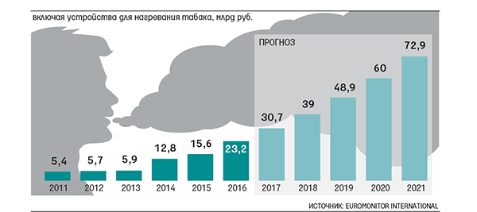
- Sales of Vape production in Russian Feredation
Electronic cigarettes - 3
(Vapes and disposable cigarettes) - this type of product is gaining popularity among the population and is an immediate threat to classic cigarettes. It is very important to understand that tobacco corporation products (tobacco heating system) do not belong to this product category. Vapes and disposable cigarettes use liquid nicotine salts.
Hookah – 2
Speaking of hookahs, this type of consumption of nicotine-containing products is not a direct competitor to cigarettes, as it is a ritual that requires time and company. Hookah can be related to the type of leisure activities. Therefore, it does not directly affect cigarettes, therefore, the hookah audience does not directly depend on and does not affect the cigarette business
Snus – 1
Snus - a Swedish invention at one time was gaining popularity and had the opportunity to influence the tobacco industry, but due to fatal outcomes it was banned from sale in the territory of the Russian Federation
General score 2

- Porter’s 5 Forces analysis
Force | Score
Competition in the Industry | 3
Potential of New Entrants Into an Industry (Threat of entry.) | 2
Suppliers group ability | 1
Customer power | 1
The threat from substitute products | 2
Composed by author on the basis of news articles

Based on the analysis of Porter's 5 forces, we can conclude that now, the tobacco market is in the process of a certain stagnation, in the presence of fierce competition among participating companies, brands copy and adopt good practices (case with the creation of iqos), which in turn without interference force majeure does not threaten the positions of companies. However, the political crisis that led to the sanctions policy against the Russian Federation may lead to the loss of its leading position if the Chinese tobacco giant enters the market.

SDGs Compass
The SDG compass is a tool designed to identify global goals, which in the case of this work will correlate with the tobacco industry, in other words, the tool helps to find the most optimal goals that a company in a particular industry can fulfill.
Fig. 9 shows the value chain, the full cycle of production of finished tobacco products, at each stage of production, two tobacco organizations are able to influence certain factors, which will lead to power in achieving a particular goal.
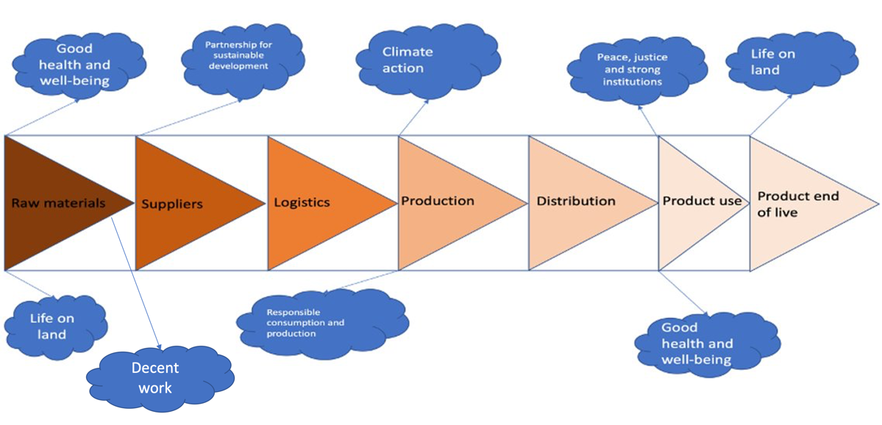
- Mapping the SDGs against the value chain
Tobacco is grown in countries, of which approximately more than half are representatives of states with a significantly low index of human development, where the level of prosperity of the population is quite low. In addition, as a result of the pursuit of profits, manipulations can be carried out on the territory, which can later lead to damage to the tobacco crops themselves. Starting from the beginning, namely with operations on raw material, organizations will be faced with the fact that tobacco is grown in states, of which approximately more than half are representatives of states with significantly low index of human development, where the level of prosperity of the population is quite low, and also because of the pursuit of profits, manipulations can be carried out on the territory , which later can lead to damage to the earth.
It may appear that a cigarette or an electronic tobacco heating system is not a very complex product; however, these items require a large number of distinct components, such as wrapping paper for cigarettes and sticks and lithium-ion batteries for electronic tobacco heating systems. Suppliers play an important role as an intermediary in the production of products. Due to the fact that the firms in issue present themselves as being socially responsible, they are obligated to choose suppliers that have high standards and are domestic to the customer and society as a whole.
In addition, various issues could come up throughout the manufacturing process. There are a lot of things that harm the globe and impact the climate, and one of those things is a dependency on carbon minerals (energy). Additionally, due to the ethical concerns that are brought up by products, businesses are obligated to produce goods of the greatest possible quality and to approach the resources they use in a responsible manner in order to prevent any of those resources from being wasted.
Utilization of goods - Maintaining robust institutions of regulation, for the purpose of preventing, for instance, the sale of items to those who are under the legal age to purchase them, is an essential objective here. It is also extremely essential from the perspective of goal-setting to make a contribution to the well-being of humans by reducing or eliminating the damage that is caused to the body as a result of the intake of tobacco products. Product life cycle - unfortunately, cigarette butts pollute the environment and take a long time to decompose, while waste from electronic heating systems (lithium batteries) is a difficult process to recycle, so tobacco corporations must control processes to cleanse the earth.

Stakeholder analysis
This part of the diploma is dedicated to stakeholder analysis in order to determinate the main stakeholders, their interests and how they are able to influence the tobacco market in Russian Federation. Firstly, the analysis is started from the chart:
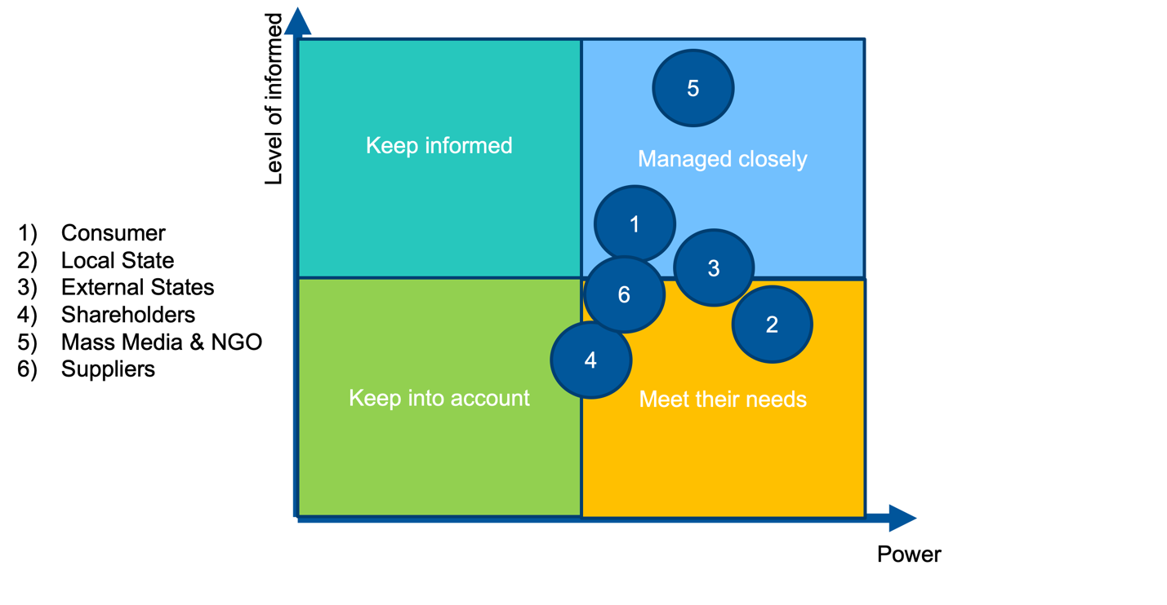
- Determination of main stakeholders
5) The Mass Media The mass media is one of the most significant stakeholders since there is a tendency toward a healthy lifestyle in today's society, which is covered in all disciplines of knowledge. They have a high degree of awareness, interest, and information power, which, in turn, may activate the state, which is the most influential of the stakeholders. This is because they work in tandem with a huge number of organizations that combat the spread of cancer and other illnesses.
2) The internal state (politics and law) is the most significant and influential factor in terms of legislation, prohibitions, and other factors like these. Because they are consistent tax payers, state governments often choose to ignore sports productions that adhere to ethical standards. However, taking into consideration the fact that the state, as the social guarantor of society, is now tuned to the trend of increasing life expectancy and improvements in health, the ideas behind responsible production are also very significant.
1) The customer has complete control over the producer since the consumer is the one who provides the funding for this enterprise, which cannot depend on government subsidies owing to the nature of the firm. It is essential to have this understanding since the success of the company is dependent on the patronage of its customers. Additionally, the fact that his devotion is based on reliance places him in a position that is an order of magnitude lower than the state in its capacity as an interested actor should be taken into consideration. It is important for me to point out that smokers are well aware that goods have negative health effects and are eager to find ways to mitigate those effects while they are still using the items.
4) Shareholders have an interest in generating a return from their investments; nevertheless, the UGSS, as a criteria for selecting an investment portfolio in today's market, also plays a very major part in the decision-making process.
3) States external to the organization (politics and pressure from the global community) The global community, to which the parent organizations of all of the companies in question belong, can exert pressure on organizations to significantly restrict their operations in sanctioned countries. This solidarity with the global community is referred to as solidarity with the global community. This point in time should also be taken into consideration in order to appropriately develop a conversation and make things easier for the nations who are hosting the event and their "allies."
6) Suppliers are one of the most significant elements that an organization must reckon with and meet their expectations. This is because a sustainable supply chain is highly crucial for a sustainable company owing to the high quality of raw materials, established networks, and other factors like these.

Materiality matrix
The results of a materiality evaluation may be more easily seen with the use of a materiality matrix. There have been many different interpretations of what should be considered relevant for reporting and what should be considered vital for strategy. This is because the earlier guideline on materiality was quite vague, and attempts have been made to tailor the exercise to match the specific requirements of each organization.
Philip Morris International Matrix:
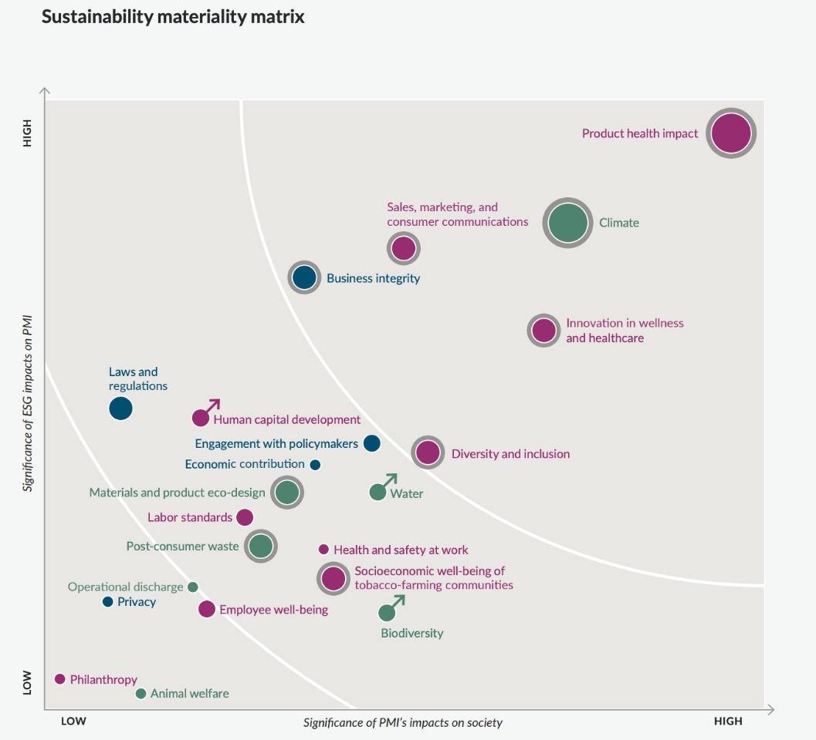
3 stage of priority
2 stage of priority
1 stage of priority
- Philip Morris International Matrix
This table has two levels of analysis: the first level examines the significance of the newly added elements on the functioning of society, while the second level examines the ESG agenda. The ESG agenda is comprised of three pillars: environmental, social, and governance. These non-financial components are becoming an increasingly essential component of the research process that investors employ to discover serious threats and development potential. ), as well as the significance of these factors for Philippe Marris and the other stakeholders. This effort will center on evaluating the significance of various aspects from the perspective of the company as well as the many stakeholders.
It is very evident that, for Philip Morris and its stakeholders, the element of importance that is of the utmost significance is the goods and the influence that they have on health, followed by worries over the climate. While sales, marketing, and communication with customers are of equal significance, the degree of importance of innovation in the sphere of well-being and health is lower. Stakeholders are more concerned with these aspects of the business. The dependability of the business's operations is the following aspect of the situation that should be thought about from the point of view of maximizing the interests of all of the parties concerned (its image). Integrity in business entails eliminating any disconnects between intentions and actions, as well as ensuring that interactions with customers, workers, suppliers, investors, and regulators are in line with the goals and objectives that have been articulated. Other aspects of integrity in business include maintaining a positive reputation in the community. The chart presents the organization's commitment to diversity and inclusivity as the last crucial aspect in the most critical stage (1) of the process.
At the 2nd priority level, there are the following factors that are important for the stakeholders, as well as for the organization: Materials and product eco-design, Socioeconomic well-being of tobacco-farming communities, Post-consumer waste. This is followed by such factors as (interested stakeholders, but not top for PMI material): Laws and regulations, Human capital development, Engagement with policymakers, Water, Labor standards, Health and safety at work, Biodiversity.
At the 3rd level of priority, factors such as: Operational discharge, Employee well-being, Philanthropy, Privacy, Animal welfare.
Japan Tobacco international Matrix:
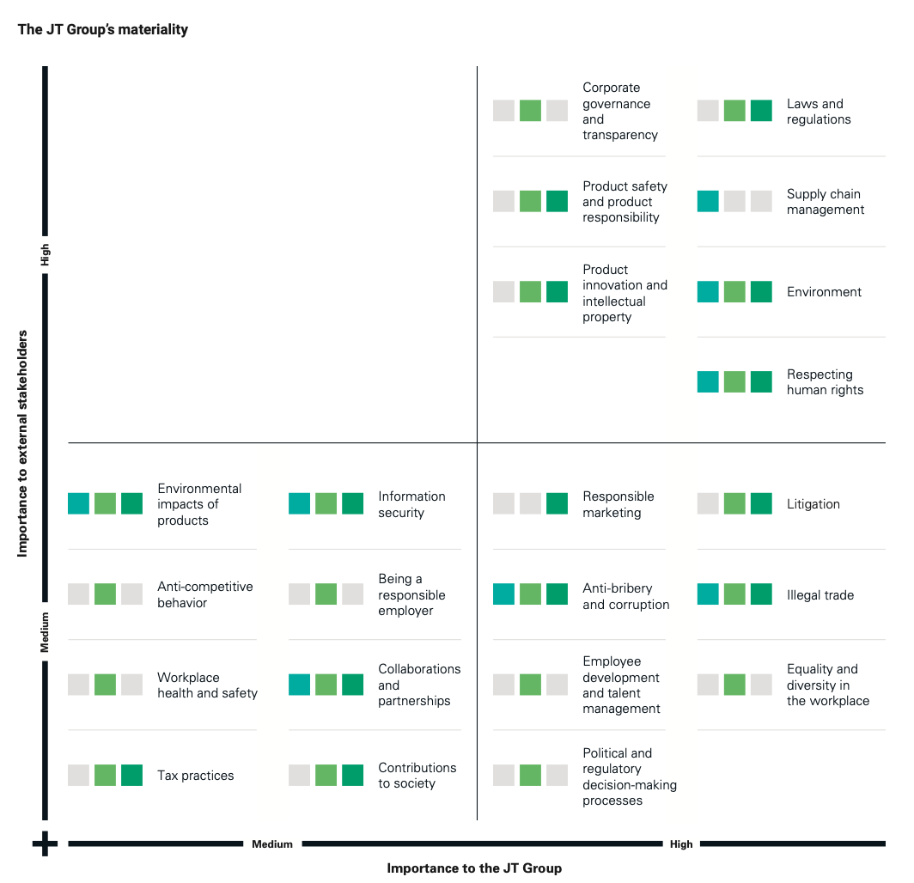
- Japan Tobacco international Matrix
The JTI’s matrix is a little bit different from the one that came before it. It is distinguished by the fact that it incorporates one level of the components that are taken into consideration, and that level is the dependency between the interests of stakeholders and the organization. In this context, I would like to stress that the most significant aspects for the organization are (from the point of view of the organization's chain of command) corporate management. Legitimacy, product safety, and product innovation are important factors for the corporation as well as its customers. The importance of the supply chain cannot be overstated when considering the fact that suppliers are one of the primary stakeholders. Additionally, the environment and respect for human rights are the two aspects that all stakeholders and the business consider to be of the utmost importance.
British American Tobacco Matrix:
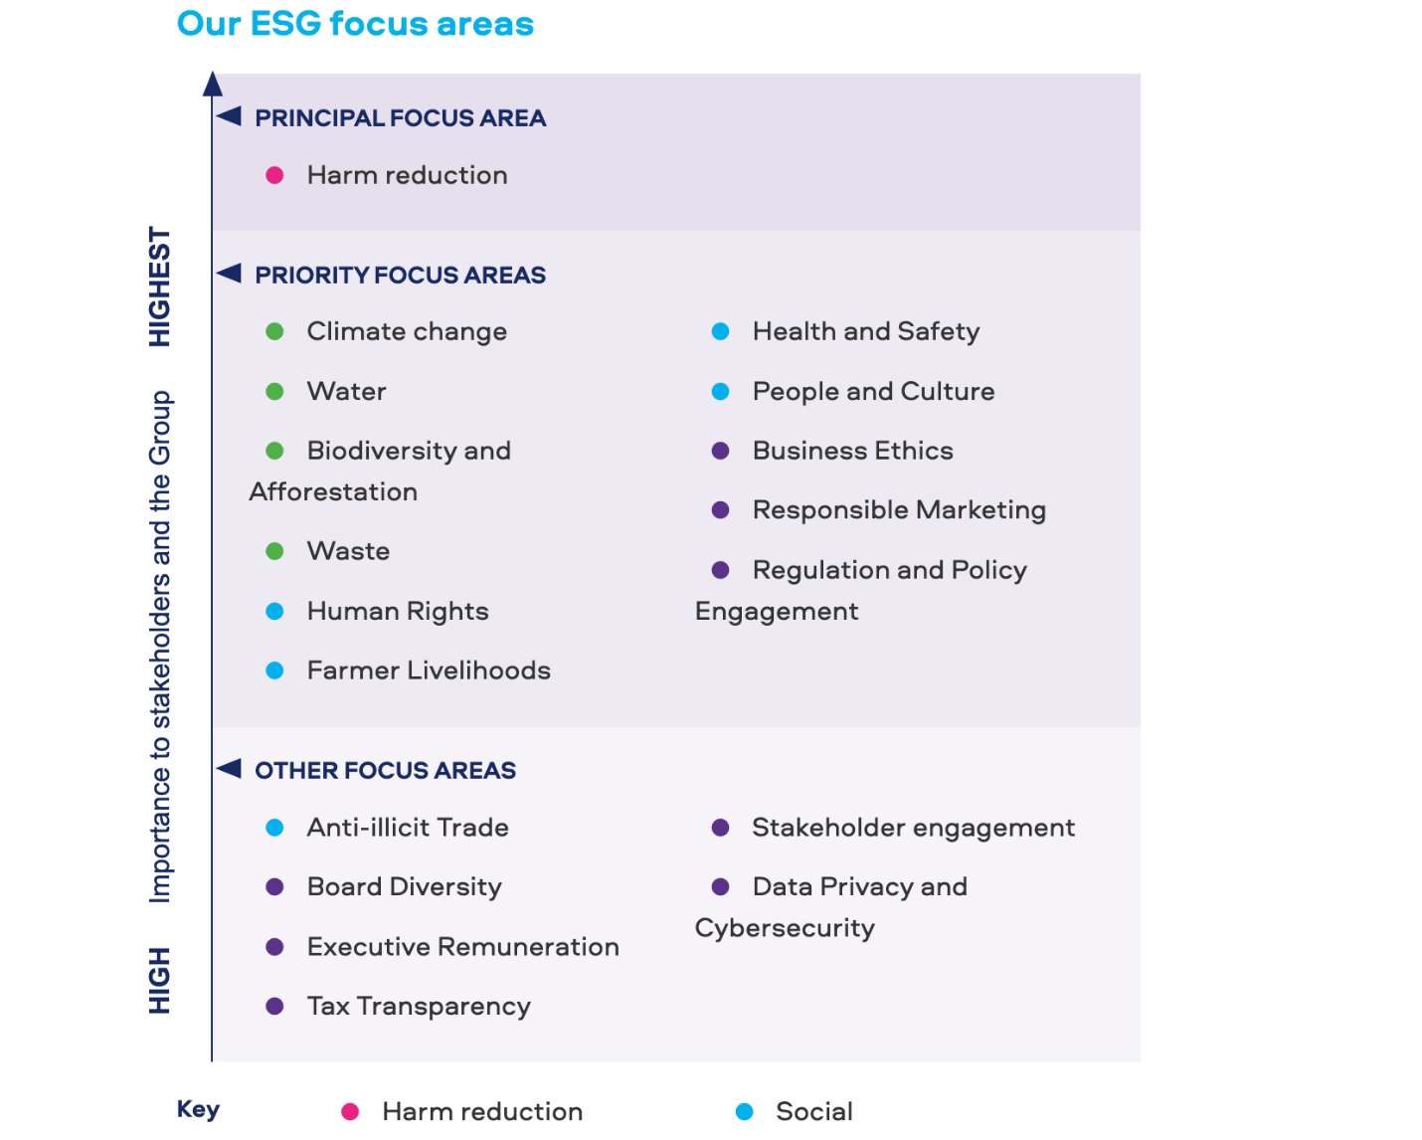
- ESG focus areas of BAT
British American Tobacco does not have a classic materiality matrix, their matrix shows the interest of stakeholders in relation to certain ESG agendas that the company undertakes to implement.
The most important factor for the stakeholders of baht is the reduction of harm to health, the priority areas are climate change, water resources, biodiversification, human rights, health and safety, business ethics (image), etc.
Because the purpose of all matrices is to obtain a visual result—that is, to determine the gradation of problems that are important for stakeholders in the context of the activities of tobacco companies—it is important to note that the differences in interpretations (design, axes name) are insignificant. This is an important point to keep in mind.
In general, it would be helpful to illustrate the fundamental tendencies that are present in all corporations by referring to the materiality matrices that have been provided below for three different organizations. These matrices have been provided for the purpose of illustrating these fundamental tendencies. When it comes to the graphics, human health (the minimization of potential damage caused by products) is of the biggest importance, followed by concerns about the climate (the environment), the transparency and honesty of companies, and the general inclusion of organizations.

The sustainability SWOT (sSWOT)
In this part of the work, it is planned to conduct a sSWOT to identify the main weaknesses and strengths of the CSR activities carried out by companies. It seems to the author that this tool will help to study and understand companies and their actions in more detail, which are aimed at developing a sustainable business.
The World Resources Institute (WRI) developed the sustainability SWOT (sSWOT) to assist businesses in addressing environmental issues. It encourages businesses to collaborate on strategies to develop and sustain long-term value with internal departments, as well as suppliers, customers, and other stakeholders. The sSWOT can be used to engage and encourage coworkers, especially those who are unfamiliar with environmental problems or company sustainability. Most significantly, it can assist senior decision makers in identifying and communicating fresh ideas.

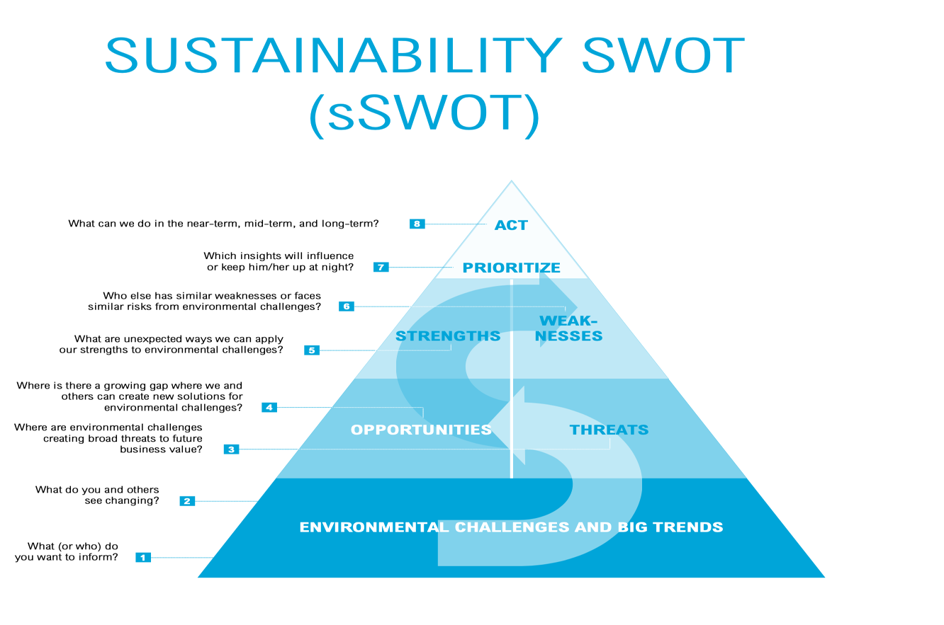
- Sustainability SWOT

Environmental challenges & trends for considered tobacco companies
Philip Morris
Environmental challenges & big trends:
According to the Philip Morris Sustainability Report 2021, organizations identify and are challenged by the following criteria from UN SDG list with 17 positions that they believe they can change or contribute to change in 13 fields:
1) Good health and well-being
2) Quality education
3) Gender equality
4) Clean water and sanitation
5) Decent work and economic growth
6) Industrialization, infrastructure innovation
7) Reducing Inequality
8) Sustainable cities and communities
9) Responsible consumption and production
10) Climate action
11) Life on land
12) Peace, justice and strong institutions
13) Partnership for sustainable development
14) No poverty (Is not the aim of PM)
15) Zero Hunger (Is not aim of PM)
16) Affordable & clean energy (Is not the aim of PM)
17) Life below water (Is not the aim of PM)
These goals correlate with internal targets set by Philip Morris:
- Internal stated goals of PMI
Innovation to create better products | Promoting effective work
- Impact of products on health  - Access to smoke-free products  - Product dependency  - Product realiability | - Responsible marketing and sales activities  - A sustainable approach to supply chain management  - Respect for human rights  - Responsible R&D activities  - Privacy and data protection  - Business ethics  - Countering the trade in illegal tobacco products  - Responsible approach to position promotion companies  - Conscientious payment of taxes
Caring for the people we work with | Environmental protection
- Social and economic well - being of tobacco farming communities  - Health, safety and wellbeing of employees  - Fair working conditions  - Support for local communities  - Diverse and inclusive work environment  - Attracting and retaining talent | - Climate protection  - Prevention of pollution by debris  - Eco-friendly design and closed life cycle  - products  - Conservation of forests  - Biodiversity  - Rational use of water resources water reduction
Composed by author on the basis of business sustainability report
Based on the trends set by the UN as a sustainable business task, we see that Philip Morris identifies 13 tasks out of 17 that they are trying to solve in one way or another within their organization, as well as changing the environment.
Japan Tobacco International
Environmental challenges & big trends:
Continuing to compare the trends followed by companies and the tasks they take on themselves, according to the UN list, I would like to note that the Japanese Tobacco Company takes on fewer, in terms of the number of tasks, responsibilities to society.
Their list is as follows:
- Good health & well being
- Decent work and economic growth
- Reducing Inequality
- Sustainable cities and communities
- Responsible consumption and production
- Climate action
- Life on land
- Peace, justice and strong institutions
- Partnership for sustainable development

Speaking about the structure of the internal goals that the company sets for itself, there are similarities with the goals of other companies. These goals are:
- Internal stated goals of JTI
Products and services | Supply Chain
- Reduced - Risk Products  - Product materials and packaging | - Greenhouse gas emissions  - Water and waste  - Forestry  - Agricultural Labor Practices  - Supplier screening
People | Regulatory environment and illegal trade
- Zero injuries  - Community investment  - Employer of choice | - Engagement  - Illegal trade
Composed by author on the basis of JTI sustainability report

British American Tobacco
Turning now to British American Tobacco, I would like to point out that the company's goals and objectives are not directly related to the goals of the United Nations' Sustainable Development Goals (SDG), but they do have a direct correlation with those goals as well as the goals of other companies that compete with them.
- Internal stated goals of BAT
Reducing the health impact of our business | Positive impact on society
• Choice for consumers  • World class science  • Standards and regulation | • Human Standard of living farmers  • Security and safety  • People and culture
Environmental Excellence | Responsible corporate governance
• Changing of the climate  • Water consumption  • Biodiversity and afforestation  • Waste | •Business ethics  • Responsible marketing  • Regulation and policies on interaction
Composed by author on the basis of BAT sustainability report

As you can see, in terms of the goals and objectives that the international multinational tobacco corporations follow the same, since they are taken from the UN sustainable development goals. That is why this sSWOT analysis is conducted for 3 companies and applicable for all companies. However, in sSWOT they are considered as one unit due to same goals they claim.

sSWOT

The starting point is the task of understanding how the current CSR strategy is successful
- Sustainability SWOT-analysis
Threats: | Opportunities:
- Anti-tobacco state program  - A healthy lifestyle and complete cessation of tobacco usage  - Internal competition & Substitute products  - Increasing levels of pollution (steers and packs of cigarettes)  - International community pressure on the corporation as a result of its activity in the Russian Federation  - Forced withdrawal from the Russian market due to the geopolitical situation | - Development of fast-decaying cigarette butts, etc.  - Following the state initiative to improve the image of the enterprise thanks to an increase in R&D of tobacco heating systems  - A more rapid shift (in terms of product development and execution of improved flavor) to goods with lower smoke performance.  - Take on additional environmental and internal environment difficulties, displaying good problem solving.  - Implementing employee health support initiatives to reduce medical expenditures  - Transfer of assets with the possibility of their redemption (return back) in the era of a trade war  - Rejection of carbon dependence and the use of recycled materials as raw materials
Strength: | Weaknesses:
- A plethora of financial resources  - Image of socially active companies  - Programs for long-term sustainability with frequent reporting  - Brand loyalty | - Ethically questionable business  - Continuous product improvement does not make a product safe for health  - Suspension of investments  - High resource dependency dependence (from carbohydrates to cellulose)
Composed by author on the basis of previously performed analysis
The findings of the investigation indicate that there is a potential risk to the long-term growth of Philip Morris BAT and Japanese tobacco in Russia. There are some risks that are presented by the COVID-19 pandemic, increasing levels of public well-being, and stricter restrictions that businesses are able to handle and change from risks into opportunities via investment alone. However, as of this moment, the corporations have formally indicated that they would not be making any new investments in their businesses located in the Russian Federation. As a result, it will be difficult to put any of the initiatives into action. Due to the fact that there is insufficient financing available for projects associated with a specific program in the Russian Federation, it is not feasible to make any predictions about the future of sustainable development strategy in Russia.
As the suggestions will coincide with the business sustainability typology (BST) studied in the article below, Stages 7 (prioritization) and 8 (action) will be explained in Chapter 3.

Analyzes dedicated to companies position according to BS
In this part of the work, a comparative analysis will be carried out in order to find out the level of business sustainability. Since the tobacco industry is quite specific for the logic of corporate social responsibility due to products that raise questions from the point of view of ethical dubiousness, it is proposed to divide this business into two segments of sustainability, the first will be related directly to products, and the second to sustainable production.

Part dedicated to sustainable products
Smokers are most likely to switch to new product categories when they find a product that matches their preferences, according to BAT report.
Therefore, it is proposed to consider replacement products from 3 companies that are designed to replace the consumption of classic cigarettes.
- Comparison of sustainable products
Company | PM | JTI | BAT
Name of the product | IQOS | Ploom | Glo
Contribution by product to sustainable business | Since there is no combustion process when using the IQOS tobacco heating system, the result is no smoke and ash, and the levels of harmful and potentially harmful substances emitted are reduced  by an average of 90–95%. | According to studies, +- 95 percent of harmful and potentially harmful substances emitted are reduced in Ploom products | Glo studies show that the release of harmful substances is reduced by 90-95%, toxicity  - by 95%, and the air quality in the rooms where the systems are used is improved by 95% compared to traditional cigarettes. The change in assessed biomarkers with full transition to glo was equivalent to smoking cessation.
Year of running | 2014 | 2016 | 2016
Composed by author on the basis of sustainability reports
As can be clearly seen from the comparison, the products of all companies technologically, from the point of view of minimizing harm to human health, have identical indicators. Since in this comparison there is a complete parity between the companies. The only thing that can be noticed is that Philip Maurice was the first to launch the sale of devices, ahead of his competitors by 2 years. Philip Morris International was the first company to launch a massive promotion of tobacco heating systems. Pilot sales began in November in selected cities in Japan. If, according to surveys in 2015, 0.3% of the total population of the country aged 15-69 reported using IQOS, then two years later this figure rose to 3.6%. Between 2015 and 2016, the average monthly searches for IQOS increased by 1426%. According to some reports, IQOS won 10% of the country's entire tobacco market in less than a year of sales, according to others, in 2018 the figure was only 2.2%. At that time, about 3.1 million Japanese regularly used IQOS.

Level of development of sustainable products
Based on the presented new products, which were discussed above, it seems possible to assess the level of development of the organization in terms of sustainable development:
After comparing the sustainable products produced by the companies discussed above, I would like to emphasize that their products are a certain kind of "reaction" to global trends. Also, when comparing products with the level of development of a responsible business, Dyllick and Muff comes to mind with their work on BS 1.0, BS 2.0, BS 3.0. You might think that the tobacco business is representative of "business as usual", but if you look more closely at Dyllick's definition, you can see that the underlying assumption is that typical economic interests (e.g., access to cheap resources, efficient processes, striving for a strong market position) are pursued to create economic value in the form of profit, market value or, more generally, shareholder value. This approach usually results in significant external costs that are not understood, measured or declared. An inside-out perspective, with the business and its goals as the starting point and main reference point for all planning and action. The main beneficiaries of the economic value created are shareholders, as well as management and customers.
Using this business model, companies would not take for the value of products - a social problem, in an attempt to solve which or at least minimize the consequences for the health of smokers, create, develop and promote significantly different products from classic cigarettes. Because the motives of the company come exclusively from economic perspectives, where research and development is one of the solid items of expenditure.
The reader will now see evidence that the cigarette products are at the Sustainable Business 2.0 phase:
- Business sustainability 2.0 criteria
 | Concerns (what?) | Values created (what for?) | Organizational perspective (how?)
BS 2.0 | Three-dimensions concerns | TBL | Inside-out
Composed by author on the basis of scientific article

Three-dimensions concerns:
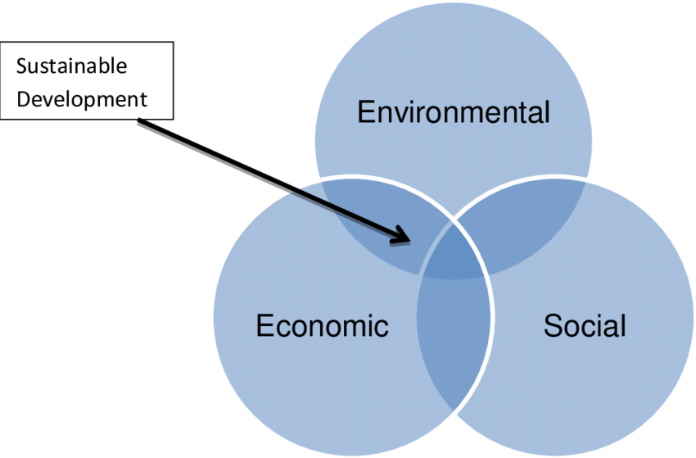
- Three dimensions of sustainability and a selection of indicators
Speaking about the Three-dimensions concern, I would like to note that a sustainable business lies in the solution of all the problems that are shown in the illustration.
Economic concerns
In the sustainable business development stage 1.0 according to Dylick, companies also continue to follow the principle of generating direct revenue generation from products.
Environmental concerns
Problem: In this case, we mean waste from the use of cigarettes such as bulls, packaging, the amount of smoke emitted and its toxicity.
Solution thanks to the product: Less waste, as the machine is reusable. Also, when using tobacco heating systems, tobacco vapor is formed, which allows you to feel the real taste of tobacco without burning, without ash and without smoke, which, accordingly, pollutes nature less in terms of emission Carbon dioxide
Social concerns
Problem: Cigarette toxicity for the smoker. Cigarettes, due to burning, synthesized a very large number of dangerous things that later caused serious diseases, for example, lung cancer. In correlation with the addiction that cigarettes caused in smokers, in fact it was a "time bomb".
Solution thanks to the product: When using tobacco heating systems, 95% less harmful substances are emitted compared to cigarettes, but it is important to remember that this does not mean a 95% reduction in risk. The use of the product does not exclude health risks.

Triple bottom line
Here can be already implemented BS 2.0 with TBL approach in value creation in terms of Electric heating systems:
Economic value: Reducing production costs.​
Environmental value: Technologically clean products from carbon monoxide and other emissions harmful to the environment & less harmful for consumer
Social value: Minimization & consistent illumination of harm caused by tobacco stuff using.​
However, classic cigarettes do not meet BS 2.0 standards, as they are the value they created cannot yet meet BS 2.0 due to their significant harm to human health.

Organizational perspective
As in the previous "business as usual" model, the organizational perspective of value transfer for product creation (reactions from the company) follows the type from the company to society, i.e. tobacco organizations created the product not at the request of stakeholders, but based on the task of reducing the level of harm to human body with ordinary cigarettes. After the creation, the companies began to actively promote new products, proving and convincing the public of its prospects and usefulness, thereby creating its value from inside to outside.

Part dedicated to sustainable production
Starting to consider this part of the work, it should be noted that the final product certainly raises ethical questions that do not allow sustainable business to develop in this category, but returning to sustainable production, we can say that the problems caused by the industry are typical for any industrial production, so here tobacco companies are an order of magnitude higher than the level of ethics of their product.
For a baseline comparison of companies and their actions, the author plans to address the issue of carbon neutrality. Carbon neutrality is a term that means that a company has reduced to zero emissions of carbon dioxide and its equivalents in the course of its production activities or offset these emissions through carbon-negative projects.
- Comparison of productions’ sustainability
Company | PMI | JTI | BAT
Aim of the company: | Philip Morris plans to significantly reduce the amount of energy that produces harmful emissions by reducing GJ/million cigarettes. So, for example, the goal of Philip Maurice at Russian factories is to reduce to 6.81 GJ / million cigarettes by the year 2021, and in 2023 to bring the figure to 4.3 GJ / million cigarettes  We achieved significant absolute CO2e emission reductions in 2020: Emissions across our value chain (scope 1+2+3) contracted by 18 percent, and those in our direct operations (scope 1+2) by 26 percent. | The company plans to replace all energy sources with carbon neutral ones by increasing the proportion of renewable energy by 50 percent by 2030 and by 100 percent by 2050 | BAT plans to achieve carbon neutrality in its own activities by 2030, and by 2050 in the entire supply chain. As well as a correspondingly smaller amount of gases emitted into the atmosphere.
Achievements | According to a 2020 report, Philip Maurice reduced energy consumption by 25 percent from 9.97 GJ/million cigarettes in 2020 to 7.49 GJ/cigarettes in 2020  Company achieved significant absolute CO2e emission reductions in 2020: in the direct operations by 26 percent | In 2019, 373 thousand tons of carbon dioxide were released into the atmosphere directly due to the production of products, while in 2020 this figure fell to 344, which is 8 percent less & in summary with Indirect GHG emissions (consumption of purchased electricity, heat, or steam) it was in 2019, 756 thousands of tons to 679 thousands of ton (10 percent difference) | 26.8% of the total direct energy consumption in 2020 came from renewable sources (up 10 percentage points from 2019).
Composed by author on the basis of sustainability reports
As can be seen from the information that is provided in the report, only Philip Maurice discloses information on the amount of energy that is consumed in their factories that are located in Russia, whereas baht and the Japanese Tobacco Corporation provide plans, results, and goals for all production capacities, therefore only providing a general picture, but not in Russia. After conducting an investigation into the aims and objectives, it has been abundantly evident that they are same for businesses; specifically, the entire rejection of carbon fuel by the year 2050, along with a large reduction in its portion by the year 2030. Although Philip Morris is in the lead in terms of the pace of emission reduction, the overall picture is fairly comparable to that of his rivals, who are mentioned in the table located above.

Level of development of sustainable production
- Business sustainability 2.0 criteria
 | Concerns (what?) | Values created (what for?) | Organizational perspective (how?)
BS 2.0 | Three-dimensions concerns | Triple bottom line | Inside-out
Composed by author on the basis of scientific article

Three-dimensions concerns:
Economic concerns
Problem: Increasing cost of carbon resources
Solving the problem with carbon neutrality: Large investments that will reduce the cost of buying carbon and pay off in the long term
Environmental concerns
Problem: Scientifically proven fact of environmental pollution due to carbon dioxide, which spoils the air and the ecosystem. Increases the risk of cancer and other diseases
Solving the problem of carbon neutrality: It will turn out to reduce damage to nature, restore the ecosystem, etc.
Social concerns
Problem: Closely related to environmental issues, society does not like that nature is destroyed by this kind of production, as well as that in production areas people inhale a dangerous mixture of oxygen with carbon monoxide, which is harmful to health and causes many fatal diseases.
Solving the problem of carbon neutrality: Will help reduce the number of diseases, return the ecosystem to the right track, which is the goal of the modern conservation agenda

Triple bottom line:
This structure is very reminiscent of three dimensions concerns, you can see it in the illustration below. As factors influencing the creation of values - economic, social and environmental factors.
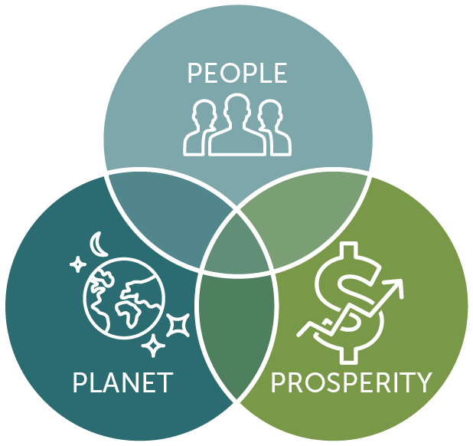
- Triple Bottom Line Model
All these aspects are directly correlated, with concerns, because the same factors are used in both structures.
Economic concerns
Create value: reducing production costs.
Environmental concerns
Create value: participation in "cleaning the planet", caring for the environment.
Social concerns
Create value: contributing to the fight against many diseases caused by poor human environment.

Organizational perspective
The organizational perspective of value transfer for product creation (reactions from the corporation) follows the type from the company to society, i.e. cigarette companies built new level production facilities not in response to stakeholder requests, but in order to reduce environmental harm. Following their formation, businesses began to actively market their accomplishments, demonstrating and persuading the public of their potential and utility, so producing value from the inside out.

Chapter 3. Recommendations & outcomes based on the reasearch.

Recommendations for the industry:
- Development of BS stages for products & production
Development of sustainable products. | Development of sustainable production.
The possibility of moving products to the next level (BS 3.0) is speculative, since when preserving tobacco products that are harmful to human health, this issue is complex, and when changing to product substitutes (tobacco heating systems), today there is no confirmation that these products can be safe for the health of a smoker with a subject to further development of technology. | The “true” sustainable production - is possible through the application of the recommendations described above - as the implementation of threats to business can lead the company to address concerns (starting with sustainable challenges) and lead to the creation of values ​​for the common good – creation value for both business & society (e.g. Crating shared value by Michel Porter)) after all, solving the problems of air pollution, the well-being of employees, as well as preventing the smuggling of low-quality products - can be considered as the concept of the common good.
Composed by author on the basis of the paper
Based on the sSWOT, general recommendations for the industry can be identified, the following opportunities for the development of companies can be identified:
- Development of fast-decaying cigarette butts, etc.
- Assistance and promotion of the state initiative to improve the image of the enterprise thanks to a reduction in the production of classic products (cigarettes) and an increase in the production of tobacco heating systems.
- A more rapid shift (in terms of product development and execution of improved flavor) to goods with lower smoke performance.
- Take on additional environmental and internal environment difficulties, displaying good problem solving.
- Implementing employee health support initiatives to reduce medical expenditures
- Transfer of assets with the possibility of their redemption (return back) in the era of a trade war.
Due to the geopolitical events of 2022, the level of uncertainty has increased, as the problem of exiting companies is quite acute. In this regard, these recommendations should be divided into two categories: for managers who are able to apply them locally (on the territory of the Russian Federation), as well as for the global management of organizations, since these are global decisions that cannot be made by local leaders.
It is very important to note that the recommendations are divided into two subtypes: recommendations for sustainable products - which cannot lead to the final transition to BS 3.0 due to the fact of harm to health, which today cannot be eliminated, but at the same time, the development of which must certainly be carried out. The second subtype of recommendations related to sustainable production, which could certainly bring an opportunity for the transition of BS 3.0, since there are no ethical and moral issues before the production process.

Development of fast-decaying cigarette butts, etc. Sustainable products.
Having found out that in accordance with the goals of sustainable development (compass SDG), as well as thanks to the proclamation of the goals of the companies in question (Philip Morris, Japanese Tobacco International, as well as British American Tobacco), it can be observed that the goal of live on land, as well as the problem of waste and pollution of the planet - are acute for the company.
According to the study, discarded cigarette butts reduce the likelihood of grass sprouting in that area by 10%, clover by 27%, and their shoot length by 13% and 28%, respectively. It is not yet known how cigarette butts affect other plants, but it is unlikely that the dynamics will be positive.
Every year, people throw away more than 4.5 trillion cigarette butts, almost half of them are not thrown into landfills, but into open nature. The decomposition of a cigarette butt produces cellulose acetate and plastic, which can lie in the ground for at least 10 years. As part of the study, scientists took soil samples from sites in Cambridge where 128 cigarette butts per square meter were thrown. As a result, plants on such soil germinated much worse than on ordinary soil.
Now environmentalists are trying to get a ban on the use of cigarette filters, since they do not bring any health benefits, but only act as a marketing tool. So far, the authorities of almost all countries refuse to ban cigarette filters, since there is currently insufficient data on their impact on nature.
For example, GENIA and its cigarettes are liked by smokers, politicians and nature.
The filter material is 100 percent cellulose, a renewable resource. It is certified to EN 13432 and reduces the amount of inhaled phenol and tar.
Thanks to the patented airlaid material, the filter is made without the use of adhesives or bonding agents. Unlike conventional filters containing acetate plastic and a synthetic binder, Genia is completely biodegradable. These filters decompose in just a couple of weeks.
Genia is the product of extensive research and development that spanned over twenty years. We are now launching these filters, which mix pleasure and responsibility, in white and beige, as well as a variant for cigarette rolls. These filters integrate the two concepts of pleasure and duty.
Smokey Treats, a firm based in South Africa, has made headlines by announcing the launch of the world's first biodegradable eco-cigarettes. They continue to pose a threat to human health, yet being totally harmless to the environment. Filters for eco-cigarettes are often constructed of wood pulp. According to the people who started Smokey Treats, once some time has passed, there won't be any sign that a cigarette butt was ever there.
Speaking about considered companies, PMI, BAT and JTI took the Environmental Pledge and immediately started searching for ways to dramatically cut the amount of plastic waste produced by their filter products. In order to do this, Philip Morris has established a goal to create filters that are constructed from materials that are more natural, biodegradable, or recyclable. Philip Morris & others is unwavering in its dedication to achieving its target of reducing the amount of waste plastic produced by its products by 50 percent by the year 2025. In addition, the business plans to continue manufacturing tobacco products in 14 other countries. The packaging of these goods will include the motto "Leave No Trace." The goal of this activity is to educate smokers about the issue of environmental pollution caused by cigarette butts and to encourage them to take action against the problem. International tobacco companies will also continue to investigate and assess possible substitutes for cellulose acetate in the production of filters.

Following the state initiative to improve the image of the enterprise thanks to an increase in R&D of tobacco heating systems Sustainable Products.
On the 28th of January, a new legislation that is intended to strengthen the control of items that contain nicotine went into effect in Russia (for example, vape liquids and tobacco sticks for electronic heating systems). In particular, the promotion of e-cigarettes and their sale over the internet are made illegal, and strict regulations are imposed on the amount of nicotine that may be present in liquids used in e-cigarettes.
The reaction of the tobacco companies was ideal and helped to strengthen their image, namely:
"JTI's strategy is to provide the adult consumer with a choice: both in the nicotine-containing products that he prefers, and in where and how it is convenient for him to buy them. Our products are well represented in retail throughout the country, especially in federal networks, therefore, the ban on online sales is not critical for this area. Retail provides a much larger volume of sales of nicotine-containing products than online trading" – official representative of JTI.
Philip Morris International (PMI) fully supports the ban on access to any nicotine-containing products by minors, said Sergei Slipchenko, vice president of corporate affairs at PMI Russia. "It is also clear that mass uncontrolled advertising of these products should be significantly limited. However, there remains the problem of insufficient legislative separation of the concepts of "advertising" and "informing the consumer about the product", which, of course, will make it difficult to inform adult smokers about less harmful alternatives."
This reaction shows that companies understand the fundamental issue of ethical dubiousness of the products they produce, which, from the point of view of the interests of stakeholders, helps them to continue to function.
At PMI, the primary responsibility of the company's scientists was the development of goods that did not involve the combustion process. The Food and Drug Administration (FDA) believes that the combustion of tobacco results in the production of more than 7,000 distinct chemical components. Nearly one hundred of them are either hazardous or possibly dangerous compounds that may cause ailments that are associated with smoking.
Heating tobacco in a manner that causes the emission of vapor containing nicotine has been identified as a potential solution to this issue by PMI. At the moment, the business manufactures two items that make use of tobacco heating technology. They make use of complex electronics to regulate the temperature at which the tobacco stick is heated. It does not get over 350 degrees.
All in all, according to information obtained from OFD.ru by RBC, analysts at the fiscal data operator OFD.ru recorded a decrease in the share of cigarette sales in monetary terms for the first half of 2021 in comparison to the same period last year. On the other hand, they recorded an increase in the share of tobacco heating systems.
Therefore, if the percentage of people who smoked cigarettes during the first half of 2020 was 93.2 percent, then over the same time period in current year, that percentage dropped to 82.5 percent. When compared to the same time period in the previous year, the first half of 2021 saw a rise in the percentage of tobacco heating devices (which did not include electronic cigarettes or vapes) from 6.8 percent to 17.3 percent.
PMI has R&D facilities in Singapore and Switzerland. It cost over $120 million to construct a research center called The Cube. More than 400 scientists are presently employed by it.
In addition, PMI has built a global network of research partners that includes some of the world's most renowned scientific organizations. The R&D team consists of around 900 scientists, engineers, and technicians in total. The amount of money spent on anti-smoking goods for adults has increased by more than eight billion dollars since 2008.
This behavior helps show organizations that they understand the ethical contention of their products, but that they continue to develop and improve products that are less harmful to human health.

A more rapid shift (in terms of product development and execution of improved flavor) to goods with lower smoke performance. Sustainable products.
The participants in the study indicated that the product did not deliver the same degree of intensity as smoking combustible cigarettes; hence, IQOS's comparisons with combustible cigarettes were not considered trustworthy by the researchers. Participants in Switzerland also said that the less intense flavor and less sensory signals were factors that discouraged ongoing usage. A participant from Switzerland offered the following observation: "There's simply something about that after-work beer, and I need a nice smoke with it." The same may be said of coffee; smoking just "goes" with coffee.
Accelerating the development of new flavors, as well as the availability of classic cigarettes with the same effect, will help companies kill even more smokers to abandon classic cigarettes in favor of tobacco heating systems.
However, as it was previously mentioned Singapore and Switzerland house PMI R&D. The Cube cost about $120 million. It employs 400+ scientists.
PMI's worldwide network of research partners includes prominent scientific institutions. R&D has 900 scientists, engineers, and technicians. Since 2008, people have spent over $8 billion on anti-smoking products.

Implementing employee health support initiatives to reduce medical expenditures. Sustainable production.
COVID-19 has demonstrated the importance of early screening of employees and their undergoing mid-term examinations, contracts with hospitals to conduct regular health screenings will help the organization not to lose employees during pandemic crises like COVID-19 and, in general, improve the internal environment and well-being of employees. These tests should be controlled by companies & obligatory for staff. Internal rules for medical control by organizations should be created that, on certain days, would allow employees, without prejudice to their personal time, as well as without penalties or deprivation of payment for a day trip, to undergo certain examinations that, from one point of view or another, the company deems necessary due to for the current situation in the world.

Transfer of assets with the possibility of their redemption (return back) in the era of a trade war. Sustainable production.
Philip Morris is exploring its departure strategies from the Russian market at this time. According to the explanation provided by the corporation, the decision was made because of continuous problems in logistical operations as well as changes in the regulatory environment.
According to the explanation provided by the firm, "this decision has been made owing to continuous logistical challenges and changes in the regulatory environment," both of which "have a direct influence on the speed and volume of manufacturing of tobacco and nicotine-containing goods." - according to RBC.
Such a decision will help preserve business, jobs, as well as commitment to responsible business and preventing smuggling into the territory of the Russian Federation. Preventing smuggling - inherently indirectly correlates with many of the SDGs, for example
- Good Health and Well-being owing to the Possibility That Cigarettes Obtained Illegally May Be Fake or Made with Materials of Lower Quality Consumption of such items will provide even more benefits to the health of human beings.
- Decent Work and Economic Growth - cigarette manufacturing requires a large human resource in terms of the number of employees, so the closure of the plant will lead to layoffs and loss of income for people
- Responsible Consumption and Production - in the event of withdrawal and subsequent nationalization, the new owners may not be committed to sustainable development and produce low quality products, as well as reduce the level of sustainable production. Which in turn brings back to point Good Health and Well-being, as well as to Life on Land
Rejection of carbon dependence and the use of recycled materials as raw materials. Sustainable production.
As written above, companies are already planning to go carbon-free in 2030 in their own operation and for whole production cycle by 2040-2050, which is a very important challenge. Additionally, the firm is encouraged to make use of recycled raw materials in the production of their goods (for example, plastic for heating system housings, cellulose for filters and wrappers, product packages.) Companies will be able to make a substantial contribution in this manner to the achievement of the objectives of Life on Land, as well as many other variables that are connected to these goals, such as Climate Action, Good Health and Well-being, Clean Water and Sanitation.
Demonstration of implementation of the recommendation provided below:
Outputs
Outcomes
Activities
Inputs
Impacts
Inputs Activities Outputs Outcomes Impacts
Reduction of illness connected with smoking & planet pollution
Consumer will use more safety products

Better product in terms of less harm to consumer & environment
Integration of updated products
R&D spending’s

- The logic model for sustainable products
Fig. 16 shows that when a company invests in research and development to improve its product, the company will end up with a product that is safer for society and the environment. This, in turn, will encourage smokers to switch to products that are safer for both them and the environment, which, in turn, illustrates the contribution to such goals as life on earth as well as health and well-being. The contribution of research and development to improving a product. However, this logic model is unable to move the company in terms of its goods to the BS 3.0 level. This is because it is impossible to speak about the prospect of decreasing the risk of harm to health to 0 at this point owing to the lack of availability of research on the topic.

Outcomes
Activities
Inputs
Impacts
Outputs
Inputs Activities Outputs Outcomes Impacts
Improvement of the environment, counteracting poor quality products, improving the well-being of employees
Medical Initiative.
Maintaining control of business in Russia.
Carbon neutrality.
Employee health control.
Business management according to statutory standards.
Transition to clean energy.
Increasing the efficiency level of the staff.
Understanding the state of business in Russia and its support.
Use of clean energy (less spending on energy sources).
Increased efficiency of employees, readiness to withstand epidemics.
Companies can react to factors that worsen business sustainability (smuggling, poor raw materials, etc.).
Reduced emissions of harmful substances associated with production

- The logic model for sustainable production
Fig 17 depicts the steps involved in accomplishing the firms' objectives and aims, as well as the suggestions that were made and the following outcomes for the company in terms of its contribution to the Sustainable Development Goals (SDG). Companies will be able to solve global sustainability problems associated with SDGs and geopolitical pressure on business, bringing company values to level of creation of the common good, and will also be able to transform many challenges from the outside to the inside thanks to a strong sustainability strategy if they achieve carbon neutrality, improve the efficiency of their employees, and maintain control over their production in the Russian Federation. This will allow the companies to reach BS 3.0.

Conclusion
As part of this work, a number of analyzes were carried out to achieve the goal of developing recommendations for tobacco corporations operating in the Russian market. The work carried out such analyzes as: historical, in order to understand the development of concepts that are relevant at the present time; analysis of the tobacco industry for understanding external and internal influencing factors
In this work, corporate information obtained through interviews was not presented, because due to the geopolitical situation, it was not possible to conduct such interviews by order of the management of organizations.
When the findings of this research were summarized, it was found that the international tobacco industry in Russia is now in a severe "stalemate" owing to the current state of geopolitical affairs. The influence of the geopolitical role in the current situation was taken out of the brackets from the point of view of the general cluster of problems caused by this phenomenon and was considered exclusively in the format of a sustainable business.
Businesses that are involved in the tobacco sector face a significant obstacle in the form of a contemporary geopolitical environment, as well as the expansion of a society that has healthy tendencies and a feeling of social responsibility. Together, these two factors provide a formidable obstacle. Analyses such as PESTEL and Porter's 5 Forces (to understand the external variables impacting the industry) and Porter's 5 Forces (to verify the internal environment of the firm) - made it possible to evaluate what elements influence the industry. Speaking about business sustainability analyses (SDG compass, sSWOT, stakeholder analysis, as well as analysis by business sustainability typology), this helped to determine the current state of affairs in companies in terms of their sustainable development goals, problems (weaknesses and threats), and the expectations of stakeholders from the actions of the company.
Following that, in sum, all of the analyses that were performed gave the author the opportunity, based on them, to produce suggestions based on increasing the degree of company sustainability. Which have been narrowed down to just two categories: environmentally friendly production and environmentally friendly production. During the same time period, the question concerning the feasibility of transitioning sustainable products to a new level (BS 3.0) arose in the course of the research. This was due to the fact that tobacco products are inherently harmful to human health and do not satisfy the requirements for BS 3.0 as a result of this quality. At the conclusion of the paper, the author presented logical models for two different directions based on the SDG compass to highlight the process of developing suggestions, beginning with their implementation and continuing with the positive effect those recommendations have on a sustainably companies.

Reference list

- Шпотов, Б. (n.d.). Социально-экономические эксперименты Генри Форда. Международный Журнал “Проблемы Теории и Практики Управления”. Номер 6/02. Retrieved April 26, 2022, from http://vasilievaa.narod.ru/19_6_02.htm
- Международная организация труда (МОТ) | Организация Объединённых Наций в Российской Федерации. (n.d.). Организация Объединённых Наций в Российской Федерации. Retrieved April 26, 2022, from http://www.unrussia.ru/ru/agencies/mezhdunarodnaya-organizatsiya-truda-mot#:%7E:text=%D0%9C%D0%B5%D0%B6%D0%B4%D1%83%D0%BD%D0%B0%D1%80%D0%BE%D0%B4%D0%BD%D0%B0%D1%8F%20%D0%BE%D1%80%D0%B3%D0%B0%D0%BD%D0%B8%D0%B7%D0%B0%D1%86%D0%B8%D1%8F%20%D1%82%D1%80%D1%83%D0%B4%D0%B0%20(%D0%9C%D0%9E%D0%A2)%20%E2%80%93,%D0%B0%D0%B3%D0%B5%D0%BD%D1%82%D1%81%D1%82%D0%B2%D0%BE%D0%BC%20%D0%9E%D0%9E%D0%9D%20%D0%B2%201946%20%D0%B3%D0%BE%D0%B4%D1%83.
- Социальная ответственность бизнеса: теоретический аспект. (2012). КиберЛенинка. Retrieved June 2, 2022, from https://cyberleninka.ru/article/n/sotsialnaya-otvetstvennost-biznesa-teoreticheskiy-aspekt).
- Blagov, Y. E. (2006). Генезис концепции корпоративной социальной ответственности. Вестник Санкт-Петербургского Университета, 8(2), 1–24.
- Carroll, A. B. (2016). Carroll’s pyramid of CSR: taking another look. International Journal of Corporate Social Responsibility, 1(1). https://doi.org/10.1186/s40991-016-0004-6
- Siltaoja, M. E. (2013). Revising the Corporate Social Performance Model - Towards Knowledge Creation for Sustainable Development. Business Strategy and the Environment, 23(5), 289–302. https://doi.org/10.1002/bse.1783
- Preston, L.E. and J.E. Post, 1976. Private management and public policy: The principle of public responsibility.. The Journal of Business, 49(2). Date Views 26.05.2022 www.jstor.org/stable/2352262.
- Gayle, K., J. Kim and B. Amanda, 2008. A framework of Corporate Social Responsibility for advertising accountability: The case of Australian government advertising campaign. Journal of Marketing Communications, 14(2). Date Views 26.05.2022 www.researchgate.net/publication/27472816_A_framework_of_Corporate_Social_Responsibility_for_advertising_accountability_The_case_of_Australian_government_advertising_campaign.
- Siltaoja, M., 2014. Revising the Corporate Social Performance Model Model – Towards Knowledge Creation for Sustainable Development. Business Strategy and the Environment, 23(5). Date Views 26.05.2022 www.researchgate.net/publication/264288511_Revising_the_Corporate_Social_Performance_Model_-_Towards_Knowledge_Creation_for_Sustainable_Development.
- Blagov, Y.E. and A.A. Petrova-Savchenko, 2021. The transformation of corporate sustainability model in the context of achieving the UN SDGs: evidence from the leading Russian companies. Emerald Publishing Limited, 21(2): 308-321.
- Dyllick, T. and K. Muff, 2016. Clarifying the Meaning of Sustainable Business : Introducing a Typology from Business-as-Usual to True Business Sustainability. Organization & Environment, 29(2). Date Views 26.05.2022 www.journals.sagepub.com/doi/pdf/10.1177/1086026615575176.
- United Nations (2015) Resolution adopted by the General Assembly on 25 September 2015, Transforming our world: the 2030 Agenda for Sustainable Development (A/RES/70/1 Archived 28 November 2020 at the Wayback Machine). Date Views 26.05.2022 www.un.org/en/development
- THE 17 GOALS | Sustainable Development. (n.d.). United Nations: Department of Economic and Social Affairs. Date Views 26.05.2022 www.sdgs.un.org/goals.
- KPMG. (2017, December). Sustainable Development Goals (SDGs): Leveraging CSR to Achieve SDGs. Date Views 26.05.2022 www.assets.kpmg/content/dam/kpmg/in/pdf/2017/12/SDG_New_Final_Web.pdf.
- Smoking Rates by Country 2022. (n.d.). World Population Review. Retrieved June 1, 2022, from https://worldpopulationreview.com/country-rankings/smoking-rates-by-country
- Агентство экономической информации ПРАЙМ. (2021, December 28). Как изменятся цены на сигареты в 2022 году. ПРАЙМ. Retrieved April 26, 2022, from https://1prime.ru/consumer_markets/20211228/835630099.html
- Курение губит и людей, и окружающую среду. (2017, May 30). Новости ООН. Retrieved April 26, 2022, from https://news.un.org/ru/story/2017/05/1305561#:%7E:text=%D0%A2%D0%B0%D0%B1%D0%B0%D1%87%D0%BD%D1%8B%D0%B9%20%D0%B4%D1%8B%D0%BC%20%D1%81%D0%BE%D0%B4%D0%B5%D1%80%D0%B6%D0%B8%D1%82%20%D0%B1%D0%BE%D0%BB%D0%B5%D0%B5%20%D1%81%D0%B5%D0%BC%D0%B8,%D1%81%D0%BE%D1%81%D1%82%D0%B0%D0%B2%D0%BB%D1%8F%D1%8E%D1%82%2030-40%20%D0%BF%D1%80%D0%BE%D1%86%D0%B5%D0%BD%D1%82%D0%BE%D0%B2%20%D0%BC%D1%83%D1%81%D0%BE%D1%80%D0%B0.
- Емельяненко, В. (2021, June 24). В России растет число приверженцев ЗОЖ. Российская газета. Retrieved April 26, 2022, from https://rg.ru/2021/06/24/ranhigs-v-rossii-rastet-chislo-priverzhencev-zozh.html
- Tobacco. (2022, May 25). WHO. Retrieved June 1, 2022, from https://www.who.int/news-room/fact-sheets/detail/tobacco
- Федеральный закон “Об охране здоровья граждан от воздействия окружающего табачного дыма, последствий потребления табака или потребления никотинсодержащей продукции” от 23.02.2013 N 15-ФЗ (последняя редакция) \ КонсультантПлюс. (n.d.). FZ-15. Retrieved June 1, 2022, from http://www.consultant.ru/document/cons_doc_LAW_142515/
- Чабалов, К. (2022, March 9). Табачная компания Imperial Brands прекращает деятельность в России. РИА Новости. Retrieved April 26, 2022, from https://ria.ru/20220309/imperialbrands-1777272436.html
- Отчет о деятельности в области устойчивого развития. (2019). Philip Morris International. Retrieved April 26, 2022, from https://рспп.рф/upload/uf/8c5/sustainability-report-russia-2019.pdf
- Integrated Report PMI 2021. (2022). PMI. Retrieved June 1, 2022, from https://www.pmi.com/resources/docs/default-source/pmi-sustainability/pmi-2021-sustainability-materiality-report.pdf?sfvrsn=1ceaafb7_8
- Jegede, A. (2019, January 1). Top 10 Largest Tobacco Producing Countries In The World. The Daily Records. Retrieved June 2, 2022, from http://www.thedailyrecords.com/2018-2019-2020-2021/world-famous-top-10-list/world/largest-tobacco-producing-countries-statistics/6876/
- Third World Countries 2022. (n.d.). World Population Review. Retrieved June 2, 2022, from https://worldpopulationreview.com/country-rankings/third-world-countries
- Integrated report JTI 2020. (2019). JTI. Retrieved June 1, 2022, from https://www.jti.com/sites/default/files/global-files/documents/jti-annual-reports/integrated-report-2020-update.pdf
- British American Tobacco - Materiality. (n.d.). BAT. Retrieved May 31, 2022, from https://www.bat.com/materiality#
- Clinical study shows biomarker of potential harm measured in Ploom TECH users is close to never-smokers. (2020, March 26). Japan Tobacco Inc. Retrieved April 26, 2022, from https://www.jti.com/sites/default/files/default/files/press-releases/documents/2020/the-results-of-a-clinical-study.pdf
- New heat-not-burn brand from RAI. (2015, June 4). Tobacco Journal International. Retrieved April 26, 2022, from http://www.tobaccojournal.com/New_heat-not-burn_brand_from_RAI.52768.0.html
- Caputi, T. L., Leas, E., Dredze, M., Cohen, J. E., & Ayers, J. W. (2017). They're heating up: Internet search query trends reveal significant public interest in heat-not-burn tobacco products. PloS one, 12(10), e0185735. https://doi.org/10.1371/journal.pone.0185735
- РБК. (2021, September 13). Что такое углеродная нейтральность. РБК Тренды. Retrieved April 26, 2022, from https://trends.rbc.ru/trends/green/5ffd5a099a7947594de716ce
- Japan Tobacco Inc. (2022, February 14). JT Group Expands Sustainability Ambition across Entire Value Chain to Achieve Net-Zero Greenhouse Gas Emissions by 2050. Retrieved April 26, 2022, from https://www.jti.com/sites/default/files/press-releases/documents/2022/jtg_expands_sustainability_ambition_to_achieve_net-zero_2050.pdf
- Creating Shared Value. (2020, October 22). Harvard Business Review. Retrieved June 1, 2022, from https://hbr.org/2011/01/the-big-idea-creating-shared-value
- Иванов, С. (2019, July 22). Биологи: выброшенные окурки могут на 10% снизить количество растений на Земле. Хайтек. Retrieved May 31, 2022, from https://hightech.fm/2019/07/22/smoke
- ibd
- Genia. (n.d.). Startseite. Retrieved May 31, 2022, from https://www.mcairlaids.net/en/products/cigarette/zigarettenfilter.html
- Official web site. (n.d.). Smokey Treats. https://www.smokeytreats.co.za
- Россия ужесточила регулирование никотинсодержащей продукции. (n.d.). Intrefax. Retrieved May 31, 2022, from https://www.interfax.ru/russia/748201
- ibd
- РБК. (2021, December 27). Наука без дыма: зачем табачный гигант вкладывает миллиарды в исследования. РБК Тренды. Retrieved May 31, 2022, from https://trends.rbc.ru/trends/innovation/cmrm/6192b80c9a794720e81a88d5
- Чернышова, Е. (2021, September 15). В России доля устройств для нагревания табака увеличилась в 2,5 раза. РБК. Retrieved May 31, 2022, from https://www.rbc.ru/economics/15/09/2021/61414b029a79477924f81d3c
- Hair, E. C. (2018, November 1). Examining perceptions about IQOS heated tobacco product: consumer studies in Japan and Switzerland. Tobacco Control. Retrieved May 31, 2022, from https://tobaccocontrol.bmj.com/content/27/Suppl_1/s70
- Полякова, В., & Левинская, А. (2022, March 24). Philip Morris допустила передачу активов в России. РБК. Retrieved May 31, 2022, from https://www.rbc.ru/business/24/03/2022/623c700f9a79474b96f1dd9b
- Edie Newsroom. (2020, March 27). British American Tobacco targets carbon neutrality by 2030. Edie. Retrieved June 1, 2022, from https://www.edie.net/british-american-tobacco-targets-carbon-neutrality-by-2030/
- JT GROUP EXPANDS SUSTAINABILITY AMBITION ACROSS ENTIRE VALUE CHAIN TO ACHIEVE NET-ZERO GREENHOUSE GAS EMISSIONS BY 2050. (n.d.). JTI. Retrieved June 1, 2022, from https://www.jti.com/jt-group-expands-sustainability-ambition-across-entire-value-chain-achieve-net-zero-greenhouse-gas
- Sustainable Workplace: PMI is working on a zero emissions office. (n.d.). PMI. Retrieved June 1, 2022, from https://www.pmi.com/sustainability/low-carbon-transition-plan

Шпотов, Б. (n.d.). Социально-экономические эксперименты Генри Форда. Международный Журнал “Проблемы Теории и Практики Управления”. Номер 6/02. Retrieved April 26, 2022, from http://vasilievaa.narod.ru/19_6_02.htm
Международная организация труда (МОТ) | Организация Объединённых Наций в Российской Федерации. (n.d.). Организация Объединённых Наций в Российской Федерации. Retrieved April 26, 2022, from http://www.unrussia.ru/ru/agencies/mezhdunarodnaya-organizatsiya-truda-mot#:%7E:text=%D0%9C%D0%B5%D0%B6%D0%B4%D1%83%D0%BD%D0%B0%D1%80%D0%BE%D0%B4%D0%BD%D0%B0%D1%8F%20%D0%BE%D1%80%D0%B3%D0%B0%D0%BD%D0%B8%D0%B7%D0%B0%D1%86%D0%B8%D1%8F%20%D1%82%D1%80%D1%83%D0%B4%D0%B0%20(%D0%9C%D0%9E%D0%A2)%20%E2%80%93,%D0%B0%D0%B3%D0%B5%D0%BD%D1%82%D1%81%D1%82%D0%B2%D0%BE%D0%BC%20%D0%9E%D0%9E%D0%9D%20%D0%B2%201946%20%D0%B3%D0%BE%D0%B4%D1%83.
Социальная ответственность бизнеса: теоретический аспект. (2012). КиберЛенинка. Retrieved June 2, 2022, from https://cyberleninka.ru/article/n/sotsialnaya-otvetstvennost-biznesa-teoreticheskiy-aspekt).
Blagov, Y. E. (2006). Генезис концепции корпоративной социальной ответственности. Вестник Санкт-Петербургского Университета, 8(2), 1–24.
Carroll, A. B. (2016). Carroll’s pyramid of CSR: taking another look. International Journal of Corporate Social Responsibility, 1(1). https://doi.org/10.1186/s40991-016-0004-6
Siltaoja, M. E. (2013). Revising the Corporate Social Performance Model - Towards Knowledge Creation for Sustainable Development. Business Strategy and the Environment, 23(5), 289–302. https://doi.org/10.1002/bse.1783
Preston, L.E. and J.E. Post, 1976. Private management and public policy: The principle of public responsibility.. The Journal of Business, 49(2). Date Views 26.05.2022 www.jstor.org/stable/2352262.
Gayle, K., J. Kim and B. Amanda, 2008. A framework of Corporate Social Responsibility for advertising accountability: The case of Australian government advertising campaign. Journal of Marketing Communications, 14(2). Date Views 26.05.2022 www.researchgate.net/publication/27472816_A_framework_of_Corporate_Social_Responsibility_for_advertising_accountability_The_case_of_Australian_government_advertising_campaign.
Siltaoja, M., 2014. Revising the Corporate Social Performance Model Model – Towards Knowledge Creation for Sustainable Development. Business Strategy and the Environment, 23(5). Date Views 26.05.2022 www.researchgate.net/publication/264288511_Revising_the_Corporate_Social_Performance_Model_-_Towards_Knowledge_Creation_for_Sustainable_Development.
Blagov, Y.E. and A.A. Petrova-Savchenko, 2021. The transformation of corporate sustainability model in the context of achieving the UN SDGs: evidence from the leading Russian companies. Emerald Publishing Limited, 21(2): 308-321.
Dyllick, T. and K. Muff, 2016. Clarifying the Meaning of Sustainable Business : Introducing a Typology from Business-as-Usual to True Business Sustainability. Organization & Environment, 29(2). Date Views 26.05.2022 www.journals.sagepub.com/doi/pdf/10.1177/1086026615575176.
United Nations (2015) Resolution adopted by the General Assembly on 25 September 2015, Transforming our world: the 2030 Agenda for Sustainable Development (A/RES/70/1 Archived 28 November 2020 at the Wayback Machine). Date Views 26.05.2022 www.un.org/en/development/desa/population/migration/generalassembly/docs/globalcompact/A_RES_70_1_E.pdf.
THE 17 GOALS | Sustainable Development. (n.d.). United Nations: Department of Economic and Social Affairs. Date Views 26.05.2022 www.sdgs.un.org/goals.
KPMG. (2017, December). Sustainable Development Goals (SDGs): Leveraging CSR to Achieve SDGs. Date Views 26.05.2022 www.assets.kpmg/content/dam/kpmg/in/pdf/2017/12/SDG_New_Final_Web.pdf.
Smoking Rates by Country 2022. (n.d.). World Population Review. Retrieved June 1, 2022, from https://worldpopulationreview.com/country-rankings/smoking-rates-by-country
Производители объяснили снижение выпуска сигарет ростом нелегального рынка. (2020, January 27). RETAILER.ru. Retrieved June 2, 2022, from https://retailer.ru/proizvoditeli-objasnili-snizhenie-vypuska-sigaret-rostom-nelegalnogo-rynka/?utm_source=yxnews&utm_medium=desktop
Агентство экономической информации ПРАЙМ. (2021, December 28). Как изменятся цены на сигареты в 2022 году. ПРАЙМ. Retrieved April 26, 2022, from https://1prime.ru/consumer_markets/20211228/835630099.html
Курение губит и людей, и окружающую среду. (2017, May 30). Новости ООН. Retrieved April 26, 2022, from https://news.un.org/ru/story/2017/05/1305561#:%7E:text=%D0%A2%D0%B0%D0%B1%D0%B0%D1%87%D0%BD%D1%8B%D0%B9%20%D0%B4%D1%8B%D0%BC%20%D1%81%D0%BE%D0%B4%D0%B5%D1%80%D0%B6%D0%B8%D1%82%20%D0%B1%D0%BE%D0%BB%D0%B5%D0%B5%20%D1%81%D0%B5%D0%BC%D0%B8,%D1%81%D0%BE%D1%81%D1%82%D0%B0%D0%B2%D0%BB%D1%8F%D1%8E%D1%82%2030-40%20%D0%BF%D1%80%D0%BE%D1%86%D0%B5%D0%BD%D1%82%D0%BE%D0%B2%20%D0%BC%D1%83%D1%81%D0%BE%D1%80%D0%B0.
Емельяненко, В. (2021, June 24). В России растет число приверженцев ЗОЖ. Российская газета. Retrieved April 26, 2022, from https://rg.ru/2021/06/24/ranhigs-v-rossii-rastet-chislo-priverzhencev-zozh.html
Tobacco. (2022, May 25). WHO. Retrieved June 1, 2022, from https://www.who.int/news-room/fact-sheets/detail/tobacco
Федеральный закон “Об охране здоровья граждан от воздействия окружающего табачного дыма, последствий потребления табака или потребления никотинсодержащей продукции” от 23.02.2013 N 15-ФЗ (последняя редакция) \ КонсультантПлюс. (n.d.). FZ-15. Retrieved June 1, 2022, from http://www.consultant.ru/document/cons_doc_LAW_142515/
Чабалов, К. (2022, March 9). Табачная компания Imperial Brands прекращает деятельность в России. РИА Новости. Retrieved April 26, 2022, from https://ria.ru/20220309/imperialbrands-1777272436.html
Отчет о деятельности в области устойчивого развития. (2019). Philip Morris International. Retrieved April 26, 2022, from https://рспп.рф/upload/uf/8c5/sustainability-report-russia-2019.pdf
Jegede, A. (2019, January 1). Top 10 Largest Tobacco Producing Countries In The World. The Daily Records. Retrieved June 2, 2022, from http://www.thedailyrecords.com/2018-2019-2020-2021/world-famous-top-10-list/world/largest-tobacco-producing-countries-statistics/6876/
Third World Countries 2022. (n.d.). World Population Review. Retrieved June 2, 2022, from https://worldpopulationreview.com/country-rankings/third-world-countries
Integrated Report PMI 2021. (2022). PMI. Retrieved June 1, 2022, from https://www.pmi.com/resources/docs/default-source/pmi-sustainability/pmi-2021-sustainability-materiality-report.pdf?sfvrsn=1ceaafb7_8
Integrated report JTI 2020. (2019). JTI. Retrieved June 1, 2022, from https://www.jti.com/sites/default/files/global-files/documents/jti-annual-reports/integrated-report-2020-update.pdf
British American Tobacco - Materiality. (n.d.). BAT. Retrieved May 31, 2022, from https://www.bat.com/materiality#
Clinical study shows biomarker of potential harm measured in Ploom TECH users is close to never-smokers. (2020, March 26). Japan Tobacco Inc. Retrieved April 26, 2022, from https://www.jti.com/sites/default/files/default/files/press-releases/documents/2020/the-results-of-a-clinical-study.pdf
New heat-not-burn brand from RAI. (2015, June 4). Tobacco Journal International. Retrieved April 26, 2022, from http://www.tobaccojournal.com/New_heat-not-burn_brand_from_RAI.52768.0.html
Caputi, T. L., Leas, E., Dredze, M., Cohen, J. E., & Ayers, J. W. (2017). They're heating up: Internet search query trends reveal significant public interest in heat-not-burn tobacco products. PloS one, 12(10), e0185735. https://doi.org/10.1371/journal.pone.0185735
РБК. (2021, September 13). Что такое углеродная нейтральность. РБК Тренды. Retrieved April 26, 2022, from https://trends.rbc.ru/trends/green/5ffd5a099a7947594de716ce
Japan Tobacco Inc. (2022, February 14). JT Group Expands Sustainability Ambition across Entire Value Chain to Achieve Net-Zero Greenhouse Gas Emissions by 2050. Retrieved April 26, 2022, from https://www.jti.com/sites/default/files/press-releases/documents/2022/jtg_expands_sustainability_ambition_to_achieve_net-zero_2050.pdf
Creating Shared Value. (2020, October 22). Harvard Business Review. Retrieved June 1, 2022, from https://hbr.org/2011/01/the-big-idea-creating-shared-value
Иванов, С. (2019, July 22). Биологи: выброшенные окурки могут на 10% снизить количество растений на Земле. Хайтек. Retrieved May 31, 2022, from https://hightech.fm/2019/07/22/smoke
ibd
Genia. (n.d.). Startseite. Retrieved May 31, 2022, from https://www.mcairlaids.net/en/products/cigarette/zigarettenfilter.html
Official web site. (n.d.). Smokey Treats. https://www.smokeytreats.co.za
Россия ужесточила регулирование никотинсодержащей продукции. (n.d.). Intrefax. Retrieved May 31, 2022, from https://www.interfax.ru/russia/748201
Ibid.
РБК. (2021, December 27). Наука без дыма: зачем табачный гигант вкладывает миллиарды в исследования. РБК Тренды. Retrieved May 31, 2022, from https://trends.rbc.ru/trends/innovation/cmrm/6192b80c9a794720e81a88d5
Чернышова, Е. (2021, September 15). В России доля устройств для нагревания табака увеличилась в 2,5 раза. РБК. Retrieved May 31, 2022, from https://www.rbc.ru/economics/15/09/2021/61414b029a79477924f81d3c
Hair, E. C. (2018, November 1). Examining perceptions about IQOS heated tobacco product: consumer studies in Japan and Switzerland. Tobacco Control. Retrieved May 31, 2022, from https://tobaccocontrol.bmj.com/content/27/Suppl_1/s70
Полякова, В., & Левинская, А. (2022, March 24). Philip Morris допустила передачу активов в России. РБК. Retrieved May 31, 2022, from https://www.rbc.ru/business/24/03/2022/623c700f9a79474b96f1dd9b
Edie Newsroom. (2020, March 27). British American Tobacco targets carbon neutrality by 2030. Edie. Retrieved June 1, 2022, from https://www.edie.net/british-american-tobacco-targets-carbon-neutrality-by-2030/
JT GROUP EXPANDS SUSTAINABILITY AMBITION ACROSS ENTIRE VALUE CHAIN TO ACHIEVE NET-ZERO GREENHOUSE GAS EMISSIONS BY 2050. (n.d.). JTI. Retrieved June 1, 2022, from https://www.jti.com/jt-group-expands-sustainability-ambition-across-entire-value-chain-achieve-net-zero-greenhouse-gas
Sustainable Workplace: PMI is working on a zero emissions office. (n.d.). PMI. Retrieved June 1, 2022, from https://www.pmi.com/sustainability/low-carbon-transition-plan

