Saint Petersburg State University
Graduate School of Management
Master in Corporate Finance Program

Existence and the Size of Green Bonds’ Premium
in Different Industries

Master’s Thesis by the 2nd year student
Concentration – Master in Corporate Finance
Pavel Miasnikov
Research advisor:
Prof. Alexander Yu. Andrianov, Senior Lecturer
Department of Finance and Accounting

Saint Petersburg
2022
ЗАЯВЛЕНИЕ О САМОСТОЯТЕЛЬНОМ ХАРАКТЕРЕ ВЫПОЛНЕНИЯ
ВЫПУСКНОЙ КВАЛИФИКАЦИОННОЙ РАБОТЫ
Я, Мясников Павел Олегович, студент второго курса магистратуры направления «Менеджмент», заявляю, что в моей магистерской диссертации на тему «Существование и размер премии зеленых бондов в различных индустриях», представленной в службу обеспечения программ магистратуры для последующей передачи в государственную аттестационную комиссию для публичной защиты, не содержится элементов плагиата.
Все прямые заимствования из печатных и электронных источников, а также из защищенных ранее выпускных квалификационных работ, кандидатских и докторских диссертаций имеют соответствующие ссылки.
Мне известно содержание п. 9.7.1 Правил обучения по основным образовательным программам высшего и среднего профессионального образования в СПбГУ о том, что «ВКР выполняется индивидуально каждым студентом под руководством назначенного ему научного руководителя», и п. 51 Устава федерального государственного бюджетного образовательного учреждения высшего образования «Санкт-Петербургский государственный университет» о том, что «студент подлежит отчислению из Санкт-Петербургского университета за представление курсовой или выпускной квалификационной работы, выполненной другим лицом (лицами)».

_______________________________________________ (Подпись студента)
31 мая 2022 года

STATEMENT ABOUT THE INDEPENDENT CHARACTER OF
THE MASTER THESIS
I, Miasnikov Pavel, a second-year master's student, in the program «Management», state that my master thesis on the topic «Existence and the Size of Green Bonds’ Premium in Different Industries», which is presented to the Master Office to be submitted to the Official Defense Committee for the public defense, does not contain any elements of plagiarism.
All direct borrowings from printed and electronic sources, as well as from master theses, Ph.D., and doctorate theses which were defended earlier, have appropriate references.
I am aware that according to paragraph 9.7.1. of Guidelines for instruction in major curriculum programs of higher and secondary professional education at St.Petersburg University «A master thesis must be completed by each of the degree candidates individually under the supervision of his or her advisor», and according to paragraph 51 of Charter of the Federal State Institution of Higher Education Saint-Petersburg State University «a student can be expelled from St.Petersburg University for submitting of the course or graduation qualification work developed by another person (persons)».

________________________________________________(Student’s signature)
On the 31th of May, 2022

 | ABSTRACT
Автор |  | Мясников Павел Олегович
Название ВКР |  | Существование и размер премии зеленых бондов в различных индустриях
Образовательная программа |  | Корпоративные финансы
Направление подготовки |  | Менеджмент
Год |  | 2022
Научный руководитель |  | Андрианов Александр Юрьевич
Описание цели, задач и основных результатов |  | Целью данного исследования является изучение премии «зеленых» облигаций в различных отраслях, создание методологии, позволяющей обновлять результаты такого исследования в будущем. Для достижения этой цели была создана и апробирована на примере банковской отрасли методика расчета зеленой премии на вторичном рынке (выборка из более чем 22 тыс. простых облигаций и 474 зеленых облигаций; 68 пар из трех отраслей (банковское дело, автомобилестроение и телекоммуникации). Результаты данного Исследования показывают, что, несмотря на то, что методология данного Исследования является значимой, позволяющей оценить размер премии в различных отраслях, гипотеза не может быть принята или отвергнута, так как объективно недостаточно данных на рынке в этом году. Кроме того, в этом Исследовании проводится теоретическое обсуждение возможности отрицательной зеленой премии. Однако в эмпирической части Исследования отрицательная зеленая премия не дискутировалась.
Ключевые слова |  | Зеленые облигации, премия по зеленым облигациям, зеленая премия, гриниум, поиндустриальные размеры зеленых премий, банковская зеленая премия, положительная и отрицательная зеленая премия

 | ABSTRACT
Master Student’s Name |  | Pavel Miasnikov
Master Thesis Title |  | Existence and the Size of Green Bonds’ Premium in Different Industries
Educational Program |  | Master in Corporate Finance
Main field of study |  | Management
Year |  | 2022
Academic Advisor’s Name |  | Alexander Yu. Andrianov
Description of the goal, tasks and main results |  | The purpose of this Research is to investigate the green bonds’ premium in different industries, creating a methodology to renew the results of this Research in the future. To achieve this goal, the methodology of calculation of green premium on the secondary market was created and tested on the banking industry example (sample of over 22k plain vanilla bonds, and 474 green bonds; 68 pairs from three industries (banking, automotive, and telecommunications). The results of this Research show that, notwithstanding that the methodology of this Research is significant, allowing for assessment of the amount of the premium in different industries, the hypothesis cannot be accepted or rejected, as there is, objectively, not enough data in the market up to this year. Additionally, in this Research there is a theoretical discussion on the possibility of a negative green premium. However, the empirical part of this Research did not, being not focused on it, show that the negative green premium exists or does not exist.
Keyword |  | Green bonds, green bonds premium, green premium, greenium, industrial green premiums, banking green premium, positive and negative green premium

TABLE OF CONTENTS
CHAPTER I. INTRODUCTION | …….……………………..……………………..……. |  |  | 7
1.1. Urgency of the Research | …….……………………..……………………..……. |  |  | 7
1.2. Goals of the Research | …….……………………..……………………..……. |  |  | 7
1.3. Steps of the Research | …….……………………..……………………..……. |  |  | 8
1.4. Practical contribution | …….……………………..……………………..……. |  |  | 8
CHAPTER II. RESEARCH GAP | …….……………………..……………………..……. |  |  | 10
CHAPTER III. THEORETICAL PART OF THE RESEARCH |  |  | …………..………..…… | 11
3.1. Brief history of ESG investment | …….……………………..……………………..……. |  |  | 13
3.2. Sustainable Finance | …….……………………..……………………..……. |  |  | 14
3.3. Sustainable Finance Map | …….……………………..……………………..……. |  |  | 15
3.4. Plain Vanilla Bonds and Its Differences from Green Bonds |  |  | …………..………..…… | 16
3.5. Green Bonds Market Overview | …….……………………..……………………..……. |  |  | 19
3.6. Green Premium | …….……………………..……………………..……. |  |  | 23
3.7. Why Green Premium Differs in Different Industries |  |  | …………..………..…… | 24
3.8. CONCLUSION - Theoretical part of the Research |  |  | …………..………..…… | 24
CHAPTER IV. EMPIRICAL PART OF THE RESEARCH |  |  | …………..………..…… | 26
4.1. Hypothesis Development | …….……………………..……………………..……. |  |  | 26
4.2. Data Resource | …….……………………..……………………..……. |  |  | 27
4.3. Steps of the Research | …….……………………..……………………..……. |  |  | 28
Step I. Finding appropriate data | …….……………………..……………………..……. |  |  | 28
Step II. Finding pairs of plain vanilla and green bonds |  |  | …………..………..…… | 36
Step III. Calculating the amount of green premium for an industrial comparative analysis |  |  | …………..………..…… | 40
Step IV. Summary & managerial implication |  | …….……………………..…………… |  | 45
4.4. CONCLUSION - Empirical part of the Research |  | …………………………..………..…… |  | 45
CHAPTER V. RESEARCH CONCLUSION |  | …………………………..………..…… |  | 47
THE LIST OF REFERENCES | …….……………………..……………………..……. |  |  | 48

I. INTRODUCTION

This Master's paper (hereinafter - ‘Research’) is focused on practical aspects of green premium. Green premium is a relatively new phenomenon, meaning, in simple words, the difference in price between a regular bond and a comparable green bond.

Notwithstanding that there are, at least, 16 papers that were investigating green bonds premium, I cannot help but highlight that there is a research gap regarding industrial aspects of (the size therein) the green bonds premium: the scientific research lacks a methodology accordingly with which it would be possible to assess, especially in practice, the size of a green premium before the issue of a green bond.

1.1. Urgency of the Research
The sustainable bonds market is still emerging, notwithstanding that the first green bonds were issued years ago, and since 2015 there are many sustainable bonds in the market. In the last decade, socially responsible states, as well as corporations, have usually been trying to achieve the 17 Sustainable Development Goals that were announced by the United Nations on the 25th of September 2015 (Resolution of the General Assembly).

The 17 Sustainable Development Goals are: (1) No Poverty, (2) Zero Hunger, (3) Good Health and Well-being, (4) Quality Education, (5) Gender Equality, (6) Clean Water and Sanitation, (7) Affordable and Clean Energy, (8) Decent Work and Economic Growth, (9) Industry, Innovation and Infrastructure, (10) Reduced Inequality, (11) Sustainable Cities and Communities, (12) Responsible Consumption and Production, (13) Climate Action, (14) Life Below Water, (15) Life On Land, (16) Peace, Justice, and Strong Institutions, (17) Partnerships for the Goals (United Nations, 2015).

A situation in which investors finance any project taking into account not only their revenue but also the ‘green’ effect of their actions is called ESG investments. Green bonds are one of many green finance instruments that are represented currently in the market serving to achieve Sustainable Development Goals.

1.2. Goals of the Research
The goal of this Research is to create a methodology, using which it would be possible to assess any industry and approximate a green premium therein.

Green bonds were chosen for this analysis, as they are publicly traded and it seems that there is a lot of information to track green bonds. With all that, green bonds are one of the most frequently used green finance instruments, which means that the contribution of this Research shall be also significant to the market needs.

As a result of this Research, I would like to have a methodology of approximation of green premium within a particular industry. This methodology shall be tested in, at least, one industry. The results of this test shall be significant. Finally, the methodology shall apply to any other industry in the future.

Moreover, I would like to make this methodology work at any point of time in the future.

1.3. Steps of the Research
There are 3 main steps of the Research: research gap, theoretical and empirical parts of the Research. These steps are necessary to find an area of research, in which it is possible to make significant new research, get the theoretical background of this research, as well as find the methodology, with which it would be possible to assess green premiums by industry in the future.

a. Research gap
As the first step, I am going to provide a literature review. In the Research gap part, it is stated that, notwithstanding that there are a lot of papers on green premium which were written within the last years, there is no significant research that would investigate, how to estimate the size of green premium within one industry, comparing companies within it.

b. Theoretical part of the Research
In this part, I would like to state some common points regarding green bonds and a green premium, such as a formal definition, or their position of them within sustainable finance instruments. This part is important as it allows us to get deeper into green bonds, and understand the fundamentals of green premium.

Moreover, in the theoretical part of this Research, it is necessary to discuss the differences between plain vanilla bonds and green bonds, as it allows us to find necessary filters with which I would be able to find an appropriate data sample.

c. Empirical part of the Research
This part of the Research would be the main one. In this part, it would be necessary to make statistical and numerical analyses of green premiums within the banking industry (as the main target) as well as in other industries.

The historical data on green bonds will allow us to test the methodology of the future assessment of green premiums in different industries.

1.4. Practical contribution
In this Research, I would like to estimate and analyze the size of the green premium in the banking industry (in which the green bonds are issued most actively nowadays). In the example of the banking industry, I would like to show the working methodology for assessing the size of the green bonds.

In practice, the issuers, as well as the facilitators of emissions, lack scientific research with which it would be possible approximate the green premium in an industry. This research is important, especially, to the facilitators of emissions, as their potential clients are looking for additional benefits of using green financing instruments.

Therefore, I would like to create a methodology that, being strong in scientific means, would be worthwhile to the industry, having a possible managerial implication, — explain to a potential client the percentage that they could win, using green financing instrument in the market.

To make this methodology work at any point time in the future, I would like to assess secondary market green and plain vanilla bonds via their duration, hence, the methodology would be applicable in the future.

II. RESEARCH GAP
The thematic of green bonds premium is not that new to the scientific society today. Since the beginning of active discussions of green bonds, researchers globally started to discuss different aspects of green bonds. At the same time, from the practical perspective, the market faced a problem, shortly, - with which premium to offer green financial instruments (especially, bonds) to the market to make these ‘investments’ attractive to potential customers. Since then, the researchers started to find the substance that is called ‘green premium’.

Many researchers started to research the green bonds since, approximately, 2017 (Zerbib, 2017). In total, to commence this Research, I analyzed 15 papers, the theme of which is related to green bonds premium. Many of them were focused on finding the green premium (mainly, on the secondary market). That is to say, the authors of these papers found out if the green premium does exist.

Analysis of these papers reveals that the researchers do not agree on the existence of the green premium. For example, Bachelet, 2019 states that green bonds have a positive green premium, while Karpf, 2018 (on a sample of over 1800 bonds) shows that there are statistically significant results that prove a negative green premium.

Notwithstanding that the researchers of the green premium did many analyses, their focus was different than of industrial green premium, on different markets, and with other methodologies. Accordingly to my calculations, at least 10 researchers were focused on the secondary market, 3 researchers — on the primary market, and 2 researchers — both on the primary and the secondary markets of green bonds.

At the same time, many works were written when the sustainable agenda became well-known in the scientific society. Their contribution is, mostly, made on data from 2013/15 to 2018/19 years. Thus, here I would like to mention that some future researchers might use previous methodologies to extrapolate into the time frame from 2020 to 2022 and later. But for the goal of this Research, I decided to choose another option, as I expected a too-small data sample for 2020-2022 for statistically significant results.

With all that, I would like to say that among the researchers some were focused on governmental and/or corporate bonds, while other were focused only on one of these kinds of bonds. However, I cannot help but highlight that these researchers of previous years have never divided bonds by industry, hence, have never analyzed the green premiums accordingly.

It seems that the potential research gap might be, in particular, the following:
- An industrial comparison of green bond premiums;
- A geographical analysis of green bond premiums;
- The influence of currency on the amount of the green bond premium;
- Research of the same to one of the previous successful methodologies, but extrapolated to 2020-2022 and later.
For this paper, I have chosen topic No. 1 “An industrial comparison of green bond premium”, while what I mentioned above is the result of my analysis of the literature on the theme “Green premium”.

The papers that were studied by be to find the Research Gap are the following:
- Febi, Wulandari, Dorothea Schäfer, Andreas Stephan, and Chen Sun. 2018. The impact of liquidity risk on the yield spread of green bonds. Finance Research Letters 27: 53–59.
- Hachenberg, Britta, and Dirk Schiereck. 2018. Are green bonds priced differently from conventional bonds? Journal of Asset Management.
- Karpf, Andreas, and Antoine Mandel. 2018. The changing value of the ‘green’ label on the US municipal bond market. Nature Climate Change 8: 161–65.
- Bachelet, Maria Jua, Leonardo Becchetti, and Stefano Manfredonia. 2019. The green bonds premium puzzle: The role of issuer characteristics and third-party verification. Sustainability 11: 1098.
- Gianfrate, Gianfranco, and Mattia Peri. 2019. The green advantage: Exploring the convenience of issuing green bonds. Journal of Cleaner Production 219: 127–35.
- Nanayakkara, Madurika, and Sisira Colombage. 2019. Do investors in the green bond market pay a premium? Global evidence. Applied Economics 51: 4425–37.
- Zerbib, Olivier David. 2019. The effect of pro-environmental preferences on bond prices: Evidence from green bonds. Journal of Banking & Finance 98: 39–60.
- Hyun, Suk, Donghyun Park, and Shu Tian. 2020. The price of going green: The role of greenness in green bond markets. Accounting & Finance 60: 73–95.
- Kanamura, Takashi. 2020. Are green bonds environmentally friendly and good performing assets? Energy Economics 88: 104767.
- Larcker, David F., and Edward M. Watts. 2020. Where’s the greenium? Journal of Accounting and Economics 69: 101312.
- Partridge, Candace, and Francesca Romana Medda. 2020. The evolution of pricing performance of green municipal bonds. Journal of Sustainable Finance & Investment 10: 44–64.
- Tang, Dragon Yongjun, and Yupu Zhang. 2020. Do shareholders benefit from green bonds? Journal of Corporate Finance 61: 101427.
- Wang, Jiazhen, Xin Chen, Xiaoxia Li, Jing Yu, and Rui Zhong. 2020. The market reaction to green bond issuance: Evidence from China. Pacific-Basin Finance Journal 60: 101294.
- Immel, Moritz, Britta Hachenberg, Florian Kiesel, and Dirk Schiereck. 2021. Green bonds: Shades of green and brown. Journal of Asset Management 22: 96–109.
- Lizhenina, K. 2021. Analysis of green bond premium. Saint Petersburg State University.
All the aforementioned authors were not focused on the green premium’s amount in the scope of industrial analysis. Mainly, the authors were researching the fact that the green premium exists or not.

Therefore, I would like to focus this Research on green bonds premium within different industries.

III. THEORETICAL PART OF THE RESEARCH

As it was mentioned above, the Research gap here is an industrial analysis of green premium. To commence with, it is necessary to discuss some theoretical questions about sustainable bonds (in general), and green premium (in particular). Therefore, for the theoretical part of this Research, I would like to discuss theory in the form of questions: the place of green bonds within sustainable bonds and bonds at all, and then some points regarding green premium.

3.1. Brief history of ESG investment
The history of ESG investment accounts for around 40 years. The first-ever word in ESG was said in the United States in 1983 regarding global warming, ozone layer depletion, and other issues. In the United States, the World Commission on Environment and Development was created, later renamed to Brundtland Commission (named after Gro Harlem Brundtland, the first head of the commission), and supported by the United Nations (University of Louisville, 1991).
During the last decades, many countries and organizations paid attention to environmental issues. A significant impact on understanding ESG issues was made by the United Nations that published The 2030 Agenda for Sustainable Development (adopted by all United Nations Member States in 2015) (United Nations, 2015). What was made by the United Nations is a ‘codification’ of the Sustainable Development Goals which today helps to separate ESG issues into 17 groups.

ESG investment is a responsible investment approach when an investor chooses assets concerning environmental, social, and governance factors, hence, evaluating not only their business profit but also environmental, social, and governance outcomes (which could be both positive and negative).

The green finance instrument was developed later in 2017 in Islamic countries. Being unique (not only in finance but also in legal aspects), Islamic law & finance made their analog to green bonds, named ‘green Sukuk’. (Tang and Zhang 2020). With all that, the questions of green Sukuk were developed enough by researchers from different countries. Green Sukuks (being similar to green bonds in the Western finance world) have differences in design between them and Western bonds.

Table III.1. Comparative analysis of principles of sukuk and conventional bonds (Adel, 2017)
Sukuk | Conventional bond
Ownership of assets | No ownership of assets
Pricing by profit from underlying assets | Pricing by interest rate
Profit after risk-sharing | No risk-sharing
Reward to investor after income earned | Reward paid even if no income earned
Payments: fixed or variable | Payments: fixed or variable

However, later in the Research, I will exclude Sukuks from the sample, as their structure is too different from that of Western bonds (both plain vanilla and green bonds).

3.2. Sustainable Finance
To serve the 17 Sustainable Development Goals, it is necessary to finance any actions. Therefore, in this case, it is probable to use a different finance instrument - sustainable finance.

While ESG investment is about additional criteria, investment approaches live in the dichotomy of which asset to buy and which money to use to buy this asset.

Thus, the framework that an investor or another market player uses while evaluating an ESG investment opportunity, depends on the side at which the investor or the other market player is:
- The asset side opportunity means that an investor chooses an asset that either has a positive or less (than other opportunities) negative impact on the factors under Sustainable Development Goals. As an example, the investor chooses to invest their money in a startup that develops a technological solution that helps enterprise clients to catch carbon dioxide (CO2) at the clients’ fabrics (positive impact). Another example is when the investor chooses between two assets to give money to a bank’s deposit with a 2% p.a. return, and a green bond with a 1.8% p.a. return. Notwithstanding that the return of the green bond is less than that of the bank’s deposit rate, the investor might interested to buy the green bond which provides a more positive influence on the environment.
- The financing side opportunity means that for a market player it could be financially more attractive to use sustainable finance instruments to finance its ESG-related projects, rather than to spend their cash or attract finance via regular finance instruments. A good illustration of this situation might be a case in which the enterprise client (which would like to install on many own fabrics the technical solution of the startup mentioned above to mitigate negative CO2 impact) considers, either using a bank loan (say, at a 3% p.a. rate) or to issue green bonds (at a 1.8% p.a. rate).

Therefore, in the context of ESG investment, there are two viewpoints to sustainable finance instruments: it is either an opportunity to invest money or a method to attract finance to a project, paying attention.

Anyway, in both cases, the difference is only the market player, whilst both of them operate with a sustainable finance instrument (at the seller or the buyer side). Thus, sustainable finance instruments are the blood of ESG vessels, allowing them to operate.

3.3. Sustainable finance map
In general, green finance instruments might be divided into four groups: 1) debt instruments, 2) equity instruments, 3) credit enhancement mechanisms, and 4) risk transfer mechanisms. (Climate Bond Initiative, 2019).

This Research concerns debt instruments while putting aside equity instruments of green finance, credit enhancement, and risk transfer mechanisms.
By the classification made by Climate Bonds Initiative, debt instruments of green finance are represented by:
- Supra-national and sovereign green bonds;
- Sub-sovereign green bonds;
- General obligation green bonds;
- Green revenue bonds;
- Green structured finance;
- Green securitization;
- Green convertible bonds;
- Green project bonds;
- Environmental impact bonds / pay-for-results green bonds;
- Green loans, syndicated loans, and credit lines;
- Mezzanine and subordinated debt.

3.4. Plain vanilla bonds and their differences from green bonds
The analysis of green premium is made (as is stated later in the Empirical part of the Research) on a comparison of plain vanilla bonds and green bonds.

Key definitions
A plain vanilla financial instrument is a ‘basic’, or ‘standard’ version of a financial instrument (Dhir, 2021). They are usually opposing (in the meaning) to newly made or exotic financial instruments. A plain vanilla bond, in the context of this Research, is a fixed-coupon bond with no underlying Sustainable Development Goal.

A green bond is a type of bond instrument where the proceeds or an equivalent amount will be exclusively applied to finance or re-finance, in part or in full, new and/or existing eligible green projects and which are aligned with the four core components of the GBP. (Green Bond Principles, 2021).

The four core components of the GBP are:
1. Use of Proceeds
2. Process for Project Evaluation and Selection
3. Management of Proceeds
4. Reporting

Four types of green bonds
As of now, there are four types of green bonds: Standard green bond, green revenue bond, green project bond, green securitized bond, and green project bond. In this Research, the main focus is on the standard green bonds being a recourse-to-the-issuer debt obligation aligned with the GBP (Green Bond Principles, 2021).

This kind of green bond is the most suitable for comparative analysis with plain vanilla bond, accordingly to the methodology (as it is described in the empirical part of this Research).

With all that, it shall be mentioned what are the other three kinds of green bonds. In simple words, green revenue bonds pledge to give a part of a cash flow (from revenue, taxes, or other earnings).
Green project bonds are those aligned to the risk of a particular project. At the same time, green securitized bonds are those, the repayment of which generally is linked to a cash flow of a particular asset.

However, the number (kinds) of green bonds is expected to enlarge with the future development of the green bonds market.

However, as with any other financial instrument, green bonds are in place of discussion, as they have both advantages and disadvantages. Notwithstanding that the theoretical discussion on this matter could be interesting, I would say that the detailed analysis of advantages and disadvantages has already been done by previous researchers, hence, I would like to provide here their results (as value them as significant and adequate).

Table III.2. Advantages and disadvantages of green bonds (Lizhenina, 2021)
For issuer
Advantages | Disadvantages
- to Environment, Social and Governance (ESG) issues improving diversification of bond issuer investor base, potentially reducing exposure to bond demand fluctuations  - reputational benefits  - strong investor demand can lead to  oversubscriptions and potentially increase  issuance size  - evidence of more ‘buy and hold’ investors  (lower bond volatility in secondary market)  - articulation and enhanced credibility of the  sustainability strategy  - access to ‘economies of scale’ as majority of  issuance costs are in setting up the processes | - reputational risk if a bond’s green credentials are challenged  - up front and ongoing transaction costs from labeling and associated administrative, certification, reporting, verification and monitoring requirements (cost estimates vary)  - investors may seek penalties for a ‘green default’ whereby a bond is paid in full but its issuer breaks the agreed green clauses
For investor
Advantages | Disadvantages
- investors can balance risk-adjusted financial returns with environmental benefits  - improved risk assessment in an otherwise opaque fixed income market through the use of proceeds reporting recognized by the United Nations Framework Convention on Climate Change (UNFCCC) as non-state actor ‘climate action’  - potential use pure-play, project to actively  hedge against climate policy risks in a portfolio that includes emissions-intensive assets | - lack of unified standards may stir up confusion and result in reputational risk if green integrity of bond is questioned  - small and nascent market  - small bond sizes  - lack of standardisation can lead to complexities in research and need for extra due diligence that may not always be fulfilled  - limited scope for legal enforcement of green  integrity

3.5. Green Bonds Market Overview
The green bonds market was analyzed on standard green bonds, as they are close to the comparative plain vanilla bonds.

For this part of the Research, I choose an open-source database (which at the same time does not provide the information that is needed for the Empirical part of the Research) of the Climate Bonds Initiative.
Scheme III.1. G7 countries that issue green bonds.
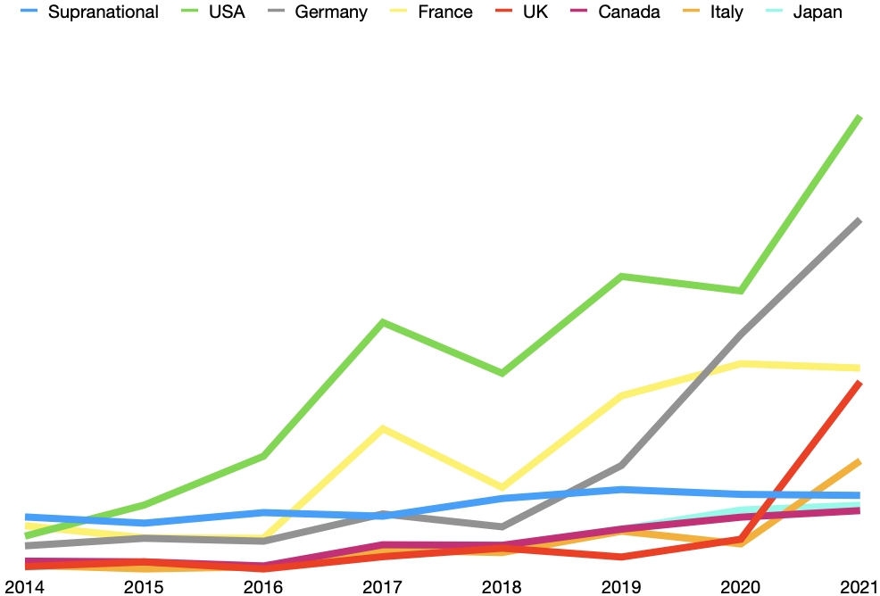

Scheme III.1 shows the growth of the interest in the green bond market from 2014 to 2021. It is well-known that the green bonds market was initially created in Europe and the United States. Thus, notwithstanding the growth of bonds issued worldwide now more frequently than that was in 2014, It is clear that among G7 countries, the amount of money that was raised through green bonds in European countries and the United States is higher and growing faster than that in Canada and Japan.

Scheme III.2. Total amount of money raised via green bonds instruments, in USD | Scheme III.3. Total number of countries of underlying risk
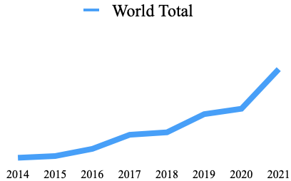 | 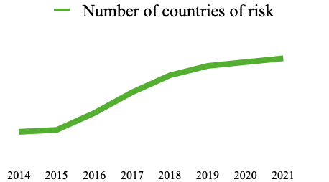
Scheme III.4. Comparison of growth: money raised to the number of countries of risk
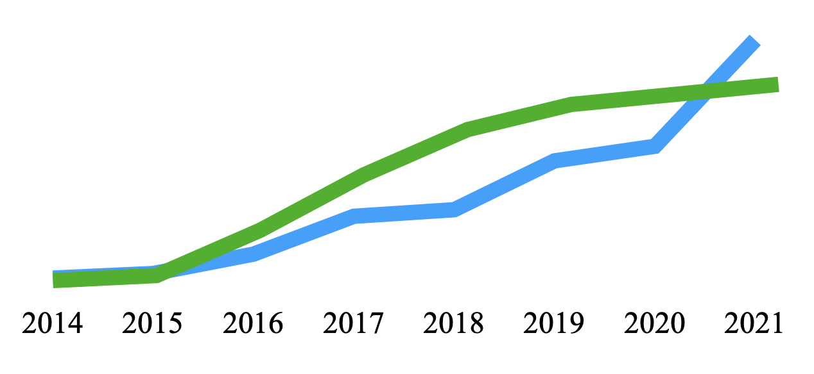

Schemes III.2 and III.3 show that the amount of issuance via green bonds instruments grow year to year since 2014, as well as the number of countries os risk. As of 2014, the amount of issued green bonds was over $37 billion, while in 2021 it reached, roughly, 509 billion. At the same time, the governments and companies, which issued green bonds from 2014 to 2021, operate in particular countries of risk, with the number of 18 in 2014 and 57 in 2021.

The interesting fact is that Schemes III.2 and III.3 cross as shown on Scheme III.4. This is an interesting statistical result that shows that in recent years the number gross amount of money raised via green bonds was done, mainly, by the contribution of (middle-size, accordingly to the data sample) new country-“members”, while since 2020, the number of the issuing countries crossed the raised amount. From 2020 to 2021, the number of countries-“members” of risk grew from 55 to only 57.

The pattern that was detected with these descriptive statistics is that since 2020 (with the beginning of the Covid Pandemic), the number of green bonds issued (and the amount of money raised with them) became a lot higher, as current countries-“members” of green bonds market made a bigger contribution, and some previous “members” quitted the market for 2020 and/or 2021.

Scheme III.5. Total amount of money raised via green bonds instruments, by region, in USD | Scheme III.6. Total amount of money raised via green bonds instruments, three minor regions from Scheme III.7 (macro scale)
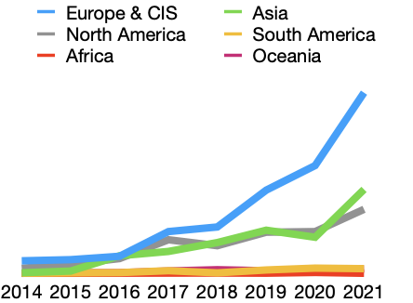 | 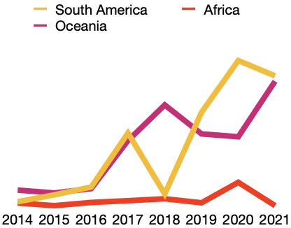

Schemes III.5 and III.6 reveal that the amount of money raised via green bonds in the years 2014-2021 was very different from region to region. As is expected, the regions-leaders are Europe & CIS, Asia, and North America, while the other three regions revealed very unstable growth. The most stable is the growth of the Oceania region (including Australia and New Zealand). At the same time, Asia and North America grow, in fact, in quite the same mean.

Another comparison could be made through the prism of the kinds of issuers, as well as the use of proceeds. The analysis of the data from the Climate Bonds Initiative shows, in the example of the Europe & CIS (the absolute market leader, as was shown above), that the number of non-financial corporates that issued green bonds in 2021 was as many as 40% of green bonds market players.

Scheme III.7. Total amount of money raised via green bonds instruments, by region, in USD
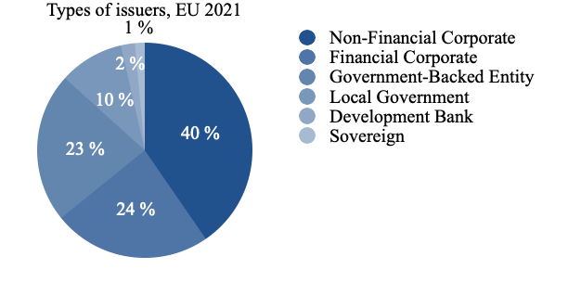

With all that, the local government, development bank, and sovereign issuers, combined, take as little as 13% of the total market players in 2021. However, while I was making the literature review, I found much research done in this market. I am utterly convinced that the research in this field might lead to insignificant results in industrial analysis (that is why I would like to exclude government-related subjects from the scope of this Research).

It is expected, at the same time, that in the major industries, in which much more money was raised (accordingly with the use of proceeds), it would be easier to find matching pairs.

Scheme III.8. Use of proceeds, USA 2021 | Scheme III.9. Use of proceeds, USA 2021
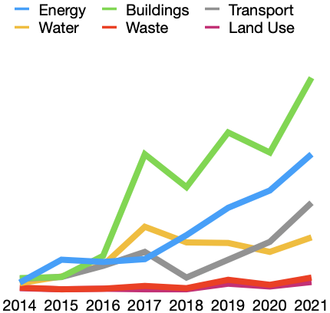 | 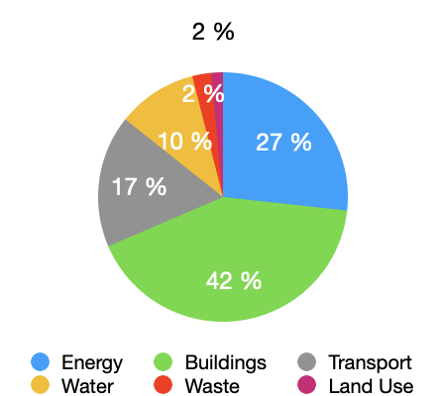

In the example of the United States (available via Climate Bonds Initiative), I would like to highlight that there are three major industries, in which the pairs matching is expected (among non-financial corporate).

The schemes above show that the major non-financial issuers could contribute to energy usage, the building of eco-friendly buildings, and the transportation industry. At the same time, the use of proceeds for water, waste, and land use suffers from less attention, having as little as 14% of the total amount of USD raised via green bonds.
3.6. Green Premium
“The average retail price for a gallon of jet fuel in the United States over the past few years has been around $2.22, while advanced biofuels for jets cost around $5.35 per gallon. The Green Premium is the difference between the two, which is $3.13, or an increase of more than 140 percent.” - says Bill Gates (Gates, 2020).
Gate’s definition is quite important to the analysis of green bonds’ premium: the bonds’ is the price that an investor pays or, respectively, the issuer earns when trades a green bond. That is to say, the green premium is a difference between the price of a plain vanilla bond and a comparable green bond.

Therefore, from this perspective, it is logical that the green premium on a primary market will be a difference between coupons of a fixed-coupon bond and a plain vanilla (fixed-coupon) bond that have the same characteristics (such as issue date, date of maturity, issuer and many others — more details in the empirical part of the Research).

At the same time, the green premium would be harder to calculate on a secondary market example. Usually, in the secondary market, there are no bonds with, at least, the same date of issue (here I would like to offer my methodology — more details in the empirical part of the Research)

However, many researchers before me stated that a green premium could be either negative or positive. In the case of a negative green premium, a green bond is traded at a higher price or percent than that of a plain vanilla bond. Therefore, an issuer shall pay out more, as they issue a green bond, while an investor has to buy such a bond at a higher price.

At it is stated by Gates, 2020, a positive green premium could be a dangerous phenomenon. To tackle the negative effects of environmental problems, humanity shall somehow solve the problem of the higher price of ‘green’ things soon. That is to say, green things, including bonds, shall cost the same price that has a plain vanilla bond.
However, real-life examples account for examples of negative green premium: for example, it can be cheaper to buy and install an electric (greener) cooker, rather than to manipulate with a gas-fueled analog. (Breakthrough Energy, 2020).
3.7. Why green premium differs in different industries
Starting this paragraph, I would like to get back to the aforementioned examples with cookers and gallons of petroleum.

In a hypothetical example, a single firm (which has the same credit rating and other features) sells two products in the United States: gas cookers and conventional petroleum. Another firm also sells two products in the United States: electric cookers and ecology-neutral petroleum. Let it be so that these two firms sold in the last reporting year the same number of cookers, as well as the same amount of petroleum, in gallons. Moreover, to simplify this example, let us imagine that these cookers have similar characteristics (fit the same demand), whilst petroleum allows them to run the same number of kilometers per gallon and that all other factors are equal to these two firms.

In this case, it would be clear that these two firms shall have different revenue: the ecology-neutral firm shall earn more in the petroleum business, while the ecology-negative firm will earn more in the cookers industry. It has happened in this case, as these two firms sold their products at different prices.

At the same time, it cannot be expected that the two firms would have the same revenue: it might be so that to ‘win’ a $1000 on a green premium, one of these firms shall sell either 10 cookers or, respectively, 500 gallons of petroleum.

This simplified example shows that two similar firms that both sell in two same industries, might operate with two different green premiums, as they operate in different industries.

Going back to the green premium of green bonds, I cannot help but highlight that there is no reason why the green premium shall be similar within two different industries.

3.8. CONCLUSION - Theoretical part of the Research
Notwithstanding that green bonds are actively traded for around a decade, there is no conventional opinion among the researcher regarding the existence of green premium. Many of them claim it to be positive, while others state it to be negative.

With all that, notwithstanding that positive green premium seems to be more logical, the examples in which green premium would be negative are also possible and sound logical.

Simplified examples show that in different industries, notwithstanding which green premiums are (negative or positive), ergo, it is possible to conclude that the green premium, at the same time, might be different in different industries when we talk about green bonds.

Comparison analysis of green bonds and respective plain vanilla bonds might show this difference, while a simple comparison of the amount of green premium would show, how different they are.

IV. EMPIRICAL PART OF THE RESEARCH

4.1. Hypothesis Development

Hypothesis 1: Green premium differs from industry to industry
The first hypothesis that I would like to state in this Research is that the green premium in different industries can be compared effectively. As was mentioned in the Literature Review above, the research gap in the area of green bond premiums constitutes of comparison of this green bond premium in different industries.

I reasonably assume that the green premium can be different in different industries, and, what is more important, it is possible to match the results of green premium difference between many industries. What I mean is that in any industry, there are market players that have credit ratings, and they issue bonds accordingly with similar rules.

Hence, it is possible to compare similar bonds (green and plain vanilla) to each other, and then compare the difference between the YTMs of a green bond and a plain vanilla bond within an industry, and within the market itself.

Methodology - matching method
One of the most practically-oriented research methodologies is the matching method.

The matching method means that the bonds are compared to find differences between them. However, it is possible to compare only those items (including bonds) that are similar in many details, and different only in some of them. Therefore, to provide this Research with the Matching method, I have to choose criteria (filters) with which I will find the appropriate data scope.

For this Research, I would like to compare plain vanilla bonds with the other plain vanilla bonds, with an underlying green goal (green bonds) of the same issuer.
However, the matching method has a limitation: it requires significant data to make comparisons (pairs). For this Research, it is possible to find a lot of data, which might only be limited by objective market reasons. For example, there is a total of 22.1k plain vanilla bonds, with which it is possible to make comparisons.

4.2. Data Resource
Cbonds (https://cbonds.ru) is the main data source that was used to сollect data. Cbonds is a Russian-based database that provides data about bonds. The database of Cbonds is considered to be one of the largest databases of bonds, being the largest database that provides data on bonds in the Russian language.

In total, the database of Cbonds constitutes 297.5k bonds that are currently traded (of the total 639.9k bonds which were issued once in history). Thus, I can reasonably assume that the database provides enough data to provide proper information about the market activity of the focused issuers.

Moreover, the webpage of Cbonds (which is used as the main portal to search the data) has a lot of useful filters. The filters allow us to find appropriate bonds to analyze within this part of the Research. The filters of the Cbonds platform consist of 5 main parts: “Basic”, “Ratings”, “Classification”, “Information about emission”, and “Coupon”.

1. “Basic” part consists of “Name of the issuer”, “Region”, “State”, “Sector”, “Industry”, “Status”, “Type”, “Currency”, “Index”, “Yield”, “Duration”, “Placement”, and “Repayment”. 6 of them were used in this Research to make the found bonds appropriate to the goals of the Research.

2. “Rating” part consists of “Rating of an issuer in national currency”, “Rating of an issuer in foreign currency”, “Rating of emission”, and a ticker button “Find bonds with ratings only”. In this Research, as I did not expect to use this, but taking into account the significance of the rating itself, I decided to tick the button “with ratings only”.

3. “Classification”, “Information about emission”, and “Coupon” were used to find appropriate bonds, which I would like to get deeper into Part 4.3. Steps of the Research (Step I. Finding appropriate data). In brief, the filters available in those 3 main parts are worthwhile to make the data sample for analysis in this Research.

With the data provided by Cbonds, it was possible to commence with the analysis of hundreds of bonds for this Research.

4.3. Steps of the Research
Step I. Finding appropriate data
As it was mentioned above, the database that was used in this research was Cbonds where there are 297.5k bonds traded now. Out of the 297.5k bonds, I had to choose appropriate bonds for an analysis of this Research. That is to say, I had to apply some of the abovementioned filters to cut all the bonds which are not appropriate to the goal of this paper.
With all that, to apply these filters, it is necessary to understand, which bonds shall be used accordingly to the methodology. As for Hypothesis 1 (H1), the methodology is defined as a matching method, hence, the appropriate pairs of bonds (green bonds matched with respective vanilla bonds). For the matching method, at the first level (having 297.5k traded bonds) I found it necessary to narrow this scope to some bonds of similar characteristics.

The matching method is possible to apply only when there are identical bonds. Therefore, to pair a green bond, plain vanilla bonds were chosen.

The characteristics of the green bonds and the plain vanilla bonds are quite similar. In other words, the green bonds are plain vanilla bonds that have sustainable development underlying goals. Thus, the initial characteristics of the green and plain vanilla bonds are similar in this Research, except for the underlying sustainable goal which only green bonds have.

To find those bonds, I applied the following filters:
1. “Basic” group of filters.
I applied 6 filters of 13 available in this part, and there are the reasons why:

Applied filters:
- “Sector” filter allows choosing between “Governmental”, “Corporate”, and “Municipal” bonds. I did apply this filter, having to search only “Corporate” bonds, as a proper industrial analysis of industrial green premiums is possible with corporate bonds only (governments and municipalities might also issue the bonds which might be allocated to any industry, however, their goals are different). Thus, this filter is used to properly choose only the bonds that apply to this Research.
- “Industry” filter was applied, as to analyze the green premium in different industries as a part of this Research. Cbonds platform separates all bonds into 68 industries. It would not be worthwhile to mention all of them here, whilst I would like to mention that (as the Research will show below) the main part of the bonds issued are within the banking industry. I cannot help but say that practically every industry has green bonds issued, however, for many of them, it was not possible to find appropriate pairs accordingly to the Methodology of this Research.
- “Status” filter is applied. In the scope of this research, there are only currently traded bonds.
- “Type” filter provides differentiation between Eurobonds and simple bonds. This filter was used in the following stages of the Research, as it is not possible to pair Eurobonds and similar bonds: the Eurobonds are traded in the global market and, hence, have higher liquidity than simple bonds, therefore, it can influence the price.
- The “Currency” filter was applied at this stage to tighten the data scope: the analysis of this Research is made on USD (United States Dollar) and EUR (Euro). USD and EUR are the most popular currencies to issue bonds. The research of green premium within different currencies seems to be a research gap which, however, lies out of the scope of this Research. In this Research, USD and EUR were chosen, as it is more probable to find pairs of green and plain vanilla bonds within the most popular bonds. Thus, the analysis of this Research covers (in means of currency, 52% of the globally traded bonds). However, some other currencies seem uncovered in this Research (CHY, INR, KRW, and JPY) which, combined, cover approximately 27% of the global market. As all of them are located in Asia, it seems that the regional analysis of the green premium of “Asian bonds” (nominated in “Asian” currencies”) might be a research gap for the future researchers of green premium.
The currency distribution of traded bonds in the market is represented in the chart below.

Scheme IV.1. Number of green bonds emissions in particular currency | Scheme IV.2. Distribution of green bonds emissions by major currencies
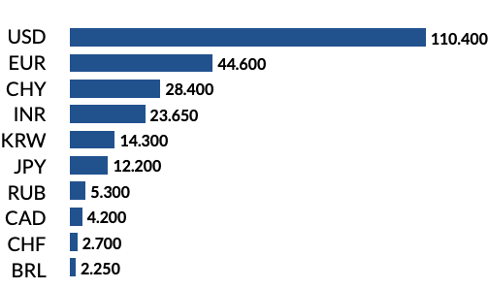 | 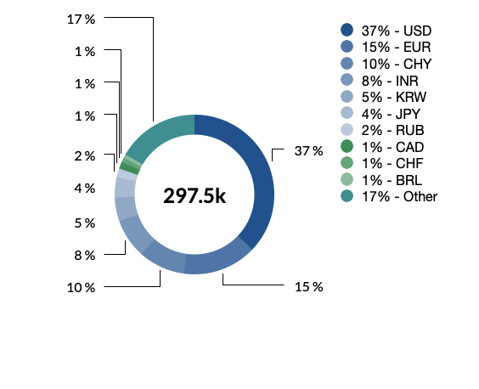
Note: USD - United States dollar, EUR - Euro, CHY - Chinese yuan, INR - Indian rupee, KRW - Korean Republic’s won, JPY - Japanese yen, RUB - Russian ruble, CAD - Canadian dollar, CHF - Swiss franc, BRL - Brazilian real.

Unapplied filters:
- “Name of the issuer” filer was not applied, since it tightens the scope too harshly for this stage.
- “Region” & “State” filer were not applied, since it makes inappropriate filtration to the goals of this Research (the goal is industrial, not regional analysis).
- “Yield”, “Duration”, and “Repayment date” were not applied, as it was not possible to predict the exact or range of numbers to put in these filters at the beginning of the Research.
- “Index” filter is not applied as it was not possible to predict the indices to use within this Research.

2. “Rating” group of filers
In this group of filters, the only one I used is a ticker button “Find bonds with ratings only”. The bonds with ratings are easier to compare, and, mainly, they have much more information over other metrics of such bonds. Hence, all the bonds that are in the data sample for this research, are those which are

3. “Classification” group of filers
This is by far the largest group of filers in the database of Cbonds. It is divided into two similar parts: while the first part applies the filters as “lookup only”, the second part applies the same filters, but in the mean of “lookup, excluding”.
Mainly, to compact an appropriate data sample for this Research, I would use the “lookup, excluding” option, as it is usually easier to exclude the things which are not appropriate to the goal of the Research than to find the exact appropriate bonds using the filters.

From the sample of this Research were excluded:
- Amortization bonds, being bonds the nominal value of which returns to an investor linearly or non-linearly (amortization-alike) with the lifetime of the bonds. They are excluded since the cash flow of these bonds differs from plain vanilla bonds.
- Perpetual bonds are bonds without a maturity date. These bonds are inappropriate in the mean of the Methodology of the Matching Method (as we compare bonds with a similar duration that, hence, shall have a maturity date).
- Euro-Commercial Paper (ECP) are short-term debt instruments (on average, they durate for 182 days). As their term is much lower than that of bonds, they are inappropriate to pair matching.
- Retail bonds are bonds with a low face value. The first offering of these bonds might participate private investors. As they are different from plain vanilla bonds, they were excluded from the sample.
- Сovered bonds, being debt instruments (bonds) that are traded under collaterals, were excluded from the sample, as their risks differ (seniority) from that of vanilla bonds, hence, they shall have different prices, and, in the end, inappropriate to match pairs.
- Bonds that are in the Pawnshop of the Central Bank of Russia were excluded from the sample as they have strong regional belonging.
- Callable bonds, being a bond that gives their issuers rights, at their discretion, to redeem the obligation ahead of schedule before the end of its circulation period, were excluded from the sample, as their cash flow differs from that of vanilla bonds.
- Guaranteed bonds, Secured bonds, and Subordinated bonds were excluded from the Research’s sample, as their risks differ from that of plain vanilla bonds.
- Sukuk is an Islamic finance instrument. These instruments (being unusual for European and American financial tradition) were excluded from the sample of this Research, as they are too specific for the goal of this Research.
- Convertible bonds were excluded from the sample, as their structure significantly differs from that of plain vanilla bonds: convertible bonds might be converted to stocks of the debtor.
- Mortgage bonds, being bonds (issued by banks only) the payment of which is linked to and secured by the mortgage payments of individuals and corporations, that pay mortgage payments to banks, were excluded from the sample herein, as they have different risks than that of plain vanilla bonds, and, in addition, is issued by banks only.
- Collateralized debt obligations (CDO) are bonds solvency which is ensured with different debt instruments. Their risks are lower than that of vanilla bonds, therefore, I reasonably assume to exclude this type of bond from the sample, as their pricing is different from that of vanilla bonds.
- Default bonds are excluded as they are already in an insolvency process, hence, have different risks.
- Bond with indexation of nominal, as well as the bonds, the coupon of which is linked to the inflation rate, were excluded from the sample, as their cash flow is different from that of vanilla bonds.
Table IV.1. The main exclusion reasons
Different Risks | Different Cash Flow | Methodological inappropriatance
Covered bonds | Amortization bonds | Perpetual bonds
Callable bonds | Guaranteed bonds | Euro-commercial paper
Mortgage bonds | Secured bonds | Retail bonds
Collateralized debt obligations | Subordinated bonds | Pawnshop bonds
Defaul bonds | Bonds with indexation of nominal | Sukuk
 | Bonds, the coupon of which is linked to inflation rate | Convertible bonds

However, there is another filter, that was used to separate green bonds from plain vanilla bonds. It is a “Green bonds” filter. To create a separate sample of green bonds, and a separate one for plain vanilla, I used this filter, respectively, as “lookup only”, and “lookup, excluding”.

4. “Information about emission” group of filters
This group of filters consists of 9 filters, “SPV”, “Participants of listing”, “Offering date”, “Nominal trade lot”, “Volum of emission, mln in the currency of emission”, “Volume of emission, mln USD”, “Start of listing”, “Price, % of face value”, “Place of listing”.

These filters are mainly related to primary market bonds, while the goal of this Research is to look up the secondary market. However, I took into account the last date of placement (the date on which the placement is over).

With all that, I cannot help but highlight that Cbonds parce information through 196 listings, like London, Luxemburg, or Frankfurt exchanges.

5. “Coupon” group of filters
This group of filters is one of the most important, and the smallest one in the mean of the number of filters. There are three filters: “Type of bond”, “Type of rate”, and “Coupon size”. While the first two filters were applied in this Research, the last one was not, as it was unpredictable at the beginning of the Research, which coupon size to consider, and which not, to reach the goals of the Research.

- The “Type of bond” filter might be three: discount, coupon, and interest on redemption. As the goal of this Research is to look up plain vanilla bonds, the coupon bonds were chosen exclusively.
- “Type of rate” filter allows choosing between “fixed” and “floating” rates. The goal of this Research was to look up the bonds that have fixed coupons only, hence, those with “floating” rates are out of scope.

Results of Step I. Finding appropriate data
In this step, I made the sample appropriate for analysis. The goal of the Research is to research plain vanilla bonds in comparison with green bonds, to find the difference in green premium on a particular date (the last update of the sample: the 12th of May 2022).

As a result of this step, I received two spreadsheets (one for green bonds, and one for plain vanilla bonds). The goal of this paper was to compare fixed-coupon corporate bonds which have the simples cash flow and no special risk-related rules (plain vanilla bonds) with the other plain vanilla bonds but with a green underlying goal (green bonds).

The scheme below shows the pipeline of bonds that I went through to complete the sample:

Scheme IV.3. Bonds pipeline
Total traded bonds (297.5k)
Fixed-coupon bonds (214.7k)
Corporate bonds (147.6k)
Fixed-coupon bonds (214.7k)
USD & EUR (76.7k)
With a rating of issuer (62.5k)
Plain vanilla (31.8k)
Green bonds (517)

Hence, out of the total of 297.5k currently traded bonds, for the analysis of this paper, there were 517 green bonds and 31 845 bonds chosen.

However, later in the Research, there were only 474 green bonds, and 21 614 plain vanilla bonds analyzed, as I have tightened the analysis with the timeframe between 01/01/2017 and 05/10/2022. This period was chosen as the most appropriate, regarding the time of the writing of this Research, as well as the concern that in the initial stage of the green bonds market (since 2007, and until 2015-2017) the market was emerging, hence, there could be many biasedness in the pricing of the green bonds (Lizhenina, 2021).

Furthermore, the analysis of these bonds is possible, by the Methodology, which requires pairs of green bonds and plain vanilla bonds. Moreover, for this Research, it is not enough to find one pair of a green bond and a plain vanilla bond, it is necessary to find a lot of plain vanilla bonds to each green bond, as well as many pairs within an industry. Hence, it is necessary to observe the number of plain vanilla and green bonds together by industry.

Scheme IV.4. Industries of bonds’ issuers
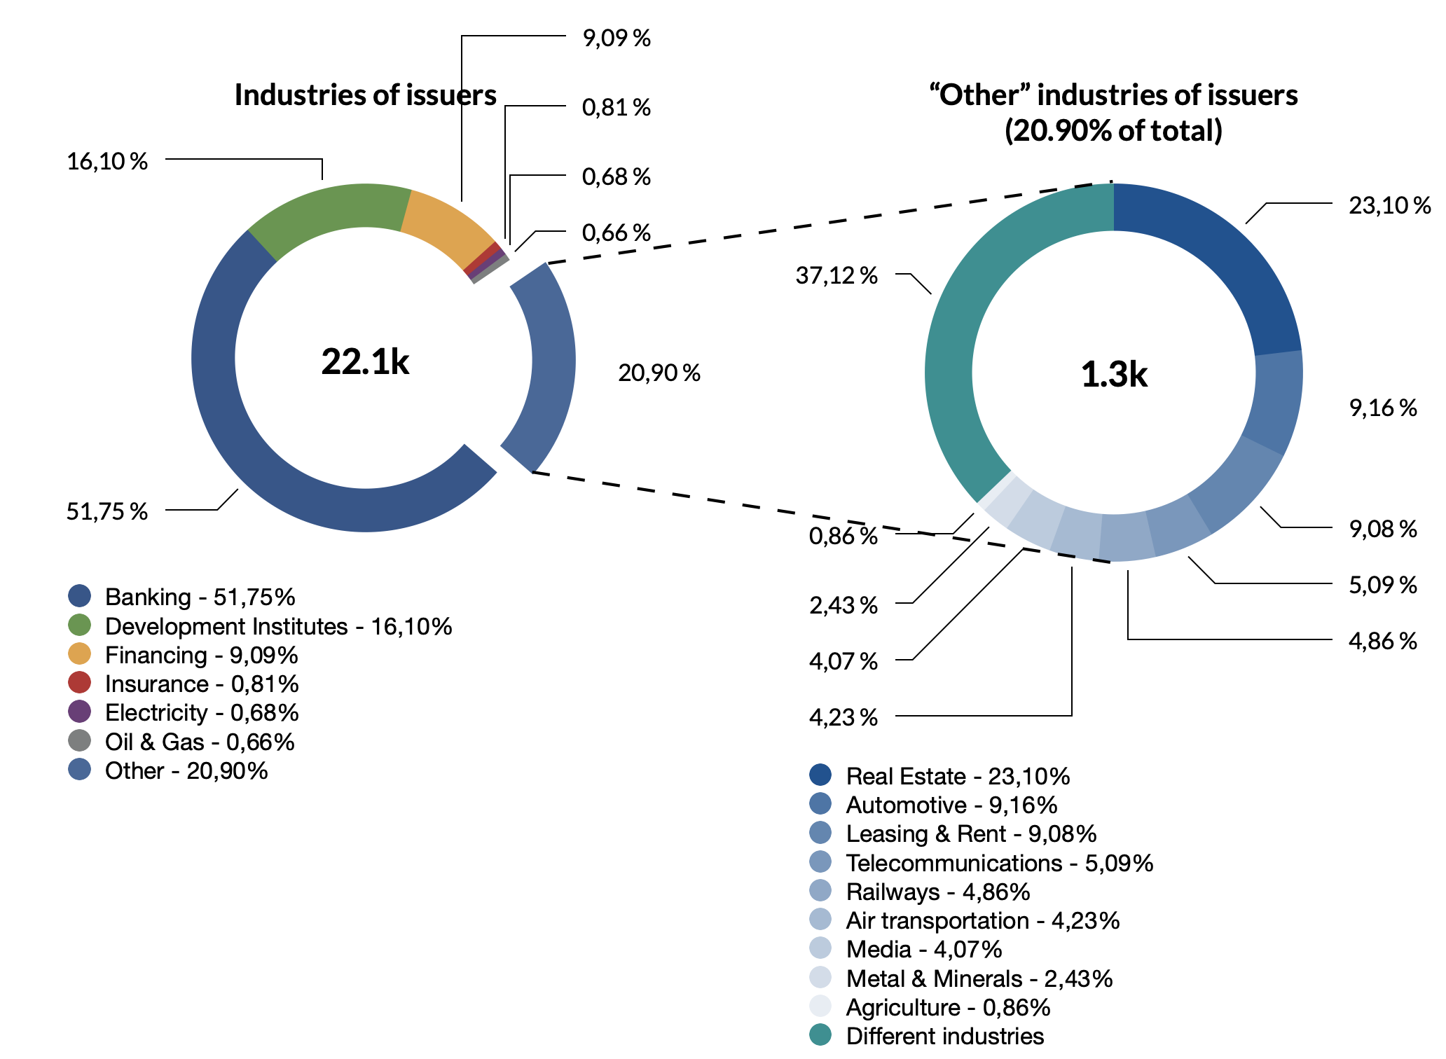
Scheme IV.5. Industries of green bonds’ issuers
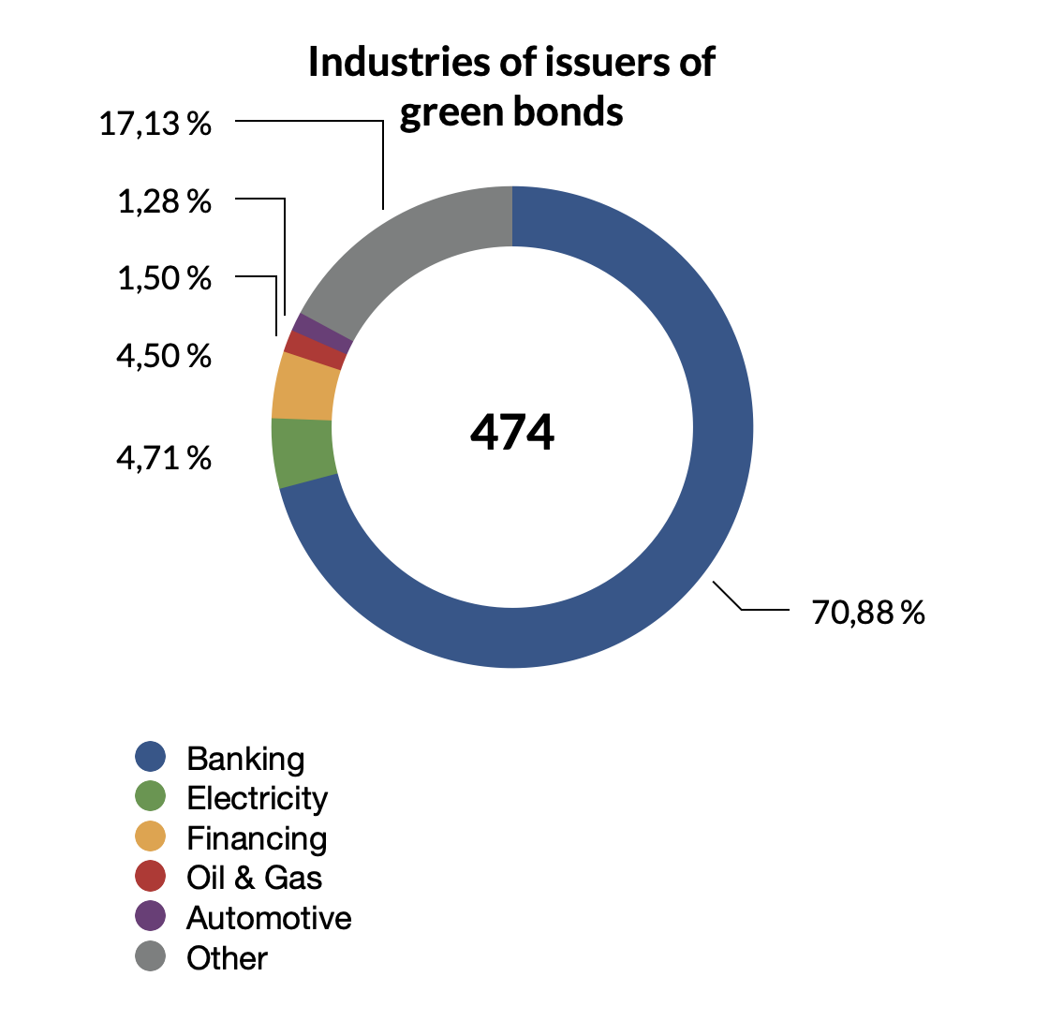
This descriptive statistic shows that 51.75% of the plain vanilla & green bonds (22.1k) were issued by banks, 16.1% were issued by State Development Institutes, and 9.09% of the bonds issued are held by Finance and Microfinance issuers, and 0.8% are held by Insurance companies. That is to say, in 77.75% of the cases of the plain vanilla & green bonds that were issued between 2017 and 2022, the issuers are more or less related to financial institutions. Simply, this might mean that the green premium amount is driven by financial society & industry. At the same time, 70,88% of the green bonds were issued by banks solely. Hence, it is probable that the best strategy is to deeply analyze the banking industry’s green premium.

Step II. Finding pairs of plain vanilla and green bonds
As required by the Methodology, to analyze the green premium it is necessary to find pairs of green bonds and plain vanilla bonds.

Paired could be only the bonds that were issued by a single issuer, in one currency (USD or EUR), and in either in form of a Eurobond or a simple bond. With all that, the coupon, as well as the maturity and issue date are not important as-is: the pairs will be analyzed with duration, and yield to maturity.

That is to say, a pair of plain vanilla and green bond will be determined as a pair when they have a similar duration. The duration allows comparing two bonds: issued, for example, in 2017 and 2019.
The formula is the following:
Where:

- yield to maturity of a green bond
- yield to maturity of a plain vanilla bond

For this Research, out of the industries mentioned before, and due to objective reasons (mostly, the green bonds are issued by banks, while I have looked up roughly whole available green bonds).

Thus, some industries such as agriculture, air transportation & airfields, water transportation, and real estate have green bonds, and at the same time, the same issuers have also plain vanilla bonds. However, in the case of the mentioned industries, there are no pairs due to the different duration of those bonds.

To reach the objective of this Research, I found pairs of bonds in 3 industries: banking, automotive industry, and telecommunications. However, there are tens of pairs of green bonds regarding one issuer.

To illustrate this, and explain the design of the results, I would like to commence with one example from the banking industry.
Table IV.2 |  |  |  |  | As of the 12th of May 2022
Issuer | Currency | Coupon | Number of payments per year | End of placement | Yield to maturity, % | Duration, days
Asian Development Bank (ADB) | USD | 1,75 % | 2 | 14.06.21 | 3,111 | 1.480,91
Asian Development Bank (ADB) | USD | 0,25 % | 2 | 07.07.20 | 2,340 | 424,31
Asian Development Bank (ADB) | USD | 0,25 % | 2 | 29.09.20 | 2,493 | 506,31
Asian Development Bank (ADB) | USD | 0,38 % | 2 | 02.06.21 | 2,704 | 748,51
Asian Development Bank (ADB) | USD | 0,38 % | 2 | 25.08.20 | 2,953 | 1.186,53
Asian Development Bank (ADB) | USD | 0,50 % | 2 | 27.01.21 | 2,983 | 1.331,71
Asian Development Bank (ADB) | USD | 0,63 % | 2 | 21.04.20 | 2,928 | 1.061,26
Asian Development Bank (ADB) | USD | 0,63 % | 2 | 28.09.21 | 2,842 | 863,22
Asian Development Bank (ADB) | USD | 0,75 % | 2 | 30.09.20 | 3,236 | 2.926,84
Asian Development Bank (ADB) | USD | 1 % | 2 | 07.04.21 | 3,003 | 1.388,95
Asian Development Bank (ADB) | USD | 1,25 % | 2 | 02.06.21 | 3,167 | 2.098,18
Asian Development Bank (ADB) | USD | 1,50 % | 2 | 10.10.19 | 2,860 | 865,44
Asian Development Bank (ADB) | USD | 1,50 % | 2 | 11.01.22 | 3,083 | 1.629,06
Asian Development Bank (ADB) | USD | 1,50 % | 2 | 24.02.21 | 3,252 | 2.959,04
Asian Development Bank (ADB) | USD | 1,63 % | 2 | 08.03.22 | 2,649 | 657,24
Asian Development Bank (ADB) | USD | 1,63 % | 2 | 15.01.20 | 1,999 | 253,55
Asian Development Bank (ADB) | USD | 1,75 % | 2 | 06.09.17 | 1,462 | 124,00
Asian Development Bank (ADB) | USD | 1,75 % | 2 | 11.09.19 | 3,217 | 2.481,73
Asian Development Bank (ADB) | USD | 1,88 % | 2 | 08.03.22 | 3,201 | 2.311,29
Asian Development Bank (ADB) | USD | 1,88 % | 2 | 09.07.19 | 1,077 | 70,00
Asian Development Bank (ADB) | USD | 1,88 % | 2 | 15.01.20 | 3,231 | 2.570,50
Asian Development Bank (ADB) | USD | 2,50 % | 2 | 07.05.19 | 3,132 | 1.852,91
Asian Development Bank (ADB) | USD | 2,63 % | 2 | 26.04.19 | 3,075 | 1.580,32
Asian Development Bank (ADB) | USD | 2,63 % | 2 | 23.01.19 | 2,612 | 607,13
Asian Development Bank (ADB) | USD | 2,75 % | 2 | 13.03.18 | 2,141 | 305,57
Asian Development Bank (ADB) | USD | 2,75 % | 2 | 14.08.18 | 3,141 | 1.894,00
Asian Development Bank (ADB) | USD | 2,88 % | 2 | 21.04.22 | 2,933 | 1.038,82
Asian Development Bank (ADB) | USD | 3,13 % | 2 | 27.04.22 | 3,298 | 3.103,68

In the table above, there is a green bond (in green color) issued by Asian Development Bank in 2021. Its duration is roughly 1481 days. With all that, out of 27 plain vanilla bonds that were also issued by Asian Development Bank from 2017 to 2022. The 27 are all the plain vanilla bonds that were issued within this term by Asian Development Bank.

When comparing durations, it is easy to find out that no bond has the same (1481 days) duration. And the similar situation is with the second green bond of the Asian Development Bank:
 |  |  |  |  | As of the 12th of May 2022
Issuer | Currency | Coupon | Number of payments per year | End of placement | Yield to maturity, % | Duration, days
Asian Development Bank (ADB) | USD | 1,75 % | 2 | 14.06.21 | 3,111 | 1.480,91
Asian Development Bank (ADB) | USD | 3,13 % | 2 | 19.09.18 | 3,204 | 2.095,28

Thus, we can see that there are two green bonds, one of which has a higher coupon, being at the same time issued in 2018. Therefore, the two green bonds have quite similar yields to maturity (3.1% and 3.2%), while their durations are significantly different (1481 days and 2095 days).

At the same time, it is not possible to find a plain vanilla bond with exactly 2095 days of duration, while there is a plain vanilla bond (highlighted with higher case and in bold) the duration of which is 2098 days. Thus, it seems that it is possible to say that the difference in 3 days in duration does not have a significant influence on the yield to maturity.

Thus, I decided to divide all the durations into 3 tiers of accuracy (5 groups). The first group is the largest, and the most precise lies within +/- 5% of the duration of a green bond, it is the first tier. The second tier is less precise but one can claim that its accuracy is enough for them. The second tier lies between -5% and -10%, and +5% and +10% from the value of a green bond’s duration. The third tier lies between -10% and -15%, and +10%, and +15% from the value of a respective green bond’s duration. Another differentiation in durations seems to be too unprecise for this Research.

This way, I received 4 pairs for the green bond (1) (with a 1.75% coupon), and another 4 pairs for the second green bond. The results of the calculation of green premium are calculated, and represented below:
Table IV.3. Asian Development Bank Green Premium
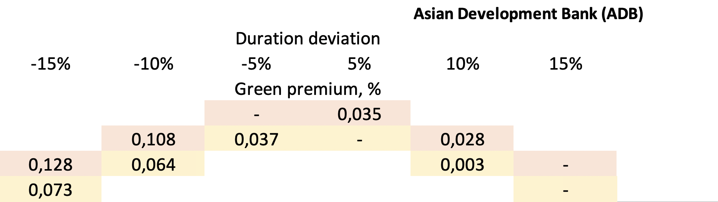

This table shows two green bond premiums calculations, the first (with the 1.75% coupon) is colored in red, while the second is in yellow.

It shall be mentioned that for the first tier, the comparison was done on two different green bonds, with two different respective plain vanilla bonds, while the result of the calculations is very similar: the green premium is 0.037% or 0,035%, however, the duration, coupon, and date of issue are very different in these pairs.

At the same time, all these bonds are similar in the mean of the issuer, risks, and cash flow. Hence, the example above shows that the green premium exists, and its size is approximately 0,036% (simple average) for the Asian Development Bank. However, it is clear that there is a limitation: the results and the amount of the green premium are found in just two pairs. That means that, on the one hand, it is highly probable that the green premium in the case of the Asian Development Bank does exist, while, on the other hand, it shows that there is a probable biasedness.

Thus, the best possible way to check, if there is a green premium, is to check the whole industry by doing an industrial comparative analysis.

Step III. Calculating the amount of green premium for an industrial comparative analysis
- Banking industry.
To calculate the results, I decided to start with the banking industry, as it holds roughly 71% of green bonds, and 52% of the total market of plain vanilla bonds. Therefore, it is much easier to find out the green premium within an industry.

Table IV.4 Industrial green premium in banking industry 2017-2022
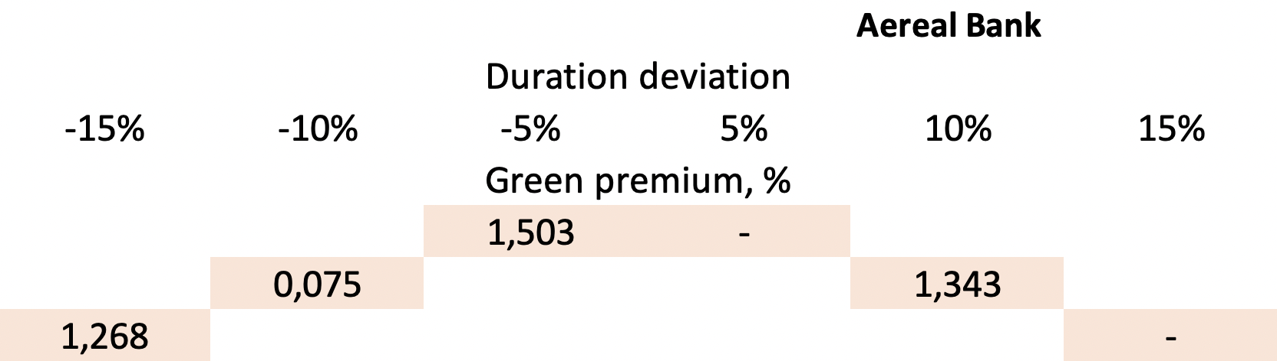 | 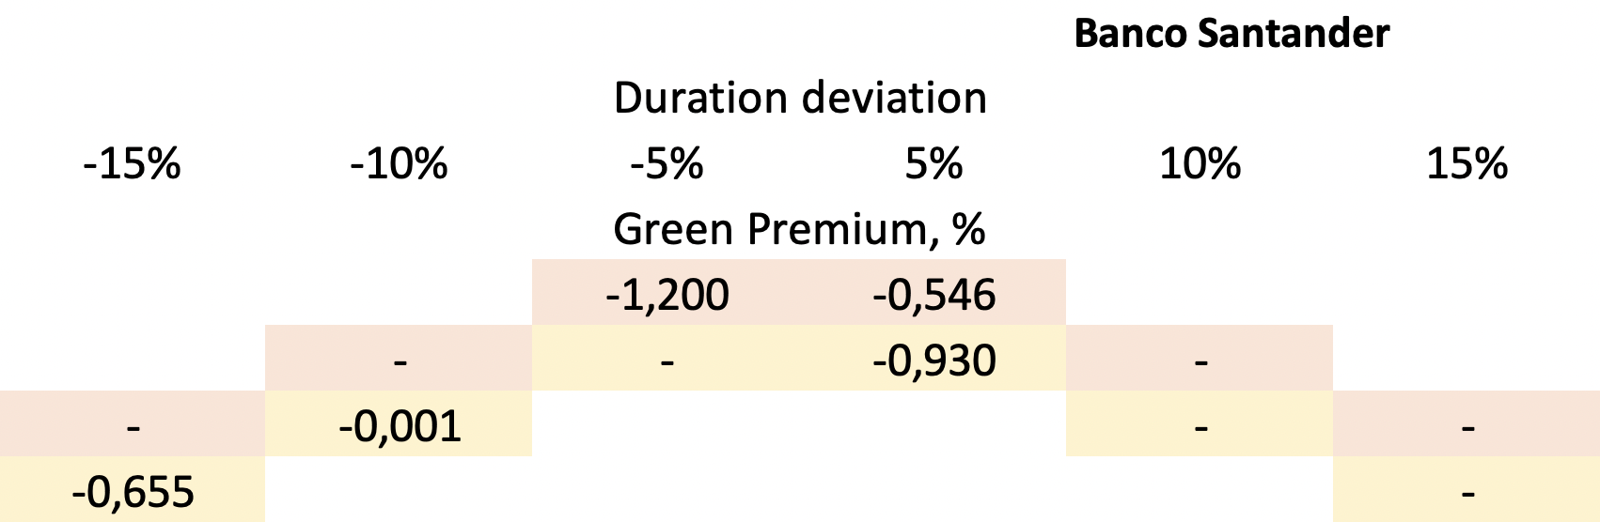
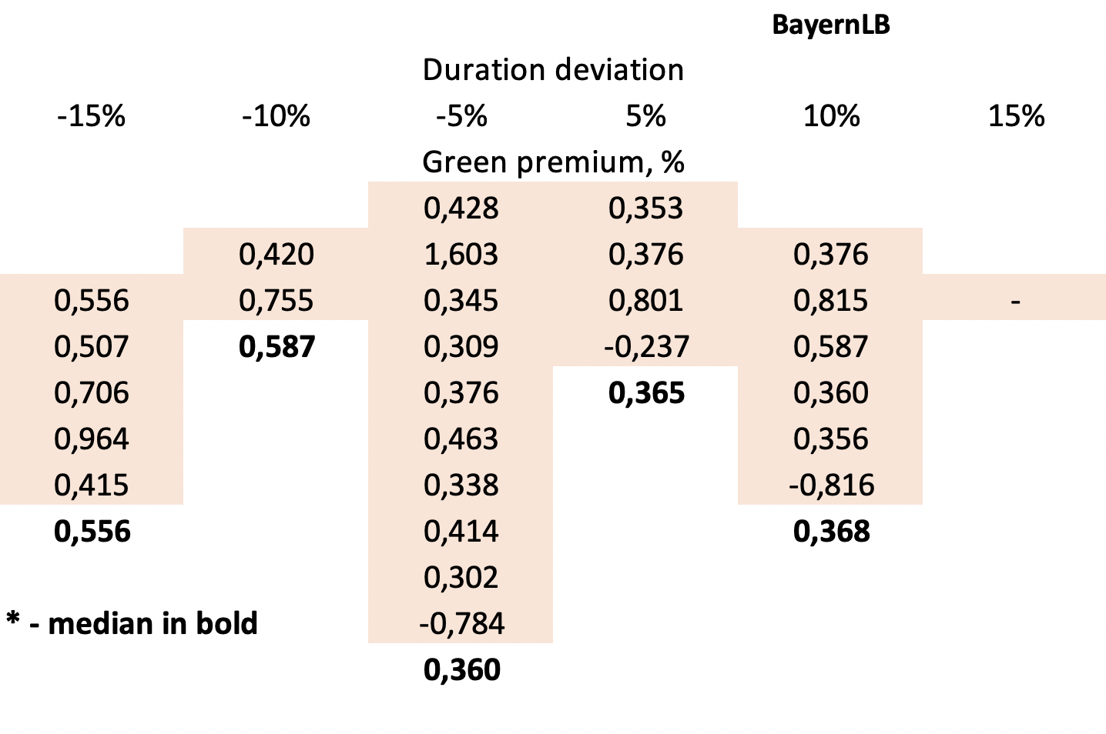 | 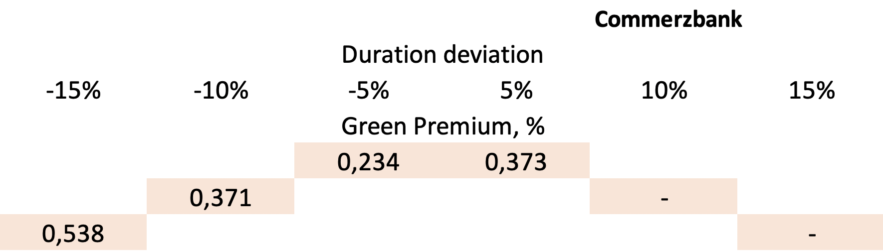
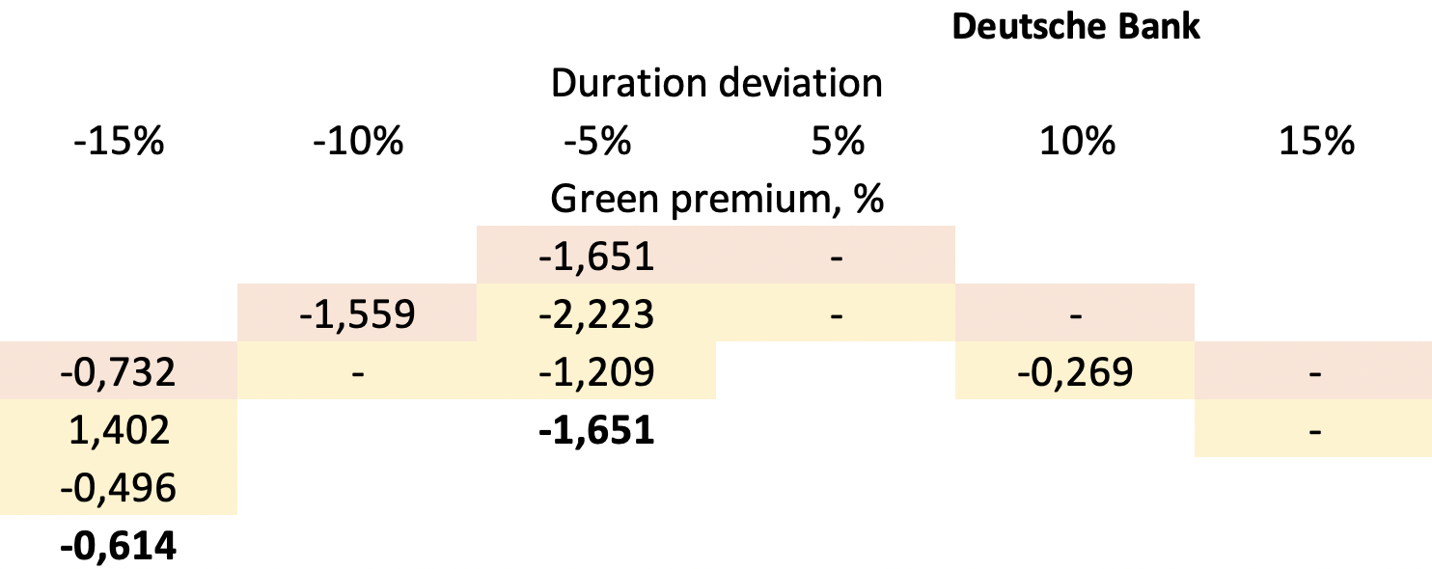 | 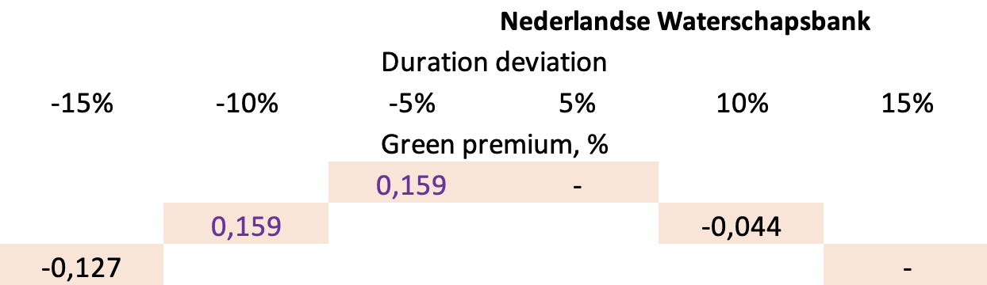

The results of the calculation of green premium are shown above. The received results are additionally represented in Table IV.4 Rating of issuers below, where I provide additional data on the country of risks, as well as the rating of the issuer.

 | Table IV.4 Rating of issuers
 | Name of an issuer | Country of risk | Rating | Rating agency | Green premium (-5%), % | Emission, USD
1. | Asian Development Bank | Philippines | AAA | S&P | 0,036 | 750.000.000,00
2. | Aereal Bank | Germany | A3 | Moody’s | 1,503 | 500.000.000,00
3. | Banco Santander | Spain | A2 | Moody’s | -1,200 | 100.000.000,00
4. | BayernLB | Germany | A3 | Moody’s | 0,360 | 527.230.000,00
5. | Commerzbank | Germany | A1 | Moody’s | 0,234 | 527.230.000,00
6. | Deutsche Bank | Germany | A2 | Moody’s | -1,651 | 527.230.000,00
7. | Nederlandse Waterschapsbank | Netherlands | AAA | S&P | 0,159 | 500.000.000,00
 | Average green premium of A-rated issuer in banking industry (positive) |  |  |  | 0,4584
 | Average green premium of A-rated issuer in banking industry (negative) |  |  |  | -1,4255
 | Weighted average green premium of A-rated issuers in banking industry (positive) |  |  |  | 0,4176

For the average green premium within the banking industry, there was the tier 1 of deviation in duration chosen (the -5% part), as it is the most tier, being the only part of the tier, in which each of the 7 banks has a green premium calculated.

As all of the issuers’ rating lies within A1 to A3 (or AAA) accordingly to rating agencies Moody’s and S&P. That is to say, their risks are quite similar.

To understand the reasons why in some cases (Banco Santander and Deutsche Bank) the green premium is negative, opposite to that of other banks, I state many sub-hypothesis:
- Is the structure of bonds similar?
After a double-check, I found out that the structure of the plain vanilla bonds and the paired green bonds have the same structure, including the seniority of bonds. The only difference is the number of issued money.

- Is the rating of emission similar in both cases? Is it different from the rating of the issuer?
Here we found an appropriate answer to the question.

Theoretically, a price of a bond is influenced by the rating of an issuer, as well as a rating of emission. Therefore, I checked the emission rating of Banco Santander and Deutsche Bank. For many of the bonds, notwithstanding that there is a rating of the issuer, there was no rating of emission.
Here I would like to show the example of Deutsche Bank:
 | Table IV.5 Rating of emission, Deutsche Bank
 | ISIN | Green premium, % | Rating agency | Rating of emission
1. | DE000DB9U6V6 | - | Moody’s | A2
2. | DE000DL19TG3 | -1,651 | Moody’s | Baa2
3. | DE000DL19T42 | -1,559 | - | -
4. | DE000DL19UH9 | -0,732 | Moody’s | A2
5. | DE000DB9U6W4 | - | Moody’s | A2
6. | DE000DL19WJ1 | 0,980 | - | -
7. | DE000DL19U23 | -1,615 | Moody’s | Baa2
8. | DE000DL19TJ7 | -1,792 | - | -
9. | DE000DL19V22 | 1,420 | Moody’s | A2
10. | DE000DB9U2L6 | -0,496 | - | -
11. | DE000DE04XH0 | -0,269 | - | -

 | Table IV.6 Rating of emission, Banko Santander
 | ISIN | Green premium, % | Rating agency | Rating of emission
1. | XS2063247915 | - | Moody’s | A2
2. | XS1548444816 | -1,200 | Moody’s | Baa2
3. | XS2113889351 | -0,546 | Moody’s | Baa1
5. | XS2194370727 | - | Moody’s | Baa1
6. | XS1767931121 | -0,930 | Moody’s | Baa2
7. | XS2113889351 | -0,002 | Moody’s | Baa1
8. | XS1548444816 | -0,655 | Moody’s | Baa2

The analysis above shows that there are three possible situations: the green premium (being the difference between YTMs of the green bond minus plain vanilla bond) might be roughly 0, significantly negative, or significantly positive.

In case, when the green premium is roughly equal to 0, the ratings of emission shall be equal (and vice versa). When there is a significantly negative green premium, the rating of emission of plain vanilla bonds is significantly different from that of a paired green bond.

Therefore, the main reason why the green premium is negative is a significant difference that has ratings of emissions of respective green and plain vanilla bonds. This rule has happened 6 times out of 6.

The case of Nederlandse Waterschapsbank
However, I found out that there is another case, in which the ratings of emissions are equal, while the green premium is both negative and positive.
Getting deeper with bonds of Nederlandse Waterschapsbank, I found out that the two bonds that have negative green premium have a different structure: their underlying goal is social SDGs (social bonds). Social bonds are a rare thing in the market and, hence, are not tracked by Sbonds, while their underlying goals are, in fact, not different from that of green bonds. Therefore, it is possible to say that, depending on circumstances, social bonds could be priced higher or lower than green bonds.

Conclusion for the analysis of the banking industry
From the banking industry analysis, the bonds with negative green premium shall be excluded, since the paired therein bonds have different credit ratings or different structures. However, the analysis of the bonds with similar structures shows that the green premium exists.

With all that, on average, the green premium in the banking industry is equal to 0,4584%.

2. Automotive industry
The second industry I have checked for this Research was the Automotive industry. There are only two companies that actively trade their bonds (including green bonds) in the market: Kia and Daimler. However, the proper pairs (accordingly to the methodology of this Research) were possible to make with Daimler only.

Simply, the results are as follows:
Table IV.5 Industrial green premium in automotive industry 2017-2022
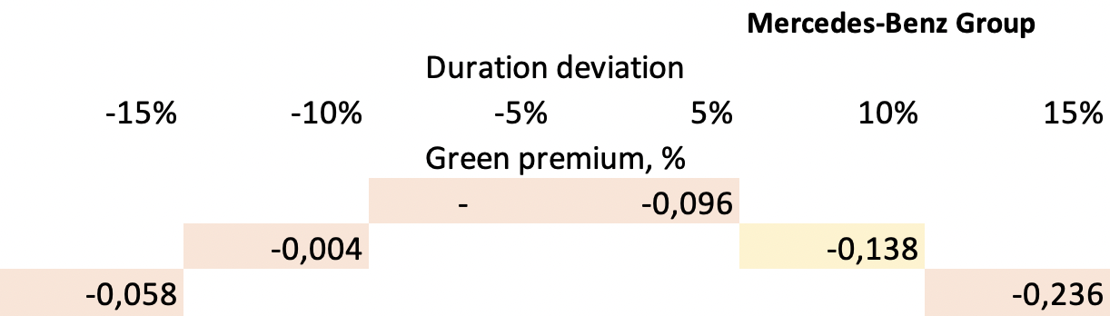

The green premium in the automotive industry in the example of Mercedes-Benz Group shows negative meaning.

3. Telecommunications industry
Table IV.6 Industrial green premium in telecommunications industry 2017-2022
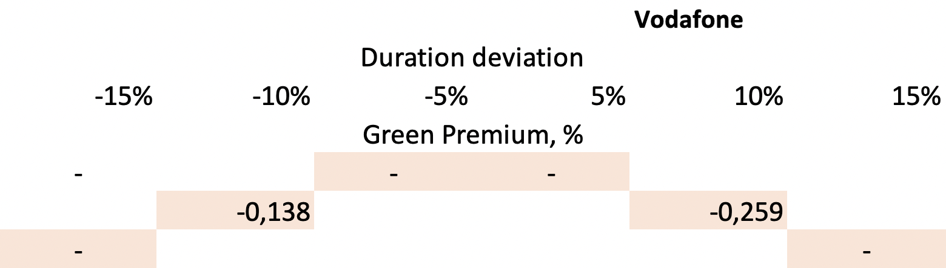

The green premium in the telecommunications industry shows, unfortunately, controversial results.

Step IV. Summary & managerial implication
At the current stage, the industrial comparison of green bonds is not possible to process due to objective reasons: the number of plain vanilla bonds and green bonds (paired one to another) is strictly limited, as the market seems to be undeveloped.
However, it is possible to say that the banking industry holds approximately 71% of the green bonds and 52% of the total plain vanilla bonds market. With all that, it was proven that the methodology of this Research is significant, hence, it is possible to highlight that the methodology of this Research might be used in practice in the future to calculate the green premium within different industries, — all that is needed is more green bonds in these different industries, as well as more issuers.

4.4. CONCLUSION - Empirical part of the Research
As a result, I found out that, as of now, in the major industry (banking), the green premium does exist, and the amount of the green premium shall be, approximately, 0.458% (simple average), or 0.4176% (weighed average).

However, as a result of data analysis, I shall say that currently in the market there is an objective impossibility to compare bonds in other industries, as there are no significant pairs. It happens, as these market participants are not active in fundraising green cash via green bonds.
Therefore, notwithstanding that it is possible to compare the bonds by industry theoretically, in practice, the current market does not allow to make a proper analysis of green premium in many industries, except for the banking industry solely.

With all that, notwithstanding that the H1 of this Research was rejected, I shall highlight that the market participant with A1-A3 credit ratings, anyway, shall orient themselves to the number 0.4176% - weighted average (or at least 0.4584 - simple average) to be a green premium, as it is in the banking industry. That is because the banking industry solely holds now over 70% of the green bonds in the corporate sector, as was shown by us above.

V. RESEARCH CONCLUSION
Notwithstanding that, in theory, and accordingly with other researchers, the green premium might be negative, I found no examples of statistically significant negative green premium within the banking industry. However, this Research provides no opposite evidence (negative green premiums do not exist), as finding the answer to this question was only a side opportunity for this Research.

Mainly, this Research was focused to find an answer to the question of the difference in the size of green premiums in different industries. Hypothesis 1 was not accepted, and not rejected, as (as the example of the banking industry revealed), the methodology of the Research is possible-to-live and can significantly explain the results of research. At the same time, the market suffers from the objective lack of data: the market has only 474 green bonds available to research, with over 22k of plain vanilla bonds. Thus, it was possible, accordingly to this methodology, to find 9 companies with pairs only.

However, as in this Research, I reached the goal of managerial implication - to create a methodology that would allow to access the size of green bonds premium in the future.
THE LIST OF REFERENCES
- 1991 - The United Nations World Commission on Environment and Development — University of Louisville. (1991). Our Common Future.
- United Nations. 2015. THE 17 GOALS | Sustainable Development. URL: https://sdgs.un.org/goals
- Climate Bond Initiative. 2019. ASEAN Green Financial Instruments Guide. URL: https://www.climatebonds.net/files/reports/asean_green_fin_istruments_cbi_012019_0.pdf
- Breakthrough Energy. 2020. The Green Premium. https://www.breakthroughenergy.org/our-challenge/the-green-premium-v1
- The Green Bond Principles. 2021. Green Bond Principles. Voluntary Process Guidelines for Issuing Green Bonds. URL: https://www.icmagroup.org/assets/documents/Sustainable-finance/2021-updates/Green-Bond-Principles-June-2021-140621.pdf
Adel, D. 2017. Sukuk bonds as an alternative source of funding: risks and implications. Graduate School of Management.
- Febi, Wulandari, Dorothea Schäfer, Andreas Stephan, and Chen Sun. 2018. The impact of liquidity risk on the yield spread of green bonds. Finance Research Letters 27: 53–59.
- Hachenberg, Britta, and Dirk Schiereck. 2018. Are green bonds priced differently from conventional bonds? Journal of Asset Management.
- Karpf, Andreas, and Antoine Mandel. 2018. The changing value of the ‘green’ label on the US municipal bond market. Nature Climate Change 8: 161–65.
- Bachelet, Maria Jua, Leonardo Becchetti, and Stefano Manfredonia. 2019. The green bonds premium puzzle: The role of issuer characteristics and third-party verification. Sustainability 11: 1098.
- Gianfrate, Gianfranco, and Mattia Peri. 2019. The green advantage: Exploring the convenience of issuing green bonds. Journal of Cleaner Production 219: 127–35.
- Nanayakkara, Madurika, and Sisira Colombage. 2019. Do investors in the green bond market pay a premium? Global evidence. Applied Economics 51: 4425–37.
- Zerbib, Olivier David. 2019. The effect of pro-environmental preferences on bond prices: Evidence from green bonds. Journal of Banking & Finance 98: 39–60.
- Hyun, Suk, Donghyun Park, and Shu Tian. 2020. The price of going green: The role of greenness in green bond markets. Accounting & Finance 60: 73–95.
- Gates, B. (2020, September 29). Introducing the Green Premiums. Gatesnotes.com. URL: https://www.gatesnotes.com/Energy/Introducing-the-Green-Premiums
- Kanamura, Takashi. 2020. Are green bonds environmentally friendly and good performing assets? Energy Economics 88: 104767.
- Larcker, David F., and Edward M. Watts. 2020. Where’s the greenium? Journal of Accounting and Economics 69: 101312.
- Partridge, Candace, and Francesca Romana Medda. 2020. The evolution of pricing performance of green municipal bonds. Journal of Sustainable Finance & Investment 10: 44–64.
- Tang, Dragon Yongjun, and Yupu Zhang. 2020. Do shareholders benefit from green bonds? Journal of Corporate Finance 61: 101427.
- Wang, Jiazhen, Xin Chen, Xiaoxia Li, Jing Yu, and Rui Zhong. 2020. The market reaction to green bond issuance: Evidence from China. Pacific-Basin Finance Journal 60: 101294.
- Immel, Moritz, Britta Hachenberg, Florian Kiesel, and Dirk Schiereck. 2021. Green bonds: Shades of green and brown. Journal of Asset Management 22: 96–109.
- Lizhenina, K. 2021. Analysis of green bond premium. Saint Petersburg State University.
- Dhir, Rajeev. 2021, May 30. Plain Vanilla. Investopedia. URL: https://www.investopedia.com/terms/p/plainvanilla.asp

