**MA thesis evaluation form**

**Title of thesis: US-China trade war from the perspective of Global Value Chains**

**Written by: Xuhui**

|  |  |  |  |  |  |  |
| --- | --- | --- | --- | --- | --- | --- |
|  |  | | Amount of points, grade | | | |
|  | **Merit scale** | **Points** | High | Moderate | Low | Poor |
|  | **Excellent (А)** | **7.1 – 8.0** |
|  | **Very good (В)** | **6.1 – 7.0** |
|  | **Good (С)** | **5.1 – 6.0** |
|  | **Satisfactory (D)** | **4.5 – 5.0** |
|  | **Poor (Е)** | **4.0 – 4.4** |
|  | **Failed (F)** | **<4.0** |
|  | **Results of plagiarism control, %** | **3,9** | **0.8-**  **1.0** | **0.5-**  **0.7** | **0,3-**  **0.4** | **0.0**  **0.2** |
|  | Relevance of the Paper to the Programme | | 1 |  |  |  |
|  | Importance of the Topic/issues addressed in the Thesis | | 1 |  |  |  |
|  | Originality and interpretive significance of the Thesis | | 1 |  |  |  |
|  | Conceptual Rigor  (Treatment of relevant literature, logical reasoning, etc.) | | 1 |  |  |  |
|  | Methodological Rigor  (Research design, sample, measures, and analysis) | | 0,9 |  |  |  |
|  | Clarity of the objectives | | 1 |  |  |  |
|  | Presentation/Implementation of research Goals | | 1 |  |  |  |
|  | Readability of the MA Thesis | | 1 |  |  |  |
|  | **Total** | | **7,9** | | | |

**Comments and Suggestions:**

According to my consideration the **master thesis of Xuhui is an excellent MA Thesis**. It is also worth to mention that due to my experience of supervising Chinese students **Xuhui herself is exceptional person.** During her study she has shown the best level of English compare to any of my former Chinese student, outstanding motivation and efforts to study Economics and maths (despite pure humanitarian background) and great capacity to do research.

**Conclusion.** The MA Thesis of Xuhui fits the requirements imposed to MA thesis and deserves “А” (excellent) grade.

Scientific Supervisor

Associate Professor Vadim I.Kapustkin 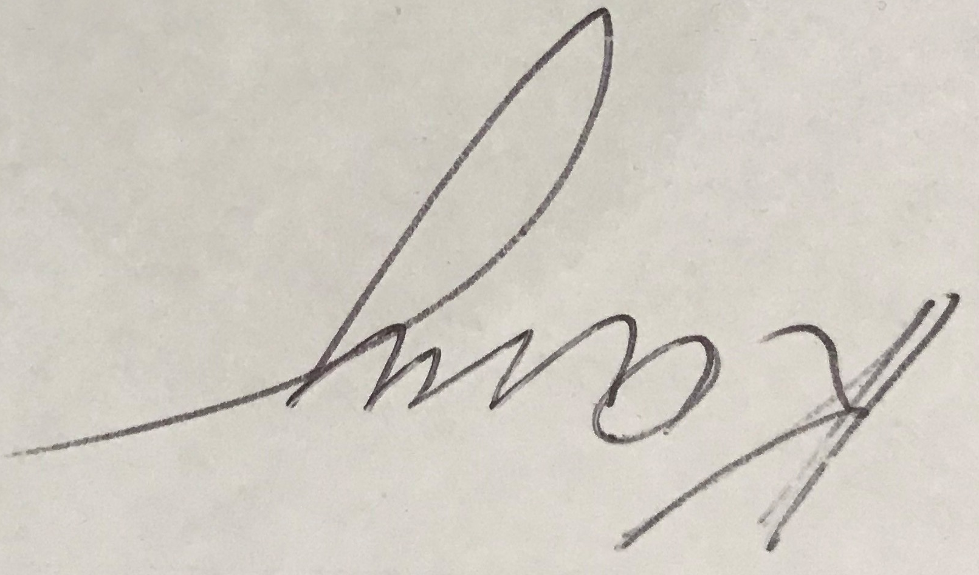

04.06.2020