Saint-Petersburg state university

Department of World Economics

RUSSIAN WOOD TRADING POLICY

Thesis submitted in partial fulfillment of the requirements

for the degree of

Master of Arts 38.04.01 “Economics”

(International Trading System MA program)

Scientific adviser:

Candidate of Economic Sciences

Trofimenko Olga Yurievna

Author:

Student of department of world economics

Matveev Andrey Valierivich

Saint-Petersburg

2020

CONTENT

Introduction…….………………………………………………………………………3

Chapter 1 International trading theory: Michel Porter’s Dimond Model……….……. 5

* 1. Michel Porter’s Dimond Model………...…………….…………………………...5
  2. Alternative views on Michael Porter’s Dimond Model….…………...………….12

Chapter 2 International market of wood-based products......……..…………………..17

2.1 Review of international market of forestry products…. .……..………………….17

2.2 Russia’s place in international forestry market………….…..…...………………22

2.3 International policies and agreements affecting global market of forestry products……………………………………………………………………………….28

Chapter 3 Domestic forestry industry of Russia and Finland ……...………………...34

3.1 Present situation of Russia’s domestic forestry industry ………..……………….34

3.2 Finland’s forestry industry……………………………..…………………………47

3.3 Dimond model of Russia’s forestry industry and policy recommendations.……..55

Conclusion…...…………………………………………………………...…………..62

Bibliography...……………………………………………………..…………………64

**Introduction**

Wood trading policy is a a complex of decisions and actions taken by certain institutions both national and international as well as different tools to achieve certain objectives that are based upon social, environmental and economic priorities of the state in the field of forestry trading sector. The importance of this topic is based upon four factors. The first factor is the national wood resources of Russia, which in this day is believed to be around 20% of the whole wood resources in the world. Since a single country holds 1/5th of all the forestry resources its trading policy of any product that is made from this resource will have a major impact on the international market. The second factor is the export quantity of wood-based products from Russia, which as of right now is the 3rd biggest. The third factor, which is no less important is who consumes the product that is made from this resource. The biggest consumers of lumber and plywood in the world right now is U.S., China and Egypt. Two of those countries are major world powers, which means that Russian wood trading policy will have an effect on the internal markets of those countries. The last major reason, which explains the importance of this subject is the underutilization of this resource by the Russian producers, which in term hurts the national economy.

The aim of this paper is to formulate possible policy suggestions on how to improve current export policy of wood-based products, as well as domestic forestry industry of Russia. As previously mentioned, Russian forestry industry is seriously underperforming especially on the international market. The main factor that effects the performance of export of a certain industry is the trading policy. Trading policy is in turn also affected by many factors and it’s important to understand which factors and how they effect the trading policy.

Objectives of this paper:

1. To look at different trading theories that could potentially help explain the present situation of Russian wood trading policy
2. Analyze the current wood industry of Russia
3. Find out the main trends of world’s trading forestry sector
4. Give policy suggestions for Russian forestry industry

The object of this study is Russian wood trading policy. The subject of this study is external and internal factors that have an effect on forestry industry of Russia as well as its trading policy.

In terms of theoretical basis for this paper Michel Porter’s Dimond Model was used. It helps to analyze the countries wood industry based on the competitive factors that were explained by Porter’s model, as well as taken into account the critique that this model received.

**Cheaper 1. International trading theory: Michel Porter’s Dimond Model**

**1.1 Michel Porter’s Dimond Model**

International trade has never before been such an important factor of growth for a country’s economy. Industrialization, advancements in technology, globalization, multinational corporations and outsourcing of production processes have all played a major part in progression of international trade. Without this system of sale and purchase of products from abroad a country would only be limited by its own production powers and it’s natural resources, for most countries it isn’t enough to survive on their own. International trade has begun in the oldest of civilizations but in recent years it has become a necessity of survival in the modern age. World bank datashows that exports of goods and services in terms of % of total GDP has grown from 13% in 1970 to 29% in 2017[1].

For Russian Federation trade has been a very significant part of its national economy. For example, Russian export of goods and services increased from 74.551$ billion in 1994 to 507.756$ billion in 2018 and before sanctions on Russia were introduced it exported more then 591.958$ billion worth of goods in 2013-2014[2]. On the other hand, Russia’s imports of goods and services have also increased from 63.537$ in 1994 to 343.266$ billion in 2018[3]. The biggest import partner of Russia is China, who’s products imported into Russia equaled to 21% from the overall value of imports. In terms of exports China again was the biggest trading partner of Russia, 11% of all exported products and services went there. It’s important to mention that 2.2% of all our exported products were lumber and wood manufactured products, about 50% of these products were exported to China.[4]

Since we have recognized the significance of international trade for countries, we have to look at international trading theories in order to better understand why exactly countries trade and how they do it. There are many international trade theories that have existed for centuries. One of the earlier theories was the mercantilism economic theory, which was dominant in Western Europe during 16th century to the late 18th century. Another theory was put forward by Adam Smith (1723-1790), who is widely recognized as one of the founding fathers of free trade. Mostly Adam Smith rejected the ideas of mercantilism since he argued that internal competition between companies is far more beneficial for the country then total state control. In his book “The cause of nation wealth”, where he first described his Absolute Advantage theory: “If a foreign country can supply us with a commodity cheaper than we ourselves can make it, better buy it of them with some part of the produce of our own industry employed in a way in which we have some advantage”[5]. In his theory Smith explains that a country should focus its production forces on a product, where its country has an absolute advantage, it’s cheaper to make then in the other countries. In the early 19th century David Ricardo came up with another theory called The Comparative Advantage Theory. His theory stated that a country has to produce products, which can be produced at a lower opportunity court than the others. Later on, Heckscher-Ohlin theory came along. This theory was very similar to David Ricardo’s theory except it divided countries not only be the labor as factor of production but also capital.

Unfortunately, all these theories can’t explain why forestry industry in Russia is underperforming. Russia has 20% of all wood resources in the world. In terms of production of wood-based products such as timber, plywood and engineering boards Russia is without question one of world leaders in this segment for export. Mostly the situation seems fine as the country with the most resources would be one of the biggest exporters of products made from these resources. This statement is true but only to a degree. Even though Russia is quite successful in selling lumber and plywood but isn’t very affective at selling more technologically consuming products such as parquet or furniture. Everyone has heard of Italian furniture as being one of the world leaders in the international marketplace and most people have never heard of Russian companies producing furniture. The theory that comes the closest to explaining this situation that is called Theory of National Advantage also known as Diamond Model, which was proposed by Michel Porter in 1990. This model was deducted by Michel Porter, when he conducted a four year study on ten most important trading countries at that time: Denmark, Germany, Italy, Japan, Korea, Singapore, Sweden, Switzerland, United Kingdom, and U.S. Together those countries accounted for 50% of the world’s export of goods and services in 1995, which was the base year of the study. The main aim of this study was to find out what exactly made certain industries in countries competitive. First the author identified all the industries, which were successful on international market. The research also took into account the process of formation of those industries and how exactly competitive advantage had formed over the years. In the second part of the study Porter forms a list of the most competitive industries in the countries that he had chosen, which usually made up more the 20% of exports for each country and analyzed those sectors in depth. The author decided to avoid looking at natural-resource-related industries since he believed that “such industries do not form the backbone of advanced economies”[6]. The sample of industries that were analyzed allowed the author to conclude, which factors made those spheres of economy so dominant on international markets.

The model, which was deducted by Porter after his analysis, focuses on explaining why certain industries within a particular nation are competitive internationally and others are not. Michel Porter argued that “Competitive advantage is created and sustained through highly localized process”[7], which could help to explain why Russia is not a leader in wood industry even though it has the most raw material but lacks technology advancements. One of the biggest problems for wood industry in Russia is that the lack of technological availability doesn’t allow for companies to produce and export more finished wood products. Every company and every industry are different but Porter states that “companies achieve competitive advantage through acts of innovation”[8]. Innovation doesn’t just come in the form of new technology but also includes different management techniques, new ways of outsourcing certain production processes and any kind of new way of doing things. Those innovations tend to be very small and incremental, depending more on a cumulation of small changes, which were made over a long period of time. The author was also able to deduct that if a producer tends to follow the needs of the domestic market then such policy would make him less competitive, but if the producer follows the needs of the international market then his business would become more successful: “For example, as international concern for product safety has grown, Swedish companies like Volvo, Atlas Copco, and AGA have succeeded by anticipating the market opportunity in this area. On the other hand, innovations that respond to concerns or circumstances that are peculiar to the home market can actually retard international competitive success. The lure of the huge U.S. defense market, for instance, has diverted the attention of U.S. materials and machine-tool companies from attractive, global commercial markets”[9]. From Michel Porter’s paper it can be seen that the main reason why companies fail to sustain their dominance is if they stop to innovate and upgrade: “Competitors will eventually and inevitably over- take any company that stops improving and innovating. Sometimes early-mover advantages such as customer relationships, scale economies in existing technologies, or the loyalty of distribution channels are enough to permit a stagnant company to retain its entrenched position for years or even decades. But sooner or later, more dynamic rivals will find a way to innovate around these advantages or create a better or cheaper way of doing things. Italian appliance producers, which competed successfully on the basis of cost in selling midsize and compact appliances through large retail chains, rested too long on this initial advantage. By developing more differentiated products and creating strong brand franchises, German competitors have begun to gain ground”[10]. The nation or an industry is considered competitive if it can be considered productive. Abundance of natural resources, like Russia has, doesn’t make the country most competitive or it’s industry the most successful one, for example the wood industry in Russia can’t be really be called competitive. Cheap labour that exists in countries such as Uganda doesn’t make a country a global exporter. Author argues that “the only meaningful concept of competitiveness at the national level is productivity”[11]. Productivity itself depends on the final value of the product produced by a unit of labour or capital. Productivity depends on both the quality and features of products and the efficiency with which they are produced.

Michel Porter argues that domestic companies are forced to continuously innovate and upgrade only if certain conditions are met. These factors include: firm strategy, structure and rivalry, factor conditions, demand conditions and related and supporting industries. If these conditions are favorable in the certain industry, then it’s products should be competitive on international markets.

The first component of Porter’s diamond Model is “firm strategy, structure and rivalry”. In the domestic market in which national companies are created, organized and managed determines their level competitiveness when they enter international markets. The grater the competition on domestic market the better are companies prepared for competition from else where and they can quicker adapt to external forces and marketplace. A good example is such strong domestic competition is an automobile industry in Germany, where major players such as Mercedes, BMW and Volkswagen have to compete against each other on domestic market. Such an example of strong domestic competition shows that all of these companies have no problem being just as dominant internationally. Another example of strong internal competition but in Russia can be seen in the oil sector. The three biggest oil companies of Russia are Rosneft, Lukoil and Gazprom Neft. They all struggle to “fight” each other in the internal market but abroad they have far less competition. Of course, it could be argued that Russian crude oil resources far exceed most of the other countries in the world and that’s why those companies stay competitive on international level. Hackerscher-Ohlin Theory backs up this argument since it states that a country will be competitive if it exports the resource that it has the most of. It’s hard to argue with this statement but on the other hand it’s impossible to deny the fact that internal competition makes those companies even more competitive they they would be if no internal competition took place. What Heckerscher-Ohlin theory doesn’t take into account though is that even if a country does export the resource that is dominant in the country then it doesn’t necessarily mean that this product will stay competitive on international markets. Russia has 20% of all the world’s wood resources but their products that are made from wood don’t do so well when faced with foreign competition. Nations succeed in industries where they are particularly good at factor creation. Competitive advantage results from the presence of world-class institutions that first create specialized factors and then continually work to upgrade them. Denmark has two hospitals that concentrate in studying and treating diabetes and a world-leading export position in insulin. Holland has premier research institutes in the cultivation, packaging, and shipping of flowers, where it is the world's export leader.

The second element of Michel Porter’s model is “factor conditions”, which refers to the available resources of the country whether they are natural, like oil and gas, or are created such as infrastructure and know-how. Porter argues that in order for a company or an industry to stay competitive it has to continuously invest and upgrade their created factor conditions, on the other hand natural factor conditions are not as important. It could also be argued that the importance of natural factor conditions compared to importance of created factor conditions is dependent on the industry. As an example, Russian oil sector can be used again in order to show that the availability of resources really does make a difference for the industry. On the other hand, you have industries such pharmaceutical products and one the leaders in this industry is Switzerland, which has nearly no available natural resources at all. Though out the years Switzerland has constantly upgraded and invested in their created factor conditions, which kept them at the very top.

The third factor of diamond of national advantage is “related and supporting industries”. Michel Porter stresses the fact that the presence or the absence of related industries or the suppliers for that industry that are also competitive at international level is a very important comparative advantage. For example, if the Russian industry of wood related machinery would be successful then that would be a huge advantage point for the whole wood industry of Russia and would substantially improve the export situation. The author points out that the easy access to technology is not the most important factor here: “Far more significant than mere access to components and machinery, however, is the advantage that home-based related and supporting industries provide in innovation and upgrading - an advantage based on close working relationships. Suppliers and end-users located near each other can take advantage of short lines of communication, quick and constant flow of information, and an ongoing exchange of ideas and innovations. Companies have the opportunity to influence their suppliers ‘technical efforts and can serve as test sites for R&D work, accelerating the pace of innovation”[12]. Home based national competitors can also have a positive effect on innovation for those domestic companies. Having competition will force companies to innovate and to learn and evolve new skills in order to survive just domestically.

The fourth and the final factor of the base diamond model is “demand conditions”, which essentially the situation of the domestic market for that industry. The nature of the buyers in the domestic market can also be an advantage if they are sophisticated and demanding buyers for the product or service. Sophisticated, demanding buyers provide a window into advanced customer needs; they pressure companies to meet high standards; they prod them to improve, to innovate, and to upgrade into more advanced segments. As with factor conditions, demand conditions provide advantages by forcing companies to respond to tough challenges. He shifts in needs of the domestic buyers can also be a good indicator of the shift in the international market. This means that the industry can react earlier than most of its competitors and gain a competitive advantage in the future. Michel Porter gives an example of such case: “For example, Japanese consumers, who live in small, tightly packed homes, must contend with hot, humid summers and high - cost electrical energy - a daunting combination of circumstances. In response, Japanese companies have pioneered compact, quiet air-conditioning units powered by energy-saving rotary compressors. In industry after industry, the tightly constrained requirements of the Japanese market have forced companies to innovate, yielding products that are kei-haku-tan - sho - light, thin, short, small - and that are internationally accepted”[13].

The author states that all of those four factors constitute a different edge of the doomed model. All of those factors are dependent on each other, if one of those elements of competitive advantage is not up to a certain standard then the other ones will not able to to be reinforced into an advantage. Sophisticated buyers will not have an effect on the company’s product if the internal competition is nearly nonexistent. There is no point for the producer to innovate or to adapt to the users demands if he doesn’t face an internal competition. Another effect of the diamond's systemic nature is that nations are rarely home to just one competitive industry but rather, the diamond creates an environment that promotes blocks of competitive industries. Competitive industries are not scattered throughout the economy but are usually linked together through vertical or horizontal relationships.

Government regulation also has a roll in the competitiveness of nations. Some argued that government should be able to intervene at any moment in order to steer the industry at the right direction. But still many believe that a free market economy without any help of the government is the only possible way for nations to become competitive in the international market. Porter believes that both of those statements are wrong: “On one hand, advocates of government help for industry frequently propose policies that would actually hurt companies in the long run and only create the demand for more helping. On the other hand, advocates of a diminished government presence ignore the legitimate role that government plays in shaping the context and institutional structure surrounding companies and in creating an environment that stimulates companies to gain competitive advantage”[14]. The government plays a role of a catalyst instead of an enforcer. It can not creat competitive industries or force company’s into being more innovative or more successful. The main role of the government is to provide the framework, where it is possible for certain industries in the country to flourish but only if they themselves make an effort to do so. Creating infrastructure and the proper law base, protection of intellectual property and running an anti-monopoly police are all of the things that a government can do in order to promote competition and drive companies to want to get better.

The role of chance is also often included in Michel Porter’s model even though he didn’t include it himself. So called “chance” is often described as events that can’t be predicted by any government or company. These occurrences can have both a positive or a negative impact on the industry. A good example of this is the unfortunate COVID-19 pandemic that has had a devastating effect on the airline industry but has been quite beneficial for console gaming companies all around the world.

Overall Michel Porter’s Dimond model of competition is a set of four factors, which if implemented, will force companies to innovate and become more competitive on international markets. The author sees this model as a system since he believes that all of those factors are connected to each other. If one is not up to a certain standard, then it will negatively affect the other ones. Government also has a role to play in this model. Complete government control or total free market economy is not the way to go. Government should be the catalyst of competition and should only address those areas, which would provide the proper framework for a healthy competition. The only true measure of competitiveness of the industry is its level of productivity and the only way to create a more productive industry is for that industry to continuously innovate.

* 1. **Alternative views on Michel Porter’s Dimond Model**

Michel Porter’s Dimond Framework has been intensely discussed by representatives of both economic school and the school of management. The main point of discussion has been how Porter identifies competition. A.J. Smith, who is an Associate Professor at University of South Africa in 2010 wrote a paper regarding his thoughts of Porter’s Dimond Model. In this paper Smith tries to show how the Dimond Framework is not a new theory that explains the international competitiveness of countries. The author looks at all the four different underlying conditions for the competitive advantage of the nation according to Porter’s model.

The first element of this model is “Factor Conditions”. Smith shows the difference between how traditional trade theories define factor conditions and how Porter defines factor conditions. In tradition trade theories factor conditions are consist of land, labour and capital. Porter on the other hand considers factor conditions to be human resources, physical resources, knowledge resources, capital resources and infrastructure. Even though Porter uses a logically based reasoning to identify these factors and not a mathematical model, this doesn’t invalidate the standard theory of comparative advantage.

The second element that the author talks about is the Demand condition. He argues that Porter wasn’t the first to use demand as a factor of trade. In 1961 Linder first introduced it explain domestic trade: “According to the Linder hypothesis, countries with similar per capita incomes will have similar spending patterns. In terms of the Linder hypothesis, these comparable demand conditions in countries lead to analogous demand structures, which enhance intra- industry trade”[15].

The third element of national competitive advantage is a firm strategy, structure and rivalry. The main emphasis here is that the strategies and structures of firms depend heavily on the national environment and that there are systematic differences in the business sectors in different countries that determine the way in which firms compete in each country and ultimately their competitive advantage. From the Smith’s point of view Porter identifies competitiveness of countries to be interconnected to competitiveness of individual firms in the country and thus that the international trade engagement of countries is a negative sum game, as it is in the case of firms. His general understanding is that “trade is a positive sum game irrespective of the nature of the sources from which such gains from trade are derived”[16].

The forth element of Porter’s model is concerned around related and supported industries, which is the eyes of Smith could be explained in two ways: “on the one hand, scholars see it as homogenization of economies, and on the other hand as specialization of economies as explained by the standard economic theory. In the former case, it is believed that almost anything could be moved or sourced around the globe. In the latter case, it is believed to result in an intense specialization and clustering of competitive advantages in different locations as the world becomes increasingly integrated”[17].

Smith criticizes double diamond concept of Porter for the fact that it sees no difference between the Dimond model of domestic trade and the Dimond model of International trade, that’s why he presents just one Dimond model in his research. Another point of criticize that the author speaks about is that Porter looks at companies and at industries as the same. If a country is competitive then the firm will also be competitive. This concept some how brings the idea that countries have to compete against each other. Specifically, Smith’s criticism of Porter’s theory comes down to the fact that in his opinion Porter’s analysis is insufficient: “there is no core theory, it has no ex ante prediction power, and it is a typical partial equilibrium analysis that leads to a misinterpretation of the traditional and new trade theories. Furthermore, the relationships between national welfare, productivity, trade, exports and competitiveness are misunderstood and wrongly interpreted. Lastly, whereas the traditional and new trade theories explain trade, they do not explain the factors that determine the international competitiveness of a country’s firms, which is what Porter attempts to explain in his Diamond Model”[18]. In conclusion Smith says that Porter’s thesis does not hold up as its own new theory and can not replace theory of comparative advantage. At most Dimond Model can be used as a set of guidelines for managers to identify potentially areas of competitive advantages. Therefore, it cannot be used as a system to devise trade policy of the country.

Another critique of Michale Porter’s model came from McKelvey. He claimed that Porter overestimates the importance of domestic markets for international competitiveness. In his mind domestic competition has very little if at all to do anything with international trade. “MNE’s are actors in many markets and Porter’s four conditions exist in all these markets/countries; therefore, these companies’ capacity to innovate may be used on national systems of innovation in many countries and not just one”[19].

Stewart J.M. in his paper “Canada at the сrossroads dialogue” critiques Porter’s model as being way too restrictive. In his opinion there is no world demand or competition in the model. He notes that in some way Porter is right. If all the factors of competition in the economy that Porter mentions are well developed, then the country will be very competitive. What he argues is that these circumstances are practically unrealistic and can only happen in a very well-developed economy. This means that Porter’s model can not explain why certain industries in most countries are competitive on international level.

Danish economist Dalum Bent also argues against the idea that national clusters, which are a part of supported and domestic industries of Michel Porter’s model. He argues that it’s up to debate whether internal clusters would either help or compromise industries in terms of international trade. Dalum points out that Porter didn’t do an extensive research in order to prove his theory that domestic and supportive industries would have a positive effect on international trade of the country[20].

Overall, it seems that most economists and critiques of Porter’s model do believe that it could be used to explain a competitive nature of some industries. On the other hand, there hasn’t been much support of scientific literature that would agree with the fact that the same factors apply to countries in general. The second most important point of downfall of Dimond model is that the research is not sufficient enough to back up some of Porter’s claims. He used more of the logical approach to his model rather than a mathematical one, which means that he particularly has no data to back up some of his claims. Porter tried to use a simple model to try to explain both domestic factors of competition as well as international ones, which in opinion of some economists doesn’t grasp the full complexity of international trade.

The main aim of this paper is to analyze Russia’s forestry industry and it’s trading policy in this sector. Having looked at all aspects of the Dimond Model in depth it will be chosen as the main tool to analyze Russia’s forestry industry. Having said that, it is necessary to understand that this particular model will be adopted in a way as it was build more for sectors that are not so reliant on the natural resources of the country. Michel Porter stated that natural resources of the country are don’t play a very important role when it comes to the competitiveness of the industry. This statement is true but forestry industry in particular is very reliant on those natural resources. In the case of Russian forestry industry it will be important to consider not only the quantity of natural resources but also their accessibility and their quality.

**Chapter 2. International market of wood-based products**

**2.1 Review of international market of forestry products**

Before Russia’s domestic forestry industry will be analyzed it is important to look at the market as a whole on international level. Russian forestry industry is very export orientated, that means that production and consumption in the foreign markets plays a significant part when it comes to shaping Russia’s export policy.

First, we will be looking at round wood market and how it has evolved in past couple of years. This market is especially vital for Russia as most of exports of wood products are sawn wood. The global trade of softwood logs increased in 2018 and 2019 to reach its second-highest level in ten years. An estimated 84 million m3 of softwood logs were traded internationally in 2019, of which the UNECE region exported 75%. The UNECE region has long been a net exporter of both softwood and hardwood logs. In 2017, net log exports in the region reached 29.5 million m3, up from 25.2 million m3 in 2016. The major changes in trade in 2016-2017 were increased softwood log shipments from North America to Asia and a decrease in European hardwood log imports from the Russian Federation[21]. The major global trade flows of industrial roundwood are from New Zealand, the Russian Federation and the US to China. Most of these increased in 2017-2019[22]. In Europe, the major softwood log trade has been from the Czech Republic to Austria and Germany and from Norway to Sweden. The global trade of softwood logs rose for the second consecutive year in 2019, with Europe accounting for approximately 34% of total imports. Year-on-year changes differed for the world’s top six importing countries, with China, Germany, Austria and Sweden increasing log imports in 2019 compared with 2018, and Japan and the Republic of Korea decreasing their log imports. The softwood log trade has been on an upward trajectory for the last ten years, with lumber production increasing worldwide. Shipments have increased by 36% worldwide and by 29% in Europe since a 20-year low in the global log trade in 2009. The outlook is for continued expansion in lumber demand in the next few years, and the log trade is therefore likely to continue its upward trend.

There were several changes in the world’s top five softwood log importers between 2009 and 2019 (Fig. 1 and Fig. 2).

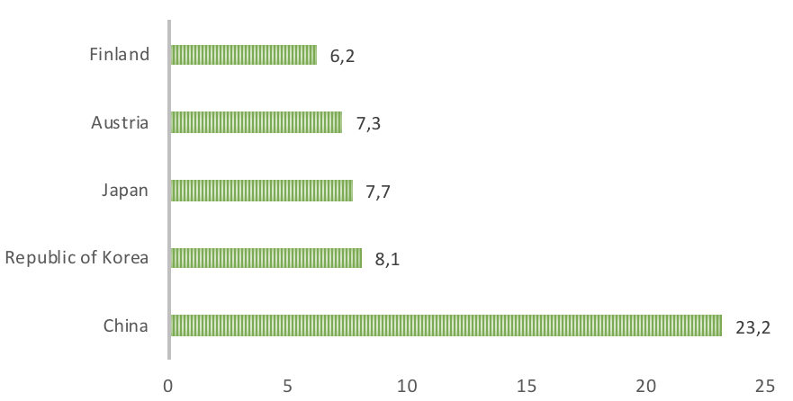

Fig. 1. Top 5 softwood log importers in 2009, million m3

Source of data: www.fao.org

As seen on Fig. 1 the largest importer of softwood logs was China in 2009. What is interesting is that Finland was the 5th largest importer of softwood logs but is one of the largest exporters of finished wood-based products right now.

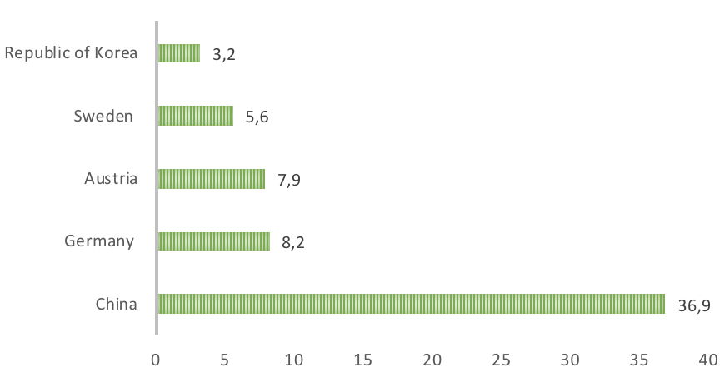

Fig. 2. Top 5 softwood log importers in 2019, million m3

Source of data: www.fao.org

China’s share of total worldwide imports increased from 23% to 37% over the period. Germany ascended to second position, with its share of global import volumes doubling. Japan, previously the third-largest importer of softwood logs, fell out of the top five as the country increased its use of domestic forest resources, and Finland also exited the list. Sweden entered the top five in fourth place, above the Republic of Korea, the softwood log imports of which declined by more than 50% over the period.

In terms of exports of round wood, The Russian Federation is the world’s second-largest exporter of softwood logs after New Zealand and the largest exporter of hardwood logs. Russian hardwood log exports trended upward in the eight years to 2019, to 7.5 million m3, with more than 90% going to Finland and China. The Russian Federation’s hardwood log export volume in 2019 was more than twice the volume in 2008, which was an all-time low. Almost 85% of the export volume in 2019 went to China. Although the Chinese forest industry has a history of importing logs for its raw material needs due to a lack of domestic sources, the trend in the last three years has been towards the import of softwood lumber rather than logs. Chinese importers have gradually shifted their historical preference for logs away from the Russian Federation towards New Zealand[23].

The price up shift also caused an increase export of this product. Sawlog prices rose in many countries in 2019 due to strong demand for softwood lumber in key world markets, including China, Europe and the US, rising lumber prices, and a growing international log trade. The Global Sawlog Price Index, a volume-weighted price index comprising average prices for coniferous sawlogs in 20 of the world’s largest sawlog-consuming regions, jumped by 15% between the first quarter of 2018 and the first quarter of 2019[24].

Another important industry to look at is hardwood manufacturing as there has been new applications of this material in recent years. Hardwoods were once commonly used in construction but have long been supplanted by softwoods. Many hardwoods have superior strength-to-volume ratios compared with softwoods, and their use in products such as structural beams, cross-laminated timber and glue-laminated timber is being investigated. In addition to product advances, innovations in processes are improving the efficiency of sawmills. One of the most promising of these is the use of computed tomography scanning to map and measure internal log defects. This technology allows mills to optimize grade yields and even to determine optimal log uses.

Global demand for hardwood remained strong in 2019, enabling sawn hardwood producers to ship record volumes to markets outside the UNECE region, mainly China. Sawn hardwood exports in the UNECE region reached an all-time high in 2019, increasing by 9.6% to 13.7 million m3. Strong demand for sawn hardwood enabled producers to maintain production. Global demand for hardwood logs was even stronger, with prices up significantly in 2017[25]. European and North American producers are increasingly concerned about a shortage of raw materials caused by increasing Chinese demand for hardwood logs. Outside the UNECE region, the Asia-Pacific region continued to dominate trade in tropical sawn hardwood in 2019, with China the major global importer and Thailand and Malaysia the biggest exporters. Furniture consumption – another important source of demand for sawn hardwoods – grew by 2% in the main markets of France, Germany, Poland, Spain and the UK in 2019[26]. Europe continued to lose market share to Asia in both production and consumption. The value of furniture production nearly doubled in Asia and the Pacific between 2008 and 2017, from $122 billion to $239 billion. In general, parquet consumption continues to grow in the EU, benefiting from an encouraging economic environment and positive trends in the construction sector. Nevertheless, Germany – the biggest European market for parquet – reported a significant decline in parquet demand. Consumption in the European Federation of the Parquet Industry area was up by 0.3% in 2017, at about 79.2 million m2. Germany’s market share was 21.2%, followed by France 10.7% and Sweden 10.0%. Europe’s total imports of sawn hardwood increased by 0.1% in 2018, to 4.92 million m3, and their dollar value increased by 1.6%, to $3 billion. Sawn hardwood consumption in North America decreased by 13,1% in 2018. Sawn hardwood imports fell by 12.1%. In 2017 Canadian sawn hardwood consumption declined by 14.1% and in the US by 2.8%. Outside the UNECE region, Asia and the Pacific continues to dominate the trade in tropical sawn hardwood, with China the largest importer globally and Thailand and Malaysia the major exporters. About 55% of China’s sawn hardwood imports are from tropical countries. Its tropical sawn hardwood imports grew by 29% in 2018 and by 1.5% in 2017. Growth in Chinese demand for tropical sawn wood is in response to a decline in the availability of tropical logs and rising manufacturing costs in China, which have made tropical produced sawn wood. Nevertheless, China’s sawn hardwood import volume declined overall by 14% in 2019 due to a significant drop in imports of birch from the Russian Federation[27].

The future of forestry sector in the global market can already be seen as a positive image despite the fact that the last decade has been characterized by crises in the global economy and a decline in a number of industries. The basis for this is an increase in the share of new products, and a change in the centers of production and consumption. The growth driver of the world timber industry complex will be the growth of the world population and an increase in the level of wealth in developing countries. Since the occurrence of these trends, we can expect a further increase in the value of various types of wood waste as a source of raw materials for the production of other types of products, which will be a natural factor in increasing the efficiency of advanced forestry enterprises. The wood waste market will grow and segmented, and the cost of wood waste will increase as demand increases. To accommodate such demand there would have to be substantial technological progress form the biggest exporters such as Russia.

As to the global present trends of the market of wood products where the top 20 lumber-consumer consuming countries in the world increased the importation of wood products by 10% from 2014 to 2018 resulting in global trade reaching its heights level in 10 years[28]. The U.S. imported 10% more lumber then in the previous few years as well as some of the consumers in European Union have also increased their consumption. On the other hand, we can see a decrease of importation of lumber in the Middle East and North Africa[29]. In general, we can see a drastic price drop all across the biggest producers. Lumber prices in Sweden have fallen 30% from their five year high in Match 2014. Norway lumber prices have also crushed by 20% in the past few years. All of this means that even tough we see an increase in consumption of wood products all across the world, expect for Asia and Middle East, the prices on international arena might not grow as much as the demand will. This is explained by the fact since domestic prices of Russia, Sweden and Norway have fallen, and their producers will be looking to sell their product in European and U.S. markets. Russia has also increased its production of raw based wood products, which means that the competition in these markets will become tougher for the lower end products such as plywood and soft wood. As for the key trends in the sector of end use wood products such as parquet the demand will be increasing as well. Countries such as Norway, Sweden and Canada are prepared for these changes as the have been heavily invested in the technological progress of such a hard-produced product. What will come from this is that Russia is most likely to lose it’s already unstable and weak position in this sector unless its own domestic 2030 strategy will show a considerable progress in the upcoming years, which seems unlikely.

As for the movement of prices of lumber in general they can be identified by selecting the most important exporting and importing markets. In U.S. prices of lumber have been decreasing for the past four years due to difficulties in housing market. Historically Canadian lumber accounted for the 93-96% of all the imported lumber in U.S. However, non-Canadian imports have been increasing for past six consecutive years mainly to trade disagreements between US and Canada. Softwood lumber exports from Canada overall went down by 6% in 2019[30]. This is due mainly to decrease in exports to US. Canada subsidized by concentrating more on Chinese market. Swedish export market situation has always been quite stable, which can’t be said about the domestic prices which crushed in the past couple of years. Despite much uncertainty in the near future for the Chinese economy, lumber imports rose in the first quarter of 2019 by as much as 14%, as compared to the same quarter in 2018. Most of the increase was due to increases in shipments from Russia and Canada, while imports of lumber from Europe and Latin America declined.

**2.2 Russia’s place in international forestry market**

It was previously mentioned that Russia’s forestry sector is very export oriented. That’s why it’s export structure of wood-based products is very important when it comes to analyzing Russia’s forestry sector as a whole.

Russia’s exports of wood-based products equaled to 10,412 billion USD in 2019. For the past 5 years Russia’s exports in terms of value are steadily growing, with an exception of 2019, when they dropped by 9% (Fig. 3).

Fig. 3. Russian exports of forest products in 2015-2019, billion US

Source of data: Russia’s Federal Customs Service

From this graph we can see that Russia’s exports were steadily increasing through out the years, with an exception of last year, where we can see a drop in exports. This would suggest that Russia’s forestry in have been on a positive trend and has been performing well for the past 5 years. Unfortunately, this figures don’t have much meaning if we don’t look at the structure of those exports. What this means is that the overall value of exports are not as important as the structure by product categories of total exports.

In general wood-based products are divided into in 4 different categories depending on how close the product is to being considered a finished product. Those categories are (Table 1):

|  |  |  |  |
| --- | --- | --- | --- |
| 1. **Raw wood products** | 1. **Basic semi-finished products** | 1. **Primary processing** | 1. **Further processing/**   **Finished products** |
| Saw logs | Chopped wood | MDF | Flooring/Parquet |
| Veneer logs | Viscose fibers | OSB | Furniture |
| Construction timber | Lamel | Plywood | Paper |
| Forest residue | Wood pulp | Wood coal | Biofuel |
| Firewood | Sawn timber |  |  |

Table 1. Wood-based products by categories

Source of data: Author

Products that are in “raw wood products” (1) category and those that are in “basic semi-finished product” (2) category tend to be in high demand, since they are used as basic materials to make products that are in categories (3) and (4). Those products are also much easier to make and don’t require a vast amount of investments to start an operation to produce them. The downside of course is that producers of products that are in category (1) or (2) tend to lose out on a lot of profit, as their product never reaches the end consumer.

Overall, exports of Russian wood-based products can be divided into 8 main categories that range from raw wood products to finished products (Fig. 4.):

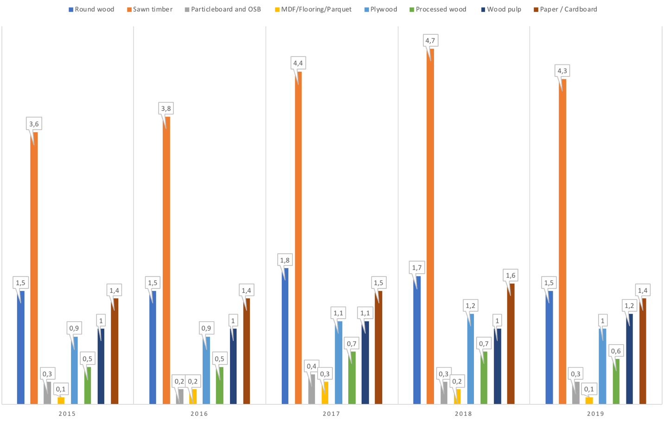

Fig. 4. Russian exports of forest products in 2015-2019 by categories, billion USD

Source of data: Russia’s Federal Customs Service

Out of all of those 8 woods products categories 3 of them will be looked at in this paper. The first one round wood and sawn timber as they are the biggest categories of export for Russian producers. The second one is Russian plywood industry, which one of the most thriving industries of wood products in Russia. The third one will be chemical wood pulp as being of the highest value-added products in the wood products market, and as being if the most valuable sectors in this industry.

From Fig. 4 it can be seen that Russia’s biggest exported forest product is sawn timber and in second place comes roundwood. Both sawn timber round wood can be considered raw wood products, in some cases sawn timber is considered to be as a semi-finished product but it is still essentially a wood log that has been cut into different shapes and sizes. It is important to note that in most countries export of round wood is illegal. By selling pure raw materials Russia loses potential gains.

Right now, Russia is the second biggest exporter in terms of global market share of sawn wood. Even though the demand for this product is projected to increase especially from China, Russia and other countries might struggle to meet the demand. Domestic consumption is also expected to increase, which would increase the prices and will give producers a higher profit margin. Unfortunately, Russia’s strategy 2030 is going to be trying too meet that demand instead of trying to focus its forestry resources on other more profitable wood products that come with much higher profit margins. Right now, Russia exports most of its sawn timber to China, which is more than 50% of all the total exports of Russian sawn timber (Fig. 5).

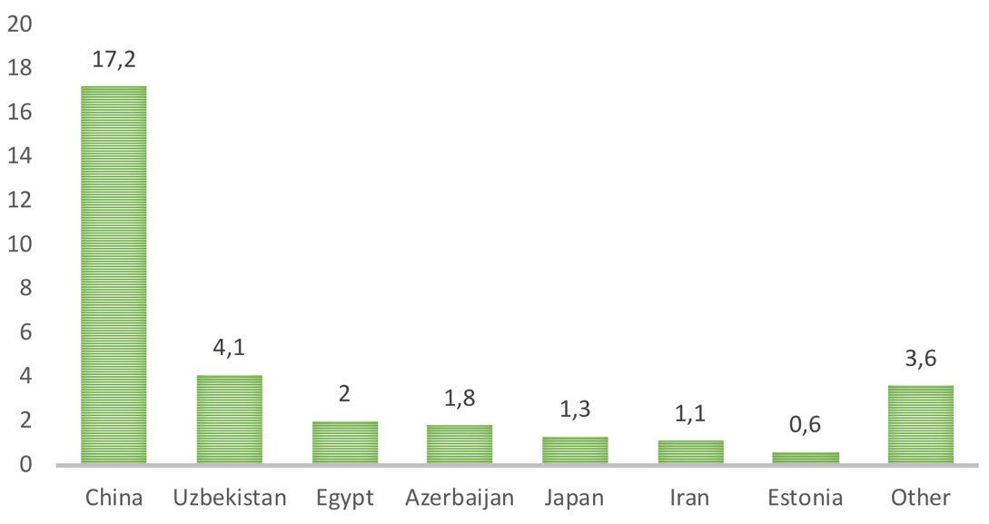

Fig. 5. Russian sawn timber exports by country in 2019, million m3

Source of data: www.fao.org

On the other side of the spectrum of Russian industry of forestry products is the wood pulp industry, which is a highly value-added product. However, it’s production in Russia is nearly non-existent. Thus, Russia’s share of the market of value-added, higher priced chemical pulp is small. Heavy investments are needed, along with extensive government support, to modernize domestic pulp plants. This industry has been static in Russia for the past 10 years, only increasing by 11 % in the past decade[31]. Once again China is biggest importer of Russia’s chemical / wood pulp, followed by South Korea and Japan (Fig. 6).

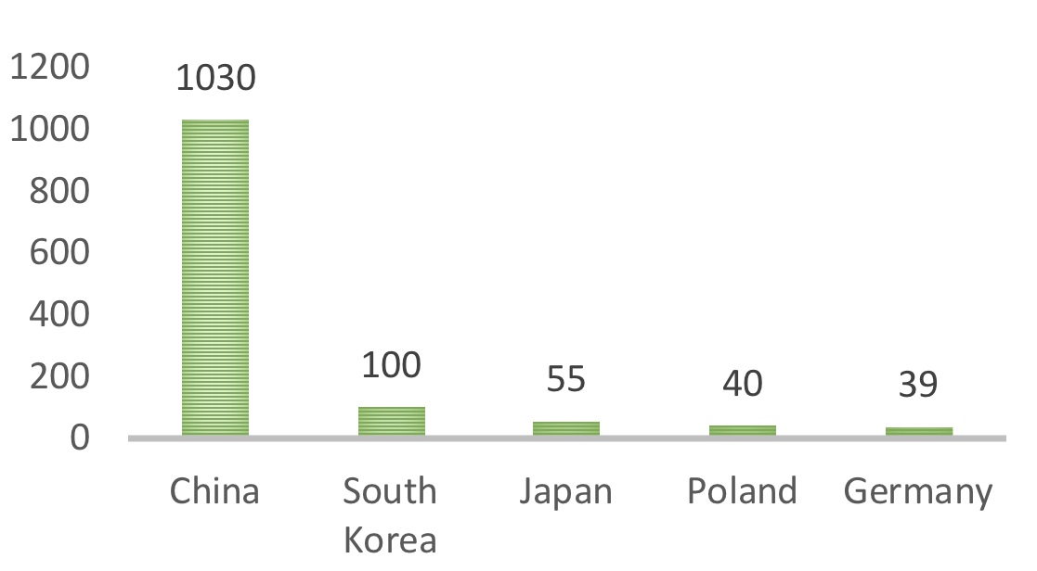

Fig. 6. Russia’s exports of chemical pulp in 2019, million USD

Source of data: www.fao.org

In this industry China is again number one trade partner for Russia. It would seem that the Asian market is an important asset. Russia is among the top ten pulp producers globally. Pulp production in Russia is dominated by unbleached pulp, which is in lower demand in the global market compared with other more value-added products.

One of the most thriving industries of Russian wood product manufacturing is plywood industry. Owing to its geographical location and an abundance of birch veneer, Russia is the leading producer and exporter of birch plywood globally, ranking among the top three exporters of plywood. Birch plywood has unique properties and is highly valued compared with other types of plywood. In this sense Russia is ahead of the market, where domestic producers are able to meet the quality requirements that are necessary and also meet the global demand. Plywood is used for building construction, furniture manufacturing and parquet production. Global demand for plywood totaled 160 million cubic meters in 2019, with its global exports rising by 6.7% year-on-year in monetary terms. Russia’s exports of plywood rose by 8.6% in physical terms as Russia accounted for 9% of global plywood exports, supplying more than 60% of domestic output abroad. European, East Asian and U.S. markets are top destinations for Russian plywood exporters (Fig. 7).

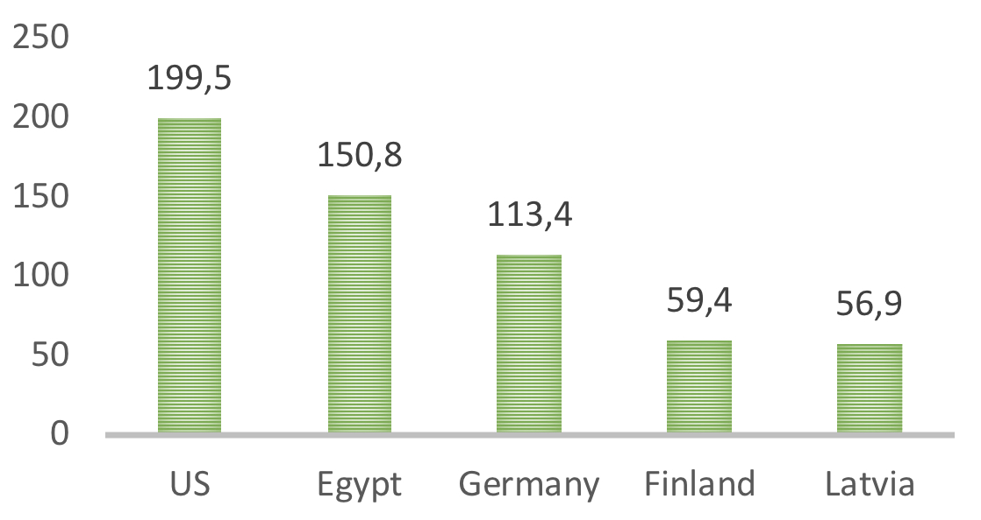

Fig. 7. Russia’s exports of plywood in 2019, million USD

Source of data: www.fao.org

The weakening of the Russian ruble in the last couple of years has driven Russian plywood exports, with the industry seeing increased investment inflows and the emergence of new players.

Overall, when we look at the general strategies of the firms that exist in the forestry sector of Russia, we can see that most of them choose to concentrate on raw wood products and semi-finished products with the exception of plywood industry. The main difference between those industries is that plywood manufacturers are heavily subsidized by foreign inflow of capital. Main Russian competitors, for example Finland, choose to concentrate on the production of finished products. Finland mostly export cardboard and paper, and also of the main leaders in the production of biofuels.

**2.3. International policies and agreements affecting global market of forestry products**

What is important to understand is that international market exists in the framework that is shaped by international organizations and agreements. New data is beginning to illustrate the impacts of regulations on the trade of tropical timber, and forest certification programmes continue to show only rapid growth globally. Diverse actions by governmental organizations and the private sector continue to emerge in response to the uncertain policy and economic climate.

The most important and influential organization that has an immense effect on a trading activity in the world economy today is the World Trade Organization. WTO can be viewed in many different ways. Some might characterize it as a system of rules, which exists in order to promote free trade worldwide. Others might argue that WTO is an organization for settling trading disputes between countries as well as keeping all of its members in check. As stated on World Trade Organization official website: “Essentially, the WTO is a place where member governments try to sort out the trade problems they face with each other”[32]

The history of WTO and how it came to be is also best described on it’s official website: “The WTO was born out of negotiations, and everything the WTO does is the result of negotiations. The bulk of the WTO’s current work comes from the 1986–1994 negotiations called the Uruguay Round and earlier negotiations under the General Agreement on Tariffs and Trade (GATT). The WTO is currently the host to new negotiations, under the “Doha Development Agenda” launched in 2001”[33]. WTO is not only an organization that helps to promote international free trade, it also focuses on protecting consumers from trade barriers and external factors such as diseases. There are numerous documents and agreements which shape the overall policy of WTO. Though out all of those documents key principles can be seen in all of them:

1. Non-discrimination: a country is not allowed to discriminate any of their trading partner, between their domestic and imported products or services.
2. More open: the aim for each and every member is to insure a more open and free trade by demolishing existing trade barriers.
3. Predictable and transparent: predictable and stable environment should encourage foreign investment, create jobs and benefit the end buyer.
4. More competitive: governments should abandon addition support to their domestic industry and let fair competition be the main tool that regulates international markets.
5. More beneficial for less developed country: in most of WTO agreements there are special provisions that help less developed or developing countries adjust to the WTO system for a certain period of time.
6. “Protect the environment: the WTO’s agreements permit members to take measures to protect not only the environment but also public health, animal health and plant health. However, these measures must be applied in the same way to both national and foreign businesses. In other words, members must not use environmental protection measures as a means of disguising protectionist policies”[34].

The reason why WTO is so important for Russian export policy is because ever since 22nd of August 2012 Russia has been a member of the WTO. By becoming a member Russia took upon itself some responsibilities, which in term would affect its trading policy. These responsibilities that were taken up by Russia are divided into different groups, which mainly concern import. Since import of certain products into the country has effect on its national economy it can be argued that it intently also effects the export policy of the country. The first group is “tariff and boarder fees”, where Russia agreed to bind 11,170 tariff lines in its tariff schedule. According to the WTO statistics after Russia completes all of its tariff bindings, its simple average final bound rate for all goods will be approximately 7,6%[35]. In contrast, before Russia become a member of WTO it averaged about 20%. The second group is customs fees regulations, where Russia has agreed to be in compliance with Article 8 of the GATT 1994, which requires that fees and charges imposed on or in connection with importation be limited to the approximate cost of the service provided. Since Russia is considered to de a developed country it had to take part in the Trade Facilitation Agreement (TFA). TFA was entered into force on February 22nd, 2017 and builds upon the foundation of earlier provisions in the GATT. Trade Facilitation Agreement further expands the progress towards faster movement, release, and clearance of goods and goods in transit. However, even though Russia was supposed to implement all of the provisions of this Agreement it failed to provide the necessary transparency notifications. Upon entering in WTO Russia had also make accession commitments, which forced it to eliminate any kind of requirement for an activity license to import and export products. This heavily impacts the trading policy of Russia since it directly weakens state control over all sectors of the economy.

Before the accession, Russia was not bound by any rules and it could design and implement its trade and industrial policies without restrictions and without any additional obligations[36]. As a member, Russia is bound by its multilateral obligations and, legally, has no room for applying discriminatory policies. For the forestry industry this means that Russia, after WTO accession, can no longer protect it’s domestic producers like it used to: “The scope for this type of support to domestic industries is strictly limited, which implies that the national producers, in many cases, have to compete on a level playing field with foreign companies in order to stay in business”[37]. Russia’s accession to WTO also has some positive aspects to it. For example, domestic producers now have better access to foreign financial markets. This is very important since Russia’s own banking system is questionable in some areas, especially when it comes to giving out loans to businesses.

There are other international trade related issues that affect the global market of forestry products. One of those is The Comprehensive Economic and Trade Agreement (CETA) between EU and Canadian, which came into force in September 2017. The European Parliament approved the CETA on 15 February 2017 and Canada ratified it on 16 May 2017. The CETA should result in expanded transatlantic trade, including of value-added forest products. Canada being one of the largest exporters of forestry products and EU being one of the major importers, this agreement will most definitely hurt Russia’s position on EU markets.

The Softwood Lumber Agreement between Canada and the US expired on 12th of October 2015. In place since 2006, this agreement addressed tariffs on lumber traded between the two countries as part of a decades-long trade dispute. In April 2017, the US government announced tariffs of 3-24% on imported lumber from Canada. In April 2018, at the request of Canada, the Dispute Settlement Body of the World Trade Organization agreed to establish two panels to examine Canada’s complaints regarding antidumping and countervailing duties imposed by the US on imports of Canadian softwood lumber. This may sway Canada to look for alternative markets for their softwood lumber production. One of those markets can be China, which is a very important market for Russia.

A very significant occurrence for forestry international market was a referendum in the UK on 23rd of June 2016, when majority of voters voted in favour of leaving the EU. The UK’s “Brexit” was due to take place on 30 March 2019. Brexit may change the UK’s supply and consumption of wood products. The country is the largest net importer of wood products in the EU, with the great majority of wood coming from other EU countries. Following separation from the EU, the UK may change supply streams to resources from outside the EU and strengthen domestic sourcing. This is only speculation, however, and depends on the modalities of the future relationship between the UK and the EU. This may also have a significant affect on Russian forestry industry as many exporters of finished wood products to England are mostly importers of Russian raw wood products and semi-finished products, such as sawn wood and birch plywood.

Another important trend on EU markets is the promotion of use of renewable energy, one of which is biofuels. Two EU directives (2009/28/EC on promotion of the use of energy from renewable sources and 2012/27/EU on energy efficiency) have a significant impact on renewable energy and energy efficiency in EU member countries. The European Commission published a proposal for a revised Renewable Energy Directive in late 2016 with the aim of ensuring that renewables constitute at least 27% of final energy consumption in the EU by 2030. The European Council adopted its position on the revised Renewable Energy Directive on 18 December 2017, confirming the targets proposed by the European Commission. The European Parliament, however, considered the 27% target to be too low and, in January 2018, it endorsed proposals by the Environment Committee of the European Parliament for more ambitious targets by 2030. These include a 35% improvement in energy efficiency; a minimum 35% share of energy from renewable sources in the gross final consumption of energy. This will have a major effect on the biofuels industry in Europe and in Russia. Unfortunately, if EU producers already took some steps to increase their competitiveness on the EU markets, for example moving production facilities to China, Russian producers have not and this industry in Russia is basically non-existent.

Looking at international organizations and agreements we can see that forestry industry is definitely moving towards a more sustainable development. Another trend that we can see is that production of more finished product and more innovative wood products is going to be in demand for years to come, as new international agreements and legislations are moving in that direction.

**Chapter 3. Domestic forestry industry of Russia and Finland**

**3.1 Present situation of Russian domestic forestry industry**

In the previous chapters it was made clear that certain factors in accordance with Michel Porter’s diamond model have direct effect on competitiveness of the country. These factors include national resources, domestic competition, related and supporting industries, demand factors and government support and chance.

As stated in the Porter’s Dimond Model, “Factor Conditions” play an important role, when it comes to competitiveness of the industry. That’s why it is necessary to analyze the forest resources of Russia. Another reason why domestic resources of Russia are so important is because the core of the problem of this paper lies in the fact that Russia is home to one of the world’s largest wood reserves but is behind it’s competition when it comes to exporting wood-based products, which is shown in Fig.8.

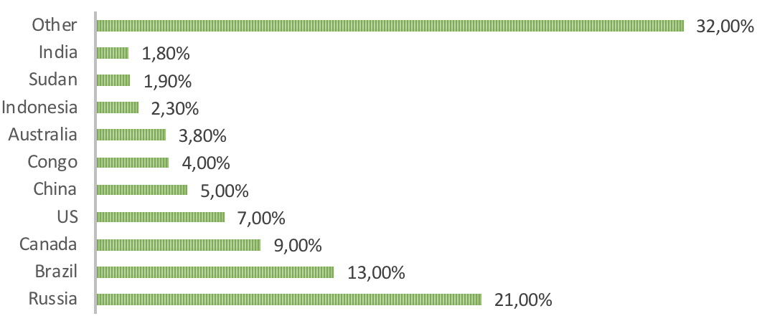

Fig. 8. Countries with the largest wood reserves in 2019, % of the world’s wood reserves

Source of data: www.lesonline.ru

As we can see from this data, Russia’s wood reserves add up to 21% of all wood reserves in the world. Closest to them is Brazil with 13% and then Canada with 9%. Its forest land totaled around 1,185 million hectares in 2019, with 67% of it covered with growing stock. Despite its vast reserves, Russia ranks only fifth globally in timber harvesting (Fig 9).

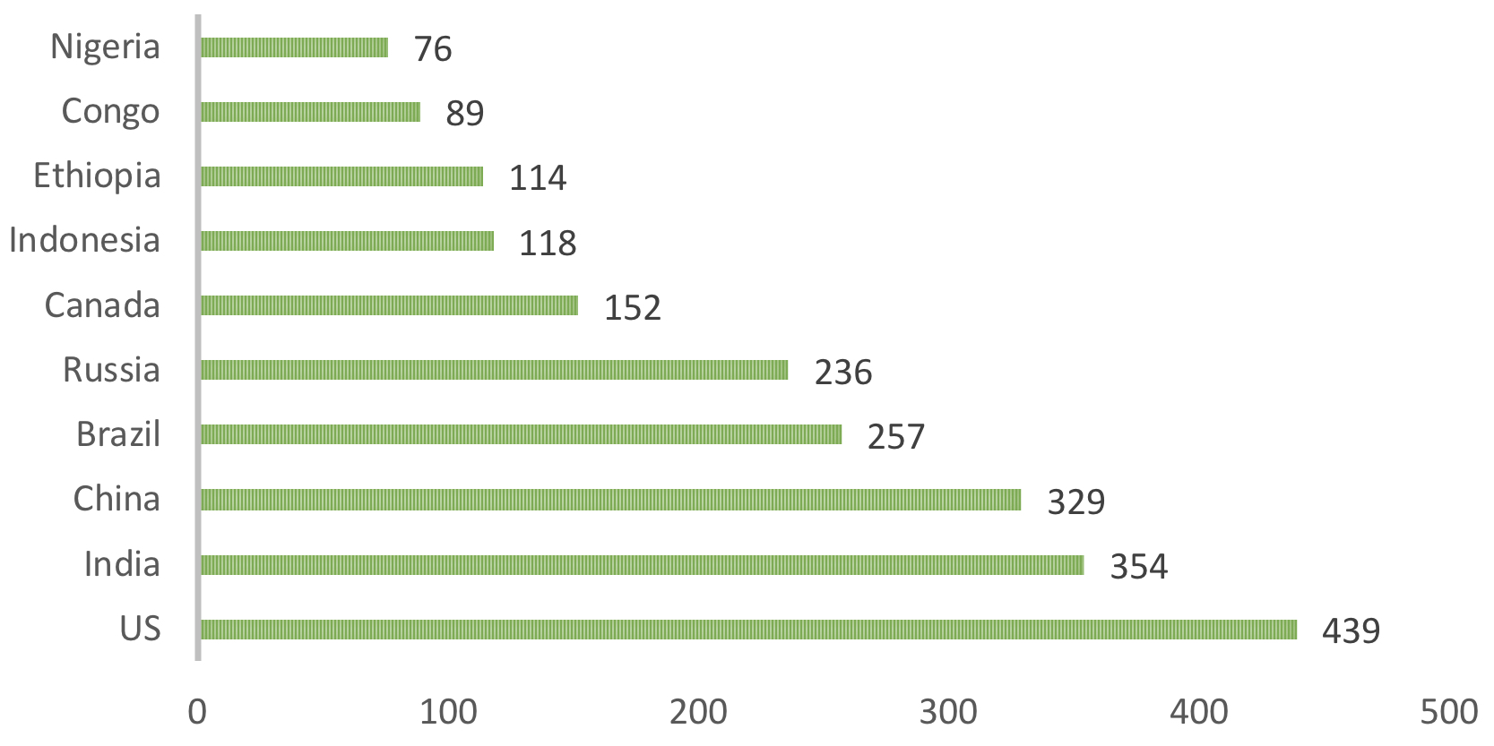

Fig. 9. Countries with the highest timber harvesting volumes in 2019, million m3

Source of data: www.fao.org

The reason for such low numbers is intensive exploitation of the forest resources and their depletion. Currently, there has been a gradual shift to intensive forest exploitation practices as the depletion of the resources has become a major problem across all of the industry. Just in 2019 around 7.4 million hectares of forest were burned down, which is nearly double the amount of 2018. This could be of the reasons why Russia’s exports dropped by 9 % in 2018-2019 (Fig. 10).

Fig. 10. Russia’s forest product exports in 2013-2019, USD million

Source of data: Russia’s Federal Customs Service

When we consider the quantity of natural resources of Russia, we also have to look at their availability. That’s why it is extremely important to look at the structure of those resources. According to the Forest Code of 2007, the main legislative document regulating management and use of forests in Russia, forest resources fall under federal ownership, and there are currently no possibilities for the privatization of forests. Thus, forests are leased on an auction basis for harvesting of wood, agriculture or hunting. As of 2019, the government was leasing 21% of forest lands in the country. The majority of leased forests are rented for wood harvesting (Fig. 11).

Fig. 11 Forest use structure in Russia in 2019, %

Source of data: www.rosleshoz.gov.ru

On average, leaseholders harvest around 65% of their annual allowable cut. The majority of forests are not leased for any use due to the fact that most of them are located in remote areas with no or low levels of infrastructure and are far from wood processing facilities. Overall, Russia can’t make full use of it’s natural resources as legislatives documents don’t allow for private individuals to own forest land. This in turn hinders any possibility for competitive market structure when it comes to forestry resources.

It is important to understand that factor conditions don’t only consist of natural resources. It is also necessary to look at the labour costs of the workers in forestry industry. Forestry activities, harvesting and wood processing are still quite labour-intensive in Russia, providing substantial opportunities for local people to gain employment from companies in the forest sector. However, the salary level in the forest sector is rather low (Fig. 12).

Fig. 12. Annual average labour costs of workers in forestry sector in 2019, USD

Source of data: (1) Finnish Forest Industries database, (2) EMISS

Russia’s annual salary per worker is significantly lower than their closest competitors. Different factors contribute to this. Forestry industry in Russia is more depended on manual physical labour during the production process. The cost of living is also lower than in Finland, Sweden and Canada. Overall, Russia does have an advantage over competitors in terms of availability of cheap labour in the forestry sector.

An even more important indicator is the annual productivity per worker in forestry industry. Both Canada and Finland have a much more expensive labour costs, but the productivity levels of the workers are much higher (Fig. 13).

Fig. 13. Annual production per employee in the forestry sector, m3

Source of data: (1) Finnish Forest Industries database, (2) EMISS

On country level wood-based products production per employee is highest in Finland and Canada. The labour costs are much higher in Finland then in Russia, but the higher productivity compensates the labor cost difference to some extent. Russia has very low productivity as the forestry industry in Russia mostly consists of old production sites, which have been build more than 2 decades ago. Another reason for such poor productivity in the sector is lack of implementation of managerial strategies and the general choice of production methods. There is one exclusion when we talk about the plywood industry. Many plywood manufacturers in Russia have built new and technologically advanced production sites in recent years mostly thanks to foreign investors.

It is also important to look at the general level of education but in this case it isn’t necessary. First of all, the level of education in the forestry sector in all of those countries previously mentioned is very similar. Also, historically, education level has not been a significant limiting factor in the forest industry. However, in the new biofuel industry it could play a major role.

Overall, after looking at factor conditions of Russia, it is possible to come up with a conclusion. The main takeaway here is the fact that Russia holds most wood resources in the world but due to some factors the lack of availability of those resources causes the industry to underperform both internally and externally. In comparison to competitors, the ownership structure of forests and the infrastructure that is needed to get to those resources are both holding the industry back. However, the cost labour and decent educational system could both be considered neutral factors in comparison to competitors. Unfortunately, the productivity levels of this sector are something that needs to be improved dramatically.

The second element of Michel Porter’s Dimond Model is “Firm strategy, structure and rivalry”. This element is important since it shows what firms choose to do with the available factor conditions. If we take a look at wood-based products, which are considered semi-finished products then we can see that their production has been steadily increasing over the past 5 years (Fig. 14). This would indicate that Russian forestry industry has not shifted it’s focus from the production of products that are closer to raw materials rather then finished-products.

Fig. 14. Annual production of semi-finished wood products in Russia, million m3

Source of data: www.fao.org

Sawlogs production in Russia has been the largest sector that has been growing over the years. The problem with this is that sawlogs are just wood logs that have been cut with no additional manufacturing process added. This means that the the value added to this product is very small in comparison to paper products, where value added is much higher.

On the other side of the spectrum we have chemical pulp and paper, which are considered to be high value added products. Unfortunately, paper and pulp production in Russia has stagnated over the years (Fig. 15). This is a very negative sigh since this indicates that there is large amount of value that is being lost.

Fig. 15. Annual production of chemical pulp and paper in Russia, million tonnes

Source of data: www.fao.org

The third element of Michel Porter’s model is “Related and Supporting Industries”. This is an important factor as it allows the rest of the industry to function efficiently. The most important factors of this element for forestry sector are logistical infrastructure, transportation costs and access to financing.

Access to capital remains a challenge for Russian companies compared with their competitors. Loans bear high interest rates, while loan security requirements are extensive. Apart from high interest rates, access is complicated by elaborate lending procedures and difficulties with obtaining long-term loans. As there are a big number of requirements that must be satisfied to qualify for reduced interest rates, soft loans are usually granted only to holding companies. Forest sector projects have long payback periods, especially capital-intensive projects in the pulp and paper industry. Increases in debt costs after the start of a project may force investors to abandon it. It is extremely difficult to obtain finances for a project with a payback period of seven to eight years. Thus, forest sector companies are left with little choice but to focus on investment projects with quicker returns. Also, the depreciation of rouble in 2014 has affected the forest sector in several ways, also in regard to access of Russian forest companies to financing. Fully or partly foreign-owned forest companies have access to investments through their own channels. Examples of such companies are mainly present in the plywood industry, which does perform well on international markets.

Another important element is the overall logistical infrastructure. It was previously mentioned that Russia’s access to its forest resources is limited by its lack of transport infrastructure. On the other hand, Russia has a good geographical location as it is quite close European markets as well China. It has relatively well developed transport infrastructure system including railways, motor roads, water and air ways. There are 8 large sea ports in the North-West Federal District: Saint-Petersburg, Kaliningrad, Murmansk, Arkhangelsk, Vyborg, Vysotsk, Primorsk and Luga. At the national level over half of sea freight containers are transported through ports of the North-West. Logistical companies in Russia offer much cheaper services then in countries like Finland or Canada and it is equally cheaper for Russian producers to export their product to central Europe then it would for Finnish or Canadian manufacturer.

Overall, the lack of logistical infrastructure and high cost for further development puts forestry sector in Russia in the behind positions in comparison to its competitors but cheaper logistical costs do give domestic manufacturers an upper hand over their foreign competitors.

The fourth element of Michel Porter’s Dimond Model is “Demand Conditions”. All of the competitors are aiming for the same markets: US, China and central Europe. Buyers in all of those markets tend to demand the same standards of product quality and service from producers. The main producers in the Russian forestry sector tend to export around 90% of their production volume since domestic market is not of an interest to them. That is why domestic consumer doesn’t play a major role when it comes to the exports and the overall production. Although, it is important to understand that most foreign consumers require FSC certification. In Russia only around 25% of forests have that kind of certification, where in Finland more than 90% of forests are certified. This means that producers have an easier time selling their product.

Overall, forestry industry is very exposed to external factors and changes since its highly oriented toward exports. In finance, beta coefficient is used to measure the risk from exposure to movements in general market. If beta is lower than 1 then investment is considered to have lower volatility, then the market. If beta is 1 or higher then it means that an asset tends to be more affected by the movement in the market and tends to move in the same direction. The beta value for companies in the forest sector exceeds 1.0[38]. This means that returns can dramatically decline during economic recession. Investments in the forest sector are risky even in developed economies. However, the degree of market risk can obviously depend on the industry. For instance, the biofuel industry that produces feedstock for electricity is less sensitive to macroeconomic volatility as opposed to boards that are used in construction.

The main difficulty for Russian producers is the difference in standards of quality: one for export and second one for domestic markers. In truth, domestic Russian market demands much lower standards of quality if compared to European markets. This, though, can’t be said about the manufacturers in Finland, where domestic consumers require the same standards of quality as in the foreign markets.

The fifth element of the Dimond Model that Russian forestry industry will be analyzed through is “Government”. This factor probably has the biggest influence on how export policy is formed. For the past two decades of political and economic reforms in Russia have demonstrated that the forest sector is both slow and has difficulty in adaptations to international forest management requirements.

The main legislative document that sets up laws and procedures for Russian forestry sector is Russian Forest Code, which was put into force in 2006. The Forest Code governs the protection, ownership, use and renewal of forest resources in the Russian Federation. The Act consists of 16 Chapters divided into 109 articles:

1. general provisions;
2. forest use;
3. forest protection;
4. forest renewal and afforestation;
5. forest management planning;
6. making publicly-owned and municipally-owned forest parcels available to citizens and legal persons;
7. sale-purchase contracts for forest stands;
8. forest auctions;
9. powers of the public authorities in the sphere of forest relations;
10. administration of forest use, protection and renewal;
11. payment for forest use and forest valuation;
12. state forest inspection;
13. liability;
14. dispute settlement;
15. protection forests
16. production forests and reserve forests.

The Forest Code contains important provisions regarding ownership and use of forests specifying that forest parcels within the forest estate lands shall pertain to federal property and the ownership of other forest parcels shall be regulated by land legislation. Public forests shall be conceded on lease, which shall be charged, and gratuitous use for established periods. Regarding classification of forests the Act establishes that forests on the forest estate lands shall be classified into protection forests, production forests and reserve forests in accordance with their designation.

Russia’s Ministry of Trade specifically covers the trading policy of wood sectors which means its policy is more heavily linked with the export rather than the general development of this specific sector. Ministry of trade consists of many departments one of which is the Department of light industry and forestry. This specific department oversees the whole of forestry industry operations in Russia. The latest strategy for development of forestry sector was put into place on 11th of February 2015 called “Strategy of development of forestry complex in Russian Federation until 2030”. It bares completely a new way for development of Russian forestry sector. Its main aim is to structural issues, which prevented economic development and the strengthening of Russian companies positions on the export market. Some of the present problems that this strategy describes are:

* inefficiency in using resources;
* unsustainable development of technological progress;
* insufficient export of “end use” products.

From these points it can clearly be seen that the Ministry of Light Industry and Trade recognizes the problems that Russian forestry industry faces today. In order to fix the current situation, the following tools will be used:

* Support of development projects for processing wood industry
* Stimulation of the demand
* Better access to the raw material
* Development of new technologies for the end use products

By following this strategy Russia hopes that by 2030 added value of the product will grow to 1 trillion rubles, which is about 40% more then it is now and the overall export of wood products in the total export will increase by 0,5%. So far, this strategy hasn’t borne any fruits since the economic and political situation in Russia hasn’t been stable. So far there hasn’t been any new ground that have been established for the forestry business to develop and evolve in such way that it could produce more of the end use product. This of course can be accounted to several factors such as:

* Global economic crisis 2008-2009
* Oil prices crash 2014-2015
* Economic sanctions that were put forward again Russia after the Crimea crisis

After such negative developments this new Strategy 2030 has been put into question several times already and its main objectives may be corrected seeing as how some of these aims aren’t very likely to be accomplished. What makes the situation even worse is that some of the more recent events such as depreciation of Russian ruble, COVID-19 epidemic and OPEC+ negotiations have significantly hurt Russia’s economy.

By looking at the survey that was done by EY and ASPPI agency in 2019[39] respondents outlined the main government mechanisms that may have the greatest impact on the forest sector in the next 5-7 years (Fig. 16).

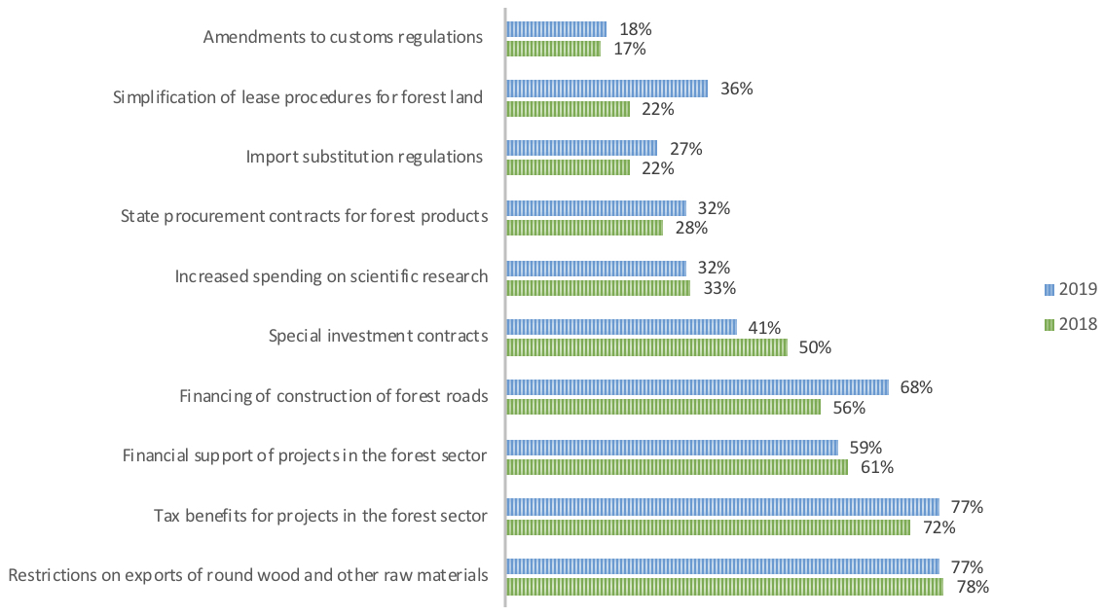

Fig. 16. Government support mechanisms that may have the greatest impact on the forest sector

Source of data: https://www.ey.com

Respondents cited tax benefits and changes in customs regulations among the initiatives that are stimulating forest sector projects most in 2019. At the same time, the percentage of companies applying tax benefits dropped in 2019 despite the recognition of their important role for project activities. This is probably due to the complicated process of applying for tax benefits as well as business concerns about possible disputes with the tax authorities. Forest sector companies need to study available tax benefits to apply them on a larger scale and rule out any disputes with the tax authorities. Priority Investment Projects and Special Investment Contracts are the most popular government initiatives among investors. However, a big number of companies use none of the available instruments. Possible reasons may include non-compliance with eligibility criteria, which is unlikely given the abundance of tax benefits and the eligibility scope, as well as low awareness and a poor understanding of how the company can apply available tax benefits.

As mentioned below Russian taxation regime plays a major role for domestic producers, as well as potential investors. In January 2019, Russia’s Ministry of Finance published a draft of amendments regarding changes in Tax Code. The finance ministry proposes replacing charges for negative environmental impact with an environmental tax to be imposed on legal entities and sole entrepreneurs for environmental damage caused by their operations in Russia. Following a discussion on the draft amendments to the Tax Code with the business community, the authors added a provision allowing companies to recycle waste using their own resources, as they are currently allowed to do. Companies that recycle goods and packaging on their own will be eligible for a tax deduction of no more than the product of all sales in the 12 months fee period and the applicable recycling quota in this period. The entry into force date is still under consideration.

Department of development and regulation of foreign economic activity is in charge of forming export policy for forestry products. This department coordinates the implementation of activities of the state program “Development of foreign economic activity” and priority projects in the framework of the strategic development “International Cooperation and Export”. Most of the wood-based products are categorized under the VED code 4421999900. Right now, export duties for those products are 0%, while import duties are 9%. Unfortunately, there is no escalation of export duties for products that are considered wood raw-materials.

The last element of the diamond model is “chance”. In this context “chance” includes all force-majeure occurrences that potential could effect the industry in some way. On one hand, this element doesn’t play a major role in the competitiveness of the industry, since most of these occurrences effect all major wood exporters in the world the same way they would effect Russia’s industry, for example COVID-19 forced to cease nearly all exports of wood-based products around the world for all manufacturers. The second reason this element doesn’t play a major part in the competitiveness of Russian forest industry is because most of these occurrences don’t have a lasting effect on the industry as a whole. On the other hand, there are some unpredictable occurrences/factors that could directly effect the forestry industry in Russia. The first factor is the weakening of the Russian ruble. If the national currency weakens then domestic manufacturers will most likely start to concentrate on the sales in the domestic market, as in comparison, this would be more profitable to them. Also it would become more costly for them to buy the necessary equipment from abroad, this could potentially create supply shortages. The second factor are potential sanctions against Russia from either U.S. or E.U. In past couple of years some of the Russian products have been under sanctions. Both E.U. and U.S. could choose to expand those suctions on wood-based products as well. The third factor are forest fires. This has been a major problem for Russian forestry industry over past couple of years. Of course there are many ways in which damages from forest fires could be prevented but it it’s not always possible. That is why forest fires are one of the main reasons that the forestry industry suffers from shortages of raw materials.

It is obvious that Russia realizes its problems in the sphere of wood export and export of all goods in general. Strategies that have been mentioned previously are obviously moving towards a more sustainable and progressive development of forestry industry in Russia, which is not so concentrated only on raw material-based products. This just goes to show that the present wood export policy is not good enough and it fails to realize of the industries potential. In order for this industry to catch up until 2030 many things have to happen, and a lot of changes have to be made. In the current political and economical climate theses changes might not be able to take place as they are planned to. Already we are seeing that “Strategy of development of forestry complex in Russian Federation until 2030” have been failing to live up to its expectations, which means things might not change as everyone hopes they will.

**3.2 Finland’s forestry industry**

One of Russia’s biggest competitor in forestry products market is Finland. It’s important to look at external competition since this will help to understand why Russia’s wood trading policy is shaped the way it is. Comparing different wood trading policies from different countries will be a key instrument in forming different advices on the changes that are necessary for Russia’s present wood trading policy.

As mentioned previously Russia has the largest wood reserves in the world with 29% of the world’s wood reserve, which add up to 8,200,000 km2 of forest area. Finland, on the other hand, is ranked 24th in world in terms of forest area, which adds up to 220,000 km2. This statistic is key since this shows that one of those countries have an abundance of raw materials and the other one doesn’t. So, this in a way could suggest Russia’s forestry sector is doing much better than the Finish forestry sector but that’s equally a false statement. Russia’s exports of forest products in 2019 equaled 10,412 million USD, where Finland’s exports of forest products in 2019 equaled 13,080 million USD (Fig. 17).

Fig. 17. Finnish and Russian forest product exports in 2019, USD million

Source of data: Russia’s Federal Customs Service, Finnish Institute of Forest Industries

The forest industry is a major contributor to wellbeing in Finland. The sector accounts for over 20% of Finland’s export revenue and it is a major employer, especially in regional areas. Finland has potential to increase the annual harvest by 9 million m3 , which equals 11% additional harvest potential from the total annual allowable cut. Although with the growing biofuel industry, limitations of wood resources could become an issue for future development. If we look at the export structure of wood products of Finland than it is obvious that it is substantially different from Russia’s export structure (Fig. 18).

Fig. 18. Finnish and Russian exports of forest products in 2019, billion USD

Source of data: Russia’s Federal Customs Service, Finnish Institute of Forest Industries

Russia mainly exports sawn timber and round wood both of which are considered raw wood products, where Finland mainly exports paper and cardboard products which are considered to be more finished products. That’s the first major difference that we can see between Russian exports and Finnish exports of wood products. Exporting a more finished product means that the value you get back for it is higher.

The main question is how Finland is able to export more in terms of value wood products than Russia with having much less available resources. To answer this question, it is necessary to look at Finnish forestry industry on a domestic level to understand what cases their export policy to perform so well.

Michel Porter’s Dimond Model will be used to analyze domestic forestry sector of Finland. The first element of this model that will be looked at is “Factor Conditions” which characterize the available resources of the country. It was already mentioned that Finland ranks 24th in world in terms of forest area, where Russia is ranked 1st. This means that Finland lacks natural factor conditions compared to Russia. What also has to be looked at is availability and the structure of those factor conditions. Most of the forest in Finland is owned by private individuals, which 53% of the total forest land. 35% of the forest is publicly owned by the State Forest Enterprise municipalities. State forests are concentrated in the Northern and Eastern Finland and include national park and conservation areas. The State Forest Enterprise is the largest individual forest owner, and an important client for the wood processing industry (Fig. 19).

Fig. 19. Finland’s forest ownership structure

Source of data: National Resources Institute of Finland

However, a clear majority of the wood volume is harvested from private forests, partly due to many State Forest Enterprise’s forest in Northern Finland, where the forest growth is slower than in the South. Forest holdings owned by private individuals are small, on average only 30 hectares. Forest land is bought and sold in the market, but majority of the forest is passed on within a family as inheritance. Due to the inheritance law, the average size of a forest holding continues to decrease, as forest area is distributed between siblings. It can pose threats to forest harvesting, as a larger share of forest owners live in cities and may be passive in wood markets. Consolidated ownership, in which several people combine their forest ownership under a single entity, has an increasing trend. On the hand, Russia’s forest is fully under state ownership according to the Forest Code of 2007. Around 20% of forests are leased for wood harvesting but majority of the forests are not used in any way as their remote location and lack of infrastructure provide leave no option for harvesting them. In general Russia’s ownership structure isn’t built for competitive environment unlike Finnish one. The fact that Finland’s forests are mostly owned by individuals makes them compete against each other which in return provides a more stable and favorable environment for wood product manufacturers.

Another important element of factor conditions apart from forestry resources is labor costs of workers in forestry industry. Finland is a social democracy, where the state takes responsibility for funding and organizing public healthcare, education, pension system and social security. Social security costs are therefore high and paid partly by the employer. On average, the social security cost is 30% cost addition to the direct earnings from the employer perspective. Workers pay progressive tax from their salary, which is approximately 30% for average salary. The total salary costs per employee in forestry sector were on average 52,000 USD annually per worker. In Russia this number is significantly less, where annual salary average per worker is 6,150 USD (Fig. 20).

Fig. 20. Average annual labour costs of workers in forestry sector in Russia and Finland, USD

Source: Finnish Forest Industries database, EMISS

Such a difference in annual salary between workers is a definite advantage for Russian producers when it comes to saving production costs. Of course, when we look at factor conditions, we not only have to consider the costs of those factors but also the quality and the availability. If we look at general level of education for working people in Finland and compare it to Russia than we can see that there isn’t much difference between those countries. In Finland around 41% of working people have bachelor’s degree or higher and 59% have high school equivalent level of education or lower. In case of North-West Russia, around 34% of working people have bachelor’s degree or higher and 66% have high school equivalent level of education or lower. There is a difference but its not high enough to suggest a serious quality disturbance between those two countries.

As far as quality of forest resources goes, over 93% of all commercial forests in Finland are either PEFC or FSC certified. Both national PEFC and FSC standards, set requirements that go beyond legal obligations. These standards set provisions on training of forest owners and workers, as well as on educating the people on forestry. In comparison, in Russia around 25% of commercial forest area is FSC certified.

All and all, when it comes to factor conditions Finland does have an upper hand over Russia when it comes to the availability and quality of those resources and not only the pure quantity of them.

Second factor of Michel Porter’s Dimond model is “Related and Supporting Industries”. Arguably, the three most important elements of this factor for forestry sector are logistical infrastructure, transportation costs and access to financing. When it comes to financing Finnish banking system is stable. Existing big forest industry companies haven’t had difficulties in getting loans to large investments. There are less private equity investors in Finland than in other European regions. However, the state may provide loan guarantees to investments. Finnvera, which is the state-owned official Export Credit Agency can provide loans to investments in special circumstances, but it mainly provides export credit guarantees. Business Finland finances innovation, pilot projects and R&D. Long-term credit rating of Finland is AA+/Aa1, which is the second highest rating level, so the interest rates of state loans are moderate. In terms of financing, Finland benefits from the stability of Euro. Loan interest likely remains low in the future, as the Euro Interbank Offered Rate has remained negative during the past two years. The inflation rate in Finland remains lower than the average rate in EU. In 2020, the inflation was 0.94% in Finland, based on consumer price index. Access to financing in Finland does not limit forestry industry development unlike in Russia.

When it comes to logistical infrastructure Finland is way ahead of Russia. See transportation can be used all year around at the main harbors at Baltic Sea, due to existing icebreaking fleet. Forest Industry uses over 15 seaports to export and import. Within Finland, the train network and road network are also very well developed. Trucks, together with their cargo, can weight up to 76 tonnes if they have nine axels. Therefore, trucks that have 8 or 9 axels can carry heavy cargo of more than 40 tonnes, which has decreased unit costs for transportation. The state is responsible for maintaining and developing motorways, trunk roads and other primary roads. Moreover, the state maintains and develops all the railways. The most important element of Finland’s transportation infrastructure is that it has one of the most extensive forest road network in the world. The forest roads are built by the forest owners, which provide good access to forests. This is crucial as forest owners are the ones that are most interested in good access to their forests since it is necessary to sell their product. This is probably the main and the most importance difference between Russia and Finland, where most of Russia forest is so remote and the lack of infrastructure doesn’t allow access to it.

R&D in Finland than it is especially strong in pulp and paper production. The public sector finances universities and research institutions that take part in R&D. Most of the big forest sector companies cooperate with universities in the field. Business Finland provides finance, either as grants or loans, to innovation, piloting and R&D of Finnish companies. The total R&D expenditure in forest industry is 120 million USD, which is the second highest spending to sectoral GDP of 2% among the top exporters of forestry products. In comparison, Russia’s R&D spending is only 0.01% of the sectoral GDP (Fig. 21).

Fig. 21. Total R&D spending of the total sectoral GDP, %

Source of data: INDUFOR, Finnish Forest Industries database, EMISS

Overall, Finland’s forestry sector does not suffer from the lack of R&D spending and is equally ahead of its competitors.

The third element of Michel Porter’s Dimond Model is “Demand Conditions”. As previously mentioned, all of the exporters of wood-based products exist in the same foreign markets: China, US and Central Europe. Standards in those regions tend to also be the same and differ from each other too much. That’s why this element of the model isn’t as important as other ones since there isn’t much difference for most of the manufacturers that compete in those markets. Having said that, when it comes to the domestic consumers in Finland than the situation is quite different if we compare it to the domestic consumers of Russia. Finnish consumers of wood-based products require same high-quality standards as consumers in the foreign markets. This in a way forces Finnish manufacturer to apply same high-quality standards to all of their products.

The fourth element of the Dimond model is “Firm strategy, structure and rivalry”. When it comes to domestic competition between wood-based producers in Finland we can see that majority of the production in this industry takes place in paper industry. Since majority of the necessary natural resources are privately owned all of the domestic producers have an opportunity to get an access to those resources. This in turn lets this sector to expand and grow. Also, easy access to capital allows for even smaller manufacturers to exist and take place in their own niche.

The fifth element of Michel Porter’s model is “Government”. When it comes to government policies in Finland most of them are directed at sustainable developed of the industry. The National GHG Emissions strategy follows objectives and actions agreed in EU, aims to increase the share of renewable energy sources to over 50% of the total energy consumption in 2020’s. The strategy includes actions and objectives to increase the use of wood fuels, especially by-products and to refine value-added fuels from them. The National Energy and Climate Strategy for 2030 aims to increase the share of biofuels in road traffic to 30% by the year 2030. This has a direct effect on the entire forestry industry in Finland since either the manufacturer is the producers of biofuels or he is a consumer of energy. Another important government policy is The Act on the Financing of Sustainable Forestry aims to guarantee tending of young forests and their growth. In 2015, forest owners gained 1.6 billion euros as revenue from selling wood and spent 223 million euros to silviculture, of which 65 million euros were state subsidies. Overall, in 2019 Finnish forestry industry received over 82 million USD of direct government subsidies. Production of renewable energy is subsidized with feed-in tariffs. Wood chips, biogas, and fuelwood use for energy production benefit from the tariffs. The feed-in tariff is paid according to the difference between the desired price and the market price of electricity. Forest industry benefits from several energy subsidies in addition to the emission right compensation. Overall, Finnish forest industry benefits from many direct subsidies and tax deductions, which benefit the industry.

**3.3 Dimond model of Russia’s forestry industry and policy recommendations**

Analysis of Russia’s forestry sector through Michel Porter’s Dimond Model has shown exactly in which elements of the model domestic sector is underdeveloped. Finland’s forestry sector was also chosen for the analysis through the Dimond model in order to better understand what the main differences between forestry sectors between both of those countries are.

As it was previously mentioned that Michel Porter’s Dimond Model consists of four main elements. Each element was individually looked at and analyzed through the various available informational resources. This allowed to form different factors, both positive and negative, which all exist in the framework of the Dimond Model (Fig 22).

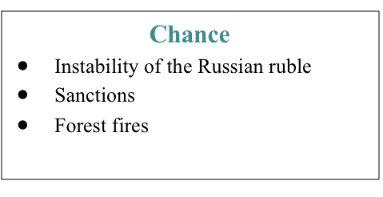

Fig. 22. Dimond model of Russian forestry sector

Source of data: Author

From this model it is obvious that Russian forestry sector is in difficult situation. Each of the elements of the model holds different factors that are graded: negative, neutral or positive. Factors were chosen based on how influential they’re to the forestry industry. They were graded mainly based on how they compared to the competition. In the first element of the model “Factor conditions” 7 different factors were graded:

1. “Quantity of natural resources”. As previously was mentioned Russia holds most forest resources in the world that’s why it has an absolute advantage in this area of its competitors.
2. “Availability of natural resources”. Russia’s forest ownership structure is one of the main reasons why this factor is very limiting to the forest industry. Also, most of forest resources are located in areas which cannot be accessed through current available infrastructure.
3. “Quality of natural resources”. Only 25% of Russian forests are FSC certified. This certificate is necessary if domestic producers are willing to export their product to the international market. In contrast, over 90% of Finland’s forests are certified.
4. “Costs of labour”. In terms of the labour costs Russia does have an advantage over its competition: Canada, Sweden, Finland. Average cost of labour in the forestry sector in Russia is more then 8 times lower than in Finland, which allows domestic producers to significantly bring down the costs of production.
5. “Quality of labour”. Historically the level of education has not been a deciding factor in the forestry industry. Nevertheless, the level of education in Russian forestry sector is close to other countries level of education.
6. “Productivity of labour”. Annual average production per employee in the forestry sector is only 422 m3. In comparison, Finland this indicator is more than 3 times higher, which would suggest that Russia’s domestic forestry industry either lacks managerial skills or is technologically underdeveloped.
7. “Geographical positioning”. Russia has a good geographical location as it is situated quite close to the EU and is well connected to the main European ports. An advantage that Russia has over its competition is that it shares border with China, who is one of the main consumers of wood-based products.

Overall “Factor Conditions” of Russia does give it an upper hand over its competition. After looking at the statistics it is obvious that the main problem is the availability of resources. Also, in order to improve quantity of exports it is necessary for the industry to improve its productivity in the sector.

In the second element of the model “Demand Conditions” 2 main factors were analyzed:

1. “Domestic consumers”. In general, domestic consumer doesn’t play a major role in the export sector. This is caused by the fact that majority of the wood-based products that are produced are exported, so they are initially made for foreign market and not the domestic one. It is important to mention though that the quality that is demanded by the local consumer is much lower than in the foreign markets. This causes companies to differentiate the quality of their products based on which market they want to sell their product in.
2. “Foreign consumers”. This is a very important factor since it directly effects what kind quality of wood-based products should or shouldn’t be exported. Most of the consumers require FSC certification and high level of quality standards. Those consumers generally coincide in the very well-developed markets and have good access to digital technologies, which means they are well informed. This poses a major difficulty for Russian producers as only 25% of Russian forests are FSC certified and the necessary technology for high quality standards are generally very expensive to obtain.

The third element of the model “Firm strategy, structure and rivalry” consists of 2 main factors:

1. “Efficient use of natural resources”. Most of the domestic producers choose to concentrate on raw wood products and semi-finished products with the exception of plywood industry. The main difference between those industries is that plywood industry is heavily subsidized by foreign inflow of capital. Main Russian competitors, for example Finland, choose to concentrate of the production of finished products. Finland mostly export cardboard and paper, and also of the main leaders in the production of biofuels. This in term means that the products value is much lower than it could been if it was put through the necessary production processes to turn it into a finished product.
2. “Domestic competition”. Domestic competition is held back by 2 major factors. The first one is the availability of forest resources. Since all of the forest land in Russia is state-owned and afterwards is leased, it is difficult for smaller manufacturers to get the necessary resources when faced by competition from bigger companies. Probably the most limiting factor is the financial support availability. Banking system in Russia is formed in such a way that it’s nearly impossible for smaller companies to get credit lines that are viable for their business.

The fourth element of the model “Related and Supporting industries” consists of 4 main factors:

1. “Transformational infrastructure”. It was previously mentioned that Russia’s access to its forest resources is limited by its lack of transport infrastructure. On the other hand, it has relatively well-developed transport infrastructure system including railways, motor roads, water and air ways but it still doesn’t compare to either Canada or Finland.
2. “Logistical costs”. Logistics companies in Russia offer much cheaper services then in countries like Finland or Canada and it is equally less expensive for Russian producers to export their product to central Europe then it would for Finnish or Canadian manufacturer.
3. “Banking sector”. Access to capital remains a challenge for Russian companies compared with their competitors. Loans bear high interest rates, while loan security requirements are extensive. Apart from high interest rates, access is complicated by elaborate lending procedures and difficulties with obtaining long-term loans. As there are a big number of requirements that must be satisfied to qualify for reduced interest rates, soft loans are usually granted only to holding companies.
4. “R&D”. Russia’s R&D spending is only 0.01% of the sectoral GDP. In comparison, R&D expenditure in forest industry is 120 million USD, which is the second highest spending to sectoral GDP of 2% among the top exporters of forestry products.

What is also important to consider is “chance”. This element of the diamond model consists of 3 most important factors that could potentially effect Russia’s forestry industry. The first one of these factors is instability of the national currency. It’s not a secret that Russian ruble is extremely dependent of the prices of oil. That is why the national currency is so unstable. If ruble depreciates in value, then the national producers will be more interested in exporting it since they will get paid in foreign currency and in the end will get more value for their product. The second factor that could potentially affect the forestry industry of Russia is the introduction of sanctions against wood-based products by either U.S. or E.U. In the past couple of years Russia has been having policy all issues with both of those countries because of various reasons. This led to introduction of sanctions against some of the Russian products, luckily non of those products are wood based. Although, in the future it is possible that wither E.U. or U.S. could expand their sanctions that would affect the exports of Russian wood-based products. And the third major factor that could affect Russia’s forestry industry is forest fires. This occurrence, especially in Russia, is nothing new. There have been many issues in the past where natural forest resources of Russia have been heavily by those natural disasters.

The main driver of improvement of the main 4 elements of the Dimond Model should be the government. In Michel Porter’s Dimond Model government acts as a catalyst for the industry in order to set the path for future efficient and stable development. That is why it is important to look at current as well as future policies for domestic industry as a whole. Russia’s current export policy of wood-based products can be summarized by the latest report that was published by the department of forestry. In this report it states that all the wood products are characterized in four different categories: raw material, industrial sector, industrial production and end use. In all of these categories different products exist. Each of these products in each category is marked but the color depending on how important it is to the countries forestry policy. Most of the products that are considered vital for export are placed in the “raw material” or the “industrial sector” category, which means that Russia’s export policy only sees those products that are important for trade that have very little production process put into them. “End use” products are considered “Of less importance” and only some products in these categories are considered “Important for domestic use”. As far as domestic policy is concerned it would most probably be unchanged in the upcoming years. Most of the government support is concentrated on the large investments projects, which means that competitiveness climate in the forestry industry will most likely will be remained unchanged. The consumption of raw wood materials and semi-finished wood products is likely to grow, which means that it will be even more difficult for the government to shift industries interest towards more finished wood-based products manufacturing.

Having analyzed all of the different elements of the Dimond Model of Russian forestry sector it is possible to form recommendations for future policies. Main recommendations are:

* Promote technological modernization of the forestry industry by facilitating access to advanced foreign equipment and technologies.
* Change the ownership structure of forest resources within the country or optimize an existing system.
* Expand the use of customs and tariff exports incentives including the reduction of duties on raw materials and equipment for the production of export products.
* Further introduction of infrastructure development programs, especially in the remote regions, where forest resources are still inaccessible.
* Decrease in the rates of export duties as the depth of product also increases: creation of maximum duties on raw materials, components, and the minimum for finished goods.
* Gradually increase the level of competition in the domestic market of services such as banking.

**Conclusion**

The aim of this paper is to formulate possible policy suggests on how to improve current export policy of wood-based products, as well as domestic forestry industry of Russia. Export policy directly depends on the state of the domestic industry and that is why Russia’s domestic forestry sector was also analyzed through Michel Porter’s diamond model. This model consists of six main elements:

* factor conditions;
* demand conditions;
* firm strategy, structure and rivalry;
* related and supporting industries;
* government;
* chance.

Having looked at factor conditions of Russian forestry industry it is obvious that the vast amount of natural resources puts Russia ahead of its competition. Russia holds 20% of all of the forestry resources in the world but there 2 major issues. The first issue comes from the fact that most of those forestry resources are unavailable due to lack of infrastructure and efficient ownership structure.

Demand conditions are represented by domestic and foreign consumer. In the domestic market consumers usually don’t require the same high standards of quality that is required for the foreigh market. The main issue here is that Russia’s domestic producers have to keep different standards of quality depending on which market they are planning to sell their product.

Firm strategy, structure and rivalry element of the diamond model mostly comes down to how domestic producers choose to utilize resources that are available to them. In Russia manufacturing in the forestry sector is mainly focused on the production on semi-finished products, rather then focusing on finished products. Because of this considerable amount of value is being lost.

Related and supporting industries element of the diamond model mainly focuses on logistical infrastructure and banking sector, especially in Russia’s forestry sector. Lack of logistical infrastructure prohibits the full use of the forestry resources in the country, which considerably hinders the domestic industry. Banking system is also very important to consider. Right now, banking system in Russia is formed in such a way that it’s nearly impossible for smaller companies to get credit lines that are viable for their business.

Government and its policy acts as a catalyst to push the industry in the right direction. Most of the government support is concentrated on the large investments projects, which means that competitiveness climate in the forestry industry will most likely remain the same. Government also doesn’t provide any incentives for exporters to sell products are more finished.

The last element of the diamond model is chance, which are all force-majeure occurrences that potentially could affect the industry in some way. The main ones that should be highlighted are: unstable national currency, possible future sanctions against exported wood-based products and forest fires.

On the basis of the analysis of the current situation in the domestic industry, as well as current export policy, possible policy suggestions were made for Russian government:

* promote technological modernization of the forestry industry by facilitating access to advanced foreign equipment and technologies;
* gradually increase the level of competition in the domestic market of services such as banking;
* decrease in the rates of export duties as the depth of product also increases: creation of maximum duties on raw materials, components, and the minimum for finished goods;
* change the ownership structure of forest resources within the country or optimize an existing system.

Russia’s forestry industry has the potential to be the world leader both in terms of the total output volume and in terms of the total value-added. What forbids it from being that is the lack of sufficient structure and government support. If those issues will be fixed through policy changes then Russia’s forestry sector could quite possible maximize it’s potential.

**Bibliography**

1) Backman, C. A. The forest industrial sector of Russia: Opportunity awaiting. New York: Parthenon Pub., 1998

2) Barr, B. M., & Braden, K. E. The disappearing Russian forest: A dilemma in Soviet resource management. Totowa, N.J: Rowman & Littlefield., 1988

3) Berry, Wendell. Excerpt from ‘The Whole Horse’ taken from ‘The Art of the Commonplace: Agrarian Essays of Wendell Berry’. Washington, D.C.: Counterpoint., 2002

4) Robbins, A. China’s Forest Sector: Essays on Production Efficiency, Foreign Investment, and Trade and Illegal Logging (Doctoral dissertation). Received from author via personal communication. University of Washington, Seattle, WA., 2011

5) Russia’s official export statistics 2018, source: ru-stat.com

6) World’s Top Export Countries report, source: worldstopexport.com

7) The cause of nation wealth/Adam Smith/Tribe production/ Volume 5/issue 2/ autumn 2012.

8) OEC, International trade data: Russia, source: atlas.media.mit.edu

9) International trade data: United States, source: atlas.media.mit.edu

12) OEC, International trade data: China, source: atlas.media.mit.edu

13) Russian forestry report 2019, source: https://lesprominform.ru

14) Resolution of the Government of the Russian Federation from 05.06.2008 No.

470 “On the Ministry of Economic Development of the Russian Federation”,

source: http://www.consultant.ru

15) Global Forest Products Market Update – 4th quarter 2018,

source: https://woodprices.com

16) World Trade Organization official website, source: wto.org

17) World Tariff Profiles 2018, applied MFN tariffs, source: https://www.wto.org

18) A draft version of the Forest Policy of Russia, proposed for public comment,

source: http://lp.vniilm.ru/viewforum.php?f=6

19) Forecast of socio-economic development of the Russian Federation for 2013

and the planning period of 2014-2015. Ministry of Economic Development of

the Russian Federation., 2012.

source: http://www.economy.gov.ru

20) China Timber Processing Industry Report, 2018-2019

source: www.researchinchina.com

21) Annual Report on Forest and Forestry in Japan. Fiscal Year 2018. Forestry

Agency, 2018, source: www.maff.go.jp

22) Dementiev A. Key problems of timber industry development. Official website

of the RF Ministry of Industry and Trade,

source: http://www.minpromtorg.gov.ru/industry/wood/40

23) Porter, M.E. The Competitive Advantage of Nations. Harvard Business Review.,1990

24) Smith A. J., The competitive advantage of nations: is Porter’s Diamond Framework a new theory that explains the international competitiveness of countries? Southern African Business Review Volume 14. 2010

25) McKelvey. M., How do National Systems of Innovation Differ? A paper presented at the European Association for Evolutionary Political Economy conference entitled “Rethinking Economists” in Italy. 1990

1. World bank data, link: https://data.worldbank.org
2. Ibid
3. Ibid
4. Russia’s export, link: ru-stat.com
5. The cause of nation wealth/Adam Smith/Tribe production/ Volume 5/issue 2/ autumn 2012.
6. Porter, M.E. (1990). The Competitive Advantage Of Nations. Harvard Business Review, p. 72.
7. Ibid, p. 72.
8. Ibid, p. 73.
9. Porter, M.E. (1990). The Competitive Advantage Of Nations. Harvard Business Review, p. 76.
10. Ibid, p. 76.
11. Ibid, p. 77.
12. Porter, M.E. (1990). The Competitive Advantage Of Nations. Harvard Business Review, p.79.
13. Ibid, p. 81.
14. Porter, M.E. (1990). The Competitive Advantage Of Nations. Harvard Business Review, p. 81.
15. Smith A. J. (2010), The competitive advantage of nations: is Porter’s Diamond Framework a new theory that explains the international competitiveness of countries?, Southern African Business Review Volume 14, p. 110.
16. Ibid, p. 112.
17. Ibid, p. 114.
18. Smith A. J. (2010), The competitive advantage of nations: is Porter’s Diamond Framework a new theory that explains the international competitiveness of countries?, Southern African Business Review Volume 14, p. 120.
19. McKelvey. M. (1990), How do National Systems of Innovation Differ? A paper presented at the European Association for Evolutionary Political Economy conference entitled “Rethinking Economists” in Italy, p. 15.
20. Dalum B. (1991), Porter og den erhvervspolitiske debat. Samfunsokonnen, p. 33.
21. Forestry industry report 2019, link: www.fao.org
22. Global Forest Products Market Update –2019, link: https://woodprices.com
23. Forestry industry report 2019, link: www.fao.org
24. Ibid
25. Forestry industry report 2019, link: www.fao.org
26. Ibid
27. Russian forestry report 2019, link: https://lesprominform.ru
28. Forestry industry report 2019, link: www.fao.org
29. Global Forest Products Market Update – 4th quarter 2018, link: https://woodprices.com
30. Global Forest Products Market Update – 4th quarter 2018, link: https://woodprices.com
31. Russian forestry report 2019, link: https://lesprominform.ru
32. World Trade Organization official website, link: wto.org
33. Ibid
34. World Trade Organization official website, link: https://www.wto.org
35. World Tariff Profiles 2019, applied MFN tariffs, link: https://www.wto.org
36. Integrating into the multilateral trading system and global value chains: the case of Russia/ Sergei F. Sutyrin, Alexandra G. Koval and Olga Y. Trofimenko/ World Trade Organization 2014, p.10
37. Ibid
38. EY and ASPPI Survey, source: https://www.ey.com
39. EY and ASPPI Survey, source: https://www.ey.com