

SAINT-PETERSBURG STATE UNIVERSITY

***Zhang Ruoyu***

**Master thesis**

***Socioeconomic Factors of Consumption and Production of Aquatic Products－comparative study of Beijing and London***

Field of Study **39.04.01 «Sociology»**

The main educational Master program

**BM.5686.2019** **«International Sociology»**

«Studies in European Societies»

|  |  |
| --- | --- |
|  | Scientific supervisor:  Professor, Head of the Department of Economic Sociology, PhD in Sociology,  Veselov Yuri Vitalievich  Reviewer:  Researcher, The School of Health Humanities, Peking University,  PhD in Sociology,  Jin Junkai |

St Petersburg

2021

**Table of Contents**

Acknowledgement.......................................................................................................4

Abstract........................................................................................................................5

1. Introduction..............................................................................................................6

1.1. Background........................................................................................................6

1.1.1. Aim of Research.........................................................................................6

1.1.2. Meaning of Research..................................................................................6

2. Literature Review...................................................................................................17

2.1. Aquatic Product................................................................................................17

2.2 Socioeconomic Factor........................................................................................17

2.3 Relevant Theories and Research........................................................................18

2.3.1. Income Theories......................................................................................18

2.3.2. Sociology of Food and Taste...................................................................22

2.3.3. Current Research Situation......................................................................24

3. Hypothesis and Research Method.........................................................................27

3.1. Hypothesis.......................................................................................................27

3.1.1. Demographic Factor................................................................................27

3.1.2. Cooking Method......................................................................................27

3.1.3. Online Videos/V-logs..............................................................................28

3.1.4. Online Shopping......................................................................................28

3.1.5 Surrogate and Staple Food........................................................................28

3.1.6. Urbanization.............................................................................................29

3.1.7. Ready-to-eat Aquatic Products................................................................29

3.2. Methodology...................................................................................................30

3.2.1. Administration of Survey........................................................................30

3.2.2. Data Handling and Statistical Analysis...................................................31

4. Descriptive Analysis..............................................................................................32

4.1. Research Process.............................................................................................32

4.1.1. Questionnaire Design...............................................................................32

4.1.2. Method and Process of Survey.................................................................32

4.2. Population Statistics........................................................................................34

4.3. Status of Consumption and Purchase..............................................................40

4.3.1. Place for Purchasing.................................................................................40

4.3.2. Frequency of Purchase.............................................................................41

4.3.3. Expenditure of Consumption...................................................................41

4.3.4. Personal Consumption Amount...............................................................42

5. Factors Affecting the Consumption of Aquatic Products.......................................44

5.1. Factors Considered when Purchasing.............................................................44

5.2. Cooking Methods............................................................................................51

5.3. Videos about Trying Aquatic Products on the Internet...................................56

5.4. Influence of Online Shopping.........................................................................60

5.4.1. Factors Considered when Buying Aquatic Products Online....................62

5.5. Urbanization....................................................................................................66

5.6. Habit of Consuming Aquatic Products............................................................69

5.7. Entertainment...................................................................................................71

5.8. Price of Other Surrogate Food Sources............................................................74

5.9. Religion............................................................................................................79

5.10. Work Industry.................................................................................................80

5.11. Family Size.....................................................................................................82

5.12. Education........................................................................................................84

5.12.1. Overseas Education...............................................................................87

5.13. Traditional Food Culture................................................................................88

5.14. Gifting............................................................................................................89

5.15. Ready-to-eat Aquatic Products.......................................................................91

5.16. Income............................................................................................................94

5.17. Marital Status.................................................................................................97

5.18. Gender............................................................................................................99

5.19. Age...............................................................................................................100

5.20. Pandemic......................................................................................................102

6. Conclusion and Discussion....................................................................................105

6.1. Research Conclusion.....................................................................................105

6.1.1. Demographic Factors and Consumption................................................105

6.1.2. Influential Factors during Purchase.......................................................107

6.1.3. Other Socioeconomic Factors................................................................108

6.2. Suggestion....................................................................................................110

6.2.1. Vending.................................................................................................110

6.2.2. Food Policy...........................................................................................112

6.3. Innovation....................................................................................................112

6.4. Limitation....................................................................................................113

Reference.................................................................................................................114

Appendix..................................................................................................................118

**Acknowledgement**

Firstly, I wish to express my gratitude to my scientific supervisor---Dr. Vitalievich Yuri Veselov for being unstinting in his help every time I was in need, it was my greatest possible pleasure to conduct research under his coaching brimful of wisdom and erudition.

Secondly, many thanks to all the respondents who partook in my research by using their precious time, their patience and kindness made the best result possible.

Meanwhile, I am grateful to all the faculties I have met at St. Petersburg University for helping me with both academic affairs and my life here in St. Petersburg.

Lastly, I am deeply indebted to all the predecessors who specialize in sociology of food for the works they have done, scarcely could I enjoy a better apprehension of my research without their endeavors.

**Abstract**

Centering on consumption part, this study examined the socioeconomic factors affecting the consumption and production of aquatic products in Beijing and London. The needed data of this study were gleaned by means of a questionnaire encompassing totally 44 questions which was administered to 450 respondents chosen by using a multistage random sampling technique. Finally, a total of 404 pieces of credible answered questionnaires were obtained. The answers were then imported into IBM SPSS for further analysis. The result of analysis indicated that family size, overseas education experience, income, marital status, cooking methods, culture, religion, online video&V-log, the development of the Internet, urbanization, processing status, and the increment in the price of surrogate food resource were the socioeconomic factors impacting on the consumption of aquatic products to different extents, whereas occupation, education level, age, and gender did not seem to be evidently influential. Meanwhile, as the research result bespoke, cooking methods, urbanization, entertainment, and policies (driven by the pandemic situation) appear to be influential to the production of aquatic products. Further, this research also explored the factors broadly considered by consumers while buying aquatic products online, the symbolic meaning of aquatic products as a type of gift, and the impact of the COVID-19 pandemic on both the production and consumption of aquatic products. Recommendation from the study focused mainly on the refinement of vending mode from the aspects of online video advertising, online shopping, packing, processing status, and information of breeding status. In addition, a further self-contained and well-regulated system of food policy was also suggested to be implemented in Beijing to guarantee both the quality and safety of aquatic products.

**Key word:** aquatic product, socioeconomic factor, consumption, production

**1. Introduction**

**1.1. Background**

**1.1.1. Aim of Research**

By using the collected statistics and the data of aquatic products consumption of Chinese and British residents, and combining with the obtained questionnaire answered by the informants from Beijing and London, this paper explores the socioeconomic factors affecting the consumption and production of aquatic products in Beijing and London. Based on the analysis of all gleaned materials, the major factors affecting the consumption of aquatic products in Beijing and London are disclosed. Combined with consumption theory and previous research results, multiple postulations are suggested and tested, and the effect degree of each influencing factor is analyzed. Finally, through both the qualitative and quantitative analysis of the obtained data, the conclusion is drawn, which can provide possible help for the relevant policy recommendations, advertisement, retailing, and may also promote the development of domestic aquatic product consumption market in Beijing and London.

**1.1.2. Meaning of Research**

As for aquatic products, both China (the PRC) and the United Kingdom (the UK) enjoy flourishing domestic aquaculture industries, relatively long history of consuming aquatic products, and the massive demand for various aquatic products either domestically produced or imported.

Having been the economical, cultural, and political centers of their respective countries for centuries, both Beijing and London can be considered to be the conjunction in which different branches and types of food culture exist, compete, and evolve together. Nevertheless, different modes of consuming aquatic products can be witnessed in these two cities over the past two centuries.

According to Ronggguang Zhao in his book *A History of Food Culture in China* (2006), Beijing is one of core cities of the so-called “Jingjin Food Culture Circle”, and rest one being Tianjin. Benefited by both the geographical edges of being the capital city and having a close neighboring coastal city---Tianjin, a massive variety of aquatic products, either the freshwater or the marine, have their solid position in the food market in Beijing for centuries. Further, driven by the inimitable prosperity of Beijing by then, the aquatic species which were originally native only to Southern China, together with the classic cuisines prevailing there, had also been gradually introduced into “Jingjin Food Culture Circle”, and finally honed the diversity of this circle to a further extent. As what we can find in numerous ancient Chinese literature works such as the well known *Dream of the Red Chamber*, a great abundance of aquatic species, ranging from the Yellow River carp, Tianjin crabs and shrimps, to innumerable fish species from Southern China, could already be seen in Beijing starting from the 17th century, which has significantly diversified the consumption patterns of locals. Moreover, owing to the relatively developed fishery techniques, citizens in Beijing could also enjoy most freshwater species with generally acceptable prices, and sometimes even more economic than that in their origin places. However, limited by the prohibitive cost of transportation, fresh marine products were mostly consumed by imperial and gentry classes at that time, while most of the ordinary could only choose the freshwater one as the major source of aquatic products. Luxurious aquatic products, such as dried sea cucumber and abalone, were only for the imperial class as a manifestation of both wealth and privilege (or power).

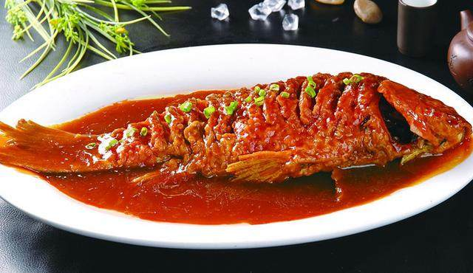

* Braised carp: a dish demonstrative of Chinese people’s consumption of fish (source: Google)

After the collapse of the last ruling imperial dynasty of China---Qing which happened in the early 20th century, Beijing was still a city brimful of abundant aquatic species owing to various celebrities who resided there, albeit fresh sea food had still no been commonly consumed by local folks because of the cost. Later on, influenced by a long and harsh period of time wreaked by wars and political disorders, Beijing, as well as most inland cities in China, had not been able to embrace a flourishing market of aquatic products. The Chinese economic reform, starting from the late 1970s, literally marked a watershed in the aquatic market in Beijing. With the introduction of further advanced fishery techniques, and the development of logistics, aquatic products have finally been able to the part of most citizens’ quotidian existence, no matter whether they are freshwater or marine, and either fresh or frozen. Nowadays, most aquatic products are already far from being prohibitive, and have been accepted as a comparatively healthier nutrition source by increasing numbers of citizens year by year.

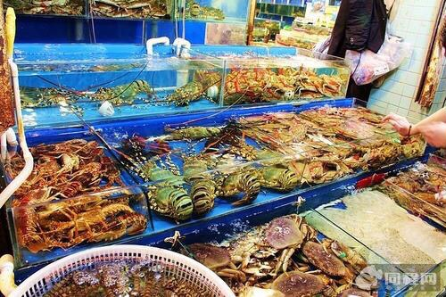

* The flourishing aquatic market in Beijing nowadays (source: Baidu)

As a city enjoying paramount importance from multiple dimensions, such as politics and finance, London has been a metropolis where different cultures have been gathering in conjecture for centuries. When it comes to English modes of consuming aquatic products, fish and chips, broadly deemed, is emblematic of both fish consumption and English cuisine in general. Originating in England, this dish has its two components introduced from separate immigrant cultures: Iberian Jewish fried fish with Belgian fried potatoes. Rather, being typical of even the whole British food culture, fish and chips shoulder the major part of the fish consumption history in the UK, and has already been an irreplaceable existence in the life of the British.

Influenced by the long-standing Roman Catholic tradition of having Fridays meat-free, and the relatively higher price of red meat, numberless British people took fish and chips as the major surrogate for meat owing to its irresistible merits: palatable, easy to cook, rich in energy, more affordable, and posing no violation to the doctrine. From a specific point of view, this aforementioned religious taboo boosted the proliferation of the catering industry specializing fish and chips. Focusing on cod as the major original material, the fried fish encompasses a diverse variety of fish species which can be cook in the same way, such as halibut, haddock, and sole fish. Since 1870s, fish and chips, by taking advantage of the industrial revolution, had gradually stepped into innumerable families as a comparatively more economic staple dish abundant in nutrition, which guaranteed both the basic dietary and gustatory needs of those belonging to working class and the families of lower income levels.

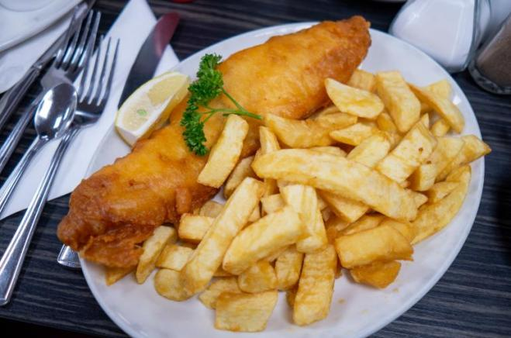

* Fish and chips, photoed by Matthias Mackel, 17.11.2018

Further, fish and chips had even constituted a dish of patriotism. It was one of the only few food sources which were free from the limitation of food rations during the two world wars in Britain. Aside from being the staple food of most civilians, fish and chips also played an integral role in the diets of millions of British soldiers, which was the reason why it was described as a “good mate (friend)” for the British by Winston Churchill. Witnessing almost two centuries of history, fish and chips has already become a classic element which is embedded indelibly in the memories of the British, a national dish regardless of consumers’ social classes, and a symbol of British culture into the bargain.

Of course, there are also other aquatic species which have their firm positions in British food cultural system. Estimated by the British government in 1910 as the most important industry in the world, oyster has a shorter but more “strenuous” history in London comparing to fish and chips. Interestingly, oysters had been reckoned as the food for the needy for a rather long period of time from the middle of the 19th century to the end of the Second World War owing to the common food safety incidents, albeit it was actually wreaked by the polluted water other than oysters themselves. Nowadays, succulent exotic oysters are already embraced as a sumptuous delicacy on the table of the wealthy, as well as other imported luxurious aquatic species.

Generally, starting from Billingsgate Fish Market which was the largest fish market in the world in the 19th century, the aquatic market in London has never waned itself, albeit the massive consumption of aquatic products, together with abundant species, has come into existence since the middle of the 20th century. In actuality, the proliferation of aquatic industry in London, as well as its counterpart in Beijing, was also mainly begotten by: 1, further advanced fishery techniques which has largely promoted the totally supply and lowered down the cost in general; 2, increasingly efficient logistics system which has fundamentally enriched the aquatic species available to consumers; 3, the influx of migrants with different cultural backgrounds which has basically enlivened the indigenous monotonous cuisines for preparing aquatic products, such as those from China, Indian, Japan, etc.



* Billingsgate fish market (source: Zhihu)

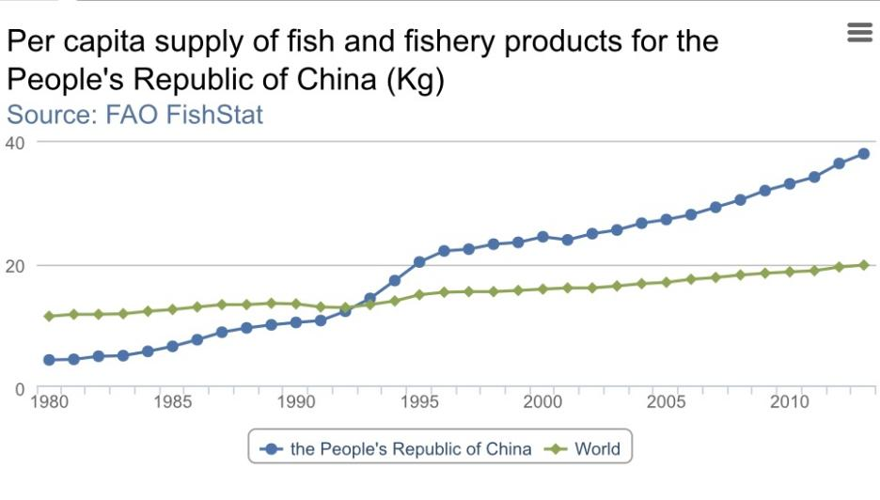

**Figure 1.1. Source: UN Food and Agriculture Organization (FAO)**

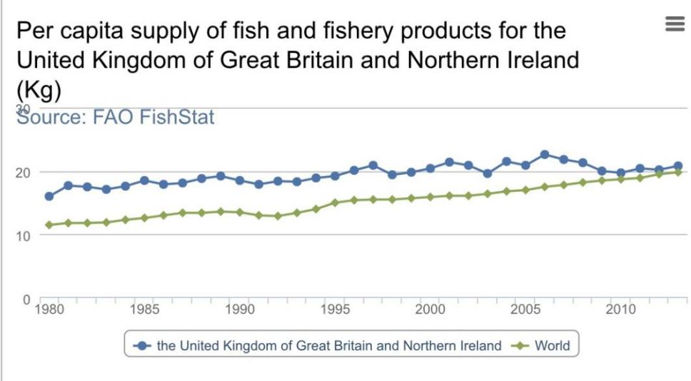

**Figure 1.2. Source: UN Food and Agriculture Organization (FAO)**

Moving to the 21th century, as Figure 1.1 and Figure 1.2 depict, until 2013, the per capita supply of the fish and fishery products for the UK was about 20.30 kg, while the supply for China nudged 37.90 kg per capita. In a word, the per capita supply of the fish and fishery products for either the UK or China is higher than the world’s average level. Specifically, there has been a significant in the growth of per capita fish and fishery products supply for China since 1980.

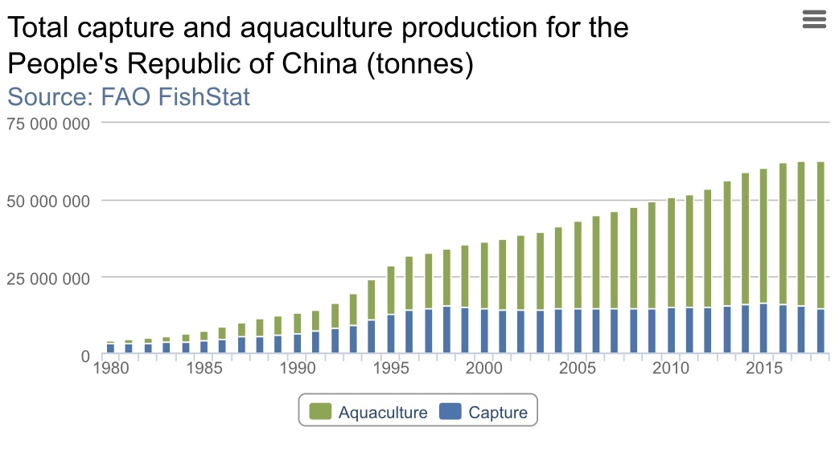

**Figure 1.3. Source: UN Food and Agriculture Organization (FAO)**

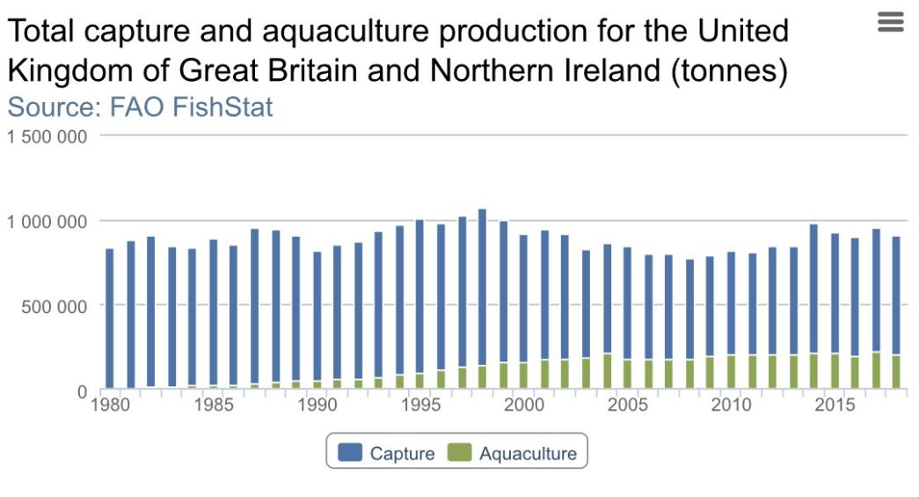

**Figure 1.4. Source: UN Food and Agriculture Organization (FAO)**

Starting from 2002, the gross amount of aquaculture production in China has been in the leading position in the whole world. Both China and the UK are the major aquaculture countries worldwide. However, as Figure 1.3 and Figure 1.4 demonstrate, the generality of the production of fish and fishery productions in China are from aquaculture practices, whereas the generality of the production in the UK are conversely acquired from capturing. Hence, a distinctive difference between China and the UK from the facet of fishery production is the proportion ratio of captured aquatic products to those acquired from aquaculture practices.

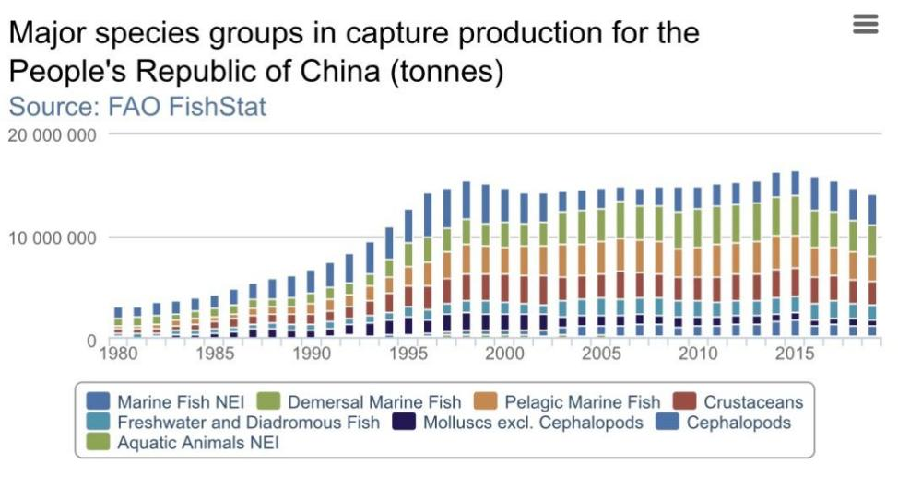

**Figure 1.5. Source: UN Food and Agriculture Organization (FAO)**

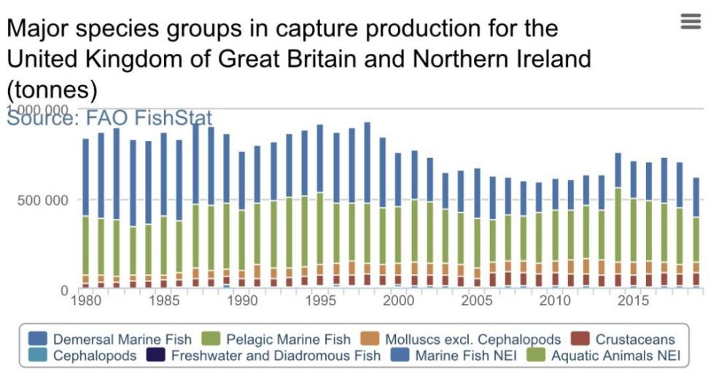

**Figure 1.6. Source: UN Food and Agriculture Organization (FAO)**

Comparing figure 1.5. with figure 1.6., we can find two evident distinctions among the major aquatic species produced in China and the UK: 1, demersal marine fish and pelagic marine fish enjoy a comparatively much larger proportion in the gross capture production amount for the UK, significantly dwarfing all the rest species captured, whereas fish is also a major part of aquaculture capture production for China, albeit being evidently less dominant; 2, comparing to the UK, China enjoys a further abundance in the major species groups in capture production, while the disparity among different species by production amount is comparatively smaller either. In a word, fish appears to be a significantly integral part in the production of aquatic products in the UK, while further abundant species with a less obvious difference among each other by amount tends to be the major trait of the aquatic production in China.

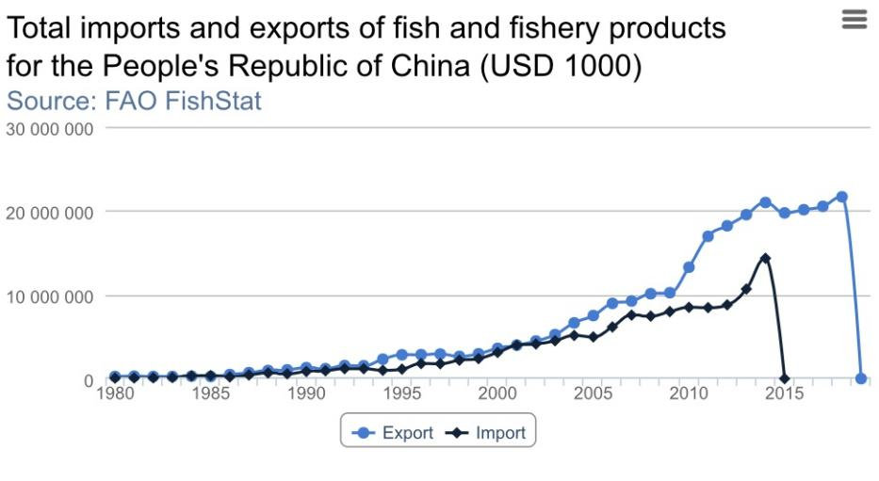

**Figure 1.7. Source: UN Food and Agriculture Organization (FAO)**

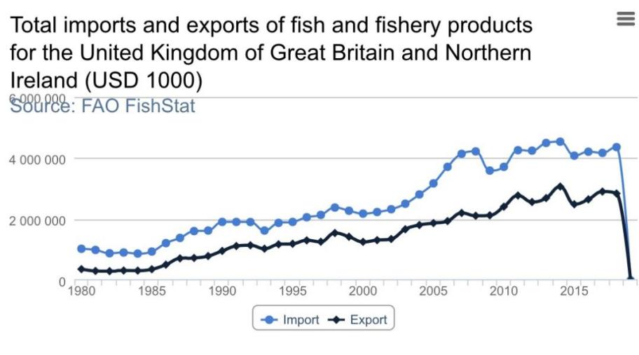

**Figure 1.8. Source: UN Food and Agriculture Organization (FAO)**

As Figure 1.5 and Figure 1.6 indicate, although both having a totally massive amount of importing and exporting, there is an obvious discrepancy between China and the UK. While China has been exporting obtrusively more than importing, the UK, however, has been importing apparently more than exporting. From a certain point, the information above shows that a higher level of self-reliance is seen in the aquaculture industry in China.

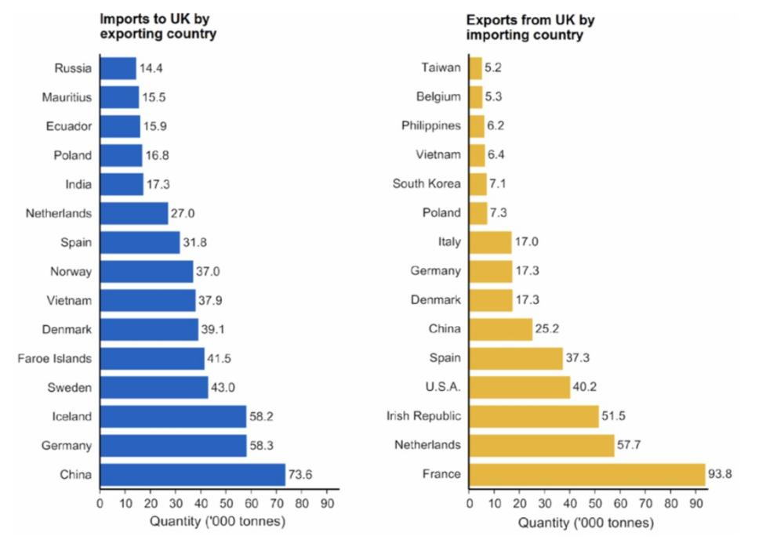

**Figure 1.9. Source: UK Sea Fisheries Statistics 2019**

Interestingly, until 2019, China has become the UK’s largest exporting country in the field of fish and fishery products and significantly outnumbered other exporting countries in the amount.

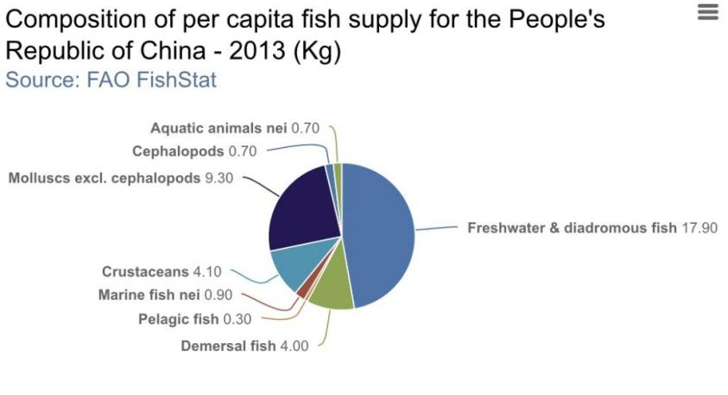

**Figure 1.10. Source: UN Food and Agriculture Organization (FAO)**

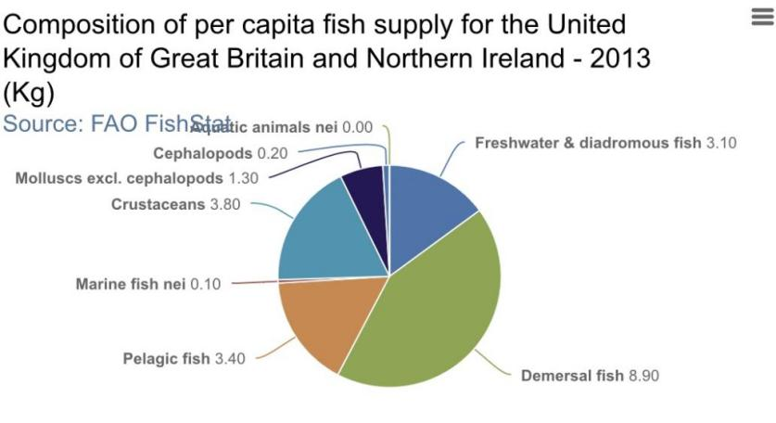

**Figure 1.11. Source: UN Food and Agriculture Organization (FAO)**

According to Figure 1.8 and Figure 1.9, except the difference in the per capita supply by amount, the compositions of the supplies in China and the UK also differ from each other. As for the composition of the supply in China, freshwater & diadromous fish takes the majority, whereas demersal fish occupies the generality of the supply in the UK. Further, other fishery products such as crustaceans and shellfish have also taken a comparatively larger proportion in the per capita supply for China, while various fish species in the UK, instead, still hold the relatively largest part of the whole per capita supply.

With the social developments achieved in both China and the UK in recent years, aquatic products, broadly deemed to be a healthier and more nutritious food source which should play an integral role in diet, have been gaining further attention from innumerable consumers. Chasing for a healthier style of life, consumers do not merely focus on the quantity of food consumption, but rather the quality of food to a further higher degree. During this process, the change of the demand for aquatic products appears to be significant. Hence, the analysis of the factors affecting the consumption and production of aquatic products is of vital importance, if we wish to further stimulate consumers’ demand for aquatic products and expand the scales of the existing aquatic markets in both London and Beijing.

**2. Literature Review**

Before starting the further review of previous works, it behooves us to have a clear comprehension of the definitions of both aquatic products and socioeconomic factors.

**2.1. Aquatic Product**

According to the definition of “Law Insider Dictionary”, aquatic products refer to *any food or fiber products obtained through the practice of the aquaculture, including mariculture; or by harvest from the sea when such products are cultured or landed in this state. Such products include but are not limited to fish, shellfish, seaweed or other water based plant life*. However, from of point of consumption, most scholars focus on the purchase and eating of: fish, shellfish, crustacean (e.g. crab, shrimp), cephalopoda (e.g. squid), and aquatic plants. Hence, this paper will also mainly concentrate on the consumption of these aforementioned types.

**2.2 Socioeconomic Factor**

Rather, the definition of socioeconomic factors varies when it comes to different contexts in which it is mentioned. From the facet of consumption, especially the food one, John Adrian and Raymond Daniel (1976) suggest that it mainly encompasses education, family size, income, age, marital status, and gender. Further, Gao Jintian (2013) and Liu Haosen (2003) point out that the degree of urbanization, culture, and the prices of other major food sources would also impact on the consumption of aquatic products. In additional, different researchers have also more or less delved into other socioeconomic factors considering consumption such as processing, modes of selling, etc. Last but not least, when it comes to consumers belonging to higher social classes or of the income level significantly above the average, we should not neglect a probable causal reason of consuming luxurious aquatic products and making it a fad: demonstrative consumption. Coined by the Norwegian-American economist and sociologist Thorstein Veblen in his book *The Theory of the Leisure Class* in 1899, demonstrative consumption, or as conspicuous consumption, refers to consumers who buy sumptuous items to display their wealthy and sometimes even social status other than to gratify their real needs. In other words, what these luxurious items can symbolize eclipses what they can actually be made use of. Functioning as a token of wealth, prohibitive aquatic products, such as abalone and sea cucumber, have not only been chosen by the rich and middle classes to denote their wealth, but also occasionally opted for as a decent type of gift. Hence, while studying the consumption modes of consumers, especially concerning consumption habit and expenditure, we should also not overlook the motivation hidden behind their purchases, or in other words, whether they have influenced others to purchase, or conversely, being influenced into consume. In this paper, we will discuss the influence of various socioeconomic factors including: gender, family size, education level, urbanization, age, income, marital status, processing, culture (especially food culture), surrogate food sources, occupation, and the development of technology in terms of logistic and the Internet.

**2.3. Relevant Theories and Research**

**2.3.1. Income Theories**

1). Absolute Income Hypothesis:This theory is part of the classic consumption theories proposed by John Maynard Keynes. According to Keynes, the level of consumption rises concurrently when income rises, albeit not necessarily at the same rate. The model can be lucidly depicted by the following equation: C (consumption at time) = α (autonomous consumption) + β (marginal propensity to consume, 0<β<1)Y (income at time). This idea is usefully applied in this study as to consumption and production. With the increment of disposable income in the last decade, the general folk attitude to food consumption has also more or less changed, and citizens are already not simply focusing on basic needs of nutrition. Broadly deemed to be a pricier and healthier source of nutrition, aquatic products have gradually been taken into the daily diet of most families, which has also stimulated the proliferation of aquatic markets---ranging from domestic products to imported goods. In a word, the increased disposable income has made aquatic products more affordable for citizens, and both the quality of quantity of consumption have consequently increased, which directly results in further vitalization of aquatic markets. As a result, the disposable income at time, in some cases, can be a decisive factor affecting consumption demand at time.

Meanwhile, the marginal propensity to consume is practically applied in Keynes’ consumption theory as a metric qualifying induced consumption---consumption occurs with an increment in income and is not higher than this increase. On the other hand, the higher the extra income increases, the lower the propensity to consume goes. Instead, a larger proportion of money is saved, rather than being spent. Predictably, consumers are far from willing to squander all the disposable income in merely a basic aspect---food, and this is clearly reflected in part of the collected empirical data. Comparing with the growth rate of disposable income, the increased rate in both the consumption and production is relatively lower, for it would be politic to have the amount of saving increased as a precaution for countering possible risks. Further, the growth rate of consumption amount among the wealthy is apparently lower than that of the less-wealthy, as the basic means of livelihood enjoy a relatively smaller portion in the gross income of the wealthy, which partly explains the reason why the increased amount of aquatic products consumption is actually lower among the wealthy.

2). Relative Income Hypothesis: Suggested and developed by James Duesenberry, this hypothesis states that an individual’s attitude to consumption and saving is dictated more by his income in relation to others instead of by abstract standard of living, and neither simple absolute income. Unlike what the absolute income hypothesis insists, the relative income hypothesis suggests that the present consumption level is also influenced by the peak consumption level ascended previously. In other words, it is not easy for a family to lower its consumption level once ever attained. Hence, current consumption levels, in this way, may scarcely be fully determined by the income at time, and a comparison to the previous peak income is always made. This concept is particularly helpful for explaining the consumption situation during economic recession, such as the recent one wreaked by the COVID-19 pandemic, when consumption levels do not simultaneously reduce as income does. Consumption, considered from particular aspects, is a chronic habit than merely a basic need or irrational desire. Consumers are still prone to consume in the way they were previously given to, even if the current income is certainly lower than the peak level once reached. This phenomenon is termed “ratcheting effect”, which proves the stability of consumption and its positive role of consumption in maintaining economic stability. The change of consumption usually appears later than that of income, for consumers are willing to sacrifice part of saving in order to keep their previous consumption levels, at least in a short period of time. Corroborated by part of obtained empirical data of the consumption in Beijing, this theory is explained by this phenomenon: the consumption of aquatic products and other nutrition sources would remain relatively stable, when the general living cost (especially housing price) has increased tremendously over the past one decade. Although the general housing price has been boosted (wage in comparison increased by a much lower ratio), the amount of consumption in particular aspects remains stable, as consumers can hardly drop down their levels of consumption suddenly, though it is not the only decisive reason.

Further, the questions listed in the author’s questionnaire on the motivation of purchasing aquatic products can be elaborated by another concept coming together within the relative income hypothesis---demonstrative effect. Considered to be typical social behavior, consumption is ineluctably more or less impacted by social relations among consumers and their behavior. Hence, an individual’s consumption level is not only influenced by the absolute income level, but also dictated by the consumption levels of others around. In this way, Bandwagon effect, predictably, comes into existence among consumers. Once a sudden increment of aquatic products consumption is observed among the families that were not wont to consume aquatic products previously, this relatively new nutrition source can possibly be reckoned to be a fashion no matter in consideration of health awareness or wealth-showing. To be accurate, some consumers do not make aquatic products a part of their quotidian existence, especially the exotic one, in the light of habit, but more for comparing with or even imitating other consumers who enjoy similar income levels. Generally, this notion does not only help the author to have a deeper insight of consumption demand affected by income, but also a psycho-sociological facet from which consumers’ motivation can be further delved into.

3). Permanent Income Hypothesis: Firstly developed by Milton Friedman, this hypothesis contradicts Keynes’ absolute income hypothesis. It hypothesizes that an individual’s consumption at a point in time is dictated not just by their current income but also by the income expected (predictable) in future years---as the “permanent income”. Broadly agreed, income comprises mainly two parts: a permanent one, and a transitory one (such as awards, extra remuneration). In the model of permanent income hypothesis, the transitory income is not the determinant of consumption. Conversely, only the income predicted within a long period of time in the future brings more powerful impacts on consumption. How can the permanent income of an individual be possibly predicted? Usually, it is determined by an individual’s assets: immovable property (houses, cars, businesses such as companies), movable property (bank balance, cash, share stock, flexible investment), and immaterial property (education, experience, particular skills). These factors influence both a consumer’s ability in earning money and the willingness to save money. In this way, stimulating consumption by simply reducing taxes may not work for some consumers, because the increased income from the reduced taxes may not be immediately used in consumption. By analyzing part of the empirical data collected from both Beijing and London, especially that about younger generations, this theory has been partially tested: pressured by the consistently increasing housing price, some young people have not increased their levels of consumption with the increased income levels. The explication can be: as what they can predict, the ratio of housing price to the increase in income will still be increasing in the predictable future years, hence, it will be politic to have more money saved for buying houses instead of wasting them imprudently.

1. . Life-cycle hypothesis also draws another conclusion: the proportions of different age groups in a society will affect the total consumption and savings. For example, if the proportion of both young people and senior citizens in the society is larger, the consumption propensity will be higher and the saving tendency will be lower; if the proportion of middle-aged people outnumbers that of any of the rest age groups, the saving tendency will be higher and the consumption tendency will be lower. As what is shown in the gleaned data of consumption and saving, generally both the younger and elder generations tend to consume relatively more, though dictated by different reasons that younger generations consume more because their savings on average appear to be less than what has been spent in consumption, and elder generations, in contrast, readily consume more and save less from income because they have already had enough money saved. And the middle-aged generations, burdening multiple economic pressures such as loan, family expense, and the education of offspring, are more likely to save more by even sacrificing part of consumption, for no matter whether the income in future times and expenditures remain equally unpredictable.

**2.3.2. Sociology of Food and Taste**

As a study of food, sociology of food comprises multiple components including: cooking methods, production, consumption, distribution, conflict, medical application, food safety policies, ritual, spiritual, ethical, and cultural factors, and also labor and environmental issues. As for the author’s dissertation which is related to consumption and production of aquatic products, specific attention should be paid to cooking method, cultural factors, food supply chain, and the exchange of markets. Considering the role of food from sociological aspects, food itself can denote something greater than simply a source of nutrition. By bringing people together and connecting them at multiple levels, food, on the one hand, stands for the culture and uniqueness of particular ethnic groups which are significant in the study of sociology; on the other hand, it pertains to conflict theory as it is an integral part of living, which can be further delved into in order to have a clearer view of the respective occupation, saving, and consumption patterns, etc. Meanwhile, from the perspective of psychology, food is no more simply a source of nutrition, but also a kind of attitude, and a token of life quality. According to Pierre Bourdieu’s theory of capital and social distinction theory, food, as a component of one’s general taste, is an important factor in reflecting one’s social class, as what a person eats, in certain cases, denotes who this person is. By analyzing some crucial socioeconomic factors such as education, people of higher education level tend to possess a higher level of health awareness and pursue higher life quality. Pricier and nutritious food such as aquatic products (especially the sumptuous one) are gradually being consumed and deemed to be a manifestation of healthy life and wealth (especially for some Chinese consumers), which may be unexpectedly linked to expenditures and saving under particular motivations of consumption, for they are not only something newly needed, but also a factor which can possible influence the diet tradition of particular families.

Further, as food cultures in both China and the UK enjoy relatively long histories, the influence of cultural factor, as a part of socioeconomic factors, can be further understood by reading the histories, developments, and changes of food in these two countries. In this way, the impact of both cultural and socioeconomic factors affecting food consumption can be further explored. Moreover, by considering the status of food in history, and its vulnerability to external factors such as exotic elements to a certain extent, a tendency of the development of food markets in the aforementioned countries can be feasibly foreseen, for cultural and traditional factors usually appear to be firmer and more stable comparing with other factors, such as income.

In addition, both of the domestic and foreign cooking methods deserve our attention while studying consumption. Domestic cooking methods, as a type of tradition, decidedly influence the major amount of food consumption in most known cases, as they are already part of our daily life “handed down” from generations to generations. Foreign cooking methods, such as western cooking methods which have become popular in major cities in China, increase the varieties of food consumption and promote the prosperity of imported aquatic products in China. On the one hand, driven by curiosity, consumers pursuing fashion are willing to have something new, especially when it comes to food “fanatics”. On the other hand, considered to be a new and higher quality of life, consumers of higher income levels do not mind to try these exotic products and even have them assimilated to their daily diets, which corroborates a type of consumption motivation mentioned before---demonstrative effect.

Considered to be a complicated factor as to choice and preference, taste is firmly associated to social relations and dynamics among people, which is also somewhat linked to consumption from the point of relative income hypothesis. Therefore, the concept of social taste is usually associated with its accompanying sociological concepts. Also, understanding taste as something expressed in behavior between people helps us to observe particular social phenomena which are unobtrusive from other dimensions.

Arguably, preferences and choices of taste in various cultural milieus are connected with education, social origin, and income. Hence, different socioeconomic groups can be generally differentiated by their taste preferences exhibited. As we have mentioned before that socioeconomic factors can affect the consumption driven by taste, taste, by thinking in turn, can also stand for the social class it belongs to. By analyzing the choices and preference shown in consumption activities, consumers’ social classes can be postulated, which helps us to understand the role of socioeconomic factors from a relatively more comprehensive aspect, instead of simply considering the relation between consumption and income, education, or tradition, for consumption dictated by taste is a rather complicated issue with the combination of different factors which are either decisive or indirectly causal. To conclude, sociology of taste dose not only provide us a comprehensive reference within which multiple socioeconomic factors are mingled, but also a deep insight into the motivation of consumption which can not always be directly reflected in socioeconomic factors, but is indeed influence by them.

Lastly, what else can food bring to us except physical satisfaction does matter: symbolic meaning. Sign-value, as a theory suggested by Jean Baudrillard in his book *The Consumer Society: Myths and Structures* (1970), can even make function-value pale in comparison sometimes. In other words, we do not simply consume an item out of its functional use, but in some cases more like a symbol. To explicate this theory, we may use a prohibitive Tasmanian giant crab as an example. Essentially, consuming this crab would lead the consumer to gustatory pleasure, if it is consumed by this person alone. However, if this crab appears in, for instance, a business banquet, or this consumer’s Facebook profile, anywhere its value can be understood by any others, it would represent how moneyed this person is other than how pleasurable he/she is after enjoying this delectable dish---no one can ever possibly estimate. Thus, the crab in this case functions more like a symbol rather than simply an edible item, and this is probably the reason why it is consumed: what it can display instead of what it tastes like. By looking back to the history of food consumption, there have already been innumerable aquatic products functioning as the symbol of wealth and high social class in either China or Britain. Equally, what certain food can stand for nowadays also deserves our attention if we wish to delve further into the consumption of them.

In general, as far as the author reckons by concluding all the theories related to sociology of food and taste, food, explicated lucidly, can bring people together and differentiate them from each other concurrently.

**2.3.3. Current Research Situation**

Considering the factors affecting the consumption of aquatic products in China, different researchers have different focuses shown in their research. Radolfo M. Nayga and Oral Capps (1993), Gao Jintian (2013) and Liu Haosen (2003) suggested that the degree of urbanization, the development of market, culture, income, and the price of other surrogate and staple food sources could lay a powerful impact on the consumption of aquatic products. Further, they have also concluded that with the increase in the total consumption amount, the structure would also be reshaped. For example, the increment in the demand for marine fish and fishery product would be more significant than that for freshwater fish. When it comes to the correlation between income and the demand for food, Meng Fanying (2010) reached the following conclusion: during the recent 20 years in China, people’s demand for grains and staple food such as rice and flour has been waning; the demand for fresh fruit and vegetable remained relatively stable; and there has been a gradual increment in the demand for aquatic products, meat and poultry.

Based on the studies of different regions in China, Sun Chen (2015) has pointed out in his research that consumers’ demand for aquatic products would vary tremendously owing to the differences in geographical features and cultural traditions. For example, the consumers in Shanghai were more likely to purchase aquatic products due to both consumption habits and the geographical edges, whereas the consumers in Beijing would prefer to consume more meat such as beef and mutton owing to the local food traditions.

As for the influence of family size in affecting the consumption of aquatic products, Huang and Bouis (1996), and Abdulai (1999) has stated that in the families containing relatively more members, the increase in the demand for the less expensive food such as vegetable and grains would be comparatively higher than that for the pricier food such as meat and aquatic products. Hence, the correlation between family size and the gross amount of food consumption would be positive, but whether family size would be positive correlated with the consumption amount of aquatic products, according to the research of different scholars, is still questionable.

A consensus on whether education level is positively correlated with the consumption of aquatic products has still not been reached. Occasionally, the higher the education level is, the more aquatic products are consumed. For example, Yuan Rong (1997) and Abdulai (1999) proposed in their research that the consumers enjoying higher education level would prefer to consume relatively more aquatic products driven by health awareness. However, with the development of science of technology, the knowledge about health and education is not sole to school education, as there are increasing numbers of channels through which the concepts of healthy diets can be acquired. Hence, whether education level is still positively correlated with the consumption of healthy food such as aquatic products remains unclear.

The influence of age on the consumption of aquatic products is yet contentious. Radolfo M. Nayga and Oral Capps (1993) concluded that age significantly impacted on the consumption of aquatic products. However, Magnusson (1996) thought that the correlation between age and aquatic product consumption was negative, as the younger generation arguably possessed further positive attitude to aquatic products driven by both curiosity and health awareness.

From the point of gender, Govindasamy (1998) and O’Donovan (2002) concluded that females would be more likely to purchase aquatic products owing to both the concern for the health of family members, and their family role, whereas Thompson (1998) found in his research that gender was not necessarily connected with the consumption of aquatic products. Qing Ping (2006) has also disclosed the similar result in his research.

The role of occupation in affecting the consumption of aquatic products, according to Flynn (1994) and Zeng Yinchu (2004), would be influential to a certain extent if it is related to the work industry such as education, science, medicine, and catering.

Duan Hongmei (2007) suggested that convenient processing status such as ready-to-eat food would arguably become more popular in major cities. Limited by both time and the possible inconvenience in cooking, there would be an increasing number of consumers having instant aquatic products as part of their diets.

In addition, other factors such as marital status and different modes of purchase have also been explored in different research.

1. **Hypothesis and Research Method**

**3.1. Hypothesis**

**3.1.1. Demographic Factor**

According to the available previous articles, researchers possess different opinions on the correlation between demographic factors and the consumption of aquatic products. By common consent, income, marital status, and family size are more or less associated with the consumption of aquatic products, but gender, education, occupation, and age are not significantly influential to consumption. The possible reasons can be: 1. the species of aquatic products vary, and different consumers may have various attitudes to different aquatic species; 2. the previous research focused on the consumers from different regions in either China or the UK. Driven by both cultural and economic differences, consumers’ behavior of purchase would also be affected from different degrees. This research will focus on the residents in Beijing and London, considering the major influential demographic factors explored by previous researchers, the hypotheses are:

H1: Demographic factors are influential in affecting the consumption of aquatic products

H1-1: age is an influential factor affecting the consumption of aquatic products

H1-2: family size is an influential factor affecting the consumption of aquatic products

H1-3: occupation/work industry is an influential factor affecting the consumption of aquatic products

H1-4: education is an influential factor affecting the consumption of aquatic products

H1-5: gender is an influential factor affecting the consumption of aquatic products

H1-6: marital status is an influential factor affecting the consumption of aquatic products

H1-7: religion is an influential factor affecting the consumption of aquatic products

**3.1.2. Cooking Methods**

Most scholars deem cooking methods to be an influential factor affecting the consumption of numerous food resources. With multiple cooking methods given, consumers are more likely to consume what are originally new for them by using suitable cooking methods. Meanwhile, each country has its unique food culture system as a part of its traditional cultural elements. In this way, our hypotheses are:

H2: Cooking methods are an influential factor affecting the consumption of aquatic products

H2-1: Traditional food culture in terms of cooking methods is an influential factor affecting the consumption of aquatic products

**3.1.3. Online Videos/V-logs**

With the proliferation of the online videos/V-logs about trying aquatic products, there are increasing numbers of viewers who have shown their interest in aquatic products, and some of them have even expressed their willingness of trying the aquatic products mentioned in these videos. Although there is still not sufficient research exploring the influence of these videos on the consumption of aquatic products, we may still have our hypothesis:

H3: Online videos/V-logs can be an influential factor affecting the consumption of aquatic products

**3.1.4. Online Shopping**

Many researchers have deeply explored the factors influencing consumers’ decision making while shopping online, but the role of online shopping in shaping the consumption pattern of aquatic products appears to be less clear hitherto. In this way, our hypothesis is:

H4: Online shopping is an influential factor affecting the consumption of aquatic products

Further, the extent to which online shopping influences the consumption of aquatic products will be also explored in this paper.

**3.1.5. Surrogate and Staple Food**

Innumerable research has shown that there is always an interplay among the consumption of aquatic products and other food sources. Previous researchers mostly focused on the consumption balance between aquatic products and: red meat (pork, beef, lamb/mutton), poultry, egg, dairy, rice, flour, and other grains. In this way, we may also have the following hypotheses:

H5: the increment in the price of surrogate/staple food is an influential factor affecting the consumption of aquatic products

H5-1: the increment in the price of pork is an influential factor affecting the consumption of aquatic products

H5-2: the increment in the price of beef is an influential factor affecting the consumption of aquatic products

H5-3: the increment in the price of lamb/mutton is an influential factor affecting the consumption of aquatic products

H5-4: the increment in the price of poultry is an influential factor affecting the consumption of aquatic products

H5-5: the increment in the price of eggs is an influential factor affecting the consumption of aquatic products

H5-6: the increment in the price of dairy is an influential factor affecting the consumption of aquatic products

H5-7: the increment in the price of rice is an influential factor affecting the consumption of aquatic products

H5-8: the increment in the price of flour is an influential factor affecting the consumption of aquatic products

H5-9: the increment in the price of other grains is an influential factor affecting the consumption of aquatic products

**3.1.6. Urbanization**

Pointed out by many researchers, urbanization, in terms of logistics and vending modes, is rather influential in boosting the aquatic industry and stimulating the consumption demand for aquatic products. As both metropolises and capital cities, Beijing and London enjoy a high level of urbanization, with the flourishing aquatic markets which are seen in each city. Here the hypothesis is:

H6: urbanization is an influential factor affecting the consumption of aquatic products

**3.1.7. Ready-to-eat Aquatic Products**

Although there are already numerous scholars who have rather in-depth insights into the role of processing status in food consumption, the instant type, especially when it comes to aquatic products, is still a relatively new topic. Considering the instant aquatic products such as in the form of snacks which are currently rather popular in China, we may have the following hypothesis;

H7: ready-to-eat aquatic products appear to be a processing mode which is influential in affecting the consumption of aquatic products.

**3.2. Methodology**

In order to have a more in-depth insight into the factors affecting aquatic products purchase, ways of cooking, and consumption pattern for citizens in Beijing and London, an exploratory survey with sampling methods was adopted. The result disclosed the cultural, socioeconomic determinants and food security policies involved in aquatic products consumption in the aforementioned two cities.  
  
The survey was conducted in the form of an online questionnaire. The questionnaire encompassed three sections altogether with 44 questions, and was minutely checked for the possible bias in translation since it was made in English and Chinese.   
  
**3.2.1. Administration of Survey**  
The questionnaire was transformed into a link via an online questionnaire platform named “Wenjuanxing” and sent to the participants who have agreed to partake in this survey. In order to make sure that the informants must be the residents in Beijing/London, a limit on users’ IP address was set. After everything was well prepared, the questionnaire was administered to a total of 450 respondents, and they were chosen by means of a multistage random sampling technique. At the end, the response rate was 97.33%, which means that totally 438 respondents filled in the given questionnaire, with 404 pieces credible answered questionnaires left after careful selection. Among those who responded to the survey were 188 (46.53%) men and 216 (53.47%) women. Most of the informants were freelancers, businessmen, and others working in various fields. There was also a number of college students doing different educational programmes, such as bachelor programmes and master programmes. A total of nearly two months of response time was given from the day the questionnaire had been given out by the investigator after receiving the permission from all the participants.  
  
**3.2.2. Data Handling and Statistical Analysis**  
The collected data were entered in a database and exported to “IBM SPSS (Statistical Product and Service Solution) Statistics” for further analysis. Double checking was done to ensure the possible minimal data entry bias. The survey was analyzed by using descriptive and inferential statistics. The results of analyzed data were expressed in the form of table.

**4. Descriptive Analysis**

In this chapter, the results of empirical research will be presented in an exhaustive way. The first part of this chapter gives an introduction to the process of empirical research, including the questionnaire design and research methods. Then, the results as to the situation of purchase and consumption, purchase modes, and demographic features will be described in a detailed way.

**4.1. Research Process**

**4.1.1. Questionnaire Design**

By combining previous theories with hypothesis, a sketchy first version of the questionnaire was designed. Later, after a pilot study which was done with a small number of informants, the questionnaire was further refined from the aspects of logic, layout, and appropriate use of words.

The questionnaire encompasses three parts. The first part is an adumbrated introduction of the research, with the protection of informants’ privacy included. The second part is the major content of the questionnaire, it is further divided into three sub-sectors: the first sub-sector is given to the general situation of purchase and consumption, containing seven questions; the second sub-sector contains the questions related to consumers’ recognition and opinions of domestic & imported aquatic products, and the factors affecting consumers’ preference, containing eight questions; the last sub-sector lists out various factors influencing consumers’ demand for aquatic products, such as cultural factors, urbanization, family size, education, containing 29 questions. The gratitude to informants is included in the third part.

In addition, funded by several online retailers altogether, this questionnaire contains more questions than what the goal of this research needs. Hence, we will center on the questions which are germane to the theme of this paper.

**4.1.2. Method and Process of Survey**

The survey took grossly three months to finish, which was relatively a long period of time, for there were only five members including the author himself in the survey team. The whole process of the survey can be divided into two stages. The first stage ranged from 07. 2020 to 08. 2020, during this period of time, the survey team has been looking for the informants as many as possible. The second stage started from the end of August, 2020, and ended at the end of September, 2020, totally 438 pieces of answered questionnaires had been collected at this time stage.

The informants of this survey were randomly chosen from the residents living in Beijing and London, regardless of citizenship, gender, age, and the residential address. The reason why they were chosen randomly, considering the available literature and papers, was that the socioeconomic factors affecting consumption encompassed various elements ranging from ethnicity, environment (in which consumers were born and brought up), education, to even age. Hence, choosing locals alone would not suffice to demonstrate all the possible influential factors in a comprehensive and unbiased way.

Unfortunately, the survey was mostly done in the form of an online questionnaire owing to the pandemic situation. Having the questionnaire designed and imported into an online questionnaire platform named “Wenjuanxing”, the survey team shared the link of questionnaire in both Chinese and English versions to informants from Beijing and London. Before being shared with the link, informants were asked whether they had the habit of consuming aquatic products, if not, they would not be shared with the link in order to not waste their time. Furthermore, each answered questionnaire was scrutinized minutely in consideration of ensuring its credibility. During this process, two major standards were set to differentiate the credible (or useful) and perfunctory answers: 1, the time used for answering, the reasonable minimum time used for answering all the questions, according to what the survey team tested, should be at least six minutes; 2, whether certain answers in the same questionnaire contradict each other. Totally 34 pieces of answered questionnaires, considering the aforementioned two standards, were deemed to be less credible and removed.

**4.2. Population Statistics**

The survey team invited totally 450 informants to partake in the online research, and finally had 438 pieces of answered questionnaires received. At the end, 404 pieces of credible questionnaires were selected for further analysis. Among these 404 pieces of gleaned questionnaires, 104 of them were from London, and the rest 300 were from Beijing. A detailed statistical description of these 404 informants was done from the facets of: age, gender, income, work industry, education level, family size, and marital status. The result is shown below:

**Table 4.1. Population statistics of Beijing**

|  |  |  |  |
| --- | --- | --- | --- |
| Basic feature | Category | Number (people) | Percentage |
| Gender | Male | 135 | 45% |
| Female | 165 | 55% |
| Age (year) | < 15 | 1 | 0.33% |
| 15-20 | 2 | 0.67% |
| 21-25 | 41 | 13.67% |
| 26-30 | 61 | 20.33% |
| 31-35 | 70 | 23.33% |
| 36-40 | 72 | 24% |
| 41-45 | 26 | 8.67% |
| 46-50 | 14 | 4.67% |
| 51-55 | 8 | 2.67% |
| 56-60 | 1 | 0.33% |
| 61-65 | 3 | 1% |
| 66-70 | 1 | 0.33% |
| 71-75 | 0 | 0% |
| 76-80 | 0 | 0% |
| > 80 | 0 | 0% |
| Income (thousand CNY/month) | < 3 | 8 | 2.67% |
| 3-5 | 14 | 4.67% |
| 5-7 | 53 | 17.67% |
| 7-9 | 95 | 31.67% |
| 9-12 | 64 | 21.33% |
| 12-20 | 40 | 13.33% |
| 20-30 | 9 | 3% |
| 30-50 | 9 | 3% |
| 50-100 | 6 | 2% |
| > 100 | 2 | 0.67% |
| Work industry | Education | 38 | 12.67% |
| Art/culture | 20 | 6.67% |
| Entertainment | 15 | 5% |
| Finance/economics | 35 | 11.67% |
| Healthcare/medicine | 41 | 13.67% |
| Industry/manufacturing | 32 | 10.67% |
| Science/technology | 14 | 4.67% |
| Media | 22 | 7.33% |
| Retail/wholesale | 22 | 7.33% |
| IT/Internet | 17 | 5.67% |
| Government/politics | 21 | 7% |
| Students | 10 | 3.33% |
| Other | 3 | 1% |
| Self-employed | 6 | 2% |
| Do not work | 4 | 1.33% |
| Education level | Primary school | 3 | 1% |
| Junior high school | 7 | 2.33% |
| Senior high school | 22 | 7.33% |
| Bachelor | 175 | 58.33% |
| Master | 54 | 18% |
| Ph.D | 18 | 6% |
| Secondary technical school | 11 | 3.67% |
| Junior college | 10 | 3.33% |
| Other | 0 |  |
| Family size (person) | 1 | 17 | 5.67% |
| 2 | 33 | 11% |
| 3 | 145 | 48.33% |
| 4 | 69 | 23% |
| 5 | 23 | 7.67% |
| > 5 | 13 | 4.33% |
| Marital status | Married | 219 | 73% |
| Unmarried | 81 | 27% |

**Table 4.2. Population statistics of London**

|  |  |  |  |
| --- | --- | --- | --- |
| Basic feature | Category | Number (people) | Percentage |
| Gender | Male | 53 | 50.96% |
| Female | 51 | 49.04% |
| Age (year) | < 15 | 6 | 5.77% |
| 15-20 | 7 | 6.73% |
| 21-25 | 9 | 8.65% |
| 26-30 | 5 | 4.81% |
| 31-35 | 10 | 9.62% |
| 36-40 | 8 | 7.69% |
| 41-45 | 4 | 3.85% |
| 46-50 | 9 | 8.65% |
| 51-55 | 4 | 3.85% |
| 56-60 | 9 | 8.65% |
| 61-70 | 12 | 11.54% |
| 71-75 | 6 | 5.77% |
| 76-80 | 9 | 8.65% |
| > 80 | 6 | 5.77% |
| Income (thousand GBP/month) | < 1 | 8 | 7.69% |
| 1-2 | 12 | 11.54% |
| 2-3 | 7 | 6.73% |
| 3-4 | 8 | 7.69% |
| 4-5 | 16 | 15.38% |
| 5-6 | 6 | 5.77% |
| 6-7 | 4 | 3.85% |
| 7-8 | 7 | 6.73% |
| 8-9 | 3 | 2.88% |
| 9-10 | 4 | 3.85% |
| 10-15 | 3 | 2.88% |
| 15-20 | 8 | 7.69 |
| 20-30 | 4 | 3.85% |
| 30-40 | 4 | 3.85% |
| 40-50 | 5 | 4.81% |
| > 50 | 5 | 4.81% |
| Work industry | Education | 15 | 14.42% |
| Art/culture | 5 | 4.81% |
| Entertainment | 3 | 2.88% |
| Finance/economics | 6 | 5.77% |
| Healthcare/medicine | 4 | 3.85% |
| Industry/manufacturing | 6 | 5.77% |
| Science/technology | 5 | 4.81% |
| Media | 5 | 4.81% |
| Retail/wholesale | 7 | 6.73% |
| IT/Internet | 5 | 4.81% |
| Government/politics | 8 | 7.69% |
| Students | 10 | 9.62% |
| Other | 10 | 9.62% |
| Self-employed | 9 | 8.65% |
| Do not work | 6 | 5.77% |
| Education level | Primary school | 27 | 25.96% |
| Junior high school | 22 | 21.15% |
| Senior high school | 1 | 0.96% |
| Bachelor | 23 | 22.12% |
| Master | 14 | 13.46% |
| Ph.D | 0 | 0% |
| Vocational schools | 9 | 8.65% |
| Other | 8 | 7.69 |
| Family size (person) | 1 | 1 | 0.96% |
| 2 | 18 | 17.31% |
| 3 | 29 | 27.88% |
| 4 | 19 | 18.27% |
| 5 | 12 | 12.5% |
| > 5 | 24 | 23.08% |
| Marital status | Married | 71 | 68.27% |
| Unmarried | 33 | 31.73% |

Gender: generally, the ratio of male to female informants from London is 53 : 51, which means that the questionnaires were almost equally distributed from the aspect of gender. The ratio of male to female informants from Beijing is 136 : 165, which seems to be comparatively less even than the London’s, but it does not appear to be an evident discrepancy.

Age: the generality of the informants from Beijing have their ages mostly ranging from 21-55 (years old), without many informants who are younger than 20 or elder than 55, which means that most of them are at the work-appropriate age. The informants from London, in comparison, seems to be distributed in different age groups in a relatively equal way, without an age group in which a manifest majority can be observed.

Income: the standard used in this survey was based on the monthly wage level. 84% of informants from Beijing have their monthly income level ranging from 5,000 to 20,000 Yuan, while 8.7% of all informants can have their monthly wage level higher than 20,000 Yuan, and 7.3% of them, less than 5,000 Yuan. The reason why there is such a variety is owing to the form of the survey taken as an online questionnaire, regardless of informants’ residential addresses. By adopting the same form of survey in London, informants are distributed in different wage levels in a relatively more equal way.

Education: as what these two tables show above, 47.16% of the informants from London have their education level lower than high school, and 35.58% have accepted higher levels of education such as bachelor and master. In contrast, 82.33% of the informants from Beijing have accepted higher levels of education from bachelor to even doctorate. The reason why there are more informants from Beijing who have received higher level of education is that the generality of them are between 21-55 years old, while there is not an evident “age-concentration” found among the informants from London.

Family size: both of the two groups of informants appear to living in the families mostly sizing from two to five members. However, there are comparatively more informants from Beijing who live alone, while they are also more informants from London who are from the families containing more than five members.

Occupation: a variety of work industries is observed from both of the two groups of informants. As for the informants who do not work, there are 5.77% from London and 1.33% from Beijing. The correlation between occupation and consumption will be discuss later.

Marital status: the ratios of the married to the unmarried in the two groups do not appear to have an obtrusive discrepancy.

**4.3. Status of Consumption and Purchase**

**4.3.1. Place for Purchasing**

**Table 4.3. informants from Beijing (multiple choices)**

|  |  |  |
| --- | --- | --- |
| Place | Number (people) | Percentage |
| Supermarkets | 146 | 48.67% |
| Open fairs for agricultural products | 210 | 70% |
| Shops specializing aquatic products | 206 | 68.67% |
| Wholesale markets for aquatic products | 197 | 65.67% |
| Online shopping | 64 | 21.67% |
| Other | 1 | 0.33% |

**Table 4.4. informants from London (multiple choices)**

|  |  |  |
| --- | --- | --- |
| Place | Number (people) | Percentage |
| Supermarkets | 70 | 67.31% |
| Open fairs for agricultural products | 16 | 15.38% |
| Shops specializing aquatic products | 38 | 36.54% |
| Wholesale markets for aquatic products | 42 | 40.38% |
| Online shopping | 58 | 55.77% |
| Other | 42 | 40.38% |

Multiple choices were allowed while answering this question. As the two tables depict, supermarkets, aquatic shops, wholesale markets, online shopping, and other ways are more preferred by the informants from London for buying aquatic products, whereas the informants from Beijing prefer to purchase via online shopping, wholesale markets, aquatic shops, open fairs, and supermarkets. What is worth noticing here is that the informants from Beijing tend to do their purchase more likely from open fairs, aquatic shops, and wholesale markets---which are comparatively more traditional modes of purchase, while the informants from London prefer to try relatively new modes of purchase such as online shopping and supermarket. This phenomenon can be caused by: 1, the abundance of aquatic products; 2, the convenience of purchase; 3, price; 4, freshness; 5, traditions of purchase, which will be further explore by combing with other factors later in the text.

**4.3.2. Frequency of Purchase**

**Table 4.5. Frequency of purchase**

|  |  |  |  |  |
| --- | --- | --- | --- | --- |
|  | London | | Beijing | |
| Frequency | Person | Percentage | Person | Percentage |
| Everyday | 12 | 11.54% | 18 | 6% |
| Once every 2-3 days | 27 | 25.96% | 96 | 32% |
| Once per week | 34 | 32.69% | 107 | 35.67% |
| Once every 2-3 weeks | 16 | 15.38% | 60 | 20% |
| Once per month | 15 | 14.42% | 19 | 6.33% |

From the table shown above, when it comes to the purchase frequency, the majority of the informants from both Beijing and London appear to buy aquatic products at least once per week, and with a similar shared percentage of informants who usually do the purchase at least once every two to three weeks. However, the informants from London who make their purchase almost everyday or once per month form a comparatively much larger part than what the informants from Beijing do.

**4.3.3. Expenditure of Consumption**

**Table 4.6. Expenditure of consumption in London**

|  |  |  |
| --- | --- | --- |
| Expenditure (GBP) | Number (people) | Percentage |
| < 50 | 8 | 7.69% |
| 50-100 | 11 | 10.58% |
| 100-200 | 10 | 9.62% |
| 200-300 | 10 | 9.62% |
| 300-400 | 10 | 9.62% |
| 400-500 | 12 | 11.54% |
| 500-600 | 2 | 1.92% |
| 600-700 | 3 | 2.88% |
| 700-800 | 10 | 9.62% |
| 800-900 | 6 | 5.77% |
| 900-1000 | 4 | 3.85% |
| 1000-1500 | 14 | 13.46% |
| > 1500 | 4 | 3.85% |

**Table 4.7. Expenditure of consumption in Beijing**

|  |  |  |
| --- | --- | --- |
| Expenditure (CNY) | Number (people) | Percentage |
| < 100 | 8 | 2.67% |
| 100-300 | 42 | 14% |
| 300-500 | 73 | 24.33% |
| 500-700 | 74 | 24.67% |
| 700-1000 | 76 | 25.33% |
| > 1000 | 20 | 6.67% |
| > 2000 | 7 | 2.33% |

Generally, the majority of the informants from Beijing spend no more than 1/6 of their average monthly income on aquatic products, while the situation in London slightly differs with generally a higher number of informants spending more than 1/6 of the average monthly wage on aquatic products.

**4.3.4. Personal Consumption Amount (monthly)**

**Table 4-8.**

|  |  |  |  |  |
| --- | --- | --- | --- | --- |
|  | London | | Beijing | |
| Amount | Person | Percentage | Person | Percentage |
| < 0.5kg | 6 | 5.77% | 18 | 6% |
| 0.5-1.0kg | 26 | 25% | 49 | 16.33% |
| 1.0-2.5kg | 15 | 14.42% | 117 | 39% |
| 2.5-3.5kg | 3 | 2.88% | 73 | 24.33% |
| 3.5-5.0kg | 21 | 20.19% | 31 | 10.33% |
| > 5.0kg | 33 | 31.73% | 12 | 4% |

As the table depicts above, the informants from London, as for the consumption amount, are mainly divided into two groups: 0.5-2.5kg; 3.5-5.0+ kg. And the informants from Beijing, on the other hand, are mostly concentrated into one but comparatively broader range: 0.5-3.5kg. To summarize, the informants from London consume relatively more aquatic products on average than the informants from Beijing, albeit the distinction is not obvious.

**5. Factors Affecting the Consumption and Production of Aquatic Products**

In this chapter, different factors affecting the consumption of aquatic products, together with their possible influence on the related production, will be analyzed and discussed from multiple points, such the degree of influence, and the correlation between some factors and consumption amount, expenditure, and frequency.

**5.1. Factors Considered when Purchasing**

**Table 5.1. The case of London (unit: person)**

|  |  |  |  |  |  |  |
| --- | --- | --- | --- | --- | --- | --- |
|  | Highly important  (person&  percentage) | Important  (person&  percentage) | Just so-so  (person&  percentage) | Not really important  (person&  percentage) | Don’t care  (person&  percentage) | No idea  (person&  percentage) |
| price | 30  28.85% | 21  20.19% | 42  40.38% | 4  3.85% | 2  1.92% | 5  4.81% |
| taste | 32  30.77% | 37  35.58% | 22  21.15% | 3  2.88% | 4  3.85% | 6  5.77% |
| health,  nutrition | 46  44.23% | 20  19.23% | 27  25.96% | 3  2.88% | 2  1.92% | 6  5.77% |
| food safety | 22  21.15% | 35  33.65% | 35  33.65% | 1  0.96% | 7  6.73% | 4  3.85% |
| freshness | 49  47.12% | 20  19.23% | 25  24.04% | 4  3.85% | 2  1.92% | 4  3.85% |
| brand | 47  45.19% | 17  16.35% | 29  27.88% | 5  4.81% | 2  1.92% | 4  3.85% |
| origin | 30  28.85% | 31  29.81% | 31  29.81% | 5  4.81% | 3  2.88% | 4  3.85% |
| farmed/wild | 21  20.19% | 26  25% | 47  45.19% | 2  1.92% | 4  3.85% | 4  3.85% |
| State of processing | 27  25.95% | 27  25.96% | 38  36.54% | 2  1.92% | 3  2.88% | 7  6.73% |
| packing | 36  34.62% | 32  30.77% | 26  25% | 2  1.92% | 6  5.76% | 2  1.92% |
| advert | 31  29.81% | 25  24.04% | 38  36.54% | 3  2.88% | 1  0.96% | 6  5.76% |
| Sales promotion | 45  43.27% | 34  32.69% | 14  13.46% | 7  6.73% | 3  2.88% | 10  9.62% |

**Table 5.2. The case of Beijing (unit: person)**

|  |  |  |  |  |  |  |
| --- | --- | --- | --- | --- | --- | --- |
|  | Highly important  (person&  percentage) | Important  (person&  percentage) | Just so-so  (person&  percentage) | Not really important  (person&  percentage) | Don’t care  (person&  percentage) | No idea  (person&  percentage) |
| price | 27  9% | 87  29% | 131  43.67% | 24  8% | 17  5.67% | 14  4.67% |
| taste | 113  37.67% | 107  35.67% | 48  16% | 19  6.33% | 7  2.33% | 6  2% |
| health,  nutrition | 78  26% | 133  44.33% | 36  12% | 13  4.33% | 12  4% | 8  2.67% |
| food safety | 134  44.67% | 87  29% | 44  14.67% | 11  3.67% | 14  4.67% | 10  3.33% |
| freshness | 93  31% | 103  34.33% | 65  21.67% | 13  4.33% | 14  4.67% | 12  4% |
| brand | 69  23% | 69  23% | 91  30.33% | 52  17.33% | 11  3.67% | 8  2.67% |
| origin | 40  13.33% | 113  37.67% | 81  27% | 39  13% | 19  6.33% | 8  2.67% |
| farmed/wild | 59  19.67% | 123  41% | 67  22.33% | 24  8% | 16  5.33% | 11  3.67% |
| State of processing | 48  16% | 99  33% | 100  33.33% | 26  8.67% | 13  4.33% | 14  4.67% |
| packing | 80  26.67% | 76  25.33% | 74  24.67% | 43  14.33% | 19  6.33% | 8  2.67% |
| advert | 35  11.67% | 92  30.67% | 82  27.33% | 52  17.33% | 32  10.67% | 7  2.33% |
| Sales promotion | 54  18% | 112  37.33% | 65  21.67% | 34  11.33% | 21  7% | 14  4.67% |

As for the standard of “being influential”, the options “highly important” and “important” are chosen for reference. If there are more than 50% of informants choosing either of these two options when considering a factor, then this factor can be deemed to be influential. The more the informants who chose these two options, the more influential the factor is. The analysis of all the factors shown in the table is:

1. . Price: grossly 49.03% of informants from London and 38% of informants from Beijing considered this factor highly important or important, which means that price is not a veritably influential factor affecting the consumption demand for aquatic products. However, as for the informants from London, price is still comparatively more influential in affecting their consumption demand. To explain this phenomenon, we can look back to the situation of informants’ wage levels. Around 92.67% of Beijing’s informants enjoyed the wages approaching or higher than the nominal average wage level in Beijing, while around 74.04% of London’s informants earned nudging or higher than the average nominal. Consequently, price tends to be a factor considered more by the informants from London.
2. . Taste: 56.73% of London’s informants and 73.33% of Beijing’s informants considered this factor highly important or important, which means that taste is an influential factor affecting the consumption demand for aquatic products. Especially, when it comes to the traditional Chinese food culture, by common consent, taste is an integral indicator denoting the quality of a dish and whether it is worth recommending. According to a certain number of informants from both Beijing and London, the taste of aquatic products, broadly considered, mainly encompasses the following factors: 1, flavor, in specific, the aroma of the food when being both fresh and prepared; 2, texture, whether the food is chewy, succulent, or tender; 3, difficulty of cooking, whether the cooking can be as simple as possible to reach the desired effect, in other words, to be tasty as what it is expected to be.
3. . Health/nutrition: 63.46% of London’s informants and 70.33% of Beijing’s informants considered this factor highly important or important, which means that health/nutrition appears to be influential in affecting the consumption demand for aquatic products. Comparing with the impact of taste on London’s informants, health/nutrition appears to be more influential. Rather, as what most informants have been taught since childhood, aquatic products are veritably nutritious and broadly believed to be helpful specifically in: 1, protecting and maintaining eyesight (especially fish); 2, making children relatively cleverer (mostly fish and shrimp); 3, lowering down the speed of aging, as there is a large variety of crustacean species containing abundant reducers (opposite to oxidizers), such as astaxanthin (widely found among crabs, shrimps, and prawns); 4, supplementing the needed calcium, as taking shrimp shell has been believed to be an effective way of ingesting calcium, especially in some regions in China. Being given special attention to their nutritious merits, aquatic products, predictably, take precedence over many other food sources in the field of nutrition and health.
4. . Food safety: 54.81% of London’s informants and 73.67% of Beijing’s informants considered this factor highly important or important, which means that food safety appears to be influential in affecting the consumption demand for aquatic products. Food safety, comparing with the aforementioned three factors, has been given further attention to by Beijing’s informants. Perturbed by various accidents caused by food safety issues which have been seen in China in recent years, such as the residual pesticide tested from different agricultural products, Chinese consumers concern relatively more about the possible risks generated from food safety. Although numerous incidents reported and spread online were finally proved to be factitious, such as feeding contraceptives to freshwater eels in order to make them grow faster, and breeding crayfish in severely contaminated water, these rumors and gossips still seemed to be powerful in deterring consumers’ consumption demand for aquatic products for a certain period of time, especially based on the precondition that a certain large percentage of informants are not well versed in natural science, and consequently, can hardly be discerning enough in front of the aforementioned falsehoods. Confirmation basis, coined by British psychologist Peter Wason, can be an explanation of the above-mentioned phenomenon. Fallacies would become ossified as almost beliefs once they have been reiterated umpteen times to consumers, and the truth, conversely, would be difficult to be accepted if it opposes what people have been informed countless times already.
5. . Freshness: 66.34% of London’s informants and 65.33% of Beijing’s informants considered this factor highly important or important, which means that health/nutrition constitutes an influential factor in affecting the consumption demand for aquatic products. Enjoying a relatively higher level of protein content, aquatic products are comparatively easier to rot and decay than red meats, vegetables, grains, etc., which would bring unwanted risks to consumers. Further, broadly agreed, the distinction between the taste & flavor of frozen aquatic products and the fresh one is more obvious than that of most other meats. In this way, freshness may be one of the most important factors considered when purchasing aquatic products.
6. . Brand: 61.54% of London’s informants and 46% of Beijing’s informants considered this factor highly important or important, which means that health/nutrition appears to be influential only to London’s informants in affecting the consumption demand for aquatic products. This can be explained by the difference among the places where these informants prefer to buy aquatic products. With the recognition of specific brands or even the further preference developed from supermarkets, online shopping, etc., London’s informants possess a comparatively clearer recognition of the preferred brands when purchasing aquatic products, while Beijing’s informants, in comparison, prefer to purchase from open fairs or aquatic shops where the concept of specific brands is more or less blurred and freshness of aquatic products plays a more important role. Interestingly, there are still not many well-known brands and companies specializing aquatic products in China, albeit the products from various famous origin places are indeed sought-after, such as Rushan (a city in Shandong Province) Oyster, Yangcheng Lake (in Suzhou, Jiangsu Province) large crab (a Chinese mitten crab species), and Qiandao Lake (in Hangzhou, Zhejiang Province) bighead carp. Driven by curiosity, the writer interviewed around 50 informants from Beijing in order to have a deeper insight into their attitudes to the brands and companies specializing aquatic products. Surprisingly, while pursuing the authentic products from well-known origin places including the aforementioned, they were barely loyal to almost any brand, or to be accurate, they did not pay much attention to it. In other words, the authenticity of aquatic products, as for these informants, eclipses the requirement for specific brands. The possible explanation of this phenomenon, as far as the author thinks, is that consumers’ interest in brand can hardly be piqued owing to the insufficiency of relatively pre-eminent brands and companies, and while the above-mentioned renowned aquatic products can easily be adulterated.
7. . Origin: 58.65% of London’s informants and 51% of Beijing’s informants considered this factor highly important or important, which means that the origin place of aquatic products appear to be influential in affecting the consumption demand for aquatic products, and more of a determinant to London’s informants. Comparing with its Beijing counterpart, the market of aquatic products in London possesses a generally larger imported portion, and the origin places of these imported aquatic products are usually known to consumers. According to the answers to the 9th question in the questionnaire, 76.92% of London’s informants have consumed imported aquatic products. By consuming imported and domestic products together, it is easier for consumers to make a comparison between the imported and the domestic, and further attention to the origin places of these products will be paid due to the nuances among these foods.
8. . Farmed/wild: around 45.2% of London’s informants and 60.67% of Beijing’s informants considered this factor highly important or important, which means that whether the aquatic products are wild or farmed appears to be influential only to Beijing’s informants in affecting the consumption demand for aquatic products. Driven by the preference for healthier, safer, tastier, and more nutritious food, Chinese consumers tend to have further desire for wild food sources, which can be corroborated by Chinese consumers’ preference for these factors discussed above: 1. taste; 2. health/nutrition; 3. food safety. Broadly considered, wild aquatic products tend to be more privileged than the farmed one in China, for they are usually tastier, more nutritious, and can be comparatively pesticide-free. Furthermore, wild aquatic products, predictably, are comparatively more expensive than the farmed one, no matter whether they are imported or domestic. Hence, enjoying wild aquatic products, especially some rare species, can arguably be considered to be a token of an individual’s wealth, which means that consumers do not only focus on the use-value of them, but also the sign-value, and this is also a reason why wild aquatic products are specifically popular in particular business banquets in China.
9. . State of processing: 51.92% of London’s informants and 49% of Beijing’s informants considered this factor highly important or important, which means that this factor appears to be more influential to London’s informants in affecting the consumption demand for aquatic products, albeit it is also more or less influential to Beijing’s informants. Heretofore, aquatic products had been presented more often in the either fresh or frozen forms in most open fairs, supermarkets, and aquatic shops in China. However, with the further abundance of the aquatic products processed in different ways, such as canned fish, smoked salmon, and dried shrimp, more options have been left open to Chinese consumers. As a result, facing numerous choices, consumers in China have begun to consider further about the processing states of the aquatic products available in markets, no matter whether they have already tried, or are ready to try. This factor will be discussed further in the part of “ready-to-eat aquatic products”.
10. . Packing: 65.38% of London’s informants and 52% of Beijing’s informants considered this factor highly important or important, which means that packing appears to be influential in affecting the consumption demand for aquatic products, and comparatively more influential to London’s informants. According to Lin Xia (2015)[1], during the process of purchasing, consumers tend to pay certain attention to an item’s packing which should be commensurate with its price. With a comparatively higher average price, aquatic products are also arguably expected to be packed in a more delicate way other than most of agricultural products. Specifically, when it comes to gifting, delicately packed aquatic products are preferred by some consumers for denoting “a higher taste level”, which can be corroborated by the question about “choosing aquatic products as gifts” later in this article.
11. . Advert: 53.85% of London’s informants and 42.33% of Beijing’s informants considered this factor highly important or important, which means that this factor appears to be influential only to London’s informants in affecting the consumption demand for aquatic products. Actually, this factor is usually connected with another above-mentioned factor---brand. Focusing less on brands, Beijing’s informants appeared to be less influenced by adverts as well while buying aquatic products. According to what has been discussed above concerning brand, with the insufficiency of renowned companies and brands specializing aquatic products, the respective advertisements would be consequently less common in China. Instead, the advertisements as to the aquatic products from general origin places, mostly on different online-shopping websites, appear to be more familiar to Chinese consumers, which can also corroborate Chinese consumers’ clearer recognition of origin places other than that of specific brands when purchasing aquatic products.
12. . Sales promotion: 75.96% of London’s informants and 55.33% of Beijing’s informants considered this factor highly important or important, which means that this factor is certainly influential in affecting the consumption demand for aquatic products. Influencing London’s informants to a further extent, this factor can be explicated in the following two ways: 1. comparing with the 92.67% of Beijing’s informants whose wage level is approaching or higher than the nominal average, there are 74.04% of London’s informants who earned more than the average. Consequently, price tends to be a factor which is considered more by London’s informants; 2, Beijing’s informants, in comparison, have a further focus on the freshness of aquatic products, whereas the aquatic products taken into sales promotion may be believed to be less fresh, or of lower quality, and as a result, appear to be less attractive to Chinese consumers.

**5.2. Cooking Methods**

**Table 5.3. The extent to what cooking methods affect the consumption demand for aquatic products**

|  |  |  |  |  |
| --- | --- | --- | --- | --- |
|  | London | | Beijing | |
| Extent | Person | Percentage | Person | Percentage |
| Tremendously | 14 | 13.46% | 28 | 9.33% |
| Largely | 45 | 43.27% | 109 | 36.33% |
| Just so-so | 34 | 32.69% | 119 | 39.67% |
| Not really | 8 | 7.69% | 28 | 9.33% |
| Almost none | 3 | 2.88% | 16 | 5.33% |

To analyze the role of cooking methods in affecting the consumption demand for aquatic products, we should consider cooking methods from two aspects: 1. whether cooking methods play an important role in food consumption; 2, to which extent do cooking methods shape or influence consumers’ demand for aquatic products. Starting from the first aspect, cooking methods, as what has been shown in the table above, play an evidently more important role in affecting the consumption demand of London’s consumers---with 56.73% of informants from London deemed it “tremendously” or “largely” influential, whereas only 45.67% of informants from Beijing considered it in the same way. A relatively reasonable explanation of this difference can be: when it comes to consuming aquatic products, Beijing’s informants, in comparison, focus more on taste and nutrition than what their London’s counterparts do. However, the taste in this case is not necessarily referring to what the ingredients and seasonings can help, instead, how much the freshness and delectability (as “鲜美” in Chinese language) and the original taste (as “原汁原味” in Chinese language) of aquatic products can be still remained after cooking. In a word, the cooking methods of aquatic products, as for Chinese people, do not have to be complicated. Further, chasing for healthier and more nutritious food, Chinese people commonly agree that the nutrition of food would be lessened if they are overcooked with excessive ingredients added. Furthermore, generally reckoned by informants from Beijing, when it comes to preparing aquatic products, especially the sumptuous species, the fresher and pricier the materials (food) are, the simpler the respective cooking methods should be, or the desirable qualities and nutrients of food would be ruined. In other words, the more luxurious an aquatic species is, the less cooked it should look like in order to not depreciate its sign-value. According to Thorstein Veblen, consumers spend money on sumptuous items not simply out of their actual functions, but also in order to publicly display how wealthy these consumers are. Meanwhile, considering a general fact that sumptuous aquatic products, such as most lobster species and exotic crabs, are still hardly affordable to the generality of the residents in Beijing. In this way, luxurious aquatic products are still an irreplaceable part of various business banquets---the cases in which food can be evaluated by both its appearance and taste, and overcooked aquatic products, consequently, may be deemed to be of a lower level, as they may have been overcooked because they are cheap and not very fresh, and can hardly be reckoned to be delicate from how they have been prepared. Apparently, it is scarcely what most consumers anticipate by spending much on luxurious aquatic products. Further, as the aforementioned idea as to cooking has been reiterated and spread around, more and more consumers would begin to consider it plausible and have it applied in their own life, just according to what they have heard and noticed. Hence, the major available types of cooking methods for aquatic products, specifically the less affordable species, are comparatively more limited comparing to other kinds of meat, and Chinese consumers tend to pay less attention to how delicate aquatic products can be cooked, instead, how nutritious and freshness-saving these products can be after cooking. Unfortunately, owing to the insufficiency of respondents, this answer cannot be guaranteed to be axiomatically tenable.

Furthermore, as far as the author reckons, there can also be another explanation for the aforementioned phenomenon, albeit less plausible: different styles of cuisine available in each city. Being a further internationalized city in comparison, London enjoys a greater variety of residents with different cultural backgrounds than Beijing, as a result, relatively more abundant styles of cuisine have come in, which has, on the one hand, provided more choices to locals in consuming aquatic products; on the other hand, made the locals rely further on cooking methods, especially the foreign one (which can be corroborated by Table. 5.20. later in the article) other than the original tastes of aquatic products. Predictably, focusing further on cooking methods, and driven by the desire of trying new exotic cuisines, cooking methods seem to be factor which is more influential to London’s informants. As for Beijing’s informants, chasing for enjoying the original tastes of food as fully as possible, and with less strong preference for foreign cuisines, and either less choices, they are predicted to pay less attention to either the complexity or the variety of cooking methods.

Nevertheless, by looking to a further extent, we can notice that there are still certain numbers of informants from both Beijing and London deemed cooking methods more or less influential by choosing the “just so-so” option. Totally calculated, 89.42% of London’s informants and 85.33% of Beijing considered cooking methods influential from different extents including “tremendously”, “largely”, and “just so-so”, which means that cooking methods are generally influential in affecting the consumption demand for aquatic products from different levels. To conclude, cooking methods impact on the informants from both Beijing and London when consuming aquatic products, and possess a higher level of influence on London’s informants considering that fact that 56.73% of London’s informants thought cooking methods more or less important in shaping their consumption demand.

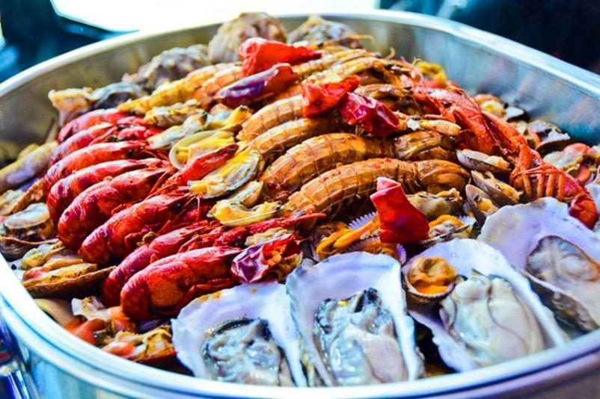

* Steaming---a typical Chinese way of cooking with food’s original flavor remained to the possible maximum (source: Baidu)

Cooking methods, especially foreign ones, can also possibly influence production of certain aquatic species in a less direct way, especially those which were not commonly consumed or native to the consuming area previously. To corroborate this idea, we may choose the consumption of salmon and fresh water rainbow trout as an example. Neither salmon or rainbow trout were a common component of most Chinese people’s aquatic consumption list even back to the beginning of the 21th century owing to: 1. These two species, historically, had been rarely consumed, as their general taste, especial the meat texture, would be pale in comparison to other fishes when cooked, while Chinese people were given to having almost all aquatic species fully cooked; 2. proper cooking methods of salmon and trout were scant in China, while traditionally the Chinese cooked aquatic products mainly via braising, steaming, and frying, which did not seem optimal for fish species such as salmon, trout, and tuna. However, with the introduction of various foreign cooking methods, such as sashimi, searing with butter, and grilling with ground black pepper, both salmon and trout, ultimately, embraced a chance to be accepted and appreciated by numberless Chinese consumers.

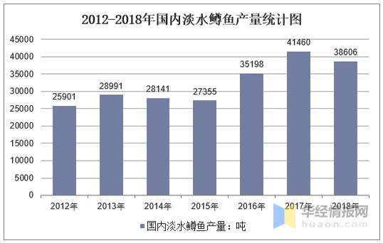

* Gross production amount of freshwater trout in China from 2012 to 2018, unit: tone.

Source: wap.stats.gov.cn

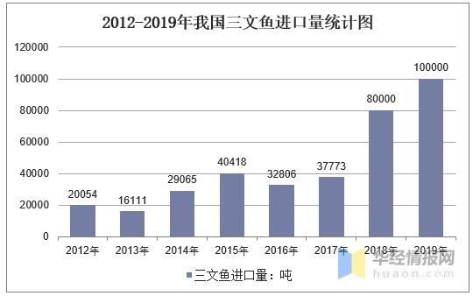

* Gross import of salmon to China from 2012 to 2019, unit: tone

Source: wap.stats.gov.cn

As the two groups of statistic shown above, an evident increment can be seen in both the domestic production amount of trout and the importation of salmon in China over the last several years. Perfect to be taken raw or undercooked, both trout and salmon appear to be further succulent, tender, and flavorful comparing to most other fish species commonly consumed in China, which piques the interest of increasing numbers of Chinese consumers each year. Thus, driven by the surging consumption demand, either trout or salmon have enjoyed an increasing explosion in their production amount. By looking to a further extent, exotic cooking methods, in this case, have functioned to be a major stimulant to the gradually increasing consumption demand for the above-mentioned two species and helped innumerable Chinese consumers open to either new species and novel cuisines.

Furthermore, the history of cod consumption in the UK also tells volumes. Traditionally, unlike salmon and trout in China, cod was not a fish source rarely consumed by the British, albeit to a much smaller extent compared with today’s enormous cod market in the UK. The introduction of fish & chip, as an exotic cuisine totally new to the British by then, has made both the production and consumption of cod boosted tremendously. According to the statistics published on *ukfisheries.net*, there are over 10,500 fish & chip shops across the country serving up 167 million fish and chip meals a year, dwarfing the 1,200 outlets of McDonalds, and either the 840 of KFC. With 80% of people visit fish & chip shops at least once a year, 22% of people visit fish & chip shops every week, and even 56% of people consider and purchase fish & chip as a quotidian family meal, at least 83% of the gross population said that fish & chips has the best claim to be the UK’s national dish. Hence, driven by the vast consumption demand, the importation of cod is a vitally important part of the whole fishery market in the UK.

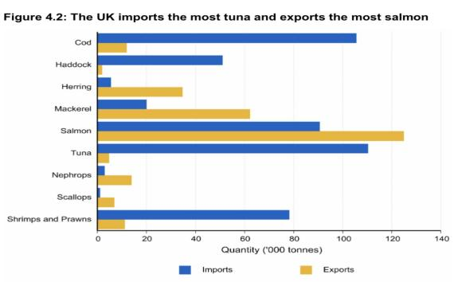

* Source: assets.publishing.service.gov.uk

As the statistics shown above, cod has been one of the most imported fish species considering its importation amount in the UK by 2018, second only to tuna. Benefited by enormous consumption demand, the production of cod, ranging from capturing, importing, processing, and serving, has been going prosperous over the last several decades in the UK. Of course, by tracing back to the consumption history, we can conclude that fish & chip, as a foreign style of cooking, has stimulated the consumption of cod in the UK to a vast extent, and further, made the respective production industry buoyant.

To conclude, cooking methods, when it comes to certain aquatic species, can also become a less direct factor affecting the production of the respective species.

**5.3. Videos about Trying Aquatic Products on the Internet**

**Table 5.4. Do you usually watch the videos as to dabbling with aquatic products (especially the rare/prohibitive one) on the Internet (e.g. YouTube)?**

|  |  |  |  |  |
| --- | --- | --- | --- | --- |
|  | London | | Beijing | |
| Frequency | Person | Percentage | Person | Percentage |
| Yes, and I’m even wont to wait for updates | 3 | 2.88% | 47 | 15.67% |
| Occasionally | 46 | 44.23% | 177 | 59% |
| Rarely do that | 28 | 26.92% | 50 | 16.67% |
| Almost don’t | 27 | 25.96% | 26 | 8.67% |

As the table depicts above, 74.04% of London’s informants and 91.33% of Beijing’s informants have watched various types of online videos as to dabbling aquatic products. To a further extent, these videos have piqued up the interest of totally 47.12% of London’s informants and 74.67% of Beijing’s informants, as such type of videos have almost become part of their quotidian existence. However, there are still 25.96% of informants from London who have almost never watched these videos, while there are only 8.67% of Beijing’s informants who did the same. To partly explain this difference, we may look back to the distribution of informants’ age groups. Around 44.23% of London’s informants are elder than 50 years old, whereas the informants over 50 years old take only 4.33% of the whole group from Beijing. As for these informants, online videos may seem less interesting than what they do to younger generations. However, this explanation is not infallible, as the difference between the informants from these two cities who have almost never watch the aforementioned online videos is significantly smaller than that between the informants from these two cities who are elder than 50 years old.

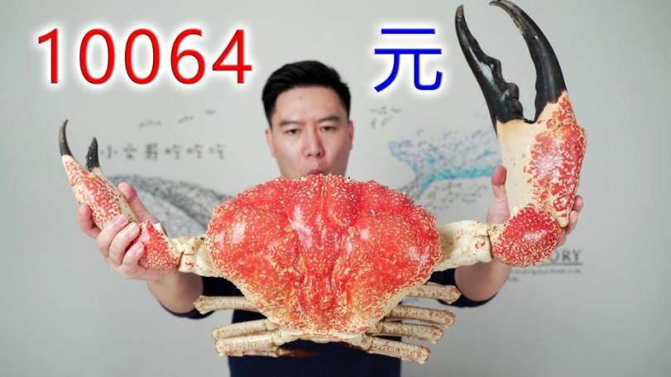

* Xiaowenge, a well known Chinese Youtuber who focuses his videos on exotic seafood

**Table 5.5. Have you ever tried any new aquatic products after hearing of/watching these videos?**

|  |  |  |  |  |
| --- | --- | --- | --- | --- |
|  | London | | Beijing | |
| Influence | Person | Percentage | Person | Percentage |
| Yes, and already tried loads | 38 | 36.54% | 85 | 28.33% |
| Only several times | 49 | 47.12% | 160 | 53.33% |
| Almost never | 17 | 16.35% | 55 | 18.33% |

According to the table above, after watching these online videos, 83.56% of London’s informants and 81.67% of Beijing’s informants have been motivated into consuming the aquatic products which were previously new to them. Further, 36.54% of London’s informants and 28.33% of Beijing’s informants have been even “persuaded” to consume relatively more of new aquatic products. Thinking from a particular aspect, the newly popular and proliferate online videos about trying aquatic products function as an inchoate form of adverts which can arguably motivate consumers into purchase in a relatively effective way. Comparing with traditional adverts, these online videos are mostly not aimed to promulgate certain products, at least evidently, however, more to share the experience of trying aquatic products from buying, processing, eating, and evaluating. Hence, consumers may find these videos more valuable for reference from the following two points:

1. . Credibility: without at least deliberately mentioning the sources where the aquatic products are acquired, and neither the brands which are worth recommending, viewers are more likely to believe the credibility of these videos as purely the makers’ personal experiences rather than propaganda. Further, the makers’ opinions of a particular aquatic product vary as their personal tastes differ, there are inevitably neutral and even negative comments left on almost all seafood species, which makes these videos further credible and valuable to viewers than commercial adverts. Inadvertently, these videos function as another form of non-profitable adverts which may attract viewers in a more efficient way.

Further, except the above-mentioned subjective views given by video makers, objective feedback can also be considered to be another factor for reference. The feedback, in this context, encompasses the general reputation of the video maker, how many times a video has been watched and liked, and the comments left below the video. Considering both the quality and credibility of a video by taking all the aforementioned factors into account, viewers could enjoy a better chance of making choices in a relatively unbiased and easier way, or to make it more lucid, whether the filmed product would be worth trying;

1. . Abundance of information: limited by either time or coverage, traditional adverts can hardly be exhaustive enough in describing an item. However, when it comes to these online videos, without a strict time limit, they can contain comparatively much more information about an item than what most traditional adverts can possibly do. These videos about aquatic products commonly contain: 1. the adumbrated description of a species; 2. in which ways they can be possibly processed/cooked; 3. the process of cooking it; 4. the feeling of eating it; 5. general comments. In other words, they can be even likened to a form of guidance for viewers when considering a new species of aquatic product which they have not tried before. Moreover, these online videos, in general, are usually filmed to be deliberately enticing and appetizing from the aspects of both cooking procedure and the result, which might be capable of: 1, convincing viewers in a more efficacious way, as most viewers would deem videos more credible than the photos which have been retouched for countless times; 2, motivating viewers, especially gourmets, to try what is still new to them. With enough and “useful” information provided, consumers are predictably more likely to be influenced by these videos.

Further, Thorstein Veblen’s demonstrative consumption theory, in this case, can also offer us a clearer view of the function of these online videos. Of course, influenced by ambiguity effect (Daniel Ellsberg, 1961), consumers may feel uncertain about the videos of dabbling with novel aquatic products filmed by some less well-known video makers without much useful information given. However, considering the reputation of those celebrated video posters with millions of subscribers online, viewers would tend to be less suspicious of the credibility of the videos made by these “online celebrities”. Moreover, a common trait of these “online celebrities”, as most viewers reckon, is being wealthy and enjoying a delicate style of life. In this way, imitating these video posters by consuming the same novel and expensive aquatic species, as for some viewers, equals either being every bit as moneyed or having an equally delicate lifestyle. Is consuming novel and sumptuous aquatic products already a fad which can also been deem to be a form of cultural capital (Pierre Bourdieu)? Scarcely can we feel safe to totally agree with it. However, having a particular luxurious and novel aquatic species appeared on either table or our social networks, in some cases, can truly present ourselves with an affluent image to others. Personally, the author would even not hesitate to deem some pricey aquatic species, such as Tasmanian giant crab, more demonstrative than most known luxurious accessories such as bags and shoes, for a Tasmanian giant crab costing at least 800 USD can be finished just within an hour, whereas a Louis Vuitton handbag worth 2,000 USD can be used for years if well cleaned.

There is an indeed interesting phenomenon found during the research: sometimes these online videos can promote the sales of certain aquatic products even via the negative views contained. Firstly, aquatic products are actually a contentious type of food owing to their unique flavor, which means that it can be either the reason why some consumers deem aquatic products the most delectable or the cause of others’ aversion to them. In this way, once a certain species is disliked by the video makers because of its specific controversial odor, it can also attract the attention of those who are exactly looking for this. This is what traditional adverts could hardly do: advertising an item in a critical way. Secondly, driven by curiosity, some viewers may also wish to try aquatic products with unusual flavors in order to disclose the reason why these foods are disliked. Lastly, described to be atrocious by some video makers, some aquatic products, especially the stinky and pungent types, have also been chosen by some mischievous buyers to prank their family members, friends, and colleagues, albeit it is less common comparing to the above-mentioned two cases.

In a word, the recently popular and proliferated online video as to trying aquatic products hitherto have left an apparently positive influence on consumers, and effectively stimulated certain numbers of buyers to enrich their option list of aquatic products.

**5.4. Influence of Online Shopping**

**Table 5.6. To what extent have the currently popular online shopping and the proliferated logistics companies influenced your attitude to the consumption of aquatic products?**

|  |  |  |  |  |
| --- | --- | --- | --- | --- |
|  | London | | Beijing | |
| Influence | Person | Percentage | Person | Percentage |
| tremendously, the generality of these products can be simply bought online | 29 | 27.88% | 34 | 11.33% |
| largely, usually these products can be bought online, but occasionally still purchase from supermarkets/shops/fairs | 31 | 29.81% | 121 | 40.33% |
| just so-so, sometimes online shopping can be a good option, but supermarkets/shops/fairs are still comparatively preferred | 15 | 14.42% | 88 | 29.33% |
| not really, except particular species, most aquatic products needed can be purchased from supermarkets/shops/fairs | 11 | 10.58% | 36 | 12% |
| almost none, never considered online shopping an option | 18 | 17.31% | 21 | 7% |

As the table shows above, 57.69% of London’s informants and 51.67% of Beijing’s informants appear to be active buyers in favor of online shopping---a relatively new mode of purchase which is benefited by the rapid development of the Internet. Meanwhile, 14.42% of London’s informants and 29.33% of Beijing’s informants consider online shopping a good option when purchasing aquatic products, albeit they still prefer to buy from other sources. In addition, online shopping is also thought to be a choice by 10.58% of London’s informants and 12% of Beijing’s informants when they need to buy specific aquatic products which are either not available or expensive in local markets, even if they are wont to purchase aquatic products from physical stores in most cases. As a relatively new form of purchase, online shopping outdistances other traditional purchase modes from the following dimensions:

1. . Convenience: enjoying the advancement of the Internet, purchase can be done just online without needing to go to markets by possibly wasting hours. The merit of online shopping, in this case, is manifest: time-saving. As for the residents in major cities such as Beijing and London, this edge tends to be one of the most attractive ones, for they do not have to concern about any frustrating traffic congestion which may occur on the way to supermarkets or fairs, and neither whether these places would be teeming with customers, nor wasting much time on searching online owing to the previously dated shopping systems. Furthermore, with the efficiency of the logistic systems which has been enhanced in recent years, the ordered aquatic products can be delivered to customers with the greatest possible expedition once the purchase is done.
2. . Price: another advantage of online shopping is that it offers a generally lower price than physical stores when it comes to buying aquatic products. When it comes to seafood, especially the fresh one, they are usually even pricier in physical stores owing to the extra cost from transportation and the apparatus used for keeping them alive. But as for online shopping, the aforementioned extra would be redundant to be concerned, for most of aquatic products can be shipped directly from the places where they are acquired. In this way, consumers are likely to choose online shopping as a feasible mode of purchasing aquatic products, with a generally more acceptable price offered, but without sacrificing their qualities. In addition, coming together with various festivals and activities, numerous discounts and sales promotions may also become a stimulant for consumers to purchase what they originally did not consider in the shopping list, from the aspects of either quantity or variety.
3. . Abundance of species: similarly, limited by the extra cost of transportation and storing, some seafood species are not likely to be available in the local markets of some inland cities. Online shopping, once again, has left consumers open to more options. Consumers can order almost all possible seafood species as they want, as only they are available on various websites specializing online shopping, such as “Alibaba Online Shop”. By enjoying such an edge, consumers who live in inland cities are also able to try the exotic seafood species which cannot even be seen in the local shops.

To sum up, online shopping, according to the obtained data, has almost largely influenced the consumption pattern of the informants from both Beijing and London, albeit there are still a small number of consumers who did not take this mode of purchase into consideration. Generally, the increasingly developing Internet has been gradually reshaping the purchase modes of most of informants from Beijing and London, especially when it comes to the facet of aquatic products.

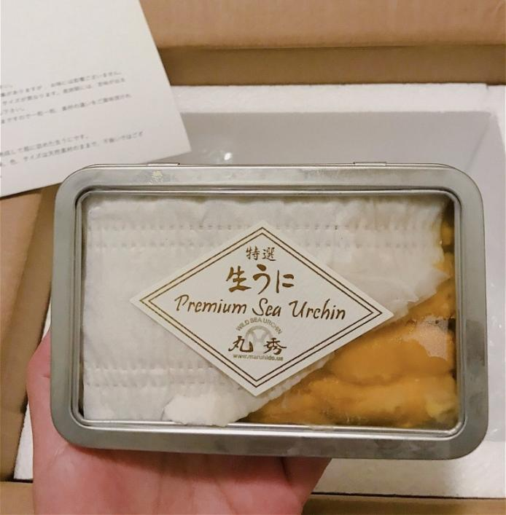

* A box of Japanese sea urchin bought online by a respondent from Beijing

**5.4.1. Factors Considered when Buying Aquatic Products Online**

**Table 5.7. To what extent do the following factors matter to you, if you need to buy aquatic products online? (London case)**

|  |  |  |  |  |  |  |
| --- | --- | --- | --- | --- | --- | --- |
|  | Highly important  (person&  percentage) | Important  (person&  percentage) | Just so-so  (person&  percentage) | Not really  Important  (person&  percentage) | Don’t care  (person&  percentage) | No idea  (person&  percentage) |
| Efficiency of logistics | 19 18.27% | 16  15.38% | 36  34.62% | 21  20.19% | 2  1.92% | 10  9.62% |
| Advert/  sales promotion | 23  22.12% | 28  26.92% | 28  26.92% | 4  3.85% | 9  8.65% | 12  11.54% |
| Credibility of sellers | 20  19.23% | 30  28.85% | 25  24.04% | 17  16.35% | 4  3.85% | 8  7.69% |
| Reviews from other buyers | 15  14.42% | 17  16.35% | 43  41.35% | 10  9.62% | 5  4.81% | 14  13.46% |
| Abundance of product information | 19  18.27% | 35  33.65% | 26  25% | 8  7.69% | 7  6.73% | 9  8.65% |

**Table 5.8. To what extent do the following factors matter to you, if you need to buy aquatic products online? (Beijing case)**

|  |  |  |  |  |  |  |
| --- | --- | --- | --- | --- | --- | --- |
|  | Highly important  (person&  percentage) | Important  (person&  percentage) | Just so-so  (person&  percentage) | Not really  Important  (person&  percentage) | Don’t care  (person&  percentage) | No idea  (person&  percentage) |
| Efficiency of logistics | 119  39.67% | 72  24% | 69  23% | 26  8.67% | 8  2.67% | 6  2% |
| Advert/  sales promotion | 73  24.33% | 93  31% | 67  22.33% | 35  11.67% | 24  8% | 8  2.67% |
| Credibility of sellers | 56  18.67% | 108  36% | 74  24.67% | 33  11% | 22  7.33% | 7  2.33% |
| Reviews from other buyers | 59  19.67% | 113  27.67% | 73  24.33% | 27  9% | 18  6% | 10  3.33% |
| Abundance of product information | 62  20.67% | 111  37% | 74  24.67% | 23  7.67% | 16  5.33% | 14  4.67% |

In this part, we will delve further into the factors considered by informants while purchasing aquatic products online. To analyze the influence of each factor, the following standard is made: the options “highly important” and “important” are chosen for reference. If there are more than 50% of informants choosing either of these two options when considering a factor, then this factor can be deemed to be influential

1. . Efficiency of logistics: with 33.65% of informants from London and 63.67% of informants from Beijing considered this factor highly important or important, we can hardly classify this factor as “commonly influential”. To explain this difference saliently existing between two groups of informants, we may still look at the preference of Beijing’s informants for the freshness, safety, and nutrition of aquatic products. Looking for fresher, safer, and more nutritious seafood, informants from Beijing would predictably think more of the efficiency of logistics, for these products are relatively easier to lose their freshness, and further, to decay. Hence, the more efficient the logistics can be, the fresher, safer, and healthier aquatic products they can enjoy. And the efficiency of logistics, from a particular aspect, denotes the better qualities of aquatic products. In addition, an interesting fact was disclosed in the interviews which the writer took with some informants from the two cities: Beijing’s informants would prefer buying what they could not find in the local markets, which meant that the shipping distance would be long, whereas London’s informants preferred short-term delivery---just ordering from local supermarkets and seafood shops, which could have the delivery done on the same day of making order. Comparing to multiple latent risks hidden behind a long-distance delivery, a short-term one, in most cases, did not appear to be worth concerning that much.
2. . Advert/sales promotion: with 49.03% of informants from London and 55.33% of informants from Beijing considered this factor highly important or important, we can consider this factor more or less influential to both of these two groups. The slight difference between these two groups can be interpreted as: comparing with the situation in London, there are further more types of sales promotion which can be seen in various websites of online shopping during almost all kinds of festivals in China, such as the Spring Festival, the Mid-autumn Festival, and even the so-called “Double Eleven” (an inchoate activity created for online shopping). Sales promotion, in this case, has benefited the informants from both London and Beijing from enjoying an abundant variety of aquatic products with a relatively more affordable price.
3. . Credibility of sellers: with 48.08% of informants from London and 56.67% of informants from Beijing considered this factor highly important or important, similarly, we may consider this factor more or less influential to both of these two groups. By common consent, the better reputation a seller enjoys, the better qualities his/her products can be, and the more experienced he/she is in shipping these products with the greatest possibility to remain them fresh, which is vitally important for long-distance deliveries. Further, a seller of good repute, broadly deemed, also provides better after-sales service, which functions as a way of amelioration for customers if anything goes awry with the ordered products.
4. . Reviews from other buyers: a manifest distinction is observed between the two groups of informants---only 30.77% of informants from London considered this factor highly important or important, while there were surprisingly 57.33% of informants from Beijing had their focus on this factor. Hence, we can only consider this factor influential to Beijing’s informants. According to the observation of the author, when it comes to buying aquatic products online in China, there are comparatively more informative reviews from previous buyer available on various online shopping websites with usually pictures and videos attached, which can be taken as a more accurate and vivid reference by the perspective buyers other than the reviews simply written in words or rated with stars. Once again, these detailed reviews seem to be more important to Beijing’s informants who prefer to order the products needing long-distance deliveries and from unfamiliar sellers, while London’s informants tend to order more from local supermarkets and shops which are generally already not new to them, and it is always not troublesome to contact sellers for refunding or returning if anything goes awry with the ordered products. Further, by leaving detailed reviews with the photos or videos of the received products attached, buyers sometimes can also be benefited by sellers in multiple forms, such as coupon. As a result, buyers in China are more willing to leave detailed reviews in order to enjoy further benefits from sellers, and these reviews also work as a reference for future buyers, albeit some of these reviews may be more or less exaggerated.

5). Abundance of product information: as 51.92% of informants from London and 57.67% of informants from Beijing considered this factor highly important or important, we can consider this factor influential to both of these two groups with certitude. Rather, shopping online has also its downside: uncertainty. Without actually seeing the products, and neither having much information of them, consumers can hardly make their decisions with certainly nothing to concern. Hence, the much information and description of a seafood species are available, such as the origin place, date of acquiring, and recommendations for cooking, etc. the highly level of certitude consumers can have in making their decisions. The abundance of information encompassing two facet: 1. the detailed description provided by both sellers and previous buyers; 2. the extra related information which can be searched on the Internet. No matter from which aspect different consumers think more of, the more abundant information a seafood product owns, the better chance it is being given to be considered by future consumers.

**5.5. Urbanization**

**Table 5.9. With the progress of urbanization made in London/Beijing, various modes of vending/retailing have also come into existence, and either the further advancement of both transportation and networks. To which extent do you think that these aforementioned factors have promoted your consumption demand for aquatic products?**

|  |  |  |  |  |
| --- | --- | --- | --- | --- |
|  | London | | Beijing | |
| Influence | Person | Percentage | Person | Percentage |
| tremendously, benefited by various modes of retailing/vending, more options are open to us in selecting aquatic products | 24 | 23.08% | 75 | 25% |
| largely, at least we can enjoy the convenience generated by these modes | 36 | 34.62% | 168 | 56% |
| just so-so, albeit sometimes we may try some new species | 21 | 20.19% | 29 | 9.67% |
| not really, just get attracted a few times | 9 | 8.65% | 17 | 5.67% |
| almost none | 14 | 13.46% | 11 | 3.67% |

To consider whether urbanization has influenced informants’ consumption demand for aquatic products, here are two questions which we should have in mind: 1. whether urbanization has influenced informants’ consumption demand; 2. to which extent it has influenced informants. Starting from the first question, the informants who have chosen the first three options “tremendously”, “largely”, and “just so-so”, in this case, can be deemed to be “being practically influenced by urbanization”. As the table shows above, with 77.88% of London’s informants and 90.67% of Beijing informants who have at least more or less enjoyed the convenience generated by urbanization, we can consider urbanization generally influential and beneficial to the informants of both these two groups. Proceeding to the second question, 57.69% of London’s informants and 81% of Beijing’s informants reckoned this factor tremendously or largely influential, which proves that urbanization appears to be a factor potently affecting a certain number of informants’ consumption demand for aquatic products.

Considering from the aspect of aquatic products, the rapid growth in the degree of urbanization has enhanced the aquatic market in two ways: 1. increasing modes of retailing and wholesaling which purvey further multiple options of purchasing aquatic products to consumers---they are no longer limited to the traditional ways of purchase such as fairs or supermarkets; 2. more efficient systems and networks of logistics/transportation which have not only lowered the extra cost of shipping aquatic products, but also made a great variety of new seafood species available in aquatic markets and stores. Specifically, when it comes to the situation in Beijing, various emergent aquatic shops such as “He Ma Xian Sheng” (as 盒马鲜生in Chinese) have attracted increasing numbers of consumers with impressively abundant seafood species obtainable: ranging from Australian lobsters, Russian crabs, Japanese scallops, to New Zealand salmon, and numerous domestic species into the bargain. Therefore, having made generally more abundant and affordable species available, urbanization plays an important role in affecting consumers’ consumption demand for aquatic products, no matter whether buyers are driven by the curiosity for emerging species, or by the fiscal benefit from the generally lower prices offered.

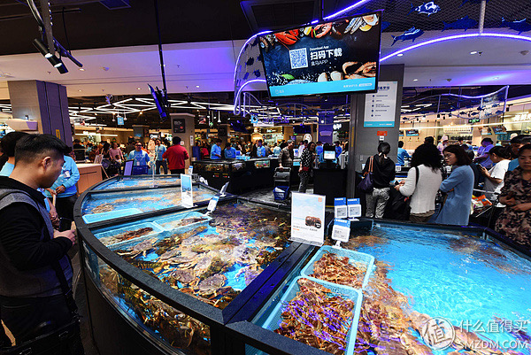

* A corner of a Hemaxiansheng shop located in Beijing (source: Baidu)

Meanwhile, considering the consumption and production of salmon and cod which were discussed in 5.2. on cooking methods, we can also be clearer of the role of urbanization in influencing the production of aquatic products. The gradually increasing urbanization rate and population witnessed in both Beijing and London, on the one hand, has laid a solid foundation in the accretion of consumption potential; on the other hand, also furbished both Beijing and London with further vibrant markets and advanced technology, especially in logistics and transportation. In this way, numerous aquatic shops and restaurants could come into existence and make the most fresh and palatable aquatic products possible to consumers, since numerous aquatic species can be transported with the great possible expedition and kept alive and fresh without being further costly owing to efficient logistics. As a result, the production of the commonly consumed aquatic species, together with the increasing consumption demand, can also embrace a chance to go further prosperous, especially from the aspects of processing and serving.

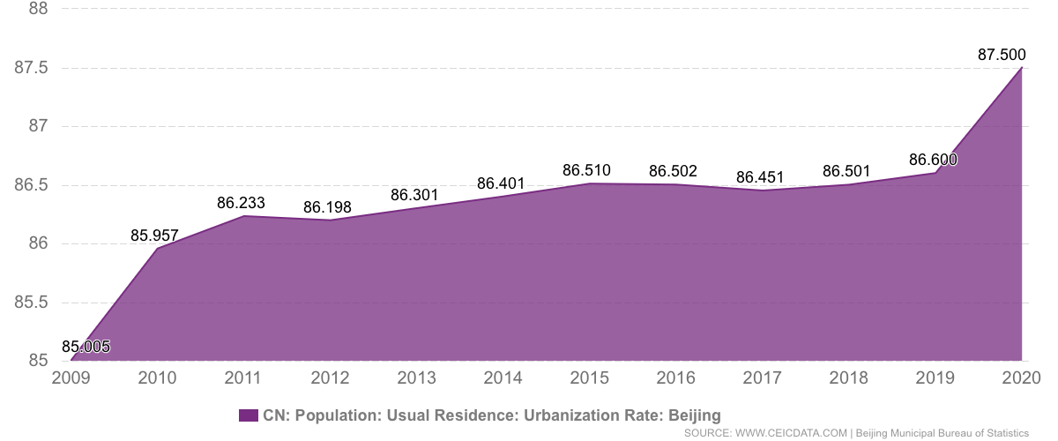

* Urbanization rate of Beijing

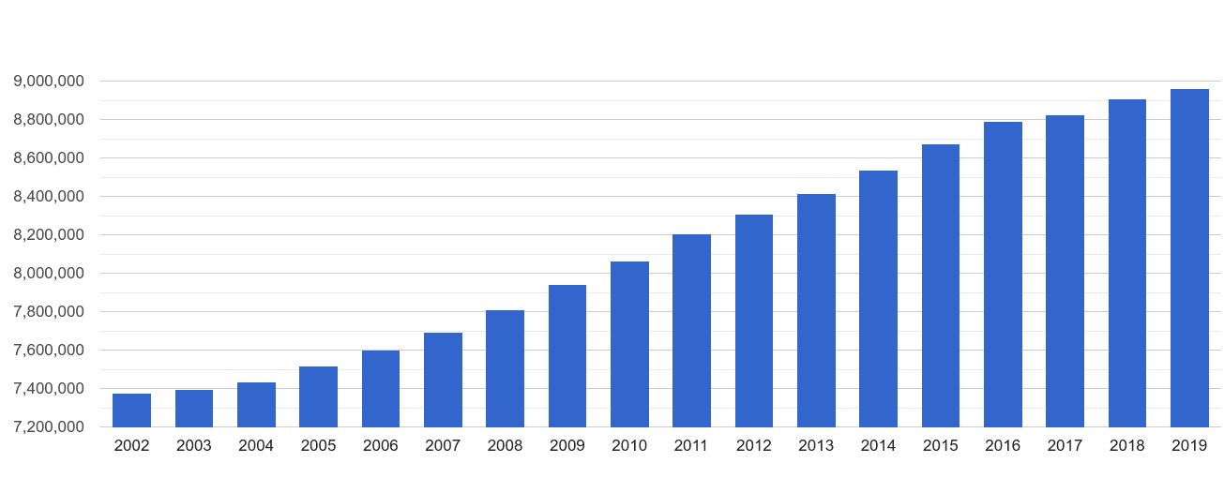

* Population growth rate of London. Source: statista.com

**5.6. Habit of Consuming Aquatic Products**

**Table 5.10. How did you pick up your habits of consuming aquatic products? (multiple choices)**

|  |  |  |  |  |
| --- | --- | --- | --- | --- |
|  | London | | Beijing | |
| Reason | Person | Percentage | Person | Percentage |
| from family, aquatic products have already been part of my quotidian existence from childhood | 48 | 46.15% | 96 | 32% |
| from education, aquatic products are known for being comparatively healthier and more nutritious | 56 | 53.85% | 200 | 66.67% |
| driven by curiosity, for I’ve seen others (e.g. friends, colleagues) buying these products | 50 | 48.08% | 154 | 51.33% |
| geographical factor, for aquatic products are rather prevalent in my hometown | 31 | 29.81% | 166 | 55.33% |
| cultural factor, I’m specifically fond of aquatic products | 49 | 47.12% | 98 | 32.67% |
| standing for the life of higher quality, for premium aquatic products are prohibitive | 27 | 25.96% | 35 | 11.67% |

As the table shows above, there are five major reasons listed out which may possibly shape the consumption habits of informants. In this part, we will delve into all these factors and have a comparative analysis of the extents to which these factors have influenced our informants.

1. . Family: the factor in this case has is scarcely connected with family size or components, instead, it is more about how does family background shape informants’ consumption habits. According to the obtained result, 46.15% of London’s informants and 32% of Beijing’s informants cultivated their habits of consuming aquatic products from their families. Hence, we cannot certainly consider family factor to be influential. As for the distinction between the two groups of informants, in this case, it is probably because of the precipitous increment in the average amount of consumed aquatic products per capita in Beijing. The generality of Beijing’s informants are elder than 20 years old, which means that their childhood dates back at least to two decades ago---when the average consumption amount of aquatic products per capita was obtrusively low in China. In this way, except those who were born and brought up in coastal areas where the resources of aquatic products are usually rich, most Chinese informants who are from inland cities could hardly cultivate their habit of consuming these products which were not a frequent part of their daily diets.
2. . Education: known as a healthier and more nutritious food source, aquatic products have been gradually noticed more by younger generations. In the table above, 53.85% of London’s informants and 66.67% of Beijing’s informants gained the habit of consuming aquatic products from education, albeit the level of education does not necessarily to be high, and neither obtained from schools. Hence, we can deem education an influential factor in affecting the consumption pattern of aquatic products. Benefited by education, informants from both two groups enjoyed a chance to be clear of the merits of aquatic products comparing with other traditional protein sources such as red meats, and were further encouraged to make this healthier food source part of their daily diets.
3. . Curiosity: studying and imitating play an integral role in shaping consumption patterns. In this case, influenced by others around, 48.08% of London’s informants and 51.33% of Beijing’s informants started to try aquatic products out of curiosity. Hence, we may deem this factor actually influential to both of the two groups of informants. As metropolises, both Beijing and London are teeming with migrants, no matter whether they are domestic or foreign. And for those who rarely eat aquatic products before, their interest and curiosity with aquatic products can be more or less piqued by the consumption habits of the others around, through different ways such as parties and banquets. Even, some of them may try to cultivate their own habits of eating aquatic products after their first tries led by other people around.
4. . Geographical factor: with merely 29.81% of London’s informants but 55.33% of Beijing’s informants choosing this option, we do not feel safe to identify this factor as “commonly influential”. Unfortunately, we can hardly explain the apparent distinction between the two groups of informants, for there are not sufficient statistics about the demographic component of the migrants in Beijing. Consequently, the origins places of these migrants can hardly be distinguished minutely.
5. . Cultural factor: arguably, aquatic products take a salient position in the food cultures of certain ethnicity groups. However, with 47.16% of London’s informants and 32.67% of Beijing’s informants consuming aquatic products coming down to their own cultural backgrounds, we can not deem cultural factor influential with certitude.

6). Higher level of class/taste: as more complicated as this factor seems to be, it can not simply be ascribed into cultural influence, but more about the psychology of consumption. According to the table above, only 25.96% of London’s informants and 33.65% of Beijing’s informants considered aquatic products a manifestation of a higher taste level. Actually, with the proliferation of aquatic industries and the increment in the average wage level, there are increasingly less numbers of informants in both Beijing and London who tend to believe in the sumptuousness and sign-value of aquatic products, especially when it comes to the daily consumed species, albeit the situation with specific exotic species still differs. Generally, the generality of the informants from both Beijing and London no longer deem consuming aquatic products sumptuous.

**5.7. Entertainment**

**Table 5.11. In which way have you also consumed aquatic products, except for food? (multiple choices)**

|  |  |  |  |  |
| --- | --- | --- | --- | --- |
|  | London | | Beijing | |
| Mode | Person | Percentage | Person | Percentage |
| pet (e.g. aquarium fish, turtle) | 64 | 61.54% | 199 | 66.33% |
| recreation (e.g. fishing) | 93 | 89.42% | 150 | 50% |
| pet feeding (e.g. feeding cats/dogs) | 95 | 91.35% | 101 | 33.67% |

The consumption of aquatic products is not merely limited in the form of eating. Instead, there are also various ways of consuming aquatic products.

1. . Petting: with 61.54% of London’s informants and 66.33% of Beijing’s informants petting multiple aquatic species including fish, freshwater crayfish, turtle, etc., a new form of consuming aquatic products, in this case, comes into existence. Hitherto, the pet market takes also a certain proportion of the whole aquatic market, and is still gradually expanding. Generally, the major reasons of petting aquatic species, according to most informants, are: 1, standing for great fortune. Some aquatic species, such as fancy carp and turtle, have their auspicious meanings in Chinese culture, which makes them always popular as pets in China; 2, easier and safer to pet. Comparing to traditional pets such as mammals and birds, aquatic species in general require less attention to be paid on food and medicine, and are relatively smaller and tamer, which seems to be less risky to be kept as pets; 3, a better gift for children. Based on the second reason, and with a generally more affordable price, aquatic animals are always popular to be chosen as gifts for children, which does not only function as a riveting form of entertainment, but also provides children a valuable chance of getting closer to nature; 4, novelty. Tired of traditional pet species, some customers may wish to keep new species out of curiosity. Hence, exotic aquatic species, ranging from fish, crayfish, shellfish, to even crab, can largely gratify those aforementioned pet keepers from the aspect of novelty, albeit not all of them are affordable to all customers.

Meanwhile, being a relatively non-major branch of aquaculture, aquatic pet industry, especially that of pet fish, has also embraced a significant increase during the past several years.

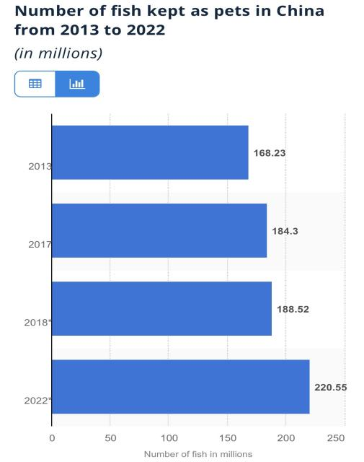

* Source: statista.com

As the statistics shown above, an estimated increment of 31.1% will be observed in the gross amount of petted fish in China from 2013 to 2022. Unlike other fish species which are bred for eating, most pet fish species are reproduced solely for petting, as they are hardly an ideal food source considering their size, taste, and price. Thus, pet fish production, in comparison, is further strictly determined by consumption demand. The increment seen in the picture above, to a certain extent, is capable of reflecting the respective increase in the gross production amount. Hence, the increasingly popular pet fish, as a mode of entertainment, can also be deemed to be an indirect factors affecting the related production by boosting consumption demand, though consumers are not chasing for gustatory please this time.

1. . Recreation: rather, it appears to be tough to calculate the gross consumed amount of aquatic products via this way, and we may just discuss those who have ever consumed aquatic products in this way. According to the table above, 89.42% of London’s informants and 50% of Beijing’s informants have partaken in the recreational activities related to consuming aquatic products such as fishing. Specifically, as a unique type of culture which has been developing for centuries in the UK, fishing has been broadly considered an “elegant” form of recreation and favored by people from almost all age groups.
2. . Pet feeding: 91.37% of London’s informants and 33.67% of Beijing’s informants took aquatic products as also a food source for their pets such as cats and dogs. The distinction between these two groups can be explicated by: 1. according to the statistic as to the numbers of domestic pets in the UK and China, British people possess pets such as dogs and cats around twice more than Chinese people do based on the family average. Predictably, the more pets there are, the more food sources will be needed, with a further variety seen as well; 2. comparing with their British counterparts, the Chinese people who pet dogs and cats, arguably, are apt to feed their pet with the food remnant from their daily diets instead of purchasing food specifically prepared for pets. Hence, the distinctively lower amount of aquatic products added in pets’ diets should be expected.

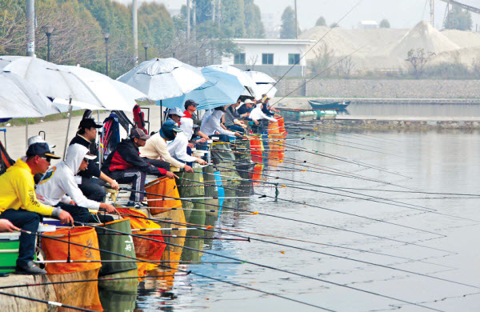

*A fishing race (source: Baidu)

**5.8. Price of Other Surrogate Food Sources**

**Table 5.12. To which extent can your consumption of aquatic products can be influenced, if there is a precipitous increment in the prices of the following products? (London)**

|  |  |  |  |  |  |  |
| --- | --- | --- | --- | --- | --- | --- |
|  | Tremendously, even forgo consuming aquatic products  (person&  percentage) | Largely,  consuming obviously less  (person&  percentage) | Just so-so,  consuming relatively less  (person&  percentage) | Not really,  consuming a mite less  (person&  percentage) | Almost none  (person&  percentage) | No idea  (person&  percentage) |
| Pork | 27  25.96% | 25  24.04% | 23  22.12% | 13  12.50% | 9  8.65% | 7  6.73% |
| Beef | 12  11.54% | 30  28.85% | 35  33.65% | 6  5.77% | 10  9.62% | 11  10.58% |
| Lamb/ mutton | 35  33.65% | 16  15.38% | 26  25% | 12  11.54% | 9  8.65% | 6  5.77% |
| Poultry | 32  30.77% | 9  8.65% | 37  35.58% | 13  12.50% | 2  1.92% | 11  10.58% |
| Eggs | 27  25.96% | 27  25.96% | 23  22.12% | 6  5.77% | 11  10.58% | 10  9.62% |
| Dairy | 17  16.35% | 28  26.92% | 33  31.73% | 6  5.77% | 10  9.62% | 10  9.62% |
| Rice | 12  11.54% | 29  27.88% | 36  34.62% | 8  7.69% | 4  3.85% | 15  14.42% |
| Flour | 40  38.46% | 15  14.42% | 23  22.21% | 11  10.58% | 8  7.69% | 7  6.73% |
| Other grains | 29  27.88% | 29  27.88% | 20  19.23% | 11  10.58% | 11  10.58% | 4  3.85% |

**Table 5.13. To which extent can your consumption of aquatic products can be influenced, if there is a precipitous increment in the prices of the following products? (Beijing)**

|  |  |  |  |  |  |  |
| --- | --- | --- | --- | --- | --- | --- |
|  | Tremendously, even forgo consuming aquatic products  (person&  percentage) | Largely, consuming obviously less  (person&  percentage) | Just so-so, consuming relatively less  (person&  percentage) | Not really, consuming a mite less  (person&  percentage) | Almost none  (person&  percentage) | No idea  (person&  percentage) |
| Pork | 53  17.67% | 60  20% | 87  29% | 40  13.33% | 51  17% | 9  3% |
| Beef | 52  17.33% | 67  22.33% | 77  25.67% | 69  23% | 25  8.33% | 10  3.33% |
| Lamb/ mutton | 22  7.33% | 92  30.67% | 63  21% | 50  16.67% | 65  21.67% | 8  2.67% |
| Poultry | 32  10.67% | 77  25.67% | 76  25.33% | 62  20.67% | 42  14% | 11  3.67% |
| Eggs | 47  15.67% | 70  23.33% | 57  19% | 57  19% | 56  18.67% | 13  4.33% |
| Dairy | 48  16% | 73  24.33% | 65  21.67% | 64  21.33% | 41  13.67% | 9  3% |
| Rice | 29  9.67% | 80  26.67% | 57  19% | 61  20.33% | 62  20.67% | 11  3.67% |
| Flour | 41  13.67% | 58  19.33% | 64  21.33% | 70  23.33% | 55  18.33% | 12  4% |
| Other grains | 38  12.67% | 63  21% | 70  23.33% | 55  18.33% | 58  19.33% | 16  5.33% |

As what has been equally listed in the tables above, there are some surrogate food sources which may influence and even supplant the consumption of aquatic products. In this part, we will analyze from the following two facets: 1. to which extent do these factors matter to the consumption of aquatic products; 2. their influences.

1. . Pork: taken as a common source of meat in both the UK and China, pork has its place firmly embedded in people’s life. According to the tables above, 72.16% of London’s informants and 66.67% of Beijing’s informants chose the options “tremendously”, “largely”, and “just so-so”, which means that those people would change their consumption amounts of aquatic products to different extents if there would be a precipitous increase in the price of pork. Further, 50% of London’s informants and 37.66% of Beijing’s informants even chose the options “tremendously” and “largely”, which denotes a fact that the rise in pork price would obviously reduce their consumption amounts of aquatic products. Hence, the increase of pork price, as the analysis shows above, can be proved to be an influential factor which would impact on the generality of the informants of both London and Beijing.
2. . Beef: differing from pork, beef is commonly considered to be a relatively healthier and pricier meat source, albeit it is also an integral element in most people’s diets. According to the tables above, 74.04% of London’s informants and 65.33% of Beijing’s informants chose the options “tremendously”, “largely”, and “just so-so”, which means that those informants would have to change their consumption amounts of aquatic products to different extents if there would be a sharp increase in the price of beef. Further, 40.38% of London’s informants and 39.67% of Beijing’s informants even chose the options “tremendously” and “largely”, which denotes a fact that the rise in beef price would obviously reduce their consumption amounts of aquatic products. Hence, the increase of beef price, as the analysis shows above, can be proved to be an influential factor which would impact on the generality of the informants of both London and Beijing.
3. . Lamb/mutton: although not accepted by everyone owing its unique smell, lamb/mutton is still a common part of numerous people’s diets. According to the tables above, 74.04% of London’s informants and 59% of Beijing’s informants chose the options “tremendously”, “largely”, and “just so-so”, which means that those people would change their consumption amounts of aquatic products to different extents if there would be a sharp increase in the price of lamb/mutton. Further, 49.04% of London’s informants and 38% of Beijing’s informants even chose the options “tremendously” and “largely”, which indicates a fact that the rise in lamb/mutton price would obviously reduce their consumption amounts of aquatic products. Hence, the increase in lamb/mutton price, as the analysis shows above, can be proved to be an influential factor which would impact on the generality of the informants of both London and Beijing.
4. . Poultry: comprising a massive variety of species, poultry functions as a meat source with more options available to consumers, such as chicken, duck, quail. Moreover, the price of poultry, generally, is more acceptable than other major meat sources. According to the tables above, 75% of London’s informants and 61.67% of Beijing’s informants chose the options “tremendously”, “largely”, and “just so-so”, which means that those people would be likely to change their consumption amounts of aquatic products to different extents if there would be a sharp increase in the price of poultry. Further, 39.42% of London’s informants and 36.33% of Beijing’s informants even chose the options “tremendously” and “largely”, which denotes a fact that the rise in poultry price would obviously reduce their consumption amounts of aquatic products, but in a way which is less influential compared with pork, beef, and lamb/mutton. However, the increase of poultry price, as the analysis shows above, can still be proved to be an influential factor which would impact on the generality of the informants of both London and Beijing.
5. . Eggs: easy to cook, tasty, nutritious, and less pricey, these merits support eggs to enjoy a certain firm position in most people’s diets. According to the tables above, 74.04% of London’s informants and 58% of Beijing’s informants chose the options “tremendously”, “largely”, and “just so-so”, which means that those people would change their consumption amounts of aquatic products to different extents if there would be a sharp increase in the price of eggs, albeit in a way that is generally less obviously than other meat sources, especially considering the situation of Beijing’s informants. Further, 51.92% of London’s informants and 39% of Beijing’s informants even chose the options “tremendously” and “largely”, which denotes a fact that the rise in eggs’ price would obviously reduce their consumption amounts of aquatic products. Hence, the increase of eggs’ price, as the analysis shows above, can be proved to be an influential factor which would impact on the generality of the informants of both London and Beijing. However, unlike the roles of the aforementioned meat sources, the consumption of eggs has two major traits: 1. stable, as certain numbers of people have the habit of taking eggs as part of breakfast; 2. limited consumption amount, there are not many people who would prefer to have eggs appearing in all of their meals like what they may do with other meat sources. In this way, the increase of eggs’ price, on the one hand, is more or less influential in affecting the consumption of aquatic products; but on the other hand, it is less powerful than those major meat sources.
6. . Dairy: driven by different dieting habits, the informants from London and Beijing consequently keep different attitude to consuming diaries, but they are still undeniably a nutritious food source. According to the tables above, 75% of London’s informants and 62% of Beijing’s informants chose the options “tremendously”, “largely”, and “just so-so”, which means that those people would change their consumption amounts of aquatic products to different extents if there would be a sharp increase in the price of diaries. Further, 43.27% of London’s informants and 40.33% of Beijing’s informants even chose the options “tremendously” and “largely”, which denotes a fact that the rise in diaries’ price would obviously reduce their consumption amounts of aquatic products. Hence, the increase of diaries’ price, as the analysis shows above, can be proved to be an influential factor which would impact on the generality of the informants of both London and Beijing.
7. . Rice: previously functioning as a major food resource for the people from Asian countries, rice has also gradually been accepted worldwide with the rapid step of globalization. According to the tables above, 74.04% of London’s informants and 58.67% of Beijing’s informants chose the options “tremendously”, “largely”, and “just so-so”, which means that those people would change their consumption amounts of aquatic products to different extents if there would be a sharp increase in the price of rice. Further, 39.42% of London’s informants and 39.67% of Beijing’s informants even chose the options “tremendously” and “largely”, which denotes a fact that the rise in rice price would obviously reduce their consumption amounts of aquatic products. Hence, the increase of rice price, as the analysis shows above, can be proved to be an influential factor which would impact on the generality of the informants of both London and Beijing.
8. . Flour: no matter whether in eastern or western food cultures, flour is ineluctably a noticeable part without which some renowned dishes could not even be created. According to the tables above, 75% of London’s informants and 54.33% of Beijing’s informants chose the options “tremendously”, “largely”, and “just so-so”, which means that those people would change their consumption amounts of aquatic products to different extents if there would be a sharp increase in the price of flour. Further, 52.88% of London’s informants and 33% of Beijing’s informants even chose the options “tremendously” and “largely”, which denotes a fact that the rise in pork price would obviously reduce their consumption amounts of aquatic products. Benefited by their colorful food culture, Chinese consumers enjoy a further abundance of staple food sources such as rice, flour, beans, corns, etc. In this way, the increment in flour price seems to be less influential to Beijing’s informants compared to their counterparts from London. Hence, the increase of flour price, as the analysis shows above, can be proved to be an influential factor which would impact on the generality of the informants mostly from London, but less important to Beijing’s informants.
9. . Other grains: except the aforementioned food sources, various grains such as beans and corn are also more than a simple form of snacks. According to the tables above, 84.62% of London’s informants and 57% of Beijing’s informants chose the options “tremendously”, “largely”, and “just so-so”, which means that those people would change their consumption amounts of aquatic products to different extents if there would be a sharp increase in the price of various grains. Further, 55.77% of London’s informants and 33.67% of Beijing’s informants even chose the options “tremendously” and “largely”, which denotes a fact that the rise in different grains’ price would obviously reduce their consumption amounts of aquatic products. Hence, the increase of grains’ price, as the analysis shows above, can be proved to be an influential factor which would impact on the generality of the informants of both London and Beijing.

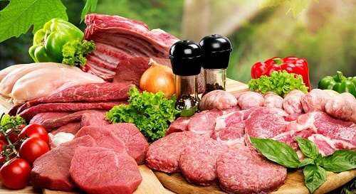

* Red meats are also the major meat source (source: Google)

**5.9. Religion**

**Table 5.14. Are there any specific species of aquatic products which you can’t eat due to religious factors?**

|  |  |  |  |  |
| --- | --- | --- | --- | --- |
|  | London | | Beijing | |
| Limit | Person | Percentage | Person | Percentage |
| Yes | 72 | 69.23% | 144 | 48% |
| No | 32 | 30.77% | 156 | 52% |

As a salient part of social factors, the influence of religion can hardly be neglected, especially by considering the common feature of Beijing and London---metropolises, where people of different ethnicities and cultural backgrounds can be seen almost everywhere. In this survey, we found that 69.23% of London’s informants and 48% of Beijing’s informants were limited to certain species of aquatic products coming down to religions, which means that religions also construct a factor which more or less affect some people in consuming aquatic products. Comparing with the Beijing’s case, there are relatively more informants from London who were prohibited from eating certain aquatic species.

The reason why there is an evident distinction between the numbers of informants from London and Beijing who have specific religious limits can be: the nationality of all the Beijing’s informants is Chinese, while the London’s informants possess a further variety of nationalities and cultural backgrounds, which provides a further abundance of religious individuals as well.

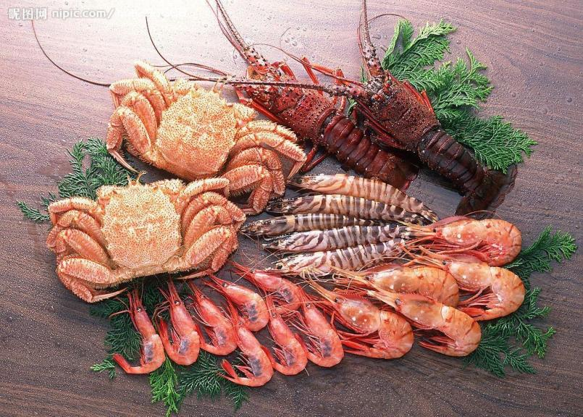

* Crab, shrimp, and lobster are usually proscribed to Muslims (source: Google)

**5.10. Work Industry**

**Table 5.15. To what extent does your occupation/working industry matter to your habits of consuming aquatic products?**

|  |  |  |  |  |
| --- | --- | --- | --- | --- |
|  | London | | Beijing | |
| Extent | Person | Percentage | Person | Percentage |
| Tremendously | 7 | 6.73% | 18 | 6% |
| Largely | 34 | 32.69% | 93 | 31% |
| Just so-so | 34 | 32.69% | 79 | 26.33% |
| Not really | 4 | 3.85% | 54 | 18% |
| Almost none | 15 | 14.42% | 51 | 17% |
| No idea | 10 | 9.62% | 5 | 1.67% |

According to the table above, 72.12% of London’s informants and 63.33% of Beijing’s informants chose the options “tremendously”, “largely”, and “just so-so”, which means that work industry influences the majority of both groups with their habits of consuming aquatic products. In order to have a more in-depth insight into the correlation between occupation/work industry and consumption, there are three elements which should be analyzed: frequency of purchase, expenditure on aquatic products, the total amount of consumption. By using IBM SPSS, the results are:

|  |  |  |
| --- | --- | --- |
|  | Work industry (London) | Work industry (Beijing) |
| Frequency of purchase  **Pearson Correlation**  **Significance (two-tailed)**  **N** | .137  .165  104 | -.009  .874  300 |
| Expenditure  **Pearson Correlation**  **Significance (two-tailed)**  **N** | -.116  .242  104 | -.001  .985  300 |
| Amount of consumption  **Pearson Correlation**  **Significance (two-tailed)**  **N** | .059  .555  104 | -.110  .057  300 |

As the result shows, the correlation among occupation/work industry and frequency, expenditure, and consumption amount is not obvious. However, we should not confuse the current consumption pattern with the consumption habits which were previously developed. As for some informants who belong to certain industries, business meals are part of their quotidian existence, which provides them a better chance of familiarizing themselves with aquatic products, for some aquatic species, such as fish and shrimp, are already common in various business meals, especially in China. In addition, coming back to Table 5.10, as what the result clearly demonstrates, at least 50% of informants from each group have picked up the habit of consuming aquatic products owing to the influence of their friends and colleagues. Benefited by the aforementioned chance, some informants, predictably, would have cultivated the habit of consuming aquatic products for life, or at least make them appear more frequently in their daily diets, in consideration of both the sign-value and function-value (Thorstein Veblen) of aquatic products: they are not simply pricey as a “face-saving” food source, but also great for health. In other words, consumption habits structured the current consumption pattern of these informants. Meanwhile, unknown to these informants’ previous average consumption amount of aquatic products, we can hardly have a comparison between how much they previously used to consume and how much they usually consume nowadays, and neither feeling safe to say that correlation between work industry and consumption amount is none. Moreover, we are also not sure whether all informants have included the consumed aquatic products in business meals into the gross consumption amount or not, and it appears to be more difficult for informants to count the amount they consumed outside. Hence, we may still deem occupation/work industry influential to the consumption of aquatic products.

**5.11. Family Size**

**Table 5.16. To what extent does the family size (especially with kids/seniors) influence your gross consumption amount of aquatic products?**

|  |  |  |  |  |
| --- | --- | --- | --- | --- |
|  | London | | Beijing | |
| Extent | Person | Percentage | Person | Percentage |
| Tremendously | 9 | 8.65% | 23 | 7.67% |
| Largely | 22 | 21.15% | 85 | 28.33% |
| Just so-so | 25 | 24.04% | 107 | 35.67% |
| Not really | 4 | 3.85% | 45 | 15% |
| Almost none | 23 | 22.12% | 33 | 11% |
| No idea | 21 | 20.19% | 7 | 2.33% |

With 53.85% of London’s informants and 71.67% of Beijing’s informants choosing the options “tremendously”, “largely”, and “just so-so”, family size appears to be a factor more or less influencing the gross consumption amount of aquatic products. Further, 29.81% of London’s informants and 36% of Beijing’s informants considered family size rather influential in affecting their consumption amount, as they chose “tremendously” and “largely”.

To corroborate the aforementioned analysis, the correlation among family size and purchase frequency, consumption amount, and expenditure is made:

|  |  |  |
| --- | --- | --- |
|  | Family size (London) | Family size(Beijing) |
| Frequency of purchase  **Pearson Correlation**  **Significance (two-tailed)**  **N** | -.024  .810  104 | -.013  .827  300 |
| Expenditure  **Pearson Correlation**  **Significance (two-tailed)**  **N** | -.110  .268  104 | .060  .302  300 |
| Amount of consumption  **Pearson Correlation**  **Significance (two-tailed)**  **N** | .791**  .000  104 | -.037  .523  300 |

As the analysis depicts, the correlation between family size and personal consumption amount, as for London’s informants, is significant. But when it comes to the informants from Beijing, this correlation is not obvious. As the author thinks, this difference can be explained by consumption habits of family members. When it comes to the situation in China, the elder generations generally tend to consume less aquatic products than what younger generations do. In other words, younger generations, arguable, are mainly responsible for the consumption amount of a whole family. Further, burdened with heavy workload, the younger generations in Beijing tend to dine outside more frequently rather than at home. Predictably, if the majority of their consumed aquatic products is taken outside instead of with family members at home, family size may have less influence on the gross personal consumption amount.

Meanwhile, as the research goes further, an interesting fact has been disclosed: periodical consumption. According to some Beijing’s informants whom have been interviewed by the author, pursing the nutrition for both pregnant mothers and children, they themselves or their spouses would prefer to consume significantly more aquatic products, especially fish, shrimp, and shellfish, during both pregnancy period and lactation period. Later on, during the childhood of their births, they would also making aquatic products a good and frequent addition to their children’s diets. As their children grew elder, the place of aquatic products would be more or less supplanted by red meats and poultry coming down to the fact that meat on average provides more energy, since juveniles and teenagers are at an energy-consuming age, and arguably pay comparatively more attention to gustatory feelings. Although this mode of consumption usually appears to be periodical and is not easy to be accurately calculated, it dose seem to be influential to the gross consumption amount.

To conclude, family size is rather influential to London’s informants from the aspect of the gross amount of consumed aquatic products, and arguable influential to Beijing’s informants. However, due to insufficient samples, the validity of this conclusion should be proved further.

**5.12. Education**

**Table 5.17. Education background (London’s informants)**

|  |  |  |
| --- | --- | --- |
| Education | Number (person) | Percentage |
| Primary school | 27 | 25.96% |
| Junior high school | 22 | 21.15% |
| Senior high school | 1 | 0.96% |
| Bachelor | 23 | 22.12% |
| Master | 14 | 13.46% |
| Ph.D | 0 | 0% |
| Vocational schools | 9 | 8.65% |
| Other | 8 | 7.69 |

**Table 5.18. Education background (Beijing’s informants)**

|  |  |  |
| --- | --- | --- |
| Education | Number (person) | Percentage |
| Primary school | 3 | 1% |
| Junior high school | 7 | 2.33% |
| Senior high school | 22 | 7.33% |
| Bachelor | 175 | 58.33% |
| Master | 54 | 18% |
| Ph.D | 18 | 6% |
| Secondary technical school | 11 | 3.67% |
| Junior college | 10 | 3.33% |
| Other | 0 |  |

The correlation among education background and purchase frequency, consumption amount, and expenditure is shown below:

|  |  |  |
| --- | --- | --- |
|  | Education level (London) | Education level (Beijing) |
| Frequency of purchase  **Pearson Correlation**  **Significance (two-tailed)**  **N** | -.100  .314  104 | -.109  .059  300 |
| Expenditure  **Pearson Correlation**  **Significance (two-tailed)**  **N** | -.109  .271  104 | .064  .267  300 |
| Amount of consumption  **Pearson Correlation**  **Significance (two-tailed)**  **N** | .070  .483  104 | .077  .186  300 |

As the result shows, the correlation among education level and purchase frequency, expenditure, and consumption amount is not obvious among the informants from either London or Beijing. As for the author’s personal viewpoint, this phenomenon can be enunciated in the three following ways:

1. . The relevant knowledge about the advantages of consuming aquatic products can be gained from a very early stage, such as primary school. In this way, the health awareness about consuming aquatic products does not necessarily relate to a relatively high level of education, or in other words, school students can be equal as university students in knowing the edges generated from eating aquatic products;
2. . Further, the awareness of consuming aquatic products does not even necessarily have to be obtained from school education. There are numerous ways in which the benefits of consuming aquatic products can be known, such as various resources on the Internet, the suggestion from others around, and from TV channels, etc. In this way, being aware of the merits of aquatic products is not necessarily linked to education;
3. . Differing from knowledge and ways of thinking which can be readily shaped by education, a person’s taste, essentially the preference for specific food, cannot be easily changed by exogenous factors such as education. The construction of a person’s taste, by common consent, encompasses mainly: 1, endogenous factors such as a person’s inherent preference for, and either aversion to, specific categories of taste; 2, genetic reasons, for example, whether a person is allergic to particular nutrition sources; 3, the milieu in which a person has been since birth, which effectively shapes both a person’s consumption habit and pattern. Coming down to this precondition, either what a person is wont to consume or what a person do not even wish to dabble owing to various reasons, such as family tradition and religious prohibition, have already been almost ossified deep in this person’s mind. Honestly, benefited by the merits brought up by education like health awareness, a person’s consumption pattern can be partially altered, for example, by consuming less of the unhealthy food and trying the new healthier surrogates, but a substantial transmutation of a person’s basic taste preference is still hardly possible. In other words, we can neither cajoling nor coercing a person who totally cannot abide aquatic products into loving them merely via education.

Arguably, when it comes to pricier aquatic products, the informants possessing higher education background would be more rational when purchasing other than blindly trying what was new for them, this also might be a reason why there was not an obvious increment in their expenditure on aquatic products.

To summarize, according to the obtained statistic, there seems to be a no clear correlation between education level and the consumption of aquatic products, albeit this conclusion may vary if there would be further more samples available.

**5.12.1. Overseas Education**

**Table 5.19. To what extent does your overseas education background matter to your habits of consuming aquatic products? ( for those who have received overseas education)**

|  |  |  |  |  |
| --- | --- | --- | --- | --- |
|  | London | | Beijing | |
| Extent | Person | Percentage | Person | Percentage |
| tremendously, I picked up my habits exactly during that period | 2 | 4.55% | 12 | 11.01% |
| largely, I have been consuming obviously more since that time | 24 | 54.55% | 44 | 40.37% |
| just so-so, I started to consume more in a way which was not very obvious | 15 | 34.09% | 28 | 25.69% |
| not really, juts tried the local aquatic products there several times | 1 | 2.27% | 15 | 13.76% |
| almost none, my habits of consuming aquatic products has almost never been changed | 2 | 4.55% | 10 | 9.17% |
| Total | 44 | | 109 | |

Differing from the standard domestic education, overseas education purveys a further opportunity of intercultural communication, in other words, placing ourselves in a different cultural context, and actually experiencing and comparing cultural diversities. In this way, after receiving overseas education, some people may have more or less changed their consumption habits over aquatic products.

As the table shows above, grossly 44 out of 104 London’s informants have the experience of overseas education, while there are totally 109 out of 300 Beijing’s informants who have the same experience. In order to have a more in-depth insight into the role of overseas education in affecting consumption patterns, here are two questions we need to have in mind while discussing: 1. does overseas education practically influence informants’ consumption patterns; 2. if it does, to what extent?

According to the obtained statistics, 93.18% of London’s informants and 77.06% of Beijing’s informants chose the options “tremendously”, “largely”, and “just so-so”, which means that overseas education appeared to be influential in affecting their consumption patterns from different levels. Moreover, 59.09% of London’s informants and 51.38% of Beijing’s informants deemed overseas education experience rather efficacious in shaping their consumption patterns, as they chose the options “tremendously” and “largely”. In a word, placing themselves once in different cultural and geographical milieus, informants could either actively or passively change their original consumption habits, and overseas education experience, as the result shows, can be proved to be an influential factor reshaping consumption patterns and habits.

**5.13. Traditional Food Culture**

**Table 5.20. To which extent does the traditional British/Chinese cooking culture influence your habits of consuming aquatic products?**

|  |  |  |  |  |
| --- | --- | --- | --- | --- |
|  | London | | Beijing | |
| Extent | Person | Percentage | Person | Percentage |
| tremendously, basically I prepare/consume almost all the aquatic products using traditional British/Chinese cooking methods, very delectable | 9 | 8.65% | 42 | 14% |
| largely, generally I do prefer traditional British/Chinese cooking methods | 22 | 21.15% | 124 | 41.33% |
| just so-so, foreign cooking methods are also quite acceptable sometimes | 35 | 33.65% | 86 | 28.67% |
| not really, I usually take aquatic products simply for nutrition/health, or foreign cooking methods are comparatively more preferred | 22 | 21.15% | 36 | 12% |
| almost none, I don’t take aquatic products, or I have fully inured myself to foreign cooking methods | 16 | 15.38% | 12 | 4% |

When it comes to the preparation of aquatic products, cooking methods always appear to be an integral element. Encompassing either traditional domestic ways and inchoate foreign methods, cooking methods, undeniably, influence consumers’ demand to a certain extent. In this part, we will discuss the role of traditional domestic cooking methods in both London and Beijing.

As the table shows above, 29.81% of London’s informants and 55.33% of Beijing’s informants chose the options “tremendously” and “largely”, in this way, traditional domestic cooking methods play a rather importance role in affecting the consumption patterns of Beijing’s informants, but less influential to London’s informants. To explicate the obvious difference between these two groups, we shall look into the demographic features of our informants: all the Beijing’s informants are Chinese, but not all the London’s informants are British. Although residing in metropolises, Beijing’s informants, comparatively, are more likely to be circumscribed within their own traditional food culture. And the informants from London, conversely, enjoy a better chance of exploring various exotic food cultures coming down to: 1. some of them already possess different cultural backgrounds and even nationalities themselves; 2. the level of internationalization in London is comparatively higher than that in Beijing. Hence, having a better opportunity to dabble further abundant cuisines, informants from London tend to be less strongly influenced by the traditional British food culture, whereas their counterparts from Beijing are further inured to traditional Chinese cooking methods.

**5.14. Gifting**

**Table 5.21. Have you ever taken aquatic products as a form of gift to your friends/family members/colleagues/superiors?**

|  |  |  |  |  |
| --- | --- | --- | --- | --- |
|  | London | | Beijing | |
| Gift | Person | Percentage | Person | Percentage |
| Yes | 53 | 50.96% | 143 | 47.67% |
| No | 51 | 49.04% | 157 | 52.33% |

Consuming food does not merely encompass eating by ourselves by numerous means, however, taking food as a form of gift is also a mode of consumption, albeit these gifts are not ultimately consumed by the givers. As the table shows above, 50.96% of London’s informants and 47.67% of Beijing’s informants have taken aquatic products as gifts to their friends, family members, colleagues, and superiors. There does not seem to be a distinctive difference between the numbers these two groups, however, but an obvious nuance between these two groups from the aspect of purpose instead. The generality of London’s informants, according to the obtained answers, chose aquatic products due to the abundant nutrients contained, which is of course health awareness concern further, and a small number of them deemed these products luxurious which could be taken as a gift of higher taste level. The situation in Beijing went in an almost converse way, where most of informants considered aquatic products as a sumptuous gift by which business affairs and even promotion could be expedited.

In this case, we may take both Thorstein Veblen’s demonstrative consumption theory and Pierre Bourdieu’s theory of capital and social distinction for reference. Luxurious aquatic products, in most cases known, are capable of gratifying the demonstration need of both gift givers and receivers. When it comes to the situation in which gift givers’ social level is lower than receivers’, rather, gift givers do not aim to consume sumptuous aquatic products, such as desiccated premium abalone and sea cucumber, by themselves. However, gift receivers would feel satisfied to certain extent, as they receive something luxurious which is commensurate with their classes, which equals recognizing their higher social level, and expensive aquatic products as gifts, in this way, function as a symbol of social level recognition from the inferior. On the other hand, once gift givers belong to a social class higher than receivers’, it would be givers who can demonstrate either their wealth or a comparatively higher social class shown via a better taste. In both of the two aforementioned situations, aquatic products as gifts always function as a manifestation of demonstrative consumption and occasionally social distinction, albeit the role of respective demonstrators is hardly fixed.

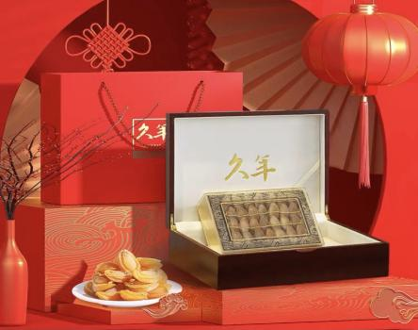

* Desiccated abalone is always preferred as a type of gift in China (source: Alibaba.com)

**5.15. Ready-to-eat Aquatic Products**

**Table 5.22. What do you think of ready-to-eat aquatic products? (e.g. canned, dried)**

|  |  |  |  |  |
| --- | --- | --- | --- | --- |
|  | London | | Beijing | |
| Attitude | Person | Percentage | Person | Percentage |
| strongly favored, even become the major mode of consuming aquatic products | 14 | 13.46% | 40 | 13.33% |
| favored, and often take them | 44 | 42.31% | 139 | 46.33% |
| just so-so, just take them occasionally | 33 | 31.73% | 90 | 30% |
| not very favored, only seldom dabble with them | 1 | 0.96% | 22 | 7.33% |
| not favored at all, almost never tried | 12 | 11.54% | 9 | 3% |

With the advancement achieved in technology, there are vastly increasing modes of processing aquatic products with their original taste preserved to the maximum. The ready-to-eat aquatic products, as an exemplary successful model, have come in and become popular in both Beijing and London. According to the obtained answers showing above, totally 88.47% of London’s informants and 97% of Beijing’s informants have at least tried ready-to-eat aquatic products before, which proves the current prevalence of this mode of processing. Further, 55.77% of London’s informants and 59.67% of Beijing’s informants found ready-to-eat rather acceptable, as they chose the options “strongly favored” and “favored”. Although we can hardly estimate to which extent this new mode of consumption has supplanted the traditional cooking methods owing to insufficient samples and statistics, and neither predict the possible future of ready-to-eat products, we can still deem ready-to-eat aquatic products a mode of both production and consumption which has been commonly embedded into most informants’ consumption patterns, and can even reshape some of informants’ consumption habits at the moment.

**Table 5.23. Advantages of ready-to-eat aquatic products (multiple choices)**

|  |  |  |  |  |
| --- | --- | --- | --- | --- |
|  | London | | Beijing | |
| Advantage | Person | Percentage | Person | Percentage |
| taste better | 37 | 35.58% | 78 | 26% |
| convenient/time-saving | 62 | 59.62% | 195 | 65% |
| easy to be stored/taken with | 36 | 34.62% | 172 | 57.33% |
| less pricey comparing with the fresh one | 32 | 30.77% | 130 | 43.33% |
| more frequent sales promotion | 26 | 25% | 134 | 44.67% |
| of novelty | 31 | 29.81% | 42 | 14% |
| with various species available | 35 | 33.65% | 40 | 13.33% |

1. . Better taste: as 35.58% of London’s informants and 26% of Beijing’s informants have chosen this factor, we may deem it an advantage attracting part of informants, albeit the taste of almost all ready-to-eat food, especially the canned (encompassing a great variety such as fish, shellfish, crab), is always questionable. However, with the technological advancement achieved in food industries over the past decade, the flavor of some ready-to-eat products as snacks (e.g. sliced squid, spicy scallops, dried shrimp) have been further refined, probably, some aquatic products, as a fad, can also be added into the list of commonly favored snacks later in the near future.
2. . Convenience: as what has been expected, 59.62% of London’s informants and 65% of Beijing’s informants---the majority of both groups opted for ready-to-eat aquatic products out of the convenience and the time which can be saved. Being burdened with heavy workloads, time is of preciousness for most younger generations in both Beijing and London, which does not leave them much leeway to delicately prepare dishes by themselves. Instant aquatic products, especially seafood, as a form of products which is less fresh but comparatively much more time-saving and with generally acceptable tastes, have inevitably come into the sights of numerous young people, which makes a good addition to the monotonous working lunch of certain numbers of young people.
3. . Easy to be stored/taken with: with 34.62% of London’s informants and 57.33% of Beijing’s informants reckoning instant aquatic products easy to be stored and taken with, another merit of this type of products is revealed: relatively easier to store. Further, the reason why there are comparatively more informants from Beijing agreed with this advantage is due to the further abundance of choices in choosing instant aquatic products. Except the traditional forms such as canned or already-cooked food which are always available in supermarkets, another form of ready-to-eat aquatic products has seemingly become a fad in China---snacks. With a comparatively better taste and more delicate way of packing, aquatic products have been given a new life: they are already not something necessarily connected with meals or dishes, but rather snacks which can be enjoyed at almost anytime and everywhere, no matter whether when enjoying films, having parties with friends, or simply drinking alcohol and looking for something tasty as a complement.
4. . More affordable price: 30.77% of London’s informants and 43.33% of Beijing’s informants considered this factor advantageous. Comparing with the fresh and living aquatic products, instant food enjoys a relatively more affordable price on average, albeit the cost is the sacrifice of taste, and probably, nutrition as well. However, as a less pricey offer, it is still accepted by certain numbers of consumers. Moreover, with comparatively lower prices, and without sacrificing much of their original flavors, instant aquatic products also purvey some consumers a chance of trying new aquatic species without needing to concern that these new species may be hard to process at home.
5. . More frequent sales promotion: 25% of London’s informants and 46.67% of Beijing’s informants deemed this factor beneficial. Again, the difference between this two groups can be explained by the further abundance of available types in Chinese markets and online shopping platforms, especially the second one where there are comparatively more discounts generated from different festivals and activities. Some Chinese consumers, in this way, are more likely to purchase a larger amount of instant food or snack considering the benefit they may enjoy, either taking by themselves, or sharing with friends and family members.
6. . Novelty: only 29.81% of London’s informants and 14% of Beijing’s informants considered instant aquatic products something of novelty, which means that this form of products has already not been new to most people, albeit still not fully accepted by everyone.
7. . Abundance of species: undoubtedly, not all aquatic species are able to be processed into instant form owing to cost, loss of the original flavors, shorter expiration time period, etc., in this way, the available instant aquatic species are still far less abundant than the fresh one. Hence, only 33.65% of London’s informants and 13.33% of Beijing’s informants have ever thought highly of the abundance of aquatic species in the mode of instant food.

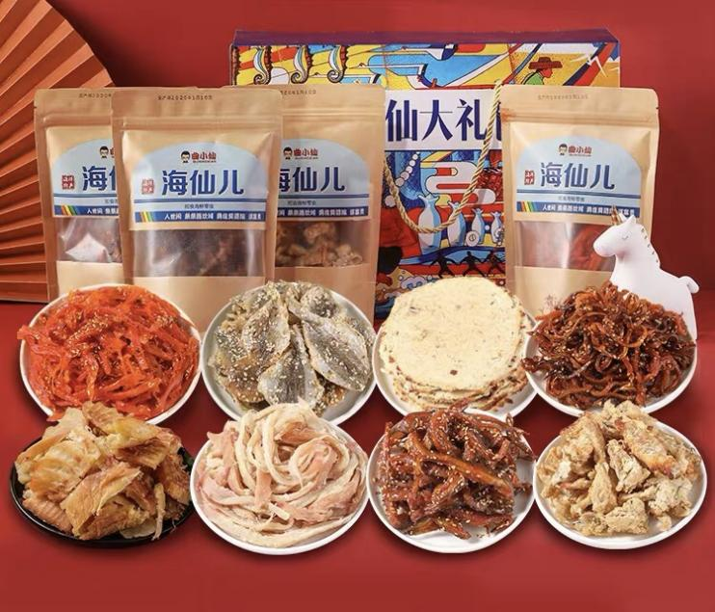

* Ready-to-eat aquatic products can also be a popular form of snack (source: Baidu)

**5.16. Income**

**Table 24. Situation of income (Beijing)**

|  |  |  |
| --- | --- | --- |
| Income (thousand CNY/month) | Number (person) | Percentage |
| < 3 | 8 | 2.67% |
| 3-5 | 14 | 4.67% |
| 5-7 | 53 | 17.67% |
| 7-9 | 95 | 31.67% |
| 9-12 | 64 | 21.33% |
| 12-20 | 40 | 13.33% |
| 20-30 | 9 | 3% |
| 30-50 | 9 | 3% |
| 50-100 | 6 | 2% |
| > 100 | 2 | 0.67% |

**Table 5.25. Situation of income (London)**

|  |  |  |
| --- | --- | --- |
| Income (thousand GBP/month) | Number (person) | Percentage |
| < 1 | 8 | 7.69% |
| 1-2 | 12 | 11.54% |
| 2-3 | 7 | 6.73% |
| 3-4 | 8 | 7.69% |
| 4-5 | 16 | 15.38% |
| 5-6 | 6 | 5.77% |
| 6-7 | 4 | 3.85% |
| 7-8 | 7 | 6.73% |
| 8-9 | 3 | 2.88% |
| 9-10 | 4 | 3.85% |
| 10-15 | 3 | 2.88% |
| 15-20 | 8 | 7.69 |
| 20-30 | 4 | 3.85% |
| 30-40 | 4 | 3.85% |
| 40-50 | 5 | 4.81% |
| > 50 | 5 | 4.81% |

The analysis of the correlation among income and purchase frequency, expenditure, and consumption amount is shown below:

|  |  |  |
| --- | --- | --- |
|  | Income (London) | Income (Beijing) |
| Frequency of purchase  **Pearson Correlation**  **Significance (two-tailed)**  **N** | .098  .320  104 | -.036  .529  300 |
| Expenditure  **Pearson Correlation**  **Significance (two-tailed)**  **N** | .782**  .000  104 | .031**  .000  300 |
| Amount of consumption  **Pearson Correlation**  **Significance (two-tailed)**  **N** | -.205*  .036  104 | .215**  .000  300 |

According to the result of analysis, income is not firmly correlated with the purchase frequency of either the informants from London or the informants from Beijing, which is easily understandable, as the purchase frequency does not denote the total purchase amount, and neither the gross expenditure. Then, moving to the expenditure, a significant positive correlation between income and expenditure is observed from both of the two groups of informants. Specifically, the expenditure which London’s informants paid on aquatic products is further correlated with their income level. However, when it comes to the correlation between income and consumption amount, a dramatic distinction is found between these two groups of informants: the correlation between London’s informants’ income and their consumption amount is negative, while the result of Beijing’s informants is positive. As the author’s opinion, a reasonable explanation of this result can be: as there are comparatively more imported luxurious species which can be seen in London, such as luxurious Australian lobsters, rare oyster species, the informants enjoying higher income levels tend to focus more on the quality and sumptuousness of aquatic products instead of simply the amount, for eating is also a social action from which consumers’ social status can be shown considering the sign-value of pricey novel aquatic products. In a word, quality takes precedence over quantity this time. However, as for the informants from Beijing, the aforementioned exotic species are still relatively new for them and not positively accepted by everyone. Moreover, these aquatic species, in comparison, are less affordable in Beijing owing to: 1, higher shipping cost; 2, relatively higher tariff; 3, high cost of the apparatuses used for keeping them alive and fresh; 4, the increasing rentals of shops and supermarkets considering the dear housing prices in Beijing. Comparing with trying these exotic species with “unfriendly” costs and under the risk that they may not be palatable, some conservative Chinese consumers may still wish to consume the species which are familiar to them, and probably have them more frequently appearing on the table. Unfortunately, owing to the insufficient samples and relevant statistics, this explanation may vary with further available informant provided.

To conclude, when it comes to the consumption of aquatic products, income is firmly correlated with the expenditure, but not necessarily with the purchase frequency, and neither the consumption amount. Hopefully, with more detailed statistic provided in the future, the correlation between income and consumption amount can be further explored.

**5.17. Marital Status**

**Table 5.26. Marital status**

|  |  |  |  |  |
| --- | --- | --- | --- | --- |
|  | London | | Beijing | |
| Status | Number (person) | Percentage | Number (person) | Percentage |
| Married | 71 | 68.27% | 219 | 73% |
| Unmarried | 33 | 31.73% | 81 | 27% |

The analysis of the correlation between marital status and purchase frequency, expenditure, and consumption amount is shown below:

|  |  |  |
| --- | --- | --- |
|  | Marital status (London) | Marital status (Beijing) |
| Frequency of purchase  **Pearson Correlation**  **Significance (two-tailed)**  **N** | -.010  .919  104 | -.046  .423  300 |
| Expenditure  **Pearson Correlation**  **Significance (two-tailed)**  **N** | .343**  .000  104 | .052  .372  300 |
| Amount of consumption  **Pearson Correlation**  **Significance (two-tailed)**  **N** | -.098  .324  104 | .177**  .002  300 |

As the result shows, the correlation between marital status and purchase frequency is not obvious in both two groups. Proceeding to expenditure, an evident positive correlation between London’s informants’ marital status and their expenditure on aquatic products is observed, whereas a similar correlation is not found among Beijing’s informants. Then, as for the significant correlation between marital status and consumption amount, it is solely found from Beijing’s informants.

As a complicated question, the difference between the two groups in marital status/expenditure and marital status/consumption amount can hardly be exhaustively explained, for the author does not have sufficient samples hitherto, and neither the relevant information. As the author presumes, it can be possibly understood in this way: considering both the relatively heavier workloads and the Chinese cultural traditions, those married informants from Beijing, especially males, are more likely to spend most of their time in taking business meals and banquets outside with their friends and colleagues, such as in dining halls, restaurants, instead of with their family members. During this process, they arguably have more opportunities to consume aquatic products either actively due to their personal habits or passively owing to the need of business meals, as aquatic products are commonly deemed to be a food source denoting a better taste and higher social status (as the so-called “face-saving” in Chinese culture). Hence, their consumption amount of aquatic products can possibly increase after getting married because of the further more social interactions needed for work, albeit the expenditure may not change precipitously. Further, combining what we have discussed in the part of family size, more aquatic products, although periodically, would be consumed in consideration of the health need of children and pregnant mothers, as fish and shrimp are specifically believed to be good for the growth of children in China.

In a word, the correlation between marital status and purchase frequency is not obvious, while the expenditure and consumption amount, according to the analysis, are both partly correlated with marital status. However, a further clearer and more persuasive answer should be based on more detailed relevant materials.

**5.18. Gender**

**Table 5.27. Gender**

|  |  |  |  |  |
| --- | --- | --- | --- | --- |
|  | London | | Beijing | |
| Gender | Number (person) | Percentage | Number (person) | Percentage |
| Male | 53 | 50.96% | 135 | 45% |
| Female | 51 | 49.04% | 165 | 55% |

The analysis of the correlation among gender and purchase frequency, expenditure, and consumption amount is shown below:

|  |  |  |
| --- | --- | --- |
|  | Gender (London) | Gender (Beijing) |
| Frequency of purchase  **Pearson Correlation**  **Significance (two-tailed)**  **N** | -.009  .930  104 | .025  .669  300 |
| Expenditure  **Pearson Correlation**  **Significance (two-tailed)**  **N** | -.094  .342  104 | -.014  .807  300 |
| Amount of consumption  **Pearson Correlation**  **Significance (two-tailed)**  **N** | .098  .322  104 | .004  .944  300 |

As the result demonstrates, the correlation among gender and purchase frequency, expenditure, and consumption amount is not manifestly observed from neither of the two groups, which proves that gender does not play an influential role in affecting the consumption of aquatic products, no matter whether for London’s informants or the informants from Beijing. As the author reckons, consumption habit and taste preference are more of personal habit and choice other than being significantly determined by gender, albeit some aquatic species are believed to be beneficial to particular genders, such as oyster to males.

**5.19. Age**

**Table 5.28. Age distribution (Beijing)**

|  |  |  |
| --- | --- | --- |
| Age (year) | Number (person) | Percentage |
| < 15 | 1 | 0.33% |
| 15-20 | 2 | 0.67% |
| 21-25 | 41 | 13.67% |
| 26-30 | 61 | 20.33% |
| 31-35 | 70 | 23.33% |
| 36-40 | 72 | 24% |
| 41-45 | 26 | 8.67% |
| 46-50 | 14 | 4.67% |
| 51-55 | 8 | 2.67% |
| 56-60 | 1 | 0.33% |
| 61-65 | 3 | 1% |
| 66-70 | 1 | 0.33% |
| 71-75 | 0 | 0% |
| 76-80 | 0 | 0% |
| > 80 | 0 | 0% |

**Table 5.29. Age distribution (London)**

|  |  |  |
| --- | --- | --- |
| Age (year) | Number (person) | Percentage |
| < 15 | 6 | 5.77% |
| 15-20 | 7 | 6.73% |
| 21-25 | 9 | 8.65% |
| 26-30 | 5 | 4.81% |
| 31-35 | 10 | 9.62% |
| 36-40 | 8 | 7.69% |
| 41-45 | 4 | 3.85% |
| 46-50 | 9 | 8.65% |
| 51-55 | 4 | 3.85% |
| 56-60 | 9 | 8.65% |
| 61-70 | 12 | 11.54% |
| 71-75 | 6 | 5.77% |
| 76-80 | 9 | 8.65% |
| > 80 | 6 | 5.77% |

The analysis of the correlation among age and purchase frequency, expenditure, and consumption amount is shown below:

|  |  |  |
| --- | --- | --- |
|  | Age (London) | Age (Beijing) |
| Frequency of purchase  **Pearson Correlation**  **Significance (two-tailed)**  **N** | .007  .947  104 | -.096  .097  300 |
| Expenditure  **Pearson Correlation**  **Significance (two-tailed)**  **N** | .322**  .001  104 | .063  .279  300 |
| Amount of consumption  **Pearson Correlation**  **Significance (two-tailed)**  **N** | -.069  .489  104 | .015  .802  300 |

According to the result of analysis, neither purchase frequency nor consumption amount are necessarily correlated with age. However, a noticeable correlation between age and expenditure is observed among London’s informants, while Beijing’s informants still do not have their age correlated with expenditure. Consumption habits and modes, in this case, are probably responsible for this discrepancy. Comparing with the senior informants from Beijing, London’s elder informants are more apt to consume aquatic products, which can be corroborated by the average personal consumption amount in the recent several decades---the citizens in Beijing consumed comparatively much less aquatic products previously. Further, consumption habits and taste preference, as what we have discussed in the part of education, are difficult to be transmuted by exogenous factors, and when consumers grow older, their consumption habits which have been kept for decades would be further ossified. Moreover, health awareness and the regularly consumed species are also worth discussing here. Pursuing healthier nutrient sources, the senior informants from both Beijing and London would consider aquatic products a feasible surrogate for red meats and poultry. However, what they can possible choose seem to be rather different. Considering the availability of aquatic species in markets, Beijing’s informants are more likely to consume freshwater fish such as carp and goldfish, but a problem here appears: these fish species have comparatively much more small bones inside the body, which poses a potential threat to consumers, especially the seniors who are unable to completely remove all the splinter-like small bones. With numerous incidents caused by eating fish every year in China, some senior citizens would prefer not to risk themselves eating much fish for merely a small amount of nutrition. Hence, although with rather abundant aquatic species available, and either younger family members who consume relatively more, the elder informants from Beijing have not actually reshaped their consumption patterns of aquatic products much. However, coming down to the insufficient samples of the senior informants from Beijing, this explanation is not undeniably faultless.

**5.20. Pandemic**

**Table 5.30. To which extent does the current COVID-19 (Coronavirus) influence your consumption of aquatic products?**

|  |  |  |  |  |
| --- | --- | --- | --- | --- |
|  | London | | Beijing | |
| Extent | Person | Percentage | Person | Percentage |
| Tremendously | 34 | 32.69% | 60 | 20% |
| Largely | 27 | 25.96% | 144 | 48% |
| Just so-so | 10 | 9.62% | 67 | 22.33% |
| Not really | 11 | 10.58% | 19 | 6.33% |
| Almost none | 22 | 21.15% | 10 | 3.33% |

Under the continuously rampant pandemic situation worldwide, the author feels curious whether pandemic has ever changed the consumption of aquatic products in both London and Beijing. According to the table, 68.27% of London’s informants and 90.33% of Beijing’s informants have chosen the options “tremendously”, “largely”, and “just so-so”, which indicates that pandemic has certainly impacted on the consumption demand of the generality of informants from both two cities. Further, as 58.65% of London’s informants and 69% of Beijing’s informants opted “tremendously” and “largely”, we can consider pandemic rather influential in affecting the consumption of aquatic products.

Rather, pandemic itself is neither a social nor an economic factor, and consequently we cannot ascribe it directly into the list of influential socioeconomic factors in our research. However, pandemic can beget certain socioeconomic factors affecting both the consumption and production of aquatic products. According to the obtained materials, the pandemic situation this time begets the following influential factors:

1. Policies
2. . As the corona virus was once detected in a massive open aquatic market named “Xinfadi” in Beijing on the 15th of June, 2020, several major aquatic markets teeming with customers were asked to shut down for almost a month under the order of the local government in order to preempt further possible spread of the COVID-19. With such a disorder happened to the local aquatic markets, both the production side and consumption side were more or less affected. From the consumption side, limited by the less abundant sources, consumers in Beijing have generally lessened down their original consumption amounts of aquatic products and turned to other surrogates. From the side of production, the local aquatic industry of Beijing has also reduced the previous scale of production owing to both the lowered consumption demand and the further stricter limitation on the inflows of aquatic products into markets;
3. . Feared by the corona virus which has been detected from various imported aquatic products, such as the shrimps from Ecuador, the salmon from Sweden, and the forzen king crabs from the USA, the Chinese government has proscribed the import of multiple species of aquatic products from a number of countries (China Dialogue). Consequently, it is not simply the production and vending parts which have been negatively impacted on, but also the consumers who are wont to consume the imported aquatic products from this prohibited list of countries. Imported seafood, especially salmon and shrimps, have already become part of some consumers’ quotidian diets. Predictably, these aforementioned consumers may even have to change their consumption patterns to different extents, and either the production side;
4. . At the outset of the pandemic in China, Hubei Province appeared to be the region with the most serious problems. Hence, the Chinese government issued a quarantine upon the whole province. As a result, the outflow of the local aquatic products was also seized owing to the stringent traffic control, which posed a detrimental damage to almost the whole aquatic industry of Hubei Province;
5. . During the one-month-long quarantine taken in the whole China, residents were strictly limited from leaving their abodes. With significantly much less time to go out for purchase, numerous consumers in Beijing, consequently, have passively reduced their average consumption of aquatic products from different degrees.
6. Unemployment

Affected by pandemic, the unemployment rates in both Beijing and London have more or less increase as numerous companies went bankrupt. Without stable income, and even further burdened by other types of expenditure or debts, the unemployed consumers faced an impending issue---reducing the budget of life expensive. Aquatic products, as a food source which is not paramount for the majority of consumers, have also predictably been considered by the unemployed on whether the expenditure of them should be reduced, or further, even being removed from some consumers’ daily diets. According to the correlation between income and consumption we have analyzed, once there is an evident decrease in income, the expenditure and consumption amount will also be consequently reduced, especially when it comes to the food sources which are not the vitally integral part of most people’s diets, such as aquatic products.



* An aquatic market in Wuhan was closed owing to the pandemic (source: Baidu)

**6. Conclusion and Discussion**

**6.1. Research Conclusion**

**6.1.1. Demographic Factors and Consumption**

By using the obtained data, we have analyzed the correlation between various demographic features and consumption, specifically from the points of purchase frequency, expenditure, and the personal consumption amount. According to the result, family size, religion, overseas education experience, income, and marital status are correlated with the consumption of aquatic products from different extents, but an obvious correlation among consumption and occupation/work industry, education level, age, and gender is not observed.

The gender factor is not actually influential to the consumption of aquatic products. Although some scholars have found the correlation of different degrees between the consumption of aquatic products and gender, and females are more likely to consume aquatic products, but as the research shows, an evident influence of gender is not found. Presumably, with the evenly distributed levels of income and education, both males and females have the similar health awareness, and are all able to afford most of the aquatic products they wish to consume.

Age is also not firmly correlated to the consumption of aquatic products. What is noticeable is that the correlation between age and expenditure, when it comes to the informants from London, is positive. As what has been analyzed before, consumption habit may be the major reason which can explain this phenomenon. With the habits of consuming aquatic products more frequently which has been lasting for almost decades, and further health awareness, London’s senior informants are more likely to increase the expenditure on aquatic products, while it still might be difficult for the senior informants from Beijing to change their food consumption habits, and either considering the possible inconvenience of taking some aquatic species, albeit they have already enjoyed both a flourishing aquatic market and more expendable wealth than before.

Income is positively correlated with the consumption of aquatic products, especially from the facets of expenditure and consumption amount. However, what seems to be less usual is the negative correlation between London’s informants’ consumption amount and their income, the higher they earn, the smaller amount they consume. A reasonable answer to this question is that the wealthy informants from London would pay more attention to the quality and luxuriousness of some pricey and rare species (owing to their sign-value) other than simply increase the proportion of aquatic products in their diets, whereas wealthier informants from Beijing tend to be more conservative to both these exotic species and the related foreign cooking methods in comparison, and would prefer to consume more of the aquatic products which are already familiar to them.

As for education level, the research hitherto has not disclosed a clear correlation among education level and purchase frequency, and neither expenditure nor consumption amount. Because, firstly, the benefits of eating aquatic products can be known at a basic educational stage such as primary school, and there dose not appear to be an obtrusive different between those having only primary school education level and those possessing bachelor degrees from the point of health awareness in consuming aquatic products; secondly, the merits from consuming aquatic products are not limited to be known from school education, there are various channels through which they can be acquired, such as the people around, online videos, and TV programs; thirdly, personal preference for specific tastes can hardly be reshaped easily by exogenous factors such as education, as it is like a habit which has been kept for a long period of time. Further, the informants possessing higher education background would also tend to be more rational in purchasing other than increasing their expenditure on aquatic products blindly. However, the informants who have ever taken overseas education are found of a relatively noticeable changed in their consumption habits, as the generality of them have been influenced to consume more aquatic products after overseas education.

Marital status is partly correlated with the consumption of aquatic products from the dimensions of expenditure and consumption amount. According to the result, London’s informants are more likely to increase their expenditure on aquatic products after marrying, and Beijing’s informants tend to increase their consumption amount. Unfortunately, owing to the insufficient samples, a veritably reasonable explanation could hardly be provided.

Family size, as what the informants’ personal views show, is influential to the consumption amount of aquatic products. However, according to the analysis of the correlation, family size is a factor merely positively affecting the consumption amount of London’s informants. As the author thinks, this can be explained by both consumption habits and the places where informants consume aquatic products more frequently, and either specific period of time during which the consumption amount of aquatic products would increase, which has left an indelible memory to some consumers, albeit it is periodical. However, this postulation should be corroborated with further materials.

Occupation/work industry, as the analysis of correlation depicts, appears to be not truly influential to the informants’ consumption patterns. However, according to the informants’ opinions, this factor has still more or less helped to shape their consumption habits which has led to their current consumption patterns, this is what should not be confused with.

Religion is a factor which affects the consumption of aquatic products, as there are certain numbers of informants who are religiously limited to certain aquatic species in both two groups. Specifically, there are rather more informants from London possessing different cultural backgrounds who have various religious prohibitions, while the informants from Beijing are generally less affected by religion in consuming aquatic products.

**6.1.2. Influential Factors during Purchase**

When purchasing aquatic products, in informants from both London and Beijing focus commonly on the taste, health/nutrition, food safety, freshness, origin place, packing, and sales promotion. As for other factors, specifically, London’s informants pay more of their attention to price, brand, processing status, and advert, while Beijing’s informants are more likely to notice whether the aquatic products are farmed or wild. Generally, taste, health/nutrition, food safety, freshness, origin place, packing, and sales promotion play the roles in both the two groups’ consumption patterns which are influential to different degrees, albeit there are still nuances between the informants from London and Beijing in the focus of each factor.

**6.1.3. Other Socioeconomic Factors**

The currently prevailing online videos and V-logs about trying aquatic products have laid a noticeable influence on the informants from both Beijing and London. According to the answers, both the two groups of informants have the majority who are more or less stimulated to purchase new aquatic products after watching these videos, and this is even more evident among the informants from Beijing. As a new form of non-profitable advertisements with a higher level of credibility and further abundant information, online videos and V-logs have been gradually stepping into the life of more people and influencing their consumption habits either subliminally or obtrusively.

Cooking methods, as a part of cultural elements, and regardless of whether they are foreign or domestic, affect the consumption patterns of the informants from both Beijing and London in a positive way. Moreover, the traditional Chinese cooking methods play an important role in shaping the consumption patterns of Beijing’s informants, while the traditional British cooking methods seem to be less influential to the informants from London. Last but not least, cooking methods, especially the exotic one, can also promote the production of certain aquatic species, once they are adopted and considered to be part of locals’ quotidian life, such as salmon in China, and cod in the UK.

The development of the Internet, especially in terms of online shopping, appears to be an influential factor affecting the consumption of aquatic products to a certain extent, as there are over half of informants from each group who are frequent online buyers. While shopping online, the efficiency of logistics, credibility of sellers, and the abundance of products’ information are commonly considered by both London’s informants and Beijing’s informants. Further, the reviews and comments from previous buyers are also taken for an importance reference by the informants from Beijing, while the informants from London paid less attention to these reviews and comments. In addition, benefited by various activities and festivals, numerous sales promotion have also stimulated Beijing’s informants to purchase more than the usual.

Urbanization, especially from the dimensions of logistics and various modes of retailing, has not merely broadened the aquatic markets in either Beijing or London, but also benefited the residents from enjoying a better chance to access the fresher and more available aquatic products. As a result, there are increasing numbers of consumers who can step further into the world of aquatic products under the merits of urbanization. Further, begotten by urbanization process and population grown, catering industry, various aquatic shops, and logistics also appear to be significant to the production of aquatic products from the facets of transportation, processing, and serving.

When it comes to cultivating the habits of consuming aquatic products, geographical factor, as a part of social factors, has also shaped the consumption habits of the generality of Beijing’s informants, since they were born and brought up in the regions where aquatic products were part of the locals’ quotidian diets.

The increment in the price of the surrogate food source and either staple food apparently impacts on the consumption of aquatic products. In this paper, there are nine options listed including other meat sources, eggs, dairies, and staple food sources such as grains. Specifically, the increase in the prices of various meats appears to be the most influential factor compared to other food sources, while the increment in the prices of other major food sources would also lower the consumption amount of aquatic products, but to a less negative extent.

Given a symbolic meaning in some occasions, aquatic products have also been chosen by certain numbers of informants from both London and Beijing as a type of gift, as they are usually deemed to be pricey, face-saving, and either nutritious and healthier.

The ready-to-eat aquatic products, as another form of processing, have also become further popular in both Beijing and London. Driven by convenience, consumers are likely to buy these instant aquatic products in order to save their precious time. Specifically, while being processed into the form of snacks, aquatic products are further more popular among the informants in Beijing, as this type of aquatic products affects the consumption habits of consumers by shifting its role from a food source heretofore mostly appearing on the table to a kind of snack which can be enjoyed at consumers’ convenience.

Except consuming aquatic products in the way of eating, the informants from both London and Beijing could also consume aquatic products through petting and recreation such as fishing. Arguably, the related markets and production scale may have an opportunity to be further expended.

Although it is neither a social nor economic factor itself, pandemic has begotten different socioeconomic factors affecting both the consumption and production of aquatic products. Firstly, the policies which were made to limit the domestic aquatic markets, and neither proscribed the seafood imported from certain countries, which has comparatively less options left to either consumption side or production part. Secondly, with the limited expenditure caused by unemployment, some consumers have to reduce the proportion of aquatic products in their diets unwillingly, or supplant them with other food sources.

**6.2. Suggestion**

**6.2.1. Vending**

1. . Using the edge of online videos and V-logs: unlike traditional adverts, making online videos enjoys the merits such as the comparatively much lower cost, the opportunity to provide more detailed descriptions, and even better credibility in some cases. Further, the recommended cooking methods for specific species can also be shown in videos in order to further stimulate and benefit the prospective customers. Hence, no matter whether wholesalers, retailers, and individual farmers can popularize their products in this way of promulgation, and either via the cooperation with renowned V-loggers to make their products known in a more detailed and efficient way on the Internet.
2. . Online shopping: considering the fact that the abundance of products’ information is of great importance for the informants from both London and Beijing, more detailed descriptions of the aquatic products are recommended to online seller. Except the description in words and picture, short videos can also be a good option, especially those containing further information about the products, such as the origin places, and even how fascinating they look after being properly processed. As for the online sellers in the UK, encouraging the previous buyers to leave more detailed comments and reviews, such as with pictures or videos, is also suggested, for this may make the comments and reviews more credible and reference-worthy. In additional, online sellers in China may also improve their reputation through better after-sales service in order to mitigate the uncertainty felt by potential consumers when purchasing, this can be done, for example, by adding the part of service rating in previous buyer’s reviews.
3. . Packing: as aquatic products are accepted by more consumers and deemed to be a decent form of gift, appropriate packing can also be taken into account. Of course, the packing does not have to be opulent, for consumers may hesitate owing to the extra cost. Instead, further details about the related products such as recommended cooking methods, the benefits of eating it, and any possible issues worth noticing such as what kinds of people are not suggested to consume it or what types of food should not be complemented with it, etc. Aquatic products in proper packing can be face-saving---due to their comparatively higher prices, and either “caring”---to those who do not know how to enjoy it in a better way.
4. . Breeding status: as Beijing’s informants appear more sensitive to the breading status of aquatic products---wild or farmed, specific tags or labels can be made and attached to the aquatic products which are acquired naturally, and also with the description of places where they are acquired, in order to help consumers to clearly differentiate the wile and the farmed with specific guarantee.

5). Ready-to-eat food: considering the fast-step lifestyle of the younger generations in major cities, aquatic products can be processed into various forms of instant food, such as snack, without sacrificing much of their original flavors. In this way, instant aquatic products cannot only be time-saving, but as also a type of palatable snack which can be taken in most occasions and enjoyed by the people of different age groups ranging from children to even seniors according to their flavors.

**6.2.2. Food Policy**

As an issue which has been existing for years, food safety has been a major factor perturbing and even preventing Chinese consumers from consuming certain aquatic species, such as mitten crabs. Hence, the government should have stricter supervision and regulation on both the quality and safety of aquatic products. Firstly, no matter whether farmed or wild aquatic products, if possible, should have the information which can be traced from the origin places, processing, and flowing to markets. Secondly, either individual farmers or firms should be asked to provide the official examining reports before selling in order to make sure that their products are bred, processed, and stored according to the national standards of food safety. Lastly. As for some aquatic products which are counterfeited to be acquired from certain renowned origin places, the relevant departments should strengthen the investigation and punishment, and resolutely put an end to the issuance and use of origin labels through unofficial channels, in order to ameliorate the uncertainty and concern felt by consumers when purchasing.

**6.3. Innovation**

This paper is probably innovative from the following aspects:

1. . Comparing with the previous works, this paper delves deeper into the influence of other food source on the consumption of aquatic products by exploring the extents to which the increment in their prices will possibly reduce the consumption amount of aquatic products;
2. . Traditionally, the previous scholars mostly discussed whether education would be a factor affecting the consumption of aquatic products. In this paper, the correlation between overseas education experience and the habits of consuming aquatic products is further disclosed;
3. . This paper has also explored the symbolic meaning of aquatic products in terms of gifts, and with the motivation of gifting aquatic products given;
4. . There have already been numerous papers related to the influence of online videos/V-logs on consumption. However, the detailed information as to the impact which these videos have on aquatic products is still insufficient. This paper helps us to have a relatively clearer insight into the influence of online videos on the consumption of aquatic products;
5. . As there are not sufficient materials about the role of ready-to-eat aquatic products available, this paper provides us a comparatively more accurate answer about the role of instant aquatic products in the consumption patterns of different consumers, and either the major reasons why consumers choose aquatic products.

**6.4. Limitation**

There major limitations of this paper are:

1. . Limited by the COVID-19 pandemic, there are still insufficient informants which are only 404, which appears to be an actually small sampling considering the gross population of either London or Beijing;
2. . For respecting the personal privacy of informants, sufficient information about their nationalities, religions, and ethnicity have not been acquired;
3. . As an online questionnaire containing some questions about personal information, some informants might be unwilling to disclose some important details such as income, education level, and family size, which may lead to inaccurate results in correlation analysis.

**Reference**

[1]Rongguang Zhao. “A History of Food Culture in China”*.* SCPG 2015

[2]Majumdar, Simon. “The Good Companions: The True Story of Fish & Chips”. *Eat My Globe*. Retrieved 27 December 2019

[3]高金田,李京梅,刘铁鹰. 中国水产品居民消费需求趋势及影响因素分析[J]. 东岳论

丛,2013,01:118-123.

[4]刘浩淼. 中国城乡居民水产品需求研究[D]. 中国农业科学院,2003.

[5]T. Trondsen, T. Braaten, E. Lund, A.E. Eggen. Consumption of seafood－the influence of overweight and health beliefs. [J]. *Food Quality and Preference*, 2004

[6]Michael Fabinyi, Neng Liu, Qingyu Song, Ruyi Li. Aquatic Product Consumption Patterns and Perceptions among the Chinese Middle Class. [J]. Regional Studies in Marine Science 7 (2016) 1-9

[7]王丽娟,田志宏. 我国城镇居民水产品消费特征分析[J]. 渔业经济研究,2009,01:8-11.

[8]张欢,孙琛. 我国居民水产品消费水平与消费特征分析[J]. 农业现代化研

究,2009,04:430-433.

[9]Wenbing Wu, Yanwei Deng, Mingyu Zhang, Yihua Zhang. Performance Rvaluation on Aquatic Product Cold-Chain Logistics. [J]. *Journal of Industrial Engineering and Management*, 2015-8(5)

[10]孙琛,王建国,张海清. 中国大城市居民水产品消费水平和消费特征对比分析[J]. 中国农学通报,2015,08:86-92.

[11]李德玉,傅崇辉,李玉柱.未来人口变化与消费方式转换对我国渔业资源的影响[J]. 中国渔业经济, 2004. 6: 22-25.

[12]孙建富,鹿丽.中国水产品消费市场影响因素分析[J]. 大连海事大学学报(社会科版),

2007.6: 98-100.

[13]胡求光,王艳芬.我国水产品的消费特征及其影响因素分析[J].农业经济问

题,2009(4):97-102.

[14]刘锐,李冉,陈洁. 我国水产品消费特征及增长潜力[J]. 农业展望,2011,03:53-58.

[15] Abdulai, Awudu, DevendraK.Jain and Ashok K.Sharma,1999, "Household Food Demand Analysis in India"，Journal of Agriculture Economics ,50(1999): 316-327

[16] Huang, Jikun and HowarthBouis，1996，"Structural Changes in the Demand for Food in Asia"2020 Discussion Paper ,International Food Policy Research Institute, Washington D.C

[17]Spancer, Colin (2003). *British Food: An Extraordinary Thousand Years of History*. Columbia University Press. ISBN 978-0-231-13110-0

[18]Broomfield, Andrea (2007). “Food and cooking in Victorian England: a history”. pp. 149-150. Greenwood Publishing Group, 2007

[19]谭城,张小栓.我国城镇居民水产品消费影响因素分析[J].中国渔业经济,2005.5: 41-43.

[20]X Lin, KS Kim. Empirical Analysis on the Factors Affecting the Consumption of Aquatic Products in China Using Panel Data. [J]. *The Journal of Fisheries Business Administration*, 2013

[21]胡求光,王艳芬.我国水产品的消费特征及其影响因素分析[J].农业经济问

题,2009.4:p.97-102.

[22]王丽娟, 田志宏. 我国城镇居民水产品消费特征分析[J]. 渔业经济研究, 2009.1: 8-11.

[23]H Li, C Tan. Empirical Analysis on Affecting Factors of Aquatic Products Consumption per capita. [J]. *Heilongjiang Agricultural Sciences*, 2012

[24] Christopher L. Delgado, Nikolas Wada. Fish to 2020 Supply and Demand in Changing Global Markets. International Food Policy Research Institute. Washington, D.C. 2006一1002

USA.2003

[25] Richard S.Johnston, IngolfurArnarson, JolantaZieziula,etc.Extented Fishery Jurisdiction and the Internationlization of Groundfish Markets and Market Channels[J]NatoASI series volume

201,1991:125一137.

[26] Justo Manrique, Helen H. Jensen. Socio-Economic Factors Affecting Household Expenditures on Fresh and Prepared Seafoods: The Spanish Case.Journal of Agricultural Economics [J].2001(3):23一37

[27] JioneJung, Won W. Koo. An Econometric Analysis of Demand for Meat and Fish Products in Korea [D]. North Dakota State University.2000

[28] Svein Ottar Olsen. Antecedents of Seafoods Consumption Behavior. Journal of Aquatic Food Product Technology [J].2004(3):79一91

[29] Deaton, A., and J. Muellbauer.“An Almost Ideal Demand System.”Amen Econ.Rev. 70(Junel 980):312一26

[30] Keynes, John M. The General Theory of Employment, Interest and Money. London: Macmillan, 1936.

[31] Friedman, Milton (1957). "The Permanent Income Hypothesis". *A Theory of the Consumption Function*. Princeton University Press. ISBN 978-0-691-04182-7.

[32] Meghir, C. (2004). "A Retrospective on Friedman's Theory of Permanent Income". Retrieved 2014-08-09.

[33] Hall, Robert E.; Mishkin, Frederic S. (1982). "The Sensitivity of Consumption to Transitory Income: Estimates from Panel Data on Households". Econometrica. 50 (2): 461–81.

[34] Shapiro, Matthew D.; Slemrod, Joel (2003). "Consumer Response to Tax Rebates". American Economic Review. 93 (1): 381–96.

[35] Stephens, Melvin, Jr. (2003). "'3rd of tha Month': Do Social Security Recipients Smooth Consumption Between Checks?". American Economic Review. 93 (1): 406–22.

[36] Souleles, Nicholas S. (1999). "The Response of Household Consumption to Income Tax Refunds". American Economic Review. 89 (4): 947–58.

[37] Mankiw, N. Gregory; Shapiro, Matthew D. (1985). "Trends, Random Walks, and Tests of the Permanent Income Hypothesis". Journal of Monetary Economics. 89 (5): 165–74.

[38] Flavin, Majorie A. (1981). "The Adjustment of Consumption to Changing Expectations About Future Income". Journal of Political Economy. 89 (5): 974–1009.

[39] Bernanke, Ben S. (1984). "Permanent Income, Liquidity, and Expenditure on Automobiles: Evidence From Panel Data". Quarterly Journal of Economics. 99 (3): 587–614

[40] Modigliani, Franco (1966). "The Life Cycle Hypothesis of Saving, the Demand for Wealth and the Supply of Capital". Social Research. 33 (2): 160–217.

[41] Deaton, Angus (2005). "Franco Modigliani and the Life Cycle Theory of Consumption". Banca Nazionale del Lavoro Quarterly Review. 58 (233–234): 91–107.

[42] Bourdieu P. “Distinction: A Social Critique of the Judgement of Taste.” Camb., Mass.: Harvard Univ. Press and Routledge&Kegan Paul Ltd. 1984

[43] Gronow J. <Sociology of Taste>. London: Routledge, 1997

[44] Poulain J.P. <The Sociology of Food: Eating and the Place of Food in Society>. Bloomsbury: Academic, 2017

**Appendix**

**Questionnaire (English version)**

Thank you for partaking in our research activity using your precious time. I am a researcher from Saint Petersburg State University, and currently conducting a research project: socioeconomic factors affecting the consumption and production of aquatic products---comparative study of Beijing and London. This questionnaire will be taken anonymously, and the result will be employed for academic purposes only. Protection of your personal information is strictly observed. Your response will help us have the best result possible.

1. What kind of aquatic products do you usually purchase? (multiple choices)

□ fish □ crustaceans □ molluscs □ other

And may I have the detailed species please (no less than two species)?

1. Where do you usually buy aquatic products? (multiple choices)

□ supermarkets □ open fairs for agricultural products

□ shops specializing aquatic products □ wholesale markets for aquatic products

□ online shopping □ other

1. How often do you usually buy aquatic products?

□ almost every day □ once every 2-3 days □ once per week

□ once every 2-3 weeks □ once per month

1. How much do you usually spend on aquatic products monthly (GBP):

□ less than 50 □ 50-100 □ 100-200 □ 200-300 □ 300-400

□ 400-500 □ 500-600 □ 600-700 □ 700-800 □ 800-900

□ 900-1000 □ 1000-1500 □ more than 1500

1. Please choose the way in which you usually prepare aquatic products. (multiple choices)

□ fried/seared □ boiled □ steamed □ braised □ soup

□ raw (e.g. Sashimi) □ other

1. How much do you usually spend on dining out monthly (GBP)?

□ less than 50 □ 50-100 □ 100-200 □ 200-300 □ 300-400

□ 400-500 □ 500-600 □ 600-700 □ 700-800 □ 800-900

□ 900-1000 □ 1000-1500 □ more than 1500

1. When it comes to dining out, how much do you usually spend on aquatic products monthly (GBP)?

□ less than 50 □ 50-100 □ 100-200 □ 200-300 □ 300-400

□ 400-500 □ 500-600 □ 600-700 □ 700-800 □ 800-900

□ 900-1000 □ 1000-1500 □ more than 1500

1. To what extent do you consider the given factors when buying aquatic products?

|  |  |  |  |  |  |  |
| --- | --- | --- | --- | --- | --- | --- |
|  | Highly important | important | Just so-so | Not really important | Don’t care | No idea |
| price | □ | □ | □ | □ | □ | □ |
| taste | □ | □ | □ | □ | □ | □ |
| health,  nutrition | □ | □ | □ | □ | □ | □ |
| food safety | □ | □ | □ | □ | □ | □ |
| freshness | □ | □ | □ | □ | □ | □ |
| brand | □ | □ | □ | □ | □ | □ |
| origin | □ | □ | □ | □ | □ | □ |
| farmed/wild | □ | □ | □ | □ | □ | □ |
| State of processing | □ | □ | □ | □ | □ | □ |
| packing | □ | □ | □ | □ | □ | □ |
| advert | □ | □ | □ | □ | □ | □ |
| Sales promotion | □ | □ | □ | □ | □ | □ |

1. Please give your evaluation of the domestic (produced in the UK) aquatic products from the following aspects:

|  |  |  |  |  |  |
| --- | --- | --- | --- | --- | --- |
|  | Highly satisfactory | satisfactory | Just acceptable | Not very satisfactory | Not satisfactory |
| price | □ | □ | □ | □ | □ |
| taste | □ | □ | □ | □ | □ |
| Health/  nutrition | □ | □ | □ | □ | □ |
| Food safety | □ | □ | □ | □ | □ |
| freshness | □ | □ | □ | □ | □ |
| Convenience of buying | □ | □ | □ | □ | □ |
| Brand/  popularity | □ | □ | □ | □ | □ |
| packing | □ | □ | □ | □ | □ |
| State of processing | □ | □ | □ | □ | □ |
| Advert/sales promotion | □ | □ | □ | □ | □ |

1. Have you ever tried imported/exotic aquatic products?

□ yes □ no

11. Where do you usually buy imported aquatic products? (multiple choices)

□ supermarkets □ open fairs for agricultural products

□ shops specializing aquatic products □ wholesale markets for aquatic products

□ online shopping □ other

12. How often do you usually buy imported aquatic products?

□ almost every day □ once every 2-3 days □ once per week

□ once every 2-3 weeks □ once per month

13. To what extent do the following factors matter to you when buying imported aquatic products?

|  |  |  |  |  |  |  |
| --- | --- | --- | --- | --- | --- | --- |
|  | Highly important | Important | Just so-so | Not really important | Don’t care | No idea |
| taste | □ | □ | □ | □ | □ | □ |
| health,  nutrition | □ | □ | □ | □ | □ | □ |
| curiosity | □ | □ | □ | □ | □ | □ |
| Nice packing | □ | □ | □ | □ | □ | □ |
| Of a higher (social) class | □ | □ | □ | □ | □ | □ |

1. And may I have the detailed species (imported aquatic products) which you usually buy please? (no less than two)
2. How many aquatic products do you usually consume per month?

□ less than 0.5kg □ 0.5-1.0kg □ 1.0-2.5kg

□ 2.5-3.5kg □ 3.5-5.0kg □ more than 5.0kg

1. To what extent do cooking methods influence your consumption demand for aquatic products?

□ tremendously □ largely □ just so-so

□ not really □ almost none

1. Comparing with the traditional British cooking methods, what do you think of different foreign cooking methods for preparing aquatic products:

□ generally more preferred, or even a glutton for it

□ not that bad, but just dabbled several times

□ comparatively not very much preferred

And may I have the foreign cooking methods which you prefer please? (no less than two)

1. Do you usually watch the videos as to dabbling aquatic products (especially the rare/prohibitive one) on the Internet (e.g. YouTube)?

□ yes, and I’m even wont to wait for updates

□ occasionally

□ rarely do that

□ almost don’t

1. Have you ever tried any new aquatic products after watching the aforementioned videos on the Internet?

□ yes, and already tried loads

□ only several times

□ almost never

1. To what extent have the currently popular online shopping and the proliferated logistics companies influenced your attitude to the consumption of aquatic products?

□ tremendously, the generality of these products can be simply bought online

□ largely, usually these products can be bought online, but occasionally still purchase from supermarkets/shops/fairs

□ just so-so, sometimes online shopping can be a good option, but supermarkets/shops/fairs are still comparatively preferred

□ not really, except particular species, most aquatic products needed can be purchased from supermarkets/shops/fairs

□ almost none, never considered online shopping an option

1. To what extent do the following factors matter to you, if you need to buy aquatic products online?

|  |  |  |  |  |  |  |
| --- | --- | --- | --- | --- | --- | --- |
|  | Highly important | Important | Just so-so | Not really  important | Don’t care | No idea |
| Price | □ | □ | □ | □ | □ | □ |
| Efficiency of logistics | □ | □ | □ | □ | □ | □ |
| Food safety | □ | □ | □ | □ | □ | □ |
| Freshness | □ | □ | □ | □ | □ | □ |
| Brand | □ | □ | □ | □ | □ | □ |
| Origin | □ | □ | □ | □ | □ | □ |
| Farmed/  wild | □ | □ | □ | □ | □ | □ |
| State of processing | □ | □ | □ | □ | □ | □ |
| Packing | □ | □ | □ | □ | □ | □ |
| Advert/  sales promotion | □ | □ | □ | □ | □ | □ |
| Credibility of sellers | □ | □ | □ | □ | □ | □ |
| Reviews from other buyers | □ | □ | □ | □ | □ | □ |
| Abundance of product information | □ | □ | □ | □ | □ | □ |

22. With the progress of urbanization made in London, various modes of vending/retailing have also come into existence, and either the further advancement of both transportation and networks. To which extent do you think that these aforementioned factors have promoted your consumption demand for aquatic products?

□ tremendously, benefited by various modes of retailing/vending, more options are open to us in selecting aquatic products

□ largely, at least we can enjoy the convenience generated by these modes

□ just so-so, albeit sometimes we may try some new species

□ not really, just get attracted a few times

□ almost none

1. How did you pick up your habits of consuming aquatic products? (multiple choices)

□ from family, aquatic products have already been part of my quotidian existence from childhood

□ from education, aquatic products are known for being comparatively healthier and more nutritious

□ driven by curiosity, for I’ve seen others (e.g. friends, colleagues) buying these products

□ geological factor, for aquatic products are rather prevalent in my hometown

□ cultural factor, I’m specifically fond of aquatic products

□ standing for the life of higher quality, for premium aquatic products are prohibitive

1. In which way have you also consumed aquatic products, except for food? (multiple choices)

□ pet (e.g. aquarium fish) □ recreation (e.g. fishing) □ pet feeding (e.g. feeding cats/dogs)

1. Which of the following nutritious food do you also always consume? (multiple choices)

□ pork □ beef □ lamb/mutton □ poultry □ eggs □ dairy

1. To what extent can your consumption of aquatic products can be influenced, if there is a precipitous increment in the prices of the following products?

|  |  |  |  |  |  |  |
| --- | --- | --- | --- | --- | --- | --- |
|  | Tremendously (even forgo consuming aquatic products) | Largely  (consuming obviously less) | Just so-so  (consuming relatively less) | Not really  (consuming a mite less) | Almost none | No idea |
| Pork | □ | □ | □ | □ | □ | □ |
| Beef | □ | □ | □ | □ | □ | □ |
| Lamb/ mutton | □ | □ | □ | □ | □ | □ |
| Poultry | □ | □ | □ | □ | □ | □ |
| Eggs | □ | □ | □ | □ | □ | □ |
| Dairy | □ | □ | □ | □ | □ | □ |
| Rice | □ | □ | □ | □ | □ | □ |
| Flour | □ | □ | □ | □ | □ | □ |
| Other grains | □ | □ | □ | □ | □ | □ |

1. Are there any specific species of aquatic products which you can’t eat due to religious factors?

□ yes □ no

1. Which industry do you work in?

□ education □ art/culture □ entertainment □ finance/economics

□ healthcare/medicine □ industrial/manufacturing □ science/technology

□ media □ retail/wholesale □ IT/Internet □ government/politics

□ student □ other □self-employed/freelancer □ don’t need to work

1. And your job title (optional):
2. To which extent does your occupation/working industry matter to your habits of consuming aquatic products?

□ tremendously □ largely □ just so-so □ not really

□ almost none □ no idea

1. And your monthly income? (GBP)

□ less than 1,000 □ 1,000 to 2,000 □ 2,000 to 3,000 □ 3,000 to 4,000

□ 4,000 to 5,000 □ 5,000 to 6,000 □ 6,000 to 7,000 □ 7,000 to 8,000

□ 8,000 to 9,000 □ 9,000 to 10,000 □ 10,000 to 15,000

□ 15,000 to 20,000 □ 20,000 to 30,000 □ 30,000 to 40,000

□ 40,000 to 50,000 □ over 50,000

1. And your marital status?

□ married □ unmarried

1. How many family members are there at your home?

□ 1 □ 2 □ 3 □ 4 □ 5 □ more than 5

1. To what extent does the family size (especially with kids/seniors) influence your gross consumption amount of aquatic products?

□ tremendously □ largely □ just so-so □ not really

□ almost none □ no idea

1. And your gender?

□ male □ female □ other

1. And your age? (year)

□ younger than 15 □ 15-20 □ 21-25 □ 26-30 □ 31-35

□ 36-40 □ 41-45 □ 46-50 □ 51-55 □ 56-60 □ 61-70

□ 71-75 □ 76-80 □ elder than 80

1. And your education level?

□ primary school □ junior high school □ senior high school

□ bachelor □ master □ PhD □ vocational schools □ other

1. And your obtained overseas education level?

□ bachelor □ master □ PhD □ none

1. To what extent does your overseas education background matter to your habits of consuming aquatic products? ( for those who have received overseas education)

□ tremendously, I picked up my habits exactly during that period

□ largely, I have been consuming obviously more since that time

□ just so-so, I started to consume more in a way which was not very obvious

□ not really, juts tried the local aquatic products there several times

□ almost none, my habits of consuming aquatic products has almost never been changed

1. To what extent does the immemorial British cooking culture influence your habits of consuming aquatic products

□ tremendously, basically I prepare/consume almost all the aquatic products using traditional British cooking methods, very delectable

□ largely, generally I do prefer traditional British cooking methods

□ just so-so, foreign cooking methods are also quite acceptable sometimes

□ not really, I usually take aquatic products simply for nutrition/health, or foreign cooking methods are comparatively more preferred

□ almost none, I don’t take aquatic products, or I have fully inured myself to foreign cooking methods

1. Have you ever taken aquatic products as a form of gift to your friends/families/colleagues/superiors? May I have the reason why, if you have ever done that?
2. What do you think of the ready-to-eat aquatic products (e.g. canned, dried)

□ strongly favored, even become the major mode of consuming aquatic products

□ favored, and often take them

□ just so-so, just take them occasionally

□ not very favored, only seldom dabble with them

□ not favored at all, almost never tried

1. In your opinion, what are the merits of ready-to-eat aquatic products? (multiple choices)

□ taste better □ convenient/time-saving □ easy to be stored/taken with

□ less pricey comparing with the fresh one □ more frequent sales promotion

□ of novelty □ with various species available

1. To what extent does the current COVID-19 (Coronavirus) influence your consumption of aquatic products?

□ tremendously □ largely □ just so-so □ not really

□ almost none

Thank you again for helping, I do wish you all well in your endeavors, have what you love, and love what you have. Have a nice quarter of an hour!

**Questionnaire (Chinese version)**

声明：非常感谢您在百忙中抽出宝贵时间来填写此问卷。本人目前就读于圣彼得堡国立大学，因研究生毕业论文需要，故设计此匿名问卷。数据结果仅作学术研究之用，请您放心填写。

1. 您经常购买何种水产品？（可多选）

□ 鱼类 □ 贝蚌类 □ 虾蟹 □ 其他

请具体写出您经常购买的水产品种类；

1. 您经常在哪里购买水产品？（可多选）

□ 大型超市 □ 农贸市场 □ 海鲜水产店(如“盒马鲜生”） □ 水产批发市场

□ 网购(如淘宝等） □ 其他

1. 您一般多久购买一次水产品呢？

□ 几乎每天 □ 2-3天一次 □ 一周一次 □ 大概2-3周一次 □ 一月一次

1. 您每月大概在水产品上消费多少呢？

□ 不到100元 □ 100-300元 □ 300-500元 □ 500-700元 □ 700-1000元

□超过1000元 □ 超过2000元

1. 您经常如何烹饪水产呢？（可多选）

□ 煎 □ 炸 □ 炒 □ 蒸 □ 煮 □ 炖 □烤 □ 红烧 □ 熬汤

□ 生吃（如“生鱼片”） □ 其他

6. 您每月平均在外就餐的花费？

□ 不到200元 □ 200-400元 □ 400-600元 □ 600-800元 □ 800-1000元

□ 超过1000元 □ 超过2000元

7. 您在外就餐时在水产品上的消费？

□ 不到100元 □ 100-200元 □ 200-400元 □ 400-600元

□ 超过600元

8. 您在购买水产品时考虑的因素：

|  |  |  |  |  |  |  |
| --- | --- | --- | --- | --- | --- | --- |
|  | 很重要 | 重要 | 一般 | 不太重要 | 不在意 | 不清楚 |
| 价格 | □ | □ | □ | □ | □ | □ |
| 口感 | □ | □ | □ | □ | □ | □ |
| 健康/营养 | □ | □ | □ | □ | □ | □ |
| 食品安全 | □ | □ | □ | □ | □ | □ |
| 鲜活度 | □ | □ | □ | □ | □ | □ |
| 品牌 | □ | □ | □ | □ | □ | □ |
| 产地情况 | □ | □ | □ | □ | □ | □ |
| 养殖/野生 | □ | □ | □ | □ | □ | □ |
| 加工程度 | □ | □ | □ | □ | □ | □ |
| 包装 | □ | □ | □ | □ | □ | □ |
| 广告宣传 | □ | □ | □ | □ | □ | □ |
| 促销活动 | □ | □ | □ | □ | □ | □ |

9. 您对国产水产品的满意度：

|  |  |  |  |  |  |
| --- | --- | --- | --- | --- | --- |
|  | 很满意 | 满意 | 一般 | 不太满意 | 不满意 |
| 价格 | □ | □ | □ | □ | □ |
| 口感 | □ | □ | □ | □ | □ |
| 健康程度 | □ | □ | □ | □ | □ |
| 食品安全 | □ | □ | □ | □ | □ |
| 鲜活度 | □ | □ | □ | □ | □ |
| 购买方便 | □ | □ | □ | □ | □ |
| 品牌/欢迎度 | □ | □ | □ | □ | □ |
| 包装 | □ | □ | □ | □ | □ |
| 加工状态 | □ | □ | □ | □ | □ |
| 广告/促销 | □ | □ | □ | □ | □ |

10. 您是否购买过进口水产品？

□ 是 □ 否

11. 如果您曾买过进口水产品，您一般在哪里购买呢？（可多选）

□ 大型超市 □ 农贸市场 □ 海鲜水产店 □ 水产批发市场 □ 网购 □ 其他

12. 您一般多久购买一次进口水产品呢？

□ 几乎每天 □ 2-3天一次 □ 一周一次 □ 大概2-3周一次 □ 一月一次

13. 您在购买进口水产品时的影响因素：

|  |  |  |  |  |  |  |
| --- | --- | --- | --- | --- | --- | --- |
|  | 非常同意 | 同意 | 一般 | 不太同意 | 不同意 | 完全不同意 |
| 味道好 | □ | □ | □ | □ | □ | □ |
| 更健康 | □ | □ | □ | □ | □ | □ |
| 好奇 | □ | □ | □ | □ | □ | □ |
| 档次高 | □ | □ | □ | □ | □ | □ |
| 包装好看 | □ | □ | □ | □ | □ | □ |

1. 请写出您常购买的进口水产品种类：
2. 您平均每月消费的水产品数量：

□ 不到一斤 □ 1-2斤 □ 2-5斤 □ 5-7斤 □ 7-10斤 □ 10斤以上

16. 以您个人的观点而言，烹饪方法在多大程度上影响了您的水产消费需求呢？

□ 非常大 □ 较大 □ 一般 □ 较小 □ 几乎没有太多影响

17. 相比传统中式烹饪手法，您是否更喜欢国外烹饪水产品的方法呢？

□ 是的，更喜欢国外的烹饪方法 □ 还好，仅仅是尝鲜 □ 更喜欢中式烹饪方法

请写出您比较喜欢的几种国外烹饪水产品的方法 (如果有）：

1. 您是否看过网上有关水产品的“吃播”呢（如“大祥哥来了”,“翔翔大作战”）

□ 经常看，而且会坐等更新 □ 有时候会看 □ 不怎么看 □ 几乎没看过

1. 您是否会受网络吃播的影响而购买以前从未尝试过的水产品呢？

□ 是的，而且因此购买了不少 □ 还好，试过几次 □ 基本不会

1. 当下便捷的电商与物流发展在多大程度上影响您对水产品的消费态度呢？

□ 非常大，完全可以通过网购来购买各种新鲜水产品

□ 较大，可以经常在网上购买，偶尔会去市场/超市

□ 一般，有时候会在网上购买，但大多数时候还是选择超市/市场等实体店

□ 较小，除了某些特定水产品外，基本都在实体店里购买

□ 完全没有，从不在网上购买水产

1. 如果需要在网上购买水产品，您的考量因素：

|  |  |  |  |  |  |  |
| --- | --- | --- | --- | --- | --- | --- |
|  | 很重要 | 重要 | 还好 | 不重要 | 不在意 | 不清楚 |
| 价格 | □ | □ | □ | □ | □ | □ |
| 物流速度 | □ | □ | □ | □ | □ | □ |
| 食品安全 | □ | □ | □ | □ | □ | □ |
| 新鲜度 | □ | □ | □ | □ | □ | □ |
| 品牌 | □ | □ | □ | □ | □ | □ |
| 产地 | □ | □ | □ | □ | □ | □ |
| 养殖/野生 | □ | □ | □ | □ | □ | □ |
| 加工程度 | □ | □ | □ | □ | □ | □ |
| 包装 | □ | □ | □ | □ | □ | □ |
| 广告/促销 | □ | □ | □ | □ | □ | □ |
| 店铺口碑 | □ | □ | □ | □ | □ | □ |
| 买家评论 | □ | □ | □ | □ | □ | □ |
| 产品信息在网上的丰富程度 | □ | □ | □ | □ | □ | □ |

1. 随着北京市近年内在城市化进程中取得的的高速进步，物流、交通、网络等系统也在不断完善，您认为这对您在水产品方面的消费是否有促进作用？

□ 非常大，新增的各种水产销售模式（如盒马鲜生）让自己有了更宽广的选择

□ 较大，各种新兴的水产销售模式在一定程度上为购买提供了便利

□ 一般，有时候会光顾这些新兴的店铺

□ 较小，偶尔会被吸引

□ 几乎没有，基本保持原有的水产消费习惯

1. 您的水产品消费习惯的培养主要来自于 (可多选)：

□ 家庭传统，自小就有吃水产品的习惯

□ 教育影响，得知水产品相较于其他肉类产品更健康且有营养

□ 好奇驱使，看到周围人买，自己也尝试一下

□ 地域原因，以前家乡盛产水产品，属于基本饮食的一部分

□ 文化因素，对水产品有特殊偏好

□ 身份象征，优质水产品在某种程度上代表了高品质生活

1. 除了饮食，您还在以下哪些方面消费过水产类呢？（可多选）

□ 宠物，如观赏鱼等 □ 娱乐，如垂钓等 □ 宠物饲料，如猫罐头等

1. 除了水产品外，您还经常食用以下哪些营养丰富的食品呢？（可多选）

□ 猪肉 □ 牛肉 □ 羊肉 □ 禽类 □ 蛋类 □ 奶制品

1. 当以下食物的价格明显上涨时对您水产品消费的影响：

|  |  |  |  |  |  |  |
| --- | --- | --- | --- | --- | --- | --- |
|  | 非常大(可以因此放弃水产） | 较大(明显减少水产消费） | 一般(会适量减少水产消费） | 不太大(水产消费略有减少） | 基本无影响 | 不清楚 |
| 猪肉 | □ | □ | □ | □ | □ | □ |
| 牛肉 | □ | □ | □ | □ | □ | □ |
| 羊肉 | □ | □ | □ | □ | □ | □ |
| 禽类 | □ | □ | □ | □ | □ | □ |
| 蛋类 | □ | □ | □ | □ | □ | □ |
| 奶制品 | □ | □ | □ | □ | □ | □ |
| 大米 | □ | □ | □ | □ | □ | □ |
| 面粉 | □ | □ | □ | □ | □ | □ |
| 其他谷物 | □ | □ | □ | □ | □ | □ |

1. 您是否有因为宗教或传统禁忌而禁食的水产品？

□ 是 □ 否

1. 您的工作领域：

□ 教育 □ 艺术/文化 □ 娱乐行业 □ 金融/贸易 □ 医疗/健康

□ 制造业 □ 科研 □媒体/新闻 □ 批发/零售业 □ 互联网/IT

□ 政府/机关 □ 学生 □ 其他 □ 自主创业 □ 无需工作

1. 您的具体职务(非必填）：
2. 您认为工作领域/性质对您水产消费的影响：

□ 非常大 □ 较大 □ 一般 □ 较小 □ 基本没影响 □ 不清楚

1. 您的月收入(单位：元）：

□ 3000以下 □ 3000-5000 □ 5000-7000 □ 7000-9000 □ 9000-12000

□ 12000-20000 □ 20000-30000 □ 30000-50000 □ 50000-100000 □ 超过100000

1. 您的婚姻状态：□ 已婚 □ 未婚
2. 您的家庭人口（共同居住）：

□ 1人 □ 2人 □ 3人 □ 4人 □ 5人 □ 多于5人

34. 您认为家庭人口的组成（尤其是有老人、小孩）对水产品消费量的影响：

□ 非常大 □ 较大 □ 一般 □ 较小 □ 基本没有影响 □ 不清楚

35. 您的性别：□ 男 □ 女

1. 您的年龄：

□ 小于15岁 □ 15-20 □ 21-25 □ 26-30 □ 31-35 □ 36-40

□ 41-45 □ 46-50 □ 51-55 □ 56-60 □ 61-65 □ 66-70 □ 71-75

□ 76-80 □ 高于80岁

1. 您的受教育程度：

□ 小学 □ 初中 □ 高中 □ 大学本科 □ 硕士研究生 □ 博士/博士后

□ 中专 □ 大专 □ 其他

1. 您所接受过的海外教育程度：

□ 大学本科 □ 硕士研究生 □ 博士/博士后 □ 未接受过海外教育

1. 如果您曾接受海外教育，您认为海外教育对您的水产品消费习惯的影响(此问题仅限接受过海外教育的答友回答）：

□ 非常大，正是从海外的生活经历中养成了水产消费的习惯

□ 较大，原来在国内较少消费水产，到海外后开始明显增加水产消费

□ 一般，水产消费有所增加，但并不是非常明显

□ 较小，有时会品尝当地的水产，但总体来说没有什么改变

□ 基本没有，基本保持原先在国内的习惯

1. 您认为我国传统饮食文化对您的水产消费习惯的影响：

□ 非常大，国内的各种菜系中不乏关于水产的精粹

□ 较大，相对而言还是喜欢中式口味

□ 一般，中外饮食文化各有所长

□ 较小，吃水产是为了营养/健康，或更偏向于国外烹饪方法

□ 几乎没有，并不喜欢吃水产，或基本采用国外烹饪方法

1. 您是否曾购买过水产品作为礼品来赠送亲朋好友或领导上司呢？如有，请写出将水产品作为礼品的原因：
2. 除去传统烹饪方式外，您对即食类水产品（如零食、罐头、腌制品）的态度为：

□ 非常喜欢，几乎成为了自己水产消费的主要方式

□ 较喜欢，会经常食用这些产品

□ 一般，有时会尝试，但主要还是喜欢传统烹饪方式

□ 不太喜欢，仅仅是偶尔尝试

□ 不喜欢，基本不会吃

1. 您认为当下流行的即食海鲜都有哪些突出优势(可多选）：

□ 味道更好 □ 食用方便，节省时间 □ 物美价廉，相比鲜活产品来说性价比更高

□ 便携 □ 经常会有各种打折/促销活动 □ 比较新颖 □ 种类繁多

1. 您认为此次新冠疫情对您消费水产品的影响：

□ 非常大 □ 较大 □ 一般 □ 较小 □ 基本没影响

再次感谢您的配合，我们再次祝您及家人生活愉快、工作顺心！

1. 林霞. 产品包装中的消费心理因素探析[J]. 中国市场. 2015 (14)