St. Petersburg University
Graduate School of Management

Master in Management Program

How Live Shopping Influences Impulse Buying Desire: An
S-O-R model perspective

Master's Thesis by the 2nd year student — Siqi Wang

Research advisor: Associate Professor, Maria M. Smirnova

St. Petersburg

2021

ЗАЯВЛЕНИЕ О САМОСТОЯТЕЛЬНОМ ХАРАКТЕРЕ ВЫПОЛНЕНИЯ ВЫПУСКНОЙ КВАЛИФИКАЦИОННОЙ РАБОТЫ
Я, Ван Сыци, студент второго курса магистратуры направления «Master in Management», заявляю, что в моей ВКР на тему «Влияние совершения покупок в режиме реального времени на импульсивные покупки: перспектива модели S-O-R», представленной в службу обеспечения программ магистратуры для последующей передачи в государственную аттестационную комиссию для публичной защиты, не содержится элементов плагиата. Все прямые заимствования из печатных и электронных источников, а также из защищенных ранее выпускных квалификационных работ, кандидатских и докторских диссертаций имеют соответствующие ссылки.
Мне известно содержание п. 9.7.1 Правил обучения по основным образовательным программам высшего и среднего профессионального образования в СПбГУ о том, что «ВКР выполняется индивидуально каждым студентом под руководством назначенного ему научного руководителя», и п. 51 Устава федерального государственного бюджетного образовательного учреждения высшего профессионального образования «Санкт-Петербургский государственный университет» о том, что «студент подлежит отчислению из Санкт-Петербургского университета за представление курсовой или выпускной квалификационной работы, выполненной другим лицом (лицами)».
____________________ _________________ (Подпись студента)
__________________06.06.2021_________________(Дата)

STATEMENT ABOUT THE INDEPENDENT CHARACTER OF THE MASTER THESIS
I, Siqi Wang, second year master student, program «Master in Management», state that my master thesis on the topic «How Live Shopping Influences Impulse Buying Desire: An S-O-R model perspective», which is presented to the Master Office to be submitted to the Official Defense Committee for the public defense, does not contain any elements of plagiarism. All direct borrowings from printed and electronic sources, as well as from master theses, PhD and doctorate theses which were defended earlier, have appropriate references.
I am aware that according to paragraph 9.7.1. of Guidelines for instruction in major curriculum programs of higher and secondary professional education at St. Petersburg University «А master thesis must be completed by each of the degree candidates individually under the supervision of his or her advisor», and according to paragraph 51 of Charter of the Federal State Institution of Higher Professional Education Saint-Petersburg State University «a student can be expelled from St. Petersburg University for submitting of the course or graduation qualification work developed by other person (persons)».

____________________ _________________ (Student's signature)
__________________06.06.2021__________________(Date)

АННОТАЦИЯ
Автор | Ван Сыци
Название ВКР | Влияние совершения покупок в режиме реального времени на импульсивные покупки: перспектива модели S-O-R
Образовательная  программа | Менеджмент (Master in Management - MIM)
Направление подготовки | Маркетинг, Потребительское поведение
Год | 2021
Научный руководитель | Смирнова Мария Михайловна
Описание цели, задач и  основных результатов | Цель этой работы - определить факторы, влияющие на импульсное покупательское поведение в режиме прямой трансляции, и их взаимосвязь. В этом исследовании была построена модель импульсной покупки в условиях прямой трансляции электронной коммерции.  Целями исследования являются:  1. Изучить самые последние и актуальные исследования, связанные с импульсным покупательским поведением и индустрией продаж в прямом эфире.  2. Разработать структурную модель исследования факторов, влияющих на импульсное покупательское поведение в ситуации покупок во время прямой трансляции.  3. Собрать первичные данные и протестировать сформулированную модель  4. Разработать рекомендации для практиков прямой трансляции в электронной коммерции для повышения эффективности каждой прямой трансляции.  Эмпирические результаты показали, что положительное влияние потребителей значительно влияет на импульсивное желание потребителей покупать в ситуации прямой трансляции. Стратегия дефицита, взаимодействие и ценовое стимулирование, применяемые в прямом эфире, оказывают положительное влияние на положительное отношение потребителя и могут влиять на импульсное желание потребителей покупать через положительное влияние. Среди них ценовое стимулирование в основном влияет на желание потребителей совершить импульсную покупку, оказывая положительное воздействие на потребителей, а прямое влияние ценового стимулирования на желание совершить импульсную покупку является слабым.
Ключевые слова | Продажи во время прямо трансляции, поведение импульсных покупок, Стимул-Организм-Реакция

Abstract
Master Student's Name | Siqi Wang
Master Thesis Title | How Live Shopping Influences Impulse Buying Desire: An S-O-R model perspective
Educational Program | Management (Master in Management - MIM)
Main field of study | Marketing, Consumer behavior
Year | 2021
Academic Advisor's Name | Smirnova Mariya Mikhaylovna
Description of the goal, tasks, and main results | This study aims to identify factors that influence impulse buying desire in live streaming shopping and figure out the interrelationship between these factors. This research constructed an impulse purchase model under the e-commerce live streaming situation.  The research objectives are:  1. To study the most recent and relevant research related to impulse buying behavior and the live commerce industry.  2. To develop a structural research model of factors affecting impulse buying behavior in the live shopping environment.  3. To collect primary data and test formulated model  4. Develop recommendations for livestreaming e-commerce practitioners for better performance of each live broadcast.  The empirical results showed that the positive affect of consumers significantly influences consumer's impulse buying desire in the livestreaming context. The scarcity strategy, interaction, and price promotion applied in livestreaming positively impact the consumer's positive affect and can further influence consumers' impulse buying desire through positive affect. Among them, price promotion mainly affects consumers' impulse purchase desire by influencing consumers' positive affect, and the direct influence of price promotion on impulse purchase desire is weak.
Keywords | Live e-commerce, Emotion theory, Impulse buying, Stimulus-Organism-Response

CONTENT
Chapter 1. Introduction 9
1.1 Research motivation and research gap 9
1.2 Research goal and questions 13
Chapter 2. Impulse buying behavior: theories and frameworks 16
2.1 Overview of online impulse buying behavior 16
2.1.1 Definition and measurement of online impulse buying behavior 16
2.1.2 Overview of theoretical foundation in online impulse buying studies 18
Conclusion 22
2.2 Overview of emotion theory 22
2.2.1 Definition and dimensions of emotions 23
2.2.3 Relationship between positive affect and impulse buying behavior 24
Conclusion 24
2.3 Hypotheses development and conceptual model 25
2.3.1 Hypotheses development 25
2.3.2 Conceptual Model 29
Conclusion 30
2.4 Conclusion on Chapter 2 30
Chapter 3. Methodology 32
3.1 Research design 32
3.2 Instrument Development 32
3.3 Sampling and Data collection 35
3.4 Techniques for data analysis 36
3.5 Conclusion on Chapter 3 36
Chapter 4. Data analysis and recommendation 38
4.1 Data analysis 38
4.1.1 Participants Characteristics 38
4.1.2 Assumption Tests 40
4.1.3 Undimensionality 42
4.1.4 Measurement Model 44
4.1.5 Structural Model & Hypotheses testing 47
4.1.6 Mediation Effect 48
4.2 Conclusion and discussion 50
4.2.1 Research results 50
4.2.2 Practical implications 53
4.2.3 Limitations and further research 56
Reference: 57
Applendix A: Literature review 65
Appendix B: Mesurement Model 68
Applendix C: Questionnaire 69

Chapter 1. Introduction

1.1 Research motivation and research gap
Live commerce can be considered a revolutionary form of social commerce, focusing on increasing online product sales through real-time social interaction. We can find such a function in Amazon and Taobao e-commerce platforms - "Amazon Live" and "Taobao Live"'. The one who plays a vital role in this real-time selling process is streamer. The products are presented in a more natural and consumer-friendly way in their live broadcast. At the same time, they will also carry out gamified interaction or provide some exclusive live offers to increase consumer stickiness and prompt consumers to place orders. Researchers propose that the main reason why live commerce has gained such rapid spread and wide consumer acceptance is that it overcame the asynchronous downside of traditional online product sales. Consumers can interact with anchors in real-time through chat boxes. At the same time, streamers can share links to products in their live streams anytime and anywhere. (Chen et al., 2020).
In recent years, more and more social commerce sites or e-commerce sites have added "live shopping" features, wanting a piece of cake in this new market. Some of the better ones doing this feature so far are Amazon, Facebook, Instagram, and Taobao.com. A report of Market Research Future estimated that the global livestreaming market would up to USD 247,275 million by 2027, growing continually at 28.1% compound annual growth rate throughout the prediction period. Live streaming has actually gone through a relatively long development phase before 2020. It can be said that the lockdown caused by COVID-19 gave the live e-commerce industry a chance to grow and change, as well as the live e-commerce industry, which has been building up its strength for a long time. Due to the epidemic, The scope of people's daily activities has been greatly reduced, and links to the outside world are lessened by staying at home. Live streaming can be taken consider as a source of valuable content and an essential tool for communicating with the outside world in real-time. More and more people unfamiliar with the live streaming format started to learn and use it during the epidemic - the DAUs and hours of use on the relevant platforms were much higher than in 2019. Taobao Live, for example, attracted 113 million viewers in its top 20 streams in January and grew 2.2 times to 360 million by March. More and more practitioners and researchers are beginning to focus on the live shopping market, which has excellent potential. However, studies on livestreaming commerce are still in a small number (Cai and Wohn 2019). So there is no standard definition of the term "livestreaming commerce" in academia till now. But we can extract some familiar elements from the descriptions of previous authors to summarize the concept of live streaming commerce. livestreaming commerce was defined by Cai et al. (2018) as e-commerce that embedded real-time human-to-human interaction through live streams. Liu (2020) assumes that livestreaming commerce is essentially an extension and upgrade of TV shopping in the traditional media era, which is internalized on top of the traditional media production, reflecting the real-time characteristics and interactivity of communication in the new media era.
On the one hand, compared with traditional TV shopping, livestreaming commerce has more prominent advantages in presenting product details. Real-time, comprehensive product displays can effectively eliminate consumers' concerns about product quality issues during online shopping. On the other hand, livestreaming commerce also inherits the traditional TV shopping fine content production. To present the complete details of the products in front of the audience requires a professional production team and streamers to complete them together.
Since streaming media provides mostly short and fragmented product information, this type of product information comes with attributes that can shorten consumers' decision paths. In addition, Chen et al.(2019) suggested that marketing stimuli, such as issuing coupons, cash vouchers during live streaming, can also cause consumers to make impulse purchases with high probability (Chen et al., 2019).
The live commerce industry currently consists of three primary forms of live streaming (Wongkitrungrueng, Dehouche, and Assarut, 2020).
The first type is live streaming features embedded in shopping websites (e.g., Amazon, Taobao) and shopping mobile apps (e.g., Shopshops).
The second type is defined by Sun et al.(2018), which is originally a social platform that introduces live streaming as a commercialization model outside of its ad casting commercialization format. Merchants can open stores directly on social platforms, such as Facebook and Instagram.
The third type of platform is the one initially started as a live service and accumulated a large number of loyal service user monkeys and started to integrate product sales, which can be virtual or physical products. Twitch, for example, turned out to be a live gaming platform, and streamers mainly rely on fan bounties or taking ads to make money. However, after the platform introduced live shopping, streamers could post links to e-commerce websites while broadcasting to encourage viewers to buy (Cai et al., 2018).
Our focus is on the first type of livestreaming commerce where sellers or streamers own the excellent source of products to sell, and the viewers can directly purchase during the livestreaming shopping process without clicking into any extra links (outside the livestreaming shopping environment) in order to buy anything. And we defined livestreaming commerce in our paper as a marketing approach launched by e-commerce platforms, on which live streaming is adopted on PC or mobile terminals to facilitate brand promotion or product sales for e-commerce merchants. The necessary attributes include marketing as the purpose, live broadcast as the method, online (excluding the traditional live TV), time limitation, and high interactivity. It is believed that the article can enrich and add to the definition part of livestreaming.
Research in live commerce industry
Most researchers have studied the area focusing on customer's motivation to viewing and purchase behavior (most about rational purchase behavior), also try to explain the reason of these behaviors occurring by adopting user perception (perceived value, perceived risk, perceived usefulness, perceived enjoyment), flow theory, IT affordance theory (Cai et al., 2018; Sun et al., 2019). Researchers have tried to determine the reasons behind the rise of live e-commerce as a new feature that brings enormous traffic to platforms and huge sales to products by studying consumers' behavioral responses. However, few studies consider live shopping as an impulsive environment and further explore the elements affecting impulse buying behavior in the live shopping process. Verhagen and Dolen (2011) found that 40% of most people's online spending can be attributed to impulse purchases. On a traditional shopping website, sensory attributes and product attributes may positively influence consumer online impulse buying behavior (Park et al., 2012). Better than traditional web shopping, the new live streaming function embedded in e-commerce platforms brought consumer a new type of shopping experience, which provided real-time interaction between consumer and streamer, visualization of time, and product quantity limits during live streaming relist in more substantial stimulus to impulse buying than ever before. So our study can make the following contribution:
From a theoretical perspective, this paper consolidates the theoretical foundation of the online impulse purchase field. Previous studies have primarily focused on technology effects, consumers' credibility of static product information, quality of the website (Kim et al., 2011; Wu et al., 2013; Chen & Yao, 2018). There is less research on real-time interaction and marketing stimuli in a live shopping context. This paper extracted the unique streamer characteristics in e-commerce live streaming - interaction and marketing-related characteristics in live e-commerce - price discount, scarcity - by studying impulse purchase behavior in e-commerce live streaming context. This paper enriches the research theory of online impulse buying behavior and broadens the influencing factors of online impulse buying behavior in specific contexts. In addition to this, this paper also diversified the theoretical basis of impulse purchase behavior research in live e-commerce research. While previous studies on live e-commerce have focused on viewing motivation, purchase intention, and user perception, this study focuses on impulse buying behavior in live e-commerce. Based on environmental psychology theory (S-O-R Model), this paper investigates the mediating role of positive emotions in the relationship between interactivity, marketing stimuli, and impulse purchase desire. This study explains the whole process of impulse buying behavior formation in the live shopping environment from the antecedent variable to the mediating variable to the dependent variable.
From a practical perspective, the explosion of e-commerce live streaming brings new vitality to e-commerce. Live e-commerce can improve shopping efficiency and increase user stickiness. At the same time, online impulse buying behavior is an essential behavior in e-commerce, and it is a critical behavior to improve product sales and customer conversion rate. The study of impulse buying in the live e-commerce context can provide managerial suggestions for practitioners who wants to participate in or already in the live e-commerce industry. The study helped e-commerce platforms and merchants, and streamers understand consumer behavior more in-depth, gradually strengthening consumers' impulse purchase intentions and prompting them to complete their impulse purchase behaviors. It is conducive for merchants to think differently and improve consumers' shopping experience in consumption.

1.2 Research goal and questions
Online external environmental factors do change consumers' emotional states, as has been proven by many researchers. (Xie, 2012; Hu, 2015). Emotional states that determine a vital status can either enhance the influence of the external environment on action or diminish that influence. (Yan, 2009; Fu et al., 2018; Wu, 2014). Here we regard interaction as an environmental factor in the livestreaming context. The real-time interaction between anchors and consumers in the live broadcast is a feature not available in the original static e-commerce website or TV shopping. Although few papers investigated the relationship between interaction and impulse buying behavior in the livestreaming context, we could find previous literature, which demonstrated that human interaction effectively promotes consumer impulse purchase impact (Rusman, 2010). Human interaction online and offline both belong to "face-to-face," real-time interaction. In addition, various marketing stimuli with price or visual features are also important factors in triggering consumers' impulse purchases during their online consumption. (Aggarwal et al., 2011; Parker & Lehmann, 2011; Graciola et al., 2018). Therefore, this study focuses on interactions and marketing stimuli and explores how they influence impulse purchase behavior. To investigate the influence of such external environmental factors. We use the classical stimulus-organization-response (S-O-R) model to put in the factors we have chosen. By applying the S-O-R model, we are well-positioned to abstract consumer responses to the consumer environment for use in answering the research questions we posed initially, allowing us better to understand the complex processes behind consumer responses and decisions. (Verhagen and Dolen, 2011; Parboteeah et al., 2009; Chen & Yao, 2018).
Research goal and objectives: the primary goal of the research is to identify factors that affect impulse buying behavior in live streaming shopping and their relationship. In order to achieve this goal, we formulated several objectives:
- To study the most recent and relevant research related to impulse buying behavior and the live e-commerce industry.
- To develop a structural research model of factors affecting impulse buying behavior in the live shopping environment.
- To collect primary data and test formulated model
- Develop recommendations for livestreaming e-commerce practitioners for better performance of each live broadcast.
Research questions: In this study, the following research questions were extended based on our research goal:
1. What is the process by which external stimulus (interaction, marketing stimuli) in a live shopping context influences consumer impulse buying behavior, and to what extent do they influence consumer impulse buying behavior?
2. What role does consumers' emotional response have on the relationships between external stimuli and consumer impulse buying behavior?
This study is divided into four chapters:
The Chapter 1 introduced the development overview and basic characteristics of the study of live e-commerce, the characteristics and influencing factors of impulse buying behavior in the live e-commerce context, as well as described the purpose and significance of this study, generalized the research goal, objectives and questions. Also presented what are the innovative points of this paper compared with previous studies.
In Chapter 2, we focus on theoretical overview. This chapter first introduces the definition and measurement of online impulse buying, the framework of previous research on online impulse buying behavior, and the influencing factors. Then a literature review is conducted on the emotion theory involved in this paper. Finally, based on the literature, 10 hypotheses of this paper are proposed and the theoretical model of this paper is constructed.
The Chapter 3 discussed the methodology of this study. The chapter refers to the existing research scales related to online impulse buying behavior, live e-commerce, and measures the five variables in this paper using the Likert seven-point scale. Finally, we decided on the selection of the sample, the channel of questionnaire distribution and the method of data used to analyze the questionnaire.
Chapter 4 - Data Analysis and results. Data analysis was performed using Statistical Package for the Social Sciences (SPSS) and Analysis of Moment Structures (AMOS) software, including descriptive statistics, unidimensionality (screening of construct items), reliability & validity analysis, model fit test, path coefficient test, and mediating effect test. Conclusions were drawn based on the data analysis results. Practical implications for e-commerce practitioners were proposed, and the shortcomings of this study and future research outlook on impulse buying behavior in live e-commerce were summarized.

Chapter 2. Impulse buying behavior: theories and frameworks

2.1 Overview of online impulse buying behavior

2.1.1 Definition and measurement of online impulse buying behavior
Clover (1950) proposed that impulse buying is unplanned buying, and Stern (1962) argued that impulse buying is a hedonic and complex buying behavior that is unplanned and can stimulate consumer interest. Although there are differences in academic definitions of impulse buying, scholars' definitions of impulse buying cover these four characteristics: firstly, it is unplanned, and impulse buying is something that consumers do not intend to buy before entering the store; secondly, it is a behavior that arises from certain stimuli, which can be promotional activities, the product itself and others; thirdly, it is accompanied by an emotional response, and unlike rational buying response, impulse buying results from emotion over rationality; fourth, it is a solid and sudden impulse, where consumers are stimulated by external stimuli to buy without carefully considering the possible consequences. Most scholars endorse Stern's (1962) classification of impulse purchases, which he classifies into four categories based on whether consumers make rational decisions, whether they plan to buy, and the shopping context.
- Pure Impulse Buy: Impulse buying behavior, which is caused by emotional changes and other factors with little or no knowledge of the product, is the most typical impulse buying behavior, and it accounts for the smallest percentage of actual impulse buying behavior.
- Reminder Impulse Buying: At the outset, consumers do not have a purchase plan, but when they see the product information on some occasions, they think that they really need the product and thus generate impulse buying behavior happens when the goods are on sale.
- Suggestion Impulse Buying: When consumers first see a product, they have no demand for it but are aware of the potential demand for the product when introduced by a salesperson or a friend hence have an impulse buying behavior.
- Planned Impulse Buying: A consumer who has a plan to purchase a product, but is not part of that purchase plan, ends up purchasing a product in that purchase after entering a shop or browsing a website, due to factors such as promotional information or a change in sentiment, and an unplanned purchase occurs.
Based on previous research, this paper defines impulse buying behavior in the e-commerce live-streaming environment as a sudden and immediate online purchase behavior in which a consumer is influenced by some stimulus to buy a product while watching a live stream, without having a purchase plan for that product before watching the live-stream. According to Stern's (1962) classification and the definition of impulse buying behavior in a live e-commerce environment, many purchases that occurred can be considered as impulse buying behavior:
Consumer A, who watched a livestreaming commerce just to kill time but finally bought a lipstick, can be seen as a pure impulse purchase.
Consumer B saw cereal on sale and remembered that the cereal at home was almost finished, generating a recall impulse purchase.
A student realized that he or she has a potential need for the item and suggestive impulse buying occurred when he saw the favorite streamer was recommending a recorder pen and displaying that it can automatically convert the recording content into text.
Consumer C had a plan to buy a particular lipstick but did not intend to buy it in this livestreaming. While he or she was watching the livestreaming, he or she found that a lipstick brand was on sale or for other reasons, he or she bought a brand of lipstick that was not originally in this purchase plan, resulting in planned impulse buying behavior.
However, many researchers are troubled by the fact that it is often difficult to directly measure impulse buying behavior using the most common interview or questionnaire methods. In most cases, when investigators asked participants to recall their last impulse purchase or monitor their actual behavior directly, their behavior tends to be biased because they subconsciously view impulse purchases as negative behaviors and do not want to acknowledge them. (Smith & Bolton, 1998). Later, Beatty and Ferrell (1998) answered this question using an indicator of structural model fit. They found that the model fit for observing the desire to make impulse purchases could be better than the fit when observing the actual impulse behavior. This suggests that impulse purchase desire is a more accurate measure of human impulsivity. This problem also exists for online impulse buying behavior, and Parboteeah et al. (2009) suggest that studies usually require situational experiments or individual recall methods to measure actual impulse buying. However, impulse buying is negative behavior. As a result, individuals tend to choose the favorable desirable option when they recall it, which makes the measurement results challenging to reflect the actual situation. To avoid such bias, they chose to measure online impulse purchase desire instead of measuring actual impulse purchase behavior. Much of this subsequent literature has chosen to use impulse purchase desire to represent actual impulse purchase behavior (Vonkeman et al., 2017; Liao et al., 2016). Hence, this paper also opted to measure impulse purchase desire using a questionnaire approach in actual impulse purchase behavior measurement.

2.1.2 Overview of theoretical foundation in online impulse buying studies
The research theories and frameworks adopted in existing online impulse buying studies are abundant. Verhagen et al. (2011) found that beliefs about functional convenience (product attractiveness, ease of use) and representational delight (enjoyment, website communication style) influence impulse buying behavior by affecting consumer emotions based on cognitive emotion theory. Wu et al. (2013) found that a higher level reduces enjoyment on impulse purchase desire based on flow theory, combined with impulsive consumer personality. Kim et al. (2011) found that hedonic shopping motivation influences exploratory information seeking and impulse purchase intention based on the technology acceptance model. In addition to this, resource allocation theory, heuristics information processing theory, Elaboration likelihood model, etc. Among these, the S-O-R (stimulus-organism-response) model is the most famous theoretical framework for online impulse buying behavior studies.
The Mehrabian-Russell model provides a good illustration of how a person's response to an external stimulus from the environment occurs. It views the environment as an assemblage of stimuli (S) that elicit internal evaluation by someone (O), which then produces a response (R) (Mehrabian and Russell, 1974).
Stimulus
Organism
Response
Fig 1. S-O-R model of Mehrabian & Russell (1974)

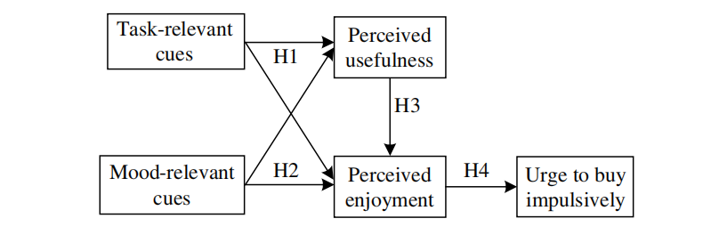
Many researchers have used the S-O-R model to study impulse buying behavior, which is a sudden reaction to a stimulus and is accompanied by an emotional response, which can be explained by the S-O-R model and explain the complex processes underlying consumers' impulse buying behavior. Typical studies of impulse buying based on S-O-R, such as Parboteeah et al. (2009), used the S-O-R model as a theoretical framework to study the impulse buying behavior occurring among consumers during web shopping. Environmental cues were used as stimuli, divided into high task-related cues (helping users to complete shopping tasks efficiently, e.g., security) and low task-related cues (not directly influencing shopping tasks, e.g., ambiance), with perceived usefulness as a cognitive response and perceived entertainment as an affective response that ultimately influences impulse purchase desire. The research model is shown in Figure 2.
Fig 2. Model of Parboteeah et al. (2009)

Chen & Yao (2018) selected the mobile auction platform integrating the S-O-R model. The interrelationship between situational factors and impulsive buying behavior were well explored by them. They developed their model (Figure 3) to investigate further the relationship between the architectural quality of websites and consumer's affective/cognitive reaction, the relationship within consumers' organism, the relationship between internal reaction, personal traits, and impulse buying behavior. More literature applying the S-O-R model can be found in Appendix 1.
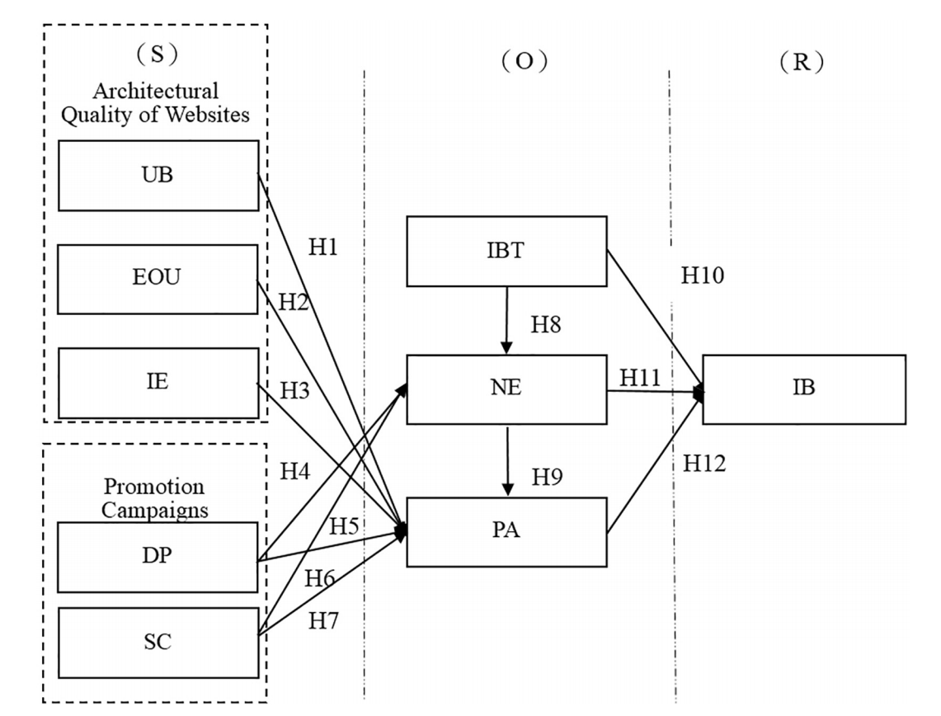
Fig 3. Model of Chen & Yao (2018)
Most researchers have confirmed the application of the environmental psychology model (SOR model) on consumers' impulsive purchase intention in different online environments (e.g., web shopping, mobile aution platform mentioned above). However, the live e-commerce environment characteristics are very different from those of the ordinary online shopping environment. From Parboteeah to Chen & Yao's model, the research environment delves from website shopping to auction site shopping. We noticed that Chen & Yao mainly changed the consumer's internal response from perception to emotional response. This is also mainly related to the immediacy of auctions. The same immediacy of our live environment amplifies the impact of the external environment on emotions and thus on consumer behavior. So organism in SOR with emotions would be more applicable to the new version of online shopping environment - real-time e-commerce.
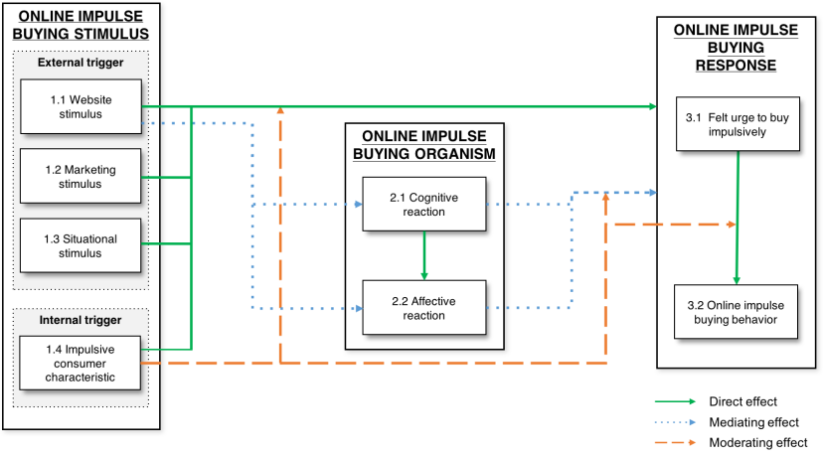
Many influencing factors influence impulse buying behavior: environmental cues, marketing cues, and personality traits all influence impulse buying behavior (Dholakia, 2000). Chan et al. (2017) reviewed 34 papers on online impulse buying behavior between 2002-2014 and categorized the factors influencing online impulse buying based on the S-O-R model. They have grouped the stimuli into external stimuli (website stimuli) and internal stimuli (personality traits). External stimuli are website stimuli, marketing stimuli, and situational stimuli; and the internal stimuli were consumer characteristics, such as hedonic consumer demand, hedonic shopping motivation, instant gratification and others. The organism refers to consumers' internal evaluations, which include cognitive and affective reactions. This article sheds great light on the delineation of external factors in online shopping and further confirms that there is sufficient research to support the placement of emotional responses between external factors and consumer impulse buying behavior. And external factors can also directly influence consumers' impulse buying behavior
Fig 4. Factors classification in S-O-R framework of Chan et al. (2016)

Conclusion
Based on Stern's (1962) classification of impulse purchases, this paper generalized impulse buying behavior in the e-commerce live-streaming environment as a sudden and immediate online purchase behavior in which a consumer is influenced by some stimulus to buy a product while watching a live stream, without having a purchase plan for that product before watching the livestreaming. In terms of measurement, we choose to measure consumers' impulse purchase desire rather than consumers' actual purchase behavior in order to prevent consumers from avoiding their actual negative impulse purchase behavior when completing the questionnaire. And this approach has been shown to be sensible in previous research papers (Beatty & Ferrell, 1998; Vonkeman et al. al., 2017; Liao et al., 2016)
As for model selection, we will select the most famous theoretical framework used in online impulse buying behavior studies, the "S-O-R Model," and apply it to a new version of the online shopping environment – live e-commerce. Refer to Chan et al. (2017), the stimuli in our next conceptual model will be an environmental stimulus and marketing stimulus in the live e-commerce context. As for the consumer's internal evaluation system - organism, we will focus on the emotional response rather than cognition response since the time of the live shopping broadcast is usually within 2 hours, which is usually not enough to build the user's internal cognition.

2.2 Overview of emotion theory
The emotions arising during the shopping process of consumers will affect the products they are about to buy. When consumers are triggered by the external environment, they have a strong interest in owning the product, leading to different emotions. This study suggests that when consumers are inspired by external stimuli, their desire to buy is immediately triggered and leads to irrational purchase behavior. Thus, emotions play an essential role in the relationship between external stimuli and purchase intentions. In the following, this study will focus on emotion theory and related concepts.

2.2.1 Definition and dimensions of emotions
Different scholars have different views on the definition of emotions. Westbrook (1991) defined emotions in a physical shopping environment in his study and argued that emotions refer to an internal perception formed by consumers after being stimulated by external information, which is an emotional experience of the product and external stimuli. Oliver (1993) also argued that emotions are emotional experiences that individuals use to react to the perception of the external environment. The definition of consumer emotions online is similar to offline. He et al. (2010), in their study on online consumers, identified emotions as the psychological reactions that occur when consumers are exposed to external stimuli in the online store environment crucial factor influencing decision making. Researchers using the S-O-R model generally agree that consumers' internal emotional reactions to different external environmental stimuli during the shopping process will vary, and in turn, consumers will react with converging or avoiding behaviors. Based on these perspectives, this study suggests that the term emotion refers to consumers' psychological reactions and attitudinal behavior due to stimulation by external factors.
There are two main perspectives on the two dimensions of emotion: one is the P-A (Pleasure-Arousal) model proposed by Russell and Pratt (1980), who argued that consumers generate two dominant emotions during the shopping process: pleasure emotion and arousal emotion. Pleasure emotions are the happy and joyful emotions that consumers feel when they see and then buy a product, while arousal emotions are the intense satisfaction that consumers feel when they have purchased the product, which is manifested as excitement and thrill. Since arousal emotions are mainly aroused after purchasing a product and do not correspond to the emotions during the live shopping process, we want to study in this paper. This definition was not utilized. Another viewpoint is to divide emotions into positive and negative emotions. Swinyard (1993) found that when consumers are in a good mood, they have more positive evaluations of a quality shopping experience. Nevertheless, too poor shopping experiences can cause such mood protection mechanisms to fail. So it is necessary to stratify consumer moods positively and negatively to view them separately. Verhagen & Doven (2011) agree with this classification and apply it to the online sentiment segmentation of consumers. In their view, positive and negative influences are universal, do not carry national geographical characteristics or age-gender characteristics, and can find their way into almost all cultures. So they define positive emotions as the degree to which a person feels enthusiastic, excited and inspired. Negative emotions are defined as the degree to which a person feels distressed, irritable and restless.
In this study, the positive affect will be selected as the observed variable. Concerning previous definitions, the positive emotion that influences consumers' impulsive purchase in the live e-commerce environment is defined as the extent to which a person feels enthusiastic, excited, and inspired when exposed to external stimuli.

2.2.3 relationship between positive affect and impulse buying behavior
Sherman et al. (1997) conducted an empirical study to investigate the relationship between buyer emotions and purchase behavior in traditional offline stores. The findings suggested that consumer emotions mediate the relationship between store environmental stimuli and final purchase decisions and that external environmental stimuli at the time of shopping can affect consumers' emotions (e.g., excitement, joy, satisfaction), which in turn influence their consumption behavior. In their study, Jing and Yue (2005) found that consumers' internal emotional reactions significantly influence their purchase intentions, with a positive relationship between positive emotions and impulsive purchase intentions. In addition to the influence of emotions on offline shopping behavior, there is also a significant influence on online purchase intention. Floh & Madlberger (2013) also found that consumers' emotional reactions to traditional offline stores can influence their purchase behavior.
Combining the above elaboration and according to the specific needs of this study, positive emotions were selected as emotional responses and analyzed whether consumers would be willing to make impulsive purchases due to strong emotional responses in a live shopping context.

Conclusion
Based on previous studies, this study suggests that the term emotion refers to consumers' psychological reactions and attitudinal behavior due to stimulation by external factors. According to extant papers (Jing & Yue, 2005; Floh & Madlberger, 2013), in impulsive buying environment we will mainly focus on the effect of positive affect on impulse buying desire. And the positive emotion that influences consumers' impulsive purchase in the live e-commerce environment is defined as the extent to which a person feels enthusiastic, excited, and inspired when exposed to external stimuli.

2.3 Hypotheses development and conceptual model

2.3.1 Hypotheses development
Interaction - environment stimulus
In this paper, interaction in the live e-commerce environment is defined as the real-time online interaction between the streamer(s) and consumers during the live broadcast, emphasizing that the two interacting parties are the streamer and the consumer. This is also one of the critical features that distinguish the live room from ordinary website shopping. Consumers comment in the evaluation section, and anchors give feedback based on the comments. Feedback from streamer(s) includes verbal responses, live demonstrations and others.
Hajli et al. (2017) found that in e-commerce, facilitating the connection between buyers and sellers is the basis for the co-creation of value. The communication interaction between buyers and sellers facilitates the exchange of knowledge, experience, and information, which leads to purchase behavior. In traditional offline shopping, merchants and consumers communicate face-to-face, and buyers can genuinely feel sellers' emotions. Face-to-face interaction is lacking in traditional e-commerce, but social media provides an alternative to face-to-face interaction to enhance emotional communication (Rusman, 2010). In live e-commerce, consumers can see the streamer in person, and the interaction between the streamer and the consumer will reduce the mental distance between them. This is one of the main reasons why live e-commerce is relatively well developed. In a live room with not much traffic, streamer(s) can interact with almost every viewer and answer questions from them, who will psychologically feel that they are being cared for. In addition to answering consumers' questions about the products, there are also exciting interactions where the anchor will talk to consumers about something they have experienced or their opinions about something, which will bring consumers closer to the anchor emotionally and create a sense of closeness, as well as stimulate positive affect in consumers (Xiang et al., 2016).
Currently, there are two main opinions on the relationship between online interaction and consumer impulsive buying behavior: one believes that online interaction has a direct relationship with consumer impulsive buying behavior. For example, Xie (2012) proved by empirical analysis that the interactivity between customers and online providers positively affects impulsive online buying. Another one suggests that online interactional factors influence consumers' impulse buying behavior through mediating variables (e.g., emotion, trust). For example, Hu (2015) conducted an empirical study in a group purchase scenario. He demonstrated the mediating effect of positive affect and consumer perception between external stimuli and consumer impulse behavior, consumer browsing behavior. Both group purchases and live shopping are characterized by temporal synchronization, so our article can also make the hypothesis that emotions can act as mediating variables.
Based on the above literature, we hypothesize as follows:
H1：The interaction between the streamer and consumers positively influences the positive affect of consumers.
H2：The interaction between streamer and consumers has a significant positive effect on consumers' urge to buy impulsively.

Price promotion and scarcity strategy - Marketing stimuli
According to Chen & Yao (2018), we categorized marketing stimuli into "price promotion" and "non-price promotion." The price promotion strategy means that "the discount offered in the live room is stronger than that in other channels." For non-price promotion, we use the "scarcity" promotion strategy, limiting the item's quantity and time of availability and increasing the value and attractiveness of that product or service in a livestreaming context. We consider these two strategies as marketing stimuli and help us figure out exactly which type of promotions are more effective in the live room.
Price promotion (Discounted price): Piron (1990) found that impulse buying behavior focuses on immediate benefits and ignores possible long-term gains and that price discounts often bring this immediate pleasure. In today's rapidly developing e-commerce, commodity prices are becoming more and more transparent. Consumers can compare prices not only between platforms but also within platforms, such as the "Find Similar Items" function within online shopping platforms, which allows users to find the same or similar products and compare prices. In such a competitive environment, consumers are more price-sensitive, and where they end up buying is often determined by price (Graciola et al., 2018). In e-commerce live streaming, streamers will often first say the offline price of the product, the in-store price, raise the psychological expectations given to consumers, and then say the live streaming price to highlight the strength of the price discount and increase consumer surplus. The higher the consumer surplus, the more users will feel that the price discount is extensive. Thus they will feel more excited and more inspired. Different web celebrities have different supply chains and bargaining power with the suppliers in live streams hosted by web celebrities. Price discounts are seen as a symbol of status. Web celebrity often tries to get more price discounts from suppliers for consumers, which created the user mentality that the products in livestreaming generally cheaper than those in other channels.
Non-price promotion (Scarcity): Scarcity refers to the strategic limitation of the availability, timing or other purchase conditions of a product by a merchant or operator in order to achieve the goal of making the consumer feel that the likelihood of purchasing the product is low. (Aggarwal et al., 2011). In live e-commerce, especially in the sec-killing, streamers often use scarcity strategies. After introducing a commodity, the streamer informs the user that there is limited warehousing of the extant commodity and then provides a link to the commodity. The popular commodity will be sold out within a few seconds, so consumers have no chance to contemplate. A hesitation is likely to cause them to miss the commodity. In addition to quantity restrictions, there are also time restrictions, and the promotion time is often limited to the time of the live streaming. The promotion ends as soon as the streamer finishes today's live stream. Strong positive consumer emotions are induced when they see through digital media that the product is available or only available within a specific time frame. (Lin & Lin, 2013). For consumers, scarcity strategy affects the attractiveness of the product. When there is a shortage, consumers tend to judge the product in such a way that the product is in short supply because it is popular and therefore sells well. This is when they are more likely to make an immediate purchase (Parker and Lehmann, 2011).
Based on the above literature, we hypothesize as follows:
H3：Discounted price in live streaming e-commerce positively influences the positive affect of consumers.
H4：Discounted price in live streaming e-commerce has a significant positive effect on consumers' urge to buy impulsively.
H5：Scarcity strategy in live streaming e-commerce positively influences the positive affect of consumers.
H6：Scarcity strategy in live streaming e-commerce has a significant positive effect on consumers' urge to buy impulsively.

Positive Affect – Affective reaction
Wu (2014) verified that positive affect positively and significantly influences impulse purchase intention in online group purchase contexts, similar to livestreaming context with scarcity strategy, time limitation, and high interactivity. Consumers are prone to emotional responses when stimulated by product information, price discounts, etc., and emotional responses may override cognitive responses and directly prompt impulse purchase decisions. Fu et al. (2018) found that consumers with higher emotional states are more likely to make spontaneous purchases. Compared to consumers in a low emotional state, those with positive emotions have more unspecified shopping lists, which means that consumers with positive emotions are more likely to make impulse purchases. Based on the above literature, we hypothesize as follows:
H7: Positive affect of consumers during the live streaming e-commerce process positively influences consumers' urge to buy impulsively.
Yan (2009) found that external environmental stimuli can significantly affect consumers' emotional responses and eventually cause impulse buying behavior. In this paper, we put the previous theories on emotion and impulse purchase intention in the context of live e-commerce and argue that external stimuli in this scenario can influence consumers' impulse purchase behavior by eliciting their positive emotions. Therefore, based on hypotheses H1-H7, the following hypotheses can be further formulated in this study:
H8：Positive affect mediates the effect of interaction on consumers' urge to buy impulsively.
H9：Positive affect mediates the effect of discounted price on consumers' urge to buy impulsively.
H10：Positive affect mediates the effect of scarcity strategy on consumers' urge to buy impulsively.

2.3.2 Conceptual Model
This study is based on the environmental psychology theory (S-O-R Model) to explore the factors influencing consumers' impulse purchase intentions in the live e-commerce environment. It is believed that when external factors stimulate consumers, they will have a specific emotional reaction inside, and this emotional reaction predicts the emergence of certain behavior. This paper collated relevant research, linked the actual shopping environment of live e-commerce with these studies, and classified the external factors affecting impulsive purchase intention in the live e-commerce environment into two categories: marketing factors and environment factor (interaction). Marketing factors further include both discounted price promotion and scarcity strategies (time and quantity constraints). Based on the environmental psychology paradigm, this paper constructed a model that takes marketing factors, interaction as antecedent variables and influences consumers' online impulsive purchase desire directly or by affecting their positive affect. In summary, the research model and hypotheses of this paper is established as shown in Figure 5.

(H8-H10)
H7
H6
H5
H4
H3
H2
H1
Discounted Price
Scarcity
Interaction
Positive Affect
Urge to Buy Impulsively

Marketing Stimuli
S (Stimulus)
O (Organism)
R (Response)
H1
Environment Stimulus
Fig 5. Research model and hypothesized relationships.

Conclusion
Firstly, we put forward ten hypotheses of this paper based on the relevant studies, combined with the specific context of live e-commerce. Then we constructed the theoretical model of this paper based on environmental psychology theory (S-O-R model).

2.4 Conclusion on Chapter 2
The rise of live e-commerce happened in 2016, mainly focusing on viewing motivation, user perception, and purchasing behavior (rational and irrational). As a newly emerging form of online shopping, there is a small amount of research literature in this area, and there is a lack of multi-faceted research that delves into the area of consumer behavior in this form of online shopping, such as less research that explores irrational behavior in the live shopping environment.
So, in this section, we first explore how previous researchers have studied impulse shopping on offline and traditional online websites. Based on this, we defined impulse buying behavior in a live e-commerce environment and chose impulse buying desire instead of impulse buying behavior to measure. Although researchers have used various types of theory and frameworks to study online consumers' impulse buying behavior (e.g., technology acceptance model, flow theory, cognitive emotion theory, resource allocation theory, heuristics information processing theory, elaboration likelihood model), the existing studies of online impulse buying have consistently examined the relationships between environmental cues, consumers' cognitive and affective reactions, and the resulting behavior. Most researchers have drawn primarily on the environmental psychology paradigm, which can be reconciled with the S-O-R framework (Chan et al., 2016). So, we used the S-O-R model to study impulse buying behavior, which is a sudden reaction to a stimulus and is accompanied by an emotional response, which can be explained by the S-O-R model and explain the complex processes underlying consumers' impulse buying behavior.
In the framework of SOR, we tried to identify several factors that are most relevant to the livestreaming scenario. Then we established the relationship between these factors and impulse purchase desire based on previous literature to formulating our hypothesis. So finally, in our conceptual model, the stimuli are divided into price promotion, scarcity strategy (time and quantity constraints), and interaction. The organism refers to positive affect companying the sudden reaction to these stimuli. We assumed that promotion, scarcity strategy (time and quantity constraints), and interaction could directly influence impulse buying desire of consumers or indirectly influence impulse buying desire through the positive affect.

Chapter 3. Methodology

3.1 Research design
The theoretical model presented in Figure 5 we intend to use a survey to test the model. Among the many forms of questionnaires, we decided to use the web-based electronic questionnaires as the survey method for its fast response rate and low cost. The collection method also avoids large-scale human-to-human contact (preventing the spread of the virus) during an outbreak, making it a safe and effective way to conduct research. There are also paid forms of online surveys, similar to data-based marketing, which can help us to accurately filter the audience and send our questionnaire to the corresponding groups. If we compared online survey methodology to traditional collection methods for data, like e-mail or phone surveys, we could find that the former has more advantages - faster response rates, a relatively low cost, no geographical distribution restrictions (Sue & Ritter, 2012).

3.2 Instrument Development
Survey items are provided in Table 3.2.1, all of which are adapted to the context of research from previously validated scales. We use seven-point Likert scales to measure each item (1 = strongly disagree; 7 = strongly agree).
Table 3.2.1 Survey Instruments
Construct | Identification | Item | Reference
Discounted Price | A price that is more favorable than usual | DP1: I think the goods in the livestreaming are cheap.  DP2: The price discount in the livestreaming attracted my attention.  DP3: I was tempted by the low price of products in livestreaming.  DP4：When I saw a product on sale in the livestreaming, I got the desire to buy it.  DP5: The stronger the discount, the easier it is to make me want to buy. | Dittmar & Beatti (1995), Chen (2020)
Scarcity | A method of limiting the number of items or opening the hours of availability in order to increase the value and appeal of a product | SC1: I worried about the limited time when I watch the livestreaming.  SC2: I was concerned about limited quantity when I watched the livestreaming.  SC3: I became anxious when I see a "sold out" sign in the livestreaming.  SC4: I feel that the limited edition of a product caused many people to buy.  SC5：I think that the current supply of a limited product is small in livestreaming. | Chen & Yao (2018)
Interaction | Online real-time interaction between the streamer(s) and consumers during the live broadcast, emphasizing that the two interacting parties are the streamer and the consumer. | IN1: The streamers actively involved customers in determining their specific needs.  IN2 Streamers provided advice that was relevant for customers' needs.  IN3: Streamers adapted their sales pitch very much to customers' interests.  IN4: Streamers talked with customers about their objections in a detailed manner.  IN5: When presenting products and services, the streamer responded very individually to customers' requirements. | Homburg et al. (2011), Zheng (2019)
Positive Affect | The extent to which a person feels enthusiastic, excited, and inspired | PA1: When watching livestreaming, I became excited to see the products I want.  PA2: I felt pleased during the live shopping.  PA3: I felt enthusiastic during the live shopping.  PA4: I felt proud during the live shopping  PA5: I felt inspired during the live shopping | Beatty & Ferrell (1998), Chen & Yao (2018)
Urge to Buy Impulsively | A state of desire that  is experienced upon encountering an object in the (live commerce environment). | UTB1: I experienced a number of sudden urges to buy things I had not planned to purchase in the livestreaming shopping process  UTB2: In the livestreaming shopping process, I saw a number of things I wanted to buy even though they were not on my shopping list.  UTB3: I experienced no strong urges to make unplanned purchases on this trip. ª  UTB4: During this live streaming shopping, I felt a sudden urge to buy something. | Beatty & Ferrell (1998)  Zhang (2012)
a. Item was reversed scored.

The questionnaire includes three parts: The first part is a screening question (Did you have experience using Taobao live streaming commerce to shop? Yes/No). We screened the respondents who answered "yes," and only their responses were used as the database for this study. The second part - the items for constructs in the model (including 25 questions divided into five dimensions). This part required respondents to recall their personal experience of live shopping and to describe the interaction between customers and streamers, the marketing stimuli (price, quantity, time), and the consumer's emotions and impulse purchase intentions at the time based on their experience. The third part is demographic research, including gender, age, education level, frequency of using live streaming platforms to shop, and favorite categories.

3.3 Sampling and Data collection
Data were collected in China, a representative country with a significant e-commerce sales level. According to eMarketer global e-commerce report, China has the highest rate of e-commerce of any country as a percent of total retail sales (44.8% in 2020), the highest e-commerce sales ($2296.95 billion in 2020, more than three times the U.S. total). As for the live streaming share in China's e-commerce platform, Alibaba's Taobao live accounted for around 80%, which can be named the leader in livestreaming e-commerce market (was launched in 2016), while Amazon, another leading online marketplace in the world, has introduced live shopping function to their merchants and influencers group since 2019. Given many potential shoppers and sellers, Taobao was the first E-commerce platform that introduced a livestreaming function. Therefore, this paper selects consumers who have watched Taobao Live and purchased its products as survey respondents.
We distribute the questionnaire on the Wenjuanxing website (https://www.wjx.cn/), Only those who with live streaming shopping experience (passed our screening questions) were given access to further questions. We guided these respondents to answer questions based on their previous live streaming shopping experiences with notification. In total, 401 valid questionnaires were received, there were no missing values in the data.

3.4 Techniques for data analysis
Structural equation modeling (SEM) is considered the primary method to test our conceptual model in this paper, with the advantage of measuring the relationship between multiple variables simultaneously by putting them all under the same framework.
In order to test the proposed model, We chose the Analysis of Moment Structures (AMOS) statistical packages and the widely used software SPSS- Statistical Package for the Social Sciences, which are commonly used for SEM data testing. In order to analyze the participants' characteristics, we firstly used SPSS. Then We adopted the assumption tests through SPSS to make sure our data is suitable for the SEM approach. With the help of AMOS, we need to perform a CFA analysis to determine, first, that there are no redundant items in the constructs and, second, to determine the overall model fitness (which includes both reliability and validity analysis). After passing all the previous tests, we can perform the path analysis in the SEM model and the mediation analysis with the help of the AMOS tool.
Before we start to collect data, it is necessary to determine the sample size according to the complexity level of our conceptual model. Specifically, for each parameter, observations should more than 20 (Kline, 2015). The ratio of N/q in the study (80.4:1) met the principal for testing the proposed model.

3.5 Conclusion on Chapter 3
In this chapter, based on the hypothesis and theoretical model of the previous chapter, the online questionnaire method in quantitative was chosen, and the scale was constructed based on a solid literature base. Afterward, we developed a questionnaire based on the measured scales and distributed it on the Wenjuanxing website. The respondents who filled out the questionnaire were from China, where live e-commerce was first developed. The core model building method is Structural equation modeling (SEM). Specific tools used are as follows: use SPSS to conduct descriptive analyses and assumption testing. Use AMOS to do unidimensionality, measurement model testing (based on confirmatory factor analysis), path analysis in the structural model, and mediation effect testing.

Chapter 4. Data analysis and recommendation

4.1 Data analysis

4.1.1 Participants Characteristics
Table 4.1.1.1 Characteristics of Survey Respondents
Characteristics | Description | Frequency  (N=401) | Percent (%)
Gender | Male | 190 | 47.40%
 | Female | 211 | 52.60%
Age | Under 18 | 2 | 0.50%
 | 18-23 | 126 | 31.40%
 | 24-29 | 156 | 38.90%
 | 30-35 | 94 | 23.40%
 | 36-41 | 15 | 3.70%
 | >41 | 8 | 2.00%
Education | High school or less | 16 | 4.00%
 | 2-year college | 84 | 20.90%
 | 4-year college/university | 256 | 63.80%
 | Postgraduate | 45 | 11.20%
Social Status | Students | 89 | 22.20%
 | Civil servants | 115 | 28.70%
 | Freelancers | 97 | 24.20%
 | Company employees | 94 | 23.40%
 | Others | 6 | 1.50%
Frequency of  Taobao Live use | Multiple times a day | 65 | 16.20%
 | Once a day | 130 | 32.40%
 | A couple of times a week | 127 | 31.70%
 | Once a week | 53 | 13.20%
 | Occasionally | 26 | 6.50%
Money spent on  live shopping /month | Under $77 | 59 | 14.70%
 | $78-$154 | 144 | 35.90%
 | $158-$462 | 147 | 36.70%
 | $462-$923 | 33 | 8.20%
 | Over $923 | 18 | 4.50%
Favorite categories  on live shopping | Fashion (apparel, cosmetics, etc.) | 277 | 69.10%
 | Food | 284 | 70.80%
 | Baby | 138 | 34.40%
 | Electronics | 210 | 52.40%
 | Daily Necessity | 223 | 55.60%
 | Others | 3 | 0.70%
The sample consisted of 401 participants. 211 were women (52.6%), and 190 were men (47.4%). The majority of participants were between the ages of 18 and 35, a proportion similar to Taobao Live users (Taobao Live Ecological Development Trend Report, 2020). It shows that the user group of e-commerce live mostly is from the young generation with solvent ability.
Participants' professions ranged from students, civil servants, freelancers to company employees with an equal portion around 20-30%. Regarding education level, more than 70% of the participants with high education level (4-year college or masters level), which is consistent with the tendency of high education of online shopping population in CNNIC 47th China Statistical Report on Internet Development Report. 63.8% of participants indicated that they completed 4-year college (63.8%), while 20.9% had a 2-year college degree.
The majority of participants were frequent users of Taobao Live. Participants visited Taobao Live once a day (32.4%), a couple of times a week (31.7%), or multiple times a day (16.2%). The money they spent on Taobao live monthly is ranging from $78 to $462. In terms of the types of product that consumers are likely to purchase in e-commerce live streaming, food, fashion products (apparel, cosmetics, and others.), daily necessities, and electronics accounted for 70.8%, 69.1%, 55.6%, and 52.4% respectively, far exceeding other categories of products.
In summary, the sample population of this study shares parts of the demographic characteristics of the online shopping population, i.e., the shopping population tends to be young, highly educated, and the online shopping products are mostly clothing, beauty products, and food products.

4.1.2 Assumption Tests
As specified, we determine to test the suitability of our data for structural equation modeling (SEM) from the following assumptions:
(1) the normality of the data
(2) reliability of the measures
(3) multicollinearity among latent variables.
We examined skewness and kurtosis of the data to assess the normality of the data (see Table 4.1.2.1). For sample sizes greater than 300, the normality value can be referred to the histogram, and the skewness and kurtosis value without considering the value of Z. Reference skewness value is less than 2.0 and kurtosis not exceeding 7.0 are considered normal (Kim, 2013). Since the skewness values are between -1.409 and 0.657, while the kurtosis values are between -1.714 and 2.631, which are in the acceptable range. So we can consider our data as symmetric.
Table 4.1.2.1 Normality of Primary Data (n = 401)
Construct | Item | Mean | Std. Deviation | Skewness | Kurtosis
Discounted Price | DP1 | 5.59 | 1.18 | -0.657 | 0.166
 | DP2 | 5.71 | 1.103 | -0.986 | 1.463
 | DP3 | 5.68 | 1.199 | -1.157 | 1.782
 | DP4 | 5.81 | 1.063 | -1.174 | 2.121
 | DP5 | 5.8 | 1.183 | -1.409 | 2.631
Scarcity | SC1 | 5.31 | 1.457 | -0.963 | 0.57
 | SC2 | 5.31 | 1.407 | -0.989 | 0.655
 | SC3 | 4.95 | 1.576 | -0.707 | -0.195
 | SC4 | 5.58 | 1.259 | -1.365 | 2.341
 | SC5 | 5.09 | 1.431 | -0.862 | 0.532
Interaction | IN1 | 5.57 | 1.231 | -1.039 | 1.299
 | IN2 | 5.48 | 1.145 | -1.025 | 1.962
 | IN3 | 5.44 | 1.22 | -0.999 | 1.12
 | IN4 | 5.42 | 1.233 | -1.019 | 1.504
 | IN5 | 5.58 | 1.208 | -1.192 | 2.134
Positive Affect | PA1 | 5.68 | 1.16 | -1.269 | 2.327
 | PA2 | 5.53 | 1.206 | -1.028 | 1.417
 | PA3 | 5.52 | 1.263 | -1 | 1.171
 | PA4 | 5.02 | 1.46 | -0.732 | 0.214
 | PA5 | 5.37 | 1.299 | -1.17 | 1.538
Urge to Buy Impulsively | UTB1 | 5.41 | 1.32 | -1.068 | 1.169
 | UTB2 | 5.25 | 1.317 | -0.902 | 0.843
 | UTB3 | 5.03 | 1.53 | -0.703 | -0.174
 | UTB4 | 5.26 | 1.345 | -0.951 | 0.766
We use Cronbach's alpha to assess our measurement's reliability (see Table 4.1.2.2). A value of 0.70 or above indicates that the reliability is acceptable and can be used for subsequent data analysis (Nunnally, 1978). Our alpha values fell between .839 and .898; thus, all measures were acceptable.
Table 4.1.2.2 Reliability of Measures
Construct | Number of Items | Cronbach's Alpha  Coefficients
Discounted Price | 5 | .898
Scarcity | 5 | .893
Interaction | 5 | .897
Positive Affect | 5 | .887
Urge to Buy Impulsively | 4 | .838
The final step in assumption testing is multicollinearity. If our variables are highly correlated and not only to the dependent variables, we think there might be a multicollinearity problem. What is worse, the multicollinearity problem might cause a non-positive covariance matrix in later SEM (Kline, 2005). We conduct a correlation matrix of our five variables to check if there will be any multicollinearity problem between them. Value over .85 indicated a potential problem with multicollinearity (Kline, 2005). All values of our database are under .85 without any multicollinearity problem (see Table 4.1.2.3).
Table 4.1.2.3 Correlation Matrix of Variables for Primary Data Analyses
Construct | DP | SC | IN | PA | UTB
Discounted Price | 1
Scarcity | .638** | 1
Interaction | .769** | .618** | 1
Positive Affect | .760** | .625** | .787** | 1
Urge to Buy Impulsively | .617** | .573** | .563** | .649** | 1
*p < .05. **p < .01. ***p < .001.

Note. DP = Discounted Price. SC = Scarcity. IN = Interaction. PA = Positive Affect. UTB = Urge to Buy Impulsively.

4.1.3 Unidimensionality
We conducted confirmatory factor analysis (CFA) on each of the five constructs. To ensure that the data can be used for subsequent SEM, we carefully examed the magnitude of 94 item error variances, large modification indices (MI), and standardized residuals values. CFA assessment results contributed to the decision of items' deletion and retention. Finally, five items were removed (i.e., DP1, SC4, IN3, PA4, PA5). After deleting above mentioned items in constructs (i.e., discounted price, scarcity, interaction, positive affect), significant improvements in fit (i.e., $x^{2}$statistics, CFI) were shown. Also, with root mean square error of approximation (RMSEA) statistics of less than .025 or less (< .05) (see Table 4.1.3.1), the fit of all reduced-item set models improved.
As a result of these initial analyses, 19 of the initial 24 items were retained for hypothesis testing. Table 4.1.3.2 lists the final measures used for data analysis by construct.
Table 4.1.3.1 Goodness-of-Fit Statistics for Full and Reduced Item Sets
Construct | Full Item Set |  | Reduced Item Set
 | Number of Items | Model Fit Statistics | Number of Items | Model Fit Statistics
Discounted Price | 5 | $x^{2}$=12.356  $ⅆf$=5  $p$=.030  CFI=.994  RMSEA=.067 | 4 | $x^{2}$=.098  $ⅆf$=2  $p$=.629  CFI=1.000  RMSEA=.000
Scarcity | 5 | $x^{2}$=25.542  $ⅆf$=5  $p$=.000  CFI=.982  RMSEA=.101 | 4 | $x^{2}$=.956  $ⅆf$=2  $p$=.620  CFI=1.000  RMSEA=.000
Interaction | 5 | $x^{2}$=37.805  $ⅆf$=5  $p$=.000  CFI=.971  RMSEA=.128 | 4 | $x^{2}$=.494  $ⅆf$=2  $p$=.287  CFI=1.000  RMSEA=.025
Positive Affect | 5 | $x^{2}$=59.994  $ⅆf$=5  $p$=.000  CFI=.950  RMSEA=.166 | 3 | Saturated  Model
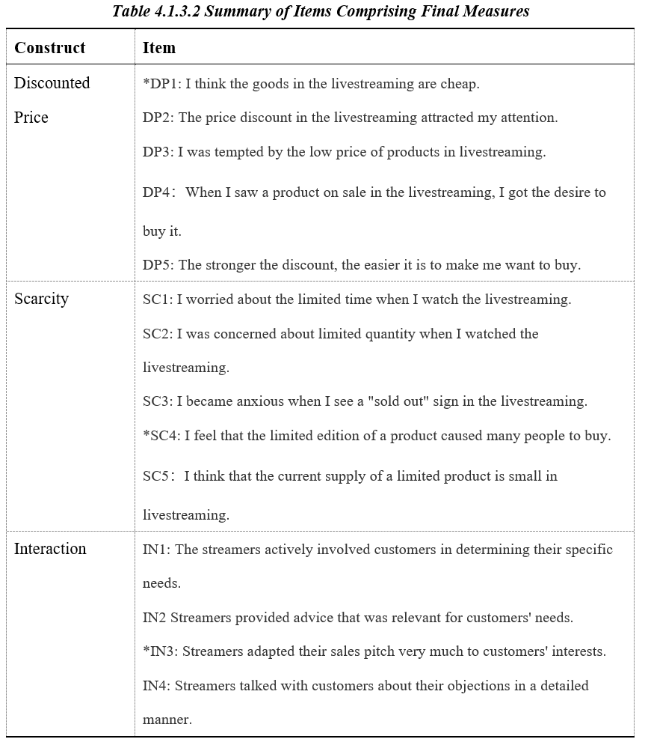
Note. RMSEA = root mean square error of approximation. $ⅆf$= Degree of freedom. CFI= comparative fit index. $x^{2}$ = chi-square
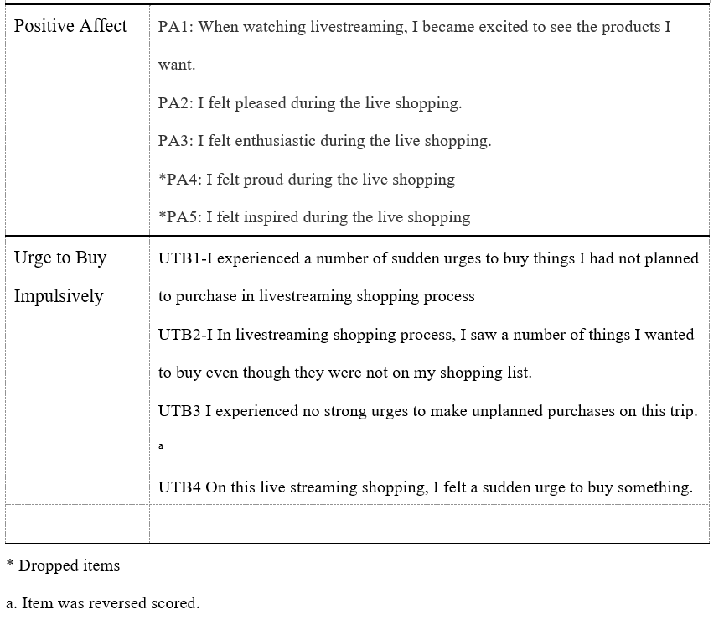

4.1.4 Measurement Model
We conducted confirmatory factor analysis with maximum likelihood in order to test the measurement model containing 19 indicators of 5 constructs. See Appendix 2 for the measurement model specification.
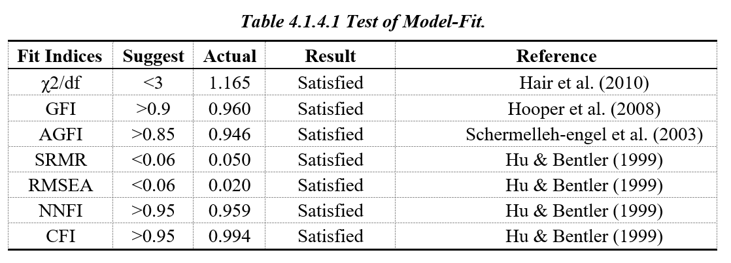
We assessed the overall model fit by multiple indices such as the comparative fit index (CFI), $x^{2}$statistics, the ratios of chi-square to degrees of freedom ($ⅆf$), the non-normal fit index (NNFI), the standardized root mean square residual (SRMR), adjusted goodness of fit index (AGFI), the goodness of fit index (GFI) and the root mean square error of approximation (RMSEA). In general, AGFI of .85 or higher (Schermelleh-engel et al., 2003), GFI of .90 or higher (Hooper et al., 2008), CFI, NNFI values of .95 or higher, RMSEA and SRMR of .06 or lower indicate a satisfactory model fit (Hu & Bentler, 1999). After confirming the results of fit indices, we can say that the measurement model had satisfactory construct validity (see See Table 4.1.4.1)
Convergent validity was supported by the following (Hair et al., 1998):
(1) all loadings are significant (p < .001)
(2) the composite reliability for each construct exceeded the recommended level of .60
(3) the average variance extracted (AVE) for each construct fulfilled the recommended benchmark of .50
All the factor loadings were significant (p < .001), with composite reliability greater than .75 and AVE larger than .50 (see Table 4.1.4.2), except for AVE of discounted price construct is a bit lower than the recommended level of .50 (.437). According to Fornell and Larcker (1981), the average variance extracted may be a more conservative estimate of the validity of the measurement model, it can be accepted at the level lower but close to .50, when the composite reliability of other (five) constructs is well above the recommended level (>.6), so the internal reliability of the measurement items is acceptable.

Table 4.1.4.2 Convergent Validity Assessment Matrix of the Measurement Model
Construct | Item | Unstd. | S.E. | t-value | P | Factor loading | SMC | CR | AVE
DP | DP1 | 1.000 |  |  |  | .674 | .454 | .756 | .437
 | DP2 | .977 | .099 | 9.878 | *** | .668 | .446
 | DP3 | .962 | .098 | 9.839 | *** | .663 | .440
 | DP4 | .909 | .094 | 9.634 | *** | .639 | .408
IN | GS1 | 1 |  |  |  | .814 | .663 | .903 | .700
 | GS2 | 0.995 | 0.052 | 19.159 | *** | .846 | .716
 | GS3 | 1.017 | 0.053 | 19.294 | *** | .851 | .724
 | GS4 | 0.965 | 0.051 | 18.812 | *** | .834 | .696
SC | SC1 | 1.000 |  |  |  | .805 | .648 | .874 | .635
 | SC2 | .974 | .057 | 17.002 | *** | .812 | .659
 | SC3 | 1.084 | .064 | 16.888 | *** | .807 | .651
 | SC4 | .930 | .059 | 15.832 | *** | .762 | .581
PA | PA1 | 1.000 |  |  |  | .709 | .503 | .799 | .571
 | PA2 | 1.220 | .101 | 12.129 | *** | .782 | .612
 | PA3 | 1.193 | .098 | 12.128 | *** | .773 | .598
UTB | UTB1 | 1.000 |  |  |  | .754 | .569 | .883 | .655
 | UTB2 | 1.157 | .072 | 16.037 | *** | .811 | .658
 | UTB3 | 1.182 | .072 | 16.470 | *** | .834 | .696
 | UTB4 | 1.152 | .070 | 16.501 | *** | .835 | .697
Note. SE = standardized estimate. Unstd. = unstandardized estimate.
CR = composite reliability. AVE= average variance extracted.
*p < .05. **p < .01. ***p < .001.
We measured the square root of each construct's AVE to assess discriminant validity (see Table 4.1.4.3). These square roots were larger than the correlations between the constructs, which confirmed the discriminant validity (Tsang, 2002). It indicates that there is a difference between the constructs and the construct's, explained by the different dimensions.
 | AVE | UTB | PA | SC | IN | DP
UTB | .655 | .809
PA | .571 | .496 | .756
SC | .635 | .479 | .496 | .797
IN | .700 | .700 | .357 | .358 | .837
DP | .437 | .396 | .605 | .402 | .287 | .661
Note. The shaded numbers in the diagonal row are square roots of the average variance extracted.
After ensuring the well-accepted convergent and discriminant validity of measures, we can evaluate the structural model to test hypotheses.

4.1.5 Structural Model & Hypotheses testing
We conducted a bootstrapping technique with a resample size of 5000 in this study to estimate path coefficient significance. Figure 6 illustrates the result of the structural model analysis, including path coefficient and R². Overall, six hypotheses are supported. However, H4 is not supported.
Further, We considered R² values as another vital indicator of path model predictive power. In this study, about 46% of the variance of positive affect is explained by discounted price, scarcity strategy, and interaction between customers and streamers (R² =0.456), while the remaining is explained by other variables. Approximately 58% variance of impulse buying desire is explained by discounted price, scarcity strategy, interaction, and customers' positive affect, while the remaining is explained by other variables.
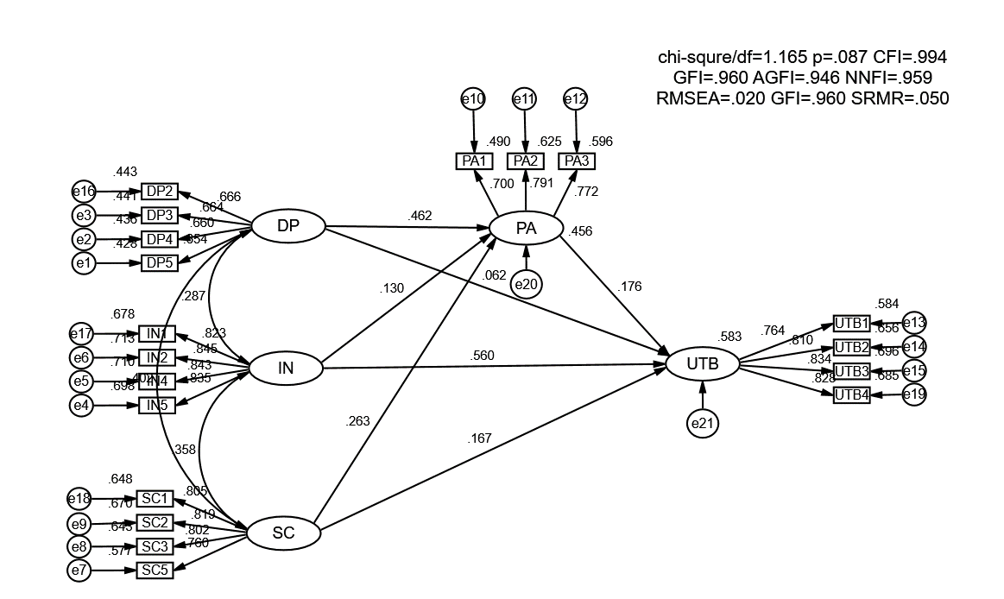
Fig 6. Results of path analysis.
According to the antecedents of impulse buying desire, we find interaction between customers and streamers (β = 0.560***, z-value =10.364), scarcity strategy (β = 0.167**, z-value = 3.184) and customers’ positive affect (β = 0.176**, z-value = 2.628) all have a positive impact on impulse buying desire. However, the effect of discounted price (β = 0.062, z-value = 0.981) does not, supporting H2, H6, H7 but not H4. All the relationships between discounted price (β = 0.462***, z-value = 6.353), scarcity strategy (β = 0.263***, z-value = 4.277), interaction (β = 0.130*, z-value = 0.018) and customers’ affect are significant (confirmed H1, H3 and H5). Table 4.1.5.1 shows the detail results of path analysis.

Table 4.1.5.1 Results of path analysis
Hypothesis | Path relationship | Estimate | S.E. | z | P | Standardized coefficient | Result
H3 | DP→PA | 0.548 | 0.086 | 6.353 | *** | 0.462 | Supported
H1 | IN→PA | 0.086 | 0.036 | 2.37 | 0.018 | 0.130 | Supported
H5 | SC→PA | 0.2 | 0.047 | 4.277 | *** | 0.263 | Supported
H7 | PA→UTB | 0.224 | 0.085 | 2.628 | 0.009 | 0.176 | Supported
H4 | DP→UTB | 0.093 | 0.095 | 0.981 | 0.327 | 0.062 | Not Supported
H2 | IN→UTB | 0.469 | 0.045 | 10.364 | *** | 0.560 | Supported
H6 | SC→UTB | 0.161 | 0.051 | 3.184 | 0.001 | 0.167 | Supported
*p < .05. **p < .01. ***p < .001.

4.1.6 Mediation Effect
To further understand the relationship between external stimulus and the urge to buy impulsively, indirect associations were estimated by testing the mediating roles of positive affect between discounted price, scarcity strategy, interaction, and the urge to buy impulsively. Firstly we ran multiple regression analyses using Amos 23.0 and interpreted the result following a 4-steps approach (Baron & Kenny,1986).
Step 1: To demonstrate that the dependent variable is correlated with the outcome. Use Y as the criterion variable and X as the predictor variable in the regression equation (estimate and test path c in the figure above). This step identifies that there is a possible mediating effect.
Step 2: To demonstrate that the dependent variable is correlated with the mediating variable. Use M as the criterion variable and X as the predictor variable in the regression equation (estimation and test path a). This step focuses on treating the mediator as an outcome variable.
Step 3: Demonstrate the effect of the mediator on the outcome variable. Use Y as the criterion variable and X and M as predictors in the regression equation (estimation and test path b). It is not sufficient to correlate the mediator with the outcome because the mediator and the outcome can be correlated because they are both caused by the dependent variable X. Therefore, when determining the effect of the mediator on the outcome, it is necessary to control for the dependent variable.
Step 4: The effects of both step 3 and step 4 are estimated in the same equation. Because we need to be sure that M fully mediates the X-Y relationship, the effect of X on Y (path c') controlling for M should be zero (the discussion on significance tests is mentioned below).
If all four steps are met, then the data are consistent with the hypothesis that variable M fully mediates the X-Y relationship, and if the first three steps are met, but step 4 is not, then it indicates partial mediation.
Model 1 showed that, when the direct path from positive affect to the urge to buy impulsively was freely estimated, the paths from discounted price (β=.144; p<.01), scarcity (β = .213; p< .001) and interaction (β = .582; p < .001) to the urge to buy impulsively were both significant. So there is an effect that may be mediated.
Model 2 showed that all the three variables (discounted price, scarcity, and interaction) are correlated with the mediator-positive affect. In model 3, when all the three variables were controlled, the positive affect still effected the urge to buy impulsively at p < .01 ( β = .176).
Model 4 demonstrated that when the discounted price on the urge to buy impulsively was estimated along with positive affect, the path from discounted price to the urge to buy impulsively became weak (β = .062; p > .05), but the path coefficient was still larger than 0. Hence, positive affect functions as a partial mediator between the discounted price and the urge to buy impulsively. Similarly, between scarcity and urge to buy impulsively (β = .167; p <.01), interaction and urge to buy impulsively (β = .560; p < .001), positive affect can be regarded as a partial mediator. Hypotheses 8,9,10 were approved. Table 4.6.1 shows the detailed results of testing the models.
Table 4.1.6.1 Results of a full model test (based on mediation effect)
Path relationship | Path coefficients
 | Model 1 (Step 1) | Model 2 (Step 2) | Model 3 (Step 3) | Model 4 (Step 4)
DP-UTB | 0.144** (p=0.007) |  | 0.062 (p=0.328) | 0.062 (p=0.328)
SC-UTB | 0.213*** (p=0.000) |  | 0.167* (p=0.010) | 0.167** (p=0.001)
IN-UTB | 0.582*** (p=0.000) |  | 0.560*** (p=0.000) | 0.560*** (p=0.000)
DP-PA |  | 0.462*** (p=0.000) |  | 0.462*** (p=0.000)
SC-PA |  | 0.264*** (p=0.000) |  | 0.264*** (p=0.000)
IN-PA |  | 0.130* (p=0.018) |  | 0.130* (p=0.018)
PA-UTB |  |  | 0.176** (p=0.009) | 0.176** (p=0.009)
Construct | Squared multiple correlation (% of variance explained)
PA |  | 45.6% |  | 45.6%
UTB | 56.6% |  | 58.3% | 58.3%
Note. *p < .05. **p < .01. ***p < .001.
DP-discounted price, SC-scarcity, IN-interaction, PA-positive affect, UTB-urge to buy impulsively
Goodness of fit for the models: Model 1 (χ2/df=1.21, CFI=.994, GFI=.964, RMSEA=.023), Model 2 (χ2/df=1.166, CFI=.995, GFI=.970, RMSEA=.020), Model 3&4 (χ2/df=1.165, CFI=.994, GFI=.960, RMSEA=.020)

4.2 Conclusion and discussion
This paragraph would be devoted to the interpretation of statistical results to the business language and the development of the list of practical recommendations for steamers, e-commerce merchants, and designers of e-commerce platforms.

4.2.1 Research results
9 out of 10 hypotheses were accepted. Research revealed that positive effects on impulse buying desire has: interaction, price promotion, scarcity strategy, and positive affect. The most influential factors are interaction and price promotion. Positive affect mediates the effect of interaction on impulse buying desire, the effect of scarcity strategy on impulse buying desire, and the effect of price promotion on impulse buying behavior. But the price promotion itself does not significantly influence impulse buying desire, which indicates that in our model of live e-commerce, price promotion mainly affects consumers' impulse purchase desire by influencing consumers' positive affect, and the direct influence of price promotion on impulse purchase desire is weak. The remaining two external stimuli, scarcity strategy, and interaction can influence consumers' impulse buying desire both directly or indirectly through positive affect. So we just deleted one path from discounted price to positive affect. The result of testing are shown in Table 4.2.1.1 and the modified model are shown in Figure 7.
Table 4.2.1.1 Results of hypotheses testing
Hypothese | Content | Result
H1 | The interaction between the streamer and consumers positively influences the positive affect of consumers. | Supported
H2 | The interaction between streamers and consumers has a significant positive effect on consumers' urge to buy impulsively. | Supported
H3 | Discounted price in live streaming e-commerce positively influences the positive affect of consumers. | Supported
H4 | Discounted price in live streaming e-commerce has a significant positive effect on consumers' urge to buy impulsively. | Not Supported
H5 | Scarcity strategy in live streaming e-commerce positively influences the positive affect of consumers. | Supported
H6 | Scarcity strategy in live streaming e-commerce has a significant positive effect on consumers' urge to buy impulsively. | Supported
H7 | The positive affect of consumers during the livestreaming e-commerce process positively influences consumers' urge to buy impulsively. | Supported
H8 | Positive affect mediates the effect of interaction on consumers' urge to buy impulsively. | Supported
H9 | Positive affect mediates the effect of a discounted price on consumers' urge to buy impulsively. | Supported
H10 | Positive affect mediates the effect of scarcity strategy on consumers' urge to buy impulsively. | Supported

Discounted Price
Scarcity
Interaction
Positive Affect
Urge to Buy Impulsively

Marketing Stimulus
S (Stimulus)
O (Organism)
R (Response)
H1
Fig 7. Modified model
The findings of the study are summarized in three main areas：
- Positive emotions significantly affect impulse purchase intentions.
This paper demonstrates that impulse purchase intentions are generated when consumers have a positive affect. When consumers perceive positive affect, they are inclined to self-rewarding behavior while ignoring the product's price and their affordability and generating impulsive purchase intentions. Positive affect is emotionally driven, consistent with previous studies that impulse an emotional response often accompanies buying.
- The impact of streamer-consumer interaction on impulse buying desire
Of all the factors that influence impulse buying desire in our model, the most significant influence lies in the interaction between the streamer and consumers. The interaction between the streamer and consumers consists of professional explanations and answers to questions about the product. When the consumer perceives the streamer as professional and able to recommend more appropriate products and thus perceives the streamer as reliable and competent in choosing products, it can directly contribute to an eventual impulse purchase. Our study also demonstrated that the interaction could influence impulse purchase intention by affecting positive affect. In livestreaming shopping, the interaction is based on customers’ personalized needs. According to Aljukhadar & Senecal (2011), the more the information provided to consumers for product recommendation meets the consumer's needs, the higher the consumer's trust in the streamer and e-commerce platform, the more positive the attitude toward live shopping, and the more pleasant the consumer's emotion. Furthermore, the positive affect can further help trigger the impulse buying desire.
- The impact of marketing stimuli on impulse buying desire
Both price discounts and scarcity strategies can trigger positive affect from consumers, which influences impulse purchases. Among them, the scarcity strategy in live e-commerce directly impacts consumers' impulse purchases because it requires consumers to make quick purchase decisions through quantity and time constraints. The mediating effect of positive affect is most potent on discounted price.

4.2.2 Practical implications
In e-commerce live streaming, the effect of 3 external stimuli, namely scarcity strategy, promotional price, and interaction between streamers and consumers, has contributed significantly to consumers' impulse buying desire or strengthen the consumers’ impulse buying desire through positive affect. These results yield several practical suggestions for steamers, e-commerce merchants, and designers of e-commerce platforms.
Interaction has the greatest positive effect on impulse buying desire- enhance professional ability of streamers/interactive function plug-in
Traditional online shopping is search-based shopping, where consumers search for what they want, select and compare and then purchase. The initiative of this search-based shopping is in the hands of consumers, who have an obvious shopping purpose, while in e-commerce livestreaming, consumers are more likely to have no clear shopping purpose and watch live streaming with the mindset of killing time. The interactivity in the live e-commerce environment can significantly influence consumers' willingness to purchase online, so it becomes imperative whether the content of live e-commerce is interactive and whether it can bring fun, interest, and pleasure to consumers. In addition to the anchor itself can use a more humorous language to explain the product, with personality charm to attract fans to interact. Merchants can also use more functional plug-ins to enhance interaction in the live stream, such as the lucky draw function plug-in, which gives fans who stay in the live stream for a certain length of time the opportunity to open cash red packets to offset the final payment price. Another example is the rating function plug-in. In the chat box after a certain number of message, consumer can obtain the corresponding rating, which visualized in chat-box. This rating plug-in can give users the most intuitive visual feedback and psychological feedback, so that users feel the binding relationship between the live room and its more willing to purchase in the live room. Another part of the interaction is the precise answer to consumer questions. The streamer needs to understand the product in detail and then explain it to consumers in depth through livestreaming visually and interactively, including the quality, usage, and effect of the product, showing the quality of the product in terms of content quality, allowing consumers to perceive the value of the product, enhancing their willingness to buy and promoting purchase behavior. Therefore, the professional ability of the e-commerce streamer plays an important role. Merchants need to hire streamers with relevant and professional product knowledge to perform livestreaming.
Positive emotions significantly affect impulse purchase intentions and mediate the effect of scarcity strategy, promotional price, and interaction on impulse buying desire. From our empirical results, we can see that consumer emotion is an important bridge to enhance the external factors of the live broadcast on consumer purchase, so if we can make consumers come in with positive emotions, then consumers are more likely to make orders quickly in this live broadcast and promote the conversion of the whole broadcast. Merchants can promote before the live broadcast begins: if the anchor already has a particular popularity, you can use the fan effect to release a preview of the direct fan benefits of the live broadcast. Or tease which big brands this live broadcast will cooperate with and offer exclusive prices or exclusive giveaways. Advance promotion previews can filter out consumers who have a strong desire to participate in this live stream and get them into the booth with positive emotions (anticipation, confidence, etc.). This is when both the environmental and marketing stimulus of the live broadcast can be more effective in promoting impulse purchases by these consumers and increasing product sales during the live broadcast. The anchor also needs further to induce positive consumer emotions as the live broadcast proceeds. This study demonstrates that price, scarcity strategies, and interaction effectively reinforce positive consumer emotions and further motivate them to make orders. In e-commerce live streaming, streamers can first say the offline price of the product, the in-store price, raise the psychological expectations given to consumers, and then say the live streaming price to highlight the strength of the price discount and increase consumer surplus. The higher the consumer surplus, the more users will feel that the price discount is extensive. Thus they will feel more excited and more inspired. As for the scarcity strategy, the streamer can inform the user that there is limited warehousing of the extant commodity and then provides a link to the commodity. The popular commodity will be sold out within a few seconds, so consumers have no chance to contemplate. A hesitation is likely to cause them to miss the commodity. Interactivity the streamer can follow what we mentioned in suggestion number 1. The three factors in the livestreaming context can be freely combined to randomly change or highlight a particular factor depending on the live and real-time situation of the day. The indirect indicators to observe whether the positive consumer sentiment is fully mobilized are the average length of stay of the user in the live stream, the number of likes of the user, the number of shares of the live stream, and the frequency and content of the user's interaction with the anchor in the chatbox. Moreover, the direct indicator to observe whether the consumer is cheerful or not is the GMV (Gross margin value) of products he bought during live shopping.
It is worth noting that positive emotions have the most apparent effect on price enhancement. When the merchant conducts a live broadcast of goods with a relatively obvious price advantage, the consumer emotions before the live broadcast and the live broadcast of consumer emotions mobilization is more critical. Merchants should pay attention to the indicators of positive consumer sentiment and adopt the factor mentioned above strategies.

4.2.3 Limitations and further research
(1) In this paper, impulse purchase intention is used instead of measuring actual impulse purchase behavior. Although it is well documented that impulse purchase intention significantly affects impulse purchase behavior, impulse purchase intention is not fully representative of impulse purchase behavior due to the actual environment and the complexity of consumer purchase decisions. Future research could use methods that can accurately measure actual impulse buying behavior.
(2) No further classification was conducted to study different e-commerce live streams. There are different types of e-commerce live broadcasts, which can be divided into key opinion leader live broadcasts, celebrity live broadcasts, and merchant self-broadcasts. The strategies applied in the three types of live broadcasts can be slightly different, and the factors influencing impulse buying are also different. For example, in the key opinion leader's live broadcast, the seckilling and scarcity strategies are used more frequently than others. In contrast, the merchants focus more on interaction in their livestreaming and prefer explaining their products one by one, who are less likely to adopt the scarcity strategy. This study only extracts the common points in the three types of live broadcast and does not analyze the influencing factors of different types of live broadcast in detail. Future research can study the influencing factors on impulse buying in the three different live broadcasts separately.
(3) Consider the influence of individual consumer characteristics. Some researchers found that people with stronger impulsive tendencies, hedonic shopping inclination, or control desire make impulse purchases more likely to be triggered. Since this study used questionnaires and was self-assessed by consumers, consumers are constrained and often have difficulty in reflecting natural history. Future research could consider adding the influence of individual consumer characteristics while utilizing multiple methods to conduct research.

Reference:
- Aggarwal, P., Jun, S. Y., & Huh, J. H. (2011). Scarcity messages. Journal of Advertising, 40(3), 19-30.
- Aljukhadar, M., & Senecal, S. (2011). Usage and success factors of commercial recommendation agents: A consumer qualitative study of MyProductAdvisor. com. Journal of research in Interactive Marketing.
- Arne Floh, A., Madlberger, M. Role of Atmospheric Cues in Online Impulse Buying Behavior[J]. Electronic Commerce Research and Applications, 2013, 12(4): 66-78.
- Baron, R. M., & Kenny, D. A. (1986). The moderator-mediator variable distinction in social psychological research: Conceptual, strategic and statistical considerations. Journal of Personality and Social Psychology, 51, 1173-1182.
- Beatty, S. E., & Ferrell, M. E. (1998). Impulse buying: Modeling its precursors. Journal of retailing, 74(2), 169-191.
- Beatty, S. E., & Ferrell, M. E. (1998). Impulse buying: Modeling its precursors. Journal of retailing, 74(2), 169-191.
- Cai, J., and D. Y. Wohn. (2019). Live streaming commerce: Uses and gratifications approach to understanding consumers’ motivations. In Proceedings of the 52nd Hawaii International Conference on System Sciences.
- Cai, J., Wohn, D. Y., Mittal, A., & Sureshbabu, D. (2018). Utilitarian and hedonic motivations for live streaming shopping. In Proceedings of the 2018 ACM international conference on interactive experiences for TV and online video (pp. 81-88).
- Chan, T. K., Cheung, C. M., & Lee, Z. W. (2017). The state of online impulse-buying research: A literature analysis. Information & Management, 54(2), 204-217.
- Chen, C. C., & Yao, J. Y. (2018). What drives impulse buying behaviors in a mobile auction? The perspective of the Stimulus-Organism-Response model. Telematics and Informatics, 35(5), 1249-1262.
- Chen, C. C., & Yao, J. Y. (2018). What drives impulse buying behaviors in a mobile auction? The perspective of the Stimulus-Organism-Response model. Telematics and Informatics, 35(5), 1249-1262.
- Chen, C., Y. Hu, Y. Lu, and Y. Hong. 2019. “Everyone can be a Star: Quantifying grassroots online sellers’ live streaming effects on product sales.” In Proceedings of the 52nd Hawaii International Conference on System Sciences.
- Chen, Y. Q. (2020). Research on the Influence Factors of E-commerce Live Broadcast onConsumers' Purchase Intention (master’s thesis). Jinan University, Guangdong, China.
- Clover, V. T. (1950). Relative importance of impulse-buying in retail stores. Journal of Marketing, 15(1), 66-70.
- Dholakia, U. M. (2000). Temptation and resistance: An integrated model of consumption impulse formation and enactment. Psychology & Marketing, 17(11), 955-982.
- Dittmar H, Beattie J, Friese S. (1995). Gender identity and material symbols: Objects and decision considerations in impulse purchases. Journal of economic psychology, 16(3): 491-511.
- Floh, A., & Madlberger, M. (2013). The role of atmospheric cues in online impulse-buying behavior. Electronic Commerce Research and Applications, 12(6), 425-439.
- Fornell, C., & Larcker, D. F. (1981). Evaluating structural equation models with unobservable variables and measurement error. Journal of marketing research, 18(1), 39-50.
- Fu, S., Yan, Q., & Feng, G. C. (2018). Who will attract you? Similarity effect among users on online purchase intention of movie tickets in the social shopping context. International Journal of Information Management, 40, 88-102.
- Global Ecommerce report (2020). URL: https://www.emarketer.com/content/global-historic-first-ecommerce-china-will-account-more-than-50-of-retail-sales (reached 14.05.2021)
- Gong, X. X., Ye, Z. L., Wu, Y. P., & Liu, J. Y. (2019). Research on the influencing mechanism of atmosphere clue on impulse purchase intention in a live streaming context. Chinese Journal of Management, 16(06), 875-882.
- Graciola, A. P., De Toni, D., de Lima, V. Z., & Milan, G. S. (2018). Do price sensitivity and price level influence store price image and repurchase intention in retail markets?. Journal of Retailing and Consumer Services, 44, 201-213.
- Hair, J. F., Anderson, R. E., Babin, B. J., & Black, W. C. (2010). Multivariate data analysis: A global perspective (Vol. 7): Pearson Upper Saddle River.
- Hair, J. F., Anderson, R. E., Tatham, R. L., & Black, W. C. (1998). Multivariate data analysis. Upper Saddle River, NJ: Prentice-Hall.
- Hajli, N., Sims, J., Zadeh, A. H., & Richard, M. O. (2017). A social commerce investigation of the role of trust in a social networking site on purchase intentions. Journal of Business Research, 71, 133-141.
- He, A. Z., & Gong, W. C. (2010). Empirical research on the influence of e-shopping experience upon customer behavioral intention. Journal of Beijing Technology and business university (social science), 25(2): 43-47.
- Homburg C, Müller M, & Klarmann M. (2011). When does salespeople’s customer orientation lead to customer loyalty? The differential effects of relational and functional customer orientation. Journal of the Academy of Marketing Science, 39(6):795-812.
- Hooper, D., Coughlan, J., & Mullen, M. R. (2008). Structural Equation Modelling: Guidelines for Determining Model Fit. The Electronic Journal of Business Research Methods, 6(1), 53–60.
- Hu, B. (2015). How do online social interaction affect consumers’ impulse purchase? University of Science and Technology of China (Master’s thesis), Beijing, China.
- Hu, L. T., & Bentler, P. M. (1999). Cutoff criteria for fit indexes in covariance structure analysis: Conventional criteria versus new alternatives. Structural Equation Modeling, 6, 1-55.
- Huang, L. S. (2015). Trust in product review blogs: the influence of self-disclosure and popularity. Behaviour & Information Technology, 34(1), 33-44.
- James, L. R., & Brett, J. M. (1984). Mediators, moderators, and tests for mediation. Journal of Applied Psychology, 69, 307-321.
- Jing, F. J., & Yue, H. L. (2005). A study of Chinese consumers' impulsive buying tendency scale. Financial Research (5): 37-40.
- Judd, C. M., & Kenny, D. A. (1981). Process analysis: Estimating mediation in treatment evaluations. Evaluation Review, 5, 602-619.
- Kim, H.-Y. (2013). Statistical notes for clinical researchers: assessing normal distribution (2) using skewness and kurtosis. Restorative Dentistry & Endodontics, 38(1), 52–4.
- Kim, S., & Eastin, M. S. (2011). Hedonic tendencies and the online consumer: An investigation of the online shopping process. Journal of Internet Commerce, 10(1), 68-90.
- Kline, R. B. (2015). Principles and practice of structural equation modeling. Guilford publications.
- Laros, F. J., & Steenkamp, J. B. E. (2005). Emotions in consumer behavior: a hierarchical approach. Journal of Business Research, 58(10), 1437-1445.
- Liao, C., To, P. L., Wong, Y. C., Palvia, P., & Kakhki, M. D. (2016). The impact of presentation mode and product type on online impulse buying decisions. Journal of Electronic Commerce Research, 17(2), 153.
- Lin, P.-C., & Lin, Z.-H. (2013). Buying impulse triggered by digital media. The Service Industries Journal, 33(9-10), 892–908.
- Liu, F. J., Meng, L., Chen, S. Y., & Duan, K. (2020).The Impact of network celebrities’ information source characteristics on purchase intention. Chinese Journal of Management, 17(01),94-104.
- Liu, L, Y. (2020). E-commerce + "live" vs. live + "e-commerce": live with the development path of merchandising and content logic. Southeast communication (06), 89-91.
- Mehrabian, A., dan Russel, J.A. (1974). An Approach to Environmental Psychology. Cambrige, Mass: MIT press.
- Oliver, R. L. (1993). Cognitive, affective, and attribute bases of the satisfaction response. Journal of consumer research, 20(3), 418-430.
- Parboteeah, D. V., Valacich, J. S., & Wells, J. D. (2009). The influence of website characteristics on a consumer's urge to buy impulsively. Information systems research, 20(1), 60-78.
- Park, E. J., Kim, E. Y., Funches, V. M. and Foxx, W. (2012). Apparel product attributes, web browsing, and e-impulse buying on shopping websites. Journal of Business Research, 65(11), 1583-1589.
- Parker, J. R., & Lehmann, D. R. (2011). When shelf-based scarcity impacts consumer preferences. Journal of Retailing, 87(2), 142-155.
- Piron, F. (1991). Defining impulse purchasing. ACR North American Advances.
- Rusman, E., Van Bruggen, J., Sloep, P., & Koper, R. (2010). Fostering trust in virtual project teams: Towards a design framework grounded in a TrustWorthiness ANtecedents (TWAN) schema. International Journal of Human-Computer Studies, 68(11), 834-850.
- Russell, J. A., & Pratt, G. (1980). A description of the affective quality attributed to environments. Journal of personality and social psychology, 38(2), 311.
- Schermelleh-engel, K., Moosbrugger, H., & Müller, H. (2003). Evaluating the Fit of Structural Equation Models: Tests of Significance and Descriptive Goodness-of-Fit Measures. Methods of Psychological Research Online, 8(2), 23–74
- Sherman, E., Mathur, A., & Smith, R. B. (1997). Store environment and consumer purchase behavior: mediating role of consumer emotions. Psychology & Marketing, 14(4), 361-378.
- Smith, A. K., & Bolton, R. N. (1998). An experimental investigation of customer reactions to service failure and recovery encounters: paradox or peril? Journal of service research, 1(1), 65-81.
- Stern, H. (1962). The significance of impulse buying today. Journal of marketing, 26(2), 59-62.
- Sue, V. M., & Ritter, L. A. (2011). Conducting online surveys. Thousand Oaks, CA: Sage Publications.
- Sun, Y., Shao, X., Li, X., Guo, Y., & Nie, K. (2019). How live streaming influences purchase intentions in social commerce: An IT affordance perspective. Electronic Commerce Research and Applications, 37, 100886.
- Sun, Y., X. Shao, K. Nie, Y. Qi, and Y. Guo. (2018). “Why Do Customers Buy Products on Social Commerce Platform? A Study from Affordance Theory.” In Proceedings of the 18th International Conference on Electronic Business, 731–738, Guilin, China
- Swinyard, W. R. (1993). The effects of mood, involvement, and quality of store experience on shopping intentions. Journal of consumer research, 20(2), 271-280.
- Taobao Live Ecological Development Trend Report (2020). URL: https://www.fxbaogao.com/pdf?id=1892022&query=%7B%22keywords%22%3A%22%E5%95%86%E5%AE%B6%E7%9B%B4%E6%92%AD%22%7D (reached 14.05.2021)
- The 47th China Statistical Report on Internet Development Report (2021). URL: http://www.cac.gov.cn/2021-02/03/c_1613923423079314.htm (reached 14.05.2021)
- Tsang, E. W. (2002). Acquiring knowledge by foreign partners for international joint ventures in a transition economy: Learning by doing and learning myopia. Strategic Management Journal, 23 (9), 835–854.
- Verhagen, T. and Dolen, W. V. (2011). The influence of online store beliefs on consumer online impulse buying: A model and empirical application. Information & Management, 48(8), 320-327.
- Vonkeman, C., Verhagen, T., & Van Dolen, W. (2017). Role of local presence in online impulse buying. Information & Management, 54(8), 1038-1048.
- Westbrook, R. A., & Oliver, R. L. (1991). The dimensionality of consumption emotion patterns and consumer satisfaction. Journal of consumer research, 18(1), 84-91.
- Wongkitrungrueng, A., Dehouche, N., & Assarut, N. (2020). Live streaming commerce from the sellers’ perspective: implications for online relationship marketing. Journal of Marketing Management, 36(5-6), 488-518.
- Wu, L., Chiu, M. L., & Chen, K. W. (2020). Defining the determinants of online impulse buying through a shopping process of integrating perceived risk, expectation-confirmation model, and flow theory issues. International Journal of Information Management, 52, 102099.
- Wu, Y. L. (2014). Study on impulsive purchase intention of online group buying based on personal traits and buying situation (Master’s thesis). Northeastern University, Shenyang, China.
- Wu, Y. L., & Ye, Y. S. (2013). Understanding Impulsive Buying Behavior in Mobile Commerce. In PACIS (p. 142).
- Xiang, L., Zheng, X., Lee, M. K., & Zhao, D. (2016). Exploring consumers’ impulse buying behavior on social commerce platform: The role of parasocial interaction. International journal of information management, 36(3), 333-347.
- Xie, Y. Y. (2012)A Study of the Impact of interactivity of shopping website on Consumer’s Impulse Buying (Master’s thesis). South China University of Technology, Guangzhou, China.
- Yan, Q. L. (2009). Empirical study on consumer impulsive buying behavior (Master’s thesis). Southwest Jiaotong University, Chengdu, China.
- Zhang, K. Z., Hu, B., & Zhao, S. J. (2014). How online social interactions affect consumers' impulse purchase on group shopping websites?. In PACIS (p. 81).
- Zhang, X. Y. (2012). An online impulsive purchase research based on the perspective of e-commerce marketing (Master's thesis). North West Agriculture and Forestry University, Shanxi, China.
- Zheng, C. C. (2019). Research on influencing factors of consumer impulsive purchase behavior based on online shopping live situation (Master's thesis). Anhui University, Anhui, China.
- Zheng, X. (2019). Research on the influence of different types of e-commerce live interaction on consumers’ impulsive purchase intention (Master’s thesis). Chongqing Technology and Business University, Chongqing, China.
- Zheng, X., Men, J., Yang, F., & Gong, X. (2019). Understanding impulse buying in mobile commerce: An investigation into hedonic and utilitarian browsing. International Journal of Information Management, 48, 151-160.

Applendix A: Literature review
Study (year) | Independent Variable | Variables with mediating or moderating effect | Dependent variables | Theory & Conceptual Model
Research on live commerce (including live e-commerce field)
Cai et al. (2018) | preference for streamers  usefulness and favor of the product |  | consumer motivations (hedonic and utilitarian) | TAM
Sun et al. (2019) | visibility, meta-voicing, guidance shopping | customer engagement (mediating effect) | purchase intention | IT affordance theory
Jin (2018) | types and forms of interactive marketing of live mobile commerce | user involvement (moderating effect) | user experience and attitude
Research on impulse buying behavior in live commerce context
Gong et al. (2019) | ambiance cues (content quality, navigation design, and aesthetic design) | flow experience (mediating effect)  "Golden Mean" attitude (moderating effect) | impulse purchase intention | S-O-R model  flow theory  "Golden Mean" attitude
Liu et al. (2020) | characteristics, professionalism, interactivity, attractiveness, and trustworthiness | consumers' perceived shopping value (mediating effect)  weblebrity and product image consistency (moderating effect) | impulse purchase intention | social similarity  flow theory
Zheng (2019) | promotional discounts, perceived interactivity, consumer impulse traits | consumer impulse purchase intention (mediating effect) | consumer impulse purchase behavior | S-O-R model
Studies of impulse purchase behavior in traditional online shopping
Verhagen et al. (2011) | Cognition-functional convenience, representational delight | emotion-negative/positive affect(mediating affect) | impulsive action (browsing,urge to buy impulsively, impulse buying) | Cognitive Emotion Theory (CET)
Wu et al. (2013) | convergence in mobile media technology-effects of mobile devices, mobile service performance, and content  flow experience: consumers' attentional involvement & consumers' enjoyment | consumer impulsive personality (moderating effect) | impulse buying intention | convergence in mobile media technology model  flow theory
Kim et al. (2011) | hedonic motivation tendency  perceived credibility of product information |  | exploratory information seeking & impulse purchase intention  impulse buying frequency  pre-purchase browsing time | TAM
Wu et al. (2020) | Perceived risk, perceived usefulness, e-store performance confirmation  task skill, task challenge  flow state  satisfaction |  | online impulse buying | expectation confirmation model (ECM) integrates expectation confirmation theory(ECT)  flow theory
Studies of impulse buying behavior based on the S-O-R model
Parboteeah et al. (2009) | environmental cues (task-related cues & mood relevant cues) | perceived usefulness  perceived entertainment | urge to buy impulsively | S-O-R framework
Chen & Yao (2018) | the architectural quality of websites (ubiquity, ease of use, information exchange)  promotion campaigns (discounted price, scarcity) | The urge to buy impulsively  normative assessment  positive affect | impulsive buying behavior (measure the desire instead) | S-O-R framework
Floh & Madlberger (2013) | atmosphere cues(content, design, navigation)  shopping enjoyment | impulsiveness  browsing | impulse buying behavior | S-O-R framework
Huang (2015) | bloggers’ product evaluation self-disclosure social  self-disclosure  popularity | cognitive trust  affective trust | product attitude  feedback intention | S-O-R framework
Zheng et al. (2019) | interpersonal influence  visual appeal  portability | hedonic browsing  utilitarian browsing | urge to buy impulsively | S-O-R framework

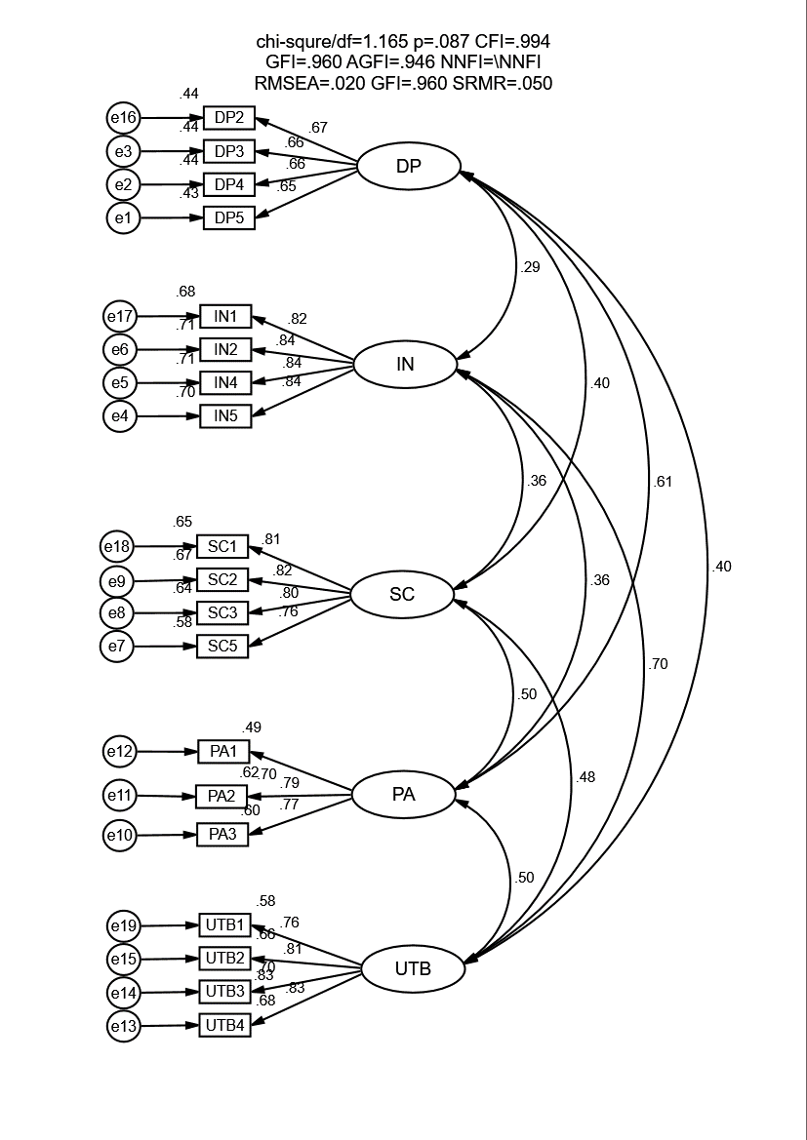
Appendix B: Mesurement Model

Applendix C: Questionnaire

Dear respondent,
As part of my Master’s thesis at the GSOM I am conducting a survey that investigates the users' attitudes towards live shopping. Any information obtained in connection with this study that can be identified with you will remain confidential.
The questionnaire consists of two parts, the attitudes towards your live shopping experience and personal information. It takes about 10-15 minutes in total.
1. Please rate the following statement according to the actual situation of your live shopping experience you have most impressed with.
1-Strongly disagree, 2-Disagree, 3-Somewhat disagree, 4-Neutral, 5-Somewhat agree, 6-agree, 7-Strongly agree.
 | Strongly disagree → Strongly agree
Please fill in One circle for each question | 1 | 2 | 3 | 4 | 5 | 6 | 7
Discounted Price
1. I think the goods in the livestreaming are cheap.
2. The price discount in the livestreaming attracted my attention.
3. I was tempted by the low price of products in livestreaming.
4. When I saw a product on sale in the livestreaming, I got the desire to buy it.
5. The stronger the discount, the easier it is to make me want to buy.
Scarcity
1. I worried about the limited time when I watch the livestreaming.
2.I was concerned about limited quantity when I watch the livestreaming.
3.I became anxious when I saw a "sold out" sign in live shopping.
4.I felt that the limited edition of a product caused many people to buy.
5.I thought that the supply of a limited product in live shopping was small.
Interaction
1. Streamer(s) actively involved customers in determining their specific needs.
2. Streamer(s) provided advice that was relevant to customers’ needs.
3. Streamer(s) adapted their sales pitch very much to customers’ interests.
4. Streamer(s) talked with customers about their objections in a detailed manner.
5. When presenting products and services, the streamer responded very individually to the customer's requirements.
Positive Affect
1. When watching livestreaming, I became excited to see the products I want.
2. I felt pleased during the live shopping.
3. I felt enthusiastic during the live shopping.
4. I felt proud during the live shopping.
5. I felt inspired during the live shopping.
Urge to Buy Impulsively
1. I experienced a number of sudden urges to buy things I had not planned to purchase in livestreaming shopping process.
2. In livestreaming shopping process, I saw a number of things I wanted to buy even though they were not on my shopping list
3. I experienced no strong urges to make unplanned purchases on this trip.
4. Duting this live streaming shopping, I felt a sudden urge to buy something.
2. Personal information:
1)What is your gender?
- Female
- Male
- Other(specify)
2)What is your age?
- Below 18
- 18-23
- 24-29
- 30-35
- 36-41
- 41 and more
3) What’s your current social status?
- Students
- Civil servants
- Freelancers
- Company employees
- Others
4) Your monthly consumption on live shopping is
- Under $77
- $78-$154
- $158-$462
- $462-$923
- Over $923
5) The time you spend on live shopping every is
- Multiple times a day
- Once a day
- A couple of times a week
- Once a week
- Occasionally
6) Your favorite categories on live shopping are (multiple choice)
- Fashion (apparel, cosmetics, etc.)
- Food
- Baby care
- Electronics
- Daily Necessity
- Others

List of Tables
Table 3.2.1 Survey Instruments 32
Table 4.1.1.1 Characteristics of Survey Respondents 38
Table 4.1.2.1 Normality of Primary Data (n = 401) 40
Table 4.1.2.2 Reliability of Measures 41
Table 4.1.2.3 Correlation Matrix of Variables for Primary Data Analyses 41
Table 4.1.3.1 Goodness-of-Fit Statistics for Full and Reduced Item Sets 42
Table 4.1.3.2 Summary of Items Comprising Final Measures 43
Table 4.1.4.1 Test of Model-Fit. 45
Table 4.1.4.2 Convergent Validity Assessment Matrix of the Measurement Model 45
Table 4.1.4.3 Discriminant Validity Assessment Matrix of the Measurement Model 46
Table 4.1.5.1 Results of path analysis 48
Table 4.1.6.1 Results of a full model test (based on mediation effect) 49
Table 4.2.1.1 Results of hypotheses testing 51

List of Figures
Fig 1. S-O-R model of Mehrabian & Russell (1974) 15
Fig 2. Model of Parboteeah et al. (2009) 16
Fig 3. Model of Chen & Yao (2018) 17
Fig 4. Factors classification in S-O-R framework of Chan et al. (2016) 17
Fig 5. Research model and hypothesized relationships. 27
Fig 6. Results of path analysis. 44
Fig 7. Modified model 49

List of Abbreviations
IN -- Interaction
SC -- Scarcity
UTB -- Urge to Buy Impulsively
PA-- Positive affect
SOR -- Stimulus-Organism-Response

