St. Petersburg University
Graduate School of Management

Master in Urban Management and Development

Smart Learning Approach in Higher Education: The Case of St. Petersburg

Master’s Thesis by the 2nd year student
Concentration – MUMD
Tsvetkova Tatiana Dmitrievna

Research advisor:
Dr. Natalia Drozdova Petrovna,
Associate Professor

St. Petersburg
2021
АННОТАЦИЯ
Автор | Цветкова Татьяна Дмитриевна
Название ВКР | Умный подход к обучению в высшем образовании:  на примере Санкт-Петербурга
Образовательная программа | Менеджмент и развитие городских агломераций
Направление подготовки | 38.04.04 Государственное и муниципальное управление
Год | 2021
Научный руководитель | Дроздова Наталья Петровна
Описание цели, задач и основных результатов | Магистерская диссертация посвящена роли внеучебной деятельности как формы самообучения в контексте умного обучения путем анализа концепции умного обучения с целью определения единиц измерения, характеристик и атрибутов для выявления уровня интеллектуальности, а также определения места внеучебной деятельности студента как формы самообучения в рамках умного обучения. Определены информационные потоки, связанные с внеучебной деятельностью в существующем образовательном процессе. Целью диссертации является разработка методов и рекомендаций по сокращению информационных потоков о внеучебной деятельности. Теоретическая часть включает обзор литературы по данной теме, изучение вторичной информации: исследования на национальном и глобальном уровнях, обзор опыта успешной реализации концепции умного обучения, а также основных базовых показателей, выявление характеристик и атрибутов умного обучения на основе контент-анализа определений. В качестве практической прикладной части на основе проведенного исследования автор разрабатывает ряд рекомендаций по сокращению информационных путей и адаптации передачи информации с точки зрения концепции smart, которые могут быть использованы для более структурированной, эффективной передачи информации от производителя к получателю. Основное ожидание заключается в том, что предлагаемые методы могут быть использованы в сфере высшего образования в Санкт-Петербурге.
Ключевые слова | интеллектуальное образование, интеллектуальное обучение, умное обучение, умное образование, электронное образование, электронное обучение, образовательный процесс, самообучение, внеучебная деятельность, информационные потоки

ABSTRACT
Master Student’s Name | Tsvetkova Tatiana
Master Thesis Title | Smart Learning Approach in Higher Education:  the Case of St. Petersburg
Faculty | Master in Urban Management and Development
Program | 38.04.04 State and municipal administration
Year | 2021
Academic Advisor’s Name | Dr. Natalia Drozdova, Associate Professor
Description of the goal, tasks and main results | The master's thesis is devoted to the role of extracurricular activities as a form of self-learning in the context of smart learning by analyzing the concept of smart learning in order to determine the units of measurement, characteristics and attributes to identify the level of smartness, as well as to determine the place of a student's extracurricular activities as a form of self-learning within smart learning. In the master's thesis describes the information flows associated with extracurricular activities in the existing educational process. The purpose of the master's thesis is to develop methods and recommendations for reducing information flows about extracurricular activities. The theoretical part includes the literature review related to this topic, the study of secondary information: research at the national and global levels, a review of the experience of successful implementation of the concept of smart learning, as well as the main basic indicators, the identification of characteristics and attributes of smart learning based on the content analysis of definitions. As a practical application part, based on the conducted research, the author develops a number of recommendations for reducing information paths and adapting information transfer from the point of view of the smart concept, which can be used for a more structured, efficient transfer of information from the producer to the recipient. The main expectation is that the proposed methods can be used in the field of higher education in St. Petersburg.
Keywords | smart education, smart learning, intellectual learning, intellectual education, e-education, e-learning, educational process, self-learning, extracurricular activities, information flows.

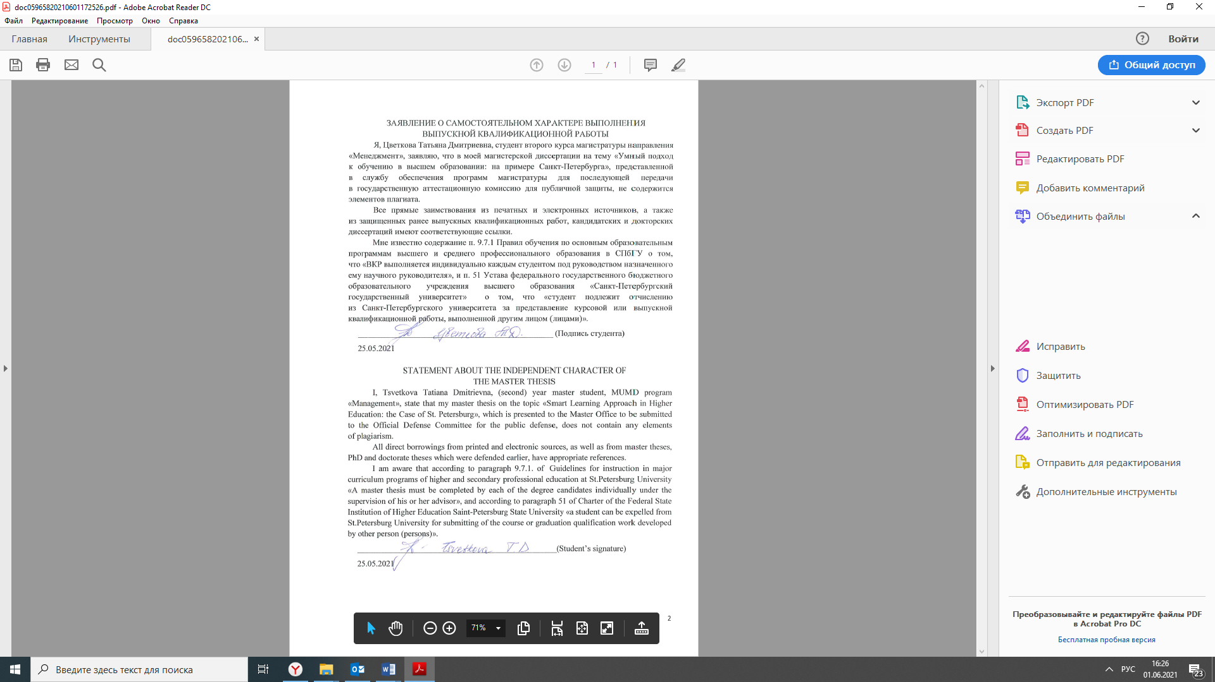
Table of contents
Introduction…………………………………………………………………………………..……6
1. Theoretical foundations of the concept of smart learning
1.1. Smart learning: conceptual approach …………………………………………………..10
1.2. Smart learning characteristics and attributes …...……………………………………...14
1.3. Existing smart status criteria …………………………………………………………...23
1.4. The role of self-learning of student in the context of smart learning and their forms... .27
1.5. Summary of Chapter I………………………………………………………………….32
2. Extracurricular activity of the student and methods of transmitting information in the field
of higher education
2.1. Stakeholders in the learning processes.………………………………….……………..33
2.2. Problems of transmitting information on extracurricular activities…...…………...…..36
2.3. Information flows within the educational organization of higher education and external information flows in the field of higher education………………………….………….45

2.4. Available regional resources informing about extracurricular activities………….……54
2.5. Recommendations for reducing the ways of delivering information on extracurricular activities ………………………………………………………………………...……...56
2.6. Summary of Chapter II…………………………………………………………………63

Conclusion……………………………………………………………………………………….64
References………………………………………………………………………………………..67
Appendix 1. Interview Guideline for representatives of the authorities in the field of higher education……………………………………………………………………………..…73
Appendix 2. Interview Guideline for representatives of higher educational institutions located
on the territory of St. Petersburg……………………………………………..….……..74
Appendix 3. Interview Guideline for organizers of extracurricular activities………………...…75
Appendix 4. Questionnaire for students ………………………………………………………...77
Appendix 5. Students’ survey results …………………………………………………………...78
Appendix 6. The card of accounting of the incoming documents to the Committee on Science
and Higher Education, reflecting the performers on the received request……………….82
Appendix 7. Requests received by the Committee on Science and Higher Education with
a request to provide information support for competitions………………………….…83
Appendix 8. Interview Guideline for the Director of the Coordination Center for International Scientific, Technical and Educational Programs……………………………………….87
Appendix 9. Visualization of the portal of extracurricular activities……………………………..88

Introduction
In the current situation in the world today, when educational processes must apply new technologies, go completely online and get knowledge remotely, the topic of smart education is more relevant than ever. The rapid development of digital technologies (for example, AR, computer vision, speech recognition, mobile and wearable technologies) and analytical technologies (for example, learning analytics and social-awareness technologies) provides various opportunities for implementing intelligent educational environments and significantly facilitates the lives of teachers and students. The higher education sector is constantly in need
of transformation due to rapid changes in the market, the economy and many other factors. Higher education institutions are trying to quickly adapt to the new requirements of employers, authorities and students, so they are actively applying new approaches to training. In addition, the scientific community should not lag behind scientific and technological progress. It is extremely important to use new technologies and follow the trends in training.
Modern teenagers independently isolate the necessary information from the information noise. They consume a huge amount of diverse content from social media, so today it is important not just to provide a theoretical basis in universities, but to form knowledge and competencies
for real practical activities. In addition, the use of third-party resources such as scientific
and educational portals, online courses, scientific videos and films, in addition to textbooks, the main course of study forms a versatile mindset and a broad Outlook. Each student has a mobile phone, usually with access to the Internet, so everyone can have universal access to information resources and be online. New technologies are the potential for a new stage of evolution in the field of education, characterized by continuous learning (Chan et all., 2006). The problem
of intellectualization of computer-based educational environments, which contributes to improving the effectiveness and quality of education, as well as allows organizing personalized training, is of current importance and of great theoretical and practical importance (Kose, Deperlioglu, 2012).
Smart learning focuses on providing holistic learning to students using modern technology to prepare them for a radically changing world where adaptability is essential. This form of education changes the way students access education. Constantly evolving technologies currently make it difficult for teachers to predict the future educational model. This problem is solved through intelligent education, which uses the latest technology to help both students and teachers prepare for the future. According to a new report from Reports and Data, the global smart education and training market is projected to reach US $ 1,047. 75 billion by 2026. According to another study, the global market for intellectual education and training was estimated at $ 240 billion in 2017 and is projected to reach $ 994 billion by 2024, increasing by an average of 22.7% From 2018 to 2024. In General, we can trace the huge progress and interest of all parties in a reasonable approach to learning. The growing importance of e-learning in corporate and academic structures, active government initiatives to promote e-learning in emerging markets, and the increase in the number of mobile learning applications are the main factors contributing to the growth of the market for smart learning and training. That is why the topic of a smart approach to education is extremely relevant today.
Smart has become a paradigm for the rapid development of the information society, which requires the capabilities of ICTs, including in the field of education. Today's schoolchildren and students – generation Z, or «digital generation» (children born in 1995-2012). That means they live in a digital world, where there is no boundary between the real and the virtual. In addition, it is worth adding that the onset of the pandemic is a challenge for universities in the development of online and distance learning. It is these factors that the author explains the actuality and the justification for the relevance of the chosen topic.
However, new opportunities have created new challenges. Covid-19 has impacted education systems around the world, and there are signs that it may have a lasting impact on the trajectory of innovation in learning and digitalization. It is necessary to transform the educational paradigm, but at the same time to preserve the well-established classical model, proven by time. Universities have opened online courses, and many have given access to lectures and materials while pandemic. A huge amount of information comes to the educational organization every day. Not always a particular message reaches the recipients in time, and sometimes it is completely lost due to a long chain of transmitters. Students need to receive structured information, be able to search for and access it.
The research question: How can information paths be shortened in the context of smart learning?
The research aim is to determine a way to improve the effectiveness of information exchange in the context of smart learning.
Research objectives:
- literature review and study of research on the concept of «smart learning»;
- compare concepts and define construct definitions;
- identifying the characteristics and attributes of smart learning;
- allocation of the units of refinement of the identified characteristics and attributes by smartness
- track and understand the flow of information involved in learning processes;
- identify and justify key stakeholders in learning processes;
- monitor the mechanisms of interaction between stakeholders;
- conducting interviews with experts from the field of higher education in Russia and
St. Petersburg, with representatives of the city government and with employees of the sphere of science and education;
- develop recommendations for changing the existing information transmission system;
- development of proposals for the use of platform or website for posting key messages for the rapid and systematic transfer of information between stakeholders of St. Petersburg universities.
The object - information flows between stakeholders in the sphere of higher education in
St. Petersburg.
Subject of research – smart approach to information transfer, ensuring the educational process.
Methods:
Quantitative - conducting a survey among one of the stakeholders of St. Petersburg universities-students who are the main recipient of information, in order to test the hypothesis of duplicate information flows, an overabundance of communication channels and a complicated model of information transmission, as well as the survey is conducted to predict the benefits of a potential platform or website for structuring information flows.
Qualitative - conducting expert interviews with representatives of the authorities in the field of education, with heads of universities and educational areas, with entrepreneurs who have projects in the educational environment in order to confirm or refute the schemes of information flows, to evaluate the proposed solutions for the modernization of information paths from competent persons.
Еxpected results:
- identification of attributes, indicators and units for assessing the level of smartness in the learning process;
- description of the existing information flows and methods of information transfer between stakeholders working in the field of higher education in St. Petersburg;
- develop proposals for ways to shorten information paths without losing important information;
• development of proposals for the use of platform or website with structured information
on a given topic (such as forming a unified database of competitions, Olympiads, conferences, forums, and other extracurricular activities) in the universities of St. Petersburg for the integration of existing information systems into a single space.

In the master's thesis, the theoretical foundations of the concept of smart learning will be considered, its characteristics and attributes will be highlighted. The author will prove that extracurricular activities play an important role in the context of smart learning. The forms of extracurricular activities will be determined to highlight the focus of further research. The second part of the master's thesis is an empirical study, which includes the collection of data and the formation of conclusions on a given topic, taking into account the opinions of leading experts in the field of higher education, including in the field of extracurricular activities. Also, the practical part of the work contains recommendations for the implementation of a method for transmitting information about extracurricular activities from the point of view of a smart approach.

It is important to differentiate the concepts of smart learning and smart education,
e-learning, e-education, intelligent education, intelligent learning. It is also necessary to separate the concepts, which is presented in the next subparagraph.

- THEORETICAL BACKGROUND OF SMART LEARNING CONCEPT
1.1. Smart learning: conceptual approach
Today's concept of education means lifelong learning. These processes lead to the fact that a competence-based one is gradually replacing the knowledge-based approach in education. (Avdeeva, Z. K., et all. 2015, p. 220). We can now observe the transition of a number of educational processes to online- the context and, as a result, the flexibility of educational processes, the availability and openness of information. The continuity of lifelong learning can be traced in the concept of so-called seamless learning. The concept of seamless education is interpreted as a comprehensive and open path to learning, consisting of interrelated learning tasks that can be initiated by the student or facilitated by the teacher. However, the author is closer and clearer to the wording given by Michael Sharples: «Continuous learning can be a collective or individual process, can spread across time and places, provide ubiquitous access to learning resources, cover the physical and digital worlds, involve multiple types of devices, and integrate different approaches to learning» (Sharples et al., 2014, p.24). The concepts of physical or virtual learning in the concept of continuity and seamless learning are not irrelevant; on the contrary, they are becoming increasingly important, and when designing learning environments, it is necessary to organize the various ways in which a person can learn, combining formal and informal situations (Gros B. 2016). Thus, the concept of continuous or seamless learning has an essential position in the concept of smart learning, but the transition to an online, virtual, technical format is not always a prerequisite for smart learning. The most important characteristic is that the system will be able to be adapted to the needs of the students. A smart learning environment is one that provides students with real-time opportunities and benefits.

The International Association of Intelligent Learning Environments (IASLE) highlights various interpretations of the concept of smart learning environments. For example, a learning environment can be considered smart when it uses adaptive technologies, or when it is designed to incorporate innovative features and capabilities that improve understanding and performance (Spector, J. M. 2014.).

Smart learning environment involves the integration of educational resources into a system that covers such components and parts of the educational process as student support and continuity of learning, the introduction of distance and open education, educational content management, learning management systems, tools for analyzing the requirements of the standard and the employer, forecasting the needs of specialists in the labor markets. (Finogeev et al., 2018).
Smart learning environments can be fully digital or mix digital with physical, and the degree of digital intelligence can range from simple rule-based systems to deep learning approaches (Dron J., 2018). As we can see, there are a number of approaches to determining whether a learning environment is smart or not.
As a result of the intensive development of information technologies, which have become an integral part of the modern human environment, the concept of smart education is now associated with a number of definitions, many of which do not have a clear interpretation. It is necessary to interpret such concepts as smart education, smart learning, intelligent learning, intelligent education, e-learning, e-education and compare them. Perhaps it is worth starting with an analysis of the concept of smart education.
Smart education, a concept describing learning in the digital age. Today, this term is receiving increased attention. In a broad sense, Smart learning environments represent a new wave of educational systems that involve the effective and efficient interaction of pedagogy, technology and their fusion to improve learning processes. The development of new technologies allows students to learn more effectively, efficiently, flexibly and comfortably (Roumen, Kovatcheva 2017).

If we discard the prefix smart and look at the very concepts of education and training, we can characterize education as a process that contributes to the development of the individual in different directions, as well as an end result, for example, a diploma in a narrower sense. Learning is more often seen as an activity, the transfer of knowledge. In the master's thesis, the author will rely on the term smart learning, as he is interested in understanding more the stages of activity and aspects of the learning process to define it as smart. Therefore, in this paper, the concept of smart learning will be encountered. Moreover, smart education atmosphere can be considered as a smart learning environment with the smart and virtual tools to support the learning (Hoel, Mason, 2018; Koper, 2014).
Next, author will describe the concept that is also most often found in the context of smart learning - intelligent learning. Intelligent learning systems focus on the use of artificial intelligence techniques, particularly in the use of learning applications (Helder, Sosnovsky, Dimitrova, 2017). Intelligent environment is a new concept for implementing human-technology-environment interaction, where people are surrounded by an intelligent and intuitive interface. An intelligent environment is a physical and technical structure that includes computer networks, actuators, technical equipment, cameras, and so on (Afanasyev et al., 2016). That is, we can conclude that online learning using such platforms as Microsoft Teams, Moodle, Zoom, which are the most popular among online learning, especially during the pandemic, can be called intelligent. As it was found out, the concept of intellectual education is not mentioned in scientific works and generally does not stand out as a generally recognized term, so it is not given a definition, it will not be used in the Master Thesis.
The key element of the smart learning, which is impossible without the accumulated experience is e-learning (Aletdinova, Melnichenko, 2015). E-learning (short for Electronic Learning) is a system of learning using information and electronic technologies. There is a definition given by UNESCO experts: «Е-learning -learning via the Internet and multimedia». In conclusion, we can conclude that e-learning is part of the smart learning system.
In addition to this term, the concept of e-education is often found, in fact, there is no separate interpretation, a clear thesis is not formulated, in General, e-education is a process of learning using technical means, remotely, through electronic devices (Zagrebina et al., 2015). Thus, we can conclude that e-education and e-learning are synonymous and have a similar meaning.
It is important to note that e-learning can be part of intellectual education. The key features are that the definitions of e-learning and e-education share common characteristics, while the definitions of intelligent learning and intelligent education are similar. The main difference between these concepts is that smart learning implies not only technology, but also communication, communication. For example, the e-learning format does not need to build a single pedagogical community, a certain corporate environment, a single approach, common goals, values, that is, intellectual learning is an approach in general that unites the scientific potential, personnel and teaching staff in a single community, a built system. A university doesn't have to have augmented reality screens to make its educational programs smart. Of course, the smart console requires some upgrades, innovations and the use of technical means. However, an innovative approach to the educational process also implies not only technical means and the use of new technologies, but also the latest approaches to the educational process.
The concept of smart learning is also related to intellectual education, e-learning, innovations. The concept of smart learning is interpreted in the context of learning systems, namely: modeling the learning process, using a dynamically developing knowledge base, automatic selection of a rational learning strategy for each student, automated accounting of new information, etc.
At this stage of the study, it is quite difficult to determine what is part of what.
Based on the conclusions above, we can say that it is possible to interpret the definition of smart learning from different sides and in different contexts. However, it is obvious that all the concepts and definitions considered by the author are interrelated, close in meaning and correlate
with each other. Based on this analysis, we can conclude that smart learning not only intersects with electronic and intelligent learning, but also includes them. The author sees it this way:
Smart learning
Intellectual learning
e-learning
Figure 1. The concept of smart learning, which includes the definitions
However, at the same time, the author asks the question: Could smart learning exist without augmented reality, personal computers for each student, and 3D technologies? The answer is yes, because these concepts can only touch, and not be part of the other. These definitions can also
be considered as related, because smart learning is considered as a holistic process, approach,
or system, endowed with a number of components from the concept of intelligent learning and
e-learning.

Intellectial learning
e-learning
Smart
learning

Figure 2. The concept of smart learning that intersects with similar definitions
In general, we can assume that the term smart learning is considered from the point of view of pedagogy, it describes the approach to learning, and not the learning itself using technical means, in turn, it includes many aspects, such as behavioral and psychological factors of students, progressive teaching models, relevant courses and modules in the educational program, the presence of feedback and interaction, communication, and more.
For a more detailed analysis, in order to determine the smart learning environment from the not smart one, it is necessary to distinguish the characteristics and distinctive features of this type of training.
1.2. Smart learning characteristics and attributes
Today, the concept of smart is increasingly used not only in the context of technologies (smart set-top box, smart home, smart charging), but also in the context of entire systems, such as cities or education. A smart environment is defined as a physical infrastructure that allows the surrounding intelligence to function (Kapustina, Kondratenko, 2012). The word «smart» is now routinely used by the educational research community forming new terminology like Smart Education, Smart University, Smart Learning, Smart Classroom, Smart Learning Environment, etc (Uskov et al, 2017).
The International Association of Smart Learning Environments (IASLE) provides a highly eclectic definition of smart learning as «an emerging area alongside other related emerging areas such as smart technology, smart teaching, smart education, smart-e-learning, smart classrooms, smart universities, smart society» (IASLE, 2018, par. 1). Some researchers claim smart learning is a new field of research (Hoel and Mason, 2018), others contest it is a new concept of learning (Hwang 2014; Kim, 2013); several point out that it is a new educational paradigm (Duran-Sanchez et al., 2018; Kim, 2011; Lee, 2014; Zhu, 2016), while some refer to it as a phenomenon (Tikhomirov, 2015). Tikhomirov describes smart learning as an ambiguous new trend with different interpretations, thus causing «conceptual uncertainty» (p. 48) and making it difficult to understand its peculiarities. While new generations of learners will require an education system that attends to developing smarter learning environments and technologies, smarter pedagogies, and smarter learners, researchers in the field have shown greatly varied perspectives and research interests.
Despite several attempts made by researchers, there is no clear definition on the concept of «smart learning» (Duran-Sanchez et al. 2018; Kim et al. 2013; Lee et al. 2013; Lee et al. 2015; Sung 2015). The purpose of this study is to examine the concept of «smart learning».
Before defining smart learning, it is worth noting that in scientific works, the authors use such concepts as smart education, intelligent education, intelligent learning, and others. The author of this master thesis has focused on the main term, which is devoted to the master's thesis «smart learning» simply to avoid unnecessary redundancy and to ensure consistency throughout the Master Thesis.
Smart learning is the learning activity which can enable high learning experiences, high content suitability, and high learning efficient (Liu, Huang, Chang, 2016). Unfortunately, at this stage there are no generally accepted criteria for evaluating a smart education system. In other words, it is necessary to understand what kind of education can be considered smart and by what criteria to assess the level of smartness. Consider the key characteristics and definitions of smart learning given by different authors:
Table 1. Definitions of smart learning
Authors | Definition
Kim, Ilon, Altmann, 2013  P. 6 | smart learning is providing self-learning, self-motivated and personalized services that students can attend courses at their own pace and can access personalized learning content according to their personal needs.
Spector, 2014  P. 2-3 | The use of smart learning involves some of the attributes:  - support and innovation; intellectual learning environment promotes student engagement and teacher effectiveness and efficiency of their joint work, which is spread over the support and cooperation of teachers with students (smart people often turn to for advice and leadership to others);  - smart teachers identify and help students who have difficulties;  - smart teachers spend time and effort to attract attention, show relevance, and provide feedback to develop confidence and satisfaction in the learning process.
Aletdinova, Melnichenko, 2015  P.2-3 | considered as an open, smart environment that brings together faculty, higher education institutions for continuity and completeness of content using new technologies, technical means for students. And also smart learning is qualitatively new knowledge. Smart learning should include both formal communication and informal presentation of material.
Dneprovskaya, Yankovskaya, Shevtsova, 2015  P. 45 | system or process that manifests itself in interaction with the environment, and gives the system and/or process the ability to:  • respond immediately to changes in the external environment;  • adaptations to changing conditions;  • self-development and self-control;  • effective achievement of results.
Zhi-ting, Ming-Hua-Yu, Riezebos, 2016  P. 5 | self-regulating technical systems in learning theories that could indicate which interfaces should be affected to achieve the goals of better and faster learning.
Kinshuk, Cheng, Chew, 2016  Р. 569 | effective, intelligent, tailored training based on advanced IT infrastructure. Technology plays an important role in supporting intelligent learning, but the focus should not only be on the use of smart devices.
Spector, 2016  P. 2731 | The learning environment is a broad concept that unites universities, students, teachers or groups in which training takes place, and also includes support staff, technical specialists of the institution, thereby forming communities.
Popenici, Darwin, Kerr, 2017  P. 11 | significant advances in smart education through machine learning and artificial intelligence that opening up new opportunities and challenges for higher education.
Hoel, Mason, 2018  Р. 10 | introduction of new information technology standards for learning, education and training, Information Technology for Learning, Education and Training (ITLET), which discards the old framework, the classic approach in education.
Lorenzo, Gallon, 2019  Р. 41 | smart learning spaces (SLSs) are expanding into the unknown horizon of extreme automation (machine learning), ubiquitous connectivity (Internet of Things), and hybrid societies (combining human and artificial intelligence).
Uskov, Bakken, Heinemann, Rachakonda, Guduru, Thomas, Bodduluri, 2017  Р. 192-195 | smart environment development is to improve the traditional learning process. In this context, Component Based Software Development (CBSD) is seen as a way to address the software development crisis by leveraging digitalization, computerization, and technology to provide teachers with the necessary tools to personalize learning, adapt teaching and evaluation, and create appropriate learning environments for students. An intelligent educational environment should take into account the adaptation of the environment to the needs and behavior of specific students.
Molina-Carmona, Villagrá-Arnedo, 2018  Р. 645–647 | smart learning approach is a broad term that includes artiﬁcial intelligence-based solutions for developing of the teaching-learning processes with particular focus on their personalization with their speciﬁcities and goals, but sharing a common ultimate goal: helping students to learn.
García-Peñalvo, Casado-Lumbreras, Colomo-Palacios, Yadav, 2020  P. 2 | Smart learning is a learning process with the introduction of intelligent technology ecosystems that do not pretend to replace teachers in this process, but help and support them with more reliable and intelligent services that facilitate follow-up, provide feedback, the purpose of which is not only to reduce teaching efforts, but also to increase the student's learning opportunities with more meaningful learning technologies.

From the fundamental definitions, it is possible to identify several characteristics that can be extracted and used as a preliminary set of indicators of smartness of the learning environment. Based on these definitions, it can be concluded that smart learning should be considered as a kind of educational environment in which learning takes place in an interactive environment with the use of high technologies. A smart approach to learning is based on flexibility, rapid response and adaptation to the external environment, the needs of the market and students, the possibility of self-control and training, and free access to information.

Table 2. Сharacteristics and attributes based on the listed definitions
Authors | Characteristics of smart learning, given in the definition from Table 1
 | Self-learning, self-motivated self-regulating technical systems | Integration high-tech devices and electronic technologies | The use of machine learning | The use of artificial intelligence | Personalize learning, consideration of individual areas of study | Mandatory interaction with the teacher | Continuity of training and accessibility to programs | Association of teaching staff, community of universities
Kim, Ilon, Altmann,2013, P. 6 | √ |  |  |  | √
Spector, 2014, P. 3-5 |  | √ |  |  |  | √
Aletdinova, Melnichenko, 2015, P. 2-3
Dneprovskaya, Yankovskaya, Shevtsova, 2015, P. 45 | √
Zhi-ting, Ming-Hua-Yu, Riezebos, 2016, P. 5 | √ |  |  |  |  |  | √
Kinshuk, Cheng, Chew, 2016, Р. 569 |  | √
Spector, 2016, P. 2731 |  |  |  |  |  |  |  | √
Popenici, Darwin, Kerr, 2017, P. 11 |  |  |  | √
Hoel, Mason, 2018, Р. 10 |  |  | √
Lorenzo, Gallon, 2019, Р. 41
Uskov, Bakken, Heinemann, Rachakonda, Guduru, Thomas, Bodduluri, 2017, Р. 192-195 | √ | √ |  |  | √ | √
Molina-Carmona, Villagrá-Arnedo, 2018, Р. 645–647 |  |  |  | √ | √
García-Peñalvo, Casado-Lumbreras, Colomo-Palacios, Yadav, 2020 |  | √ | √ |  |  | √
Note: √ — component that explicitly mentioned in the definition

Smart learning is directly related to characteristics such as digitalization, autonomy, interactivity, remote control, accessibility, and continuity.
It is important to note that education is largely focused on people, not technology. Despite the rapid development of Ai, the idea that we can only rely on technology is a dangerous path. In addition, at the moment, the development of smart learning is hindered by the lack of common constructs and approaches that could lead to a stable, consistent and comprehensive understanding of the smart educational environment, thereby ensuring the development of standards for teaching, educating and teaching the concept of smartness. It is important to understand that smart learning is a revolutionary approach to the accepted working educational system, so that there is no substitution of concepts (Ashfaque et al., 2014).
The key objective of smart learning is to optimize the operation of intelligent learning environments, which ensures an effective cycle of innovation (Helder, Sosnovsky, Dimitrova, 2017).
The smart learning cycle includes such factors as monitoring and evaluating the learning process, student behavior, tracking student results, continuous communication between teachers and students, and feedback from students (Liu, Huang, Chang, 2016).
In fact, in the last recent years, the emerging concept of smart learning, aiming initially to make learning more learner-centric, effective, individualized and tailored becomes the new umbrella under which all the aspects related to the effective use of ICT to support smart learning can be placed, including policies and strategies, raising awareness, capacity building, IT infrastructure, education (Jemni, Khribi, 2016).
Another idea of the concept of a smart approach to learn is to use intelligent solutions to personalize students. As V. P. Tikhomirov writes in his work «The World on the path of smart education. New development opportunities» the concept of intelligent adaptive learning is based on the idea of individualization. In particular, he says that it is necessary to make programs more mobile for different students, so that you can notice the individual characteristics and orientation of each (Tikhomirov, 2011).
The article intersects with the idea of the candidate of economic Sciences, Director of the Department of information technologies of Kazan state University - E. N. Babin. In the article «Digitalization of the University: building an integrated information environment», he describes the development map of University employees based on the KPI calculation system. Its model includes such indicators as paper document flow, interaction with students, involvement in the life of the University, the number of articles and others. This allows you to organize network interaction between superiors and subordinates, as well as manage the project activities of the University (Babin, 2018). I wouldn't say that I agree that the long-established higher education system needs to be revised if we want to make it smart. In other words, the change of disciplines and educational programs is a very complex and lengthy process that depends on the Ministry and the authorities. Part of his idea can be traced to the innovations of «elective courses», «plug-in modules», when students can choose a course from a list. However, I agree that every student's success should be noticed. What I can offer as a criterion for evaluating individual achievements is the introduction to universities an application or system where the student's rating was tracked, which could be calculated by various indicators, such as attendance, academic performance, comparison of time spent on completing the task and the result, compliance with deadlines. Moreover, as a career development, it would be useful for students to keep their own diary of achievements, where information is processed by a machine. This system creates additional competition, and can also serve as an additional incentive.
Summarizing all of the above, we can highlight a number of the main features of smart learning.
Smart
learning
Community
of universities (content sharing
by all
universities)
Сontinuity of training and accessibility to programs
Individualization of training
(personalize learning)
Integration
high-tech
devices
Self-learning, self-motivated self-regulating technical systems

Use of machine learning

Use of artificial intelligence
Continuous communication and feedback

Figure 3. Smart Learning characteristics
Based on the analysis of the definitions, we can conclude that smart learning is a whole set of activities aimed at achieving the best results in the process of acquiring knowledge. Smart learning should be adaptive, rapidly changing and adapting to the surrounding reality, the economic situation, and global trends. Also, smart learning should involve communication and continuous communication, community integration and the use of new technologies. As we see the concept of smart learning is multi-faceted, then you need to understand how it differs from intelligent learning, what it includes and what key features share it with the terms of e-learning.
Having identified some of the characteristics of smart learning, we need to understand how to measure them. To begin with, it is worth considering the issue of self-study, self-motivation and systems for tracking the student's personal results. Students with a high level of self-motivation are more disciplined, they are focused on continuous learning and development, and they want to achieve results in the learning process. (Markova, 1996). How can you track the level of motivation? In the works of Antonov V. G., Rumyantseva I. A., Korotenko T. Y. to assess motivation, internal and external factors are given, such as the dynamics of interests, the need to be the best, the success of parents, clearly set goals - for example, to graduate from university with a red diploma. In addition, the methodology of Rean A. A. is used to assess motivation in higher education (Rean, 2004).There is also a method for diagnosing students ' learning motivation (Rean and Yakunin, modified by Badmaeva), which provides the following criteria: become a qualified specialist, get a diploma, acquire deep and solid knowledge, keep up with the same group, avoid gaps in the study of subjects of the educational cycle, be ready for the next classes. In order to measure the level of self-preparation and self-study at the university, you can calculate the number of subjects and tasks for individual or home study outside of school time, that is, the number of tasks for self-control of students. These two characteristics have been combined, as I consider them to be directly related. Without proper motivation, the student is not is not able to self-education and self-development. The author's arguments are confirmed in the work "Research of motivational characteristics of students 'self-education", where it is said that the non-applicable characteristic of effective self-education and activation of self-development and independent activity is stable personal motivation (Bankovskaya, 2010). Also in another work of this author, entitled Self-education in the system of advanced training, a number of motivational indicators on scales that lead to success in the learning processes of an individual are given. Accordingly, drawing a conclusion from the above, it is impossible to deny the importance and necessity of having a system for tracking students ' personal achievements. This can be expressed both in the offline scoring system, and online, for example, in the form of a student's personal account.
The next characteristic is the introduction of high technologies in educational processes. This characteristic can be estimated using the following units of measurement: the number of interactive whiteboards in the university classrooms, a single Internet network - access to WIFI for students and teachers in the university building, the number of projectors, the number of computers or laptops in the context of 100 or 1000 students, groups, subgroups, the share of documentation in the course of training translated into an electronic environment (electronic document management).
In order to track the level of use of Machine Learning in student learning processes, it is necessary to calculate what part of all administrative processes (the number of tasks) that are performed using machine learning methods and technologies.
The availability and continuity of programs can also be assessed by the criterion of its translation into an online format, by the criterion of openness (public access or closed).
The selected characteristic about interaction with the teacher is extremely important to us, since in the process of analyzing the existing theory, the mandatory conduct of the student and communication with the teacher in full-time format were revealed. During the pandemic, most educational programs around the world were converted to distance learning or to a mixed format. Many universities have launched training modules and courses, given open access to their students, and translated the work into a format of self-study and control. Different approaches were used: recorded lectures in videos, a collection of textbooks and articles for home study, tests, and so on. However, it is necessary to understand that in the learning process, communication can not be one-sided. This refers to the issue of feedback and translation of training tasks into independent work. Student-teacher interaction in e-learning is extremely important (Alawamleh, Al-Twait, Al-Saht, 2020). Collecting feedback after an online course helps in assessing student satisfaction. The thesis of continuous communication and communication between teachers and students is confirmed in the article «The effect of online learning on communication between instructors and students during COVID-19 pandemic». The idea of learning without interaction is absurd. Interaction plays a key role in the effectiveness of modern online learning systems. This characteristic can be calculated as the number of additional hours spent outside of the training schedule. The possibility of interaction between the student and the teacher not only in a formal way, but also in an informal way, using technology - that is, through mail, messengers, chats, groups.
According to Hwang (2015), three key features define an intelligent learning environment:
1. Context-sensitive: the system should be able to provide online and real-time learning support.;
2. Adaptive support: The system should offer instant and adaptive support to students based on their individual needs from different perspectives (learning effectiveness, learning behavior, profiles, personal factors, etc.), as well as the context of the online and real world in which they are located.;
3. Adaptive interface: The system must be able to adapt the interface to the user (how information is presented, learning preferences, learning performance, etc.).
As we can see, the characteristics highlighted by Hwang do not contradict the above features of smart learning highlighted by other authors. On the contrary, the characteristics of Hwang are very similar and coincide with those previously identified. The main idea is based on the fact that training should be accessible, should take into account the personal preferences of students, and information should be provided in the most convenient way.
Returning to the theory of Spektor (2014), it is also very desirable that in a smart learning environment, motivation for learners, development and recognition students ' competencies, combinations of learning styles, and consideration of interests. Here again, the importance of training aimed at the individual and at his independence and interest in knowledge is traced and emphasized. Self-organization, self-learning are components for improving one's competence and level of education. Separately, another important component is the ability to reflect: the learning environment offers various activities that are adjusted to improve overall effectiveness in the learning process. The success and achievements of the student raise their self-esteem, give them greater motivation and thereby increase productivity, and then generate new knowledge.
It is necessary to focus on the last two most frequently mentioned ideas about methods of information transmission, as well as ways to personalize and take into account the student's personal interests in teaching. The author of the Master Thesis writes about this in detail both in the first theoretical chapter, and confirms this theory in the research, and then implements these key ideas in the practical part.

1.3. Existing smart status criteria
The research gap lies in the fact that at the moment there are no clear developed criteria for measuring the effectiveness of smart education, there are no interpretations of their integration and application in the world experience. To date, there is not much literature and research devoted to this topic, which makes the process of analyzing information more difficult and subjective.
In addition, the gap in research can not show the full picture and answer the questions why implement a smart education system, how it can affect the level of education at the city level and at the national level, what it will do, what changes it will bring (positive or negative).
One of the gaps in the study of smart learning is the conceptual ambiguity. From the analysis of the definitions, it can be seen that different authors emphasize either the technology or the approach to learning. The article «Unpacking conceptual elements of smart learning in the Korean scholarly discourse» provides a number of indisputable arguments that can be used to describe research gaps in the discourse of smart learning. This work is relevant, as it provides a content analysis of 62 definitions of smart learning, shows how the context and concept of smart learning changed in the scientific literature in the period from 2010 to 2018. As a result of the above content analysis, a difference in the concepts of intellectual learning was revealed: it is defined in completely different ways - as an environment, as a system, as a learning technology, as an approach to learning. This study also describes the concepts of smart learning from the point of view of innovation and high technology, from the point of view of smart pedagogy and approach to the educational process, and even from the point of view of a smart student.
The difference in approaches is a significant gap in the study of smart learning. In addition, we see that a single and generally accepted thesis, the definition of smart learning has not yet been given, some concepts do not even correlate with each other and are not compared, since they belong to different categories. For example, Lee (2012) defined smart learning as «an individual intelligent learning system aimed at strengthening student competence in the 21st century, which consists in transforming educational systems such as the educational environment, educational content, teaching methods, and assessment» (p. 148). And the criteria of the Wang system (2018) describe student support as a function where students can receive adaptive learning assistance
and guidance throughout the learning process, including frequently asked questions, the use
of textbooks, learning tips, and access to expert answers (p. 86). These different points of view
are indicative of the conceptual ambiguity present in the global discourse of intellectual learning. The study showed that the scientists ' discourse on intelligent learning has both similar patterns
in the context of intelligent learning, and radically different opinions and approaches, which confirms the words of the author of the Master Thesis about the conceptuality of ambiguity. Despite the fact that scientists give completely different points of view of the definition of smart learning, in general, we can conclude that the concept of smart learning implies the use of high technologies, two-way communication, adapted to students.
If we consider the existing criteria for assessing the level of intelligence, it is the research of Korean scientists that is considered the most relevant, since it is Korea that is known as one of the first Asian countries where the central government initiated the smart learning project. According to Duran-Sanchez (2018), there are more scientists from Korea who write about smart learning than other countries such as China, India, Canada, and the United States. The country provides a unique context for studying the conceptual development of intellectual learning, since for them intellectual learning is more than a scientific concept. Therefore, the author of the Master Thesis relied on the criteria of intelligence, which are used in Korea, and took their examples of evaluation as a basis. For the fifth year in a row, South Korea ranks among the top three as one of the most outstanding countries in the information technology sector, based on the International Telecommunication Union Global ICT Development Index. As part of the state's smart learning reform, the Korean Ministry of Education, Science and Technology has defined a number of criteria for assessing the level of smartness. One of the characteristics is based on a concept developed by (Kwak, 2010). He focused on the individual learner and tracking the individual's abilities. In general, this correlates with the highlighted characteristic - «Individualization of training (personalized learning)». This characteristic emphasizes the importance of taking the student's opinion into account and taking into account their needs (Gallagher, 2016; Kim, 2013). Other characteristics of intelligent learning include self-directed, real-world, and personalized learning (Sung, 2015, p. 117). This characteristic also correlates with the one highlighted above about personalization, self-control in the learning process. This is followed by such characteristics as flexibility, accessibility, adaptability, interactivity, collaborative and updated learning, which allows you to define it as smart. It was Jang (2010) who defined intellectual learning as collaborative, flexible, and interactive, again these characteristics were not overlooked in the theoretical analysis and the content is the same. While Korean scientists have tried to define and describe intelligent learning and its characteristics, to date there is no clear definition of intelligent learning. We see that there are no formulated clear measures that are not subjective in nature, that differ in accuracy and unambiguity, which is confirmed by the researchers themselves and brought out as a problem (Jo, 2012; Kim, 2011; Lee, 2013; Lee, 2015; Sung, 2015).
At the moment, even the existing certain criteria and characteristics do not give a clear understanding of how to implement a smart program, how to modernize it and turn it into a smart one, and most importantly, how it can be measured. Therefore, the proposed recommendations on meters based on the identified attributes from the definitions in paragraph 1.2. of this master's thesis can be considered more than relevant and useful in the discourse of intellectual learning.
However, it is impossible to think negatively and deny the positive dynamics in the field of smart learning. In some countries, intellectual learning has become a driving force
for educational reform and innovation. For example, Singapore implemented the Smart Nation master plan in 2015, and Malaysia implemented the Smart education project back in 1997, developing a school implementation plan and creating the Malaysian Smart School (Ong, 2006). That is, we can safely say that the lack of common criteria and understanding of the smart learning paradigm are not a barrier and an obstacle to its implementation in existing educational standards.
Summarizing the above information and concluding the literature review, it should be emphasized that the gap in research is due to the lack of a common approach to the implementation of smart learning tools. As well as the lack of an approach that could be used to manage performance and determine the smartness of the solutions introduced.
Based on the content analysis of the concepts, we can conclude about the most common characteristics, there are two of them: self-learning, self-motivated self-regulating technical systems and the integration of high-tech devices and electronic technologies. These characteristics can be considered an integral part of smart learning, and therefore considered as attributes. Indeed, without the availability of new technologies and tools (such as a smartphone, tablet, computer, interactive screen and other electronic devices), the learning process can hardly be called smart. And although many of the authors mentioned above in the content analysis do not directly highlight this important point, but in all works, without exception, they imply the use of new technologies and means of communication in the context of smart learning. The concept of smart learning emphasizes the importance of technological design to improve learning. Smart learning implies and involves learning with the use of high technologies. That is why the author distinguishes this characteristic as an integral part of the concept, and accordingly calls it an attribute. The research discovery was the frequent mention of self-learning, self-learning, systems for monitoring and controlling personal results and student progress. Of course, modern conditions require a full approach of the student to the study (that is, it is important not only to get the knowledge that teachers give at the university, but also to be integrated into the process, to be interested in new things, to think broadly and to study the field of activity both from the inside and outside).
Summing up, we can distinguish the main functions of smart learning in two blocks.
Тhe first one concerns personalization, adaptability to the student's personal request and includes such basics as:
- SL implies an individual approach to learning;
- the smart concept should provide personalized learning;
- the smart system forms competencies through various activities;
- SL helps students to be motivated and constantly gain knowledge;
- the smart learning concept includes the freedom of independent learning.
The second block combines the topic of information transfer and open access to it, which implies the following principles:
- the SL must contain the availability and transparency of the information;
- SL as a system for adapting content for students;
- providing visual and timely access to educational resources and services;
- ensuring continuous service when connecting a high-tech device;
- sending a message in real time according to the request using various resources, services and platforms.
The author combines an individual, personalized, independent and continuous approach to learning as part of self-learning. It is possible to evaluate students' personal achievements through self-learning or participation in extracurricular activities. Self-learning gives an realization of the level of competence formation. The importance of providing information and high technologies the author combines and formulates the thesis - the provision of information through high-tech methods. Thus, in smart learning is important to adapt the content and structure the information to the student. The most important characteristic is the adaptive way of informing students.
Key aspects of smart learning in the context of information transfer: smart learning process should offer an instant, convenient and adaptive interaction system. Adaptability includes ways of presenting information. That is why the author will analyze information flows and ways of transmitting information.
An individual approach to learning as one of the tasks of SL can be implemented through self-learning Assessment of students ' personal achievements through participation in extracurricular activities. Self-study directly depends on the motivation of the student's purposefulness in the educational process. Conclusion: the issues of individual orientation in learning, self-learning and motivation of students are closely interrelated - one follows from the other. The author would like to focus on this attribute and understand component self-learning in more detail.

1.4. The role of self-learning of student in the context of smart learning and their forms
Initially, it is necessary to understand what is meant by the concept of self-regulating learning, as well as what applies to it. To do this, the author analyzed a number of definitions. Self-regulated learning is a process in which students set goals for their learning and then attempt to control, regulate, and control their cognition, motivation, and behavior, guided and limited by contextual features in the environment (Pintrich, 2000, P. 453).
Based on the above definition, the question arises: how to evaluate this process. In a study by Schunk, D. H. (2005, p. 84) it is the goals that serve as criteria for assessing progress, including setting and changing specific tasks. Pintrich believed that self-regulating activities mediate the relationship between students and their environment and affect student achievement (Pintrich, 2000; Pintrich & Zusho, 2002). Zimmerman and Martinez-Pons (1988) concluded that self-regulating learners are not passive learners, they actively seek information in the external environment when necessary. Self-efficacy refers to individuals' beliefs about their ability to learn or perform actions at certain levels (Bandura, 1986, 1997).
In the context of an individual educational trajectory, it is necessary to determine how an individual approach can be implemented, since recently the most acute problem is the individual approach, motivation and purposefulness of the student in the learning process. A personalized or individual approach can be traced in self-study, since the student analyzes exactly the material and the issues that interest him and do not affect the main curriculum. Teachers have a positive attitude to such initiatives and are open to consultations, so self-study solves the problems of an individual approach in educational processes. Since the university cannot force a student to do more than the academic schedule and, accordingly, all students are on an equal footing, but if the students themselves are active and initiative, then everyone will be given special attention and everyone will move in the direction of their own interests. Thus, we see how closely interrelated are the issues of individual orientation in learning, self-learning and student motivation - one follows from the other. Without proper motivation and zeal for self-study, the educational institution cannot implement an individual approach.
It is also important to evaluate students 'personal achievements in extracurricular activities, which can give an idea of the level of competence formation.
L. V. Aliyeva states that to evaluate personal achievements – the results of extracurricular activities, using two groups of criteria:
- external (quantitative) - wins in competitions, Olympiads, an increase in the number of project participants, an increase in the number of student associations;
- internal (personal) – the formation of competencies ( Alieva L. V., etc., p. 118).
As we can see, one of the criteria is participation and achievements in competitions and Olympiads. The next stage of the study is to describe the forms and types of extracurricular activities and what applies to them, but initially it is necessary to analyze in more detail the concept of self-learning and its relationship with the definition of extracurricular activities.
According to Malcolm Knowles (1975), self-learning is defined as: the process by which people take the initiative, with or without the help of others, in diagnosing their learning needs, formulating learning goals, identifying human and material resources for learning, and evaluating learning outcomes. The monograph on self-directed learning by Tan, Divaharan and Cheah (2011), in addition to self-monitoring the learning process, which includes planning, task management, and time and resource allocation, also includes an important aspect about expanding learning, that is, learning beyond the educational organization. Thus, we can conclude that self-learning is understood as gaining experience, knowledge and skills independently without the direct and direct participation of anyone. In the theoretical chapter, the author never mentions the concept of independent work, independent learning. The concept of self-learning includes independence. Therefore, these terms «self-learning» and «independent learning» are interpreted identically in the work and are perceived in a single context. To a greater extent, the author refers to the analysis of the definition of self-learning.
Self-directed learning is not only related to a continuous learning process, but it is also contextually related to practical activities (Candy, 2004; Pilling-Cormick & Garrison, 2007; Song and Hill, 2007; Thomas, Strage & Curley, 1988).
Summarizing the above definitions, the author formulates the following thesis: Under the student's self-study, he understands the personal experience of the student's activities, realized and controlled by the subject (student) himself, for self-development and mastering knowledge and competencies in any subject area. Self-study is a key component of the system of continuing education. Next, it is necessary to understand in what way self-learning manifests itself, what complex of activities is its integral part In addition to absorbing information on third-party resources, outside of the curriculum, students can not only read, learn theoretical materials, but also get practical basics in the process of self-learning.
The analysis of works and articles on the topic of extracurricular activities has shown that extracurricular activities are considered as a form of practice-oriented, independent, creative, informal, continuous education (self-education), as well as a variety of activities carried out outside of the main academic time and training programs. Extracurricular activities are defined as a form of continuous learning. practice-oriented, professional education, carried out on the principles of personal interest, voluntariness, needs, individual abilities and capabilities of the student (Alieva L. V., 2013, Vintin I. A., 2006., Kanaeva T. M. 2012., Ivanayskaya T. A., 2010.). Drawing a conclusion from the definitions, the author believes that the concepts of self-learning and extracurricular activities can be considered synonymous for a number of characteristics given in the analysis of the researchers mentioned above. Later in the course of the master's thesis, these concepts are interchangeable.
Extracurricular work contributes to the self-realization of the student's personality, increases his self-confidence, enriches his personal experience in both theoretical and practical activities. G. H. Vakhitova notes that the significance for the realization of the potential opportunities and abilities of each student is precisely a variety of activities that are manifested in participation in Olympiads, scientific student competitions, as well as in conferences (Vakhitova G. H., 2012, p. 84). The forms of organizing extracurricular activities of future specialists in a modern university can be Olympiads, competitions, conferences, forums, master classes, additional lectures, workshops, sports and creative events (Petrukhina O. A. et al., 2016).
Participation in competitions, Olympiads, conferences implies the development of the ability to independently acquire knowledge, skills and competencies and therefore can be attributed to extracurricular activities. Thus, in the context of self-education and extracurricular activities, the author will analyze such forms as competitions, Olympiads and conferences, as well as cover the following types of extracurricular activities: forums, master classes.
In addition to independent cognition and study of various materials that are not included in the educational program, an a huge number of conferences, scientific and practical-oriented lectures, master classes, Olympiads, forums are held for students. Independent work of students of all forms and types of training is one of the mandatory types of educational activities that ensure the implementation of the requirements of the Federal State Standards of Higher Professional Education (FSES), created on the basis of Federal Law № 273-FZ of 29.12.2012 «Education in the Russian Federation».
The role of Olympiads, competitions and other events in the development of students ' educational potential is extremely important. The place of self-education in the context of smart learning: participation in various third-party events can be a very important incentive for cognitive activity. In order for learning to be identified as smart, students must not only sit in classrooms, but also realize themselves outside. The formation of a stable interest in the subject under study can arise through research activities, participation in competitions, conferences, and Olympiads.
SMART – can be interpreted both the approach and the designation of learning methods. George T. Doran in his work «A smart way to write management's goals and objectives» (Doran, G. T, 1981) suggests interpreting the abbreviation as follows: Specific, Measurable, Achievable, Realistic, Timed and means:
S – Goal must be specific. The goal must be clearly and concretely defined and formulated, and the result to be obtained is clear to all those involved in its achievement. Otherwise, in the end, a result can be achieved that is significantly different from what was intended.
M – The goal should be measurable (in percentages, in points, in a certain periodicity, etc.).
A – The goal should be ambitious, cause drive, desire to achieve it. It is necessary to set rather complex goals that involve effort.
R – Goals must be realistic within the established resources, knowledge, and time required to complete them
T – Any goal must be achievable at a certain point in time. There should be enough time to cope with the task, but they should not be scattered.
If we consider the student's participation in extracurricular activities as a goal, then after analyzing in accordance with the proposed Drucker theory, we can conclude that it meets all the above criteria and conditions. The goal is specific - to take part in an additional event. The results of participation in a conference, olympiad, or forum can be evaluated both in a point system and in a certain way - for example, gaining experience, acquiring new acquaintances, publishing in a scientific journal based on the results of the conference, awarding for participation, and so on.
It is logical that by participating in a particular event, a student wants to achieve the intended result, for example, to form a unique set of competencies, to be one step ahead of fellow students, to have advantages when applying for a job, since there is additional experience in addition to a university degree and a diploma. The goal has a deadline - it is the deadline for submitting applications, holding the event and putting forward the results, and is also limited in time. We conclude that participation in extracurricular activities outside the university can indeed be interpreted in the context of smart decisions and smart learning.
High competition in the labor market and the need for lifelong learning increase the relevance of the formation of a personal educational trajectory and adaptive management of the process of creative development of the individual. the need for continuous professional development increases the relevance of using the resources of digital educational platforms, especially in online learning (S. Marathe, 2018). The individual's need for self-realization, taking into account the limited opportunities of the educational environment of one university, can be provided by the student's participation in extracurricular, scientific and additional activities for the implementation of personal educational requests. The direction chosen by the student and the training program is limited by the curriculum and the established norms of the educational process, training at the university is aimed at solving specific narrowly focused tasks in the specialty. Therefore, it is important to develop skills and potential in different paradigms, to cover new areas and applied subjects for greater development of mental abilities and horizons.
As it was found out through content analysis, smart learning is flexible learning, the formation of an environment for the continuous development of students ' knowledge, skills and competencies using various content, so events for additional education-conferences, forums, Olympiads, competitions, master classes and other educational formats can be considered as part of self-educational competence, as well as a characteristic of smart education. The goal of smart education is to make the learning process more efficient. By participating in additional programs outside of the main curriculum, the student receives new necessary knowledge through their own efforts and individual work, thereby forming mental independence.
Professional competitions and Olympiads are rightfully one of the most effective forms of work in order to improve the level of professional training, development and popularization of a particular profession.olympiads and professional competitions are an effective means of forming the knowledge, skills and abilities of students necessary for their personal and professional self-determination. Olympiads and competitions stimulate and motivate the personal and intellectual development of the young generation, support gifted young people, promote their self-determination and continuing education, develop and support the interest of students in cognitive activities. Olympiads and competitions help to increase students ' interest in the disciplines and modules taught, to develop research skills, logical thinking, creative activity, and ultimately to improve the quality of training of future specialists.
In addition, it should be noted that self-learning is extremely important in the context of distance learning. During the pandemic, students were trained from home online through services, the Internet, and a personal computer. Since it was found out that one of the attributes of smart learning is the use of new technologies and integration high-tech devices, and the process of self-learning involves their use and application, the author concludes that self-learning is inextricably linked with the formulation of smart and is an integral part of it.

1.5. Summary of Chapter I
As part of the analysis of the theoretical foundations of the concept of smart learning, the author considered the definitions of smart learning environments, continuous or so-called seamless, intelligent and e-learning. Making a conclusion, it is necessary to note the close relationship of the concepts under consideration and in some way synonymy, but the selected terms have a different context and key message. The definitions under consideration can be interpreted both in the context of smart learning, and independently and separately from it, which the author has demonstrated schematically.
For a more detailed and in-depth analysis of the concept of smart learning, a content analysis of a number of definitions by different authors was performed. To sum up, I believe that the concept of smart learning is not only the use of technologies such as touchpads, interactive tablets, projectors, 3D videos, and others, but also the use of social networks, new types of communication, and fast information transfer. In addition, the approach to higher education itself can be called smart.
What is also important to add, the author believes that in the context of smart, there should be an association of educational institutions and teaching staff, students, employers of St. Petersburg and other interested parties in a single integrated system, a single mechanism that successfully interacts and meets the requirements of all participants. Within the framework of smart learning, it is important to create an intelligent, progressive, friendly environment for the continuous development of students ' knowledge, skills and competencies in the interests of society and the state.
Using the content analysis of the definitions, the characteristics inherent in smart learning were identified. They also suggested ways to introduce and use the characteristics of smart learning in higher education. In the sections of the first chapter, the criteria and methods for assessing the level of intelligence of the training program are developed. Of course, in order to call learning smart, it is not necessary to apply the entire set of the proposed characteristics, but the author believes that to identify the smartness of a particular training program, one of the attributes must be present. In total, the study identified two main attributes: Integration of high-tech devices and electronic technologies and Self-learning. It is on Self-learning that the author of the master's thesis focused his attention. As Self-learning, the paper considers Olympiads, competitions, conferences, master classes and forums, which are covered by the term extracurricular activities. Self-learning occupies an important place in the context of smart learning and affects the educational process of students, which the author confirms in the theoretical part and plans to confirm in the empirical part when collecting data.
2. EXTRACURRICULAR ACTIVITY OF THE STUDENT AND METHODS
OF TRANSMITTING INFORMATION IN THE FIELD OF HIGHER EDUCATION
2.1. Stakeholders in the learning processes

In order to understand how information flows move in the educational environment, including in the field of higher education, it is necessary to identify a number of parties that are directly involved and interested in the learning processes, which in one way or another are the senders and recipients of information, whose interests are taken into account in the organizational and training processes, on the needs of which the higher education system is based and the sphere is focused.
While creating a favorable environment for the development of new approaches, including in learning processes, it is extremely important to understand for whom certain innovations are introduced, who is responsible for them for their implementation and successful functioning, what they will give in the final result and who is interested in this result. To explore issues related to smart learning, the journal Smart Learning Environments was created in 2014. This journal is supported by the National Engineering Laboratory of Cyber Learning and Intelligent Technology and the Institute of Intelligent Learning of Beijing Normal University. For this master's thesis, the journal is of great scientific value, since it contains the best articles of world authors, and most importantly, the points of view of various stakeholders in the learning processes are highlighted. It is crucial to help the various smart learning environments stakeholders better understand each other's role in the overall educational process and how they can support each other.
At this stage, it is advisable to identify the main stakeholders in the field of educational services consumption: when considering this issue on a large scale, it is possible to divide the stakeholders into two categories:
- External:
- initially, the author identifies the stakeholder-the state. Indeed, the state and federal authorities that carry out regulatory and legal activities are interested in training qualified specialists. This is confirmed in the study of the Center for the Study of Educational Policy at the University of Twente on the program «Higher Education and the stakeholder society», where it is proved that representatives of the authorities are part of the university administration. Moreover, the state is the main customer for training specialists, since it is from the federal budget that the number of budget places in a particular field of training is distributed. Of course, the regional authorities are also an interested party, because at the moment higher education institutions are considered as centers of attraction for young people in large educational centers and cities where the higher education sector is most developed. The local government and the city government are interested in the development of human capital. Universities are considered as places of implementation of research activities that contribute to the socio-economic development of the region. (Neustroev, 2012) A high level of education provides the following advantages to the region: Strengthening the human resources potential of the region; Performing fundamental and applied scientific research; Using the results of scientific research and promoting the modernization of the region's industry; Supporting social projects to support talented young people, ensure open access to knowledge, develop civil society, promote sports, and so on;
- next interested party in the educational process is the business and commercial sector. These are employers, industrial enterprises, small and medium-sized businesses, and the real sector of the economy, which needs competent, qualified specialists, as well as interns;
- a separate interested party can be identified as public organizations and associations that also need socially active citizens with a pronounced civic and life position, young people who are ready to participate in movements, mass events, actions, concerts, charity events, and so on. These can be both voluntary and social institutions and organizations, as well as creative associations, unions, social groups, and political parties. In general, the needs of this group coincide with the needs of the second selected group (the commercial sector). Moreover, both of these parties are interested in partnering with educational institutions, for example, to develop common programs and implement projects. Like the state, the commercial sector wants to interact with scientists, with the teaching staff for the purposes of consultations, consulting and other types of mutually beneficial cooperation. As we can see, the need does not rest only on young professionals and human resources, here the range of needs is much wider. This may be the provision and rental of space, the same laboratories under the jurisdiction of a particular educational organization, the need to provide information support and disseminate important news on educational resources;
- another external group of stakeholders are students and applicants who are looking for an educational organization for further education, as well as their parents. The main need of this party is for information. It is important that the admission campaign of universities works openly, in time to give information about the recruitment, number of places, features of training programs, prospects and opportunities that are provided to students. But another need that applies not to the educational organization itself, but to other stakeholders is the need for places of practice, for open information about career prospects - this story is especially relevant for targeted training (when an organization or institution pays for a student's education, and he, in turn, then works at a certain enterprise).
- Internal:
- students who are already studying, who have needs for a high-quality and proper level of education, as well as what is most relevant in the research within the framework of the master's thesis - the need for high-quality and structured information. To the selected group, you can add an interested party - parents of students who want to receive information about the progress, progress and success of their children;
- the employees of the educational organization, the teaching staff, administrative and other departments of the higher educational institution that directly affect the work of the university are involved in internal processes. Their needs, in addition to good working conditions, compliance with legal regulations, and monetary remuneration for work, are also to provide clear and structured information that is directly related to their work activities.
In this regard, it can be concluded that information flows through all stakeholders, regardless of their needs, and all need timely provision of relevant information, its structuring, systematization and ordering, and the avoidance of information noise. That is why it is important to track the way information is delivered within an educational organization and between stakeholders. The next section of the master's thesis is devoted to information flows affecting the above-mentioned stakeholders.

2.2. Problems of transmitting information on extracurricular activities
Empirical part of the study to confirm the hypothesis about the importance of extracurricular activities for students in the learning process, identify problems and form conclusions related to information paths about extracurricular activities.
As part of the study, expert in-depth interviews were conducted with identified stakeholders who are involved in sending, transmitting, or receiving information about extracurricular activities.
Interviews are conducted in order to confirm the assumptions that,
- that participation in extracurricular activities gives a number of advantages to the student, develops his potential, helps to acquire a number of professional competencies and influences future prospects;
- information paths are too long and labor-intensive, they need to be reduced, and this is possible by creating a single database or platform for placing the above type of information, for transmitting it directly from the sender to the recipients;
- A platform or a single database with information about competitions, forums, conferences, Olympiads and other events will be useful for all interested parties:
- state bodies and universities, as there will be a saving of resources (human, time) spent on transmitting information about events,
- the organizers, since the message transmission time will be reduced, the criteria for posting information about the event will be immediately stated, which will be publicly available, it is more likely that the message will reach the interested recipient,
- students, because the information will be systematized, placed in the public domain, less likely to lose information and fewer situations with missed deadlines due to late transmission of information.
Initially, an interview was conducted with representatives of the authorities: with the Deputy Chairman of the Committee for Science and Higher Education – Anna Stepanova and the head of the Department for the development of programs and projects in the field of vocational education – Inesa Novoselova. According to Stepanova Anna Olegovna, the student's participation in extracurricular activities gives the student a broad development of professional, personal, creative, team qualities, the opportunity to compare the student's potential with his colleagues and the resources offered by the field of higher education. Participation in various events gives the student the opportunity to study not only in a narrow direction and the training program that he passes, but also the opportunity to practice, which captures many areas and forms competencies applicable in real work.

Novoselova Inesa Gennadievna also joined her words, and also highlighted the key tasks that independent work solves within the educational process at the university: - consolidation and expansion of knowledge and skills acquired by students during classroom and extracurricular activities, turning them into stereotypes of mental and physical activity; - acquisition of additional knowledge and skills in the disciplines of the curriculum; - formation and development of knowledge and skills related to research activities; — the development of orientation and attitude to the qualitative development of the educational program; - the development of self-organization skills; — the formation of independent thinking, the ability to self-development, self-improvement and self-realization; - the development of skills for effective independent professional theoretical, practical and educational research activities. This confirmed the author's thesis statement about the importance of self-study and extracurricular activities in the context of smart education.
Regarding the incoming letters about extracurricular activities, the Deputy Chairman said that the authorities receive a huge number of requests and appeals from citizens, organizations and universities with the promise to provide information support and support various initiatives, including competitions, Olympiads, conferences and forums. The Committee on Science and Higher Education is the executive state body of the subject and it has no right to ignore the numerous appeals received. Any incoming letter must be processed according to the proper scheme: it is registered and painted in the department, then a performer or performers are appointed, who report on the work done and redirect the response to higher authorities. Letters about extracurricular activities and attracting students to participate in a particular event are no exception, they go the same way (registration, painting, and filling out, sending a response) in accordance with the Federal Law on Citizens ' Appeals No. 59, according to which any citizen and any organization has the right to apply to the government. However, not all requests are redirected to universities. The Committee makes a certain selection according to the following criteria: the format of the competition and participation - paid or free competition, the Committee does not have the right to promote commercial events, the performer needs to find information about non-commercial events, check it for relevance and relevance, look at the area affected by the competition, conference, etc. event in order to understand which universities need to be informed. For example, it does not make sense to send design, art and other creative competitions to technical universities that do not implement the corresponding areas of training. For example, a conference on the topic of cinema, filming, photography is irrelevant for students of the Naval University. This function of control and some filtering of information is an initiative of the Committee and is not enshrined in law. According to Anna Olegovna, this process can be dispensed with, since when placing information on the Internet, for example, on a website, usually the criteria are initially stated, based on which information can be placed or vice versa can not. Due to the fact that there are a lot of requests for extracurricular activities, and the process of approving and transmitting information takes a long time, and also involves a large number of resources, both temporary and labor (many people are busy with one request), experts consider this process complex and difficult. Moreover, both respondents think that the excessive flow of third-party information complicates the activities of the authority, since in this case the Committee is forced to engage in activities that are not relevant to it. Indeed, forwarding letters requesting information is not the main activity of the Committee. The Committee for Science and Higher Education holds its own competitions of the Government of St. Petersburg, which it posts information about on the official website. Also, the official sources of the Committee cover only those events that are extremely important for St. Petersburg. Inesa Gennadievna and Anna Olegovna expressed the opinion that combining information about competitions, Olympiads, forums and conferences in a single place, whether it is a website or a portal proposed by the author, will significantly facilitate the work of the Committee and other authorities. In addition, it will also be useful for students and universities, because the information will be structured, open access, with the advent of a single resource, it will be easier to track the deadlines for submitting documents, the time of participation, and evaluate the opportunities and feasibility of participation.
In order to consider the situation from several sides and understand the position of other stakeholders, not only state authorities, several more interviews were conducted within the framework of the study - with representatives of non-profit organizations that conduct competitions, Olympiads, forums and conferences, as well as with representatives of higher educational institutions of St. Petersburg.
The author conducted an interview with Irina Lapina, Vice-Rector for Youth Policy, Head of the Department of History and Philosophy of the St. Petersburg State University of Architecture and Construction. It is to this vice-rector that letters about extracurricular activities are received and signed, so her opinion is extremely relevant for a master's thesis. Also, an interview at the University of Architecture and Civil Engineering was taken from Irina Valeryevna Nuriyeva, head of the Department of Social and extracurricular work with students. Irina Valeryevna was not chosen by chance. The main tasks of the department are the formation of a competitive, active, intellectual and spiritually developed personality with a high civic and patriotic consciousness, creating conditions for self-improvement, self-development and self-realization of future professionals in all spheres of life. All of the above is similar to the theoretical basis of self-learning. The Department ensures interaction between the University departments, student self-government bodies, and youth associations of the city and the region. The management of educational activities has a flexible, evolving structure depending on the tasks and the resources available for their solution, which echoes the characteristics of the smart concept (adaptability, flexibility).
Irina Yurievna, believes that the participation of students in events that are related to their field of education, participation in extracurricular activities outside the university is a huge boost in the development of their skills, competencies and the formation of a common understanding of the real situation. In addition, active students who win prizes at various competitions and Olympiads, represent the university, they not only increase their level of knowledge, but also play an important role in shaping the rating and image of the educational organization. Moreover, Irina Valeryevna says that for successful results in extracurricular activities, students are awarded material rewards in the quality of bonuses, increased scholarships. Participation in Olympiads, competitions, formulas and conferences helps the student to fill his portfolio, which further gives him a competitive advantage. For example, when entering the next stage of study - master's or postgraduate studies, the student must provide not only a diploma and good grades, but also the confirmation of participation in various events will be a bonus in order for this particular student to receive additional points and privileges.
Irina Yuryevna emphasizes the interest and activity of students of the University of Architecture and Civil Engineering, and in the city as a whole, she also notices that students show initiative and want to participate in various events. However, she believes that due to the fact that students can not clearly separate specialized activities and their interests are often too extensive, excessively frequent participation in third-party events can affect their studies, as they are absent and miss pairs in the main curriculum.
Universities receive letters not only from the Committee on Science and Higher Education, but also from event organizers who can send them directly to the university. Letters about events are received from the Ministry, other Committees, District Administrations, and other universities. The expert reports that there is a problem of double messages, that is, duplication, which creates unnecessary difficulties. In addition, this interview also highlighted the problem of meeting deadlines, the delay of information due to the long transmission path. It happens that the information gets to the vice-rector untimely, the information comes too late, when, for example, the deadline for submitting applications or registering for an event is already over. There is an order of receipt of the document in the university: the document must be sent to the general department, registered, handed over to the head, who passes it to the profile management. The manager may not approve this document at all. Of course, some of the events may not be interesting for the university, such information is not covered and is not brought to the student. That is, at this stage there is also a selection function, which, according to the author, is somewhat subjective.
It is important that the author highlights from the interview - the educational organization is not obliged to perform the function of informing. Also, the university should definitely not respond to such incoming requests, that is, it should not write a cover letter with a report that the information was brought to the students, such a number of people will participate, and so on. It is necessary to add that there are measures of a commercial nature, with paid participation, with an organizational fee. Irina Yuryevna says that to receive funds from the accounting department of the university, an official letter is required, within the framework of which a shift will be formed and funds will be allocated for participation. Irina Valeryevna also faced such a problem when students are extremely interested and would like to participate in an event that they found themselves, an event that is really important and useful for students, but to obtain permission from higher structures, an official ground is required. As the head of the department says, we usually use letters from the committee or other state bodies to confirm the need for participation. Therefore, for the researcher, the question arises: How can the university do without the letters of the Committee, on which it can rely to form an application for reimbursement of cash funds to students or the department? The author reveals this point in paragraph 3 and offers a solution that minimizes this problem.
Irina Yurievna and Irina Valeryevna believe that a portal where students can independently find information about competitions, Olympiads, forums, conferences is very necessary and even necessary.
The Committee on Science and Higher Education received a request to provide information support from the non-profit organization «The Foundation for the Preservation of Ethno-Cultural Heritage. Miklukho-Maklaya» (presented in Aрреndix 6). It was with a representative of this organization that the author decided to conduct an interview to understand why emails are sent in this way, what alternative options exist, as well as problems with message transmission. The interview was conducted with the assistant to the head of the Foundation and the main coordinator of the team - Evgenia Andreevna Zholud.
The Evgenia's opinion about extracurricular activities generally coincides with the position of the previous 4 experts. She also believes that various events, including competitions, Olympiads, forums and conferences, form a student's broad outlook, a worthy background. Evgenia says that extracurricular activities are an additional step in building a future career.
The process of informing takes place just through the executive bodies of state power. Yevgenia and her colleagues believe that this way the event will definitely be given due attention, the letter will not be left without attention, which is why the information is usually sent to the highest authorities. Regarding the legal basis or documents on the basis of which such a chain of communication is arranged, the assistant to the head of the fund replied that such a system has been adopted for a long time and operates without any fixed legislative bases. If the event is a profile event, the Foundation can immediately send it to those organizations that are interested in participating. That is, in other ways, without the participation of the authorities, information is also provided. We also use the accumulated databases on organizations and previously participating students, and make email newsletters. Information about events is posted on websites on the Internet, in social networks, sometimes the event is promoted through content and targeted advertising.
The key question to the NGO representative was: why do you send letters to the governors or the ministry? The fact is that non-profit organizations can not always immediately understand who to address a particular request, which committee or body is responsible for the issue they are interested in. I will give a simple example, a student competition on territorial development is organized - the more difficult thing is that there are doubts where to send a letter on the affiliation of the Committee on Science or to the Committee on Territorial Development....Therefore, it is easier for the highest authority to assign the necessary performer and lower it to a lower level, or it can appoint two performers at once, therefore increasing the coverage. Another rather important reason is the ability to track the path - the document is registered and the number assigned to it is sent to the organization, there is a phone number of the performer. The organizers of the event can contact the authority and trace the path. However, at the most important point at the stage of transfer to the university, this process is very difficult. It should also be clarified that the Committee is not obliged to notify the applicant of the submission of information and the processing of the letter. The Committee reports this to the highest authority. In addition, the author emphasizes the important fact that it is very difficult to get through and find out the internal registration numbers and this process is long. That is, we make the main conclusion that it is possible to track the path of information transmission, but it is very problematic to find out exactly whether it is brought to the students (to the final recipients).
Evgenia Andreevna agrees with the statement that the process of transmitting information about extracurricular activities is long, complex and difficult. The expert says that a potential database, portal or website where the organizers could upload all the information on their own would be extremely useful and important. This would certainly simplify communication both for the representatives of NGOs and for the students themselves, because the latter are not always given the full amount of information, they transmit contacts of people to whom students could ask questions. Well, the main disadvantage, which was previously emphasized - the path takes a huge amount of time because of this, the information may seem irrelevant.
During the research and empirical part, the author identified an organization that is directly related to extracurricular activities and is also involved in information processes, this is the Federal Agency for Youth Affairs (Rosmolodezh). The federal executive authority in Russia, which performs the functions of providing public services in the field of state youth policy, implementing measures aimed at promoting the realization of their professional opportunities by young people. Rosmolodezh is the only specialized national public authority whose activities are entirely focused on the development of young citizens of Russia. The author conducted an interview with Tatyana Igorevna Seliverstova, who heads the Department for International Activities, and is also the Deputy Chairman of the All-Russian public Organization «Russian Union of Youth» and the executive director of the Russian-Chinese Club of Young Entrepreneurs.
Tatyana Igorevna expressed her position on how important extracurricular activities are in the development of human resources for the country, the economy, and especially for the students themselves. Participation in extracurricular activities gives a huge reserve for the future, in addition, students receive letters of thanks, diplomas, certificates, which complements their characteristics in the resume. Rosmolodezh informs students in different ways - the main one is through a single information system, otherwise called an automated information system (AIS). The website of the AIS Youth of Russia publishes and covers Federal, All-Russian and international major forums, conferences, competitions and other events (hackathons, marathons, festivals, etc.). Within the framework of the master's thesis, the author develops recommendations of regional significance, namely, on the example of St. Petersburg. According to the author, it is extremely important to rely on the experience of higher structures and leading bodies in the field of education and youth (these bodies are the Ministry of Education of Russia and Rosmolodezh). However, not all communication is conducted through the site. Also, as it was found out earlier, Rosmolodezh sends information letters to the governors, which are then sent to the Committee on Science and Higher Education. Such a process of information transfer is carried out in accordance with the rules of interaction of executive authorities, in accordance with which the type of information about the activities of the state body is defined. We draw an important conclusion - that Rosmolodezh should notify the regions about its activities. However, the author decided that at this stage, if another method of informing students was chosen, the chain would be interrupted and this type of activity notification letter would not be further extended. Another reason why the letters go from the governor through the committees to the universities is the increased attention to the event. With these the author also agreed, but still not all events should be known to the governor. Again, this goal is achieved through information letters about the activity, which do not need to be sent further. Thus, it is still possible to cut the chain. Tatiana Igorevna also mentioned other ways of interaction between students and notifying them about events - through social networks, through advertising, through mailing lists and through informal communication (announcements at major events about further important events and calls for participation). These options the author explores (refutes or confirms) further in the work of the ps using a survey of students, the results of the survey will demonstrate which of the methods is the most effective, and which are not. Tatyana Igorevna believes that today the process of transmitting information is too complicated and complicated, and the path is too long. She also stressed the need to reduce the path of information transmission and speed up the time of message transmission. A platform or a single portal for posting information about extracurricular activities would be extremely useful for the region, the expert believes.
To confirm the information received:
- about the interest of students studying at higher educational institutions of
St. Petersburg in participating in extracurricular activities (competitions, Olympiads, forms and conferences);
- that the university informs students about events;
- the fact that information may arrive too late and untimely, when the deadline for submitting an application, registration, or even the dates of the event itself have already expired and are overdue,
the author conducted a survey of students. Appendix 5 to the master's thesis contains questions and survey results. A total of 113 people took part in the survey - students who study in St. Petersburg.
Almost 80 percent of the respondents have previously participated in competitions, Olympiads, forums and conferences, most often the respondents participated in conferences. The respondents agree with the statement that participation in extracurricular activities is an important part of the educational process, which gives practical experience, useful acquaintances and connections, additional knowledge and much more. Students do learn about extracurricular activities at the university, from teachers and on the university's resources (such as the official website, chat rooms, channels, and social media groups), but about half of the respondents also said that they learn from friends and acquaintances, and 40 percent of respondents search for this information themselves. Only a little more than 22 percent of the students participating in the study receive information through the mailing list from the organizers. Very few people learn about extracurricular activities through contextual and outdoor advertising. The method of informing students about a particular event at other exhibitions, forums, competitions and conferences is also not the most effective based on the results of the study. Almost half of the respondents identified the problem of the large flow of unstructured information, due to its lack of open access. The students also noted the problem of the duration of information transmission and once again confirmed that information sometimes comes too late. More than 60 percent of the respondents found themselves in a situation where they were ready, wanted to take part in the event, but could not do it, because the information did not reach them in time.
Students supported the initiative to create a platform that would host information about extracurricular activities (competitions, conferences, forums, Olympiads), they believe that this would be extremely useful since the information would be combined in a single place and that is not unimportant in the public domain.

2.3. Information flows within the educational organization of higher education and external information flows in the field of higher education

Information flows in the higher education system can be either in speech, documentary, or electronic form. The development of an effective logistics system of information flows requires the structuring of the system, the structuring of information, a certain filter of information messages is required. In order to track the message transmission path, you must first understand the general information transmission system using the example of a higher education institution.
Messages can come from outside, and be formed internally on those issues that arise in the processes of the organization's functioning. Before discussing the way of transmitting messages about extracurricular activities, which the author will describe in detail in the next paragraph, it is necessary to understand the structure of the organization, the methods for transmitting and transmitting messages, and the number of departments involved. That is why the author considered and outlined the way of transmitting the message in general.
External incoming messages, as well as internal issues, most often fall into the highest regulatory body - the Rector's office. As described in the interview, the university, as well as the executive body of state power, receives a huge number of different requests every day. There is a unified system of document accounting, today most of the document flow is converted to electronic format. Any incoming document or request is registered by the office or the general department. Next, a performer is assigned in accordance with the subject of the request.
The main method of filtering information is the division of a particular information flow by type of activity and the direction to the appropriate department that performs the associated functionality (Rodkina, 2001. p. 8). For example, the provision of paid services, the provision of reports on calculations is usually the responsibility of planning and economic departments, such as accounting. That is why in universities, the rector's office - the highest regulatory and managerial body-is divided into vice-rectors in various areas: for scientific activities, for educational work, and so on.
Let's consider the simplest system of communication and the relationship between the leading departments of a higher educational institution. It is important to explain that at this stage a general understanding of the moving information flows and the allocation of the main departments of the average university in Russia is required, since most of them have a similar organizational and administrative structure.

Ministry of Education and Science of the Russian Federation

Rector's Office

Scientific council
Academic Council
Scientific and Methodological Council
University Institutes
Educational Process Support Services
Center for Quality Training of Specialists
Organizational and Methodological Committee
Audit Department
Analytical Department
Information Department
University Complex
Schools, colleges, firms, foreign organizations, partners
Students
Experts and quality commissioners
Employers

Figure 5. Information flows in the higher education system
In this scheme, we see a hierarchical structure of relationships, several closely interacting structures and divisions. The Ministry can be considered both an internal part and an external part of the structure of an educational organization. However, it is advisable to depict it in the diagram, since, firstly, it is the main regulatory body, and secondly, it is through the ministry and from the ministry that the main information flow enters the university. The information received by the university in any case passes through the higher authorities.
Based on the identified stakeholders in paragraph 2.1., a scheme should be built that will cover the external environment that interacts with the educational organization.

Schools
Parents
Public organizations
Volunteer organizations
Charitable Foundation
University
Executive authorities
Investigative Committee
Administrations
Committees
Applicants
Commercial organizations
Manufactures
Companies
Agencies

Figure 5. External information flows reflecting communication between dedicated stakeholders and universities
According to the author, this scheme generally reflects the external structures that interact with the university in one way or another. This scheme is simplified and not overloaded. It was necessary to group the stakeholders into general categories and clearly describe the information flows, and most importantly, the issues on which the main interaction is conducted.
In this scheme, it is important to cancel the two-way type of communication again. It is obvious that applicants and their parents communicate with the university on educational programs, entrance exams, the number of budget places, and others. Public organizations can involve students in their activities, ask universities for volunteers for charity events and volunteer movements. The commercial sector can also inform students about projects in which they can participate, invite them to practice, and invite them to work after graduation.
As we can see, it circulates and somehow passes through the internal divisions. Of course, the rapid processing of such a large number of information flows is helped by the computerization of the university's document flow, ensuring open access, where possible, to the University's information resources, and integration into a single corporate information environment. Such a system can be built only when switching from local systems with their own information content to an integrated information and analytical environment that will cover all aspects of business processes at the university, automate administrative and economic activities, manage financial flows, and provide information support for decision-making. In addition to the interaction of organizational structures within the educational institution, universities also send information from outside and receive information to the external environment. The movement of information flows with the external environment will be considered by the author further.
The Committee on Science and Higher Education of the Government of St. Petersburg is the authority in the field of higher education, which daily conducts close communication and interaction with the universities of St. Petersburg. There is also a Committee on Education, but this executive body of the State authority closely interacts with schools. Through the Committee on Science, requests are sent to universities from other authorities - from the Ministry of Science and Higher Education in the first place, other Ministries (for example, an annual request from the Ministry of Labor for the number of officially employed students after graduation), from Rospotrebnadzor, from the Federal Tax Service, from other Committees, including the Committee on Culture, which implements programs for citywide action plans approved by the Governor of St. Petersburg, through higher educational institutions. A huge number of public organizations daily ask for support in informing higher educational institutions.
Next, author need to describe the information flows on the given and studied topic -extracurricular activities.

As it was found out in the research part of the interview, organizations send a request most often to higher officials (the Governor), so the author considered the full chain, starting with the office of the city governor. Then the letter is forwarded to the vice-governor according to the request. If we are talking about letters about competitions, Olympiads, forums and conferences, then information in the field of higher education is sent to the office of Vice-Governor Vladimir Knyaginin. Inside the office, the document is also registered, it is awarded a new number with the code of the office of the vice-governor, the incoming letter is viewed by the chief of staff Maxim Sergeevich Mulyukin and the adviser, they decide on the further re-extension of the request. Information related to the field of higher education in St. Petersburg is forwarded to the Committee on Science and Higher Education.
The Committee for Science and Higher Education is the executive authority of the subject of the Russian Federation, so any request received by it must be registered and fulfilled. Letters received by the government from citizens or organizations are considered appeals and must be processed along the entire chain (from the highest level in the government to the executor and back). According to subparagraph 2 of paragraph 1 and paragraph 2 of Article 10 of the Federal Law «The Procedure for Considering Appeals of Citizens of the Russian Federation», the executive body of state power is obliged to consider the appeal within the limits of its competence within the prescribed period ( there are different periods of 5-day, 10-day, 15-day, 30-day, and others). Further, the executive body also goes through a long process of transmitting the letter. The incoming request is also registered with the new number of the Committee, the chairman gets acquainted with it and redirects it to the deputy by type of activity, the deputy in turn writes how to work out the order (find information, find the program, list of participants, conditions, time of the competition, information about the organization that conducts the competition) and gives it to the development department of programs and projects in the field of extracurricular education.
The head of the department appoints the contractor, sets the deadlines. Further, the contractor, on behalf of the event, draws up a certificate about the event: where, when, by whom, how long ago, the scope, the list of universities-potential participants who would be interested in this or that event, the program of the event, the rules of participation, conditions, regulations, regulations on the event, and others. If necessary, the contractor can check the organization: since what year it has been functioning, who the founder is, mentions in the media. Thus, the control function is performed. The collected materials are passed up the chain-to the chief and the deputy chairman. Only after their approval, the contractor prepares a letter to the educational organizations with a request to inform the staff and students.
Further, the chain already consists of the above: the rector's office, vice-rectors for educational or educational work, deans of the faculty, the student office and other structures that interact with students. Below is a schematic diagram of the chain of transmission of a single message about extracurricular activities.

Office of the Vice-Governor

Vice-Rector for Educational Work
Dean's Office 1
Dean's Office 3
Dean's Office 2
First Vice-Rector
Students
Adviser to the Vice-Governor
Governor's Office
Vice-Governor
Head of the Governor's Office
Executor
Head of Department 1
Chairman of the Committee
Executor
Head of Department 2
Vice Chairman
Committee on Science and Higher Education

Head of Department 3

Executor

Higher Education University

Rector's Office

Figure 6. Scheme of the information path of extracurricular activities in the field of higher education

As we can see in the diagram, the process of transmitting information is quite complex and difficult, at least because it requires a large resource cost. On the diagram, you can count the number of people involved in the transmission of a single message - 16 people, with the exception of the document management departments and the office, which receive, register and send the document. If we also include them in the calculations, then we need to add + 2 at each stage of the message transmission, that is, in each structure. It turns out already +8 people. In total, a minimum of 24 people can participate in the process of transmitting a single request. Of course, this is a very significant number. The author provides confirmation of such a long path in appendix 6, which contains a record card of incoming documents to the Committee on Science and Higher Education, reflecting the performers on the received request. Also in this document (the map of incoming documents), the deadlines for the execution and processing of the request are written. The document was received by the governor on 19.04, the same number was sent to the office of the vice-governor and registered, then on 20 chsila the document was received by the Committee, but it was painted in the department for execution only on 23, 23.04 all the necessary information and information about the event was collected (24-25. 04 were days off), after the approval of 26, a draft letter was prepared to universities, then signed by the deputy 27 and sent to universities only on 28.04. As we can see, it took more than a week from the moment of receiving the request to sending it. I must say that the card presents fairly quick work-outs and the terms can stretch within state bodies for more than a month. This is confirmed by an expert interview with the Deputy Chairman and head of the Department for the development of programs in the field of vocational education of the Committee. A large amount of time is required due to a large flow of letters, a large amount of work that is not related to informing, so the document may lie on the execution for a reason of no particular importance. Moreover, the deadlines are increasing due to the fact that the state authorities need to coordinate all the performers, it is necessary to collect visas and sign them from the chief and deputy. Thus, this visa collection process also increases the transmission time of the message. After sending to the university, you can then add days for the same scheme (registration, transfer to departments) at the university itself. Making a conclusion, the minimum and shortest terms are 10-15 days from the moment of receipt to the moment of informing the final recipient-the student.
In Appendix 7, the author attaches examples of informational letters to educational organizations (in Russian), written from the Committee on Science and Higher Education. Also in this application, you can see the incoming name of the request «please inform», «please provide information support», «for sending information to universities» and 3 events are presented for which requests are received, and the author emphasizes the reliability that these are requests for competitions.
The author analyzed where the state authorities receive requests for information. Organizations that hold competitions, Olympiads, conferences and forums are also divided into state and non-profit organizations. Various events can be organized by Committees, such as the Committee on Youth Policy, on Culture, on Social Policy, on Transport Infrastructure, and others. Many Olympiads and competitions, as well as other extracurricular activities, are held by higher educational institutions. If you divide it by territory, then requests come not only about regional events, but also about All-Russian ones. In this case, requests are sent to the Ministry of Science and Higher Education, and then the whole chain remains the same. A large number of events for students are held by the Federal Agency for Youth Affairs (Rosmolodezh). Federal agencies most often send letters to the reception office of the city governor, bypassing the ministries. Autonomous non-profit organizations also seek to reduce the chain, so they also send it to the governors. It happens that requests go directly to the Membership Committee. For example, the Autonomous Non-Profit Organization «Russia-the Land of Opportunities» is familiar with the specifics of its activities and sends information letters directly to the Committee on Science and Higher Education. But there are also organizations that do not often work with state bodies and do not know their jurisdiction, do not understand who needs to disseminate information and through which bodies, so in this case, it happens that the request comes even from the reception of the president, since any citizen or organization can also apply there. The President delegates the request to the Ministry, the Ministry in turn sends it to the city level, and then all according to the previous scheme described above.
St. Petersburg is one of the largest scientific and educational centers in Russia, where more than 10% of the country's scientific potential is concentrated, which consists of 317 scientific organizations, including more than 50 organizations of the Russian Academy of Sciences and other state academies, 10 state research centers, 153 civil educational organizations of higher and secondary vocational education. As we can see, the coverage is really wide. If we talk about the field of higher education, then most often informational letters about extracurricular activity are sent to state and private universities, less often to scientific organizations, academies, research institutes, centers, and so on. There are 43 state universities and 26 private educational organizations operating on the territory of St. Petersburg. Therefore, the mailing list is in any case large-scale and extensive. The mailing of letters to the Committee on Science and Higher Education is carried out in a special way. Signed and registered letters are sent to the subordinate organization-the «Expert Center for the Evaluation of Additional and Secondary Vocational Education», which in turn carries out the sending. The Education Assessment Center currently provides material, technical and organizational support for the activities of the Committee on Science and Higher Education, including the implementation of programs and activities of the Committee on Science and Higher Education aimed at improving the quality of the educational process, stimulating the work of the teaching staff, scientific creativity of students, attracting and selecting talented professionally-oriented youth studying in educational institutions of secondary, higher and additional professional education. This further increases the chain. It happens that letters about a significant and major event are sent only to specialized universities, an invitation from the rector or representatives of the university is required, special attention of the rector's office is required, in this case, individual letters are written to the rector. It turns out that an even greater amount of time is spent by the performer.
Further, the author conducted research on the number of such requests and letters with a request to provide information support.
Table 3. Number of requests to the Committee on Science and Higher Education for the year with a request to provide information support for extracurricular activities

 | March 2020 | April 2020 | May 2020 | June 2020 | July 2020 | August 2020 | September 2020 | October 2020 | November 2020 | December 2020 | January 2021 | February 2021 | March 2021
Contests | 219 | 96 | 127 | 131 | 168 | 169 | 212 | 229 | 247 | 273 | 152 | 205 | 216
Olympiads | 110 | 24 | 25 | 26 | 35 | 29 | 43 | 49 | 51 | 56 | 42 | 45 | 69
Forums | 91 | 42 | 29 | 67 | 54 | 52 | 68 | 66 | 65 | 85 | 74 | 67 | 84
Conferences | 123 | 61 | 56 | 75 | 112 | 77 | 111 | 110 | 108 | 163 | 108 | 117 | 119

The statistics are taken from the state document accounting system-the unified electronic document management system. Based on the statistics for the year, the Committee on Science and Higher Education receives an average of 436 reports per month on a given topic (extracurricular activities) with a request to inform students. Of course, the burden on the executive authority is significant, even if we consider only requests on the selected and narrowed topics. Taking into account the number of employees involved, the amount of time, and the huge number of incoming emails related to extracurricular activities, we can say that significant resources have been spent to transmit this kind of information.
Summing up, the author makes the main conclusion that information flows are too complicated, elongated. The study once again confirms that the way of transmitting information about competitions, Olympiads, conferences, and forums should be shortened.

2.4. Available regional resources informing about extracurricular activities

Before putting forward the idea of combining information flows into a single information field, the author analyzed the available sources on a given topic. The author was looking for resources on the Internet (sites, platforms) that contain information about extracurricular activities - competitions, Olympiads, forums and conferences. If we take the federal level, then as it was already written earlier, All-Russian competitions and other events are posted on the information portal AIS Youth of Russia from Rosmolodezh, then the website of the Ministry of Education and Science, the official website of the Ministry of Education. These are the most relevant sources in the context of this study, as they cover major events supported by the state, that is, most events on a non-commercial basis. Also, if you take third-party resources for posting information about All-Russian extracurricular activities, then there are a number of sites that meet the chosen focus of the study. Namely, the International educational portal of modern Competencies Profconcourse, the All-Russian scientific and educational magazine FgosUrok, the student Portal STUDPORTAL, the MirOlimpiad, which hosts All-Russian Olympiads and competitions, the Online Olympiad, VseznaykinoRF and All-competitions. Further, the author searched for sources of information on extracurricular activities on a territorial basis, that is, by region (St. Petersburg). Regarding local, regional and interregional (St. Petersburg and Leningrad region) events for extracurricular activities, the author concludes that there are not even common resources, such as, for example, for All-Russian ones. That is, what the universities themselves, non-profit organizations conduct, those events from the requests to the KNSH are either not posted at all, or have their own separate website, or are published on the information resources of universities. As we can see, there are a sufficient number of different resources with information on extracurricular activities.
What disadvantages does the author see at this stage?:
- а large number of informants and different sources-you need to go to a number of sites, independently search for a suitable event;
- the information is not homogeneous and not structured-again, here we mean the lack of a single concept for hosting such events, some sites have information exclusively about competitions, others post information about competitions and Olympiads, respectively, there is no clear division by category;
- there is no explanation and division by the level of holding, format (online or face-to-face, by the methods of participation, often there is no information about the organizers, that is, the student needs to additionally search for information, which takes a significant amount of time.
Small commercial events have their own resources (sites or pages in social networks, groups), on which they post news.
Further, the author searched for sources of information on extracurricular activities on a territorial basis, that is, by region (St. Petersburg). There is a website «St. Petersburg Education», but it contains a very small number of extracurricular activities out of the total number. In addition, there is also information about events for schoolchildren, that is, again, we conclude about the structure of information submission, its division and differentiation by category - it is absent. The website of the Committee on Science and Higher Education hosts those competitions held by the Committee itself. Regarding local, regional and interregional (St. Petersburg and Leningrad region) events for extracurricular activities, the author concludes that there are not even common resources, such as, for example, for All-Russian ones. That is, what the universities themselves, non-profit organizations conduct, those events from the requests to the Committee are either not posted at all, or have their own separate website, or are published on the information resources of universities.
At this stage, it is absolutely clear that there is no such resource. The theses about the difficult search for information, about its fragmentation, are once again confirmed. Therefore, the proposals for the development of a single information portal on extracurricular activities for the city are extremely relevant.

2.5. Recommendations for reducing the ways of delivering information on extracurricular activities
Taking into account the opinions of experts and stakeholders, it is necessary to develop a number of comments for a potential portal where information about extracurricular activities will be posted. The author tried to group the opinions of each participant in the information transfer process according to the main points and points that concern them, in order to put forward useful solutions.
To begin with, it is worth highlighting a number of issues or controversial points that have arisen in the empirical part of the study:
- The Committee for Science and Higher Education conducts a certain control function, that is, the executive body does not pass some of the requests due to the criteria by which this or that event does not take place. That is, it was found out that information about commercial competitions, Olympiads, etc. is not redirected to universities. The information is also checked for the organizer, when the company offering the competition started its activities, from what moment it conducts the competition, on what basis. If managers consider the information questionable, for example, the company was founded and registered in 2019, and the competition has been held since 2015, then such a request can be processed with the mark «commercial events», that is, it is not redirected further down the chain.
- The next question was put forward by the universities - they needed an official letter for the accounting department to reimburse the students, for example, to cover the road, the organizing fee.
- Another problem was raised by the students. It consists in the fact that the materials for the competitions must be searched for themselves (the program, application deadlines, deadlines).
- The fourth interested party is the direct informants or organizers of the events. For them, there is a problem in tracking the receipt of the message by the end user-students. There are not always contacts of the event organizers, which greatly complicates the process of possible participation.
- The fifth problem is highlighted by the author himself based on his practical experience in the committee for 2 years. The letters come from completely different parts of the country, from Khabarovsk, Murmansk and other places far from St. Petersburg. Local students are less likely to participate in such events, also due to the lack of funds for transfers, for living expenses and for many other reasons, which is very obvious. The question always arises - whether it is worth redirecting such letters to universities, since the percentage of potential participants is too small.
The author offers the following solutions:
- First, the control function is completely voluntary, it is not mandatory and is not formally fixed. According to the Vice-Chairman, it is possible to do without it, it is only the initiative of the Committee staff. The control function on such a portal will be described later, as it all depends on the method of replenishment of the portal. Then it should be said that according to all the experts interviewed, paid competitions or any extracurricular activities on a commercial basis are also beneficial for students, they are interesting to them and most often have a small amount of contributions, so information about such events is also valuable for the student. The author believes that paid events, those that require organizational contributions or other material investments, can also be placed on the site in a separate section. This category can be placed in a separate tab of commercial events. This option would be convenient for students, since this kind of content would be viewed exclusively by interested guys who, on the contrary, have a desire to go to another city to participate, can allocate funds for this, or know that the university will agree, reimburse and allocate a budget.
- Next, the following problem arises smoothly from the previous sentence. How can a student apply for compensation funds if there is no official letter? In accordance with the information received from representatives of universities that an official letter is needed to justify the participation of students and approve student passes, as well as the allocation of the budget for research within the competition, materials (these can be banners, stands, flags of the university/department, handouts, and much more), and sometimes funds are required for travel or food, the author of the master's thesis puts forward the idea of forming a single form (template) of an information letter, where the organizers upload information about the event. The solution is that a special unified form should be developed for the portal, where information about the competition is placed. You can take a template for informational letters that are prepared by the Committee for sending to the university. At the bottom there should be a signature that the form is approved by the Committee of Science and Higher Education of the Government of St. Petersburg. Accordingly, the management of the university or a student interested in participating in the event will be able to download such an official letter and attach it to the application for reimbursement of funds.
- The problem of tracking deadlines, perhaps, really worries the organizers, universities, state bodies, and students. The author suggests entering a calendar of events on the site, and not just a news feed, where the information will be provided separately. The calendar will allow you to see the dates of the event itself, as well as a separate tab in the calendar for the submission of materials and applications. All events that get to the site will be uploaded there automatically. The chance to miss something or not see it with such a schedule is simply not there. The student will also be able to see what events are taking place in parallel and in the same time frame. Regarding the lack of information - this issue itself is solved with the help of the platform, since when uploading information to the site, you will need to attach a full set of documents, such as the program of the event, the rules of participation, the regulations, the regulations on the competition, the Olympiad, as well as the contacts of the responsible persons to whom you can ask any questions of interest. Because at the moment it happens that students are sent information that is not enough for them, they ask the heads of the university, the university calls the Committee, and the Committee staff, in turn, do not have the necessary data, since they are not the organizers of the event. Here again there is a huge and long complex chain that is easily solved. In addition, a separate website or group, or a social media page, is usually created for each event. Active links to these resources will be placed on the platform.
- For the organizers, the author suggests solving their question in this way - enter the number of ad views or create a feedback button (the event is interesting, interested in participating) or track the number of applications submitted through the portal. However, here we smoothly move on to another issue - to collect such data, you need to register a student. Here we can talk about different goals that the author pursues when creating the platform. The first and main goal is to inform with large coverage, plus a user-friendly interface for finding the necessary information. The second is to attract and directly collect participants and their applications through the platform. Thus, there are two suggestions for the platform: The student can view the information without registering and logging in to the personal account on the portal. The second is to create a personal account and verify the student's data (full name, place of study, direction of study, and so on). In this case, it is necessary to introduce additional functionality for data transmission, which requires more complex technical solutions that require not just verbal recommendations, but approbation and testing.
- And the last problem is about the division of activities on a territorial basis. At the moment, the author conducted research within the framework of his master's thesis on the example of St. Petersburg and in the context of the higher education sector of the selected city. However, St. Petersburg is considered one of the educational capital of Russia and students have a huge potential to participate in various events, often receive prizes and awards, not only in different cities of the country, but also in different countries. Therefore, according to the author, it is also necessary to post information on the portal not only about regional events, but also about extracurricular activities throughout Russia, to which our students can be admitted and invited. This is also simply put in a separate tab for all-Russian events.
The most important and obvious question that arises in this section of recommendations is: for whom does the author develop proposals? Who will lead the platform? After talking with the chairman of the Committee on Science and Higher Education, it turned out that the Committee is extremely interested in such a resource and is ready to take on management functions for it. Then the author turned to the software and service department with questions about the implementation. Programmers believe that at the moment, due to limited technical resources and restrictions of the authorities in terms of collecting personal data, authorization, and other things, this kind of portal can only be made informational. The author put forward a proposal to automate the portal, that is, to make it possible for the organizers to upload content independently. As we have already found out, press releases and newsletters will be placed in a special unified template. Here it is necessary to return to the question of the control function, which must be disclosed separately. Which organizers will be able to upload and distribute information, and how the dropout will take place. The control function that the committee performs can be transformed into criteria. They are initially posted on the website for organizations that want to upload and post information on the platform. But if we consider the creation of such a platform at this stage, then according to programmers, this process of loading content can not be immediately automated for the same reasons. Therefore, there is only one way - to add content to the portal manually. That is, a performer is assigned who is responsible for posting information and filling the site. That is, instead of preparing and sending a letter, tracking its admission to the university, this person will be responsible for uploading it to the site. Yes, there is still a human resource involved, but still in this scenario, the chain is already reduced to the Committee, which will be the end point of the message transmission. That is, the organizers send it to the governor, then it goes down to the Committee, but the committee, in turn, does not send information to universities, but immediately places it on a separate resource - a platform about extracurricular activities. Moreover, with the appearance of such a portal, the organizers will be notified about it and it will be in their own interests to shorten the way of transmitting information and send requests directly to the Committee, and not through the highest state bodies. So the transfer time and time will be reduced.
In Appendix 10, the author schematically visualized the prototype of the platform by content, categories, and examples of functions and content (the Russian version is presented). The platform must contain news about higher education, upcoming events, and the results of the competitions that have just taken place. The author also applies a possible type of event calendar to track the dates of events, deadlines for submitting applications. According to the author, the portal's visual should be as simple and understandable as possible. The user must find information freely, quickly and intuitively understand how to use the resource. If in the future it will be possible to authenticate users, the author suggests that you immediately log in in accordance with the target orientation: a student as a participant of events will be able to register, fill out his calendar, give feedback and ask questions, an organizer who will be able to upload and post content, as well as a university that will be able to track the schedule of events, add events of interest to his calendar, perhaps even see his students who have registered and submitted applications.
In order for the recommendations proposed by the author of the master's thesis to be relevant an expert interview was conducted with the director of the Coordination Center for International Scientific, Technical and Educational Programs, Yuri Snisarenko. The Coordination Center is an institution of the Committee on Science and Higher Education, which is created to achieve the following goals:
- Material and technical support of activities in the field of science, vocational education and innovation activities in the field of science and vocational education.
- The subject of the Institution's activities is the material and technical support for the implementation of the following powers of the Committee: development of draft programs and plans in the field of vocational education, science, scientific and technical and innovative activities in the field of science and vocational education.
Under the leadership of Yuri Alekseevich, the «Studyinspb» portal was implemented, which is successfully functioning and has more than 500 visits per day by the number at the moment without a single investment in its promotion. That is, the portal is so convenient and functional that users have the desire to visit it. Users of this portal are applicants, students, foreign citizens who want to study in St. Petersburg, government agencies and businesses who view statistics and news on the site. In fact, the target audience is the same, since the portal is also in the field of education. That is why the opinion of the chosen expert is extremely relevant in the framework of the master's thesis.
As for the development of platforms, the Coordination Center, perhaps, occupies a leading role among state bodies, as it has proper and sufficient resources and experience. Therefore, another option for the developer and manager of this kind of portal can be the center. It is a subordinate structure of the Committee and has the appropriate powers. Yuri Alekseevich confirmed the words of the Committee's programmers that at the moment the technical support of all services in the state body may not be enough, the available technological solutions are not enough to transfer everything to the automatic filling mode of the platform, that is, it is necessary to fill the resource in manual mode. In this context, of course, the center is more equipped, more advanced and has clear advantages from a technical point of view. The main task, according to the expert, is to turn the process of transmitting information into a fully automated one, that is, to completely remove emails that spend considerable resources, and as a result, budget money. At the moment, the center's employees see the prospect of digitalization of all the processes of the education system. The Center has been developing a system for conducting online competitions through the existing portal «Studyinspb» for more than a year. In the near future, these developments will be tested and a number of competitions will be held in a fully online mode and automation of processes (from the moment of submitting an application to the certification of all documents using an electronic signature). The idea of integrating the entire ecosystem of professional education in the city into a platform was put forward by the center at a meeting with the vice-governors of the city. It is supported by Vice-governors V. N. Knyaginin, E. V. Botanov, S. V. Kazarin, as well as a large number of experts, including the Council of Rectors of St. Petersburg. The integration of existing paper processes into a digital format is more than relevant, according to Yuri Alekseevich. The project developed by cent to create a single platform as an ecosystem and concentrate the scientific and educational potential of the city, of course, requires huge funding (according to preliminary estimates, this is about 250 million rubles). As long as the authorities are interested in this, they are ready to allocate a budget. The idea of creating a separate resource for extracurricular activities was supported and approved by the director of the center. He believes that this could be included as part of a single city portal, which is projected to be launched by 2024. In such a portal, students will be identified as regular users, and will be able to register online to participate and submit applications for Olympiads, contests, forums and conferences. Yuri Alekseevich believes that there should not be a lot of portals, there is an urgent need to integrate all information flows and systems into a single marketplace and create a market for educational resources. In other words, extracurricular activities in the future should be integrated into a single digital urban platform. Such a portal should be updated by itself. Today, comprehensive solutions are required to help integrate the scientific and educational sphere into a single resource. The first circuit in the planning of the platform involves the creation of the most necessary services: personal accounts for all interested parties with authorization with a single identification and authentication system that allows you to sign documents there, then the distribution of clear blocks and role models on the portal for intuitive use of the portal, the development of functional modules to reach a huge audience, including legal and regulatory frameworks (agreements with universities, the issue of placing personal data of students when verifying them on the resource, and more). The module on the digitalization of extracurricular activities can be included in the planned unified platform.
According to Yuri Alekseevich, the archaic form of sending letters has long outlived its usefulness, and attracting students to participate with the help of an administrative resource is not the right way. Interested students are able to find the information themselves and do not need to be forced or pushed to participate. According to the experience of the Center, which also conducted a number of competitions, when this method of informing is eliminated (through letters from higher authorities), the number of applications decreases quite a bit, but there are still high-quality and most real applications from interested students. This is once again proved by the example of Rosmolodezh, which informs students in an informal way-through social networks or through its portal AIS Youth of Russia. In addition, the expert added that competitions in digital and electronic form have become especially extremely relevant during the pandemic. Therefore, the direction of extracurricular activities should now be considered first of all. The prospects for development are very rapid and positive. In the future, such a portal containing all the content about the scientific and educational environment of the city can also become a source for collecting and analyzing big data. Students who log in to the site can demonstrate which universities they are affiliated with and what activities they are interested in, what results they show. Electronic city services are increasingly in demand among consumers today. Making a conclusion, it can be stated that the research work and the developed recommendations are relevant and valuable. The author's idea of creating a platform with information about extracurricular activities coincides with the work already carried out and implemented by the center, which are directly involved in the process of informatization and digitalization of the processes of information and data transmission. The proposed recommendations can be included as one of the services in the overall system, which is planned to be developed in St. Petersburg.
What are the advantages of such a unified system?: Тhis is a digital assistant that provides relevant information to those who have personal accounts, from Pay Per calls to the navigator of a scientist/student/representative of the scientific community, who can use the platform to find out what scientific laboratories are in the city, master's thesis councils, scientific and technical base, in general, everything by topic and by tags that the creators put down. In addition, such a platform is a marketplace of events and content related to Olympiads, competitions, forums and conferences is incredibly suitable here. Further, such a resource will provide barrier-free access to all information on the market.

2.6. Summary of Chapter II
In-depth expert studies confirmed the conclusions made in the first chapter about the importance of self-study, that is, experts in the field of education emphasized the importance and significance of students ' participation in extracurricular activities (competitions, Olympiads, formulas and conferences).
As a result of the analysis of information paths, it was concluded that the existing system forcibly affects the higher authorities, then it is redirected to the executive bodies of state power for execution, then it sends information to the university administration. The office, the rector's office and the methodological department are under a huge load for processing incoming information and requests from external stakeholders. In addition, the flow of information in the educational environment is huge. Executive bodies are overloaded with non-core activities - redirecting information and processing incoming requests with a request to provide information support. The plural number of information sources and informants, as well as the structures through which a particular information flow passes, seriously complicates the process of transferring information from the producer to the recipient.
The author believes that the system of integrating information flows into a single portal still cannot be unified, that is, cover all areas of the university's activities, since information flows have different recipients and different goals. The task of integrating all information flows into a single database at the moment seems impossible to me. It is much more logical at the initial stages to combine information flows in clusters and in separate branches in order to minimize these paths. That is why author analyzed the information flows associated with a narrow specificity-extracurricular activities and identified key events (Olympiads, competitions, conferences and forums) for a more detailed and in-depth analysis.
In the course of an empirical study, after 6 interviews with experts in the field of higher education who participate in the chain of transmission of information about extracurricular activities, it was revealed that the information path of transmitting the message is too long, takes a lot of time and requires a significant number of human resources. There is a problem in tracking the information, in delivering the message to the final recipient. It is necessary to provide comfortable, maximally simplified access of end users to the information that can be sent directly, bypassing state authorities, departments and universities. A platform or portal where information about extracurricular activities is systematized and combined is of interest to government agencies, universities, non-profit organizations, and most importantly, students. Therefore, the author of the master's thesis in the next paragraph develops recommendations for creating such an information resource that combines the flow of information and reduces the information path.
Based on the results of the study, the author analyzed the existing sources about extracurricular activities. The sample included Russian information resources, both federal and regional. As a result of monitoring various sites, it is concluded that there are common resources with the placement of relevant information about All-Russian competitions, Olympiads, conferences and forums. At the city level, namely for regional events, there are no such resources and there is a need for its creation. On the Internet, information about extracurricular activities is published either on the official websites of the university, or a separate new source is created for each event. There is no clear structuring and ordering of information on a given topic. The problem of disjointed and disordered information is also highlighted.
While developing recommendations for visualization, content, functions, and content of a potential portal about extracurricular activities, the author took into account the wishes of stakeholders identified in the process of empirical research. The main voiced problems of the process of transmitting a message about extracurricular activities are formulated in a thesis and a solution is given and proposed within the framework of the development of the platform. This section highlights the concerns and possible limitations in creating such a resource.
It is important to highlight the main point that the need to create such a platform exists at this stage. The platform would be useful for students, government officials, universities, and other stakeholders.
In addition, the main question of who will be the possible creator and manager of the portal was highlighted. After analyzing all the opportunities and barriers, the author put forward suggestions about who in St. Petersburg can take charge of this source of information. This method of transmitting information will reduce the information path of the message, which means that it will save both human and economic resources. With the proposed method, the time of information transmission from the sender of the message to the final recipient is significantly reduced. The information will be accessible and transparent, which meets the characteristics of smartness.
The portal is an online resource on the Internet, which implies the use of new high technologies and devices, there is a direct relationship with the attribute highlighted in the first part of the master's thesis.
The suggestions put forward by the author were evaluated by the expert. He confirmed the relevance of the chosen method of information transmission. It was found out that the process of implementing a single scientific and educational portal in St. Petersburg has been launched, which just makes sense to include a separate block on extracurricular activities: competitions, Olympiads, forums and conferences.

CONCLUSION
In the course of the study, the concept of smart learning was analyzed, the main characteristics and its attributes were highlighted. The author focused on the concept of self-learning, openness, accessibility of information, and the attribute of using smart technologies. Self-learning is a part in the context of smart learning and plays a key role in assessing smartness. Combining self-learning, transparency and accessibility of information as one of the most important criteria for identifying smart learning from non-smart, it was decided to narrow the study to the study of information flows about self-learning. By self-study, the author understands extracurricular activities, which include оlympiads, forums, conferences and competitions in the field of higher education.
The methods of transmitting information on the chosen topic (extracurricular activities) are identified and clarified, and the main conclusions are made that the methods used for transmitting the message are complicated, outdated and costly. According to the researcher, the concept of smart learning includes the concept of smartization of the way information is transmitted.
In response to a research question about the reduction of the information path, the idea was formulated about a possible way of transmitting information that would meet the criteria of smartness, would be convenient, fast, transparent, adaptive and simple. The idea is to create a platform that hosts information about extracurricular activities. The proposed method of information exchange in the context of smart learning meets the task of increasing effectiveness of message transmission from the sender to the final recipient. Effectiveness is measured in the amount of resources consumed, the amount of time it takes to deliver a message, and the number of people involved in the process.
At the moment, the issue of creating and maintaining a single information space (Portal) aimed at popularizing the above — mentioned activities, including informing all interested parties-the state, universities, event organizers, non-profit organizations, business representatives and, finally, students, is extremely relevant.
The author highlights the advantages of creating a portal for all interested parties:

- For state bodies:
- the main one is that the state body is removed from the task of informing, which is not mandatory;
- saving human and time resources;
- reducing the number of incoming requests for information support;
- the ability to digitalize the process of transmitting information.

- For universities:
- the ability to track updated information in a structured form;
- the ability to select the necessary activities in which the university is interested;
- the absence of the need to be an informant and a message transmitter.

- For organizers of extracurricular activities:
- the ability to track the transmission of a message to the final recipient;
- a significant reduction in the time of transmission of the message;
- the ability to analyze the market for such events, since they are all placed in a single database;
- the ability to post information about the event yourself.
- For the student: openness, transparency, ordering of information on a single topic;
- the ability to track the dates of the event and the deadlines for submitting applications;
- the availability of all summary information about the event;
- the ability to contact specific representatives, contact and responsible persons who organize the event.

And there are also a number of other potential opportunities when registering and verifying users on the platform: the ability to register online for a particular event, the ability to track the acceptance and approval of an application, the ability to collect information about interested participants, the ability to create your own schedule for the necessary events.
If we consider such a resource within the city and analyze its profits from the portal, then it should be said that in the future, it can become a huge database with relevant information that is necessary for the authorities, businesses and citizens. The unified portal will be automated and will automatically collect information about the number of educational organizations in the city, the number of students, the number of foreign students, scientific potential, and so on. With the help of the collected data, using artificial intelligence, it will be possible to track the correlation of educational programs and the success of students in competitions, оlympiads, studying in specific areas, to track the representatives of which universities occupy leading places and have the greatest achievements.
The author has developed a number of recommendations on the content and design, on the methods of participation, on possible functions, as well as the implementation of such a platform at the level of St. Petersburg. The recommendations were reviewed and approved by the experts interviewed during the work. These proposals are applied in the direction of future research as an opportunity to use the results obtained in the development of the educational cluster in St. Petersburg.

References
- Afanasyev, A., Voit, N., Kanev, D., Afanaseva, T. 2016. Organization, development and implementation of intelligent learning environments. In: Proceedings of the 10th International Technology, Education and Development Conference, INTED-2016, pp. 2232–2242;
- Alawamleh, M., Al-Twait, L.M. and Al-Saht, G.R. 2020. The effect of online learning on communication between instructors and students during the Covid-19 pandemic. Asian Education and Development Studies. https://doi.org/10.1108/AEDS-06-2020- 013;
- Aletdinova A. A., Melnichenko A. A. 2015. Development of smart education as an innovative technology. Bulletin of the Ugra state University. № S2 (37). 14-16;
- Alieva L. V. 2013. Extracurricular activities of the university – the space of polysubject education. Education of students: pedagogical search: collection of scientific works. Moscow: NOU VPO «Academy of MNEPU», 100 p.;
- Alieva L. V., Rudenko I. V., etc. 2017. Theoretical foundations of formation general professional competencies of students in the process of educational organizations: monograph. M.: Publishing House of the Academy of Natural Sciences, p. 172;
- Ashfaque M. W., Tharewal S., Shaikh A. S., Banu S. S., Sohail M. A., Hannan S. A. 2014. Trends in education smart learning approach. International Journal of Advanced Research in Computer Science and Software Engineering 4 (10). 319-327;
- Avdeeva, Z. K., Taratuhina, Y. V., Omarova, N. O. 2015. Smart educational environment as a platform for individualized learning adjusted to student's cultural-cognitive profile. In: Smart Innovation, Systems and Technologies, vol. 41, pp. 219-229;
- Babin E. N. 2018. Digitalization of the university: Construction of the integrated informational environment. University Management: Practice and Analysis. 22 (6): 44-54. (InRuss.);
- Bandura, A. 1986. Social foundations of thought and action: Asocial cognitive theory. Englewood Cliffs, NJ: Prentice Hall;
- Bandura, A. 1997. Self-efficacy: The exercise of control. New York: Freeman;
- Bankovskaya N. I. 2010. Research of motivational characteristics of students ' self-education. pp. 282-293;
- Candy, P. C. 2004. Linking thinking: Self-directed learning in the digital age. Commonwealth of Australia: Department of Education, Science and Training;
- Chan T., Roschelle J., Hsi S., Kinshuk K., Sharples M., Brown T., Patton C. et al. One-to-one technology-enhanced learning: An opportunity for global research collaboration. Research and Practice in Technology Enhanced Learning, 2006, no. 1 (1), pp. 3–29;
- Dneprovskaya N. V., Yankovskaya E. A., Shevtsova I. V. 2015. Conceptual foundations of the concept of smart education. Open education. № 6. 43-51;
- Doran, G. T. 1981. There's a S.M.A.R.T. way to write management's goals and objectives // Management Review. Vol.70, no. 11;
- Dron J. 2018 Smart learning environments, and not so smart learning environments: a systems view. Smart Learning Environments, vol. 5, №. 25,
- Duran-Sanchez A., Garcia, J. A., Rama, D. R., Sarango-Lalangui, P. (2018). Analysis of the scientific literature published on smart learning. Espacios, 39(10). http://www.revistaespacios.com/a18v39n10/18391007.html
- Fetter I. V., Petrukhina O. A. Competition as a form of organization of extracurricular activities in a pedagogical university. Problems of modern pedagogical education. Ser.: Pedagogy and psychology. Yalta. RIO GPA № 50(3). pp. 191-197;
- Finogeev A., Kravets A., Deev M., Bershadsky A. and Gamidullaeva L. 2018. Life-cycle management of educational programs and resources in a smart learning environment Smart Learning Environments, vol. 5, №. 9;
- García-Peñalvo F. J., Casado-Lumbreras C., Colomo-Palacios R., and Yadav A. 2020. Smart Learning. Applied Sciences 10 (19);
- Gros B. 2016. The design of smart educational environments. Smart Learning Environments. vol. 3: № 15;
- Helder, E., Sosnovsky, S., Dimitrova, V. Adaptive intelligent learning environments. In: Duval, E., Sharples, M., Sutherland, R. (eds.) Technology Enhanced Learning: Research Themes, pp. 109–114. Springer, New York (2017);
- Hoel T., Mason J. 2018. Standards for smart education – towards a development framework. Smart Learning Environments, Vol 5, Issue 1. 1-25;
- Hwang Y., Jin Y., Shim C., Choi K., Kim K. 2011. Study on history class design using GBS under smart learning environment. The Korean Journal of the Learning Sciences 5(1), рр. 57-81;
- Hwang, G-J. 2014. Definition, framework and research issues of smart learning environments – A context-aware ubiquitous learning perspective. Smart Learning Environments 1(1),
pp. 492–414. URL: https://doi.org/10.1186/s40561-014-0004-5;
- Hwang G.J., Chu H.C., Yin C., Ogata H. 2015. Transforming the educational settings: innovative designs and applications of learning technologies and learning environments. Interact. Learn. Environ. 23(2), pp. 127–129;
- IASLE. 2018. Smart learning. Retrieved July 9 from http://iasle.net/about-us/background/
- Ivanayskaya T. A. 2010. Extracurricular activities as a factor of professional self-determination of the student. Orenburg, 217 p.;
- Jemni M, Khribi MK. The ALECSO Smart Learning Framework. In: Proceedings of International Conference on Smart Learning Environments (ICSLE 2016). p. 28–30;
- Kanaeva T. M. 2012. The concept of extracurricular activities in the aspect of professional development of secondary school students. Modern studies of social problems (electronic scientific journal). №. 11 (19). URL: www.sisp.nkras.ru;
- Kapustina L. M., Kondratenko Yu. N., On the concept of «smart enterprise» in the digital economy, a series of reports (green books) within the framework of the project «Industrial and Technological Foresight of the Russian Federation». St. Petersburg: Center for Strategic Research Foundation North-West, 2012, Issue 4. 62;
- Kim J. L. and J. Altmann, (2013). Adapting Smartphones as Learning Technology in a Korean University. Journal of Integrated Design and Process Science, 17(1), 5-16;
- Kim S., Song S.-M., Yoon Y.-I. 2011. Smart learning services based on smart cloud computing. Sensors 11(8), рр. 7835–7850;
- Kinshuk C. N., Cheng, I., Chew, S. W. (2016). Evolution is not enough: Revolutionizing current learning environments to smart learning. International Journal of Artificial Intelligence in Education, 26(2), 561–581;
- Knowles, M. S. 1975. Self-Directed Learning. New York: Association Press.Association Press, 291 Broadway, New York;
- Konanchuk D., Volkov A. 2013. The era of «Greenfield» in education. Research. Sedek.
- Koper, R. 2014. Conditions for effective smart learning environments. Smart Learning Environments, 1(1), 5;
- Kose, U., Deperlioglu, O. 2012. Intelligent learning environments within blended learning for ensuring effective C programming course. Int. J. Artif. Intell. Appl. 3(1), 20;
- Kwak D.-H. 2010. Meaning and Prospect for Smart Learning. In Proceedings from the seminar for Korea e-learning industry association;
- Lee J.E., Jin S.M. 2014. Implementation of smart learning model for improving digital communication competencies of middle aged. The Journal of the Korea Contents Association 14(4), 522–533;
- Lee J.E., Zo H., Lee H. 2014. Smart learning adoption in employees and HRD managers. British Journal of Educational Technology. 45(6), 1082–1096;
- Liu X., Huang R., and Chang T.-W. 2016. Design of Theoretical Model for Smart Learning, in State-of-theArt and Future Directions of Smart Learning, pp. 77–86;
- Lorenzo, N., Gallon, R. 2019. Smart pedagogy for smart learning. In L. Daniela (Ed.), Didactics of smart pedagogy, pp. 41–69;
- Marathe S. 2018. Digitalization in education sector. International Journal of Trend in Scientific Research and Development (IJTSRD), Special Issue: International Conference on Digital Economy and its Impact on Business and Industry, pp. 51-56;
- Markova, A. K. Psychology of professionalism. - M.: Obrazovanie, 1996. - p. 308;
- Molina-Carmona, R.; Villagrá-Arnedo, C.J. 2018. Smart learning. In TEEM’18: Sixth Edition Technological Ecosystems for Enhancing Multiculturality, Proceedings of the Sixth International Conference on Technological Ecosystems for Enhancing Multiculturality, Salamanca, Spain, 24–26 October 2018; García-Peñalvo, F.J., Ed.; ACM: New York, NY, USA, 2018; p. 645–647;
- Neustroev S. S. 2012. On the assessment of the contribution of the innovation factor and the results of the economic development of the region, Vol. 3 (21), 86-91;
- Official city portal of the higher professional education system of Saint Petersburg‑St. Petersburg. Education and science. «Scientific and educational potential»;
- Official website of the Administration of St. Petersburg;
- Ong E.-T. 2006. The Malaysian smart schools project: An innovation to address sustainability. Presented at the 10th UNESCO-APEID International Conference on Education (Thailand, Bangkok) Retrieved from http://www.teo-education.com/teophotos/albums/userpics/ong_6B.doc;
- Philling-Cormick, J. and Garrison, D. R. 2007. Self-Directed and Self-Regulated Learning: Conceptual Links. Canadian Journal of University Continuing Education, Vol. 33, № 2, pp. 13-33;
- Pintrich, P. R. (2000). Multiple goals, multiple pathways: The role of goal orientation in learning and achievement. Journal of Educational Psychology, 92(3), 544–555. https://doi.org/10.1037/0022-0663.92.3.544;
- Pintrich, P. R., & Zeidner, M. 2000. Handbook of self-regulation. San Diego, CA: Academic.
- Pintrich, P., & Zusho, A. 2002. The development of academic self–regulation: The role of cognitive and motivational factors. In A. Wigfield & J. Eccles (Eds.), Development of achievement motivation (pp. 249–284). San Diego: Academic;
- Ponomareva S. V., Zakharova R. G., Barg M. A. 2015. Building a scheme of information flows of an educational organization. p. 1-9;
- Popenici. S. Kerr. S December, 2017. Exploring the impact of artificial intelligence on teaching and learning in higher education. Journal ResearchGate;
- Rean A. A. 2004. Personality Psychology is used. Socialization, behavior, communication.
St. Petersburg;
- Rodkina, T. A. 2001. Information logistics. M.: Exam. р.353;
- Roumen, E. S., Kovatcheva, N. E. 2017. Conceptualising of Smart Education. Online: https://www.researchgate.net/publication/320623528_Conceptualising_of_Smart_Education;
- Schunk, D. H. 2005. Self-regulated learning: The educational legacy of Paul R. Pintrich. Educational Psychologist, 40, 85-94;
- Sharples M., Adams A., Ferguson R., Gaved M., McAndrew P., Rienties B., Weller M., Whitelock D. 2014. Innovating Pedagogy. Open University Innovation Report 3. The Open University, Milton Keynes;
- Song, L., & Hill, J. R. 2007. A conceptual understanding of self-directed learning in online environments. Journal of Interactive Online Learning, 6(1), 27 – 41;
- Spector, J. M. 2014. Conceptualizing the emerging field of smart learning environments. Smart Learning Environments, 1(1), 2;
- Spector, J. M. 2016. Smart learning environments: Concepts and issues. In Proceedings of SITE 2016, pp. 2728-2737;
- Sung M., 2015. A study of adults’ perception and needs for smart learning. Procedia-Social and Behavioral Sciences 191, 115–120;
- Tan, S. C., Divaharan, S., Tan, L., & Cheah, H. M. 2011. Self-directed learning with ICT: Theory, practice and assessment. Singapore: Ministry of Education;
- Thomas, J. W., Strage, A., & Curley, R. 1988. Improving self-directed learning: Issues and guidelines. The Elementary School Journal, 88(3), 313 – 326;
- Tikhomirov V., Dneprovskaya N., Yankovskaya E. 2015. Three dimensions of smart education, vol 41, pp. 47–56;
- Tikhomirov. V. P. 6 April, 2011. The world is on the path of smart education. New opportunities for development. The journal «New technologies» of the Moscow state University of Economics, statistics and Informatics;
- Uskov, V.L., Bakken, J.P., Heinemann, C., Rachakonda, R., Guduru, V.S., Thomas, A.B., Bodduluri, D.P., 2017. Building smart learning analytics system for smart university. International Conference on Smart Education and Smart E-Learning, vol 75 Springer International Publishing, pp. 191–204;
- Vakhitova G. H. 2012. Organization of extracurricular activities of students in the context of the formation of their professional pedagogical competencies. Bulletin of the Tomsk State Pedagogical University (Vestnik). Issue. Issue № 11 (126). pp. 84-87;
- Vintin I. A. 2006. Pedagogical foundations of social self-determination students in extracurricular activities at a higher educational institution. Saransk.
- Wang S., Feng M., Cui W. 2018. Adaptive learning goes to China. Artificial Intelligence in Education, LNCS (LNAI), vol. 10948, 2018, pp. 89-93;
- Zagrebina E.I., Sharafetdinova Z.G., Lushchik I.V., Konyushenko S.M, Ermoshina N.V., Kosyakova E.Y., Ashrafullina G.S. 2015. The Electronic Learning System as a Means of Forming Professional Competencies among University Students. J. Sustain. Dev. 8(3).
pp. 178–184;
- Zhu Z.-T., Yu M.-H., Riezebos P. 2016. A research framework of smart education. Smart Learning Environments. Vol. 3 (4);
- Zimmerman, B. J., & Martinez-Pons, M. 1988. Construct validation of a strategy model of student self-regulated learning. Journal of Educational Psychology, 80(3), 284–290. URL: https://doi.org/10.1037/0022-0663.80.3.284;

Appendix
Appendix 1. Interview Guideline for representatives of the authorities in the field of higher education
Вопросы для представителей органов власти (заместителя председателя Комитета по науке и высшей школе – Степановой Анны Олеговны и начальника отдела развития программ
и проектов в сфере профессионального образования – Новоселовой Инесы Геннадьевны)
1) Считаете ли Вы внеучебную деятельность студента - участие в конкурсах, олимпиадах, конкурсах - важной частью обучения?
2) Каким образом внеучебная деятельность влияет на перспективы, на дальнейшую карьеру студента по Вашему мнению?
3) Каким образом Комитет по науке и высшей школе регулирует деятельность по мероприятиям, касающихся внеуниверситетских мероприятий (конкурсов, форумов, конференций, олимпиадах и т. п.)?
4) С какой периодичностью и в каких масштабах?
5) Какие организации чаще всего направляет информацию о мероприятиях через органы государственной власти?
6) Как происходит процесс передачи информации, касающейся сферы внеучебной деятельности (о конкурсах, олимпиадах, форумах и так далее), в государственных органах?
7) Когда была организована такая система передачи информации и на основании каких документов?
8) По каким критериям Комитет отбирает конкурсы, олимпиады и иные мероприятия, информация о которых может быть донесена до студентов и перенаправлена в университет? Насколько обязательна функция контроля? Можно ли обойтись без отбора, если информация будет направляться отправителем сообщения сразу до конечного получателя?
9) Насколько, по Вашему мнению, процесс передачи информации сложен и трудозатратен?
10) Могут ли организаторы мероприятий доводить информацию о мероприятиях до университетов или студентов, без участия государственных органов? Если да, то каким образом?
11) Как вы считаете, существует ли необходимость сократить путь передачи информации?
12) По вашему мнению, портал или единая платформа, где размещалась бы информация о проводимых мероприятиях (о конкурсах, олимпиадах, форумах и других) будет полезен для того, чтобы сократить путь передачи информации, а том числе не задействовать государственные органы, в частности Комитет?

Appendix 2. Interview Guideline for representatives of higher educational institutions located on the territory of St. Petersburg
Для ректоров и представителей ВУЗов.
1) Считаете ли вы необходимым участие студентов во внеучебной деятельности помимо основной программы и обучения в университете?
2) Что дают обучающему конкурсы, олимпиады, форумы, мастер-классы?
3) Как вы оцениваете заинтересованность и потребность студентов в участии в олимпиадах, конкурсах, форумах, мастер-классах вне основной программы обучения?
4) Важно ли доносить информацию до студента о проводимых в городе, стране, мире внеуниверситетских мероприятиях и почему?
5) Поступают ли в Вашу образовательную организацию информационные письма о конкурсах, олимпиадах, форумах, мастер-классах или приглашения к участию в них?
С какой периодичностью?
6) Откуда чаще всего поступают информационные письма о конкурсах, олимпиадах, форумах, мастер-классах с просьбой проинформировать студентов?
7) Каким образом в Вашем университете информация о мероприятиях доводится
до сведения обучающихся?
8) По Вашему мнению, насколько затруднен и усложнен процесс передачи информации
в настоящее время?
9) Есть ли необходимость в сокращении сроков передачи информации и информационного пути?
10) Могут ли организаторы конкурсов, олимпиад и других событий напрямую информировать студентов? Если да, то каким образом?
11) Что затрудняет процесс передачи информации от производителя к получателю?
12) Как Вы считаете, будет ли полезен для студентов и университетов портал, сайт или единая платформа, где размещалась бы информация о проводимых мероприятиях (конкурсах, олимпиадах, форумах и других)?

Appendix 3. Interview Guideline for organizers of extracurricular activities
Для представителей общественных, некоммерческих организаций, которые проводят внеучебные мероприятия (конкурсы, олимпиады, конференции, форумы и т.п.)
1) Считаете ли Вы участие во внеучебной деятельности (олимпиады, конкурсы, форумы, конференции) полезным для студентов?
2) Какие преимущества дает студенту участие во внеучебной деятельности?
3) Каким образом Вы информируете студентов о проводимых мероприятиях?
4) Куда направляется информация о мероприятии в первую очередь?
5) На основании каких документов информация передается именно таким образом?
6) Считаете ли Вы процесс передачи информации затрудненным и усложненным?
7) Вы имеете возможность отследить передачу сообщения до конечного потребителя? Может быть так, что Ваша информация не была передана? Если да, то почему?
8) Считает ли Вы, что существует необходимость сокращения информационных путей и как следствие необходимость в сокращении времени передачи сообщения?
9) Могут ли организаторы оповещать о внеучебных мероприятиях конечных получателей? Если да, то каким образом? Если нет, то в чем заключается проблема?
10) Как Вы считаете, будет ли полезен портал, сайт или единая платформа для заинтересованных сторон, где размещалась бы информация о проводимых мероприятиях (о конкурсах, олимпиадах, форумах и других)?

Appendix 4. Questionnaire for students
Для студентов высших учебных заведений, расположенных на территории
Санкт-Петербурга.
1) На какой программе Вы обучаетесь?
- Бакалавриат
  - 1 курс
  - 2 курс
  - 3 курс
  - 4 курс

- Специалитет
- 1 курс
- 2 курс
- 3 курс
- 4 курс
- 5 курс
- Магистратура
  - 1 курс
  - 2 курс

- Аспирантура
2)Был ли у Вас опыт участия в олимпиадах, конкурсах, мастер-классах, конференциях, форумах и других мероприятиях вне учебной программы?
  - Да
  - Нет
3) Если да, то в каких?
  - олимпиады
  - конкурсы
  - мастер-классы
  - конференции
  - форумы
  - свой вариант ______________________________
4) Считаете ли Вы участие во внеучебных, дополнительных мероприятиях важной частью образовательного процесса?
- Да
- Нет
5) Что дает Вам участие во внеучебных, дополнительных мероприятиях?
  - Дополнительные знания
  - Практический опыт
  - Полезные знакомства и связи
  - Преимущества при переходе на следующий уровень образования (например, дополнительные баллы, публикации для поступления в магистратуру/аспирантуру)
  - Возможность самореализации и раскрытия потенциала
  - Опыт публичных выступлений, апробации исследований
  - Свой вариант __________________________________
6) Ваше учебное заведение информирует Вас о предстоящих форумах, конференциях, олимпиадах, мастер-классах и прочих мероприятиях?
  - Да
  - Нет
7) Каким образом Вы узнаете о потенциальных мероприятиях, упомянутых выше?
  - Ищете информацию сами
  - На ресурсах университета (сайт, канал, чат, группы в социальных сетях), в котором обучаетесь
  - От преподавателей или учебных отделов вашей образовательной организации
  - На сторонних образовательных порталах, группах, которые нашли самостоятельно и вступили по собственной инициативе
  - Из рассылок по почте от организаторов мероприятий
  - От друзей и знакомых
  - Посредством контекстной рекламы в социальных сетях
  - Посредством наружной рекламы: баннеров, плакатов и другой печатной рекламы
  - На выставках и конференциях
  - Свой вариант ______________________________
8) Считаете ли Вы процесс поиска информации о мероприятиях затрудненным?
  - Да
  - Нет
9) Почему?
  - Нет информации в открытом доступе
  - Слишком большой поток неструктурированной информации в открытом доступе
  - Нет исполнителей и контактов организаторов мероприятия в открытом доступе
  - Длительный процесс передачи информации (не от организатора к студенту, а через университет)
  - Свой вариант _________________________
10) Были ли случаи, когда Вам не удалось принять участие в интересном для Вас мероприятии из-за несвоевременного информирования о нем?
  - Да
  - Нет
11) Был бы полезен, на Ваш взгляд, портал, сайт или единая платформа, где размещалась бы информация о проводимых мероприятиях (о конкурсах, олимпиадах, форумах и других)?
  - Да
  - Нет

Appendix 5. Students’ survey results
Results of the survey of students of higher educational institutions located in the territory of St. Petersburg
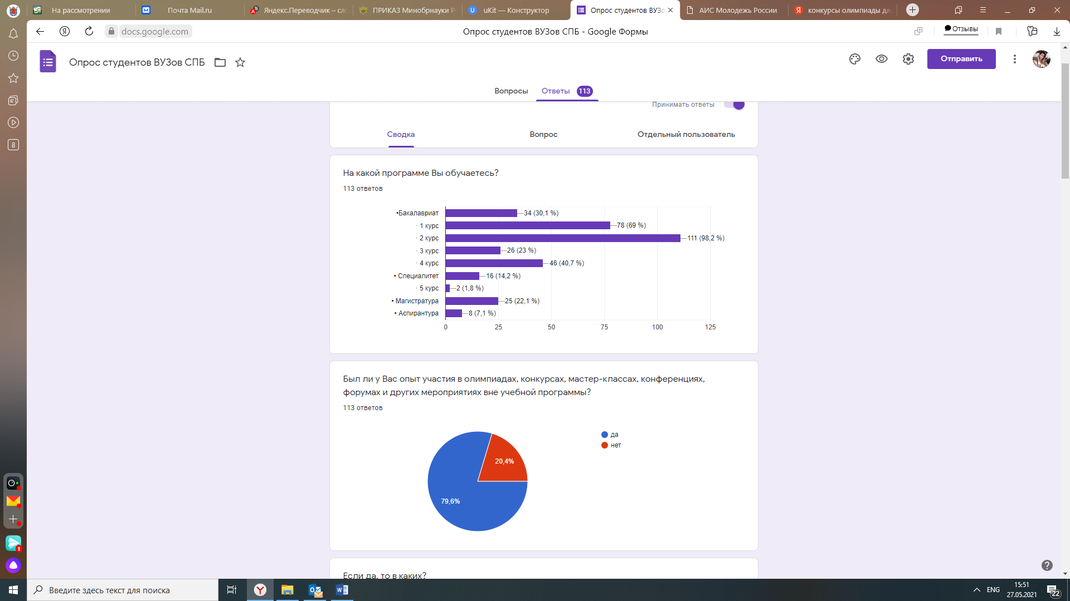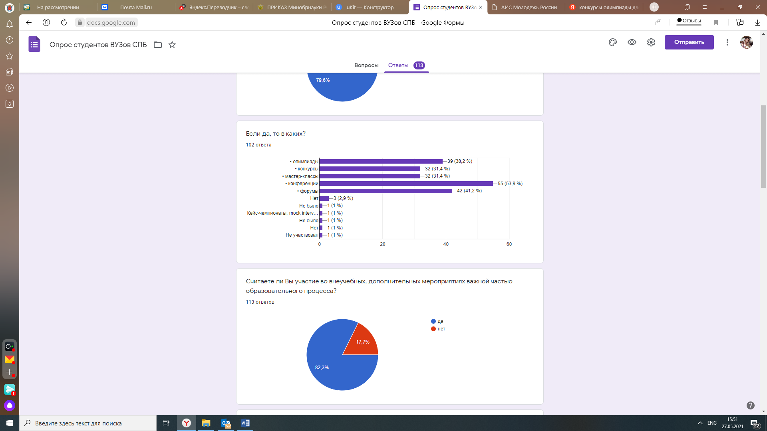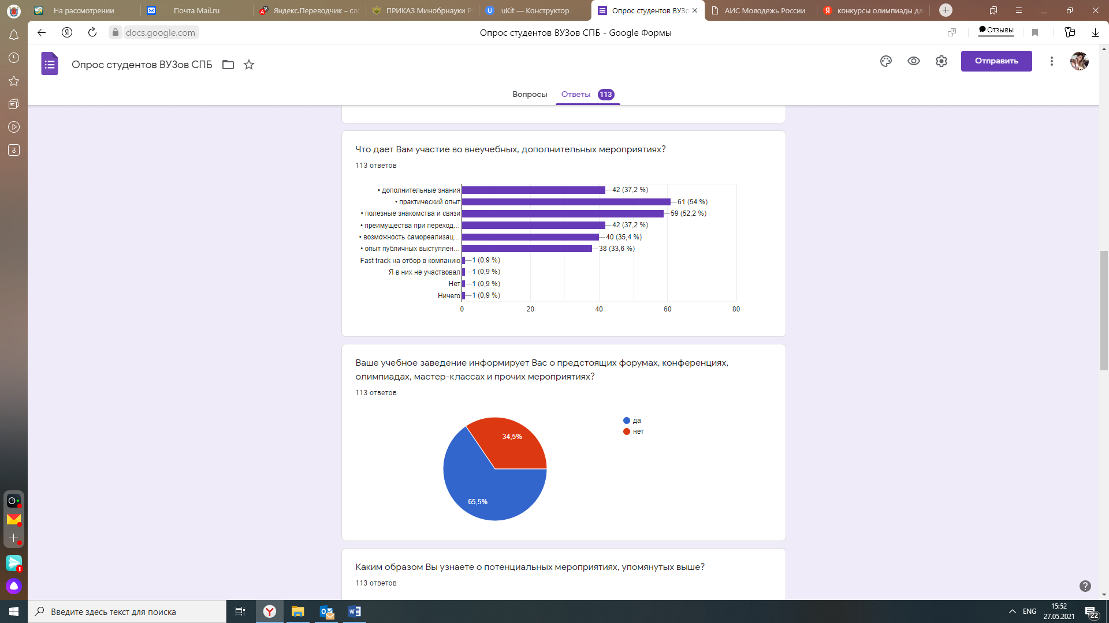

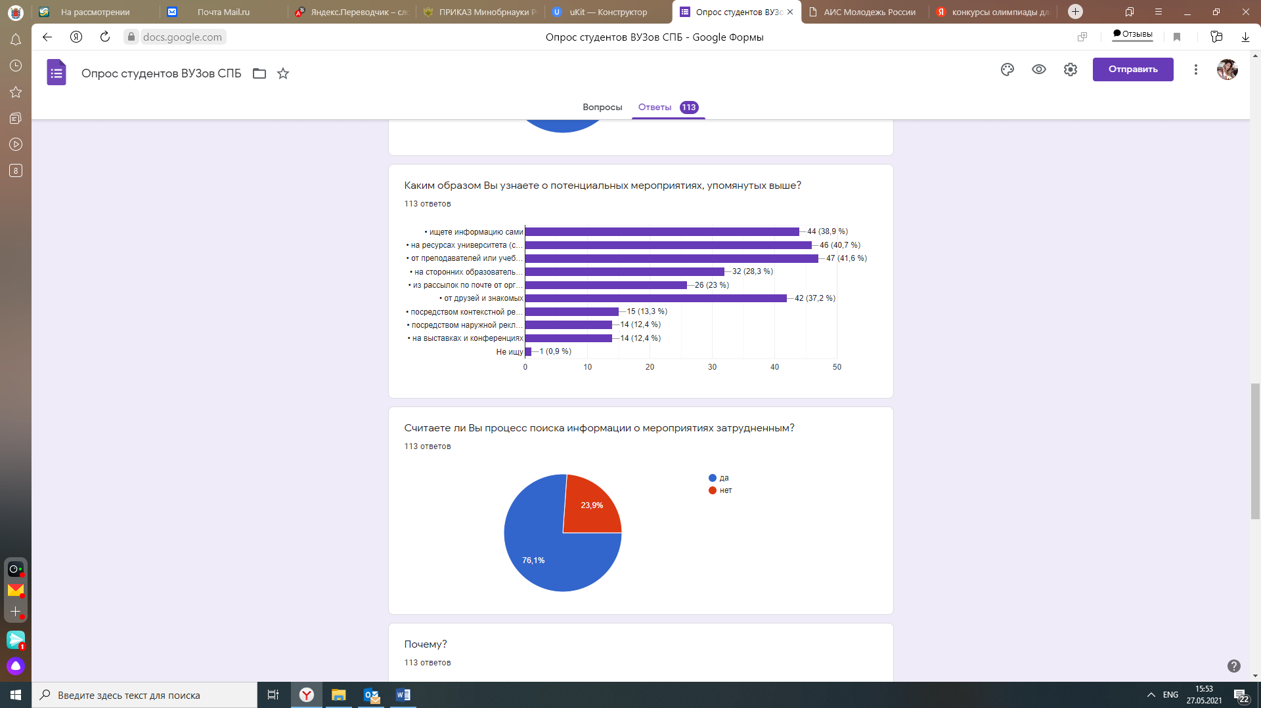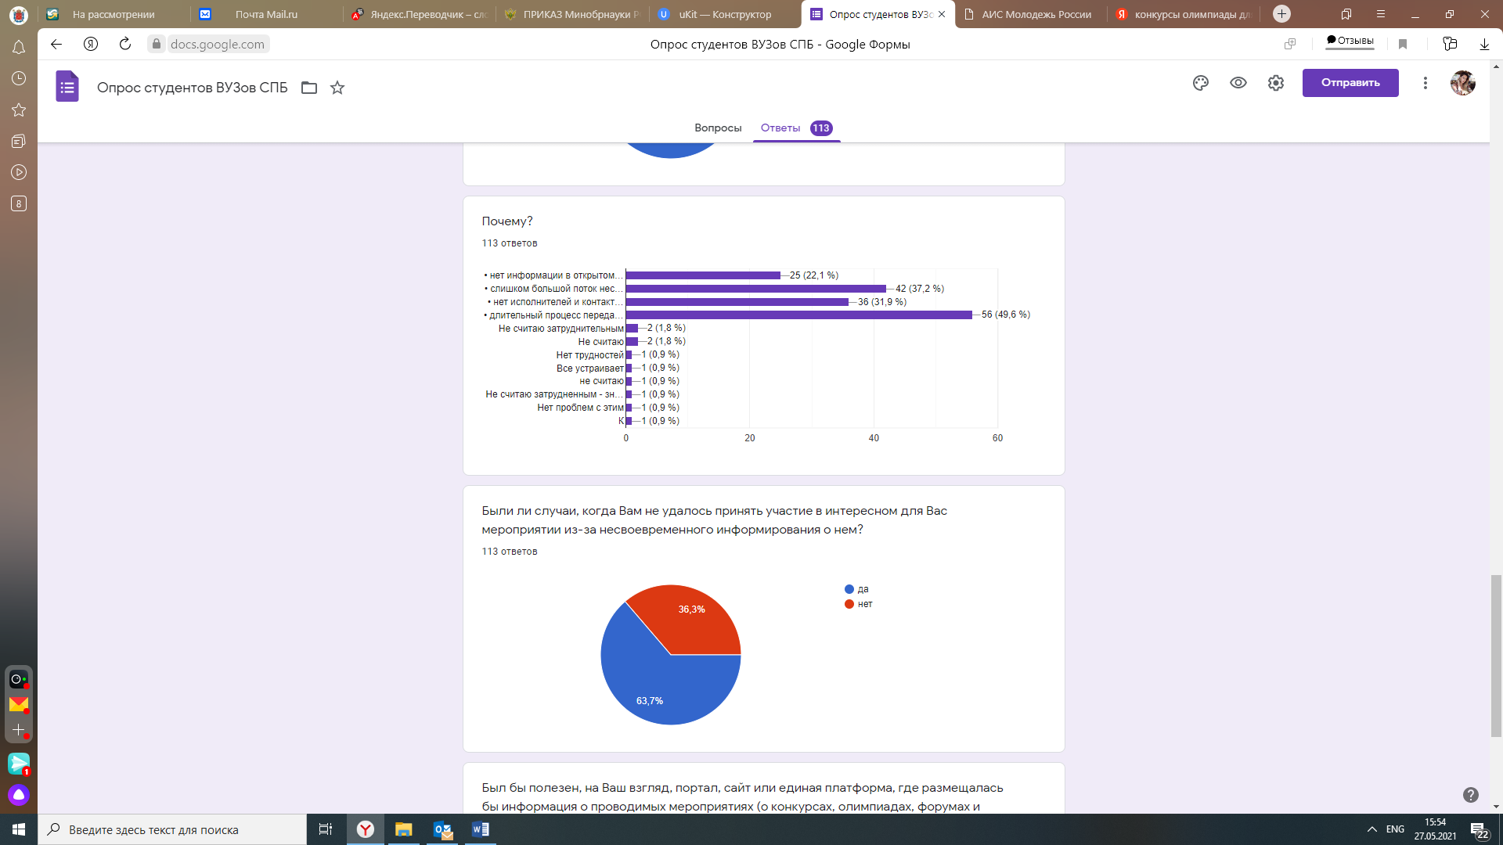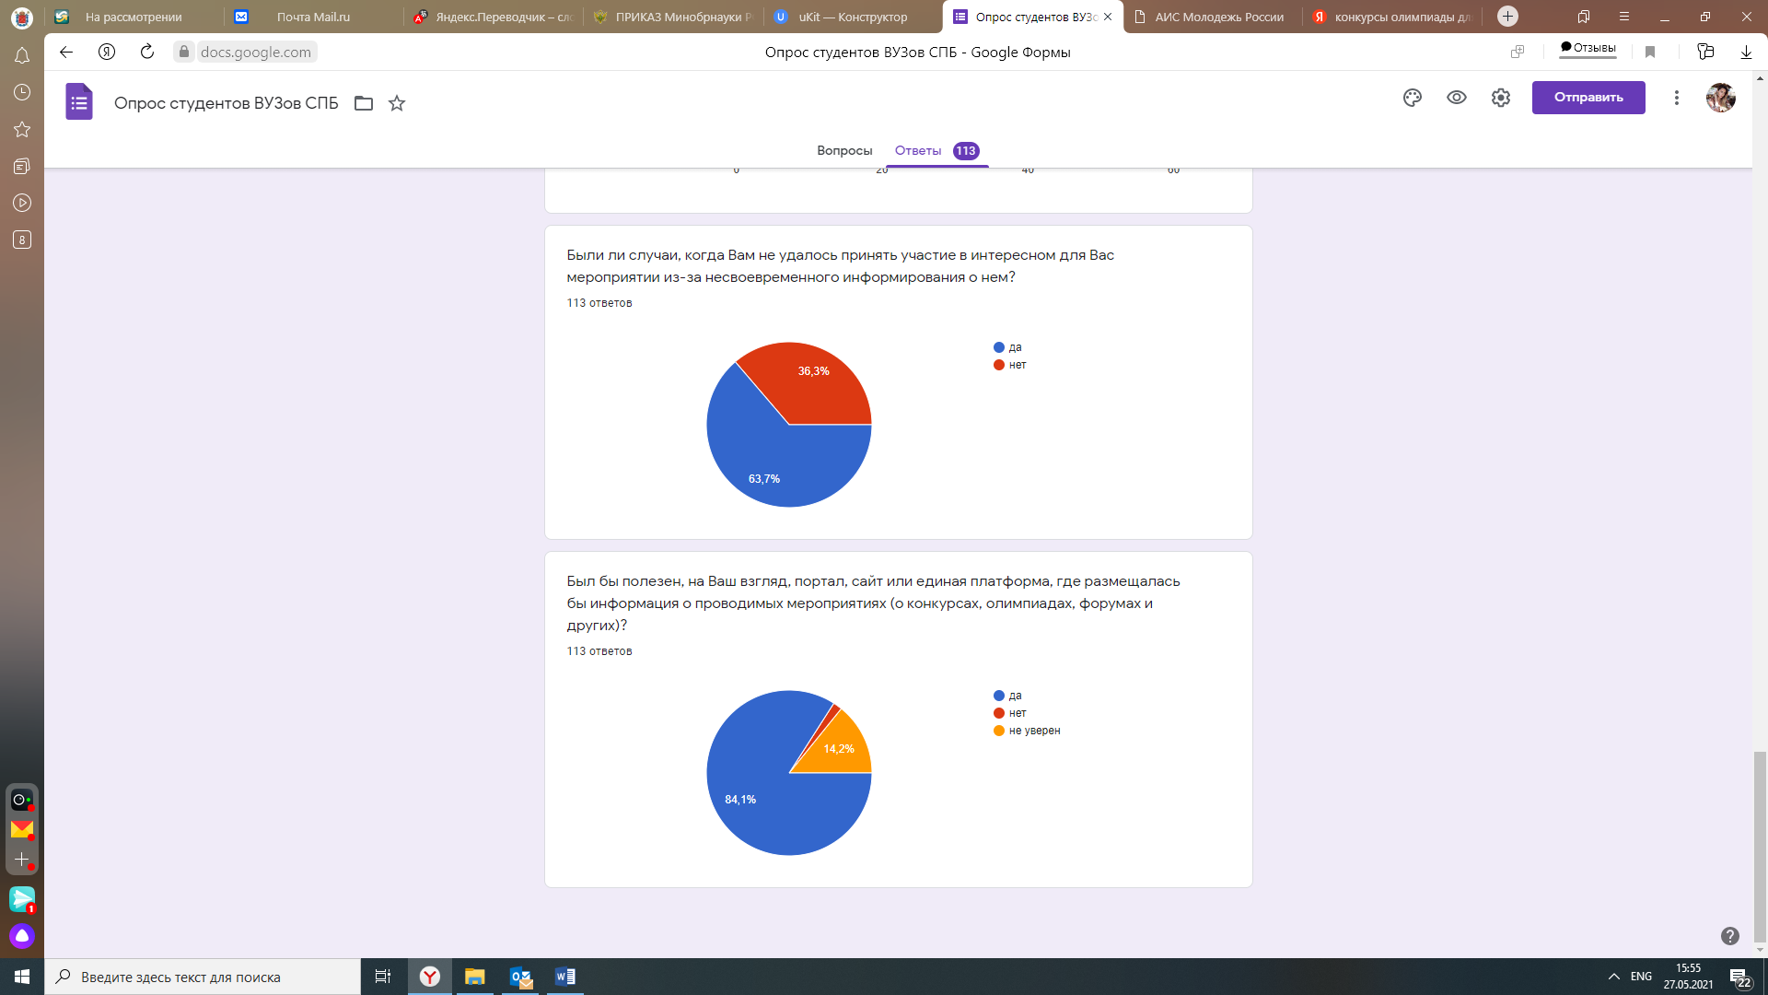

Appendix 6. The card of accounting of the incoming documents to the Committee on Science
and Higher Education, reflecting the performers on the received request
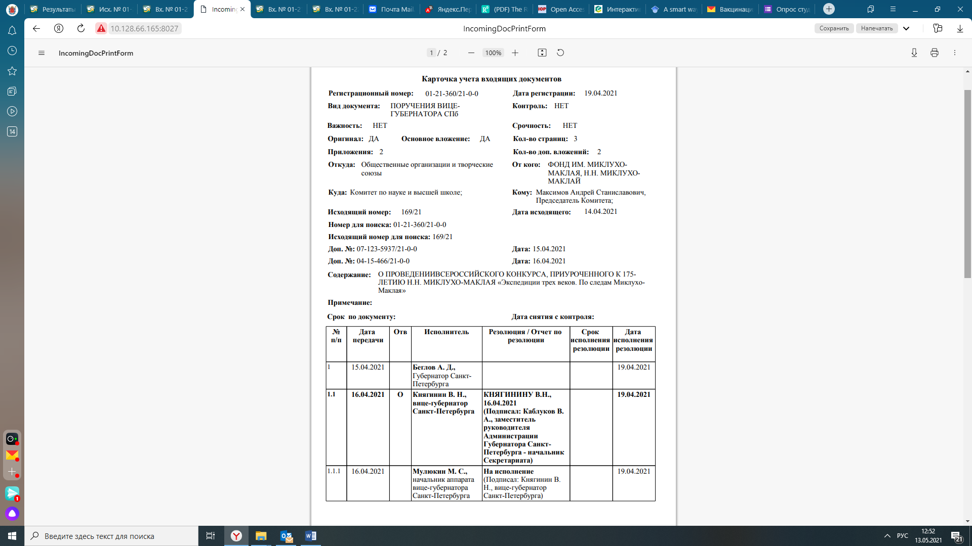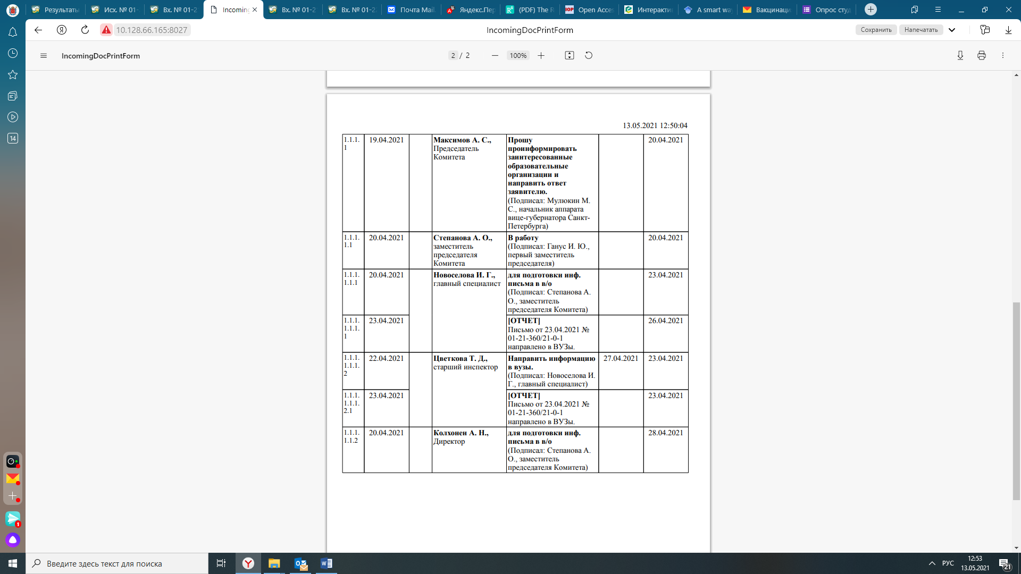

Appendix 7. Requests received by the Committee on Science and Higher Education with a request to provide information support for competitions
7.1. An example of a fulfilled request by the Committee for Science and Higher Education is a letter about working out to the Vice-Governor
of St. Petersburg
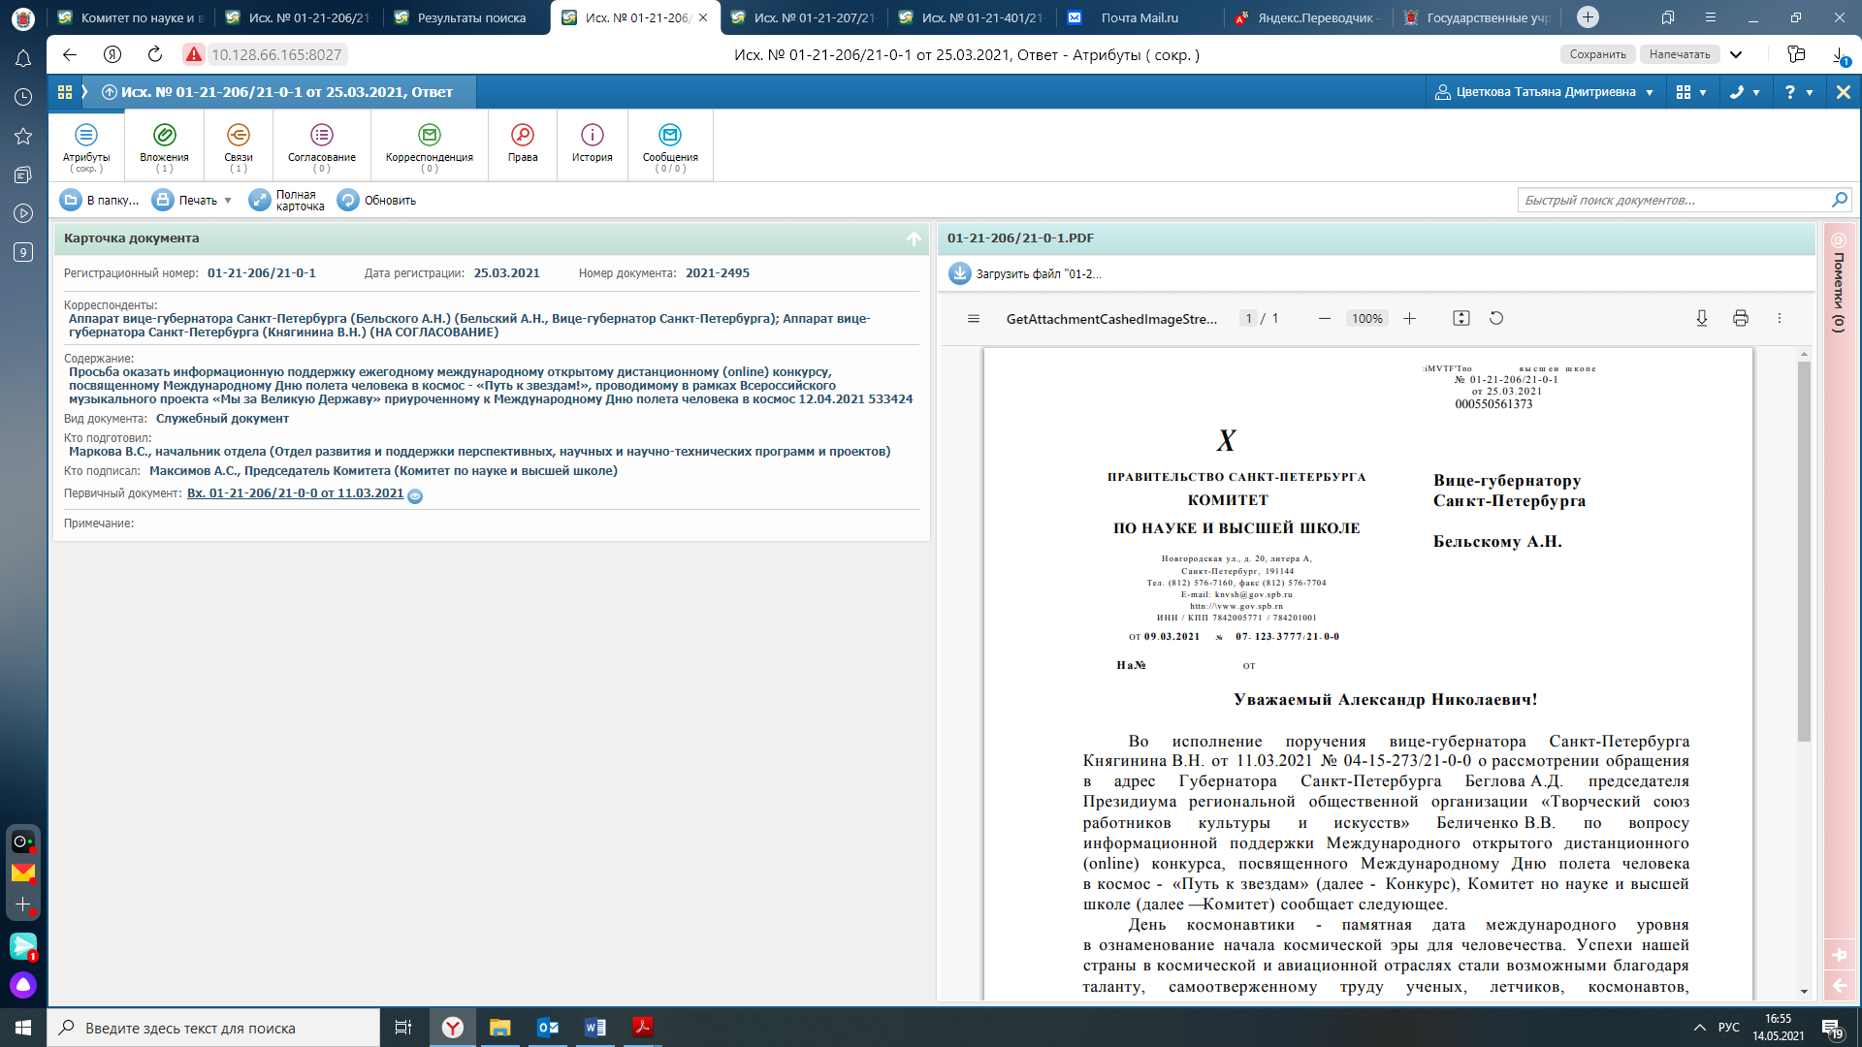

7.2. Example of an information letter from the Committee on Science and Higher Education to educational organizations

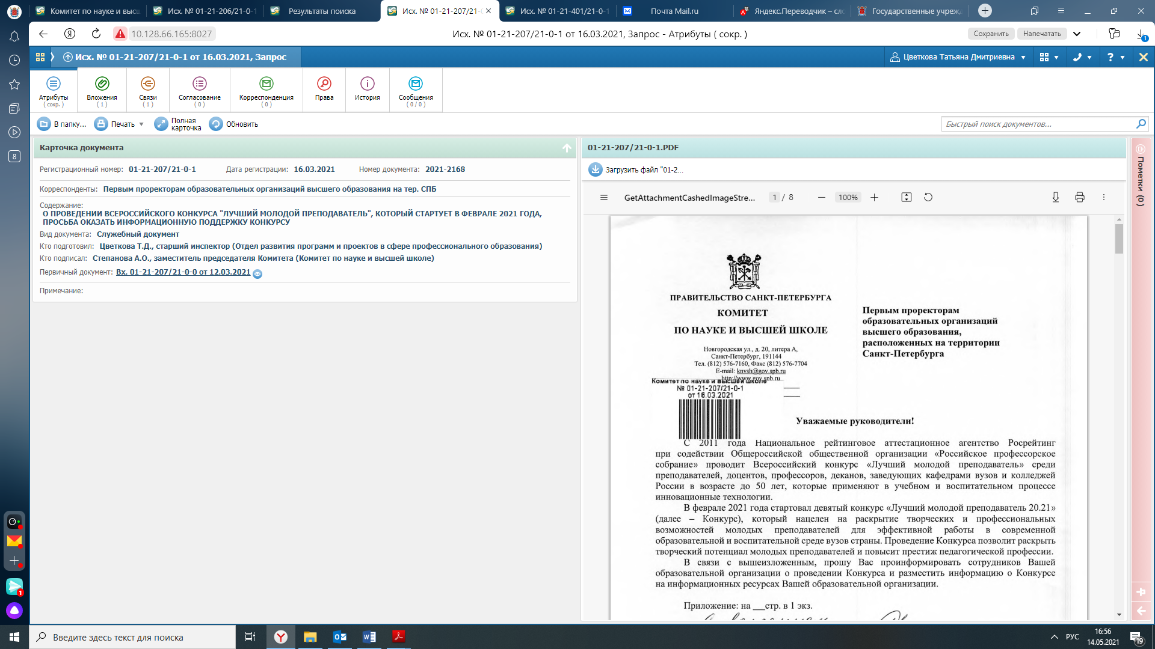
7.3. Example of a letter from the Committee on Science and Higher Education to educational organizations asking them to convey information to employees and students

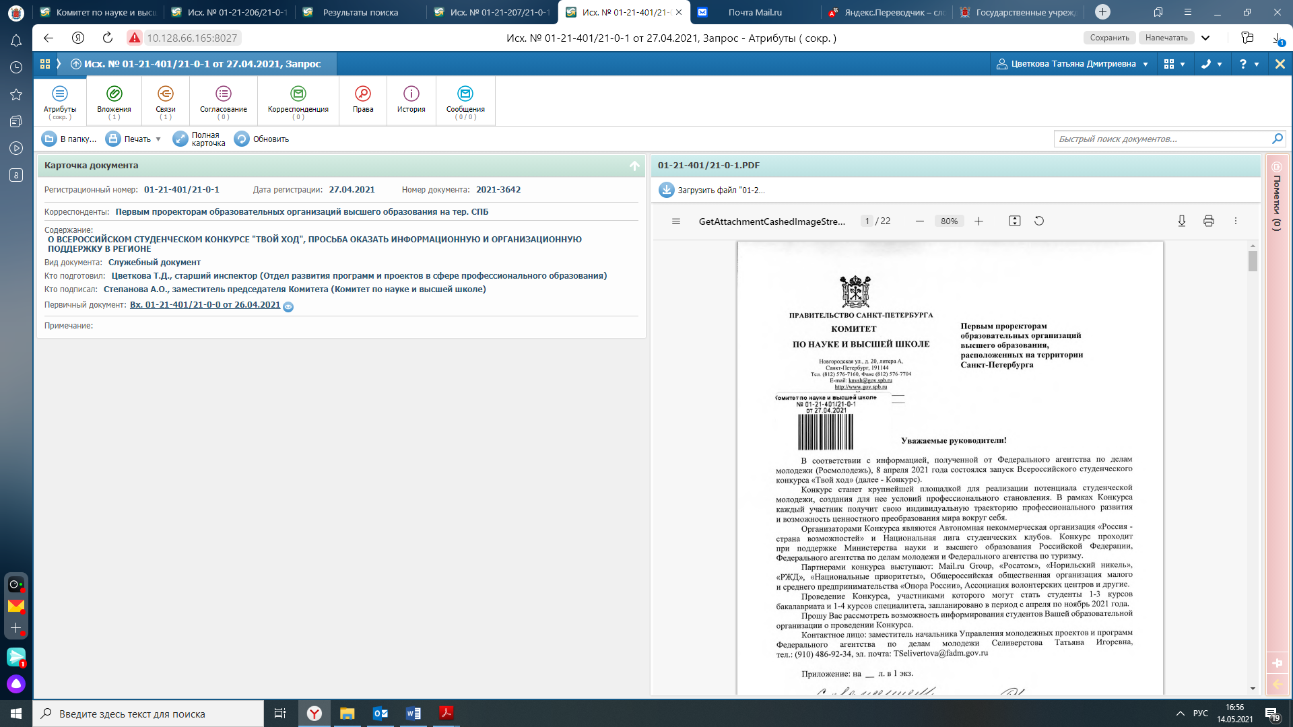
Appendix 8. Interview Guideline for the Director of the Coordination Center for International Scientific, Technical and Educational Programs

Вопросы для директора Координационного центра международных научно-технических и образовательных программ Снисаренко Юрия Алексеевича
- Как вы считаете эффективна ли сегодняшняя схема передачи информации
о внеучебной деятельности (от организаций в гос.органы и через вузы к студентам)?
- Существует ли необходимость сокращения общепринятого информационного пути?
- Был бы полезен портал с мероприятиями о внеучебной деятельности для всех заинтересованных сторон и почему?
- Кто мог бы управлять и пополнять контент в подобном канале коммуникации?
- Каковы перспективы в сфере высшего образования имеет единый портал, платформа для передачи информации?
- В чем заключается сложность перевода имеющихся процессов в цифровую среду?
- Заинтересован ли город переводить существующие процессы (бумажные
и электронные) в цифровой, более современный формат?
- Готов ли город финансировать подобного рода проект?
- Каким образом логичнее всего выстроить управление каналом: через Комитет по науке или отдать на аутсорс?
- Есть ли у Координационного центра достаточное количество ресурсов для ведения портала?

Appendix 9. Example of visualization of the portal about extracurricular activities

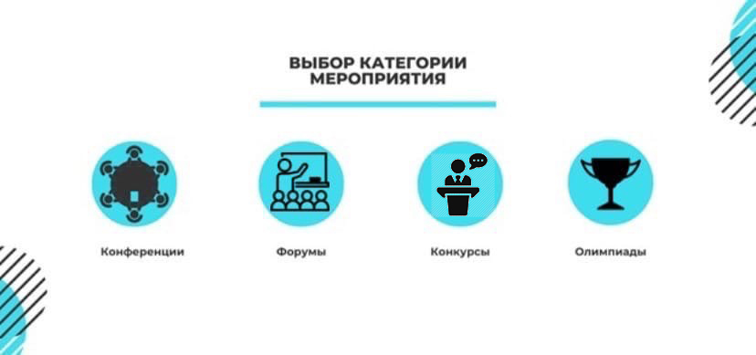
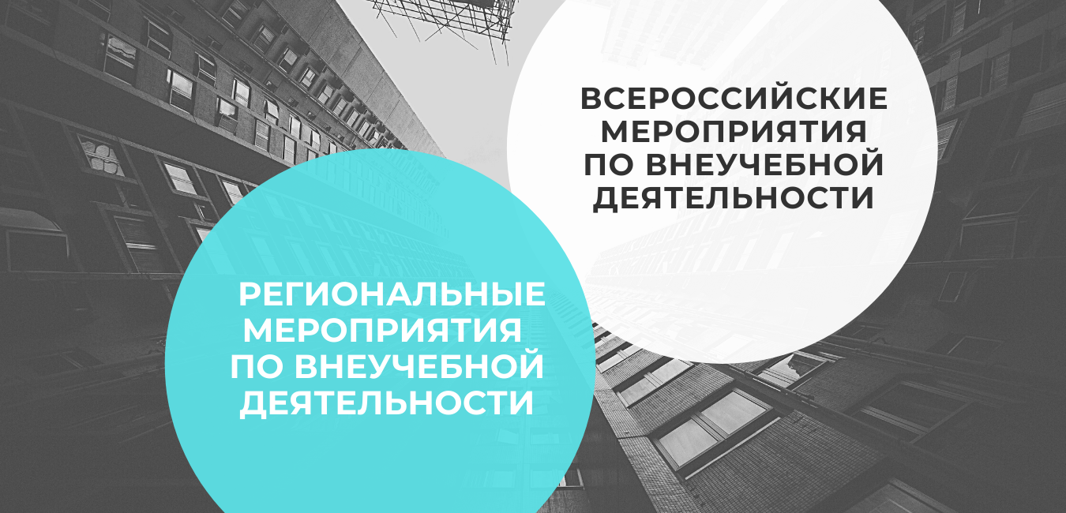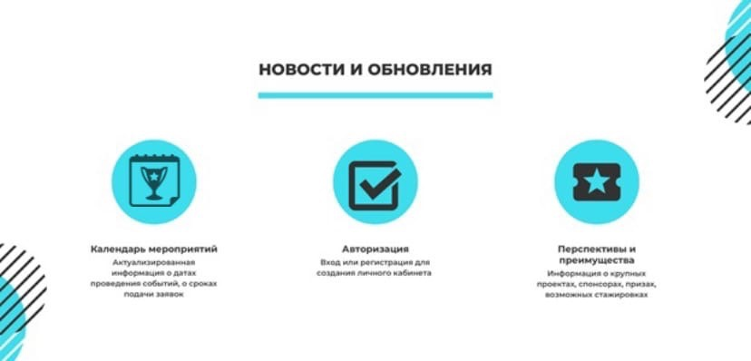
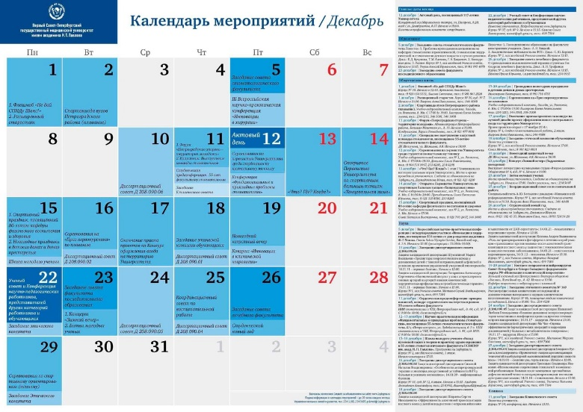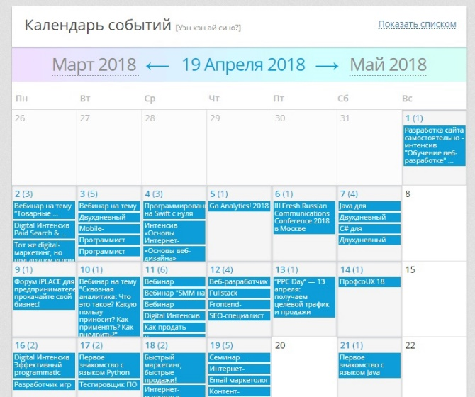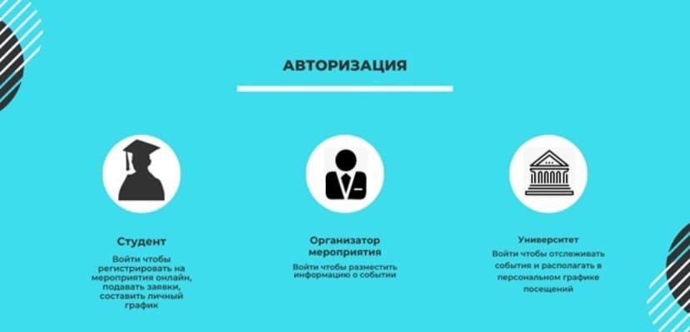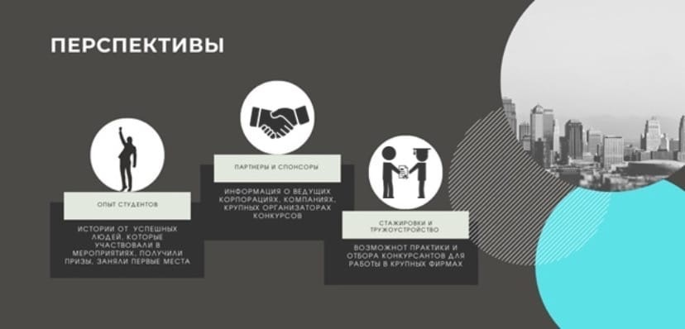


- D.-H. Kwak, (2010). Meaning and Prospect for Smart Learning. In Proceedings from the seminar for Korea e-learning industry
- association
- D.-H. Kwak, (2010). Meaning and Prospect for Smart Learning. In Proceedings from the seminar for Korea e-learning industry
- Association

