St. Petersburg University
Graduate School of Management

Master in Management Program

Implementing Agile Approach in Traditional Organization

Master’s Thesis by the 2nd year student of Master in Management — Kalinina Anna Sergeevna
Research advisor: Associate Professor, Elvira V. Strakhovich

St. Petersburg
2021

ЗАЯВЛЕНИЕ О САМОСТОЯТЕЛЬНОМ ХАРАКТЕРЕ ВЫПОЛНЕНИЯ
ВЫПУСКНОЙ КВАЛИФИКАЦИОННОЙ РАБОТЫ

Я, Калинина Анна Сергеевна, студент второго курса магистратуры направления «Менеджмент», заявляю, что в моей магистерской диссертации на тему «Внедрение Agile подхода в традиционной организации», представленной в службу обеспечения программ магистратуры для последующей передачи в государственную аттестационную комиссию для публичной защиты, не содержится элементов плагиата.

Все прямые заимствования из печатных и электронных источников, а также из защищенных ранее выпускных квалификационных работ, кандидатских и докторских диссертаций имеют соответствующие ссылки.

Мне известно содержание п. 9.7.1 Правил обучения по основным образовательным программам высшего и среднего профессионального образования в СПбГУ о том, что «ВКР выполняется индивидуально каждым студентом под руководством назначенного ему научного руководителя», и п. 51 Устава федерального государственного бюджетного образовательного учреждения высшего образования «Санкт-Петербургский государственный университет» о том, что «студент подлежит отчислению из Санкт-Петербургского университета за представление курсовой или выпускной квалификационной работы, выполненной другим лицом (лицами)».

/ Калинина А. С. /
01.06.2021

STATEMENT ABOUT THE INDEPENDENT CHARACTER OF
THE MASTER THESIS

I, Kalinina Anna Sergeevna, (second) year master student, program «Management», state that my master thesis on the topic «Implementing Agile Approach in Traditional Organization», which is presented to the Master Office to be submitted to the Official Defense Committee for the public defense, does not contain any elements of plagiarism.

All direct borrowings from printed and electronic sources, as well as from master theses, PhD and doctorate theses which were defended earlier, have appropriate references.

I am aware that according to paragraph 9.7.1. of Guidelines for instruction in major curriculum programs of higher and secondary professional education at St.Petersburg University «A master thesis must be completed by each of the degree candidates individually under the supervision of his or her advisor», and according to paragraph 51 of Charter of the Federal State Institution of Higher Education Saint-Petersburg State University «a student can be expelled from St.Petersburg University for submitting of the course or graduation qualification work developed by other person (persons)».
/ Anna Kalinina /
01.06.2021

АННОТАЦИЯ
Автор | Калинина Анна Сергеевна
Название магистерской диссертации | Внедрение Agile подхода в традиционной организации
Факультет | Высшая школа менеджмента
Направление подготовки | 080200 “Менеджмент” (Профиль: Менеджмент)
Год | 2021
Научный руководитель | Страхович Эльвира Витаутасовна
Описание цели, задач и основных результатов | Целью работы было сформулировать общий механизм перехода организации от текущих процессов к методологии Agile. Для достижения этой цели было проведено несколько кейс-стади. В исследовании были выявлены ситуации, когда традиционные организации могут проводить Agile-трансформацию, разработана схема внедрения Agile и определены вызовы Agile-трансформации для традиционных организаций.
Ключевые слова | Agile трансформация, традиционная организация, Scrum, организационная структура, Россия

ABSTRACT
Master Student's Name | Kalinina Anna Sergeevna
Master Thesis Title | Implementing Agile Approach in Traditional Organization
Faculty | Graduate School of Management
Main field of study | 080200 “Management” (specialization: Master in Management)
Year | 2021
Academic Advisor’s Name | Elvira V. Strakhovich
Description of the goal, task and main results | The aim of the work was to formulate a general mechanism for the organization's transition from current processes to the Agile methodology. To achieve this goal, multiply case studies were conducted. The study identified the situations when Agile transformation can be used by the traditional organizations, developed an Agile implementation scheme and identified the Agile transformation challenges for the traditional organizations.
Keywords | Agile transformation, traditional organization, Scrum, organizational structure, Russia

TABLE OF CONTENTS
1. INTRODUCTION 7
1.1 Relevance of the study 7
1.2 Research gap and research questions 7
2. LITERATURE REVIEW 9
2.1 Definition of Agile transformation 9
2.2 Three waves of Agile 9
2.3 Agile transformation models and frameworks 11
2.3.1 Agile Scaling Model 11
2.3.2 Scaled Agile Framework (SAFe) 12
2.3.3 Agile Adoption Framework 13
2.3.4 Scrum 14
2.3.5 Kanban 17
2.4 Process of Agile transformation 18
2.5 Agility in the time of COVID-19 22
3. EMPIRICAL STUDY 25
3.1. Methodology 25
3.2 Agile in banking: case of Sberbank 27
3.3 Agile in metallurgy: case of Severstal 33
3.4 Agile in publishing: case of Mann, Ivanov and Ferber 37
3.5 Conclusion 40
4. Development of proposals for improving the organization's management processes based on the principles of agile transformation 42
4.1 Defining the situation for the Agile transformation 42
4.2 Steps of the Agile transformation 45
4.3 Challenges that the traditional organization face when implementing Agile 51
5. Conclusion 53
References 55

1. INTRODUCTION
1.1 Relevance of the study

The business environment is changing rapidly nowadays, especially if we take into consideration all the economic crises, catastrophes of the last few years and finally coronavirus pandemic. The ability to react to constantly changing conditions, to predict new changes and to be able to be ahead of the time, to take actions in advance becomes crucial. And while modern companies and start-ups are ready to take these challenges, established companies face a lot of problems while adapting to the new requirements. Agile transformation is one of the possible solutions, that can them to adapt their organizational structure to the new environment. Moving to agile model, however, is not easy for traditional organizations, as there are several different roads and many starting points, but agile transformations all share the common elements described further in this paper.

Agile methods were developed in 90s and then defined in Agile Manifesto in 2001. They formed forming the basis for a revolution in the way software is developed and were the opposite of slow, bureaucratic waterfall methods, that were traditionally used in software development. But in the past decade this revolution increased its footprint as principles to define entire organizations and led to attempts how to apply an agile approach in the industrial companies and what benefits it can have. According to Deloitte survey, only 10% of CEOs considers their organizations to be “highly agile”, and 90% of top managers have an opinion that “agility and collaboration” are very important for their firms. (Deloitte, 2018) If, on the other hand, the company has been traditionally managed, the Agile transformation will entail fundamental transformations in attitudes, values, mindsets, methods of thinking, and ways of engaging with the outside world, ultimately transforming the entire organizational culture. And despite its popularity agile approach can’t be “one and for all” solution, and there is still lack of information of situations in traditional companies, where agile methods can be implied and examples of their successful implementation.

1.2 Research gap and research questions

It is obvious why traditional companies are so interested in agile transformation. According to McKinsey studies, firms and units implementing agile do better financially than those that don't. (Brosseau et al., 2018) The key goal that managers seek to achieve is for an organization to be able to renew itself and adapt to a fast-changing environment, to be able to swiftly rearrange strategy, structure and processes in order to create and protect value.
However, the problem is that many managers are interested in Agile only because it is a trend, and they start to implement Agile without making a preliminary assessment of the transformation and understanding whether their organization even needs it. At the very least, innovations do not lead to any result, and sometimes they can even worsen the situation, and the company returns to the traditional approach. The goal of my thesis is to formulate a general mechanism for the organization's transition from current processes to the Agile methodology.

In order to achieve this goal, it is necessary to answer the following research questions:
- How does an agile transformation in a traditional organization look like?
- How does an organizational structure change, when implementing an Agile approach?
- What are the main steps for implementing Agile in the traditional organization?

2. LITERATURE REVIEW
2.1 Definition of Agile transformation
According to McKinsey, “traditional organizations are built around a static, siloed, structural hierarchy, while agile organizations can be characterized as a network of teams operating in rapid learning and decision-making cycles”. (Brosseau et al., 2019) Traditional companies make decisions from the top down, with decision-making authority flowing down the hierarchy. Agile companies, on the other hand, instill a shared purpose and leverage fresh data to provide decision-making authority to the teams that are close to the information. An agile organization, in its ideal state, will combine speed and agility with stability and efficiency. (McKinsey, 2019)

Agile began as a set of IT development work practices that were focused on ensuring that product development was customer-centric, moreover, end-user-centric. This is one of the main associations people have with Agile at the level of work practice. Nowadays these working practices are expanding, not just in IT, but across the entire organization, and these traditional companies face with a necessity to transform, to organize in a different way in order to become faster, more productive, and more responsive. (Tudor & Walter, 2006)

2.2 Three waves of Agile
Agile as a social movement comprised three waves. (Rudd, 2016) Every wave marks a stage in the evolution of Agile practice that has altered the essence of the movement while broadening its reach. When individuals begin to organize around new techniques to tackle an issue, a wave begins to form, and as it expands in size, a separate community of practice emerges. Divergent viewpoints arise at initially as the emerging society seeks solutions. Opinions eventually converge as the community assimilates differences. The wave is complete when practices settle and an agreement arises on how to apply them to regularly generate positive results. When the community of practice switches its focus to a new challenge, a new wave begins and the cycle is repeated. The three waves of the Agile social movement are depicted in the diagram below.

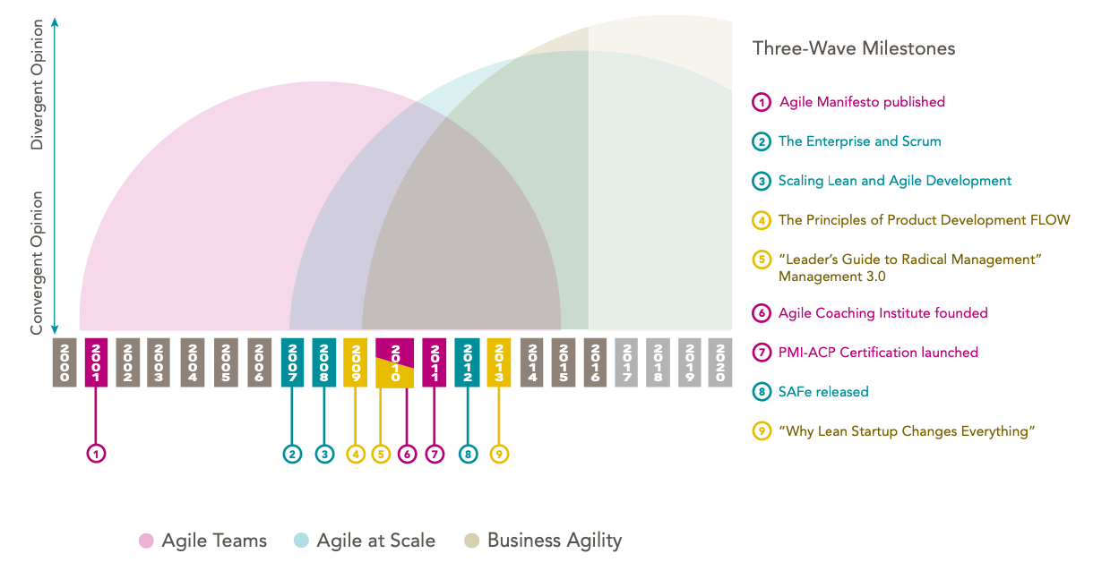
Figure 1. Three Waves of Agile (Rudd, 2016)

The first wave's goal was to form a small Agile team to generate better software. It all started with the publishing of the Agile Manifesto in 2001, which launched the Agile industry. Although the definition of an effective team practice was hotly discussed at first, an agreement eventually evolved. Today, the Agile industry agrees that by appropriately using methods like Scrum and Extreme Programming, an efficient Agile software delivery team can be built pretty much anyplace; the first wave was accomplished.

The first wave covers two work domains: software development and project management, which correspond to the two most popular Agile team methodologies, Extreme Programming and Scrum. Although the Scrum Alliance and the PMI have missions that apply to all projects and there are examples of Agile teams outside of software development, when compared to the software development industry, where Agile is quickly becoming the standard practice, Agile in other domains is still in its infancy. The software sector, on the other hand, has advanced to the second wave of Agile, known as Agile at Scale.

The second wave's goal is to integrate and coordinate work across Agile teams while also keeping Agile teams alive in an institutional context. Because what works effectively for a small group of individuals does not simply convert to a big group of people, scaling Agile is fundamentally different from forming an Agile team.

The first wave spawned a new field of study: team coaching.
The second wave has also spawned a new discipline: agile organizational change management (OCM). Agile OCM is distinguished from its predecessors by the introduction of key Agile principles like as transparency, empowerment, and feedback-driven adaptation into the change management process.. When the community of practice comes to an agreement on how to conduct Agile OCM, it's a good sign that the second wave's cycle is coming to an end.

The growing breadth of scaled Agile transformations heralds the arrival of Agile's third wave: Business Agility. The third wave's goal is to change how managers charter, lead, and manage companies by adopting an Agile mentality, cultivating an organizational learning culture, and implementing organization-wide Agile operations. The subject broadens to embrace all knowledge work domains and the whole organization as we turn our focus to general management and leadership methods. (Ashmore et al., 2017)

With each subsequent wave, the Agile movement's reach has expanded to cover new types of work and issue areas. The original focus on software development has expanded to cover all types of knowledge labor, including as design, engineering, marketing, and management.

And what began as an emphasis on teams has grown to include the whole business. The dedication to Agile principles and values is what unites the Agile movement as it evolves. These have been separated from their Scrum, Extreme Programming, and Agile Manifesto beginnings over time to have greater applicability and relevance while staying substantially intact.

2.3 Agile transformation models and frameworks

While a traditional model is the foundation of a firm and all workers are proficient in it, the most essential issue in companies is how to make the change. It is true that everything appears complex in the initial stages for everyone, but agile may be effectively implemented with the correct and strong backing of top management teams and agile coaches. Almost all models and frameworks that are used as guides for firms transitioning from a traditional to an agile technique are discussed in this section.
2.3.1 Agile Scaling Model

Ambler (Ambler, 2009) defines a contextual model as a roadmap for more effectively implementing agile methodologies and tackling the particular problems that system delivery teams face. The Agile Scaling Model is classified into three categories, as indicated in Figure.
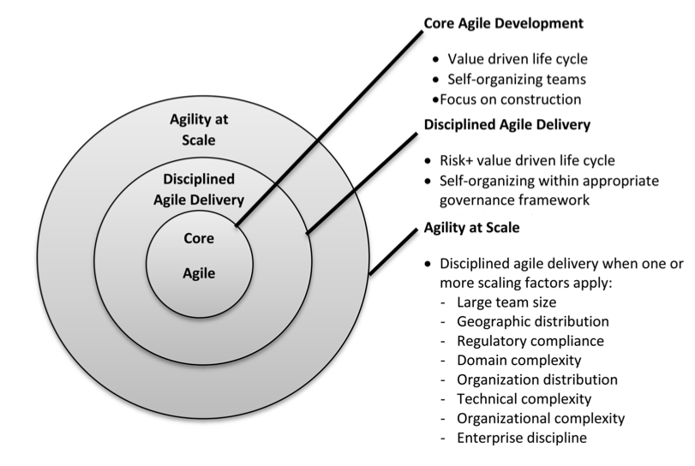
Figure 2. Agile Scaling Model (Ambler, 2009)

The first category is designed for small groups working on very simple systems. It is made up of self-organizing core agile methodologies that have a value-driven system development lifecycle and correspond to a stage in the development lifecycle. The second group is responsible for the whole software development lifecycle, from the start of the project to the delivery of the system to the market or production environment. The last category focuses on well-ordered agile delivery that allows for several scaling variables. Team size, regulatory compliance, geographical dispersion, technological complexity, organizational complexity, enterprise discipline (such as enterprise architecture and governance), and organizational dispersion were all cited by Ambler (Ambler, 2009) as scaling considerations.

2.3.2 Scaled Agile Framework (SAFe)

Scaled Agile Framework (SAFe) was designed by Leffingwell (Leffingwell, 2010), and it is an accepted knowledge-based framework for implementing agile principles in businesses. For agile requirements practices, this model functions as both an organizational and a process model. This framework's main user interface is a graphical large picture that depicts three levels of scale: portfolio, program, and team.

Around seven agile team members describe, create, and test user scenarios in sequences of encounters at the team level. The creation of larger-scale system features is finished at the next level, the program level, by several teams working in a synchronized Agile Release Train (ART) (Leffingwell, 2010). A long-lived agile team is known as an ART, and it typically has 50-125 people. The portfolio level refers to a collection of investment themes that are used to guide the organization's investment preferences. The pattern will be used to ensure that the work being done is the work that is necessary for the firm to communicate its chosen business strategy (Leffingwell, 2010). Obviously, SAFe isn't a one-size-fits-all solution. SAFe, on the other hand, is a framework that tackles with complex challenges and delivers intricate solutions.

2.3.3 Agile Adoption Framework

Sidky et al. (Sidky, Arthur, & Bohner, 2007) provided an agile adoption framework (Figure ) with two sections to help and drive enterprises toward agility adoption. The first is an agile measurement index, which is used to assess agile potential, and the second is a four-stage procedure that uses the agile measurement index to determine how and to what degree agility may be promoted in an organization.

Figure 3. Agile Adoption Framework Process (Sidky et al., 2007)

This framework is not dependent on agile approaches; it may be used in conjunction with Scrum, FDD, XP, or any other agile approach. The coach uses the Sidky agile measuring index as a scale to assess the potential agility of a project or an organization in this framework. The framework's four step procedures guide firms in identifying the optimal agile methods for their environment and circumstances. The first step identifies the limiting issues and any limitation procedures that prohibit agile adoption from succeeding. The measuring index is used in the second stage to identify the greatest level of agility for each project. The measuring index is used in the third stage to determine organizational preparedness. The final stage of agile adoption defines the last set of tasks, which include adopting the target agile level from the second stage and assessing the organization's readiness from the third stage.
The Agile Adoption Framework, on the other hand, is merely a necessary component of adopting agility; an agile coach (who understands how to implement the framework) is also required.

2.3.4 Scrum

Scrum is a technique that helps teams work together. Scrum is a heuristic by definition. It is built on a foundation of continuous learning and adaptability to changing circumstances. According to Scrum, the team will not know everything at the start of the project, but will learn as the project progresses. Scrum is built to allow teams to adapt to changing surroundings and user needs with ease. The workflow includes prioritization changes and short release cycles, which encourages continuous learning and improvement of the team. The structure does not prevent the Scrum methodology from being flexible. It can be tailored to the needs of the organization.

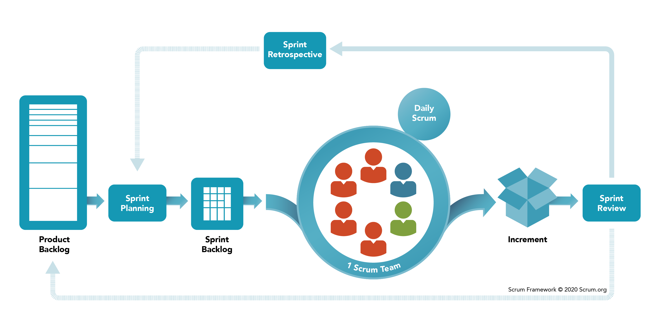
Figure 4. Scrum Framework (Scrum.org, 2008)

There are three Scrum artifacts: Product Backlog, Sprint Backlog, and Increment.
- The Product Backlog is a master list of tasks that need to be completed. It is maintained by the owner or product manager. This is an ever-changing list of features, requirements, improvements and fixes from which the tasks for the sprint backlog are composed. In general, this is a list of team tasks. The Product Owner is constantly referring to the Product Backlog, changing priorities and keeping it up to date, because new information may appear or the market may change, which makes it meaningless to complete existing tasks or new ways of solving problems appear.
- A Sprint Backlog is a collection of work items, user stories, or bug fixes chosen for implementation in the current sprint cycle by the development team. Before each sprint, a sprint planning meeting is held, where the team chooses which tasks from the product backlog to complete within the sprint. The sprint backlog may not be fixed and may change as the sprint progresses. However, nothing should interfere with the achievement of the main goal of the sprint - what the team wants to achieve in the current sprint.
- An Increment (or sprint goal) is a ready-to-use final product at the end of a sprint.

An important part of the Scrum methodology is the meetings that the teams regularly hold:

- Backlog organization. This activity, also known as backlog maintenance, is the responsibility of the product owner. His main responsibilities include bringing the product in line with its concept and constantly monitoring market sentiment and customer needs. To do this, the product owner maintains a list, changing priorities in it and keeping it up to date based on information from users and the development team, so that at any time a team member can start working on the tasks entered into it.

- Sprint planning. In this meeting, the development team, led by the Scrum Master, plans the work (sprint scope) to be completed during the current sprint. On it, the sprint's aim is chosen. The sprint is then filled with specific user stories from the product backlog. The aim is constantly at the center of these stories. The Scrum team negotiates stories that may be implemented throughout the sprint in this way. Each member of the Scrum team should know what tasks can be done in a sprint and how to increment before the conclusion of the planning meeting.

- Sprint. A sprint is the actual amount of time that the Scrum team works together to create a finished increment. Typically, a sprint lasts two weeks, although some teams find it easier to plan a sprint volume for one week or a worthwhile increment in a month. All activities, from planning to retrospective, take place during the sprint. Once the time frame for the sprint is determined, it should remain the same while development is in progress. This will help the team learn valuable lessons from past experiences and apply the findings to future sprints.

- Daily Scrum meeting, or stand-up. This is a very short daily meeting and is held at the same time and in the same place for convenience. Usually it’s about 15 minutes. A daily Scrum meeting is held so that each team member is aware of what is happening, does not deviate from the goal and receives a work plan for the next 24 hours. Stand-up is a good time to report anything that prevents a team member from reaching the sprint goal, including blockers.

- Sprint retrospective. A retrospective is for the team to capture and discuss all the successes and failures of the sprint, project, participants and their relationships, tools, or even specific meetings. The goal of retrospective is to create the conditions so that the team can pay attention to everything that has succeeded and what needs to be improved next time, and does not dwell on failures.

The composition of a scrum team has three distinct roles: product owner, scrum master, and development team.

- Owners stand up for their product. Their job is to understand the requirements of the business, customer and market. Based on this understanding, they prioritize work tasks that the technical team will perform in the appropriate order. The role of the product owner is not always combined with the role of the product manager. The owners strive to create the right conditions for the development team to create maximum business value.
- Scrum Masters monitor the application of Scrum principles in their teams. They educate teams, product owners and the rest of the company in the finer points of the Scrum process and try to optimize the application of this practice. The success of a Scrum Master depends on how well they understand the work the team is doing, and can help the team increase transparency and streamline the product delivery process. This is the main coordinator who makes a list of required resources (human and logistical) for sprint planning and review meetings, stand-up and sprint retrospective meetings.
- Scrum teams do the bulk of the work. They are experts in balanced design principles. The most successful teams are close-knit, located in one place and usually consist of 5-7 members. Scrum teams create a plan for each sprint. They predict the amount of work they can do in an iteration, using their speed in past sprints as a guide. With a fixed iteration duration, the development team can analyze the correctness of the estimate of the complexity and the delivery process of the product, which, in turn, significantly improves the accuracy of its predictions over time.

2.3.5 Kanban

Kanban work is built around a Kanban board that is used to visualize and streamline the workflow. While some teams prefer real whiteboards, whiteboards have long been a must-have feature of any agile software development tool, making them easier to track, collaborate, and access from multiple locations.

Boards are needed to visualize team work, standardize the process, and find and eliminate blockers and dependencies. And it doesn't matter in what form they are presented - physical or digital. On a standard Kanban board, the process consists of three steps: Planned, In Progress, and Done. However, the board can be customized according to the team's process, depending on its size, structure, and goals.

The Kanban methodology is based on full transparency of work and the exchange of information on resources in real time. Thus, the Kanban board should be the only reliable source of information about the team's work.

Kanban provides teams of all sizes with a number of additional benefits in terms of scheduling tasks and ensuring productivity. The Kanban team focuses only on the current work. When a work task is completed, the team picks up the next task from the top of the backlog. The Product Owner can change the priority of tasks in the backlog without interfering with the work of the team, since the changes occur outside of the current work tasks. If the product owner makes sure the most important work items are at the top of the backlog, the development team will be guaranteed to deliver the most valuable product to the business. Thus, there is simply no need for the fixed duration sprints used in the Scrum methodology.

Cycle time is a key metric for Kanban teams. Cycle duration refers to the time a work task passes through its life cycle, from the start of work on a task to its delivery. By optimizing cycle times, the team can confidently predict the delivery time of tasks in the future.

Multitasking kills efficiency. The more unfinished tasks, the more often a worker have to switch between them, and this affects the timing of their completion. Therefore, a key principle of Kanban is to limit the amount of work in progress (WIP). WIP limits allow to quickly identify bottlenecks and bottlenecks in team work, caused by a lack of focus, people, or skills.

2.4 Process of Agile transformation

Agile transformation is a “process of transitioning an entire organization to a nimble, reactive approach based on agile principles”. (McKinsey, 2020) But it’s not simply adopting agile software development methodologies. During this transformation an organization is most likely to embrace Scrum, Kanban, and other agile methods, that were described earlier, but the whole transition extends far beyond product development and needs a much larger effort than just changing how software gets built. Agile companies foster teams that take ownership of a purpose or business objective and can carry it out more or less independently. Teams are dynamic; their priorities vary on a regular basis, and the mission and team makeup may also vary. An Agile company is made up of many small, high-performing teams, each with a clear objective that they can complete from start to finish.

McKinsey believes, there are three types of journey to make an agile transformation: (Brosseau et al., 2019)
- All-in: entails a company-wide commitment to Agile transformation and a sequence of Agile transformation waves;
- Step-wise: entails a systematic and more discreet approach;
- Emergent: is basically a bottom-up approach.

As it was mentioned earlier, companies from IT industries and start-up are mostly agile from the beginning, while in other industries it’s a rare example. Hence, most traditional organizations to order to become agile need transformations, that can vary in scope, approach and pace, but all contain a common set of elements, which are depicted below.

Figure 5. Elements of an Agile transformation (McKinsey, 2020)

McKinsey summarizes these concepts as follows: “Most transformations start with building the top team’s understanding and aspirations, creating a blueprint to identify how agility will add value, and learning through agile pilots. These three elements inform one another and often overlap.” (McKinsey, 2020)

- Top-team aspiration: At the top of the organization, ambitious and aligned leadership is required for successful agile transitions. A unified ambition to alter the firm is required.
- Blueprint provides a clear vision and design for a new operating model.
- Agile pilots: A pilot's goal is to demonstrate the benefit of agile working practices through quantifiable business outcomes. At initially, pilots may be confined to single teams, but most of them eventually expand to include many teams in order to test the larger aspects of enterprise agility. Employees that have demonstrated success through agile working might minimize CEO skepticism.

The first stage in the blueprinting process is to figure out where the value is. All operating-model design must be based on a knowledge of how value is produced in the industry as well as how value is produced inside the individual firm. This is inextricably linked to strategy.
Then there's the structure. An agile organization is made up of cells (or "teams," "squads," or "pools") that are brought together around shared missions and are referred to as "tribes." The blueprinting component should provide a "tribe map" to show how individuals who work together get things done, as well as a more recognizable organization chart to show the capability axis along which common skill sets are owned and governed.

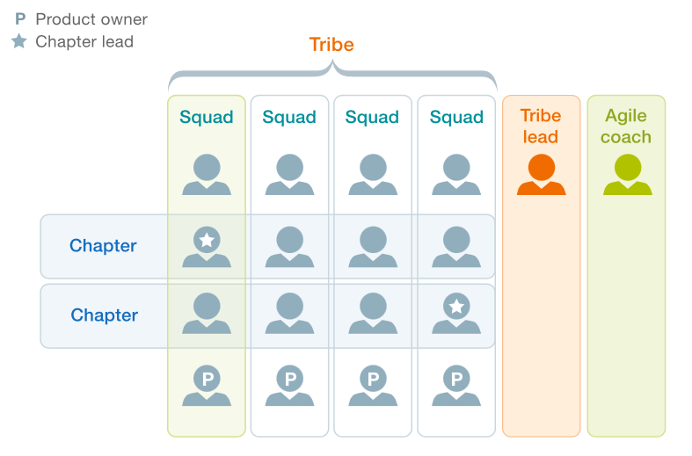
Figure 6. Example of the Tribe (McKinsey, 2020)

McKinsey posits that there are 4 facets of an organization that are impacted by a comprehensive agile transformation. These are people, process, strategy, structure and technology. These are depicted in the image below.
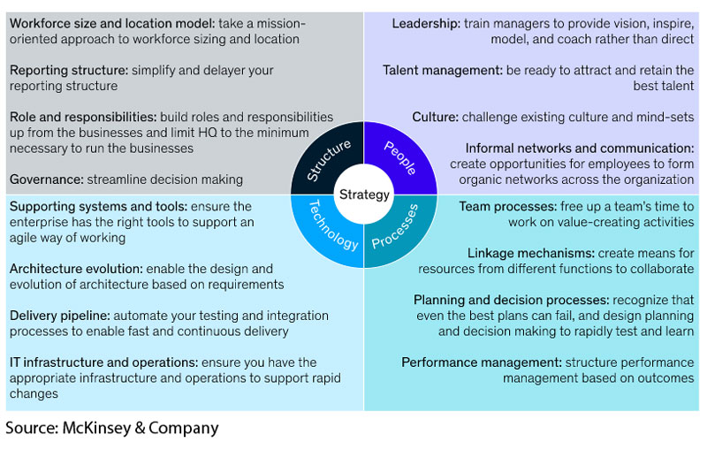Figure 7. Facets of an organization (McKinsey, 2019)

Based on its recent experience and research, McKinsey defined the five fundamental “trademarks” of agile organizations, that can be used by the companies as concrete markers of their progress. For each trademark, an emerging set of “agility practices” was identified — the practical actions McKinsey have observed organizations taking on their path to agility. (McKinsey, 2019)

 | Trademark | Organizational-agility practices
Strategy | North Star embodied across the organization | - A common goal and vision  - Recognizing and capturing opportunities  - Allocating resources in a flexible manner Strategic counsel that is actionable
Structure | Network of empowered teams | - Clear, flat structure  - Clear accountable roles  - Hands-on governance  - Robust communities of practice  - Active partnerships and ecosystem  - Open physical and virtual environment  - Fit-for-purpose accountable cells
Process | Rapid decision and learning cycles | - Rapid iteration and experimentation  - Standardized ways of working  - Performance orientation  - Transparency of information  - Constant learning  - Decision-making that is action-oriented
People | Dynamic people model that ignites passion | - Cohesive community  - Entrepreneurial drive  - Role mobility
Technology | Next-generation enabling technology | Technology architecture, systems, and tools are all changing  Practices for developing and delivering next-generation technologies
Table 1. The five trademarks of agile organizations (McKinsey, 2020)

2.5 Agility in the time of COVID-19
Before the coronavirus pandemic, organizations already needed to manage change and make decisions faster than ever to meet the demands of business and technological forces. Due to COVID-19, these requirements have increased even more. Never before have companies of all sizes been challenged to keep their business models up to date with changing demands. And this need for speed will not be temporary - digitization, globalization, automation, analytics and other forces of change will also accelerate. (Brändli & Delava, 2020).

To stay afloat and succeed in this more unstable, uncertain, complicated and ambiguous world, people need to become flexible and get benefits from it. Enterprise agility presents the company as a collection of highly effective teams, each with a clear goal. In the beginning of agility, these teams - often referred to as squads - of developers, testers, data analysts, customer relations specialists, and user interface designers - have been at the forefront of the digital transformation of organizations. But the same models are now being launched across the entire spectrum of business and technology. The distributors use squads tuned around product categories (for instance, fresh vegetables) to increase profitability and volume. Carriers want squads to streamline their products. Operations of the mining companies become more secure and productive by empowering their operations, maintenance and engineering squads. Companies in different industries are shifting from efforts to improve their productivity within disparate functions to gaining value between them.

These groups must all be pulling in the same direction, otherwise the organizations that depend on them may fail. A 90-day priority-setting and resourcing period, a shared ethos, “chapters” (groupings of workers of identical organizational backgrounds) responsible for continuity, a longer-term roadmap for individual functional fields, and agile leadership are all examples of connective tissue—the stable backbone—at the organization level. These enterprise-level aspects of unity become increasingly relevant as organizations (such as ING, Spark, and TDC) scale up to hundreds of teams.

According to McKinsey report, agile organizations outperformed others in transitioning to coronavirus pandemic environment. They have accelerated their work and adapted to emerging business landscapes by analyzing their goals and using practices such as objectives and key results. Agile teams' weekly and everyday rhythms have proven to be effective in remote environments. Iterative sprints enable agile teams to run at a breakneck pace. Their success depends on their ability to focus and communicate. Prior to Covid-19, there was a widespread belief that Agile teams needed to collaborate face-to-face in order to perform efficiently and effectively. As a result, many executives thought their Agile teams would be placed on hold when the pandemic has begun, relocating about three-quarters of white-collar jobs to distant locations. Some, on the other hand, wanted to see how their teams could function remotely. The preliminary results are now available. While some businesses respond more readily to all forms of remote work, growing data suggests that remote Agile teams are now succeeding in a number of industries. According to Bain & Company (Brändli & Delava, 2020):
- In non-governmental organization adjustment of priorities became twelve times faster;
- In FMCG company productivity increased by the factor of four;
- In oil company cost savings became three times faster;
- In service company team satisfaction has significantly improved.

According to data from the Standish Community, Agile teams are up to twice as successful as non-Agile teams in normal situations. Agile's benefit seems to grow as teams operate remotely, according to recent experience. A explanation for this may be because the same issues that render conventional operating methods difficult—lack of prioritization, multitasking, and ambiguous decision-making—become much more problematic when a company goes interactive. Agile's precisely described functions, activities, objects, and pacing, on the other hand, become ever more important. (Jadoul et al., 2020)
Time zones become more of a concern as the gap between them grows, but Agile software development teams have been working this way for decades. They've built a complex suite of tools for collaborating in a simulated world, getting customer input on prototypes, and balancing changing goals in a manner that everybody can see.
Communication, team connection, prototyping, customer reviews, and team sustainability are five major obstacles for remote Agile teams.

According to Bain & Company report, after the Covid-19 pandemic has passed, remote Agile teams are unlikely to become the standard. In-person formation, coordination, and communication have many advantages. However, there are certain benefits of working with a remote team. They can draw on a larger talent pool, are less costly to manage, and can help a company advance its digitalization efforts, among other aspects. (Brändli & Delava, 2020).

Agile teams that work remotely have grown used to a variety of technologies and activities that can help collocated teams as well. These teams are also familiar with immersive teamwork platforms (Microsoft Teams, Slack), videoconferencing (Zoom, Webex), collaborative whiteboards (Miro, Mural), virtual polling (Poll Anywhere, Qualtrics), job schedule management (Jira, Trello), and methods for recording the voice of the client or employee (Remesh, Waggl). Their advantages have been developed, and their use by all teams is expected to increase.

Agile teams do not just return to pre-Covid-19 operating practices. Rather, they will use omnichannel tactics to blend the best of both worlds, similar to how conventional stores have used omnichannel strategies to incorporate the best of both worlds.

3. EMPIRICAL STUDY
3.1. Methodology
The qualitative methods of research, to be precise, multiple case studies were used to describe existing phenomenon based on the theoretical information in the selected sectors.
Source of data: secondary
- qualitative: market research reports, consultancy reports, conference speeches
- quantitative: annual reports

Research design looked as follows:
Step 1: A study’s questions
Step 2: Propositions
Step 3: Units of analysis
Step 4: The logic linking the data to the prepositions
Step 5: The criteria for the interpreting data

The expected findings of this thesis are to elevate and elaborate previous research within the use of agile methods in traditional organizations with empirical material, rather than to examine completely new scientific findings. By presenting new ways to implement an agile transformation, this thesis can be seen as a methodological contribution of best practices, for instance a potential pathway for non-IT departments to become agile. The study will be based on banking, metallurgy and publishing sectors. This thesis’ key findings will suggest solution to challenges and drivers to facilitate an agile transformation.
The following industries and companies were selected to study the implementation of Agile in a traditional organization: banking, represented by the largest Russian bank - Sberbank, metallurgy, represented by the most efficient steel company in Russia Severstal, and publishing house "Mann, Ivanov, Ferber". The companies are united by the fact that:
- they have successful experience in implementing Agile methodology in their work processes, which answers the first research question “How does an agile transformation in a traditional organization look like?”;
- all of them significantly changed their organizational structure during the transformation;
- all of them operate primarily on the Russian market, which is rather slow in introducing innovations, which creates additional challenges for digital transformation.
- have positive financial and non-financial indicators that are a consequence of their Agile transformation.

For the study, areas that are very different in their structure and functioning were selected:
- banking industry, that is digitizing very quickly, and increasingly competing with pure digital players.
- metallurgy, which, on the other hand, is a traditional production, with a huge number of rules, regulations and bureaucracy that is slow to change.
- publishing, where, on the one hand, the development process is much faster, on the other, there are not many opportunities for a radical transformation of the workflow.

Thus, any common patterns that will be identified as a result of cases analysis, as well as general steps that companies have taken, can be extended to traditional organizations of any industry in the Russian market, which answers the third question “What are the main steps for implementing Agile in the traditional organization?”

3.2 Agile in banking: case of Sberbank
Banks are now looking at their strategy from the digital angle, and according to Francesco Di Marcello, McKinsey Partner at the Moscow office, “an agile approach allows banks to solve pain points in the client journey in a micro fashion, and to build on these changes incrementally”. (Di Marcello, 2018) Specialists believe, that there are two ways for an agile transformation in banks: first, start with an IT-department, and then look wider, implementing this approach in other departments such as marketing and financial product design to speed up decision-making, before moving on to the support functions.

Another way is to roll out agile end-to-end in one area of a business, for instance, a product, a service, or a customer journey. It also could be a business line or an IT-product, that will be a starting point for a bank and an example of successful approach.

Sberbank is a Russian financial conglomerate with 96.2 million active individual clients and 2.6 million active corporate clients, making it Russia's biggest multinational and universal bank. Sberbank offers a wide range of banking services, and in recent years, as part of the business's plan to transform itself into a technological corporation, non-banking services such as online e-commerce sites, telephony, insurance, medical, and other services have begun to rise in importance. (Sberbank Press Release, 2020a)

About five years ago a transformation began, one of the key parts of which was rethinking and changing the approach to product development. After having studied the experience of foreign financial institutions and successful companies in Silicon Valley, the bank has built its own model of work that takes into account the basic principles of Agile development - the bank calls it Sbergile. (Sbergile, 2021)

According to German Gref, the head of Sberbank, unlike tech giants and fintech companies, Sberbank was not an Agile company from the very beginning. (Gref, 2018) However, the bank has demonstrated that this 21st century management philosophy can be successfully implemented. And the company can enjoy its benefits for itself and the customers, regardless of the number of employees. Thanks to this approach, Sberbank has significantly increased the speed of work: for example, by reducing the time to market a product to several weeks compared to a few months earlier, thus saving the most valuable resource - time.

Since then, top management has been leading the Agile transformation, and Sberbank has been striving to become an IT company with a banking license. The product line must quickly adapt to market demands. It is important to mention that Agile is not an end in itself for a bank, but just a way to achieve goals and remain competitive in the face of a rapidly growing number of fintech startups.

Agile transformation at Sberbank is concentrated in three main areas: customer satisfaction, employee productivity, and improvement in key metrics such as the time it takes to make decisions, bring the product to market, and deliver the product to customers. More than 30000 employees at Sbergile are divided into tribes. Each tribe is an agglomeration of teams united around some common business goal, for example, the development of card products. And "card" in this case is a conventional designation, because the area of ​​responsibility of this direction includes any payment methods, including acquiring, smartphones, NFC-rings and others. The goals of each tribe follow from the bank's development strategy and are formed by the tribe leaders with the participation of the bank's top management. (Sberbank Press Release, 2020b)

Each quarter, tribe curators work with tribe leaders to discuss goals for the next three months. At the same meeting, tribe leaders synchronize with each other, discuss the results of the previous quarter and plans for the next. Teams then decompose these goals into specific tasks in the backlog and divide them into sprints. Examples of tribes, each of which employs from hundreds to several hundred people (now more than 20 tribes): “Acquiring and bank cards”, “Payments and Transfers”, “Borrow and Save”, Digital Business Platform “Sberbank Online”, a web and a mobile application for various devices. They are both standalone products and a channel for other products.

The adoption of Agile development is an ongoing experiment. Different tribes are at different stages of maturity in terms of using Agile practices. Some are in the stage of formation and transition, while others are already fully working in the Agile logic. Tribes are made up of teams, which, in their turn, are made up of specialists. Each team employs from 9 to 12 people, who are divided in different proportions into categories - business and IT. Direct communication between them in itself speeds up the work.

But uniting developers and business is not a sufficient condition for increasing the speed and quality of development. All employees moving to the Agile development system undergo compulsory training according to the special Sbergile Basics program, which is conducted by Agile coaches. After that, the coaches run the teams and accompany them further. At the moment, Sberbank employs more than 60 coaches on a permanent basis. (Sbergile, 2021)

Teams may differ from each other depending on goals and product, but in general, everyone plays by the same rules. These rules - including those that are mandatory for all teams in the ceremony - discipline and help teams move faster:

1. Sprint planning. The team, together with the product owner, prioritizes, forms a backlog in order to show the result in two weeks.
2. Daily stand-up. The team discusses plans for the day. Each participant answers three questions:
1. What did I do yesterday to achieve the sprint goal?
2. What will I do today?
3. What problems and obstacles have I faced?
3. Demonstration. A presentation of the results of a two-week sprint, where the team collects independent feedback on their MVP (Minimum Viable Product). The leader of the chapter is present at the meeting – it is a person who supervises the work of specialists in one area of ​​knowledge in different teams.
4. Product synchronization. Synchronization of backlogs of teams (including from different tribes) working on one product. It takes place at least once per sprint. Helps ensure product integrity and lead times.
5. Retrospective. The team, with the help of a coach, analyzes the actions and decides what needs to be changed at work in order to be more efficient and move faster.
6. Portfolio marketplace. Synchronizing commands and identifying interdependencies at the tribe level. Product owners, tribe leader, chapter leaders, coaches are present.
7. Quarterly review of tribe results. Synchronization between tribes, prioritization, meeting of tribe leaders, IT and business leaders.

Transformation results at Sberbank:
- The Agile perimeter employs more than 30,000 employees who are involved in the creation and development of products, as well as perform support functions (HR, marketing, procurement, and others);
- Average time to market for a product has been reduced by more than 7 times;
- The number of product supplies doubles year-on-year.
- As a result of its own transformation, Sberbank launched a new consulting service on the market - Sbergile as a Service. As part of this service, the bank's experts help interested companies on the entire range of issues of transition to Agile: from training to the full implementation of Agile transformation. (Sberbank Press Release, 2020a)

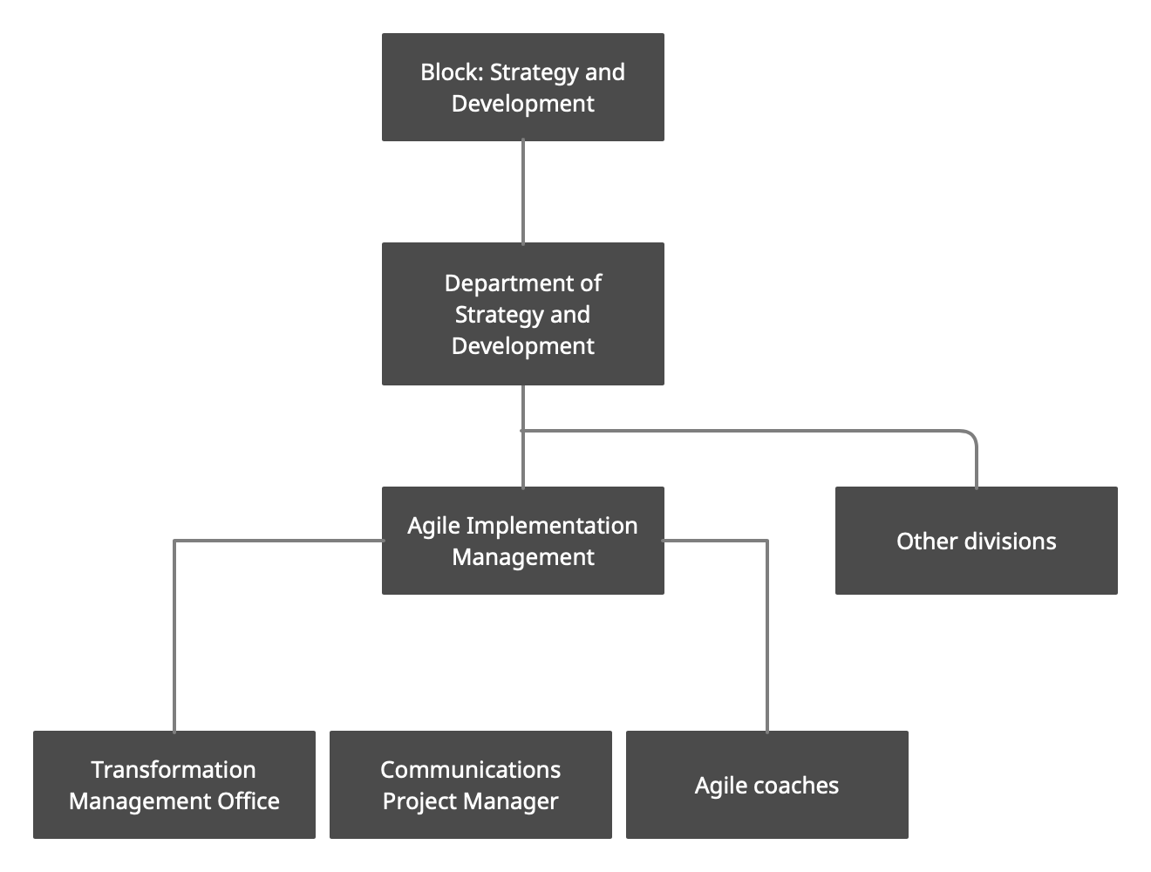
Figure 8. The project of changing the organizational structure with the allocation of departments for the Agile Transformation in Sberbank (Sberbank, 2020)

Moreover, Sberbank also considers internal Agile transformations of the departments, that don’t have serious IT functionality. For instance, marketing is very different from IT development, since it is a project work involving a large number of contractors, subcontractors, etc. And according to Konstantin Levkin, Sberbank Agile-coach, the question is whether it will be possible to apply Agile practices and tools in marketing, was open. Despite some skepticism, at the end of 2019, the bank began an internal process of Agile transformation in marketing department, but the coronavirus pandemic began right afterwards. The team was faced with the need to quickly transfer their work to new rails, to rebuild interaction into online mode. Suddenly, it became clear that Agile tools help to make the process of human interaction less formal.

Any marketing activity is a cross-functional project where there is a business represented by a customer, contractors and internal specialists. People of different specialties are involved in the project, and Agile helps them find a common language faster. If this whole structure works along the classical path of the waterfall development methodology, then people exchange briefs, technical specifications. These tasks come down from above, and then discussed in meetings, and all this can drag on indefinitely.

As a rule, it takes 4-6 months to launch a large advertising campaign - from setting a task to a video clip on the air. Sberbank has learned to reduce this period to two months, and not only due to automation, but also due to a change in the principles of the team's work. Sberbank notes that it is more comfortable for employees to interact inside, because Agile has many tools that allow people to remove emotional barriers.

Transformation results in marketing department:
- Due to the coronavirus crisis, the volume of work has increased several times and the anxiety in the team has increased. Moreover, online interaction is still a little slower than offline. Agile, thanks to its flexibility and decentralization of responsibility, helped the department to get through this stage more easily.
- The work with contractors has changed: earlier, in the cascade system of work, a brief came from the client through the account manager, then a long process of corrections and approvals began. Now the work is proceeding in a mixed mode: the briefs remained, but they began to assemble teams together with the contractors' employees, thus the role of the account manager was abolished. Sberbank's marketing team and contractors form a single cross-functional team that works according to the principles of Agile.
- The approach to metrics has changed: conversion, contact price, return on marketing investment, etc. The Agile philosophy assumes that the output should be measurable results due to clearly defined goals.
- In general, thanks to Agile, the speed of reaction and the quality of communications have increased, which is crucial for the marketing department.

All of the above transformations and processes allowed Sberbank to fulfill the goals of its strategy until 2020. Over the past three years, Sberbank has become a technology company, and thanks to investments in the development of technologies and its ecosystem, it was able to transfer 50% of all customers to use exclusively digital channels and a third of customers to non-cash channels. (Sberbank Press Release, 2020b)

Sberbank also expanded its presence outside the financial market and entered almost all digital industries, and now the Group's companies are striving to cover all the final needs of customers in the digital world.

Sberbank realized its technological strategy by launching the ultra-modern cloud platform Platform V, which is R&D from start to finish, and creates unique technological products for the market (SberCloud, a family of voice assistants, devices). Artificial intelligence, which has already become a common practice and is used in all processes, and its IT solutions have allowed Sberbank to cut the cost of transactions in half.

The strategy until 2023 is as follows:
- TOP 3 - TOP 5 in the e-commerce market by the end of 2023 with GMV of about 500 billion rubles, as well as creating the foundation for subsequent leadership in this industry;
- The profitability is above 17%.
- Basic capital adequacy (Common Equity Tier 1) > 12.5%.
- The level of dividend payments is 50% of net profit.
- Discipline in cost and risk management.
- Growth in revenue from non-financial services - more than 100% annually.
- By the end of the strategy, the share of revenues from non-financial services of Sberbank in the Group's net operating income will be at least 5%.
- The development of the Platform V digital platform remains a key technological investment and a fundamental component of the strategy, on which all plans for the development of Sberbank's financial and non-financial business are based.
- Create a unified and highly personalized customer journey with unifying elements and suggestions. (Sberbank, 2021)

3.3 Agile in metallurgy: case of Severstal
PJSC is a public-private partnership. Severstal is a vertically integrated mining and metallurgical business based in Russia with a modest number of international operations. Severstal continues to be the world's most efficient steel company, with the greatest EBITDA margin among steel firms, positive free cash flow throughout the cycle, and on track to reach its objectives. (Severstal – About, 2021)

Severstal has modified its strategy to assure continued performance growth, keeping its key advantages while adding new aspects. The company's organizational structure has been altered by Severstal. The company began to use the principles of agile in management: all production and sales divisions of the company now form two directions or streams - upstream and downstream, for which common business goals are set. (Severstal is restructuring the company, 2018)

Upstream includes all raw materials enterprises of Severstal (Vorkutaugol, Karelsky Okatysh, Yakovlevsky GOK, Olkon), coke oven and steel-making plants, as well as Vtorchermet and SPb-Giproshakht. The most essential objective of this flow is to secure the company's cost leadership through end-to-end goal-setting, shared motivation, and tighter coordination because these divisions account for 70% of the cost of production. (Severstal Project Hub, 2021)

The downstream includes the production of flat, long and tubular products, the Severstal-Metiz workshop producing finished products, marketing and sales functions, and a material flow management department. Downstream is divided into three key areas, representing Severstal's main customer segments: construction, energy and mechanical engineering.

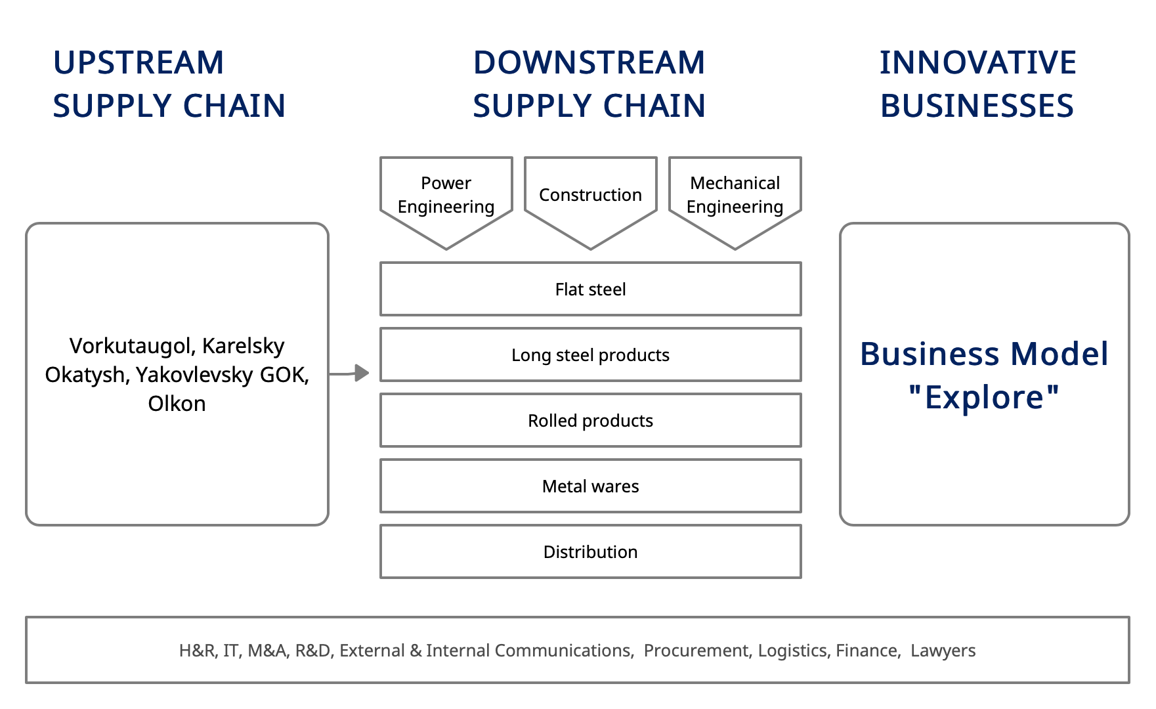
Figure 9. New Severstal organizational structure (Severstal, 2020)

The key challenge for industry teams in all three areas is to work directly with the client, optimize a range of processes and jointly develop and create unique selling propositions. Experts from the Directorate for Technical Development and Quality and Technology Development Centers are involved in the work of industry teams to directly implement consumer initiatives in production.

For example, in the Russian Steel division, new types of products are developed using the Scrum project management method. In 2016, a problem arose with the development of new types of products - work at Severstal was very slow, not only in comparison with foreign companies, but even with Russian competitors. The most problematic indicator was the time to market - new products were introduced to the market for a very long time, on average 2–2.5 years, and sometimes by the time of their appearance some of them were unnecessary. Seeing all this, people were very disappointed in their work, lost faith in themselves. In addition, the factor of criticality of mistakes was very important: in metallurgy, they are very expensive, since the minimum batch of new goods is 350 tons. The solution was to implement the Scrum approach but with serious adaptation to production realities. (Sucharev, 2016)

In 2016, Severstal launched two pilot projects for product development in a new format. Taking the Scrum methodology as a basis, we assembled two small cross-functional teams of four to five people each, using all the typical attributes in their work: sprints, stand-ups, reviews, scrum masters. It immediately became clear that the work went better, although people were involved in projects by only 20-30%. But even these first experiments had a noticeable effect, and development was accelerated by 2–3 times. It is important that the new methods of interaction were appreciated by the team members themselves. As a result, 2017 was marked by a sharp increase in such projects: about 25 teams appeared. For instance, one of the Scrum team's tasks was to develop a stronger, more flexible flat-rolled packing tape for both internal and external customers. The project lasted 9 months, and as a result, the Technical Development and Quality Directorate created a high-strength packaging tape. Previously, the development of such a project took two to three years.

Among the main problems of implementation of the approach, noted by managers, was the decrease in manageability. When there were a lot of teams, confusion began, transparency disappeared, it became unclear in what directions the main work was going. The second block of problems is the discomfort caused by the participation of employees in several teams. People were forced to visit stand-ups, planning, reviews several times. In 2018, it was decided to reconfigure the work of teams, organizing them in the form of value streams.

The reorganization resulted in a product division that includes five product lines. Each of them has united around a specific technological chain and is supported by cross-functional teams. Each team consists of different specialists: technology developer, marketer, salesperson, technical support specialist, and so on. Other specialists are added to the teams as needed. Moreover, the people in the teams are allocated for full time.

Standard Scrum tools were clearly insufficient for the successful functioning of the division, and Severstal also implemented structural changes. The first such change was the replacement of individual goals with team goals. Thus, a number of internal contradictions between team members were eliminated. In addition, all teams are now located in one room - an open space office. They had the opportunity to communicate conveniently, quickly negotiate, exchange practices and solutions to problems. The reporting format has changed: common demo days have been defined when all teams present the results of their work to colleagues, managers and other stakeholders. The meetings themselves began to take place in a different way: if before people sat at tables with computers, now all the participants stand and move around the room during the presentations of various teams.

The next block that has undergone changes is the grading system. Team members began to evaluate each other themselves, and before this was done by the heads of divisions. It is obvious that after an employee moves from a unit to a Scrum team, his line manager is unlikely to be able to adequately assess him.

Finally, the leaders of the division realized that Agile was gaining momentum and that it was necessary to prepare their own training programs - Severstal opened its own school of scrum masters.

In addition to new product developers, the company has two additional support teams - the metascrum team and the overall transformation team. The fact is that if the teams themselves also deal with changes, then they will not have time to work on products. The top management team, called Metascrum, is an important tool in terms of speed. Its task is to solve problems that require intervention at a higher level. She also works with Scrum elements and by example motivates subordinates to new achievements.

It is equally important that the development teams are part of the same division with a common goal, and each group works for a “common pot”. Yes, teams are relatively autonomous, but they act in concert as a single organism. But it is worth noting that the emergence of new roles, changing relationships and teamwork were painful - it was definitely difficult for employees during the change.

Finally, when creating any innovations, it is necessary to fit into the regulations, because Severstal is a huge and rather dangerous production facility, safety is at the forefront here: standards, rules and strict control.

Nevertheless, the management positively assesses the use of Scrum, as the main result was the indicator of the time to create new products has been halved to 1-1.5 years, and the number of projects has reached 70. Moreover, there is huge room for further improvement.

3.4 Agile in publishing: case of Mann, Ivanov and Ferber
«Mann, Ivanov and Ferber» is a Russian publishing house founded in 2004, which was initially focused on publishing business literature. Today it also publishes children's literature, sports literature, books about personal development. MIF publishes more than 350 books a year and now is one of the market leaders. The structure of the company is unique for the Russian market: MIF was the first publishing house that switched to remote work completely. It has the central office in Moscow but the whole team is located worldwide, including top management.

Figure 10. Business process of publishing house MIF before transformation (Mann, Ivanov, Ferber, 2017)

It should be noted that revenue streams are excluded from this figure since the publishing house doesn’t earn money from the first circulation, but from the reprintings. Moreover, since MIF often explores the new segments first (e.g. comic books), this cycle takes around nine – twelve months, when usually the process takes at most six months.

In 2015 MIF decided to implement Scrum for the pilot book teams. It set the further goals:
- increase the speed of product launch to market;
- make portfolio management transparent;
- provide horizontal scaling of teams;
- align processes to support the strategic objectives of the organization.

However, local optimization did not significantly affect the success of the publishing house. There were two main reasons:

1) The book's release time has not been significantly shortened, since it has more to do with external technological constraints, and not with the work of the release team itself.
2) As it was mentioned earlier, the main profit is made by the publishing house not from the release of individual books, and, moreover, their first circulation, but from the reprints and the release of a series of books, considered as a product line. This level was not affected by the transformation, as it was encapsulated at the top of the company. (Gorshunov & Stepanov, 2017)

MIF developed rapidly and planned to expand its business, therefore the existing structure was a limitation. And the company decided for the second wave of Agile implementation and chose the SAFe framework this time.

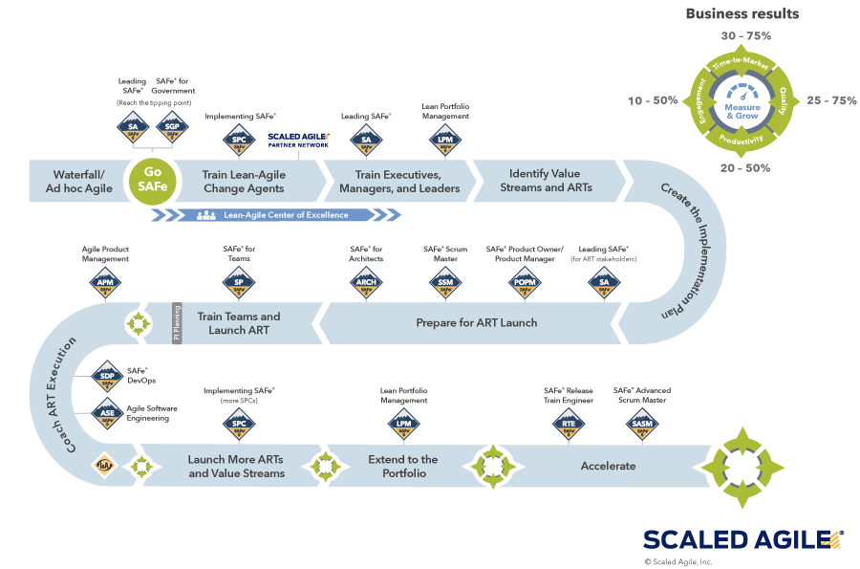
Figure 11. SAFe Implementation Roadmap (Scaled Agile Inc., 2021)

SAFe framework supports complex work with value chains. In fact, this was the main change and the key to success: the transformation from functional departments into cross-functional teams that implement specific business projects, for example, launching serial comics on the market. The team drew up the following preliminary work plan:

1. Introduction to 3 levels of agility for key stakeholders (top management)
2. Audit of current processes and tools
3. Value stream mapping workshop
4. Prepare a transformational backlog including training plans and process coaching
5. Starting the first value stream
6. Scaling to other value streams

It should be mentioned that this concerns publishing not one book, but a series that forms a value stream: for starters, the first book is launched, and if it is successful, everything is ready for others to be released. If it fails, on the contrary, publishing can be rolled up with limited losses. Separate project streams (value streams) are combined into three large value streams in the areas of business: retail, corporate and online, while due to cascading, each project has its place and significance in the implementation of the strategy as a whole. And this complex picture is collected and broadcast to the company as a whole.

Figure 12. Project Portfolio Scheme in MIF based on Scrum (Gorshunov & Stepanov, 2017)

Previously, there was no such idea of ​​a company's production as a value stream at all. And the complex picture was collected only in the heads of the tops and was not broadcast to the company, everyone thought only in their own fragment.

In addition to the business value streams, which make money, there are also support streams that are aimed at solving specific problems in the performance of functions - because although each team completely leads the product, including, for example, its marketing, in general the company's marketing must work in concert. It is interesting that within the framework of such streams, they really have a collective, not personal leadership. The transformation of the company is also carried out by teams, while progressing to the result is tracked, as is customary in Agile. One of the significant results is that the changes take place very quickly, now they are able to do in a week what they used to do for a month and a half. (Gorshunov & Stepanov, 2017)

3.5 Conclusion
As mentioned at the beginning of the work, Agile teams work in difficult conditions, when solutions to problems have not yet been found or project requirements may change. This can be seen in all three examples above. Severstal has implemented the Scrum approach in projects where there is no final solution, no final product; MIF has transformed, thanks to SAFe, the approach to publishing books as a value stream, and Sberbank uses Agile for the most modern areas, where new innovations are constantly being introduced, for example, in cloud storage or artificial intelligence.

Flexible teams are best suited to work with innovative projects. Applying new approaches, they improve the quality of the product itself and business processes. They decompose large complex problems and develop solutions for each individual component, and after rapid prototyping and feedback, the teams integrate the solutions into a coherent whole. Agile teams are more process-oriented than plan-driven, and are more accountable for metrics like revenue growth and customer loyalty than individual lines of code and the number of projects developed.

One of the hallmarks of an agile team is a high level of self-management. An increase in the level of self-government, a shift in responsibility from a manager to an employee (including to the “blue collars” at Severstal) was noted as a key characteristic in all the cases presented. Thus, it should be emphasized that it is important for agile team leaders to embrace this methodology and manage teams flexibly. They are called upon to solve problems and do not delegate this process to subordinates, since they are ultimately responsible for the overall results and training of other team members, and also help other employees and monitor their active participation in the work.

With Agile, it is impossible to plan every detail in advance. At the beginning, leaders do not yet know how many agile teams they will launch, how soon and to what extent they will be affected by bureaucratic constraints. Instead of planning, they launch the first wave of agile teams and analyze their work to take the next step. It helps to weigh the effectiveness of teams (in terms of financial performance and employee productivity) and costs (financial investment and organizational problems). If the benefit exceeds, the next waves of agile teams are launched. If not, it analyzes how the effectiveness can be improved (for example, re-prioritize work, improve the quality of prototypes, or hire agile specialists). To begin testing and studying teams, leaders typically use two main tools: a classification and a plan that reflects the company's top priorities. This thesis was vividly illustrated by the example of the case of the publishing house "Mann, Ivanov, Ferber", which began their transformation locally, with the introduction of Scrum for teams that publish books. This did not lead to any results, since this component was not a driver of the publisher's profit. Thus, before Agile transformation, it is worth analyzing the company's value chains in order to assess the fundamentally achievable potential for economic success.

It is important for leaders to set priorities and sequencing of actions, taking into account many criteria such as strategic importance, budget constraints, costs, risks, and so on. The most important thing is not to forget about the pain that customers and employees experience on the one hand and the constraints of the organization on the other. This will keep the balance and understand how many agile teams the company can launch and maintain. This thesis is illustrated in the work by the example of Severstal, which began transformation with 2 pilot projects in one division, and after quickly achieving serious results, soon had 25 such projects.

4. Development of proposals for improving the organization's management processes based on the principles of agile transformation

4.1 Defining the situation for the Agile transformation

As mentioned in the introduction, agile transformation methodologies were originally created for software development - that is, in fact, for narrowly focused design activities. Consequently, the project activities of enterprises can be considered as a possible application of flexible principles in the management of an organization.

Many companies face the challenge of project management - internal and external, focused on clients and customers. Projects consist of many stages that are difficult to coordinate with each other (for example, the start date of one stage depends on the timing of the previous stages). Effective project management requires well-functioning organizational processes based on open communication and control over the workflow.

One of the main benefits of using agile development methodologies is achieving the goals that were set at every stage of the job, while remaining flexible and open to change. Thus, agile development answers the question faced by many large companies - how to gain control over the development of projects, while at the same time innovating and retaining creativity.

Most projects carry a certain amount of risk. One of the ways to minimize risks is to be open to changes in project development processes. By encouraging individual responsibility and team member interaction, agile development ensures adaptability in project management. In addition, an agile workflow encourages creativity, thus ensuring the development of the project.

Traditional project management is based on a linear structure - the process of project execution is broken down into successive interdependent stages. This method is best employed in projects when the order of work must be strictly adhered to.

The traditional approach to project management is usually PMBOK (Project Management Body of Knowledge).
The project life cycle is divided into five stages:
- Initiation. The project manager and team define the project's requirements. Meetings and "brainstorming" sessions are frequently held at this stage to establish what the project's final output should be.
- Planning. The team chooses how it will attain the goal specified in the previous step during this step. The team confirms and outlines the project's goals and outcomes, as well as the scope of work, at this stage. The team creates a timetable and budget based on this information, analyses risks, and identifies stakeholders.
- Execution. This phase entails the majority of the project's effort, such as creating code, constructing a structure, and so on. The content of the project, which was established previously, begins to be constructed in accordance with the defined plans, and control is carried out according to the specified metrics. The product is tested and examined for conformity with the customer's and interested parties' criteria in the second portion of this phase. Product flaws are found and addressed by testing;
- Monitoring. The project's progress is analyzed and monitored at this stage in order to discover deviations from the project management plan. Corrective measures are conducted as needed to meet the project's objectives.
- Project's completion. This phase may consist of a simple transfer of project results to the client or a protracted process of contact with clients to enhance the project and raise their happiness, as well as support the project outcomes, depending on the project. This is true for initiatives involving customer service and software.

The cost and level of employee engagement in a project is low at the outset, rises as work advances, and falls as the project concludes. The capacity to influence a project's ultimate result without significantly influencing cost is greatest at the beginning of the project and diminishes as it nears completion. As a project nears completion, the cost of making adjustments and rectifying errors tends to rise dramatically.

One of the main significant disadvantages of the traditional approach to project management is precisely the intolerance to change. This flaw may have little impact if the project is running in a relatively stable environment. However, nowadays, many organizations operate in a hyper-competitive environment - in this regard, the frequency of changes to the project is significantly increasing. Thus, the cost of an error in project activities significantly increases - a small miscalculation at the initial stages of a project can lead to many times higher costs at later stages.

The introduction of agile development methodologies can increase the efficiency of project teams, as well as improve the quality of work in certain areas. In addition to directly implementing these methodologies, companies can also use general agile principles to improve overall workforce performance, reduce costs, and support creativity.

To implement agile development methodologies, the management of the organization requires a clear understanding of the need to make fundamental changes in the organizational and management processes of the company. Agile development, however, is not a one-size-fits-all solution to all organizational problems. In an organization's activities that are not project-related or based on a strict sequence of work, implementing agile methodologies can be difficult - or, moreover, redundant and even harmful.

Agile can be used in the following situations:
- the requirements for the project results have not been worked out, and the project customer is not ready to single out a separate stage of the project for their detailed study and spend several months on it;
- the development of project results can be carried out through prototypes, checking on them how the team has guessed the customer's expectations. At the same time, the cost of developing prototypes is relatively low;
- the customer of the project is ready to manage the priorities of the requirements for the results of the project and, most importantly, is ready to abandon their part, while realizing that without them the product of the project will still have value for its consumers;
- the customer of the project is ready to participate in the project at least 2-4 hours every week.

How to understand that the team is ready to start working on Agile:
- Key business opportunities are in focus.
- Employees are held accountable for specific results.
- Employees are self-oriented, guided by certain decision-making rights.
- Staff are resourced and multidisciplinary experts.
- The team adheres to the principles of the methodology.
- The team is focused on close cooperation with clients.
- Employees are able to quickly prototype and provide feedback.
- Employees are focused on supporting senior leaders who drive team work.

It is difficult for the leaders of traditional companies to accept that small teams can work on long-term large projects. But the point is, there is no limit to how many agile teams will work on a project. No matter how complex it is, you can organize effective multi-team work. Agile transformation is a multi-stage process, and can be applied not at once throughout the organization, but only on one project or in one department.

4.2 Steps of the Agile transformation

The first step to moving to Agile is realizing the need for change, both on the part of management and on the part of staff. For example, managers may have concerns that after implementing agile development:
- the general plans for the development of the organization will be under attack;
- the organizational structure within the project teams will collapse;
- individual responsibility for the results of work will disappear;
- it will become difficult to assess the contribution of group members to the overall result.

The Agile implementation process can be divided into five stages, as it shown in the Figure 13.
Figure 13. Agile Implementation Scheme (Compiled by the author)

Agile transformation itself is a full-fledged and rather lengthy project. The smaller the company and the smaller the division, the easier and faster the transformation process will be. In large companies, transformation can take 3-5 years. In addition, it is worth noting the impossibility of creating a single plan for the transition to agile methodologies. Each specific case of an individual organization is unique, and one of the main tasks of managers is to take into account all the fundamental features of the enterprise.

Preparing for the implementation of the methodology is first and one of the most important steps for the correct implementation of Agile. In general, this process can be represented as a diagram (Figure 14).

Figure 14. Agile Implementation Preparation Chart (Compiled by the author)

It is necessary to start the transformation process with an understanding of where the company is now and where it wants to be after the transformation. Therefore, before deciding to implement an agile methodology, a thorough analysis of the company's processes is required to understand the goals of the transition. The company should not switch to Agile just because it is an effective forward-looking methodology: Leadership should make an informed decision based on a real need and confidence that Agile is the one that needs to be applied in the organization.
Next, the organization needs to select the desired final scale for the implementation of agile methodologies. There are three possible options here:
- implementation of agile methodologies in a limited format of one or more teams;
- the transition of all project activities of the organization to Agile;
- transformation of the entire organization according to the principles of Agile.

Most companies in Russia have a dominant culture of control — the emphasis is on having a forecast of the future and relentlessly keeping track of it. The functioning of such companies takes place in a rigid vertical hierarchy. On the one hand, management cannot trust employees to make key decisions. On the other hand, subordinates are not inclined to take the initiative, and therefore sometimes even trivial issues rise up the hierarchy, overloading management and slowing down the company.

A culture of control is exactly the opposite of the principles behind Agile. Therefore, before implementing agile methodologies, a culture change is required. First of all, it is necessary to train employees of the organization on the principles of Agile on the basis of all kinds of trainings. However, this alone is not enough - changes are required to the organization as a whole:
- the priority goal of the organization should not be profit, but customer satisfaction;
- the work of project teams should not be carried out with reports from employees to their superiors, but in the form of self-regulating teams: the role of management is not to interfere with the work of the team as much as possible, provide the necessary conditions and remove obstacles;
- coordination of work on projects does not take place in a bureaucracy with rules, plans, reports, but according to the principles of Agile;
- striving for the prevalence of horizontal communications, avoiding the development and strengthening of vertical ties.

Based on the above points, it can be concluded that agile methodologies will work fully only in companies with a flat organizational structure. This does not mean that the implementation of agile methodologies is impossible in hierarchical structures - however, in this case, significant changes in the organizational structure may be required, since a separate implementation for a specific project team may not lead to the desired results. Thus, further analysis of the organizational structure is required, which in general terms is as follows:
- build a graphical model of the organizational structure;
- determinate primary quantitative characteristics - the number of management levels, the number, the nomenclature of positions, the number of structural units;
- determinate some quantitative estimates;
- define quality characteristics using expert assessments;
- assess the conformity of the organizational structure of management to the system, goals, technology, size of the enterprise, the state of the external environment.

The next step in implementing Agile is employee analysis, which collects information about employee interests, interpersonal relationships, small groups, formal and informal leaders, and possible roles in Agile. The analysis can be based on a sociometric method of analysis, which uses surveys, focuses on the quantitative measurement of interpersonal relationships and the analysis of small social groups in formal and informal situations.

At the stage of selecting a base methodology, an existing agile development methodology is selected that is most suitable for the project activities in the organization. It should be noted that Kanban, Scrum, SAFe and others are not strictly defined methodologies, but rather a "framework" on the basis of which a manager can later create his own methodology.

After deciding to choose a specific Agile methodology, management is faced with the task of choosing a trainer or consultant specializing in the chosen Agile methodology. After choosing a coach, the next step is to choose the team that will be the first to work according to the chosen methodology. At the initial stage of implementation, it will be preferable to select one specific team, while the choice on the part of the leadership should be deliberate. A team can consist of 7-9 people and work on a long complex project (six months, a year). But in practice, Agile elements can also be used by small teams in short projects.

Working on the principles of agile methodology requires a well-coordinated team with a high level of qualifications and professionalism. Otherwise, the implementation of Agile can lead not to the expected increase in the efficiency of the team, but to a significant decrease. However, the choice of a strong team can also negatively affect the results of implementation, since its members can implicitly "resist" the transition if the work processes have already been fine-tuned and the transition is imposed on it as a tribute to fashion or the desire of management to implement progressive approaches. Thus, a strong team, whose members are aware of the imperfection of their work processes, is a good choice for implementing Agile. In addition, the attention should be paid to specific team members. Agile is not very suitable for specialists who value individual performance assessment, since team results are evaluated. Therefore, it is advisable to bet on "team players", since specialists need to be in contact all the time to find optimal solutions and ideas for improving the product.

The next step in implementing Agile is to adapt the chosen methodology to the requirements of the project, team and organization. At the adaptation stage, the course of which is shown in the Figure, an analysis of conflicts between the chosen agile methodology and the principles of the organization or the interests of employees is carried out, after which the necessary changes are made.

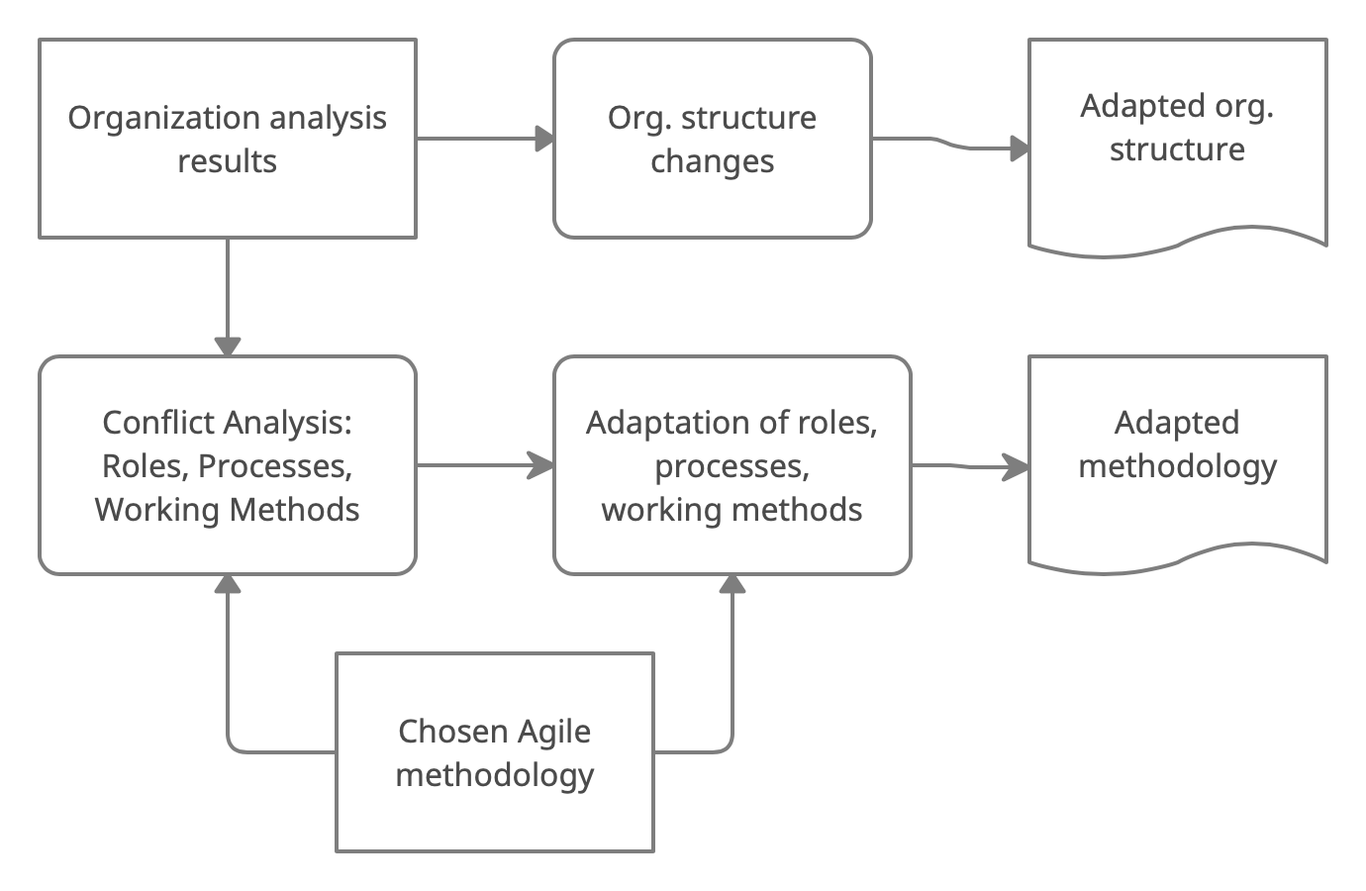
Figure 15. General outline of the agile adaptation phase (Compiled by the author)

During the adaptation phase, the following elements of the chosen agile methodology are analyzed: roles within the team, processes and working methods. Role adaptation can be done in three ways:
- reorganization of existing roles based on new methodologies;
- adding new roles to existing ones;
- adapting the roles of agile methodologies to existing roles.
In parallel with the adaptation of roles based on the results of the analysis organization and identified conflicts is carried out by changes in the organizational structure.

The organizational structure of an Agile company, in general, should correspond to the organizational structures aimed at project activities. There are two groups of organizational structures involved in the process of regulating the company's project activities:
- permanently operating;
- temporary.

Suppose that a company requires permanent project teams - therefore, they must be fully integrated into the existing organizational structure. A project and matrix organizational structure is best suited for this kind of integration. In the classical linear-functional structure, which is characterized by a clear system of one-man management, further changes can be made:
- unification of several functional divisions into one product group;
- reduction in the number of managers;
- making the transition from departments to functional areas characterized by a low level of bureaucratization and open communications.

A possible adapted structure is shown in the figure.

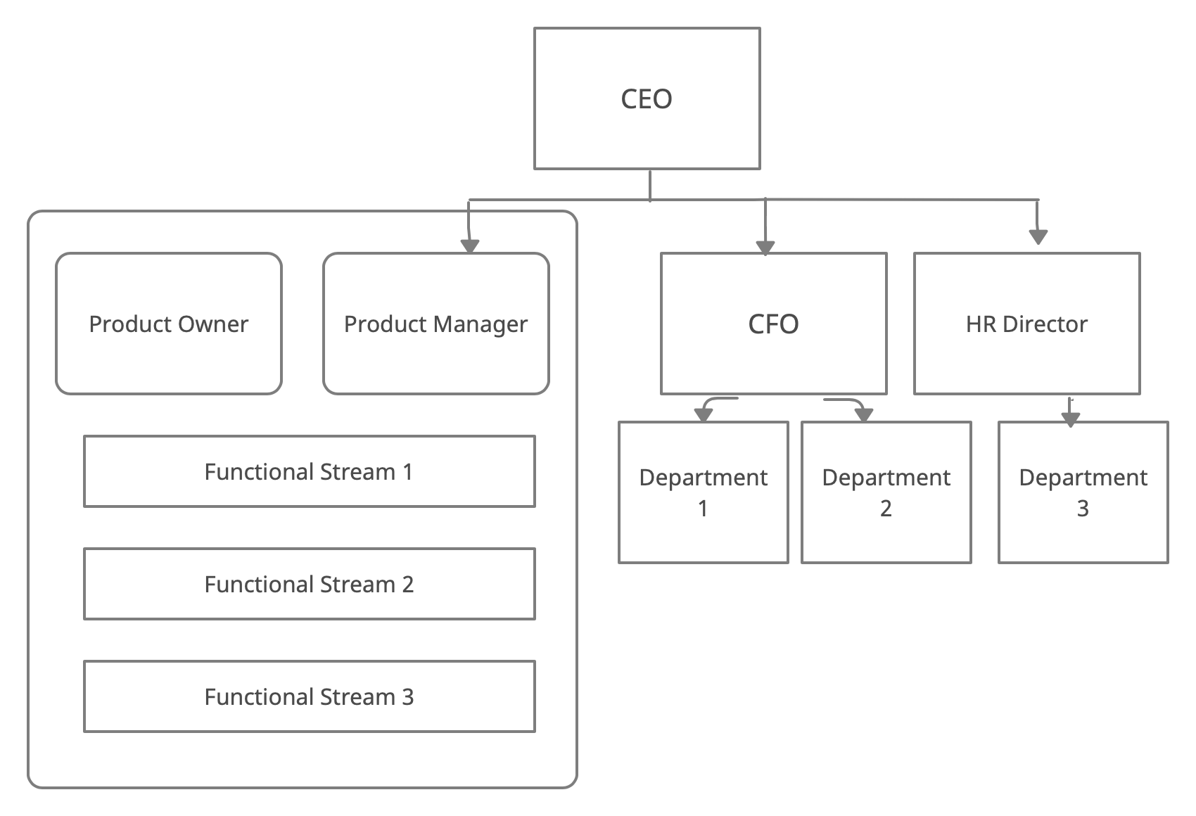
Figure 16. The organizational structure after implementing Agile (Compiled by the author)

The details of the organizational structure may vary depending on the specific methodology: for example, the role of the line manager for the product may not be present.

Another option for transforming the organizational structure is the matrix structure. In the established linear-functional structure, special bodies are introduced that coordinate the existing horizontal relations for the implementation of a specific program (project), while maintaining the vertical relations inherent in this structure. Most of the employees involved in the implementation of the program are subordinate to at least two managers.

The transition to this structure is the least painful, but in some cases less effective at the expense of the dual-head system. However, its application is necessary in cases where projects, although they are an important part of the functioning of the organization, but at the same time are not an absolute dominant in the structure of activities. When using such a structure, priority should be given not to the functional but to the project direction to ensure the greatest possible independence of the project teams. In addition, it is worth remembering the special role of the project manager in the chosen methodology.

4.3 Challenges that the traditional organization face when implementing Agile

In the ideal case of implementing Agile, the company should switch to the project organization of work, and project management should become one of the main directions of the company's life management. Changes in the organizational structure are followed by changes in powers. The transfer of work to project management unambiguously changes the rights and responsibilities of employees and departments, if only simply because new departments and committees are emerging responsible for change management. Changes in the organizational structure and mandate are followed by a change in the incentive system. The introduction of project and linear systems of motivation, their mutual balancing is a necessary step in transformations in a company that is moving to flexible methodologies.

Next, the parameters of work for the team should be selected. In well-functioning daily work, the parameters are determined by the team itself, however, at the initial stage of implementation, initial values ​​should be selected in consultation with an invited trainer.

After the preparatory part, the direct implementation of the selected methodology is carried out. When implementing, companies face many challenges and make many mistakes. Using the example of Scrum, which was implemented in all the cases presented in the work, possible errors as well as possible ways to solve them, will be presented in the table below.

Agile implementation mistakes and challenges | Ways to avoid / solve them
Companies continue to measure project progress by checkpoints | Use the Agile methods measuring, e. g. Scrum’s burnout diagram
Companies face a difference in the duration of life cycles (traditional processes have longer project life cycles) | The duration of the project’s life cycle needs to be adjusted before start
Companies fail to determinate the scope of the forthcoming work, which leads to a slowdown | - Instead of estimating the timing of tasks, the labor intensity should be evaluated;  - This assessment should be carried out by direct performers, not managers;
The problem of forming sprints - work on some projects cannot be divided into small sprints in such a way as to get the last increase at the end of each sprint | the same task can be completed over several sprints
Companies ignore daily Scrum meetings or don’t understand the role of the product journal | All parts of the transformation should be explained to the team members in advance
Mixing the roles of Scrum Master and Project Manager | clear assignment of responsibilities should be made
Table 2. Agile Implementation mistakes and the ways to solve them (Compiled by the author)

Summing up the issues listed above, it can be noted that most of them arise as a result of the team's misunderstanding of the essence of agile development, and in particular, misunderstanding of the mechanisms of work on a specific methodology. Thus, it can be concluded that the most important step towards the transition to Scrum is the education and training of staff and managers, as well as the product owner.

5. Conclusion

In the course of writing the master thesis, the following was done:
- general characteristics and history of Agile development were given;
- the key features of the main Agile methodologies were given;
- the facts of how Agile transformations can be conducted in times of COVID-19 pandemic were investigated.
- the possibilities of using flexible methodologies in the management of a traditional organization were explored;
- the situations, when Agile transformation can be used by the traditional organizations were defined;
- as a result, a general mechanism was formulated for the organization's transition from current processes to the Agile methodology. On the basis of the proposed mechanism, any Russian company can assess the need to introduce flexible methodologies, make an informed decision and carry out the implementation according to the stages proposed in the work.

It is worth saying that the implementation of Agile requires full commitment, both from the management and from the employees. The range of problems that organizations face when implementing agile methodologies is very wide - the main reasons for these problems can be called a lack of understanding of the principles of Agile, ignorance of basic methods, the reluctance of management to give freedom to personnel and the unwillingness of personnel to accept this freedom. One of the key points in the work is the conclusion that for the successful implementation of any Agile methodology in a company, it may be necessary to change the existing corporate culture and organizational structure. At the same time, companies do not need to implement agile methodology exactly in the form in which it was proposed by its creators. Agile itself is a set of principles rather than strict guidelines, but they should be considered for achieving maximum work efficiency after implementation.

Agile methodologies bring great benefits to all stakeholders in an organization. Thus, investors as a result of Agile transformation can get a reduced cost of projects, managers - increased efficiency of staff work, clients - the product they need in a shorter time frame. The staff, in turn, receives a friendly and open for discussion workflow, in which company employees are not just performers, but at the same time are responsible persons and planners.
Transformations, with the correct implementation of Agile, will inevitably lead to a decrease in the hierarchy of management in the organization and the development of horizontal connections. In turn, this change leads to increased flexibility in organizations, which is key to the survival of the company in the face of uncertainty.

Summarizing and comparing the possible outcomes of Agile transformation and the challenges facing modern organizations, it can be concluded that the implementation of Agile can help solve a number of problems faced by modern companies.

References
Ambler, S. W. (2009). The Agile Scaling Model (ASM). Adapting Agile Methods for Complex Environments.
Ashmore, S., Townsend, A., DeMarie, S., & Mennecke, B. (2018). An exploratory examination of modes of interaction and work in waterfall and agile teams. International Journal Of Agile Systems And Management, 11(1), 67. https://doi.org/10.1504/ijasm.2018.091361
Boehm, B., Turner, R. (2005). Management challenges to implementing agile processes in traditional development organizations. IEEE Software. Volume 22, Issue 5, 30-39.
Brändli, H., & Delava, F. (2020). Agile Works at Home. Bain. Retrieved from https://www.bain.com/insights/agile-works-at-home/.
Brosseau, D., Ebrahim, S., Handscomb, C., & Thaker, S. (2019). The journey to an agile organization. Retrieved from https://www.mckinsey.com/business-functions/organization/our-insights/the-journey-to-an-agile-organization.
Buchalcevová, A., & Mysliveček, T. (2016). Lean Startup and Lean Canvas Using for Innovative Product Development. Acta Informatica Pragensia, 5(1), 18-33. https://doi.org/10.18267/j.aip.82
Ciric, D., Lalic, B., Gracanin, D., Tasic, N., Delic, M., & Medic, N. (2019). Agile vs. Traditional Approach in Project Management: Strategies, Challenges and Reasons to Introduce Agile. Procedia Manufacturing, 39, 1407-1414. https://doi.org/10.1016/j.promfg.2020.01.314
Di Marcello, F. (2018). A discussion on Agile in banking: Beyond buzzwords. McKinsey. Retrieved from https://www.mckinsey.com/industries/financial-services/our-insights/banking-matters/a-discussion-on-agile-in-banking-beyond-buzzwords.
Ghani, I., Jawawi, D., Niknejad, N., Khan, M., & Jeong, S. (2016). A Survey of Agile Transition Models. Advances In Systems Analysis, Software Engineering, And High Performance Computing, 141-164. https://doi.org/10.4018/978-1-4666-9858-1.ch008
Gorshunov, V., & Stepanov, A. (2017). On the Way to Business Agility [TV]. Agile Business Conference.
Gref, G. (2018). Герман Греф выступил на панельной сессии Давосского форума — СберБанк. Sberbank.com. Retrieved 29 May 2021, from https://www.sberbank.com/ru/news-and-media/press-releases/article?newsID=81b5f5f3-814f-4d9c-9273-0d5006e78af3&blockID=7&regionID=77&lang=ru&type=NEWS.
Handscomb, C. (2018). How to mess up your agile transformation in seven easy (mis)steps. McKinsey. Retrieved from https://www.mckinsey.com/business-functions/organization/our-insights/how-to-mess-up-your-agile-transformation-in-seven-easy-missteps.
Jadoul, Q., Nascimento, A., Salo, O., & Willi, R. (2020). Agility in the time of COVID-19: Changing your operating model in an age of turbulence. McKinsey. Retrieved from https://www.mckinsey.com/business-functions/organization/our-insights/agility-in-the-time-of-covid-19-changing-your-operating-model-in-an-age-of-turbulence.
Kapur, P., Kumar, D., Singh, S., & Gupta, V. (2019). Analytical evaluation of agile success factors influencing quality in banking sector. International Journal Of Industrial And Systems Engineering, 33(3), 346. https://doi.org/10.1504/ijise.2019.10025000
Khasis, L. (2015). First deputy CEO of Sberbank: "Sberbank is actually an IT-company" [TV].
Kolobov, A. (2018). Severstal. Topic of the Week: Scrum and Agile in Metallurgy [TV].
Kusters, R.J., Van De Leur, Y., Rutten, W.G.M.M., Trienekens, J.J.M. (2017). When agile meets waterfall: Investigating risks & problems on the interface between agile & traditional software development in a hybrid development organization. ICEIS 2017 - Proceedings of the 19th International Conference on Enterprise Information Systems. Volume 2, Pages 271-278.
KPMG. (2019). Agile Transformation. From Agile experiments to operating model transformation: How do you compare to others?.
Larman, C., & Vodde, B. (2009). Scaling lean & agile development. Addison-Wesley.
Leffingwell, D. (2010). Agile software requirements: lean requirements practices for teams, programs, and the enterprise. Addison-Wesley Professional.
McKinsey. (2018). The five trademarks of agile organizations. Retrieved from https://www.mckinsey.com/business-functions/organization/our-insights/the-five-trademarks-of-agile-organizations
McKinsey. (2020). The journey to agile: How companies can become faster, more productive, and more responsive. The McKinsey Podcast [Podcast]. Retrieved from https://www.mckinsey.com/business-functions/organization/our-insights/the-journey-to-agile-how-companies-can-become-faster-more-productive-and-more-responsive.
Mohanarangam, K. (2020). Transitioning to Agile—In a Large Organization. IT Professional, 22(2), 67-72. https://doi.org/10.1109/mitp.2019.2902345
Patel, J., Poston, R., Dhaliwal J. (2017). A Workaround Model for Competent Project Managers using Agile Development in a Traditional Organization. ICIS 2017: Transforming Society with Digital Innovation
Rodionova, A., & Zotov, M. (2020). What is Sbergile and how it differs from Agile. vc.ru. Retrieved from https://vc.ru/sber/132215-chto-takoe-sbergile-i-chem-on-otlichaetsya-ot-agile.
Rudd, C. (2016). The Third Wave of Agile. SolutionsIQ. Retrieved from https://www.solutionsiq.com/resource/white-paper/the-third-wave-of-agile-2/.
Sberbank Press Release. Sberbank.com. (2020a). Retrieved from https://www.sberbank.com/ru/news-and-media/press-releases/article?newsID=e4fc337e-1ea2-4665-be2d-daf2f7a64e61&blockID=7&regionID=77&lang=ru&type=NEWS.
Sberbank Press Release. Sberbank.ru. (2020b). Retrieved from https://www.sberbank.ru/ru/press_center/all/article?newsID=c93d07dc-7682-4ce8-a5d4-e8b555322915&blockID=1303&regionID=77&lang=ru&type=NEWS.
Sbergile. Sberbank.ru. (2021). Retrieved from https://www.sberbank.ru/ru/legal/services/sbergile.
Severstal - About. Severstal.com. (2021). Retrieved from https://www.severstal.com/eng/about/.
Severstal is restructuring the company. Finam. (2019). Retrieved from https://www.finam.ru/analysis/newsitem/severstal-perestraivaet-strukturu-kompanii-po-principam-agile-20190529-133143/.
Severstal Project Hub. Projecthub.severstal.com. (2021). Retrieved from https://projecthub.severstal.com.
Sukharev, V. (2018). Ускоряя «Северсталь»: суровый металлургический Agile. Издательство «Открытые системы». Retrieved from https://www.osp.ru/cio/2018/06/13054672.
Tudor, D., Walter, G.A. (2006). Using an agile approach in a large, traditional organization. AGILE Conference. Volume 2006, Article 1667600, Pages 367-373.

