Saint Petersburg State University
Graduate School of Management

Master in Urban Management and Development

Applying digital technologies in social marketing
to solve the problem of environmental pollution
Использование цифровых технологий в социальном маркетинге
для решения проблемы загрязнения окружающей среды

Master’s Thesis by the 2nd year student
Concentration — Master in Urban Management and Development
Syrneva Elizaveta Andreevna

Research advisor:
Candidate of Science (Mathematics), Associate Professor, Ivanov A.E.

Saint Petersburg
2021
АННОТАЦИЯ
Автор | Сырнева Елизавета Андреевна
Название ВКР | Использование цифровых технологий в социальном маркетинге для решения проблемы загрязнения окружающей среды
Образовательная программа | Менеджмент и развитие городских агломераций
Направление подготовки | 38.04.04 Государственное и муниципальное управление
Год | 2021
Научный руководитель | Иванов Андрей Евгеньевич
Описание цели, задач и основных результатов | Целью диссертации является разработка комплекса мер, в первую очередь, опирающихся на механизмы социального маркетинга, для повышения качества городской политики противодействия загрязнению окружающей среды. Чтобы достичь поставленной цели, были изучены вопросы правовой базы экологической политики, современные тенденции и пути реализации такой политики различными организациями посредством применения механизмов социального маркетинга, внедрения экологических инноваций, осуществления экологической пропаганды, проведен кейс-анализ современных решений реализации экологического просвещения и выявлены приоритетные направления использования цифровых технологий в рамках реализации экологической политики. Кроме итого, проведен опрос жителей города Санкт-Петербурга и ЛО с целью выявления потребительских инсайтов и получения ответов на поставленные вопросы. Кластерный анализ позволил выделить 4 кластера с характерными признаками и предпочтениями, которые легли в основу рекомендаций по разработке программ мероприятий и выбор каналов коммуникаций. Проведенное исследование и предложенные рекомендации призваны повысить качество реализации экологической политики и эффективность экологического просвещения, а также сформировать определенный вектор для обеспечения устойчивого развития территории и решения важных социальных проблем.
Ключевые слова | Экологическая политика, экологическая культура, экологическое просвещение, социальный маркетинг, цифровые технологии, экологические инновации, зеленое продвижение

ABSTRACT
Master Student's Name | Syrneva Elizaveta Andreevna
Master Thesis Title | Applying digital technologies in social marketing to solve the problem of environmental pollution
Educational Program | Master in Urban Management and Development
Main field of study | 38.04.04 Public Administration
Year | 2021
Academic Advisor’s Name | Ivanov Andrey Evgenievich
Description of the goal, tasks and main results | The aim of the Master’s Thesis is to develop a set of measures based on the mechanisms of social marketing to improve the quality of urban policies to combat environmental pollution. In order to achieve this goal, we studied the issues of the legal framework of environmental policy, current trends and ways of implementing the policy by various organizations through the use of social marketing mechanisms, the introduction of environmental innovations, the implementation of environmental propaganda, etc. Analysis of modern solutions for the implementation of environmental education was carried out. The priority areas of digital technologies in the framework of policy implementation were identified. In addition, an online-survey of residents of St. Petersburg and Leningrad Region was conducted. It let us to identify consumer insights and get answers to the research questions. The cluster analysis allowed us to identify 4 clusters with some features and preferences, which formed the basis for recommendations on the development of event programs and the choice of communication channels. The research and recommendations were created to improve the quality of environmental policy implementation and the effectiveness of environmental education, as well as to determine a vector for ensuring the sustainable development of the territory and solving important social problems.
Keywords | Environmental policy, environmental culture, environmental education, social marketing, digital technologies, environmental innovation, green promotion

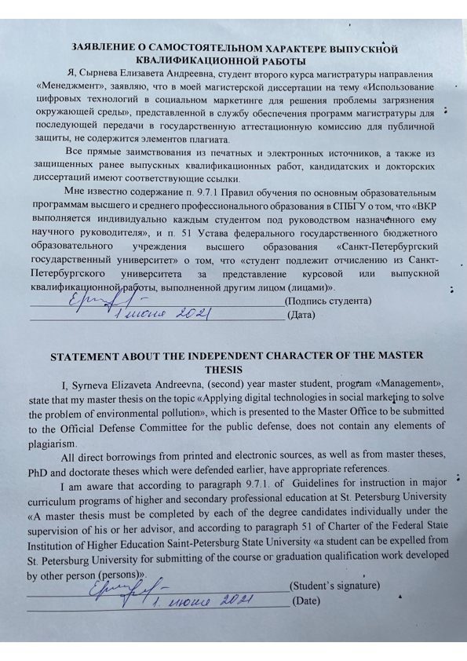

Content
Introduction 6
CHAPTER 1. METHODOLOGY OF THE ENVIRONMENTAL POLICY RESEARCH 9
1.1 Definitions 9
1.2 Review of legislative acts 10
1.3 Literature review 24
1.4 Case study 36
1.4.1 The review of environmentally significant projects in Russia and abroad 36
1.4.2 The review of environmental projects in St. Petersburg and Leningrad region concerning environmental education 47
1.4.3 The review of digital environmental projects in St. Petersburg and Leningrad region concerning environmental education 49
CHAPTER 2. EMPIRICAL STUDY OF PROBLEMS OF CITIZENS' INVOLVEMENT IN ENVIRONMENTAL ISSUES 58
2.1 Methodology 58
2.1.1 Data collection method 58
2.1.2 Research questions 59
2.2 Descriptive statistics 60
2.2.1 Analysis of online survey 60
2.2.2 Cluster analysis 67
2.3 Recommendations 69
Conclusion 77
Literature 79
Appendix 1. Legislation of the environmental policy 89
Appendix 2. Questionnaire for residents of St. Petersburg and Leningrad region 93

Introduction
The issues of changing the state of the environment are acute for a long period of time. Experts from different countries strive to minimize the damage caused by human actions for many centuries. Thus, 2017 in Russia was declared the Year of Ecology, which is called to involve the citizens in solving environmental problems, improve Russia's environmental performance, ensure environmental safety and form a level of environmental responsibility. The key areas of the environmental agenda in 2017 were some directions like reform in the field of waste management, conservation of the forest fund, development of the system of specially protected natural areas, animal management, control of harmful emissions of enterprises and the introduction of the best available technologies. (State Duma of the Russian Federation 2017)
According to the Environmental Performance Index 2020, Russia ranks 58th (out of 180 countries) in terms of ecology with an index of 50.8, Denmark is the leader (82.5), and Liberia (22.6) concludes this list. If we compare with 2018 year, Russia has fallen by 6 positions. This index include 32 indicators like ozone, air quality, lead, water pollution and etc. (figure 1).
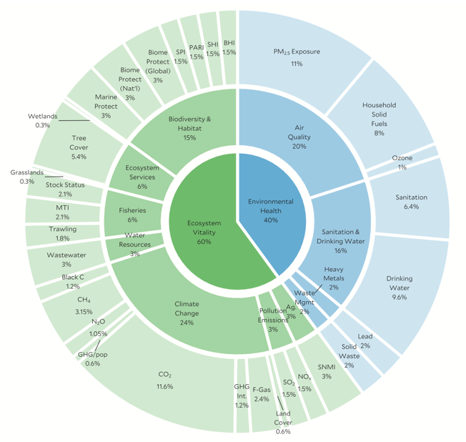
Figure 1 Environmental Performance Index 2020 (Wendling Z.A. 2020)
23 March, Alexander Beglov declared 2021 the regional year of Ecology, during which it is planned to pay great attention to environmental issues and government should increase the number of activities aimed at improving the environmental situation in St. Petersburg. (Official website of the Administration of St. Petersburg 2021)
According to the consolidated index of the National Environmental Rating for 2020, St. Petersburg ranks 8th among the regions of the Russian Federation and 5th according to the socio-economic index. (Green patrol 2021)
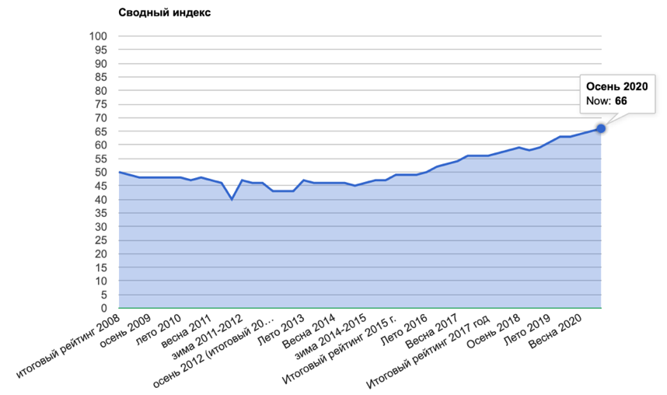
Figure 2 Summary index of the National Environmental Rating, 2020
According to the official website of the Administration of St. Petersburg St. Petersburg entered the top 100 cities in the world in terms of quality of life in 2021. The quality of life is determined by the physical, social and emotional factors of person's life that are important to him and affect him (Figure 3). There are several criteria for assessing the quality of life, these are physical, environmental, psychological, and the level of independence. The environment includes the safety of public life, ecology, safety, information, training opportunities, accessibility and quality of medical care, etc. (WHO)

Figure 3 Quality of life
Environmental issues are considered on a par with safety issues, which is reflected in Maslow's pyramid of needs (figure 4). Security is a first necessity, it is determined by the level of security. The environmental situation directly affects the state of human health and also the level of satisfaction with the place of residence. It is important to note that the basic needs are typical for the majority of citizens, which once again underlines the urgency of solving environmental problems.

Figure 4 Maslow’s Hierarchy
Thus, emphasizing the importance and relevance of environmental issues, we will take a closer look at the implementation of environmental policy in St. Petersburg, identify strengths and weaknesses and define ways to improve the real situation.
The object of the study is the environmental policy of St. Petersburg.
The subject of the study is using of digital technologies as a social marketing tool to increase the involvement of citizens in the fight against environmental pollution.
The goal is to develop a set of measures, including social marketing mechanisms, to improve the quality of urban policies to combat environmental pollution.
The objectives are follows:
- to study the main directions of environmental policy in St. Petersburg;
- determine the importance of environmental education in the implementation of environmental policy in St. Petersburg and assess the quality of its implementation tools;
- conduct an independent assessment of the achievement of the official environmental education targets in St. Petersburg;
- develop recommendations for improving environmental education through using digital technologies (using an example of a mobile application).

CHAPTER 1. METHODOLOGY OF THE ENVIRONMENTAL POLICY RESEARCH

1.1 Definitions
Environmental policy:
According to Appendix to the Resolution of the Government of St. Petersburg of June 18, 2013 No. 400 " On the Environmental Policy of St. Petersburg up to 2030 (as amended on June 14, 2017)», environmental policy, within the framework of this document, is considered as a set of intentions and principles of such an organization of targeted activities of executive authorities, which is aimed at creating a base (basis) for developing a list of goals and relevant tasks in the field of environmental protection and ensuring environmental safety. The activities of the executive authorities in these areas are regulated and evaluated in accordance with the current and legally approved criteria and performance indicators.
Environmental Marketing:
Within the framework of this work "environmental marketing" is:
- organization of the activity of an economic entity that would be aimed at satisfying the interests of consumers by promoting products and services that are minimally harmful to the environment at all stages of the life cycle (sequential and interrelated stages of the production system from the receipt of raw materials or natural resources to the final location in the environment);
- mechanisms for increasing the level of social responsibility by minimizing the negative impact of their activities on the environment, completely rethink the well – known 4P model (from the English product – "product", place – "place", price – "price", promotion - "promotion").
Social Marketing:
A set of processes of development programs for acceptability of social ideas in communication channels. (Philip Kotler 1971).
Environmental education:
Environmental education is a set of measures aimed at the formation of an ecological culture, environmental values among the population, as well as the development of certain patterns of behavior. Environmental education in the territory of St. Petersburg is carried out in the following forms::
1) informing the population of St. Petersburg about the adopted and developed regulatory legal acts in the field of environmental protection and environmental safety;
2) implementation of environmental propaganda on the territory of St. Petersburg;
3) organization and holding of scientific and practical conferences, lectures, seminars, "round tables" and other forms of citizens ' meetings for solving and discussing issues in the field of environmental protection, rational use of natural resources, and environmental safety;
4) publication of literature on environmental protection, environmental safety and environmental management;
5) conducting international, all-Russian, regional and local mass environmental actions, competitions, festivals, exhibitions dedicated to environmental protection, rational use of natural resources, and environmental safety;
6) other forms that do not contradict the current legislation.
Environmental innovations:
Environmental innovations are technological and social innovations in the field of environmental protection, rational use of natural resources and the formation of environmental values among citizens in the framework of joint economic and environmental development. (Mityakov, et al. 2018)
Digital technologies:
Digital technologies — technologies for collecting, storing, processing, searching, transmitting and presenting data in electronic form. These include additive technologies, computer engineering, industrial Internet of Things, industrial robots / automated lines, sensors for data collection, environmental monitoring, service robots, subtractive technologies, short-range wireless data transmission (NFC) technologies, virtual and augmented reality technologies, artificial intelligence (machine learning) technologies) and etc. (Abdrakhmanova, et al. 2020)

1.2 Review of legislative acts
Before considering the characteristic features of the current environmental situation in St. Petersburg, as well as the details of state regulation and support for the environment, we will consider the main provisions of this issue. Disclosure of the term "environmental policy» is given in the Annex to the Decree of the Government of St. Petersburg from June 18, 2013 № 400 "On the Environmental Policy of St. Petersburg for the period up to 2030 (as amended on June 14, 2017)". The environmental policy in the framework of this document is considered as a set of intentions and principles of such organization of target activities of the executive authorities, which is aimed at creating a base for the development of the list of goals and relevant tasks in the field of environmental protection and environmental safety. The activities of the executive authorities in these areas are regulated and evaluated in accordance with the current and legally approved criteria and performance indicators.
It is the environmental policy that determines not only the main strategic goals and objectives in the field of environmental protection, but also within the system of rational distribution and use of natural resources, ensuring environmental safety of the region, but also the mechanisms, methods and tools for their achievement within the established period in accordance with the norms and requirements of the current legislation.
It is the environmental policy that determines not only the main strategic goals and objectives in the field of environmental protection, but also within the system of rational distribution and use of natural resources, ensuring environmental safety of the region, but also the mechanisms, methods and tools to achieve them in a timely manner in accordance with the norms and requirements of the current legislation.
The main strategic goal of environmental policy is to maintain and ensure the optimal state of the environment, to create a system of conservation of natural resources, protection and reproduction of ecological systems in order to meet the needs not only of our generation, but also of future generations, in order to realize the human and civil right to exist in a favorable environmental environment, as well as to ensure environmental security.
Among the fundamental tasks of environmental policy, aimed at achieving the strategic goal discussed above, it is customary to include:
1) formation, implementation and development of the management system in the field of environmental protection, environmental safety and use of natural resources;
2) minimization (up to complete prevention) of the negative impact on the environment;
3) compensation for environmental damage - elimination of damage from activities of economic entities, restoration of ecological systems, etc.;
4) creation of systems of preservation of elements of ecological systems, fauna objects, flora objects (including green plantations), as well as territories under special protection;
5) creation of a system to ensure environmental safety in general;
6) development of systems of material and non-material incentives for implementation of a set of measures to protect the environment and ensure environmental safety;
7) research, identification and practical application/implementation of elements of creation of ecological culture in citizens;
8) development of systems of material and non-material incentives for the participation of commercial and non-commercial institutions, as well as the population in addressing issues directly related to environmental security measures, rational use of natural resources, environmental protection;
9) formation of a set of measures to create a system of international cooperation and partnership in environmental protection and maintenance of an optimal level of environmental safety (Annex to the Decree of the Government of St. Petersburg of June 18, 2013 №400 "On the Environmental Policy of St. Petersburg until 2030 (as amended on June 14, 2017)" б.д.).
Regulatory of environmental protection, environmental safety, environmental education, solid municipal waste management in the Russian Federation and in St. Petersburg is carried out on the basis of a number of key legal acts: the Constitution of the Russian Federation, Federal Law №7 of 10.01.2002 "On Environmental Protection", various codes and Federal Laws (appendix), National Project " Ecology "(the project passport was approved by the Presidium of the Presidential Council for Strategic Development and National Projects, Protocol №16 of December 24, 2018), regulatory legal acts of St. Petersburg, Resolution of the Government of St. Petersburg № 487 of 17.06.2014 "On the State program of St. Petersburg" Improvement and Environmental Protection in St. Petersburg» and etc. (appendix 1).
In addition to the listed main regulatory documents, certain issues of environmental protection, environmental safety, environmental education, and solid municipal waste management are regulated:
- international environmental regulations ratified by the Russian Federation (for example, the United Nations Framework Convention on Climate Change and the Kyoto Protocol, the Convention on Biological Diversity, the Convention for the Protection of Wild Fauna and Natural Habitats in Europe, etc.).)
- regulatory acts of environmental ministries, departments, and executive authorities (federal and St. Petersburg) (resolutions, instructions, orders, orders, etc.) detailing and clarifying certain issues of environmental protection, environmental safety, environmental education, and solid municipal waste management.
Regulatory in the field of environmental protection is greatly influenced by the structure of available natural resources, the current environmental situation, the specifics of the design and development of measures related to the preservation and reproduction of elements of ecological systems, and much more. Also, it is worth mentioning the fact that in the development of programs of state regulation and support for environmental protection in St. Petersburg and Leningrad region two main tendencies play a role, reflecting the nature of the federal form of territorial structure. Further, it is advisable to consider these factors in more detail.
The essence of the first trend is the unification and universalization of regional sources of environmental legislation, which manifests itself in the creation of normative documents of regional scale, partially or completely duplicating already existing federal laws and by-laws approved at the federal level. The principle of state sovereignty and the desire to preserve the integrity of the legal system on the territory of the Russian Federation plays a special role here. As an example of normative legal acts of this category we can mention the Resolution of the Government of St. Petersburg "On Measures to Implement in St. Petersburg the Law of the Russian Federation "On Subsoil" or the Resolution of the Government of St. Petersburg "On the Committee for Nature Use, Environmental Protection and Ecological Safety" (expired from 10. 03.2017), the powers and specifics of whose activities were subsequently addressed in the St. Petersburg Government Decree of March 9, 2017 № 127 "On measures to improve public administration in the areas of landscaping, nature management and environmental protection and amendments to some resolutions of the Government of St. Petersburg".
The second trend is opposite to the first and consists in the desire to specify and individualize the standards, norms and requirements of normative-legal regulation of regional environmental policy. Thus, on the territory of St. Petersburg and the Leningrad region, the nature and regulation of environmental relations depend on such factors as the "urbanization" (from the Latin "urbanus" - "city") of the region, the number of population (million-strong city), climate features, the location of the region in direct interaction with the water system "Lake Ladoga - Neva - Gulf of Finland", the size and volume of industrial capacity of certain categories of economic entities, characteristics of traffic flows and much more.
As part of controlling the use of production capacity by companies, as well as the impact of industrial production on the environment, the Governments of St. Petersburg and Leningrad Region in 2005 adopted a joint decision «On cooperation in the field of production and consumption waste management in St. Petersburg and Leningrad Region», which created a special governing body - the Coordinating Council, developed a unified scheme of facilities for processing and disposal of industrial waste.
Subsequently, the relations between St. Petersburg and the Leningrad region in the framework of control over the processing and movement of waste began to be regulated by the Law of St. Petersburg of December 20, 2017 "On approval of the Agreement on cooperation between the Leningrad region and St. Petersburg on the issue of production and consumption waste management". The main controlled areas of the said regulatory legal document were:
1) Regulation of operators for the handling of solid municipal waste at the regional level;
2) Regulation of types of activities related to transportation, processing, neutralization, utilization and/or disposal of solid municipal wastes that have entered the territory of the Leningrad Oblast and the city of St. Petersburg;
3) development and subsequent approval by regional authorities of territorial waste management schemes (including solid municipal waste) .
The third point of the list of controllable directions - development and approval of territorial schemes of waste management is reflected in the Order of the Government of St. Petersburg dated July 13, 2020 № 193-r "On approval of the territorial scheme of production and consumption waste management".
Protection of water bodies in St. Petersburg is carried out in accordance with the List of water bodies in St. Petersburg, subject to regional state supervision of water body use and protection, approved by the Government of St. Petersburg on 15 April 2008. Thus, as it was mentioned earlier, St. Petersburg is in close cooperation with one of the main water systems "Lake Ladoga - Neva - Gulf of Finland". That is why it is so important to protect these water streams, especially considering the fact that the phosphate content in this water system has significantly increased by 2020 (Figure 5).
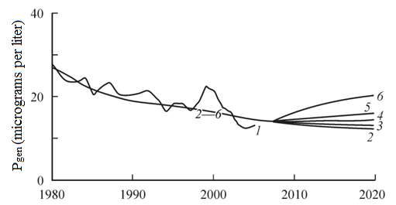
Figure 5 Dynamics of phosphate content changes in water system "Lake Ladoga - Neva - Gulf of Finland"
1 - phosphate concentration level; 2 - calculation of concentration level under condition of maintaining load at the level of 2005-2007; 3 - double increase in load; 4 - triple increase in load; 5 - five-fold increase in load;
6 - ten-fold increase in load.
*Drawing was made according to scientific report of V.A. Rumyantsev, S.A. Kondratyev, Sh. R. Pozdnyakov, V.A. Ryabchenko, L.V. Basova, M.V. Shmakova "Main factors determining functioning of Ladoga Lake - Neva River - Neva Bay - eastern part of Gulf of Finland water system in modern conditions".
Regarding assessment of soil contamination level on the territory of Saint-Petersburg and Leningrad region as well as development and implementation of a set of measures on soil protection, this segment was earlier controlled by the Order of the Mayor of Saint-Petersburg dated August 30, 1994 № 891-r "On Introduction of the Regional Soil Protection Standard in Saint-Petersburg".
Also, within the framework of the Order of the Committee for Nature Use, Environmental Protection and Ecological Safety of the Government of St. Petersburg a list of measures aimed at evaluation of soil contamination level and a number of measures aimed at soil remediation was developed and legally approved on February 7, 2006 .
The importance of forming the system of evaluation, analysis, monitoring and control over the degree of soil pollution was mentioned in the law "About ecological monitoring on the territory of Saint-Petersburg" adopted on March 29th, 2006. It is also worth mentioning that in accordance with the mentioned law, a decree "On creation of the state information system in the sphere of environment protection and nature management "Ecological passport of St. Petersburg territory" was issued.
There is a separate regulatory framework aimed at control and protection of land use by individuals and legal entities through scheduled and unscheduled inspections. There is a law "On Land Control" which specifies a list of recommendations and measures aimed at implementation of protection activities related to land plots on the territory of St. Petersburg. Also, this law considers a set of norms, requirements and state standards for conducting activities of economic entities in certain territories.
One of the most comprehensive legal and regulatory documents in the field of environmental conservation and environmental protection is the Environmental Code of St. Petersburg, which aims to regulate all kinds of relations related to the use of natural resources, conservation and reproduction of ecological systems, and environmental protection.
This Code reveals basic concepts related to protection of ecological systems, determines main management areas, legislative norms and authorities of state bodies within the framework of protection activities, as well as highlights such an important issue as environmental education of population and formation of "ecological culture" among citizens. In other words, we can say that the Environmental Code of St. Petersburg is a certain "collective" document aimed at comprehensive regulation of all areas of environmental protection and conservation in the city.
As part of the initiative, aimed at maintaining and developing the idea of environmental awareness of the population, there is the development, approval and implementation of numerous projects, one of the latest in the list of which is the national project "Ecology", aimed at achieving by 2024 the percentage of neutralized, recycled solid waste of at least 48.7%, as well as a unique water conservation project, aimed at clearing not less than 1 km of the riverbed. These projects are supervised by the Vice-Governors of St. Petersburg N.L. Bondarenko and V.V. Kirillov.
During the study of the legal and regulatory framework for environmental protection, a special place and role of citizens in the development of this area was noted. This problem began to be considered in various documents, for example, a reference to environmental development can be found in the "Strategy for Environmental Security of Russia until 2025" separately emphasizes the low level of environmental education and environmental culture of Russians (Decree of the President of the Russian Federation of 19.04.2017 № 176 "On the Strategy of ecological safety of the Russian Federation for the period until 2025" б.д.). Over the past few years, the formation of environmental awareness and ecological culture of the population has been brought to the forefront. Thus, the Government of St. Petersburg approved a separate Decree on July 18, 2018, which emphasized the need to create a separate state body - the Coordinating Council, which would deal with issues of environmental education and enlightenment of citizens, as well as the formation of environmental culture in St. Petersburg (Постановление Правительства Санкт-Петербурга от 18 июля 2018 года № 588 «О создании Координационного совета по экологическому просвещению, экологическому образованию и формированию экологической культуры на территории Санкт-Петербурга» (с изм. 7.10.2020) 2018).
Thus, the State Program of St. Petersburg "Improvement and Protection of the Environment in St. Petersburg" (as amended on October 16, 2020) highlights a number of target goals of the city's environmental policy. The Committee for Public Works of St. Petersburg coordinates the activities of the executive bodies of state power of St. Petersburg, which are the implementers of the state program. One of the priorities is to ensure that all target groups have access to information about the state of the environment, environmental education and formation of environmental culture of the population on the territory of St. Petersburg. However, no specific tasks to address this issue are noted in the program, nor is there a budget line.
The Committee for Nature Use, Environmental Protection and Environmental Safety in St. Petersburg occupies an important position in the implementation of environmental policy and is an executive body of state power. "Formation of ecological consciousness and culture among inhabitants of megacities today becomes one of the priorities of state and municipal policy in Russia, and in fact is part of a long-term strategy in the field of national security. Opening our eyes to the global threats and challenges of pollution is necessary not only for children and young people, but also for all residents of our city, primarily representatives of business, managers at all levels who make decisions and are responsible for environmental damage.
Environmental culture is an integral part of human culture, the level of moral development of society, including moral and ethical standards of behavior of people at work, at home and at leisure, formed in the process of life and activity of generations through a system of continuous environmental education and environmental education, contributing to a healthy lifestyle, spiritual growth of society, sustainable socio-economic development, ensuring environmental safety.
The necessity of environmental education, a constituent element of which is obtaining environmental information, is based on article 42 of the Constitution of the Russian Federation, which states: "...everyone has the right to a favorable environment, reliable information about its state and to compensation for damage caused to his health or property by an environmental offense".
The Federal Law of January 10, 2002, № 7 "On environmental protection" is the basic law of the Russian Federation about the necessity to form the ecological culture of the population. It lays the foundation for the creation of a system of environmental education.
The issues of environmental education and awareness are reflected in the Ecological Doctrine of the Russian Federation, approved by the Decree of the Government of the Russian Federation on August 31, 2002, № 1225-r. This document notes that the main goal of environmental education is to increase the environmental culture of the population, educational level and professional skills and knowledge in the field of ecology. The Federal Law dated March 14, 1995 № 33-FZ "On Especially Protected Natural Areas" sets ecological education as one of the main tasks of state nature reserves and national parks. In the Strategy of ecological safety of the Russian Federation for the period until 2025, approved by the Decree of the President of the Russian Federation from April 19, 2017 № 176, the development of environmental education and awareness, professional development in the field of environmental safety is designated as one of the priority directions in solving the main tasks in the field of environmental safety.
Inclusion of the issue of "ecological education, as well as the organization of ecological education and ecological culture in the field of solid municipal waste management" in the jurisdiction of inner-city municipalities of St. Petersburg will allow to complete the system of education of ecological consciousness of citizens and bring the ideas of sustainable development and ecological well-being to all territories of St. Petersburg, the local urban communities and individual enterprises.
The main objectives of environmental education and the formation of an environmental culture on the territory of St. Petersburg are:
- creation of favorable conditions for environmental education and formation of environmental culture on the territory of St. Petersburg;
- creation of an interdepartmental system of interaction between the public authorities of St. Petersburg, organizations and citizens in carrying out environmental awareness, environmental education and fostering an environmental culture on the territory of St. Petersburg;
- interregional cooperation in the area of environmental awareness, environmental education and fostering an environmental culture.
In accordance with p.44 p.1 article 10 of the Law of St. Petersburg № 420-79 of September 23, 2009 "On organization of local government in St. Petersburg", the issue of local significance of municipalities of municipal districts includes the issue of "implementation of environmental education and creation of environmental culture in the sphere of solid municipal waste handling" (hereinafter - the local significance issue).
For certain municipalities of municipal districts in accordance with the list established by Law of Saint-Petersburg dd. 23.09.2009 No 420-79 besides this (in addition) the list also includes "participation in environmental protection measures within the borders of the municipality, except for organization and implementation of environmental control measures" (pp.2 p.2 art.10).
For each municipality, the list of issues of local significance and the authority to implement them is included in the charter of the municipality, which must not contradict the laws of the Russian Federation and the provisions of the law "On Organization of Local Government in St. Petersburg.
Implementation of an issue of local significance is facilitated by the following powers of municipalities:
- making amendments and additions to the charter of the municipal entity, and issuing municipal legal acts;
- development, approval and ensuring the implementation within the limits of the municipal program to carry out environmental education, as well as the organization of environmental education and the formation of environmental culture in the field of solid waste management (hereinafter - the municipal program, the Program);
- the organization of activities under the municipal program, including through the procurement of goods, works, services to meet municipal needs in accordance with applicable legislation of the Russian Federation on the contractual system in the procurement sphere;
- the financing of environmental education activities, as well as the organization of environmental education and the shaping of an environmental culture in the sphere of solid municipal waste management;
- analysis of the effectiveness of participation of local municipalities in environmental education activities, as well as the organization of environmental education and promoting an environmental culture in the field of solid municipal waste management;
- establishment of a printed mass media for publication of municipal legal acts, discussion of draft municipal legal acts on local issues, bringing to the attention of residents of the municipality official information on socio-economic and cultural development of the municipality, the development of public infrastructure and other official information;
- assistance in monitoring compliance with legislation in the field of improvement, including the approval of closure of warrants for earthworks, construction and repair work related to the improvement of neighborhoods;
- other powers stipulated by the Charter of the municipality and not contradicting the legislation of the Russian Federation and St. Petersburg. [quoted from:]
The program-targeted method is proposed as an implementation method by the committee, which makes it possible to adopt a municipal program to implement an issue of local importance. Environmental education on the territory of St. Petersburg is carried out by public authorities of St. Petersburg, local governments of St. Petersburg, non-profit organizations and public associations, mass media, as well as organizations engaged in educational activities, cultural institutions, museums, libraries, environmental protection institutions, sports and tourism organizations, and other legal entities.
Environmental education on the territory of St. Petersburg is performed in the following forms:
1) informing the population of St. Petersburg about adopted and developed normative legal acts in the field of environmental protection and environmental safety;
2) carrying out ecological propaganda in the territory of St. Petersburg;
3) organizing and conducting scientific and practical conferences, lectures, seminars, "round tables" and other forms of meetings of citizens to address and discuss issues in the area of environmental protection, rational use of natural resources, and environmental safety;
4) Publication of literature on environmental protection, environmental safety and environmental management;
5) carrying out international, all-Russia, regional and local mass environmental actions, contests, festivals and exhibitions on environmental protection, rational use of natural resources and environmental safety;
6) Other forms not c ontradicting the current legislation.
The system of interaction of organizations in the implementation of environmental education in the territory of St. Petersburg is presented on Figure 6.
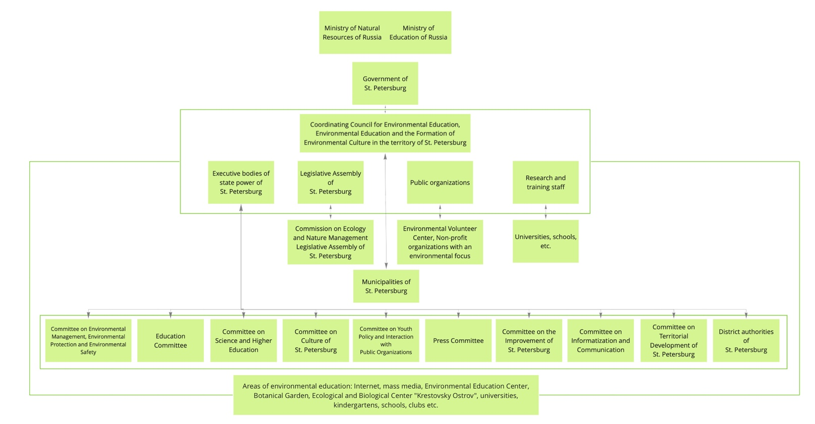
Figure 6 The system of interaction of organizations in the implementation of environmental education in the territory of St. Petersburg (Sukhenko and Bogdanov 2018)
Ecological propaganda in St. Petersburg is performed via mass media, including specialized radio and TV programs, social advertising, movies, programs and broadcasts, printed publications devoted to environmental protection, rational use of natural resources, ecological safety, and in other forms not contradicting to the Russian Federation legislation and St. Petersburg legislation.
One of the main tasks of the Committee for Nature Management is to carry out environmental education in order to form an environmental culture on the territory of St. Petersburg. In 2018, in order to organize systematic and systematic work on environmental education of the city residents, the Committee developed the "Concept of continuous environmental education in St. Petersburg" which presents three possible scenarios for the further development of domestic environmental education and enlightenment (Committee on Environmental Management, Environmental Protection and Ecological Safety 2021):
1.Traditional environmental education and enlightenment, with "living nature" at its center. The main principle is biocentrism. Educational and enlightenment practices are paired with the environmental movement.
2.Ecological education and enlightenment for sustainable development - direction that along with economic and social direction for sustainable development reflects implementation of ideology of sustainable development into content of environmental education and enlightenment. The main principle is ecocentrism.
3.Education and enlightenment for sustainable development - socio-ecological-economic integrative direction in the system of innovative, "advanced" education and enlightenment based on the principle of polycentrism - equivalence of society, economics, ecology and culture.
These activities create conditions for the transition from anthropocentric ecological consciousness to ecocentric consciousness and are based on the key ideas of a truly global civilization:
- the idea of the value of human life and safety in all environments (natural, social, technogenic, cultural, educational, etc.);
- the idea of human quality in all the manifestations of his life;
- the idea of environmental quality;
- the idea of the value of human health and the health of the environment;
- the idea of the quality of human life in the environment. [quoted from: (Committee on Environmental Management, Environmental Protection and Ecological Safety 2018)]
Also, within the framework of this paper, a proposal is put forward: to introduce the concepts of "continuous environmental education" instead of "environmental education" and "system of continuous environmental education" into the Environmental Code of St. Petersburg.
Thus, after studying the normative-legal base aimed at regulating relations in the sphere of ecology on the territory of St. Petersburg and the Leningrad Region, we can conclude that due to the trends of unification and individualization of state standards and norms, the regulatory system is not of a systemic nature. Some of the normative documents that set forth the rules for regulating this or that area of ecology are no longer in force and have not been modernized and updated in accordance with new state requirements. Among such documents, for instance, is the Распоряжение губернатора Санкт-Петербурга от 15 октября 1999 № 1101-р "О водоохранных зонах и прибрежных защитных полосах водных объектов Санкт-Петербурга".
That is why one of the most necessary measures for improvement will be the creation of a universal document, a comprehensive regulatory act, the basis for which can be the already existing Environmental Code of St. Petersburg. The purpose of creating such a document is to develop the fundamental elements of environmental legislation at the federal level, as well as to create and improve regulatory documents on a regional scale, taking into account numerous geographical, biological and socio-economic factors.
Also, referring to the majority of normative legal acts in the field of environmental policy, it is worth highlighting the special place of the population in environmental issues, as well as the importance of forming an environmental culture and continuous environmental education of citizens. This fact underlines the presence of this direction in all the main documents on the formation of environmental policy in St. Petersburg, as well as the fact that this direction is included in the category of "priority". Environmental education on the territory of St. Petersburg is carried out in such forms as informing the population of St. Petersburg about the adopted and developed regulatory legal acts in the field of environmental protection and environmental safety, environmental propaganda, holding events and scientific conferences, including international ones, and other events that do not contradict the legislation. However, an important drawback of the policy on this issue is the lack of specific objectives and indicators to assess the effectiveness of the policy, as well as the lack of a single channel of communication with the population, which directly contradicts the objectives and goals of environmental education.

1.3 Literature review
Relationship between man and ecology has been one of the most important questions for many decades. Formation of the system of optimal interaction between man and nature promotes not only satisfaction of needs and realization of the rights, but also protection of ecological systems, increase of efficiency and rationality of use of natural resources under condition of minimization of negative influence on environment. This paragraph will review and analyze the scientific literature, revealing the issues of environmental education and culture, marketing promotion in the field of ecology, social marketing as a tool to manage the behavior of the population, digitalization of society and its impact on the environmental situation.
The issue of the impact of human activity on the environment is raised in many research papers. Thus, the work of T.V. Timoshenko entitled "Ecology and human needs", published in 2013, stands out. In this work the author notes such a fact as the inertia of human thinking, which slows down the development of innovations in the field of ecology. The reason for such negative dynamics of innovative development in this sphere is the mass resistance to all kinds of innovations, arising due to the mass devaluation of social norms and the decrease in the level of social responsibility of the population. Timoshenko emphasizes the importance of the development of the system "Man - Nature - Society" by maintaining harmony in the interaction of its constituent elements.
This kind of research necessitates the intervention of public authorities and the development of a number of measures to protect the environment. In the paper Rachmanin Yu.A. (2016) analyzed the results of the Plenum of the Scientific Council of the Russian Federation on Human Ecology and Environmental Health (17.12.2015 - 18.12.2015). Among the main areas of discussion at the Plenum were: the creation of human "chemical pressure" in relation to the environment and its impact on public health, the trend of widespread increases in air, water and soil pollution indicators at the regional and federal levels, the use of optimal methods to assess risk and economic damage from worsening environmental conditions in the country, optimization of methodology of hygiene standardization, implementation of research and development work in the field of environmental protection, as well as the study of patterns of formation of the "response" of the human body to chemical pollution (Rakhmanin 2016).
It is also worth noting that the President of the Russian Federation on November 1, 2013 approved the developed Fundamentals of State Policy in the field of chemical and biological safety for the period up to 2025 and further perspective. This document emphasizes the importance of such areas of improvement of the environmental protection system as ensuring chemical and biological safety of the Russian population through the development and implementation of measures to minimize the risk of exposure of citizens and the environment as a whole to dangerous biological and chemical elements (Fundamentals of state policy in the field of chemical and biological security of the Russian Federation for the period up to 2025 and beyond 2013).
As part of the study of anthropogenic factors affecting the environment, the materials of the International Forum of the Scientific Council of the Russian Federation on human ecology and environmental hygiene "Environmental problems of our time", which was held in 2017, were studied. Thus, the key areas of improvement of environmental policy were recognized as: modernization of the system for assessing the degree of environmental safety for public health, supplementing the system for assessing the risks of critical environmental situations, expanding research activities in the study of adverse environmental factors, improving and expanding the methodological support systems of social and health monitoring and control, creating a single database, which includes environmental factors (Decision of the International Forum of the Scientific Council of the Russian Federation on Human Ecology and Environmental Hygiene 2018).
Back in the 1990s, academician D.S. Likhachev emphasized the role of the so-called "human factor" in addressing environmental issues. He argued that it was impossible to solve the problem of environmental protection by orders alone. Likhachev did not consider ecology to be an interdisciplinary science, but referred it to the category of human cultural problems. The reasons for environmental problems, in his opinion, were the low cultural level of society, the lack of morality and ethics, the resistance to change, and the lack of human initiative (D.S.Likhachev 2007).
In the research paper by E.N. Ustyugova called "From Urban Ecology to Human Ecology" (2013) the author emphasizes the importance of finding harmony between human activity, urbanization and digitalization of cities and the environment. As an example, this study cites the urban structure in Holland, a feature of which is the construction around large cities, the so-called satellite cities, which contain a huge number of objects of vegetation (terraces, parks, squares, gardens, and even greenhouses on the roofs of houses). The author points out that under this scheme of urban development the human creation changes and adapts to life "in the city among nature. According to Ustyugova, the ecology of nature and man, the culture of nature and man, being isolated multi-element systems, represent the facets of the whole (E.N.Ustyugova 2013).
In a number of works such term as "ecological activism" is disclosed from different sides, which implies the human desire to fight for the preservation of the environment. This term can be considered simultaneously from different points of view. For example, V.B. Golbraikh in his 2016 research paper considers environmental activism as nothing more than a form of political participation. The author noted the increasing desire of citizens, commercial and non-profit organizations to influence environmental policy by using a wide range of communication tools and strategies, such as storytelling, technological activation of addressee co-participation, content visualization, and general communicative leadership. The most effective application of a combination of elements of these strategies in practice will result in the adoption of laws, projects, and other political decisions, an increase in the number of discourse participants, and the transition of activity to an online format (Golbraikh 2016).
The collective research work by T.L. Kaminskaya, I.A. Pomiguev and N.A. Nazarova, published in 2019 and entitled "Environmental activism in the digital environment as a tool to influence government decisions" was also studied within the framework of this topic. The authors have studied and analyzed in depth the existing digital environment and communication elements of influence most commonly used by state, municipal, (non)commercial institutions to raise the awareness of citizens about environmental changes at the federal and regional levels. The main problems were the problem of trash separation, cruelty to animals, and waste from large industries (soil, water, and air pollution). Also, the authors compiled a summary of the discourse on these issues (Figure 7).
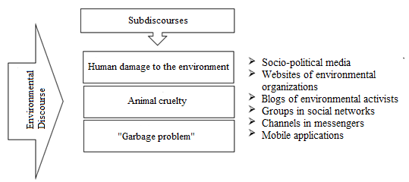
Figure 7 Scheme of Environmental Discourse
*Drawing is based on the research paper by T.L. Kaminskaya, I.A. Pomiguev, N.A. Nazarova "Environmental activism in the digital environment as a tool to influence government decisions".
Thus, after studying the peculiarities of organization of environmental activist movements, we can conclude that most of them resort to such communication tool as personal coverage of issues of interest with visualization of presented content. The purpose of this approach is not only to increase the number of citizens taking part in the environmental discourse, but also to provoke a response from the authorities (Kaminskaya, Pomiguev and Nazarova 2019).
Social marketing as a tool to influence the consciousness and behavior of people has been of interest to scientists for several centuries. For example, F. Kotler and D. Zaltman in their work "Social Marketing: An approach to Planned Social Change" considered the possibility of applying classical marketing concepts to social cause-effect relationships. In this work, the term "social marketing" is understood not only as the relationship between the organization and the consumer, but also as a set of processes of development, implementation, monitoring and control of numerous programs aimed at increasing the acceptability of social ideas in such areas as pricing policy, communication channels, product distribution, as well as market research.
When it comes to marketing products and services, choosing the right set of marketing tools, methods, and approaches to attract the attention of the target audience plays a special role. The promotion of goods and services is directly linked to the provision of the most important information to the potential consumer through various channels of communication. If we consider social marketing programs concerning such issues as environmental pollution, private education, drug abuse and public health, in this case marketers have to work closely with less defined and insufficiently financially supported communication channels, and apply a set of key concepts and tools in order to gain mass acceptance (Kotler and Zaltman, Social Marketing: An approach to Planned Social Change 1971).
The use of social marketing principles in addressing environmental issues was addressed by Edward Maybach in his 1993 study Social Marketing for the Environment: Using Information Campaigns to Promote Environmental Awareness and Change Behavior. The author describes social marketing as one approach to developing solutions to many of the environmental problems currently facing the global community.
E. Maybach emphasizes that such principles of social marketing as can be used in the development of environmental awareness campaigns. Among the main activities in the development and creation of environmental campaigns the author includes:
1) Consumer orientation (audience interest in and sensitivity to the campaign topic), a mutual exchange between the marketer and the audience. This theory of exchange mainly focuses on "pro-social communication" as a voluntary exchange of resources, and thus maximizing consumer orientation.
2) Audience analysis and segmentation - processes aimed at dividing a large audience into smaller subgroups of individuals based on a set of criteria, such as needs, behavior, values and other characteristics, to develop tailored and therefore more effective activities and messages.
3) setting appropriate and realistic campaign objectives, applying research results, analyzing communication channels, using behavioral theory, creating a marketing mix (a set of actions or tactics that marketers use to promote their brand or product in the market).
4) The application of process and outcome evaluation strategies, communication at the macrosocial level, as well as the establishment of timelines that contribute to the institutionalization of campaign objectives (Maibach 1993).
Macrosocial communication is considered to play a very important role when it comes to environmental campaigns, because it is crucial for the effectiveness of the campaign to avoid "blame the victim" strategies (when the consequences of a negative action are shifted to the "responsibility" of the victim). There is a serious need to create systems of information exchange between audiences and government agencies, companies and corporations. These systems should include information about the structure and culture of organizations, government policies in the form of laws and other regulations, tax structures, subsidies and social programs.
Russian researchers have begun to touch upon the topic of social marketing much more frequently in the 21st century. E.V. Smirnova, candidate of economic sciences and social and environmental marketing consultant, in her book "Environmental Marketing and its Basics" published in 2011, emphasizes the fact that the relevance of environmental issues is reflected not only in the works of scientists, but also in the way business entities conduct business, in the activities of authorities at all levels, as well as in the life of society in general.
Environmental problems are regularly covered in a variety of media, and thousands of blogs, non-profit websites, and forums are devoted to them. This demonstrates that addressing environmental issues has moved to a qualitatively new level - widespread, which is accompanied by the involvement of all social groups in solving environmental problems.
In connection with such wide coverage of problems of ecological development and environmental protection in sources the term "ecological marketing" which originated during the seminar of the same name of the American Marketing Association in 1975, and then was opened and in the book "Ecological marketing" began to appear more often.
This type of marketing became more widespread in the 1990s as a branch of the development and expansion of the concept of social and ethical marketing (the main focus - satisfaction of needs, social and moral benefits of the goods and services sold), which defined the task of any company as establishing the needs, expectations and interests of the target markets and ensuring satisfaction of needs in the most effective and productive (than competitors) ways. This concept arose as a result of the conflict of traditional marketing of that time with the rapidly deteriorating state of the environment, the scarcity of natural resources, population growth, inflation and the negative state of the industry of social services (Banerjee 2008).
The essence of ecological marketing consists in such an organization of activity of an economic entity, which would be aimed at satisfying the interests of consumers by promoting products and services that are minimally harmful to the environment at all stages of the life cycle (sequential and interrelated stages of the production system from the receipt of raw materials or natural resources to their final location in the environment). It is safe to say that due to the fact that the environmental component in the development of society has become a new factor of influence on business in general and on marketing in particular. Today, environmental marketing is no longer just "desirable", it plays the role of an accepted norm in the activities of many companies (Prokopenko and Ossik 2015).
D. Mackenzie-Mohr, Nancy R. Lee, P. W. Schultz and F. Kotler in their book "Social Marketing for Environmental Protection", published in 2012, focused not only on the application of principles and concepts of social marketing in addressing environmental issues, but also considered specific opportunities and threats (in the book - "barriers"). The authors noted that one of the most difficult issues was the design of the information base for the implementation of marketing programs at the level of municipalities due to the need to take into account the specifics of a particular entity. Specialized agencies (FSP agencies) often rely on information provided by the institutions themselves, which reduces their role to primitive financing of already developed programs. However, programs designed in this way cannot be recognized as viable.
The solution to this situation is, in the opinion of the authors, phased financing of programs and activities (this type of financing is now used almost everywhere), in which the development and implementation of a pilot project is financed first, and then, based on a comprehensive assessment of the indicators of its socio-economic effectiveness, the decision on its further development is made (Kotler, Takahashi, et al. 2009).
Features of application of ecological marketing were considered by D.S. Zaitseva and I.V. Krakovetskaya in the scientific article of 2016 under the name "Ecological marketing: trends and prospects". The authors noted that the application of this type of marketing includes not just "greening" (derived term from the English green marketing - "green/environmental marketing") of the services sold, but also "greening" the activities of business entities as a whole. Companies that seek to increase the level of social responsibility by minimizing the negative impact of their activities on the environment, completely rethink the well-known 4P model (from "product", "place", "price", "promotion").
Special attention in this article is paid to the term "Green Promotion", which includes classic promotion tools such as advertising, marketing materials, signage, informational documentation, websites, videos and presentations, taking into account behavioral patterns, concern for the environment and at the same time financial benefits. Zaitseva and Krakovetskaya also proposed a classification of key "green" marketing strategies:
1) "Lean Green". Does not focus on "green" initiatives and advertising. The main goal is to reduce costs and increase the efficiency of production at the expense of its safety for the environment. Achievement of competitive advantage by reducing the price of goods/services, and not at the expense of advertising activities.
2) "Defensive Green". It is primarily a marketing tool of a reactive nature, i.e. it is used to counteract competitors or as a response to a market crisis. It is often used to improve the company's image while minimizing possible losses. However, this strategy significantly reduces the possibility of "separating" oneself from competitors only on the basis of "green" advantage.
3) "Shaded Green". Companies using this strategy see "greening" as an opportunity to create innovative products, systems and technologies. In this case, the sale of environmentally friendly products is carried out using classical methods of promotion and sales channels, without emphasizing the importance of "greening". When implementing this strategy, companies are ready to invest a large amount of material, labor, time, information resources on a long-term basis. It is one of the most effective "green" marketing strategies.
4) "Extreme Green". It is more like a philosophy of an organization with a set of corresponding values. In the system of conducting business, in the system of production and realization of goods and services full integration of principles of preservation and protection of the environment is carried out. For the companies using this strategy, environmental and social responsibility acts as a driving force. However, the most effective application of such a strategy is possible in markets with narrow specialization and with a limited number of distribution channels (Zaitseva D.S. 2016). If we consider the relationship between each of the above strategies and the elements of the 4Ps concept, the relationship is as follows (table 1).
Table 1 Link between environmental marketing strategies and the elements of marketing mix 4P
Name of strategy | Element of marketing mix 4P
 | Product | Price | Place | Promotion
«Lean Green» | х
«Defensive Green» | х |  |  | х
«Shaded Green | х | х |  | х
«Extreme Green» | х | х | х | х
*The table is based on the work of Zaitseva D.S., Krakovetskaya I.V. "Environmental marketing: trends and prospects".
In 2016, Gelmanova Z.S., Zhaksybaeva G.Sh. and Osik Y.I. published a scientific article titled "Ecological Marketing", in which they considered in detail several basic approaches of using marketing tools and methodology to solve problems of ecological nature. The first approach is based on the use of interrelated elements of marketing activities, which are schematically presented in figure 8.

Figure 8 Components of ecological marketing of the enterprise
*Figure compiled according to the research Gelmanova Z.S., Zhaksybaeva G.Sh., Osik Y. "Environmental marketing".
The second approach focuses on the production processes, the modernization of which, taking into account the minimization of the negative impact of production on the environment, gives business entities the opportunity to modernize. This approach involves the use of marketing for internal and external cooperation of companies in order to conduct activities in accordance with environmental and economic requirements and norms. Particular attention should be paid to regional characteristics in the division of labor and cooperation of production of goods and services in order to achieve environmental targets.
The third approach prioritizes the establishment of lines of communication between producers of goods and services and their target audiences. In this case, to increase the effectiveness of promotional activities it is necessary to use traditional marketing (market research, segmentation of the target audience, competitive analysis, marketing mix, etc.) tools and principles of social marketing (forming a model of consumer behavior, hierarchy of needs, the study of "barriers", etc.) (Gelmanova, Zhaksybaeva and Osik 2016).
Thus, after analyzing the theoretical and methodological sources, we can conclude that the concept of social marketing, which became widespread in the XX century, by now is an integral part of the overall social responsibility of economic entities. Due to the fact that the problems of environmental protection are among the most pressing, the social marketing of companies is aimed precisely at modernizing the environmental and economic principles of production and sale of goods and services.
Classical marketing concepts combined with socio-ethical elements allow to revise and complement the methodology of performance promotion, improve the image and increase the degree of competitiveness of organizations, and attract the target audience, primarily by creating sustainable communication channels based on coverage of current environmental problems and the involvement of citizens in the development and implementation of measures to address them.
Another issue with regard to environmental policy is the development of "environmental innovation" or "eco-innovation". Environmental innovations are technological and social innovations in the field of environmental protection, rational use of natural resources and the formation of environmental values among citizens in the framework of the joint development of the economy and ecology (Mityakov, et al. 2018). In modern statistics, environmental innovations are divided into two types. The first of them provide an increase in environmental safety in the process of production of goods. The second - the increase in environmental safety as a result of consumer use of innovative goods. According to the authors of the article, traditional and eco-innovations are largely related to various internal factors of innovation, eco-innovations are much stronger and more stable connected with external factors of innovation (S Anthony Frigon 2020).
The transition to a green economy, which should be the focus of new efforts to integrate environmental and social considerations in economic decision-making in preparation for the United Nations Conference on Sustainable Development (Rio+20) and beyond (UnitedNations 2011), promotes a circular economy (or circular economy), which is an alternative to the traditional linear economy, its idea is to use resources repeatedly, extracting maximum value from them The authors of the article distinguish indicators characteristic of this type of economy [quoted from: (Yadav, et al. 2020)].
Table 2 Circular economy related indicators reported in the literature [quoted from: (Yadav, et al. 2020)]
Sl. No. | Circular economy related indicators | Description
1 | Effective planning and management | Effective planning and management to align resources appropriately for CE adoption
2 | Top management commitment | Top management engagement and involvement enhance opportunities for CE adoption
3 | Allocation of financial budgets | Separate budget allocation for the execution of CE practices is crucial
4 | Sustainable resource management | Appropriate usage of sustainable resources is required for CE adoption
5 | Supportive participation of stakeholders | Stakeholders’ participation is essential for the adoption of CE framework
6 | Building a brand image | Brand image in effective CE culture boosts the opportunities
7 | Understanding exact implications of CE (economic and social benefits) | Economic and social benefits are required to be understood explicitly for an effective CE adoption
8 | Focussed training for CE adoption | Appropriate training sessions facilitate CE adoption process
9 | Employee empowerment and motivation | Motivating employees and transferring responsibilities to them to improve the productivity of an organisation
10 | Multi-stage quality check system | Conducting quality checks for in-process products at checkpoints assist in diagnosing defects at an early stage for necessary rework
11 | Adoption of 6 R’s | Adoption of 6 R’s helps organisation to penetrate CE effectively
12 | Effective inventory management | Appropriate forecasting techniques aid practitioners to manage inventories
13 | Reduction in carbon emission | Reducing carbon emission and using it further for any productive recycling process boosts the CE adoption process
14 | Coordination and collaboration among SC members | Effective collaboration and communication among the supply chain entities help to manage supply chain operations
15 | Supplier commitment for recyclable materials | Suppliers’ commitment to recyclable materials promotes the CE adoption process
16 | Adopting reverse supply chain practices (e.g. EPR, reverse logistics) | Effective implementation of EPR and reverse logistic practices indirectly assist in the CE adoption process
17 | Adopting green practices (in purchasing, design and packaging) | Adoption of green purchasing, design and packaging develop a recyclable product
18 | Educating customers for CE practices | The end-users are required to be educated regarding the benefits of CE
19 | Adopting innovative practices | Adoption of advanced quality improvement practices at different functional areas of supply chain help in the CE adoption process
20 | Advanced technological transfer and applicability | Availability and applicability of advanced technology transfer help in mapping activities that improve inter-departmental communication within the organisation
21 | Penetrating social media and big data analytics in the organisation | Implementation of big data analytics and social media in the organisation facilitates understanding of customers’ requirements to take effective measures
22 | Effective facility layout decision making | Allocation of facilities in an optimised manner is extremely important that directly correlates to the product cost
23 | Constant monitoring of changing market needs | Observation on changing market needs helps effectively in modifying/developing products
24 | Effective information management system (e.g. IoT) | Effective implementation of the internet of things (IoT) in the organisation facilitates in handling complex information management system
25 | Adopting industrial ecology initiatives | Implementation of industrial ecology facilitates the assessment of the system’s environmental impact
26 | Availability of CE oriented framework (e.g. ReSOLVE) | Focussed CE framework facilitates its better penetration in the organisation
27 | Redesign based on customer (internal and external) feedback | An effective closed-loop feedback system facilitates appropriate modification in design
28 | Effective life cycle analysis | Review and analysis of product life cycle and its effective implementation facilitates to adapt new products
29 | Rewards and incentives for greener activities | Rewards and incentives boost employee morale to facilitate the implementation of environmentally sustainable activities
30 | Identifying performance measures for CE | Effective performance measures assist in analyzing CE’s benefits
31 | Supportive government policies | Government regulations for promoting CE and subsequent subsidies and rebate in taxes can enhance the CE adoption process

According to the Ministry of the environment, energy, and marine affairs, in charge of international relations on climate change (Auzanneau, et al. 2017), the circular economy is based on three areas of activity and seven pillars (fig. 9). It is based on methods of exchange and production, which at each stage of the life cycle of a product (goods and services) are aimed at increasing the efficiency of resource use and reducing the impact on the environment, as well as improving the well-being of individuals. "
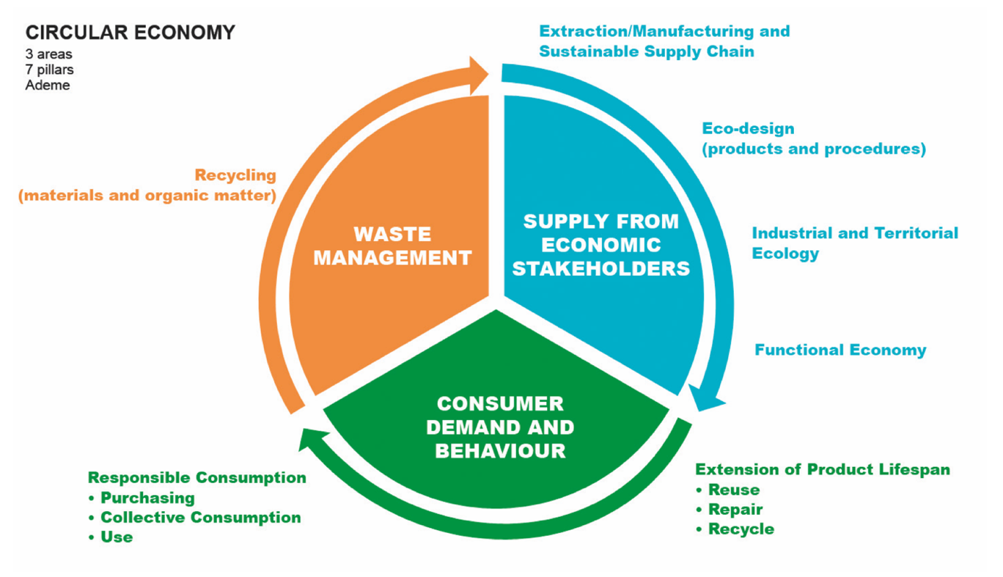
Figure 9 Circular economy [quoted from: (Auzanneau, et al. 2017)]
Thus, when solving modern environmental problems, various issues are raised based on modern trends and innovative processes. A separate place is occupied by social marketing and environmental education, which allow emphasizing the value of a person in solving problems through effective communication.
The place of man in solving environmental problems is highlighted in the works of many authors. In the works presented in this study, special attention is paid to the process of effective communication. The ideas of social marketing are closely related to the implementation of effective communication. Social marketing as a tool for influencing people's consciousness and behavior has been of interest to scientists for several centuries. F. Kotler and D. Zaltman considered the possibility of applying classical marketing concepts to social cause-and-effect relationships.
E. Maybach emphasizes that such principles of social marketing can be used in the development of environmental awareness campaigns. Among the main activities in the development and creation of campaigns in the field of ecology, the author includes:
- consumer orientation (the audience's interest in the campaign topic and its sensitivity to it), mutual exchange between the marketer and the audience;
- audience analysis and segmentation-processes aimed at dividing a large audience into smaller subgroups of individuals based on a set of criteria, such as needs, behaviors, values, and other characteristics, to develop customized and therefore more effective activities and messages;
- setting appropriate and realistic campaign goals, applying research results, analyzing communication channels, using behavioral theory, and creating a marketing mix;
- apply strategies for evaluating process and results, communicating at the macro-social level, and setting time frames that help institutionalize campaign goals.
It is important to note the growing role of environmental innovations, which include technological and social developments that contribute to improving the quality of communication and environmental education, as well as promoting environmental activism.
The ideas discussed in this paragraph are the basis for the further study of the needs of the audience which conducted in this paper.

1.4 Case study

1.4.1 The review of environmentally significant projects in Russia and abroad
In recent years, the life of society has changed, humanity has entered a new stage of progress and moved to the concept of an information society. This concept dates back to the times of widespread industrialization when due to the development of production processes, the widespread dissemination of the media, the application of the principle of division of labor duties, there was a sharp leap in the development of society.
It was then that a positive attitude was formed towards all sorts of innovations in various spheres of society, which began to be considered as the so-called "engines of progress." The readiness of the population to accept the changes has accompanied the development of the post-industrial information society. The basis for further modification and improvement of the information society is the development of information and computer systems, physical-technical and chemical-biological developments, successful research and development work, the implementation of many innovative projects in various spheres of society (Yakobson and Kirillova 2014). A competent and rational application of the results of innovative developments is a prerequisite for the formation of a new type of economy, namely, an innovative one.
Thus, we can say with confidence that the process of digitalization, or, as it is commonly called, the digital transformation of society and the economic system, affects all spheres of life of the population and the activities of economic entities. Changes in the technological structure, the traditional market mechanism, and the institutional structure lead to the creation of “augmented reality”, which is based on the harmonious interaction of real and virtual components (Litvintseva, et al. 2019).
When addressing issues related to improving the environmental situation and protecting the environment in general, digital transformation plays a huge role because thanks to it, it is possible to achieve a high level of citizen involvement in innovative processes aimed at optimizing the current environmental situation by ensuring regular the flow of information on the progress of implementation of innovative projects and opportunities for participation in them, as well as well-developed and relevant methods to stimulate participation (Strelkova and Makusheva 2014). Next, we will consider the mechanism of the impact of digitalization of society on the development and implementation of environmental projects.
One of the largest environmental projects implemented on the territory of the Russian Federation is the national project “Ecology”, which was approved by the Presidium of the Council under the President of the Russian Federation for Strategic Development and National Projects on December 24, 2018. The structure of this project consists of eleven key elements, which include projects: "Clean Country", an integrated system for the management of municipal solid waste, infrastructure for waste management of I-II hazard classes, "Clean air", "Clean water", rehabilitation the Volga rivers, the preservation of Lake Baikal and other unique water bodies, the preservation of biological diversity and the development of ecological tourism, the preservation of forests and the introduction of the best available technologies (The Ministry of Natural Resources and Ecology of the Russian Federation 2020).
This draft has been revised and supplemented several times since its approval. Particular attention has always been paid to the BAT block - the introduction of newly available technologies since it is these activities that would optimize production processes in such a way as to minimize the negative impact on the environment. The project budget is 2.4 trillion. rubles, of which 27 billion were provided by the federal budget. The main goals of the project are:
- Issuance of IEP (integrated environmental permits) to enterprises that pollute the environment (forecast: issuance of 6900 IEP by the end of 2024);
- development of programs and measures to improve the environmental safety of mechanical engineering;
- revision of the information base related to BAT;
- improvement of the system for issuing subsidies for coupon rates on bonds that are issued to finance projects in the field of introducing new technologies (Discussion on the implementation of the federal project "BAT Implementation" n.d.).
However, this project has several disadvantages. According to the analysis of the components of the project "Ecology" carried out by the World Wildlife Fund of the Russian Federation, the main disadvantages of the direction "Introduction of new accessible technologies" were:
1) The project is “torn apart” between the four largest and most significant structural units - the Clean Water and Clean Air projects, as well as the project to create an algorithm for working with solid municipal waste and waste of I-II hazard classes. All these projects must be fully supported by materially and technologically.
2) The analysis revealed that only a small part of the targets contains innovations in production technologies, measures to reduce the amount of waste generated in the production process, and indicators of air pollution.
3) As indicated in clause 1, the direction "Implementation of newly available technologies" is aimed at servicing and supporting other projects, however, the project budget significantly exceeds the budgets of the Clean Water and Clean Air projects.
4) Taking into account the potential demand for new available technologies in the amount of ~ 800 billion rubles, the risk of non-repayment of investments increases, which may serve as a reason for the subsequent redistribution of costs to the federal budget (for example, through the buyout of enterprises, redistribution of debts to development institutions, etc. ) (What is being done to implement the national project "Ecology" n.d.).
Considering all the above, the experts of the World Wildlife Fund of the Russian Federation proposed to redesign the target tasks of the Clean Water and Clean Air projects, as well as projects to create an algorithm for working with solid municipal waste and waste of I-II hazard classes in such a way that they correlate with the results of the introduction of new technologies into production processes. Under the new goals, the structure of the project budget should also be changed. As for the potential level of demand for BAT, it should be interdependent with the size of investments in the capacity of environmentally optimal machine building.
Another important factor is the actualization of the information provided on the "Ecology" project. Thus, it was proposed to update all reference documents no later than 2022 by international requirements, standards, and norms, to cut the risk of technological lag behind more developed countries. It is necessary to assess the economic efficiency from the acquisition of the necessary technological components from domestic and foreign manufacturers to optimize the cost allocation system for the project (Analysis of the components of the National project Ecology and proposals for their improvement - Federal project "Implementation of the best available technologies" (No. 11) n.d.).
Within the framework of this project, possible ways of attracting Russians to solving environmental problems by introducing the concept of a "smart city", which is aimed at creating and using energy conservation systems, at solving the "garbage problem" (waste separation), at preserving elements of animal and plant nature, and another (Passport of the national project "Ecology" n.d.).
The concept of building smart cities was laid down at the level of architecture and landscape schools. So, when analyzing the research work of Ustyugova E.N. “From urban ecology to human ecology” (2013) it was noted that when creating Dutch cities, architects do not aim to dominate the environment, but, on the contrary, strive to fit urban infrastructure into it. Thus, the relationship and interconnection of a man with nature are maintained. Most urban development projects are based on in-depth conceptual studies of landscape and climate characteristics to use them for urban development. Thus, the use of water, sun, and even wind energy is widely used, the construction of buildings and structures using environmentally friendly materials, the construction of dams, artificial fill islands, and "floating quarters" (A.S.Pushkin 2013).
Dutch companies at the present stage adhere not only to the concept of a smart city but also to the concept of “smart cities”. Thus, WAAG "Technology & Society" strives to provide citizens with all the necessary information about the effectiveness of the use of new technologies to improve environmental conditions. An important principle is not only the establishment of communication channels between companies involved in the organization of smart cities but also the creation of a system of citizen engagement based on the independent use of the technologies and tools provided (WAAG «Technology & Society»: About us n.d.).
In 2014, the WAAG Smart City laboratory of the same name was created, whose employees not only received feedback from the residents of Amsterdam regarding the use of BAT to solve environmental issues but also sent a team of experts to explain the most effective algorithm for their application. The events organized by the laboratory included brainstorming discussions on topics ranging from urban planning to the latest state-approved environmental requirements and standards (Smart City VS Smart Citizens: Dutch fundraiser Cohen Bergman - on how technologies will help live in modern cities - Projects and their results n.d.).
The company is currently developing several projects aimed at monitoring air and water quality, as well as noise pollution. A characteristic feature of these projects is that the measurements and fundamental research necessary for their implementation are carried out by the citizens themselves (WAAG «Technology & Society»: Making Sense: from pilots to Citizen Sensing, a Toolkit! n.d.).
An example of this approach is WAAG's collaboration with FabLab manufacturing, research, and training center in Barcelona. The center was responsible for the computer-aided design and manufacture of sensors for measuring air pollution levels (FabLab Barcelona: About n.d.). Despite the initial rather large cost of the sensors and the cost of their subsequent modification, the sensors were issued to citizens completely free of charge. The next important step after the measurements was the registration of the results. The key principle was the simplicity and clarity of the "message" for the addressee, not just for environmental experts. That is why WAAG engages a whole team of specialists working with a large array of statistics, graphic designers, and other experts to make environmental projects as attractive and understandable as possible for a wide audience (Smart City VS Smart Citizens: Dutch fundraiser Cohen Bergman - on how technologies will help live in modern cities - Projects and their results n.d.).
Another example of the most successful implementation of the smart city concept in Melbourne, Australia. The vision of a smart city in the case of Melbourne is to design and implement aspects of urban life and development in such a way as to enable a flexible system to respond to changes in economic, social, and environmental factors in the short and long term (City of Melbourne: Melbourne as a smart city n.d.).
All activities and programs are based on working with citizens and developing innovative digital solutions, taking into account the diverse needs of all groups of the population. For example, when implementing programs for citizens with disabilities, platforms and other tools are being developed to count the number of pedestrians in certain sections of the city to assess the degree of traffic congestion for subsequent redistribution of the load. In partnership with Vision Australia, a service provider for blind and visually impaired citizens (Vision Australia: About us n.d.), Campbell Arcade beacon technology was piloted in conjunction with Transpire's specially designed applications that enable visually impaired people to navigate multiple entrances and exits, as well as attractions. Bluecat Bluetooth Low Energy (BLE) beacons are optimal as they are ideal for pinpointing the location of smartphones indoors where GPS and Wi-Fi are not effective. The solution allows beacons to send alerts and notifications to the app, which then provides detailed instructions for the user to navigate the area (Transpire: Enabling people with vision impairment to navigate independently using beacons n.d.).
In Melbourne, the issue of greening urban areas, including roofs (the city is "famous" for green areas on the roofs of city buildings) is especially acute. That is why the city has a goal to grow at least three thousand trees annually. To achieve this goal, state authorities in 2019 allocated about 19.1 million dollars to the Urban Forest Fund, 1.9 million of which were implemented in the first year of implementation of this plan. The municipality already has over forty green roofs (Archi.Ru: official site. Urban forests: Melbourne urban greening plan n.d.).
The authorities also emphasize the problem of rational use of water resources. Plans include a rainwater harvesting and reuse program to protect world-renowned gardens, including the 1,400 m² rooftop Victorian Comprehensive Cancer Center (SmartCity Press: Why Melbourne Is the Most Liveable City On the Planet? n.d.). To implement this initiative, the city authorities plan to allocate about $ 4.2 million from the budget. For rooftop landscaping and stormwater distribution, a partnership was signed with ZinCo, which provides new affordable greening technologies to optimize urban environments and improve environmental conditions (ZinCo: Green Roofs System n.d.).
Also, it is worth noting the fact that city budget funds will also be directed to the development and implementation of a set of measures to transfer urban infrastructure facilities to fully renewable energy. Energy from the wind farm (~ 80 MW) will be distributed to street lighting systems, recreation centers, sanatoriums, churches, libraries, etc (Archi.Ru: official site. Urban forests: Melbourne urban greening plan n.d.).
The City of Melbourne is committed to keeping the streets clean and committed to getting everyone involved in recycling its waste. By introducing innovative waste management and recycling methods, citizens can be involved in keeping the streets clean and waste minimized in busy urban areas. For example, the city has 450 solar-powered smart bins, 230 public waste bins, 2,000 public garbage cans, and 500 cigarette butt containers. These containers are strategically located to dispose of waste and recyclable items. The new smart dumpsters use technologies to provide more sustainable, long-term services for city residents, workers, students, and visitors. When disposing of commercial waste, special collectors/digesters are used (from the English "methane" - methane and "tank" - a reservoir), designed to convert food waste into environmentally friendly water, which subsequently enters the sewer system. A special desiccant is used to convert food waste into soil fertilizer. Garbage compactors and recycling centers have also been commissioned in high-traffic locations throughout the central city (City of Melbourne: Reducing litter n.d.).
As for the implementation of the concept of smart cities in the Russian Federation, the importance of digitalization for the development of the economy has been emphasized more than once, especially in the framework of the development and implementation of support programs for large, medium, and small businesses. Thus, in many regions of the country, full-fledged "innovation clusters" are being formed, technoparks and special economic zones are being built, business accelerators are developing and expanding (Yu. 2020).
The main directions of development were: new technologies for housing and communal services (solid waste management, energy efficiency, smart home technology), transport infrastructure (installation of video surveillance systems, unmanned vehicles), energy use (alternative, renewable energy sources, electric transport), as well as the introduction of 5G systems to improve the speed of connections. Figure 10 shows the geographic structure of a “smart city” in the Russian Federation, compiled based on technology market research data by iKS-Consulting experts (iKS-Consulting n.d.).

Figure 10 Geographic structure of the "smart city" in the Russian Federation in 2019
* The figure is based on the results of a study by iKS-Consulting on the topic "Smart city technology market 2019".
It is also worth noting that the growth of the market for technological solutions in Russia is not great. So, at the end of 2018, the increase was only 8%, which led to a mark of 81 billion rubles. Further, the market began to show negative dynamics, and in the first half of 2019, its volume was estimated by iKS-Consulting experts at only 77.1 billion rubles (iKS-Consulting n.d.) (Figure 11).

Figure 11 Dynamics of changes in the volume of the market for technological solutions of the "smart city" in the Russian Federation in 2017-2019
* The figure was compiled based on the results of a study by iKS-Consulting on the topic "Smart city technology market 2019".
Thus, we can conclude that at this point the market of technological solutions in Russia is not only in a state of decline, but can also be characterized as extremely uneven, because most of all initiatives and programs (93%) are concentrated on the territory of Moscow, only 2% - on the territory of St. Petersburg, and the remaining 5% are distributed among other regions. Many experts are inclined to believe that only state funding of this area can "spur" the growth and interest of citizens and economic actors in introducing the principles of a "smart city" into their activities.
Since the practice of greening roofs of buildings in Melbourne has already been considered, we have the opportunity to make a comparison with a similar initiative in Moscow. Back in 2017, the Ministry of Construction, Housing, and Utilities of the Russian Federation published an order "On the approval of guidelines for the preparation of rules for the improvement of the territories of settlements, urban districts, inner-city districts", according to which the area of ​​roofs for landscaping should be calculated taking into account the total number of amenities (Order of the Ministry of Construction and Housing and Communal Serv. of the Russian Federation "On Approval of Methodological Recommendations for the Prep. of Rules for Improvement of Territories of Settlements, Urban Dist, Intracity Dist" №217 2017). And already in 2020, GOST was introduced under the name “Green Standards. Greened and maintained roofs of buildings and structures. Technical and Environmental Requirements " (GOST R 58875-2020 “Green standards. Greened and maintained roofs of buildings and structures. Technical and environmental requirements " б.д.), which was developed by specialists from NRU MGSU in cooperation with the National Roofing Union and manufacturers of building materials.
The provision of GOST R 58875-2020 must be observed in the process of design, construction, and direct operation of landscaped structures on the roofs of buildings and structures. The roof is proposed to be landscaped by the selected type of plants, that is, landscaping can be of an intensive type, semi-intensive type, and extensive type. Also, this standard establishes a whole list of climatic, ecological, and weather conditions for landscaping, conditions for the compatibility of materials and plants, and protection of plants from harmful substances.
As a result of the research carried out, it was revealed that on the territory of the Central District of Moscow, about 5% of roofs are available for landscaping and meet the established standards (for example, they are ready to withstand a substrate with a thickness of more than 10 cm and a permissible load of more than 150 kg per square meter). Greening of roofs is most advisable in the city center since the creation of a plant reserve by other means is practically impossible due to dense buildings.
According to the developed strategy, over the next 10 years, approximately 30% of the roofs of Moscow will be landscaped (Smagrinskaya 2020). The results of the practical implementation of this program will be:
1) Purification of rainwater when passing through the "green" roof. Such water will not absorb fuel oil, gasoline deposits, and other impurities before it passes into the storm sewer. The possibility of installing tanks for collecting rainwater with subsequent use for technical needs is also being considered.
2) The result of greening roofs can be a general decrease in air temperature by about 1.3 ° C, thereby preventing the appearance of the "heat island" effect, which is caused by the lack of green areas, the number of exhaust gases, and other vapors, large areas of impenetrable surfaces, congestion, and building density.
3) Reduced operating costs by using green areas for additional thermal insulation. If houses with such roofs lose less heat in winter and keep cool in summer, this will significantly reduce the cost of air conditioning and heating of residential premises.
4) The presence of green roofs is a prerequisite for the development of entrepreneurship by opening cafes, children's, and sports grounds on such sites, which, in turn, will provide additional taxes and fees to the regional budget (LiveJournal: Green roofs are what you need now! 2020).
Another of the most serious problems of the Russian Federation is the “garbage problem”. This is due to the fact that under the condition that 2 billion tons of municipal solid waste are generated annually in the world, approximately 77 million tons of which are in Russia. The main types of waste generated on the territory of the Russian Federation every year are shown in figure 12.

Figure 12 Percentage of types of garbage on the territory of the Russian Federation
* The figure is compiled based on the data presented in the article "The expert found a solution to the garbage problem" published in the Russian newspaper.
Almost all garbage (about 90%) is sent to landfills, where the waste can be recycled in whole or in part. Some of them, like plastic, can take hundreds of years to decompose. The total area of ​​landfills and dumpsites in the Russian Federation is about 4 million hectares, which is comparable to the area of ​​Denmark or Belgium (E.Berezina 2020).
One of the largest environmental projects in this area is the project called "Climate-neutral waste management in the Russian Federation", which is being implemented within the framework of the International Climate Initiative by the Ministry of Natural Resources and Ecology of the Russian Federation in cooperation with the Federal Ministry of the Environment, Nature Conservation and Nuclear Safety of Germany ... This project is intended, first of all, to ensure the formation of an information base and technological (digital) support to optimize the mechanism of waste management in Russia. Also, the project is aimed at familiarizing with the German regulatory framework aimed at regulating the "garbage issue", with the delimitation of the areas of responsibility of regions, municipalities, individual organizations, and citizens themselves in solving this problem (O.Nikiforov 2019).
The pilot region for the implementation of this project will be the Voronezh region, the government of which has agreed with the Ministry of Nature and the German Society for International Cooperation. Under this agreement, work was planned in such areas as an expert and methodological assistance in the formation of a regulatory and legal framework, the development and implementation of programs for the exchange of experience and advanced training in the established area, the development of environmental demonstration projects, information support to disseminate the results, the use of new technologies for solving the "garbage problem" (The implementation of the international project "Climatically Neutral Waste Management" has started in the Voronezh Region n.d.).
So one of the very first results of the project will be considered the complete adaptation into Russian of the Federal Republic of Germany's law on the closed-cycle economy in waste management dated February 24, 2012, which contains a complete list of rules and principles for handling solid municipal waste separately for individuals, legal entities, commercial and non-commercial organizations, in other words, for all waste “generators”.
It should also be noted that all the goals and objectives of the project "Climatically neutral waste management in the Russian Federation" correlate with the goals and objectives of the previously considered national project "Ecology". One of the main directions is the improvement of the national industrial system and the creation of a sustainable mechanism for waste management. Together, the two projects aim to quadruple the recycling of municipal solid waste by 2024 - from 9% to 36%. Achieving such an ambitious goal will be a new step towards creating a circular economy in the Russian Federation, which, in turn, can create opportunities for optimizing waste processing and recycling rates, as well as improving the overall quality of life of the population by modernizing the environmental protection system (Not rubbish, but a resource. A sustainable waste management system is being created in Russia 2019).
Thus, having analyzed such large-scale environmental projects in Russia and abroad, the first conclusion that can be drawn is the importance of digitalization in solving environmental problems. This is since computer technologies, predictive analysis tools, artificial intelligence, together with the modernization of standards and requirements for the waste management quality management system, air, and water pollution systems, can have a significant impact on the environmental consciousness of citizens and, consequently, on the formation of the federal system. solving environmental issues. Tools such as intelligent modeling, technological standardization, the creation of monitoring and control systems lead to the creation of a single platform aimed at optimizing the environmental situation (Digitalization of ecology: how will we save the situation? n.d.).
However, unfortunately, at the moment Russia is significantly lagging behind the world practices of solving environmental issues. Thus, when implementing the concept of “smart cities”, most of the information, labor, time, and material and technical resources are concentrated on the territory of Moscow, which makes it impossible to develop key approaches and principles in other regions. Also, as practice shows, the level of awareness of Russians about problems in the field of environmental protection is extremely low. Studies show that a little more than 20% of citizens are aware of their responsibility for the environment, many of them are not aware of the most pressing environmental issues (for example, about 26% are not aware of the "garbage reform") (The Russians named the main environmental problems of the country 2020). This testifies to the insufficient dissemination of the necessary information messages among the population, as well as to the fact that the research results are not sufficiently clear.
The budgeting of environmental projects at the regional and federal levels does not always correspond to the levels of demand for technological support, which can lead to non-recoupment and project closure. Therefore, fundamental and in-depth sectoral research should be carried out not only based on the data provided by the municipalities but at the state level. Budget allocation should be made in accordance with the severity of a particular environmental issue to avoid situations in which supporting projects receive more funding than the main ones (for example, Clean Water, Clean Air, and a supporting project to introduce new available technologies) ...
Russia has a long way to go to achieve global environmental performance. However, there are already prerequisites for international cooperation, the initial goal of which is to exchange experience and use the necessary knowledge to improve the environmental situation.

1.4.2 The review of environmental projects in St. Petersburg and Leningrad region concerning environmental education
Within the framework of environmental education, various educational and propaganda activities, competitions of eco-journalists are held, the development of environmental newspapers, lectures, etc. is supported. From the point of view of the development of environmental education in the Internet space, it is expected to timely update relevant information on official websites, as well as data on the environmental atlas of the city. (Committee on Environmental Management, Environmental Protection and Ecological Safety 2021)
The ecological portal of St. Petersburg is a means of communication of the Committee for Nature Management, Environmental Protection, and Environmental Safety and Citizens with the aim of enlightening and fostering ecological culture (Infoeco n.d.). There are several main directions for the formation of environmental culture: an increase in the volume of published specialized literature, magazines, newspapers, booklets, advertising materials on environmental issues and its distribution among the population of St. Petersburg, improving the work of the environmental video library; creation and maintenance of websites on topical issues of environmental protection. Social networks were proposed as the main communication channel: VKontakte, Facebook, and Instagram. However, it can be noted that as of December 21, 2020, there are only 1291 participants in the VKontakte group (Committee on Environmental Management, Environmental Protection and Environmental Safety. Official group VKontakte. n.d.), which may indicate a low level of promotion of this project.
The All-Russian Environmental Dictation (Environmental dictation. Official site. n.d.) is an annual project aimed at shaping environmental culture, popularizing environmental knowledge among various segments of the population, increasing the level of environmental literacy as a measure to prevent environmental offenses and the main component of environmental safety. Ecodictant takes place online on the ecodictant.ru portal, as well as on offline platforms. The organizers of the Ecodictant are the Federation Council Committee on Agrarian and Food Policy and Environmental Management, ANO "Ravnopravie", OOD "Angel-Childhood Guardian" and FGBOU DO "Federal Children's Ecological and Biological Center".
In St. Petersburg, a geographic information system (GIS) is presented, provided by the Committee for Nature Management, Environmental Protection, and Environmental Safety, which allows to obtain data about (Thematic maps on the ecological situation in St. Petersburg. Administration of St. Petersburg. Official site. n.d.) (Committee on Environmental Management, Environmental Protection and Ecological Safety 2017):
- location of monitoring posts of the automated air monitoring system and air pollution graphs according to AFM data;
- condition of water bodies by quality class;
- specially protected natural areas (SPNA), etc.
The methodological recommendations of the Committee on Nature Management, Environmental Protection and Ensuring Environmental Safety present successful practices in the field of environmental education with the participation of municipal authorities:
1. Garden City (St. Petersburg) justmint.ru - a volunteer project to attract children from orphanages, incl. children with Down syndrome, to eco-practices under the guidance of a volunteer mentor, from growing organic vegetables and fruits in a greenhouse to participating in environmental campaigns (garbage collection, ecological master classes, visiting farmers' fairs). Funding primarily through crowdfunding through a charitable organization. Target audience: children and adolescents, adult volunteers. No funding. Organizational support from municipalities where events are held.
2. Urban environmental movement of eco-volunteers
(Kolomna) (vk.com/ecologykolomna) - An active local community organizing regularly: - environmental education events in the city, where they talk about ways to sensibly handle waste, about an environmentally friendly way of life and the introduction of citizens to respect for the nature of the native land; - ecological action on Separate waste collection workshops on upcycling and (using old things in a new way) and responsible consumption. More than 1600 participants. Organizational and technical support from the municipality (provision of premises for meetings, promotions, master classes).
Thus, it can be noted that in St. Petersburg an important place is occupied by projects aimed at environmental education. They are implemented by various government and non-government organizations. However, there is difficulty in finding relevant information about the activities of organizations in this matter, the reason for this is the insufficient level of communicating information to citizens, not using the capabilities of social networks for quick and understandable communication, the lack of a single platform where we can receive timely detailed information and take part in environmental projects, etc.

1.4.3 The review of digital environmental projects in St. Petersburg and Leningrad region concerning environmental education
Currently, the Internet presents various platforms that contain information about the state of the environment (air pollution, water pollution, etc.) in different regions, countries:
- Official website of Росатом;
- official data of Ministry of Nature;
- project nebo.live;
- «Зеленый патруль» (Green patrol) and etc.
Рассмотрим подробнее основные черты некоторых из них:
- Project «Экология России» Mass media online publication «Экология России» – нацпроектэкология РФ». The goal of the national project "Экология" is to radically improve the environmental situation and have a positive impact on the health of Russians. The participants are the authorities, performers, curators of federal projects, public organizations and citizens. The national project includes 9 federal projects. The work is carried out in five areas: waste, water, air, biodiversity, and technology until December 31, 2024. (Ecologia Rossii n.d.) The platform contains information on the main directions of the National Project, environmental news, articles, eco-life hacks, current trends in environmental behavior, etc. The project contributes to raising the level of ecological culture among the citizens.
- Ministry of Natural Resources and Ecology of the RF it also has an official page where important information about the ministry's activities is published. Citizens can find up-to-date information on official documents, contests and auctions, up-to-date statistics, an interactive map of Russia, etc.
- Nebo.live is a project aimed at raising awareness of the problem and providing access to data on local air quality. The developers focus on the discrepancy between the official data and the real situation in the cities. The data on the site is obtained using experimental equipment developed to obtain information about air pollution. This project has both an official page and a mobile application for ease of use. (Nebo.live 2021)
- Thematic maps on the environmental conditions in St. Petersburg (Committee on Environmental Management, Environmental Protection and Ecological Safety 2021) is an information resource that contains information about the environmental situation in St. Petersburg, as well as reports and statistics. The data is generated based on the results of monitoring various systems.
- «Зеленый патруль» is a Russian public organization that actively implements projects that are significant for the country. These include the "National Environmental Rating of Regions"; "ЭКОГЕРОЙ", a project aimed at attracting citizens to solve environmental problems, as well as a number of regional and other projects. Also, the organization has implemented an interactive map of Moscow, which allows to post information about violations. This data can be used for troubleshooting by specialists. (Green patrol 2021)
- Greenpeace Recyclemap is a waste collection map that is implemented for a number of Russian cities and allows to find collection points for clothing, plastic, hazardous materials and other waste. This project attracts volunteers and ordinary residents to replenish the collection card and update the data. Thus, the organization seeks to influence the process of implementing separate garbage collection in Russia. (Greenpeace 2021)
Thus, we have considered only a part of the popular digital projects that are aimed at solving environmental problems and forming an ecological culture among citizens through informing and involving them in the process.
Beyond digital platforms, currently, various mobile applications are gaining popularity, created with the aim of involving the population in solving environmental problems, as well as forming environmental behavior, which are designed to track their environmental behavior, calculate the carbon footprint, etc. We reviewed the most popular ones on the market (table 3).
Table 3 Environmental mobile apps and platforms
Title | Description | Objectives | Algorithm | Link
TrashOut | This is an interactive map of unauthorized landfills, with which you can mark the places where garbage accumulates in an area, city or anywhere else in the world and report it to the community. | Involve responsible persons in solving the problem of landfills.  To interest the residents. | «1. You report an illegal dump  You found an illegal dump, took a picture and reported it using TrashOut mobile app.  2. Relevant people get notified  Environmental organisations, municipalities and interested individuals who subscribed to receiving notifications will be notified via email.  3. Cleaning event is organized  Environmental organisation, municipality or a local activist organises a cleaning event. You can even join in.  4. Dump you've reported is cleaned up  After the event, you will be notified that the dump you've reported has been cleaned up. On to the next one!» | https://www.trashout.ngo
Joulebug | «JouleBug is the easy way to make your everyday habits more sustainable, at home, work, and play.» | Instill eco-friendly habits in the population | We enter all the information in the app, participate in challenges, attract friends, get statistics, get a rating in the environmental community, etc. | https://joulebug.com/about/
Наша природа | «Наша природа» is the official application of the Ministry of Natural Resources and Ecology of the Russian Federation, through which residents of Russia can inform the authorities about environmental violations. | Creating an effective mechanism for public control, monitoring current issues, studying the opinions of the population and creating feedback. | «1. Take a photo of the offense or take a video of it, adding a brief description and location.  2. Then the application will be submitted for execution to Rosprirodnadzor or municipal authorities.» | https://play.google.com/store/apps/details?id=ru.rfimnr.nature&hl=ru
Экополка | The free mobile app "Экополка" from the "Ecological Union" allows you to find proven environmental products from any categories in the nearest stores.  Ecopolka is designed for those who want to learn how to live eco-friendly, surround themselves with eco-friendly products and make their lives safer and healthier. Here everyone will find information that the most important element of an eco-friendly lifestyle is eco-consumption, and the identification mark of eco – goods is eco-labeling, " the project's website says. | Teach people to live eco-friendly. | It contains useful information and tips, news and articles. | http://ecopolka.ru/kak-vybrat-tovar-kotoryy-ne-vredit-vashemu-zdorovyu.html
Эко-трекер | This app can help to consolidate eco habits and make your contribution to improving the environment around the world, starting with yourself. The authors of the app offer a list of habits from which users can choose more useful and suitable for them. Then it is recommended to review your list of habits daily and note what has been done for today. You can also view the eco-tracker for a week, month, or year and evaluate your progress. | Instill eco-friendly behavior. | Recording and monitoring of eco-activities, generating reports. | https://apps.apple.com/us/app/эко-трекер-привычки-жить-эко/id1199800514
Oroeco - Carbon footprint calculator | The Carbon Footprint calculator can calculate your impact on climate change. So, it can calculate how much your electricity consumption, transport use, food habits and hobbies affect the climate. | Teach people to live eco-friendly. | The entry of consumed goods and services, on the basis of which the carbon footprint is calculated and statistics and recommendations are generated. | https://www.oroeco.com
Ecosia | Allows to track the number of trees around the world. | Instill eco-friendly behavior.  Save nature. | - «You search the web with Ecosia.  - Search ads generate income for Ecosia.  - Ecosia uses this income to plant trees.» | https://www.ecosia.org
Your plan, your planet | The app from Google shows the impact on the environment in an interactive form and gives tips on how to make life eco-friendly. | Instill eco-friendly behavior. | It is divided into 4 sectors: things, food, water and energy.  The program offers you to take tests to understand how much resources we spend. In addition, the interactive system provides tips. In particular, about the economical use of water in everyday life and the proper storage of food. | https://yourplanyourplanet.sustainability.google
GP Calculator | A calculator app from Greenpeace that calculates how much greener some modes of transport are than others. | Instill eco-friendly behavior. | It shows emissions of carbon dioxide and nitrogen dioxide. | https://greenpeace.ru/blogs/2018/08/08/uznaj-naskolko-obshhestvennyj-transport-jekologichnee-lichnogo-avtomobilja/
EcoHub | Assistant for separate garbage collection. | Instill eco-friendly behavior. | «1. Map of separate garbage collection points.  2. Instructions and recommendations  3. News» | https://apps.apple.com/ru/app/ecohub/id1487260038
Посади Лес (Plant the Forest) | With this app, you will be able to consolidate your eco habits and make your contribution to improving the environment around the world, starting with yourself. The authors of the app offer a list of habits from which users can choose more useful and suitable for them. Then it is recommended to review your list of habits daily and note what has been done for today. You can also view the eco-tracker for a week, month, or year and evaluate your progress. | Instill eco-friendly behavior.  Save nature. | Steps:  1. Make a contribution  2. Get a certificate  3. Get confirmation of tree planting.  It also contains a landing map, manuals, and a mobile game (about the forest). | https://posadiles.ru

The use of digital technologies to implement environmental education is a popular and effective way. There are both commercial and government projects that are implemented under different conditions. Thus, we can identify the main areas that are typical for environmental applications. As a rule, these projects are created to :
- implement effective mechanism of public control;
- involve responsible persons in solving the problem of landfills;
- interested residents;
- instill eco-friendly habits.
Also, we summarize common functions like:
- accounting for achievements;
- up-to-date information on the ecological state;
- tips and tricks for improving eco-behavior;
- environmental lectures, webinars;
- map of events;
- calendar of events;
- a list of stores with eco-friendly products.
An example of a project in related areas can serve as a Digital civic platform "Страна Онлайн", which is a " civic platform of public online cooperation and digital self-government for the implementation of the image of a happy future of the country through digital services for socio-political activities and social entrepreneurship, where the social rating takes into account the individual contribution of everyone to social development».
The platform contributes to the creation of portfolio and social rating by participating in the proposed activities: voting, completing tasks, contests, networking, etc. As a result, it is expected to change the qualitative and quantitative indicators that characterize the degree of participation of citizens in public groups.
Thus, the analysis of the legal framework and scientific sources, as well as modern solutions in the field of environmental education, allowed us to identify the following positions:
- Environmental policy occupies an important position in the strategic development of St. Petersburg. The main areas of the state's attention are: environmental protection, solid municipal waste management, conservation of natural resources, environmental education, etc.
- Environmental issues are covered in an extensive list of documents and legal acts such as The Constitution of the Russian Federation, Federal Law № 7 of 10.01.2002 "On Environmental Protection", various codes and Federal Laws (appendix), the National Project " Ecology "(the project passport was approved by the Presidium of the Presidential Council for Strategic Development and National Projects, Protocol №16 of December 24, 2018), regulatory legal acts of St. Petersburg, Resolution of the Government of St. Petersburg of 17.06.2014 № 487 "On the State program of St. Petersburg" Improvement and Environmental Protection in St. Petersburg», etc.
- There are 2 trends in St.Petersburg that can be find out official documents: the unification of regional sources and the specification of policy standards.
- Special attention of the environmental policy is paid to the management of solid waste.
- Assessment of the level of pollution of the territory and regular monitoring of indicators that characterize the state of the environment are an important policy direction in St. Petersburg.
- The development of ecological culture among the population is reflected in all the documents of the city, including the Environmental Code. This is one of the priority areas of the policy, according to experts of the region. Environmental culture includes a number of areas: environmental education, the development of environmental awareness.
- The importance of the human being in solving environmental problems is emphasized, but at the same time there is a problem of a low level of environmental awareness among citizens, which requires additional actions to improve the indicators.
- Environmental education on the territory of St. Petersburg is carried out by the state authorities of St. Petersburg, local self-government bodies in St. Petersburg, non-profit organizations and public associations, mass media, as well as organizations engaged in educational activities, cultural institutions, museums, libraries, environmental institutions, sports and tourism organizations, and other legal entities. The Coordinating Council is the responsible body, however, there are no specific tasks to address this issue in the program, and there is also no budget line.
- The implementation of environmental education takes place at the city and local levels through events, information on official resources on the Internet, as well as using other social marketing mechanisms.
- Environmental propaganda plays an important role in environmental education. It is aimed at informing citizens and creating effective communication.
- "The concept of continuous Environmental Education in St. Petersburg" contains one of the possible directions for the development of environmental education in the interests of sustainable development, which corresponds to the key ideas of global civilization: the quality of the environment, the quality of life, human health and the environment, etc.
- The need to form the necessary level of ecological culture is noted in the works of famous scientists. D. S. Likhachev emphasized the role of the so-called "human factor" in the field of solving environmental issues. He argued that it was not possible to solve the problem of environmental protection only by orders. Likhachev did not consider ecology an interdisciplinary science, but referred it to the category of problems of human culture. The reasons for environmental problems, in his opinion, were the low cultural level of society, the lack of morality and morality, resistance to change and lack of initiative of people
- The phenomenon of environmental activism occupies an important position as a political tool and includes a set of modern communication tools for achieving goals.
- Social marketing is a tool for influencing people's minds and it is directly related to environmental policy, as it is aimed at increasing the acceptability of social ideas. E. Maybach considers the mechanisms of social marketing as fundamental for solving environmental problems. Also, a number of other scientists (F.Kotler, P. W. Schultz, et al.) holds a similar position. The main problem that adherents of the ideas of social marketing address is the complexity of communicating information to the audience.
- Environmental marketing is a modern direction of environmental policy of various organizations and it includes a set of measures related to awareness, legal mechanism, level of marketing, etc.
- From the point of view of the implementation of environmental policy in practice, there are trends towards its integration with smart city systems and the creation of various green zones and spaces, as well as the use of modern digital technologies for monitoring, informing citizens, and implementing rapid response to changes. The emphasis is also placed on the development of areas for the creation of fully renewable energy, as well as effective ways of waste management, etc.
- From the point of view of the implementation of environmental education in St. Petersburg, at the moment there is a difficulty in finding up-to-date information about the activities of organizations in this matter, the reason for this is the insufficient level of communication of information to citizens, not using the capabilities of social networks for quick and understandable communication, the lack of a single platform where you can receive timely detailed information and take part in environmental projects, etc.
- Digitalization in the implementation of environmental education takes an important position, although it is not sufficiently developed in our time. Digital projects are created in order to introduce an effective mechanism of public control, attract responsible persons to solve the problem of landfills, as well as interested residents, instill environmentally friendly habits, etc.
Thus, identified the importance of environmental education and the main points of improvement in this area, we will conduct further research through an online-survey of St.Petersburg citizens to conduct an independent assessment and identify needs and preferences.

CHAPTER 2. EMPIRICAL STUDY OF PROBLEMS OF CITIZENS' INVOLVEMENT IN ENVIRONMENTAL ISSUES

This chapter presents the results of a study of the responses of respondents obtained through an online survey of residents of St. Petersburg and the Leningrad Region. The survey was conducted in urban groups of the city of St. Petersburg, district groups from March 16, 2021-April 16, 2021. During this period, 213 responses were received. The limitations of the study are the time of the survey, the region, as well as the lack of a financial component, which undoubtedly affects the number of responses.

2.1 Methodology

2.1.1 Data collection method
The questionnaire questions are divided into 4 logical blocks:
- General view of the respondent: this block includes general questions such as gender, age, employment, interests, interest in the environment area and etc.
- Questions about the knowledge of environmental policy at the place of residence: they include information about the results of the activities of the authorities and their work.
- Questions for the analysis of the assessment of personal responsibility of citizens in matters of environmental protection and also their involvement in environmental problems.
- Identification the needs of the population, there are some questions to determine the interest of citizens in receiving information about environmental changes and activities, as well as questions about the environmental application as a communication tool, its functionality.
In addition, the survey suggests that there are stop points on various issues to exclude respondents which are not interested in survey’s ideas. These questions include "are you interested in environmental policy?", after which there are 2 possible scenarios. If the respondent answered "no", then the survey ends, but if the respondent answered rather" no", then he has the opportunity to continue the survey.
The question in block 2 about environmental activities also contains additional questions for those who know about these activities.
The question about the environmental application allows to determine not only the interest in the application itself, but also the necessary functionality, which is also an additional question. The design of survey is shown in the figure 13.
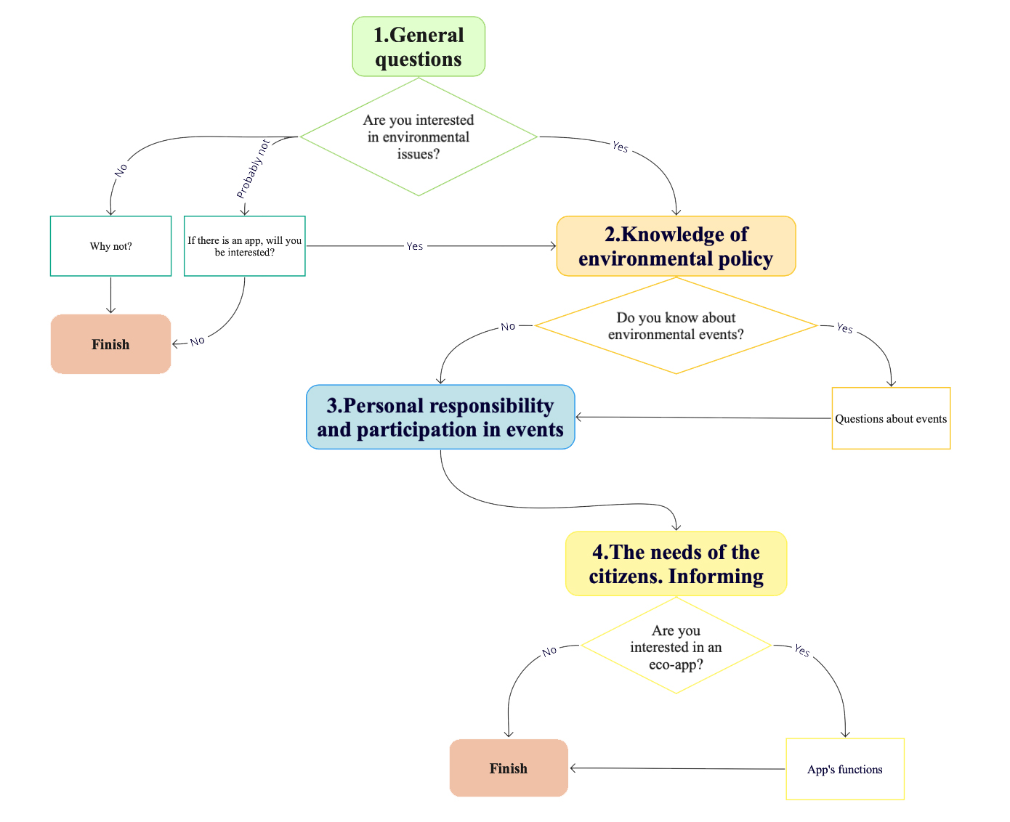
Figure 13 Survey’s design

2.1.2 Research questions
In the course of the study of regulatory documentation and ready-made solutions in the market for environmental education, it became necessary to get feedback from respondents and find out their real knowledge and needs in this matter. This approach is based on the ideology of social marketing and a systematic approach (Kotler, Takahashi, et al. 2009) to assessing the situation. For the study 4 main research questions (RQ) were put forward, which will determine the main directions of environmental policy, as well as ways to improve it, taking into account the interests of residents.
RQ1. There are differences between official statistics and real data.
RQ2. Citizens do not feel their own responsibility for environmental problems.
RQ3. Citizens are not sufficiently aware of the environmental issues.
RQ4. The availability of information affects the engagement of citizens.
Consider the data obtained to confirm or refute the RQ in the next paragraph of the paper.

2.2 Descriptive statistics

2.2.1 Analysis of online survey
According to the survey, 70% of respondents were women. The highest number of responses was given by respondents aged 36-49 years, this number is 37% (figure 14.)

Figure 14 Age structure
Figure 15 shows the distribution of respondents by type of employment: almost 30% of respondents work in a commercial organization, and 20% - in a state organization, and a large proportion of respondents classified themselves as students and a homemaker. The least interested group were schoolchildren and business owners.

Figure 15 Occupation of respondents
RQ1. There are differences between official statistics and real data
Based on the official data of the report on the implementation of improvement programs in St. Petersburg, the positive assessment of the level of improvement was 79.4%, which exceeds the planned values by 8.6%, but our results differ significantly from the official data and account for only 34.7% of positive assessments (4 and 5). It is also worth noting that the survey showed that residents have a low level of satisfaction with the environmental situation in their place of residence, only 22% responded positively. Moreover, 75% believe that the environmental situation has deteriorated (Fig. 14), while official figures indicate little positive change. (Committee on Environmental Management, Environmental Protection and Environmental Safety 2020)

Figure 14 How has the state of the environment changed for the last 5 years?
To the question "How have the environmental parameters changed in the last 5 years?" (fig. 15), the majority of respondents said that the parameters have deteriorated, with the exception of industrial emissions, for which the respondents are not sure. Most of all, people are sure that environmental issues in relation to transport pollution are the most acute, but other indicators are not far behind.
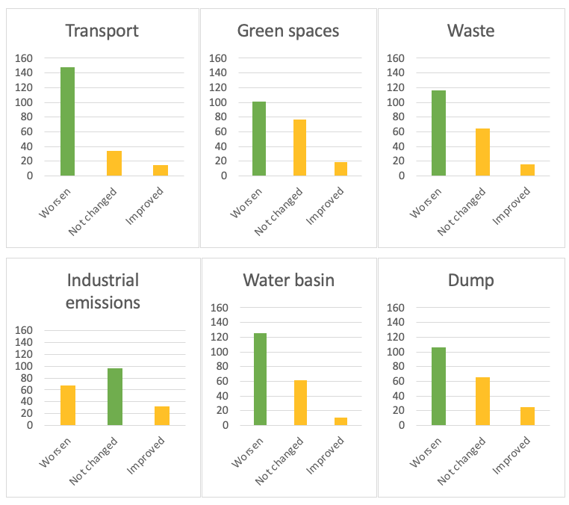
Figure 15 How have the environmental parameters changed in the last 5 years?

RQ2. Citizens do not feel own responsible for environmental issues
In order to answer the second RQ, we will use the results from Figure 16. Almost 50% of respondents are interested in environmental issues. According to the respondents, the responsibility should be borne by the municipal authorities (28%), the population was 19% (this is the 3rd position out of 5). More than half of the respondents are sure that they cannot help the environment, of which 23% are sure of this. Also, respondents define their area of responsibility in the nearby territory (yard), which can serve as useful information when developing recommendations.
Who should be responsible for the state of the environment?
Do you feel responsible for the condition of the environment?
Can you improve the environmental situation?

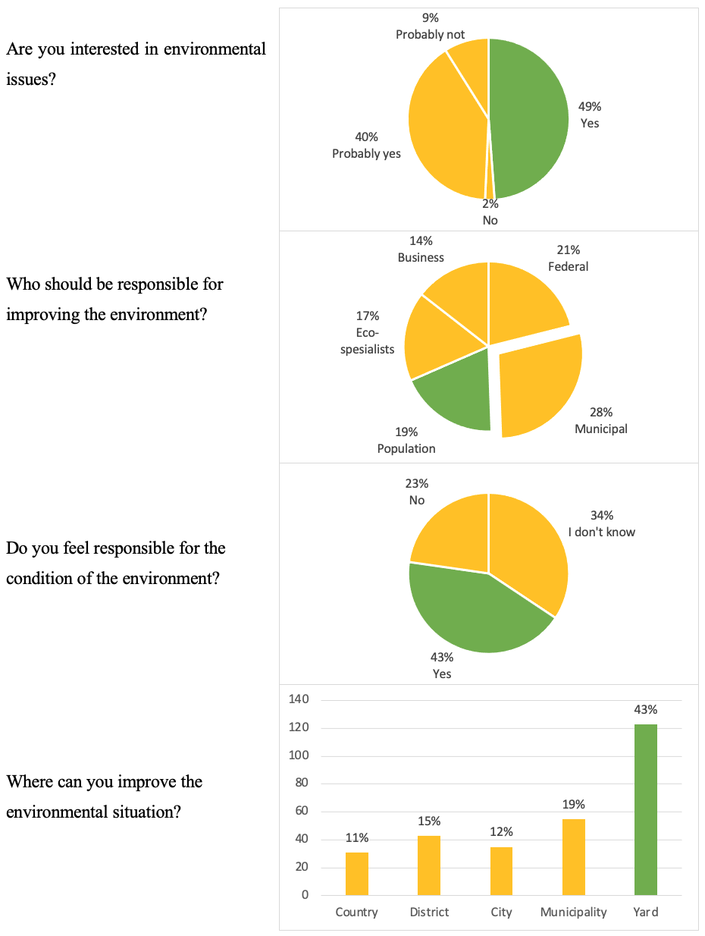
Figure 16 Level of response
The selected area allows to determine the level of responsibility of authorities for the implementation of environmental education. According to the survey, municipal authorities should be the responsible for communication with citizens.

RQ3. Citizens don’t have enough knowledge of environmental issues
More than half of the respondents do not know about the implementation of state projects in support of the environment. The vast majority of respondents (72%) do not know where to turn if there is an environmental problem. However, the issues of environmental measures are covered in more detail.
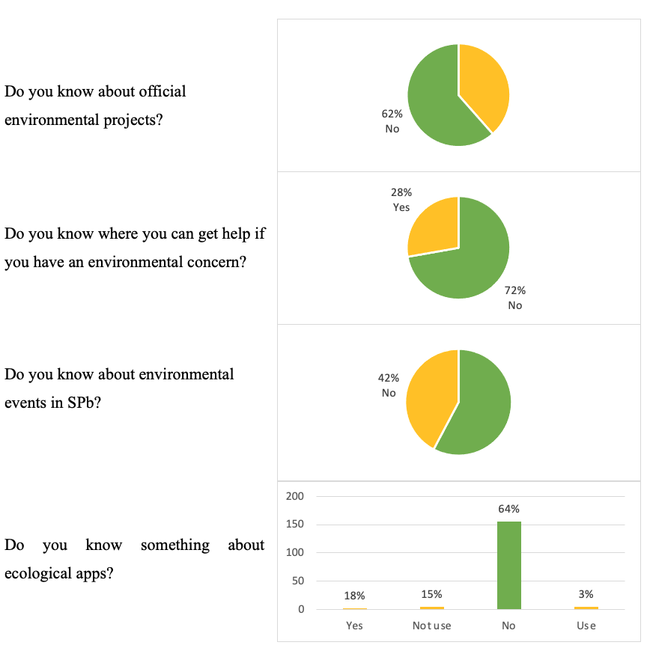
Figure 17 Knowledge of environmental issues
- In addition, respondents noted the need for a feedback function, the ability to submit complaints and receive a response to them.
- Citizens need feedback from the government, as well as reports on the work done.
- It is important for respondents to know how to track the results of their work. For example, reports on waste recycling and sorted waste.

RQ4. The availability of information affects the citizens involvement
In general, respondents equally noted the need for the proposed measures, which indicates their relevance (fig. 18), and more than 50% were interested in an environmental application that contains relevant information (fig. 19).

Which measures are currently needed to improve the environmental situation?

Figure 18 Measures for improving

Are you interested in a multifunctional phone app where you can keep an environmental diary, get up-to-date information about the state of the environment, etc.?

Figure 19 Interested in eco-app
Also, the respondents chose all the proposed functionality, but the most interesting items were those with an assessment of the quality of the environment. In sum, it can be noted that the respondents who responded positively to the desire to use an environmental application are interested in all the proposed functionality almost equally, which indicates the need to provide them with information on environmental issues.

Figure 20 Functions of the eco-app
Thus, based on the survey’s results, we have received information that allows us to identify certain problems in the existing environmental policy process, which is the basis for a more in-depth study of the respondents' responses in order to formulate recommendations for improving the level of involvement of citizens and improving the quality of environmental education.

Analysis by age groups
We will structure the respondents according to their age for further analysis and then determine the main characteristics of groups (Table 4). Respondents aged 18-25 are the least interested in environmental issues, but they are also more satisfied with the level of the environmental situation in their place of residence. The largest number of respondents are aged 36-49 years and make up 37%. The group of this age is characterized by a high interest in environmental issues, and they also believe that the municipal authorities should be the greatest responsibility in environmental issues. Despite the low number of respondents over the age of 60, this group is most aware of the existence of state programs in support of the environment. As a rule, respondents of all groups receive information through social networks, but a smaller part knows about the existence of applications. Also, respondents of all age groups believe that it is necessary to take measures regarding the involvement and increase the level of responsibility of residents in environmental issues. More than 50% of respondents of all age groups, with the exception of people aged 60 and older, are interested in an environmental application that will allow to keep records of personal achievements and get all the necessary information about environmental activities.

Table 4 Analysis by the age groups
 | 0-18 | 18-25 | 26-35 | 36-49 | 50-59 | 60 +
Gender (m/w) | 50% / 50% | 44% / 56% | 33% / 67% | 24% / 76% | 9,5% / 90,5% | 33% / 67%
Interesting in ecology (yes) | 83% | 79% | 92,6% | 91% | 90,5% | 100%
Satisfied with the ecological situation (yes) | 17% | 32,6% | 13% | 21,5% | 28,6% | 20%
Responsibility | Eco specialists, business | Municipal authorities | Municipal authorities | Municipal authorities | Municipal authorities | Municipal authorities
Know eco-programs (yes) | 33% | 41,9% | 35% | 37% | 38% | 60%
Eco-activity | Nature, excursions | Nature, excursions | Nature, excursions, social work | Nature, excursions, social work | Excursions, social work | Lectures, social work, exhibitions
Own responsibility | Municipality, yard | Yard | Yard | Yard | Yard | Yard
Measures | Responsibility, involvement | Eco-culture, involvement | State attention, involvement | Eco-culture, state attention | Responsibility | State attention, responsibility
Know some eco-apps (yes) | 25% | 8,3% | 4,3% | 3,2% | 5,9% | 11,1%
Source of information | Friends and social media | Social media | Social media | Social media | Social media | Social media
Interesting in eco-app (yes) | 80% | 57,9% | 65% | 51% | 50% | 40%

Despite the presence of similar features in all age groups, it is possible to identify clusters with characteristic features that will allow to form recommendations depending on own preferences and improve the effectiveness of environmental education.

2.2.2 Cluster analysis
First of all, cluster analysis was carried out in a hierarchical way, in which the Manhattan metric was used to measure the distance between objects and the Ward method to calculate the distance between clusters. As a result of this clustering, a dendrogram was constructed, shown in the figure. Thus, the graph below shows the presence of four clusters.
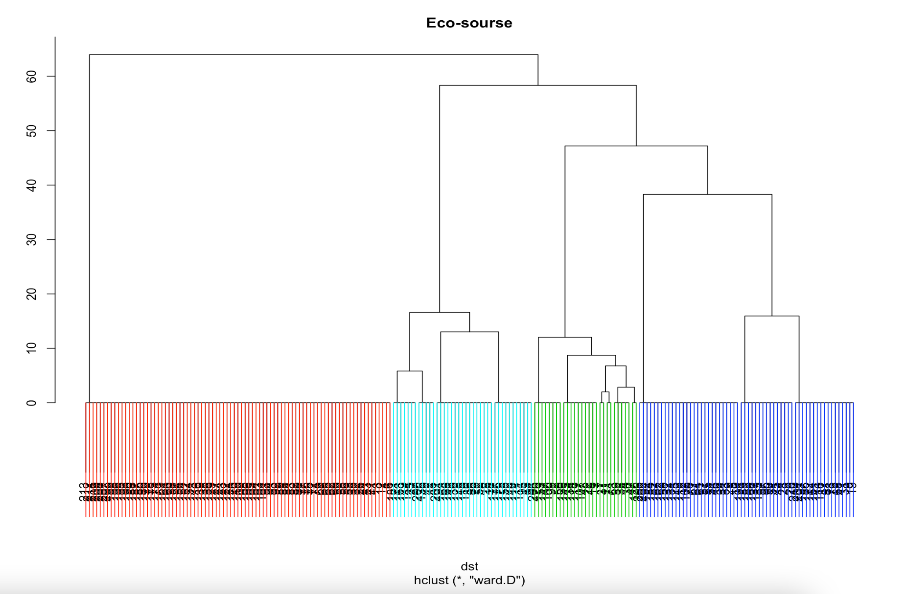
Figure 21 Dendrogram
Then we will consider the main features that are characteristic of each of the 4 clusters and define the names for ease of further use.
- Knowledgeable (40%) this is the most filled group and is determined by knowledge about environmental policies and activities that are carried out in support of the environment.
- Source: SM (social media);
- Age 26-49;
- Most people know about environmental events;
- Most of all accept the responsibility of the citizens;
- Interested in eco-app;
- Interested in events, monitoring and changes, calendar;
- Use eco-app.
- Volunteers (14%) are more ready than others to take part in volunteer projects and in various events.
- Source: friend+SM;
- Age 0-25, 60+;
- Volunteers;
- Interested in diary, event, calendar;
- Use eco-app;
- They are ready to participate in environmental exhibitions, lectures, excursions and tours.
- Passive (28%) respondents less interested in environmental issues than others.
- Source: site+SM;
- Age 36-49;
- The least interested in ecology;
- Interested in events, reports, monitoring and changes;
- They are ready to participate in environmental tours and clean-up of the territory .
- Eco-activists (18%) more than others are ready to take part in all the activities proposed in the survey.
- Source: app+SM+site;
- Age 26-35;
- Most of all are interested in ecology and eco-app;
- Interested in diary, events, reports, monitoring and changes, calendar, interactive map and eco-shops.
Thus, these clusters allow to identify the characteristics that should be useful for developing recommendations. So, referring to the information about the interests of the cluster, it is necessary to develop a specific list of activities and assign responsible and it is also worth paying attention to the interest in the application, since we previously identified its importance as a digital innovation in environmental education.

2.3 Recommendations
As mentioned earlier, the main objectives of environmental education and the formation of environmental culture on the area of St. Petersburg are:
- creation favorable conditions for environmental education;
- creation of an interdepartmental system of interaction between the state authorities of St. Petersburg, organizations and citizens in the implementation of environmental education, and the formation of environmental culture on the territory of St. Petersburg;
- organize interregional cooperation in the field of environmental education.
By defining the direction of development, we can emphasize the need to apply a systematic approach to achieve the best result. Taking into account the data obtained on the implementation of environmental policy in St. Petersburg during the analysis of official documents, we can identify the following areas for improving environmental policy:
- improving policy and legislation: the formation of clear goals that should be achieved within the framework of environmental education policy, the creation of a universal document, a comprehensive regulatory act, the basis for which can serve as the existing Environmental Code of St. Petersburg. The purpose of creating such a document is to develop the fundamental elements of environmental legislation at the federal level, as well as to create and improve regulatory documents of a regional scale, taking into account numerous geographical, biological and socio-economic factors.
- preparation and implementation of specific programs aimed at improving the level of environmental culture, including expanded indicators for evaluating the effectiveness of their implementation, as well as identifying responsible persons for achieving the targets;
- formation and implementation of an action plan taking into account the needs of residents, based on the basics of social and environmental marketing;
- use of modern communication channels to improve the efficiency of information transmission, taking into account the preferences of the audience, based on the considered theory (Maibach 1993);
- introduction of digitalization to solve the problem of effective information of citizens (for example, the introduction of a city mobile application);
- specification and updating of the system of indicators for assessing the effectiveness of environmental education.
- Budget regulation: setting targets and allocating funds to achieve them. They should be in the framework of programs for the implementation of environmental education.
As a method of implementation, a program-target method can be proposed, which makes it possible to adopt a program for the implementation of the issue. Environmental education on the territory of St. Petersburg is carried out by the state authorities of St. Petersburg, local self-government bodies in St. Petersburg, non-profit organizations and public associations, mass media, as well as organizations engaged in educational activities, cultural institutions, museums, libraries, environmental institutions, sports and tourism organizations, and other legal entities. In this connection, it is necessary to link activities that promote environmental education and other activities included in the environmental policy.
Taking into account the data obtained on preferences in environmental activities and the main communication channels, we can identify the main positions for each cluster:
Knowledgeable
- Communication channel: SM;
- Response: Municipal authorities;
- Regular statistical reporting, structuring information, creating an application.

Volunteers
- Communication channel: friend+SM;
- Response: Municipal authorities;
- Ecological activity and involvement, volunteer activities.
Passive
- Communication channel: site+SM;
- Response: Municipal authorities;
- Involvement in environmental activities in the yard and in nature.
Eco-activists
- Communication channel: app+SM+site;
- Response: Municipal authorities;
- Structuring information, creating an application.
Despite the number of areas of implementation, there is no single communication channel where we can find all the relevant information that is understandable to residents of all ages. Also, as the survey showed, residents are interested in the appearance of a multifunctional application or platform, where in an interactive format, it would be possible to get up-to-date information. In order to implement the problem of improving the efficiency of information delivery to the population, as well as the implementation of the policy in the field of environmental education, we propose the introduction of a mobile application as a communication channel between the population, the state, business and environmental activists, as well as other stakeholders. Thus, we need a modern channel that systematizes information and provides it to residents in a convenient format. we can combine the main requests of the clusters:
- structuring information in one place;
- environmental events by interests;
- website (platform) adaptation;
- publish clear reports and statistics;
- interactive map (garbage disposal points, shops, events);
- personal activity.
The solution can be the introduction of digital technologies. Eco-app (figure) is a multifunctional application aimed at solving problems of communication and informing citizens. Due to the tendency to use foreign terms in the names of organizations, we suggest "Eco-App", where the word "App" can be replaced with a short name of the territory for which the application is intended (for example, "Eco-SPb" for St. Petersburg). An example of the logo is shown in Figure 22.
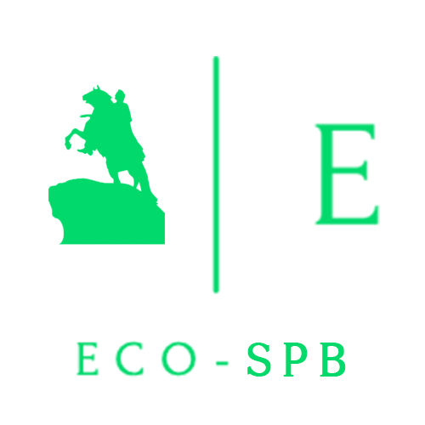
Figure 22 Logo of Eco-app (compiled using the service (TurboLogo 2021))
and Eco-SPb
The purpose of the application is the environmental education and also increasing the level of involvement of citizens in environmental issues.
Eco-app, in other words, is an Environmental Diary-an application for the phone that contains functionality for monitoring personal achievements in the field of ecology and information about all environmental events in the city. The mission is to involve citizens in solving environmental problems through information and self-assessment of personal achievements.
Project objectives:
- to increase the level of ecological culture among different age groups in a particular territory;
- systematize information on the implementation of environmental policy in the territory;
- involve all stakeholders in solving environmental problems;
- creation of a single communication platform within the framework of the implementation of environmental education, etc.
Application functionality:
- taking into account the personal achievements of a city resident in relation to environmental behavior (the number of environmentally positive actions performed, regularity, contribution to the overall solution of environmental problems, etc.). In other words, it is an assessment of the environmental activity of a person through personal entry of data in a diary. As a result, a person forms a general idea of the activities in relation to the environment;
- up-to-date information about ongoing actions, events, volunteer movements, activities of municipal districts, etc. in a single place (calendar of environmental events of the city with the opportunity to apply for participation);
- up-to-date information about the ecological state of the city (using maps from the official website of the committee on environmental policy, etc.);
- environmental reports and regulatory documents;
- environmental lectures;
- the possibility of advertising records of environmental topics from companies;
- map of events, garbage collection points, organizations related to the environment, shops with eco-goods, etc.;
- chat for discussing complaints and events, etc.
Stakeholders:
- Government: implementation of tasks for the formation of environmental culture, popularization of environmental problems, involvement of citizens in solving environmental problems, easier accounting of events and participants;
- Citizens: convenient search for environmental events, accounting for personal contributions, participation in projects, etc.;
- Companies: implementation of corporate environmental policy; advertising of their products and services using green marketing mechanisms, etc.;
- Environmental organizations.
Possible financing options for the application development project:
- budget financing;
- PPP (Merk, et al. 2012), perhaps PPP for people for sustainable development (UNECE 2021).
This project is socially oriented, but attracting commercial organizations and giving them the opportunity to publish their products and services directly related to environmental policy in the application system can be a way to make a profit from the implementation of this project.
A possible application layout that can be implemented and applied in practice is shown in Figure 23. It reflects the stages of registration, functionality: diary, reports, map, calendar of events and events, personal data of organizations responsible for events, etc. This layout can form the basis of a full-fledged application for the implementation of environmental education.
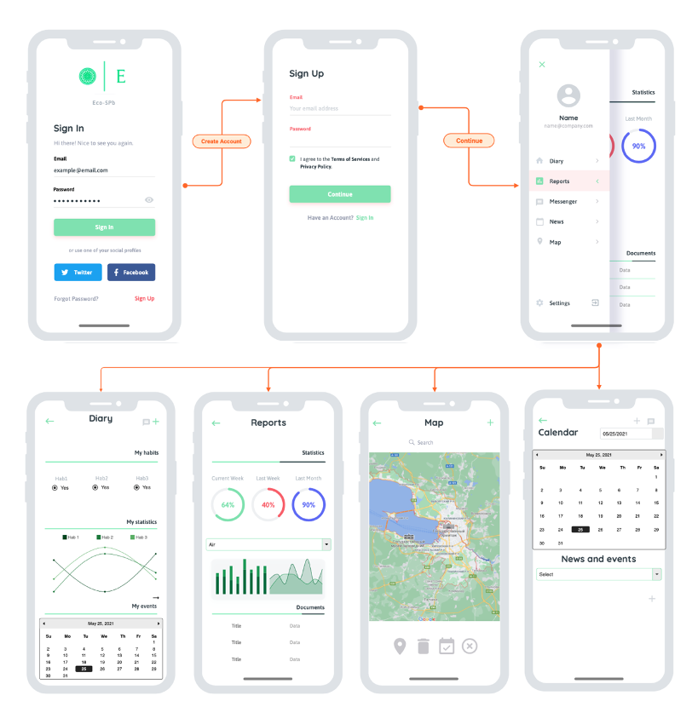
Figure 23 Layout of the environmental application (compiled with the service (Mobile App Wireframe 2021))

As additional developments that can be used to attract an audience and advertise the product, we offer merchandise and diaries shown in figure 24. There might be another products containing the logo and corporate colors of the project.
Figure 24 Branded merch of Eco-App
Project steps:
- setting goals, drawing up a work plan and identifying responsible persons;
- creating technical documentation;
- API and database design;
- mobile app design and development;
- mobile application development for various operating systems;
- system debugging;
- implementation of the application in state systems and promotion among the population.
Below we list the risks that may be present in the development of this project:
- violation of implementation deadlines;
- the difficulty in implementing the project in government structures and the rejection of users;
- low level of use by the population, despite the interest in the application;
- other risks associated with the implementation and promotion of the application.
In order to assess the effectiveness of the policy on environmental education of citizens, including through the environmental application, it is necessary to expand the list of indicators that will determine the quality of its implementation. Let's look at the possible options in more detail:
- percentage of app traffic during the study period;
- the number of people of different age groups who signed up through the app and participated in the events;
- percentage of persons (city residents) interested in environmental issues;
- the percentage of people who assess the level of improvement of the territory by 4 or 5 out of 5 points;
- percentage of people who live in a certain territory and take part in events in support of the environment;
- the number of organizations that regularly publish information in the eco-app;
- percentage of residents who know about the implementation of environmental policy in the territory;
- percentage of garbage collection sites marked on the app map;
- the share of citizens who know about the principles of eco-friendly behavior, etc.
A large part of the information for calculating indicators can be obtained thanks to statistical information from electronic resources and eco-app, the rest of the information is collected through surveys of residents and expert surveys.
Thus, the considered recommendations can be applied to improve the environmental education of the population and increase the level of environmental culture.

Conclusion
Thus, the study emphasizes the importance of human beings in the implementation of environmental policy. One of the policy directions should be the actions aimed on improving the level of environmental culture among the citizens. We have studied the issues of the legal framework of environmental policy, current trends and ways of implementing the policy by various organizations through the use of social marketing mechanisms, the introduction of environmental innovations, the implementation of environmental propaganda, etc. Also, analysis of modern solutions for the implementation of environmental education was carried out and the priority areas of digital technologies in the framework of policy implementation were identified.
In the second chapter, an empirical analysis was conducted. It based on a survey of residents of St. Petersburg and the Leningrad Region and let’s to identify consumer insights and get some answers to the research questions. During the analysis, it was determined that there are differences between official statistics and real data about the satisfaction of residents with the state of environmental indicators and the level of improvement, as well as a rather low level of environmental responsibility among the population and insufficient involvement of citizens in solving environmental problems. Finally, an important conclusion is the insufficient level of information and interaction with the population, which contradicts the ideology of environmental education policy. The cluster analysis carried out in the second chapter allowed us to identify 4 main clusters with some same features and preferences, which formed the basis for recommendations for the further development of event programs and choice of communication channels.
Based on the analysis and the identified positions for improving the implementation of environmental education in St. Petersburg, we put some practical recommendations for improving the efficiency of public authorities (table 5).
Table 5. Recommendations
Directions | Description | Reference
Improving policy and legislation | Setting clear goals that should be achieved within the framework of environmental education policy; creating a universal document, a comprehensive regulatory act, the basis for which can serve as the existing Environmental Code of St. Petersburg. The purpose of creating such a document is to develop the fundamental elements of environmental legislation at the federal level, as well as to create and improve regulatory documents of a regional scale, taking into account numerous geographical, biological and socio-economic factors. | pp. 24-25
 | Budget regulation. Setting targets and allocating funds to achieve them. Setting goals in the framework of programs for the implementation of environmental education. | p. 19
 | Specification and updating the system of indicators to assess the effectiveness of environmental education.  Preparation and implementation specific programs aimed at improving the level of environmental culture, including expanded indicators for evaluating the effectiveness of their implementation, as well as identifying responsible persons for achieving the targets. | pp. 76-77
Application of Social marketing | Using the modern communication channels to improve the efficiency of information transmission, taking into account the preferences of the audience.  (Maibach 1993), (Kotler and Zaltman, Social Marketing: An approach to Planned Social Change 1971). | p. 29 and  survey’s results
Implementation of digital technologies | Introduction of digitalization to solve the problem of effective communication between citizens and authorities (mobile application "Eco-App" or "Eco-SPb"). | pp. 72 - 76

Thus, the research was conducted and recommendations were defined to improve the quality of environmental policy implementation and increase the effectiveness of environmental education, as well as to form a certain vector for ensuring the sustainable development of the territory and solving important social problems.

Literature
2016. " Закон Санкт-Петербурга от 18.07.2016 № 455-88 «Экологический кодекс Санкт-Петербурга»." Электронный фонд правовой и нормативно-технической документации. 06 29. Accessed 12 2020. Закон Санкт-Петербурга от 18.07.2016.
2017. "Указ Президента Российской Федерации от 19.04.2017 г. № 176 «О Стратегии экологической безопасности Российской Федерации на период до 2025 года»." Президент России. 04 19. Accessed 11 11, 2020. http://www.kremlin.ru/acts/bank/41879.
2016. "Закон Санкт-Петербурга «Экологический Кодекс Санкт-Петербурга» (с изменениями на 26 мая 2020 года)." Электронный фонд правовой и нормативно-технической документации. 06 29. Accessed 11 11, 2020. http://docs.cntd.ru/document/456009803.
2016. "Закон Санкт-Петербурга Экологический кодекс Санкт-Петербурга (с изменениями на 26 марта 2021 года)." Электронный фонд правовых и нормативно-технических документов. 06 26. Accessed 11 11, 2020. http://docs.cntd.ru/document/456009803.
2007. "Закон Санкт-Петербурга от 15 июня 2007 года № 265-49 «О земельном контроле за использованием земель в Санкт-Петербурге» (с изменениями на 17 февраля 2017 года)." Электронный фонд правовой и нормативно-технической документации. 06 15. Accessed 11 11, 2020. http://docs.cntd.ru/document/8451977.
2017. "Закон Санкт-Петербурга от 20 декабря 2017 года «Об утверждении Соглашения о взаимодействии между Ленинградской областью и Санкт-Петербургом по вопросу обращения с отходами производства и потребления»." Электронный фонд правовой и нормативно-технической документации. 12 20. Accessed 11 10, 2020. http://docs.cntd.ru/document/556184702.
n.d. Official website of the Administration of St. Petersburg: Annex to the Decree of the Government of St. Petersburg of June 18, 2013 № 400 "On the Environmental Policy of St. Petersburg until 2030 (as amended on June 14, 2017)"; General provisions (paragrap.
A.S.Pushkin. 2013. "Ustyugova E.N. From city ecology to human ecology - 2013 - No. 12-03 - 99-100 p." Bulletin of the Leningrad State University 12-03: 99-100.
Abdrakhmanova, G., K. Vishnevsky, K. Utyatina, and E. Levin. 2020. "Digital technologies in industry and IT industry." НИУ ВШЭ. 05 27. Accessed 12 15, 2020. https://issek.hse.ru/news/368076191.html.
n.d. "Analysis of the components of the National project Ecology and proposals for their improvement - Federal project "Implementation of the best available technologies" (No. 11) ." World Wildlife Fund RF. Accessed 10 16, 2020. https://wwf.ru/upload/iblock/876/ndt.pdf.
n.d. "Annex to the Decree of the Government of St. Petersburg of June 18, 2013 №400 "On the Environmental Policy of St. Petersburg until 2030 (as amended on June 14, 2017)"." Official website of the Administration of St. Petersburg. Accessed 11 10, 2020. https://www.gov.spb.ru/gov/otrasl/ecology/ecopolicy2/.
n.d. Archi.Ru: official site. Urban forests: Melbourne urban greening plan. Accessed 11 17, 2020. URL: https://archi.ru/tech/84750/gorodskie-lesa-plan-melburna-po-ozeleneniyu-goroda.
Auzanneau, Muriel, Philippe Calatayud, Mélanie Gauche, Xavier Ghewy, Marthe Granger, Sophie Margontier, and Eric Pautard. 2017. "10 Key Indicators for Monitoring the Circular Economy." The Monitoring and Statistics Directorate (SOeS).
Banerjee, Dr. Sunmeet. 2008. "Environmental Marketing." IOSR Journal of Business and Management (IOSR-JBM) 2: 70-73. http://www.iosrjournals.org/iosr-jbm/papers/7th-ibrc-volume-2/24.pdf.
n.d. City of Melbourne: Melbourne as a smart city. Accessed 11 17, 2020. https://www.melbourne.vic.gov.au/about-melbourne/melbourne-profile/smart-city/Pages/smart-city.aspx.
n.d. City of Melbourne: Reducing litter. Accessed 11 17, 2020. https://www.melbourne.vic.gov.au/residents/home-neighbourhood/Pages/reducing-litter.aspx.
Committee on Environmental Management, Environmental Protection and Ecological Safety. 2018. "Концепция непрерывного экологического просвещения на территории Санкт-Петербурга." Экологический портал Санкт-Петербурга. http://www.infoeco.ru/assets/f/kontseptsia.pdf.
—. 2021. "Environmental Education." Ecological portal of St. Petersburg: official website. Accessed 11 27, 2020. http://www.infoeco.ru/index.php?id=4467.
—. 2017. Methodological recommendations for local self-government bodies of inner-city municipalities of St. Petersburg on the implementation of the issue of local importance for the implementation of environmental education... Accessed 12 12, 2020. URL: http: //mo-akademicheskoe-spb.ru/mestnaya-vlast/mestnaya-administratsiya/МР%20Ecological%20education_21%2011%202019.pdf.
—. 2021. Thematic maps on the environmental situation in St. Petersburg-St. Petersburg. Accessed 02 2021. https://www.gov.spb.ru/gov/otrasl/ecology/maps/.
Committee on Environmental Management, Environmental Protection and Environmental Safety. 2020. "Report on the environmental situation in St. Petersburg in 2019." Edited by Д.С. Беляев and И.А Серебрицкий. СПб.: ООО «Типография Глори». https://www.gov.spb.ru/static/writable/ckeditor/uploads/2020/08/07/57/doklad_2019.pdf.
n.d. Committee on Environmental Management, Environmental Protection and Environmental Safety. Official group VKontakte. Accessed 12 10, 2020. https://vk.com/infoeco_spb.
D.S.Likhachev. 2007. "Russian culture." (M.: Art-SPb) 92-99.
2018. "Decision of the International Forum of the Scientific Council of the Russian Federation on Human Ecology and Environmental Hygiene." Russian Hygiene and Sanitation 97(11): 1128 .
n.d. "Decree of the President of the Russian Federation of 19.04.2017 № 176 "On the Strategy of ecological safety of the Russian Federation for the period until 2025"." Accessed 11 20, 2020.
n.d. Digitalization of ecology: how will we save the situation? Accessed 11 10, 2020. https://ict2go.ru/news/22974/.
n.d. "Discussion on the implementation of the federal project "BAT Implementation"." Ecology of Russia. Natsproektekologiya.rf. Accessed 10 16, 2020. https://ecologyofrussia.ru/sobitie/diskussiya-o-realizatsii-federalnogo-proekta-vnedrenie-ndt/.
E.Berezina. 2020. The expert called the solution to the garbage problem . 03 04. Accessed 10 2020. https://rg.ru/2020/03/04/ekspert-nazval-reshenie-musornoj-problemy.html.
E.N.Ustyugova. 2013. "From urban ecology to human ecology." Bulletin of the Leningrad State University named after A.S. Pushkin 12-03: 100.
Ecologia Rossii. n.d. Mass media online publication "Ecologia Rossii". Accessed 12 2020. https://ecologyofrussia.ru.
n.d. Environmental dictation. Official site. Accessed 12 10, 2020. https: //ekodiktant.rus.
n.d. FabLab Barcelona: About. Accessed 10 17, 2020. https://fablabbcn.org/about .
2013. Fundamentals of state policy in the field of chemical and biological security of the Russian Federation for the period up to 2025 and beyond. 11 1. Accessed 11 11, 2020. https://www.garant.ru/products/ipo/prime/doc/70423098/.
Belyaev, D. S., and I. A. Serebritsky, . 2020. "Доклад об экологической ситуации в Санкт-Петербурге в 2019 году." SPb.: ООО «Tipografia Glori». Accessed 03 5, 2021. https://www.gov.spb.ru/static/writable/ckeditor/uploads/2020/08/07/57/doklad_2019.pdf.
Gelmanova, Z.S., G.Sh. Zhaksybaeva, and U. Osik. 2016. "Environmental marketing." Environmental technologies 4: 495-498.
Golbraikh, V.B. 2016. "Environmental activism: new forms of political participation." Power and elites 1: 114.
n.d. "GOST R 58875-2020 “Green standards. Greened and maintained roofs of buildings and structures. Technical and environmental requirements "." Electronic fund of legal and regulatory technical documentation. Accessed 11 17, 2020. http://docs.cntd.ru/document/1200173462.
Green patrol. 2021. Green patrol. About the organization. Accessed 2021. http://greenpatrol.ru/ru/ob-organizacii.
—. n.d. "National Environmental Rating 01.09.2020 - 30.11.2020." Green patrol. Official site. Accessed 01 15, 2021. https://greenpatrol.ru/sites/default/files/pictures/prilozhenie_2._ekologicheskiy_reyting_regionov._federalnye_okruga._osen_2020.pdf.
—. 2021. The winter 2020-2021 год, St. Petersburg. Accessed 02 4, 2021. https://greenpatrol.ru/ru/regiony/sankt-peterburg.
Greenpeace. 2021. Greenpeace. Recycle Map. Accessed 2021. https://recyclemap.ru/spb .
iKS-Consulting. n.d. "Smart City Technology Market 2019 - Geographic Structure." iKS-Consulting. Accessed 10 17, 2020. http://survey.iksconsulting.ru/page5160775.html.
n.d. Infoeco. Accessed 12 12, 2020. http://www.infoeco.ru .
Kaminskaya, T.L., I.A. Pomiguev, and N.A. Nazarova. 2019. "Environmental activism in the digital environment as a tool to influence government decisions." Public Opinion Monitoring: Economic and Social Change 5(153): 391.
Kotler, Ph., and G. Zaltman. 1971. "Social Marketing: An approach to Planned Social Change." Journal of Marketing 35: 4-9.
Kotler, Ph., B. Takahashi, D. McKenzie-Mohr, N. Lee, and P. Wesley Schultz. 2009. "Review of «Social Marketing to Protect the Environment: What Works» № 11(1) – pp." Environmental Education and Communication an International Journal 8. 11(1): 141-143.
Litvintseva, G. P., A. V. Shmakov, E. A. Stukalenko, and S. P. Petrov. 2019. "Assessment of the digital component of the quality of life of the population in the regions of the Russian Federation." Terra Economicus 17(3): 107-111.
2020. LiveJournal: Green roofs are what you need now! 05 16. Accessed 11 17, 2020. https://varlamov.ru/3896230.html.
Maibach, Edward W. 1993. "Social marketing for the environment: using information campaigns to promote environmental awareness and behavior change." Health Promotion International 3(8): 209-220.
Merk, O., S. Saussier, C. Staropoli, E. Slack, and J-H Kim. 2012. "Financing Green Urban Infrastructure." OECD Regional Development Working Papers (OECD Publishing).
Mityakov, S.N., O.I. Mityakova, E.S. Mityakov, I.V. Alenkova, and то то то. 2018. "Innovative development of Russian regions: environmental innovations." Innovations 3 (233).
2021. Mobile App Wireframe. Accessed 05 2021. https://app.moqups.com/ovTMNMWkwX/edit/page/ae8fe8eb0.
Nebo.live. 2021. Official site. Nebo.live. Accessed 02 2021. https://ru.nebo.live.
2019. Not rubbish, but a resource. A sustainable waste management system is being created in Russia. 06 5. Accessed 11 18, 2020. https://rg.ru/2019/06/05/v-rossii-sozdaetsia-ustojchivaia-sistema-obrashcheniia-s-othodami.html.
O.Nikiforov. 2019. The "garbage problem" cannot be solved without state support. 12 9. Accessed 11 2020. https://www.ng.ru/ng_energiya/2019-12-09/9_7747_trash.html.
Official website of the Administration of St. Petersburg. 2021. "In the regional year of ecology, many decisions and projects will be aimed at improving the quality of the environment." Official website of the Administration of St. Petersburg. 04 21. Accessed 04 25, 21. https://www.gov.spb.ru/press/governor/212249/.
2017. "Order of the Ministry of Construction and Housing and Communal Serv. of the Russian Federation "On Approval of Methodological Recommendations for the Prep. of Rules for Improvement of Territories of Settlements, Urban Dist, Intracity Dist" №217." Electronic fund of legal and normative-technical documentation. 04 13. Accessed 10 17, 2020. http://docs.cntd.ru/ document / 456060415.
n.d. "Passport of the national project "Ecology"." Ecology of Russia. Natsproektekologiya.rf . Accessed 10 16, 2020. https://ecologyofrussia.ru/document/.
Prokopenko, O.V., and Yu.I. Ossik. 2015. "Green marketing: Teaching manual." (Karaganda: KSU Publishing House) 15.
Rakhmanin, Yu.A. 2016. "Decision of the Plenum of the Scientific Council of the Russian Federation on Human Ecology and Environmental Hygiene ." Russian Hygiene and Sanitation 95(8): 792.
S Anthony Frigon, David Doloreux, Richard Shearmur,. 2020. "Drivers of eco-innovation and conventional innovation in the Canadian wine industry." Journal of Cleaner Production 275.
Shamina, L.K, E.A. Syrneva, and Kulachinskaya A. 2020. "3rd International Scientific and Practical Conference, DEFIN 2020, 19 March 2020 - 20 March 2020." Possibilities of Applying Modern Digital Technologies to Solve Current Environmental Issues.
Smagrinskaya, Yu. 2020. "There will be more green roofs in Moscow." My home is Moscow. 07 13. Accessed 11 17, 2020. https://moydom.moscow/2020/07/13/ozelenennyh-krysh-v-moskve-stanet-bolshe-posle-vvedeniya-novogo-gosta/.
n.d. Smart City VS Smart Citizens: Dutch fundraiser Cohen Bergman - on how technologies will help live in modern cities - Projects and their results. Accessed 10 17, 2020. https://news.itmo.ru/ru/education/trend/news/7885/.
n.d. SmartCity Press: Why Melbourne Is the Most Liveable City On the Planet? Accessed 11 17, 2020. https://www.smartcity.press/melbourne-smart-city-initiatives/.
State Duma of the Russian Federation. 2017. "The results of the year of ecology are summed up." Official cite of State Duma of the Russian Federation. 12 12. Accessed 03 5, 2021. http://duma.gov.ru/news/25872/.
Strelkova, L.V., and Yu.A. Makusheva. 2014. Economics and organization of innovations: theory and practice. M .: Unity-Dana.
Sukhenko, K. E., and S. I. Bogdanov. 2018. "Ecology and culture." Environment of Saint Petersburg 4 (10): 18.
n.d. The implementation of the international project "Climatically Neutral Waste Management" has started in the Voronezh Region. Accessed 11 2020. http://www.mnr.gov.ru/press/news/realizatsii_mezhdunarodnogo_proekta_klimaticheski_neytralnoe_obrashchenie_s_otkhodami_startovalo_v_v/?special_version=Y.
The Ministry of Natural Resources and Ecology of the Russian Federation. 2020. "Passport of the national project " Ecology – Structure of the National Project Ministry of Natural Resources of the Russian Federation." The Ministry of Natural Resources and Ecology of the Russian Federation. 10 16. Accessed 12 2020. https://www.mnr.gov.ru/upload/medialibrary/5e7/ecology.pdf.
2020. The Russians named the main environmental problems of the country. 02 6. Accessed 11 2020. https://www.rbc.ru/politics/06/02/2019/5c59b1709a79478082250bcb.
n.d. Thematic maps on the ecological situation in St. Petersburg. Administration of St. Petersburg. Official site. Accessed 12 11, 2020. https://www.gov.spb.ru/gov/otrasl/ecology/maps/.
n.d. Transpire: Enabling people with vision impairment to navigate independently using beacons. Accessed 11 17, 2020. https://www.transpire.com/our-work/vision-australia/.
2021. TurboLogo. Accessed 05 2021. https://turbologo.ru/designs/4745144.
UNECE. 2021. "Draft version. People-first PPP Evaluation Methodology." UNECE. 01 18. Accessed 05 30, 2021. https://unece.org/sites/default/files/2021-03/UNECE-People-first-PPP-Self-Assessment-Tool-UserGuide-English.pdf.
UnitedNations. 2011. "Green economy in the context of sustainable development and poverty eradication." 11 18. Accessed 12 10, 2020. http://www.cawater-info.net/green-growth/files/ece-rpm-4-r.pdf.
n.d. Vision Australia: About us. Accessed 10 17, 2020. https://www.visionaustralia.org/about-us/who-we-are-and-what-we-do .
n.d. WAAG «Technology & Society»: About us. Accessed 11 17, 2020. https://waag.org/en/about-us.
n.d. WAAG «Technology & Society»: Making Sense: from pilots to Citizen Sensing, a Toolkit! Accessed 11 2020. https://waag.org/en/about-us.
Wendling Z.A., Emerson J.W., de Sherbinin A., Esty D.C., et al. 2020. "Global metrics for the environment: Ranking country performance on sustainability issues." Environmental Performance Index 2020. Accessed 02 3, 2021. https://nonews.co/wp-content/uploads/2020/08/epi2020.pdf.
n.d. "What is being done to implement the national project "Ecology" ." Russian newspaper RG.RU. Accessed 10 16, 2020. https://rg.ru/2019/03/13/chto-delaetsia-dlia-realizacii-nacionalnogo-proekta-ekologiia.html.
WHO. n.d. WHO short questionnaire for assessing the quality of life (WHOQOL-BREF). Accessed 03 5, 2021. https://www.who.int/substance_abuse/research_tools/whoqolbref/ru/.
Yadav, G., S. K. Mangla, A. Bhattacharya, and S Luthra. 2020. "Exploring indicators of circular economy adoption framework through a hybrid decision support approach." Journal of Cleaner Production 277.
Yakobson, A.Ya., and T.K. Kirillova. 2014. Innovation management. Textbook. M .: Omega-L.
Yu., Tishina. 2020. "What results has Russia achieved in the construction of "smart cities"." Kommersant newspaper, 03 31: 7.
Zaitseva D.S., Krakovetskaya I.V. 2016. "Environmental marketing: trends and prospects." Bulletin of the KemSU 2: 57-59.
n.d. ZinCo: Green Roofs System. Accessed 10 17, 2020. https://zinco-greenroof.com/green-roof-systems.
1999. "Распоряжение губернатора Санкт-Петербурга от 15 октября 1999 № 1101-р "О водоохранных зонах и прибрежных защитных полосах водных объектов Санкт-Петербурга" ." Система «Гарант». 10 15. Accessed 11 11, 2020. http://base.garant.ru/8029141/.
2020. "Распоряжение Правительства Санкт-Петербурга от 13 июля 2020 года № 193-р «Об утверждении Территориальной схемы обращения с отходами производства и потребления»." Электронный фонд правовой и нормативно-технической документации. 07 13. Accessed 11 10, 2020. http://docs.cntd.ru/document/565311780.
2008. "Распоряжение Правительства Санкт-Петербурга от 15 апреля 2008 года № 52-р «Об утверждении перечня водных объектов на территории Санкт-Петербурга, подлежащих региональному государственному надзору в области использования и охраны водных объектов»." Электронный фонд правовой и нормативно-технической документации. 04 15. Accessed 11 10, 2020. http://docs.cntd.ru/document/8472531.
2006. "Распоряжение Правительства Санкт-Петербурга от 17 февраля 2006 года № 9-р «Об утверждении методических рекомендаций»." Электронный фонд правовой и нормативно-технической документации. 02 17. Accessed 11 11, 2020. http://docs.cntd.ru/document/8426661.
1994. "Распоряжение мэра-председателя Санкт-Петербурга от 30 августа 1994 года № 891-р «О введении регионального норматива по охране почв в Санкт-Петербурге»." Электронный фонд правовой и нормативно-технической документации. 08 30. Accessed 11 10, 2020. URL: http://docs.cntd.ru/document/9102762.
2018. "Постановление Правительства Санкт-Петербурга от 18 июля 2018 года № 588 «О создании Координационного совета по экологическому просвещению, экологическому образованию и формированию экологической культуры на территории Санкт-Петербурга» (с изм. 7.10.2020)." Электронный фонд правовой и нормативно-технической документации. 07 18. Accessed 11 11, 2020. http://docs.cntd.ru/document/456009803.
2005. "Постановление Правительства Санкт-Петербурга от 4 октября 2005 года № 1508 «О мерах по реализации на территории Санкт-Петербурга Закона Российской Федерации «О недрах» (с изменениями на 9 марта 2017 года)." Электронный фонд правовой и нормативно-технической документации. 10 4. Accessed 11 10, 2020. http://docs.cntd.ru/document/8418353.
2004. "Постановление Правительства Санкт-Петербурга от 6 апреля 2004 года № 530 «О Комитете по природопользованию, охране окружающей среды и обеспечению экологической безопасности (с изменениями на 16 декабря 2016 года)» (утратило силу с 10.03.2017)." Электронный фонд правовой и нормативно-технической документации. 04 6. Accessed 11 10, 2020. http://docs.cntd.ru/document/8393386.
2010. "Постановление Правительства Санкт-Петербурга от 7 октября 2010 года N 1344 «О создании государственной информационной системы в сфере охраны окружающей среды и природопользования «Экологический паспорт территории Санкт-Петербурга»." Электронный фонд правовой и нормативно-технической документации. 10 7. Accessed 11 11, 2020. http://docs.cntd.ru/document/565311780.
2017. "Постановление Правительства Санкт-Петербурга от 9 марта 2017 года № 127 «О мерах по совершенствованию государственного управления в сферах благоустройства, природопользования и охраны окружающей среды и внесении изм. в нек. постан. Правительства СПб»." Электронный фонд правовой и нормативно-технической документации. 03 9. Accessed 11 10, 2020. http://docs.cntd.ru/document/456048278.
2014. "Постановление Правительства от 17 июня 2014 года N 487 О государственной программе Санкт-Петербурга "Благоустройство и охрана окружающей среды в Санкт-Петербурге" (с изменениями на 16 октября 2020 года)." Электронный фонд правовых и нормативно-технических документов. 06 17. Accessed 11 11, 2020. https://docs.cntd.ru/document/822403594.
2020. "Приложение №1. Справка о цифровой гражданской платформе «Страна онлайн» ." Администрация Санкт-Петербурга. Accessed 03 5, 2021. https://www.gov.spb.ru/static/writable/ckeditor/uploads/2020/09/08/59/ФАДН_СТРАНА_ОНЛАЙН.pdf.
n.d. "Приложение к Постановлению Правительства Санкт-Петербурга от 18 июня 2013 года № 400 «Об Экологической политике Санкт-Петербурга на период до 2030 год (с изменениями на 14 июня 2017 года)» Общие положения (п. 1.4)." Официальный сайт Администрации Санкт-Петербурга. Accessed 11 10, 2020. https://www.gov.spb.ru/gov/otrasl/ecology/ecopolicy2/.
2020. "Проект сохранения уникальных водных объектов." Администрация Санкт-Петербурга. Accessed 11 11, 2020. https://www.gov.spb.ru/static/writable/ckeditor/uploads/2020/03/24/23/g8.pdf.
2020. "Национальный проект «Экология»." Администрация Санкт-Петербурга. Accessed 11 11, 2020. https://www.gov.spb.ru/static/writable/ckeditor/uploads/2020/03/24/23/g2.pdf.
2005. "Совместное решение Правительства Санкт-Петербурга и Правительства Ленинградской области от 19 апреля 2005 года №1 «О взаимодействии в сфере обращения с отходами производства и потребления на территории Санкт-Петербурга и Ленинградской области»." Электронный фонд правовой и нормативно-технической документации. 04 19. Accessed 11 10, 2020. http://docs.cntd.ru/document/8413435.
2017. "Соглашение о взаимодействии между Ленинградской областью и Санкт-Петербургом по вопросу обращения с отходами производства и потребления." Комитет Ленинградской области по обращению с отходами. 06 1. Accessed 11 10, 2020. https://waste.lenobl.ru/ru/deiatelnost/soglasheniia-o-sotrudnichestve/.

Appendix 1. Legislation of the environmental policy
Конституция Российской Федерации, Федеральный закон от 10.01.2002 No 7-ФЗ «Об охране окружающей среды», различные кодексы и ФЗ (приложение),
- Земельный кодекс Российской Федерации от 25.10.2001 No 136-ФЗ
- Водный кодекс Российской Федерации от 03.06.2006 No 74-ФЗ
- Лесной кодекс Российской Федерации от 04.12.2006 No 200-ФЗ
- Федеральный закон от 14.03.1995 No 33-ФЗ «Об особо охраняемых природных
территориях»
- Федеральный закон от 04.05.1999 No 96-ФЗ «Об охране атмосферного воздуха»
- Федеральный закон от 24.04.1995 No 52-ФЗ «О животном мире»
- Федеральный закон от 20.12.2004 г. No 166-ФЗ «О рыболовстве и сохранении
водных биологических ресурсов»
- Федеральный закон от 21.02.1992 No 2395-1 «О недрах» (в ред. Федерального
закона от 03.03.1995 No 27-ФЗ)
- Федеральный закон от 24.06.1998 No 89-ФЗ «Об отходах производства и
потребления»
- Федеральный закон от 23.11.1995 No 174-ФЗ «Об экологической экспертизе»
- Федеральный закон от 21.11.2011 No 323-ФЗ «Об основах охраны здоровья
граждан в Российской Федерации»
- Федеральный закон от 30.03.1999 No 52-ФЗ «О санитарно-эпидемиологическом
благополучии населения»
- Федеральный закон от 09.01.1996 No 3-ФЗ «О радиационной безопасности
населения»
- Основы государственной политики в области экологического развития
Российской Федерации на период до 2030 года (утв. Президентом Российской
Федерации 30.04.2012)
- Постановление Правительства РФ от 15.04.2014 No 326 «Об утверждении
государственной программы Российской Федерации «Охрана окружающей
среды»
- Указ Президента РФ от 19.04.2017 No 176 «О стратегии экологической
безопасности Российской Федерации на период до 2025 года»
- Постановление Правительства РФ от 16.03.2016 No 197 «Об утверждении требований к составу и содержанию территориальных схем обращения с
отходами, в том числе с твердыми коммунальными отходами»
- Национальный проект «Экология» (паспорт проекта утвержден президиумом Совета при Президенте Российской Федерации по стратегическому развитию и
национальным проектам, протокол от 24 декабря 2018 No 16)
2) Нормативно-правовые акты Санкт-Петербурга
- Закон Санкт-Петербурга от 18.07.2016 No 455-88 «Экологический кодекс Санкт- Петербурга» (Принят Законодательным Собранием Санкт-Петербурга 29.06.2016)
- Постановление Правительства Санкт-Петербурга от 18.06.2013 No 400 «Об экологической политике Санкт-Петербурга на период до 2030 года»
- Закон Санкт-Петербурга от 17.04.2006 No 155-21 «Об экологическом мониторинге на территории Санкт-Петербурга»
- Закон Санкт-Петербурга от 28.06.2010 No 396-88 «О зеленых насаждениях в Санкт-Петербурге»
- Закон Санкт-Петербурга от 25.12.2015 No 891-180 «О благоустройстве в Санкт- Петербурге»
- Закон Санкт-Петербурга от 23.04.2008 No 254-41 «О разграничении полномочий органов государственной власти Санкт-Петербурга в области обращения с отходами производства и потребления в Санкт-Петербурге»
- Постановление Правительства Санкт-Петербурга от 24.08.2015 No 732 «Об утверждении Порядка организации и осуществления регионального государственного экологического надзора на территории Санкт-Петербурга и внесении изменений в постановление Правительства Санкт-Петербурга от 06.04.2004 No 530»
- Постановление Правительства Санкт-Петербурга от 09.11.2016 No 961 «О Правилах благоустройства территории Санкт-Петербурга и о внесении изменений в некоторые постановления Правительства Санкт-Петербурга»
- Постановление Правительства Санкт-Петербурга от 09.03.2017 No 127 «О мерах по совершенствованию государственного управления в сферах благоустройства, природопользования и охраны окружающей среды и внесении изменений в некоторые постановления Правительства Санкт-Петербурга»
- Постановление Правительства Санкт-Петербурга от 16.12.2016 No 1147 «О Территориальной схеме обращения с отходами, в том числе твердыми коммунальными отходами»
- Распоряжение Комитета по благоустройству Санкт-Петербурга от 30.11.2018 No410-р «Об утверждении Порядка накопления твердых коммунальных отходов (том числе их раздельного накопления) на территории Санкт- Петербурга» (в ред. от 17.05.2019 No 111-р)
- Постановление Правительства Санкт-Петербурга от 17.06.2014 No 487 «О государственной программе Санкт-Петербурга «Благоустройство и охрана окружающей среды в Санкт-Петербурге»
Кроме перечисленных основных нормативно-правовых документов, отдельные вопросы охраны окружающей среды, обеспечения экологической безопасности, экологического просвещения, обращения с твердыми коммунальными отходами регулируются:
- нормативно-правовыми актами международного характера в сфере охраны окружающей среды, ратифицированными Российской Федерацией (например, Рамочная конвенция ООН об изменении климата и Киотский протокол, Конвенция о биологическом разнообразии, Конвенция об охране дикой фауны и природных сред обитания в Европе и т.д.)
- нормативными актами природоохранных министерств, ведомств, органов исполнительной власти (федеральных и Санкт-Петербурга) (постановления, инструкции, приказы, распоряжения и т.д.), детализирующими и уточняющими отдельные вопросы охраны окружающей среды, обеспечения экологической безопасности, экологического просвещения, обращения с твердыми коммунальными отходами.
Например:
- Постановление Правительства Российской Федерации от 13.09.2016 No913 «О ставках платы за негативное воздействие на окружающую среду и дополнительных коэффициентах»
- Постановление Правительства Российской Федерации от 23.06.2016 No572 «Об утверждении Правил создания и ведения государственного реестра объектов, оказывающих негативное воздействие на окружающую среду»
- Постановление Правительства Российской Федерации от 09.08.2013 No681 «О государственном экологическом мониторинге (государственном мониторинге окружающей среды) и государственном фонде данных государственного экологического мониторинга (государственного мониторинга окружающей среды)»
- Постановление Правительства Российской Федерации от 16.05.2016 No422 «Об утверждении Правил разработки и утверждения методик расчета выбросов вредных (загрязняющих) веществ в атмосферный воздух стационарными источниками»
- Приказ Минприроды России от 05.12.2014 No541 «Об утверждении Порядка отнесения отходов I - IV классов опасности к конкретному классу опасности»
- Приказ Минприроды России от 30.09.2011 No792 «Об утверждении Порядка ведения государственного кадастра отходов»
- Административные регламенты Комитета по природопользованию, охране окружающей среды и обеспечению экологической безопасности Правительства Санкт-Петербурга (например, Распоряжение Комитета по природопользованию, охране окружающей среды и обеспечению экологической безопасности Правительства Санкт-Петербурга от 14.06.2016 No140-р «Об утверждении Административного регламента Комитета по природопользованию, охране окружающей среды и обеспечению экологической безопасности по исполнению государственной функции по формированию и обеспечению функционирования территориальных систем наблюдения за состоянием окружающей среды в Санкт-Петербурге»)
- Постановление Правительства Санкт-Петербурга от 22.04.2008 No 451 «О порядке проведения работ по компенсационному озеленению»
- Постановление Правительства Санкт-Петербурга от 28.12.2007 No 1730 «О порядке учета обеспеченности внутригородских муниципальных образований Санкт-Петербурга зелеными насаждениями общего пользования и расчета доступности зеленых насаждений общего пользования» и другие.
- Национальные стандарты (ГОСТ) (например, ГОСТ 17.0.0.01-76 Система стандартов в области охраны природы и улучшения использования природных ресурсов и др.) и другими НПА.

Appendix 2. Questionnaire for residents of St. Petersburg and Leningrad region

Блок 1.
Выберите, пожалуйста, подходящий вариант

Ваш пол:
- Мужчина
- Женщина

Ваш возраст:
- До 18 (не включая)
- 18-25
- 26-35
- 36-49
- 50-59
- 60 и старше

Город/регион
СПб
ЛО

Занятость:
- Учащийся
- Студент
- Самозанятый (ая)
- Работаю в государственном учреждении
- Работаю в некоммерческой организации
- Работаю в коммерческой организации
- Бизнесмен, индивидуальный предприниматель
- Занят(а) домашним хозяйством
- Нахожусь в декретном отпуске, отпуске по уходу за ребенком
- Пенсионер (в том числе по инвалидности, неработающий)
- Безработный(ая)

Участвуете ли Вы в волонтерских проектах:
Да
Нет

Блок 2.

Устраивает ли Вас экологическая ситуация в Вашем городе?
-Да
-Нет
-Не уверен

На Ваш взгляд, состояние окружающей среды в Вашем городе изменилось за последние 5 лет?
- Состояние окружающей среды значительно улучшилось
- Состояние среды улучшилось
- Состояние окружающей среды ухудшилось
- Состояние среды не изменилось
- Затрудняюсь ответить
В какой сфере в наибольшей степени, на Ваш взгляд, проявляются негативные тенденции в состоянии среды?(выберите не более 3 вариантов)
- Плотность транспортного потока
- Сокращение зеленых насаждений
- Увеличение твердых бытовых отходов
- Производственные выбросы заводов
- Загрязнение водоемов
- Несанкционированные свалки

Как Вы считаете, кто должен нести ответственность за состояние окружающей среды в Вашем городе? (проранжируйте по степени возрастания ответственности от 1 до 5)
-федеральные/региональные или государственная власть
-муниципальные или местные органы власти
- население
- специалисты в области экологии
- бизнес и некоммерческие организации

Вас когда-нибудь интересовали вопросы экологии?
Да
Скорее да
Скорее нет
Нет

(Если ответили «нет») Почему не интересуетесь?
- не вижу смысла
- нет времени
- другое ________

(Если ответили «нет») Если бы было приложение, которое давало информацию об экологических проектах, вас бы мог заинтересовать этот вопрос?
-Да (спрашиваем про приложения)
-Нет
-Скорее нет

Оцените уровень благоустройства города, в которым Вы живете по шкале от 1 до 5
5
4
3
2
1

Было бы Вам интересно узнать больше об экологии?
- да
-скорее нет
-нет (завершем) Благодарим за участие

Блок 3.

Знаете ли Вы, что в СПб реализуются государственные программы в поддержку экологии?
Да
Нет
Знаете ли Вы, что в Санкт-Петербурге реализуются следующие подпрограммы? (можно выбрать несколько вариантов)
- "Охрана окружающей среды и обеспечение экологической безопасности"
- "Эффективное управление территориями зеленых насаждений Санкт-Петербурга, сохранение средообразующих, защитных, оздоровительных и полезных функций указанных территорий, а также повышение их потенциала"
- "Региональная программа Санкт-Петербурга в области обращения с отходами, в том числе с твердыми коммунальными отходами"
- "Обеспечение эпизоотического и ветеринарно-санитарного благополучия на территории Санкт-Петербурга"
- "Развитие и содержание объектов благоустройства"
- Не слышал(а)

Знаете ли Вы, что в СПб проводятся экологические мероприятия?
Да
Нет

Откуда Вы узнаете об экологических мероприятиях? (если да)
- официальный сайт государственного учреждения
- страница в соц. сетях государственного учреждения
- новостная лента социальных сетей
- СМИ
- конференции
- учебное заведение/работа
- страницы/группы экологических организаций
- друзья/родственники

Как часто Вы участвуете в мероприятиях в поддержку экологии: (если да)
- 1 раз в год
- 1 раз в 6 месяцев
- 1 раз в месяц
- Несколько раз в месяц
- Меньше 1 раза в год

Как Вы считаете, способны ли Вы улучшить экологическую обстановку в Вашем городе?
- да, могу улучшить
- нет, не могу повлиять
- не знаю

Укажите, в какой мере Вы чувствуете ответственность за состояние окружающей среды в Вашем...?
 | В полной мере | В значительной мере | В незначительной мере | Не чувствую
Стране
Районе
Городе
Муниципальном образовании
Дворе

(если первые 3 ответа в вопросе об экологии) Что вы делаете, чтобы помочь окружающей среде:
- разделяю мусор
- утилизирую старые товары
- стараюсь меньше ездить на машине
- контролирую потребление воды и электроэнергии

Какие меры, на Ваш взгляд, необходимы в настоящее время для улучшения экологической ситуации в городе?
- Увеличение ответственности за загрязнение окружающей среды
- Повышение уровня экологической культуры
- Больше внимания к данным проблемам со стороны власти
- Увеличение вовлеченности населения
- Затрудняюсь ответить

В рамках реализации Программы экологического просвещения в Санкт-Петербурге запланированы мероприятия экологического характера. Пожалуйста, оцените свою готовность принять участие от 0 до 4, где 0 – не готов.
 | 0 | 1 | 2 | 3 | 4
Эко-квесты и игры
Выставки
Кинопоказы
Конкурсы/викторины
Театрализованные постановки
Лекции
Воркшоп/мастер-класс
Экологический диктант
Экскурсии (на заводы по переработке мусора/очистные сооружения и т.д.)
Выезд на природные объекты (посещение особо охраняемых природных территорий, экологических троп и тд.)
Массовые мероприятия (совместная уборка территорий, посадка зеленых насаждений в городских скверах и парках и тд)

Знаете ли Вы, в какие службы и организации необходимо обращаться, если Вы столкнулись с экологической проблемой?
Да
Нет
Блок 4.

Какие приложения Вы чаще всего открываете на телефоне (можно выбрать несколько):
- Социальные сети/ мессенджеры
- Фитнес приложения
- Образовательные/для самообучения
- Планнеры
- Приложения магазинов
- Новостные приложения

Где Вы предпочитаете планировать свои задачи:
- В телефоне
- В обычном ежедневнике
- На компьютере
- Не планирую

Пользуетесь ли Вы каким-нибудь экологическим приложением для телефона:
да
нет

Где Вам больше нравится получать актуальную информацию об экологических мероприятиях:
- друзья/родственники
- социальные сети
- СМИ
- сайты
- приложения

Если бы было отдельное приложение для телефона, Вы бы следили за изменениями в вопросах экологии:
- да
- скорее нет
- нет

Интересно ли Вам многофункциональное приложение для телефона, где можно вести экологический дневник, получать актуальную информацию о состоянии экологии и обо всех мероприятиях в городе?
- да
- скорее нет
- нет

Если да: Выделите, какие функции Вам были бы интересны: (можно выбрать несколько вариантов)

- Учет личных достижений (оценка потребления электроэнергии, водных ресурсов, участие в мероприятиях и др.)
- актуальная информация обо всех экологических мероприятиях в городе
- отчеты и нормативные документы об экологической деятельности города
- актуальная информация об экологическом состоянии города (загрязнение и др.)
- советы и рекомендации по улучшению экологического поведения
- экологические лекции, вебинары
- карта мероприятий
- календарь мероприятий
- список магазинов с экологичными товарами
- другое________

Если нет: Почему не интересно?
- У меня и так есть вся информация
- Не буду пользоваться
- Другое______

Благодарим за участие!

"Приложение к Постановлению Правительства Санкт-Петербурга от 18 июня 2013 года № 400 «Об Экологической политике Санкт-Петербурга на период до 2030 год (с изменениями на 14 июня 2017 года)» Общие положения (п. 1.4)." Официальный сайт Администрации Санкт-Петербурга. Accessed 11 10, 2020. https://www.gov.spb.ru/gov/otrasl/ecology/ecopolicy2/.
"Закон Санкт-Петербурга от 18.07.2016 № 455-88 «Экологический кодекс Санкт-Петербурга»." Электронный фонд правовой и нормативно-технической документации. 06 29. Accessed 12 2020. Закон Санкт-Петербурга от 18.07.2016.
"Приложение к Постановлению Правительства Санкт-Петербурга от 18 июня 2013 года № 400 «Об Экологической политике Санкт-Петербурга на период до 2030 год (с изменениями на 14 июня 2017 года)» Общие положения (п. 1.4)." Официальный сайт Администрации Санкт-Петербурга. Accessed 11 10, 2020. https://www.gov.spb.ru/gov/otrasl/ecology/ecopolicy2/.
"Приложение к Постановлению Правительства Санкт-Петербурга от 18 июня 2013 года № 400 «Об Экологической политике Санкт-Петербурга на период до 2030 год (с изменениями на 14 июня 2017 года)» Общие положения (п. 1.4)." Официальный сайт Администрации Санкт-Петербурга. Accessed 11 10, 2020. https://www.gov.spb.ru/gov/otrasl/ecology/ecopolicy2/.
"Постановление Правительства Санкт-Петербурга от 4 октября 2005 года № 1508 «О мерах по реализации на территории Санкт-Петербурга Закона Российской Федерации «О недрах» (с изменениями на 9 марта 2017 года)." Электронный фонд правовой и нормативно-технической документации. 10 4. Accessed 11 10, 2020. http://docs.cntd.ru/document/8418353.
"Постановление Правительства Санкт-Петербурга от 6 апреля 2004 года № 530 «О Комитете по природопользованию, охране окружающей среды и обеспечению экологической безопасности (с изменениями на 16 декабря 2016 года)» (утратило силу с 10.03.2017)." Электронный фонд правовой и нормативно-технической документации. 04 6. Accessed 11 10, 2020. http://docs.cntd.ru/document/8393386.
"Постановление Правительства Санкт-Петербурга от 9 марта 2017 года № 127 «О мерах по совершенствованию государственного управления в сферах благоустройства, природопользования и охраны окружающей среды и внесении изм. в нек. постан. Правительства СПб»." Электронный фонд правовой и нормативно-технической документации. 03 9. Accessed 11 10, 2020. http://docs.cntd.ru/document/456048278.
"Совместное решение Правительства Санкт-Петербурга и Правительства Ленинградской области от 19 апреля 2005 года №1 «О взаимодействии в сфере обращения с отходами производства и потребления на территории Санкт-Петербурга и Ленинградской области»." Электронный фонд правовой и нормативно-технической документации. 04 19. Accessed 11 10, 2020. http://docs.cntd.ru/document/8413435.
"Закон Санкт-Петербурга от 20 декабря 2017 года «Об утверждении Соглашения о взаимодействии между Ленинградской областью и Санкт-Петербургом по вопросу обращения с отходами производства и потребления»." Электронный фонд правовой и нормативно-технической документации. 12 20. Accessed 11 10, 2020. http://docs.cntd.ru/document/556184702.
"Соглашение о взаимодействии между Ленинградской областью и Санкт-Петербургом по вопросу обращения с отходами производства и потребления." Комитет Ленинградской области по обращению с отходами. 06 1. Accessed 11 10, 2020. https://waste.lenobl.ru/ru/deiatelnost/soglasheniia-o-sotrudnichestve/.
"Распоряжение Правительства Санкт-Петербурга от 13 июля 2020 года № 193-р «Об утверждении Территориальной схемы обращения с отходами производства и потребления»." Электронный фонд правовой и нормативно-технической документации. 07 13. Accessed 11 10, 2020. http://docs.cntd.ru/document/565311780.
"Распоряжение Правительства Санкт-Петербурга от 15 апреля 2008 года № 52-р «Об утверждении перечня водных объектов на территории Санкт-Петербурга, подлежащих региональному государственному надзору в области использования и охраны водных объектов»." Электронный фонд правовой и нормативно-технической документации. 04 15. Accessed 11 10, 2020. http://docs.cntd.ru/document/8472531.
"Распоряжение мэра-председателя Санкт-Петербурга от 30 августа 1994 года № 891-р «О введении регионального норматива по охране почв в Санкт-Петербурге»." Электронный фонд правовой и нормативно-технической документации. 08 30. Accessed 11 10, 2020. URL: http://docs.cntd.ru/document/9102762.
"Распоряжение Правительства Санкт-Петербурга от 17 февраля 2006 года № 9-р «Об утверждении методических рекомендаций»." Электронный фонд правовой и нормативно-технической документации. 02 17. Accessed 11 11, 2020. http://docs.cntd.ru/document/8426661.
"Постановление Правительства Санкт-Петербурга от 7 октября 2010 года N 1344 «О создании государственной информационной системы в сфере охраны окружающей среды и природопользования «Экологический паспорт территории Санкт-Петербурга»." Электронный фонд правовой и нормативно-технической документации. 10 7. Accessed 11 11, 2020. http://docs.cntd.ru/document/565311780.
"Закон Санкт-Петербурга от 15 июня 2007 года № 265-49 «О земельном контроле за использованием земель в Санкт-Петербурге» (с изменениями на 17 февраля 2017 года)." Электронный фонд правовой и нормативно-технической документации. 06 15. Accessed 11 11, 2020. http://docs.cntd.ru/document/8451977.
"Закон Санкт-Петербурга «Экологический Кодекс Санкт-Петербурга» (с изменениями на 26 мая 2020 года)." Электронный фонд правовой и нормативно-технической документации. 06 29. Accessed 11 11, 2020. http://docs.cntd.ru/document/456009803.
"Национальный проект «Экология»." Администрация Санкт-Петербурга. Accessed 11 11, 2020. https://www.gov.spb.ru/static/writable/ckeditor/uploads/2020/03/24/23/g2.pdf.
"Проект сохранения уникальных водных объектов." Администрация Санкт-Петербурга. Accessed 11 11, 2020. https://www.gov.spb.ru/static/writable/ckeditor/uploads/2020/03/24/23/g8.pdf.
"Указ Президента Российской Федерации от 19.04.2017 г. № 176 «О Стратегии экологической безопасности Российской Федерации на период до 2025 года»." Президент России. 04 19. Accessed 11 11, 2020. http://www.kremlin.ru/acts/bank/41879.
"Постановление Правительства Санкт-Петербурга от 18 июля 2018 года № 588 «О создании Координационного совета по экологическому просвещению, экологическому образованию и формированию экологической культуры на территории Санкт-Петербурга» (с изм. 7.10.2020)." Электронный фонд правовой и нормативно-технической документации. 07 18. Accessed 11 11, 2020. http://docs.cntd.ru/document/456009803.
"Постановление Правительства от 17 июня 2014 года N 487 О государственной программе Санкт-Петербурга "Благоустройство и охрана окружающей среды в Санкт-Петербурге" (с изменениями на 16 октября 2020 года)." Электронный фонд правовых и нормативно-технических документов. 06 17. Accessed 11 11, 2020. https://docs.cntd.ru/document/822403594.
Комитет по природопользованию, охране окружающей среды и обеспечению экологической безопасности Правительства Санкт-Петербурга. Методические рекомендации для органов местного самоуправления внутригородских муниципальных образований Санкт-Петербурга по реализации вопроса местного значения по осуществлению экологического просвещения, а также организации экологического воспитания и формирования экологической культуры в области обращения с твердыми коммунальными отходами – URL: http://mo-akademicheskoe-spb.ru/mestnaya-vlast/mestnaya-administratsiya/МР%20Экологическое%20просвещение_21%2011%202019.pdf (дата обращения 11.11.2020)
"Закон Санкт-Петербурга Экологический кодекс Санкт-Петербурга (с изменениями на 26 марта 2021 года)." Электронный фонд правовых и нормативно-технических документов. 06 26. Accessed 11 11, 2020. http://docs.cntd.ru/document/456009803.
"Распоряжение губернатора Санкт-Петербурга от 15 октября 1999 № 1101-р "О водоохранных зонах и прибрежных защитных полосах водных объектов Санкт-Петербурга" ." Система «Гарант». 10 15. Accessed 11 11, 2020. http://base.garant.ru/8029141/.
"Приложение №1. Справка о цифровой гражданской платформе «Страна онлайн» ." Администрация Санкт-Петербурга. Accessed 03 5, 2021. https://www.gov.spb.ru/static/writable/ckeditor/uploads/2020/09/08/59/ФАДН_СТРАНА_ОНЛАЙН.pdf.
Belyaev, D. S., and I. A. Serebritsky, . 2020. "Доклад об экологической ситуации в Санкт-Петербурге в 2019 году." SPb.: ООО «Tipografia Glori». Accessed 03 5, 2021. https://www.gov.spb.ru/static/writable/ckeditor/uploads/2020/08/07/57/doklad_2019.pdf.

