Federal State Institution of Higher Professional Education
Saint Petersburg State University
Graduate School of Management

Diploma Thesis
Anti-counterfeiting strategy of Louis Vuitton on the Russian market

The 4th year student of the bachelor program,
International Management,
Panfilova Mariia

Scientific advisor:
Verkhovskaya Olga
Associate Professor of the Department of Strategic
and International Management

Reviewer:
Klyomina Tatyana
Associate Professor of the Department of Strategic
and International Management

Mark of the scientific advisor
Of the work’s correspondence to the requirements,

« ___» ____________ 2021

Saint Petersburg
2021

Statement on the independent completion of the course work

I, Panfilova Mariia Dmitriyevna, the fourth-year student of direction Management (International Management), I declare that in my diploma thesis, on the topic “Anti-counterfeiting strategy of Louis Vuitton on the Russian market” submitted to the bachelor program office for public protection, does not contain elements of plagiarism.
All direct borrowings from printed and electronic sources, as well as from previously curated and final qualification works, candidate and doctoral dissertations have relevant references.
I know that according to paragraph 12.4.14 of the "Rules of Education at the GSOM SPBU Bachelor's Program" the discovery in the WRC of the student of elements of plagiarism (contextual or direct borrowing of text from printed and electronic original sources, as well as from previously protected final qualification papers, Ph.D. dissertations without appropriate references) is the basis for the presentation of the HAC evaluation "unsatisfactory".

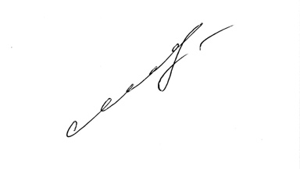
________________________________________ (Student's signature)
________________02.06.2021_______________ (Date)

Table of contents
INTRODUCTION 5
The relevance of the topic 5
Research goal 6
Research objectives 6
Research object 6
Research subject 7
Methodology overview 7
Description of the sources of information used 7
Structure 8
PART 1. ANALYSIS OF THE COMPANY 10
1.1. Company’s description 10
1.2. Anti-counterfeiting strategy of Louis Vuitton 17
Conclusion 21
PART 2. SPECIFICITIES of COUNTERFEITING AND LUXURY FASHION SEGMENT 23
2.1. The nature of counterfeit 23
2.2. Consumers’ intentions and behavior toward counterfeit and luxury goods 28
2.3. Strategies of fighting against counterfeiting activity 33
2.4. Role of governmental regulations in the process of elimination counterfeiting activities 39
2.5 Famous brands’ anti-counterfeiting experience 40
Conclusion 41
PART 3. DESCRIPTION OF THE COUNTERFEITING ON THE RUSSIAN MARKET 42
3.1. Reasons for counterfeiting in Russia 42
3.2. Current situation 43
3.3. Stakeholder analysis 45
3.4. Regulations 48
3.5. PESTEL analysis 49
3.6. Survey Analysis 55
3.7. Interview analysis 61
Conclusion 64
PART 4. RECOMMENDATIONS FOR LOUIS VUITTON ON THE RUSSIAN MARKET 66
CONCLUSION 70
References 73
Appendix 79

INTRODUCTION
Clothing appeared together with the appearance of man on the Earth, so that as human society developed, clothing became more complex and acquired various features. The characteristics and forms of clothing have always reflected the people’s lives, their culture. Fashion is an essential part of every person in the world. People wear clothes on a daily basis that ranges in price, quality, color, and social value.
It is worth mentioning that fashion influences people’s mind in many aspects. It sets the attitude not only in terms of the appearance of people, but also it determines their views, their behavior. People, who follow trends, have goals. They subconsciously want to express themselves, to attract attention to themselves and to their tastes. The importance of fashion is great, it unites people because of their demand for style and beauty, and this desire will always make a person better.
In this paper the whole fashion industry won’t be considered, the focus is on the luxury fashion segment and its anti-counterfeiting strategies. The reason for that is because the counterfeiting activity possesses a great threat for the whole premium fashion industry. It is important for companies to understand consumer behavior and to put a great emphasis on formulation of right strategies in order to avoid financial and reputational losses because of fakes.
In this paper threats possessed by counterfeiting will be considered as well as preventive measures proposed by government, and companies themselves. The conclusions will be made based on both primary and secondary data.

The relevance of the topic
Louis Vuitton is one of the most copied brands in the world. The brand realizes that counterfeiting is one of the main threats for their brand image, profit, and business existence as a whole. It is necessary to control the appearance of illegal goods on the market for many reasons because it involves not only brand manufacturers and business representatives, but also ordinary people, the national economy, and society as a whole.
Counterfeits affect the effectiveness of the companies’ operations, ethics of consumer behavior, and sustainable development principles. In addition, by buying a counterfeit, people thereby condone the prosperity of the shadow economy and allow illegal entrepreneurs to earn income. At the same time, the sale of counterfeit products incentivizes the shadow machine of materialism: there is no secret that thoughts about things and the desire to buy them have filled people's minds. Moreover, those thoughts are usually supported by the media and social networks. This is what we are constantly told from TV screens, it is taught by bloggers and other opinion leaders, and advertising campaigns of certain products. As a result, people tend to buy things they like not taking into consideration the consequences. All these external factors force people to buy brands, but in case they do not have enough financial resources, they buy counterfeits to stay trendy and respectable.
The most uneven victim of counterfeiting activity is the national economy. It happens in a way that fake firms’ transactions are not registered, therefore, GDP level decreases, taxes are not paid and overall country’s well-being suffers.
Therefore, there is a reason to assess the risks possessed by the counterfeits production, theoretical strategic approaches and counterfeits fighting leaders of luxury segment that are used for prevention of counterfeiting activity, and identify key features of consumer behavior, which force people to support this type of illegal activity, and, as a result, provide recommendations for companies based on primary and secondary data, and research with the purpose of risk reduction on the Russian market.

Research goal
The goal of this paper is to form recommendations for Louis Vuitton in the process of combating counterfeits on the Russian market.

Research objectives
- To assess current performance, position and relationships with counterfeiting of Louis Vuitton;
- To outline the results of the LVMH (Louis Vuitton) anti-counterfeiting activity;
- To outline the specificities of the counterfeits and luxury fashion segments;
- To identify consumers’ incentives in the process of buying counterfeits and luxurious goods on the Russian market;
- To outline existing strategies and anti-counterfeiting governmental regulations;
- To identify specificities of the Russian market of the textile industry segment, and find out how companies can benefit or suffer from them;
- To assess whether Louis Vuitton’s strategies are effective on the Russian market;
- To provide strategic recommendations for luxury fashion companies and Louis Vuitton on the Russian market.

Research object
In the first chapter of the paper, I am going to analyze the anti-counterfeiting strategies of Louis Vuitton, therefore, the research object is a following:
Louis Vuitton (LVMH Group)
Louis Vuitton is a French brand specializing in the production of suitcases and bags, fashion clothing, perfumes and luxury accessories under the same brand name. The fashion house was founded in 1854 by Louis Vuitton. Nowadays Louis Vuitton is a part of big holding LVMH (Louis Vuitton Moet Hennessy). Louis Vuitton and Moet Hennessy merged in 1987.
LVMH is a French multinational company, a well-known manufacturer of luxury goods under the brands Christian Dior, Louis Vuitton, Givenchy, Guerlain, Moët & Chandon, Hennessy, Chaumet, etc. The head office of LVMH Group is located in Paris. LVMH group includes 75 unique brands that combine unique craftsmanship, carefully preserved heritage, and modern trends.
This company is the illustration of thoughtful strategy and practices in the process of fighting against counterfeiting activity.

Research subject
Anti-counterfeiting strategies were chosen as a subject of this research.
Counterfeits possess a great threat to businesses, society, and the world as a whole. Theorists, government and companies are constantly working on development of a set of actions that can reduce the impact of such fraudulent activities.

Methodology overview
This paper is a consulting project. I’ve chosen one of the most copied brands in the world. Louis Vuitton puts a great emphasis on protection of intellectual property and elimination of adverse consequences possessed by counterfeiting activity. In this research, I will provide recommendations for Louis Vuitton in terms of adaptation and the best use of their strategy on the Russian market. I am going to use primary and secondary data to draw the right conclusion and make worthy strategic recommendations with the help of existing literature, interviews and survey results made on my own. I am aimed at the production of contextual real-world knowledge about the behaviors, social structures, and shared beliefs of a sample group of people.
The methods of data collection will help me to identify the incentives of consumers, as well as the nature of industries and companies, and to come to the right strategy that will be the most effective for considering companies and the market.

Description of the sources of information used
Primary data gathering
- I am going to conduct a survey in order to identify the incentives of Russian consumers in the process of buying luxurious goods or counterfeits, and whether Louis Vuitton’s world approach of fighting against fake production is appropriate for the market in question. The main goal of the survey is to achieve a clear result that can explain the key reasons that incentivize consumers to buy original or fake products, and consumers’ readiness to use already existing anti-counterfeiting approaches for purchasers of Louis Vuitton.
Sample: The sample group consists of 130 people and will include people of different ages, occupations, social statuses.
The participants of the survey will be sent a Google Forms questionnaire with a sheet of detailed information about the research. The respondents will be achieved via social networks, and personal networks. Participation in this focus group presents no potential risks to the participants. Participants and their organizations will not be named in subsequent write-ups and material submitted for publication.
- Interview
I am going to conduct an interview with the representatives of LVMH Group in Russia and France. The interview will reveal whether the approaches of Louis Vuitton Moet Hennessy are similar for all countries of existence, or not. In addition, this type of primary data gathering will help to assess the effectiveness of LVMH’s strategies on the Russian market.
Secondary data gathering
The literature provided in the paper contains valuable knowledge and managerial approaches connected to the diploma topic and will help to draw the right conclusions and find worthy solutions. In addition, the list of literature includes papers, describing the nature of both textile industry’s segments and cross-country consumers’ incentives in the buying processes.

Structure
In order to achieve the goal of the paper I will use the following algorithm:
- Description of Louis Vuitton brand and LVMH Group and its anti-counterfeiting strategies
It is important to have a vision of existing Louis Vuitton’s strategies targeted at fighting against counterfeits with the purpose of testing them on the Russian market and understanding advantages and disadvantages.
- Analysis of counterfeiting nature and its influence on luxury fashion segment
Primarily, it is important to understand the peculiarities of counterfeiting with its incentives, manufacturing and distribution processes. Secondly, assess all threats possessed by the illegal business and possible consequences.
- Assessment of consumer behavior in the process of decision-making whether to buy a fake product or an original one
Demand forms the supply, therefore, if the counterfeiting is growing at a very fast pace, demand grows first. So that luxury goods companies should understand consumers’ intentions to buy fakes and try to do their best to fulfill the needs covered by counterfeiting firms.
- Description of the existing anti-counterfeiting measures and strategies
Theoretical background and other secondary sources will be used to identify the wide range of existing strategies. Some of them prove to be useful, some of them are not, however, market factors play an important role in this question.
- Analysis of the Russian market counterfeiting environment
Based on the literature review, and PESTEL analysis it will be easy to identify the peculiarities of counterfeiting business on the Russian market, and further choose the best strategy for the needs of Russian environment.
- Survey analysis and results
Assessment of consumer preferences on the Russian market in relation to counterfeits and original production is extremely important in the process of formulation of right strategies and elimination of risks possessed by counterfeits manufacturers.
- Interview analysis
This type of primary data gathering allows the research to go deeper and get insider information with the purpose of formulating anti-counterfeiting recommendations for Louis Vuitton on the Russian market.
- Development of the best anti-counterfeiting strategy for the Russian market
With the theoretical background, primary data gathering, and experience of worldwide-known companies it would be reasonable to form the best managerial recommendations for the companies in the luxury fashion segment and for Louis Vuitton (LVMH Group).

PART 1. ANALYSIS OF THE COMPANY

1.1. Company’s description
Louis Vuitton is a French “Maison” specializing in the production of suitcases and bags, fashion clothing, perfumes and luxury accessories under the same brand name. The fashion house was founded in 1854 by Louis Vuitton. Initially the company operated as a suitcase manufacturer. Napoleon III's wife was the first influential female who made Vuitton famous. Thanks to her, the name of Louis Vuitton sounded among the Parisian elite, and later became a sign of luxury throughout Continental Europe. The designers, who made the brand so famous are Louis Vuitton, Georges Vuitton, Gaston-Louis Vuitton, Henri Racamier, Yves Carsel, Marc Jacobs, Paul Helbers, Kim Jones, Nicolas Guesquiere, and Virgil Abloh. Nowadays, Nicolas Guesquiere is responsible for female collections, while Virgil Abloh is responsible for male ones.
Louis Vuitton continues designing luggage, but nowadays the range of products provided is much wider. The brand designs and sells bags, leather wallets and accessories, fragrances, clothes, accessories, footwear, jewelry, watches, and luggage. In addition, they provide customization services, so that Louis Vuitton prints special titles on bags or clothes or customizes clothes.
Nowadays Louis Vuitton is a part of big holding LVMH (Louis Vuitton Moet Hennessy). Louis Vuitton and Moet Hennessy merged in 1987. LVMH, the world’s leading luxury products group, gathers 75 prestigious brands, with 44.7 billion euros revenue in 2020 and a retail network of over 5,000 stores worldwide.
LVMH is a strong brand that is built upon key values of the company, they are the following: delivering excellence, being creative and innovative, cultivating an entrepreneurial spirit, taking action to make a difference. According to LVMH official website, the company hires 150,479 employees. These employees are inspired and driven by the key values mentioned above.

1.1.1. Strategy
Strategy is a comprehensive managerial plan that should strengthen the company's position on the market and ensure coordination of efforts, attracting and satisfying consumers, successful competition and achieving global goals. At the same time the strategic vision reflects the future of the company, and the mission - the present. It is important to understand the current strategy in order to provide further solutions and recommendations for the company.
The brand in question is Louis Vuitton. All of the decisions for this brand come from the LVMH Group management. To understand the strategic direction of the LVMH, let’s have a look at the mission, vision and business model of the company.
Mission: “to represent the most refined qualities of Western "Art de Vivre" around the world. LVMH must continue to be synonymous with both elegance and creativity. Our products, and the cultural values they embody, blend tradition and innovation, and kindle dream and fantasy.” (Comparably. com (n.d.))
Vision: “LVMH has successfully preserved a family spirit that places priority on long-term vision. The Group’s vocation is to ensure the development of each of its Houses while respecting their identities and their autonomy, providing the resources needed to create, produce and market their products and services through carefully selected channels. The three fundamental values articulated by Bernard Arnault are shared by every member of LVMH. These three imperatives inspire excellence and constitute the pillars of our performance and long-term success.” (Comparably.com (n.d.))
Business model: “Our business model is anchored in a long-term vision that builds on the heritage of our Houses and stimulates creativity and excellence. This model drives the success of our Group and ensures its promising future.” (lvmh.com (2021)) The company is focused on questions regarding ethics, environmental and social responsibility, fulfilling the needs of all stakeholders. Their unique operating model is based on 6 pillars: decentralized organization, vertical integration, sustaining savoir-faire, organic growth, creating synergies, balance across business segments.
Corporate social responsibility, on the one hand, allows the company to build a constructive dialogue with various sectors of society, on the other hand, it is an effective tool for the company's self-development. In addition, it helps to fulfill the needs and demands of the organization's internal and external stakeholders.
LVMH pays a lot of attention to the sustainability questions. It has a program, which is called LIFE (LVMH Initiatives for the Environment). It includes a wide range of actions and activities targeted at creation of a sustainable future for the luxury world. Examples of action and principles according to the LIFE program are the following:
- Sourcing responsibly
- Acting on climate change
- Commiting to circular creativity
- Fostering diversity and inclusion
- Supporting communities
- Developing “savoire-faire”
As a result, according to FashionUnited.uk (2018), Louis Vuitton has been awarded the Butterfly Mark by Positive Luxury for excellence across areas of innovation, social and environmental practices, governance, and philanthropy.

1.1.2. Current position of LVMH
Louis Vuitton Moet Hennessy (LVMH) operates in 80 countries worldwide. From Figure 1 it is evident that for the year 2020 Asia, excluding Japan, is the most successful market for the LVMH in terms of revenue and number of stores. But the overall map and scope of operation is rather impressive. It is evident that LVMH succeeded to grow a strong well-known brand, and the company is not going to stop.

- LVMH geographic footprint
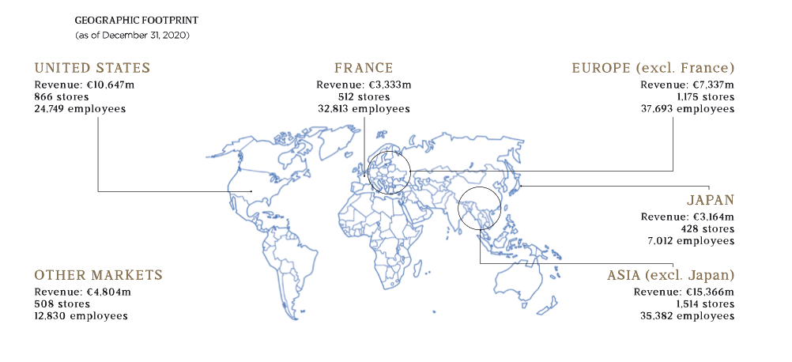
Source:https://hosting.fluidbook.com/LVMH/2020interactiveannualreport/en/#/page/2

Figure 2 below shows the shares of companies that are connected to LVMH. It is evident that almost the whole brand Louis Vuitton belongs to Louis Vuitton Moet Hennessy (99,9%). It means that decision-making processes in all systems and departments, as well as formulation of strategies and positioning on the market of Louis Vuitton depend on the decisions of LVMH Group.

- LVMH’s shares
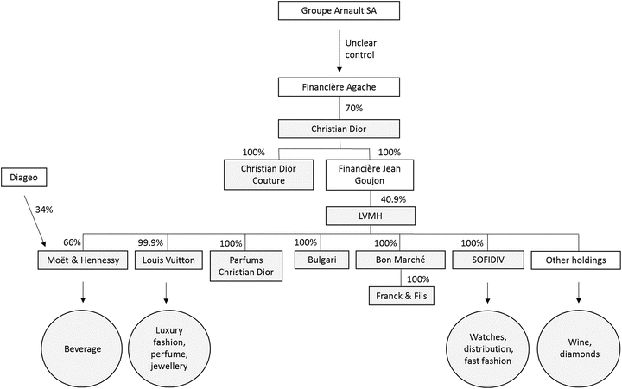

Source: Donzé PY. (2018) The Birth of Luxury Big Business: LVMH, Richemont and Kering. In: Donzé PY., Fujioka R. (eds) Global Luxury. Palgrave, Singapore.

1.1.3. Board of directors
Let’s consider the executive committee and board of directors of Louis Vuitton Moet Hennessy. The board of directors consists of a big number of workers, but this paper is focused on Louis Vuitton, therefore, here will be considered members of the executive committee who are related to this brand. The whole picture of the LVMH Executive Committee is outlined in the appendix.
Bernard Arnault is a chairman and chief executive officer of LVMH, in other words, the main person in the organization. Delphie Arnault is responsible for Louis Vuitton and she is a member of the Ethics & Sustainable Development Committee. Antonio Belloni is a LVMH group managing director. Nicolas Bazire is a Development and Acquisitions director. Chantal Gaemperie is responsible for managing human resources and synergies. Michael Burke stands for Tiffany and Louis Vuitton in the Executive Committee.
These are the main decision-making bodies, not advisory ones. They form a strategic management body, the main task of which is to carry out general management of the company's activities, as well as supervisory and supervisory functions. Therefore, these people are responsible for all material decisions within the company.

1.1.4. Financial performance
In this part we will have a look at the financial indicators of LVMH Group in order to understand the successfulness of organizational development. Management of any organization requires knowledge of its initial state, information about how the object existed and developed in the periods preceding the present. Only after obtaining sufficiently complete and reliable information about the activities of the object in the past, about the current trends in its functioning and development, people can develop confident management decisions, business plans and programs for the development of objects for future periods. It applies to enterprises, firms, regardless of their role, scale, type of activity, form of ownership. Primarily, yearly financial indicators will be considered, next, they will be compared to the ones of the main competitors in the luxury goods segment.
Figure 3 shows the total revenue of the group from 2008 to 2020. LVMH’s revenue has a positive trend and steadily grows with an only exception in 2020. It can be explained by the fact that Covid-19 pandemic affected volumes of sales, as all stores worldwide were closed for a particular period.

- Total revenue of the LVMH Group worldwide from 2008 to 2020 (in million euros)
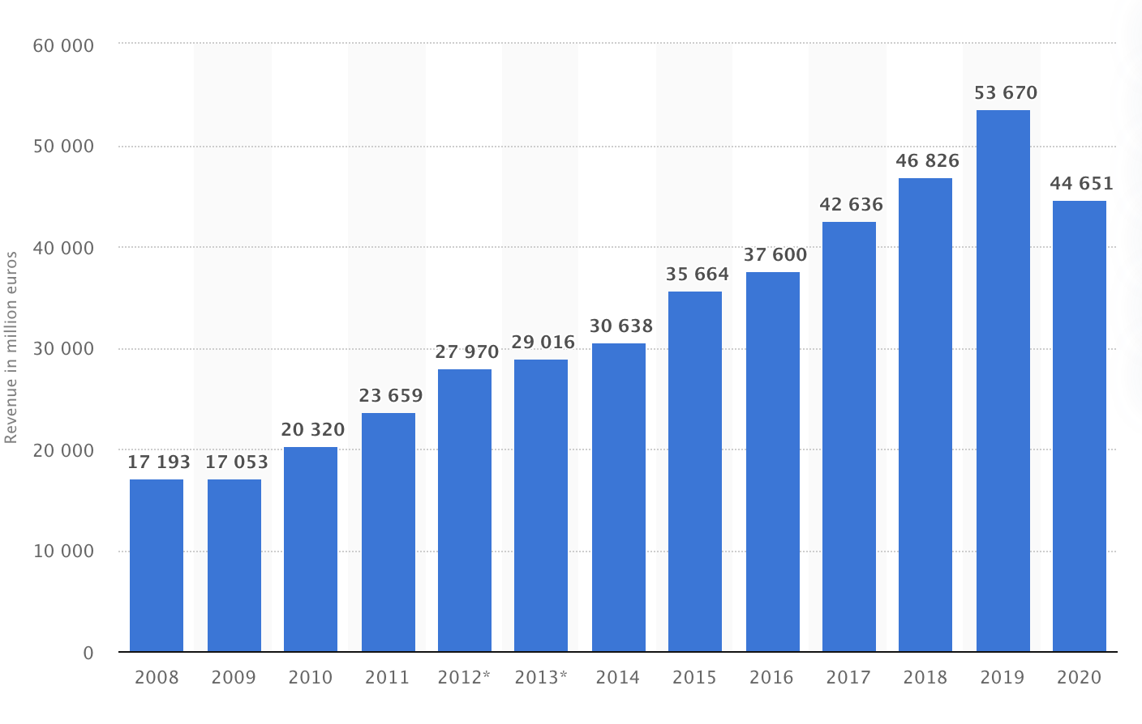
Source:https://www.statista.com/statistics/245852/total-revenue-of-the-lvmh-group-worldwide/

Louis Vuitton Moet Hennessy has 5 main business groups that form a total revenue for the Group. They are the following: fashion & leather goods, perfumes & cosmetics, watches & jewelry, selective retailing and other activities, and wines & spirits. Figure 4 shows a distribution of revenue by segments (in %) of products in the 2020 financial year. It is evident that almost a half of the total revenue is formed by the fashion & leather goods segment, which directly refers to Louis Vuitton. Selective retailing and other activities segments come second, and other three business groups bring approximately the same amount of money to the total revenue.

- LVMH revenue by business group
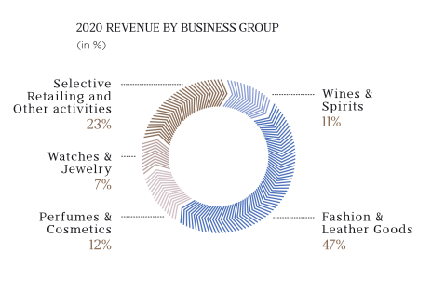
Source: https://hosting.fluidbook.com/LVMH/2020interactiveannualreport/en/#/page/22

Gross margin of the Louis Vuitton Moet Hennessy groups is outlined in Figure 5. An important fact to mention is that net profit shows absolutely the same trend, as revenue. Even though, LVMH tried to cut its expenses in 2020 (-18%), net profit suffered from the circumstances that appeared due to Covid-19 pandemic.

- Gross margin of the LVMH Group worldwide from 2017 to 2020 (in million euros)
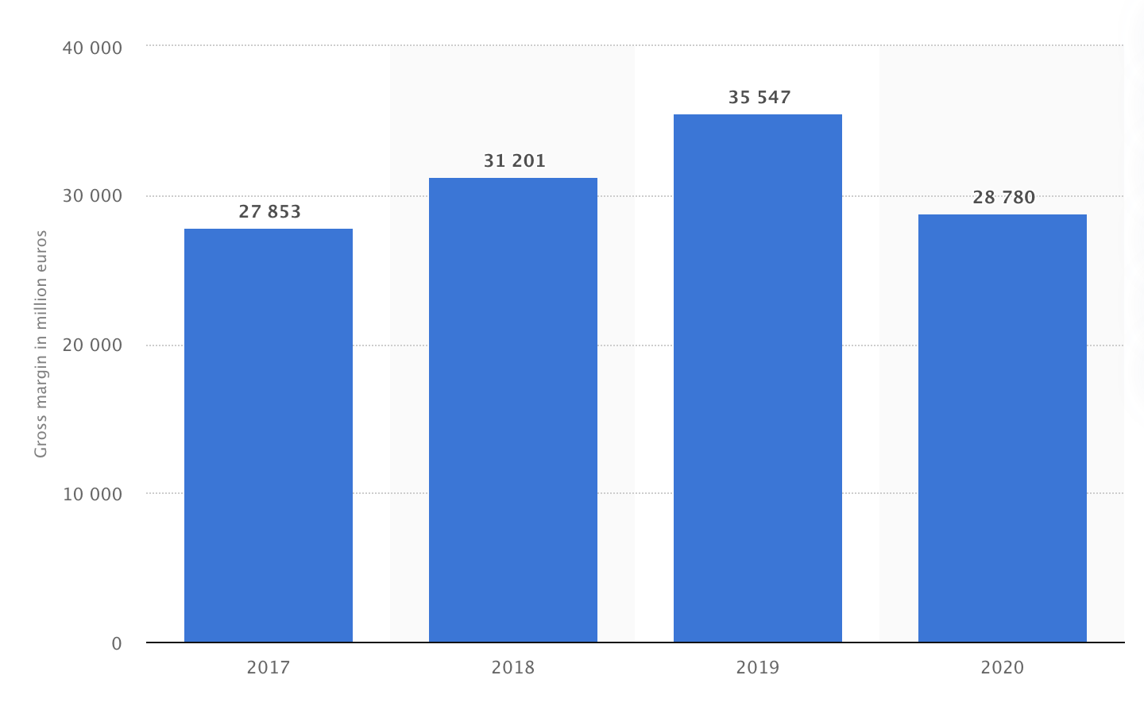
Source: https://www.statista.com/statistics/245885/lvmh-gross-margin-worldwide/

Figure 6 shows the numbers on market cap, enterprise value, and number of employees of the main market players in the luxury goods segment. Comparing the financial performance of Louis Vuitton Moet Hennessy Group to the main market players in the industry, it is rather evident that the company is an absolute leader in terms of market cap, that is almost 5 times bigger than of the first largest competitor. The same trend is highlighted in the question of enterprise value that achieved an indicator of 360.22B. In addition, LVMH employs the biggest number of workers.

- Comparison of the main market players in luxury goods segment
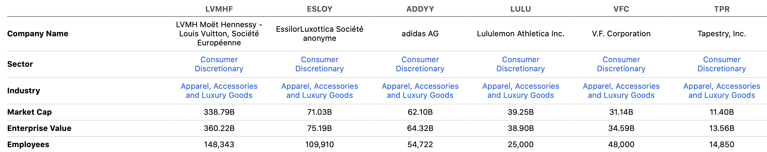
Source: https://seekingalpha.com/symbol/LVMHF/peers/comparison

Conclusion
Louis Vuitton as a part of Louis Vuitton Moet Hennessy Group shows outstanding results in terms of financial performance, competitive positioning, internal and external environment of the company under wise management of LVMH’s board of directors. The company puts a great emphasis on corporate social responsibility that serves as a good base for combating counterfeiting activity, as well as reserves of financial resources.
In the next parts, it would be reasonable to go deeply into the practices and strategies that this company uses with the purpose of eliminating fraudulent activities connected to illegal fakes distribution and have a look whether these strategies are successful and applicable to the Russian market.

1.2. Anti-counterfeiting strategy of Louis Vuitton
1.2.1. Current relationship between Louis Vuitton and counterfeiting firms
Famous bags are the most commonly faked category, according to Bloomberg Business. According to the Global Brand Counterfeiting Report 2018-2020 Louis Vuitton is in the list of most copied brands throughout the world. The company fights with copies of its accessories and products in all possible ways that are described below. Even though it is impossible to predict the total amount of losses, as fake market purchases in most cases cannot be registered, they are material.
The problem with counterfeiting activity appeared in the very first years of the company's existence. In 1895, the company's designers, under the direction of Georges Vuitton, developed a legendary canvas with monograms that were very difficult to copy. The image was patented and later became the brand name of Louis Vuitton. Thanks to this, the percentage of counterfeit Louis Vuitton products in the world has significantly decreased.
The fight against counterfeiting is one of the long-term components of Louis Vuitton's global sustainable development strategy. Supporting creativity and protecting the rights of designers, artists, and brands is vital to their long-term survival. Counterfeiting is by far one of the greatest threats to this survival, and its consequences are far more serious than someone buying a cheap bag on the street of a distant city while on vacation.
Louis Vuitton has been fighting counterfeiting for years. The forgery is an insult to the talent, the art of the masters, and the creative ingenuity of the designers and artists to whom Louis Vuitton owes its success. The theft of intellectual property devalues the investment and knowledge invested in the development of the company. Counterfeiting is harmful to society, as it contributes to the spread of uncontrolled and dangerous working conditions and violations of human rights, in particular, the use of underage labor and forced labor. This is a high price for buying a cheap counterfeit bag. Louis Vuitton takes this issue very seriously and takes plenty of measures on a daily basis.
Next, this paper goes deeper into the set of practices as a part of an anti-counterfeiting strategy used by Louis Vuitton to prevent fraudulent activities.

1.2.2. Anti-counterfeiting strategy
Louis Vuitton is the most counterfeited fashion brand, so it puts a great emphasis on right formulation of its attitude towards this type of fraudulent activities. Their fight against fake production is an essential part of their sustainability strategy and principles. According to Harvard Business Review (2019), LVMH Group $17 mln annually on anti-counterfeiting legal actions.
The fight against counterfeiting is organized at the level of each brand in the LVMH Group. The Group coordinates their efforts, in particular when it comes to interaction with the authorities of various countries or measures taken directly against manufacturers and distributors of counterfeit products.
To start with, on the official website Louis Vuitton provides a document, which is called “BRAND PROTECTION”. The document states that nowadays counterfeiting is one of the biggest threats for a company's survival, that is why the fight against counterfeits takes a big part in their long-term sustainability strategy because counterfeiting is a form of violation and robbery of intellectual property.
The practices and results are shown in the Table 1 below.

- Practices in “BRAND PROTECTION”
Acting Body/Practice | Action | Result
- Intellectual Property Department  - Team of lawyers | - Creation of 12000 intellectual property right, including trademarks, designs and copyrights  - Registering domain names, fighting cyber squatting, tracking counterfeits online | 2,000 litigious websites were shut down, 100,000 auctions were terminated
- 250 agents throughout the world  - Team of lawyers and law-enforcement professionals | 13800 raids and 33258 anti-counterfeiting procedures worldwide | Break-up of criminal networks, easing the plight of workers working for illegal organisations
Program “Contributory liability principle” (pioneered in 2003) | Fight against counterfeiting targeted at “intermediaries” such as landlord, courier companies and payment facilities providing services to underground counterfeit networks | This program has been very effective in certain counterfeiting spots like New York’s Canal Street
Source: Made by author

Among other anti-counterfeiting practices of Louis Vuitton, the following practices are worth mentioning:
- The company launched AURA, the first international blockchain that helps consumers to check the authenticity of luxury goods. (FashionUnited.uk (2019))
This platform was developed on the basis of Microsoft and blockchain software company ConsenSys. This Platform checks the full range of Louis Vuitton products and Christian Dior perfumes. This app helps in protection of intellectual property, as it allows consumers to trace a product’s lifecycle from design to distribution. Additional options provided are sourcing of raw materials, provision of tailored services, and strengthening of consumer loyalty. The app provides detailed information about products, first purchase and resales.
- Implementation of NFC (Near-Field-Communication) tags
It works in a way that little sensors that are often attached to the insides of luxury products enable to put any information into NFC tags, so that consumers can review the information from the smartphones by putting tags into needed applications. If the consumer scans a tag attached to the counterfeit item, he or she will be redirected to the brand's website, with the detailed information about the original item.
- Participation in anti-counterfeiting alliances
LVMH is a member of the Alibaba Big Data Anti-Counterfeiting Alliance. The alliance is focused on use of the latest technologies and big data in the process of fighting against counterfeits. According to Alibaba’s chief platform officer, Jessie Zheng (2016), “With our robust data capabilities, we are confident the alliance will accelerate the digital transformation in our global fight against counterfeits.” These technologies check 10 million product listings a day, as a result, in 2016, 380 mln product listings were eliminated and 180,000 third party sellers were closed.
- Court demanding the closure of sites offering counterfeit products under the name of a fashion house or having similar domain addresses.
Louis Vuitton demands to "remove" counterfeiting websites from the world Web, by depriving them of the possibility of indexing through search engines
- Distribution of information regarding counterfeiting among internal and external stakeholders
According to BURO. (2015)Louis Vuitton implemented a set of measures targeted at the increase of knowledge on the topic of counterfeiting activity threats. Among these practices are employees training, training for customs officials and increasing the flow of information between the public and private sectors.
- Creation of unique design
Louis Vuitton uses costly technologies that allow to create a design of the final product that can hardly be repeated. Each individual product is created manually and has several features. First of all, it is a strict color matching. Most of the brand's products are brown (various shades). All such bags should have a beige-gray lining made of cotton. Some models in other colors may still have a red lining. Consumers also need to carefully inspect the metal elements. They are made by hand and are usually covered with gold. It is worth noting that this manufacturer never uses any special pads to protect their bags from damage. The fact is that the skin under the influence of external factors will still change over time, and this was taken into account in advance, because the appearance of the bag will not deteriorate. And the coating on the metal elements is not afraid of mechanical damage. It will remain attractive even after 10 years of active use. These are only some of the design elements that should be taken into consideration, while identifying an original product, therefore, it is very hard to copy.
- Limited number of distribution channels
Louis Vuitton production can be found only in official LV stores, official retailers and ordered online on official websites. All the channels of distribution are outlined on Louis Vuitton’s official web page.

Conclusion
Nowadays Louis Vuitton is more determined than ever to fight against counterfeiting and to protect the interests of its customers, employees and those who suffer from the activity performed by the counterfeiting. For example, according to lvmh.com (2019), “on the occasion of the 22nd World Anti-Counterfeiting Day, the LVMH Group’s Market Protection department received an award for the best team (Business category) for its achievements in the fight against counterfeiting.” The company uses a wide range of fighting measures on a daily basis, which helped to achieve outstanding results. However, we cannot be sure whether these measures are useful for all markets or not. However, the company is moving towards elimination of the threat possessed by the counterfeiting industry.
The success of Louis Vuitton in terms of fighting fake production resulted in a big number of awards the company wins for its efforts. Protection of stakeholders as well as bringing valuable changes to the world forces LVMH to act responsibly and to fight against counterfeit firms.
In the next parts the paper analyses the applicability of existing Louis Vuitton strategies to the Russian market environment, and in case they are not applicable, the recommendation for the company will be provided.

PART 2. SPECIFICITIES of COUNTERFEITING AND LUXURY FASHION SEGMENT
In this part, firstly, the counterfeits will be analyzed with its influence on the society and luxury segment. Further, the consumer intentions and behaviors will be assessed with the help of the frameworks provided in earlier theoretical papers. Next, analysis of already given anti-counterfeiting strategies by researchers. And finally, the peculiarities of the Russian market will be revealed and counterfeiting influence on Russia will be assessed.
All of the secondary data from the first part will be useful for right recommendations formulation in the second part.

2.1. The nature of counterfeit
In this part the nature of counterfeiting will be considered. This part starts off with the description of the nature of the business and ends by defining the threats and consequences brought by this type of illegal business activity.

2.1.1. The nature of counterfeiting and current situation in the world
There are many definitions of «Counterfeit», for example, Lai and Zaichkowsky (1999) define counterfeit as illegally made products that resemble genuine goods but are typically of lower quality in terms of performance, reliability, or durability. Counterfeits possess a great problem to original companies themselves, economics, society, sustainability, and consumers. Ronald F. Bush, Peter H. Bloch and Scott Dawson (1989) sees the problem of growing counterfeiting because multinational marketing has created high worldwide demand for well-known brands.
According to Wonder Community (2014), in 2014, from 5 to 7 percent of all goods produced in the world were pirated, with an average annual turnover of 500-600 billion dollars, which was about twice the income from illegal drug trafficking. The sale of counterfeit goods online is growing by about 20 % every year. People can build a dozen theories about why in a civilized world with a powerful fashion industry that can offer cool things in literally any price category, the turnover of fake goods is not going to decrease. The whole mechanism works on the principle of human psychology (that will be considered later) according to which we increase our status in the eyes of others due to certain visual markers. And if at the peak of brand mania, the logo was in the foreground, then with the arrival of the mass market, the idea of copying a well-known name was replaced by copying the intellectual property product itself-in other words, the design.
As for 2020, clothing is the most popular industry sector in terms of counterfeiting. Fig.7. below provides detailed information about sales losses by retail segments. However, an important fact to mention is that counterfeiting refers to the “grey” market, therefore, it is rather hard to name the accurate numbers in terms of losses, as usually illegal transactions are not registered.

- Sales losses from counterfeit goods worldwide in 2020, by retail sector (in billion euro)
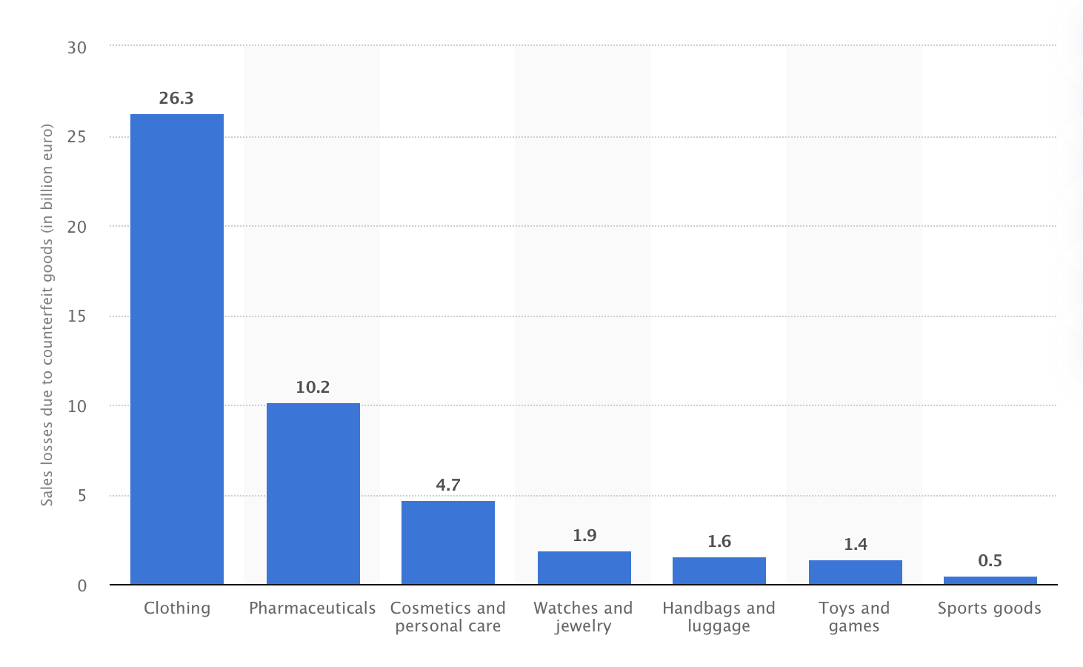
Source: https://www.statista.com/statistics/1117921/sales-losses-due-to-fake-good-by-industry-worldwide/

However, we should divide counterfeits into categories. According to Soldatova L. (2019), there exists 4 ways of counterfeiting, they are the following:
- The use of a brand name or trademark that is very similar to the designation of any of the" promoted " brands. Usually, 1-2 letters change in the name of a well-known brand on the label, as a result many consumers do not pay attention to this product feature and buy counterfeit goods, believing that they become the owners of a branded item.
- Using someone else's logo without making changes to it at the same time as copying the external features of the product. Counterfeiting in this form is less common than the previous one, since the fact of an offense in this case is obvious, and therefore it is much easier to bring the distributor to justice.
- "Piracy". It is the sale of copies of musical, artistic, and literary works without the permission of the author or copyright holder. This group also includes gratuitous counterfeit (the distribution of such works on the Internet).
- The use of inventions, developments (including computer programs), the rights to which are registered to other persons.
This paper is focused on the first two ones.

2.1.2. Parties involved in the counterfeiting activity
There are many parties that are involved in a counterfeiting activity, starting from creation of a product, ending with the achievement of a final customer. All of them are members of illegal fraudulent activity.
Let’s consider those who participate in business:
- Manufacturer of counterfeiting goods
Most of the counterfeiting products in the world originated from China, the main market of “fake” products. Some of the manufacturers make a similar product to an original one, some of them an accurate copy, the price varies depending on similarity to an original item. However, these manufacturers do not use all the technologies that are used by the original brand.
- Counterfeiting firm
It is the main distributor of the fakes taken from the manufacturers. Manufacturer and counterfeiting firm may be situated in separate countries. It can operate through a physical store, or with the help of the Internet.
- Workers
Workers involved in the production process of counterfeiting are usually victims of awful working conditions, set by the firm they are working on. Childish labor, low wage rates, overtime working hours and other features of working conditions are often performed in Asia, where the biggest part of counterfeiting activity is outsourced. The reason for this outsourcing is costs reduction.
- Landlords
These are the owners of real estate that is used with counterfeiting trade. The land can belong both to an independent physical person or legal entity or owned by a counterfeiting firm itself.
- Courier companies
Those who deliver counterfeiting products from point A to point B.
- Payment facilities providers
Those who provide firms with the opportunity of electronic purchases methods.
- Consumers
Those who initially had an intention, and finally, receive a counterfeit product.
An interesting fact to mention is that not all of the bodies mentioned above are objects to punishment, when it comes to prevention of fraudulent activity.

2.1.3. Distribution channels
In the modern world counterfeits are distributed through different online and offline channels.
In all studies, it is noted that the main factor in the rapid growth of the counterfeit trade has become e-commerce. Simplified buying and selling digital platforms that allow third-party sellers to create accounts in the relatively unregulated environment of online marketplaces, only contribute to the boom of counterfeit goods on the Internet. According to Forbes (2020), the biggest part of counterfeit goods is sold through Instagram, VKontakte and Telegram. The researchers found that in seven cases out of ten luxury goods purchased in social networks will be fake.
Nowadays the most popular distribution channels are the following:
- Social networks (Including Instagram, Telegram, Vkontakte and Facebook)
- Marketplaces (Such as eBay)
- Resellers (Including luxury resale marketplaces)
- Bazaars
- Unfair retailers

2.1.4. Threats possessed by counterfeiting
Even though in most cases literature analyses the threats possessed by all segments of counterfeiting activity (pharmaceuticals, electronics, automobile spare parts, fashion, cosmetics, etc.), in this paper only consequences related to luxury fashion will be considered.
According to Springer (2008), threats possessed by counterfeiting business can be divided into 3 levels:
- Economic level
This level includes profit losses of the organizations selling original products, and according to the sales losses outlined in Fig.7. they are more than material. The counterfeiting creates a business environment with unfair competition, as products sold look similar, but fake ones are with much lower price. In addition these illegal firms steal the intellectual property of the original brand. And the most global threat on this level is to the world economy, because these companies do not pay taxes, their transactions are usually not registered, as a result the GDP of the country is much lower than it could be.
- Social level
One of the main impacts of this type of illegal business activity is that people lose an opportunity to work and to earn money. The algorithm works in the following way: due to counterfeiting, the brand loses sales, workers lose their job and the government loses tax. Another threat is possessed to counterfeiting workers, as they work overtime in awful working conditions and as a result, receive small wages.
- Public order level
Counterfeiting increases dismissive attitudes in the society. These firms do not respect the legitimacy and initiate more and more illegal actions. For example, according to Springer (2008), in Malaysia (2001) president of municipal council was a subject to death threat after initiation of action against those selling counterfeit Video Compact Disks. In Russia, the director of Russian anti-piracy org was a subject to a murder attempt, that was directly linked to the operation conducted a few days before. It is not only a threat to legitimate bodies’ health, but also dismissal of public order.
European Economic and Social Committee (2017) provided numbers on the topic of losses due to counterfeiting activity. Numbers are depicted below:

- Value and losses of counterfeiting
Value of trade in counterfeit products | Between EUR 600 billion (UN) and close to EUR 1 trillion
Jobs losses | (800,000) jobs
Annual tax revues, including VAT and excise duties | (14.3) billion
Source: https://www.eesc.europa.eu/en/news-media/news/fake-products-cost-800000-jobs-annually

The volumes of counterfeiting activity are growing on a daily basis at a very fast pace. One of the main factors influencing this rapid growth is e-commerce. Because of the Internet many new counterfeiting online distribution channels appeared. All these factors are the stimulus for “fake” firm development. In the process of counterfeiting many parties are involved, and all of them are potential subjects to legal punishment. The consequences brought by this rapidly increasing illegal activity are threatening to society and the world economy.
However, as it was mentioned before “if there is a supply, there is a demand”. So that the next part of this chapter will be dedicated to the understanding of consumer behavior and the intentions to buy counterfeited production.

2.2. Consumers’ intentions and behavior toward counterfeit and luxury goods
The base for counterfeiting is divided into supply and demand sides. There are a lot of theoretical papers that are dedicated to the supply side, but demand is important as well. As long as there is a demand, the business will be lucrative. In this paper the demand side will be analyzed from many perspectives, as it is extremely important for development of best strategies for the luxury segment in terms of combating counterfeits and delivering the real value. Demand side is fully about consumers’ intentions to make a purchase, so that this paper describes how these intentions appear.
Many theorists starting from the second part of the 20th century started doing research on the topics related to consumer behavior, customers’ incentives in terms of counterfeits purchase, luxury goods production, and counterfeits production.
Let’s start off by describing the demand side. Before diving into the peculiarities of consumer incentives in the decision-making process of whether to purchase a fake product or a real version it is important to understand that there exist conscious and unconscious purchases. Nia and Zaichkowsky (2000) in their work describe this as deceptive and non-deceptive counterfeiting. Deceptive one is when the consumer is not aware of the fact that he or she buys fake production, in most cases he or she is deceived by a manufacturer. This type of counterfeiting is more used in the auto industry, pharmaceuticals and electronics (Grossman and Shapiro 1988). However, this paper is focused on luxury goods counterfeiting that in most cases relates to non-deceptive counterfeiting, however, there are some deceptive counterfeiters such as unfair retailers and distributors, who position fake products as real ones and try to fool their customers. In case of non-deceptive counterfeiting, the consumer is aware of the fact that he or she purchases fake production, that may be illegal, but pursues a goal of getting material or psychological benefits from the product.
The incentives of buying counterfeits are discussed in many theoretical sources. However, the base for all of the is «Theory of planned behavior» by Icek Ajzen (1985). Planned behavior theory considers social influences, such as social norms and normative beliefs, based on collectivist, cultural variables. Given that an individual's behavior can be perfectly recorded and depend on social networks and organizations (e.g., peer groups, family, school, and work teams), the social influence factor proved to be an important addition.
Fig. 8. outlines the principles according to which a person forms a decision-making process. In our case it is about purchasing decisions. Ajzen’s theory may be also useful in forming counterfeit combating and marketing strategies, as the goal of the fashion industry is to form consumers’ intentions.

- “Theory of planned behavior”
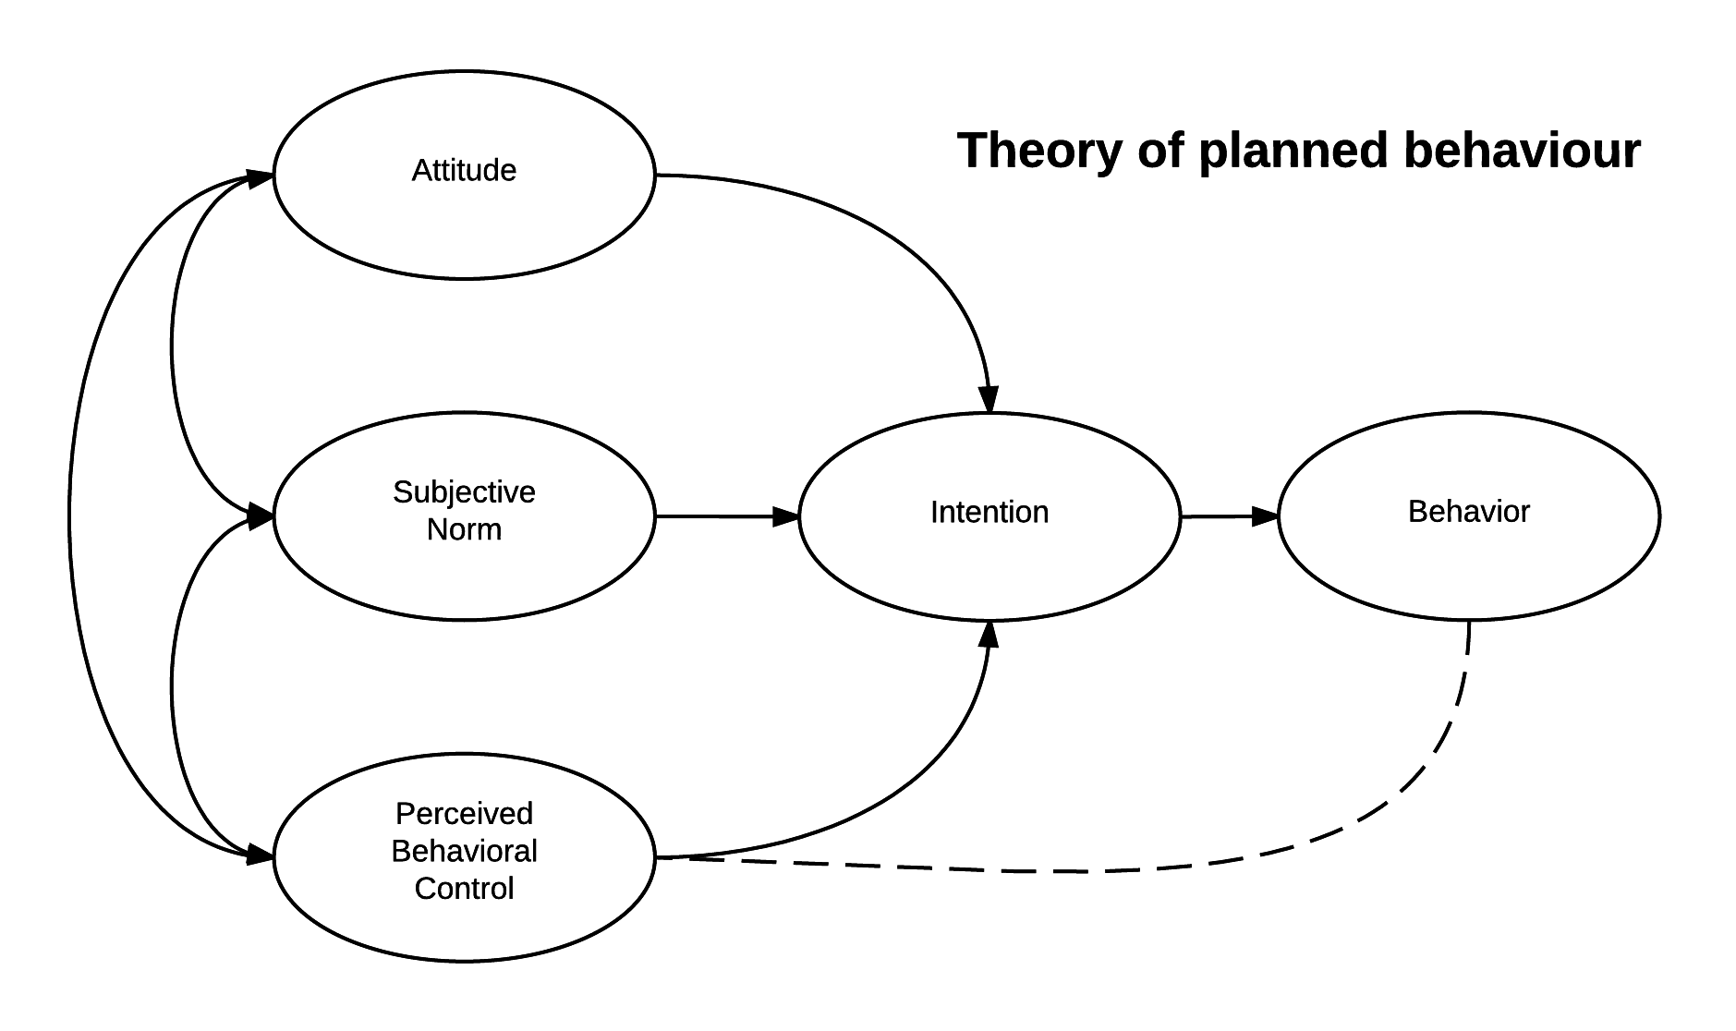
Source: Ajzen, I. (2011). The theory of planned behaviour: Reactions and reflections.

An application of Ajzen's theory of planned behavior in marketing can help to explain why advertising fashion campaigns that simply present information don't work. In other words increasing knowledge will not lead to a significant change in behavior, in case the consumer lives in a society with absolutely opposite norms and behaviors. Campaigns that target attitudes, perceived norms, and control in the implementation of change or the purchase of certain products have better results.
The next framework that helps explaining the formation of consumer behavior is made by Martin Fishbein and it is called “the theory of reasoned action” (1979). The new theory includes all the elements of the theory of planned behavior; however, it is more deeply considered elements that form the intention to buy a product.

- “Theory of reasoned action”
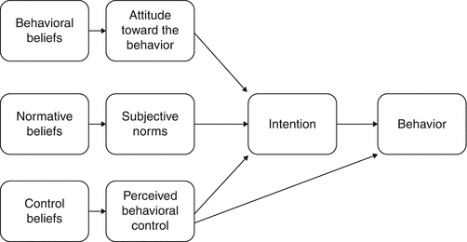
Source: Fishbein, M. (1979). A theory of reasoned action: some applications and implications.

In particular, behavioral intentions for the implementation of a certain type of behavior are a function of two factors: the individual's own attitudes towards behavior and the subjective norm associated with other people's ideas about how they should act in such situations. For example, if a person considers buying a fake Louis Vuitton bag as something not immoral and the society that surrounds him or her do the same thing, he will receive an intention to buy, and with high probability will buy a fake item.
However, not every person pursues the same goals while buying a product. Wilcox, K., Kim, H. M., & Sen, S. (2009) considers people’s attitudes towards counterfeiting from two perspectives: social-adjustive and value-expressive. Smith, Bruner, and White (1956) explain that people that pursue social-adjustive functions in their behavior, buy things in order to fit into society, gain respect, and approval of others in particular social circumstances with the help of physical goods. Therefore, luxury things may serve as a way of showing that they are respectable and valuable in the society, but in case, they do not have enough financial resources to buy original items, they would buy counterfeits in order to fit into the society. This is one of the examples of how the intention forms according to the theory of planned behavior (1985) and theory of reasoned action (1979).
On the contrary, Katz (1960) describes a value-expressive attitude as a way of placing own values and beliefs first and fulfilling own needs according to self-established moral norms with the help of material things. For example, if a person has a value-expressive attitude and does not consider buying counterfeit as something immoral, he or she is more likely to buy fake production. In addition, a person who thinks that a purchase of counterfeit goods contradicts his or her moral principles will be less likely to buy fakes. The negative impact and reasons for contradiction moral principles are described later in this paper. Wilcox, K., Kim, H. M., & Sen, S. (2009) provide a research that resulted in a fact that while choosing between two products: fake and real, in case it fulfils the salient goal set by a social-adjustive or value-expressive consumer, the consumer will more likely choose a counterfeit, because of the price factor. This statement is also supported by Ratneshwar et al. (2001).
It is worth saying that the price factor may seem attractive to potential counterfeit buyers. Firstly, Bloch, Bush, and Campbell (1993) in their article state that the target audience of counterfeit manufacturers is of lower social status, especially in comparison to those who can afford buying original premium segment production. In this work they deeply describe the potential consumer of counterfeits production, and place income and social level first in the process of deciding whether to buy fake clothes or not. In addition, in this article the main reasons proposed is to impress others by the uniqueness of their look. This correlates to the social-adjustive function explained by Wilcox, K., Kim, H. M., & Sen, S. (2009).
Lai and Zaichkowsky (1999) connects incentives for purchase to social and cultural context, depending on the shopping environment in the area of production. For example, Chinese shopping environment differs in many aspects from the ones in Russia, Europe, or the United States. That is why it is of extreme importance to understand the peculiarities of the considering market, in our case it is Russian market.
Understanding consumer incentives is very important, if the company wants to fight against counterfeiting successfully and deliver the value of original products to consumers. Brands should think about the society the target customer lives in and use needed tools for awakening the intentions to buy original items.
Taking all theory into consideration, it is possible to conclude that there are 2 types of counterfeiting: deceptive and non-deceptive (Nia and Zaichkowsky (2000)). Talking about the intentions of consumers in terms of non-deceptive counterfeiting, they tend to pursue either fulfillment of social-adjustive function (Wilcox, K., Kim, H. M., & Sen, S. (2009)), or value-expressive one (Katz (1960)), depending on self-established norms, moral beliefs, social status and income level. Marketers should target the intentions of their audience to prevent fraudulent activities of counterfeit firms.
As for the prevention of consumers’ intentions to buy counterfeits, it is possible through the change of social norms and regulatory policies targeted at consumers.

2.3. Strategies of fighting against counterfeiting activity
As companies are the victims of counterfeiting activity, they try to create the ways of fighting against it. The purpose of their strategies is focused on legitimate punishment of those, who steal intellectual property, their potential profit and brand image.
In this part different anti-counterfeiting approaches and strategies will be considered, taken from both theoretical background and experience of luxury companies.

2.3.1. Classification of strategies
Kotelnikova Z. V. (2008) in her paper dedicated to the topic of counterfeiting divides the businesses’ attitudes and strategies towards combating counterfeit influence into 2 groups. The groups are the following: those who make efforts to protect their brands, and those who, despite the presence of fakes of their products, do not deal with the issues of its elimination at all. She identifies them as "fighters" and "connivers". In turn, in each group two subgroups are identified, so that we have 4 groups in total: a) anti-counterfeiting fighters: activist fighters and occasional fighters; b) connivers: forced connivers and mercantile connivers. The peculiarities of “fighters” sub-groups are outlined in Table 3 below.
- Distinctive characteristics of the behavior of "activist fighters" and "occasional fighters" in relation to counterfeit goods
Characteristics of the fight | Fighter-activists | Occasional fighters
Form of struggle | Permanent | Discrete
Measures of struggle | Set of measures | Sample measures
Return from struggle | Focus on long-term returns | Focus on returns in the medium and short term
The scope of the fight | All cases of violation | Electoral cases
The level of the problem | Global/Regional | Local
The volume of fakes | Regardless of the volume of forgeries | The volume of forgeries exceeds the company's tolerance threshold
Source: Котельникова, З. В. (2008). Товар с чужим лицом, или Почему правообладатели торговых марок попустительствуют контрафакту?. Экономическая социология, 9(4).

The main difference between activists and those who fight on occasion is that the former fight constantly and comprehensively, the latter - in raids and chaotically. The former develop well-thought-out strategies to clear the markets of counterfeit goods and use all the levers for this, including information, legal, political, administrative and economic, while the latter apply selective measures to combat them, depending on each specific case. The former initiate proceedings on all cases of violation of their exclusive rights without exception, the latter – only on the largest ones. The former fight against counterfeiting regardless of its nature and the volumes that exist in consumer markets, the latter - only when the counterfeits exceed the threshold of tolerance of the company and significantly affect sales volumes.
Talking about forced connivers, this group includes those whose actions are blocked by fear. To start with, the fear that the initiation of the fight against counterfeit goods will shake their position on the market. Secondly, especially for foreign management, the fear of criminal groups that are involved in the production and implementation. This fear is reinforced by the belief of foreign leaders in the impunity of offenders who are held captive by myths about the rules of business.
The second group of connivers is a group of mercantile connivers that includes the copyright holders of trademarks that intentionally benefit from the current situation. They believe that from an economic point of view, the distribution of counterfeit goods, especially during the period of market conquest, is profitable. Fake products promote the brand's penetration into those market niches where its rightful owner has not yet reached. In such cases, counterfeit goods play the role of an advertising medium. In addition, among the mercantile connivers, there are also companies whose local management is in secret collusion with the offenders. They enter into secret agreements with underground businessmen and receive part of the income from their illegal activities.
2.3.2. Anti-counterfeiting strategies
The fight against counterfeiting is costly for organizations, requiring considerable material, time and labor investments. Such expenses include the costs of: developing a product protection system (the complexity of packaging and the frequency of its updates, applying a hologram, etc.), monitoring the market and identifying cases of wrongdoing, assisting in the legal registration and prosecution of offenders. Therefore, when weighing the possible costs and potential benefits, some companies come to the conclusion that from an economic point of view, such a struggle is meaningless: the costs exceed the returns, while others believe that although the costs are great, the struggle is worth it. Even though it is costly for small-sized businesses, well-established luxury brands have enough financial resources for the strategies development and active fight against fakes. In addition, in the textile industry only famous luxury brands are usually victims of counterfeiting manufacturers.
Each brand can have its own understanding of “successful anti-counterfeiting strategy”. The organization defines a set of key performance indicators in relation to counterfeiting activity. There are no mutual ones, therefore we cannot identify them here. It can vary from the number of closed counterfeiting firms to the number of items destroyed. However, there exists a number of independent organizations that assess anti-counterfeiting action and give awards to companies that succeed.
Now it would be reasonable to proceed to a description assessment of strategies. Literature provides a set of concrete preventative measures or strategies. Hoecht, A., & Trott, P. (2014) provide a scheme of issues based on 3 levels: societal, consumer and firm levels. Societal level includes parties involved in brand vs counterfeiting firm relationships. Consumer issues and behaviors are considered in the earlier parts. between suppliers, manufacturers, copied firms, counterfeit firms, and consumers. According to this scheme, manufacturers develop strategies to affect counterfeiting forms. The set of strategies provided in Fig.10. below.
- Framework of management strategies for firms to combat counterfeit firms
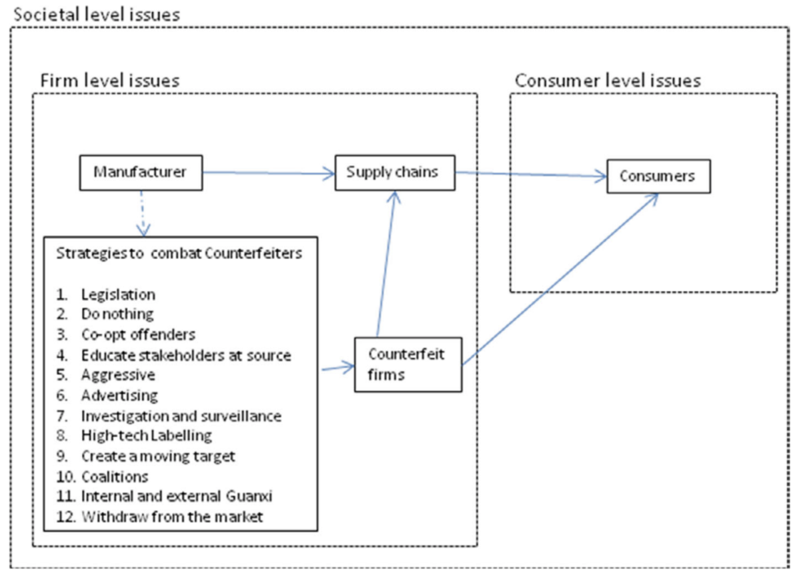
Source: Hoecht, A., & Trott, P. (2014). How should firms deal with counterfeiting? A review of the success conditions of anti‐counterfeiting strategies. International Journal of Emerging Markets, 9(1), 98-119.

Hoecht, A., & Trott, P. (2014) provides a suggestion for clothing companies to choose lower prices to compete with counterfeit firms. On the other hand, from my perspective, there is no sense for such companies as Louis Vuitton and Burberry to lower prices, as this factor makes their consumers feel privileged and valuable, especially those who has social-adjustive function (Wilcox, K., Kim, H. M., & Sen, S. (2009)). Another approach for the fashion industry this paper suggests is to use high technology labeling and rapid design changing in order to make the copying process more difficult in terms of manufacturing.
Hilton, B., Choi, C., & Millar, C. (2000) in their paper suggest putting a great emphasis on consumer education in order to prevent deceptive counterfeiting (Grossman and Shapiro 1988) (when people are not aware of the fact that they buy fakes). First of all, Hilton, B., Choi, C., & Millar, C. (2000) claim that purchases should be educated how to identify original serial numbers of the products. Secondly, keeping open the information regarding all organization’s distribution channels. And finally, delivering the value, uniqueness and priority of original products over fakes.
Hilton, B., Choi, C., & Millar, C. (2000) contradict the work of Hoecht, A., & Trott, P. (2014) and state that in the luxury fashion segment the higher the price, the more the demand for the product. Luxury segments should make their product unique in terms of value, technologies, design, and price, so that companies do not need to achieve the highest indicators in terms of volumes of sales, instead they should create a limited number of distribution channels, making their products something not achievable. I would not agree that this approach helps to prevent counterfeiting. It definitely makes the product more demanded, but those who cannot afford to buy it, will buy a cheaper copy of an item.
Hilton, B., Choi, C., & Millar, C. (2000) As this paper is focused on further suggestions for luxury fashion companies, from his work we should draw a conclusion that brands should make their quality something not achievable by any counterfeiters. Secondly, limitation of distribution channels with the purpose of controlling all of them. Thirdly, education for purchasers should take place for avoiding deceptive counterfeiting. Finally, to make a visible difference in price levels.
Amaral, N. (2020) suggests a framework for addressing luxury counterfeit supply and demand sides. The approaches of this framework are divided at two main groups: low levels of stakeholder motivation and increase of proactive collaborative measures. Two of eleven strategies refer to both groups. The strategies are outlined below:
Both groups:
- Increase stakeholder awareness about economic losses (e.g. employment from counterfeiting)
- Partner with taxation officials (sales, employment, corporate taxes)
Address low levels of stakeholder motivation:
- Educate consumers about the environmental and health risks associated with counterfeiting
- Educate consumers and policy makers about ties to terrorist organizations and organized crime
- Emphasize after sales service and warranties to consumers
- Increase awareness about economic losses (e.g. trade deficits, foreign investment implications)
- Lobby legislators and agencies to increase anti-counterfeiting activities
Increase proactive collaborative strategies:
- Implement inter-organizational collaboration for data gathering, surveillance and enforcement
- Provide intermediaries to gather and share information
- Formalize collaborative partnerships with local and federal law enforcement agencies
- Utilize consumer call to action campaign to lobby elected officials and law enforcement agents
Amaral, N. (2020) continues summarizing the papers on the topic of one important aspect of anti-counterfeiting strategies - protection of intellectual property (IP). He outlines what strategies are more effective by country. However, from his paper it is evident that all of these strategies have a mutual feature of limited effectiveness, therefore, should be complementary to other anti-counterfeiting actions.
- IP protection strategies
Potential effectiveness | Tactic description | Summary
Limited effectiveness | Force landlords to take legal action against tenants who take who engage in counterfeit production or sales | Effective in the USA, but requires constant monitoring
Limited effectiveness | IP (trademark) protections | Virtually ineffective in the USA; more effective in Europe
Limited effectiveness | Criminal prosecution | Seen as low priority relative to other counterfeiting industries
Limited effectiveness | Lobby and educate law enforcement and government agencies | Potentially effective strategy to increase the motivation to investigate and prosecute - limited by local scope of most agencies
Source: Amaral, N. (2020). What can be done to address luxury counterfeiting? An integrative review of tactics and strategies. Journal of Brand Management, OnlineFirst, 1-19.

Later on, the paper considers the peculiarities of the Russian market and intellectual property protection strategies will be chosen accordingly to the peculiarities of the environment there.
Talking about distribution channels, Roberto Fontana, Stéphane J.G. Girod, and Martin Králik (2019) suggest luxury fashion brands such as Louis Vuitton, Gucci, and Burberry, to transfer manufacturing to their home countries with the purpose of stricter control over supply and distribution. For example, if the brand has its factory in the country of origin, it can more easily control factory overruns, or when the factory produces surplus, the additional products can be easily redistributed to distribution channels. However, labor costs in home countries are much higher than in Asia, but this cost brings more return than a threat of counterfeiting.

2.4. Role of governmental regulations in the process of elimination counterfeiting activities
Even though companies may develop and implement plenty of different practices targeted at elimination of counterfeiting activities, in most cases it won’t be relevant and useful without appropriate governmental regulations.
On the country level counterfeiting activity may be very harmful for the economy, as counterfeiting transactions are usually not registered, therefore, influence the decrease of GDP and devalue national currency. This factor may have both internal and external effects for the country.
Each country has its own policies and regulations regarding counterfeiting activity. However, in this paper Russian regulations are only considered as the strategy is developed for the Louis Vuitton on the Russian market.

2.5 Famous brands’ anti-counterfeiting experience
Let’s consider the successful experiences of famous luxury brands in 2012-2017 that are deeply describe on Vogue.ua (2017):

- Anti-counterfeiting practices of famous brands
Brand | Anti-counterfeiting approach
LVMH (2017) | The holding company represents the watch brands Hublot, Zenith and TAG Heuer, and in order to reach out directly to the sellers of counterfeit goods, it was decided to start buying watches in online stores that are not official distributors.
Alexander Wang (2016) | Sued 45 counterfeit dealers who sold counterfeit brand products on 459 websites. The District Court of New York sided with Alexander Wang and legitimately forced the sellers of fakes to pay $90 million.
Kering (2015) | Filed a lawsuit against Alibaba's marketplace in US federal court in Manhattan, accusing the Chinese online store of selling counterfeit goods of its brands Gucci, Balenciaga and Yves Saint Laurent (YSL). As a result, Alibaba's capitalization at the New York auction in 2015 fell by more than $ 75 billion in a few months due to accusations of promoting fakes.
Cartier, Chanel, Christian Dior, Lacoste Longchamp, Van Cleef & Arpels и Louis Vuitton (2012) | Distributed social advertising with the following writings:"Buy a fake Cartier - get a real criminal record", "With this phone you can call your lawyer!" and "Real ladies do not like fakes" - thanks to Comite Colbert and French customs, ten thousand similar posters were released, which were placed at airports and train stations in France, they urged citizens to refuse to buy counterfeit goods. The found counterfeit products were publicly destroyed on special equipment.
Source: Made by author

The strategies written in the table relate to different sectors of influence. For example, Louis Vuitton influenced directly the counterfeiting firm, Kering and Alexander Wang applied to the legitimate system, Cartier, Chanel, Christian Dior, Lacoste Longchamp, Van Cleef & Arpels и Louis Vuitton called on the society. As for now, we cannot draw a conclusion, what strategy will be the best for the Russian market, as analysis is needed, because according to Amaral, N. (2020) different strategies suit different markets.

Conclusion
Taking all theory into consideration, it is possible to conclude that there are 2 types of counterfeiting: deceptive and non-deceptive (Nia and Zaichkowsky (2000)). Behavior exists on 3 levels. Talking about the intentions of consumers in terms of non-deceptive counterfeiting, they tend to pursue either fulfillment of social-adjustive function (Wilcox, K., Kim, H. M., & Sen, S. (2009)), or value-expressive one (Katz (1960)), depending on self-established norms, moral beliefs, social status and income level. Marketers should target the intentions of their audience to prevent fraudulent activities of counterfeit firms.
The set of anti-counterfeiting strategies proposed by researchers addresses internal control of companies, stakeholders, consumers. The effectiveness of strategy depends on the country's business environment. There are a lot of measures to be taken, but, from my perspective, without governmental support it is almost impossible to eliminate the threat possessed by counterfeiting firms.
The organizations in relation to counterfeiting activity can be divided into two groups "fighters" and "connivers" (Kotelnikova (2008)). Those who try to fight can achieve different target groups through different levels: social, firm and consumer. Legitimate actions may be very effective, as law should regulate illegal activity. Fighting counterfeits is a costly process, but affordable for luxury brands. Therefore, we should have a look at the market for strategy development in order to develop personalized approaches in further parts.

PART 3. DESCRIPTION OF THE COUNTERFEITING ON THE RUSSIAN MARKET
As this paper is aimed at providing recommendations for luxury fashion companies on the Russian market in relation to counterfeits, considering market should be analyzed. In this part the current situation in Russia from political, economic, social, technological, legal and environmental perspectives will be analyzed.

3.1. Reasons for counterfeiting in Russia
Let’s start this part by looking at theoretical papers in order to better understand the real motives of counterfeiting firms on the Russian market. Salnikova A.V. (2020) in her work identifies the peculiarities of counterfeits production on the Russian market, reasons for demand, and supply channels. She states that most of the fashion industry’s counterfeit goods enter the Russian market from far-abroad countries. Counterfeit goods can originate from any country on all continents, but China, which shares a common border with Russia, has continued to hold the leading position in this area over the past few years. However, we should understand the environmental peculiarities for counterfeiting development and distribution.
She identifies the following reasons for counterfeiting on Russian market:
- Clothing, shoes and accessories are the most attractive products for counterfeiting due to the high turnover and frequent changes of buyers.
- The outsource of fashion clothing, shoes, and accessories production of the majority of foreign companies developing and least developed countries.
- The lack of anti-counterfeit culture among Russian buyers. Europeans show an active civic position, they are interested in the information about goods (services) and the production features. In comparison to Europeans, Russian consumers have almost no civic consciousness in this area, as evidenced by one recent study provided on BMONITOR (2019), according to which 86 % of Russians are loyal to the purchase of counterfeit goods. In addition, the biggest part of the sample is ready to buy fake clothes, shoes and accessories. Talking about sales channels, Russians are ready to buy counterfeits both in retail stores and on-line. At the same time, 75% of respondents consider it normal to buy fakes not only for themselves, but also as a gift. Moscow residents are the most tolerant to luxury brand fakes, and only 20 % of Russian capital citizens are willing to buy original things.

3.2. Current situation
Talking about the situation in Russia, there is no accurate data on the sales losses, volumes of sales and other indicators related to counterfeits. However, according to A. Lebsak-Kleimans (2019), the total market of illegitimate products in Russia is estimated to be up to 30%, and up to 45% of all sales of clothing, shoes and accessories. Sales at markets, clothing fairs and various formats of "transferrable trade" account for about a quarter of all sales of clothing and shoes in Russia. Well-known brands are the most imitated in the market of counterfeit clothing. It works in a way that counterfeit producers print recognizable logos on arbitrary products, allowing potential consumers to become closer to prioritized social position. The most popular distributing objects of copying in Russia are handwriting recognizable models from brands. Imitations of Louis Vuitton, Gucci, Chanel, Michael Kors, etc. bags are especially popular. Well-known sports brands, such as Adidas, Nike, Reebok, New Balance, etc., are also actively copied. In Russia and all over the world, fakes of well-known brands are focused on sales not for the premium segment, but for the mass one, and these products are sold through the markets and counters of the "transferrable trade".
Talking about country-suppliers, according to Karaseva O. (2020) most of the fakes on the Russian market are produced in China — up to 85% of the counterfeit goods come from there. From 10 to 15 % of fake clothing, shoes and accessories come to Russia from Turkey. Turkish copies are considered better than Chinese ones and they are more expensive. But manufacturers from the CIS countries are also beginning to engage in a competitive struggle with counterfeit dealers from China and Turkey and are trying to grab their market share. Illegal fake factories have already appeared in Kazakhstan, Kyrgyzstan, and Ukraine.
In July 2019, it turned out that Russians buy more fakes of luxury brands than original luxury goods. The authors of the study BrandMonitor — a company specializing in the protection of intellectual property and the fight against counterfeiting, estimated that the fake luxury market in Russia exceeds the legal turnover by 13%. Sales of replicas of luxury fashion brands reach 280 billion rubles a year, while the volume of the legal luxury market last year amounted to 248 billion rubles, according to Fashion Consulting Group. At the same time, most often buyers buy fake T-shirts, sneakers, jeans and bags, according to the study.
In Russia counterfeiting production is distributed through all possible channels. Kotelnikova Z. V. (2008), also continues the work of Nia and Zaichkowsky (2000) on the topic of deceptive counterfeiting, and provides the most popular distribution channels for fake production in Russia. It can be found everywhere, including usual stores: Duty Free, expensive supermarkets, supermarkets, etc. However, in Russian reality, these are rather exceptions. This happens, for example, because of the bad faith of individual employees of trade organizations, who for a certain "kickback" can take the left batch of goods, mix it with the original products and thus sell it to consumers. In addition, “fake” goods are often distributed through the showrooms and Instagram. According to RBC (2020), every third online supplier has a traditional showroom in Moscow, and every tenth has offline stores in St. Petersburg and Krasnodar, according to BrandMonitor. 3-7% of sellers of fake luxury goods have stores in other cities with millions of people.
Kotelnikova Z. V. (2008) in her empirical research provides information regarding the results of the interviews with the owners of companies that can be or already attacked by counterfeit firms. She states that on the Russian market the situation with fakes production becomes better. Since the mid-2000s, the volume of counterfeit products on the Russian consumer goods markets have tended to decrease. This is evidenced by the quantitative data of the companies they interviewed and the opinions of experts. For example, the results show that in 2007– 2008, depending on the product’s industry, the strength of the trademark and the level of the company, they ranged from 1 to 15%, and in 2003, their spread was from 5 to 50%.
After the results of gathered data, Kotelnikova Z. V. (2008) considers the reasons for the reduction in volumes of counterfeit sales:
- Activation of law enforcement agencies;
- Development of judicial approaches for resolving disputes in the field of intellectual property;
- Increase in the purchasing power of the population and increase in the culture of consumption;
- Popularization of counterfeiting issues in the media;
- Activation of leading manufacturers-copyright holders of branded trademarks in the process of combating counterfeiting;
- Formation of a business culture among local entrepreneurs, etc.
Among the main trends in terms of the counterfeiting in Russia, Kotelnikova Z. V. (2008) identifies the importance of intellectual property protection, updated in the public consciousness, the reduction in volumes of counterfeiting sales, the reduction in the number of businesses involved in fake import and production.
Nevertheless, the problem of counterfeiting production is still relevant nowadays. A distinctive feature of the Russian context is that most of the fight against counterfeiting falls on the shoulders of copyright holders. They protect their exclusive rights to trademarks that largely determine the effectiveness of the fight against counterfeiting and its displacement from the markets, including training employees of the Federal Customs Service, the Ministry of Internal Affairs and the Department of Internal Affairs on how to distinguish a fake from the original product, how to register goods in the customs register of trademarks, and how to respond to incoming signals about cases of violation.

3.3. Stakeholder analysis
In the process of strategy development for a particular market, it is important to define key stakeholders, as the strategy will be targeted at them.
In this part only considered the stakeholders who somehow relate to the problem of elimination of counterfeiting activity.

- Stakeholder analysis for Louis Vuitton on the Russian market
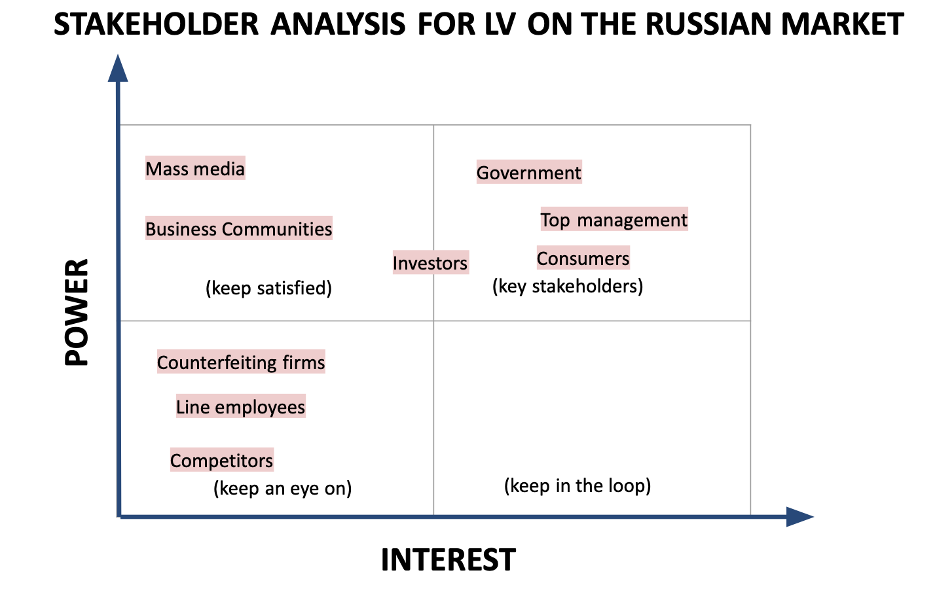
Source: Made by author

- Stakeholder analysis for Louis Vuitton
Stakeholder | Interest | Source of power
Government | Protection of national economy | Legitimate
Top management | Financial results and brand image | Decision-making
Consumers (counterfeiting/luxury) | Development/prevention of counterfeiting activity | Creation/reduction of demand
Investors | Profits | Keep/sell shares, decision-making
Mass media | No interest | Social influence
Business Communities | No interest | Networking, delivering message
Line employees | No interest | No power
Competitors | No interest | No power
Counterfeiting firm | No interest | No power
Source: Made by author
Government is the most influential in terms of prevention of counterfeiting activity, as they have the most powerful tool - legitimacy. This stakeholder is interested because of the threats possessed to the national economy.
Top management is a key stakeholder as well. The power they have is based on the influence on decision making of the company regarding strategy and actions. Top management is interested in this problem, because counterfeiting activity influences the financial results of the company and brand image.
Consumers are very powerful stakeholders, as they create a demand. I can distinguish two types of consumers in this problem: counterfeit consumers and luxury goods consumers. They have different motives, interests and sources of power, but their interest and power are high in both cases. Counterfeiting consumers are interested in the development of counterfeiting activity, while luxury goods consumers are interested in the prevention. The power they have is based on their ability to create demand and support business.
Investors are powerful and interested. The reason for that is because if the group loses its loyal customer base and profits, it won’t be profitable for them to keep the shares and they will sell them. Occurrence of fakes on the market serves as a base for the loss of customer base and profits. On the other hand, the investors are interested in this problem only when it arises.
Mass media is not interested so much in this problem. However, they are very influential for consumers that are key stakeholders, therefore, mass media is powerful.
Business communities represent a rather influential source of power. If the problem is delivered in the right way. Initially business communities are not interested or are not aware of the fact that counterfeiting possesses a great threat to country, firms, and consumers. However, networking can create a great platform for development. In Russia, there are some business communities, for example, Business Family or Moscow Entrepreneurs Association. In addition, such organizations may be more influential in terms of delivering the need for changes to government.
Line employees are usually not interested in the problem of counterfeiting. They work for a salary and have no power over the situation.
Competitors are interested in the problem of counterfeiting only in case it relates to their business performance. In this case we consider only interest in this type of illegal activity’s influence on the Louis Vuitton brand, therefore, competitors have no power and interest.
Counterfeiting firms have no power and interest over the current problem, as the luxury segment can be considered a threat to their survival.
From the stakeholder analysis, it is evident that anti-counterfeiting strategies should be targeted at fulfilling the needs of three groups of stakeholders: government, management, and consumers. In other words, strategy should be developed on three levels of operations: country, firm, and consumer.
Other groups of stakeholders worth paying attention to, but should not be prioritized.
So it would be reasonable to start with the country level (government as a stakeholder) and consider existing regulations.

3.4. Regulations
Salnikova (2020) also cites the governmental regulations and political aspects that initiate production and consumption of counterfeits in Russia. The issue is that in Russian legislation, as in the legislation of most foreign countries, there is no penalty for the purchase of counterfeit goods. Many domestic and foreign researchers deny the need to introduce liability measures for buyers of counterfactual products. So that the paper considers the formation of a moral and legal position of citizens in relation to counterfeit goods to be a priority task.
Even though, in Russia and many other countries there is no penalty for counterfeiting businesses, in some countries there are some. By the thirteenth century, counterfeiting had become so common that the copying of valuable trademarks was made a criminal offense punishable by torture and death in some European countries (Higgins and Rubin 1986).
Let’s consider governmental regulations that end penalties for production and distribution of counterfeits in Russia. There are several types of liability for the sale of counterfeit products: civil, administrative, and criminal.
Within the framework of civil liability, counterfeit goods are withdrawn from circulation. The seized products are subject to disposal at the expense of the distributor. The owner of the intellectual property has the right to sue for damages. The exact amount is determined in the court process. In accordance with Article 1253 of the Civil Code of the Russian Federation, if intellectual property rights have been systematically violated, the prosecutor may submit to the court a demand for the liquidation of the guilty legal entity or for the termination of the activities of a citizen as an individual entrepreneur.
Criminal liability occurs in the case of causing damage to the owner in a large amount, more than 100 thousand rubles. Illegal distribution of intellectual property is qualified under Article 147 of the Criminal Code of the Russian Federation, is punishable by a fine of up to 200 thousand rubles or in the amount of a salary for a year and a half, mandatory, correctional, or forced labor or imprisonment for up to 2 years.
Distribution of counterfeit goods on a particularly large scale in the amount of more than 1 million rubles, is punishable by forced labor for up to 5 years, or imprisonment for up to six years with or without a fine of up to 500 thousand rubles or in the amount of a salary for 3 years.
As the average price of premium fashion segment items is above 100 thousand rubles, the criminal liability for counterfeiting firms should occur.

3.5. PESTEL analysis
In order to better understand factors influencing relationships between the counterfeiting and luxury fashion segment, I suggest having a look at macro factors, influencing the business environment in a country that are depicted in Table 7. It would be reasonable to assess the significance of the factors and have a look at their influence on Louis Vuitton’s strategy and possible improvement in the future. This analysis is done with the purpose of help in the process of recommendations formulation.
The table values and are decoded below:
By time*:
→ affects currently, will stop influencing (within 12 months) - P;
→ affects now and will continue to influence (more than 12 months) – P\F;
→ will matter in the future-F;
→ short-term effect-ST.
By type**:
→ positively affects +;
→ negatively affects –.
By dynamics***:
→ influences and increases influence >;
→ influences with constant significance =;
→ affects, but reduces the impact <.
Relative significance****:
→ Critical: threaten the company's existence;
→ Very important: cause changes in the company's activities;
→ Important: involve some (limited) changes in the activity
→Material: affect, but do not require significant changes;
→Not important: not having a significant impact on the company.

- PESTEL factor analysis
External factors | Significance of the influence of factors |  |  |  | Influence on the strategy
 | By time* | By type* | By dynamics* | Relative significance*
Political
Corruption at the sale points | P | - | = | Very important | Sales of production only in official stores and retail corners
Close borders to counterfeits countries-suppliers | P/F | - | = | Important | Increased involvement of lawyers and courts
Economic
Low salary levels | P/F | - | = | Material | Release of the collection at a cheaper price
Currency fluctuations | P | - | > | Material | Release of the collection at a cheaper price
Economic downturn due to Covid Crisis | P | - | < | Important | Release of the collection at a cheaper price
Social
Lack of anti-counterfeit culture among Russian buyers | P/F | - | = | Important | Request legal punishments for purchasers
Popularity of “transferable trade” in smaller Russian cities | P/F | - | < | Material | Request legal punishments for purchasers
The growth of e-commerce popularity among consumers | P/F | - | > | Very important | Creation of alliances with marketplaces on the Russian market
Technological
Ability to verify the authenticity of the product via the Internet | F | + | > | Material | Continue development of application
Legal
Existence of intellectual property rights | P/F | + | = | Very important | Lawyers
Existence of litigation rights | P/F | + | = | Very important | Lawyers
No penalties for purchasing counterfeiting goods for consumers | P | - | = | Important | Request legal punishments for purchasers
Ecological
Poor waste management | P | + | < | Not important | Increase consumers’ awareness regarding counterfeiting waste management
Source: Made by author

Political
- Corruption at the sale points
As Transparency International states, Russia is among highly corrupt countries in the ranking. In 2020 Russian Corruption Perception Index 2020 was 30, and the country was surrounded by African countries in the ranking. It means those who act illegally on the Russian market can just give bribes to the government (in the form of profit percentage or any other forms), and as a result continue their fraudulent activities. This factor exists in many developing countries, where counterfeiting products can be met in every corner and Russia is not an exception.
- Close borders to counterfeits countries-suppliers
As the paper already discussed, China supplies 85% of the fakes on the Russian market, the reason for that is that Russia borders on China. This factor plays an important role in the prosperity of distribution of illegal goods on the market in question.
Economic
- Low salary levels
According to Trading Economic (2021), the average wage rate in Russia is 49516 rubles in January 2021. If we compare this amount of money to an average price of a product in the luxury goods segment, we can definitely see that people cannot afford it, because the price of one item of premium brands is around 100,000-500,000 rubles. So that, in case a Russian consumer wants a trendy branded item, he or she can only afford buying counterfeit.
- Currency fluctuations
Russia has a floating exchange rate regime, it means that the value of Russian currency depends on the market forces. Nowadays the ruble falls in value, therefore, the price of imported goods increased almost twice. That is why consumers will prefer buying “fake”.
- Economic downturn due to Covid crisis
Covid pandemic forced many organizations to close, people lost their jobs and salaries as well. This factor influenced the increase in the number of people who belong to the lower class, and cannot afford to buy original products offered by the luxury fashion segment.
Social
- Lack of anti-counterfeit culture among Russian buyers
Salnikova (2008) in her work explains that Russian consumers do not understand the negative influence of counterfeiting activity, and got used to buying fakes, as they do not see a material difference. This factor leads to prosperity of counterfeiting activity
- Popularity of “transferrable trade” in smaller Russian cities
There are just a few or an absence of small towns. Things are bought through “transferrable trade” counters at bazaars. At bazaars light segment goods are sold in small wholesale, brought there from different countries of the world, but mostly the goods are from China.
- The growth of e-commerce popularity among consumers
Covid-19 affected the growth of e-commerce from many perspectives. The main point is that people switched to electronic mode of shopping, where counterfeiting is easily distributed. According to Russian Search Marketing (2020), given changes in consumer behavior in 2020, researchers now expect a CAGR of 33.2%, with sales growth from 1.7 trillion to 7.2 trillion rubles in the period 2021-2024.
Technological
- Ability to verify the authenticity of the product via the Internet
Due to technological growth, luxury companies create applications and websites for the originality check. For example, Louis Vuitton’s application is based on blockchain technology. This is a perfect helper for those who bought LV items as second hand production or do not trust the point of sale.
Legal
- Existence of intellectual property rights
The main Law regulating legal relations in the field of intellectual property in Russia is the Civil Code of the Russian Federation part four "Intellectual Rights and means of individualization". This Law regulates at the same time the institute of copyright and related rights, the system of collective management of copyright and related rights, patent law, designations, and other types of intellectual rights, establishes the conditions for the registration of intellectual property, as well as the means of protecting rights.
- Existence of litigation rights
Current regulations in relation to counterfeiting activity are described in part “3.4. Regulations”
- No penalties for purchasing counterfeiting goods for consumers
There are no penalties for the purchasers of “fake” products in Russia, that is why consumers may rely only on their own norms and moral beliefs in the process of deciding whether to buy counterfeits or not.
Environmental
- Poor waste management
In most cases in Russia people are not focused on sustainability issues, and do not think about waste management at all. There is no waste management education or recycling culture. In addition, counterfeiting stock overruns are utilized in an appropriate manner. This may act as an advantage of luxury goods companies, as corporate responsibility is a very important part of almost every luxury brand.
From the PESTEL factor analysis it is evident that macro factors are in most cases negative for Louis Vuitton on the Russian market. However, there exist rights for brand protection, the situation with counterfeiting activity can become even better if Russian government will release legal punishments for purchasers and confiscation of counterfeiting production. Corruption is rather constant for Russian Federation, only lawyers may help in this case and distribution of information that official Louis Vuitton production is only sold in official stores. It will improve the overall situation on the market, even the last “very important” factor connected to the growth of e-commerce popularity, which is the number one distribution channel for counterfeiting firms, will be somehow eliminated.
The volume of fake sales and level of development of counterfeiting activity differ in each country, in most cases, depending on the level of corruption and economic development. The situation in Russia shows that the development of counterfeiting activity in this country is influenced by many factors mentioned by Salnikova (2020). PESTEL analysis revealed that factors that lead to prosperity of counterfeiting in Russia overweight those of the luxury segment. It is worth mentioning that low income levels, a big number of fake distribution channels, because of the border with China and free trade zones with the main countries-suppliers of counterfeits have led to the prosperity of this industry. In addition, there are no penalties and governmental regulations for conduction of such activities in Russia. However, technological development, legitimacy and focus on sustainability may play as win factors for luxury companies. There are a lot of measures to be taken from the governmental side to stop this fraudulent activity.
There is a research gap on the topic of luxury segment’s anti-counterfeiting strategies that are appropriate for the Russian market. The further research will be focused on it.

3.6. Survey Analysis
3.6.1. Description of the survey
To better understand the peculiarities of Russian consumers, the survey was conducted which was called “Identification of the characteristics of the Russian consumer. Louis Vuitton and counterfeit goods”. As Russian market analysis revealed, macro factors in this country create a lucrative environment for counterfeiting activity. Therefore, it would be reasonable to gather primary data and to assess the extent to which Russian buyers are affected by the Russian factors. In addition, Louis Vuitton has an approach of fighting counterfeiting targeted at interaction with customers, it is a mobile application that checks whether the item bought is original or not. That is why the survey is also needed with a purpose of assessment whether this approach is relevant for Russian consumers or not.
The survey is targeted at Russian consumers' perception of “fake” production exposure, and revealing attitudes toward the Louis Vuitton brand and its tools to combat counterfeits.
The sample group consists of 130 people and includes people of different ages, occupations, social statuses. The sample is randomized in terms of people, who do both buy counterfeits and buy luxury production.
The survey was conducted within 2 days.
The participants of the survey were sent a Google Forms questionnaire with a sheet of detailed information about the research. The respondents are achieved via social networks and personal networks. Participation in this focus group presents no potential risks to the participants. Participants and their organizations will not be named in subsequent write-ups and material submitted for publication.
Not all the questions were obligatory to answer. Some of the questions required 1 answer. Some of them were allowed to choose a few options, some of the questions had a line for expression of personal opinion that is not mentioned in the possible answers.

3.6.2. Survey results
The first question revealed that the biggest part of the respondents were of age 18-24 (88) persons. This factor can be a sign of lack of financial resources, as this group consists of students and those who are just starting their career paths. However, there were 36 representatives from 25 to 64 years, that probably may afford to buy Louis Vuitton.
The survey has a little bias in terms of gender, because about 75% of respondents were women. There are many theoretical papers dedicated to the differences in the perception of purchases among people of male and female gender. Therefore, we should draw attention to this factor.
In attempts to reveal consumer perception of counterfeits and original production, it is very important to understand the level of life and surrounding environment in terms of proximity to official stores. The results revealed that the sample consisted of representatives from big Russian cities. 125 respondents from 130 were from capital cities: Moscow and St. Petersburg. Other five were from Ekaterinburg, Perm, Tver, Sochi, Khabarovsk. Therefore, the average level of income of the respondents should be higher than the average one in Russia.
The next question was targeted at revealing financial opportunities to buy luxury goods. Only 27 people replied “I have enough money for everything”, but the most popular reply was “I have enough money to cover basic needs and for vacation, but I have to save up for an apartment purchase”. 26 of the respondents replied “I have enough money to cover basic needs”, and the last 2 cannot cover basic needs. Therefore, from this question we can expect that only 27 individuals can afford buying Louis Vuitton, and 75 can somehow save up for this purchase if they really wish to buy it. Figure 12 depicts the results of this question.

- How can you describe your financial situation?
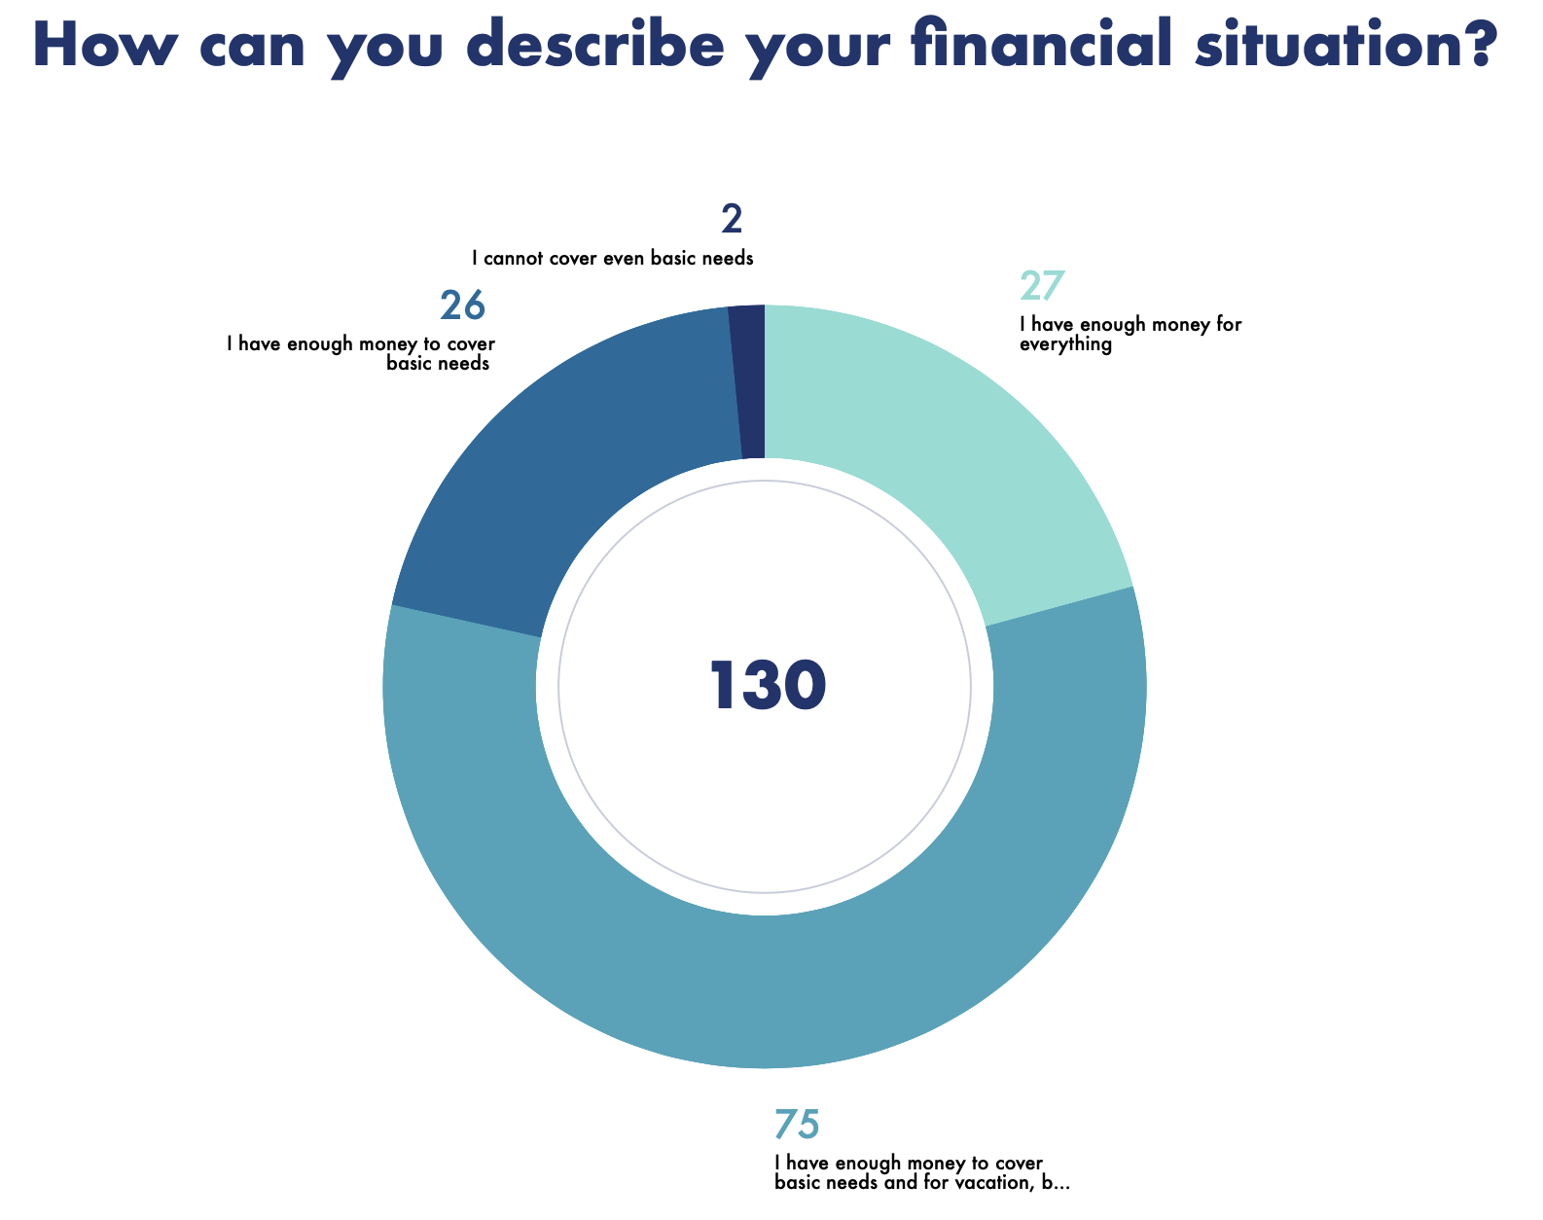
Source: Made by author

The 5th question aimed at revealing the attitudes of Russian consumers towards counterfeiting activity. More than a half of the respondents were neutral, therefore, they do not see something immoral in buying “fakes, 57 have negative attitudes that serve as a sign of consciousness. Figure 13 on the next page shows the results for this question.

- What is your attitude towards the distribution and purchase of counterfeit products?
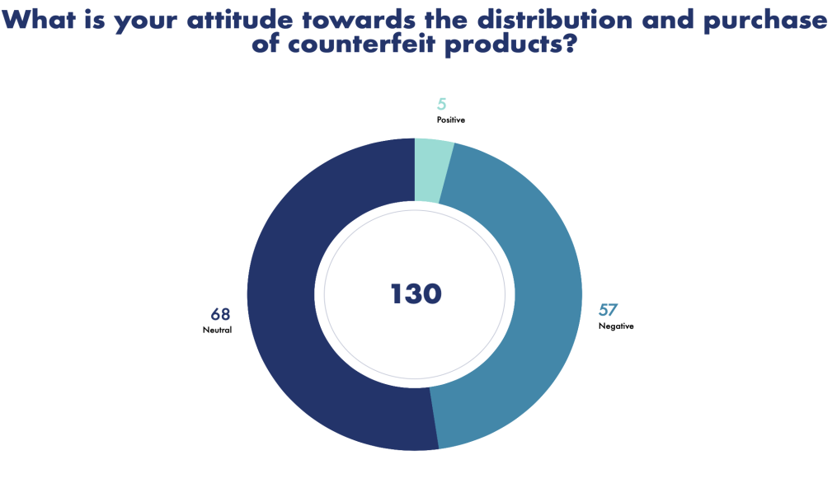
Source: Made by author

The next question revealed the awareness of the consumers in terms of threats possessed by counterfeiting activity. The proportion of answers is almost the same. We can suppose that those who answered “neutral” and “negative” to the previous question, answered “no” and “yes” accordingly here.

- Are you aware of the threats that arise from the counterfeiting activity?
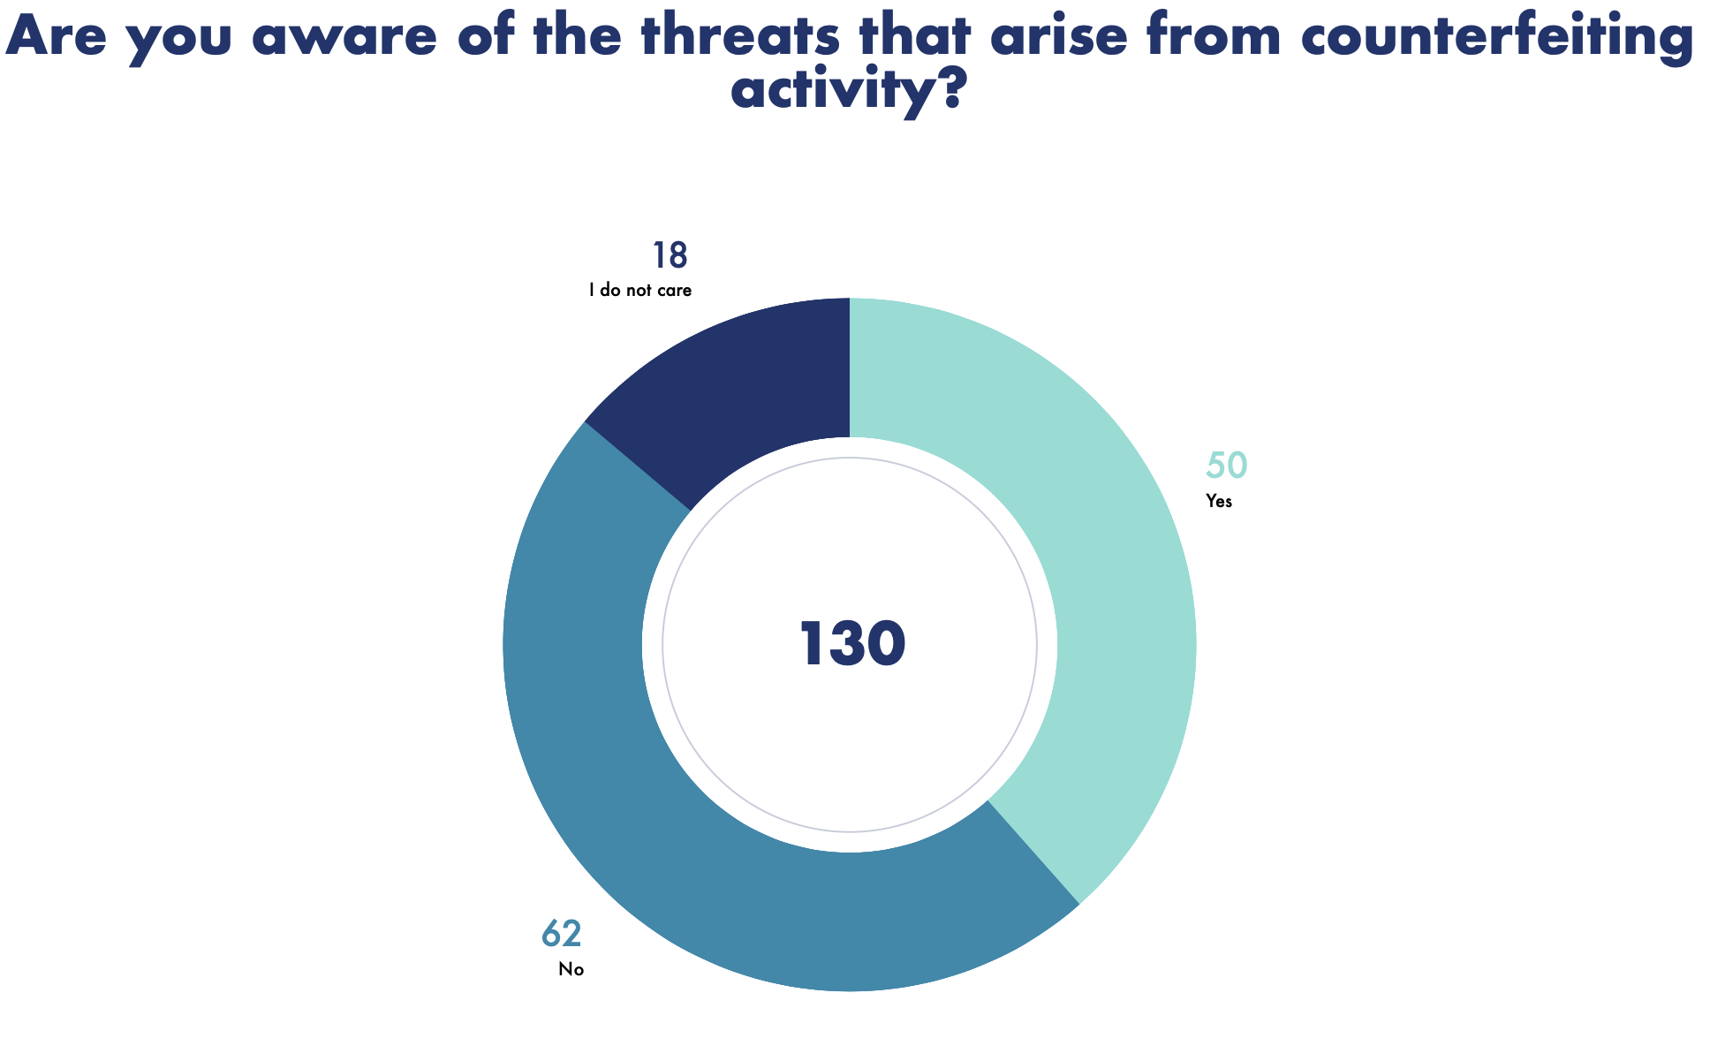
Source: Made by author

The next question showed that almost 40% of the respondents bought fakes. It can be explained by different facts: personal attitude, social, or macro factors in Russia that are the base for counterfeiting prosperity. In addition, in Russia there are no penalties for counterfeiting purchasers, so that people are not afraid of buying it.
The next question is targeted at revealing a more common way of counterfeiting in Russia. From the results, we can conclude that non-deceptive (when people are aware of the fact that they buy counterfeits (Nia and Zaichkowsky (2000)) is twice higher in the country in question. However, a deceptive one exists as well and can be explained by unfaithful retailers.
Talking about factors that attract customers in buying original production, an absolute leader is quality of the production. For example, those consumers who appreciate the quality and think that counterfeiting is immoral, would probably save up for buying Louis Vuitton. This is a perfect example of value-expressive attitude (Katz (1960)). Design and a factor that society perceives brands as something respectable are important as well, as many people responded “demonstration of social status” and “respect from the society”, so that if these people cannot afford to buy Louis Vuitton on a daily basis they will by counterfeits. This is an example of social-adjustive function (Smith, Bruner, and White (1956)). All of the question results are depicted in Figure 15.
In the process of formation of strategies, we should put an emphasis on what Russian consumers appreciate the most in the luxury fashion segment, and target recommendations there.

- What attracts you in buying original premium segment products?
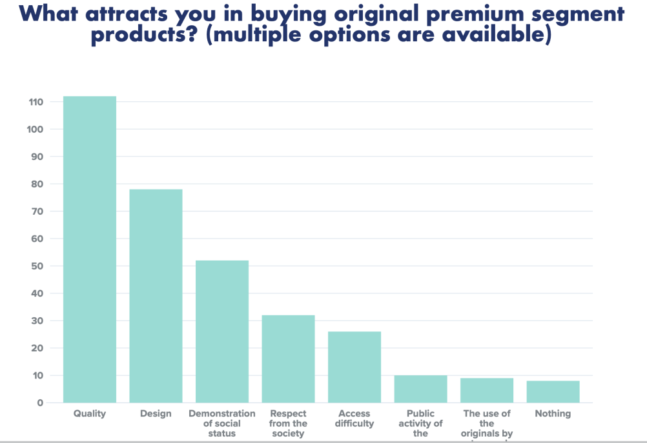
Source: Made by author

The following question revealed that 30,8% of the respondents experienced Louis Vuitton purchases. Even though only 27 people replied that they can afford everything. Analyzing the information given, we can conclude that some representatives of other financial groups are ready to save up to buy an original item to fulfill its own purposes.
The next question depicted in Figure 16 outlines the factors that stop consumers from buying Louis Vuitton production, and an absolute leader is price. It should not be a factor that forces people to buy counterfeiting instead of original products or mass market legal clothes or bags. These results will be taken into consideration, while preparing recommendations for the company.

- If “no”, what was stopping you?
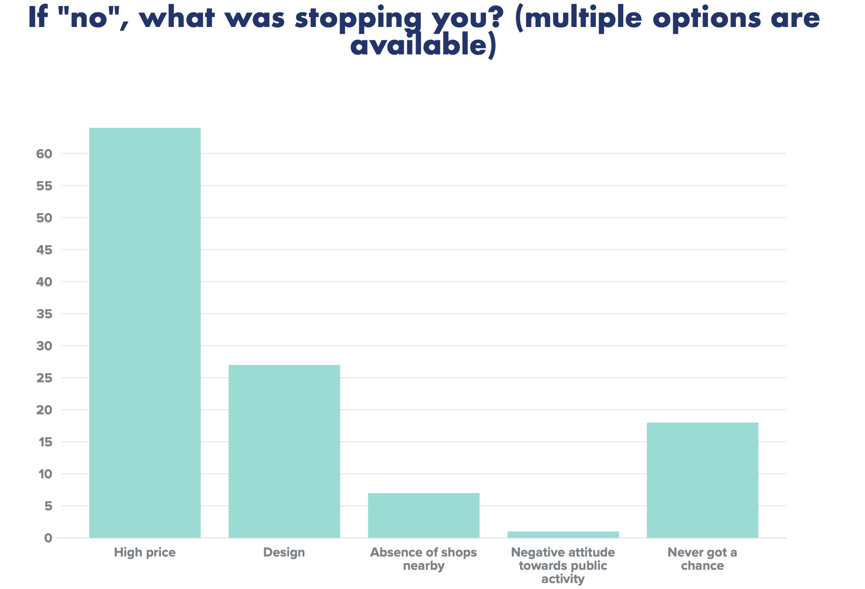
Source: Made by author

And the last question was aimed at applicability of the Louis Vuitton world approach in terms of anti-counterfeiting help for consumers on the Russian market. From Figure 17 we can see that the biggest part of the respondents is ready to use this approach. Therefore, Louis Vuitton should distribute more information on the topic of their mobile application.

- After purchasing premium products, would you use the app on your phone to verify the authenticity of the purchased item?
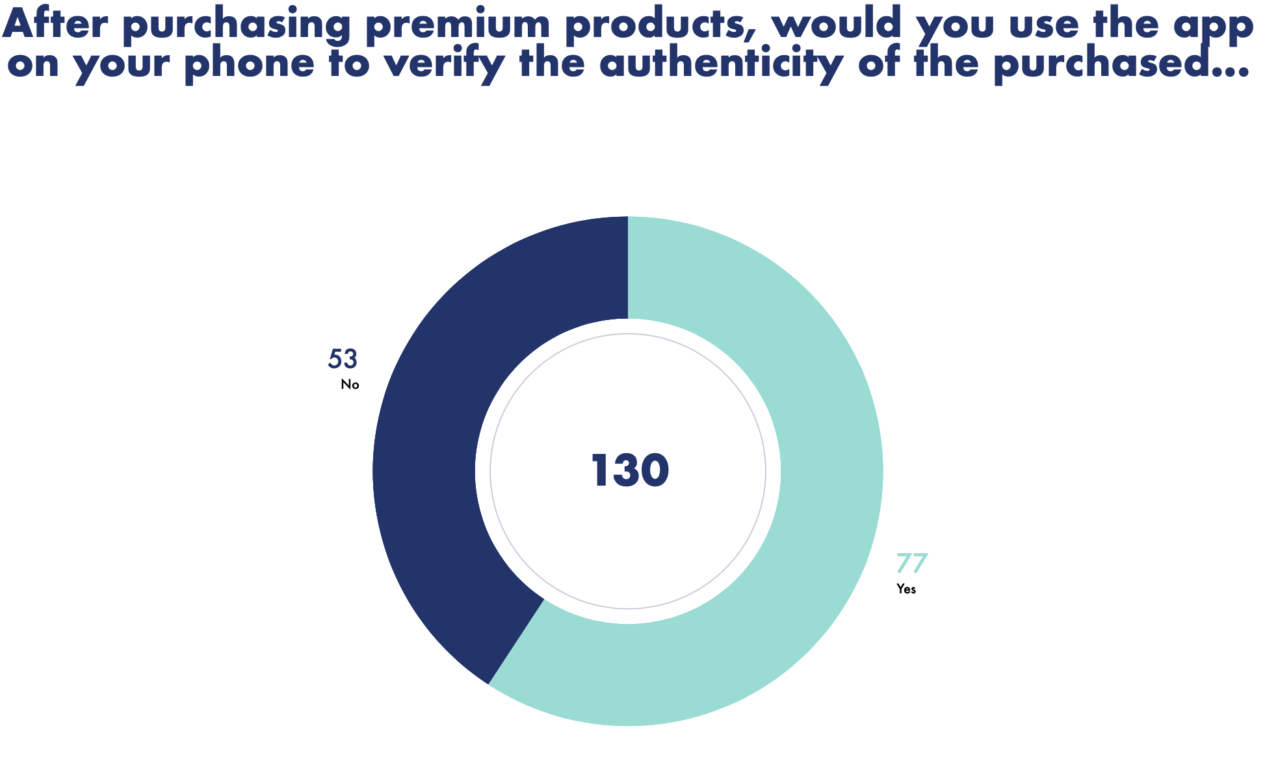
Source: Made by author

Conclusion
The survey revealed that Russian consumers do not have enough information about the negative influence of counterfeiting on firms, society and environment, therefore, the biggest part has a neutral attitude towards counterfeiting.
Many of the respondents have an experience of buying “fake” products. It can be explained by availability and absence of penalties for the purchases.
In addition, the main factor that Russian consumers appreciate in the luxury fashion segment is quality, therefore, Louis Vuitton should put a great emphasis on it. As for the factor that stops people from buying the production of the company in question, the main one is price.
The result that 30,8% of the respondents have an experience of buying original Louis Vuitton production is quite impressive, even though not all of them can afford it. From here, we can draw a conclusion that the company is in demand.
The last but not least, applicability of Louis Vuitton anti-counterfeiting world approach is relevant on the Russian market. Therefore, the company should implement these technologies here.

3.7. Interview analysis
3.7.1 Description of the interview
After the research I have made some assumptions about peculiarities of the Russian market in terms of consumption of fake and luxury goods. They were the following:
- Louis Vuitton has no customization of anti-counterfeiting strategy to each market of operations;
- Wide spread of counterfeiting goods on the Russian market is connected to the prevailing of social-adjustive function among Russian consumers and to the absence of punishments for fake purchasers;
- Louis Vuitton’s current anti-counterfeiting strategy is not effective for the Russian market;
- The most influential stakeholder in terms of prevention of counterfeiting activity is the government.
The questions were formed to support or reject the above assumptions.
I have conducted an interview with two respondents. The respondents were contacted via personal networks and LinkedIn social network. The first one is Daria Kazarina, who works as a digital and retail support director at Louis Vuitton Easern Europe. The second respondent is Daria Zhemaletdinova, who worked as a data analyst in Guerlain in Paris. As Guerlain is a part of LVMH Group, Daria confirmed that she is able to answer the interview questions.
The goal of the interview is to reveal peculiarities of anti-counterfeiting approaches on different markets, as well as to distinguish advantages and disadvantages of current strategy. In addition, the respondents were asked to describe the Russian market in terms of fake consumption in their personal opinion.
All respondents were asked to answer the same questions that are outlined below:
1. Is there an adaptation of the anti-counterfeiting strategy to each market of operations? What are the features of the Russian market’s approach?
2. How would you describe the Russian market in terms of consumption and distribution of counterfeit products of the Louis Vuitton brand?
3. Do you think that the current brand protection strategy is effective?
4. What do you think is the most successful element of the strategy and what is missing?
The first interview was conducted in a written form in LinkedIn, the second one was conducted in the form of voice messages in Telegram.

3.7.2. Interview results
The Table 8 below depicts the results of the interview.

- Results of the interview
 | Is there an adaptation of the anti-counterfeiting strategy to each market of operations? What are the features of the Russian market’s approach? | How would you describe the Russian market in terms of consumption and distribution of counterfeit products of the Louis Vuitton brand? | Do you think that the current brand protection strategy is effective? | What do you think is the most successful element of the strategy and what is missing?
Daria Kazarina (Digital & Retail Support Director at Louis Vuitton Eastern Europe) | “The head office in Paris is responsible for the fight against counterfeits, and there are also partners in Russia. The main feature of Russian market in terms of counterfeit goods is that in most cases they are distributed online. Therefore, Eastern Europe office is responsible for the provision of information regarding counterfeits on the current market (information about websites that sell counterfeit goods online)” | “The Russian market is very specific, quite a large % of the population prefers to buy counterfeit goods instead of original ones, in most cases this feature relates to people with average income level. There are also a lot of fashion buyers in Russia who offer the service of buying goods in Europe. In fact, this product often turns out to be not original, later on customers find out the truth, by contacting the official store for after-sales service” | “No, because online distribution is prevailing. And it is necessary to fight not only with sellers, but also with manufacturers.” | “Europe is a great example because of their policy of confiscation of counterfeit goods and punishments for counterfeit  purchase. These actions proved to be successful. Thus, the end user is no longer willing and tempted to purchase the product from an unofficial seller. And if there are no customers. there is no business.”
Daria Zhemaletdinova (Data Analyst at Guerlain Paris) | “As far as I know, there are no differences in strategies for different markets. The actions of the company that reduce counterfeiting activity are the following: official stores are the only sales points of original production;  there is a special product code; trying to make it impossible to confuse the original product with the fake one due to technologies and design;  provision of information on recognizing fakes, for example, there are special blogs where they reveal websites with fakes;  on the website all official retailers are indicated;  you can always call and find out about distribution channels in the custom service.” | “Russian culture implies the cultivation of wearing a brand and showing-off, in Russia it is difficult to fight counterfeiting activity, because people consciously buy fakes.” | “I believe that the strategy is effective, especially checking special codes, and checking official retail partners on the website.” | “Companies should provide information regarding recognition of the fakes on the official websites. LV does it.”
Source: Made by author

Problems
- From the interview it is evident that for the luxury fashion Russian market the main problem is prevailing online distribution of counterfeits. Even though Louis Vuitton provides their distribution channels on the website, the existence of so-called “fashion buyers from Europe” makes the fight against counterfeiting harder.
- Russian culture of showing off and logomania
Russian strategy
There is no adaptation to each market, all decisions are from the head office in Paris. The actions described by the respondents are the same as were described earlier in this paper. Respondents describe current actions as somehow effective, but in case of online distribution, it is hard to fight it, as well as in case of conscious purchase.
Solutions to the problems
- Fight manufacturers
- Confiscation and punishment to counterfeit purchase
The interview revealed that Louis Vuitton should continue their actions on the firm level, however, the best solution to the problem is to target country level by requesting changes in legislation and incorporation of punishments and confiscation practices. This is the only way to reduce demand for those who are aware of buying counterfeits with the purpose of showing off.

Conclusion
Part 3 of the paper outlines the specificities of counterfeiting activity on the Russian market.
First of all, Russian people are usually aware of the fact that they buy counterfeits and they do it intentionally and consciously. The purpose of their purchases is showing off their social status and being respectable in the society. These motives were described in the “Consumer behavior” part, as well as in Ajzen, I. (2011) model.
The stakeholder analysis shows that strategy should be targeted at key stakeholders: government, management and consumers. In addition, their interests should be fulfilled and power used in the right way.
PESTEL analysis showed that Russia represents an environment with prevailing negative macro factors, therefore, the business environment for the counterfeiting activity is lucrative. However, there exist positive ones that can be used in the process of fighting against illegal activity.
The survey conducted supported the statements that were made before about consumer preferences. People in Russia even of average income are ready to buy brands to prove that they are of valuable social statuses. A lot of people are not aware of the threats possessed by counterfeiting activity. In addition, the survey checked the applicability of the current approach of Louis Vuitton on the European market to the Russian market, most of the respondents replied that they are ready to check the authenticity of products via mobile application.
The interview with the representatives of the LVMH group revealed that the main problem for the Russian market is online distribution of fake production. Current approach of the brand is worth staying, but legislative changes are needed through contacting government bodies. The world approach for combating counterfeiting is common for Louis Vuitton and managed from the head office in Paris.
Now, the paper combines the whole picture of the Russian market, its advantages and disadvantages, therefore, it would be reasonable to proceed to the recommendations for Louis Vuitton’s strategy on the Russian in the process of combating counterfeiting activity and brand protection.

PART 4. RECOMMENDATIONS FOR LOUIS VUITTON ON THE RUSSIAN MARKET
In this part, the paper considers solutions to the problems in question that proved to be effective in experiences of other countries and companies. The elements of strategy will be considered on three levels: consumer, company, and country, and outlined below in the table below. I must admit that many elements of current strategy are left but modified for the Russian market.

- Element of Louis Vuitton anti-counterfeiting strategy
Element of strategy | Description | Approximate price
Consumer level
- AURA application with NFC tags | Louis Vuitton should continue development of their application  Further actions: widen the range of products that can be checked, distribute the information among Russian consumers that application is available for downloading. | Creation 6000$+monthly support (salaries of back-end and front-end IT specialists)
- Provision of information about distribution channels and threats possessed by counterfeiting activity | Further actions:  - Make the information about distribution channels and threats more visible on the website.  - Use mass media for delivering messages about threats. For example, social campaigns on TV and YouTube, information on Instagram, articles in the magazines. | It would be better to make temporary (start with 3 months) TV campaign about 1 minute per channel a day on 2 channels (Perviy and TNT), after 3 months track the results  2050000+1350000=3400000 rub/day  For social networks we start from 10 influencers with a high number of subscribers and advertising price not more than 300000 rub=3mln rub.  Track the results, and continue if the actions are successful
- Campaigns targeted at social priority of LV consumers | Further actions:  Russian consumers pursue social-adjustive function of behavior, therefore, due to the Ajzen’s theory we can understand that the campaign should deliver that people purchase not only the thing but also social status. | The same price as for usual campaigns
Firm level
- Program “contributory liability principle” | This program proved to be successful for Louis Vuitton in the United States. This program is focused on fighting landlords, courier companies and payment facilities providing services to underground counterfeit networks.  Further actions: incorporation of a program on the Russian market based on collaboration with the government + adding fighting not only intermediaries, but also manufacturers. | The program already exists, information about costs is anonymous
- IP Protection department for Louis Vuitton Eastern Europe | The IP Department is located in the head office in Paris and all decisions are made there.  Further actions: to open the IP Department for Louis Vuitton Eastern Europe as problems with counterfeiting on different markets depend on cultural and environmental peculiarities. The department will develop customized solutions for the Russian market based on the consumer behavior and governmental regulations. | Information about costs and salaries is anonymous
- Louis Vuitton’s lawyers + Independent agencies | Further actions: leave as it is | Information about costs and salaries is anonymous
- Release of the collection at a relatively cheaper price | Further actions: develop clothes collection for youngsters at a cheaper price, for those who dream about LV but cannot afford it. Successful examples of competitors’ cheaper collections or brands are Prada’s Miu Miu, CDG’s Commes Des Garcon Boy, Cavalli’s Just Cavalli, Moschino’s Love Moschino and so on. | Depends on the materials used and on the designers’ decisions
Country level
- Anti-counterfeiting alliances with Russian marketplaces | There exists a successful alliance of LVMH Group on the world level with Alibaba.  Further actions:  Create anti-counterfeiting alliance with Russian marketplaces, where fake productions are highly distributed and demanded. The members of the alliance may be Wildberries, Lamoda, OZON, Yandex Market and so on. | Alliances are made on the base of mutual agreement and benefit
- Punishment for counterfeiting purchasers and confiscation of goods | In Russia there are no punishments for counterfeiting consumers, therefore, nothing stops people from buying desired things for an affordable price.  Further actions:  Make a collective request for the government with the need to make these changes. This will not only help luxury companies to improve their financial indicators, but also will improve the national economy. | Free
- Restrictions on import of counterfeiting goods | Close borders to counterfeiting countries-manufacturers make the situation on Russian market worse.  Further actions:  The companies should raise the question about fake imports in Russia and propose restrictions on transfer. This will result in better companies’ financial indicators and increased performance of the national economy. | Free
Source: Made by author

The earlier research helped to gather all needed information for the formation of recommendations. These recommendations address different stakeholders and levels of strategy.

CONCLUSION
The problem of counterfeiting appears worldwide nowadays. It possesses a great threat to original companies, national economy, consumers, and environment. There exist a set of tools that help in partial prevention of this activity, but external factors sometimes may be stronger. The harmful influence of counterfeiting should be reduced.
Louis Vuitton as a part of LVMH group is one of the most copied brands in the world. Louis Vuitton was founded in 1854. Brand’s fight against illegal copies started from its first years of existence, when George Vuitton invented monogram bags that were very hard to copy. Nowadays the Group has many awards for being successful in fighting against counterfeiting, however, the problem is still relevant and world counterfeiting turnover of sales increases each day.
The practices as parts of Louis Vuitton’s anti-counterfeiting strategy are the following: “BRAND PROTECTION”, which includes intellectual property department, team of LV lawyers, 250 agents throughout the world, and program “Contributory Liability Principle”; AURA mobile application that helps to check the authenticity of the goods with the help of NFC tags; participation in anti-counterfeiting alliances, such as Alibaba Big Data Anti-Counterfeiting Alliance; constant courts connected to brand protection and theft of intellectual property; distribution of information about threats possessed by counterfeiting among internal and external stakeholders; creation of unique design; sale of goods only through official stores and limited number of retailers that can be found on the official website.
In 2020, sales losses because of counterfeiting accounted for 26,3 bln euro only for the clothing segment of textile industry. But the main incentive for counterfeiting to continue their business is the demand from current and potential consumers. In the process of this type of illegal business involved many parties, starting from manufacturer, ending by end consumer. There are many distribution channels, but the one that should be highlighted is the Internet. Nowadays, fake production is in most cases distributed with the help of e-commerce.
The theoretical background in paper helps in understanding the consumer behavior and preferences and existing anti-counterfeiting strategies.
The first thing the companies should have a look at in the process of consumer behavior analysis is whether the purchase of counterfeit goods is deceptive (consumer is not aware that the product is not original) or non-deceptive (consumer is aware that the product is not original) (Nia and Zaichkowsky (2000)). Theorists Wilcox, K., Kim, H. M., & Sen, S. (2009) divide the attitude of consumers towards choice whether to buy original or fake goods into two functions: social-adjustive and value expressive. Ajzen, I. (2011) model explains how the external environment influences the process of decision-making and how the consumer decides to buy or not to buy this or that item.
Hoecht, A., & Trott, P. (2014) divides anti-counterfeiting strategies into 3 levels: consumer, firm, and societal. This approach is used when paper’s recommendations are formed. The strategies described by theorists have similar features but divided into different typologies. For example, Amaral, N. (2020) addresses stakeholders by their level of motivation. Famous luxury brands have a similar approach to Louis Vuitton’s way of fighting.
After the analysis of Louis Vuitton’s strategy and literature, it becomes evident that the most powerful way to fight it is governmental legitimacy. Even though the consumers create the demand, companies cannot change their behavior in one year.
The third chapter describes the situation with counterfeiting on the Russian market. There exist many reasons for the prosperity of fake production on the Russian market, starting from the absence of anti-counterfeiting culture, ending by the absence of punishments for purchasers. Talking about consumer behavior, the analysis revealed that among Russian consumers social-adjustive function is prevailing, therefore, there is a need for them to be respectable with the help of luxury brands. The statistics are outstanding and shocking, as the total market of illegitimate products in Russia is estimated to be up to 30%, and up to 45% of all sales of clothing, shoes and accessories.
The stakeholder analysis revealed that key stakeholders for Louis Vuitton in the process of combating counterfeits are government, top management, and consumer. Therefore, it becomes more reasonable to use Hoecht, A., & Trott, P. (2014) model in the process of strategy formation. The PESTEL analysis showed that macro factors are mostly negative, however, their influence can be reduced with the help of some actions.
The paper combines two ways of primary data gathering: survey and interview with the representatives of LVMH. The survey revealed that consumers are not aware of the negative impact possessed by counterfeiting. The biggest part of respondents experienced purchasing fake production, while 30% experienced Louis Vuitton purchases. The survey proved that even people of average income are ready to buy original Louis Vuitton productions to show-off their social status (social-adjustive function). The survey was targeted at assessing whether consumers are ready and willing to check the authenticity of goods with the help of AURA application, the results showed the positive outcome.
The interview questions were based on the assumptions based on earlier research and addressed to 2 representatives of LVMH group. The main outcome of the interview is that the current approach is on the one hand, effective, but on the other hand, without governmental legitimate changes no improvements in the situation are possible. In addition, all decisions about the anti-counterfeiting strategy of Louis Vuitton come from the head office in Paris and there is no adaptation to markets. The popularity of e-commerce makes the situation with the fakes spread worse and worse.
Based on all research, the recommendations for the brand on 3 levels were given: country, brand, and consumer. Consumer level: to continue development of AURA application, provision of information about distribution channels and threats possessed by the counterfeiting activity on TV, YouTube and social networks, campaigns targeted at social priority of Louis Vuitton’s consumers. Firm level: to continue the program “Contributory liability principle”, to open IP Protection department for Louis Vuitton Eastern Europe, to continue working with independent agents and Louis Vuitton’s lawyers, to release a collection at relatively cheaper price, for example, for youngsters. Country level: to create anti-counterfeiting alliances with Russian marketplaces, to request legitimate punishments and confiscation for purchasers of counterfeiting in Russian Federation, to request restrictions on import of counterfeiting goods. All recommendations are not obligatory and can be used together at the discretion of top management.
The recommendations are given based on previous research, and the goal of the paper is reached. The paper proved that counterfeiting is a threat to the survival of the luxury segment. The government is the strongest stakeholder in the process of prevention; therefore, they can save the business and national economy.

References
- (2008). Counterfeiting: a global spread, a global threat. Trends in Organized Crime, 12(1), 59-77.

- Ajzen, I. (2011). The theory of planned behaviour: Reactions and reflections.

- Alizila Staff (2017) Alibaba Launches “Big Data Anti-Counterfeiting Alliance”. [online] Available at: https://www.alizila.com/alibaba-launches-big-data-anti-counterfeiting-alliance/ [Accessed 5 April 2021]

- Bloch, P. H., Bush, R. F., & Campbell, L. (1993). Consumer “accomplices” in product counterfeiting: a demand side investigation. Journal of consumer marketing.

- BMONITOR (2019) More than 80 % of Russians agreed to buy counterfeit goods. [online] Available at: https://brandmonitor.ru/materials/bolee-80-rossiyan-soglasilis-pokupat-kontrafakt/ [Accessed 20 March 2021]

- BURO. (2015) Louis Vuitton signed the anti-counterfeiting pact. [online] Available at: https://www.buro247.ru/news/lifestyle/louis-vuitton-boretsya-s-poddelkami.html [Accessed 5 April 2021]

- Business Family (n.d.) [online] Available at: https://bizfam.ru [Accessed 10 May 2021]

- Business Journal (2019) Anti-Counterfeiting: Expert Opinion. [online] Available at: https://business-magazine.online/fn_35000.html [Accessed 2 December 2020]

- Comparably (n.d.) LVMH. [online] Available at: https://www.comparably.com/companies/lvmh/mission [Accessed 2 April 2021]

- Don-Alvin Adegeest (2018) Louis Vuitton recipient of Positive Luxury Award. FashionUnited [online] Available at: https://fashionunited.uk/news/fashion/louis-vuitton-recipient-of-positive-luxury-award/2018101139397 [Accessed 3 April 2021]

- EESC (2017) Fake products cost 800,000 jobs annually. [online] Available at: https://www.eesc.europa.eu/en/news-media/news/fake-products-cost-800000-jobs-annually [Accessed 8 April 2021]

- Fishbein, M. (1979). A theory of reasoned action: some applications and implications.

- Forbes (2020) Sales of counterfeit luxury goods in social networks exceeded 23 billion rubles. [online] Available at: https://www.rbc.ru/rbcfreenews/5f44e9629a794752aae84a97 [Accessed 8 April 2020]

- Global Counterfeiting Report, 2018. (2019)

- GRAVITEC (2018) The cost of developing a mobile application, the stages of development. [online] Available at: https://gravitec.net/ru/blog/stoimost-razrabotki-mobil-nogo-prilozheniya-e-tapy-razrabotki/ [Accessed 26 May 2020]

- Grossman, G. M., & Shapiro, C. (1988). Foreign counterfeiting of status goods. The Quarterly Journal of Economics, 103(1), 79-100.

- Hilton, B., Choi, C., & Millar, C. (2000). Quality, Counterfeits and Strategy in the Fashion Industry. Security Journal, 13(4), 53-70.

- Interregional Public Organization Moscow Association of Entrepreneurs (n.d.) [online] Available at: https://www.moomap.ru [Accessed 10 May 2021]

- Katz, D. (1960). The functional approach to the study of attitudes. Public opinion quarterly, 24(2), 163-204.

- Lai, K. K. Y., & Zaichkowsky, J. L. (1999). Brand imitation: do the Chinese have different views?. Asia pacific journal of management, 16(2), 179-192.

- Louis Vuitton (n.d.) BRAND PROTECTION. [online] Available at: https://www.louisvuitton.com/content/dam/lv/online/text/allcountry/Brand_Protection_EN.pdf [Accessed 23 March 2021]

- LVMH (2019) Louis Vuitton recognized for its efforts in the fight against counterfeiting on World Anti-Counterfeiting Day. [online] Available at: https://www.lvmh.com/news-documents/press-releases/lvmh-recognized-for-its-efforts-in-the-fight-against-counterfeiting-on-world-anti-counterfeiting-day/ [Accessed 5 April 2021]

- LVMH (2021) Annual Report 2020. [online] Available at: https://www.lvmh.ru/investors/ [Accessed 2 April 2021]

- LVMH (n.d.) The LVMH model. [online] Available at: https://www.lvmh.com/group/about-lvmh/the-lvmh-model/ [Accessed 2 April 2021]

- lvmh.ru [online] Available at: https://www.lvmh.ru/группа/ [Accessed 2 December 2020]

- Macrotrends (2021) Louis Vuitton Operating Expenses 2011-2020. [online] Available at: https://www.macrotrends.net/stocks/charts/LVMUY/louis-vuitton/operating-expenses [Accessed 5 April 2021]

- National Business (n.d.) Fight against counterfeits in Russia. [online] Available at: https://nb159.ru/rubric/strategy/borba-s-poddelkami-v-rossii/ [Accessed 2 December 2020]

- Nia, A., & Zaichkowsky, J. L. (2000). Do counterfeits devalue the ownership of luxury brands?. Journal of product & brand management.

- PLAYMEDIA (2021) Calculating the cost of advertising. [online] Available at: https://playmediatv.ru/federaltv/reklama-na-tnt/ [Accessed 16 May 2020]

- Ratneshwar, S., Barsalou, L. W., Pechmann, C., & Moore, M. (2001). Goal-derived categories: The role of personal and situational goals in category representations. Journal of Consumer Psychology, 10(3), 147-157.

- Reference for Business (n.d.) Burberry Ltd. - Company Profile, Information, Business Description, History, Background Information on Burberry Ltd. [online] Available at: https://www.referenceforbusiness.com/history2/22/Burberry-Ltd.html#ixzz6fVQyEpfE [Accessed 2 December 2020]

- Retail Loyalty (2019) The major market players are primarily interested in the fight against counterfeiting.. [online] Available at: https://retail-loyalty.org/expert-forum/v-borbe-s-poddelkami-prezhde-vsego-zainteresovany-krupnye-igroki-rynka/ [Accessed 5 December 2020]

- Roberto Fontana, Stéphane J.G. Girod, and Martin Králik (2019) How Luxury Brands Can Beat Counterfeits? Harvard Business Review [online] Available at: https://hbr.org/2019/05/how-luxury-brands-can-beat-counterfeiters [Accessed 9 April 2021]

- Roberto Fontana, Stéphane J.G. Girod, and Martin Králik (2019) How Luxury Brands Can Beat Counterfeits. Harvard Business Review [online] Available at: https://hbr.org/2019/05/how-luxury-brands-can-beat-counterfeiters [Accessed 5 April 2021]

- Robyn Turk (2019) LVMH introduces blockchain to prevent luxury counterfeits. FashionUnited [online] Available at: https://fashionunited.uk/news/business/lvmh-introduces-blockchain-to-prevent-luxury-counterfeits/2019052143290 [Accessed 6 April 2021]

- Russian Search Marketing (2020) E-commerce market in Russia in 2020-2024. [online] Available at: https://russiansearchmarketing.com/e-commerce-market-in-russia-in-2020-2024/ [Accessed 9 April 2020]

- Seeking Alpha (2021) LVMH Moët Hennessy - Louis Vuitton, Société Européenne. [online] Available at: https://seekingalpha.com/symbol/LVMHF/peers/comparison [Accessed 7 April 2021]

- Smith, M. B., Bruner, J. S., & White, R. W. (1956). Opinions and personality.

- Statista (2020) Sales value losses from counterfeit goods worldwide in 2020, by retail sector. [online] Available at: https://www.statista.com/statistics/1117921/sales-losses-due-to-fake-good-by-industry-worldwide/ [Accessed 22 March 2020]

- Statista (2021) In 2020, LVMH had a gross margin of 28.78 billion euros. [online] Available at: https://www.statista.com/statistics/245885/lvmh-gross-margin-worldwide/ [Accessed 2 April 2021]

- Statista (2021) Total revenue of the LVMH Group worldwide from 2008 to 2020. [online] Available at: https://www.statista.com/statistics/245852/total-revenue-of-the-lvmh-group-worldwide/ [Accessed 1 April 2021]

- Trading Economics (2021) Russia Average Monthly Wages. [online] Available at: https://tradingeconomics.com/russia/wages [Accessed 9 April 2021]

- Transparency International (2021) Corruption Perception Index 2020. [online] Available at: https://www.transparency.org/en/cpi/2020/index/rus# [Accessed 9 April 2021]

- Vogue.ua (2017) Fashion theft: how big brands fight counterfeiting. [online] Available at: https://vogue.ua/article/fashion/brend/modnoe-vorovstvo-kak-bolshie-brendy-boryutsya-s-kontrafaktom.html [Accessed 1 April 2021]

- Wilcox, K., Kim, H. M., & Sen, S. (2009). Why do consumers buy counterfeit luxury brands?. Journal of marketing research, 46(2), 247-259.

- Wonder (2014) Abibas. How fakes took over the world. [online] Available at: https://www.wonderzine.com/wonderzine/style/style/203429-fake-history [Accessed 2 December 2020]

- Карасева О. (2020) Рыночная фейкономика: Как в России торгуют подделками Чем отличаются реплики из шоурумов от дешевого «абибаса». The Village [online] Available at: https://www.the-village.ru/business/stories/poddelki [Accessed 9 April 2021]

- Коммерсант (2016) Код подлинности. [online] Available at: https://www.kommersant.ru/doc/3135463 [Accessed 24 March 2021]

- Котельникова, З. В. (2008). Товар с чужим лицом, или Почему правообладатели торговых марок попустительствуют контрафакту?. Экономическая социология, 9(4).

- РБК (2020) Продажи подделок товаров в соцсетях превысили 23 млрд руб. [online] Available at: https://www.rbc.ru/rbcfreenews/5f44e9629a794752aae84a97 [Accessed 3 April 2021]

- РБК (2021) “Наше время пришло”: как создается новый технологический уклад. [online] Available at: https://www.rbc.ru/spb_sz/03/01/2021/5ff097a39a7947903446c7e8 [Accessed 4 April 2021]

- Сальникова, А. В. (2020). Модный контрафакт в России: современные тенденции. Актуальные проблемы экономики и права, (1).

- Сергей Максимов (2015) Как бренд Louis Vuitton борется с подделками. [online] Available at: http://ruscrimea.org/news/54931-kak-brend-louis-vuitton-boretsya-s-poddelkami.html [Accessed 6 April 2021]

- Солдатова Л. (2019) Виды контрафакта и ответственность за его продажу. [online] Available at: https://63.мвд.рф/news/item/18486308/ [Accessed 7 April 2021]

Appendix

Fashion house
LVMH (2021) Annual Report 2020. [online] Available at: https://www.lvmh.ru/investors/ [Accessed 2 April 2021]
Comparably (n.d.) LVMH. [online] Available at: https://www.comparably.com/companies/lvmh/mission [Accessed 2 April 2021]
LVMH (n.d.) The LVMH model. [online] Available at: https://www.lvmh.com/group/about-lvmh/the-lvmh-model/ [Accessed 2 April 2021]
Don-Alvin Adegeest (2018) Louis Vuitton recipient of Positive Luxury Award. FashionUnited [online] Available at: https://fashionunited.uk/news/fashion/louis-vuitton-recipient-of-positive-luxury-award/2018101139397 [Accessed 3 April 2021]
Donzé PY. (2018) The Birth of Luxury Big Business: LVMH, Richemont and Kering. In: Donzé PY., Fujioka R. (eds) Global Luxury. Palgrave, Singapore.
Macrotrends (2021) Louis Vuitton Operating Expenses 2011-2020. [online] Available at: https://www.macrotrends.net/stocks/charts/LVMUY/louis-vuitton/operating-expenses [Accessed 5 April 2021]
Global Counterfeiting Report, 2018. (2019)
Roberto Fontana, Stéphane J.G. Girod, and Martin Králik (2019) How Luxury Brands Can Beat Counterfeits. Harvard Business Review [online] Available at: https://hbr.org/2019/05/how-luxury-brands-can-beat-counterfeiters [Accessed 5 April 2021]
Louis Vuitton (n.d.) BRAND PROTECTION. [online] Available at: https://www.louisvuitton.com/content/dam/lv/online/text/allcountry/Brand_Protection_EN.pdf [Accessed 23 March 2021]
Robyn Turk (2019) LVMH introduces blockchain to prevent luxury counterfeits. FashionUnited [online] Available at: https://fashionunited.uk/news/business/lvmh-introduces-blockchain-to-prevent-luxury-counterfeits/2019052143290 [Accessed 6 April 2021]
Alizila Staff (2017) Alibaba Launches “Big Data Anti-Counterfeiting Alliance”. [online] Available at: https://www.alizila.com/alibaba-launches-big-data-anti-counterfeiting-alliance/ [Accessed 5 April 2021]
BURO. (2015) Луи Витон подписал пакт о борьбе с контрафактной продукцией. [online] Available at: https://www.buro247.ru/news/lifestyle/louis-vuitton-boretsya-s-poddelkami.html [Accessed 5 April 2021]
LVMH (2019) Louis Vuitton recognized for its efforts in the fight against counterfeiting on World Anti-Counterfeiting Day. [online] Available at: https://www.lvmh.com/news-documents/press-releases/lvmh-recognized-for-its-efforts-in-the-fight-against-counterfeiting-on-world-anti-counterfeiting-day/ [Accessed 5 April]
Lai, K. K. Y., & Zaichkowsky, J. L. (1999). Brand imitation: do the Chinese have different views?. Asia pacific journal of management, 16(2), 179-192.
Bush, Ronald F., Peter H. Bloch, and Scott Dawson. "Remedies for product counterfeiting." Business Horizons 32.1 (1989): 59-66.
Wonder (2014) Abibas. Как подделки захватили мир. [online] Available at: https://www.wonderzine.com/wonderzine/style/style/203429-fake-history [Accessed 2 December 2020]
Soldatova L. (2019) Виды контрафакта и ответственность за его продажу. [online] Available at: https://63.мвд.рф/news/item/18486308/ [Accessed 7 April 2021]
Forbes (2020) Продажи подделок люксовых товаров в соцсетях превысили 23 млрд руб. [online] Available at: https://www.rbc.ru/rbcfreenews/5f44e9629a794752aae84a97 [Accessed 8 April 2020]
(2008). Counterfeiting: a global spread, a global threat. Trends in Organized Crime, 12(1), 59-77.
EESC (2017) Fake products cost 800,000 jobs annually. [online] Available at: https://www.eesc.europa.eu/en/news-media/news/fake-products-cost-800000-jobs-annually [Accessed 8 April 2021]
Nia, A., & Zaichkowsky, J. L. (2000). Do counterfeits devalue the ownership of luxury brands?. Journal of product & brand management.
Grossman, G. M., & Shapiro, C. (1988). Foreign counterfeiting of status goods. The Quarterly Journal of Economics, 103(1), 79-100.
Ajzen, I. (2011). The theory of planned behaviour: Reactions and reflections.
Fishbein, M. (1979). A theory of reasoned action: some applications and implications.
Wilcox, K., Kim, H. M., & Sen, S. (2009). Why do consumers buy counterfeit luxury brands?. Journal of marketing research, 46(2), 247-259.
Smith, M. B., Bruner, J. S., & White, R. W. (1956). Opinions and personality.
Katz, D. (1960). The functional approach to the study of attitudes. Public opinion quarterly, 24(2), 163-204.
Ratneshwar, S., Barsalou, L. W., Pechmann, C., & Moore, M. (2001). Goal-derived categories: The role of personal and situational goals in category representations. Journal of Consumer Psychology, 10(3), 147-157.
Bloch, P. H., Bush, R. F., & Campbell, L. (1993). Consumer “accomplices” in product counterfeiting: a demand side investigation. Journal of consumer marketing.
Котельникова, З. В. (2008). Товар с чужим лицом, или Почему правообладатели торговых марок попустительствуют контрафакту?. Экономическая социология, 9(4).
Hoecht, A., & Trott, P. (2014). How should firms deal with counterfeiting? A review of the success conditions of anti‐counterfeiting strategies. International Journal of Emerging Markets, 9(1), 98-119.
Hilton, B., Choi, C., & Millar, C. (2000). Quality, Counterfeits and Strategy in the Fashion Industry. Security Journal, 13(4), 53-70.
Amaral, N. (2020). What can be done to address luxury counterfeiting? An integrative review of tactics and strategies. Journal of Brand Management, OnlineFirst, 1-19.
Roberto Fontana, Stéphane J.G. Girod, and Martin Králik (2019) How Luxury Brands Can Beat Counterfeits? Harvard Business Review [online] Available at: https://hbr.org/2019/05/how-luxury-brands-can-beat-counterfeiters [Accessed 9 April 2021]
Vogue.ua (2017) Модное воровство: как большие бренды борются с контрафактом. [online] Available at: https://vogue.ua/article/fashion/brend/modnoe-vorovstvo-kak-bolshie-brendy-boryutsya-s-kontrafaktom.html [Accessed 1 April 2021]
Сальникова, А. В. (2020). Модный контрафакт в России: современные тенденции. Актуальные проблемы экономики и права, (1).
BMONITOR (2019) Более 80 % россиян согласились покупать контрафакт. [online] Available at: https://brandmonitor.ru/materials/bolee -80-rossiyan- soglasilis-pokupat-kontrafakt/ [Accessed 20 March 2021]
Retail Loyalty (2019) В борьбе с подделками прежде всего заинтересованы крупные игроки рынка. [online] Available at: https://retail-loyalty.org/expert-forum/v-borbe-s-poddelkami-prezhde-vsego-zainteresovany-krupnye-igroki-rynka/ [Accessed 5 December 2020]
Karaseva O. (2020) Рыночная фейкономика: Как в России торгуют подделками Чем отличаются реплики из шоурумов от дешевого «абибаса». The Village [online] Available at: https://www.the-village.ru/business/stories/poddelki [Accessed 9 April 2021]
RBC (2020) Продажи подделок товаров в соцсетях превысили 23 млрд руб. [online] Available at: https://www.rbc.ru/rbcfreenews/5f44e9629a794752aae84a97 [Accessed 3 April 2021]
Business Family (n.d.) [online] Available at: https://bizfam.ru [Accessed 10 May 2021]
Interregional Public Organization Moscow Association of Entrepreneurs (n.d.) [online] Available at: https://www.moomap.ru [Accessed 10 May 2021]
Transparency International (2021) Corruption Perception Index 2020. [online] Available at: https://www.transparency.org/en/cpi/2020/index/rus# [Accessed 9 April 2021]
Trading Economics (2021) Russia Average Monthly Wages. [online] Available at: https://tradingeconomics.com/russia/wages [Accessed 9 April 2021]
Russian Search Marketing (2020) E-commerce market in Russia in 2020-2024. [online] Available at: https://russiansearchmarketing.com/e-commerce-market-in-russia-in-2020-2024/ [Accessed 9 April 2020]
GRAVITEC (2018) The cost of developing a mobile application, the stages of development. [online] Available at: https://gravitec.net/ru/blog/stoimost-razrabotki-mobil-nogo-prilozheniya-e-tapy-razrabotki/ [Accessed 26 May 2020]
PLAYMEDIA (2021) Calculating the cost of advertising. [online] Available at: https://playmediatv.ru/federaltv/reklama-na-tnt/ [Accessed 16 May 2020]

