Federal State Institution of Higher Professional Education

Saint-Petersburg University

Graduate School of Management

International Management

**Impact of renewable energy M&A deals on stock returns of oil and gas companies**

Final paper by

4th year bachelor student,

International Management program

Sviridov Artem

Scientific Advisor:

Associate Professor, Department of Strategic and International Management

Olga L. Garanina

Saint-Petersburg

2021

**STATEMENT ABOUT THE INDEPENDENT CHARACTER OF THE COURSE PAPER.**

I, Sviridov Artem, the fourth-year bachelor student, GSOM SPbU (program “International Management”), state that my course paper on the topic “Impact of renewable energy M&A deals on stock returns of oil and gas companies”, which is presented for the public defence in June 18th 2020, does not contain any elements of plagiarism.

All direct borrowings from printed and electronic sources, as well as from bachelor and master theses, PhD and doctoral theses, which were defended earlier, have appropriated references.

I am aware that according to the paragraph 9.7.1. of Guidelines for instruction in major curriculum programs of higher and secondary professional education at St. Petersburg University “Final thesis must be completed by each of the degree candidates individually under the supervision of his or her advisors, and according to the paragraph 51 of Charter of the Federal State Institution of Higher Professional Education St. Petersburg State University “a student can be expelled from St. Petersburg State University for submitting of the course or graduation qualification work developed by other person (persons)”.

Date: 3 June 2021

Signature:



Table of contents

Introduction 5

Chapter 1. literature review 7

1.1 The oil and gas industry 7

1.3 Research gap 21

Chapter 2. Hypotheses and research model 22

2.1 Hypotheses formulation 22

2.2. Research methodology 24

2.2.1. Event study 24

2.2.1. (a) Short-term study 25

2.2.1. (b) Long-term study 29

Summary 33

2.3. Data sampling 35

2.3.1 Data for short-term study 39

2.3.1 (a) Descriptive statistics 41

2.3.2 Data for long-term study 44

2.3.2 Conclusion on the 2nd chapter 47

Chapter 3. Event study 48

3.1 Results discussion 48

3.1.2 Results of short-term study 48

3.1.3 Results for long-term study 53

3.1.4 Conclusion 58

Managerial implications 59

3.2. Contribution to academic literature 60

3.2 Limitations of the study 60

Chapter 4 Conclusion 62

Reference list 65

Appendix 66

# Introduction

The oil and gas industry is one of most important part of modern economy and major proportion of global economy depends from companies operating in this sector.

Nevertheless, nowadays exist a crucial challenge of energy transition to low carbon sources, what can significantly undermine this industry positions on market, especially in Western countries, where the measures for energy transition are most severe. In general, the process of economy move from fossil fuels to green energy is just a part of the sustainable development context that raise the awareness of global problems like climate change. In average, among researches there are a prevalent consensus of the role of oil&gas industry being responsible for most greenhouse emissions. Since, investors becoming more aware of global problems as well, they start allocating their capitals in sustainable companies more than in not sustainable. Therefore, the oil&gas companies are at the face of big risks of losing not only its positions in demand/supply energy chain due to appearance of new energy solutions, but also losing its investors, what in combination with current low oil prices and other internal industry problems could have very negative impact on oil and gas firms.

As the result, O&G companies rethink their business models and planning to adopt its strategies to new low emissions reality. One of possible ways that actually is used is entering the renewable energy sector through conducting M&A deals. Therefore, **the goal** of this research is to show, how the stock market reacts to the transformation oil and gas companies in the context of mergers and acquisitions in the current conditions low carbon energy transition. In order to address the stated goal the next **objectives** have been formulated:

* Arrange the literature review covering issues oil&gas industry in context of low-carbon transition

The literature review can be logically divided into three parts, in one part the issues of sustainable development and ESG, then narrowing discussion to oil&gas industry in the context of low carbon transition and finally the oil&gas business transformation. On the basis of this literature review the research gap will be formulated.

* Formulate hypotheses based on research gap

There will be a main hypotheses that will test short-term and long-term market reaction and in addition some supplementary hypotheses could be added in order to clarify the portrait of the companies that bring the highest returns.

* Develop and justify the research methodology
* Collect necessary data
* Perform an empirical study for testing hypotheses
* Formulate findings results implication
* Mention the space for further study

The **object** of this **study** is– O&G companies acquiring renewable energy companies, while the **subject** is – the dynamic of abnormal stock returns.

# Chapter 1. literature review

In the first chapter of my research the description of oil and gas industry is provided first, in order to have a brief understanding of peculiarities of this sector of economy. This subpart is finished with a discussion of what trends are shaping the industry and logically move to the next subchapter. There the topic on the transition of the energy market from fossil fuels is covered, or in a broader sense, the transition from a high-carbon industry to a low-carbon economy, that is usually understand as renewable energy sources. This discussion flows into the consideration how oil and gas companies are addressing this challenge. The particular attention here is paid to the process of investing and acquiring renewable energy companies by O&G companies, what turns the latter into integrated energy entities.

## 1.1 The oil and gas industry

The gas and oil industry remains as one of the most crucial part of the global economy. Moreover, being the primary source of energy nowadays, the role of this industry spreads not only on economic issues but also on geopolitical that includes the energy security, international relations and conflicts. The inner structure of O&G industry is rather complex, therefore, in this part I am going to make an introduction into main aspects if this industry according to (A. C. Inkpen, M. H. Moffett)[1].

***Market players***

The market is presented by thousands of companies in O&G sector, however, all of them can be categorised in major several names.

International oil companies (IOC). Distinctive features of such a company are vertical structure, ability to compete on all levels of value chains, operates internationally. Its main goal is profit maximization. Generally based in the United States and Europe, major IOCs are Exxon, Total, BP, and Shell (M. Grasso, 2019).

National oil companies (NOC). Its main feature is that they belong to a state. In comparison with a IOCs its main goal is not always profit maximization, actually they can act as a tool for geopolitical influence. Very often these companies become partners of IOCs. Examples are Rosneft and Sinopec.

These two types play the major role in the industry, but there exist other types of companies like independent producers, service companies, traders and downstream operators.

***Value Chain***

By itself this industry has a complex value chain that is divided into three major segments, in particular upstream, midstream and downstream. Starting with the **upstream** segment, on this level the O&G industry starts with the exploration and further extraction of crude oil and gas. This process includes obtaining a lease for a development of field, drilling operations, sea platforms installation, production and a field management, thus this is the initial stage of the value chain. On this level, the companies involved into process depend a lot on the local government decisions, since all fields belong to some state. Very often the conflict of interests appear here.

The next stage, **midstream** is about trading, transportation and refinery of obtained resources on the previous stage. The process of transportation take place through pipelines and ships, in some cases it can be railroads as well. The main goal here is to supply the crude oil to refiners. Main market players on this stage are traders, refiners, and logistics and transportation firms, also OPEC plays an important role here. All negotiations among these parties have a strong impact on the daily oil prices.

Finally, the **downstream** is about refinery and selling of final oil and gas goods. The downstream part of value chain is crucial, because here crude oil get processed into final goods like plastics, gasoline, petrochemicals, and other refined petroleum products. Then these products are sold to final customers.

In addition to conventional oil&gas companies participating in these parts, there are also companies that can specified by oil&gas industry and that provide **equipment and services** to conventional oil&gas companies, so also paying a crucial role in the industry. In services can be included those firms that work in geology services, engineering and platforming, providing equipment like turbines and pipelines, refinery operation and so on. c. (C .Ribeiro, T. Furtado, 2014)[2]

There also exist companies that are operate in several segments, or in all three at the same time, such companies are known as vertically integrated companies. Very often these are IOCs or NOCs companies.

***Importance of the industry***

Since 1965 the share of fossil fuels in primary energy consumption has been solid and always has been dominating over other types of energy sourses. The reason why is oil dominated is its attractiveness for large economies of scale and its cheapness for transporting. The further oil and gas demand is also expected to grow in case of global GDP also will grow, however this will not take a place in a situation of crises undermining the growth (P. Stevens, 2016)[3]. The coronovarirus is the good example of such situation, when the oil demand had drammatically fallen.

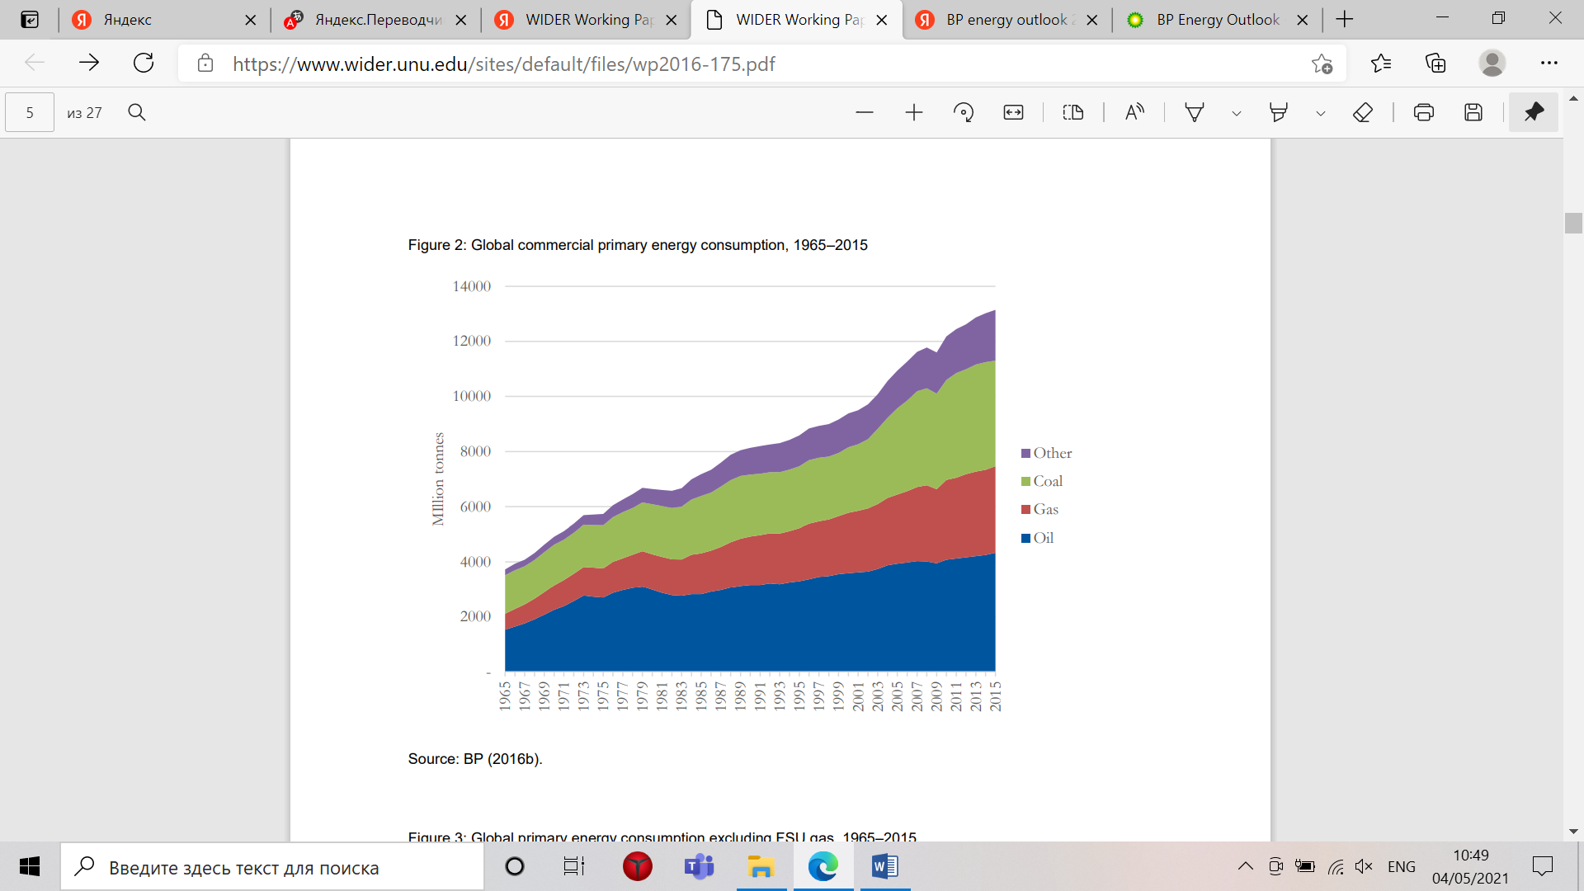

1. Global commercial primary energy consumption, 1965-2015. Source: [P. Stevens, 2016]

Main drivers for change towards decreased oil and gas demand will be innovations, like improved batteries for electro vechiles, emergung markets, increase in energy efficiency and wider implemenation of renewable energy (A. C. Inkpen, M. H. Moffett; P. Stevens, 2016).

Even though the topic that is studied in this research is connected to the oil&gas industry, actually this is an individual case of general transition of whole economy to sustainable future. Thus, the topics connected to theory on sustainable development will are discussed first: stakeholder theory, revaluation of sustainable business, recent trends in sustainability, ESG in investments are covered in this part. After the discussion of this theory, the literature review moves to the specific issues affecting oil&gas industry and its transition process.

***Stakeholder theory***

The concept of stakeholders has been proposed quite a while ago. R. E. Freeman and J.F. Mcvea (2001)[4] provide an evidence that companies that will be able to build a collaborative relations with their stakeholders, so providing the balance of interests could hope to become more successful in the next decade. So, by the beginning of 21st century these authors have correctly assumed companies that would be able to include the interests of their stakeholders and go beyond the profit maximization, would become more successful. In addition to that T. Donaldson and L. E. Preston (1995)[5] argue that companies theory of stakeholder is not only about that firms have some stakeholders, but also that stakeholder theory is fully applicable to management.

***Awareness of sustainability***

Sustainability actually has its roots in stakeholder theory, as the business is responsible to stakeholders for its actions in broad terms.

The idea of sustainable company is still evolving, thus before moving to the discussion how sustainable image of the future will influence already influencing the of oil and gas companies, the idea of sustainable business will be clarified first. It should be noted that a big disconnect between the progress on micro level (business) and the macro-level deterioration exist (global problems). Even though more and more companies admit its commitment to the sustainability, the global problems, like a climate change and hunger still remains and even become more severe. Mainly this happens because global sustainable goals differ from the business sustainable goals. Therefore, the concept of business being sustainable is under reconsideration. A fully sustainable business denoted a company, which concerns are surrounded among ESG principles rather than firm’s economic concerns; the value created is not only for business and its shareholders but for all levels of triple bottom, including people, planet and profit; from the organizational perspective a business should become outside-in what means the focus on society and sustainability challenges. If all these three levels included, then business can be assessed as sustainable according to the Business sustainability 3.0 (T. Dyllick, K. Muff, 2016)[6].

Nowadays, the financial profitability of companies and GDP indicator are not considered as core value anymore. Thus, the value of business is under the process of rethink. For example, researches are trying to understand how to include the environmental capital in the evaluation process, for example such metrics as Gross Environmental Damages (GED), has been proposed. But, the main goal of these new metrics is about to create more sustainable future, where the financial incentives with sustainability objectives will be aligned (J. Messina, J.A. Zanten, 2021)[7]. In 2020, after the crisis caused by the Covid, the awareness of sustainability has significantly increased. Among many trends in the scope of sustainable development, industrial decarbonisation one of major one. The industry is responsible for the third of greenhouse emissions, thus companies and its stakeholders are trying to find solutions for this problem. Solutions that are proposed to cope with the greenhouse risk are all connected with transition to green energy technologies and structural transformation of business models of oil&gas sector to become more eco-friendly.

Among many risks that arise ahead of our world, the climate risk is one of the most dangerous. Extreme weather conditions are starting to have a material impact on the global economic system. One of solutions that has been proposed is to putting the price on the carbon emissions (J. Makower, 2021). Both of these, the trend and the risk will influence a lot the fossil fuel industry and the oil&gas sector as part of it.

In order to evaluate the transition of companies, the ESG principles, especially in relation to the climate change, become included into the balance sheet, so ensure the transition to the sustainable future.

***Importance of ESG (Environmental, social and corporate governance)***

ESG performance of a company influence the attitude of stakeholders more and more. The first proposed kind of ESG metrics was the SAM Corporate Sustainability Assessment (CSA)[8], first established in 1999 and now published by S&P Global. Each year, over 3,500 publicly traded companies are invited to participate in the CSA. “Of these, the largest 2,500 global companies by market capitalization are eligible for inclusion in the flagship Dow Jones Sustainability World Index (DJSI World)[9]” (J. Makower, 2021).

In 2020 there have been a record high capital inflows in ESG investments options. During the pandemic the ESG funds have proven itself to be more effective than non-ESG .It should be expected that updating regulatory on ESG will accelerate the process further, especially in Europe. Therefore, it is expected that ESG investments decisions will become even more popular among fund managers in the nearest future (L. Street, et. Al, 2021)[10].

The main value of business that following ESG gives is that it can help an entity to reduce its costs and improve the firm valuation, because more investors want to allocate their capitals in firms with a stronger ESG scores (G. Serafeim, et al. 2020)[11] Also, by implementing ESG principles into its value chain, companies safeguards themselves from strict regulations, for example connected to limitations of carbon emissions. The companies that have higher CSR (corporate social responsibility) ratings attract more institutional investors as well individual investors (J. Kim, B. Li, Z. Liu, 2018)[12]

***Oil&gas companies causing climate harm***

Now, then the general issues of sustainable theory and trends can be discussed the literature review can be narrowed to consideration of oil&gas industry in the new reality of sustainable transition.

There are a lot of studies, old and new one, raising the issue of oil and gas extraction directly influencing the climate change by increasing CO2 in the atmosphere. One of research made by Richard Heede has explicitly showed that 100 major carbon majors were responsible for 71% global industrial emissions starting from the 1988 (R. Heede, 2014)[13]. Since, the second half 20th century scientist has been warned about the climate change and started to provide advises on how to solve the problem (E. Robinson and R.C. Robbins, 1968; M. Hope, 2018). Most emissions nowadays come from downstream industry, it counts for 70-90% lifecycle emissions (S. Dietz, V. Julius, J. Noels, 2020)[14]. However for some period of time in the beginning of 90s most of companies, especially the NOCs who were protected by their governments, refused to acknowledge the anthropogenic impact on climate, but later on few years this situation has changed (M.S. Bach, 2017)[15]. What is more significant, there are different attitudes to the problem from both sides of Atlantic, while European companies, like BP and Shell are more willing to take action about climate change, American companies, especially Exxon and Chevron, proclaimed a ruinous effect of emissions cut policies (Marco Grasso, 2019). As it will observed later in the literature review on the topic how O&G companies transforming into integrated energy companies, US’s companies still hold to oil energy, but improving efficiency, whereas European companies investing more in renewable energy companies. Even though some IOCs (Exxon) were trying to stop ratification of climate acts, like Kyoto Protocol[16], most of oil and gas producing countries have signed it, hence the further move to low carbon sources of energy can be expected (G. Supran and N. Oreskes, 2017)[17].

***Economy transition to low carbon energy***

It is expected that the main driver for energy transition will become the electro vehicle industry K. Dobson and M. Jus (2021)[18]. This trend will or sure has a strong impact on oil and gas companies, because it significantly cuts the demand on fossil fuel products, in combination with low oil prices it will undermine the industry. Mostly it will affect the upstream sector. Nevertheless, it opens a space for companies to review its strategies and restructure its business models to correspond to the appearance of EVs. In addition to EV market there are other energy technologies that will accelerate the process of low-carbon transition. These are hydrogen production, storage projects and new efficient batteries (M. Motyka, 2021)[19]

***Improvements in alternative energy sector***

As it was already stated in the end of the previous part, new sources of energy that are characterised by such peculiarities like being low-carbon and renewable have a strong impact on the development of oil and gas industry. This trend will only accelerate in future decades. As it was supposed in BP Energy outlook report for 2020[20], the shares in primary energy of oil, gas and coal will decrease, whereas, the share of nuclear, hydro, wind, solar and bio energy will increase.

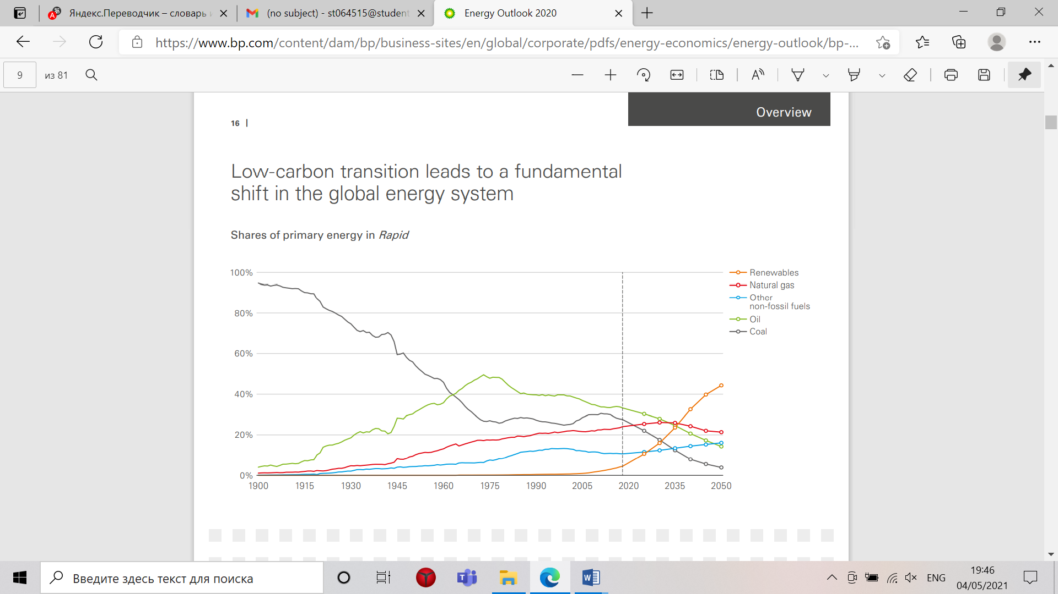

1. Shares of primary energy share. Source [BP Energy outlook 2020]

Considering the low carbon transition by regions (US, EU, India and China), it was verified by BP report that a gradual shift from oil towards renewables will be made, particularly for Europe and US, therefore companies oriented into these regions might expect profit decrease.

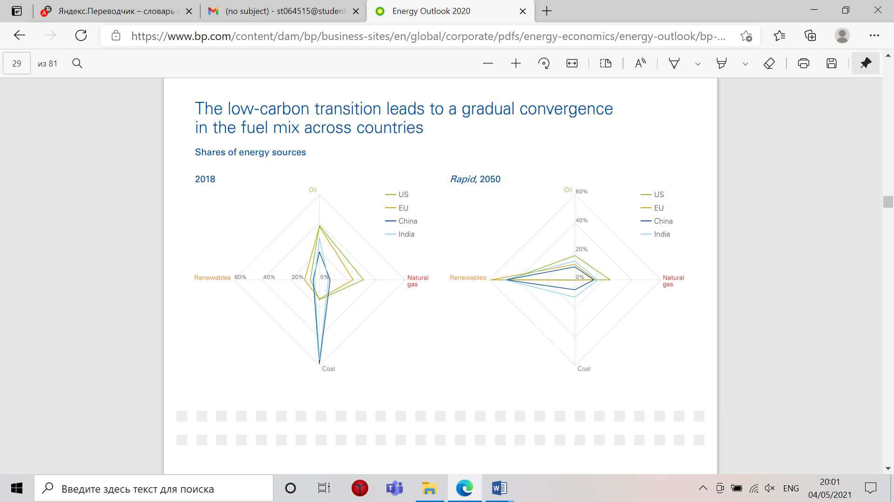

1. Fuel mix by each region. Source [BP Energy outlook 2020]

This scenario is supported by several factors. The cost of solar and wind energy will reduce in all three scenarios, by 2050, what will make these sources of energy more efficient for the usage.

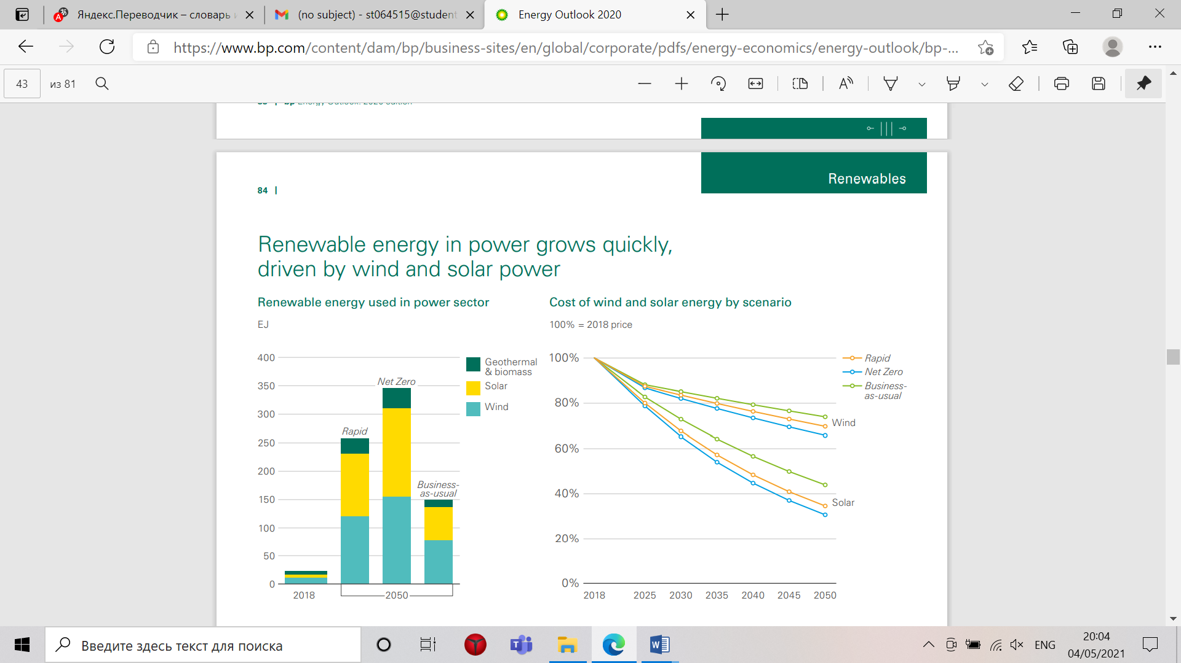

1. Cost of wind and solar energy. Source [BP Energy outlook 2020]

At the same time the capacity of these sources of power are also promised to increase rapidly in next 15 years.

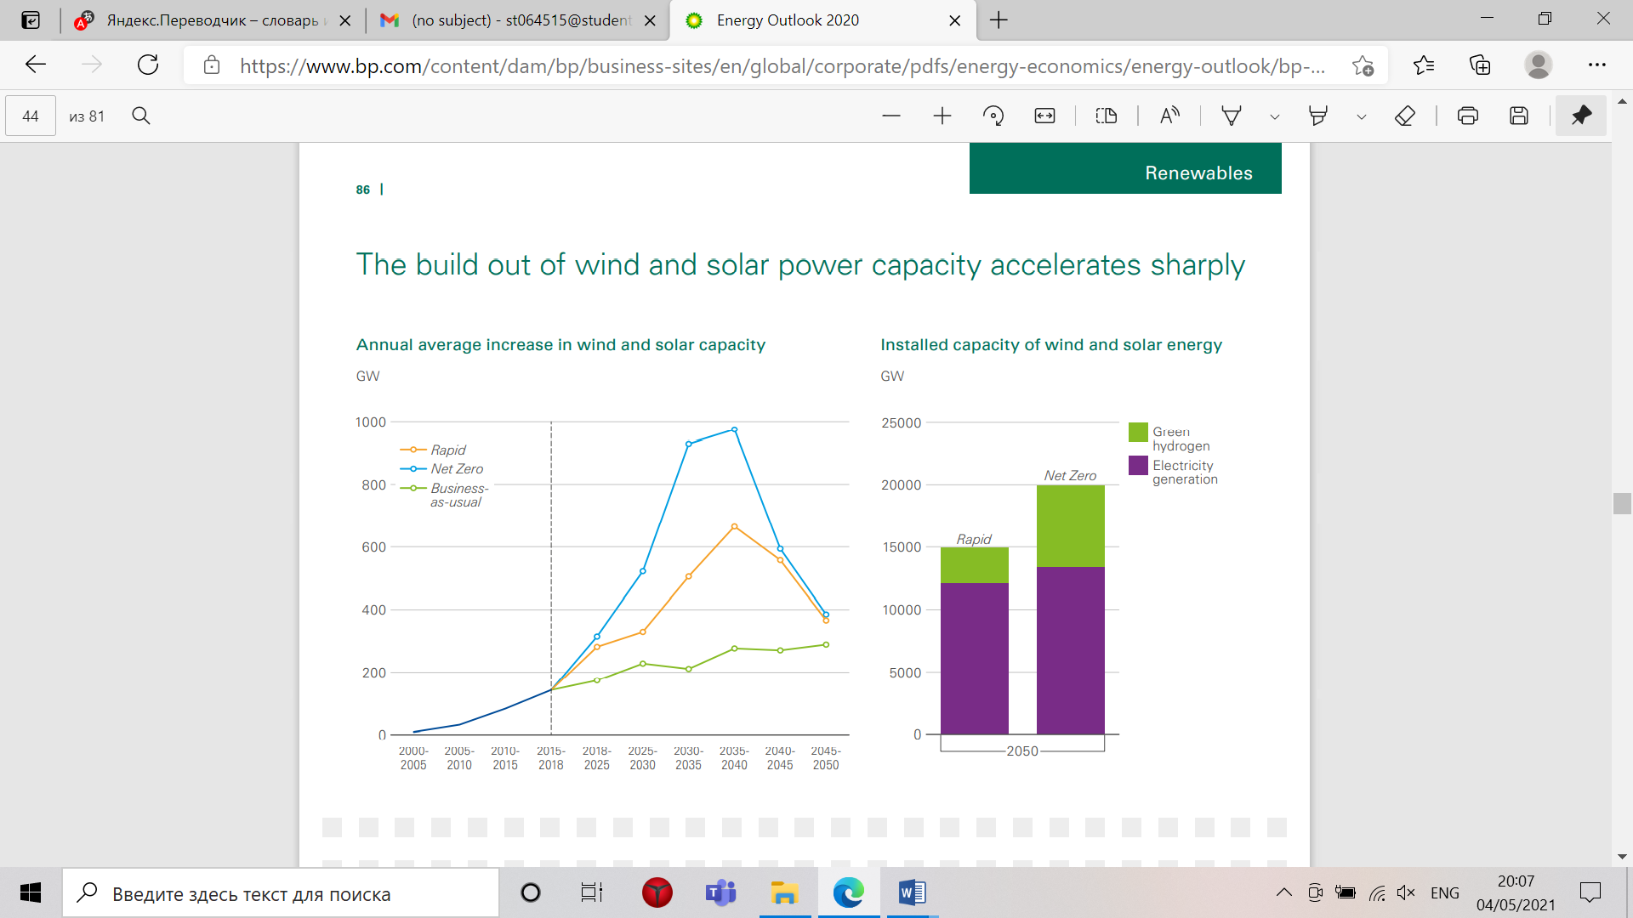

1. Average annual increase in wind and solar capacity. Source [BP Energy outlook 2020]

At the same, BP’s report states that in front of reduction in consumption and production of oil and gas, the extra investments in upstream sector will be needed. Therefore, it can be assumed that companies working in this sector will need to find extra funds in order to maintain its profitability.

***Internal industry reasons***

The industry specific problems undermine the power of oil&gas companies as well. The profitability (according to return on capital employed) in all parts of value chain (upstream, midstream and downstream) has decreased in the period 2000-2012. In addition to that EU and US majors are losing its technological advance due to Chinese oil and gas companies investing much more in R&D. Increasing cost of production of US and Europe major companies take place because of depletion of conventional place for extraction and move to more expensive deep water drilling, for instance, upstream CapEx rose by 4.5 times from 2000 to 2012. Another problem that threaten major oil companies is loss of leverage on tax regimes, which partly may explain higher taxes. Even though the shares return of US major were twice more than EU major returns, all these reasons might be an explanation why investors’ return from oil companies are decreasing since 2006. Therefore, all these problems in oil and gas industry will accelerate the move of capitals from expensive hydrocarbon industry to renewables. (Ruud Weijermars, Oswald Clint, Lain Pyke, 2014)[21].

***Climate change policies***

However, despite of economic reasons for energy transition, discussed above, there exist strong political one that will accelerate the energy transition. Carbon restriction policies will lead and already has led to a reduced investments in oil and gas projects, what, logically, will undermine the ability of oil and gas companies to attract investments, especially in countries where exist strong transition policies like in Europe (R. J. Johnston, R. Blakemore, R. Bell, 2020)[22]. To expand the argument on climate change agreements, let us discuss the successful one and their influence on oil and gas industry. Most significant agreements for last several decades were Montreal Protocol (1987)[23] and its supplement Kigali Amendment (2016)[24], which were dedicated to reduce negative impact on ozone layer and reduce carbon emissions; UN Framework Convention on Climate Change (1992)[25] the goal of this framework was stabilizing the concentration of greenhouse gases in the atmosphere, 192 countries has ratified it, later it has become the basis for next two agreements; Kyoto Protocol (2005) was the first binding act that has developed requirements to participants on emission reduction and a monitoring system; Paris Agreement (2015) this one is considered as the most important so far, according to it all ratified governments should take all possible actions on preventing the climate change, its final aim is to reach the zero level of emissions (L. Maizland, 2021)[26]. The Paris Agreement has, probably, the most significant impact on oil and gas industry, fossil fuels come with financial risks for its investors nowadays. It was revealed by the study that subsidies made into US oil industry are responsible for profits of companies, in case of oil prices are below 50$, but at the same time will make these companies to produce more CO2 emissions by 2050 and not hold to Paris Agreement. Therefore, after US has returned to the Paris Agreement these subsidies in US might be cut, what will lead to loss in profits fir US companies (P. Erickson, A. Down, M. Lazarus and D. Koplow, 2017)[27]. Ideas of sustainable development and especially about circular economy are playing crucial role in energy transition from oil to renewables sources of energy (R. J. Johnston, R. Blakemore, R. Bell, 2020). Talking about theories and frameworks that will influence the oil and gas industry further, the two that are likely to have the most impact on the O&G sector are the Task Force on Climate Disclosures (TCFD)[28] and the Principles for Responsible Investing (PRI)[29]. PRI standards are difficult for any public oil and gas company to ignore given the scale of the financial institutions that have signed up to support the goals of the organization.

***Public opinion***

In sphere of general public exists a sceptic perception towards oil and gas industry in context of its negative influence on the climate. According to the poll study conducted by EY (D. Byers, et.al, 2017)[30], renewable energy sector has much higher positive perception in comparison with the oil&gas industry, and around 60% consider it as a polluter. Another poll study (Oil and Gas Industry Reputation, 2020)[31] has found that most unfavourable view of the industry connect with its adverse effect on the environment. In real life, recent examples of negative public attitude can include protests against the Keystone XL pipeline (H. Honderich)[32], largely driven by climate concerns, as well as the Dakota Access Pipelines in US. Another example took place in London two years ago, where the group Extinction Rebellion vandalise the office of Shell, even though the company has already repositioned itself to eco-friendly (K. Giblom, 2019)[33].

**Influence of ESG principles on investors behaviour**

***Change in investors’ attitude and funding actions***

This situation is crucial not only for companies itself but for their shareholders as well, because major oil and gas companies have to generate returns for them. Otherwise, the situation can end up in decreasing stock returns and there on investors leaving industry, what would worse situation for oil and gas companies. To begin with, it should be mentioned that overall trend on sustainable investments (investments in companies following ESG principles, where ESG stands for Environmental, Social, and Governance) by fund managers is observed. The report by Global Sustainable Investment Alliance (2018)[34] verified that Europe, the United States and Japan were major regions in terms of value of their sustainable investing assets. For example, in 2018 the total investments made by EU funds has reached €25.2 trillion, increase by 11% since 2016. In US has reached $12.0 trillion, increased by 38% since 2016. Main reasons for US investors were to pursue social or environmental benefits, to improve returns over time, to minimize risks and fulfil one or more UN sustainable goal. Therefore, fund managers are taking such decisions according to both moral values and financial profitability.

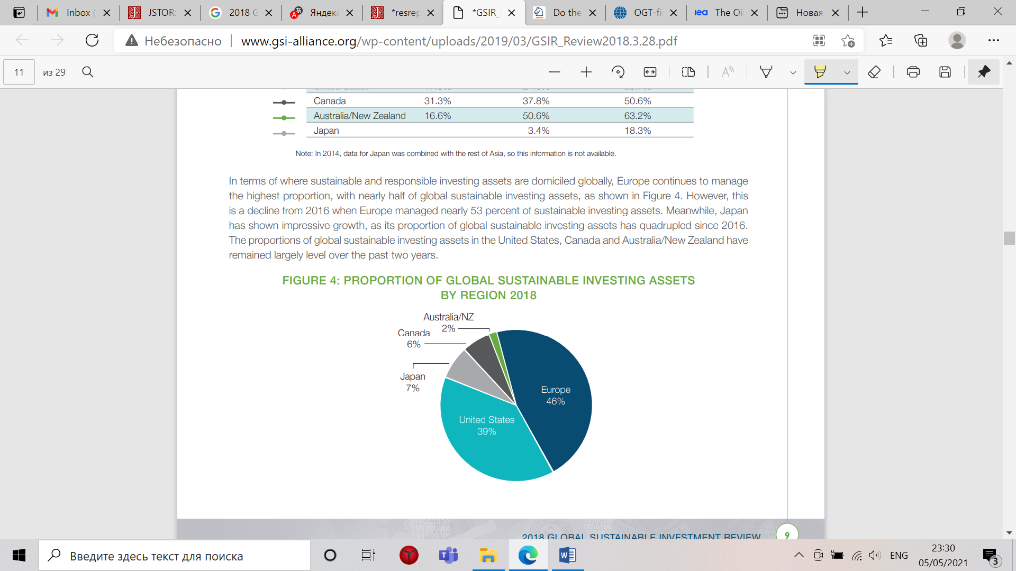

1. Proportion of global sustainable investing assets by regions, Source: [global sustainable alliance, 2018][35]

Narrowing the scope of discussion to attitude of investors to oil and gas industry, the report made by Climate Change Collaboration and UKSIF revealed that 68% of fund managers believed oil companies would still be attractive for further investments if they adopted business models aligned with the Paris targets. Usually fund managers are allocating its money among public entities traded on stock market according to such criteria like market value, revenue or dividends, etc., but now some investors start to include ESG scores as a new metric (D. Halcoussis, A. D. Lowenberg, 2019)[36]. Therefore, companies that do not implement ESG principles in their business activities might not be in a list for investments in the nearest future. Even now a trend on divestments from fossil fuels already exists, what means the reducing interest of investors in companies working in O&G industry (M. Scott, 2019)[37]. It approximately calculated that 8.84$ trillion institution divestments from O&G and 5.2$ billion divestments by individuals. (T. Cojoianu, F. Ascui, G. L. Clark, A. Hoepner, D. Wojcik, 2019)[38] Among types of organizations that are leading the divestment process are often high education organizations (universities), for example, prestigious Western Universities like, University of Massachusetts, Cambridge University, University of London, Glasgow University, and the University of Sydney; at the same time Stanford, Boston, Yale and Toronto Universities declared their plans to divest. Around the world 641 Universities have made crucial changes to their portfolios, over $3.4 trillion already divested from fossil fuel companies (W. Leal Filho et al., 2018)[39]. One of major reasons for divestments become a moral position of most actors on climate change, which insists on fossil fuels business models being inconsistent with keeping climate change below disastrous levels. It even expected that divestment actions addresses an emerging legal responsibility of investors to cope with climate change challenge. (S. Braungard, J. van den Bergh, T. Dunlop, 2019)[40]. Considering the returns of those who stopped investing in fossil fuel industry and reallocated its funds to low carbon industry positive returns are (D. Halcoussis, A. D. Lowenberg, 2019), (I. Henriques, P. Sadorsky, 2018)[41]. Both studies conducted its analysis on data from S&P 500. The first study showed that fossil fuel-free portfolio earns a slightly higher rate of return than the overall market return, mostly because of poor performance of fossil related companies, and these investments are not costly. According to the second study it is possible to divest from O&G industry and reinvest to clean energy companies and reach higher risk adjusted return, however these results are common for traders with the US trading accounts.

Nevertheless, some authors are raising the discussion about possible negative impact of transition for investors (U. Volz, G. Semieniuk, E. Campiglio, Jean-Francois Mercure., Ulrich V., N. Edwards, 2019)[42] discusses more specifically the impact of the transfer of capital from high carbon industry to low carbon industry. Financial losses in high carbon industry will lead to their diminished ability to repay its debt, what could end up bankruptcy of banks; for institutional investors who are holding its money in oil and gas companies will also have negative portfolio effects.

***Transition strategies***

Considering such trends, oil and gas companies start thinking about their future actions on how to address new challenge. There are quite many reports that raise the problem and discuss what steps were and going to be taken by oil and gas industry. Most of studies discuss the only major integrated oil and gas companies like BP, Chevron, Shell, Total and other, because these companies are more transparent and they are more interesting because they are market leaders, and therefore set the direction for smaller players. Most of studies verify quite similar approaches companies are using in order to respond to energy transition. The recent Deloitte report stress out short term and long term transition strategies of oil and gas companies, if on short term perspective companies rather tend to reduce emissions, on long term perspective companies tend to invest in biofuels and renewable electricity production. The last might include electricity demand management, energy storage and batteries. Among other top strategies there are merges and acquisitions outside core business areas and partnerships/joint ventures. The first option is especially popular within companies with a capitalisation less than 5 bill$ and more than 10 bill$; the second option is mostly popular within less than 5 bill$ group and 5-10 bill$. (S. Porter, D. Dickson, K. Hardin, T. Shattuck, 2020)[43]. Discussing basic approaches undertaking by particular companies, nine major oil and gas players, like BP, Petro China, Royal Dutch Shell, Ørsted, Equinor, Total S.A., Chevron, ExxonMobil, and Saudi Aramco use three types of strategies: (1) the petroleum business turns to the natural gas business; (2) reduces carbon emissions in production and operation; (3) develop and utilize renewable energy. For the goals of my research the third point, renewable energy utilization, plays the most crucial role. Investment in renewable energy mainly concentrates on solar energy, geo-thermal energy, wind energy, and bioenergy. Also, it was shown that major oil and gas companies have invested funds in new energy fields and carbon capture, storage technologies battery and charging technologies for sake of improving its own efficiency in transportation. American big companies like Chevron and Exxon, focus mostly on energy efficiency rather than development of renewable energy projects, because of “An America First Energy Plan” (2017)[44], which supports the traditional oil and gas energy. Below I provide the scheme that generalise the transition strategies of oil&gas majors. (H. Lu, L. Guo, Y. Zhan, 2019)[45]

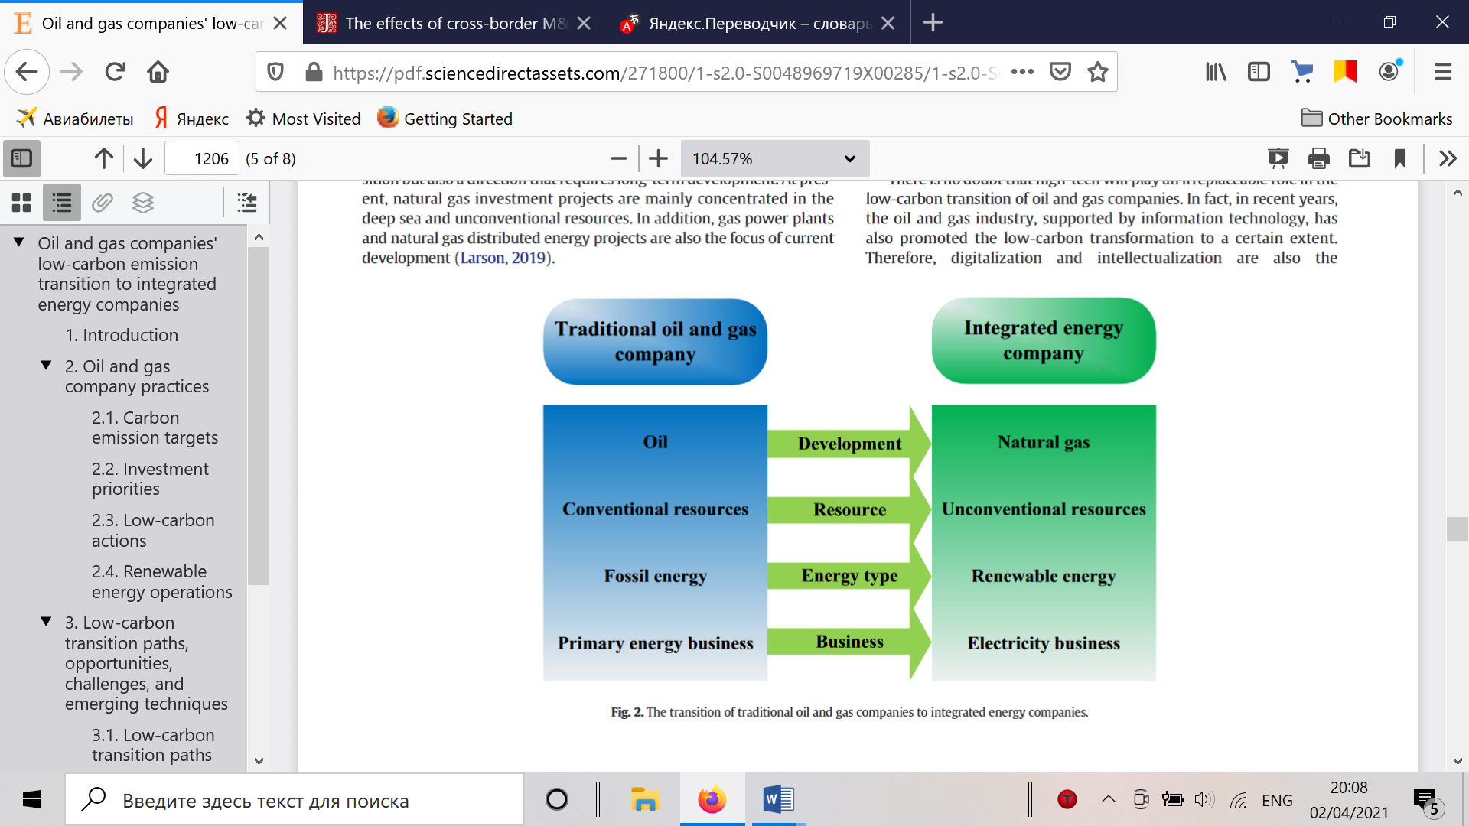

1. The transition of traditional oil and companies to integrated energy companies, Source: [et. Al. Y. Zhan, 2019]

Going a bit deeper what types of investing strategies oil and gas companies are undertaking these are two main approaches: acquisitions of other companies working in green energy sector or buying a partial stake in such entities, for example, the Royal Dutch Shell has bought First Utility, a UK-based electricity and gas supplier and invested in the US-based solar developer Silicon Ranch, by taking a 44% stake in a deal valued at more than US$200 million. What is more significant, is the relation between the proved oil reserves of a company and its activity in renewables, smaller reserves more activities are observed, (some exceptions exist). Major oil companies from Europe are more willing to participate in transition rather than US companies, like Chevron and Exxon. (M. J. Pickl, 2019)[46]. The same results for EU companies more willing to invest in renewables than US companies has also been verified by another study (Asmelash, E. and R. Gorini, 2021)[47]. However, we could also wait that US oil companies will change its course, because US has returned to Paris agreement recently. McKinsey report access major solutions for transitioning from two perspectives, first is attractiveness and ability of O&G competitively fit a solution. Such strategies as entering renewable energy market (solar and wind in particular), usage of hydrogen and EV charging as most. All in all, the strategy of becoming an integrated energy company is one of most perspective one, because it allows to defend current dividend streams and market valuations built upon hydrocarbon activities. The good example is a Danish company Ørsted that has divested from all its carbon activities and decided to become the largest offshore wind plants, so far the market reaction to this decision was positive. Only drawback here is whether oil and gas companies can emerge here as winners, versus the leading utility players (Chantal Beck, Jayanti Kar, 2021)[48]

## 1.3 Research gap

Overall, the literature review part raise the issues that oil and gas companies are facing plenty of industry specific and macro challenges in the conditions of sustainable development. Basically, the case of low oil and gas industry is an individual case of bigger context on sustainable transition. Oil and gas companies here are strongly affected by transition to low-carbon energy sources. However, the importance of this industry is too high to ignore the possible disruptions that might happen to it, otherwise negative scenarios can be applied to whole economy and especially to investors. Therefore, the oil and gas companies are searching ways on adopting to new reality, and incorporating the renewable energy assets is one of such solutions. However, there are only one quite similar study (K. Yoo, 2013)[49] that investigates the market reaction on M&A deals renewable energy industry. However, this study has been conducted 8 years ago and since then the sustainability issues have become more severe. Moreover, it was not aimed to be used by oil&gas companies managerial decisions.

Therefore, it will be interesting from both, academic and business perspective, to find out whether the market reacts positively on such deals or the topic of energy transition is just overhyped and fund managers do not consider O&G companies buying renewable energy companies as something special and promising for their stock returns.

The results of the study will be useful both for oil and gas companies and for their shareholders (individual and institutional investors). From a corporate perspective, this will respond to question if it is a wise decision to invest and buy renewable energy if they want to attract new capital and retain their investors for the future. For shareholders, it also plays a crucial role, because it will tell them whether it will bring them additional revenue.

# Chapter 2. Hypotheses and research model

## 2.1 Hypotheses formulation

This chapter I start with a formulation of hypotheses that flow from the previous chapter, based on the literature review. Thereon I propose the research model that will explain the structure of analysis itself, as well as sample for this research.

***H1****: Abnormal positive stock returns for bidder firms (O&G companies) are observed after M&A deal between oil and gas companies and alternative energy solution companies.*

This is my main hypothesis that I am going to research in my study. All in all, in the literature dedicated to the market reaction analysis of such event like IPOs, M&As, new market entering and etc., does not clearly state either there always positive reaction or negative one, as all cases are quite individual. Thus, it always possible to assume that both variants equally possible. Even though, one recent study (K. Yoo, 2013) has shown a negative market reaction to heterogeneous-energy (between a traditional energy company and a renewable energy company) merges and acquisitions deals, I can still assume that the green transformation of oil&gas companies will create an environmentally friendly image of them and positively influence firms’ value.

The studies from the literature review provide some basis for such hypothesis. First of all, shareholders saw stagnating stock returns from oil and gas companies in previous years (R. Weijermars, O. Clint, L. Pyke, 2014)[8]. At the same time fund managers that have hold carbon free portfolios have higher returns than those who have fossil companies in their portfolios (D. Halcoussis, A. D. Lowenberg, 2019)[15], (I. Henriques, P. Sadorsky, 2018)[20]. The example of Ørsted, even though the case of this company differs a bit from the case of companies that I am going to investigate, has shown a positive market reaction (C. Beck, J. Kar, 2021)[26]. Therefore, it can be expected that market will positively react on events of an oil&gas company buying a renewable energy company or acquiring a stake in it.

Following hypothesis are supplementary for the first one. In general, by adding a number of such clarifying sub hypotheses, it will help to form a portrait of the company that will be attractive to an investor.

I am going to study the market effect from short-term and long-term horizon. The short-term results will tell shareholders what they can expect from such events immediately. The first reaction of market to events like M&A shows expectations of investors and what they really think about it. If, in my study, a positive abnormal return for an event will be revealed this will mean that market participants consider the strategy of transition of oil&gas companies transformation into energy companies as something positive. Otherwise, if the reaction will be negative, it would mean that from the point of view of investors, energy transition is not worthy and will undermine positions of oil and gas companies participating in such M&As.

Nevertheless, M&As have strong structural effects on firms, hence the results for business are unpredictable and not always hold with the investors’ expectations at the day of an event. By incorporating assets of another business or a whole firm might strongly change the operations of a bidder company, therefore affecting its shares (investors’ expectations also depend upon annual reports of firms and how well they are doing, if these reports show that an entity is healthy and profitable, then its market value increases, as investors believe that this firm will bring them excess returns). In the energy sector, which is very capital intensive, changes in value chain might take some time. Even though, M&As with alternative energy companies can be considered as cross-sectional (take place in the energy industry) deals, this is still new operations and markets for oil&gas companies, so it will take some time for them to adopt renewable energy assets for their business models. Therefore, for a long-run we can suggest that an oil&gas companies’ operations have been improved due to incorporation of alternative energy solutions into its value chain, thus improving financial position, improved investor opinion about a company and as a result excessive stock returns.

To sum up, short-term study will assess the first market reaction of investors, while the long-term study will evaluate how well bidder companies have adopted alternative energy solutions into its business model.

***H 1.2****: M&As with solar and wind companies brings higher returns*

As it was discussed in literature review on energy transition strategies, oil and gas companies more often invest or acquire green companies working in the production of wind and solar energy (H. Lu, L. Guo, Y. Zhan, 2019)[50]. Moreover, wind and solar energy are holding second and third places in the list of most popular sources of renewable energy (Power Technology report, 2020)[51]. Hence, it can be assumed that while solar and wind energy has high value for global economy, so it will be for the value of oil and gas companies acquiring them. Therefore, I come to hypothesis that M&A with solar&wind is most valuable in terms of market reaction.

## 2.2. Research methodology

### 2.2.1. Event study

For the first hypothesis, the approach of event studies is going to be used. The simple idea behind the event study is that it can reveal important information about how a security is likely to react to a given event, in our case the M&A deal. The objective of event studies is to assess how stock markets reacts to certain event that took place and to which extent investors can expect to earn excess or returns from shares because of an event that carries new informational content. (A. Sorescu, L. Warren, L. Ertekin, 2016). The first study that researched the effect of an event on stock price was formulated by James Dolley in 1930 (Dolley, 1930)[52]. Other authors, who lately have significantly enriched the event study approaches were Ball and Brown in 1968 (Ball, R. 1968)[53] and Fama in 1969 (E. Fama, F. Fisher, et.al, 1969)[54]. Very crucial theory that is used in event studies is the efficient market hypothesis (EMH) that was brought to its final form by Fama in 1970[55] (Fama, 1970), according to this hypothesis stock markets incorporate instantly effects caused by events. So, for short-term studies usually very short periods are used around the event day in order to assess its influence. Nevertheless, this theory is not that strict, and Fama in his same research differentiated strong, semi-strong and weak market efficiency, meaning that markets need some time to react on an event.

The usefulness of these studies is that statistics on stock returns in accordance with a particular event provides a measure of impact of this type of event on the wealth of companies’ shareholders, who were affected by that (P. Kothari, B. Warner, 2006)[56].

Considering the event study approach there exist many models that research of corporate and macro events, but they all can be categorised in two big groups, which main criteria is time period. Hence, one major type of event of study is short-term study that assess abnormal returns around the event day and a long-term study that uses longer time periods, from 1 to 5 years Mid-term studies also take place (up to 1 year), but they are not that often. Inside these two main categories different calculation approaches exist, all aimed on calculation of abnormal returns. Right now, there are no consensus among researchers what model is a most accurate one, more or less they are all equal. In addition, since event study is a part of statistics science, results should be checked with a help of significance test. In following parts I am going to discuss in detail, what exactly models will be used in study and how I am going to assess it.

As it was proposed by MacKinlay (MacKinlay, 1997)[57] multistep steps methodology is used for event studies, the same approach has been used in the similar study on M&A in renewable energy sector (K. Yoo, 2013). However, since I am going to use two time frames, short-term and long-term I will use modified scheme and divide it into two parts.

### 2.2.1. (a) Short-term study

1. **Event definition:**

Here I identify the event itself and an event windows. In my research the event is the M&A deal between oil&gas company from the acquirer side and alternative/renewable energy company from the target side.

1. **Time sampling**
   1. **Short-term**

Speaking of event windows, this means what days I will be using for calculating the effect of an event. Short-term, is going to be used in order to access the simultaneous reaction of investors on the event, it will show what is first thought of investors on such type of energy transition strategy undertaken by oil&gas companies from their portfolios. Among researchers there are no particular approach on determine of number of days to be taken into event window. Also, the short-term studies specify an additional estimation window that is defined later used in calculation for calculating normal returns. The shortest periods include the 0 day of announcement and 1 day after the event (Tipton et.al, 2008)[58] , such short periods are used in relation with EMH, however this period is only enough to assess abnormal returns and to aggregate them, moreover the EMH not always hold as it was stated already. In case of longer time horizons, like 10 days before and 10 days after, a researcher would have more possibilities to observe price dynamics, nevertheless so long events windows undermine the explanatory power of results and increase volatility. Therefore, I am going to put rather short event window, but not just 1 day, so daily price dynamics could evaluated and all market players could have a chance to react on the event. I apply 7 days window, 3 days before and 3 days after a deal announcement date, including the event day itself. This also significant for event windows not to overlap among shares, otherwise breaks the assumption of abnormal returns among shares being independent from each other. Thus, I denote the date of announcement of a deal as $t_{0}$ = 0 trading day, $t_{-3}$ = -3 trading days before the event and $t_{3}$ = 3 trading days after the event, hence t ∈ $T_{1}$ [-3; +3]. In addition to event window, the estimation window is needed for further estimation of expected returns. Firstly, estimation window should not overlap with an event window, secondly it should be at least 100 trading days before the denoted window, so at least 103 before the M&A deal announcement. In genera the estimation length is from 120 to 255 days (Li Ding, H. Lam, .C.E. Cheng, H. Zhou)[59], and for example Sevindik and Gökgöz used -128 days (I. Sevindik, F. Gökgöz)[60]. However, these windows should not be too long. I am going to use -140 days before the event window and 143 before the M&A, hence $T_{2}$ ∈ [-143,-3] trading days. I am using trading days instead of common days, because stocks are not traded very day on the markets. $[T_{1}$ $T_{2}$] ∈ *T (*whole period).

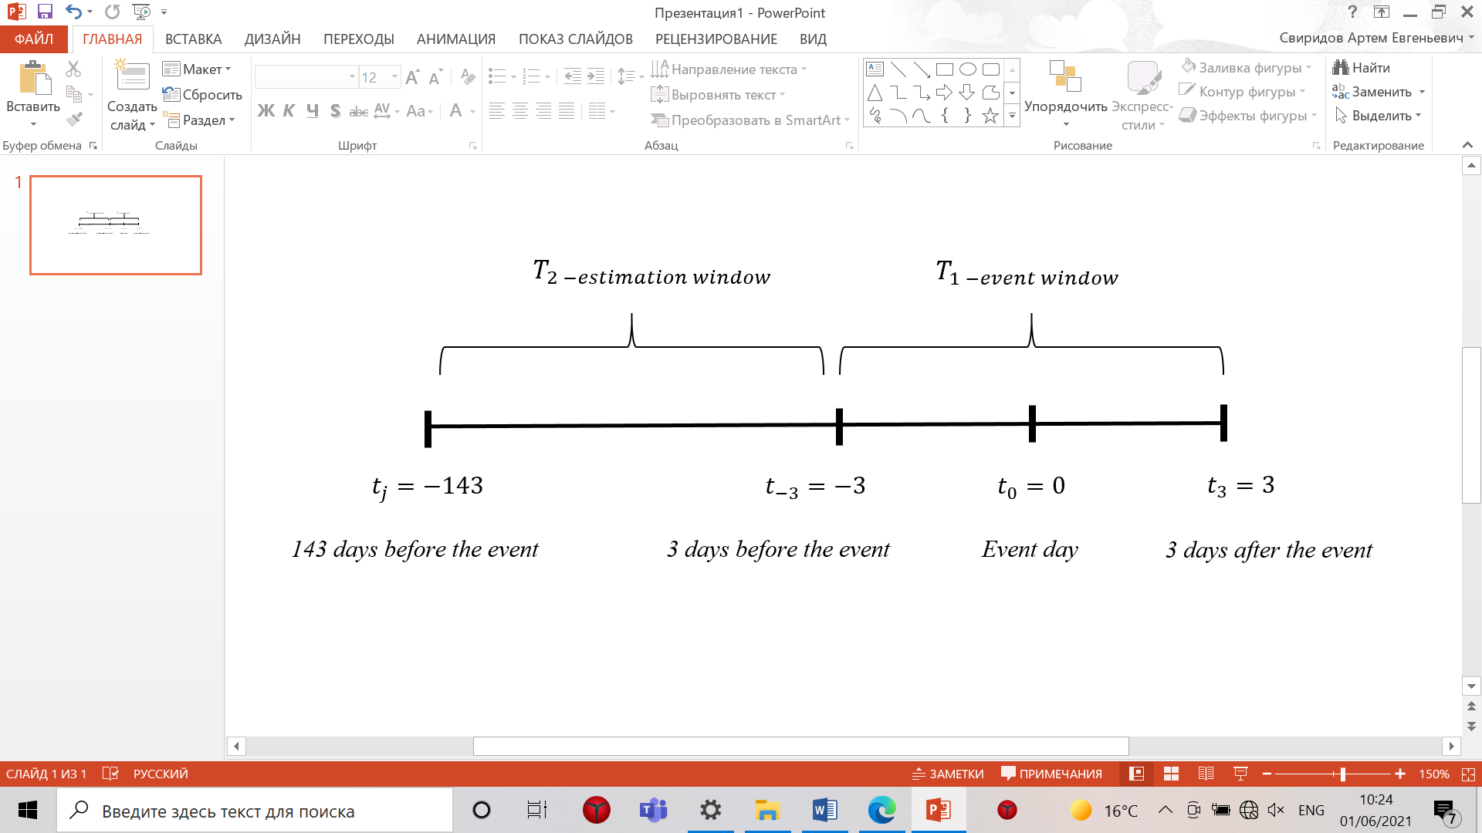

1. Time line for the event study
2. **Sample selection criteria:**

In short-term study the daily return data is used with the corresponding benchmark return, for long-term study monthly returns will be used. MacKinlay propose several restriction criteria like belonging to a particular stock market, firms being from one industry or having particular corporate features. In my case, I am not going to reduce a sample to one stock market and use the corresponding market to each stock. This will afford evaluate abnormal returns more accurately and my study will be useful for investors from different countries, because not everyone are trading at S&P 500, NYSE or FTSE. For example, study mentioned before uses different stock markets (I. Sevindik, F. Gökgöz). As for industry, it oil&gas with the alternative energy sector. All other peculiarities for data sample will be discussed later in the chapter.

1. **Measurement of expected returns:**

Before the expected returns can be calculated, normal returns should be estimated first. Normal returns are those returns that company should had in normal circumstances, in other words, if an event did not take a place. Expected returns are calculated by different methods. One of the most common is the market adjusted model (Scholes and Williams, 1977)[61] that will be used in my research. According to this model, a linear relationship exists between an individual secuirity and the market portfolio. According to Brown and Warner (1985)[62] study on this model is nor worse nor better than market model, and shows quite similar results on short event windows, like mine (L. Sorescu, et al., 2016). In general, the formula for calculating a normal return looks following way:

$$R_{it}=α_{i}+β_{i}*R_{mt}+ε_{it}$$

Where,

- is the stock return of a company i at day t.

*Rmt* – is the return of the corresponding market of stock *i.*

*\** Returns are based on the relation of closed prices of a stock

$α_{i} and β_{i}$*-* estimated for each share *i* for each over the whole period. The $α_{i}$ is the intercept term and more professionally it stands for percentage above or below a market index. The $β_{i}$ is the systematic risk, in finance it also means correlation between market moves and individual firm moves

𝜀it is the error term, or unexpected situation individual to a firm affecting its stock price, that has a zero mean disturbance term:

$$E\left(ε_{it}\right)=0 and var \left(ε_{it}\right)= σ_{ε_{it}}^{2}$$

Therefore the error term is excluded from the abnormal return formula, since its mean is equal to 0. Then the expected return will have the following form:

$$E\left(R_{it}\right)=α_{i}+β_{i}*R_{mt}$$

Before I can explain how the normal return calculated for long-term study, I need to specify and justify the model itself, as the benchmark is related to the model used in the long-term study. Therefore, it will be discussed in the next point.

1. **Evaluation of abnormal returns:**

The abnormal return is calculated as firm *i* real return that took place in real situation, minus expected returns at day *t.*

$${AR}_{it}= R_{it}-E\left(R_{it}\right)= R_{it}- α_{i}-β_{i}*R_{mt}$$

ARit – abnormal return of a firm *i* in the day *t.*

1. **Aggregation of abnormal returns:**

For each individual firm then required to calculate cumulative abnormal returns (CAR). This shows how many an investor could accumulate for several days included in event window. The formula is looking following way:

$${CAR}_{i}= \sum_{t}^{T_{1}}{{AR}_{it}}$$

However this approach mostly required for assessing one firm only, in case of portfolio of observations covering several firms, CAR is calculated for all observations from the sample. To do that the average abnormal return should be accumulated .After the AR has been calculated for a particular company for estimation and event window, then the mean (or averaged) of abnormal returns being calculated for all events N in the corresponding days from the set T. The formula has a following form:

$${AAR}_{t}=\frac{1}{N}\sum_{i-1}^{N}{{AR}_{it}}$$

AAR is aggregated average abnormal returns for N number of observations in the sample.

At this point it is possible to get the cumulative average abnormal return for whole sample:

$${CAAR}_{T_{1}}=\sum_{t}^{T_{1}}{{AAR}_{t}}$$

In combination with the AAR measure, the CAAR will provide a final result on market reaction to the event of M&A.

1. **Null hypothesis test:**

Nevertheless, before the final conclusion can be made, a null hypothesis test is required. This hypothesis states that in spite of event the mean of abnormal returns should be zero.

$$H_{0}μ=0$$

While, the opposite is:

$$H_{1}μ≠0$$

If the null hypothesis does not hold, it would mean that stock price change could be explained by the event. In order to test the null hypothesis, the significance test should be used. In most studies the standardised t-test is used for that (MacKinlay, 1997), (K. Yoo, 2013), (S. Kothari, J. Warner, 2006) (J. Warner, S. Brown, 1984), (Li Ding, H. Lam, .C.E. Cheng, H. Zhou) under the assumption that abnormal returns are normally distributed and have time-series independence. Therefore, the t-test is measured for AAR by following way:

$$t_{AAR}=\frac{{AAR}_{t}}{σ\left({AAR}_{T_{2}}\right)}$$

And for CAAR:

$$t_{CAAR}= \frac{{CAAR}_{T_{1}}}{σ\left({CAAR}_{T_{1}}\right)}$$

Where $σ$ stands for standard deviation of AAR and CAAR correspondingly.

### 2.2.1. (b) Long-term study

The long-term approach will be needed to evaluate continuous effect of such deals on oil&gas companies. Usually, M&A deals have a strong structural effect on a company business operations. Especially, this is the case, when oil&gas companies change its business models through acquiring renewable energy assets, so this might have an impact over the months and years. Moreover, the energy sector is capital intensive by itself and a long period could be needed in order to incorporate alternative energy assets into its value chain. This information will be also important for passive investor, who prefer to hold shares and not act in aggressive trading process.

All long-term event studies are aimed on period from 1 to 5 years post announcement date. Similar to short-term studies there are a lot of scientific literature discussing long-term event studies for many years. However, the models itself are different for these types of studies. At the corner of a long-horizon event methodology lie two main goals, one is to measure the long run abnormal returns after the event and the second to test the null hypothesis that mean if abnormal returns equal to zero (J. Ang, S. Zhang, 2014)[63]. The extensive literature on long-run event studies was proposed by Barber and Lyon (1997)[64], Kothari and Warner (1997)[65], Fama (1998)[66], Lyon, Barber, and Tsai (1999), Mitchell and Stafford (2000) (A. Dutta, 2015). The major drawback of long-term event studies is difficult to interpret, (Fama, 1991)[67]. In defining the long-horizon methodology I am going to use the multi-step approach that I have used for short-term study.

1. **Event definition:**

Remains the same as for short-term study.

1. **Time sampling:**

In average, the timespans for several years are used in order to assess the abnormal returns in long event studies. Like for short-term study, there no singular rule how long it should be, usually it takes from 1 to 5 years. In the appendix the summary table for different approaches is presented. For my study, I am going to use the two year line from the event day $t_{0}$ = 0. I will use monthly returns for each stock in the sample, including the month when the event took place $τ_{0}=0$, and up to 2 years after the month of the event, so 25 month in total. $τ_{m} ∈T \left[0;25\right]$, where *m* is the moth from the sample.

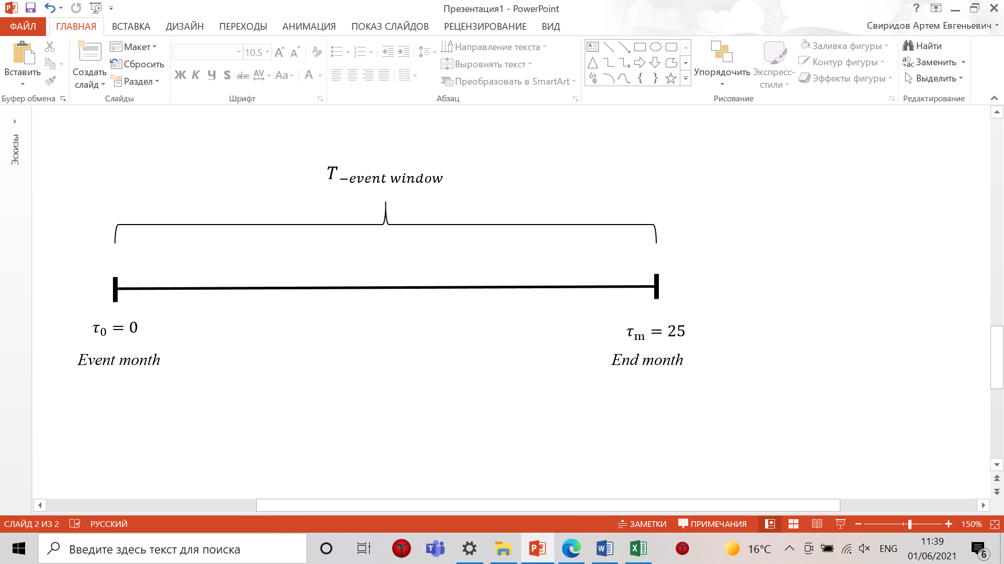

1. Time line for long-term study
2. **Sample criteria**

It remains the same as for short-term study, all peculiarities on filtering the data will be discussed in more details in the next part, data sampling.

1. **Estimation Model: (**τ**)**

In the literature on long-term event studies two models are used. The first is buy-and-hold abnormal returns (BHAR) and measures the abnormal return trough the usage of a benchmark, to which the stock return is compared to. The second is Jensen alpha approach developed by Jaffe (1974)[68] and Mandelker (1974)[69] monthly calendar-time portfolio, which forms a portfolio in each calendar month made of firms that participated in an event within a certain time period prior to the month and tests the null hypothesis (J. Ang, S. Zhang, 2014). Starting with Ritter (1991)[70], BHAR is defined as the popular estimator of long-run abnormal performance. Another research conducted by the Mitchell and Stafford (2000)[71] define BHAR as the average return from a strategy of investing in stocks participate in an event and then selling at the end of a holding period under which the study model was used. “An appealing feature of using BHAR is that buy-and-hold returns better resemble investors actual investment experience than periodic (monthly) rebalancing entailed in other approaches to measuring risk-adjusted performance” (A. Dutta, 2015). However, the BHAR model has some drawbacks, for example Fama (1998) stand against this method because of some statistical and test significance issues of this model. One of biases[72] that this model reveal is its right wing skewness and standardised t-statistics is not powerful enough to measure the level of significance, so modified tests sometimes are needed. However, this model suits well for cross-sectional (for stocks belonging to one particular feature, for example to a same industry) studies Markovitch and Golder (2008)[73]. Therefore, as my portfolio consists from oil&gas companies only then the usage of BHAR is justified in my study.

In the long-term study used a different compounding principle in comparison with a short-term study. While in CAR used daily ARs composition, the BHAR model is using the multiplication principle over the month, so the difference between two approaches like the difference between the arithmetic and geometric average. The return formula for a stock *i* looks following way:

$${BHR}_{iτ}= \prod_{τ=0}^{T}{(1+r_{iτ})}-1$$

Where, BHR means buy-and-hold return of the particular company i for a considering period from the starting moth τ up to the T. Returns are based on the end of a month.

The process of matching the correct benchmark to evaluate the expected return and then accumulate the abnormal return is more specific than for a short-term study. Comparing returns by using a market adjusted model is considered too biased therefore, another way is applied. For defining the expected returns the matched stock or a portfolio of stocks is used (Barber and Lyon 1997[74]; Lyon et al. 1999[75]). Previous studies on event study research methodology have developed a straightforward measurement technique, which can be used in order to match the stock from the sample with a peer stock, so called control firm. According to Barber and Lyon (1997) a control stock helps to diminish the problem of listing, rebalancing biases and skewness. The most significant rule is that it should be a company that did not participate in the event at the same period, so to avoid overlapping. Then a common practice is to find such control firm that matches the event firm on size (market capitalisation) and BE/ME (book-to-market value). According to Fama and French (1992) that size and BE/ME combine to capture the cross-sectional variation in average monthly stock returns and that market beta has no additional power in explaining cross-sectional return differences (Ang and Zhang, 2004). Except for these two indicators, it would have a positive on accuracy of the test if companies suit to the same industry. Therefore, in my study I am going to match each firms from the sample to control firm that did not participate in the same event during the event window T, match by market capitalisation, BE/ME and industry (oil&gas) at the middle of period of event window T. Then the expected return for control firm *c* will have the following form:

$${BHR}_{cτ}=\prod_{τ=0}^{T}{\left(1+r_{cτ}\right)-1}$$

Where, r corresponds to control firm’s return.

Further the buy-and-hold abnormal return can be calculated as:

$${BHAR}_{iτ}=\left(\prod_{τ=0}^{T}{\left(1+r_{iτ}\right)}-1\right)-\left(\prod_{τ=0}^{T}{\left(1+r_{cτ}\right)-1}\right)$$

After the adjustment the final formula is:

$${BHAR}_{iτ}= \prod_{τ=0}^{T}{\left(1+r_{iτ}\right)-\prod_{τ=0}^{T}{(1+r_{cτ}}})$$

Eventually, for a portfolio of shares, the average BHAR should be estimated for all events N:

$${ABHAR}_{τ}= \frac{1}{N}\sum_{1}^{N}{{BHAR}_{τ}}$$

1. **Null hypothesis testing**

Under the null hypothesis the mean of abnormal returns should be equal to zero, In order to reject the null hypothesis, the t-test should be applied to prove the significance of results. The conventional t-statistics used for ABHAR is:

$$t_{ABHAR}=\frac{{ABHAR}_{τ}*\sqrt{N}}{σ({BHAR}_{I})}$$

Where, N is the number of observations, $σ({BHAR}_{I}$) is cross-sectional sample standard deviation of abnormal returns for the sample containing N events.

However, conventional t-test for mean of BHAR has several significant problems. It was found by several studies Mitchell and Stafford (2000)[76], Boehme and Sorescu (2002), Jegadeesh and Karceski (2009)[77] that for cross-sectional studies, which is my situation, BHAR yields misspecified t-test. Moreover, as it was mentioned before the distribution is skewed, because the BHAR is bounded below by 100% but not above, this implies right-wing (positive) skewness of abnormal returns calculated this way (S. P Khotari and J. B. Warner, 2006; A. Dutta, 2015). Then the skewness adjusted version is used (J. D. Lyon, B. Barber and C. Tsai, 1999)[78]. The adjusted t-test is:

$$t_{bharsa}=t_{ABHAR}+\frac{γ}{3*\sqrt{N}}*\left(t_{ABHAR}^{2}+\frac{1}{2}\right)$$

Where, $γ$ stands for the estimate of the skewness coefficient of BHAR (i) (t). Therefore, if in my calculations, the asymmetry would be found then I will use the skewness t-adjusted test.

### Summary

In this part of research paper, the research methodology has been discussed for short-term study and long-term one in relation to fundamental literature on the topic of event studies methodologies. Now, the summary table for both approaches will be provided. Then in next part of the second chapter we will move on to the discussion of data sample to which the models proposed here will be applied in the research itself.

The common approach that I will apply for both event studies in evaluating t-tests significance for rejecting a null hypothesis is that I am going to use values from t value table, which shows the value of t for a particular number of degree of freedom (N-1 sample) in correspondence with a level of significance.

1. Research model summary

|  |  |  |
| --- | --- | --- |
| Research models | | |
|  | Short-term study | Long-term study |
| Time Period | t ∈ $T_{1}$ $T_{2}$– any day from the short term study $T_{1}$ ∈ [-3; +3] – event window; $T_{2}$ ∈ [-143,-3] – estimation window | $$τ_{m} ∈T \left[0;25\right]$$ |
| Expected return | $$E\left(R_{it}\right)=α_{i}+β_{i}*R_{mt}$$ | $${BHR}_{cτ}=\prod_{τ=0}^{T}{\left(1+r_{cτ}\right)-1}$$ |
| Abnormal returns | $${AR}_{it}= R_{it}-E\left(R_{it}\right)$$ | $${BHAR}_{iτ}= \prod_{τ=0}^{T}{\left(1+r_{iτ}\right)-\prod_{τ=0}^{T}{(1+r_{cτ}}})$$ |
| Aggregating abnormal returns | ${AAR}_{t}=\frac{1}{N}\sum_{i-1}^{N}{{AR}_{it}}$; $${CAAR}_{T_{1}}=\sum_{t}^{T_{1}}{{AAR}_{t}}$$ | $${ABHAR}_{τ}= \frac{1}{N}\sum_{1}^{N}{{BHAR}_{τ}}$$ |
| Null-hypothesis testing | $$t_{AAR}=\frac{{AAR}_{t}}{σ\left({AAR}_{T_{2}}\right)}$$ $$t_{CAAR}= \frac{{CAAR}_{T_{1}}}{σ\left({CAAR}_{T_{1}}\right)}$$ | $$t_{ABHAR}=\frac{{ABHAR}_{τ}*\sqrt{N}}{σ({BHAR}_{I})}$$ If skewness appear then: $$t_{bharsa}=t_{ABHAR}+\frac{γ}{3*\sqrt{N}}*\left(t_{ABHAR}^{2}+\frac{1}{2}\right)$$ |

1. Variables

|  |  |
| --- | --- |
| t – any day used for short-term study from the given sample $T_{1}$ – the event window of 7 days $T_{2 }$ – the estimation window  *i –* stock of a firm  *N –* number of observations in the sample $R_{it}$ *–* daily return of a firm at particular day (based on the closed prices) $α_{i}$ *–* intercept measure $β_{i}$ *– ­*systematic risk $R_{mt}$ *–* daily return of an index at particular day (based on the closed prices) ${AAR}_{t}$ *–* average abnormal returns ${CAAR}_{T_{1}}$ *–* cumulative average abnormal returns $σ$ *–* standard deviation $t_{AAR/CAAR}$ *–* ordinary t-test for mean abnormal returns | $τ$*–* a month from the event window  *m –* number of month (e.g 24) $T$ *–* event window sample  *c –* control firm $r_{iτ}$ *–* monthly return of a company from the sample at particular month (based on the end of the month period) $r_{cτ}$ *–* monthly return of a company from the control sample at a particular month (based on the end of the month period)  *N –* number of observations in the sample $t_{ABHAR}$ *–* ordinary t-test for rejecting null hypothesis $γ$ *–* skewness measure of BHAR $t_{bharsa}$ *–* skewness t-adjusted test for rejecting the null hypothesis |

## 2.3. Data sampling

The core aim if this research, as it was mentioned in the previous part, is to define an existence of any abnormal return to M&A deals, or simply a positive market reaction. In advance to discussion of research methodology, the data sample will be defined first. The primary source for data was the Thomson Reuters Eikon platform. This software is widely used for analysis, because it provides wide range of data on fundamental financial information over 40 000 companies all over the world. The Eikon information portal provides real-time information for making operational decisions in the financial markets. The following information is available on the Eikon platform:

* Data and analytics by country, region, and industry
* Forecasts of interest rates, oil, and macroeconomic indicators
* Current and historical prices for financial market instruments
* Analytical models, charts, calculators

Before moving to the final sample list, main criteria for selection and the process of filtering will be discussed here.

**Criteria for sampling:**

*I am going to use quite soft criteria for filtering the data in order to get a solid data range, thereafter the initial acquired results will be thoroughly analysed and data that logically do not suit to my data will be excluded from my study.

* *Time range.* The initial period selection will not be restricted to particular years in short-term study. The whole possible period from Thomson Eikon will be considered. The different approach for long term study will be used. I am going to use upper period restriction that will be the end of 2017, so my long-term research could end before the beginning of Coronavirus crisis, otherwise, my results will be spoiled and probably unreliable due to supply and demand shocks that took place in 2020. However, during the process of filtering the timespan can be adjusted.
* *Types of acquirers.* On the side of acquirers, companies participating in oil and gas industry (including all parts of value chain) will be included. In addition to that, these companies should be publically traded (independent oil companies) at the moment of analysis, otherwise it will not possible to study a market reaction.
* *Region/subregion/country of acquirers.* As for geography of oil&gas companies I am going to use Europe and North American companies. On the side of Europe, I am not going to restrict myself only to European Union companies, but include all companies belonging to European region as well. As for North American region, this will include only companies from US and Canada. All these Atlantic have more similarities with each other than differences, what provides the principle of homogenous to my study. Moreover, oil and gas companies of Europe or US origin, in studies related to the research of M&A inside the O&G industry are the most active (Yue Guo, Yu Yung, Chang Wang, 2021)[79].
* *Target company.* The most crucial criteria here is that companies from target side should belong to renewable/alternative energy company.
* *Region/subregion/country of target companies.* In terms of geography, there no restriction to a particular region. The whole possible population will be considered. This will allow us to gather additional results that not directly related to core study goal, but brings valuable information, which can be used for further studies.
* *Size of a deal.* No restrictions here, as well as for the ratio of stake acquired, because sometimes such information cannot be available at all.

These are preliminary selection criteria for defining my sample, which I am going to use for data sampling. Further on, some additional criteria or specification can be added in order to get a proper picture of data for the analysis.

**Gathering and filtering of data**

The Thomson Eikon, the platform that I have mentioned before, allows to gather information on different types of M&A deals. Inside the platform inserted different filters that allow to build a required list of M&A deals. To get a full and concrete picture for my research I have used almost all of them, in accordance with evaluation criteria defined above. To begin with, I will provide a step by step description the process of data filtration, starting with an initial picture of a sample and eventually showing the final data sample.

The table of results included following columns:

* Deal Number
* Announcement date – for time period the maximum possible time san has been used.
* Deal size
* Reported Deal Value (M USD)
* Deal Status
* Acquirer Ultimate Parent
* Acquirer Name
* Acquirer Business Description
* Target Ultimate Parent
* Target Name
* Target Business Description
* Acquirer Nation
* Acquirer Region/Subregion
* Acquirer Industry – Oil&gas was selected in filters
* Target Industry
* Form of the Transaction
* % acquired
* Target Public Status
* Acquirer Public Status
* Target& Acquirer RIC – an identifier on stock market.

*First results:* the time span that was from 1990 to 2021; all deals had a Completed status;

Acquirer industry was Oil&gas;

Target industry was Alternative energy that according to Thomson Eikon include all energy companies participating in non-fossil fuel industry; acquirers regions were Europe and North America, on the side of Europe all companies are from Western Europe except for one from Romania;

The total number of deal in the initial list were 98;

As for form of transaction it included several different types like Merger, Acquisition of Majority Assets, Acquisition of Assets, Acquisition of Partial Interest and Acquisition of Remaining Interest (all these are types of M&A deals according to Thomson Reuters).

*Notes*:* deal size factor was not considered as significant for further data selection, because some deals reported 0 deal value, while the % of acquired were 100%, what can tell that the data on deal size probably is not publically available;

sometimes the information between the type of deal did not relate to information on % acquired, for example, it was stated 0% acquired and Acquisition of Majority of assets, what could be interpreted as not availability of true information on % acquired, hence, the column of % acquired did not influence further selection of information;

Acquirer ultimate parent data was needed as the companies that participated in deals, were often not public (what is exposed in Acquirer Public Status column), therefore only their parents’ trading data was available;

Acquirers’ business description later on was needed to analyse if these companies suit to my study; target business description was later used to diversify among solar&wind companies and other types of alternative energy entities for my; the final column acquirer RIC was used to gather stock return information.

There on, the crude initial data obtained from the Eikon has been filtered, the process itself was quite long and multi stepped. Since, the major goal of my study is to access the market’s reaction on M&A deals between companies belonging to Oil&gas industry from the acquirer side and companies belonging to alternative energy solutions from target side. Thus if companies according to its description did not belong to these categories, then were excluded.

On the side of targets there were not any obstacles and these companies’ functions description responded to the definition of alternative Energy. The opposite situation took place with acquirers. Even though, the Thomson platform has defined them as oil&gas industry, according to their business description this was not always the case. For example, some companies were involved in coal mining like Alkana Energy PLC, hydrogen and biofuel energy, services providers for oil&gas industry, companies participating in renewable energy like Ørsted. Therefore, all companies from the acquirer’s side that could not be included in any part of value chain typical for oil and gas industry (up/mid/downstream) according to their business description were excluded from the list, otherwise they would spoil the results of my research. However, if listed business to exclude was just a part of their business activities and were combined with activities in oil and gas sector, then those companies were left.

Second major filter was the availability of stock prices for left companies. Initially not all companies had RICs, what meant that all of them are publically traded. The availability on stock market was double checked through the Yahoo finance. Even if companies left are available on stock market, some of them did not went IPO at the period needed for my analysis that was the case mostly for companies that participated in deals before 2000s.

One of issues that appeared during selecting the traded companies that several companies from the acquirers list being subsidiaries of a same parent company, therefore the stock returns of that parent company has been analysed. This has reduced the number of companies in the list, but not the number of observations.

All these filters that I have discussed has considerably reduced the number of observations from 98 to 25 for short term study and to 16 for long term study (deals starting from 2018 have been excluded for long term, that 7 deals from 2018 to 2021).

Now moving to the summary of data sample the table of M&A, which effects will be analysed, two tables presenting data for short-term and long-terms studies respectively, are provided below. The tables are presented in time consequence order of deals starting from latest one and ending by the earliest.

### 2.3.1 Data for short-term study

1. Data sample for short-term study. Source [made by author, data acquired from Thomson Eikon]

|  |  |  |  |  |  |  |  |
| --- | --- | --- | --- | --- | --- | --- | --- |
| Announcement date | Acquirer parent | Acquirer Name | Acquirer RIC | Acquirer nation | Target name | Target nation | Form of transaction |
| 10/02/2021 | Engie SA | Storengy SAS | ENGIE.PA | France | Dijon Metropole Smart Energhy | France | Acquisition Of Partial Interest |
| 19/12/2019 | Equinor ASA | Equinor ASA | EQNR.OL | Norway | Scatec Solar ASA | Norway | Acquisition Of Partial Interest |
| 21/11/2019 | Snam SpA | Snam 4 Environment | SRG.MI | Italy | Renerwaste SRL | Italy | Acquisition Of Majority Assets |
| 27/02/2019 | Royal Dutch Shell PLC | Shell Petroleum Co Ltd | RDSa.AS | United Kingdom | Limejump Ltd | United Kingdom | Acquisition Of Assets |
| 03/12/2018 | Snam SpA | Snam 4 Mobility SpA | SRG.MI | Italy | Enersi Srl | Italy | Merger |
| 15/11/2018 | Equinor ASA | Equinor ASA | EQNR.OL | Norway | Scatec Solar ASA | Norway | Acquisition Of Partial Interest |
| 05/07/2018 | Snam SpA | Snam 4 Mobility SpA | RDSa.AS | Italy | IES Biogas Srl | Italy | Acquisition Of Majority Assets |
| 19/09/2017 | Total SA | Total SA | TOTF.PA | France | EREN Renewable Energy SA | France | Acquisition Of Partial Interest+Acquisition Of Majority Assets |
| 25/04/2016 | Statoil ASA | Statoil ASA | EQNR.OL | Norway | AWE Arkona Windpark Entwicklungs GmbH | Germany | Acquisition Of Majority Assets |
| 29/10/2015 | RWE AG | RWE Innogy Ltd | RWEG.DE | United Kingdom | Galloper Offshore Wind Farm | United Kingdom | Acquisition Of Remaining Interest |
| 07/07/2015 | Suncor Energy Inc | Suncor Energy Inc | SU.TO | Canada | TransAlta Corp-376 MW Poplar Creek Cogeneration Facility | Canada | Acquisition Of Assets |
| 22/06/2015 | Gas Natural SDG SA | Gas Natural SDG SA | NTGY.MC | Spain | Gecal Renovables SA | Spain | Merger |
| 29/12/2014 | TransCanada Corp | TransCanada Corp | TRP.TO | Canada | Canadian Solar Solutions Inc-Liskeard 1 | Canada | Acquisition Of Assets |
| 02/10/2014 | TransCanada Corp | TransCanada Corp | TRP.TO | Canada | Canadian Solar Solutions Inc-Solar Power Facilities(3) | Canada | Acquisition Of Assets |
| 31/12/2013 | TransCanada Corp | TransCanada Corp | TRP.TO | Canada | Canadian Solar Solutions Inc- Mississippi Mills | Canada | Acquisition Of Assets |
| 28/06/2013 | TransCanada Corp | TransCanada Corp | TRP.TO | Canada | Canadian Solar Solutions Inc- Brockville 1 | Canada | Acquisition Of Assets |
| 06/12/2012 | Gas Natural SDG SA | Gas Natural SDG SA | NTGY.MC | Spain | Vientos del Noroeste SA / Energias Especiales Espina SL | Spain | Acquisition Of Assets / Acquisition Of Assets |
| 01/07/2011 | Gas Natural SDG SA | Gas Natural SDG SA | NTGY.MC | Spain | Actividades de Construccion y Servicios SA{ACS}-Wind Power Assets | Spain | Acquisition Of Assets |
| 14/04/2011 | Total SA | Total SA | TOTF.PA | France | Tenesol SA | France | Merger |
| 02/11/2010 | Suncor Energy Inc | Suncor Energy Inc | SU.TO | Canada | General Electric Co-Wind Turbines(55) | Canada | Acquisition Of Assets |
| 15/04/2010 | OMV AG | OMV Petrom SA | ROSNP.BX | Romania | SC Wind Power Park SRL | Romania | Merger |
| 28/07/2009 | BP PLC | BP Solar Espana SAU | BP.L | Spain | Orisol Corporacion Energetica SA | Spain | Acquisition Of Assets |
| 26/02/2008 | Gaz de France SA | Gaz de France SA | ENGIE.PA | France | Nass & Wind Technologie SAS | United Kingdom | Acquisition Of Assets |
| 20/04/2005 | Gas Natural SDG SA | Gas Natural SDG SA | NTGY.MC | Spain | Dersa SA | Spain | Merger |
| 23/07/2003 | Royal Dutch Petroleum Co | Royal Dutch/Shell Group | RDSa.AS | Netherlands | La Muela Wind Farms Project |  |  |

### 2.3.1 (a) Descriptive statistics

The blue colour stands for a company that operates in wind energy sector, whereas the yellow for solar energy sector.

In this subpart, in spite of being not the core main goal of my study, the discussion of observation will be provided. This will show trends on the topic of business model transformation of oil and gas companies that have been discussed previously in the literature review and complement the picture.

Nevertheless, I have to mention the limitation of the sample that I have acquired. The main one is the sample size.

1. M&A activities by year. Source [made by author, data acquired from Thomson Eikon]

Fig. 8 presents the number of deals made by public oil&gas companies since 2003 and up to 2021. According to this bar chart the trend on intensifying deals activity can be observed. While in 2000s the cross-sector deals were quite rare, starting from 2010s they have become more often. The increase in 2015 and following decrease in 2016 and 2017 probably can be connected with a oil price drop in 2015 and further prices stabilization in next years, but this does not fully explain why M&A activity increased again in 2018 and 2019. Hence it could be speculated that oil&gas companies became more interested in business model transformation and green energy.

1. Number of deals by each company. Source [made by author, data acquired from Thomson Eikon]

Fig 9 depicts activity of each company from the sample list in terms of number of deals of arranged by each company. A Canadian company, Trans Canada Corp and a Spanish company, Gas Natural are at the top. Both can be considered as midstream companies.

1. Acquirer type. Source [made by author, data acquired from Thomson Eikon]

|  |  |
| --- | --- |
| **Type of oil&gas company** | **% of total** |
| Integrated | 6 (55%) |
| Midstream | 3 (27%) |
| Services | 2 (18%) |

According to the Table 3 that differentiate companies according to its type of activity inside of value chain, dominating ratio of companies come from integrated oil&gas companies. According to the description of such types of companies from the introduction part, these are companies that work on all levels of value chain. Thus, we can speculate that such companies are more interested in transition than other types, or that such companies have more possibilities to start energy transition, since integrated oil entities are usually big international players, like Total or BP from the list, therefore they have more resources to enter alternative energy market.

On the second place goes companies that could be identified as midstream. Here we can speculate want to get less risky position in a value chain by diversifying its energy mix that they deliver. Since, demand/supply oil&gas shocks strongly affects midstream companies that is logically why midstream sector wants to safeguard its positions.

1. Type of target business. Source [made by author, data acquired from Thomson Eikon]

|  |  |
| --- | --- |
| **Type of target business** | **% of total** |
| Wind | 34.62% |
| Solar | 23.08% |
| Other | 34.62% |
| biofuels | 7.62% |

By the type of target companies, wind energy plants have a solid 1st place among all types of companies, what means oil&gas companies value this type of alternative energy producers the most. In the list companies that operate in geothermal or hydro energy lack at all, there can be several interpretations why, like being too expensive to acquire or worse expects ions from them. Still, extra researches are needed on the topic for clarification of such issues and now this discussion is not the main purpose of my study.

1. Type of deal. Source [made by author, data acquired from Thomson Eikon]

|  |  |
| --- | --- |
| **Type of deal** | **% of total** |
| Acquisition Of Assets | 44% |
| Acquisition Of Partial Interest | 19% |
| Merger | 19% |
| Acquisition Of Majority Assets | 15% |
| Acquisition Of Remaining Interest | 4% |

Table 5 shows the distribution by deal type. Among all merges itself are not so wide spread, therefore we can speculate that companies are not always interested in becoming one entity with an alternative energy company and prefers to remain its core business of fossil fuel company, while step by step adding renewable energy assets in its energy mix, that is why acquisitions of assets type of the deal stands on the first place. A good example can be the TransCanada Corp that was acquiring different solar plants from the Canadian Solar Inc.

Finally, looking at sample from country and regional perspective, there are only 2 companies from North America, and no from USA, whereas all other comes from Europe, mostly Western Europe, except for one company from Romania. That tells us about European companies being more involved in the process of the energy transition, however, among European companies not particular country can be revealed as the most active one, the companies are equally distributed among them. What is more significant, there are 4 integrated oil companies from the side of Europe like Total, Shell, BP and Statoil. This firmly correlates with the findings from the literature review. Previous studies on the topic of business transition of oil&gas companies revealed US companies, like Chevron and Exxon being more sceptical on energy transition. One more issue is about cross border against domestic deals, the provided sample shows that domestic types of deals strongly prevails (23 against 3) and these 3 left take place in the same region (Europe-Europe, NA-NA). Partially it could be explained by several reasons. First, is that Western countries have more developed alternative energy sector than other regions, so there are simply almost no companies to acquirer outside the region. Even more significant reason is that Western countries have better institutions that allow smooth M&As, what was shown as most significant reason for oil&gas companies to deal M&As.

To sum up the description that I have provided here, there are 11 companies in total mostly coming from Europe. As for target companies wind energy produces become most popular one, and domestic deals strongly prevails over cross-border, with an asset acquisitions as the most popular type of a deal. In general, this type of cross-industry energy deals have become more intensive starting from 2010s.

### 2.3.2 Data for long-term study

Below I provide the sample that I am going to use for long-term window analysis. In addition, a table of benchmark companies that will be used for calculation of buy-and-hold abnormal return over two year will be shown as well.

1. Data sample for long-term study. Source [made by author, data acquired from Thomson Eikon]

|  |  |  |  |  |  |  |  |
| --- | --- | --- | --- | --- | --- | --- | --- |
| Announcement date | Acquirer parent | Acquirer Name | Acquirer RIC | Acquirer country | Target name | Target country | Form of transaction |
| 19/09/2017 | Total SA | Total SA | TOTF.PA | France | EREN Renewable Energy SA | France | Acquisition Of Partial Interest+Acquisition Of Majority Assets |
| 25/04/2016 | Statoil ASA | Statoil ASA | EQNR.OL | Norway | AWE Arkona Windpark Entwicklungs GmbH | Germany | Acquisition Of Majority Assets |
| 29/10/2015 | RWE AG | RWE Innogy Ltd | RWEG.DE | United Kingdom | Galloper Offshore Wind Farm | United Kingdom | Acquisition Of Majority Assets |
| 07/07/2015 | Suncor Energy Inc | Suncor Energy Inc | SU.TO | Canada | TransAlta Corp-376 MW Poplar Creek Cogeneration Facility | Canada | Acquisition Of Remaining Interest |
| 22/06/2015 | Gas Natural SDG SA | Gas Natural SDG SA | NTGY.MC | Spain | Gecal Renovables SA | Spain | Acquisition Of Assets |
| 29/12/2014 | TransCanada Corp | TransCanada Corp | TRP.TO | Canada | Canadian Solar Solutions Inc-Liskeard 1 | Canada | Merger |
| 28/06/2013 | TransCanada Corp | TransCanada Corp | TRP.TO | Canada | Canadian Solar Solutions Inc- Brockville 1 | Canada | Acquisition Of Assets |
| 06/12/2012 | Gas Natural SDG SA | Gas Natural SDG SA | NTGY.MC | Spain | Vientos del Noroeste SA / Energias Especiales Espina SL | Spain | Acquisition Of Assets |
| 01/07/2011 | Gas Natural SDG SA | Gas Natural SDG SA | NTGY.MC | Spain | Actividades de Construccion y Servicios SA{ACS}-Wind Power Assets | Spain | Acquisition Of Assets |
| 14/04/2011 | Total SA | Total SA | TOTF.PA | France | Tenesol SA | France | Acquisition Of Assets |
| 02/11/2010 | Suncor Energy Inc | Suncor Energy Inc | SU.TO | Canada | General Electric Co-Wind Turbines(55) | Canada | Merger |
| 15/04/2010 | OMV AG | OMV Petrom SA | ROSNP.BX | Romania | SC Wind Power Park SRL | Romania | Acquisition Of Assets |
| 28/07/2009 | BP PLC | BP Solar Espana SAU | BP.L | Spain | Orisol Corporacion Energetica SA | Spain | Merger |
| 26/02/2008 | Gaz de France SA | Gaz de France SA | ENGIE.PA | France | Nass & Wind Technologie SAS | United Kingdom | Acquisition Of Assets |
| 20/04/2005 | Gas Natural SDG SA | Gas Natural SDG SA | NTGY.MC | Spain | Dersa SA | Spain | Acquisition Of Assets |
| 23/07/2003 | Royal Dutch Petroleum Co | Royal Dutch/Shell Group | RDSa.AS | Netherlands | La Muela Wind Farms Project |  | Merger |

The meaning o colour for target companies is the same as it is in the short-term study table.

I do not provide a descriptive statistic for long-term study as the sample is almost the same to short-term sample, the only difference is that data here is restricted by 2017. In all other terms both lists are similar.

1. Sample vs control. Source [made by author, data acquired from Thomson Eikon]

|  |  |  |  |  |  |  |  |
| --- | --- | --- | --- | --- | --- | --- | --- |
| Europe | | | | | | | |
| Sample | | | | Control | | | |
| Company name | RIC | mcap | BE/ME | Company name | RIC | mcap | BE/ME |
| Total SA | TOTF.PA | 168 bill$ | 0.7 | BP PLC | BP.L | 145 bill$ | 0.68 |
| Total SA | TOTF.PA | 112 bill$ | 0.8 | Eni SpA | ENI.MI | 84 bill$ | 0.93 |
| Gaz de France SA | ENGIE.PA | 71 bill$ | 0.81 | Eni SpA | ENI.MI | 81 bill$ | 0.84 |
| Statoil ASA | EQNR.OL | 53 bill$ | 0.65 | NK Rosneft' PAO | ROSNq.L | 59 bill$ | 0.91 |
| RWE Innogy Ltd | RWEG.DE | 9.5 bill$ | 0.68 | Snam SpA | SRG.MI | 20 bill$ | 0.47 |
| Gas Natural SDG SA | NTGY.MC | 19 bill$ | 0.78 | Snam SpA | SRG.MI | 20 bill$ | 0.49 |
| Gas Natural SDG SA | NTGY.MC | 24 bill$ | 0.72 | Snam SpA | SRG.MI | 17 bill$ | 0.54 |
| Gas Natural SDG SA | NTGY.MC | 12 bill$ | 1.29 | Repsol SA | REP.MC | 19 bill$ | 1.59 |
| Gas Natural SDG SA | NTGY.MC | 13 bill$ | 0.47 | Snam SpA | SRG.MI | 8.7 bill$ | 0.79 |
| OMV Petrom SA | ROSNP.BX | 8.55 bill$ | 0.68 | Polski Koncern Naftowy Orlen SA | PKN.WA | 8.9 bill$ | 0.81 |
| BP PLC (BP Solar Espana SAU) | BP.L | 117 bill$ | 0.86 | Royal Dutch Shell PLC | RDSb.L | 170 bill$ | 0.83 |
| Royal Dutch Petroleum Co | RDSa.AS | 68 bill$ | 0.35 | Chevron Corp | CVX.N | 99 bill$ | 0.36 |
| Suncor Energy Inc | SU.TO | 46 bill$ | 0.70 | ConocoPhillips | COP.N | 51 bill$ | 0.77 |
| Suncor Energy Inc | SU.TO | 63 bill$ | 0.53 | Occidental Petroleum Corp | OXY.N | 81 bill$ | 0.41 |
| TC Energy Corp | TRP.TO | 21 bill$ | 0.7 | Kinder Morgan Inc | KMI.N | 57 bill$ | 0.4 |
| TC Energy Corp | TRP.TO | 33 bill$ | 0.46 | Kinder Morgan Inc | KMI.N | 37 bill$ | 0.35 |

The table provides companies from sample and their peers from control benchmark. As it was already discussed in the research methodology part, the peers were chosen according to two indicators, size of a firm (market capitalization) and a book-to-market value (BE/ME). These ratios were taken one year after the deal conducted, so being in the middle of event window (e.g. Suncor participated in deal in 2016, so its ratios were accessed in 2017, the event window ended in 2018). Some companies can be repeated as deals were conducted by them at different event days, therefore their mcap and BE/ME differed from year to ear and another control firm was require to suit by these ratios. Additionally, an industry factor for sample and control companies of being from oil&gas was taken into consideration but was not the main criteria, hence, if one company belonged to oil refinery subindustry or other than this difference was ignored. Also, I did not make any tight to a country of origin, so companies from my list could belong to different countries.

Moreover, the sample is very small (16 observations), the sample is cross-sectional (all firms are from oil&gas industry) and some event windows are partially overlapped, all these are signs for skewness problem to appear when using BHAR methodology, so ordinary t-test being incorrect in order to reject the null hypothesis, probably the skewness adjusted model will be needed.

## 2.3.2 Conclusion on the 2nd chapter

In this chapter I have proposed several hypotheses that should respond to the question stated in the goal and clarify the portrait of the most attractive type of acquirer. Then the typical research models required for analyzing these hypotheses were provided. Hence, I have to typical models that suit for all event study, including post M&A effects, one for short term estimation another for long-term. After that the selection criteria for data sampling were defined, according to which the data was accumulated and then filtered in order to suit to my study. Moreover, I have provided data description, so to clarify the whole picture on M&As between oil&gas companies and their peers from alternative energy industry. Now, when all parts required for research are here I could move to the next chapter Results.

# Chapter 3. Event study

## 3.1 Results discussion

The results acquired on the data sample thorough the event study methodologies proposed in the previous chapter are presented in this part. To begin with, I will show the results from the event study fist and then discuss it. After the results from the long-term study will be provided and discussed as well.

Before we move to observation of study outcome, it should be taken under account that denomination of significance in the text is made through “*” sign, higher number of * the higher level of significance. To determine either my results are statistically significant I am using the t value table, as it was proposed in the chapter 2, research methodology. However, since the study sample is quite small for both event windows, with 25 observations in short-horizon study and 16 in long-horizon, then the results will be granted as significant with 85% level of significance at least. For short-horizon study with 25 observations degree of freedoms equals to 24 and for long-horizon equals to 15 (df = N-1).

### 3.1.2 Results of short-term study

All measure for abnormal returns are in %.

For further discussion, I’m going to present tables with average abnormal returns (AAR) and cumulative average abnormal returns (CAAR) values with a corresponding significance t-tests, firstly for the main hypothesis about positive abnormal returns then for the second hypothesis that is aimed on differentiation between solar and wind alternative solutions and other types of renewable energy. In relation with each hypotheses a corresponding charts to AAR and CAAR results are presented, so as to provide information in visual and clearer manner. The timeline, as described in research methodology is from three days before and three days after the event day 0, [-3;+3], so seven days in total.

The first table below and tow corresponding line charts will show any abnormal reaction of the market on the event of M&A, according to the first hypothesis:

***H1****: Abnormal positive stock returns for bidder firms (O&G companies) are observed after M&A deal between oil and gas companies and alternative energy solution companies.*

1. Abnormal returns in short event window

|  |  |  |  |  |
| --- | --- | --- | --- | --- |
| Day, t | AAR | $$t_{AAR}$$ | CAAR | $$t_{CAAR}$$ |
| 3 | +0.08% | 0.36 | +0.26% | 1.169* |
| 2 | +0.18% | 0.77 | +0.17% | 0.796 |
| 1 | +0.26% | 1.15 | -0.00% | -0.001 |
| 0 | **-0.32%\*\*** | **-1.39** | -0.26% | -1.2* |
| -1 | **+0.38%\*\*** | **1.65** | +0.05% | 0.247 |
| -2 | **-0.45%\*\*\*** | **-1.98** | -0.32% | **-1.472\*\*** |
| -3 | +0.13% | 0.56 | +0.13% | 0.587 |

*\* Significant at 85% (p<0.15)*

*\*\* Significant at 90% (p<0.1)*

*\*\*\* Significant at 95% (p<0.05)*

*For CAR at day 0 the significance level is significant at level of 88%, what is almost 90% (p<0.1), what can be granted as trustworthy result for small sample. Similarly on day 3 after the event the CAAR has significance level at 88% as well.*

The estimated results in the table above, depict the stocks market reaction at the end of the day, as closing prices were used, to the announcement on the event. As far as it can be observed the first market reaction at event day [0] is slightly negative that simply means that investors considered this event as something worsening the position of stocks in the portfolio. At this day the AAR has the value of -0.32%, with the t-test = -1.39, which the significance of 90% (p<0.1), what is statistically significant result and it can be explained by the event and not by the random. The significance still holds for two previous days t= -1 with the significance level of 90% (p<0.1) and t = -2, with a significance of 95% (p<0.05). To sum up, the abnormal dynamic returns over three days [-2;0] can be granted as significant and then the null hypothesis can be rejected and the stock market reaction can be tighten to the announcement of M&A deal. The three following days after the event [1;3] have much lower level of significance, thus the results are not fully explained by the event itself and that it is not enough to reject the 0 hypothesis.

According to the results acquired on cumulative average abnormal return, on the event day the CAAR is logically negative at day t=0, however the significance level at this day is 88% what is not enough for a standard statics study, however, as I have a small sample size in comparison with a typical event study on M&A, and the firms are cross-related (belong to the same industry), then this result of CAAR with a significance level of 88% can be still explained by the event.

1. Abnormal average return dynamic

The chart above visually presents the dynamic of AAR for the event window. The behaviour of the line show the V shape from day -1 to day +1, with the value under the 0% at the event day. What leads us to conclusion that the market players reacted negatively to the announcement of M&A deal. The following returns increase can be explained as market recovery after the event.

1. Cumulative average abnormal return dynamic

For the figure above, even though the whole trend on CAAR is rising over the event window, at the day t=0 investors could expect their returns to slightly decrease.

To conclude, my first hypothesis ***H1****: Abnormal positive stock returns for bidder firms (O&G companies) are observed after M&A deal between oil and gas companies and alternative energy solution companies,* has not been proved and the reverse result has been acquired.

After the discussion of the results on H1, we can move forward to the consideration of results on the sub hypothesis that should reveal the relation between the stock prices reaction and type of target business: ***H1.1****: M&As with solar and wind companies brings higher returns.*

For this sub hypothesis, there are 13 observations of M&As between oil&gas companies and alternative energy companies participating only in wind and solar; and 12 observations for M&As, where the target firms belong to other categories of renewable energy solutions. Therefore, for “other” category 11 degrees of freedom to apply, while 12 for wind and solar type of observations.

1. Abnormal returns of M&A between other alternative energy solutions and solar&wind alternative energy

|  |  |  |  |  |  |  |  |  |
| --- | --- | --- | --- | --- | --- | --- | --- | --- |
|  | Other alternative energy solutions | | | | Solar and wind alternative energy | | | |
| Day, t | AARoth |  | CAARoth |  | AARs+w |  | CAARs+w |  |
| 3 | +0.12% | 0.29 | -0.35% | -0.87 | +0.05% | 0.20 | **+0.81%4\*** | **2.69** |
| 2 | -0.06% | -0.14 | -0.46%* | **-1.16** | **+0.39%\*\*** | **1.58** | **+0.76%\*\*\*** | **2.53** |
| 1 | **+0.66%\*\*** | **1.62** | -0.40% | -1.01 | -0.10% | -0.40 | +0.37%* | 1.23 |
| 0 | -**0.56%\*\*** | **-1.38** | **-1.06%\*\*\*** | **-2.65** | -0.09% | -0.38 | **+0.47%\*\*** | **1.57** |
| -1 | +0.28% | 0.69 | **-**0.50%* | -**1.26** | **+0.47%\*\*\*** | **1.90** | **+0.57%\*\*\*** | **1.88** |
| -2 | **-1.01%\*\*** | **-2.50** | **-0.78%\*\*\*** | **-1.95** | +0.06% | 0.25 | +0.10% | 0.32 |
| -3 | +0.23% | 0.57 | +0.23% | 0.58 | +0.03% | 0.14 | +0.03% | 0.11 |

*\* Significant at 85% (p<0.15)*

*\*\* Significant at 90% (p<0.1)*

*\*\*\* Significant at 95% (p<0.05)*

*4* Significant at 99% (p<0.01)*

*CAAR (oth) at day 2 after the event has a significance level of 87%. At day -1 (1 day before the event), CAAR (oth) had 89% level of significance. For CAAR (s+w) has significance level of 88%*

The notion (s+w) in the table stands for target firms that work in solar and wind energy sectors, whereas the term (oth) logically means other types of alternative energy solutions. The results on separately arranged short-term studies depending on targets’ business operations will be discussed under the charts, and now the explanation of both part of the table will be provided.

At day t=0 the average abnormal return for other type of targets has shown a negative result AAR (oth) = -0.56%, with the significance level of 90% (p>0.1), then at day t=1 the AAR (oth) has become positive (+0.66%) with the significance level at 90% as well (p>0.1). These finding on AAR (oth) show that fluctuations in stock prices have been influenced by the event, so the null hypothesis can be rejected. The similar conclusion can be applied the cumulative abnormal results as well, at day t=0, CAAR (oth) = -1.06%, with a high significance level of 95% (p<0.05), so the negative reaction can be explained by the M&A event as well. By the end of the event window the CAAR still remained negative with a -0.35% at day t=3, however the more or less an acceptable level of significance CAAR has at day t=2 (CAAR=-0.46) with 87%, which is can be still used considering the size of my sample for this hypothesis.

For solar and wind types of M&A the market reaction has been more positive. Average abnormal returns at the event day is -0.09%, however, the significance level for this day is too low in order to make reject H(0), and it is probable that the market reaction has been not due to the event. However, the return on day t=2 is significant at level 90% (p<0.1), so this return is related to the event. Considering the CAAR (s+w) results at day t=0 stocks enjoyed positive abnormal return CAAR (w+s) = +0.47%, being significant at 90% (p<0.1), what tell us to consider this reaction in relation to the M&A deal. The positive returns in days 2 (95%, p<0.05) and 3 (99%, p<0.01) have even higher level of significance according to the used t-test.

1. Comparison on average abnormal return

The chart above shows the dynamic of average abnormal returns for both types of target firms. According to this figure we could observe a negative market reaction for both types of deal, but for wind and solar companies slightly better. The further market reaction in following days after the event [+1;+3] is a bit confusing and difficult to interpret. At day 1 the AAR (oth) is significant and is higher than AAR (w+s), but at this day AAR (w+s) is not significant, so the low return might not be explained by the fact of M&A deal be the previous day. The similar situation holds for the second day after the event, when the AAR (w+s) become higher and statistically significant, while AAR (oth) lower and insignificant. Therefore, the average abnormal chart is simply not enough to assess which companies are doing better, so we move forward to observation of cumulative average abnormal returns.

1. Comparison on cumulative abnormal average return

According to the chart above, the CAAR is substantially higher (and even positive) for wind and solar category of targets and its results are statistically significant. Moreover, the trend line on (w+s) shows a positive increase, while for (oth) a negative one. Therefore, according to the chart of cumulative average returns we can come to a conclusion that markets have better attitude to M&A with wind and solar energy firms. That tells that the ***H1.1****: M&As with solar and wind companies brings higher returns,* holds.

### 3.1.3 Results for long-term study

All measure for abnormal returns are in %.

The ABHARs have been calculated according to the model and benchmark of peers companies with a similar market capitalisation and book-to-market value proposed in the research methodology part.

Now, as we have discussed all results acquired in short-term event window, the discussion can move forward to the next part of long-term study. The length of the study includes 25 month with counting a 0 month, when the deal was made: [0;24], so 2 years in total. The sample of long-term study has 16 observations, hence 15 degrees of freedom that will be used in further calculation of level of significance. Also, in the case when the skewness appeared, the skewness t-adjusted test was used, in order to get more accurate results.

1. Abnormal returns for long-term study

|  |  |  |
| --- | --- | --- |
| Months, $τ$ | $${ABHAR}_{τ}$$ | $$t_{bharsa}$$ |
| 24 | **+14.344%4\*** | **2.86** |
| 23 | **+14.280%4\*** | **2.84** |
| 22 | **+14.088%4\*** | **2.80** |
| 21 | **+8.574%\*\*** | **1.62** |
| 20 | **+7.599%\*\*** | **1.43** |
| 19 | **+8.562%\*\*** | **1.62** |
| 18 | **+7.565%\*\*** | **1.42** |
| 17 | +6.438%* | 1.20 |
| 16 | +4.422% | 0.82 |
| 15 | +3.359% | 0.62 |
| 14 | -1.562% | -0.22 |
| 13 | -0.396% | -0.03 |
| 12 | +0.096% | 0.05 |
| 11 | +0.880% | 0.19 |
| 10 | +4.222% | 0.78 |
| 9 | -0.931% | -0.12 |
| 8 | +0.044% | 0.04 |
| 7 | +0.896% | 0.19 |
| 6 | -0.115% | 0.02 |
| 5 | -0.031% | 0.03 |
| 4 | -0.349% | -0.02 |
| 3 | +0.259% | 0.08 |
| 2 | +2.047% | 0.39 |
| 1 | +0.166% | 0.06 |
| 0 | +0.735% | 0.16 |

*\* Significant at 85% (p<0.15)*

*\*\* Significant at 90% (p<0.1)*

*\*\*\* Significant at 95% (p<0.05)*

*4* Significant at 99% (p<0.01)*

*The level of significance at month 17 is 88%.*

Like in the previous part I start the discussion with the analysing the first hypothesis, ***H1****: Abnormal positive stock returns for bidder firms (O&G companies) are observed after M&A deal between oil and gas companies and alternative energy solution companies*, but from the long-horizon approach. The BHAR methodology has been used for this type of event of study as described in the second chapter. Observing the returns estimated by t model, the portfolio enjoyed a high positive abnormal returns, by the end period τ = 24, the ABHAR = +14.344%, with a very high level of significance of 99% (p<0.01), the approximately same abnormal returns in previous two months τ = [22; 23], the skewness adjusted t-test has shown the same level of significance at level of 99% (p<0.01). So we can for sure reject the null hypothesis for these months. Also, during the period τ = [18;21] results have been positive and significant al level of 90% (p<0.1). Therefore, these positive returns can be explained by the event. Making an assumption that lower level of significance is acceptable, given into account the size of sample and its cross-correlation, the abnormal return on 17th month with significance of 88% might be granted some confidence.

1. Average buy-hold abnormal returns dynamic

The chart on ABHAR shows the abnormal returns starting from the 0 month and up to 14th month were around zero, but starting with the 15th month the trend has change on positive. So, it can be suggested that it took more than a year for oil&gas companies to incorporate new assets of alternative energy and then it had a positive effect on their operations and resulted in positive abnormal returns. The overall, trend is positive. In addition, the shape of this chart tells us about its right-wing skewness, as it was supposed in the research methodology part (skewness for this chart is γ=0.877), thus the skewness-adjusted has shown better results for significance.

To sum up the discussion on the long-run returns, the main hypothesis ***H1****: Abnormal positive stock returns for bidder firms (O&G companies) are observed after M&A deal between oil and gas companies and alternative energy solution companies,* has been verified.

Now, then the first hypothesis has been confirmed, we can separate observation into to subsamples according to the type of target firms, like it was done in the short-horizon study and test the sub hypothesis, ***H1.1****: M&As with solar and wind companies brings higher returns.*

In long-horizon study, the sample of solar and wind energy has 8 degrees of freedom and for other types of energy 6.

1. Abnormal returns of M&A between other alternative energy solutions and solar&wind alternative energy

|  |  |  |  |  |
| --- | --- | --- | --- | --- |
|  | Other alternative energy solutions | | Solar and wind alternative energy | |
| Months, $τ$ | ${ABHAR}_{τ}$ (other) | $$t_{bharsa}$$ | ${ABHAR}_{τ}$ (solar+wind) | $$t_{ABHAR}$$ |
| 24 | **+15.503%\*\*** | **1.79** | **+15.554%\*\*** | **1.77** |
| 23 | +10.988%* | 1.29 | **+20.043%\*\*\*** | **2.29** |
| 22 | **+14.199%\*\*** | **1.65** | **+18.258%\*\*\*** | **2.08** |
| 21 | +6.299% | 0.78 | **+15.784%\*\*** | **1.80** |
| 20 | +5.569% | 0.69 | **+15.073%\*\*** | **1.72** |
| 19 | +9.331% | 1.11 | **+13.528%\*\*** | **1.54** |
| 18 | +6.188% | 0.76 | **+16.472%\*\*\*** | **1.88** |
| 17 | +6.674% | 0.82 | **+13.718%\*\*** | **1.56** |
| 16 | +4.190% | 0.54 | **+11.332%\*\*** | **1.29** |
| 15 | +3.309% | 0.44 | +10.187%* | 1.16 |
| 14 | +0.974% | 0.19 | +2.169% | 0.25 |
| 13 | +3.065% | 0.42 | +3.417% | 0.39 |
| 12 | +5.162% | 0.65 | +4.886% | 0.56 |
| 11 | +5.229% | 0.66 | +4.953% | 0.56 |
| 10 | +12.128%* | 1.42 | +4.756% | 0.54 |
| 9 | +9.309% | 1.11 | -2.323% | -0.26 |
| 8 | +11.376%* | 1.34 | -2.838% | -0.32 |
| 7 | +9.042% | 1.08 | -0.523% | -0.06 |
| 6 | +6.718% | 0.82 | -1.863% | -0.21 |
| 5 | +4.103% | 0.53 | -0.353% | -0.04 |
| 4 | +1.825% | 0.28 | +0.329% | 0.04 |
| 3 | +4.729% | 0.60 | -0.457% | -0.05 |
| 2 | +5.728% | 0.71 | +2.199% | 0.25 |
| 1 | +3.833% | 0.50 | -0.006% | 0.00 |
| 0 | +4.607% | 0.59 | +0.253% | 0.08 |

*\* Significant at 85% (p<0.15)*

*\*\* Significant at 90% (p<0.1)*

*\*\*\* Significant at 95% (p<0.05)*

*4* Significant at 99% (p<0.01)*

*For ABHAR (oth), for months 23, 10 and 8 the significance levels are 89%, 89.8% and 89% respectively. For ABHAR (s+w) at month 15 can be explained with a significance level of 87%.*

In the table above, the ABHAR returns for other firms are positive and highest at τ = 24, with return abnormal return of ABHAR (oth) = 15.503%, and statistically significant at 90% (p<0.1) The same significance level applies to the month τ=22, which ABHAR (oth) = 10.988% . Under the same assumption that a bit lower significance is acceptable, the return for the same category (oth), in the previous month τ = 23, as its significance level is 89%, so almost enough for p<0.1 The same can be done for 10ty and 8th months with its level of significance at 89.8% and 89% respectively. For calculation of t-statistics for (oth) types abnormal returns the skewness adjusted test has been used, because the estimation on the subsample has revealed the skewness γ= 1.1, after the new test has been used the power of t-test has improved.

The results from the (w+s) sub sample, the average buy-and-hold abnormal returns is positive after two years of observation. The test that I am using for this subsample is ordinary t-test, because the skewness here is absent (γ=0). For τ=24 ABHAR (w+s) = 15.554, which is slightly more than for (oth) sub sample returns. The t-test has shown the 90% significance (p<0.1). In comparison with a first sub sample, the (w+s) returns are significant for τ=[16;24], sometimes at level of 95% (p<0.05) and if take the same assumption then the 15th month with a 87% level can be also used for rejecting the null hypothesis on mean abnormal return being equal to 0.

1. Comparison on abnormal average returns

After the discussion the results on the test of hypothesis H1.1, we can compare the curves of two charts and make a conclusion on which returns are higher. During the first year, firms with an acquired (other) alternative energy solutions show higher results, but starting with the second year oil&gas companies with wind and solar energy companies in their portfolios become significantly better. Both trend lines have positive slopes but the (w+s) category depicts more intensive category.

Therefore, we can conclude that in long-horizon event study for oil&gas companies the strategy on acquiring forms operating in wind and solar energy sectors bring higher returns and ***H1.1****: M&As with solar and wind companies brings higher returns,* has been confirmed for long-term-term study.

### 3.1.4 Conclusion

In the short-term study for both hypotheses, the statistically significant results have been acquired, what tells us that these abnormal results come not from random, but justified by the announcements of M&As deals.

The ***H1***, in the short-term study has not been proved and stock markets show negative reaction on such types of deals. We could assume that this happens because investors associate the renewable energy business as not profitable and high costly, thus expecting that oil&gas companies holding alternative energy solutions in their portfolio will bear extra costs on them and so worse their financial positions in the future. In simple terms, expectations that financial positions of oil&gas companies after M&As will be diminished make investors react negatively on these announcements. However, if to consider the same hypothesis ***H1*** from the long-horizon perspective, then the positive market reaction over the two years of monthly observations are seen. This is even more interesting, if to remind that in BHAR model the compounded returns of event companies are compared to compounded returns of control firms, hence it adds additional points to a suggestion that in long-run companies that have incorporated renewable energy assets into its business models are doing better than their peers that did not. Thus, its abnormal returns by the end of period are positive (and statistically significant), what does not respond first reaction of the market on announcements and the hypothesis ***H1*** is confirmed for long-run studies.

The sub hypothesis ***H1.1*** that was aimed on defining with what types of alternative energy companies to merge or to acquire has shown the advance of M&A deals with companies operating in wind and solar energy sectors. However, in the long-term study it took these assets a year to become more profitable in term of share returns. The results have been proved to be statistically significant.

## Managerial implications

Now that the analysis has been carried out, the hypotheses have been tested and the results have been discussed, we can proceed to the managerial recommendations. As it was mentioned in the research gap the value of this research paper is two-sided from practical point of view. This means that the results acquired during the empirical research can be used by managers of oil&gas companies and by its shareholders and external investors. Practical recommendations are presented above:

* Oil and gas companies should participate in M&A with alternative energy companies if they want to attract become more attractive for investors and thus gain excess investments that will strengthen their positions and increase capitalization in the long-term perspective
* Oil and gas companies should choose wind and solar energy assets to acquire. These type of targets provide not only the portfolio diversification and help in energy transition in context of low-carbon energy transition, but also bring higher short-run and long-run returns
* Institutional and individual investors should consider oil&gas companies that have recently participated in M&A deals with the renewable energy companies as a promising entities to allocate their money, because in the long-run it would bring them positive abnormal returns. But, current holding investors should be aware that at a day of announcement of such type of deals their stocks will show negative abnormal returns, but they still need to hold these shares because in the future, when renewable energy assets will be incorporated, they will enjoy high abnormal returns.
* Investors should pay an extra attention to the deals of oil&gas companies with solar and wind alternative energy firms, as such types of deals bring higher returns in comparison with other categories of renewable energy sector.

### 3.2. Contribution to academic literature

In space of researches on M&A, mostly there are plenty of studies covering issues of the internal industry deals, like (K.S. Reddy, En Xie, 2017), (Y. Guo, Y. Yang, C. Wang, 2021)[80] and (K. Hsu, M. Wright, Z. Zhu, 2017)[81]. However, there exist very important study (K. Yoo, 2013) that used an event method to assess the market reaction on M&A deals carried out in alternative energy industry, however the study is wider and considers heterogeneous deals (within renewable energy), cross sectional (within energy sector) and with other types of industries, whereas my study is more narrowed an focus on M&A deals between strictly oil&gas companies and renewable energy companies. The goal of my study is not just to evaluate markets reaction on particular this types of event but to clarify if this type of transition strategy of oil&gas companies would bring them additional short and long-run value. Right now, this is probably a first study (in open sources) that evaluates not only short-term reaction (what has been partially done by Yoo, 2013) but a long-horizon dynamic as well. Therefore it makes a next step for studies that discuss the transitions strategies of oil and gas companies, but do not evaluate its effect for companies itself and their shareholders (Stanley Porter, Duane Dickson, Kate Hardin, Thomas Shattuck, 2020), (H, Lu, L. Guo, Y. Zhan, 2019), (Matthias J. Pickl, 2019).

A small contribution might be applied to the research methodology of buy-and-hold abnormal returns that I used in long-horizon studies. In my case, the right wing skewness has appeared in several sample and the samples itself ae cross-sectional, so the skewness adjusted t-test has proved itself to be more accurate for measuring the level of significance (J. D. Lyon, B. Barber and C. Tsai, 1999).

### 3.2 Limitations of the study

Nevertheless, the study implies several limitations. The main drawback lies in the research methodology that can be improved, even though I have used the most widely applicable models for short-term and long-term studies, as suggested by many authors. However, the research approaches for event type’s studies are evolving and an improved statistical model can be always proposed with a more accurate significance tests. For example, a multifactor regression model can be applied in my study (G. V. Henderson, Jr 1990)[82]. For example, by including oil&gas industry returns, as all my event forms belong to this industry; add an oil prices changes, because the study (K.S. Reddy, En Xie, 2017)[83] show a positive correlation between M&A activity in oil&gas industry and low oil prices have been revealed, so add this type of variable could improve the results. In general more specifications of firm-specific level and macro variables could be added to my model. The same case is for long-term study, where BHAR model have some drawbacks. However, the core goal of my research was to reveal the abnormal returns and not to test different event study methodologies.

The second major limitation of my study is directly connected to sample size. Smaller sample size in event detect excess returns less accurately than large samples do (H.-C. Jung, 2006)[84]. Nevertheless, the largest possible sample that respond to sample’s criteria was gathered from Thomson Reuters Eikon for a longest possible period. Right now there are not that many such deals in the population, probably we can expect that the trend will change and M&A deals between the oil&gas industry and renewable energy companies will intensify and then results will be more representative.

# Chapter 4 Conclusion

The goal of this research was to show the market reaction to the transformation oil and gas companies in the context of mergers and acquisitions in the current conditions of low carbon energy transition. In order to do that, the cross literature review was done, covering different topics in relation to the research. In particular, there were considered thee type of sections. The first included the discussion about the sustainable development, the role of stakeholders and for management and the influence of ESG on companies and its investors. Then the discussion was narrowed to the oil and gas industry and how it is affected by the low carbon transition. Finally, the transition strategies taken by oil and gas companies were discussed.

As the result of literature review, the core hypothesis ***H1****: Abnormal positive stock returns for bidder firms (O&G companies) are observed after M&A deal between oil and gas companies and alternative energy solution companies* has been formulated, since there are recent studies that tried to assess the market reaction on low carbon energy transition. Then another sub hypothesis ***H 1.2****: M&As with solar and wind companies brings higher returns,* has been proposed, because from the point of view of investors and companies it would be interesting to understand what assets to acquire in order to get the highest returns. Both hypotheses were proposed to be tested in short and long-run, because the first reaction of the market shows what are the expectations from the deal and long-term allow to evaluate how well companies are really doing since 2 years after a deal.

In order to test hypotheses the conventional research methodology that is widely used in event studies have been proposed, justified and explained. Then data required to the research was gathered and filtered according to sample criteria. The total sample for short-term study have 25 observation since 2003 an up to 2021, consisting of 11 oil&gas traded companies. The long-term study consisted of 16 observations from the 2003 and 2017. What is interesting, during the descriptive statistics part it was revealed that, there are actually not that many deals of public oil&gas companies with renewable energy companies, but such activity has intensified starting from 2010, with majority of acquirers come from Europe with no acquirers from US, what makes think that European companies are more aware of energy transition than their US peers.

After the abnormal returns for both hypotheses have been estimated in short-run of event window 3 days before and 3 days after the announcement date. The results show the negative market reaction of -0.34% of abnormal returns with enough level of significance, however during the comparison different types of deals, acquisitions of wind and solar energy show better results. The same pattern was revealed in the long-term study, but in comparison with a short-run the abnormal return for whole sample are positive and by the end of the period of 24 months (2 years) is equal to +14.3%.

These results bring to conclusion that investors evaluate such deals as something negative at first sight, when a deal has been just announced, what could tell about their negative expectations, however, after a long period of time these companies illustrate higher abnormal returns than their peers from industry, from what can be assumed that by incorporating their alternative energy solutions in their business structure significantly improve their positions, however, this is actually a question for further research on the topic either their stock returns rise because of improved operation that happened because of energy portfolio operations, or there are other hidden reason for that.

Finally, four recommendations, two for managers of oil&gas companies and two for investors have been proposed. Overall, it could be said that decision to diversify energy business and enter alternative energy market through the M&A is the wise decision, and that investor should consider such companies as attractive, especially those with solar and wind energy.

However, taking into account that my study, it is an individual case of oil&gas energy transition there exist a wide range of issues that can be discovered in addition to my study. Here I would propose several recommendations for further researches:

* Consider the more advanced regression model in order to catch specific reasons for stock prices moves and get fuller picture on M&As. This recommendation goes directly from the Limitation of the study part.
* If to expand the scope of interest in the topic, then future researches might evaluate this type of transition from the internal study. As I have already assumed several times, acquisition of renewable energy assets have a long-term effect on oil&gas companies, so probably this happens because of serious structural changes in the acquirer’s business. This issue, how such deals affect internal operations, should be also important to clarify, since if it has a positive effect on the operations, then it would be even more incentives or companies to acquire renewable energy assets.
* Conducting an qualitative study, for example, how companies’ managers assess such transitions, what are their expectations and what they consider as the main reasons for that, also would be an interesting topic to discover
* Compare from quantitative and qualitative approaches different type of transition strategies and aimed on revealing the most promising one
* Apply event study and other types proposed above for different markets
* Eventually, a consulting study for oil&gas companies can be proposed as the result of empirical researches.

All in all, there exist quite enough uncovered issues relating to my research.

# Reference list

Andrew C. Inkpen, Michael H. Moffett (2011), The global Oil & gas industry: management strategy & finance, PennWell

Ribeiro, C., Tosi Furtado, A. T. (2014). Government Procurement Policy in Developing Countries: The Case of Petrobras. Science, Technology and Society 19 (2), 161–197

WIDER Working Paper 2016/175, The role of oil and gas in the development of the global economy (unu.edu)

Edward Freeman and. Edward Freeman (2001), A stakeholder approach to strategic Management, Handbook of Strategic Management, Oxford: Blackwell Publishing

Thomas Donaldson and Lee E. Preston (1995), The Stakeholder Theory of the Corporation: Concepts, Evidence, and Implications: The Academy of Management Review, Vol. 20, No. 1 (Jan., 1995), pp. 65-91

Thomas Dyllick1 and Katrin Muff (2016), Clarifying the Meaning of Sustainable Business: Introducing a Typology from Business-as-Usual to True Business Sustainability

Jan Messina and Jan Anton van Zanten (2021), The Sustainability Yearbook 2021, Rethinking the value of everything, pp. 10-20

The CSA 2021 is now open, S&P Global https://www.spglobal.com/esg/csa/

Dow Jones Sustainability World Index, S&P Sow jones Indices https://www.spglobal.com/spdji/en/indices/esg/dow-jones-sustainability-world-index/#overview

Laura Street, Rosie Powell-Tuck, Aiste Blackley, Mark Lee (2021) What’s next for Sustainable business? 2021 Trend Report (2021)

George Serafeim et al. (2020), Making Sustainability count, Harvard Business Review

Jeong-Bon Kim, Bing Li, Zhenbin Liu (2018), Does social performance influence breadth of ownership?, Journal of Business finance accounting

Ekwurzel, B., Boneham, J., Dalton, M.W. et al. The rise in global atmospheric CO2, surface temperature, and sea level from emissions traced to major carbon producers. Climatic Change 144, 579–590 (2017)

Simon Dietz, Valentin Julius Jahn, Dan Gardiner Jolien Noels (2020) Emissions targets in the oil and gas sector: How do they stack up? Londin School of Economics

Matthew S. BachDutch (2017) Is the Oil and Gas Industry Serious About Climate Action?

Research Institute for Transitions (DRIFT) of Erasmus University Rotterdam in the Netherlands

What is the Kyoto Protocol?https://unfccc.int/kyoto_protocol

Geoffrey Supran2 and Naomi Oreskes (2017), Assessing ExxonMobil's climate change communications (1977–2014), Environmental Research Letters, Volume 12, Number 8

Kieran Dobson and Manjit Jus (2021)Driving the energy transition: more than just hedging downside demand

Marlene Motyka (2021), 2021 renewable energy industry outlook

BP, Energy outlook 2020 edition, <https://www.bp.com/content/dam/bp/business-sites/en/global/corporate/pdfs/energy-economics/energy-outlook/bp-energy-outlook-2020.pdf?utm_source=newsletter&utm_medium=email&utm_campaign=newsletter_axiosgenerate&stream=top>

Ruud Weijermars, Oswald Clint, Iain Pyle, Competing and partnering for resources and profits: Strategic shifts of oil Majors during the past quarter of a century,

Energy Strategy Reviews, Volume 3, 2014, Pages 72-87,

Johnston, Robert J., et al. KEY DRIVERS OF THE LOW CARBON TRANSITION. Atlantic Council, 2020, pp. 5–14, THE ROLE OF OIL AND GAS COMPANIES IN THE ENERGY TRANSITION, www.jstor.org/stable/resrep23543.5. Accessed 3 June 2021.

The Montreal Protocol https://www.unep.org/ozonaction/who-we-are/about-montreal-protocol

Amendment to the Montreal Protocol on Substances that Deplete the Ozone Layer https://treaties.un.org/Pages/ViewDetails.aspx?src=TREATY&mtdsg_no=XXVII-2-f&chapter=27&clang=_en

<https://unfccc.int/files/essential_background/background_publications_htmlpdf/application/pdf/conveng.pdf> UNITED NATIONS FRAMEWORK CONVENTION ON CLIMATE CHANGE

Lindsay Maizland (2021), Global Climate Agreements: Successes and Failures, Council on Foreign relation

Global Sustainable Review 2018 www.gsi-alliance.org/wp-content/uploads/2019/06/GSIR_Review2018F.pdf

Dennis Halcoussis, Anton D. Lowenberg, 2019 The effects of the fossil fuel divestment campaign on stock returns, The North American Journal of Economics and Finance, Volume 47, , Pages 669-674,

Mike Scott (2019), Investors Demand Oil And Gas Firms Adopt Climate Targets, But They Must Also Apply Them To Their Funds, Forbes https://www.forbes.com/sites/mikescott/2019/04/29/investors-demand-oil-gas-firms-adopt-climate-targets-but-they-must-also-apply-them-to-their-funds/?sh=491ac74e6e4e

Erickson, Peter, et al. 2017 How Would Eliminating Subsidies to the U.S. Oil Industry Affect Potential Oil Production and CO2 Emissions? Stockholm Environment Institute, www.jstor.org/stable/resrep02806. Accessed 3 June 2021.

About | Task Force on Climate-Related Financial Disclosures (fsb-tcfd.org)

Deborah Byers et. Al (2017) How can oil and gas fuel tomorrow as well as today? EY

https://www.energyresources.org.nz/dmsdocument/167 Oil and Gas Industry Reputation (2020)

Holly Honderich, Keystone XL: Why I fought for - or against - the pipeline, BBC https://www.bbc.com/news/world-us-canada-55816229

Kelly Gilblom, (2019), Shell's London Headquarters Vandalized by Climate Protesters, Bloomberg <https://www.bloomberg.com/news/articles/2019-04-15/shell-s-london-headquarters-vandalized-by-climate-protesters>

PRI, What are the Principles for Responsible Investment? https://www.unpri.org/pri/what-are-the-principles-for-responsible-investment

Theodor Cojoianuet al. (2019), Economic geography of Fossil Fuel Divestment, environmental policies and oil and gas financing https://ec.europa.eu/jrc/sites/jrcsh/files/4_3_cojoianu_presentation.pdf

Walter Leal Filho, Ali Beynaghi, Abul Quasem Al-Amin, Charbel Jose Chiappetta Jabbour, Miguel Esteban, Masoud Mozafari, Low-carbon transition through a duty to divest: Back to the future, ahead to the past, Renewable and Sustainable Energy Reviews, Volume 94, 2018, Pages 183-186,

Sibylle Braungardt, Jeroen van den Bergh, Tessa Dunlop, Fossil fuel divestment and climate change: Reviewing contested arguments, Energy Research & Social Science, Volume 50, 2019,Pages 191-200,

Irene Henriques, Perry Sadorsky, Investor implications of divesting from fossil fuels, Global Finance Journal,Volume 38,2018,Pages 30-44,

Gregor Semieniuk and other,(2019)Low-carbon transition risks for finance

Stanely Porter and other, oil, gas and the energy transition, Deloite Insights https://nor.deloitte.com/rs/712-CNF-326/images/DI-Oil-gas-and-the-energy-transition.pdf?_ga=2.189358571.1781744088.1620305824-454345659.1620305824

VAKHSHOURI, SARA. The America First Energy Plan: Renewing the Confidence of American Energy Producers. Atlantic Council, 2017, www.jstor.org/stable/resrep17116. Accessed 3 June 2021.

Hongfang Lu, Lijun Guo, Yitong Zhang, Oil and gas companies' low-carbon emission transition to integrated energy companies, Science of The Total Environment, Volume 686,2019, Pages 1202-1209,

Matthias J. Pickl, The renewable energy strategies of oil majors – From oil to energy?, Energy Strategy Reviews, Volume 26, 2019,

Asmelash, E. and R. Gorini (2021) International oil companies and the energy transition, International Renewable Energy Agency, Abu Dhabi

Chantal Beck, Jayanti Kar, Stephen Hall, Dara Olufon, Donatela Bellone (2021) The big choices for oil and gas in navigating the energy transition, McKinsey &Company https://www.mckinsey.com/industries/oil-and-gas/our-insights/the-big-choices-for-oil-and-gas-in-navigating-the-energy-transition

Kyungjin Yoo, Youah Lee, Eunnyeong Heo, Economic effects by merger and acquisition types in the renewable energy sector: An event study approach, Renewable and Sustainable Energy Reviews, Volume 26, 2013, Pages 694-701

2020, The world’s most used renewable power sources <https://www.power-technology.com/features/featurethe-worlds-most-used-renewable-power-sources-4160168/>

Dolley, J. C. (1933). Characteristics and procedure of common stock split-ups. Harvard Business Review, 11(3), 316–326.

Ball, R., & Brown, P. (1968). An empirical evaluation of accounting income numbers. Journal of Accounting Research, 6(2), 159–178

Fama, E. F., Fisher, L., Jensen, M. C., & Roll, R. (1969). The adjustment of stock prices to new information. International Economic Review, 10(1), 1–21

Fama, Eugene (1970). "Efficient Capital Markets: A Review of Theory and Empirical Work". Journal of Finance. 25 (2): 383–417

S. P Khotari and Jerold B. Warner (2006), “Econometrics of Event Studies” “Econometrics of Event Studies”

MacKinlay, C.A. (1997) Event Studies in Economics and Finance Journal of Economic Literature, 35

Science, 26(6), 758–773. Tipton, M. M., Bharadwaj, S. G., & Robertson, D. C. (2009). Regulatory exposure of deceptive marketing and its impact on firm value. Journal of Marketing, 73(6), 227–243

[A Comparative Abnormal Return Analysis of Mergers and Acquisitions in the Emerging Markets | IntechOpen](https://www.intechopen.com/books/financial-management-from-an-emerging-market-perspective/a-comparative-abnormal-return-analysis-of-mergers-and-acquisitions-in-the-emerging-markets)

5. Scholes, Myron and Joseph Williams, 1977, Estimating Betas from Nonsynchronous Data, Journal of Financial Economics, 5: 309-28.

Brown, S. J., & Warner, J. B. (1985). Using daily stock returns: the case of event studies. Journal of Financial Economics, 14(1), 3–31

James S. Ang and Shaojun Zhang (2014), Evaluating Long-Horizon Event Study MethodologyHandbook of Financial Econometrics and Statistics pp 383-411

Barber, B. and J. Lyon (1997). Detecting Long-run Abnormal Stock Returns: The Empirical Power and Specification of Test Statistics, Journal of Financial Economics, 43, pp. 341-372

Kothari, S.P. and J.B. Warner (1997). Measuring Long-horizon Security Price Performance, Journal of Financial Economics, 43, pp. 301-339

Fama, E. (1998). Market Efficiency, Long-term Returns, and Behavioral Finance, Journal of Financial Economics, 49, pp. 283-306

Fama, E. (1991). Efficient Capital Markets: II, Journal of Finance, 46, pp. 1575-1617.

Jaffe, J., (1974), Special information and insider trading, Journal of Business 47: 411-428

Mandelker, G., (1974), Risk and return: The case of merging firms, Journal of Financial Economics 1: 303-335.

. Ritter, J. (1991). The Long-Term Performance of Initial Public Offerings, Journal of Finance, 46, pp. 3-27

. Mitchell, M. and E. Stafford (2000). Managerial Decisions and Long-term Stock Price Performance, Journal of Business, 73, pp. 287-329

Markovitch, D. G., & Golder, P. N. (2008). Findings-using stock prices to predict market events: evidence on sales takeoff and long-term firm survival. Marketing Science, 27(4), 717–729

Lyon, J. D., Barber, B. M., & Tsai, C. L. (1999). Improved methods for tests of long-run abnormal stock returns. The Journal of Finance, 54(1), 165–201

Lyon, J. D., Barber, B. M., & Tsai, C. L. (1999). Improved methods for tests of long-run abnormal stock returns. The Journal of Finance, 54(1), 165–201.

Boehme, D.R. and S.M. Sorescu (2002). The Long-Run Performance Following Dividend Initiations and Resumptions: Under reaction or Product of Chance? Journal of Finance, 57, pp. 871-900.

esh, N. and J. Karceski (2009). Long-run Performance Evaluation: Correlation and HeteroskedasticityConsistent Tests, Journal of Empirical Finance, 16, pp. 101-111.

John D. Lyon, Brad M. Barber and Chih-Ling Tsai, (1999), The Journal of Finance, Vol. 54, No. 1, p. 165-201

Yue Guo, Yu Yang, Chang Wang, Global energy networks: Geographies of mergers and acquisitions of worldwide oil companies, Renewable and Sustainable Energy Reviews, Volume 139, 2021, 110698, ISSN 1364-0321

Kuang-Chung Hsu, Michael Wright, Zhen Zhu, What motivates merger and acquisition activities in the upstream oil & gas sectors in the U.S.?, Energy Economics, Volume 65, 2017, Pages 240-250, ISSN 0140-9883,

Glenn V. Henderson, Jr. (1990) Problems and Solutions in Conducting Event Studies, The Journal of Risk and Insurance, Vol. 57, No. 2, pp. 282-306

K.S. Reddy, En Xie, Cross-border mergers and acquisitions by oil and gas multinational enterprises: Geography-based view of energy strategy, Renewable and Sustainable Energy Reviews, Volume 72, 2017,Pages 961-980, ISSN 1364-0321

H.-C. Jung (2006), Small sample size problems and the power of the test in the event study methodology

Event Studies in M&A Research <https://www.eventstudytools.com/mergers-acquisitions>

Ana Paula Serra, (2002) EVENT STUDY TESTS - A BRIEF SURVEY, FACULDADE DE ECONOMIA, UNIVERSIDADE DO PORTO

Terhi Luoma and Seppo Pynnönen (2010), Terhi Luoma and Seppo Pynnönen, Terhi Luoma and Seppo Pynnönen

Johan Knif, James W. Kolari, Seppo Pynnonen, A Powerful Testing Procedure of Abnormal Stock Returns in Long-Horizon Event Studies

Anupam Dutta and Probal Dutta (2015). Measuring long-run security price performance: a review. Investment Management and Financial Innovations, 12(2), 26-32

Li Ding, Hugo K.S. Lam, T.C.E. Cheng, Honggeng Zhou, A Review of Short-term Event Studies in Operations and Supply Chain Management.

# Appendix

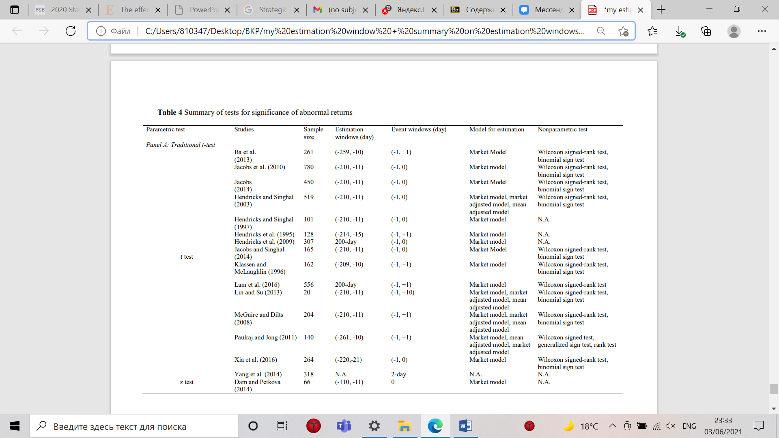

1. Summary on short-term literature. Source [Li Ding and other]

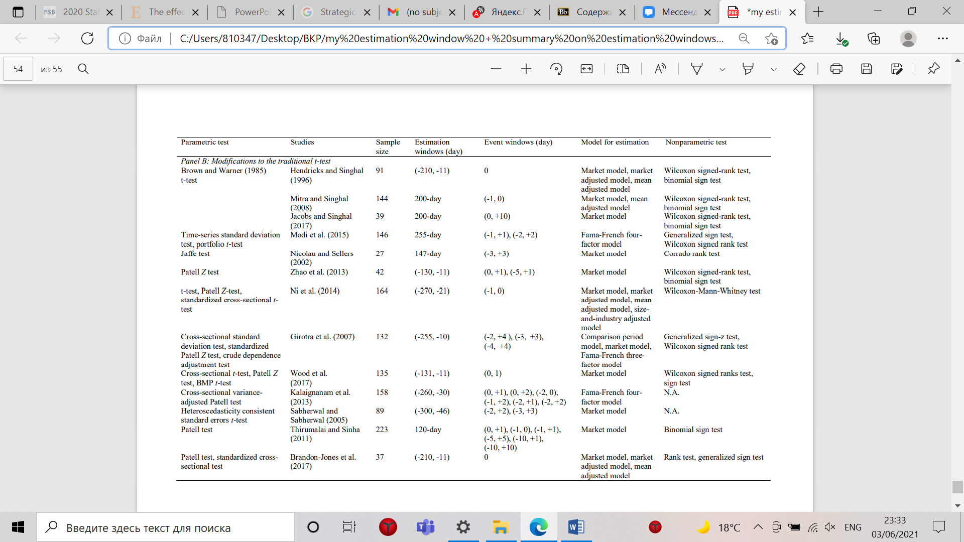

1. Summary on short-term literature. Source [Li Ding and other]

1. Andrew C. Inkpen, Michael H. Moffett (2011), The global Oil & gas industry: management strategy & finance, PennWell
2. Ribeiro, C., Tosi Furtado, A. T. (2014). Government Procurement Policy in Developing Countries: The Case of Petrobras. Science, Technology and Society 19 (2), 161–197
3. WIDER Working Paper 2016/175 The role of oil and gas in the development of the global economy (unu.edu)
4. . Edward Freeman and. Edward Freeman (2001), A stakeholder approach to strategic Management, Handbook of Strategic Management, Oxford: Blackwell Publishing
5. Thomas Donaldson and Lee E. Preston (1995), The Stakeholder Theory of the Corporation: Concepts, Evidence, and Implications : The Academy of Management Review, Vol. 20, No. 1 (Jan., 1995), pp. 65-91
6. Thomas Dyllick1 and Katrin Muff (2016), Clarifying the Meaning of Sustainable Business: Introducing a Typology From Business-as-Usual to True Business Sustainability
7. Jan Messina and Jan Anton van Zanten (2021), The Sustainability Yearbook 2021, Rethinking the value of everything, pp. 10-20
8. The CSA 2021 is now open, S&P Global <https://www.spglobal.com/esg/csa/>
9. Dow Jones Sustainability World Index, S&P Sow jones Indecies <https://www.spglobal.com/spdji/en/indices/esg/dow-jones-sustainability-world-index/#overview>
10. Laura Street, Rosie Powell-Tuck, Aiste Blackley, Mark Lee (2021) What’s next for Sustainable business? 2021 Trend Report (2021)
11. George Serafeim et al. (2020), Making Sustainability count, Harvard Business Review
12. Jeong-Bon Kim, Bing Li, Zhenbin Liu (2018), Does social performance influence breadth of ownership?, Journal of Business finance&accounting
13. Ekwurzel, B., Boneham, J., Dalton, M.W. et al. The rise in global atmospheric CO2, surface temperature, and sea level from emissions traced to major carbon producers. Climatic Change 144, 579–590 (2017)
14. Simon Dietz, Valentin Julius Jahn, Dan Gardiner Jolien Noels (2020) Emissions targets in the oil and gas sector: How do they stack up? Londin School of Economics
15. Matthew S. BachDutch (2017) Is the Oil and Gas Industry Serious About Climate Action?

    Research Institute for Transitions (DRIFT) of Erasmus University Rotterdam in the Netherlands
16. What is the Kyoto Protocol?<https://unfccc.int/kyoto_protocol>
17. Geoffrey Supran2 and Naomi Oreskes (2017), Assessing ExxonMobil's climate change communications (1977–2014), Environmental Research Letters, Volume 12, Number 8
18. Kieran Dobson and Manjit Jus (2021)Driving the energy transition: more than just hedging downside demand
19. Marlene Motyka (2021), 2021 renewable energy industry outlook
20. BP, Energy outlook 2020 edition <https://www.bp.com/content/dam/bp/business-sites/en/global/corporate/pdfs/energy-economics/energy-outlook/bp-energy-outlook-2020.pdf?utm_source=newsletter&utm_medium=email&utm_campaign=newsletter_axiosgenerate&stream=top>
21. Ruud Weijermars, Oswald Clint, Iain Pyle, Competing and partnering for resources and profits: Strategic shifts of oil Majors during the past quarter of a century,

    Energy Strategy Reviews, Volume 3, 2014, Pages 72-87,
22. Johnston, Robert J., et al. KEY DRIVERS OF THE LOW CARBON TRANSITION. Atlantic Council, 2020, pp. 5–14, THE ROLE OF OIL AND GAS COMPANIES IN THE ENERGY TRANSITION, www.jstor.org/stable/resrep23543.5. Accessed 3 June 2021.
23. The Montreal Protocol <https://www.unep.org/ozonaction/who-we-are/about-montreal-protocol>
24. Amendment to the Montreal Protocol on Substances that Deplete the Ozone Layer <https://treaties.un.org/Pages/ViewDetails.aspx?src=TREATY&mtdsg_no=XXVII-2-f&chapter=27&clang=_en>
25. <https://unfccc.int/files/essential_background/background_publications_htmlpdf/application/pdf/conveng.pdf> UNITED NATIONS FRAMEWORK CONVENTION ON CLIMATE CHANGE
26. Lindsay Maizland (2021), Global Climate Agreements: Successes and Failures, Council on Foreign relation
27. Erickson, Peter, et al. How Would Eliminating Subsidies to the U.S. Oil Industry Affect Potential Oil Production and CO2 Emissions? Stockholm Environment Institute, 2017, www.jstor.org/stable/resrep02806. Accessed 3 June 2021.
28. [About | Task Force on Climate-Related Financial Disclosures (fsb-tcfd.org)](https://www.fsb-tcfd.org/about/)
29. PRI, What are the Principles for Responsible Investment? <https://www.unpri.org/pri/what-are-the-principles-for-responsible-investment>
30. Deborah Byers et. Al (2017) How can oil and gas fuel tomorrow as well as today? EY
31. <https://www.energyresources.org.nz/dmsdocument/167> Oil and Gas Industry Reputation (2020)
32. Holly Honderich, Keystone XL: Why I fought for - or against - the pipeline, BBC <https://www.bbc.com/news/world-us-canada-55816229>
33. Kelly Gilblom, (2019), Shell's London Headquarters Vandalized by Climate Protesters, Bloomerg <https://www.bloomberg.com/news/articles/2019-04-15/shell-s-london-headquarters-vandalized-by-climate-protesters>
34. Global Sustainable Review 2018 [www.gsi-alliance.org/wp-content/uploads/2019/03/GSIR_Review2018.3.28.pdf](http://www.gsi-alliance.org/wp-content/uploads/2019/03/GSIR_Review2018.3.28.pdf)
35. Global Sustainable Review 2018 [www.gsi-alliance.org/wp-content/uploads/2019/06/GSIR_Review2018F.pdf](http://www.gsi-alliance.org/wp-content/uploads/2019/06/GSIR_Review2018F.pdf)
36. Dennis Halcoussis, Anton D. Lowenberg, The effects of the fossil fuel divestment campaign on stock returns, The North American Journal of Economics and Finance, Volume 47, 2019, Pages 669-674,
37. Mike Scott (2019), Investors Demand Oil And Gas Firms Adopt Climate Targets, But They Must Also Apply Them To Their Funds, Forbes [h](https://www.forbes.com/sites/mikescott/2019/04/29/investors-demand-oil-gas-firms-adopt-climate-targets-but-they-must-also-apply-them-to-their-funds/?sh=f5c8c7f6e4e1)ttps://www.forbes.com/sites/mikescott/2019/04/29/investors-demand-oil-gas-firms-adopt-climate-targets-but-they-must-also-apply-them-to-their-funds/?sh=491ac74e6e4e
38. Theodor Cojoianuet al. (2019), Economic geography of Fossil Fuel Divestment , environmental policies and oil and gas financing <https://ec.europa.eu/jrc/sites/jrcsh/files/4_3_cojoianu_presentation.pdf>
39. Walter Leal Filho, Ali Beynaghi, Abul Quasem Al-Amin, Charbel Jose Chiappetta Jabbour, Miguel Esteban, Masoud Mozafari, Low-carbon transition through a duty to divest: Back to the future, ahead to the past, Renewable and Sustainable Energy Reviews, Volume 94, 2018, Pages 183-186,
40. Sibylle Braungardt, Jeroen van den Bergh, Tessa Dunlop, Fossil fuel divestment and climate change: Reviewing contested arguments,Energy Research & Social Science,Volume 50,2019,Pages 191-200,
41. Irene Henriques, Perry Sadorsky,Investor implications of divesting from fossil fuels,Global Finance Journal,Volume 38,2018,Pages 30-44,
42. Gregor Semieniuk an other,(2019)Low-carbon transition risks for finance
43. Stanely Porter and other, oil,gas and the energy transition, Deloite Insights <https://nor.deloitte.com/rs/712-CNF-326/images/DI-Oil-gas-and-the-energy-transition.pdf?_ga=2.189358571.1781744088.1620305824-454345659.1620305824>
44. VAKHSHOURI, SARA. The America First Energy Plan: Renewing the Confidence of American Energy Producers. Atlantic Council, 2017, www.jstor.org/stable/resrep17116. Accessed 3 June 2021.
45. Hongfang Lu, Lijun Guo, Yitong Zhang, Oil and gas companies' low-carbon emission transition to integrated energy companies, Science of The Total Environment, Volume 686,2019, Pages 1202-1209,
46. Matthias J. Pickl, The renewable energy strategies of oil majors – From oil to energy?, Energy Strategy Reviews, Volume 26, 2019,
47. Asmelash, E. and R. Gorini (2021) International oil companies and the energy transition, International Renewable Energy Agency, Abu Dhabi
48. Chantal Beck, Jayanti Kar, Stephen Hall, Dara Olufon, Donatela Bellone (2021) The big choices for oil and gas in navigating the energy transition, McKinsey &Company <https://www.mckinsey.com/industries/oil-and-gas/our-insights/the-big-choices-for-oil-and-gas-in-navigating-the-energy-transition>
49. Kyungjin Yoo, Youah Lee, Eunnyeong Heo, Economic effects by merger and acquisition types in the renewable energy sector: An event study approach, Renewable and Sustainable Energy Reviews, Volume 26, 2013, Pages 694-701
50.
51. 2020, The world’s most used renewable power sources <https://www.power-technology.com/features/featurethe-worlds-most-used-renewable-power-sources-4160168/>
52. Dolley, J. C. (1933). Characteristics and procedure of common stock split-ups. Harvard Business Review, 11(3), 316–326.
53. Ball, R., & Brown, P. (1968). An empirical evaluation of accounting income numbers. Journal of Accounting Research, 6(2), 159–178
54. Fama, E. F., Fisher, L., Jensen, M. C., & Roll, R. (1969). The adjustment of stock prices to new information. International Economic Review, 10(1), 1–21
55. Fama, Eugene (1970). "Efficient Capital Markets: A Review of Theory and Empirical Work". Journal of Finance. 25 (2): 383–417
56. S. P Khotari and Jerold B. Warner (2006), “Econometrics of Event Studies” “Econometrics of Event Studies”
57. MacKinlay, C.A. (1997) Event Studies in Economics and Finance Journal of Economic Literature, 35
58. Science, 26(6), 758–773. Tipton, M. M., Bharadwaj, S. G., & Robertson, D. C. (2009). Regulatory exposure of deceptive marketing and its impact on firm value. Journal of Marketing, 73(6), 227–243
59. Li Ding, Hugo K.S. Lam, T.C.E. Cheng, Honggeng Zhou, A Review of Short-term Event Studies in Operations and Supply Chain Management.
60. [A Comparative Abnormal Return Analysis of Mergers and Acquisitions in the Emerging Markets | IntechOpen](https://www.intechopen.com/books/financial-management-from-an-emerging-market-perspective/a-comparative-abnormal-return-analysis-of-mergers-and-acquisitions-in-the-emerging-markets)
61. 5. Scholes, Myron and Joseph Williams, 1977, Estimating Betas from Nonsynchronous Data, Journal of Financial Economics, 5: 309-28.
62. Brown, S. J., & Warner, J. B. (1985). Using daily stock returns: the case of event studies. Journal of Financial Economics, 14(1), 3–31.
63. James S. Ang and Shaojun Zhang (2014), Evaluating Long-Horizon Event Study MethodologyHandbook of Financial Econometrics and Statistics pp 383-411
64. Barber, B. and J. Lyon (1997). Detecting Long-run Abnormal Stock Returns: The Empirical Power and Specification of Test Statistics, Journal of Financial Economics, 43, pp. 341-372
65. Kothari, S.P. and J.B. Warner (1997). Measuring Long-horizon Security Price Performance, Journal of Financial Economics, 43, pp. 301-339
66. Fama, E. (1998). Market Efficiency, Long-term Returns, and Behavioral Finance, Journal of Financial Economics, 49, pp. 283-306
67. Fama, E. (1991). Efficient Capital Markets: II, Journal of Finance, 46, pp. 1575-1617.
68. Jaffe, J., (1974), Special information and insider trading, Journal of Business 47: 411-428
69. Mandelker, G., (1974), Risk and return: The case of merging firms, Journal of Financial Economics 1: 303-335.
70. . Ritter, J. (1991). The Long-Term Performance of Initial Public Offerings, Journal of Finance, 46, pp. 3-27
71. . Mitchell, M. and E. Stafford (2000). Managerial Decisions and Long-term Stock Price Performance, Journal of Business, 73, pp. 287-329
72. Anupam Dutta and Probal Dutta (2015). Measuring long-run security price performance: a review. Investment Management and Financial Innovations, 12(2), 26-32
73. Markovitch, D. G., & Golder, P. N. (2008). Findings-using stock prices to predict market events: evidence on sales takeoff and long-term firm survival. Marketing Science, 27(4), 717–729
74. Lyon, J. D., Barber, B. M., & Tsai, C. L. (1999). Improved methods for tests of long-run abnormal stock returns. The Journal of Finance, 54(1), 165–201
75. Lyon, J. D., Barber, B. M., & Tsai, C. L. (1999). Improved methods for tests of long-run abnormal stock returns. The Journal of Finance, 54(1), 165–201.
76. Boehme, D.R. and S.M. Sorescu (2002). The Long-Run Performance Following Dividend Initiations and Resumptions: Underreaction or Product of Chance? Journal of Finance, 57, pp. 871-900.
77. esh, N. and J. Karceski (2009). Long-run Performance Evaluation: Correlation and HeteroskedasticityConsistent Tests, Journal of Empirical Finance, 16, pp. 101-111.
78. John D. Lyon, Brad M. Barber and Chih-Ling Tsai, (1999), The Journal of Finance, Vol. 54, No. 1, p. 165-201
79. Yue Guo, Yu Yang, Chang Wang, Global energy networks: Geographies of mergers and acquisitions of worldwide oil companies, Renewable and Sustainable Energy Reviews, Volume 139, 2021, 110698
80. Yue Guo, Yu Yang, Chang Wang, Global energy networks: Geographies of mergers and acquisitions of worldwide oil companies, Renewable and Sustainable Energy Reviews, Volume 139, 2021, 110698, ISSN 1364-0321
81. Kuang-Chung Hsu, Michael Wright, Zhen Zhu, What motivates merger and acquisition activities in the upstream oil & gas sectors in the U.S.?, Energy Economics, Volume 65, 2017, Pages 240-250, ISSN 0140-9883,
82. Glenn V. Henderson, Jr. (1990) Problems and Solutions in Conducting Event Studies, The Journal of Risk and Insurance, Vol. 57, No. 2, pp. 282-306
83. K.S. Reddy, En Xie, Cross-border mergers and acquisitions by oil and gas multinational enterprises: Geography-based view of energy strategy, Renewable and Sustainable Energy Reviews, Volume 72, 2017,Pages 961-980, ISSN 1364-0321
84. H.-C. Jung (2006), Small sample size problems and the power of the test in the event study methodology