Federal State Institution of Higher Professional Education

Saint-Petersburg University

Graduate School of Management

**Final bachelor thesis**

**German market entry strategy for Russian company “Ijiza”**

Education level: bachelor's degree

Direction 38.03.02 "Management"

Basic educational program CB.5087 International Management

Made by

the 4th year student of bachelor program,

Group IM,

Zoya A. Gusarova

Signature

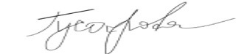

Associate Professor, Department of Strategic and International Management

**Olga L. Garanina**

**Signature**

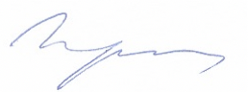

Saint-Petersburg

2021

**The statement about the independent nature of graduate qualification work.**

I, Gusarova Zoya, the 4th year student of the Graduate School of Management, St. Petersburg State University, "Management” direction, "International management" program, confirm that my graduate qualification work on the thesis “German market entry strategy for Russian company “Ijiza”, which will be presented for public defense in June 2021, does not contain elements of plagiarism.

All direct borrowings from printed and electronic sources, as well as from previously curated and final qualification works, candidate and doctoral dissertations have relevant references.

I know that according to paragraph 12.4.14 of the "Rules of Education at the GSOM SPbU Bachelor's Program" "the discovery in the WRC of the student of elements of plagiarism (contextual or direct borrowing of text from printed and electronic original sources, as well as from previously protected final qualification papers, Ph.D. dissertations without appropriate references) is the basis for the presentation of the HAC evaluation "unsatisfactory".

(Gusarova Z.A.)  
(Signature of the student with transcript)

03.06.2021 (Date)

Table of Contents

Introduction 4

Chapter 1: General characteristics of the organization external and internal environment 6

1.1 Company overview 6

1.2 Automated universal heat chamber IJIZA-Z115-A overview 9

1.3 Key success factors 12

1.4 VRIO analysis of Ijiza 16

1.5 Situation on the Russian smoking equipment market and “Ijiza” position on it 20

1.6 Reasons for internationalization for “Ijiza” 22

1.7 Conclusion to the Chapter 1 25

Chapter 2: Target market analysis 27

2.1 General analysis of the German economy and German smoking equipment market 27

2.2 PEST analysis 30

2.3 Porter’s Five Competitive Forces analysis (including in-depth competition analysis) 41

2.4 SWOT analysis 50

2.5 Conclusion to the Chapter 2 51

Chapter 3: Development of a strategy for penetrating the foreign market 53

3.1 Types of entry mode, advantages and disadvantages 53

3.2 Finding a potential distributor via Russian-German Chamber of Commerce 59

3.3 Assessing the German market entry strategy in terms of revenue and scope of work 63

3.4 Conclusion to the Chapter 3 74

Conclusion 76

Reference 78

Appendix 1 83

Appendix 2 84

Appendix 3 85

# **Introduction**

In the modern world, under the conditions of globalization, each successfully developing company strives for international expansion and expanding the boundaries of selling its products to foreign markets. The company's entry into the international arena contributes to attracting new customers, increasing capitalization, reducing the risks of losses and increasing competitiveness.

Every company that is going to enter the international market must answer the following three questions:

1. Which overseas market to choose?
2. When is it worth entering the market?
3. What type of market entry strategy should it choose?

In order to answer the first question, it is necessary to pay attention to the macroeconomic model. After that, the attractiveness of the country as a market for international business, which depends on the ratio of the advantages of this market and possible costs, as well as on the level of risk associated with the implementation of the project. It is necessary to pay attention to factors such as market size, purchasing power of the country's population, potential future growth. Also, sustainable competitive advantage is an important factor, which determines the indicator of the stability of the product in the market and the value that international business can bring.

This work is research as we analyze the Russian smoking equipment company “Ijiza” for future international expansion to the German market. The company was founded in 1992 and is one of the best manufacturing company of smoking equipment in the country. In the manufacture of smoking equipment, innovative technologies are used. The company is B2B because they deliver their products to corporate clients. Also, the company has experience in the international field through delivery of smoking equipment around the world.

The company has a strong position in the Russian market, but they have a problem with the demand for products due to the economic crisis in the country and the depreciation of the national currency. Therefore, the company decided to go out that they needed international expansion to the foreign market, and specifically to the German market. The product that they would like to introduce to this market is the fully automated know-how smoking equipment. Consequently, the managerial problem of the bachelor's work is the stagnation of “Ijiza” LLC on the Russian market. The object of the work is the company “Ijiza” and the subject of the work is the strategy. The main aim of the work is to develop a strategy for entering the German market. The main objectives of the work are:

1. To provide general characteristics of the organization external and internal environment
2. To provide analysis of the German market for industrial smoking equipment
3. To consider potential options for entering the German market and choosing the right one
4. To provide a strategy for entering the German market

In the first chapter, we will make a description of “Ijiza” company in the domestic market, provide their international experience, make VRIO analysis and identify their competitive advantages, find out reasons of stagnation and analyze the global market. In the second chapter we will describe the German market, conduct PEST, Porter’s five forces analyzes examine SWOT – analysis in order to understand whether it is reasonable to enter this market. Based on two chapters, we will need to conclude and in the third chapter present possible options for entering the German market, provide risk assessment and recommendations for international expansion.

# **Chapter 1: General characteristics of the organization external and internal environment**

## **Company overview**

Smokehouse manufacturer “Ijiza”, LLC located its production in the city of St. Petersburg, in 1992 where it has been producing smoking chambers and equipment since then. Ijiza is a large wholesale supplier of smoking chambers in Russia and the CIS countries (Ijiza, LLC). The company develops and manufactures industrial smokehouses with a unique smoking technology producing smoke without carcinogens. Today the company manufactures around sixteen different models of smoking chambers.

Many positive factors, such as: knowledge accumulated over 29 years, unique experience, the latest design solutions, the use of patented modern technologies, continuous improvement of the production, modern components; prompt and high-quality warranty and post-warranty service of the supplied equipment, and most importantly - the availability of highly qualified specialists allowed the company to take a leading position among domestic manufacturers of the similar equipment (Ijiza, LLC).

According to Russian Production - information center (2018) the company manufactures and offers following products / equipment:

1. Cold and hot smoking chambers;
2. Smoking installations (range of models);
3. Universal heat chamber;
4. Drying and drying chamber;
5. Automatic BBO Smoker, etc.

Ijiza produces semi-automated and automated industrial smoking equipment and a special series of smokehouses for public canteens.

The company has own manufacturing base. Over the past years, continuous modernization of equipment made it possible for Ijiza to achieve high technical and economic characteristics of the manufactured product. The production process is equipped with modern metalworking equipment with a CNC system, which ensures the high quality of the product manufactured. Solid expertise and scientific potential of the enterprise made Ijiza’s equipment technologically advanced as it includes latest innovative high-tech solutions (Russian Production - information center, 2018).

Among the company clients are small and medium-sized businesses and public catering establishments. Company’s targeted segment is medium and small business, food processing, farmers, fish farmers, restaurants, cafes, shops and private sectors. Semi-automated equipment is bought be companies that are in the low and mid-price segments, while automated industrial smoking equipment is mainly purchased by those from the premium segment (Ijiza, LLC).

The company succeeded in building long-term relationships with its partners based on highly professional service, individual approach, search for non-standard solutions, and flexible pricing system (Ijiza, LLC).

As for Ijiza’s organizational structure, it has a functional management structure that includes the grouping of specific positions in departments based on general types of activities. Such structural view was presented by the head and founder of the company, please see Figure 1.1.

**Figure 1.1 Organizational structure of the company “Ijiza”**

Source: Ijiza, LLC

Production department includes a production manager, welders, electricians and locksmiths. Also, engineers and logisticians function in this department.

Sales department has three employees: general manager, top manager and line manager. Ijiza, LLC operates in the B2B segment.

Finance department consists of a chief accountant and a financial director. The responsibility of the chief accountant is the management and regulation of tax accounting in accordance with the requirements of the legislation, timely formation of accounting and tax reports, keeping records of company's economic activities in the accounting registers. The functions of the financial director are to plan the company's activities, evaluate financial results, ensure that the company complies with all requirements related to financial stability of the company and monitor constantly changing legislation.

HR department of includes two people - the head of the HR department and the HR manager. Today the head of the personnel department is responsible for the following activities: planning personnel scope of work together with the heads of departments and the general director; conducting personnel certification (developing tasks, assessment criteria, conducting certification procedures, as well as analytics), arranging classes for employees; planning advertising; facilitating the selection and interview procedures with applicants; accepting calls; arranging research and works on reports.

Overall about 100 employees are working for the company at the moment and in case a special project is implemented the activities and departments might be grouped in matrix structure to comply with the project goals. (Spark Interfax, 2002).

With regards to Ijiza’s geographical coverage, the company has more than 4000 clients all over the world. The company supplies its equipment abroad to Cyprus, Norway, Kazakhstan, Spain, Israel, America, Canada, Chile, Japan, Oceania, South Africa, Latvia, Estonia, Lithuania, Uzbekistan, Tajikistan, Kyrgyzstan, Belarus, Qatar, UAE, Portugal and Turkey. Although supplies to these countries have been established, there is no further growth, since the product is purchased only by small enterprises or medium-sized businesses. The company wants to supply more of automated equipment designed for the premium segment and it began to focus on the premium segment and constant cooperation. Thus, Ijiza realized the need of studying the global market to identify countries with great production capacity of smoked goods (beef, pork, fish, and different kind of sausages) and stable market demand for such products; that would be interested in importing the equipment.

Moreover, considering that Russian economy is struggling to survive under the sanctions last five years; and the fact that a volume of foreign investment also significantly dropped it affect producers’ (that are potential Ijiza;s clients) investment capability. Internal Russian market is already familiar with Ijiza’s product as a number of possible clients has been worked through, and others smoked meat producers are working with an old equipment and not ready yet to invest in new one since economic situation is unpredictable. Hence, seeking foreign clients who are interested in technologically advanced equipment and have stable economy seems a good option for Ijiza.

## **Automated universal heat chamber IJIZA-Z115-A overview**

As we already mentioned Ijiza manufactures sixteen different models of smoking chambers. However, it is planning to invade a new market with its one of best product - the fully automated smoking equipment IJIZA-Z115-A. A unique development of the engineers of the company established on the basis of many years of experience in smoking equipment production and design.

Ijiza introduced an innovation - the arrangement of heating elements along the walls of the smoking chamber, significantly increases energy efficiency and uniformity of product heating. IJIZA-Z115-Ahelped to solve the problem of splashing the side rows of the product with smoky condensate, which was and is a frequent problem even in the most expensive smokehouses. In German cameras, which are one of the best among international rivals, this problem is solved exclusively by washing the cameras once in a shift. The IJIZA-Z115-A set includes the F15 automated smoke generator, the v0110 automatic dampers control system and an extended stainless-steel control box (Ijiza, LLC, 2020a).

According to Ijiza’s commercial offer, the equipment can be applied in different places for the following purposes:

1. In smoking shops - for smoking and baking products from fish, meat, poultry, bacon and cheese;

2. In farms - for the preparation of high-quality smoked products from available raw materials;

3. In restaurants and kitchen factories - for the preparation of premium smoked products, such as stewed smoked ribs in Texas (pork, beef, lamb, etc.), BBQ products, cuts of smoked sausages, cooked smoked lard, gourmet hot smoked fish;

4. For traditional cold smoking and damp-curing (option);

5. For preparing meat chips and jerks.

High productivity and minimal space requirements make it possible to use the smokehouse for both small and large smoking shops.

The design and construction of the equipment includes:

1. Control block;

2. Smoke generator;

3. Heat chamber housing, see Figure 2.

Below you can see IJIZA-Z115-A where four automatic dampers are marked in blue, which control the air flow in all modes of operation of the heat chamber; The red arrow is where the smoke is ejected from the chamber.

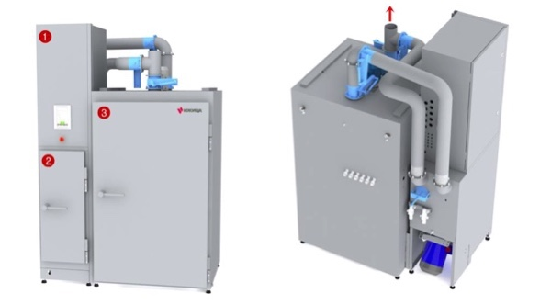

**Picture 1.1 Design of the universal camera IJIZA-Z115-A**

Source: Ijiza Commercial Offer, 2020

The smoke generator operates on a block of 80x80x600 mm in size. In its smoke is generated by rubbing the bar against a specially shaped cutter, the wood does not overheat; therefore, the smoked product is obtained with an excellent smell and without carcinogens. This aroma is especially appreciated in the manufacture of premium products, in which the own taste should not be replaced by the smell of smoking, but supplemented. Real delicacies are obtained with the correct fusion of the aroma of smoke and the own taste of high-quality raw materials. Good news is that it is possible to use different types of wood: alder, beech, aspen, wood of fruit trees, including dried pine.

Having described the technical details of the IJIZA-Z115-A we can see that equipment represents a number of advantages; they are:

1. Heating elements are located along the right and left walls of the housing. That makes it possible to increase heating efficiency and reduce electricity consumption by 30%.
2. Increased efficiency of steam generation, because water droplets pass through the heating elements along the body and have time to completely turn into steam. Cooking moisture is 12% higher than analogs, which means a decrease in the percentage of losses and an increase in the cooking speed by 15-20%.
3. The heating elements are isolated from each other, so they do not overheat and last longer. Manufactured from heat-resistant stainless steel.
4. The special shape of the impeller of the chamber protects the motor from overheating and moisture ingress. Engines have been in service for over 5 years.
5. Thanks to the carefully calculated aerodynamics, the smoke is distributed evenly between the rows of the product, which ensures the uniformity of the golden color and the maximum yield of the finished product.
6. The control system allows to conveniently change and control temperature, air flow rate, humidity and smoke density.
7. Temperature sensors with a platinum core. They are more expensive than analogues, more reliable and withstand higher temperatures.
8. The seams of the structure connection are fully welded, which ensures complete tightness of the internal volume for a long time.

Equipment, including agricultural, industrial and medical equipment, is subject to mandatory assessment and verification of compliance with its safety requirements. Mandatory certification of equipment is a process of confirming compliance with the requirements stipulated by the applicable standards, rules and regulations, as well as applicable technical regulations. Certification of equipment on a mandatory basis is required for all types of household (household appliances), food, heating, metalworking, radio-electronic, woodworking equipment, as well as hot water supply devices, etc. A certificate of conformity for equipment is issued only on the basis of tests carried out, during which it is certified that it meets certain requirements. Since the equipment is of different types, then its certification can take place according to various regulatory documents.

The equipment must have three certificates. First, the company must provide a declaration of conformity (see Appendix 1), which indicates that the products are manufactured in accordance with GOST 15150-69 “Machines, instruments and other industrial products. Modifications for different climatic regions. Categories, operating, storage and transportation conditions as to environment climatic aspects influence”. This International Standard should be applied to the design and manufacture of products. In particular, it should be used in the preparation of technical specifications for the development or modernization of products, as well as in the development of state standards and technical conditions that establish requirements in terms of the impact of climatic environmental factors for a group of products, and in the absence of these group documents - for certain types of products. Also, it must be indicated that the equipment meets the requirements of: TR CU 004/2011 “On safety of low-voltage equipment” - This technical regulation of the Customs Union applies to low-voltage equipment put into circulation in the common customs territory of the Customs Union. Low-voltage equipment, which is subject to this technical regulation of the Customs Union, includes electrical equipment designed for use at a rated voltage of 50 to 1000 V (inclusive) AC and from 75 to 1500 V (inclusive) DC. TR CU 020/2011 Electromagnetic compatibility of technical equipment.

Secondly, a letter on the absence of smoke (See Appendix 2), which states that in the electrostatic smoking installation produced by Ijiza, smoke is circulated in a closed cycle, that is, all the smoke generated in the smoke generator is deposited directly on the product by electrostatic deposition. No smoke fractions are emitted into the atmosphere.

Thirdly, it is necessary to provide a test report for carcinogens (See Appendix 3), which indicates that the research results do not exceed the standard value.

In the appendix, you can see all three certificates for the products with which the company will enter the German market.

We have outlined technical details and advantages of the main product, Ijiza will enter a new market with. Further we will assess the company’s performance to see how well it is ready to expansion.

## **Key success factors**

International shipment of goods can be beneficial only if the company has a clear strategic view of its internal and external activities. Here we need to mention the key success factors of “Ijiza”, LLC. Key success factors are important elements of the business which articulates what the company must do to achieve the goals outlined in its strategic plan. The company must be flexible, reliable, have good emotional connection with its clients and diversity of goods or services. So as for the “Ijiza” the first factor is – strategic focus in its day to day operations.

The strategic focus is the first and the main aspect of success meaning that the company's goals, brand, and actions are moving toward the intended goal. Companies that managed to survive in competitive markets are those whose leaders define their values and a realistic mission. Ijiza has a strong strategic view regarding the international shipment and we presume that it will succeed in this regard as the company has the strong brand among the rivals all around the world, despite the fact that it is relatively young. Company’s strategic view is linked to the ultimate business goal and ensures that every project is focused on achieving that goal. We know that important part of the strategic focus is to ensure that the chosen goal is tailored to the needs and requirements of the client, therefore Ijiza is permanently studying clients need to satisfy them before they are voiced.

The second factor, which is as important as the first one is – people. It is not only about smoking chambers but also about personnel. Ijiza has the highly qualified personnel with rich experience, they are responsible and loyal what gives company competitive advantage to offer high level service. Also, Ijiza is open to accept progressive ideas of their employees and motivates them to express their opinion.

Third key factor of the company is its’ operational processes. Company has developed and modernized producing technology which gives it a solid base and advantage to compete with global giants. Although the company has only 29 years of experience it has moved far away from its rivals in terms of equipment development level.

As for the fourth key factor which is marketing, it is really sad to admit that the marketing force of the company is really poor. It is one of the main aspects that slow down the company’s international expansion. The current marketing force cannot develop a strong company brand and this influences the brand recognition. Even though the company has undoubtedly the best equipment, it has quite week brand and that creates obstacles for brand positioning on the global recognition.

Last but not least factor is financial performance. The main indicators of profitability, as well as revenues for recent years (2016-2020) can be observed on the Figure 1.3 (Ijiza, LLC, 2021).

**Figure 1.2 Ijiza financial results for the period of 2015-2020, in million rub**

Source: Ijiza financial report, 2021

According to the financial results, it is obvious that during the period 2016-2020, the company has been developing steadily making around 270 million rubles in sales and earning profit over 110 million rubles annually. Moreover, the crisis associated with the COVID pandemic didn’t have a great influence on Ijiza business. It might be explained by the fact that food consumption increased during the pandemic, therefore production of meat and other smoked food also rose pulling up the demand for smoked houses. The company plans to continue its growth and is going to introduce a robust strategy to grow and expand internationally.

The Figure 1.3 represents all company sales and as it initially is planning to export only one model Ijiza-Z115-A it is crucial to look at its sales during the same period (Figure 1.3)

**Figure 1.3 Sales of smoking chamber model Ijiza-Z115-A during 2015-2020, in million rub**

Source: Ijiza financial report, 2021

It can be noticed that sales of Ijiza-Z115-A smoking chamber model are demonstrating a positive trend and representing one fifth of all company sales (Figure 1.5), despite the fact that actually there are 16 models that Ijiza is currently producing and selling.

**Figure 1.4 Sales of all 16 models of smoking chambers in 2020, in million rubles**

Source: Ijiza financial report, 2021

As it was stated before company is exporting some of its product abroad and current sales structure in terms of sales by regions is following (Figure 1.6).

**Figure 1.5 Sales structure be country as for 2020, in %**

Source: Ijiza financial report, 2021

We can see that the country mainly operates in internal market as Russia represents 60% of company sales; one third of the equipment is sold to CIS countries that are the members of The Custom Union, and only 6% is sent to export (Deutsche Welle, 2021a; Ijiza, LLC, 2021).

Further we go deeper in company analysis and for that purpose we apply VRIO analysis tool.

## **VRIO analysis of Ijiza**

In order to determine the competitive advantage of the company, we need to conduct the resource-based view (RBV). The resource-based view is a model that allows you to reveal a competitive advantage. RBV relies on tangible and intangible resources that must be heterogeneous and immobile and have VRIO attributes. VRIO means value, rareness, imitability and organization (Savkin, 2021). The results of the analysis conducted on the company are represented on Table 1.1.

**Table 1.1 VRIO analysis of “Ijiza” resources and capabilities**

| **Resource or capability** | **Does it have value?** | **Is it rare?** | **Is it not imitable?** | **Is the company organized to exploit this resource?** |
| --- | --- | --- | --- | --- |
| **Manufacturing process** | Yes | No | Yes | No |
| **Technology** | Yes | Yes | Yes | Yes |
| **Product** | Yes | No | Yes | Yes |
| **Customer support** | Yes | No | Yes | No |
| **Advertising** | No | No | Yes | No |

Based on the description of the company “Ijiza” and the assessment of its main resources, we can distinguish its competitive advantages in the Russian market.

Manufacturing process is the main capability of the company, thanks to many years of experience of more than 29 years, the company has achieved excellence in the production of smoking chambers and gained recognition in Russia and the CIS among smoking chambers for small and medium-sized businesses. The manufacturing process is organized in way to provide a maximum outcome and add value by applying all available techniques, although the company managements recognizes a need for further improvement in terms of quality and efficiency.

In terms of capacity Ijiza every year manufactures and sales over 800 smoking chambers annually, if we look at the Figure 1.7, we see how many equipment of each model was produced and sold in 2020

**845**

**Figure 1.6 Capacity of production, quantity of each smoking chamber model produced and sold in 2020, in pieces**

Source: Ijiza financial report, 2021

We can see that 845 pieces were produced sold in 2020 and among them 65 were Ijiza-Z115-A. It is quite significant amount of production and sale. Thus, capacity of production is around 800 pieces pet year.

Technology, is one of companies main advantages as Ijiza develops special smoking technologies, thanks to which it has the following advantages (Ijiza, LLC, 2020a):

* Aroma - natural purified smoke is used for smoking, so the fish is obtained with a delicate natural smoking aroma, which does not interrupt the taste of the product itself.
* Juicy - due to the reduction in smoking time, the product loses less moisture, and, accordingly, it turns out to be juicier.
* Taste - retaining moisture, the finished product does not become salty (with a loss of moisture, the salt in the meat is felt more strongly).
* Color - smoked fish takes on the bright golden color of alder smoke, which attracts the attention of customers.
* Environmentally friendly - smoked product does not contain carcinogens, which is confirmed by tests. After its use, there is no heartburn and heaviness in the abdomen. This type of fish is eaten more and bought more often, and the volume of sales is growing.
* Increase in sales by an average of 5% - smoked fish is becoming not just an appetizer, but a main course.
* Profitability - achieved not only by reducing the percentage of losses of finished products during smoking, but also by minimizing the consumption of wood and electricity. The cost of smoking 85 kg of products is 1.5 laths of 25 rubles each. This is 44 kopecks per 1 kg. finished products. Electricity consumption for one smoking cycle (i.e. for 85 kg of finished products) is only 1.8 kW.

Product, the equipment of the “Ijiza” company is designed in a unique way, using high-quality materials, although even in Germany steel analogs are used to create smoking chambers. For example, AISI 304 stainless steel has a German counterpart - X5CrNi18-10 alloy, which is inferior to the characteristics of the original (Steel Service, 2019). Also, due to the fact that the company provides a different range of smoking chambers in size, you can purchase both the most compact smoking chambers and for industrial production. In the smoking house the product is smoked from 30 minutes instead of 4 hours, as in other chambers. One of the most important factors in their success and high sales is energy savings of up to 90%. Thanks to the unique design of the heating elements, the average energy consumption has been reduced to 3.5 kW per hour. Smoke is fed into the chamber from below, which eliminates the splashing of the side rows of products with black dots of smoke condensate, even without regular washing. High quality of smoke and minimal consumption of chips due to the ability to control the draft of the smoke generator, and therefore the smoldering temperature, there is no need to soak the chips an hour before smoking, as in similar smoking chambers. Wet wood chips add unnecessary bitterness to the product and exclude the possibility of obtaining high-quality aromatic smoke without soot and tar; the draft of the smoke generator is controlled by a gate, the operation of which can be automated.

Customer support service of the company is unique and includes:

* Providing a special engineer that helps the client to set up the equipment and start the production. Moreover, once in a month he can visit the client to make sure that everything works well (Tickets and hotel accommodation in case of a business trip are paid separately);
* Consultations on smoking technology and equipment operation by phone and skype;
* Joint development of new recipes for finished products;
* Optimization of the workshop.

The company provides absolute support to its customers. Departure of specialists to another city to track installation, repair and do other things. Also, they are always ready to advise to provide technical support once a month. In addition, the company provides training in the installation and operation of smoking equipment (Ijiza, LLC).

Advertising, as we mentioned earlier is one of weak sides of the company as it has no significant marketing activities to advance the product in the market and make the brand more popular. There are some advertising activities, but they are not widespread. However, despite that the company managed to build own permanent customer base.

In conclusion, the main resources and capabilities of the company that it can rely on when entering the German market are firstly product - equipment, which makes the process of smoking 30 times faster, energy savings of up to 90% and the control system is completely digital. Moreover, it is developed only by Ijiza and it uses original and high-quality materials, thanks to which the cameras serve longer. Secondly, the technology that applied by the company, it creates the product, thanks to which it becomes distinguishable among competitors. The last one is customer support - the company provides aftersales support to its customers. However, there are still many things to be done to improve Ijiza’s competitive advantages in such areas as: advertising and the manufacturing process.

## **Situation on the Russian smoking equipment market and** **“Ijiza” position on it**

To perceive the state in Russian smoking equipment market it is crucial to analyze current macroeconomic situation of the country as it crucially affects all markets including one for the smoking equipment. In light of recent events Russian economy is struggling to grow, international economic sanctions, decrease in foreign investments make this struggle even more challenging. We further go through main macroeconomic indicators to demonstrate current macroeconomic circumstance.

Gross Domestic Product (GDP) over last had been rising over last five years from 2016 to 2020 (see Figure 1.8). The figures are seasonally adjusted and represented in process of the year 2016 (Bloomberg, 2020).

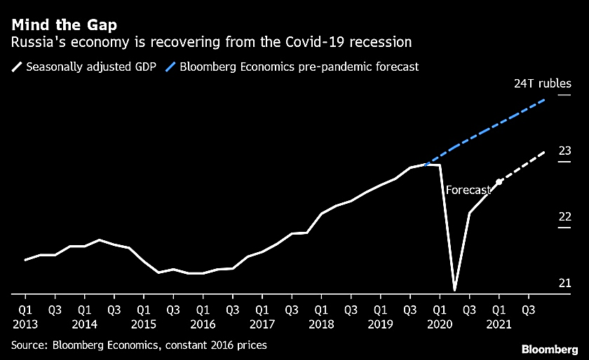

**Figure 1.7 GDP of Russia for the period of Q1 2013 - Q1 2020 with the forecast for Q2 2020 –Q1 2021, trillion rubles**

Source: Bloomberg, 2020

As we can see the economy was growing and only in 2020 there was a crucial drop due to Covid-19 lockdown. If the pandemic hadn’t irrupted Russia’s GDP would have reached 24 trillion rubles by now.

Another negative factor for the Russian economy is fall in foreign investment flow, please see Figure 1.9.

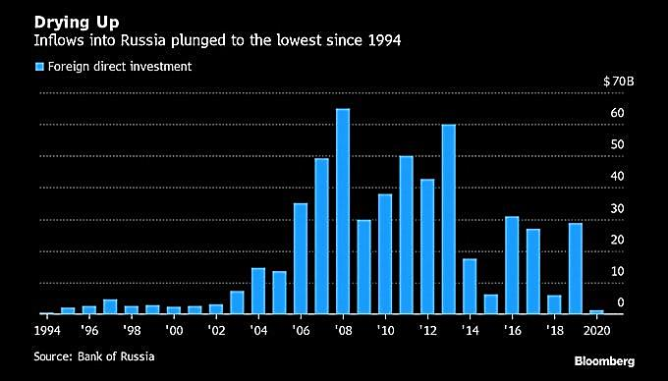

**Figure 1.8 Direct foreign Investment into Russia for the period of 1994 - 2020, billion US dollars**

(Central Bank of Russia, 2020)

As Central Bank of Russia (2020) declares there were no change between 1995 and 2003, but after that we can see a surge in foreign investment flow and in 2008 it reached its highest value – 65 billion US dollars. However, after 2013 there was a sharp fall and in 2020 foreign investments reached the lowest point the same, they had in 1994.

Having looked at the macroeconomic situation further we will proceed to analysis of the smokehouse equipment market. According to the data provided by “Ijiza” LLC, the market for smoking chambers in Russia amounted to 10 billion rubles in 2016, which is 25% less than in 2017. In 2018, it was equal to 18 billion rubles. In 2019, it reached 22 billion rubles.

In the structure of the market consumption of smoking chambers, the largest percentage is occupied by the middle and premium segments. They account for more than half of the market share as a whole (35% for the medium segment and 40% for the premium segment). In 2018, the premium segment increased its market share by 15%.

According to the forecast of “Ijiza” LLC, the market volume of smoking chambers in Russia in 2019-2022 will amount to 127,1 billion rubles in value terms. The market has reached its limit and for the last two years’ sales have not increased, but they have not decreased either.

For the period 2014-2018 the largest share of the market of smoking chambers was occupied by “Ijiza” LLC. In 2018, its market share in Russia was 42%. Also, one of the largest market participants are the companies “KTD” and “TEKHTRON+”. The market shares of these companies in value terms in 2018 amounted to about 15% and 20%, respectively, and rest 23% is represented by other small players.

The volume of the premium segment of the smoking chamber market in Russia in 2018 amounted to 7.2 billion rubles. The largest category in this segment is cameras for Euroframe with a load of 250, 500 and 750 kg - 4.5 billion rubles.

According to the calculations of Ijiza, LLC, in 2018 about 10,000 smoking chambers were produced in Russia and in 2019 the number rose to 13,000. The largest number of smoking chambers is produced in St. Petersburg, Leningrad Region.

The price range of the equipment is wide; it can start from 100,000 rubles and go up to several millions. It all depends on size of the chamber and smoking technology (Ijiza, LLC, 2020b; Avito Marketplace, 2021).

The growth of the smoking chamber market stalled in 2020, most likely due to a pandemic. At the moment, the situation with the pandemic in the world is stabilizing and soon in case the company develops a robust strategy for expansion and successfully implements all necessary measures to strengthen its market positions and increase brand awareness there will be a full-fledged opportunity to present oneself on the other markets, the company management is thinking to expand to German market. Further we will provide an analysis and argumentation why it should be a German market.

## **Reasons for internationalization for “Ijiza”**

Based on the above analysis of the company and the analysis of the Russian macroeconomic situation and the market for smoking equipment, we concluded that the company has reached its highest possible sales volume in Russian market, the market will less likely grow significantly since as we mentioned earlier the investment opportunities are worsening, and economy shrank in 2020. Thus, companies will think twice before making significant purchase such as chambers.

In this scenario we see that good option for the company’s further growth would be:

1. Change monetization, switch to shareware model, enter payment "by subscription", enter discounts;
2. Focus on one specific product;
3. Try other ways to attract customers;
4. Review the site usability;
5. Change the client format. B2B to B2C;
6. Try to target a less solvent audience and vice versa;
7. Sell low-margin goods for the Russian market, and high-margin goods on the global;
8. Pay attention to new uses of the product;
9. Launch completely new products / services that the company has not previously considered in principle.
10. Enter to the new markets - international shipment.

Considering shrink in Russia’s economy and fall in foreign investment flow we presume that for Ijiza the most suitable way out of stagnation and further development would be to enter a new market. There are a number of reasons supporting this option such as: the company has a strong reputation in CIS market as a reliable supplier; it produces the high quality equipment that is designed according to latest business and environmental standards and allows to save up to 90% of energy comparing to alternatives, the fact that European countries are sensitive to all that related to environment and energy efficiency makes Ijiza, LLC the best supplier for them (Khokhlov & Eremenko, 2021).

As mentioned above, the company already had experience in international sales to specific countries. Thanks to this experience, the company has increased sales. Therefore, for this growth trend to continue, greater expansion into new markets is required.

Initially, the German market was chosen at the request of the company and from a number of reasons such as:

1. Solid, extensive and remarkable intercountry trade between Russia and Germany.

According to Russian Export Center (2020) Germany is the second country with whom Russia has biggest goods exchanges and it is ranked as the third biggest country to whom Russia exports its goods. If we exclude raw materials and energy from exported goods, Germany becomes the ninth biggest country to whom Russia exports ready products and this figure has been constantly growing since 2016, see Figure 1.10.

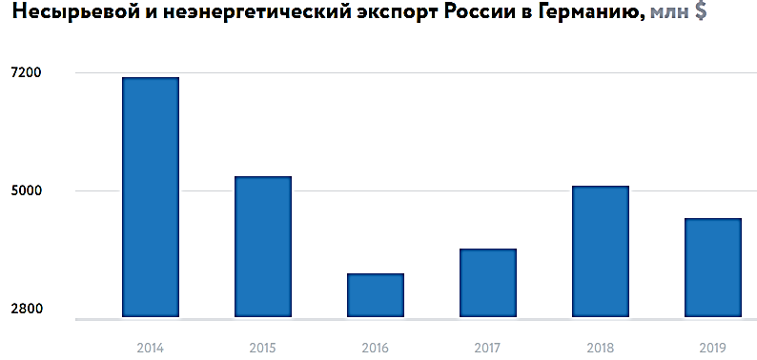

**Figure 1.9 Russian non-resource and non-energy export to Germany for the period of 2014 - 2019, million US dollars**

Source: Russian Export Center (2020)

1. Market size and purchasing power.

The purchasing power in Germany is strong and growing, consumption of smoked meat in Germany is stable, details and necessary analysis will be provided and discussed in Chapter 2.

3. Price competitive advantage.

The main element in the manufacture of smoking equipment is stainless steel and ferrous metal products. The price for these positions in Russia is much cheaper and the quality is much higher comparing to alternatives presented in European market. German is the leader among other European in terms of appreciation of high-quality equipment and production of smoked meat. Consequently, the company will be able to compete in the German market in terms of price. Also, based on the fact that in Russia the rate / hour of manual labor is several times lower than in Germany.

4. Logistic availability.

It is possible to supply equipment to the German market by any logistic routes: air transportation, road, sea, container and rail transportation of goods. This market has great attractiveness in comparison with America or Asia due to logistics availability.

5. The relationship of smoked products with traditional hop consumption.

Beer is the hallmark of Germany. More than 5 thousand types of beer are produced in Germany and 1320 breweries with sometimes centuries of experience work there. Beer is not only an important element of the cuisine, but also an indispensable part of the national culture. Czechs are in first place in terms of “liquid bread” consumption, while Germans are in second place. There are about 102 liters of this foamy drink per capita per year. The Germans reserve the invention of beer, since the first official document confirming the very fact of the production of a foamy drink dates back to 766 and tells about its delivery to the monastery of St. Gallen (October Fest, 2019).

In Germany, Rauchbier is popular - a beer with a special taste, which is given to it by smoked malt. The characteristic smoky aftertaste is reminiscent of smoked meat. There is a legend about the appearance of this type of beer, according to which, one day, a fire broke out in the brewery, and the malt stored there was saturated with smoke. The poor brewer was forced to sell beer from this tainted malt. Its taste, however, was very popular with the visitors. This is how a new beer was born. In fact, many beers were previously smoked. This is due to the way malt is produced, which must be dried in order to make beer. Since drying in the sun was not possible in all regions, drying over an open fire was used, as in the case of the Chinese smoked tea Lapsang Souchong. Heat and smoke passed through the raw malt lying on the grate and dried it, thereby increasing the shelf life. The Germans prefer smoked sausages and fish as snacks to the foamy drink. For them, it is like an integral part of the kitchen.

## **Conclusion to the Chapter 1**

Having analyzed the company's activities its main financial indicators, technology, production process and clientele we managed to reveal its strong and weak sides. Key success factors completely outlined the situation and highlighted pros of the entity. The company was also analyzed in by application of VRIO tool, based on which, the main competitive advantages of “Ijiza” LLC in the Russian market were identified, weak sides were revealed and opportunities for future development were outlined.

Analysis of Russian economy and Russian smoked chamber market confirmed the company’s concern about negative trend and stagnation. We saw that GDP was affected by the pandemic and sanctions as well as foreign investment flow these facts serve as a main signal for Ijiza to expand to other markets.

The idea of entering the German market is plausible place, since the company manufactures high quality and relatively cheap (comparing with German products) and eco-friendly product. It already established itself in the Russian market as a leader in the manufacturer of industrial smoking equipment and has a huge experience in cooperation with companies from the CIS countries. It seems that the company has required resources and capabilities to enter the international market, using them widely and developing a clear strategic and robust plan for expansion it might have good chances to successfully enter new foreign market such as Germany. However, before that a detailed analysis of German economy and market is required, and it will be provided in the next chapter - Chapter 2.

# **Chapter 2: Target market analysis**

## **General analysis of the German economy and German smoking equipment market**

According to World Bank & Trading Economics (2019) in 2019 German Gross Domestic Product per capita[1] stood at the figure of 53,815.40 US dollars, when adjusted by purchasing power parity (PPP), please see Figure 2.1.

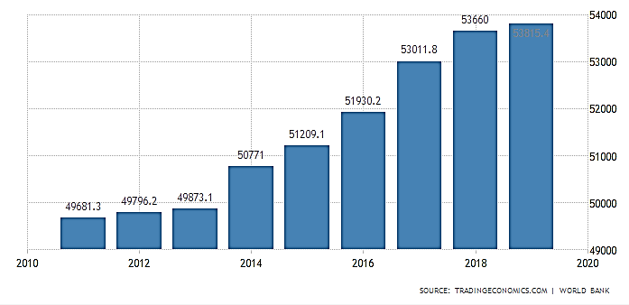

**Figure 2.1 Germany GDP per capita adjusted by PPP for the period of 2010 – 2019 in US dollars**

Source: World Bank & Trading Economics, 2019

The GDP per Capita, in Germany, when adjusted by Purchasing Power Parity is equivalent to 303% of the world's average. It can be observed that over last ten years there has been a permanent positive growth of GPD per capita adjusted by PPP which is a sign of stable and strong economy, growing disposable income and total consumption in Germany. Thus, our presumption of growing German market was right and expansion to Germany seems a very good strategy.

Since Ijiza sells equipment for smoking any kind of meat it would be logical to look at the production of meat in Germany next please look at Figure 2.2. The Figure provides information on different types of meat production in Germany for the last 30 years.

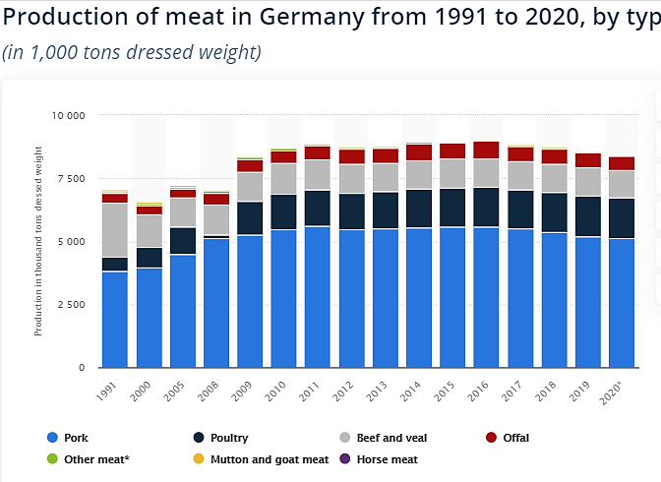

**Figure 2.2 Production of meat in Germany between 1991 and 2020 by type in thousands tons dressed weight**

Source: Statista database, 2021

As international database Statista database (2021) declares there is a stable consumption of meat, it had been growing since 2000 from 6 million tons to 8 million tons per year, but last four years the consumption is around 8 million tons and not growing further. Some experts explain that by the popularity of health food movement (Deutsche Welle, 2021b). We do not see a negative sign here as the consumption is still high. Moreover as Russian supplier of fish Fish Kamchatka (2017) declares that in 2017 fish consumption in Germany increased - thus their per capita consumption increased from 13.5 kg to 14.2 kg. Over the past year, the total consumption of fish and seafood in Germany amounted to 1.16 million tons.

Now it is time to look at the market itself. According to prediction model of Cognitive Market Research (2021) European market (including markets of Germany, UK , France, Italy, Russia, Spain and Rest of Europe) of smoked chambers will continue to grow (in terms of revenue it generates) and by 2027 will be at least 35-40% bigger than it was in 2020.

According to the data provided by “Ijiza” LLC, the market volume of smoking chambers in Germany amounted to 38 billion rubles in 2016 (513 million euros at the average annual exchange rate of the Central Bank of the Russian Federation), which is 9% less than in 2017. it was equal to (582 million euros at the average annual rate of the Central Bank of the Russian Federation) 43 billion rubles. In 2019, it reached the mark (690 million euros at the average annual exchange rate of the Central Bank of the Russian Federation) 50 billion rubles.

In the structure of the market volume of smoking chambers, the largest percentage is occupied by the middle and premium segments. They account for more than 75% of the market share as a whole (35% for the medium segment and 40% for the premium segment). In 2018, the premium segment increased its market share by 18%.

According to the forecast of Ijiza, LLC, the market volume of smoking chambers in Germany in 2019-2022 will amount (778 million euros) 60 billion rubles in value terms. The market is constantly growing and developing in the production of smoking equipment.

As for rivalry, for the period 2014-2018 the largest market share in smoking chambers was held by Reich (Reich Food System). Also, one of the largest market participants is Fessmann. The market share of these companies in 2018 was about 29% and 18%, respectively, the remaining small companies accounted for 15%.

The volume of the premium segment of the smoking chamber market in Germany in 2018 amounted to RUB 25 billion. The largest category in this segment is cameras for Euroframe with a load of 250, 500 and 750 kg - (228 million Euros at the average annual rate of the Central Bank of the Russian Federation) 15 billion rubles.

According to the calculations of Ijiza LLC, in 2018 about 25,000 smoking chambers were produced in Germany. In 2019, 30,000 were released.

The largest number of smoking chambers is produced in Schechingen. As of 2018, 14,000 smoke chambers were produced in Schehengen.

The volume of exports of smoking chambers to Germany in 2018 is 7% less than in 2017. In the export of smoking chambers to Germany, Reich is in the lead.

Among all segments of smoking chambers exported from Germany in 2018, the trademark “Reich” is the leader in value terms - 15%. On the second position is company called "Fessmann" - 20%.

The average producer price on the smoking chamber market was set in 2017 at the level of 29 million rubles, in 2018 it was equal to 31 million rubles.

Thus, we see that in Germany economy is growing with a good paste, meat consumption is stable, smoked products are in demand and an invariable attribute of the table, so smoking equipment is gaining more and more popularity and the growth of the market for smoking chambers in the world is noted every year. Against the background of the stabilizing situation in the world with the pandemic, there are fewer and fewer restrictions, which will soon restore the usual rhythm of life and it will be possible to visit the usual mass events, festivals, carnivals, which is associated with feasts and the consumption of a large number of smoked snacks. Hence, we can conclude that, the German market is favorable for the expansion of Ijiza LLC.

## **PEST analysis**

A PEST analysis is a strategic business tool used by organizations to discover, evaluate, organize, and track macro-economic factors which can impact their business now and, in the future, (3-10 years). This framework examines opportunities and threats due to political, economic, social, and technological forces in current market or targeted one if the company plans expansion (Group Map).

We run the PEST analysis on German smoking chamber market and revealed following facts (Table 2.1).

**Table 2.1 PEST analysis of expansion to German market**

|  |  |
| --- | --- |
| **POLITICAL**   * Forest restrictions * Quality standards * Food industry legislation | **ECONOMICAL**   * Positive trend in GDP and meat consumption * Stable currency rate * Low inflation rate * Acceptable unemployment rate * COVID-19 |
| **SOCIO-CULTURAL**   * Taste preferences * Language difficulties * Traditional preferences | **TECHNOLOGICAL**   * Technology developments |

Source: self-developed by the author

**Political:**

1. Forest restriction

From an interview with the general director of Ijiza LLC, it became known that in the northern regions, beech chips are mainly used for meat and alder chips for fish. In the southern regions, it is mainly smoked on chips of fruit trees. Large fractional chips of 10-12 mm are used.

With hot smoking, first there is a stage of drying, thermal and steam treatment, only after the stage of smoking and at the stage of smoking, the chips are set on fire. That is, out of 1.5-2 hours of smoking during hot smoking, the smoking process itself takes 40-50 minutes. With cold electrostatic smoking, the whole process is accompanied by the entry of smoke into the chamber, taking from 40 minutes to 3 hours, depending on the size and fat content of the product. The innovation of the IZHITSA-1200M3 smokehouse lies in the use of the effect of an electronic wind, which picks up the smoke mixture and directs it to the product. Thanks to the electronic wind, the process of saturation with smoke is accelerated tenfold. In the Izhitsa-1200M3 installation, the smoking time is only 1.5 hours, instead of 8 hours, as with traditional smoking. The product remains juicy because will not have time to lose weight. Thanks to the technology of active smoking using electronic wind, all the smoke is deposited on the product, no more than 3% of the smoke generated by the smoke generator gets into the atmosphere. This allows you to smoke food in the immediate vicinity of residential buildings, in supermarkets and shops. Izhitsa-1200M3 is a versatile cold-smoked smokehouse that can smoke all types of food, such as fish, meat, bacon, poultry, cheeses and even salt.

In Germany, trees have a special status and are protected by the state. It is strictly forbidden to just cut down trees for any of your needs, as is often the case in Russia. In Germany, it is forbidden to cut and injure trees from March 1 to September 30. At this time, birds build their nests and raise chicks. These rules even apply to those trees that grow on a private plot, if their trunk volume exceeds 30 cm. Illegal felling of trees can result in a fine of up to 100,000 euros (Library of Congress, 2020). In Germany, it is impossible to cut down a park to build a new shopping center or a temple. Residential areas in Germany are surrounded by trees and shrubs. Low-rise apartment buildings surrounded by foliage create a feeling of comfort and coziness. This picture contrasts with the rows of high-rise buildings and concrete courtyards-wells, which are so common now in Russia.

Based on the foregoing, we can conclude that, for the company “Ijiza” LLC, the Law on Deforestation in Germany once again emphasizes the great importance of a healthy environment and the use of environmentally friendly products, which meets all the requirements of the equipment of Ijiza LLC. In the process of smoking on the equipment of “Ijiza” LLC, natural wood chips are ignited, without the use of artificial, chemical fumes and flavor enhancers, which is an integral part of the production process, and the company equipment saves up to 90% (it is indirect effect on wood) which means that the processes comply with environmental standards and German Laws. This has a positive effect when entering the German market.

2. Quality standards

Ijiza in the production of smoking equipment uses stainless food grade AISI 304 steel. Currently, steel is very popular, which according to the American classification is called AISI 304. It belongs to the category of low-carbon stainless anti-corrosion austenitic steels. The advantage is a long service life of products made of this metal, low operating costs. Useful properties include:

* Long-term resistance to high or low temperatures;
* Good anti-corrosion resistance;
* Excellent environmental friendliness. The company is positioned internationally as an Inox material. It received this category due to the fact that it does not absorb any substances, including toxic ones;
* Well processed;
* High strength with low specific gravity;
* Almost perfect prevention of contamination of products stored in containers made of this steel;
* Excellent aesthetics and ease of cleaning after using the dishes.

In Russia we have steel grade AISI 304, in the European Union it is 1.4301. It should be noted that many countries have their own classification system, and AISI 304 steel meets international standards. This steel grade has the highest steel performance ratings in the international market. It is known that the German market has its own steel grade X5CrNi18-10, which is analogous to AISI 304 (Steel Service, 2019).

It can be concluded that despite the fact that many countries producing steel create analogues of the AISI 304 grade, the Russian AISI 304 is recognized as the best in terms of its characteristics and ratings. Therefore, this factor can be considered an advantage for our company in competition in the German market.

3. Food industry legislation:

German Federal Ministry of Food and Agriculture (2020) promotes policy aimed on healthy diet implementation into Germans’ lifestyles. According to the web site of the Ministry, there is a huge programme called IN FORM, which is German national initiative that promotes healthy diets and active lifestyle. Moreover, the Ministry provides variety of projects aimed at raising quality of consuming goods. Their idea is to offer Germany citizens, children high quality products and to inspire people with the idea of healthy lifestyle. So, this policy can make an influence on the products which are not seemed to be quite healthy as smoked fish or meat. Alas smoked products can be harmful as its consumption can provoke the development of cancer cells. The smoke emitted by wood contains volatile carcinogens that accompany the development of cancer.

**Economical:**

1. Positive trends in GDP per capita and meat consumption last 10 years

As we have already seen previously (Figure 2.1 and Figure 2.2) there is a positive trend in German economy. The World Bank and Agency of Statistical research - Statista stated that GDP per capita is constantly growing last decades, meaning that the economy increases its production and consumption results and meat consumption is stable.

2. Currency rate

One of the main threats company, which has started exporting, can face with is currency rate changes. Obviously, currency changes are one of the most inconvenient factors of the exporting process. As it is under influence of enormous number of factors: geopolitical environment, internal crises, economical purposes, oil prices, inflation rate, market influence and so on. So, that threat can influence the final price, as the company is going to supply its’ equipment abroad currency changes may affect the final invoice. Because of this, when shipping abroad, the exporting company incurs a lot of costs, such as logistics costs, cargo insurance, customs duties, certificates, taxes, and so on. Mostly all payments are made in a foreign currency, so the final price should include a fair ratio of costs and future profit. Since the volatility affects the price, and it is impossible to change prices constantly, depending on the exchange rate, the supplier is faced with the task of setting the optimal price, which would not be overstated, but would protect against possible exchange rate changes.

We do not see a big threat here as Germany is a strongest economy in Eurozone, Euro currency is relatively stable, and considering that in case of expansion to German market the price of Ijiza equipment will be stated in Euro which is much stronger than Ruble, and if Ruble falls the company might gain from that change in the Exchange Rate.

3. Inflation rate

Inflation has a negative impact on the country's economy in such a way that it reduces production, since fluctuations and rising prices make the prospects for its development uncertain; state resources are depreciating; speculation is growing as a result of a sharp change in prices; the number of credit operations is reduced(Ильиных & Киселева, 2019).

The inflation rate in Germany was 1.35 percent in 2019. The current rate meets the European Central Bank’s target rate, which is “below, but close to, 2 percent.” Many central bankers favor inflation between 2 and 3 percent, but Germans in particular would rather risk deflation than too much inflation.

Causes of inflation: Central bank likes low, stable inflation because this is a sign of a growing economy. When the economy grows, workers become more productive and spend more, and prices slowly rise. Monetary policy can cause inflation, but Germany has given this responsibility to the European Central Bank (ECB). Importantly, inflation expectations affect inflation, making it a self-fulfilling prophecy.

The German context: during the eurozone crisis, German politicians were advocating for the ECB to raise interest rates quickly. This would have reduced inflation, possibly causing deflation, but would have presented another hurdle for the struggling Greek economy. This is because of the hyperinflation of the Weimar Republic in the 1920s, when Germans carried their pay home in wheelbarrows because the banknotes had lost so much value. Ever since, Germans often warn that inflation harms pensioners and that personal provisions are necessary in any case. Fortunately for them, this statistic forecasts stable, modest inflation that does not alarm many economists (Figure 2.3).

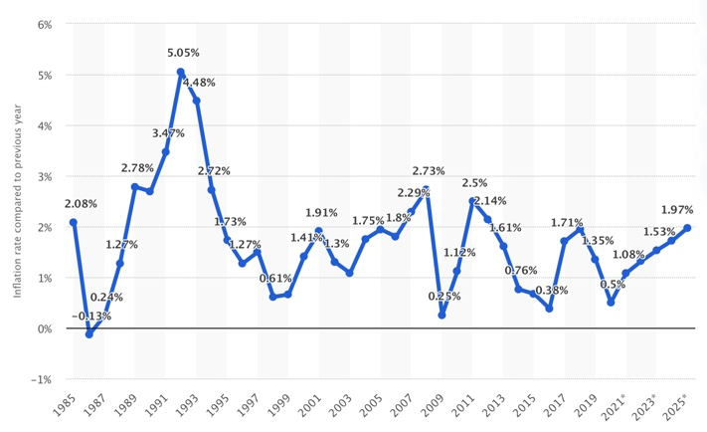

**Figure 2.3 Germany: Inflation rate from 1985 to 2025 (compared to the previous year)**

Source: Statista 2021

According to Statista database (2021a) the inflation stays low, the lowest figure was in 2009 when it was 0,25%, last five years it fluctuated around 0,3-1,7% meaning the strength of German economy and currency.

4. Unemployment rate

The unemployment rate shows the share of unemployed people among potential employees available for the job market. This figure is calculated as follows - number of unemployed persons: number of unemployed persons + number of employed persons = unemployment rate (in percent).

The status of being unemployed is defined as when an employed person is laid off, fired or quits his work and is still looking for a job. Even in a healthy economy unemployment occurs. If former employed persons go back to school or leave the job to take care of children they are not defined as unemployed. Unemployment can be a result of advanced technology, when machines replace worker tasks. Sometimes unemployment is caused by job outsourcing, when a company gets insolvent. Large-scale unemployment is also caused when consumer demands gets down and companies lose profit.

Unemployment benefit payments in Germany are only paid, if you are unemployed and worked for the last 12 months. Otherwise benefits are received in the form of Arbeitslosengeld II, also called Hartz IV, which distributes social payments to people without an income who cannot work to make a living.

According to Statista database, (2021c) annual average unemployment rate in Germany from 2004 to 2020 has been decreasing (Figure 2.4). For 2020 thus far, the annual average unemployment rate amounted to 5.9 percent

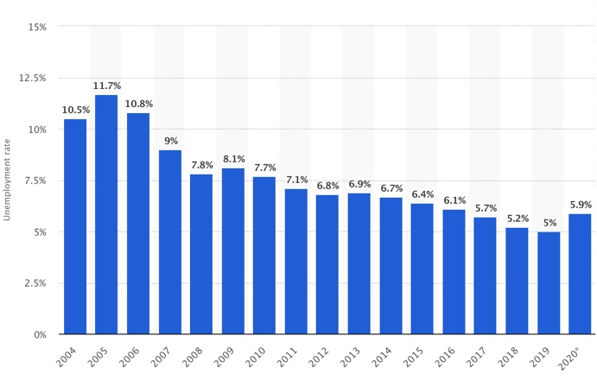

**Figure 2.4 Germany: Annual average unemployment rate in Germany from 2004 to 2020**

Source: Statista, 2021

Unemployment rate around 5% is considered a very good and reassuring figure meaning German economy is moving forward and providing job to its residents.

At last COVID-19

The pandemic of coronavirus infection COVID-19 has far-reaching consequences in addition to the spread of the disease itself and attempts by different countries to organize quarantine. In the media, the phenomenon of the influence of the disease on the life of society and its consequences are increasingly called the term “corona crisis”.

The COVID-19 pandemic has changed not only the lives of many people, but also the global and local markets. Around the world, there has been a significant reduction in production capacity due to the closure of borders between countries and the introduction of a self-isolation regime. The coronavirus pandemic has disrupted the familiar ties between producers and consumers. The catering segment has been one of the hardest hit by the pandemic’s restrictions.

Many advertising and information events, international exhibitions were canceled, thanks to which the “Ijiza” LLC company could acquaint potential buyers with its products.

The situation with the number of infected in Germany continues to get worse. Over the past time (2021), 124.9 cases of infection were registered per 100,000 population. This parameter is the highest since the beginning of the year 2021.

Experts associate the increase in the incidence rate mainly with the spread of new mutations and strains (Deutche Well, 2021). Since its appearance in Germany, the causative agent of COVID-19 has claimed the lives of 75,780 people (a daily increase of 157), about 2,477,500 patients have recovered. From December 16, 2020, a tough lockdown has been in effect in Germany. It has been extended until April 18th. German residents are still being asked to reduce contacts to the absolutely necessary minimum. Employers are instructed to look for opportunities to expand teleworking.

It should be concluded that the long period of the pandemic in the world and the situation with the spread of new strains of the virus and the jump in the incidence of the population at the moment still does not make it possible to enter the German market. In the future, there will naturally be a decline in the incidence and spread of the virus, which means that the borders will open and the situation with restrictive measures will weaken and in the near future the situation will stabilize, which means there will be a full opportunity to enter the German market.

**Socio-cultural:**

1. Taste preferences

According to data from the Society for the Study of Consumption GfK, (2013), 85% of Germans consider the consumption of meat and sausages "natural and sustainable", and 83% - under no circumstances are ready to exclude them from their diet. Every second German consumes sausage or meat every day. For the Germans, meat symbolizes abundance, power, prosperity and masculinity; in their subconsciousness, life is a success if there is meat on the table. According to a 2020 survey by the Federal Ministry of Food and Agriculture, 26% of the German population consume meat and sausages daily, with 32% of German men and 20% of German women. Only a small part of the population consistently refuses to consume meat and animal products, and the younger the age category, the more vegetarians there are. According to a 2015 study, there are about 3% of them in Germany, 2% of pescatarians, and 1% of vegans. According to data for 2018, the Germans consume an average of 60.1 kg for food per year, of which 35.7 kg is for pork, 13.2 kg for poultry meat, 9.7 kg for beef and veal. According to the Fisch-Informationszentrum (FIZ), (2017), consumers in Germany increased their spending on fish and seafood in 2017, and their per capita consumption increased from 13.5 kg to 14.2 kg. Over the past year, the total consumption of fish and seafood in Germany amounted to 1.16 million tons. At the same time, however, sales of these products in the retail sector amounted to only 411,876 tons, a decrease compared to the annual period when they were at 420,402 tons. The value of purchases, in turn, increased on an annual basis by 2.4 percent to 3.8 billion euros.

All indicators of consumption of meat and fish products include all types of cooking, including smoked ones. Consequently, such popularity in the consumption of meat and fish contributes to a favorable entry into the German market.

2. Language difficulties

The “Ijiza” LLC is engaged in its own production of industrial smoking equipment under the “Ijiza” brand. However, to promote its equipment to the German market under the “Ijiza” brand would be difficult. The name of the company “Ijiza” means the name of the last letter of the Church Slavonic and the old Russian alphabet (V), denoting the sound "and". Consequently, pronunciation and understanding of this word will be difficult for foreign citizens. However, there is a great number of Russian speaking Germans living in Germany that may help others to get used to the brand name.

3. Traditional preferences

Linking smoked products to traditional hop consumption. Beer is the hallmark of Germany; it is an integral part of the culture, traditions and gastronomy of Germany. More than 5 thousand types of beer are produced in Germany and 1320 breweries with sometimes centuries of experience work there. Beer is not only an important element of the cuisine, but also an indispensable part of the national culture. Czechs are in first place in terms of “liquid bread” consumption, while Germans are in second place. There are about 102 liters of this foamy drink per capita per year. The Germans reserve the invention of beer, since the first official document confirming the very fact of the production of a foamy drink dates back to 766 and tells about its delivery to the monastery of St. Gallen (October Fest, 2019).

In Germany, Rauchbier is popular - a beer with a special taste, which gives it a smoked malt. The characteristic smoky aftertaste is reminiscent of smoked meat. There is a legend about the appearance of this type of beer, according to which, one day, a fire broke out in the brewery, and the malt stored there was saturated with smoke. The poor brewer was forced to sell beer from this tainted malt. Its taste, however, was very much appreciated by the visitors. This is how a new beer was born. In fact, many beers were previously smoked. This is due to the way malt is produced, which must be dried in order to make beer. Since drying in the sun was not possible in all regions, drying over an open fire was used, as in the case of the Chinese smoked tea Lapsang Souchong. Heat and smoke passed through the raw malt lying on the grate and dried it, thereby increasing the shelf life.

German beer bars are a kind of contrast to the excessive luxury of famous restaurants. Nevertheless, the meat dishes in them are of excellent quality. The most common snack is the famous smoked sausages.

Following traditions, culture and formed gastronomic preferences in Germany, of great importance is the use of beer and, accordingly, snacks for it, including various smoked meats. There is a need for the production of smoked products, both meat and fish, and cheeses, and this means the need for high-quality equipment for smoking, and therefore favors the entry of Ijiza LLC into the German market.

**Technology developments**

Ijiza has developed its own technology for the production of smoking equipment. Thanks to this, they were able to reduce the average energy consumption, eliminate the splashing of the side rows of products with black dots of smoke condensate even without regular washing, achieve high quality smoke and minimal consumption of chips. Also, there is no need to soak wood chips an hour before smoking, as in similar smoking chambers. The work is automated.

In standard smoke generators, which are installed on almost all other smoking chambers, the chips must be wetted, which leads to an excess temperature in the combustion area, a loss of subtle aroma and an increased consumption of chips. The total surface area of ​​heating elements is three times higher than that of analogs. This allows you not to overheat the heating elements and extend their service life up to 15 years.

Reliable heating elements made of stainless steel manufactured by a defense plant. Unique proprietary control system:

* quickly mastered by employees;
* precisely controls all technological steps;
* displays in a convenient form all the parameters of the camera;
* fine tuning of steam generation for different pressures in the water supply system;
* library of step-by-step recipes.

However, German smoking chambers also have their own innovations today and can progress. For example, the Reich smoking chambers have an automatic char sieve. This can either extinguish the hearth after the smoke generation process, or remove tar deposits in the carbonization sieve with an integrated sieve cleaning. This makes the G 700 H series smoke generators optimal for long smoking processes. In addition, the new smoke generators have a built-in fire extinguishing system. Once the built-in sensors report a temperature rise, an automatic preventive firefighting process is carried out to prevent damage to the system and associated hazards.

Based on the foregoing, we can conclude that the Ijiza, LLC has every chance to successfully enter the German market. This is due to the factors discussed and analyzed above. For example, it is described that the equipment of Ijiza, LLC is made of high-quality steel, which has high characteristics, due to which the equipment does not emit carcinogens and harmful fumes during operation, as well as when operating the equipment in technological processes, only natural raw materials are used, namely wood chips trees, without the use of artificial, chemical fumes and flavor enhancers, which complies with environmental standards and the Laws of Germany on the preservation of a healthy environment and the priority of the production of environmentally friendly finished products of high quality. Also, the advantage is that the equipment of Ijiza, LLC is made from high-quality raw materials, namely, from AISI 304 steel, and competitors from other countries, including Germany, use analogs of AISI 304 steel in the production of equipment, which are inferior in their characteristics and estimates. Therefore, this factor can be considered a company advantage in competition on the German market. The priority factor influencing the successful entry into the German market is the great popularity in the consumption of beer, snacks for beer, especially in the form of smoked meats from meat and fish, as a result of centuries-old traditions and gastronomic preferences, as a result of which there is a need for the production of smoked meats, which means and the manufacture of equipment for smoking, which means that it contributes to a favorable entry into the German market for Ijiza.

One of the options for entering the German market is considering the possibility of mutually beneficial cooperation with German companies, for example, collaboration with German market leaders in smoking equipment. The mutual benefit is obvious, for German companies the equipment will become less energy-consuming and the smoking process itself will become much faster without reducing the quality of products, in turn, for Ijiza, the benefit will be that cooperation with German companies also gives an advantage when entering the German market in the trust of potential buyers. As for the situation with the pandemic, thanks to the joint efforts of all countries of the world, in the near future the situation will stabilize, which means there will be a full-fledged opportunity to enter the German market. From the analysis of all the factors influencing the entry into the German market, it can be concluded that the German market is favorable and the enter is expected to be successful.

## **Porter’s Five Competitive Forces analysis (including in-depth competition analysis)**

An analysis of Porter’s five forces will help to assess the market situation even deeper. Also, it is used for assessing the nature of competition and attractiveness in an industry. This analysis includes five main forces which shape the industry. They are threat of new entrants, threat of substitutes, bargaining power of customers and suppliers, industry rivalry of the global smoking chamber market.

**Threat of new entrants**

The power of influence of new players depends on the barriers to entry in the industry and the speed of influence of existing market players. If the barriers to entry into the industry are high and the level of opposition from existing companies in the industry is high, then the impact of new applicants on the profit in the industry will be minimal. Therefore, when working with new players, it is important to correctly build exit barriers. Porter identifies six main factors that influence the strength of barriers to entry into the industry, which are shown on the Table 2.2 (Power Branding, 2018).

**Table 2.2 Threat of new entrants**

|  |  |  |  |
| --- | --- | --- | --- |
| **Evaluation parameter** | **Parameter estimate** | | |
| **3** | **2** | **1** |
| Number of players | High level of market saturation | Medium level of market saturation | Low level of market saturation |
|  | + |  |
| Market growth rate | Market stagnation or decline | Slowing down but growing | High |
|  | + |  |
| Product differentiation rate | Companies sell standardized goods | The product is standardized in terms of key properties, but differs in additional benefits | Companies' products differ significantly from each other |
|  | + |  |
| Price increase restriction | Fierce price competition in the market | There is a possibility of price increases only to cover cost increases | There is always room for price increases to cover cost increases |
|  | + |  |
| **Final score** | **8** | | |
| 4 score | Low level of intra-industry competition | | |
| 5-8 score | Medium level of intra-industry competition | | |
| 9-12 score | High level of intra-industry competition | | |

Source: self-developed by the author basing on knowledge of Porter analysis provided by Power Branding, 2018

We can conclude that the threat of new players is at an average level, since the industry is very narrowly focused and there are few players in this arena who could or would like to enter the German market. It is quite costly attempt for new players to enter the market as it requires significant capital investment in the production. Also, the German market for smoking equipment is growing, but not very noticeable. All products have one application. However, it can only differ in the choice of materials for the production of equipment. Prices will only be able to increase by covering costs in the event of an increase in material prices. The calculation was made basing on data provided by the CEO of Ijiza LLC.

**Threat of substitutes**

Substitute products limit the potential of the market in terms of price increases. Usually, substitute products have an impact on the establishment of the upper limit of market prices, which in the face of rising production costs and raw materials reduces the profitability of companies. Until market players are able to improve product quality and differentiate their products from substitute products, the industry will have low profits and limited market growth (Power Branding, 2018), see Table 2.3

**Table 2.3 Threat of substitutes**

|  |  |  |  |
| --- | --- | --- | --- |
| **Evaluation parameter** | **Parameter estimate** | | |
| **3** | **2** | **1** |
| Substitute goods in the “price-quality” position | Exist and have a high market share | They exist, but have just entered the market and their share is small | Not exist |
|  |  | + |
| **Final score** | **1** | | |
| 1 score | Low threat from substitute products | | |
| 2 score | Medium threat from substitute products | | |
| 3 score | High threat from substitute products | | |

Source: self-developed by the author basing on knowledge of Porter analysis provided by Power Branding, 2018

From the above analysis, only one conclusion can be drawn that this product cannot be replaced. Smoking fish, meat and other products is possible only in specialized smoking equipment. Consequently, the threat is low.

**Bargaining power of customers**

Buyers can influence the competitiveness of the company's product in the market, since in fact they are consumers of the finished product and ensure the existence of the market by satisfying their needs. When developing a strategy, a company should select those buyers who are the least influential in the market (Power Branding, 2018). As it was mentioned before, company supplies the equipment to domestic and foreign businesses and for some exclusive requests straight to the clients (Khokhlov & Eremenko, 2021).

**Table 2.4 Bargaining power of customers**

| **Evaluation parameter** | **Parameter estimate** | | |
| --- | --- | --- | --- |
| **1** | **2** | **3** |
| Strong brands with a high level of knowledge and loyalty | There are no major players | 2-3 large players hold about 50% of the market | 2-3 large players hold about 80% of the market |
|  | + |  |
| Product differentiation | Low product variety | There are micro-niches | All possible niches are occupied by players |
|  |  | + |
| The level of investment and costs to enter the industry | Low (pays off in 1-3 months of work) | Medium (pays off in 6-12 months of work) | High (pays off in 1 year of work) |
|  | + |  |
| Access to distribution channels | Access to distribution channels is completely open | Access to distribution channels requires moderate investment | Access to distribution channels is limited |
| + |  |  |
| Government policy | No restrictive acts by the state | The state interferes in the activities of the industry, but at a low level | The state fully regulates the industry and sets restrictions |
| + |  |  |
| The willingness of existing players to reduce prices | Players will not go for price reductions | Large players will not go for price reductions | Players will reduce prices whenever they try to enter a cheaper offer |
|  | + |  |
| Industry growth rate | High and growing | Slowing down | Stagnation and fall |
|  | + |  |
| **Final score** | **13** | | |
| 8 score | Low threat of entry of new players | | |
| 9-16 score | Medium threat of entry of new players | | |
| 17-24 score | High threat of entry of new players | | |

Source: self-developed by the author basing on knowledge of Porter analysis provided by Power Branding, 2018

We can conclude that there are only 2 companies on the German market that are leaders in the production of smoking equipment - “Reich” and “Fessmann”. Both companies manufacture automated smoking equipment and target the premium segment. Consequently, the audience that orders their equipment already trusts these companies. The Germans are prone to trusting relationships, however, the equipment of “Ijiza” LLC, which will be supplied under the “VARMEN” brand, will work many times faster and will not be inferior in quality to its competitors. Therefore, the opportunity to win potential customers will be high, since one of the main factors of confidence of the German consumer is quality, which even surpasses their domestic quality. There are many buyers who consume the smoking chamber equipment and they are separated, meaning not unified that makes their bargaining power very low with regards to dictating the price. Moreover, Germans are prone to trusting relationships; therefore, it seems that the buyers will have higher switching costs to other supplier Therefore, their bargaining power can be regarded as medium.

Industry is growing as it was mentioned above according to the Global Smoking Chamber Market Report (2021), , consumption will have double increase to 2026. However, basing on our macroeconomic analysis, we noted that meat consumption is not growing further due to the health diet movement. Hence, we conclude that industry growth is medium it is not raped, but not negative either.

**Bargaining power of suppliers**

Suppliers can influence the competitiveness of the company's product in the market, since they are the owners of the resources for the production of industry products. The rise in prices for raw materials and the conclusion of transactions on conditions unfavorable for the company leads to an increase in the cost of finished products, an increase in production costs. If it is impossible to increase retail prices for finished goods at a level comparable to the growth of raw materials, the profitability from the sale of goods or services decreases in the industry, see Table 2.5 (Power Branding, 2018).

**Table 2.5 Bargaining power of suppliers**

|  |  |  |
| --- | --- | --- |
| **Evaluation parameter** | **Parameter estimate** | |
| **2** | **1** |
| Number of suppliers | Few suppliers or monopoly | Wide range of suppliers |
| + |  |
| Limited supplier resources | Limited volume | Unlimited volume |
|  | + |
| Switching costs | Low costs of switching to other suppliers | High costs of switching to other suppliers |
|  | + |
| Priority direction for the supplier | Low priority of the industry for the supplier | High priority of the industry for the supplier |
|  | + |
| **Final score** | **5** | |
| 4 score | Low level of supplier influence | |
| 5-6 score | Medium level of supplier influence | |
| 7-8 score | High level of supplier influence | |

Source: self-developed by the author basing on knowledge of Porter analysis provided by Power Branding, 2018

Based on the above analysis, it can be concluded that this equipment uses a certain stainless-steel metal and can only be supplied by a few suppliers in unlimited quantities. Materials for the production of smoking equipment are provided by the company Promex (Promex). The industrial company "PROMEX" was founded in 2002 and now occupies a leading position in the North-West region in the field of high-tech sheet metal processing. Promex being a universal enterprise, provides a full range of production services: from receiving orders to delivering finished products to the customer's address. The company carries out cutting, bending and other procedures that allow you to create complex shapes from a simple sheet, including an exclusive design from all types of metal and material. Laser cutting of metal is carried out on Trumpf laser complexes with power from 3 to 7 kW. The company received such awards as the best company of the year, the All-Russian industrial award "Global Industry" and the best taxpayer. This supplier provides original metals and alloys and the supplier is important for the company, therefore this threat can be regarded as medium.

**Industry rivalry**

Rivalry among existing competitors boils down to striving by all means to improve their position in the market, to win market consumers. Intense competition leads to price competition, an increase in the cost of promoting a product, sometimes to an increase in product quality, and an increase in investment in new developments. All this reduces the profitability of the industry (Power Branding, 2018)

**Table 2.6 Industry rivalry**

| **Evaluation parameter** | **Parameter estimate** | | |
| --- | --- | --- | --- |
| **3** | **2** | **1** |
| Number of players | High level of market saturation | Medium level of market saturation | Low level of market saturation |
|  | + |  |
| Market growth rate | Market stagnation or decline | Slowing down but growing | High |
|  | + |  |
| Product differentiation rate | Companies sell standardized goods | The product is standardized in terms of key properties, but differs in additional benefits | Companies' products differ significantly from each other |
|  | + |  |
| Price increase restriction | Fierce price competition in the market | There is a possibility of price increases only to cover cost increases | There is always room for price increases to cover cost increases |
|  | + |  |
| **Final score** | **8** | | |
| 4 score | Low level of intra-industry competition | | |
| 5-8 score | Medium level of intra-industry competition | | |
| 9-12 score | High level of intra-industry competition | | |

Source: self-developed by the author basing on knowledge of Porter analysis provided by Power Branding, 2018

There are two main competitors for the “Ijiza” LLC in the German market. First one is German company Fessman was established by Wilhelm Fessmann in 1924. Since that time, the company has been engaged in the production of equipment for frying, cooking, baking, smoking, as well as intensive cooling of various products. The factory and the company's headquarters are located in Winnenden. For more than 90 years, the company has been improving its machines and optimizing processes, as a result of which the once small family business has become known all over the world. The Fessmann brand is popular in Russia, Asia, Europe and America. Over the years, the company has created more than 75,000 pieces of equipment.

Second one is Riech - Germany's oldest name in the field of thermophoresis systems for food and one of the world's leading suppliers in this industry. The company was founded by Karl Reich in 1893. The company offers solutions for thermophoresis of meat and sausage products, fish, poultry, cheese, semi-finished products, vegan and vegetarian products, as well as pet food. The company positions itself as a reliable, innovative and dynamic partner of the food industry. Product philosophy: uncompromising quality combined with the highest performance and efficiency.

In order to evaluate industry rivalry, we need to conduct a competitive analysis to assess how difficult it will be for new players to enter the German market. To do this, we distinguish 5 parameters by which we identify key competitors in the German market: manufacturing process, segment, experience, price and customer support. These indicators help us due to the fact that production process requires expertise and experience and customers need to trust the company. For the new player to win customer’s trust is a challenging task and there are many such tasks. Let’s look at current players (Table 2.7)

**Table 2.7 Main competitors in the German smoking equipment market**

|  |  |  |  |  |
| --- | --- | --- | --- | --- |
| № | Indicator | "Reich" | “Fessmann” | “Ijiza” |
|  | **Manufacturing process** | The process of smoking – 2,5 hours;  Energy savings of up to 60%;  The control system is completely digital. | The process of smoking – 4 hours;  Energy savings of up to 80%;  The control system is completely digital. | The process of smoking - 30 minutes;  Energy savings of up to 90%;  The control system is completely digital. |
|  | **Segment** | From low to premium | From low to premium | From low to premium |
|  | **Experience** | 128 years | 97 years | 29 years |
|  | **Price** | From 5700 to 78000€ | From 5700 to 78000 € | From 718 to 9 837 € |
|  | **Customer support** | Yes | Yes | Yes |

Source: self-developed by the author

There are strong competitors on the German market, as mentioned above. They have a long history and traditions which is so important for locals but nevertheless “Ijiza” can fairly compete with “Reich” and “Fessmann”. However, the company “Ijiza” LLC surpass them in the speed of equipment operation and energy saving. These factors are of great value as it is one of the nowadays crucial points. Energy saving is one of the most vital aspects in contemporary production as it becomes more and more critical to save energy and to use renewable resources. Also, it does not retreat in quality, since “Ijiza” uses food-grade stainless steel, and the German company uses analogs. It is important to mention that stainless still is harmless for people and it gives “Ijiza” great opportunities as an eco-friendly and safe equipment. Alas there is no public price data of new “Reich” and “Fessmann” equipment, but there is some information about used equipment and the prices start from 4000 euro. So according to the public data of “Ijiza” company we can consider that the prices start from 5 700 euro which is 8 times higher than prices of “Ijiza” equipment. Obviously Ijizas’ equipment is more profitable than competitors one. As for the customer support it is completely clear that most Germans will maintain local brands. But if “Ijiza” company can prepare transparent and engaging marketing campaign it can gain attention of potential consumers.

Having analyzed company internal factors and the German market and external factors we now can summarize everything all of identifies aspects in company SWOT analysis. Thus, we apply SWOT analysis tool to analyze strong and weak sides of Ijiza in entering German market.

## **SWOT analysis**

A SWOT is a set of marketing and other studies of the enterprise’s strengths and weaknesses. It includes four factors: strengths, weaknesses, opportunities and threats. In the table below “Ijiza’s” important factors are reviewed.

**Table 2.8 SWOT analysis**

|  |  |
| --- | --- |
| **S- strengths**   * 90% energy saving * Smoking process is 30 times faster than rivals has * Price is 8 times cheaper than the competitors’ * Unique technology * Fully automated equipment | **W-weaknesses**   * Low brand recognition * Weak marketing campaign * Decrease in sales during last years |
| **O-opportunities**   * Professional equipment global exhibitions participation * Obtaining the patent * Participation in obtaining international equipment quality certification * International expansion | **T-threats**   * Economic growth rate slowing down * Political sanctions against Russia * Currency volatility / ruble’s devaluation * Pandemics * Reduction of smoked production demand due to the growing healthy food consumption trend |

Source: self-developed by the author

Among Ijiza’s strong sides we can name: product unique qualities in terms of process efficiency, energy saving and technology. Obviously, the company has a good equipment and professional staff, but management is still struggling to provide further development. The company does not have a competent marketing strategy, which affects the weak positioning of the brand, both in the foreign and domestic markets and may lead to further rise in sales decrease.

As for external threats which can not only restrain company’s development but also lead it to the stagnation and crises in whole economy in which Ijiza is operating we have identified latest most powerful factors such as: Covid -19 long-lasting consequences, international sanctions against Russia, devaluation of ruble due to the drop in oil and gas price, and new popular trend agitating for healthy vegetarian food.

Nevertheless, the threats can be overcome by working through company’s opportunities such as participation in famous equipment exhibitions, obtaining certificates and patents that can help company to gain recognition and increase global trust to the company and pave its way to international expansion, namely to German market.

## **Conclusion to the Chapter 2**

Having evaluated the macroeconomic condition of Germany and the current situation in the smoking house market by application of PEST, 5 Porter’s force and general analysis tools we came to the conclusion that it more than luring to enter the German market as it demonstrates strong growth in GDP, stable trend in meat consumption and according to forecast it will continue to do so.

Moreover, the market analyses didn’t reveal any significant threats or barriers that Ijiza cannot overcome considering the technological and price advantage of its product. Although Ijiza, LLC is a foreign company with relatively short history, company has already done a lot for its’ self-development. Unlike the competitors, it has a fully automated production process which can be not only convenient but also can reduce labor expenditures and safe energy. Moreover, the equipment is made of stainless steel, which also distinguishes them from competitors and guarantees safe and long-term operation.

Hence, we conclude that it would be very beneficial for the company enter the German market.

# **Chapter 3: Development of a strategy for penetrating the foreign market**

## **Types of entry mode, advantages and disadvantages**

The organization that has decided to enter the foreign market should understand for itself the three main aspects that are the key stages in getting access to a foreign market. The company must clearly understand it’s time to market: to become the first-mover (pioneer, first to enter the market) or a follower. Each of these strategies has its own advantages and risks, which you can read about in a separate article (Corporate Finance Institute, 2016).

The company must determine its scale of market entry: aggressive mass market capture or a gradual consistent expansion of the business. The final decision depends on the resources, investments and company’s management competencies. The company must decide which markets, in which segments it is most profitable to enter at a given time; in other words, find a balance between the attractiveness of the industry, the risks and costs of entering foreign markets.

There are many types of entry into the foreign market. We will consider some of them that are considered the most popular and most of all can come up to our company (Mariadoss, 2018).

1. Exporting

The easiest way to enter the international market is exporting and many companies start with it when expand internationally. Export is the sale of products or services to foreign countries from a home country.

The advantage of this method is that firms avoid the cost of organizing operations in a new country. However, companies are required to be able to distribute and sell their products in a new country through a contractual agreement with a local company or distributor. The firm should also consider labeling, packaging and pricing proposals in accordance with the market. A firm can inform potential buyers of its offerings through advertisements, trade shows, or a local sales department (Mariadoss, 2018).

The disadvantages of export are the costs of transporting goods to the country, which can be high and have a negative effect on the company. Applying the tool provided by World Freight Rates, one can calculate the cost of transportation, but you must specify the exact destination, type of goods, value of commodity, load and accessorial charges. Also, some countries impose tariffs on goods, which affect the profits of the company. In addition, companies that work under the contract have little control over operations and must pay distributors for these services.

Typically, companies export products to countries that are close to them due to low transportation costs and due to geographical and regional similarities. Since the value of exports is lower than in other entry modes, entrepreneurs and small businesses are more likely to use exports as a way to deliver their products to markets around the world. Even with export firms are still faced with exchange rate problems. While large firms have specialists who manage exchange rates, small enterprises rarely have such experience (Russian Export Center & EXIAR, 2016).

2. Licensing

A company that wants to engage in retail on the foreign market with minimal risk can use the Licensing and franchising strategy which provides an opportunity for another business to take the risk on behalf of the company. While the licensee or franchisee assumes the risks and incurs all losses, he shares part of his income and profits with you. This strategy is best suited when, for example, in the Germany there is already an existing company that has established itself in the market and has its own loyal audience. At the same time, there are problems in their product line that need to be filled. Therefore, it would be wise for this company to use someone else’s product to fill this gap.

There are several advantages of Licensing and Franchising such as the relatively low cost of entering the international market, the person with whom the collaboration will take place has knowledge of the local market, can be regarded as a passive source of income, low political risk since most likely a licensing or franchising partner will be a local business, the possibility of interaction in several regions with minimal investment.

As for the drawback, minimal control over partners, licensees and franchises can become your competitors, if partners are not competent, then you risk losing your brand image and reputation in foreign markets (Karagulyan, 2015).

This method is not suitable for Ijiza since the company would like to mainly supply its products to the international market and promote its brand. “Ijiza” also does not currently have trusted companies with which it would be possible to cooperate in the German market.

3. Joint Venture

Joint venture is one of the options of entry mode for those who are willing to share their knowledge and experience with others. A company entering the international market creates a joint venture with a local company abroad, where partners share the risks associated with businesses and the benefits of cooperation. Both companies share profits, losses, costs and investments. This type of entry into the international market is suitable for those countries where there is no 100% ownership of foreign property in certain industries. The difference between licensing / franchising and joint venture is that franchise will only work well if your franchiser company is a major brand in this particular product. Your company may be the most famous in your country, but not in the country of franchisees. As for joint venture, both brands have the same level of brand strength and therefore companies want to explore this product together in the international market (Abakumova, 2014).

The advantage of this type is that both partners use their experience and knowledge to grow and expand in the international market. There are also low political risks since there is a local partner who knows the local market and its business environment. And the sharing of knowledge of the international market, technology and assets is a positive aspect.

As for the downsides, cultural misunderstanding may occur due to differences in corporate culture in both companies. Also, if a conflict occurs and firms decide to liquidate the enterprise, this process can take a very long time and there will be a rather complicated legal process.

For Ijiza this method is not suitable because at the moment our company is not so famous in the German market and has not yet established themselves as a major brand. Also, there is a very big risk of creating a joint venture with unfamiliar companies personally. The risk is great in the event that conflicts are likely to occur and can lead to the ruin of the business or unnecessary cost (Mariadoss, 2018).

4. Foreign Direct Investments

Ways to enter the international market that have been described previously do not require large investments in equipment or plants to participate in the foreign market. Foreign Direct Investments (FDI) provides the highest level of control in the international market. There are two ways of direct foreign investment. The first is the creation of a new company in the foreign market, but the highest costs will be required here, because the company needs to create new contacts and sales channels, find a workplace and employees, and purchase equipment. The second method may be the acquisition of an existing foreign company, where it will only be necessary to make changes to the organizational structure of the company.

Among the advantages, it can be distinguished: mainly for large enterprises that seek to pursue a single policy in all their markets, the enterprise can fully determine the marketing and sales policy. It also allows more efficient price competition, since if the goods are produced in the country of sale, then you do not have to bear the transport costs, as well as the costs associated with tariffs. Finally, the company receives direct contact with its customers in the foreign market and, therefore, can more fully satisfy their requirements, which increase its competitiveness (Russian Export Center & EXIAR, 2016).

Among the shortcomings: a rather large risk associated with the devaluation of foreign currency, political instability, a recession in the market and the possible nationalization of property. The flexibility of enterprise policies may be reduced due to large financial investments in the foreign market. If a company wants to leave a foreign market, it may lose significant resources invested in it and, possibly, a threat to its reputation. In addition, a foreign government may impose restrictions that impede a company’s policy regarding its products or their marketing.

This method is not suitable for our company on the basis that they are not going to buy an existing company or create their own enterprise in Germany since they need to make as little investment as possible. Based on this point, you can no longer consider this option as there is a more suitable option (Karagulyan, 2015).

Following our analysis of all possible scenarios of entry we developed a table shortly summarizing all the positive and negative sides of each scenario / option as well as Ijiza management’s position / opinion regarding each option. The results are presented on Table 3.1.

**Table 3.1 Advantages and disadvantages of four potential entry modes**

| **Type** | **Advantages** | **Disadvantages** | **Opinion of Ijiza, LLC** |
| --- | --- | --- | --- |
| **Exporting** | Fast entry, low risk | Low control, low local knowledge, potential negative environment impact of transportation | Plausible option. Transportation costs are bearable, but low knowledge of the market is that company should work on in future to be able to better control contractors |
| **Licensing and Franchising** | Fast entry, low cost, low risk | Less control, licensee may become a competitor, legal and regulatory environment must be sound, reputational risk | Company management rejects this option as they take seriously the matter with the company reputation, value it and don’t want to become dependent on the licensee |
| **Joint Ventures** | Gain local knowledge, low political risk, more control | High cost, high risk due to cultural misunderstanding | The option is suitable for Ijiza as costs and risks are high, and Ijiza prefers to keep its independent position |
| **FDI** | More control, Leverage low-cost labor, cheaper material | Political risk, substantial investments | The option can’t be accepted as it requires substantial investments that Ijiza can’t provide |

Source: self-developed by the author

It can be noted that most favorable option to enter the German market for Ijiza’s management is export. It implies the least cost of resources, because all marketing functions will mainly be performed by intermediaries. When exporting using brokers, the company minimizes its efforts aimed at promoting goods to foreign markets, and therefore this option is especially useful for companies that are just starting to master the scope of international trade. In this case, the company does business with a broker located in the domestic market. The main advantage of this type of export is that the company can avoid all the difficulties associated with the delivery of goods abroad, tariffs, foreign laws and other similar problems. All these responsibilities are transferred to the intermediary. In addition, the risk for the enterprise is minimal and significant investments are not required. Finally, such export opens up wide opportunities for the company to leave the market if the profits do not live up to expectations or the market situation becomes unfavorable.

At this stage of the work, we established that the most favorable mode of entrance to the German market is export, hence further we need to determine which type of export is suitable for Ijiza, by considering the necessary conditions and studying some examples of such export. There are two types of export flows: direct and indirect.

In indirect export, the company sells its goods to foreign markets through independent intermediary organizations. A company that produces goods does not directly export activities. This is done, for example, by a broker, export or trading company. They independently sell the goods in foreign markets, without any involvement of the producer. The main advantage of this export is the improvement of business results with limited resources and a minimum amount of investment. Among the shortcomings can be identified the loss of control over the distribution and promotion of goods, for example, the establishment of underestimated or inflated prices for goods. Also, there may be a loss of contact with potential buyers, which will not allow to reveal the attitude to the product, to determine real needs (Russian Export Center & EXIAR, 2016).

With direct export, the producer sells his goods directly to the importer or some buyer in the foreign market. The implementation of direct export requires the establishment of direct contacts with foreign partners, conducting market research, developing and implementing international marketing strategies. Moreover, the production of goods and international marketing are carried out directly by the producer. Sale of goods to end consumers and their service can be carried out either directly by the company, or they can be transferred to some structure in the foreign market. The disadvantage of this export is that the company incurs additional expenses related to marketing activities and needs to face high degree of risk in business activities. This option is more costly in terms of resources and riskier, since it should be carried out thorough and lengthy work – the company should first find the export agency or company that will help to arrange the supply chain, and second it should conduct I direct control over all stages of processes as it does in domestic market.

Thus, the most suitable option is indirect export and oriented on B2B sales. Being provided by the services of intermediary companies, “Ijiza” will be able to more effectively export to the German market due to the fact that these companies already have experience and are more informed about all the nuances of this process. Having identified the entry mode, we further need to analyze potential options of distribution – distributing partners.

## **Finding a potential distributor via Russian-German Chamber of Commerce**

It is a challenging task to find reliable partner in the new market, especially in such saturated market as German one. For a small and medium sized businesses, it is even more challenging work. Thus, we presume that more secure and reliable mean to find partners to work in Germany would be assistance of Russian-German Chamber of Commerce.

Since 2007, the Russian-German Chamber of Commerce (in Russian Российско-Немецкая ВТП – внешнеторговая палата (VTP), in German AHK - Deutsch Russische Auslandshandelskammer) has represented the interests of the German economy in Russia and the Russian economy in Germany. At the moment, about 900 companies are members of the VTU, most of which are small and medium-sized businesses (Russian-German Chamber of Commerce, n.d.).

The Russian-German Chamber of Commerce represents the interests of 900 German companies in Russia and provides support to Russian organizations cooperating with German enterprises especially to small and medium sized businesses that are struggling to find support and assistance in foreign market. Thus, we suppose that to find reliable distributors Ijiza should seek a help and advice of the Chamber as it has many online and offline tools to do so.

The Chamber has online portal - "VTP Partnership Exchange". The portal can help a business to briefly and convincingly tell more than 1000 VTP member firms about its company and find new partners and clients among them. On the online portal, a business seeking partners can specify details of the company it would like to work with.

To be able to find a distribution partner Ijiza first need to become a member of VTP. VTP member companies are represented by the domestic market from reliable and quality-conscious manufacturers, product suppliers and service providers.

The Chamber provides extensive information for its members on domestic (Russian or German) market as well as on main players and potential partners. We visited the website of the Chamber and managed to get information on partners without even registering (see, Table 3.2), imagine how much information could be available to Ijiza after becoming a Chamber VTP member.

**Table 3.2 Information on partners from The Chamber**

| [Компания [https://russland.ahk.de/typo3conf/ext/cps_fmp/Resources/Public/Images/Icons/sortable.gif](https://russland.ahk.de/ru/vtp/spisok-kompanii?tx_cpsfmp_companymainplugin%5bcontroller%5d=Company&tx_cpsfmp_companymainplugin%5bdirection%5d=DESC&tx_cpsfmp_companymainplugin%5borderBy%5d=tx_cpsfmp_domain_model_company.title&tx_cpsfmp_companymainplugin%5bpage%5d=1&cHash=10781d48c03a81b5caad2b0e4f2f572f)](https://russland.ahk.de/ru/vtp/spisok-kompanii?tx_cpsfmp_companymainplugin%5Bcontroller%5D=Company&tx_cpsfmp_companymainplugin%5Bdirection%5D=DESC&tx_cpsfmp_companymainplugin%5BorderBy%5D=tx_cpsfmp_domain_model_company.title&tx_cpsfmp_companymainplugin%5Bpage%5D=1&cHash=10781d48c03a81b5caad2b0e4f2f572f) | [Компания-член ВТП [https://russland.ahk.de/typo3conf/ext/cps_fmp/Resources/Public/Images/Icons/sortable.gif](https://russland.ahk.de/ru/vtp/spisok-kompanii?tx_cpsfmp_companymainplugin%5bcontroller%5d=Company&tx_cpsfmp_companymainplugin%5bdirection%5d=ASC&tx_cpsfmp_companymainplugin%5borderBy%5d=tx_cpsfmp_domain_model_company.ahk_member&tx_cpsfmp_companymainplugin%5bpage%5d=1&cHash=00a5d2721556ebdb04be2d7021f7a45d)](https://russland.ahk.de/ru/vtp/spisok-kompanii?tx_cpsfmp_companymainplugin%5Bcontroller%5D=Company&tx_cpsfmp_companymainplugin%5Bdirection%5D=ASC&tx_cpsfmp_companymainplugin%5BorderBy%5D=tx_cpsfmp_domain_model_company.ahk_member&tx_cpsfmp_companymainplugin%5Bpage%5D=1&cHash=00a5d2721556ebdb04be2d7021f7a45d) | [Страна [https://russland.ahk.de/typo3conf/ext/cps_fmp/Resources/Public/Images/Icons/ASC.gif](https://russland.ahk.de/ru/vtp/spisok-kompanii?tx_cpsfmp_companymainplugin%5bcontroller%5d=Company&tx_cpsfmp_companymainplugin%5bdirection%5d=DESC&tx_cpsfmp_companymainplugin%5borderBy%5d=countries.cn_title&tx_cpsfmp_companymainplugin%5bpage%5d=1&cHash=78847950699c1967e754bd79a3e7b1d8)](https://russland.ahk.de/ru/vtp/spisok-kompanii?tx_cpsfmp_companymainplugin%5Bcontroller%5D=Company&tx_cpsfmp_companymainplugin%5Bdirection%5D=DESC&tx_cpsfmp_companymainplugin%5BorderBy%5D=countries.cn_title&tx_cpsfmp_companymainplugin%5Bpage%5D=1&cHash=78847950699c1967e754bd79a3e7b1d8) | [Индекс [https://russland.ahk.de/typo3conf/ext/cps_fmp/Resources/Public/Images/Icons/sortable.gif](https://russland.ahk.de/ru/vtp/spisok-kompanii?tx_cpsfmp_companymainplugin%5bcontroller%5d=Company&tx_cpsfmp_companymainplugin%5bdirection%5d=ASC&tx_cpsfmp_companymainplugin%5borderBy%5d=tx_cpsfmp_domain_model_address.zip&tx_cpsfmp_companymainplugin%5bpage%5d=1&cHash=d78263c6359e89576eff3675d9a49316)](https://russland.ahk.de/ru/vtp/spisok-kompanii?tx_cpsfmp_companymainplugin%5Bcontroller%5D=Company&tx_cpsfmp_companymainplugin%5Bdirection%5D=ASC&tx_cpsfmp_companymainplugin%5BorderBy%5D=tx_cpsfmp_domain_model_address.zip&tx_cpsfmp_companymainplugin%5Bpage%5D=1&cHash=d78263c6359e89576eff3675d9a49316) | [Город [https://russland.ahk.de/typo3conf/ext/cps_fmp/Resources/Public/Images/Icons/sortable.gif](https://russland.ahk.de/ru/vtp/spisok-kompanii?tx_cpsfmp_companymainplugin%5bcontroller%5d=Company&tx_cpsfmp_companymainplugin%5bdirection%5d=ASC&tx_cpsfmp_companymainplugin%5borderBy%5d=tx_cpsfmp_domain_model_address.city&tx_cpsfmp_companymainplugin%5bpage%5d=1&cHash=053628f8251b6d35367ac29158cd92d5)](https://russland.ahk.de/ru/vtp/spisok-kompanii?tx_cpsfmp_companymainplugin%5Bcontroller%5D=Company&tx_cpsfmp_companymainplugin%5Bdirection%5D=ASC&tx_cpsfmp_companymainplugin%5BorderBy%5D=tx_cpsfmp_domain_model_address.city&tx_cpsfmp_companymainplugin%5Bpage%5D=1&cHash=053628f8251b6d35367ac29158cd92d5) | | [Веб-сайт [https://russland.ahk.de/typo3conf/ext/cps_fmp/Resources/Public/Images/Icons/sortable.gif](https://russland.ahk.de/ru/vtp/spisok-kompanii?tx_cpsfmp_companymainplugin%5bcontroller%5d=Company&tx_cpsfmp_companymainplugin%5bdirection%5d=ASC&tx_cpsfmp_companymainplugin%5borderBy%5d=tx_cpsfmp_domain_model_address.www&tx_cpsfmp_companymainplugin%5bpage%5d=1&cHash=2033748c8526d81b611a3ea39d6a885d)](https://russland.ahk.de/ru/vtp/spisok-kompanii?tx_cpsfmp_companymainplugin%5Bcontroller%5D=Company&tx_cpsfmp_companymainplugin%5Bdirection%5D=ASC&tx_cpsfmp_companymainplugin%5BorderBy%5D=tx_cpsfmp_domain_model_address.www&tx_cpsfmp_companymainplugin%5Bpage%5D=1&cHash=2033748c8526d81b611a3ea39d6a885d) |
| --- | --- | --- | --- | --- | --- | --- |
| [А. Т. Карни Холдингс Бетайлигунгсгезельшафт мбХ](https://russland.ahk.de/ru/vtp/spisok-kompanii/dannye-o-kompanii?tx_cpsfmp_companymainplugin%5Baction%5D=show&tx_cpsfmp_companymainplugin%5Bcompany%5D=956766&tx_cpsfmp_companymainplugin%5Bcontroller%5D=Company&tx_cpsfmp_companymainplugin%5Bdirection%5D=ASC&tx_cpsfmp_companymainplugin%5BorderBy%5D=countries.cn_title&tx_cpsfmp_companymainplugin%5Bpage%5D=1&cHash=32419dc5825384f4c69fb7a0b0628ed5) |  | Германия | 40212 | Düsseldorf | [https://russland.ahk.de/typo3conf/ext/cps_fmp/Resources/Public/Images/Icons/google_maps.gif](https://maps.google.com/maps?q=Drescheibenhaus%201,40212,D%C3%BCsseldorf%20(%D0%90.%20%D0%A2.%20%D0%9A%D0%B0%D1%80%D0%BD%D0%B8%20%D0%A5%D0%BE%D0%BB%D0%B4%D0%B8%D0%BD%D0%B3%D1%81%20%D0%91%D0%B5%D1%82%D0%B0%D0%B9%D0%BB%D0%B8%D0%B3%D1%83%D0%BD%D0%B3%D1%81%D0%B3%D0%B5%D0%B7%D0%B5%D0%BB%D1%8C%D1%88%D0%B0%D1%84%D1%82%20%D0%BC%D0%B1%D0%A5)&iwloc=A) | [www.atkearney.com](http://www.atkearney.com/) |
| [Аахенер Принтен- унд Шоколаденфабрик Генри Ламбертц ГмбХ энд Ко.КГ](https://russland.ahk.de/ru/vtp/spisok-kompanii/dannye-o-kompanii?tx_cpsfmp_companymainplugin%5Baction%5D=show&tx_cpsfmp_companymainplugin%5Bcompany%5D=13014&tx_cpsfmp_companymainplugin%5Bcontroller%5D=Company&tx_cpsfmp_companymainplugin%5Bdirection%5D=ASC&tx_cpsfmp_companymainplugin%5BorderBy%5D=countries.cn_title&tx_cpsfmp_companymainplugin%5Bpage%5D=1&cHash=03a34b43106dc0302d28ca76de7ec636) |  | Германия | 52072 | Aachen | [https://russland.ahk.de/typo3conf/ext/cps_fmp/Resources/Public/Images/Icons/google_maps.gif](https://maps.google.com/maps?q=Borchersstra%C3%9Fe%2018,52072,Aachen%20(%D0%90%D0%B0%D1%85%D0%B5%D0%BD%D0%B5%D1%80%20%D0%9F%D1%80%D0%B8%D0%BD%D1%82%D0%B5%D0%BD-%20%D1%83%D0%BD%D0%B4%20%D0%A8%D0%BE%D0%BA%D0%BE%D0%BB%D0%B0%D0%B4%D0%B5%D0%BD%D1%84%D0%B0%D0%B1%D1%80%D0%B8%D0%BA%20%D0%93%D0%B5%D0%BD%D1%80%D0%B8%20%D0%9B%D0%B0%D0%BC%D0%B1%D0%B5%D1%80%D1%82%D1%86%20%D0%93%D0%BC%D0%B1%D0%A5%20%D1%8D%D0%BD%D0%B4%20%D0%9A%D0%BE.%D0%9A%D0%93)&iwloc=A) | [https://www.lambertz.de](https://www.lambertz.de/) |
| [АЦ Хаазе Остхандельсгезельшафт мбХ](https://russland.ahk.de/ru/vtp/spisok-kompanii/dannye-o-kompanii?tx_cpsfmp_companymainplugin%5Baction%5D=show&tx_cpsfmp_companymainplugin%5Bcompany%5D=11935&tx_cpsfmp_companymainplugin%5Bcontroller%5D=Company&tx_cpsfmp_companymainplugin%5Bdirection%5D=ASC&tx_cpsfmp_companymainplugin%5BorderBy%5D=countries.cn_title&tx_cpsfmp_companymainplugin%5Bpage%5D=1&cHash=3e526a65d16f5a7828bf74630265aa57) |  | Германия | 20249 | Гамбург | [https://russland.ahk.de/typo3conf/ext/cps_fmp/Resources/Public/Images/Icons/google_maps.gif](https://maps.google.com/maps?q=Heilwigstra%C3%9Fe%2031a,20249,%D0%93%D0%B0%D0%BC%D0%B1%D1%83%D1%80%D0%B3%20(%D0%90%D0%A6%20%D0%A5%D0%B0%D0%B0%D0%B7%D0%B5%20%D0%9E%D1%81%D1%82%D1%85%D0%B0%D0%BD%D0%B4%D0%B5%D0%BB%D1%8C%D1%81%D0%B3%D0%B5%D0%B7%D0%B5%D0%BB%D1%8C%D1%88%D0%B0%D1%84%D1%82%20%D0%BC%D0%B1%D0%A5)&iwloc=A) | [www.achaase.de](http://www.achaase.de/) |
| [ад-медиа ГмбХ](https://russland.ahk.de/ru/vtp/spisok-kompanii/dannye-o-kompanii?tx_cpsfmp_companymainplugin%5Baction%5D=show&tx_cpsfmp_companymainplugin%5Bcompany%5D=1325363&tx_cpsfmp_companymainplugin%5Bcontroller%5D=Company&tx_cpsfmp_companymainplugin%5Bdirection%5D=ASC&tx_cpsfmp_companymainplugin%5BorderBy%5D=countries.cn_title&tx_cpsfmp_companymainplugin%5Bpage%5D=1&cHash=38ab049dd995bca5c7c8cbc03ecc7a56) |  | Германия | 50999 | Köln | [https://russland.ahk.de/typo3conf/ext/cps_fmp/Resources/Public/Images/Icons/google_maps.gif](https://maps.google.com/maps?q=Industriestrasse%20180,50999,K%C3%B6ln%20(%D0%B0%D0%B4-%D0%BC%D0%B5%D0%B4%D0%B8%D0%B0%20%D0%93%D0%BC%D0%B1%D0%A5)&iwloc=A) | [www.ad-media.de](http://www.ad-media.de/) |
| [Адамс Арматурен ГмбХ](https://russland.ahk.de/ru/vtp/spisok-kompanii/dannye-o-kompanii?tx_cpsfmp_companymainplugin%5Baction%5D=show&tx_cpsfmp_companymainplugin%5Bcompany%5D=1456636&tx_cpsfmp_companymainplugin%5Bcontroller%5D=Company&tx_cpsfmp_companymainplugin%5Bdirection%5D=ASC&tx_cpsfmp_companymainplugin%5BorderBy%5D=countries.cn_title&tx_cpsfmp_companymainplugin%5Bpage%5D=1&cHash=7e3fd16900fded8ceb4ef0e16759631f) |  | Германия | 44653 | Херне | [https://russland.ahk.de/typo3conf/ext/cps_fmp/Resources/Public/Images/Icons/google_maps.gif](https://maps.google.com/maps?q=%D0%91%D0%B0%D1%83%D0%BA%D0%B0%D1%83%D0%B5%D1%80%20%D1%88%D1%82%D1%80%D0%B0%D1%81%D1%81%D0%B5%2055,44653,%D0%A5%D0%B5%D1%80%D0%BD%D0%B5%20(%D0%90%D0%B4%D0%B0%D0%BC%D1%81%20%D0%90%D1%80%D0%BC%D0%B0%D1%82%D1%83%D1%80%D0%B5%D0%BD%20%D0%93%D0%BC%D0%B1%D0%A5)&iwloc=A) | [https://adams-armaturen.de](https://adams-armaturen.de/) |
| [Ангефельт недвижимость АОЗТ ЗАО](https://russland.ahk.de/ru/vtp/spisok-kompanii/dannye-o-kompanii?tx_cpsfmp_companymainplugin%5Baction%5D=show&tx_cpsfmp_companymainplugin%5Bcompany%5D=11964&tx_cpsfmp_companymainplugin%5Bcontroller%5D=Company&tx_cpsfmp_companymainplugin%5Bdirection%5D=ASC&tx_cpsfmp_companymainplugin%5BorderBy%5D=countries.cn_title&tx_cpsfmp_companymainplugin%5Bpage%5D=1&cHash=441fedfc132d0974b6766eb2a79ef652) |  | Германия | 40476 | Дюссельдорф | [https://russland.ahk.de/typo3conf/ext/cps_fmp/Resources/Public/Images/Icons/google_maps.gif](https://maps.google.com/maps?q=Kennedydamm%2055%20/%20Ross-Strasse,40476,%D0%94%D1%8E%D1%81%D1%81%D0%B5%D0%BB%D1%8C%D0%B4%D0%BE%D1%80%D1%84%20(%D0%90%D0%BD%D0%B3%D0%B5%D1%84%D0%B5%D0%BB%D1%8C%D1%82%20%D0%BD%D0%B5%D0%B4%D0%B2%D0%B8%D0%B6%D0%B8%D0%BC%D0%BE%D1%81%D1%82%D1%8C%20%D0%90%D0%9E%D0%97%D0%A2%20%D0%97%D0%90%D0%9E)&iwloc=A) | [www.aengevelt.com](http://www.aengevelt.com/) |
| [Агравис Райффайзен АГ](https://russland.ahk.de/ru/vtp/spisok-kompanii/dannye-o-kompanii?tx_cpsfmp_companymainplugin%5Baction%5D=show&tx_cpsfmp_companymainplugin%5Bcompany%5D=12005&tx_cpsfmp_companymainplugin%5Bcontroller%5D=Company&tx_cpsfmp_companymainplugin%5Bdirection%5D=ASC&tx_cpsfmp_companymainplugin%5BorderBy%5D=countries.cn_title&tx_cpsfmp_companymainplugin%5Bpage%5D=1&cHash=e76b7f69503d40963c4e932bf7265bb6) |  | Германия | 48155 | Мюнстер | [https://russland.ahk.de/typo3conf/ext/cps_fmp/Resources/Public/Images/Icons/google_maps.gif](https://maps.google.com/maps?q=%D0%98%D0%BD%D0%B4%D1%83%D1%81%D1%82%D1%80%D0%B8%D0%B2%D0%B5%D0%B3%20110,48155,%D0%9C%D1%8E%D0%BD%D1%81%D1%82%D0%B5%D1%80%20(%D0%90%D0%B3%D1%80%D0%B0%D0%B2%D0%B8%D1%81%20%D0%A0%D0%B0%D0%B9%D1%84%D1%84%D0%B0%D0%B9%D0%B7%D0%B5%D0%BD%20%D0%90%D0%93)&iwloc=A) | [www.agravis.de](http://www.agravis.de/) |
| [Алеф Еквити ГмбХ](https://russland.ahk.de/ru/vtp/spisok-kompanii/dannye-o-kompanii?tx_cpsfmp_companymainplugin%5Baction%5D=show&tx_cpsfmp_companymainplugin%5Bcompany%5D=731226&tx_cpsfmp_companymainplugin%5Bcontroller%5D=Company&tx_cpsfmp_companymainplugin%5Bdirection%5D=ASC&tx_cpsfmp_companymainplugin%5BorderBy%5D=countries.cn_title&tx_cpsfmp_companymainplugin%5Bpage%5D=1&cHash=02335afd380415855cab86f8f6993d12) |  | Германия | 64287 | Darmstadt | [https://russland.ahk.de/typo3conf/ext/cps_fmp/Resources/Public/Images/Icons/google_maps.gif](https://maps.google.com/maps?q=Heidenreichstr.%2026,64287,Darmstadt%20(%D0%90%D0%BB%D0%B5%D1%84%20%D0%95%D0%BA%D0%B2%D0%B8%D1%82%D0%B8%20%D0%93%D0%BC%D0%B1%D0%A5)&iwloc=A) | [www.alephequity.com](http://www.alephequity.com/) |

Source: Russian-German Chamber of Commerce

As we can see from the Table 3.2 the Chamber provides contact information of potential partners, their location and website links. Ijiza can register itself on the "VTP Partnership Exchange" by following the link: <https://russlandahk.microsoftcrmportals.com/ru-RU/>

The Chamber not only helps to find a partner, but also provides a qualitative market research on the industry the company most interested in. Thus, we see a big perspective here for Ijiza (Russian-German Chamber of Commerce, n.d.). the Chamber provides its services free of charge as it is a governmental entity that was founded with the purpose of supporting business activities and exporters in Germany as well as in Russia, therefore its general informational services provided to business for free. There are some trainings that should be paid for, but that kind of services are for those companies that need full package support and have no idea how to act in Germany market.

The Chamber provides following services for the companies that are planning to enter German market:

* Individual advice on export activities
* Intercultural communication trainings
* Individual marketing market research
* Adaptation of marketing materials
* Modernization and adaptation of the site to the requirements of German partners and consumers
* Trainings and webinars: export know-how
* Information trips and business missions
* Entering the market through online platforms
* Search for business partners

The Chamber has a ready-to-go solution or model for those companies who are thinking of German market. Below we present the outline Chamber’s approach in assisting Russian companies to enter German market, please see Figure 3.1.

The Figure 3.1 provides information for Russian companies (therefore it is given in Russian) on Chambers approach in helping Russian companies to enter German market.

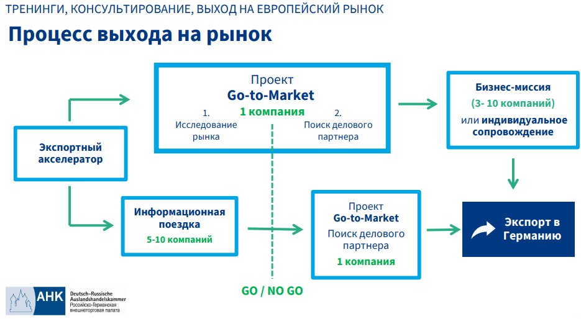

**Picture 3.1 Process of entering German market via assistance of The Russian-German Chamber**

Source: (Russian-German Chamber of Commerce, n.d.)

Moreover, the Chamber provides training sessions and full assistance regarding export activities in German market, see Figure 3.2

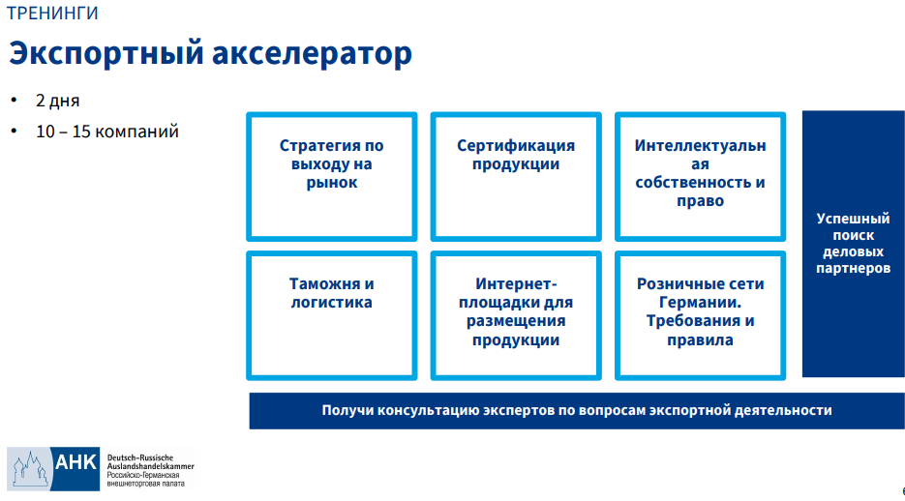

**Picture 3.2 Export accelerator trainings provided by The Russian-German Chamber**

Source: (Russian-German Chamber of Commerce, n.d.)

It can be seen that the Russian-German Chamber of Commerce represents a very powerful source of information and expertise in export to German market.

We suppose that Ijiza should send application to the Chamber to become its member and get access to their service, list of potential partners and full assistance in entering German market and finding a reliable partner that will find buyers in German and represent Ijiza’s interests in Germany.

Another option is getting help from other companies assisting in distributing goods in German market. It seems that many other options of finding partners apart from the one offered by the Russian-German Chamber of Commerce less reliable. As basing on our own research and attempt to contact other organizations/ companies that claim to assist in distributing Russian goods in German market we found out that such companies in fact just provide transportation services, assistance in filling all necessary documents, consultation on domestic regulations and custom support services, but don’t help to find customers in the German market and exploit the product.

Hence, we conclude that at this stage it seems irrelevant and incorrect to identify and name potential partners as it is a huge scope of work that requires preliminary steps to be done such as: contacting the Chamber, becoming member of the Chamber and ext. However, we can identify scope work that should be done and indicative budget of entering the German market, all that will be presented in the next subchapter 3.3

## **Assessing the German market entry strategy in terms of revenue and scope of work**

To identify the scope of work we divided Ijiza’s German market entry strategy into four stages, each stage has it is own strategic goal with the tasks to achieve that goal, see Figure 3.3. Looking at the strategy from even higher point of view we can say that there are two main scope of work: first – preliminary work and second –market entry activities Export

We go through each stage and explain how the estimation was made:

**Stage 1** lasts from two to six months during the year of 2021 and its main goal is to get in contact with the Russian-German Chamber of Commerce, the tasks of the stage are:

* Ijiza contacts the Chamber and sends the application to the organization to become its member;
* Ijiza receives all necessary information (that may include industry reports and experts view) and consultation on entering German smoking chamber market;
* Together with the Chamber Ijiza forms a list of potential partners basing on Chamber’s list of reliable partners and its requirements.

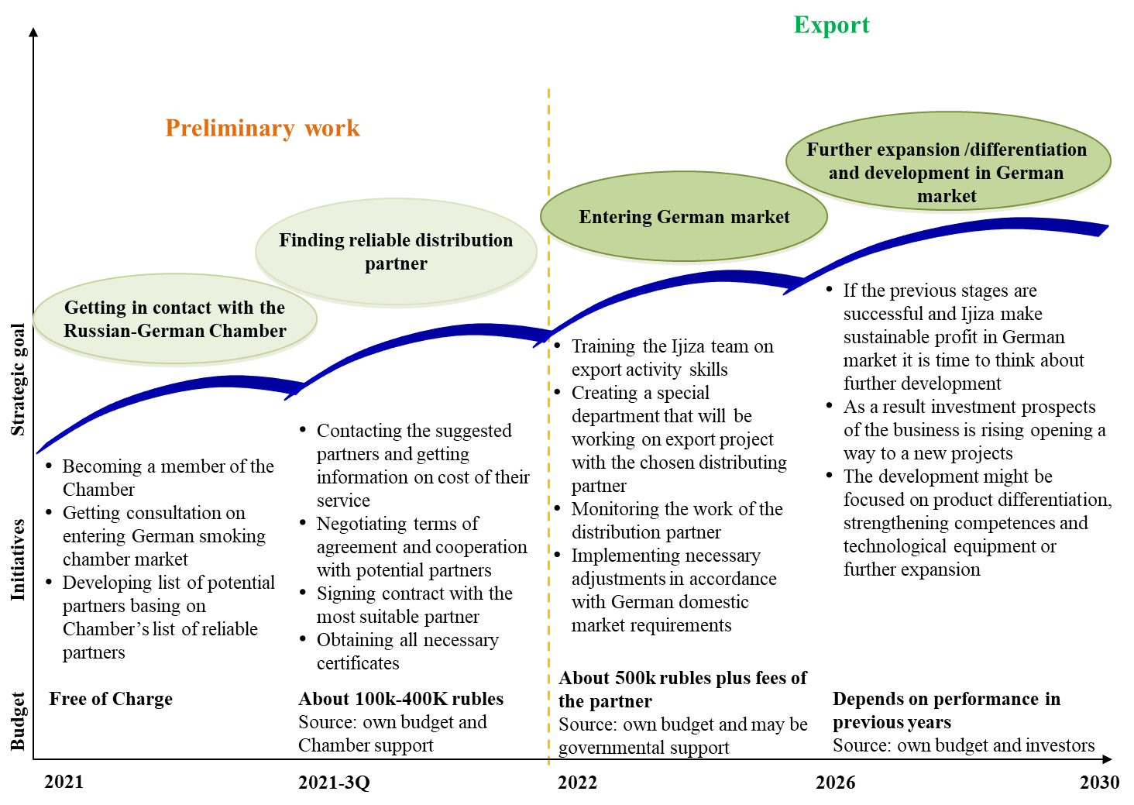

**Figure 3.1 Ijiza’s German Market Entry Strategy– Action Plan**

Source: self-developed by the author

At this stage no extra costs are incurred by Ijiza as Chamber provides these kinds of services free of charge.

**Stage 2** might take from around three months to one year and takes place between 2021 and 2022 and its main goal is to meet with the chosen potential partners and find the one:

* Ijiza meets with the distribution partners from the list that was formed in previous stage to discuss details;
* Terms of agreement is discussed with potential partners: price, time, scope of work and other terms;
* Contract is signed;
* The preparation for Export activity stage starts, it includes getting all necessary certificates, documents, and reaching out Russian and German authorities.

The budget of the stage is calculated basing on costs of business trips (if any allowed by German authorities due to Covid-19 restrictions) and fees for issuing necessary Certificates. The source of the budget is Ijiza’s finance and Chamber support.

**Stage 3** lasts about three years (may take longer depending on the market situation) during the period 2022 - 2026 and its main goal is entering the German market. The stage tasks are:

* Prepare and train the Ijiza team how to perform export related activities;
* Create a special department that will be working on the export project with the chosen distributing partner;
* Monitor and correct the work of the chosen distribution partner in Germany;
* Implement necessary adjustments in accordance with German domestic market requirements. The adjustment might vary in forms and scales; therefore, they are cannot be identified now, they will be known in 2022 - only after entering the German market and upon receiving feedback regarding the product from customers

The budget of the stage is calculated basing on costs of hiring new stuff which according to Head Hunter database (2021) whose salary might be within the range from 100 thousand to 250 thousand rubles as well as costs of training current stuff or man hours spent by stuff in new export department. The source of the budget is Ijiza’s finance and perhaps governmental support. Governmental support is provided by the government through providing low interest loans, funding projects via governmental development institutes giving tax holidays to companies that are in need of investments.

**Stage 4** will presumably take up to four years during the period 2026 - 2030 and its main goal is further development of the product via differentiation or technical improvement and further expansion. The stage tasks are:

* If the previous stages are successful and Ijiza make sustainable profit in German market it is time to think about further development of the product via differentiation or technical improvement (R&D)
* As a result, investment prospects of the business are rising opening a way to new projects
* The development might be focused on product differentiation, strengthening competences and technological equipment or further expansion

The source of the budget is Ijiza’s finance and investors. The budget of the stage is hard to calculate as well as give precise value of the amount of money that will be needed in the period between 2026 and 2030. As by 2026 everything may change dramatically: economy, market, customer preferences and company itself. Investors (that according to our view will be one of sources of financing) are also hard to name today as todays investors may not exist in 5 years or they may change their decision to invest in Ijiza by 2026 as economic, politic and market situation may amend unpredictably, good example is Covid-19 - no one expected such dramatic curve, before March 2020 all forecasts regarding powerful national economies were positive, but now we see recession in these powerful economies such as USA, UK and others. Moreover, customers’ preference may change by 2026, and then no one will need smoking cameras and investments will not be needed. Another difficulty to give exact number is that the national currency may change dramatically and we can’t estimate exact real value of things in 2026.

Thus, we conclude that all of it will depend on situation in period 2026 -2030 and Ijiza managers’ decision on future strategic development will be made in accordance with the situation at that point of time.

Thus, following the information provided in Figure 3.3 we estimated approximate cost on export activities.

Further we need to estimate potential revenue Ijiza will earn after entering the German market of smoked chambers. For such calculations we need input data on size of German market, its annual growth rate and Ijiza’s potential market share. Ijiza’s potential market share in Germany was estimated basing on the analysis of its key success factors, financial performance, description of technological superiority of its product and estimation of its manufacturing capacity provided in Chapter 1. Following that small assumption was made that Ijiza is fully capable to take at least 0,1% of German’s smoking chamber market share.

Therefore, basing on the data provided by the analysis conducted in Chapters 1 and 2 we established following facts:

1. Market size of smoking chambers in Germany amounted to 38 billion rubles in 2016 and 60 billion rubles in 2019;

2. Having the information on market size dynamics we calculated CAGR[2] according to the formula:

Where:

BV - Initial value, BV (beginning value)

EV - End value, EV (ending value)

n - Number of periods

Thus, our CAGR is 7,1%;

3. The largest percentage of German chamber market is represented by the middle and premium segments which account for more than 75% of the market share (35% for the medium segment and 40% for the premium segment);

4. Consequently the premium segment (our targeted segment) market share is 53%;

5. Considering Ijiza’s production capacity is:

* 820 - 845 chambers of different models per year
* 60 – 65 chambers of Ijiza-Z115-A model the one that will be exported to Germany it, and that generates around 52 - 57 million rubles annually in Russian market

and considering that German market volume is 60 billion rubles it seems a realistic scenario for Ijiza to get at least 0,1% of German market share at the beginning of its export activities.

Hence, basing on these inputs we calculated potential outcomes for Ijiza in pursuing its export plan, please see Table 3.3, section “Realistic scenario”

**Table 3.3 Forecast of Ijiza’s potential gains/ revenues in German market of smoked chambers**

|  |  |  |  |  |  |  |
| --- | --- | --- | --- | --- | --- | --- |
|  | **Fact** | **Forecast** | | | | |
| **2019** | **2021** | **2022** | **2023** | **2024** | **2025** |
| **Realistic scenario** | | | | | | |
| **Market size (million rubles)** | 50 000 | 50 000 | 50 100 | 51 603 | 53 409 | 55 545,5 |
| **Growth rates of the market as a whole (CAGR on market size of 2016-2019)** | 7,1% | 0,0% | 0,2% | 3,0% | 3,5% | 4,0% |
| **Ijiza's potential market share ( %)** | - | - | 0,1% | 0,2% | 0,2% | 0,3% |
| **Ijiza's potential revenue (million rubles)** | - | - | **50** | **103** | **107** | **167** |
| **Pessimistic scenario** | | | | | | |
| **Market size (million rubles)** | 50 000 | 50 000 | 50 000 | 49 750 | 49 253 | 48 267,5 |
| **Growth rates of the market as a whole (CAGR on market size of 2016-2019)** | 7,1% | 0,0% | 0,0% | -0,5% | -1,0% | -2,0% |
| **Ijiza's potential market share ( %)** | - | - | 0,0% | 0,0% | 0,01% | 0,02% |
| **Ijiza's potential revenue (million rubles)** | - | - | **0** | **0** | **5** | **7** |
| **Optimistic scenario** | | | | | | |
| **Market size (million rubles)** | 50 000 | 50 000 | 51 000 | 53 550 | 57 299 | 62 455,4 |
| **Growth rates of the market as a whole (CAGR on market size of 2016-2019)** | 7,1% | 0,0% | 2,0% | 5,0% | 7,0% | 9,0% |
| **Ijiza's potential market share ( %)** | - | - | 0,3% | 0,4% | 0,5% | 0,6% |
| **Ijiza's potential revenue (million rubles)** | - | - | **153** | **214** | **286** | **375** |

Source: self-calculated by the author based on data from Chapters 1 and 2

The actual market size data we have is for the year of 2019, the future periods are predicted basing on calculated and predicted volume of CAGR (7,1%. for the period of 2016 and 2019). As we learned in Chapter 2 the smoking chamber market is growing and some experts predict it will grow further while others a bit skeptical as meat consumption is not growing lately and might decrease due to health diet trend. Such trend might impact the demand of smoked chamber. Thus, we concluded that in real scenario the market will not grow at the same rate as it did in previous years, but it will grow anyway just with a less notable rate and it will lead to less notable growth of market size/consumption. Thus, the consumption will increase from 50 billion rubles in 2019 to 55,5 billion rubles in 2025

In pessimistic scenario we predict that market will go down due to the unexpected stagnation in German economy (which is extremely unlikely), health diet and customers ‘switch to meat substitutes. Therefore, the market will fall to 48,2 billion rubles by 2025.

In optimistic scenario we expect that German market of smoked chamber will grow at more significant pace as it is predicted by several economists and will reach the amount of 62,4 billion rubles by 2025.

Basing on German market scenario we calculated Ijiza’s revenue gain in future in three possible scenarios (realistic, pessimistic, and optimistic) each of the revenue scenario is also based on market share Ijiza may win after entering the German smoking chamber market and ability of the company to overcome possible threats and risks.

We see that in realistic scenario Ijiza will earn revenue by gaining market share of 0,1% at the beginning and increasing it to 0,3% by the year 2025. Such market share will lead to increase in Ijiza earnings from 50 in 2022 to 167 million rubles in 2025. In optimistic scenario company’s earnings are even greater and may reach between 2022 and 2025 it may grow from 153 to 375 million rubles, in pessimistic scenario company’s revenue will be around 6 million rubles.

Further to calculate the profitability of the export activities we need to evaluate the costs company is incurring now and will incur in future after entering German markets (Figure 3.4).

**92,9**

**Figure 3.2 Ijiza’s current costs break down, 2020 million rubles**

Source: Ijiza financial report, 2020

It is noted that in 2020 total cost stood at 99,9 million rubles of almost half of which were costs related to the raw material – metal (39 million rubles), another biggest expense item is taxes (40 million rubles). However, these are the costs for total production of all models. Considering that Ijiza will enter the market with only its best seller model Ijiza-Z115-A, we need to calculate cost of its production only.

As Ijiza manager noted - entering new market will require additional personnel, therefore the company will hire following specialists, see Table 3.4.

**Table 3.4 Additional stuff to be hired to work with German market**

|  |  |  |  |  |
| --- | --- | --- | --- | --- |
| **Employee** | **Quantity** | **Salary per month** | **Salary per year** | **in RUB** |
| Installer in Germany | 2 | € 4 000 | € 4 000 | 1 793 600 RUB |
| Accountant | 1 | 70 000 RUB | 840 000 RUB | 10 080 000 RUB |
| Administrator | 1 | € 6 000 | € 72 000 | 6 456 960 RUB |
| Sales Manager | 2 | 70 000 RUB | 1 440 000 RUB | 1 440 000 RUB |

Source: Calculated by author based on data received from Ijiza

We see that two workers that will be responsible for installing the equipment will be hired, Ijiza supposes that at first, they will not work full-time as the sales will be very modest at the beginning of entering the German market; therefore, we calculate their work load as 5 months of full work. Extra two sales managers, an administrator and accountant will be taken in. The salary is converted into rubles in accordance with current Euro/Ruble exchange rate declared by Central Bank of Russia (2021).

Other costs are those that related to production and distribution fee. As for the distribution fee, we learned that Ijiza managers are ready to pay its German distributors 8% of sales as a fee for their services.

Having this data and revenue data provided in Table 3.3 we can calculate Ijiza’s costs and profitability for realistic scenario for next two years 2022 and 2023, Table 3.5 (a, b).

**Table 3.5a Calculation of profit (rubles) and profitability (%) Ijiza will earn in German market in 2022**

|  |  |  |  |  |  |  |  |  |  |  |  |
| --- | --- | --- | --- | --- | --- | --- | --- | --- | --- | --- | --- |
| **Realistic scenario** | | | | | | | | | | | |
| **Year** | | | - | | - | **2022** | | **2023** | **2024** | | **2025** |
| **Ijiza's potential revenue (million rubles)** | | | - | | - | **50** | | **103** | **107** | | **167** |
| **Additional stuff costs** | | | | | | | | | | | |
|  | **Employee** | **Quantity** | | **Salary per month** | | | **Salary per year** | | | **in RUB** | |
|  | Installer in Germany | 2 | | € 4 000 | | | € 4 000 | | | 1 793 600 RUB | |
|  | Accountant | 1 | | 70 000 RUB | | | 840 000 RUB | | | 10 080 000 RUB | |
|  | Administrator | 1 | | € 6 000 | | | € 72 000 | | | 6 456 960 RUB | |
|  | Sales Manager | 2 | | 70 000 RUB | | | 1 440 000 RUB | | | 1 440 000 RUB | |
| **Distribtion costs** | | | | | | | | | | | |
|  |  | **% of sales** | | **Sales in 2022 in rub.** | | |  | | | **in RUB** | |
|  | Distributor Commission (min) | 8% | | 50 000 000 RUB | | |  | | | 4 000 000 RUB | |
| **Other production related costs** | | | | | | | | | | | |
|  |  |  | | **Costs in 2022** | | |  | | | **in RUB** | |
|  | See fig. 3.2 |  | | 25 000 000 RUB | | |  | | | 25 000 000 RUB | |
| **TOTAL** | |  | |  | | |  | | | **RUB 48 770 560** | |
|  | **PROFIT FOR THE YEAR 2022** | | |  | | |  | | | **1 229 440 RUB** | |
|  | **PROFITABILITY (MARGIN) FOR THE YEAR 2022** | | | | | |  | | | **2,46%** | |

Source: Calculated by author based on data received from Ijiza

It can be seen that in accordance with the realistic scenario Ijiza will earn 1,2 million rubles of profit first year of work in German market and its profitability will stand at 2,46%. Now let’s look at the profits and profitability in 2023, Table 3.5b.

**Table 3.5b Calculation of profit (rubles) and profitability (%) Ijiza will earn in German market in 2023**

|  |  |  |  |  |  |  |  |  |  |  |  |
| --- | --- | --- | --- | --- | --- | --- | --- | --- | --- | --- | --- |
| **Realistic scenario** | | | | | | | | | | | |
| **Year** | | | - | | - | **2022** | | **2023** | **2024** | | **2025** |
| **Ijiza's potential revenue (million rubles)** | | | - | | - | **50** | | **103** | **107** | | **167** |
| **Additional stuff costs** | | | | | | | | | | | |
|  | **Employee** | **Quantity** | | **Salary per month** | | | **Salary per year** | | | **in RUB** | |
|  | Installer in Germany | 2 | | € 4 000 | | | € 4 000 | | | 1 793 600 RUB | |
|  | Accountant | 1 | | 70 000 RUB | | | 840 000 RUB | | | 10 080 000 RUB | |
|  | Administrator | 1 | | € 6 000 | | | € 72 000 | | | 6 456 960 RUB | |
|  | Sales Manager | 2 | | 70 000 RUB | | | 1 440 000 RUB | | | 1 440 000 RUB | |
| **Distribtion costs** | | | | | | | | | | | |
|  |  | **% of sales** | | **Sales in 2023 in rub.** | | |  | | | **in RUB** | |
|  | Distributor Commission (min) | 8% | | 103 000 000 RUB | | |  | | | 8 2400 000 RUB | |
| **Other production related costs** | | | | | | | | | | | |
|  |  |  | | **Costs in 2023** | | |  | | | **in RUB** | |
|  |  |  | | 51 500 000 RUB | | |  | | | 51 500 000 RUB | |
| **TOTAL** | |  | |  | | |  | | | **RUB 48 770 560** | |
|  | **PROFIT FOR THE YEAR 2023** | | |  | | |  | | | **23 489 440 RUB** | |
|  | **PROFITABILITY (MARGIN) FOR THE YEAR 2023** | | | | | |  | | | **22,81%** | |

Source: Calculated by author based on data received from Ijiza

We can see from Table 3.5b that in 2023 Ijiza will make great profit 23,4 million rubles and its profitability will be 22,81% which is a great value considering the time (within one and a half or two years).

Further we learn risks that company may face in German market and evaluate their probability of realization.

**Risks in realistic scenario and its effect on revenue**

We can see from Table 3.3 that in negative scenario German market fall doubled with Ijiza inability to win market share will lead to company’s zero revenue in 2022 and 2023 and some small amount of earning in 2024 and 2025 which will stand at the figure of 5 and 7 million rubles respectively.

In optimistic scenario we estimated that Ijiza will own 0,6% of market share by 2025 and earn 375 million rubles in revenue that year.

In realistic scenario we assume that following risks will be realized, see table 3.6.

**Table 3.6 identified risks for Ijiza and probability of their realization in realistic scenario**

| **Identified risks** | **Probability of realization** | | | | |
| --- | --- | --- | --- | --- | --- |
| **High** | **Medium** | **Low** | **Extremly low** | **Almost impossible** |
| **External global economic or politic risks** | | | | | |
| International sanctions against Russian companies (medium probability) |  |  |  |  |  |
| Global economic recession due to Covid – 19 (medium probability) |  |  |  |  |  |
| Fall in German economy (almost impossible) |  |  |  |  |  |
| **External German market risks: customers, rivals, regulations** | | | | | |
| German authorities strengthening regulation with regards to Russian suppliers (medium probability) |  |  |  |  |  |
| Decrease in smoked meat consumption due to healthy diet (medium probability) |  |  |  |  |  |
| German consumer rejection of Ijiza’s equipment (low probability) |  |  |  |  |  |
| Change in customer preferences switch to an alternative cheaper and low-quality equipment (extremely low probability) |  |  |  |  |  |
| Rivals aggressive measures – damping or (low probability) |  |  |  |  |  |
| **Internal company performance related risks** | | | | | |
| Poor performance of the distribution partner (medium probability) |  |  |  |  |  |
| Extra costs occur that are unbearable to Ijiza (low probability) |  |  |  |  |  |
| Ijiza’s inability to handle German market competition (low probability) |  |  |  |  |  |
| Ijiza’s low qualification and poor performance poor service in supporting export activities (extremely low probability); |  |  |  |  |  |
| Lack of financial resources to produce and supply more equipment for German market (low probability); |  |  |  |  |  |

Source: self- developed by the author

In realistic scenario we expect that there will be no risks that will have high probability of realization. Major amount of risks represented in Table 3.6 have medium, low or extremely low probability of realization. All risks were categorized in three main groups: External global economic or politic risks; External German market risks: customers, rivals, regulations; and Internal company performance related risks.

Among most likely risks are: international sanctions, Global economic recession due to Covid, regulations, decrease in smoked meat consumption, and poor performance of the distribution partner.

Major amount of abovementioned risks will not be realized therefore Ijiza will be able to earn revenue by gaining market share of 0,1% at the beginning and increasing it to 0,3% by the year 2025. Such market share will lead to increase in Ijiza earnings from 50 in 2022 to 167 million rubles in 2025.

Hence looking at Table 3.6 we see that working and managing the mentioned risks Ijiza has quite good chases to enter German market of smoked chamber successfully and even grow there.

## **Conclusion to the Chapter 3**

The estimations made on the basis of analysis conducted in previous two chapters are feasible and prove that Ijiza might win competition in German market. As we showed there are many macroeconomic and industrial and company internal factors / risks that impact the final outcome for Ijiza. Therefore, it is essential for the company to develop action plan for each scenario and be ready for any negative factor to play out.

As it was demonstrated in Figure 3.3 the company should approach the export matter carefully and gradually. Excellent opportunity presented itself in face of Russian-German Chamber of Commerce that provides different kinds of services and support to small and medium sized businesses. The Chamber can be a great help to Ijiza in choosing the right partner as it has an exhaustive database on all possible and most importantly reliable partners that will be delighted to represent Ijiza’s interest in German market. There are no other such databases and there is no such organization with highly qualified and highly motivated stuff to help companies to thrive.

Thus, we conclude that Ijiza should apply the plan presented in Figure 3.3, and mitigate all identified risks demonstrated in Tables 3.4 and 3.5 to be able to earn revenue presented in Table 3.3 in positive and realistic scenarios.

# **Conclusion**

Having conducted detailed research of Ijiza’s performance and overall market circumstances: local and international (German) we managed to identify the company's strong and weak points by analyzing its activities, key financial indicators, technology, manufacturing process, and clients and learn about external threats and opportunities. All possible future development scenarios (pessimistic, realistic, and optimistic) were thoroughly described, and the benefits of the entity was stressed. The company was also examined using the VRIO tool, which highlighted the primary competitive advantages of “Ijiza” LLC in the Russian market, as well as the firm's weak points and future development potential.

The company's concerns regarding a negative trend and stagnation were validated by an analysis of the Russian economy and the Russian smoked chamber market. We witnessed how the pandemic and sanctions impacted GDP as well as foreign investment flow; these facts serve as a strong signal for Ijiza to grow into new markets.

The company produces high-quality, relatively inexpensive (when compared to German analogs) and environmentally friendly, therefore entering the German market is a viable option. It has already established itself as a market leader in the manufacturing of industrial smoking equipment in Russia, and it has extensive experience working with CIS firms. It appears that the company has the necessary resources and competencies to enter the European market. By utilizing these resources and building a clear strategic and comprehensive expansion strategy, the company may have a strong chance of succeeding in a new foreign market such as Germany.

As for external circumstances, after applying PEST, 5 Porter's Forces, SWOT and general analysis tools to the macroeconomic situation of Germany and the current situation in the smoking house market, we came to the conclusion that it is more than enticing to enter the German market because it demonstrates strong GDP growth, a stable trend in meat consumption, and is expected to do so in the future.

Furthermore, market evaluations revealed no substantial threats or impediments that Ijiza could not overcome, given its technology and cost advantages. Despite the fact that Ijiza LLC is a new international company with a short history, it has already accomplished a lot in terms of business acumen and efficient technologically advanced production. Unlike its competitors, it has a fully automated manufacturing process, which is not only convenient but also saves money and energy. Furthermore, the equipment is composed of stainless steel, which sets them apart from the competition and ensures a safe and long-term functioning. As a result, we think that entering the German market would be extremely beneficial to the organization.

The forecasts are plausible and show that Ijiza may gain its market share in Germany. However, we have seen, there are several macroeconomic, industrial, and company-specific factors and risks that may influence Ijiza's final performance. Therefore, it is critical for the organization to follow the above outlined action plan, and prepare itself for each scenario to prevent undesirable outcome.

The corporation should address the export subject carefully and gradually. The Russian-German Chamber of Commerce, which offers a variety of services and support to small and medium-sized firms, presented an excellent opportunity. The Chamber can assist Ijiza in finding the proper partner because it has an extensive database of all possible and, most importantly, trustworthy partners who will be happy to represent Ijiza's interests in German market. There are no other databases like it, and no other firm with highly skilled and driven employees to assist businesses succeed.

As a result, we conclude that Ijiza should implement the plan and mitigate all identified risks in order to earn the income.

# **Reference**

Abakumova, N.V. (2014) *Development of the company’s marketing strategy for foreign markets entry*. [Online]. Available from: https://elar.urfu.ru/bitstream/10995/36137/1/m_th_m.v.abakumova_2014.pdf.

Avito Marketplace (2021) *smoking chamber - Ready business and equipment in Russia | Buying and Selling a Business | Avito*. [Online]. 2021. Avito. Available from: https://www.avito.ru/rossiya/dlya_biznesa?q=%D0%BA%D0%BE%D0%BF%D1%82%D0%B8%D0%BB%D1%8C%D0%BD%D0%B0%D1%8F+%D0%BA%D0%B0%D0%BC%D0%B5%D1%80%D0%B0 [Accessed: 26 May 2021].

Bloomberg (2020) *Russia’s GDP from 2013 to 2021*. [Online]. 2020. TAdviser.ru. Available from: /index.php/Статья:ВВП_России [Accessed: 25 May 2021].

Central Bank of Russia (2020) *Direct Foreign Investment into Russia fall*. [Online]. 2020. TAdviser.ru. Available from: /index.php/Статья:Прямые_иностранные_инвестиции_в_России [Accessed: 25 May 2021].

Central Bank of Russia (2021) *Official exchange rates for a given date, set daily | Central Bank of Russia*. [Online]. 3 June 2021. Available from: http://www.cbr.ru/currency_base/daily/ [Accessed: 3 June 2021].

Cognitive Market Research (2021) *Smoking Chamber Market Report 2021 | Market Growth | CAGR | Forecast*. [Online]. Available from: https://www.cognitivemarketresearch.com/smoking-chamber-market-report#request_sample [Accessed: 29 May 2021].

Corporate Finance Institute (2016) *First Mover Advantage - Benefits & Drawbacks of Being First*. [Online]. 2016. Corporate Finance Institute. Available from: https://corporatefinanceinstitute.com/resources/knowledge/strategy/first-mover-advantage/ [Accessed: 28 May 2021].

Deutche Well (2021) *Коронавирус: ситуация в Германии продолжает осложняться | DW | 27.03.2021*. [Online]. 21 March 2021. DW.COM. Available from: https://www.dw.com/ru/koronavirus-situacija-v-germanii-prodolzhaet-oslozhnjatsja/a-57022884 [Accessed: 26 May 2021].

Deutsche Welle (2021a) *The Customs Union*. [Online]. 1 January 2021. DW.COM. Available from: https://www.dw.com/ru/%D1%82%D0%B0%D0%BC%D0%BE%D0%B6%D0%B5%D0%BD%D0%BD%D1%8B%D0%B9-%D1%81%D0%BE%D1%8E%D0%B7/t-17449026 [Accessed: 26 May 2021].

Deutsche Welle, D. (2021b) *How does Germany’s meat industry work? | DW | 19.06.2020*. [Online]. 2021. DW.COM. Available from: https://www.dw.com/en/germany-meat-industry-statistics/a-53876016 [Accessed: 26 May 2021].

Fisch-Informationszentrum (FIZ) (2017) *Потребление рыбы на душу населения в Германии выросло до 14,2 кг*. [Online]. 28 September 2017. Available from: http://fishkamchatka.ru/articles/world/21636/ [Accessed: 26 May 2021].

Fish Kamchatka (2017) *Потребление рыбы на душу населения в Германии выросло до 14,2 кг*. [Online]. 28 September 2017. Available from: http://fishkamchatka.ru/articles/world/21636/ [Accessed: 29 May 2021].

German Federal Ministry of Food and Agriculture (2020) *BMEL - Healthy diet*. [Online]. 2020. Available from: https://www.bmel.de/EN/topics/food-and-nutrition/healthy-diet/healthy-diet_node.html [Accessed: 26 May 2021].

GfK (2013) *GfK-Studie ‘Essen und Trinken in Deutschland’: Salziges vor dem Fernseher, Süßes vorm PC*. [Online]. 2013. Available from: https://www.marktforschung.de/aktuelles/marktforschung/gfk-studie-essen-und-trinken-in-deutschland-salziges-vor-dem-fernseher-suesses-vorm-pc/ [Accessed: 26 May 2021].

Global Smoking Chamber Market Report (2021) *Smoking Chamber Market Report 2021 | Market Growth | CAGR | Forecast*. [Online]. 24 May 2021. Available from: https://www.cognitivemarketresearch.com/smoking-chamber-market-report#request_sample [Accessed: 26 May 2021].

Group Map (n.d.) *PEST Analysis Template - Political, Environmental, Social, Technological*. [Online]. GroupMap. Available from: https://www.groupmap.com/map-templates/pest-analysis/ [Accessed: 26 May 2021].

Head Hunter database (2021) *Вакансия Менеджер по экспорту в отдел развития (экспорт менеджер) в Москве, работа в компании UNION*. [Online]. 2021. Available from: https://hh.ru/vacancy/44620874 [Accessed: 30 May 2021].

Ijiza, LLC (2021) *Account statement of Ijiza for the period of 2011-2020*. [Online]. 2021. Available from: https://www.audit-it.ru/buh_otchet/1831080127_ooo-izhitsa [Accessed: 25 May 2021].

Ijiza, LLC (2020a) *Commercial Offer, Ijiza*.

Ijiza, LLC (n.d.) *Ijiza, LLC*. [Online]. Available from: https://ijiza.ru/ [Accessed: 25 May 2021a].

Ijiza, LLC (2020b) *Price of the smokong equipment*. [Online]. 2020. Available from: https://ijiza.ru/catalog/smoking/ [Accessed: 26 May 2021].

Ijiza, LLC (n.d.) *Services*. [Online]. Available from: https://ijiza.ru/catalog/parts/uslugi/ [Accessed: 25 May 2021b].

Ijiza, LLC (n.d.) *Subscription service for smoking industries*. [Online]. Available from: https://ijiza.ru/catalog/detail/uslugi/abonentskoe-obsluzhivanie-koptilnyh-proizvodstv-konsultatcii [Accessed: 26 May 2021c].

Karagulyan, E.A. (2015) *МЕТОДИЧЕСКОЕ ПОСОБИЕ РАБОТА ПРЕДПРИЯТИЯ ПО ВЫХОДУ НА ВНЕШНИЙ РЫНОК. МАРКЕТИНГОВЫЕ ИССЛЕДОВАНИЯ. СТРАТЕГИИ ВЫХОДА КОМПАНИИ НА ВНЕШНИЕ РЫНКИ*. Ханты-Мансийск.

Khokhlov, A. & Eremenko, E. (2021) *10+ SMOKING CHAMBERS TOP suppliers from 🇷🇺 Russia, Kazahstan [2021]*. [Online]. 21 May 2021. ЭкспортВ. Available from: https://exportv.ru/smoking-chambers-suppliers-russia.html [Accessed: 26 May 2021].

Library of Congress (2020) *Guide to Law Online: Germany | Law Library of Congress*. [Online]. 2020. Available from: https://www.loc.gov/law/help/guide/nations/germany.php [Accessed: 26 May 2021].

Mariadoss, B.J. (2018) *7.1 International Entry Modes – Core Principles of International Marketing*. https://opentext.wsu.edu/cpim. [Online]. Available from: https://opentext.wsu.edu/cpim/chapter/7-1-international-entry-modes/ [Accessed: 28 May 2021].

October Fest (2019) *10 funny facts and myths about beer*. [Online]. 2019. 10 funny facts and myths about beer • Oktoberfest.de - The Official Website for the Oktoberfest in Munich. Available from: https://www.oktoberfest.de/en/magazine/eat-and-drink/10-funny-facts-and-myths-about-beer [Accessed: 26 May 2021].

Power Branding (2018) *Модель пяти конкурентных сил Майкла Портера: описание и пример анализа — PowerBranding.ru*. [Online]. 2018. Available from: http://powerbranding.ru/biznes-analiz/porter-model/#ff [Accessed: 26 May 2021].

Promex (n.d.) *Завод металлообработки: компания по металлообработке Промэкс*. [Online]. Available from: https://promexcut.ru/o-kompanii [Accessed: 26 May 2021].

Reich Food System (n.d.) *Special for Climate and Smoking systems*. [Online]. Available from: https://www.reich-foodsystems.com/?lang=en [Accessed: 26 May 2021].

Russian Export Center (2020) *Экспорт в Германию из России: статистика и перспективы*. [Online]. 2020. Available from: https://www.exportcenter.ru/international_markets/world_map/western_europe/germany/ [Accessed: 29 May 2021].

Russian Export Center & EXIAR (2016) *Учебное пособие для начинающих экспортеров*. [Online]. Available from: https://minec.gov-murman.ru/about/obsch_sovet/novosti/uchebnoe-posobie.pdf.

Russian Production - information center (2018) *Smokehouse manufacturer ‘Ijiza’ - production and wholesale of equipment and smoking chambers*. [Online]. 2018. product center. Available from: https://productcenter.ru/producers/19073/ooo-kb-izhitsa [Accessed: 25 May 2021].

Russian-German Chamber of Commerce (n.d.) *AHK Membership*. [Online]. AHK Russland. Für die Wirtschaft. In Russland vor Ort. Available from: https://russland.ahk.de/en/network/ahk-membership [Accessed: 30 May 2021a].

Russian-German Chamber of Commerce (n.d.) *Analysing the Russian market*. [Online]. AHK Russland. Für die Wirtschaft. In Russland vor Ort. Available from: https://russland.ahk.de/en/markt/analysing-the-russian-market [Accessed: 30 May 2021b].

Russian-German Chamber of Commerce (n.d.) *Список компаний*. [Online]. AHK Russland. Für die Wirtschaft. In Russland vor Ort. Available from: https://russland.ahk.de/ru/vtp/spisok-kompanii?tx_cpsfmp_companymainplugin%5Bcontroller%5D=Company&tx_cpsfmp_companymainplugin%5Bdirection%5D=ASC&tx_cpsfmp_companymainplugin%5BorderBy%5D=countries.cn_title&tx_cpsfmp_companymainplugin%5Bpage%5D=1&cHash=efbea779108ab86a05018e863e8a4936 [Accessed: 30 May 2021c].

Russian-German Chamber of Commerce (n.d.) *Экспорт в Германию: тренинги, консультирование, выход на рынок*. [Online]. AHK Russland. Für die Wirtschaft. In Russland vor Ort. Available from: https://russland.ahk.de/ru/rynok/ehksport-v-germaniju-treningi-konsultirovanie-vykhod-na-rynok [Accessed: 30 May 2021d].

Savkin, A. (2021) *Model of VRIO-analysis in strategic planning*. [Online]. 26 January 2021. Available from: https://bscdesigner.ru/analyz-vrio.htm [Accessed: 26 May 2021].

Spark Interfax (2002) *Database,company informationon Ijiza, LLC*. [Online]. 2002. Available from: https://www.spark-interfax.ru/sankt-peterburg-kalininski/ooo-izhitsa-inn-1831080127-ogrn-1021801175912-82e6b5e0880b4d30b8fd70d6cc35d0bd [Accessed: 25 May 2021].

Statista database (2021a) *Germany - Inflation rate 2026*. [Online]. 2021. Statista. Available from: https://www.statista.com/statistics/375207/inflation-rate-in-germany/ [Accessed: 26 May 2021].

Statista database (2021b) *Meat: production by type in Germany 2020*. [Online]. 2021. Statista. Available from: https://www.statista.com/statistics/515212/meat-production-by-type-germany/ [Accessed: 26 May 2021].

Statista database (2021c) *Unemployment rate in Germany 2020*. [Online]. 2021. Statista. Available from: https://www.statista.com/statistics/227005/unemployment-rate-in-germany/ [Accessed: 26 May 2021].

Steel Service (2019) *AISI 304 steel - stainless steel characteristics*. [Online]. 19 February 2019. Available from: https://steelservice.com.ua/aisi-304/ [Accessed: 26 May 2021].

World Bank & Trading Economics (2019) *Germany GDP per capita PPP | 1990-2019 Data | 2020-2021 Forecast | Historical | Chart*. [Online]. 2019. Available from: https://tradingeconomics.com/germany/gdp-per-capita-ppp [Accessed: 26 May 2021].

World Freight Rates (n.d.) *World Freight Rates 2020*. [Online]. Available from: https://worldfreightrates.com/freight [Accessed: 28 May 2021].

Ильиных, А.А. & Киселева, П.С. (2019) *Влияние инфляции на экономику страны и общество в целом*. [Online]. 2019. Available from: http://arbir.ru/articles/a_3128.htm [Accessed: 26 May 2021].

# **Appendix 1**

Declaration of conformity

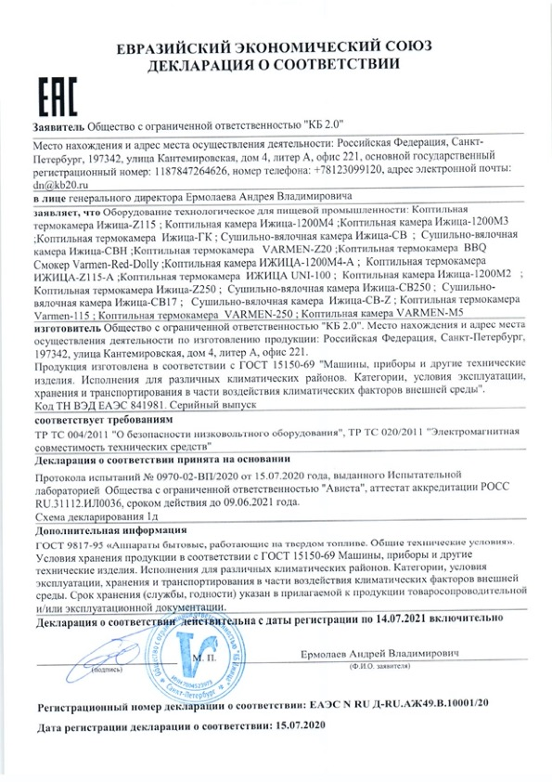

# **Appendix 2**

Letter on the absence of smoke

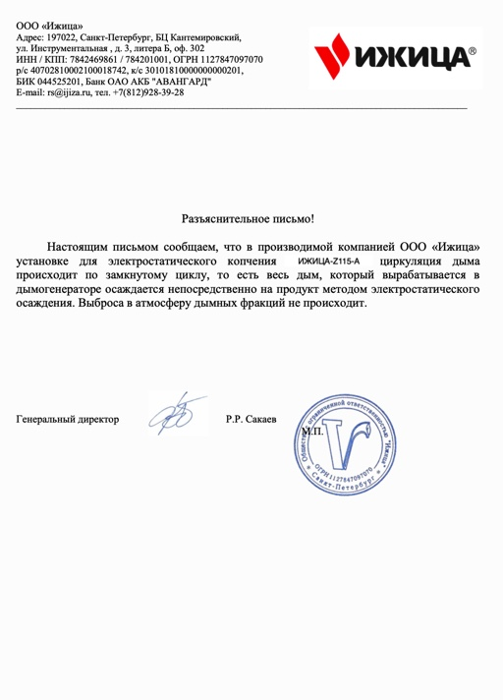

# **Appendix 3**

Test report for carcinogens

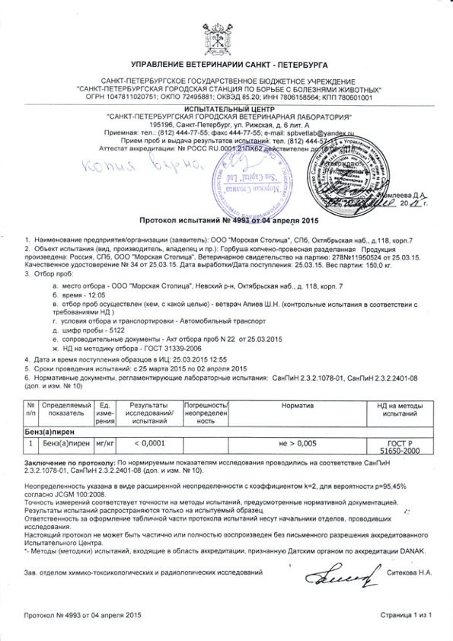

1. The GDP per capita PPP is obtained by dividing the country’s gross domestic product, adjusted by purchasing power parity, by the total population.
2. Compound annual growth rate (CAGR) is a business and investing specific term for the geometric progression ratio that provides a constant rate of return over the time period