Federal State Institution of Higher Professional Education
Saint-Petersburg University
Graduate School of Management

Kim Natalia Vladimirovna

Final bachelor thesis
Amway business model adaptation for entry to Uzbekistan

Education level: bachelor's degree
Direction 38.03.02 "Management"
Basic educational program CB.5087 International Management

Scientific Advisor:
Senior Lecturer,
Department of Strategic and International Management
Ermolaeva Lyubov Andreevna

Reviewer:
Associate Professor,
Department of Strategic and International Management
Blagov Yuri Evgenievich

Saint-Petersburg
2021
STATEMENT ABOUT THE INDEPENDENT CHARACTER OF THE COURSE PAPER.

I, Natalia Kim, 4th year student of bachelor program in Graduate School of Management (group IM) confirm that in my final paper on the topic of “Amway business model adaptation for entry to Uzbekistan” that is subjected to the public defense on the 1 of June 2020, does not contain elements of plagiarism.
All direct borrowings from printed and electronic sources, as well as from bachelor and master theses, PhD and doctoral theses, which were defended earlier, have appropriated references.
I am aware that according to the paragraph 9.7.1. of Guidelines for instruction in major curriculum programs of higher and secondary professional education at St. Petersburg University “Final thesis must be completed by each of the degree candidates individually under the supervision of his or her advisors, and according to the paragraph 51 of Charter of the Federal State Institution of Higher Professional Education St. Petersburg State University “a student can be expelled from St. Petersburg State University for submitting of the course or graduation qualification work developed by other person (persons)”.

__________________(Kim N.V.)____________
(Signature of the student with transcript)
________________02.06.2021__________________ (Date)

Table of content

Introduction 5
Methodology 7
CHAPTER 1: THEORETICAL FRAMEWORKS 9
1.1 Business model 9
1.2 Business adaptation/innovation definition 14
1.3 Transition economies 16
CHAPTER 2: ANALYSIS OF RUSSIAN MARKET 18
2.1 Case study 18
2.2 Adaptation 32
2.3 Factors identification 45
2.4 Factors and change interdependence 81
CHAPTER 3: ANALYSIS OF UZBEKISTAN 84
3.1 Factors identification 84
3.2 Adaptations of business model for Uzbekistan 103
Conclusion 112
Reference list: 114
Appendix 1 Earnings in Network marketing companies 121
Appendix 2 Support materials 126

Introduction

Amway is an international manufacturer of personal care products, household chemicals, cosmetics, dietary supplements and household items. Founded in 1959 in the USA. The Russian branch of the company was established in March 2005. Ukraine and Kazakhstan in 2003 and 2013 respectively, they formed one region and had more or less same business model with some minor differences. Ukraine market was for all year part of European region, but this year was added to Russia and Kazakhstan, regional manager now works on implementing new practices to Ukrainian market. For all year when Amway operated in the market the changes in business model appeared that is why business model in this region has differences from the American one. Russia, Ukraine and Kazakhstan used to be a part of Soviet Union which could have impact on markets. In this work the changes from company internationalisation to current days in Russia is analysed to understand which factors influenced each change. This is the only market chosen as it was opened earlier than Kazakhstan, so some practices already were made in Russia and then implemented in Kazakhstan. Ukraine just joined region this year and more European approaches can be found there.
Amway consider the implementation of business model in Post-Soviet Union region to new markets in Uzbekistan. The aim of this work is to understand the relevance of this business model and find out what changes will work in new markets. To achieve this goal at first the business model should be decried and all changes should be found then internal and external factors which cause each change identified, information is provided from Deputy director of Russia, Kazakhstan and Ukraine and individual business owners who are in the same time clients and distributors of company. In order to understand the relevance of implementation of each change the external factors in Uzbekistan are compared with the ones in Russian. Out of this comparison based on similarities and differences the final recommendation on adaptation of business model are proposed. The results of this work can help to make conclusions which factors on new market will create a need to make concrete change. The analysis of new market is needed to find out the factors and in case they are the same as in Russian market, then a recommendation can be made about the changes of business model required by new markets.

Goal of this consulting project is to adopt a business model to needs of Belarus and Uzbekistan.
Object - Amway company
Subject – business model adaptation
Limitation- the study’s limitation is connected with the availability of information about the Uzbekistan as this country usually are not analysed by academics and reliable sources such as Statista also do not have info about it. The official information is provided either in Uzbek language or Russian that is the reason of having sources on Russian.

Objectives:
- Define business model adaptation
- Identify business model in Russia
- Identify changes in business model in Russia
- Identify internal and external factors, affected business model change in Russia
- Investigate which factor led to specific change
- Identify external factors in and Uzbekistan
- Comparison of countries’ economic, political and cultural environments
- Suggest adaptations of business model

The PESTEL, CAGE and 5 forces of Porter frameworks were used to compare two countries. The big gap in terms of culture and economic situation were found in macro level while in industry level countries are quite similar. The only difference is that multilevel marketing firms operates in Russian market for years when in Uzbekistan they are comparatively young players.
As a result of this work most of the changes in Russian market are relevant to the Uzbekistan as well, but some correctives were given to each of them to make them more effective in new market.
Moreover, additional recommendations were made to individual business owners who are going to operate in Uzbekistan market as they need to take into account cultural and economic situation in the country to build relationships with new clients and satisfy their needs.
In addition, the recommendation according to the way of entrance new market was made. Amway usually enters market after IBOs, but according to the changes happened in Russian market, to be more specific the appearance of company’s product on marketplace, it became possible to export its goods with Ozon help as it already operates in new market.

Methodology
3.1. Research methodology
Based on literature review, the aim of this work is to find out which business model adaptation should be made in order to meet the need of new market. In order to understand which changes should be made the experience of company on Russian market is analyzed. The changes from entrance in Russia to current moment are identified and internal and external factors described. The interest is to find out which factor influenced company to make a specific change. The external factors of new markets then identified, there are no internal ones as company still did not entered market. Based on the similarity of factors it is possible to find out which adaptations to business model should be made. Finally, a business model which suits the need of new market identified and proposed to Amway.

3.2. Research setting
American company Amway internationalization to the emerging markets, to be more concrete post-Soviet Union territory, is researched. Russian market is chosen as the one which were opened earlier and had specifics for post-Soviet Union territory. This region is interesting due to its significant difference with the home American market where company was founded. In addition, transition economies have their own specificity which can make companies to adopt business model.
Such context will clearly show how company adopt to a new environment in transition economy so it will be possible to get similar. (Siggelkow, 2007).

3.3. Data collection and analysis
Two types of data are used in this paper: primary and secondary. Primary data consists of the (1) interview with representative of Amway who is currently have a position of Deputy of general manager of region(Russia, Kazakhstan, Ukraine) which results in 5 pages of transcription, (2) 8 seven interviews with Independent Business Owners (IBOs)which are total 6 hours, (3) author presence during managers and workers of companies speeches, successful IBOs speeches, meetings of group leaders, master classes, “field” work of IBOs, online webinars, seminars for IBOs in partnership with Network21 company for year. Network 21 is a company founded by one of IBOs to share the knowledge from successful IBO.
Secondary data sources are website, annual reports, company presentations, advertisement emails. Interviews with IBOs, company presentations and advertisement emails are the sources for finding the changes which took place in Russian market, company started to make email sending in recent years that is why they contributed only to trach new changes. The author presence in different meeting is aimed to understand the business model of company and see changes by myself. The interview with Deputy of regional manager to understand the internal reason of company to make changes. The rest of data is used to find out external factors in all markets.

CHAPTER 1: Literature review

1.1 Business model
In 1965 the term “business model” appeared for first time in title of scientific work (Wirtz, 2016), but only during 90s the business model (BM) become a topic of interest for many writers, as a result the number of managerial literatures about it increased during these times when Internet become widespread and already started to be used by people as well as various businesses. That gave customers access to information and increased the customer power while business adopted it massively for electronic commerce. BM describes how the organisation is functioning to produce value for its customers and helps to find a way to make profit from building sustainable competitive advantage through showing the logic and interconnections between the dimensions of BM. It is also shows costs which company has to support it business and revenues streams. The are several elements which must be determined, those elements ware proposed by David Teece and are described below.
- Select technologies and features to be embedded in the product/service
- Determine benefit to the customer from consuming/using the product/service
- Identify market segments to be targeted
- Confirm available revenue streams
- Design mechanisms to capture value

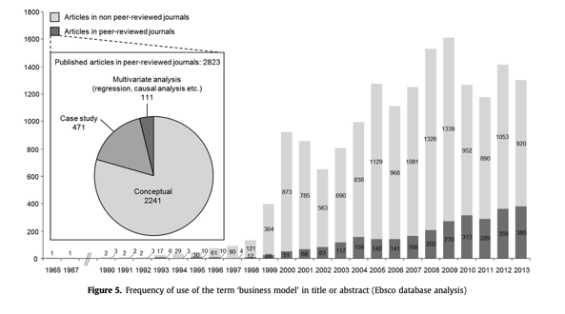
- Frequency of use of the term ‘business model” in title or abstract (Ebsco database analysis)
Source: [Wirtz, B. W., Pistoia, A., Ullrich, S., & 18(3), 5-14. Göttel, V . (2016). Business models: Origin, development and future research perspectives]
The researches started to specify characteristics of a business model. Two dimensions were identified: value creation and value capture. Teece (2010) described it as ‘the design or architecture of the value creation, delivery, and capture mechanisms’ of an organization.
Business model is often used for two aims: first one is descriptive, it is aimed to highlight the interdependence between components and is called “static approach”, another is a “transformational approach” aimed to focus on change and innovation in organisation or BM. Static view makes it possible to describe and make classification, the example which is provided by Demil and Lecocq is low cost airlines as an innovative way to organise business in a way which will allow airline companies to provide relatively cheap tickets. From this perspective a BM provide an opportunity to create value by making possible to portray the business ability to generate profit and functions. Transformational view is a tool for managers which helps to make changes in the BM that is why the interconnections between dimensions are more important in this type as it is designed to see how changes will affect a company and what activities should be adopted to get most benefit from implementing innovation and coherent business units which supports new activity. New business models are known for ability to radically change industry.
For our purpose static approach suits better since transformational is highly valued in terms of implementing real changes by managers, for them to get the better result all dimensions should support this change and the link between all dimensions are aimed to see what should be done to get higher effectiveness. For purpose of this work a tool that enables the description of the company which will help not only to clearly describe the activity of a company, but also to classify all changes already happened in the business.
In order to choose the most relevant model which can describe and show differences which occurs in business due to its entering to a foreign market, the description and comparison of several business model frameworks is essential. There are several frameworks which help to describe a business in a structured way.
First of them is a business model canvas which was developed by Alexander Osterwalder & Yves Pigneur. It consists of 9 parts: customer segments, value propositions, channels, customer relationships, revenue streams, key resources, key activities, key partnerships and cost structure. This framework is really helpful for entrepreneurs as canvas is a good visionary tool where it is possible to understand the interconnections between its parts. Although, it is not convenient to describe companies which are vertically and horizontally integrated in that framework as lineages become blurred and it is not clear which of points refers to the same business entity. Moreover, taking into account the specificity of the Amway company it is not clear where the distributors/customers should be placed.
The second framework is RCOV model created by Demil and Lecocq, their aim was to make a model which will be a tool for detailed analysis and will combine the benefits of static and transformational approach in one model. It consists out of the three components: resources and competences, organisation, value proposition. These dimensions determine the structure of costs and revenues. The advantage of this model that it gives a possibility to track how changes in one of the dimensions influence to the rest of the organisation. It helps make right changes to rest of dimension in order to get cohesive business model. That is helpful for managers to adopt changes in whole organisation. Although, our purpose not to see how specific change influence to the whole organisation, but to investigate how internalisation influence each dimension which in its term are broadly formulated and not concrete. Moreover, model doesn’t have a description of clients and the relationships with them. For our case it is important as clients are at the same time represent marketing and sales departments.
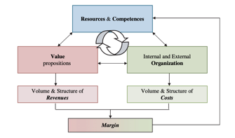
- RCOV model
Source: [Demil and Lecocq (2010) Business Model Evolution: In Search of Dynamic Consistency]

Third is Lean canvas which was proposed by Ash Maurya in Aug 2010. This model is based on the business model canvas, but author claims that this one is better in terms of “its ability to enable more learning”. Lean canvas is adopted for entrepreneurs and some dimensions are changed to consider risks and uncertainty which start ups have a need to meet and respond. The interesting dimensions which were added are solution and problem which has the same idea as value proposition canvas. It is aimed to find out what exactly customer needs and which solution is better suited to their exact pains and desires. The advantage of this framework is that it is constructed by concrete dimensions and enable learning, but the focus is on entrepreneurial activity and product design which does not suit the needs of this work.
Fourth is proposed by Clauss, it has three dimensions: value proposition, value creation and value capture. The first one shows which benefits compony propose to the customers, products and services of company are presented in this dimension. Second is showing the way how company make its product or service which activity and channels of distribution are important to make it. The last showing the revenue streams which company has in other words defines how firms gain revenues that cover cost and achieve profits that ensure sustainable performance. These dimensions are broad and in case of not knowing the business that can be hard to understand the way how business working from reading it presented in the Clauss model. However, there is an advantage as well this model is easy to implement and no questions appear while putting the facts into it.
- Comparison of business model frameworks
Study | Business model | Dimensions | Industry or company | Advantages | Disadvantages
Demil and Lecocq (2010) | The BM encompasses the main areas of an organisation that involve the transformation of inputs into a good/service to the customer. | (RC) resources and competences, (O) organisation, (V) value proposition. | English football club Arsenal FC over the last decade | - Clear interconnection between business dimensions | - No description of clients and the relationships with them.  - Dimensions are too broad  - No need in transformational approach  - Not convenient for vertically and horizontally integrated business  - Not clear where the distributors/customers should be placed
Ash Maurya (2010) | - | Customer segments, Unfair advantage, Channels, Value proposition, Solution, Key metrics, Problem, Cost structure, Revenue stream | Lean start up | - Concrete dimensions  - Enable learning | - Oriented on start-up designing  - Focus on product creation  - Not convenient for vertically and horizontally integrated business  - not clear where the distributors/customers should be placed
Alexander Osterwalder & Yves Pigneur | BM is a tool that encompasses a set of concepts and their mutual relations rendering explicit the operating logic of a given enterprise. | (1) Product – value proposition; (2) Interface with clients – channels and relationship; (3) Infrastructure management – main resources and key activities; (4) Financial aspects – cost structure and sources of revenue. | - | - Concrete dimensions  - Descriptive tool | - Not convenient for vertically and horizontally integrated business  - not clear where the distributors/customers should be placed.
Clauss (2017) | BM | value proposition (to the chosen customer segment), value creation and delivery (value chain architecture), and value capture (revenue streams). | - | - Ease of implementation | - Dimensions are too broad
Source: Compiled from [Fabian Ariel Salum, Karina Garcia Coleta, Dalila Pereira Rodrigues “The business models’ value dimensions: an analytical tool” and Göttel, V. (2016). “Business models: Origin, development and future research perspectives”]
As a result of business model comparison, the most suitable is the one made by Alexander Osterwalder & Yves Pigneur as it has the least number of disadvantages and is a good descriptive tool which cover different aspects of business. Using this model can also be helpful to find out which dimension is mostly affected by adaptation of business model to internationalisation.

1.2 Business adaptation/innovation definition
Business models are often discussed in the context of creation of business, but much smaller number of studies are dedicated to its adaptation especially in the context of entrance to a foreign market. There are two words which are frequently used while addressing not critical changes in business model there are adaptation and innovation. In order to find out the difference between them if it exists it is better to find out the definitions which researchers propose.
In recent years business model innovation process becoming a topic of interest for researchers especially its nature. Business model innovation can be seen as a process of learning and simultaneous building and maintaining performance during changes in a business model. “Several studies characterize business model innovation as a continuous, evolutionary process, and emphasize the role of learning in business model innovation. All parts of business model should be integrated with external environment and relationships with customers and partners. Innovation can be an improvements, changes and extension of an existing model. From such formulation it is clear that innovation is an ongoing process while company changing its processes in order to improve its performance taking into account the external environment factors which has an influence on a company. However, according to Markides innovation is associated with creation of completely new which is going to disrupt whole industry or in response to such proposition from competitors.
Two types of business model innovation can be identified: renewal and replication. The first is about is creation of new model which is not similar to any already existing ones the examples of such models can be Airbnb, Facebook and Uber, business models of this companies disrupted the industry. The second one is adjustments which are made to the already existing business model. Replication is basically about adaptation to a new context where already existing model is not effective anymore. Reasons which lead to business model adaptation can be transfer to another context or change in the current one. For the purpose of work the second type is more relevant as the aim to see how existing company with its model changes under the pressure of a new environment. For the convenience of managers and better understanding in the work the world adaptation will be used with meaning of replication
Operations management is chiefly concerned with planning, organizing and supervising in the contexts of production, manufacturing or the provision of services. As such, it is delivery-focused, ensuring that an organization successfully turns inputs to outputs in an efficient manner. The inputs themselves could represent anything from materials, equipment and technology to human resources such as staff or workers.
Examples of the types of duties or specialist positions this encompasses are procurement (acquiring goods or services from external sources), managing relations with those involved in processes and improving a company’s sustainability with regard to their use of resources.
There are two key terms that can help answer the question of what operations management is more precisely: supply chain management and logistics. Operations management has firm foundations in both areas. For example, understanding global trends in supply chain management in order to meet client demand is often critical. With logistics the careful and considered use of resources, as well as cost-effectiveness, has become increasingly important in an era in which resources can often be in short supply and customer expectations have skyrocketed.
It is crucial to understand the difference between business model and operational management. The administration of business activities to achieve the best level of efficiency feasible inside an organization is known as operations management (OM). It is concerned with efficiently transforming materials and labor into goods and services in order to maximize an organization's profit. The goal of operations management teams is to produce the largest net operational profit achievable by balancing costs and income. The use of resources such as people, materials, equipment, and technology is part of operations management. Operations managers buy, develop, and supply items to customers based on the needs of the customer and the company's capabilities. As a result, the main difference between two concepts is that OM is improving efficiency of delivering value to customer while BM focus on the value itself.

1.3 Transition economies
Emerging market is attractive for companies from developed countries as they provide opportunities such as high growth potential which can decrease the risks of firm according to political and economic situation in home market by diversification risk between several countries. However, it is important to understand that business model which provides a competitive advantage to a firm in home country can be challenged in the emerging one because growth potential is tightly connect with risk.
Several difficulties which are connected with entering of emerging market are highlighted in a literature. First are different institutions (often undeveloped) which play important role for companies born in developed markets as they expect that institutions will function efficient, but the situation varies in developing markets as the rule of the game can be different and the institution itself could not support regulations. Second is the difference of the customer behaviour and needs. For example, even cheese should have different qualities as in France people are used to the fact that cheese can change its smell and even taste in the period from purchasing to the last piece was eaten while in Russia that change can be understood as the product is spoiled. That is why it is important to make changes in other words adopt model to the local needs.

CHAPTER 2: ANALYSIS OF RUSSIAN MARKET

2.1 Case study

Types of network marketing
Amway is a corporation that represents the network marketing model. It's important to note that network marketing firms come in a number of different forms. Each of them has one thing in common: you must express your own view on the company's product. All of them have one thing in common: you must express your own opinion on the company's product. The underlying premise is that traditional marketing methods such as flyers and television or Internet advertisements are not as effective as marketers would want, and customers would still choose to buy something that has been suggested by a friend over one that has been promoted. Network marketing is based on that principle and uses that form of advertising.
The first method of network marketing is single-tier network marketing, in which an organization only requires individuals to sell their goods. This ensures that people must direct consumers to their shop and only be compensated for jobs that they did themselves. Since the company doesn't provide opportunities for potential dealers to hire new ones, people's roles are limited to advertising and selling, and their earnings are solely dependent on their activities. Avon is an example of a business that follows this model. Affiliate services are included in this category as well. The company pays for the traffic that people drive to their website, also known as pay-per-click (PPC) and pay-per-lead (PPL).
Two-tier network marketing is a form of network marketing in which rewards are dependent on the product distribution of individuals you directly employ, on your direct sales (or traffic that an individual drive to a website), and on direct sales or referred traffic made by affiliates or distributors that that person has hired to operate. An example of a two-tier program is Ken Envoy's Site Sell.
The last one is multi-level marketing it is contains two or more tiers. Some MLM programs allow to make money five or more tiers deep, so that is an incentive to recruit. Examples of MLM businesses include LuLaRoe, Magnetic Sponsoring, and Amway. The difference between two-tier and multi-level marketing is often confusing so the main difference is that in two-tier company you are receiving percentage only from purchases of people which you personally recruited while in multi-level marketing you have a percentage from all purchases from all people who whom you recruit and all people who were recruited by them and who were recruited by them and etc., all these people are in your group and etc., all these people are in your group.
In single-tier network marketing, for example, an individual earns money solely from his own efforts. If person A signs a deal with a corporation of this kind (Fig1), he can only earn a percentage from goods that he directly sells, and he will be the first tier. In the case of a two-tiered organization, he will also earn a percentage from the work of individuals B, C, and D, who were all directly hired by A and are all in one rank. And it's likely that the number of candidates who can be directly hired is small. If the number of individuals hired is equal to two, A will only register B and C and will only earn a percentage of the transactions they make.
The number of levels in multi-level organizations can be more than two, but the number of tiers and the number of people hired can also be restricted. If an individual's maximum number of candidates is two and the number of tiers is three, person A is not permitted to hire person D, but will earn a percentage from all those in the second tier, as well as all others in the third: E, G, I, and J. All MLMs have one thing in common: the person who signs a deal with the company gets a discount on all of his sales and will even make money by reselling it at a better price than they paid for it. The sales would be determined by the number of products sold.
A
D
C
B
E
G
F
H
J
I
1st tier
2nd tier
3rd tier
4th tier

- Illustration of tiers for examples
Source: [made by author]
In MLM you have more opportunities some companies still have restrictions, although Amway do not put any, as a result you can recruit as much people as you want, and you receive percent from commodity circulation of all people whom you recruit and all people in your group. In our illustration person A receives percentage from all people from each tier and can recruit as many people as he wants. John R. Sparks and Joseph A. Schenk in their article describe the structure of multilevel marketing organizations and relationships between distributors are well explained. “Sponsors” (MLM members who invite others to join the MLM) take responsibility for their “recruits” (those invited by sponsors to join the MLM) and provide full information about the amount of money that they earn for each amount of work, products and events in order to help person to make stable money. Through their sponsors, recruits can see not only financial benefits, but also see other benefits in their work (Sparks and Schenk 2001). Additional non-economic motivations to work include a friendly atmosphere and emotional, non-competitive, and strongly supportive social interactions, which help to understand the zeal and loyalty participants have for their MLMs.
Now we need to figure out what sets Amway apart from other MLM firms. In order to show all specifies of Amway that we are going to compare it business model canvas with one which is made for multi-level marketing companies in general.
Below there is business model canvas of multi-level marketing companies in general.
- Business model canvas of multi-level marketing companies in general
Key Partners  - Distributors  - Suppliers | Key Activities  - Sustain online platform  - Production | Value Proposition  - Product  - Share of earned money  - Education | Customer Relationships  - Distributers  - Call-center | Customer Segments  - Clients  - Distributors
 | Key Resources  - IT specialists  - Factory |  | Channels  - Distributers  - Official shops  - Website
Cost Structure  - Production  - Human capital  - Delivery |  |  | Revenue Streams  - Sales of companies’ products
Source: [made by author]

History
Richard de Vos and Jay Van Andel tried themselves in several businesses some of them were a disaster while some were more successful. The company, which was found by them, still exists and have an impressive financial result during all years is Amway. It was founded in 1959 and named Amway. Nowadays company is presented in more than 120 countries, it never left a market which they already entered. Amway internationalization on Russian market happened in 2005. The company's activities are not limited to the production and sale of goods. Each buyer can become an independent Amway entrepreneur and create their own sales business. Amway has expanded worldwide and is ranked by Forbes as number 49 of the largest private companies in the United States, with annual earnings of more than $8 billion.

International business strategy
Amway company has a global international business strategy. This means there is no adaptation of product to a local market and absolutely same products are sold in all countries. The adaptation of model is more about the company interconnection with clients and IBOs. In the interview with deputy of regional management it become clear that major decisions are made by top managers and local ones do not have much freedom to make new initiatives. All monetary payments are implemented by senior management, but regional one can decide to make discounts and sales for some product positions. Although local managers do not have power to influence the prices, they can launch projects connected with improve of work for IBOs and services with clients. Example provided during interview is the decentralisation of decision making according support of IBOs at regional level.

Amway business model
In order to make it easier to understand it is important to know that Amway company is vertically integrated and both canvases are describing all activities from plantations to distribution. Although, some of each part is done by other companies or by IBOs in case of distribution.

- Business model canvas of Amway

Key Partners  - Independent Business Owners  - Educational companies  - Production | Key Activities  - Sustain online platform  - Production of ecological friendly products  - Sales | Value Proposition  - High-quality product  - Share of earned money |  | Customer Relationships  - Independent Business Owners  - Call-center | Customer Segments  - B2C  - B2B  Amway perspective  - Customer  - VIP client  - VIP + customer  - Amway Partner(IBO)
 | Key Resources  - Online platform  - Science lab  - Factory |  |  | Channels  - Independent Business Owners  - Official shops  - Website
Cost Structure  - R&D  - Production  - Human capital |  |  | Revenue Streams  - Sales of Amway products (IBOs, Company owned channels)
Source: [made by author]

- Customer segments
Amway divided their clients into groups based on their level of interest in the business and the amount of money they spent. There are many types of customers. Amway cleaning fluids are aimed at the consumer market at first, but they are very concentrated, which is why some of them must be diluted with water, while some need much less in comparison to comparable products. This has an impact on prices, but the condition is that prices are higher, but it is used for a much longer period of time. People who are looking for a low price as well as those who are unwilling to change their behavior cannot be Amway customers. The change in purchasing behavior is needed due to the fact that there is only one physical store in the city where an order can be made, but there are also options for home delivery that can be used. While the former type of products is open to all, others are described as luxury goods and have corresponding costs, as a result buyer segment varies, target market comprises customers who want to get a high-quality goods and can afford it.
The second consumer category is B2B; although it is illegal to resell company products in regular stores, it is permissible to use company products. A restaurant owner, for example, may buy pots, a mixer, and cleaning fluids to cook and clean with. Under this case, the consumer will save money because dishwasher detergent and liquid are less expensive than most products of comparable nature.
Furthermore, where there are many restaurants, it is likely to receive compensation.
Amway splits their clients into many divisions, and the discounts and paybacks differ depending on the segment.
The first are those who want to use high-quality, environmentally friendly, and effective materials. They are concerned about their health and/or the environment, and they want to save money because Amway goods are less expensive than other high-quality products.
The second section consists of individuals who sometimes resell Amway goods and will benefit from this; this is income that will disappear as soon as they stop selling; in fact, this individual works as any other distributor and earns on the difference between the cost of the product and the price of the product. which he/she sold and the money earned from customers
Last group wishes to become a partner with the business to gain consistent money; Amway proposes signing a deal between the individual and the company that requires the company to pay for the product turnover that the person would create. An individual who signs such a contract is referred to as an Independent business owner (IBO), and he receives a percentage of all sales made by people to whom he has suggested Amway goods.

Customer
A customer is someone who purchases goods for himself and his house. The company provides such customers with a wide range and flexible conditions for obtaining products, delivery, thematic events and master classes in shopping centers. To begin using Amway items, you must first register on the Company's website or at the Amway Center's self-registration desk easily, without providing any passport information, and make your first payment within 30 days. If the purchase is not completed, the Client must re-register after 30 days. A customer purchases product at a client price, and there is often a scheme of discounts on the first purchase.

VIP client
The Account enters the VIP client group after making a total of 10,000 rubles in purchases. A VIP customer is a devoted customer who purchases goods for himself but is unable to recommend them to his friends and associates. The organization does not restrict the time it takes to change to VIP status; you can purchase goods for this price in one day and get this status right away. VIP client gets a big discount on goods.

Amway Partner or individual business owner (IBO)
Amway Partner is a partner of the Company, a client in the status of Self-Employed / IP / LLC, who chose for himself the opportunity to build a business and earn money with Amway. Amway Partner can advise customers on products and develop a partnership network by conducting training and motivational events. To cooperate with the Company in this category, it is necessary to conclude an agreement. Amway partners (IP, LLC) need to pay a registration fee of 500 rubles. The service fee of 500 rubles is annual for all Amway Partners, including the Self-Employed. Amway Partner receives discounts on product purchases, active discounts, Amway Plan rewards, and incentive rewards.
- Types of customers
 | Customer | VIP client | Amway Partner
Description | - Buys for himself  - Cannot recommend to friends  - Does not resell | - Buys for himself  - Cannot recommend to friends  - Does not resell | - Builds a business with Amway  - Develops affiliate network  - Conditions
Conditions | - First purchase in the first 30 days  - No points are awarded  - At least one purchase within 12 months to maintain the status | - To switch to VIP status, make personal purchases on 10,000 rubles  - To maintain the status, make personal purchases totaling 10,000 rubles per year  - No points are awarded | - Entering into an agreement with Amway  - Submission of documents within 30 days  - Registration fee 500 rubles (for IP and LLC)  - On-line training course and test  - Annual service fee 500 rubles  - Points are awarded
Benefits | - Simple free registration without passport data  - 15% off Amway products  - Discount for first purchase  - Promotions | - Auto Transition from client status  - 23% discount on Amway products  - Promotions | - 23% discount on Amway products  - Amway’s Sales and marketing plan  - Rewards for additional incentive programs  - Active discounts
Source: [made by author]

- Value proposition
The most important thing that company proposes is its products which even have voluntary certificates and international certifications which guarantee the quality, that is the main distinction from many other producers. For people who decided just to use product that is the confirmation of the rightness of their choice.
This consideration also ensures IBOs that they are recommending a high-quality product to relatives and associates and that their clients will enjoy using all purchases and will not suffer any harm as a result of them.
The company's product portfolio ranges from household cleaners to cosmetics. There are several brands.

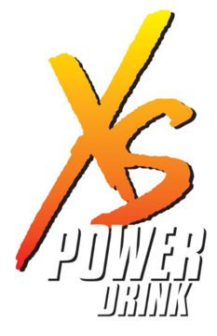

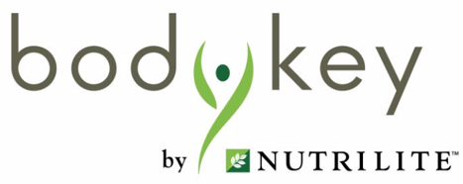


- Brands of Amway

Source: [made by author]

Artistry is a line of women's skincare, lipstick, and fragrance accessories.
Hymm is a men's merchandise line that includes shampoos, shavers, shaving cream, and other products.
Amway home includes all chemicals used to scrub the house, wash clothing, and do the dishes.
Icook is a company that sells pots, skillets, and blenders.
eSpring is a type of water filter.
Nutrilite contains proteins, minerals, and phytonutrients, both of which are referred to as biologically active additives.
G&H offers a wide range of body care items, including gel, creams, lotions, and more.
Bodykey consists of food bars and protein.
Glister connects all things used to brush teeth, such as toothpaste, dental floss, and so on.
Satinique refers to all hair makeup, including all washing and styling products.

Second thing that company propose is to share the earned money with VIP+ client and Amway partners. It is possible if person satisfy all conditions to have that kind of relationships with company.
For those who has a desire to earn money company also gives:
- Retail margin from every Amway product you sell.
- Bonuses calculated from your business growth.
- Incentives rewarded as you reach key milestones in your business.

- Revenue streams
The company makes money by selling its manufactured goods, which include a wide range of cosmetics, both decorative and treatment, supplements and biologically active ingredients, and household cleaning products such as dish soap and washing powder. This is Amway's primary source of income.

- Channels
The main channel is an online store where customers can buy anything they want and get it delivered to their house. There are physical stores in some markets, like Russian, where people can purchase goods. Delivery is also open to all, but in certain areas and markets, it is free if the order exceeds a certain amount. Independent Business Owners will also purchase it for their clients and deliver it, but only if they have the desire to do so.

- Customer relationships
Independent Business Owners provide information about Amway’s plan rewards payment scheme and product characteristics, they answer questions which appear and give consultations on order to help people improve their earnings. There is also call-center which is aimed to answer questions about website, solve any problems with orders and etc.

- Key activities
The company is continuously working on inventing new technologies and formulas to improve the quality of product which they sell, this fact helps them to improve the loyalty of customers as they always know that they have goods which were worked out by science workers and almost all products of Amway have patents which were invented by them.
It is important for Independent Business Owners to that Amway's plan incentives is clear in order to increase their profits faster. Furthermore, the stability is critical because people do not want to risk losing savings in a single financial crisis. The stability is dependent on the company's internationality, as it can maintain one market by sales in others, and Amway has never left any market during its entire lifetime.
Products are made from natural ingredients, mostly grown on the plantations of the company’s own farms, Amway do not use pesticides, chemical fertilizers and plant growth regulators.
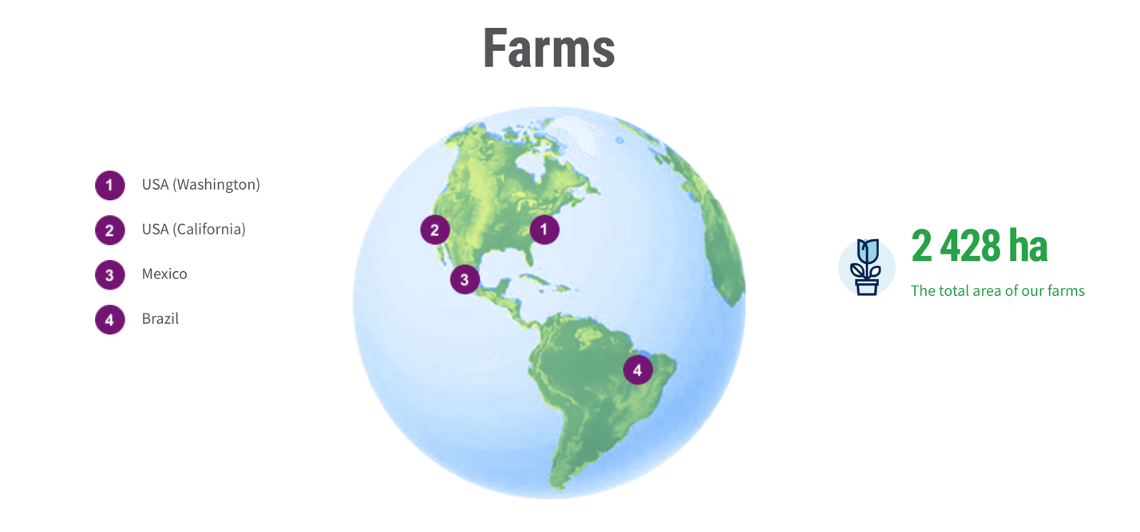
- Farms of Amway
Source: [official website of Amway company]

18 plants, which are owned by Amway, are manufacturing product worldwide and companies from fortune 500 in USA have contract for production
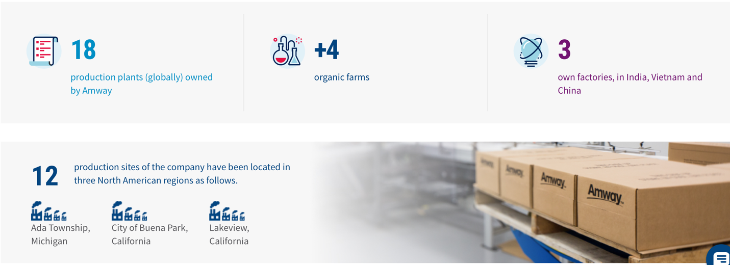
- Information about production
Source: [official website of Amway company]

- Key resources
Amway holds over 800 patents as a result of its scientific lab, which is constantly focused on inventing new technologies or developing ones that already exist. Amway also has its own plantations that do not use pesticides and instead rely on eagles and ladybugs to keep insects and rodents away.
Factories and plantations are important assets for a company as that gives a possibility to control all processes and ensure that quality of product.

- Key partners
Independent Business Owners are key partners as they make tight relationships with customer which helps to make them loyal and return to Amway shop. Moreover, Independent Business Owners know the difference between Amway’s product and others and tried everything themselves that helps to share their own experience and emotions not just provide a formal description of ingredients.
There is a businesse that keep education going, named Network21, and it works in collaboration with Amway. Its goal is to exchange knowledge of IBO from different structures in order to maximize outcomes. It is even useful if an individual lives in a different town so there is still potential to learn and improve knowledge even yourself. Network 21 hosts a variety of meetings ranging from large to small in size. Speakers include IBOs, Amway bosses, and consultants who discuss new bonuses, new technologies, and their background in the industry.
Outsourced companies are also essential, as product quality is critical for company image. The company only purchases raw materials from plantations that do not use child labor, slaves, or do not pay a salary to people.

- Cost structures
To achieve better results in scientific labs, companies spend a lot of money on R&D, which forces them to adopt manufacturing facilities for introducing new technologies. As Amway has strict quality standards, all ingredients must be in their finest condition, which raises the cost structure. Amway does not sign contracts with businesses that employ child labour or unnatural pesticides on farms. Additionally, over the last seven years, Amway has spent $335 million in new manufacturing and R&D facilities throughout the Americas, adding one million square feet to their plants in Michigan, California, and Washington.
Human capital is quite costly as well as Amway pay for employees such as managers, consultants, operators of call-center all workers in plants, scientists and to IBOs.
The main Amway distinction is a high-quality of product and a wide range which it can offer to clients.

System of compensation

Sales and marketing plan (plan of Amway)
Repayment scheme which Amway provides to its IBOs is called Amway’s Sales and marketing plan which was not change from the day of establishment of company 60 years ago. That shows the stability of company and ensures IBOs that they will receive money which they deserve, it is also important that Amway always did payed all repayments and bonuses in time without any delays or cancellation. The only thing to change was the equality of bonuses (PV) which IBO receive to amount of money. Sales and marketing plan brings the biggest revenues to IBOs in comparison to all others monetary programs. It is also distinguish Amway from all others as most of MLM companies do not pay to each IBOs individually, it is often practise that they pay money only to the leader of the group and then he distributes them to all group members.
The amount of money which Amway pays to its IBO is calculated monthly by the following scheme.
- Plan of Amway
% | PV
3% | 200
6% | 600
9% | 1200
12% | 2400
15% | 4000
18% | 7000
21% | 10000
Source: [official website of Amway company]
%- shows the % which IBO receives for the commodity turnover which he and his group made for that month. It also shows ”level”
PV- are points which person receive each time when he purchases any product in Amway store.
PV=100rub while you buy
PV=84rub while counting money which you earned, as there is a need to pay a % to a government from the price of product as VAT (Value added tax in Russia)
In order to understand which percent person receives it is needed to summarise the purchases of all people in his group in PV.
There is a formula which is used to calculate earnings:
Number of PV made by group x 84rub x difference in the percentage between you and leader of a group
IBO also receive cash back for their own PV and from purchases of registered clints. In order to calculate this the following formula is used.
There are several examples which is aimed to help how this work on practice
Number of PV made by IBO x 84rub x percentage which IBO have
Number in the circle is an amount of PV which person made.
Number above is the percentage which IBO receives.
In the red circle the person itself is represented, then in others colours there are different groups. The revenue is calculated by summing up of revenue from each group
3%
3%
6%
200
200
100
100
- 1st example of structure to receive repayment from plan of Amway
Source: [made by author]

1)200x84x6%=1008rub- revenue from individual and clients purchase
2)200x84x(6%-3%)=504rub- revenue from green group
3)200x84x(6%-3)=504rub- revenue from blue group
Overall:2866
9%
6%
3%
3%
200
100
200
200
200
100
100
100
100
100
- 2nd example of structure to receive repayment from plan of Amway
Source: [made by author]

1)200x84x9%=1512rub - revenue from individual and clients purchase
2)700x84x(9%-6%)=1764rub- revenue from green group
3)400x84x(9%-3%)=2016rub- revenue from blue group
4)100 x84x9%=756rub- revenue received from registered client which are calculated by the same formula as from the purchases of IBOs himself
Overall:6898

In case when IBO and the leader of one his group both have 21% return, IBO receives 6% as a leadership remuneration each month. In case that more than one leader achieved 21% of payment, than IBO receives 6% from each group.
21%
21%
3%
21%
200
100
10000
10000
200
100
- 3rd example of structure to receive repayment from plan of Amway
Source: [made by author]

1)200x84x21%=3528rub- revenue from individual and clients purchase
2)10000x84x6%=50400rub- revenue from green group
3)10000x84x6%=50400rub- revenue from blue group
4)100x84x21%=1764rub- revenue received from registered client
Overall:106092

2.2 Adaptation
In this section the information from interviews and email letters which include news from company are used for changes identification and description. Changes timeline was divided into for parts at first is pre-enter, the rest parts were divided in periods which also shows the economy situation in Russia: Growth, Crisis, Covid. The same logic was used for factors. In factors part the aim is to find out internal and external factors which had an influence on company and which was a cause for changes.

- Timeline of changes

Source: [made by author]

Pre-enter
Amway company has an unusual way to enter the foreign market since the product appear in the market not as a result of activities and decisions to internationalize to foreign country, it happened thanks to the activity of IBOs. IBOs of company is not a distributer which we are used to know their activity is much wider than selling products and be nice with clients. Among other responsibilities there is an entrepreneurship activity. And as entrepreneurs IBOs take the product from the market where Amway already officially enters to the new market, they organize logistics and support all needed activities to find new clients. It is often practice that they continue to search for new IBOs and loyal client. From technical side they are signing contract in the already opened market and receive all money earned from Amway directly. Such entrepreneurs can lead business for several years on new market and the leaders of the group who has a meeting with Amway management while proposing the improvements rise a question of entering the market. As a result, while company decide to enter a market there is already a big number of loyal customers and people who are interested to become an IBOs officially on their own market. This situation is unique as Amway product is already in the market while compony itself did not contribute in internationalization at all.
Such entrepreneurial activity has a great influence on new market in term of IBOs activity. It can be easily explained because there is only one requirement for IBOs is to be at least 18 years old or officially adult that involve that people do not specialize in the activity which is needed to be a successful IBO, in plus their background, experience and skills vary significantly. They need to learn and have a mentor who will guide them, this person is the IBOs who decided to enter foreign market as there are no one else. New persons get all his knowledge who have an experience which is used in other market and as no one really knows what is like to be an IBO and what skills and knowledge are needed, team in new market duplicates practices which are used by person who entered market. In the case of Russian market IBOs from Ukraine market was the ones who entered new market while in its turn Russian IBOs entered Kazakh market.

2005-2013
During this stage Amway company officially entered to Russia. In some markets including Russian there are also physical store to which people can go and buy products. The delivery is also available for everyone, but in some regions and markets it is free of pay if your purchase is more expensive than some fixed sum. Sometimes Independent Business Owners can buy it for their customers and deliver, but they do that only in case if they have a desire to do that.

That is why during this period company was working on the increase of available products. At first, only chemicals for house was available, in time care and decorative cosmetics, vitamins, water filter and dishes appeared. The range of product was widened. Nutrilite brand made a new product which include all basic vitamins, minerals and phytonutrients which are needed to support the needs of body. The cosmetics brand in its turn was wholly renewed and all positions were replaced with new one with better formula.
The YouTube channel was made in these years but was not in priority for company as the number of videos posted are quite low.
New regional business development and sales managers
One monetary incentive was made, but in time were cancelled.

Active Discount Program
From each purchase in the amount of 200 PV in the current month, client get a discount of 1000 rubles for purchases in the next month. Personal and customer points are taken into account.

2014-2019

Monetary Incentives
All monetary incentives described below were implemented all over the world including Russian Federation.

Progressive discount scale
Is a scheme by which discounts for next purchases are calculated for the people who are in the category VIP + client. The same formula and logic as in sales and marketing plan is used there, but instead of PV of IBOs there are PVs of clients and VIP clients.
- Progressive discount scale
% | PV
3% | 200-599
6% | 600-1199
9% | 1200-2399

Source: [official website of Amway company]

Active Discount Program
From each purchase in the amount of 100 PV in the current month, VIP+ client get a discount of 500 rubles for purchases in the next month. Personal and customer points are taken into account.

Tell A Friend Program
This is another program which launched for VIP+ clients, it works until the December of 2020. If you talked about Amway products to your friend, who became an Amway VIP client, you will receive a discount of 500 rubles for your future purchases for each new friend. It is limited in time from the beginning, but it was working for a long period and ended in 2021.
Business plus
There is new program which is called Business plus which is aimed to increase interest of IBOs to grow their business and introduce additional payments for their work. This is an diversified program which provide additional discounts for VIP+ clients and increase revenue for IBOs.

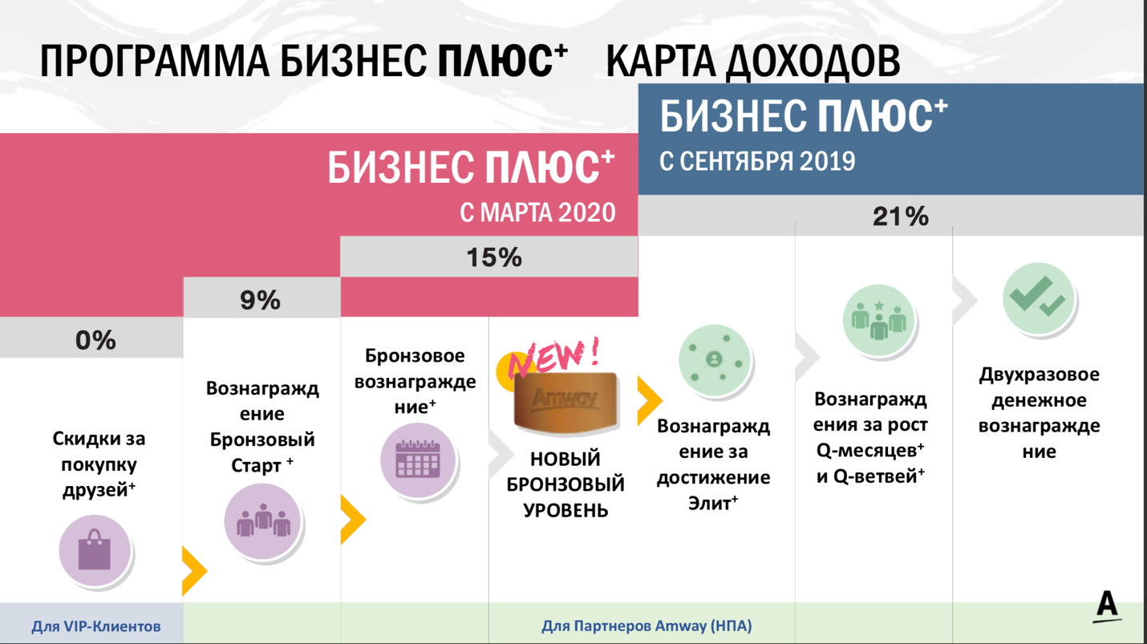
Program business plus

Business plus from March 2020
Business plus from September 2019
Discounts from purchase of friends
Bronze start
Bronze award
New bronze level
For VIP+ clients
For IBOs
Reward for achivement Elit
Reward for growth Q-months and Q-groups
Double cash reward
- Program “Business plus” depending on the %
Source: [official website of Amway company]

Discounts from purchase of friends

The VIP+ clients receive bigger discounts from the purchases of clients and VIP clients, the discount is calculated by the following scheme.
- Discounts from purchase of clients

Discount from Progressive discount scale | Discount from purchase of clients | Overall
12%( plan of Amway) | 0% | 12%
9% | 1% | 10%
6% | 4% | 10%
3% | 7% | 10%
0% | 10% | 10%
Source: [official website of Amway company]

In case when person have 0% from progressive discount scale, he would not receive discounts from purchases of his friend, but due to the implementation of this program, there are 10% from purchase of client which VIP+ client receive as a discount.
0%
0%
0%
20
79
100
- 1st example of structure to receive discounts from purchase of clients
Source: [made by author]

In the case which is represented in the Fig.11 the discount equals to 10%.
The
1)(100+79)x10%x84=1503rub-discount from business plus program

- 2nd example of structure to receive discounts from purchase of clients
From several clients
From several 0% VIP+
6%
100
200
300
Source: [made by author]

In 2nd example (Fig.12) the discount is 10%-6%=4%
1)100x84x6%=504rub- discount from purchase
2)200x84x6%=1008rub-discount from purchases of 0% VIP+
3)200x84x4%=672rub-discount from business plus
Overall:3696 rub

Bronze start

Requirements for participation is to have 9% level or higher, at least 3sponsored friends who are on 3% level minimum and 200PV made by yourself. Remuneration for a month is increased by 25%.
3%
9%
3%
3%
100
200
200
200
400
400
From several clients
From several 0% VIP+
- Example of structure for Bronze start
Source: [made by author]

1)500x84x9%=3730rub- revenue for own purchases and purchases of clients
2)(200x84x(9%-3%))x3=3024rub-revenue from all groups
3)400x84x9%=3024rub-revenue from purchases of several 0% VIP+
Overall:9828 without business plus program

From business plus
400x84x1%=336 rub -remuneration from purchases of clients
9828x25%=2457rub-Bronze start

Overall:12621rub+2500rub of active discounts

Bronze award

Requirements for participation is to have 15% level or higher, at least 3 sponsored friends who are on 6% level minimum and 200PV made by yourself. Remuneration for a month is increased by 35%
- Example of structure for Bronze awards
C.3%
9%
A.9%
B.9%
200
200
200
200
400
400
From several clients
From several 0% VIP+
600
From 3 3% VIP+
Source: [made by author]

1)600x84x15%=7560rub- revenue for own purchases and purchases of clients
2)1200x84x(15%-6%)=6048rub-from A structure
3)1200x84x(15%-6%)=6048rub-from B structure
4)200x84x(15%-3%)=2016rub-from D structure
5)400x84x9%=3024rub-revenue from purchases of several 0% VIP+
6)600x84x12%=6048rub-revenue from purchases of several 3% VIP+

Overall:30744 rub

From business plus
1)30744 x25%=7686rub-Bronze start
2)30744 x35%=10760rub- Bronze award
Overall:49190 rub

Non-monetary

It also became possible to register not like individual entrepreneur, but also like self-employed for ones who want to become an IBOs. This possibility brings benefits in terms of tax payments.

Nearly 4 years ago Amway also tried to hire consultants which can help with choice and make recommendation, but they did not stay for a long time as IBOs, who comprise the biggest part of buyers, knew much more about product then consultants and often correct them.
In some markets including Russian there are also physical store to which people can go and buy products. But the shop was completely changed. Previously there was only shelves with products and cashier. After company opened a new kind of shop called My Center Amway. There are not only products displayed, but also a space where it is possible to have a business mattings and master classes. For the second there are several zones which equipped for different types of master classes. First is culinary where all products related with cooking like pans, water filter are available. Another space has a smart weigher which shows how much internal fat is in body among another indicators. This helps to find out what is happening in the body, so right vitamins can be chosen. Third one is dedicated to cosmetic procedures where special machine is available, it helps serum to go deeper in the skin. All rooms can be booked by any IBOs for an hour. Moreover, there is a Phytocafe where shakes with power drink or protein can be purchased.

Change of general manager to Irina Menshikova.

The company changed the design of its website and made a single database for all previously separated by markets websites. This took quite a long time and for months after launching there were still bags, which made the work of IBOs more complicated. The design become more convenient for work, but not so for clients as you need to know the brand to find a product, this can be hard for new client.
VIP + client was added as one more additional way of relationships with company. That category appeared to increase the number of benefits which customer can receive.
Benefits for the VIP + customer
VIP Client can get VIP + status, for this you need to go through online registration with the provision of passport data. The VIP + client also buys products for himself but can recommend the products to his friends and acquaintances, helps them become customers of the company and receives additional discounts on privilege programs. The VIP + client receives a large discount on purchases of goods and a discount account to which he receives all discounts. He receives discounts on the loyalty program, active discounts, discounts on purchases of his friends, and can also participate in promotions. To confirm the status of VIP +, it is necessary to make a personal point purchase and participate in the loyalty program (at least one customer purchase) within 90 days after registration. In order to maintain VIP + customer status, it is necessary to make personal purchases totaling 10,000 rubles and participate in loyalty programs in 12 months.
In 2016, XS brand appeared during these years all over the world as Amway purchased a new brand. XS is a line of power drinks which contains various types of vitamin d and do not contain sugar.
In 2017, the company launched production of the G&B Baby product line in Russia.
Free education for registered clients and IBOs were launched in this period. The videos and tests appeared in the official website and can be seen only in case of log in. At first some topics related to products such as vitamins and cosmetics were launched. In vitamins part the lectures explain which functions each vitamin have. In cosmetics different rules for make up and correct usage of care products were explained. Then the digital topics appeared, presentations were dedicated to explain how make social media more attractive, it has its own name Digital Lab and experts who succeed themselves are often invited. Rubilix, it is sustaining the online education of people.
Creators is a program which is a new way to work with young generations who work online and it unite all young IBOs of Amway. Its aim is to double the number of young IBOs by 2025. It already has results. Increase of purchase by 50% in Russia.
It includes Digital way which is tools and instructions which can be helpful in the first steps to build a business.

2020-2021
This period experienced big changes due to the need to go online as a result of coronavirus.

One of the changes which company experienced is the increase of prices in Russian market that is planned to happen on 16 March 2021 and be equal nearly 4%. This also affect the PV which will be 88 rub.
Amway do support the activity of the leaders and email to its clients the events, marathons and master classes among them there is a detox program which was developed by one of the IBOs and provide discounts for the related bundle of products. The events are free, but in order to become a participant, you need to make a purchase of minimum required number of products. This is a requirement as the program itself is built in the way that it relies on the effect which vitamins, nutrition and protein give. Another program that company support are master classes which teaches IBOs of social media marketing basis. For instance, the topic of personal brand was discussed with an expert who is a founder and strategic director of digital agency.

The company itself did change a lot, Amway launch seasonal discounts as well, for example, in winter the bundle of vitamins to strengthen immunity which include vitamin C, D, echinacea. The unique propositions were made by company exclusively on Russian market. It was Black Friday discounts up to 50 % for whole week. This is unusual and never happened before, Black Friday is a discount day which originate from USA that is why this event became more interesting as this discount was only in Russian territory. Products from different categories participate in the promotion, but not all and limited in amount.
Speaking about marketing, emails from company appeared, it contains not only information about discount, but also a simple explanation how this vitamins work. Second, on its YouTube channel named Amway Today they introduce new launched product where Irina Menshikova - Managing Director of Amway Russia, Kazakhstan, Ukraine participates as well as specialists. Lots of others events are broadcasted in this platform all news can be found there and the master classes organized by Amway as well. The educational platform Rubilix became a platform where the recording of some of events are available. The Instagram account became more active as well lots of master classes are broadcasted there, and even advertisement from celebrities were bought. For example, Tina Kandelaky made a post with vitamins.
TikTok account was launched recently. Company sees its mission as “Tell about Amway and share that here you can find like-minded people who love what they do, enjoy life and earn money!”. In the account, they are going to tell about the life of young and active Amway partners, as well as showing to the audience products and benefits of the NUTRILITE, ARTISTRY, iCOOK and XS brands, while following the trends and participating in challenges.
Amway has become the general partner of the Family Council national forum organized with the support of the State Duma of the Russian Federation. It became possible to become a member of this forum. Family Council is 5 thematic online sessions that will take place during 2021. Each session is a conversation among representatives of government, business and non-profit organizations on one of the topics that worries every Russian family. The best experts in the field of healthy lifestyle, sports and medicine will gather to discuss the most pressing issues of maintaining health. How not to get sick? How to improve immunity? Should I be vaccinated? How to protect your family? What sports to do? How to deal with stress and burnout?
The charity of the company is also changing the new “goodbutton” was added to the website. Now it is possible to make charity while making order by choosing the sum and paying by card. All the money will go to the program “Responsible for the future” which aim is to make world cleaner.

The questioner was sent to clients and IBOs where it is possible to give feedback on the work of local employees and actually change a situation and help company to see weak points and improve. Although, the time for complete is strict, last time it was 10 days.
The production of some product lines was started in Russian territory. This includes XS and some products from P&G.
Recently, Amway launched new initiative to sell product on marketplaces which is contradictive to the main principle of company as still it is impossible to buy product in the official shop if you did not register on the website. For now, only description of products appeared, it is still impossible to make purchases. The company explain such decision in the way that products of company appear on marketplaces unofficially, so while doing this company make a contract which will make it the only provider for Ozon

Clauss business model
This business model helps to track which adaptation influenced which dimension of BM. The same model was used in the work “The role of home market context in business model change in internationalizing SMEs” and the changes such as Sales and support in new market; marketing in US and development in Russia and etc. are seen as changes to business model. As a result, the adaptation of company which was implemented in Russian market also can be seen as change of business model. The model proposed by Clauss will be used to make conclusion which dimension were influenced mostly from the company internationalization.
- Clauss model for Amway

Value proposition | Value capture | Value creation
High-quality product:  - Increase range of product  - New vitamins set  - New assortment of cosmetics  - XS brand appear | Sales of Amway products (IBOs, Company owned channels)  - Increase of prices | Independent Business Owners  - Support for IBOs events  - Creators
Share of earned money:  - VIP+ client  - Active discounts  - Monetary incentives  - Self-employed  - Education | Rental payments  My center Amway | - Official shop  - My center Amway
- | Hr costs | Website:  - Change of website
- | Production costs | Sustain online platform
- | - | Production of ecological friendly products:  - Local production
- | - | Sales:  - Marketplace
- | - | Science lab
- | - | Shop
- | - | Brand image:  - YouTube channel appeared  - Family Council  - Charity  - Marketing
- | - | HR policy  - New managers  - Consultant  - Change of general manager

Source: [made by author]

From the table 9 above, it is clear that the most of changes made influence the value creation of the firm, then is a value proposition. The least change dimension is value capture, but new revenue stream appeared. This is money which are paid as a rent for rooms which are equipped to make master classes and business meetings.

2.3 Factors identification

Country level

CAGE for Russia
Is a tool which helps to understand the differences between countries not only in geographical perspective, but also cultural, administrative, economic ones. All of them influence internationalization of company and should be taken into account while adaptation. In our case the comparison Russia and Uzbekistan is needed, the specifics of Russian. Market are presented below.
- Cage framework for Russia

Cultural | Geographical
- Hofstede dimensions  - Language  - Ethnicity  - Religion | - Time  - Climate  - Water boundaries
Administrative | Economic
- Currency  - International trade organisations  - Corruption  - Democracy  - Court system  - Ease of doing business  - Heritage | - GNI  - GDP  - PPP  - Income  - Unemployment rate  - Income distribution
Source: [made by author]

Cultural differences

The Hofstede framework is a tool which can be used to analyze cultural differences. From the picture below, characteristics of Russian market is clear. Each of them is explained in more detail.

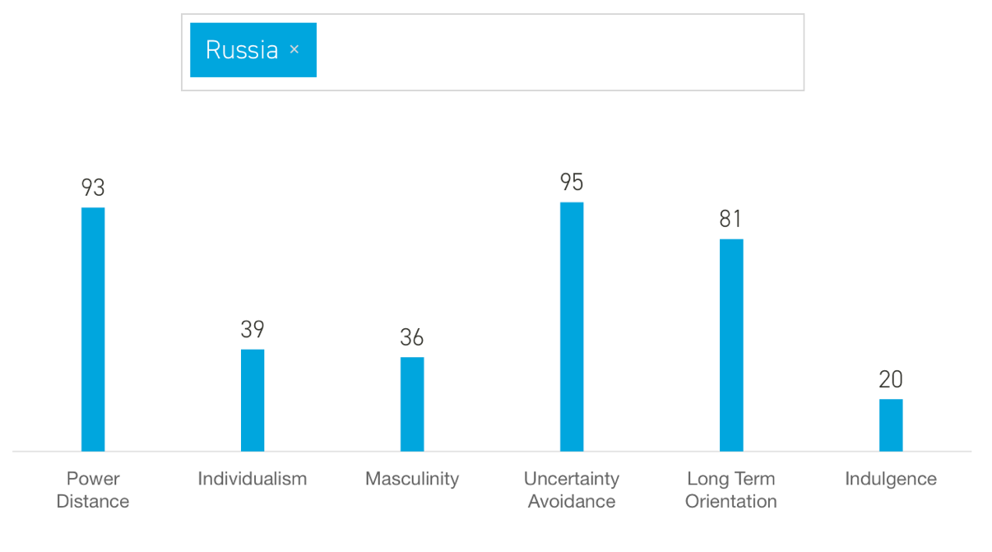
- Hofstede dimensions

Source: [website Hofstede insights]

Power distance is great in Russian Federation that means it is important to follow the instructions of the boss and it is not possible to disagree with any decision made by a person who is higher than you in the organizational hierarchy. Clear and straightforward instructions for accomplishing a task are usually given. While communicating with a potential partner it is important to show your respect in case the person's job title is higher in organizational hierarchy than yours.
Second, the individualistic parameter is low in Russia which implies that there are features of collectivistic society. Local people sometimes are ready to behave in the way that society will benefit and have a higher preference for belonging to a larger social framework. The decisions can be influenced by the opinion of one’s family or work group. Relationships play role in hiring, promotion decisions and applied to contract making process as well.
Third, Russian people are less impulsive and control their emotions that can be seen by other cultures as non-emotional or cold society.
Finally, Russia is more long term orientated and more uncertainty avoiding, contracts for a longer period should be proposed to them. For the former it means that citizens of emerging economies do care about others more in comparison to the countries with lower score. For latter risk projects won’t be welcomed and it is better to propose something that does not have big risk to future partners. However, there is one dimension where the difference is not that significant, it is masculinity so all of considered countries are result oriented.
There are several more differences which must be considered. Speaking about languages each country has its own, in Russia this is Russian. Second, the ethnicity differs a lot for each country. Russians and Ukrainians make up the majority of the population in Russia, 77.7%. Belarusian represent a significant part. In Russian Federation of Russia minority are Tatar, Ukrainian, Bashkir, Chuvash, Chechen. Third is religion
Orthodox Christianity and Roman Catholicism are the most prevalent religious affiliations in Russia. An interesting point that the majorities believe that the faith in God is important to being “truly Russian”.

Administrative differences

Currency in Russia is called ruble. For American company that means increased risks as it will depend on the fluctuations in currencies exchange rate. One more fact is that USA does not entered any international trade organizations where post-Soviet Union countries presented except WTO which regulates general rules of trading and do not provide any benefits such as lower import taxation.
Transparency index for Russia is 30 where 100 is very clean and 0 is highly corrupted. There is a democracy, but despite of this fact in Russia the same president rule country for much longer period and the election process is not by choosing the representative, but each citizen gives it vote directly for candidate on president post.

- Administrative differences
Indicators | Russia | Uzbekistan
CPIA transparency, accountability, and corruption in the public sector rating (1=low to 6=high) | - | 2,5
Ease of doing business index (1=most business-friendly regulations) | 28 | 69
Heritage | 61,5 | 58,3
Source: [made by author]

Ease of doing business ranked countries from the easiest to the hardest to do business in following way that Russia received 28 while the 1 is most business friendly. Heritage score shows the economic freedom of the country putting Russia in a better half with bigger economic freedom

Geographical differences

Climate is specific in Russia where winter is much colder and cities are used to snow. That also influence the business since transportation of products will require special equipment that protects some products from cold and unforeseen weather conditions such as blizzard can postpone the delivery. Geographical size of territory is much greater than any other country, to be more specific Russia is 17,130,000 km².

The country is not surrounded by ocean, access only form North and ships could not be used to deliver goods from one city to another. In plus there is no such cold winter so rivers are not frozen and this type of transportation could be used during whole year. However, in post-Soviet Union territory shipment can be chosen only during warm period which starts and ends not in a fixed date. The territory itself does have a long water boundary which are located mostly in the South. The river system has the same issue and large cargo ships do not have enough space to go throw them. Moreover, road map does not cover whole territory and its density does not satisfy the needs to freely and easy transportation as already exciting roads which connects cities except the largest one is not of best quality. This facts affect the time needed to get from one city to another and while considering this mean of transport it is essential to understand that it will take more time.

Economic differences

In the table below the main indicators of financial well-being are presented.
- Economic indicators

Indicators | Russia
Unemployment rate | 4,43%
Gross national income per capita | 11,216$
GDP per capita | 29,181$
Purchasing power parity | 24,82
Income | Upper middle
Income share held by highest 20% | 29,9
Income share held by lowest 20% | 7,1
Population growth (annual %) | -0,1%
Labor force(thousands) | 72,025
Source: [made by author]

From the table above, it is clear that unemployment rate is low in Russia and is 4,43% while labor force is 72,025 thousand people which means nearly 3,190 thousand of people are unemployed. Out of the numbers showing a distribution of income between wealthy and low-income citizens it is clear that in Russia the difference in wealth of people with highest income and with lowest is sagnificant. It is important to remember that there is much less people who has high income while the latter group consists of much more greater amount, the 1% of population owns a third from wealth, taking this fact into account the income share held by highest 20% is 29,9% while it is only 7,1% held by lowest 20% altogether. This information tells us that gap between poor and rich is great. However, in comparison with other countries Russia still were put in the group of countries with upper middle income. Population is decreasing in Russia which implies that the number of potential consumers decrease.
GNI and GDP per capita shows a general wealth of the country these indicators are 11,216$ and 29,181$. Purchasing power parity calculated shows that in Russia people have upper middle income in comparison to other countries, as a result citizens have more money to spend. Salaries in Russia are lower that is attractive for American companies as they can pay less to their employees on emerging markets and still be a company of interest for the job seekers. It adds one more advantage of the internationalization in these countries.

PESTEL for Russia
- PESTEL analysis of Russia

Political  - International trade organisations  - Sanctions  - Special Investment Contracts  - Foreign Investment Advisory Council  - Agency for Strategic Initiatives  - Natural resources  - Investors rights | Technological  - Internet availability  - Restricted online freedom  - YouTube  - Ozon
Economic  - Exchange rate  - Inflation  - Purchasing power | Environmental  - Standards for utilization
Social  - Decrease of population  - Healthy lifestyle  - Education | Legal  - Tax policy (geopolitical)  - Sovereign Internet Law  - Self-employed
Source: [made by author]

Political

Russia is a member of a number of international organisations that help it stay competitive in the business and foster good ties with other nations. The country is a member of the World Trade Organization, the Commonwealth of Independent States, the United Nations, the Eurasian Union, and several other international organizations. Being a part of those groups may have both positive and negative consequences on an insurance provider. To begin with, membership in such organisations allows for the facilitation of foreign ties and commerce, as well as the ease of accessing new markets. The explanation for this is that countries that participate in associations also have the same set of rules and regulations, which helps the globalization process. In the other hand, these organizations present an obstacle for the firm as international companies can easily enter market. As a result, domestic firms risk losing their market share.
In 2018, the Russian Federation began to enact regulatory changes, moving up four places in the World Bank's Doing Business 2019 Report to 31st position out of 190 economies. However, in addition to Western sanctions, underlying structural problems in the economy continue make foreign direct investment throughout Russia less attractive.
Russia's justice system, in fact, is overwhelmingly skewed in favour of the government, leaving investors with few options in court conflicts with the government.
Furthermore. In 2014, Russia's behaviour in eastern Ukraine and Crimea led to EU and US sanctions, which limited commercial operations and raised prices. Investors from the United States in Russia strictly comply by all US sanctions. The investors from Western countries are restricted by newly implemented sanctions.
Since 2015, the Russian government has offered international investors an incentive package such as Special Investment Contracts (SPICs). Foreign investors who signed contracts were offered a special customs treatment, the right to apply for government sole-source contracts, and other benefits. These contracts, which are usually agreed with and signed by Russia's Ministry of Industry and Trade, enable foreign firms to engage in Russia's import replacement programs by supplying foreign manufacturers with access to some incentives if they set up local production. This makes investments in production facilities more attractive
A total of 53 multinational firms are members of the Foreign Investment Advisory Council (FIAC), with four companies serving as observers. The FIAC helps a small group of international investors to openly express their opinions on how to improve Russia's investment climate and advises the government on regulatory rule-making. This system aims to ensure that international and domestic investors in Russia have equal treatment. Exemptions are allowed, however, where they are considered appropriate to protect the Russian constitution, morals, health, civil rights, and national security or protection, as well as to support Russia's socioeconomic growth. Foreign investors are entitled to use the sales and income generated from their investments in Russia for whatever reason as long as they do not break Russian law. This make it possible for foreign firms communicate with government authorities and solve problems which restrict their operation.
President Putin founded the Agency for Strategic Initiatives (ASI) in 2011 with the goal of increasing creativity and reducing bureaucracy. Since 2014, ASI has published an annual ranking of Russia's regions based on the relative attractiveness of their investment climates, providing valuable information to prospective investors about the regions that are most attractive to foreign investment. As a result of ASI's provision of an index for comparing regions, the "Regional Investment Standard," competition between regions has increased, resulting in an overall improved investment environment in Russia. This program provides more information to investors and make region compete with each other.
Natural resources of russia oil, gas, gold, copper, iron ore, thermal and brown coal, diamonds.
In the event that new laws and other regulatory legal acts of the Russian Federation come into force, which change the size of federal taxes on goods, which lead to an increase in the total tax burden on the investor's activities. Stability for an investor carrying out a priority investment project, the conditions and regime specified in this article, is guaranteed during the payback period of the investment project, but not more than seven years from the date of the start of financing of the specified project.

Economic

Some of factors are included in the CAGE framework, but there are some more aspects which can better show the situation in Russia.
The dollar ruble exchange rate is relevant to see as lots of products are made in United States and the dramatic change in rate directly influence company revenue. The data from central bank of Russia shows that during this year the rate is fluctuating and the depreciation of ruble can be seen after lock down because of Covid pandemic. Before Covid exchange rate was 64, It is currently fluctuating between 72,9 and 76,6 rubles per dollar. For company this means that money which were earned in Russian market converted in US dollars became smaller and can cover less costs.
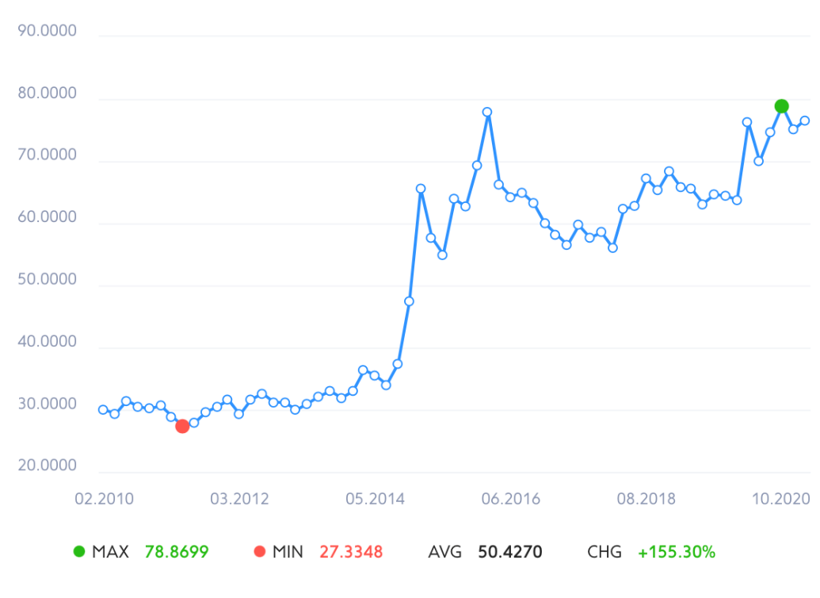
- Dollar exchange rate
Source: [website rumbler]

According to the 2019 figures, average inflation in Russia was 4.47 percent,estimated inflation in 2020 and 2021 are 3,22 and 3,25 respectively. It can be noticed that inflation in Russia droped by 1.25 percent in 2019 compared to 2018, remaining at low level for three years. The impact of low inflation is evident –it raises buying ability of citizens as their salaries do not lose value due to inflation.
The extreme effect of the recession on jobs and disposable incomes is being offset by social reforms enacted earlier this year, such as a rise in the overall level of unemployment insurance and a set of family payments and pension benefits. However, the recession has worsened unemployment across whole country, with the majority of work losses concentrated in only a few economic sectors (manufacturing, construction, and retail/hospitality services).According to data provided by World Bank, while single-person and parents with one child families saw their incomes fall, families with at least two children, as well as retirees, saw their incomes grow as a result of the social benefits distributed during the recession. The authorities agreed that sending relief payments to people through established mechanisms— child benefits and one-time payments to retirees— was preferable to attempting to recognize and assist all those impacted by the crisis. From the picture below the percentage change in disposable income is shown. The last actual number is growth by 2,3% in 2018. The latter numbers are predictions. But even without Corona-virus effect the growth declines in 2019 and 2020 after which the negative change can be seen again. All the factors described above show that the purchasing power of population worsen. For company which sells premium quality goods this tendency is not attractive.
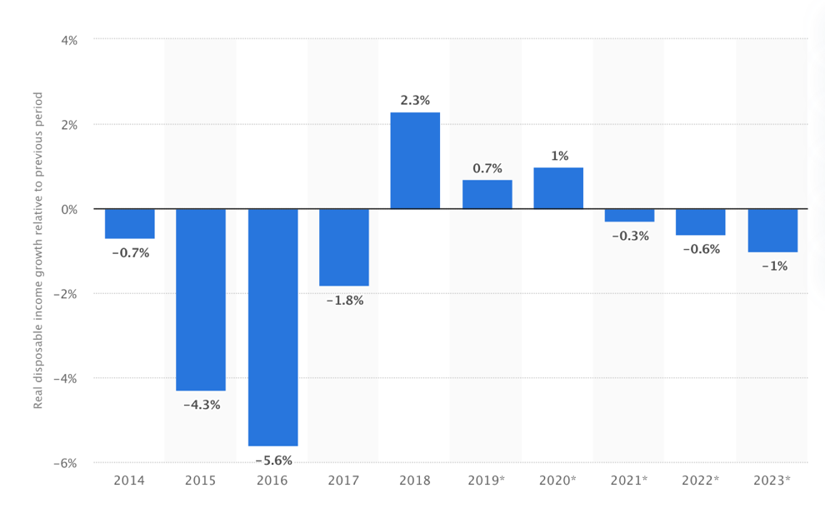
- Year-over-year real disposable income growth of the population in Russia from 2014 to 2023
Source: [website statista]

Social

Total population of Russian federation is 146,24 mln. Life expectancy is 73,3 years. In the picture below it can be seen that in all age groups over 35 years old, the number of women in Russia surpassed the number of men by 2020. The lowest female-to-male ratio was found among Russians aged 15 to 19, with 956 women per 1,000 males. The percentage of females in the group of people aged 70 and over was about 2.3 times higher than the number of males.
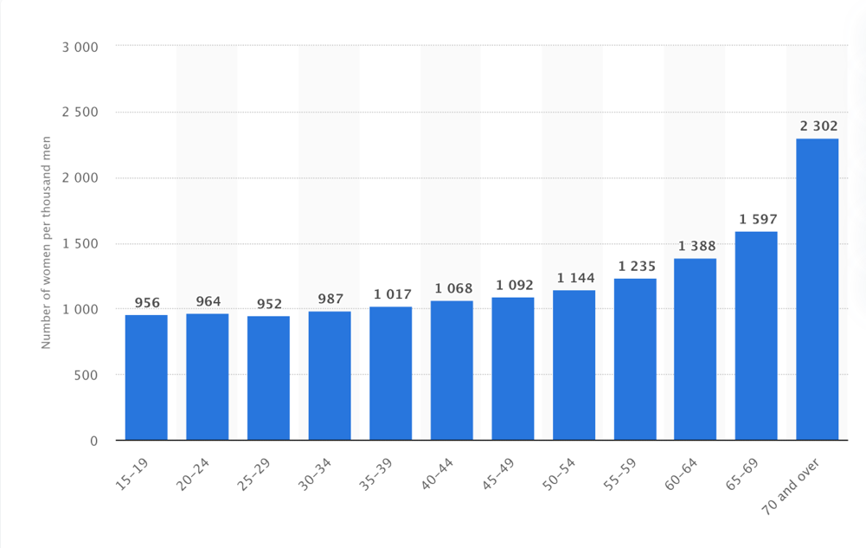
- Number of women per 1,000 men in Russia in 2020, by age group
Source: [website statista]

According to source news outlet RBC, Russia's population is forecast to fall by 325,500 people this year, which is 11 times higher than in 2019 (when the actual number of Russians dropped by just 32,100 people). The expected population decline in 2020 is already more than double what the government predicted in its most recent survey, released in August, when federal officials predicted that Russia's population will begin to rise again as soon as 2022 years. According to a study released in October, Russia's population will likely decrease by 1.2 million people by2024, with a steady decline until 2030. Vladimir Putin decided to implement immigration policies that would guarantee long-term demographic growth by 2030. The latest decree replaces executive orders signed two years ago, when the president assumed that normal population increases would resume by 2024. From January to August 2020, Russia's population loss was 346,900 citizens, according to the Federal State Statistics Service (Rosstat) (up from 219,200 people during the same period a year earlier). Against the backdrop of the coronavirus pandemic, the death rate in Russia grew by almost 6% in the first eight months of2020, with 71,748 more people dying than in the same timeframe of 2019. Between April and August2020, the coronavirus claimed 45,663 lives in Russia, according to Rosstat. Against the backdrop of the coronavirus pandemic, the death rate in Russia grew by almost 6% in the first eight months of 2020, with 71,748 more people dying than in the same timeframe of 2019. Between April and August 2020, the coronavirus claimed 45,663 lives in Russia, according to Rosstat. (This includes mortality from other causes in individuals who were diagnosed with COVID-19). As foreign tourism came to a halt this year, so did immigration into Russia. Russia's migrant inflow was just 65,300 people between January and July, down from 153,900 people in the same timeframe last year. The inflow of migrants compensated only for 20.6 percent of Russia's natural demographic loss in the first seven months of the year. The decrease of citizens means that less people in the market who can buy a product. In time the number of elderly people who cannot afford premium quality goods will comprise the bigger part of population than employed adults who will have to financially support their parent as well.
Every year, more people become involved in healthier lifestyle patterns: they are the first to adopt the latest trends in the fitness market, research brands, and experiment with innovative diet and workout formats. However, in the midst of the pandemic, health care has taken precedence. Searches for immune supplements are up 200% in 2020. According to a recent WCIOM survey, 99 percent of Russians consider wellbeing to be the most important value, and 18 percent take this problem more seriously during the time of self-isolation. According to the non-profit organisation The Global Wellness Institute (GWI), the market of products and services for a healthier lifestyle is rising twice as quickly as the global economy as a result of the transition of public strategies. According to GWI figures, the overall demand for healthier living products and services grew by 7.14 percent in 2018.
Education trend in Russia increased which is proved by Smart Ranking and IT holding TalentTech made the top 45 Russian EdTech companies in the second quarter of 2020, market experts identified trends in this area. Russian EdTech is repeating the fate of fintech and is growing at a record pace, exacerbated by the pandemic. The total revenue of the rating participants in the second quarter of this year amounted to 6.2 billion rubles, which is 26.5% more than in the fourth quarter and 87% higher than in the second quarter of last year.
The position in the ranking is determined by the amount of revenue for the second quarter of 2020. The preparation used data from companies, the Kontur.Fokus system, and open sources. From the table below it is clear that SkillBox, SkyEng, Нетология and Geekbrains are the leaders which got the biggest profit in this period. We can see that
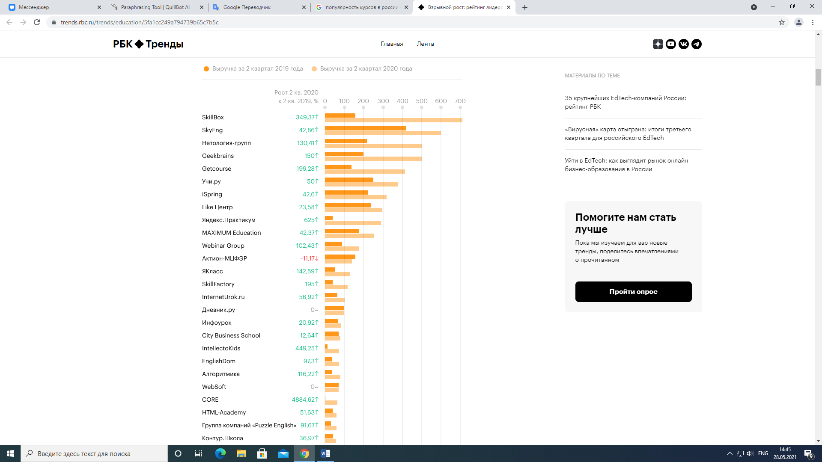
- Profits of online education
Source: [website rbc]
On the other hand, specialized online schools, especially those focused on the corporate training market, are doing worse. According to Dmitry Zatsepin, director of the educational business "Aktion-MCFER" (accounting), the number of students they had during quarantine even increased, but the company lost an average check due to discounts, and as a result - in revenue (minus 17.5% relative to the first quarter). “The purchasing power of individuals and legal entities has greatly decreased,” also admits Svetlana Kravchenko, head of Kontur.School, the SKB Kontur training center. - Companies stop allocating funds for training their employees, and previously agreed budgets are redistributed to funds to combat coronavirus (antiseptics, masks, gloves, etc.). According to our estimates, in the third quarter we lost more than RUB 14 million. This is a new reality, and we are trying to adapt to it. " Losses are incurred by companies teaching independent offline professions. So, Vsevolod Belchenko, director of the Sikorsky Academy, the largest online school for training hairdressers and beauty masters, estimates his losses in quarantine at 24 million rubles.
The transition to "remote" has created a demand for training in relevant skills. According to The Future of Jobs 2020, a report prepared by the World Economic Forum with the support of TalentTech, in 2020 the number of self-taught workers has quadrupled, and employers providing this opportunity have quadrupled. The number of students under state programs has increased nine times. According to the report, two-thirds of the companies surveyed (66%) expect to receive a return on investment in staff development and retraining in the first year. At the same time, completely different educational strategies were outlined: if the unemployed were interested in gaining knowledge in the field of data analysis, computer science and information technology, then the employed prefer courses in personal development.
The rating participants also note the trend towards combining different forms of teaching information presentation. If earlier the mainstream believed that “people will get used to studying online, and he will win everything,” now there is an opinion from different sides that offline is also important and necessary, including as an important addition to online learning.
The emergence of a new player on the market – universities. The largest universities began to enter the market en masse with their online continuing education programs. In addition, partnership programs between universities and online schools began to develop.
According to Pavel Astafurov, Marketing Director of SkillFactory, there are more and more such requests, and often it is not just a search for a new job, but "building a career track and planning professional growth, taking into account the acquired knowledge. "The demand for long-term training programs has also increased significantly, in which the client can master a full-fledged profession, and not just acquire a specific skill.
Speaking about the bachelors diploma there is a myth that almost all citizens in Russia has bachelor diploma, but this information is not correct. Only 27% of Russians aged 25 to 64 graduated from a university. In the group from 25 to 34, there are more such people - 34%, but this is still far from universal higher education. Indeed, in younger generations, more and more people receive higher education, but this is an international trend and Russia is no exception. In the UK, France, Germany, the percentage of people with higher education is higher. Russia is on a par with Latvia, Bulgaria and Poland. After the 9th grade, about 40% of students left school for the system of secondary vocational education - technical schools and colleges, which continue to play an important role in Russian education. Of those who stayed in school and graduated from the 11th grade, about 80% went to universities. It is the educational transition after the 9th, not the 11th grade that turned out to be the most important in terms of the formation of social inequality. Overall, only about half of the students in the original sample ended up in higher education. There are lots of online educational platforms in Russian language which helps people to get the knowledge in programming, management, languages and other fields.

Technological

To thrive in today's industry, it's crucial to be able to easily adapt business to emerging technology, modernizing not only manufacturing tools, but also communication strategies, customer behavior habits, and business processes. The digital revolution is occurring all over the world, and nearly everyone uses computing technology to some extent, ranging from social media to accessing public services. As a result, digital market integration has become a prerequisite for businesses to remain competitive. About every industry has embraced digital goods and services.
Ministry of Digital Development, Communications and Mass Media of the Russian Federation has objectives includes improvements in telecommunications, mass media, information technologies, Public services in electronic form. The goals to reach broadband coverage of over 90%, enabling residents in 250 towns and villages to use the Internet quickly; each year achieve over 20 million people gain access to 4G mobile Internet; access to lawful digital content is simple; every Russian resident has a next generation passport that allows for electronic identification; public services are available in electronic form to 70% of the Russian Federation's population; and all public services are available in electronic form. This prove that implementation of technologies became important in governmental level and more people will have access to fast Internet. That can help company to reach potential customer in digital world as people will became more used for digital way of making things. For now the total number of internet users in Russia aged over 12 was 95 million in 2019, equating to more than 78% of the population, according to state-owned audience researcher Mediascope.
The Kremlin has taken measures to restrict online freedoms. Authorities can block websites without explanation, prominent bloggers must register with the mass media regulator Roskomnadzor, and internet providers must allow authorities access to users' details. This means that it is better not to have any statements against government in the website as it increase a chance to be blocked.
According to Rossiyskaya Gazeta, in April 2013, 2% of the audience of the service, or 51 million people, were Russians. On November 13, 2007 YouTube launched the Russian version of the portal at https://www.youtube.com. In 2019, according to a VTsIOM poll, 58% of Russians are users of the YouTube video hosting service. Of these, 25% of respondents use the site almost every day, 19% - several times a week, 8% - several times a month, 7% - at least once every six months. 20% of survey participants do not use the service, but go online. Another 22% use the Internet less than once every six months or do not use it at all. Most often men (67%) use YouTube, as well as young people (88% - at the age of 18-24, 90% - 25-34). Video hosting is used by 25% of people over 60 years old. As sociologists found out, 30% of respondents prefer to watch music videos on YouTube, 23% - humorous ones. Also, Russians are interested in videos related to family, home and parenting (16%), sports or fitness (14%), social and political life (14%), technology and technology (13%), travel (13%), education (12%), beauty and health (10%).
Ozon is presented in the market and is frequently used by citizens

Ecological

The cage framework already provided some information about weather conditions and its disadvantages. Ecological fee is compulsory for importers and manufacturers and must be paid to a government. The standards for utilization of waste left after goods exploitation are also made by Ministry of Natural Resources and Environment of the Russian Federation. Each category of goods has their own numbers.

Legal

Self-employed is an alternative way of registration for people which do receive earnings from their own activity. It was only one way to make earnings legal by registration as individual entrepreneur, but the process is much complicated in comparison with self-employed. Individuals and individual entrepreneurs who are switching to a new special tax regime (self-employed) with a preferential rate of 4% on income from individuals and 6% on income from legal entities and individual entrepreneurs. You can use it at will. Professional income tax is paid by those who work themselves or sell goods of their own production.This allows you to legally run a business and earn income from part-time jobs without the risk of getting a fine for illegal entrepreneurial activity.
There are several benefits in comparison with individual entrepreneur:
- You cannot pay insurance premiums. There is no obligation to pay fixed contributions for pension insurance. Pension insurance is carried out on a voluntary basis
- The tax is calculated automatically in the application. Payment - no later than the 25th day of the next month.
- Combination with work under the employment contract. Salary is not taken into accountwhen calculating tax. Work experience at the place of work is not interrupted.

Industry level

Porter’s 5 forces of competition for Russia

In order to verify key external factors that have influence on the company the analysis of the industry that Amway operates in is made. The forces that are strong on the market of multi-level marketing companies are analyzed and their effect on the company’s position on the market and strategy is analysed. This helped to detect what threats and what opportunities they open. While choosing industry the decision to compare companies which work based on multi-level marketing principle are chosen as the opportunity to earn money is considered as main product of the company.
“Porter’s 5 forces of competition” analysis: the extent to which these 5 forces influence the company is shown in figure 1. This correlation was built on basis of the ranking system from 0 to 6 points, where each force was estimated by 3 criteria each equally rated at maximum 2 points.

Buyers and costumers:

Number of consumers are significant as multi-level companies usually operates in a B2C
The size of each customer order varies due to the incentives program which can give a bigger discount from a particular amount. Although as purchases are made not by other firms the size of the order is usually not big and are approximately 300$ per month, taking into account that some IBOs make purchases to their clients which are not registered in a data base. The difference between companies is in the range of product provided and the scheme how new distributers should be registered in order to get the highest profit and percentage which person receive from commodity turnover. For the people who make decision to work the price sensitivity is not high as this also implies that percent received will be higher in money equivalent. Buyers usually are reluctant to substitute after they achieved the level of money with which they feel safe, but switches can happen in early phases when person only get started to make first steps. Usually the information about percentage received is closed until registration as a member in a company, so this is an essential stage to switch. Switching costs will also depended on the payment scheme of companies, but there are no costs of leaving the company except change of consumer behavior.

Bargaining power of suppliers
Parameter | Elimination of parameter
 | 0 | 1 | 2
Sensitivity of consumers to prices | The consumers' choice of the suppling company is independent of the price | Insignificant fluctuations of prices do not change the preferences of consumers | The consumers' choice is highly defendant even on minor price changes
Information availability | Consumers have almost no information available | The consumer has an access to a limited amount of information | The consumer has an opportunity to access to a full information to compare different companies
Switching costs | Switching costs are that high that they outweigh any benefits received from switching | There are costs which will make person double think before leaving | The consumers do not have any costs which can influence them to stay
Total | 4
0-2 points | low level of buyers’ influence
3-4 points | medium level of buyers’ influence
5-6 points | high level of buyers’ influence
Source: [made by author]

There are several suppliers in the industry and their presence will depend on a company. Some of them are vertically integrated and have their own manufactures and plantations while other can fully outsource all products, so first supplier are fabrics. The second is the delivery companies which can be local are a worldwide company including transportation of product from country to country and delivery to the door of consumer. For the latter their services are not unique and is more or less the same in whole industry while the fabrics are required to have equipment to make products needed by a company. The ability to substitute of delivery company is high since they can transport anything and do not really tight with a company when manufacturing firms can have an equipment which make the details for the exact product, but this usually is not a case for MLM companies as they produce something for everyday use.

Threats of new entrants:

Parameter | Elimination of parameter
 | 0 | 1 | 2
Number of suppliers | The market of suppliers is greatly varied | The number of suppliers is varied but still there exists a risk for company not to find the alternative to the current supplier in case of emergency | The market of suppliers is monopolized and it’s hard to find alternative sources of supply
Cost of changing suppliers | Low | Relatively high but manageable | High
Limitation of suppliers’ resources | The resources are not limited, and suppliers have very low risks of running out of them | There is a possibility for suppliers to lose the source of their product | The resources are scares and not renewable, which creates a difficulty for the suppliers’ flexibility
Total | 2
0-2 points | low level of suppliers’ influence
3-4 points | medium level of suppliers’ influence
5-6 points | high level of suppliers’ influence
Source: [made by author]

There are several things needed to entry the market a software where all distributors will be registered and there linkages to each other as well as a system which will calculate earnings for each of them. Second, it is essential to understand that all sales of product is made by distributors and no one cannot buy things without registration and not knowing a person who are already registered. Such policy makes it difficult to start. In addition to the barriers which are put by the specifics of the MLM, the cost of production is also should be taken into account as company will have a need to outsource manufacturing, either invest in building a fabric. The production of huge number of product lead to the benefits from economy of scale which are not possible to reach for young company. Brand loyalty play a crucial role in this industry as distributors are also users and in case of having a bad product they can stop buying and selling it to others. The distributors of other companies already have experience and know various ways in which the job can be done while the new company still needs to learn. Government policies must be followed and company must prove that it is not a pyramid to enter market. Moreover, all distributers will have earnings from firm and it is its duty to take care of tax payment from salaries. The switching cost to an online shop will be medium taking into account that website is already made and there will be no longer need to pay for a huge cloud where information about distributers are saved, but additional investing in personal who will work I marketing and sales departments are needed instead of distributers.

Industry rivalry:

Parameter | Elimination of parameter
 | 0 | 1 | 2
Strong brands on the market with the high level of loyalty of clients | There is no or there are few not very strong brands as competitors on the market. | There are few strong brands as competitors on the market. | There are many strong brands as competitors on the market
The size of expenses and investments to enter the industry | Big capital and huge amount of investments are necessary for entering the market. | Not so much investments are necessary for entering the industry. | Big capital and huge amount of investments are unnecessary for entering the market.
Cumulative experience | High | Temperate | Low
Total | 1
0-2 points | low level of new entrants’ threat
3-4 points | medium level of new entrants’ threat
5-6 points | high level of new entrants’ threat
Source: [made by author]

There are several big competitors in the world which can be compared with Amway according presence in different markets, commodity turnover, the payments received by distributors and their numbers. The biggest and more widespread are: Herbalife, Oriflame, Avon and NL

Avon

David McConnell created the corporation in 1886, when some countries still did not have the right to vote. The mission is to advocate for the financial independence of women, support their undertaking and the desire to conduct a business in their rules. The company product is cheap and available for everyone.
In 1993 Avon reached the Russian market. In just three years, Russia will become the fastest growing market of the company. In 2004 Russia, an Avon plant opened, producing more than 150 million units of products per year. The company products are available in 104 countries.
The Avon Global Research Center is located in Sauffern (USA). It is here that first-class scientists create global beauty innovations. There are three laboratories: laboratory of decorative cosmetics which per year is being developed more than 250 new makeup products; perfumery laboratory which is the most fragrant and creates several hundred perfume compositions of high quality per year; laboratory of Person and Body which creates more than 60 new products annually. Plant Avon In Naro-Fominsk, the Moscow Region began producing gels for hands with an antibacterial effect.

Products:
- Cosmetics
- Body care
- Hair care
- Perfumery
- Clothes and shoes
- Household products

Herbalife

Herbalife history began in 1980, when her founder Mark Hughes decided to create a manufacturing and promotion company in the United States but only since 1980, the company develops and implements direct sales method for balanced nutrition, weight control and personal care product distribution. Today there is a wide range of products rich in protein, fiber and vitamins for a balanced nutrition and a healthy lifestyle that can be purchased in more than 95 countries of the world. The commercial line is represented by more than 130 names:
- including protein cocktails and bar
- dietary supplements (vitamins, nutrition)
- energy and fitness drinks
- skin care products
- hair care products
- water filter
Most of products are produced on the flagship enterprise Herbalife - the center of innovation and production in Winston Salem (USA). In addition to him, Herbalife works in close cooperation and with other major enterprises - Fine Foods, Italy, Liotécnica Tecnologia Em Alimentos, Brazil engaged in the production of ingredients and raw materials. Headquarters of Herbalife International located in America. Currently, the company employs 8 thousand employees.
Already, Herbalife has a lot of production facilities around the world, including China, Germany, India and other countries. Highly qualified specialists, modern equipment and control at all production stages ensure the compliance of our products to the most stringent quality standards. The company adopted the concept of "from the planted seed to the product on your table", within which the products are undergoing 14 stages of verification. It is involved in its implementation 10 special laboratories and 300 full-time employees with a degree scientist. The Herbalife Scientific Consulting Council, which includes more than 20 authoritative scientists from around the world, is engaged in the development of new products, search for effective ingredients, testing, and also participates in the training of independent partners Herbalife.

From 1986 Herbalife shares are listed on NASDAQ and NYSE stock exchanges.
In 2004 change of the business model in Russia: Sales Centers were opened, free telephone lines for independent partners, taking orders by phone and the Internet, delivering products to all cities of Russia
In 2009 opening of the first new generation brand centers in Russia.

Oriflame

The company was founded in 1967 in Sweden by the brothers Jonas and Robert Afi Yokniki.
where now corporate offices located as well as in Switzerland. A wide range of products, numbering about 1000 Names of natural Swedish innovation cosmetics which is on out of two category which produced by company, the second are assesories.
In 1982 the company opens the Central Research and Production Complex in Ireland. It also entered the London Exchange, and it was the first appearance of a foreign company there since the Second World War. Since 2004, the company's shares are listed on the NASDAQ OMX Exchange.
In 2008 Research Center was launched the new, which houses the OriDerm Laboratory for Clinical Research. Conduct research with the help of volunteers to obtain more accurate results. 100+ scientists do work in company to ensure the quality and creation of new products.
In 1992 the start of the company's activities in Russia and Ukraine;
In 2003 - the company acquired a new production complex in Sweden. In 2005 - the opening of production in forty kilometers from Shanghai, China;
To sum up the facilities of the company, it has five own factories located in Sweden, Poland, Russia, China and India and two research and development centers - in Dublin (Ireland) and Stockholm (Sweden) .
Nowadays company has more than 3 million Oriflame consultants and nearly 7,500 Oriflame employees, and presented in more than 60 countries.
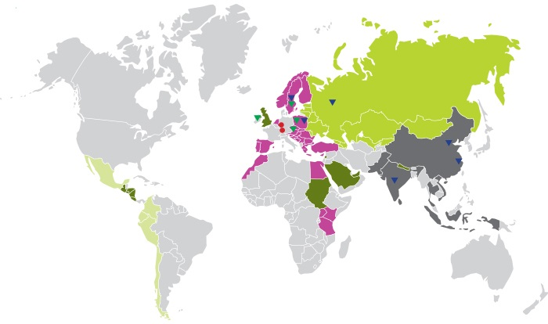
- Oriflame presence in the world

Source: [official website of Oriflame]

Comply with environmental requirements not only in our own activity, but also at all stages of the creation, production and transportation of our products. Main tasks are the maximum possible use of renewable resources and environmental materials, reducing emissions into the atmosphere and reservoirs, as well as the maximum decrease in the number of any waste.
On February 18, 2015, the solemn opening of the Oriflame production and logistics complex in the Noginsk district with the participation of the top management of the Swedish cosmetic company. The plant produces shampoos, shower gels, deodorants, liquid soap and other foam-detergent products, as well as lipsticks, glitters and lip balms. Planned production capacity - 150 million units of products per year. The new production and logistics center will allow the company to increase the share of own production near the main markets of sales, optimize the speed and cost of production, storage and transportation of products, which will be the basis for the further development of the company in Russia and the CIS region and the contribution of the company to the company in socio-economic development Moscow region.

NL
The company headquarters is located in Novosibirsk. The company founded in 2000 and are presented in 24 countries (83 stores and 284 offices) has 2.6m customers. The company provides jobs to 150 employees, most of which have been working in production since its inception.

The product range is counting more than 300 product names the main categories are:
- Functional nutrition including tea and coffee
- Vitamins for men, women and children
- Household chemicals
- Cosmetics

NL has a production facility in Novosibirsk which occupies more than 2.5 thousand square meters including the territory of headquarters. Fully automated lines for filling and packaging products, which eliminate the human factor and guarantee the reliability, safety and quality of the product during the entire shelf life used in manufacturing. 5,000 square meters including production facilities and a state-of-the-art analytical laboratory equipped with the latest technology. The laboratory is controlling the quality of goods produced. In addition, products are manufactured at the bases of independent manufacturers in Russia, France and Germany, Italy and Korea in full compliance with technological cycles and control of finished products.
In 2019, the company received a significant and valuable ISO 22000 certificate - this is an international standard in the field of food products. Another received the voluntary confirmation of the compliance of our products with the Halal requirements. This is especially important for the national republics in Russia, as well as in Kazakhstan, Uzbekistan and Kyrgyzstan.

- Key Factors of Success of Amway

KFSs’ groups | KFS | Characteristics
Related to organization | The availability of product on different markets | Presenting of product on the market by the firm gives it advantage over competitors as distributors can work in different markets and have earnings in several currencies which is attractive for people.
 | Current range of products | This factor influences the earnings of distributers as more categories have more aspect of life it covers and more a single person can buy in single company.
Related to skills and knowledge of specialists | Highly qualified scientific team | High level of qualification of operational team lets firms to make their products more qualitative and in the bigger amount for a shorter period of time
 | Cumulated experience of independent partners | The cumulated experience plays crucial role in the MLM businesses as from year to year the number of distributors grow faster and faster each year. In addition, they become more experienced
Related to innovation | Development of new projects and expansion of production | Development of new technologies it leads to quality improvement of products and services that are offered by firms.In addition, gives opportunity to attract more customers who put attention to the quality and ecological friendly aspect of production.
 | Ability to introduce new products in rapid manner | Presenting of new product on the market by the firm gives it advantage over competitors. In addition, it gives opportunity to attract new clients. In this section the comparison of laboratories of companies are compared.
Related to distributers | The payment scheme for distributers | There are often posed some restriction on the maximum earning or people allowed to invite as new distributers.
 | Ability of company to make payments to each distributor | This is crucial factor as the payments to a leader of the group have its consequences as he will give salaries to his team members
Source: [made by author]

- Comparison be Key Factors of Success of Amway and its rivals

KFC | Amway | Herbalife | Oriflame | NL | Avon
The availability of product in different countries | 120+ | 95+ | 60+ | 24 | 100+
Current range of products | 400+  - Vitamins  - Water filters  - Pans  - Household chemical  - Cosmetics  - Accessories, clothes  - Energy drink  - Tea, coffee | 130+  - protein cocktails/bar  - vitamins  - energy drinks  - cosmetics  - water filter | 1000  - Cosmetics  - Accessories | 300+  - Vitamins  - Tea, coffee  - Cosmetics | - Cosmetics  - Clothes and shoes  - Household products
Public company | No | Yes | Yes | No | Yes
Cumulated experience of independent partners | 1959 | 1980 | 1967 | 2000 year | 1886
Development of new projects and expansion of production | 4 organic plantation  18 fabrics | production facilities in China, Germany, India and other countries | factories located in Sweden, Poland, Russia, China and India | production facility in Novosibirsk  independent manufacturers in Russia, France and Germany, Italy and Korea | manufacturers in Russia, France and Germany, Italy and Korea
Ability to introduce new products in rapid manner | 700+ patents  100+labs  800+ scientists | the center of innovation and production in Winston Salem (USA).  20 authoritative scientists | two research and development centers - in Dublin (Ireland) and Stockholm (Sweden)  12 scientists | The laboratory is controlling the quality of goods produced and new product creation | 60 new products annually  Lab of quality control
The payment scheme for distributers | No restrictions | Payments from reselling (87%) |  | Invite only 2 people | 1800 rub is a minimum purchase per month  The percentages are lower
Ability of company to make payments to each distributor | Payment to each distributor
Source: [made by author]

Industry rivalry

Parameter | Elimination of parameter
 | 0 | 1 | 2
Number of competitors | There are no or few firms, which can compete on the market. | The industry is highly competitive; however, there are not so many rivals. | The industry is highly competitive with many rivals.
Flexibility of increase of competition through price changes | There is a monopolist on the market, which dictates prices, so companies are not able to change the situation. | Firms and companies are not ready to compete through change in prices because of the dependency on state orders. | Firms and companies presented on the market are ready to compete through changes in prices.
Tempos of growth of the market | Low | Temperate | High
Total | 4
0-2 points | low level of competitors’ influence
3-4 points | medium level of competitors’ influence
5-6 points | high level of competitors’ influence
Source: [made by author]

The closest propositions from companies to benefit from purchasing are loyalty cards, discounts and promotions as we consider the earnings possibility for each customer as the main product. Buyer usually are reluctant to substitute as the benefits which he receives are much less in any proposed substitute. The proposition itself can be seen as suspicious that is why people tend to choose the way they used to live and buy products in usual shops. The characteristics of product can vary that is why the price vary as well and such ccomparison should be made with a precise company. Switching costs depends on the earnings received by person in MLM that means that people who just started buying have a low switching cost.

Threat of substitutes

Parameter | Elimination of parameter
 | 0 | 1 | 2
Number of substitutes | There are no substitutes for the product of the firm. | There are few substitutes for the product of the firm. | There are many substitutes for the product of the firm.
Possibility of introduction of new substitutes | The appearance of substitutes is not observed in the nearest future. | The appearance of substitutes is observed in the nearest future. | Substitutes are already introduced and ready to be presented on the market.
The risk of price competition with potential substitute | The introduction of potential substitutes will not influence the prices on the market. | The introduction of potential substitutes will influence the prices on the market but not significantly. | The introduction of potential substitutes will change prices on the market and will lead to high rivalry.
Total | 1
0-2 points | low level of substitutes’ threat
3-4 points | medium level of substitutes’ threat
5-6 points | high level of substitutes’ threat
Source: [made by author]

Conclusion of “Porter’s 5 forces of competition”:

- Porter’s 5 forces of competition

Source: [made by author]

Factors in Russia

Source: [made by author]

Pre-enter
Internal

There are no internal factors which could influence as the company itself did not entered market yet.

External

Russia made a new Civil Code, system of commercial courts and legislation on joint-stock companies securities markets, and bankruptcy. In paper, mostly the needed legal infrastructure was established to support a market economy. Rules which regulates the behavior and institutions which enforce these rules were created. However, companies were reluctant to utilize formal legal institutions, this was the main reason why the system was not effective. The consequence was that “the formal rules and Russian firms’ everyday practices for enforcing contracts and protecting property diverged”.
Informal institutions became the rules for business during the early 1990s, among them are social norms, social networks and repeated interactions. As a result, informal interactions, aimed to avoid and resolve business conflicts, were widely used. Actually, these two practices can coexist and in practice do all over the world. Although, violence and corruption became a part of doing business in Russia. “Criminal protection rackets offered entrepreneurs protection against other criminals or unprincipled competitors, a service referred to as providing a “roof” (krysha), and frequently aided in contract enforcement, debt collection, vetting of business partners, and arbitration of business disputes”. By 1993 nearly 5 000 private security agencies were registered which in fact perform the same functions as criminal groups. In late 2000s the number of such agencies increased up to 30 000. Big firms had an internal department for these needs.
Moreover, the corruption of government representative flourished in 1990s, they used their privileged access to resources in order to get individual benefits and even provide services which is similar to the criminal protection rackets. “The services of rackets run by the Ministry of Internal Affairs (MVD) State Directorate for the Struggle with Organized Crime (GUBOP) and its regional branches (RUBOPs), as well as FSB (the KGB successor) units devoted to economic and organized crime, were in particularly high demand”. In time firms started to prefer krysha from government representatives as they are protected by law and have more available resources. In mid 1990s the drop of contract killing was noticed, it is interesting that not business man were targets, but mostly journalists and human rights activist. In the same period the criminal groups start to disappear as well.

Growth

Internal

Company entered market with household chemicals which were the most popular category of the company, but do not bring the highest profit. In order to increase it, other categorise of products were started to appear on shelves. The development of regions also increases the number of clients and as a result revenue.
Moreover, the interest of clients also should be supported as the company officially entered after IBOs, so Amway should provide more benefits to support their policy of not reselling in local shop but make it more profitable to lead clients to official store. In addition, the need for managers who have an experience and a new vision to lead market, although the internal recruitment is developed and usually internal workers are promoted to higher positions.

External

In American market shops did not exists, but in Russia people wanted to see actual product and preferred to make first purchase offline.
In 2005 33 business people were murdered in the course of conducting business while in 1997 the number was up to 213 (Matveeva, 2007). This show a significant change in the way how business was conducted and decrease of physical coercion. In 2010 there were only 4% of respondents who reported contact with criminal protection rackets in recent 3 years. Nearly 20 % of interviewed firms confirmed using of government representatives and law enforcement agencies in unofficial way to solve problems (Gans-Morse, 2020). From 1994 to 2010 the number of court procedure started by companies increased to more than a million from 200 000. Although, nearly 14% in 2010 admitted giving briberies to get a needed decision of judge. The business environment became less violence and the solving disputes in court became more popular.

Crisis

Internal

Amway see the need to support new IBOs at first steps as lots of people drop on this stage, increase revenues in the beginning is a good decision which latter bring results.
The implementation of existing in non-network marketing practises. Although shops were already opened, they still did not have consultants as stores usually have.
The existing practises of network marketing is also become interest for company. For instance, the free education of distributers was already implemented by some companies. The need to support IBOs and their entrepreneurial activity became more interesting as this can increase volume of sales.
Amway wants to increase the number of young IBOs as they are customer segment which are not covered by company and their attraction can boost a growth.

External

Following the financial crisis of 2014-2016, the economy is now showing signs of recovery. In reality, many Russians are willing to spend more money than they have in the past on the goods and services that are most important to their quality of life. At the same time, the financial crisis has left its imprint on Russian families, with personal finances tight and inflation outpacing income growth. Consumers have become more conservative, realistic, and value-conscious as they have adjusted to the current economic reality over the last decade. Consumers show traits associated with shoppers of more developed economies. Although most Russians are cutting back on non-essential items such as ready-to-eat foods, nearly half plan to spend more on items critical to their health and the well-being of their families, such as fresh foods, education, and travel. Lower global oil prices and Western sanctions imposed in the aftermath of the Ukrainian political crisis have prevented Russia from resuming its previous rapid economic development. Indeed, between 2014 and 2016, the economy contracted by an average of 2% a year, while the population living below the poverty line increased by 23%, to about 20 million. Meanwhile, the ruble has devalued twice against global currencies since 2014, making imported products and services costlier. As a result, from 2013 to 2016, inflation climbed almost twice as high as wages, eroding household buying power. This suggests that families would pay rising premiums not only for manufactured luxuries like automobiles, but also for everyday needs like medication and food.

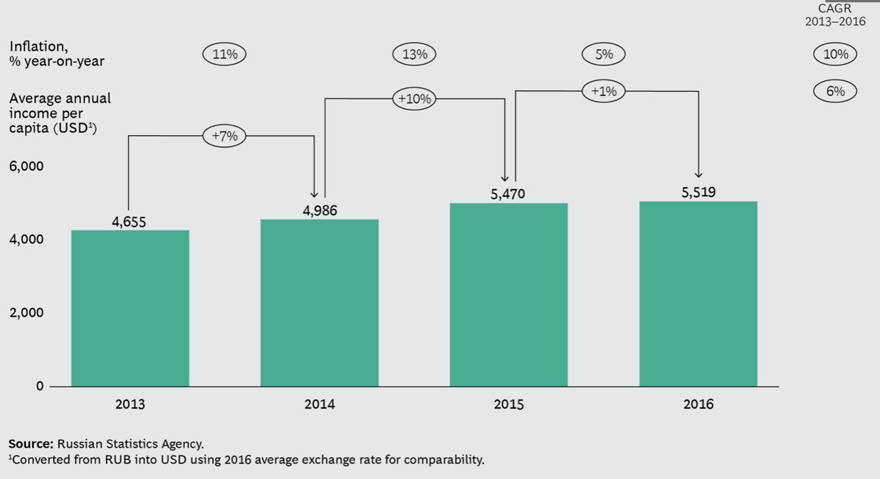
- Inflation outpacing income growth

Source: [official website of BCG]

Russian customers were asked what they valued most, the vast majority, 83 percent, said “family and home” and “health” (78 percent). The purchasing preferences cited by Russian customers show the significance of these principles. According to our findings, while customers have been more cautious shoppers in recent years, they are still able to spend more—and bear rising prices—on products and services that improve the standard of life for their families.
In the 2014-2018, consumers have become even more price-conscious and constantly seek out bargains. For example, 57% plan to purchase more promotional goods, compared to 40% in 2013; 46% claim they shop more often at discount stores or outlet malls, compared to 33% previously. The proportion of Russian consumers who regularly review prices online before making a purchase increased from 40% to 47%.
Russian shoppers, with the exception of those with comparatively high wages, have been more likely to forego comfort and service while shopping. More than 40% of customers with household incomes of $1,000 or less say they are reluctant to spend more to shop at a better positioned supermarket, compared to about 30% who approve. When asked if they would spend more for quality service in a supermarket, the answer is close. Where Russians do spend their money, however, they expect quality—regardless of where they shop or the brand they choose. More than three times as many respondents (46%) expect to move their spending to higher-quality products and services than those who claim they have no such intentions. Consumers more often list healthful living, well-being, and personal enrichment as priorities for expanded spending. In nonfood groups, 22% plan to spend more on prescription medications and supplements, indicating that many shoppers are willing to pay higher premiums rather than risk their health.

Covid
Internal
-
External

Because of the COVID-19 pandemic, nearly all purchases have moved online, mostly to self-service internet channels. All seems to be comfortable with the current arrangements. Buyers favor digital communications, whereas sellers prefer the increased efficacy.
Products of company appeared on marketplaces without Amway agreement. Such reselling of product is restricted by company, but this violated the company rule.

2.4 Factors and change interdependence
All factors in Russia were already described above as well as changes which happened in this market. In this section the aim is to understand which factor make company adopt changes.
In the following table different colors are used to show is the factor internal, external or change was made all over the world.
-internal factors
- external factors
- change happened all over the world
- Factors and change interdependence

Changes of business model | Period | Factors | Clauss
Shop | 2005-2013 | Customer habits (no reliability to online shopping and to online communication) | Value creation
Increase range of product | 2005-2013 | High profit product appearance | Value proposition
New vitamins set | 2005-2013 | Increase range of products and number of high profit products | Value proposition
New assortment of cosmetics | 2005-2013 | Increase range of products and number of high profit products | Value proposition
YouTube channel appeared | 2005-2013 | Brand image,  YouTube became popular | Value creation
New managers | 2005-2013 | Development of region | Value creation
Active discounts | 2005-2013 | New customers attraction | Value proposition
Monetary incentives | 2014-2019 | Increase attractiveness of being IBO in first steps | Value proposition
Self-employed | 2014-2019 | Self-employed appearance, Ease the process of receiving money | Value proposition
Consultant | 2014-2019 | Customer habits (the usual shop way of working) | Value creation
My center amway | 2014-2019 | Customer habits (Space to work for IBOs and show the shop and product) | Value capture
Change of general manager | 2014-2019 | Need to have experience from outside, Relationships between Russia and America | Value creation
Change of website | 2014-2019 | the single data base to easy storage and work with data | Value creation
VIP+ client | 2014-2019 | Crysis, PPP decrease | Value proposition
XS | 2014-2019 | Increase range of products | Value proposition
Education | 2014-2019 | Online schools are popular | Value proposition
Creators | 2014-2019 | Attraction of young IBOs | Value creation
Increase of prices | 2020-2021 | Inflation, Increase of exchange rate $/₽ | Value capture
Support for IBOs events | 2020-2021 | Increase the effectiveness of IBOs activities | Value creation
Marketing | 2020-2021 | Business online (Covid)  Make need to build brand image online  Personal contact is important | Value creation
Family Council | 2020-2021 | Covid,  Professional recommendations | Value creation
Charity | 2020-2021 | Brand image improvement | Value creation
Production | 2020-2021 | Special Investment Contracts, inflation, exchange rate  sanctions | Value creation
Marketplace | 2020-2021 | Violated policy  Online shopping ( Covid)  Похождения по подъездам заменяется на маркетплейс | Value creation
Source: [made by author]

From the table above, it is clear that the most of changes made influence the value creation of the firm, then is a value proposition. The least change dimension is value capture, but new revenue stream appeared. This is money which are paid as a rent for rooms which are equipped to make master classes and business meetings. For this work changes which happened due to external factors of the company are more interests as the firms needs can be different from market to market and cannot be known, but external factors can be analysed.

CHAPTER 3: ANALYSIS OF UZBEKISTAN
The factors in Uzbekistan should be found out in order to compare them with the Russian ones to understand which changes are relevant for the new market and which are not. The focus of all of the following analysis will be made taken into account the factors which ones had influence on Russian market.

3.1 Factors identification

Country level

CAGE

- Cage framework for Uzbekistan

Cultural | Geographical
- Hofstede dimensions  - Language  - Ethnicity  - Religion | - Time  - Climate  - Water boundaries
Administrative | Economic
- Currency  - International trade organisations  - Corruption  - Court system  - Ease of doing business  - Heritage  - Democracy | - GNI  - GDP  - PPP  - Income  - Unemployment rate  - Income distribution
Source: [made by author]

Cultural differences
- Hofstede dimensions

Source: [Website Hofstede insights]
Due to limited amount of information the information about culture in Uzbekistan was taken from interviews with people who used to live there.
Power distance is big, and employees are not allowed to propose their improvements as it will be seen as critics but in case of good relationships with a boss it is possible to have a friend like relationships. The possibility to change the way of operation is possible only in case when trustful relationships are built. For Amway it means that strict directions should be given to employees in first time meanwhile working on relationships. It is crucial to show respect while interacting with a possible partner if the person's job title is higher in the organizational hierarchy than yours.
Second, Uzbekistan is a collectivistic country as the family is put in priority over individual needs, not only parents and child are seen as a family but also brothers and sister, their wives and husbands parents from both sides and etc. The older people are respected, and their opinion are carefully listened. This fact is in our case means that IBOs should understand how to behave with elderly people knowing that they also respected. In their families and the growth of business is directly depend on the. Number of people who use company’s products. The opinions of one's family or work group might have an impact on one's decisions. Relationships have a role in recruiting, promotion choices, and contract negotiations. Third, Masculinity is a middle as due to economic situation people now put more attention to the salary and less to non-monetary incentives but people at work usually help each other to complete some challenging tasks and they also can do it even in case person did not asked, they do it when they can see that person has some troubles.
Uncertainty avoidance is less as people do not try to write everything in contract and due to their relationships, they believe each other. Long-term orientation is high since people can make savings of money to purchase a care then and do not make impulsive purchases out of the budget. Indulgence is higher than in Russia, people are more emotional, and they do let themselves to make some actions due to their feelings.
There are several factors which should be taken into account. The purchasing of grocery and some household’s chemicals which can be found on the market are usually done by man. The interesting fact that, for instance, the washing powder can be bought not in the packages made by producer but is bought by weight. Although, the products connected with beauty are still purchased by women. Another factor is that the role of women is seen as households who takes care of children and home it will be strange for them to hear that woman wants to make career, in less conservative families wife can work, but usually do not have an intention to became a manager. Another fact is that having several wives is approved by society and still happen in this situation wife makes purchases for her own. The last son with a wife lives with his parents, this means there no mean to talk with him about household’s chemicals as he does not use it.
There are several more differences which must be considered. Speaking about languages each country has its own, but in Uzbekistan lots of people speak Russian two. In Uzbekistan the knowledge of Russian depends on the region. For long period country wanted to make all institutes in Uzbek languages. Although, recently in Tashkent, a memorandum of cooperation was signed between the Ministry of Public Education of Uzbekistan and the Ministry of Education of the Russian Federation, within the framework of which a joint educational project called "Class!", Or "Zur!" in Uzbek. At the request of the Uzbek side, 32 specialists from the Herzen Russian State Pedagogical University will be involved in the republic, who will be engaged in teaching Russian as a separate subject on the spot, as well as expanding academic disciplines in English. The signed memorandum implies that starting next year, a hundred teachers will leave for Uzbekistan, and in the future, their number will increase by another hundred every year. This implies that the company which has an experience to work in Russian language will have an advantage over others.
Ethnicity of a country is the following Uzbeks make up 82 percent of the population, and their share of the growing population is steadily rising. Tajiks occupy the second place (4.8 percent), and other Central Asians (Kazakhs, Karakalpaks, Kyrgyz, Turkmen, and others) live there as well. Russians continue to be one of the most numerous ethnic minorities in Central Asia, accounting for 2.6 percent of the total population and other Slavic peoples.
Muslim is the most prevalent religious affiliations in Uzbekistan which comprise nearly 90% of citizens. Most people do follow general rules.

Administrative differences

Currency in Uzbekistan is called som. For American company that means increased risks as it will depend on the fluctuations in currencies exchange rate.
Uzbekistan has signed trade treaties with 45 countries, all of which provide most favored nation treatment. It has also signed bilateral investment treaties with 53 nations, five of which have yet to enter into force. The nation joined the Eurasian Economic Union as an observer in 2020. (EAEU). Uzbekistan is not a member of the WTO, although it is moving toward membership. Uzbekistan and Russia signed a Strategic Framework Agreement in 2004, which included concessions on free trade and investment. The administration signed the “Treaty of Alliance Relations” with Russia in November 2005, which included measures for economic cooperation. The 2004 agreement between Uzbekistan and Ukraine eliminates all bilateral trade obstacles. In 2014, Uzbekistan was admitted to the CIS Free Trade Zone.
The “Treaty between the Governments of the Republic of Uzbekistan and the Governments of the United States of America Concerning the Encouragement and Reciprocal Protection of Investment” was signed on December 16, 1994, in Washington, D.C., and confirmed soon after by the Uzbekistani Parliament. The US administration, on the other hand, has taken no action to bring this agreement into force. Uzbekistan signed the regional Trade Investment Framework Agreement (TIFA) in 2004 with the United States Trade Representative's Office and four of its Central Asian neighbors - Tajikistan, Turkmenistan, Kazakhstan, and Kyrgyzstan.
Transparency index for Uzbekistan is 26 where 100 is very clean and 0 is highly corrupted. This information implies that company should take into account additional expanses which can occur during opening a new brunch in a country.
The USAID-funded Rule of Law Partnership in Uzbekistan Project works to strengthen public access to and trust in the country's judicial system, with an emphasis on criminal, economic, administrative, and civil courts. The initiative collaborates closely with Uzbekistan's Supreme Court, the High Judicial Council, and other major stakeholders in the national judiciary and justice sectors. The fundamental accomplishment of the initiative has been to change Uzbekistan's courts from tools of government administration to a way of ensuring citizens' rights are upheld. So far, the initiative has been effective in closing justice gaps and strengthening the rule of law in Uzbekistan. The initiative has assisted the Supreme Court in implementing substantial judicial reforms based on best international practice. This led in Uzbekistan's rating in the Doing Business Index's ‘Enforcement of Contracts' sub-index rising from 41st in 2019 to 22nd in 2020.
- Administrative differences

Indicators | Uzbekistan
CPIA transparency, accountability, and corruption in the public sector rating (1=low to 6=high) | 2,5
Ease of doing business index (1=most business-friendly regulations) | 69
Heritage | 58,3
Source: [made by author]

CPIA transparency is 2,5 which is quite low and make Uzbekistan attractive. Ease of doing business ranked countries from the easiest to the hardest to do business in following way that Uzbekistan received 69 while the 1 is most business friendly. Heritage score shows the economic freedom of the country putting Uzbekistan in a better half with bigger economic freedom with score 58,3.

Geographical differences

The time difference between Russia and Uzbekistan is 2 hours so it is needed to be plus 2 to Russian Moscow time.
There are water bounders with see which is located on a territory of Kazakhstan and Uzbekistan, there are also several lakes one of which connects it with Turkmenistan, these are two countries with which Uzbekistan has the longest boundaries. Speaking about rivers, country does not have a system of lakes which can be used for transportation needs. As a result, no ships transportation seen as attractive Uzbekistan-447,400 км². On September 1, the Asian Development Bank (ADB) granted a loan of $ 274.2 million for the rehabilitation of 240 kilometers of roadways in western Uzbekistan. “As a landlocked country, Uzbekistan has made regional outbound communications a central element of its transport policy,” said ADB Senior Transport Specialist Pavan Karki. "This project will help the country develop as a regional transport and logistics hub between Europe and Southeast Asia, contributing to economic growth."
The resources will also be utilized to improve safety on critical portions of the country's national road network in order to boost regional commerce and transportation ties.

Economic differences
- Economic indicators

Indicators | Uzbekistan
Unemployment rate | 6,08%
Gross national income per capita | 1,800$
GDP per capita | 7,308$
Purchasing power parity | 2,085
Income | Lower middle
Income share held by highest 20% | 28,3
Income share held by lowest 20% | 7,4
Population growth (annual %) | 1,9%
Labor force(thousands) | 14,384
Source: [made by author]
The Labor force in Uzbekistan equals 14, 384 thousand people
Population is growing in Uzbekistan, the population growth in Uzbekistan equals 1,9% per year.
According to the data above, the unemployment rate in Uzbekistan is 6.08 percent, with a work force of 14,384 thousand individuals, implying that almost 87 thousand individuals are jobless. Based on the data indicating the distribution of income between affluent and low-income persons, it is obvious that in Uzbekistan, the wealth gap between those with the greatest and lowest incomes is significant. It is vital to remember that the former group consists of a significantly smaller number of individuals, meanwhile the later group consists of a considerably larger number of individuals. With this in mind, the income share held by the richest 20% is 28,3 percent, while the lowest 20% has just 7,4 percent. According to this data, there is a significant disparity between the affluent and the poor. However, in relation to other nations, Uzbekistan is still classified as a low-middle-income country. Uzbekistan's population is growing, which means that the number of prospective consumers is growing as well.
GNP and GDP per capita indicate the country's overall wealth; these measures are $1,800 and $7,308 respectively.
Purchasing power parity calculated shows that in Uzbekistan the money which people can spend is restricted and the country was put in lower middle-income group of countries.

PESTEL for Uzbekistan
- PESTEL analysis of Uzbekistan

Political  - Decree to make favorable conditions for entrepreneurs  - More democratic  - International trade organisations  - Natural resources  - Advantages to chemical and pharmaceutical companies  - Investors rights protected  - Sanctions | Technological  - Internet availability  - YouTube  - Ozon
Economic  - Exchange rate  - Inflation | Environmental  - Standards for utilization
Social  - Decrease of population  - Healthy lifestyle  - Education  - Make up | Legal  - Tax policy (geopolitical)  - Self-employed
Source: [made by author]

Political

From December 14, 2016 (from September 8, 2016 he was temporarily acting) President of Uzbekistan is Shavkat Miromonovich Mirziyev. This in fact means that the same president rules the country for 5 years. The legal way before him the president, Islam Abduganievich Karimov, was leader of a country for 16 years. The country under his rule was more a totalitarian and were closed for international trade. President of Uzbekistan Shavkat Mirziyev March 23 signed a decree "On additional measures to further create favorable conditions for the population and entities of entrepreneurship in the use of public services, a reduction in bureaucratic barriers in this direction." Passport, marriage registration, medical examination - by an extraterritorial principle, cancellation of 17 types of documents and information is canceled, the Personal identification number of individual (PINFL) has become a single identifier certifying the identity of a citizen when providing civil service.
According to the Decree, starting from June 1, 2021:
Legal entities - entrepreneurs, when paying for fees and state duties established for the use of civil servants, is allowed to pay for cash through their representatives. Second, the amounts of payments that are excessively paid by individuals and legal entities when using services through the Civil Service Centers, as well as the amounts of fees that are additionally paid for the provision of public services in an expedited manner (in case of non-searching services in an accelerated manner), are returned to a simplified procedure at the expense of the extrabudgetary fund of the State Agency services for one working day. At the same time, the return funds are charged by the Agency with the relevant state bodies and organizations in the order of regression. Third, the procedure for the provision of duplicates of documents issued by the simplicity of QR code (matrix barcode) during the provision of civil serviculture is canceled. These documents are obtained in electronic form for free and in unlimited quantities through a single portal of interactive public services. The last is the reduction of the number of documents required by state bodies, communities, government agencies and institutions from the population and entrepreneurs are also cancelled.
This week, several events occurred at once, which can be considered indicative from the point of view of changes occurring in Uzbekistan. On Thursday, the Senate approved the draft law on the transformation of the National Security Service (National Security), Issifier during the Presidential Board of Islam Karimov (1991-2016), in the State Security Service (SGB). We are not talking exclusively about changing the name: the powers of the SGB will be much less than its predecessor - it is said in the decree of President Mirziyev of March 14. SNB, according to President of Uzbekistan, allowed many offenses: "Used torture", "even a pillar could put in prison," kept entrepreneurs in fear.
Since the fall of the Soviet Union, Uzbekistan has solidified its reputation as a country with a protectionist trade policy, as evidenced by high tariff and non-tariff barriers to finished goods imports, excessive government intervention in the economy, discriminatory import taxes, and restrictions on international payments (limited conversion) and other administrative restrictions. As a result, Uzbekistan frequently ranks worst in international rankings when it comes to analyzing the business environment, the amount of corruption, and the investment climate. Uzbekistan, for example, was ranked 156th in the World Bank's Doing Business ranking in 2013 and 168th in the Corruption Perception Index. Treaty on a free trade zone of the CIS. Country started preparation for entrance to WTO in 2020, the International Trade Center and the European Union will help Uzbekistan prepare documents, sanitary standards and trade procedures for joining the World Trade Organization.
Natural gas, gold, cotton, and minerals are Uzbekistan's principal exports (there are more than 2,700 deposits and promising manifestations of about 100 types of mineral raw materials in the country). Uzbekistan is the world's second-largest exporter of cotton and the fifth-largest producer of cotton.
Potential foreign investors' advantages and preferences. Foreign investors in the Republic of Uzbekistan include international organizations established in line with agreements or other treaties between states or as subjects of public international law.
An international investor has the following rights:
- to attract finances to the Republic of Uzbekistan in the form of loans and borrowings
- to recover damages caused by unlawful acts (inaction) and decisions of government bodies, local government bodies, and their personnel
- unilaterally and freely dispose of revenue generated as a consequence of investing activity (including unrestricted repatriation)
- There are no investment limitations in the Republic of Uzbekistan in terms of sectors of the economy or regions where direct private foreign investments are directed.
Along with the customs and tax advantages available to all firms in the Republic of Uzbekistan, there are a number of advantages available to chemical and pharmaceutical companies, encouraging direct private international investment. These businesses are free from paying income (profit) tax, property tax, social infrastructure and landscaping tax, environmental tax, a single tax for microbusinesses and small businesses, and required donations to the Republican Road Fund.
Foreign investors who conduct business in the Republic of Uzbekistan have their rights guaranteed and protected by the government. If future legislation in the Republic of Uzbekistan worsens investment conditions, international investors are subject to the laws in effect at the time of investment for a period of 10 years. A foreign investor has the option of using those sections of the new laws that improve the terms of his investment at his discretion.
Uzbekistan is feeling the impact of Western sanctions against Russia, which is the most important partner for the republic.

Economic

The ruble som exchange rate is important to monitor since there is a possibility of importing some goods from Russian market, a significant shift in the rate has a direct impact on firm revenue in this case. The data shows that during this year the rate is fluctuating between 125 and 150 , the depreciation of som happened in 2017.. For company this means that money which were earned in Uzbekistan market converted in rubles became smaller and can cover less production and transportation costs.

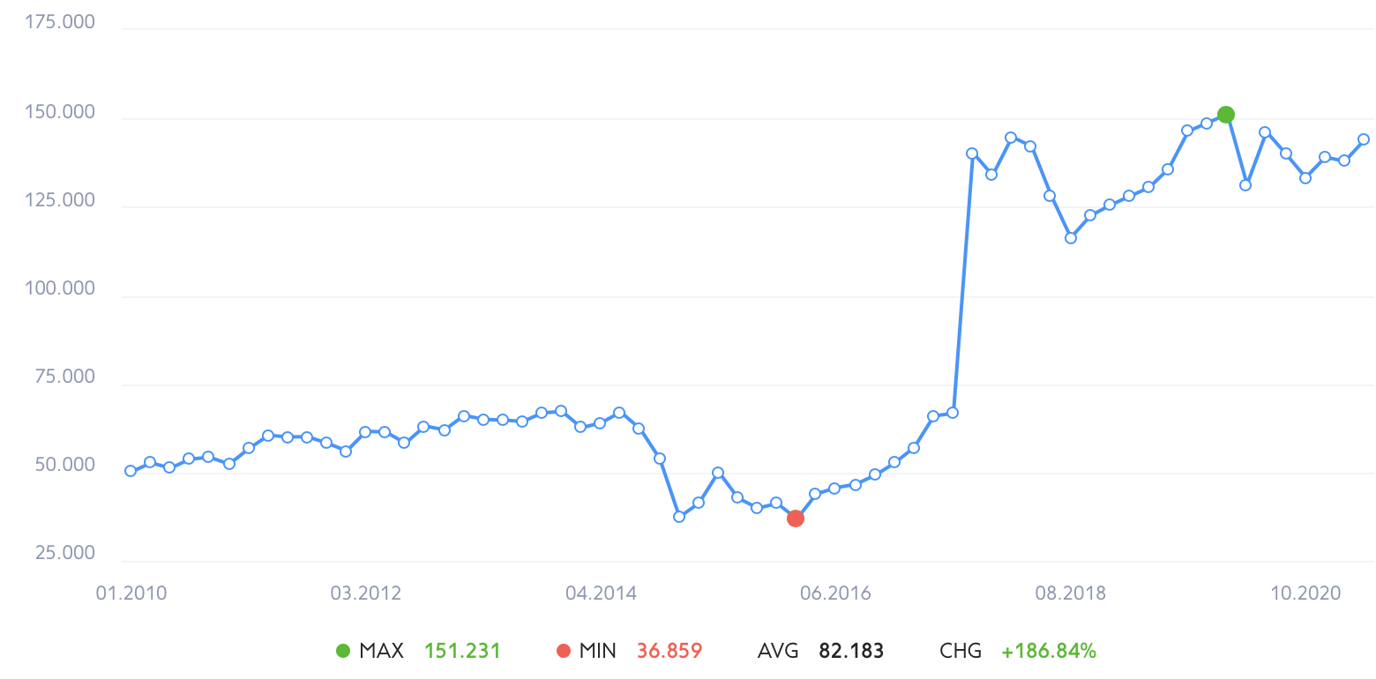
- Exchange rate rubble som

Source: [website Rambler]

The dollar som exchange rate is important to monitor since many items are manufactured in the United States, and a significant shift in the rate has a direct impact on firm revenue. The data shows that during this year the rate is fluctuating, and the depreciation of som can be seen after lock down because of Covid pandemic. Before Covid exchange rate was 9 000, It is currently fluctuating nearly 10 000 som per dollar. The dramatic drop happened in 2018 when currency depreciated in two times. For company this means that money which were earned in Uzbekistan market converted in US dollars became smaller and can cover less costs.

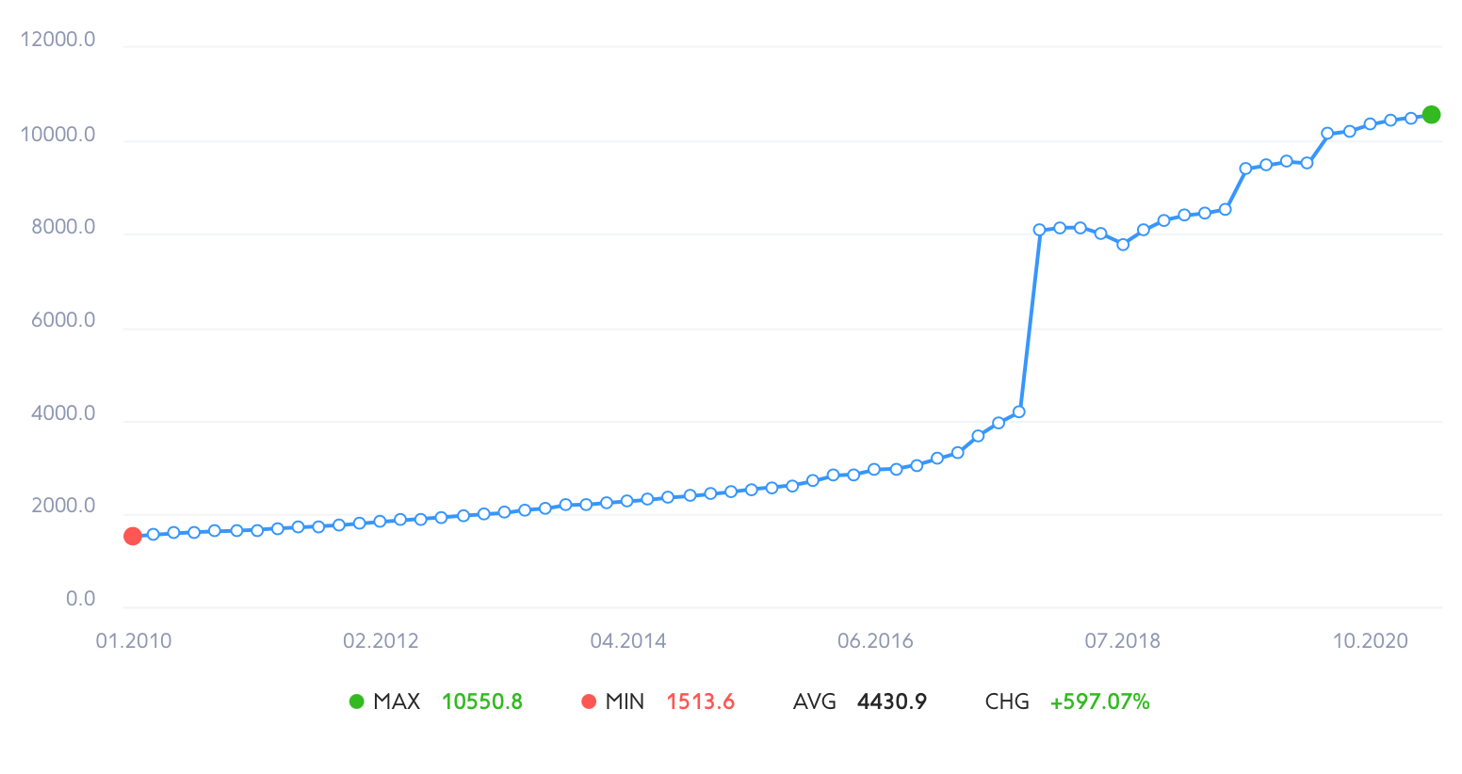
- Exchange rate dollar som
Source: [Website Rambler]

According to the 2021 figures, inflation in Uzbekistan is 11 %,estimated inflation in 2020 and 2021. The indicator justifies the forecasts of the Central Bank - the regulator predicted inflation in the range of 11-12.5%. The regulator attributed this to the emerging situation in the economy and uncertainty amid the ongoing pandemic. 11.1% is the lowest rate since 2017, when statistics became more transparent and objective. That year it was 14.4%, in 2018 it was 14.3%, in 2019 - 15.2%. For 2021, the goal is to achieve inflation of 10%. Until 2017, inflation for decades was in the region of 3-5%, but these figures raise strong doubts on the part of international organizations.
- Inflation of som

 | To a previous month (%) | To the corresponding month of the previous year (%)
April 2021 | 1,5 | 10,7
March 2021 | 0,8 | 10,9
February 2021 | 0,6 | 11,4
January 2021 | 1,0 | 11,6
December 2020 | 1,6 | 11,1
November 2020 | 1,5 | 11,3
October 2020 | 1,4 | 11,5
September 2020 | 1,4 | 11,7
August 2020 | 0,5 | 11,7
July 2020 | -0.3 | 14.4
June 2020 | -0.2 | 14.2
May 2020 | 0.3 | 14.0
Source: [central bank of the republic of Uzbekistan]

Having salary 200$ is considered to be good, but prices for grocery are almost the same as in Russia. This makes it hard for people to buy something. Most of money for such families are spend on the food.

Social

The resident population of Uzbekistan as of January 1, 2021 reached 34 million 558 thousand 913 people, according to the website of the State Statistics Committee. The increase over the past year amounted to 653.7 thousand people, or 1.9%. As of January 1, 2020, the resident population was 33 million 905 800 people, an increase in 2019 - 650.3 thousand, or 2%. When in 2018 the population grew by 1.8% (597.4 thousand), in 2017 - by 1.7% (533.4 thousand), in 2016 - by 1.7% (545.8 thousand) and in 2015 - by 1.8% (553.9 thousand).
Hikers in Uzbekistan will be able to receive cash payments. Monthly, those who walk the most among city dwellers will be paid about $ 30, in the regions - about $ 50. The best in the country will receive about $ 100 each. The corresponding decree was signed by the President of the country Shavkat Mirziyoyev, the parliamentary newspaper reports. From June 1 next year in Uzbekistan, children under 5 years old (this is about 6 million children) will receive free vitamins and micronutrients, and children under 10 years old - antiparasitic drugs. Iodine supplements will be provided to pregnant women, breastfeeding mothers and children under 15 (about 10 million), and folic acid and ferrum for women under 35 (over 6 million). The decree on this was signed by President Shavkat Mirziyoyev on Friday. As it was noted at the meeting under the leadership of the head of state on reforming the healthcare system, these medicines and vitamins will be distributed by family doctors. Both of these projects show that even government started to pay it attention to the health of its citizens, people will understand the needs for vitamins.
According to the Ministry of Higher and Secondary Specialized Education, there are currently 58 universities operating in Uzbekistan, including 20 universities, 36 institutes, 2 academies and 14 their branches in the regions. This number does not include 7 universities created jointly with foreign higher educational institutions (from Great Britain, Italy, Singapore, South Korea, Russia). In the graph below, compiled according to the Ministry of Higher Education, the yellow line shows the admission quota for all state universities from 1996 to 2017, the red line is the number of applicants who submitted documents during this period.

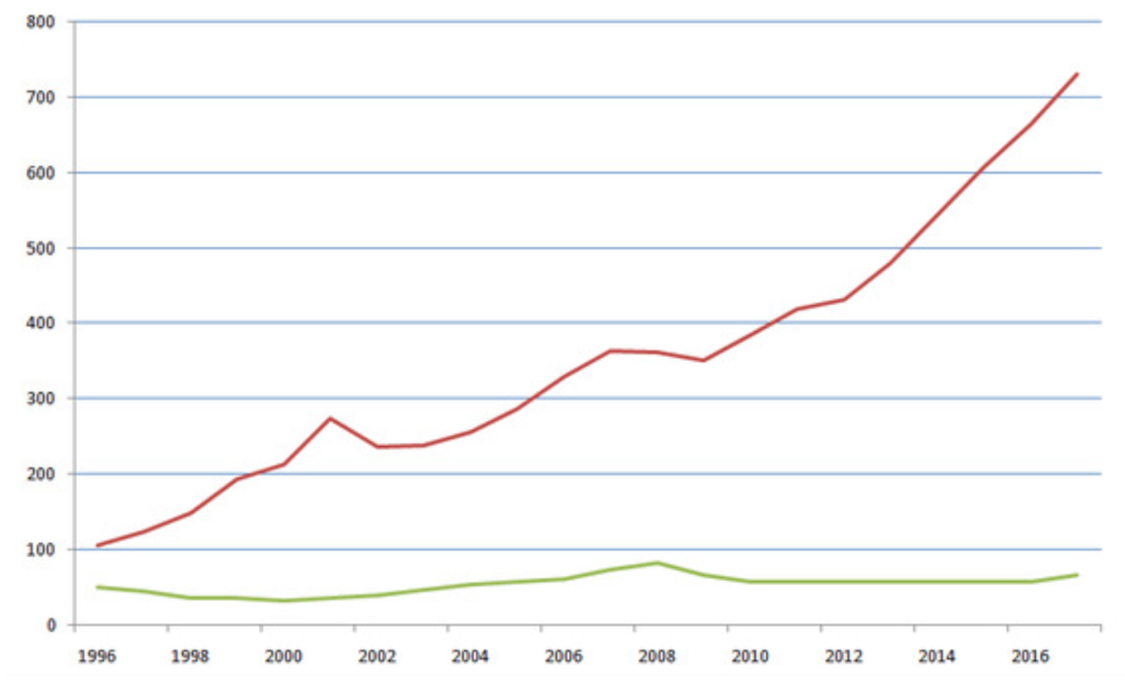
- Number of applicants and places in Uzbekistan universities, in thousands of people
Source: [Ministry of higher and secondary specialized education of the republic of Uzbekistan]

The number of additional places is very small. In the 2016/2017 academic year, about 61.2 thousand students were admitted to universities, including branches of foreign universities. 663.3 thousands of 729.9 thousand applicants did not enter state universities in 2017! The enrollment rate is at a historic low. Coverage of graduates of secondary educational institutions with higher education in 2030 should reach 50%. The percentage of people who has a high education is 20% in 2019 while most have secondary specialized 47%.
Online educational platforms are also presented in the market but only Russian language are available for the users, for example Netologia do have earnings from Uzbekistan.
Another social trend is that women makes make up every day and use lots of cosmetics, this pattern of behavior is interesting as this affect the sales of cosmetics since each women in general use more in comparison to Europe for instance.

Technological

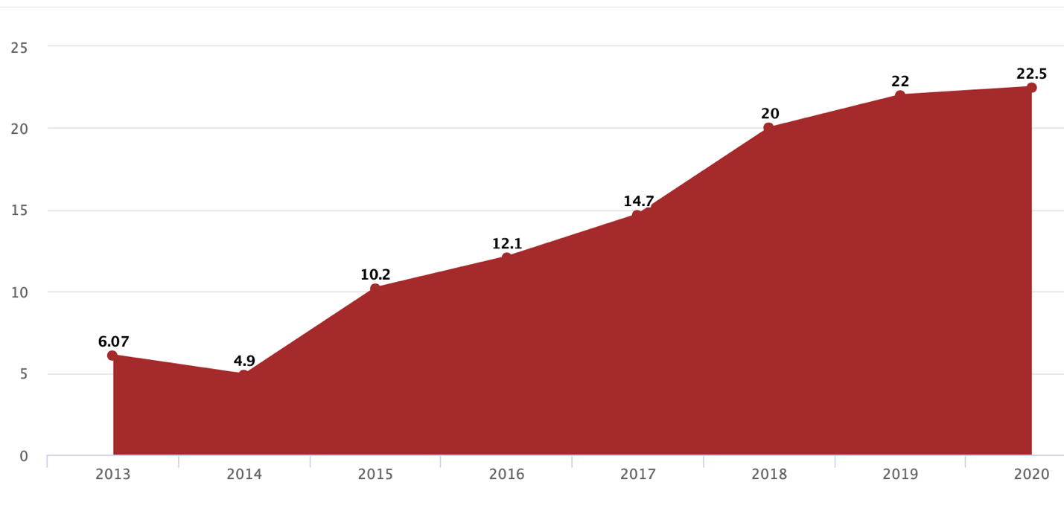
- Number of Internet users in millions
Source: [Newspaper of Uzbekistan]

The number of Internet users in Uzbekistan has reached 22.1 million people, including 19 million mobile Internet subscribers, the Ministry for the Development of Information Technologies and Communications said at a December 11 press conference. Note that Mininfocom reported 22 million Internet users, of which mobile users also accounted for 19 million people. In a press release, the ministry notes that in 2020-2022 it is planned to increase the level of Internet coverage to 2.5 million units, to bring the coverage of the population with mobile Internet to 95%. The total bandwidth of the international data transmission network has not changed since November 2018 and is 1200 Gbps. The price for operators and providers decreased by 36.1% since the beginning of the year and amounted to 45 thousand soums per 1 Mbps.
Since the beginning of the year, 4,500 base stations of mobile communications have been built and put into operation, 3,000 stations have been modernized. As a result, the Mininfocom notes, the level of mobile communication coverage of settlements in the country amounted to 97%, and mobile Internet - 87%. During the reporting period, 1 million ports were installed, their total number reached 3 million.
YouTube has over 100 million views monthly in Uzbekistan. This was announced on Friday, February 21, in Tashkent by Samson Bezmyatezhny, head of Genesis YouTube Central Asia, YouTube's official partner in Central Asia. The video service is the 10th most popular website in the country. This was explained by the fact that people are still afraid to enter the site because of the expensive Internet. When assessing the audience, citizens of Uzbekistan in Russia and other countries were taken into account. “The number of users in Uzbekistan itself is not yet large - 25%, which is 25 million views per month,” Bezmyatezhny said. The average Uzbek user watches at least five videos a day. Session - 20 minutes a day. The main audience is men (70%). Uzbeks visit the site mainly from mobile devices (72%), in second place are desktops (24%). The core of the video service in Uzbekistan are people aged 25-34, who account for 38% of the total audience. Since April of this year, the income of Uzbek bloggers with their own page on YouTube video hosting has dropped sharply. The reason was that the YouTube administration refused to financially encourage the authors of channels intended for the Uzbek-speaking audience. YouTube does not officially carry out its activities, bloggers leading their page on it do not get additional opportunities. Now Uzbek bloggers will not be able to earn income even from advertising.
There are Ozon in Uzbekistan market, this can easy the internationalization of Amway.

Environmental

Standards for emissions including air depends on the region and the category of danger for of pollutants. Importers and producers are required to pay an ecological charge to the government. In Uzbekistan, there are no restrictions on the export or import of hazardous waste for final disposal or utilization, as well as on the transit of waste through the country.

Legal

Official voluntary registration of self-employed persons started in Uzbekistan on July 1, 2020. Self-employed citizens are individuals of working age who, in order to obtain labor income, independently and with personal labor participation, perform work and provide services. Self-employed pay once a year social tax in the amount of not less than 50% of the amount of the basic calculated value (BRV) - this is 111 500 soms, regardless of the actual hours worked as a self-employed person. This amount is fully transferred to the off-budget Pension Fund, on the basis of which the amount of earnings is determined for calculating the pension in the manner prescribed for individual entrepreneurs.
- Do not pay tax on income from individuals (Article 369 of the Tax Code)
- The work experience is counted
- The self-employed is calculated a pension.
As of July 13, 2020, more than 101.5 thousand citizens have chosen the status of self-employed persons, having passed notification registration in the Soliq application and on the my.soliq.uz website. Despite the fact that in terms of regions, the Bukhara region is still in the lead - 20,885 (+172) self-employed, the largest number of newly registered self-employed citizens was recorded in the Khorezm region, 6,982 (+2,214). Namangan region has high rates - 20 145 (+1 602), Fergana region - 13 567 (+1 049), Tashkent region - 11 778 (+836). In July 20, 157,400 citizens have already registered as self-employed. In two months, 370,412 citizens were interested in the new format of employment - this is the number of registered self-employed persons at the beginning of autumn.
If you enter the Republic through international airports, you can import goods up to USD 2,000 duty-free, through railway and river checkpoints - up to USD 1,000, through road (pedestrian) checkpoints - up to USD 300!
Tax policy for the new year provides for the preservation of the main tax rates for VAT (15%), income tax (15%, for certain categories - 20%), personal income tax (12%), corporate property tax (2% ), land tax for agricultural land (0.95%), social tax (economic entities - 12%, budgetary organizations - 25%) and turnover tax (base rate - 4%). The excise tax on 73 items was canceled, including on electrical products (refrigerators, air conditioners, washing machines), tractors and semi-trailers, food products (margarine, confectionery and other products), etc.

Industry level

Porter’s 5 forces of competition for Uzbekistan
Industry rivalry:
There are not much of major rivals in the globe that may be compared to Amway in terms of market presence, commodity turnover, payments earned by distributors, and their numbers. The most important and widespread are: Herbalife, Oriflame, and NL. This companies already entered Uzbekistan.

Herbalife
In August 2020, the Center for the Sales of Herbalife Nutrition was opened in Tashkent - World Expert in Balanced Nutrition. Due to quarantine restrictions, the official opening passed in a narrow circle of brand adherents. Top managers and company executives from different points of the world joined online congratulations.
Instagram name of official account is herbalife_uzbekistan, it has825 followers and already has 66 posts.

Oriflame
On November 27, 2019, the grand and long-awaited opening of the official representative office of Oriflame in Uzbekistan took place in the capital. The event brought together influencers, beauty experts and key representatives of the Swedish cosmetics company.
Company has an YouTube channel which is named Oriflame Uzbekistan and has 4,85 thousands subscribers.
Instagram name of official account is oriflameuzbekistan_official, it has 10 900 followers and already has 461 posts.

NL
In 2 December 2018 Technical opening of a store in Tashkent.
Instagram name of official account is nl_uzbekistan, it has 494 followers and already has 63 posts.
In 2019, the company received a significant and valuable ISO 22000 certificate - this is an international standard in the field of food products. Another received the voluntary confirmation of the compliance of products with the Halal requirements. This is especially important for the national republics in Russia, as well as in Kazakhstan, Uzbekistan and Kyrgyzstan.
The approximate number of consumers are taken from the number of subscribers to official social media accounts, but this. Should be taken into account
- Comparison of Amway’s rivals in Uzbekistan

Factors | Herbalife | Oriflame | NL
Date of entering to Uzbekistan | August 2020 | November 2019 | December 2018
Approximate number of customers | 825 | 10900 | 494
Number of cities with shop | 1 | 1 | 11
Additional info |  |  | compliance of products with the Halal requirements
Source: [made by author]

- Industry rivalry in Uzbekistan
Parameter | Elimination of parameter
 | 0 | 1 | 2
Number of competitors | There are no or few firms, which can compete on the market. | The industry is highly competitive; however, there are not so many rivals. | The industry is highly competitive with many rivals.
Flexibility of increase of competition through price changes | There is a monopolist on the market, which dictates prices, so companies are not able to change the situation. | Firms and companies are not ready to compete through change in prices because of the dependency on state orders. | Firms and companies presented on the market are ready to compete through changes in prices.
Tempos of growth of the market | Low | Temperate | High
Total | 4
0-2 points | low level of competitors’ influence
3-4 points | medium level of competitors’ influence
5-6 points | high level of competitors’ influence
Source: [made by author]

Conclusion:
The situation in Uzbekistan is better as one company still did not entered market. NL became first company which first appeared officially in Uzbekistan in 2018, the next one was Oriflame and the last Herbalife. NL already opened 11 spots where product cn be bought while the rest company opened only in Tashkent. Despite of the fact that NL has the least number of followers in the social media that leads to the least number of distributers.

3.2 Adaptations of business model for Uzbekistan

Comparison of factors

- Comparison of factors for Russia and Uzbekistan

Criteria | Similarities | Differences
 |  | Russia | Uzbekistan
Culture
Hofstede | power distance  collectivistic | Uncertainty avoidance is more  less long-term orientation  Indulgence is lower | family plays a bigger role in life, more collectivistic  More feminine as people help even strangers
Purchase habits | Purchase of cosmetics are made by woman | Bigger number of purchases made in shops more often by women | Purchase of household chemicals are made by man  Bigger number of purchases made on the market
Role of women | Housewifes are common  Part of women work | Building a career is possible | Several wives  Less working women
Family | Elderly people are respected | Family includes grandparents, parents, children | The last son with a wife lives with his parents,  Family includes everybody
Language | Russian language | - | Uzbek language
Ethnicity of a country | Russians | Russians and Ukrainians – 77,7%.  Belarusians represent a significant part.  Tatar, Ukrainian, Bashkir, Chuvash, Chechen. | Uzbeks - 82 % their share is steadily rising  Tajiks - 4,8 %; Russians - 2.6 %  Kazakhs, Karakalpaks, Kyrgyz, Turkmen,
Religion | - | Orthodox | Muslim
Administrative
Currency | - | ruble | som
Transparency index | - | 30 | 26
Political regime | Democracy, one president for long time | - | -
CPIA transparency |  | - | 2,5
Ease of doing business index (1=most business-friendly regulations) | (1=most business-friendly regulations) | 28 | 69
Heritage |  | 61,5 | 58,3
Geographical
Access to the sea | yes | From the north | To the small sea
Road’s network |  | Not good | Project on making better roads
Rivers | - | There are few rivers which can be used | No rivers network to use for ship transportation
Winter | Is cold | - | -
Summer | - | medium | hot
Economic
Unemployment rate | - | 4,43% | 6,08%
Gross national income per capita | - | 11,216$ | 1,800$
GDP per capita | - | 29,181$ | 7,308$
Purchasing power parity | - | 24,82 | 2,085
Income | - | Upper middle | Lower middle
Income share held by highest 20% | - | 29,9 | 28,3
Income share held by lowest 20% | - | 7,1 | 7,4
Population growth (annual %) | - | -0,1% | 1,9%
Labor force(thousands) | - | 72,025 | 14,384
Political
International trade organisations | WTO  CIS | the United Nations, the Eurasian Union | -
Sanctions | - | From western countries | No, but has a dependence on Russia
Foreign direct investment | Programs which make own production more attractive | - | Advantages to chemical and pharmaceutical companies
Foreign Investment Advisory Council | - | multinational firms have an opportunity to influence business climate | -
Agency for Strategic Initiatives | - | Comparison of regions in terms of attractiveness for investment | -
Business climate | Not favorable | Russia still have better climate than in Uzbekistan | Decree to make favorable conditions for entrepreneurs
Natural resources | Gas, gold | Oil, copper, iron ore, thermal and brown coal, diamonds | cotton, and minerals
Investors rights protected in case of change | - | Only to priority investment project for 7 years | 10 years and possibility to choose more favorable one
Economic
Exchange rate |  | ruble 77 per dollar | som 10 500 per dollar  som 130 per ruble
Inflation |  | 4.47% | 11%
Social
Population | - | Decrease of population | Increase of population by 2%
Healthy lifestyle | Became more popular | - | -
Education | Nearly 27 % with high degree | Most applicants accepted to university | Most applicants are not accepted
Make up | Women use lots of cosmetics | - | -
Technological
Internet availability | Most people have an access | 78% | 63% of population
YouTube | Can be used | Officially on the market | Not official  Do not pay to bloggers who make content in Uzbek language  Sometimes problems with opening
Ozon | Presented in both markets | - | -
Environmental
Production requirements | regulated | Standards for utilization | Restriction on possible amount of emission
Ecological fee | compulsory | - | -
Legal
Self-employed | In both countries | - | -
Source: [made by author]

The changes which happened due to the external factors are represented below. The Uzbekistan and Russia are compared and the changes for implementation are proposed taken into account additional information received previously.

Recommendations
- Changes in Uzbekistan with correctives

Changes of business model | Factors Russia | Factors Uzbekistan | Additional information | Changes in Uzbekistan
Shop | Customer habits (no reliability to online shopping and to online communication) | Face to face communication is important | The purchase on the market is common, especially of household chemicals | Location of the shop near the market can ease the transition for buyers.
YouTube channel appeared | Brand image,  YouTube became popular | YouTube became popular  Unofficial presence | YouTube do not support content on Uzbek language | The Russian channel can be used for Russian speaking  The channel in Uzbek language can be made as the revenue from YouTube are not so crucial.
Self-employed | Self-employed appearance, Ease the process of receiving money | Self-employed exitance | Has its own procedure for registration and tax payment | Adopt according to the legal needs
Consultant | Customer habits (the usual shop way of working)  did not last for long in Russia | There are no experienced IBOs who knows product |  | This practice can be implemented for few years.
My center amway | Customer habits (Space to work for IBOs and show the shop and product) | More collectivistic country, Family consists of bigger number of people. | No IBOs  More people with secondary specialized education | The bigger working space needed  New IBOs need a coach which will teach them to make master classes and use product correctly
Change of general manager | Need to have experience from outside, Relationships between Russia and America | Uzbek language,  Cultural specifics,  Dependence on Russia | High power distance | General manager needs to know both languages and understand the cultural specifics
VIP+ client | Crisis, PPP decrease | PPP is lower | The salaries are lower | Implement
Education | 30% with bachelor  Lots of online educational platforms | The same number of people with bachelor,  Not much of educational system,  Low rate of acceptance to university,  Dense economic situation | Only Russian online educational platforms,  More people with secondary specialized education,  lots of people who was not accepted to university | Free education will be more demanded as people tend to learn, but have no money
Increase of prices | Inflation, Increase of exchange rate $/₽ | Inflation, Increase of exchange rate $/₽ |  | The price should be chosen, so not to increase it constantly
Marketing | Business online (Covid)  Make need to build brand image online  Personal contact is important | Business online (Covid)  Personal contact is important | Muslim  Cultural specifics  Men purchase household chemicals | Implement change of language and adaptation to the religion and cultural aspects.
Family Council | Covid,  Professional recommendations | Covid |  | In case of dense situation with Covid, can be implemented
Production | Special Investment Contracts, inflation, exchange rate,  sanctions | Advantages to chemical and pharmaceutical companies, inflation, exchange rate,  sanctions | Investors rights protected | Production of vitamins is possible
Marketplace | Violated policy  Online shopping (Covid) | Ozon is presented in the Uzbekistan |  | Possibility to enter market through Ozon network
Source: [made by author]

In the first column the changes in Russia which was made by company during its existence in the market and had external factors to be implemented are presented. IN the second column there are external factors in Russia while in third the same factors in Uzbekistan are described. In fourth column there is an additional information which should be considered to make modification for new market needs. Finally, in the last column there are recommendations for each changes which will help company to benefit more from changes implementation.
- Changes due internal factors

Changes of business model | Period | Factors | Clauss
Increase range of product | 2005-2013 | High profit product appearance | Value proposition
New managers | 2005-2013 | Development of region | Value creation
Creators | 2014-2019 | Attraction of young IBOs | Value creation
Support for IBOs events | 2020-2021 | Increase the effectiveness of IBOs activities | Value creation
Source: [made by author]

The changes that happened all over the world will be implemented in all markets as the company see them as universal. Change of website, Charity and appearance of new products (XS, vitamins set, assortment of cosmetics) will take place in the new market. The internal factors which had influenced company to introduce changes seem relevant to the new market as well, but some of them can be made after the company entrance to the market depending to the financial situation of the company. Creators program can be implemented from the beginning especially the excess to the young IBOs from other countries can be provided to Uzbekistan youth as company see a tendency all over the world that they lack people aged 18 to 35 years.

Additional recommendations
Recommendations for IBOs
The culture of Uzbekistan differs from the one in Russia that is why it is crucial to take into account the cultural specifics of the country. The impact of each identified difference to the work of the IBOs are described below.
First, respect of elderly people in Uzbekistan is more important to follow and while speaking with potential client he/she will expect polite and interested to their point of view communication. Moreover, they have a big family where their opinion is the heaviest and losing contact with elder person, IBOs also loss his/her family as potential clients. Third, although the opinion of parents is respected and followed the household work are usually done by last son and his wife as they continue to live with parents due to traditions. This means that the decision to buy new household chemical production are made by all four people in the home, of course, some of them more then others. IBOs should take this habit of live into account as to finalize the deal and have the regular purchases all four better to agree. Fourth is that purchases of these chemicals are often made by man as they go to the market to buy food and household chemicals are also sold there. This supports the impertinence to speak not only with women, but also with men to get new clients. Fifth, people tend to help each other in usually life as well as in work that is why more coaching style is needed, IBOs better to spend more time discussing the strengths and weaknesses of new candidate, all steps should be explained and done together more than once. The last is connected more with economic situation in the country, people do think about earnings, and they need to have results faster that is why it is better to invest more time with each new IBO and in short time make them achieve earnings to reduce number of people who quit in order to earn money in second job for example.
- Respect to elderly people
- Parents have influence on children
- Last son lives with parents
- Men makes purchases of household chemicals
- More coaching style as feminine
- Make money fast as people do thing more about earnings and can switch to other activity where they will receive more.

There is a recommendation for Amway according choosing the possible way of entrance.
3 ways of Entrance:
- Ozon,
- Amway,
- IBOs
The usual way of entrance for Amway is when IBOs start selling and transportation of product on new market. As a result, by the time when company officially enters the market, it already has a significant number of local consumers and even IBOs who usually register officially in the market from which purchases are made and then transported to that new market.
Despite the practice of entering the market begins with IBOs, this can be changed this time as the marketplace where company products presented appeared. This can lead to the compliance with company policy to reduce the number of copies presented in the market and will make a good brand image because the quality of goods will be the same as promised. The company can also start to acquire the market share as IBOs from other countries can have friends or relatives there who can register in the site officially and receive bonuses and paybacks for their purchases as well as earnings from commodity turnover. This type of entrance needs some investments such as work on the website to make a version on Uzbek language and negotiation with Ozon. This way brings more benefits in comparison to the entrance by IBOs as company can provide lower prices as the economies of scale will lower transportation costs while IBOs can have less money to invest in buying product as a result the restricted number and range will be provided in Uzbekistan market.
The entrance by the company itself will provide additional value as my center Amway which includes shop and workspaces for IBOs which are find out to be important in Uzbekistan market. However, company will need to invest more to attract existing IBOs interest towards new market which can be hard in case they have lots of work to do in their own country. In practice IBOs start their activity of entering new market when they have stagnation in the current market or rapid growth without their intervention. This is one of the reasons why Amway do not usually enter the market first.
Taking into account everything that is described above, Recommendation will be to enter the market with the help of Ozon as there are already some IBOs who are interested to work on Uzbekistan market and the company will make it possible to provide cheaper prices which are essential for Uzbekistan.

From the 5 forces of Porter the rivalry in Uzbekistan was identified as medium. The range of products and the way of how companies calculate earnings to their IBOs were found out, out of this data it is clear that leaders’ earnings are the highest in Amway while earnings which people receive from the beginning are little higher, it is also needed to take into account that make commodity turnover is easier while range of product is higher. Amway do have the widest range of product and it differentiate from all others by the quality of product. The Amway has a premium class goods while all the rest have an economy one. This also influence the number of products which needed to be sold to increase earnings. Out of this Amway can enter the market with any of its product as it can attract more wealthy people. Although 3 out of 4 competitors did enter market, Avon still is not presented. This can be used to acquire the consumers for household chemicals as this is one of the categories which presented in Amway and Avon, first mover advantage still can be used.

Conclusion
At first the literature review was provided with general explanation of business models, existing frameworks and their features. The definition of the adaptation and innovation were provided in for this work two these words do have an equal meaning with change. The difference between adaptation of business model and change of operations is that the first is done in order to change the value that company propose to a customer while second improves effectiveness of providing existing value.
In the paper the business model of Amway company was described as well as all changes which happened in the market. Changes includes monetary incentives for IBOs, appearance of production and the shop. Some of them happened due to internal needs of company while others are influenced by external factors in the market. For instance, shop appearance explained by the people’s negative attitude to online shopping. Another example is the modification of shop which implies the appearance of working spaces for individual business owners and the equipment to make master classes connected with different categories of products. In order to find out the internal reasons the interview with deputy of regional manager for Russia, Kazakhstan and Ukraine was made, it also helped to find out additional information about changes and the correlation between the change and reason. Interviews with individual business owners were made with the same intentions.
The reasons for each change are identified and described in the body of the work as well. Knowing the reasons why each of adaptation occur it became possible to start searching information about Uzbekistan market in the same fields to understand the environment to which business model need to be adopted in general and specifically. The websites of ministries were used as sources of information as well as interview with person who used to live in Uzbekistan. The former source provided information according to regulations in country and current data about the economic, political and legal situation while the latter became the source to know the culture of country and habits of citizens.
To compare two countries, the PESTEL, CAGE, and Porter 5 Forces frameworks were employed. At the macro level, there is a significant cultural and economic divide. Citizens of Uzbekistan do more follow traditions and religious rules which can be seen in their relationships with family. For instance, the last son and his new family do live with parents for whole live and help them with housework. The women do not choose career path, but some of them in more modern families can work. The people attitude towards each other are more friendly, they tend to help each other at workplace and even to unknown people. The economic situation is worse than in Russia, citizens have lower salaries but prices for grocery just little bit lower this makes most families to spend lots of money for food. The numbers which show the attractiveness for business are lower as well. Based on the similarities and differences the changes which happened in Russian market was suggested with correctives to the needs of Uzbekistan.
Yet at the industrial level, countries are relatively comparable. The main distinction is that multilevel marketing companies have been operating in the Russian market for years, but they are relatively new in Uzbekistan. The main competitors of company were chosen thinking that the possibility to earn money is the main product, so there are several major companies which can be compared with Amway in such terms including Avon, Oriflame, NL and Herbalife. All of them except Avon already had entered Uzbekistan starting from 2018 to 2020. That is why market is still not mature and Amway can take advantage in case of entering the market in recent time, the household chemicals are also still not proposed to consumers as only Avon has this category of product. The main distinguish of Amway from others is the premium class product and high quality that is why wealthy citizens who value these qualities will choose Amway’s product despite the fact that other competitors already operate in the market.
Most of the modifications in the Russian market are applicable to Uzbekistan as well, but each of them was given some correctives to make them more successful in the new market. The majority of modifications made have an impact on the firm's value creation, the second place is taken by a value proposition. Value capture has seen the least amount of change, although a new revenue source has emerged. This is the amount paid as a rent for rooms fitted to hold master courses and business meetings. The full table with recommendation can be found in the section named Recommendation. One of changes are also proposed to be implemented in new market despite of the fact that it quite recently vanished in Russian market, this is consultant in the shop. This change can be helpful as market is new for company and there are not much IBOs who knows a product, so for new clients help of consultants to know the features of product and the correct use of it can be crucial.
Additionally, further advice was offered to individual business owners who plan to operate in the Uzbekistan market, as they must consider the country's cultural and economic conditions while building relationships with new consumers and meeting their demands. Furthermore, a recommendation was provided based on the method of entering a new market. Amway generally enters the market after IBOs, but due to developments in the Russian market, namely the debut of the company's product on the marketplace, it has become feasible to export its goods with the aid of Ozon, which already works in the new market.

Reference list:

- "Коммерсантъ" от 30.03.2018, 14:49. (2018, March 30). Узбекистан открывает самого себя. Узбекистан открывает самого себя – Мир – Коммерсантъ. https://www.kommersant.ru/doc/3590933.
- 1 доллар США (USD) в узбекских сумах (UZS) сегодня. Рамблер/финансы. (n.d.). https://finance.rambler.ru/calculators/converter/1-USD-UZS/.
- 1 рубль (RUB) в узбекских сумах (UZS) сегодня. Рамблер/финансы. (n.d.). https://finance.rambler.ru/calculators/converter/1-RUB-UZS/.
- Amit R. and Zott C., Value creation in e-Business, Strategic Management Journal 22(6/7), 493e520 (2001).
- Amit, R. and Zott, C. (2012) Creating value through business model innovation. Mit Sloan Management Review, 53, 3, 41–49.
- Amway Europe Events. (n.d.). https://m.facebook.com/europeanamwayevents/.
- Amway Russia m.facebook.com
- Amway Russia. (n.d.). https://m.facebook.com/amwaytoday.
- Amway Академия. (n.d.). https://m.facebook.com/academyamway/?ref=py_c&eid..
- Amway Академия. VK. (n.d.). https://m.vk.com/amwayacademy.
- Amway Россия и Казахстан www.youtube.com
- Amway Россия. VK. (n.d.). https://m.vk.com/public.amwaytoday.
- Amway. (n.d.). https://www.amway.ru/terms-partnership-amway-vipplus.
- Baden-Fuller C. and Morgan M., Business models as models, Long Range Planning 43(2e3), 156e171 (2010).
- BBC. (2020, January 7). Russia profile - Media. BBC News. https://www.bbc.com/news/world-europe-17840134.
- Business model adaptation for emerging markets: a case study of a German automobile manufacturer in India Christian Landau, Amit Karna and Miriam Sailer
- By Juliana Menasce Horowitz, Ruth Igielnik and Rakesh Kochhar
- Central Intelligence Agency. (n.d.). Central Intelligence Agency. https://www.cia.gov/the-world-factbook/countries/uzbekistan/.
- Chanal, V. and Caron-Fasan, M.-L. (2010) The difficulties involved in developing business models open to innovation communities: the case of a crowdsourcing platform.
- Chesbrough H. and Rosenbloom R., The role of business model in capturing value from innovation: evidences from Xerox Corporation’s technology spin-off companies, Industrial and Corporate Change 11(3), 529e555 (2002);
- Christian J. Broberg, Alexander McKelvie, Jeremy C. Short, David J. Ketchen, William P. Wan, Political institutional structure influences on innovative activity, Journal of Business Research, Volume 66, Issue 12, 2013, Pages 2574-2580, ISSN 0148-2963.
- Clauss, T. (2017), “Measuring business model innovation: conceptualization, scale development, and proof of performance”, R&D Management, Vol. 47 No. 3, pp. 385-403.
- Corruption Perceptions Index 2020 for United States. Transparency.org. (n.d.). https://www.transparency.org/en/cpi/2020/index/usa.
- Country Rankings: World & Global Economy Rankings on Economic Freedom. (n.d.). https://www.heritage.org/index/ranking.
- CPIA transparency, accountability, and corruption in the public sector rating (1=low to 6=high). Data. (n.d.). https://data.worldbank.org/indicator/IQ.CPA.TRAN.XQ.
- Demil and Lecocq (2010) Business Model Evolution: In Search of Dynamic Consistency
- Ease of doing business index (1=most business-friendly regulations). Data. (n.d.). https://data.worldbank.org/indicator/IC.BUS.EASE.XQ.
- Elagina, D. (2020, November 23). Russia: women to men ratio by age 2020. Statista. https://www.statista.com/statistics/1089814/russia-women-to-men-ratio-by-age/.
- Elagina, D. (n.d.). Topic: Healthcare in Russia. Statista. https://www.statista.com/topics/4824/health-care-in-russia/.
- Forbes Magazine. (n.d.). Amway. Forbes. https://www.forbes.com/companies/amway/.
- Forbes Magazine. (n.d.). Amway. Forbes. https://www.forbes.com/companies/amway/?sh=257af8a6ec41.
- GDP per capita, PPP (current international $). Data. (n.d.). https://data.worldbank.org/indicator/NY.GDP.PCAP.PP.CD.
- General information. Ministry of Digital Development, Communications and Mass Media of the Russian Federation. (n.d.). https://digital.gov.ru/en/ministry/common/.
- Ghaziani A. and Ventresca M. J., Keywords and cultural change: frame analysis of business model public talk, 1975e2000, Sociological Forum 20(4), 523e559 (2005).
- Heij, C.V., Volberda, H.W., and Van den Bosch, F.A. (2014) How does business model innovation influence firm performance: the effect of environmental dynamism. In Academy of Management Proceedings (Vol. 2014, No. 1, p. 16500) Academy of Management.
- International center for trade and sustainable development https://ictsd.iisd.org/bridges-news/мосты/news/присоединение-узбекистана-к-договору-о-зоне-свободной-торговли-снг-союз-без
- January 9, 2020. Most Americans say there is too much economic inequality in the US, But fewer than half call it a top priority. Democrats and republicans differ on whether addressing economic inequality requires major changes to the economic system
- Jordan Gans-Morse. Taxes, Banking, and Legal development in Russia: Lessons about institutional Complementarities and the rule of Law (2020) Demokratizatsiya: The Journal of Post-Soviet Democratization 28 pp. 47-76.
- Key Features of Common Law or Civil Law Systems. PUBLIC-PRIVATE-PARTNERSHIP LEGAL RESOURCE CENTER. (n.d.). https://ppp.worldbank.org/public-private-partnership/legislation-regulation/framework-assessment/legal-systems/common-vs-civil-law.
- Khanna and Palepu, Winning in emerging markets: A road map for strategy and execution,2010
- Khanna et al., Strategies That Fit Emerging Markets, (2005)
- Kotov, I., Boutin, N., Tuschen, S., Yakovlev, N., Pogorelskaya, E., Ivanova, A., & Bakhtin, M. (2021, January 8). Russian Consumers and the New Economic Reality. Russia - RU. https://www.bcg.com/ru-ru/publications/2018/russian-consumers-new-economic-reality.
- Kuznets, D. (n.d.). The recovery year 'Meduza' answers key questions about what awaits the Russian economy in 2021. Meduza. https://meduza.io/en/feature/2021/01/07/the-recovery-year.
- Magretta J., Why business models matter, Harvard Business Review 80(5), 86e92 (2002);
- Maltzeva, A. (2020, October 11). Гонка за здоровьем: бизнес хочет не отставать от своих потребителей. Ведомости. https://www.vedomosti.ru/partner/articles/2020/10/11/838509-gonka-zdorovem.
- Markides, C. (2006) Disruptive innovation: in need of better theory. Journal of Product Innovation Management, 23, 1, 19–25.
- Maurya A., Why Lean Canvas vs Business Model Canvas?, (2018)
- McKinsey & Company. (2021, May 12). COVID-19: Implications for business. McKinsey & Company. https://www.mckinsey.com/business-functions/risk/our-insights/covid-19-implications-for-business#.
- Meduza. Russia’s population will decline by 352,500 people this year — 11 times more than in 2019
- Melkadze A., & 9, A. (2021, April 9). Russia: disposable household income 2014-2023. Statista. https://www.statista.com/statistics/1055790/russia-disposable-household-income/.
- Meyer A. D., Adapting to environmental jolts, Administrative Science Quarterly 27(4), 515e537 (1982).
- Michael Alexeev, Andrey Chernyavskiy. Natural resources and economic growth in Russia’s regions
- Ministry of investments and foreign trade of the Republic of Uzbekistan. Ўзбекистон Республикаси Инвестициялар ва ташқи савдо вазирлиги. (n.d.). https://mift.uz/en/investp.
- Newrosinf. (2021, February 16). Федеральная служба государственной статистики. https://rosinfostat.ru/natsionalnyj-sostav/#i.
- Nutrilite Россия и Казахстан. (n.d.). https://m.facebook.com/nutriliterussia.
- NUTRILITE Россия и Казахстан. VK. (n.d.). https://m.vk.com/nutriliterussia.
- O'Neill, A. (2021, April 1). Uzbekistan - unemployment rate 1999-2020. Statista. https://www.statista.com/statistics/809064/unemployment-rate-in-uzbekistan/.
- O'Neill, A. (2021, May 7). Russia - Inflation rate 2025. Statista. https://www.statista.com/statistics/271376/inflation-rate-in-russia/.
- Oecd. (n.d.). Income Distribution Database : by country. https://stats.oecd.org/index.aspx?queryid=66670.
- Oriflame торжественно открылся в Узбекистане. Газета.uz. (2019, December 2). https://www.gazeta.uz/ru/2019/12/02/oriflame/.
- Oriflame. Oriflame Cosmetics. (n.d.). https://www.oriflame.ru/.
- Pankaj Ghemawat, “Distance Still Matters,” Harvard Business Review 79, no. 8 (September 2001): 1–11.
- Religion in America: U.S. Religious Data, Demographics and Statistics. Pew Research Center's Religion & Public Life Project. (2020, September 9). https://www.pewforum.org/religious-landscape-study/.
- Religious Belief and National Belonging in Central and Eastern Europe. Pew Research Center's Religion & Public Life Project. (2020, May 31). https://www.pewforum.org/2017/05/10/religious-belief-and-national-belonging-in-central-and-eastern-europe/?utm_source=Pew%2BResearch%2BCenter&utm_campaign=efff8a5e05-EMAIL_CAMPAIGN_2017_05_10&utm_medium=email&utm_term=0_3e953b9b70-efff8a5e05-400288249.
- Research and Development. Research and development | Oriflame Cosmetics. (n.d.). https://corporate.oriflame.com/About-Oriflame/Research-Development.
- Rfe/rl. (2016, December 22). Безуспешные попытки импичмента в странах СНГ. Радио Азаттык (Кыргызская служба Радио Свободная Европа/Радио Свобода). https://rus.azattyk.org/a/28190372.html.
- Rule of Law Partnership In Uzbekistan: Fact Sheet: Uzbekistan. U.S. Agency for International Development. (2020, April 30). https://www.usaid.gov/uzbekistan/fact-sheets/rule-law-partnership-uzbekistan.
- Russia - Investment Climate StatementRussia - Executive Summary. export.gov. (n.d.). https://legacy.export.gov/article?id=Russia-Investment-Climate.
- Russia Economic Report. World Bank. (n.d.). https://www.worldbank.org/en/country/russia/publication/rer.
- Russia's population will decline by 352,500 people this year - 11 times more than in 2019. Meduza. (n.d.). https://meduza.io/en/news/2020/10/16/russia-s-population-will-decline-by-352-500-people-this-year-11-times-more-than-in-2019.
- Schneider S. , Spieth P. , Business model innovation: towards an integrated future research agenda, Int. J. Innov. Manage., 17 (2013), Article 1340001
- Services, F. N. S. (n.d.). Налог на профессиональный доход. Специальный налоговый режим для самозанятых граждан: Налог на профессиональный доход | ФНС России. https://npd.nalog.ru/.
- Shifrina, E. (2020, November 16). Здоровое потребление: какие ЗОЖ-привычки станут нормой в 2021 году - NewRetail. New Retail. https://new-retail.ru/business/zdorovoe_potreblenie_kakie_zozh_privychki_stanut_normoy_v_2021_godu3847/.
- Shutterstock, Ф. M. M. /. (2020, November 6). Взрывной рост: рейтинг лидеров рынка онлайн-образования России. РБК Тренды. https://trends.rbc.ru/trends/education/5fa1cc249a794739b65c7b5c.
- Six US Natural Resources That Boost the Economy.BY KIMBERLY AMADEO
- Socialization communication, organizational citizenship behaviors, and sales in a multilevel marketing organization. John R. Sparks and Joseph A. Schenk
- Sputnik Узбекистан. (2020, November 9). В Узбекистане любителям пеших прогулок будут выплачивать до $100 в месяц. Sputnik Узбекистан. https://uz.sputniknews.ru/20201102/V-Uzbekistane-lyubitelyam-peshikh-progulok-budut-vyplachivat-do-100-v-mesyats-15308998.html.
- Sputnik Узбекистан. (2021, March 5). Запад "душит" экономику Узбекистана - делает он это не напрямую, а через РФ. Sputnik Узбекистан. https://uz.sputniknews.ru/20210304/Uzbekistan-v-odnoy-lodke-s-Rossiey-kogda-rech-zakhodit-o-zapadnykh-sanktsiyakh-16129043.html.
- Szmigiera M., & 12, M. (2021, March 12). Big Mac index 2020. Statista. https://www.statista.com/statistics/274326/big-mac-index-global-prices-for-a-big-mac/.
- Szmigiera, M. (2021, April 7). Price level index comparison: IMF, by country 2018. Statista. https://www.statista.com/statistics/426431/price-level-index-comparison-imf-and-world-bank-by-country/.
- Teece, D.J. (2010), “Business models, business strategy and innovation”, Long Range Planning, Vol. 43 Nos 2/3, pp. 172-194.
- The Foreign Investment Advisory Council (FIAC). (n.d.). https://fiac.ru/.
- The top 1% controls a third of the wealth, and the poor are getting poorer. How Russia became one of the most unequal places on Earth. Meduza. (n.d.). https://meduza.io/en/feature/2019/01/23/the-top-1-controls-a-third-of-the-wealth-and-the-poor-are-getting-poorer-how-russia-became-one-of-the-most-unequal-places-on-earth.
- The top 1% controls a third of the wealth, and the poor are getting poorer. How Russia became one of the most unequal places on Earth. January 23, 2019
- Tikkanen H., Lamberg J.-A., Parvinen P.. Kallunki and J.-P, Managerial cognition, action and the business model of the firm, Management Decision 43(6), 789e809 (2005).
- Transparency International Global Corruption Barometer: Ukraine has become more corrupt over the last two years, The Ukrainian Week (9 July 2013)
- User, S. (n.d.). Уровень образования населения в возрасте 25 лет и старше по Республики Узбекистан. Гендерная статистика - Asosiy. https://gender.stat.uz/ru/ii-group-ru/880-uroven-obrazovaniya-naseleniya-v-vozraste-25-let-i-starshe-po-polu.
- Wirtz, B.W., Pistoia, A., Ullrich, S. and Göttel, V. (2016), “Business models: origin, development and future research perspectives”, Long Range Planning, Vol. 49 No. 1, pp. 36-54.
- Wirtz, B.W., Pistoia, A., Ullrich, S. and Göttel, V. (2016), “Business models: origin, development and future research perspectives”, Long Range Planning, Vol. 49 No. 1, pp. 36-54.
- Wolfe, L. (n.d.). 3 Types of Network Marketing Programs to Make Money. The Balance Small Business. https://www.thebalancesmb.com/the-network-marketing-business-model-is-it-right-for-you-3515493.
- Worldwide Bureaucracy Indicators Dashboard. World Bank. (n.d.). https://www.worldbank.org/en/data/interactive/2019/05/21/worldwide-bureaucracy-indicators-dashboard.
- XSNation.rus. (n.d.). https://m.facebook.com/xsnation.rus/.
- XSNation.rus. VK. (n.d.). https://m.vk.com/xsnationrus.
- YouTube перестал платить деньги авторам каналов из Узбекистана. CentralAsia.media. (2021, May 25). http://centralasia.media/news:1704769.
- YouTube. (n.d.). Amway Россия и Казахстан. YouTube. https://m.youtube.com/user/amwtodayru.
- YouTube. (n.d.). Oriflame Uzbekistan. YouTube. https://www.youtube.com/channel/UCnkc5L9CReDwZJFlsZ3zYYg.
- Zott, C. and Amit, R. (2010) Business model design: an activ- ity system perspective. Long Range Planning, 43, 2, 216– 226.
- Zott, C., Amit, R., and Massa, L. (2011) The business model: recent developments and future research. Journal of Management, 37, 4, 1019–1042.
- АБР выделил $274 млн на улучшение дорог в Узбекистане. Газета.uz. (2020, September 3). https://www.gazeta.uz/ru/2020/09/01/adb-roads/.
- Бессуднов, Алексей Куракин, Дмитрий & Малик, Валерия (2017, October 9). Миф о всеобщем высшем образовании. Ведомости. https://www.vedomosti.ru/opinion/articles/2017/10/10/737202-mif-o-vseobschem-visshem.
- Благовещенский, Антон (2013, April 24). Россияне составили 5 процентов от общей аудитории YouTube. Российская газета. https://rg.ru/2013/04/24/youtube-site.html.
- В Ташкенте озвучили показатели YouTube в Узбекистане. Spot. (2020, February 22). https://www.spot.uz/ru/2020/02/21/youtube/.
- ВЦИОМ. Новостной портал. ВЦИОМ. Новости. (n.d.). https://wciom.ru/.
- Государственный комитет Республики Узбекистан по статистике. (n.d.). https://stat.uz/ru/.
- Государственный налоговый комитет Республики Узбекистан. (n.d.). https://soliq.uz/press-services/news/show/samozanyatost--faktov-legalnogo-trudoustroystva?lang=ru.
- Государственный налоговый комитет Республики Узбекистан. (n.d.). https://soliq.uz/press-services/news/show/samozanyatost-rubezh-v--dney?lang=ru.
- Детям будут бесплатно выдавать витамины и йодные препараты. Газета.uz. (2020, November 6). https://www.gazeta.uz/ru/2020/11/06/vitamins/.
- Дефицитное высшее образование. Газета.uz. (2020, February 18). https://www.gazeta.uz/ru/2018/05/28/education/.
- Инновационные и безопасные продукты для полноценной жизни - NL International. Контакты - NL International. (n.d.). https://nlstar.com/ru/contact/.
- Инновационные и безопасные продукты для полноценной жизни - NL International. О компании - NL International. (n.d.). https://nlstar.com/ru/about/.
- Инструкция. Как самозанятым зарегистрироваться через мобильное приложение? Газета.uz. (2020, July 3). https://www.gazeta.uz/ru/2020/07/03/self-employed/.
- Инфляция. Центральный банк Республики Узбекистан. (n.d.). https://cbu.uz/ru/monetary-policy/annual-inflation/.
- Казинформ. (2021, February 15). На казахстанско-узбекской границе откроют центр международной торговли. www.forbes.kz. https://forbes.kz//finances/markets/na_kazahstanskouzbekskoy_otkroyut_tsentr_mejdunarodnoy_torgovli/.
- Казинформ. (2021, February 15). На казахстанско-узбекской границе откроют центр международной торговли. www.forbes.kz. https://forbes.kz//finances/markets/na_kazahstanskouzbekskoy_otkroyut_tsentr_mejdunarodnoy_torgovli/.
- Корня, Анастасия (2019, July 11). Предприниматели назвали условия для бизнеса в России неблагоприятными. Ведомости. https://www.vedomosti.ru/politics/articles/2019/07/11/806358-usloviya-dlya-biznesa.
- Курс доллара США (USD) по ЦБ, Forex и ММВБ на сегодня и завтра, калькулятор, динамика курса доллара США к рублю. Рамблер/финансы. (n.d.). https://finance.rambler.ru/currencies/USD/?updated.
- МИНИСТЕРСТВО ВЫСШЕГО И СРЕДНЕГО СПЕЦИАЛЬНОГО ОБРАЗОВАНИЯ РЕСПУБЛИКИ УЗБЕКИСТАН. Статистические данные. (n.d.). https://edu.uz/ru/pages/sss.
- Налоги в Узбекистане в 2021 году: что изменилось. Газета.uz. (2021, January 4). https://www.gazeta.uz/ru/2021/01/04/taxes-2021/.
- Население Узбекистана превысило 34,5 миллиона. Газета.uz. (2021, January 16). https://www.gazeta.uz/ru/2021/01/16/population/.
- Национальный рейтинг состояния инвестиционного климата в регионах. Агентство стратегических инициатив. (n.d.). https://asi.ru/government_officials/rating/.
- Нурмуратов. (n.d.). Постановление министерства финансов республики узбекистан государственного налогового комитета республики узбекистан. https://lex.uz/getwordfile/330001#333996.
- Об актуальных вопросах исполнения "расширенной" ответственности производителей, импортеров товаров. Об актуальных вопросах исполнения "расширенной" ответственности производителей, импортеров товаров - Минприроды России. (n.d.). https://www.mnr.gov.ru/activity/directions/otvetstvennost_proizvoditelya_i_importera_tovarov_po_utilizatsii_otkhodov/.
- Об инвестиционной деятельности в Российской Федерации, осуществляемой в форме капитальных вложений. (n.d.). https://docs.cntd.ru/document/901727484.
- Официальный интернет-магазин косметики Avon в России. (n.d.). https://my.avon.ru/.
- Официальный сайт государственного таможенного комитета Республики Узбекистан. (n.d.). https://www.customs.uz/ru/lists/view/112.
- Охват высшим образованием к 2030 году планируется довести до 50%. Газета.uz. (2019, October 8). https://www.gazeta.uz/ru/2019/10/08/education/.
- Президент подписал указ о сокращении бюрократии. Газета.uz. (2021, March 23). https://www.gazeta.uz/ru/2021/03/23/bureaucracy/.
- Продукты. Russian Federation. (n.d.). https://herbalife.ru/.
- Продукты. Russian Federation. (n.d.). https://herbalife.ru/history/.
- Савчук, С. (2021, May 26). Узбекистан и русский язык. РИА Новости. https://ria.ru/20201014/yazyk-1579605843.html.
- События Amway Россия и Казахстан. VK. (n.d.). https://m.vk.com/amwayrukzevents.
- Старостина, Ю. (2020, October 15). Правительство резко ухудшило прогноз по убыли населения России. РБК. https://www.rbc.ru/economics/15/10/2020/5f8846b39a7947323dcb06c5.
- Ткачёв, И., & Фадеева, А. (2019, March 14). 55 триллионов в запасе: как власти оценили все природные ресурсы России. РБК. https://www.rbc.ru/economics/14/03/2019/5c8931029a7947b028b8886c.
- Цыряпкина, Ю. Н. (n.d.). Русские в узбекистане: языковые практики и самоидентификация.
- Число интернет-пользователей в Узбекистане - 22,1 миллиона. Газета.uz. (2020, December 14). https://www.gazeta.uz/ru/2020/12/11/network/.

Appendix 1 Earnings in Network marketing companies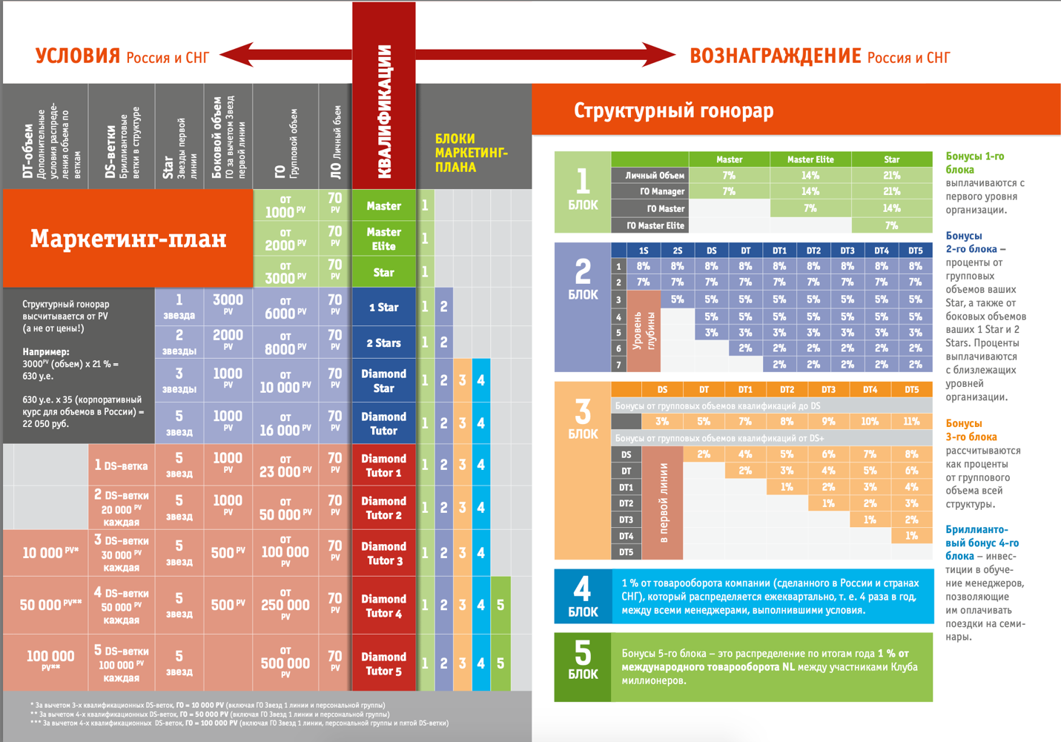

- Business models division for Clauss

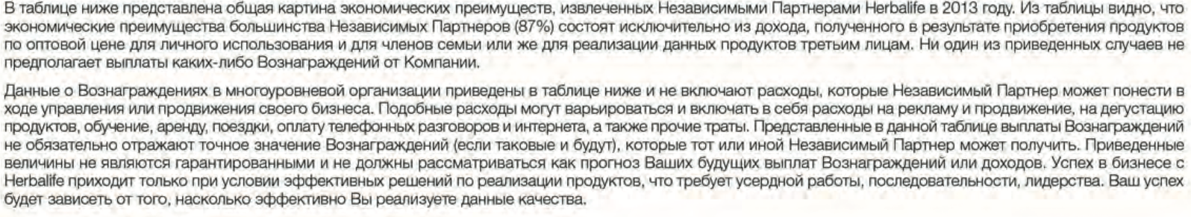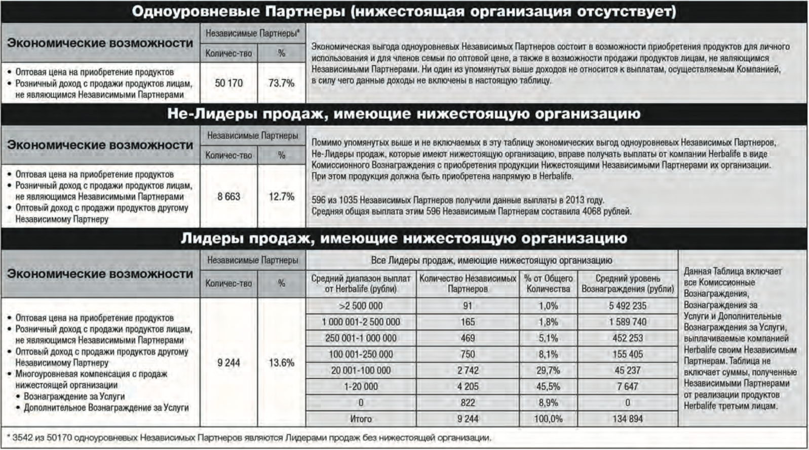
- Herbalife payments
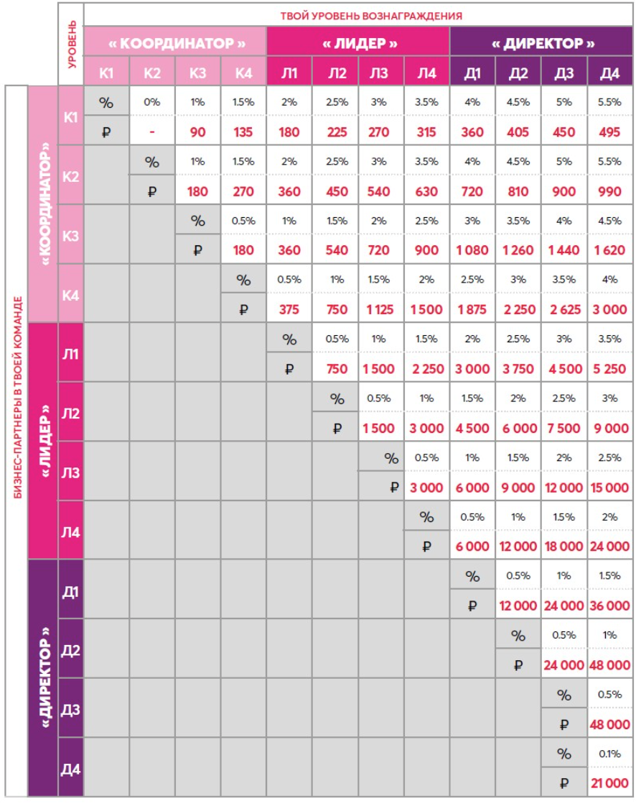
- Payments in Avon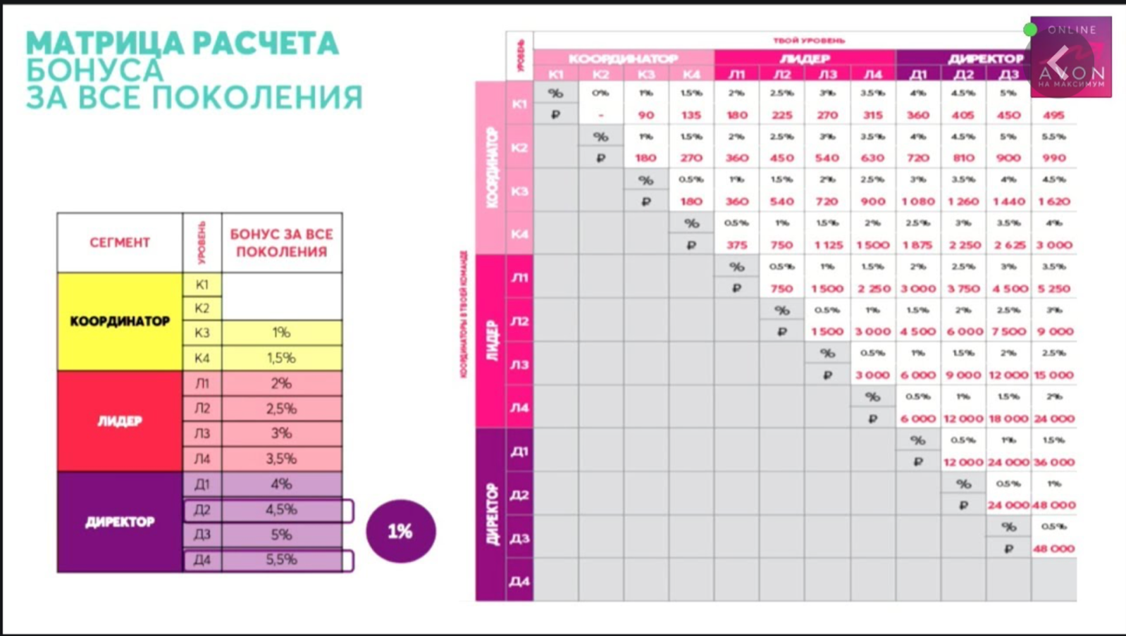
- Avon payments
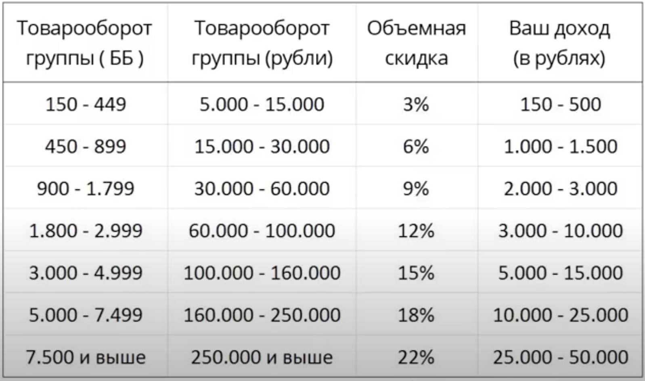
- Oriflame payments
- NL payments

Appendix 2 Support materials

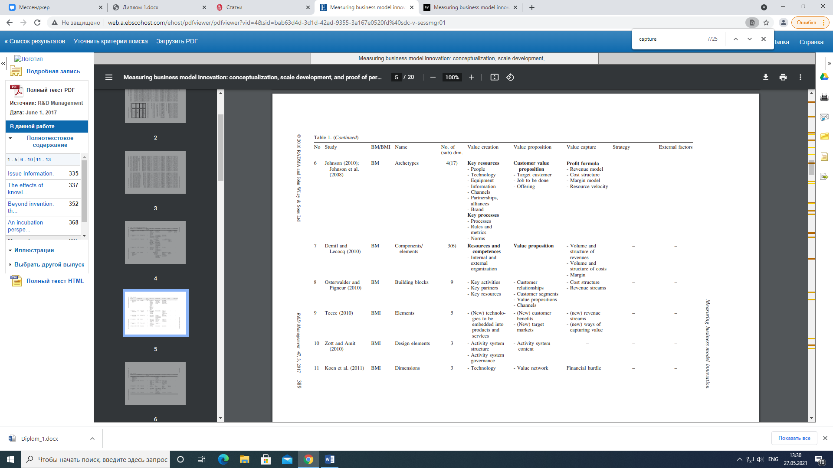
- Business models division for Clauss

Interview questions
1. Сколько лет вы уже являетесь предпринимателями Amway?
2. Помните ли вы как вы узнали о продукции? О бизнес возможности?
3. Какие мероприятия посещали?
4. Отличается ли ваш личный опыт знакомства с компанией от того, что вы сейчас делаете? Что именно изменилось и почему, как вам кажется?
5. Какой вариант считаете более эффективным?
6. Каким образом вы работали в начале?
7. Поменяли ли вы подход потом? Что послужило причиной для изменений?
8. Какие это дало результаты?
9. Общаетесь ли вы с коллегами из других стран? знаете ли вы что-то об их опыте?
10. Как выстраиваются отношения внутри компании / команды? что менялось в этом вопросе в течение времени?
11. Как изменился рынок, на котором вы работаете? в плане клиентов? конкурентов? условий работы?
12. Как изменился продукт, с которым вы работаете?

Wirtz, B. W., Pistoia, A., Ullrich, S., & 18(3), 5-14. Göttel, V . (2016). Business models: Origin, development and future research perspectives
A. Ghaziani and M. J. Ventresca, Keywords and cultural change: frame analysis of business model public talk, 1975e2000, Sociological Forum 20(4), 523e559 (2005).
H. Tikkanen, J.-A. Lamberg, P. Parvinen and J.-P. Kallunki, Managerial cognition, action and the business model of the firm, Management Decision 43(6), 789e809 (2005).
Teece, D.J. (2010), “Business models, business strategy and innovation”, Long Range Planning, Vol. 43 Nos 2/3, pp. 172-194.
Wirtz, B. W., Pistoia, A., Ullrich, S., & 18(3), 5-14. Göttel, V . (2016). Business models: Origin, development and future research perspectives
H. Chesbrough and R. Rosenbloom, The role of business model in capturing value from innovation: evidences from Xerox Corporation’s technology spin-off companies, Industrial and Corporate Change 11(3), 529e555 (2002); J. Magretta, Why business models matter, Harvard Business Review 80(5), 86e92 (2002); A. D. Meyer, Adapting to environmental jolts, Administrative Science Quarterly 27(4), 515e537 (1982). C. Baden-Fuller and M. Morgan, Business models as models, Long Range Planning 43(2e3), 156e171 (2010).
R. Amit and C. Zott, Value creation in e-Business, Strategic Management Journal 22(6/7), 493e520 (2001).
Demil and Lecocq (2010) Business Model Evolution: In Search of Dynamic Consistency
Demil and Lecocq (2010) Business Model Evolution: In Search of Dynamic Consistency
Maurya A., Why Lean Canvas vs Business Model Canvas?, (2018)
Clauss, T. (2017), “Measuring business model innovation: conceptualization, scale development, and proof of performance”, R&D Management, Vol. 47 No. 3, pp. 385-403.
Schneider S. , Spieth P. , Business model innovation: towards an integrated future research agenda, Int. J. Innov. Manage., 17 (2013), Article 1340001
Chanal, V. and Caron-Fasan, M.-L. (2010) The difficulties involved in developing business models open to innovation communities: the case of a crowdsourcing platform.
Zott, C. and Amit, R. (2010) Business model design: an activ- ity system perspective. Long Range Planning, 43, 2, 216– 226.
Zott, C., Amit, R., and Massa, L. (2011) The business model: recent developments and future research. Journal of Management, 37, 4, 1019–1042.
Markides, C. (2006) Disruptive innovation: in need of better theory. Journal of Product Innovation Management, 23, 1, 19–25.
Heij, C.V., Volberda, H.W., and Van den Bosch, F.A. (2014) How does business model innovation influence firm performance: the effect of environmental dynamism. In Academy of Management Proceedings (Vol. 2014, No. 1, p. 16500) Academy of Management.
Khanna et al., Strategies That Fit Emerging Markets, (2005)
Christian Broberg J., Alexander McKelvie, Jeremy C. Short, David J. Ketchen, William P. Wan, Political institutional structure influences on innovative activity, Journal of Business Research, Volume 66, Issue 12, 2013, Pages 2574-2580, ISSN 0148-2963.
Khanna and Palepu, Winning in emerging markets: A road map for strategy and execution,2010
Socialization communication, organizational citizenship behaviors, and sales in a multilevel marketing organization. John R. f and Joseph A. Schenk https://www.thebalancesmb.com/the-network-marketing-business-model-is-it-right-for-you-3515493
https://www.forbes.com/companies/amway/?sh=7a2642e1ec41
- Rissanen, T., Ermolaeva, L., Torkkeli, L., Ahi, A., & Saarenketo, S. (2019). The role of home market context in business model change in internationalizing SMEs.
Pankaj Ghemawat, “Distance Still Matters,” Harvard Business Review 79, no. 8 (September 2001): 1–11.
Religion in America: U.S. Religious Data, Demographics and Statistics. Pew Research Center's Religion & Public Life Project. (2020, September 9). https://www.pewforum.org/religious-landscape-study/.
Religious Belief and National Belonging in Central and Eastern Europe. Pew Research Center's Religion & Public Life Project. (2020, May 31). https://www.pewforum.org/2017/05/10/religious-belief-and-national-belonging-in-central-and-eastern-europe/?utm_source=Pew%2BResearch%2BCenter&utm_campaign=efff8a5e05-EMAIL_CAMPAIGN_2017_05_10&utm_medium=email&utm_term=0_3e953b9b70-efff8a5e05-400288249.
Corruption Perceptions Index 2020 for United States. Transparency.org. (n.d.). https://www.transparency.org/en/cpi/2020/index/usa.
CPIA transparency, accountability, and corruption in the public sector rating (1=low to 6=high). Data. (n.d.). https://data.worldbank.org/indicator/IQ.CPA.TRAN.XQ. Ease of doing business index (1=most business-friendly regulations). Data. (n.d.). https://data.worldbank.org/indicator/IC.BUS.EASE.XQ.Country Rankings: World & Global Economy Rankings on Economic Freedom. (n.d.). https://www.heritage.org/index/ranking.
Published by M. Szmigiera, & 12, M. (2021, March 12). Big Mac index 2020. Statista. https://www.statista.com/statistics/274326/big-mac-index-global-prices-for-a-big-mac/. Szmigiera, M. (2021, April 7). Price level index comparison: IMF, by country 2018. Statista. https://www.statista.com/statistics/426431/price-level-index-comparison-imf-and-world-bank-by-country/. Oecd. (n.d.). Income Distribution Database : by country. https://stats.oecd.org/index.aspx?queryid=66670. GDP per capita, PPP (current international $). Data. (n.d.). https://data.worldbank.org/indicator/NY.GDP.PCAP.PP.CD.
The top 1% controls a third of the wealth, and the poor are getting poorer. How Russia became one of the most unequal places on Earth. January 23, 2019 https://meduza.io/en/feature/2019/01/23/the-top-1-controls-a-third-of-the-wealth-and-the-poor-are-getting-poorer-how-russia-became-one-of-the-most-unequal-places-on-earth
https://www.state.gov/reports/2019-investment-climate-statements/russia/
The Foreign Investment Advisory Council (FIAC). (n.d.). https://fiac.ru/.
Национальный рейтинг состояния инвестиционного климата в регионах. Агентство стратегических инициатив. (n.d.). https://asi.ru/government_officials/rating/.
Ткачёв, И., & Фадеева, А. (2019, March 14). 55 триллионов в запасе: как власти оценили все природные ресурсы России. РБК. https://www.rbc.ru/economics/14/03/2019/5c8931029a7947b028b8886c.
Об инвестиционной деятельности в Российской Федерации, осуществляемой в форме капитальных вложений. (n.d.). https://docs.cntd.ru/document/901727484.
Курс доллара США (USD) по ЦБ, Forex и ММВБ на сегодня и завтра, калькулятор, динамика курса доллара США к рублю. Рамблер/финансы. (n.d.). https://finance.rambler.ru/currencies/USD/?updated.
O'Neill, A. (2021, May 7). Russia - Inflation rate 2025. Statista. https://www.statista.com/statistics/271376/inflation-rate-in-russia/.
Russia Economic Report. World Bank. (n.d.). https://www.worldbank.org/en/country/russia/publication/rer.
Kuznets, D. (n.d.). The recovery year 'Meduza' answers key questions about what awaits the Russian economy in 2021. Meduza. https://meduza.io/en/feature/2021/01/07/the-recovery-year.
Published by A. Melkadze, & 9, A. (2021, April 9). Russia: disposable household income 2014-2023. Statista. https://www.statista.com/statistics/1055790/russia-disposable-household-income/.
Elagina, D. (2020, November 23). Russia: women to men ratio by age 2020. Statista. https://www.statista.com/statistics/1089814/russia-women-to-men-ratio-by-age/.
Meduza. Russia’s population will decline by 352,500 people this year — 11 times more than in 2019 https://meduza.io/en/news/2020/10/16/russia-s-population-will-decline-by-352-500-people-this-year-11-times-more-than-in-2019
Shifrina, E. (2020, November 16). Здоровое потребление: какие ЗОЖ-привычки станут нормой в 2021 году - NewRetail. New Retail. https://new-retail.ru/business/zdorovoe_potreblenie_kakie_zozh_privychki_stanut_normoy_v_2021_godu3847/.
ВЦИОМ. Новостной портал. ВЦИОМ. Новости. (n.d.). https://wciom.ru/.
Maltzeva, A. (2020, October 11). Гонка за здоровьем: бизнес хочет не отставать от своих потребителей. Ведомости. https://www.vedomosti.ru/partner/articles/2020/10/11/838509-gonka-zdorovem.
Shutterstock, Ф. M. M. /. (2020, November 6). Взрывной рост: рейтинг лидеров рынка онлайн-образования России. РБК Тренды. https://trends.rbc.ru/trends/education/5fa1cc249a794739b65c7b5c.
Бессуднов, Алексей Куракин, Дмитрий & Малик, Валерия (2017, October 9). Миф о всеобщем высшем образовании. Ведомости. https://www.vedomosti.ru/opinion/articles/2017/10/10/737202-mif-o-vseobschem-visshem.
General information. Ministry of Digital Development, Communications and Mass Media of the Russian Federation. (n.d.). https://digital.gov.ru/en/ministry/common/.
BBC. (2020, January 7). Russia profile - Media. BBC News. https://www.bbc.com/news/world-europe-17840134.
Благовещенский, Антон (2013, April 24). Россияне составили 5 процентов от общей аудитории YouTube. Российская газета. https://rg.ru/2013/04/24/youtube-site.html.
Коммерсантъ. (2019, November 25). ВЦИОМ: 58% россиян пользуются YouTube. Новости – Общество – Коммерсантъ. http://www.kommersant.ru/doc/4171182.
Об актуальных вопросах исполнения "расширенной" ответственности производителей, импортеров товаров. Об актуальных вопросах исполнения "расширенной" ответственности производителей, импортеров товаров - Минприроды России. (n.d.).
Services, F. N. S. (n.d.). Налог на профессиональный доход. Специальный налоговый режим для самозанятых граждан: Налог на профессиональный доход | ФНС России. https://npd.nalog.ru/.
Официальный интернет-магазин косметики Avon в России. (n.d.). https://my.avon.ru/.
Продукты. Russian Federation. (n.d.). https://herbalife.ru/history/.
Research and Development. Research and development | Oriflame Cosmetics. (n.d.). https://corporate.oriflame.com/About-Oriflame/Research-Development.
Инновационные и безопасные продукты для полноценной жизни - NL International. О компании - NL International. (n.d.). https://nlstar.com/ru/about/.
Jordan Gans-Morse. Taxes, Banking, and Legal development in Russia: Lessons about institutional Complementarities and the rule of Law (2020) Demokratizatsiya: The Journal of Post-Soviet Democratization 28 pp. 47-76.
Kotov, I., Boutin, N., Tuschen, S., Yakovlev, N., Pogorelskaya, E., Ivanova, A., & Bakhtin, M. (2021, January 8). Russian Consumers and the New Economic Reality. Russia - RU. https://www.bcg.com/ru-ru/publications/2018/russian-consumers-new-economic-reality.
McKinsey & Company. (2021, May 12). COVID-19: Implications for business. McKinsey & Company. https://www.mckinsey.com/business-functions/risk/our-insights/covid-19-implications-for-business#.
Савчук, С. (2021, May 26). Узбекистан и русский язык. РИА Новости. https://ria.ru/20201014/yazyk-1579605843.html.
Цыряпкина, Ю. Н. (n.d.)., РУССКИЕ В УЗБЕКИСТАНЕ: ЯЗЫКОВЫЕ ПРАКТИКИ И САМОИДЕНТИФИКАЦИЯ. , Томский журнал ЛИНГ и АНТР. Tomsk Journal LING & ANTHRO. 2015. 3 (9) http://ling.tspu.edu.ru/files/ling/PDF/articles/tsyryapkina_y._n._18_28_3_9_2015.pdf
Religion in America: U.S. Religious Data, Demographics and Statistics. Pew Research Center's Religion & Public Life Project. (2020, September 9). https://www.pewforum.org/religious-landscape-study/.
Corruption Perceptions Index 2020 for United States. Transparency.org. (n.d.). https://www.transparency.org/en/cpi/2020/index/usa.
Rule of Law Partnership In Uzbekistan: Fact Sheet: Uzbekistan. U.S. Agency for International Development. (2020, April 30). https://www.usaid.gov/uzbekistan/fact-sheets/rule-law-partnership-uzbekistan.
CPIA transparency, accountability, and corruption in the public sector rating (1=low to 6=high). Data. (n.d.). https://data.worldbank.org/indicator/IQ.CPA.TRAN.XQ. Ease of doing business index (1=most business-friendly regulations). Data. (n.d.). https://data.worldbank.org/indicator/IC.BUS.EASE.XQ. Country Rankings: World & Global Economy Rankings on Economic Freedom. (n.d.). https://www.heritage.org/index/ranking.
АБР выделил $274 млн на улучшение дорог в Узбекистане. Газета.uz. (2020, September 3). https://www.gazeta.uz/ru/2020/09/01/adb-roads/.
Szmigiera M., & 12, M. (2021, March 12). Big Mac index 2020. Statista. https://www.statista.com/statistics/274326/big-mac-index-global-prices-for-a-big-mac/. Szmigiera, M. (2021, April 7). Price level index comparison: IMF, by country 2018. Statista. https://www.statista.com/statistics/426431/price-level-index-comparison-imf-and-world-bank-by-country/. Oecd. (n.d.). Income Distribution Database : by country. https://stats.oecd.org/index.aspx?queryid=66670. GDP per capita, PPP (current international $). Data. (n.d.). https://data.worldbank.org/indicator/NY.GDP.PCAP.PP.CD. O'Neill, A. (2021, April 1). Uzbekistan - unemployment rate 1999-2020. Statista. https://www.statista.com/statistics/809064/unemployment-rate-in-uzbekistan/.
Безуспешные попытки импичмента в странах СНГ. Радио Азаттык. Дата обращения: 4 апреля 2020.
Президент подписал указ о сокращении бюрократии. Газета.uz. (2021, March 23). https://www.gazeta.uz/ru/2021/03/23/bureaucracy/.
"Коммерсантъ" от 30.03.2018, 14:49. (2018, March 30). Узбекистан открывает самого себя. Узбекистан открывает самого себя – Мир – Коммерсантъ. https://www.kommersant.ru/doc/3590933.
International center for trade and sustainable development https://ictsd.iisd.org/bridges-news/мосты/news/присоединение-узбекистана-к-договору-о-зоне-свободной-торговли-снг-союз-без Министерство экономического развитияРоссийской Федерации https://www.economy.gov.ru/material/departments/d11/soglasheniya_o_svobodnoy_torgovle/gosudarstva_uchastniki_sng/
Казинформ. (2021, February 15). На казахстанско-узбекской границе откроют центр международной торговли. www.forbes.kz. https://forbes.kz//finances/markets/na_kazahstanskouzbekskoy_otkroyut_tsentr_mejdunarodnoy_torgovli/.
Ministry of investments and foreign trade of the Republic of Uzbekistan. Ўзбекистон Республикаси Инвестициялар ва ташқи савдо вазирлиги. (n.d.). https://mift.uz/en/investp.
Sputnik Узбекистан. (2021, March 5). Запад "душит" экономику Узбекистана - делает он это не напрямую, а через РФ. Sputnik Узбекистан. https://uz.sputniknews.ru/20210304/Uzbekistan-v-odnoy-lodke-s-Rossiey-kogda-rech-zakhodit-o-zapadnykh-sanktsiyakh-16129043.html.
1 рубль (RUB) в узбекских сумах (UZS) сегодня. Рамблер/финансы. (n.d.). https://finance.rambler.ru/calculators/converter/1-RUB-UZS/.
1 доллар США (USD) в узбекских сумах (UZS) сегодня. Рамблер/финансы. (n.d.). https://finance.rambler.ru/calculators/converter/1-USD-UZS/.
Инфляция. Центральный банк Республики Узбекистан. (n.d.). https://cbu.uz/ru/monetary-policy/annual-inflation/.
Население Узбекистана превысило 34,5 миллиона. Газета.uz. (2021, January 16). https://www.gazeta.uz/ru/2021/01/16/population/. Государственный комитет Республики Узбекистан по статистике. (n.d.). https://stat.uz/ru/.
Sputnik Узбекистан. (2020, November 9). В Узбекистане любителям пеших прогулок будут выплачивать до $100 в месяц. Sputnik Узбекистан. https://uz.sputniknews.ru/20201102/V-Uzbekistane-lyubitelyam-peshikh-progulok-budut-vyplachivat-do-100-v-mesyats-15308998.html.
Детям будут бесплатно выдавать витамины и йодные препараты. Газета.uz. (2020, November 6). https://www.gazeta.uz/ru/2020/11/06/vitamins/.
МИНИСТЕРСТВО ВЫСШЕГО И СРЕДНЕГО СПЕЦИАЛЬНОГО ОБРАЗОВАНИЯ РЕСПУБЛИКИ УЗБЕКИСТАН. Статистические данные. (n.d.). https://edu.uz/ru/pages/sss.
Дефицитное высшее образование. Газета.uz. (2020, February 18). https://www.gazeta.uz/ru/2018/05/28/education/.
Охват высшим образованием к 2030 году планируется довести до 50%. Газета.uz. (2019, October 8). https://www.gazeta.uz/ru/2019/10/08/education/.
User, S. (n.d.). Уровень образования населения в возрасте 25 лет и старше по Республики Узбекистан. Гендерная статистика - Asosiy. https://gender.stat.uz/ru/ii-group-ru/880-uroven-obrazovaniya-naseleniya-v-vozraste-25-let-i-starshe-po-polu.
Число интернет-пользователей в Узбекистане - 22,1 миллиона. Газета.uz. (2020, December 14). https://www.gazeta.uz/ru/2020/12/11/network/.
В Ташкенте озвучили показатели YouTube в Узбекистане. Spot. (2020, February 22). https://www.spot.uz/ru/2020/02/21/youtube/.
YouTube перестал платить деньги авторам каналов из Узбекистана. CentralAsia.media. (2021, May 25). http://centralasia.media/news:1704769.
Нурмуратов. (n.d.). Постановление министерства финансов республики узбекистан государственного налогового комитета республики узбекистан. Https://lex.uz/getwordfile/330001#333996.
Инструкция. Как самозанятым зарегистрироваться через мобильное приложение? Газета.uz. (2020, July 3). https://www.gazeta.uz/ru/2020/07/03/self-employed/. Государственный налоговый комитет Республики Узбекистан. (n.d.). https://soliq.uz/press-services/news/show/samozanyatost--faktov-legalnogo-trudoustroystva?lang=ru.
Государственный налоговый комитет Республики Узбекистан. (n.d.). https://soliq.uz/press-services/news/show/samozanyatost-rubezh-v--dney?lang=ru.
Официальный сайт государственного таможенного комитета Республики Узбекистан. (n.d.). https://www.customs.uz/ru/lists/view/112.
Налоги в Узбекистане в 2021 году: что изменилось. Газета.uz. (2021, January 4). https://www.gazeta.uz/ru/2021/01/04/taxes-2021/.
Oriflame торжественно открылся в Узбекистане. Газета.uz. (2019, December 2). https://www.gazeta.uz/ru/2019/12/02/oriflame/.
YouTube. (n.d.). Oriflame Uzbekistan. YouTube. https://www.youtube.com/channel/UCnkc5L9CReDwZJFlsZ3zYYg.
Official Instagram account https://www.instagram.com/oriflameuzbekistan_official/
Official Instagram account https://www.instagram.com/nl_uzbekistan/
Корня, Анастасия (2019, July 11). Предприниматели назвали условия для бизнеса в России неблагоприятными. Ведомости. https://www.vedomosti.ru/politics/articles/2019/07/11/806358-usloviya-dlya-biznesa.

