Saint Petersburg State University
Graduate School of Management
Master in Management

The Influences of Different Styles of Leadership
on Employee’s Innovation

Master’s Thesis by the 2nd year student
Concentration—International Business
Liu Mengxue
Academic advisor: Andrey Zamulin

St. Petersburg

2020

ЗАЯВЛЕНИЕ О САМОСТОЯТЕЛЬНОМ ХАРАКТЕРЕ ВЫПОЛНЕНИЯ
ВЫПУСКНОЙ КВАЛИФИКАЦИОННОЙ РАБОТЫ
Я, Лю Мэнсюе, студентка второго курса магистратуры направления «Менеджмент», заявляю, что в моей ВКР на тему «Влияние различных стилей
лидерства на инновационную активность сотрудников», представленной в службу обеспечения программ магистратуры для последующей передачи в государственную аттестационную комиссию для публичной защиты, не содержится элементов плагиата.
Все прямые заимствования из печатных и электронных источников, а также из защищенных ранее выпускных квалификационных работ, кандидатских и докторских диссертаций имеют соответствующие ссылки.
Мне известно содержание п. 9.7.1 Правил обучения по основным образовательным программам высшего и среднего профессионального образования в СПбГУ о том, что «ВКР выполняется индивидуально каждым студентом под руководством назначенного ему научного руководителя», и п. 51 Устава федерального государственного бюджетного образовательного учреждения высшего профессионального образования «Санкт-Петербургский государственный университет» о том, что «студент подлежит отчислению из Санкт-Петербургского университета за представление курсовой или выпускной квалификационной работы, выполненной другим лицом (лицами)».

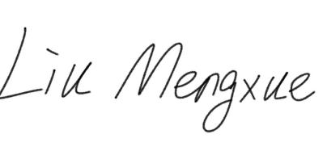 (Подпись студента)

01.06.2020 (Дата)

STATEMENT ABOUT THE INDEPENDENT CHARACTER
OF THE MASTER THESIS
I, Liu Mengxue, (second) year master student, program «Management», state that my master thesis on the topic «The Influences of Different Styles of Leadership on
Employee’s Innovation», which is presented to the Master Office to be submitted to the Official Defense Committee for the public defense, does not contain any elements of plagiarism.
All direct borrowings from printed and electronic sources, as well as from master thesis, PhD and doctorate thesis which were defended earlier, have appropriate references.
I am aware that according to paragraph 9.7.1. of Guidelines for instruction in major curriculum programs of higher and secondary professional education at St. Petersburg University «А master thesis must be completed by each of the degree candidates individually under the supervision of his or her advisor», and according to paragraph 51 of Charter of the Federal State Institution of Higher Professional Education Saint-Petersburg State University «a student can be expelled from St. Petersburg University for submitting of the course or graduation qualification work developed by other person (persons)».

(Student's signature)

01.06.2020 (Date)
АННОТАЦИЯ
Автор | Лю Мэнсюе
Название ВКР | Влияние различных стилей лидерства на инновационную активность сотрудников
Образовательная праграмма | Менеджмент
Направление подготовки | Менеджмент
Год | 2020
Научный руководитель | Замулин Андрей Леонидович
Описание цели, задач и основных результатов | Целью данной статьи является выяснение взаимосвязи между тремя стилями лидерства (лидерство в трансформации, лидерство в сделках и лидерство в невмешательстве) и инновационным поведением сотрудников, а также в том, играют ли посреднические роли между психологическими полномочиями и организационным климатом.  Создав модель отношений и проведя анкетный опрос в китайской коммуникационной компании, автор обнаружил, что только трансформационное и транзакционное лидерство оказывают существенное положительное влияние на инновационное поведение сотрудников.  Психологические возможности и организационный климат как промежуточные переменные могут как влиять на инновационное поведение сотрудников, так и так далее. Результаты исследования показывают, что корпоративные лидеры должны не только трансформироваться в трансформационных лидеров, но и создавать психологический опыт и хорошую организационную атмосферу для сотрудников, улучшая тем самым их инновационное поведение.
Ключевые слова | трансформационное лидерство,  транзакционное лидерство, бесцеремонное лидерство, расширение прав и возможностей, организационный климат, инновационное поведение сотрудников

Abstract

Master Student’s Name | Liu Mengxue
Master Thesis Title | The Influences of Different Styles of Leadership on Employee’s Innovation
Educational Program | Management
Main field of study | Management
Year | 2020
Academic Advisor's Name | Andrey Zamulin
Description of the goal, tasks and main results | The purpose of this paper is to find out the relationship between three leadership styles (transformational leadership, transactional leadership and laissez-faire leadership) and employee innovation behavior, as well as whether psychological empowerment and organizational climate have intermediary roles between them. By establishing a relationship model and conducting a questionnaire survey in a Chinese communication company, author found out that only transformational and transactional leadership have a significant positive effect on employee innovation behavior. Psychological empowerment and organizational climate as intermediary variables can both affect employee innovation behavior and so on. The results of the study show that corporate leaders are supposed to not only transform themselves into transformational leaders, but also create a psychological empowerment experience and a good organizational atmosphere for employees, thereby improving their innovation behavior.
Keywords | transformational leadership, transactional leadership, laissez-faire leadership, psychological empowerment, organizational climate, employee innovation behavior

ACKNOWLEDGEMENT

Here I highly wish to express my appreciation and gratitude to my academic supervisor Andrey Zamulin, Associate Professor, for his supportive guidance and valuable suggestions to me these days, which helped me a lot in writing my master thesis. I would also like to thank all the respondents as well as employees of the company who helped me to do the research. Last but not least, I would like to thank my family and friends for their endless support and encouragement for these two years.

TABLE OF CONTENT

Introduction 9
1.1 Research Background 9
1.2 Research Gap, Research Questions and Significance 12
Chapter 1. Factors influencing the employee innovation behaviour 15
1.1 Leadership Theory 15
2.2 Theory of Innovation 21
2.3 The Mechanism of the Influence of Leadership style on Employee Innovation Behavior 22
2.4 The Results and Shortcomings of Previous Research 29
Chapter2. Research Structure 30
2.1 Research Model 30
2.2 Research Tools 31
Chapter 3. Model validation 32
3.1 Research Procedure 32
3.2 Data Analysis 34
3.3 Reliability Analysis 36
3.4 Validity Analysis 38
3.5 Regression Analysis 39
Chapter 4. Data interpretation and discussion 56
4.1 Test of Research Hypothesis 56
4.2 Analysis of the Influence of Different Leadership Styles on Employee Innovation Behavior 57
4.3 Analysis of the Intermediary Role of Psychological Empowerment and Organizational Climate 59
Chapter 5. Conclusions and implications 60
5.1 Conclusions 60
5.2 Theoretical and Practical Significance 61
5.3 Limitations and Recommendations for Further Research 63
References 64
Appendix. Questionnaire in English Language 78

Introduction

1.1 Research Background
The era of the knowledge economy has been developed widely around the world. If companies want to occupy a place in the domestic and international markets, they must continue to come up with new ideas and thought. And innovation is a panacea for companies to maintain their sustainable competitiveness. Innovation is critical to sustaining business competitiveness and improving productivity. It is also the foundation of the economic growth. Indeed, some research have pointed out the significance of innovation as well as its influences on the success of companies, some researchers have also identified that support and encouragement from top managers are vital factors of promoting innovation (Amabile et al., 2004; Jung et al., 2008; Yindong & Xinxin, 2013; Javed et al., 2017). The leadership behavior and style of managers directly affect the work performance of subordinates, as well as make a variety of positive or negative impacts on the performance of teams, departments, as well as organizations.(Muchiri, Michael & Mcmurray, Adela & Nkhoma, Mathews & Pham, Hiep, 2020). The development of creative ideas which leaders of an organization put forward could be helpful to innovative services and products (Yuan & Woodman, 2010) and it may gain the competitive advantage over others.
A large number of international studies have shown that leadership style is a very important factor for the success of contemporary enterprises, especially organizational teams, and it also makes influences on how they cope with change and development. (Bos-Nehles, A, Bondarouk, T & Nijenhuis, K, 2017). Leadership has an impact on the self-growth, job satisfaction, organizational commitment, and turnover tendency of organizational employees, so it's important for corporate employees. Generally, leadership is not only the focus of researchers, but also the issue which management practitioners pay most attention to.
The innovation performance of an organization comes from the innovation behavior of employees.( Mumford, MD & Licuanan, B, 2004). The special survey report on the growth and development of Chinese enterprise managers in 2018 pointed out that lacking innovative talents is the first factor that hinders the technological innovation of enterprises, so the creation of incentives for employees to become innovative is the key to improve the organizational innovation. Employee innovation is closely related to the innovation atmosphere of the company and the leadership behavior as well as the leadership style of the company's management (Sheehan, M, 2016). How to make employees loyal to the company? How to make them willing to contribute their wisdom and strength to the enterprise? And how to improve the performance of individual employees and organizations? Every enterprise manager needs to think about the questions above. In addition, more and more scholars no matter from which country are beginning to pay attention to these questions. Most of the previous researches focused on the dimension of organizational innovation, but the research targeting employee innovation is still in the initial stage of development.
In the beginning of the book <Leadership> from James Burns said that “One of the most universal cravings of our time is a hunger for compelling and creative leadership.” Since 1980s, the study of these leadership styles has been proposed by Burns (1978) and Bass (1985). And since the concepts of leadership styles were put forward and expounded systematically, they have been regarded as a major breakthrough in leadership theory research and a hot topic in leadership theory research.
Bass (1999) pointed out that the mechanism of transformational leadership to work attitude of employees is one of the future research directions, which means, the influence mechanism and process of transformational leadership on leadership behavior and employee’s work attitude. Vandenberghe (2002) further proposed an opinion on the basis of the theory of Bass that psychological empowerment is a very important mediating variable to explain the type of leadership mechanism.
A study by Jung (2001) found that in experimental scenarios, transformational leadership can inspire higher levels of creativity in subordinates. Transformational leadership has a positive impact on employee behavior.(Jaiswal, N. K., & Dhar, R. L.,2016) Although transactional leadership is not as effective as transformational leadership in many aspects, it can also make a difference by the effect of situational factors and the influence of leaders. (Xu Changjiang, Shi Kan, 2016)
With the realization of the globalization of information and industry, the business development and organizational structure of companies have become more and more complicated, management ranks have gradually increased as well. Leaders cannot make decisions by themselves, so it is important to use empowerment to manage the whole organization(Tvarijonavičius, M., & Bagdžiūnienė, D.,2014). George, E., and K.a., Z. (2018) assumed that empowerment is not only delegating the task to subordinate employees, but also transferring the rights required to that person in order to complete the task. Talking about the empowerment, it has certain principles(Men, L. R., 2011). The leader only delegates the decision-making rights of personnel selection, capital deployment, overall coordination, communication planning, etc. to the employee, but the necessary responsibilities must remain with him. Different ranks in an organization have different levels of authority, and authority flows between different levels (Baczynska, A., & Korzynski, P., 2017). Effective empowerment is an important management skill. If authorized properly, all participants can benefit from it. Therefore, empowerment is also considered to be the essence of the effectiveness of modern enterprises.
In the past, a large number of scholars have verified that empowerment is closely related to the personality, values, work pressure, organizational recognition, and innovation performance of employees as well (Ukil, M. I.,2016). Therefore, it is often used as an intermediate variable in the research of leadership styles and organizational results.. George, E., & K.a., Z. (2018) believed that the innovation performance of employees is affected by leadership behaviors and psychological empowerment. The innovation ability of employees directly affects the innovation vitality of an enterprise organization. So it is meaningful to discuss it in depth, and it is of practical significance to help enterprises improve their competitiveness. Employees' innovative ideas are inseparable from a certain amount of material and human resource support, so they need more support and encouragement from the organization to create a good atmosphere of innovation. Many organizations definitely have innovative employees, but they may lose their employees and the corresponding innovative organizations because of the lack of an innovative atmosphere to accept innovative ideas which could encourage employees. An organization can achieve the purpose of becoming an innovative organization only if it creates a good climate that encourages innovation behavior, and continuously stimulates the employees' willingness to innovate (Szczepańska-Woszczyna, K.,2015). Shanker, R., Bhanugopan, R., Heijden, B. I. V. D., & Farrell, M. (2017) also proved that organizational climate is also an important variable which could make influences on employees’ innovation behavior. Tao, Y. and Hong, Y. (2014) believed that innovation is formed in an organizational atmosphere, from which members in the organization recognize the need for innovation, the opportunities for innovation, and efforts to support innovation. The research on the theory of climate for innovation has practical significance for the innovation of enterprises. Therefore, research about the stimulation of organizational innovation on employee innovation performance has been paid more and more attention in the field of research no matter in China or in other countries. And It is also an important variable to stimulate the innovation performance of employees in this paper.
To sum up, the paper is based on such realistic and theoretical background, carrying on research about the relationship between leadership behavior styles such as transformational leadership, transactional leadership and employee innovation behavior, and in the same time, try to identify how psychological empowerment and organizational innovation which works as mediators play the role in the process.

1.2 Research Gap, Research Questions and Significance

1.2.1 Research Gap and Research Questions
The leader is the most important person in an enterprise, and it is also related to the core factors of the success of the enterprise.(PG Northouse, 2018). However, the rapid changes which is resulted by the increasingly globalization of the world economy today require newer and higher requirements for today's leaders. What kind of leadership behavior can bring more benefits to enterprises is a question that the public and the theoretical community have been trying to explore. Talking about the transformational leadership style, transactional leadership style, and laissez-faire leadership style, most of the previous studies are focusing on a macro perspective, but there is less discussion on the relationship with the creativity of employees at the individual level. What kind of leadership can stimulate employees' creativity and whether they need to rely on variables, the existing research involves less about these questions. But this type of research is related to the enterprise, and it is more realistic to the development of the organization.
Therefore, according to the background of the topic and the research motivation, this study mainly explores the following three questions:
1. Does the transformational leadership style, transactional leadership style, and laissez-faire leadership have impacts on employees' innovation capabilities? That is, verifying which leadership style best inspires creativity of employees.
2. How do different leadership styles influence employees innovation behavior? Does it need to be achieved through the intermediary role of psychological empowerment and organizational ? If yes, how？
3. Whether different leadership styles influence psychological empowerment and organizational climate or not? If yes, how?

1.2.2 Research Gap and Significance
Each theory like leadership style, psychological empowerment, organizational climate and employee innovation behavior has some theoretical research results and empirical research results in the international academic circles, but there are relatively few research results on the relationship between these theories. And in terms of transformational leadership style, transactional leadership style, and laissez-faire leadership style, most of the previous studies are focus on a macro perspective, but there is less discussion about the relationship of leadership styles and the innovation behavior of employees at the individual level. What kind of leadership can stimulate employees' innovation behavior and whether they need to rely on which variables? About these questions the existing research involves less, but this topic of research has some practical meanings.
Therefore, on the one hand, this study will carry out a detailed study targeting the relationship between these theories, and also try to figure out the mediating role and influence mechanism of psychological empowerment and organizational climate. On the other hand, by verifying these theories against the Chinese unique cultural background and current status of corporate development, it could be helpful eventually to see if these research results can be used to guide the development and growth of Chinese companies. And if the answer is yes, it is also promising for the application of Russian companies as well as enterprises in other countries. In general, the theoretical significance of this research is to conduct empirical verification of these leadership theories in China to enrich their theoretical development.
Regarding the research on employee innovation, researchers and practitioners mainly focus on the innovation performance and innovation results at the organizational level, and there is relatively little research on the individual level of employees. This paper will focus on the individual employee's innovation behavior combining the organizational aspects, and the study of the mechanism of leadership style on it, hoping to enrich and improve the research results at the individual employee level.
The practical significance of this research is giving some suggestions to Chinese business leaders, especially the IT company where most R&D employees work, to help them choose appropriate leadership behaviors and leadership behavior styles in order to promote employee innovation. In the process of exercising leadership behaviors, how to use psychological empowerment and organizational climate to motivate employees and improve their autonomy, and finally improve their innovative behavior and organizational performance. In the training process of corporate leaders, we can also use the research results of this paper to train and improve the effectiveness of leadership.

Chapter 1. Factors influencing the employee innovation behaviour

1.1 Leadership Theory

1.1.1 Leadership
Researchers usually define leadership according to their individual perspectives and the aspects of the phenomenon which are the most interesting ones to them(Bass, 1985). And most definitions of leadership reflect the assumption that it involves a process whereby intentional influence is exerted over other people to guide, structure, and facilitate activities and relationships in a group or organization. Yukl, a well-known American researcher on leadership theory, sorted out eight representative definitions of leadership in 1998. For example, “Leadership is about expressing vision, embodying values, and creating an environment where things can be done” (Richards & Engle, 1986). “Leadership is the process of giving a goal (a meaningful direction) to a collective effort and leading to efforts to achieve it.” (Jacobs & Jaques, 1990). “Leadership is the process of figuring out what people do together so that people can understand and make commitments” (Drath & Palus, 1994). For now, organizational leadership is one of the key factors which could support an organization's success in terms of achieving its goals. In a community environment composed of formal or informal organizations, there is always someone who have more value than others, and then people with these capabilities are appointed to govern others. Usually, such people are called leaders or managers (Zainal, Hadad, and Ramly, 2017). In summary, although scholars from different countries have slightly different definitions of leadership, they all believe that leaders have an impact on others (individuals, groups, organizations, or society), and then achieve their goals. Therefore, this paper defines leadership as the ability, characteristics, and behavioral processes that lead to influence others (individuals, groups, organizations, or societies) in an effort to achieve group goals.
Since human society entered the civilization of the industrial age, people have gradually discovered that leaders are standing in a special position in enterprises, and they have a significant impact on the success or failure of enterprises. Therefore, what kind of person is a qualified enterprise leader? What leadership style should this person have? Different research institutions and researchers have conducted in-depth research on this, and have given different or not exactly the same answers. To sum up, the study of leadership style theory can be divided into two basic phases: the traditional leadership style theory phase and the modern leadership style theory phase.

2.1.2 Historical Development of Traditional Leadership Theory
Leadership theory is an important research area of organizational behavior and human resource management, and it is proposed by western society (Burns, J. M.,1978). According to the timeline of research, The development of traditional leadership style theory has also gone through three stages: the trait theory stage, the behavioral theory stage, and the contingency theory stage.
Trait theory prevailed in the 20th century, and it was the earliest attempt to systematically study leadership behavior. The research basis and method are aiming to find common traits from outstanding leaders, including physical traits, intellectual traits, personality traits, work traits, social traits, and so on. Stogdill (1948) and Gibb (1969) all point out the multiple personality characteristics of leaders, and believe that all behaviors of leaders and the results of their behaviors can be predicted by the personality characteristics of leaders.
The behavior theory emphasizes that the leader is effective because he exercises effective performance behaviors, not the internal characteristics of the leader. (Herdman-Barker, E., & Wallis, N.C., 2016). Behavior theory is mainly to study how the leader's behavior and behavior mode make influences on others and his teamwork performance, as well as predict its performance results based on its behavior. A common question behind this approach is: What are leaders doing to distinguish them from non-leaders? (Greenberg & Baron, 2003; Robins, 2003). According to Robbins (2003), the main difference between natural and behavioral methods in terms of applications lies in underlying assumptions. If the theory of character is valid, then there are no natural leaders.
The contingency theory of leadership starts from the external environment of leadership and it is not limited to the leadership itself. It has made a breakthrough contribution to the study of leadership theory. The theory of contingency related to leadership is very common, representing the mediating role of understanding leadership, pointing out the limitations of traits and behavioral methods, and integrating previous research results.(Tortorella, G.L., de Castro Fettermann, D., Frank, A. and Marodin, G.,2018). According to contingency theory, leadership styles are not always effective in any situation, and certain individual, job, and organizational variables can be used as "alternatives to leadership", which affects the single influence factor of leaders to some extent. Contingency theory supplements the trait theory and behavioral theory from the external environment, and incorporates the theory of interactive psychology as its research factor (Van Dun, Desirée & Hicks, Jeff & Wilderom, Celeste.,2017). Its theoretical and practical significance has been approved by more and more scholars.

2.1.3 New Development of Leadership Theory
The heyday of leadership research appeared in the 1960s and 1970s, and many scholars put forward many far-reaching leadership theories. Graen & Dansereau proposed the Leader-Member Exchange (LMX) theory in 1972. They believed that leaders would treat their subordinates differently in actual work, and adopted different leadership styles based on different types of relationships established. Stephen P. Robbins(1982) stated that leadership is an ability that can affect teams to achieve their goals. Richard L. Daft (2018) also found the same understanding, saying that leadership is a capability that can influence others and lead them to their goals. Moreover, some scholars have proposed visionary leadership, which means visionary leaders are driven and inspired by what a company can become. Lulu Zhou et al. (2018) expressed visionary leadership, which is directly proportional to the creativity of employees in the organization. Zhou, Zhao, Tian, Zhang, & Chen (2018) also identified the close relationship of visionary leadership and companies. In their opinions, visionary leaders know how to look from the outside, challenge the current status, and they know how to be proactive, how to discover and develop talent, as well as transform the vision of the future (House, R.J., 2016). In addition, imaginative and visionary leaders can drive major changes in the organization(Ndalamba, Caldwell, & Anderson, 2018).
Scholars have further studied the research towards leadership theory and some researches of classic leadership theory have also been enriched. Based on the theory of leadership traits, scholars have expanded the connotation of leadership traits and developed charismatic leadership theory. According to this theory, leaders influence their subordinates through their outstanding talents and extraordinary charisma, so that the stated goals can be achieved. Based on this foundation, empowerment leadership has also been developed. Empowered leaders give their subordinates greater autonomy, face the tasks assigned, and work at the expense of changing established rules of the enterprise(Boulu-Reshef, B., Holt, C. A., Rodgers, M. S., & Thomas-Hunt, M. C., 2019). According to the strength of empowerment, it can be divided into laissez-faire leadership, transactional leadership, and transformational leadership. It is also the development of leadership behavior theory. The three types of leadership styles are described in detail below.

2.1.3.1 Transformational leadership
Burns (1978) created the concept of transformational leadership as a description of political leaders who transform the values of their followers, but Bass (1985, 1990) later expanded the scope to include leadership within organizational settings.Since then, transformational leadership has become one of the most widely studied leadership styles because it emphasizes changing workplace norms and motivating employees to perform beyond their expectations (Yukl, 1989).
Transformational leadership is typically divided into four major components: inspirational motivation, idealized influence, individualized consideration and intellectual stimulation.(Yalokwu, 2016). And the main characteristics include the following four items: employment, decision making, consensual and strong culture.
Transformational leadership has been acknowledged as an important influencing factor in innovation systems across a range of industries(Sawasn Al-Husseini, Ibrahim El Beltagi & Jonathan Moizer, 2019). Previous empirical evidence also revealed a positive relationship between transformational leadership and innovative work behavior (Afsar, B.; Badir, Y.; Bin Saeed, B. 2014; Pradhan, S.; Jena, L.K, 2018). And transformational leaders will reward employees by demonstrating positive behaviors and attitudes that have a positive impact on the organization, such as organizational commitment and citizenship behavior, job satisfaction and performance, as well as innovative work behavior(Nazir, Shafi, Qun, Nazi, Tran.,2016).

2.1.3.2 Transactional Leadership Theory
Transactional Leadership was proposed by the Leader Member Exchange Theory (LMX). This theory assumes that the relationship between the leader and employees is connected through a contract. The leader meets employees’ expectations and requirements by rewarding employees with salaries, benefits, promotion, and recognition. At the same time, employees needs to agree and complete the tasks assigned by the leader. Such a return process is similar to a transaction. The transactional leadership behavior constructs the foundation for specifying expectations, negotiating contracts, clarifying responsibilities and providing the rewards and recognition to achieve the set objectives and expected performance between leaders and followers (Bass, 1985). The transactional leadership style satisfies the need of followers in the form of recognition or exchange or rewards after reaching the agreed task objectives and goals achieving the expectations of leaders (Bass, 1997; Podsakoff, MacKenzie, Moorman, & Fetter, 1990). Jansen, Vera, and Crossan (2009) pointed out that the transactional leadership style is suitable for followers' motivation to contribute and participate in the organization's vision. At the same time, Sadeghi and Pihie (2012) believed that transactional leadership is beneficial for helping employees to realize their own wishes, for example, reducing workplace anxiety and stress, focusing on clear organizational objects, as well as improving quality of products and customer service, reducing costs and increasing productivity. At the same time, Northouse believes that the transactional leadership style involves communication between leaders and employees, and uses rewards and penalties to motivate employees or teams. (Northouse, 2019)
The transactional leadership style often works well by making everyone know and agree on the goals, priorities and methods. However, the transactional style may not work when the situation calls for a big change in direction, or circumstances demand creative problem solving. According to the study from Abiodun Tope Samson on the aspects of transactional leadership (passive avoidance and contingent reward), he suggested that transactional leadership might not give rise to an increase in firm performance in SMEs. (Abiodun Tope Samson, 2019). In such a climate, a transformational style is often required and tends to be more successful than transactional.

2.1.3.3 Laissez-faire leadership theory
In the literature, a recognized premise as such is that of laissez-faire leadership, for example, leadership characterized by avoiding leadership tasks and non-response to the needs of subordinates (Bass, 1999; Skogstad, Hetland, Glasø, & Einarsen, 2014). From a laissez-faire leader's perspective, the key to success is to build a strong team and then stay out of the way. Laissez-faire leader does not give subordinates too much guidance, hoping that they will find problems by themselves and leaders rely on employee decisions to complete the task. When the performance results really do not meet their stated goals, a little guidance will be given by them to give a little support.
In this kind of leadership team, employees' performance will be relatively low, it will be difficult to have a unified organizational culture, and there’s a bad ethos prevails. Research has also proven that the company which has laissez-faire leaders are more likely to have conflicts, harassment, bullying behaviors and escalation than other companies (Mats Glambek, Anders Skogstad & Ståle Einarsen, 2018).
If the leader keeps working like this, the company will form a "donkey-like corporate culture" from a chinese perspective, which means, the personal ability can not be truly developed, there is no real teamwork, which will certainly lead to the disorderly development of the enterprise. The purpose of this study is to explore the creative leadership that can inspire employees. Laissez-faire leadership is not closely related to the organization and does not have much influence. Therefore, the following pages will focus on the role of transactional and transformational leadership in employee performance influences.

2.2 Theory of Innovation
Innovation is the idea of practice or object that individuals or other adopters consider to be new, and adoption is the decision to make full use of innovation as the best course of action (Rogers, 1995). Kirton (1988) distinguished between adopters and innovators. He assumed that the goal of the adopter is to "do better", while the goal of the innovator is to "do different things", and the innovator is more likely to reconstruct the problem when pursuing change. When individuals or other decision-making departments put innovation into practice, implementation occurs (Rogers, 1995). This shows that innovation is any product or process that has been implemented and is not important to the enterprise (Thong, 1999). When Peter Drucker defined innovation as "creation of a new dimension of performance", he used improvement as a dimension of innovation (Hesselbein, Goldsmith, and Somerville, 2002)
With the competitive environment becoming increasingly uncertain, companies that want to survive and thrive should rely more on innovation (Stroeva et al., 2015; Azar and Ciabuschi, 2017; Zhang et al., 2018). Innovation not only concerns R & D professionals, but other employees and areas in the organization must be open to innovation within their respective areas of responsibility in order to achieve long-term success.(Li et al., 2019). As a key factor in improving the organization's ability to innovate, employee innovation is often beneficial and has been seen as an important source of organizational competitive advantage (Shin et al., 2016). The issue of involving employees in the development of the organization has been a subject of growing interest in academic literature (Hornsby, Naffziger, Kuratko and Montagno, 1993; Janssen, de Vries and Cozijnsen, 1998; Sharma and Chrisman, 1999; Janssen, 2000). About the innovation behavior of employees, it is defined as behavior from an employee towards developing new products, developing new markets, or improving business routines in their employing organization. There is an ever-increasing need for all employees to intensify their level of performance regarding innovation (Wu C. H., Parker S. K., 2017). Many scholars have confirmed the influence of leaders on employee innovation behavior in theory and experience, which is mainly carried out from the perspective of the characteristics of leaders, such as ethical leadership (Tu and Lu, 2013), servant leadership (Cai et al., 2018), Transformational and transactional leadership (Pieterse et al., 2010). Therefore, how to use leadership to effectively promote employees' innovative behavior is particularly important for the current time.

2.3 The Mechanism of the Influence of Leadership style on Employee Innovation Behavior
With the development of modernization and the gradual progress of society, management plays an increasingly important role in the production and operation and development of enterprises. Enterprise leaders take on the concrete role of management, and their leadership style "will directly affect the management attitude and management methods for employees".
Leaders are recognized by their leaders for their charisma and personalized care, and consciously contribute to the organization's progress towards higher-level goals. Due to the influence of leaders, followers will be psychologically motivated to take on more work than required to achieve self-worth. With the increase of work tasks, it is impossible for the leader to take the work alone, and then “authorize” the work to the trusted leader, and the leader cares for employees and increasingly builds trust to make employees psychologically authorization.
A number of studies in academia indicate that employees' creative activities are significantly affected by leadership behaviors. The following will also specifically explore the specific mechanism factors of leadership styles on employee innovation behavior: psychological empowerment and organizational innovation atmosphere.

2.3.1 Impact of Leadership Behavior on Employee Innovation Behavior
Innovation is a key factor in organizations’ ability to create a sustainable competitive advantage (Kim, Min, & Cha, 1999). For innovation organizations often rely on teamwork (Dumaine, 1994; Ilgen, Hollenbeck, Johnson, & Jundt, 2005), and nearly the whole research and development (R&D) sector emphasizes teamwork. There is a clear correlation between leadership behavior patterns and employee innovation performance (Tiemey, Farmer, 2010; Zhou, George, 2003). The key reason that affects the creation of a performance environment is leadership (Scott, Bruce, 1994; Tierney P, 2008).
Sosik, Kahai and Avolio (1999) studied the impact of transformational leadership and transactional leadership on individual creativity, and pointed out that different leadership behaviors affect employees through the way they affect the individual's psychological state and behavioral motivation. Innovation performance. In addition, inclusive leaders provide a supportive external environment by inspiring employees to share their perspectives on new changes (Choi, Tran and Park, 2015). Moreover, leadership was found to be an important situational factor which could promoted employee’s innovative work behavior (Herman, Wallis, 2016).
Stenbert & Lubert (1991) proposed the theory of creative investment, which believes that creativity is the result of separate and mutually interacting external factors such as environment and motivation. A key factor in the environment that has a substantial impact on creativity is leadership (Scott & Bruce, 1994; Tierney, Farmer & Graen, 1999). Leaders show certain behaviors, which will cause employees to have corresponding perceptions, which will affect their motivation and psychological state, and ultimately affect their creativity.
Based on those statement, some hypothesis are formulated:
Hypothesis1: Transformational leadership has a significant positive effect on on employee innovation behavior.
Hypothesis2: Transactional leadership has a significant positive effect on employee innovation behavior.
Hypothesis3: Laissez-faire leadership has a significant negative effect on employee innovation behavior.

2.3.2 Psychological Empowerment
Employment empowerment has been generally defined as “delegation of authority by the managers to each employee, mostly with respect to job practices and methods” (Sibson, 1994). There have been many efforts to define psychological empowerment. For example, Conger and Kanungo (1988) defined empowerment as a process of enhancing the feelings of self-efficacy among organizational members, which would also include that the employees perceive themselves to be empowered (Conger & Kanungo, 1988). The first efforts for defining psychological empowerment as a structure of multiple facets came from Thomas and Velthouse (1990), who defined psychological empowerment as four cognition reflecting an employee‟s orientations towards his/her job namely impact (the ability employees have to affect organizational outcomes). According to Thomas and Velthouse (1990) developed multidimensional cognitive factors of meaning, choice, competence, and impact as the set of intrinsic task motivation enablers. Through the individual's all-rounded tendency to perceive their own work, four specific cognitive dimensions are summarized, which are meaning, self-efficacy or competence, self-determination and impact. This psychological empowerment concept and its structure have been greatly developed. The recognition of most scholars is a solid theoretical basis for empirical research on psychological empowerment.
Javed et al. (2017) stated that the generation of innovative ideas is an unconventional task, and individuals must transcend their standard operating procedures by implementing the psychological empowerment and belief provided by all the support and means of these ideas. The main task of psychological empowerment is to improve the ability of employees to appreciate their own strengths and qualities and also support them to value the role of their own jobs and the contribution of their organization in general, which at the end will lead to the feeling of satisfaction (Spreitzer, Kizilos, & Nason, 1997). In addition, a lot of researchers in the past had proved empirically that psychological empowerment enhanced employees’ innovative work behavior(Zhang & Bartol, 2010; Seibert, Wang, & Courtright, 2011; Singh & Sarkar, 2012; Çekmecelioglu & Özbag, 2016). And a present study by Fang Liu (2017) proposed that psychological empowerment is an important determinants of individual innovative behavior.

2.3.3 Organizational Climate
Organizational climate is derived from the study of group dynamics and extends to management. It is believed that organizational atmosphere is the individual's common perception and experience of the organizational environment, which determines the individual's motivation and behavior, and is affected by the environment. Organizational atmosphere refers to the feeling that people work in a specific environment, and it refers to the "workplace atmosphere", which includes norms, values, expectations, policies, and flows that affect individual and group behavior patterns. James & McIntyre (1996) and James&Sells (1981) conceptualized organizational climate as an aggregated psychological climate. It refers to the “set of perceptions that reflect how work environments, including organizational attributes, are cognitively appraised and represented in terms of their meaning to and significance for individuals' (James et al, 1988). They argue that if people in an organization share similar perceptions of a psychological climate dimension, it is legitimate to aggregate these individual perceptions into an indicator of organizational climate. In public or private organizations, if the perception of their employees towards their organizational climate is more egoistic and less ethical, employees are more prone to corruption (Gorsira, M.; Steg, L.; Denkers, A.; Huisman, W. 2018) Further more, Chang, Wu, and Liu (2018) collected data from 34 human resource managers and 354 employees from China's manufacturing and service industries. Their results suggest that work styles and workplace events can affect employee job satisfaction. And a three-year study (2007, 2009, 2010) conducted by the Spanish Ministry of Labor and Social Security on 5,656, 6274, and 5841 public officials shows that organizational climate is the top five affecting employee job satisfaction Factors (M.C, Sánchez Sellero; P. 2016)
According to Tidd and Bessant (2014), the organization's innovation process needs to be managed in a systematic or integrated manner, which requires strategic leadership and guidance (such as innovation strategy) and the establishment of innovation organizations (such as structures and environments that promote employee innovation ) And, innovation networks (such as internal and external collaboration).

2.3.4 Relationship between Leadership Styles and Organizational Climate
The role of leadership at the workplace is characterized as a key agent of change in the companies, which is well established in the literature((Krause, 2004; De Jong & Den Hartog, 2008; Amabile, 2012; Javed et al., 2017). Diversified leadership styles will also affect and change the internal values, operating models, and internal communication of the enterprise to a certain extent, which directly affects the corporate atmosphere. Research on the organizational innovation atmosphere began in the 1960s. Some relevant scholars like Ekvall, Iisaksen, Amabile, Britz and Tesluk put forward their own opinions respectively about the definition of organizational innovation atmosphere. For example, some previous studies have already pointed out that leadership style is the biggest environmental factor affecting achievements of subordinates, morale and satisfaction, which also is one of variables of affecting the achievements of an organization. During the past 20 years, some researchers think the innovation climate have gradually become more and more important. Ekvall & Ryhammar’s study (1999) found that atmosphere of an organization is mainly in the charge of the leadership behavior, culture and values of it. while Chinese scholars also gave their opinions in succession. Scholars Liu Yun and Shi Jintao (2009) believe that organizational innovation atmosphere is a perception of organizational members supporting organizational environmental innovation. Chen Baojie (2008) believes that the characteristic of organizational innovation atmosphere is that the organization should have an atmosphere where everyone believes that innovation is an opportunity rather than a threat. Individuals with creative potential are willing and able to release their potential to promote the organizational innovation performance . Through in-depth analysis and talking with some relevant scholars and the key position employees, this dissertation has designed an organizational innovation atmosphere questionnaire of E-commerce organization from scholars Liu Yun and Shi Jintao’s scale. Because this scale is based on our country’s actual situation. In the questionnaire, the design of the options used by five categories (specific dimensions: manager support, organization concept, team support, resource supply, task characteristic).Therefore, leadership behavior is an important factor affecting the organizational climate, and it has a profound impact on employees' perception of the organizational innovation atmosphere (Ekvall & Arvonen, 1984; Ekvall, 1996).
According to Jung, Chow and Wu (2003) and Jung and Ali (2017), one of the most important characteristics of a good and comfortable workplace is the organizational atmosphere. So if leaders can create a great workplace, it will increase employee productivity. Several studies (Ekvall, G .; Ryhammar, L. 1998; Kao, R.-H. 2017; Maamari, B.E .; Majdalani, J.F. 2017) all point out that leadership styles have some positive effects on organizational climate.

2.3.5 Relationship between Organizational Climate and Employee Innovation Performance
There are three main variables that influence organizational innovation performance: organizational variables, personal variables, and environmental variables. As an important part of the organizational innovation atmosphere, the organizational environment is also an important influence variable. Scholars Lee and others studied the degree of product innovation of scientific researchers and found that the higher the support of their superiors, the higher their innovation performance. Speaking of the research relationship between creative work environment and organizational innovation performance, Amabile found that personal creativity in the organization, organizational productivity and organizational encouragement, superior encouragement, work team support, freedom, and challenging work have a significant positive correlation with it, and Organizational barriers are negatively correlated, and the effects of work stress and adequate resources are not obvious enough. And personal creativity, organizational innovation system, and innovation performance are also positively related. In recent years, Chinese scholars have also conducted an empirical analysis and research on the atmosphere of organizational innovation. The main result comes from Taiwan scholar Yin Qiming. He found that the formation of an open, participatory, and pursuit of growth and freedom within the organization will lead to an innovative tendency in the organization. Affects the organization's innovation performance. The scholar Cai Qi researched more than 100 enterprises during the research of corporate organizational innovation, and also concluded that the organizational innovation atmosphere can significantly improve employee innovation performance and innovation behavior.
So based on these theories of psychological empowerment and organizational climate, some hypothesis could be formulated:
Hypothesis4: Transformational leadership has a significant positive effect on psychological empowerment and organizational climate.
Hypothesis5: Transactional leadership has a significant positive effect on psychological empowerment and organizational climate.
Hypothesis6: Laissez-faire leadership has no significant impact on psychological empowerment and organizational climate.
Hypothesis7: Psychological empowerment and organizational climate work as mediators in the relationship of transformational leadership and employee innovation behavior.
Hypothesis8: Psychological empowerment and organizational climate have significant positive effects on employee innovation.

2.4 The Results and Shortcomings of Previous Research

2.4.1 The Results of Previous Research
(1) The process of knowledge innovation is carried out by individuals through the mutual conversion of implicit knowledge and explicit knowledge among members of the organization. Scholar Nonaka (1994) established the SICT model of knowledge innovation during the research process. The related factors of knowledge socialization, knowledge externalization, knowledge combination, and knowledge internalization, the four interacted intuitively and reflected the innovation process.
(2) The research on leadership behavior has more detailed results and detailed classification characteristics. The research on transformational leadership on organizational outcome variables, such as organizational citizenship behavior, job satisfaction, organizational commitment, innovative behavior, organizational innovation performance, etc. Significantly relevant, including measuring perceptions of changing leadership styles from an employee perspective. Various scholars have also used progressive scales to measure progressive leadership styles.
(3) With the widespread promotion and application of psychology, psychological empowerment is also included as a variable by researchers in the research that influences the transformational leadership style, and it is also used as an intermediary variable.
(4) With the growth of the organization, the organizational climate has also become an influential factor on the innovation performance of the organization. Scholars have also compiled some scales for measurement.

2.4.2 Inadequacy and Evaluation of Previous Research
(1) According to previous scholars investigations, leadership behaviors do play an important role in corporate innovation, but there is a lack of in-depth and specific analysis on how to affect employees' innovation performance, and a detailed analysis of the impact on internal mechanisms. And innovation is the key factor for a company to maintain vitality and spontaneity, it is the key lifeblood of a company to stand out from the competition, and its innovation comes from its employees.
(2) The research on the essence of organizational innovation is also fruitful, but it is often used as a single variable to explore its effect. However, in the actual organization, any variable is not single, and the organizational innovation atmosphere is more similar to the buffeting variable in the organizational culture. The intertwined influence with other variables has an impact on the innovation performance of employees.

Chapter2. Research Structure

2.1 Research Model
Based on a large amount of literature reading and analysis, combined with the external organizational environment and internal psychological empowerment factors that could affect employee innovation performance, this paper mainly studies the influence mechanism of three different types of leadership styles on employee innovation performance, and proposes the following theoretical model.
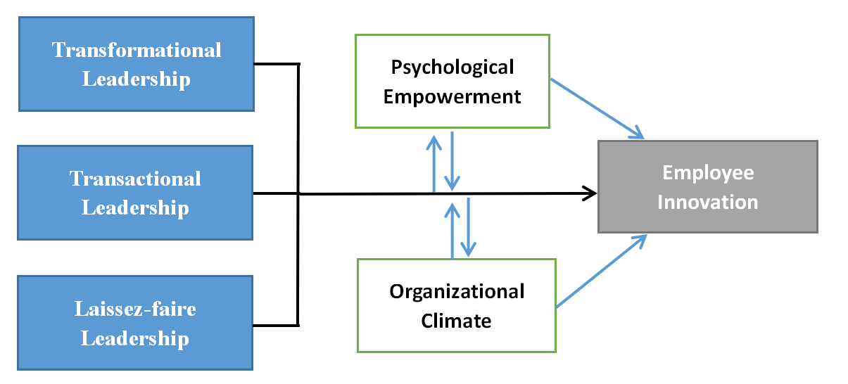
Figure2.1 Research Model

As you can see from the figure above, these three different leadership could effect the employee innovation directly, this is what previous research already proved. And what is new from this paper is that I introduce psychological empowerment and organizational climate as mediators which could not only effect the process where leadership makes influence on employee innovation behavior, but also directly effect the employee innovation performance. Moreover, one interest thing is psychological empowerment and organizational climate can be influenced by leadership as well.

2.2 Research Tools
This research mainly uses a combination of theoretical analysis and empirical research to study the relationship between leadership style and employee innovation behavior.
1) Literature method. Through extensive reading of relevant domestic and foreign literature and monographs, I have learned about the concepts, structures, and mechanisms of transformational leadership, transactional leadership, and laissez-faire leadership, as well as the factors that influence psychological empowerment, organizational climate and employee innovation behavior.
2) Questionnaire. The questionnaire of this paper mainly includes four sub-questionnaires - leadership styles questionnaire, psychological empowerment questionnaire, organizational climate questionnaire and innovation behavior questionnaire. The target group is around 400 R&D employees in a branch of Chinese communication equipment company. Through the questionnaire, the data of the relationship between the manager's leadership style and the employee's innovation behavior in the actual operation of the company is obtained. And relevant data of psychological empowerment and organizational climate is gathered as well, which provides effective input for the data analysis of this study.
3) Statistical tools. This paper used SPSS and Likerts to check the statistical analysis of all data. Statistical analysis mainly includes reliability analysis, validity analysis, and regression analysis. Among them, reliability analysis and regression analysis were completed by SPSS, and validity analysis is conducted by confirmatory factor analysis (CFA) of Lisrel.

Chapter 3. Model validation

3.1 Research Procedure
As I mentioned before, the test is conducted among around 400 R& D employees from the Shandong branch of a large communications company.
The questionnaire mainly includes four sub-questionnaires - leadership style questionnaire, psychological empowerment questionnaire, innovation behavior questionnaire and organizational climate questionnaire. The questionnaire is scored using Likerts 5 point rating scale, and all questions are answered online.
The leadership style questionnaire used in this survey is Bass (1995) Multifactor Leadership Questionnaire (MLQ), Including three-part test questionnaires such as transformational leadership, transactional leadership, and laissez-faire leadership. The scoring method I used Likerts five points rating method, and each number represents the frequency of specific leadership behaviors in the work of the participants, of which "1" represents "strongly disagree", "2" means "disagree" 3 "" means "neutral", "4" means "agree", and "5" means "strongly agree".
The psychological empowerment questionnaire adopts the psychological empowerment scale for work compiled by Spreitzer et al. It includes four dimensions: meaning, competence, self-determination, and impact. I choose one out of 3 from each dimension, in total there are 4 questions of 4 dimensions. The questionnaire also used Likerts five points rating method, in which "1" represents "strongly disagree", "2" means "disagree" 3 "" means "neutral", "4" means "agree", and "5" means "strongly agree".
The innovation behavior questionnaire adopts the employee innovation questionnaire developed by George and Zhou (2001), in which includes 13 items measured on a Likert type scale ranging from 1 (Never) to 5 (Always).
About the organizational climate part this paper used three-dimensional scale of organizational innovation atmosphere revised by Chinese scholar Liu Yun et al. (2009) based on the KEYS scale as the final measurement tool of this study. The three-dimensional scale of organizational innovation atmosphere revised by Liu Yun et al. (2009) selected three creativity promotion factors in the KEYS scale, namely organizational support, supervisor support, and team support. They passed empirical tests and concluded 12 items . This part of the questionnaire also uses Likert's 5-point scoring method, in which "1" represents "strongly disagree", "2" means "disagree" 3 "" means "neutral", "4" means "agree", and "5" means "strongly agree".
After the questionnaire was recovered, I moved to the data collecting and data entry part. Finally, by using SPSS and Likerts, I finished the statistical analysis of all data. Statistical analysis mainly includes reliability analysis, validity analysis, and regression analysis. Among them, reliability analysis and regression analysis were completed by SPSS, and validity analysis is conducted by confirmatory factor analysis (CFA) of Lisrel.

3.2 Data Analysis
This research is mainly aimed at a large-scale well-known telecommunications listed company in China. The company has more than 30,000 employees in the world and there are about 10,000 people who are engaged in R & D related work. The target of this study is the R & D team members of the company's Shandong branch who are engaged in research and development department. A total of 400 questionnaires were issued this time, all of which were distributed through online surveys and through the internal questionnaire survey system of the questionnaire after the communication, agreement and cooperation from the HR leader of the company. After recovering the questionnaires and doing the preliminary analysis, a total of 347 valid questionnaires were obtained, and the effective recovery rate was 86.75%. The reason for choosing this company is that as a large-scale Chinese IT communication company, the IT level of this company is upstream in China. This IT level means that the company has a large number of R&D employees, which is consistent with the employee innovation variable which is going to be tested in this paper. The reason for choosing this branch in Shandong Province is that I am a Shandong native person. Choosing a local company can improve the efficiency of the questionnaire survey and communicate with the company's employees in a timely manner.
The basic information analysis of the test is shown below.

3.2.1 Distribution of Age-gender
In the valid questionnaires recovered, 85.87% of the testers were male and 14.13% were female. Based on past experience, male employees in communications and high-tech companies have an absolute advantage in number. This sample analysis also verified this.
In this survey, the testers also answered the question about their ages. Drawing on previous research, this paper divides age into 5 stages. The number of people aged 0-24 was 3, accounting for 0.86% of the total sample. The number of testers aged 24-30 was 236, accounting for 68.01%. We got 104 employees from 30 to 40 years old , accounting for 29.97% And here were 3 left testers aged 40 to 50 years old, accounting for 0.86%. There was only 1 tester aged 50 to 60 years old, accounting for 0.29%. This age distribution also matched the company's industry sectors, particularly the communications industry and high-tech companies.

3.2.2 Distribution of marriage and education
In terms of the distribution of marital status, the percentage of married testers is 30.9% and unmarried is 69.1%. Based on the age distribution of the aforementioned testers and the geographical location of the company as a tier-one city along the northern coast of China, the marital status of the company's employees is also rational.
In terms of the distribution of education levels, the percentage of junior college degrees is only 0.2%, and the undergraduate degree accounts for 28.2%.
Masters accounted for 70.5%, and doctors accounted for 1.1%. It can be seen that the average academic level of the testers is relatively high, and almost all the academic levels are undergraduate or even above, among which the majority are masters. I think the reason is that the characteristic of the company's industry is communication, and the company's development level is in the leading position in China. Therefore, it has higher requirements for the education level of their employees, and the sample distribution matched the expectations.

3.2.3 Distribution of Working Years
In terms of the distribution of working years, the percentage of new employees within one year is 16.9%, and those between 1 and 3 years are 26.1%. And 28.3% of employees have worked for 3 to 5 years, 23.9% for 5 to 10 years, 4.6% for 10 to 20 years, and 0.2% for more than 20 years.
It can be seen from the above that, generally speaking, the working age of the research testers is mainly under 10 years (95.2%). The testers were relatively evenly distributed in the three stages of 1-3 years, 3-5 years, and 5-10 years. A reasonable number of new employees (16.9%) was added. According to the company's development stage, development level, industry status and industry nature, the distribution of the research samples is in line with the researchers' expectations.

3.2.4 Distribution of Team size and Team type
In terms of the distribution of team size, the percentage distribution of less than 20 people and more than 20 people is 55.7% and 44.3%. And talking about the distribution of team types, the percentages of administrative teams is 48.2% and the percentage of project teams is 51.8% respectively. Since the target enterprise belongs to the R&D enterprise in the communications industry, and the typical matrix management mode is implemented within the enterprise, so the distribution of the research sample is understandable with the status of the industry and the researchers' expectations.

3.3 Reliability Analysis
Reliability is mainly used to check whether the questionnaire is precise, in other words, to evaluate whether the collected data is true and reliable. A good questionnaire or scale should have a high reliability coefficient. Reliability coefficient measurement methods usually include test-retest reliability, scorer reliability, parallel-forms reliability, Cronbach's alpha and so on.
Among them, the biggest advantage of Cronbach's alpha is that it only takes one measurement to estimate the reliability coefficient, which could save time and effort. In addition, the Cronbach's alpha coefficient is generally higher than the reliability coefficient calculated by est-retest reliability, scorer reliability. In this paper, Cronbach's alpha coefficient was used to test the reliability of the scale.
A total of four questionnaires were used in this study, which were multi-factor leadership questionnaire (MLQ), psychological empowerment questionnaire, employee innovation questionnaire and organizational climate questionnaire. Among them, the MLQ contains three sub-scales, namely transformational leadership sub-scale, transactional leadership sub-scale, and laissez-faire leadership sub-scale. These three sub-scales respectively contain several small scales, of which the transformational leadership sub-scale includes five scales of Idealized influence behaviors, idealized influence attributes, inspirational motivation, individual consideration and intellectual stimulation. Transactional one contains three scales like contingent reward, management by exception active, and management by exception passive. Here we tested the reliability of total scales and each sub-scale in this survey. In order to make the results more clear and easy to understand, I have combined all the data of the various scales. The specific results are shown in the following table:
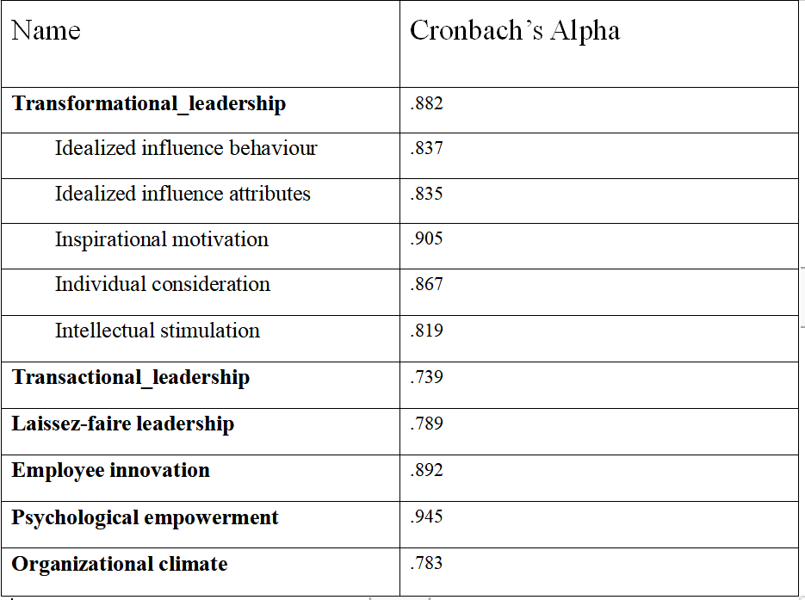
Table1. Coefficient of Internal Consistency of the questionnaire

From the overall results of internal consistency, the scale used in this study shows that the internal consistency of each dimension is relatively good, because all the indexes are located in the range of 0.7 to 1. The results of reliability analysis show that the design of the topic is reasonable and effective. Therefore, we believe that these scales have good reliability and they can meet the needs of research.

3.4 Validity Analysis
Validity is a measure of the degree of validity or the validity of a research instrument.In addition to a higher reliability coefficient, a good test also needs to have a better validity structure. The measured validity includes content validity and structural validity. In order to ensure the scientific use of this questionnaire, it is necessary to test the validity of the questionnaire.
There are mainly four questionnaires which are used this time - leadership style questionnaire, psychological empowerment questionnaire, organizational climate questionnaire and innovation behavior questionnaire. The various dimensions of transformational leadership, transactional leadership, and laissez-faire leadership will appear as independent variables, so only the structural validity of the questionnaire will be analyzed.
Confirmatory Factor Analysis is used here to verify the structural validity of the leadership style questionnaire. According to the recommendations of experts, some representative fitting indices were selected for comparison.
Among them, RMSEA means Root Mean Square Error Approximation, GFI means Goodness of Fit Index, NNFI means Non-Normed Fit Index, CFI means Comparative Fit Index, IFI means Incremental Fit index. It is generally believed that RMSEA is less than 1, indicating a good fit, less than 0.05, indicating a very good fit, and less than 0.01, indicating a very good fit. It is generally believed that if RMSEA is less than 0.01, GFI, NNFI, CFI and IFI are above 0.9, which is a good model. The results are shown in the table below:
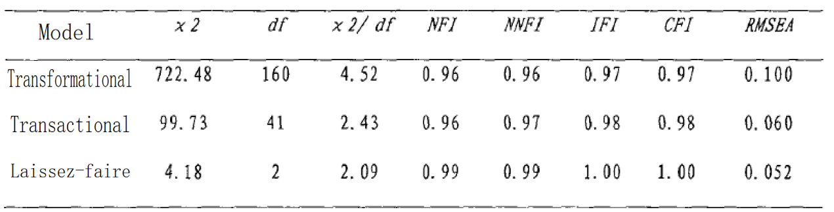
Table2. The output of validity test of three leadership style.

The analysis results show that the confirmatory factors of each model fit well. The RMSEA values of transactional leadership and laissez-faire leadership are 0.060 and 0.052, respectively, and the value of transformational leadership is 0.10. Each index is within the critical value. This shows that the leadership style questionnaire has good structural validity.

3.5 Regression Analysis

3.5.1 Research on the Relationship Between Leadership Style, Psychological Empowerment, Organizational Climate and Employee Innovation Behavior
3.5.1.1 Relationship between leadership styles and employee innovation behavior
Taking innovation behavior as the dependent variable and three leadership styles as the independent variables, the forced regression method is adopted. And outputs can be showed as following:

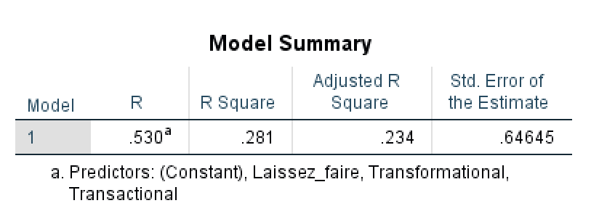
Table 3. Analysis of the fitting process of the relationship between leadership styles and innovation behavior

It can be seen from the table that the R between the dependent variable and the independent variable is 0.530, reflecting the strong linear relationship between the independent variable and the dependent variable. The R² is 0.281, indicating that the explanatory power of the selected independent variable to the dependent variable reaches 28.1%, which is workable for this study.

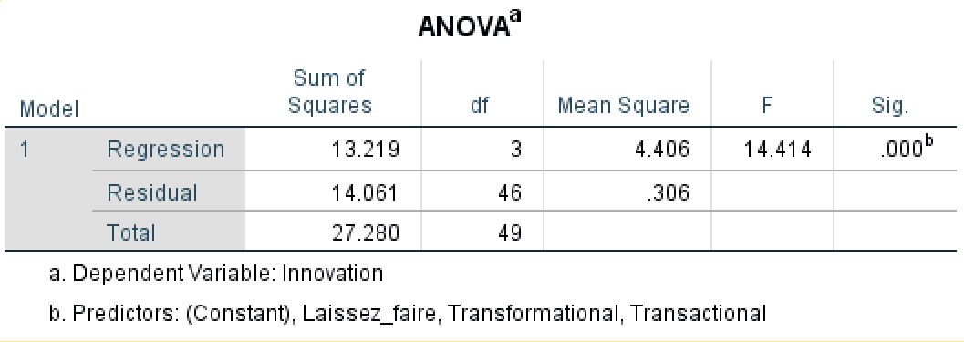
Table 4. Analysis of ANOVA between leadership style and employee innovation behavior

As we can see, the mean square of Regression is 4.406, Residual is 0.306, the regression equation is generally significant.(sig.<0.01)

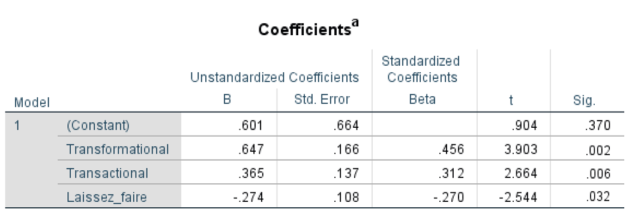
Table5. Analysis of Coefficients between leadership style and employee innovation behavior

The regression coefficients of the three independent variables Transformational, transactional and Laissez-faire are all significant (sig.<0.05). Among them, the regression coefficients of transformational leadership and transactional leadership are positive (0.456 and 0.312), while the regression coefficients of laissez-faire leadership are negative(-0.270). It means that transformational leadership and transactional leadership have a significant positive predictive effect on employees 'innovative behavior (sig. <0.01), while laissez-faire leadership has a significant negative predictive effect on employees' innovative behavior (sig. <0.05). The standardized regression coefficient of transformational leadership is 0.456, which is slightly larger than the standardized regression coefficient of transactional leadership 0.312, indicating that transformational leadership is slightly stronger than transactional leadership in predicting employee innovation behavior. And both are higher than laissez-faire leaders (standardized regression coefficient is -0.27)

3.5.1.2 Relationship between psychological empowerment and employee innovation behavior
Taking innovation behavior as the dependent variable and psychological empowerment as the independent variables, the forced regression method is adopted. And results can be showed as following:
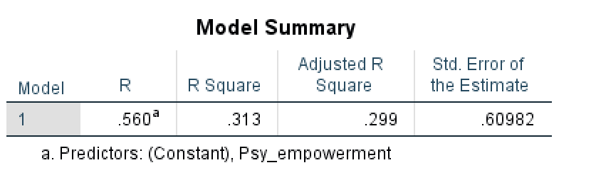
Table 6. Analysis of the fitting process of the relationship between psychological empowerment and innovation behavior

It can be seen from the table that the R between the dependent variable innovation behaviour and the independent variable psychological empowerment is 0.560, reflecting the strong linear relationship between the independent variable and the dependent variable. The R² is equal to 0.313, indicating that the explanatory power of the selected independent variable to the dependent variable reaches 31.3%, which means the research is applicable.

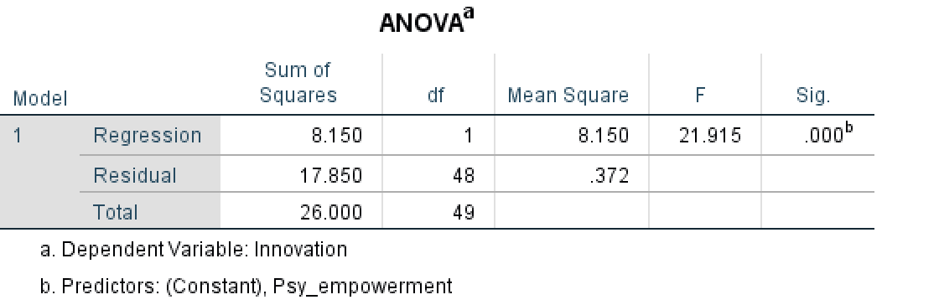
Table 7. Analysis of ANOVA between psychological empowerment and employee innovation behavior

As we can see, the mean square of Regression is 8.150, Residual is 0.372, the regression equation is generally significant.(sig.<0.01)
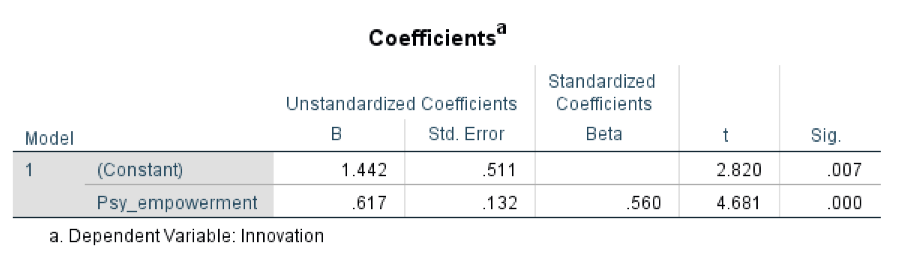
Table 8. Analysis of Coefficients between psychological empowerment and innovation behaviour

The regression coefficient of psychological empowerment is significant (sig. <0.05), indicating that psychological empowerment has a significant positive predictive effect on employee innovation behavior.

3.5.1.3 Relationship between organizational climate and employee innovation behavior
Now we need to check the relationship between organizational climate and employee innovation behavior. Again, take organizational climate as independent variable and innovation behaviour as dependent variable, and results are showed as followed:

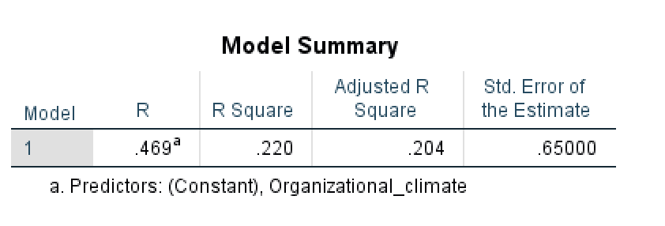
Table 9. Analysis of the fitting process of the relationship between organizational climate and employee innovation behavior

We can see that R is equal to 0.469, reflecting the strong linear relationship between the independent variable and the dependent variable. The R² is equal to 0.22, indicating that the explanatory power of the selected independent variable to the dependent variable reaches 22%, which means the research is applicable.
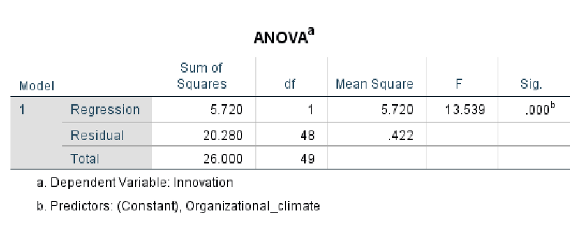
Table 10. Analysis of ANOVA between organizational climate and employee innovation behavior

As we can see, the mean square of Regression is 5.72, Residual is 0.422, the regression equation is generally significant.(sig.<0.01)
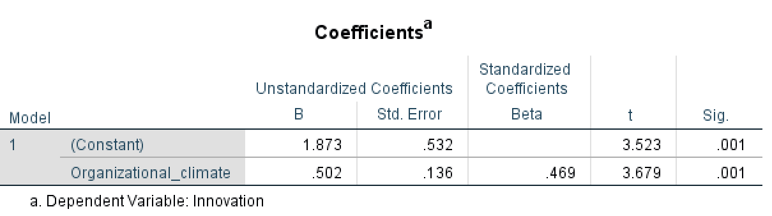
Table 11. Analysis of Coefficients between organizational climate and innovation behaviour

The regression coefficient of organizational climate is significant (sig. <0.05), indicating that organizational climate has a significant positive predictive effect on innovation behavior.

3.5.1.4 Relationship between leadership styles, psychological empowerment, and organizational climate
As the research model which is showed above, we assumed that psychological empowerment and organizational climate can also be influenced by different leadership styles. So let’s run the statistical analysis of these three variables.

3.5.1.4.1 Relationship between transformational leadership, psychological empowerment, and organizational climate
Taking transformational leadership as dependent variable, psychological empowerment, organizational climate as independent variable, we get outputs below:
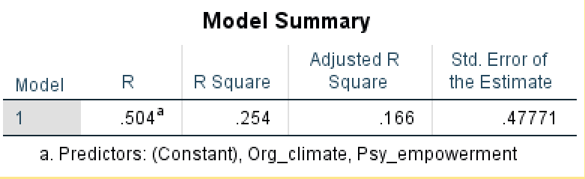
Table 12. Analysis of the fitting process of the relationship between transformational leadership, psychological empowerment and organizational climate

We notice that R is equal to 0.504, reflecting the strong linear relationship between the independent variable and the dependent variable. The R² is equal to 0.254, indicating that the explanatory power of the selected independent variable to the dependent variable reaches 25.4%, which means the result is meaningful.
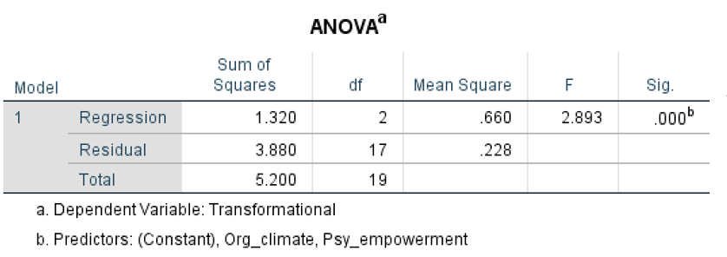
Table 13. Analysis of ANOVA between transformational leadership, psychological empowerment and organizational climate

The regression coefficient of transformational leadership is significant (sig. <0.05), indicating that transformational leadership has a significant positive predictive effect on psychological empowerment and organizational climate.
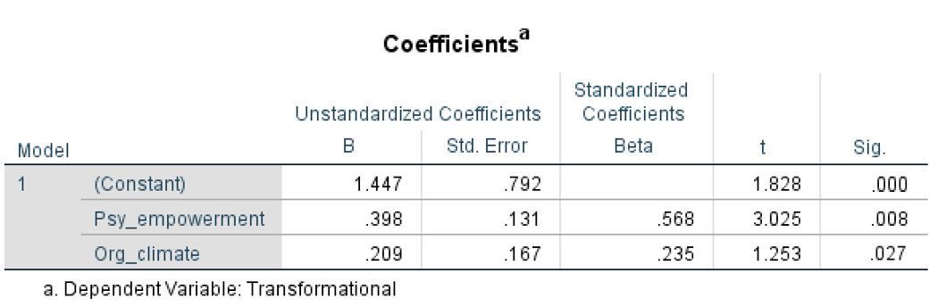
Table 14. Analysis of Coefficients between transformational leadership, psychological empowerment and organizational climate.

The regression coefficient of transformational leadership is significant (sig. <0.05), indicating that transformational leadership has a significant positive predictive effect on psychological empowerment and organizational climate. And since Beta of psychological empowerment (0.568) is bigger than Beta of organizational climate (0.235), which means that the influence of transformational leadership to psychological empowerment is stronger than that to organizational climate.
3.5.1.4.2 Relationship between transactional leadership, psychological empowerment, and organizational climate
Taking transactional leadership as dependent variable, psychological empowerment, organizational climate as independent variable, we get outputs below:
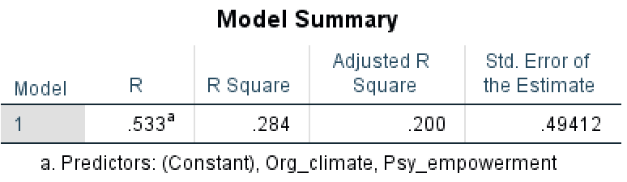
Table 15. Analysis of the fitting process of the relationship between transactional leadership, psychological empowerment and organizational climate

We notice that R is equal to 0.533, reflecting the strong linear relationship between the independent variable and the dependent variable. The R² is equal to 0.284, indicating that the explanatory power of the selected independent variable to the dependent variable reaches 28.4%, which means the result is meaningful.
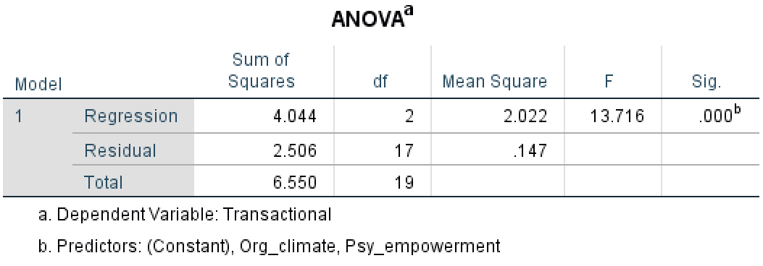
Table 16. Analysis of ANOVA between transactional leadership, psychological empowerment and organizational climate

The regression coefficient of transactional leadership is significant (sig. <0.05), indicating that transactional leadership has a significant positive predictive effect on psychological empowerment and organizational climate.
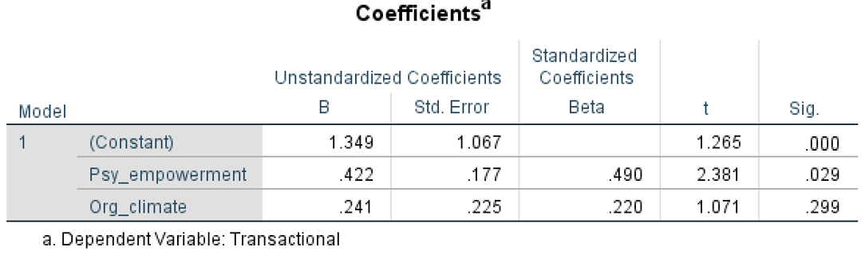
Table 17. Analysis of Coefficients between transactional leadership, psychological empowerment and organizational climate.

We can see that only the regression coefficient of psychological empowerment is significant (sig. <0.05), indicating that transactional leadership has a significant positive predictive effect on psychological empowerment and organizational climate. And the influence of transactional leadership to organizational climate is not that much.

3.5.1.4.3 Relationship between laissez-faire leadership, psychological empowerment, and organizational climate
Taking laissez-faire leadership as dependent variable, psychological empowerment, organizational climate as independent variable, we get outputs below:
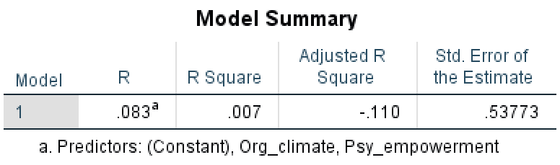
Table 18. Analysis of the fitting process of the relationship between laissez-faire leadership, psychological empowerment and organizational climate

As we see from the table above, the coefficient of R and R Square is too small, which means there’s no or pretty less linear relationship between the independent variable and the dependent variable. And the research about these variable is meaningless.

3.5.1.5 Relationship between leadership styles, psychological empowerment, organizational climate and employee innovation behavior

Taking innovation behavior as the dependent variable, three leadership styles, psychological empowerment, and organizational climate as independent variables, the forced regression method is used. The results are shown in the tables below.
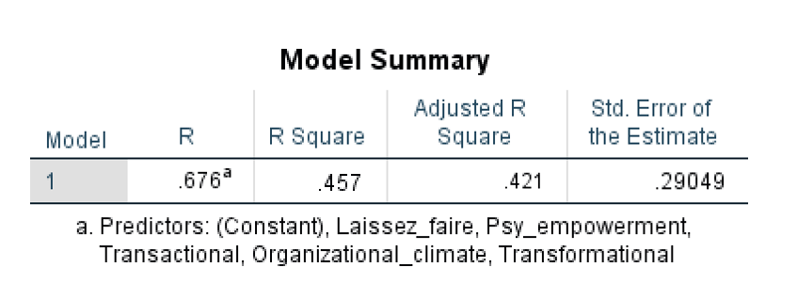
Table 19. Analysis of the fitting process of the relationship between leadership styles, psychological empowerment, organizational climate and employee innovation behavior

It is obvious that R is equal to 0.676, reflecting the strong linear relationship between the independent variable and the dependent variable. The R² is equal to 0.457, indicating that the explanatory power of the selected independent variable to the dependent variable reaches 45.7%, which means the result is meaningful.
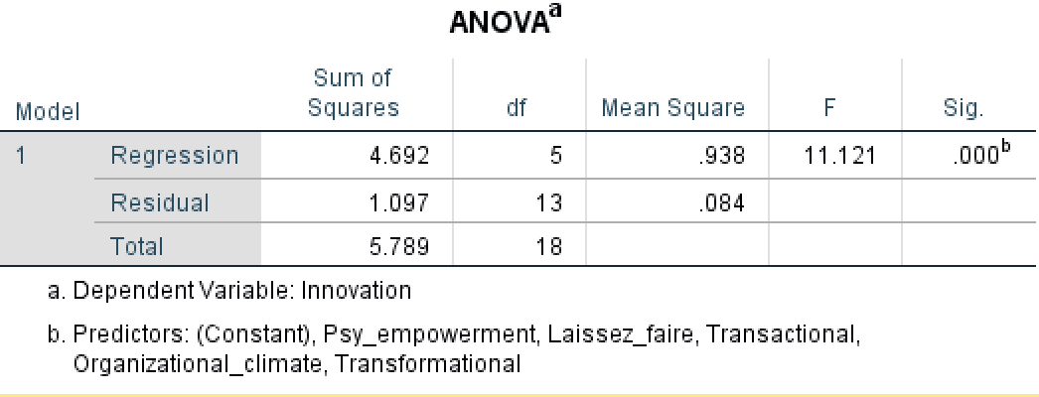
Table 20. Analysis of ANOVA between leadership style, psychological empowerment and organizational climate and employee innovation behavior

As we can see, the mean square of Regression is 0.938, Residual is 0.084, the regression equation is generally significant.(sig.<0.01)

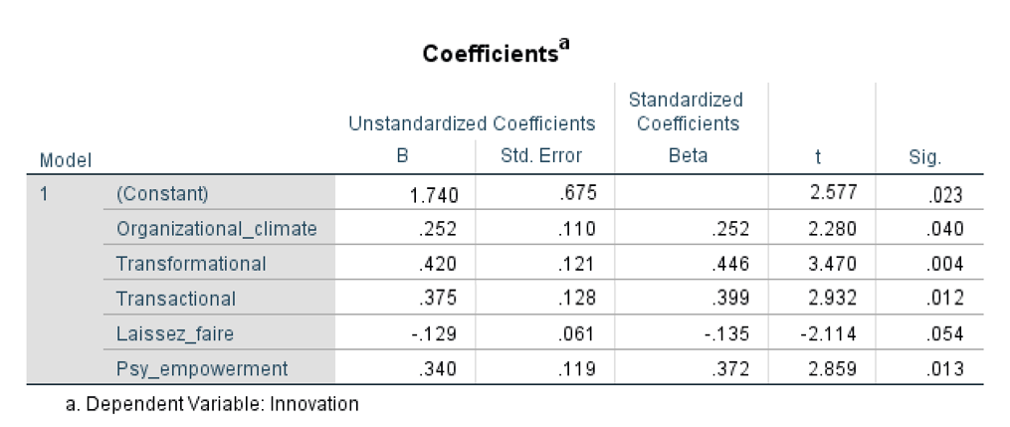
Table 21. Analysis of Coefficients between leadership style, psychological empowerment,organizational climate and innovation behaviour

The regression coefficient of organizational climate, transformational, transactional and psychological empowerment is significant (sig. <0.05), indicating that in this model, organizational climate, transformational, transactional and psychological empowerment have significant positive predictive effects on innovation behavior. The regression coefficient of Laissez-faire is not significant (sig.>0.05). Moreover, Beta of transformational leadership (0.446) is bigger than the others.

3.5.2 Research on the relationship between different dimensions of leadership styles, psychological empowerment, organizational climate and employee innovation behavior
After drawing the above research results, the following further explores which dimensions of the three leadership styles are influencing employees' innovative behavior through psychological empowerment and organizational climate.

3.5.2.1 The relationship between different dimensions of leadership and psychological innovation
Taking innovation behavior as the dependent variable and each dimension of these three leadership styles as the independent variables, the forced regression method is adopted. And outputs can be showed as following:

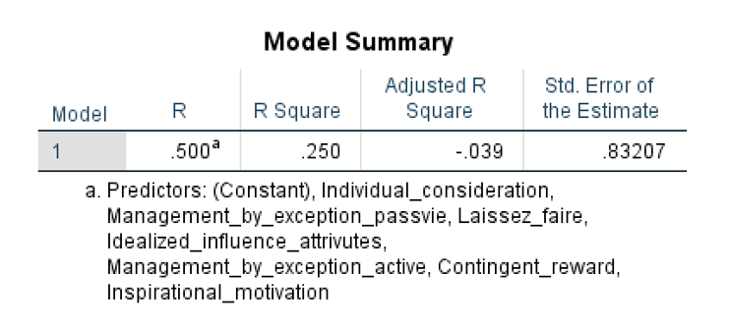
Table 22. Analysis of the fitting process of the relationship between dimensions of leadership styles and innovation behaviour

It can be seen from the table that the R between the dependent variable innovation behaviour and the independent variable each dimension of leadership style is 0.500, reflecting the strong linear relationship between the independent variable and the dependent variable. The R² is equal to 0.250, indicating that the explanatory power of the selected independent variable to the dependent variable reaches 25.0%, which means the research is applicable.
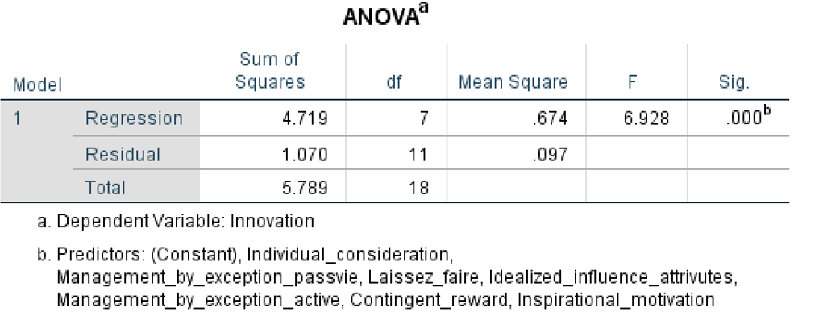
Table 23. Analysis of ANOVA between each dimension of leadership style and innovation behavior

As we can see, the mean square of Regression is 0.674, Residual is 0.096, F is equal to 6.928 and the regression equation is generally significant.(sig.<0.01).
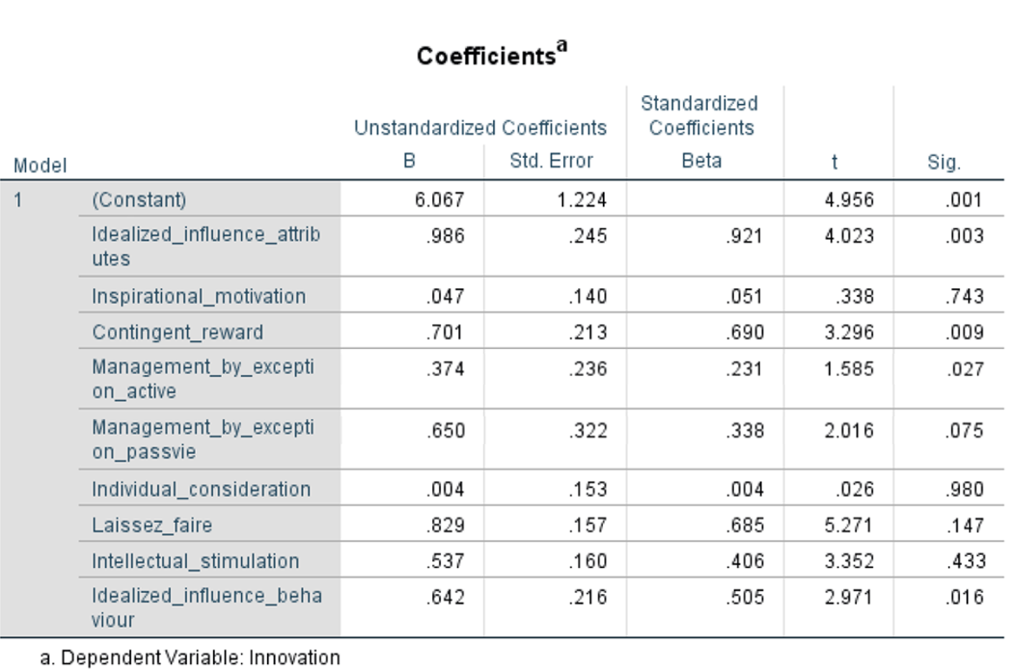
Table 24. Analysis of Coefficients between dimensions of leadership style and innovation behaviour

We can see that the regression coefficients of idealized influence attributes, contingent reward, management by exception active and idealized influence behavior are significant (sig. <0.05). This shows that the four dimensions of idealized influence attributes, contingent reward, management by exception active and idealized influence behavior can significantly predict the innovation behavior of employees. In terms of prediction degree, from high to low are Idealized influence attributes (Beta = 0.921), contingent reward (Beta = 0.690), Idealized influence behavior (Beta = 0.505) and management by exception active (Beta = 0.231)

3.5.2.2 The relationship between psychological empowerment and innovation behaviour
According to the previous research results(3.5.1.2), with innovation behavior as the dependent variable and psychological empowerment as the independent variable, the regression equation is generally significant (sig. <0.01). The regression coefficient of psychological empowerment is significant, indicating that psychological authorization has a significant positive predictive effect on employee innovation.

3.5.2.3 The relationship between organizational climate and innovation behaviour
In addition, based on the previous research results(3.5.1.3), we take innovation behavior as the dependent variable and organizational climate as the independent variable, the regression equation is generally significant (sig. <0.01), which means that the regression coefficient of is significant, indicating that organizational climate has a significant positive predictive effect on employee innovation.

3.5.2.4 The relationship between different dimensions of leadership style, psychological empowerment, organizational climate and innovation behaviour
Taking innovation behavior as the dependent variable, taking various dimensions of the three leadership styles, psychological empowerment, and organizational climate as the independent variables, using the forced regression method, the results are shown in the following tables:
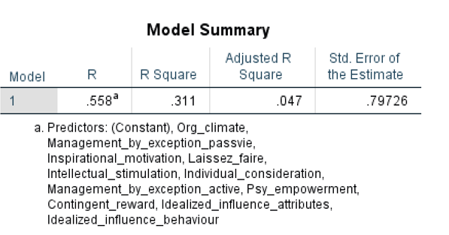
Table 25. Analysis of the fitting process of the relationship between dimensions of leadership styles, psychological empowerment, organizational climate and innovation behaviour

It can be noticed from the table that the R between the dependent variable innovation behaviour and the independent variable each dimension of leadership style, psychological empowerment and organizational climate is 0.558, reflecting the strong linear relationship between the independent variable and the dependent variables. The R² is equal to 0.311, indicating that the explanatory power of the selected independent variable to the dependent variable reaches 31.1%, which means the research is applicable.
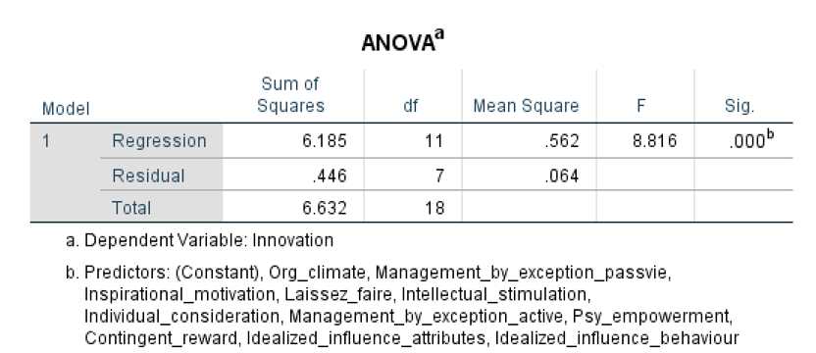
Table 26. Analysis of ANOVA between each dimension of leadership style, psychological empowerment, organizational climate and innovation behavior

As we see, the mean square of Regression is 0.562, Residual is 0.064, F is equal to 8.816 and the regression equation is generally significant.(sig.<0.01).
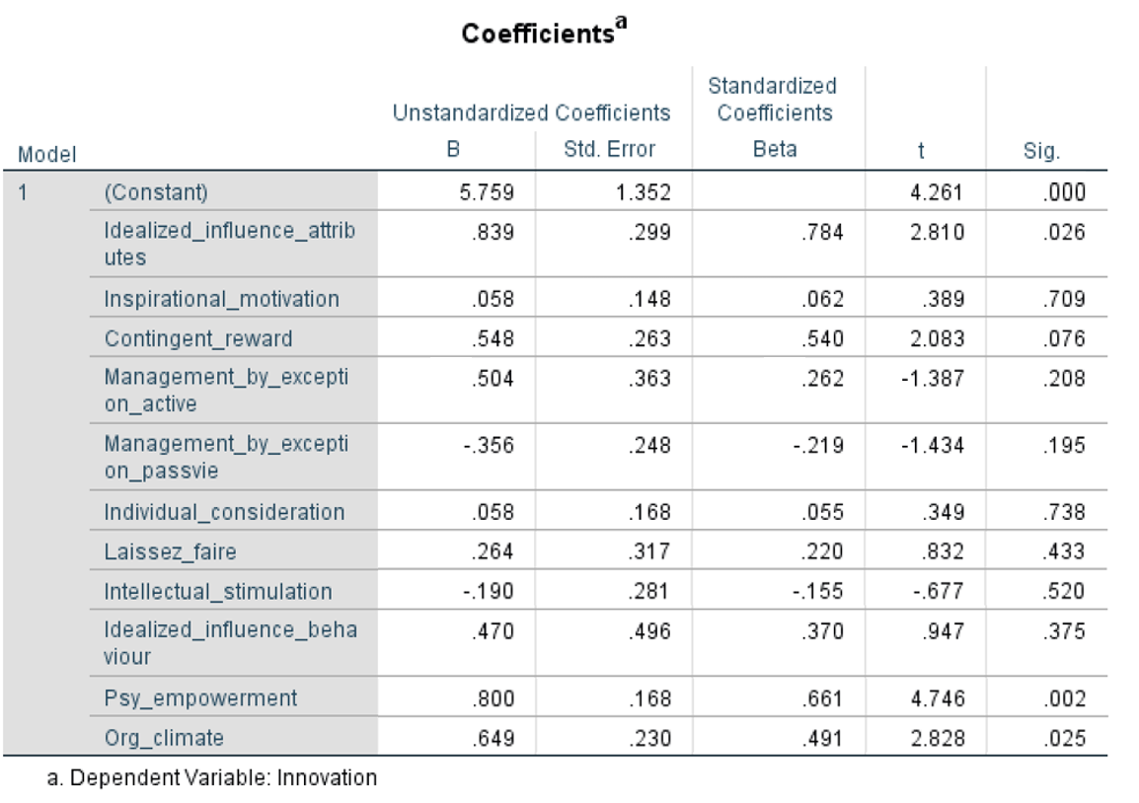
Table 27. Analysis of Coefficients between dimensions of leadership style, psychological empowerment, organizational climate and innovation behaviour

We notice that the regression coefficients of Idealized influence attributes, psychological empowerment and organizational climate are significant (sig. <0.05), which shows that the these three factors can significantly predict the innovation behavior of employee. In terms of prediction degree, from high to low are Idealized influence attributes (Beta = 0.784), psychological empowerment (Beta = 0.661), organizational climate (Beta = 0.491).

3.5.2.5 Conclusion of this section
Taking innovation behavior as the dependent variable and each dimension of the three leadership styles as the independent variables, the regression equation is established by the method of mandatory regression. The results show that:
a. The regression equation is significant overall.
b.The regression coefficients of idealized influence attributes, contingent reward, management by exception active and idealized influence behavior are significant (sig. <0.05). Other independent variables are not significant. This shows that these four dimensions of idealized influence attributes, contingent reward, management by exception active and idealized influence behaviour can significantly predict the innovation behavior of employees. In terms of prediction degree, from high to low are Idealized influence attributes (Beta = 0.921), contingent reward (Beta = 0.690), Idealized influence behavior (Beta = 0.505) and management by exception active (Beta = 0.231)
Taking innovation behavior as the dependent variable and psychological empowerment as the independent variable, the forced regression method is adopted, and the results show that:
a. The regression equation is significant overall (sig. <0.01)
b. The regression coefficient of psychological empowerment is significant (sig. <0.01), indicating that psychological empowerment has a significant positive predictive effect on employee innovation behavior.
Taking innovation behavior as the dependent variable and organizational climate as the independent variable, the forced regression method was used, and the results showed:
a. The regression equation is significant overall (sig. <0.01)
b. The regression coefficient of organizational climate is significant (sig. <0.01), which means that organizational climate has a significant positive predictive effect on employee innovation behavior.
Taking leadership styles as independent variables, psychological empowerment and organizational climate as dependent variables, the results indicate as following:
- Transformational leadership has a significant positive predictive effect on psychological empowerment and organizational climate.(sig. <0.05). And it makes stronger influence on psychological empowerment than organizational climate.
- Transactional leadership has a significant positive predictive effect only on psychological empowerment(sig. <0.05) , but not on organizational climate(sig.>0.05)
- There’s no strong relationship between laissez-faire leadership, psychological empowerment and organizational climate.
Taking innovation behavior as the dependent variable, taking various dimensions of the three leadership styles, psychological empowerment, and organizational climate as the independent variables, the regression equation is established using the forced regression method. The results show that:
a. Regression equation is generally significant
b.The regression coefficients of idealized influence attributes, psychological empowerment, and organizational climate are significant (sig. <0.05), which shows that these three factors can significantly predict the innovation behavior of the employee. Other factors are not significant. In terms of prediction degree, from high to low are idealized influence attributes (Beta = 0.781), psychological empowerment (Beta = 0.661), organizational climate (Beta = 0.491).

Chapter 4. Data interpretation and discussion

4.1 Test of Research Hypothesis
The purpose of this study is to explore the relationship between leadership style and employee innovation behavior, as well as the impact of psychological empowerment and organizational climate. Summarizing the previous research results, the testing situation for the theoretical assumptions of this study is summarized as follows:

Number | Hypothesis | Accepted or not
1 | Transformational leadership has a significant positive effect on on employee innovation behavior. | Accepted
2 | Transactional leadership has a significant positive effect on employee innovation behavior. | Accepted
3 | Laissez-faire leadership has a significant negative effect on employee innovation behavior. | Accepted
4 | Transformational leadership has a significant positive effect on psychological empowerment and organizational climate. | Accepted
5 | Transactional leadership has a significant positive effect on psychological empowerment and organizational climate. | Accepted
6 | Laissez-faire leadership has no significant impact on psychological empowerment and organizational climate. | Accepted
7 | Psychological empowerment and organizational climate work as mediators in the relationship of transformational leadership and employee innovation behavior. | Accepted
8 | Psychological empowerment and organizational climate have significant positive effects on employee innovation. | Accepted
Table28. Test of research hypothesis

4.2 Analysis of the Influence of Different Leadership Styles on Employee Innovation Behavior
The regression analysis data in the third chapter of this paper shows that from the perspective of the influence of different leadership styles on employee innovation behavior, transformational leadership and transactional leadership have a significant positive predictive effect on it. And laissez-faire leadership has a significant negative predictive effect on innovation behavior. It indicates that transformational leadership and transactional leadership are conducive to the occurrence of employee innovation behavior, and laissez-faire leadership inhibits employee innovation behavior. This coincides with the opinions and research hypothesis from experts which are mentioned in the literature review and research hypothesis proposal in this paper. For example, Kesting, Peter & Ulhøi, John & Song, Jiwen & Niu, Hongyi. (2016) also proved that transformational leadership and transactional leadership make influences on innovation behavior, however laissez-faire leadership not. And it validates hypothesis 4, hypothesis 5, and hypothesis 6.
In the same time, the standardized regression coefficient of transformational leadership (beta = 0.456) is slightly larger than the standardized regression coefficient of transactional leadership (beta = 0.312), indicating that transformational leadership is slightly stronger in predicting employee innovation behavior, and transformational leadership and transactional leadership are higher than the standardized regression coefficient of laissez-faire leaders (beta = - 0.270). The results of this data validate the hypothesis 7 of this paper, indicating that the style of transformational leadership can best promote the innovative behavior of employees, followed by the style of transaction, and the style of laissez-faire leadership cannot be adopted.
From the perspective of the impact of various dimensions of leadership style on employee innovation behavior, different dimensions of transformational leadership, transactional leadership, and laissez-faire leadership have different effects on employee innovation behavior, and the values of P are : idealized influence attributes (0.003), idealized influence behavior (0.016), inspirational motivation (0.743), intellectual stimulation (0.433), contingent reward (0.009), individual consideration(0.980), management by exception active (0.027), management by exception passive (0.075) and laissez -faire leadership (0.147).
The data results show that idealized influence attributes (0.003), idealized influence behavior (0.016), management by exception active (0.027), contingent reward (0.009) these four dimensions can significantly predict employee innovation behavior. In terms of predictability, management by exception active (0.027) is stronger than idealized influence behavior (0.016), followed by contingent reward (0.009) and idealized influence attributes (0.003).
This result is consistent with previous studies, but there are also some difference. Talking about the same point, for instance, Goodwin et al, (2001) and others believed that contingency rewards have a positive impact on innovation, which is the same output with what I got.
About the novelty which is new and different compared to previous study, tables of my data shows that except contingent reward, only idealized influence attributes, idealized influence behavior and management by exception active can significantly predict employee innovation behavior, other variables have no influences or just a bit. But previous studies are not the same. For example, Bass & Avolio (1996) believes that "management by exception passive" is an invalid way of behavior, and "management by exception active" has neither positive nor negative effects, while I got the result that management by exception passive is not significant, but management by exception active could make influence on innovation behavior. In addition, previous study proved that intelligence stimulation and inspiration are positively related to creativity (Sosik et al., 1997), Elkins and Keuer (2003) proposed that leaders adopt inspirational motivation and intellectual stimulation as keys to innovation. Li Chaoping, Meng Hui and Shi Kan (2016) found that intellectual stimulation had a positive effect on extra effort and leadership effectiveness. Meanwhile, Mao Minxin (2008) believes that the positive impact of intellectual stimulation is the largest factor in terms of innovation impact, followed by contingent reward. Management by exception active and laissez-faire leadership is not significant. These scholars all assumed that intellectual stimulation and inspirational motivation could make positive influences on innovation behavior, and intellectual stimulation even could be the most efficient factor, which contradict my assumption. According to the result which I got, intellectual stimulation has no big influences on innovation behavior, while management by exception active and idealized influence do.
Analyzing the situation and difference, I supposed the mean reason is the the difference of research target group. To be more specific, the reasons could be listed as followed:
- The responses studied in this paper are mainly high-educated groups, most of them have master's degrees and science and engineering background. They work in communication industry, and most of them are men. They are highly educated, smart enough and working in high-technology industry, so intellectual stimulation is not that important for them, which can explain why intellectual stimulation have no significance in the results.
- Talking from the material level, most of the respondents have more requirements for self-actualization rather than higher material satisfaction because of their higher education and working environment. Compared to higher salary and wage, self-actualization need is more important for them. So their responses to the impact of idealization and management by exception is obvious and not the same with what previous study showed.

4.3 Analysis of the Intermediary Role of Psychological Empowerment and Organizational Climate
From the perspective of the relationship between leadership styles and employee's innovative behavior in relation to psychological empowerment and organizational climate, when we add psychological empowerment and organizational climate to this process, the equation is generally significant, the regression coefficient of psychological empowerment and organizational climate is significant (sig. <0.01), and the regression coefficient of transactional leadership is still significant (sig. <0.01), but the regression coefficient of transformational leadership has become insignificant.
This shows that psychological empowerment and organizational climate completely mediate the positive influence between transformational leadership and employee innovation behavior. This is consistent with the assumption 8 in this article. This result also confirms the views of previous scholars. For example, Vandenberghe (1999) believes that psychological empowerment is very likely to be a very important intermediary variable between transformational leadership and innovation variables. Tebogo Sethibe and Renier Steyn (2018) believed that organizational climate mediates the relationship between transformational leadership and innovative behaviour.

Chapter 5. Conclusions and implications

5.1 Conclusions
Different leadership styles have different leadership effectiveness. Previous studies have focused more on the effectiveness of leadership styles on organizational performance. There is less research on individual employees, and fewer individual research on R&D employees. This paper focuses on the relationship between leadership styles and employees' innovative behaviors, and which leadership styles psychological empowerment and organizational climate can mediate.
The research results of regression analysis are as follows:
1. From the perspective of three first-level dimensions of MLQ, transformational leadership, transactional leadership, and laissez-faire leadership, transformational leadership and transactional leadership have significant positive predictive effects on employees innovation behavior, while laissez-faire leadership has a significant negative predictive effect on employees innovation behavior. In terms of predicting employee innovation behavior, transformational leadership is slightly stronger than transactional leadership, and both are higher than laissez-faire leadership.
2. Transformational leadership and transactional leadership have a significant positive predictive effect on psychological empowerment. In the prediction degree of employee psychological empowerment, transformational leadership is stronger than transactional leadership. Transformational leadership has a significant positive predictive effect on the organizational climate.
3. Psychological empowerment and organizational climate both have significant positive predictive effects on employee innovation behavior. They are mediating variables in the process where transformational leadership affects employee innovation behavior.
4. Talking about nine secondary-level dimensions of the MLQ - idealized influence attributes, idealized influence behavior, inspirational motivation, intellectual stimulation, individual consideration, contingent reward, management by exception active, management by exception passive, laissez-faire leadership, among these 9 dimensions, only idealized influence attributes, contingent reward, management by exception passive and idealized influence behavior can significantly predict the innovation behavior of employees. In terms of prediction degree, from high to low are idealized influence attributes, contingent reward, idealized influence behavior, and management by exception passive.

5.2 Theoretical and Practical Significance
This paper is the first attempt verifying the effect of psychological empowerment and organizational climate in leadership style and employee innovation behavior in the background of communication companies which are dominated by R&D employees.
The innovation of this study is the introduction of two mediating variables - psychological empowerment and organizational climate, how they work in the effect of leadership style on employee innovation behavior. The verification of the role of intermediary allows us to clarify the internal psychological perception of employees and the importance of creating a good organizational atmosphere. This study also conducted an in-depth analysis of various dimensions of leadership style, and clarified the different effects of different dimensions of leadership style on employee innovation. These research results will further verify the applicability of leadership style in the context of R&D enterprises.
In terms of research methods, the questionnaires that include the variables of leadership style, psychological empowerment, organizational climate, and innovative behavior are all answered by R&D project team members, so they can typically represent the true situation of the R&D team. Meanwhile, as Chinese companies gradually change from simple manufacturing to smart manufacturing, there will be more and more R & D teams in the companies and organizations. The research results of this paper also have some reference significance for these teams. And this is a major advantage of this paper as well.
From the theoretical perspective, this paper explores the influence mechanism of the transformational leadership and transactional leadership style of the R&D team managers in a more in-depth way, which has a certain theoretical significance. At the same time, it enriches the research of psychological empowerment and organizational climate for employee innovation.
From the practical perspective, this paper has a certain reference value to the practice of Chinese enterprise management. Innovation has become the most critical factor for continued survival in this competitive world, however, many Chinese enterprises still do not pay enough attention to innovation even in the current fierce competition, especially in the area of knowledge innovation. Although some companies value employee innovation, because of improper methods and no real implementation, there’s little effect in the actual innovation practice. Therefore, it is of great significance to truly carry out innovative research of enterprises under such a background. The conclusions of this study can be applied to the management practice of Chinese enterprises, which could be helpful to guide enterprise leaders how to cultivate and improve employee innovation behavior in many ways, and how to make themselves to be transformational leaders. The study pointed out that it is applicable to support and care employees’ development through idealized influence, contingent reward, intellectual stimulation, etc., in order to encourage employees to make efforts, improve their psychological empowerment, enhance their work enthusiasm, create a good organizational climate, and eventually improve their innovation behavior.

5.3 Limitations and Recommendations for Further Research
One of the limitations of this study is the limitation of the sample. The sample size of this paper is moderate, including a number of around 400 R & D project members, and a total of 347 valid questionnaires. However, the samples were all taken from the R&D team of the brunch of a large communication equipment manufacturing company, and most of the R&D employees are male.
In terms of applicability, further exploration is needed to see whether this research result can be extended to other communication equipment manufacturing companies or other types of organizations. Therefore, the future research direction can also be like: through expanding the sample size and expanding the scope of the sample, collecting data in different types of enterprises and organizations of different categories, as well as through data analysis to further confirm the conclusions of this paper.
Moreover, this paper only discusses the mediating effect of psychological empowerment and organizational climate on leadership style and employee innovation behavior on the surface. There is no analysis of the mediating effect of the two variables from different dims. So it could also be carried out and further explored in theory and empirical in the future.
In addition, the study design of this paper is cross-sectional. The research process is supposed to have a certain time span, but this study measured variables in the same time interval and did not conduct data collection across the intervals, so the causal relationship among these variables cannot be really determined, and there may exist some limitations in the test of the causal relationship between the variables. In future research, it is necessary to use longitudinal design research methods to collect data with a time span to further explore the causal relationship between variables and examine the effect of leadership style on employee innovation behavior across time periods, which is more meaningful.
Future research can also include analyzing the influence mechanism of leadership behavior at different levels. For instance, studying the influence mechanism of leadership style from the individual, group and organizational levels, as well as exploring more different intermediary variables and moderating variables in the influence mechanism of leadership style and innovation behavior, which could be helpful to provide strong theoretical support, as well as better reveal and examine the influence mechanism of leadership behavior.

References
Abiodun Tope Samson & Ilesanmi, Oladele Ayodeji, 2019. "The relationship between transactional leadership, transformational leadership and performance of SMEs in Nigeria”. Noble International Journal of Business and Management Research, Noble Academic Publsiher, vol. 3(4), pages 73-85, April.
Afsar, B., F. Badir, Y., & Bin Saeed, B. (2014). Transformational leadership and innovative work behavior. Industrial Management & Data Systems, 114, 1270–1300. doi:10.1108/imds-05-2014-0152
Amabile, T. M. (1988). A model of creativity and innovation in organizations. Research in Organizational Behavior, 10, 123–167.
Amabile, T. M. (1997) Motivating Creativity in Organizations. California Management Review, 40, 22-26
Amabile, T. M. (2012). Componential theory of creativity. Boston, MA: Harvard Business School.
Azar G., Ciabuschi F. (2017). Organizational innovation, technological innovation, and export performance: the effects of innovation radicalness and extensiveness. Int. Bus. Rev. 26 324–336. 10.1016/j.ibusrev.2016.09.002
Baczynska, A., & Korzynski, P. (2017). Leadership Competences Among Managers. Journal of Management and Business Administration. Central Europe, 25(2), 6–22. doi: 10.7206/jmba.ce.2450-7814.193
Bass, B. M. (1985). Leadership and performance beyond expectations. New York, NY: The Free Press.
Bass, B. M. (1997). Does the transactional-transformational leadership paradigm transcend organizational and national boundaries? American Psychologist, 52, 130–139. https://doi.org/10.1037/0003-066X.52.2.130
Bass, B. M. (1999). Two decades of research and development in transformational leadership.European Journal of Work and Organizational Psychology,8,9–32
Bass, B. M., & Avolio, B. J. (1990). The Multifactor Leadership Questionnaire, Consulting. Palo Alto, CA: Psychologists Press.
Bilal, A. (2019). Transformational leadership and innovative work behavior. Academy of Management Proceedings, 2019(1), 11866. doi: 10.5465/ambpp.2019.11866abstract
Bois, H. (2003). Stephen P. ROBBINS : Organizational Behavior. Concepts, Controversies and Applications. 3rd ed., Englewood Cliffs, Prentice-Hall, 1986, 554 pp., ISBN 0-13-641549-0-01. Relations Industrielles, 41(4), 879. doi: 10.7202/050272ar
Bos-Nehles, A, Bondarouk, T & Nijenhuis, K 2017, ‘Innovative work behavior in knowledge-intensive public sector organizations: the case of supervisors in the Netherlands fire services’, The International Journal of Human Resource Management, vol. 28, no. 2, pp. 379-398.
Both transactional and transformational have been considered as the important contemporary leadership styles.
Boulu-Reshef, B., Holt, C. A., Rodgers, M. S., & Thomas-Hunt, M. C. (2019). The impact of leader communication on free-riding: An incentivized experiment with empowering and directive styles. The Leadership Quarterly, 101351. doi: 10.1016/j.leaqua.2019.101351
Burns, J. M. (1978): Leadership, Harper and Row, New York.
Cai W., Lysova E. I., Khapova S. N., Bossink B. A. G. (2018). Servant leadership and innovative work behavior in chinese high-tech firms: a moderated mediation model of meaningful mork and job autonomy. Front. Psychol. 9:1767. 10.3389/fpsyg.2018.01767
Çekmecelioğlu, H. G., & Özbağ, G. K. (2016). Psychological empowerment and support for innovation in Turkish manufacturing industry: Relations with individual creativity and firm innovativeness. Journal of East European Management Studies, 21(1), 10–34. doi: 10.5771/0949-6181-2016-1-10
Chang, P.-C.; Wu, T.; Liu, C.-L. Do High-Performance Work Systems Really Satisfy Employees? Evidence from China. Sustainability 2018, 10, 3360.
Chen, B.J. (2008) Organizational Innovation Atmosphere and Measurement. Team Management, 92-96. (in Chinese)
Chen, B.J. (2008) Organizational Innovation Atmosphere and Measurement. Team Management, 92-96.
Chez Sellero, M.C.; Sánchez Sellero, P. Factores Determinantes de la Satisfacción Laboral en España antes y Durante la Crisis de 2008. OmniaScience 2016, 12, 1192–1220.
Choi, S.B.; Kim, K.; Ullah, S.E.; Kang, S.-W. How transformational leadership facilitates innovative behavior of Korean workers: Examining mediating and moderating processes. Pers. Rev. 2016, 45, 459–479.
Choi, S. B., Tran, T. B. H., & Kang, S. W. (2017). Inclusive leadership and employee well-being: The mediating role of person-job fit. Journal of Happiness Studies, 18(6), 1877–1901.
Conger, J. A., & Kanungo, R. N. (1988). The empowerment process: Integrating theory and practice. Academy of management review, 13(3), 471-482.
Daft, R. L. (2018). First, Lead Yourself. Contemporary Issues in Leadership, 125–133. doi: 10.4324/9780429494000-15
De Jong, J. P., & Den Hartog, D. N. (2008). Innovative work behavior: Measurement and validation. EIM Business and Policy Research, 1–27
Drath, W. H., & Palus, C. J. (1994). Making common sense: Leadership as meaning-making in a community of practice. Greensboro, NC: Center for Creative Leadership.
Drucker, P.F. (1998) The Discipline of Innovation. Harvard Business Review, 149-157.
Dumaine, B. (1994, September 5). The trouble with teams. Fortune, 130(5), 86 –92.
EKVALL, G. (1996). The organizational climate for creativity and innovation. European Journal of Work and Organizational Psychology, 5, 105-123.
Ekvall, G. and Ryhammar, L. (1999) The Creative Climate: Its Determinants and Effects at a Swedish University. Creativity Research Journal, 12, 303-310. http://dx.doi.org/10.1207/s15326934crj1204_8
Ekvall, G. and Ryhammar, L. (1999) The Creative Climate: Its Determinants and Effects at a Swedish University. Creativity Research Journal, 12, 303-310. http://dx.doi.org/10.1207/s15326934crj1204_8
EKVALL, G., & ARVONEN, J. (1984). Leadership styles and organizational climate for creativity: Some findings in one company. Stockholm: The Swedish Council for Management and Work Life Issues.
Ekvall, G.; Ryhammar, L. Leadership style, social climate and organizational outcomes: A study of a Swedish University College. Creat. Innov. Manag. 1998, 7, 126–130.
Gelei, A, Losonci, D,, Matyusz, Z. Lean production and leadership attributes—the case of Hungarian production managers. J Manuf Technol Manage 2015; 26(4): 477–500
George, E., & K.a., Z. (2018). An Overview of Employee Empowerment. Psychological Empowerment and Job Satisfaction in the Banking Sector, 21–46. doi: 10.1007/978-3-319-94259-9_2
George, E., & K.a., Z. (2018). An Overview of Employee Empowerment. Psychological Empowerment and Job Satisfaction in the Banking Sector, 21–46. doi: 10.1007/978-3-319-94259-9_2Men, L. R. (2011). How employee empowerment influences organization–employee relationship in China. Public Relations Review, 37(4), 435–437. doi: 10.1016/j.pubrev.2011.08.008
Gibb, C. A. (1969). Leadership. In G. Lindzey and E. Aronson (Eds.), Handbook of social psychology (Vol. 4, pp. 205–282). Reading, MA: Addison-Wesley.
Goodwin, V. L., Wofford, J. C., & Whittington, J. L. (2001). A theoretical and empirical extension to the transformational leadership construct. Journal of Organizational Behavior, 22, 759-775.
Gorsira, M.; Steg, L.; Denkers, A.; Huisman, W. Corruption in organizations: Ethical climate and individual motives. Adm. Sci. 2018, 8, 4.
Graen, G. B., Dansereau, F., & Minami, T. (1972) ‘Dysfunctional Leadership Styles’, Organizational Behavior and Human Performance 7: 216–36.
Greenberg, J., & Baron, R. A. (2003). Behavior in organizations: understanding and managing the human side of work. Upper Saddle River, NJ: Prenctice Hall.
Herdman-Barker, E., & Wallis, N.C. (2016). Imperfect beauty: Hierarchy and fluidity in leadership development. Challenging Organisations and Society: Reflective Hybrids, 5(1). 1-17.
Hesselbein, F., Goldsmith, M. and Somerville, I. (2002) Introduction. In F. Hesselbein, M. Goldsmith, and I. Somerville. (eds.), Leading for innovation and organizing for results, Jossey-Bass: San Francisco.
Hornsby, J.S., Naffziger, D.W., Kuratko, D.F. and Montagno, R.V. (1993) An interactive model of the corporate entrepreneurship process, Entrepreneurship Theory and Practice, 17, 2-29.
House, R. J. (2016) ‘Path–Goal Theory of Leadership: Lessons, Legacy, and a Reformulated Theory’, Leadership Quarterly 7: 323–52.
https://xs.scihub.ltd/https://doi.org/10.1007/s11846-017-0263-y
Ilgen, D. R., Hollenbeck, J. R., Johnson, M., & Jundt, D. (2005). Teams in organizations: From input–process– output models to IMOI models. Annual Review of Psychology, 56, 517–543.
Jacobs, T. O.; Jacques, E. (1990): 'Military executive leadership'. in Gal, R.; Manglesdorf, A. D. (Editors): Handbook of Military Psychology, John Wiley & Sons, New York.
Jaiswal, N. K., & Dhar, R. L. (2016). Fostering Employee Creativity through Transformational Leadership: Moderating Role of Creative Self-Efficacy. Creativity Research Journal, 28(3), 367–371. doi: 10.1080/10400419.2016.1195631
James, L. R., & McIntyre, M. D. (1996). Perceptions of organizational climate. In K. Murphy (Ed.), Individual differences and behavior in organizations (pp. 416–450). San Francisco: Jossey-Bass.
James, L. R., & Sells, S. B. (1981). Psychological climate: theoretical perspectives and empirical research. In D.Magnusson (Ed.), Toward a psychology of situations: An interactional perspective (pp. 275–295). Hillsdale, NJ:Erlbaum
James, L. R., Joyce, W. F., & Slocum, J. W. (1988). Comment: organizations do not cognize. Academy of Management Review, 13, 129–132.
Jansen, J. J. P., Vera, D., & Crossan, M. (2009). Strategic leadership for exploration: The moderating role of environmental dynamism. The Leadership Quarterly, 20, 5–18. https://doi.org/10.1016/j.leaqua.2008.11.008
Jansen, J. J. P., Vera, D., & Crossan, M. (2009). Strategic leadership for exploration: The moderating role of environmental dynamism. The Leadership Quarterly, 20, 5–18. https://doi.org/10.1016/j.leaqua.2008.11.008
Janssen, O. (2000) Job demands, perceptions of effort-reward fairness and innovative work behaviour, Journal of Occupational and Organizational Psychology, 73, 287-302.
Janssen, O. and van Yperen, N.W. (2004) Employees goal orientation, the quality of leader-member exchange, and the outcomes of job performance and job satisfaction, Academy of Management Journal, 47, 368-384.
Janssen, O., de Vries, T. and Cozijnsen, A.J. (1998) Voicing by adapting and innovating employees: An empirical study on how personality and environment interact to affect voice behavior, Human Relation, 51, 945-967.
Javed, B, Naqvi, SMMR, Khan, AK, Arjoon, S & Tayyeb, HH 2017, ‘Impact of inclusive leadership on innovative work behaviour: the role of psychological safety’, Journal of Management & Organization, vol. 23, no. 1, pp. 1-20.
Javed, B., Khan, A. A., Bashir, S., & Arjoon, S. (2017a). Impact of ethical leadership on creativity: The role of psychological empowerment. Current Issues in Tourism,20(8), 839–851.
Jena, L. K., Pradhan, S., & Panigrahy, N. P. (2018). Pursuit of organisational trust: Role of employee engagement, psychological well-being and transformational leadership. Asia Pacific Management Review, 23(3), 227–234. doi: 10.1016/j.apmrv.2017.11.001
Jung, D.I.; Chow, C.; Wu, A. The role of transformational leadership in enhancing organizational innovation: Hypotheses and some preliminary findings. Leadership. Q. 2003, 14, 525–544.
Jung, H.-J.; Ali, M. Corporate Social Responsibility, Organizational Justice and Positive Employee Attitudes: In the Context of Korean Employment Relations. Sustainability 2017, 9, 1992.
Kao, R.-H. The relationship between work characteristics and change-oriented organizational citizenship behavior: A multi-level study on transformational leadership and organizational climate in immigration workers. Pers. Rev. 2017, 46, 1890–1914.
Kesting, Peter & Ulhøi, John & Song, Jiwen & Niu, Hongyi. (2016). The impact of leadership styles on innovation - a review. Journal of Innovation Management. 3. 22. 10.24840/2183-0606_003.004_0004.
Kim, Y., Min, B., & Cha, J. (1999). The roles of R&D team leaders in Korea: A contingent approach. R&D Management, 18(2), 153–165.
Kirton, M. (1988) Adopters and innovators: Problem solvers in organizations. In Grønhaug and K. Kaufman G. (eds.), Innovation: A cross-disciplinary perspective, 65-86, Universitetsforlaget: Oslo, Norway.
Krause, D. E. (2004). Influence-based leadership as a determinant of the inclination to innovate and of innovation-related behaviors: An empirical investigation. The Leadership Quarterly,15(1), 79–102
Li, C. P., H. Meng, and K. Shi. 2016. The effects of transformational leadership on organizational citizenship behavior. Psychological Science 29 (1):175–9
Li, Hui Sajjad, Nazir Wang, Qun Muhammad Ali, Asadullah Khaqan, Zeb and Amina, Shafi 2019. Influence of Transformational Leadership on Employees’ Innovative Work Behavior in Sustainable Organizations: Test of Mediation and Moderation Processes. Sustainability, Vol. 11, Issue. 6, p. 1594.
Liu, F., Chow, I. H.-S., Zhang, J.-C., & Huang, M. (2017). Organizational innovation climate and individual innovative behavior: exploring the moderating effects of psychological ownership and psychological empowerment. Review of Managerial Science, 13(4), 771–789. doi: 10.1007/s11846-017-0263-y
Liu, F., Chow, I.H., Zhang, J. et al. Organizational innovation climate and individual innovative behavior: exploring the moderating effects of psychological ownership and psychological empowerment. Rev Manag Sci 13, 771–789 (2019).
Liu, Y. and Shi, J.T. (2009) The Development of Organizational Innovative Atmosphere Questionnaire Based on Key. Industrial Engineering and Management, 14, 105-107. (in Chinese)
Maamari, B.E.; Majdalani, J.F. Emotional intelligence, leadership style and organizational climate. Int. J. Organ. Anal. 2017, 25, 327–345.
Madelijne Gorsira & Linda Steg & Adriaan Denkers & Wim Huisman, 2018. "Corruption in Organizations: Ethical Climate and Individual Motives," Administrative Sciences, MDPI, Open Access Journal, vol. 8(1), pages 1-19, February.
Mats Glambek, Anders Skogstad & Ståle Einarsen (2018) Workplace bullying, the development of job insecurity and the role of laissez-faire leadership: A two-wave moderated mediation study, Work & Stress, 32:3, 297-312, DOI: 10.1080/02678373.2018.1427815
Mohamed, L. M. (2016). Assessing the effects of transformational leadership: A study on Egyptian hotel employees. Journal of Hospitality and Tourism Management, 26, 49–59. 10.1016/j.jhtm.2016.04.001
Muchiri, Michael & Mcmurray, Adela & Nkhoma, Mathews & Pham, Hiep. (2020). Mapping Antecedents of Innovative Work Behavior: A Conceptual Review. The Journal of Developing Areas. 54. 10.1353/jda.2020.0047.
Mumford, MD & Licuanan, B 2004, ‘Leading for innovation: conclusions, issues, and directions’, The Leadership Quarterly, vol. 15, no. 1, pp. 163-171.
Nazir, S., Shafi, A., Qun, W., Nazir, N. and Tran, Q.D. (2016), “Influence of organizational rewards on organizational commitment and turnover intentions”,Employee Relations, Vol. 38 No. 4,pp. 596-619
Ndalamba, K. K., Caldwell, C., & Anderson, V, Leadership Vision as a Moral Duty (2018). Journal of Management Development. https://doi.org/10.1108/JMD-08-2017-0262, 2018
Nonaka, I. (1994). ‘A dynamic theory of organizational knowledge creation’. Organization Science, 5, 1, pp 14-37.
Parker, S. K., & Wu, C. H. (2014). Leading for proactivity: How leaders cultivate staff who make things happen. In D. V. Day (Ed.), The Oxford handbook of leadership and organizations (pp. 380–405). Oxford, UK: Oxford University Press
PG Northouse - 2018 - Leadership: Theory and practice
Pieterse A. N., Van Knippenberg D., Schippers M., Stam D. (2010). Transformational and transactional leadership and innovative behavior: the moderating role of psychological empowerment. J. Organ. Behavior. 31 609–623. 10.1002/job.650
Podsakoff, Philip & MacKenzie, Scott & Moorman, Robert & Fetter, Richard. (1990). Transformational leader behaviors and their effects on followers' trust in leader, satisfaction, and organizational citizenship behaviors. The Leadership Quarterly. 1. 107-142. 10.1016/1048-9843(90)90009-7.
Pradhan, S., & Jena, L. K. (2019). Does Meaningful Work Explains the Relationship Between Transformational Leadership and Innovative Work Behaviour? Vikalpa: The Journal for Decision Makers, 44(1), 30–40. doi: 10.1177/0256090919832434
Richards, D., & Engle, S. (1986). After the vision: Suggestions to corporate visionaries and vision champions. In J. D. Adams (Ed.), Transforming leadership. Alexandria. Englewood cliffs, NJ: Prentive Hall.
Rogers, E.M. (1995) Diffusion of Innovations, 4th ed., The Free Press: New York.
Sadeghi, A.; Pihie, Z.A.L. Transformational leadership and its predictive effects on leadership effectiveness. Int. J. Bus. Soc. Sci. 2012, 3, 186–197
Sadeghi, A.; Pihie, Z.A.L. Transformational leadership and its predictive effects on leadership effectiveness. Int. J. Bus. Soc. Sci. 2012, 3, 186–197.
Sánchez Sellero, M.C.; Sánchez Sellero, P. Factores Determinantes de la Satisfacción Laboral en España antes y Durante la Crisis de 2008. OmniaScience 2016, 12, 1192–1220
Sawasn Al-Husseini, Ibrahim El Beltagi & Jonathan Moizer (2019) Transformational leadership and innovation: the mediating role of knowledge sharing among higher education faculty, International Journal of Leadership in Education, DOI: 10.1080/13603124.2019.1588381
Scott, S. G., & Bruce, R. A. 1994. Determinants of innovative behavior: A path model of individual innovation in the workplace. Academy of Management Journal, 37: 580–607.
Seibert, S. E., Wang, G., & Courtright, S. H. (2011). Antecedents and consequences of psychological and team empowerment in organizations: A meta-analytic review. Journal of Applied Psychology, 96, 981-1003
Sethibe, T., & Steyn, R. (2018). The Mediating Effect of Organizational Climate on the Relationship between Leadership Styles and Their Components on Innovative Behaviour. Journal of Entrepreneurship and Innovation in Emerging Economies, 4(1), 22–32. doi: 10.1177/2393957517747313
Shanker, R., Bhanugopan, R., Heijden, B. I. V. D., & Farrell, M. (2017). Organizational climate for innovation and organizational performance: The mediating effect of innovative work behavior. Journal of Vocational Behavior, 100, 67–77. doi: 10.1016/j.jvb.2017.02.004
Sharma P, Chrisman JJ. Toward a reconciliation of the definitional issues in the field of corporate entrepreneurship. Entrep Theory Pract. 1999;23(3):11–27. Blackwell, Spring.
Sheehan, M. (2016). Leadership Style and Behaviour, Employee Knowledge- Sharing and Innovation Probability. Human Resource Management, Innovation and Performance, 179–196. doi: 10.1057/9781137465191_12
Shin, S. J., Jeong, I., & Bae, J. (2016). Do high-involvement hrm practices matter for worker creativity? A cross-level approach. The International Journal of Human Resource Management, 29(2), 260–285.
Sibson R, E. (1994). Maximizing Employee Productivity: A manager’s Guide. New York: American Management Association.
Sibson, R. E. (1994). Maximizing Employee Productivity: A Managers Guide: American Management Association.
Singh, M., & Sakar, A. (2012). The relationship between psychological empowerment and innovative behavior: A dimensional analysis with job involvement as mediator. Journal of Personnel Psychology, 11, 127-137.
Skogstad, A., Hetland, J., Glasø, L., & Einarsen, S. (2014). Is avoidant leadership a root cause of sub-ordinate stress? Longitudinal relationships between laissez-faire leadership and role ambiguity.Work & Stress,28, 323–341
Sosik, J. J., Kahai, S. S., & Avolio, B. J. (1998). Transformational leadership and dimensions of creativity: Motivating idea generation in computer-mediated groups. Creativity Research Journal, 11(2), 111– 121.
Spreitzer, G. M., Kizilos, M. A., & Nason, S. W. (1997). A dimensional analysis of the relationship between psychological empowerment and effectiveness satisfaction, and strain. Journal of management, 23(5), 679-704.
Sternberg, R. J., & Lubart, T. I. (1991). An investment theory of creativity and its development. Human Development, 34(1), 1–31
Stogdill, R. M. (1948). Personal factors associated with leadership: Asurvey of the literature. Journal of Psychology, 25, 35–71.
Stroeva O., Lyapina I. R., Konobeeva E. E., Konobeeva O. E. (2015). Effectiveness of management of innovative activities in regional socio-economic systems. Eu. R. Stud. J. 18 63–76.
Sung, C.T. The study of Relationship between Transformational Leadership and Organizational Learning. Master’s Thesis, 2012. Unpublished Work. Available online: https://ndltd.ncl.edu.tw/
Szczepańska-Woszczyna, K. (2015). Leadership and Organizational Culture as the Normative Influence of Top Management on Employees Behaviour in the Innovation Process. Procedia Economics and Finance, 34, 396–402. doi: 10.1016/s2212-5671(15)01646-9
Tao, Y., & Hong, Y. (2014). Organizational innovation climate and individual innovation behavior: Has organizational commitment any effect? Management Innovation and Information Technology. doi: 10.2495/miit131712
Thomas, K. W., & Velthouse, B. A. (1990). Cognitive elements of empowerment: An “interpretive” model of intrinsic task motivation. Academy of management review, 15(4), 666-681.
Thomas, K. W., and B. A. Velthouse. “Cognitive Elements of Empowerment: An ‘Interpretive’ Model of Intrinsic Task Motivation.” Academy of Management Review 15.4 (1990): 666–681.
Thong, J.Y.L. (1999) An integrated model of information systems adoption in small businesses, Journal of Management Information Systems, 15, 187-215.
Tidd, J., & Bessant, J. (2013). Managing Innovation (5th ed.). Chichester: John Wiley & Sons.
Tierney, P. 2008. Leadership and Creativity. In J. Zhou & C. E. Shalley (Eds.), Handbook of organizational creativity: 95-124. Hillsdale, NJ: Erlbaum.
Tierney, P., & Farmer, S. M. (2010). Creative self-efficacy development and creative performance over time. Journal of Applied Psychology, 96, 277–293.
Tortorella, G.L., de Castro Fettermann, D., Frank, A. and Marodin, G. (2018), "Lean manufacturing implementation: leadership styles and contextual variables", International Journal of Operations & Production Management, Vol. 38 No. 5, pp. 1205-1227. https://doi.org/10.1108/IJOPM-08-2016-0453
Tu Y., Lu X. (2013). How ethical leadership influence employees’ innovative work behavior: a perspective of intrinsic motivation. J. Bus. Ethics. 116 441–455. 10.1007/s10551-012-1455-7
Tvarijonavičius, M., & Bagdžiūnienė, D. (2014). The Impact Of Empowering Leader Behavior And Structural Empowerment On Employee Psychological Empowerment. International Journal of Psychology : a Biopsychosocial Approach, 14, 113–138. doi: 10.7220/2345-024x.14.6
Ukil, M. I. (2016). The Impact of Employee Empowerment on Employee Satisfaction and Service Quality: Empirical Evidence from Financial Enterprizes in Bangladesh. Verslas: Teorija Ir Praktika, 17(2), 178–189. doi: 10.3846/btp.2016.651
Van Dun, Desirée & Hicks, Jeff & Wilderom, Celeste. (2017). Values and behaviors of effective lean managers: Mixed-methods exploratory research. European Management Journal. 35. 174-186. 10.1016/j.emj.2016.05.001.
Vandenberghe, C., Stordeur, S., & Dhoore, W. (2002). Transactional and Transformational Leadership in Nursing: Structural Validity and Substantive Relationships. European Journal of Psychological Assessment, 18(1), 16–29. doi: 10.1027//1015-5759.18.1.16
Wu C. H., Parker S. K. (2017). The role of leader support in facilitating proactive work behavior: a perspective from attachment theory. J. Manag. 43 1025–1049. 10.1177/0149206314544745).
Wunderer, R. (2001) Employees as “co-intrapreneurs” – a transformation concept, Leadership & Organizational Development Journal, 22, 193-211.
Yalokwu, P. O. (2016). Fundamentals of Management. Lagos: African Centre for Management and Education.
Yindong, T & Xinxin, L 2013, ‘How ethical leadership influence employees’ innovative work behavior: a perspective of intrinsic motivation’, Journal of Business Ethics, vol. 116, no. 2, pp. 441–45
Yuan, F & Woodman, RW 2010, ‘Innovative behavior in the workplace: the role of performance and image outcome expectations’, Academy of Management Journal, vol. 53, no. 2, pp. 323–342
Yukl, G. (1989). Managerial Leadership: A Review of Theory and Research. Journal of Management, 15(2), 251–289. doi: 10.1177/014920638901500207
Zainal, V. R., Hadad, M. D., & Ramly, M. R, Kepemimpinan dan Perilaku Organisasi (12th ed.). Jakarta: PT. Raja Grafindo Persada Jakarta, 2017
Zhang Y., Zhang J., Forest J., Chen C. (2018). The negative and positive aspects of employees’ innovative behavior: role of goals of employees and supervisors. Front. Psychol. 9:1871. 10.3389/fpsyg.2018.01871
Zhang, X., & Bartol, K. M. (2010). Linking empowering leadership and employee creativity: The influence of psychological empowerment, intrinsic motivation, and creative process engagement. Academy of management Journal, 53(1), 107- 128.
Zhou, J., & George, J. M. (2003). Awakening employee creativity: The role of leader emotional intelligence. The Leadership Quarterly, 14, 545–568.
Zhou, L., Zhao, S., Tian, F., Zhang, X., & Chen, S, Visionary Leadership and Employee Creativity in China. International Journal of Manpower, 2018, https://doi.org/10.1108/IJM-04-2016-0092

Appendix. Questionnaire in English Language
Questionnaire about employee’s innovation behavior in R&D department
- Respondent information
- Age
- Gender
- Single or married
- What education do you have?
- How long have you been working in this company?
- What size is your team and what type is it?

- Questions

Statement: There is no right or wrong opinion in this questionnaire, so please mark "√" on the option you think is appropriate according to the actual situation of your department. Since incomplete questionnaire will make your questionnaire lose its research value, please don't miss any item.
Thank you very much!

Please rate your agreement with each of the following statements. |  | 1=Strongly disagree | 5=Strongly agree
1 | I go beyond self-interest for the good of the group | 1 2 3 4 5
2 | I consider the moral and ethical consequences of decisions | 1 2 3 4 5
3 | I talk optimistically about the future. | 1 2 3 4 5
4 | I reexamine critical assumptions question whether they are appropriate. | 1 2 3 4 5
5 | I help others to develop their strengths. | 1 2 3 4 5
6 | I make clear what one can expect to receive when performance goals are achieved. | 1 2 3 4 5
7 | I keep track of all mistakes. | 1 2 3 4 5
8 | I avoid making decisions. | 1 2 3 4 5
9 | I am confident about my ability to do my job. | 1 2 3 4 5
10 | I have a great deal of control over what happens in my department. | 1 2 3 4 5
11 | I have considerable opportunity for independence and freedom in how I do my job. | 1 2 3 4 5
12 | I have significant influence over what happens in my department. | 1 2 3 4 5
13 | Suggests new ways to achieve goals and objectives | 1 2 3 4 5
14 | Comes up with new and practical ideas to improve performance | 1 2 3 4 5
15 | Searches out new technologies, processes, techniques, and/or product ideas | 1 2 3 4 5
16 | Suggests new ways to increase quality | 1 2 3 4 5
17 | Is a good source of creative ideas | 1 2 3 4 5
18 | Not afraid to take risks | 1 2 3 4 5
19 | Promotes and champions ideas to others | 1 2 3 4 5
20 | Exhibits creativity on the job when given the opportunity to | 1 2 3 4 5
21 | Develops adequate plans and schedules for the implementation of new ideas | 1 2 3 4 5
22 | Often has new and innovative ideas | 1 2 3 4 5
23 | Comes up with creative solutions to problems | 1 2 3 4 5
24 | Often has a fresh approach to problems | 1 2 3 4 5
25 | Suggests new ways of performing work tasks | 1 2 3 4 5
26 | Colleagues help and support each other in the department. | 1 2 3 4 5
27 | Me and my colleagues often communicate and discuss the questions which we face during the work. | 1 2 3 4 5
28 | My supervisor will support and assist subordinates in realizing their creative work. | 1 2 3 4 5
29 | My supervisor encourages subordinates to propose to improve production or service | 1 2 3 4 5
30 | The company often provides rewards for employees’ innovative ideas. | 1 2 3 4 5
31 | The company advocates freedom and openness and innovation. | 1 2 3 4 5

