St. Petersburg State University

Graduate School of Management

Master in Management Program

**Relationship between personnel motivation systems and job satisfaction:   
case of print and publishing industry**

Master’s Thesis by the 2nd year student, Concentration — Marketing

Aleksandr Shmakov

Research advisor: Associate professor, Antonina Yu. Lisovskaya

St. Petersburg

2020

ЗАЯВЛЕНИЕ О САМОСТОЯТЕЛЬНОМ ХАРАКТЕРЕ

ВЫПУСКНОЙ КВАЛИФИКАЦИОННОЙ РАБОТЫ

Я, Шмаков Александр Андреевич, студент второго курса магистратуры направления «Менеджмент», заявляю, что в выпускной квалификационной работе не содержится элементов плагиата.

Все прямые заимствования из печатных и электронных источников, а также из защищенных ранее выпускных квалификационных работ, кандидатских и докторских диссертаций имеют соответствующие ссылки.

Мне известно содержание п. 51 Устава федерального государственного бюджетного образовательного учреждения высшего образования «Санкт-Петербургский государственный университет» о том, что «студент подлежит отчислению из Санкт-Петербургского университета за представление отчета о производственной практике, курсовой или выпускной квалификационной работы, выполненной другим лицом (лицами)».

03.06.2020

STATEMENT ABOUT THE INDEPENDENT CHARACTER OF

THE MASTER THESIS

I am, Aleksandr Shmakov, a second year master student, program «Management», state that my Master thesis does not contain any elements of plagiarism.

All direct borrowings from printed and electronic sources, as well as from master theses, PhD and doctorate theses, which were defended earlier, have appropriate references.

I am aware that according to paragraph 51 of Charter of the Federal State Institution of Higher Education Saint-Petersburg State University «a student can be expelled from St. Petersburg University for submitting the internship report, course or graduation qualification work developed by another person (people) ».

03.06.2020

**АННОТАЦИЯ**

|  |  |
| --- | --- |
| Автор | Шмаков Александр  Андреевич |
| Название ВКР | Взаимосвязь систем мотивации и удовлетворенностью трудом производственного персонала. Пример издательско-полиграфической отрасли |
| Образовательная программа | Менеджмент |
| Направление подготовки | Менеджмент |
| Год | 2020 |
| Научный руководитель | Лисовская Антонина Юрьевна, доцент |
| Описание цели, задач и основных результатов | Цель исследования-определить и выявить взаимосвязь между системами мотивации персонала и удовлетворенностью работой среди работников с трудовыми позициями в типографиях, ответив на следующие вопросы:  Какие существуют взаимосвязи между различными факторами удовлетворенности работой сотрудников полиграфической отрасли? Какова связь между факторами удовлетворенности работой и удовлетворенностью системой мотивации? Как социально-демографические и связанные с работой факторы влияют на мотивацию и удовлетворенность работой?  Результаты проведенного анализа показывают, какие факторы удовлетворенности работой связаны с системой мотивации труда с дальнейшими предложениями по управленческим реализациям. |
| Ключевые слова | Системы мотивации, удовлетворенность трудом, вознаграждения, издательско-полиграфическая отрасль, несколько тематических исследований |

**ABSTRACT**

|  |  |
| --- | --- |
| Master Student's Name | Shmakov Aleksandr Andreevich |
| Master Thesis Title | Relationship between Personnel Motivation Systems and Job Satisfaction: Case of Print and Publishing Industry |
| Educational Program | Master in Management |
| Main field of study | Management |
| Year | 2020 |
| Academic Advisor’s Name | Assoc. Prof. Antonina Yu. Lisovskaya |
| Description of the goal, tasks and main results | The study aims to define and to discover the relationship between personnel motivation systems and job satisfaction among labor position workers in printing companies, by answering the following questions:  What relationships between different job satisfaction factors for staff in the printing industry exists? What is the relation between job satisfaction factors and satisfaction with the motivation system? How socio-demographic and job-related factors influence motivation and job satisfaction?  The results of the analysis show what factors of job satisfaction related to the job motivation system with further suggestions for managerial implementations. |
| Keywords | Motivation systems, job satisfaction, remuneration systems, Print and Publishing Industry, multiple case study |

# Content

Content 4

Introduction 6

Relevance of the study 7

Research gap 9

Research questions and aims of the study 10

Chapter 1. Motivation, productivity, leadership and job satisfaction 11

1.1. External factors affecting productivity and efficiency 11

1.2. Internal decisions made to increase profitability 13

1.3. Types of motivation 15

1.4. Leadership 18

Necessary leadership styles that help the motivation process 19

1.5. Job satisfaction 23

1.6. Russian literature review 25

Chapter 2. Plan of empirical study and the questionnaire development 28

2.1. Methodology 28

2.2. Data collection 28

2.3. Hypothesis 30

2.4. Limitations 30

Chapter 3. Data analysis and further developments 32

3.1. Integral job satisfaction 32

3.2. Existing motivation systems in the analyzed companies 33

3.3. Correlation matrices 35

3.4. Regression analysis 38

1.1. Managerial implementations 45

Conclusion 47

References 50

Academic Literature in English 50

Academic Literature in Other Languages 52

Appendix 53

# Introduction

***“Human Resources isn’t a thing we do. It’s the thing that runs our business.” – Steve Wynn, Wynn Las Vegas***

***“In order to build a rewarding employee experience, you need to understand what matters most to your people.” – Julie Bevacqua, CRO of Rise People***

I am Aleksandr Shmakov, a second year MIM student, an operating director of printing company NP-Print, LLC and the owner of the publishing company Goodwin, LLC. Before my masters, I was always wondering how to make people work better? How to get more from the existing for so long, at the same time declining business. By the beginning of the second year of the Master program, I found myself in the middle of an M&A deal, where my family’s company NP-Print is taking over other printing company of about the same size. By the time of finalizing the master thesis, an economic crisis hit. All of that had raised a set of questions, and the search for answers for them is an aim of the given research – how to motivate and satisfy people better.

The aim of this research is to analyze the correlation between job satisfaction and the satisfaction with the motivation system that has been implemented in Small and Medium Enterprises from the printing and publishing industry, which operates in Russia. It is an interesting topic because results of productivity of such low-profit industries might become outstanding if certain practices were introduced. The study of the ways of survival and development of SMEs in emerging economies in declining markets would be assessed as well, because it is what the Printing industry in Russia is right now. All findings would be applied to the present companies named Printing Company NP-Print, LLC, Rise Corporation, LLC, Goodwin Publisher LLC. However, other representatives of production companies of about the same size from EM SMEs may be interested in it and I would be more than happy to share the research results.

By looking at any production business more closely, there is clear evidence that at least one thing uniting all production SMEs in emerging markets is employees. They are not loyal, motivation-lacking people who are not trying to perform better. Therefore, the goal has been set – to study the motivation of labor position employees in SMEs from the print and publishing industry in Russia, because they are operating in transforming market with old machinery within the emerging economy to improve its performance afterwards.

## Relevance of the study

The world economy is experiencing fourth industrial revolution significant in a matter of transition from production to service economy. Despite this fact in many advanced economies around the globe processing manufacturing account for more than a fourth of the overall employment.

Been an insider to the printing industry drives the interest in researching particular industry. Despite the decline in public consumption demand for informational and educational printed products and increasing competition for printed publications from electronic media, printing production retains its potential and its niche (Federal Agency for press and mass communications report, 2019).

To get a helicopter view on the most recent situation in the Russian economy we got to the Business climate in industry in November-December 2019 Report (HSE). The report is conducted on a monthly basis by the Center for market research of the Institute of statistical research and Economics of knowledge of The national research University "Higher school of Economics", where presented the information and analytical materials on the results of market surveys of business activity of industrial enterprises. Based on the November-December time-period (I am sure that after the coronavirus pandemic the situation would be different) the production companies experienced mild optimism (Figure 1).

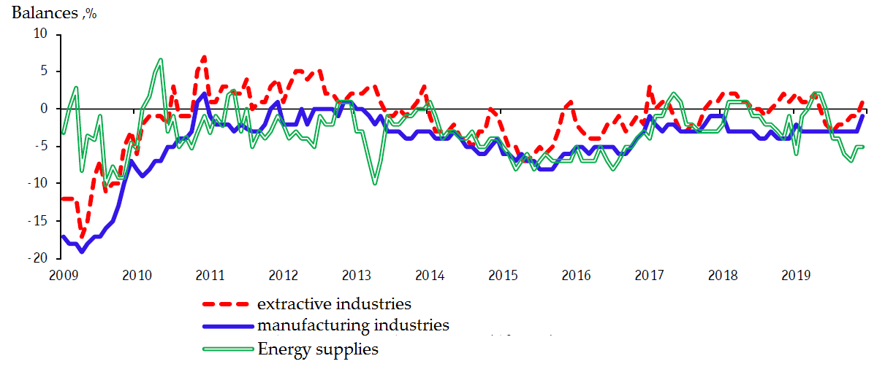

1. Dynamics of the entrepreneurial confidence index. From the Business climate in industry in November-December 2019 Report

At the same time the Economic sentiment index (HSE IEN) in the fourth quarter of 2019 maintained the value of the previous quarter (-13%), recording a pause in the gradual recovery of the total consumer sentiment of the Russian population. Therefore, the customers are less willing to spend money on new products, entrepreneurs less willing to invest in new machinery.

An internal part of the working process in production companies could be divided into two major factors: people and machinery. The average age of the machinery in Print and publishing industry tend to be quite old (10.2 years) among all other production industries in Russia, according to the study of investment activity of industrial enterprises in Russia (2019):

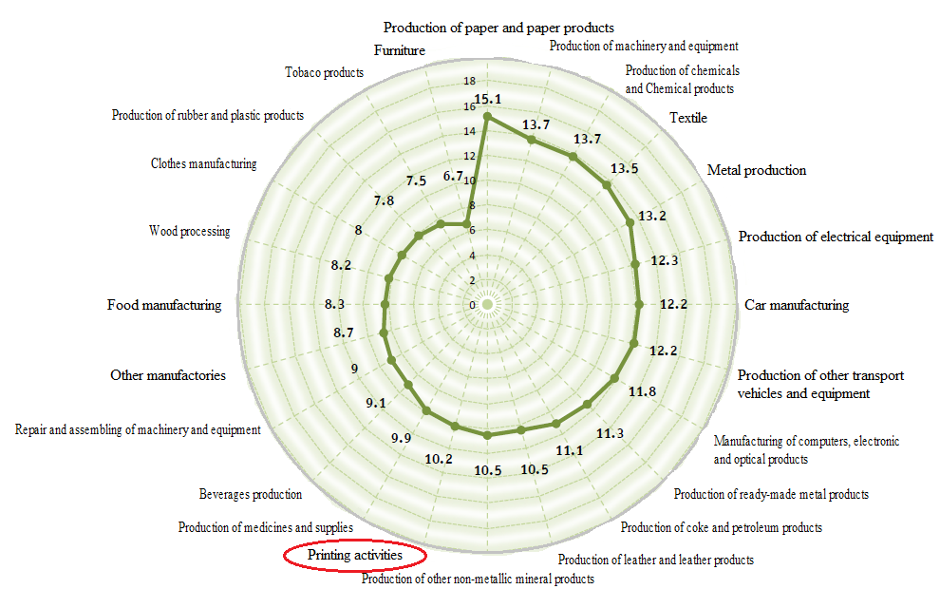

1. Estimation of the average age of machinery and equipment in the manufacturing industry by type of economic activity in 2018 (years)

Therefore, the other thing that could be affected to increase the quality of the outcome – the more precisely implemented employee motivation practices.

In the era of numerous possibilities, the main goal of companies is set to attract and retain workers, no matter in what industry it operates. The difficulty for SMEs is that they need to compete with corporations that could afford to spend more money on the HR and remuneration of its employees. That is why it is important for SMEs to know what the most efficient practices are considering that they do not have resources to spend on inefficient ones. The situation becomes more complex and difficult when it is referred to companies operating in the changing markets with low profits within the emerging economy (such as printing). Employees may feel stressed and underestimated that is why it is so important to pay precise attention to the motivation of such employees.

## Research gap

Job satisfaction is the pleasurable emotional state resulting from the appraisal of one's job as achieving or facilitating the achievement of one's job values. (Locke, 1969)

The statement that job motivation is driven by the level of job satisfaction of employees(Stefanovska-Petkovska, Bojazdiev, Handjiski, Trajkovska, V, 2017) shows that some analysis of the relation between job satisfaction and motivation system has been done before, but how properly, if any, in the context of the chosen industry?

Despite the fact that job motivation and job satisfaction considered as quite well elaborated in the context of HR management studies, but there is a lack of modern studies concerning following issues:

1. Differences in job satisfaction and the motivation of blue collar employees in developing and developed countries

Existing researches are focused primarily on the office workers and managers from banks, public services and health industry. The most recent research from the developed country was concerning the amount of pay compensation in banking industry. The findings were that interpersonal relationships and internal climate play a greater role and serve as the most significant variables of compensation policies of the company. The amount of money paid was found not related to job satisfaction and intrinsic motivation (Olafsen, Halvari, Forest, & Deci, 2015)

For developing country, the most recent research was about comparison the intrinsic and extrinsic motivation. Extrinsic factors were found to affect job satisfaction in a greater way compared to intrinsic factors. The level of payment is four times greater than any other study variables and is considered as the strongest determinant of workplace satisfaction (Addis, Dvivedi, and Beshah, 2018).

1. Motivation and job satisfaction in the print and publishing industry.

If one would be looking for printing industry articles, the situation would be even worth. The last time when the US Printing association published an article on the motivation was in “Motivating employees” (Oller, 2002, pp. 33-35) for the UK, the last article was “Working for your workers”. (Chadwick, 2008, pp. 28-29). It is obvious that the interest in the topic from the emerging market researchers is higher because of their need for managing such employees more efficiently. For China printing companies (for example), it is common to have a high level of internationalization, when in Russia their orientation is on the internal market only. The printing companies from the developing countries due to the fact that are heavily penetrating European and American markets of print and publishing, cover the topic a bit, for instance in “Employee Motivation on the Organizational Growth of Printing Industry in the Kumasi Metropolis'' (Boakye-Amponsah, Enninful, & Osei-Poku, 2015, pp. 8-20) and “Motivating employees for effective organizational advancement: the focus on the managers of printing industry in the Kumasi Metropolis” (Boakye-Amponsah, Enninful, & Osei-Poku, 2016, pp. 72-86) but significantly less in a number and the length of studies in comparison to the banking managerial motivation studies. It is good to remember the phrase of the classical author that Russia has its own third path, different from the eastern and the wester worlds. That is an angle from which we are going to look at the motivation of the industry’s employees.

1. Recent studies of blue-collar employees in CIS countries.

The existing fundamental researches could be to out-of-date. These are researches conducted by Yadov & Zdravomyslov and Gerchik throughout the period of 1970s-2000s. As the environment changes, methods and approaches need to be adjusted to market alterations in order to reach success. In addition, it is a lack of questionnaires developed to measure the labor position workers’ job satisfaction as well as the motivation system analysis.

To sum it up: a low interest to the motivation of the labor position workers from the developed countries and the high level of internationalization of printing companies in developing world creates a gap of a size of the motives and motivation of the labor position workers from the emerging economies but that works for companies operating in changing and challenging market like Russian printing companies does.

## Research questions and aims of the study

**The aim of the given research** is to define and to discover relationship between personnel motivation systems and job satisfaction among labor position workers in printing companies.

**The questions are:**

1. What correlations among different job satisfaction factors for staff in printing industry exists?
2. What is the relation between job satisfaction factors and the level of contentment with the motivation system?
3. How socio-demographic and job related factors influence on motivation and job satisfaction?

# Chapter 1. Motivation, productivity, leadership and job satisfaction

## External factors affecting productivity and efficiency

In order to commence the research, there is a need to analyze basic measurement methods of productivity and efficiency in companies. There is a huge range of internal as well as external conditions that may seem crucial for businesses. The analysis would help to comprehend what factors need to be taken into account while trying to pursue a goal of increasing indicators of any firm with further emphasis on the most significant of them. In addition, modern measurement approaches uncover possibilities for growth if implemented thoroughly. Firstly, the analysis of external factors will be held moving on to internal ones. Then the differences of management strategies in motivation will be assessed. The next step is to determine what effect a leadership style has in workers` motivation. Russian research will be the final step of the project and will sum it up by providing general recommendations.

Sickles and Zelenyuk (2019) detail a wide variety of approaches used in estimating productivity and efficiency using methods to track frontier production. 'The R programs include such approaches to estimation as the time invariant fixed effects, varying fixed effects, correlated and uncorrelated random effects estimators, semi-parametric efficient panel frontier estimators, factor models for cross-sectional and time-varying efficiency', etc. Theoretical underpinnings and an empirical implementation combined with implications of neoclassical economic theory present a wide variety of methods.

'Measurement of Productivity and Efficiency' provides a huge range of possible actions taken with the perspective to evolve with further analysis and results interpretation. However, authors indicate that internal parameters of created models and methodologies highly depend on human resources of the organization and their performance. This conclusion leads to further investigation of the importance of employee motivation in terms of future success of any company. The difficulty is in finding the links between the personnel motivation and results of the whole company and in ability to prove that the assumptions are correct and their further implementation would be profitable.

It is hardly arguable that culture, business environment and SMEs' profitability are linked. Cultural milieu affects habits, ways of life and expectations of a country's population. Therefore, it is reasonable to divide the world into segments with similar cultural history and, consequently, business environments in order to apply uniform motivation practices, for instance. However, this action may lead to deprivation of practices used in the rest of the world, which might be valuable. The European business environment differs from Russian one. Therefore, studies made in Europe still need to be adapted. The extent to which the adjustment process is required differ from industry to industry and from region to region. The concept is clear, though, in terms that national peculiarities need to be assessed as well as external ones in order to apply practices correctly leaving all discrepancies behind.

Retracing the idea of milieu affecting behavior of organizations and profitability, it has been proven that freedom from corruption, a better environment in terms of easiness of getting credit, and fewer government regulations related to business operation enhance profitability (Gaganis, Pasiouras, & Voulgari, 2018). The work of these Greek authors has shown that individualism, masculinity, and long-term orientation affect profitability and add to its growth, whereas power distance and uncertainty avoidance act the opposite and only lead to disturbances with future losses.

National culture in this context is an additional important factor, which cannot be excluded. It may also be concluded from the work that political stability is one of the first factors to consider while attempting measuring the significance of national culture impact on effectiveness and efficiency of the company.

An argument that corruption might decrease aggregate productivity by deteriorating firm management practices appears in other works, too. Athanasouli and Goujard (2015) have investigated the impact of corruption on the management quality of firms with the focus on the manufacturing sector. The degree of dependence on contract institutions is considered the basis for measuring the level of corruption in manufacturing areas. It has been discovered that being located in more corrupt regions with higher level of contract obligations, firms tend to lack implementations of important management practices and, therefore, have low management quality. A more centralized decision-making process, which does not pay attention and neglects allocation of money to education among administrative personnel adds to the overall situation and worsens it. HR-management in the manufacturing sector suffers from being omitted while there is a crisis.

Russian conditions, which could not be described as corruption-free, are predominantly unstable referring to economy and politics. Uncertainty of future indicators leaves companies with short-term orientation because of inability to predict and plan their actions normally. Such trends in business operation usually regard spending on motivation as costs not as investments still because of short-term outlook. The works of European authors have proven that external factors affect internal conditions. Straight-forward approach with standard practices that are recommended by a number of institutions with the government in the first place narrows possible options of decision-making and assets allocation and results in poor indicators and frustrated labor-force who have not been treated adequately.

## Internal decisions made to increase profitability

Even though the milieu plays a huge role in business operations, leaders of any company should make efforts in order to improve what they have. It is undoubtful that in each country even if it is strictly regulated, there are firms that are able to adjust by being flexible in their practices perhaps by using different approaches while communicating with the outside world and inside workers. It may be considered as the best option out of existing ones.

There is the Denison Organizational Culture Survey, a methodology of ways to evaluate the performance and to make changes where needed. The guide was developed in order to help to better understand what the organization obtains and what it may use to boost effectiveness and performance.

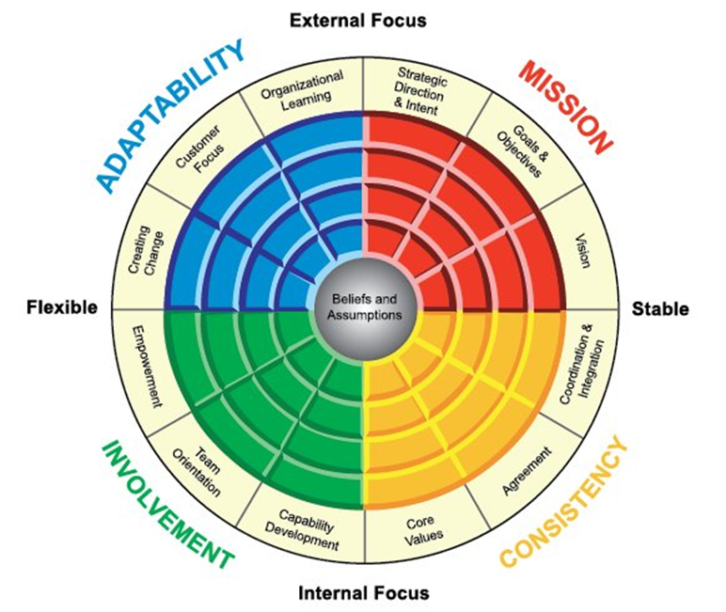

1. Denison model. From “Denison Organizational culture Survey” by D. Denison and Neale W., 1997

From Figure 3 it could be clearly seen that a firm is being looked at as the business focusing on stability or flexibility and having more of an external or internal focus of actions.

The analysis of the situation in Russia brings us to the conclusion that businesses have external focus and are flexible or at least are trying to remain flexible to the outside world. It is more important, though, to be capable of mixing these strategies. In addition, Customer Value Chain (Adaptability and Consistency) could be the option for Russian companies to choose. Adaptability is largely concerned with the market and Consistency values internal processes and people. High performing organizations must be able to adapt and respond to the market requirements and to execute in a way that produces quality products and services taking into account core values and integration (Denison & Neale, 1997).

Denison (1990) in his book 'Corporate culture and organizational effectiveness' points out that correctly chosen and formed corporate culture increases a firm's profitability because it adequately communicates with stakeholders: employees, government, NPO, etc. The author has proposed four hypotheses, which illustrate how exactly the culture and the effectiveness correlate:

1. The involvement hypothesis, which suggests that high levels of involvement and participation lead to a sense of ownership, and responsibility, which grows a greater commitment to an organization. Increasing the input of organizational members is also seen as increasing the quality of decisions and their implementation. Here the difference in the attitude could be seen. Spending on personnel is an investment because dedicated employees are eager to develop the company. Their desire has a cumulative effect and the result could be tracked after some time.
2. The consistency hypothesis argues that a shared system of values in the organization affects the ability to reach consensus and carry out coordinated actions positively. Members follow a common framework and commit actions based on internalized values. It is beneficial for the company because in an unpredictable environment employees still react in predictable long known ways.
3. The adaptability hypothesis asserts that an organization is in need to hold a system of norms and beliefs that encourages changes in internal behavior when the environment asks to react. By doing so, a company increases its chances for growth and development. It means that a complex adaptive system helps to overcome obstacles by altering internal structure. Managers who obtain the capacity to restructure and to integrate different practices are to be successful at introducing change, which is crucial to integrate in the dynamic world of the XXI century.
4. The mission hypothesis. Mission, or a shared definition of the purpose and direction of an organization and its members, is a crucial part of a company's strategy which makes it prosperous. A mission shows non-economic reasons for employees to stay in the company and make it better. In addition, a mission sets goals and defines courses of upcoming development. Employees become assured of what to do as well as confident that their actions matter.

By combining these four hypotheses and summing up the information, it could be clearly stated that the author emphasizes the role of corporate culture in context of communicating with employees. Workers have to be involved and taken care of. Paying more attention to workers attitudes and feelings would lead to future growth. Neglecting these practices is considered a huge mistake, which may result in staff turnover and extra costs in teaching new workers. Therefore, when you spend the money on forming the corporate culture, you actually save them if it is viewed from the long-term perspective.

The need for an innovation also needs to be considered. The company's development strategy should be based on innovation and regular improvements. In “Growing SMEs the role of Service Innovation: The Case of CCoI'' was stated that Innovation, in general, is recognized to be critical to the growth and survival of SMEs, despite their potential for innovation, are nonetheless resource constrained: finance, expertise and technology. As we go for a service innovation, it is clearly not about the finance or knowledge, but nothing more than people. Service dominant Logic provides a useful lens to reconsider the nature of innovation. Indeed, service orientated SMEs have leveraged the service dimension of innovation to provide sustainable growth. More traditional manufacturing orientated SMEs have struggled to leverage the service dimension of their offering. That paper covered how traditional textile manufacturers, through design method interventions, turned their operations into a service-centered business. Short-term operational restructuring, linked to the design method interventions helped organization fast turnaround that released the potential of service innovation. The most useful part of the paper in the given research is the shown role of the staff collaborations for innovation implementations.

Integrated staff motivation indicator as a key indicator of the implementation of an innovation strategy (Zhdankin 2019) gives us the most recent overview on the tradeoff between the innovation and the personnel motivation, stating categories of the factors that we will compare to the results of deep interviews with.

## Types of motivation

Denison, Haaland, and Goelzer (2004) state that there is no huge gap in management of different countries and regions. They aimed to help to understand the impact that organizational culture has on organizational effectiveness. A concept of empowerment is being considered and referred to important practices. The model indicates the presence of a necessary set of traits while the expression of the traits is being left to regions.

As for implementation of the study to the project, it can be stated that the basics stay the same. Motivation and workers satisfaction should exist in the company as fundamental concepts. However, the ways of their introduction may vary.

The further analysis is focused on the question of what type of motivation practices are more desirable and what has the strongest effect on job satisfaction. It is understandable that for workers compensation-related as well as interpersonal motivation are needed. The question is discovering in what proportion they could be implemented.

There has been a study commenced which brought up an argument that interpersonal relationships and internal climate play a greater role and serve as the most significant variables of compensation policies of the company. Moreover, procedural justice was the only variable related to intrinsic work motivation that has shown the ways of determination of compensation. Its implications for employees’ need satisfaction have also been shown. To make it clear, the amount of money paid was found not related to job satisfaction and intrinsic motivation (Olafsen, Halvari, Forest, & Deci, 2015). In Figure 4 you may see how exactly these factors affect intrinsic motivation.

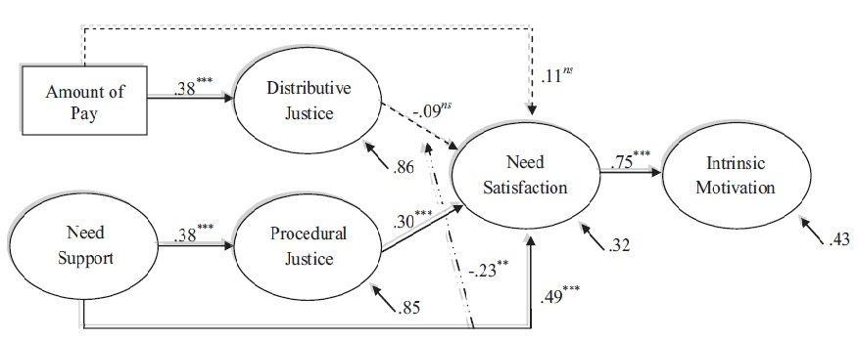

1. Structural equation analysis. From 'Show them the money?' by Olafsen, Halvari, Forest, and Deci, 2015

Surprisingly, money-based motivation is not that important. However, background, social position, family and many other factors have to be taken into account before making a decision about motivation. There might be a need to divide personnel into categories and to use group approach in motivating. Therefore, each group is satisfied and gets only what it desires.

The level of pay satisfaction is crucial for any employee to put efforts in the working process. Ram and Prabhakar (1976) have studied pay satisfaction in a developing country. They have created four dimensions for pay satisfaction:

* pay-rise,
* benefits,
* structure/administration,
* pay-level.

It has been indicated that all factor loadings are strong with the highest for pay-rise. The research by Ram and Prabhakar was made for Jordan.

One more research on the determinants of pay satisfaction has been conducted. Dyer and Theriault (2010) have created a modified model, which is shown in Figure 5. This model connects actual level of payment with pay satisfaction through several other factors. Many perceived criteria are exposed which also influence the level of satisfaction.

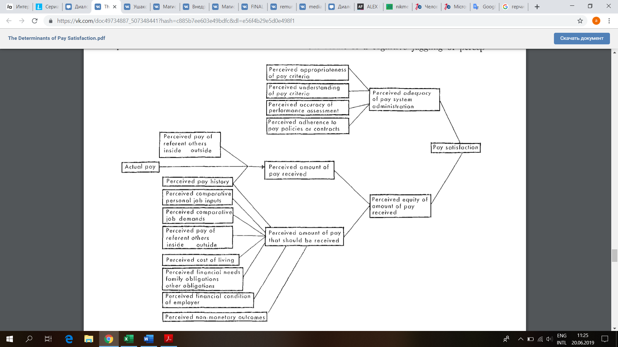

1. Modified model. From 'The determinants of pay satisfaction' by Dyer and Theriault, 2010

Addis, Dvivedi, and Beshah (2018) have conducted their own research on job satisfaction, which was for Ethiopia. The job satisfaction of workers in the developing world has not been studied properly so there is a gap, which should be fulfilled. The results of the study have shown that extrinsic factors affect job satisfaction in a greater way compared to intrinsic factors. Additionally, the level of payment is four times greater than any other study variables and is considered as the strongest determinant of workplace satisfaction. Payment remains the leader among motivators which incline workers to be successful in reaching firm's goals and following its inside rules. Other factors that follow financial bonuses are performance appraisal system, promotional opportunities and communications. Therefore, extrinsic organizational rewards such as salaries and job security could be called the most powerful determinant of job satisfaction. They are commonly used in companies and are referred to basic ones.

Now it is seen that both money-based and compensation-unrelated practices are to be implemented and considered equal while referring to the motivation of workers at any type of organization all around the world. Practice makes perfect so the owner has to experiment and see what affects the company's results more.

Another study on workplace satisfaction was conducted in a Chinese context. Pay satisfaction and work values were the considered determinants of commitment to the work process and turnover intention. The results have revealed that pay satisfaction leads to a greater level of commitment and lower turnover intention. Personal viewpoint of workers was that work values significantly affect normative commitment and turnover intention through pay satisfaction (Wang, Chen, & Hyde, 2010).

It is one more proof to the idea of payment level playing the leading role while attempting to motivate personnel. It inclines to make emphasis on financial remuneration rather than compensation-unrelated practices. However, the motivation model should be balanced because people are not one-sided creatures. They seek diversity and are eager to be surprised in a positive way so that the company is unique for them.

## Leadership

Leadership is considered as a vital element in the implementation of reforms and the activities in organizations. It is a guideline to encourage and motivate the actions of employees towards the planned organizational result in order to achieve those objectives that the company has predetermined (Xiarasagar 2005).

Transformational leadership raise consciousness of followers by appealing to higher ideas and values such liberty, peace justice and equality (James and Sarros 2001)

Transactional leadership occurred when leader and follower are having same type of exchange relationship in order to get needs met, for instance, in exchange of work for money (Bass and Avolio, 1990, 1995)

“Leadership is coordinating and integrating employees with different styles through a process of applied creativity that includes continuously discovering and defining new problems, solving those problems and implementing the new solutions (Basadur 2004)”. “Leadership is an important process in an organization to induce a subordinate to behave in a desired manner towards accomplishing organizational goals” (Hughes; Ginnett & Curphy 2009).

As could be seen there are a lot of different definitions of leadership, but they all are similar in one – the right leadership type helps people to work better.

### Necessary leadership styles that help the motivation process

To make the research up-to-date, the decision to explore crisis times is quite necessary because the political and economic situation in Russia is very unstable. There is a question whether firms should curtail their expenditures on motivation practices and what is a common approach in the world.

In the context of a crisis, which is indicated with scarce munificence and high uncertainty, Dolz, Iborra, and Safon (2018) use the term 'ambidexterity' of organization in order to analyze SMEs survival. The results of the research suggest:

1. firm survival is associated with ambidexterity;
2. diversity in top management team's tenure affects firm ambidexterity positively;
3. a negative effect is noticed between family ownership and ambidexterity;
4. A positive effect is seen between family ownership and survival.

So, the research outlines the superiority of ambidexterity for survival during the crisis leaving no other option but to be ready to evolve with the rest of the market or to lag behind if you are not able to catch up.

Flexibility in decision-making processes, openness to changes and fearlessness to take responsibility are the key qualities to obtain in crisis times. Family ownership brings stability during a crisis but flexibility suffers. In Russia, there are a lot of production SMEs that are family-owned businesses. Unfortunately, it may result in stagnation.

As there is a great number of family firms, the assessment of their business performance and ways to deal with lack of ambidexterity should be undertaken. Effectiveness of such businesses depends critically on measurements of goals and performance outputs. At the same time, efficiency is dependent on measurements of outputs and resource inputs (Chua, Chrismand, Massis, & Wangh, 2018). They also mention that the non-financial goals of dominant stakeholders should be assessed. The focus on family-oriented non-financial benefits is shown and its importance is confirmed. Socioemotional wellness is considered to be one of the unique sources of motivation.

So, the study states that non-financial focus of family firms is the most significant advantage. However, family goals may be different as well as performance assessments. Choices are made by firm`s owners therefore human factor is crucial. Management decisions are not always predictable but there is always some basis the manager relies on. And if he or she is the right person, the foundation is chosen correctly.

The leader of any firm should be a risk-taker. His or her transformational outlook has to lead the company to new horizons and let it develop and grow. Aryee, Walumbwa, Zhou, and Hartnell (2012) have studied transformational leadership and its influence on task performance. Three main findings have been discovered:

1. transformational leadership relates to work engagement via the meaningfulness of work and the responsibility for outcomes (mediation process);
2. work engagement influences task performance through innovative behavior (mediation process);
3. leader-member exchange (LMX) moderates the 'work engagement – innovative behavior' relationship; the relationship is stronger for high quality LMX subordinates (moderation process).

Figure 6 illustrates that the factors are positively related. The significance is high so it may be concluded that the mediation process exists.

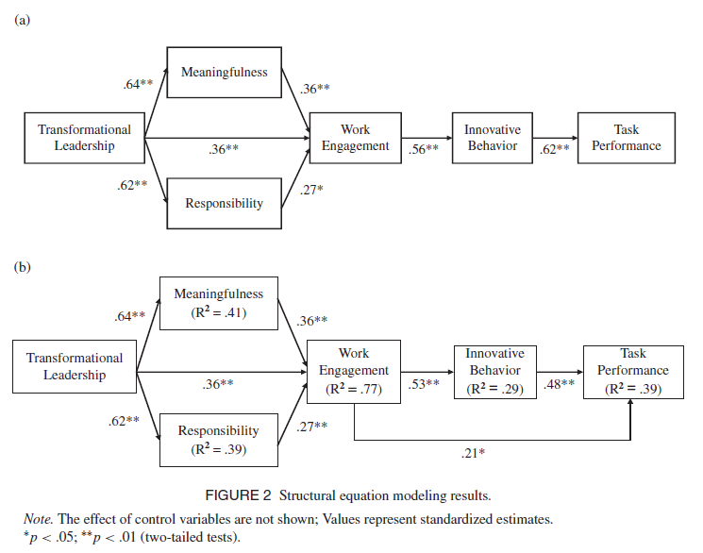

1. Mediation process. From 'Transformational Leadership, Innovative Behavior, and Task Performance: Test of Mediation and Moderation Processes' by Aryee, Walumbwa, Zhou, and Hartnell, 2012

Figure 7 illustrates the moderating influence of LMX on the 'work engagement – innovative behavior' relationship.

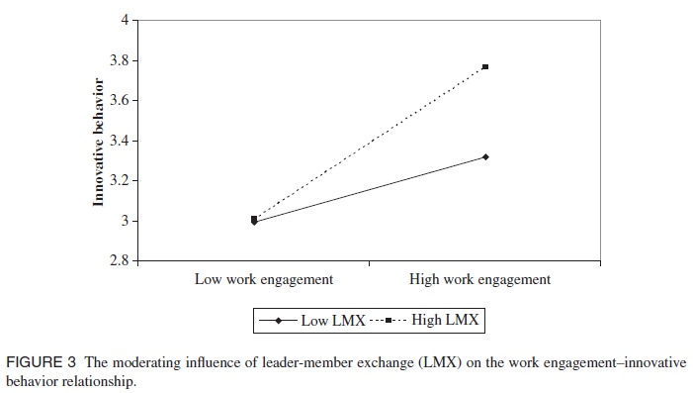

1. Moderating process. From 'Transformational Leadership, Innovative Behavior, and Task Performance: Test of Mediation and Moderation Processes' by Aryee, Walumbwa, Zhou, and Hartnell, 2012

It is such important findings in terms of consolidation of the viewpoint that transformational leadership and ability to think critically and predict, to be flexible and open-minded but at the same time – responsible and full of suggestion do matter when it comes to task performance. New methods of motivation could be called transformational, too.

Zhang, Cao, Wang (2018) have also studied the mediation role of leadership styles. The conclusions that may be taken into account are:

1. Leadership styles link the relationship between project leaders, emotional intelligence and satisfaction from collaboration.
2. Project managers should be appointed to integrated project participants because these managers obtain emotional intelligence and necessary leadership behavior to promote collaboration.
3. Transformational leadership affected outcomes most. It concludes that setting an example is essential for the indicators of the operational process.
4. Top management should not neglect and consider assigning project managers for integrated projects because their emotional intelligence would speed the process up and would result in overall process satisfaction.

Leadership, especially transformational leadership, creates an atmosphere of true trust, productivity, self-realization and sleekness for development. More skilled and qualified personnel inspire average employees and emotional intelligence come in hand when financial methods do not work. Having transformational leaders makes the process of motivation easier in terms of understanding each other, empathy and desire to be helpful. So, motivation is not only about workers but it is also about those people who create practices and are in charge of the outcome (meaning top-managers).

Arnolds and Boshoff (1999) reason whether the leadership style and, therefore, non-financial practices motivate frontline personnel and accelerate their productivity. They come up with the conclusion that this type of workers is motivated predominantly by low-order needs such as monetary rewards and affiliation needs. They use the term 'gainsharing' which means enhancing firms' productivity by providing workers with bonuses according to their work performance. Daily planning and performance feedback are the basis for this approach, and they make the working process easier for employees in terms of planning and setting the goals. Remuneration is clearly expressed which makes the understanding between top-managers and workers easier.

Figure 8 illustrates what level of correlation exists between job performance and chosen factors affecting it.

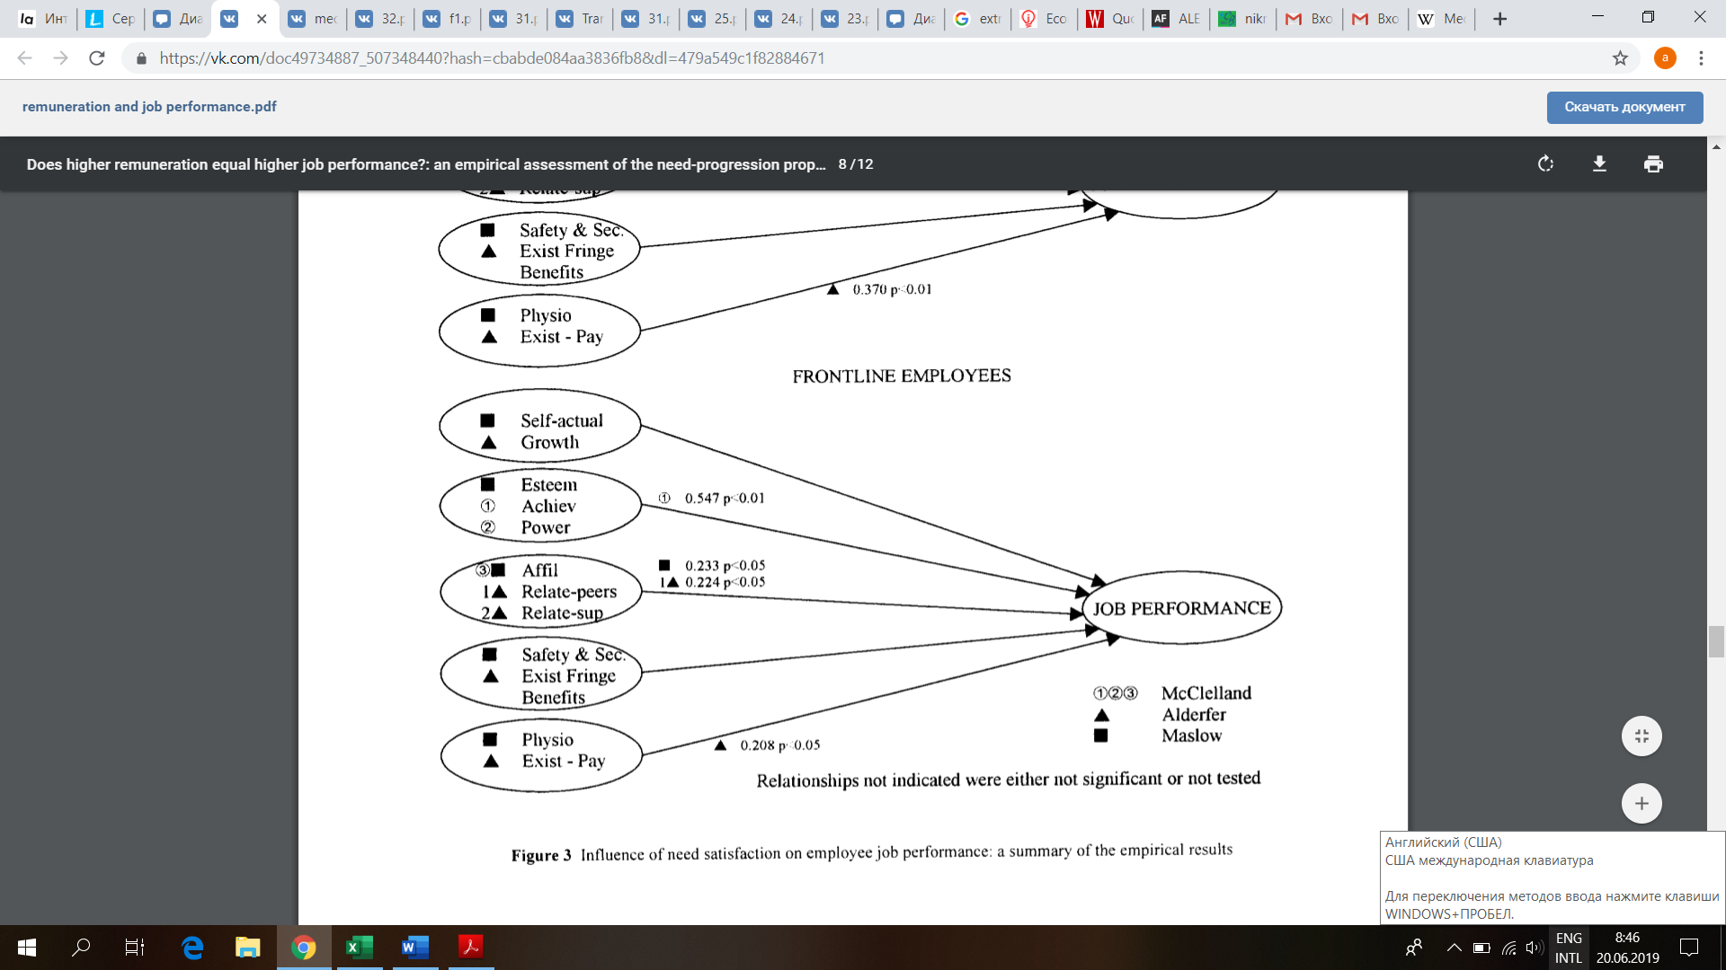

1. Frontline workers. From 'Does higher remuneration equal higher job performance?' by Arnolds and Boshoff, 1999

In the MBA research work, the author discovered a relationship between leadership styles (transformational and transactional) of managers and work values (intrinsic and extrinsic) of employees in the printing industry in Penang (Loh Jin Han, 2010).

Leadership is conceptualized by the behavioral areas from laissez-faire style (non-leadership), through transactional leadership (which hinges on reward system and punishments), to transformational leadership (which is Performance and leadership outcome correlates based on inspiration and behavioral charisma) (Bass and Avolio, 1993).

In the given work, leadership would not be assessed as a matter of how the leader inspire the peers, but more as a way that people communicate with their supervisors. As long as we are considering SMEs in turbulent times, we should keep in mind that the ability to count on the supervisor, in other words supervisor-employee communications, may have effect on the job security perception from the employee and the job satisfaction as well.

## Job satisfaction

Edwin A. Locke (1969) did a lot of research on job satisfaction. In his first big work “What is job satisfaction?” (pp. 309-336). He stated that to explain job satisfaction, and other psychological phenomena, the policy of correlation without explanation must be abandoned. The first question a scientific investigator must ask is not "How can I measure it?" but rather, "What is it?"

He answered that question in the following manner: Job satisfaction is the pleasurable emotional state resulting from the appraisal of one's job as achieving or facilitating the achievement of one's job values. Job dissatisfaction is the unpleasable emotional state resulting from the appraisal of one's job as frustrating or blocking the attainment of one's job values or as entailing disvalues. Job satisfaction and dissatisfaction are a function of the perceived relationship between what one wants from one's job and what one perceives it as offering or entailing.

The next important step is to define the correlation between the job satisfaction and the job performance. In addition, Edwin A. Locke covered that in his next work Job Satisfaction and Job Performance: A Theoretical Analysis (Locke, 1970, pp. 484-500). According to the findings, to big surprise, job satisfaction is a product of good work performance, not the other way. That is what the author stated in his work: In conclusion, this writer suggests that satisfaction should be regarded primarily as a product of performance (as an outcome of action as appraised by the individual) and only very indirectly as a determinant of performance. Past satisfaction reflects the degree to which one's past actions attained or failed to attain one's values and thus serves as an incentive to maintain one's course of action or to change it. However, emotions do not control a man's behavior (unless he is very neurotic). A man's actions are directed by the goals he is seeking, which goals are the result of his basic values, his interpretation of the situation, his knowledge, anticipations, and methods of thinking.

With all of that in mind, let us move to the stage of measuring it.

It is offered to create a list of events that could serve as motivation factors for a worker to continue making improvements (Ushakova, 2016).

1. Satisfaction with management relationships:

* To monitor the socio-psychological situation in the team;
* To improve the system of non-material incentives (verbal gratitude, verbal praise, substantive conversation with a positive assessment of the work performed, presentation to awarding a diploma, etc.)
* To create conditions for the prevention of professional burnout (equipping the workplace so that the person does not feel confined, the organization of activities for the preservation of health and professional health, organization and holding of health days).

2. Preferences of the work process itself to high earnings:

* To obtain the equipment of working spaces in accordance with modern requirements (the acquisition of modern equipment, necessary facilities, etc.);
* To create comfortable conditions (bringing the state of inside facilities in accordance with sanitary standards and requirements: lighting, air condition, cleanliness, noise level).

3. Claims in professional activities:

* To create conditions of competitiveness (organizing, conducting and accompanying during participation in professional competitions);
* To create conditions for improving self-esteem, self-assertion, achieving social success;
* To assist in the development of modern production technologies (organizing the activities of problem creative groups on issues of interest to them, organization of round tables, methodical seminars, etc.)

## Russian literature review

Zdravomyslov and Yadov (2003) have researched the topic of motivation thoroughly and their student book has been studied in the universities in the Russian Federation. The main conclusions are listed further:

1. Social conditions set an attitude of the worker to the working process, not technology as it was thought earlier.
2. Given the general social conditions of development of modern society, the content of work, creative work opportunities are the leading specific factors that determine the attitude of the worker to work predominantly.
3. Financial incentives for employees increase productivity and quality of work regardless of the content of labor activity. However, only if the labor itself has a meaningful content, it is effective to shape attitudes towards work as the need of the individual, otherwise, it is pointless.
4. Differences in the content of labor leads to the fact that the process of turning it into the demand is uneven, although the principle of labor organization in all production areas is uniform.
5. The most significant motives of labor activity are optimized in two directions:
   1. in relation to general social conditions that predetermine the content and composition of the elements included in the motivational "core",
   2. In relation to the functional content of labor, which determines the order, the hierarchy of motives that make up the "core" of the structure.
6. One of the most important social problems of education is the formation of an optimal structure of value orientations among workers.

They have summed up everything that has been mentioned earlier but with an emphasis on Russian society. Their findings are easier to implement because they take into account Russian peculiarities and do not avoid them. The content of work itself plays a leading role. This fact makes it hard to motivate production workers because their working process may seem routine. However, it provides us with opportunities to create new approaches, to make the process more exciting. Probably, it might be connected with the result.

Payment motivation is significant. However, it is the next step, remuneration, after fixing the level of satisfaction among personnel and giving them a breath of fresh air after many years of similar practices.

Motivation methods could be classified as follows:

• Organizational and administrative,

• Economic,

• Socio-psychological, which were previously among the most common, but now unfairly forgotten (Arkhipova, 2013).

In employees of industrial enterprises management practices, as a rule, first of all application of economic and socio-psychological methods takes place. In modern conditions for effective motivation management, it is truly necessary to use all three groups of methods in order to achieve higher results.

As the company grows and passes different development cycles (start, growth, maturity, recession) the role of the financial remuneration system is increasing. To form an effective payment system in accordance with a firm's business strategy is necessary at the very early stages of business development. The system of indirect material motivation – so-called compensation package (social package) – is provided to the employee depending on the level of his position, professionalism, credibility, etc.

In addition, every employee should feel his value in the enterprise. The first step is to start with maintaining corporate spirit and teamwork. In factories there are management, engineering and working staff, people of various specialties, they are all united in brigades, workshops, and departments. It is proposed to make a list of indicators that will be taken into account (monthly or quarterly) at the time of distribution of additional funds (for example, premium, and annual bonus).

So, in order for the organization to function properly all three dimensions need to be applied. Lack of payment may cause frustration but the absence of company spirit leads to unwillingness to come to the working place. The system of parameters that might affect the amount of extra payments could include plan over fulfilment or profession development: visiting lectures, seminars, etc. The indicators that decrease the payment level could be smoking not during regulated breaks, non-compliance with the working schedule and so on. If they are announced to workers, personnel will pay more attention to the working process. Employees would understand that their payment is highly dependent on what they do every day. In addition, these practices might add to company spirit and respect.

Gureeva (2016) states that according to the empirical evidence, industrial companies see the solution to the problem of motivation in the development of a financial remuneration system. With the growth of the company's turnover and profitability, the absolute value of the salary fund increases, but the growth rate of revenue or profit must outpace the growth rate of payroll.

Critical motivational value for workers of industrial enterprises have legal and social conditions of labor. Providing employees with necessary information has a direct motivational value. Dissatisfaction with the staff of industrial companies (especially those with insufficient education) may be due to a lack of information and, accordingly, the inability to assess benefits offered by the employer.

To conclude, it is important to say that the research has been started with the fact that there are many factors, which affect productivity of the company. However, if the working process and all of the machines operate at the highest level, the stagnation period would eventually take place and other improvements would have to be considered.

Unfortunately, top-managers think about spending more on motivation of personnel only when they have reached the maximum from the machines and there is no other way. If they started earlier, the long-term perspectives would seem brighter.

This is when transformational leadership is observed. It is an ability to predict and to use the resources with the most desirable outcome in the future. These leaders do consider motivating workers to be an obligatory action because motivation affects results positively even though there is a need to wait.

Further works of different authors have proven that the topic of motivation methods is still discussable. However, a systematic approach is claimed to be the most effective but costly. It is systematic in terms of application of both financial and non-financial motivation for employees in order to maintain their satisfaction and willingness to put efforts in the working process and company's future. Financial part may vary and depend on discipline, for instance, or a desire to learn more about the field of work. Not only workers but also top managers need to react. Administrative personnel has to create informal activities for production workers so that the corporate culture is visible. Collaboration of managers and workers would result in understanding, empathy and flexibility. Motivation would inspire everyone: starting with people who get the benefits to people who create programs and look at the very root of the problem and see its future opportunities.

# Chapter 2. Plan of empirical study and the questionnaire development

The plan was to apply a mixing of methods with different sources of data collection. To start with, a set of deep personal interviews with top managers and owners of the companies operating in the print and publishing industry was conducted. Based on the insights from the managers and owners on the roots of motivation of labor position workers a questionnaire was created, by mixing the insights from the interviews with questions from the previously conducted researches on the motivation from Russian and foreign researchers. Those questionnaires were Google-forms based as well as paper-blanks, depending on what was more convenient to distribute in the new reality of the coronavirus pandemic when some people tended to self-isolate and some employers limited social contacts of their employees. The questionnaire was created for top managers and employees. All information (qualitative and quantitative) was going to be analyzed using structural equation modeling in SPSS presented in further research.

## Methodology

There are different methods that were used while making a research:

* mixing of methods,
* multiple case study,
* regression modeling.

This set of methods is complex and covers almost every aspect assessed. Therefore, the research was conducted from different perspectives using a few instruments.

## Data collection

The multiple case study that was conducted with the information obtained through the set of personal interviews with the top-managers and owners of Russian printing companies classified as SMEs specifically picked from the industry. The printing and publishing industry was chosen for numerous reasons:

1. It is the industry the researcher is acquainted with so more insights were collected and the bigger number of contacts of top-managers and owners of companies was gathered.
2. From the insights, it could be seen that the motivation of the labor position workers in the industry is a point of tension for many companies’ owners. The industry suffers from a skip decline in consumption due to the movements of the information consumers to other then physical sources of information as well as the decline in the printed advertisement and the movement to the internet.

As for questionnaires mentioned above, experience from “The determinants of pay satisfaction”, “The impact of the working position on the level of employee motivation in Slovak Furniture companies” (2018) and the most popular in Russia test "Integral job satisfaction" (A. V. Batarshev) were used in order to conduct proper questionnaires for job satisfaction of employees in observed companies/industries and leadership and social responsibility of the heads of companies. The questionnaires were distributed through managers of the companies.

The questionnaire could be found in Appendix 1.

Demographics of the people in the data set are presented below:

|  |  |  |  |  |  |  |  |  |  |  |  |  |  |  |  |  |  |  |  |  |  |  |  |  |  |  |  |  |  |  |  |  |  |  |  |  |  |  |  |  |  |  |  |  |  |  |  |  |  |  |  |  |  |  |  |  |  |  |  |  |  |  |  |  |  |  |  |  |  |  |  |  |  |  |  |  |  |  |  |  |  |  |  |  |  |  |  |  |  |  |
| --- | --- | --- | --- | --- | --- | --- | --- | --- | --- | --- | --- | --- | --- | --- | --- | --- | --- | --- | --- | --- | --- | --- | --- | --- | --- | --- | --- | --- | --- | --- | --- | --- | --- | --- | --- | --- | --- | --- | --- | --- | --- | --- | --- | --- | --- | --- | --- | --- | --- | --- | --- | --- | --- | --- | --- | --- | --- | --- | --- | --- | --- | --- | --- | --- | --- | --- | --- | --- | --- | --- | --- | --- | --- | --- | --- | --- | --- | --- | --- | --- | --- | --- | --- | --- | --- | --- | --- | --- | --- | --- |
| |  |  |  |  |  |  | | --- | --- | --- | --- | --- | --- | | Sex | Female | Male |  |  |  | |  | 54,22% | 45,78% |  |  |  | | Age | 18-35 | 36-50 | 51-65 | 65+ |  | |  | 21,43% | 44,05% | 33,33% | 1,19% |  | | Education | Higher | Secondary technical education | High School |  |  | |  | 44,58% | 43,37% | 12,05% |  |  | | Department | Management | White-collar | Blue-collar |  |  | |  | 17,65% | 16,47% | 65,88% |  |  | | Experience | <1 | 10+ | 1-3 Years | 4-5 years | 6-10 years | | In the industry | 3,53% | 77,65% | 3,53% | 7,06% | 8,24% | | Tenure | 5,88% | 50,59% | 14,12% | 11,76% | 16,47% | | Salary | <18 | 18-24 | 25-35 | 36-50 | 50+ | |  | 8,43% | 9,64% | 31,33% | 25,30% | 25,30% | | Time to work | 15 | 30 | 60 | 90 | 120 | | In minutes | 2,35% | 11,76% | 37,65% | 44,71% | 3,53% | |

1. Demographics

As could be seen from the demographics the division between males and females is almost equal. The majority of the workers employed in the industry is rather old, ¾ of all employees are in the range 36-65 years.

The education of workers in the given data sample shows that almost 45% of employees have a higher education degree and other 43% have Secondary technical education and only 12% have no special educational background.

As for the respondents’ department, almost 2/3 belong to the production department and roughly equal number of the respondents were from office and the management of the companies.

Most of the questioned employees have spent more than 10 years working in the industry and for a particular company it shows that people tend to stay within the sector and the chosen company for a long period.

The salary distribution showed that only a quarter of respondents is being paid more than 50 thousand rubles, another quarter receives 36-50 thousand rubles and almost a third of the employees gain from 25 to 35 thousand rubles a month. Some respondents admitted that their monthly salary is below 18 thousand rubles which means they are getting paid less than minimum wage for the region.

The data was collected on the time spent traveling to work. Overall more than 85% of workers spend 60 minutes or more to get to the workplace.

Demographic features would help to understand the behavior of people and the decisions made by them.

## Hypothesis

It was expected that there would be found something different from only financial incentive from workers answering the question of motivation. Therefore, it is the null hypothesis:

H0: There are no factors other than financial remuneration that affect motivation satisfaction.

H1: There are factors that affect motivation satisfaction other than financial remuneration.

In general, there is a desire to find the best practices and the strongest effect-wise side factor on motivation.

Cross correlations between the factors presented in the questionnaire was analyzed.

The block in the questionnaire was on the satisfaction of employees by the existing companies' remuneration systems so it was measured as well.

In addition, it was truly interesting to find out whether the production industries in Russia differed from other industries in terms of motivation. If so, further analysis would include the research on what factors affect such situations and whether there is an opportunity to adopt motivation practices from other industries so that they are beneficial. That would be conducted after the research by the comparison with the relevant literature on the subject.

## Limitations

There were certain factors, which should have been taken into consideration when interpreting the results. Firstly, a single sector was the object of the investigation. The respondents had different levels of education and other specializations and lived in Saint Petersburg and Leningrad region only so they did not automatically represent the general workforce in the whole industry in Russia (e.g. people who work in the service and manufacturing industries could have different work values related to organizational commitment and turnover intent).

The questionnaires were distributed manually and in the beginning of the corona crisis, so the total number of answers was limited and an increase in the number of respondents could not have given more accurate results.

The scales in questionnaires are based on the personal perception of the person being questioned on the subject of satisfaction, so unless a more reliable way of measuring job satisfaction would not be discovered it is not certain how to address this data as a 100% objective one.

The last but not least is that even though the research was conducted on the anonymity basis some employees may experience pressure from unsatisfying

Future researchers should test the reliability of the findings with other business and industry sectors, and consider demographics in the analysis as control variables.

**Pre-analysis insights**

During the data collection, the question on the improvements suggestions was asked. The preliminary results of the analysis are that people ask for:

1. Yearly salary indexation;
2. Salary payments in accordance with the results;
3. Fair and equal work load;
4. Opportunity for professional development.

It does not answer the question about the importance of salary but gives an idea that there should be something else.

# Chapter 3. Data analysis and further developments

All data collected from the questionnaires was digitized and analyzed using Microsoft Excel and SPSS programs.

After all, 85 questionnaires filled in by respondents from nine printing companies have been collected. From the origin, the research was aimed at getting around 150 answers from representatives of at least three printing companies. However, the coronavirus affected the market to great extent so that it became more complicated to gather the responses due to the sensitivity of the data: the questionnaire includes questions on remuneration and overall motivation system for employees. At the moment, some of these workers are left with no compensation and the rest is experiencing stress due to the fear of being fired. Therefore, the decision to obtain fewer but more qualitative results has been made.

The shortage in the revenues for printing companies in March-April (main months for the data collection) period was 50-80% according to the reports of the companies, and it was the reason for firing from 30 to 70% of all employees.

The firms were contacted through the managing directors or owners of the companies and some of them after getting acquainted with the questionnaires answered the questions by themselves with the unwillingness to pass the questionnaire on to the employees. From 12 printing companies which have been contacted, 3 firms rejected to participate and in 2 more companies only directors filled in the surveys.

The consolidated permanent staff of all companies are approximately 420 employees and the given number of responses (85) stands for 20.24% response rate (which is solely based on the availability of employees and the will of the CEOs).



## Integral job satisfaction

To measure the Level of satisfaction with the labor, the methodology described by the A. V. Batarshev in "Methods of determining the integral job satisfaction" has been used. An analysis has been conducted and the following results have been obtained:

* 57.65% of the respondents are happy with the current job and the test estimates their attitudes as High;
* 41.18% of the respondents had Medium job satisfaction;
* Only 1.18% reported to have Low job satisfaction.

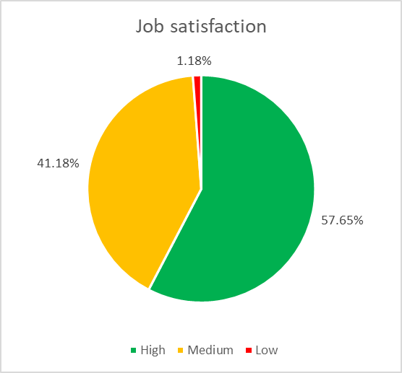

1. Integral job satisfaction pie chart

It needs to be noted that:

1. The research was conducted at the beginning of the “corona crisis” and it could later affect the overall satisfaction of people that still have a job.
2. The existing system of motivation meets the needs of employees and the average response rate was 2.68 out of 5. At the same time, the average answer of 2.88 was for the question that the existing system of motivation is ineffective.

Before conducting a correlation analysis for the factors from the research, the HR practices existing in the analyzed companies should be determined.

## Existing motivation systems in the analyzed companies

During the data collection, respondents were asked to fill in what motivation practices they think exist in their companies.

The results are presented in Table 2.

|  |  |  |
| --- | --- | --- |
| COMPENSATIONAL REMUNERATION | Basic salary | 100% |
| For night time shifts | 22,03% |
| For overtime | 55,93% |
| For working on holidays | 54,24% |
| For low qualification job | 3,39% |
| Penalties for job failed | 1,69% |
| Rise up to minimum pay | 1,69% |
| For hard conditions | 5,08% |
| Multi-shifts | 5,08% |
| Harmful conditions | 8,47% |
| STIMULATING REWARDS | Qualification | 10,17% |
| For proficiency | 15,25% |
| Combining positions | 27,12% |
| Wider range of resp. | 11,86% |
| Working for absent | 13,56% |
| BONUSES | One time only | 47,46% |
| For the results | 27,12% |
| SOCIAL TRANSFERS | Public assistance | 6,78% |
| Insurance | 23,73% |
| Children care | 6,78% |
| OTHER | Birthdays | 72,88% |
| board of honor | 0,00% |
| Clear hierarchy | 0,00% |
| Adaptation and trainings | 8,47% |
| Corporate events | 66,10% |

1. Motivation practices

As it could be seen, not all of the existing and enforced by the government regulations compensations take place. i.e. night shifts compensations. It could be happening for two reasons:

1. Not everyone is well-informed about that and in this case they
2. Receive the compensations not being aware of it,
3. Do not receive the compensations at all.
4. Employers do not provide compensations because
5. They do not know about their obligation to pay extra money for a certain list of work activities,
6. It is not obligatory and they do not think it would help,
7. They use illegal ways to save money.

The most and least popular answers have been highlighted (see Table 1).

Many people (>50%) admit that they receive compensation for working overtime and during holidays.In addition, people enjoy corporate events and their birthday celebrations. As for remunerations, only 27.12% people agreed that they receive bonuses for the results and 47.46% said that the bonuses are non-recurring.

What is more insightful is that none of the respondents said that the company has a clear hierarchy and opportunities to climb a career ladder. The reason for it could be the focus only on the SMEs and the difficulty to get a job offer at the office department due to no required educational background and training for regular production employees.

Only one person admitted that there are penalties for failing to meet the goals.

The last step should be the observation of the ways how different people react to the company’s remuneration policies. They perceive such activities differently in terms of what these policies consist of as well as employees’ attitudes towards them. Therefore, statistical tools need to be used in order to analyze what correlations exist between job satisfaction, remuneration policies and personal characteristics of workers.

## Correlation matrices

To analyze the correlation between factors, a correlation matrix analysis has been run in SPSS.

The matrix requires a lot of space due to its dimensions therefore find it in Appendix 2.

In the given appendix all insignificant values were cleared up with the values below 0.4 in accordance with the scale of Chaddock (see Table 2) as Trivial ones, the level of significance was stated * for 0.05 and ** for 0.01.

|  |  |
| --- | --- |
| **Value** | **Interpretation** |
| from 0 to 0,3 | Trivial |
| from 0,3 to 0,5 | Small |
| from 0, 5 to 0,7 | Moderate |
| from 0,7 to 0, 9 | Large |
| from 0,9 to 1 | Very large |

1. Chaddock correlation coefficient scale

To start with, Table 3 shows the information on the existence of correlation between department and salary as well as experience in the field and tenure.

|  |  |  |
| --- | --- | --- |
|  | Department | Experience |
| Tenure | - | ,651** |
| Salary | ,423** | - |

1. Tenure, Salary, Department and Experience correlation

This table does not provide a lot of the information but gives an insight that many people in the field work for one company over a long period of time. It might seem evident that the salary correlates with the department but it points out the difference in salaries for office workers and blue-collar employees.

The Table 4 illustrates the correlations between interest in work, the feel of professional growth, achieved success in the profession and the satisfaction from the results and the process of work.

|  |  |  |  |  |
| --- | --- | --- | --- | --- |
|  | Interest in work duties | Achieved successes in the profession | Satisfaction with the results | Feel of professional growth |
| Achieved successes in the profession | ,515** | - | - | - |
| Satisfaction with the results | ,536** | ,367** | - | - |
| Feel of professional growth | - | ,426** | ,714** | - |
| Satisfaction with the process | ,576** | ,440** | ,811** | ,680** |

1. Correlation matrices
2. As it could be seen, interest in work has a moderate correlation with every other factor in the table. Indirectly it could be the explanation of the situation in the industry. Employees enjoy their preoccupation thus the companies get better results.

Surprisingly, passion for books does not have any significant correlation with any other metrics for people in the industry so this conclusion from the deep interviews was wrong. In the given sample, companies specialize in the books printing which could be obvious but it is not.

In the research, the analysis has been conducted only on moderate and up on scale correlations, and Love to books was marked as important but the value was considered as Trivial. Probably, in a longer research or in a research with less factors, it could play a more significant role.

The next important observation from the data is represented in Table 5. It shows the correlation between supervisor’s understanding of the employee and employee’s satisfaction with the overall organization processes.

|  |  |  |
| --- | --- | --- |
|  | Unsatisfactory organization | Arguments with colleagues |
| Supervisor does not understand | ,443** | ,495** |

1. Supervisor understanding correlation

It needs to be admitted that the moderate correlation between “supervisor does not understand” and “arguments with colleagues” could reflect one person’s readiness to conflict. Nevertheless it is highly important to make sure that companies’ managers and supervisors demonstrate empathy and listen carefully to the problems of workers.

A moderate correlation between the difficulty to change a job and a habit to go to work has been observed as expected. It serves as a reminder that the research analyzes an old industry.

An unforeseeable correlation is between the loyalty to the company and job satisfaction as well as the level of education and job satisfaction (see Table 6) because by looking at the data, it could be seen that the loyalty correlates with the education level.

|  |  |  |
| --- | --- | --- |
|  | I would not change a job for better paid position | Level of education |
| Satisfaction from the work is more important than financial remuneration | ,422** | ,415** |

1. Job satisfaction correlation

Moreover, the level of education correlates with each factor (see Table 7).

|  |  |
| --- | --- |
|  | Education |
| Department | ,540** |
| Experience | ,428** |
| Tenure | ,499** |
| Salary | ,591** |

1. Education correlation

While making managerial decisions, education level needs to be considered as a crucial factor for hiring employees. The more educated the worker is, the longer he/she stays with the company and the more satisfied with work duties he/she is. It means that educated workers lead the company to future development and progress which should not be underestimated.

## Regression analysis

The final chapter of the data analysis is a regression modeling. It is known what factors of job satisfaction techniques correlate with the motivational system satisfaction. Converting data into binary options has taken place and the regression modeling has been made in SPSS.

A model with significant p-value of Fisher statistics has been obtained (see Table 8) with Job loyalty, Salary, Colleagues respect and good working conditions being included.

|  |  |  |  |  |  |  |
| --- | --- | --- | --- | --- | --- | --- |
| **ANOVAa** | | | | | | |
| Model | | Sum of squares | df | Mean square | F | Significance |
| 1 | Regression | 61,198 | 16 | 3,825 | 2,790 | ,002b |
| Residual | 93,226 | 68 | 1,371 |  |  |
| Total | 154,424 | 84 |  |  |  |
| a. Dependent variable: Motivation system satisfaction | | | | | | |
| b. Predictors: (constant), Job loyalty , Salary, Colleagues respect me , Good working conditions | | | | | | |
|

1. Model significance

As the data has been transformed into binary, the analysis needed to have been made five times. All five tables could be found in Appendix 3. In the report, one of them has been included for visibility and easiness to explain the results.

|  |  |  |  |  |  |  |
| --- | --- | --- | --- | --- | --- | --- |
| **Coefficients a** | | | | | | |
| Model | | Unstandardized coefficients | | Standardized coefficients | t | Sig. |
| B | Std. Error | Beta |
| 1 | (Constant) | 3,627 | 0,768 |  | 4,726 | 0,000 |
|  | Salary 2 | -0,504 | 0,661 | -0,109 | -0,763 | 0,448 |
|  | **Salary 3** | **-1,377** | **0,520** | **-0,476** | **-2,650** | **0,010** |
|  | Salary 4 | -0,151 | 0,548 | -0,048 | -0,275 | 0,784 |
| Salary 5 | 0,282 | 0,545 | 0,092 | 0,518 | 0,606 |
| Good working conditions 2 | 0,660 | 0,731 | 0,104 | 0,903 | 0,370 |
| **Good working conditions 3** | **0,897** | **0,520** | **0,303** | **1,724** | **0,089** |
| **Good working conditions 4** | **0,916** | **0,504** | **0,319** | **1,818** | **0,073** |
| **Good working conditions 5** | **1,850** | **0,523** | **0,572** | **3,536** | **0,001** |
| Job loyalty 2 | 0,662 | 0,521 | 0,165 | 1,272 | 0,208 |
| Job loyalty 3 | 0,204 | 0,412 | 0,073 | 0,494 | 0,623 |
| Job loyalty 4 | 0,487 | 0,469 | 0,134 | 1,039 | 0,303 |
| Job loyalty 5 | -0,487 | 0,460 | -0,130 | -1,060 | 0,293 |
| **Colleagues respect me 2** | **-2,910** | **1,402** | **-0,233** | **-2,075** | **0,042** |
| **Colleagues respect me 3** | **-1,928** | **0,685** | **-0,572** | **-2,813** | **0,006** |
| **Colleagues respect me 4** | **-1,910** | **0,652** | **-0,708** | **-2,930** | **0,005** |
| **Colleagues respect me 5** | **-1,285** | **0,662** | **-0,418** | **-1,942** | **0,056** |
| a. Dependent variable: Satisfaction with the existing motivation system | | | | | | |

1. Regression 1

The constant significance of 0,000 means there are enough factors included in the model.  
The significance of each binary factor should be viewed. If the significance is more than 0.1, it means that there is no difference in motivation level among the group and the base group (a group that has been omitted). If the significance is less than 0.1, it leads to the conclusion that there are differences in motivation between the group and the base group. With all other factors being fixed, the motivation level of the group is different from the base group by coefficient B.

The salary increase affecting motivation has a gap in groups of people’s earnings in the interval of people earning from 25 thousand rubles to 35 thousand, so in comparison of salaries <18 thousand rubles (1) and 25-35 thousand rubles (3), people with the higher salaries experiencing stronger fault in motivation on -1,377 pp, which means that for people with salaries under 18 000 rubles money are more significant in overall satisfaction with the existing system of motivation, and the people earning 25-35 are less motivated with the money, so in this group should look for something else.

The reason for that could be people with the minimal payment are the ones who answered that they go to work because they are used to do that and it was hard for them to find another job, see the correlation between these two factors of job satisfaction sector, and so they cannot find another job and the present job with the minimum payment is the main reason why they are doing that. At the same time, for people with salaries in the range on 25-35 thousand rubles, it is evident that they could find a similarly paid job in the same sector and the salary is not the only characteristic of the job but they look for other parts of the remuneration policy and aspect they are facing during the work.

| **Coefficientsa** | | | | | | |
| --- | --- | --- | --- | --- | --- | --- |
| Model | | Unstandardized coefficients | | Standardized coefficients | t | Sig. |
| B | Std. Error | Beta |
| 2 | (Constant) | 3,273 | 0,943 |  | 3,472 | 0,001 |
|  | Salary 1 | 0,715 | 0,684 | 0,146 | 1,046 | 0,299 |
|  | Salary 3 | -0,865 | 0,530 | -0,299 | -1,633 | 0,107 |
|  | Salary 4 | 0,338 | 0,559 | 0,108 | 0,604 | 0,548 |
|  | Salary 5 | 0,668 | 0,529 | 0,217 | 1,264 | 0,211 |
|  | Good working conditions 1 | -0,876 | 0,721 | -0,190 | -1,215 | 0,229 |
|  | Good working conditions 3 | 0,305 | 0,613 | 0,103 | 0,497 | 0,621 |
|  | Good working conditions 4 | 0,252 | 0,613 | 0,088 | 0,411 | 0,682 |
|  | **Good working conditions 5** | **1,185** | **0,631** | **0,366** | **1,877** | **0,065** |
|  | Job loyalty 1 | -0,663 | 0,540 | -0,187 | -1,226 | 0,224 |
|  | Job loyalty 3 | -0,441 | 0,462 | -0,158 | -0,954 | 0,343 |
|  | Job loyalty 4 | -0,193 | 0,534 | -0,053 | -0,361 | 0,719 |
|  | **Job loyalty 5** | **-1,101** | **0,547** | **-0,294** | **-2,011** | **0,048** |
|  | Colleagues respect me 1 | 1,157 | 1,185 | 0,130 | 0,976 | 0,332 |
|  | Colleagues respect me 3 | -0,783 | 0,793 | -0,233 | -0,988 | 0,326 |
|  | Colleagues respect me 4 | -0,715 | 0,780 | -0,265 | -0,917 | 0,362 |
|  | Colleagues respect me 5 | -0,112 | 0,791 | -0,036 | -0,141 | 0,888 |
| a. Dependent variable: Satisfaction with the existing motivation system | | | | | | |

1. Regression 2

From Table 10 it could be observed that only motivation satisfaction of those people whose work place conditions have been marked with the highest point (Good working conditions 5) significantly differs from the motivation satisfaction of people whose working conditions have value of 2.

Level of motivation satisfaction of people who evaluated their job loyalty as 5 is lower by 1.1 than the motivation satisfaction level of the workers who put 2 for their loyalty towards the company. It may be connected with the fact that the maximum for job loyalty has been put by managers of the businesses who would not change their work place due to the high salaries though they could not be delighted with the job overall.

| Coefficientsa | | | | | | |
| --- | --- | --- | --- | --- | --- | --- |
| Model | | Unstandardized coefficients | | Standardized coefficients | t | Sig. |
| B | Std. Error | Beta |
| 3 | (Constant) | 1,603 | 0,421 |  | 3,806 | 0,000 |
|  | **Salary 1** | **1,584** | **0,548** | **0,323** | **2,889** | **0,005** |
|  | Salary 2 | 0,798 | 0,529 | 0,173 | 1,507 | 0,136 |
|  | **Salary 4** | **1,185** | **0,383** | **0,379** | **3,093** | **0,003** |
|  | **Salary 5** | **1,604** | **0,380** | **0,521** | **4,226** | **0,000** |
|  | **Good working conditions 1** | **-0,971** | **0,577** | **-0,210** | **-1,683** | **0,097** |
|  | Good working conditions 2 | -0,307 | 0,656 | -0,048 | -0,468 | 0,641 |
|  | Good working conditions 4 | -0,048 | 0,343 | -0,017 | -0,139 | 0,890 |
|  | **Good working conditions 5** | **0,910** | **0,406** | **0,281** | **2,241** | **0,028** |
|  | Job loyalty 1 | -0,146 | 0,430 | -0,041 | -0,339 | 0,735 |
|  | Job loyalty 2 | 0,444 | 0,462 | 0,111 | 0,962 | 0,340 |
|  | Job loyalty 4 | 0,248 | 0,400 | 0,068 | 0,619 | 0,538 |
|  | Job loyalty 5 | -0,733 | 0,442 | -0,196 | -1,659 | 0,102 |
|  | **Colleagues respect me 1** | **1,821** | **0,962** | **0,205** | **1,892** | **0,063** |
|  | Colleagues respect me 2 | -1,090 | 1,352 | -0,087 | -0,806 | 0,423 |
|  | Colleagues respect me 4 | -0,080 | 0,363 | -0,030 | -0,221 | 0,825 |
|  | Colleagues respect me 5 | 0,512 | 0,424 | 0,166 | 1,206 | 0,232 |
| a. Dependent variable: Satisfaction with the existing motivation system | | | | | | |

1. Regression 3

Table 11 illustrates the differences in satisfaction with the motivation system. Employees whose salary was evaluated as 1, 4 or 5 have satisfaction level higher by more than 1 point than those workers who put 3 for their salary. It may be due to the fact that at lower salary ranges people have no other option but to stay with the company and be conformists in terms of motivation satisfaction because they are afraid of nor being able to find a job anywhere else. At higher salary ranges, workers are satisfied with the motivation because they get paid enough.

Compared to the satisfaction of people who assigned 3 points to their working conditions, satisfaction of people who put 1 for conditions at work is 0.9 lower and for those who put 5 it is 0.9 higher. It is quite logical: people with better conditions are more satisfied with motivation at work and vice versa.

It was discovered that the satisfaction level of people who stated that their colleagues do not respect them is 1.8 higher compared to those who put 3 for their relationship with colleagues.

| Coefficientsa | | | | | | |
| --- | --- | --- | --- | --- | --- | --- |
| Model | | Unstandardized coefficients | | Standardized coefficients | t | Sig. |
| B | Std. Error | Beta |
| 4 | (Constant) | 2,956 | 0,465 |  | 6,361 | 0,000 |
|  | Salary 1 | 0,442 | 0,552 | 0,090 | 0,801 | 0,426 |
|  | Salary 2 | -0,347 | 0,559 | -0,075 | -0,620 | 0,537 |
|  | **Salary 3** | **-1,169** | **0,381** | **-0,404** | **-3,065** | **0,003** |
|  | Salary 5 | 0,422 | 0,400 | 0,137 | 1,053 | 0,296 |
|  | **Good working conditions 1** | **-0,976** | **0,556** | **-0,211** | **-1,757** | **0,083** |
|  | Good working conditions 2 | -0,259 | 0,648 | -0,041 | -0,399 | 0,691 |
|  | Good working conditions 3 | 0,049 | 0,340 | 0,017 | 0,144 | 0,886 |
|  | **Good working conditions 5** | **0,929** | **0,382** | **0,287** | **2,430** | **0,018** |
|  | Job loyalty 1 | -0,348 | 0,489 | -0,098 | -0,711 | 0,480 |
|  | Job loyalty 2 | 0,172 | 0,535 | 0,043 | 0,321 | 0,749 |
|  | Job loyalty 3 | -0,238 | 0,400 | -0,086 | -0,596 | 0,553 |
|  | **Job loyalty 5** | **-0,924** | **0,489** | **-0,247** | **-1,887** | **0,063** |
|  | **Colleagues respect me 1** | **1,832** | **0,918** | **0,206** | **1,995** | **0,050** |
|  | Colleagues respect me 2 | -1,054 | 1,318 | -0,084 | -0,800 | 0,427 |
|  | Colleagues respect me 3 | -0,143 | 0,359 | -0,042 | -0,397 | 0,693 |
|  | Colleagues respect me 5 | 0,520 | 0,355 | 0,169 | 1,462 | 0,148 |
| a. Dependent variable: Satisfaction with the existing motivation system | | | | | | |

1. Regression 4

From table 12 similar conclusions may be derived. Level of motivation satisfaction of those people whose salaries were evaluated as 3 is 1.2 lower than the motivation satisfaction of the workers who put 4 points for their salary. Also, motivation satisfaction level of people who put 4 for their working conditions is 0.9 higher than the same variable of employees who have 1 for their working conditions and 0.9 lower compared to the motivation satisfaction of workers who are absolutely delighted with their workplace.

One of peculiar findings is that motivation satisfaction is 0.9 lower among those employees who have the highest job loyalty compared to the workers who have job loyalty level of 4. Also, it might not be evident that the satisfaction with motivation is 1.8 higher among employees who do not receive respect from their colleagues compared to workers who put 4 points out for respect.

| Coefficientsa | | | | | | |
| --- | --- | --- | --- | --- | --- | --- |
| Model | | Unstandardized coefficients | | Standardized coefficients | t | Sig. |
| B | Std. Error | Beta |
| 5 | (Constant) | 3,963 | 0,494 |  | 8,023 | 0,000 |
|  | Salary 1 | -0,119 | 0,559 | -0,024 | -0,212 | 0,833 |
|  | Salary 2 | -0,771 | 0,529 | -0,167 | -1,456 | 0,150 |
|  | **Salary 3** | **-1,667** | **0,381** | **-0,576** | **-4,370** | **0,000** |
|  | Salary 4 | -0,418 | 0,397 | -0,134 | -1,051 | 0,297 |
|  | **Good working conditions 1** | **-1,822** | **0,568** | **-0,395** | **-3,208** | **0,002** |
|  | **Good working conditions 2** | **-1,142** | **0,667** | **-0,179** | **-1,712** | **0,091** |
|  | **Good working conditions 3** | **-0,847** | **0,400** | **-0,286** | **-2,119** | **0,038** |
|  | **Good working conditions 4** | **-0,890** | **0,381** | **-0,310** | **-2,336** | **0,022** |
|  | Job loyalty 1 | 1,296 | 0,923 | 0,146 | 1,405 | 0,165 |
|  | Job loyalty 2 | -1,685 | 1,327 | -0,135 | -1,270 | 0,209 |
|  | **Job loyalty 3** | **-0,710** | **0,415** | **-0,211** | **-1,712** | **0,091** |
|  | **Job loyalty 4** | **-0,645** | **0,351** | **-0,239** | **-1,835** | **0,071** |
|  | Colleagues respect me 1 | 0,543 | 0,466 | 0,154 | 1,164 | 0,248 |
|  | **Colleagues respect me 2** | **1,127** | **0,543** | **0,281** | **2,076** | **0,042** |
|  | Colleagues respect me 3 | 0,659 | 0,435 | 0,237 | 1,515 | 0,135 |
|  | **Colleagues respect me 4** | **0,936** | **0,486** | **0,258** | **1,925** | **0,058** |
| a. Dependent variable: Satisfaction with the existing motivation system | | | | | | |

1. Regression 5

It might be concluded that the best working conditions lead to higher level of motivation satisfaction. Though, colleagues respect at its maximum does not lead to the higher level of motivation satisfaction. On the contrary, it leads to the declining of satisfaction level. Job loyalty of 5 points leads to the rise of motivation satisfaction by more than 0.6 compared to job loyalty 3 and 4.

## Managerial implementations

The factors affecting the employee motivation are necessary to know. Therefore, the research provides insights on what these factors are and what their correlations to the job satisfaction and satisfaction with the remuneration system is. However, it is important that the productivity leads to the job satisfaction, not the other way around. In printing industry, we can see that people are enjoying the working process in general, but that is not connected with the productivity, only with the job satisfaction.

Good working conditions not only has effect on the job satisfaction but also on the satisfaction with the existing in the firm motivational system, so the manager operating the company should probably focus on the improving the working conditions (before that he/she had to learn from their employees what are exactly a good working conditions for them). That would also help the company as an employer to improve its brand.

An employee loyalty to his job position / company has a positive correlation with the motivation system satisfaction, which is basically good and understandable, but the people with the highest loyalty to the company has a negative effect of loyalty to the motivational system and that could be because the motivation itself is not so important to the person. In case of people with no thrills and expectations with the company as well as Top managers who stick with the company and could be loyal to it with no other options not to be. In general, management should be able to increase the job loyalty that could allow them to cut expanses on the remuneration. However, that fact is due to the additional checking.

The last section of the analysis reminded of the need to implement effective communications between team, so people when they feel the respect – are more satisfied with the existing remuneration.

Summing up in a few sentences – the best way to effect the people satisfaction with the existing system of motivation is to improve the working conditions on the plant and to enforce professional communications among all employees.

That is it for management of the team, but the correlation between the factors defining job satisfaction could provide the management and HR with some insides about hiring people, that people with the higher education and/or more experience in the industry tend to stay with the company for longer, that it is of some importance the attitude of the worker towards books and printing and binding work in general, that the person truly enjoying it could reach out further in the profession.

# Conclusion

Researchers in various sciences have long studied the phenomenon of motivation and job satisfaction: psychology, management, labor Economics, and sociology. Based on scientific research, company managers began to use various programs to motivate their own staff in order to increase their productivity, but how to measure and effect on their job satisfaction?

In the theoretical part of this work, the main approaches to defining the concept of "personnel motivation" in a production company were considered, The analysis of the main theories, it became evident that the relation between job satisfaction and the motivation system in the production companies were not studied well recently due to the lack of interest from the developed countries researchers and the national incentives from other countries and industries in similar field of research. In general the motivation comes down to three points: the disclosure of the contents of the leading motives of human behavior, review the behavior in the context of a certain event and the effects of incentives. Motivation can be characterized through the relationship of internal motives and external incentives, adding job satisfaction to the analysis gives a broader view and provides a possibility for deeper understanding of the personnel working attitudes and perceptions.

Each company has its own history and corporate culture; it is characterized by certain working conditions and socio-psychological climate in the team. To properly develop a motivation program and effectively implement it, one needs to study the needs and interests of those employees to whom it is intended. Clearly, shifting interest of the researchers from financial remuneration, such as amount of pay to other means of it such as managerial need support, and justice perceptions regarding pay (Olafsen, Halvari, Forest, and Deci, 2015).

The study shows that in printing industry, where the labor has a meaningful content itself, financial remuneration is not the main factor effecting on the employee motivation. Good working conditions and quality managerial support (or lack of it) influence on the motivation system satisfaction, so should be taken into consideration during remuneration systems development.

The success of the entire motivation system organization significantly depends on the interpersonal communication of its staff. Because of their interaction, employees develop an image of the company, form and maintain its image of a caring one that leads to the feel of job security.

Employees' satisfaction with their work should be regularly monitored. It is important to strengthen the effect of factors that are positively perceived by the staff, and to eliminate those factors that contribute to the destructive motivation of staff.

Based on the results of an empirical study, the following conclusions can be drawn. First, comfort of the workspace is important for the production employees, so should be carefully carried out. Second, a quality of the communications within the team have an effect on the total level of satisfaction with the motivation system, reminding all managers about the need to organize the leader-member exchange for the employees of all levels. Third, defined the factors allowing the industry employers to predict the outcome of the future employment such as retention and loyalty from simple factors as educational level and experience in the industry. Development of the ability to judge the attitude towards the process could help with it even better.

In addition, company management often does not pay due attention to the development of a system of non-material incentives for employees, believing that only money can achieve the desired effect. However, money is needed only for the implementation of primary needs, the formation of a sense of security. While non-material methods of motivation contribute to the satisfaction of secondary needs. With their help, managers can ensure the emotional attachment and loyalty of employees to the company, which will reduce employee turnover rates.

The same interests and needs of employees are manifested in different ways, as their life experience, age, gender, social status, and much more differ. Due to these circumstances, the ways to meet the same needs may also differ.

The needs that underlie motives vary according to the degree to which they are met. It turns out that the motives of labor behavior have their own dynamics. It is important to consider this for successful employee motivation.

The main goal of this work is to study the process of personnel motivation management and develop recommendations for improvement of the motivational system in the printing industry - was achieved through the study of conceptual scientific approaches to understanding the phenomenon of motivation, analysis of the existing system of material and non-material incentives. The paper defines the main indicators of staff satisfaction with the existing system of motivation. An empirical study of the features of staff motivation management in the printing companies in Saint Petersburg and the Leningrad region was conducted. The main factors affecting level of satisfaction with motivational program are defined.

The following positive aspects were identified in the program for motivating and stimulating the staff of the printing companies under study: good working conditions, stable salaries, and transparency of its calculation. However, significant disadvantages are conflicts among employees, lack of ways of non-material motivation, lack of opportunities for career growth, and low level of professional training. Based on the shortcomings in the work, management recommendations were also identified for the development of a competent staff motivation program, as well as a model for evaluating such a motivation program on the part of the company.

The study of the effectiveness of the motivation program plays an important role in the context of the enterprises themselves, who are interested in the success of their own activities. Even the most effective motivation program cannot be simply translated from organization to organization with relevant positive results, since the objects of its influence have a set of interests and needs that are unique to them.

Reducing the turnover rate has always been an important area for human resource managers to focus on. This study has provided three directions for positive development; understanding the employee’s work values, evaluating pay satisfaction, and measuring organizational commitment. Human resource managers should combine these objectives into their functions of recruitment, education, and evaluation.

The study was not without limitations. There are certain factors that should be kept in mind when interpreting the results. First, the target of the investigation was a single industry. The respondents possessed a different level of education and other specializations, so they are not necessarily representative of the general workforce in the printing industry in Russia (e.g., people working in the service and manufacturing departments might possess different work values relating to organizational commitment and turnover intention). Future researchers should test the reliability of the findings with other sectors of business and industry, as well as taking demographics into account as control variables in the analysis. Additionally, there is a possibility that the structure of this research might have been too simplistic, and the survey may also suffer from common method variance.

Attempts to explain an increase or decrease in the level of organizational commitment and job satisfaction can involve many factors. Work values and pay satisfaction are just two factors that were used in this study; however, there are many other factors that could be considered or examined. This study might also have been limited by the quantification methods that were used.

Future researchers could include qualitative measures for obtaining additional information from the participants. Generalizing the opinion of individuals could provide a more complete picture of the relationships between organizational commitment, pay satisfaction and job satisfaction in general. Additionally, the questionnaires were distributed in the Saint Petersburg and Leningrad region area; hence, their representation might not be generalizable to other areas in Russia.

# References

## Academic Literature in English

1. Addis S., Beshah B., & Dvivedi A (2018). Determinants of job satisfaction in Ethiopia: evidence from the leather industry*. African Journal of Economic and Management Studies*, *9*(4), 410-429.
2. Arnolds C., & Boshoff C. (1999). Does higher remuneration equal higher job performance? *South African Journal of Business Management, 31*(2), 53-64.
3. Aryee S., Walumbwa F., Zhou Q., & Hartnell C. (2012). Transformational Leadership, Innovative Behavior and Task Performance: Test of Mediation and Moderation Processes. *Human Performance*, *25*(1), 1-25.
4. Athanasouli D. & Goujard A. (2015). Corruption and management practices: Firm level evidence. *Journal of Comparative Economics*, *43*(4), 1014-1034.
5. Boakye-Amponsah A., Enninful E., & Osei-Poku P. (2016). Motivating employees for effective organizational advancement: the focus on managers of printing industry in the Kumasi Metropolis. *British Journal of Education,* 4(5), 72-86.
6. Boakye-Amponsah A., Enninful E., & Osei-Poku P. (2015). Employee Motivation on the Organisational Growth of Printing Industry in the Kumasi Metropolis. *Journal of Education and Practice, 6*(33), 8-20.
7. Stefanovska-Petkovska M., Bojazdiev M., Handjiski V., & Trajkovska, V. (2017). The “Blue-collar” Motivation: Personal and Work Environment Predictors of Job Satisfaction among Construction Workers. *Universal Journal of Management,* 5(3), 149-159.
8. Cao T., Wang Y., & Zhang L. (2018). The mediation role of leadership styles in integrated project collaboration: An emotional intelligence perspective. *International Journal of Project Management, 36,* 317-330.
9. Chadwick P. (2008). Working for your workers. *PrintWeek,* 28-29.
10. Chen M.-H., Hsieh L., Hyde B., & Wang C. (2010). Chinese employees’ work values and turnover intentions in multinational companies: The mediating effect of pay satisfaction. *Social behavior and personality*, *38*(7), 871-894.
11. Chua J., Chrismand J., Massis A., & Wangh H. (2018). Reflections on family firm goals and the assessment of performance. *Journal of Family Business Strategy*, *9*(2), 107-113.
12. Deci E., Forest J., Halvari H., & Olafsen A. (2015). Show them the money? *Scandinavian Journal of Psychology,* *56*, 447-457.
13. Denison D. (1990). Corporate Culture and Organizational Effectiveness (1st ed.), Michigan, Elsevier Science Ltd.
14. Denison D., & Neale W. (1997). Denison Organizational Culture Survey (1st ed.). Michigan, Denison Consulting, LLC.
15. Denison D., Goelzer P., & Haaland S. (2004). Is Asia Different from the Rest of the World? *Organizational Dynamics*, *33(1)*, 98-109.
16. Dolz C., Iborra M., & Safon V. (2018). Improving the likelihood of SME survival during financial and economic crises: The importance of TMTs and family ownership for ambidexterity. *Bus. Res. Q*. <https://doi.org/10.1016/j.brq.2018.09.004>
17. Dyer L., & Theriault R. (2010). The determinants of pay satisfaction. *Journal of Applied Psychology*, *61*, 596-604.
18. Gaganis C., Pasiouras F., & Voulgari F. (2018). Culture, business environment and SMEs' profitability: Evidence from European Countries. *Economic Modelling*. <https://doi.org/10.1016/j.econmod.2018.09.023>
19. Han L.J. (2010). The relationship between leadership style and work values of employees in the printing industry in Penang.
20. Locke E. (1970). Job Satisfaction and Job Performance: A Theoretical Analysis. *ORGANIZATIONAL BEHAVIOR AND HUMAN PERFORMANCE*, 5, 484-500.
21. Locke E. (1969). What is Job Satisfaction? *ORGANIZATIONAL BEHAVIOR AND HUMAN PERFORMANCE*, 4, 309-336.
22. Marandi E., Moghaddas E. (2013). Motivation factors of Blue collar workers verses White collar workers in Herzberg's Two Factors theory.
23. Oller S. (2002). Motivating employees. *American Printer,* 33-35*.*
24. Prabhakar G., & Ram P. (2010). Determinants of pay satisfaction: A study of the hotel industry in Jordan. *European Journal of Social Sciences*, *14*(3), 442-459.
25. Sickles R., & Zelenyuk V. (2019). Measurement of Productivity and Efficiency (1st ed.). Great Britain, Cambridge University Press.

## Academic Literature in Other Languages

1. Архипова А.Д. (2013). Внедрение систем мотивации на промышленных предприятиях России. *Экономика в промышленности, 2*, 58-62.

Arkhipova A. (2013). The introduction of motivation systems at industrial enterprises in Russia. *Industrial Economics, 2*, 58-62.

1. Бобрович А.Д., Закиров Д.М., Каган Б.В., Кузьмин Б.А. (2019). Российская полиграфия: состояние, тенденции и перспективы развития. Отраслевой доклад.

Bobrovich A., Zakirov D., Kagan B., Kuzmin B. (2019). Russian polygraphy: state, trends and prospects of development. Industry report.

1. Гуреева Е.Г. (2016). Разработка программы мотивации как фактор повышения эффективности кадрового менеджмента производственного предприятия. УДК: 331.104, ББК: 65.050

Gureeva E. (2016). Development of a motivation program as a factor in increasing the efficiency of personnel management of a manufacturing enterprise. UDC: 331.104, BС: 65.050

1. Здравомыслов А.Г., Ядов В.А. (2003). Человек и его работа в СССР и после: Учебное пособие для вузов (2-е изд.). Россия, Аспект Пресс.

Yadov V., & Zdravomyslov A. (2003). The man and his work in the USSR and after: Textbook for universities (2nd ed.). Russia, Aspect Press.

1. Ушакова Е.А. (2016). Факторы удовлетворенности трудом как основа мотивации персонала. *Инновационное развитие экономики: предпринимательство, образование, наука,* 141-144.

Ushakova E. (2016). Factors of job satisfaction as the basis of staff motivation. *Innovative development of the economy: entrepreneurship, education, science*, 141-144.

# Appendix

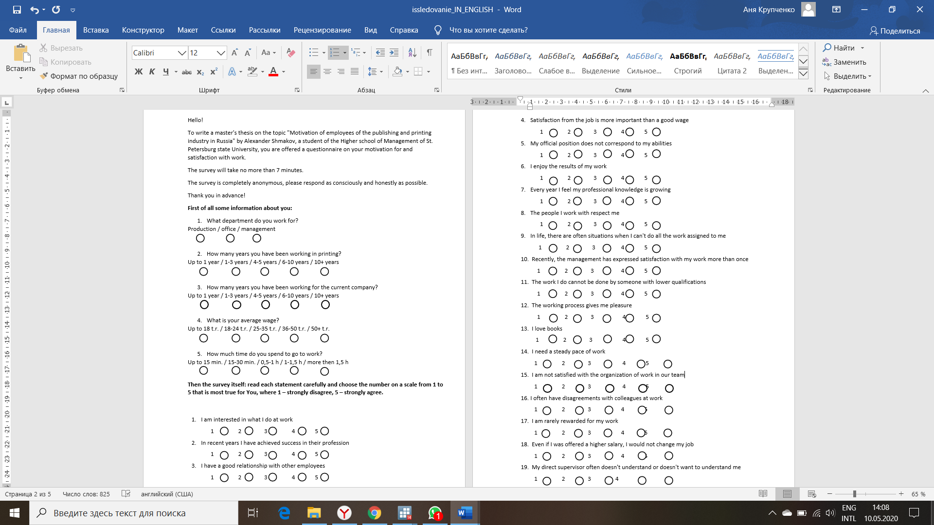

1. *Questionnaire*



1. *Questionnaire, pt.2*

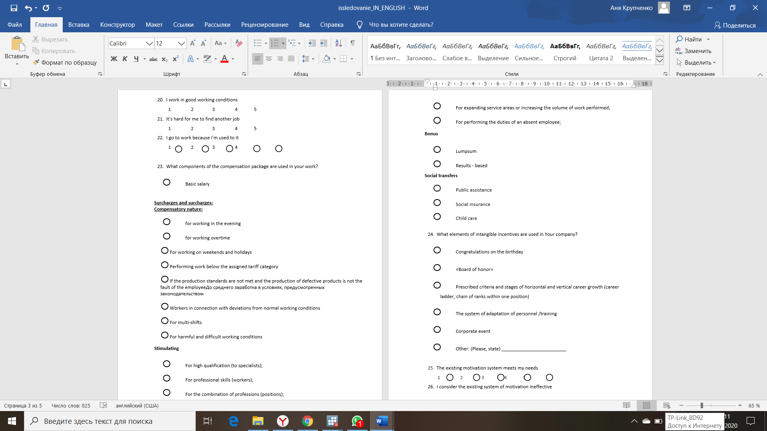

1. *Questionnaire, pt.3*



1. *Questionnaire, pt.4*

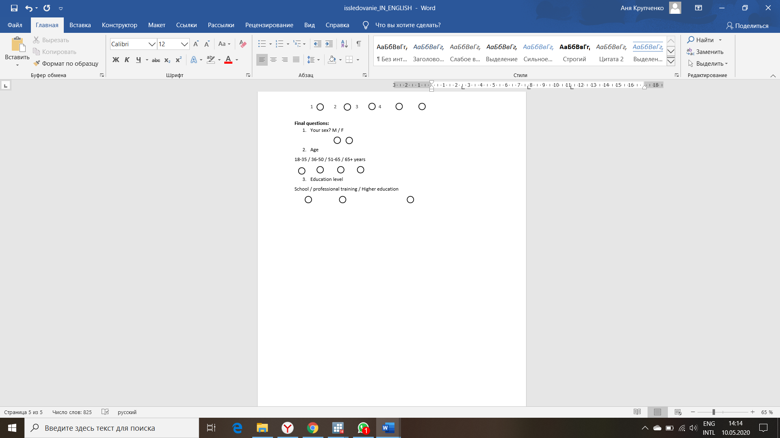

1. *Questionnaire, pt.5*

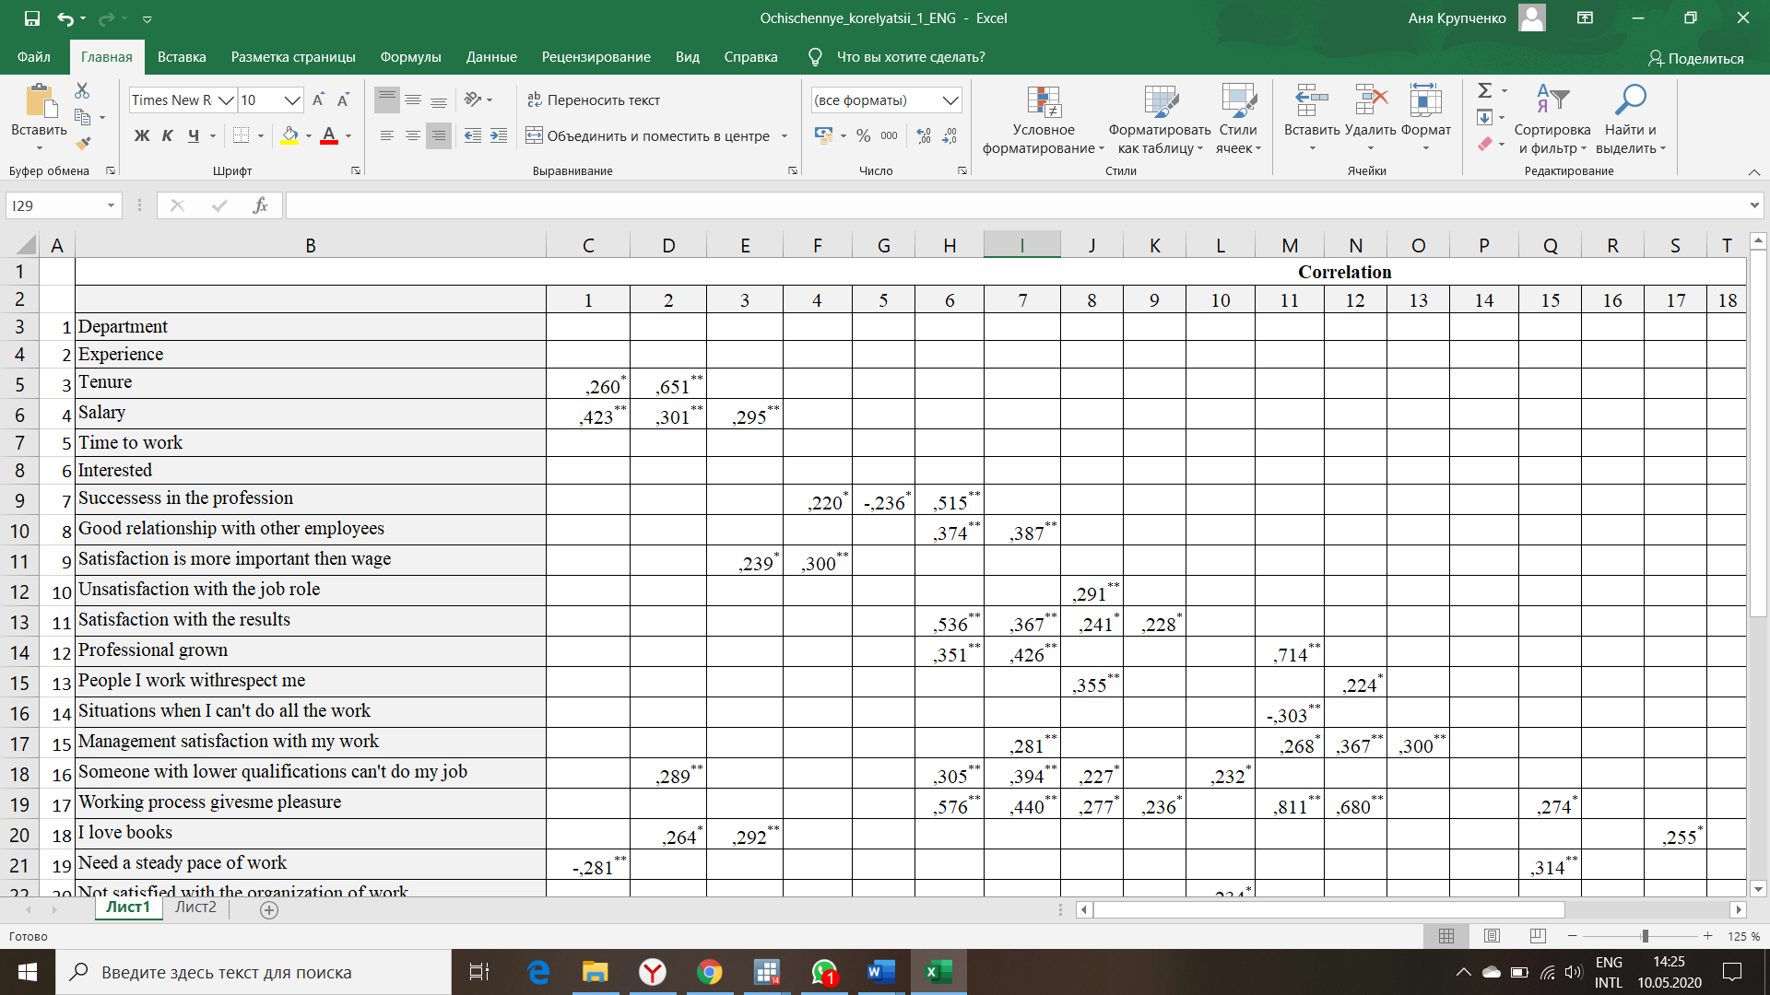

1. *Correlation 1*

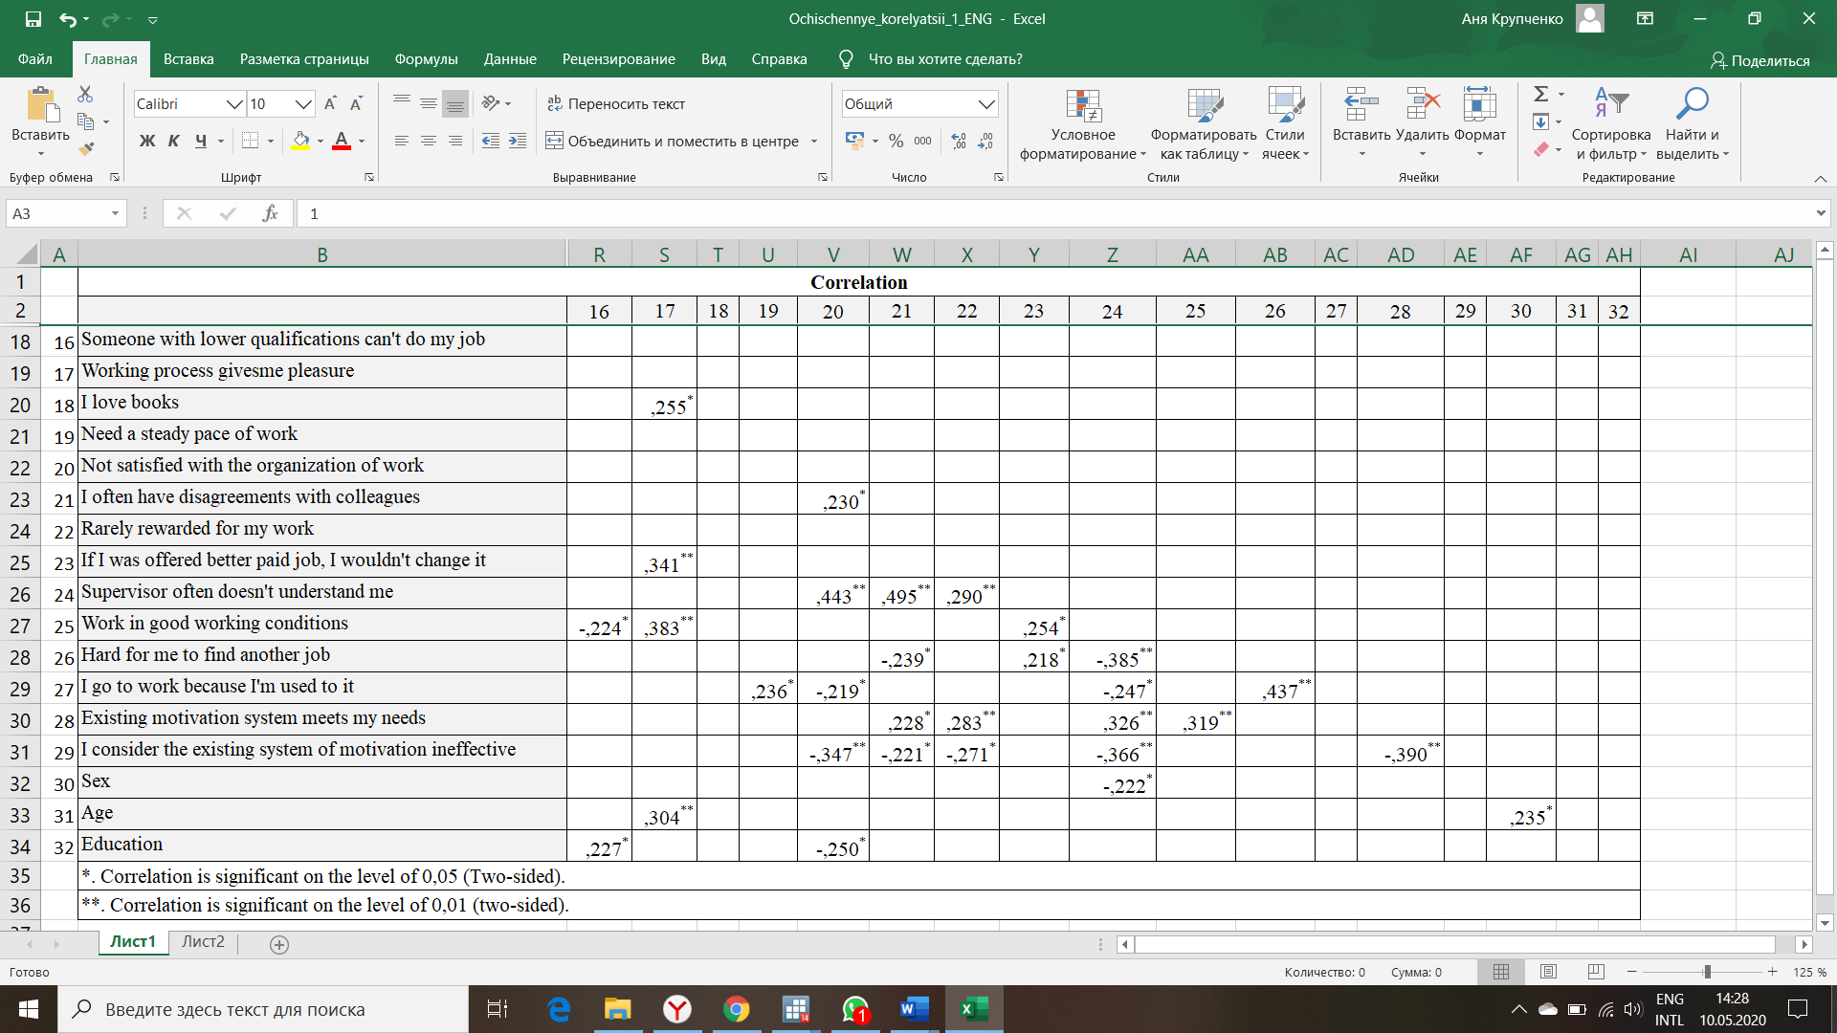

1. *Correlation 2*

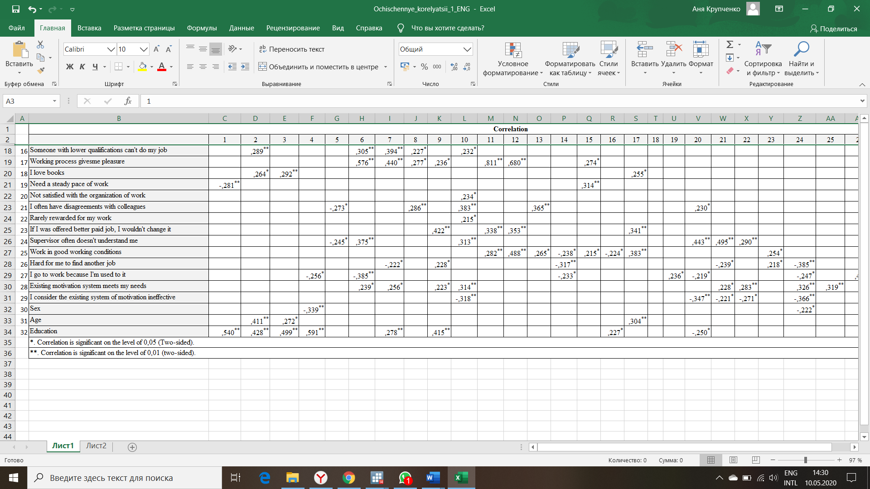

1. *Correlation 3*