Federal State Institution of Higher Professional Education

Saint Petersburg State University

Graduate School of Management

**Integration of UN Sustainable Development Goals into value chain of Uniqlo**

Final qualification paper

of 4th year bachelor student,

international management program

Anna Spiridonova

____________________________

Scientific advisor:

Associate Professor,

Strategic and International Management Department

Tatiana N. Klemina

____________________________

Saint-Petersburg

2020

**Statement of the substantial character of the work**

I, Anna Spiridonova, the fourth-year student of the Graduate School of Management SPbU, studying bachelor program International Management (38.03.02), confirm that there are no elements of plagiarism in the individual final qualification paper on the topic “Integration of UN Sustainable Development Goals into value chain of Uniqlo”, which is presented to the bachelor office to be submitted to the official defense committee for the public defense. All direct borrowings from printed and electronic sources, as well as presented earlier course projects and graduate works, candidate and doctoral dissertations have appropriate references.

I am aware that according to paragraph 9.7.1 of Guidelines for instruction in major curriculum programs of higher and secondary professional education at Graduate School of Management SPbU, according to which plagiarism detection (direct borrowing from other sources without the corresponding references) and the provision of work completed by other parties are the basis for assessing the individual qualification paper with the grade “unsatisfactory” and expelling of a student correspondingly.

**Table of contents**

Introduction 4

Chapter 1. General characteristics of Uniqlo 6

1.1. Company overview 6

1.2. Value chain analysis 9

1.3. Resource and competence analysis 14

Conclusion to Chapter 1 18

Chapter 2. Analysis of the industry environment of the company 19

2.1 Industry overview 19

2.2. Porter’s Five Forces Analysis 21

2.3. SWOT Analysis of Uniqlo 26

Conclusion to Chapter 2 33

Chapter 3. Recommendations for integrating the UN Sustainable Development Goals into key processes of Uniqlo 34

3.1. Role of SDGs in fashion industry 34

3.2. Implementation of SDGs into value chain 44

3.3. Identification of problems 46

3.4. Practical recommendations 48

Findings 56

Conclusion 57

Reference list 59

Appendix 66

# **Introduction**

In this work, the **object** of the study is the company “Uniqlo ”- a subsidiary of the Japanese holding Fast Retailing Co., Ltd. Uniqlo positioned themselves as a social responsible brand and implemented sustainable mission statement “Unlocking the Power of Clothing” meaning that the clothes can change the world for the better aiming for harmony, the sustainable stewardship of natural resources and responsible development of human potential, focus on planet, people and community.

The **subject** of this paper refers to integration of UN Sustainable Development Goals into company’s value chain. These goals were made to guide governments as well as companies for better understanding of global problems and improving well-being of economic, social, and environmental problems. Especially important is the introduction of sustainable development in the international companies as today there has been increased attention of the nations to social economical, and environmental issues and companies are starting to compete on sustainability to gain leadership positions on the market.

The **goal** of the work is to develop recommendations for the successful implementation of the "UN Sustainable Development Goals" in Uniqlo on the Russian market. Uniqlo has already begun to work on sustainable development world widely, but in Russia minimum sustainable practices are introduced. To achieve this goal, it is necessary to accomplish the following **objectives**:

1. To analyze company “Uniqlo”, its business strategy, value chain, resources and competencies, and its current market position to understand internal practices and how they can be developed;
2. To access current competition in the Russian fashion retail market in mass market segment;
3. To analyze “UN SDGs”, its definition, basic principles, content, relevance and examples to understand how they can be implemented in practice;
4. To identify main problems and gaps in sustainable development of Uniqlo in Russia;
5. To develop practical recommendations to the identified problems with the help of UN SDGs on the selected market;
6. To analyze the effectiveness of the recommended measures.

The **form** of the bachelor diploma thesis is a consulting project.

As for research methodology, the following tools were used to collect information: among a primary source of data were 2 semi-structured interviews with Romantsova Ksenia Igorevna - manager of Uniqlo shop in Rostov-on-Don, mainly to reveal the problems in Uniqlo Russia and to understand business processes better. The interviews were made in online form via video conference on 25 December 2019 and on 20 May 2020. Also, the survey was conducted with the potential customer to understand their needs. It was done on 20 March 2020. The survey consists of 9 multiple choice and 2 open-ended questions, overall, 200 respondents participated in it. The questions and sample characteristics can be seen in Appendix 1. The survey was made to understand the awareness of people of Uniqlo, identify purchasing behavior, reveal the readiness of customers to changes in sustainable development. Moreover, open sources of data were used as a secondary data: company documentation, official website, databases such as MarketLine, Statista, expert opinions in the field of sustainable development, and theoretical articles of the specialist in the sphere of sustainable development and fashion industry.

The paper is divided into 3 chapters. The first chapter includes an overview of the company, its business strategy, its value chain, and what resources and competencies does the company have for implementing SDGs. The second chapter dedicated to the Russian apparel industry overview, as well as the main aspects of SDGs, and its practical implementation using benchmarking with other companies. Based on data from the first and second chapters, SWOT analysis was compiled to identify strategies. In the third chapter the problems in sustainability in Uniqlo Russia will be identified and recommendation will be given to decrease the harm of the Uniqlo of social, economic, and environmental issues.

### **Chapter 1. General characteristics of Uniqlo**

### **Company overview**

Uniqlo was found in 1949 in Yamaguchi, Japan. It is an apparel company working in fashion retail industry and originally was operating as textile manufacturer. It is a subsidiary of Fast Retailing Co., Ltd. which owns other apparel companies including J Brand, GU, Theory, Comptoir des Cotonniers, Princesse, and Tam-Tam. Uniqlo headquarters is located in Tokyo, Japan. Now, company is working in 20 countries and has 2260 stores around the world( Australia, China, France, Germany, Hong Kong, Macau, Indonesia, Japan, Korea, Malaysia, Philippines, Russia, Singapore, Spain, Taiwan, Thailand, Canada, India, USA, and the UK.[1] In all stated countries Uniqlo has online and offline presence.

Uniqlo focuses on mass production of the clothing basics but making them bright and colorful. Brand concept is to make good quality everyday wear for different weather conditions with the unique technology which helped them to make several iconic product lines. For example, HEATTEACH solution was created to make clothes thin while having a feature to hold heat. Another iconic product line gives an opportunity of compact storing and contributes to the lightness and warmth of Ultra Light Down allowing to fold the jacket up, pack it into its pouch and carry it with you wherever you go. And another iconic line called “Airism” that makes clothes strechability, quick dying, smooth texture, and absorption. So, as we can see Uniqlo making their best to make their clothes comfortable to wear for any weather conditions and life situations.

The company’s mission is "Unlocking the Power of Clothing". It is directed to the sustainability and aiming that the clothing has the power to change the world for the better with the help of harmony in the corporate environment, conscious use of natural resources and responsible development of human potential.[2] The brand positioning itself as a mass market brand with progressive sustainable development and good quality of clothes.

The company’s logo is executed in red and white colors to show attachment to Japan, as Japanese flag consists of the same colors. Moreover, red colors represent power and eye catching. So, designers of the Uniqlo logo wanted to show that the brand is strong and use the logo as a unique distinctive feature.[3]

*Pic.1 “Logo of Uniqlo”*

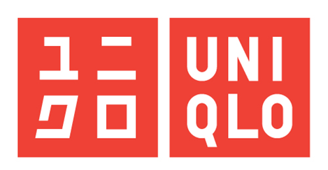

*Source:* [*https://www.uniqlo.com/*](https://www.uniqlo.com/)

*Pic.2 “Map of presence of Uniqlo”*

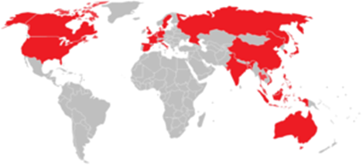

*Source:* [*https://www.uniqlo.com/*](https://www.uniqlo.com/)

One of the forms of Uniqlo differentiation among other apparel brands that it makes emphasis on basic clothes that is not relying on recent trends in fashion and with wide size range and different color palette for one item. That makes Uniqlo production be easily sold worldwide without special adaptation for foreign markets as the basic clothes can be wearable for everyone. Uniqlo began international expansion in 2005 with the opening of the two first stores in USA: on the East Coast in New Jersey and New York. The ease of entry in new markets was provided by the well-known brand name that helps large mass of people to be aware of the store opening in their cities and to new attract customers fast. Also, Uniqlo usually opens stores in urban areas especially in shopping malls where they gain a stable flow of customers.

Uniqlo entered Russian market in 2010.Now, there are 41 stores in Russia. The majority of shops are located in Moscow and its surroundings (24). All stores are located at the western part of Russia in such cities: Moscow, Saint-Petersburg, Kazan, Ekaterinburg, Rostov-on-Don, Nizhny Novgorod. Legal entity name is limited liability company “Юникло Рус”. Officially, it has 2060 employees.[4] Since 2010, revenue is constantly growing and at the end of 2018 it counted for 12 billion rubles.

So, Uniqlo decided to target audience according behavioral and geographical bases. Uniqlo is focused on everyday clothes, which is comfortable to wear to various daily activities such as walking, sporting, and travelling that implies different warmth of clothes. That is why high variety of Uniqlo products are made for different weather conditions. For example, HEATTECH, cashmere and fleece items are suitable for cold weather, while collection AIRism is a “breathable clothes” and has good air permeability, so it is suitable for warmer climate. According to these bases, it turns out that Uniqlo target wide range of people, as it sells clothing for women, men, and children, it targets wide range of people not depending on gender. According to behavioral basis, I assume that Uniqlo’s customer portrait are people, who leads active lifestyle, enjoys various sport activities and cares about quality and comfortability of the clothes and also as almost all Uniqlo shops are located in shopping malls, the target audience are people from age from 15 to 60 years old because children usually do not buy clothes by themselves and generally this age group visit big shopping malls.

Uniqlo business strategy is based on SPA (Specialty store retailer of Private label Apparel) model meaning that the whole product-making from design and production to distribution and selling is controlled by Uniqlo[5]

It starts with the *design* including the stages of development and procurement of materials, materials manufacturers, R&D, and merchandising. This model is starting with the design and pattern making of the fabrics at the R&D stage. As Uniqlo is global brand, they are trying to globalize product development. New products are being developed through the global R&D system, which connects Tokyo and New York. This includes exploring and analyzing the latest trends of fashion and lifestyle worldwide and search for new materials and patterns, developing functionality, silhouette, feel, and texture of materials. After the research company representatives select samples, create concepts, design and adjust products until they are done.

At the stage of *development and procurement of materials* Uniqlo provides a stable supply of high-quality materials at a low price which is possible by direct negotiations with manufacturers of materials and by placing large orders. Materials for our core subjects are especially important. In order to create consistent supply of products the company works in collaboration with materials development teams and Chinese manufacturing enterprises to create supply of materials. In addition, strategic cooperation with textile manufacturers, allows develop new materials. One such example is a strategic partnership with Torey Industries, where Heattech material with outstanding functions was created. Clothes made with Heattech technology are very popular among buyers because it is a unique technology that is not present among other brands.

At the *merchandise* stage there is a monitoring the level of sales, determination of the range of products and quantity of them, thus solving a problem of the seasonal volatile production.

During the *production,* raw materials transforms to the fabrics. It consists of spinning, dyeing, knitting, sewing, and processing. Uniqlo doesn’t have its own factories, but they outsource all the production to the partner factories, which are closely managed and monitored by production department team. Last year Uniqlo cooperates with 49 core fabric mills located in China (58%), Japan (12%), Vietnam (12%), and the remaining in Thailand (8%), Indonesia

(4%), Turkey (2%), Malaysia (2%),

Bangladesh(2%).[6]

The production department entails production teams and textile takumi. Production teams control partner production factories on the weekly basis and solve quality issues, delivery schedule, managerial problems during the production. TAKUMI are engineers with a rich experience in the Japanese textile industry who are working on the factories and providing instructions about production technology, technical support and philosophy of the Uniqlo during all stages of production of materials.

*Sales* stage starts with production planning when merchandisers and the marketing department work together and monitor sales and stock weekly to ensure the right amount of store inventory. Marketing is crucial stage of successful sales. With the regard of the season Uniqlo makes promotional campaigns and highlights the benefits for core product lines such as Heattech, Ultra Light Down jackets, Airism with the help of outbound and inbound marketing. In Japan, Uniqlo uses promotion flyers in the newspapers and social media to attract customers with limited-period discounts. Completing previous steps in sales in offline selling points- flagship stores in major cities around the world or online stores with a delivery or an opportunity to collect purchases in nearby Uniqlo stores helps Uniqlo strategy to build international network of stores.[7]

### **1.2. Value chain analysis**

As written before, Uniqlo controls entire value chain, so they are responsible for all actions in the product development. That’s why Porter’s value chain analysis will be used to understand internal activities of the company, reveal the gaps and challenges, and identify steps of creating competitive advantage, in our case related to sustainability. A firm can gain competitive advantage when it provides the demand which links to the customers’ needs and has capabilities not only to meet these needs, but to meet them more efficiently and effectively than its competitors[8]. According to Porter, competitive advantage can be gained through implementation of cost leadership and differentiation strategies. So, the sustainability issue is referred to differentiation strategy as it suits to social, ecological considerations and has observable characteristics that are the dimensions of differentiation and that are highly valued by buyers.[9]

The value chain is divided into two categories: primary and secondary (or support) activities, which are interconnected and can affect each other. Together, these activities are formed in a value chain which includes actions in the development of product, from the raw materials stage to the final product. The main activities from the raw materials to the final stage can be divided into five categories: inbound logistics, operations, outbound logistics, marketing and sales, and service. Secondary activities are developed to support primary in efficient and effective manner through the firm’s infrastructure, human resource management, technology development, and procurement.[10] Figure 1 illustrates main primary and secondary activities and the linkages between them in Uniqlo company.

*Figure 1* *— Value chain of Uniqlo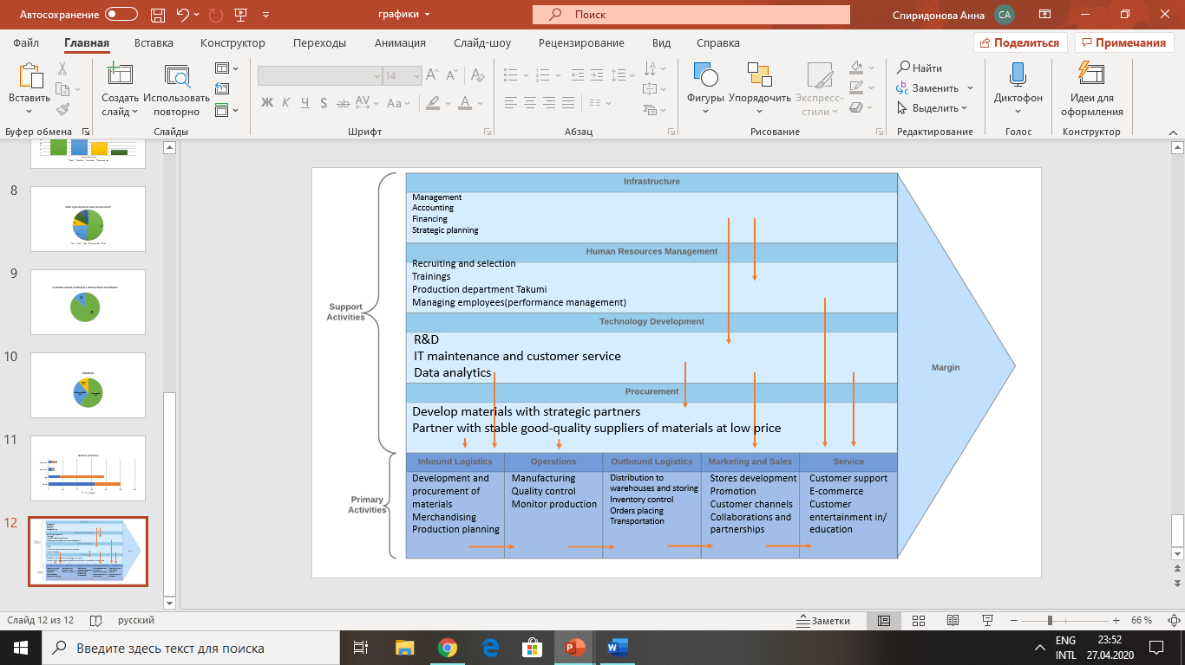Source: Created by author*

*Inbound logistics*

Uniqlo inbound logistics comprises development and procurement of materials. As Uniqlo periodically add new product lines such as HEATTECH and others, where the clothes is made from innovative materials that can adapt to the weather conditions, they need to establish strong relationships with strategic partners who produces fabrics and have high R&D in design and in patterns making to analyze the latest trends, use innovative materials. At merchandising and production planning stages Uniqlo decides about the volumes of manufactured clothes, product range, and when to increase or decrease the production during the season to avoid shortages and bottlenecks. When the production planning is done, materials are directed to the manufacturing factories.

*Operations*

Uniqlo doesn’t own its own factories, but they partner with them, that’s why it is needed to control carefully the production process. This includes spinning and dyeing, knitting and sewing, processing and finishing goods. To sustain the quality of clothes Uniqlo has strict requirements which is controlled by special department. This department is located in Shanghai Ho Chi Minh City, Dhaka, Jakarta, Istanbul, and Bengaluru and monitors the whole production process.[11]

*Outbound logistics*

Uniqlo partner factories are mainly located in China.[12] So, it is needed to find the best transportation option to separate and spread the manufactured goods to the warehouses located all over the world, where the items will be stored for further sales. Uniqlo has strong relationships with transportation companies that allowed them to establish global supply chain. On this stage, it is important to have accurate inventory control to provide constant supply to meet the market demand in particular item. The managers of the stores are responsible for inventory control and order placing. They manage optimum level of instore inventory by monitoring it on the weekly basis with the use of Jit system.

*Marketing and sales*

The crucial part of sales of international company such as Uniqlo is the store development. The right store location can attract maximum number of potential customers and the attractive design and layout in the stores also accelerate sales. Uniqlo usually uses grid store layout which is divided on zones: women’s, men’s, children’s wear and on product lines such as sportswear, UT, different collaborations, etc. This helps Uniqlo to use maximum amount of space at lower costs, easier merchandise exposure and customer familiarity. Besides the physical presence Uniqlo has online store in their official website with the delivery among all the country where the website is operating, this helps them to attract more customers. Furthermore, Uniqlo promotes itself by releasing promo-clips in the internet, high use of endorsement usually partnering with athletes, and through clothes collaborations with famous designers and artists, which helps the company to develop unique brand equity to stand out from the competitors. The sales stage should be supported by close customer relations and after-sales service.

*Services*

To maintain customers loyalty and meet or exceed their expectations Uniqlo has customer service. At the stores and during the e-commerce interactions, Uniqlo collects opinions of clients about overall impression of Uniqlo and this data is send to the head office departments, where it is analyzed for latest trends in purchasing behavior, Also, on the stores level Uniqlo deals with customer queries via phone, email, website, and social networks. Moreover, to stimulate pre-purchase behavior, Uniqlo actively leads social networks and website, where there they have blogs with entertaining and educating information about new products and trends in fashion.

*Firm infrastructure*

Firm infrastructure links to all primary activities and it helps to optimize all value chain. It includes various types of management: separation and creation of new departments, quality control over all functions, and allocation of resources and firm’s management is closely linked to the human resource management. Also accounting and financing is crucial for the company to effectively manage its resources and work within the low. Moreover, strategic planning is actively used in Uniqlo to follow its internationalization, digitalization, and overall strategies. Strategy depend on technology development and needs to include rapid advancement of technology in strategic planning.

*Human resource management*

Uniqlo very carefully select employees on the management positions. They have special program called Uniqlo Manager Candidate (UMC). To start the career with management position candidates should proceed through several stages; submit CV, interview with HR team, online test and case, then practical phase in the store, and final interview with the General Manager. If the applicant successfully goes through all these stages, he/she starts to follow Uniqlo educational and trainings program and after 12 months applicant can start the career with the position of manager of store. This program helps to choose Uniqlo only professionals who knows about Uniqlo every process in details. Also, HRM is closely tied to operations, Uniqlo’s production department with the special group of takumi team which is responsible for technical guidance on the partner factories, controlling the quality of manufactured goods and monitor production schedules. They maintain close contact between factories and Head Office to follow the progress and identifying and solving problems, which aims Uniqlo to make improvements on quality and production process yields. Furthermore, HRM supports service part of value chain through the performance management to maintain high level of service in stores, increase motivation of employees, follow performance plans and analyze customer feedback.

*Technology development*

Technology can be analyzed through different aspects in value chain. It tied with inbound logistics as Uniqlo has advanced R&D in the fabrics used and in design. R&D follows the cycle of research, concept creation, design, coordination, and sales, which helps the company to create innovative unique materials that don’t have competitors. Uniqlo uses e-commerce to analyze data of purchasing behavior to search for latest trends and provide actual promotion campaigns, and as online sales of Uniqlo counts for 11% of total sales worldwide and planning to increase with numbers,[13] they need to deal with customer service during online shopping. Recently, as a part of digital transformation Uniqlo introduced Ariake project. It is working in different parts of value chain. At the stage of product planning and design Uniqlo cooperates with Japanese companies Shima Seiki and Toray to develop unique products such as Heattech, Ultra Light Down, and others. Logistics transformation happened due to the successful partnership with leading Japanese logistics firm Daifuku Co., Ltd, which provides equipment at Ariake warehouse with the latest automated equipment and systems, helps Uniqlo to open fully operational automated warehouse. Thanks to the introduction of radioidentification frequency (RFID) tags on all products, Uniqlo can automatically complete warehouse processes such as stock receipt, sorting, picking, and inspection. Around the clock operation eliminates delivery delays caused by labor shortages during busy periods. Plans are now underway to use automated warehouses to make product delivery Uniqlo stores more efficient as well. And to provide rapid connections with clients and to exclude failures in all digital processes, Uniqlo have special department of IT support.[14]

*Procurement*

To deal with inbound logistics and manufacturing Uniqlo established trustful relationships with its strategic partners to create new materials and constantly develop them. And to provide stable flow of materials of good quality, Uniqlo partner with 70 factories[15] located in Asia, mostly in China. The distances from production facilities should be provided by effective distribution and inventory management to exclude additional costs and keep customers satisfaction.

To sum up, from the value chain analysis it is clearly seen the connections between activities in Uniqlo, what support actions should be implemented and what can be improved to increase efficiency in the company. The analysis of the chain allows you to identify the strengths and weaknesses of the company, its real and potential competitive advantages, to identify the reserves that are most available at the points of interaction of individual links. In order to maximize value through all participants of value chain, it is needed to carefully adjust and coordinate it, organize interaction of chain participants and optimize links between them, and provide use of all reserves and opportunities. It leads to the formation of sources of competitive advantages of the organization based on the use of the interaction capabilities of all participants in the chain.

### **1.3. Resource and competence analysis**

After identification of main activities in the value chain, resource and competence analyses is made in this section to understand what resources Uniqlo management is able to use and integrate for the development of the company and gaining more sustained competitive advantage among competitors. In the this paragraph are listed core competencies that allows Uniqlo to add value to its products and services and to achieve strategic goal. From the value chain analysis, it is possible to identify the most valuable internal resources and capabilities that helps Uniqlo to maintain sustainable development and succeed on the market.

Intangible resources:

* Website. Uniqlo has its own website in different languages that serves for awareness and educational information for their stakeholders. Moreover, there is an online catalogue of items that can be purchased via website.
* Brand name. Uniqlo operating in 20 countries all over the world, has strong marketing promotion and social media presence with millions of followers, that is why the brand name is widely known. This helps Uniqlo in internationalization strategy, the ease of entry in new markets is provided by the well-known brand name that helps them notify large mass of people about the store opening in their cities and to new attract customers fast. Uniqlo is on 9th place of the most valuable brands in the world. Uniqlo’s value is $12,878 for 2020.[16]

Human resources:

* Skilled employees. As Uniqlo has strict requirements for applicants, rather long recruiting process for managing roles and constant trainings, employees in the company are highly educated professionals in their profile. And as organization is separated into departments, employees are working in narrow specialization and exactly know the pitfalls in the area of their duties. In addition, special group of workers “takumi team” who controls the quality and production process provides superiority in the quality of materials and sewing of clothes.
* High R&D. Uniqlo has its own R&D team to create new designs of clothes and it cooperates with Japanese technological companies to find and develop unique fabrics which are highly valued by customers.

Competences:

* Ability to provide effective control over production. Uniqlo uses the combination of both backward and forward integration that helps to control over entire supply chain, starting from R&D of materials, manufacturing to the selling its production in the stores and online. (see section 1.2) Uniqlo does not own production factories, however it controls the whole process of manufacturing with the help of special departments, it leads Uniqlo to backward integration. Forward integration of Uniqlo mean that they control post-production process by selling its production in retail stores and on the official website. It helps Uniqlo to maintain closer contact with customers.
* Ability to position brand as sustainable one. Uniqlo differentiates itself as a company with sustainable development and constantly publicize the news about importance of sustainability.[17] Moreover, brand’s rather low product range of designs and independence of fashion trends aiming on basic clothes with good quality of materials used, innovation fabrics also refer to differentiation strategy. It helps products to be more durable and therefore leading less environmental harm because people can wear them longer without overconsuming.
* Sustainable development. Uniqlo cares about people, planet, and community. As for now, sustainable development of the brand has 6 areas of focus: value creation through products and services, respecting Human Rights in supply chain, supporting employees’ contentment, caring about transparent governance, respecting environment, and supporting communities. Employees are recruited on the equal basis regardless of the gender, race, religion, etc. Uniqlo cares about employees on factories, however there are cases of minor and significant human rights violations in it in 2019. The concept LifeWear provides affordable clothes for everyone with the environmental commitment of production process. Moreover, in Uniqlo Japan there is a foundation called "Setouchi Olive Fund" which fundraising money to save and restore the natural environment.[18] Also. Uniqlo has strong support of community by partnering with various organizations in order to help refugees, children and people who became victims of natural disasters. Nevertheless, Uniqlo already took a direction of sustainable development, but there are a lot of opportunities and gaps for further advancements of the company and its position among competitors.

The next step to analyze resources is VRIO analysis. It is made in order to understand what capabilities helps Uniqlo to perform better than its competitors and to reveal gaps which is needed to be solved to achieve long-term competitive advantage. The sustained competitive advantage can be achieved if a firm implement strategy that is rarely implemented by existing or potential competitors and when it is hard for competitors to duplicate the advantages of this strategy.[19] Figure 2 indicates the strategic importance of resources and capabilities for the company to potentially generate profit and maintaining competitive advantage.

*Figure 2 —VRIO analysis of Uniqlo*

|  |  |  |  |  |  |
| --- | --- | --- | --- | --- | --- |
| Resources and capabilities | Valuable | Rare | Inimitable | Organized to exploit | Performance implication |
| Website | Yes | No | No | Yes | Competitive parity |
| Skilled workers | Yes | No | Yes | Yes | Competitive parity |
| R&D | Yes | Yes | No | Yes | Temporary competitive advantage |
| Brand name | Yes | Yes | Yes | Yes | Sustained competitive advantage |
| Vertical integration | Yes | No | No | Yes | Competitive parity |
| Differentiation | Yes | Yes | Yes | Yes | Sustained competitive advantage |
| Sustainable development | Yes | Yes | Yes | Yes/Partly | Sustained competitive advantage/Unused competitive advantage |

*Source: Created by author*

Uniqlo official website with the online catalogue of clothes is valuable resource for the clients and give additional financial benefits to Uniqlo through the online purchase function, that is why is it valuable, however it is not rare and inimitable because all the competitors have official website with online catalogue. So, website gives Uniqlo only a competitive equality. Skilled labor force is not rare resource, but in terms of how the labor force is organized it is hard to imitate the whole process with nuances because Uniqlo has unique departments and highly skilled workers who proceed through constant trainings. This leads to competitive parity too. High R&D of Uniqlo in designing and creating innovative materials gives temporary competitive advantage because even though innovative materials are rarely used at competitors now, but in future these technologies can be introduced in other brands. Control over entire value chain gives Uniqlo competitive parity. It helps to improve efficiency, reduce costs and better manage over business process, but competitors of apparel industry also are likely to integrate vertically. The differentiation that Uniqlo uses in its products assortment satisfies all criteria to achieve sustained competitive advantage. The differentiation can be changed through the time depending on competitors’ action and improvements. Now in Uniqlo one of the differentiation sources is sustainable development. It is valuable for the company and clients, rare among competitors as it is timely and costly to imitate, it is used in the organization but there are more directions and opportunities to improve sustainability issue in the company. So, it is partly used in the organization and can lead to the competitive advantage that can be secured over time.

### **Conclusion to Chapter 1**

As a part of Fast Retail Group, Uniqlo is a successful international company operating in 20 countries and reaching annual revenue of ¥1.026 trillion globally.[20] Its value is to create sustainable society. It is vertically integrated company which has control over entire value chain. So, Porter’s value chain analysis was made in this chapter to analyze internal activities of the company, efficiently match primary and secondary activities, and reveal the gaps connected with the actions mapping. This was made for further analysis of resource and competencies that can be used for gaining competitive advantage. Brand name of the company and differentiation strategy gives Uniqlo sustained competitive advantage. Moreover, sustainable development can be a source of long-term competitive advantage too, but it is used party in Uniqlo. There are many areas and gaps that can be filled in sustainability to fully get this durable advantage as Uniqlo has access to many resources and capabilities that are needed to fulfill this goal. But the gain of new resources and constant investments in R&D help to create new solutions in company’s development.

In order to fully analyze the company, understand which SDGs can be applied in a particular market, it is not enough just to analyze the company internally. Therefore, the external analysis of the environment will be conducted in the next chapter.

**Chapter 2. Analysis of the industry environment of the company**

After the analysis of internal factors, external analysis should be implemented to identify possible future directions and risks within the industry, as any company operates in specific environment. From the external environment company can understand what factors are necessary for the formation and maintenance of its potential. And after identification of both internal and external factors, it is possible to define and choose a strategy for further development of the company.

### **2.1 Industry overview**

The Russian apparel retail industry had total revenues of $42.7bn in 2018 with a compound annual growth of 4.6% between 2014 and 2018 and according to experts forecasts this value will be increasing steadily from 2018 to 2023 with a compound growth rate of 3,6% annually. So, in 2023 Russian apparel industry is forecasted to have value of $50.9 billion.[21]

Fashion market can be divided into many segments, each of it is working independently and has its own specifics and peculiarities. There are several approaches to segmentation of the clothing market. For example, segmentation by based on such parameters as quality of products, pricing, and number of collections during the year. So, market can be split into 3 segments. Luxury segment, which is defined by high quality of products and service, design aesthetics, brand and designer name, and high price which reflects the increased expense of incorporating these elements into a luxury product. Secondly, mass market characterized as lower price segment, which is possible due to economies of scale, not such good quality of products, without targeting any specific group of customers, and usually redesigning items of luxury segment. Thirdly, premium segment which is defined as designer clothes of medium price range that are using both luxury and mass market specifics in its strategy.

According to TAXCOM statistics, market is divided into 3 segments depending on the price of goods sold. Russian fashion market in 2019 mainly consist of mass-market or lower segment, which counts 59% of total market share. Less popular segment is premium or middle-price segment which accounts 30%, and 11%comprises luxury market or upper segment.

*Figure* *3 — Structure of the Russian apparel market by price principle by the end of September 2019*

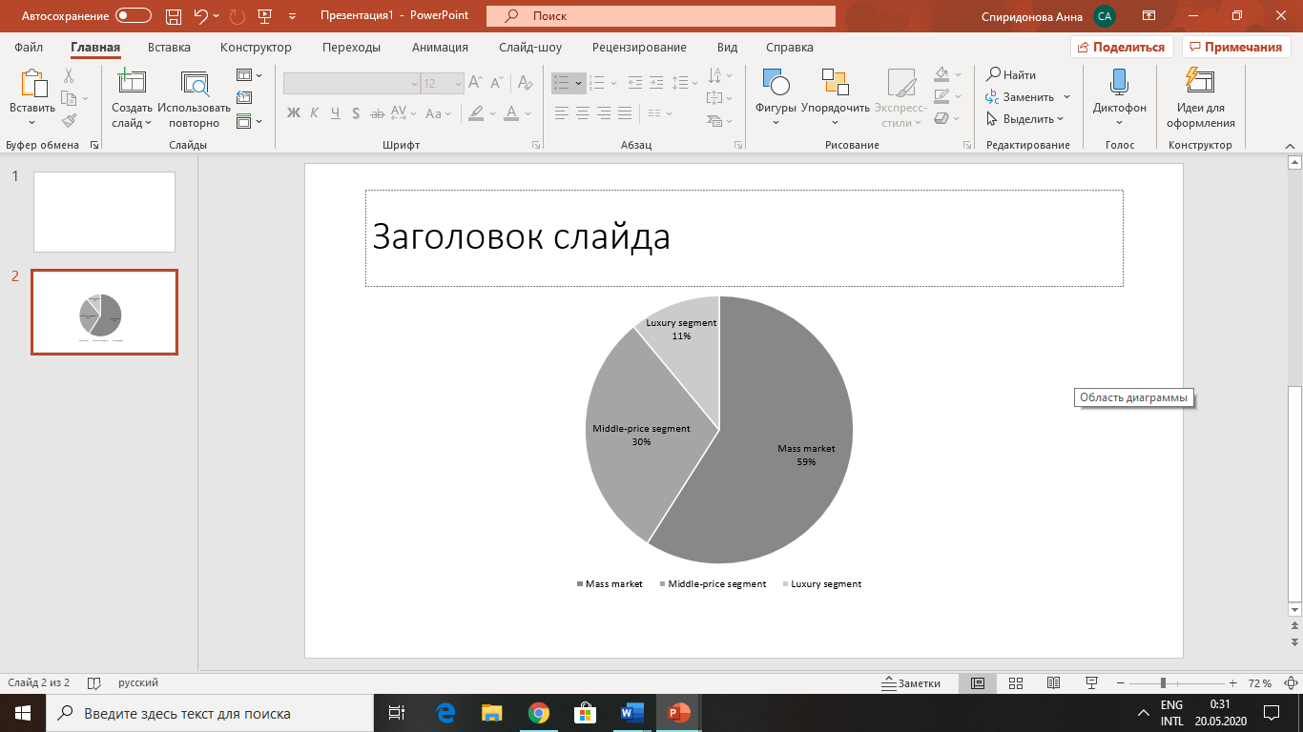

*Source: Taxcom statistics*

Moreover, speaking about category segmentation of the market, 60,1% of total consumption falls on women's clothing. The rest is distributed between menswear which accounts 27,8% and childrenswear has 12,1% of industry total value.

*Figure 4 — Russian apparel retail industry category segmentation: % share, by value, 2018*

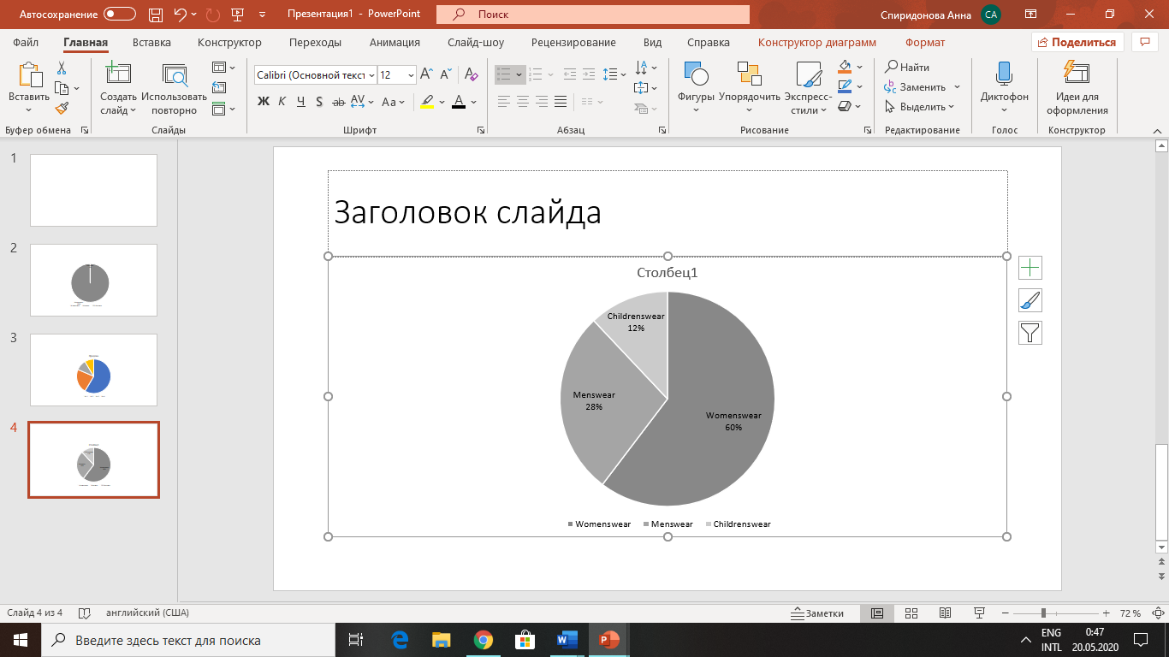

*Source: MarketLine*

Uniqlo has chosen the bestselling price segment on Russian market and has all possibilities to gain huge amount of purchases in its stores and compete successfully among its competitors.

Russian market of women's clothing retail accounts for 5% of global sales, what characterizes it as capacious and attractive.[22] Also, with the digitalization and high usage of social networks and websites, international companies can easily expand to Russian market via online shops. Thus, apparel market in Russia nowadays is characterized by the domination of international brands and 96% of Russian consumers prefer foreign clothing brands to the local ones.[23] The most popular place for purchasing apparel is shopping malls which accounts of 71% of respondents’ answers. Then 21% of Russian consumers prefer to buy clothes through online stores, but this number might be increased in the future due to rapidly dynamical market.[24] Nowadays, online apparel retail is the second largest segment after electronical and electronics retail in online sector.[25]

*Figure 5 —* *The most popular mass market brands in Russia*

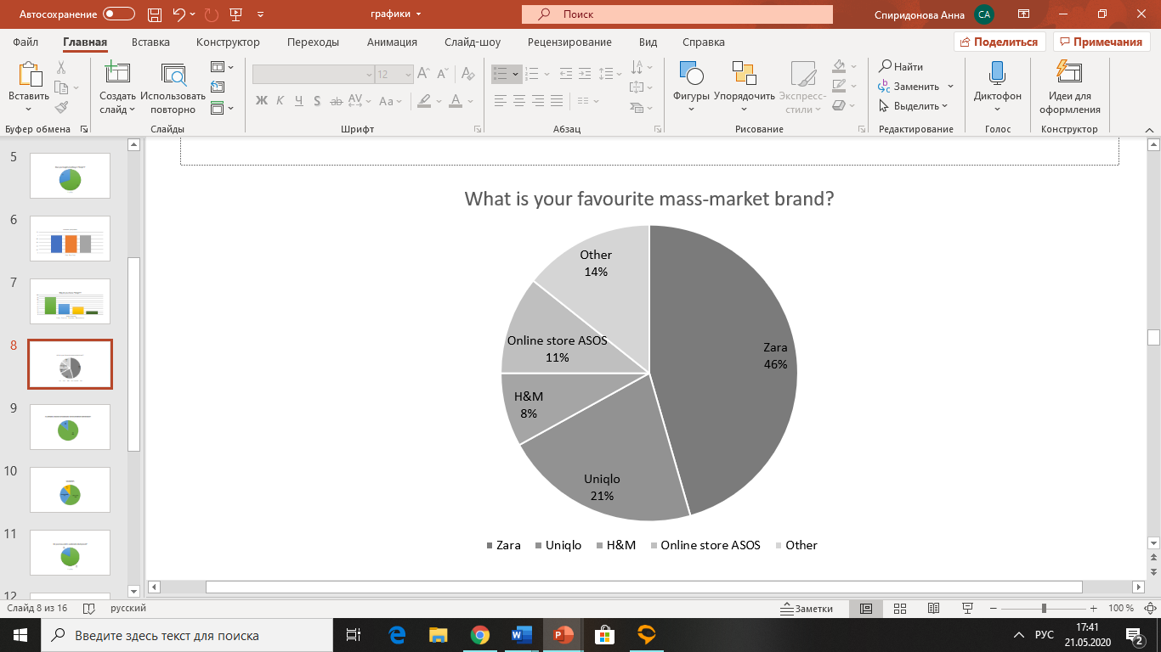

*Source: Created by author based on the survey*

Moreover, Figure 5 shows that the most popular brands are Zara with the 37% of votes, Uniqlo with 12%, H&M and online store ASOS with 9% and 6% of votes respectively.[26] Based on these results, I revealed that the main international players on Russian market are: Zara, H&M, Uniqlo, and online store ASOS. So, Zara, H&M and ASOS are the biggest competitors of Uniqlo Russia as Uniqlo is presented in online and offline segments.

### **2.2. Porter’s Five Forces Analysis**

Five forces analysis was used to understand competition of Russian apparel market and to evaluate actors who are involved in value chain - suppliers and buyers. Also, some practices will be presented in order to get along with suppliers and customers, change the level of competition and get ahead of competitors. An assessment of the force of each factor will be evaluated on a five-point scale: 1- low; 5-high. The main players are considered as retail apparel companies.

**Competitive rivalry**

Russian apparel industry in mass market segment consists of huge number of network retailers and increasing number of independent stores. Large players who have several shops under a single brand name are exploiting economies of scale and have opportunities to invest heavily in advertising and branding, thus increasing competitiveness. For instance, a leading player on Russian market Inditex promotes sales through multiple channels which increases the company’s direct-to-consumer business. Inditex trades its products through eight commercial formats each with a unique and separate personality, image and offering; these include Zara, Pull & Bear, Massimo Dutti, Bershka, Stradivarius, Oysho, Zara Home and Uterque. While for independent stores is may be costly to open additional selling points and highly advertise the brand. However, there is opportunity for independent stores to compete successfully through the changes in consumer shopping behavior.

Another issue that changes competition is product innovation. It expands the variety and quantity of target audience by providing new types of products suitable for more people, which lowers the intensity of rivalry Brands create new product lines and categories such as plus size and athleisure lines. The athleisure trend is very popular around the world mostly among millennials but also for all ages. This led apparel retails to create their own new ranges of product categories. For example, H&M created sportswear line to compete with specialized sportswear shops.

In-store experience is another crucial point to maintain competitive edge. Friendly and educated personnel who knows every item in the store and polite manners of communication could lead to better in-store experience. These contributes to better sales and increasing competitive edge.

The use of technology such as “smart dressing rooms” where customers can see the availability of sizes, colors presented into the store or to look how items suit to each other on the model, can possibly decrease waiting lines in dressing rooms and increase customer satisfaction during in-store stay.

Also, online direction opens a lot of new opportunities to the retail stores. Brands can go online partnering with multi-brand online stores or launching independent online catalogue. Creating online stores gives opportunities from one side to better understand the target audience and analyze purchasing behavior, from another side to decrease waiting lines on the cash desks and dressing rooms, reduce rental costs and expand geographical location with the delivery option to the cities and suburb areas where there are no stores of the brand. Companies can also increase its competitiveness and differentiate themselves from competitors by establishing presence in social medial networks. Brands started to be present in such highly used social networks in Russia as Vkontakte, Instagram, Facebook to advertise its products. Constant communication with people and dealing with customers queries in a personal way can improve brand-customer relationships. This factors can increase customers contact and theirs loyalty and increase the power of the brand. This is important as the customers switching costs are low and brand loyalty is rather low.

Overall, considering high similarity of players ease of exit, the competitive rivalry on Russian market is moderate and scaled for 3 points

**Threat of new entrants**

Entry to the Russian apparel market is hard for international players due to the large size of the country, different climate and different tastes that varies throughout the region. Therefore, it might be difficult to new entrants to establish target audience and to build a strong brand among all regions of Russia. Furthermore, latest governmental and economic regulations can complicate expansion to Russian market. Increased tariffs on imported goods and sanctions imposed by the international community in response to Russia's military action in Ukraine has increased inflation in the country. And floating exchange rates applies risks to international plyers who want to enter Russian mass market segment because any price increase in Russian currency can play a crucial role in purchasing power. Due to that fact a lot of international brands such as RiverIsland, New Look and others left Russian market recently. Despite of this, expansion of Uniqlo in Russia continues, it opened 7 new stores and closed only 1 store in Russia in 2019.[27] While, there is a growing trend for local brands to enter the market. Small online shops and show rooms, who concentrate on one type of clothes, for example, clothes for women are not direct competitors for international player, but they can gradually reduce the market share of large companies. The capital investments are rather high because of high R&D, unexpected demand for each clothing and need for maintaining inventories to satisfy demand constantly**.** Furthermore, new entrants can easily get access to distribution networks**,** which makes a threat of new entrants to increase. Considering all the factors, the threat of new entrants is medium and scaled for 3 points.

**Bargaining power of buyers**

Buyers power in mass market is enhanced by the high level of choice with a similar price range and product types, that’s why customer can switch easily among brands and the brand loyalty is low, which makes buyers power stronger. For this reason, some brands trying to differentiate clothes styles, create new product lines and offer additional discounts and promotional deals to attract more clients. And as a fashion is unpredictable and fast-changing even several times a year, brands need constantly renew the assortment to meet customers demand.

Moreover, as a consumer behavior is changing, brands are trying to satisfy it. One of the recent trends in fashion is sustainable development. The awareness of people to save nature and protect human rights is increasing and customers began to monitor this. According to the results of the survey it turned out that 86% of customers are thinking that sustainable development of apparel brand is important, and a lot of people think about sustainability of the company in a decision-making stage. And 65% of respondents answered that they will not be disconnected with 5% price increase for more sustainable brand.[28]

*Figure 6 — Does the sustainable development important for apparel brands?*

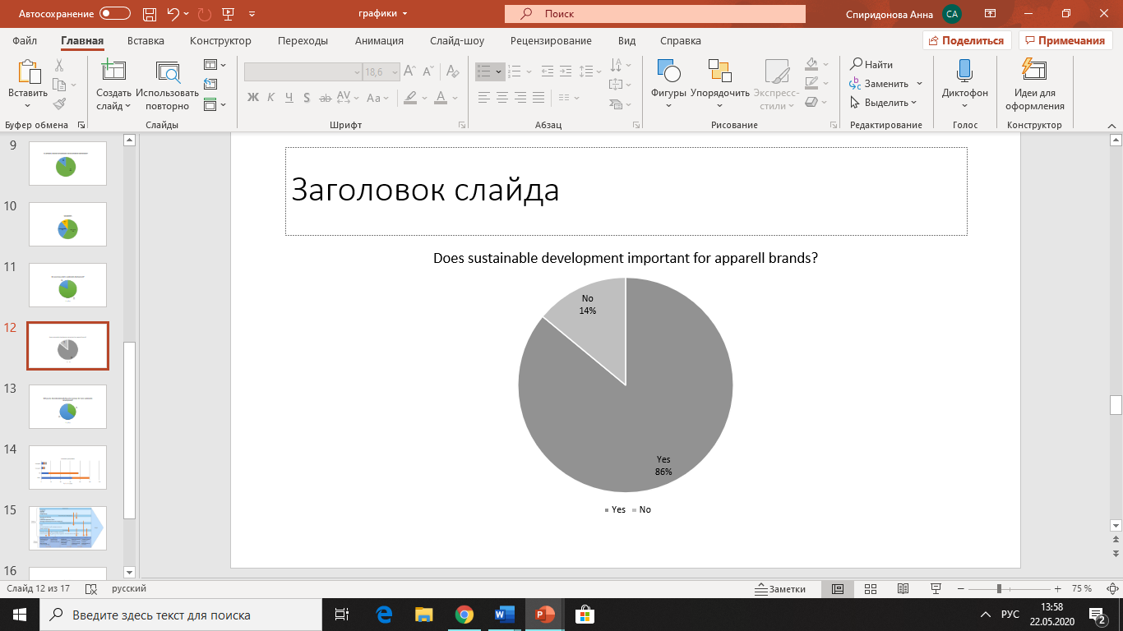

*Source: Created by author*

Moreover, in mass market segment customers are price sensitive meaning that the price is considered as one of the main factor in purchase decision-making and well-educated in the product, these factors increasing the buyer’s power. So, the buyers power is high (4) in mass market segment of the industry.

**Bargaining power of suppliers**

The suppliers of the industry are clothing manufacturers. Usually big companies who have capital chose a possibility of backwards integration, they manufacture and sell their products by their own because it helps to reduce costs and make control over value chain more efficient: lesser transportation costs, optimization of resource distribution and competencies. Unlike, small retailers who prefer not to backward integrate are dependent on suppliers who propose them with raw materials and manufacturing. World widely, oligopoly threat is low because of the abundance of suppliers around the world, which makes supplier’s power weaker However, the majority of manufacturers are located in Asia that can incur problems with logistics, delays, and quality issues. Moreover, the supplier’s power is low because of the fact that brands are only customers for that type of suppliers and the profits of the industry are tied with the suppliers, that is why suppliers tended to provide reasonable prices. These factors cause weak power of suppliers and scaled for 2 points.

**Threat of substitutes**

The threat of substitutes of apparel industry is low because clothes doesn’t have a direct substitute and all companies selling clothes with different pricing and quality are considered as a competition.

*Figure 7 — Five Forces Analysis*

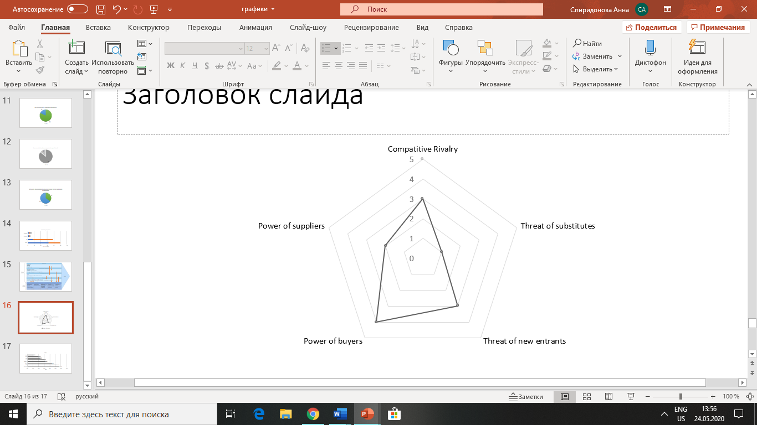

*Source: Created by author*

To sum up, Porter’s analysis of 5 Forces shows that the competition in Russian apparel industry is not intense. With the development of new technologies there is an opportunity to find strategic gaps and grow beyond the industry barriers that increases chances to success. Overall, as the rivalry level of retail stores of mass market segment in fashion industry is medium and industry is considered as a rather attractive one, there is a possibility of new players is low, existing companies will create new basis for competition. One of these factors is sustainability issue which is gaining popularity among clients and considering the factor that the development of technology and social media is increasing, people can demand the sustainable processes in both online and offline experiences.

### **2.3. SWOT Analysis of Uniqlo**

After the internal analyses of Uniqlo and analysis of industry are made and all the features are put together, it is possible to create SWOT analysis for the company. To identify strong and weak sides of the company, in is needed to understand what company’s features are mostly valued by the group of customers. So, critical success factors for the particular industry should be identified. A lot of CSFs are related to sustainability. For example, quality control is responsible not only for quality of clothes, but also for compliance with working standards, quality, and environmental friendliness of materials, etc. Company’s R&D also responsible for the quality of the materials, the durability of the clothes and their features, the raw materials from which clothes are made. R&D is mainly introduced due to the motivation for sustainable development. An efficient supply chain means not only a quick update of the assortment and low inventories, but also a reduction in transport impacts on the environment, protection of human rights, control over working conditions.

The Competitive Profile Matrix (CPM) is presented in the Figure 9. It shows the importance of each critical success factor for the industry and quantitative rating for the competitors’ companies.[29] The comparison is based on the companies of apparel industry located in Russia. The companies used in the table are leading international companies on Russian market and main competitors of Uniqlo.

*Figure 9 —The competitive profile matrix*

|  |  |  |  |  |  |  |  |
| --- | --- | --- | --- | --- | --- | --- | --- |
| **Critical Success Factor** | **Weight** | **Uniqlo** | | **Zara** | | **H&M** | |
| **Rating** | **Score** | **Rating** | **Score** | **Rating** | **Score** |
| Cheap materials suppliers | 0,19 | 2 | 0,38 | 3 | 0,57 | 4 | 0,76 |
| Efficient supply chain management | 0,15 | 2 | 0,3 | 4 | 0,6 | 2 | 0,3 |
| Promotion | 0,08 | 2 | 0,16 | 1 | 0,08 | 3 | 0,24 |
| E-commerce | 0,15 | 4 | 0,6 | 4 | 0,6 | 4 | 0,6 |
| Location of outlets with mass congestion of potential customers | 0,05 | 4 | 0,2 | 4 | 0,2 | 4 | 0,2 |
| Wide range of styles | 0,1 | 2 | 0,2 | 4 | 0,4 | 4 | 0,4 |
| Constant new collections releases | 0,05 | 1 | 0,05 | 4 | 0,2 | 3 | 0,15 |
| R&D | 0,1 | 4 | 0,4 | 2 | 0,2 | 3 | 0,3 |
| Quality control | 0,08 | 4 | 0,32 | 3 | 0,24 | 2 | 0,16 |
| Brand name | 0,05 | 4 | 0,2 | 4 | 0,2 | 4 | 0,2 |
| **Total** | **1** |  | **2,81** |  | **3,29** |  | **3,21** |

*Source: Created by author*

After the analyses of the CSFs and business environment, SWOT analyses is used to conclude how Uniqlo can develop in Russia. The goal of SWOT analysis is to determine the degree to which the current strengths and weaknesses are related to the business environment opportunities and how they can deal with external threats for further strategic development. Strengths and weaknesses make it clear what competitors do in terms of sustainability, that Uniqlo does not. A rating was assigned to each company depending on performance, starting with 1- major weakness to 4- major strength. Furthermore, the analysis of opportunities and threats helps to understand external factors that influence on the company and the direction of development of the industry Uniqlo operates. Opportunities and threats were identified from industry characteristics and recent trends of economic development over the world. World trends are considered as Uniqlo has global value chain, in which many countries are involved.

*Figure 10 —SWOT analysis of Uniqlo international*

|  |  |
| --- | --- |
| Strengths | Weaknesses |
| 1. Brand name 2. Value for quality 3. Innovations 4. Control over entire value chain 5. Online and offline presence 6. Size-inclusivity | 1. Limited products and styles in comparison to competitors |
| Opportunities | Threats |
| 1. Importance of sustainable development 2. High growth of social media and e-commerce 3. Increasing attention to partnerships | 1. Increasing competition 2. Exchange rate 3. Unstable situation in the world in 2020 |

*Source: Created by author*

Strengths

* Brand name. Uniqlo almost does not have advertising on TV and billboards, but highly invests in promoting its brand with the partnerships with stars, athletes, and collaborations with popular fashion designers. Thus, they attract attention of populations and attract clients. Despite not intensive advertising, the brand is known by a large number of people, namely potential customers, as the brand has many selling points around the world with bright illuminated logos on the showcases. According to my survey, 97% of respondents know the brand Uniqlo. This confirms the fact that Uniqlo has a strong brand name.[30]
* Value for quality. Almost all respondents highlighted quality as the main advantage of Uniqlo. And 44% think that quality of textile and sewing is one of the key success factors of the brand.

*Figure 11 — Why do you choose Uniqlo?*

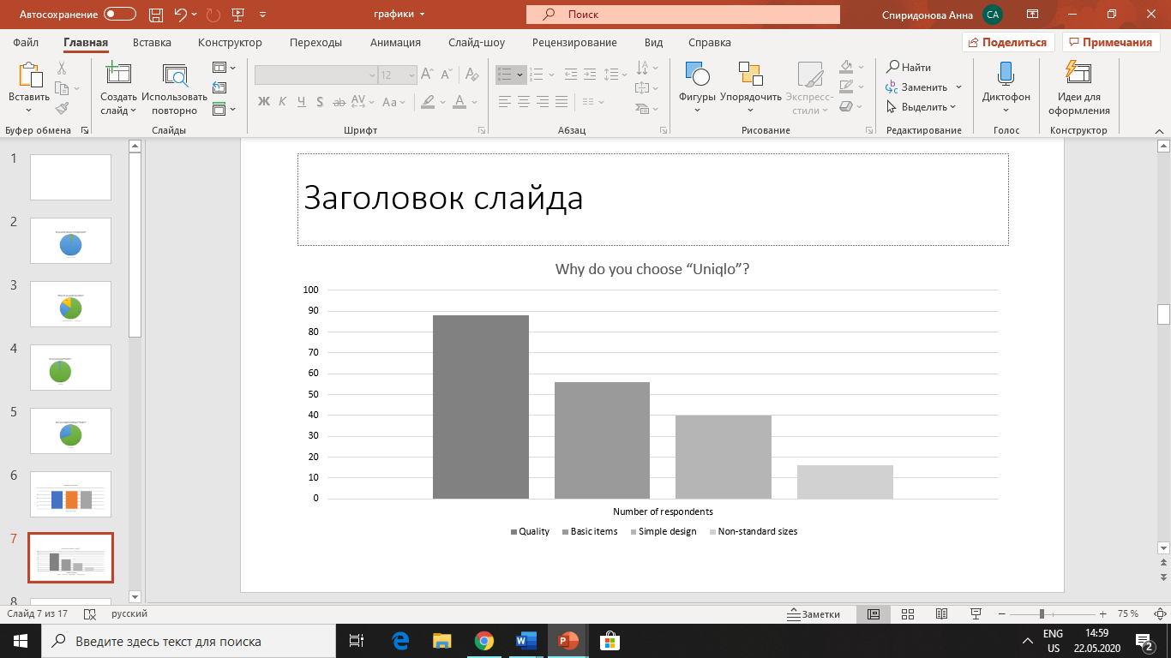

*Source: Created by author*

For or instance, knitwear of Uniqlo is made from high-quality materials, which accounts almost 70% of knitwear made of natural fabrics. In comparison, Zara uses only 20% of natural fabrics for its knitwear collection.[31] Overall, Uniqlo uses 30% of cotton in its collections and only 20% of polyester.[32] While for competitors, polyester is usually the preferred choice material. Despite a higher quality of materials, Uniqlo is able to keep products at an affordable price. The average price for knitwear is 37,47€ for Uniqlo and 33,16€ for Zara, which is a minimal difference when looking at their higher use of natural materials.[33] Thus, it is seen that Uniqlo has the best value for quality in compared segment. Moreover, there is a special department in Uniqlo for controlling not only quality of materials and sewing, but also the monitoring of work on compliance with all working standards.

* Innovations. Uniqlo is advanced in R&D in the development of new fabrics technologies. It has different product lines of clothes made from the advanced materials such as Heattech, Ultra Light Down jackets, Airism which can adapt to the different weather conditions. They help to save standard body temperature and prolong clothes term of use. These fabrics innovations helped Uniqlo to rise its popularity and attract new clients.
* Control over entire value chain. Uniqlo controls entire value chain and thus can maintain their costs as low as possible. Moreover, Uniqlo has stable relationships with their suppliers, which helps them to manage inventories level more efficiently, maintain needed level of quality of products by coaching and controlling the work of suppliers.
* Online and offline presence. Uniqlo is present in online and offline forms. The offline selling points are usually located in shopping malls. These are 2 forms of how customers prefer to buy clothes. The survey shows that 62% of people prefer to do shopping in shopping malls, which gives Uniqlo an opportunity to gain large customer base as the large number of stores are in shopping malls. Another 23 % of respondents tend to buy clothes online and Uniqlo also has its own online catalogue with a possibility to purchase online with the delivery to 20 countries.

*Figure 12 — Where do you usually buy clothes?*

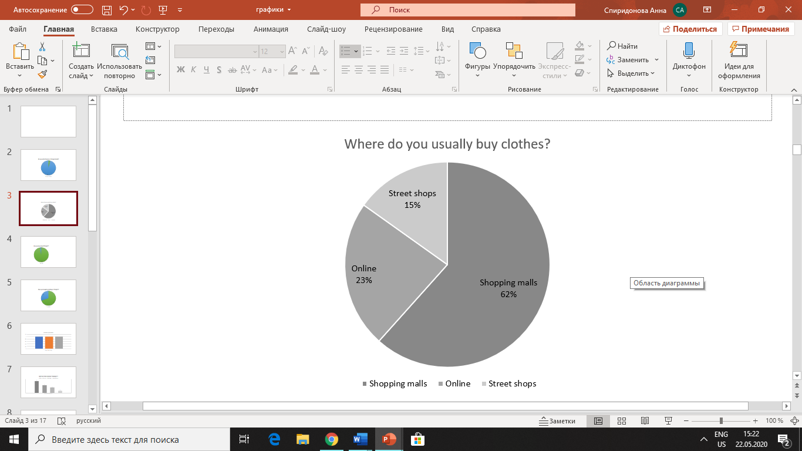

*Source: Created by author*

* Size inclusivity. Size inclusivity partly refers to the CSF wide range of styles. Uniqlo offers extended the number of sizes in its collections to increase the demand of more people. Now, Uniqlo has sizes from XXS to XXL for clothes and propose different length on trousers to meet the demand of people with non-standard body proportions. However, wide range of styles also includes differentiated designs and clothing styles. In Uniqlo has no aim to make more diverse clothes in styles because they concentrate on basic items. That is why size inclusivity as a part of the CSF can be attributed as a minor strength.

Weaknesses

* Limited products and styles in comparison to competitors. Uniqlo focus is not oriented on the quantity of styles produced and their relevance to fashion trends, but rather their quality. Uniqlo producing basic items of different colors for everyday life. The size of offering of Uniqlo is 1970 items, while Zara and H&M has 6313 and 17705 items correspondently.[34]

Opportunities

* Importance of sustainable development. As identified in the external business analysis, consumers within the industry are becoming more conscious about their health, climate changes, human rights and other issues related to sustainable development. So, Uniqlo can take advantage in the segment of mass market as they control entire value chain and they have possibilities to change operations and processes to be more sustainable organization. Uniqlo is already paying attention to the problems in sustainability, but sustainable development includes many areas in which improvements can be made.
* High growth of social media and e-commerce. With the technology development, there is a growing trend in online purchases. The Russian online retail sector generated total revenues of $15.0bn in 2018, representing a compound annual growth rate (CAGR) of 19.5% between 2014 and 2018.[35] Development of technological devices and a strong use of internet leads to the increasing demand in e-commerce. According to the World Bank, internet penetration 80.9% in 2018, an increase from 70.1% in 2015. As the internet penetration is increasing, more and more people constantly use social networks for leisure and business.[36] That’s why brands actively manage their pages in social networks to rise brand awareness, maintaining close relationships with the customers, promoting their products and earning money via digital channels. So, Uniqlo can earn revenue via online sales and relate to better customer contact.
* Increasing attention to partnerships. Nowadays, at the era of globalization, partnerships between companies, states, non-governmental organizations, and multi-stakeholder relationships are important for sustainable development. In all forms of business partnerships there is exchange of technology, knowledge, financial resources, and shared risk. It aims companies to get better resources and capabilities to solve environmental, economic, social, and community issues thus creating shared value.[37] Moreover, in many sectors industry boundaries are becoming blurred. Direct governmental role becomes not so significant, while governmental role for businesses and society becoming more extensive. That is why creation of shared value is important for in achieving SDGs.

Threats

* Increasing competition. Increasing competition within the industry putting pressure on prices. Low switching costs of consumers and wide range of brands make companies especially in the mass market segment to compete on prices. This could lead to reduced revenue for Uniqlo because its prices are higher than the main competitors prices comparing same products.[38] Moreover, the gaining popularity of small local shops can also affect the market share of Uniqlo.
* Exchange Rate. Unstable exchange rate of Russian currency to other worlds currencies can affect international companies. The company that sells internationally while the suppliers’ prices are formed locally because most part of suppliers are located in Asia. And the decrease in RUB currency may affect pricing and the prices of Uniqlo in Russia may increase.
* Unstable situation in the world in 2020. Due to the recent COVID-19 epidemic, clothing stores work only online, which greatly reduced sales. This can lead to changes in purchasing behavior and it is expected that in the future people will buy more online. Coronavirus affected international companies. Factories are working on reduced capacity for over than 3 months, that is why there is a possible threat of disruptions in the supply of materials and finished goods from Asian and other countries, which will lead to delays in the production of finished products. Thus, companies can expect a shortage of next season products.

*Figure 13 — TOWS matrix for Uniqlo Russia*

|  |  |  |
| --- | --- | --- |
|  | Strengths | Weaknesses |
| Opportunities | S-O strategies:  Introduce and develop sustainable practices (S2S3S4O1)  Increase turnover in online segment (S1S5O2)  Improve efficiency via digitalization of business processes (S3S4O1O2) | W-O strategies:  Define clear positioning to reduce number of items in favor of sustainability and promote it through internet (W1O1O2)  Develop recycling of clothing practices through partnerships, the limited products and styles provide ease of sorting before clothes recycling (W1O1O3) |
| Threats | S-T strategies  Further development of innovations (S3T1)  Start production in Russia to avoid volatile exchange rates and to provide quick response to changing demand (S2S4T1T2T3) | W-T strategies:  Introduce special offers for buying several items of one product style  (W1T1T3) |

*Source: Created by author*

After understanding strong, weak sides of the company and opportunities and threats with which company can face in the future, it was possible to identify strategy options of company development. From the Figure 13, it is seen that Uniqlo can implement various strategies aiming on different external circumstances. As already seen from the analysis of external environment, sustainable development is becoming more crucial for fashion brands and for aiming sustainable practices Uniqlo can lean to S-O and W-O strategies.

### **Conclusion to Chapter 2**

The analysis of industry showed that companies operating on Russian market has increasing competition with the domination of large international brands who have more opportunities for development. The majority of brands refer to the mass-market segment where the biggest international players are Zara, H&M, Uniqlo, ASOS. Overall, competition is increasing over the years and brands need to pay great attention to the needs of their customers to lead the competition. Now, the focus of the brands is mainly directed to R&D, innovations, and increasing efficiency through sustainable practices.

By summarizing SWOT analysis, it is seen that Uniqlo looks not bad among competitors. Overall, the company has a lot of strengths that are important to succeed in the market and has few weaknesses. Moreover, opportunities and threats show new directions of how apparel companies can be developed in the future. That is why Uniqlo can search for S-O and W-O strategies to lead the competition by using strengths to maximize opportunities and minimizing threats. This strategies and recommendations will be proposed in the next chapter with the regard of the internal managerial problems in Russian Uniqlo stores.

## **Chapter 3. Recommendations for integrating the UN Sustainable Development Goals into key processes of Uniqlo**

### **3.1. Role of SDGs in fashion industry**

Since this paper is dedicated to the integration of UN Sustainable Development Goals into value chain, it is needed to understand main targets of the goals, prioritize these goals with regard of the company’s values, identify at what parts of value chain they could be implemented, and consider successful sustainable practices in other apparel companies.

The formation of Global Goals began in the last century when people started to understand that the world is facing global problems which are needed to be solved urgently in order to stop harming the environment and the wealth of states and individuals. The beginning was the introduction of Agenda 21 in 1992 at the World Summit. It was a comprehensive plan to be adopted in 187 countries-members to make actions in every area in which human impacts on the environment. Then, in 2000 the Millennium Development Goals (MDGs) were adopted by member states. It consisted of 8 goals, which were aimed at reducing poverty, improve health, and ensure environmental sustainability. Later, The Johannesburg Declaration on Sustainable Development and the Plan of Implementation were created based on Agenda 21 and the Millennium Declaration by highlighting multilateral partnerships among members. In 2012 at the United Nations Conference on Sustainable Development (Rio+20) member-states decided to create a document that embraced understandable and practical measures for implementing sustainable development and was focused on the political outcome. It was the basis of the modern sustainable development goals which was introduced in 2015 by the United Nations General Assembly and has to be implemented by 2030 by 193 member states. The Sustainable Development Goals (SDGs) were introduced to call to action emanating from all countries - poor, rich and moderately developed. It aims to improve well-being and protect our planet. States recognize that measures to eradicate poverty must be taken in parallel with efforts to boost economic growth and address a range of issues in education, health, social protection, and employment, as well as combating climate change and protecting the environment. SDGs consists of 17 missions in different directions which are integrated, which means that actions in one area will affect outcomes in others and that this development must balance social, economic and environmental sustainability. The Sustainable Development Goals are:

1. No Poverty
2. Zero Hunger
3. Good Health and Well-being
4. Quality Education
5. Gender Equality
6. Clean Water and Sanitation
7. Affordable and Clean Energy
8. Decent Work and Economic Growth
9. Industry, Innovation, and Infrastructure
10. Reducing Inequality
11. Sustainable Cities and Communities
12. Responsible Consumption and Production
13. Climate Action
14. Life Below Water
15. Life On Land
16. Peace, Justice, and Strong Institutions
17. Partnerships for the Goals[39]

Nowadays, more and more people are starting to recognize and understand the problems of sustainability and environmental protection, especially in fashion industry. There are 4 levels of adoption in the concept of sustainable development: global, national, regional, and the company level. In this chapter, I would like to concentrate on company level to describe how companies of fashion industry can integrate Sustainable development principles in the value chains.

In this section, I will cover not all the goals, but several ones that are mostly connected and affected the development of sustainable value chains in companies of the fashion industry and that can help with the introduction of sustainable practices in Uniqlo Russia with a regard of identified problems. So, the goals “Decent Work and Economic Growth”, “Responsible consumption and production”, “Climate action”, “Life below water”, and “Partnership for the goals” could serve as a base for further analysis of fashion industry and ways of implementation of sustainability problems in fashion retail stores.

**Goal 8: “Decent Work and Economic Growth”**

To begin with, goal 8 is aimed to promote sustainable economic growth, full and productive employment and decent work for all, achieve higher levels of economic productivity through diversification, technological upgrading, and innovation, promote development-oriented policies that support productive activities, decent job creation, entrepreneurship, creativity and innovation, and encourage the formalization and growth of micro-, small- and medium-sized enterprises, including through access to financial services, improve global resource efficiency in consumption and production and endeavor to decouple economic growth from environmental degradation, following the 10-year framework of programs on sustainable consumption and production, by 2030, achieve full and productive employment and decent work for all women and men, including for young people and persons with disabilities, and equal pay for work of equal value, substantially reduce the proportion of youth not in employment, education or training, protect labor rights and promote safe and secure working environments for all workers, including migrant workers, in particular, women migrants, and those in precarious employment.[40]

Since the United Nations Conference on Sustainable Development in 2012 unemployment rate in the world has gradually decreasing and thus labor productivity (measured as GDP per employed person) increasing. In 2012 the unemployment rate was 5.353% in comparison with 4.936% in 2019. So, it is seen that companies including apparel brands that are growing fast provide job opportunities for population, develop economic conditions and wealth of the states.[41]

According to “Know the chain” resource, Adidas brand is disclosing about labor practices and policies. They have ethical employment practices in recruiting, training, and management and engagement with stakeholders on forced labor in place.[42] Moreover, it has ‘A-’ grade in Ethical Fashion Report in 2019, which investigates working conditions including payment of a living wage, transparency and worker empowerment initiatives.[43]

**Goal 12: Responsible consumption and production**

Worlds consumption is tending to increase each year, which is jeopardizing the development and future success of the sustainable development goal #12. So, governments, companies and populations should take actions to ensure that current material needs do not lead to the over extraction of resources or to the degradation of environmental resources. In 2017, worldwide material consumption reached 92.1 billion tons, up from 87 billion in 2015 and a 254 per cent increase from 27 billion in 1970, with the rate of extraction accelerating every year since 2000.[44] This reflects the increased demand for natural resources that has defined the past decades, resulting in undue burden on environmental resources.

A large part of the population is consuming much more than needed in everyday life, so it is important to ensure that people from different regions and backgrounds have relevant access to information and awareness for sustainable development, sustainable patterns of consumption and thus trying to minimize harm on an everyday basis. In the direction to companies, this goal targets that companies, especially large and transnational companies, to start adopting sustainable practices to improve resource efficiency in production by reducing waste generation through prevention, reduction, recycling, and reuse. And integrating sustainability information into their reporting cycle.

One of the reasons for the overconsumption of clothes and accessories is a “fast fashion” business model, which is gaining popularity among the fashion industry, especially mass-market firms implementing it. Fast fashion involves updating product range several times a season. It implies instant adaptation to new trends due to copying successful models of higher segments of the fashion market and delivering them to the mass production market. It aimed at consumers who want to update their wardrobe several times a season chasing the latest fashion trends. [45]The emphasis of the fast fashion concept is on optimizing certain elements of the supply chain so that these trends are developed and manufactured quickly and inexpensively, which allows target consumers to buy the latest fashionable clothing at a lower price. To maintain lower prices, companies tend to use synthetic fabrics which are usually made from polyester, which is plastic and is a by-product of petroleum, which is harmful to the environment during its production because of greenhouse gas emissions and it is non-degradable. Another problem with fast fashion is that companies should keep short production rates. To do so, manufacturing factories are usually located in developing countries and there are strict timelines and bad working conditions. In fast fashion, there are about 50 life cycles a year, while in traditional fashion there are only 2.[46] These fast-changing trends in reinforcement with low prices cause people to consume more. The average consumer is now purchasing 60 percent more items of clothing compared to 2000.[47]

For example, Levi Strauss & Co implemented this goal with the implementation of “Care Tag for Our Planet Program”. It tells buyers about sustainable ways of caring and washing items. With this program the company maintains close customer contact and reeducates about sustainable consumption. Moreover, Levi Strauss & Co developed Life Cycle Assessment to understand entire production cycle to identify the gaps where they can change behavior, use resources more effectively, and optimize business processes.

**Goal 13: Climate action**

From the problem of overconsumption and fast fashion it is seen that it is not good for the environment, especially climate change. The aim of this goal is to strengthen resilience and adaptive capacity to natural disasters, raise awareness of populations on climate change mitigation, adaptation, impact reduction and early warning, promote mechanisms for raising capacity for effective climate change-related planning and management in least developed countries and small island developing States, including focusing on women, youth and local and communities.[48]

Global climate change has become one of the crucial problems of the world’s economics and politics. The main reason of climate change is anthropogenic impact. Human influence on the environment is a consequence of increasing population density, urbanization, globalization, and developing economies. Anthropogenic impact affects environment as the greenhouse gas emissions. With the beginning of the industrial revolution in the 19th-20th centuries, the presence of greenhouse gases (carbon dioxide, methane, nitric oxide, and others) increased in the atmosphere. Nowadays the number of greenhouse emissions are 50 percent higher than in 1990. Greenhouse gases are gases that create a greenhouse effect. With this phenomenon, solar heat reflected from the surface of the Earth heats the atmosphere and does not go out into space. The higher the concentration of greenhouse gases in the atmosphere, the stronger and faster the increase in temperature on the planet. Global warming is causing long-lasting changes to our climate system, which threatens irreversible consequences if we do not act.

According to IPCC Fifth Assessment Report on climate change, it was revealed that from 1880 to 2012 the average world temperature increased by 0.85 degrees Celsius.[49] But by the end of the century, the increase in world temperature is likely to exceed the level of 1.5 degrees Celsius established between 1850 and 1900 due to anthropogenic impact on environment such as plowing, deforestation and high levels of greenhouse emissions, expansion of territories of settlements, and pollution of water ( all can be causes of fashion industry) lead to changing balance in atmosphere, hydrosphere and the soil.[50] The danger of increasing temperature on the Earth is increase in rainfall, melting of glaciers and ice, which can lead to the sea level rise and flooding of territories. Increase in temperature by 1 degree leads to a decline in crop yields by about 10 percent.[51] Speaking about flora and fauna, climate change could lead to loosen biodiversity on the planet, the extinction of plant and animal species. Nowadays, some species are unable to survive, and they die prematurely, so the number of populations decreases significantly, often leading to the complete extinction of the species and plants. The pace of evolution is not keeping with the speed of climate change. Therefore, animals will not be able to fully adapt to climate change. Already more than 700 species of animals and birds are threatened with extinction due to the changing climate. Today, 47% of terrestrial mammals and 23.4% of birds have been affected one way or another by global warming.[52] The reason for the conservation of biodiversity is that it plays a leading role in ensuring the stability of ecosystems and the biosphere as a whole: absorption of pollution, stabilization of the climate, ensuring livable conditions.

Clothes and shoes production accounts about 8 % of global manmade pollution in 2016 because of the huge greenhouse emissions and high usage of water and resources during the production process.[53] The impact of clothing production on climate change increased by 35% between 2005 and 2016 and tend to grow steadily in 2020 and 2030 if the current business scenario will continue in the biggest part of organizations. The climate change is a consequence of the increase in consumption per capita and shift to synthetic fibers, which are made from oil and which is very energy intensive. This trend affects on climate change, freshwater withdrawal, resource depletion, ecosystem quality and human health.

Another common material for making clothes is cotton. Cotton is used by different companies among different types of firms regardless on its size of market segment because it is durable, soft and is considered hypoallergenic and suitable for all ages and skin types. Moreover, many different types of fabrics are obtained from cotton, such as velvet, denim, satin and others, which are suitable for different types of clothes. Cotton is of plant origin and can decompose, but at the same time it can be processed, which requires less energy to make a new one. But the harm to the ecology of cotton begins at the first stage of obtaining fabric-growing of cotton. They are treated with chemical fertilizers and pesticides to maintain a good crop and protect against pests and weeds, with mechanical harvesting, which is mainly used by companies, chemical treatment serves to separate the fiber from the plant. Heavy use of pesticides also raises concern for the health of farm workers and nearby populations. After only one year of growing cotton, the land is significantly depleted: the plant takes nitrogen and phosphorus from the soil. Given the widespread irrigation of land by chemicals, pressure is increasing. And pesticides, meanwhile, fall into groundwater, creating a threat of contamination of water sources, rivers, lakes, wetlands. These affect biodiversity by immediate toxicity or indirectly through long-term accumulation and creates concerns for the health of farmers and population nearby. Moreover, making cotton fabrics need high water use during growing and processing of seed cotton into a textile.

Some experts contend that cotton is the largest user of water among all agricultural commodities. Currently around 70% of the world's cotton is grown in India, China, USA and Pakistan, with over one quarter of cotton production occurring in India, where scarcity of water is observed.[54] Estimates vary, but in traditional cotton production it can take about 10,000 liters of water to produce one kilogram of cotton fabric.[55] To grow a cotton plant, it is needed almost one year and during these time farmers constantly water plants, so it takes huge amounts of water. Surface and ground waters are often diverted to irrigate cotton fields, leading to freshwater loss through evaporation, and inefficient water management. This effect on depletion of water resources, drainage of rivers, reduction of biodiversity.

The final problem of climate change in production of clothes is transportation. It is tended to be paradoxical in nature, from one side it has positive socioeconomic benefits, from another side it has harmful effect on environment. Freight transportation is divided by a mode of transport: air cargo, trucking, rail, pipelines and intermodal terminals. Each mean of transport affecting environment in different spheres. The most important environmental threat is air pollution, which appears from air and road transport. Burning fossil fuels like gasoline and diesel releases carbon dioxide, a greenhouse gas, into the atmosphere. The buildup of carbon dioxide (CO2) and other greenhouse gases like methane (CH4), nitrous oxide (N2O), and hydrofluorocarbons (HFCs) is causing the Earth’s atmosphere to warm, resulting in changes to the climate we are already starting to see today.[56] Another problem of transportation is water pollution. Shipping activity affects the quality of water. Shipping is a source of oil and chemical spills at port, in coastal waters, and more rarely at sea. The routine maintenance dredging of ports and inland waterways stirs up toxic sediment and frequently leads to the disposal of dredged material in the open ocean. These problems increase with growth in shipping, although they are less directly linked to ton-kilometers of freight than is air pollution.

For example, clothes brand “Patagonia” is a part of “Sustainable Apparel Coalition” environmental organization aiming for reducing negative environmental impact on the planet and increasing positive social impact. Moreover, 56% of textiles it uses are in accordance with Bluesign Standard[57] meaning that it uses safe chemicals during the handling which supports to control water pollution and reducing negative CO2 emissions, it uses materials of high quality which are durable to minimize consumption, and large percentage of the clothes are made from recycled fabrics such ad wool, nylon, and polyester.[58]

**Goal 14: Life Below Water**

As stated previously, synthetic fabrics became more popular for companies who want to remain prices low and offer wide range of items. Furthermore, sport brands usually use synthetic fibers because of its searchability and moisture absorption property. Washing of synthetic clothes is identified as a threat to environment as parts of microplastics from synthetic fabrics are getting into world waters. Tiny plastic fibers easily pass through sewage treatment plants. Then the wastewater is discharged into rivers and seas along with the fibers.[59]Microplastic is toxic to the wild. In addition, acting as a sponge, it absorbs toxins from the water. This plastic is swallowed by marine animals, and it accumulates in the food chain.

In 2016, environmentalist Imogen Napper developed a test to see how many fibers can get into the environment when washing. Front-loading training equipment with a special filter for collecting crystalline fibers and tested samples of three types of fabrics: a t-shirt made from a mixture of polyester and cotton, thick polyester and an acrylic sweater. After several washes, it turned out that the acrylic fabric lost the most fibers. Next is polyester, then a mixture of polyester and cotton.[60]

The lower the proportion of polyester products in fashion stores, the better. From the Figure 14, it is seen the shares of polyester dresses in several mass-market clothes stores. Thus, Uniqlo uses less polyester that its competitors. More than half of products in Vero Moda are made of synthetic fabrics.

*Figure 14 —Share of dresses containing polyester on the world market*

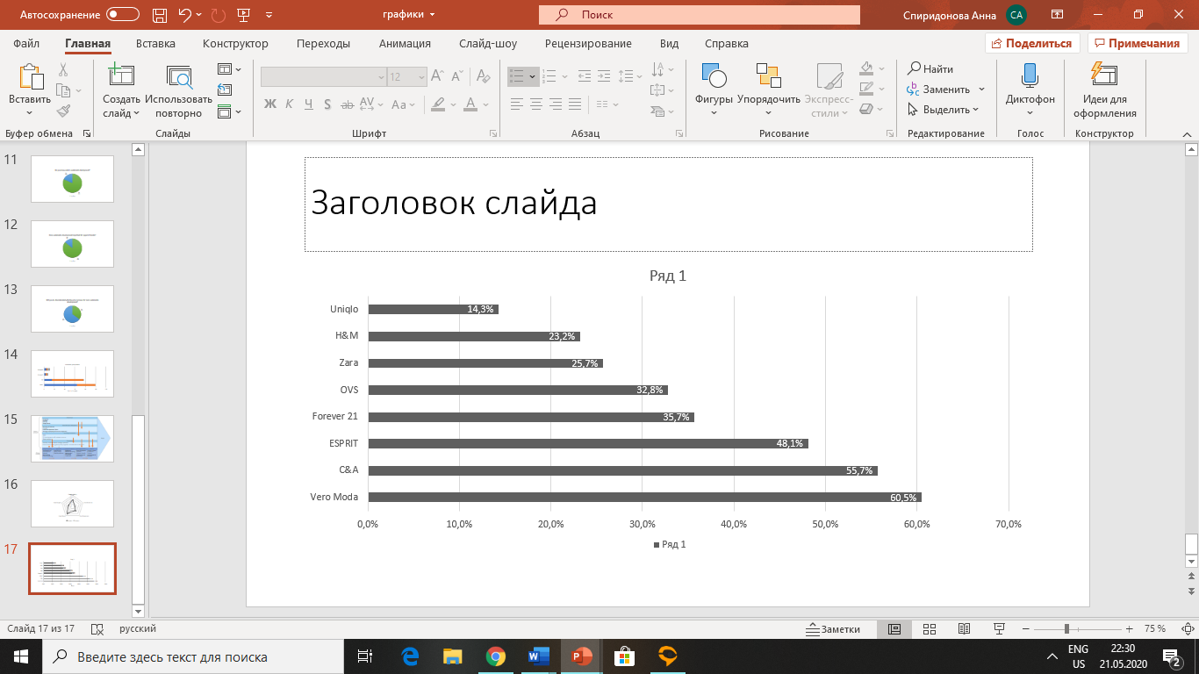

*Source:* [*https://retviews.com/blog/industry/polyester-fiber/*](https://retviews.com/blog/industry/polyester-fiber/)

Another threat to the life below water of fashion industry is plastic in a form of plastic bags, transportation packaging, and indirect plastic products such as plastic bottles and dishes which is consumed by employees of the organizations. Plastic single-use bags correspond to the threat to the nature. During the production of plastic bags, there is an output of radiation. Moreover, not all the bags can be recycled, thus plastic pollutes the landfills and many local authorities just burn them as it was expensive to recycle that type of plastic. It doesn't melt down easily and is often not realistically able to be reused from its original form without considerable overhaul to the facility.

Nowadays, in the Pacific Ocean there is a garbage spot made from plastic. It accounts for around 0.7-1.5 million square km. It is formed with 80% of plastic bags thrown from the coasts of Asia, North and South America.[61]

Also, animals become endangered as the plastic is thrown in the forests and water, where these animals live. Animals perceive plastic as food and therefore eat it and die from indigestion or starvation. Specialists say that plastic is consumed by more than 100 species of sea birds and by 31 species of marine animals.[62] And more than a million birds and 100,000 sea mammals and turtles die annually from eating or getting tangled in plastic waste.[63]

To solve a problem with excessive plastic use in apparel companies, clothes brand “Toad&Co” is cooperating with “LimeLoop” firm that produces recycled vinyl packages. Toad&CO removed disposable cardboard boxes during the online shopping experience and replaced them with recycled vinyl mailers that can be used for several times. After customer receive online purchase, they take an item out from the mailer and then drop empty mailer in the mail for return and reuse. Thus, company reducing the usage of single-use plastic which pollutes the Earth.[64]

**Goal 17: Partnerships for the goals**

This goal implies international cooperation in order to achieve other goals of sustainable development. The goal is divided into 5 targets in different areas: finance, technology, capacity building, trade, and systemic issues such as policy and institutional coherence, multi-stakeholder partnerships, data, monitoring and accountability. On the company level it is possible to use only systematic issues section because it aims to create partnerships on local level and encourages states to cooperate with businesses in order to provide effective implementation of SDGs. It means that effective partnerships between civil, public and public-private sectors should be created based on experience and resource partnership strategies. Moreover, in multi-stakeholder partnerships should be formed exchange of knowledge, experience, technology and financial resources between the participants to achieve development goals in all countries. It may include partnering with governments, NGOs and other agencies in form of strategic partnerships, volunteering, charity, etc. Although NGOs and other organizations are closely related to SDGs, achieving these goals will not be possible without the participation of the private sector.

To target sustainable goals UN issued a commitment “SDGs for fashion” to help fashion industry to move with a regard of sustainability. The incentive includes 3 categories of participants who will be engaged in project:

* Students. It is important to provide knowledge about the SDGs to the fashion related students of students of universities because they will be the main force of the market in the coming years.
* Companies. Lectures and conferences, as well as individual seminars and individual consultations should be organized to help fashion and textile companies align their sustainable documents and reporting to the targets of SDGs.
* Consumers. Interacting with consumers and educating them for better consumption patterns is critical in implementing sustainable initiatives.[65]

Partnerships are becoming more important for the development of states and businesses, as the boundaries between sectors are becoming blurred. Companies from different sectors need to establish partnerships to have proper development. Partnerships are mutually beneficial for cooperators in overcome complexities easier, finding new opportunities, and creating new solutions by the exchange of valuable resources.

For example, H&M is supporting local communities with a partnership the British Red Cross. H&M donates unsold stock from the UK stores to charity, ensuring that the unsalable stock is not going to waste thus helping environment. Due to this partnership H&M raised over £4 million for the British Red Cross.[66]

Moreover, H&M Foundation which is owned by the largest shareholders of H&M, partners with different organizations globally to improve education, water, equality and planet conditions and helping to meet urgent needs. One of the recent completed projects was in a partnership with non-profit organization “Reach for Change” to support Ethiopian social entrepreneurship aiming for solving issues facing women and children. The fund provided entrepreneurs with seed funding, advise and expertise of how to improve business and skills.[67]

### **3.2. Implementation of SDGs into value chain**

The effective implementation of Sustainable Development Goals considers several steps: understanding SDGS, defining priorities for a company, setting goals for each SDG, integrating them into the value chain, and reporting on sustainable development for stakeholders. Not all SDGs are equally important for companies operating in fashion industry. The most prioritized goals that can be suited to the fashion industry value chains and to the Uniqlo values are: Goal 8, Goal 12, Goal 13, Goal 14, Goal 17. They are targeting economic, social and environmental problems. While choosing these goals, I took into consideration industry peculiarities, suppliers’ and buyers’ powers and market dynamics, as well as internal company’s features. And with the implementation of these goals, there is an opportunity to increase competitiveness through resource efficiency.

*Figure 15 —Value chain of the industry*

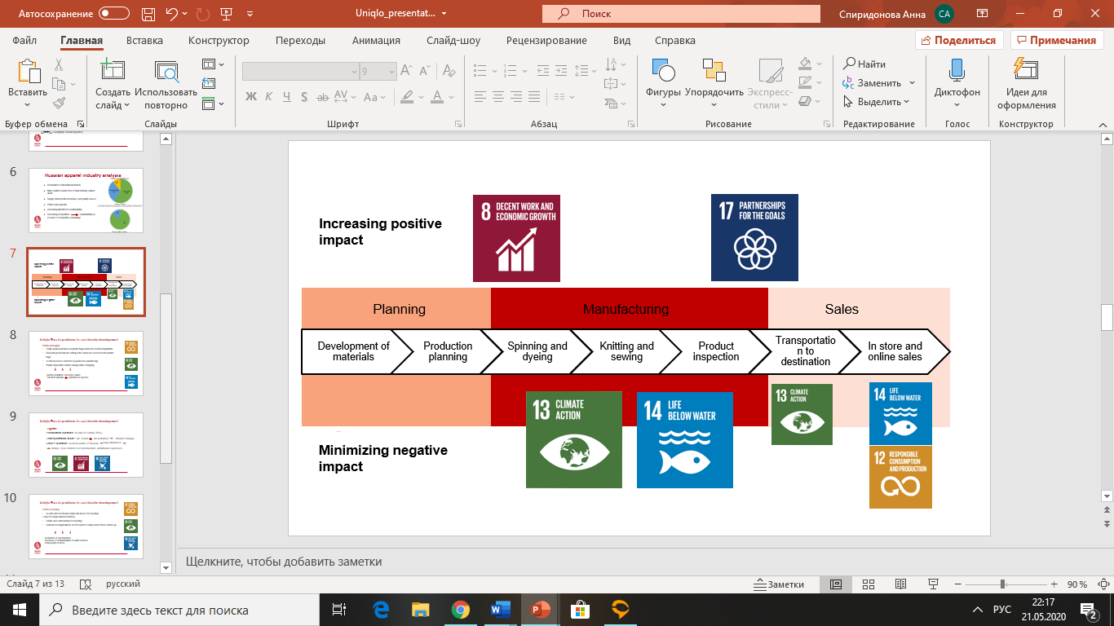

*Source: Created by author*

At the Figure 15, sample value chain of apparel industry is given to understand more precisely at what parts SDGs can be implemented. SDGs can work in different parts of value chain and aiming to minimize negative impact or increase positive impact of social, economic, and environmental areas. The mapping of SDGs in the value chain of particular industry can help to understand where the impact leads to the greatest value generation. By increasing positive effect on goal 8, companies can achieve economic growth, promote job creation thus decreasing unemployment. The goal 17 can be applied through all value chain with the cooperation with governments, NGOs, and other companies to increase efficiency in the business process and help people and nature. The goal 13 is aimed to minimize negative impact on environment and can be introduced in the manufacturing stage and during transportation and distribution. The goal 14 also plays a role in manufacturing stage and in sales stage during in store experience and online sales. Companies who prioritize on these goals can help environment by using more natural and recycled fabrics, reducing emissions, water, and energy use, and introducing sustainable management practices. And the Goal 12 can be applied mainly during in store and after sales experience. By introducing this goal, companies trying to reduce waste generation and rising awareness of people about eco-friendly lifestyles and conscious consumption.

### **3.3. Identification of problems**

A recent trend in the fashion industry are the concepts of sustainable development and ethical clothing production. Customers awareness and interest about the affects of the fashion industry towards the environment is increasing. As a result, brands need to catch these changes and introduce sustainable elements to their products and managing company.

Even though fast fashion is inexpensive and quickly produced fashion items in response to popular trends is very popular now, the sustainable fashion is the opposite in some respects. The foundation of sustainable fashion is control over the entire product life cycle, such as design, production, delivery, and sustainable practices in sales and after sales. It considers how to reduce the harmful effects on the environment, employees, and the community for the end consumer. However, sustainable development is complex, requiring a phased, long-term implementation, so this market is not yet oversaturated. But, as the community started to call for sustainable practices, companies have gradually started to use strategies in direction of sustainable development. For instance, some companies implement sustainable processes in supply chains to reduce water and energy consumption during the production. Likewise, the use of hazardous chemicals while dyeing and finishing clothes is a concern. As a result, brands introducing new ways to address dyes and finishes for features like wrinkle-resistance and water-repellency.

One of the examples of sustainable concept in apparel brands is a circular fashion value chain. It implies the elimination and development of company’s practices in every stage of value chain to more sustainable processes. It begins with the designing stage on which zero waste design process should be achieved. In the production stage renewable and sustainable fabrics should be used. Moreover, automated production of high-quality garments should be implemented to reduce the use of resources such as water, energy, chemicals. These could increase the value of products for consumers and prolong garment life. In the distribution stage on-demand distribution and retail sales should be organized to minimize waste by reducing unsold items. And in the sales stage, the collection and recycling of textiles and other waste as packaging should be used to eliminate waste and help community.

*Packaging*

Nowadays one of the most attracting attention issues of humanity and UN is the plastic consumption. Based on UN research, plastic not only pollutes the planet, but also contributes to global warming. Plastic bags are especially dangerous because they contain large quantities of polyethylene - one of the most active sources of methane and ethylene. While decomposing under the influence of solar radiation, plastic emits admixtures of greenhouse gases of methane and ethylene, which increases over time.[68] That is why it is important not only to reduce consumption of plastic but reduce the production of plastic. By using plastic bags in stores, Uniqlo stimulates plastic production, so the changes of plastic usage in the company needed to be implemented.

After the interview with the manager of the store in Rostov on Don and the analysis of current trends in fashion industry over the world, the issue with excessive use of plastic in Uniqlo stores was highlighted for several reasons:

* Uniqlo packs purchases in plastic bags which are non-biodegrabable;
* Discount goods that are sold in the shops are covered in the plastic bags;
* Heattech and Airism (thermal underwear) are also packaged in plastic;
* In delivery boxes each item is packed in a plastic bag so that it does not get dirty and wet during the transportation.

On the monthly basis Uniqlo stores together use approximately 800 000 plastic shopping bags and about the same quantity of plastic packaging in which was covered each item. Moreover, online store sends to the customers around 35 000 purchases monthly in single-use plastic mailers. As we can see, plastic is used in Uniqlo on everyday basis and it is needed to be reduced. Intensive usage of plastic causes excessive waste after the use because it is usually single used and then thrown away, so this cause surface pollution. Another threat to environment of excessive plastic that it threatens to animals who accidentally eat indecomposable pieces of plastic and this plastic stuck in the stomachs of land and sea animals that can lead to extinction of species in long-term.

Europe has already begun to struggle with a plastic decrease on the governmental level. In 2015 European Parliament amended directive 94/62/EC for reducing the consumption of lightweight plastic carrier bags.[69] And in 2019, European Parliament has agreed a new law to ban single-use plastic items by 2021.[70] However, in Russia such amendments only discussed and planned, while the environmental harm is seen today. That is why companies, especially with the sustainable development, should take action on the company level to reduce negative effects of plastic on our planet.

*Clothes recycling*

The recycling of clothes is working on reducing negative effect on environment and health, and on improving well-being of people in need. Large and poor families, people with disabilities, retirees, homeless people, people affected by natural disasters need material aid. Therefore, apparel stores can help them by giving collected or unsold clothes.

Speaking about environmental effect, the cultivation of natural fibers and processing of raw materials into fabrics are the most environmentally harmful stage of fabric production. A large amount of pesticides is used during the cultivation that pollutes water and causes decreased soil fertility. Manufacturing stage of fabrics from raw materials implies pollution and high-water use, especially in denim production. Moreover, production of clothes accounts for 25% of chemicals used globally.[71] These chemical fumes cause a health threat to the employees working with raw materials. While recycling clothes, it is possible to exclude raw materials stage and reduce negative effect on nature and people’s health.

Around the world, Uniqlo has already started to help people with clothes. In each store in Uniqlo there are special boxes for receiving old clothes, but it is possible to hand over only Uniqlo branded items. In Russia Uniqlo does not recycle clothes by its own, instead it uses outsourcing companies by giving clothes to them. The problem is that these organizations do not report to Uniqlo where these clothes go. In Moscow Uniqlo partner with charity foundation «Второе дыхание». They donate clothes which is in a good condition only, where the rest of the clothes goes is not reported. This fund does not have its own clothes recycling factory for unfit clothes. Therefore, it becomes unclear where the rest of the clothes go. In other regions of Russia, Uniqlo does not report with which funds it cooperates.

### **3.4. Practical recommendations**

Fast fashion has changed the way the industry operates, and stores are constantly launching new designs and consumers expect new designs in store or online a lot sooner. This has also meant there is an increase in waste. Sustainable fashion looks at increasing garment longevity and in turn reducing waste. Many years ago, sustainable fashion was associated with being more costly than traditional high street retailers. However, the gap between sustainable and traditional fashion has reduced in recent years.

The recommendations were created based on the problems, which were identified during the interview with the manager of Uniqlo, based on analysis of Uniqlo’s sustainable development reports, and on the industry development with the accordance to the UN sustainable development goals. This gave a picture of the fact that the company is taking steps to integrate the SDGs into its activities. The data obtained made it clear that the SDGs should be integrated into company’s value chain, especially these parts:

• Problem with packaging relates to distribution, sales, and after sales stages

• Necessity of clothes recycling relates to after-sales stage.

*Packaging*

With the increasing attention of society to sustainability and more awareness of the threat of plastic which is non-biodegradable, the implementation of eco-packaging to the companies which sell products directly to customers can help not only to decrease environmental harm but at the same time increase brand loyalty among eco-conscious clients. Material science and packaging engineering developing at an incredible speed. As a result, more ecofriendly packaging options are appearing on the market and brands can easier find and implement.

Sustainable packaging is the development and use of packaging which results in improved sustainability and which satisfies the following criteria:

* Is beneficial, safe, and healthy for individuals and communities throughout the life cycle
* Meets market criteria for performance and cost
* Is sourced, manufactured, transported, and recycled using renewable energy
* Optimizes the use of renewable or recycled source materials
* Is manufactured using clean production technologies and best practices
* Is made from materials healthy throughout the life cycle
* Is physically designed to optimize materials and energy
* Is effectively recovered and utilized in biological and/or industrial closed loop cycles[72]

In other words, it means that the sustainable packaging needs to be functional- to protect products from external factors and serve to carry these goods. Furthermore, cost-effective as the packaging should not be much more expensive that ordinary packaging and need to be reusable. And to support human and ecological health, to do so the production process need to be energy efficient with a possibility to use renewable energy, clean technology, water reuse, and without use of toxic to human health materials; made from renewable, biodegradable, and compositable materials not to cause contamination of the recycling stream or could be recycled.

The implementation of sustainable packaging especially in large multinational companies can be a solution to several UN Sustainable Development Goals. Environmental goals such as Climate action, As written before, plastic from which shopping bags are made is thrown in the oceans that violates underwater environment because this plastic stuck in the stomachs of sea animals and kill them, this threat refers to the “Life below water” and goal. Companies could help local communities in waste reduction to resolve “Decent Work and Economic Growth” goal because packaging refers to the municipal waste that is managed at the community level and in many communities especially for underdeveloped or emerging economies it is a challenge to manage effectively this waste. And directly companies that produce sustainable packaging can solve the “Climate action” goal by using eco-efficiency strategies during the production that reducing the quantity of toxic emissions, conserving raw materials, energy, water and eliminating waste thereby increasing overall efficiency and diminishing risks to the environment and human health.

After the overview and analysis of types of packaging and a threat of plastic, the recommendations will be given towards 3 directions of packaging: packaging connected with delivery of the good after purchase, packaging connected with the shopping bags while selling goods directly to the customers, packaging in which clothes were transported from the warehouses to the shops. These types of packaging are used most frequently in apparel retail stores.

Nowadays, there are many solutions and technologies to the reduction of waste of the packaging in which products are delivered from factories to the warehouses and shops, and from the warehouses to the customer in during online shopping. New companies emerging to solve these problems, that’s why retailers can select the most appropriate variant easier for their sustainable direction of the brand.

The first stage is to implement sustainable packaging options is to prepare potential customer to change and to transform buying behavior if it is needed to reduce transaction costs because sustainable packaging assumes actions from the customer side. Customers should be prepared for changes connected with sustainability issue of shopping bags and understand action principles how to reduce negative effect to the environment. To do so, Uniqlo can influence to their customers and explain them the threat of plastic and how to consume and reuse shopping bags more conscious. The most simple way to increase awareness of conscious consumption of large amount of people is through the digital channels: Uniqlo’s website and social media such as Vkontakte and Instagram because Uniqlo already has the audience in this social networks, in Vkontakte group of Uniqlo there are 96,9 thousand followers and in Uniqlo Russia in Instagram 295k followers. Uniqlo can start educating people of conscious consumption relying on “Zero waste” concept, which is based on 5R principles: Refuse, Reduce, Reuse, Recycle and Rot.[73] This Concept of rational use of resources focusing on refusal of plastic means that people can decrease environmental harm by not consuming unnecessary things such as plastic bags, by reducing its consumption, by reusing packaging and recycling it. The posts need to be informative, eye-catching and explaining the importance of reducing plastic consumption in our lives and how to reject disposable shopping bags while buying clothes. For people, who are not using social media, it is needed to provide educational posters in the shops. In the shops in the area of cash desks there should be small information plates with motivating information about 5R principles and benefits of taking reusable packaging. The place of these plates near the cash desks is due to the fact that while people are waiting for their turn at the checkout, they have free time to read about the danger of plastic and this will give an incentive effect to refuse of buying a package.

*Packaging connected with delivery to the customer after purchase*

In order to shift to more sustainable packaging Uniqlo Russia needs to rethink its delivery model for the purchases made online. Uniqlo can introduce special reusable transportation packaging for delivering orders. After receiving purchased goods, buyers will hand over transportation packaging to Uniqlo where these packaging is collected, and new purchases will be covered in it again. The cycle of transporting reusable mailers can be organized in several ways:

* if the delivery with a courier directly to the house is chosen, customer have an opportunity to hand the mailer back to the courier, which will be transported back to the warehouse/sorting center
* if the option of delivery to the post office is selected, the client can send the mailer back by post to the address of Uniqlo or return this mailer to Uniqlo store directly where it will be collected for further use.

Here is important to know that the customer is ready to receive the mailer back to Uniqlo to provide minimum price for the mailer and use it to the wear out. Therefore, an ongoing process of learning and of changing customers behavior will be conducted through the social media.

*Shopping bags*

The main problem of shopping bags is that Uniqlo and many other companies uses plastic bags which are non-biodegradable that pollutes environment. Some companies, like Zara have partially switched to paper bags, they use them every time besides of the 2 months in year during the sale season. However, Uniqlo in Russia uses plastic bags every time not regarding the sale period. And as Uniqlo tries to position themselves as sustainable company they need to implement better packaging option.

From the internal perspective, Uniqlo can introduce reusable canvas bags to reduce plastic supply. Moreover, brands’ logo on these bags can work as additional source of advertising. Uniqlo can create and sell branded design reusable canvas bags, which are a good alternative to disposable bags. Canvas bags can be used not only for the clothes clients just bought, but also for the everyday life.

Another working option to reduce plastic bags consumption is to replace them by paper bags. and not to give them for free after the purchase, but to sell for X rubles. For example, H&M in Austria sells bags for 0,15€ after the purchase, which makes customers think about is it worth it to buy package and by that brand can reduce the tendency of unconscious usage of shopping bags. Paper bags decompose within 2 months, while bags made from plastic remain on the surface up to 20 years.[74]

The price of the bag will be counted according to the wholesale purchase price of the bag plus margin to eliminate expenses and even get some profit. The average usage of plastic shopping bags counts for 800 000 pieces monthly for all Uniqlo stores in Russia. And considering the statistics of respondents, that 63% of people will buy a bag for 10 rubles,[75] thus a monthly revenue for Uniqlo from selling only shopping bags will be:

800 000*0,63*10=5 040 000 RUB/ month

Final earnings will depend on the price of the supplier, who will propose the best price for a wholesale order and the costs of transportation.

*Packaging in which clothes are transported from the warehouses*

During the transportation to the stores, all items are covered in separate plastic packaging to avoid from clothes contamination. After the items are laid down in the store, these packaging are thrown away and disposed. Moreover, items which are selling poorly during the season are exposed on a separate clothes rack and marked as a sale offer. These items are also covered in plastic and if the buyer wants to unroll and look on the item, he/she pulls it out from the bag, after that the item is packed again in a new plastic bag, so a lot of plastic waste is formed. This is made for maintaining items in the selling condition and avoid from contamination because these items may linger in the store for a long time. So, the problem of excessive plastic waste in Uniqlo stores can be solved by plastic recycling.

The type of plastic is important while recycling because different types of plastic should be recycled separately, and some types of plastic could not be recycled. The type of plastic of packaging for clothes is LDPE. This type is usually used for packaging in the food industry and other industries to protect against dust, water and keep food intact. Moreover, the color of the plastic makes difference. The transparent LDPE plastic can be sold to recycling factories cheaper than colored one. The clothes in Uniqlo are covered in transparent packages.

There are several options of plastic disposal in Russia. Most of plastic waste in Russia is disposed in landfills, waste incineration plants, or it can be recycled. First two options are environmentally unsafe, that is why recycling of plastic transportation packaging should be used in Uniqlo to manage the waste in the stores. In Russia there are a lot of plastic processing plants, but they are loaded not at maximum capacity since in Russia there is no separate garbage collection. To stimulate the delivery of raw materials and constant work of the factory, plants buy plastic of different types for recycling. On average, the price per kilogram of plastic material ranges from 5 to 30 rubles depending on the factory. Appropriate factories are located in every city in Russia where Uniqlo operates. Mainly, recycling company is engaged with a collection and transportation of plastic by itself, so it takes care of the transportation costs. To reduce transportation costs and time, decrease storage costs and to optimize control over packaging flow, it is reasonable to partner with recycling plants located nearby stores. The Figure 16 shows examples of recycling factories operating in the cities of Uniqlo stores with the best proposed price.

*Figure 16 — Plastic recycling factories in Russia*

|  |  |  |
| --- | --- | --- |
| City | Factory | Price |
| Saint-Petersburg | “Синай” | Up to 15 rub/kg |
| Moscow | “РусМак” | Up to 30 rub/kg |
| Kazan | “Полимер Рус” | 11 rub/kg |
| Ekaterinburg | “ЭкоТранс” | 22 rub/kg |
| Nizhny Novgorod | “ЭкопэтНН” | 12-18 rub/kg |
| Rostov-on-Don | “МирВторСырья” | 30 rub/kg |

*Source: Created by author*

The economic effect of introduction of sustainable packaging is positive for the company; when it is introduced, the company will not incur losses, on the contrary the company will receive economic benefit while selling paper bags and canvas bags to the customers after the purchase. The recycling of plastic packaging by selling plastic waste to the recycling factories located in the regions also incur positive economic effect. The environmental effect will be seen gradually by creating plastic turnover and reducing contamination of landfills. Thus, Uniqlo will be more sustainable and it will lead to better customer attitude of the brand and improved trust to the brand.

*Clothes recycling*

Clothes recycling can be implemented in accordance with SDGs such as: “Responsible production and consumption”, “Climate action”, and “Partnership for the goals”. Responsible production can be achieved using recycled materials in the brands assortment. While recycling clothes, the soil and air depletion declining and there is a retrenchment of electricity because the process of recycling clothes does not require processing raw materials, which causes contamination, and which is energy intensive. Besides, the collection of clothes and donating it for secondary use maintains conscious consumption. By donating old clothes, people can eliminate overflow of landfills, thus caring about environment. And by giving clothes to charity help other people.

One of the main problems of small life cycle of clothes and huge number of clothes wastes is unconscious shopping, it leads to the presence of large number of unnecessary clothes. Also, due to the rapid spread of "fast fashion", clothes are made from low-quality materials and quickly lose its appearance. In Russia there is no production of recycled textiles from clothes, but garment processing can be done through recycling process called downcycling, as a result of which recycled materials are used as technical felt, soundproof materials, flooring and lining agents.

The procedure of processing clothes is long because it includes several stages of manual labor: sorting, getting rid of zippers, buttons and other sewing accessories, washing and cleaning of various contaminants, and separation of fabrics into fibers that are used in the manufacture of new fabrics. In Russia there are few processing plants, that is why most part of clothes go to the landfills, yet some clothes go to second hands or not-profit organizations.

After the analysis of textile downcycling plants and potential partners of Uniqlo in terms of the cycle of clothes, the better option to establish partnerships with non-profit organizations who has their own downcycling plants or who cooperates with processing plants. Such NGOs should operate in the cities of Uniqlo stores to reduce transportation environmental effect and costs. Further I will give examples of possible partnerships in some cities of Russia.

In Saint-Petersburg the charity foundation “Лепта” independently collecting and processing worn clothes. This foundation fundraising for their activities through the secondary sale of wearable clothes and recycling of cast-off clothing. Furthermore, the foundation provides free clothes assistance for large families, low-income citizens, senior citizens, people with disabilities.

In Ekaterinburg social project called “Вещь Добра” is collecting used clothes. The collected textiles are disassembled into 2 parts. Clothes in good condition is sold or donated to charity funds, while heavily worn clothing go to Chelyabinsk Vtor-Kom processing plant for recycling. From old clothes they produce fabrics such as thermal felt and batting, which can be used for new clothes.

Such types of partnerships can be established in all cities and stores of Uniqlo. The NGOs by themselves are engaged in the installation of the container for collecting clothes. Containers are installed in public places: in shopping centers, business centers, lofts with minimal anti-vandal protection. The greater the flow of people on the place of installation, the better for a NGOs. Thus, Uniqlo stores are great place to put a container as the stores are mainly in shopping centers. Clothes from containers are taken by a charity organization on an agreed basis as the container is filled. The transportation costs are covered by NGO. With such type of partnerships, Uniqlo will not have any expenses, but this activity gives great impact on community and environment.

To motivate consumers to collect old clothes and donate to the charity, it is needed to educate clients too. It can be done through the internet as well as packaging and through the posters in the shops. These posters should be located at the entrance of the shop to raise awareness of the people that in this shop they can donate old clothes and help the community. That placement of the posters will give the most involvement of people, not only who just visited the shop, but also for people passing by the shop.

The expenses of such partnership are minimal. The main cost is to design and create stickers for containers and posters. For example, print company “Coral print” provides design service as well as printing production. The design should be made for the stickers for the clothes containers and for the posters to visualize the importance of clothes recycling. The size of the sticker should be put on 3 sides of the container and the size of one sticker should be 100х60 sm. As Uniqlo already has the stands for the posters from previous campaigns, the size of the poster should suite to these stands and it is 60х40 sm. So, considering this information, the total expenses from partnership can be seen from the Figure 17.

*Fig. 17 – Expenses from clothes recycling partnership for one store*

|  |  |  |
| --- | --- | --- |
| Name | Quantity | Price, RUB |
| Design | 2 | 2*990= 1980 |
| Sticker on the clothes container | 3 | 3*300=900 |
| Poster | 2 | 1300*2=2600 |
| Total: |  | 5480 |

*Source: Created by author*

### **Findings**

According to the results of the final chapter, it was possible to identify several gaps where SDGs can be implemented in Uniqlo in Russia. As a result, it was possible to propose to both qualitative and monetary benefits from the proposed recommendations, which increases the value for the company.

With the interviews with the store manager of Uniqlo and company reports, it was possible to identify the main gaps where it is possible to introduce SDGs. The identified gaps are high usage of plastic packaging in Uniqlo stores and ill-conceived system of clothes recycling. The data obtained made it clear that the SDGs should be integrated into company’s value chain, especially these parts:

• Problem with packaging relates to distribution, sales, and after sales stages

• Necessity of clothes recycling relates to after-sales stage

To address these two problems, the following recommendations were made.

The first problem of packaging can be divided into three parts depending on type of packaging. The first type relates to the delivery to the customer after purchase made online. The recommendation is to introduce special reusable transportation packaging for delivering orders and to start the cycle of these packages to reduce consumption and waste of disposable mailers. The second type of packaging is shopping bags. The recommendation is to eliminate plastic bags and replace them with paper bags and reusable canvas bags and sell them. It will give not only positive environmental effect of eliminating plastic, but also will give economic benefit from selling the bags. And the third type of packaging is in which clothes are transported from the warehouses to the stores. This type of packaging causes the most waste of the Uniqlo. That is why the recommendation is to recycle this plastic on factories located in regions of the stores. From this recommendation environmental benefit and economic benefit will be gained as plastic waste will be sold to the recycling factories.

The second gap of Uniqlo Russia is the recycling of clothes. The problem can be solved through partnerships with NGOs who has access to the clothes recycling factories. The wearable clothes go to the charity to help people in need, the rest of clothes go to recycling to avoid raw material stage in fabrics production and reduce negative effect on environment from raw material stage. All these recommendations should be reinforced with educational process of the customers for more sustainable practices in their behavior to maximize benefits in these practices.

In this case, intangible benefits are more significant than economic ones because sustainable development does not primarily mean economic benefits for the company but benefits for environment and people.

## **Conclusion**

In the first part of the work, the internal analysis of the Uniqlo was made. The analysis of the company shows that internationally Uniqlo puts strong emphasis on innovations, thus providing with quality clothes, on human resource management to establish control over entire value chain and working on digitalization to increase revenues in online segment. For companies as Uniqlo that have global value chains, it is necessary to monitor not only the general condition of the company, but also pay attention to every market in which it operates because the company may face unique problems in different countries. In the second part of the paper, the analysis of external environment was made. The focus was oriented on the analysis of competition within the industry, purchasing behavior, and readiness of customers to change on Russian market. It showed that the competition is increasing within the industry, customers values are changing for more digitalized processes and to the protection of environment, human rights, and community. That is why companies should implement new sustainable solutions in order to get long-term competitive advantage. Uniqlo has already started to implement sustainable practices world widely, but Uniqlo in Russia lags the leading countries in sustainable development, although people need and require more stable processes in creating clothes. This argument pushed the fact that in Uniqlo Russia it is necessary to begin the implementation of the SDGs.

Implementation of the SDGs requires an integrated approach. States should help businesses by creating special programs to simplify the implementation of the SDGs and companies use these opportunities and increased cooperation with third-party organizations to make changes in consumer behavior to lead people to reduce social, environmental, and economic problems. As it turned out, the fashion industry causes an irreversible effect on the environment and society, but with the introduction of the SDGs, these consequences can be stopped. By the nature SDGs are divided into 2 types. Those that reduce negative impact and increase positive impact. The most valuable goals for Uniqlo according to the problems were “Decent Work and Economic Growth”, “Partnerships for the goals”, “Responsible consumption and production”, “Climate action”, and “Life below water”. The first two goals are aimed to increase positive impact on economy and community and can be implemented in all stages of value chain. Other goals are targeting to minimize negative impact on the environment and society, and they are implemented mainly in the stages of production, sales and after-sales experience. In the third part of the work, recommendations were developed for the company Uniqlo for Russian market according to the identified problems. These recommendations will provide the company with the more sustainable practices to the implementation of the concept of Sustainable Development Goals. These sustainable practices could be a success factor in achieving competitive advantage over other brands in mass market segment.

As the recommendations are mainly given to the sales stage of value chain and they imply direct contact with customers, implementation of proposed actions should be carried out in the nearest future, since this actions immediately result in customers perception of the company. Moreover, economic effect for the company from implementation of these recommendations will be positive, as proposed recommendations pay back and even provide economic benefits through margins or social benefit through partnerships. Thus, the proposed recommendations will accelerate the process of introducing the SDGs into company and will continue to develop sustainable development of the brand.

## **Reference list**

1. Fast Retaining. Annual Report 2019, 2020, <https://www.fastretailing.com/eng/ir/library/pdf/ar2019_en.pdf>. Accessed 23 January 2020.
2. Unlocking The Power Of Clothing. UNIQLO Sustainability, 2020, https://www.uniqlo.com/en/sustainability/. Accessed 23 January 2020.
3. UNIQLO Logo Designed By Kashiwa Sato | Toni Marino. Toni Marino, 2018, https://tonimarino.co.uk/uniqlo-logo/. Accessed 10 May 2020.
4. Юникло (Рус), ООО. СБИС, 2020, https://sbis.ru/contragents/7705878750/770901001. Accessed 18 May 2020.
5. Uniqlo Core Fabric Mill List. Fastretailing.Com, 2020, https://www.fastretailing.com/eng/sustainability/labor/pdf/UniqloCoreFabricMillList_2019Apr.pdf. Accessed 12 January 2020.
6. Uniqlo operations. Fastretailing.Com, 2020, https://www.fastretailing.com/eng/ir/library/pdf/ar2011_en_08_n.pdf. Accessed 27 May 2020.
7. Grant, Robert M. “Prospering in Dynamically-Competitive Environments: Organizational Capability as Knowledge Integration.” Organization Science, vol. 7, no. 4, 1996, pp. 375–387. https://www.researchgate.net/publication/237713466_Prospering_in_Dynamically-Competitive_Environments_Organizational_Capability_as_Knowledge_Integration. Accessed 1 April 2020.
8. Porter, M.E. (1985). Competitive Advantage. Free Press. New York. P.1-30 <https://www.researchgate.net/publication/238333593_Competitive_Advantage_Revisited_Michael_Porter_on_Strategy_and_Competitiveness>. Accessed 1April 2020
9. CEO Insights. Fastretailing.Com, 2018, https://www.fastretailing.com/eng/ir/library/pdf/ar2018_en_04.pdf. Accessed 24 March 2020.
10. Ценностная цепочка и ее анализ. Studme, 2020, https://studme.org/312965/menedzhment/tsennostnaya_tsepochka_analiz. Accessed 24 March 2020.
11. Rao, Sree. "Capabilities And Competencies ". Citeman.Com, 2011, https://www.citeman.com/13414-capabilities-and-competencies.html. Accessed 24 March 2020.
12. The annual report on the most valuable and strongest apparel brands, 2020, https://brandirectory.com/download-report/brand-finance-apparel-50-2020-preview.pdf. Accessed 23 May 2020.
13. "Setouchi Olive Foundation│Unlocking The Power Of Clothing. UNIQLO Sustainability". Setouchi Olive Foundation│Unlocking The Power Of Clothing. UNIQLO Sustainability, 2020, https://www.uniqlo.com/en/sustainability/planet/olive/. Accessed 23 May 2020.
14. "Firm Resources And Sustained Competitive Advantage - Jay Barney, 1991". 2020, p. ., https://journals.sagepub.com/doi/10.1177/014920639101700108. Accessed 25 March 2020.
15. MarketLine industry report. Apparel Retail in Russia. 2018. <https://www.marketline.com>. Accessed 19 March 2020.
16. Капустина, Л. М., Кондратенко, Ю. Н., Лыкова, К. В., & Тимохина, Г. С. (2018). Конкурентные Позиции Бренда Zara На Российском Рынке Одежды. Practical Marketing / Prakticheskiy Marketing, 252(2), 32–40., <https://cyberleninka.ru/article/n/konkurentnye-pozitsii-brenda-zara-na-rossiyskom-rynke-odezhdy>. Accessed 20 March 2020.
17. MarketLine industry report. Global Online Retail. 2020. <https://www.marketline.com>. Accessed 19 March 2020.
18. Competitive Profile Matrix: A Theoretical Review". Researchgate, 2020, https://www.researchgate.net/publication/308706961_Competitive_Profile_Matrix_A_Theoretical_Review. Accessed 8 May 2020.
19. Uniqlo Strategy - The Differences With Competitors H&M And Zara | Retviews. Retviews, 2019, https://retviews.com/blog/focus/uniqlo-competitors/. Accessed 8 May 2020.
20. Uniqlo Strategy - The Differences With Competitors H&M And Zara | Retviews. Retviews, 2019, https://retviews.com/blog/focus/uniqlo-competitors/. Accessed 8 May 2020.
21. "Number Of Social Media Users Worldwide 2010-2021 | Statista". Statista, 2020, https://www.statista.com/statistics/278414/number-of-worldwide-social-network-users/. Accessed 8 May 2020.
22. "Number Of Social Media Users Worldwide 2010-2021 | Statista". Statista, 2020, https://www.statista.com/statistics/278414/number-of-worldwide-social-network-users/. Accessed 12 May 2020.
23. Collaborative Efforts for Sustainable Development: Surveying the Literature on Multi-Stakeholder Initiatives to Realize the Sustainable Development Goals
24. Task Team on CSO Development Effectiveness and Enabling Environment, Erasmus University, 2018. Accessed 12 Nay 2020.
25. Why Collaboration Will Be Key To Achieving The Sustainable Development Goals. World Economic Forum, 2020, https://www.weforum.org/agenda/2017/01/realising-the-potential-of-cross-sector-partnerships/. Accessed 12 May 2020.
26. "Sustainable Development Goals .:. Sustainable Development Knowledge Platform". Sustainabledevelopment.Un.Org, 2020, https://sustainabledevelopment.un.org/?menu=1300. Accessed 23 January 2020.
27. "Goal 8. Sustainable Development Knowledge Platform". Sustainabledevelopment.Un.Org, 2020, https://sustainabledevelopment.un.org/sdg8. Accessed 23 January 2020.
28. Unemployment, Total (% Of Total Labor Force) (Modeled ILO Estimate) | Data". Data.Worldbank.Org, 2020, https://data.worldbank.org/indicator/SL.UEM.TOTL.ZS?end=2019&start=2012&view=chart. Accessed 23 January 2020.
29. APPAREL & FOOTWEAR BENCHMARK FINDINGS REPORT. Knowthechain.Org, 2018, https://knowthechain.org/wp-content/plugins/ktc-benchmark/app/public/images/benchmark_reports/KTC_AF_2018.pdf. Accessed 20 May 2020.
30. The 2019 Ethical Fashion Report. Business-Humanrights.Org, 2020, https://www.business-humanrights.org/sites/default/files/documents/FashionReport_2019_9-April-19-FINAL.pdf. Accessed 20 May 2020.
31. "Transparency In Fashion – UNECE Mobilizing Industry And Experts To Develop Blockchain ‎Traceability Tool And Policy Framework Under EU-Funded Project". Unece.Org, 2020, https://www.unece.org/info/media/news/trade/2019/transparency-in-fashion-unece-mobilizing-industry-and-experts-to-develop-blockchain-traceability-tool-and-policy-framework-under-eu-funded-project/doc.html. Accessed 27 March 2020.
32. Goal 12. Sustainable Development Knowledge Platform". Sustainabledevelopment.Un.Org, 2020, https://sustainabledevelopment.un.org/sdg12. Accessed 18 January 2020.
33. "How Fast Fashion Works". Investopedia, 2020, https://www.investopedia.com/terms/f/fast-fashion.asp. Accessed18 January 2020.
34. "The Apparel Industry’S Environmental Impact In 6 Graphics". World Resources Institute, 2017, https://www.wri.org/blog/2017/07/apparel-industrys-environmental-impact-6-graphics. Accessed 15 May 2020.
35. Style that’s sustainable: A new fast-fashion formula, 2016, <https://www.mckinsey.com/business-functions/sustainability/our-insights/style-thats-sustainable-a-new-fast-fashion-formula>. Accessed 25 January 2020.
36. Goal 13. Sustainable Development Knowledge Platform. Sustainabledevelopment.Un.Org, 2020, https://sustainabledevelopment.un.org/sdg13. Accessed 25 January 2020.
37. Climate Change. Un.Org, 2016, https://www.un.org/en/sections/issues-depth/climate-change/. Accessed 26 January 2020.
38. Chapter 1 — Global Warming Of 1.5 ºC. Ipcc.Ch, 2020, https://www.ipcc.ch/sr15/chapter/chapter-1/. Accessed 26 January 2020.
39. "Глобальное Изменение Климата Как Вызов Мировой Экономике И Экономической Науке". Cyberleninka.Ru, 2020, https://cyberleninka.ru/article/n/globalnoe-izmenenie-klimata-kak-vyzov-mirovoy-ekonomike-i-ekonomicheskoy-nauke/viewer. Accessed 25 January 2020.
40. Бондаренко Л.В., Маслова О.В., Белкина А.В., Сухарева К.В. ГЛОБАЛЬНОЕ ИЗМЕНЕНИЕ КЛИМАТА И ЕГО ПОСЛЕДСТВИЯ. Вестник Российского экономического университета имени Г. В. Плеханова. 2018;(2):84-93. <https://doi.org/10.21686/2413-2829-2018-2-84-93>. Accessed 25 January 2020.
41. Measuring fashion. Environmental Impact of the Global Apparel and Footwear Industries Study Quantis-Intl.Com, 2020, https://quantis-intl.com/wp-content/uploads/2018/03/measuringfashion_globalimpactstudy_full-report_quantis_cwf_2018a.pdf. Accessed 25 January 2020.
42. Футболка-Убийца: Почему Даже Хлопок Наносит Вред Планете. Wonderzine, 2017, https://www.wonderzine.com/wonderzine/style/style/230584-silk-and-other-stuff. Accessed 21 May 2020.
43. Как Выбрать Безопасную Одежду, Которая Не Вредит Природе И Человеку. Recycle, 2015, https://recyclemag.ru/article/kak-vybrat-bezopasnuju-odezhdu-kotoraja-ne-vredit-prirode-i-cheloveku. Accessed 21 May 2020.
44. Toward sustainable water use in the cotton supply chain. Waterfootprint.Org, 2020, https://waterfootprint.org/media/downloads/Assessm_water_footprint_cotton_India.pdf. Accessed 21 May 2020.
45. "How Much Water Is Used In Cotton Production? – Better Cotton Initiative". Better Cotton Initiative, 2020, https://bettercotton.org/about-bci/how-much-water-is-used-in-cotton-production/. Accessed 21 May 2020.
46. Carbon Pollution From Transportation | US EPA. US EPA, 2015, https://www.epa.gov/transportation-air-pollution-and-climate-change/carbon-pollution-transportation#EPA%20Programs%20to%20Reduce%20Carbon%20Pollution. Accessed 17 March 2020.
47. What Is The ‘Bluesign’ Standard For Textiles?. Business Ethics, 2012, https://business-ethics.com/2012/11/11/what-is-the-bluesign-standard-for-textiles/. Accessed 17 March 2020.
48. "How Ethical Is Patagonia?". Good On You, 2017, https://goodonyou.eco/how-ethical-is-patagonia/. Accessed 21 May 2020.
49. Accumulations of microplastic on shorelines worldwide: sources and sinks.Plasticsoupfoundation.Org, 2020, https://www.plasticsoupfoundation.org/wp-content/uploads/2015/03/Browne_2011-EST-Accumulation_of_microplastics-worldwide-sources-sinks.pdf. Accessed 29 March 2020.
50. Napper, Imogen & Thompson, Richard. (2016). Release of synthetic microplastic plastic fibres from domestic washing machines: Effects of fabric type and washing conditions, <https://www.researchgate.net/publication/308736592_Release_of_synthetic_microplastic_plastic_fibres_from_domestic_washing_machines_Effects_of_fabric_type_and_washing_conditions>. Accessed 29 March 2020.
51. Экологический Сбор За Использование Полиэтиленовых Пакетов. Досье. ТАСС, 2020, https://tass.ru/info/4660581. Accessed 21 May 2020.
52. Polyester Fiber - The Impact Of Fashion Brands On Ocean Pollution. Retviews, 2019, https://retviews.com/blog/industry/polyester-fiber/. Accessed 29 March 2020.
53. Инфографика: 10 рек, ответственных за 95% пластика, попадающего из рек в океаны, Наука на TJ, 2019, <https://tjournal.ru/science/117535-infografika-10-rek-otvetstvennyh-za-95-plastika-popadayushchego-iz-rek-v-okeany>. Accessed 29 March 2020.
54. Sustainabledevelopment.Un.Org, 2020, https://sustainabledevelopment.un.org/content/documents/Ocean_Factsheet_Pollution.pdf. Accessed 29 March 2020.
55. Wasteful Packaging Is Going Out Of Fashion". Vogue Business, 2020, https://www.voguebusiness.com/technology/eco-friendly-reusable-packaging-sustainability. Accessed 29 March 2020.
56. Sdgs For Better Fashion - United Nations Partnerships For Sdgs Platform. Sustainabledevelopment.Un.Org, 2020, https://sustainabledevelopment.un.org/partnership/?p=28041. Accessed 13 April 2020.
57. Charity-Partners. H&M, 2020, https://www2.hm.com/en_gb/ladies/shop-by-feature/charity-partners.html. Accessed 11 May 2020.
58. Current Projects. Hmfoundation.Com, 2020, https://hmfoundation.com/projects/. Accessed 11 May 2020.
59. Неожиданное открытие: пластик не только загрязняет планету, но и способствует глобальному потеплению, 2018, <https://news.un.org/ru/story/2018/08/1336>. Accessed 11 May 2020.
60. Sustainability Experts Say There's Actually No Such Thing As 'Eco-Friendly' Clothing". Good Housekeeping, 2020, https://www.goodhousekeeping.com/clothing/g27154605/sustainable-fashion-clothing/. Accessed 11 May 2020.
61. URL: https://eur-lex.europa.eu/legal-content/EN/TXT/?uri=celex:32015L0720
62. The E.U. Voted To Ban Single-Use Plastics By 2021. Time, 2020, https://time.com/5560105/european-union-plastic-ban/. Accessed 16 May 2020.
63. Industrial Building Consumer Packaging Made Of Paper And Cardboard. Vivredamouretdegateaux.Com, 2020, https://vivredamouretdegateaux.com/sample/industrial-building-consumer-packaging-made-of-paper-and-cardboard.php. Accessed 2 May 2020.
64. Definition of sustainable packaging. Sustainablepackaging.Org, 2020, https://sustainablepackaging.org/wp-content/uploads/2017/09/Definition-of-Sustainable-Packaging.pdf. Accessed 2 May 2020.
65. 5R: Как Жить По Принципу Ноль Отходов. Greenpeace В России, 2020, https://greenpeace.ru/blogs/2019/07/08/5r-kak-zhit-po-principu-nol-othodov/. Accessed 2April 2020.
66. Как Долго Разлагается Мусор, Выброшенный Нами?. Infoniac.Ru, 2020, https://www.infoniac.ru/news/Kak-dolgo-razlagaetsya-musor-vybroshennyi-nami.html. Accessed 2 April 2020.
67. Утилизация И Переработка Старой Одежды. Нетмус - Оборудование Для Сортировки, Измельчения, Переработки Отходов В РФ. Netmus.Ru, 2020, https://netmus.ru/press-center/articles/utilizaciya-i-pererabotka-staroy-odezhdy/. Accessed 15 May 2020.
68. "Прием Одежды". Второе Дыхание. Фонд, 2020, https://vtoroe.ru/for-companies/office-service/. Accessed 15 May 2020.
69. SDG industry matrix.Cloudfront.Net, 2020, https://d306pr3pise04h.cloudfront.net/docs/issues_doc%2Fdevelopment%2FSDGMatrix-ConsumerGoods.pdf. Accessed 27 April 2020.
70. Sustainable Technologies For Fashion And Textiles". Google Books, 2020, https://books.google.ru/books?id=Z8i2DwAAQBAJ&pg=PA57&lpg=PA57&dq=production+of+clothes+accounts+for+25%25+of+chemicals+used+globally.&source=bl&ots=PM_YBgLRsn&sig=ACfU3U0iDl3POzXjD0PUP21bSqqRjx5baw&hl=ru&sa=X&ved=2ahUKEwiWyNaDo9zpAhVKw8QBHeT2B5IQ6AEwAHoECAoQAQ#v=onepage&q=production%20of%20clothes%20accounts%20for%2025%25%20of%20chemicals%20used%20globally.&f=false. Accessed 15 May 2020.

## **Appendix**

Appendix 1

*Questions for the survey with potential customers*

1. Do you prefer Russian or foreign brands?
2. Where do you usually buy clothes?
3. Do you know brand "Uniqlo"?
4. Have you bought something in "Uniqlo"?
5. Why do you choose “Uniqlo”?
6. What is your favorite mass-market brand?
7. Do you know what is sustainable development?
8. Does sustainable development important for apparel brands?
9. In practice, do you pay attention to sustainable development when choosing clothes?
10. Will you be discontented with 5% price increase for more sustainable development?
11. If you knew that Uniqlo sells shopping bags for 10 rubles, would you buy a package or take your purchase without a package?

*The sample characteristics*

A sample a of people for the survey was selected in connection with the characteristics of Uniqlo potential buyers in Russia. As Uniqlo sell clothes for women, men, and children, the participants are of both genders. The age of people is from 15 to 60 years old because children usually do not buy clothes by themselves and as most Uniqlo stores are in shopping malls, generally this age group visit big shopping malls. Geography of participants is Russia. Income and educational level is not important, as Uniqlo clothes are bought by people not depending on their income and education because Uniqlo sells basic items.

Appendix 2

*Highlighted questions from the interviews with Uniqlo store manager*

1. What problems does the company have world widely in the field of sustainable development, in the areas of environment, assistance to employees, assistance to society?
2. What problems could you highlight in your store or in other Uniqlo stores in Russia?
3. Who is responsible for the procurement of goods, each store separately or there is a corporate center in Russia where everything is distributed to the stores?
4. Where are the warehouses for delivery to the store (in each region or one for the whole of Russia) and where does the clothing for online orders come from?
5. Does the online segment operate separately from offline? Where are the orders sent from?
6. Who is responsible for packaging procurement? And how many packages are being purchased or used at the store or in all Uniqlo stores in Russia per time unit?
7. Who is responsible for clothes recycling? And how is it organized?

1. Fast Retaining. (2019). Annual Report 2019. Retrieved from https://www.fastretailing.com/eng/ir/library/pdf/ar2019_en.pdf
2. UNIQLO Sustainability. (2020). Retrieved from https://www.uniqlo.com/en/sustainability/
3. UNIQLO Logo Designed By Kashiwa Sato | Toni Marino. (2018). Retrieved from https://tonimarino.co.uk/uniqlo-logo/
4. Юникло (Рус), ООО. Retrieved from https://sbis.ru/contragents/7705878750/770901001
5. Ibid.
6. Uniqlo Core Fabric Mill List. (2020). Retrieved from https://www.fastretailing.com/eng/sustainability/labor/pdf/UniqloCoreFabricMillList_2019Apr.pdf
7. Uniqlo operations (2020). Retrieved 27 May 2020, from https://www.fastretailing.com/eng/ir/library/
8. Grant, Robert M. Prospering in Dynamically Competitive Environments: Organizational Capability as Knowledge (1996). Retrieved from https://www.researchgate.net/publication/237713466_Prospering_in_Dynamically-Competitive_Environments_Organizational_Capability_as_Knowledge_Integration
9. Porter, M.E. (1985). Competitive Advantage. Free Press. New York. P.1-30. Retrieved from https://www.researchgate.net/publication/238333593_Competitive_Advantage_Revisited_Michael_Porter_on_Strategy_and_Competitiveness
10. Ibid.
11. Fast Retaining. (2019). Annual Report 2019. Retrieved from https://www.fastretailing.com/eng/ir/library/pdf/ar2019_en.pdf
12. Uniqlo Core Fabric Mill List. (2020). Retrieved from https://www.fastretailing.com/eng/sustainability/labor/pdf/UniqloCoreFabricMillList_2019Apr.pdf
13. Fast Retaining. (2019). Annual Report 2019. Retrieved from https://www.fastretailing.com/eng/ir/library/pdf/ar2019_en.pdf
14. CEO Insights (2018). Retrieved from https://www.fastretailing.com/eng/ir/library/pdf/ar2018_en_04.pdf
15. Fast Retaining. (2019). Annual Report 2019. Retrieved from https://www.fastretailing.com/eng/ir/library/pdf/ar2019_en.pdf
16. The annual report on the most valuable and strongest apparel brands. (2020). Retrieved from https://brandirectory.com/download-report/brand-finance-apparel-50-2020-preview.pdf
17. Porter, M.E. (1985). Competitive Advantage. Free Press. New York. P.1-30. Retrieved from https://www.researchgate.net/publication/238333593_Competitive_Advantage_Revisited_Michael_Porter_on_Strategy_and_Competitiveness
18. Setouchi Olive Foundation│Unlocking the Power of Clothing. UNIQLO Sustainability. (2020). Retrieved from https://www.uniqlo.com/en/sustainability/planet/olive/
19. Barney, J. (1991). Firm Resources and Sustained Competitive Advantage. Journal of Management, 17(1), 99–120. Retrieved from https://doi.org/10.1177/014920639101700108
20. Fast Retaining. (2019). Annual Report 2019. Retrieved from https://www.fastretailing.com/eng/ir/library/pdf/ar2019_en.pdf
21. MarketLine industry report. Apparel Retail in Russia, (2018). Retrieved from https://www.marketline.com
22. Капустина, Л. М. (2018). Конкурентные Позиции Бренда Zara На Российском Рынке Одежды. Practical Marketing / Prakticheskiy Marketing, 252(2), 32–40. Retrieved from https://cyberleninka.ru/article/n/konkurentnye-pozitsii-brenda-zara-na-rossiyskom-rynke-odezhdy
23. Ibid.
24. Ibid.
25. MarketLine industry report. Global Online Retail, (2020). Retrieved from https://www.marketline.com
26. Appendix 1
27. Fast Retaining. (2019). Annual Report 2019. Retrieved from https://www.fastretailing.com/eng/ir/library/pdf/ar2019_en.pdf
28. Appendix 1
29. Competitive Profile Matrix: A Theoretical Review. (2020). Retrieved from https://www.researchgate.net/publication/30
30. Appendix 1
31. Uniqlo Strategy - The Differences with Competitors H&M and Zara | Retviews. (2019). Retrieved from https://retviews.com/blog/focus/uniqlo-competitors/
32. Ibid.
33. Ibid.
34. Uniqlo Strategy - The Differences With Competitors H&M And Zara | Retviews. (2019). Retrieved from https://retviews.com/blog/focus/uniqlo-competitors/
35. MarketLine industry report. Apparel Retail in Russia, (2018). Retrieved from https://www.marketline.com
36. Number of social media users worldwide 2010-2021 | Statista. (2020). Retrieved from https://www.statista.com/statistics/278414/number-of-worldwide-social-network-users/
37. Collaborative Efforts for Sustainable Development: Surveying the Literature on Multi-Stakeholder Initiatives to Realize the Sustainable Development Goals

    Task Team on CSO Development Effectiveness and Enabling Environment, Erasmus University, 2018
38. Uniqlo Strategy - The Differences With Competitors H&M And Zara | Retviews. (2019). Retrieved from https://retviews.com/blog/focus/uniqlo-competitors/
39. Sustainable Development Knowledge Platform. (2020). Retrieved from https://sustainabledevelopment.un.org/?menu=1300
40. Goal 8. Sustainable Development Knowledge Platform. (2020). Retrieved from https://sustainabledevelopment.un.org/sd
41. Unemployment, total (% of total labor force) (modeled ILO estimate) | Data. (2020). Retrieved from https://data.worldbank.org/indicator/SL.UEM.TOTL.ZS?end=2019&start=2012&view=chart
42. APPAREL & FOOTWEAR BENCHMARK FINDINGS REPORT. Knowthechain.Org, (2018). Retrieved from https://knowthechain.org/wp-content/plugins/ktc-benchmark/app/public/images/benchmark_reports/KTC_AF_2018.pdf
43. The 2019 Ethical Fashion Report. Business-Humanrights.Org, (2020). Retrieved from https://www.business-humanrights.org/sites/default/files/documents/FashionReport_2019_9-April-19-FINAL.pdf.
44. Goal 12. Sustainable Development Knowledge Platform. (2020). Retrieved from https://sustainabledevelopment.un.org/sdg12
45. How Fast Fashion Works. (2020). Retrieved from https://www.investopedia.com/terms/f/fast-fashion.asp
46. The Apparel Industry’s Environmental Impact in 6 Graphics. (2017). Retrieved 29 May 2020, from https://www.wri.org/blog/2017/07/apparel-industrys-environmental-impact-6-graphics
47. Style that’s sustainable: A new fast-fashion formula. (2016). Retrieved from https://www.mckinsey.com/business-functions/sustainability/our-insights/style-thats-sustainable-a-new-fast-fashion-formula
48. Goal 13. Sustainable Development Knowledge Platform. (2020). Retrieved from https://sustainabledevelopment.un.org/sdg13
49. Climate Change. (2016). Retrieved from https://www.un.org/en/sections/issues-depth/climate-change/
50. Chapter 1 — Global Warming of 1.5 ºC. (2020). Retrieved from https://www.ipcc.ch/sr15/chapter/chapter-1/
51. Глобальное изменение климата как вызов мировой экономике и экономической науке. (2020). Retrieved from https://cyberleninka.ru/article/n/globalnoe-izmenenie-klimata-kak-vyzov-mirovoy-ekonomike-i-ekonomicheskoy-nauke/viewer
52. Бондаренко Л.В., Маслова О.В., Белкина А.В., Сухарева К.В. ГЛОБАЛЬНОЕ ИЗМЕНЕНИЕ КЛИМАТА И ЕГО ПОСЛЕДСТВИЯ. Вестник Российского экономического университета имени Г. В. Плеханова. 2018;(2):84-93, Retrieved from https://doi.org/10.21686/2413-2829-2018-2-84-93
53. Measuring fashion. Environmental Impact of the Global Apparel and Footwear Industries Study Quantis-Intl.Com. (2020). Retrieved from https://quantis-intl.com/wp-content/uploads/2018/03/measuringfashion_globalimpactstudy_full-report_quantis_cwf_2018a.pdf.
54. #### Toward sustainable water use in the cotton supply chain. *Waterfootprint.Org*. (2020). Retrieved from https://waterfootprint.org/media/downloads/Assessm_water_footprint_cotton_India.pdf

   
55. How much water is used in cotton production? – Better Cotton Initiative. (2020). Retrieved from https://bettercotton.org/about-bci/how-much-water-is-used-in-cotton-production/
56. Carbon Pollution From Transportation | US EPA. (2015). Retrieved from https://www.epa.gov/transportation-air-pollution-and-climate-change/carbon-pollution-transportation#EPA%20Programs%20to%20Reduce%20Carbon%20Pollution
57. What Is the ‘Bluesign’ Standard for Textiles?. (2012). Retrieved 29 May 2020, from https://business-ethics.com/2012/11/11/what-is-the-bluesign-standard-for-textiles/
58. "How Ethical Is Patagonia?". Good On You. (2017). Retrieved from https://goodonyou.eco/how-ethical-is-patagonia/.
59. Accumulations of microplastic on shorelines worldwide: sources and sinks. Plasticsoupfoundation.Org. (2020). Retrieved from https://www.plasticsoupfoundation.org/wp-content/uploads/2015/03/Browne_2011-EST-Accumulation_of_microplastics-worldwide-sources-sinks.pdf
60. Napper, Imogen & Thompson, Richard. (2016). Release of synthetic microplastic plastic fibres from domestic washing machines: Effects of fabric type and washing conditions. Retrieved from https://www.researchgate.net/publication/308736592_Release_of_synthetic_microplastic_plastic_fibres_from_domestic_washing_machines_Effects_of_fabric_type_and_washing_conditions
61. "Экологический Сбор За Использование Полиэтиленовых Пакетов. Досье". ТАСС. (2020). Retrieved from https://tass.ru/info/4660581
62. Инфографика: 10 рек, ответственных за 95% пластика, попадающего из рек в океаны — Наука на TJ. (2019). Retrieved from https://tjournal.ru/science/117535-infografika-10-rek-otvetstvennyh-za-95-plastika-popadayushchego-iz-rek-v-okeany
63. Sustainabledevelopment.Un.Org. (2020). Retrieved from https://sustainabledevelopment.un.org/content/documents/Ocean_Factsheet_Pollution.pdf
64. "Wasteful Packaging Is Going Out Of Fashion". Vogue Business. (2020). Retrieved from https://www.voguebusiness.com/technology/eco-friendly-reusable-packaging-sustainability
65. SDGs for Better Fashion - United Nations Partnerships for SDGs platform. (2020). Retrieved from https://sustainabledevelopment.un.org/partnership/?p=28041
66. Charity-partners. (2020). Retrieved from https://www2.hm.com/en_gb/ladies/shop-by-feature/charity-partners.html
67. Current projects. (2020). Retrieved from https://hmfoundation.com/projects/
68. Неожиданное открытие: пластик не только загрязняет планету, но и способствует глобальному потеплению. (2018). Retrieved from https://news.un.org/ru/story/2018/08/1336
69. URL: <https://eur-lex.europa.eu/legal-content/EN/TXT/?uri=celex:32015L0720>
70. The E.U. Voted to Ban Single-Use Plastics by 2021. (2020). Retrieved from https://time.com/5560105/european-union-plastic-ban/
71. Sustainable Technologies for Fashion and Textiles. (2020). Retrieved 30 May 2020, from https://books.google.ru/books?id=Z8i2DwAAQBAJ&pg=PA57&lpg=PA57&
72. Definition of sustainable packaging. (2020). Retrieved from https://sustainablepackaging.org/wp-content/uploads/2017/09/Definition-of-Sustainable-Packaging.pdf
73. #### 5R: как жить по принципу ноль отходов. (2020). Retrieved from https://greenpeace.ru/blogs/2019/07/08/5r-kak-zhit-po-principu-nol-othodov/

   
74. #### Как долго разлагается мусор, выброшенный нами? (2020). Retrieved from https://www.infoniac.ru/news/Kak-dolgo-razlagaetsya-musor-vybroshennyi-nami.html

   
75. Appendix 1