Federal state budgetary educational institution of   
higher professional education

Saint Petersburg state University  
Graduate school of management

**The Strategy of the Company “LOVE REPUBLIC”  
 Based on Sustainability Principles**

Graduate Qualification Work

4th year bachelor student

«International management» program

**Vera Yurkina**

**__________________**(Signature )

Scientific advisor:

Senior Lecturer,

Department of Strategic and International Management

**Aray Yulia Nikolaevna**

_________________________

(Signature )

Referee:

Associate Professor,

Department of Strategic and International Management

**Blagov Yury Evgenievich**

_________________________

(Signature )

“CORRESPONDS TO REQUIREMENTS”

_______________________ (Signature of scientific advisor)

«___»_______________2020.

Saint Petersburg

2020

**The statement about the independent nature of graduate qualification work.**

Me, Yurkina Vera, student of the 4th course of the Graduate School of Management, St. Petersburg State University, "Management” direction, "International management" program, confirm that my graduate qualification work on the thesis “The Strategy of the Company “Love Republic” Based on Sustainability Principles”, which will be presented for public defense in June 2020, does not contain elements of plagiarism.

All direct borrowings of print and electronic sources as well as from final ranking works and previously protected term-papers, candidate and doctoral dissertations, have appropriate links.

I am familiar with the current Graduate School of Management, SPBU regulations of the educational process, according to which the detection of plagiarism (direct borrowing from other sources without provision of links) is the basis for “F” estimation of work.

___________________________________________   
(Signature of the student with transcript)

___________________________________________ (Date)

# Table of contents

Table of contents 3

Introduction 6

Chapter 1. Company and industry analysis 9

1.1. Overview of “Love Republic” Company 9

1.1.1. Company’s profile 9

1.1.2. Love 2.0. initiative 11

1.1.3. Business Model Canvas 13

1.1.4. Value chain of Love Republic 18

1.1.5. Summary of the company overview 22

1.2. Apparel Retail Industry analysis in Russia 22

1.2.1. Market overview 24

1.2.2. Macroenvironmental analysis 26

1.2.3. Industry specific analysis 38

1.2.4. Analysis of competitors’ sustainability practices on Russian market 46

1.2.5. Summary of apparel retail industry analysis in Russia: 56

1.3. SWOT analysis for Love Republic by sustainability 57

1.4. Summary of Chapter 1 61

Chapter 2. Best practices of international companies 63

2.1 Hennes & Mauritz’s practices analysis 65

2.1.1. Sustainability Strategies: 65

2.1.2. H&M activities towards sustainability across its value chain’s primary activities 67

2.1.3. H&M Practices through the value chain’s supporting activities: 76

2.1.4. Summary of the H&M’s practices and initiatives 82

2.2 Inditex company practices analysis 86

2.2.1. Sustainability Strategies 87

2.2.2. Inditex activities towards sustainability across its value chain’s primary activities 88

2.2.3. Inditex practices through the value chain’s supporting activities 97

2.2.4. Summary of Inditex Activities 102

2.3. Summary of Chapter 2 104

Chapter 3. Sustainable strategies development and implementation for Love Republic 107

3.1. Elaboration of sustainability strategies for Love Republic 108

3.1.1. Strategies and recommendations identification 108

3.1.2. Recommendations overview and relevance analysis 111

3.1.3. Stakeholder Analysis 120

3.2. Recommendations implementation 126

3.2.1. Timeframes for recommendations’ implementation 126

3.2.2. Detailed Action Plan for initiatives’ implementation 127

3.2.3. Risk Analysis 132

3.3. Summary of Chapter 3 135

Conclusion of the graduation paper 137

List of literature used: 140

Appendices 147

Appendix A, Decomposition of Porter’s five forces analysis 147

Appendix A.1. Threat from new entrance 147

Appendix A.2. Threat from existing rivalry 148

Appendix A.3. Bargaining 148

Appendix A.4. Bargaining power of suppliers 149

Appendix B, Sustainable Development Goals 149

# Introduction

Nowadays the concept of sustainability is becoming more important for all industries and correspondingly for all companies. Many executives all over the world consider sustainable business conducting and transparent publication of sustainability reports, describing target sustainable goals are primarily activities to ensure the competitiveness of the market.  
In other terms, sustainability becomes a business trend aiming at creation of long-term value for all stakeholders involved, by considering triple bottom line approach. This approach is stated that company should create value simultaneously in three different perspectives: social, ecological and economic.  
The apparel industry is not an exception, most of the world players have already switched to developing sustainability strategies. The reason is that a lot of emissions to environment come exactly from apparel industry: chemicals and water consumption during cotton growing, emissions from production and manufacturing, impact on the ocean from ship-logistics, energy and water consumption for stores and facilities, detergent and water while dyeing at finally impacts from the clothes when they are disposed. The companies among industry has understood it and started implementation of different initiative in order to reduce the footprint from its operations as well as help other companies put themselves at the sustainable direction.

Such sport brands Nike and Adidas has implemented initiatives towards waste creation. Nike’s focus was on reducing the wastes and by that eliminating footprints, while Adidas has introduced greener supply chain. Swedish men’s wear company Nudie Jeans has implemented 100% organic cotton usage in jeans production and by then, established a return system where customers can get 20% discount if bring old jeans on exchange on new ones. Thus, company has introduced closed -loop economy and reduce the amount of raw materials needed for further production. These companies have achieved strong commitments mostly due to transparency in reporting and active innovations. Thus, all stakeholders were able to find out necessary information to ensures the sustainability of their companies.

This work is dedicated to the development of sustainable strategies for Russian fashion brand Love Republic. This brand is owned by the Joint Stock Company Melon Fashion Group, the headquarters of which is located in Saint Petersburg. Russian market is full of international players in the apparel industry, many of which has successfully implemented sustainable strategies in their local markets as well as on Russia one. Thus, in order not to lose its market share and keep its competitiveness, Love Republic has started implementing initiatives that are aimed at decreasing environmental footprint. Company has established partnership with charity shop Spasibo and create the possibility for customers to hand it old clothes that further go to reuse or recycling stages. Moreover, company has implemented different social events aimed at provision the workplaces for children from orphan houses. Nevertheless, company didn’t put these actions as sustainability, they are just ‘benignities. Thus, Love Republic, understands the importance of transition to sustainable development and is interested in this transition.

The main goal of the paper is to elaborate recommendations for strategy development for apparel company “Love Republic” based on the sustainability principles. This work is a consultancy project for “Love Republic” company. For doing this, it is required to analyze current performance of the company on the market as well as provide analysis of the current situation on the market and its prospect directions. Also, as international companies have already succeeded in the transition, benchmarking is required. According to the goal of the work, following objectives were formulated:

* Analyze Love Republic’s current performance through business model’ components and company’s value chain
* Conduct macroeconomic analysis for apparel sector
* Conduct an industry specific analysis for apparel retail sector
* Analyze the competitors’ sustainability practices on Russian market
* Identify critical success factors for apparel company
* Perform a SWOT analysis based on sustainable development for Love Republic
* Examine the best world practices in sustainability of fashion industry
* Develop sustainability strategies for Love Republic
* Elaborate recommendations for strategies’ implementation
* Estimate relevance and risks of recommendations
* Perform a Stakeholder Engagement and Collaboration Analysis
* Develop action plan for strategies’ implementation

The object of the study is fashion brand – Love Republic, the subject of the study – strategy based on sustainability principles

The work consists of three chapters, covering assigned objectives. The first chapter analyzes the current initiatives company is implementing towards sustainable development as well as the industry, where company operates. Thus, chapter includes the description of LOVE 2.0. initiative and social events held by Love Republic. Also, chapter includes business model and stakeholders’ analysis. In the second section of the chapter there are environmental analysis of factors that influence industry, Porter’s Five Forces Analysis and Competitors Analysis. The second chapter is dedicated to the analysis of the best sustainable practices in the fashion industry. Thus, for analysis two best companies were chosen: H&M and Inditex. The third chapter includes recommendations about sustainability strategies to implement with further justification of its relevance.

The methodology used for the work includes primary and secondary data. Primary data includes the interviews conducted with the Love Republic’s Brand Producer, CEO of Spasibo shop and co-founder of Raoul foundation. Also, primary data includes questionnaire conducted to estimate the relevance of recommendations. The questionnaire includes 228 respondents, which are women 16-45 years with income more than 30 000 Rubles, target customers of Love Republic. Questionnaire involved obligatory and supportive questions.   
Secondary data includes articles dedicated to the analysis of sustainable cases in fashion industry, books with novel models to assess sustainability (A.Osterwalder& Y.Pigneur, K.Kohl, A.Huovila& C. Antuna), statistical and financial reports from Central Bank about the market and annual companies’ sustainability reports (H&M, Inditex, Zara, Mohito, Mango, LPP)

Tools that were used during the work include:

* Business Model Canvas introduced by Alexander Osterwalder and Yves Pigneur, with the additional Building Blocks that were adjusted by Aapo Huovila and Carmen Antuña
* Value chain, introduced by Michael Porter
* PESTEL Analysis, introduced by Harvard professor Francis Aguilar
* Five Forces analysis, introduced by Michael Porter
* SWOT Analysis
* Benchmarking (H&M, Inditex)
* Stakeholders’ Engagement Matrix introduced by Kristina Kohl
* Sustainable collaboration Matrix, introduced by Ram Nidumolu, Jib Ellison, John Whalen and Erin Billman
* Sustainable Value Framework introduced by Stuart Hart
* Risk Scenario Matrix

# Chapter 1. Company and industry analysis

This chapter is dedicated to the analysis of the Love Republic, its current position on the market, its current and prospect strategies towards sustainable development as well as the analysis of the industry it operates in. Precisely, the subchapter considering the company analysis would include overall overview of current activities along its business model with description of the challenges company would like to overcome. For this such tools as Business Model Canvas introduced by Alexander Osterwalder & Yves Pigneur and adjusted by Aapo Huovila and Carmen Antuña was used. In the section of industry analysis, it would be described current trends in the industry as well as potential financial forecasts with the assessment of macroenvironmental factors that could influence the further development of the industry. The tools used include PESTEL analysis, Porter’s Five Force analysis by Michael Porter and Competitors Analysis.

## Overview of “Love Republic” Company

I this section company’s current performance is analyzed. One of the crucial initiatives created by Love Republic – LOVE 2.0. is described with the challenges occurred. In this section Business Model Canvas was build. The Canvas has two additional blocks concerning social and environmental benefits and costs.

### Company’s profile

Love Republic is a Russian fashion brand owned by Melon Fashion Group Company, which was founded in 2005. Melon Fashion Group has 3 more brand: SELA, befree and Zarina. Melon Fashion Group formulates its mission as to be at the forefront of Russian *underground.* Main activities of the Group include retail and franchising distribution of clothes, footwear and accessories. The Group defines its operating and reportable segments on the basis of brand; thus, each brand is managed by its own director, has own network of owned and franchise stores and suppliers. Love Republic is part of MFG since 2009. Till 2009 brand was named ‘Taxi”, the founder of which was Sergey Plastinin. Obviously, Love Republic serves B2C customer segment and offers exclusive, bright fashion clothes and accessories. As it is stated on the brand’s website[1]:  *Love Republic is a lifestyle brand for bright and confident ladies who are in love with their life. Clothes that they choose are reflection of their character and individuality.* Brand strives to deliver life, personality, sensitivity and character as basic concepts of its clothes. Brand managers are interested in collaboration with young talents in order to keep in touch with current trends in the industry. Love Republic strives to collaborate with world famous top-models and show business representatives. Through years ambassadors of Love Republic were Vera Brezhneva and Nadezhda Granovskaya, VIA GRA, Naomi Campbell, Madalina Genea, Vanessa Essler and other. Since 2019 the ambassador is Alessandra Ambrosio. In 2014, brand was sponsoring popular Russian TV-Show “Holostyak, where protagonists of the show demonstrated clothes from brand’s collection.

At February 1, 2020 Love Republic has retail network accounts 162 store in 5 countries: 148 in Russia (26 franchise), 5 stores in Ukraine, 3 in Belorussia, 4 in Kazakhstan and 2 in Armenia. The variety of assortment includes clothes as dresses, skirts, blouses, jeans, t-shirts etc. as well as coats, cloaks and jackets. Moreover, brand offers shoes, accessories, underwear and swimsuits.

In the annual report of Melon Fashion Group has stated that their holding is aimed at making world better and being useful for society. Thus, Melon Fashion Group has actively cooperated with charity organizations as Raoul Fond that helps children from orphan home to find their future workplaces. Indeed, Love Republic has provided support to the charity ball for the pupils of orphanage homes, organized by the “Polden” foundation.[2] Thus, Love Republic gives new gowns to girls. Moreover, in 4 cities, namely in Moscow, Saint-Petersburg, Kazan and Voronezh, Love Republic has recently introduced initiative “Love 2.0.” Main goal of this project is to gather garment for further re-selling or recycling. During this project brand has partnered with two organizations: Charity shop Spasibo in Saint Petersburg and Vtoroe Dyhanie. Fond in other three cities. Thus, people can come to the shop and left their old garment for further recycling or transferring to the shop in order to give it the second life. On exchange, customers receive a discount on their loyalty card.

In terms of financial indicators Melon Fashion group has diversified information about the brands revenue and included it into annual report. Thus, the change of revenue through the last 4 years, namely from 2014 to 2018 was analyzed.

The graph below (Figure 1) shows this change. It can be seen that through years company has increased in revenue from 4,14 billion rubles up to 5,6 billion rubles through the period. It means that company has improved its business operations and increased the sales volume.

Figure 1. Changes in the Love Republic Revenue from 2015 to 2018 in bln. rubles[3]

### Love 2.0. initiative

Last year Love Republic has introduced new initiative that was called Love 2.0. It emphasizes the importance of conscious utilization of the garment. The motion of this initiative is ‘Give garment new life!’. Brand understands the importance of balance between consumption and production in the modern world due to the amount of CO2 emissions coming from the textile decomposing on the landfills comparing to the same amount that in generated by 450 thousand of cars. The biodeterioration of natural fibers takes hundreds of years, however for synthetic fibers it is much longer, moreover with extraction of hazardous chemicals threatening the environment. Thus, Love Republic started to collaborate with Spasibo shop and Vtoroe Dyhanie foundation in 4 cities. The shops of Love Republic around cities became a point where people can hand in old clothes and receive 500 discount points on the loyalty card. Gathered textile then goes to these non-profit organizations. Old conditioned clothes go to recycling, whereas well-conditioned are transferred to beneficiaries and, finally, clothes in perfect condition go to second – hand shops, proceeds of which are distributed to other charity programs. Currently, brand states that it has already received 6,7 tons of gathered garment.

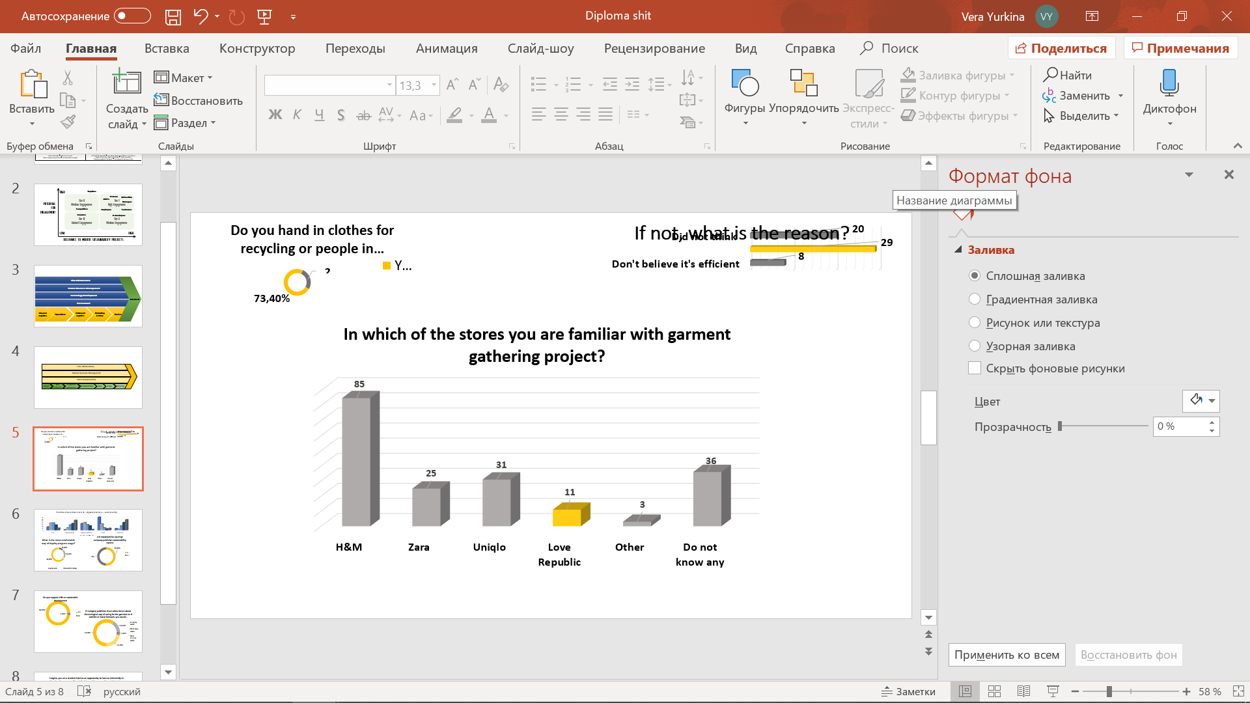Nevertheless, this program directly addresses sustainability and closed loop economy, that could move company to another competitive stage, the brand does not cope with this initiative properly. By collecting responses of those who have already handed in the clothes and finding the feedback of customers on website there are several problems concerning this initiative. First of all, the most obvious is that there is no information for people in the boutique that company gathers clothes. Lack of promotion significantly decreases the chances to collect much garment. For example, in H&M there is a box nearby the cashier that told that “here you can hand in the clothes”. In Love Republic there is not such information. The only way you an know it is finding the post on Instagram dated the beginning of September or on the website in the window “LOVE 2.0.” what is not easy to find. Figure 2 below represents the results of the questionnaire conducting. From the histogram it is clearly seen that most of the respondents are not familiar with the Love Republic’s initiative, however our brands are familiar to public.

Figure 2. Results of the questionnaire about the awareness of garment gathering

Next issue is that personnel in the shops are not rather aware of the program. Some clients wanted to give their garments ask additional questions and the only answer was “Read information on the website”. Moreover, when someone hands in the clothes they are not always control the components of the bag, depending on the cashier who takes it. This also indicates the low level of awareness among staff. Additionally, when people start this exchange the process of QR code identification is rather difficult. Firstly, person need to download Love Republic app on his or her smartphone, then register there. Afterwards, the downloading of QR-code identification program happens. So, the process that could be done in 2-3 minutes takes up to 10 or even longer. Thus, many customers, who are unwilling to wait just drop the idea. Next problem that arises is that bonuses are nulled before the issue of new collection. From the response of one customer[4]: she receives bonuses after garments handing, but as soon as she wanted to spend them it appears that her loyalty card was blocked. She admitted that this was coincided with the appearance of new collection. So, summing up, the idea of introducing such a program is rather beneficial for company if it wants to switch to the direction of sustainable development. The initiative can reduce the amount of CO2 emissions from the garments disposed and give a new life for clothes and materials. However, due to recent introduction it still has some challenges to cope with.

### Business Model Canvas

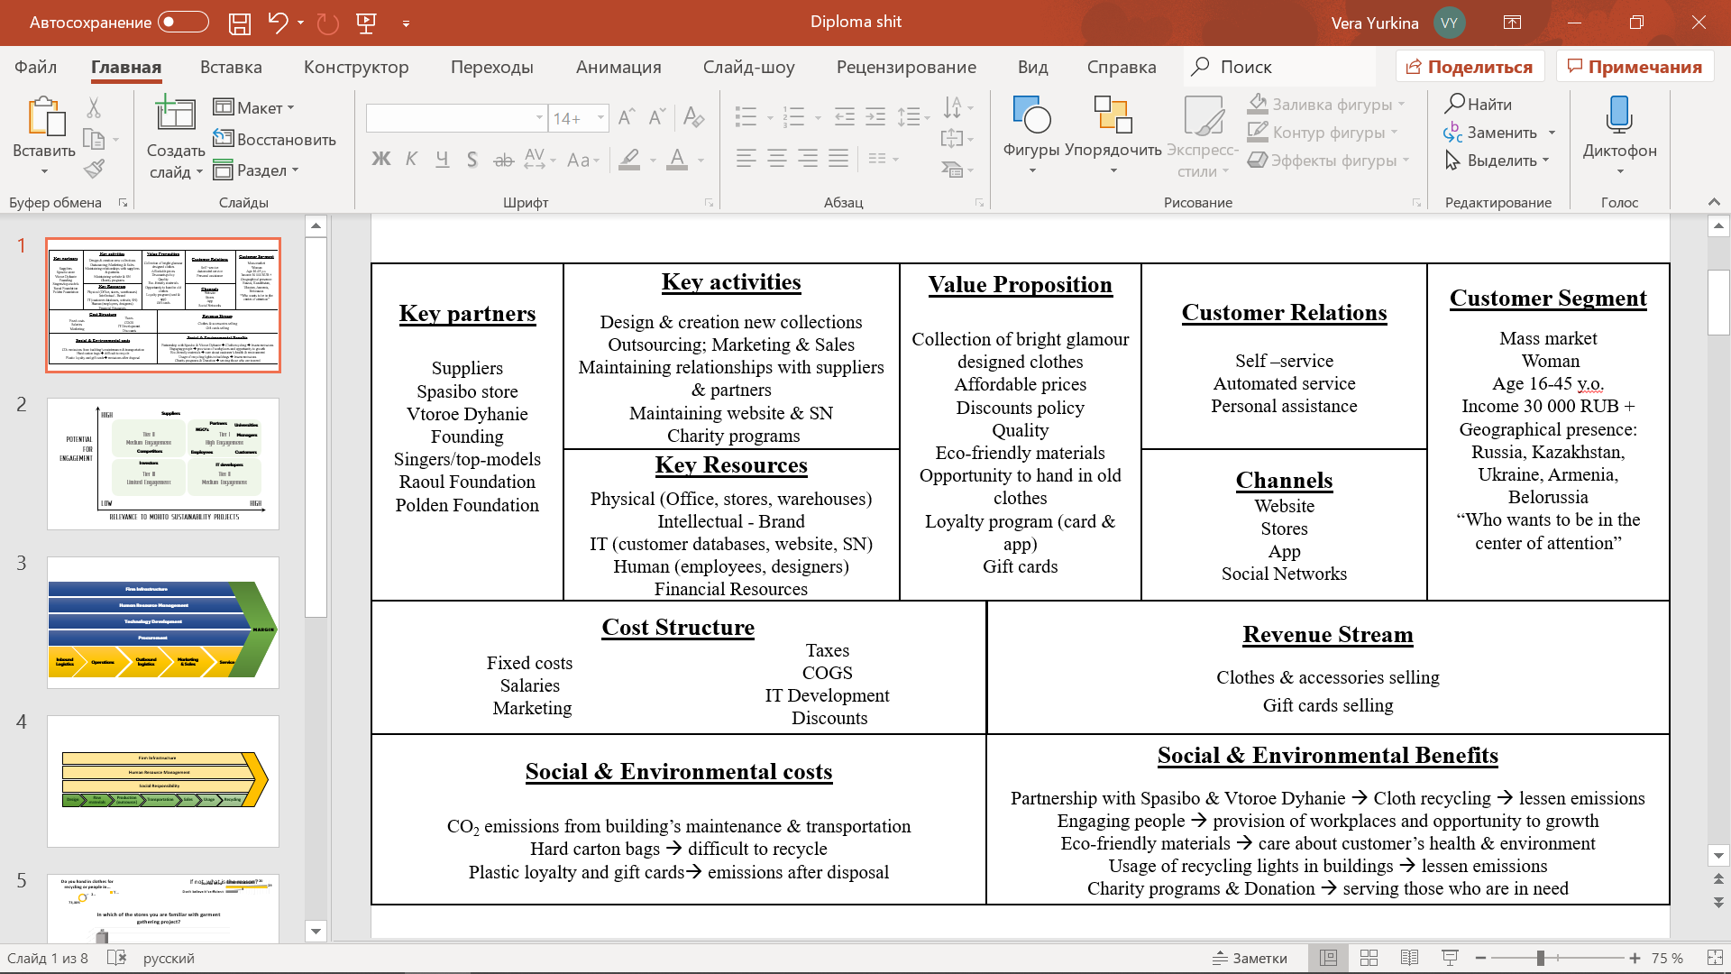Business model canvas is a tool introduced by Alexander Osterwalder and Yves Pigneur, which was adjusted by Aapo Huovila and Carmen Antuña by adding social and environmental costs and benefits that are produced by companies’ operations. As the original business model helps to describe the entire interaction between the company operations, understanding the logics and consequence how company makes profits. The discussion is built on 9 blocks that corresponds to the 4 main aspects of business development: customers, offer, infrastructure and financial viability.

Figure 3. Business Model Canvas for Love Republic[5]

Adjusted canvas also, emphasize the impact these processes have on the environment and society and build two more blocks for costs and benefits, respectively. Business Model Canvas for Love Republic is presented on the Figure 3 above.

#### Customer Segment:

Starting from the customer service building block that is responsible for defining the target group company reaches and serves, it is seen that company operates in the mass market with the focus on women segment. Love Republic’s main targeting group is women from the age of 16 to 45, who “wants to stand out the crowd and be in the center of attention”, as the motion of brand states. In terms of income of the targeted customers it varies from 30 000 rubles and higher. In terms of geographical segmentation, Love Republic currently serves 5 countries around the globe: Russia, Kazakhstan, Belorussia, Armenia and Ukraine.

#### Value Proposition:

The following block represents the particular product or service that company creates for its targeted customer segment. Thus, the main value proposition Love Republic offers to its target customer segment is creation and development of the high-quality glamour bright-designed clothes collection at the affordable prices. Also, Love Republic has discounts programs on the regular basis. Thus, any time customers want to buy something there always be discounts on some clothes. Moreover, company offers opportunity to be a part of the loyalty program to increase the percentage of discounts. The consumer can either have a loyalty card or download an app on his/her smartphone. Also, company provides gift cards with, which customers could pay for the purchase or make a gift to others.  
In terms of materials used, company offers its consumers the benefits of eco-friendly materials that are healthier to them and have less footprint for environment. Also, Love Republic creates an opportunity to hand in old garments for people. The clothes are taken on the cashier’s desk. Furthermore, garments are collected by the company-partner (Spasibo or Vtoroe Dyhanie) and then distributing according to its condition: clothes that are in a good condition are transferred to charity shops for further reselling, while those in bad condition are transferred to recycling companies.

#### Channels:

The next building block – channels, is used to describe the ways how company interacts with its customer segment and reaches it to deliver a value proposition. Thus, for Love Republic there are 4 channels, all represent direct ones. For the face-to-face interactions company has stores around the served geographical segments, where customers may purchase clothes, gift cards or obtain loyalty card as well as hand in the clothes for reuse or recycle. Next channel is Love Republic App, which facilitates online sales of clothes and is used to obtain discounts from the garments gathering. Website is serving for raising the awareness about brand, online communication with customers, and obtaining information about the latest news about company. Social Networks as Vkontakte, Instagram or Facebook are used in order to have online interactions with customers.

#### Customer relations:

The following building block represents the types of relationships company build with its customer segments. Thus, company provides personal assistance that is based on the direct interactions between humans. Thus, customers are free to communicate directly with company representatives both offsite and online. In terms of self-service company establishes online sales where consumers can purchase without the communication with company’s representatives. Automated services allow customers to benefit from the customized services on the website, where after purchases it would offer clothes that are likely to be in the same style that customer prefers.

#### Revenue Stream:

This block shows the monetary reward, profit company generates from the segment it targets. It is obvious that the biggest share of the revenue generation goes to clothes and accessories selling both online and in-store, what is the main activity of the company. Secondly company generates revenue from selling gift cards the price of which varies from 1 000 rubles to 15 000 rubles.

#### Key resources:

The Key Resources building block indicates the crucial resources the company need to make the business model work, thus, to deliver value to customers, support channels and maintain relationships with customer segment. The resources required are spread to four categories: Physical, Financial, Intellectual and Human. Starting from the physical assets Love Republic requires facilities as office, that is located in Saint-Petersburg, warehouses and stores in the countries where it operates. Intellectual resources obviously include brand and IT systems. IT, therefore, includes customer databases, social networks accounts and website. Human resources are employees that work in stores and warehouses, designers that creates clothes, managers and IT specialists, which maintain IT systems. Financial resources include cash required for maintaining operations.

#### Key activities:

The following building block describes the main operations company should perform to make the business model work. It includes the essential actions for successful operations, moreover, they should also correlate with the Value proposition, channels and customer relations. So, obviously the main activities of Love Republic include the production of the clothes, which starts from the idea development by the designers in the Saint-Petersburg office. Then, when the design of new collection is ready, company send it to its suppliers for outsourcing the production. Next stage is provision of marketing campaign to promote new collection as well as start its selling. Complemented activities include maintaining relationships with suppliers and partners to ensure the compliance with Code of Conduct. Also, it is important to support constantly website and social networks to have constant dialogue with customers.  
Moreover, for additional activities that company performs is constant provision of charity programs, that include blood donation, charity and support children from orphan houses.

#### Key partners:

The Key Partnerships building block shows the networks of suppliers and partners that company work with to deliver the value proposition to customers. Key partners of Love Republic could be divided on four categories, the first one is suppliers the company work with. Nevertheless, there is no precise names of the organizations, from the interview with its partner, Mikhail Krivonos, representative of Raoul Foundation, the main suppliers of Love Republic are located in Asian countries as India, China, Bangladesh etc. Secondly, company collaborates with show-business representatives to be ambassadors of the brand and take part into marketing campaigns. Thus, through years brand has successfully collaborated with such famous people as Vera Brezhneva, Nadezhda Granovskaya, Viagra, Naomi Campbell, Irina Sheik, Vanessa Hessler, Emily Di Donnato and current representative of the brand - Alessandro Ambrosia. The third group of partners are those that help Love Republic to implement Love 2.0. initiative that is aimed at cloth gathering. These partners are Spasibo company and VtoroeDyhanie Foundation. The last group represent foundations that collaborate with Love Republic to provide support for children from orphan houses to find their future career path. These partners are Raoul and Polden foundations.

#### Cost structure:

This building block describes the costs that incurred within the operations of Love Republic. Among fixed costs, company has those that requires payment for rental the stores and warehouses, lightning, energy and water in all the facilities. Moreover, the permanent cost are payments of salaries to employees. Additional costs are required for marketing and IT development in order to support the current operations. Main cost is incurred into Cost of Goods Sold, procurement and production. However, additional costs also include those that goes to discounts on loyalty programs and tax payments as well.

#### Environmental and social benefits:

The next building block is added to the common Business Model Canvas it represents the benefits for society and environment that company has within its operations. Thus, the prime social and environmental benefit the company has is it partnership with Spasibo charity shop and VtoroeDyhanie foundation that reduces the emissions of CO2 to the atmosphere and also, give clothes new life in charity shops. The profit from Spasibo, for example then goes to charity.  
Partnership with Raoul and Polden creates workplaces and engaging children from orphan houses, thus targeting those who are in need to be employed.  
Usage of eco-friendly materials for clothes and packages mitigates the amount of CO2 emissions while usage by customers as during washing or dying as while disposed. Usage of recycled lights in the offices also lessens emissions and energy consumption in the company’s office.

#### Environmental and social costs:

The last block is dedicated to the costs and negative footprint companies’ operations create for society and environment. The biggest share of negative footprint company’s operations creates from the facilities. Thus, energy and water consumption create the amount of CO2 emissions that harms environment. Moreover, the bags company uses are made from carton, but still are not positive for environment due to amount of chemical paint on it. Moreover, usage of plastic cards for loyalty program and gift ones also extract emissions when disposed.

### Value chain of Love Republic

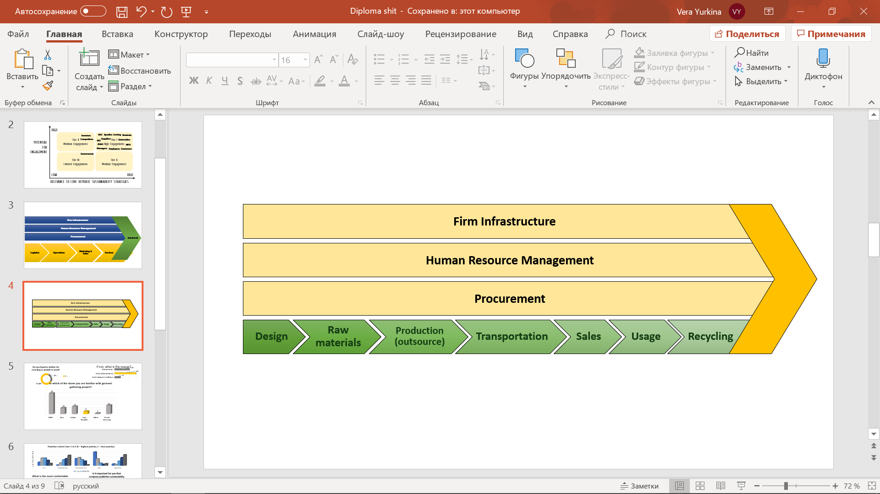Love Republic has already started implementing some of the practices to achieve sustainability. In order to better understand these practices along the processes of value creation. For this the value chain introduced by Michael Porter[6]. The value chain of Love Republic has 3 blocks of supporting activities: Firm Infrastructure, Human Resource Management and Procurement. Technology Development stage is absent in Love Republic Value chain because brand has no vertical integration and does not owe own production facilities, thus there is no improvements of the production process that could be done by the company. Along the primary activities there are 7 stages (Figure 4). All the process starts from the design stage, where the models are created, and the required materials are chosen. Then, the identified raw materials are offered. Next, company send the designs to its suppliers where the garment is produced and further through the transportation is delivered back in Russia and distribute it through its centers. Then, clothes are sold in the company stores or online. Finally, company has introduced garment gathering initiative – Love 2.0. which creates recycling stage.

Figure 4. Value Chain of Love Republic

#### Firm Infrastructure

Firm infrastructure includes provision of transparent sustainability reports as well as financial reports. Also, it includes actions considering provision of the amount of resources used and emissions that are generated by the company. Nevertheless, company provide only two or three financial indicators in its separate section inside Melon Fashion Group Report. There is no differentiation among brands when MFG reports its financial performance. In terms of sustainability reporting neither Love Republic nor Melon Fashion Group publish any information. Companies has introduced CSR activities as charity programs and donations. Also, it stated to use eco-materials, however there is no precise names of such materials. Overall, it could be stated that company does not do a lot in terms of transparency reporting.

#### Human Resource Management

In terms of practices concerning human resources company has been working with employees, training them and ensures following the norms of sustainable development. In terms of employees, there is no information about the practices company has towards training or treatment. Moreover, in the report it is stated that next year company is aiming at provision personnel training and development. It is planned to pay more attention to newcomers and managers as well as to development and promotion of corporate culture. Overall, company still does not provide relevant information.

#### Procurement

This stage contributes to the choosing sustainable and socially responsible suppliers, their training and ensuring to comply with Code of Conduct. In terms of relationships with suppliers’ company is written to monitor that relationships follow Code of Conduct and company tries to achieve it. In terms of compliance with Human Rights there is no information in current sustainable report of the group. The same as with employees, company seems to follow the sustainable requirements of suppliers’ treatment but has not approvals to do it.

#### Design

Moving to the primary activities and starting from the design stage company still has no significant initiatives to reduce negative environmental impact and move towards sustainable development. The actions implemented in this stage include the development of ideas and the creation of the list of materials to use further in the production process.

#### Raw Materials

In the report of the group it is stated that company is using eco – materials in their production such as eco-skin that is posted in their online store.[7] It is stated that these materials are better for health and environment aiming at achieving #3,#6 and #13 sustainable goals. Nevertheless, there is no precise information in the report about the type of material used. It is known that company has not use cotton much in the collections, the resource is used only for T-shirts production. Thus, organic or better cotton are not the materials used by Love Republic. The lack of transparency creates misunderstanding concerning the relevance of eco-materials.

#### Production

The production process is done outside Russia, thus after deciding on design and materials needed for model to be alive the required materials are transferred to the suppliers where the garments sewed. Thus, the production process is outsourced. Nevertheless, Company has no information about the activities to monitor supplier’s compliance with Code of Conduct or Human Rights as well as no information about the sustainability level of the suppliers. The only thing is that major supplier country of Melon Fashion Group is China (up to 85%) and by this it can be stated that the greatest part of Love Republic supplies also count on this country. The second supplier is Bangladesh with near 10% and the others are India, Uzbekistan, Vietnam, Russia, Kyrgyzstan having less than 5% of the total share of production[8]. Thus, it can be stated that China is the main supplier of Love Republic.

#### Transportation

Most of the logistics of the company (52%) is done through the railway services. Second most used transport is ships or sea-delivery (30%). Also, company uses air transportation (14%) and truck one (4%)[9]. Any transport used creates a significant amount of emissions negatively influenced environment. However, company has no information about the existence of practices to reduce this impact. So, there is a possibility of absence of any.

#### Sales

Sales stage includes marketing activities to promote the products as well as sales process and customer relations. In terms of marketing, there is a poor awareness about the LOVE 2.0. program and not so many know about the possibility to hand in clothes. Secondly, the packages company uses is made from carton what reduce the negative impact while disposed, however still have a lot of chemical dyeing and by this increase the impact and threat to health of people.

Moreover, company uses plastic loyalty and gift cards that created a negative impact as well while disposed. According to the report, in 2018 company has issued 574 469 new cards. The share of checks made with the loyalty card accounts to 90%, meaning that company’s loyalty program is working. Thus, company need to implement practices to reduce the impact from the cards.

The immense environmental impact comes from the buildings’ maintenance. It includes electricity and water consumption and CO2 emissions in the office and stores. In order to influence this and reduce the environmental impact and address #7 (Renewable energy) and #13 (Climate Action) sustainable goals. To do this company has already introduced ECO-lights into the stores that could be recycled. Moreover, in the Melon Fashion Group said that the offices of their brands are made from the wood and eco-materials.

#### Usage

During usage stage garments are in total ownness of the customers. Company has not provided any advice to help to care about the product to prolongate its lifecycle. Neither there is no information provided about the sustainable usage of the garment, it recycles or disposal.

#### Recycle

Currently company has started the initiative 2.0. which made company closer to the introduction of the closed loop economy. Through the partnership with Spasibo company has prevented disposal of almost 6 tons of garment and manage to keep them life. It is expected that bad-conditioned clothes will be transferred to recycling and then back to production. Nevertheless, company has started targeting #12 sustainable goal which is rather crucial for this industry.

### Summary of the company overview

After analysis of Business Model Canvas with the focus on Environmental and Social impacts from the business operations, it is clear that Love Republic has already started its first moves towards sustainable development. Company has successfully introduced social events targeting children from orphan houses and donating blood. Moreover, company has started to gather clothes in its stores, however, the results are not quite pleasant, because many customers are not aware about the existence of such an initiative and others face unawareness from the side of employees. In terms of environmental issues, company has introduced eco-friendly materials usage, however there is no information about precise suppliers or raw materials used.   
However, in terms of partnerships company partnered several foundations that help it to achieve social goals. Thus, it could be said that company has some practices towards development it Corporate Social Responsibility through charity and children focus, as Sustainable Development through practices along value chain.

In terms of the goal targeting, company has started and is on the beginning of the way of achieving #7 (Renewable energy), #8 (Decent work), #10 (Reduced inequalities), # 12 (Reasonable consumption) and # 13 (climate action) sustainable goals. Also, probably company strives to achieve #3 (Good health) and #6 (clear water) goals, however due to the lack of transparency it is rather hard to trace.

## Apparel Retail Industry analysis in Russia

Love Republic is a brand owned by Melon Fashion Group company that is a prominent representative of apparel retail industry in Russia. Apparel retail include manufacturing, distribution and selling clothes, footwear and accessories. Clothes retail industry is the second large consumer industry in the world after goods & staples retail one. The Russian apparel retail industry has grown by 5,4% in 2018 against 2017 and achieved $42.7 billion. However, according to MarketLine analysis[10], it is forecasted that industry would reach a value $50.9 billion, what is 19,2% more than in 2018. In terms of segmentation, the major part of the sector is obviously taken by the womenswear, which accounts for 60,1% of the industry. Whereas, in terms of geographical segmentation Russia accounts for 10,3% of the European apparel retail sector value.   
Russian fashion retail industry consists of large number of local as well as international actors. Due to relatively low diversification among players the degree of rivalry increases. International players presented in Russia are Inditex (Zara, Stradivarius, OYSHO etc.), Colin’s, H&M, Adidas, Nike LPP (Mohito, Reserved, Cropp, House). Local companies are Melon Fashion Group (Sela, befree, Love Republic and Zarina), Incity, Ostin, Sportmaster, Gloria Jeans etc. Many of these retailers have strong networks of stores and thus, have introduced online platforms as part of multichannel platform and thus, also, competes with online retailers as Wildberries. Nevertheless, healthy growth in the industry mitigates the competition and increases the possibility of positive sum-game.

In terms of sustainable development apparel industry is challenged to be one of the industries that highly influence climate change. Due to it highly negative environmental impact and extremely increasing pollution caused by the amount of CO2 emissions from all the stages along value chain and from the chemicals used. Moreover, industry is highly resource-intensive, it requires a lot of water and energy to consume along the value chain that would be analyzed later. The significant areas of water and energy input are raw materials cropping, production and usage stages of value chain. In other terms, the challenge is that industry has significant negative influence on climate change and environment in general.

Nowadays there is an increasing trend on switching from ‘take, make, dispose’ economy to introduction the closed loop or circular economy within the company’s operations. The main goal is to introduce such a business process to maximize resource efficiency. Thus, when the lifecycle of the product is coming to the end and disposal it would be either reused or recycled. Apparel industry is not an exception. Thus, many companies of fashion world have already introduced recycling boxes in order to gather old clothes and collaborate further on with organizations either to recycle it or transport to charity and second-hand shops. As a result, resources from the recycled fibers are input back to the production stages. This is how circular economy is created. However, the other side of this stage is that the production volumes of the garments are huge, whereas the capacity to recycle all the amount gathered is not enough.

Another trend in the industry in favor of sustainability is that consumers became more aware and more discerning in choosing the garments. Nowadays the price is not always the most important factor in decision making, thus price wars of the competitors would not always work well to gain competitive advantage. Indeed, customers tend to choose clothes based on the materials used in the production and its quality. Thus, sustainable companies tend to win this competition on the market. So, in the apparel industry it is highly essential to switch to sustainable business conducting.  
Another challenge that exist in the apparel industry that almost all suppliers are from the poor countries in the world. One of the aspects of sustainability is to ensure the absence of violation the working conditions and inequality issues and to ensures the fair wages and opportunity for employment. Thus, most of the companies in the industry strives to provide the transparent information about compliance with Human Rights Standards, Code of Conduct and Sustainability Principles.  
Also, the challenge is that the industry is highly competitive. Russia has more than 100 brands serving the market. However, the giants take the biggest share. In Russia, the giants are Hennes and Mauritz, Inditex and Gloria Jeans. However, the latter, does not implement sustainability practices in the business processes.

### Market overview

Over the history apparel industry in Russia has grown significantly and, according to MarketLine forecasts, it is expected to continue this trend. Ruble is rather volatile currency since it has recovered since 2014. Last decade Russian economy increased import tariffs, even restricting some products to import. Also, the inflation was increased because of the sanctions imposed be the international community. Thus, many fashion retailers exited Russian market as New Look or River Island. Nevertheless, the compound interest growth rate (CAGR) between 2014 and 2018 is 4,6%, however the revenue increased on 5,6% compounded to $42,7 billion or ₽ 2 684,7 billion.

On the Figure 5 there is seen the increasing trend of the total revenue gained by the apparel companies in the period since 2014 till 2018. It is important to mention that in some previous reports of MarketLine the data of the revenue represented in dollars and euro might be different due to difference in the exchange rate. Thus, in annual reports MarketLine adjusted the data due to valuations in order to facilitate the comprehension

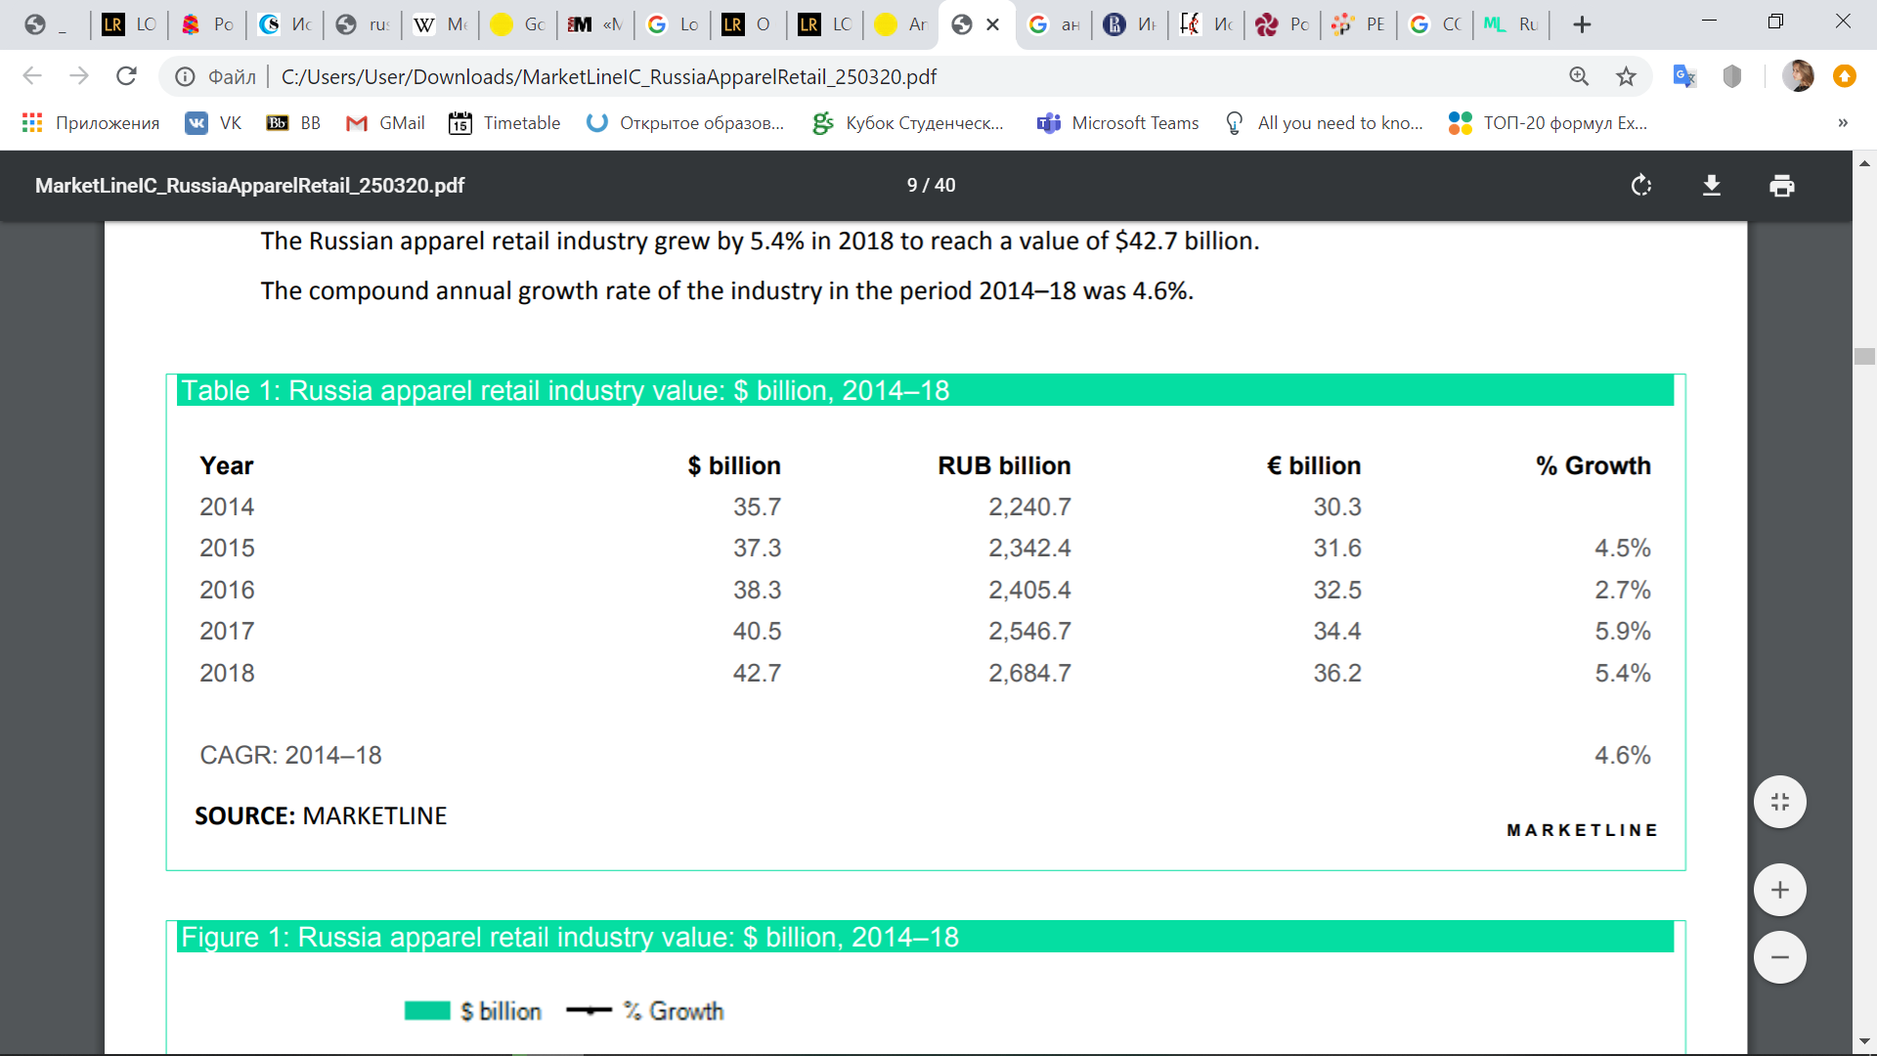Figure 5 Russia apparel retail industry value 2014-2018[11]

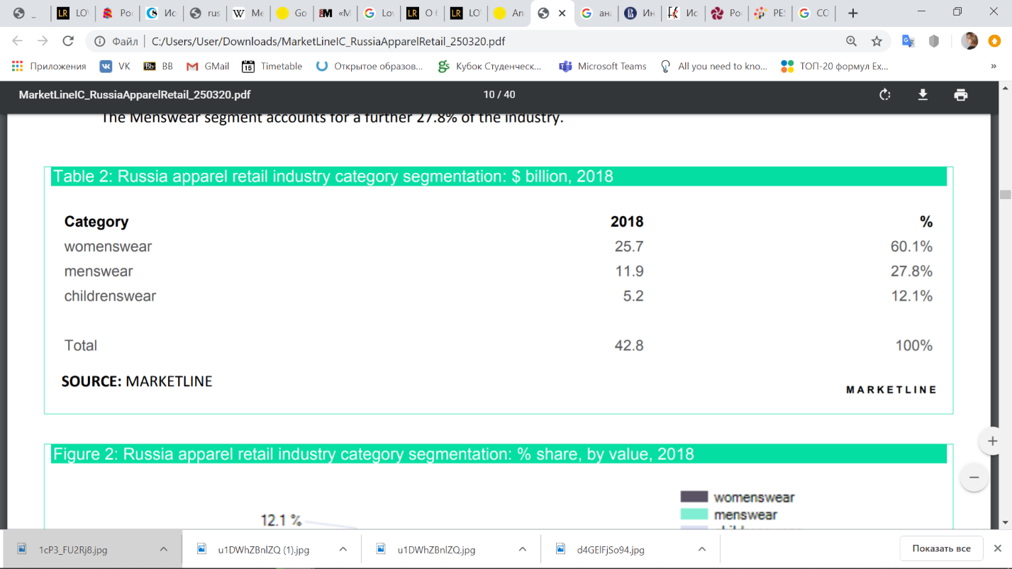As it was previously said that womenswear segment, what Love Republic is actually targeted on, is the biggest in the industry and thus the most lucrative one. The revenue of this segment accounts for $25,7 bn, what is equal to 60,1% of the overall value in the industry. The Figure 6below shows this distribution, where 27,8% and 12,1% are gone to menswear and children swear, correspondingly. Thus, companies targeting women are represent the greater share in the market and have more opportunities for profitability.

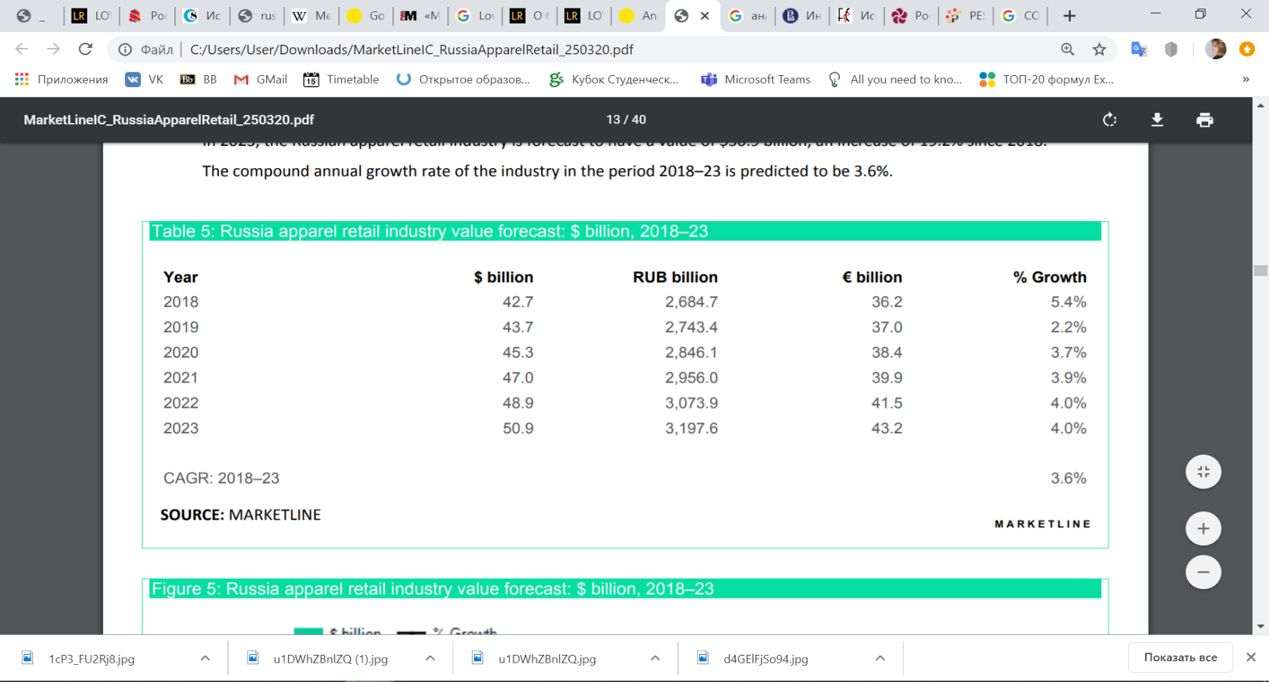Figure 6. Russia apparel retail industry category segmentation in 2018[12]

Figure 7. Russia apparel retail industry value forecast till 2023[13]

In recent years customers started to switch on online shopping, that has also impacted apparel retail industry. This type of shopping creates such benefits to customers as convenience, cheaper prices, wider variety and possibility to buy from any part of the world. Thus, nowadays online channel of distribution accounts for 4,9% of total industry value, also influencing the further growth of the industry as a whole. Nevertheless, the trend on online shopping is increasing, the specialist retailers managed to remain the dominants in Russia, accounting for 73% percent of the industry value. Indeed, those retailers who were able to introduce both channels, now benefit from presence on online and physical stores, and drive their sales correspondingly.

According to the forecast made by MarketLine on the Figure 7 the industry growth is expected to decelerate and achieve $50,9 bln. industry value by 2023, with corresponding CAGR of 3,6% for 2018-2023. Also, it is expected that the online channel would raise its popularity. From the side of consumers, report indicates that they are expected to be more confident in their spending and thus stimulate the industry growth due its convenience and unbeatable prices.

### Macroenvironmental analysis

Analysis of external environment is performed in order to indicate potential opportunities and threats for companies of the apparel retail industry with respect of the highly volatile and unpredictable environment.In the analysis I use two tools. First one is PESTEL analysis, which is performed in order to estimate the current situation in the country throw different perspectives and understand the impact of factors on the industry. Next tool is Five Forces Analysis introduced by Michael Porter. It is used for analysis of the industry in particular, considering the dependence and threat from stakeholders, namely buyers and suppliers, competitors, new entrants and substitutes. It also includes the competitors’ analysis for estimate the degree of rivalry in the industry on the basis of comparison of sustainability practices implemented by local and international brands presenting on the Russian market.

#### PESTEL analysis.

For indication the environmental factors that directly or indirectly affects the apparel industry I performed PESTEL analysis, Harvard professor Francis Aguilar. Each section is devoted to one of the letters in the abbreviation: Political, Economic, Social, Technological, Environmental and Legal. The factors are assessed considering future prospects of their change as well as the degree of influence on the industry and its players. The Table 1 represents the summary of the factors corresponding to the areas of influence.

|  |  |
| --- | --- |
| **Political**   * High level of perceived corruption index * Power Stability * Membership in world organizations | **Economic**   * Decrease in economic activity * Inflation rate and ruble devaluation * Increase in dollar to ruble exchange rate |
| **Social**   * Decrease in population size * Health consciousness in the society * Social trend towards sustainable lifestyle | **Technological**   * Rapid digitalization of businesses * Popularization of online shopping * Trend on distant work and education |
| **Environmental**   * Coronavirus pandemic * Raising importance of sustainable development * Climate change * Air & water pollution | **Legal**   * Restrictions towards cross border transportation (temporary) * Employment law’s restrictions towards inequality * Consumer protection law’s regulation towards stakeholders’ relationships * Compliance with service standards |

Table 1. PESTEL Analysis for Russia

##### Political factors:

Corruption level [14]: Recently, the international anticorruption movement Transparency International has published the results of Corruption Perception index for 2019. CPI is composite index, which shows the level of perception of corruption in different countries. A country is estimated by several experts and entrepreneurs on the scale from 0 to 100, where 0 is the highest level of corruption perception and 100 the lowest. Russia has gained 28 score and placed number 137 out of 180 in the Corruption Perception Index. So, as soon as Russia has only 28, the same score as last year, it means that Russia has relatively high corruption level. The average score of all countries is 43 score. Thus, Russia has higher than average corruption perception level. It is forecasted that during next year’s Russia would have quite the same score, because the trend from past shows that during previous 5 years the score is rather the same. Moreover, Russia has not ratified the Civil Law Convention on Corruption, which requires member states to take some actions to combat corruption. Thus Russia, could introduce the possibility of receiving compensation from the state for a person who has suffered or damaged because of the corruption. In a country where corruption flourishes, for businesses it is hardly difficult to achieve a fair trial or other legal protection against abuse or fraud. That is why it is important for country to have strong and independent juridical system, which could eradicate corruption.

Power stability: Russia is also a presidential country, which has unchangeable president for almost 20 years. Moreover, in the analysis of ControlRisk[15] it is stated that around 55% of Russians noted that they would like to see Putin remaining on the presidency after 2024, and 43% do not see a viable alternative candidate for the presidency. Russia is a rule-of-state country. In the basis of state power there is a principle of division legislative, executive and judicial power. All the actions are regulated by different laws, Constitution and Tax Code of Russian Federation. Additionally, it is probable that in prospect future the situation is not going to change a lot, because recently Vladimir Putin has signed the law on amendments to the Constitution of the Russian Federation, which will allow him to continue to remain in power till 2036[16]. This factor can have a slight positive impact on the industry because the stability of the ruling body assures the stable economy and minimizes risks considering changes in economic policies.

Membership in world organizations: Russia is a member of many international organizations, that help the country to remain competitive on the market and support favorable relations with other countries. Country is a member of WTO, CIS, UN, Eurasian Union and many others international cooperation. Being a member of such organizations could affect as positively as negatively on the fashion company. Firstly, membership of such organizations provide opportunity for international relationships and trade facilitating as well as easiness of entering new markets. The reason is that countries who are engaged in organizations somehow often share the same set of rules and regimes and this facilitates the globalization process.  
From the other side these organizations create an adversity for apparel sector being captures by the international firms. Consequently, domestic countries can lose their share in the market as well as loose its competitiveness.

##### Economic factors:

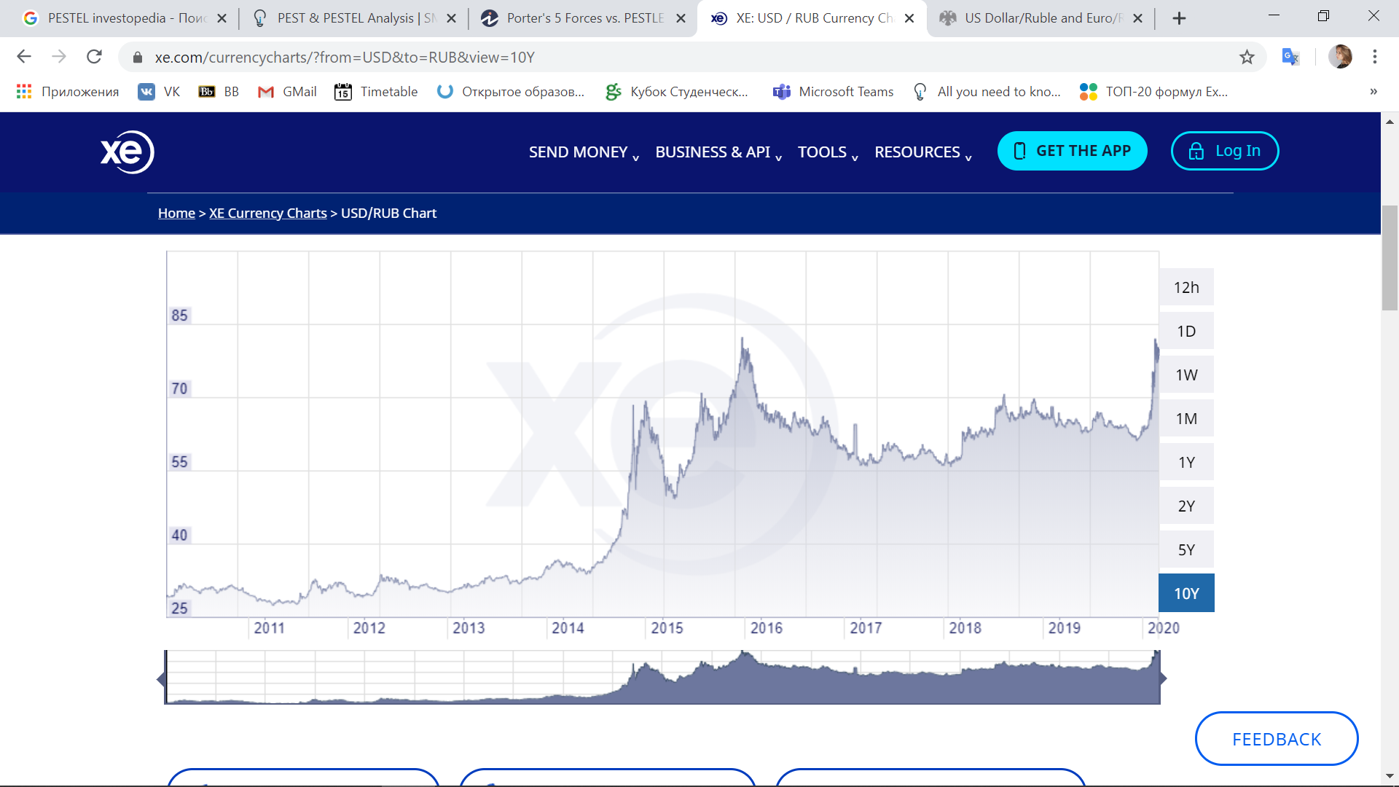Increase in Dollar to Ruble exchange rate – in the begging of 2020 there was a sharp increase in dollar to ruble exchange rate due to the drastic drop of oil prices. Thus, in the end of the March 2020, the exchange rate was 80,4 Rub per 1 USD. Comparing to the same periods in 2 last years, the indicator was 64,8 and 57,2 RUB per 1 USD in 2019 and 2018, respectively. This leap consequently affects the consumers’ price and would negatively affect the customers’ purchasing power. However, from the chart on Figure 8[17] it is seen that during last 10 years the increasing trend of exchange rate takes place, with 3 more shock in 2014-2016 years. Thus, there is a probability that during the year dollar exchange rate would be slightly lower as a recession after shock.

Figure 8. Dollar USD to Ruble RUB exchange rate 2010-2020[18]

Inflation rate and ruble devaluation: This year is full of unexpected events that lead Central Bank to the decision about changing yearly key inflation rate up to 6%. The first half of 2020 is developing against the previous years forecasted scenarios. Because of the increased epidemy of coronavirus, that would be discussed into environmental part, and oil prices’ drop – ruble’s devaluation that was recently mentioned appeared and now it is “proinflation” driver. Nevertheless, Central Bank expects yearly inflation rate to return to 4% in 2021, however in 2020 inflation is expected to be temporarily higher and the boost of inflation will be in nearest months. Ruble devaluation would cause increase in consumers prices and by this decrease is external and internal demand, which will affect as a ‘desinflator’ and holdback a recession to achieve prospects in 2021. However, it is hardly difficult to predict and make forecasts nowadays, monetary policy in Russia is aimed at improving the welfare of Russian citizens. The Bank of Russia implements monetary policy in the framework of the inflation targeting regime, and its priority is to ensure price stability, that is, to achieve stable low inflation. Thus, Central Bank would adjust its forecasts as soon as situation would become cleaner. However, after the drop of oil prices and coronavirus pandemic – there is high possibility for crisis to appear. Last time, when economic crisis was, the apparel market has dropped on 33%. The most affected segment then was middle price segment, which was the most massed.

Decrease in economic activity – according to the same challenges that modern faces currently, especially spread of coronavirus epidemy and by this introduction of restrictive measures for cross-border transportation and sharp deterioration in the dynamics of global commodity and financial markets - the moderate growth of the Russian economy at the beginning of the year may be replaced by a decrease in economic activity in the coming quarters. Talking about current growth of economic indicators: recently S&P has reduced the forecast of GDP on 2020[19]. Thus, Russia is expected to enter into recession and the expected GDP growth from 1,8% to (-0,8%), however in 2021 the economy growth is expected to recover to 3,8%.  
By the end of February 2020, the unemployment rate in Russia has ‘updated’, as Central Bank[20] says, its historical minimum and achieved 4,4% and as Mintrud[21] forecasted that till next year this indicator will not surpass 4,7%. Increases of real disposable income by 1,5% and real wages by 2,3% would support the consumer demand, however in the situation with COVID-2019 the demand on many products and services decreased a lot. In terms of clothes and shoes industry, people are not so willing to purchase it because it is not the goods of prime necessity.

The dynamics of growth would be affected from the future scope of the coronavirus spread and the methods to prevent it and its consequences on the people’s activity and demand, which depend on the mitigation of governmental restriction measures. Thus, all forecasts could be adjusted as situation changes.

##### Social factors:

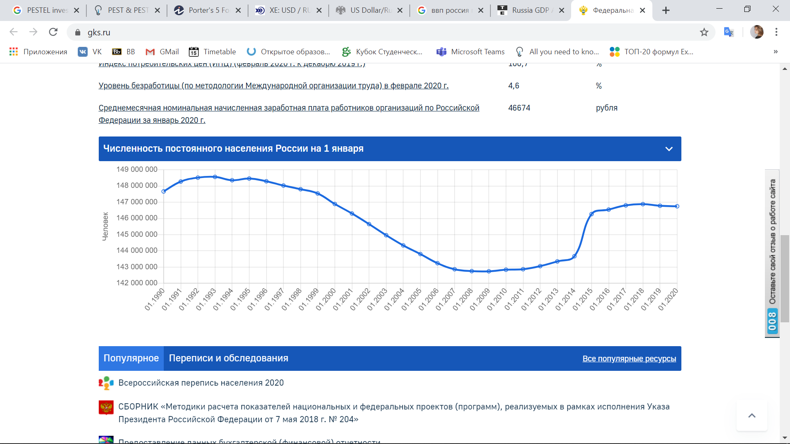Decrease in population size – on January 1st the permanent population of Russia compounded to 146 745 098 people, which is 0,024% lower than in 2019. The gender distribution is following: 46% men and 54% women Considering coronavirus epidemy there is a probability of further decrease in population. On the graph on Figure 9 it is seen the trend of population size from 1990 till 2020. So, till the end of 90s the population was much larger than in the first decade of 21st century. However, since 2015 the situation has started to recover. Rosstat has recently published a demographic forecast until 2036. The most optimistic scenario suggests an increase in the country's population to 150.1 million people by the beginning of 2036. The most pessimistic is the decline in the population to 134.3 million people. The most realistic option is that by 2036, 143 million people will live in the country. Due to current situation with coronavirus that was not taken into account for the period when forecast was made, the pessimistic one is closer.

Figure 9. Population in Russia from 1990 to 2020[22]

Health consciousness in the society– nowadays people start thinking about quality more than about prices when choosing clothes. If previously price was determinant factor, nowadays it is not in the priority. After conducting a questionnaire, where one of the questions was to range 5 criteria in the order of the priority from 5 to 1, where 5 is the most preferred, following results were achieved, that are presented on the Figure 10. Thus, it could be stated that people place quality more times in the priority position rather than price. While prices are mostly on the 3rd or 4th place, quality is on the 1st or second. So, people tend to buy clothes according to its feelings not price.

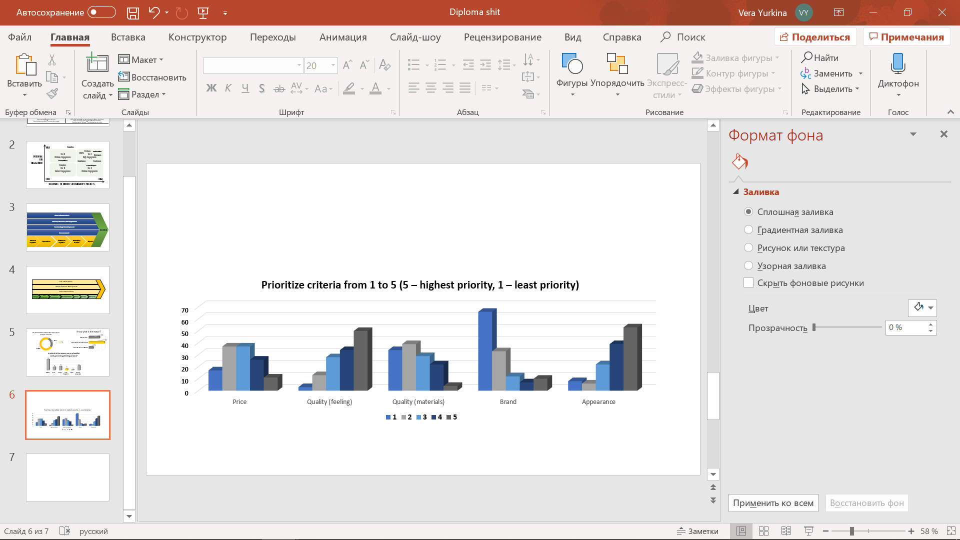Figure 10. Distribution of priorities while choosing clothes (Results of Questionnaire)

Moreover, Inc. Russia News[23] has recently published an article that confirms the social trrend on conshious shopping especially within younger generation that was strengthen by the pandemic. It is said that customers are willing to buy clothes which could be used longer. Thus, highlighting the importance of choice of sustainable clothes. According to the research of Business of Fashion[24] customers would change their preferences in a favor of weighted purchases and conschios choice of the cloths made from organic mterials. Companies that are targeting the sustainable development will be able to serve the bigger audience than even before.

Social trend towards sustainable lifestyle - people are willing to help its country to move on the more ecological way of living. After conducting a questionnaire, it was found that in terms of overall shift to sustainable and ecological lifestyle, the majority of responses were for, precisely 96,9 % (Figure 11). Moreover, it was founded that almost 74% of the respondents are already handing in clothes for further recycling (Figure 12). However, among left 26,6 % almost 60% said that they don’t hand in clothes because they do not know where they can do it (Figure 13). The same statistics was true about garbage distribution. However, in terms of garbage more than half admitted that they do not differentiate waste, but the reason is that they do not know where it could be done.

Thus, from the charts, it is possible to say that, population is willing to hand in clothes but not all are aware about the place where they can do it, or they don’t believe it is really matters. rom all this, it could be stated that society supports the transition towards sustainability.

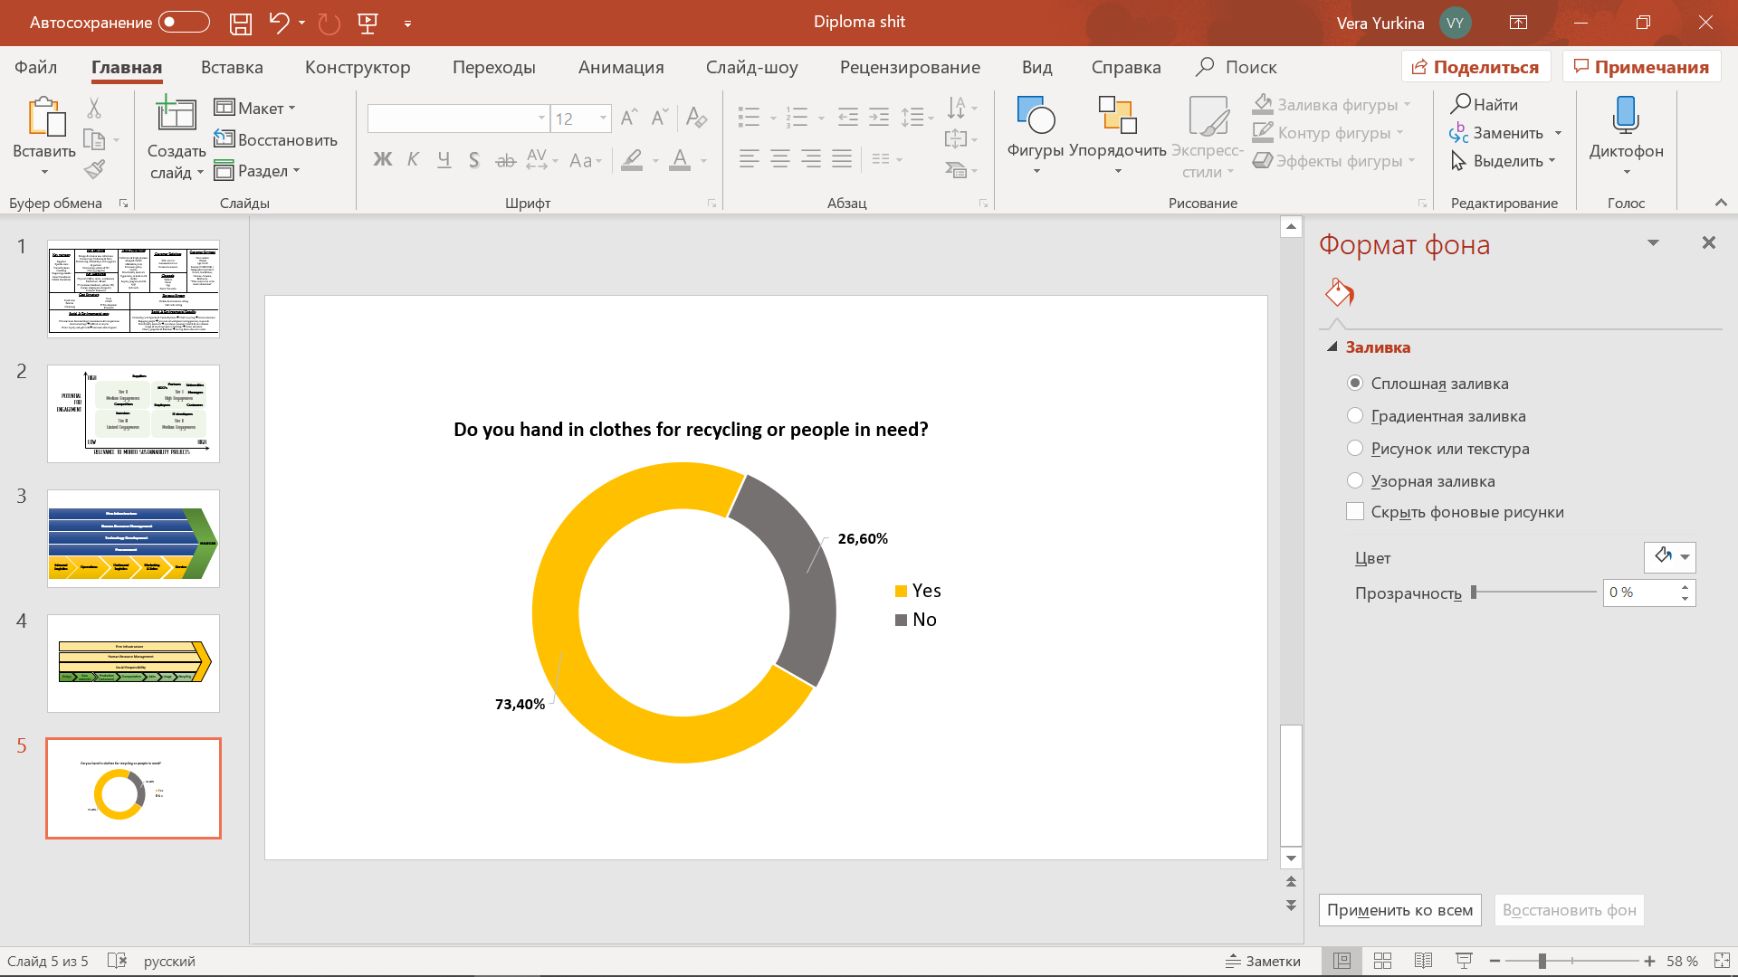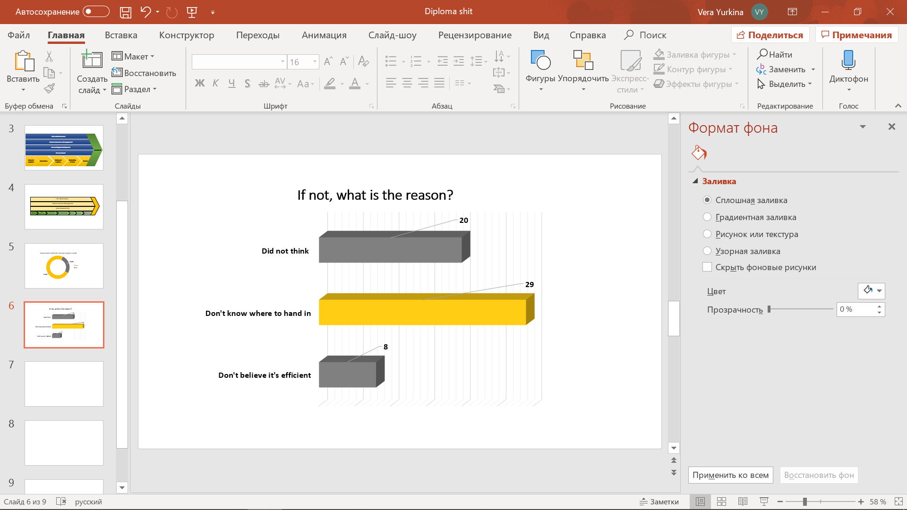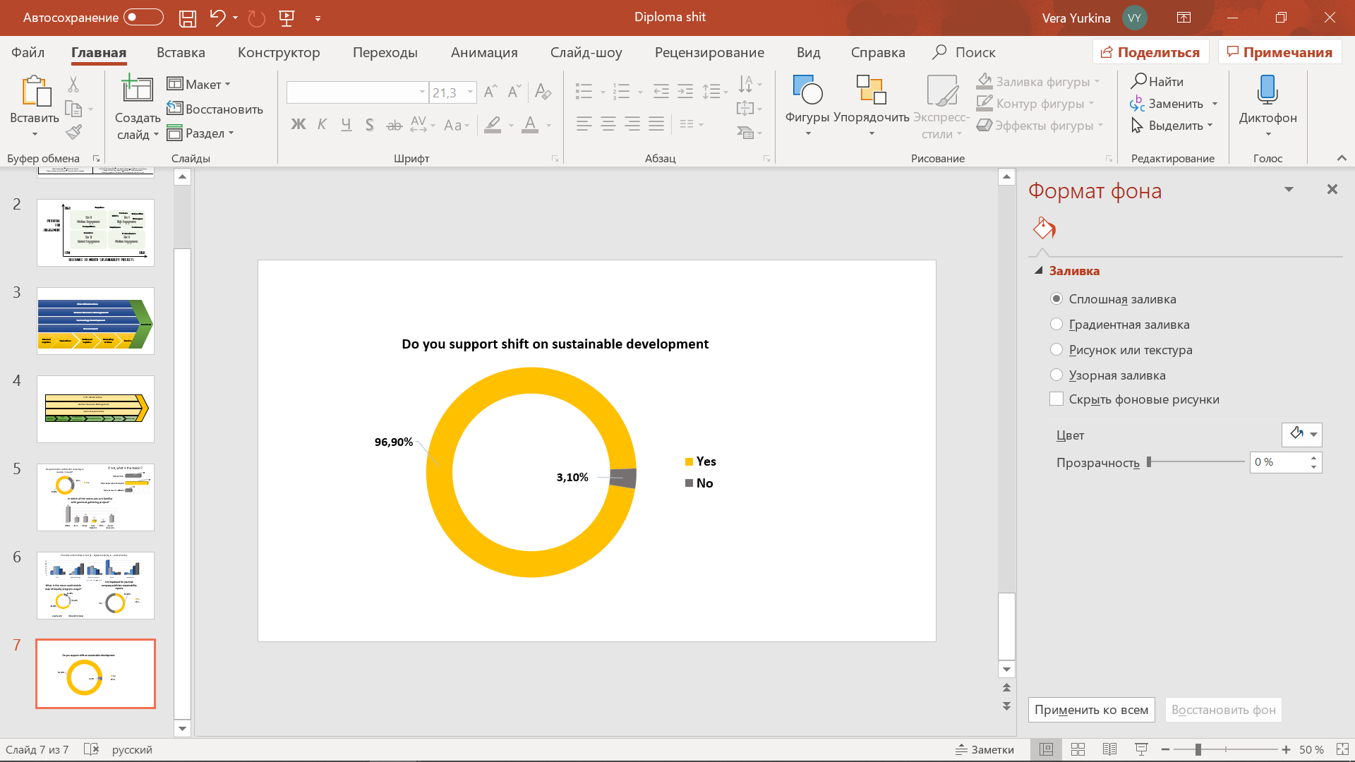

Figure 11. Distribution of answers on whether people for or against sustainability (Results of questionnaire)

Figure 12. Distribution of answers towards clothes' handing in (Results of questionnaire)

Figure 13. Distribution of answers towards the reason why not handing in clothes (Results of questionnaire)

##### Technological factors:

Rapid digitalization of businesses - in today's market conditions, to achieve success, it is important to be able to very quickly adapt business to innovations, modernizing not only the tools of production, but the old methods of communication, consumption patterns of goods and business processes. The digital revolution is taking place all over the world, almost all people use computer technologies to varying degrees, ranging from social networks, television and ending with the receipt of public services. Thus, digital business transformation has become the main condition for companies to survive in competition. It is developing in Russia since 2016. Digital products and services have been introduced almost in every industry as well as in fashion. Factor has a positive influence because provision of digital marketing increases the variety of sources to use.

Popularization of online shopping – because of this digitalization many companies who provide consumer goods and services started to introduce online shopping platforms and developing Apps that could be downloaded on their smartphone, from which they could easily but the cloth they want. Thus, online shopping is more competitive because it I more convenient, cheaper and you can make shopping from any part of the world. Such as coronavirus is the trend of environmental factors, it would be mentioned later, however in time when many people leave at home and do not want to make close contact with each other – online shopping is the best solution/

Trend on distant work and education – one more current trend due to strengthening of coronavirus epidemy is active adoption to the distant work and education. Even if flexible working out and ‘work-from-home’ were already used in the country for many professions, current situation made everyone adapt to it. Thus, many stared to provide educative video-classes, videoconferences for work. However, for apparel production is not a good way of market development because it is hardly difficult to sew new apparel from home, actually it is impossible because of the necessity of special equipment.

##### Environmental factors:

Coronavirus pandemic -currently is the biggest challenge around the globe. The COVID-2019 has appeared in the world so rapidly and unexpectedly, that now most of the countries move to distant work and education and need to adapt to absolutely new conditions. So, the virus has affected all sectors of life. As, it was previously mentioned because of coronavirus the economy is expected to recess, there appeared many restrictions towards movement and transportation, socially people are afraid going out from home and obviously their demand on purchasing clothes decreased significantly. The most significant issue, that even Russia has taken preventive measures there is still high uncertainty about what is going to be. So, making any forecasts concerning coronavirus epidemy is impossible. This is the situation, where companies must show their flexibility and adaptability.   
What is interesting is that there are several facts that prove the benefits of coronavirus, thus in Italy the canals became cleaner and dolphins return and in China the emissions lessened a lot. So, it proves that humanity is harmful for environment. So, it is expected that after the pandemic people would think more about their influence on environment and become active movers for sustainability.

Raising importance of Sustainable Development – in the end of 2015 UN has adopted 17 sustainable goals[25]. The main idea is to meet the needs of current population without compromising for future generations. Thus, it is said about rationality of resource usage. The goals serve so called triple-bottom line, meaning that the world should targeted three areas simultaneously in order to achieve sustainability: economic, social and environmental. The goals include issues as health, diversity and equality, infrastructure, energy, consumption, climate change, water and land ecosystems, education and partnerships for achieving sustainability. Many countries around the globe started implementing sustainability principles into their operations. As, UN stated that the progress is visible since 2015, however only 10 years left and the speed of achieving target is not at the expected scale. Thus, much companies should reflect about the transition to sustainable direction, especially from the apparel industry, which affects many spheres that could possibly have negative impact on micro and macroenvironment. Thus, fashion companies started to introduce closed-loop economy in order to reduce the amount of inputted resources.

Climate change – the factor that also affect all countries nowadays and affect life. Greenhouse gas emission now are at the highest level ever in history. Also, what is happening in the environment is the rise of sea levels and warming the weather. In terms of Russia the situation is even worth[26] because climate is warming 2,5 times faster than world average. The reason of this is that Russia is located into time zone where the surface of land surpasses the surface of the water. Other transformation is also happening, the amount of precipitation changes, circulation in the air and in the oceans. Thus, on December 25,2019 Russia signed the ‘national plans for actions’ in order to prevent climate catastrophe. Nevertheless, government expects that change will affect a lot, some regions would be more rainy, others drier, the amount of fires would increase – in any way it is a great adverse to all country and its population and another prove that Russia needs to take rapid measures towards moving to sustainable direction.

Air & water pollution – as a part of climate change, even the reason of it the pollution of ecosystems threatens not only to humanity but for the all live creatures. Oceans help environment to absorb around 30% of the greenhouse gas emissions and neutralize climate change. However, due to unconscious disposal of wastes and usage of fossil fuel in ship transportation ocean systems are now polluted and unable to manage with CO2 emissions.[27] The same effect has air pollution that is happening due to spread of chemicals and toxic fibers in the atmosphere from production, transportation etc. As it was stated that the area where Russia is located is that with surpassed land, so for the continent thee is even less effect from ocean neutralization and by this climate change is closer. Air pollution threats land ecosystem and humanity and could cause allergy and premature mortality. The conclusion is that Russia immediately should reconsider its actions towards climate change in order to preserve its population.

##### Legal factors:

Compliance with service standards[28] In the state standard of the Russian Federation R 51306-99 “Services for repair and tailoring of garments” provides a classification of services for repair and tailoring of garments, general technical requirements, safety requirements, acceptance rules, control methods, storage and transportation. The standard governs the requirements for customer service during the execution of the order, ensuring the safety of service and the safety of consumer property

Employment laws’ restrictions towards inequality[29] – Labor Code of Russian Federation includes different standards about the treatment of organization towards its employees. So, the basic ideas are that all employees must have equal rights, and nobody can be restricted in their rights as well as any discrimination must be avoided: nobody could be abused or contrast have some advantages due to his or her gender, race, religion, nationality etc. Moreover, there stated that that any extracted labor as well as child labor is forbidden.

Consumer protection law regulation towards stakeholders’ relationships [30] - The Law of the Russian Federation from February 07,1992 №2300-1 “On the Protection of Consumer Rights" regulates the relations arising between industry stakeholders: consumers and manufacturers, performers, importers, sellers when selling goods. Also, it establishes consumer rights to purchase goods or services of adequate quality and safety in terms of life, health, consumers’ and the environmental property. Moreover, it receives information about goods and services as well as their manufacturers (performers, sellers), education, state and public interest protection, and also determines the mechanism of realization of all rights, mentioned above.

Restriction towards cross boarder movement – as it has been already mentioned in economic factors previously, due to coronavirus spread Russian government has introduced restrictions towards cross-boarders transportation. Thus, many companies, apparel retail as well, should reconsider its import and export of raw materials and fabric. Nevertheless, it is a temporary measurement there is no forecast when boarder will be opened

Thus, activities in the field of clothing production are regulated by many laws and standards that have a direct impact on the development of the industry in the country.

#### Summary of macroeconomic analysis

From the analysis it is seen that currently coronavirus epidemy is the most severe challenge that world has faced. It touches every other area and limits people and businesses’ activities. So, as virus spreads highly rapidly government has introduced quarantine regime and all people need to stay home. Because of this, the purchasing power of people decreased almost to zero, people buy only primary need products and apparel is not in the list of them. Moreover, due to the sharp drop of oil prices and increased exchange rate between dollar and ruble, the prices for goods are expected to rise. These factors can lead economic activity to dramatic decrease as well as increased risk of potential crisis. Moreover, because of the virus population has adapted to transfer their activities to the distant format, enhancing by this the novel of the technologies. Nevertheless, the situation concerning climate change and pollution of ecosystems is getting worth and due to the huge surface Russia is in critical position nowadays. So, country should rapidly decide on sustainable direction of business. Nevertheless, people are already willing to help planet by separate waste distribution for example. So, people need some push from the higher organizations as companies and government.

### Industry specific analysis

After understanding the macro climate of the country as a whole, the industry specific analysis is required in order to understand the direction of the most severe threats. The industry analysis is made by using Five Forces Analysis introduced by Michael Porter[31]. This tool helps to understand the strong and weak points in the industry. The forces assessed into this tool are bargaining power of suppliers and buyers, threat of substitutes and new entrants and existing rivalry in the industry. In order to estimate each force several factors were assessed on the scale from 1 to 3, where 1 point got factors that has minimum threat to industry players and 3 points mean, respectively, maximum threat. Each of the force has each own star diagram, which helps to identify the score for the whole force. The decomposed results of all Five Forces influence on the industry are described below.

#### Decomposed Porter’s Five Forces Analysis

##### Threat of new entrants:

Figure 14. Assessment the threat from new entrants

This force analyzes the ease of entry into the marketplace for new participants, including such factors as time and costs for example. In case the entry is easy, then this factor indicates a high level of competition and threats existing companies. For understanding the threat coming from entering the new players into the market several factors were assessed. The results are presented in the Figure 14, where 1-point significates the minimum threat from the factor and point 3 – maximum threat from the factor. (Detailed assessment in Appendix A)

First of all, in the industry the differentiation of products is rather high. Brands tend to differentiate their product and create something unique rather than to have standardize one. So, all possible market niches are already targeted by existing companies. It correlates with the demand because customers also want to stand out of the crowd by wearing fascinated clothes. So, for new entrants it would be hardly difficult to introduce something without imitation of other brands.   
Secondly, there is a fierce competition in the industry. On the Russian market there are already more than 100 brands. Most of them target the same group, however they are different due to their styles. In the market there are several low-cost international giants as H&M, or the widely present group Inditex, which has many brands in the industry. These players held over 80% of the market.

Thus, presence of already established strong companies decreases the threat from new entrants. Also, due to the size of the country and variation of tastes and preferences it is hardly difficult to new players to entry, because all possible targets are already served by others. On the one hand it is easier to enter because of the large surface and low switching costs from buyers, from the other hand it is difficult to find a target group the demand of which requires new company. Moreover, in case some companies establishes price-decrease, other companies start to do the same introducing by his price war.  
Also, in terms of economics of scale, it is rather difficult to obtain in the market because of such players as H&M, for those who produces large capacitates could have a cost advantage, however for new entrants it will be hardly difficult to make production less cost than the one retailer giants have. However, economics of scale is a significant factor to ensure competitive advantage.  
For new entrants enter such an experienced market however will require huge expenditures to incur. Also, the costs to be spend on Research on Development are also high. Thus, the payoff period is rather extended – up to 1 year and even more. This factor increases the threat to enter the market for any new player. However, if companies entered, in terms of access to distribution networks they will have advantaged due to already experienced players. Also, nowadays there is an opportunity to make everything online, thus, players can start distributing their products with little force. What is more is that concerning legislation for apparel industry, nevertheless, there are some requirements including licensing to fulfil in order to start business, government has no restrictive actions towards entering new businesses on the market. Moreover, the growth rate of the industry is not active, indeed, rather moderating. Russia has become one of the largest emerging industries for apparel in the world, however due to country’s foreign and economic policy, economy now suffers, and it influence apparel industry as well. The restrictions towards import and export of some goods and thus is why industry growth has lost is active development. Thus, moderate growth of the industry opens the door for new entrants to capitalize their share on the industry.  
From all the factors above, the threat of new entrants is estimated as moderate and got 2 point. So, the entrance is possible, but any new company is slightly possible to make severe competition to existing giants and erode their profit.

##### Threat of existing competition:

This factor assesses the number and activity of a company’s rivals, the higher the number of mentioned the less power has single company in the market. Obviously, the more established rivals the greater the competition. However, manager also need to assess the likelihood that any one rival can dominate the industry. The results are presented in the Figure 15, where 1point means the minimum threat from the factor and 3 points – maximum threat from the factor. (Detailed assessment in Appendix A).

Figure 15. Assessment the degree of rivalry

First of all, the number of players in the industry is extremely high. On Russian market currently there are more than hundreds of brands. Moreover, the great share is held by giants as Inditex an H&M groups. Also, there are representors of local fashion groups as Melon Fashion Group or Gloria Jeans. So, the competition between them is fierce, especially because some of their brands have similar styles and thus increasing the rivalry. Moreover, the switching costs for buyers are very low. So, no one tied to one or other company.  
Secondly, as it was already stated that the industry growth rate has started to slow but still growing, thus there is not so active development as it was previously, however companies need to address innovations in order to meet new customers demand. As well as the industry is from those which change fast because of the current trends it is assessed as moderate.   
Also, the differentiation of the product offered is high, as it was stated previously. However, in the analysis of new entrance potential threat differentiation was assessed from the point of view of targeting groups, now it is assessed from the assortment offered. Thus, in the industry the products are standardized for the key factors and functions but are highly differentiated by the additional nuances as styles, colors, materials and design.  
Next factor is the possibility to increase prices. However, in the section of new entrants is was stated that the companies tend to decrease prices as someone did it, here there is a possibility still to increased prices in order to overcut the cost incurred when it is necessary.  
Also, there is a challenge in the industry that companies should quickly respond to the changing demands of the customers . The industry is extremely unpredictable, and the fashion preference are changing more often that in a year. Thus, companies are benefited from being first mover in terms of new trend. The reason is that further rapid imitation comes. If something new introduced by one company is liked by consumers, then many others starts to imitate the product.  
From assessment of the factors it is seen that the threat from existing rivalry if High, thus this force got 3 points for final estimation.

##### Threat of substitutes:

This one estimates possibility of a new good or service to appear on the market and erode sales of already existing products and services. In case company produces something, which is hardly to replace by anything else, then it has more power to change prices.

Substitute good in theory is a product that have similarities to another good and can be used instead of it. So, for clothes there is no other alternative to use. The products in industry are substitutes among each other. As, dresses are substitutes for hoodies etc. Thus, if looking products as a whole set of clothes then there is no other perfect alternative to use instead of it. Thus, the threat is low and got 1 point.

##### Bargaining power of buyers:

This force assesses the ability of customers to have power to drive prices on the desired level. The analysis includes the number of consumers and the power of each individual one. Also, it includes the cost for a company to find new customers or markets for its products. The more customers company has, the less adverse the situation is and then company. In case a consumer has a strong bargaining power, then this will drive down prices for the finished good and erode profitability. The results are presented in the Figure 16, where 1 point indicates the minimum threat from the factor and 3 points – maximum threat from the factor. (Detailed assessment in Appendix A).

Figure 16. Bargaining power of buyers

So, in apparel retail sector all ‘buyers’ are individuals and retailer in turn have large amount of them. Thus, for particular company the loss of one customer does not have significant impact on the profitability. In terms of offered products the market has a lot of different options, by these consumers have a wide assortment to choose from. Individual consumers are not closely tied to one or another brand, so their switching costs are rather low. Thus, having one brand in priority does not limits the decision making towards buying clothes in other stores and consumers can easily switch from one shop to another. However, apparel companies differentiate themselves by introducing different styles by this lowering the bargaining power of buyers, because some want casual, some sport and by these customers have less options to switch on. Moreover, if some brands introduce something extraordinary that no one other can produce bargaining power declining to minimum.

Concerning price sensitivity, it varies from region to region, however it also depends on brands. Thus, some brands serve people with low disposable income, others, which are luxury and premium otherwise target those who have high disposable income. However, most of the brands, especially retailers are focused on medium segment. Here the switching costs appear again, there are many different brands and customers tend to choose those which has lower prices. Due to this trend the power increases, because then these companies have to adjust prices and offer discounts more often in order to attract those who can switch to low-priced companies as H&M.

Moreover, companies should be highly adaptable for the market demand. Apparel industry is extremely changeable. And in case company manages to be a first mover and introduce new trend, which consumer will like, this company immediately go to the top of competition. Thus, consumer choice has rather high power. Nevertheless, there is almost no possibility for individuals for backwards integration as well as for retailers to integrate forward, thus balancing the situation.  
Nowadays, the trend is sustainable development, thus, that companies that have already introduced sustainability practices and transparency in the reporting are now leading the market. Consumers are willing to buy clothes that are less harmful for environment.

From the factors analyzed, the bargaining power of buyers is assessed as moderate-high and got 4 points. So, it means that buyers have enough power and companies try to target them and provide discounts to attract new ones. Even if one or several individuals switch to another brand it is not the severe threat to company because in this industry consumers are not bounded only to one specific company and are free to change their decisions from time to time.

##### Bargaining power of suppliers:

This force evaluates the easiness for suppliers to drive up costs of inputs and manage companies. It measures the uniqueness of those inputs as well as cost for companies to switch from one supplier to another. In case there are few suppliers supervising the scarce resources, competition may get heavy for this particular resource and by thus increasing costs and eroding profits.

The fewer the suppliers in the industry the greater is their bargaining power. On the other hand, when there are many suppliers or low switching costs between rival suppliers a company can keep its input costs lower and enhance its profits. The results are presented in the Figure 17, where 1 point means the minimum threat from the factor and 3 points – maximum threat from the factor. (Detailed assessment in Appendix A).

The Figure 17. Assessment of bargaining power of suppliers

The key suppliers in the apparel retail industry are manufacturers and farmers. The lack of differentiation between provided products and services weaken their power. Comparing to the companies are free to choose any supplier to order products from, meaning that switching from one supplier to another does not require a lot of costs. So, in case of extensive sudden demand one supplier will not be able to offer the product or service, retailers can switch to another. With the liberalization of the international trade the suppliers influence is decreasing due to competition from low-wages areas. Raw materials mostly are imported from other low-cost countries as Asia. The manufacture’s sector is rather fragmented, meaning that retailers have an ability to source keeping the costs down. The possibility of oligopoly is also not high due to the number of alternative suppliers. Nevertheless, the Asian region became lucrative one.  
As well as nowadays there is a trend towards sustainable development and corporate social responsibility customers are willing to get corresponding products and transparency from companies and simultaneously from suppliers. Thus, suppliers tend to operate in a more ethical way in order to meet the requirements and expectations of other players engaged. Nevertheless, there are not so many suppliers who are successful in terms of introducing transparency and sustainability, thus companies are willing to work with this little amount. Thus, the power of suppliers increases.  
In terms of vertical integration, it is possible because many manufactures became retailers themselves, with the production centers in low-cost countries.

After analysis of the factors, the threat from suppliers is assessed as moderate and got 2 points for final assessment. So, currently suppliers have power in terms of changing trend on sustainability, by this increasing the switching costs for retailers to find another one.

#### Summary of Porter’s Five Forces analysis

Figure 18. Porter's Five Forces analysis

After analysis it is clear that the industry is extremely competitive. The results of overall analysis are presented above on the Figure 18. There are already many players as Russian (Melon Fashion Group, Gloria Jeans) as International (Inditex, H&M). The competition is strengthening due to serving mass market. In the industry much depends on the buyer’s choice, because industry is highly unpredictable, and trends are changing extremely fast, thus companies have to adapt and innovate in an extremely short time. Moreover, in a such a competitive industry companies are trying to strengthen their competitive advantage through the leadership in the chosen strategy. Thus, most of the apparel companies choose the strategy of differentiation trying to offer the unique clothes. Thus, companies that are focused on cost leadership strategy such as Love Republic, also start change the focus of their direction towards differentiation strategy in order to keep the competitiveness in such a fierce market. However, nowadays, sustainability strategies are playing the crucial role. Taking into account pandemic situation and customer switch to the conscious shopping, companies that target sustainable development would be industry leaders. Nevertheless, there is still the differences in customer segments that help companies to differentiate themselves according to the style consumers prefer. Thus, sport clothes companies are not direct competitors for casual ones. Thus, for companies is inevitable to start implementation of sustainability strategies.

### Analysis of competitors’ sustainability practices on Russian market

The five forces analysis by Michael Porter shows that the industry is highly competitive and in order not to lose the current share and current customers and, what is more important, to attract new one’s companies need to innovate and respond to customers. So, it is necessary to compare the closest competitors for Love Republic in order to understand the gaps and opportunities to become more attractive to customers. As well as in Russia there are more than hundreds of brands for analysis were taken 4 which represent the same style as Love Republic does, with more or less the same price segment. Moreover, for analysis were taken brands from groups as LPP or Inditex and in order not to compare brands from the same group only one from which were taken, which represents the highest competition to Love Republic. Moreover, for analysis were taken as Russian as International brands.

The first company is chosen from the Spanish Group Inditex which has 8 brands: ZARA, Pull&Bear, Massimo Dutti, Bershka Stradivarius, Oysho, Zara Home and Uterque.[32]. Three out of these have similar style characteristics of the products provided as Love Republic: Massimo Dutti, Uterque and Zara, however in terms of prices, the closest competitor is ZARA. Secondly, Mango company was chosen, because of the same price diapason and relatively similar style. Thirdly, from the Poland group LPP, which has 5 brands: Reserved, Cropp, House, Mohito and Sinsay. From these brands the only one that is direct competitor for Love Republic is Mohito. Among Russian companies the most resembled to Love Republic is Incity in terms of style as price diapason.  
As well as the main topic of this work is sustainability practices the company are compared on the factors that show the level of sustainability of the players chosen. Thus, the criterion for comparison includes:

* Whether companies provide sustainability reports on the regular basis
* Which actions were taken in order to manage the environmental challenges
* Which actions were taken to target challenges of society
* Whether companies are transparent for the stakeholders
* Whether companies introduced garments recycling programs in their shops
* Whether companies use eco-friendly materials in production
* Whether companies establish partnerships for sustainability

#### ZARA’s sustainability practices

Zara is one of the largest international brands, that belongs to Spanish distribution group Inditex. The main groups targeted are women, men and children, however the biggest share comes on woman segment. Zara

Sustainability reporting – nevertheless, Zara is a brand owned by Inditex Group, it has its own sustainability reporting on its website. However, Zara, has no own sustainability report it is included in the Inditex’s one. Nevertheless, among other brands, Zara is the only that differentiate itself from other group’s brands, publishing its own actions and practices to achieve sustainability. The same is true about evaluating emissions and consumption by the company in order to place it in the annual report.

Activities towards environmental issues – Zara has several initiatives that are aimed at managing environmental challenges. Zara is a part of ZDHC that mitigates the environmental footprint of chemicals during production processes. Moreover, Zara is a part of Sustainable Apparel Coalition, which has introduced together Higgs Index that helps to reduce the negative footprint from apparel and shoes production. Company also tries to reduce its water and energy consumption during the production processes and in the offices and shops.

Activities towards social aspects – company has introduced a program that is aimed at tracking the way of production the garment. By this, Zara could know what materials were used but what is more important whether suppliers and employees are fairly treated. Also, company has partnered IndustriALL that is aimed at creation the workplaces and career growth for employees. Zara has established a number of programs that are focused in serving those who are in need. This, the program Salta is aiming at provision the workplaces for those who could be suffered by inequality or social isolation. Zara has also partnered universities and creates a program full Intercultural, which are aimed at educational programs for young generation.

Transparency for stakeholders - Zara on its website shares openly with all current actions it does. As well as the whole Group, the same is Zara is building the relationships with stakeholders based on transparency thus everyone can detect what is going on. Company is targeted at achieving the compliance of suppliers and employees with the Code of Conduct and Human Rights. Zara has developed a program that helps to track the history of produced cloth. In order to ensure the compliance with ethics for employees and suppliers. Company also freely shares its prospect goals with all the stakeholders.

Garment gathering – company has already introduced the recycling boxes for garments gathering in European shops. Nevertheless, it has also introduced it on the Russian market, however it is not present in all shops around the country. Thus, several shops in different cities collect the clothes. By the end of 2020, Zara is expected to have 100% shops gathering clothes.

Eco-friendly materials – Zara uses environmentally friendly materials in the production of both: garment and packaging. For clothes Zara has partnered Better Cotton Initiative to supply more organic cotton, it also uses Tencel material that is produced by peppermint fibers and produce O2 while disposed. Also, the bags and boxes Zara uses are made from the recycled carton that also minimizes the CO2 emissions from it. Till 2025 company aims to launch its Green to Pack program that will use totally eco-friendly materials from already recycled ones as well as has 100% ecological cotton and linen

Partnerships for sustainability: Company actively starts to collaborate with different organizations. Such as Ethical Trading Initiative, IndustriALL, International Trade Organization are aimed at provision the workplaces and educational courses for the companies and its employees. These collaborations also ensure the ethical policy of the company. Company is also the part of Zero Discharge of Hazardous Chemicals the initiative that helps to eliminate the amount of chemicals in the production processes. Also, SAC coalition helps to reduce the negative effect of production on environment. Zara also partner universities.

#### MOHITO sustainability practices[33]

Mohito is a Polish brand that is included into the family owned company - LPP Group. The brand is directly focused on women from the age of 18 to 35. Mohito brand as for now is presented into 15 countries around the world.

Sustainability reporting – Mohito is a brand owned by the group, thus the reports of it is included into the report of LPP. Report underlines the sustainability initiatives that are currently implemented by the company. It includes as social, as environmental as economical aspect. Thus, company implements strategies on the triple-bottom line. Report includes the required Code of Conduct for suppliers that should be accomplished as well as the necessity of partnerships to achieve sustainability. Company has adopted the sustainability program LPP More that indicates the prospect goals of the company. In terms of data about consumption and emission neither LPP nor Mohito perform such an analysis.

Activities towards environmental issues – one of the goals described in the LPP More report is that by 2025 company is aiming to reduce CO2 emissions on 15%. Moreover, company is an active participant of Zero Discharge of Hazardous Chemicals (ZDHC) program, which is aimed at reducing the amount of chemicals during the production stage. Company has denied using the angora wood since 2014.  
Company has also transferred their knowledge about ecological care about clothes in order to prolongate their life. Company is also proud of introducing ECO-Aware collection with 0% using of fur and angora wool.  
The distribution centers and Mohito offices are made in eco-friendly manner, that means company is using the latest technologies in terms of heating and lightning that helps to decrease the energy use. LPP has also published the consumption and emissions of energy and waste for each country they operate in, thus its help the group to manage gaps properly.

Activities towards social aspects – company actively targeted the social programs to enhance the live of its stakeholders. Thus, it creates workplaces for students from the universities company partner. Moreover, company takes care about the condition their employees and suppliers work in. Thus, company ensures, all of them are responding current Code of Conduct and all have equal rights and equal wages. Moreover, company has introduced initiative to organize LPP foundation that finance those who are in need and provide volunteering help.   
LPP has initiated cancer awareness workshops, where employees to get engaged into the problem. Moreover, company is financing the centers that helps to beat cancer.

Transparency for stakeholders - company provides open to access reports to all stakeholders, where it is seen that company pays attention to its suppliers to comply with the Code of Conduct. Moreover, company freely shares its financial indicators and its future plans to achieve. Mohito, also provide the full list of the materials it uses for production and the list of initiatives that was taken to reduce footprint. Company also shares its attitude towards employees, that they respect equality and diverse as well as worth every employee and supplier company has. Company also, publishes in its report that they do not have corruption inside the organization.

Garment gathering – LPP group has introduced clothes gathering in their shops. Several were also introduced in Mohito stores. The group plans till 2023 to have all Mohito stores occupied with the recycling boxes. However, this project has not been started in Russia still.

Eco-materials – Mohito is actively pushes the usage of recycled materials as organic cotton, lyocell (wood pulp cellulose), recycled linen and Repreve (fiber made from recycled plastic bottles). Moreover, Mohito also takes care about the packaging to be sustainable. Thus, all the boxes and bags are made from recycled materials and reduce the negative footprint from the CO2 emission, when disposed.

Partnerships for sustainability – Mohito believes that partnerships are essential component to achieve sustainability. Thus, its actively partner design and fashion universities. Thus, it supports the creation of workplaces for young generation. Company has also signed an agreement with Otwarte Klatki not to use natural fur anymore. Moreover, Mohito is a part of Fur Free Retailer program.  
From the social perspective, company is a member of ACCORD program, which is aimed at improving working conditions in the apparel industry.  
In economic terms, company has partnered over than 300 Polish businesses in order to give them opportunity to grow, by investing in them.

#### Mango sustainability practices[34]

Mango is a Spanish apparel retail company. It targets three customers segments of mass market men, women and children. Company presents in more than 90 countries in the world as well it is an active player on the Russian market that creates severe competition for Love Republic.

Sustainability reporting – Mango has published it sustainability reports on the official website. There, it describes all the current practices implemented by the company as well as future prospects and goals. In terms of estimation the amount of emissions generated, and the level of water consumption Mango is one of the leaders among industry. The main part of Mango sustainable report in TAKE ACTION project that includes all sustainability initiatives concerning production, procurement as well as environmental and social impacts from the actions.

Activities towards environmental issues – Mango has introduced in 2017 the research project considering water footprint calculations based on the experiment on jeans.  
Company actively starts to use Tencel material in their collections, it is a new fiber made from peppermint fibers that during usage will creates not CO2 but O2. Thus, the more Tencel would be used the more O2 would be created. AS with water footprint calculation company has also introduced carbon footprint calculation, which does the same but concerning greenhouse gas emissions. Mango has also introduced DETOX initiative which is aimed at eliminating the hazardous chemicals from the supply chain of the companies.

Activities towards social responsibility – Mango has a lot of partnerships aimed at provision financial support of giving the workplaces for people from poor families or for those who are disables. Also, company supports donors’ initiatives. Moreover, company has introduced training courses for directors and CSR managers in order to accrue information for quantifying the impact caused by organizations on society. In terms of employees, company is tried to create a diverse environment for each person to have equal opportunities on the workplace. Moreover, company provides workplaces for students as internships.

Transparency to stakeholders – company is rather transparent about all the activities, reports, figures and results to all stakeholders. Thus, anyone who wants can find the necessary information in their reports. In the report it could be found the detailed profiles of the company’s suppliers. Also, there stated that the suppliers are aligned with the commitments and Code of Conduct, which is fully presented in the report.

Garment gathering CSR department of Mango in order to have a circular economy suggested to introduce Second Chance project, which was initiated in Barcelona. After the successful implementation the project was spread on other regions of Spain and other European countries later. The initiative includes placing the boxes for gathering the garments in the shops where people can bring their clothes and hand in. Thus, company has actually introduced the cloth gathering boxes, however it has not spread it to Russian market.

Eco-materials – Mango has introduced the Committed Collection which is sustainable fashion collection that is aimed as for men as for women. It is designed and sewed from sustainable materials, such as sustainable, organic and recycled cotton or Tencel (new bio-fiber that creates O2, not CO2). Mango has joined Better Cotton Initiative in order to strengthen its commitment to support sustainable cotton. Also, almost 100% of bags and packages are produced from recycled carton that also decreases negative impact on the environment.

Partnerships for sustainability: Mango tries to establish a lot of partnerships to help community move towards sustainability. The first of them is Koopera. which collects clothes from the boxes and then transfer them either to reusage or recycling. Another is with Vicente Ferrer foundation, which is aimed on creation the workplaces for woman with disabilities, and then provision them with income allowing them to create independent life. Rather similar collaboration is with Vita Mundi foundation, which is the supplementary feeding project for people who live in a permanent shanty town Ganeshnagar. Also, Mango collaborates with Josep Carreras International foundation aiming at creation the databases of donors and patients. Moreover, there are more than 10 additional collaborations that serve social needs.   
Mango, also, collaborates with different schools and universities to help student find their destination and by that provide opportunities for internships in their office.  
in terms of the materials and supply chain, company creates strategic alliances with organizations that could guarantee efficient and not harmful materials. It also joined Better Cotton Initiative to have access to more sustainable cotton

#### Incity sustainability practices[35]

Incity is a Russian apparel company, which targets only women and children market segments. Company has more than 330 shops around 140 cities in Russia. Company is not presented in any other country.

Company has not published anything in terms of sustainability as well as has no information on the website neither about strategies or goal nor about suppliers and materials used. So, it even has no latest financial reports. The last is dated back to 2014.

In terms of garments gathering company has not provided any initiatives and there is no   
Talking about transparency to stakeholders, the website does not contain any valuable information. It has only contact for partnerships and some reports, that are rather outdated. The reports are dated from 2012 to 2015.

There is also no information about the materials company choose to sew the clothes. That also proves the lack of transparency for clients, investors and any other stakeholder. However, the bags company uses for garments are plastic and not depending on the size there is no organic bags provided by the shop.

So, obviously there is no information about environmental or social initiatives that company implements. The only thing is that company actively promotes different discounts as 4=2 four clothes by the price of 2. By this practice company creates a significant price war for its competitors.  
From the absence of information it could be concluded that Incity is not on a way of sustainability and is not currently making attempts to stand on this way.

#### Love Republic Sustainability practices[36]

Love Republic is a Russian Brand owned by Melon Fashion Group company. The main targeted group of the company is women. Brand currently is presented in 5 countries

Sustainability reporting – brand is a part of Melon Fashion Group and all the year reports of the brand are published in the Group’s one. Nevertheless, Melon Fashion Groups stated that the brand uses eco-materials or performing charity and other social activities they do not place it as sustainability. Thus, report contains a lot about social side of the company’s activities as compliance of suppliers with the Code of Conduct, charity events and blood donation, but these are not the part of sustainable development. However, there group states that they want to help environment be cleaner.

Activities towards environmental issues – there is no apparent initiatives that are aimed at solving ecological challenges, however it stated that in the office company placed eco-lights which could be further recycled and by this reduce negative footprint of emissions as well as reduce energy consumption. In terms of bags used, company is on the half on the sustainable way. Love Republic refused plastic bags but use hard carton one that is full of chemical paint. So, it is rather better for environment but still not the best choice. Also, company moved to eco-materials and introduce eco-collection, but it is still not as a part of sustainability strategy.

Activities towards social responsibility – company has done a lot for targeted society. First of all, all the group including employees of all 4 brands on a yearly basis goes to the center to donate blood. Company has also partnered many organizations and foundations that could help to create workplaces for the children from the orphan homes. Other partnerships are aimed at clothes collection for further transportation to charity shops or recycling firms. Together with Polden foundation Love Republic supports ball for children from orphan houses by sharing its branded dresses to girls there.

Transparency for stakeholders – company has just started its way towards sustainability and ecological business conducting. In terms of transparency, company tries to introduce all its goals and current actions in the report of the whole group. In case of supplier and employees’ relationships the brand is rather transparent and provide the rules, stakeholder should comply with, however in terms of materials used and the list of suppliers the brand’s information is rather vague.

Garment gathering – recently company has established partnerships with non-governmental organizations as Spasibo company and VtoroeDyhanie foundation. With these partners brand has introduced the initiative of clothes gathering in the stores. The initiative is successfully introduced in 4 cities within Russian Federation. As soon as people hand in clothes they receive discount on their loyalty card. However, when clothes are gathered, they are transmitted to the partners and there go either on recycling or to the charity shops for further reselling.

Eco-materials – company has introduced in the report that it uses eco-friendly materials in the new collection. However, there is no information presented in the annual report about the precise materials company uses. In terms of the packaging, it was already said that the carton from which bags are made is rather solid and full of chemicals in paint, but it is still recyclable comparing with the plastic ones

Partnerships for sustainability – company has established a number of partnerships but all of them are focused on the social aspect of the triple bottom line. So, company has no partners that could help to overcome environmental challenges modern world is facing nowadays. From the social perspective, company has partnered different foundation that helps to build future career for children from orphan houses, such partners are Raoul and Polden foundations. It also partnered Spasibo shop and VtoroeDyhanie foundation that are aimed on garments recycling.

#### Summary of analysis of competitors’ sustainability practices

Figure 19. Summary of competitors’ sustainability practices

Analysis was conducted among 5 brands which represent different countries of origin. The summary is presented on the Figure 19. The factors that were taken for analysis are concerning the sustainability performance of companies. Thus, it is seen that all international companies have already stepped on the path of sustainability and develop their strategies in accordance with Sustainable Development Goals. Companies are sure that partnerships and initiatives are key to achieve sustainability. Most of the practices they use are concerning usage eco-friendly materials, provide garment gathering and ensure transparency and fair behavior towards stakeholders. Among international brands that were analyzed only Zara has already successfully implements garment gathering on Russian market, however Mohito and Mango have introduced it only on their countries of origin. Talking about Russian brands, Incity is not doing anything in terms of sustainable development or ecological way of production. Lack of transparency and no information sharing on the accessible resources creates an opinion that company is not even thinking about moving to sustainability. In terms of Love Republic, company has recognized the importance of changing its way of operation in the direction of sustainability. Nevertheless, it has already introduced garments gathering and number of social projects it is still far away from its international competitors. However, international ones are not fully introducing the same sustainable actions on the Russian market, Love Republic has chance to be on the same level, if it starts thinking about sustainability strategies as soon as possible

### Summary of apparel retail industry analysis in Russia:

The environment in which Love Republic operates is highly volatile and unpredictable. Nevertheless, the whole industry is developing, there are several factors that inhibit it. Thus, PESTEL analysis indicates that current challenge with pandemic of COVID-2019 is a severe threat to the industry because it affects the customers purchasing power and demand concerning clothes as well as blasts economic situation in the country. Even more, it tends to boost the existing trend on purchasing sustainable clothes, that ensures the necessity of sustainability strategies for Love Republic. Moreover, increased exchange rate of Dollar to Ruble decreases economic activity in Russia and together with coronavirus factor adverse Russia to enter in the period of crisis. However, from the positive side the overall trend of sustainable development increases. Society is willing to help organizations to enter on the path of sustainability but has some problems for implementation of this will. Additionally, climate change issues and coronavirus are expected to raise the awareness about ecological challenges even more.

From the Porter’s Five Forces analysis it is seen that industry is extremely competitive. There are plenty of brands on the market, which are struggling for the customers who are one of the major players in the industry. Companies’ operations depend on consumers a lot. Thus, due to unpredictability of the industry, trends are changing extremely fast and companies need to adapt to it quicker than its rivals, in other case it has to imitate. However, the buyers’ power is high, the suppliers is not so. As there are no perfect substitutes for clothes, competition even increased because of the common characteristics’ companies’ products have.   
Thus, 4 brands were compared with Love Republic on the several sustainability criteria. As the result it is seen that international players tend to introduce more sustainable practices on the local markets and even started implementation of strategies on the Russian one. Thus, for Love Republic it is crucial now to enter the sustainable direction as far as possible.

## SWOT analysis for Love Republic by sustainability

After the analysis of macroclimate of the apparel industry, its competition level and competitors themselves several critical success factors were identified. The factors show the crucial aspects apparel company should have in order to strength its market position and competitive advantage in terms of sustainability. According to critical success factors apparel company should:

* Have strong brand power associated with sustainable company
* Provide transparent sustainability reports with the data of carbon footprint, water, energy and resources consumption
* Use eco-materials into production
* Introduce garments gathering program that is aimed at wastes reduction and usage of recycled materials
* Choose suppliers that direct sustainable development
* Establish partnerships for sustainability

Factors directly affects sustainable development. Based on these factors the primary SWOT matrix introduced by Albert Humphrey in 1960s[37] was performed. The matrix was built with the focus of sustainability in order to highlight the strong and weak internal competences Love Republic already has for sustainable development, whereas Opportunities and Threats correspond to external environment that could positively and respectively, negatively affects industry at all and Love Republic in particular, while achieving sustainability. On the Table 2 there is the structured representation of the factors.

The analysis of company shows that it has recently started implementation of some of sustainability strategies. It has introduced LOVE 2.0. initiative that is aimed at garments collection and transportation of it to charity shops or recycling centers. However, the importance of moving to sustainable direction is realized by the company, it has many weak points that overweight the strong ones. It has a lot to do more in order to change its performance towards sustainable and reach the level its international competitors have already achieved. From the industry analysis it is seen that the market is extremely competitive and unpredictable, thus Love Republic have to innovate to increase its market share and gain competitive advantage. In terms of macroenvironment, the trend towards sustainable lifestyle and business conducting is seen, however economic situation in the country tend to negatively affect the industry. Below is the detailed description of the factors.

|  |  |
| --- | --- |
| **S**   1. Strong brand name on the Russian market 2. Introduction of LOVE 2.0. Initiative 3. Partnerships with Spasibo and Vtoroe Dyhanie | **W**   1. Brand not associated with sustainability 2. Absence of the transparent reports 3. Lack of awareness about LOVE 2.0. both for clients and staff 4. Ambiguous usage of eco-materials 5. Ambiguous collaboration with sustainable suppliers |
| **O**   1. Raising demand for sustainable business conducting 2. Health consciousness 3. Trend towards circular economy 4. Rising amount of world sustainable organizations along apparel industry | **T**   1. Decrease of Economic Activity:    1. Coronavirus pandemic    2. Ruble devaluation 2. Fierce competition in the industry 3. Environmental pollution 4. Scarcity of natural resources |

Table 2. SWOT matrix for Love Republic

Starting from the strength it is important to mention that Love Republic is a brand owned by strong Russian origin fashion group – Melon Fashion Group. Being a part of the group allow company to stay competitive on the market with the strong brand name and to have constant stable revenues that have positive tendency of increase. Moreover, Love Republic is the first Russian fashion brand to launch garments gathering initiative by partnering with non-profit charity shop Spasibo. This program is called LOVE 2.0. and it allows Love Republic to make the first step towards introduction of close loop economy and make step to sustainable future. Additionally, company has also collaborated with NGO’s as Spasibo and Vtoroe Dyhanie to boost the LOVE 2.0. imitative through the clothes collection and further distribution to the shops or recycling centers.

Nevertheless, the weaknesses company has cramped the enhancement of sustainable performance. Starting from the LOVE 2.0. initiative, that is rather beneficial project, however most of the customers is not aware of it. There is no promotion neither on the website nor in Social Networks nor in the stores. Thus, when customers come to the store, they have an idea they could hand in clothes there. Moreover, even if they are aware of the program the process of getting the discount is very complicated and could annoy clients and they prefer to hand in some other shop. Even not all of the employees in the store are aware about the procedure and when they are asked for consultation, they respond to take a look on the website. Another weakness, that is rather severe is full absence of transparency and sustainability reporting. Even being a part of a strong brand and reporting inside Melon Fashion Group’s Annual Reports company does not provide reliable information about the practices. They’ve told to have responsible supply management and ensured procurement of sustainable raw materials, however there is no evident in the reports that these statements are true. Thus, the issues concerning suppliers and eco – materials are rather ambiguous. The company has told to comply with the norms of people treatment; however, it does not state exactly which of the norms they are trying to comply with. The same happens with the raw materials that are named “eco”, but there are no precise names of these materials. Thus, company is more likely to hide the information about the business activities, however transparency is one of the key elements in sustainable development. Also, company does not perform an analysis concerning its carbon emissions or water or resource consumption. Such an analysis could be a reliable estimator in the annual progress in terms of sustainability movement. Overall, even if the brand is rather strong on the market it is not associated with the sustainable performance.

Moving to external environment there is a rapid and intense shift towards sustainability in the macroenvironment. Thus, customers are willing to behave in sustainable manner towards several activities, however, sometimes do not know how to do. Thus, sustainable business conducting and provision of timely transparent reports on sustainable development inspire clients and could attract more of them. Nevertheless, there willingness to help environment is obvious. Moreover, customers have become more health consciousness and price is not playing the crucial part in decision making. For clients currently the quality of the products has become a priority and even price decreased would not always guarantee competitive advantage for company. Thus, the quality become a priority to keep customers. Moreover, because of the pandemic customers are wiling to purchase more sustainable clothes than earlier. Next, the textile industry has a trend on moving to closed loop or circular economy, that allow to input the materials back into production after the products are disposed. The introduction of such economy could positively affect all sides of the triple-bottom line: from economic prospective companies could reduce costs on procurement, from social perspective recycled materials are less harmful for health because of lessen chemicals used and from environmental perspective it positively affects responsible consumption of resources and reduction of water, chemicals and energy consumption and CO2 emissions. These three factors are directly following sustainability principles, thus sustainable development is the strongest driver of apparel industry. Nevertheless, opportunity is also created by the increase of world organizations that support and drive sustainability in the apparel industry. Such companies tend to share their experience and tools to the other companies to help them to achieve sustainable development

Talking about threats, currently the most severe one is the decrease of economic activity because of such factors as oil prices drop, coronavirus pandemic and ruble devaluation. All these factors negatively affect any industry in Russia and companies have to do extremely lot in order to keep their market positions. One of the major threats comes from the existing fierce rivalry among companies. Nowadays Russian market is full of more than 100 brands of clothes. Clients have rather low switching costs and the competition is rather strong. Presence of successful international brands creates more adverse to local companies. Moreover, the global challenge of environmental pollution creates milestones for industry because of the changing requirements towards business conducting. This pollution affects employees and customer health, the naturality of resources and damages world ecosystems. This is a global challenge to handle. The same is true concerning the scarcity of natural resources as water or cotton. That is why Love Republic should handle with its weaknesses quickly and improve their strong points to meet opportunities in order to keep it market share and increase it.

Primary SWOT analysis was performed based on key success factors for apparel company to achieve sustainable development. The matrix is used in order to understand the current performance of Love Republic in terms of sustainability. Particularly, it shows already made steps towards sustainability that strengthen the company’s position and the gaps that company should implement in order to achieve sustainable development. Opportunities and Threats represent the external factors that could facilitate or impede, respectively, the company’s shift towards sustainable development. The primary matrix was built in order to clearly understand the gaps company has in terms of sustainability and the potential impediments and boosters that could arise on the way. However, for further strategies development the primary SWOT analysis is not enough, thus, analysis of the practices of world best companies in terms of sustainability is required.

## Summary of Chapter 1

In this chapter the internal and external environment of Love Republic were analyzed. From the company analysis it was seen that Love Republic has started its way towards sustainable development, however the first attempts need additional research and improvements. From the Adjusted Business Model Canvas and Value chain Frameworks it was discovered that company has introduced several practices that affect not only company’s performance but social and environmental as well. One of major innovations is LOVE 2.0. initiative that aims at introducing garments gathering in the stores with further recycling or reusage of clothes. However, in terms of transparency company is far from sustainable business conducting. Company seems to use eco-materials or partner sustainable suppliers but does no prove it vi the reports that creates ambiguity.   
From the industry analysis it was discovered that overall market is rather growing and have future potential. The major trend is introduction of circular economy in order to reduce the water and resource consumption during the clothes creation. PESTEL analysis has shown that the major factors that could affect industry are social, environmental and economic. However, the current major challenge is coronavirus pandemic that limits the business operations. Porter Five Forces, however, shows that the rivalry in the industry is extent, and for these reason company has to shift towards sustainability rapidly. International players have already introduced such practices on their own markets and started even introducing them on Russian one. In order not to lose the market position Love Republic should act actively.

From the analysis key success factors for sustainable apparel company were identified, and base of them primary SWOT matrix was performed. Overall company has a strong reputation on the market and has already implement first steps towards sustainability, however total absence of transparency as resources, emissions or suppliers, tend to reduce the power of brand. Opportunities are mostly concerned with the human readiness to move towards sustainability and the world shift to it. However, threats are mostly concerned economic side of activity declining and environmental challenges that could arise.

Linking the current company’s performance with global sustainable development goals shows that company has already target to achieve #7 (Renewable energy), #8 (Decent work), #10 (Reduced inequalities), # 12 (Reasonable consumption) and # 13 (climate action) sustainable goals. Probably company tries to achieve #3 (Good health) and #6 (clear water) goals, however due to the lack of transparency it is rather hard to trace. These goals reflect on impact towards global sustainable world.

# Chapter 2. Best practices of international companies

This chapter is dedicated to the analysis of international apparel companies that have already succeeded in the area of sustainability. Through the detailed analysis of their activities in the direction of sustainability as well as their value chains the best practices would be determined that could help Love Republic to increase its level of sustainability. Moreover, after distinguishing these practices they would be approved as well as their impact with the latest theoretical background. In order to determine which companies to choose for benchmarking the latest world ranking would be checked as well as different sustainability indices to understand who the best performers in terms of sustainability in fashion industry is.

Corporate Knights has recently issued its 2020 global 100 ranking[38] where there are presented the most sustainable companies in the world. Among hundreds of companies only 4 listed represent apparel and accessory products and retail industry. The first highest-ranking company among the industry is Kering SA, taking 23th position in the whole list, whereas 27 and 55 places have been taken by Hennes & Mauritz AB and Adidas AG, correspondingly. The fourth apparel company that was listed is Industria de Diseno Textil SA on the 94th rank. Moreover, all four companies were listed in the Dow Jones Sustainability Index (DJSI)[39]. This index tracks the best stock performers in terms of social, environmental and economic criteria among 2,500 largest companies, that are listed in S&P Global Broad Market Index. Also, Kering and H&M were listed in the Carbon Disclosure Project (CDP)[40] list with an A mark on the managing the climate change, whereas other companies got marks from D to B on all three: climate change, water security and forest security. Nevertheless, all companies are submitted in the project to be concern about the environmental impact of their businesses.

Thus, due to these rankings it is obvious that these companies have been recognized to be the best in the fashion world in terms of sustainability. So, it was decided to take a close look on the approaches of several of them towards sustainable business conducting and by this formulate the core practices for companies to be sustainable. It was decided not to include into analysis Kering SA and Adidas due to the different market segment: Kering’s focus is on the luxury goods provision, whereas Adidas is directed towards sport equipment. Therefore, Hennes & Mauritz and Inditex, representing the apparel retailing and distribution, are taken to the analysis.The main idea of the analysis is to learn practices that companies implement in terms of sustainability and link them with the global sustainable development goals that were adopted by the United Nations. The areas of practices are divided accordingly to the value chain blocks. All the practices indeed serve triple bottom line of sustainability – intersection of social, environmental and economic impact. Thus, primary activities mainly are those that create economic value, the supporting are mostly concerned about social and environmental aspect. Nevertheless, all activities, primary or supporting directly or indirectly influence all three perspectives of triple bottom line, by this driving companies closer for achieving sustainable development goals.

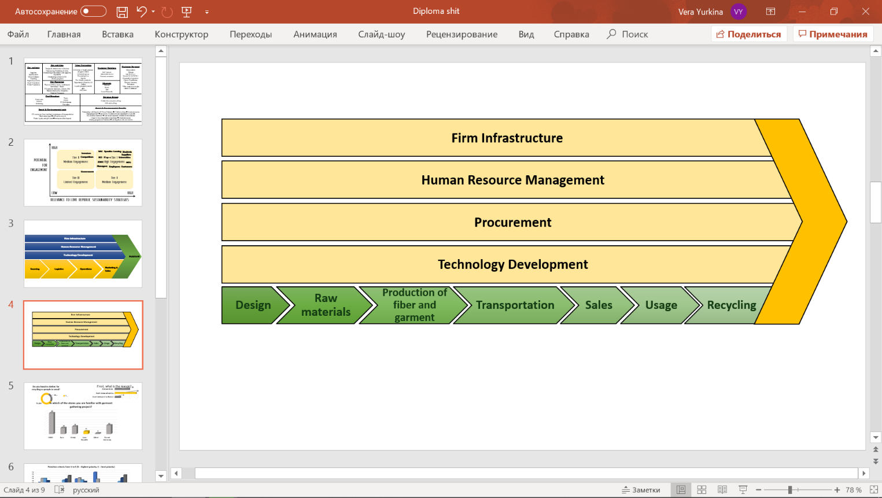 For the analysis, it is required to build apparel industry value chain. Value chain is a business tool invented by Michael Porter[41] in order to divide company’s performance on the different strategic block of correlated activities to see the practices that were made for lessen negative environmental and social footprint and increase economic one.

Figure 20. Value chain for apparel industry

On the figure above Figure 20 it is presented the value chain for the apparel industry[42] as a whole. All the primary activities start from the idea development and design creation. The next one includes procurement of required resources from farms or suppliers. Later fabric and garment production stage comes. Afterwards, the produced garments are transported to the stores or distribution centers. Then, sales come, following by usage stage that is the target one. After, recycling stage comes, where garments are recycled in order to input the old materials into production again. In terms of supporting activities, firm infrastructure is about provision of transparent resources and analysis of data about resource usage and emissions produced., while human resource management consider fair treatment to employees. Procurement stage includes practices towards searching sustainable suppliers. Technology Development stage includes introduction of novel practices that could change the value creation process.

## 2.1 Hennes & Mauritz’s practices analysis

Hennes & Mauritz is a Swedish company operating in the apparel retail sector. In terms of the geographical scope it is the world second largest company in the industry just behind the Spanish corporation Inditex. H&M is present in 71 countries around the world. In terms of sustainability company position itself as active player, which strongly concerned about the achievement of sustainable development goals. It is proved by the inclusion of the company in the world rankings in top sustainable companies that were mentioned before, as corporate knights, DJSI and CDP. Now, it would be described what company has already done for sustainability, which initiatives were introduced as well as what are the future prospects of the company and what are the ways of obtaining them.

### 2.1.1. Sustainability Strategies[43]:

*Main goal of the company is to deliver fashion and quality at the best price for everyone and do it in sustainable way – today, tomorrow and in the future –* this is how H&M group formulate itself their goal towards sustainability. Also, company provides current future plans to be achieved:

* By 2020, H&M Group aims to source 100% sustainable cotton
* By 2030, H&M Group aims for 100% recycled or other sustainably sourced materials
* By 2040, H&M Group aims to have a climate positive value chain

The Group emphasize their long-term perspective in terms of sustainability by raising the awareness of the generation towards economic, social and environmental challenges of the modern world that company tries to deal with. The main focus is not only on making the products of the company available to everyone and in the same time sustainable, but also to influence people to change their lifestyle in the sustainable direction. Company believes it could be an inspirator and ‘mentor’ for other companies, own suppliers, employees and clients towards movement to sustainable lifestyle. The vision and the strategy of the company is based on three pillars:

* 100% Leading the Change including the importance of innovations and transparency as well as provision of the rewards for sustainable actions
* 100% Circular & climate positive which is about circularity in the production and usage of the products as well as usage of sustainable recycled resources and have a climate positive value chain
* 100% fair & equal is concerned about creation a fair workplace with trust, respect, diversity and inclusion

These pillars combine all routine practices that exist in the company. Thus, company is striving to focus on its employees as the main resource of the company, encouraging them and making the inclusive safe workplace with the equal rights, respect, support, humbleness and dignity, promoting diversity and equality with no discrimination or harassment.[44] H&M has its own Code of ethics which states that the Group is not tolerant to any type of corruption. Another important issue that company stresses is that it respects privacy and confidential information as contracts, pricing information, marketing plans and another documentary for both employee and customer data.

Being open and transparent to all the stakeholders is another main ingredient of H&M’s strategy, especially relationships with clients. The company states that: *products should be durable, user-friendly, well-made, well-cut, safe and free from harmful chemicals.* H&M notices the increasing awareness of the customers attitude towards sustainability and the negative footprint that could raise from the customers operations. Thus, the company put maximum efforts on sustainability in order to satisfy the needs of the customers and provide the transparent information about the conscious actions company does to deliver the main message to the clients about sustainability.

Hennes & Mauritz does not have own factories but, instead, buys products from Asian and European suppliers. Thus, for company its crucial to closely communicate with suppliers in order to ensure their compliance with the company’s Code of Conduct and Code of Ethics. H&M believes that long term relationships can lead to successful alliance for shared risks and rewards and result in stronger sustainable performance. Thus, H&M strives to promote its sustainable operations among its partners through the sustainable supply chain.

Moreover, company tends to provide fully sustainable buildings maintenance. Company has made a lot of efforts to change its infrastructure in buildings as stores and offices. Most of these practices are directed towards #7 SDG about clear energy usage and #6 of water usage. H&M is aimed at reducing the negative impact from the CO2 emissions and energy consumption. Thus, the Group tries to reduce the level of energy usage. For example, by using natural carbon sinks. The sinks as forest one directly affects water and biodiversity issues.

Moreover, The Company strives to change its fossil – based energy to wind or solar one. H&M has partnered with Vietnam’s Direct Power Purchase Agreement that helps at provision procure electricity in Vietnam’s firms from private enterprises that provide renewable energy. Thus, Vietnam firms could afford usage of 100% renewable energy. So, company plays an active role in the supportive actions to provide solar energy in Vietnam, which is one of the major suppliers for the company. In terms of the energy used in stores company is aimed at energy efficiency as well. The group has practices towards reduction of electricity consumption by improving actions in terms of heating, ventilation, air conditioning and lightning systems. For the latter company has already switched to LED lights. This switch helps to achieve company’s goal to become fully climate positive till 2040. Via usage the renewable energy company is closer to achieve the goal.

### 2.1.2. H&M activities towards sustainability across its value chain’s primary activities

From the description of all activities and initiatives made by H&M that would be decomposed later there is no doubt that this is the industry leader in terms of sustainability. The Group has succeeded to introduce sustainable changes into all parts of value chain and beyond it. Below is the representation of company’s value chain (Figure 21) and the detailed description of all activities implemented in terms of sustainability.

Figure 21. Value chain for apparel industry

Starting from the primary activities all the following blocks are analyzed in detail about the practices and initiatives H&M has already implemented. In the analysis yarn & fabric and garment production are joined together because of the similarities of practices introduced. Also, during the stages of primary activities sometimes there are some aspects concerning supporting ones, ensuring the intersection of the business processes and corresponding intersection of triple bottom line areas.

#### Design:

Design stage includes analysis and further decisions towards style and materials to produce. In this stage company introduced screened chemistry approach that helps to identify the chemicals that are harmful to being inputted. Through this process company reduces its impact on human health and environment

##### Screened chemistry:

The Group has adopted a Screened Chemistry[45], an innovative method that helps to assess, score and certify textile chemicals for human and environment health. This method helps ZDHC companies to increase the supply chain transparency through the better comprehension and choice of chemicals used. Using this method company can range all the alternatives for further production onto preferred chemicals, acceptable and chemical of concern. Each ‘ingredient’ and impurity receive a score in the diapason 0-50 for the further formulation and range to corresponding category. After identifying the necessary ‘ingredients’ necessary for operation company should calculate the overall screen chemistry score for the group it wants to use. It is simply the weighted average of ingredient score multiplied be its concentration. Exceptions exist only with formulation of chemi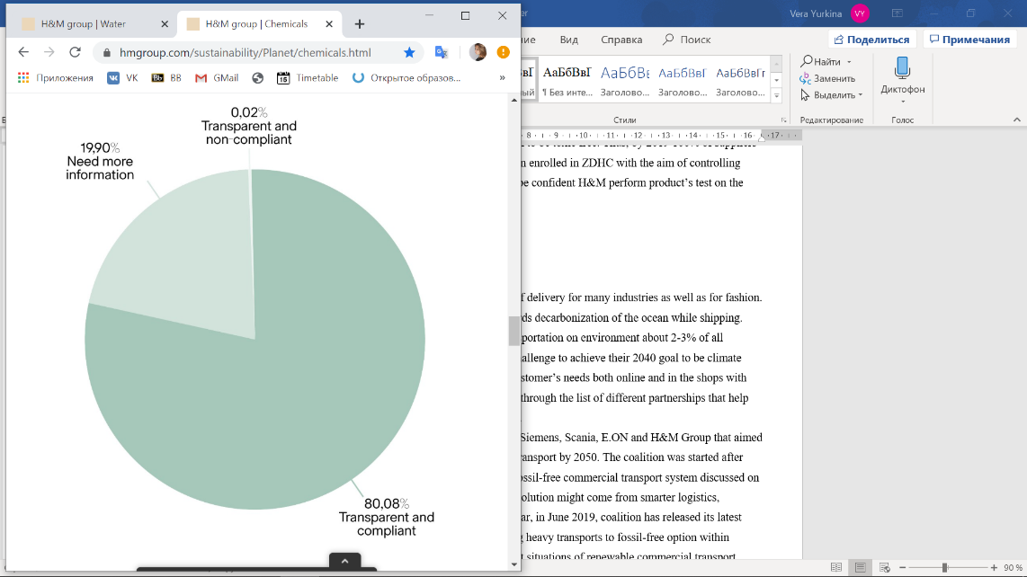cals of concern, calculation of which results in a cap score to flag the problematic formulation.

Figure 22. How H&M control ZDHC compliance[46]

With this method company can quickly identify where it might have a chemical of concern and where it might look for safer alternative. According to the Figure 22currently H&M has achieved 80% ZDHC transparency and compliance of input chemicals. The Screened Chemistry approach helps H&M to achieve its 2030 goal to be toxic free. Thus, by 2019 100% of suppliers with wet processes (dyeing, printing) has been enrolled in ZDHC with the aim of controlling chemical input and water output. In order to be confident H&M perform product’s test on the regular basis.

As well as H&M uses circular or closed-loop economy, recycled materials are crucial there. However, the usage of recycled materials and in the same time staying toxic-free raise a big challenge to the group. In order to ensure that hazardous chemicals cannot enter the production cycle, the company initiated the mapping of textile waste streams and chemicals’ assessment.

#### Raw materials:

In fashion industry resources are key elements for creation of the product. H&M has been actively introducing different initiatives in order to support this stage of value chain. Thus, company strives to use fully sustainable materials as well as ensure that these materials are made in accordance with sustainable practices. Company has also, actively invested in the innovations and search for more sustainable alternatives to use in the production.

##### Organic cotton:

Cotton is a popular natural renewable and biodegradable fiber for clothes production. Nevertheless, it is also the source of negative impact on environment because it a climate intensive crop related to high usage of water and chemicals.   
Referring to the future prospects of the company, especially that for 2020 about using 100% sustainable cotton, it is important to mention that this year company has been listed in the Sustainable Cotton Ranking in the list of leading companies and is considered as the world third best company in terms of usage the organic cotton.[47]

The issue behind organic cotton is that it strives to manage many environmental and socio-economic challenges that conventional cotton is unable to deal with. Environmental issues include excessive misuse of chemical pesticides that harmfully influence the ecosystem and health. The same overuse is true about usage of synthetic fertilizers that destroys the quality of water and soil causing the acidification and loss of fertility. Also, it emphasizes the misuse of water, because of the volume needed to seed cotton, which is compared with 1,5 Olympic swimming pools per tonne of cotton.[48] Thus, wrongdoing in water usage can lead to the limiting the amount of water for people and nature.

Socio-economic challenges of conventional cotton include the poor working conditions for farmers as usage of child labor, low incomes under the threat of constant uncertainty and high debts because of the costly inputs of fertilizers and pesticides. Nevertheless, subsistence crops provide farmers with income and if, farmed sustainably, cotton can give farmers a decent income and improve the wellbeing. The problem that exist in sustainable cotton is that whereas there is the lack of market demand it will remain niche product and the triple bottom-line problems will exist as well. Currently, only 25% of available organic cotton is used by the companies. Thus, it is necessary to accelerate the demand for this and then boost the usage of sustainable cotton

Figure 24. Sustainable cotton share through years

Figure 23. Distribution of cotton types share through years

H&M is striving to fully use the organic cotton in order to be an inspiring example in the apparel industry. The usage of the cotton is highly connected with the 2030 goal of having all the materials either reused or recycled, as cotton is the fiber for most of the products in the company. So, company invest a lot in the sustainable cotton, and company increased its sourcing from year to year, including recycled, organic and BCI (Better Cotton Initiative) cotton. As it is seen on the Figure 24 the Group has increased the share of sustainable cotton of total by 73% within 5 years. By 2019, the three types of sustainable cotton constitute 97% of the total cotton used by H&M Group. Moreover, from the Figure 23 it’s clearly seen that better cotton from the BCI constitute the major part of total sourced. Both figures prove the dynamic ambitions of H&M group regarding the usage of sustainable cotton and implementing sourcing of it into its own value chain. With the help of global non-profit organization – Better Cotton Initiative, the company is becoming closer to achieve its 2020 goal. The initiative is aimed at making global cotton production better for people who produce it, for environment and for industry in future through developing better cotton as mainstream commodity.[49] BCI is linked to a mass-balance system, meaning that cotton isn’t separate from other types of the cotton on the journey from crop to final product. This system encourages suppliers to buy and use more Better Cotton as well as it does not require complexity as costly physical segregation along the supply chain. Organic cotton is grown without the usage of any chemicals leading to the better environmental impact. None of the crops is genetically modified and in the case of organic cotton the fiber is kept separate from the cotton field to the finished product. The harvest of this type of cotton is lower thus the ground needed is also lower. Currently, organic cotton contributes to only 1% of total cotton produced in the world, thus being a minor niche business. However there exists an initiative – Organic Cotton Accelerator which is aimed at augmenting the supply and demand for organic cotton. Recycled cotton is a win-win situation for both: it reduces usage of virgin raw materials as well as prevents waste materials go to landfill. It is cotton that is made from textile remnants or from post-consumer textile waste from collected garments. However, due to technological challenges now it’s hardly difficult to recycle more than 20-30% of cotton without quality loss. So, company actively invest in their technologies to overcome this challenge. Moreover, conventional cotton is no longer traceable, thus, for company organic one is the priority.

##### Animal welfare project[50]

Company stated that it takes care about the safety of the animals because no one should be harmed in order to produce clothes. Company is working with the group of experts that on the constant basis investigates the transparency of suppliers not to harm any of the species. Company is aimed via its research and development department to find out the fibers that will be no worth quality as animals ones but will not be from animal origin.  
Company also restricted all the animal tests that were ever conducted to try its cosmetic products. As well company denied from using fur, exotic skin, angora wool and mohair.  
As a strategy 2030 company sets to eliminate conventional cashmere from the production.

#### Fabric and garment production:

The two blocks are joined together because most of the practices and initiatives are about right chemical management that is used in the both stages. Nevertheless, Circulose is related only to fabric production one.

##### Circulose[51]:

This year is extremely important for H&M because they are presenting the upcoming Conscious Exclusive collection made from the brand – new patented material named – сirculose, that has been developing since 2014. This material is first one made on the basis of chemically recycled fibers from the discarded garments sold at scale. The material was produced by re:newcell, that H&M has supported from its start. Circulose is a revolutionary fiber because it’s totally replaces forest raw materials, in commercial quantities, without compromising of the quality. Circulose is made of a circular way of producing from viscose and cotton. The process uses a closed loop system for water and chemicals powered by renewable energy. So, the percentage distribution in circulose’s cotton and viscose is 50% from recycled jeans and 50% from FSC – certified wood.  
This new material is a good opportunity to H&M to become fully circular.

##### Chemicals[52]:

Chemicals are essential in the fashion industry. They are also used into the raw materials stage in order to grow crop as well as during product stage while washing dyeing and printing. Thus, good chemical management is crucial to rational usage and reusage of materials in the closed-loop economy. H&M is thriving to ensure that all the products sold by its brand are safe to produce and use, including water, soil and air. Therefore, company tries to create a toxic-free future. Following this mission in 2011 H&M Group signed a commitment to phase out hazardous or chemicals within textile and leather supply chains by 2020 by forming Zero Discharge Hazardous Chemicals Foundations (later ZDHC). This is program to ensure good chemical management. H&M has successfully implemented this program over 600 facilities around the world. Wastewater is closely monitored, and the results are publicly disclosed. Also, maintaining relationships with suppliers, the Group ensures that their partners have effective management systems. Trustful system includes transparency about all the chemicals used, thus company strives to achieve it along the facilities. By controlling input, the group ensures that only safety chemicals enter the production process. The suppliers put the chemicals information into the system and the results is shared with the team from the group. ZDHC MRSL is a list which includes all of the chemicals that are forbidden in fashion production. This is the way company measures its compliance rate against the list.

H&M was one of the first companies in the textile industry to introduce Chemical Restriction List in 1995 and has been continuously improving it till nowadays. This list is based on the precautionary principle that underlines the restriction over using the material if its hazardous are uncertain. So, company’s suppliers must comply with it. Moreover, H&M Group is member of Apparel and Footwear RSL Management (AFIRM), which aimed at reducing the use of hazardous chemicals in the Apparel and Footwear Supply chains.

PFAS (Per- and polyfluoroalkyl substances)[53] are the group of chemicals that mostly is used to make outerwear water resistant. These substances are also hazardous to human health because of its persistence, bio-accumulativeness and slow elimination time from the human body. Moreover, there is no natural source of PFAS in the environment, it can travel long distances: move through soil, seep into the groundwater or carry through the air.

The H&M group is the first fashion company to phase out PFAS in outerwear and another garment. In 2009, started investigation of PFAS-free alternatives to water repellents in functional outerwear. From that time company started actively work in eliminating PFAS from products and as the first step winter wears were taken. Then the same work was made with sportswear, umbrella and rain clothes. By December 2010, the first products with PFAS-free finishing were introduced. H&M banned PFAS in its products in 2013 and now is a part of POPFREE – 3-years project which is aimed at creating activities towards transition to better alternatives in sectors that often use PFAS. Also, H&M has published Positive list[54]б which includes the better alternatives to hazardous chemicals, thus company started evaluating alternatives for further production

#### Transportation:

As well as companies’ stakeholders are located all over the world company should evaluate its logistics’ impact on sustainability. Thus, delivering materials to factories and products to distribution centers should be considered. So, company tries mostly to rely on sea transportation in this part of value chain.

##### Sea transportation[55]:

To transport product over sea is a vital way of delivery for many industries as well as for fashion. So, H&M aimed at implementing steps towards decarbonization of the ocean while shipping. Nevertheless, H&M assess its impact of transportation on environment about 2-3% of all emissions, they still see transportation as a challenge to achieve their 2040 goal to be climate positive. So, the group strives to fulfill the customer’s needs both online and in the shops with the least possible impact on the environment through the list of different partnerships that help them to achieve higher level of sustainability.

The first is The Pathways Coalition between Siemens, Scania, E.ON and H&M Group that aimed at achieving a fossil free commercial heavy transport by 2050. The coalition was started after Pathways Study, where it was founded that fossil-free commercial transport system discussed on Paris Agreement is possible to achieve. The solution might come from smarter logistics, electrification of vehicles or biofuels. Last year, in June 2019, coalition has released its latest report, assessing the opportunities for shifting heavy transports to fossil-free option within Sweden. Report includes current and prospect situations of renewable commercial transport alternatives through Swedish transportation system as biogas, biodiesel, bioethanol and electrification.

The second is partnership with Maersk’s Eco Delivery. The group supports Maersk – one of the world largest transport providers – in its last innovation “Eco delivery”. This type of delivery implies usage of biofuel-blend, which comes from wasted cooking oil for example, has shown results in reducing the emissions from the ocean shipping. So, company actively supports this initiative as its shows the potential to make the supply chain carbon neutral.

#### Sales:

In terms of sales company has not great initiatives, however it eliminates plastic loyalty cards and replaced them with online loyalty program connected with the telephone number. Moreover, the program of garments collection on exchange of which customers could get additional discounts for further purchases.

Additionally, company has denied from using plastic bags for purchased goods and replace them with organic one. The organic carton bags are better substitutes for plastic ones because of it lessen impact on environment while disposed. Moreover, these bags are easier to recycle, whereas materials could be inputted into production one more time. For creation a sustainable packages company has collaborated with Ellen MacArthur Foundation aimed at packaging reduction, circular design, materials choice and recycling.

#### Usage

At the usage stage company takes care about the health of the customers as well as the longevity of the product’s life. Thus, company has introduced several advices for the better treatment to clothes. The advices are published on the official website of the Group, where every person could read them. Such advice includes the right way of the washing and dyeing of each type of fabric. Here the right temperature is important. H&M has launched Take Care inspiration service online and on-store. Company there explains what practices should be done in order to lessen the water consumed for washing and the amount of detergent needed for this washing.

#### Recycling

The H&M group has introduced garment gathering boxes in their stores. So, customers could come and hand in clothes for the further recycling and on exchange receives a discount on its loyalty online card. Thus, company introduced new fiber called Circulose that is made 100% from recycled materials. Thus, partnering with such companies as I:CO or re:newcell, which help to recycle the disposed clothes and produce new raw materials is essential for companies, that want to achieve sustainability in their operations. This year, company has already used 2,2% of recycled materials into its production, among which 0,55% is recycled cotton.[56]

### H&M Practices through the value chain’s supporting activities:

Supporting activities of apparel industry value chain include firm infrastructure concerning the way company reports on its sustainable performance. The second block is about Human Resource Management that engage the relationships with employees, their treatment, training and compliance with sustainability goals. The third block is Procurement that ensures companies choice in favor of sustainable suppliers as well as their compliance with Code of Conduct and Human Rights. The last block is Technology Development that includes the introduction of innovative solutions towards changing process with more sustainable alternatives.

#### Firm Infrastructure[57]

Obviously, company provides fully integrated sustainable reporting in the annual report of the group. The report includes all the results, that are already achieved as well as progress towards the goals accomplishment. Thus, all stakeholders that are engaged and interested in company’s performance could easily monitor the changes and the progress. Moreover, company analyses its emissions and consumption of water, energy and resources. Nevertheless, company does not provide any data about its researches it follows the reduction of negative impact. Financials are also in free access for everybody. Thus, it could be stated that overall company acts rather transparently.

##### Treadler innovation[58]:

Recently, on March 4, 2020 H&M has introduced new initiative in order to drive sustainable growth – Treadler. This initiative offers access to H&M Group’s global supply chain as a service to external companies. Clients will be able to benefit from H&M’s 70 years of experience, long-term supply partnerships and strategic sustainability work, by overcoming existing barriers for moving to sustainable direction. So, it is a B2B service, from product development to logistics, that accelerates change in the industry in the direction of sustainability. Suppliers map includes USA, Morocco, European countries, India, Pakistan, China, Indonesia, and others Asian countries.

H&M considers that in order to provide sustainable fashion for current as well as for future generations change is required. This, they introduce Treadler, offering access to own supply chains to other companies. The group believes it’s a ‘win-win-win-win’ situation for Treadler’s clients, suppliers, H&M group and wider society. This service is a part of H&M’s vision to use the scale and size of the company to lead the global change towards sustainable fashion future.

#### Human Resource Management:

It is not a secret that employees are as most important for company as suppliers and even more. Employees create a corporate culture that drives organization in a direction of sustainability. So, provision of satisfying working conditions should be the core focus of company. H&M states that the group is responsible not only for its own employees but also for the workers employed by their suppliers. H&M currently has a goal of being 100% fair and equal company. H&M strives to ensure good working conditions for its employees and partners who share the respect for people and environment as well. H&M allows its employees to build tight relationship with partners through direct communication. It means that H&M company helps their partners to improve their sustainability performance through training, capacity building and rewarding.

H&M has combined all its requirements in terms of healthy workplaces, healthy ecosystems and animal welfare into Sustainability Commitment that has been finalized in 2016. Before entering into partnership H&M assess the potential partner to pass the fundamental requirements. However, there also exist the aspirational level of performance in order partners to strive the best results. Thus, all partners of the Group should follow this Commitment to have a shared vision and common expectations towards sustainability. Sustainability Commitment[59] include:

* Working Conditions (Hours, wages, benefits)
* Health and Safety
* Recognized employment
* Freedom of association and collective bargaining
* Child labor & forced, prison and illegal labor

Wages are one of the biggest challenges in the fashion industry because nowadays many garment workers are not paid enough. Thus H&M aims at improving wages through its size and influence in order to give example for other companies to do the same. The Group stated, *‘Instead of being the part of the problem we decided to be the part of solution’.* This shows the H&M attitude to bring sustainability to the whole ecosystem not only egoistically focus on the own company. Thus, company strives to provide fair wages to all its workers, which is defined as the one that fulfils the basic needs of the farmer and his family as well as offer some spare money to safe. According to International Labour Organization[60] there is no one unique benchmark for determining a living wage. However, ILO stresses the importance of freedom of association and collective bargaining, which are the part of Sustainability Commitment created by H&M. This point of commitment allows workers to negotiate their desired wages and conditions. The inspiration behind such a work composition is the Swedish model, where parties are able to negotiate and decide together.  
One of the crucial aspects here is the governmental engagement, because government must establish a legislative environment for better labor rights and better balance of power and support.   
Moreover, for driving to the fair wages, collaboration is key. That is why the Group partner with a wide range of stakeholders making the whole fashion industry aware about the sustainability challenges and the ways to bring change into world. Thus, company collaborate with NGO’s, fashion experts, trade unions and other brands as well. Through this intra-industry collaboration parties are able to collectively address the ways to solve sustainability aspects, because individually it is hardly possible. Thus, the ACT initiative appears. Major garment and textile brands together with IndustriALL launch an ACT (Action, Collaboration, Transformation) initiative which is aimed at working together to achieve living wages for workers in textile and garment production industries.

#### Procurement

As well as suppliers are the important stakeholders that directly influence value chain its essential to mention the supplier compliance in terms of sustainability. The H&M Group has reported the data[61] about the level of compliance among its first-tier suppliers by 31th of May 2015. First-tier supplier are those that either owned, meaning that they perform the final manufacture or subcontracted – perform certain tasks as dyeing and washing. The group does not have its own factories but instead collaborate with them, having around 80 suppliers worldwide There are several types of them:

* Manufacturing factories – those that are either owned or contracted that are responsible for making products. In general, they are called “cut and sew” factories that made final products.
* Processing factories – these factories are responsible for specific tasks as creating prints, washing, embroideries etc. due to required facilities that are absent in manufacturing ones. Thus, these factories usually serve as outsource ones. However, sometimes factory can be both manufacturing and processing one. An example can be a manufacturing company that has certain production processes as in-house washing and offers this service to other manufacturing factories.
* Platinum, gold & silver – these are strategic partners of H&M and as group called them ‘preferred suppliers. This type of suppliers benefits from long-term partnership with incentives as joint capacity planning up to 5 years and make around 60% of the group’s products. The long-term relationships allow factories to use their capacity efficiently and provides greater planning security.
* Other – this category includes the suppliers that have recently started to collaborate with H&M. Also, it includes the suppliers whose products are offered rarely, and thus long-term relationships are impossible

Additionally, suppliers are subdivided into regions: Far East, South Asia and Europe, Middle East and Africa (EMEA). Overall its compounded to 38 countries which are suppliers to H&M.[62] Audit included 11 question to address the suppliers: child labor, different workers’ rights, health and safety, environment, housing conditions, home workers, chemical handling, metal plating and transparency & monitoring. Analyzing the data from the audit it’s seen that the worst result is 65% referring to young worker’s requirements. The highest level of compliance is achieved in child labor and transparency monitoring given 100% and 99%, correspondingly. The average sum of all areas and all regions is contributed to 83% level of compliance. The result is satisfactory, meaning that most of the suppliers are covered by Sustainability Commitment that has replaced the previous Code of Conduct and by Sustainable Impact Partnership Program (SIPP) that aimed to replace Full Audit Program (FAP). This data allows H&M to monitor as well as whole picture of its suppliers as particular cases and identifies the gaps its compliance. Thus, it’s an important tool for making the strategic decisions in cases of unacceptable compliance levels. It provides the company the level of transparency and trust to enter into open dialogue with its suppliers in order to improve the situation for both parties. Moreover, this data helps companies to distinguish the current situation in terms of geographical location of suppliers and differentiate them correspondingly. Also, H&M determines the best performers and make appraisals for them.

#### Technology Development

H&M is highly concerned about negative impact it has within and outside their operations. As a world player it believes that it can address changes through the own activities and innovations. One of the current long-term goal company has is becoming climate positive till 2040. The Group is aimed at reducing the greenhouse gas emissions on the all blocks of the value chain. H&M considers that 70% of their impact comes from manufacturing processes, because of the high energy consumption in materials’ processing, dyeing and making fibers. Company extensively invest in R&D to find new techniques that could potentially absorb greenhouse gases and turn it into new fabrics and products. As well as searching for new ways of clothes sewing for example from citrus peel and old fishnets. So, company strives to achieve more sustainable processes to enhance its production.

##### Innovations towards water consumption[63]:

Water is the most valuable resource in the world, because without water, there is no life. In 2018 UN reported[64] that “the world is not on track to achieve the global SDG 6 targets by 2030 at the current rate of progress”. As for today, around 2.3 billion people lack fresh water and sanitation services. Water presents almost in all business activities of H&M through its value chain, so the company is water-intense one. Company extensively work towards reducing water negative impacts via partnering with WWF. Company checks that every supplier it works with is following Sustainability commitment and existing laws and regulations. With WWF the company starts introducing change via Water Stewardship. It includes understanding risks, manage water in a sustainable way, engage other companies and policy makers to make a change. The partnership results in improved water management in H&M Group’s supply chain in China, Introduction of water management guideline for Industrial Parks. It also encouraged farmers to use more sustainable practices to help restore the health of the Yangtze river in China. 500 of H&M’s suppliers started to use less chemicals and use water in more sustainable way. Also, a Cleaner Production Guideline for the textile industry was developed in Turkey. HSBC, Tommy Hilfiger, Target and other brands joined H&M Group in collective action for Water Stewardship and H&M is open to join other companies for cleaner water, nature and people. H&M considers that companies in fashion industry can compete in business but must be joined for a sustainable future, because no one can manage this problem alone. H&M is also partner with Solidaridad and the Swedish Textile Water Initiative.

Together with WWF H&M introduce 5-step water stewardship strategy. This was made to become a leader in water stewardship with the industry. The first step is Water Awareness, which includes raising awareness inside the company, through suppliers and through customers in order to ensure high level of understanding of the global water challenges and their dependence on freshwater. The second step, knowledge of impact, enlarges the basic understanding adding measuring water impact and risks within the company’s stores, warehouses and suppliers’ factories. Third one, internal action, is about improving the use of water within the stores, warehouses and factories. The fourth step, stakeholder’s engagement, includes increase focus on collective action with company, government and NGOs via multi-stakeholder platform. And the last, fifth one is influence governments, which increase focus o government influence by engaging with public policymakers to manage water basins in sustainable way.

H&M has introduced water roadmap for supply chain in 2018. It is part of transformation the textile industry, with the closest goal until 2022. It addresses water-related challenges world currently faces and help fashion industry to step on the path of accomplishing SDG#6 “ensure availability and sustainable management of water and sanitation for all”. This roadmap represents a paradigm-shifting change for integrated water management that values water as a shared resource. So, the goal is to recycle 15% of wastewater back into production till 2022. H&M has already started to use five new water recycling solutions for apparel production processes, which would improve the quality and create opportunities for water recycling in many of production countries.

### 2.1.4. Summary of the H&M’s practices and initiatives

As it is seen H&M has actively participate into the world activities to drive the sustainable changes. It has initiated many new ways to deliver sustainability and engage other parties. Moreover, Company serves triple-bottom line, while implementing these practices, corresponding to Economic, Social and Environmental part of the system with corresponding Sustainable Development Goals[65]

So, it is seen that many of the approaches are interconnected between lenses, this proves acting in the right direction, because sustainable company should meet all three. Starting from social one, company has made a lot to ensure fair working conditions for its employees, which also the part of Economic side of the triple – bottom line and targets #3 (Good Health), #5 (Gender Equality), #8 (Decent work and economic growth) and #16 (Peace, justice and strong institutions) Sustainable development Goals. Also, company tries to involve poorer countries and provide workplaces for people living there that targets #1 (No Poverty), #8, #10 (Reduced inequalities) Sustainable goals. Moreover, being transparent to all stakeholders, raises awareness about resources, suppliers and current progress, and by this ensures participation of all for sustainability. New B2B serviced introduced by H&M – Treadler, is a grand step for industry, because other companies can use already experienced and reliable suppliers in the area of sustainability that support #11 (Sustainable cities and communities) goal.

All aspects of social sphere are highly correlated with economic ones, because both of them involve employees and suppliers and ensuring their working conditions. However, the significant change in social terms is achieved due to H&M introduction of ZDHC and refusal of PFAS that target. So, management of chemicals positively influence health of the people as in the raw materials and production stage as for clients who will wear the clothes (#3 SDG). Also, reduction of chemicals is beneficial to reduce climate change (#13, #15 SDG) Moreover, by provision of advice about ways of caring for the wear, H&M influence water and detergent usage, which positively affect environment and society (#3, #6 SGDs)

In environmental area company does a lot to reduce CO2 emissions and water usage as well as preserve animal welfare (#13, #14, #15 SDGs). As it has been already told about the initiatives to reduce chemical impact but also company tries to switch to the organic cotton that will require less water usage. Also, company partner a lot of organizations to secure water pollution, as Maersk Eco Delivery that plan to change is fossil – fuels on biofuel-blend (#14 SDG). Also, company strives to change fossil – based energy to wind or solar one (#7 SDG). Another initiative introduced by the group is to recycle water waste for further production and by that be closer to #6 and #14 SDGs. Also, direction towards elimination the animal used materials helps to keep the biodiversity of the planet (#15 SDG).

It is clearly seen that partnerships with different organizations, other fashion companies, NGO’s and etc. are extremely crucial for sustainability. As H&M states, that acting individually company are hardly to deal with global challenges, however joining in one coalition can benefit for all parties involved as well as adress global challenges with synergy. Number 17 Sustainable development goal also emphazise the strength amd importance of global partnership for sustainability. Thus, company has a lot of partners in different spheres that all are aimed at achieving sustainability: from water and nature security, chemicals’ impact to creation of world network of companies to tackle with sustainability challenges. Moreover, company is striving to have 100% renewable energy and implement all required actions to make the buildings owned to lessen electricity consumption (#7 SDG)

Talking about the activities of value chain- they can be combined into the circular approach, because the recycled material is given the 2nf life and go back to production stage. Thus, this circular approach helps to limits the consumption ow raw materials (#12 SDG)

H&M emphasize that fashion industry is no longer should operate in a linear manner, whereas it must shift to a circular business model. New type of business model introduced by the company is aimed at maximizing resources and minimizing waste. Traditionally company impute resources, then they go to production, usage and then to disposal, when only 1% is recycled. However, circular business model is aimed at prolonging the usage of resources as long as possible before being regenerated into new products or materials, reducing the negative impact by this.  
Among the initiatives that H&M implement to maintain circularity is the Take Care initiative, which provide useful guidance for using products, as for example washing or dyeing in order to make the cloth’s life longer.

Figure 25 introduces the H&M’s circular approach consisting of 5 stages: Design, Material choice, production, usage and product recycling or reuse. These blocks are the components of H&M’s value chain for sustainability. So, it is crucial to understand what is going in terms of sustainability in each of the blocks[66]:

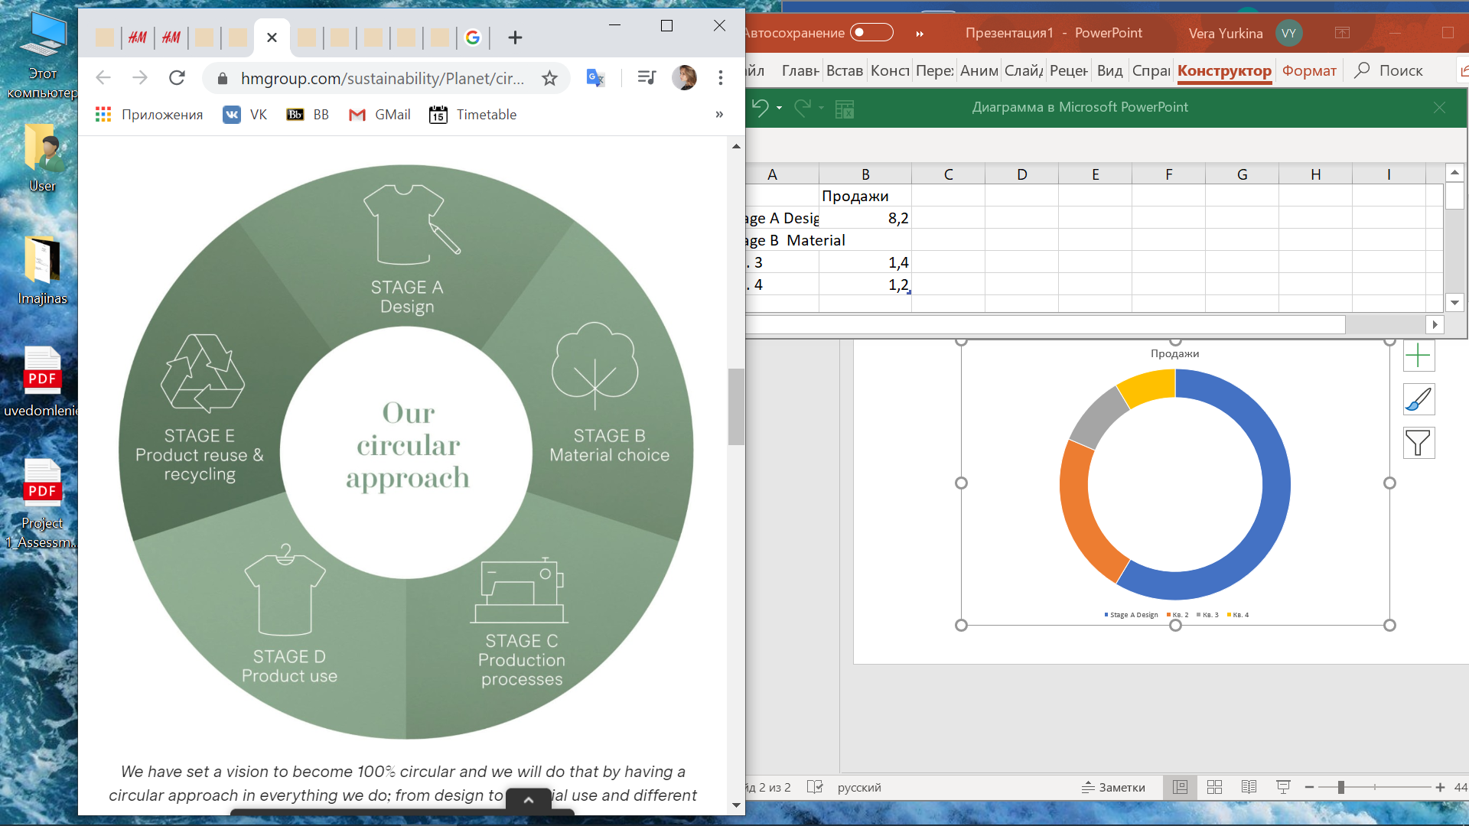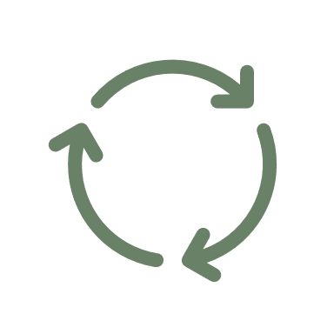

Figure 25. H&M circular approach

H&M states that sustainability starts before inbound logistics, it is started in the phase of design. Here company ‘create fashion without compromising on design, quality, price or sustainability’. At this stage company decides not only about the design of cloth but also the material from which it would be sued. It is analyzed through the prism of the negative environmental or social impact that could arise from their choice. On the design stage company attract young talents to train and by this achieving #4 good education sustainable goal.

As it has already been mentioned in the design stage, H&M reflects carefully about the choice of the materials that would be used in the production phase. The stage of material choice includes the supply of raw materials. The choice is important due to several effects that could have other parties involved. Thus, as it was discussed with cotton, material choice affects environment in such aspects as chemicals and water usage as well as social side as child labor and wages issues (#1, #3, #6, #8, #9 #10, #13, #16 SDGs). So, at this stage it is important to increase traceability as much as possible in order to understand where materials come from as well as understand how sustainable they are and under which conditions they were made. H&M estimates itself as having 87% water impact under this stage and 9% of climate impact. Also, it assesses the social impact as high.

The stage of production includes two processes: production of fabric and product manufacturing. In terms of fabric production, after purchasing raw materials company should reflect upon water and chemical usage as well as working conditions and greenhouse gas emissions (#2, #3, #5, #6, #7, #8, #10, #13, #15, #16 SDGs). So, at this stage company strives to enhance partnerships with such organizations as WWF and Swedish Textile Water Initiative in order to help mils to improve their performance (#17 SDG). As a result, H&M has already integrated fabric and yarn mils composing around 60% of the production into the supply assessment system. H&M considers that at this stage company has 46% climate impact and 6% water impact. Also, social impact is high involving the same issue considering wages and work conditions. The same is true about product manufacturing, where 62% of all employed are women (#5 SDG). Thus, conditions, reduction in overtime, salient human rights and fair living wages are important to being socially sustainable (#8 SDG).

Caring for the clothes at home represents about 26% of all of the greenhouse gas emissions in a garment’s life cycle. At this stage almost all responsibility for impacts are going into the hands of customers, however H&M still tries to reduce negative impact here. It manages to do this by introduction of specific rules and advice for conscious caring for clothes. So, company tries to inspire their clients to be careful with the products and treat with due care to environment. One of the examples of such practice is to use 30°C instead of 60°C while washing and then hanging the laundry to dry in order to cut energy use and save customers’ money.

This stage is important for and H&M because it closes the previous operations and drives to the first one. Thus, the close loop economy or so-called circular approach appears. The group introduces garments recycle service (#12 SDG). Thus, anyone can come to the shop and share own clothes with the company, afterwards, garments would be either reused or recycled. Recycled materials then, go at raw materials stage. Due to this circularity negative impact on environment from the raw materials stage reduces. Moreover, for H&M this results into creation of new fiber which will be launched this spring (#9 SDG)

Overall, it is seen that company is an active player in sustainable development. Nevertheless, it does a lot within its value chain, all practices have either social or environmental impact, or even both simultaneously. However, all then are directed to increase economic value as well. Also, it’s important to mention that company is an active initiator of new approaches and practices that could lead all the industry to another level. Company has invented many sustainable initiatives by itself. These may include, Treadler, Water Recycling or Circulose. So, been innovative, caring about employees, creating a safe product and engage stakeholders are crucial aspects in H&M business.

Nevertheless, the most crucial lesson is that partnerships for sustainability are crucial. It is impossible to struggle with world challenges individually, however collaborating and sharing the experience everything is possible and H&M group is a good example of this. As a result of linking H&M’s practices with the corresponding SDG’s to achieve the following conclusion was made: H&M currently strives at achieving 17 out of 17 Sustainable Development goals. All other goals are actively driving and enhancing through year to year.

## 2.2 Inditex company practices analysis

The second company chosen for benchmark analysis is Spanish based apparel group Industria de Diseno Textile. As it was already stated Inditex has been listed in the Corporate Knights Global Ranking for 2020. The group is considered to be in the list of the best performers in terms of sustainability. From the four apparel companies listed there, Inditex is number 4 while globally it is 94th. It is also listed in the Dow Jones Sustainability Index which ensures its serious activities towards sustainability. As well as Hennes and Mauritz, Inditex would be analyzed in terms of implemented activities, practices and initiations implemented towards sustainable development. The analysis is performed through the stages of industry value-chain basing on the sustainable triple bottom line, which is about targeting economic, social and environmental perspective of business conducting. As a result, on the global perspective it would be set which sustainable goals Inditex is strives to achieve.

Inditex is one of the world largest and innovative retail companies in the fashion world. The company has originated in Spain and currently has widely spread geographically and is presented in 93 markets with 7 200 stores established and 41 online markets. The group owns 8 brands, which are ZARA, PULL & BEAR, Massimo Dutti, Bershka, Stradivarius, OYSHO, Zara Home and UTERQUE. As Inditex is the leading company, it strives to propose creativity, innovation especially in terms of sustainability, which is the main challenge of current world.

### 2.2.1. Sustainability Strategies[67]

The company itself sees its values is strong customer direction and self-reliance as well as n modesty, provision the innovation, creativity, diversity and eco-efficiency. To do this Inditex actively monitor Policy on Human Rights, Right to Wear guiding principles, Code of Conduct and Responsible Practices, Code of Conduct for suppliers and manufacturers. Overall, the goal is to achieve sustainability in all possible areas. Thus, company strives to offer fashion to satisfy the triple bottom: economic, social and environmental perspective. Company sees the priority in sustainable management of the supply chain and monitor the level of compliance with the Code of Conduct and Sustainability Principles. Also, company actively control the efficient usage of resources as well as right corporate governance. Overall, company is striving to improve community welfare.

Company is aiming to have fully eco-efficient stores by the end of 2020. The same date is stated for becoming fully digital, fully sustainable by the end of the same year. In its previous report of 2018[68] company stated that it has already achieved 85% of this transition. Moreover till 2025 company is targeting to achieve 80% of renewable energy in all the facilities along the value chain  
In terms of used-clothing containers company has already introduced around 1300 in 24 markets and strives to achieve 2 000 by the end of 2020. It also strives to achieve Zero Landfill Waste by 2025. Stores are the key part of Inditex Business because it is the major channel of serving customer segments. Company agreed on the importance of investing into the firm infrastructure to be welcoming for clients and promote sustainability. As company stated[69] almost 93% of the stores are considered ‘eco’ ones, that use at least 20% less energy and 40% less water than any other stores. Company’s stores have full LEED (leadership in Energy and Environmental Design) and BREEAM certification, which considered to be two major benchmarks in the environmental standards.  
Inditex has put electronic air curtains that regulate temperature stability in the stores, which saves energy up to 15%. It also established speed-controlled escalators that save energy due to movements detection. Also, company put LED lights that are forth time longer than common ones. The goal pursued is to have 100% of eco-stores by the end of 2020. In China company has already achieved this target. Also, company states that till 2025 all facilities owned will use renewable energy.

Inditex has also committed to achieve #6 SDG concerning clean water by becoming a part of Zero Discharge of Hazardous Chemicals by the end of 2020. In terms of materials used company has limited its mohair constitution in product and till 2020 aims and eliminating it fully.  
In terms of climate action company has already signed Fashion Industry Charter for Climate Action in 2018 that is sponsored by UN and has also targeting to reduce greenhouse gas emissions by 30% till 2030. Overall, company has targeted almost all goals of the sustainable development. The strategies are concerning the creation of long-term vision of the further company’s development based on sustainability principles.

### 2.2.2. Inditex activities towards sustainability across its value chain’s primary activities

So, after understanding that company actively pursuits the sustainability it is required to look at the practices that Inditex has already implemented in their business operations. In order to do this industry value chain introduced by Michael Porter was built. The practices are analyzed corresponding to the primary and secondary activities. The value chain is presented on the Figure 26.

The value chain consists of three supporting activities which are firm infrastructure, Human Resource Management and Research and Development. It also includes eight stages of primary activities, which in result achieves closed loop economy. The stages are design, raw materials, yarn & fabric production, garment production, transportation, Sales, Usage and Recycling.

Figure 26. Value chain of apparel industry

#### 2.2.2.1. Design[70]

During the design stage the employed designers decide on the style and the model, but what is more important they decide on the materials to use. As the main goal is to offer the more sustainable fibers reducing the negative environmental impact. Exactly during this stage, the choice of usage, the sustainable resources is made, and the efficiency of the resources used is completed. Designers in the amount of 700, are striving the fully satisfy the demand of customers and by this tend to adapt to arising trends. Thus, collections are constantly updated. Company has updated it twice a week. The decision made in the first stage influence other stages and the sustainability criteria is spread simultaneously. Thus, during this stage the creation of responsible fashion starts. Company highlights the importance of Drawing Board to make a right choice towards the design and materials incurred. Thus, Inditex is aimed at having 100% designers trained to achieve circular design process and input materials after the recycling stage by the end of 2020.

The List that evaluates 27 000 chemicals to ensure the reliability of resources used in the production. Another tool for measuring the quality of the garments and other product is Picking program. It starts from the design stage where the potential risks of usage of particular resource are identified.

Company has partnered with design schools such as Bunka Gauen University in Japan via the project VIEW.S that aimed at provision workplaces for the students. By this #4 goal, good education is targeted to achieve. Within the collaboration students are able to create capsules together with Zara’s design team. Moreover, all brands of the group have adopted Join life excellence seal[71]. It is a label that all the garments that are produced via the best sustainable practices have. In 2017 company has put already around 74 million garments on sale within all 8 brands owned. According to this label, the garments that are produced by supplier should be assessed either with A or B mark in the social audit. The same marks or qualification must be achieved by wet factories that potentially will be involved. Thus, in 2018 already company has reached the growth of 85% in the number of garments featuring. After the design stage is done the materials are procured.

#### 2.2.2.2. Raw materials

During the design stage company has told to decide on the materials incurred. This stage is dedicated exactly to the eco-materials company inputs in the production. In the Annual Report of Inditex Group[72] company emphasizes the importance of usage sustainable materials in order to embed sustainability in the process of value delivery. Main idea of materials choosing is them to be recyclable. As it is seen from the value chain company tries to make the production processes closed loop. It means that materials that would further go to recycle be organic, sustainable and recyclable to reduce the negative impact during cloth’s disposal.   
Company tries not only to find more sustainable suppliers to guarantee the quality of the materials ordered but also ensures the ways of these materials are transported and turned into the final garment. So, company has a close eye on the processes to be environmentally friendly and suppliers to comply with the Code of Conduct.

##### Cotton

Company uses cotton in the production and by this target to collaborate with organizations that provide the sustainable material that is beneficial for health and environment simultaneously. One of such collaboration is with Better Cotton Initiative that is aimed at provision the better cotton than organic one bit in the same situation more sustainable in terms of water consumption and chemicals usage. Another collaboration partner is Textile Exchange and Organic Cotton Accelerator which is aimed at the ensuring and accelerating the supply of organic cotton. This type of cotton is cropped without fertilizers or any chemical pesticides involved. Moreover, seeds of this cotton are not genetically modified, thus, it is a natural material. Organic cotton requires 90% less water and 60% less energy that ordinary one. Via these initiatives not only company and customers benefit from the sustainable fashion but also cotton farmers have benefit by improving the social, economic and environmental conditions of their work. By this #3 good health, #6 clean water, #8 decent work, #13 climate action, #15 life on land and #17 partnerships for sustainability goals are addressing. Overall company uses organic cotton, better cotton and recycled cotton. Company has a target to achieve 100% of sustainable cotton till 2025. Last year company has increased the usage of sustainable cotton by 105% comparing to 2018.

##### Other materials[73]

Besides cotton company actively uses lyocell – the fiber made from the peppermint cellulose. For this fiber company actively collaborate with Lenzing company, which manufactures TENCEL Lyocell and help company to transform the cotton waste and recycled materials into high-quality sustainable fibers. As H&M has introduced first collection made from recycled materials as Inditex has done it. The fiber created is RefibraTM Lyocell which is made from already recycled cotton and wood from sustainably managed forests, Lyocell, Viscose or other sustainable materials that are wood based also used in production. However, since 2017 company restricted the usage of them from primary conservation forests. For supporting this initiative company has adopted a Forest Product Policy that via collaboration with Canopy NGO started protecting forests and searching other alternatives for the apparel industry. Many Inditex’s suppliers have adopted this policy and started following it. Thus, the priority for company are those suppliers, which has higher proportion of the recycled and post-consumer waste materials that stimulates the circularity.

Moreover, company uses recycled polyester and polyamide in the production. The recycled type of this fibers reduces also the water and energy consumption and by this cuts the impact.  
 Company targets to have 100% sustainable viscose and 100% sustainable linen and polyester by 2023 and 2025, respectively.

##### Animal welfare:

Inditex has also developed a strict policy of protection of animal welfare. Thus, company restricted the usage of animal origin materials such as skin, shell, horn, bone, feather etc. In case animal materials are used they should be treated ethically and responsibly complying with “Five Freedoms” for animal welfare. Moreover, company stated that it will not sell cosmetics that would be tested on animals. Inditex also refused from any fur input into production. The same is stated concerning mohair, thus all products will be mohair-free by the end of 2020.

#### 2.2.2.3. Fabric and garment production

After the procurement of Raw Materials, they are input into the production process. 54% of production facilities are located nearby the company’s headquarters, namely in Spain, Morocco, Turkey and Portugal[74], so company has not so many costs on inbound logistics. Eleven of the factories are located in the north of Spain. By closer location company is able to actively respond on the changing needs in the customer’s demand. As it was previously stated, company updated the collection twice a week and the location are playing a huge role in it. Nevertheless, the goal is to make such a cloth that will not be only comfortable but also high quality and sustainable in terms of benefit to health and to environment.

Company has introduced a special system for product testing that helps to strictly monitor that all sustainable regulations are taken into account. The standards concern the suppliers’ commitment to the chemical issues and the working conditions on their fabrics. Inditex stated to constantly monitor the changes in the technological development in the industry in order always to be on the same way as the industry leaders.

##### Chemicals usage

Inditex has introduced the special program that is called Ready to Manufacture to manage the chemicals usage. The main focus of it is directed towards the wet processes such as printing, washing and dyeing. It helps to select the adequate set of chemicals that will not harm neither people nor environment. The program also monitors the implementation of sustainability practices in the manufacturing processes. After the conducting the special testing and audits materials are assessed either red or green depending on their impact. Afterwards, the decision towards their usage is taken.

Company has stated to achieve zero discharge of chemicals usage in the production by 2020. This detox commitment is supported by active involvement in different organizations eliminating chemicals. The reason is not only in the customers demand to have natural garments but also from the side of workers who require fair, safety and health conditions in the workplaces. Another driver is environment which require protection its natural resources and reducing emissions come from the hazardous materials. Thus, company has started implementing sustainable strategies into its supply chain.

Company has provided its own list of chemicals that is possible to be used in the production, however the amount of which should be minimized. It also the part of ZDHC and has eliminating PFS’s. The latter are the chemicals used for water resilience. In 2012 company has adopted PFC Elimination Policy that proved scientifically that this type of chemical is unacceptable and hazardous[75]. To ensure the implementation of the policy company has created a special chemical management team to guarantee that suppliers will comply with the practices and replace perfluorocarbons in water and oil repellent aspects. Even when company has adopted this policy there is still a portion of products that uses these chemicals. Company, then, created a special note that it puts on the label “at risk of being manufactured with PFSs”. So, customers a priori could make a choice in favor of more ecological garment. Obviously, company actively monitor the supplier’s behavior towards these practices. In case company finds out usage of restricted materials it immediately will contact the supplier and solve the issue.

The group is aimed at total elimination of the hazardous from the garment. For this purpose, company verify the material on the existence with list of restricted product substances under Clean to Wear Standard in the product manufacturing process. Also, Inditex set a chemical manage team to monitor this compliance as well as water management. Water used should also be supervised in this stage to understand the rational proportion of it to be used.

Moreover, company has created a special database that is called Material Safety Data Sheet or MSDS. After the successful creation of combined water repellent materials by suppliers, company input this new fiber in the database. Also, it asks suppliers to report on the testing made with this fiber.

##### Testing and analysis

Company has implemented the testing regime where garments are checked in terms of safety. In means that the particular cloth is examined towards the chemicals used, the dyeing, materials, equipment and wet processes used during the manufacturing process. It is a part of ZDHC program. Company has introduced special program that has been described previously.  
Another tool for measuring the quality of the garments and other product is Picking program. It starts from the design stage where the potential risks of usage of particular resource are identified. Then during the production stage, the samples of the combination of decided materials are analyzed in the special laboratories. Then the results are studied on the matter of the compliance with the requirements of sustainable fashion provision. The laboratories are owned by University of Santiago de Compostela that is the partner of Inditex that is helping in determining risks and potentials in different manufacturing alternatives. So, constant adjustments and close monitoring helps company to establish a system with low resources inputted targeting positive impact on health of the society and environment.

##### Chemical management

Inditex has issued the integrated report with the detailed analysis of water waste generated by the company processes. The research was made via the analysis of up to 320 samples of wastewater effluents through different wet processes as washing, printing, dyeing etc. The main driver of this research was the popularization and spread of Zero Discharge of Hazardous Chemicals Initiative and other environmental organizations that are aiming on reducing negative impact on environment from the textile industry. Inditex has imbedded Right to Know Principles that allow all stakeholders to freely access the environmental information posted on the company’s sources. Thus, company started posting the information concerning the emissions from the wet processes during the production stages. This way company creates transparency in order to achieve full trust from all the parties involved. Company is aimed at achieving the updated public list of wet processes of all suppliers and at least 80% of which will comply with reducing principles as ZDHC Gateway.

For the right adoption of the ZDHC program Inditex has three types of partners: scientific, which are constantly study the novel literature and regulations towards environmental and social issues; technological, which create the processes for resource substitution and supervisor partners, which are the providers of analytic opinion towards the final and intermediary results. The partnerships are inevitable part of sustainable development and are considered to be a separate goal #17.

#### 2.2.2.4. Transportation

Previously it was stated that company updated the collection twice a week, thus, the constant logistics is required. The collections are updated both in brick-and-mortar and online stores. Inditex has 10 logistics centers located in Spain that are located near the headquarters of the brands. Company states that it could deliver any order to stores in any location in the world maximum in 48 hours and even sooner.[76] Inditex has stated that elaborating such a flexible system of logistics creates the efficiency that is directly targets the commitment to sustainability. This is achieved due to the rapid integration of novel technologies into the transportation process. Thus, the system introduced could make the time management more precise and fasten the speed with which boxes are moved, collected and stored.

The distribution stage also includes the sustainable packages used for online orders. All the packaging is made with the usage of sustainable materials such as cardboard boxes. This type of bags could be recycled and go back to the production of the bags by this reducing the impact. Thus, 88% of the waste that is generated during distribution is recycled and reused. By this the goal of achieving zero waste till 2023 is becoming closer. It is said that one cardboard box can be reused 5 times.

Logistics centers are built and managed to the highest international sustainability standards. We have been systematically upgrading all our existing logistics platforms, introducing eco-efficient lighting, improving insulation, installing sophisticated climate-control equipment, supplying bicycles and electric vehicles for internal transport, and using 100% renewable energy sources.

Nevertheless, the distribution and transportation progress are not under the full control of Inditex but rather from external parties included company still tries to influence somehow. Thus, company is aimed at reducing CO2 emissions on the stage of transportation. To achieve it company has introduced a new tool to measure the emissions from the vehicle based on its type.

#### 2.2.2.5. Sales

During the sales stage company uses carton bags that are also 100% recyclable and has FSC sustainability certification. Such bags require 70% less ink and 30% less water. Last year company has eliminating all the plastic bags among all the brands. Company has Green to Pack project which is aimed at optimization the packages and reduce waste of them along the whole chain as in stores as online. Company has also refused from usage plastic loyalty cards. As a part of New Plastic Economy Global Commitment company is aiming at rejecting all plastic materials at customers sales stage.

#### 2.2.2.6. Usage

During the usage stage company provides a number of advices to reduce the negative impact from washing and drying processes. Thus, from the conscious washing customers can reduce the amount of microplastics going from the water waste to marine ecosystems. Moreover, other advices help customers to prolongate the life of their garments before disposal by caring for them in a responsible manner. Thus, both in the brick-and-mortal stores and online customers can receive a required consultation about the responsible caring about the product they buy.

#### 2.2.2.7. Recycling

Company has introduced garment gathering boxes in most of the stores worldwide. Thus, customers and employees can drop the old clothes, shoes or accessories in the box. Further, these items would be sent to NGO’s for further reselling or recycling. This stage is essential for creating circular economy. Company has gathered 15 thousand tons of garments for recycling and reusage purposes. Inditex is targeting to recreate the products without any changes in the greener way. Recycling process can keep the value of the product or even increase it. It is made via the partnerships with Non-Governmental organizations and Recycling companies that help to create close loop economy. The items gathered are donated to NGOs partners as Red Cross, Oxfam and Caritas and poor conditioned clothes go the recycling. The partnership with Lenzing helps to recycle clothes and put them back into production. Company targets to have 100% of stores having the gathering boxes till the end of 2020.

Right to Wear program is dedicated for informing customers about the further life of the clothes they have hand into special boxes. This is also the issue of traceability. Company is fully open to share about their activities. Especially when there are so many questions and distrust concerning the further path of the garment on the way of recycling. Thus, due to its partnership with Tencel Lyocell company that transfers materials back to production company able to report on their activities and boost garment gathering by increasing the level of trust.

### 2.2.3. Inditex practices through the value chain’s supporting activities

After conducting the analysis of the practices Inditex implemented along the primary activities it is crucial to see what the company has made for the whole organization’s supporting activities. Them include firm infrastructure (provision of transparent information, news, data etc.); human resource management (Practices towards employees), Procurement (Practices towards suppliers) and Technology Development (practices considered introduction of new initiatives changing the common processes).

#### 2.2.3.1. Firm Infrastructure

Firm infrastructure block includes the transparency level that company is provided. From all the practices analyzed above it is clear that company provide full transparency to its stakeholders. On the official website there is a link to annual report where all practices and activities are written in the detail. Company also duplicates the information on corresponding website pages. Moreover, there is a plenty of additional reports on the site concerning the human rights, chemicals detection, water waste management etc. So, company provide the whole information honestly and in a free access.

##### Chemical management

Inditex has issued the integrated report with the detailed analysis of water waste generated by the company processes. The research was made via the analysis of up to 320 samples of wastewater effluents through different wet processes as washing, printing, dyeing etc. The main driver of this research was the popularization and spread of Zero Discharge of Hazardous Chemicals Initiative and other environmental organizations that are aiming on reducing negative impact on environment from the textile industry. Inditex has imbedded Right to Know Principles that allow all stakeholders to freely access the environmental information posted on the company’s sources. Thus, company started posting the information concerning the emissions from the wet processes during the production stages. This way company creates transparency in order to achieve full trust from all the parties involved. Company is aimed at achieving the updated public list of wet processes of all suppliers and at least 80% of which will comply with reducing principles as ZDHC Gateway.

For the right adoption of the ZDHC program Inditex has three types of partners: scientific, which are constantly study the novel literature and regulations towards environmental and social issues; technological, which create the processes for resource substitution and supervisor partners, which are the providers of analytic opinion towards the final and intermediary results. The partnerships are inevitable part of sustainable development and are considered to be a separate goal #17.

#### 2.2.3.2. Human Resource Management

Human Resource management stage considers practices directed on the monitoring the compliance of employees’ activities with corresponding rights including Protection of Human Rights, International Labour Rights, Health and Safety, Environmental Aspects, Code of Conduct etc. So, company ensures the compliance of all parties.

Company tries to ensure the fair working conditions towards its employees. Inditex stated that it aims at the ensuring the human rights of every party involved along the whole value chain. All regulations from the Code of Conduct concerning fair wages, working conditions, child labor restrictions etc. are compiled by company’s employees. The policy was adopted in 2016 by group’s board of directors. The teamwork, collaboration, diversity and humbleness are in the center of the company’s performance. Driving by the #8 goal of sustainable development company is aiming at provision the fair workplaces and attract new talents. Currently the number of employees has achieved 176 611 people[77]. 76% of them have permanent contracts and by this have opportunities for career development and training. Company comply with Occupational Health and Safety Policy that ensures fair working conditions and pages. The practices towards employees are written in the Internal Code of Conduct introduced by the Inditex’s Board of Directors. The Code is spread between all the managers and departments in the full geographical scope of company presence. The practices are similar to the supplier’s ones as it has already been said. Thus, company is not able to hire anybody under the age of 16. Inditex should provide health and safety workplace and timely wages and monitor that there is no discrimination in any form along the all stages of the value chain. Inditex also guarantees the full data protection of personal information of its employees. Following this, employees should not cope or reproduce the information for any other purposes that are not required by Inditex operations.

Moreover, company has a special program that is aimed at recruiting and training university graduates. The program is called Inditex Go! And it helps to develop the young talent to drive company further. Another global part of the practices goes to woman employment. This is directly focusing of SDG #5 concerning the gender equality.

#### 2.2.3.3. Procurement

Company has introduced an effective system through which it checks the compliance of the suppliers with the sustainability practices. Through the traceability system company knows exactly where products are made from and where materials are come from. Constant audits help to ensure the compliance with sustainability aspects. Constant improvements are made in order to efficiently use the materials. Moreover, it ensures that suppliers do not violate the rights and polices of fair and sustainable business conducting.

Thus, issuing the special rights for suppliers and manufacturers that is calling Code of Conduct. This Code has 14 points that suppliers should have into account[78]:

* Inditex should not allow any form of involuntary or forced labor in their manufacturers and suppliers
* Inditex should not allow its suppliers and manufacturers to hire minors (under the age of 16)
* Inditex should not allow any form of discrimination based on race, castle, creed, religion, nationality, age, any type of disability, political affiliation etc. during the working processes
* Manufacturers and suppliers have to ensure that their employees have the right of association, union membership and collective bargaining
* Inditex monitor that suppliers and manufacturers treat employees with dignity and respect
* Inditex monitor that suppliers and manufacturers provide safe and healthy workplace to the employees
* Inditex monitor that suppliers and manufacturers provide fair wages to their employees
* Inditex monitor that suppliers and manufacturers adjust working hours according to norms
* Inditex monitor that suppliers and manufacturers provide employment formulas under the applicable local laws
* Manufacturers and suppliers shall not assign any work to third parties without the prior written authorization of Inditex
* Inditex ensures that all products supplied are not violating Inditex’s health and safety standards
* Inditex ensures that suppliers and manufacturers comply with Environmental Laws and Regulations
* Inditex ensures that all confidential commercial information is not spread by suppliers or manufacturers
* Manufacturers and suppliers should implement program and senior member who will be responsible for Code implementation.

Through these requirements it is seen that company directs several sustainable development goals. They include #3 good heath, #4 good education, #8 decent work, #10 reduced inequality, #13 climate action, #16 peace, justice and strong institutions goals.

#### 2.2.3.4. Technology Development

Inditex stated that constant monitoring of changes in the technological and innovations development is crucial within the industry in order to be aware of the current tools to being competitive and leading. What is more important is to be an innovator and create new methods new approaches and new initiatives that can drive sustainability. Thus, company has developed Green Code[79] that is aimed and ensuring the whole group compliance with the social and environmental standards and their adoption in the processes of supply chain and its improvement. The main goal is to identify environmental and social risks and provide potential for their reduction on the all levels of garment creation and all stakeholders taken into concern. This Code creates the special Guide of the use of chemicals in the production processes in order to achieve zero discharge target and substitution of hazardous via safer alternatives. In order to meet the target company, provide timely controls and audits and make amendments into action plan if necessary.

##### Climate action

Climate change is one of the leading global challenges that the world is striving to solve. Inditex, in turns, aimed at reduction the energy consumption in order to lessen the impact of greenhouse gas emissions. Company has sent the requests to Carbon Disclosure Project and was named as a leader on climate change among industry. Company has implemented the novel low-carbon technologies to reduce energy consumption is stores and logistics centers. As well company monitors that suppliers are also in concern of reducing the energy usage in their processes. Through the advice to customers about conscious usage of the products it reduces the energy consumption in usage stages. Finalizing with the recycling stage company reduces energy usage through the recycled materials. Company targets to have 80% of renewable energy by 2025. Another goal is reducing greenhouse gas emissions by 30% till 2030 and achieve zero discharge till 2050.

##### Water management

Water is one of the most precious and most scarce resource. Thus, company continuously makes researches and upgrades the practices and innovations concerning water usage. All the practices concerning water directly or indirectly touches #6 clean water and #14 life below water sustainable development goals. The textile industry is extremely water consuming water is used in crop manufacturing, production, wet processing, usage – washing stages of the value chain. Also, water used in all the building where Inditex is working. So, Inditex is aiming at reducing its impact along all these areas. Thus, poor water management harms environment, damages lakes, rivers and whole ecosystems. According to WWF forecasts by the end of the 2025 there will be an intense shortage of clean water. Due to its efforts in the area of sustainable water usage and protection of maritime habitants’ company was awarded with Greenpeace Detox Catwalk Awards that stated that transparency of Inditex is ‘exemplary’ for other brands. It also proves Inditex could achieve it ZDHC goal till the end of 2020. Company is following Global Water Management Strategy[80] which helped Inditex to build master plans for supply chain and system of corporate indicators of water, that provide the proper information of water consumption and areas for implementation. Main objectives of the strategy are promotion of more efficient water usage, ensure suppliers conserve the environmental quality of maritime ecosystems, develop systems of monitoring the level of consumption, engage stakeholders to solving the water issues and ensure transparency about water actions. Inditex has several partnerships and Memberships to achieve better water management. Thus, Inditex is a member of Sustainable Apparel Coalition that gathers together number of textile brands and manufacturers to battle with sustainability challenges concerning not only water but also all others. Also, it partners Leather Working Group to improve sustainability of tanning industry. As it was stated in the Raw Materials stage company is a part of Better Cotton Initiative that addresses the responsible water usage during cotton cropping.

The current goals of Inditex concerning water are reduce water usage during manufacturing through novel processes as well as in stores, warehouses, offices and other facilities; improve water management in supply chain; raise awareness among clients about the way Inditex implementing water strategy; continue to collaborate and being transparent.

### 2.2.4. Summary of Inditex Activities

From the analysis of value chain activities, it is clearly seen that company does a lot to achieve sustainable development goals. Practices implemented are spread towards all the stages of the value chain. Placement of garment gathering boxes creates a possibility to put materials back to production and via partnership with Lenzing company Inditex achieved closed-loop economy. Circularity reduces wastes that affect climate change and drive responsible consumption of resources that are drivers of #12 and #13 SDGs. By using the sustainable raw materials and being a part of ZDHC to eliminate PFSs and other chemicals from the production company aims to achieve #3 good health sustainable goal. By eliminating fur and animal origin products company drives #13 and #15 sustainable goals. In terms of choosing organic, recyclable and better cotton Inditex enhance the environmental impact (#13, #14) through reducing CO2 emissions and energy and water consumption (#6, #7).

During Transportation and Sales stages company strives to reduce its impact also. It is aimed and eliminating all plastic from the stages. Thus, transportation stage includes the plastic packages in which garments are transported. However, in sales stages it is about the denial of any plastic packages and cards in order to achieve plastic-free goal.

In terms of buildings infrastructure company is strives to implement the best materials in terms of lightning, energy usage and water consumption to reduce the CO2 emissions and level of consumption to replace the energy to fully renewable. This targets #6, #7, #9 and #12 sustainable goals.   
Previously stated practices are direct evidence of Inditex following triple bottom line approach, and that practices below are concerning environmental issues.

The practices described below would concern the second area of triple bottom line – social affect. Thus, it mostly concerns impact on health and compliance with corresponding rights.   
The resources input is decided on the design stage where the talents develop new collection taking into account chemical, energy and water usage. That also drives #12 goal. Through the partnership with design universities company and introduction the VIEW.S and Inditex Go! programs Inditex strives achieve #4 and #8 goals.

The initiative, BCI, that company follows is aimed at increasing human wellbeing through reducing hazardous and ensuring fair wages. Implementing these materials also drives improvement health (#3), working conditions (#8). After disposal, these better materials can be recycled and input back into production to create close loop economy. Traceability of supply chain ensures the compliance with labor legislation that targets #3, #5, #8, #10, #12 and #17 sustainable goals.

In terms of responsible practices and compliance with the Human Rights, International Labour organization and Code of Conduct company is aiming to fairly treat all the stakeholders and provide health and safety to society and environment. Such contribution to community welfare targets almost all goals of sustainable development except 9th, 12th and 14th. Via creation the shared value company reduces, poverty, hunger, inequalities, provide better working conditions, health education and workplaces and positively affects environment. Inditex has also set such a Management Board that fully monitor the compliance with all requirements mentioned above. Corporate Governance of the company ensures the meeting all 17sustainable goals. It also includes the gender equality issue and by achieving it company targets #5 SDG. In terms of transparency Inditex has been recognized as a leader in the industry. Inditex puts all the report, Codes and Laws and Practices Implemented. This perfectly drives sustainability.

Moreover, company is focused on constant research of new trends, new technologies and practices towards sustainability. It conducts a lot of tests and analysis in order to guarantee the integration of sustainable development goals into the business. It concerns all aspects. Company is aiming at solving climate action problem with keeping land and maritime ecosystems health and clear. It also focuses on the wellbeing of the stakeholders involved and value creation with regards towards their health, education and career growth. Finally, it achieves is economic goal of selling the product to customers and then take it back into gathering box to create closed loop economy. Obviously, it could not achieve all that it has without partnership and collaboration that are the only possible way to achieve global sustainability. As a result, company targets all 17 sustainable goals.

## 2.3. Summary of Chapter 2

After conducting the benchmarking of two industry leading companies – H&M and Inditex several key aspects were identified. It is important to mention that both companies are undoubtedly leaders in terms of sustainable development because both are targeting to achieve all 17 sustainable development goals introduced by United Nations. The difference in companies’ practices are the following: H&M mostly tries to be first-mover company and introduce novel solutions and initiatives that radically change the common processes, such for example an initiative towards water recycling and inputting back to production. Thus, H&M created the trends in the industry and innovate a lot to help other companies to become closer to sustainability, as Treadler initiative. Whereas, Inditex company is mostly researcher and analytics in terms of sustainability. Inditex has not created as much initiatives and programs inside the organization but rather tries to test already implemented actions and make them perfect. Thus, Inditex is mostly concentrating at total elimination of harms. Thus, it has a number of goals as achieving 100% free of chemicals or 100% of renewable energy. Nevertheless, both companies see partnerships as an essential part on the way to sustainability and these partnerships help companies achieve results.

The structured summary of the sustainability practices is represented on Figure 27 (Primary activities of value chain) and Figure 28 (Supportive activities of value chain). The summary includes the common practices both companies have and the target SDGs as well as the different practices each of the company has.

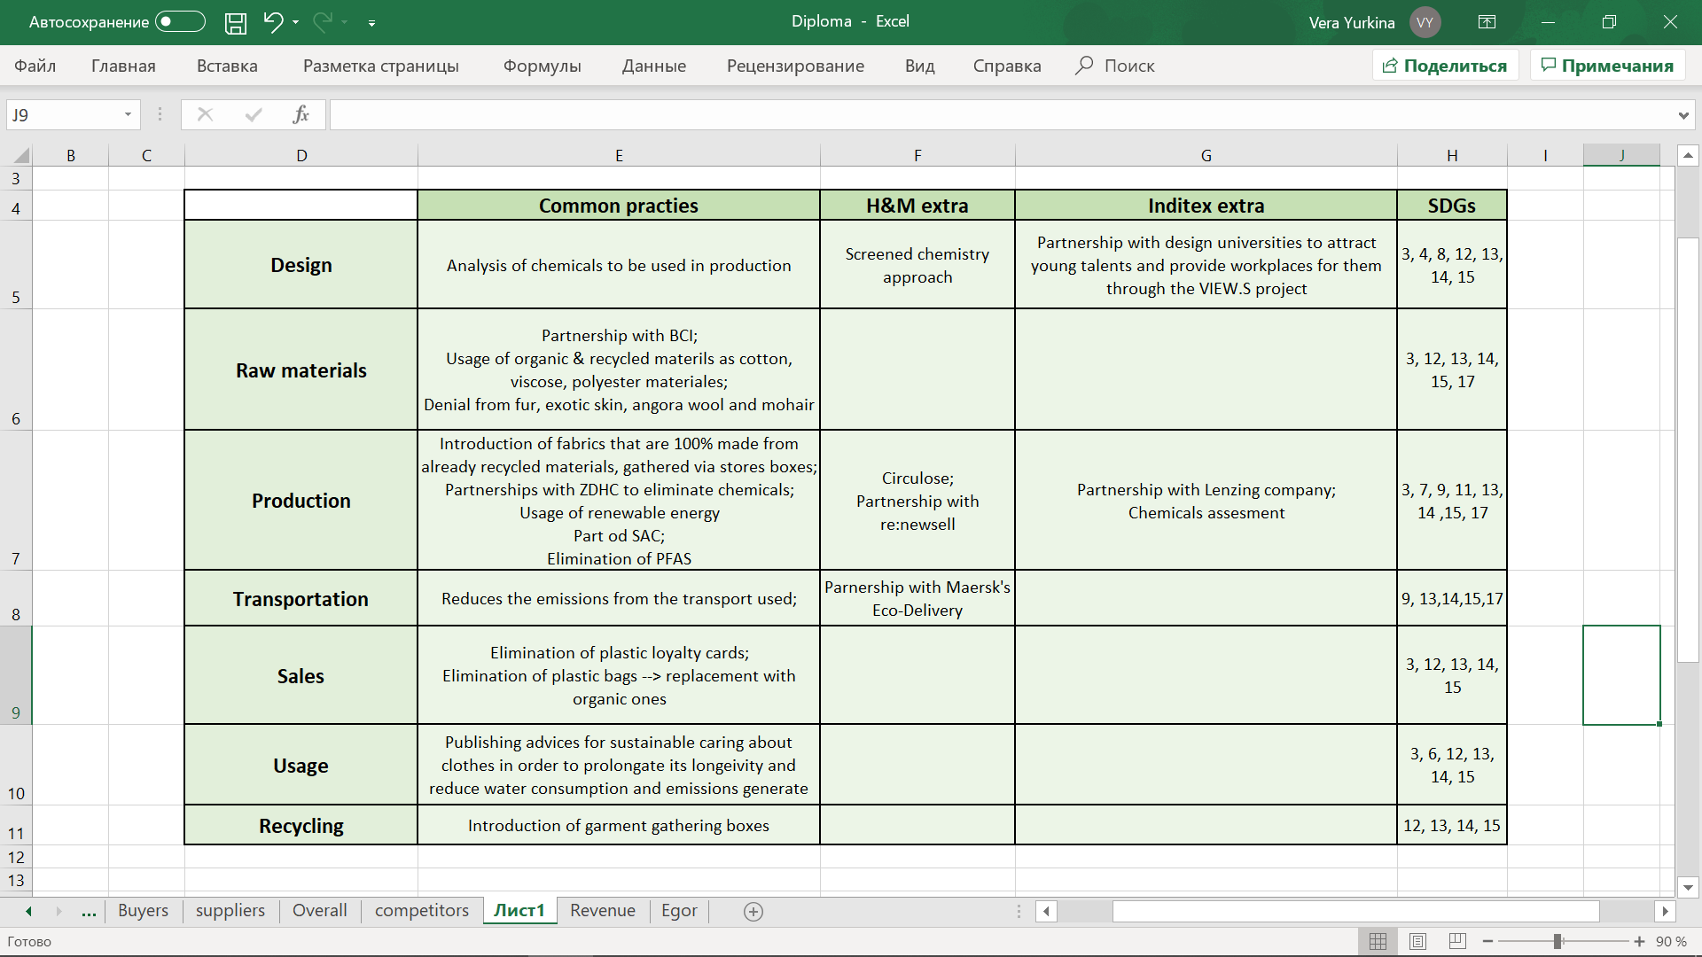Figure 27. Summary of primary activities of H&M and Inditex value chains

Starting from the design stage, both companies tend to evaluate the risk chemicals and try to reduce their amount. However, Inditex is also aimed at attraction young talents that could bring novel ideas in the industry. Also, both companies make an effort to obtain sustainable and organic cotton through partnership with Better Cotton Initiative. Also, both use other sustainable materials as lyocell, recyclable polyamide and viscose etc. Moreover, both companies have denied from using any animal origin products. This includes natural fur, mohair and angora wool. During the production stage, both companies have already achieved circular economy by introduction the garment gathering boxes in the stores and by introducing new collection made already from the recycled materials that were gathered. Another aspect that both companies are focused on is elimination of chemicals during all stages of value chain through being a part of Zero Discharge of Hazardous Chemicals. This initiative is directed towards reducing the level of hazardous in garments production and finding alternatives that will not harm neither environment nor people. Thus, both companies have goals to have no chemicals in their production. They have already denied from usage PFSs that are water resilient. For this companies have to create special Chemical Management Teams. Moreover, companies have denied from any plastic along all the sales stage of value chain. Thus, both Groups have switched to the carton bags and denied from the plastic loyalty cards. Companies have implemented consultation and on-line advice for better usage and caring about the products during washing and drying in the usage stage of value chain. Thus, companies are targeted to keep land and maritime ecosystems safe and target environmental aspect of triple bottom line. In the recycling stage companies introduce garment gathering programs that have already succeeded in the in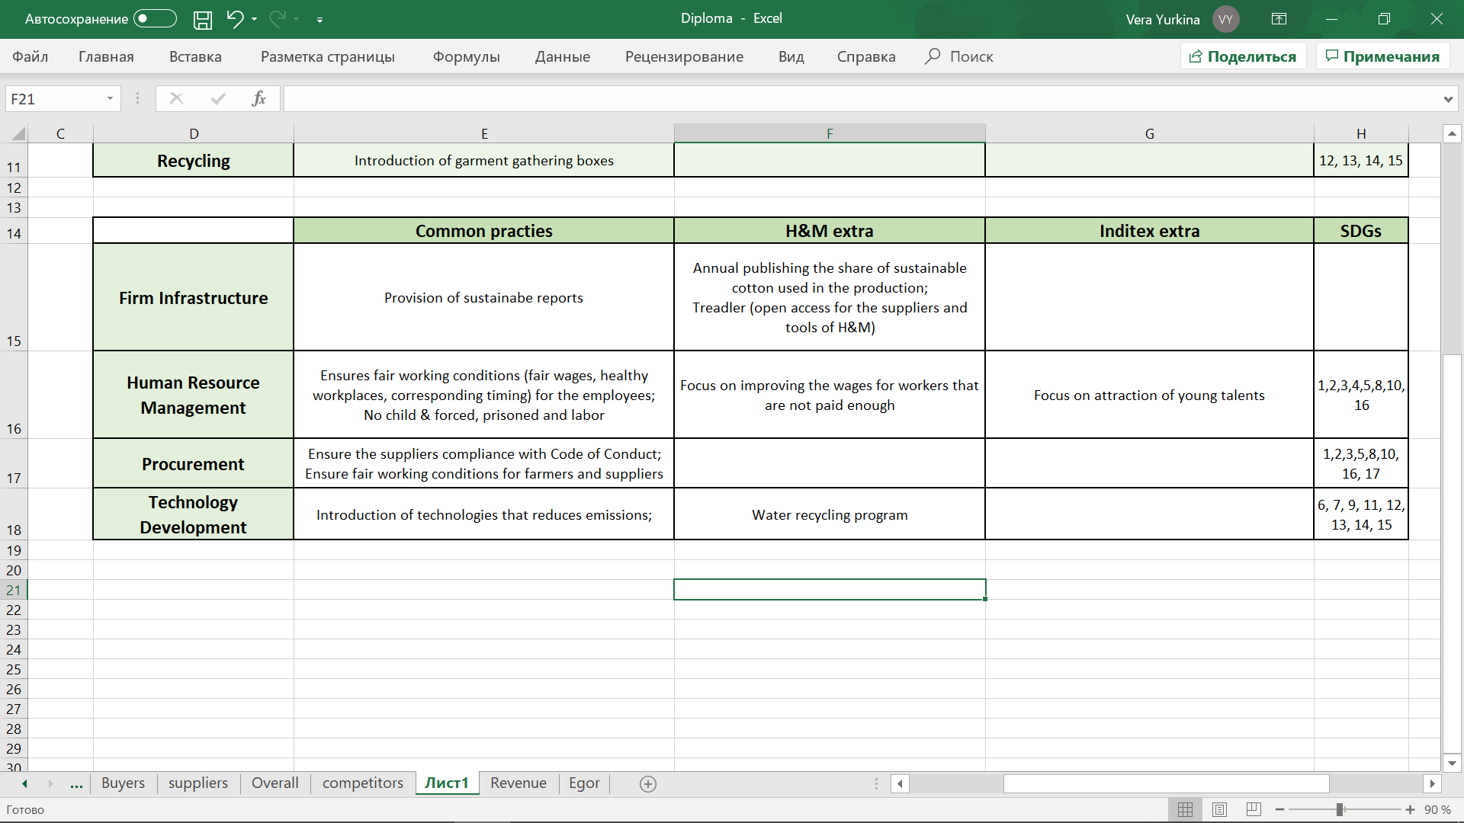troduction of novel fibers made from recycled materials.

Figure 28. Summary of supportive activities of H&M and Inditex value chains

In terms of supportive practices, companies undoubtedly provide fully transparent reports with the statistics concerning emissions and consumption. both H&M and Inditex are focused at provision fair working conditions, wages, health and safety workplaces and treat their employees and suppliers with respect of human rights and equality. So, treating employees and suppliers correspondingly is essential. These practices are mostly directed towards social aspect of triple bottom line, however, also target economic and environmental. Technology development stage includes the innovative decisions for making value creation process more sustainable by reducing the amount of emissions generated.

From economic perspective companies implement all practices not only for meeting social and environmental gaps but also to continuously create value for customers and receive economic benefit for the shareholders. All the practices are aimed at the strengthening brand reputation and companies’ performance on the market. Overall, as it was already stated both companies implement practices that are aiming at achieving all 17 sustainable development goals.

# Chapter 3. Sustainable strategies development and implementation for Love Republic

This chapter is dedicated to the strategies’ development and the recommended actions that would be implemented in the Love Republic business and out-of-business processes. The strategies are divided on the short-term and long-term perspective as well as for internal or external focus by using the Sustainable Value Framework introduced by s. Hart. The relevance of all the strategies is assessed on the Russian market through the conduction of questionnaire of potential customers. Afterwards, the Stakeholders’ Engagement analysis was conducted in order to understand which parties should be involved into strategies implementation. Moreover, through the Stakeholder’s Collaboration Matrix there would be provided the major links between parties to be established for achieving the target strategies. Afterwards, practices were relocated according to the timeframe of their implementation. Finally risks analysis was conducted and action plan of strategies implementation was developed.

For the strategies implementation there were developed six recommendations for Love Republic that could be grouped in three groups, 2 recommendation per each. The first group is concerning the improvements the existing LOVE 2.0. project by increasing the promotion of the initiative and replacing common plastic cards and QR-code loyalty program by linking it to the telephone number. Second group is concerning the integration stakeholders view into the company’s business processes through publishing integrated sustainability reports on the website and publishing video about sustainable caring for products or further life of the garment during LOVE 2.0. The third group is concerning establishment of partnerships for sustainability such as partnering design universities to attract young talents and partner organizations that enforce sustainable development in the textile industry.

For assessing the relevance of the recommendations, the questionnaire was developed. It reaches 228 respondents which are women 16-45 years with income more than 30 000 Rubles, that is the target customer segment for Love Republic. Questionnaire involved obligatory and non – obligatory questions, however all presented results in this chapter are based on obligatory questions. All the results are presented in corresponding histograms or pie charts.

## Elaboration of sustainability strategies for Love Republic

After the analysis of Love Republic internal and external environment the primary SWOT analysis with the focus on sustainability was performed. Benchmarking analysis has shown the practices that major two apparel companies are implementing. Based on the results of these analysis the sustainability strategies would be developed. For the elaboration of the strategies by element SWOT analysis could be used, however as strategies should be developed taking into account not only social and environmental factors that were identified during the primary SWOT analysis, but also broader drivers. Thus, for the results of SWOT analysis the results of benchmarking were added. Strategies would be developed via Sustainable Value Framework introduced by S. Hart, rather than by element SWOT matrix because it helps to link the social and environmental factors in global perspective with business value creation. The framework, nevertheless, would be built with the corresponding linkage to the primary SWOT analysis results and best practices analysis.

### Strategies and recommendations identification

For strategies elaboration Sustainable Value Framework introduced by Stuart L. Hart[81] was performed. It helps to link sustainability and value creation through two dimensions. The framework is the intersection of two axis, where the vertical one is dedicated to the time frame either short term or long-term and horizontal one is devoted to the internal growth of the company and involving the knowledge and skills of external stakeholders. Moreover, the framework includes recommendations to be taken in order to implement the corresponding strategy. Some of recommendations are repeating and could target several strategies simultaneously. Also, framework includes the main drivers that support corresponding strategy and the business values that are created from implementation the strategies. The drivers and recommendations are build based on the results of SWOT analysis and benchmarking. The framework is presented on the Figure 29.

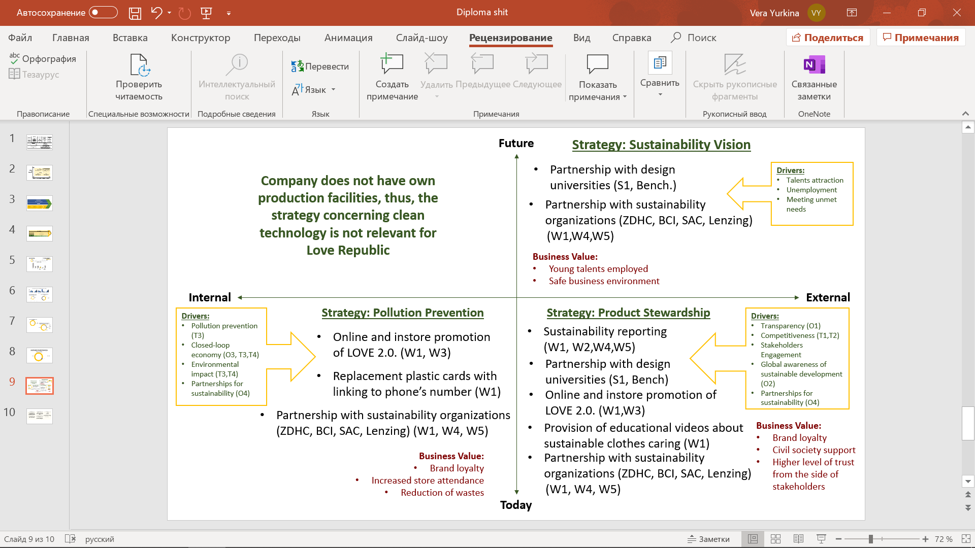Figure 29. Sustainable Value Framework

Starting from the lower-left quadrant the strategy developed is pollution prevention and efficient waste management. The drivers of this strategies are the target on pollution prevention, overall environmental impact of water, energy consumption and CO2 emissions, that come directly from the threats from SWOT matrix. From the opportunities, circular economy and partnerships were taken as drivers. Thus, on this section there are three recommendations: promotion of LOVE 2.0; cards replacement and sustainable partnerships. By implementation of these practices Love Republic would definitely increase its brand loyalty by being more responsible in garments gathering and being associated with the global sustainable organizations. Another business value that company would receive is increased store attendance because of LOVE 2.0. promotion – it is expected that when customers would come to hand in clothes they could be attracted by new collections and would be more willing to purchase something. The third business value received from pollution prevention strategy is obviously reduced amount of waste that the firm would generate. From LOVE 2.0. program there would be less emissions from the garments disposed. From the elimination of cards there would be also less emissions from the cards disposed because the plastic has long time of incineration. Global organization are also aimed and waste reduction. ZDHC reduces the wastes from chemicals, BCI is also targets to reduce chemical and hazardous used in cropping, Lenzing tends to reduce the wastes from the garments disposed and CO2 emissions from raw materials usage in the production process and SAC contributes to the same waste elimination.

Next is upper-left quadrant that is aimed at provision cleaner technology that would enable company to have more sustainable processes. However, as company does not produce anything by own production facility, this type of strategy is not relevant for the company.

Next quadrant, upper right, is devoted to strategy - creation sustainable vision by meeting social need. Here two initiatives are placed. The first is partnerships with design universities and second – partnerships with sustainable organizations. The drivers of such practices are the necessity to meet unmet needs, rising population, unemployment and attraction of young talents to the company, that were formulated from benchmarking analysis, Company could employ young talents and managed with unemployment by establishing partnerships with design universities. So, they could attract them as interns even before students are graduated. From partnerships with organizations as SAC or ZDHC company creates safer business environment for employees along all value chain. BCI also is aimed at creation workplaces for farmers and safe working conditions for them.

The last quadrant is the product stewardship strategy. The strategy is driven by provision of transparency, engagement stakeholders and society to the activities of the company and raising it’s the global awareness and action towards wastes prevention, that directly reflect the opportunities and threats generated during SWOT matrix. Here five out of six initiatives are placed: sustainability reporting would increase the transparency and level of trust for stakeholders; partnerships with design universities would engage students to the creation of collections; promotion of LOVE 2.0. would integrate stakeholders view towards the process of garment gathered and the whole lifecycle of these garments. Posting videos about sustainable caring about clothes would increase awareness of customers towards small actions that could be done locally and foster sustainable development by integration of everyone. Partnership with sustainable organization would bring together all stakeholders of textile industry to start active sustainable development in Russia.

Thus, three sustainability strategies were elaborated: Product Stewardship, Sustainability Vision and Pollution Prevention. For the implementation of these strategies six recommendations were developed:

* Increase online and in-store promotion of LOVE 2.0. program (W1, W3-O3; W1, W3 - T3, T4)
* Elimination of plastic cards and their replacement with telephone number (W1 - T3, T4)
* Provision of sustainability reports (W1, W2, W4, W5 - O1; W1, W2, W4, W5 - T2)
* Introduction of educational videos about sustainable lifestyle (W1 - O2; W1 - T3, T4)
* Partnership with design universities (benchmarking, S1-T1, T2)
* Partnership with world sustainable organizations (W1, W4, W5 - O1, O3, O4; W1, W4, W5 - T1, T2, T3, T4)

### 3.1.2. Recommendations overview and relevance analysis

After strategies identification analyses six recommendation were identified. The recommendations are subdivided into three categories concerning LOVE 2.0. program, stakeholders’ integration into processes and partnerships establishment. Via the corresponding answers from the questionnaire their relevance would be proved or denied. Afterwards, the approved initiatives would be divided onto corresponding time of implementation.

As it was already stated there are three goals to achieve through the implementation of six recommendations. The first goal is to modify and enhance LOVE 2.0. program to attract more customers to use it through modification of loyalty program and more intense promotion of the project. The second goal is to integrate stakeholders view into the business processes through raising transparency by issuing annual reports including sustainability aspects and putting videos and posts on the social networks’ pages and website to achieve larger awareness and higher level of trust. The third goal is to establish partnerships for sustainability through collaborations with design and fashion universities and world sustainable organizations.

#### 3.1.2.1. Enhancement of LOVE 2.0. program

One of the greatest actions already implemented by Love Republic is introduction garment gathering program, which is the first step towards achieving closed loop economy. However, the program is not working well. Most of Love Republic’s customers is not aware of such possibility in the stores and even not all employees know exactly the requirements for handing it. Also, the process of obtaining the discount is rather long and complicated. Thus, customers have to download Love Republic’s App to register, in case they are not participating into loyalty program they are getting plastic card as a participant and anyway customer need to register in the app. Then, client has to download QR-code to link the discount to corresponding account. This process creates a queue near the cahiers because there is no gathering boxes and all process is made on the checkout place. Thus, the process requires time and efforts and many clients prefer to hand it easier in other nearby store as H&M or ZARA. For elimination of these challenges to recommendations are developed. The first one is to increase promotion to attract more people and raise awareness about the project and replacing card and QR-code loyalty program with linkage to the telephone number.

##### Promotion increase

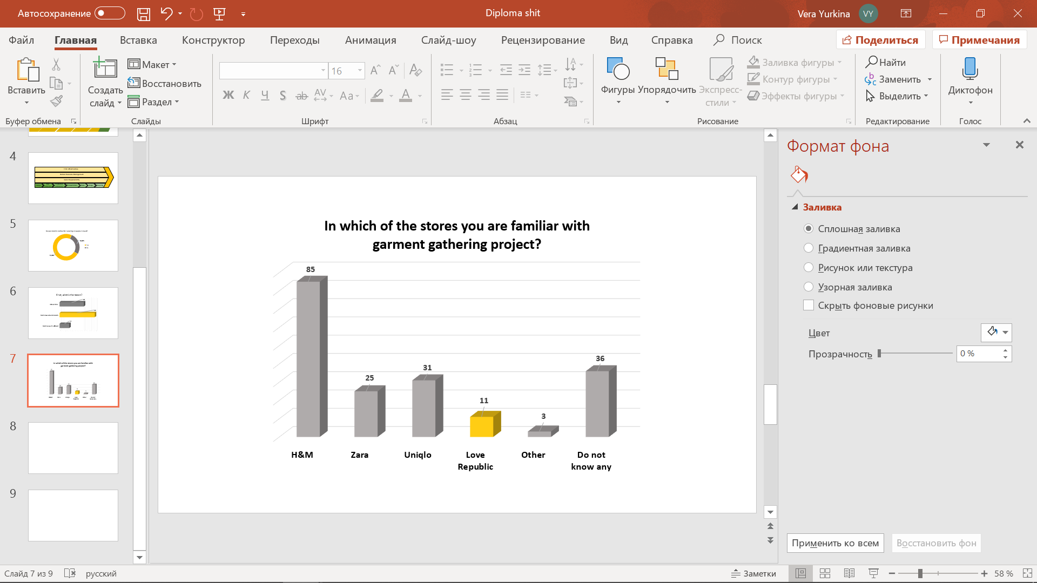As it was analyzed in the first chapter there is little awareness of customers about the possibility to hand in clothes in the Love Republic’s stores. Customers,moreover , are unlikely to know that these garments go to charity shop Spasibo where they are resold. Poor conditioned clothes go further to recycling, however Spasibo shop is currently searching for the reliable partner for recycling purposes. During the questionnaire there was a question regarding which brands are familiar to respondents to have garment gathering programs. After the questionnaire, it is clearly seen that Love Republic is the least known brand to have such a program. The distribution of answers is resented on Figure 30.

Figure 30. Questionnaire results: awareness of garment gathering in other stores

Thus, it is relevant and required for Love Republic to take actions towards increasing the promotion of this program. Company can do it in the store by ordering special posters that would contain information about the project with the required steps to do. It could be put in the entrance and near the checkout table, thus people waiting in the queue would read it and next time come to store with clothes to hand in. These posters could contain motto that increases the motivation of people to participate in the project. For exapmle: “Let’s make environmnet cleaner together”. This way company would adress the evironmnetal challenge of the wastes that cause global warming and necessity to collaborate to solve it.

Another way of advertising is using digital marketing. So company can actively uses its Social Networls account to post the requirements for the program, the potential benefit – amount of discount that they could obtain, the current results – amount of clothes gathered etc. The example of the video that could be posted as a promotion is the one including information about further life of the clothes gathered during LOVE 2.0. Thus, shooting for example the interview with Spasibo’s CEO, the video could contain information about the way clothes are transported to the center, how they are divided into groups for reselling or recycling and their future path. The result could be achieved by raising humans’ understanding towards the challenging environment and the ways to struggle it. Then, clients would be more aware of the constant process of this and will be more willing to participate if they know the program is working and by this videos level of trust from customers increases. Also, company can create a special section on the website about the initiative and post there latest news and corresponding videos. Then, if in case of social networks posts could be losts through others on the web-site there would be constant information in free access to all stakeholders interested in it. Increased promotion would boost the customers participation in the program and adress #12 sustainable goal about conscious consumption following by adressing sustainable cities and communities through goal #11 and globally affect climate change and land ecosystems in goals #13 and #15. Through enhancement the environmental concens and land on the land good health in goal #3 is also driven to achieve. Moreover, in long term perspective, active usage of these initiative would reduce the water consumption and affect #6 sustainable goal.

##### Modification of loyalty program

Next requirement is to handle with the problem of long-time uncomfortable discount deposit. The recommendation towards this issue is totally deny from QR-code identification and plastic cards. By linking the telephone numbers to customers and creating a large client database company tend to provide better customer service and cope with discounts easier. Thus, when customer tells its number the system shows him or her with full informational contained about bonuses obtained. Moreover, most of the respondents of the questionnaire, almost 66,5%, is voting for telephone number to be the most comfortable way of loyalty program usage. The corresponding results are presented on Figure 31.

However, the overall loyalty program has this possibility, the identification of discounts for LOVE 2.0. is not linking with telephone numbers at all. Thus, company should adjust the LOVE 2.0. discounts with the whole loyalty program. It could introduce a special barcode for the program and clip it during the procedure. When customer would hand n clothes it tells his or her phone number, the barcode is used, and the corresponding discounts are transferred to customers virtual wallet. This procedure would eliminate unnecessary time consumption for apps downloading and make the process easier. Then, customers will be more willing to participate in the program and receive dis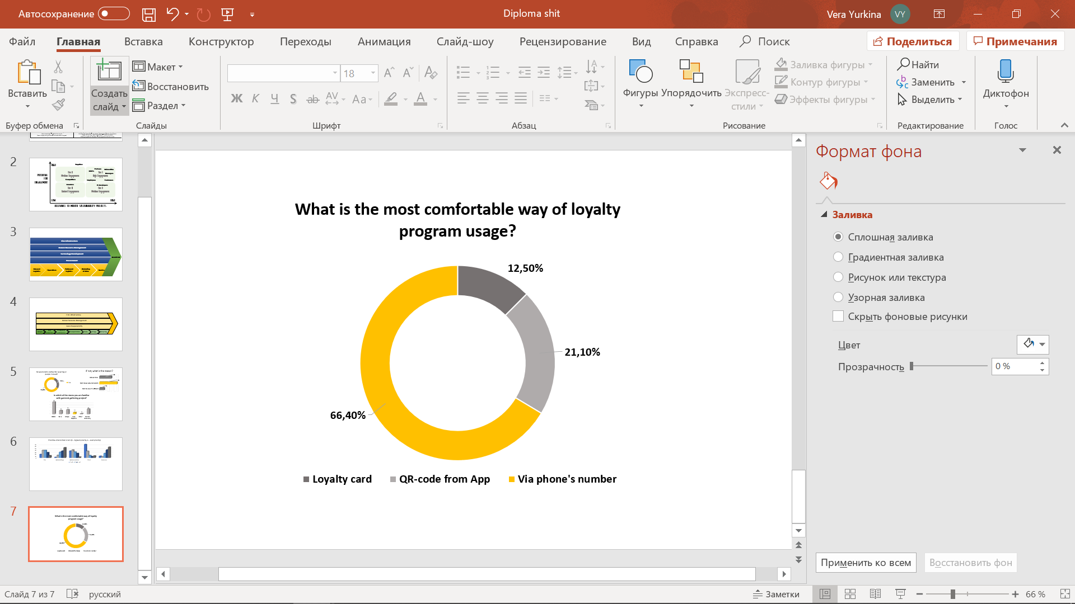counts.

Figure 31. Questionnaire results. The most preferable type of loyalty program

By acceleration the loyalty program and elimination of plastic cards company would direct #3 sustainable goal about the health and safety from the chemical emissions after the cards disposed. The reduction of emissions would also have an impact on climate change in #13 goal and simultaneously life on land in number 15.

#### Integration Stakeholders’ view in business

Next goal is to handle with the absence of transparency and increase stakeholders’ awareness through their integration into Love Republic’s business activities. The most obvious recommendation is to start reporting the activities towards sustainable development on the company’s website or Melon Fashion Group’s one. Such an initiative will eliminate doubts concerning the sustainability of resources and social norms complied with. Next recommendation concerns shooting and posting mini videos about the current activities. Such videos would serve not only as a part of raising awareness about the sustainability practices but also handing the promotion idea connected with the previously discussed initiative.

##### Sustainability reporting

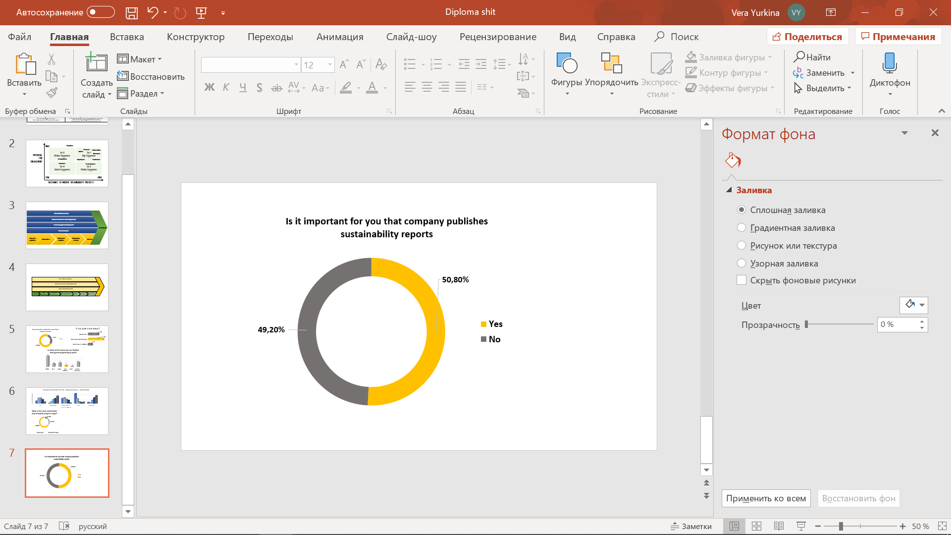As it was discussed in Chapter 1 one of the most crucial weaknesses company has in terms of sustainability is absence of transparency. Thus, company mentions usage of eco-materials or compliance with the rights and norms of Code, however in any of the cases there is no precise names of the mentioned items. So, customers, investors and potential partners and any other stakeholder could not be sure that company indeed make these activities. Thus, the recommendation is to start conscious reporting of the practices and activities. If company is a part of a Melon Fashion Group, the reports should be integrated into the full one of the whole company. Moreover, no other brand did something for sustainability and Love Republic was the first to introduce garment gather

Figure 32. Questionnaire results. Importance of sustainable reporting

ing. Thus, this kind of reporting could foster whole Group to start the way of sustainable development. So, report should contain the precise materials that are input into production, the rights and norms that Love Republic follows in employees’ and suppliers’ treatment, the set of goals targeted for sustainable development and the list of partnerships company has. It is the required minimum to put into report. The more clearly and openly company would write into reports the higher level of trust it could gain from stakeholders. In terms of relevance of such type of reports the opinions are divided almost equally However, 51% of respondents answered that for them it is important that company issuing sustainable reports to see the business ethics and scope of activities. The results of the questionnaire are presented on the corresponding pie chart on the Figure 32. In terms of pursuing sustainable goals by provision transparency company aimed at achieving more sustainable communities and unsure public access to information through goals #11 and #16 simultaneously.

##### Video posts

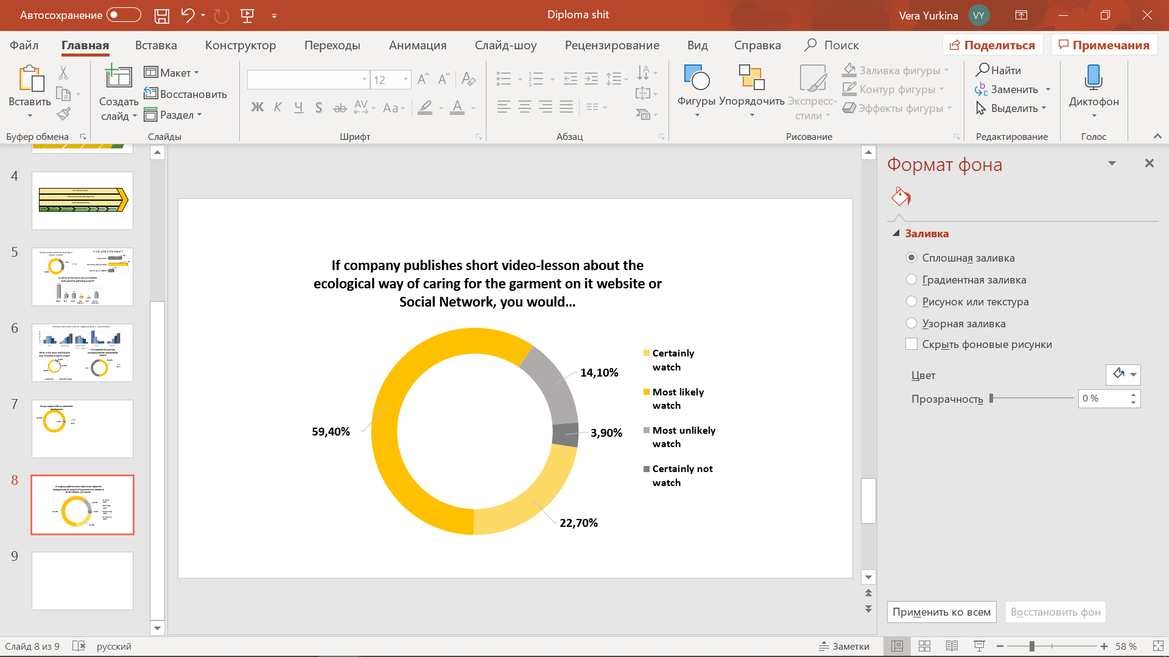The second recommendation towards integration the stakeholders’ view into the business process is shooting educational videos towards sustainable development. Publishing such videos on the websites or Social Networks would lead to raising awareness about actions and following impact that each individual can do in order to achieve sustainability. The example of such video, that was taken as a case for the questionnaire is shooting videos about sustainable caring for the clothes including the right way to choose the washing type or the advices for ironing and drying. These vieos would help to prolongate the lifecycle of the garments and raise awareness for stakeholders that all can contribute to the sustainable development. To estimate the relevance of such videos there was developed a question regarding the case if company would post video about the ecological ways of caring for the products, what would then be the potential behavior of the respondent.

Figure 33. Questionnaire results. Video publishing

The results are presented on the Figure 33. The majority, almost 60% is stated that they would likely to watch such a video, whereas also up to 23% would certainly watch it. Overall, around 85% are agreed to watch video in case it publishes. Thus, the initiative will work not only to achieve sustainable value but to promote Love Republic as well. The provision of advice lead consumers towards more responsible consumption of water, energy and resources driving #6, #7 and #12 goals. Moreover, from the right usage of detergent company improves health conditions and #3 sustainable goal. Overall in helps to create sustainable communities and deal with climate change problems through #16 and #13 goals.

#### Establish partnerships for sustainability

Partnerships are considered one of the most crucial factors for companies to achieve sustainability. It even was created the special goal by United Nations that is under number 17. The goal is to achieve partnerships for sustainable development. After the introduction of Millennium goals in the world there has appeared a number of initiatives, companies, organizations and project that are aimed at linking different stakeholders and companies as well together to drive the sustainable value to the world. Through the collaboration companies tend to exchange their knowledge in sustainability field and contribute to the creation of the sustainable world. Here, the recommendations consider not only world organizations that are aimed at sustainable development goals, but also the partnerships with local universities to provide decent workplaces what is #8 Sustainable Goal and to attract new talents to the firm.

##### Partner design universities

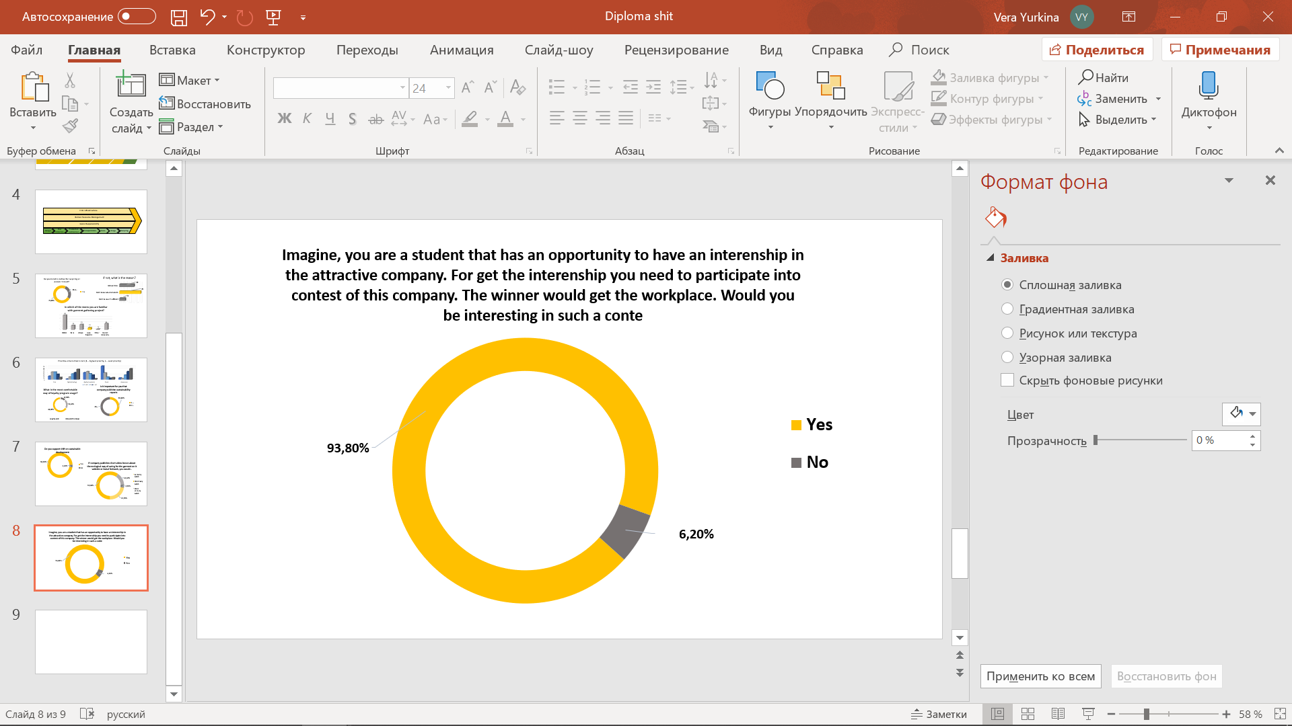This recommendation is designed to meet the sustainable goal number 4 and 8 concerning good education and decent work, respectively. The goal is to establish partnership with universities as Saint-Petersburg Textile and Fashion University or College of Petersburg’s Fashion.

Figure 34. Questionnaires results. Universities’ partnerships for internships

The idea is to exchange benefits between students and universities on one side and Love Republic on the other. Love Republic would organize special competitions or Hackathons, where students of fashion universities could participate. There would be done a special problem to solve, and students would start to come up with the creative answers. After the contest company could decide on the students, they are willing to see on the workplaces in the company. Thus, students would have an opportunity to gain internship. This case was done for a questionnaire with the question whether it would be interesting to have such an opportunity. The results on the Figure 34 shows that the vast majority – up to 94% have responded that they are interested in such a situation.

Except for provision the workplaces for a student company could also benefit universities to attract company’s representatives as guest lecturers during studying and students could receive practical knowledge based on Love Republic’s experience. Love Republic obviously benefits from the ability to attract young talents to the team. This recommendation is delivering #4 and #8 and #11 sustainable goals.

##### Partner sustainable organizations of textile industry

Partnerships are considered to be one of the most crucial resource to achieve sustainable development. All companies, that have already achieved some sustainable results unanimously stated that there is no chance to achieve sustainability alone. Thus, they have approved collaboration for sustainability is extremely important. Therefore, from the benchmarking with H&M and Inditex several world sustainable organizations were chosen Love Republic could partner with. These organizations are Zero Discharge of Hazardous Chemicals, Better Cotton Initiative, Sustainable Apparel Coalition and Lenzing. Thus, now it is important to understand which of them would be relevant for Love Republic.

* **ZDHC[82]**

Zero Discharge of Hazardous Chemicals is a group of apparel companies that are collaborating together to lead the textile industry towards elimination of all hazardous chemicals during the production process and searching for alternatives to use. By partnering this group Love Republic could have access to the novel practices and technologies to reduce the chemicals input during fibers and garments creation. Elimination of hazardous would affect not only to the provision of healthier and more safety product to customers but also ensures safe working conditions of all employees and suppliers engaged. Moreover, the elimination of chemicals would positively affect environmental through reduction of emissions.

* **BCI[83]**

Better Cotton Initiative is a non-governmental organization that is aimed at supplying cotton that promotes better standards for cropping, better working conditions for farmers and less water, energy and chemicals input. Therefore, the cotton produced is more sustainable and is more appropriate for using in garments and have positive environmental impact on environment. Love Republic share of cotton among all raw materials used is not rather high. Company uses cotton only for the production of T-shirts; however, all other garments are made from viscose, polyamide, elastin etc. Thus, the relevance of this partnership is not also high, but it could further be spread to other clothes.

* **SAC[84]**

Sustainable Apparel Coalition – is a world alliance of apparel and footwear brands, non-governmental organizations, retailers, manufacturers, experts etc. that have joined together to address world sustainability along the industry. The group is aimed at reduction of negative impact industry causes in environmental and social terms. The group has introduced Higg Index that helps the parties engaged to measure the products and brands performance of Sustainability. Moreover, most of sustainable organizations, as ZDHC, linked to textile industry are also parties of SAC, and by getting involved into the coalition they have facilitated the communication between each other. Love Republic could get easier access to sustainable suppliers and manufacturers through being a part of coalition.

* **Lenzing[85]**

Lenzing is a company that is working with production of ecological and sustainable fiber that is rather important nowadays. Company has four brands under its name. The first one is Veocel TM that is targeted to create sustainable fiber for baby care or cosmetics pads, whereas the second – Lenzing TM for creation fiber for packaging, protective equipment etc. The third of which is ECOVEROTM that is aimed at production sustainable viscose. The fourth is Tencel TM that has broader variety that the previous one. Tencel Lyocell is targeting at provision more sustainable fibers to apparel world, via REFIBRA technology that enables to recycle old garments to input back the materials. Thus, Tencel Lyocell is fiber made from recycled clothes that foster close-loop economy. For Love Republic such a partnership as Tencel and ECOVERO are rather relevant to address sustainability from the point of raw materials. Especially, Tencel Lyocell, which would foster the transition towards circular economy

Through these partnerships company is aimed at provision healthier and safety working conditions complied with required Code of Conduct. Also, the usage of water, raw materials and energy would be controlled. Also, Tencel Lenzing would have to create circular approach towards garment gathered. All partners will help to struggle with climate changes and boost the creation of sustainable cities and communities through the transparency and partnerships in terms of sustainability. By these partnerships most of the sustainable goals would be directed: #1, #3, #5, #6, #7, #8, #10, #11, #12, #13, #16, #17 goals. Whereas, in the analysis of company’s practices it was stated that company already start targeting #7, #8, #10, #12, #13 and doubtful #3 and #6 goals. Thus, by introducing these strategies it would strengthen existent and direct seven new.

### Stakeholder Analysis

For any project or strategy, it is crucial to identify key stakeholders that should be closely managed for the implementation of particular initiative. Thus, key stakeholders are those who will be fully involved in the project or strategy and who would be affected by the project completion. Usually, stakeholders are assessed based on their interest in the project and its power to affect it. Thus, using Power & Interest Grid – common tool for stakeholders’ analysis, that was introduced previously by Colin Eden and Fran Ackermann in their book – Making strategy.[86] However, as work is focused on the sustainability practices, stakeholders were assessed based on the matrix that compares the relevance of stakeholders to introduction the sustainability practices and the potential of their engagement. The matrix used is Stakeholders’ Engagement Matrix that was introduced by Kristina Kohl in the book Becoming a sustainable organization.[87] Furthermore, after identifying the key stakeholders to engage into sustainability strategy there will be defined the type of collaboration they need to implement in order to complete the project. The tool used for this will be in the Matrix for sustainable collaboration introduced by Ram Nidumolu, Jib Ellison, John Whalen and Erin Billman.[88] The results of the stakeholders’ engagement analysis are presented on the Figure 35 below.

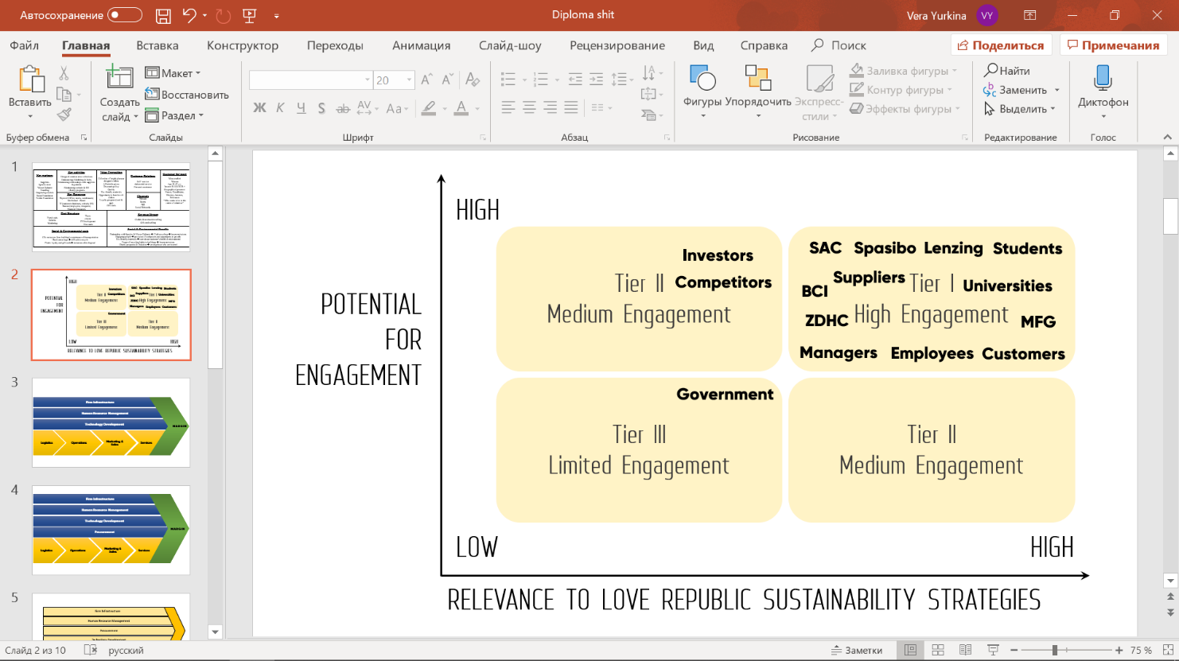

Figure 35. Stakeholders Engagement Matrix

First of all, it is important to mention that in terms of sustainability it is said that all the stakeholders should be involved and integrated into the company access. This is almost the result achieved. Almost all stakeholders of Love Republic have high potential to engage into sustainability projects among three groups. The First is investors, which is located in the upper-left quadrant and has ‘medium’ engagement policy. The reason is that investors have high potential to engage but are not aware enough about the current projects that exist in the company, but in case investors become an interested party in the project, as supporting the sustainable partnerships, they automatically will be highly engaged in it. Secondly, competitors that are located in the same quadrant and are not directly relevant for the company’s strategies, however they could be in such an initiative as LOVE 2.0. For example, when Love Republic will integrate sustainable suppliers with production of recycled made fibers, competitors which also has garment gathering program could partner Love Republic for garment recycling and inputting back to production. Third is government that is located in the lower-left quadrant and are stated to be limited engaged in the projects. In terms of government, it should be interested and engaged into the sustainable development but as well as company is a part of Joint Stock company the influence and intervene of government is limited. Thus, all the actions Love Republic implements are made independently from the government. In terms of competitors also, nevertheless, there exist severe competition on the market and each company seems to act independently from each, they should act through collaboration in terms of achieving sustainable development.

So, moving for the group that has been identified as key stakeholders the first one is to be mentioned is MFG – Melon Fashion Group, that includes the shareholders of the Group as well as 3 other brand it has. It is obviously relevant and interested as well as has the maximum engagement in the implementation of sustainability projects as well as managers of Love Republic that are also listed as key stakeholders. Next those that are out of the clothes sales as prime operations of Love Republic. They are sustainable organization Love Republic could partner (BCI, SAC, ZDHC and Lenzing), non-governmental shop Spasibo. All them, are nonbusiness stakeholders which are fully engaged in the sustainability development of the company and would influence its direction a lot. Also, universities and students are those who would be highly engaged in implementation the initiative concerning Hackathons and university partnerships. The last groups of key stakeholders are employees, customers and suppliers, that are mostly business stakeholders that interact on the daily business and are already engaged in the company’s operations. In terms of sustainability customers and employees are already collaborating in LOVE 2.0., whereas suppliers help to support the main company process of value creation. After indication the list of the key stakeholders the following were chosen: Melon Fashion Group, Sustainable organizations (BCI, ZDHC, Lenzing, SAC), universities and students, Spasibo, suppliers, managers, employees and customers.

Figure 36 represent the stakeholder’s collaboration matrix that helps to identify right focus and players engaged for the sustainable strategies and recommendations developed. In terms of the focus of collaboration as Love Republic is only started its movement towards sustainable development it should focus on changing its operational processes rather than putting high goals. So, the target focus is made on operational processes. In terms of players engaged, key stakeholders should be divided on those that are directly connected to main operations of the company along the value chain and those that are nonbusiness stakeholders. For the first one, they would include MFG’s members, managers, IT specialists, clients, employees and suppliers, which are currently creates value for customers. Also, potential partners as ZDHC, BCI, SAC, Lenzing and current partner Spasibo with its customers are considered to be player across value chain because the collaboration would impact value chain processes. The low-left quadrant strategy is mostly relevant for these 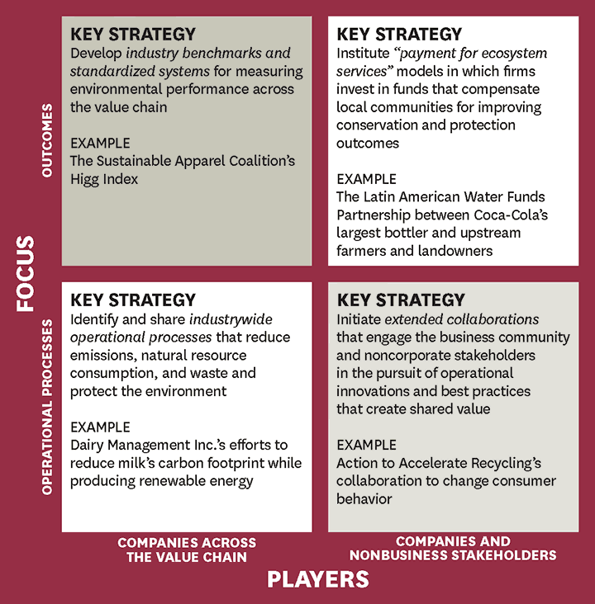players and would eliminate emissions and wastes that are produced during the operations.

Figure 36. Stakeholders Collaboration Matrix[89]

In terms of out of business stakeholders there are universities and students, however students are the party that would firstly be out of business stakeholders, however, is employed they would shift towards in business stakeholders in the group of employees. Collaboration of different parties could create greater shared value thus targeting not only Love Republic and its stakeholders but also for the whole society and environment.

Thus, now all initiatives would be described for corresponding collaboration of stakeholder. Moreover, the benefits for each party would discuss in order to ensure the collaboration as well as whole relevance not only for Love Republic but for every stakeholder engaged.

* **Increased promotion**

Nowadays, the initiative does not work well, because there is lack of communication between groups as well as lack of promotion from the heads of the company. Garments gathering will work better inside the stores if employees will closely collaborate with clients and raise awareness about the initiative. However, the initiative of promotion should come from the managers of the company. In case promotion is digital – the aid of IT specialists is required. Moreover, for the whole process Spasibo shop is also a party to collaborate, however it is already engaged in the process. Thus, by collaboration stakeholders are able to boost and foster the initiative. Thus, stakeholders to collaborate are managers of the brand to create the idea and put the advertisement and Spasibo Store that would take an active participation on the video promotion as well as the brand of the store would definitely be on advertisement. Thus, Spasibo would benefit from attracting more garments to its store, whereas managers of the brand would gain more customers in the stores and increased brand reputation.

* **Loyalty program modification**

For this initiative IT manager and company’s brand managers are required to modify the program overall. There is no collaboration in global context, only among company’s managers. Thus, it is rather internal strategy that would reduce CO2 emissions by the elimination of plastic cards. From this strategy also, company’s efficiency would increase because of the easier way of discounts obtaining and thus the queue in the stores would be less.

* **Sustainability reporting**

Reports are essential for sustainable performance, through provision of transparent information company could increase its reputation and level of trust for other interested parties. As Love Republic is a part of Melon Fashion Groups their Reports could be integrated, however issuing independent report is more beneficial for Love Republic Thus, both parties should collaborate. From the Figure 34, this collaboration stands for upper-left quadrant by sharing the outcomes and current results of sustainable development. Through this information The Group as well as Love Republic by itself would benefit from the increased interest from other stakeholders in the company’s operations. Also, through the reports of such type company could compare it annual progress in achieving sustainable goals.

* **Provision of educational videos**

This initiative stands for creating shared value for the whole society towards movement in sustainable direction. The videos would help individuals to make small steps towards sustainability. To launch this initiative managers of the company should collaborate between each other to shoot and post them on the company’s channels. However, sometimes external partiers could also collaborate to shoot some interview with advice. For example, design universities which are targeted to collaborate in another initiative could be an engaged party in videos shooting to provide information about novel findings in the studies in terms of sustainable caring for clothes. Managers of the band then would again receive increased brand loyalty and reputation in eyes of customers as well as collaborative party as university would increase its brand recognition over the country and outboards.

* **Partnerships with design universities**

Obviously, for implementation the practice partnerships managers of the brand or even whole Group should collaborate with external stakeholders – universities. From the collaboration shared value would be created for both enterprises and their dependent stakeholders. From implementation of this initiative company would get a reliable partner in term of the regular participation in Hackathons and opportunity to attract new talents with novel solutions to current industry challenges and by their creative ideas to cope with tasks and employ those that could drive company forward.

* **Partnerships with sustainable organizations**

The same as with the universities’ partnerships company’s managers with the Group’s ones would collaborate with the organizations recommended, which are ZDHC, SAC, Lenzing and BCI. Overall, these collaborations would radically influence company’s value chain operation in favor of sustainable processes. Thus, Love Republic as a part of MFG would benefit from obtaining novel practices and processes to achieve sustainable development. Thus, from BCI it would ensures the health and fair working conditions and ecological resource input. By this it reduces the negative effect during cotton cropping and CO2 emissions from cotton to recycle. Moreover, joining the initiative would provide a more progressive way for brand to make decisive steps to secure sustainable future for challenged global cotton production. In terms of ZDHC, company would benefit from the supplying ecological and chemicals free resources and garments. It also affects suppliers working conditions. Through Lenzing company would be able to fully introduce the circular economy and make LOVE 2.0. initiative fully working. Whereas, partnership with SAC would give company an opportunity to access novel sustainable practices, suppliers and access to international benchmarks and tools to measure sustainable performance. For all four organizations the partnership with Love Republic would have identical benefit that is start of the sustainable development in Russia. Being the largest company in the world, Russia would be an active and leading player in terms of sustainability, however real situation is rather contrary, because the infrastructure in Russia does not enable to move towards sustainable lifestyle even when there is demand on it. Thus, from these partnerships this global organizations and NGO’s would start spreading own practices on a new area and achieve its goals, towards fair treatment, ecological working conditions etc. in Russian Federation. Overall, partnerships would reduce wastes and emissions as well as energy and water consumption and create shared value.

## Recommendations implementation

For the implementation of recommended actions firstly they were relocated correspondingly to the time scope they should be done. Then the detailed action plan of the implementation would be developed. Finally, risks will be evaluated by using Risk Scenario Matrix.

### Timeframes for recommendations’ implementation

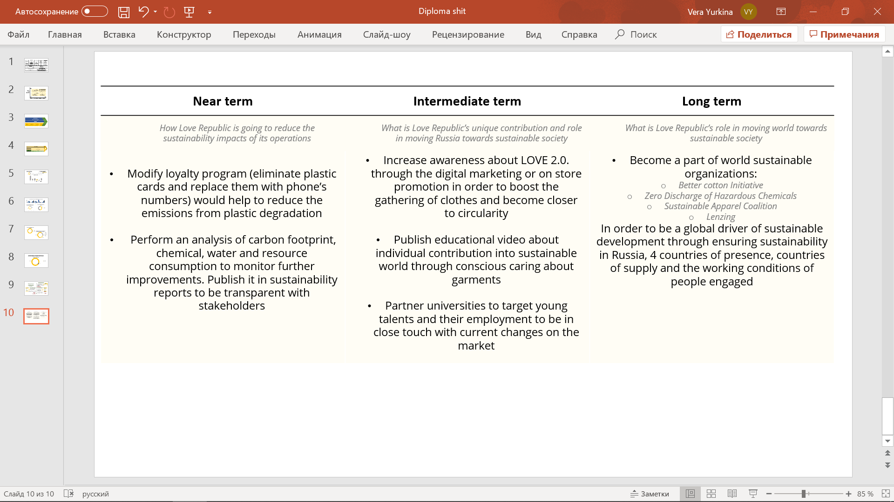As well as recommendations are proved to be relevant for Love Republic and for the market, they were distributed accordingly to three timeframes. The first one “near term” refer to the practices that would affect the company’s operations directly, thus, by these strategies the emissions would be reduced. Secondly, “intermediate term” refers to the initiatives that would boost whole country to follow sustainable development, increase the awareness and become a driver of society towards sustainability. The last timeframe, “Long term”, is related to strategies that would affect world sustainability and the impact of its introduction would create a global print. Thus, potential practices were distributed correspondingly. The detailed description of the distribution is presented on the figure 37.

Figure 37. Three timeframes for recommendations implementation

According to the figure, the near-term plan includes sustainability reports provision and loyalty program modification. The first one includes the analysis of the emissions and the amount of water or resources consumed in order to provide full transparency for stakeholders. This directly solves absence of analysis and reports and the ambiguity concerning usage of eco-materials and sustainable suppliers with regards of provision sustainable business.

Secondly, cards elimination directly affects the decrease of CO2 emissions. The process itself would move Love Republic to more digital and sustainable way of business. This could be easily achieved due to the large customer base of the company that would support the shift because of the complexity of LOVE 2.0. discounts obtaining process. LOVE 2.0. itself motivates other customers to obtain loyalty program.

Moving to the intermediate-term initiatives there are three. The first one refers to the educational videos that would boost society to change their lifestyle to more sustainable one. The strong brand and large customer base would be a positive driver of the strategy to be implemented and spread towards Russian territory. The supportive factors are digitalization and society’s switch towards health-conscious lifestyle. Next one is intense promotion of LOVE 2.0. initiative to involve Russia and spread the initiative around all presence points. Thus, weaknesses as lack of awareness and ambiguous raw materials could be solved through capturing rapid digitalization of business and possibility to achieve circular economy. The third practice is collaboration with universities to employ young talents to achieve #8 SDG through the strong brand and corresponding strength and manage threat of rapid changes in the fashion trends.

The last time frame is long-term and includes the collaboration with world succeeded organizations that would help Russia to move towards sustainability as well as move towards global sustainability and become closer to achieving goals till 2030 on the broader context. This could be done through the strong brand of the company on the Russian market with the opportunities as demand for sustainable business conducting and circularity trend. In terms of weaknesses it affects ambiguity of materials and suppliers by ensuring its ‘sustainability’ as well as help to evaluate the emissions and consumption changes.

### Detailed Action Plan for initiatives’ implementation

After analysis of stakeholders that should be engaged in the strategies’ implementation and the results of their collaboration it is required to understand which steps, they should take to achieve the desired outcome of the strategies. For this, action plans for each initiative were developed. The action plan is structured correspondingly to the timeframes that were identified earlier.

#### Loyalty program modification

For modification of loyalty program company should gather all the data concerning its clients into one database. After creating the full list of customers with their phone numbers, company have to state that plastic cards are not more required in the stores. When customer comes to the shop and calls the number the discount should be automatically linked to his virtual card in the same database. In case new customers are coming to the shop the process is the same, cashiers or managers write its data in the database together with the phone number. Thus, discounts and virtual cards are linked not only for the phone’s number but for the whole customer. The major work to be done is to create the integrated database with all customers, that are owning cards, have App on the phone or have cards through the site registration.

#### Sustainability reporting

Company has started to perform the analysis of its carbon footprint; amount of resources and energy consumed and start forming its sustainable report as soon as possible. This strategy requires time, however, should be started immediately. Company has not still published its 2019 annual report. Thus, as soon as possible company should start working on the 2020 report. Moreover, company could start posting news about its novel results in the field of sustainability right now, starting from LOVE 2.0. initiative. For this strategy, company has to be honest and transparent and gather information concerning its suppliers, practices they are using, their relationships towards sustainable development etc. Second aspect to be covered in report is treatment towards employees, which norms there are in Love Republic, which conditions and potential for growth. Also, company should publish more information concerning the resources used in order to approve it.

#### Increase promotion

For the introduction of relevant promotion company should firstly make posters inside the stores to attract the attention of those who comes to the stores. Thus, when customers are entering the shop or standing in the queue, they could drag their views onto colorful poster that states about opportunity to handle in clothes with further receiving of discount. The poster should include Spasibo’s brand to show where garments are gone next. Also, posters would be more efficient, if there are calling statements as “Share your clothes” or “Make the environment cleaner”. Also, if posters include the little description of the project itself regarding further life of the garment etc. it then would increase level of trust from customers and they would be more willing to participate.

Also, company could force its online advertisement through website or Social Networks. By shooting videos about the program, the way garments are recycled, distributed, the benefit individuals can do to achieve sustainability, company would increase the customers’ awareness together with reputation that comes to the brand. Love Republic could also shoot an interview with Natalya Galechian, CEO of Spasibo, regarding the shop and the impact viewers could bring to the world. This promotion should be posted on the company’s online channels.

#### Provision of educational videos

For provision of such videos, managers should reflect on ideas to share with viewers. Taking an example of shooting sustainable ways of caring for garments company should make a research towards such methods and shoot corresponding episodes. After the video is edited it should be posted both on the website’s corresponding page and social networks account. After the several videos, company should collect feedback on further research considering the interested areas of public.

#### Establish partnerships with design universities

For achieving these partnerships company should research on the schools and faculties that could be potentially be needed in company’s operations. Taking an example of Saint-Petersburg Textile and Fashion University, Love Republic should contact the dean of the university to discuss the potential collaboration and the requirements for it. After universities are agreed to partner the required documents and proposal for partnerships are prepared. When the partnership is established Love Republic could promote its internship positions through the university’s channels before the Hackathons starts.

#### Establish partnerships with sustainable organizations

This is the most time-consuming strategy to be implemented. For achieving partnerships with the organization recommended it is important to see the requirements of each to collaborate. Thus, all four were discussed separately.

* **SAC**

Sustainable Apparel Coalition has three types of memberships; corporate – including companies that sell or produce apparel; affiliate – trade associations that provide product but is not engaged into its direct sales or production; NGOs, Academic and Government – universities, agencies etc. Thus, Love Republic is considered to be potential corporate member.

To become a member of SAC, Love Republic has to sign SAC Membership Agreement towards being transparent; sharing reliable information with other parties and provision of support towards industry sustainable development. Moreover, it is obliged to pay annuals due in corresponding type. In terms of dues, they are based on company’s annual revenues which should be reported prior to the joining. According to the table in the SAC’s report towards membership**[90]** Love Republic revenues are placed in the field of $20-$100 million because the revenue of the company is 5,6 bln rubles. (76,3 mln dollar). The annual due then is $11 000 which equals to 807 400 rubles. However, in case all Melon Fashion Group wants to become a member it would be placed in the are $100-$500 mln with corresponding dues of $22 000 (1,6 mln rubles). By this the Group could reduce the costs on membership and all 4 brands would be members of SAC.

* **ZDHC[91]**

In order to become a member of Zero Discharge of Hazardous Chemicals Love Republic has to send a submission from the corporate account to receive the access for the private information considered the ways and steps for becoming a member. Overall, there are 4 types of memberships in ZDHC: for labs, for certificates standards ensuring, provision of training to the younger generation and friend (potential collaborator) that are interested in learning the tools to switch to sustainable development. For Love Republic it is suitable to choose now “friends” option to look at the practices overall, their approaches etc. and understand the global necessity of being a part of this project. In case everything satisfies both parties, friends are turning into collaborators - successfully integrated in ZDHC companies that have already a wide experience and trying to enhance not only own process but other companies as well. Thus, “Friends” is rather educational option, to learn more and “dive” into the industry affect from the initiative. So, it is recommended o choose firstly “friends” option. However, there is no financial information towards becoming a member of ZDHC.

* **BCI[92]**

For becoming a member of Better Cotton Initiative Love Republic has to form the application and sent it back to the BCI e-mail. Overall, BCI provides 5 options for memberships: civil society (NGOs), Produce Organizations, Suppliers and Manufacturers, Retail & Brands and Associates (those that are not suitable in neither of these categories but is interested in investing in BCI). For Love Republic “Retails & Brands” option is required. For being a part of BCI company promises to improve global cotton production through regular fees payment. For Love Republic partnership with BCI would require providing credible responsible sourcing program. Also Love Republic should comply with BCI Membership Code of Practice[93] and Terms of Membership[94] sign the confirmation and sent it to BCI’s mail. Membership fee depends on total cotton footprint company has previously published in the report. Thus, partnership could be started only next year, after Love Republic would issue its Sustainable Report 2020 with corresponding data. According to BCI membership fees[95] annual fees could fluctuate from €6,000 to €45,000. However, knowing that the portion of cotton used by Love Republic is rather small and used only for T-shirts, the fee would be minimal - €6,000 or RUB 480 000. In case all the Group- Melon Fashion would be interested the fee would increase.  
After sending the application Love Republic would wait for confirmation and then receives the invoice for fee in case of positive result. If, no other issues are arising during the documents checking and payments receiving Love Republic would become a member of BCI. The process of confirmation and becoming a full member could last up to 13 weeks.

* **Lenzing**

To become a partner of Lenzing and supply the sustainable fibers Love Republic should firstly create account on the Lenzing Official website. Detailed of information of requirements to collaboration is posted there only for private access. Next, company should ensure its suppliers have Lenzing certification number, is case there is no, company should motivate suppliers to obtain one or even find others who have already obtain it. Through the collaboration with SAC it would be easier to implement. Afterwards, the verification is made company could use beneficial offers of Lenzing and increase the brand image. The process described is suitable only if suppliers are already using the Lenzing fibers in case no, company should partner Lenzing as a fiber supplier. The information concerning requirements for such a partnership is hidden in the private access.

### Risk Analysis

After identification of required actions, stakeholder engages and relevance of the strategies it is important to understand the risks that could arise during implementation. Below there are presented all strategies with potential challenges to be appeared and the ways of their mitigation.

* **Loyalty program modification**

The risks that could arise from this initiative implementations are mostly concern IT side of the process. It could be timely to create one database with all customers especially adding those that are registered with App. Thus, the overall process requires a lot of time, however after the database is created another risk could appear. As data includes personal information with date of birth and phone number there could be risk of phone number changing and losing the loyalty card. For mitigation of this risk company should modify the process by adding the option into the program of number changing. Thus, customer, who has changed his number could come to the shop while making a purchase and said he has changed the phone number. Cashier, then, opens a data base and search the customer with his previous phone number. Afterwards, cashier asks personal data about date of birth, name and surname and after verification has an option to change linked number. By this, customers would be less risky to lose discounts.

* **Sustainability reporting**

The provision of sustainable reports could include risks of Melon Fashion displeasure of Love Republic issuing separate reports. All previous reports were published as a part of Melon Fashion Group, however sustainable reporting was never included because none of the brands follows principles. The risk avoidance is simple either to state on the necessity of separate reporting or motivate MFG to start adding action towards sustainability in its annual report. The second option is more favorable because in this case MFG could also be motivated to implement start of sustainable actions in other brands and global climate and water actions on the group level. Nevertheless, the risk of such resistance is minimal.

* **Increase promotion**

In case of promotion there is almost no risk into strategy implementation. The risk of lack of financials is so little because of the ways of promotion. Everything could be done internally. Posters should be ordered in the printing shops which Love Republic is in close contact in. In term of video advertisement company does not have much risks. The only that could be is that the media outreach would not be high, but this could be solved by introduction of target advertisement. Then, everybody who would search in the engine Love Republic would have access to this video.

* **Provision of educational videos**

As in case of promotion videos, shooting educational ones is not rather risky from the point of view of video creation. Nevertheless, this initiative could face the risk of lack of ideas and content to share. One of possible is to post the sustainable cloths caring such as washing and drying with respect of detergent used etc. Also, company could shoot interviews with its staff that call for action to follow sustainable lifestyle. Another aspect is to shoot interviews with partners about their view on sustainability and advices from their area of business. For further content company should research a lot to monitor upcoming trends in the world and adopt its videos correspondingly.

* **Partnerships with design universities**

The risk of this initiative includes universities’ unwillingness to partner with Love Republic. In order to mitigate this company, need to explore the wider range of colleges and universities to partner with. Another risk includes the potential wide scope of students desired to participate into Hackathons and to be employed. For this, company should reflect more about the required place, its space and limit towards students engaged. However, the latter action should be done after the establishment of partnerships.

* **Partnerships with sustainable organizations**

In terms of partnership BCI, ZDHC, Lenzing and SAC company could face risk of long-time approval and possibility of application to be rejected. However, for some of partnerships Love Republic could apply only in a year when introduced the data concerning cotton consumption as BCI. The process of verification towards partnerships to be established is rather long-term. Nevertheless, this process could be forced if Love Republic would create full integrated clear and transparent report and by which partner companies would ensure Love Republic would be a driver for sustainability in Russia. Thus, the risk would be mitigated.

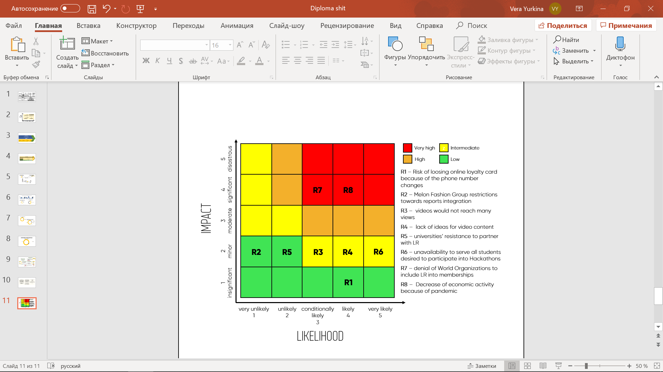 All the risks discussed are summarized by using the Risk Scenario Matrix. The results are presented on the Figure 38.

Figure 38. Risk Scenario Matrix for Love Republic’s strategies implementation

From the matrix it is seen that almost all risks discussed are not severe and could be mitigated with the practices discussed previously. However, the most severe one is possible denial of organizations as BCI, Lenzing etc. to include Love Republic into the organization’s membership. The reason could be lack of Love Republic experience in sustainable development. By this denial, Love Republic is at risk to miss the opportunity to use sustainable cotton, obtain global support in chemicals elimination, use recycled material etc. Nevertheless, as it was stated before sending the request to organizations company has to perform its first sustainable report and by this mitigate the risk of denial. Also, there is one more severe risk that has not been discussed earlier, because it is related to all strategies and to the whole performance of the company rather than to one particular. This is the risk concerning the economic downturn because of the dollar prices drop and coronavirus pandemic. The consumers’ purchase possibility would decrease, and company could decrease the purchases of the clothes. Thus, the whole business operations are at risk and the consequences are rather significant. However, the only way to deal with it is to adapt and try to move towards conscious production, because as it was stated during PESTEL analysis, customers in apparel industry would prefer more sustainable companies. Thus, the only way not to lose the customers and market position for Love Republic is to introduce sustainable business. All other initiatives, also, could be mitigated via corresponding activities that were mentioned earlier.

## Summary of Chapter 3

This chapter was dedicated to the provision of strategies to be implemented by Love Republic. By using the sustainable value framework introduced by S. Hart and linking it to previous results of SWOT analysis and benchmarking, three strategies were identified: Pollution Prevention, Sustainable Vision and Product Stewardship. To implement these strategies six recommendations were developed. The initiatives are divided onto 3 groups based on the common result achieved. Thus, the first group includes two, that are aimed at enhancement the currently introduced program of garment gathering LOVE 2.0. The first recommendation includes increased promotion online and instore. The second is considered the modification of discounts obtaining and overall loyalty program towards linking it to the phone’s number. The second group is aimed at integration stakeholders view into the company’s actions through two initiatives: issuing sustainability reports and provide educational videos thus individuals can move towards more sustainable lifestyle. The third group is directed towards partnerships established. The first group of partners includes design universities and colleges, whereas second includes partnerships with global sustainable organizations: Zero Discharge of Hazardous Chemicals, Better Cotton Initiative, Sustainable Apparel Coalition and Lenzing. Then, the list of key stakeholders was identified based on the analysis of their relevance and potential to engagement. The key ones are Melon Fashion Group, managers, Spasibo, suppliers, Sustainable organizations universities and students, employees, customers. Their collaboration impact was analyzed based on Stakeholders Collaboration Matrix. After the mutual benefits were identified, the recommendations were distributed accordingly to the three timeframes and afterwards the detailed action plan for each initiative was. Most of the recommendations could be implemented during this year, however sustainable partnerships to be established could be established at least in a year due to necessity of obtaining data concerning emissions and consumption and provision of sustainability reports. Afterwards, the risks of all strategies were analyzed, and their potential ways of mitigations set. The risk scenario matrix summarizes all the risks and estimate their significance.

By introduction of these strategies company would be able to target #1, #3, #5, #6, #7, #8, #10, #11, #12, #13, #16, #17 goals. In the chapter 1 the analysis of company’s practices ha stated that company already start targeting #7, #8, #10, #12, #13 and doubtfully #3 and #6 goals. Thus, by introducing these strategies it would strengthen existent and start targeting seven new goals.

# Conclusion of the graduation paper

This work is a consultancy project for “Love Republic” company. The work was aimed at provision of strategies for the company based on the sustainability principles.   
For understanding the necessity of the strategies company’s and industry analysis were conducted. Thus, Love Republic seems to have already started its movements towards sustainability. The greatest initiative it has recently launched is LOVE 2.0. that is aimed at garments collection in the stores and further transportation of it to charity shop Spasibo. By this initiative company starts reduction of emissions from the garments disposed and meeting social needs by reselling these garments in the store. Company has also rather stable and growing revenue that allows it to invest in sustainable development of the brand. For deeper understanding the social and environmental impact of the firm’s operations Adjusted Business Model Canvas was performed. This canvas differs from the original provided by Osterwalder and Pigneur by adding two blocks that are social & environmental benefits and social & environmental costs. Afterwards, company’s value chain was built. Through the values chain’s primary and supportive activities, it was seen how the value, namely garment, is created. Also, it was identified that company has some sustainable issues but did not report about them as those concerning sustainable development.

In terms of industry analysis, firstly global challenges and trends were identified. Thus, as apparel industry is one of the largest in terms of CO2 emissions and resource consumption it is challenged to move towards sustainability rapidly. From the trends the most crucial is introduction of circular economy by garments gathering and further recycling and inputting back to production. From the market overview it was seen that the major market segment is women. Also, it was proved that the industry is expected to grow more in following five years.

For the analysis of macroenvironmental situation and factors that could potentially influence industry PESTEL analysis was conducted. Thus, currently coronavirus pandemic is one of the major challenges in the world that affect all industries and leads to economic drop. Moreover, recent drop of oil prices caused ruble devaluation. Thus, the risk of crisis is extremely evident. From the Social Factors it was proved that population is ready to move towards sustainability but there are a lot of barriers and misunderstandings for actions. Thus, companies should act as a motivators and drivers to help people achieve the result. For the analysis of industry level of competition Porter Five Forces analysis was conducted. It approved the intense rivalry among players due to different factors. For understanding the performance of Love Republic among other. Competitors analysis was performed. It was taken 5 companies together with Love Republic, so other four are Zara, Mohito, Mango and Incity. They were compared based on several factors that are directly linked to sustainable development. The analysis has shown that all international companies have already implemented the sustainability practices in their local countries and starts it spread in Russia, however in terms of Russian companies Love Republic is the first one to stands on this path. For concluding the internal and external environment of Love Republic SWOT matrixes directed on sustainable development was built based on the identified critical success factors for apparel company to compete in terms of sustainability.

After analysis of company’s environment, it was required to look at the practices in terms of sustainability in the companies that are industry leaders. Based on the Corporate Knight Ranking and Dow Jones Index four companies were identified as leaders. However, in order to narrow practices that would be relevant for Love Republic the choice of the companies for benchmarking was limited to those that have the same customer segment with company analyzed. Thus, H&M and Inditex were taken for the analysis. The benchmarking was conducting accordingly to the industry value chain blocks. The primary activities include design, raw materials ordering, fiber and garment production, transportation, Sales and Recycling. Whereas, supportive activities are Firm Infrastructure, Human Resource Management, Procurement and Technology Development. Through the analysis of practices along all the blocks it was identifies that both companies target to achieve all 17 Sustainable Development Goals introduced by United Nations, correspondingly to the triple bottom line approach.

Afterwards, based on the results of SWOT and best practices analysis with the help of sustainable value framework strategies and recommendations were identified. The strategies elaborated are pollution prevention, Sustainable Vision and Product Stewardship. The list of recommendations includes increasing promotion of garment gathering program and modification of loyalty program that are grouped by common goal of improving LOVE 2.0. initiative. Secondly, it was proposed to start issuing sustainable reports and post educational sustainability videos, that were grouped by integration stakeholders view in company’s operations. Third group is concerned of partnership establishment. Company is proposed to collaborate with design universities and become a part of four sustainable organizations, which are Better Cotton Initiative, Zero Discharge of Hazardous Chemicals, Sustainable Apparel Coalition and Lenzing. All strategies were proved to be relevant. Also, the strategies were analyzed from the point of view of stakeholders engaged and collaborated.

Afterwards the detailed requirements and action plans based on corresponding timeframes were developed. Finally, the potential risks of strategies implementation were explored and corresponding measures to mitigate them were identified. Risk Scenario Matrix was built in order to understand the significance of risks and their potential likelihood. Thus, the most severe is considered to be the denial of world organizations to include Love Republic in their membership. Globally, through the strategy’s implementation company could start targeting almost all sustainable goals, some of which could be targeting indirectly through the partnerships with sustainable organizations.

# List of literature used:

Better Cotton Initiative. Membership Fees. Retrieved from: https://bettercotton.org/wp-content/uploads/2014/02/BCI-Membership-Fees-2017-2020_Retailers-and-Brands.pdf

Better Cotton Initiative. Membership Offer. Retrieved from: https://bettercotton.org/get-involved/membership-offer/

Better Cotton Initiative. Official site. Retrieved from: <https://bettercotton.org/about-bci/>

Better Cotton Initiative. Terms of membership. Retrieved from: https://bettercotton.org/wp-content/uploads/2013/12/BCI-Terms-of-Membership.pdf

Central Bank Russia (March 20,2020). *Press release*. Retrieved from: <https://www.cbr.ru/press/keypr/>

Central Bank (March 30, 2020) *Economy. Information-analytical comment*. Retrieved from: <http://www.cbr.ru/Collection/Collection/File/27771/EC_2020-02.pdf>

Climate Disclosure Project. Retrieved from: <https://www.cdp.net/en/responses?utf8=%E2%9C%93&queries%5Bname%5D=h%26m>

ConsultantPlus. *Consumer protection law*. Retrieved from: <http://www.consultant.ru/document/cons_doc_LAW_305/>

ConsultantPlus. *Labor Code of Russian Federation.* Retrieved from: <http://www.consultant.ru/document/cons_doc_LAW_34683/>

ControlRisk. *Protests, Presidential Popularity and Potential Political Instability*. Retrieved from: <https://www.controlrisks.com/our-thinking/insights/protests-presidential-popularity-and-potential-political-instability-in-russia>

Corporate Knights (January 21,2020) *2020 Global 100 ranking.* Retrieved from: <https://www.corporateknights.com/reports/2020-global-100/2020-global-100-ranking-15795648/>

Eden, C., & Ackermann, F. (2013). *Making strategy: The journey of strategic management*. Sage.

Gereffi, G., & Memedovic, O. (2003). *The global apparel value chain: What prospects for upgrading by developing countries* (p 7). Vienna: United Nations Industrial Development Organization.

Hart, S. L., & Milstein, M. B. (2003). Creating sustainable value. Academy of Management Perspectives, 17(2), 56-67.

Humphrey, A. S. (2005). *SWOT analysis*. Long Range Planning, 30, 46-52

Inc. Russia News. Pandemic could put an end to the era of cheap fashion clothes of Zara and H&M. Retrieved from: <https://incrussia.ru/news/pandemiya-ubyot-zara-i-h-m/>

Incity. *Official website*. Retrieved from: <https://incity.ru/>

Inditex. *About us, our brands*. Retrieved from: <https://www.inditex.com/en/about-us/our-brands/zara>

Inditex. Code of Conduct for suppliers and Manufacturers. Retrieved from: <https://www.inditex.com/documents/10279/241035/Inditex+Code+of+Conduct+for+Manufacturers+and+Suppliers/e23dde6a-4b0e-4e16-a2aa-68911d3032e7>

Inditex. *Global Water Management Strategy.* Retrieved from: <https://www.inditex.com/documents/10279/241820/Global+Water+Management+Strategy_Inditex.pdf/a128125c-4874-47cf-beab-7e65385b923e>

Inditex. *Join Life*. Retrieved from: <https://static.inditex.com/annual_report_2017/assets/pdf/c51_en.pdf>

Inditex. *Logistics*. Retrieved from: <https://www.inditex.com/how-we-do-business/our-model/logistics>

Inditex. *Official website*. Retrieved from: <https://www.inditex.com/>

Inditex. *Our employees*. Retrieved from: <https://www.inditex.com/our-commitment-to-people/our-employees>

Inditex. *PFCs Progress Report*. Retrieved from: https://www.wateractionplan.com/documents/177327/558146/PFCs+progress+report.pdf/9da1a51b-0cbf-3718-b48b-987d95580214

Inditex. *Products.* Retrieved from: <https://www.inditex.com/how-we-do-business/our-model/products>

Inditex. *Stores.* Retrieved from: <https://www.inditex.com/en/how-we-do-business/our-model/stores>

Inditex. *Sustainability Report 2018*. Retrieved from: <https://static.inditex.com/annual_report_2018/pdfs/en/Inditex%20Annual%20Report%202018.pdf>

Inditex. *Sustainable and responsible manufacturing*. Retrieved from: <https://www.wateractionplan.com/documents/177327/558146/Sustainable+and+responsible+manufacturing.+Inditex+perspective.pdf/ebe974da-c1ca-9416-ef00-aaade4a3fb03>

Inditex. *Sustainable materials.* Retrieved from: <https://www.inditex.com/our-commitment-to-the-environment/closing-the-loop/sustainable-materials>

Inditex. *Sustainable Strategy*. Retrieved from: http://static.inditex.com/annual_report_2016/en/sustainable-strategy/sustainable-strategy/

Index Family. *Overview*. Retrieved from: <https://www.robecosam.com/csa/indices/>

International Labour Organization. *Freedom of Association and Collective Bargaining*. Retrieved from: <https://www.ilo.org/global/topics/dw4sd/themes/freedom-of-association/lang--en/index.htm>

Kohl, K. (2016). *Becoming a sustainable organization: A project and portfolio management approach* (Vol. 25). CRC Press.

Lenzing official website. Retrieved from: <https://www.lenzing.com/>

Love Republic official website. *About brand*. Retrieved from: <https://loverepublic.ru/about/lr/>

Love Republic official website. *LOVE 2.0*. Retrieved from: <https://loverepublic.ru/love_2_0/>

LPP. *Annual Sustainability Report 2018*. Retrieved from: <https://www.lppsa.com/wp-content/uploads/2018/02/LPP-raport2018-online-EN.pdf>

Manda, B. K., Bosch, H., & Worrell, E. (2015). Sustainable value creation with life cycle management. In Life Cycle Management (pp. 129-146). Springer, Dordrecht.

Marketline (February 2020). *Apparel Retail in Russia.* Retrieved from: <https://advantage.marketline.com.ezproxy.gsom.spbu.ru/Analysis/ViewasPDF/russia-apparel-retail-94392>

McKinsey & Company, Business of Fashion. The State of Fashion 2020. Coronavirus Update. Retrieved from: http://cdn.businessoffashion.com/reports/The_State_of_Fashion_2020_Coronavirus_Update.pdf

Melon Fashion Group. *Annual report 2018.* Retrieved from: <https://www.melonfashion.ru/upload/iblock/e5e/Godovoy_otchet_aktsionernogo_obshchestva_za_2018_god.pdf>

Ministry of Environment and Food of Denmark (2016). *Best practice Examples of Circular Business Models*. Retrieved from: <https://www2.mst.dk/Udgiv/publications/2016/06/978-87-93435-86-5.pdf>

Mintrud Russia. *Information towards situation on labor market in Russia.* Retrieved from: <https://rosmintrud.ru/ministry/programms/inform/11>

Nidumolu, R., Ellison, J., Whalen, J., & Billman, E. (2014). *The collaboration imperative*. Harvard business review, 92(4), 76-84.

Osterwalder, A., & Pigneur, Y. (2010). Business model generation: a handbook for visionaries, game changers, and challengers. John Wiley & Sons.

Porter, M. E. (2008). *The five competitive forces that shape strategy*. Harvard business review, 86(1), 25-40.

Porter, M. E. (1985). *Value chain*. The Value Chain and Competitive advantage: creating and sustaining superior performance.

RBC (January 23, 2020). *Russia and Kenia shared 137th place on the corruption perception index.* Retrieved from: <https://www.rbc.ru/society/23/01/2020/5e2912d69a794750adc67abc>

RoadMapToZero. Join us. Retrieved from: https://www.roadmaptozero.com/join-us

Scivera. *What is screened chemistry?* Retrieved from: <https://www.scivera.com/screenedchemistry2/>

Sustainable Apparel Coalition. Membership. Retrieved from: https://apparelcoalition.org/wp-content/uploads/2020/01/2019-SAC-Brochure-Membership-2020-01.pdf

Sustainable Apparel Coalition Official website. Retrieved from: <https://apparelcoalition.org/>

Sustainable Development Goals. *Sustainable Development Goal 6.* Retrieved from: <https://sustainabledevelopment.un.org/sdg6>

TASS (March 27, 2020). *S&P reduced forecast about GDP of Russia in 2020.* Retrieved from: <https://tass.ru/ekonomika/8101537>

The H&M Group (12th of February 2020). *H&M to be the first retailer to use Circulose.* Retrieved from: <https://hmgroup.com/media/news/general-news-2020/h-m-to-be-the-first-retailer-to-use-circulose.html>

The H&M Group (20th of February 2020). *Supporting a greener transport*. Retrieved from: <https://hmgroup.com/media/news/general-news-2019/hmgroup-supporting-greener-transport.html>

The H&M Group. *Chemicals*. Retrieved from: <https://hmgroup.com/sustainability/circular-and-climate-positive/chemicals.html>

The H&M Group. *Climate*. Retrieved from: <https://hmgroup.com/sustainability/Planet/climate.html>

The H&M Group*. Our supplier factory list*. Retrieved from: <https://sustainability.hm.com/en/sustainability/downloads-resources/resources/supplier-list.html#cm-menu>

The H&M Group. *Our value chain around the world*. Retrieved from: <https://sustainability.hm.com/en/sustainability/about/about/value-chain.html>

The H&M Group. *Phasing out PHAS*. Retrieved from: <https://hmgroup.com/media/Our-stories/PhasingoutPFAS.html>

The H&M Group. *Positive List.* Retrieved from: <https://sustainability.hm.com/content/dam/hm/about/documents/masterlanguage/CSR/Policies/HM%20Group%20Positive%20List-January%202019.pdf>

The H&M group. *Stakeholders engagement.* Retrieved from: <https://hmgroup.com/content/dam/hmgroup/groupsite/documents/masterlanguage/CSR/Policies/Stakeholder%20engagement.pdf>

The H&M Group. *Supplier Compliance*. Retrieved from: <https://sustainability.hm.com/en/sustainability/downloads-resources/resources/supplier-compliance.html#cm-menu>

The H&M Group. *Sustainability strategy*. Retrieved from: <https://hmgroup.com/sustainability/vision-and-strategy.html>

The H&M group. *The H&M Group Full Sustainable Report 2018*. Retrieved from: <https://sustainability.hm.com/en/sustainability/downloads-resources/reports/sustainability-reports.html#cm-menu>

The H&M Group. *The H&M Way.* Retrieved from: <https://about.hm.com/content/dam/hmgroup/groupsite/documents/en/hm-way/HM%20Way_en.pdf>

The H&M Group. *Water*. Retrieved from: <https://hmgroup.com/sustainability/Planet/water.html>

The H&M Group. *Working Conditions*. Retrieved from: <https://hmgroup.com/sustainability/people/working-conditions.html>

Treadler. *Official website*. Available at: <https://treadler.com/>

UN. *Life Below Water*. Retrieved from: <https://www.un.org/sustainabledevelopment/ru/oceans/>

Vedomosti. *Climate change in Russia*. Retrieved from: <https://www.vedomosti.ru/opinion/articles/2020/01/12/820402-vlasti-reshayut-problemu>

Vedomosti (March 10, 2020). *Vladimir Putin will be able to remain president till 2036*. Retrieved from: https://www.vedomosti.ru/politics/articles/2020/03/10/824874-putin-ostatsya

Vtoroedyhanie.Fond. *Interview with Marina Vlasova*. Retrieved from: <https://vtoroe.ru/2019/11/26/voronezh-interview-love-republic/>

*Why a sustainable cotton ranking?* Retrieved from: <https://www.sustainablecottonranking.org/why-a-cotton-ranking>

WWF, Solidaridad & PAN UK (13th of February). *Sustainable Cotton Ranking 2020.* Retrieved from: <https://www.sustainablecottonranking.org/check-the-scores>

XE. *USD to RUB exchange rate.* Retrieved from: <https://www.xe.com/currencycharts/?from=USD&to=RUB&view=10Y>

Zero Discharge of Hazardous Chemicals official website. Retrieved from: <https://www.roadmaptozero.com/>

10OTZOVIK. *The feedback on the Love Republic garments collection*. Retrieved from: <https://otzovik.com/review_9193534.html>

# Appendices

## Appendix A, Decomposition of Porter’s five forces analysis

### Appendix A.1. Threat from new entrance

### Appendix A.2. Threat from existing rivalry

### Appendix A.3. Bargaining

### Appendix A.4. Bargaining power of suppliers

## Appendix B, Sustainable Development Goals

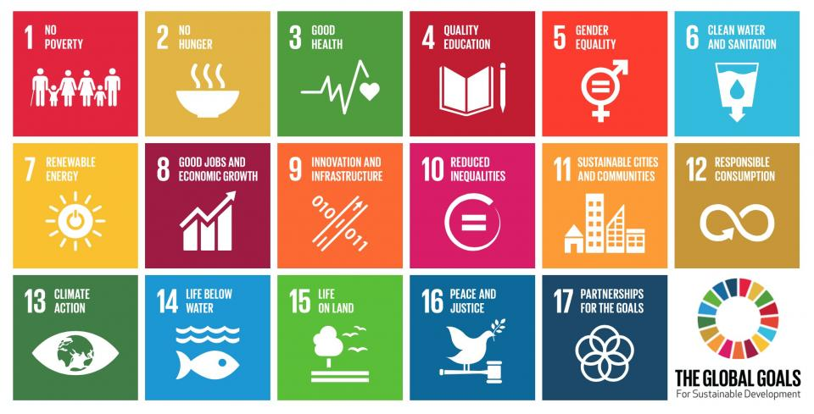

1. Love Republic official website. *About brand*. Retrieved from: <https://loverepublic.ru/about/lr/>
2. Melon Fashion Group. *Annual report 2018*. Retrieved from: file:///C:/Users/User/Downloads/Godovoy_otchet_aktsionernogo_obshchestva_za_2018_god.pdf
3. Melon Fashion Group. *Annual Reports*. Retrieved from: <https://www.melonfashion.ru/cooperation/investors/>
4. 10OTZOVIK. *The feedback on the Love Republic garments collection.* Retrieved from: <https://otzovik.com/review_9193534.html>
5. Osterwalder, A., & Pigneur, Y. (2010). *Business model generation: a handbook for visionaries, game changers, and challengers. John Wiley & Sons.*
6. Porter, M. E. (1985). *Value chain*. The Value Chain and Competitive advantage: creating and sustaining superior performance
7. Love Republic online store. Dress from eco-skin. Retrieved from: <https://loverepublic.ru/catalog/odezhda/platya/161598/>
8. Melon Fashion Group. Annual report 2018. Retrieved from: <https://www.melonfashion.ru/upload/iblock/e5e/Godovoy_otchet_aktsionernogo_obshchestva_za_2018_god.pdf> p.77
9. Melon Fashion Group. Annual report 2018. Retrieved from: <https://www.melonfashion.ru/upload/iblock/e5e/Godovoy_otchet_aktsionernogo_obshchestva_za_2018_god.pdf> p,79
10. Marketline (February 2020). *Apparel Retail in Russia.* Retrieved from: <https://advantage.marketline.com.ezproxy.gsom.spbu.ru/Analysis/ViewasPDF/russia-apparel-retail-94392> p
11. Marketline (February 2020). *Apparel Retail in Russia.* Retrieved from: <https://advantage.marketline.com.ezproxy.gsom.spbu.ru/Analysis/ViewasPDF/russia-apparel-retail-94392> p.9
12. Marketline (February 2020). *Apparel Retail in Russia.* Retrieved from: <https://advantage.marketline.com.ezproxy.gsom.spbu.ru/Analysis/ViewasPDF/russia-apparel-retail-94392> p. 10
13. Marketline (February 2020). *Apparel Retail in Russia.* Retrieved from: <https://advantage.marketline.com.ezproxy.gsom.spbu.ru/Analysis/ViewasPDF/russia-apparel-retail-94392> p.13
14. RBC (January 23, 2020). Russia and Kenia shared 137th place on the corruption perception index. Retrieved from: <https://www.rbc.ru/society/23/01/2020/5e2912d69a794750adc67abc>
15. ControlRisk. *Protests, Presidential Popularity and Potential Political Instability*. Retrieved from: <https://www.controlrisks.com/our-thinking/insights/protests-presidential-popularity-and-potential-political-instability-in-russia>
16. Vedomosti( March 10, 2020). *Vladimir Putin will be able to remain president till 2036*. Retrieved from: <https://www.vedomosti.ru/politics/articles/2020/03/10/824874-putin-ostatsya>
17. XE. *USD to RUB exchange rate.* Retrieved from: <https://www.xe.com/currencycharts/?from=USD&to=RUB&view=10Y>
18. Central Bank Russia (March 20,2020). *Press release*. Retrieved from: <https://www.cbr.ru/press/keypr/>
19. TASS (March 27, 2020). S&P reduced forecast about GDP of Russia in 2020. Retrieved from: <https://tass.ru/ekonomika/8101537>
20. Central Bank (March 30, 2020) Economy. Information-analytical comment. Retrieved from: <http://www.cbr.ru/Collection/Collection/File/27771/EC_2020-02.pdf>
21. Mintrud Russia. Information towards situation on labor market in Russia. Retrieved from: <https://rosmintrud.ru/ministry/programms/inform/11>
22. Federal State Statistics Service. Demography. Retrieved from: <https://gks.ru/folder/12781>
23. Inc. Russia News. Pandemic could put an end to the era of cheap fashion clothes of Zara and H&M. Retrieved from: <https://incrussia.ru/news/pandemiya-ubyot-zara-i-h-m/>
24. McKinsey & Company, Business of Fashion. The State of Fashion 2020. Coronavirus Update. Retrieved from: <http://cdn.businessoffashion.com/reports/The_State_of_Fashion_2020_Coronavirus_Update.pdf>
25. United Nations. The sustainable development goals. Retrieved from: <https://www.un.org/sustainabledevelopment/development-agenda/>
26. Vedomosti. Climate change in Russia. Retrieved from: <https://www.vedomosti.ru/opinion/articles/2020/01/12/820402-vlasti-reshayut-problemu>
27. UN. Life Below Water. Retrieved from: <https://www.un.org/sustainabledevelopment/ru/oceans/>
28. Russia Gosstandards. *Services for repair and tailoring of garments.* Retrieved from: <https://meganorm.ru/Data/274/27495.pdf>
29. ConsultantPlus. Labor Code of Russian Federation. Retrieved from: <http://www.consultant.ru/document/cons_doc_LAW_34683/>
30. ConsultantPlus. *Consumer rights protection law*. Retrieved from: <http://www.consultant.ru/document/cons_doc_LAW_305/>
31. Porter, M. E. (2008). The five competitive forces that shape strategy. Harvard business review, 86(1), 25-40.
32. Inditex. About us, our brands. Retrieved from: <https://www.inditex.com/en/about-us/our-brands/zara>
33. LPP. Annual Sustainability Report 2018. Retrieved from: <https://www.lppsa.com/wp-content/uploads/2018/02/LPP-raport2018-online-EN.pdf>
34. Mango. Sustainable report 2017. Retrieved from: <https://st.mngbcn.com/web/oi/servicios/rsc/pdf/IN/mem/mem2017.pdf>
35. Incity. Official website. Retrieved from: <https://incity.ru/>
36. Melon Fashion Group. Annual report 2018. Retrieved from: <https://www.melonfashion.ru/upload/iblock/e5e/Godovoy_otchet_aktsionernogo_obshchestva_za_2018_god.pdf>
37. Humphrey, A. S. (2005). SWOT analysis. Long Range Planning, 30, 46-52.
38. Corporate Knights (January 21,2020) *2020 Global 100 ranking*. Retrieved from: <https://www.corporateknights.com/reports/2020-global-100/2020-global-100-ranking-15795648/>
39. Index Family Overview. Retrieved from: <https://www.robecosam.com/csa/indices/>
40. Climate Disclosure Project. Retrieved from: <https://www.cdp.net/en/responses?utf8=%E2%9C%93&queries%5Bname%5D=h%26m>
41. Porter, M. E. (1985). Value chain. The Value Chain and Competitive advantage: creating and sustaining superior performance.
42. Gereffi, G., & Memedovic, O. (2003). The global apparel value chain: What prospects for upgrading by developing countries (p 7). Vienna: United Nations Industrial Development Organization.
43. The H&M Group*. Sustainability strategy.* Retrieved from: <https://hmgroup.com/sustainability/vision-and-strategy.html>
44. The H&M Way. Retrieved from: <https://about.hm.com/content/dam/hmgroup/groupsite/documents/en/hm-way/HM%20Way_en.pdf>
45. Scivera. What is screened chemistry? Retrieved from: <https://www.scivera.com/screenedchemistry2/>
46. The H&M Group. Chemicals. Retrieved from: https://hmgroup.com/sustainability/circular-and-climate-positive/chemicals.html
47. WWF, Solidaridad & PAN UK (13th of February). *Sustainable Cotton Ranking 2020.* Retrieved from: <https://www.sustainablecottonranking.org/check-the-scores>
48. Why a sustainable cotton ranking? *Retrieved from:* <https://www.sustainablecottonranking.org/why-a-cotton-ranking>
49. Better Cotton Initiative. Retrieved from: <https://bettercotton.org/about-bci/>
50. The H&M Group. Animal Welfare. Retrieved from: <https://hmgroup.com/sustainability/circular-and-climate-positive/animal-welfare.html>
51. The H&M Group (12th of February 2020). *H&M to be the first retailer to use Circulose.* Retrieved from: <https://hmgroup.com/media/news/general-news-2020/h-m-to-be-the-first-retailer-to-use-circulose.html>
52. The H&M Group. Chemicals. Retrieved from: <https://hmgroup.com/sustainability/Planet/chemicals.html>
53. The H&M Group. *Phasing out PHAS*. Retrieved from: <https://hmgroup.com/media/Our-stories/PhasingoutPFAS.html>
54. The H&M Group. Positive List. Retrieved from: <https://sustainability.hm.com/content/dam/hm/about/documents/masterlanguage/CSR/Policies/HM%20Group%20Positive%20List-January%202019.pdf>
55. The H&M Group (20th of February 2020). *Supporting a greener transport.* Retrieved from: <https://hmgroup.com/media/news/general-news-2019/hmgroup-supporting-greener-transport.html>
56. The H&M group. Sustainability report 2019. Retrieved from: <https://hmgroup.com/content/dam/hmgroup/groupsite/documents/masterlanguage/CSR/reports/2019_Sustainability_report/H%26M%20Group%20Sustainability%20Performance%20Report%202019.pdf>
57.
58. Treadler. *Official website*. Available at: <https://treadler.com/>
59. TheH&M Group*. Working Conditions.* Retrieved from: <https://hmgroup.com/sustainability/people/working-conditions.html>
60. International Labour Organization. *Freedom of Association and Collective Bargaining.* Retrieved from: <https://www.ilo.org/global/topics/dw4sd/themes/freedom-of-association/lang--en/index.htm>
61. The H&M Group. *Supplier Compliance*. Retrieved from: <https://sustainability.hm.com/en/sustainability/downloads-resources/resources/supplier-compliance.html#cm-menu>
62. The H&M Group. *Our supplier factory list*. Retrieved from: <https://sustainability.hm.com/en/sustainability/downloads-resources/resources/supplier-list.html#cm-menu>
63. The H&M Group. *Water*. Retrieved from: <https://hmgroup.com/sustainability/Planet/water.html>
64. Sustainable Development Goals. *Sustainable Development Goal 6. Retrieved* from: <https://sustainabledevelopment.un.org/sdg6>
65. Appendix 1.
66. The H&M Group. *Our value chain around the world*. Retrieved from: <https://sustainability.hm.com/en/sustainability/about/about/value-chain.html>
67. Inditex. Sustainable Strategy. Retrieved from: http://static.inditex.com/annual_report_2016/en/sustainable-strategy/sustainable-strategy/
68. Inditex. Sustainability Report 2018. Retrieved from: <https://static.inditex.com/annual_report_2018/pdfs/en/Inditex%20Annual%20Report%202018.pdf> p.26
69. Inditex. Stores. Retrieved from: <https://www.inditex.com/en/how-we-do-business/our-model/stores>
70. Inditex. Sustainability Report 2018. Retrieved from: <https://static.inditex.com/annual_report_2018/pdfs/en/Inditex%20Annual%20Report%202018.pdf> p.27
71. Inditex. Join Life. Retrieved from: <https://static.inditex.com/annual_report_2017/assets/pdf/c51_en.pdf>
72. Inditex. Sustainability Report 2018. Retrieved from: <https://static.inditex.com/annual_report_2018/pdfs/en/Inditex%20Annual%20Report%202018.pdf> p.93
73. Inditex. *Sustainable materials.* Retrieved from: <https://www.inditex.com/our-commitment-to-the-environment/closing-the-loop/sustainable-materials>
74. Inditex. Products. Retrieved from: <https://www.inditex.com/how-we-do-business/our-model/products>
75. Inditex. PFCs Progress Report. Retrieved from: <https://www.wateractionplan.com/documents/177327/558146/PFCs+progress+report.pdf/9da1a51b-0cbf-3718-b48b-987d95580214>
76. Inditex. Logistics. Retrieved from: <https://www.inditex.com/how-we-do-business/our-model/logistics>
77. Inditex. *Our employees*. Retrieved from: <https://www.inditex.com/our-commitment-to-people/our-employees>
78. Inditex. Code of Conduct for suppliers and Manufacturers. Retrieved from: <https://www.inditex.com/documents/10279/241035/Inditex+Code+of+Conduct+for+Manufacturers+and+Suppliers/e23dde6a-4b0e-4e16-a2aa-68911d3032e7>
79. Inditex. *Sustainable and responsible manufacturing*. Retrieved from: <https://www.wateractionplan.com/documents/177327/558146/Sustainable+and+responsible+manufacturing.+Inditex+perspective.pdf/ebe974da-c1ca-9416-ef00-aaade4a3fb03> p.3
80. Inditex. Global Water Management Strategy. Retrieved from: <https://www.inditex.com/documents/10279/241820/Global+Water+Management+Strategy_Inditex.pdf/a128125c-4874-47cf-beab-7e65385b923e>
81. Hart, S. L., & Milstein, M. B. (2003). Creating sustainable value. Academy of Management Perspectives, 17(2), 56-67.
82. Zero Discharge of Hazardous Chemicals official website. Retrieved from: https://www.roadmaptozero.com/
83. Better Cotton Initiative. Retrieved from: https://bettercotton.org/about-bci/
84. Sustainable Apparel Coalition Official website. Retrieved from: <https://apparelcoalition.org/>
85. Lenzing official website. Retrieved from: <https://www.lenzing.com/>
86. Eden, C., & Ackermann, F. (2013). Making strategy: The journey of strategic management. Sage.
87. Kohl, K. (2016). Becoming a sustainable organization: A project and portfolio management approach (Vol. 25). CRC Press.
88. Nidumolu, R., Ellison, J., Whalen, J., & Billman, E. (2014). The collaboration imperative. Harvard business review, 92(4), 76-84.
89. Nidumolu, R., Ellison, J., Whalen, J., & Billman, E. (2014). The collaboration imperative. Harvard business review, 92(4), 76-84.
90. Sustainable Apparel Coalition. Membership. Retrieved from: <https://apparelcoalition.org/wp-content/uploads/2020/01/2019-SAC-Brochure-Membership-2020-01.pdf>
91. RoadMapToZero. Join us. Retrieved from: <https://www.roadmaptozero.com/join-us>
92. Better Cotton Initiative. Membership Offer. Retrieved from: <https://bettercotton.org/get-involved/membership-offer/>
93. Better Cotton Initiative. Membership Code of Practice. Retrieved from: <https://bettercotton.org/wp-content/uploads/2014/01/The-Better-Cotton-Initiative-Code-of-Practice_Commercial-members.pdf>
94. Better Cotton Initiative. Terms of membership. Retrieved from: <https://bettercotton.org/wp-content/uploads/2013/12/BCI-Terms-of-Membership.pdf>
95. Better Cotton Initiative. Membership Fees. Retrieved from: <https://bettercotton.org/wp-content/uploads/2014/02/BCI-Membership-Fees-2017-2020_Retailers-and-Brands.pdf>