St. Petersburg University
Graduate School of Management

Doctoral Program in Economics and Management

HUMAN FACTOR IN KNOWLEDGE CREATION PROCESSES
IN THE INNOVATIVE COMPANY

Final Thesis by the 3d year doctoral student Liudmila Kokoulina

Research advisor:
Prof. Tatiana A. Gavrilova

St. Petersburg

2020

Contents
1. Introduction 3
2. Theoretical review 3
2.1 Knowledge creation and innovation 4
2.2 Champions and championing processes 5
3. Methodology 5
4. Pre-study: a survey on knowledge lifecycle 8
5. Single case study: championing and industrial symbiosis 9
5.1 Case selection 9
5.2 Case description 10
5.3 Research results 11
6. After-study: championing in digitalization for servitization 13
6.1 Case selection 13
6.2 Case timeline 14
6.3 Case analysis 14
6.4 Research findings 15
7. Discussion and conclusions 15
8. Theoretical implications 16
9. Practical implications 17
10. Further research 17
References 18

Introduction
Knowledge about customers and partners resulting in effective marketing tools, innovations in business processes aimed towards better performance provide a solid base for competitive advantage.
Authors study how the company becomes ‘innovative’ using various theoretical lenses separately and in combination: innovative behavior, learning orientation, transformational leadership, knowledge management, and innovative culture (e.g., Brix, 2017). The literature focuses on very specific perspectives such as generative cognition (e.g., Andries et al., 2013), modalities and patterns of learning (e.g., Berends et al., 2016), structural agility through modularisation (e.g., Bock et al., 2012), and organisational ambidexterity (e.g., Markides, 2013), and most of the research is conducted on the organizational level of analysis.
A lot of the cognition and learning research is related to individuals, and focuses on the early phases of knowledge creation, while agility and organisational ambidexterity focus more on managing two business models at the same time (Sohl et al., 2020). Besides, several network theories explain internal structural characteristics of social networks (Granovetter, 1973; Burt, 1992).
However, the micro level that contributes to effective knowledge creation is still less understood. The present study aimed at discovering the role of individuals in the innovative processes of knowledge creation.
The present paper is structured as follows: first, theoretical concepts are briefly described, secondly, research design and methodology is covered, thirdly, the findings are discussed, conclusions and implications are drawn.

Theoretical review

2.1 Knowledge creation and innovation
Knowledge creation refers to the continuous combination, transfer, and conversion of different kinds of knowledge. This occurs as users interact, practice and learn. Knowledge creation is at the foundation of a company’s competitive advantage.
Since the recognition of the importance of knowledge to firm competitive advantage, several studies have been undertaken investigating knowledge management, yet while the effects of knowledge on competitive advantage (Eisenhardt & Santos, 2002; Grant, 1996), and on knowledge sharing and transfer has been researched widely, there remains a dearth of information regarding knowledge creation processes (McFadyen & Cannella Jr., 2004; Un & Cuervo-Cazurra, 2004).
Knowledge creation as a process relates to the initiatives and activities performed towards the generation of new ideas or real objects. For instance, Styhre and Roth et al (2002) describe knowledge creation as the utilisation of complex and discontinuous events and phenomena to deal with collectively defined problems. As a process, knowledge creation is defined in terms of the method or means through which knowledge is generated and can be differentiated from the end result, or output. Knowledge creation as an output refers to the development of new ideas that reflect a significant elaboration or enrichment of existing knowing (Parent & Gallupe, 2000), for example, Johnson (2002) describes knowledge creation as the difference between what is known and what must be known for project success. As an output, knowledge creation is defined in terms of an immediate product the knowledge creation process, such as the representation of an idea, and can be differentiated from its impact on the organisational system, or outcome. Knowledge creation as an outcome means that new knowledge is diffused, adopted and embedded as new products, services and systems (Argyris & Schon, 1996; Nonaka, 1994; Phan & Peridis, 2000), for example, the assimilation from the outside of new codes and routines (Phan & Peridis, 2000). Knowledge creation as an outcome is defined in terms of a value adding object.
One of the issues associated with knowledge creation research is the overlap with related constructs such as innovation, defined as the process by which knowledge is directed towards
competitive ends (Dodgson & Hinze, 2000). Whether knowledge creation is a component of the innovation process, separate to the process of commercialisation, or a broader construct that incorporates innovation, both the definition and measures need to be differentiated from this and other similar constructs.

2.2 Champions and championing processes
The term ‘champion’ was originally introduced by Schon (1963) and later further developed by Witte (1973). Since that time, there has been a considerable interest in the role of individuals in promoting innovation (Fichter, 2009; Rothwell, 1992). In general, champions are defined to be individuals who actively promote new innovations in their organizations, take risks in the innovation process, possess in-depth knowledge regarding the innovation and exhibit a transformative leadership style (Chakrabati, 1974; Howell & Higgins, 1990). The activities and processes in which champions engage to promote innovations are commonly called ‘championing’.
Literature has identified various champion roles, distinguishing among power, expert, process and network champions (Klerkx & Aarts, 2013). A power champion contributes to the process through hierarchical power. An expert champion provides expert knowledge to promote the innovation (Ficther, 2009; Witte, 1973). A process champion possesses ‘organizational knowledge’ that helps to arbitrate between the technical and economic worlds (Hauschildt, 1999). Lastly, relationship or network champions encourage the innovation process through internal and external business relationships.

Methodology
Our research design included a pre-study (a survey of 104 top managers) and two in-depth case studies of championing the innovative projects (main case study and after-study).
The role of the pre-study (Gavrilova et al., 2017) was to find out the strong and weak points in KM lifecycle in the organizations. Results of the pre-study demonstrated the substantial role of leadership for all KM lifecycle and for knowledge creation processes in particular. However, consulting the literature about the underlining championing behaviour patterns showed that this topic needs further exploration. Therefore, the qualitative method of research, single case study, was chosen.
Single case study methodology is particularly suitable for studying inadequately understood phenomena (e.g. Yin, 2014), such as championing in knowledge creation. According to Lervik (2011), focusing efforts on one research site allows the implementation of complex multilevel research designs.
The first single case study was chosen because of its uniqueness in industry (high level of innovativeness) and substantial contributions of individuals. Championing roles were identified (Kokoulina et al., 2019), but whether they would hold in another context remained unanswered. There is a debate in literature regarding the role of context in research (Welch et al., 2011). So, to clarify theoretical generalization of the results of the first single case study we conducted a second single case study (comparison of the cases is given in Table 1). Hence, the results of the first single case study informed the research questions of the after-study (Kokoulina, 2020).
For both case studies, semi-structured and in-depth interviews were chosen as the data collection method because interviews are particularly well suited to studies requiring an understanding of deeply rooted phenomena or experiences (Eriksson & Kovalainen, 2008).
Table 1: Cases comparison
 | Characteristics | Single case study 1: | Single case study 2:
Empirical settings | Industry | Data center, Municipal heating | Manufacturing (electrotechnics)
 | Innovative project content | Heat reuse for municipality | Digital platform for partners
 | Innovative project type | Infrastructural (IT) | Infrastructural (Marketing)
 | Country | Finland, Russia (HQ) | Russia, France (HQ)
Theoretical replication | Levels of analysis | Individual, Organizational, Network, Institutional | Individual, Organizational, Network
 | Research object | Championing processes | Championing processes
 | Research subject | Individuals | Individuals
Inductive analysis utilizes emergent coding from interview data, and deductive analysis utilizes coding guided by a literature review. The goal of the both types of coding is to find the themes relevant to the study. For these purposes, the present research adopted the coding approach proposed by Glaser and Strauss (1999), borrowed from grounded theory. The general coding scheme consists of four categories: (1) the phenomenon under study, (2) the conditions related to that phenomenon (e.g. context conditions, intervening structural or causal conditions), (3) the actions and interactional strategies directed at managing or handling the phenomenon and (4) the consequences of the actions/interactions related to the phenomenon. This general coding scheme was adopted for both case studies.
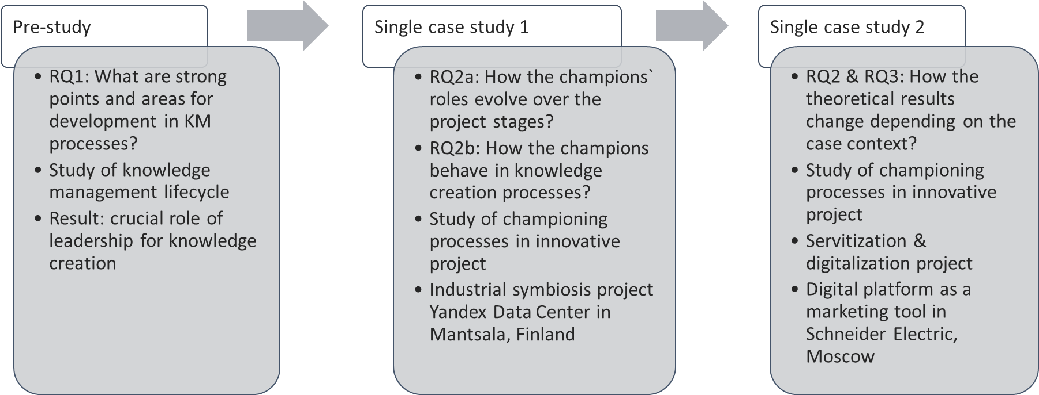
Figure 1. Research design
The research process therefore represents an inductive-deductive iterative approach. This is addressed in the research by the in vivo approach (Andersen & Kragh, 2007; 2008). The overall research design is presented on Figure 1.

4. Pre-study: a survey on knowledge lifecycle

The main goal of pre-study was to identify the specific features of the knowledge management system in Russian companies. Based on preliminary analysis, focus groups and in-depth interviews, several hypotheses were formulated on various aspects of the level of development of knowledge management practices in Russian companies.
Pre-study aimed to answer the following research question: what are the structural and functional specifics of the KM system in Russian companies?
To conduct the study, the Bukovich-Williams theoretical model was analyzed and modified for compliance with Russian KM practices. In a series of in-depth interviews with practitioners in the field of KM, it was revealed how the stages of the classical approach correspond to the real stages of KM in Russian organizations (based on the personal experience of the interviewees).
An empirical study conducted on a sample of 104 top managers of Russian companies allowed us to draw preliminary conclusions about the strengths and weaknesses of KM processes in organizations.
The hypothesis was confirmed that management support is a leading factor determining the maturity of the KM system in Russian companies. In fact, the results of descriptive analysis showed that many respondents indicate a high level of support from top management, as well as a high level of use of information technology as a tool for working with knowledge. This is because most respondents believe that the top management of the company is interested in introducing knowledge management into business practice (Gavrilova et al., 2017).
The results of the pre-study highlighted the crucial role of leadership for new knowledge creation. However, new research questions emerged: How the leaders/champions push new knowledge creation in innovative projects? Do the leaders/champions roles relate to the nature of the new knowledge in innovative projects?
To answer the above-mentioned questions, we proceeded with the qualitative research.

5. Single case study: championing and industrial symbiosis

5.1 Case selection
The main study focused on a single case study of a data centre for excess heat reuse in regional energy production. It included four organizational actors, through which the roles of individual champions and related processes that facilitate the emergence of regional industrial symbiosis were examined. The focus was on the hub company and the key individuals, and it sought to demonstrate the relevant processes, roles and relationships.
Industrial symbiosis (IS) is a type of inter-organizational relationships where organizations exchange material and resource flows in such a way as to minimize waste and create mutual benefits for all actors. IS is a key approach to building a circular economy, with potential to unlock up to $4.5 trillion in GDP growth globally by 2030 (Lacy & Rutqvist, 2016). The concept is defined as ‘engaging traditionally separate industries in a collective approach to competitive advantage involving physical exchange of materials, energy, water and by-products’ (Chertow, 2000, p. 330).
From an organizational perspective, IS can be perceived as either a business model innovation (Foss & Saebi, 2017) or an architectural innovation (Henderson & Clark, 1990); therefore, the championing literature can provide a useful foundation to study the role of key individuals in IS emergence.
While the actions of individuals have received little attention in the research on IS, some scholars have examined championing in the IS context (Hewes & Lyons, 2008; Isenmann, 2002). For instance, Hewes and Lyons (2008) found champions to be key individuals who have a significant influence on IS development. They noted that champions are able to bring together various actors and motivate them to become personally involved in IS projects by building trust with people and inspiring them through personal values. They also identified that it is important for champions to be embedded in the local community in which the IS project is taking place.

5.2 Case description

The case began in 2012. Between 2012 and 2015, the Russian information technology (IT) company Yandex set up a data centre in Mäntsälä, a small city located about 60 kilometres north of Helsinki, Finland (see the case timeline on Figure 2). This data centre supported a partnership between the technology provider and a local energy supplier to reuse waste heat from the data centre and sell it to the local energy company to warm local homes. Yandex data centres generate heat, which is collected and directed along the district heating network to Mäntsälä households. The initial collected waste heat could power approximately a thousand households. The project represented the first in the world at this scale.
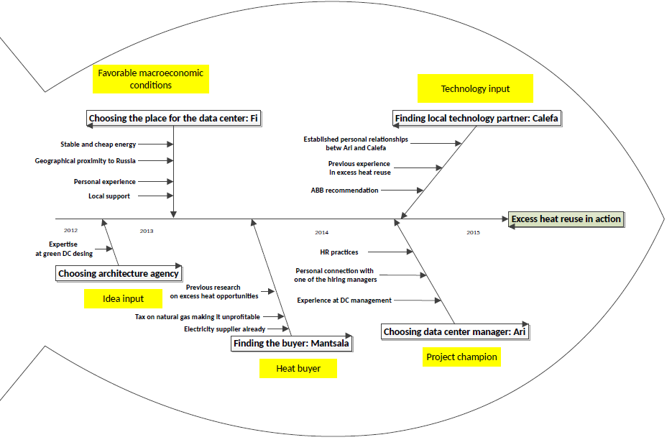Figure 2. Case timeline
Table 2 summarizes our single case research design.
Table 2. Data collection and main empirical results
Data collection | Data analysis results
- 15 semi-structured interviews  - 3 industrial firms, 1 municipal energy provider  - Secondary data: observations, media, reports | - Detailed description of the championing process and roles  - Interaction between champions  - Evolution of the champion roles  - Effect of multi-level contextual factors

5.3 Research results
Figure 3 demonstrates the three main stages of the Yandex data centre heat reuse project: idea genesis, mobilization and focused legitimization and broad legitimization. These stages involved different champion roles, with individual-level (i.e. champion related) as well as contextual factors (e.g. organizational environment and culture, macro environment). 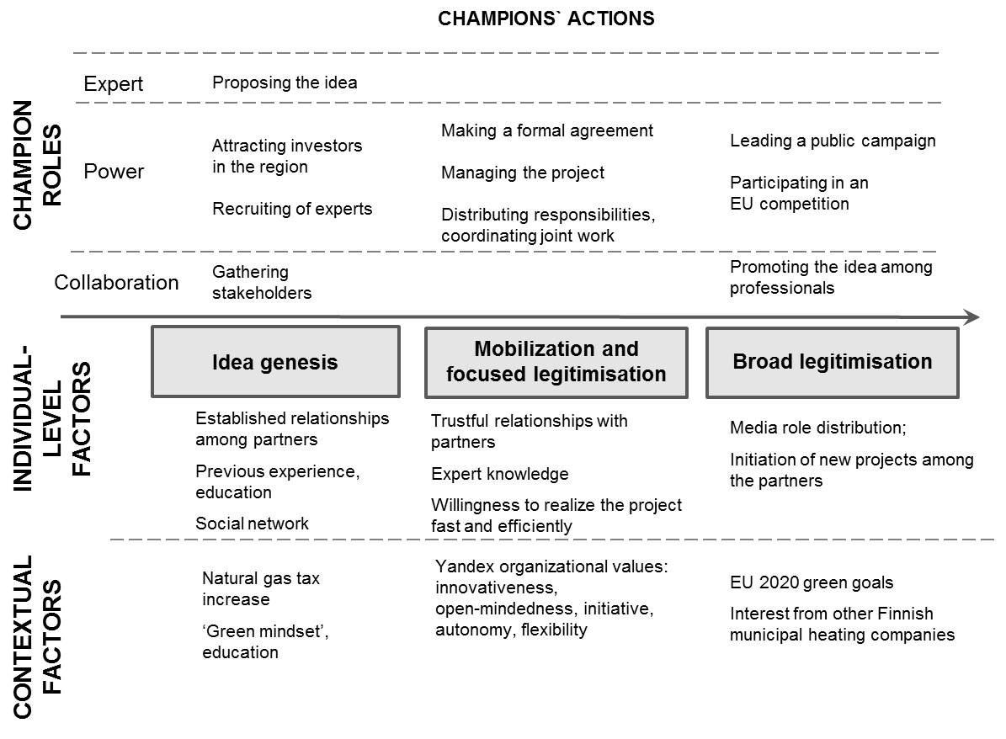
Figure 3. Campions` actions and roles
During each stage, key actions characterizing champions´ roles were identified (see Figure 2). Moreover, realization of each stage is affected by individual-champion-related and contextual factors.
It was further found that there were three domains in which championing processes took place: organizational, network and institutional. Within these domains, the three championing roles as identified during the pre-study were examined: 1) power, 2) collaboration and 3) expertise.
In general, the analysis yielded were several important observations: Firstly, the champion of the core organization played different roles in all domains, whereas the two other champions retained one major role (Calefa: expert, MSO: power) in one or two domains. Additionally, champions were more active in different domains during different stages. Specifically, during the first and last stage, the importance of the institutional domain was emphasized, whereas the network domain was emphasized during the second stage. Furthermore, with respect to role distributions, the power champion dominated in all domains and all stages.

6. After-study: championing in digitalization for servitization

To validate theoretical findings from the first case, we tried to replicate it in another context. The case of Partners Opportunity Management Platform was developed in large MNC, Schneider Electric, in Moscow, Russia.

6.1 Case selection

Traditional manufacturing companies are switching from selling pure products to offering integrated product-service solutions (PSS), recognizing the possibility of higher profits (Biotto et al., 2012). In this regard, the concept of servitization has been created. The concept is defined as ‘the innovation of an organization`s capabilities and processes to better create mutual value through a shift from selling products to selling Product-Service Systems’ (Baines et al., 2009; p. 555) where a product-service system is defined as ‘an integrated product and service offering that delivers value in use’ (Baines et al., 2007 p. 3). The symbiosis between traditional manufacturing and services, through processes of servitization is at the core of innovative technologies, initiating new sectors or improving the competitiveness of the existing ones (De Propris, 2016).
Digitalization refers to incorporation of digital technologies into the operations of the firm. The most common technologies in digital business settings are mobile applications and devices, analytical tools, platforms, and the Internet of things. Digital technologies facilitate the service innovation of manufacturers (Neu and Brown 2005; Kindström and Kowalkowski 2009; Belvedere et al. 2013) by enabling novel product service offerings (Lerch and Gotsch 2015), transforming the structure of supply chains and reshaping industry competition.
Digitalization of business model and servitization are interconnected processes (Martin-Pena et al., 2018). Digital technologies and servitization constitute potential opportunities for industry. Frequently, digitalization involves the introduction of services, and could become an enabler and a driver of servitization. Furthermore, servitization promotes digitalization as the process leading to the creation of new PSS.
There is an increasing interest in servitization as an empirical phenomenon and research topic. The number of research papers related to servitization has grown rapidly since its introduction by Vandermerwe and Rada [1988]. Previous research has focused on the identifying this phenomenon, its benefits and challenges (e.g. Zhang & Banerji, 2017). Recently authors have begun focusing on servitization microfoundations (Lenka et al., 2018).
The topic of servitization in industrial firms remains underexplored. Industry must address the challenges of digitalization and servitization to generate sustainable competitive advantage. The role of context in servitization of industrial firms also requires clarification (Kowalkowski et al. 2017).
Electrotechnical industry was chosen because of its innovativeness and high level of knowledge intensity. Moreover, electrotechnics equipment lies at the core of any technological development such as smart buildings, smart cities, and advanced manufacturing.
The case company, Schneider Electric (SE), offers integrated solutions to utilities and infrastructure, industries and machine manufacturers, non-residential building, data centers and networks and residential markets. SE is a large multinational company with several plants located in Russia. The company operates through four business segments: Building, Industry, Infrastructure, and IT.
To get deeper understanding of the mechanics behind the championing roles in digitalization and servitization projects, we have chosen one project as a case unit. This project, Partners Opportunity Management Platform, was developed and realized in SE`s marketing department in Moscow and described in detail in the following chapter.

6.2 Case timeline
POMP development could be divided into three stages. The first stage (about 2 months) in 2016 included analysis of current business model, identification of bottlenecks. Bottlenecks were identified during Customer Journey Mapping brainstorm sessions organized by the marketing department. The second stage (10 months) included pilot project which had full functionality but was limited to one region of Russia. The pilot project was introduced in 2017. After 10 months, 57 requests resulted in 25 registered projects. The third stage (ongoing) includes full scale implementation of the project, expanded to Russia and Eurasian Customs Union.

6.3 Case analysis
The primary data source is semi-structured interviews. The primary data include altogether 11 semi-structured and in-depth interviews with key decision makers (product manager, channel marketing manager, power solutions department lead, marketing and strategy director) and one external industry expert (CEO of the case company`s partner). The secondary data includes industry analytics, corporate web site, reports and media news. The data analysis results in detailed description of the championing process and the effects of multilevel contextual factors.

6.4 Research findings

Partners Opportunity Management Platform (POMP) is a tool to increase value co-created by SE and its partners while working on customers` projects. POMP allows SE to get the information on customers` projects early on the project life cycle. POMP is an innovative tool. As one respondent noted, “no one has such system. But it was a living necessity”.
Typical project life cycle lasts about 2 years and covers the following stages: requirements definition, design development phase, detailed documentation phase, and tendering.
The goals of POMP include stimulation and support for partners` investments in projects including SE`s products and providing the best service for customers. The system is based on transparency and competitiveness. As a product manager puts it, “POMP is the company`s answer to the changing market environment”.
Besides, POMP allows SE to choose the best partner for the project in terms of added value. Partner is a company providing engineering, supply, design of technical solutions implementing SE`s equipment. There are two types of partners: direct partners who have direct agreement with SE and indirect partners - those who buys SE`s equipment from official distributors. Both direct and indirect partners may participate in POMP. The opportunity should satisfy three conditions to be eligible for registration. First, the opportunity should be implemented in Russia or Eurasian Customs Union. Second, it should include one of several product groups. Third, the opportunity should have value higher then specified minimum.
The champions` roles and the dynamics of the championing process in POMP development are discussed in (Kokoulina, 2020).

7. Discussion and conclusions

The findings highlight the importance of multiple champions and their repeated interactions during the championing process. The championing processes were dynamic, and the roles of individual champions and their domains of action shifted during the innovative projects development.
Overall, power champions dominate all stages and domains, indicating the crucial role of charismatic, active and enthusiastic individuals who engage other actors.
Our study illustrates how champions’ motives were supported by the organizational (Yandex, Schneider Electric) and institutional (Mantsala municipality) environments. The interplay of these two contexts, coupled with motivations by individual champions provided the recipe for success in our case.

8. Theoretical implications
Our study elaborates the multifaceted roles played by champions, an area previously overlooked. The findings indicate that championing encompasses at different key roles: power, collaboration, expertise and institutional. Furthermore, individual champions can play multiple roles, as was the case in our main study and as was confirmed in after-study.
Furthermore, the findings demonstrate a dynamic view of the championing process (Klerkx & Aarts, 2013) confirmed by main study and after-study. We found that though one champion can play both power and collaboration roles simultaneously, these roles typically operate on different levels and might change over time.
Besides, our study contributes the studies on IS facilitation and emergence by emphasizing the role of individuals, on which studies have been notably scarce (Walls & Paquin, 2015). Moreover, our research discusses the emergence of IS (Boons et al. 2017; Mulrow et al. 2017), by highlighting the role of individual agency.
Furthermore, our study contributes to the research on servitization processes by bringing a championing processes perspective.

9. Practical implications
An increased understanding of the multifaceted roles played by champions and the dynamics of the championing process help policy-makers design effective programs and strategies to promote IS initiatives.
Managers interested in pursuing servitization strategies should realize the importance of champions in different organizations, levels and domains and let them lead their own projects. One individual may serve as a power, expert and collaborative champion, depending on the stage and domain of the process.
As championing relies highly on individual agency, it might also cause overdependence and risk. Policymakers and managers should thus aim to institutionalize the role of championing and potentially aim to distribute the role to multiple individuals.

10. Further research

Overall, our findings highlight the importance of individual agency. However, further research is needed on the potential negative aspects of championing (e.g. overreliance on individual agency and network vulnerability). Future studies could also explore the relative importance of key antecedents for championing including organizational support, personal characteristics and social networks.

References

- Andries, P., Debackere, K. and van Looy, B. (2013). ‘Simultaneous experimentation as a learning strategy: Business model development under uncertainty’. Strategic Entrepreneurship Journal, 7, 288–310.
- Baines, T.S., Lightfoot, H.W., Benedettini, O. and Kay, J.M. 2009. The servitization of manufacturing: A review of literature and reflection on future challenges. Journal of manufacturing technology management 20 (5): 547-567.
- Berends, H., Smits, A., Reymen, I. and Podoynitsyna, K. (2016). ‘Learning while (re)configuring: Business model innovation processes in established firms’. Strategic Organisation, 14, 181–219.Bock, A. J., Opsahl, T., George, G. and Gann, D. M. (2012). ‘The effects of culture and structure on strategic flexibility during business model innovation’. Journal of Management Studies, 49, 279–305.
- Belvedere, V., Grando, A. and Bielli, P. 2013. A quantitative investigation of the role of information and communication technologies in the implementation of a product-service system. International Journal of Production Research 51 (2): 410-426.
- Bertoldi, B., Giachino, C., Rossotto, C., Bitbol-Saba, N. 2018. The role of a knowledge leader in a changing organizational environment. A conceptual framework drawn by an analysis of four large companies. Journal of Knowledge Management 22 (3): 587-602. https://doi.org/10.1108/JKM-09-2017-0422
- Biotto, M., De Toni, A.F. and Nonino, F. 2012. Knowledge and cultural diffusion along the supply chain as drivers of product quality improvement: the illycaffè case study. The International Journal of Logistics Management 23 (2): 212-237.
- Brix, J. (2017), “Exploring knowledge creation processes as a source of organizational learning: a longitudinal case study of a public innovation project”, Scandinavian Journal of Management, Vol. 33 No. 2, pp. 113-127.
- Bukowitz, W., Williams, R. (1991). The Knowledge Management Fieldbook.
- Burt, R. S. (1992). Structural Holes: The Social Structure of Competition. Harvard University Press, Cambridge, MA.
- Chakrabarti, A. K. (1974). The Role of Champion in Product Innovation. California Management Review, 17(2), 58–62. https://doi.org/10.2307/41164561
- Chertow, M. (2000). Industrial symbiosis: Literature and taxonomy. Annual Review of Energy and Environment, 25, 313–337. https://doi.org/10.1146/annurev.energy.25.1.313
- De Propris, L. 2016. A fourth industrial revolution is powering the rise of smart manufacturing. London, UK: The Conversation Trust. Retrieved from https://theconversation.com/a-fourth-industrial-revolution-is-powering-the-rise-of-smart-manufacturing-57753.
- Deutz, P., & Gibbs, D. (2008). Industrial ecology and regional development: Eco-industrial development as cluster policy. Regional Studies, 42, 1313–1328. https://doi.org/10.1080/00343400802195121
- Dodgson, M., & Hinze, S. (2000). Measuring Innovation. Indicators used to measure the innovation process: defects and possible remedies. Research Evaluation, 8(2), 101-114.
- Eisenhardt, K. M., & Santos, F. (2002). Knowledge-based view: A new theory of strategy. In A. Pettigrew, H. Thomas & R. Wittington (Eds.), Handbook of Strategy and Management. London: Sage.
- Eriksson, P., & Kovalainen, A. (2008). Qualitative Methods in Business Research. SAGE, Business & Economics. https://doi.org/10.4135/9780857028044
- Fichter, K. (2009). Innovation communities: the role of networks of promotors in Open Innovation. R&D Management, 39, 357–371. https://doi.org/10.1111/j.1467-9310.2009.00562.x
- Glaser, B. G., & Strauss, A. L. (1999). The Discovery of Grounded Theory: Strategies for Qualitative Research. New Brunswick: Aldine Transaction Publishers.
- Granovetter, M. (1973). The strength of weak ties. American Journal of Sociology, 78(6), 1360-1380.
- Grant, R. M. (1996). Toward a knowledge-based theory of the firm. Strategic Management Journal, 17, 109.
- Hauschildt, J. & Gemunden, H. (1999). Promotoren – Champions der Innovation [Promotors – champions of innovation]. Wiesbaden: Gabler.
- Hewes, A. K., & Lyons, D. I. (2008). The humanistic side of eco-industrial parks: Champions and the role of trust. Regional Studies, 42, 1329–1342. https://doi.org/10.1080/00343400701654079
- Howell, J. M., & Higgins, C. M. (1990). Champions of change: Identifying, understanding and supporting champions of technological innovations. Organizational Dynamics, 19, 40–54. https://doi.org/10.1016/0090-2616(90)90047-S
- Johnson, W. H. A. (2002). Assessing Organizational Knowledge Creation Theory in Collaborative R&D Projects. International Journal of Innovation Management, 6(4), 387.
- Isenmann, R. (2002). Further Efforts to Clarify Industrial Ecology's Hidden Philosophy of Nature. Journal of Industrial Ecology, 6, 27–48. doi:10.1162/108819802766269520
- Klerkx, L., & Aarts, N. (2013). The interaction of multiple champions in orchestrating innovation networks: Conflicts and complementarities. Technovation, 33(6–7), 193–210. https://doi.org/10.1016/j.technovation.2013.03.002
- Kokoulina, L. 2020. Champions roles in servitization processes: the case of B2B company. Working paper. GSOM SPBU.
- Kokoulina, L., Ermolaeva, L., Patala, S., Ritala, P. 2019. Championing processes and the emergence of industrial symbiosis. Regional Studies, 53(4), с. 528-539.
- Kowalkowski, C., Gebauer, H. and Oliva, R. 2017. Service growth in product firms: Past, present, and future. Industrial marketing management 60: 82-88.
- Lacy, P., & Rutqvist, J. (2016). Waste to Wealth: The Circular Economy Advantage. Springer.
- Lenka, S., Parida, V., Sjödin, D.R. and Wincent, J. 2018. Exploring the microfoundations of servitization: How individual actions overcome organizational resistance. Journal of Business Research 88: 328-336.
- Lerch, C. and Gotsch, M., 2015. Digitalized product-service systems in manufacturing firms: A case study analysis. Research-Technology Management 58 (5): 45-52.
- Lervik, J. E. (2011). The Single MNC as a Research Site. In R. Piekkari & C. Welch (Eds), Rethinking the Case Study in International Business and Management Research (pp. 229–250). Cheltenham: Edward Elgar. https://doi.org/10.4337/9780857933461.00022
- Martín‐Peña, M.L., Díaz‐Garrido, E. and Sánchez‐López, J.M. 2018. The digitalization and servitization of manufacturing: A review on digital business models. Strategic Change 27 (2): 91-99.
- Markides, C. C. (2013). ‘Business model innovation: What can the ambidexteritry literature teach us?’. Academy of Management Perspectives, 27, 313–23.
- McFadyen, M. A., & Cannella Jr., A. A. (2004). Social capital and knowledge creation: Diminishing returns of the number and strength of exchange relationships, Academy of Management Journal (Vol. 47, pp. 735-746): Academy of Management.
- Neely, A. 2008. Exploring the financial consequences of the servitization of manufacturing. Operations management research 1 (2): 103-118.
- Nonaka, I. (1994). A Dynamic Theory of Organizational Knowledge Creation. Organization Science, 5(1), 14.
- Parent, M., & Gallupe, R. B. (2000). Knowledge creation in focus groups: can group technologies help? Information & Management, 38(1), 47.
- Parida, V., Sjödin, D.R., Lenka, S. and Wincent, J. 2015. Developing global service innovation capabilities: How global manufacturers address the challenges of market heterogeneity. Research-Technology Management 58 (5): 35-44.
- Phan, P. H., & Peridis, T. (2000). Knowledge creation in strategic alliances: Another look at organizational learning. Asia Pacific Journal of Management, 17(2), 201.
- Rothwell, R. (1992). Successful industrial innovation: critical factors for the 1990s. R&D Management, 22, 221–238. https://doi.org/10.1111/j.1467-9310.1992.tb00812.x
- Schon, D. A. (1963). Champions for radical new inventions. Harvard Business Review, 41, 77–86.
- Sohl, T., Vroom, G. and McCann, B. T. (2020). ‘Business model diversification and firm performance: A demand-side perspective’. Strategic Entrepreneurship Journal. https://doi.org/10.1002/sej.1342.
- Styhre, A., Roth, J., & Ingelgard, A. (2002). Care of the other: knowledge-creation through care in professional teams. Scandinavian Journal of Management, 18(4), 503.
- Vandermerwe, S. and Rada, J. 1988. Servitization of business: adding value by adding services. European management journal 6 (4): 314-324.
- Un, C. A., & Cuervo-Cazurra, A. (2004). Strategies for knowledge creation in firms. British Journal of Management, 15(S1), 27-41.
- Walls, J. L., & Paquin, R. L. (2015). Organizational Perspectives of Industrial Symbiosis: A Review and Synthesis. Organization & Environment, 28(1), 32–53. https://doi.org/10.1177/1086026615575333
- C. Welch, Piekkari, R., E. Plakoyiannaki, E. and E. Paavilainen-Mäntymäki (2011). Theorizing from Case Studies: Towards a Pluralistic Future for International Business Research, Journal of International Business Studies, 42, 5, 740-762.

- Witte, E. (1973). Organisation für Innovationsentscheidungen – Das Promotorenmodell [Organization for innovation decisions – the promoter model]. Göttingen: Schwart.
- Yin, R. K. (2014). Case study research: Design and methods (5th ed.). Thousand Oaks, CA: SAGE Publications.
- Zhang, W. and Banerji, S., 2017. Challenges of servitization: A systematic literature review. Industrial Marketing Management 65: 217-227.
- Гаврилова Т. А., Алсуфьев А.И., Кокоулина Л.О. (2017). Управление знаниями с русским акцентом: победы и поражения, Инновации, 1(219), 59-69.

