St. Petersburg University
Graduate School of Management

Master in Corporate Finance

STUDY OF THE APPLICABILITY OF MODELS FOR SHORT-TERM RETURNS: EVIDENCE FROM JAPAN'S STOCK MARKET

Master’s Thesis by the 2nd year student
Concentration — Corporate Finance
Denis Urazbakhtin

Research advisor: Assistant Professor, Aleksandr Andrianov

St. Petersburg

2020

Аннотация
Автор | Уразбахтин Денис Рифхатович
Название ВКР | Исследование применимости моделей оценки краткосрочной доходности: пример фондового рынка Японии
Образовательная программа | Корпоративные Финансы
Направление подготовки | Менеджмент
Год | 2020
Научный руководитель | Андрианов Александр Юрьевич
Описание цели, задач и основных результатов | Эта магистерская работа посвящена изучению применимости различных моделей ценообразования активов для оценки краткосрочной доходности акций на японском фондовом рынке. Для этого CAPM, две спецификации интертемпорального CAPM, 3-факторная и 5-факторная модели Фама-Френча сравниваются между собой. Данные с рынка США указывают на превосходство ICAPM над тремя другими моделями. Тем не менее, эмпирические данные указывают на то, что на самом деле трехфакторная модель Фама-Френча является наилучшей моделью для оценки краткосрочной доходности на японском фондовом рынке. Кроме того, было показано, что первоначальные доказательства в пользу интертемпоральной CAPM не были достоверными даже пдля рынка США.
Ключевые слова | CAPM, ICAPM, Интемпоральная CAPM, Модель Фамы-Френча, Японский фондовый рынок

Abstract
Master Student's Name | Denis Urazbakhtin
Master Thesis Title | Study of the Applicability of Models for Short-Term Returns: Evidence from Japan's Stock Market
Educational Program | Master in Corporate Finance
Main field of study | Management
Year | 2020
Academic Advisor’s Name | Aleksandr Andrianov
Description of the goal, tasks and main results | This master thesis is dedicated to studying the applicability of different asset pricing models to estimating short-term stock returns on the Japanese stock market. For this purpose, CAPM, two specifications of Intertemporal CAPM, 3-factor and 5-factor Fama-French models are compared. Evidence from the USA market indicated the superiority of ICAPM over the other 3 model. However, empirical evidences indicate that in fact 3-factor Fama-French model is the best specified model for short-term return estimation on the Japanese stock market. In addition, it was shown that initial evidences in favour of ICAPM were not robust even on the USA data.
Keywords | CAPM, ICAPM, Intertemporal CAPM, Fama-French model, Japan, Japanese Stock Market

Contents
Part 1. Introduction 5
Part 2. Review of the Japanese financial market 8
Part 3. CAPM and it’s improvements 16
Part 4. Methodology and Data 26
Part 4.1 Econometric Methodology 26
Part 4.1.1 ICAPM modeling 26
Part 4.1.2 Methodology for other models 28
Part 4.2 Data 29
Part 5. Empirical results 34
Part 5.1 CAPM 34
Part 5.2 ICAPM with Japanese interest rate 35
Part 5.3 ICAPM with Federal Funds rate 37
Part 5.4 ICAPM robustness check 38
Part 5.5 3-factor Fama-French model 40
Part 5.6 5-factor Fama-French model 42
Part 5.7 Second robustness check for all models 44
Part 6. Conclusion 46
References 48
Appendix 1. Individual pricing errors for CAPM 51
Appendix 2. Individual pricing errors for ICAPM with JIR 53
Appendix 3. Individual pricing errors for ICAPM with FFR 55
Appendix 4. Individual pricing errors for ICAPM robustness check 57
Appendix 5. Individual pricing errors for 3-factor Fama-French model 58
Appendix 6. Individual pricing errors for 5-factor Fama-French model 60

Part 1. Introduction
Japanese economy is one of the biggest in the world. According to NASDAQ reports in 2019 the nominal GDP of Japan was circa $5 trillion which constituted for 6% of the global GDP. Moreover, Tokyo Stock Exchange despite being less popular that NYSE, NASDAQ or London exchange is actually the third biggest stock exchange in the world and even though total market capitalization of companies listed on TSE is times less than that of NYSE or NASDAQ, it’s still 40% bigger than the London exchange. TSE is a home for such big chips as Toyota, NTT, Sony or KDDI.
Taking this into consideration, it’s surprising how unstudied the Japanese financial market is. According to EBSCO search results, there are over 659 thousand articles that are dedicated solely to USA financial market, but only 18 thousand is dedicated to Japanese one and 55 thousand dedicated to European market. These results are even more impressive when compared to the ratios of the GDPs of these markets or market capitalizations of their stock markets. The overall market capitalization of all major European stock exchanges is just 46% bigger than the TSE capitalization, while there are three times more articles dedicated to them.
Nevertheless, understanding financial markets and how prices on them are formed is crucial for any individual involved in economic activities.
Since the First Agricultural Revolution around 12,500 years ago financial institutions were developing alongside humanity and by now have become one of the most complex and fundamental parts of our civilization. Kill financial institution, remove the very idea of money or exchange and our society will crumble in minutes. This is why understanding and being able to forecast the behavior of these institutions and processes composing them became so fundamental, especially now when this market grew to become one of the biggest on Earth with some researches estimating the derivative market alone to be 10 times more than world’s total GDP.
That is why this sphere now attracts world’s best scholars whose bread and butter is to come up with complex formulas that explain certain financial phenomena. One of the main topics of their research through-out the years were returns. How do I turn $1 into $2? Studying the processes of how pricing of financial assets works, brought fame to many scholars including Eugene Fama or William Sharp. And still, after some of the greatest minds of our time spending their lives understanding these mechanisms, there are more to be understood than what we understand already.
But understanding prices and returns is important not only because we need to know how much money we will have tomorrow. It’s also about how much companies and whole economies will cost that directly translates into the wealth of the nation.
If we put it into the Corporate Finance perspective, understanding pricing might be important for the following reasons:
- It allows corporations to estimate their cost of borrowing;
- It allows investors to correctly understand the expected return on investments (whether on financial market or into tangible projects;
- It allows analysts to prepare accurate reports that will then be used for decision making by governments, corporate management, investors and other stakeholders.
Probably the most famous model for asset price estimation is Capital Asset Pricing Model that is based on the discoveries of a Nobel Prize winner Henry Markowitz and Efficient Market Hypothesis.
However, since 1960s evidences were piling up suggesting that actually CAPM fails to account for certain irrationalities in human behavior that deviate from EMH predictions. These shortcomings of CAPM were later called “anomalies” and were studied by Fama and French among others.
After that, various CAPM improvements or analogues were emerging, out of which 3-factor model developed by Fama and French is probably the most popular one. And obviously these models are constantly tested for fitness on regional or global markets. Recently, Santa-Clara md Maio have shown that Intertemporal CAPM proposed by Merton in 1973 has higher explanatory and forecasting power on US market compared to CAPM, Fama-French models and other models.
Despite the recent findings of Santa Clara and Maio, ICAPM is still a quite unstudied model. In EBSCO there are only 156 articles dedicated to this model, while there more than 650 articles on Fama French model and over 4 thousand articles that study CAPM.
However, even though there is a vast academic literature on the performance of different scientific financial models on global and regional markets, based on the survey conducted on finance practitioners, the majority of them do not implement any theoretical models but CAPM. In most cases CAPM is enhanced by in-house factors developed by the organization itself.
The goal of this research if to assess the applicability of the Intertemporal Capital Asset Pricing Model to estimating the short-term returns on the Japanese stock market.
The subject of the study is Intertemporal Capital Asset Pricing Model.
The object of the study is stock prices on Tokyo Stock Exchange.
To attain the defined goal the following tasks were set:
- Review the academic research on asset pricing models and specifically ICAPM;
- Run ICAPM calculations on Tokyo Stock Exchange data;
- Compare ICAPM performance to other widely used asset pricing models;
- Derive the conclusion on the applicability of ICAPM based on the obtained results.
This research paper is structured in the following manner:
- Part 2 provides the review of the Japanese stock market;
- Part 3 covers contains the review of the research on CAPM, ICAPM and other asset pricing models;
- Part 4 presents the overview of the sample and the research methodology;
- Part 5 is dedicated to the main results of the study;
- Part 6 concludes.

Part 2. Review of the Japanese financial market
When people discuss, study or simply mention economy or financial markets, even though they refer to them in general, most of the time what they imply is western economy or financial markets. They picture themselves Wall street if New York or Victoria street in London. Of course, today, no matter what they think of it, people accept Chinese economy and its ever-growing influence on global GDP. However, Japanese role is usually underestimated by common people. However, in fact Japan is the third biggest economy in the world and Tokyo Stock Exchange is the third biggest stock exchange. But since we do not hear about it in the news as often as we do about European or US markets, we tend to underestimate its importance. Nevertheless, it has a great history worthy of a whole doctoral thesis dedicated just to it.
As of 2019, Japanese GDP is US dollars was estimated by World Bank to be circa 5.5bn US dollars. Even though it is still almost 4 times less than US GDP, it is almost 2 times bigger than the GDPs of the UK or France.
Below is the dynamics of Japanese GDP in US dollars annual growth rate from 1961 to 2018 derived from World Bank database: Graph 1. Dynamics of Japanese GDP in USG annual growth from 1961 to 2018
As visible form the chart, Japanese economy enjoyed and considerable growths rates from 5% to almost 13% in 1968 but a year after it fell to no growth at all. However, this decrease was not associated with any major economic factors as 1969 was the year when the conflict between Japanese government and students reached its climax and lead to the break-out of massive riots. That is why when conflict was resolved GDP came back on its previous track.
Unfortunately, Japan was not enjoying growth much as already in 1974, its economy suffered another hit and this time it came from the oil crisis caused by the embargo proclaimed by the Organization of Arab Petroleum Exporting Countries (OAPEC).
After that Japanese economy was steadily growing until a crisis that was later called a “Lost Decade” broke out. Lost Decade in a nutshell was a collapse of the bubble that was inflating through 80’s driven by the record-low interest rates that were fueling stock and real estate markets pushing prices to there ever-highs. Once the bubble became obvious, Japan’s Ministry of Finance tried to prevent the crisis by increasing the interest rate which just made things worse as most of the borrowers could not repay their debts backed by overheated assets.
This was a pivotal point in Japan’s economic history that country never actually recovered from. Japanese who lived through Lost Decade changed their savings habits and significantly increased their savings and cutting spends causing deflation. The effects if this are visible to these days
Some experts also extend “Lost Decade” until 2010 as only in 2007 Japan’s economy managed to return at a pre-crisis level.

Japanese economy is unique in many senses. Despite being one of the biggest economies, as we have seen, it barely grew over the last 15-20 years. The inflation rate was also close to or below zero for this time period. The data for the next graph was obtained from FRED.
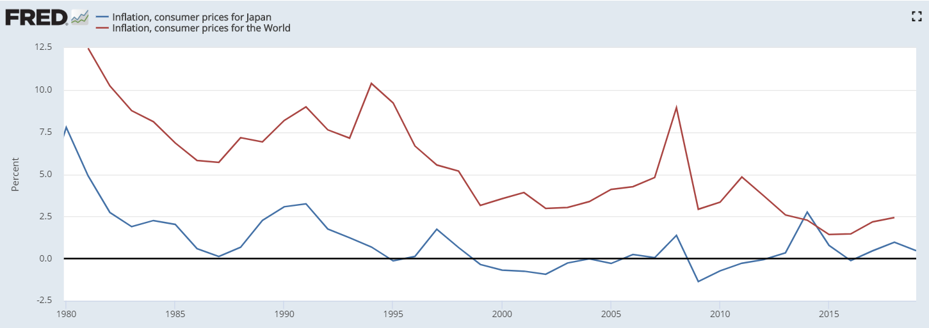
Graph 2. Annual Japan’s and global inflation rates in % from 1980 to 2019
Another unique criterion of the Japanese economy is its level of debt. USA is usually criticized for a high outstanding debt-to-GDP ratio that keeps growing. Some experts say that this is incompatible with the economic growth and will lead to a crisis. However, Japan’s example disproves such theories. USA debt currently fluctuates at about 100% of Gross Domestic Product, while Japan surpassed this level already in late 90’s and it’s debt now is at at 200% to GDP with some forecasting it to reach 300% by 2030s. Below is the graph from FRED showing the dynamics of the annual Total Debt-to-GDP ratios from Japan and USA from 1990 to 2019.
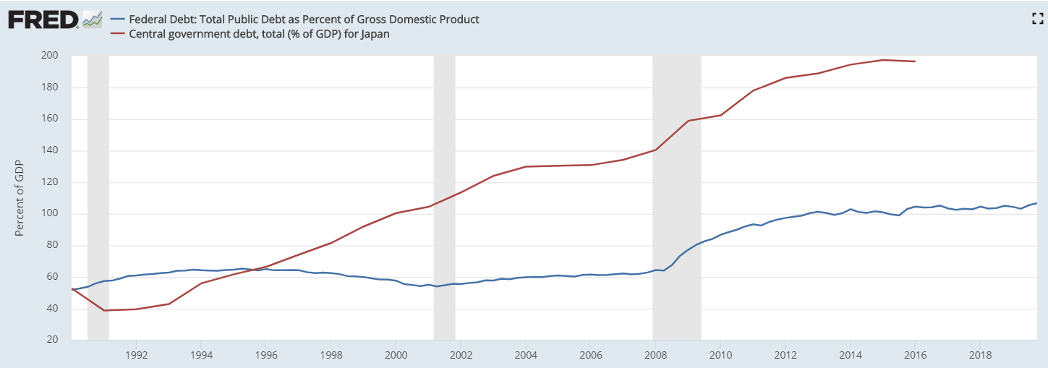
Graph 3. Annual Japan’s and USA Debt-to-GDP ratios from 1990 to 2019
As can be seen, the debt was constantly growing since 1990 as one of the Japan’s strategy was to flood the economy with cheap money to restart the business and drive the growth.
Other interesting fact is that 70+% of the national Japanese debt is actually owned by Japan’s banks and citizens, so the bond process and returns are protected form global economic factors and credit ratings revisions.
“Lost Decade” also had a significant impact on Japan’s stock market.
Japan’s stock market consists of four stock exchanges: the Tokyo Stock Exchange (TSE), the Nagoya Stock Exchange (NSE), the Sapporo Securities Exchange (SSE) and the Fukuoka Stock Exchange (FSE); of which TSE is the biggest and has over 3,00 listings. The biggest listed companies on TSE are such renowned brands as Mitsubishi, Toshiba, Sharp, Sony, Fujitsu, Nissan, Panasonic and Canon. The biggest segments by market capitalization on TSE are Electric Appliances, Information and Communication, Transportation Equipment, Chemicals and Pharmaceuticals that account for 46.3% of overall exchange capitalization.
The premier index of Japanese stock is Nikkei 225 or just Nikkei that was created in 1950. It tracks the performance of 225 TSE stock among all major sectors of Japan’s economy.
Below is the dynamics of Nikkei index from 1980 to 2019.
Bubble
Lost Decade

Graph 4. Dynamics of Nikkei 225 1980 to 2019
Dynamics of the index clearly show the periods of the bubble inflation and consequent crisis after the Nikkei index reached its all-time high in December 1989 at 38915.87 points. However, already in September 1990 Nikkei index was 20983.5 points losing more than 40% in just 9 months.
As we see, even today Japan’s stock market has not recovered from the Lost Decade.
Just like it has affected savings behavior, Lost Decade left its footprints in the investment habits of Japanese. Japanese were disillusioned after the burst of the bubble. Even though now Japanese government has a much tighter control over the financial market and economy and many ratios of the Japanese companies are on par with global and do not indicate the presence of the regional bubble, many investors still tend to quickly sell their stocks when the price rises as indicated by Nikkei internal research.
In general, a foreign investor has 3 major ways of investing in the Japanese economy: through currency, equity or bonds. This thesis is focused on the second option.
Since Japanese economy is largely export-oriented, Nikkei index is highly correlated to the Yen-to-USD Forex rate. Below is the dynamics of daily Nikkei index in Yen fx rates from 2010 to 2019
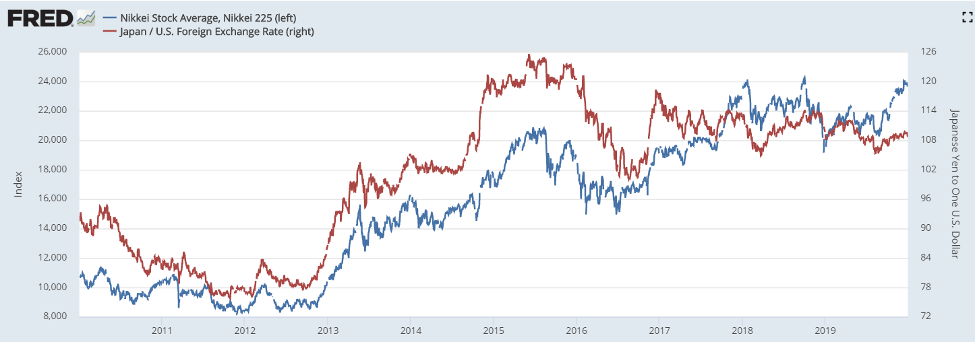
Graph 5. Daily dynamics of the Nikkei 225 and Yen fx rate from 2010 to 2019
At the time this paper was written, Tokyo Stock Exchange had circa 3,000 listed companies divided into 3 groups:
- 1st Section;
- 2nd Section;
- Mothers;
This how TSE visualize the split:
Picture 1. Segments of listed companies on Tokyo Stock Exchange
1st section is defined as a company with the following criteria. The number of shareholders should be 2,200 or more. Company’s capitalization should be 4 billion Yens or more. 1st Section company of tradable shares should be at least 20,000 units; they should account for at least 35% of all listed shares and their market capitalization should be 2 billion Yens or more. There are also requirements for net assets, profits, business continuity, etc.
If the company does not meet these requirements, it can be moved to either 2nd Section or to Mothers.
2nd section includes companies with less than 2,000 employees, market capitalization ofat least 2 billion Yens for 9 consequent months and tradable shares on 4,000 units or less with their market capitalization of 1 billion Yens or less. There are also requirements for company’s liabilities and trading volume.
1st and 2nd sections are also referred to as “main markets”.
Another segment on Tokyo Stock Exchange is Mothers or “Market Of The High-growth and EmeRging Stocks”. These are companies with 800 employees or less. Their tradable shares should be 4,000 units or less, they should account for at least 30% of all listed shares and their market capitalization should be 1 billion Yens or more.
As of time the thesis was written the split by the number of listings in each segment was as follows:

Graph 6. Split of listed companies by segments on Tokyo Stock Exchange
As can be seen, predominantly listed companies are aligned to the 1st Segment.
Among the 1st Segment, the biggest companies as of March 2020 were Toyota, NTT and Keyence. Graph 7 shows TOP-25 1st Segment companies on TSE as of the end of March 2020. Capitalization is given in 100mln Yen.

Graph 7. TOP-25 companies by market capitalization on Japanese Stock Exchange
Overall, the split between 3 segments on TSE by market capitalization estimated in 100mln Yen as of the end of March 2020 was as follows:

Graph 8. Split of listing segments by market capitalization on Tokyo Stock Exchange
1st segment companies are clearly dominating the overall exchange capitalization. TOP-25 1st Segment companies account for 29% of the overall capitalization.
Conclusion
Out of the last 30 years Japan has spent more than 20 years battling the economic crises caused by the financial bubble burst in the late 90s that Japan has not still recovered from. Only in 2007 country’s GDP came back to pre-crisis level. Tokyo Stock Exchange (TSE) was effect by the crisis as well. Nekkei 225 to this day never approached the peak of 1989.
Primarily TSE’s capitalization consists of companies from Electric Appliances, Information and Communication, Transportation Equipment, Chemicals and Pharmaceuticals industries.

Part 3. CAPM and it’s improvements
Capital Asset Pricing Model or CAPM is probably one of the most widely used and famous financial models created to this day. This model was described by various scholars like Sharp, Teynor, Linter and Mossin in the first half of 1960s. Though each in his individual manner, all authors in one or another way suggested an asset pricing model based on the findings of Markowitz around efficient portfolio theory for which he was later awarded a Nobel Prize in Economics.
Interestingly that according to journalist Jason Zweig, Markowitz actually didn’t use his efficient portfolio theory when allocating his retirement account. Zweig provides the following notes of the conversation he had with Markowitz, where Markowitz says “I should have computed the historical co-variances of the asset classes and drawn an efficient frontier. I visualized my grief if the stock market went way up and I wasn’t in it — or if it went way down and I was completely in it. So, I split my contributions 50/50 between stocks and bonds.” We will come back to the implication of this very important remark in the last chapter of this paper, but now let us get back to the topic.
CAPM by itself is a linear model that can be used to calculate the expected return on the asset using three factors: risk-free return rate (for e.x. government bonds, asset beta and expected return of the market portfolio. The model looks as follows:
E (R_{i}) = R_{f} + β_{i} (E (R_{m}) – R_{f})
Where E (R_{i}) is the expected return of the asset, R_{f} is the risk-free return rate, β_{i} is the beta and E (R_{m}) is the return of the market portfolio.
Obviously, as any financial or any other model, CAPM has its own assumption under which it works. One of the major ones is that financial markets are efficient. Efficient Market Hypothesis or EMH is probably one of the few concepts in finance that is more popular than CAPM. EMH states that asset prices reflect all available information on the market. In other words, insider trading should be impossible, and no trade should be able to make extra profits if he overhears a confidential chat between CEOs of public companies about the upcoming acquisition since theoretically everybody else learn about it in the exact same moment.
There are three versions of EMH: strong, semi-strong and weak. Weak version implies that investors cannot make use of historic data, prices and trends to predict asset prices, however fundamental analysis might help identify undervalued or overvalues stocks.
According to semi-strong EMH, all publicly available information is available to investors when they make an investment decision. This version still allows lucky traders with good hearing who can make extra profits if they know something that was not released to public yet.
The strong version denies the existence of lucky traders and strictly states that all whether public or not information is reflected in the current prices.
One of the main aspects of EMH is that investors are rational and can process as much information as needed to make an investment decision. Unfortunately, it is not true. It was shown that investors and all humans are actually irrational even when they make extremely important decisions and usually use some heuristics instead of approaching the problem directly. Stanislas Dehaene and other neuroscientists has also shown that our metal processing capacities are quite limited and a lot of process that effect our decisions happen on a subconscious level completely avoiding the sight of consciousness.
So, as we see, this part of EMH does not withstand the scrutiny. But maybe despite inborn irrationality of investors markets are still efficient and asset prices can be accurately predicted using CAPM?
Sadly, seems like they cannot. When such popular theory as CAPM appears, every person who considers himself or herself as scientist considers his or her moral obligation to test it. Since 1990s the amount of research focusing on marker inefficiencies and prices deviations has been mounting. Such deviations were even given a specific name “anomaly”. There were so many of them that distinct subtypes emerged like value anomalies, momentum anomalies, profitability anomalies and investment anomalies to list a few.
Value anomaly was studied by Fama and French. This anomaly describes poor performance of stocks with relatively low book-to-market ration also called growth stocks compared to value stocks that have relatively high book-to-market ratio. Growth stocks are the ones that are expected to outperform the market due to certain future events and value stocks stands for undervalues stocks trading lower than what fundamental analysis predicts. EMH suggests that stocks with low BM ratio should yield higher profit compared to the once with low BM, but empirical data shows that it is vice versa.
Momentum anomaly happens when stocks with high historic short-term return outperform stocks with low historic short-term return. This phenomenon was described by Titman and Jegadeesh and Fama and French. Authors come to conclusion that it might be due to the fact that when investors buy winners and sell losers, they cause prices to deviate from their long-term value.
Profitability anomaly was tackled Fama and French and Titman and Jegadeesh among others. It stands for situations when companies with higher profits tend to be the once with higher returns. Again, some scholars attribute this to investors’ overreaction or, in other words, irrationality.
That last but not the least anomaly that will be reviewed here in investment anomaly as described by Titman. This anomaly describes cases of repetitive superior performance of entities with low capital expenditures over once with high CAPEX. This study concludes that investors tend to underestimate firms that increase capital investments.
Obviously, there are way more anomalies than described here. This paper could have been dedicated to sole review of existing anomalies and mechanisms potentially causing, but it is not the goal of it.
So, we have shown that EMH is at least not almighty that jeopardize CAPM. It was estimated that its explanatory power is circa 70%. Empirical data tends to deviate from the predictions of EMH. But since agents on financial markets largely depend on their forecasts, simply declaring the insufficiency of CAPM will not do. Scholars were posed with the new task: to either improve CAPM or come up with alternatives. However, if we look on modern most used models, almost all turn out to be the descendants of the first approach.
Probably the most famous improvement of the CAPM (that became so renowned that do not even have CAPM in its name) is a Fama-French models’ family. First Fama-French 3-factor model was introduced in 1992. The main goal of that first model was to account for value anomaly and the fact that companies with small market capitalization (<$10bn) tend to outperform those with big capitalization (>$10bn). It was achieved by introducing new factors to the traditional CAPM: size premium and value premium. They were obtained from the regression run on weighted portfolios composed by the authors.
The proxy for size premium is names SMB (small minus big) and is just an algebraic difference between the returns of small-caps and big-caps. This is the original formula used to calculate it that Kenneth French provides on his official webpage:

SMB_{(B/M)} = 1/3 (Small Values + Small Neutral + Small Growth) – 1/3 (Big Value + Big Neutral + Big Growth)
SMB_{(OP)} = 1/3 (Small Robust + Small Neutral + Small Weak) – 1/3 (Big Robust + Big Neutral + Big Weak)
SMB_{(INV)} = 1/3 (Small Conservative + Small Neutral + Small Aggressive) – 1/3 (Big Conservative + Big Neutral + Big Aggressive)

In the same manner, the proxy for value premium in HML (high minus low) and is just as excess returns of stock of companies with high book-to market ratio against companies with the low one and was calculated as:

HML = 1/2 (Small Values + Big Value) – 1/2 (Small Growth + Big Growth)

The original model looks as follows:
E(R_{it}) = R_{ft} + β₁ (R_{Mt} – R_{ft}) + β₂ SMB_{t} + β₃ HML_{t}
Where:
R_{it} – total return of a stock i at time t
R_{ft} – risk free rate at time t
R_{Mt} - total return of the market portfolio at time t
R_{Mt} – R_{ft} – total excess return of the market portfolio
SMB_{t} – size premium at time t
HML_{t} – value premium at size t
Β_{1,2,3} – factor coefficients
Empirical test of model’s performance against CAPM has shown that Fama and French managed to boost original models’ performance to be able to explain up to 90% of the stock or portfolio returns. Later on in 2013 Eugene Fama received a shared Nobel Prize in Economics for his research.
In 2014 Kenneth French and Eugene Fama improved their model by adding to new factors to it: RMW and CMA.
RMW stand for robust minus week and reflects the profitability anomaly described previously and is calculated as:
RMW = 1/2 (Small Robust + Big Robust) – 1/2 (Small Weak + Big Weak)
CMA stands for conservative minus aggressive and accounts for investment anomaly that was also already covered:
CMA = 1/2 (Small Conservative + Big Conservative) – 1/2 (Small Aggressive + Big Aggressive)
After this amendments model looks as follows:
E(R_{it}) = R_{ft} + β₁ (R_{Mt} – R_{ft}) + β₂ SMB_{t} + β₃ HML_{t} + β₄ RMW_{t} + β₅ CMA_{t}
Another eye-catching model was developed by Robert Merton. He introduced an Intertemporal Capital Pricing Model or ICAPM. Merton improved CAPM but adding a new factor to it. Instead of considering just risk-free return and risk premium, he assumed that investors will try to hedge their risk-bearing position, what he reflected in his model by a state variable.
Apart from Merton himself, Paulo Maio and Pedro Santa-Clara without a doubt can be considered the most successful advocates of the Intertemporal CAPM. They have dedicated multiple articles to this topic and have proven in “Short-Term Interest Rates and Stock Market Anomalies” that on the sample they have selected ICAPM significantly outperforms other popular models, such as 3-factor Fama-French model.
The model in general looks as follows:
E(R_{i}) = R_{f} + β₁ (E (R_{m}) – R_{f}) + β₂ State Variable
Where E (R_{i}) denotes expected return of the asset i, and β₁ and β₂ are the factors coefficients.
The assumption is that there are stocks that are more exposed to the changes in the fluctuations of future investment opportunities and due to this higher correlation, they should provide higher returns since the absence of hedge cause higher risk. So, to account for it traditional ICAPM includes a certain proxy for varying market risk premium. For instance, Santa Clara and Maio in their research used Federal Funds Rate or 3-month T-bill rate as such proxy.
So instead of using just the market risk premium ICAPM also has a state variable that represents hedging and is given by the residual of the state variable that represents additional source of systematic risk. Following the existing academic research on ICAPM this residual is derived from the first-order autoregressive process.
The choice of the state variable is left for the scholars’ consideration but the current consensus in the community is that short-term rates are actually a valid source for state variables especially when short forecast horizon is considered. This approach was taken by Santa Clara and Maio, Campbell and Patelis as well as by many others.
The explanatory power of short-term rate is analyzed in the papers of Bernanke and Kuttner, Dimson, Marsch and Staunton among others. Dimson, Marsch and Staunton in their paper “Does hiking damage your wealth” analyzed over 100 years of daily returns of daily United State returns in conjunction with 85 years of United Kingdom data and their dependence on National Central Bank’s policy. The same exercise was then performed on the data form 21 countries around the globe including Japan, Canada, South Africa, France, Germany and other developed countries of the European Union. There results point out a statistically significant effect of the monetary policy expressed by the interest rate on the performance of the investment assets on local markets.
Brusa, Savor and Wilson took this research even further and suggested that Federal Reserve has a statistically significant effect on international financial markets. In their study of Federal Reserve, the Bank of England, the Bank of Japan and the European Central bank from 1998 to 2016 they have studied the effect of announcements regarding monetary policies of those Central Banks’ on financial markets. The surprising findings authors have obtained justify the pompous name of the paper “One Bank to Rule them all”. Brusa, Savor and Wilson have successfully shown the strong effect Federal Reserve had on the returns among all four markets under consideration. At the same time, such effect has not been detected for the other three Central Banks. Surprisingly, no statistically significant effect was not recorded even for these Central Banks’ announcements and return on their local markets. Authors conclude that “Investors in Japan, Germany, and the United Kingdom seem to demand a high premium for risks associated with FOMC decisions but no premium at all for risks associated with decisions by those countries own central banks.”
Even though these findings seem to partially contradict to those of Dimson, Marsch and Staunton, it is not necessarily so. While Brusa, Savor and Wilson used the data on Central Banks’ announcement that happen only several times a year, Dimson, Marsch and Staunton used daily data throughout the whole period of research. These are essentially two completely different data sets with unique distributions and parameters those papers should not be compared directly.
In addition, Campbell and Hamao has shown the existence of common movement in expected returns of the US and Japanese markets and helpfulness of US short-term interest rates in forecasting excess returns of Japanese markets based on the data from 1971 to 1989.
It is not a surprise that Central Banks through monetary policies affect economy and financial markets. Fluctuation in the interest rate can lead to a financial asset price change. For instance, the rise on the rate causes people to save more since the return on their saving increase. Simultaneously, it becomes more expensive to borough money and discount factor of the future cash flows grows. Both negatively affect these returns of stocks.
All this justifies the use of short-term interest rates as the state variable in the Intertemporal CAPM.
It is also interesting to see how CAPM, ICAPM or Fama-French models are implemented in practice.
As was shown in the above, vast theoretical evidence exists that CAPM is not the optimal tool for price modeling on any given market. There are also studies justifying the applicability of either Fama-French models or ICAPM. Solely on these facts, a reader may assume that despite its fame CAPM should be inexistent in practitioners’ sphere while Fama-French or ICAPM should be widely implemented.
However, survey conducted among representatives from US and global corporation indicate the contrary results. When asked about the model used to calculate company’s weighted average cost of capital, expected returns or other price related metric the majority of respondents still answer that they use Capital Asset Pricing Model. But this is not the traditional CAPM. Some respondents said that they introduce their own factors to the model. So, in the end of the day they are still using CAPM improvements, which ICAPM or Fama-French models, are, however practitioners tend to trust their guts more. Potentially, factors used in ICAPM and 5-factor Fama-French model can also be used in the in-house CAPM model. Some respondents said that their models contain tens of different factors.
For instance, Graham and Harvey in their paper for 2001 refer to the survey of 1999 when 392 people for large American corporations about the means of calculating the cost of capital. The percent of respondents who claimed to use solely CAPM varied from 34% to 73% among different sub-groups averaging at approximately 60%.
In the same research authors ask respondents if they were using additional factors in CAPM. Positive answer was given by 15% to 34% percent depending on the sub-group.
In another research authors asked 74 respondents from Australia companies. 72% stated that they were using CAPM to obtain the cost of capital estimations. More interestingly, in this research respondents were given the list of models to choose from and 3-factor Fama-French model was one of them. However, no respondent has selected this option.
The survey conducted by SFG Consulting in 2013 asked the respondents about the additional factors used in cost of capital calculations, project evaluation or return estimations. This survey featured ten additional risk factors that could have been used. They were:
- Commodity price risk;
- Distress risk;
- Foreign exchange risk;
- GDP or business cycle risks;
- Interest rate risk;
- Book-to-market ratio;
- Momentum;
- Risk of unexpected inflation;
- Size;
- Term structure risk.
Unfortunately, this research was conducted before 5-factor Fama-French model was introduced, so it does not include CMA and RWL factors.
Graph 9 shows the percentage of respondents who has selected a certain option.

Graph 9. % of respondents who use a certain factor in their models
As we see the majority of respondents used external factors in their models like the risk of foreign exchange rate fluctuations or interest rate fluctuations. The inclusion of the interest rate might imply that companies also consider hedging factors in their models, however most probably it is related to the borrowing costs.
Nevertheless, despite none of the respondents have mentioned that they are using Fama-French model, 16% replied that they are using bool-to-market ratio and 13% are using momentum factor. Moreover, 28% replied that there are adjusting their estimation to size.
Conclusion
We have shown that even though Efficient Market Hypothesis and Capital Asset Pricing Model are indisputably ones of the most used and renowned concept of nowadays they have downsides mainly because both were developed before the emergence of behavioral economics and major discoveries in human irrationality. That is why CAPM fundamental assumptions deviate from modern representation of a decision-making individuum.
Once these shortcomings were identified a lot of improvements appeared. Intertemporal CAPM and Fama-French models are the ones that will be of interest in this thesis in their applicability to forecasting return of the Japanese assets.
Despite the vast availability of research of CAPM, ICAPM and other financial models, practitioners mainly use in-house custom models that might include some factors from academic models, but also include many other custom factors.

Part 4. Methodology and Data
This part of the thesis will focus on data and econometric methodology used to analyze empirical data gather for Japanese market.

Part 4.1 Econometric Methodology
As it is mentioned above, the empirical results are obtained vie next steps:
- ICAPM modeling;
- Fama-French 3-factor modeling;
- Fama-French 5-factor modeling;
- CAPM modeling;
- Models results comparison.

Part 4.1.1 ICAPM modeling
In my thesis with regards to ICAPM modeling and its comparison with Fama-French I will follow the methodology described my Maio and Santa Clara. To obtain the estimates for ICAPM betas and risk prices a time-series and cross-sectional regression method is applied. It’s important to mention that this approach is not a Maio and Santa Clara’s contribution, but a widely applied method utilized in their research by such scholars as Campbell or Chikashi Tsuji among others. One of its benefits is that it allows analyzing models based on Arbitrage Pricing Theory and contain non-price factors.
To start with, a time-series regression was run for each test asset to see how assets behave with regards to each factor and to estimate factor exposures. The following formula was used:
R_{it} – R_{ft} = α_{i} + β_{iM} RM_{t} + β_{iIR} $\tilde{IR}$_{t} + ε_{it}
Where RM is the excess return of the Markowitz market portfolio and $\tilde{IR}$ is a residual or innovation, how Maio and Santa Clara call it, in the short-term interest rate.
Innovation in interest rate for ICAPM it calculated from the AR(1) process and has the following form:
$\tilde{IR}$_{t} = IR_{t} -α – β IR_{t-1}
Once the estimates were obtained, the next step is to obtain factor risk prices using Ordinary Least Squares cross-sectional regression (hence time-series and cross-sectional method):
$\overline{R_{i}- R_{f}}$ = λ_{m} β_{iM} + λ_{IR} β_{iIR} + µ_{i}
Where $\overline{R_{i}- R_{f}}$ is an average excess return for asset i over risk free asset and β are the ones obtains on step one. λ are therefore risk price estimates that we were looking for and µ is a pricing error.
An alternative approach to the one used by Maio and Santa Clara is the one proposed by Fama and MacBeth paper, however Maio and Santa Clara criticize it for the absence of beta’s error estimates. It might be interesting to compare consequences of applying these two approaches; however, this is beyond the scope of this paper.
As one might have noticed, on step to an intercept is omitted. In the scientific literature, several reasons for that are provided. For instance, some scholars state that since market betas tend to 1 it causes a multicollinearity problem. Other scholars say that if all factor betas are equal to one that implies that expected return of the asset should be equal to the risk-free rate, thus the intercept should be zero as well leading to zero risk premium of the asset. The last and more pragmatic reasoning is that cross-sectional regression in multiple reference articles is run without an intercept.
For the purpose of this study, ICAPM specification with pricing error as a hedge factor, following Maio and Santa-Clara.
However, other specifications can be considered. For instance, other researches use residuals if the term spread, default spread, market dividend yield or stock market spread among others.
Term spread is calculated as a spread between 10-year and 1-year treasury bonds, default spread is denoted as a yield spread between BAA and AAA corporate bonds, market divided yield is a ratio an annual dividends to the level of the S&P 500 index and stock market spread is a realized stock market volatility.
However, empirical data indicates poor performance of these specifications compared to that of Santa-Clara and Maio, thus their approach is preferred.

Part 4.1.2 Methodology for other models
As 3-factor Fama French model, 5-factor Fama French model and CAPM are tested on the same portfolios as ICAPM, modeling follows the same procedure.
3-factor Fama-French models results were obtained using the following formula:
$\overline{R_{i}- R_{f}}$ = β_{iM} $\overline{RM}$ + β_{iSMB} $\overline{SMB}$ + β_{iHML} $\overline{HML}$ + µ_{i}
Where:
- $\overline{R_{i}- R_{f}}$is an average excess return for asset I over risk-free asset;
- $\overline{RM}$ is an average excess return of the Markowitz market portfolio;
- $\overline{SMB}$ is an average for Small-Minus-Big factor;
- $\overline{HML}$ is an average for High-Minus-Low factor;
- Β_{1,2,3} are factor coefficients;
- µ is a pricing error.
5-factor Fama-French models results were obtained using the following formula:
$\overline{R_{i}- R_{f}}$ = β_{iM} $\overline{RM}$ + β_{iSMB} $\overline{SMB}$ + β_{iHML} $\overline{HML}$ + β_{iHML} $\overline{RMW}$ + β_{iHML} $\overline{CMA}$ + µ_{i}
As described in the previous subpart, intercept is excluded from the calculations for the same reasons.
Modeling of the CAPM was done in a traditional way and does not require any specific description due to its wide implementation. Intercept was excluded following the logic of ICAPM and Fama-French modeling.
Once the results of modeling were obtained, we now need to review how well the model performs and compare its performance with alternatives that is Fama-French models in this paper, however Maio and Santa Clara reviews some other models like Carhart model, for instance. Following Maio and Santa Clara for this determination coefficient from Ordinary Least Squares cross-sectional regression was used. The well-known formula for this coefficient is:
$R_{OLS}^{2}$ = 1 - ${{var}_{N}(\hat{α_{i}})}/{{var}_{N}(\overline{R_{i}- R_{f}})}$

Where ${var}_{N}$ is the variance of the parameter in the regression.
Since intercept is not included, this coefficient can be negative.
Another criterion used in the reference paper is testing for pricing errors’ joint equality to zero. For this, the following formula is used:
$\hat{α}' {{var}_{N}(\hat{α})}^{-1 }\hat{α}$ ~ $χ^{2}$(N – K)
Where N and K are the number of test assets and factors, respectively, α
represents a vector of pricing errors from the cross-sectional regression and variance is in fact a pseudo inverse, due to the near singularity of the variance-covariance matrix of the pricing errors.
Since factor betas were derived from the time-series regression they are not fixed, which, might cause inadequate risk price variances values, thus following Maio & Santa Clara Shanken’s error correction method is applied.
For the testing of the risk price estimates significance and $χ^{2}$ statistics bootstrapping technique is used to obtain p–values. Due to technical complexity of this method, it is not covered in the main body of the paper. The bootstrapping algorithm used in the paper is fully replicated from Santa-Clara and Maio paper and can be found in the Internet appendix to their paper available here.

Part 4.2 Data
To conduct the planned research, I will need the following data:
- USA 3-month treasury bills returns;
- Japanese 3-month government bonds return;
- Sorted portfolio of the USA and Japanese markets;
Following Maio and Santa-Clara to test my model on the USA market I initially use data from the January 1972 to December 2013. However, due to the absence of publicly available data for the same time span for Japanese government bonds, for the analysis the data for both markets from January 2000 was used. In addition to that the end date for USA and Japanese was extended to December 2019 when data was collected to conduct a robustness check on the models. To obtain the estimates both markets alongside risk-free rates I have used double-sorted portfolios from Kenneth French’s data library. The following double sorted portfolios were used:
- Size and Book-to-Market (S-BM);
- Size and Momentum (S-MOM);
- Size and Investment (S-INV);
- Size and Operating Profitability (S-OP).
Initially, double-sorted portfolios were used by Fama and French to analyze their 3-factor model. Portfolio sorting is crucial factor is any financial econometric modeling as it allows to test factor dependence on a certain characteristic. For instance, book-to-market parameter allows estimating the presence of the value anomaly described in part to and corresponds to the HML factor in Fama-French 3-factor model. Respectively, operational profitability refers to the profitability anomaly and RMW factor that was added by Fama-French to their model in recent years and is a part of the 5-factor model.
In this study, I have used 25 double-sorted portfolios sorted by size and book-to-market coefficient, 25 portfolios double-sorted by size and momentum following Maio and Santa-Clara. On top of that, for Japanese market 25 portfolios sorted by size and investment and 25 portfolios sorted by size and operational profitability were used.
All returns of the considered portfolios are provided in U.S. dollars.
USA treasury bills and Japanese government bonds data is needed to obtain the estimates of the risk-free betas in CAPM, ICAPM and Fama-French models and is obtained from the Thomson Reuters Eikon database. Sorted portfolios for analyzed markets are used to obtain the estimates of the asset betas for CAPM, ICAPM and Fama-French models and the residuals that reflect hedging in the Intertemporal CAPM.

Graph 10 shows the dynamics of the 3-months yield on Japanese 3-month government bonds (JIR) from January 2000 to December 2019.
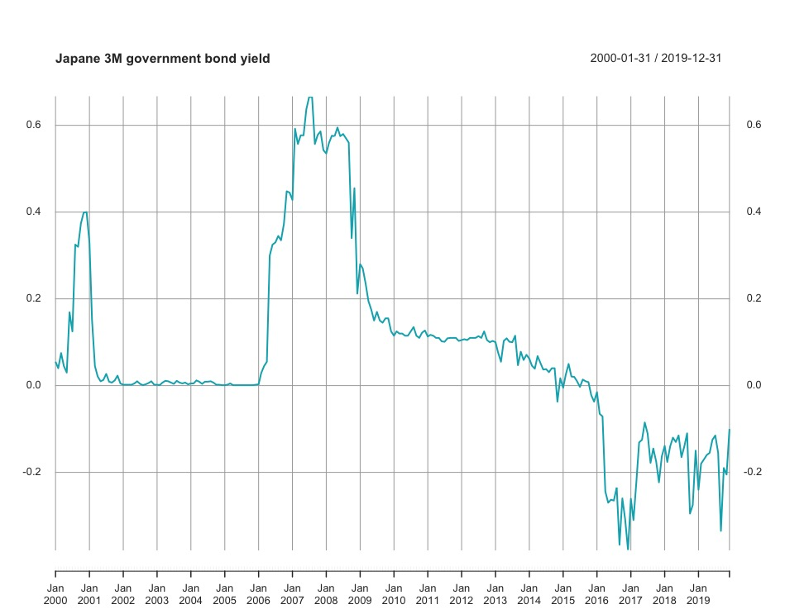
Graph 10. Dynamics of the Federal funds rate (FFR) from January 2000 to December 2019
As we see, over the period from 2000 to 2007 the rate was close to zero which was result of the government policy to drag the economy out of the crises if the “Lost Decade”. After 2016 the yield went into a negative zone following the government policy of negatives rate to compensate for stronger yen. Since then the rates remained negative until the end of the modelling period.
Graph 11 shows the dynamics of the Federal funds rate (FFR) from January 2000 to December 2019.
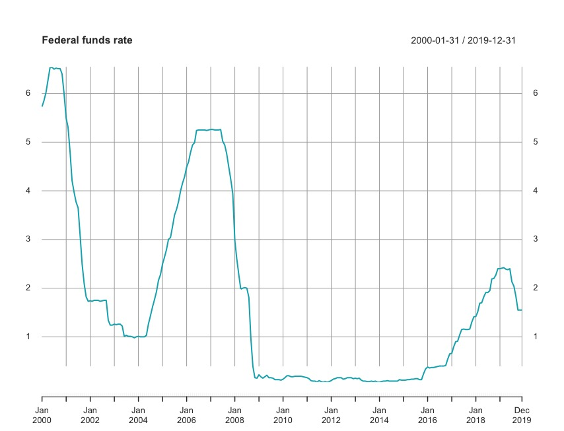
Graph 11. Dynamics of the Federal funds rate (FFR) from January 2000 to December 2019
As the graph shows, after reaching a pick in 2007, when FED was trying to prevent the economy from overheating, after that the FFR plunged to almost zero following the economy stimulation strategy.
Table 1 provides summary statistics for Federal funds rate and Japanese 3-month government bonds yield over the period from January 2000 to December 2019.
 | Mean | Stdev. | Min | Max
JIR | 0.193623 | 0.436019 | -0.379 | 2.31
FFR | 2.543214 | 2.241262 | 0.07 | 6.54
Table 1. Summary Statistics for JIR and FFR
Based on the results, we can conclude that over a modelling period FFR was more volatile than JIR as its standard deviation was estimated as circa 2.24, while for JIR its value is only circa 0.44.
Once the entry data for ICAPM innovation factor was studied through summary statistics, the next step was to study all factors used for CAPM (RM), ICAPM (RM, FFR’, JIR’), 3-factor Fama-French (RM, SMB, HML) and 5-factor Fama-French model (RM, SMB, HML, RMW, CMA). The summary statistics for them all from January 2000 to December 2019 are provided in Table 2.
 | Mean | Stdev. | Min | Max | phi
RM | 0.127 | 4.567461 | -13.55 | 15.03 | 0.116474
SMB | 0.42125 | 2.523251 | -6.46 | 8.21 | 0.032802
HML | 0.516875 | 2.946083 | -7.86 | 10.05 | 0.055714
RMW | -0.01842 | 1.623884 | -6.55 | 4.05 | -0.09631
CMA | 0.255167 | 2.042173 | -6.76 | 7.54 | 0.085164
JIR’ | -0.00061 | 0.051733 | -0.22732 | 0.244357 | -0.16009
FFR’ | 0.011232 | 0.164604 | -0.95337 | 0.288955 | 0.707503
Table 2. Summary Statistics for modeling factors
Table 3 implies that the only non-persistent factor is FFR’ as its autoregressive coefficient is 0.71. Based on standard deviation, hedging factors tend on the selected timespan is less volatile than factors used in CAPM and Fama-French models.
Once the summary statistics were presented, a correlation between hedging factors and other factors was analysed. The results of the analysis are provided in Table X.
 | RM | SMB | HML | RMW | CMA
JIR’ | 0.015964 | -0.084831215 | 0.021129 | -0.00881 | 0.006012
FFR’ | 0.194581 | -7.3029E-06 | -0.12381 | 0.152379 | -0.15195
Table 3. Correlation matrix between hedging factors and other factors
It can be concluded that hedging factors are uncorrelated with all other factors, since for any pair the correlation coefficient never exceeds 0.20 in absolute terms.
Conclusion
In this chapter the methodology of the further empirical research was outlined, and the data used in the research was described. In the next part, results on the modelling are provided.

Part 5. Empirical results
In this part of the thesis, empirical results of the test of all above-mentioned models. Two versions of ICAPM are tested: one that has innovation rate based on Japanese 3M government bond returns and another that uses Federal Fund Rate returns.

Part 5.1 CAPM
Since Capital Asset Pricing model was the foundation of this thesis and both ICAPM and Fama-French are just the improvements of it, we study CAPM results first as a benchmark for all other models.
Table 4 shows the modelling results for CAPM. The sample runs from January 2000 to December 2019 and consists of 4 batches of 25 double-sorted portfolios described above. “lambda_M” is the estimate of risk price corresponding to the market. “chi^2” is the result of the test on the joint significance of the pricing errors, while “R^2 OLS” is the cross-sectional determination coefficient. As was described previously, due to exclusion of intercept, it can be negative. In the round brackets underneath factor estimates are p-values for the corresponding factors. All estimates are rounded to the 3 digits after zero.
 | lambda_M | chi^2 | R^2 OLS
S-BM | 0.388 | 53.367 | -0.118
 | (0.0446) | (0.0058) | (0.394)
S-OP | 0.452 | 52.531 | -0.040
 | (0.0412) | (0.0044) | (0.4484)
S-INV | 0.435 | 56.100 | -0.121
 | (0.0446) | (0.0042) | (0.4616)
S-MOM | 0.482 | 54.727 | -0.077
 | (0.0162) | (0.0078) | (0.3432)
Table 4. Cross-sectional test for CAPM
The most important outcome of the modelling if that all R-squared for 4 double-sorted portfolios are negative and insignificant. As can be seen, R-squared value fluctuates from -0.121 to -0.040 while p-value never gets below 0.32 which is drastically higher than even a 10% significance level. So, we concluded that we fail to reject the null-hypothesis and they all are insignificant. Original CAPM clearly fails to explain deviations in short-term returns on Japanese stock market.
Nevertheless, market factors for all portfolios are significant with p-values being always below 5% significance level, with it being the lowest for size and momentum portfolio. This indicated that while the forecasting capabilities of CAPM are poor, market factor still effects the short-term returns.
The results of the model indicate that on the samples used CAPM does not perform well enough to act as a tool to modeling returns of the Japanese stock market.
Based in the $χ^{2}$ test, pricing errors for all portfolios are also unequal to zero as all $χ^{2}$ statistics p-values are less than 5% meaning we reject the null hypothesis for this test which is that pricing errors are jointly equal to zero.
Graph 11-14 depict the individual pricing errors for S-BM, S-MOM, S-INV and S-OP portfolios respectively. They all are given in Appendix 1.
Charts clearly justify the results of the $χ^{2}$ test. Graphs show that for most portfolios the magnitude is significant for S-BM, S-MOM, S-INV and S-OP portfolios and is above 0.25%. The highest magnitude is recognized for S-BM where 11 individual errors exceeded 0.30%. This indicates that pricing errors jointly are unequal to zero which is another justification that CAPM is not applicable to price modeling on Japanese stock market.
So CAPM is declared as an inappropriate model based on both criteria used in this study to evaluate models considered: R-squared are negative and insufficient and pricing errors are not jointly equal to zero.

Part 5.2 ICAPM with Japanese interest rate
Now we proceed to testing ICAPM model that is based in Japan’s data to test the primary scientific hypothesis of the thesis. The results show the ICAPM fail to explain investment, profitability, momentum and value anomalies on Japanese stock market, however the results are better than that of CAPM.
Table 5 shows the modelling results for ICAPM with Japanese data. The sample runs from January 2000 to December 2019 and consists of 4 batches of 25 double-sorted portfolios described above. “lambda_M” is the estimate of risk price corresponding to the market. “lambda_JIR” is the estimate of the innovation factor. “chi^2” is the result of the test on the joint significance of the pricing errors, while “R^2 OLS” is the cross-sectional determination coefficient. Due to exclusion of intercept, it can be negative. In the round brackets underneath factor estimates are p-values for the corresponding factors. All estimates are rounded to the 3 digits after zero.

 | lambda_M | lambda_JIR | chi^2 | R^2 OLS
S-BM | 0.345 | -0.022 | 45.413 | -0.067
 | (0.2208) | (0.322) | (0.0034) | (0.518)
S-OP | 0.333 | -0.061 | 21.831 | 0.375
 | (0.3298) | (0.0192) | (0.2338) | (0.2588)
S-INV | 0.371 | -0.035 | 35.174 | 0.029
 | (0.246) | (0.1112) | (0.0366) | (0.5174)
S-MOM | 0.332 | -0.069 | 19.780 | 0.347
 | (0.2548) | (0.0238) | (0.403) | (0.1548)
Table 5. Cross-sectional test for ICAPM based on Japanese 3M government bonds rate
As one can see from the Table 5, ICAPM model based on Japanese 3M government bonds return, named JIR in the model, does not perform any better compared to CAPM on the sample that was used. Even though for portfolios S-OP, S-INV and S-MOM positive results of R-squared were achieved they are still poor, with no R-squared exceeding 0.5, but most importantly they all are insignificant under even 10% significance level. They only model that get relatively close to the significance level is the one run on S-MOM, which has R-squared p-value of 0.1548. Based on these insights it can be concluded that ICAPM based on JIR fails to explain the behaviour of short-term returns and anomalies on Japanese stock market.
Interestingly, while in CAPM market factor was significant for all portfolios, in ICAPM the situation is reverse – in all models it is insignificant. The p-values of this factor fluctuates between 0.2208 and 0.3298. Innovation factor is significant only in two portfolios out of four. For portfolios S-BM and S-INV the p-values for innovation factors are 0.322 and 0.1112 respectively, indicating that they are insignificant under 5% and 10% significance levels, however innovation factor for S-INV is close to 10% significance level. For portfolios S-OP and S-MOM the p-values for innovations factor are 0.0192 and 0.238 respectively, so both are significant under 5% significance level. Also, the values of risk price estimates for the interest innovation is negative for both models that correlates with the intuition behind Merton’s ICAPM model.
Based in the $χ^{2}$ test, pricing errors for portfolios S-BM and S-INV are unequal to zero as all $χ^{2}$ statistics p-values are less than 5% meaning we reject the null hypothesis for this test. However, for portfolios S-OP and S-MOM $χ^{2}$ test indicates that errors are jointly equal to zero.
Individual pricing errors are represented on Graphs 15-18 provided in Appendix 2. All graphs indicate that on average individual pricing errors for ICAPM based in JIP are less than that derived from CAPM model. Errors rarely exceed 0.20%, especially for S-MOM and S-OP portfolio, again implying that errors can be considered as jointly equal to zero, especially with regards to S-MOM portfolio.
To conclude, even though individual pricing errors for ICAPM based on JIR performs better, for 3 portfolios out of 4 R-squared was insignificant and for two models out of four price risk estimates for the interest innovation were significant. Even though the model run on S-MOM portfolio passes cross-correlation significance test, it’s R-squared indicates that it can explain only 0.35% of volatility in the short-term interest rate which in worse than the random guess and is not suitable for any price modelling.

Part 5.3 ICAPM with Federal Funds rate
Following the poor performance of ICAPM with the innovation factor based on Japanese government bonds rate, the decision was made to consider the effect of FFR on the Japanese stock market inspired by the findings of Brusa, Savor and Wilson.
Table 6 shows the modelling results for ICAPM suing Federal Funds rate as the source for innovation factor. The sample runs from January 2000 to December 2019 and consists of 4 batches of 25 double-sorted portfolios described above. “lambda_M” is the estimate of risk price corresponding to the market. “lambda_FFR” is the estimate of the innovation factor. “chi^2” is the result of the test on the joint significance of the pricing errors, while “R^2 OLS” is the cross-sectional determination coefficient. Due to exclusion of intercept, it can be negative. In the round brackets underneath factor estimates are p-values for the corresponding factors. All estimates are rounded to the 3 digits after zero.
 | lambda_M | lambda_FFR | chi^2 | R^2 OLS
S-BM | 0.400 | -0.036 | 50.417 | -0.092
 | (0.2208) | (0.322) | (0.0034) | (0.518)
S-OP | 0.447 | 0.037 | 49.210 | -0.021
 | (0.3298) | (0.0192) | (0.2338) | (0.2588)
S-INV | 0.442 | -0.050 | 50.422 | -0.064
 | (0.246) | (0.1112) | (0.0366) | (0.5174)
S-MOM | 0.483 | -0.017 | 52.797 | -0.072
 | (0.2548) | (0.0238) | (0.403) | (0.1548)
Table 6. Cross-sectional test for ICAPM based on US Federal Funds Rate
Results of the modeling clearly indicate that ICAPM based on US Federal Funds rate does not follow the finding of Brusa, Savor and Wilson. In fact, if Federal Funds rate is used, ICAPM performance worsens. In this run, models on all four portfolios have negative R-squared values, just like when original CAPM is used. Values fluctuate from -0.092 to -0.021. Moreover, p-values for R-squared for portfolios S-BM, S-OP, S-INV and S-MOM are 0.581, 0.2588, 0.5174 and 0.1548 respectively. Again, as with ICAPM using Japanese 3 months government bonds rate, only S-MOM portfolio results get close 10% significance level. All other runs have p-values significantly higher indicating their insignificance.
With regards to p-values for model factors ICAPM with innovation factor derived from US Federal Funds rate has the same pattern as the ICAPM from the previous part. For all four portfolios, market factor is insignificant with p-values for portfolios S-BM, S-OP, S-INV and S-MOM being two and more times above even a 10% significance level which was true to ICAPM based in using Japanese government bonds rate as well. However, while for that model the values of risk price estimate for innovation factor based on Japanese bonds were all negative that was adequate to Merton’s logic, in this run only three portfolios out of four gave the same result. The risk price estimate for innovation factor for S-OP portfolio is positive and significant with p-value being 0.0192. In general, for lambda-FFR we see the same pattern: for portfolios S-OP and S-MOM risk price estimates for innovation factor are significant under 5% significance level, while these factors for portfolios S-BM and S-INV are insignificant even under 10% significance level.
Based in the $χ^{2}$ test, just like for ICAPM with JIR pricing errors for portfolios S-BM and S-INV are unequal to zero as all $χ^{2}$ statistics p-values are less than 5% meaning we reject the null hypothesis for this test, but for portfolios S-OP and S-MOM they are.
Individual pricing errors are represented on Graphs 19-22 provided in Appendix 3. Compared to ICAPM based on Japanese rate, ICAPM based on Federal Funds rate has a higher magnitude for individual pricings errors. However, in general individual pricing errors follow the same trend as the ones from the previous model.
Based on R-squared and pricing errors jointly equality to zero test it can be concluded that ICAPM model based on Federal Funds rate fails to explain the volatility on the Japanese stock market and is not applicable for price modelling.

Part 5.4 ICAPM robustness check
As the results received from ICAPM modelling were contradicting the finding of Maio and Santa-Clara the decision was made to check the model in Maio and Santa-Clara data to see if this deviation could have been caused by mechanical errors in coding.
As the first step, a model was tested on Maio and Santa-Clara original sample. In their reference paper they have used and ICAPM Federal Funds rate innovation. The sample used covers the timespan from January 1972 to December 2013. They have also used 25 portfolios sorted on S-BM and S-MOM.
Results of this run are provided in Table 7.
 | lambda_M | lambda_FFR | chi^2 | R^2 OLS
S-BM | 0.551 | -0.83 | 22.1 | 0.660
 | (0.005) | (0.001) | (0.223) | (0.000)
S-MOM | 0.64 | -0.61 | 23.21 | 0.534
 | (0.001) | (0.003) | (0.461) | (0.0004)
Table 7. Cross-sectional test for ICAPM based on Maio and Santa-Clara research
Results clearly indicate that ICAPM is indeed a suitable model for price modeling on the sample used. For both S-BM and S-MOM portfolios R-squared are significant even under 1% significance level. ICAPM explains 66% of volatility in S-BM portfolio group and 53% of volatility for S-MOM portfolio group. Moreover, both market factor and innovation factor are significant for both portfolio groups are significant under 5% significance level, while 3 out of four are significant even under 1% significance level.
Individual pricing errors are represented on Graphs 23-24 provided in Appendix 4. For both S-BM and S-MOM portfolios the magnitudes of errors are small. $χ^{2}$ as well is much higher than 0.05 so we can conclude that pricing errors are jointly equal to zero. The majority of individual pricing errors has magnitude of less than 0.25%. This justifies that ICAPM can be used for price modelling since the pricing errors can be considered to be jointly equal to zero. It also proved that the code used to run ICAPM was correct.
Another hypothesis was that it might have been the sample that caused the results to fail. To start with, ICAPM was tested on US data with Federal Funds rate as a source for innovation factor, as ICAPM was proven successful for this sample. Again, 25 double sorted portfolios sorted on S-BM and S-MOM were used. However, this time the timespan was changed to start at January 2000 and finish at December 2019.

Results of the modelling are provided in table 8.
 | lambda_M | lambda_FFR | chi^2 | R^2 OLS
S-BM | 0.83 | -0.09 | 93.63 | -0.431
 | (0.000) | (0.017) | (0.000) | (0.214)
S-MOM | 0.87 | -0.14 | 42.83 | 0.216
 | (0.001) | (0.692) | (0.005) | (0.048)
Table 8. Cross-sectional test for ICAPM based on Maio and Santa-Clara research with different sample
As we see, even if we do the robustness check on the same market on which the model was tested originally, the results are not persistent.
For S-BM portfolio, R-squared is negative and is not significant even under a 10% significance level. At the same time, market factor is still significant even under a 1% significance level, but innovation factor is not significant even under a 10% significance level.
For S-MOM portfolio the situation is different. R-squared is not negative and is significant under a 5% significance level, however based on results the model explains only 22% of volatility in short-term returns. Market factor is significant just like it is for S-BM portfolio, however innovation factor now become insignificant with p-value being 0.692.

Part 5.5 3-factor Fama-French model
Since the initial hypothesis of the thesis that ICAPM model can be used to model short-term returns on Japanese market was rejected, in this and next part the alternative models are considered. In this part results of the modeling of 3-factor Fama-French model are studied and in the next part 5-factor model is reviewed.
Table 9 shows the modelling results for 3-factor Fama-French model. The sample runs from January 2000 to December 2019 and consists of 4 batches of 25 double-sorted portfolios described above. “lambda_M” is the estimate of risk price corresponding to the market. “lambda_SMB” is the estimate of the Small-Minus-Big (SMB) factor. “lambda_HML” is the estimate of the High-Minus-Low factor. “chi^2” is the result of the test on the joint significance of the pricing errors, while “R^2 OLS” is the cross-sectional determination coefficient. Due to exclusion of intercept, it can be negative. In the round brackets underneath factor estimates are p-values for the corresponding factors. All estimates are rounded to the 3 digits after zero.

 | lambda_M | lambda_SMB | lambda_HML | chi^2 | R^2 OLS
S-BM | 0.130 | 0.418 | 0.540 | 35.190 | 0.804
 | (0.7298) | (0.0046) | (0.0002) | (0.0224) | (0.0006)
S-OP | 0.154 | 0.520 | -0.011 | 41.706 | 0.776
 | (0.7226) | (0.0001) | (0.9824) | (0.0001) | (0.0142)
S-INV | 0.117 | 0.458 | 0.564 | 38.325 | 0.820
 | (0.789) | (0.0006) | (0.0056) | (0.004) | (0.0006)
S-MOM | 0.116 | 0.507 | 0.723 | 35.377 | 0.766
 | (0.7672) | (0.0000) | (0.0702) | (0.013) | (0.0042)
Table 9. Cross-sectional test for 3-factor Fama-French model
Results are drastically different compared to that of CAPM and both ICAPM runs. For S-BM, S-INV and S-MOM portfolios R-squared are significant under 1% significance level and for all four portfolios it is significant under 5% significance level. The lowest p-values are that of S-BM and S-INV portfolios and are 0.0006 for both. Explanatory powers of the models vary from 76.6% for S-MOM portfolio run to 82% for S-INV run, but obviously for all four portfolios 3-factor Fama-French model manages to explain a significant portion of volatility of the short-term returns which is incomparable to a poor performance of CAPM or ICAPM.
Factor-wise situation 3-factor Fama-French model also performs better than ICAPM. Just like in original CAPM, in 3-factor model market factor is insignificant for all portfolios. It’s p-values vary from 0.7226 to 0.789 which indicates the insignificance of the factor. However, Fama-French specific factors are significant for all four portfolios. The only insignificant factor is HML is the S-OP run. It’s p-value is close to 1. For S-BM, S-INV and S-MOM Hign-Minus-Low factor is significant under 10% significance level and for S-BM and S-INV it is significant also under 1% significance level.
Small-Minus-Big factor is significant for all four portfolios even under 1% significance level. The highest p-value this factor has in the S-BM run where it is 0.0046, but even this is more than 2 times less than 1% significance level.
Following the findings from ICAPM robustness check, 3-factor model robustness check was conducted on the same sub-samples and results were persistent.
However, based on the $χ^{2}$ test, 3-factor Fama-French model does not pass the joint equality to zero test. For all portfolios p-values are less than 5% significance level.
On the other hand, the volatility of pricing errors is much less than for CAPM or ICAPM modelling. For all four portfolios the average magnitude of individual pricing error is less than 0.20% with outliers being no more than 0.30% for S-BM, S-INV and S-MOM. Only for S-OP the outliers magnitude exceeds 0.30% but does not exceed 0.40%. Individual pricing errors are given in graphs 25-28 and are provided in Appendix 5.
As was mentioned in the methodology section, $χ^{2}$ test can give ambiguous results which is clearly shown in the results for 3-factor Fama-French model.
To conclude, 3-factor Fama-French performs well in R-squared and is specified well enough to be used for pricing modelling on the Japanese stock market. It also drastically outperforms ICAPM. Unlike ICAPM, 3-factor model results are in line with what other studies indicate. Even though based on the joint equality to zero test the model performs worse, there is evidence that these results can be misleading.

Part 5.6 5-factor Fama-French model
The last model that is analysed in this thesis is a 5-factor Fama-French model. In addition to Small-Minus-Big and High-Minus-Low, Robust-Minus-Weak and Conservative-Minus-Aggressive factors are considered.
Table 10 shows the modelling results for 3-factor Fama-French model. The sample runs from January 2000 to December 2019 and consists of 4 batches of 25 double-sorted portfolios described above. “lambda_M” is the estimate of risk price corresponding to the market. “lambda_SMB” is the estimate of the Small-Minus-Big (SMB) factor. “lambda_HML” is the estimate of the High-Minus-Low factor. “lambda_RMW” is the estimate of the Robust-Minus-Weak factor. “lambda_CMA” is the estimate of the Conservative-Minus-Aggressive factor. “chi^2” is the result of the test on the joint significance of the pricing errors, while “R^2 OLS” is the cross-sectional determination coefficient. Due to exclusion of intercept, it can be negative. In the round brackets underneath factor estimates are p-values for the corresponding factors. All estimates are rounded to the 3 digits after zero.
 | lambda_M | lambda_SMB | lambda_HML | lambda_RMW | lambda_CMA | chi^2 | R^2 OLS
S-BM | 0.146 | 0.407 | 0.548 | 0.334 | 0.289 | 29.259 | 0.835
 | (0.6206) | (0.0028) | (0.0000) | (0.2866) | (0.496) | (0.007) | (0.0024)
S-OP | 0.151 | 0.502 | 0.155 | 0.014 | -0.095 | 39.883 | 0.785
 | (0.648) | (0.0000) | (0.7216) | (0.9114) | (0.7858) | (0.0000) | (0.0642)
S-INV | 0.117 | 0.464 | 0.574 | 0.228 | 0.287 | 34.262 | 0.856
 | (0.7192) | (0.0004) | (0.004) | (0.338) | (0.006) | (0.0018) | (0.0022)
S-MOM | 0.122 | 0.518 | 0.630 | -0.229 | 0.134 | 35.170 | 0.774
 | (0.6764) | (0.0002) | (0.0208) | (0.5032) | (0.7916) | (0.0006) | (0.0318)
Table 10. Cross-sectional test for 5-factor Fama-French model
Again, as it was for 3-factor Fama-French model, R-squared values are significant for all four portfolios. However, for 5 factor model they all are significant under a 10% significance level and R-squared for S-BM, S-INV and S-MOM are significant under 5% level and S-BM and S-INV are significant also under 1% significance level. Explanatory power of 5-factor Fama-French model varies from 77.4% for S-MOM portfolio to 85.6% for S-INV model. Compared to ICAPM runs it is a major improvement, however it’s hard to tell if 5-factor Fama-French model can indeed explain a bigger part of volatility in short-term returns of Japanese stock market, since one of the features of R-squared is that adding new factors to the model tend to increase its value even though factors themselves can be insignificant, therefore no certain statement can be made. Nevertheless, R-sqaured indicates that just like 3-factor model, 5-factor Fama-French model can be used for price modelling on the Japanese market.
Similar to the 3-factor model, in 5-factor model market factor is insignificant among all four portfolios with its p-value fluctuating between 0.6206 and 0.7192. Factor estimates for SMB and HML are persistent between models. Like in 3-factor model, in 5-factor one SMB factor is significant under 1% significance level among four portfolios and estimates values deviates by less than 5% among all portfolios. The same trend applies to HML factor estimates. For S-OP portfolio this factor is still insignificant as it’s p-value being 0.7216. For S-BM and S-INV portfolios HML factor is significant under 1% significance level and factor estimates deviate from 3-factor model by no more than 7%. Interestingly, HML’s significance for S-MOM portfolio has increased as in 5-factor run it is now significant under 5% significance level, while in 3-factor model it was significant only under 10% significance level.
Surprisingly, newly added factors are insignificant in 7 cases out of 8. RWA factor estimates are insignificant among all four portfolios with p-values being between 0.2866 and 0.9114. CMA factor is insignificant for S-BM, S-OP and S-MOM portfolios with p-values of 0.496, 0.7858 and 0.7916 respectively. Only for S-INV portfolio CMA factor estimate is significant even under 1% significance level. Model on this portfolio also had the highest R-squared.
Just like for 3-factor model, 5-factor model robustness check justified the persistency of results.
Again $χ^{2}$ test indicates that for all portfolios pricing errors are unequal to zero, but these results require a more detailed analysis.
Individual pricing errors are given in graphs 29-32 and are provided in Appendix 6. Again, pricing error magnitude on average is 0.20% or less and only for S-INV and S-MOM portfolios certain individual price error approach or exceed 0.30% magnitude, but even in these cases they do not exceed 0.40% level.
Overall, it can be concluded that 5-factor Fama-French model is well fitted to be used for modelling of prices on Japanese stock market based on the results on the sample used. It should be preferred compared to ICAPM model. However, 3-factor Fama-French model is more preferable, since though R-squared values are slightly higher for 5-factor model, new factors are insignificant in the majority of cases.

Part 5.7 Second robustness check for all models
Based on the preliminary results, Fama-French models indeed seems superior compared to CAPM and ICAPM on Japanese market.
However, as it was the case with ICAPM models, to be sure that Fama-French models are indeed more applicable, a second robustness check was conducted. In this case, the sample was divided into 2 timespans:
- From January 2000 to December 2009;
- From January 2010 to December 2019;
These timespans represent well different states of the economy, as can be seen on graphs 1-4 provided in the Part 1 of this thesis.
Below are R-squared values and associated -values of all 5 models on all four double-sorted portfolios on three aforementioned timespans.
 | CAPM | ICAPM w/ JIR | ICAMP w/ FFR | 3-Factor FFM | 5-factor FFM
S-BM | -0.010 | 0.152 | 0.040 | 0.880 | 0.888
 | (0.5166) | (0.5480) | (0.8334) | (0.0000) | (0.0010)
S-OP | -0.011 | 0.477 | 0.002 | 0.835 | 0.851
 | (0.8914) | (0.1830) | (0.9940) | (0.0010) | (0.0056)
S-INV | -0.034 | 0.113 | 0.022 | 0.878 | 0.892
 | (0.8020) | (0.6830) | (0.9226) | (0.0000) | (0.0010)
S-MOM | -0.021 | 0.305 | -0.005 | 0.677 | 0.735
 | (0.7836) | (0.2594) | (0.9366) | (0.0314) | (0.0934)
Table 11. R-squared estimates and p-values for sub-sample from 01/2000 to 12/2009

 | CAPM | ICAPM w/ JIR | ICAMP w/ FFR | 3-Factor FFM | 5-factor FFM
S-BM | -0.231 | -0.218 | -0.216 | 0.707 | 0.802
 | (0.1710) | (0.2678) | (0.2632) | (0.0028) | (0.0028)
S-OP | -0.190 | -0.107 | -0.081 | 0.665 | 0.681
 | (0.2156) | (0.3240) | (0.3110) | (0.0080) | (0.0604)
S-INV | -0.161 | -0.154 | 0.034 | 0.743 | 0.769
 | (0.1622) | (0.2966) | (0.2060) | (0.0036) | (0.0130)
S-MOM | -0.163 | -0.143 | -0.163 | 0.628 | 0.655
 | (0.1432) | (0.2156) | (0.2234) | (0.0114) | (0.0538)
Table 12. R-squared estimates and p-values for sub-sample from 01/2010 to 12/2019
As we can see from results on both sub-samples the pattern identified in previous runs remains: Fama-French models outperform both variations of ICAPM as well as the traditional CAPM. In no run does ICAPM or CAPM explanatory power exceeds the random guess.
However, it’s interesting to note that Fama French shows higher explanatory power on the first subsample from January 2000 to December 2009 that is associated with higher volatility due to the economic crisis on 2008 compared to the second subsample form January 2010 to December 2019.
This robustness check confirms that Fama French model is indeed the best specified model for Japanese financial market out of all models reviewed in this thesis.
Conclusion
After the analysis of empirical results of the modelling, the main hypothesis that ICAPM can be used for price modelling on Japanese stock market was rejected. Based on the data, if someone is choosing between CAPM, ICAPM, 3-factor Fama-French model and 5-factro Fama-French model, he or she should prefer the latter two models.
It was also shown that the results of Maio and Santa-Clara who initially have shown that ICAPM outperforms CAPM and both Fama-French models, are not persistent when the timespan of the sample is changed.

Part 6. Conclusion
The main goal of this paper was to assess the applicability of the Intertemporal Capital Asset Pricing Model to estimating the short-term returns on the Japanese stock market.
During the thesis, all research objectives were achieved:
- Review the academic research on asset pricing models and specifically ICAPM was done;
- ICAPM calculations on Tokyo Stock Exchange data was conducted;
- ICAPM performance to other widely used asset pricing models was compared;
- Conclusion on the applicability of ICAPM based on the obtained results were made.
As stated in the introduction, in the second part of the thesis Japanese stock market was reviewed. Ii was concluded that in the last 30 years Japan was mainly battling with the financial crisis and is enjoying the growth only since late 00s.
After that academic literature was examined. It was shown that bases in the results from academic paper reviewed CAPM is not fitted well for price modelling due to its inability to account for human irrationality. On the other hand, models like ICAPM or Fama-French were originally created on CAPM foundation to account for this irrationality. Vast examples of paper indicated their superiority to CAPM.
Once in part 3 methodology and data were described in part 4 the empirical results were studied. It was shown that despite the expectations ICAPM is not fitted to the price modelling on Japanese stock market while 3-factor Fama-French model performs well. One of the reasons for it might be the poor choice of the innovation factor in ICAPM. Study of other ICAPM specifications can be an interesting question for further research.
Based on the results of the research the main hypothesis of the thesis was rejected.
It can be concluded that if a company needs to model prices on Japanese stock market, based on the results from the samples used between CAPM, ICAPM and Fama-French models it should prefer the latter.
It was also shown that when developing a model financial practitioner do not directly use the finding of the theorists. The dialog between academics and practitioners seems to be rather poor in the academic worlds. So, the best approach these days is to use various academic papers as references to define certain factors that explains the fluctuations in the returns and incorporate them in the model. Even if the practitioners to not implement Fama-French model directly, it makes sense to use it as a benchmark for in-house models as it has proven its efficiency on Japanese and other markets.
An interesting topic for a further research can be the comparison of efficiency of certain corporate model that were declassified to the academic models like Fama-French one’s. The more factors are included in the models the more expensive it gets to maintain and implement it. Even though compared to overall budget of the company these expenses are insignificant, modelling process optimization is important for the workflow of the analytical departments.

References

Articles:
Alex D. Patelis. Stock Return Predictability and The Role of Monetary Policy. The Journal of Finance, Volume 52, Issue 5. 18 April 2012.
Bajpai P., The 5 Largest Economies In The World And Their Growth In 2020. Jan. 22, 2020. Available at: https://www.nasdaq.com/articles/the-5-largest-economies-in-the-world-and-their-growth-in-2020-2020-01-22
Ben S. Bernanke Kenneth N. Kuttner. What Explains the Stock Market’s Reaction to Federal Reserve Policy? March 2004 Available at: https://www.federalreserve.gov/pubs/feds/2004/200416/200416pap.pdf
Brusa F., Savor P., Wilson M. One Central Bank to Rule Them All. August 2018. Available at: https://sites.temple.edu/psavor/files/2018/08/One-Central-Bank-to-Rule-Them-All-Aug-2018.pdf
Campbell, John Y. A variance decomposition for stock returns. Economic Journal 101, no. 405, 1991. pp. 157-179.
Dimson E., Marsh P., Staunton M. Does hiking damage your wealth? Available at: http://www.q-group.org/wp-content/uploads/2016/09/Dimson_paper.pdf
Eiji O., Japan's 1968: A Collective Reaction to Rapid Economic Growth in an Age of Turmoil. Translation by Kapur N., Malissa S., Poland S. The Asia-Pacific Journal. Volume 13, Issue 12, Number 1, Mar 23, 2015.
Eugene F. Fama, Kenneth R. French. The Cross‐Section of Expected Stock Returns. The Journal of Finance, Volume 47, Issue 2. June 1992.
Eugene F. Fama, Kenneth R. French. Average Returns, B/M, and Share Issues. CRSP Working Paper No. 619. 20 May 2007.
Eugene F. Fama and James D. MacBeth. Risk, Return, and Equilibrium: Empirical Tests. The Journal of Political Economy, Vol. 81, No. 3 (May - Jun., 1973), pp. 607-636.
Hayes A. Fama and French Three Factor Model. Available at: https://www.investopedia.com/terms/f/famaandfrenchthreefactormodel.asp
Ito. T. Great Inflation and Central Bank Independence in Japan. National Bureau of Economic research. 1050 Massachusetts Avenue, Cambridge, MA 02138, February 2010
Jack L. Treynor. Market Value, Time, and Risk. August 8, 1961. Available at: https://papers.ssrn.com/sol3/papers.cfm?abstract_id=2600356
Jegadeesh N., Titman S. Returns to Buying Winners and Selling Losers: Implications for Stock Market Efficiency. The Journal of Finance, Vol. 48, No. 1. (Mar., 1993), pp. 65-91.
John Y. Campbell, Hamao Y. Predictable Stock Returns in the United States and Japan: A Study of Long-Term Capital Market Integration. Journal of Finance, Volume 47, No. 1, pp. 43-69. March 1992.
John R. Grahama, Campbell R. Harvey. The theory and practice of corporate finance: Evidence from the Field. Journal of Financial Economics, Volume 60, Issues 2–3, May 2001, pp.187-243.
Lintner J. The Valuation of Risk Assets and the Selection of Risky Investments in Stock Portfolios and Capital Budgets. The Review of Economics and Statistics, Vol. 47, No. 1 (Feb., 1965), pp. 13-37.
Mark M. Carhart. On Persistence in Mutual Fund Performance. The Journal of Finance. Volume 52, Issue 1. 18 April 2012. pp. 57-82.
Mossin J. Equilibrium in a Capital Asset Market. Econometrica, Vol. 34, No. 4 (Oct., 1966), pp. 768-783.
Nocera J. Can We Turn Off Our Emotions When Investing? The New York Times. Sept. 29, 2007. Available at: https://www.nytimes.com/2007/09/29/business/29nocera.html
Paulo F. Maio, Santa-Clara P. Short-Term Interest Rates and Stock Market Anomalies. Journal of Financial and Quantitative Analysis (JFQA), Forthcoming. February 7, 2017.
Robert C. Merton. An Intertemporal Capital Asset Pricing Model. Econometrica. Vol. 41, No. 5 (Sep., 1973), pp. 867-887.
Tamura M. 30 years since Japan's stock market peaked, climb back continues. December 29, 2019. Available at: https://asia.nikkei.com/Spotlight/Datawatch/30-years-since-Japan-s-stock-market-peaked-climb-back-continues
Titman S. K.C. John Wei, Xie F. Capital Investment and Stock Returns. National Bureau of Economic research. 1050 Massachusetts Avenue, Cambridge, MA 02138, September 2003.
Truong, G., Partington, G., Peat, M. Cost-of-capital estimation and capital budgeting practices in Australia. Australian Journal of Management, Volume 33, Issue 1, 2008. pp. 95-121.
Tsuji C. An Investigation of the ICAPM in Japan: Evidence from the Tokyo Stock Exchange with a Review of International and Accounting Research. International Journal of Accounting and Financial Reporting. Vol. 1, No. 1, 2011. pp. 18-28.
William F. Sharpe Capital Asset Prices: A Theory of Market Equilibrium under Conditions of Risk. The Journal of Finance, Volume 19, Issue 3. September 1964.
Internet resources:
Japan Exchange Group. Number of Listed Companies/Shares. Available at: https://www.jpx.co.jp/english/listing/co/index.html
Kenneth R. French’s official site. Available at: https://mba.tuck.dartmouth.edu/pages/faculty/ken.french/index.html
Largest stock exchange operators worldwide as of Mar 2020, by market capitalization of listed companies. Available at: https://www.statista.com/statistics/270126/largest-stock-exchange-operators-by-market-capitalization-of-listed-companies/
The World Bank. World Development Indicators. Available at: http://datatopics.worldbank.org/world-development-indicators/
The Fama-French model. Report for Jemena Gas Networks, ActewAGL, Ergon, Transend, TransGrid, and SA PowerNetworks. Available at: https://www.ergon.com.au/__data/assets/pdf_file/0019/228421/SFG-Report-of-Fama-French.pdf
Yahoo Finance. Available at: https://finance.yahoo.com/quote/%5EN225/history?period1=-157420800&period2=1584748800&interval=1mo&filter=history&frequency=1mo

Appendix 1. Individual pricing errors for CAPM
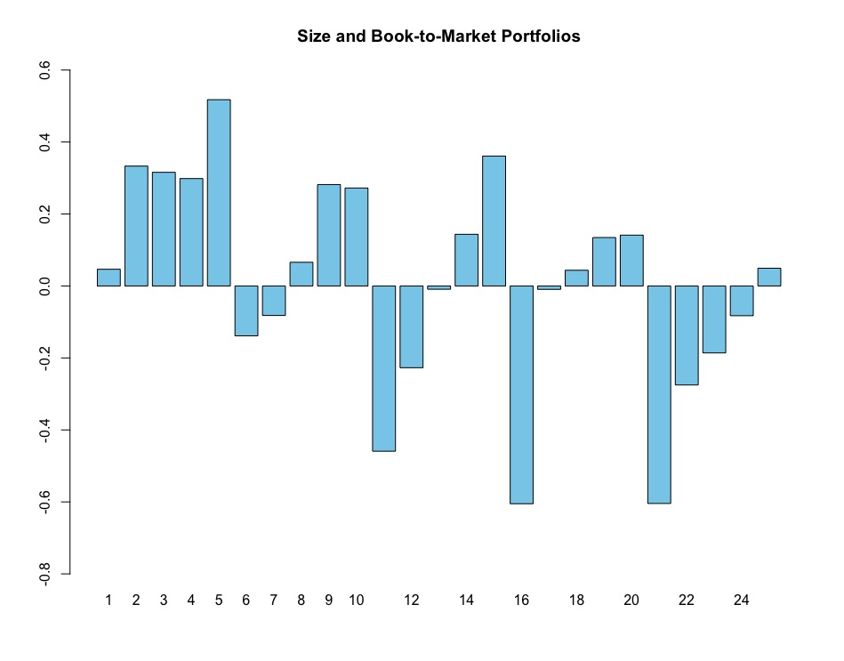
Graph 12. Individual pricing error for BM portfolio for CAPM

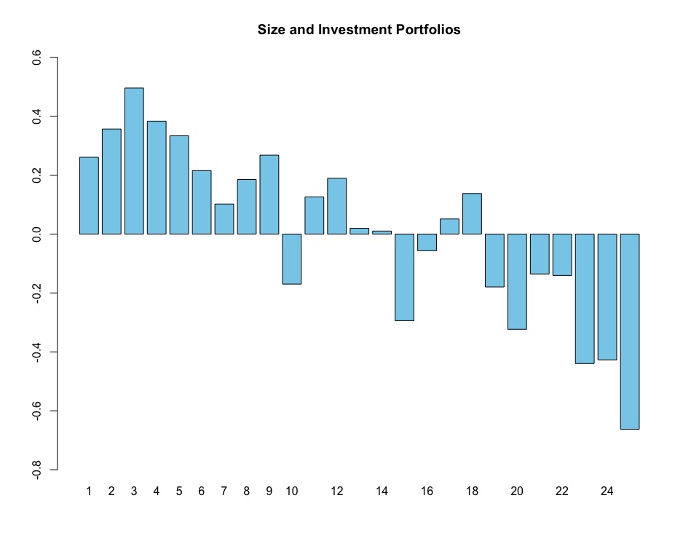
Graph 13. Individual pricing error for INV portfolio for CAPM
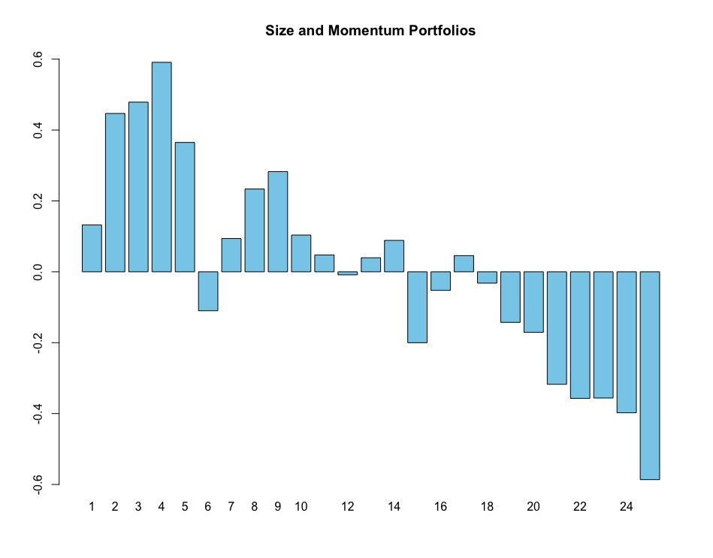
Graph 14. Individual pricing error for MOM portfolio for CAPM
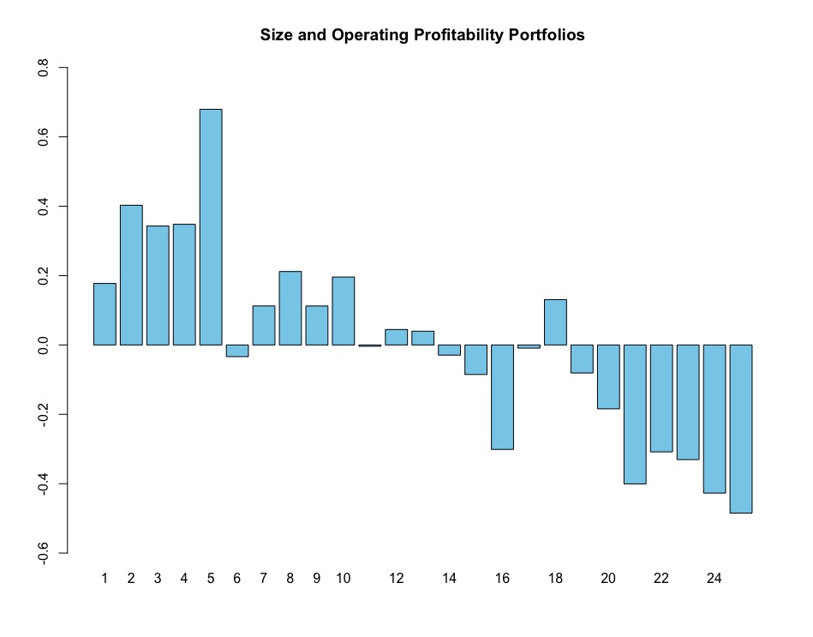
Graph 15. Individual pricing error for OP portfolio for CAPM

Appendix 2. Individual pricing errors for ICAPM with JIR
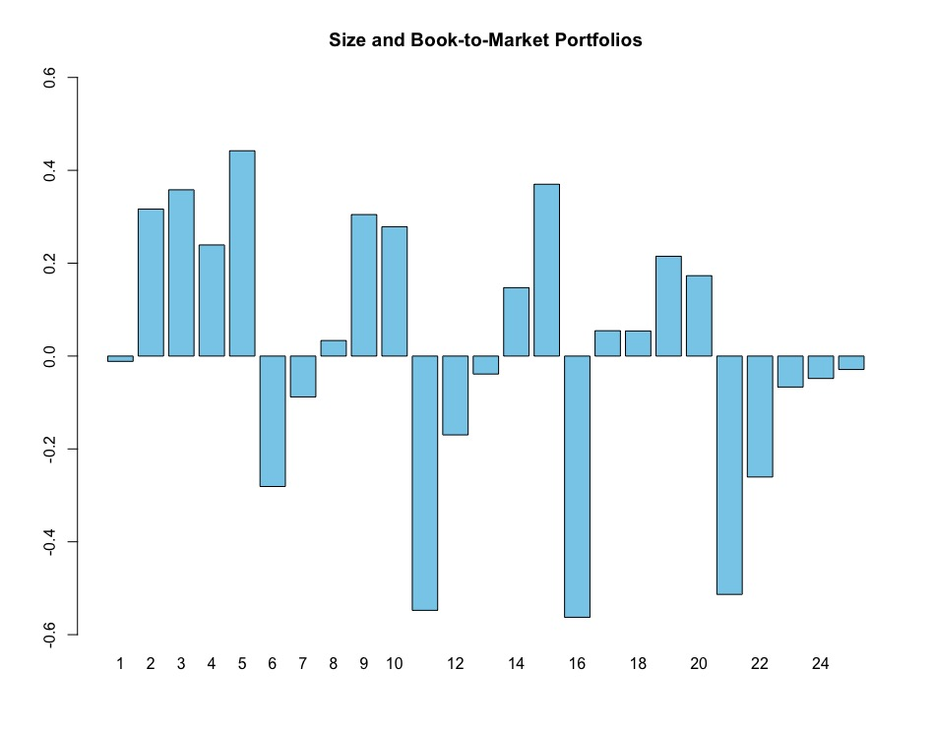
Graph 16. Individual pricing error for BM portfolio for ICAPM with JIR
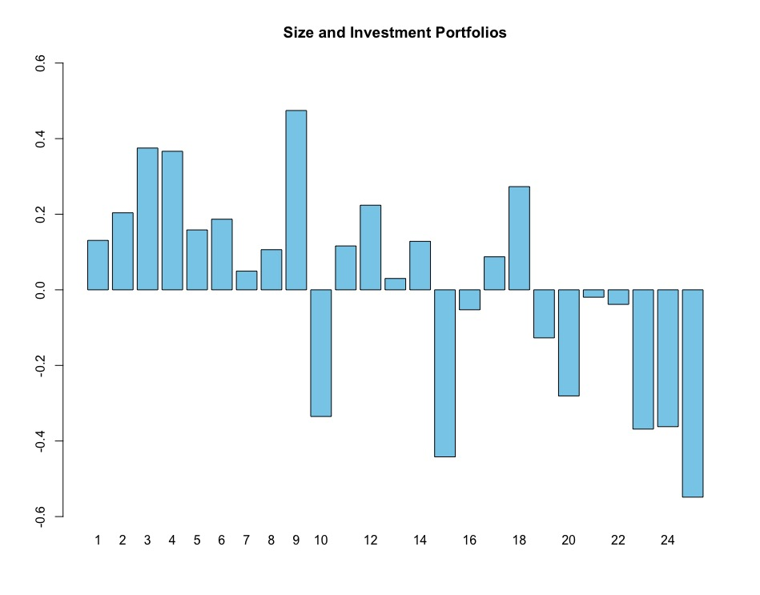
Graph 17. Individual pricing error for INV portfolio for ICAPM with JIR
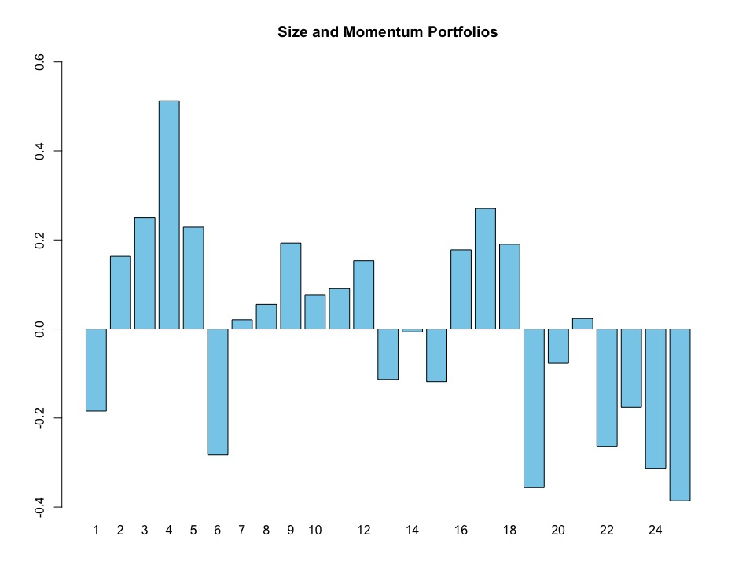
Graph 18. Individual pricing error for MOM portfolio for ICAPM with JIR
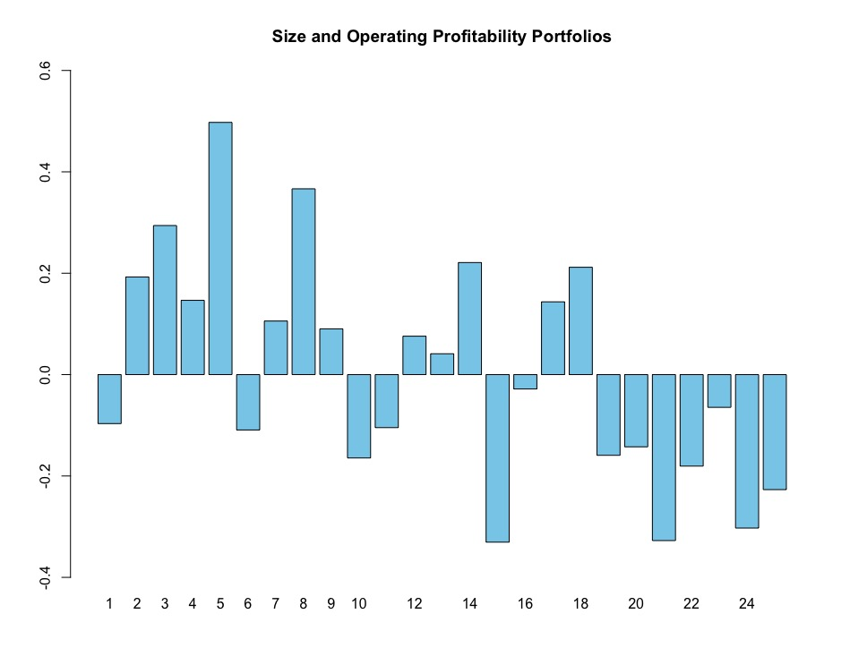
Graph 19. Individual pricing error for OP portfolio for ICAPM with JIR

Appendix 3. Individual pricing errors for ICAPM with FFR
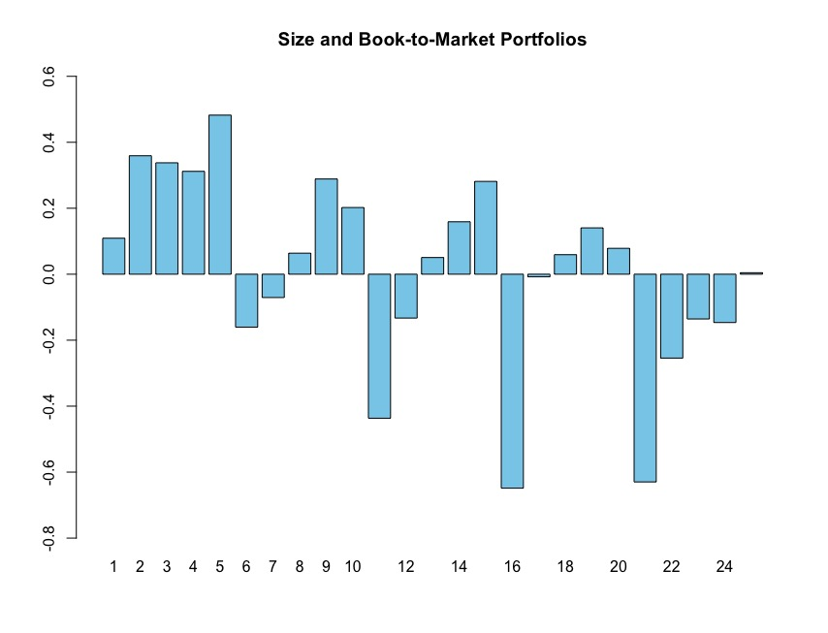
Graph 20. Individual pricing error for BM portfolio for ICAPM with FFR
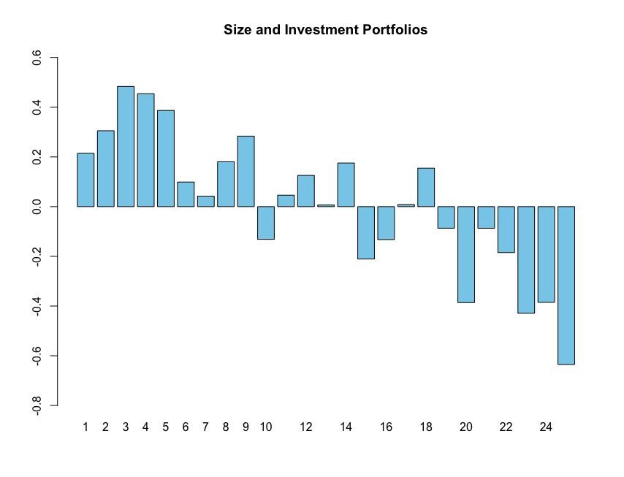
Graph 21. Individual pricing error for INV portfolio for ICAPM with FFR
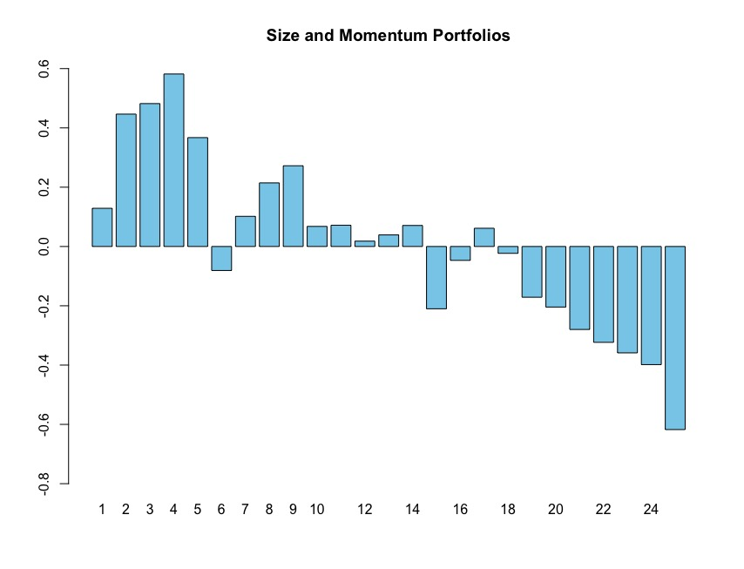
Graph 22. Individual pricing error for MOM portfolio for ICAPM with FFR
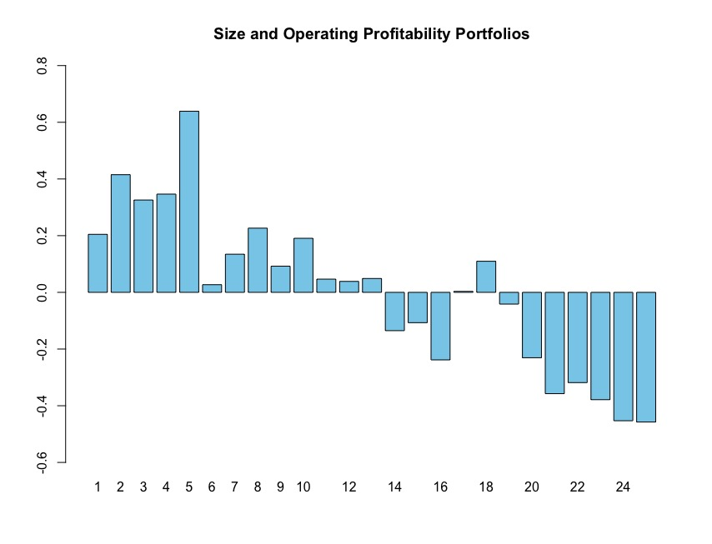
Graph 23. Individual pricing error for OP portfolio for ICAPM with FFR

Appendix 4. Individual pricing errors for ICAPM robustness check
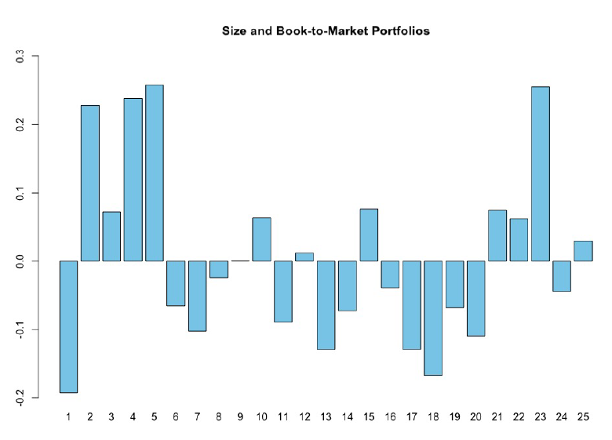
Graph 24. Individual pricing error for BM portfolio for ICAPM robustness check
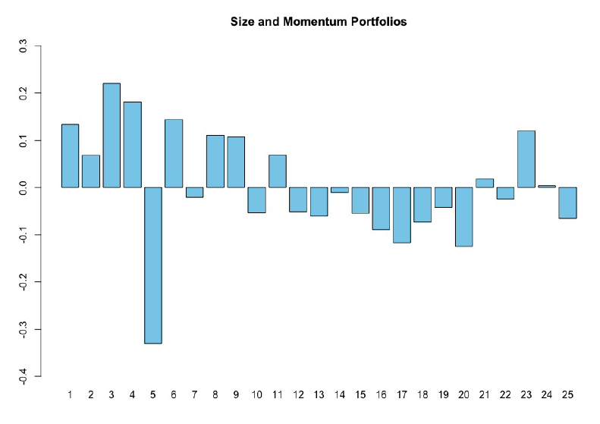
Graph 25. Individual pricing error for MOM portfolio for ICAPM robustness check

Appendix 5. Individual pricing errors for 3-factor Fama-French model
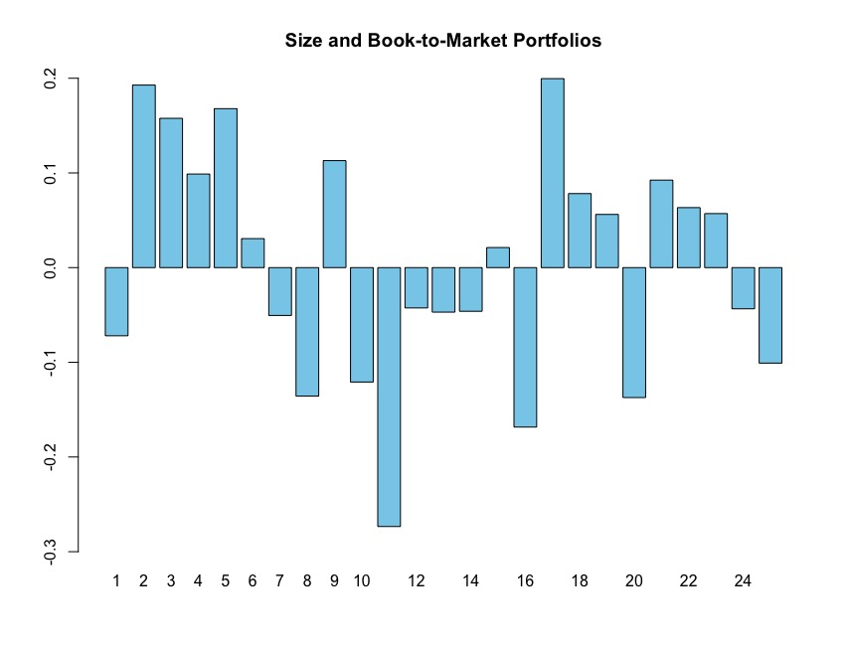
Graph 26. Individual pricing error for BM portfolio for 3-factor Fama-French model
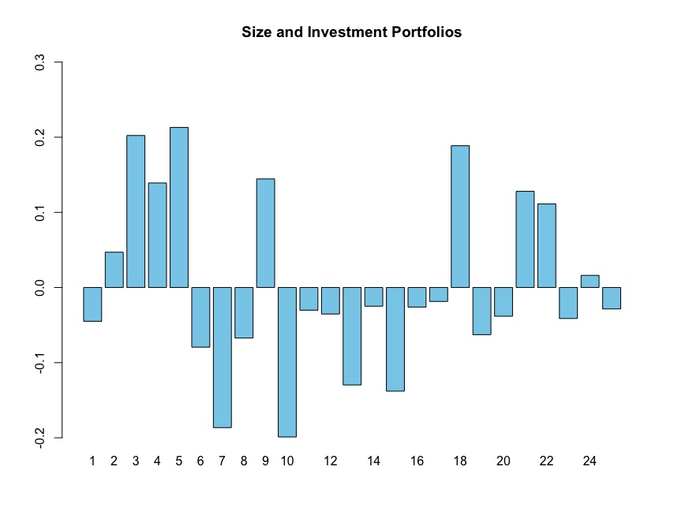
Graph 27. Individual pricing error for INV portfolio for 3-factor Fama-French model

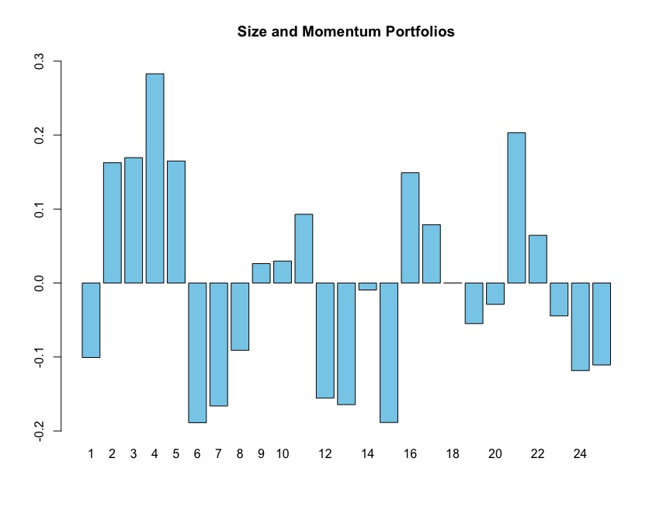
Graph 28. Individual pricing error for MOM portfolio for 3-factor Fama-French model
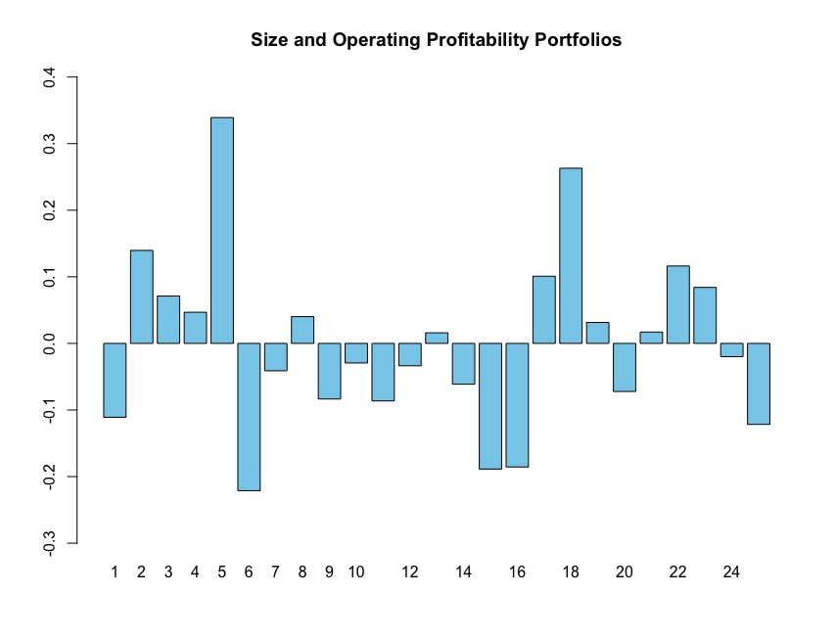
Graph 29. Individual pricing error for OP portfolio for 3-factor Fama-French model

Appendix 6. Individual pricing errors for 5-factor Fama-French model
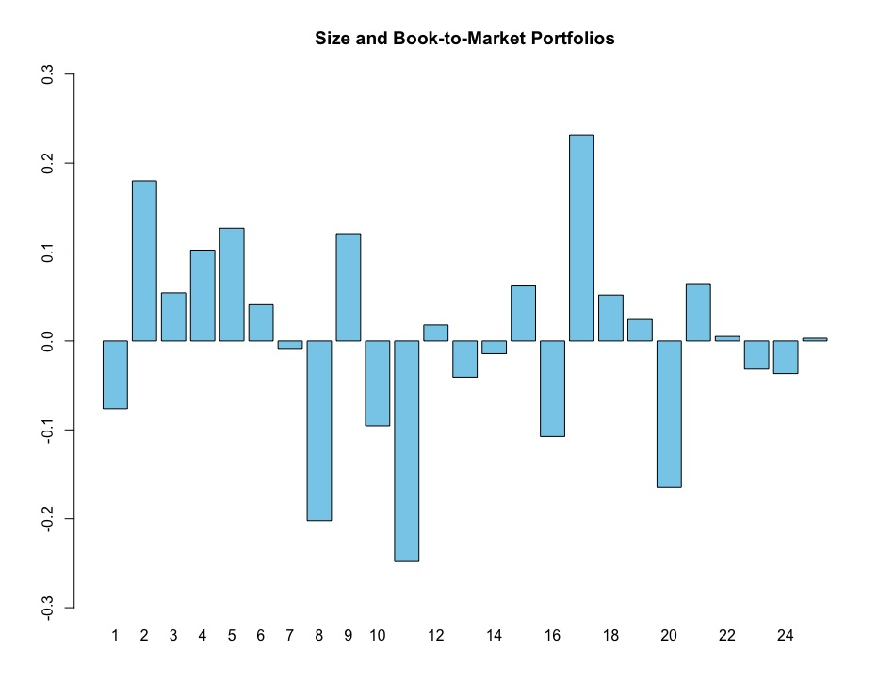
Graph 30. Individual pricing error for BM portfolio for 5-factor Fama-French model
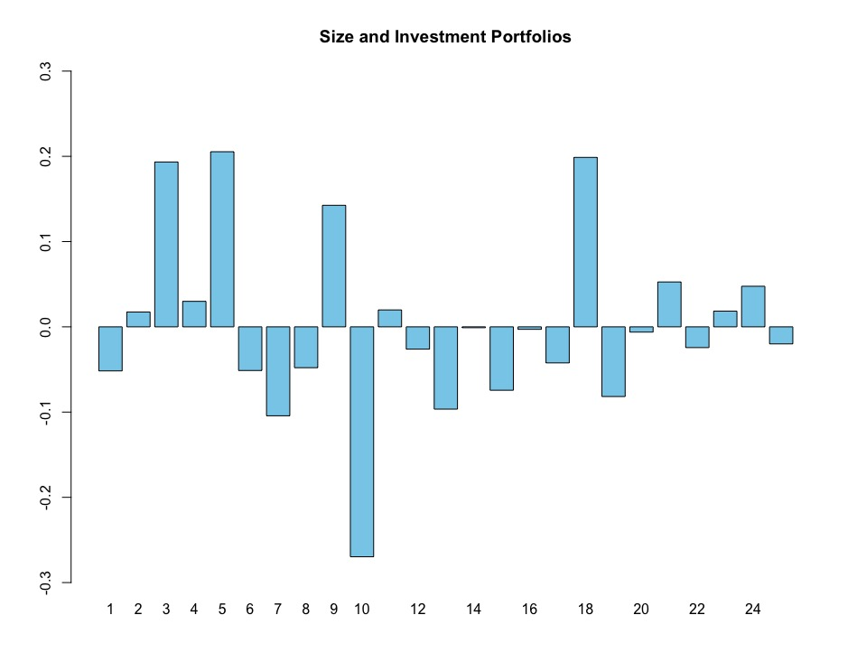
Graph 31. Individual pricing error for INV portfolio for 5-factor Fama-French model

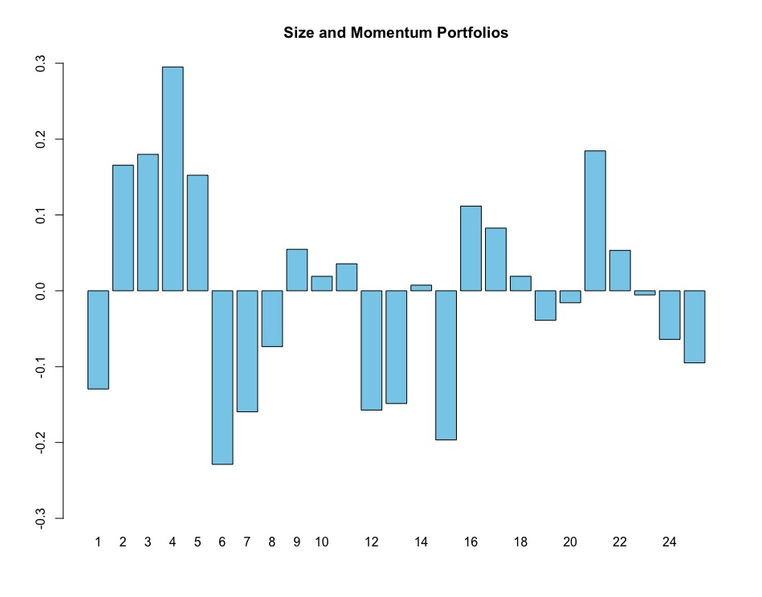
Graph 32. Individual pricing error for MOM portfolio for 5-factor Fama-French model
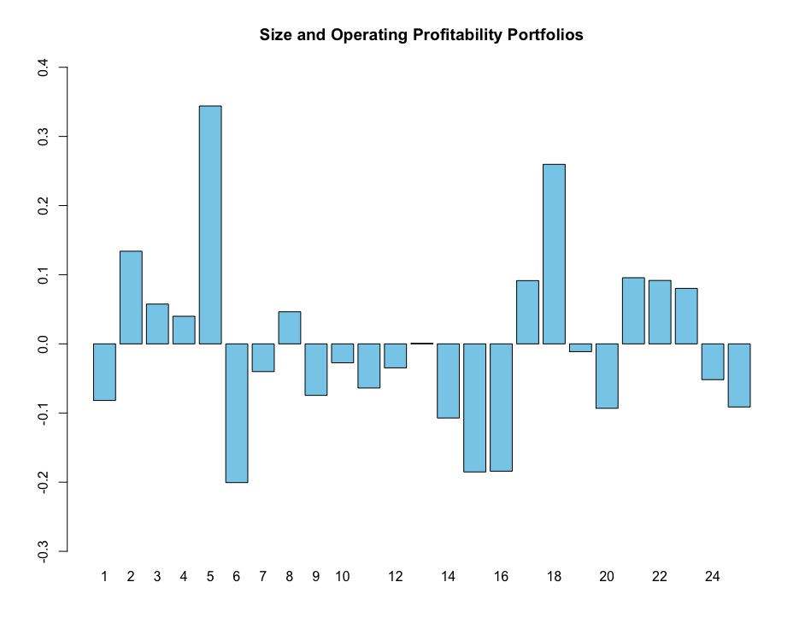
Graph 33. Individual pricing error for OP portfolio for 5-factor Fama-French model

Bajpai P., The 5 Largest Economies In The World And Their Growth In 2020. Jan. 22, 2020. Available at: https://www.nasdaq.com/articles/the-5-largest-economies-in-the-world-and-their-growth-in-2020-2020-01-22 (accessed 20 February 2020)
Largest stock exchange operators worldwide as of Mar 2020, by market capitalization of listed companies. Available at: https://www.statista.com/statistics/270126/largest-stock-exchange-operators-by-market-capitalization-of-listed-companies/ (accessed 18 March 2020)
Bajpai P., The 5 Largest Economies In The World And Their Growth In 2020. Jan. 22, 2020. Available at: https://www.nasdaq.com/articles/the-5-largest-economies-in-the-world-and-their-growth-in-2020-2020-01-22 (accessed 20 February 2020)
Largest stock exchange operators worldwide as of Mar 2020, by market capitalization of listed companies. Available at: https://www.statista.com/statistics/270126/largest-stock-exchange-operators-by-market-capitalization-of-listed-companies/ (accessed 18 March 2020)
The World Bank. World Development Indicators. Available at: http://datatopics.worldbank.org/world-development-indicators/ (accessed 14 January 2020)
Eiji O., Japan's 1968: A Collective Reaction to Rapid Economic Growth in an Age of Turmoil. Translation by Kapur N., Malissa S., Poland S. The Asia-Pacific Journal. Volume 13, Issue 12, Number 1, Mar 23, 2015.
Ito. T. Great Inflation and Central Bank Independence in Japan. National Bureau of Economic research. 1050 Massachusetts Avenue, Cambridge, MA 02138, February 2010.
Yahoo Finance. Available at: https://finance.yahoo.com/quote/%5EN225/history?period1=-157420800&period2=1584748800&interval=1mo&filter=history&frequency=1mo (accessed 5 February 2020)
Tamura M. 30 years since Japan's stock market peaked, climb back continues. December 29, 2019. Available at: https://asia.nikkei.com/Spotlight/Datawatch/30-years-since-Japan-s-stock-market-peaked-climb-back-continues (accessed 15 February 2020)
Yahoo Finance. Available at: https://finance.yahoo.com/quote/%5EN225/history?period1=-157420800&period2=1584748800&interval=1mo&filter=history&frequency=1mo (accessed 5 February 2020).
Japan Exchange Group. Number of Listed Companies/Shares. Available at: https://www.jpx.co.jp/english/listing/co/index.html (accessed 7 February 2020)
William F. Sharpe. Capital Asset Prices: A Theory of Market Equilibrium under Conditions of Risk. The Journal of Finance, Volume 19, Issue 3. September 1964. pp. 425-442.
Jack L. Treynor. Market Value, Time, and Risk. August 8, 1961. Available at: https://papers.ssrn.com/sol3/papers.cfm?abstract_id=2600356 (accessed 7 March 2020)
Lintner J. The Valuation of Risk Assets and the Selection of Risky Investments in Stock Portfolios and Capital Budgets. The Review of Economics and Statistics, Vol. 47, No. 1 (Feb., 1965), pp. 13-37.
Mossin J. Equilibrium in a Capital Asset Market. Econometrica, Vol. 34, No. 4 (Oct., 1966), pp. 768-783.
Nocera J. Can We Turn Off Our Emotions When Investing? The New York Times. Sept. 29, 2007. Available at: https://www.nytimes.com/2007/09/29/business/29nocera.html (accessed 10 January 2020)
Eugene F. Fama, Kenneth R. French. The Cross‐Section of Expected Stock Returns. The Journal of Finance, Volume 47, Issue 2. June 1992. pp. 427-466.
Jegadeesh N., Titman S. Returns to Buying Winners and Selling Losers: Implications for Stock Market Efficiency. The Journal of Finance, Vol. 48, No. 1. (Mar., 1993), pp. 65-91.
Eugene F. Fama, Kenneth R. French. Average Returns, B/M, and Share Issues. CRSP Working Paper No. 619. 20 May 2007.
Same.
Jegadeesh N., Titman S. Same.
Titman S. K.C. John Wei, Xie F. Capital Investment and Stock Returns. National Bureau of Economic research. 1050 Massachusetts Avenue, Cambridge, MA 02138, September 2003.
Eugene F. Fama, Kenneth R. French. Same.
Kenneth R. French’s official site. Available at: https://mba.tuck.dartmouth.edu/pages/faculty/ken.french/index.html (accessed 27 December 2019)
Same.
Kenneth R. French’s official site. Same.
Same.
Robert C. Merton. An Intertemporal Capital Asset Pricing Model. Econometrica. Vol. 41, No. 5 (Sep., 1973), pp. 867-887.
Paulo F. Maio, Santa-Clara P. Short-Term Interest Rates and Stock Market Anomalies. Journal of Financial and Quantitative Analysis (JFQA), Forthcoming. February 7, 2017. pp. 927-961.
Same.
Campbell, John Y. A variance decomposition for stock returns. Economic Journal 101, no. 405, 1991. pp. 157-179.
Alex D. Patelis. Stock Return Predictability and The Role of Monetary Policy. The Journal of Finance, Volume 52, Issue 5. 18 April 2012.
Ben S. Bernanke Kenneth N. Kuttner. What Explains the Stock Market’s Reaction to Federal Reserve Policy? March 2004 Available at: https://www.federalreserve.gov/pubs/feds/2004/200416/200416pap.pdf (accessed 21 February 2020)
Dimson E., Marsh P., Staunton M. Does hiking damage your wealth? Available at: http://www.q-group.org/wp-content/uploads/2016/09/Dimson_paper.pdf (accessed 3 February 2020)
Brusa F., Savor P., Wilson M. One Central Bank to Rule Them All. August 2018. Available at: https://sites.temple.edu/psavor/files/2018/08/One-Central-Bank-to-Rule-Them-All-Aug-2018.pdf (accessed 10 February 2020)
John Y. Campbell, Hamao Y. Predictable Stock Returns in the United States and Japan: A Study of Long-Term Capital Market Integration. Journal of Finance, Volume 47, No. 1, March 1992. pp. 43-69.
John R. Grahama, Campbell R. Harvey. The theory and practice of corporate finance: Evidence from the Field. Journal of Financial Economics, Volume 60, Issues 2–3, May 2001, pp.187-243.
Truong, G., Partington, G., Peat, M. Cost-of-capital estimation and capital budgeting practices in Australia. Australian Journal of Management, Volume 33, Issue 1, 2008. pp. 95-121.
The Fama-French model. Report for Jemena Gas Networks, ActewAGL, Ergon, Transend, TransGrid, and SA PowerNetworks. Available at: https://www.ergon.com.au/__data/assets/pdf_file/0019/228421/SFG-Report-of-Fama-French.pdf (accessed 18 February 2020)
Paulo F. Maio, Santa-Clara P. Same.
John Y. Campbell, Hamao Y. Same.
Tsuji C. An Investigation of the ICAPM in Japan: Evidence from the Tokyo Stock Exchange with a Review of International and Accounting Research. International Journal of Accounting and Financial Reporting. Vol. 1, No. 1, 2011. pp. 18-28.
Eugene F. Fama and James D. MacBeth. Risk, Return, and Equilibrium: Empirical Tests. The Journal of Political Economy, Vol. 81, No. 3 (May - Jun., 1973), pp. 607-636.
Paulo F. Maio, Santa-Clara P. Same.
Mark M. Carhart. On Persistence in Mutual Fund Performance. The Journal of Finance. Volume 52, Issue 1. 18 April 2012. pp. 57-82.
Paulo F. Maio, Santa-Clara P. Same.
Same.
Kenneth R. French’s official site. Same.
Brusa F., Savor P., Wilson M. Same.
Paulo F. Maio, Santa-Clara P. Same.

