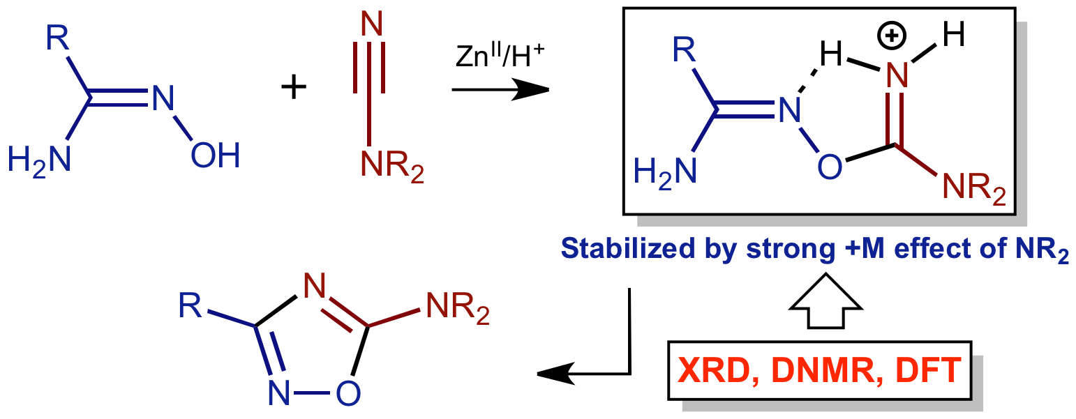

Solid state and dynamic solution structures of O-carbamidine amidoximes were studied by X-ray diffraction, dynamic NMR, and DFT calculations and the obtained data give an insight into the mechanism of zinc(II)-mediated generation of 1,2,4-oxadiazoles.

