|  |
| --- |
| St. Petersburg University  Master in Management Program  **INFLUENCE OF EUROPEAN HUB-BASED PRICING DEVELOPMENT ON GAZPROM EXPORT STRATEGY**  Master’s Thesis by the 2nd year student  Concentration - MIM IB  Anastasia Fedorenko  Research advisor:  Olga L. Garanina,  Associate Professor  Saint Petersburg  2018 |

ЗАЯВЛЕНИЕ О САМОСТОЯТЕЛЬНОМ ХАРАКТЕРЕ ВЫПОЛНЕНИЯ

ВЫПУСКНОЙ КВАЛИФИКАЦИОННОЙ РАБОТЫ

Я,_________Федоренко Анастасия Игоревна_________ студент второго курса магистратуры

направления «Менеджмент», заявляю, что в моей ВКР на тему

«Развитие спотового ценообразования в ЕС: влияние на экспортную политику ПАО «Газпром» »,

представленной в службу обеспечения программ магистратуры для последующей передачи в государственную аттестационную комиссию для публичной защиты, не содержится элементов плагиата.

Все прямые заимствования из печатных и электронных источников, а также из защищенных ранее выпускных квалификационных работ, кандидатских и докторских диссертаций имеют соответствующие ссылки.

Мне известно содержание п. 9.7.1 Правил обучения по основным образовательным программам высшего и среднего профессионального образования в СПбГУ о том, что«ВКР выполняется индивидуально каждым студентом под руководством назначенного ему научного руководителя», и п. 51 Устава федерального государственного бюджетного образовательного учреждения высшего профессионального образования «Санкт-Петербургский государственный университет» о том, что «студент подлежит отчислению из Санкт-Петербургского университета за представление курсовой или выпускной квалификационной работы, выполненной другим лицом (лицами)».

Федоренко Анастасия Игоревна 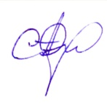 (Подпись студента)

24.05.2018 (Дата)

STATEMENT ABOUT THE INDEPENDENT CHARACTER

OF THE MASTER THESIS

I,___Fedorenko Anastasia Igorevna______ , second year master student, program «Management», state that my master thesis on the topic

«Influence of European Hub-Based Pricing Development on Gazprom Export Strategy»,

which is presented to the Master Office to be submitted to the Official Defense Committee for the public defense, does not contain any elements of plagiarism.

All direct borrowings from printed and electronic sources, as well as from master theses, PhD and doctorate theses which were defended earlier, have appropriate references.

I am aware that according to paragraph 9.7.1. of Guidelines for instruction in major curriculum programs of higher and secondary professional education at St. Petersburg University «А master thesis must be completed by each of the degree candidates individually under the supervision of his or her advisor», and according to paragraph 51 of Charter of the Federal State Institution of Higher Professional Education Saint-Petersburg State University «a student can be expelled from St. Petersburg University for submitting of the course or graduation qualification work developed by other person (persons)».

Fedorenko Anastasia  (Student's signature)

24.05.2018 (Date)

**Аннотация**

|  |  |
| --- | --- |
| Автор | Федоренко Анастасия Игоревна |
| Название ВКР | Развитие спотового ценообразования в ЕС: влияние на экспортную политику ПАО «Газпром» |
| Направление подготовки | Менеджмент |
| Год | 2018 |
| Научный руководитель | Гаранина Ольга Леонидовна |
| Описание цели, задач  и основных результатов | Цель: выявить, как развитие спотового ценообразования на европейском рынке газа влияет на экспортную стратегию ПАО «Газпром».  Задачи: выявить отсутствие или наличие корреляции между спотовыми ценами, ценами на нефть и ценами по долгосрочным контрактам на поставку газа посредством использования регрессионного анализа; проанализировать тренд изменения данной корреляции на протяжении периода 31.12.2008-31.03.2018; на основе полученных результатов сформулировать рекомендации касательно экспортной стратегии ПАО «Газпром» и других экспортеров на рынке Европы.  Результаты: выявлено наличие корреляции между спотовыми ценам, ценами на нефть и ценами по долгосрочным контрактам на поставку газа; выявлено снижении корреляции между спотовыми ценами и ценами на нефть; выявлено повышение корреляции между спотовыми ценами и ценами по долгосрочным контрактам BAFA, что подтверждает факт развития спотового рынка в Европе. На основе полученных результатов был проведен сценарный анализ, послуживший базой для формулировки практических рекомендаций. ПАО «Газпром» следует сохранять поставки по долгосрочным контрактам в Европу, однако компании следует придерживаться более гибкой экспортной стратегии, при которой «спотовый» компонент расчетной формулы по ценам на газ должен быть увеличенпри уменьшении нефтяной индексации в формуле. Данный подход позволит российскому газу быть более конкурентоспособным на Европейском рынке газа. |
| Ключевые слова | Европейский рынок газа, спотовые цены, цены на нефть, цены на долгосрочные контракты по поставке газа, экспортная стратегия, Газпром |

**Abstract**

|  |  |
| --- | --- |
| Master Student’s Name | Anastasia Fedorenko |
| Master Thesis Title | Influence of European Hub-Based Pricing Development on Gazprom Export Strategy |
| Main field of Study | Management |
| Year | 2018 |
| Academic Advisor’s Name | Olga Garanina |
| Description of the goal, tasks and main results | Goal: analyze the influence of European hub-based pricing development on the Gazprom export strategy  Tasks: identify the existence or absence of correlation between hub-based prices, Brent oil and BAFA long-term prices by carrying out regression analysis; to identify the development trend of the correlation during the time period 31.12.2008-.31.03.2018; formulate managerial implications regarding Gazprom export strategy and other exporters’ export strategy  Results: the existence of correlation between prices has been identified; the correlation strength between hub-based and oil prices is diminishing over time while the correlation between hub-based and BAFA long-term prices is increasing that signals about constant hub-based pricing development in Europe; based on results and scenario analysis Gazprom should keep selling gas under LTC conditions, however further development of pricing formula is needed, in particular the increase of “spot” component are required so that prices for Russian exported gas could be compatible in the European gas market and can react to market changes faster. The managerial implications are applicable for all exporters who are active in the European gas market. |
| Keywords | European gas market, hub-based pricing, oil prices, long-term contract prices, export strategy, Gazprom |

**Table of Contents**

Introduction 6

1.LITERATURE REVIEW 9

1.1.European gas market: the path of development 9

1.1.1.Liberalization of the European gas market 9

1.1.2.Gas consumption, production and demand in Europe: main trends 13

1.2.Gazprom export strategy in the Russian market framework 16

1.3.The notionofliquidityanditsvaluefornaturalgasmarket 21

1.4.Gas pricing: oil indexation and hub-based prices 24

1.5.Main European hubs overview 34

1.5.1.NBP – National Balancing Point in the UK 36

1.5.2.TTF- Title Transfer Facility in the Netherlands 37

1.6. Hypotheses statement 39

1.7. Summary 42

2. RESEARCH DESIGN 44

2.1. Time interval choice definition and justification 44

2.2. Data and sample specification 45

2.3. Justification of the regression analysis selection for the research 48

2.4. Preliminary plan of the research 50

3. REGRESSION ANALYSIS RESULTS 51

3.1. Analysis of the time period 31.12.2008 – 31.03.2018 51

3.2. Analysisof the first sub-period 31.12.2008 – 31.12.2011 53

3.3. Analysis of the second sub-period 01.01.2012 – 31.12.2014 55

3.4. Analysis of the third sub-period 01.01.2015 – 31.03.2018 57

3.5. Results summary 57

4.DISCUSSION&IMPLICATIONS 60

4.1.Results discussion 60

4.2.Scenario analysis 65

4.3.ManagerialImplications 68

4.4.Theoretical Implications 69

Conclusion 70

List of references 72

Appendices 78

# Introduction

Energy market is one of the most volatile, changing and developing market nowadays. Gas market has been undergoing considerable changes, especially in Europe. The rapid development of spot trading as a new alternative to gas delivery under long-term contracts has changed the European gas market conditions dramatically that directly influence foreign export companies’ strategies.

The two gas hubs – National Balancing Point (NBP) in Great Britain and Title Transfer Facility (TTF) in the Netherlands – are nowadays the most developed hubs with the high number of market participants and gas volume traded there. These two virtual gas hubs provide the European market with an ability to buy gas not only under long-term contracts but also at spot prices that enables fast gas purchase. Furthermore, the possibility to trade gas through forwards and futures at gas hubs makes spot trading at TTF and NBP lucrative financial activity. Other European hubs have low liquidity levels and thus cannot be considered as mature hubs where prices potentially respond to market changes in supply and demand.

With the development of gas hubs at Europe spot prices are considered to be dominant gas pricing mechanism nowadays while oil-indexed contract prices for gas delivery are labeled as “outdated approach” for gas pricing. While long-term contract prices are formed based on a special pricing formula that contains oil indexation and thus defines the relationship between LTC and oil prices, there is no united opinion on whether spot prices depend on oil prices or they represent independent pricing mechanism.

A number of researchers claim that there is no or very slight correlation between spot and oil prices that explains a relatively low level of spot prices in comparison with LTC prices for gas delivery (Hulshof, Maat, & Mulder, 2015). These scientists reckon that gas hubs where spot trading takes place are developed enough in terms of liquidity levels that directly depend on number of hub participant and gas volume traded to provide market with spot prices that reflect market equilibrium, e.g. market supply and demand intersection that is profitable for both buyers and suppliers.

Other scientists claim basing on their empirical research that even if liquidity levels at hubs are high spot prices could not be considered as an independent pricing mechanism that is forcing out LTC prices. These researches report that there is still quite strong correlation between spot and oil prices (Asche, Misund, &Sikveland: 2013; Komlev, 2016). Furthermore, S.Komlev (2016) claims that spot prices could be only considered as “a secondary” prices in relation to LTC prices that creates “pricing ceiling” for spot ones. Thus, in this case spot prices are not considered as an independent gas pricing paradigm since they follow oil and LTC price dynamics.

Thus, there is no united opinion on the existence of the correlation between spot, oil and LTC prices. The result of the dispute is the lack of clarity about the nature of spot prices: what in reality drive spot prices, how they correlate with oil and to what degree they represent supply and demand changes. The uncertainty regarding this issue leads to the fact that export strategy of export companies cannot be consistent enough since the analysis regarding spot prices does not have stable basement.

Furthermore, the highly rapid development speed of the European gas market requires quite often updates of the analysis. The research prepared by S. Komlev in 2016 covered the time period from 2007 till 1.01.2016. The current research covers the time period 31.12.2008 – 31.03.2018 and, thus, presents the most up-to-date analysis that include the prices even for the beginning of 2018. This enables to see the status-quo of the European gas market nowadays and its development over the last 10 years.

Finally, in the current research paper it is aimed to examine not only the existence of the correlation between spot prices, oil prices and LTC prices, but also to analyze how this correlation have been changing over a particular time period. The time period taken for the analysis is divided into three sub-periods in order to examine how correlation between spot, oil and LTC prices have been changing over time.

In this regard research questions are: is there a correlation between spot price at TTF and NBP and Brent oil prices? Is there a correlation between spot prices at TTF and NBP and BAFA long-term contract prices? If the correlation exists, is the correlation between TTF and NBP spot prices and Brent oil and BAFA prices is weakening over a particular time period?

Thus, the object of the research paper is spot prices at TTF and NBP gas hubs. The subject of the current research is the relationship of spot prices with Brent oil prices and BAFA long-term contract prices and the strength of this correlation.

The Chapter 1 comprise an overview of the European gas market and Russian gas market status-quo, the notion of the liquidity and its importance for hubs efficiency assessment, main pricing paradigms in gas market and an overview of main European gas hubs. An overview of the European gas market is presented in this research in order to show the current market reality and how the European market has been developing over the recent years. The Russian market overview and the Gazprom export strategy is discussed in the paper since managerial implications are focused primarily for Gazprom and at the second place for other exporters all over the world. Two pricing paradigm are analyzed in detail in order to have a deep insight of pricing approaches in the gas market and to reveal an absence of unique opinion on the nature of spot prices. An overview of main European hubs were elaborated in order to create the finished picture of the European gas market and to show the development process of spot trading in the market.

In the Chapter 2 the methodology for the analysis is discussed. The rational for choosing the time period 31.12.2008-31.03.2018 is explained. Furthermore, data choosing for the research and the sources where data for the analysis were extracted are reported. Finally, the research method – the regression analysis – is explained and preliminary research plan is elaborated.

The Chapter 3 presents the results of the regression analysis and the conclusions. The scenario analysis is carried out in order to get deep insights of risks for Gazprom in the current market situation and potential strategy paths how to adjust the company’s export strategy to volatile new market reality. Practical and theoretical implications of the research are explained. For practical implication to be done the scenario analysis is prepared where 4 scenarios are considered based on the scenario matrix 2x2.

# 1.LITERATURE REVIEW

# 1.1.European gas market: the path of development

# 1.1.1.Liberalization of the European gas market

Nowadays the European gas market is constantly changing. This graduate shift is linked to various factors that could be roughly subdivided to two groups. The first group units factors related to main trends in the gas industry that define its development direction. The second one is factors triggered by European Union policy concerning the gas industry. These policy directions have determined the main trends in the current European gas market.

The most important process in the European gas is the gas market liberalization. A number of official policy documents, that are presented in the Figure 1, have been established by the European Union in order to facilitate this process.

Security of Supply Directive 2004 1998

Second Gas Directive 2003

First Gas Directive 1998

Third Energy Package 2009

Third Gas Directive 2009

Regulation 1775 2005

*Figure 1 Policy documents for the market liberalization framework*

*Source: Haase (2008)*

The liberalization of natural gas market in Europe was officially started by the establishing of gas Directive of 1998 (Haase, 2008). Since then two more gas Directives (2003, 2009), two additional gas regulations (2004, 2005), and the Third Energy Package (2009) have contributed to the process. The liberalization process addresses major obstacles for the European gas market in the way of its development: low supplies competition, high import dependency, and gas market place with strictly determined national boundaries. Thus, the main and primarily goal of the reforms is to introduce competition to the European gas market alongside with integrated gas market creation.

According to the official website of the European Commission[1], the European Union imports more than half of all the energy. Its import dependency is particularly high for natural gas (66%). In 2013, Russian energy suppliers exported 39% of EU natural gas import that equals 27% of the EU gas consumption. Moreover, six countries of the EU are heavily dependent on a single external supplier, including several countries (Sweden, Finland, Lithuania, Latvia, Estonia and Bulgaria) that rely entirely on Russian natural gas export, where the main gas exporter has been Gazprom (Kulagin&Mitrova, 2015). As a result, this dependence makesthose countries vulnerable to supply disruptions that could be caused by political disputes, supplier disrupt or infrastructure failures. For instance, a 2009 gas dispute between Russia and Ukraine, that is a transit country in Russia-Europe gas deals, left many EU countries with severe shortages.[2] Moreover, in 2017 the total natural gas imports to the EU have risen by 5.5% in comparison with 2016 figures. Moreover, Russia is still the main gas importer as in 2017 it has provided over 40% of natural gas to Europe (Figure 2).[3]In order to minimize the import dependency and to diversify gas suppliers, the European Commission reported a newly developed European Energy Security Strategy in May 2014. The goal of the strategy has been the reduction of Europe’s high energy dependency.

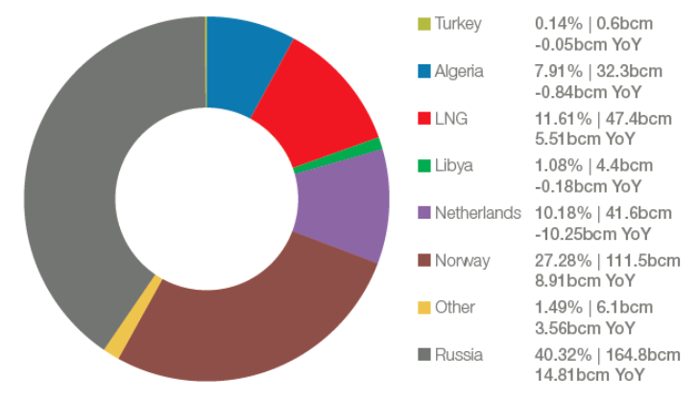

*Figure 2 Natural gas imports by suppliers*

*Source: Eurostat Estimates, 2017*

E.V. Kislitsinand V. K. Pershin (2016) suggest several solutions to this issue of suppliers diversification. Firstly, new gas pipelines from the Netherlands and Norway could be constructed as these countries have considerable gas supply. The main drawback is that in 2013 the Netherlands claimed the decline in gas extraction so the capacity of a planned pipeline will be inefficient in relation to the construction and maintenance costs. Secondly, the place of Turkey as a potential main gas supplier in the European market should not be underestimated since it is possible for the EU to meet the demand for gas and at the same time to reduce the amount of gas imported from Russia only through the cooperation with Turkey (Pershin & Kislitsin, 2016). However, the necessary infrastructure for importinggas from Turkey is absent nowadays. Till recently there has been a large scale project with Turkey – a new gas pipeline “Nabucco” – that should meet the demand for gas in the European market by delivering gas from the Middle East and the Caspian region to Europe. However, it was decided to stop the construction of “Nabucco” in 2013. This decision has led to the inability of the EU to reduce its energy dependence on the Russian gas import. Thus, the large share of gas imported to Europe is still supplied by Russia. Finally, Pershin and Kislitsin (2016) reports that the full usage of currently existing liquefied natural gas (LNG) plants could be a solution for the European Union in energy dependence issue. However, the author highlights that LNG is still quite an expensive energy source. Thus, there are drawbacks in every approach suggested by the authors that reflects the complexity of the import dependency issue.

In 1990s it was discovered that one of the key issues regarding European gas market structure was the dominance of incumbent monopolies, namely vertically integrated companies that controlled import and prices for gas as well as transmission assets (Katsis, 2013).The goal of competition enhancement and was not achievable with that kind of infrastructure. In order to enhance suppliers competition the EU has implemented a number of liberalization policy tools in order to mitigate the power of monopolies and develop market infrastructure. These policy tools are based on the standard regulatory prescriptions for the competition introduction into network industries (Joskow, 1996; Newbery, 2004). The unbundling (e.g. carving out natural monopoly services) gas transportation from trading activities and the providing third-party access to the gas network have been established in the Second Gas Directive and the Third Energy Package and aimed at opening the access to the infrastructure to new suppliers and market participants. It is stated that the same entity cannot possess control over generation, production and/or supply activities and at the same time have control over transmission system operator (TSO) (CEER Status Overview on TSOs Unbundling, 2016). Thus, the unbundling and the third-party access grant energy companies non-discriminatory access to the infrastructure.[4]

Thus, despite several actions taken by the EU to introduce competition into the gas market high import dependency and low suppliers competition are still two main issues to be solved in the future.

In order to create a fully integrated gas market where national boundaries are eroded, the EU takes such actions as the increase in underground gas storage capacity, the infrastructure development (especially for reverse gas flows), and the creation of easy access to gas storage facilities.According to V. Kulagin, 16 interconnectors for reverse gas flows were developed, modernized or constructed. Moreover, cross-border connective networks throughput capacity has grown by 14% from 1992.[5]Moreover, the unbundling and third-party access that have been discussed earlier also facilitate the infrastructure development. All these actions lead to infrastructure development that is an important step for integrated market creation.

In 2011 the EU developed Gas Target Model where the idea how the European gas market should function was emphasized. It is supposed that competitive European gas market with entry-exit zones, with liquid virtual trading points (VTPs, or hubs), with gas freely moved between market zones to the locations where there is a high demand for that gas in that particular moment should be created (ACER, 2015). Thus, the hub gas trading development strongly facilitates integrated gas market creation.

With the hub gas trading development there is a paradigm shift from oil-indexed long-term contract pricing to hub-based pricing (Kulagin,Melnikova, Galkina, Osipova, &Kozina, 2016). The new pricing paradigm is still dependent on the old one, but nowadays it is considered to be a dominant pricing approach. On the Figure 3 the proportion of oil-indexed prices to hub-based prices in 2005 and in 2015 is presented that could be a proof of hub-based pricing paradigm dominance in the gas market. The process of pricing paradigm shift and related issue will be considered further in the separate section.

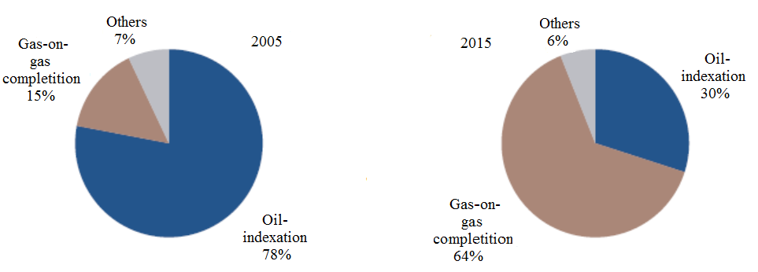

*Figure 3 Percentage of oil-indexed prices to hub-based prices in 2005 and 2015*

*Source: Platts, 2016*

The competition enforcement, import dependency mitigation, suppliers diversification and integrated market creation areaimed to achieve energy security that is the centre of liberalization process. Energy security is an issue that is of high importance for many stakeholders such as policy markers, businesses and major energy consumers in particular, and a larger community whose life quality strongly depends on secured and uninterrupted energy supply in the market (Ang, Choong, & Ng, 2015). Nowadays, there is an absence of consensus about energy security definition in the scientific literature. In formation of energy security definition some researchers are mainly focused on the security of energy supply and availability of a type of energy in the market, while others highlights the influence of energy security on economic and social welfare. Ang, Choong and Ng (2015) in their article reckon that the notion of energy security is highly dependent on the context where it is used (Ang, Choong, &Ng, 2015). The authors identified seven main dimensions of energy security: energy availability, social impacts, energy prices, governance, environment, infrastructure, and energy efficiency. Mansson, Johansson and Nilsson (2014) are mainly focused on assessing energy security from the side of energy supply. The authors also highlights the complexity of the notion of energy security that vary between different disciplines and over time (Mansson, Johansson, &Nilsson, 2014). In the article it is also emphasized that the notion is broadly perceived as the guarantee from threats to national security due to dependence on a few oil and gas producers that corresponds to the situations in the European gas market.

Thus, energy security integrates all actions taken by the EU in relation to competition reinforcement, supplier diversification, import dependency diminution and integrated market creation. Energy security is the corestone of the gas market liberalization in Europe that is one of the main triggers of the industry development in Europe.

# 1.1.2. Gas consumption, production and demand in Europe: main trends

The liberalization of the gas industry in Europe is accompanied by main trends in gas consumption and gas production within the region that influence the development of the industry.The market share of natural gas in Europe has increased rapidly from less than 10% of the total primary energy supply (TPES) in the early 1970s to approximately 24% in 2012 (Honoré, 2014). In 2012, 35 countries in Europe consumed 539 Bcm of natural gas, representing about 15.6% of the world consumption (Honoré, 2014).

However, in recent years Europe has become the only geographical region with negative gas consumption figures (Kulagin, 2015). After 2010 when the gas consumption achieved its peak position, it started to decline gradually and in 2015 fell to the consumption levels of 1995, so the consumption dropped by 23% over the period 2010-2015. This negative dynamics has determined the decline in demand for natural gas in Europe (Kulagin & Mitrova, 2015).

The negative gas consumption trend could be caused by pursuing the goals of active energy saving and energy efficiency. In 2010 the EU has adopted the package called “EU 20-20-20”, where one of the main goals was to increase the energy efficiency by 20% by 2020 by decreasing primary energy consumption by 20% (Kulagin & Mitrova, 2015). The consumption decline could be observed in European electricity power generation, where active energy saving takes place.

Other reasons for the negative gas consumption trend could be vulnerable economic situation in Europe and in the world, and the competition between different energy sources, e.g. intefuel competition. The main energy “competitors” of natural gas in the European market are coal and renewable energy sources (Kulagin, 2015). In spite the fact that the European Union has claimed the “low-carbon” energy policy in the region under which it is supposed to supplement the use of coal by natural gas, coal consumption decline is considerably lower (from 29% to 26%) in comparison with gas consumption decline (from 21% to 16%). At the same time the renewable energy level has risen from dramatically (Bros, 2017). The Figure 4 below shows the changes in each fuel’s consumption.

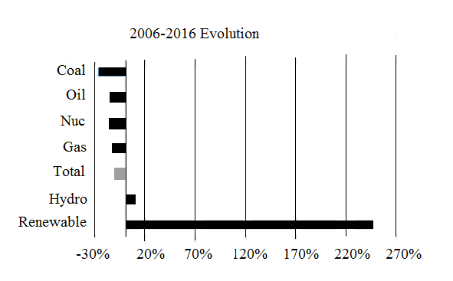

*Figure 4 Fuel consumption in Europe by types*

*Source: International Renewable Energy Agency, 2017*

The renewable energy has become a priority of the European energy. According to the official website of the European Commission, it is possible for the EU to lower its energy dependency on imported fossil fuels.[6]Moreover, the use of renewable energy is considered by the European Commission as a key element of the current energy strategy since it will facilitate the decoupling of energy prices from oil ones.[7] In some European states the costs of renewable energy production is almost equal nowadays to gas price in the market because of constantly developing technologies and well organized government support and diversified subsidy (Kulagin, et al., 2016). The EU is active in addressing climate changes. Thus, the substitution of carbon-intensive energy by renewable energy sources is an important reason for the increase in renewable energy share in Europe (Report of European Environment Agency, 2017).Finally, the renewable energy strategy is also linked to the issue of energy efficiency and energy savings. According to the report of the European Environment Agency (2017), the increase in the RES share since 2005 has resulted in a 2% EU-wide reduction in primary energy consumption in 2015.

However, in 2015-2016 the gas consumption and gas demand in Europe started to recover slightly, but the figure is still quite low in comparison with pre-2010 level (Bros, 2017). According to the official website of Eurostat, in 2016 consumption of natural gas in the EU increased by 7.0% in comparison with 2015.[8] The recovery of the European gas consumption continues in 2017. It was forecasted by the European Association of Natural Gas Industries that the gas demand of 28 EU state members has grown by 5.9% in comparison with previous year.[9]Eurogas reckons that the increase in 2017 gas consumption level stems from lower temperatures in a number of EU countries, stable economic growth, the replacement of coal-fired large-scale plants with modern gas-fired plants and the increased gas usage in transportation sector.[10] Furthermore, it is supposed that the positive trend for gas consumption in Europe over three consecutive years (2015-2017) facilitates the CO2 emission reduction that is one of the main goal of the EU.

At the same time, the situation is accompanied by negative gas production trend in Europe. In 2004 the gas production in Europe began to decrease gradually. On the Figure 5 it is shown that the overall gas consumption and production in Europe was being declined over 2008-2016, but starting from 2015 these two figures have decoupled.

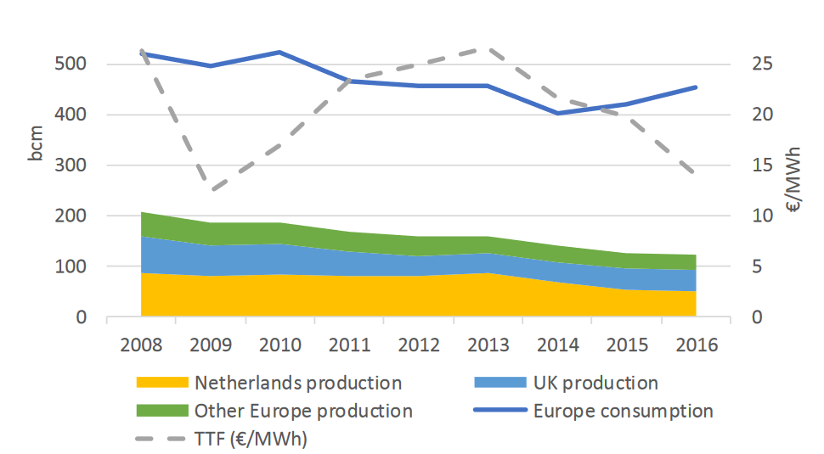

*Figure 5 Gas consumption and production levels in Europe 2008-2016*

*Source: International Monetary Fund, 2017*

In these market conditions there is still gas import dependency in Europe. Thus, the liberalization process aimed at achieving energy security by import dependency mitigation and competition reinforcement is closely linked with gas consumption and production trends. The increased gas consumption accompanied by decreased production complicates the achieving of energy security since import dependence issue is still relevant.

In conclusion, the European gas market has changed over recent years. The changes occurred in the market have impact on main gas exporters to Europe, where Gazprom takes the leading position.

# 1.2. Gazprom export strategy in the Russian market framework

According to the EIA official website, Russia held the world’s larges natural gas reserves.[11] Currently Russia’s reserves account for about one quarter of the world’s total proved gas reserves. Most of these reserves are located in large natural gas fields in West Siberia. This fact enables Russia to rely on its revenues come from energy industry and to be one of leaders in global energy sector.

Russian economic growth is mainly driven by gas exports primarily to Europe. Russia and Europe are interdependent in terms of energy. Europe is dependent on Russian gas deliveries: more than 70% of imported gas to Europe came from the Russian Federation in 2016.[12] Russia in its turn is dependent on Europe since this is the major target market for Russian gas exports (Gazprom Export Global Newsletter, 2017).

Gazprom is a Russian transnational gas company and the main exporter in the European gas market. Moreover, the principle of unified export channel preservation that has its legal acceptance in the law “About natural gas export” established in 2006 provides the company with the legal guarantee for the unique right to export Russian gas.[13] Thus, Gazprom is the main exporter of the gas and the increase of gas volumes delivered to Europe could be related to the effective company’s strategy (Figure 6).

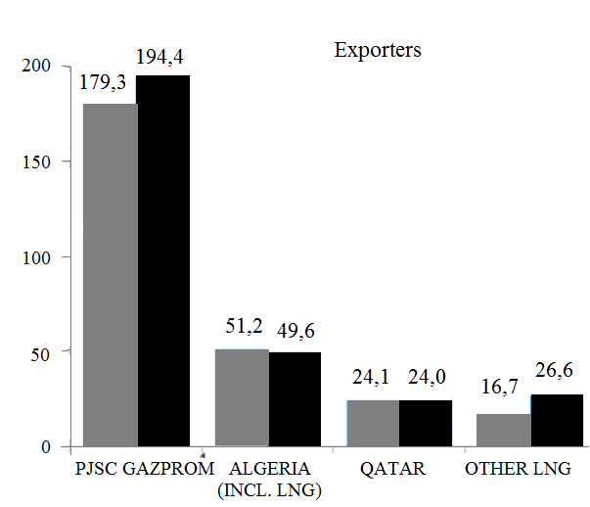

*Figure 6 Deliveries by Europe’s major exporters in 2016 and 2017*

*Source: Gazprom Export, 2017*

There is 7.2% increase in export volumes in comparison with 2016 figures. It should be mentioned that there was a decline in gas export amount in 2010. However, beginning from 2015 there is a positive dynamics in gas export volumes by Gazprom to Europe (Table 1).

*Table 1 Natural gas export volumes by Gazprom to Europe*

|  |  |  |  |  |  |  |  |  |  |  |  |  |
| --- | --- | --- | --- | --- | --- | --- | --- | --- | --- | --- | --- | --- |
| Year | 1973 | 1975 | 1980 | 1985 | 1990 | 1995 | 2000 | 2005 | 2010 | 2015 | 2016 | 2017 |
| Total | 6.8 | 19.3 | 54.8 | 69.4 | 110.0 | 117.4 | 130.3 | 154.3 | 138.6 | 158.6 | 178.3 | 192.2 |

According to the offcial website of Gazprom Export, the Western Europe consumes the largest part of gas supplied to Europe. In the Figure 7 the main gas consumers (including Turkey) are presented. The most important target buyer is Germany.[14]in this sub-region Gazprom have sold 155.9 billion cubic meters of gas in 2017.

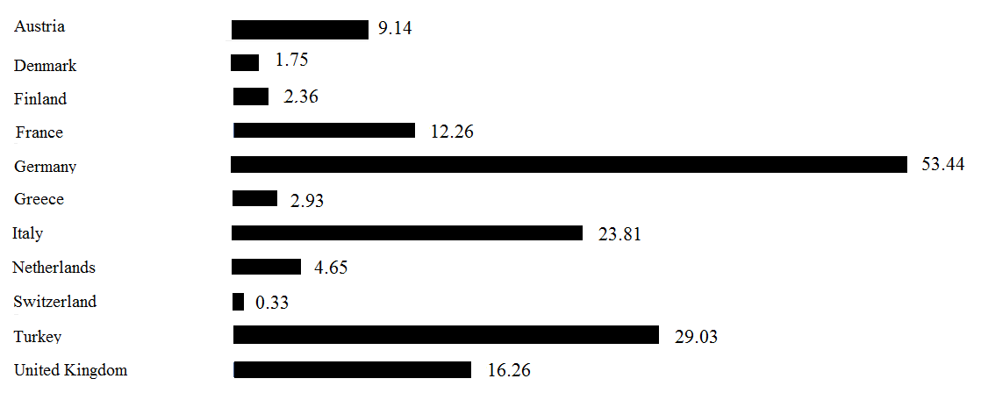

*Figure 7 Western Europe gas consumers supplied by Gazprom in 2017*

*Source: Gazprom Export, 2017*

Despite the fact that the Easetrn and Central Europe consumes smaller amount of gas , this regions if of hogh importance for Gazprom because of its territorial proximity to the Russian Federation. In 2017, Gazprom has sold 36.3 billion cubic meters of gas in this sub-region (Figure 8).

Moreover, Gazprom gas deliveries continues to grow even after the end of the winter heating season and has risen by 6.3% since the sart of 2018.[15]The largest increase was particularly demonstrated by the main importer of the russian gas – Germnay. The last-years growth in Russian gas supplies was driven by the following factors: weather conditions, gas production decline in Europe and competitive prices for Russian gas (Gazprom Annual Report, 2016).

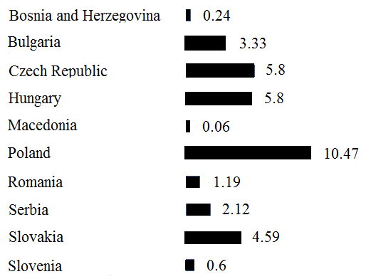

*Figure 8 Eastern Europe gas consumers supplied by Gazprom in 2017*

*Source: Gazprom Export, 2017*

The basis of the Gazprom export pricing strategy is the system of long-term contracts with the “take-or-pay” principle and oil indexation of gas prices (e.g. where gas prices are pegged to the petrolium product prices, in particular oil prices) that are calculated on the base of a special pricing formula.[16] The central strategy with oil indexation in long-term contracts for gas delivery enables the company to receive stable revenues from export sales and to guarantee secure gas supply for consumers.

Moreover, in 2015 and 2016 the company performed three gas Auctions.[17] The acution mechanism of export gas sales complementns the existing company’s strategy of long-term constracts sonce gas auction corresponds to challenges of the evolving energy market. The first gas acution tested the possibility of gas sales through the Nord Stream pipeline in 2015. The second gas auction happened in 2016 through which Baltic States were supplied with russian export gas. The third auction has resuted in signing long-term contracts with 11 European countries for gas delivery during the winter season 2016/2017.

Furthermore, the company proceeds with proactive dialogue with clients in order to make mutually effective and beneficial decisions in the conditions of constantly changing market. The company expands its business activities in liberalized deregulated markets and is currently active in spot and short-term trading of natural gas. [18]

However, despite the fact that Gazprom develops its gas export strategy in terms of new trading forms (spot and short-term trading), it ismainly based on long-term contracts wit oil indexation. The abolishment of such long-term contracts will undermine gas supply security in the Euroepan gas market and will mean a sharp decrease in Gazprom export revenues since the majority of gas volumes is currently traded under LTCs (Henderson, 2015). However, a conservative export strategy with merely no adaptation to market changes can lead Gazprom to loosing market share. Thus, the company is pushed for further export strategy development. Several actions have been already undertaken by the coampny in 2009 to make the pricing srategy more flexible so that it quickly react to exteranl market changes. The company has introduced discount systems for short-terms trading (estimated at 7 to 10%), the reduced gas volume for obligatory purchases by customers and, as it has been mentioned eralier in the paragraph, the selling of gas in spot market (approximately 15% of gas is traded in spot market) (Boussena & Locatelli, 2017). Furthermore, the company has revised its pricing formula by two ways: either by reducing the base price, or by changing the relative weight of the different petroleum products in price formation and pricign formula for long-term contracts. Finally, the “spot” component was added to the pricign formula that is resulted in realigning Gazprom’s contract-based prices with oil indexation with hub-based prices formed at the European gas hub prices (Boussena & Locatelli, 2017). In addition the company has changed central clauses in order to make the pricing formula more flexible. As a result periods of time governing prices reviews processes have become shrter (Boussena & Locatelli, 2017).

Furthermore, Gazprom is currently developing its LNG sales in new markets, mainly in Asia-Pacific region, supplying gas to both traditional consumption markets (Japan, South Korea, Taiwan), as well as to the dynamically-developing markets of India, China and Southeast Asia.[19]

As it was mentioned earlier, Gazprom is the main exporter of the Russian gas. This fact reflects the main characteristic of the whole gas industry in Russia - the high level of monopolization(Aune, Golombek, Moe, Rosendahl, & Le Tissier, 2015). The natural gas sector has remained centralized under Gazprom that is the main reason for low competition level in the Russian gas market. The company has had a monopoly on the main gas market segment including transmission system. However, this monopolized system has been questioned since nowadays the Russian gas industry is in the transition phase that could be characterized as modest decentralization (Ozdemir & Karbuz, 2015). The changes have been triggered by development in the domestic gas market and in the European gas market that has been discussed in the previous paragraph (Locatelli, 2013). Currently Russia is funding a way how to deal with the aim of the EU to create a competitive, integrated and transparent gas market with increased competition and diversified gas suppliers that was reflected in the Third Energy Package in 2009.

In this regard in recent years Gazprom has faced increased competition, mainly in domestic market. Currently the gas sector is being transformed into a four-player structure: Gazprom that remains the leader in the industry, Novatek and Rosneft that are considered as main Gazprom competitors, and other independent gas companies (Lukoil and other small companies) (Belyi, 2013).

Novatek is Russia’s second largest gas company, and it is also ranked in the top five quoted companies in the world on the base of proved gas reserves amount (Henderson, 2015). The company’s plan is to double its gas extraction by 2020 (Novatek (2011).Rosneft appears also to have significant gas reserves and the marketing ability to increase its sales in the domestic market (Henderson, 2015).

Thus, competitive market place is emerging in the industry that hinders the monopolistic position of Gazprom (Aune et al. 2015). Another factor that challenges the position of Gazprom is the decrease in volumes of gas extraction in Russia (Boguslavska, 2015). The share of Gazprom in the domestic gas production has been roughly to two thirds of the overall production (Lunden et. al., 2013). However, according to the Bloomberg official website, the domestic production of gas in Russia has risen by 7.9% in 2017 that was mainly driven by Gazprom sales to Europe and rising domestic demand.[20] Moreover, the domestic production of gas has achieved its highest level for the whole history of the Russian gas industry.

Thus, the decrease in gas production volumes (except the last year figures) and intensified competition from independent producers challenge the monopolistic position of Gazprom. In 2016 the Gazprom production share equaled 64% while in 2009 the share was 85% (Simola & Solanko, 2017). The decrease is significant and could be considered as a proof to intensified competition in the domestic market.

In conclusion, Gazprom is currently influenced by changing domestic and European gas markets. In Russian market the increased competition stimulates the company to further develop its strategy in order not to lose its unique right for Russian gas export. Furthermore, the decreased gas extraction levels in domestic market andchanges in European gas market regarding liberalization process and increased role of gas hubs stimulate Gazprom to find more flexible export pricing strategy so that Gazprom prices for exported gas could be compatible with hub-based prices in Europe. The export strategy adaptation to new market realities enables the company to keep leading position in Europe and extract high profits.

# 1.3. The notion of liquidity and its value for natural gas market

The liquidity level is considered in the scientific literature as an important and benchmark figure for literally every market. A sufficient and adequate liquidity level is a crucial for decisions whether to participate in the market or not.

The majority of attention has been paid to liquidity in the shares, bonds and money markets. In all these markets, liquidity is seen as desirable. However, there is little attention in the literature for the measuring of liquidity specifically for the gas market or energy markets as a whole[21]. In reality energy markets also require an optimal level of liquidity for an adequate operation and obtaining a reliable commodity price benchmark. Furthermore, the liquidity level allows to roughly identify the market development stage, market success and market efficiency (Heather, 2015).

According to the Energy Procurement Consultancy Company Magnus Commodities, liquidity could be defined as the degree to which a product can be quickly bought or/and sold without affecting its price and without incurring in significant transaction costs.[22] Furthermore, liquidity market is defined in the Nasdaq official website as a market where there is a possibility to buy or sell a large quantities of an asset at any time and at low transactions costs.[23] The Office of Gas and Electricity Markets (OFGEM) definition of the liquidity highlights the same features of this notion. It defines the liquidity as anability to quickly buy or sell products or services without a significant change in its price and without incurring significant transaction costs.[24]

It could be observed, that all mentioned liquidity definitions emphasize the same features. Firstly, the transaction intensity is quite high in markets with high liquidity that is related to the issue of huge traded volumes that will be discussed later. A high number of transactions within a particular time period could be assign of high liquidity level since any transaction, roughly speaking, could be fulfilled at any time in this case[25]. Secondly, liquidity implies low transaction costs. In this regard, bid-ask spread should be analyzed, which is the difference between the maximum price at which market participants want to buy (ask) and the minimum price at which market participants want to sell (bid).[26] A narrow spread provides market players with low transaction costs and at the same time with a certainty in price level to be achieved. Thus, the lower the spread, the higher the liquidity level. Furthermore, trading costs also is an indicator for market liquidity since lower trading costs (e.g. costs for brokers or taxes) stimulates a number of transactions and by this leads to higher liquidity.

Another important factor that is an indicator for a high liquidity level in the market is price volatility. According to the official website of GasTerra, there is no consensus found in the scientific literature regarding this indicator. However, it is generally accepted that lower price volatility provides market participants with a confidence that a price reflects the product’s real value. A lower price volatility generally results in a higher liquidity.[27]

Patrick Heather (2015) distinguishes a number of important elements that identify the market development stage and hubs’ development stage in particular. The first element to consider is market participants, especially market participant diversity. The number of companies trading at a gas hub is an important indicator driving the development of that market since it not only shows the willingness of traders to ‘get involved’ in the market deals but also reflects how easy it is to participate within a particular market or gas hub. Furthermore, the more participants there are, the less chance in generalof one company dominancein the market. Finally, another important criterion is the number of participants that are currently active within the market: the more companiesthat regularly trade, the more liquidity there will be (Heather, 2015). However, it is quite complicated to define “an active” market participant as it is quite a subjective decision since no precise benchmark exists. For instance, “an active” player could be defined as that who traded once per week/per day/per month etc. Thus, since this metric regarding identifying active participant is quite ambiguous and vague the whole number of market/hub participants is preferred when identifying market/hub efficiency.

The second element that is an indicator of an efficient market or a gas hub is products available for trade. P. Heather (2015) considers this metric as an important one since if there is a variety of products available in the market/hub, there are risk management opportunities for players. The author reckons that risk management opportunities are a signal of a mature efficient market/hub, and only a risk management hub could provide a benchmark prices for products traded. P. Heather (2015) highlights that liquidity attracts liquidity which in turn leads to a market success and in the future to the ‘mature’ market withreliable prices.

The third element is Tradability Index (Heather, 2015). The concept of Tradability Index is a natural benchmark for products or services tradability, e.g. how much they are actually traded (Bykova & Stöllinger, 2017). This index serves as a measure of how narrow bid-ask spread is, indicating a high level of liquidity as it has been menti9oned earlier in this chapter. It is not sufficient metric by itself to define the market/hub development stage, but if analyzing with other factors Tradability Index makes the picture of the market/hub status-quo more detailed (Heather, 2015).

The fourth element mentioned is traded volumes. As it has been mentioned earlier, transaction density is strongly linked to traded volumes – a metric that is considered to be one of the most important factor for liquidity level assessment since they are a component of the churn rate formula that will be considered next (Heather, 2015). This metric shows how intense the market activity is. In a nutshell, market/hubs with high traded volumes show high churn rates, that usually means a diverse variety of participants and the absence of price manipulation.

The last and the most important element in assessing market/hub efficiency and success is churn rate (Heather, 2015).The churn rate is defined as a portion of traded volume to actual physical output.[28] To makes the definition clearer, it could be said that churn rate is a measure of the number of times a ‘parcel’ of gas is traded and re-traded between its initial sale by a producer and the final purchase by a consumer. P. Heather (2015) claims that all other metrics considered earlier are reflected in this one last element: if there are many participants in the market/hub who traded a variety of products in huge volumes, churn rate will be also high that indicates high liquidity level. There is no consensus on the churn rate threshold value: some market participant won’t trade in a market/hub where churn rate is below 10, others will take a value of 12 or 15 as a benchmark for decision making (Heather, 2015; Konoplianyk, 2009). Thus, churn rate is considered to be the most important and vastly used metrics for liquidity level assessment in most commodity and also financial market.

To summarize factors that help to assess liquidity level, the Figure 9 is created. All metrics are grouped into three parameters: cost, time and volume. To assess the liquidity level more precisely, the systematic analysis should be carried out where all factors are considered.

Volumes

Time

Costs

Traded volumes

Bid-ask spread

Number of transaction

Trading costs

Churn rate

Number of participants

Price volatility

Products diversity

*Figure 9 Liquidity level determinants*

Thus, the high liquidity level is an evidence of a strong developed market (or of a hub in a particular case) where transaction costs are at minimum levels, products flow is free, where prices reflect the real value of a product or services since they reflect changes in supply and demand quite effectively. This fact is highly important for market participants since decisions regarding trading and investment activities (product capacity, transportation capacity, storage, etc.) will be efficient.[29]Thus, it is quite important to analyze liquidity as this is an effective tool of market analysis.

# 1.4. Gas pricing: oil indexation and hub-based prices

Generally, there are two main types of gas pricing mechanisms: oil-indexed contract prices and hub-based prices for gas. There are different points of view among scientists what pricing mechanism is dominant nowadays in the market, and what prices are appropriate signals of actual supply and demand and, thus, represent an actual value for gas. In order to better understand the gas market status-quo, we propose to analyze each pricing mechanism, in particular its development process, variables that influence this or that pricing paradigm, dependence of each prices from global oil prices etc.

According to the article “Evolution of Gas Pricing in Continental Europe: Modernization of Indexation Formulas Versus Gas to Gas Competition” written by A. Konoplyanik (2010), the initial stage of gas pricing formation process was cost-plus pricing concept that implies a gas price based on production and delivery costs incurred by a producer/supplier. Thus, it is logical that cost-plus pricing depends on a producer’s behavior. Cost-plus prices are not often exposed to fluctuations as they are based on projects’ economy, e.g. within any development project needed for gas production quite stable, predictable costs for a long period of time could be calculated that determines monotonous and constant fluctuations of such costs. Thus, the cost-plus prices based on aforementioned production costs are also not so volatile and have quite constant fluctuation character.

However, historically the dominant gas pricing paradigm has been based on the determination of gas price basing on its replacement value with other energies in the end-user sector (Konoplyanik, 2010). The use of the replacement value implies linking gas prices through a particular formula represented in long-term contracts (LTCs) to the other energies competing with gas. The main energies competing with gas in the final energy consumption have been residual fuel oil or heavy fuel oil (HFO) and gasoil/diesel or light fuel oil (LFO). In contrast to cost-plus pricing, the residual value-based pricing depends on consumer’s behavior and are more volatile since such prices are linked to prices at commodity markets where volatility dynamics is quite high. Komlev (2016) highlights that gas is the only commodity which prices rely on the replacement value pricing principle. This replacement value concept was the centre of the Groningen model that was developed in 1962.

The intent to implement a new pricing concept – Groningen-type long-term contracts concept – was to maximize the revenue for gas producing countries/companies and to mitigate risk appeared from hug investments required for gas production (Komlev, 2016). Groningen-type contracts may be characterized by several key features. Firstly, the switching from cost-plus pricing approach to replacement value pricing approach happened with the implementation of Groningen model that has been a milestone in the gas pricing historic development.

Secondly, it is long-term contracts between a gas producer/supplier and a customer that play a role of compromise for conflicting interest of both parties (Asche et al., 2013). On one hand, the buyer would like to have some volumetric flexibility to have an ability to adjust imported gas volumes to demand fluctuations since the storage of das glut in periods of low demand is quite expensive for buyers/importers. Furthermore, buyers would prefer gas prices be responsive to gas substitutes prices since this gives customers an opportunity to resell gas, and for this gas price should be compatible to other energies in the market. On the other hand, the gas producer/supplier would like to be assured that there will be an opportunity to sell a particular amount of gas over some period of time that ensures stable and long-lusting demand for gas. Such a sustainable demand could mitigate non-commercial risk because such production stages as extraction, processing and transportation are quite expensive in terms of investments. In other words, the producer would prefer to deliver a constant gas stream at maximum utilization capacity. Moreover, the producer would like to receive a fix minimum price as a guarantee for stable and to some degree predictable cash flows for the entire delivery period. Long-term contracts provide both parties with a trade-off.

This trade-off could be partially found in “take-or-pay” provisions that are included in LTCs (Vazquez & Hallack, 2016). Under “take-or-pay” provisions buyers take volumetric risk since they are obliged to pay a predefined for a minimum amount of gas. In case a buyer is able to resell acquired gas in short run, the LTCs play a role of a hedge mechanism against short-term market volatility. Thus, “take-or-pay” provisions define a minimum amount of gas that should be delivered by a gas producer/supplier, and the corresponding minimum unit price for gas purchases. The risks related to gas delivery and gas purchase is thereby shared between two mutually linked parties – producers and buyers. Thus, both parties of long-term contracts are interested in providing supplied/purchased gas at a marketable price that can compete with other marketable energies.

Thirdly, under Groningen model the market price for gas is calculated in accordance with special formula which is an integral part of LTCs. Since LTCs rely on replacement value concept, there should be alternative fuels integrated in this formula so that gas price could compete with other energies. As it was mentioned earlier, there are basically two gas alternatives that are included in the formula: gasoil/diesel fuel or light fuel oil (LFO) which competes with gas in household sector and residual fuel oil or heavy fuel oil (HFO) which competes with gas in industrial electricity and heat generation sectors (Konoplyaanik, 2010). Historically, LFO has the weight of 60% in the formula, whereas HFO has 40% (Konoplyanik, 2010).

Fourthly, there is a special clause on regular price review in every LTC since price environment as well as market conditions are constantly changing over time. The price review may take plays with a particular long-term contract pricing formula as well as within the general formula itself. The regular price review within a long-term contract is required because of two reasons. Firstly, gas prices based on the replacement value are more volatile and dynamic in comparison with cost-plus prices and, thus, are needed regular corrections and adaptations. Secondly, gas pricing formula and the gas price itself should adapt to and reflect price fluctuations of gas substitutes so that gas price remains compatible with other energies in the market (Komoplyanik, 2010).

Usually the formula adaptation lies in the changing of existing gas substitutes’ shares (as usual LFO and HFO) and/or introduction of new gas fuel substitutes in the existing formula that depicts a new energy market reality. According to A. Konoplyanik (2010), other elements that are incorporated in the gas pricing formula are coal, crude oil, electricity, inflation etc. Currently, there are more than 10 elements in European gas pricing formula. It should be mentioned that the complexity of gas pricing formula is linked to the competition level: the higher the competition in the market (e.g. the more diversified are gas suppliers/producers), the higher the gas pricing formula complexity level due to the bigger number of replacing alternatives (Konoplyanik, 2010). Furthermore, there is a reduction of all time intervals occurred as another adaptation formula stage. For instance, price reviews take place more frequently, the reference period duration and the time leg between the date of revision and the reference period is becoming shorter and shorter that results in more relevant pricing formula.

Thus, the LTC pricing formula will continue to adapt to a new energy market reality by a broader range of gas substitutes and by reduction of all time periods that are taken into account in the formula. This results in more complex pricing formula and at the same time in more up-to-date and relevant representation of gas value in the market. Finally, formula adaptation process is a basement for secure gas supply that is quite important for gas producers, customers and end-users (Konoplyanik, 2010).

Fifthly, there are special destination clauses in every long-term contract. A situation can occur when gas is delivered through the same point and then is destined to different export markets. This could lead to the existence of different prices for gas delivered by the same producer and, thus, to arbitrage opportunities, e.g. a possibility to export cheaper gas purchased by a customer at one price and then to resell this gas at a higher price in the other market. Destination clauses that in essence are gas resale restrictions are aimed at protecting gas producers’ interests, e.g. to extract the maximum possible revenue by preventing a buyer to use possibly existed arbitrage opportunities.

Finally, there is net back pricing principle under Groningen-type long-term contracts. The net back pricing is the gas replacement value minus transportation costs incurred by a supplier to deliver gas from the net back point to a buyer (Raszewski, 2017). According to the Energy Charter Secretariat (2005), the point here is that different transportation costs to different destinations are incurred and this implies different net back values earned by a supplier even if gas replacement values are equal in all these destinations. Thus, net back pricing principle secures competitiveness of gas delivered to various export markets.

Thus, Groningen-type long-term contract prices are oil-indexed that is represented in pricing formula. This pricing model with its unique characteristics guarantees secure and stable international gas supply that is the base for such a model to have been dominant pricing paradigm.

However, the gas market is constantly developing. More and more short-term structures have appeared in addition to already existing long-term contracts. Furthermore, the duration of LTCs in European gas market has diminished substantially (Komoplyanik, 2010).The transition from gas supplies with a limited number of players to a system with highly liquid market places (e.g. gas hubs) with multiple players has occurred in the recent years (Asche et al., 2013). Moreover, new pricing mechanisms and new players appear. There is a current transition undergone by European gas pricing from traditional oil-indexed pricing mechanism of LTC that have been discussed earlier to an new pricing paradigm. This is hub-based prices that could be determined as prices reflecting changing supply and demand in the market instead of relying on oil price (Stern & Rogers, 2011).

The hub-based pricing model was borrowed from the USA, where Henry Hub – the physical highly liquid market of spot gas trading – is situated.[30] The establishing of the hub called the National Balancing Point (NBP) by the United Kingdom could be considered as something considerably different as in this case there the UK has created virtual, not physical gas spot market. The creation of NBP was a trigger for other European hubs creation in Belgium, the Netherlands, France, Germany etc. Among the main reasons for pricing paradigm shift from oil-indexed long-term contract prices to hub-based prices are European gas market liberalization, the opening of Interconnector in continental Europe, the deregulation process, and the increase in competition level (Ache et al., 2013; Stern & Rogers, 2013).

There is no consensus found between those who consider Groningen model and oil-indexed prices as a leading and dominant paradigm in the current gas market and those who believes hub-based prices should be seen as an independent mature pricing mechanism that should wholly substitute “outdated” oil-indexed pricing approach in the nearest future. For the completed debates “picture” both position are to be analyzed.

The first and the most discussed question is whether hub-based prices are independent from oil and oil product prices (e.g. there is no correlation between hub-based prices and oil prices) or they follow the oil price volatility dynamics. There are mixed results in the literature regarding the existence of long-term relationship between gas and oil prices (Bunn, Chevallier, Le Pen, Sevi, 2017).

Villar and Joutz (2006) revealed shared trends among U.S. Henry Hub gas prices and oil prices thus claiming the existence of stable relationship between oil and gas prices. Brown and Yucel (2008) have received similar results: the scientists found out that movements of crude oil prices play a decisive role in shaping gas prices in the U.S. Henry Hub. Asche et al. (2013) demonstrates that the oil price may be considered as a “leader” one since oil prices determine both all long-term contract and spot prices for natural gas. The author names the high level of European gas market integration as a reason for such influence of oil prices since natural gas and oil have a common price determination process. Earlier the author (2006) reckons the gas prices follow oil prices within the European energy market. According to Sergey Komlev (2016), Oil-indexed prices have a strong influence on spot gas prices. Thus, in this case oil-indexed gas prices play a role of “anchor” prices for hub-based prices, e.g. hub-based prices follow the contract gas prices dynamics. Furthermore, it is stated in the ACER/CEER Annual Report on the Results of Monitoring the Internal Electricity and Natural Gas Markets in 2014 (2015) that although hub prices are in theory supposed to be decoupled from oil and be responsive only to market supply and demand changes, their trajectory in practice is primarily determined by the oil-indexed gas prices movement dynamics. These empirical evidences give proponents of long-term contracts and oil-indexation a ground to claim that hub-prices are derivatives in relation to contract prices, that oil-indexed gas prices are first movers, whereas hub-prices are second movers and follow oil-index ones (Komlev, 2016).

In contrast, Serletis and Rangel-Ruuiz (2004) revealed that Henry Hub in U.S. and WTI (West Texas Intermediate oil blend, that quoted at the New York Mercantile Exchange) had no common price cycles. Later Hulshof et al. (2015) found out that oil has an insignificant impact on hub-based gas prices in Europe. The authors claim that the concept of linking gas prices to oil prices despite being the leading pricing formation approach in XX century and at the beginning of XXI century has lost its importance nowadays and could be considered as outdated pricing mechanism. It is claimed that gas-to-gas competition has become the dominant pricing paradigm for gas. There are a number of reasons why oil and gas prices should have different price dynamics. Firstly, these two energies have different transportation costs. Secondly, there is a difference in the production, processing, and storage costs for these fuels. Finally, oil and gas prices should be analyzed in different geographical markets. Oil prices, whether it is WTI or Brent prices, usually correlate with each other. In contrast, natural gas prices especially at hubs are more exposed to supply and demand changes in a particular region. Despite the fact that there is a high level of integration within the European gas market (Asche et al., 2013) and regional gas markets are not independent from each other (Stern, Rogers, 2014), prices in several regional markets might have quite different dynamics and directions (Hulshof et al., 2015). Thus, oil prices should be considered in global context, whereas gas prices vary from one regional market to the other one. Furthermore, Hulshof et. al. (2015) highlights that such variables as weather conditions and storage capacity have much more impact to hub-based prices than oil prices do. Nick and Thoenes(2014) have received similar results and conclude that temperature, storage and supply shocks cause relatively short effect on gas prices whereas oil prices have small impact on spot prices. Stern and Rogers (2013) claim that hub-based pricing is an independent gas pricingmechanism that has almost replaced oil-indexation principle nowadays. The authors reckon that oil-indexed pricing approach pursues clearly commercial purposes as it is believed oil-indexed to bring higher return in comparison with hub-based prices.

The fuel substitution between oil and gas are the second issue discussed by a number of scientists. Stern and Rogers (2014) suppose that oil-indexation has become outdated pricing mechanism as there is now a limited level of substitution between oil and gas. In the past petroleum products were widely used in Europe for power generation by large-scale plants, and it was reasonable to use oil-indexation principle in gas price formation as there was a real substitution between these fuels. However, the global market system has changed and oil is currently out of power generation sector that puts a considerable limit in oil-to-gas substitution framework (Stern & Rogers, 2014).

Komlev (2016) agrees with the Stren and Rogers’s opinion that in power generation sector there is almost no substitution between oil and gas in physical terms since oil has been successfully replaced by gas. However, the author makes an emphasis on the fact that there is no need to focus only on power generation sector since a minor part of gas consumption in Europe (only 20%) belongs to this sector. S. Komlev claims there are other industries where the substitution between oil and gas is still strong. For instance, in residential, commercial and transportation sector gas consumption is much higher. Furthermore, the author highlights, that the International Energy Agency (IEA) claims that gas and oil will remain competitive fuels in industry, commercial and residential sector in the nearest future. As a final argument in favor of high substitution level Sergey Komlev states that this intefuel competition has a good chance to become stronger in the years ahead due to the broader use of natural gas in transportation sector. Based on these arguments the following conclusion might be made: since there is a competition between oil and gas in a number of sectors, there is a logic to hold oil-indexed gas pricing approach (Komlev, 2016). The fact that oil could be considered as a relevant substitute for natural gas is highlighted by Hulshof et al. (2015).

It is highly important to shed light upon the issue of to what degree hub-based prices are stable and to what extent spot pricing could be a representative market segment. Andrey Konoplyanik (2010) states that spot market segment in Europe is unstable and still underdeveloped. If the shift from oil indexation to gas-to-gas competition appears, gas prices will be pegged to quite unstable market segment that will bring higher risks both for gas producers and customers. Thus, the European spot gas market is not ready to such a shift (Konoplyanik, 2010).

Based on the fact that hub-based prices are supposed to reflect changes in market supply and demand, they are considered by a number of scientists as more fair representation of actual gas value in comparison with oil-indexed contract prices for gas. However, Sergey Komlev (2016) claims that prices even on the most liquid European hubs do not still represent a total demand and supply of the market. They reflect only a residual market segment since the majority of the gas demand and supply is met by long-term contracts with oil-indexed pricing mechanism. Thus, S. Komlev (2016) supposes that hub prices do not represent the real market equilibrium as they are supposed to do in theory, but instead such prices reflect only a small portion of the whole market. Thus, hub-based prices cannot be considered as a more fair representation of real gas value as a commodity. Moreover, the author highlights that based on the fact that hub-based prices represent a small market segment such prices may overreact to even minor imbalances and fluctuations in the market. Thus, they are considered to be unstable and highly volatile.

Low liquidity in the majority of European hubs is considered as a valuable reason by several scientists to claim that hub-based pricing paradigm cannot take the dominant position and replace oil indexation. As it was mentioned earlier, liquidity is considered as an important metric for competition level in the market. Andrey Konoplyanik (2010) reckons that the low liquidity level on European hubs is a prove that gas-to-gas competition and spot prices cannot replace oil indexation as hub-based pricing segment In Europe is still underdeveloped. Sebastian Nick (2016) highlights six years later that the liquidity level on European hubs is constantly growing, but remains still quite low. S. Komlev (2016) also emphasizes that European hubs are lack in liquidity and, thus, cannot guarantee secure gas supply in comparison with long-term contracts. In contrast, Stern and Rogers (2013) claims that churn rates on European hubs and, thus, the liquidity are high enough. It is suggested that the market has matured and now hub prices reflect more clearly the real supply and demand dynamics in the gas market.

S. Komlev (2016), D. Hulshof et. al. (2015), S. Nick (2016) make an emphasis on the existence of arbitrage opportunities since there is a coexistence of oil-indexed pricing and hub-based pricing paradigms. According to S. Komlev (2016), there are two reasons for arbitrage opportunities and to exist. Firstly, oil prices set a ceiling for gas prices so that gas prices cannot be set higher than oil ones since in this case consumers will start to buy oil as a cheaper alternative to gas. Secondly, the market structure development has led to the appearance of a new market participant - commodity traders and financial institutions. Now there is a four-tied market structure, where gas producers, customers, end-users and financial institutions and traders communicate with each other. The appearance of the fourth market player has led, according to S. Komlev, to over-contracting and paper gas glut in the market. In the current market structure customers has received an opportunity to shift volume risk from long-term contacts to the traders and financial institutions by transforming acquired gas deliveries into forward contracts. In this case a consumerhas the right to buyback a particular quantity of gas that is needed now by end-users in accordance with actual demand for gas. However, an amount of gas sold as a forward contract and an amount of gas bought back to meet the actual demand may not coincide. Thus, this difference could lead to a gap between paper and physical gas amount. As a result of this over-contracting there is paper gas glut in the market. S. Komlev (2016) claims that this glut pushes market prices below contracted prices for gas, thus, creating arbitrage opportunities.

In the Table 2 below the research analysis of the articles reported previously.

*Table 2 Research analysis of the scientific literature*

| Researchers | Time  period | Method | Variables | Outcomes |
| --- | --- | --- | --- | --- |
| Asche et al.  2013 | 1999-2010 | Cointegration analysis | LTC prices;  Spot prices | -TTF highly correlates with oil prices and with contract prices;  -NBP also does the same, but the correlation degree is lower  -Oil prices determine both spot and contract prices  -Oil prices lead spot prices  -European has market is highly integrated one |
| Hulshof et al.  2015 | 2011-2014 | Regression analysis | Heating degree days;  TTF prices;  Brent prices;  coal prices (Europe);  CO2 prices (price of carbon credits);  Gas storage;  HHI;  Wind electricity;  Global discoveries (dummy);  Fukusima disaster (dummy);  Cold spell (dummy) | -Supply and demand are important for short-term prices  -prices to a large extent determined by gas-to-gas competition  -there is a positive butsmalleffect of oil prices  -changes in price of coal have insignificant effect  -temperature is important for gas prices fluctuations in short-run  -wind generation had positive and significant effect  -no effect of HHI on spot prices |
| S. Nick  2016 | 2007-2012 | Causality tests | Spot prices;  Futures prices (one month-ahead, two month-ahead, three-month ahead) | -information is not processed simultaneously in spot and futures markets  -future markets are dominant in terms of price discovery and information efficiency  -spot markets follow futures markets changes  -so, information superiority of future markets  -European hubs can be considered as informationally efficient in the long run |
| Bunn et al.,  2017 | 1993-2010 | Factor methodology  Regression | Oil prices WTI;  Gas futures (Henry Hub)  Number of financial contracts (oil)  Number of financial contracts (gas) | -gas has a linkage with oil (due to common and economic drivers)  - the central role of financial activities in shaping the link between oil and gas prices |
| H. Li et al.,  2016 | 1997-2016 | Factor analysis;  Linear regression | Supply;  Consumption;  GDP;  Oil consumption;  Economic indexes  20 variables (in the table) | -economic conditions, gas demand, US dollar exchange rate, gas consumption and alternative energy are the major factors that influence Henry Hub gas prices  -interest rate has little influence |
| X. Mu,  2006 | 1995-2005 | Linear regression | Gas futures returns (every day in accordance with week day)  Crude oil returns | -how weather shocks impact gas future markets  -significant weather effect  -market fundamentals are important in this case |
| S. Komlev,  2016 | 2007-2016 | Regression analysis | -TTF day-ahead prices  -Brent oil prices | -strong correlation between Brent oil and TTF spot prices  -the importance of physical arbitrage between oil-indexed contracts and hub prices  -oil-indexed prices construct “a price ceiling” for hub prices  -hub prices are derivatives of oil-indexed prices |
| V. Nemov ,  2013 | 2008-2013 | Regression analysis | -TTF prices  -NBP prices  -Brent oil prices | -hub prices are mainly driven by oil-indexed prices, not by oil prices itself  -“secondary” nature of hub prices in relation to oil-indexed gas prices |
| S. Nick, S. Thoenes  2013 | 2009, 2011, 2012 | VAR | -heating degree days  -supply shortfalls  -Brent price  -storage  -LNG imports  -storage  -gas price | -German natural gas market  -gas price is affected by temperature, storage and supply shortfalls in the short term  -gas price is affected by crude oil and coal prices in long term  - the aim is to determine the impact of gas supply disrupt on the gas price |

*Table 2 (continued). Research analysis of the scientific literature*

As it might be seen, there is no consensus about what pricing paradigm is dominant nowadays in the gas market, whether hub-based prices follow oil and oil-index prices or they fluctuate independently in accordance to supply and demand changes. The results of analysis regarding this topic are quite heterogeneous, and further research is needed.

# 1.5. Main European hubs overview

As it has been mentioned earlier, the European gas market is undergoing a transformation. While oil indexation approach is still considered as the dominant pricing mechanism, it is supposed that hub-based pricing paradigm is becoming more and more important in the European gas market. In the light of this new pricing paradigm development and, moreover, a constant European hubs development, it is relevant for the research to overview the main European hubs’ status quo.

Gas hubs are considered as a marketplace where buyers and sellers can transact in an effective and transparent way based on non-discrimination and price transparency (Report of Eclipse Energy Group: 2013). Today, there are 9 natural gas hubs operating in Europe: NBP (National Balance Point in the UK), ZEE (Zeebrugge in Belgium), TTF (Title Transfer Facility in the Netherlands), PSV (in Italy), PEG and TIGF (in France), NCG, GPL (NetConnect and Gaspool in Germany correspondingly), and CEGH (Central European Gas Hub in Austria). NBP and TTF are considered to be the most liquid, matured and developed European hubs nowadays (Heather, 2015).

According to the hub classification offered by the Institute of Energy for South-Fast Europe, gas hubs could be classified as physical or virtual ones (IENE, 2014). A hub could be a physical point, at which a number of gas pipelines cross together.

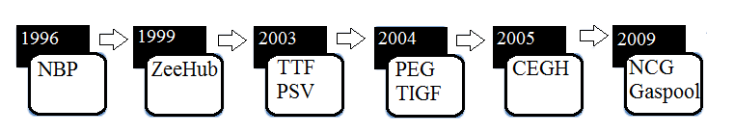

*Figure 10 The historical process of European gas hubs formation*

*Source: IENE, 2014*

In other words, a physical hub is a real transit location where pipeline cross and gas is traded. Such hubs could serve as a transit points for the gas transportation and storage (IENE, 2014). For instance, the gas hub Zeebrugge is a physical one. A hub could be also a virtual (balancing) point inside a whole gas pipeline system like NBP in the UK or TTF in the Netherlands are. A virtual hub is a trading platform for various financial transactions where a large number of market participants could make gas transactions (IENE, 2014). To say it in a different way, a trading platform could be considered as a trans-regional zone in comparison with a physical gas hub which location is highly linked to the specific region/point/zone where gas must be transported to. In case of virtual hubs gas could be injected into any point of national trans-regional grid. Thus, a virtual hub has an advantage over a physical one: all gas which has been paid for could be traded that gives a certain flexibility, while at a physical hub only an amount of gas that has passed at the precise point/location can be traded that implies high risks (IENE, 2014).

There is another gas hubs classification proposed by Patrick Heather from the Oxford Institute for Energy Studies (2015). According to the approach based on gas hubs’ market development, hubs may be distinguished into trading, transit and transition ones. Trading gas hubs are mature hubs and allow market participants to manage their gas portfolio. According to the OIES report (2015) there are only two trading mature hubs in Europe– NBP and TTF. Transit hubs are physical transit point where gas is physically traded. The main role of transit hubs is the facilitation of gas transportation. CEGH and ZEE are considered to be transit hubs (IENE, 2014). Transition hubs are virtual hubs which are quite immature, but have set prices benchmark for gas in their national markets. GPL, NCG, PEG, and PSV may be put in this hub category (OIES, 2015).

On the Figure 11 European hubs with regard of their maturity and liquidity level are presented.

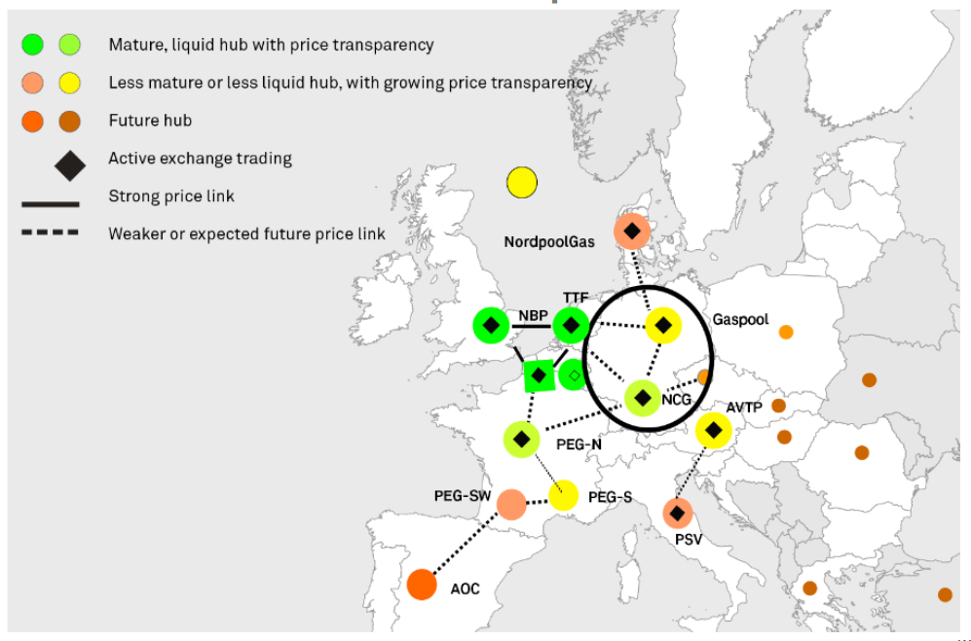

*Figure 11 European gas hubs classifications by maturity and liquidity level*

*Source: The Oxford Institute for Energy Studies, 2017*

With their rapid current development, European gas hubs might represent a second source of gas provision accompanied by long-term contracts in the region. The liquidity levels, one the most important figures for the gas hubs development stage analysis, are constantly growing. Gas hub establishment is of a crucial role for the EU since it facilitates the integrated gas market creation. However, it should be mentioned that European hubs are quite young and less developed in comparison with the US gas hubs (IENE, 2014).

# 1.5.1. NBP – National Balancing Point in the UK

National Balance Point is the oldest European gas hub that started its operations in 1996 and now is one of the most liquid hubs in Europe (IENE: 2014). Although Dutch TTF has already overtaken the leading position (that would be shown later in the Chapter), NBP has been the leading gas hub in terms of liquidity, traded volumes, churn ratio and number of market participants (Dickx, Miriello, & Polo, 2014). It is a virtual hub and is operated by the National Grid, the transmission system operator in the UK. Currently the NBP gas price is a benchmark for European wholesale market (alongside the TTF gas prices). Moreover, the NBP also serves as an indicator for the European spot LNG market with its four LNG terminals and developed market (IENE, 2014).

NBP has grown substantially over the last 10 year and continues to do so nowadays because of the close correlation with global oil prices and its attractive virtual organization that was an innovation at that time. Its range of participants include gas producers, LNG suppliers, retailers, power generators, industrial users and trading houses. As it was mentioned in the Chapter on Liquidity figure, the number of market participants is of a high importance for market liquidity level analysis and, thus, for market development stage assessment (Heather, 2015). For instance, in 2014 there were circa 200 companies involved in gas trade at NBP. This number is gradually rising every year (Heather, 2015). Trading activity at NBP made up 62% of all European gas trading in 2012. Trading volumes, one of the most important figure for hub assessing and a component of a churn rate formula, has been constantly growing over the recent years. Churn rate, the most important sign of hub/market liquidity, is also constantly growing. The Figure 12 represents gross and net churn rates for NBP over 2011-2013.

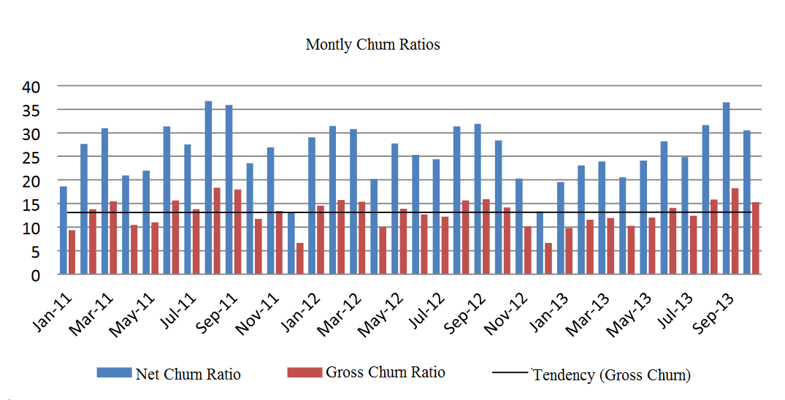*Figure 12 NBP churn rates 2011-2013*

*Source: IEFE, 2014*

However, nowadays NBP shows relative decline especially in comparison with constantly developing TTF. It could be proved by reducing number of daily transaction at NBP. This NBP decline could be explained partially by the declined demand, but the main reasons for such a situation is the effect of the increasing relevance acquired by the competitor TTF, which is becoming the new reference for natural gas transactions in Continental Europe (IENE, 2014).

# 1.5.2. TTF- Title Transfer Facility in the Netherlands

The Title Transfer Facility (TTF) is a virtual gas hub established in 2003 in the Netherlands in order to facilitate trading in the Dutch natural gas market and to increase the liquidity of the whole European gas market (IENE, 2014). Thus, at the TTF market participants transfer gas that is already available in the pipeline system.

TTF has significantly expanded over the last few years and now is considered as the biggest and highly developed gas in Europe. Liquidity levels based on churn rate analysis and traded volumes figures are evident proves for such statements. As we can see from the Figure 13, churn rates has and traded volumes have been rising steadily over 2011-2014 and now still continue to grow (IEFE, 2014).

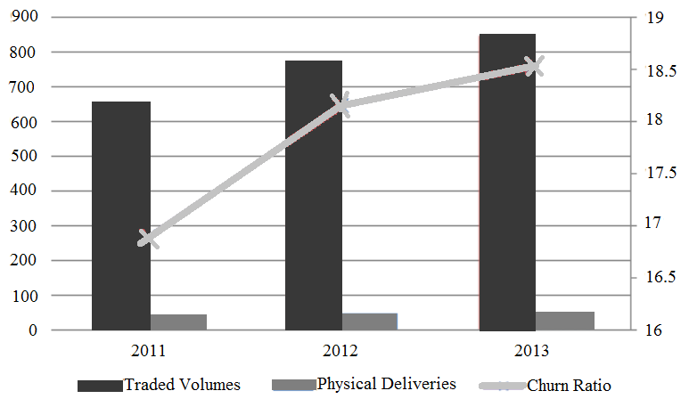

*Figure 13 TTF traded volumes and churn rates 2011-2014*

*Source: IEFE, 2014*

Number of market players has been also constantly growing over the last years (Figure 14). As a result of constantly growing liquidity levels at TTF, bid-ask spread and transaction costs have become lower over the last years. As it could be observed, beginning from 2013, all spreads have fallen under 1% (Baringa report, 2015).

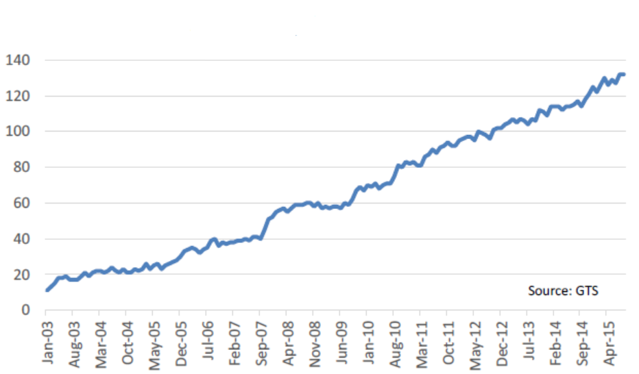

*Figure 14 TTF active players figures*

|  |
| --- |
| Source: Baringa, 2015 |

As it has been already mentioned, there is a strong competition between NBP and TTF gas hubs. According to the traded volumes figures, TTF overtook NBP in 2013 that happened for the first time since the gas hubs establishment in Europe. In 2015 TTF solidified its dominant position in the European gas market since TTF traded volumes exceeded NBP traded volumes every consequent year that could be considered as a solid trend (not an accidental result) (Figure 15).

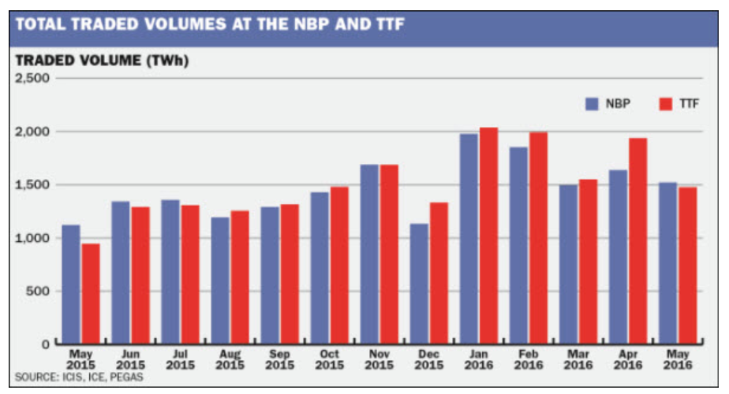

*Figure 15 NBP and TTF traded volumes 2015-2016*

*Source: Platts, 2016*

According to the S&P Global Platts, in 2015 TTF became the most liquid European hub overtaking the UK's National Balancing Point hub for the second time.[31]In July 2015, TTF trade of 1,385 TWh beats NBP's 1,353 TWh. Churn rate figures for both hubs represented in the Table 3 also prove the dominance of TTF in the European gas market (Heather, 2015).

|  |  |  |  |  |  |  |
| --- | --- | --- | --- | --- | --- | --- |
| *Table 3 NBP and TTF Churn rates 2004-2015 (Heather, 2015)* | | | | | | |
| Hub | Churn rates | | | | | |
| 2004 | 2008 | 2011 | 2013 | 2014 | 2015 |
| NBP | 7 | 14.4 | 19.8 | 18.7 | 26.2 | 22.0 |
| TTF | 0.2 | 3.3 | 13.9 | 19.3 | 36.0 | 57.0 |

Thus, TTF is considered now as the most liquid and highly developed European hub since the Dutch hub has overtaken NBP, the oldest European hub, in terms of traded volumes, liquidity levels and churn rates. These two gas hubs are the most relevant ones for the research since prices on these gas hubs have a potential to represent supply and demand fundamentals changes for natural gas. Other European gas hubs are not enough liquid since their traded volumes and churn rates are quite low especially in comparison with NBP and TTF figures.

# 

# 1.6. Hypotheses statement

The developing of the European gas market in terms of increasing liquidity levels, hub-based trading proliferation and the liberalization process aimed at energy security defines the market conditions nowadays. The decreased gas production within the market is accompanied by slightly increasing demand and quite stable middle-volume gas consumption. Furthermore, there is a graduate shift towards renewable energy resources since they are considered as the cleanest energy that fits environmentally friendly policy of the EU.

In 2015 the liquidity levels at TTF and NBP were already quite high. However, approximately at the end of 2015 TTF overtook NBP in terms of gas volume traded and number of players that were active in gas trading. Thus, the liquidity levels have been extremely high and continue to do so now. This signals that hub-based prices at TTF and NBP as liquid hubs should in theory reflect market changes in terms of demand and supply fluctuations and act as independent pricing mechanism in the European gas market (Stern & Rogers, 2013).

However, despite the facts discussed above, there is still no united opinion on whether hub-based prices represent independent pricing mechanism that forces out “outdated” oil-indexed pricing approach used in long-term contracts for gas delivery and reflect genuine supply and demand changes in the market or these prices follow oil prices dynamics and play a role of “secondary” pricing signals in relation to LTC prices that are drivers for hub-based prices and create “a ceiling” that cannot be exceeded by hub-based prices due to arbitrage opportunities. Thus, no integral and unified opinion on the essence of hub-based prices exists nowadays. These two polar opinions on hub-based prices nature are constantly in conflict.

Thus, the aim of this research is to examine the existence of correlation between hub-based prices, Brent oil and LTC BAFA prices. To achieve this goal it is aimed to answer the following research questions: what correlation exists between hub-based prices, Brent oil and BAFA LTC prices? If the correlation exists, what is the trend in correlation changes between hub-based prices and Brent oil prices? If the correlation exists, what is the trend in correlation changes between hub-based prices and BAFA LTC prices?

On the basis of the research gap and research questions formulated above the hypotheses could be formulated:

***H1: TTF gas spot prices are positively affected by Brent oil prices***

Since it is aimed to find out whether spot prices represent a separate gas pricing mechanism or they follow oil prices dynamics, the hypothesis has been formulated. Furthermore, it is supposed that there should be positive correlation between oil prices and gas spot prices at TTF since spot prices are considered to be guided by oil prices and play a role of “followers” in this case: the higher oil prices, the higher spot prices at TTF since they follow oil prices dynamics.

***H2: NBP gas spot prices are positively affected by Brent oil prices***

There is the same rational behind this hypothesis as in the H1: there is a positive correlation between spot prices at NBP hub and oil prices. Thus, it is supposed that the higher oil prices are, the higher gas spot prices at NBP are.

***H3: The correlation between TTF gas spot prices and Brent prices is weakening over the time period 2008-2018***

According to the scientific literature, markets with high liquidity level are able to depict market equilibrium (e.g. supply and demand dynamics and fluctuations). As a consequence, prices in such markets also respond to supply and demand fluctuations and are considered to be independent prices. TTF gas hub has been constantly developing over the recent years in terms of liquidity levels. Thus, it is logically to assume that as the time passes and the liquidity level at this European hub rises, the correlation between gas spot prices and oil prices should weaken over time since hub prices at liquid TTF reflect supply and demand fluctuations more and more clearly, while oil prices influence is less and less obvious.

***H4: The correlation between NBP gas spot prices and Brent prices is weakening over the time period 2008-2018***

The logic for this hypothesis is the same as for previous one: the rising of NBP liquidity level over time should enables spot prices at NBP reflect supply and demand dynamics more clearly, while the influence of oil prices dynamics should weaken.

***H5: TTF gas spot prices are positively affected by BAFA gas contract prices***

According to the S. Komlev (2016), gas spot prices are considered to be derivative and secondary pricing mechanism appeared in Europe. Thus, gas spot prices follow long term contract gas prices that play a role of principal and superior gas pricing paradigm. Furthermore, as it was reported in the previous chapter, there is an oil indexation component in the pricing formula for long term contracts for gas. Thus, if spot prices are positively affected by oil prices, the same relationship should exist between spot prices at TTF and BAFA gas long term contract prices.

***H6: NBP gas spot prices are positively affected by BAFA gas contract prices***

The similar rational states behind this hypothesis. Since spot prices are considered to be the secondary ones in relation to long term contract gas prices and there is an oil indexation component in every long term contract for gas delivery, NBP gas spot prices are positively affected by BAFA gas long term contract prices

***H7: The correlation between TTF gas spot prices and BAFA prices is increasing over the timeperiod 2008-2018***

BAFA prices is a monthly average price of natural gas on the German border that is formed in accordance with a formula including long-term contracts linked to the oil prices and spot gas prices. Thus, there is “a spot” component in the pricing formula for BAFA that initially gives a hint about the existence of the correlation between spot prices and BAFA long-term contract prices for gas delivery. However, it was previously mentioned in the scientific literature that the percentage of this spot component in the pricing formula for BAFA prices is constantly increasing due to spot trading development in the European gas market (Konoplyanik, 2010). It is aimed BAFA prices reflect up-to-date market condition and development process. Since the spot component in the pricing formula for BAFA is increasing after each session of formula review, it is logically to suppose that the correlation between spot prices at TTF gas hub and BAFA long-term contract prices for gas delivery is increasing over time

***H8: The correlation between NBP gas spot prices and BAFA prices is weakening over the timeperiod 2008-2018***

There is the same rational behind this hypothesis as it was explained for the H7 except for gas hub. It is aimed to examine whether the correlation between spot prices at NBP gas hub and BAFA long-term contract prices for gas delivery is increasing.

The stated hypotheses will be tested in the Chapter 3.

# 1.7. Summary

High pace of the European gas market development in terms of gas high liquidity levels at gas hubs, hub-based trading enhancement, and liberalization process define current market conditions. Main exporters should adapt export strategies to be competitive in the market. Gazprom has taken several measures in this regard, but there is a need to further develop its export pricing strategy.

There is a conflict between oil-indexed pricing paradigm and new hub-based pricing mechanism that formed hybrid pricing systems in Europe (Komlev, 2016). Furthermore, there is no unified opinion on hub-based prices essence in the scientific literature. A number of scientists (Stern & Rogers, 2013; Hulshof et al., 2015) consider hub-based prices as independent pricing approach that is able to reflect demand and supply fluctuations since the liquidity levels at hubs are high. In contrast, others (Komlev, 2016; Nemov, 2013; Nick, 2016) claim that hub-based prices cannot be considered as independent pricing mechanism since they are affected by oil and long-term contract prices.

Thus, it is aimed to examine the existence of the correlation between hub-based prices, oil Brent and BAFA LTC prices. In this regard eight hypotheses have been formulated.

**2. RESEARCH DESIGN**

In accordance with the research gap of the research paper exploratory research design is supposed to be used since the main goal is to explore the phenomenon of gas spot pricing mechanism in the European gas market. The main goal is to get new insights of spot pricing concept itself in order to provide more precise investigation and understanding of this rapidly developing gas pricing approach.

A quantitative research approach is supposed to be used in the research paper since the hypotheses formulated earlier in the Chapter 1 are to be tested with the use of a particular statistical procedure. Moreover, another rational for the quantitative research approach use is the fact that the correlation between such numbered data as gas spot TTF prices, oil Brent prices, BAFA contract gas prices with the use of the regression analysis will be investigated. Thus, hypotheses testing using the regression analysis statistical procedure based on the numbered data sample has an explanatory power to stick to quantitative research approach.

In the following paragraphs time interval choice, data sample as well as data sources, model type and in this regard dependent and independent variables would be explained and described in more details.

**2.1. Time interval choice definition and justification**

It was decided to analyze data over the period 31.12.2008 – 31.03.2018 for several reasons. Firstly, global financial crisis of 2008-2009 badly influenced energy market as a whole since oil market that has always had an influence on gas, coal and other energy markets fully reversed and this change could be still notices nowadays. According to the Oil&Gas Financial Journal article “Financial crisis impacts energy market” (2009), prices dropped by over two-thirds since their peak in 2008.[32] As a result, gas market also changed in response to oil market collapse. Secondly, spot gas trading at the main European hubs such as NBP and TTF has started to develop rapidly in 2008-2009 and continues to do so nowadays. Gas traded volumes and churn ratios as well as the number of active players at these hubs has been constantly growing since 2008 that could be considered as an indicator of spot gas market development. At the same time the portion of gas traded through long-term contracts is decreasing in the European gas market. In 2008 about 40% of all gas consumed in Europe was traded under long-term contracts (R. Zajdler, 2012). Thirdly, the fierce competition between TTF and NBP has started approximately in 2013. In 2013 TTF overtook NBP in the first time in terms of traded volumes. It happened once again in 2015 and from that time point TTF holds its leading position in the European gas spot market. Finally, the availability of TTF gas spot prices started from 2008 is also one of the reasons for the chosen time period for the analysis. In the light of aforementioned facts it is quite interesting to analyze data over this time period (31.12.2008 – 31.03.2018) since the analysis will reflect the main changes in the energy market and the gas market in particular.

**2.2. Data and sample specification**

For the analysis data for oil Brent price, BAFA gas price and data for TTF gas spot price and NBP gas spot price for the time period 31.12.2008 – 31.03.2018 were collected. Initially there is inconsistency in the sample in terms of time frequency of extracted data since there is daily data for NBP and TTF prices and monthly data for Brent oil and BAFA contract gas prices. In order to make the sample homogeneous in terms of data frequency representation it was decided to take an average value from daily TTF and NBP prices for every month to extract monthly TTF and NBP prices since there is no daily data for BAFA gas contract prices (e.g. these long-term prices exist only in the form of monthly prices for long-term gas contracts). Monthly data but not the annual data were collected since it is supposed that monthly data imply a higher potential for the reflecting price dynamics over a time period in comparison with annual prices which is quite an important factor in the volatile energy market.

The aforementioned variables have been chosen for the analysis in accordance with the research gap, research questions and formulated hypotheses. Since it is aimed to find out whether there is a correlation between spot gas prices formed at European gas hubs and oil prices and long-term contract gas prices and to find out whether spot gas prices are driven by oil prices and long term gas contract prices (e.g. spot prices do not in reality reflect demand and supply market equilibrium and thus are not independent gas market pricing mechanism), it is logically to choose spot prices at European hubs, Brent prices and long-term gas prices to carry out the analysis.

NBP and TTF gas spot prices have been chosen because NBP and TTF are currently the most liquid hubs in Europe. Since it is stated in the scientific literature (Komlev, 2016, Stern & Rogers, 2013) that high liquidity signals that the market is mature and developed enough and that in such a developed market with a high liquidity level prices reflect the market equilibrium, e.g. the crossing of market supply and demand, it is supposed that prices in the two hubs – NBP and TTF – should in theory respond to market supply and demand changes but not to oil prices dynamics. Thus, choosing spot prices at NBP and TTF with high liquidity level gives an opportunity to test stated hypotheses – whether spot gas prices in markets with high liquidity level reflect market equilibrium and could serve as an independent pricing mechanism. Thus, the most liquid European hubs – TTF and NBP – are taken for the analysis; gas hubs with low liquidity are excluded from the analysis. Furthermore, it was decided to choose both hubs (both TTF and NBP prices) because of several reasons. Firstly, NBP prices represent the UK gas market that has its own development history and trends, while TTF prices reflect the gas market conditions in continental Europe that has its unique traits and peculiarities. Secondly, as it was reported in the previous chapter TTF has overtaken NBP in 2015 and holds its superior position in the European gas market in terms of hub participants and liquidity level. Thus, it is important for the current research to find out whether there is a difference in correlations of these two European hubs with Brent oil prices and BAFA long term contract gas prices. It is supposed that the aforementioned reasons will enable the researcher to get in the end the whole picture of the sport gas trading in Europe and to analyze spot gas trading phenomenon in more details.

Brent oil prices were selected for the analysis in accordance with the stated research gap, the research questions and the hypotheses. Since the objective of the research is to identify whether there is a correlation between spot gas prices and oil prices, e.g. whether spot prices are driven by oil prices and cannot represent an independent pricing paradigm reflecting gas market equilibrium. Furthermore, the Brent oil prices have been selected since Brent prices are listed at the London Stock Exchange (in contrast to WTI oil prices that are listed at the New York Merchantile Exchange) that correspond to the selected target market – the European gas market. In previous research Brent prices were selected when the analysis was focused on the European market (Komlev, Hulshof, Nick), while WTI oil prices were chosen when the research was carried out specifically for the USA market (Bunn, 2017). Another reason for choosing Brent prices is that nowadays Brent oil price is considered to be a global benchmark and has been selected for the analysis by a number of scientists in previous research (Komlev, Hulshof). Thus, following previous research experience and logic and the hypotheses formulated in the current research Brent oil prices have been selected for the analysis.

It should be highlighted that 6-month-moving-average was taken for each monthly Brent price. S. Komlev (2016) in the research applied the same approach by choosing 9-month rolling average for Brent oil prices when investigating the existence of correlation between oil and hub-based prices. There is a rational behind the decision: when monthly oil prices are taken for the analysis, the comparison of three different separate products – oil, hub-based gas, and gas traded under LTC condition - takes place. However, the aim of the current research paper is to focus on prices and investigating the correlation and its strength between them, but not on products themselves. When the moving average is calculated to extract monthly prices for oil, so-called ”oil contract” is constructed. Furthermore, for calculating the LTC price for gas delivery not pure oil prices are taken, but the 9- or 6- month moving average is calculated. In this research paper it was decided to choose 9-month moving average.

BAFA prices have been selected since these prices are considered to be a benchmark for long-term gas contract prices in Europe. BAFA prices are monthly average prices for natural gas on the German border that are formed in accordance with pricing formula for long-term contracts for gas delivery. Furthermore, BAFA prices was used in a number of researches previously in order to carry out the analysis to find out whether there is a correlation between spot gas prices and long-term gas prices (Komlev, 2016, Asche, 2013). What is also brings a value for the current research is the fact that BAFA long-term contract gas formula has been changing and developing over time. As it was mentioned in the previous chapter, gas pricing formula has an adaptive ability since there is a special clause on regular price review in every long term gas contract that reflect constantly changing market conditions (Konoplyanik, 2010). Usually the formula adaptation lies in the changing of existing gas substitutes’ shares (as usual LFO and HFO) and/or introduction of new gas fuel substitutes in the existing formula that depicts a new energy market reality. Thus, the selection of BAFA gas contract prices will bring additional value to the research since the BAFA formula has been changing over time and especially over recent years in accord with the spot gas trading development. In this case it is valuable from the scientific point of view to track changes in correlation between spot prices at TTF and NBP and BAFA prices over time. Thus, the BAFA long term gas contract prices corresponds not only to the chosen market for the research – the European gas market, but also the selection of BAFA prices gives an opportunity to take into account long term gas pricing formula development and its connection with the whole European market changes.

The main source of TTF and NBP gas spot prices and BAFA gas prices is the financial analysis database Thomson Reuters Eikon. Brent prices were downloaded from the official website of the U.S. Energy Information Administration EIA (<https://www.eia.gov/dnav/pet/hist/LeafHandler.ashx?n=pet&s=rbrte&f=m>).

Thus, for the analysis quantitative continuous time series data have been taken. Overall 448 observations are taken for the analysis (Table 4).

*Table 4 Variables chosen for the analysis*

|  |  |  |  |
| --- | --- | --- | --- |
|  | Time frequency | Time period | Observations quantity |
| TTF spot prices | Monthly data (average of daily data) | 31.12.2008 -31.03.2018 | 112 |
| NBP spot prices | Monthly data (average of daily data) | 31.12.2008 -31.03.2018 | 112 |
| Brent prices | Monthly data  (9-month-moving-average) | 31.12.2008 -31.03.2018 | 112 |
| BAFA prices | Monthly data | 31.12.2008 -31.03.2018 | 112 |

**2.3. Justification of the regression analysis selection for the research**

As it was mentioned earlier in this chapter, the regression analysis has been chosen in order to test the hypotheses.

The regression analysis is a method of predictive modeling approach that investigates the relationship between a dependent and independent variables(s)/predictor(s). The regression analysis enables the researcher to find out the significant relationships between dependent and independent variable(s). Moreover, this type of modeling indicates the strength of impact of several predictors on an independent variable. For the current research multiple linear regression has been chosen since this type of regression analysis serves as the best fit for the stated hypotheses testing and for variables selected. Since it is aimed to find out what relationships are between spot prices at TTF and NBP and Brent prices and BAFA prices and whether spot prices are affected by oil prices and long-term gas contract prices where there is oil indexation in the formula or not, it is logical to select the linear regression analysis for the research. The regression is a multiple one since there are two independent variables/predictors included in the model. Another reason for choosing the regression analysis as a research method is the fact that a number of researchers who carried out similar analysis with similar aims and hypotheses used regression analysis. S. Komlev (2016), Hulshof (2015), Bun (2017), Hong Li (2016) used the regression analysis in order to examine the relationship between spot prices, oil prices, temperature, storage capacity etc. and how spot prices are affected by aforementioned variables. In this research the same logic in regard of research method is followed.

The linear regression equation is as following:

$$Y_{i}=\left(b_{0}+b_{1}X_{1i}+b_{2}X_{2i}+…+b_{n}X_{ni}\right)+ε_{i}$$

where Y is the outcome/dependent variable, $b_{0}$ is a constant, $b_{1}$ is the coefficient of the first predictor $X_{1}$, $b_{2}$ is the coefficient for the second predictor $X_{2}$, $b_{n}$ is the coefficient for the $n^{t}$ predictor $X_{n}$, and $ε_{i}$ is the error for the $i^{t}$ participant.

Now it is necessary to define a dependent variable and independent variables/predictors that would be fit in the regression model. Since the aim of the research is to define is there any correlation between spot prices and Brent oil prices and BAFA long term gas contract prices and how spot prices are affected by these two prices, the dependent variables of the model are TTF and NBP gas spot prices, while Brent prices and BAFA prices will be independent variables in the model.

*Table 5 Variables by type in the regression model*

|  |  |  |
| --- | --- | --- |
| Name of the variable | Variable name in SPSS | Dependent/independent |
| TTF monthly gas prices | TTFmon | Dependent |
| NBP monthly gas prices | NBPmon | Dependent |
| Brent oil monthly prices | Brentmon | Independent |
| BAFA monthly gas contract prices | BAFAmon | Independent |

It is supposed to run 8 regressions that are presented in the Table 6.

*Table 6 Regressions with variables and time period specification*

|  |  |  |  |
| --- | --- | --- | --- |
| № | Variables | Time period | Equation |
| 1 | Dependent: TTF prices  Independent: Brent prices, BAFA prices | 31.12.2008 – 31.03.2018 | $$TTF=\left(b_{0}+b_{1}Brent+b_{2}BAFA\right)+ε_{i}$$ |
| 2 | Dependent: NBP prices  Independent: Brent prices, BAFA prices | 31.12.2008 – 31.03.2018 | $$NBP=\left(b_{0}+b_{1}Brent+b_{2}BAFA\right)+ε_{i}$$ |
| 3 | Dependent: TTF prices  Independent: Brent prices, BAFA prices | 31.12.2008 – 31.12.2011 | $$TTF=\left(b_{0}+b_{1}Brent+b_{2}BAFA\right)+ε_{i}$$ |
| 4 | Dependent: NBP prices  Independent: Brent prices, BAFA prices | 31.12.2008 – 31.12.2011 | $$NBP=\left(b_{0}+b_{1}Brent+b_{2}BAFA\right)+ε_{i}$$ |
| 5 | Dependent: TTF prices  Independent: Brent prices, BAFA prices | 01.01.2012 – 31.12.2014 | $$TTF=\left(b_{0}+b_{1}Brent+b_{2}BAFA\right)+ε_{i}$$ |
| 6 | Dependent: NBP prices  Independent: Brent prices, BAFA prices | 01.01.2012 – 31.12.2014 | $$NBP=\left(b_{0}+b_{1}Brent+b_{2}BAFA\right)+ε_{i}$$ |
| 7 | Dependent: TTF prices  Independent: Brent prices, BAFA prices | 01.01.2015 – 31.03.2018 | $$TTF=\left(b_{0}+b_{1}Brent+b_{2}BAFA\right)+ε_{i}$$ |
| 8 | Dependent: NBP prices  Independent: Brent prices, BAFA prices | 01.01.2015 – 31.03.2018 | $$NBP=\left(b_{0}+b_{1}Brent+b_{2}BAFA\right)+ε_{i}$$ |

The first two regressions will be run for two dependent variables – TTF and NBP spot prices – for the whole time period 31.12.2008 – 31.03.2018. The aim of this carrying out the regressions for the whole period of the analysis is to find out in general terms whether spot gas prices at the two most liquid European hubs – TTF and NBP – are affected by Brent oil prices and BAFA long term prices. This step is supposed to give a general insight about the relationship between spot prices and oil and long term gas prices.

In the next stage it is supposed to divide the whole time period taken for the analysis into three time sub-periods relatively equal in their length as it is shown in the Table 5. The next 6 regressions are supposed to be run for a specific time period defined earlier. The rational for this step is to test the second and the third hypotheses formulated earlier – whether the strength of Brent prices and BAFA prices influence on gas spot prices at TTF and NBP is weakening over time or not. Thus, there are generally speaking 8 stages of the research.

**2.4. Preliminary plan of the research**

As it was highlighted earlier in the Chapter, the research will be carried out in multiple stages. Firstly, after the research gap and research questions have been formulated the hypotheses for testing are supposed to be set. Secondly, the necessary data will be collected for a time period 31.12.2008 – 31.03.2018. Thirdly, the regression models will be specified in accordance with the stated hypotheses. It is important to mention that before every regression the dataset will be checked for a list of assumptions that are needed to be met in order to run the regression. The dataset will be tested for linearity, autocorrelation (independent relationship between residuals), normal distribution and multicollinearity. Fourthly, the regression analysis in the form of aforementioned 8 stages will be carried out with the use of SPSS software. Finally, received results in the form of tables produced by SPSS will be analyzed. In the end, general conclusions and managerial implications will be formulated on the basis of the results extracted from SPSS analysis and scenario analysis regarding Gazprom export strategy.

**3. REGRESSION ANALYSIS RESULTS**

**3.1. Analysis of the time period 31.12.2008 – 31.03.2018**

After the hypotheses stating and data collection it is supposed to run multiple linear regression. However, before doing this it is necessary to check the data sample for a list of assumption that are necessary to be met to run regression. The assumptions to check are linearity, normal distribution, autocorrelation (independence of residuals) and multicollinearity.

In order to check the first two assumptions of linearity and normal distribution, e.g. whether the relationship between independent and dependent variables are linear whether the data are normally distributed, it is required to build P-P plots. It could be done in SPSS software: after downloading data sample from an Excel file, it is necessary to choose *Regression* option, then to choose data for dependent and independent variable, and then to choose *Plots* function where it is required to select and *Normal distribution plots*. After this, *Durbin-Watson test* function and *Collinearity* diagnostics have been chosen in order to check autocorrelation and multicollinearity assumptions correspondingly. The output provided by SPSS software is presented further.

As it could be observed from the charts presented in the Appendix B, the distribution of the data sample is normal (although there is some slight deviation from the straight line in both cases).

*Table 7 Durbin-Watson test and VIF results for regressions*

| № | Time period | Variables | Durbin-Watson test | VIF |
| --- | --- | --- | --- | --- |
| 1 | 31.12.2008 – 31.03.2018 | Dependent: TTF prices  Independent: Brent prices, BAFA prices | .956 | 1.907 |
| 2 | 31.12.2008 – 31.03.2018 | Dependent: NBP prices  Independent: Brent prices, BAFA prices | .902 | 1.907 |
| 3 | 31.12.2008 – 31.12.2011 | Dependent: TTF prices  Independent: Brent prices, BAFA prices | .870 | 1.001 |
| 4 | 31.12.2008 – 31.12.2011 | Dependent: NBP prices  Independent: Brent prices, BAFA prices | .840 | 1.001 |
| 5 | 01.01.2012 – 31.12.2014 | Dependent: TTF prices  Independent: Brent prices, BAFA prices | .888 | 1.255 |
| 6 | 01.01.2012 – 31.12.2014 | Dependent: NBP prices  Independent: Brent prices, BAFA prices | .847 | 1.255 |
| 7 | 01.01.2015 – 31.03.2018 | Dependent: TTF prices  Independent: Brent prices, BAFA prices | 1.19 | 1.438 |
| 8 | 01.01.2015 – 31.03.2018 | Dependent: NBP prices  Independent: Brent prices, BAFA prices | .918 | 1.438 |

Table 7 shows the results of Durbin-Watson tests and Collinearity diagnostics for all 8 regressions. As it could be observed, there is some level of autocorrelation (e.g. dependency between errors so that errors are correlated with each other) since Durbin-Watson tests results should be more than 1 and less than 3 points (e.g. 1<test statistics<3). If the test value is out of this number interval, there is some slight level of autocorrelation that is not critical for running the regression. Variance Inflation Factor or VIF quantifies how much the variance is inflated and thus is a measure used to detect multicollinearity between predictors. The VIF parameter should be in the interval 1<VIF value<10. As it is observed from the table below, VIF values for all eight regressions are in this interval. Thus, the assumption is not violated.

Thus, all necessary assumptions for the regression analysis are not violated according to the plots and tests’ results provided by SPSS software that allows running regressions.

The first two regressions are run on the data sample for the time period 31.12.2008 - 31.03.2018 in order to test the hypotheses H1, H2, H5, H6. The results of these two regressions are presented in the Table 8.

*Table 8 Regression analysis results for time period 31.12.2008 – 31.03.2018*

|  |  |  |  |  |
| --- | --- | --- | --- | --- |
| Time  period | Variables | Number of observations | $$R^{2}$$ | Sig. |
| 31.12.2008-31.03.2018 | Dependent: TTF monthly prices  Independent: Brent prices, BAFA prices | 336 | .544 | .000 |
| 31.12.2008-31.03.2018 | Dependent: NBP monthly prices  Independent: Brent prices, BAFA prices | 336 | .541 | .000 |

*Table 9 B-coefficients for time period 31.12.2008-31.03.2018. Dependent variable: TTF prices*

|  |  |  |  |
| --- | --- | --- | --- |
|  | B | Std. Error | Sig. |
| Constant | 7.223 | 1.141 | .000 |
| Brent prices | .067 | .017 | .000 |
| BAFA prices | .816 | .164 | .000 |

*Table 10 Coefficients for time period 31.12.2008-31.03.2018. Dependent variable: NBP prices*

|  |  |  |  |
| --- | --- | --- | --- |
|  | B | Std. Error | Sig. |
| Constant | 16.634 | 2.895 | .000 |
| Brent Prices | .183 | .042 | .000 |
| BAFA prices | 1.913 | .415 | .000 |

According to the regression results (Table 8, Table 9 and Table 10), the quality of the model is quite high. The measure of the model quality is $R^{2}$ known as correlation of determination since it measures the amount of variability in one variable (dependent one) that is shared by another variable (predictors). Thus, in the first case TTF prices correlate with Brent and BAFA prices quite strongly since Brent and BAFA prices share 54.4% of the variability in TTF prices ( $R^{2}$ equals .544). The same situation is with the second regression run for NBP prices as the dependent variable: 54.1% of NBP prices are shared by Brent and BAFA prices, that is a sign of a good model quality. Furthermore, the correlation is significant at the .05 level (Sig. .000). According to the correlation matrix (Appendix C and Appendix D), where correlation coefficient *r* is presented for each of the regression variables, it could be concluded that there is positive correlation between all variables (since *r*>0 for each variable) and the strength of the relationship is quite high (since *r* is approaching to 1). Thus, hypotheses H1, H2, H5, H6 are not rejected. It could be reported that there is a correlation between TTF and NBP prices and Brent and BAFA prices. To be more precise, NBP and TTF process are affected by Brent oil prices a little bit more in comparison with BAFA prices influence since correlation coefficient is higher for these variables (Appendices C and D).

**3.2. Analysis of the first sub-period 31.12.2008 – 31.12.2011**

In order to test hypotheses H3, H4, H7, H8, anther 6 regressions for three time sub-periods and two dependent variables (TTF and NBP spot prices) have been carried out. The results provided by SPSS software are presented in the Table 11.

*Table 11 Regression results for three sub-periods*

|  |  |  |  |  |
| --- | --- | --- | --- | --- |
| Time  period | Variables | Number of observations | $$R^{2}$$ | Sig. |
| 31.12.2008-31.12.2011 | Dependent: TTF monthly prices  Independent: Brent prices, BAFA prices | 111 | .767 | .000 |
| 31.12.2008-31.12.2011 | Dependent: NBP monthly prices  Independent: Brent prices, BAFA prices | 111 | .784 | .000 |
| 01.01.2012-31.12.2014 | Dependent: TTF monthly prices  Independent: Brent prices, BAFA prices | 108 | .226 | .015 |
| 01.01.2012-31.12.2014 | Dependent: NBP monthly prices  Independent: Brent prices, BAFA prices | 108 | .177 | .04 |
| 01.01.2015-31.03.2018 | Dependent: TTF monthly prices  Independent: Brent prices, BAFA prices | 117 | .802 | .000 |
| 01.01.2015-31.03.2018 | Dependent: NBP monthly prices  Independent: Brent prices, BAFA prices | 117 | .705 | .000 |

*Table 12 Coefficients for three time sib-periods. Dependent variables: TTF prices, NBP prices*

|  |  |  |  |  |  |
| --- | --- | --- | --- | --- | --- |
| Time period | Dependent Variable |  | B | Std. Error | Sig. |
| 31.12.2008-31.12.2011 | TTF prices | Constant | -6.863 | 2.349 | .006 |
| Brent prices | .137 | .019 | .000 |
| BAFA prices | 1.391 | .176 | .000 |
| NBP prices | Constant | -17.809 | 5.623 | .003 |
| Brent prices | .334 | .045 | .000 |
| BAFA prices | 3.575 | .421 | .000 |
|  |  |  |  |  |  |
| 01.01.2012-31.12.2014 | TTF prices | Constant | .164 | 7.916 | .984 |
| Brent prices | .005 | .051 | .992 |
| BAFA prices | 2.111 | .775 | .010 |
| NBP prices | Constant | -4.427 | 23.996 | .855 |
| Brent prices | .070 | .154 | .454 |
| BAFA prices | 5.025 | 2.35 | .04 |
|  |  |  |  |  |  |
| 01.01.2015-31.03.2018 | TTF prices | Constant | 2.085 | 1.429 | .053 |
| Brent prices | .141 | .033 | .000 |
| BAFA prices | 1.368 | .195 | .000 |
| NBP prices | Constant | 3.138 | 4.245 | .465 |
| Brent prices | .57 | .097 | .000 |
| BAFA prices | 1.566 | .58 | .01 |

As it is observed from the Table 11 and the Table 12, TTF and NBP prices were strongly affected by Brent and BAFA prices in the first time sub-period 31.12.2008-31.12.2011 ($R^{2}$ = .767 for TTF prices as the dependent variable and $R^{2}$ = .784 for NBP as the dependent variable). Furthermore, the correlation is significant at .05 level (Sig. = .000 in both cases). Furthermore, b-coefficients for both dependent variables are significantly different from 0 (since Sig .= .000 in most cases) that means that changed in a dependent variable (both TTF and NBP) are strongly associated with a unit change in predictors (both Brent and BAFA prices). Finally, according to the correlation matrix for this time sub-period, there is positive correlation between NBP and TTF spot prices and Brent and BAFA prices and the value of correlation coefficient *r* is approaching to 1 (that proves strong positive relationship between variables) (Appendices C and D). It should be highlighted that the strength of the correlation between hub-based prices at TTF and oil Brent prices and hub-based prices at NBP and Brent prices is quite the same (r = .847 and r=853 correspondingly) (Appendices C and D). The correlation strength between hub-based prices at both hubs and BAFA prices is less than between hub-based prices and oil prices. However, it is still quite strong and positive (r > .6 for both cases). Thus, there is a strong positive correlation between hub-based prices, Brent oil prices and BAFA prices in the first sub-period 31.12.2008 - 31.12.2011.

**3.3. Analysis of the second sub-period 01.01.2012 – 31.12.2014**

However, the situation is completely different in the second time sub-period. The value of $R^{2}$ is quite low in both regressions (.226 and .177) that is an evidence of the low quality of the model. To be more precise, this means that only 26% of TTF prices variance is shared by Brent and BAFA prices while other 74% of variance is explained by some other factors (omitted values in the model in this case). The same situation is observed with NBP spot prices: only 17.7% of NBP prices variance is shared by Brent and BAFA prices and the majority of the variance (82.3%) is explained by other variables that were not included in the model. While examining significance levels for Brent and BAFA prices presented in the Table 11, it could be concluded that only b-coefficients of BAFA prices are different from 0 in both regressions of the second sub-period (Sig. = 0.01 for TTF prices as the dependent variable, Sig = 0.04 for NBP prices as the dependent variable that is < .05 significance level). B-coefficients for Brent prices in both regressions of this sub-period is highly probable equal to 0 and thus the change in NBP and TTF prices as dependent variables are almost not associated with changes in Brent prices as the predictor. According to the correlation matrix for the time period 01.01.2012 - 31.12.2014, the values of the correlation coefficient r for TTF, NBP and Brent prices are approaching to 0 (Appendixes C and D) that is a signal that Brent prices had a very slight influence on TTF and NBP hub-based prices. At the same time the values of r for NBP, TTF and BAFA prices fluctuate around the value of .45 that indicates a moderate influence of BAFA gas long term contract prices on TTF and NBP spot prices. Thus, it may be concluded that in the second time sub-period Brent prices had very slight influence on NBP and TTF prices, while the strength of relationship between BAFA prices and NBP and TTF hub-based prices was on the moderate level (although it has still decreased in comparison with the first sub-period). The correlation strength in the second sub-period between hub-based prices and BAFA long-term prices is considerably higher than the relationship strength between hub-based prices and oil prices.

After the proficient analysis carried out it is supposed that a reason for such prices decoupling and a decrease in influence of Brent oil prices on NBP and TTF gas spot prices is skyrocketed prices for oil at the beginning of 2011 (Figure 16).

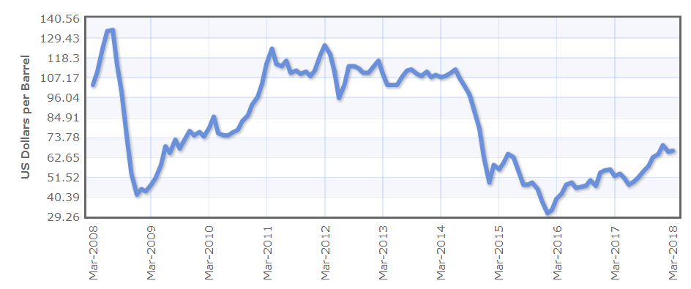

*Figure 16 The dynamics of Brent oil prices over the period 2008 – 2018*

*Source: Bloomberg Finance, 2018*

This trend of quite high oil prices was not short-term one; it was rather long-term period of skyrocketed prices for oil, especially for Brent oil that lasted from the beginning of 2011 till the middle of 2014. As it was mentioned before while reviewing scientific literature, normally spot gas prices followed oil prices and their dynamics particularly in 2011-2013 when spot markets were not developed enough and had low liquidity levels. However, it is logically to make an assumption that if oil prices are too high and this trend is long-term one, it is inefficient and roughly speaking expensive for gas spot prices to follow this “mad” oil prices dynamics. Thus, it is supposed that high prices for Brent oil might be a reason for prices decoupling.

Since the correlation strength between hub-based prices and BAFA prices has also dropped (but not so much as the correlation strength between hub-based prices and Brent oil prices did) it could be concluded that skyrocketed oil prices with long-term trend influence the relationship between hub-based prices and BAFA prices in the same manner.

For the further analysis it was decided to neglect the second sub-period since the model quality is quite low. Furthermore, as it has been mentioned earlier in the Chapter more than a half of the variance of both dependent variables are explained by other variables that are not included in the analysis in accordance with the research gap and the research questions. Thus, it is logical to neglect this sub-period when analyzing the changes in correlation strength over the sub-periods.

**3.4. Analysis of the third sub-period 01.01.2015 – 31.03.2018**

The third sub-period has relatively similar characteristics as the first sub-period does. The value of $R^{2}$ is quite high that signals about a high quality of the model. Moreover, the high value of $R^{2}$ for both regressions in this sub-period indicates that the majority of the variance of both dependent variables - TTF and NBP prices – is shared by Brent and BAFA prices. It should be highlighted that TTF are affected by Brent and BAFA prices to higher extent in comparison with NBP prices since the value of $R^{2}$ is higher in the model with TTF prices as the dependent variable. The significance level is .000 in both regressions of this sub-period. Moreover, b-coefficients in both regressions for Brent and BAFA prices do not equal to 0 since the Sig. = .000 that is > .05 critical value. This means that changes in TTF and NBP prices (dependent variables) are strongly associated with changes in Brent and BAFA prices (predictors). To make more detailed conclusions about the relationship between TTF and NBP prices and Brent and BAFA prices at the third sub-period the correlation matrix should be analyzed (Appendices and D). It should be highlighted that both hub-based prices at TTF and NBP have stronger positive correlation with BAFA prices rather than with Brent prices (for TTF prices: the value of r = .836 for BAFA prices against the value of r = .690 for Brent prices; for NBP prices: the value of r = .647 for BAFA prices against the value of r = .417 for Brent prices). However, as it could be observed from the correlation matrix, the correlation strength between NBP prices and Brent oil prices is less than .5 (for these prices r = .417) that indicates quite moderate but not strong positive correlation between prices, while the correlation strength between TTF and Brent oil prices is quite strong even nowadays (r = .690). Thus, it could be concluded that NBP prices are affected by oil prices to the less extent in comparison with TTF prices. The general conclusion regarding correlation matrix of the third sub-period is that there is strong positive relationship between TTF and NBP prices and Brent and BAFA prices.

**3.5. Results summary**

According to the analysis results there is quite strong correlation between spot prices at TTF and NBP, Brent oil prices and BAFA long-term contract gas prices for the time period 31.12.2008 – 31.03.2018. Thus, the hypotheses H1, H2, H5 and H6 are not rejected.

As it was mentioned earlier in the Chapter, in order to assess the trend regarding the correlation strength between the dependent and the independent variables it has been decided to neglect the second-sub-period for the analysis since according to the regression results and especially $R^{2}$ value and significance values of predictors described earlier it was concluded that other variables excluded from the research (since they do not correspond to the research gap and the research questions formulated) affected hub-based prices for gas at the second sub-period. Thus, this sub-period is excluded from the analysis since it is aimed to analyze the correlation between hub-based prices, oil prices and BAFA prices and how the correlation strength have changed over time. Other variables that affect hub-based prices are not of the interest of this research paper.

Thus, after analyzing two regression results in the first sub-periods and two regression results in the third sub-period, it could be concluded that the correlation strength between both NBP and TTF hub-based prices and Brent oil prices has weakened over time (Table 13).

As it is observed from the Table 13, TTF prices are affected nowadays to the less extant in comparison with the first sub-period. The same conclusion could be made for NBP prices. Thus, the hypotheses H3 and H4 are not rejected.

*Table 13 R-coefficients for the first and the second sub-periods*

|  |  |  |  |  |
| --- | --- | --- | --- | --- |
|  | Correlation strength between TTF and Brent prices  (r coefficient) | Correlation strength between NBP and Brent prices  (r coefficient) | Correlation strength between TTF and BAFA prices  (r coefficient) | Correlation strength between NBP and BAFA prices  (r coefficient) |
| 31.12.2008-31.12.2011 | .847 | .853 | .634 | .656 |
| 01.01.2015-31.03.2018 | .690 | .417 | .836 | .647 |

*Table 14 Hypotheses results summary*

|  |  |  |
| --- | --- | --- |
|  | Rejected | Is not rejected |
| H1 |  | ✔ |
| H2 |  | ✔ |
| H3 |  | ✔ |
| H4 |  | ✔ |
| H5 |  | ✔ |
| H6 |  | ✔ |
| H7 |  | ✔ |
| H8 | ✔ |  |

Analyzing r-coefficients between hub-based prices and BAFA prices, it could be concluded that the correlation strength between TTF hub-based prices and BAFA prices has increased since 2008. However, there is no increase of the correlation strength in case of NBP prices and BAFA prices: the r-coefficient has slightly decreased since 2008 (however, the decrease is not significant). Thus, it could be concluded that the hypothesis H7 is not rejected, while the hypothesis H8 is rejected.

Thus, after the regression analysis it is concluded that there is still a correlation between hub-based prices, Brent prices and BAFA prices and the strength of the correlation is quite high even nowadays. Finally, it was discovered that the correlation strength has weakened since 2008 that indicates graduate price decoupling and European hub market development. One of the reasons of price decoupling is a sharp increase in oil prices that has a long-term trend that was observed in the second sub-period. In such situations hub-based gas prices do not correlate with Brent oil prices, but they still follow BAFA prices (correlation coefficients r in correlation matrix for the second sub-periods for TTF, NBP hub-based prices and BAFA prices are around .4 that indicates moderate correlation strength).

Despite the fact that the correlation between hub-based prices at two main European hubs – TTF and NBP – is weakening over time, nowadays hub-based prices are still affected by Brent oil prices and BAFA prices.

# 4. DISCUSSION&IMPLICATIONS

# 4.1. Results discussion

The regression models for the first time period is discussed firstly. According to the results, hypotheses H1, H2, H5 and H6 are not rejected. This gives the ground to claim that, firstly, hub-based prices at two highly liquid European hubs – TTF and NBP – correlates with Brent oil prices. The correlation is positive and the strength of the relationship between spot prices at TTF and NBP and Brent oil prices is a little bit high of the middle level magnitude (see Appendix A). Thus, the higher the Brent prices, the higher prices at TTF and NBP since hub-based prices follow the oil price dynamics

The correlation of hub-based prices with oil prices were previously discovered in researches carried out by Gazprom Export and particularly by S. Komlev (2016), by Brown and Yucel (2008), by Asche et. al. (2013), Bunn et al. (2017) etc. Particularly, the analysis carried out by S. Komlev (2016) has shown quite similar results with those got from the current analysis in terms of correlation coefficient measure that shows the strength of relationship between two variables. According to the results of correlation matrix for the time period 31.12.2008 – 31.03.2018 and hub-based prices as the dependent variables and Brent prices as the independent variable for both regression models, the correlation coefficient equals .758 for TTF prices and Brent prices and .724 for NBP prices and Brent prices (Appendix A). The coefficient got by S. Komlev after the analysis equals .67 and .64 correspondingly. Thus, the results received from the current analysis prove conclusions of the previous research about the quite strong correlation between hub-based prices and oil prices.

Secondly, according to the regression analysis results, hub-based prices at TTF and NBP also correlate with BAFA long-term contract prices for gas delivery. The correlation has positive direction and the strength of the relationship between the variables is quite high (Appendix A). Thus, the higher BAFA prices for gas delivery are, the higher spot prices at TTF and NBP are.

In this regard it should be emphasized that the findings in the current research proves the argument reported by S. Komlev (2016) in his research: it was stated that hub-based prices in the European gas market play “a secondary” role in relation to long-term contract prices for gas delivery that guide hub-based prices and create “a price ceiling” for them (BAFA prices in the current research has been chosen as a benchmark for LTC prices for gas). The figures of correlation coefficient shown in the research carried out by S. Komlev (2016) and of the current research paper are around the same level that also highlights the fact of the “secondary” nature of spot prices that follow LTC gas prices by their essence. Furthermore, according to the reports provided by ACER/CEER (2016), hub-based pricing formation depends on a number of factors, but long-term contract gas prices are the main parameter that should be considered and that have considerably high impact on spot prices dynamics.

Thus, the statements in previous research on the existence of correlation between spot prices at TTF and NBP gas hub, Brent oil prices and long-term contract gas prices (BAFA prices in this particular case) have been proven in the current research and the results are quite the same.

In regard of the sub-period regression analysis the hypotheses H3, H4, H7 are not rejected. There was logical rational that the correlation between hub-based prices and oil prices should weaken over a particular time period due to increasing liquidity of European hubs (Hulshof, 2015). As it was mentioned earlier, the markets with high liquidity level (in terms of high number of participant and large gas volume traded) are able to produce prices that are genuine signals of market changes, particularly demand and supply fluctuations (Stern & Rogers, 2014). In this regard it was supposed that the increase in the liquidity level of the two main European gas hubs – TTF and NBP – the correlation should weaken, so hub-based prices at highly liquid gas hubs should become an independent pricing mechanism and reflect real market changes. The assumption was proved by the results of the regression analysis.

As it was mentioned in the previous Chapter when the analysis results have been discussed, the correlation between hub-based prices at TTF and NBP, Brent oil prices and BAFA long-term contract prices was quite strong in the first sub-period 31.12.2008 – 31.03.2011. It is quite logical since in that time gas hubs in Europe were not developed enough interms of number of participant, traded volumes and the liquidity levels so that gas prices formed at gas hubs could act as independent pricing approach and have no impact from the side of oil and LTC prices. In that time the churn ratio that acts as a measure of the liquidity level in a market for both hubs were below 10 points that is a minimum figure for a market to be named as liquid one. Thus, there should be some some factors on the basis of which hub-based prices could be formed. These facts were oil prices and LTC prices for gas delivery. As it was mentioned in the Chapter 1, oil prices determine the gas prices formation from the very beginning of the gas market creation since prices for contracts for gas delivery (Groningen pricing mechanism with oil indexation) use pricing formula where oil indexation is used (Konoplyanik, 2010). For a new pricing paradigm – hub-based pricing – oil prices also play similar role: oil prices at the beginning of hub market development in Europe strongly determined hub-based prices. The majority of trade and gas delivery were under long-term contract conditions that has been without any doubt the dominant pricing approach that also affected hub-based prices (Konoplyanik, 2010; Komlev, 2016). Thus, in the first sub-period 31.12.2008 – 31.12.2011 the strong positive correlation between hub-based prices at TTF and NBP, Brent oil prices and BAFA long-term contract gas prices may be logically explained by low liquidity levels at European hubs that made European gas hub-based prices dependent on oil prices and LTC prices. In that sub-period hub-based prices could not act as independent pricing mechanism.

This conclusion is proved by the scientific literature overviewed in the previous Chapter. Brown and Yucel (2008) in the research highlight that spot prices strongly correlate with oil prices. Two years before Asche et. al. (2006) reported quite the same results: there was strong positive correlation observed between spot prices and oil prices. One of the reasons for such situation was as was explained earlier: low liquidity levels at European gas hubs did not allow spot price act as independent pricing paradigm since the spot trading in that time only started to evolve and the majority of gas trading was carried out under long-term contracts. The lack of market participants (in this particular case at spot trading platforms) and little traded volumes led to low market liquidity at hubs that has been denoted as a reason for such a strong correlation between prices (Heather, 2015).

According to the results received from the regression analysis, there was very slight correlation between hub-based prices at TTF and NBP gas hubs and oil prices in the second sub-period 01.01.2012 – 31.12.2014. As it was discussed earlier in the Chapter 3, it has been decided to neglect the second sub-period in the analysis. The quality of the model was quite low that indicated that there are other variables that affect hub-based prices in the second sub-period. However, these omitted variables are not included in the model since they do not correspond to the formulated research goal and research questions. In the current research paper different factors that have an influence on hub-based prices are not analyzed. The aim of the research paper is to investigate the existence of the correlation between hub-based prices, oil prices and LTC prices for gas delivery. Thus, only these variables have been chosen for the analysis. Thus, since in the second sub-periods hub-based prices dynamics could be explained by some other variables, this sub-period is excluded from the analysis of the trend regarding correlation strength between hub-based prices, oil and BAFA prices.

After the proficient analysis carried out it is supposed that a reason for such prices decoupling and a decrease in influence of Brent oil prices on NBP and TTF gas spot prices is skyrocketed prices for oil at the beginning of 2011.This trend of quite high oil prices was not short-term one; it was rather long-term period of skyrocketed prices for oil, especially for Brent oil that lasted from the beginning of 2011 till the middle of 2014. As it was mentioned before while reviewing scientific literature, normally spot gas prices followed oil prices and their dynamics particularly in 2011-2013 when spot markets were not developed enough and had low liquidity levels. However, it is logically to make an assumption that if oil prices are too high and this trend is long-term one, it is inefficient and roughly speaking expensive for gas spot prices to follow this “mad” oil prices dynamics. Thus, it is supposed that high prices for Brent oil might be a reason for prices decoupling.

Hulshof et al. (2015) reckons that the correlation between hub-based prices at TTF and oil prices is very slight and insignificant. In contrast, the scientist claims that supply and demand define spot prices. It is notably that the research was carried out by Hulshof et. al. using the regression analysis of data for the years 2011-2014 that covered the data analyzed in the second sub-period of the current research. Thus, the insignificant correlation between hub-based prices and oil prices in this time period was observed not only in the current research, but also by other scientists that might be a prove for results received for the second sub-period.

It should be mentioned that the correlation between hub-based prices at TTF and NBP and BAFA long-term contract prices for gas delivery still continued to exist in the second sub-period when oil prices were at the very high level in long-term perspective. This observations could also be considered as a prove for the S. Komlev’s argument that hub-based prices play a role of “followers” of LTC prices and are secondary pricing signals in relation to LTC prices.

In the third sub-period the results of the regression analysis show that the correlation between hub-based prices, oil and LTC prices is high. There is a strong positive correlation between hub-based prices at TTF and NBP, oil prices and BAFA long-term contract prices. It should be highlighted that both TTF and NBP prices have stronger positive correlation with BAFA prices rather than with Brent prices. However, TTF prices are affected by both Brent oil and BAFA prices to higher degree in comparison with NBP prices. The general conclusion regarding correlation matrix of the third sub-period is that there is strong positive relationship between TTF and NBP prices and Brent and BAFA prices.

Thus, in the third sub-period the correlation between hub-based prices, Brent oil and BAFA prices still exists despite the fact of high liquidity levels at two main European hubs – TTF and NBP – in terms of traded volumes, market participants and churn ratios. However, for NBP prices the correlation with Brent prices is <.5 (to be precise r=.417) that indicates quite moderate but not strong correlation.

After comparison of the r-coefficients for the first and the third sub-period it could be concluded that the correlation strength between both NBP and TTF hub-based prices and Brent oil prices has weakened over time (Table 13). This could serve as an indicator of the graduate European hub-based gas market development since prices formed at hubs are becoming more and more independent in relation to oil prices. Thus, the European hub gas market is becoming mature and high liquidity levels at hubs in terms of market (hubs) participants, traded volumes (at hubs) and churn ratios facilitate this process.

However, currently NBP prices are affected by Brent oil prices to considerably less extent in comparison with TTF prices. The results in this case could be quite unexpected since nowadays TTF gas hub is more liquid in terms of churn ratio and number of hub (market) participant that according to the theoretical literature (Hulshof et al., 2015) indicate the high maturity degree of a market and high degree of price independence formed in this market. Following this logic, the correlation strength for TTF prices with Brent oil prices should be smaller in comparison with NBP prices which liquidity levels are nowadays lower than TTF ones. However, the results of the regression analysis are opposite: TTF prices are positively affected by Brent oil prices to higher degree than NBP prices are. One explanation could be that NBP gas hub has a longer process of historical development since it is the first gas hub in Europe that gave a start for hub-based gas trading in the continental Europe after the construction of Interconnector (Dickx et al., 2014). Nevertheless, the correlation strength between hub-based prices at TTF and NBP and Brent oil prices has decreased over the last ten years that is a signal of the European hub gas market and trading development. Thus, the hypotheses H3 and H4 are not rejected.

On the basis of the r-coefficients analysis for hub-based prices at both hubs and BAFA prices in the first and the third sub-periods the following conclusion could be made: the correlation between TTF prices and BAFA prices has increased over the last ten years. As it was mentioned earlier in the Chapter 1, BAFA pricing formula has a special “spot” component in line with “oil” component. Since every long-term contract for gas delivery has revision sessions when pricing formula is changed in order to be representative reflection of current market changes, this “spot” component in BAFA pricing formula is increasing after each revising sessions since hub gas market in Europe is gradually developing (Konoplyanik, 2010). Thus, the increase in correlation between TTF and BAFA prices is logically explained and the hypothesis H7 is not rejected. However, there is no increase in correlation between NBP and BAFA prices. Furthermore, there is very slight decrease in the correlation but overall could be considered as insignificant one (Table 13).One explanation could be that NBP has a longer development historical process since this is the first gas hub in Europe where hub-based trading take the beginning in the European market (Dickx et al., 2014). Thus, NBP prices could be considered as more independent even from BAFA prices, where “spot” component is presented. The hypothesis H8 is rejected.

It could be concluded that nowadays there is a strong positive correlation between TTF and Brent oil prices and a positive moderate correlation between NBP and Brent oil prices. Hub-based prices are still affected by oil prices and follow their dynamics. This fact could be an obstacle to make a statement that currently hub-based prices represent independent pricing mechanism in the European gas market. Furthermore, prices at both TTF and NBP gas hubs are positively affected by BAFA prices that supports the argument made by S. Komlev (2016) that hub-based prices play “a secondary” role in relation to LTC prices for gas delivery. Since hub-based prices follow the dynamics of Brent oil and BAFA long-term contract prices, they cannot purely represent independent pricing mechanism.

However, the correlation of hub-based prices with oil prices is weakening over time in line with the European hub trading development in terms of liquidity levels that nowadays are quite high at both TTF and NBP gas hubs. Thus, this decreasing trend is a signal that exporters should adapt their export strategy regarding LTCs and price formation in accordance with the European gas market development. Finally, the development of BAFA pricing formula and increased correlation between hub-based prices and BAFA prices proves the aforementioned argument that hub-based trading in Europe is constantly developing and influences price formation for LTCs also.

# 4.2. Scenario analysis

On the basis of the empirical findings made in the Chapter 3, it is possible to carry out scenario analysis in order to get deep insights of risks for Gazprom in the current market situation and potential strategy paths how to adjust the company’s export strategy to volatile new market reality.

Below there is a 2x2 scenario matrix that describes four possible scenarios for Gazprom at the European gas market. On the y-axis Brent prices were put, while for the x-axis gas market supply was chosen. Such a selection allows to track the behavior of spot prices since there is a correlation between spot prices and Brent prices that was proven during the empirical analysis. Furthermore, the market supply reflects the amount of gas available at the market that also influences gas prices. BAFA prices cannot be chosen for the scenario analysis since there is oil indexation in every long-term contract for gas delivery that means that Brent and BAFA prices correlate that is a deterrent for carrying out a scenario analysis.

The scenario “No worries” implies low Brent prices and low market supply (e.g. there is scarcity of gas in the market, so demand exceeds gas supply). As it was discovered during the analysis in the Chapter 3, hub-based prices do not correlate with Brent prices in a situation when Brent prices are extremely high and this trend is long-term. In other situations Brent prices influence hub-based prices at TTF and NBP quite strongly. Moreover, as it was mentioned earlier, BAFA contracts and all long-term contracts for gas delivery contain oil indexation in their pricing formula. Thus, Brent prices and BAFA prices also correlate to some degree. In this regard, BAFA prices will be low following oil prices dynamics in this scenario. In the situation of low market supply one could think that hub-based prices may increase since the demand for gas will be high while there is a scarcity in gas supplied in the market. However, according to the scientific literature (Komlev, 2016), long-term contract prices for gas create “a ceiling” for spot prices. That means that hub-based prices cannot not go higher than LTC prices because of arbitrage opportunities. Thus, hub-based prices will also be at low level following oil and LTC prices dynamics. In such a scenario gas buyers will not stick only to one type of prices for gas (either hub-based prices at TTF and NBP or LTC prices): if they start to buy gas only at hub, this will lead to increase in spot prices, while LTC prices will stay the same. At some point it will be more costly to buy gas at hub-based prices and more profitable to buy gas at LTC prices. Thus, buyers in this scenario will balance their buying decisions between spot and LTC prices. Following this rational, for Gazprom it is not vitally necessary to adapt the strategy to market changes since buyers will buy gas at both spot and LTC prices.

Brent

prices

Market supply

High

Low

High

Low

|  |  |
| --- | --- |
| Lucky one | Time for changes |
| No worries | Bad fortune |

*Figure 17 Scenario Matrix*

In the Scenario “Lucky one” the Brent oil prices are high while gas supply in the market is low. Hub-based prices will decouple from oil prices since the analysis has shown that if oil prices are high spot prices do not follow their dynamics. BAFA prices will adapt to high oil prices since there is an oil indexation in the LTC pricing formula and will be also relatively high. One may think that in this situation it is more profitable to buy gas at hub-based prices since they do not follow oil prices level and are under BAFA prices level. However, there is low gas supply at the market. This factor drives hub-based prices up making them approaching BAFA prices. Moreover, there is quite strong correlation between spot and BAFA prices. Thus, spot and BAFA prices will be at the same level. This scenario is a better situation for Gazprom since as in the Scenario “No worries” buyers will not stick to only one type of gas prices for the same reasons explained above. Moreover, as LTC prices will be higher for the same gas amount delivery, it is a more profitable scenario for Gazprom; there is no dire need for the company to adapt its export strategy.

In the Scenario “Time for changes” high oil prices are accompanied by high gas supply (e.g. there is an abundant amount of gas supplied in the market). In such a situation hub-based prices do not correlate with high oil prices. In contrast, there is positive relationship between Brent oil prices and BAFA prices that makes BAFA prices approach to oil prices. Thus, BAFA prices with their oil indexation in their pricing formula are also relatively high in this scenario. It may be logical to suppose that spot prices will approach to the BAFA prices level. However, due to abundant amount of gas supplied to the market spot prices will be dumped in accordance with the economic law of supply and demand. In this situation it will be more profitable for buyers to acquire gas at hub-based prices since they are supposed to be lower than high expensive BAFA prices that have to follow oil dynamics and are not adapt to the market supply conditions quickly. Thus, in this scenario it is highly important and vital for Gazprom to adapt its export strategy to new market reality where it is more profitable to trade at spot markets. For instance, the company may increase the “spot component” in the LTC pricing formula so that LTC prices can be more flexible and responsive to market supply changes. Without such an adaptation there is a high risk for the company to lose a part of its market share in the European gas market and as a consequence to lose a considerable part of its export profit.

In the Scenario “Bad fortune” oil prices are at the low level while the gas supply in the market is high. In this situation spot prices will follow oil prices dynamics and will be at lower level in comparison with BAFA prices. Thus, all prices – hub-based prices, Brent and BAFA prices – will be at the low level. Taking in the account the abundant amount of gas supplied in the market, one may claim that spot prices will to same degree react to such high gas supply and will be dump even lower. Thus, hub-based prices in this scenario will become the lowest and the cheapest prices for gas. As a logical consequence buyers will in most cases prefer to buy gas at hub-based prices rather than at BAFA or other LTC prices since this will be the most profitable and the cheapest decision for them. In this scenario Gazprom will lose a crucial part of its market share since LTC prices are not compatible with spot prices even if there is currently “a spot component” in the pricing formula of Gazprom’s LTCs. Thus, Gazprom should in this case adapt its export strategy by, for instance, further adaptation of its LTC pricing formula.

# 4.3. ManagerialImplications

In the research it has been proven that there is still a positive correlation between hub-based prices at TTF and NBP and Brent oil and BAFA prices. The existence of this correlation to some degree plays in favor of Gazprom current export strategy since it is possible to predict hub-based prices to some degree in this case. However, as it has been discovered during the analysis in a situation when oil prices are high in the long run spot prices does not follow their dynamics. At the same time hub-based prices strongly correlate with LTC prices and the correlation does not disappear even if there are skyrocketed oil prices. Furthermore, hub-based prices are always under LTC prices level due to arbitrage opportunities existing in the market.

According to the scenario analysis carried out earlier, there are two scenarios where there is no extreme need for Gazprom to somehow develop its strategy by elaborating new LTC pricing formula. In these two situations the company could extract high profit and does not have high risk of losing its market share in the European gas market if any other factors are held constant. However, in scenarios “Time for changes” and “Bad fortune” difficulties for Gazprom and its export strategy arise.

Due to the high volatility of the global oil market and European gas market supply (that depends on various external factors such as temperature, storage capacities, political and economical disrupts etc.) it is highly difficult to predict with the highest value of certainty what scenario out of four will happen even in the nearest future. What is also highly important is the fact that according to the results of the current research paper the correlation between hub-based prices and oil prices is gradually decreasing, while the correlation with BAFA prices represents another signal of constant European hub trading development. Thus, it is necessary for Gazprom to further adapt its LTC pricing formula by extending the weight of “a spot” component in the formula in order to make LTC price be more reflexive to market changes (particularly supply changes) by gradually reducing oil pegging in prices (now gas prices is pegged by 60% to oil prices that is quite high number). However, the company should not absolutely reject trading gas under LTC conditions. Firstly, it may lead to supply disrupt in the European market since the majority of exported gas especially in conditions of decline in gas production is delivered by Gazprom. Secondly, the sharp change in the company’s export strategy may result in decline in profit since such a significant change requires some adaptation in terms of time. Thus, the export strategy adjustment and development should be carried out at moderate pace.A more flexible export strategy will enable the company to extract higher profit, to cut risks in volatile energy market and no to lose its market share at the most profitable foreign export market. Furthermore, the company should increase gas traded volumes in spot market segment since spot market is gradually becoming the centre of gas trading in Europe.

The same recommendations could be addressed to every company that export its gas to the European gas market. An exporter should take into account the existence of positive correlation between spot prices, oil prices and LTC prices. Furthermore, in case of high oil prices spot prices will correlate only with LTC prices that create a “price ceiling” for spot prices. Gas supply at the market is one of the important factors while deciding for a company’s export strategy. The four scenarios explained earlier give an overall insight about different paths of future market development and include several uncertainty factors that helps companies to adapt their strategy correspondingly.

# 4.4. Theoretical Implications

The research method of the regression analysis has been broadly used in recent years in order to find out the correlation between hub-based prices, oil and long-term contract prices.

Normally the existence of the correlation between aforementioned prices was tested for the whole period (10 years, for instance). In the current research the approach has been further developed.Besides the regression for the whole period a number of regressionsfor sub-periods were carried out in order to examine how the correlation between hub-based prices, oil and LTC prices changes in time perspective. This approach allows researches not only to check for the existence of correlation, but also to examine whether there are some trends in correlation changes over a period of time (weakening of correlation, strengthening of correlation, fluctuations triggered by some externalities etc.). Finally, carrying out several regressions for sub-periods provides researches with opportunities to define potential factors that influence prices decoupling and prove development process in the market.

Moreover, by applying this approach not only the European gas market could be analyzed, but also Asian market, where development pace is quite high.

# Conclusion

Thus, the aim of the current research paper is to identify whether and how hub-based prices are affected by oil and long-term contract prices and whether and how the correlation between hub-based prices, oil and LTC prices is changing over time. The results of the regression analysis show that nowadays there is quite strong positive correlation between prices formed at hubs, Brent oil prices and BAFA long-term contract prices. Thus, even in the condition of quite high liquidity levels at the main European hubs – NBP and TTF – hub-based prices cannot be considered as absolutely independent prices mechanism.

However, the correlation between aforementioned prices is changing over time. According to the results of the regression analysis performed for three sub-period it is concluded that the strength of the correlation between prices at TTF and NBP and oil Brent prices is decreasing over a particular period of time. This is the indicator that hub-based prices are becoming more and more independent since the spot European gas market is constantly developing in terms of gas traded volumes, market (hub) participants and churn ratios. The results correspond to the finding from the scientific literature that in mature markets with high liquidity levels prices is independent and reflect market conditions in terms of demand and supply changes. As it was mentioned earlier, hub-based prices in the European gas market cannot be considered as absolutely independent pricing mechanism, but such prices have high potential to be representative of market demand and supply fluctuations in the future since hub-based prices are affected by Brent oil prices to smaller degree nowadays and this trend of diminishing correlation strength between prices will continue to be present further. Thus, the decreasing correlation between prices is an indicator of developing process in the European gas market towards integrated market place with the focus mainly on the hub-based pricing mechanism.

Another proof of such a constant development is the increased correlation between hub-based prices and BAFA prices. As it was mentioned earlier, the pricing formula of BAFA prices is constantly changing as any other formula of long-term contract for gas delivery. The “spot” component in BAFA formula is increasing over time in order BAFA prices reflect changes occurred in the European gas market related to the development and the proliferation of gas trading at hubs. Thus, the increase in the correlation between hub-based prices and BAFA prices appeared in the results of the regression analysis and correlation matrixes is logically explained and represent another proof that the European gas market is developing towards integrated market with eroded state boundaries and increased gas trading at liquid hubs.

The majority of gas export to Europe is provided by Gazprom under long-term contracts for gas delivery. Despite the fact that the company also expands its business activities in liberalized deregulated markets and is currently active in spot and short-term trading of natural gas, the corestone of the company’s export strategy is gas trading under LTC conditions with “take-or-pay” principle.[33] The results of the regression analysis allow carrying out the scenario analysis regarding the Gazprom export strategy. While there are two scenarios that are quite positive for the company and do not require significant development in the company’s export strategy, the two another ones are signals that there is a need for the company to further develop its export strategy in order it correspond to European gas market conditionsand not to lose its market share on the target market for gas export. In particular, it is suggested to further change pricing formula and to increase “spot” component by decreasing oil indexation (that has now 60% of weight) so prices for gas proposed by Gazprom can be competitive with constantly developing hub-based prices. Another suggestion is to increase gas traded volumes that are sold in spot market since hubs are constantly development and are becoming the centre of the gas trading in Europe.

The managerial implication made for Gazporm company are applicable for any other exporter who operates in the European gas market since changes occurred now in the market influence all exporters.

Thus, the current state on the European gas market with its developing gas hubs and graduate shift from gas trading under LTC conditions to hub-based trading defines the direction for companies’ export strategies. The lack of development in terms of gas export approach may lead to shrinking market share of an exporter and declined profit.

# List of references

1. Agency for the Cooperation of Energy Regulators (ACER) and Council of European Energy Regulators (CEER). (2015, November). *Annual Report on the Results of Monitoring the Internal Electricity and Natural Gas Markets in 2014*. Retrieved from <http://www.acer.europa.eu/official_documents/acts_of_the_agency/publication/acer_market_monitoring_report_2015.pdf>
2. Ang, B. W., Choong, W. L., Ng, T. S. (2015). Energy security: Definitions, dimensions and indexes. *Renewable and Sustainable Energy Reviews,* 42, 1077-1093. Retrieved from <http://www/elsevier.com/locate/rser>
3. Asche, F., Osmundsen, P., Sikveland, M. (2008). The UK market for natural gas, oil and electricity: are the prices decoupled? Energy Journal, 27(2), 27-40. Retrieved from <http://www.elsevier.com/locate/enpol>
4. Asche, F., Misund, B., Sikveland, M. (2013). The relationship between spot and contract gas prices in Europe. *Energy Economics,* 38, 212-217. Retrieved from <http://www.elsevier.com/locate/eneco>
5. Aune, F. R., Golombek, R., Moe, A., Rosendahl, K. E., Le Tissier, H. H. (2015). Liberalizing Russian Gas Markets: An Econometric Analysis. *The Energy Journal*, 36, 63-97.
6. Baringa Patners. (2015, September). The benefits of TTF liquidity. Retrievedf from <http://www.baringa.com>
7. Belyi, A. (2013). Institutional trends in Russia’s oil and gas sectors. *Journal of World Energy Law and Business*, 6(3), 163-178. Retrived from <https://sisu.ut.ee/sites/default/files/autumnschool2013/files/a._belyi.pdf>
8. Boguslavska, K. (2015). Gazprom: From Monopoly to Oligopoly on the Russian Gas Market. *Russian Analytical Digest*, 174(26), 2-5
9. Boussena, S., Locatelli, C. (2017). Gazprom and the complexity of the EU gas market: a strategy to define. *Post-Communist Economies, Taylor & Francis (Routledge*), 2017, 29 (4), 549 - 564. Retrieved from <http://www.tandfonline.com/doi/abs/10.1080/14631377.2017.1349667>.
10. Bros, T. (2017). European pricing dynamics [PowerPoint Slides]. The Oxford Institute for Energy Studies. Retrieved form <https://www.oxfordenergy.org/wpcms/wp-content/uploads/2017/05/European-Pricing-Dynamics-Thierry-Bros-1.pdf>
11. Brown, S. P. A., Yucel, M. C. A. (2009). Market arbitrage: European and North America natural gas prices. *Energy Journal*, 30, 167-186. Retrieved from <https://ideas.repec.org/a/aen/journl/hh-se-a11.html>
12. Bunn, D., Chevallier, J., Le Pen, Y., Sevi, B. (2017). Fundamental and Financial Influences on the Co-movement of Oil and Gas Prices. Energy Journal, 38(2), 201-228. <https://doi.org/10.5547/01956574.38.2.dbu>
13. Bykova, A., Stöllinger, R. (2017). Tradability Index: A Comprehensive Measure for the Tradability of Output, Statistical Report 6. The Vienna Institute for International Economic Studies. Retrieved from <https://wiiw.ac.at/tradability-index-a-comprehensive-measure-for-the-tradability-of-output-dlp-4123.pdf>
14. Council of European Energy Regulators (CEER). (2016, April). *Status Revieew on the Implementation of Transmission System Operators’ Unbundling Provisions of the 3rd Energy Package* (Publication No. C15-LFT-43-04). Retrieved from <https://www.ceer.eu/documents/104400/-/-/a6a22f89-3202-4f8b-f9ed-adf705185c33>
15. Dickx, L., Miriello, C., Polo, M. (2014). Balansing Systems and Flexibility Tools in European Gas Markets. Research Report № 14. Research Report Series, Centre for Research on Energy and Environmental Economics and Policy at Bocconi University. Retrieved from <http://www.iefe.unibocconi.it/wps/wcm/connect/dfdb3e33-daae-416f-af7e-1886cc32507a/Report_IEFE_14.pdf?MOD=AJPERES>
16. Eclipse Energy Group. (2017, June). 2017 Annual Eclipse Community Report. Retrieved from <https://www.eclipse.org/org/foundation/reports/annual_report.php>
17. Energy Charter Secretariat. (2005, April). Decision of the Energy Charter Conference. Brussels. Retrieved from <https://energycharter.org/what-we-do/conference-decisions/documents/2005/>
18. European Environment Agency. (2017, November). Environmental Indicator Report 2017 (Publication No. TH-AL-17-020-EN-N). Retrieved from <https://www.eea.europa.eu/publications/environmental-indicator-report-2017>
19. GasTerra. (2015, January 30). What is liquidity and how do you measure that? Retrieved from <https://www.gasterra.nl/en/news/what-is-liquidity-and-how-do-you-measure-that>
20. Gazprom Export. (2017, May). Gazprom Export Global Newsletter. Blue Fuel, 10(2). Retrieved from <http://www.gazpromexport.ru/content/file/bf/BLUE_FUEL_May2017_FINAL.pdf>.
21. Gazprom. (2016). The Power Within. PJSC Gazprom Annual Report 2016. Retrieved from <http://www.gazprom.com/f/posts/11/885774/gazprom-annual-report-2016-en.pdf> .
22. Haase, N. (2008). European gas market liberalization: Are regulatory regimes moving towards convergence? The Oxford Institute for Energy Studies. Retrieved from <https://www.oxfordenergy.org/wpcms/wp-content/uploads/2010/11/NG24-EuropeanGasMarketLiberalisationArerRegulatoryRegimesMovingTowardsConvergence-NadineHaase-2008.pdf>
23. Heather, P. (2015). The evolution of European traded gas hubs. The Oxford Institute for Energy Staduies. Retrieved from <https://www.oxfordenergy.org/wpcms/wp-content/uploads/2016/02/NG-104.pdf>
24. Heather, P., Petrovich, B. (2017). European traded gas hubs: an updated analysis on liquidity, maturity and barriers to market integration. The Oxford Institute for Energy Studies. Retrieved from <https://www.oxfordenergy.org/wpcms/wp-content/uploads/2017/05/European-traded-gas-hubs-an-updated-analysis-on-liquidity-maturity-and-barriers-to-market-integration-OIES-Energy-Insight.pdf>
25. Henderson, J. (2015). Competition for Customers in the Evolving Russian Gas Market. *Europe-Asia Studies*, 67(3), 345-369.
26. Honoré, A. (2014). The Outlook for Natural Gas Demand in Europe. The Oxford Institute for Energy Studies. Retrieved from <https://www.oxfordenergy.org/wpcms/wp-content/uploads/2014/06/NG-87.pdf>
27. Hulshof, D., Maat, J-P., Mulder, M. (2015). Market fundamentals, competition and natural-gas prices. *Energy Policy,* 94, 480-491. Retrieved from <http://www.elsevier.com/locate/enpol>
28. Institute of Energy for South-East Europe (IENE). (2014, July). THE OUTLOOK FOR A NATURAL GAS TRADING HUB IN EUROPE. IENE Study Project. Retrieved from <http://www.depa.gr/uploads/Outlook_for_a_natural_gas_trading_hub_in_SE_Europe_FINAL%20DRAFT%20%282%29.pdf>
29. Joskow, P. (1996). Introducing Competition into Regulated Network Industries: From Hierarchies to Markets in Electricity. *Industrial and Corporate Change*, 5(2), 341-82.
30. Katsis, N. (2013). *EU Unbundling and Regulation* [PowerPoint Slides]. Retrieved from <http://www.inogate.org/documents/3_EU%20Unbundling%20and%20Regulation.pdf>
31. Komlev, S. (2016). *Oil Indexation: The Best Remedy for Market Failure in the Natural Gas Industry. Part 1*. Saint-Petersburg: Demian Literary Agency.
32. Konoplyanik, A. (2010). Evolution of Gas Pricing in Continental Europe: Modernization of Indexation Formulas Versus Gas to Gas Competition. *International Energy Law and Policy Research Paper Series*, 01, 1-32. Retrieved from <http://www.konoplyanik.ru/ru/publications/articles/465_Evolution_of_Gas_Pricing_in_Continental_Europe.pdf>
33. Kulagin, V. A. (2015). Transformatsia rynkov i novye usloviia dlia eksporta rossiiskogo gaza [Market transformation and new conditions for Russian gas export] [PowerPoint Slides]. Retirieved from <https://www.eriras.ru/files/prezentatsiya_gaz_rossii_2015.pdf>
34. Kulagin, V. A., Melnikova, S. I., Galkina, A. A., Osipova, E. D., Kozina, E. O. (2016). Perspektivy rossiiskogo gaza na evropeiskom rynke v kontekste izmeneniia rynochnykh yslovii, regularotnoi sredy i energeticheskoi politiki ES[The perspectives for Russian gas in the European market within the context of changing market conditions, regulatory environment and the EU energy policy]. *Vysovy globalnogo upravleniia v oblasti energetiki*, 28-45.
35. Kulagin, V. A., Mitrova, T. A. (2015). *Gazovyi rynok Evropy: ytrachennye illuzii i robkie nadezhdy [The European gas market: lost dreams and timid hopes]*. National Research University Higher School of Economics – The Energy Research Institute of the Russian Academy of Science. Moscow: Author. Retrieved from <https://www.eriras.ru/files/gazovyy_rynok_evropy.pdf>
36. Larchenko, L. V., Kolesnikov, R. A. (2017). The Development of the Russian Oil and Gas Industry in Terms of Sanctions and Falling Oil Prices. *International Journal of Energy Economics and Policy*, 7(2), 352-359. Retrieved from <http://www.econjournals.com/index.php/ijeep/article/view/4600>
37. Li, H., Zhang, H-M., Xie, Y-T., Wang, T. (2016). Analysis of factors influencing the Henry Hub natural gas price based on factor analysis. Petrolium Science, 14(4), 822-830. <https://doi.org/10.1007/s12182-017-0192-z>
38. Locatelli, C. (2013). The Russian Gas Industry: Challenges to the “Gazprom Model”. *Post-Communist Economies*, *Taylor & Francis (Routledge),* 26(1), 53-66.
39. Lunden, L. P., Fjaertoft, D., Overland, I., Prachkova, A. (2013). Gazprom vs. other Russian gas prpducers: The evolution of the Russian gas sector. Energy Policy, 61, 663-670. Retrieved from <https://ac.els-cdn.com/S0301421513005405/1-s2.0-S0301421513005405-main.pdf?_tid=b8d1d383-12aa-4884-aa16-740ed522a478&acdnat=1527090411_83ea1e3dcc14b55e9315834af724b46e>
40. Mansson, A., Johansson, B., Nilsson, L. J. (2014). Assessing energy security: An overview of commonly used methodologies. *Energy*, 73, 1-34. Retrieved from <http://www.elsevier.com.locate/energy>
41. Mateusz Czajkowski. (2018, February). The 2017 European gas market in 10 charts. Energy Insights by McKinsey. Retrieved from <https://www.mckinseyenergyinsights.com/insights/the-2017-european-gas-market-in-10-charts/>
42. Mazneva, E., Rudnitsky, J. (2018, January 2). Russian Natural Gas Output Jumps to Record in Expansion Drive. Bloomberg official website. Retrieved from <https://www.bloomberg.com/news/articles/2018-01-02/russia-posts-highest-ever-natural-gas-output-in-expansion-drive>
43. Melnikova, S. I., Geller, E. I., Mitrova, T. A., Kulagin, V. A. (2016). GAZOVYI RYNOK ES: epokha reform [European gas market: epoch of reforms]. National Research University Higher School of Economics – The Energy Research Institute of the Russian Academy of Science. Moscow: Author. Retrieved from <https://www.eriras.ru/files/gazovyy_rynok_es_-_epokha_reform.pdf>
44. Melnikova, S. I., Mitrova, T. A., Kulagin, V. A., Grushevenko, D. A., Grushevenko, E. V. (2015). Spros I mezhtoplivnaya konkurentsia na evropeiskom neftegazovom rynke [the demand and intefuel competition in the European oil and gas market]. *Energeticheskia politika*, 5, 38-47
45. Nemov, V. (2013). Gas Hub and Oil-Indexed Prices: Still Bound Together. Blue Fuel, 6(6), 6-15. Retrieved from <http://www.gazpromexport.ru/en/presscenter/publications/>
46. Newbery, D. M. (2004). *Privatizing Network Industries*. CESIfo Working Paper № 1132. Center of Economics Studies and Ifo Institute (CESIfo). Retrieved from <http://www.ifo-dresden.de/DocDL/cesifo1_wp1132.pdf>
47. Nick, S. (2016). The Information Efficiency of European Natural Gas Hubs: Price Formation and Intertemporal Arbitrage. Energy Journal, 37(2), 1-20. Retrieved from [http://www.iaee.org/en/publications/ejarticle.aspx?id=2750](https://econpapers.repec.org/scripts/redir.pf?u=http%3A%2F%2Fwww.iaee.org%2Fen%2Fpublications%2Fejarticle.aspx%3Fid%3D2750;h=repec:aen:journl:ej37-2-nick)
48. Nick, S., Thoenes, S. (2013). What Drives Natural Gas Prices? – A structural VAR Approach. Institute of Energy Economics at University of Cologne. Retrieved from <http://www.ewi.unikoeln.de/fileadmin/user_upload/Publikationen/Working_Paper/EWI_WP_13-02_new_What_Drives_Natural_Gas_Prices.pdf>
49. Novatek. (2011). Focus on Growth [PowerPoint Slides]. Retrieved from <http://www.novatek.ru/ru/investors/presentations/archive/index.php?quarter_4=7>
50. Oxford Institute for Energy Studies (OIES). (2015). Annual Report 2015. Retrieved from <https://www.oxfordenergy.org/wpcms/wp-content/uploads/2011/02/OIES-Annual-Report-2015.pdf>
51. Ozdemir, V., Karbuz, S. (2015). A new are in Russian gas market: The diminishing role of Gazprom*. Energy Strategy Reviews*, 8, 39-44. Retrieved from <https://is.muni.cz/el/1423/jaro2017/MEB439/um/Ozdemir__2015.pdf>
52. Pershin, V. K., Kislitsin, E. V.(2016). Tendentsii Razvitija Rynka Prirodnogo Gaza Evropy: osobennosti, ychastniki, perspectivy [Natural gas development trends in Europe: peculiarities, participants, perspectives]. *Izvestiya Uralskogo gosudarstvennogo ekonomicheskogo universiteta*, 5(67), 74-87. Retrieved from <http://izvestia.usue.ru/ru/-2016/628-2016-09-20-04-52-56>
53. Serletis, A., Rangel-Ruiz, R. (2004). Testing for common features in North American energy market. Energy Economics, 26(3), 401-414. Retrieved from <https://ideas.repec.org/a/eee/eneeco/v26y2004i3p401-414.html>
54. Simola, H., Solanko, L. (2017). Overview of Russia’s oil and gas sector. Bank of Finland Policy Brief № 5, Institute for Economies in Transition. Retrieved from <https://helda.helsinki.fi/bof/bitstream/handle/123456789/14701/bpb0517.pdf?sequence=1>
55. Stern, J. H. R., Rogers, H. V. (2011). The Transition to Hub-Based Gas Pricing in Continental Europe. The Oxford Institute for Energy Studies. Retrieved from <https://www.oxfordenergy.org/publications/the-transition-to-hub-based-gas-pricing-in-continental-europe-2/>
56. Stern, J. H. R., Rogers, H. V. (2013). The Transition to Hub-Based Pricing in Continental Europe: A Response to Sergei Komlev of Gazprom Export. The Oxford Institute for Energy Studies. Retrieved from <https://www.oxfordenergy.org/wpcms/wp-content/uploads/2013/02/Hub-based-Pricing-in-Europe-A-Response-to-Sergei-Komlev-of-Gazprom-Export.pdf>
57. Stern, J. H. R., Rogers, H. V. (2014). The dynamics of a Liberalized European Gas Market Key Determinants of Hub Prices and Roles and Risks of Major Players*.* The Oxfor Institute for Energy Studies. Retrived from <https://www.oxfordenergy.org/wpcms/wp-content/uploads/2014/12/NG-94.pdf>
58. Vazquez, M., Hallack, M. (2016). Representing the Valuation of Take-or-Pay Provisions in Gas Markets With Limited Liquidity. *IEEE Transactions on Power Systems*, 31(4), 3152-3159. Retrieved from <https://ieeexplore.ieee.org/document/7286862/>
59. Villar, J. A., Joutz, F.L. (2006). The relationship between crude oil and natural gas pricing. Report of the Energy Information Administration, Office of Oil and Gas, Washington DC. Retrieved from <http://www.uprm.edu/aceer/pdfs/CrudeOil_NaturalGas.pdf>
60. Zajdler, R. (2012). The future of gas pricing in long-term contracts in Central Eastern Europe. Global market trends versus regional particularities. Sobieski Institute, Warsaw. Retrieved form <http://www.sobieski.org.pl/wp-content/uploads/the-future-of-gas-pricing_e_book.pdf>

# Appendices

Appendix A

Correlation matrix for time period

31.12.2008 - 31.03.2018

|  |  |  |  |  |  |
| --- | --- | --- | --- | --- | --- |
|  |  | 1 | 2 | 3 | 4 |
| 1 | TTF prices | 1 |  |  |  |
| 2 | NBP prices | .967 | 1 |  |  |
| 3 | Brent prices | .758 | .724 | 1 |  |
| 4 | BAFA prices | .691 | .680 | .845 | 1 |

31.12.2008 – 31.12.2011

|  |  |  |  |  |  |
| --- | --- | --- | --- | --- | --- |
|  |  | 1 | 2 | 3 | 4 |
| 1 | TTF prices | 1 |  |  |  |
| 2 | NBP prices | .984 | 1 |  |  |
| 3 | Brent prices | .847 | .853 | 1 |  |
| 4 | BAFA prices | .634 | .656 | .867 | 1 |

01.01.2012 – 31.12.2014

|  |  |  |  |  |  |
| --- | --- | --- | --- | --- | --- |
|  |  | 1 | 2 | 3 | 4 |
| 1 | TTF prices | 1 |  |  |  |
| 2 | NBP prices | .979 | 1 |  |  |
| 3 | Brent prices | .150 | .081 | 1 |  |
| 4 | BAFA prices | .475 | .415 | .855 | 1 |

01.01.2015 – 31.02.2018

|  |  |  |  |  |  |
| --- | --- | --- | --- | --- | --- |
|  |  | 1 | 2 | 3 | 4 |
| 1 | TTF prices | 1 |  |  |  |
| 2 | NBP prices | .841 | 1 |  |  |
| 3 | Brent prices | .690 | .417 | 1 |  |
| 4 | BAFA prices | .836 | .647 | .836 | 1 |

Appendix B

Normal P-Plot of Regression Standardized Residual

|  |
| --- |
| NBP regression all years PP p;ot normality.PNG |
| TTF regression all years PP plot normality.PNG |

Appendix C

SPSS output: TTF as dependent variable.

Time period: 31.12.2008 – 31.03.2018

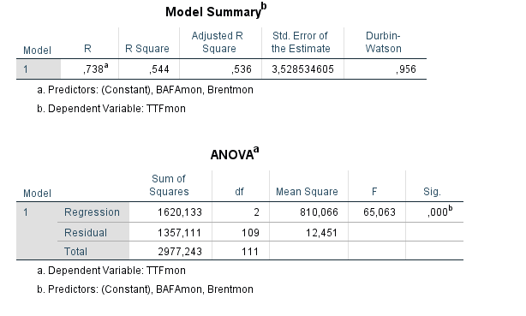

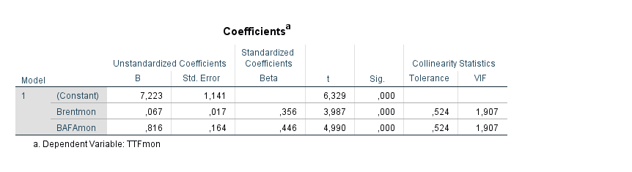

Time period: 31.12.2008 – 31.12.2011

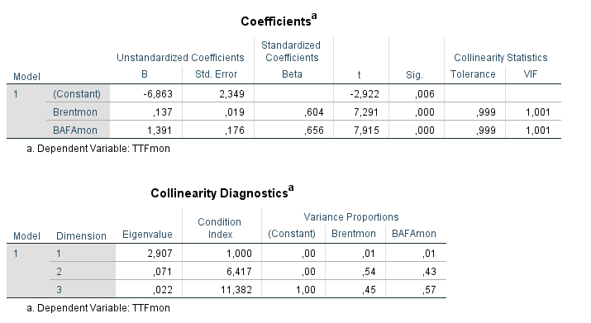

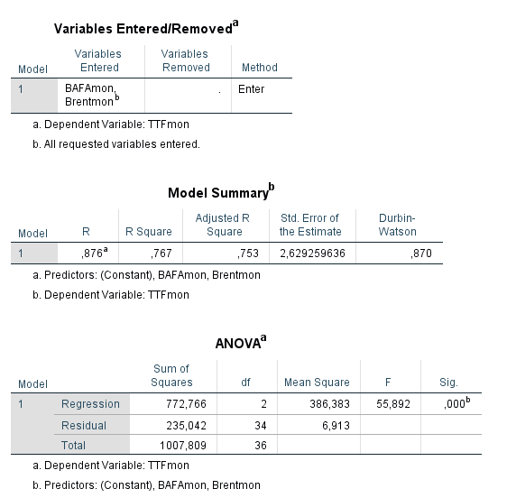

Time period: 01.01.2012-31.12.2014

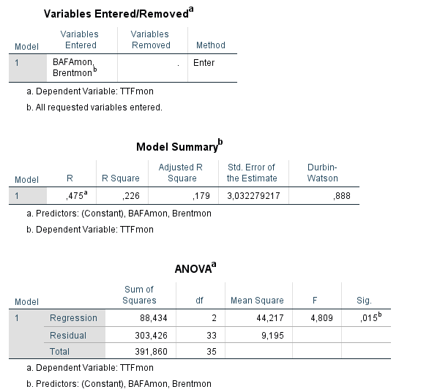

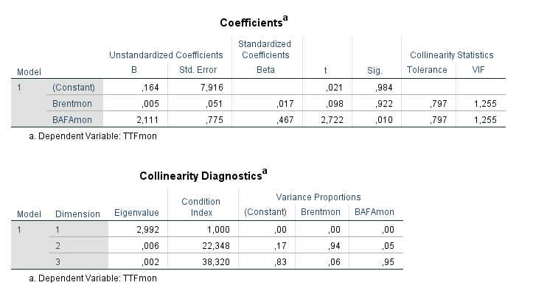

Time period: 01.01.2015-31.03.2018

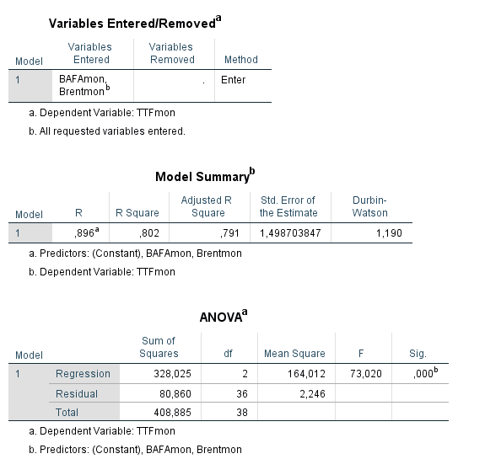

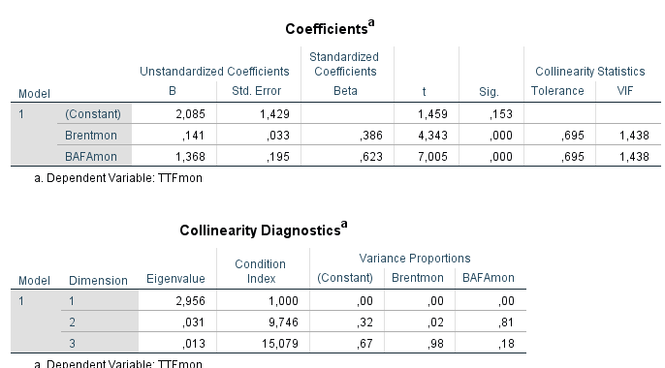

Appendix D

SPSS output: NBP as dependent variable.

Time period: 31.12.2008 – 31.03.2018

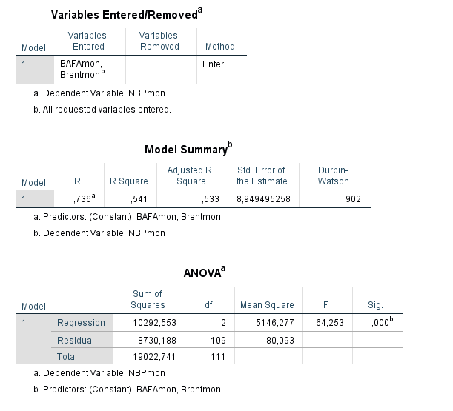

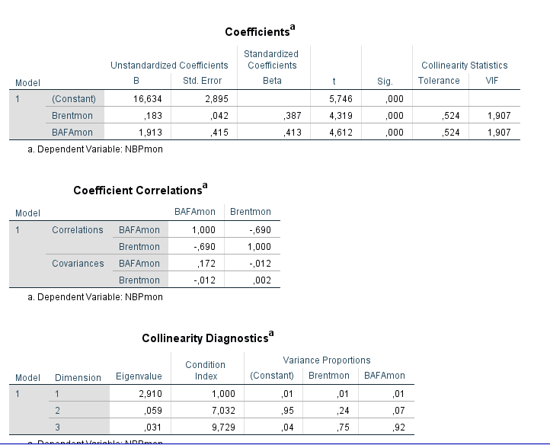

Time period: 31.12.2008 – 31.12.2011

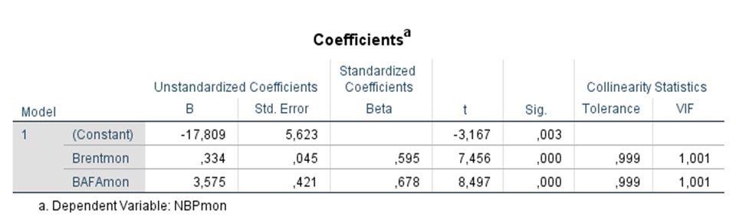

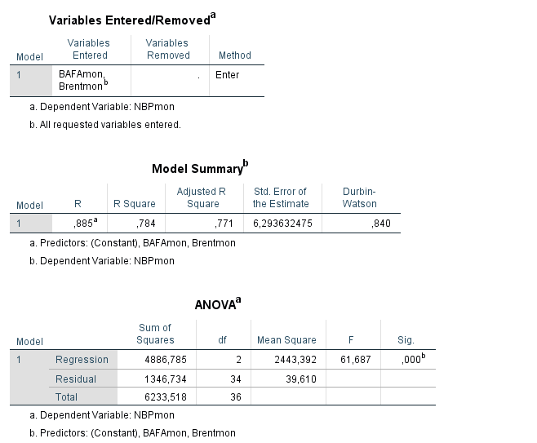

Time period: 01.01.2012-31.12.2014

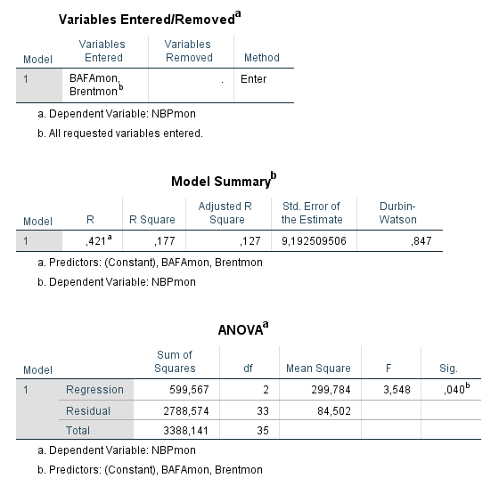

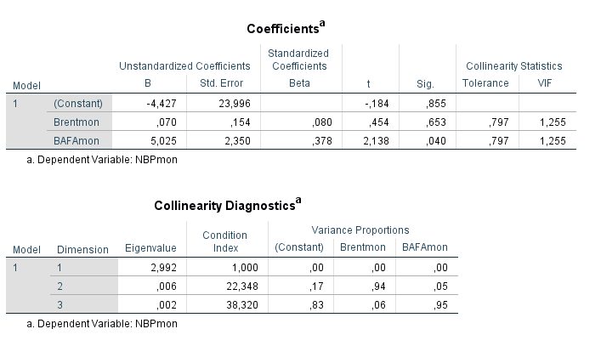

Time period: 01.01.2015-31.03.2018

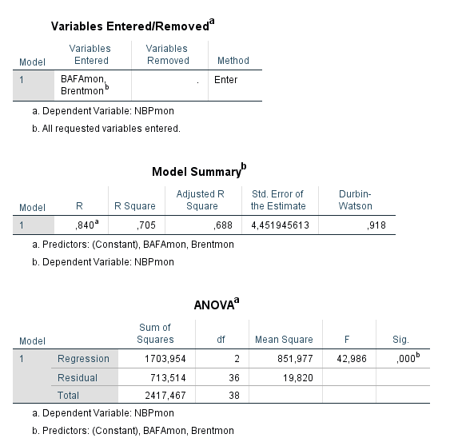

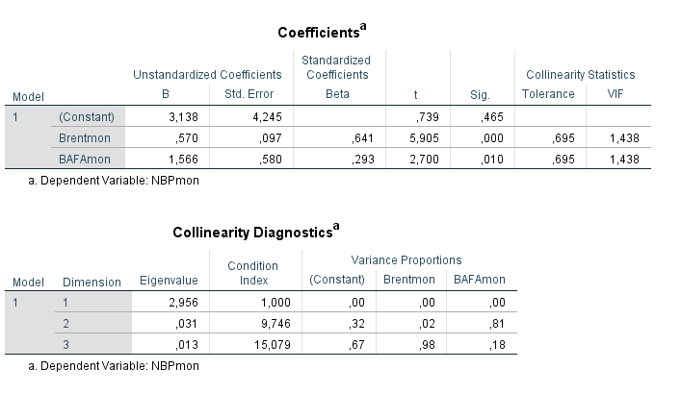

1. <https://ec.europa.eu/energy/en/topics/energy-strategy-and-energy-union/energy-security-strategy>
2. <https://www.theguardian.com/business/2009/jan/07/gas-ukraine>
3. <https://www.mckinseyenergyinsights.com/insights/the-2017-european-gas-market-in-10-charts/>
4. <https://ec.europa.eu/energy/en/topics/markets-and-consumers/wholesale-market/access-infrastructure-and-exemptions>
5. <http://neftianka.ru/gaz-v-evrope-konkurenciya-narastaet/>
6. <https://ec.europa.eu/energy/en/topics/renewable-energy>
7. <http://ec.europa.eu/eurostat/statistics-explained/index.php/Energy_statistics_introduced>
8. <http://ec.europa.eu/eurostat/statistics-explained/index.php/Natural_gas_consumption_statistics>
9. <http://pr.euractiv.com/pr/higher-gas-demand-2017-helps-lower-emissions-160216>
10. <http://www.snam.it/en/Media/energy-morning/20171107_2.html>
11. <https://www.eia.gov/beta/international/analysis.cfm?iso=RUS>
12. <https://www.eia.gov/beta/international/analysis.cfm?iso=RUS>
13. <http://www.gazprom.ru/about/strategy/implementation/>
14. <http://www.gazpromexport.ru/en/statistics/>
15. <http://www.gazpromexport.ru/en/presscenter/news/2134/>
16. <http://www.gazprom.com/about/strategy/implementation/>
17. <http://www.gazpromexport.ru/en/strategy/gas_auction/>
18. <http://www.gazprom.com/about/strategy/implementation/>
19. <http://www.gazpromexport.ru/en/strategy/markets/>
20. <https://www.bloomberg.com/news/articles/2018-01-02/russia-posts-highest-ever-natural-gas-output-in-expansion-drive>
21. <https://www.gasterra.nl/en/news/what-is-liquidity-and-how-do-you-measure-that>
22. <https://www.magnuscmd.com/liquidity-and-its-impact-on-energy-markets/>
23. <https://www.nasdaq.com/investing/glossary/l/liquid-market>
24. <https://www.ofgem.gov.uk/electricity/wholesale-market/liquidity>
25. <https://www.gasterra.nl/en/news/what-is-liquidity-and-how-do-you-measure-that>
26. <https://www.magnuscmd.com/liquidity-and-its-impact-on-energy-markets/>
27. <https://www.gasterra.nl/en/news/what-is-liquidity-and-how-do-you-measure-that>
28. <https://www.magnuscmd.com/liquidity-and-its-impact-on-energy-markets/>
29. <https://www.magnuscmd.com/liquidity-and-its-impact-on-energy-markets/>
30. <http://energypost.eu/hub-based-pricing-reshaping-eu-gas-market-even-spain/>
31. <https://www.platts.ru/latest-news/natural-gas/london/ttf-natural-gas-traded-volume-overtakes-nbp-for-26181334>
32. <http://www.ogfj.com/articles/print/volume-6/issue-1/capital-perspectives/financial-crisis-impacts-energy-industry.html>
33. <http://gasforum.ru/obzory-i-issledovaniya/583/>