St. Petersburg University
Master in Management Program

The effect of innovation types on the performance of SMEs in the hotel industry

Master’s Thesis by the 2nd year student
Concentration – MITIM
Andrei Denisenko

Research advisor:
Iya Churakova,
Associate Professor

St. Petersburg
2018
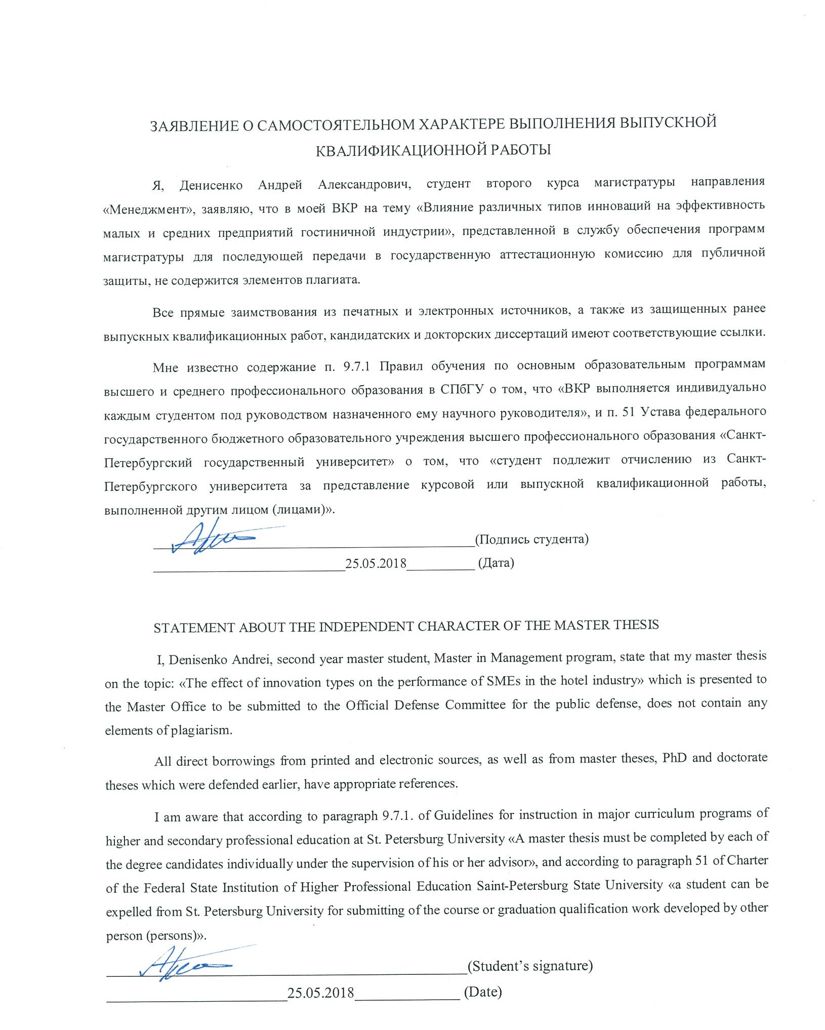
АННОТАЦИЯ
Автор | Денисенко Андрей Александрович
Название ВКР | Влияние различных типов инноваций на эффективность малых и средних предприятий гостиничной индустрии
Направление подготовки | Менеджмент
Год | 2018
Научный руководитель | Чуракова Ийя Юрьевна
Описание цели, задач и основных результатов | Целью исследования является изучение взаимосвязи между внедрением определенного типа инноваций (или сочетания нескольких типов) c изменениями показателей деятельности малых и средних гостиниц.  Задачи исследования: определить связь между интенсивностью типов инноваций и изменениями в показателях деятельности гостиниц; сравнить влияние каждого типа инноваций на производительность гостиниц; определить, является ли фокус на одном типе инноваций более эффективным, чем внедрение нескольких типов инноваций.  Выявлена положительная средне-слабая связь между интенсивностью инноваций и изменениями в показателях гостиницы. Установлено, что только определенные комбинации типов инноваций связаны с изменениями в показателях отеля, существенно отличающимися отелей с низкой инновационной активностью. Внедрение нескольких типов инноваций оказало более широкое влияние на показатели отеля по сравнению с внедрением одного типа инноваций.
Ключевые слова | Инновации, малые и средние предприятия, гостиничная индустрия, типы инноваций.
ABSTRACT
Master Student’s Name | Denisenko Andrei
Master Thesis Title | The effect of innovation types on the performance of SMEs in the hotel industry.
Main field of study | Management
Year | 2018
Academic Advisor’s Name | Churakova Iya
Description of the goal, tasks and main results | The goal of the research is to investigate the relationship between the implementation of single innovation type or a combination of multiple innovation types and changes in performance of small and medium-sized hotels.  Study was designed to: determine the association between the intensity of innovation types and changes in hotel performance; compare the effect of each innovation type on hotel performance; determine if the focus on a single innovation type is more effective rather than the implementation of multiple innovation types.  Positive medium to weak strength of association between the intensity of innovation types and changes in hotel performance was found.  Only particular combinations of innovation types are found to be associated with changes in performance that are significantly different to changes in performance of hotels not engaged in innovation activities.  Implementation of multiple innovation types found to have a broader impact on the performance of the hotel compared to the implementation of a single innovation type.
Keywords | Innovation, SME, Hotel industry, innovation types.
Table of Contents
Introduction……………………………………………………………………… | 7
CHAPTER 1 THE STATE OF ART OF INNOVATION IN HOSPITALITY……….. | 10
1.1 Definition of innovation……………………………………………………………. | 10
1.2 Hotel SMEs and innovation activity……………………………………………… | 11
1.3 Typology of innovation in the hotel industry……………………………………… | 13
1.4 Innovation as a source of competitive advantage………………………………… | 16
1.5 Factors that affect innovation process in an organization………………………….. | 17
1.6 Sources of innovation in the organization………………………………………….. | 19
1.7 Research gap……………………………………………………………………….. | 20
1.8 Conclusion of Chapter 1…………………………………………………………… | 22
CHAPTER 2 METHODOLOGY……………………………………………………… | 24
2.1 Innovation types…………………………………………………………………… | 24
2.2 Research method…………………………………………………………………… | 26
2.3 Data collection…………………………………………………………………….. | 26
2.4 Description of the hypothesis testing process……………………………………… | 30
CHAPTER 3 FINDINGS AND DISCUSSION……………………………………….. | 33
3.1 Review of the sample……………………………………………………………… | 33
3.2 Preliminary analysis of data……………………………………………………….. | 34
3.3 Analysis of the respondents……………………………………………………….. | 35
3.4 Reliability analysis………………………………………………………………… | 37
3.5 Analysis of correlation between the innovation intensity and changes in the performance metrics…………………………………………………………………… | 41
3.6 Grouping the respondents according to the intensity of each innovation types…… | 42
3.7 Analysis of existing combinations of innovation types……………………………. | 47
3.8 Results and outcomes……………………………………………………………… | 55
3.9. Conclusion of Chapter 3…………………………………………………………... | 58
chapter 4 Conclusion and implementations…………………………. | 60
4.1 Theoretical contribution…………………………………………………………… | 61
4.2 Practical implications……………………………………………………………… | 61
4.3 Limitations and recommendations for further research…………………………… | 62
LIST OF REFERENCES.…………………………………………………………… | 63

Introduction
Background
Innovation is considered as a major source of competitive advantage of the company and economic growth of the region (Evangelista, 2000). However, the majority of studies are focused on innovations in the manufacturing sector and are having difficulties in applying its theories to service industries due to their particularities. Specifically, the particularity of the hotel industry is intangible and experiential nature of its products and services. Hospitality and tourism is one of the world’s largest service industries with a global direct and indirect economic contribution of almost 7.6 trillion USD (10.2% of global GDP) (World Travel and Tourism Council, 2017) in 2016; however, there are few studies devoted to hotel innovation compared to other sectors.
Traditionally, innovation has being studied regarding the manufacturing industries. At the same time, service industries, specifically a hospitality industry, have certain attributes that distinguish them from manufacturing, such as:
- intangibility of the product or services,
- simultaneous production of services by a company and consumption by a customer,
- short shelf life of the product,
- no possibility for testing the product or services.
Paget et al. (2010) observe that tourism innovation was increasingly becoming a topic of research and has noted that tourism innovation research is unusual, scattered and fragmented. He also stated that measuring innovation and even defining it is still a challenge for a hospitality industry
Many authors agree that innovation is a critical source of competitive advantage and one of the most significant factors of a firm’s performance (Bogliacino et al., 2013).
Purpose of the study
The importance of innovation not only for SMEs but businesses of all sizes has been pointed out as crucial for profit, growth, and survivability of the firm by many researchers and the ability to innovate has been called a “secret sauce” of business success (Christensen, 2008)

The research subject is the innovation activity of small and medium-sized hotels and its impact on firm performance. The main goal of the research is to investigate the relationship between the implementation of single innovation type or a combination of multiple innovation types and changes in performance of small and medium-sized hotels.
To achieve this goal data from 151 hotel managers or hotel owners was collected and analyzed to:
- Determine the association between the intensity of innovation types and changes in hotel performance;
- Compare the effect of each innovation type on hotel performance;
- Determine if the focus on a single innovation type is more effective rather than the implementation of multiple innovation types;
Following research questions were formulated:
- Do different types of innovation associated with changes in hotel performance?
- Is there a difference in changes in performance of hotels that implement different innovation types or their combinations?
The quantitative research method was applied to answer the research questions. Primary data was collected by means of a self-administered questionnaire to evaluate the rates of innovation activity of a particular type of innovation; to assess changes in hotel performance over the period of 3 years.
A correlation analysis followed by a series of tests were performed to determine statistically significant differences in changes in performance between groups of hotels that are focused on the implementation of different innovation types.
Research results demonstrate a weak but positive association between the intensity of the implementation of each innovation type and changes in hotel performance. Changes in performance of hotels not actively engaged in innovation activities were compared to changes in performance of hotels that implemented different combinations of innovation types. Focus on the implementation of the following innovation types found to have significantly more positive changes in hotel performance:
- Product, marketing and managerial innovations;
- Process and marketing innovations;
- Product innovation;
- Marketing innovation;
- Product, process, marketing and managerial innovations.
Structure of the study
This paper consists of 3 chapters. The first chapter describes particularities of the hospitality sector, importance and impact of innovation for small and medium-sized hotels, current state of the research on innovation for the hotel industry, identifies research gaps. The second chapter describes the methodology required to answer research questions stated in chapter one. The third chapter includes analysis of data, research results and their interpretation. Conclusion states limitations of the paper and suggestions for future research, theoretical and practical implications of the master thesis.
This paper contributes to the research on innovation in the field of hospitality, provides hotel managers and hotel owners of small and medium-sized hotels with information on the effectiveness of particular innovation types, determines two combinations of innovation types that found to be associated with changes in hotel performance that are statistically more positive compared to other innovation types.

CHAPTER 1 THE STATE OF ART OF INNOVATION IN HOSPITALITY.
1.1 Definition of innovation
According to Goswami & Matheew (2005), the understanding of term “innovation” differs across industries and companies. The first definition of innovation was given by Schrumpeter (1939) who referred to an innovation as “…a technological change in a production of commodities already in use, the opening of new markets and new sources of supply, improved handling of material and any other “doing things differently” in the realm of economic life”. Although given definition is widely accepted in a scientific community, it bears a close relation to manufacturing industry and does not encompass all of the particularities of a service industry.
Essential characteristics of a service industry, compared to manufacturing industry, were introduced by Sirilli and Evangelista (1998) and stressed the importance of close interactions between production and consumption, the intangibility of services, importance of human resources and organizational culture. Additional characteristics of service industry were discussed by Miles (2008) and include intangibility, interactivity, inseparability, and variability of services, weak protection of intellectual property. Above mentioned characteristics of service industry contributes to difficulties in measuring innovation.
According to Hipp and Grupp (2005) differences between service and manufacturing innovations could be explained by following factors:
- Human factor. Personal skills and experience contribute to the efficiency of a service sector to a larger extent compared to a manufacturing sector;
- Innovation process. In services, compared to manufacturing industry, an organizational process does not focus primarily on R&D department;
- Innovation output. Pressure to continuously innovate is higher in a service sector because service innovations are easier to copy;
- Intangibility of output product (service);
- Customer integration. The customer is directly involved in the process of service delivery.
A definition of service innovation was proposed by Hall and Williams (2008) and includes all activities that lead to a product creation and development or aimed to solve a specific problem. According to a given definition, activities such as cost cuttings, reorganization of organizational structure, remodeling of a budgetary system, generation of new processes, products and services are also considered to be an innovation.
This research implements the definition provided by the Organization for Economic Co-Operation and Development: “An innovation is the implementation of a new or significantly improved product (good or service), or process, a new marketing method, or a new organizational method in business practices, workplace organization or external relations.” (OECD, 2005).
The hotel industry has specific characteristics. Therefore, the approach for innovation should not be the same as in other sectors or industries. Due to the intangibility of hotel products, inseparability of production and consumption and high influence of human factor the innovations in hotel industry are dissimilar to ones in manufacturing (Hjalager, 2010).
Studies of Nievis and Diaz (2015) demonstrated a vital role of intangible resources, spesifically human resources, in accomplishing the success of innovation and consequently improving financial performance of hotels.

1.2 Hotel SMEs and innovation activity.
In many nations, the small enterprise sector is the largest and most dynamic element in the economy. Accordingly, SMEs and innovations are closely associated with each other, and it has been a specified goal of nations and organizations to enable SME to “fulfill their role in boosting investment, creating jobs and achieving social cohesion” (OECD, 2015).
European Commission (2003) defines SMEs as enterprises employing less than 250 employees. Additionally, SMEs could be split into three categories:
- Micro, employing less than 10 persons;
- Small, employing from 10 to 49 persons;
- Medium, employing from 50 to 250 persons.
Small firms are argued to be more likely to innovate because they show a more flexible climate for quick decisions, fewer formalities and standards, a more flexible structure, motivated staff, greater capacity for adaptation and improvement, and less difficulty in adopting and implementing changes. Damanpour (2010) states that according to following particularities SMEs are more oriented to innovation: a more responsive climate for making quick decisions. At the same time, large organizations are benefitting from having the ability to resolve better complex situations, to spread of portfolio risks, the ability to support large internal research and development, greater levels of technological resources and skills, economies of scale and scope, and greater access to external capital. Knight (2001) in his study points out the fact that times of implementing new technologies and responding to emerging buyer needs are shorter for smaller firms.
Small enterprises often have informal R & D, and the share of SMEs involved in formal cooperation agreements appears to be much lower than in the case of large enterprises. Additionally, smaller firms are considered more profitable regarding innovation when comparing their innovative results with costs (Laforet, 2013).
Following internal factors (fig. 1.1) that compromise an ability of SMEs to innovate were identified by Demirbas et al. (2011).
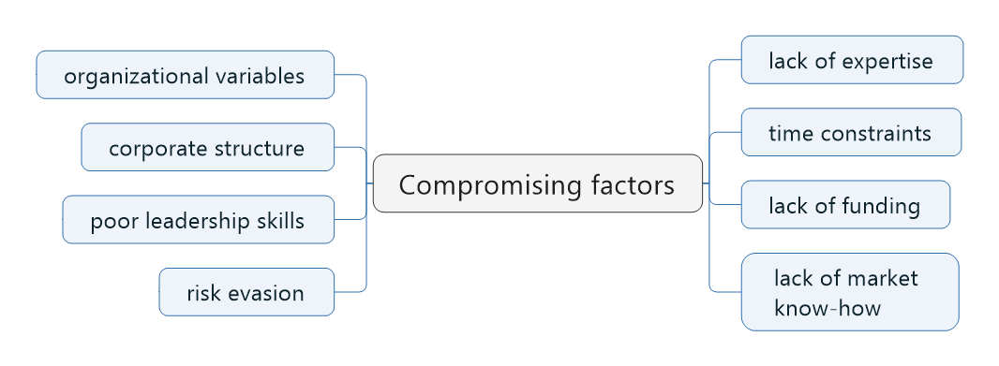
Figure 1.1. Factors compromising the innovative ability of SMEs.
Their study also pointed out that SMEs lack an ability to identify market opportunities, track current technological trends, efficiently manage knowledge, effectively participate in networking.
Studies made by Knight (2001) pointed out following barriers of SMEs to innovate: resource constraints, lack of capabilities and market power compared to large corporations. Impact of financial obstacles is particularly underlined as a decisive factor for innovation, as in case of innovation project failure survival of SME is at considerable risk.
Pikkemaat (2008) found that SMEs are dependent on the external sources of information to maintain the innovation processes. Even though small enterprises can demonstrate high rates of innovation, the resource constraints are usually an obstacle.
A study performed by Sundbo (2007) shown a positive influence of tourist size and the amount of innovation that took place. The study also pointed out that among tourist companies, hotels shown the highest rates of innovation processes. The positive relationship between the size of a company and its innovativeness was supported by Lopez (2011). Her study also pointed out that belonging to a hotel chain has a positive influence, as well as that the organizational change induce innovation decisions. Lopez (2011) also suggests in her study, that the lack of quality personnel slows the innovative process, although does not stop it.
Contrary to previous studies, Grimpe and Kaiser (2010) found a negative relationship between company size and innovation performance. However, their study included multiple sectors of a service industry.
Greco, Grimaldi, and Cricelli (2015) did not find any correlations between the size of a company and its innovation performance in their literature review and suggest many other factors to be relevant. The overall impact of firm size on innovation is still inconclusive. Revilla & Fernandez (2012) in their study also agrees that the overall impact of firm size on innovation is still not decisive.
Studying small family-owned firms in the tourism sector, Brooker (2014) concluded that the traditionally used methods of measuring an innovative activity, such as expenses on R&D and the number of patents, are not applicable for this sector. Companies in a hotel industry prefer to copy ideas that have already been introduced and tested. Small businesses prefer to imitate existing concepts because they cannot spend money and time on research.

1.3 Typology of innovation in the hotel industry.
According to Johansen et al. (2001), different innovations carry different degree of novelty. He indicated three types of innovations: incremental, radical and disruptive. Incremental innovation carries linear and minor improvements of current technology. Radical innovation involves fundamental improvement that was caused by a revolutionary change in technology. Disruptive innovation is an innovation that introduces new attributes to the existing market or creates new markets. The hotel industry is mostly represented by the incremental type of innovation (Hjalager, 2010).
Pikkemaat and Peters (2008) categorized innovations by functioning areas. They had distinguished ten specific areas of innovative activities: quality assurance, gastronomy, marketing, human resources, product bundling, wellness, information technology, operational procedures, strategy development, animation.
Hjalager (2010) categorize innovations in the hospitality industry as following: product, proses, managerial, market and institutional innovations.
Product (service) innovations referred to changes observed directly by the customer and considered new either in the sense that they were never seen before or are new to a particular company or goal. Innovations in products or services are regarded by tourists to the extent of being a factor in making a purchase decision.
Process innovations refer to back-office processes that aim to improve efficiency and productivity. Technical investment is the predominant source of process innovation with a combination of redesigned layouts of manual operations. Research has shown that productivity in the hospitality industry can be enhanced by implementing new Information and Communication Technologies (ICT), however the effect is improved when ICT innovation is aligned with other strategic and managerial practices such as knowledge and human resource management. Process innovation can be a platform for improving services that will be recognized by customers and add value to the product, but empirical research has shown that the hospitality industry uses technology primarily to improve operational efficiency and reduce costs.
Managerial innovations offer new ways of organizing internal collaboration, directing and empowering staff, building careers and compensating work with pay and benefits (Ottenbacher et al., 2005). Managerial innovations also improve workplace satisfaction and raise internal corporate knowledge and competencies. “The main challenge for tourism enterprises is to develop methods to retain staff, maintain flexibility and control costs.” (Hjalager, 2010).
Marketing innovations include new marketing concepts that change the way how overall communication with customers is undertaken. An example of such innovation is loyalty programs that changed the relationship between customers and hotels from a single purchase to an exchange of loyalty and intangible complements. These programs provide benefits to the clients, at the same time providing the company with valuable information about clients’ preferences, so that company can develop actions to improve customer loyalty and satisfaction. (Hjalager, 2010).
“A marketing innovation is the implementation of a new marketing method involving significant changes in product design or packaging, product placement, product promotion or pricing” (OECD, 2005). The use of new pricing strategies for services is another type of marketing innovation that allows companies to change the price of services according to the demand (OECD, 2005). And the implementation of digital channels allows to avoid intermediaries and decrease costs for the hotel and for the customer (Hjalager, 2010).
Institutional innovations, according to Lashley and Morrison (2000), are collaborative structures or legal entities that are aimed to improve the business in a particular sector. Franchising and licensing are also considered as institutional innovations that introduces innovative processes to a developing economies. Certification organizations belong to the same category of institutional innovation, including several entities that are responsible for control, development, and promotion. (Hjalager, 2010). The role of the state as a planner, legislator, regulator, sponsor, stimulator, promoter, and protector is also in high regard in such studies. Hjalager et al. (2010) outline the more inclusive and interactive roles of public agents in innovation systems, for example allying the resources of educational systems with the commercial partners, facilitating trade with intellectual property and acting as ‘‘intelligent consumers’’.
Table 1.1. Classes of innovations
By industry | Manufacturing, service
By intensity | Incremental, radical, disruptive
By novelty | New to the world, country, industry, company
By content | Product, process, managerial, marketing, institutional
By function | quality assurance, gastronomy, marketing, human resources, product bundling, wellness, information technology, operational procedures, strategy development, animation
Sources: OECD (2005), Hjalager (2010), Pikkemaat and Peters (2008), Johansen et al. (2001),

1.4 Innovation as a source of competitive advantage.
Some studies are concerned with the influence of innovation activity of a corporation on competitiveness, cost structure and market attractiveness. Hall and Williams (2008) notice a positive influence of innovativeness on the ability of a company to survive. Study of Victorino et al. (2005) across multiple North American hotels shown an empirical evidence that corporations that do innovate gain competitive advantage and consumer preference.
Grisseman (2013) had observed that hotels that do innovate are more successful in developing new products and services compared to their non-innovative competitors. His study found following factors of firm innovative behavior:
- employee engagement,
- customer engagement,
- information technologies,
- innovation management,
- innovation networks.
Innovation requires considerable financial and human resources. Therefore, while innovation could potentially improve operational performance of the hotel, high costs of innovation can be translated to the decrease in the financial performance. Innovation can affect the financial performance of the company in the indirect way, resulting in the improvements in customer satisfaction, competitiveness and brand value. Due to the indirect interaction between innovation and financial performance, a time lag may occur, meaning that innovation would impact financial performance only after a certain period (Nieves and Diaz-Meneses, 2016).
However, a direct and positive relationship has been proven to exist between innovative outcomes and business performances in the Andalusian hospitality industry (Martinez-Roman et al., 2015). A later analysis led to a positive change in profitability once the level of innovation in products and processes had been increased. Sandvik et al. (2014) found a positive effect of innovative activity on Norwegian hotel profitability. Similarly, Haim and Kaliappen (2015), when analyzing the Malaysian hotel industry, found an active link between process innovation, especially in the case of larger hotels, and their performance, identifying innovativeness as a key strategy of the firms. The confirmation of this relationship is a relevant finding for research on innovation in tourism
The importance of innovation not only for SMEs but businesses of all sizes has been pointed out as crucial for profit, growth, and survivability of the firm by many researchers and the ability to innovate has been called a “secret sauce” of business success (Christensen, 2008)

1.5 Factors that affect innovation process in an organization.
Study of Smith et al. (2008) finds that following factors effect company’s capabilities to innovate:
- Management style;
- Leadership;
- Resources;
- Organizational structure;
- Corporate strategy;
- Technology;
- Knowledge management;

For the large chain hotels innovations are transferred from head offices to regional units, together with an embedded knowledge, capital and managerial capacities. Therefore, an incorporation of a firm into business chains and networks plays an important role for knowledge transfer processes in hospitality industry. For small hotels open innovation is found to be a viable option and in some cases a requirement (Lichtenthaler, 2011).
Ottenbacher (2005) identifies the determinants of innovation in the hotel industry as follows: market selection, strategic management of staff, training of employees, response to the market, marketing synergy, employee commitment and tangible quality.
Additionally, Orfilastines (2009) advocates that that customers’ requests increase a hotels’ chances to innovate. At the same time, managers’ lack of experience has a negative influence on innovation.
Study of Nieves (2014) has shown that organizational knowledge and the external social relationships of managers influence product, process, and marketing innovation. The results suggest that high levels of knowledge regarding the overall business environment and efforts to engage with people or entities outside the organization significantly contribute to the achievement of innovation in the hospitality industry. This suggests that the introduction of innovations in hotel companies is linked to knowledge existing beyond organizational boundaries.
Another study by Nieves (2015) also shown that improving the capacity for innovation can also be achieved by relying on agents outside the organization. However, this study finds that the managers’ relationships with entities outside the organization do not show a significant connection with management innovation. The results suggest that the specific and personal nature of management innovation hinders the transfer of knowledge from external organizations. Thus, managers will not be able to absorb this type of knowledge to implement their own management innovations.
Hjalager (2010) in her research notes a lack of comprehensive empirical evidence to explain factors of driving forces in innovation systems, however, she considers human relations and inter-organizational structures as important ones.
The study of Hall (2009) shows that the rates of innovation in the hospitality industry are comparable to levels of innovations in other service industries. However, findings of Evangelista (2000) contradict statement described above: her empirical research has shown that in Italy 20% of hotels and restaurants innovate, compared to service industry average of 31%. She also found that knowledge sharing expenses per employee in the hospitality industry are the lowest compared to other service sectors. This phenomenon, however, might be explained by regional particularities. At the same time, the study of Christensen (2008) confirmed low level of innovativeness in the hospitality industry. It can be noticed that further research on the rates of innovation in the hospitality industry is required.
Pikkemaat (2008) studied the dependence of the size of a hotel to its ability to innovate. He finds that innovation in the hospitality sector is highly dependent on the size of a company. However, the impact of seasonal factors is also crucial. Latter finding is indirectly confirmed by Sundbo (2007), who compare innovativeness in Spain and Denmark. He also concludes that franchised units innovate less compared to chain hotels.
Research of Hoelzl et al. (2005), where ‘‘creative imitation’’ was studied as a special mode of innovation in tourism, points to managerial quality as an important prerequisite. They pointed out an importance of managerial skills (in particular, product and group management skills) and corporate culture for the development and adoption of innovation; team culture and an ability to share knowledge mentioned as facilitating factors as well. At the same time, the study of Christensen (2008) does not provide enough evidence to support the significance of the competence of the proprietor. Findings of Pikkemaat (2008) showed that entrepreneurs involved in business networks are proved to be more innovative compared to ones that do not utilize their networking capabilities.
At the same time, results of (Nievis and Diaz, 2015) provide no support for absorptive capacity, measured as the percentage of employees with higher education, moderating the link between external social relationships and firm innovation performance. The data suggest that, in the hospitality sector, knowledge incorporated from outside sources is free of technological complexity, and therefore employees do not need to be highly qualified to understand, assimilate and use it (Nievis et al., 2014).

1.6 Sources of innovation in the organization.
According to Christensen (2008), hospitality corporations rarely have a dedicated Research and Development department. Still, corporations do innovate, although the process of acquiring new knowledge is more complex and informal.
Rogers (2007) states that implementation of new technological solutions leads to the re-engineering of internal processes. This explained by the fact that technology, especially ICT, is embedded with a substantial amount of knowledge that is discovered by a corporation during the process of implementing new technology. Such purchase of knowledge allows a company to avoid R&D costs and associated risks.
According to Behara (2000), significant knowledge is available inside the corporation in the form of tacit knowledge. However, in order to influence innovation process, tacit knowledge should be transferred into explicit knowledge and then processed by the employees. Hjalager (2010) states that in tourism research an understanding of the mechanisms of above-mentioned innovation processes is still only fragmentary and that knowledge management is not yet widely regarded as a significant discipline in the tourism business. Her research shows that relationships between entrepreneurs and academia has a low impact on innovation capabilities of a company, compared to the influence of the relationships between suppliers and customers.
According to Lynch and Morrison (2007), single networks are considered essential for the fostering of innovations, particularly in small and medium-sized enterprises. Due to their smallness and resource constraints, SMEs cannot by themselves cover all activities necessary to introduce innovation and thus innovation in small companies almost always includes an external component. Another study confirms the importance of networks in innovation activity of SMEs. This importance also explained by the lack of financial and technological resources, market knowledge and managerial experience. (Pikkemaat, 2008).
Pechlaner et al. (2005) underlines the fact that the effect of free-riding is common in the tourism industry and because of that network collaborations are associated with high indirect costs by many SMEs. A balance between cooperation and competition is essential for such processes, as well as an accepted and trustworthy leadership (Hjalager, 2010). To overcome that fact the implication of certain policies is suggested for the effective network collaboration.
Ribarik (2014) also confirms the role of networks as one of general potential drivers of innovation behavior. He concludes that innovation activities are connected with innovation behavior, and, when implemented in conjunction with other stakeholders, increase their efficiency.

1.7 Research gap.
Studies suggest a positive relationship between the innovation activity of the hotel on the one hand and the improvements in the performance on the other hand. According to the Nieves and Diaz-Meneses (2016), in the hospitality sector research is primarily focused on product and service innovation, while other types of innovation such as marketing and managerial are being understudied.
At the same time, the empirical comparison of the impact of different types of innovation in hospitality industry is not exhaustive.
Types of innovation were identified by Hjalager (2010), in her study it is suggested that different types of innovation may provide a different degree of efficiency, depending on which the stage of a business process an innovation of a particular type was implemented. Only one study by Mattson and Orfila-Sintes (2014) was carried out to investigate the relationship between innovation types and the hotel performance. In their research two combination of innovation types were found to be relevant to the increase in the performance. However, the performance was measured only by the occupancy rates and revenues, not taking into the account changes in the cost structure of the hotel, as well as the perception of service quality from guest perspective.
Considering that SMEs are limited in their capacity to innovate due to resource constraints, the identification of the most efficient types of innovation is essential for the survival of the company.
The goal of this research is to fill the research gap by providing an empirical comparison of the effect of different types of innovations on hotel performance.
Research gap: Effect of innovation types and their combinations on the hotel performance.
Research goal: Investigate the relationship between the implementation of single innovation type or a combination of multiple innovation types and changes in performance of small and medium-sized hotels.
Research questions:
- Do different types of innovation associated with changes in hotel performance?
- Is there a difference in changes in performance of hotels that implement different combinations of innovation types?
Multiple studies (Orfilasintes and Mattsson, 2009; Tajeddini, 2010) in a hotel sector found a positive relationship between product and process innovations and business performance, although the studies are lacking an empirical evidence to support findings.
Bharwani and Mathews (2016) in their research found an immediate positive impact of product innovation as well as process innovation on the level of service experienced by the guests, compared to the marketing and managerial innovations with deferred positive effect on customers over a period of time. Study of Nieves and Diaz-Meneses (2016) also found positive influence of marketing innovation on the financial performance of Spanish hotels.
It is also acknowledged by the number of researchers (Hall, 2009; Demirbass et. al., 2011; Grissemann et. al.; 2013) that in a hospitality sector research results on innovation are different from region to region. According to the Carlborg et. al. (2014), most of the research is focused on Northern and Western Europe, North America and Taiwan. The same study also underlines the importance of innovation research in countries with the developing economies. As for the Russian Federation, no quantitative research was found on the topic of innovation activity and its impact on business performance of Russian hotels.
H1a: Product innovation positively impacts business performance;
H1b: Process innovation positively impacts business performance;
H1c: Marketing innovation positively impacts business performance;
H1d: Managerial innovation positively impacts business performance.
It is also assumed by Orfilasintes and Mattsson (2009) that intensity of the impact on performance varies among innovation types. Additionally, as was suggested in the study of Damanpour (2010), combining multiple types of innovation the synergy effect can be achieved, which in turn results in a stronger impact on the performance compared to the implementation of a single type of innovation. Results of the research made by Mattson and Orfila-Sintes (2014) also supports this idea. Nieves and Diaz-Meneses (2016) specifically suggests that marketing innovation has an ability to foster the effectiveness of product and process innovations, however, study also mention that in the hospitality sector no empirical research exists that would support this suggestion.
At the same time, due to the resource constraints, SMEs could benefit from concentrating on only one type of innovation instead of implementing multiple innovations simultaneously (Demirbas, et. al., 2011). Similar suggestion was stated in the research of Nieves and Diaz-Meneses (2016) where innovative activity is proposed to be associated with the decrease in firms’ financial performance due to high costs.
H2: Changes in the performance of the hotel depend on the implemented innovation type or a combination of multiple innovation types.

1.8 Conclusion of Chapter 1.
Tourism is different from manufacturing industry, therefore the traditional approaches of measuring innovation intensity with regards to R&D activity must be partly or fully changed to address the particularities of a tourism industry.
Comparison of studies shown an influence of the geographic location of an enterprise (as the result of the impact of various external factors), however, the explanation of that fact is general. “There is a lack of consistency in definition and measurement of rates of innovation, which could facilitate comparisons across industry sectors and national borders” (Hjalager, 2010).
Studies focused on the relationship between the size of a company and its innovation activity showed contradictory results. The majority of studies demonstrated that larger companies are more likely to innovate. This phenomenon is explained by the influence of multiple factors, primarily associated with financial constraints and market knowledge. However, most recent study (Greco et al., 2015) shown no correlation between the size of a company and its innovation activity.
Certain innovations can be highly visible and, therefore, difficult to protect. Innovation processes in a hotel industry are labor-intensive and relying on a highly qualified employees to provide with new ideas. Because of that, SME’s usually demonstrate an inclination to free-ride and be late and safe adopters.
There is an incomplete understanding of how innovation process take place in tourism organizations, including what types of capacities and incentives are required for innovation process to be successfully implemented. It is acknowledged that innovation in hospitality is mostly incremental and adaptive. Consumer-driven innovation and the inclusion of consumers in innovation processes is a particularity of a service sector that does not have much cover in research, although is highly applicable in hospitality, where consumer-producer interaction is closer than for many other types of enterprises. (Hjalager, 2010).
Studies devoted to the measurement of the effect of specific innovation types are scarce and lacking quantitative evidence. Most studies focus on the effect of product and process innovations, and although positive influence is found in these studies, no comparison was made between the effect of each innovation type on hotel performance.

CHAPTER 2 METHODOLOGY.
2.1 Innovation types.
This research is focused on comparing the effect of different innovation types on hotel performance. According to the studies made by Bharwani and Mathews (2016) and Nieves and Diaz-Meneses (2016) innovations may have direct and indirect effect on the performance of the hotel. A direct effect is represented by an increased operational flexibility that implies a decrease in operational expenses and increase in the market performance. Indirect effect is represented by increase in customer satisfaction, competitiveness and improvement of the corporate image (Campo et al., 2014).
To test the stated hypotheses analysis of the following information is required:
- Rates of innovation activity of the hotel according to the selected typology within the defined period;
- Changes in business performance of the hotel within the defined period.
Innovations have been classified by following categories with the regard to:
- intensity – incremental, radical, disruptive;
- novelty – new to the world, country, industry, company;
- type – product, process, organizational, marketing, institutional, etc.
This research implements the most adopted typology that was offered in OECD and Eurostat (2005) guidelines for national industry censuses and includes four main innovation types: product and service innovation, process innovation, organizational (management) innovation and marketing innovation. OECD typology is used in this research to provide comparability of the results across countries and industries.
Business performance is typically measured by assessing profitability, sales growth and return on investment (Mairesse and Mohren, 2010), however in a hotel industry measures of a firm’s performance is difficult due to the special characteristics of the industry. In this study, performance would be assessed by changes in financial and non-financial performance measures with the respect to the previous period. Measures of performance that are commonly used in the hotel industry are the occupancy rate, revenues, revenue per available room, expenses, market share, image, the percentage of returning customers, customer satisfaction, return on investment, profitability (Alvarez et. Al. 2001).
Table 2.1 Types of innovation according to OECD and Eurostat (2005)
Innovation type | Description
Product and service innovation | Product and service innovations are new or improved products or services. These innovations are focused on a customer and come in a form of new product design, new product features or new components. It also includes utilization of new materials, product or process features.
Process innovation | Process innovations are new or improved processes that aim to increase efficiency and productivity. It is achieved by implementing more efficient methods of production, new equipment, increase in automation and ease of use, introduction of energy saving practices.
Organizational innovation | Organizational innovations are new or improved methods of organizing administrative processes, organizational structure, external relations with suppliers and government regulators. Goal of organizational innovation is to reduce turnover, reduce costs and increaseThis type of innovation also reflected in significant changes in the organizational behavior and management of human capital inside the company.
Marketing innovation | Marketing innovations are new marketing methods. These methods usually include changes in product design, price strategy and promotional strategy, implementation of new distribution and promotion channels (Nicloau, Santa-Maria, 2013), new types of interactions with external stakeholders such as tourist companies, social organizations could also be interpreted as marketing innovations (Sundbo, 1998).
Sources: Ottenbacher and Gnoth (2006), Hall (2009), Hjalager (2010), Camison and Monfirt-Mir (2012), Nicolau and Santa-Maria (2013)
2.2 Research method.
There are three categories of research methods: quantitative, qualitative and mixed (Williams. 2007). Quantitative research implements statistical and mathematical techniques to perform empirical study of the observable phenomena. The goal of quantitative research is to develop mathematical theories and hypotheses to provide explanation of the phenomena and to make future predictions (Creswell, 2003). The aim of qualitative research is to provide an explanation of phenomena using non-numerical tools (Williams, 2007).
According to Hjalager (2002), information used to detect innovation in hospitality industry comes from the primary source – the industry itself. This fact can be explained by the fact that SMEs in the hospitality industry do not carry research and do not register patents.
In this research, the primary data source is used in order to the intensity of innovation, and the combination of primary and secondary data sources to determine changes in the hotel performance.
2.3. Data collection
In the hospitality and tourism research the primary data can be collected using following methods:
- Survey
- Experimental
- Ethnographic
Self-administered Survey methods are most often used for data collection (35.1%) in tourism and hospitality industry (Law et al. (2012). Line and Runyan (2012) also revealed that the field survey is the dominant research design in hospitality marketing studies.
Experimental methods are less common, and the issue of the lack of causal research was addressed by Matilla (2004).
The survey can be defined as a research method that is used to collect primary data in the form of responses of individuals. This method is mainly used to collect quantitative data, which ensure the high extent credibility of the work. According to this method, a sample size of the population should be selected and targeted to get the reviews about particular problem.
Survey methods can be divided into three categories (Denscombe, 2010):
- Questionnaires
- Interviews
- Documentation review
Purpose of the questionnaire is to collect a large amount of data over a short period of time. Questionnaire is significantly cheaper than other primary data collection methods and allow participants to remain anonymous. The disadvantage of the questionnaire is a difficulty in performing an in-depth analysis.
Interviews are offering a more personal approach to data collection and provide the opportunity of asking a follow-up questions and ensure a better understanding of questions by the respondents. Disadvantages of the interview are higher costs (time, traveling), lower degree of anonymity.
Documentation reviews are performed to study the development of the phenomenon over a certain period of time and have a higher chance of providing a comprehensive and reliable information. The drawback is getting an access to documentation can be challenging.
In this research the data is collected using a pre-structured questionnaire. A pilot version of a questionnaire made in order to indicate the questions that might be difficult for a respondent to comprehend. The questionnaire is divided into three sections. The first section collects general information on the hotel – name, size, type and classification. In the second section, the firm’s intensity of the different innovation types would be assessed. In the second section changes in firm’s performance would be evaluated. Innovation behavior of the hotel would be measured over the three-year period addressing the issue of a time lag between the implementation of innovation and the effect.
This research is implementing a structured questionnaire. Because the research is studying the effect of different innovation types, the large sample is essential to ensure the presence of data from the companies with every combination of innovation types. Questionnaire was distributed using internet mailing services to overcome the issue of geographical dispersion of hotel companies in Russian Federation. Because hotel managers and business owners are usually sensitive to sharing performance results of their company, the ability to stay anonymous ensured higher response rates and more valid data. Online questionnaire also addressed the issue of different time zones, allowed the respondents to provide research data during the time when it was most convenient for them.
According to the research results of Gyurácz-Németh et al., (2016), hotel managers are mostly unfamiliar with the exact definition and meaning of the word “innovation” therefore questions were formulated in a way to avoid asking directly about the impact of innovation, instead respondents were asked about the frequency of the activities that are directly representing the process of innovation.
Sampling is a tool to select a portion of individual among a large size, so that research can target them to gather data and their responses, which represent the responses of large population (Fuller 2011). To distribute questionnaire, a mailing list was acquired from industry professionals specialized in marketing of products and services to companies involved in tourism and hospitality. The list included the contact information on 5000 hotels that was obtained from publicly available sources. Random check was performed to guarantee the credibility of information. Inspection of the list also indicated the absence of cities with the population lower than 250 000 citizens except for the cities with the orientation towards recreational tourism. Probabilistic and non-probabilistic are two important ways of sampling. Because questionnaire was distributed only within cities with population over 250 000 citizens, this study is using a non-probabilistic sampling method, acknowledging corresponding limitations.
Secondary data is represented by:
- Accounting records of companies that are obligatory for submission to the Federal tax service and state statistics, and that are later aggregated by companies such as SCREEN and SPARK. The process of extracting the data from SCREEN AND SPARK databases is performed as follows: according to the results of the survey, company name and city was used to determine the hotel website. Information on the legal name and address of the enterprise is extracted from the website, which further makes it possible to find the enterprise in the above-mentioned database systems.
- The assessment made by the hotel guests, which can be found on the Internet booking platforms, such as booking.com. The data search was carried out based on the name of the hotel and the city specified by hoteliers or hotel owners during the survey.
As was stated in Chapter 1, innovation may have direct and indirect effect on the performance of the hotel. Direct effect is characterized by changes in revenues and expenses and, as the result, hotel profit values. Indirect effect is represented by changes in customer satisfaction, level of service, market share and image.
To determine if the formulation of question is perceived as intended by the respondents; to review what business metrics are being used by small and medium hotels of Russian Federation; to analyze what business metrics are feasible to collect using online questionnaire, the pilot survey was conducted via phone, where the respondents were guided through the structure of the questionnaire.
Pilot survey confirmed that hotel managers are generally experiencing difficulties in interpreting the definition of each type of innovation, therefore it was decided to analyze the intensity of activities associated with each type of innovation. Each type of innovation included five to eight questions. Likert-type scale was used to determine the intensity of given activities ranging from the absence of the described activity to the activity being fully present within the given period.
Pilot survey also determined that hotel SMEs are lacking tools and resources that would evaluate the market share and brand image. Other performance indicators used by SMEs are basic by their nature and include revenues, expenses and occupancy rates. At the same time, because of the high degree of involvement of manager or business owner in the relationship with guests, respondents are well informed on how innovative activity affected the quality of service and, consequently, guests’ experience.
Results of the pilot study demonstrated the unwillingness of the respondents to provide the exact financial data, as well as any data related to profit figures, primarily due to the lack of trust and lack of time. Therefore, the final questionnaire includes the respondents’ subjective measures of changes in performance that are assessed by the five-point Likert-type rank scale ranging from the significant decrease in performance metric to the significant increase in the performance metric with the intermediary point of no changes in the performance metrics.
It was decided to use following performance metrics based on the results of the pilot survey:
- Changes in occupancy rates,
- Changes in revenues,
- Changes in the amount of expenses,
- Changes in customer satisfaction
- Changes in quality of services.
Final questionnaire includes 25 Likert-scale questions related to the intensity of innovation activity, five Likert-scale questions related to the measures of changes in hotel performance, five questions regarding general information on the hotel (type, size, classification, city, position of the respondent). Additionally, survey included three questions to control for the response bias; questions inquiring the obstacles that hotel managers were experiencing while performing innovative activities. In total, questionnaire included 30 Likert-scale questions, eight closed-ended questions, and one multiple-choice question. Questions aimed to indicate innovation intensity of each innovation type were treated as equally important, no correcting coefficients were introduced for each score.
Questionnaire consists of 4 question blocks. Block 1 includes question with regards to the general information on the hotel. Questions of block 2 are aimed to assess the intensity of four innovation types. Block 3 registers changes in hotel performance. Block 4 includes questions aimed to test for the response bias, asks the respondents what obstacles were experiences during the process of implementing innovations.
2.4 Description of the hypothesis testing process.
Hypotheses testing is done as following:
First, general information on the respondents is analyzed. For the research results to be generalized it is important for the sample to adequately represent the overall population. Therefore, sample should include representatives of main hotel types – business hotels, resort-hotels, mini-hotels and sanatoriums. Because this research is focused on small and medium-sized hotels, information on the size of the hotel is also gathered.
To test for non-response bias Mann-Whitney U test is performed between two group of respondents – first group includes responses that would be collected during the first mailing. The second group includes responses that would be collected during the second mailing.
To test for the respondents bias a Spearman’s rank-order correlation test is made between the responses collected using the questionnaire and data collected from the booking platform. Following variables are included in the correlation analysis – the quality of service, cleanliness and value for money. Results of the correlation analysis will show if the subjective metrics “changes in customer satisfaction” and “changes in quality of service” are perceived adequately by the respondents.
To test if each innovation type is associated with changes in hotel performance, a Spearman’s rank-order correlation test is made between the intensity of innovation types performed in the hotel and changes in the performance metrics. Because the intensity of innovation activity according to its type is identified using multiple Likert-scale questions, an average score for each type of innovation is calculated.
A non-parametric correlation test is used because the data collected using the Likert-scale questions is ordinal by nature and therefore non-normally distributed.
As had been shown in the research of Mattson and Orfila-Sintes (2014) hotels may not be concentrated on a single type of innovation and innovation activities can be performed with various intensities. It is suggested for each type of innovation to be characterized by the corresponding innovation intensity. For the purpose of this research, hotels are grouped according to three degrees of their innovation intensity – “low”, “medium” and “high”. Grouping is performed using k-means cluster analysis. K-means cluster algorithm is a partitional type algorithm separates data into a defined number of clusters that are as compact and as separated from one another as possible. (Ahmad, Dey. 2007).
After the intensity of innovation types is defined for the hotels participating in the research, hotels are grouped according to their focus on a specific type of innovation. It is assumed that hotels are focused on a particular type of innovation in case they are demonstrating high innovation intensity of this type of innovation. It is possible for the hotel to be focused on a single type of innovation, two, three or four types of innovations simultaneously.
Hotels that are characterized by the medium degree of innovation intensity are considered not to be focused on any particular type of innovation.
For the hotels demonstrating low intensity of every innovation type, it is assumed that the impact of innovation on business performance for this category of hotels is absent. Therefore, hotels with low degree of innovation are used as a performance benchmark.
Overall, hotel activity can be categorized by 17 possible outcomes:
- Hotel is focusing on a single type of innovation – 4 outcomes;
- Hotel is focusing on two innovation types – 6 outcomes;
- Hotel is focusing on three innovation types – 4 outcomes;
- Hotel is focusing on four innovation types – 1 outcome;
- Hotel is not focusing on any particular type of innovation, but demonstrating innovation activity - 1 outcome;
- Hotel is not engaged in innovation activity – 1 outcome.
To test for the second hypotheses, an independent-samples Kruskal-Wallis test performed. Results of the Kruskal-Wallis test determine if there is a statistically significant difference among groups of dependent variables, however the results only points out the presence of at least one group of variables that is statistically different to other groups. To identify groups with statistically different changes in performance a series of tests are performed between group pairs. For these purposes, a post-hoc Dunn-Bonferoni multiple comparison non-parametric test is used (Field, A., 2013).
Results of the Kruskal-Wallis test with a post-hoc Dunn-Bonferoni analysis would determine if there is a difference between changes in performance among groups of hotels that focused on a particular innovation type, thereby testing the H2: “Changes in the performance of the hotel depend on the implemented innovation type or a combination of multiple innovation types.”

CHAPTER 3 FINDINGS AND DISCUSSION
3.1 Review of the sample.
According to the official statistics, by March 2018 in Russian Federation there is 21 284 registered facilities for temporary accommodation, 40% of which described as an “alternative accommodation facilities” and include private apartments, hostels and motels. 12 770 companies can be described as the “traditional” accommodation facilities, such as hotels.
An appropriate sample size can be determined using Slovin’s formula (Galero-Tejero, 2011):
$$n= \frac{N}{1+{N(e)}^{2}}$$
Where: n – Sample size;
N – Population size;
e – The level of precision.
For this study a degree of variability of 0.05 and a confidence level of 95% are assumed.
The recommended sample size for traditional parametric analyses for given population is calculated at minimum of 388 respondents. In this research the sample size of 151 respondents is used. Not sufficient sample size for parametric tests gives additional support of utilizing non-parametric analogs that are less sensitive to the size of the sample.
Collection of research data was performed during March and April 2018. The questionnaire was distributed using “Mailchimp” mailing platform. Out of 5000 email addresses 4132 were successfully imported to the mailing platform. The first mailing has been made on March 19. The report indicated 86% of successful deliveries (3553 recipients), 30% open rate and 116 responses. The second mailing has been made on April 12 using the same mailing list but excluding already participated hotels. The second report indicated 27% open rate and 85 responses.
The overall response rate for the questionnaire is 5,6% (201 responses). No information on the appropriate email response rate in the tourism and hospitality industry research was found. Partially, low response rate can be explained by possible intermediaries – because the research is targeting hotel managers and business owners, cover letter to the questionnaire asked the recipient to pass the questionnaire to the manager or the owner. Gathered sample size represents 1,6% of overall population.
3.2 Preliminary analysis of data.
In the first part of the survey the respondents were asked to fill the information about their position in the company and to provide general information of the company such as the number of employees, hotel type and classification
Table 3.1 Position of the respondents
 |  | Number of respondents | Percentage
 | Receptionist | 48 | 24
 | Business owner | 56 | 28
 | Top manager | 49 | 25
 | Senior manager | 21 | 10
 | Middle manager | 28 | 13
 | Overall | 201 | 100,0

Because the questionnaire was supposed to be filled by the company representative with at least middle management position, responses filled by the receptionists (47 responses) were discarded from the study. Additionally, same answer responses were also excluded.
Data was collected using a Likert-type scale, meaning that variable scale is ordinal rather than interval. This results in data being not normally distributed, meaning that the statistical tools are limited to the non-parametric tools that are free of the assumption of normality.
To measure the reliability of the scale, Cronbach’s alpha test for question blocks 2 and 3 was performed.
Question block 2, innovation activity.
Cronbach’s alpha value of 0,950 indicates high level of internal consistency and reliability of scales used in the questionnaire (Hair et. al., 1998).

Table 3.2 results of a Cronbach’s alpha test for the question block 2.
Cronbach's Alpha Based on Standardized Items | Number of questions
,950 | 27

Inter-item correlation matrix showed no pairs of variables with correlation coefficient higher than 0,858, which means that each question in the block represents separate construct, although correlates to other constructs. Deletion of any item does not increase Cronbach’s alpha coefficient, indicating that no questions of the block 2 should be excluded from the questionnaire.
Question block 3, changes in the performance of the hotel.
Cronbach’s Alpha value of 0,790 indicates acceptable level of internal consistency and reliability of scales used in the questionnaire (Hair et. al., 1998).

Table 3.3 results of a Cronbach’s alpha test for the question block 3.
Cronbach's Alpha Based on Standardized Items | Number of questions
,790 | 5

Inter-item correlation matrix showed no pairs of variables with correlation coefficient higher than 0,862, which means that each question of the block represents separate construct, although correlated to some other constructs. Deletion of any item does not increase alpha coefficient, indicating that no questions of the block 3 should be excluded from the questionnaire.
Both blocks of questions can be characterized by good levels of internal consistency with no multicollinear variables.
3.3 Analysis of the respondents.
Hotel size
47,7% of the sample represented by “micro-sized” hotels with less than 10 employees.
29.1% of the sample represented by “mini-sized” hotels with the number of employees ranging from 10 to 50.
23,2% of the sample represented by “medium-sized” hotels with the number of employees ranging from 51 to 250.
Table 3.4 Distribution of the respondents according to the hotel size
 |  | Number of the respondents | Percentage
 | Micro-sized hotel (<10 employees) | 72 | 47,7 %
 | Mini hotel (10 – 50 employees) | 44 | 29,1 %
 | Medium-sized (50 – 250 employees) | 35 | 23,2 %
 | Total | 151 | 100,0 %

Hotel type
Most of the sample is represented by mini- and business hotels (41,1% and 34,4% respectively), followed by resort hotels and sanatoriums (12,6% and 6,6%).
Table 3.5 Distribution of the respondents according to the hotel type
 |  | Number of respondents | Percentage
 | Mini-hotel | 61 | 41,1 %
 | Business hotel | 52 | 34,4 %
 | Resort | 19 | 12,6 %
 | Sanatorium | 10 | 6,6 %
 | Missing | 8 | 5,3 %
Total |  | 151 | 100,0 %

Classification
52,3% of the hotels in the sample do not have an official classification. Although process of classification in Russian Federation is still not mandatory, such a high percentage can be explained by 47,7% of the sample being represented by micro-sized hotels.

Table 3.6 Distribution of the respondents according to the hotels’ classification
 |  | Number of respondents | Percentage
 | No classification | 81 | 53,5 %
 | 1 star | 2 | 1,3 %
 | 2 stars | 6 | 4,0 %
 | 3 stars | 42 | 27,8 %
 | 4 stars | 16 | 10,6 %
 | 5 stars | 4 | 2,6 %
Total |  | 151 | 100,0 %

To better understand the reasons behind the intensity of innovation, respondents were asked to name main obstacles which they encountered during innovation activity (multiple answers were possible). The results are presented in fig. 3.1.

Figure 3.1. Obstacles for innovation

Most of the respondents (69%) named lack of finance as the main barrier for innovation, followed by the uncertainty in the results (40%) and lack of qualified personnel (39%). 28% of the respondents also believe that innovative product would not find enough demand among customers. Lack of information was mentioned by 22% of the respondents. Fairly low percentage (16%) of respondents experienced lack of motivation for innovation. Almost none of the respondents met no obstacles while performing significant changes in their company.
As can be seen from the analysis of the respondents, hotels are proportionally well represented regarding the size, type and category of the hotel.

3.4 Reliability analysis.
During the collection of data on economic and financial performance from secondary sources such as “Screen” and “Spark” the absence of information on private entrepreneurs mainly represented by micro-sized companies (47,7%) was found. Using the existing information (name of the hotel, address and city) it was possible to identify 32% of companies participated in the survey. Information extracted from the database often was not consistent as it showed high volatility in annual revenues and annual expenses, while annual profits were floating around zero mark for the majority of the companies. Spearman’s correlation analysis was performed to compare the data extracted from the database and the information provided by the respondents during the survey. With the significance levels of 0.862 and 0,414 between the survey responses and the data extracted from the database, no correlation was found between these two performance indicators. Found dissimilarity could be explained by the unwillingness of some business owners and hotel managers to report real financial data to the controlling organizations in order to lower the tax payments. Because the respondents had the option to remain anonymous and only were asked to report the magnitude of changes in revenues and expenses instead of providing the exact figures, data collected by the means of the survey is considered relatively more reliable.
Table 3.7 Results of the spearman’s rho correlation between changes in revenues over the 3-year period
 |  |  | Questionnaire data | Secondary data
 | Questionnaire data | Correlation Coefficient | 1,000 | -,060
 |  | Sig. (2-tailed) | - | ,862
 | Secondary data | Correlation Coefficient | -,060 | 1,000
 |  | Sig. (2-tailed) | ,862 | -

Table 3.8 Results of the spearman’s rho correlation between changes in costs over the 3-year period
 |  |  | Questionnaire data | Secondary data
 | Questionnaire data | Correlation Coefficient | 1,000 | ,291
 |  | Sig. (2-tailed) | - | ,414
 | Secondary data | Correlation Coefficient | ,291 | 1,000
 |  | Sig. (2-tailed) | ,414 | -

As it was impossible to extract financial data on 68% of the responded companies and because the data that was extracted was likely to be doubtful regarding its validity, the data provided by the questionnaire is used in the research.
To test the adequacy and accuracy in evaluation of the performance concepts “Customer satisfaction” and “Quality of service” by the respondents, block of three questions was included to find out the perception of the respondents in following categories (on the scale from 1 to 10):
- level of cleanliness
- level of comfort
- value for money
Gathered ratings were compared to ratings left by the customers on booking.com platform.
The results of the Spearman’s rank correlation test (tables 3.9, 3.10, 3.11) indicate moderate to high strength of correlation with the significant level (p=0,001) between the respondents’ evaluation and average customers’ reviews.
Table 3.9 Results of the spearman’s rho correlation coefficient between the level of cleanliness, assessed by the respondent and hotel guests
 |  |  | Questionnaire data | Data from booking.com
 | Questionnaire data | Correlation Coefficient | 1,000 | ,689
 |  | p-value (2-tailed) | - | ,001
 | Data from booking.com | Correlation Coefficient | ,689 | 1,000
 |  | p-value (2-tailed) | ,001 | -

Table 3.10 Results of the spearman’s rho correlation coefficient between the level of comfort, assessed by the respondent and hotel guests
 |  |  | Questionnaire data | Data from booking.com
 | Questionnaire data | Correlation Coefficient | 1,000 | ,638
 |  | p-value (2-tailed) | - | ,001
 | Data from booking.com | Correlation Coefficient | ,638 | 1,000
 |  | p-value (2-tailed) | ,001 | -

Table 3.11 Results of the spearman’s rho correlation coefficient between the assessment of value for money, assessed by the respondent and hotel guests
 |  |  | Questionnaire data | Data from booking.com
 | Questionnaire data | Correlation Coefficient | 1,000 | ,433
 |  | p-value (2-tailed) | - | ,004
 | Data from booking.com | Correlation Coefficient | ,433 | 1,000
 |  | p-value (2-tailed) | ,004 | -

To test for non-response bias, Mann-Whitney U tests were made between the responses of the first and second mailings (time interval between mailings is 4 weeks) (table 3.12).

Table 3.12 Results of the Mann-Whitney U tests for each question from blocks 2 and 3
Question | p-value (2-tailed)
Block 2 | -
Introduction of new types of services | ,885
Significant changes in existing services | ,928
New design of interior or exterior | ,913
Significant changes in room equipment | ,521
Significant changes in the list of free services | ,534
Significant changes in cleaning and maintenance procedures | ,711
Significant changes in check-in/check-out processes, processes of contacting with guests | ,767
Implementation of new energy saving methods | ,625
Implementation of new or significant changes in existing IT systems | ,810
Implementation of new types of technical equipment | ,783
Implementation of new pricing methods | ,855
New approaches in forming product packages/bundles | ,765
Utilization of new or significant changes in interaction with existing sales channels | ,955
Implementation of new principles of interaction with social media | ,951
Significant changes in the implementation of marketing campaigns | ,885
Implementation of new types of loyalty programs | ,775
Implementation of new reservation and payment methods | ,985
New methods of cooperation with external companies | ,561
Significant changes in administrative processes | ,353
New methods of decreasing costs of consumables | ,831
Introduction of new or significant changes in existing training programs | ,490
Significant changes in quality control methods | ,703
Introduction of new approaches to employee motivation | ,601
Introduction of new approaches to salary calculations | ,662
Significant changes in employee working conditions | ,633
Block 3 | -
Changes in client satisfaction | ,545
Changes in quality of service | ,502
Changes in occupancy rate | ,734
Changes in revenues | ,943
Changes in expenses | ,832

Test results indicates no significant difference in the distributions between two groups with regards to each variable.

3.5 Analysis of correlation between the innovation intensity and changes in the performance metrics.
Spearman’s rank order correlation was performed in order to measure the strength and direction of monotonic association between the intensity of type of innovation and changes in the hotels’ performance (table 3.13).
Table 3.13 Results of Spearman’s rank order correlation tests between the intensity of innovation types and changes in the performance metrics
 |  |  | Performance metric
 |  |  | Client Satisfaction | Quality of Service | Occupancy Rate | Revenues | Expenses
Innovation type | Product innovation | Spearman's rho coef. | ,501 | ,494 | ,239 | ,298 | -,007
 |  | p-value (2-tailed) | ,001 | ,001 | ,003 | ,001 | ,936
 | Process innovation | Spearman's rho coef. | ,372 | ,369 | ,247 | ,325 | -,057
 |  | p-value (2-tailed) | ,001 | ,001 | ,002 | ,001 | ,484
 | Marketing innovation | Spearman's rho coef. | ,462 | ,382 | ,346 | ,355 | -,050
 |  | p-value (2-tailed) | ,001 | ,001 | ,001 | ,001 | ,543
 | Management innovation | Spearman's rho coef. | ,326 | ,337 | ,335 | ,390 | ,059
 |  | p-value (2-tailed) | ,001 | ,001 | ,001 | ,001 | ,470

No correlation was found between the intensity of all four types of innovation and changes in expenses.
Moderate positive correlation was found between the intensity of product innovation and changes client satisfaction (r(151) = 0.501, p = 0.001), between the intensity of product innovation and changes in quality of service (r(151) = 0.494, p = 0.001), between the intensity of marketing innovation and changes in client satisfaction (r(151) = 0.462, p = 0.001).
Weak positive correlation was found between the intensity of product innovation and changes in revenues (r(151) = 0.298, p = 0.001) and occupancy rates (r(151) = 0.239, p = 0.001).
Weak positive correlation was found between the intensity of process innovation and changes in client satisfaction (r(151) = 0.372, p = 0.001), quality of service (r(151) = 0.369, p = 0.001), revenues (r(151) = 0.325, p = 0.001) and occupancy rates (r(151) = 0.247, p = 0.001).
Weak positive correlation was found between the intensity of marketing innovation and changes in quality of service (r(151) = 0.382, p = 0.001), revenues (r(151) = 0.355, p = 0.001) and occupancy rates (r(151) = 0.346, p = 0.001).
Weak positive correlation was found between the intensity of management innovation and changes in quality of service (r(151) = 0.325, p = 0.001), revenues (r(151) = 0.335, p = 0.001) and occupancy rates (r(151) = 0.390, p = 0.001).

3.6 Grouping the respondents according to the intensity of each innovation types.
Cluster analysis for the group of questions regarding each type of innovation was performed in order to differentiate between companies with 3 levels of innovative activity – “low”, “medium” and “high”.
Results of the cluster analysis for the intensity of the product innovation.
Table 3.14 Number of hotels in each cluster - product innovation
 | Cluster | Number of hotels in each cluster
 | Cluster 1 – medium rates of innovation intensity | 57
 | Cluster 2 – high rates of innovation intensity | 51
 | Cluster 3 – low rates of innovation intensity | 43
Overall |  | 151

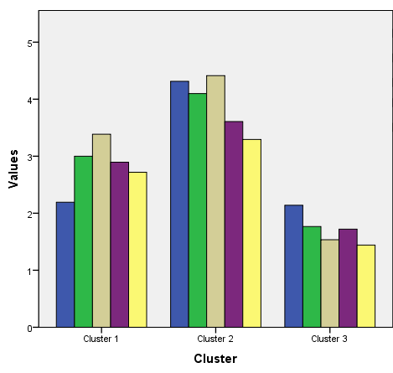
Figure 3.1 Intensity of product innovation for each cluster

Cluster with low intensity of product innovation accounted for 43 hotels with the mean rank of 1.7.
Cluster with medium intensity of product innovation accounted for 57 hotels with the mean rank of 2.8.
Cluster with high intensity of product innovation accounted for 51 hotels with the mean rank of 4.1.

Results of the cluster analysis for the intensity of the process innovation.
Table 3.15 Number of cases in each cluster - process innovation
 | Cluster | Number of hotels in each cluster
 | Cluster 1 – low rates of innovation intensity | 30
 | Cluster 2 – medium rates of innovation intensity | 67
 | Cluster 3 – high rates of innovation intensity | 54
Overall |  | 151
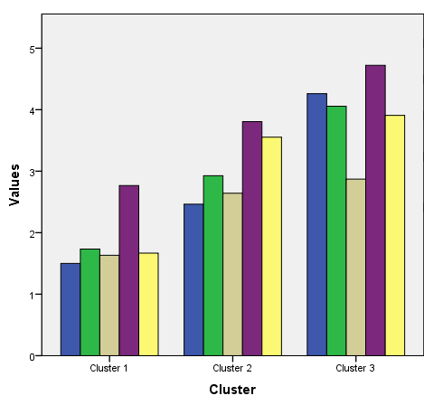
Figure 3.2 Intensity of process innovation for each cluster

Cluster with low intensity of process innovation accounted for 30 hotels with the mean rank of 2.1.
Cluster with medium intensity of process innovation accounted for 67 hotels with the mean rank of 3.0.
Cluster with high intensity of process innovation accounted for 54 hotels with the mean rank of 3.8.
Analysis of the responses also demonstrates high focus specifically on innovation in IT and ICT systems.

Results of the cluster analysis for the intensity of the marketing innovation.
Table 3.16 Number of cases in each cluster - marketing innovation
 | Cluster | Number of hotels in each cluster
 | Cluster 1 – low rates of innovation intensity | 31
 | Cluster 2 – medium rates of innovation intensity | 57
 | Cluster 3 – high rates of innovation intensity | 63
Overall |  | 151

Cluster with low intensity of marketing innovation accounted for 31 hotels with the mean rank of 1.8.
Cluster with medium intensity of marketing innovation accounted for 57 hotels with the mean rank of 3.1.
Cluster with high intensity of marketing innovation accounted for 63 hotels with the mean rank of 4.0.
Analysis of the responses demonstrates slightly higher focus specifically on the utilization of new distribution channels.
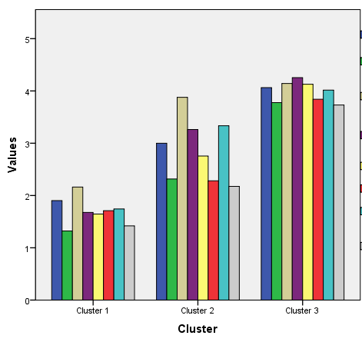
Figure 3.3 Intensity of marketing innovation for each cluster

Results of the cluster analysis for the intensity of the managerial innovation.
Table 3.17 Number of cases in each cluster - managerial innovation
 | Cluster | Number of hotels in each cluster
 | Cluster 1 – medium rates of innovation intensity | 54
 | Cluster 2 – high rates of innovation intensity | 34
 | Cluster 3 – low rates of innovation intensity | 63
Overall |  | 151

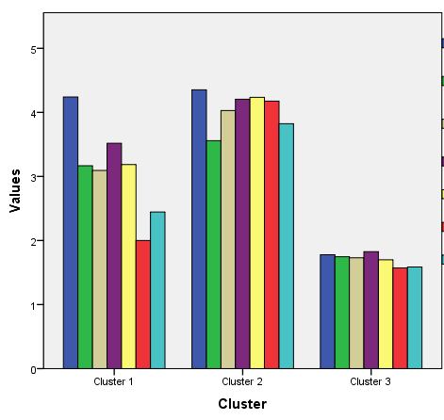
Figure 3.4 Intensity of managerial innovation for each cluster

Cluster with low intensity of marketing innovation accounted for 63 hotels with the mean rank of 1.9.
Cluster with medium intensity of marketing innovation accounted for 54 hotels with the mean rank of 2.8.
Cluster with high intensity of marketing innovation accounted for 34 hotels with the mean rank of 4.0.

3.7 Analysis of existing combinations of innovation types.
After performing the cluster analysis, it became possible to identify intensity of different types of innovations for each company.
14 outcomes were identified out of 17 possible. These outcomes and their loadings are given in Table 3.18.

Table 3.18 Found innovation types and combinations of innovation types
Innovation type or a combination of multiple innovation types | Number of  hotels | Percentage
Hotels focused on product innovation | 7 | 4,6 %
Hotels focused on process innovation | 7 | 4,6 %
Hotels focused on marketing innovation | 7 | 4,6 %
Hotels focused on product and process innovations | 4 | 2,6 %
Hotels focused on product and marketing innovations | 10 | 6,6 %
Hotels focused on process and managerial innovations | 4 | 2,6 %
Hotels focused on process and marketing innovations | 13 | 8,6 %
Hotels focused on marketing and managerial innovations | 1 | 0,7 %
Hotels focused on product, marketing and managerial innovations | 7 | 4,6 %
Hotels focused on product, process and marketing innovations | 12 | 7,9 %
Hotels focused on process, marketing and managerial innovations | 4 | 2,6 %
Hotels focused on all 4 types of innovations | 11 | 7,3 %
Hotels with low innovation intensity | 17 | 11,3 %
Hotels not focused on any type of innovation | 47 | 31,1 %
Overall | 151 | 100 %

Noticeably, the significant portion of the companies (31,1%) are not focused on the particular type of innovation.
11,3% of the companies demonstrating low intensity in every type of innovation.
7,3% of the companies demonstrated high intensity in every type of innovation.
An equal amount of companies (4,6% each) are focused primarily on product, process or marketing type of innovation. There are no examples of companies with high focus on managerial type of innovations.
Following pairs of innovation types are found – process and marketing (8,6%), product and marketing (6,6%), product and process (2,6%), process and managerial (2,6%), marketing and managerial (0,7%).
Following combinations of three innovation types are found – product, process and marketing (7,9%); product, marketing and managerial (4,6%); process, marketing and managerial (2,6%).
Hypothesis H2 was tested using Independent-Samples Kruskal-Wallis test, which is non-parametric analogue of ANOVA test, to determine the existence of differences in changes of performance between the combination of innovation types.
Analysis of changes in client satisfaction among combinations of innovation types.
The results of Kruskal-Wallis test (fig. 3.5) indicate a strong difference (p=0.001) between mean ranks of at least one pair of groups, meaning that there is at least one pair of combinations with significantly different changes in client satisfaction.
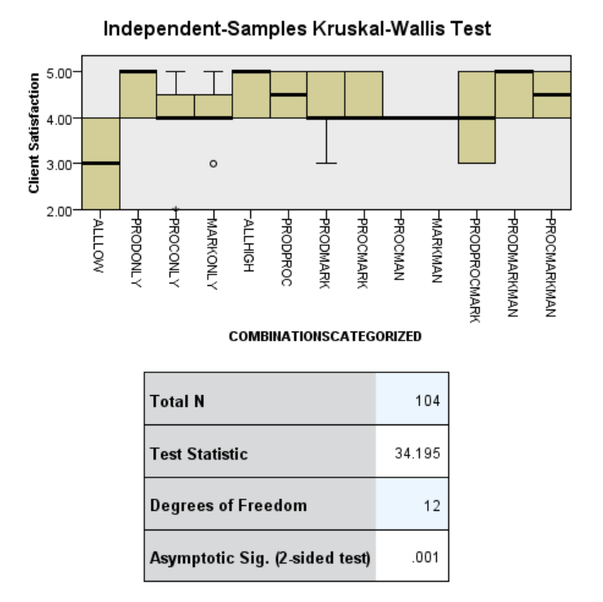
Figure 3.5 Difference in mean ranks of changes in client satisfaction among combinations of innovation types.
Dunn’s pairwise tests were carried out for the 77 pairs of groups. There was strong evidence (p < 0.05, adjusted using the Bonferroni correction) of a difference between the following groups:
- “Hotels with low innovation intensity” and “Hotels focused on all 4 types of innovation”;
- “Hotels with low innovation intensity” and “Hotels focused on Product, marketing and managerial innovations”;
- “Hotels with low innovation intensity” and “Hotels focused on Product innovations”;
- “Hotels with low innovation intensity” and “Hotels focused on Process and marketing innovations”.
Comparison in client satisfaction between other combinations of innovation types yielded no significant evidence of a difference.
Analysis of changes in quality of service among combinations of innovation types.
The results of Kruskal-Wallis test (fig. 3.6) indicate a very strong difference (p<0.001) between mean ranks of at least one pair of groups, meaning that there is at least one pair of combinations with significantly different changes in quality of service.
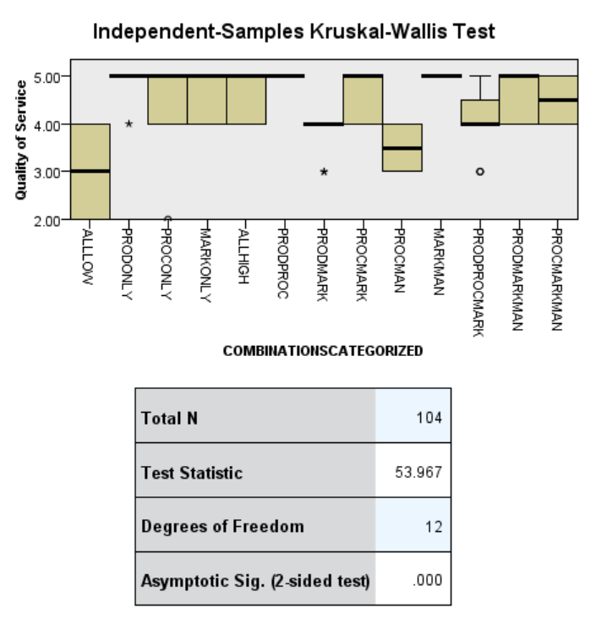
Figure 3.6 Difference in mean ranks of changes in quality of service among combinations of innovation types.
Dunn’s pairwise tests were carried out for the 77 pairs of groups. There was strong evidence (p < 0.05, adjusted using the Bonferroni correction) of a difference between the following groups:
- “Hotels with low innovation intensity” and “Hotels focused on all 4 types of innovation”;
- “Hotels with low innovation intensity” and “Hotels focused on Product innovations”;
- “Hotels with low innovation intensity” and “Hotels focused on Marketing innovations”;
- “Hotels with low innovation intensity” and “Hotels focused on Process and Marketing innovations”;
- “Hotels with low innovation intensity” and “Hotels focused on Product and Process innovations”;
- “Hotels with low innovation intensity” and “Hotels focused on Product, Marketing and Management innovations”.
Comparison in quality of service between other combinations of innovation types yielded no significant evidence of a difference.
Analysis of changes in occupancy rate among combinations of innovation types.
The results of Kruskal-Wallis test (fig. 3.7) indicate a very strong difference (p<0.001) between mean ranks of at least one pair of groups, meaning that there is at least one pair of combinations with significantly different changes in occupancy rates.
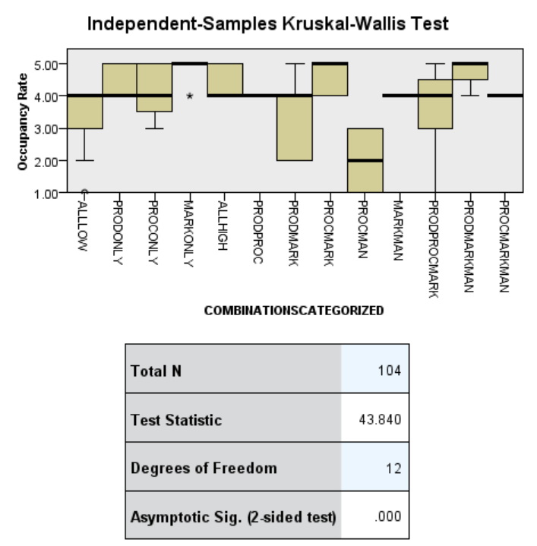
Figure 3.7 Difference in mean ranks of changes in occupancy rates among combinations of innovation types.
Dunn’s pairwise tests were carried out for the 77 pairs of groups. There was strong evidence (p < 0.05, adjusted using the Bonferroni correction) of a difference between the following groups:
  - “Hotels with low innovation intensity” and “Hotels focused on Marketing innovations”;
  - “Hotels with low innovation intensity” and “Hotels focused on Process and Marketing innovations”;
  - “Hotels with low innovation intensity” and “Hotels focused on Product, Marketing and Management innovations”;
  - Hotels focused on Process and Management innovations” and Hotels focused on Process and Marketing innovations”;
  - Hotels focused on Process and Management innovations” and Hotels focused on Product, Marketing and Management innovations”;
  - Hotels focused on Process and Management innovations” and Hotels focused on Marketing innovations”.
Comparison in occupancy rates between other combinations of innovation types yielded no significant evidence of a difference.
Analysis of changes in revenues among combinations of innovation types.
The results of Kruskal-Wallis test (fig 3.8) indicate a very strong difference (p<0.001) between mean ranks of at least one pair of groups, meaning that there is at least one pair of combinations with significantly different changes in revenues.
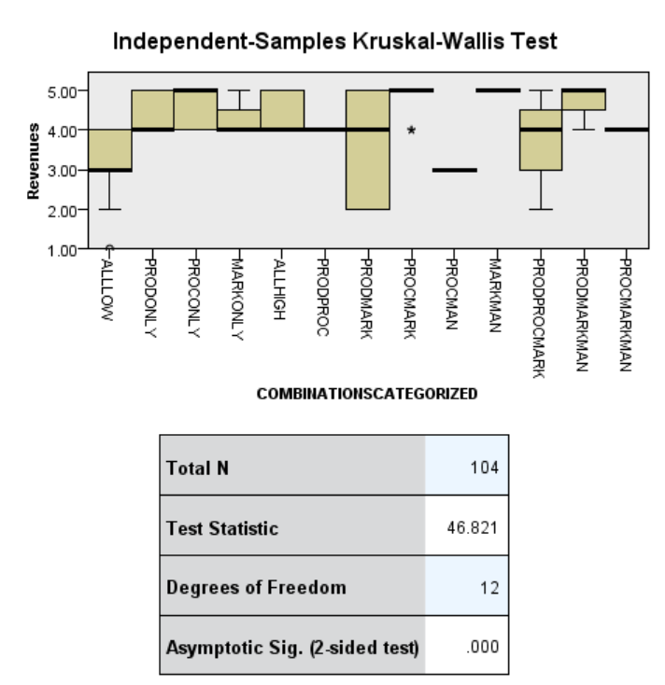
Figure 3.8 Difference in mean ranks of changes in revenues among combinations of innovation types.
Dunn’s pairwise tests were carried out for the 77 pairs of groups. There was strong evidence (p < 0.05, adjusted using the Bonferroni correction) of a difference between the following groups:
  - “Hotels with low innovation intensity” and “Hotels focused on Process and Marketing innovations”;
  - “Hotels with low innovation intensity” and “Hotels focused on Product, Marketing and Management innovations”;
  - “Hotels focused on Process and Management innovations” and “Hotels focused on Process and Marketing innovations”
Comparison in client satisfaction between other combinations of innovation types yielded no significant evidence of a difference.
Analysis of changes in expenses among combinations of innovation types.
The results of Kruskal-Wallis (fig. 3.9) test indicate no significant difference (p=0.494) between mean ranks groups. There is no significant difference in changes in expenses between hotels implementing different combinations of innovation types.
Figure 3.9 Difference in mean ranks of changes in expenses among combinations of innovation types.
3.8 Results and outcomes.
Results of the research demonstrate positive correlation between the intensity of innovative activities of the hotel and its performance, measured in revenues, occupancy rates, quality of provided services and customer satisfaction. However, the strength of association is characterized as moderate to weak. Additionally, no correlation, positive or negative, was found between the level of innovative activity and the amount of expenses carried by the hotel during the inquired period.
Although no causal relationship can be implied based on the results, it can still be argued based on the previous researches that innovation activity of the hotel has a positive impact on its performance. Therefore, following research hypotheses are confirmed:
H1a: Product innovation positively impacts business performance;
H2b: Process innovation positively impacts business performance;
H2c: Marketing innovation positively impacts business performance;
H2d” Managerial innovation positively impacts business performance.
Moderate to weak strength of association between the intensity of innovation and changes in performance indicates high influence of external social, economic and political factors. Also as stated by Atuahene-Gima (1996) critical factor of innovation success in the service industry is the human resource strategy of the company. Further research is needed to better understand the influence of external and internal factors on the innovative success in the hotel sector.
Preliminary analysis of the responses also demonstrated relatively high focus specifically on innovation in IT and ICT systems, which is also corresponds to the results of a pilot study performed by Pikkemaat and Peters (2008).
Analysis of the results demonstrates that the largest portion of the hotels (31.1%) has moderate intensity of innovation activity with no distinct focus on any particular type of innovation. This group of hotels more frequently mentioned lack of financial (76%) and human resources (43%), the uncertainty in the results (45%) as an obstacle for innovative activity, compared to the hotels focused on at least one type of innovation.
Table 3.19 represents interrelationship between four performance indicators. Table includes innovation types and their combinations where the significant differences in performance were found compared to the performance of the hotels with low intensity of innovation.
Table 3.19 Types of innovations and their combinations that are associated with the significant differences in performance compared to the hotels with low innovation intensity.
Client Satisfaction | Quality of service | Occupancy rates | Revenues
Product innovation  Marketing innovation  Managerial innovation | Product innovation  Marketing innovation  Managerial innovation | Product innovation  Marketing innovation  Managerial innovation | Product innovation  Marketing innovation  Managerial innovation
Process innovation  Marketing innovation | Process innovation  Marketing innovation | Process innovation  Marketing innovation | Process innovation  Marketing innovation
Product innovation | Product innovation | - | -
 | Marketing innovation | Marketing innovation
Product innovation  Process innovation  Marketing innovation  Managerial innovation | Product innovation  Process innovation  Marketing innovation  Managerial innovation

No hotels with high focus on managerial innovation were identified. Additionally, combinations of innovations that involve high focus on managerial innovation are less frequently represented in the sample. In could be concluded that managerial innovations are not being seeing as a main driver of positive change in business performance among the hoteliers of the Russian Federation.
There are statistically significant differences in changes in performance between companies with low intensity of innovation and companies with high focus on [product, marketing, managerial] innovations and [process, marketing] innovations among four performance indicators – client satisfaction, quality of service, occupancy rates and revenues.
High focus on all four innovation types associated with significant differences in two performance metrics - client satisfaction and quality of service, when compared to the hotels with low innovation intensity.
Companies focused on product innovation demonstrated significant difference in changes in client satisfaction and quality of service. Companies focused on marketing innovation demonstrated significant differences in changes in quality of service and occupancy rates.
Significant difference in quality of service was found between hotels with low innovation intensity and hotels focused on [product, process] innovations, however no difference was found in other performance indicators.
Further analysis demonstrated no statistically significant difference in changes in performance among described types of innovations (and their combinations).
Results of the analysis demonstrates that out of sixteen possible innovation activities only two corresponds with statistically significant differences in changes in all four performance metrics, that were found to be associated with innovation activities of the hotel when compared to hotels with low intensity of innovative activity. Results also demonstrate no statistically significant differences between these two combinations of innovation types.
It can be concluded that not every type of innovation or the combination of multiple innovation types are associated with changes in performance that are different to changes in performance of the hotels not involved in the innovative activities. Therefore the H2 hypothesis “Changes in the performance of the hotel depend on the implemented innovation type or a combination of multiple innovation types” is confirmed.
When comparing changes in the performance metrics of hotels with low innovation intensity to changes in the performance metrics of hotels with high focus on a single innovation type – product or marketing innovation, statistically significant differences between two performance metrics were found. Compared to the hotels implementing multiple innovation types, where four performance metrics are different relative to metrics of hotels not engaged in innovative activities. Therefore it can be concluded that implementation of multiple innovation types, specifically combination of [product, marketing, managerial] and [process, marketing] is more beneficial for the hotel rather than focus on a single innovation type.
However, a high focus on all four innovation types does not results in changes in only two performance metrics that are different to changes of hotels not engaged in innovative activities. Although it can be suggested that the cause is the lack of strategy or time constraints that results in an inefficient implementation, this phenomena requires further investigation.

3.9. Conclusion of Chapter 3
Although findings support the statement about the positive difference between companies that do innovate and companies that do not innovate, the strength of association of the innovation intensity and changes in performance can be described as moderate to low.
This research does not examine cause and effect relationship between changes in innovation intensity and changes in performance. Despite the fact that previous research in the field suggests innovation to be the cause of positive change in firm performance, some innovation activities could be a direct outcome of these positive changes.
Research results demonstrates that implementation of different innovation types or their combinations is associated with different changes in hotel performance when compared to the hotels with no innovation activity.
Two specific combinations of innovation types were found to have an association with positive change among four performance indicators. These combinations are:
- Combination of product, marketing and managerial innovations;
- Combination of process and marketing innovations.
Additionally, positive relationship was found between:
- Hotels focused solely on product innovation and client satisfaction, quality of service
- Hotels focused solely on marketing innovation and quality of service, occupancy rates.
Focus on all four types of innovation relates to positive changes in client satisfaction and quality of service, but not to changes in occupancy rates or revenues. Compared to the implementation of only 3 types of innovation [product, marketing and marketing], where association with changes in occupancy rates and revenues was also found.

chapter 4 Conclusion and implementations.
Analysis of the literature demonstrates lack of empirical research in the field of hospitality devoted to the comparison of the effect of different innovation types on business performance.
The goal of this paper was to investigate the relationship between the implementation of a particular type of innovation or the combination of multiple innovation types and associated changes in the performance of small and medium-sized hotels.
A sample of 151 firms was analyzed to determine the degree of relation between the innovative activity of the hotel over the last three years and changes in business performance.
As a result, a positive relationship between all four innovation types and changes in customer satisfaction, quality of service, occupancy rates and revenues was found. However, no relation was found between innovation activity and changes in the amount of expenses.
Analysis of the innovation intensity revealed that 57.6% of hotels put a particular focus on a single or multiple types of innovation. 11.3% of hotels are demonstrating low rates of innovation intensity across all four innovation types. 31.1% of hotels innovate with medium rates of innovation intensity.
Further analysis revealed that only particular combinations of innovation types are associated with changes in business performance that are significantly different to changes in business performance of hotels not engaged in innovation activities.
Two combinations of innovation types found to be associated with positive changes among four performance metrics – [product, marketing, managerial] and [process, marketing] combinations of innovation types. Additionally, focus specifically on product or marketing innovation types is associated with positive changes among two performance metrics.
Implementation of multiple innovation types found to have a broader impact on the performance of the hotel compared to the implementation of a single innovation type.
Further research is required to determine factors affecting the successfulness of innovation activities regarding the particular type of innovation in hospitality sector.

4.1 Theoretical contribution.
Positive association between the innovation activity and performance is confirmed for SMEs of hotel industry in Russian Federation. Low to medium strength of correlation between innovation intensity and the performance of the hotel indicates high influence of other factors. These factors have to be taken into account for innovation to yield successful results. Additional studies are required to determine the effect of internal and external factors on the successfulness of different types of innovation in hotel industry.
No correlation is found between the strength of innovation activity and changes in the amount of expenses. This phenomenon implies that either the effect from innovation has low impact on the amount of expenses, or costs of implementing the innovative activities outweigh the financial gains.
Not all innovation types found to be associated with changes in hotel performance that are significantly different to changes in the performance of hotels not engaged in innovation activities
Implementation of multiple innovation types are found to be associated with changes in the performance of hotels that are significantly different to changes in the performance of the hotels not engaged in innovation activity, compared to the implementation of the single innovation type, where significant differences were not found when compared to hotels not engaged in innovation activity.
It is discovered that hoteliers of small and medium-sized hotels do not put high focus on managerial type of innovation. It can be suggested the managerial innovations play a supportive role during innovative processes, however the exact effect of managerial innovation on the effectiveness of other innovation types require additional studies.

4.2 Practical implications.
Research results demonstrate the importance of implementing multiple innovation types to achieve positive changes in hotel performance.
low intensity of innovation with following options that are found to be associated with positive changes in the performance:
- Combination of product, marketing and managerial innovations;
- Combination of process and marketing innovations.
As there was no difference found in changes in performance between two over mentioned combinations, the choice should be dependent on costs of innovation and available resources.
It can be suggested that different types of innovations are requiring different amount of time for the effect to take place. It is possible to assume that marketing innovation would affect occupancy rates and revenues in a shorter period compared to other types of innovation. Therefore, the decision could depend on whether the immediate or long-term effect is required.
Therefore the suggestion is for the hotels with low intensity of innovation intensity to focus on the combination of process and marketing innovation. This suggestion based on the idea that two types of innovation combine both short and long-term effect. Additionally, implementation of two innovation types instead of three is likely to put less strain on the resources of the company. Additionally, it is rational to perform these changes in two stages, starting from marketing innovation that would presumably affect both quality of service and the occupancy rates of the hotel, and followed by the process innovation that, combined with marketing innovation, should be associated with positive changes in hotels occupancy rates, revenues, quality of service and customer satisfaction.
4.3 Limitations and recommendations for further research.
This research studies the relationship between innovation activity of a hotel and changes in performance over a period of 3 years. In this research a cross-sectional survey was used due to the time and resource constraints of the researcher. This method is usually applied to study the phenomenon at a certain point in time. An implementation of a longitudinal survey, when data is collected over a certain period of time, may provide results with a lower degree of the respondents’ subjectivity.
Data on the hotel performance represents subjective view of the respondent. Although the validity of the collected data was tested, measures of changes in hotel performance would be more accurate and informative if the financial data was used instead of the subjective evaluation of changes in performance made by manager or hotel owner. Access to proper financial data would allow to perform more precise comparison of the effect of different innovation types.
Research results are limited by the geography of the respondents. Research designed in a similar method can yield significantly different results when performed in another region due to regional particularities.
Research was conducted with data obtained from small and medium sized enterprises. Due to the particularities of the innovation processes in large organizations, the results should be applied with caution. Further comparison of the effectiveness of different innovation types in SMEs to ones in large enterprises is required.
Enterprises of a hotel industry were studied in the research. The effect of innovation in other service or manufacturing industries is expected to be different. Additional research may be conducted to compare the effect of combinations of innovation types across multiple industries.
Study found a moderate to weak strength of association between the innovation intensity and changes in business performance of the hotel, indicating the high level of influence of other internal and external factors on hotels’ performance. It is suggested for the internal and external factors to have an effect on the successfulness of innovative activities. Additional studies of interrelations between internal and external factors and the implementation processes of innovation types should indicate factors affecting the successfulness of executing innovative activities, therefore improving the effectiveness of innovations.

LIST OF REFERENCES
- Ahmad A., Dey L., (2007). A k-mean clustering algorithm for mixed numeric and categorical data, Data & Knowledge Engineering, Volume 63, Issue 2, pp 503-527
- Behara, R. S. (2000). Process innovation in knowledge-intensive services, New service development, pp. 138–151. Thousands Oaks: Sage.
- Bogliacino, F., Lucchese, M. and Pianta, M. (2013), Job creation in business services: innovation, demand, and organization, Structural Change and Economic Dynamics, Vol. 25, pp. 95-109.
- Brooker, E., Joppe, M. (2014). Developing a tourism innovation typology: leveraging liminal insights”, Journal of Travel Research, Vol. 53 No. 4, pp. 500-508.
- Campo, S., Díaz, A., Yagüe, M. (2014), “Hotel innovation and performance in times of crisis”, International Journal of Contemporary Hospitality Management, Vol. 26 No.8, pp. 1292-1311.
- Carlborg P., Kindstrom D., Kowalkowski C. (2014). The evolution of service innovation research: a critical review andsynthesis, The Service Industries Journal, Vol. 34, No. 5, 373–398
- Christensen, J. L. (2008). Innovation and management in North Jutland tourism firms. Paper for the RSA-workshop, November 28. Aalborg University: Department of Business Studies.
- Damanpour, F. (2010). An Integration of Research Findings of Effects of Firm Size and Market Competition on Product and Process Innovations. British Journal of Management, 21(4), pp. 996-1010.
- Demirbas, D., Hussain, H.M., Matlay, H., (2011). Owner-Manager’s Perceptions of Barriers to Innovation: Empirical Evidence from Turkish SMEs. Journal of Small Business and Entrepreneur Development, Vol.18, No. 4, 2011, pp. 764-780.
- European Commission. (2003, May 20). Commission Recommendation 2003/361/EC concerning the definition of micro, small and medium-sized enterprises. Official Journal of the European Union, L 124, pp. 36-41.
- Evangelista, R. (2000). Sectoral patterns of technological change in services. Economics of Innovation and New Technology, 9, pp. 182–221.
- Goswami, S., Mathew, M. (2005). Definition of Innovation Revisited: An Empirical Study on Indian Information Technology Industry. International Journal of Innovation Management, 9(3), pp. 371-383.
- Greco, M., Grimaldi, M., & Cricelli, L. (2015). Open innovation actions and innovation performance – A literature review of European empirical evidence. European Journal of Innovation Management, 18(2). Pp. 150-171.
- Grimpe, C., Kaiser, U. (2010). Balancing Internal and External Knowledge Acquisition: The Gains and Pains from R&D Outsourcing. Journal of Management Studies, 47(8). Pp. 1483-1509.
- Grissemann, U., Pikkemaat, B., Weger, C., (2013). Antecedents of innovation activities in tourism: An empirical investigation of the Alpine hospitality industry, Tourism: An International Interdisciplinary Journal, Vol.61 No.1 April 2013. Pp 7-27.
- Gyurácz-Németh, P., Horn, N., & Friedrich, N. (2016). Analyzing Hotel Innovation Behavior in the Balaton Region of Hungary to Identify Best Practices. Naše gospodarstvo/Our Economy, 62(3)
- Hair J.F., Anderson F.E., Tahtam R.L. and Black W.C. (1998), Multivariate Data Analysis, Pearson Education, Fifth Edition, New Jersey.
- Hall, C. M. (2009). Innovation and tourism policy in Australia and New Zealand: never the twain shall meet? Journal of Policy Research in Tourism, Leisure and Events, 1(1), pp. 2–18.
- Hall, C. M., Williams, A. M. (2008). Tourism and innovation. London: Routledge.
- Haim, A., Kaliappen, N., (2015). Innovation strategies and performance: are they truly linked? World Journal of Entrepreneurship, Management and Sustainable Development. 11. Pp 48-63.
- Hipp, C., Grupp, H. (2005). Innovation in the service sector: The demand for service specific innovation measurement concepts and typologies. Research Policy 34(2005). (pp. 517-535).
- Hjalager A.M. (2010). A review of innovation research in tourism. Journal of tourism Management 31 (2010). Pp. 1–12.
- Hoelzl, B., Paechlaner, H., Laesser, C. (2005). Imitation processes of SMEs – a special form of innovation? In P. Keller, & T. Bieger (Eds.), Innovation in tourism – Creating customer value, pp. 311–322, St. Gallen: AIEST.
- Knight, G., (2001). Entrepreneurship and strategy in the international SME. Journal of International Management. 7(3), pp. 155-171.
- Laforet, S. (2013). Organizational Innovation Outcomes in SMEs: Effects of Age, Size, and Sector. Journal of World Business, 48(4), pp. 490-502.
- Lashley, D., Morrison, A. (2000). Franchising hospitality services. Oxford: Butterworth-Heinemann, pp. 122-124.
- Lichtenthaler, U. (2011). Open innovation: past research, current debates, and future directions, Academy of Management, Vol. 25 No. 1, pp. 75-93.
- Lopez F. (2011). Factors encouraging innovation in Spanish hospitality firms. Cornell Hospitality Quarterly 52, 2(2011), pp. 144-152.
- Lynch, P., Morrison, A. (2007). Micro-clusters and networks: The growth of tourism. Oxford: Elsevier, pp. 43–62.
- Miles, I. (2008). Patterns of innovation in service industries. IBM Systems Journal 47(1), pp. 115–128.
- Mattson, J., Orfila-Sintes, F., (2014) Hotel Innovation and Its Effect on Business Performance, International Journal of Tourism Research, Int. J. Tourism Res., 16: 388–398 (2014)
- Nicolau J., Santa-Maria, M., (2013), The effect of innovation on hotel market value. International Journal of Hospitality Management, 32 (2013), pp. 71-79
- Nievis, J., Diaz, G., (2015). Antecedents and outcomes of marketing innovation. An empirical analysis in the hotel industry. International Journal of Contemporary Hospitality Management. Vol. 28 No. 8, 2016,pp. 1554-1576.
- Nievis, J., Quintana, A., Osorio, J., (2014). Knowledge-based resources and innovation in the hotel industry, International Journal of Hospitality Management 38 (2014). (pp. 65–73).
- OECD. (2015). Financing SMEs and Entrepreneurs 2015: An OECD Scoreboard. Paris: OECD Publishing.
- Orfilasintes, F., Mattsson, J. (2009). Innovation in the hotel industry” Omega – The International Journal of Management Science 37(2009), pp. 380-394.
- Ottenbacher, M., Shaw, V., & Lockwood, A. (2005). An investigation of factors affecting innovation performance in chain and independent hotels. Journal of Quality Assurance in Hospitality & Tourism, 6(3/4), pp. 113–128.
- Paget E., Dimanche F., Mounet J. (2010). A tourism innovation case: An Actor-Network Approach, Annals of Tourism Research, pp. 828-847.
- Pechlaner, H., Fischer, E., Hammann, E. M. (2005). Leadership and innovation processes – development of products and services based on core competencies. Journal of Quality Assurance in Hospitality & Tourism, 6(3/4), pp. 31–57.
- Pikkemaat, B. (2008). Innovation in small and medium-sized tourism enterprises in Tyrol, Austria. Entrepreneurship and Innovation, 9(3), pp. 187–197.
- Pikkemaat, B., Peters, M., 2008, Towards the Measurement of Innovation—A Pilot Study in the Small and Medium Sized Hotel Industry, Journal of QualityAssurance in Hospitality & Tourism, 6:3-4, 89-112
- Revilla, A. J., & Fernández, Z. (2012). The relation between firm size and R&D productivity in different technological regimes. Technovation, 32(11), pp. 609-623.
- Ribarik, R., (2014). Potential drivers of innovation in the MSMEs in hospitality industry in istra, Tourism and Hospitality Industry 2014, CONGRESS PROCEEDINGS Trends in Tourism and Hospitality Industry.
- Rogers, S. (2007). Innovation in food service technology and its strategic role. International Journal of Hospitality Management, 26(4), pp. 899–912.
- Sandvik, I. L., Duhan, D. F., & Sandvik, K. (2014). Innovativeness and profitability. An empirical investigation in the Norwegian hotel industry. Cornell Hospitality Quarterly, 55(2), pp. 165-185.
- Schumpeter, J. A. (1939). Business Cycles – A Theoretical, Historical and Statistical Analysis of the Capitalist Process, New York: McGraw-Hill Book Company, p. 234.
- Sirilli, G., Evangelista, R. (1998). Technological innovation in services and manufacturing: results from Italian surveys, Research Policy, Vol. 27, pp. 881-899.
- Smith, M., Busi, M., Ball, P., Van der Meer, R. (2008). Factors inﬂuencing and organization’s ability to manage innovation: a structured literature review and conceptual model, International Journal of Innovation Management, Vol. 12 No. 4, pp. 655-676.
- Sundbo, J. (2007). Management of innovations in services. The Service Industries Journal, 17(3), pp. 432–455.
- Tajeddini, K. (2010), Effect of customer orientation and entrepreneurial orientation oninnovativeness: evidence from the hotel industry in Switzerland, Tourism Management, Vol. 31 No. 2, pp. 221-231.
- Victorino, L., Verma, R., Plaschka, F., Dev, C. (2005). Service innovation and customer choices in the hospitality industry. Managing Service Quality, 15(6), pp. 555–576.
- World Travel & Tourism Council: Travel & Tourism Economic Impact 2017

